CONTENTS

5.0 Sampling 5-2
5.1 Model Changes for Samples 5-2
5.2 Search and List Samples and Sample Summaries Pages 5-2
5.2.1 Search Page 5-2
5.2.2 Coliform Sample/Sample Summary List 5-14
5.2.3 LCR Sample/Sample Summary List 5-19
5.2.4 General Sample/Sample Summary Maintenance List 5-24
5.3 Coliform Sample and Summaries Pages 5-29
5.3.1 Coliform Sample Maintenance 5-29
5.3.2 Coliform Sample Summary Maintenance 5-69
5.4 LCR Sample and Summaries Pages 5-81
5.4.1 LCR Sample Maintenance 5-81
5.4.2 LCR Sample Summary Maintenance 5-112
5.5 General Sample Maintenance Pages 5-129
5.5.1 General Sample Maintenance 5-129
5.5.2 General Result Maintenance 5-152
5.5.3 Microbiological Result Maintenance 5-169
5.5.4 Radiological Result Maintenance 5-183
5.5.5 Composite Sample Maintenance 5-189
5.5.6 Individual Sample Member Information 5-201
5.6 MDBP Summaries 5-214
5.6.1 Model Changes for MDBP Summary 5-214
5.6.2 Water Treatment (WT) Summary Page Flow 5-214
5.6.3 Water Treatment Summary 5-214
5.6.4 MRDL Summary Page Flow 5-274
5.6.5 General MDBP Summary Page Flow 5-287
5.7 Results Averages 5-307
5.7.1 Model Changes for Results Averages 5-308
5.7.2 Results Averages Page Flow 5-308
5.7.3 Historical Sampling Information Page 5-333
5.8 WQP Days Out of Compliance 5-335
5.8.1 Model Changes for WQP Days Out of Compliance 5-335
5.8.2 WQP Days Out of Compliance Page Flow 5-336
5.9 Field Results Maintenance 5-343

EXHIBITS

Exhibit 5-1. Sampling Home Page 5-1
Exhibit 5-1a. Sample/Sample Summary Search 5-3
Exhibit 5-2. Coliform Sample/Sample Summary List 5-15
Exhibit 5-3. LCR Sample/Sample Summary List 5-20
Exhibit 5-4. General Sample/Sample Summary List 5-25
Exhibit 5-5. Coliform Sample Maintenance 5-33
Exhibit 5-6. Original Sample Information 5-34
Exhibit 5-7. No Acute Speciation Indicated Advisory 5-47
Exhibit 5-8. Delete Result Dialog Box 5-59
Exhibit 5-9. Compliance Linkage Advisory 5-62
Exhibit 5-10. No Acute Speciation Indicated Advisory 5-63
Exhibit 5-11. Coliform Sample Summary Maintenance 5-70
Exhibit 5-12. LCR Sample Maintenance 5-82
Exhibit 5-13. Original Sample Information 5-106
Exhibit 5-14. Disassociation Confirm Advisory 5-110
Exhibit 5-15. LCR Sample Summary Maintenance 5-112
Exhibit 5-16. General Sample Maintenance 5-130
Exhibit 5-17. Analyte Entry Advisory 5-142
Exhibit 5-18. Delete Result Dialog Box 5-144
Exhibit 5-19. Other Sample Measure Maintenance 5-149
Exhibit 5-20. General Results Maintenance 5-153
Exhibit 5-21. No SSMPA Advisory Dialog Box 5-169
Exhibit 5-22. Microbiological Results Maintenance 5-170
Exhibit 5-23. Other Analysis Measure Maintenance 5-180
Exhibit 5-24. Radiological Results Maintenance 5-185
Exhibit 5-25. Composite Sample Maintenance 5-190
Exhibit 5-26. Delete Confirmation 5-195
Exhibit 5-27. Analyte Entry 5-197
Exhibit 5-28. Delete Confirmation 5-199
Exhibit 5-29. Individual Sample Member Information 5-202
Exhibit 5-30. WT Summary Category Selection 5-215
Exhibit 5-31. Water Treatment Summary Jump 5-232
Exhibit 5-32. Violation Types for Three Turbidity Rules 5-234
Exhibit 5-33. Combined Filter Effluent Turbidity 5-235
Exhibit 5-34. Individual Filter Effluent Turbidity 5-246
Exhibit 5-35. Entry Point RDC 5-251
Exhibit 5-36. Entry Point Chlorine Dioxide/Chlorite 5-257
Exhibit 5-37. Distribution RDC 5-262
Exhibit 5-38. MRDL Chlorine/Chloramine DS 5-270
Exhibit 5-39. Chlorine/Chloramine MRDL Summary Search 5-275
Exhibit 5-40. Chlorine/Chloramine MRDL Maintenance List 5-282
Exhibit 5-41. Chlorine/Chloramines MRDL Summary Maintenance 5-285
Exhibit 5-42. MRDL Summary Advisory 5-286
Exhibit 5-43. MDBP Summary Search/Add 5-288
Exhibit 5-44. MDBP Summary Maintenance List 5-296
Exhibit 5-45. MDBP Summary Maintenance 5-300
Exhibit 5-46. Results Averages Search 5-309
Exhibit 5-47. Results Averages Maintenance List 5-316
Exhibit 5-48. Results Averages Maintenance 5-320
Exhibit 5-49. Compliance Value List 5-333
Exhibit 5-50. Historical Sampling Information 5-334
Exhibit 5-51. WQP Days Out of Compliance Search 5-336
Exhibit 5-52. WQP Days Out of Compliance List 5-341
Exhibit 5-53. Field Results Page 5-343

This page is intentionally left blank.
ONLINE SAMPLING

The SDWIS/STATE Home Page will present the following options when the Sampling option is selected:

- Add Sample/Sample Summary.
- Maintain Sample/Sample Summary.
- MDBP Summaries.
- Maintain Results Averages.
- View WQP Days out of Compliance.

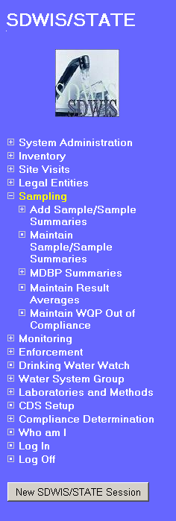 | 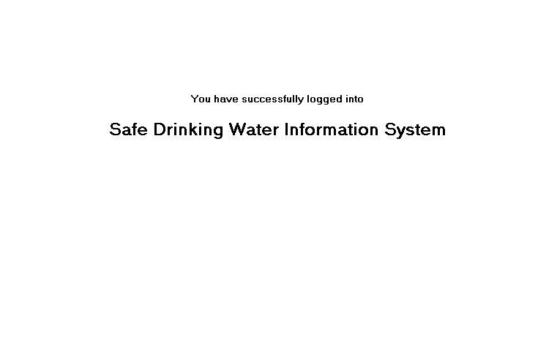

Exhibit 5-1. Sampling Home Page

Each of these selections is described in the section below.

Sampling

Model Changes for Samples
Changes to SAMPLE (TSASAMPL):
- Resize state_classification_code from 3 to 6. (R0036:A.5.1.a)

Changes to CODE (TINCODE)
- Update row to the CODE (TINCODE) table.
Code Name: SMPSTCLASS
Value Length: 6 (R0036:A.5.1.b)

Search and List Samples and Sample Summaries Pages

Search Page
Exhibit 5-1a depicts the Sample/Sample Summary Search page.

Selecting Sampling/Maintain Sample/Sample Summary will invoke the Sample/Sample Summary Search page, where users may specify the search criteria that will retrieve Samples, Sample Summaries, or Both. Pressing Search will retrieve and display selected records in the list page. The user’s current Water System Group/Regulating Agency will be used as implied search criteria in all searches for Sample/Sample Summary records. This means that the software will retrieve only samples/sample summaries linked to water systems that are linked to the user’s current Water System Group/Regulating Agency. If an exact Water System No. is entered, the software will validate that it belongs to the user’s current Water System Group/Regulating Agency.

Samples Only Search Options

Group Box One

User must select Lab Sample No. or State Sample No.; the water system is optional.

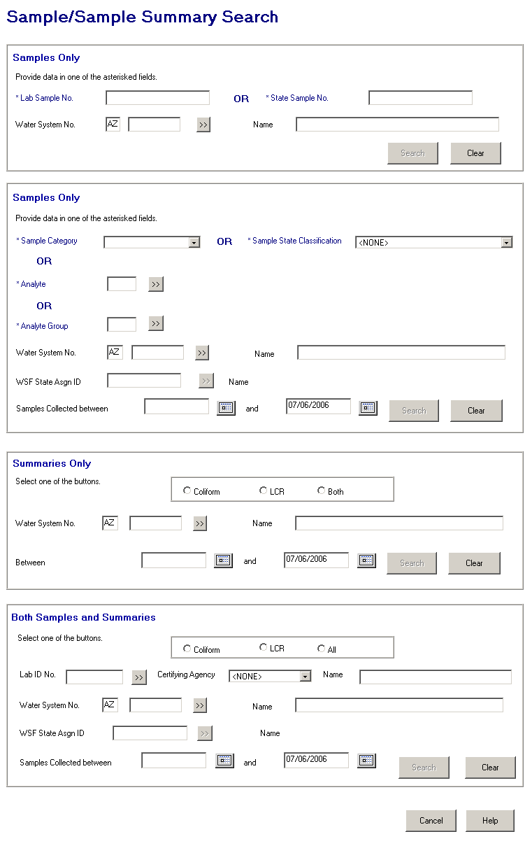

Exhibit 5-1a. Sample/Sample Summary Search
Entry Fields:

Lab Sample No. The sample identification number assigned by the laboratory for tracking the sample within the lab.

As the user enters/changes a value and tabs off the Lab Sample No. field, the State Sample No. field will be protected and the Search will be enabled. Either Lab Sample No. or State Sample No. must be supplied; both may not be supplied.

State Sample No. A value assigned by a state to uniquely identify a specific sampling occurrence.

As the user enters/changes a value and tabs off the State Sample No. field, the Lab Sample No. field will be protected and the Search will be enabled. Either Lab Sample No. or State Sample No. must be supplied; both may not be supplied.

Water System No. The specific Water System No., which consists of the two-character state code plus the seven-character number field.

The state code portion will default to the state_identification_code in the SYSTEM_VARIABLE entity view.

The Go To button may be pressed to select a water system from a list of water systems that are part of the current Water System Group or Regulating Agency. Once a valid water system has been entered or picked from a list, the water system name will be displayed on the window. If the user specifies a partial string in this field, display the closest matching water system at the top of the list. (Closest matching means a match with the Water System No., sorted alphabetically, that starts with the same text string as supplied.)

If a valid water system is entered but is not part of the user’s current Water System Group or Regulating Agency, invoke exit state error message: WS is not part of current group/agency. Change group/agency to access this WS.

This field is also present in Group Boxes 2, 3, and 4.

[Water System]
Name Standard 40-character Public Water System Name may be entered completely, partially, or left blank. If the user specifies a partial string in this field, display the closest matching water system at the top of the list. (Closest matching means a match with the Water System Name, sorted alphabetically, that starts with the same text string as supplied.)

If a valid water system name is entered the Water System No. is populated.

If a valid water system is entered but is not part of the user’s current Water System Group or Regulating Agency, invoke exit state error message: WS is not part of current group/agency. Change group/agency to access this WS.

If the name entered is not found the software will flow to the Water System Selection List. The user may then select a value and continue.

This field is also present in Group Boxes 2, 3, and 4.

Buttons:

[water system]
Go To Will present the Water System Maintenance List in single-select mode. If the user has typed part of the Water System No., it will be used in the search to invoke the Water System Maintenance List. The user may select a water system from this list. This button is also present in Group Boxes 2, 3, and 4.

Search Pressing this button will retrieve Samples based on the specified criteria. The following will be the possible search permutations:

- Search by Lab Sample No.
- Search by State Sample No.
- Search by Lab Sample No. and Water System
- Search by State Sample No. and Water System

Enabled when Lab Sample No. or State Sample No. is selected.

If only one sample exists then go directly to the appropriate sample maintenance page. If more than one sample found, display in General Sample/Sample Summary Maintenance List. If no samples found, display General Sample/Sample Summary Maintenance List and an advisory that none found with options of return to search or proceed to sample maintenance page in Add mode.

Clear Pressing this button will clear data from all fields in first Samples Only group box. All fields will become unprotected.
Group Box Two

The user must select Sample Category, Sample State Classification, Analyte, or Analyte Group. Water System, water system facility and date range are optional.

Protected Fields:

Analyte Name The common name of a contaminant as used by states and EPA in the rules and other documents.
Analyte Group
Name The name assigned to the Group of analytes.

WSF Name The name of the water system facility.

Entry Fields:

Sample Category A selectable list with the following permitted values:

TC Coliform
GE General
PB Lead and Copper

As the user selects a category and tabs off the Sample State Classification, Analyte field and Go To button, and the Analyte Group field and Go To button will be protected. Sample Category, Sample State Classification, Analyte Code, or Analyte Group Code must be supplied; more than one may not be supplied.

Sample
State Classification A selectable list of valid state classification codes. Dropdown list will be populated with values from the CODE table, code_name of ‘SMPSTCLASS’.

As the user selects a state classification and tabs off the Category, Analyte field and Go To button and the Analyte Group field and Go To button will be protected. Sample Category, Analyte Code, or Analyte Group Code must be supplied; more than one may not be supplied.

Increase size to accommodate new field length of 6. (R0036:A.5.2.1.a)

Analyte [Code] The user may enter a valid Analyte Code or use the Go To button to display the Analyte Selection List. As the user enters/changes a value and tabs off the Analyte Code field, the software will check that the supplied Analyte is valid, then populate the retrieved Analyte’s Name value in the protected Analyte Name field. If the user specifies a partial string in the field, display the closest matching analyte at the top of the Analyte Selection list. (Closest matching means a match with the Analyte Code, sorted alphabetically, that starts with the same text string as supplied.)
If the code entered is invalid, the software will flow to the Analyte Selection List. The user may then select a value and continue.

As the user enters/changes a value and tabs off the Analyte Code field, the Sample Category, Sample State Classification and Analyte Group field, and the Analyte Group Go To button will be protected. Sample Category, Sample State Classification, Analyte Code, or Analyte Group Code must be supplied; more than one may not be supplied.

Analyte Group
[Code] The user may enter a valid Analyte Group Code or use the Go To button to display the Analyte Group Selection List.

If the user specifies a partial string in the field, display the closest matching analyte group at the top of the list. (Closest matching means a match with the Analyte Group Code, sorted alphabetically, that starts with the same text string as supplied.) If the code entered is invalid, the software will flow to the Analyte Group Selection List. The user may then select a value and continue.

As the user enters/changes a value and tabs off the Analyte Group Code field, the Sample Category, Sample State Classification and Analyte fields, and the Analyte Go To button will be protected. Sample Category, Sample State Classification, Analyte Code, or Analyte Group Code must be supplied; more than one may not be supplied.

Water System No. This field is the same as the Water System No. in Group Box 1, 3, and 4.

[Water System]
Name This field is the same as the Water System Name in Group Box 1, 3, and 4.

WSF State Asgn ID Water system facility state assigned ID field may be entered or the user may choose a facility from a list by pressing the Go To button next to this field. This will be an optional field. This field will be protected until a Water System No. is entered.

If a valid water system facility State Asgn ID is entered, populate the water system facility name.

If the water system facility State Asgn ID entered is not found, the software will flow to the Water System Facility Selection List. The user may then select a value and continue.

This is an optional field.

This button is also present in Group Box 4.

Samples Collected Between
[Begin Date] This field will specify the begin date of the Sample Collection date range. A calendar function will allow the user to more easily enter dates for this field. Edit checks for date will be done later when the user clicks the Search button.

If begin date is valued and end date is not valued, search will include all samples with collection date equal to or greater than the begin date.

The default value for this field will be spaces. Do not allow future date. The error message will be: Date must not be a future date.

This is an optional field. This field is also present in Group Boxes 3 and 4.

and
[End Date] This field will specify the end date of the Sample Collection end Date range. A calendar function will allow the user to more easily enter dates for this field. Edit checks for date will be done later when the user clicks the Search button.

If end date is valued and begin date is not valued, search will include all samples with collection date equal to or earlier than the end date.

The default value for this field will be the current date. Allow future date.

This is an optional field. This field is also present in Group Boxes 3 and 4.

Buttons:

[analyte]
Go To Will present the Analyte Maintenance List in single-select mode. If the user has typed part of the analyte code, it will be used in the search to invoke the Analyte Maintenance List. The user may select an analyte from this list. Disabled when: Sample Category or Analyte Group selected.

[analyte group]
Go To Will present the Analyte Group Maintenance List in single-select mode. If the user has typed part of the analyte group code, it will be used in the search to present the Analyte Group Selection List. The user may select an analyte group from this list. Disabled when: Sample Category or Analyte selected.

[water system]
Go To This button is the same as the Water System Go To in Group Boxes 1, 3, and 4.

[water system facility]
Go To Will present the Water System Facility Maintenance List in single-select mode. If the user has typed part of the water system facility State Asgn ID number, it will be used in the search to invoke the Water System Facility Maintenance List. The user may select a water system facility from this list. Disabled when: Water System not selected.

This button is also present in Group Box 4.

Search Pressing this button will retrieve Samples based on the specified criteria. The following will be the possible search permutations:

- Search by Sample Category.
- Search by Analyte.
- Search by Analyte Group.
- Search by Sample State classification.
- Search by Water System and Sample Category.
- Search by Water System and Sample State classification.
- Search by Water System and Analyte.
- Search by Water System and Analyte Group.
- Search by WSF and Sample Category.
- Search by WSF and Sample State classification.
- Search by WSF and Analyte.
- Search by WSF and Analyte Group.
- Search by Water System, Sample Category and Samples Collected Date Range.
- Search by Water System, Sample State classification and Samples Collected Date Range.
- Search by Water System, Analyte and Samples Collected Date Range.
- Search by Water System, Analyte Group and Samples Collected Date Range.
- Search by WSF, Sample Category and Samples Collected Date Range.
- Search by WSF, Sample State classification and Samples Collected Date Range.
- Search by WSF, Analyte and Samples Collected Date Range.
- Search by WSF, Analyte Group and Samples Collected Date Range.
- Search by Sample Category and Samples Collected Date Range.
- Search by Sample State classification and Samples Collected Date Range.
- Search by Analyte and Samples Collected Date Range.
- Search by Analyte Group and Samples Collected Date Range.

If a search includes Date Range with both begin date and end date valued, then if end date is earlier than begin date, invoke exit state error message: End Date cannot be earlier than Begin Date.

Enabled when Sample Category, State Classification, Analyte or Analyte Group selected.

Clear Pressing this button will clear data from all fields in Samples Only 2nd group box. All fields will return to their original protective state and default values.

Summaries Only Search Options

Group Box Three

The user must select a summary type. The Water System and Sample Collected Date Range are optional.

Entry Fields:

[Summary Type] The user must select one of the radio buttons.

Water System No. This field is the same as the Water System No. in Group Boxes 1, 2, and 4.

[Water System]
Name This field is the same as the Water System Name in Group Boxes 1, 2, and 4.

Between
[Begin Date] This field is the same as the Begin Date in Group Boxes 2 and 4.

and
[End Date] This field is the same as the End Date in Group Boxes 2 and 4.

Buttons:

[water system]
Go To This button is the same as the Water System Go To in Group Boxes 1, 2, and 4.

[water system facility]
Go To Will present the Water System Facility Selection List. If the user has typed part of the water system facility State Asgn ID number, it will be used in the search to invoke the Water System Facility Selection List. The user may select a water system facility from this list.

Disabled when: Water System not selected.

Search Pressing this button will retrieve Summaries based on the specified criteria. The following will be the possible search permutations:

- Search by Summary type.
- Search by Summary type and Samples Collected Date Range.
- Search by Summary type and Water System.
- Search by Summary type, Water System and Samples Collected Date Range.

Enabled when: Summary type is selected.

If a search includes Date Range with both begin date and end date valued, then if end date is earlier than begin date, invoke exit state error message: End Date cannot be earlier than Begin Date.

Clear Pressing this button will clear data from all fields in Group Box Three. All fields will return to original protective state.

Both Samples and Summaries Search Options

Group Box Four

The user must select a type. Laboratory, Water System, WSF, and date ranges are optional. A user may not select both a Laboratory and a Water system.

Protected Fields:

WSF Name The name of the water system facility.

Entry Fields:

[Type Code] Available types are Coliform, LCR, or All (Coliform, LCR and General).

Lab ID No. The identification number assigned by the to the laboratory, which performed the analysis. This field will be automatically populated when a valid value is either input or selected in Laboratory Name field. The Lab ID No. may not be adequate to identify a unique Laboratory and should be used in concatenation with the Certifying Agency.

(R0059:A.5.2.1.b)
This field is protected if the water system is selected.

Certifying Agency Select a value from the dropdown list. The value will be matched against the laboratory’s Certifying Agency. The selections available via the dropdown list will be retrieved from the TINPVALS table where code_name = “CERT_AG.”

If an exact match is found using the Lab ID No. and Certifying Agency, the laboratory name will be displayed.

If none is found, the Laboratory Maintenance List will be presented in single-select mode.

Certifying Agency will be an optional field, but may be necessary if the Lab ID No. is not unique within the Laboratory table. (R0059:A.5.2.1.c)

(R0059:A.5.2.1.d

[Laboratory] Name The name of the laboratory. This field will be automatically populated when a valid value is either input or selected in Laboratory ID No..
When a value is supplied that is not found the lab maintenance list page will be presented. The selection will also populate the Laboratory ID No. and Certifying Agency. (R0059:A.5.2.1.e)

This field is protected if the water system is selected.

Water System No. This field is the same as the Water System No. in Group Boxes 1, 2, and 3. This field is protected if the laboratory is selected.

[Water System]
Name This field is the same as the Water System Name in Group Boxes 1, 2, and 3. This field is protected if the laboratory is selected.

WSF State Asgn ID This field is the same as the WSF State Asgn ID in Group Box 2.

Between
[Begin Date] This field is the same as the Begin Date in Group Boxes 2 and 3.

and
[End Date] This field is the same as the End Date in Group Boxes 2 and 3.

Buttons:

[laboratory]
Go To Will present the Laboratory Maintenance List. If the user has typed part of the Lab ID No.,. Certifying Agency, or Name it will be used in the search to invoke the Laboratory Maintenance List. The user may select a laboratory from this list. Only the ‘select’ menu will be enabled. Add/change will not be allowed for security reasons. This button is protected if water system is selected. (R0059:A.5.2.1.f

[water system]
Go To This button is the same as the Water System Go To in Group Boxes 1, 2, and 3. This button is protected if laboratory is selected.

[water system facility]
Go To This button is the same as the Water System Facility Go To in Group Box 2.

Search Pressing this button will retrieve Samples and Summaries based on the specified criteria. The following will be the possible search permutations:

- Search by type.
- Search by Laboratory and type.
- Search by Water System and type.
- Search by WSF and type.
- Search by Samples Collected Date Range and type.
- Search by Laboratory, Samples Collected Date Range, and type.
- Search by Water System, Date Range, and type.
- Search by WSF, Samples Collected Date Range, and type.

Enabled when: Type code is selected.

If a search includes Date Range with both begin date and end date valued, then if end date is earlier than begin date, invoke exit state error message: End Date cannot be earlier than Begin Date.

Clear Will clear data from all fields in Group Box Four.

Cancel Will close page and return to invoking page.

Help Will invoke online Help for the page.

Coliform Sample/Sample Summary List
Exhibit 5-2 depicts the Coliform Sample/Sample Summary List page.

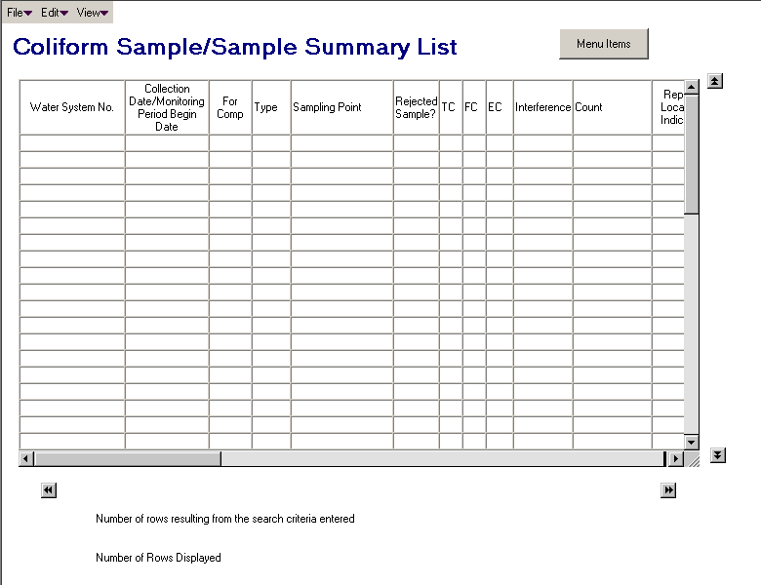

Exhibit 5-2. Coliform Sample/Sample Summary List

The Coliform Sample/Sample Summary List will display Coliform samples and/or Coliform sample summaries from the following search criteria on the Sample/Sample Summary Search page.

- User selects Sample Category of ‘TC’ from the Sample Only Search Box 2.
- User selects analyte code “3100-Total Coliform,” “3013-Fecal Coliform,” or “3014-E. coli” from the Sample Only Serach Box 2.
- User selects the radio button “Coliform” from the Summaries Only Search Box 3.
- User selects radio button “Coliform” from Both Samples and Summaries Search Box 4.

Default Sort Order: Ascending Water System No., Descending Sample Collection Date or first date of the monitoring period for sample summaries.

If no records are found using the provided search criteria, provide an informational message “No Sample or Sample Summaries found to match search criteria.” Allow user to press back button and to return to Search page with previous criteria present. User may select Edit/Add Sample or Edit/Add Sample Summary.

List Fields:

Water System No. The number of the water system for the sample/sample summary.

[Sample] Collection
Date/Monitoring
Period Begin Date The date the sample was collected or the first date of the monitoring period for a sample summary.

For Compliance
[Purpose Indicator] When it equals “Y,” the sample will be used for compliance. For samples only display “Y” or “N.”

[Sample] Type For Samples, the two-digit type code of the sample.

Sampling Point The sampling point where the sample was collected.

Rejected Sample? Will show ‘R’ if the sample rejection reason is populated, otherwise blank. (R0073:A.5.2.2.g)

[Sample Results] For Samples, there will be three columns labeled TC for total coliform (3100), FC for fecal coliform (3013), and EC for E. coli (3014). The result will be listed as A for absent, P for present and N for Null or no result associated for the analyte.

Interference If laboratory has noted interference for the Total Coliform Result, the four-digit interference code.

No. Routine Negatives For Summaries, the number of negative coliform samples.

Repeat Location Indicator The two-digit code indicating the location of the repeat sample in reference to the original positive.

State Classification For Samples, the six-character state classification code of the sample. This code is set by the user when the sample is entered using codes established by the system administrator. (R0036:A.5.2.2.a)

Water System Name The name of the water system.

Sampling Location The 20-character location of the sampling point where the sample was collected.

Monitoring Period The name of the monitoring period associated to the summary.

Lab ID No. A code assigned by the certifying authority that
(R0059:A.5.2.2.b) uniquely identifies the laboratory for samples and sample summaries.

Certifying Agency The Certifying Agency that issued the Lab ID No. (R0059:A.5.2.2.c)

(R0059:A.5.2.2.d)

Lab Sample No. The number assigned by the laboratory to the sample.

State Sample No. The number assigned by the state to the sample.

WSF State Assigned ID The twelve-digit identification code assigned to a water system facility (WSF).

Menu Items:

File

Exit Selecting File/Exit will return the user to the SDWIS/STATE Home Page.

Edit

Add
Sample Selecting Edit/Add Sample will display the Coliform Sample Maintenance page in Add mode. This option will be enabled regardless of a selection in the list box.

Add
Sample
Summary Selecting Edit/Add Sample Summary will display the Coliform Sample Summary Maintenance page in Add mode. This option will be enabled regardless of a selection in the list box.

Change Selecting Edit/Change will display the Coliform Sample Maintenance page or the Coliform Sample Summary Maintenance page with the selected record available for change. This menu item will be enabled only when a record has been highlighted.

A double-click on a highlighted row will react as an Edit/Change request.

Delete The Edit/Delete menu item will be enabled only when a record has been highlighted. If the selected Sample has results associated that are associated to a violation, present exit error statement: Cannot delete sample with results associated to violation. If sample has results that are not associated to a violation, open a dialog box advisory that reads: Results will be deleted with this Sample. Do you wish to continue?

Otherwise, the software will display a standard, protected delete confirmation dialog box for the selected record.

View

Search Selecting View/Search will invoke Sample/Sample Summary Search with previous search criteria.

Next The display area is limited to 1000 samples and/or summaries. If more than 1000 records meet the criteria, the View/Next option will be enabled so that subsequent groups of 1000 can be retrieved and displayed.

Previous If the View/Next option has been utilized, the View/Previous option will be enabled so that previous groups of 1000 can be retrieved.

Sort Selecting View/Sort will invoke the standard Sort window. Sorting will be allowed by Water System No., Collection Date, Compliance Purpose Indicator, Sample Type Code, Sampling Point Identification Code, Sample Summary Result Count Qty, Lab Sample No., State Classification, Water System Name, Sampling Point Location, Monitoring Period Name, Laboratory ID No., Certifying Agency, and Water System Facility State Asgn ID. (R0059:A.5.2.2.e)

Three sort levels will be supported.

Filter by Selecting View/Filter by will allow the user to filter by Water System No., Collection Date, Compliance Purpose Indicator, Sample Type Code, Sampling Point Identification Code, Sample Summary Result Count Qty, Number of Routine Negatives, Lab Sample No., State Classification, Water System Name, Sampling Point Location, Monitoring Period Name,. Laboratory ID No., Certifying Agency, and Water System Facility State Asgn ID. (Increase size of State Classification. R0036:A.5.2.2.f)

Refresh Selecting View/Refresh will retrieve the unfiltered list (original search criteria). Disabled if list is unfiltered.

Protected Fields:

Number of rows
resulting from
search criteria
Used: This field will show the total number of rows that met the search criteria.

Number of rows
displayed: This field will show the total number of rows that are displayed in the list, which may be less than the number of rows that met the search criteria.

LCR Sample/Sample Summary List
Exhibit 5-3 depicts the LCR Sample/Sample Summary List page.

The LCR Sample/Sample Summary List will display LCR samples and/or LCR sample summaries from the following search criteria on the Sample/Sample Summary Search page.
- User selects Sample Category of ‘PB’ from the Sample Only Search Box 2.
- User selects Analyte Code “1030-Lead” or ‘1022-Copper” from the Sample Only Search Box 2.
- User selects the radio button ‘LCR’ from the Summaries Only Search Box 3.
- User selects the radio button ‘LCR’ from the Both Samples and Summaries Search Box 4.

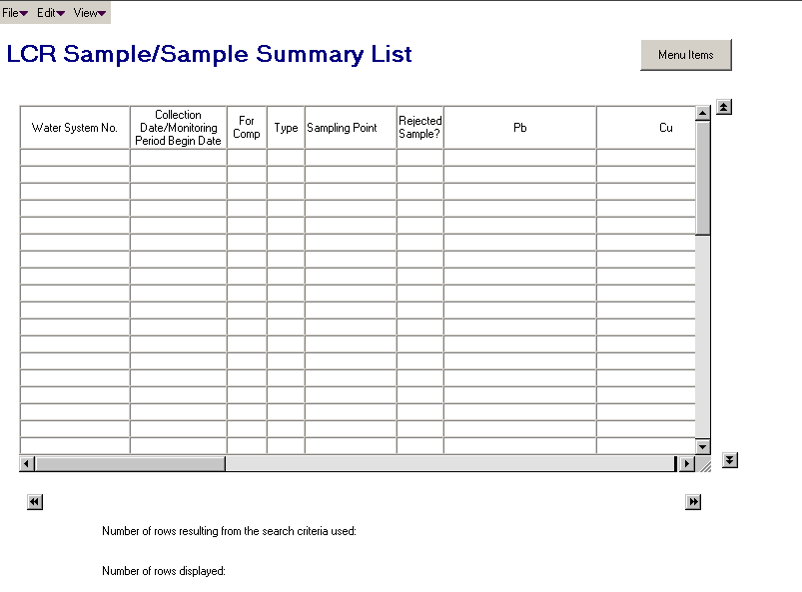

Exhibit 5-3. LCR Sample/Sample Summary List

Default Sort Order: Ascending Water System No., Descending Sample Collection Date or first date of the monitoring period for sample summaries.

If no records are found using the provided search criteria provide an exit error statement: No Sample or Sample Summaries found to match search criteria. Allow user to press back button on browser to return to Search page with previous criteria present. User may select Edit/Add Sample or Edit/Add Sample Summary.

List Fields:

Water System No. The number of the water system for the sample/sample summary.

[Sample] Collection
Date/Monitoring
Period Begin Date The date the sample was collected or the first date of the monitoring period for a sample summary.

For Compliance [Purpose
Indicator] When it equals “Y,” the sample will be used for compliance. For samples only, “Y” or “N.”

[Sample] Type For Samples, the two-digit type code of the sample.

Sampling Point The sampling point where the sample was collected.

Rejected Sample? Will show ‘R’ if the sample rejection reason is populated, otherwise blank. (R0073:A.5.2.3.h)

[Sample Results] For Samples, this will be two columns labeled Pb for lead (1030) and Cu for copper (1022). If the less than indicator equals “Y,” the result will list the less than sign (<) followed by the either the (detection limit and the detection unit of measure) or the (concentration value and unit of measure). Otherwise it will show “N” for null or no result.

For Sample Summaries, this will be two columns labeled Pb for lead 90th percentile (PB90) and Cu for copper 90th percentile (CU90). The result will list the concentration and unit of measure or “N” for null or no result.

Count The number of samples in the sample summary.

Sampling Location The 20-character location of the sampling point where the sample was collected.

Monitoring Period The name monitoring period associated to the summary.

Lab ID No. A code assigned by the certifying authority that
(R0059:A.5.2.3.a) uniquely identifies the lab for samples and sample summaries.

Certifying Agency The agency that certified and issued the Lab ID No. (R0059:A.5.2.3.b)

(R0059:A.5.2.3.c)

Lab Sample No. The number assigned by the laboratory to the sample.

State Sample No. The number assigned by the state to the sample.

State Classification For Samples, the six-character state classification code of the sample. This code is set by the user when the sample is entered using codes established by the system administrator. (R0036:A.5.2.3.d)

Water System Name The name of the water system for the sample or sample summary.

Menu Items:

File

Exit Selecting File/Exit will return the user to the SDWIS/STATE Home Page.

Edit

Add
Sample Selecting Edit/Add Sample will display the Lead and Copper Sample Maintenance page in Add mode. This option will be enabled regardless of a selection in the list box.

Add
Sample
Summary Selecting Edit/Add Sample Summary will display the Lead and Copper Sample Summary Maintenance page in Add mode. This option will be enabled regardless of a selection in the list box.

Change Selecting Edit/Change will display the Lead and Copper Sample Maintenance page or the Lead and Copper Sample Summary Maintenance page with the selected record available for change. This menu item will be enabled only when a record has been highlighted.

A double-click on a highlighted row will react as an Edit/Change request.

Delete The Edit/Delete menu item will be enabled only when a record has been highlighted. If the selected Sample has results associated, which are associated to a violation, present exit error statement: Cannot delete sample with results associated to violation. If sample has results that are not associated to a violation, open a dialog box advisory stating: Results will be deleted with this Sample. Do you wish to continue?

Otherwise, the software will display a standard, protected delete confirmation dialog box for the selected record.

View

Search Selecting View/Search will invoke Sample/Sample Summary Search with the previous search criteria.

Next The display area is limited to 1000 samples and/or summaries. If more than 1000 records meet the criteria, the View/Next option will be enabled so that subsequent groups of 1000 can be retrieved and displayed.

Previous If the View/Next option has been utilized the View/Previous option will be enabled so that previous groups of 1000 can be retrieved.

Sort Selecting View/Sort will invoke the standard Sort window. Sorting will be allowed by Water System No., Collection Date, Compliance Purpose Indicator, Sample Type Code, Sampling Point, Sample Summary Result Count Qty, Lab Sample No., State Classification, Water System Name, Sampling Point Location, Monitoring Period Name, Laboratory ID No., and Certifying Agency. (R0059:A.5.2.3.e)

Three sort levels will be supported.

Filter by Selecting View/Filter by will allow the user to filter by Water System No., Collection Date, Compliance Purpose Indicator, Sample Type Code, Sampling Point, Sample Summary Result Count Qty, Lab Sample No., State Classification, Water System Name, Sampling Point Location, Monitoring Period Name, Laboratory ID No., and Certifying Agency. (R0059:A.5.2.3.f) (Increase size of State Classification. R0036:A.5.2.3.g)

Refresh Selecting View/Refresh will retrieve the unfiltered list (original search criteria). Disabled if list is unfiltered.

Protected Fields:

Number of rows
resulting from
search criteria
used: This field will show the total number of rows that met the search criteria.

Number of rows
displayed: This field will show the total number of rows that are displayed in the list, which may be less than the number of rows that met the search criteria.

General Sample/Sample Summary Maintenance List
Exhibit 5-4 depicts the General Sample/Sample Summary List page.

The General Sample/Sample Summary List will display the data listed below from the following Sample/Sample Summary Search page search criteria in the following situations.

- Display any type of sample.
- If a Lab Sample No. selected in Search Box 1.
- If any state classification is selected in Search Box 2.
- If analyte code other than 3100, 1022 or 1030 is selected in Search Box 2.
- If an analyte group is selected in Search Box 2.
- Display non-coliform and non-LCR sample if the user selects Sample Category of “GE” in Search Box 2.
- Display any type of samples or sample summaries if a search is made from Search Box 4.

Default Sort Order: Ascending Water System No., Descending Sample Collection Date or first date of the monitoring period for sample summaries.

If no records are found using the provided search criteria, provide an exit error statement: No Sample or Sample Summaries found to match search criteria. Allow user to press back button on browser to return to Search page with previous criteria present. User may select Edit/Add Sample or Edit/Add Sample Summary.

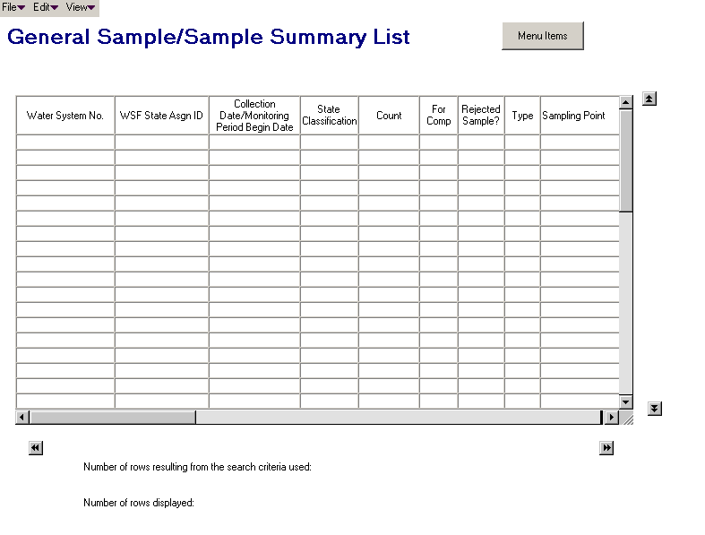

Exhibit 5-4. General Sample/Sample Summary List

List Fields:

Water System No. The number of the water system for the sample/sample summary.

WSF State Asgn ID The water system facility State Asgn ID of the sample location.

[Sample] Collection
Date/Monitoring
Period Begin Date The date the sample was collected or the first date of the monitoring period for a sample summary.

Category/State classification
Code For samples, the six-character state classification code of the sample. This code is set by the user when the sample is entered using codes established by the system administrator. (R0036:A.5.2.4.a)

Count The number of negative coliform samples for a Coliform sample summary or the number of samples for a LCR sample summary.

Compliance Purpose
Indicator When it equals “Y,” the sample will be used for compliance. For Samples, “Y” or “N.”

Rejected Sample? Will show ‘R’ if the sample rejection reason is populated, otherwise blank. (R0073:A.5.2.4.h)

Sample Type The two-digit type code of the sample.

Sampling Point The sampling point where the sample was collected.

Lab Sample No. The number assigned by the lab to the sample.

State Sample No. The number assigned by the state to the sample.

Composite? When equal to “Y,” indicates that the sample is part of a composite chemical or radionuclide sample.

Sample Rejection Reason The two-digit code for the reason a lab rejected a sample for further analysis.

Water System Name The name of the water system for the sample.

Sampling Location The 20 character location of the sampling point where the sample was collected.

Monitoring Period The monitoring period name for summaries.

Lab ID No. A code assigned by the certifying authority that uniquely identifies the lab for samples and sample summaries. (R0059LA.5.2.4.b)

Certifying Agency The agency who certified and issued the Lab ID No. (R0059:A.5.2.4.c)

(R0059:A.5.2.4.d)
Menu Items:

File

Exit Selecting File/Exit will return the user to the SDWIS/STATE Home Page.

Edit

Add
Sample Selecting Edit/Add Sample will display the General Sample Maintenance page in Add mode. This option will be enabled regardless of a selection in the list box.

Add
Sample
Summary Selecting Edit/Add Sample Summary will display a dialog box where the user must select the type of Sample Summary to add, the selected Sample Summary Maintenance page will be displayed in Add mode. This option will be enabled regardless of a selection in the list box.

Add
Composite
Sample Selecting Edit/Add Composite Sample will display the Composite Sample Maintenance page in Add mode. This option will be enabled regardless of a selection in the list box.

Change Selecting Edit/Change will display the Sample Maintenance page or the Sample Summary Maintenance page with the selected record available for change. This menu item will be enabled only when a record has been highlighted.

A double-click on a highlighted row will react as an Edit/Change request.

Delete The Edit/Delete menu item will be enabled only when a record has been highlighted. If the selected Sample has results associated that are associated to a violation, present exit error statement: Cannot delete sample with results associated to violation. If sample has results that are not associated to a violation, open a dialog box advisory that reads: Results will be deleted with this Sample. Do you wish to continue?

Otherwise, the software will display a standard, protected delete confirmation dialog box for the selected record.

View

Search Selecting View/Search will invoke Sample/Sample Summary Search with the previous search criteria.

Next The display area is limited to 1000 samples and/or summaries. If more than 1000 records meet the criteria the View/Next option will be enabled so that subsequent groups of 1000 can be retrieved and displayed.

Previous If the View/Next option has been utilized the View/Previous option will be enabled so that previous groups of 1000 can be retrieved.

Sort Selecting View/Sort will invoke the standard Sort window. Sorting will be allowed by Water System No., Water System Facility State Asgn ID, Collection Date, Sample Summary Result Count Qty, Compliance Purpose Indicator, Sample Type Code, State Classification, Sampling Point, Lab Sample No., State Sample No., Water System Name, Sampling Point Location, Monitoring Period Name, Laboratory ID No., Certifying Agency. (R0059:A.5.2.4.e)

Three sort levels will be supported.

Filter by Selecting View/Filter by will allow the user to filter by Water System No., Water System Facility State Asgn ID, Collection Date, Sample Summary Result Count Qty, Compliance Purpose Indicator, Sample Type Code, State Classification, Sampling Point, Lab Sample No., State Sample No., Water System Name, Sampling Point Location, Monitoring Period Name Laboratory ID No. (R0059:A.5.2.4.f) (Increase State Classification size. (R0036:A.5.2.4.g))

Refresh Selecting View/Refresh will retrieve the unfiltered list (original search criteria). Disabled if list is unfiltered.

Protected Fields:

Number of rows
resulting from
search criteria
used: This field will show the total number of rows that met the search criteria.

Number of rows
displayed: This field will show the total number of rows that are displayed in the list, which may be less than the number of rows that met the search criteria.

Coliform Sample and Summaries Pages

Coliform Sample Maintenance
Exhibit 5-5 depicts the Coliform Sample Maintenance page.

Protected Fields:

[Water System Facility]
Name The name of the supplied water system facility.

Monitoring Period The name of the monitoring period associated to the sample’s result(s). This field will be modifiable in change mode using the Go To button but is protected in Add mode.

[Original Sample]
Collection Date The date the original sample was collected.

[Original Sample]
Collection Time The time the original sample was collected.

[Original Sample]
Sampling Point ID The identification code of the sampling point at which the original sample was collected.

[Original Sample
Sampling] Location The name of the sampling point at which the original sample was collected.

[Total Coliform Result]
Record updated
by XXXXXXXX on
MM/DD/YYYY
HH:MI:SS The User ID and the timestamp from the last time the sample record (TSASAR) was updated.

[Total Coliform Result]
Record created
by XXXXXXXX on
MM/DD/YYYY
HH:MI:SS The initial User ID and timestamp when the sample (TSASAR) record was initially added to the database.

[Speciation Result]
Record updated
by XXXXXXXX on
MM/DD/YYYY
HH:MI:SS The User ID and the timestamp from the last time the sample record (TSASAR) was updated.

[ Speciation Result]
Record created
by XXXXXXXX on
MM/DD/YYYY
HH:MI:SS The initial User ID and timestamp when the sample (TSASAR) record was initially added to the database.
[Sample]
Record updated
by XXXXXXXX on
MM/DD/YYYY
HH:MI:SS The User ID and the timestamp from the last time the sample record (TSASAMPL) was updated.

[Sample]
Record created
by XXXXXXXX on
MM/DD/YYYY
HH:MI:SS The initial User ID and timestamp when the sample (TSASAMPL) record was initially added to the database.

Entry Fields:

Note that the tab order is left to right, top to bottom, and includes all Entry Fields and buttons unless otherwise noted.

For Compliance This check box marks the sample as being used for compliance determination. When it is checked the sample will be used for compliance if the sample type is Routine, Repeat, or Confirmation. The default is checked. Compliance samples have different rules than noncompliance samples. These are indicated below.

Lab Sample No. The sample identification number assigned by the laboratory for tracking the sample within the lab.

This is a required field for all new samples. If the Lab Sample No. is not supplied for a new sample, the error message is Samples must have a Lab Sample No. (Note that this is a change to the way SDWIS/STATE 8.0 works. In SDWIS/STATE 8.0, Lab Sample No. is optional for compliance and required for noncompliance samples.)

In change mode, if valued with other than spaces, it may be changed but may not be changed to spaces.

State Sample No. The sample identification number assigned by a state to uniquely identify a specific sample within the state.

This is an optional field.

Collection Date The date the sample was collected. A calendar function is available to aid input.

This is a required field. Do not allow future date. The error message will be: Date must not be a future date. If left blank, the error message is All samples must have a Collection Date.

Collection Time The time the sample was collected.

This is an optional field. When a user tabs out of this field or clicks out of it after entering a value, the software will verify that the value entered satisfied the form HHMM. If it doesn’t , the following error message will be: displayed and, on OK, the cursor returned to the field:
Input must match the pattern: HHMM.

Date Lab Rcpt The date the sample was received by the lab. A calendar function is available to aid input.

This is an optional field. Do not allow future date. The error message will be: Date must not be a future date. When it is provided it must be greater than or equal to the collection date or error message The date of Lab Receipt cannot be prior to the date of Sample Collection will be given.
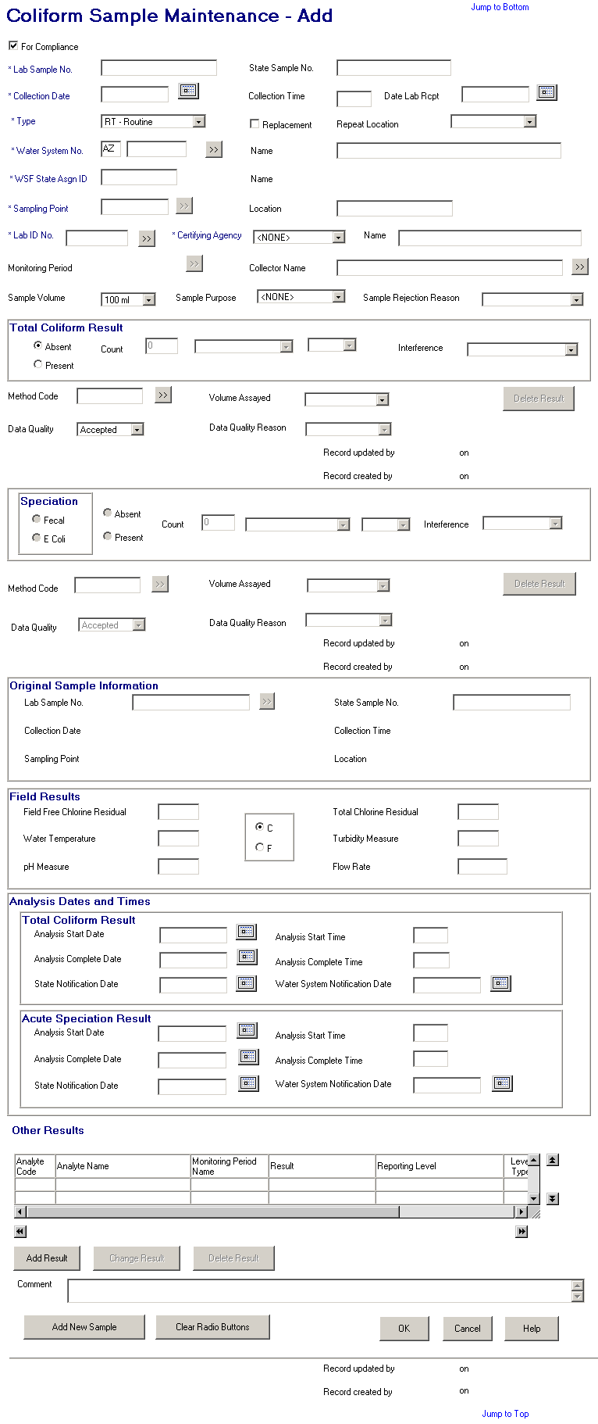
Exhibit 5-5. Coliform Sample Maintenance

Sample Type The type of sample collected. Valid selections are:

RT - Routine
RP - Repeat
SP - Special
BB - Batch Blanks
FB - Field Blanks
PE - Performance Evaluation
SB - Shipping Blanks
ST - Split Blanks
MR - Maximum Residence Time
MS – Matrix Spike
CO – Confirmation

This is a required field. If the sample type is entered or changed to any value other than Routine (RT), Repeat (RP), or Confirmation (CO), the software will uncheck the For Compliance checkbox. A user may recheck it (even if the Sample Type is not equal to RT, RP, or CO) but the sample will not be considered or processed by SDWIS compliance determination.

If the sample type is RP (repeat), the Original Sample Information page (Exhibit 5-6) will be presented after the water system is valued for capture of the original sample which led to the repeat.

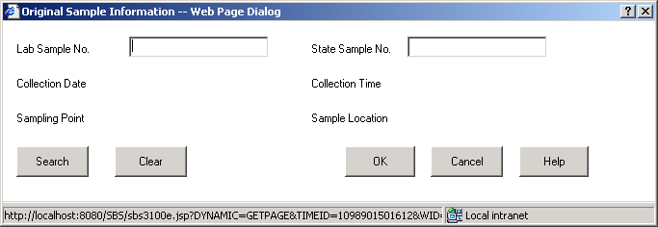

Exhibit 5-6. Original Sample Information

Search button When a candidate original sample is initiated, the software will look for all samples collected at the same water system and water system facility, collected on or before the collection date of the current sample that (a) have a Total Coliform Result or (b) have no results but is a total coliform sample. The search will return its findings on the Coliform Sample/Sample Summary List sorted on Collection Date descending. The list will return samples collected in the prior six months.

Replacement The Replacement box is used to indicate whether the sample is taken as a replacement for another sample. Replacement samples either replace lost or damaged samples that the lab could not analyze or they replace invalid samples that the lab refused to analyze due to technical reasons.

When the box is checked, it indicates a replacement sample. The default is unchecked.

When checked, the Original Sample Information page will be presented for identification of the original sample that is being replaced.

This is an optional field.

Repeat Location The location of the repeat sample with respect to the location of the original routine sample. Permitted entries and their two-digit codes are as follows:

UP - Upstream (within five connections) of the original sample location.
DN - Downstream (within five connections) of the original sample location.
OR - Original Site or At the original sampling location.
NF - Near the first service connection in the distributed system (or zone).
OT - Other site; not specifically UP, DN, OR, or NF.
<spaces>)

This field is an optional field and only valid if the sample type is equal to repeat. If this field is supplied and sample type is not repeat, the error message is Sample is not type Repeat.

Water System No. The specific Water System No., which consists of the two-character state code plus the seven-character number field.

The state code portion will default to the state_identification_code in the SYSTEM_VARIABLE entity view.

The Water System No. of the sample location.

When tabbing off or clicking outside this field after supplying a value, the water system will be retrieved and the name displayed. Any value in the WSF State Asgn ID, Sampling Point and Sample Location fields will be removed. If the sample type is Repeat or replacement indicator is checked, the Original Sample Information will be presented.

If a valid water system is entered but is not part of the user’s current Water System Group or Regulating Agency, invoke exit state error message: WS is not part of current group/agency. Change group/agency to access this WS.

If the supplied value is invalid, the Water System Maintenance List will be presented with the number that most closely matches the value entered.

This is a required field. If it is left blank, the error message will be: Water System No. must not be blank.

[Water System] Name Standard 40-character Public Water System Name may be entered completely, partially, or left blank. If the user specifies a partial string in this field, display the closest matching water system at the top of the list. (Closest matching means a match with the Water System Name, sorted alphabetically, that starts with the same text string as supplied.)

If a valid water system name is entered, the Water System No. is populated.

If a valid water system is entered but is not part of the user’s current Water System Group or Regulating Agency, invoke exit state error message: WS is not part of current group/agency. Change group/agency to access this WS.

If the name entered is not found the software will flow to the Water System Selection List. The user may then select a value and continue.

WSF State Asgn ID The Water System Facility State Assign ID of the sample location.

When tabbing off this field after supplying a value, the value will be retrieved and the name displayed.

If the supplied value is invalid, the error message will be: The WSF State Asgn ID entered does not belong to this water system.

It may be valued either by direct entry or by selecting a sampling point using the Sampling Point Go To button.

When the value in this field is modified the values in (WSF) Name, Sampling Point and Location will be cleared.

This field will be protected until a valid Water System has been supplied.

Sampling Point The identification number of the sampling point at which the sample was taken.

When tabbing off or clicking outside this field after supplying a value:

If a WSF State Asgn ID has been selected and the Sampling point entered does not match a sampling point associated to the WSF, the WSF Sampling Point Maintenance List will be displayed, showing all the existing sampling points associated to the selected WSF and enabling the user to select one. All functions of the Maintenance List page will be available to the user from here, including Edit/Add so that, if a desired Sampling Point does not exist, the record can be created.

If a WSF State Asgn ID has not been selected and the Sampling point entered does not match a sampling point associated to the water system, the Sampling Point Maintenance List will be displayed, showing all the existing sampling points for the water system and the water system facility to which they are associated and enabling a user to select one. All functions of the Maintenance List page will be available to the user from here, including Edit/Add so that, if a desired Sampling Point does not exist, the record can be created.

If a WSF State Asgn ID has not been selected and more than one sampling point is found matching this ID (but within different water system facilities), the Sampling Point Maintenance List will be presented.

(Note: the above replaces the current method of creating a new sampling point.)

Otherwise the sampling point will be retrieved and the Sample Location displayed. If the sample type is repeat or a routine with replacement indicator checked and the collection date is provided, the Original Sample Information will be presented.

Sampling Point is a required field and must be supplied using either this field or the Sampling Location field. Error message will be Each Sample must have EITHER a Sampling Point or Sample Location.

If the value of this field is modified, the value Location will be cleared.

This field will be protected until a valid Water System has been supplied.

[Sampling Point]
Location The name of the sampling point at which the sample was collected.

When tabbing off or clicking outside this field after supplying a value:

If a WSF State Asgn ID has been selected and the sampling point location entered does not match a sampling point associated to the WSF, the WSF Sampling Point Maintenance List will be displayed, showing all the existing sampling points associated to the selected WSF and enabling the user to select one. All functions of the Maintenance List page will be available to the user from here, including Edit/Add so that, if a desired Sampling Point does not exist, the record can be created.

If a WSF State Asgn ID has not been selected and the sampling point location entered does not match a sampling point associated to the water system, the Sampling Point Maintenance List will be displayed, showing all the existing sampling points for the water system and the water system facility to which they are associated and enabling a user to select one. All functions of the Maintenance List page will be available to the user from here, including Edit/Add so that, if a desired Sampling Point does not exist, the record can be created.

If a WSF State Asgn ID has not been selected and more than one sampling point is found matching the location entered (but within different water system facilities) the Sampling Point Maintenance List will be presented.

(Note: the above replaces the current method of creating a new sampling point.)

When tabbing off this field after supplying a value, the sampling location will be retrieved and the sampling point displayed. If the sample type is repeat or a routine with replacement indicator checked and the collection date is provided, the Original Sample Information will be presented.

Sampling Location is a required field and must be supplied using either this field or the Sampling Point Field. Error message will be Each Sample must have a Sampling Point or Sample Location.

If the value of this field is modified, the Sampling Point will be cleared.

This field will be protected until a valid Water System has been supplied.

Lab ID No. The identification number assigned by the to the laboratory, which performed the analysis. When a value is supplied that is not found, the lab maintenance list page will be presented. A valid value in this field will also populate Laboratory Name. (R0059:A.5.3.1.a)

This is a required field. If left blank, the error message will be: Laboratory may not be left blank.

Certifying Agency Select a value from the dropdown list. The value will be matched against the laboratory’s Certifying Agency. The selections available via the dropdown list will be retrieved from the TINPVALS table where code_name = “CERT_AG.”

If an exact match is found using the Lab ID No. and Certifying Agency, the laboratory name will be displayed.

If none is found, the Laboratory Maintenance List will be presented in single-select mode.

Certifying Agency will be a required field. It will default to STATE. (R0059:A.5.3.1.b)

When the Laboratory can be identified from the above two fields, the default Method Code for the Total Coliform Result will be populated from the Lab Analyte Method Assignment table that is associated to the Laboratory, has as relationship to Standard Method Analyte Association that is related to the 3100 analyte, has default method indicator = ‘Y’, has certification indicator = ‘Y’ and has the most recent issuance date <= (analysis end date or analysis start date, or sample collection end date to be checked in this order based upon the date being not null.) (R2001:A.5.3.1.h)

(R0059:A.5.3.1.c)

[Laboratory] Name The name of the laboratory. This field will be automatically populated when a valid value is either input or selected in Lab ID No.. . The selection will also populate the Laboratory ID No. Certifying Agency.

When a value is supplied that is not found, the lab maintenance list page will be presented. The selection will also populate the Lab ID No. and. (R0059:A.5.3.1.d)

Collector Name The name of the individual who collected the sample.

If the entered individual does not exist as a valid legal entity as a collector (i.e., collector_indicator_code = “Y”), then store the name entered with the sample (i.e., in the TSASAMPL informal_collector field.

This is an optional field.

Sample Volume The volume of sample collected and submitted to the laboratory. Permitted values are:

100 ml
300 ml
400 ml
500 ml
(Spaces)

This is an optional field but it is defaulted to 100ml when a new sample is being added.

Sample Purpose This will allow the state to document why sample was taken (e.g., surveillance, investigation). Its value will be controlled by the System Administrator. It will not be used by any automated processing. The permitted values of the dropdown list will be retrieved from the CODE table, code_name of ‘SMPLPURPOS’.

This is an optional field.

Sample Rejection Reason The reason a lab rejected a sample for further analysis.

BR – Broken
CL – Chlorine present
EH – Exceeds holding time
HS – Excessive headspace
FZ – Frozen sample
IN – Insufficient information
VO – Insufficient volume
BP – Invalid sampling point
IP – Invalid sampling protocol
LA – Lab accident
LT – Leaked in transit

This is an optional field. When it is selected, the Total Coliform Results and Acute Speciation Results will not be available for input in add-mode. See Change-mode below for processing of existing results when a sample rejection reason is updated

Total Coliform Result

(A)bsence/(P)resence The Absence and Presence indicators are used to indicate the existance of total coliform in the sample. Only one of the two buttons may be on to indicate A for absence or P for presence.

When Absent, the three fields representing the count and the Interference are not available for input. The Acute Speciation Result group is also not available for input. If any of these fields contain a value prior to the result being set to absent, the values in the fields will be removed and the fields disabled.

When Present, the three fields representing the count and the interference are available for input. The Acute Speciation Result group is also available for input.

The default selection is Absent.

Count This field and the following two fields are only available if Total Coliform is found to be present. They indicate the density of Total Coliform found in the sample. These are all three optional fields.

[First Field] The density or estimated density count of organisms in a microbiological sample or the number of tubes that were positive (on which an estimated density is based).

[Second Field] Indicates whether the density is based on an actual count of colonies present or is based on an estimate (MPN) or that density is not being reported but can be derived from the number of tubes in which the organism was present. The permitted values:

COLONIES – Colonies, using the membrane filter method.
TUBES – Number of positive tubes, using the multiple tube method.
MPN – Most Probable Number, estimated desnsity based on number of positive tubes.

[Third Field] The units of a microbiological analytical result count for COLIFORM include the following:

1 milliliter
5 milliliters
10 milliliters
100 milliliters
400 milliliters
500 milliliters
ML
Liter
Fld100 (field at 100 power)
100 liter
Gal
100 Gal
400 Gal

Interference For a Total Coliform Result under the Total Coliform Rule (TCR), the value in this field indicates that a negative result is invalid because of the interference during the analysis. According to the Total Coliform Rule, “A laboratory must invalidate a total coliform sample (unless total coliforms are detected) if the sample produces a turbid culture in the absence of gas production using an analytical method where gas formation is examined (e.g., the Multiple-Tube Fermentation Technique), produces a turbid culture in the absence of an acid reaction in the Presence-Absence (P-A) Coliform Test, or exhibits confluent growth or produces colonies too numerous to count with any analytical method using a membrane filter (e.g., Membrane Filter Technique).”

For other organisms, it means the laboratory is reporting that it encountered interference during the analysis of the sample.

The following are the permitted values for this field:

TNTC – Too numerous to count: Using the membrane filter method, the lab could not physically or feasibly count all the coliform colonies.*

CNFG – Confluent growth: Using the membrane filter method, the lab determined that numerous colonies are overgrown across the filter, making identification and quantification of individual colonies impossible.*

TCNG – Turbid culture, no gas: Using the multiple tube fermentation method, the lab determined that microorganisms were present (turbid culture), but the normal indicator of coliform organisms (gas produced in an inverted tube) did not occur.*

* This situation sometimes indicates improper sample or analytical technique and may also indicate extremely contaminated water. This situation may (or may not) be used by the lab to indicate coliform presence.

This is an optional field. If a value is present in this field the Absent indicator cannot be the selection. When it is the error message will be: Absent is not a valid selection with supplied Interference value.

Method Code Represents the method code used to analyze the sample, such as the EPA-assigned method code EPA 525.1.

Volume Assayed The quantity of water used in the analysis. The permitted values for this field are:

1 milliliter
5 milliliters
10 milliliters
100 milliliters
300 milliliters
400 milliliters
500 milliliters

This is an optional field.

Data Quality Indicates whether the sample analytical result meets established data quality acceptance criteria. The laboratory is responsible for providing data quality information for a sample analysis. Entries include the following:

A – Accepted (default)
P – Preliminary
R – Rejected
V – Validated*

*Validated is for display only. When creating a sample selecting validated will be ignored and reset to accepted. When in change-mode selecting validated will result in an error indicating validation must occur in the Compliance Determination component. Error message will be Result may be validated in the Compliance Business System.

If Data Quality is set to “Rejected” and the Sample Rejection Reason is valued, the user cannot change the Data Quality and the error message Data Quality must be “Rejected” for a Sample that has been rejected.

Data Quality Reason The reason that the quality acceptance was other than accepted. This field is only available if the QA selection is not accepted. Entries include the following:

IF – Instrument Failure
LE – Lab Error
LC – Lab Not Certified
OT – Other
RC – Requester Cancelled
WR – Water System Rejected

This field is required if the Data Quality is rejected. Displayed error message is A Data Quality Reason Code must be entered to reject a result.

Speciation Result The Acute Speciation Result area will only be enabled for input if the Total Coliform Result is indicated as present.

Acute Speciation
Fecal/E. Coli Choose either Fecal or E. coli to indicate which analyte was used in the speciation of the total coliform. A choice is required to record a sample result for speciation. If a choice is not indicated none of the other values input for acute speciation will be captured, even if they are entered.

When a selection is made, the default Method Code for the Acute Speciation Result will be populated from the Lab Analyte Method Assignment table that is associated to the Laboratory, has as relationship to Standard Method Analyte Association that is related to the selected analyte, has default method indicator = ‘Y’, has certification indicator = ‘Y’, and has the most recent issuance date <= (analysis end date or analysis start date, or sample collection end date to be checked in this order based upon the date being not null.) (R2001:A.5.3.1.g)

If the Total Coliform is marked as present and no acute speciation result is indicated, the following No Acute Speciation Indicated advisory (Exhibit 5-7) is presented when the OK button is selected.

Buttons:

OK Will add the Total Coliform sample and result with no acute speciation result.

Back Will return to the COLIFORM Sample Maintenance page.

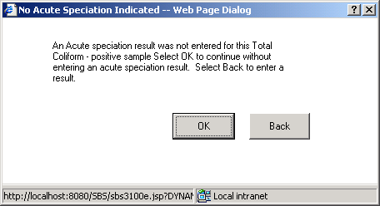

Exhibit 5-7. No Acute Speciation Indicated Advisory

(A)bsence/(P)resence The Absence and Presence indicators are used to indicate the existance of acute speciation analyte in the sample. Only one of the two buttons may be on to indicate A for absence or P for presence.

When Absent, the three fields representing the count and the Interference are not available for input. If any of these fields contain a value prior to the result being set to absent, the values in the fields will be removed and the fields disabled.

When Present the three fields representing the count and the Interference are available for input.

Count The following three fields are only available if Acute Speciation is found to be present. These are all three optional fields.

[First Field] The number of organisms counted or estimated in a microbiological sample, usually expressed as the number of organisms (count) per unit volume or 100 mL.

[Second Field] The types of organisms counted for a microbiological measurement include the following:

COLONIES – Colonies, using the membrane filter method.
TUBES – Number of positive tubes, using the multiple tube method.
MPN – Most Probable Number, estimated desnsity based on number of positive tubes.

[Third Field] The units of a microbiological analytical result count for COLIFORM include the following:

1 milliliter
5 milliliters
10 milliliters
100 milliliters
400 milliliters
500 milliliters
ML
Liter
Fld100
100 liter
Gal
100 Gal
400 Gal

Interference For a Total Coliform Result under the Total Coliform Rule (TCR), the value in this field indicates that a negative result is invalid because of the interference during the analysis. According to the Total Coliform Rule: “A laboratory must invalidate a total coliform sample (unless total coliforms are detected) if the sample produces a turbid culture in the absence of gas production using an analytical method where gas formation is examined (e.g., the Multiple-Tube Fermentation Technique), produces a turbid culture in the absence of an acid reaction in the Presence-Absence (P-A) Coliform Test, or exhibits confluent growth or produces colonies too numerous to count with any analytical method using a membrane filter (e.g., Membrane Filter Technique).”

For other organisms, it means the laboratory is reporting that it encountered interference during the analysis of the sample.

The following are the permitted values for this field:

TNTC - Too numerous to count: Using the membrane filter method, the lab could not physically or feasibly count all the coliform colonies.*

CNFG - Confluent growth: Using the membrane filter method, the lab determined that numerous colonies are overgrown across the filter, making identification and quantification of individual colonies impossible.*

TCNG - Turbid culture, no gas: Using the multiple tube fermentation method, the lab determined that microorganisms were present (turbid culture), but the normal indicator of coliform organisms (gas produced in an inverted tube) did not occur.*

* This situation sometimes indicates improper sample or analytical technique and may also indicate extremely contaminated water. This situation may (or may not) be used by the lab to indicate coliform presence.

This is an optional field. If a value is present in this field, the Absent indicator cannot be the selection. When it is the error message will be: Absent is not a valid selection with supplied Interference value.

Method Code The method code used to analyze the sample, such as the EPA-assigned method code EPA 525.1.

Volume Assayed The quantity of water used in the analysis. The permitted values for this field are:

1 milliliter
5 milliliters
10 milliliters
100 milliliters
300 milliliters
400 milliliters
500 milliliters

This is an optional field.

Data Quality Indicates whether the sample analytical result meets established data quality acceptance criteria. The laboratory is responsible for providing data quality information for a sample analysis. Entries include the following:

A – Accepted (default)
P - Preliminary
R – Rejected
V – Validated*

*Validated is for display only. When creating a sample, selecting validated will be ignored and reset to accepted. When in change-mode selecting, validated will result in an error indicating validation must occur in the Compliance Determination component. Error message will be Result may be validated in the Compliance Business System.

If Data Quality is set to “Rejected” and the Sample Rejection Reason is valued, the user cannot change the Data Quality and the error message Data Quality must be “Rejected” for a Sample that has been rejected.

Data Quality Reason The reason that the quality acceptance was other than accepted. This field is only available if the Data Quality selection is not accepted.

Entries include the following:
IF - Instrument Failure
LE - Lab Error
LC - Lab Not Certified
OT - Other
RC - Requester Cancelled
WR - Water System Rejected

This field is required if the Data Qualify selection is rejected. Displayed error message is A Data Quality Reason Code must be entered to reject a result.

Original Sample Information

Lab Sample No. The Lab Sample No. of the original sample. If the value supplied cannot be found for the same water system, the error message is Lab Sample No. either does not exist or is not on the same water system.

This is an optional field.

State Sample No. The State Sample No. of the original sample. If the value supplied cannot be found for the same water system, the error message is Lab Sample No. either does not exist or is not on the same water system.

This is an optional field.

Field Results

Field Free Chlorine
Residual The measure of free and available chlorine in milligrams per liter (mg/L).

This number is defined in the database as 5(3), that is, five significant digits, three of which are to the right of the decimal. The maximum value the database can accept for this field is 99.999. The minimum value, other than 0, that the database can accept for this field is 0.001. Any number within this range is acceptable. If you enter a number with more than two decimals, the software truncates everything beyond the second decimal.

This is an optional field.

Total Chlorine
Residual The total concentration of residual disinfectant (chlorine) in milligrams per liter found in the water, including combined and free chlorine residual.

This number is defined in the database as 5(3), that is, 5 significant digits, three of which are to the right of the decimal. The maximum value the database can accept for this field is 99.999. The minimum value, other than 0, that the database can accept for this field is 0.001. Any number within this range is acceptable. If you enter a number with more than two decimals, the software truncates everything beyond the second decimal.

This is an optional field.

Water Temperature The temperature in degrees Celsius or Fahrenheit (C or F) of the water being sampled at the time and place of microbiological or chemical sample collection.

This number is defined in the database as 3(1), that is, three significant digits, one of which is to the right of the decimal. The maximum value the database can accept for this field is 99.9. The minimum value, other than 0, that the database can accept for this field is 0.1. Any number within this range is acceptable. If you enter a number with more than one decimal, the software truncates everything beyond the one decimal.

This is an optional field.

[Temperature Measure] The indication in Celsius or Fahrenheit (C or F) of the water temperature.

This is an optional field.

Turbidity Measure The turbidity of the water being sampled at the time and place of microbiological or chemical sample collection in nephelometric turbidity units (NTU).

This number is defined in the database as 5(2), that is, five significant digits, two of which are to the right of the decimal. The maximum value the database can accept for this field is 999.99. The minimum value, other than 0, that the database can accept for this field is 0.01. Any number within this range is acceptable. If you enter a number with more than two decimals, the software truncates everything beyond the second decimal

This is an optional field.

pH Measure The pH of the water being sampled at the time and place of microbiological or chemical sample collection in pH units.

While this number is defined in the database as 4(1), the maximum value the database can accept for this field is 14. The minimum value, other than 0, that the database can accept for this field is 0.1. Any number within this range is acceptable. Numbers outside of this range will receive the error message Accepted range for pH value is between 0 and 14.0 pH units. If you enter a number with more than one decimal, the software truncates everything beyond the one decimal.

This is an optional field.

Flow Rate The flow rate of the sample collection device in gallons per minute (GPM). This measure is used primarily for collection and quantification of protozoa and virus samples.

This number is defined with six significant digits, up to four of which can be to the right of the decimal. The maximum value the window can accept for this field is 999.9999. The minimum value, other than 0, that the window allows for this field is 0.0001. Any number within this range is acceptable. If you enter a number with more than four decimals, the software will truncate everything beyond the fourth decimal. (Ev12366:B.5.3.1.a)

This is an optional field.

Analysis Dates and Times

Total Coliform Result

Analysis Start Date The start date of the laboratory’s analysis. If this date is prior to the sample collection date, the error message will be: The date of Result Analysis cannot be prior to the date of Sample Collection.

If the analysis complete date is supplied and it is before the analysis start date the error message is Start Date must precede End Date.
If Analysis Start Date is after today, error message will be: Date must not be a future date.

This is an optional field.

Analysis Start Time The start time of the laboratory’s analysis. If the value is greater than or equal to 2400, the error message will be: This field must match pattern HH:MM.

When the analysis start date is equal to the collection date and the collection time is supplied, the analysis start time must be after the collection time. If it is not, the error message will be: The time of Result Analysis cannot be prior to the time of Sample Collection.

This is an optional field.

Analysis Complete Date The complete date of the laboratory’s analysis. If this date is prior to the sample collection date, the error message will be: The date of Result Analysis cannot be prior to the date of Sample Collection.

If the analysis start date is supplied and it is after the analysis complete date, the error message will be: Start Date must precede End Date.

This is an optional field. Do not allow future date. The error message will be: Date must not be a future date.

If a Lab Receipt Date is provided for the sample, the supplied Analysis Complete Date must be on or after the Lab Receipt date. The error message will be: The Analysis Complete Date cannot be prior to the Lab Receipt Date.

Analysis Complete Time The complete time of the laboratory’s analysis. If the value is greater than or equal to 2400, the error message will be: This field must match pattern HH:MM.

When the analysis complete date is equal to the collection date and the collection time is supplied, the analysis complete time must be after the collection time. If it is not, the error message will be: The time of Result Analysis cannot be prior to the time of Sample Collection.

When the analysis complete date is equal to the analysis start date and the analysis start time is supplied, the analysis complete time must be after the analysis start time. If it is not, the error message will be: The time of Result Analysis completion cannot be prior to the Analysis Start time.

This is an optional field.

State Notification Date The date the state is notified of the analysis result.

This is an optional field. Do not allow future date. The error message will be: Date must not be a future date.
If provided, it may not be prior to:

- The sample collection date. If it is, the error message will be: The date of State Notification cannot be prior to the date of Sample Collection.
- The result analysis complete date. If it is, the error message will be: The date of State Notification cannot be prior to the date of Result Analysis.
- The sample lab receipt date. If it is, the error message will be: The date of State Notification cannot be prior to the date of Lab Receipt.

Water System Notification
Date The date the laboratory notified the water system of the analytical result.

This is an optional field. Do not allow future date. The error message will be: Date must not be a future date.
If provided, it may not be prior to:

- The sample collection date. If it is, the error message will be: The date of Water System Notification cannot be prior to the date of Sample Collection.
- The result analysis complete date. If it is, the error message will be: The date of Water System Notification cannot be prior to the date of Result Analysis.
- The sample lab receipt date. If it is, the error message will be: The date of Water System Notification cannot be prior to the date of Lab Receipt.

Speciation Result

Analysis Start Date The start date of the laboratory’s analysis. If this date is prior to the sample collection date, the error message will be: The date of Result Analysis cannot be prior to the date of Sample Collection.

If the analysis complete date is supplied and it is before the analysis start date the error message is Start Date must precede End Date.

If Analysis Start Date is after today, error message will be: Date must not be a future date.

This is an optional field.

Analysis Start Time The start time of the laboratory’s analysis. If the value is greater than or equal to 2400, the error message will be: This field must match pattern HH:MM.

When the analysis start date is equal to the collection date and the collection time is supplied, the analysis start time must be after the collection time. If it is not, the error message will be: The time of Result Analysis cannot be prior to the time of Sample Collection.

This is an optional field.

Analysis Complete Date The complete date of the laboratory’s analysis.
If this date is prior to the sample collection date, the error message will be: The date of Result Analysis cannot be prior to the date of Sample Collection.

If Analysis Complete Date is after today, the error message will be: Date must not be a future date.

If a Lab Receipt Date is provided for the sample, the supplied Analysis Complete Date must be on or after the Lab Receipt date. The error message will be: The Analysis Complete Date cannot be prior to the Lab Receipt Date.

This is an optional field.

Analysis Complete Time The complete time of the laboratory’s analysis. If the value is greater than or equal to 2400, the error message will be: This field must match pattern HH:MM.

When the analysis complete date is equal to the collection date and the collection time is supplied, the analysis complete time must be after the collection time. If it is not, the error message will be: The time of Result Analysis cannot be prior to the time of Sample Collection.

When the analysis complete date is equal to the analysis start date and the analysis start time is supplied, the analysis complete time must be after the analysis start time. If it is not, the error message will be: The time of Result Analysis completion cannot be prior to the Analysis Start time.

This is an optional field.

State Notification Date The date the state is notified of the analysis result.

This is an optional field. Do not allow future date. The error message will be: Date must not be a future date. If provided, it may not be prior to:

- The sample collection date. If it is, the error message will be: The date of State Notification cannot be prior to the date of Sample Collection.
- The result analysis complete date. If it is, the error message will be: The date of State Notification cannot be prior to the date of Result Analysis.
- The sample lab receipt date. If it is, the error message will be: The date of State Notification cannot be prior to the date of Lab Receipt.

Water System Notification
Date The date the laboratory notified the water system of the analytical result.

This is an optional field. Do not allow future date. The error message will be: Date must not be a future date. If provided, it may not be prior to:

- The sample collection date. If it is, the error message will be: The date of Water System Notification cannot be prior to the date of Sample Collection.
- The result analysis complete date. If it is, the error message will be: The date of Water System Notification cannot be prior to the date of Result Analysis.
- The sample lab receipt date. If it is, the error message will be: The date of Water System Notification cannot be prior to the date of Lab Receipt.

Other Results List Box

The Other Results List will display on the Coliform Sample Maintenance page in the same way it is displayed on the General Sample Maintenance page.

Buttons:

[water system]
Go To Will present the Water System Maintenance List where the Edit/Select will be available.

When a water system is selected, the water system will be retrieved and the name displayed. Any values in the WSF fields and Sampling Point fields will be cleared.

[sampling point]
Go To Will present the Sampling Point Maintenance List where the Edit/Select will be available. It will list all sampling points for the water system.

[laboratory]
Go To Will present the Laboratory Maintenance List. Only the ‘select’ menu will be enabled. Add/change will not be allowed for security reasons.

[monitoring period]
Go To Will present the Monitoring Period Maintenance List. Only Edit/Select will be available.

When the parent sample is associated to a distribution system water system facility, the Monitoring Period Maintenance List will only display monitoring periods that are associated to the specified water system and the TCR rule. For other non-distribution system water system facilities, all monitoring periods will be listed.

[collector]
Go To Will present the Legal Entity Maintenance List where only INDIVIDUALS indicated as collectors will be listed. The Select menu item will be the only available option under the Edit option.

[Total Coliform
standard method]
Go To Will present the Analyte Standard Method Selection List for the COLIFORM analyte (3100). If lab certification edit is enabled (reference details under the OK button), list only those standard methods approved for the laboratory and Total Coliform analyte. (R2001:A.5.3.1.k)

[Total Coliform]
Delete Result Will perform all edits as if OK button were pressed. After successfully modifying the sample, will present the delete confirmation page if no associative conflicts exist.

If the result has an association to a violation, the delete request will be denied and software will present exit error statement: Result associated to violation cannot be deleted.

Exhibit 5-8 depicts the Delete Result dialog box.
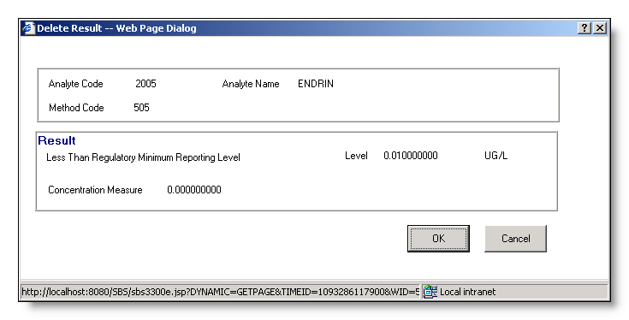
Exhibit 5-8. Delete Result Dialog Box

Buttons:

OK Will delete the Total Coliform result and the Acute Speciation result, if one exists, and return to the Coliform Sample Maintenance page.

Cancel Will abort the delete and return to the Coliform Sample Maintenance page.

Jump to Top This hyperlink will jump to the top of the page.

Jump to the Bottom This hyperlink will jump to the bottom of the page.

[Speciation
standard method]
Go To Will present the Analyte Standard Method Maintenance List in single-select mode for the FECAL COLIFORM analyte (3013) or E. COLI analyte (3014). If lab certification edit is enabled (reference details under the OK button), list only those standard methods approved for the laboratory and selected speciation analyte. (R2001:A.5.3.1.j)

[Speciation]
Delete Result Will perform same functions as [Total Coliform] Delete Result button.

[original sample]
Go To Will present the Related Sample Selection List. This button is only enabled if the sample type is Repeat or indicated as a replacement.

[Other Results List Box]
Add Result Will perform all edits as if OK button were pressed. After successfully adding/modifying the sample and results for Total Coliform and Speciation, the user will be prompted to select an analyte and then be presented with the page to create a result. The functionality for this processing is described in 5.5.1 – General Sample Maintenance and works the same except references to “General Sample Maintenance Page” are changed to “Coliform Maintenance Page.”

[Other Results List Box]
Change Result Will perform all edits as if OK button were pressed. After successfully modifying the sample and results for Total Coliform and Speciation, will present the Analytical Result Maintenance page (Section 5.5.2) in change mode. This item is only available if a result has been selected in the list area.

[Other Results List Box]
Delete Result Will perform all edits as if OK button were pressed. After successfully modifying the sample and results for Total Coliform and Speciation, will present the Delete Confirmation page.

The functionality for this processing is described in 5.5.1 – General Sample Maintenance and works the same except references to “General Sample Maintenance Page” are changed to “Coliform Maintenance Page.”

Add New Sample Will perform all edits as if OK button were pressed. After successfully adding the sample and results for Total Coliform and Speciation, the maintenance window will redisplay. The following fields will have their value retained:

- Collection Date
- Sample Type
- Repeat Location
- Water System No. and Name
- Total Coliform Result Method Code
- Sample Volume
- Total Coliform Result Volume Assayed

The cursor will be at the end of the value in the Lab Sample No.

This button will be available in both add and change mode.

Clear Radio Buttons Will reset all radio button indicators to spaces. No radio button will be indicated as being on.

OK If the sample type is repeat or it is a routine with replacement indicator checked for a routine and the sample is marked for compliance, if an original sample has not been associated the following Compliance Advisory (Exhibit 5-9) will be presented.

Compliance Linkage Advisory Buttons:

Proceed The software will finish the edit checks for the page and, if no other error messages or advisories are invoked, it will flow to the page indicated in the specifications for the button pressed on the main page.

Cancel Will return to the Maintenance page.

Help Will invoke the system online Help facility.

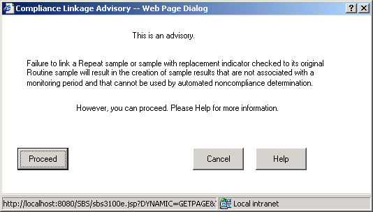

Exhibit 5-9. Compliance Linkage Advisory

If the sample type is indicated as confirmation (CO) and the selected sampling point belongs to a water system facility of distribution type (DS) the sample type will be rejected with the error message Confirmation Sample Type invalid for Distribution System Coliform Sample.

If a Total Coliform Result is indicated as present but the Acute Speciation Result is not provided, the following advisory (Exhibit 5-10) will be presented.

Exhibit 5-10. No Acute Speciation Indicated Advisory

Buttons:

OK Will continue with the addition or change request without adding an acute speciation result. Will return to the page specified for the button on the main page (e.g., if the OK button on the Maintenance page was selected, then it will return to the Sample Maintenance List).

Back Will return to the Maintenance page where an acute speciation result can be entered.

If a sample is marked as “For Compliance” and the sample type is not Routine or Repeat, the following error message will be invoked: TCR Samples taken for compliance may only be routine or repeat samples.

If a water system has not been selected, the error message will be: Water System No. must not be blank.

Collection Date is a required field. If left blank, the error message is All Samples must have a Collection Date.

If Date Lab Rcpt is provided, it must be greater than or equal to the collection date or the following error message will be: The date of Lab Receipt cannot be prior to the date of Sample Collection.

If Repeat Location is valued and the sample type is not Repeat, the following error message will be: Sample type must be Repeat to enter a Repeat Location. The Repeat Location field will be highlighted in Red and have the focus when the message is acknowledged.

If entered, a value in Collection Time must not be greater than or equal to 2400. If not, the following error message will be invoked: Time Entries must be between 00:01 and 23:59.

If the Total Coliform Result Interference field has a value, the Absent indicator may not be the selection for Total Coliform. If it is, the error message will be: Absent is not a valid selection with supplied Inteference value. The absent value will be removed.

If the Speciation Interference field has a value, the Absent indicator may not be the selection for speciation. If it is, the error message will be: Absent is not a valid selection with supplied Inteference value. The absent value will be removed.

Lab Certification
Check (R2001:A.5.3.1.i)
If the sample rejection reason is blank and the SDWIS Configuration Parameter table with Configuration ID = ‘LABCERT’ and Code Table name of ‘LC_EDITCHK’ has a paramter value of ‘ERROR’, continue with the Lab Certification check.

If the Total Coliform result is provided and its data quality code is not equal to R- Rejected, use the specified Laboratory, Method code for Total Coliform and one of (Total Coliform analysis complete time, analysis start time, or sample collection end date, in this order of priority and dependent upon a not null value), check for a laboratory analyte method assignment with certification indicator = ‘Y’ and most recent issuance date <= the provided date that is for the 3100 analyte. If not found, error message will be: This lab was not certified for this analyte and method during sample processing. Turn the total coliform method code and date that was used in the check red, reverse video.
If the Acute Speciation result is provided and its data quality code is not equal to R-Rejected, use the specified Laboratory, Method code for Acute Speciation, and one of (Acute Speciation analysis complete time, analysis start time, or sample collection end date, in this order of priority and dependent upon a not null value), check for a laboratory analyte method assignment with certification indicator = ‘Y’ and most recent issuance date <= the provided date that is for the speciated analyte. If not found, error message will be: This lab was not certified for this analyte and method during sample processing. Turn the acute speciation method code and date that was used in the check red, reverse video.

Duplicate Check Two duplicate checks may be performed prior to adding or updating the sample as follows:

The first is an advisory check that will occur on all samples. If a sample collected on the same date at the same water system and sampling point already exists for the same laboratory, the software will provide the following advisory: This is an advisory. A sample already exists that was analyzed by this lab for this water system and sampling point collected at the same date and time. If you still want to proceed to add/change the sample, press the Continue button. Otherwise, press the Cancel button to return to the Sample Maintenance Page. Pressing Continue resumes the flow as if no advisory occurred. Pressing Cancel returns the user to the current page.

The second duplicate check only occurs if a Lab Sample No. is supplied. If a sample is being added or modified and the Lab Sample No. is provided, the software will check to see if a sample with the same Lab Sample No., same collection year, and analyzed by the same laboratory already exists. If so, the software will provide the error message: This is a duplicate sample and cannot be added.

Add Mode (R0073:A.5.3.1.f)

Will create a sample:
- Will create a sample and associate it to the sampling point from which it was taken, the water system which provided it, and the laboratory that analyzed it.
- If a collector was specified it will also be associated to the individual legal entity that collected it or added to the informal_collector field if not an existing legal entity.
- If a standard method was supplied it will also be associated to the standard method code.
- If the sample is repeat or routine with replacement indicator checked and the original sample was specified, it will be associated to the original sample.
- If field results were specified a FIELD RESULT record will be created.

If Total Coliform Result was entered:
- Will create a Sample Analytical Result and associate it to the sample, and analyte 3100.
- If a standard method was supplied it will also be associated to the standard method code.
- If the sample is repeat or routine with the replacement indicator checked it will be associated to the monitoring period which is associated to the original sample.
- Will create a microbial analytical result associated to the sample analytical result.

If Acute Speciation Result was entered:
- Will create a Sample Analytical Result and associate it to the sample, and analyte for either fecal or E. coli.
- If a standard method was supplied it will also be associated to the standard method code.
- If the sample is repeat or routine with replacement indicator checked, it will be associated to the monitoring period which is associated to the original sample.
- Will create a microbial analytical result associated to the sample analytical result.

When a for-compliance sample is added that is associated to a distribution system, the software tries to associate the result to the appropriate monitoring period. To identify the correct monitoring period, the software searches for the monitoring period that:

For Routine (non-replacement) samples:
- Is associated to the same water system and to the same rule (via TMNRWSMA) as the routine (type = RT) TCR schedule in effect for the water system on the sample collection date.
- Has the same duration as the periodicity of the TCR routine schedule in effect for the water system on the sample collection date.
For Repeat or Routine Replacements:
- Use the Monitoring period associated to the designated Original Sample. (Ev10207:B.5.3.1.d)

If the software is unable to find the monitoring period using the TCR sample schedule, it will associate the result to a monitoring period for the water system and TCR rule (via TMNRWSMA) where the sample collection date falls inside the monitoring period start and end date range.

If a monitoring period is still not found, the error message is Cannot add sample. Mntg Prd Assoc required for this collection date & WS No.

For non-compliance samples, the monitoring period is not system populated.

Change-mode

If the Sample Rejection Reason is populated on a change and the sample already has associated sample results, an advisory will be presented notifying the user that the data quality for each existing result will be set to “R-Rejected” and the data quality reason set to “Other.” The existing result(s) for a rejected sample will be disassociated from any referenced monitoring period. The rejected results will continue to be presented on display. (R0073:A.5.3.1.e)

Will update the sample:
- If a collector was added, it will also be associated to the individual legal entity that collected it or added to the informal_collector field if not an existing legal entity. If the collector is removed, the individual legal entity will be disassociated or removed from the informal_collector field.
- If the sample is repeat or routine with the replacement indicator checked and the original sample was specified, it will be associated to the original sample. If the original sample selection is cleared, the association will be removed.
- If field results were changed, a microbiological sample will be created if none existed, or the existing microbiological sample will be updated. Even when the field result values were not themselves changes, the existing field result (TSAMCSMP) will be updated to set d_cds_trigger_ts to current timestamp. (B.5.3.1.e)

- If Sample Type is changed from Repeat to some other type and the sample is not a sample with the replacement indicator checked and the sample is associated to an original sample, delete the association to the original sample.
- If a sample is changed so that it is no longer a replacement sample and the sample type is not repeat and the sample is associated to an original sample, delete the association to the original sample.
- If a new or different sample is designated as the original sample, transfer the associated monitoring period based upon the monitoring period of the new original sample. (Ev10207:B.5.3.1.c)

If Total Coliform Result was entered:
If the sample is a for-compliance sample that is associated to a distribution system, the software will try to associate the result to the appropriate TCR monitoring period as described above under Add Mode. In the unlikely event that the software is unable to find a monitoring period, the error message is Cannot add result. Mntg Prd Assoc required for this collection date & WS No.
- Otherwise, the software will create a Sample Analytical Result and associate it to the sample, analyte 3100, and the appropriate TCR monitoring period.
- If a standard method was supplied it will also be associated to the standard method code.
- Will create a microbial analytical result associated to the sample analytical result.

If Total Coliform Results was changed:
- Will update the Sample Analytical Result and/or microbial analytical result.
- The Total Coliform Result was changed from Present to Absent, the Acute Speciation Sample Analytical Result and microbial analytical result will be deleted.
- If a standard method code was supplied, it will also be associated to the standard method code. If the standard method code was removed, the association will be deleted.

If Acute Speciation Result was entered:
- If the sample is a for-compliance sample that is associated to a distribution system, the software will try to associate the result to the appropriate TCR monitoring period as described above under Add Mode. In the unlikely event that the software is unable to find a monitoring period, the error message is Cannot add result. Mntg Prd Assoc required for this collection date & WS No.
- Otherwise, the software will create a Sample Analytical Result and associate it to the sample, analyte for either fecal or e coli and the appropriate TCR monitoring period.
- If a standard method code was supplied, it will also be associated to the standard method code.
- Will create a Microbial Analytical Result record and associate it to the sample analytical result.

If Acute Speciation Results was changed:
- Will update the Sample Analytical Result and/or microbial analytical result.
- If a standard method code was supplied, it will also be associated to the standard method code. If the standard method code was removed, the association will be deleted.

If the Total Coliform Result is changed to absent, which would result in an Acute Speciation result being deleted, the update will be denied if the acute speciation result has already generated a violation. The error message is May not delete the Result because it is associated to a Violation. The violation will have to be deleted before the result can be modified.

If a different monitoring period was selected, the software will associate each result for the sample to the newly selected monitoring period. Additionally if this is an original sample to any Repeats or Replacements, the monitoring periods for each associated Repeat and Replacement will be transferred to the new monitoring period of this originating sample. (Ev10207:B.5.3.1.b)

Cancel Will present the standard cancel confirmation page.

Help Will invoke the system online Help facility.

Coliform Sample Summary Maintenance
Exhibit 5-11 depicts the Coliform Sample Summary Maintenance page.

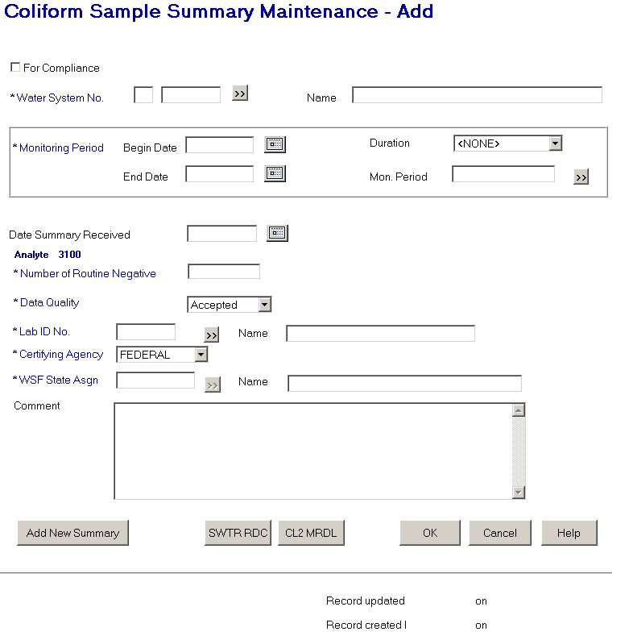

Exhibit 5-11. Coliform Sample Summary Maintenance

Protected Fields:

Analyte 3100 Indicates that summary is for Total Coliform.

Record updated
by XXXXXXXX on
MM/DD/YYYY
HH:MI:SS The User ID and the timestamp from the last time the sample record (TSASMPSM) was updated.

Record created
by XXXXXXXX on
MM/DD/YYYY
HH:MI:SS The initial User ID and timestamp when the sample (TSASSAR) record was initially added to the database.

Entry Fields:

For Compliance This check box defaults to checked and indicates that the sample summary is used for compliance determination.

Water System No. The specific number of the water system for which the samples were collected, it consists of the two-character state code plus the seven-character number field.
The state code portion will default to the state_identification_code in the SYSTEM_VARIABLE entity view.

This is a required field. If left blank, the error message will be: Water System No. must not be blank.

When a valid water system is found, the system will look for a water system facility of type distribution system (DS). If one and only one is found, it will be populated in the WSF State Asgn ID and WSF Name fields. If no distribution WSF is found, the fields will be blank. If more than one is found, the error message will be: Multiple Distribution Systems exist for this Water System. Choose DS WSF.

[Water System] Name Standard 40-character Public Water System Name may be entered completely, partially, or left blank. If the user specifies a partial string in this field, display the closest matching water system at the top of the list. (Closest matching means a match with the Water System Name, sorted alphabetically, that starts with the same text string as supplied.)

If a valid water system name is entered, both the water system name and number will be populated. When a valid water system is found, the system will look for a water system facility of type distribution system (DS). If one and only one is found, it will be populated in the WSF State Asgn ID and WSF Name fields. If no distribution WSF is found, the fields will be blank. If more than one is found, the error message will be: Multiple Distribution Systems exist for this Water System. Choose DS WSF.

If a valid water system is entered but is not part of the user’s current Water System Group or Regulating Agency, invoke exit state error message: WS is not part of current group/agency. Change group/agency to access this WS.

If the name entered is not found, the software will flow to the Water System Selection List with the name that most closely matches the value entered. The user may then select a value and continue.

Monitoring Period The four Monitoring Period fields will be enabled only after the user values Water System No. The user may select a valid monitoring period by any of these combination: Mon. Period [Name]; Begin Date + Duration; Begin Date + End Date; Duration + End Date; or by pressing the Monitoring Period Go To button.

Monitoring Period is a required field.

[Monitoring Period]
Begin Date If Begin Date and either End Date or Duration are valued, on tabbing off or clicking outside of the field, the software will retrieve the monitoring period that matches the criteria and display it in all monitoring period fields. If no monitoring period exists that matches the criteria, it will invoke the Monitoring Period Maintenance List in single-select mode. The software will take no action if only Begin Date is valued.

[Monitoring Period]
Duration The user may enter a valid monitoring period Duration. Only durations of monthly (MN), quarterly (QT), annual (1Y), or every 6 months (6M) will appear in the dropdown list. The default duration will be monthly. If Duration and either Begin Date or End Date are valued, on tabbing off or clicking outside of the field, the software will retrieve the monitoring period that matches the criteria and display it in all monitoring period fields. If no monitoring period exists that matches the criteria, the software will invoke the Monitoring Period Maintenance List in single-select mode. The software will take no action if only Duration is valued.

[Monitoring Period]
End Date If End Date and either Begin Date or Duration are valued, on tabbing off or clicking outside of the field, the software will retrieve the monitoring period that matches the criteria and display it in all monitoring period fields. If no monitoring period exists that matches the criteria, it will invoke the Monitoring Period Maintenance List in single-select mode. The software will take no action if only End Date is valued.

Mon. Period [Name]
If the user enters a valid monitoring period name, on tabbing off or clicking outside of the field, the software will retrieve the monitoring period that matches the criteria and display it in all monitoring period fields. If the user enters a partial string or an invalid monitoring period name, the Monitoring Period Maintenance List will be invoked in single-select mode.

Date Summary
Received The date the summary was received.

This is an optional field.

Number of Routine
Negatives This is a numeric representing the number of negative results for the monitoring period. Positive results must be entered individually using the Coliform Sample Maintenance page or other SDWIS sample entry components.

This is a required field. If it does not contain a value the error message will be: Must specify Number of Routine Negatives.

Data Quality The quality of the samples received. The permitted values are:

A - Accepted
P - Preliminary
R - Rejected
V - Validated

Data Quality will be a required field.

Lab ID No. The identification number assigned by the to the laboratory, which performed the analysis. When a value is supplied that is not found, the lab maintenance list page will be presented. A valid value in this field will also populate the Laboratory Name.

This is a required field. (R0059:A.5.3.2.a)

Certifying Agency Select a value from the dropdown list. The value will be matched against the laboratory’s Certifying Agency. The selections available via the dropdown list will be retrieved from the TINPVALS table where code_name = “CERT_AG.”

If an exact match is found using the Lab ID No. and Certifying Agency, the laboratory name will be displayed.

If none is found, the Laboratory Maintenance List will be presented in single-select mode.

Certifying Agency will be a required field. It will default to STATE. (R0059:A.5.3.2.b)

(R0059:A.5.3.2.c)

[Laboratory] Name The name of the laboratory. This field will be automatically populated when a valid value is either input or selected in Lab State ID No.. (R0059:A.5.3.2.d)

When a value is supplied that is not found, the lab maintenance list page will be presented. The selection will also populate the Lab ID No. and .Certifying Agency. (R0049:A.5.3.2.e)

This is an optional field.

WSF State Asgn ID The state assigned identifier of the water system facility for which the samples were collected. This field will not be available for input until a valid Water System No. has been provided. When Water System No. this field will be defaulted as described above in Water System No. If water system changed, this field will be reset for new water system.

When tabbing off the field the input value will be edited. If a match is found for the provided water system, the name will be displayed in the water system facility name field. If an exact match is not found the water system facility maintenance list will be presented.

This is a required field. If left blank, the error message will be: Water system facility must not be blank.

When the value in this field is modified, including removal of the value, the WSF Name field will be removed.

[WSF] Name The name of the water system facility. The name will be populated when a valid water system facility is either input in the WSF State Asgn ID number or chosen from the selection list.

This field will not be available for input until a valid Water System No. has been provided.

A name may be input into this field. When tabbing off the field, if the name is not found as a valid water system facility for the provided water system, the water system facility maintenance list will be presented in single-select mode.

When the value in this field is modified, including removal of the value, the WSF State Asgn ID field will be removed.

This is an optional field.

Comment A free-form comment area where descriptive text about the sample summary can be recorded.

This is an optional field.

Buttons:

[water system]
Go To Will present the Water System Maintenance List where the Edit/Select will be available.

When a valid water system is found the system will look for a water system facility of type distribution system (DS). If one and only one is found it will be populated in the WSF State Asgn ID and WSF Name fields. If no distribution WSF is found the fields will be blank. If more than one is found the error message will be: Multiple Distribution Systems exist for this Water System. Choose DS WSF.

[monitoring period]
Go To Will present the Monitoring Period Maintenance List where the Edit/Select will be available. Enabled when a water system has been selected.

[laboratory]
Go To Will present the Laboratory Maintenance List. Only the ‘select’ menu will be enabled. Add/change will not be allowed for security reasons.

[water system facility]
Go To Will present the Water System Facility Maintenance List where the Edit/Select will be available. Enabled when a water system has been selected.

Add New
Summary The summary will be processed as described with the OK button below. When successful, the Summary Maintenance Page will be represented. The monitoring period, date received, and laboratory of the current record will be carried forward.

The button will be available in both add and change mode.

WT RDC (B.5.3.2a) This button will only be enabled when a distribution water system facility has been selected along with the monitoring period.

The summary will first be processed as if the OK button was selected. After successful completion of that function, the following processes are performed.

(1) The software will select the FANL that establishes a minimum level (Level Type is “MIN”) for chlorine (Analyte Code 0999) or chloramine (Analyte Code 1006) that is linked to the current WSF. This will result in the selection of zero, one, or two FANL records.
If a FANL meeting these criteria is not found, the following error message will be invoked: FANL for analyte chloramine (1006) or chlorine (0999) of type MIN not found for this WSF or Mon. Period. Return the cursor to the WSF State Asgn ID field with the maintenance page in Change mode.

(2) If a FANL meeting these criteria is found, the software will run the selected FANL through the following checks that would let the user know that a FANL exists but still cannot be used. If any of these checks is validated, an error message will be invoked. After the user presses OK on the message, return the cursor to the WSF State Asgn ID field with the maintenance page in Change mode.

- If one or more FANL is found but none of the FANL found are in effect on the first day of the user-selected monitoring period (FANL Effective Begin Date is not on or before the Monitoring Period Begin Date), the following error message will be invoked: Facility Analyte Level not in effect during this monitoring period.

- If one or more FANL are found but none of the FANL found has its MDBP Summary Check Flag set to “Yes,” the following error message will be invoked: Facility Analyte Level with MDBP Summary Check Flag set to YES not found.

- If a FANL record is found but does not indicate a Summary Type of “DSRD” or “SDRD,” the following error message will be invoked: Facility Analyte Level with MDBP Summary type “DSRD” or “SRDR” not found.

- If one or more FANL are found that satisfy the above criteria and is in effect on the first day of the user-selected monitoring period, the software will select it and go to step (4).

(3) The software will next select:

- One MDBP Summary that is linked to the FANL whose field Summary Type is DSRD and is linked to the user-specified monitoring period; it will also select

One MDBP Summary that is linked to the FANL whose field Summary Type is “SDRD” and is linked to the user-specified monitoring period.

(4) The software will then flow to the Distribution RDC page, displaying the selected Water System No., Water System Name, WSF State Asgn ID. WSF Name, Monitoring Period Begin Date, Monitoring Period Duration, and FANL.

If it finds one of the MDBP Summaries described above; it will also display its data in the page in Change mode, with the cursor in the first entry field.

- If it does not find any of the possible MDBP Summaries, this page will appear in Add mode.

Upon return to the TCR Sample Summary Maintenance page, whether a MDBP Summary was added or not, the page will be in Change mode.

CL2 MRDL This button will only be enabled when a distribution water system facility has been selected along with the monitoring period.

The summary will first be processed as if the OK button was selected. After successful completion of that function the following processes are performed.

(1) After the WSF has been selected, the software will select the FANL that establishes a maximum level (Level Type is “MAX”) for chlorine (Analyte Code 0999) or chloramine (Analyte Code 1006) that is linked to the current WSF. This will result in the selection of zero, one, or two FANL records.

If a FANL meeting these criteria is not found, the following error message will be invoked: FANL for analyte chloramine (1006) or chlorine (0999) of type MAX not found for this WSF. Return the cursor to the WSF State Asgn ID field with the maintenance page in Change mode.

(2) If a FANL meeting these criteria is found, the software will run the selected FANL through the following checks that would let the user know that a FANL exists but still cannot be used. If any of these checks is validated, an error message will be invoked. After the user presses OK on the message, return the cursor to the WSF State Asgn ID field with the maintenance page in Change mode.

- If one or more FANL are found but none of the FANL found are in effect on the first day of the user-selected monitoring period (FANL Effective Begin Date is not on or before the Monitoring Period Begin Date), the following error message will be invoked: Facility Analyte Level not in effect during this monitoring period.

- If one or more FANL are found but none of the FANL found have its MDBP Summary Check Flag set to “Yes,” the following error message will be invoked: Facility Analyte Level with MDBP Summary Check Flag set to YES not found.

If a FANL record is found but does not indicate a Summary Type of “MRDL,” the following error message will be invoked: Facility Analyte Level with MDBP Summary type “MRDL” not found.

If one or more FANL are found that satisfy the above criteria and is in effect on the first day of the user-selected monitoring period, the software will select it and go to step (4).

(3) The software will next select one MDBP Summary whose field Summary Type is MRDL that is linked to the FANL and is linked to the user-specified monitoring period.

(4) The software will then flow to the MRDL Chlorine/Chloramine DS page, displaying the selected Water System No., [Water System] Name, WSF State Asgn ID., [WSF] Name, Analyte Code, [Analyte Code] Name, Monitoring Period Begin Date, Monitoring Period Duration, and FANL.

- If it finds the MDBP Summary described above, it will also displays its data in the page in Change mode, with the cursor in the first entry field.

- If it does not find the MDBP Summary, this page will appear in Add mode.

Upon return to the TCR Sample Summary Maintenance page, whether a MDBP Summary was added or not, the page will be in Change mode.

OK
Duplicate Check The duplicate criteria for sample summary is the combination of water system, water system facility, analyte, and monitoring period. If a sample summary is found matching these four criteria, the following decision advisory will be presented:

A Sample Summary for the same Water System, Water System Facility, Analyte, and Monitoring Period already exists. Select Change to modify the existing Sample Summary or Cancel to return to previous page.

Pressing Change will present the Sample Summary Maintenance page in Change mode with the existing record displayed.

Pressing Cancel will return the Sample Summary Maintenance page in Add mode with the previous data displayed but no new record will have been added.

Add Mode The following actions are taken:
- A Sample Summary is created and associated to the water system, 3100 analyte, water system facility, and monitoring period.
- If a laboratory was provided, the sample summary is associated to the laboratory.
- A Sample Summary Result is created of type ‘RT” and associated to the Sample Summary.

Change Mode In change mode the following information can be changed:
- Sample Summary comment, compliance purpose, and summary received date.
- Association to a different monitoring period.
- Association to a different water system facility.
- Association to a different laboratory or removal of the laboratory association.
- Sample Summary Result number of negative samples and data quality code.

When successful the list page will be presented.

Cancel If no data has been input or changed the page will close and present the list.

If data has been input or changed the standard Cancel Confirmation page will be presented.

Help Will invoke the system online Help facility.

LCR Sample and Summaries Pages

LCR Sample Maintenance
Exhibit 5-1 depicts the LCR Sample Maintenance page.

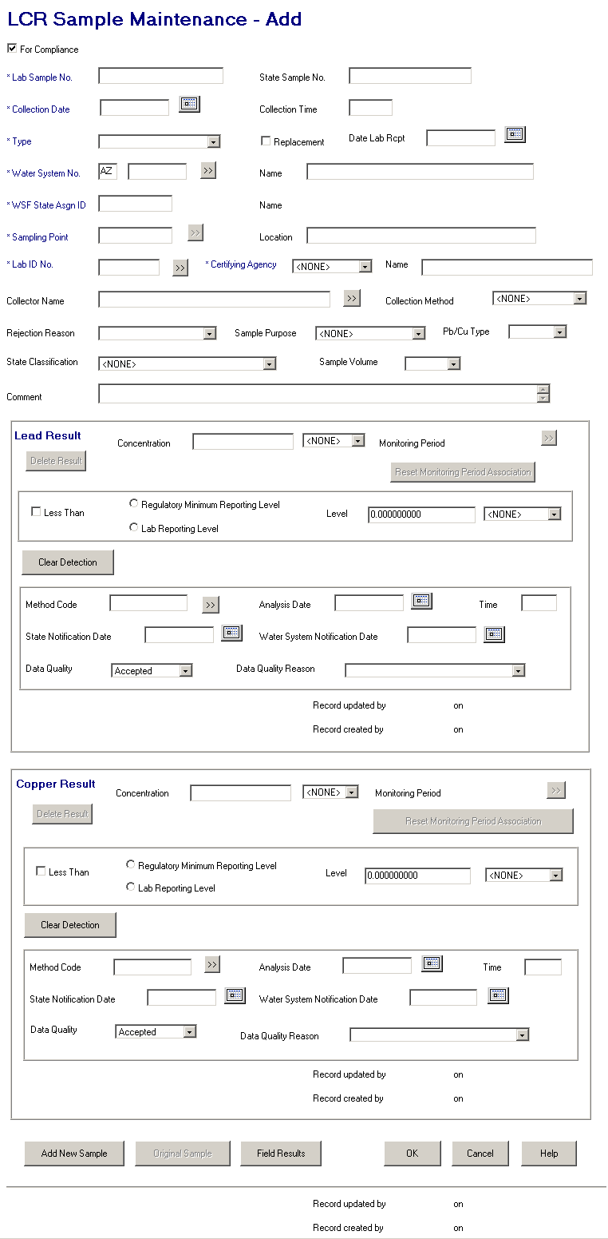

Exhibit 5-12. LCR Sample Maintenance
Protected Fields:

[Water System Facility]
Name The name of the supplied water system facility.

[Lead Result]
Monitoring Period The monitoring period name. When a for-compliance sample is added, CDS Setup uses the collection date and the corresponding sample schedule to determine the appropriate monitoring period for the lead result.

For non-compliance samples, CDS Setup will not calculate the monitoring period.

On add, this field is protected. This field can be changed in change mode using the Go To button.
[Lead Result]
Record updated
by XXXXXXXX on
MM/DD/YYYY
HH:MI:SS The User ID and the timestamp from the last time the sample analytical result record (TSASAR) was updated.
[Lead Result]
Record created
by XXXXXXXX on
MM/DD/YYYY
HH:MI:SS The initial User ID and timestamp when the sample analytical result (TSASAR) record was initially added to the database.

[Copper Result]
Monitoring Period The monitoring period name. When a for-compliance sample is added, CDS Setup uses the collection date and the corresponding sample schedule to determine the appropriate monitoring period for the copper result.

For non-compliance samples, CDS Setup will not calculate the monitoring period.

On add, this field is protected. This field can be changed in change mode using the Go To button.

[Copper Result]
Record updated
by XXXXXXXX on
MM/DD/YYYY
HH:MI:SS The User ID and the timestamp from the last time the sample analytical result record (TSASAR) was updated.
[Copper Result]
Record created
by XXXXXXXX on
MM/DD/YYYY
HH:MI:SS The initial User ID and timestamp when the sample analytical result (TSASAR) record was initially added to the database.

Record updated
by XXXXXXXX on
MM/DD/YYYY
HH:MI:SS The User ID and the timestamp from the last time the sample record (TSASAMPL) was updated.

Record created
by XXXXXXXX on
MM/DD/YYYY
HH:MI:SS The initial User ID and timestamp when the sample (TSASAMPL) record was initially added to the database.

Entry Fields:

Note that the tab order is left to right, top to bottom, and includes all Entry Fields and buttons unless otherwise noted.

For Compliance This check box marks the sample as being used for compliance determination. When it is checked, the sample will be used for compliance if the sample type is Routine, Repeat, or Confirmation. The default is checked. Compliance samples have different rules than noncompliance samples. These are indicated below.

Lab Sample No. The sample identification number assigned by the laboratory for tracking the sample within the lab.

This is a required field for all new samples. If the Lab Sample No. is not supplied for a new sample the error message is Samples must have a Lab Sample No.

(Note: this is a change to the way SDWIS/STATE 8.0 works. In SDWIS/STATE 8.0, Lab Sample No. is optional for compliance samples and required for noncompliance samples.)

In change mode, if valued with other than spaces, it may be changed but not be changed to spaces.

State Sample No. The sample identification number assigned by a state to uniquely identify a specific sample within the state.

This is an optional field.

Collection Date The date the sample was collected. A calendar function is available to aid input.

Collection Time The time the sample was collected (in local time).

This is an optional field. If it is provided, the valid range is between 0001 and 2359. Values greater than 2359 will generate error message Time Entries must be between 00:01 and 23:59.

[Sample] Type The reason for the sample collection. Valid selections are:

RT - Routine
RP – Repeat
CO - Confirmation
SP - Special
BB - Batch Blanks
FB - Field Blanks
PE - Performance Evaluation
SB - Shipping Blanks
ST - Split Blanks
MR - Maximum Residence Time
MS – Matrix Spike

This is a required field. If the sample type is entered or changed to any value other than Routine (RT), Repeat (RP), or Confirmation (CO), the software will uncheck the For Compliance checkbox. A user may recheck it (even if the Sample Type is not equal to RT, RP, or CO) but the sample will not be considered or processed by SDWIS compliance determination.

If the sample type is CO (confirmation) the Original Sample Information page will be presented for capture of the original sample which is being repeated.

Replacement The Replacement box is used to indicate whether the sample is taken as a replacement for another sample. Replacement samples either replace lost or damaged samples that the lab could not analyze or they replace invalid samples that the lab refused to analyze due to technical reasons.

When the box is checked it indicates a replacement sample The default is unchecked.

When checked, the Original Sample Information page will be presented for identification of the original sample that is being replaced.

This is an optional field.

Date Lab Rcpt The date the sample was received by the lab. A calendar function is available to aid input.

This is an optional field. When it is provided, it must be greater than or equal to the collection date or error message The date of Lab Receipt cannot be prior to the date of Sample Collection will be given. This edit check is performed when a user tabs out of or clicks out of the field as well as when the record is saved.

Water System No. The specific Water System No., consisting of the two-character state code plus the seven-character number field.

The state code portion will default to the state_identification_code in the SYSTEM_VARIABLE entity view.

When tabbing off or clicking outside this field after supplying a value, the water system will be retrieved and the name displayed. Any value in the WSF State Asgn ID and Name, Sampling Point and Sample Location fields will be removed. If the sample type is Repeat or a routine with the replacement indicator checked, the Original Sample Information will be presented.

If a valid water system is entered but is not part of the user’s current Water System Group or Regulating Agency, invoke exit state error message: WS is not part of current group/agency. Change group/agency to access this WS.

If the supplied value is invalid, the Water System Maintenance List will be presented with the number that most closely matches the value entered.

This is a required field. If it is left blank, the error message will be: Water System No. must not be blank.

[Water System] Name Standard 40-character Public Water System Name may be entered completely, partially, or left blank. If the user specifies a partial string in this field, display the closest matching water system at the top of the list. (Closest matching means a match with the Water System Name, sorted alphabetically, that starts with the same text string as supplied.)

If a valid water system name is entered, the Water System No. is populated.

If a valid water system is entered but is not part of the user’s current Water System Group or Regulating Agency, invoke exit state error message: WS is not part of current group/agency. Change group/agency to access this WS.

If the name entered is not found, the software will flow to the Water System Selection List. The user may then select a value and continue.

WSF State Asgn ID The Water System Facility State Assigned ID of the sample location.

When tabbing off this field after supplying a value, the value will be retrieved and the name displayed.

If the supplied value is invalid, the error message will be: The WSF State Asgn ID entered does not belong to this water system.

It may be valued either by direct entry or by selecting a sampling point using the Sampling Point Go To button.

When the value in this field is modified the values in (WSF) Name, Sampling Point and Location will be cleared.

This field will remain protected until a valid Water System has been supplied.

Sampling Point The ID of the sampling point where the sample was taken.

When tabbing off or clicking outside this field after supplying a value, the software will function the same as described for this field on the Coliform Sample Maintenance page with the following exception: if the sample type is a repeat or confirmation; or is a routine with the replacement indicator checked and the collection date provided, the Original Sample Information will be presented.

This field will remain protected until a valid Water System has been supplied.

[Sampling Point]
Location The name of the sampling point where the sample was collected.

When tabbing off this field after supplying a value, the software will function the same as described for this field on the Coliform Sample Mainteannce page with the following exception: if the sample type is a repeat or confirmation; or is a routine with the replacement indicator checked and the collection date is provided, the Original Sample Information will be presented.

This field will remain protected until a valid Water System has been supplied.

Lab ID No. The identification number assigned by the to the laboratory, which performed the analysis. When a value is supplied that is not found, the lab maintenance list page will be presented. A valid value in this field will also populate the and Laboratory Name. (R0059:A.5.4.1.a)

This is a required field. If left blank, the error message will be: Laboratory may not be left blank.

Certifying Agency Select a value from the dropdown list. The value will be matched against the laboratory’s Certifying Agency. The selections available via the dropdown list will be retrieved from the TINPVALS table where code_name = “CERT_AG.”

If an exact match is found using the Lab ID No. and Certifying Agency, the laboratory name will be displayed.

If none is found, the Laboratory Maintenance List will be presented in single-select mode.

Certifying Agency will be a required field. It will default to STATE. (R0059:A.5.4.1.b)

When the Laboratory can be identified from the above two fields, the default Method Code and default Lab reporting limit and UOM for both the Copper Result and Lead Result will be populated from the Lab Analyte Method Assignment table that is associated to the Laboratory, has as relationship to Standard Method Analyte Association that is related to the lead and copper analyte, has default method indicator = ‘Y’, has certification indicator = ‘Y’ and has the most recent issuance date <= (analysis end date or analysis start date, or sample collection end date to be checked in this order based upon the date being not null.) (R0059:A.5.4.1.f)

(R0059:A.5.4.1.c)

[Laboratory] Name The name of the laboratory. This field will be automatically populated when a valid value is either input or selected in Lab ID No.and Certifying Agency.

When a value is supplied that is not found, the lab maintenance list page will be presented. The selection will also populate the Lab ID No. and Certifying Agency. (R0059:A.5.4.1.d)

Collector Name The name of the individual who collected the sample.

If the entered individual does not exist as a valid legal entity with collector_indicator_code = ‘Y,’ then set TSASAMPL informal_collector equal to entered individual.

This is an optional field.

Collection Method The standard method used to collect the sample. When a value is supplied, it must be pre-defined in the standard methods table. If the value supplied is not found, a selection list of standard methods will be presented.

This is an optional field.

Rejection Reason The reason a lab rejected a sample for further analysis.

BR - Broken
CL - Chlorine present
EH - Exceeds holding time
HS - Excessive headspace
FZ - Frozen sample
IN - Insufficient information
VO - Insufficient volume
BP - Invalid sampling point
IP - Invalid sampling protocol
LA - Lab accident
LT - Leaked in transit

This is an optional field. In Add mode when a value is selected, the result entry fields for Lead Result and Copper Results will be protected from entry. If any of those fields already contain a value, other than the default, an advisory will be presented notifying that the values will be removed.

Sample Purpose This will allow the state to document why sample was taken (e.g., surveillance, investigation). Its value will be controlled by the System Administrator. It will not be used by any automated processing. The permitted values for the dropdown list will be retrieved from the CODE table, code_name of ‘SMPLPURPOS’.

This is an optional field.

PbCu Type The type of sample for lead and copper rule compliance purposes. Permitted values are:

FSD - 1st Draw (default)
ATS - At Source
FLS - Flushed
LSL - Lead Service Line

This is an optional field.

State Classification This field will allow user to assign the sample to a classification pre-defined by the System Administrator. The permitted values for the dropdown list will be retrieved from the CODE table, code_name of ‘SMPSTCLASS’.

If left blank, it will default to the value in the state classification field of the analyte of the first sample analytical result added. Although this field will not be as valuable as it is on the General Sample Maintenance Page, it will still be made available here.

This is an optional field. Increase display size to accommodate increased field size. (R0036:A.5.4.1.e)

Sample Volume The volume of sample collected and submitted to the laboratory. Permitted values are:

1 liter (default)
100 ml
300 ml
400 ml
500 ml
(Spaces)

This is an optional field.

Comment A free-form comment area where descriptive text about the sample can be recorded.

This is an optional field.

Lead Result:

Concentration
(and unit of measure) A value that represents the result obtained from a sample analysis, typically expressed in units per volume.

Enter the concentration and choose the unit of measure from the dropdown list. Permitted values are those rows from the Unit of Measure table for chemical result type (C), sorted by the Sort Priority recorded in the Unit of Measure table. This will produce the following list of UOM Codes.

mg/L
ug/L
ng/L

This is an optional field. If a concentration value is provided, the Unit of Measure must be selected. If it is not, the error message will be: Analysis Result Concentration Measure Unit may not be left blank.

The concentration must be a numeric value. If it is not, the error message will be: Reported Measure may only be a valid number. If the value is greater than 999,999, the error message will be: Value too Large. SDWIS can support up to 6 digits to the left of the decimal.

Reporting Level Type
(including the less than
check box) Indicates that the analytical result (Concentration) was less than the regulatory minimum reporting level or the laboratory reporting level, which must be less than or equal to the regulated maximum contaminant level (MCL) for the analyte. Results “less than” these levels are sometimes referred to as “not quantifiable” or “not detected.” Selecting the “less than” checkbox and either “Regulating Minimum Reporting Level” or “Lab Reporting Level” is the equivalent of specifying “non-detect” for the analyte.

If the result is less than either level, select the box beside Less Than and then choose either Regulatory Minimum Reporting Level (MDL) or Lab Reporting Level (MRL).

If MDL is chosen, the analyte’s current regulatory method detection limit is retrieved from the Analyte Level Rule (or TMNALRA) table and displayed in the protected level field.

If MRL is chosen, the user must enter a reporting level that is not above the regulated MCL for the current analyte. If left blank, the error message will be: Lab Reporting Level may not be blank when a reporting level type is selected. (Note: SSWr1 may include the ability to record Lab Reporting Levels. If so, this will work as described above for MDL.)

When the “less than” box is checked, a reporting level type must be selected. If it is not, the error message will be: Reporting Level Type may not be left blank.

Level
(and unit of measure) The limit established by the laboratory below which scientifically reliable results cannot be achieved. In many cases, if the lab’s detection limit is below the EPA-mandated method detection limit (MDL) then the MDL is used as the detection limit. If the lab’s detection limit is above the EPA’s MDL, then the lab’s detection limit is used.

Enter the result and choose the unit from the dropdown list. Permitted values are those rows from the Unit of Measure table for chemical result type (C), sorted by the Sort Priority recorded in the Unit of Measure table. This will produce the following list of UOM Codes.

mg/L
ug/L
ng/L

This field is available and required only if the Reporting Level Type is designated as Lab Reporting Level (MRL).

If the value entered in the field is greater than the maximum contaminant level for this analyte in the Analyte Level Rule (or TMNALRA) table, the warning message Lab Reporting level may not be greater than the MCL for this Analyte. will be presented.

If no value is found in the Analyte Level Rule for the MCL, the level value entered will be checked against the action level goal value in the Analyte Level Rule table for this analyte. If the value in the level field is greater than the action level goal (ACL) for this analyte in the Analyte Level Rule (or TMNALRA) table, the warning message Lab Reporting level may not be greater than the ACL for this Analyte. will be presented.

Method Code Represents the method code used to analyze the sample, such as the EPA-assigned method code EPA 525.1. If a value is supplied, it must be a valid standard method code assigned to this analyte. If it is not, the list of valid method codes will be presented for selection. If lab certification edit is enabled (reference details under the OK button), list only those standard methods approved for the laboratory and lead analyte. (R2001:A.5.4.1.j)

When the Laboratory and Method Codes are entered, if neither RMDL nor LRL detection level radio button has been set, set LRL detection level radio button and default Lab reporting limit and UOM. Result will be populated from the Lab Analyte Method Assignment table associated to the Laboratory, has as relationship to Standard Method Analyte Association that is related to the lead analyte, has certification indicator = ‘Y’, and has the most recent issuance date <= (analysis end date or analysis start date, or sample collection end date to be checked in this order based upon the date being not null.) (R0059:A.5.4.1.m)

This is an optional field.

Analysis
[Complete] Date The date the analysis was completed.

This is an optional field. If provided, it may not be prior to the sample collection date. If it is, the error message will be: The date of Result Analysis cannot be prior to the date of Sample Collection.

[Analysis Complete]
Time The time that the analysis was complete. The maximum value for this field is 2359. If a supplied value exceeds this maximum, the error message will be: Time entries must be between 0001 and 23:59.

If the result complete date is equal to the sample collection date, the result complete time cannot be greater than the sample collection time. If it is, the error message will be: The time of Result Analysis cannot be prior to the time of Sample Collection.

This is an optional field.

State Notification Date The date that the state was notified of the sample result for this analyte.

This is an optional field. If provided it may not be prior to:
- The sample collection date. If it is, the error message will be: The date of State Notification cannot be prior to the date of Sample Collection.
- The result analysis complete date. If it is, the error message will be: The date of State Notification cannot be prior to the date of Result Analysis.
- The sample lab receipt date. If it is, the error message will be: The date of State Notification cannot be prior to the date of Lab Receipt.

Water System Notification
Date The date the laboratory notified the water system of the analytical result.

This is an optional field. Do not allow future date. The error message will be: Date must not be a future date. If provided, it may not be prior to:

- The sample collection date. If it is, the error message will be: The date of Water System Notification cannot be prior to the date of Sample Collection.
- The result analysis complete date. If it is, the error message will be: The date of Water System Notification cannot be prior to the date of Result Analysis.
- The sample lab receipt date. If it is, the error message will be: The date of Water System Notification cannot be prior to the date of Lab Receipt.

Data Quality Indicates whether the sample analytical result meets established data quality acceptance criteria. The laboratory is responsible for providing data quality information for a sample analysis. Entries include the following:

A - Accepted
P - Preliminary
R – Rejected

This is a required field that will default to Accepted. If no value is selected, the error message will be: Analysis Result Data Quality Code may not be left blank.

Data Quality Reason The reason for rejection of an analytical result. Entries include the following:

IF - Instrument failure
LC- Lab not certified
LE - Lab error
OT - Other
RC - Requester canceled
WR - Water system rejected the result

This field becomes required if the Data Quality is selected as Rejected. If left blank for a rejected data quality selection, the error message will be: A Data Quality Reason code must be entered to reject a result.

Copper Result:

Concentration
(and unit of measure) A value that represents the result obtained from a sample analysis, typically expressed in units per volume.

Enter the concentration and choose the unit from the dropdown list. Permitted values are those rows from the Unit of Measure table for chemical result type (C), sorted by the Sort Priority recorded in the Unit of Measure table. This will produce the following list of UOM Codes.

mg/L
ug/L
ng/L

This is an optional field. If a concentration value is provided, the Unit of Measure must be selected. If it is not, the error message will be: Analysis Result Concentration Measure Unit may not be left blank.

The concentration must be a numeric value. If it is not, the error message will be: Reported Measure may only be a valid number. If the value is greater than 999,999, the error message will be: Value too Large. SDWIS can support up to 6 digits to the left of the decimal.

Reporting Level Type
(including the less than
check box) Indicates that the analytical result (Concentration) was less than the regulatory minimum reporting level or the laboratory reporting level, which must be less than or equal to the regulated maximum contaminant level (MCL) for the analyte. Results “less than” these levels are sometimes referred to as “not quantifiable” or “none detected”; selecting the “less than” checkbox and either “Regulating Minimum Reporting Level” or “Lab Reporting Level” is the equivalent of specifying “non-detect” for the analyte.

If the result is less than either level, select the box beside Less Than and then choose either Regulatory Minimum Reporting Level (MDL) or Lab Reporting Level (MRL).

If MDL is chosen, the analyte’s current regulatory method detection limit is retrieved from the Analyte Level Rule (or TMNALRA) table and displayed in the protected level field.

If MRL is chosen, the user must enter a reporting level field that is not above the regulated MCL for the current analyte. If left blank, the error message will be: Lab Report Level may not be blank when a reporting level type is selected. (Note that SSWr1 may include the ability to record Lab Reporting Levels. If so, this will work as described above.)

When the “less than” box is checked, a reporting level type must be selected. If it is not, the error message will be: Reporting Level Type may not be left blank.

Level
(and unit of measure) The limit established by the laboratory below which scientifically reliable results cannot be achieved. In many cases, if the lab’s detection limit is below the EPA-mandated method detection limit (MDL) then the MDL is used as the detection limit. If the lab’s detection limit is above the EPA’s MDL, then the lab’s detection limit is used.

Enter the result and choose the unit from the dropdown list. Permitted values are those rows from the Unit of Measure table for chemical result type (C), sorted by the Sort Priority recorded in the Unit of Measure table. This will produce the following list of UOM Codes:

mg/L
ug/L
ng/L

This field is available and required only if the Reporting Level Type is designated as Lab Reporting Level (MRL).

If the value entered in the field is greater than the maximum contaminant level for this analyte in the Analyte Level Rule (or TMNALRA) table, the warning message Lab Reporting level may not be greater than the MCL for this Analyte will be presented.

If no value is found in the Analyte Level Rule for the MCL, the level value entered will be checked against the action level goal value in the Analyte Level Rule table for this analyte. If the value in the level field is greater than the action level goal (ACL) for this analyte in the Analyte Level Rule (or TMNALRA) table, the warning message Lab Reporting level may not be greater than the ACL for this Analyte will be presented.

Method Code Represents the method code used to analyze the sample, such as the EPA-assigned method code EPA 525.1. If a value is supplied, it must be a valid standard method code assigned to this analyte. If it is not, the list of valid methods will be presented for selection. If lab certification edit is enabled (reference details under the OK button), list only those standard methods approved for the laboratory and copper analyte. (R2001:A.5.4.1.k)

When the Laboratory and Method Codes are entered, if neither RMDL nor LRL detection level radio button has been set, set LRL detection level radio button and default Lab reporting limit and UOM. Result will be populated from the Lab Analyte Method Assignment table associated to the Laboratory, has as relationship to Standard Method Analyte Association that is related to the copper analyte, has certification indicator = ‘Y’, and has the most recent issuance date <= (analysis end date or analysis start date, or sample collection end date to be checked in this order based upon the date being not null.) (R0059:A.5.4.1.l)

This is an optional field.

Analysis
[Complete] Date The date the analysis was completed.

This is an optional field. If provided, it may not be prior to the sample collection date. If it is, the error message will be: The date of Result Analysis cannot be prior to the date of Sample Collection.

[Analysis Complete]
Time The time that the analysis was complete. The maximum value for this field is 2359. If a supplied value exceeds this maximum, the error message will be: Time entries must be between 00:01 and 23:59.

If the result complete date is equal to the sample collection date, the result complete time cannot be later than the sample collection time. If it is, the error message will be: The time of Result Analysis cannot be prior to the time of Sample Collection.

This is an optional field.

State Notification Date The date that the state was notified of the sample result for this analyte.

This is an optional field. If provided, it may not be prior to:

- The sample collection date. If it is, the error message will be: The date of State Notification cannot be prior to the date of Sample Collection.
- The result analysis completes date. If it is, the error message will be: The date of State Notification cannot be prior to the date of Result Analysis.
- The sample lab receipt date. If it is, the error message will be: The date of State Notification cannot be prior to the date of Lab Receipt.

Water System Notification
Date The date the laboratory notified the water system of the analytical result.

This is an optional field. Do not allow future date. The error message will be: Date must not be a future date. If provided, it may not be prior to:

- The sample collection date. If it is, the error message will be: The date of Water System Notification cannot be prior to the date of Sample Collection.
- The result analysis complete date. If it is, the error message will be: The date of Water System Notification cannot be prior to the date of Result Analysis.
- The sample lab receipt date. If it is, the error message will be: The date of Water System Notification cannot be prior to the date of Lab Receipt.

Data Quality Indicates whether the sample analytical result meets established data quality acceptance criteria. The laboratory is responsible for providing data quality information for a sample analysis. Entries include the following:

A - Accepted
P - Preliminary
R – Rejected

This is a required field that will default to Accepted. If no value is selected, the error message will be: Analysis Result Data Quality Code may not be left blank.

Data Quality Reason The reason for rejection of an analytical result. Entries include the following:

IF - Instrument failure
LC- Lab not certified
LE - Lab error
OT - Other
RC - Requester canceled
WR - Water system rejected the result

This field becomes required if the Data Quality is selected as Rejected. If left blank for a rejected data quality selection, the error message will be: A Data Quality Reason must be entered to reject a result.
Buttons:

[water system]
Go To Will present the Water System Maintenance List with Edit/Select available and allowing only a single-selection.

Once a water system is selected, the water system will be retrieved and the name displayed. Any value in the WSF fields and Sampling Point fields will be cleared.

[sampling point]
Go To Will present the Sampling Point Maintenance List with Edit/Select available and allowing only a single-selection.

[laboratory]
Go To Will present the Laboratory Maintenance List. Only the ‘select’ menu will be enabled. Add/change will not be allowed for security reasons.

[collector]
Go To Will present the Legal Entity Maintenance List displaying INDIVIDUALS designated as collectors. The Edit/Select menu item will be available and only a single-selection will be allowed.

[collection method]
Go To Will present the Collection Method Maintenance List with Edit/Select available and allowing only a single-selection.

[Lead Result]
Delete Result If result is associated to a violation, the software will present the error message: Result is associated to violation and may not be deleted. If result is not associated to a violation, the software will present standard deletion confirmation dialog box. Before deleting a result, if the result was created by CDSSETUP (d_userid = CDSSETUP), the software will present the advisory CDS Setup automatically created this result and will not recreate it if deleted. Do you wish to proceed? The advisory dialog box will have Yes and No buttons to allow the user to confirm or cancel the delete request.

If deletion is confirmed and the result is associated to one or more SSMPA or sub-SSMPA, the software will update the d_last_updt_ts for each associated SSMPA and sub-SSMPA to the current timestamp and set the d_userid_code to CDSSETUP.

Finally the sample analytical result (TSASAR) is deleted along with a cascade delete of all associated:
- SSMPA_ SAR_ASSOCIATION (TMNSPSRA)
- SPUBA_ SAR_ASSOCIATION (TMNSBSRA)
- OTHER SAMPLE ANALYSIS MEASURES (TSAOSAM)

[Lead Result
monitoring period]
Go To Will present the Monitoring Period Maintenance List with Edit/Select available and allowing only a single-selection. This button is only enabled in change mode.

[Lead Result]
Reset Monitoring
Period Association This button is only enabled in change mode and only if the result is associated to a monitoring period (either directly or via an SSMPA). When this button is pressed the following actions will occur. These changes will not be undone if the Cancel button is subsequently selected.

- Disassociate the SAMPLE ANALYTICAL RESULT from the MONITORING PERIOD by setting the TSASAR.tmnmprd_is_number and TSASAR.tmnmprd_st_code to nulls.
- For each SSMPA associated to the SAMPLE ANALYTICAL RESULT (via the SSMPA_SAR_ASSOCIATION (TMNSPSRA)):
- update the d_last_updt_ts to current timestamp
- delete the SSMPA_SAR_ASSOCIATION (TMNSPSRA) record.
- For each sub-SSMPA associated to the SAMPLE ANALYTICAL RESULT (via the SPUBA_SAR_ASSOCIATION (TMNSBSRA)):
- update the d_last_updt_ts to current timestamp
- delete the SPUBA_SAR_ASSOCIATION (TMNSBSRA)

[Lead Result]
Clear Detection Will clear Less Than Indicator, Regulatory Minimum Reporting Level radio button, Lab Reporting Level radio button, detection level, and detection level unit of measure fields.

[Lead Result
Method Code]
Go To Will present the Analyte Standard Method Maintenance List with Edit/Select available and allowing only a single-selection. If lab certification edit is enabled (reference details under the OK button), list only those standard methods approved for the laboratory and Lead analyte. (R2001:A.5.4.1.g)

[Copper Result]
Delete Result This button will function the same as [Lead Result] Delete Result button.

[Copper Result
monitoring period]
Go To Will present the Monitoring Period Maintenance List with Edit/Select available and allowing only a single-selection. This button is only enabled in change mode.

[Copper Result]
Reset Monitoring
Period Association This button will function the same as [Lead Result] Reset Monitoring Period Association button.

[Copper Result]
Clear Detection Will clear Less Than Indicator, Regulatory Minimum Reporting Level radio button, Lab Reporting Level radio button, detection level and detection level unit of measure fields.

[Copper Result
Method Code]
Go To Will present the Analyte Standard Method Maintenance List with Edit/Select available and allowing only a single-selection. If lab certification edit is enabled (reference details under the OK button), list only those standard methods approved for the laboratory and Copper analyte. (R2001:A.5.4.1.h)

Add New Sample Will perform all edits as if OK button were pressed. After successfully adding the sample and results, the maintenance window will redisplay. The following fields will retain their value:

- For Compliance
- Collection Date
- Sample Type
- Date Lab Received
- Water System No. and Name
- All WSF and Sampling Point fields
- All Lab fields
- Collector
- Collection Method
- Sample Purpose
- Sample Volume
- Pb/Cu Type

This button will be available in both add and change mode.

Original Sample Will present the Original Sample Information (Exhibit 5-13). This button is enabled when the sample is a confirmation, repeat or a routine with the replacement indicator checked and the collection date and sampling point have been supplied (because these two pieces of information are used to search for candidate original samples).

Exhibit 5-13. Original Sample Information

Search Button When a candidate original sample is initiated, the software will look for all samples collected at the same water system and water system facility, collected on or before the collection date of the current sample that (a) have either a lead (1030) or copper (1022) result or (b) have no results for a general sample. The search will return its findings on the General Sample/Sample Summary List sorted on Collection Date descending.

Field Results Will perform all edits as if OK button were pressed. After successfully adding the sample and results, the software will flow to the Field Results page described below.

OK
Duplicate Check Two duplicate checks may be performed prior to adding or updating the sample as follows:

The first is an advisory check that will occur on all samples. If a sample collected on the same date at the same water system and sampling point already exists for the same laboratory, the software will provide this advisory: This is an advisory. A sample already exists that was analyzed by this lab for this water system and sampling point collected at the same date and time. If you still want to proceed to add/change the sample, press the Continue button. Otherwise, press the Cancel button to return to the Sample Maintenance Page. Pressing Continue resumes the flow as if no advisory occurred. Pressing Cancel returns the user to the current page.

The second duplicate check only occurs if a Lab Sample No. is supplied. If a sample is being added or modified and the Lab Sample No. is provided, the software will check to see if a sample with the same Lab Sample No., same collection year and analyzed by the same laboratory already exists. If so, the software will provide the error message This is a duplicate sample and cannot be added.

Result
Duplicate Check If a sample analytical result is found for the same sample, analyte, analytical method and uom_category, the error message will be: Result for the same sample, analyte, method and category of UOM already exists.

Otherwise, the Sample analytical result will be created and associated to the sample and analyte. If a method code was provided, it will also be associated to the standard method code.

Other Edit Checks If the “less than” box is not checked, no Reporting Level Type selection was made, and no Concentration value was provided, the error message will be: Report Level Type and Concentration may not both be left blank.

If the sample is a replacement and has been associated to an Original Sample and the Original Sample has not been invalidated, advise the user that the original sample needs to be invalidated with the following message: The selected original sample has not been invalidated. It should be invalidated.

Lab Certification
Check (R2001:A.5.4.1.i)
If the sample rejection reason is blank and the SDWIS Configuration Parameter table with Configuration ID = ‘LABCERT’ and Code Table name of ‘LC_EDITCHK’ has a paramter value of ‘ERROR’, continue with the Lab Certification check.

If the Lead result is provided and its data quality code is not equal to R-Rejected, use the specified Laboratory,Method code for Lead, and one of (Lead Result analysis complete time, analysis start time, or sample collection end date, in this order of priority and dependent upon a not null value), check for a laboratory analyte method assignment with certification indicator = ‘Y’ and most recent issuance date <= the provided date that is for the Lead analyte. If not found, error message will be: This lab was not certified for this analyte and method during sample processing. Turn the Lead Result method code and date that was used in the check red, reverse video.

If the Copper result is provided and its data quality code is not equal to R-Rejected, use the specified Laboratory,Method code for Copper, and one of (Copper Result analysis complete time, analysis start time, or sample collection end date, in this order of priority and dependent upon a not null value), check for a laboratory analyte method assignment with certification indicator = ‘Y’ and most recent issuance date <= the provided date that is for the Copper analyte. If not found, error message will be: This lab was not certified for this analyte and method during sample processing. Turn the Copper Result method code and date that was used in the check red, reverse video.

All other edit checks given above that are applied at the field level will also be applied when a record is saved.

Add-mode Will create a sample:

- Will create a sample and associate it to the sampling point from which it was taken, the water system which provided it, and the laboratory that analyzed it. The d_initial_timestamp, d_last_update_timestamp, d_userid_code and d_initial_userid codes will be set to current values.
- If a collector was specified, it will also be associated to the individual legal entity that collected it, if the name supplied is valid legal entity. If not, the name is populated in the TSASAMPL informal_collector field.
- If a standard method code was supplied, it will also be associated to the standard method code.
- If the sample is confirmation or replacement and the original sample was specified, it will be associated to the original sample. If the sample is confirmation, the SSMPA of the original sample will have the timestamp set to current timestamp.

If the Rejection Reason has a value, no Sample Results will be created; otherwise

If Lead Results were provided, a SAMPLE_ANALYTICAL_RESULT will be created and associated to the lead analyte (analyte code = “1030”) and the new sample. The d_initial_timestamp, d_last_update_timestamp, d_initial_userid and d_userid_code will be set to current values.

If Copper Results were provided, a SAMPLE_ANALYTICAL_RESULT will be created and associated to the copper analyte (analyte code = “1022”) and the new sample. The d_initial_timestamp, d_last_update_timestamp, d_initial_userid and d_userid_code will be set to current values.

Change-mode Will update the sample:

- When Collector Name is changed:
- From spaces to a value, if the value is a valid LEGAL_ENTITY, associate the two. If not, populate the TSASAMPL informal_collector with the name.
- From one value to a different value, remove the old value from TSASAMPL informal_collector or disassociate from the existing LEGAL_ENTITY. If the new value is a valid LEGAL_ENTITY, associate the two. If not, populate the TSASAMPL informal_collector with the name.
- From an existing value to spaces, remove the old value from TSASAMPL informal_collector or disassociate from the existing LEGAL_ENTITY.

If an original sample was specified, it will be associated to the original sample. If the sample is a confirmation and the original sample selection is cleared, an advisory (Exhibit 5-14) will be presented.
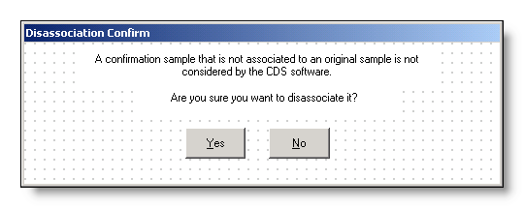
Exhibit 5-14. Disassociation Confirm Advisory

- The association to the original sample will be removed when the YES button is selected.
- The association to the original sample will be retained when the NO button is selected.

- If the [Sample] Rejection Reason is changed from spaces to a value and the Sample already contained a Lead and/or Copper result that has a Data Quality of other than rejected, an advisory will be presented notifying that the data quality for the Lead or Copper Result, whichever applies, will be set to “R-Rejected” and the Data Quality Reason will be set to “Other.”

If a different monitoring period is chosen for the lead result:

- The SAR will be directly associated to the selected monitoring period.
- For each SSMPA associated to the Sample Analytical Result (via the SSMPA_SAR_ASSOCIATION (TMNSPSRA)):
- update the d_last_updt_ts to current timestamp
- update the d_userid_code to CDSSETUP
- delete the SSMPA_SAR_ASSOCIATION (TMNSPSRA) record.
- For each sub-SSMPA associated to the SAMPLE ANALYTICAL RESULT (via the SPUBA_SAR_ASSOCIATION (TMNSBSRA)):
- update the d_last_updt_ts to current timestamp
- update the d_userid_code to CDSSETUP
- delete the SPUBA_SAR_ASSOCIATION (TMNSBSRA)
- If the sample is a “for compliance” sample, the software will display the following advisory: CDS Setup will use the selected Monitoring Period rather than the sample date to determine the schedule and monitoring period satisfied by this result (Exhibit 5-21).

If a different monitoring period is chosen for the copper result:

- the SAR will be directly associated to the selected monitoring period.
- For each SSMPA associated to the Sample Analytical Result (via the SSMPA_SAR_ASSOCIATION (TMNSPSRA)):
- update the d_last_updt_ts to current timestamp
- update the d_userid_code to CDSSETUP
- delete the SSMPA_SAR_ASSOCIATION (TMNSPSRA) record.
- For each sub-SSMPA associated to the SAMPLE ANALYTICAL RESULT (via the SPUBA_SAR_ASSOCIATION (TMNSBSRA)):
- update the d_last_updt_ts to current timestamp
- update the d_userid_code to CDSSETUP
- delete the SPUBA_SAR_ASSOCIATION (TMNSBSRA)
- if the sample is a “for compliance” sample, the software will display the following advisory: CDS Setup will use the selected Monitoring Period rather than the sample date to determine the schedule and monitoring period satisfied by this result (Exhibit 5-21).

When either the Lead Sample or the Copper Sample is updated, if the Sample has a Field Result associated, the Field Result (TSAMCSMP) should have its d_cds_trigger_ts updated to the current timestamp. (B.5.4.1.a)

Cancel Will present the standard cancel confirmation page.

Help Will invoke the online Help facility.

LCR Sample Summary Maintenance
Exhibit 5-15 depicts the LCR Sample Summary Maintenance page.

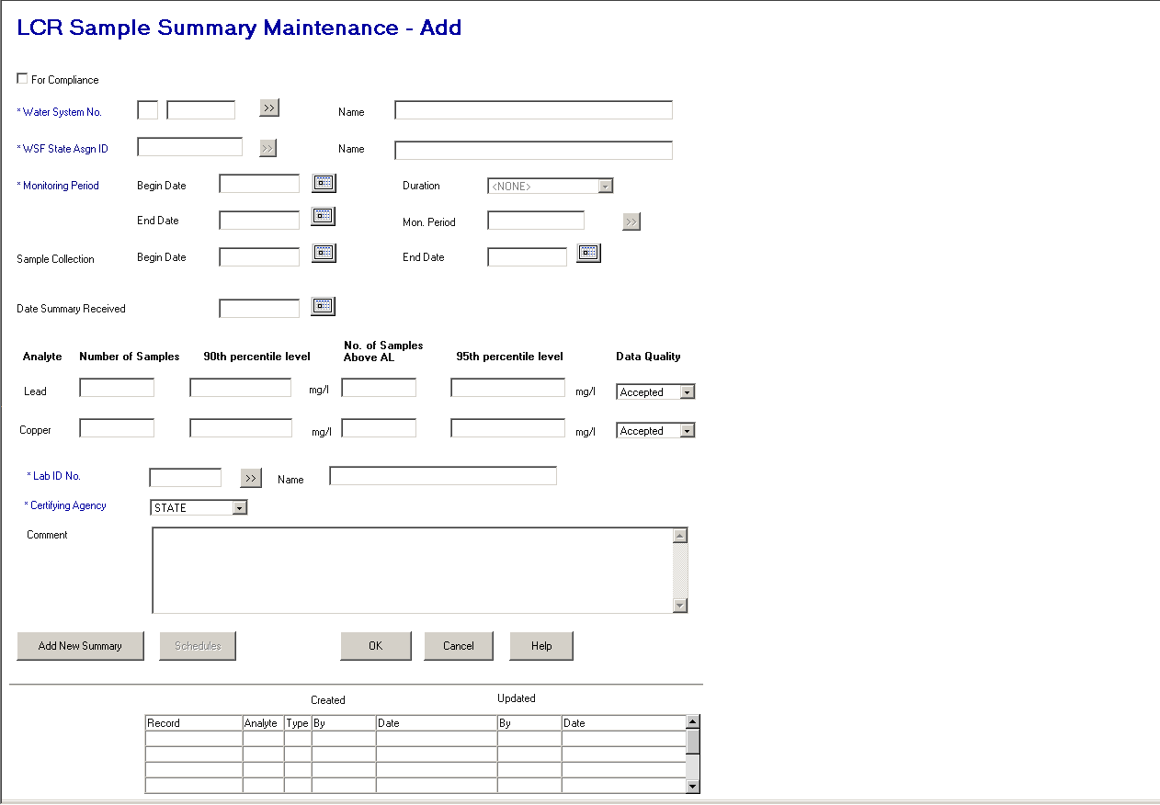

Exhibit 5-15. LCR Sample Summary Maintenance

Protected Fields:

[Audit Information] A table of User ID and timestamps for the sample summary created for each analyte. It will contain the table name (record), analyte, type, and the timestamp and User ID of when the record was created and last updated.

Entry Fields:

Note that the tab order is left to right, top to bottom, and includes all Entry Fields and buttons unless otherwise noted.

For Compliance This check box defaults to checked and indicates that the sample summary is used for compliance determination.

Water System No. The specific Water System No. consisting of the two-character state code plus the seven-character number field.

The state code portion will default to the state_identification_code in the SYSTEM_VARIABLE entity view.

This is a required field. If left blank, the error message will be: Water System No. must not be blank.

If a valid water system is entered but is not part of the user’s current Water System Group or Regulating Agency, invoke exit state error message: WS is not part of current group/agency. Change group/agency to access this WS.

When a valid water system is found, the system will look for a water system facility of type distribution system (DS). If one and only one is found, it will be populated in the WSF State Asgn ID and WSF Name fields. If no distribution WSF is found, the fields will be blank. If more than one is found, the error message will be: Multiple Distribution Systems exist for this Water System. Choose DS WSF.

[Water System] Name Standard 40-character Public Water System Name may be entered completely, partially, or left blank. If the user specifies a partial string in this field, display the closest matching water system at the top of the list. (Closest matching means a match with the Water System Name, sorted alphabetically, that starts with the same text string as supplied.)

If a valid water system name is entered, the Water System No. is populated. When a valid water system is found, the system will look for a water system facility of type distribution system (DS). If one and only one is found, it will be populated in the WSF State Asgn ID and WSF Name fields. If no distribution WSF is found, the fields will be blank. If more than one is found, the error message will be: Multiple Distribution Systems exist for this Water System. Choose DS WSF.

If a valid water system is entered but is not part of the user’s current Water System Group or Regulating Agency, invoke exit state error message: WS is not part of current group/agency. Change group/agency to access this WS.

If the name entered is not found, the software will flow to the Water System Maintenance List. The user may then select a value and continue.

WSF State Asgn ID The state assigned identifier of the water system facility for which the samples were collected. This field will not be available for input until a valid Water System No. has been provided.

When tabbing off or clicking outside the field, the input value will be edited. If a match is found for the provided water system, the name will be displayed in the water system facility name field. If an exact match is not found, the water system facility maintenance list will be presented.

This is a required field. If left blank, the error message will be: Water system facility must not be blank.

If this field is modified, the values should be removed from the [WSF] Name.

[WSF] Name The name of the water system facility. The name will be populated when a valid water system facility is either input in the WSF State Asgn ID or chosen from the selection list.

This field will not be available for input until a valid Water System No. has been provided.

A name may be input into this field. When tabbing off the field, if the name is not found as a valid water system facility for the provided water system, the water system facility maintenance list will be presented.

This is a required field.

If this field is modified, the values should be removed from the WSF State Asgn ID.

Monitoring Period The four Monitoring Period fields will be enabled only after the user values Water System No. The user may enter a valid monitoring period or press the Monitoring Period Go To button.

Monitoring Period is a required field.

[Monitoring Period]
Begin Date Must not be a future date. The error message will be: Date must not be a future date. If Begin Date and either End Date or Duration are valued, on tabbing off or clicking outside of the field, the software will retrieve the monitoring period that matches the criteria and display it in all monitoring period fields. If no monitoring period exists that matches the criteria, it will invoke the Monitoring Period Maintenance List. The software will take no action if only Begin Date is valued.

[Monitoring Period]
Duration The user may enter a valid monitoring period Duration. If Duration and either Begin Date or End Date are valued, on tabbing off or clicking outside of the field, the software will retrieve the monitoring period that matches the criteria and display it in all monitoring period fields. If no monitoring period exists that matches the criteria, the software will invoke the Monitoring Period Maintenance List. The software will take no action if only Duration is valued. New permitted values of 2W- Every 2 Weeks and 2M – Every 2 Months will be included in the dropdown list. (R03017,R2013:A.5.4.2.a)

[Monitoring Period]
End Date May be a future date. If End Date and either Begin Date or Duration are valued, on tabbing off or clicking outside of the field, the software will retrieve the monitoring period that matches the criteria and display it in all monitoring period fields. If no monitoring period exists that matches the criteria, it will invoke the Monitoring Period Maintenance List. The software will take no action if only End Date is valued.

Mon. Period [Name]
If the user enters a valid monitoring period name, on tabbing off or clicking outside of the field, the software will retrieve the monitoring period that matches the criteria and display it in all monitoring period fields. If the user enters a partial string or an invalid monitoring period name, the Monitoring Period Maintenance List will be invoked.

In Add mode, once a Water System, Water System Facility and Monitoring Period have been entered; the software will look for any existing Sample Summaries that match on these three pieces of information. If found, the software will display all the data associated to matching records on the page, and move from Add to Change mode.

If no match is found, the software will allow the user to continue entering data for the new summary.

[Sample Collection]
Begin Date The begin date of the period in which the samples were taken.

This is an optional field. Must not be a future date. The error message will be: Date must not be a future date.

[Sample Collection]
End Date The end date of the period in which the samples were taken. Providing a value in this field requires that a value be provided in the sample collection begin date. If the begin date is blank, the error message will be: Cannot enter an End Date without a Begin date.

The end date cannot be prior to the begin date and must not be a future date. If it is, the error message will be: Start Date must equal or precede the End Date or Date must not be a future date.

This is an optional field.

Date Summary
Received The date the summary was received.

This is an optional field. Must not be a future date. The error message will be: Date must not be a future date.

Lead Summary Fields

For the same water system and monitoring period, all lead and copper summary data will be maintained together, even if it is not all entered at the same time. For example, a user might initially enter the number of lead and copper samples and the 90th percentiles for those samples and then, later enter the 95th percentile lead result, and still later the number of lead results above the action level. If, when entering a 95th percentile at a later date, the user forgets that he/she had entered the number of lead and copper samples and the 90th percentiles and so uses the Add flow, the software will recognize that two matching summaries already exist.

If a user enters all four pieces of summary information for lead, the software will create one sample summary and three summary result records.

Lead
Number of Samples The number of lead samples included in the summary result.

This is an optional field, but one of either Lead or Copper Number of Samples must be provided. If both are blank, the error message will be: Must specify the number of samples for Lead, Copper, or both.

Lead
90th percentile Level The concentration value of lead in the tap water exceeded by 10 percent of the sites sampled in the summary. The value is measured in mg/l and must be a valid number. If it is not a valid number, the error message will be: Reported Measure may only be a valid number. If the number is greater than 999,999, the error message will be: Value too Large. SDWIS can support up to 6 digits to the left of the decimal.

This is an optional field, but if the Lead 90th percentile Level is not spaces, the Lead Number of Samples must be provided. If Lead Number of Samples is zero the error message will be: Must specify the Number of Samples for Lead. (B.5.4.2.a)

Lead
No. of Samples
Above A.L. The number of lead samples above the action level. . The value must be a valid integer. If it is not a valid integer, the error message will be: Count may only be a valid integer. If the integer is greater than 9,999,999,999, the error message will be: Value too Large. SDWIS can support up to 10 digits to the left of the decimal. (B.5.4.2.e)

This is an optional field.

Lead
95th percentile Level The concentration value of lead in the tap water exceeded by 5 percent of the sites sampled in the summary. The value is measured in mg/l and must be a valid number. If it is not, a valid number the error message will be: Reported Measure may only be a valid number. If the number is greater than 999,999, the error message will be: Value too Large. SDWIS can support up to 6 digits to the left of the decimal.

This is an optional field, but if the Lead 95th percentile Level is not spaces, the Lead Number of Samples must be provided. If Lead Number of Samples is zero the error message will be: Must specify the Number of Samples for Lead. (B.5.4.2.b)

Lead
Data Quality The quality of the sample water analyzed. Permitted values are:

A - Accepted (the default)
P - Preliminary
R - Rejected
V - Validated

Copper Summary Fields

For the same water system and monitoring period, all lead and copper summary data will be maintained together even if it is not all entered at the same time. For example, a user might initially enter the number of lead and copper samples and the 90th percentiles for both, then later enter the 95 th percentile copper result, and still later the number of copper results above the action level. If, when entering a 95th percentile at a later date, the user forgets that he/she had entered the number of lead and copper samples and the 90th percentiles and uses the Add flow, the software will recognize that two matching summaries already exist.

If a user enters all four pieces of summary information for copper, the software will create one sample summary and three summary result records.

Copper
Number of Samples The number of copper samples included in the summary result.

This is an optional field, but one of either Lead or Copper Number of Samples must be provided. If both are blank, the error message will be: Must specify the number of samples for Lead, Copper, or both.
Copper
90th percentile Level The concentration value of copper in the tap water exceeded by 10 percent of the sites sampled in the summary. The value is measured in mg/l and must be a valid number. If it is not a valid number, the error message will be: Reported Measure may only be a valid number. If the number is greater than 999,999, the error message will be: Value too Large. SDWIS can support up to 6 digits to the left of the decimal.

This is an optional field, but if the Copper 90th percentile Level is not spaces, the Copper Number of Samples must be provided. If Copper Number of Samples is zero the error message will be: Must specify the Number of Samples for Copper. (B.5.4.2.c)

Copper
No. of Samples
Above A.L. The number of copper samples above the action level.

The value must be a valid integer. If it is not a valid integer, the error message will be: Count may only be a valid integer. If the integer is greater than 9,999,999,999, the error message will be: Value too Large. SDWIS can support up to 10 digits to the left of the decimal. (B.5.4.2.f)

This is an optional field.

Copper
95th percentile Level The concentration value of copper in the tap water exceeded by 5 percent of the sites sampled in the summary. The value is measured in mg/l and must be a valid number. If it is not a valid number, the error message will be: Reported Measure may only be a valid number. If the number is greater than 999,999, the error message will be: Value too Large. SDWIS can support up to 6 digits to the left of the decimal.

This is an optional field, but if the Copper 95th percentile Level is not spaces, the Copper Number of Samples must be provided. If Copper Number of Samples is zero the error message will be: Must specify the Number of Samples for Copper. (B.5.4.2.d)

Copper
Data Quality The quality of the sample water analyzed. Permitted values are:

A - Accepted (the default)
P - Preliminary
R - Rejected
V - Validated

Lab ID No. The identification number assigned by the to the laboratory, which performed the analysis. When a value is supplied that is not found, the lab maintenance list page will be presented. A valid value in this field will also populate the Laboratory Name.

This is a required field. R0059:A.5.4.2.b)

Certifying Agency Select a value from the dropdown list. The value will be matched against the laboratory’s Certifying Agency. The selections available via the dropdown list will be retrieved from the TINPVALS table where code_name = “CERT_AG.”

If an exact match is found using the Lab ID No. and Certifying Agency, the laboratory name will be displayed.

If none is found, the Laboratory Maintenance List will be presented in single-select mode.

Certifying Agency will be a required field. It will default to STATE. (R0059:A.5.4.2.c)

(R0059:A.5.4.2.d)

[Laboratory] Name The name of the laboratory. This field will be automatically populated when a valid value is either input or selected in Lab State ID No. and Certifying Agency.

When a value is supplied that is not found the lab maintenance list page will be presented. The selection will also populate the Lab ID No. and Certifying Agency. (R0059:A.5.4.2.e)

This is an optional field.

Comment A free-form comment area where descriptive text about the sample summary can be recorded.

This is an optional field.

Buttons:

[water system]
Go To Will present the Water System Maintenance List where the Edit/Select will be available.

When a valid water system is found the system will look for a water system facility of type distribution system (DS). If one and only one is found, it will be populated in the WSF State Asgn ID and WSF Name fields. If no distribution WSF is found, the fields will be blank. If more than one is found, the error message will be: Multiple Distribution Systems exist for this Water System. Choose DS WSF.

[monitoring period]
Go To Will present the Monitoring Period Maintenance List where the Edit/Select will be available. Enabled when a water system has been selected.

[laboratory]
Go To Will present the Laboratory Maintenance List. Only the ‘select’ menu will be enabled. Add/change will not be allowed for security reasons.

[water system facility]
Go To Will present the Water System Facility Maintenance List where the Edit/Select will be available. Enabled when a water system has been selected.

Add New
Summary The summary will be processed as described with the OK button below. When successful, the Summary Maintenance Page will be presented. The monitoring period and laboratory of the current record will be carried forward.

This button will be available in both add and change mode.

Schedules Will present the Non-TCR Sample Schedule Maintenance List containing Lead and Copper 90th percentile schedules for selected water system and facility.

Usually the schedules for lead (1030) and copper (1022) tap samples will be group schedules (i.e., schedules that reference an analyte group). The software will look for appropriate schedules (i.e., schedules that reference violation types 51 and 52 and reference either lead or copper) through the underlying hidden schedules but will display the group schedule. The default list of schedules will only display current and future lead and copper tap schedules but the user will be able to see all the lead and copper tap schedules by selecting View/Show All on the Non-TCR Sample Schedule Maintenance List.

OK
Duplicate Check Duplicate criteria for the sample summary is defined as an existing summary for the same water system, water system facility, analyte, and monitoring period. If an existing sample summary is found, the error message will be: A Sample Summary for the same Water System, Water System Facility, Analyte, and Monitoring Period already exists. You may either edit the existing sample summary or delete it and add a new sample summary.

Add Mode When Lead values are provided, the following actions are taken:
- A Sample Summary is created and associated to the water system, Pb90 analyte, water system facility, and monitoring period.
- If a laboratory was provided the sample summary is associated to the laboratory.
- If a 90th percentile level is provided (field not blank), a Sample Summary Result of type_code ‘90’ is created with the Number of Samples field populated in the count_qty field, the 90th percentile level populated in the measure field, “MG/L” is populated as the unit of measure, and the summary result is associated to the Sample Summary.
- If the no. of samples above AL is provided (field not blank), a Sample Summary Result of type ‘AL’ is created and associated to the Sample Summary. The No. of Samples Above AL field is populated in the count_qty field and measure is 0.
- If the 95th percentile is provided (field not blank), a Sample Summary Result of type ‘95’ is created with the Number of Samples field populated in the count_qty field, the 95th percentile level populated in the measure field, “MG/L” is populated as the unit of measure, and the summary result is associated to the Sample Summary.

If the Lead number of Samples Above AL is provided, and a 90th percentile level is not provided, and does not already exist, give an advisory asking: “Do you want to add the record or proceed adding a 90th percentile?.” If the user decides to proceed, the following actions are taken:
- A Sample Summary is created and associated to the water system, Pb90 analyte, water system facility, and monitoring period.
- If a laboratory was provided, the sample summary is associated to the laboratory.
- A Sample Summary Result of type ‘AL’ is created and associated to the Sample Summary. The No. of Samples Above AL field is populated in the count_qty field and measure is 0.
- If the 95th percentile is also provided, a Sample Summary Result of type ‘95’ is created and associated to the Sample Summary. The Number of Samples field is populated in the count_qty field, the 95th percentile level is populated in the measure field and “MG/L” is populated as the unit of measure.

If the Lead 95th percentile is provided and a 90th percentile lead level is not provided and does not already exist, give an advisory asking: “Do you want to add the record without adding a 90th percentile?” If the user decides to proceed, the following actions are taken:
- A Sample Summary is created and associated to the water system, Pb90 analyte, water system facility, and monitoring period.
- If a laboratory was provided, the sample summary is associated to the laboratory.
- A Sample Summary Result of type ‘95’ is created and associated to the Sample Summary. The Number of Samples field is populated in the count_qty field, the 95th percentile level is populated in the measure field and “MG/L” is populated in the unit of measure.

When Copper values are provided, the following actions are taken:
- A Sample Summary is created and associated to the water system, Cu90 analyte, water system facility, and monitoring period.
- If a laboratory was provided, the sample summary is associated to the laboratory.
- If a 90th percentile level is provided (field not blank), a Sample Summary Result of type_code ‘90’ is created with the Number of Samples field populated in the count_qty field, the 90th percentile level populated in the measure field, “MG/L” is populated in the unit of measure and the summary result is associated to the Sample Summary.
- If the No. of Samples above AL is provided (field is not blank), a Sample Summary Result of type ‘AL’ is created and associated to the Sample Summary. The No. of Samples Above AL field is populated in the count_qty field and measure is 0.
- If the 95th percentile is also provided (field not blank), a Sample Summary Result of type ‘95’ is created and associated to the Sample Summary. The Number of Samples field is populated in the count_qty field, the 95th percentile level is populated in the measure field and “MG/L” is populated in the unit of measure.

If the Copper number of Samples Above AL is provided and 90th percentile level is not provided and does not already exist, give an advisory asking: “Do you want to add the record without adding a 90th percentile?” If the user decides to proceed, the following actions are taken:
- A Sample Summary is created and associated to the water system, Cu90 analyte, water system facility, and monitoring period.
- If a laboratory was provided, the sample summary is associated to the laboratory.
- A Sample Summary Result of type ‘AL’ is created and associated to the Sample Summary. The No. of Samples Above AL is populated in the count_qty field and the measure is 0.
- If the 95th percentile is also provided, a Sample Summary Result of type ‘95’ is created and associated to the Sample Summary. The Number of Samples field is populated in the count_qty field, the 95th percentile level is populated in the measure field, and “MG/L” is populated in the unit of measure.

If the Copper 95th percentile is provided and a 90th percentile level is not provided and does not already exist, give an advisory asking: “Do you want to add the record or proceed without adding a 90th percentile?” If the user decides to proceed, the following actions are taken:
- A Sample Summary is created and associated to the water system, Cu90 analyte, water system facility, and monitoring period.
- If a laboratory was provided, the sample summary is associated to the laboratory.
- A Sample Summary Result of type ‘95’ is created and associated to the Sample Summary. The Number of Samples field is populated in the count_qty field, the 95th percentile level is populated in the measure field, and “MG/L” is populated in the unit of measure.

Change Mode In change mode, the following information can be changed:
- Sample Summary comment, compliance purpose, sampling begin and end date, summary received date.
- Association to a different monitoring period.
- Association to a different laboratory or removal of the laboratory association.
- Sample Summary Result number of samples, 90th percentile level, no. of samples above AL, 95th percentile level, or data quality code. Rules of adding additional sample summary results are documented in the add-mode processing. If the Number of Samples value is added or changed, it must effect the county_qty values of both the 90th percentile (type code = ‘90’) and 95th percentile (type_code = ‘95’) sample summary result records for the appropriate analyte’s sample summary.

Cancel If no data has been input or changed, the page will close and return to the previous page. If data has been input or changed, the standard Cancel Confirmation page will be presented.

Help Will invoke the system online Help facility.

General Sample Maintenance Pages

General Sample Maintenance
Exhibit 5-16 depicts the General Sample Maintenance page.

Protected Fields:

[Water System Facility]
Name The name of the supplied water system facility.

Record updated
by XXXXXXXX on
MM/DD/YYYY
HH:MI:SS The User ID and the timestamp from the last time the sample record (TSASAMPL) was updated.

Record created
by XXXXXXXX on
MM/DD/YYYY
HH:MI:SS The initial User ID and timestamp when the sample (TSASAMPL) record was initially added to the database.

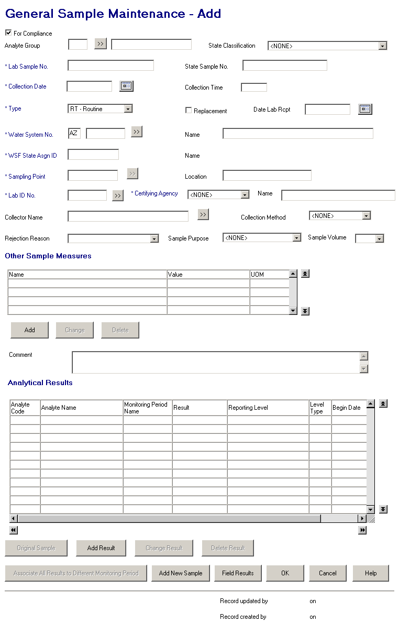

Exhibit 5-16. General Sample Maintenance

Entry Fields: In tab sequence.

For Compliance This check box marks the sample as being used for compliance determination. When it is checked, the sample will be used for compliance. The default is checked. Compliance samples have different rules than noncompliance samples. These are indicated below.

Analyte Group [Code] The four-digit code of the analyte group selected by the user when adding a new sample. Selecting an analyte group in Add mode will determine the analytes presented for entry of results and the order in which they are presented. This attribute is only displayed when adding a new sample and only if an analyte group was selected. It is not stored with the sample data. If a valid analyte group code is entered, the software will aslo value analyte group name.

This is an optional field. This field is protected in the Change Mode.

[Analyte Group Name] The name of the analyte group selected by the user when initiating the addition of a sample. If a valid analyte name is entered, the software will also value analyte group code.

This is an optional field. This field is protected in the Change Mode.

State Classification [Code] This field will allow user to assign the sample to a pre-defined sample group. The permitted values for the dropdown list will be retrieved from the CODE table, code_name of ‘SMPSTCLASS’.

If left blank, will default to the state classification code of the analyte of the first sample analytical result added.

This is an optional field. (Increase size. (R0036:A.5.5.1.a))

Lab Sample No. The sample identification number assigned by the laboratory for tracking the sample within the lab.

This is a required field. If the Lab Sample No. is not supplied for a noncompliance sample, the error message is All samples must have a Lab Sample No.

State Sample No. The sample identification number assigned by a state to uniquely identify a specific sample within the state.

This is an optional field.

Collection Date The date the sample was collected. A calendar function is available to aid input.

This is a required field. Must not be a future date. The error message will be: Date must not be a future date.

Collection Time The time the sample was collected (in local time).

This is an optional field. If it is provided, the cannot be greater than or equal to 2400. If so, the error message will be: Time Entries must be between 00:01 and 23:59.

[Sample] Type The reason for the sample collection. Valid selections are:

RT – Routine
RP – Repeat
CO – Confirmation
SP – Special
BB – Batch Blanks
FB – Field Blanks
PE – Performance Evaluation
SB – Shipping Blanks
ST – Split Blanks
MR – Maximum Residence Time
MS – Matrix Spike

This is a required field. If the sample type is entered or changed to any value other than Routine (RT), Repeat (RP), or Confirmation (CO), the software will uncheck the For Compliance checkbox. A user may recheck it (even if the Sample Type is not equal to RT, RP, or CO) but the sample will not be considered or processed by SDWIS compliance determination.

If the sample type is RP (Repeat) or CO (Confirmation), the Original Sample button will be enabled and the Original Sample Information page will be presented for capture of the original sample when the sampling point is supplied.

Replacement The Replacement box is used to indicate whether the sample is taken as a replacement for another sample. Replacement samples either replace lost or damaged samples that the lab could not analyze or they replace invalid samples that the lab refused to analyze due to technical reasons. When the user check this box and tabs off, the Original Sample button will be enabled and Original Sample Information page will be presented for capture of the original sample which is being replaced when the sampling point is supplied.

Date Lab Rcpt The date the sample was received by the lab. A calendar function is available to aid input.

This is an optional field and must not be a future date. The error message will be: Date must not be a future date. When it is provided, it must be greater than or equal to the collection date or error message The date of Lab Receipt cannot be prior to the date of Sample Collection. will be given.

This is an optional field.

Water System No. The specific Water System No., which consists of the two-character state code plus the seven-character number field.

The state code portion will default to the state_identification_code in the SYSTEM_VARIABLE entity view.

When tabbing off or clicking outside this field after supplying a value, the water system will be retrieved and the name displayed and the WSF State Asgn ID field, sampling point and sampling point location and sampling point Go To button will be enabled. Any value in the WSF ID, WSF Name, Sampling Point and Sample Location fields will be removed.

If a valid water system is entered but is not part of the user’s current Water System Group or Regulating Agency, invoke exit state error message: WS is not part of current group/agency. Change group/agency to access this WS.

If the supplied value is invalid, the Water System Maintenance List will be presented listing only Water Systems in the current WS group or regulating agency.

This is a required field. If it is left blank, the error message will be: Water System No. must not be blank.

[Water System] Name The name of the water system of the sample location.

Standard 40-character Public Water System Name may be entered completely, partially, or left blank. If the user specifies a partial string in this field, display the closest matching water system at the top of the list. (Closest matching means a match with the Water System Name, sorted alphabetically, that starts with the same text string as supplied.)

If a valid water system name is entered, the Water System No. is populated, and the WSF State Asgn ID, sampling point and sampling point location fields and sampling point Go To button are enabled. Any value in the WSF State Asgn ID and Name, Sampling Point and Sample Location fields will be removed.

If a valid water system is entered but is not part of the user’s current Water System Group or Regulating Agency, invoke exit state error message: WS is not part of current group/agency. Change group/agency to access this WS.

If the name entered is not found, the software will flow to the Water System Maintenance List. The user may then select a value and continue.

WSF State Asgn ID The Water System Facility State Assign ID of the sample location.

When tabbing off or clicking outside this field after supplying a value, the value will be retrieved and the name displayed

If the supplied value is invalid, the error message will be: The WSF State Asgn ID entered does not belong to this water system.

This is an optional entry field. It will be valued with the WSF of the selected sampling point.

If the value of this field is modified the values in [WSF] Name, Sampling Point, and Location will be cleared.

This field will remain protected until a valid Water System has been supplied.

Sampling Point The ID of the sampling point where the sample was taken.

When tabbing off or clicking outside this field after supplying a value, the software will function the same as described for this field on the Coliform Sample Maintenance page with the following exception: if the sample type is a repeat or confirmation; or is a routine with the replacement indicator checked and the collection date is provided, the Original Sample Information will be presented.

This field will remain protected until a valid Water System has been supplied.

[Sampling Point]
Location The name of the sampling point.

When tabbing off this field after supplying a value, the software will function the same as described for this field on the Coliform Sample Mainteannce page with the following exception: if the sample type is a repeat or confirmation; or is a routine with the replacement indicator checked and the collection date is provided, the Original Sample Information will be presented.

This field will remain protected until a valid Water System has been supplied.

Lab ID No. The identification number assigned by the to the laboratory, which performed the analysis. This field will be automatically populated when a valid value is either input or selected in Laboratory Name.

When a value is supplied that is not found, the lab maintenance list page will be presented. A valid value in this field will also populate the Laboratory Name. (R0059:5.5.1.b)

This is a required field. If left blank, the error message will be: Laboratory may not be left blank.

Certifying Agency Select a value from the dropdown list. The value will be matched against the laboratory’s Certifying Agency. The selections available via the dropdown list will be retrieved from the TINPVALS table where code_name = “CERT_AG.”

If an exact match is found using the Lab ID No. and Certifying Agency, the laboratory name will be displayed.

If none is found, the Laboratory Maintenance List will be presented in single-select mode.

Certifying Agency will be a required field. It will default to STATE. (R0059:A.5.5.1.c)

(R0059:A.5.5.1.d)

[Laboratory] Name The name of the laboratory. This field will be automatically populated when a valid value is either input or selected in Lab ID No. and Certifying Agency.

When a value is supplied that is not found, the lab maintenance list page will be presented. The selection will also populate the Lab ID No. and Certifying Agency . (A0059:A.5.5.1.e)

Collector Name The name of the individual who collected the sample.

If the entered individual does not exist as a valid legal entity with collector_indicator_code = ‘Y,’ then set TSASAMPL informal_collector equal to entered individual.

This is an optional field.

Collection Method The standard method used to collect the sample. When a value is supplied, it must be pre-defined in the standard methods table. If the value supplied is not found, a selection list of standard methods will be presented.

Rejection Reason The reason a lab rejected a sample for further analysis. Permitted values will be available in a dropdown list.

BR - Broken
CL - Chlorine present
EH - Exceeds holding time
HS - Excessive headspace
FZ - Frozen sample
IN - Insufficient information
VO - Insufficient volume
BP - Invalid sampling point
IP - Invalid sampling protocol
LA - Lab accident
LT - Leaked in transit

This is an optional field. When this field is valued in the Add mode, the Add Results button will be disabled.

Sample Purpose This will allow the state to document why sample was taken. The values entered by the System Administrator will be available in a “permitted values” dropdown list. The values will be retrieved from the CODE table, code_name of ‘SMPLPURPOS’.

This is an optional field.

Sample Volume The volume of sample collected and submitted to the laboratory. Permitted values are:

1 liter
100 ml
300 ml
400 ml
500 ml
[Spaces] (default)

This is an optional field.

Other Sample Measure(s) List Box

The “Other Sample Measure(s)” list box will allow a user to record additional measures associated with a sample. This capability will be added specifically to enable users to record additional sample measures related to cryptosporidium sampling proposed in the Long-Term 2 Enhanced Surface Water Treatment Rule (e.g., number of filters used, the packed pellet volume, sample volume spiked, estimated number of oocysts spiked).

List Fields:

Display four rows, allow up to 100 rows, default sort by Name ascending.

Name The name of the other measure type as recorded in table Other Sample Measures (TSAOSM), field Name.

Value The numeric or text value of the other sample measure. Only one will contain a value.

UOM The unit of measure abbreviation for the other sample measure value.

Comment A free-form comment area where descriptive text about the sample can be recorded.

This is an optional field.

Analytical Results List Box

In change mode, this list will show all analytical results associated to the sample sorted by analyte code ascending. Display up to 10 rows, allow up to 200 rows.

List Fields:

Analyte Code The four-digit code of an analyte.

Analyte Name The name of the analyte for which the sample was tested.

Monitoring Period Name The name of the monitoring period for the result. If the result is associated to multiple monitoring periods (via multiple SSMPA rows), this field will show the word “Multiple”.

Result For a Microbiological analyte, the software will display whether the analyte was present or absent plus the count of organisms (all three fields).

For a Radiological analyte, if the result is less than detect, the software will display the less-than sign (<) plus the detection limit value and unit of measure. If it is not less-than detect, the software will display the result concentration value and unit of measure plus the counting error.

For all other analytes, if the result is less than detect, the software will display the less-than sign (<) plus the detection limit value and unit of measure. If it is not less-than detect, the software will display the result concentration value and unit of measure.

Level Type The level type that the detection was measured against. Values are MDL (Regulatory Minimum Reporting Level) or MRL (Lab Reporting Level).

Reporting Level When MDL this value is the reporting level set by the regulation. When it is MRL, it is the value set by the laboratory, which must be less than the regulatory level.

[Monitoring Period]
Begin Date The begin date of the monitoring period for which this sample result applies. If the Monitoring Period Name shows the word ‘Multiple’ the begin date will be populated with the begin date of earliest monitoring period associated to the result via any SSMPA rows.

[Monitoring Period]
End Date The end date of the monitoring period for which this sample result applies. If the Monitoring Period Name shows the word ‘Multiple’ the end date will be populated with the end date of earliest monitoring period associated to the result via any SSMPA rows.

Data Quality The data quality of this result; preliminary, accepted, validated or rejected.

Method Code The code associated to the method used by the laboratory during the analysis.

Analysis Date The date the sample was analyzed for this result.

Buttons:

[analyte group]
Go To Will present the Analyte Group Maintenance List. Only the ‘select’ menu will be enabled. Add/change will not be allowed for security reasons.

[water system]
Go To Will present the Water System Maintenance List with water system from the current WS group or regulating agency. Only the ‘select’ menu will be enabled. Add/change will not be allowed for security reasons.

[sampling point]
Go To Will present the Sampling Point Maintenance List. Only the ‘select’ menu will be enabled. Add/change will not be allowed for security reasons.

[laboratory]
Go To Will present the Laboratory Maintenance List. Only the ‘select’ menu will be enabled. Add/change will not be allowed for security reasons.

[collector]
Go To Will present the Legal Entity Maintenance List displaying only INDIVIDUALs designated as collectors. Only the ‘select’ menu will be enabled. Add/change will not be allowed for security reasons.

[collection method]
Go To Will present the Collection Method Maintenance List. Only the ‘select’ menu will be enabled. Add/change will not be allowed for security reasons.

[Other Sample Measure(s)]
Add Will perform all edits as if OK button were pressed. After successfully adding or modifying the sample, the software will present the Other Sample Measure maintenance page in add mode.

[Other Sample Measure(s)]
Change Will perform all edits as if OK button were pressed. After successfully modifying the sample, will present the Other Sample Measure maintenance page in change mode. This item is only available if a row has been selected in the list area.

[Other Sample Measure(s)]
Delete Will perform all edits as if OK button were pressed. After successfully modifying the sample, the software will delete the Other Sample Measure record. This item is only available if a row has been selected in the list area. No delete confirmation message is presented.

Original Sample Will present the Original Sample Information. This button is enabled when the sample is a confirmation, repeat or a routine with the replacement indicator checked and the collection date and sampling point have been supplied. Reference page documentation above for more details on the Original Sample Information page.

Add Result Will perform all edits as if OK button were pressed. After successfully adding or modifying the sample, the software will present the Analytical Result Maintenance page. If an Analyte Group was selected and no results exist, pressing this button will present the Analytical Result maintenance page that corresponds to the analyte type (as specified below) of the first analyte in the group. Otherwise, the user will be prompted to enter an analyte on the Analyte Entry page. Based on the Type Code of the analyte, the software will flow to the appropriate result maintenance page.

Analyte Entry

Exhibit 5-17 depicts the Analyte Entry advisory.

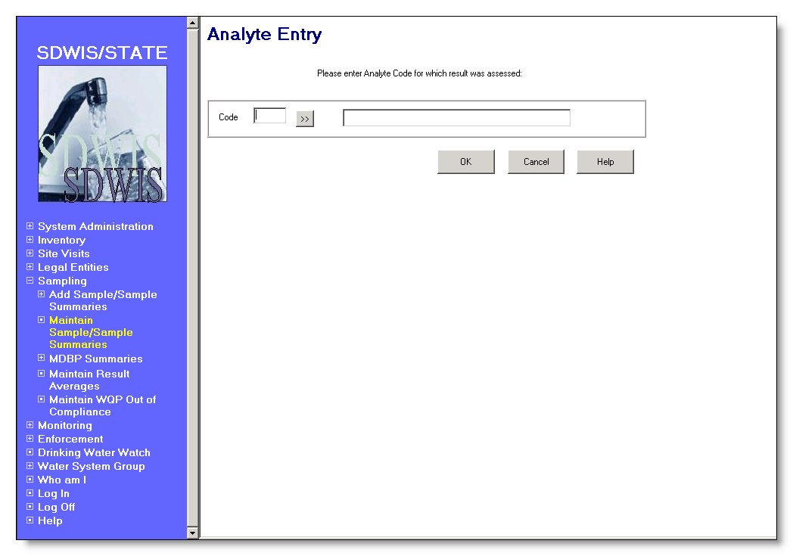

Exhibit 5-17. Analyte Entry Advisory

Entry field:

Analyte Code The four-digit analyte code for which a result will be entered for this sample.

This is a required field. When a valid value is entered, the name will be presented. If an invalid value is entered, the Analyte Selection List will be presented.

[Analyte] Name The name of the analyte.

Buttons:

[analyte]
Go To Will present the Analyte Selection List

OK Using the Type Code of the selected analyte, the software will flow to the appropriate Result Maintenance page as specified below.

Analyte Type Code | Result Maintenance Page
IOC, OC, WQ, OT | General Result
RA | Radiological
MOR | Microbiological

Cancel Will close the page and return to the General Sample maintenance page.

Help Will invoke the system online Help facility.

Change Result Will perform all edits as if OK button were pressed. After successfully modifying the sample, will present the Analytical Result maintenance page in change mode. This item is only available if a result has been selected in the list area.

Delete Result Will perform all edits as if OK button were pressed and successfully modifying the sample.

If the result has an association to a violation, the delete request will be denied. The error message will be: May not delete this Result because it is associated to a Violation.

Before deleting a result, if the result was created by CDSSETUP (d_userid = CDSSETUP), the software will present the advisory CDS Setup automatically created this result and will not recreate it if deleted. Do you wish to proceed? The advisory dialog box will have Yes and No buttons to allow the user to confirm or cancel the delete request. If Yes is chosen, the Delete Result confirmation dialog box will be presented. If No is chosen the page will return to the General Sample Maintenance page.

If no conflicts or advisory conditions exist, the Delete Result confirmation will be presented.

This item is only available if a result has been selected in the list area.

Exhibit 5-18 depicts the Delete Result confirmation dialog box.
Exhibit 5-18. Delete Result Dialog Box

Buttons:

OK If confirmed and the result is associated to one or more SSMPA, the software will update the timestamp for each associated SSMPA to the current date and time and set the d_userid to CDSSETUP. The software will next delete the associative record between the result and SSMPA (a new entity introduced in SSWr1) and finally will delete the result. The informational message Sample Analytical Result has been removed from the database will be presented and then the General Sample Maintenance page will be presented with the result removed from the list.

Cancel Will abort the delete and return to the General Sample Maintenance page.

Associate All
Results to Different
Monitoring Period Will present the Monitoring Period Maintenance List in single-select mode. Once a monitoring period is selected, the software will do the following for each result. These changes will not be undone if the Cancel button is subsequently selected.

Associate the result directly to the selected monitoring period.
- For each SSMPA associated to the Sample Analytical Result (via the SSMPA_SAR_ASSOCIATION (TMNSPSRA)):
- update the d_last_updt_ts to current timestamp
- update the d_userid_code to CDSSETUP
- delete the SSMPA_SAR_ASSOCIATION (TMNSPSRA) record.
- For each sub-SSMPA associated to the SAMPLE ANALYTICAL RESULT (via the SPUBA_SAR_ASSOCIATION (TMNSBSRA)):
- update the d_last_updt_ts to current timestamp
- update the d_userid_code to CDSSETUP
- delete the SPUBA_SAR_ASSOCIATION (TMNSBSRA)

If the SAR is not a TCR result (see specifications elsewhere) and the sample is a “for compliance” sample, the software will display the following advisory: CDS Setup will use the selected Monitoring Period rather than the sample date to determine the schedule and monitoring period satisfied by this result (Exhibit 5-21).

Add New Sample Will perform all edits as if OK button were pressed. After successfully adding the sample, the maintenance window will redisplay. The following fields will have their value retained:

- For Compliance
- Analyte Group
- State Classification
- Collection Date
- Sample Type
- Date Lab Received
- Water System No. and Name
- All WSF and Sampling Point fields
- All Lab fields
- Collector
- Collection Method
- Sample Purpose
- Sample Volume

This button will be available in both add and change mode.

Field Results Will perform all edits as if OK button were pressed. After successfully adding the sample and results, the software will flow to the Field Results page described below.

OK

Duplicate Check Two duplicate checks may be performed prior to adding or updating the sample as follows:

The first is an advisory check that will occur on all samples. If a sample collected on the same date at the same water system and sampling point already exists for the same laboratory, the software will provide this advisory: This is an advisory. A sample already exists that was analyzed by this lab for this water system and sampling point collected at the same date and time. If you still want to proceed to add/change the sample, press the Continue button. Otherwise, press the Cancel button to return to the Sample Maintenance Page. Pressing Continue resumes the flow as if no advisory occurred. Pressing Cancel returns the user to the current page.

The second duplicate check only occurs if a Lab Sample No. is supplied. If a sample is being added or modified and the Lab Sample No. is provided, the software will check to see if a sample with the same Lab Sample No., same collection year and analyzed by the same laboratory already exists. If so, the software will provide the error message: This is a duplicate sample and cannot be added.

Add-mode Will create a sample and associate it to the sampling point from which it was taken, the water system which provided it, and the laboratory that analyzed it. The sample d_initial_timestamp, d_last_update_timestamp, d_userid_code and d_initial_userid will be set to current values.

If a collector was specified it will also be associated to the individual legal entity that collected it, if the name supplied is a valid legal entity. If not a valid legal entity the name will be populated in the TSASAMPL informal_collector field.

If a standard method was supplied, it will also be associated to the standard method code.

If the sample is confirmation, repeat or routine with the replacement indicator checked and the original sample was specified, it will be associated to the original sample. If the sample is confirmation, the SSMPA of the original sample will have the timestamp set to current timestamp.

Change-mode Will update the sample:
When Collector Name is changed :
- From spaces to a value, if the value is a valid LEGAL_ENTITY associate the two. If not, populated the TSASAMPL informal_collector with the name.
- From one value to a different value, remove the old value from TSASAMPL informal_collector or disassociate from the existing LEGAL_ENTITY. If the new value is a valid LEGAL_ENTITY associate the two. If not, populated the TSASAMPL informal_collector with the name.
- From an existing value to spaces, remove the old value from TSASAMPL informal_collector or disassociate from the existing LEGAL_ENTITY

If the sample is confirmation, repeat or routine with the replacement indicator checked and the original sample was specified, it will be associated to the original sample. If the original sample selection is cleared, an advisory will be presented.
If the Rejection Reason is changed from no value to a value, if the sample has any associated results with a data quality value of other than rejected, an advisory will be presented notifying that all associated results will be updated with a Data Quality value of “R-Rejected” and a Data Quality Reason code of “Other.”

When the Sample has as associated Field Result, the Field Result d_cds_trigger_ts should also be updated to current timestamp. (B.5.5.1.a)

Cancel Will present the standard cancel confirmation page.

Help Will invoke the system online Help facility.

Other Sample Measure Maintenance
Other Sample Measure Maintenance page (Exhibit 5-19) will allow a user to enter and maintain additional measures associated with a sample. This capability will be added specifically to enable users to record sample measures related to cryptosporidium sampling proposed in the Long-Term 2 Enhanced Surface Water Treatment Rule (e.g., number of filters used, the packed pellet volume, sample volume spiked, estimated number of oocysts spiked). A sample can optionally have one or more additional sample measures.

Protected Fields:

Lab Sample No. The supplied Lab Sample No.

State Sample No. The supplied State Sample No.

Water System No. The number of the selected water system for the sample.

[Water System] Name The name of the water system.

WSF State Asgn ID The state ID number of the water system facility to which this sampling point belongs.

[WSF] Name The name of the water system facility to which the sampling point belongs.

Sampling Point The user-assigned ID of the sampling point.

[Sampling Point] Location The user-supplied name of the sampling point.

Lab ID No. A code assigned by the state certifying authority that
(R0059:A.5.5.1.1.a) uniquely identifies the lab.

Certifying Agency The agency that certified or issued the Lab ID No. (R0059:A.5.5.1.1.b)

(R0059:A.5.5.1.1.c)

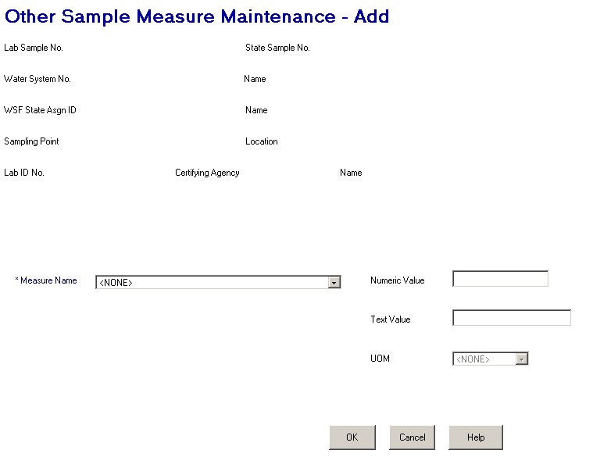

Exhibit 5-19. Other Sample Measure Maintenance

Entry Fields:

Measure Name The name of the measure type as recorded in table Other Sample Measure (TSAOSM), field Name. This field is required.

This will be a dropdown field. Permitted values for this field will be recorded in table Sample Measure Type (TSASMMT) and will include the following:

VOLUME FILTERED
NUMBER OF FILTERS
VOLUME SPIKED
EST NUMBER OOCYSTS SPIKED
PACKED PELLET VOLUME

Numeric Value The numeric value of the other sample measure as recorded in table Other Sample Measure (TSAOSM), field Value_num. The size of the value that can be entered will be controlled by the specifications recorded in table Sample Measure Type. A numeric value is required if the data_type of the selected sample measure type is “N.” If the data_type of the selected sample measure type is not “N,” this field will be protected. Zero will be treated as a value.

Text Value The text value of the other sample measure as recorded in table Other Sample Measure (TSAOSM), field Value_text. The size of the value that can be entered will be controlled by the specifications recorded in table Sample Measure Type. A text value is required if the data_type of the selected sample measure type is “T.” If the data_type of the selected sample measure type is not “T,” this field will be protected.

UOM The unit of measure abbreviation for the sample measure value as recorded in table Other Sample Measure (TSAOSM), field UOM_CODE.

This field is optional for text values and required for numeric values. When not provided for a numeric value the error message will be: UOM code is required for a numeric measure value.

The permitted values for this field will be controlled by the associations between the selected measure type and unit of measure as recorded in table Other Sample Permitted Measures (TSAOSPM). The following are examples

Sample Measure Type | Permitted UOM
NUMBER OF FILTERS | N (number)
PACKED PELLET VOLUME | G (gallons)  L (liters)  mL (milliliter)
VOLUME FILTERED | G (gallons)  L (liters)  mL (milliliter)
VOLUME SPIKED | G (gallons)  L (liters)  mL (milliliter)

Buttons:

OK If a value is not supplied for Name, the error message will be: Measure type Name must be supplied.

If the data type of the selected measure type is equal to N and Numeric Value or UOM are not supplied, the error message will be: Both a numeric value and UOM are required for this measure type.

If the data type of the selected measure type is equal to T and a Text Value is not supplied, the error message will be: A Text Value is required for this measure type.

Duplicate check If a record is found in the database with the same Measure Name for the current sample, the error message will be: Other Sample Measure already exists for current Sample.

Add-Mode An Other Sample Measure will be created and associated to the sample.

Change-Mode The Other Sample Measure will be changed.

The software will flow back to the previous sample maintenance page in Change mode.

Cancel If changes have been made the standard cancel confirmation page will be presented. If no changes have been made the page will close and return to the sample maintenance page in change mode.

Help Will invoke the system online Help facility.

General Result Maintenance
Exhibit 5-20 depicts the General Results Maintenance page.

The General Result Maintenance page has two different methods of capturing information. One is based upon individual analyte selection, the second is based upon an analyte group selection whereby the analytes contained by the group are automatically presented on the page. The Microbiological Result Maintenance page and the Radiological Result Maintenance page function similarly to the General Result Maintenance page. Design for those pages only discusses the exceptions to this page.

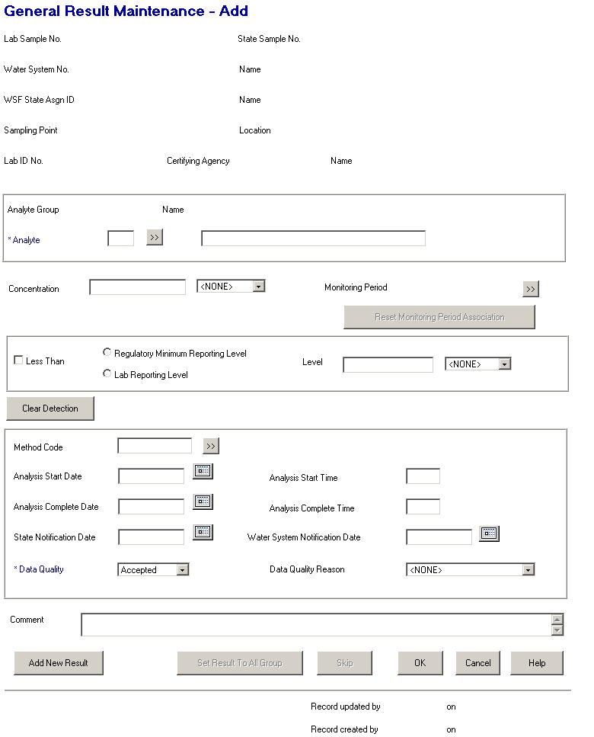

Exhibit 5-20. General Results Maintenance

Protected Fields:

Lab Sample No. The supplied Lab Sample No.

State Sample No. The supplied State Sample No.

Water System No. The number of the selected water system for the sample.

[Water System] Name The name of the water system.

WSF State Asgn ID The state ID number of the water system facility to which this sampling point belongs.

[WSF] Name The name of the water system facility to which the sampling point belongs.

Sampling Point The user-assigned ID of the sampling point.

[Sampling Point] Location The user-supplied name of the sampling point.

Lab ID No. A code assigned by the state certifying authority that uniquely identifies the lab. (R0059:A.5.5.2.a)

Certifying Agency The agency that certified or issued the Lab ID No. (R0059:A.5.5.2.b)

(R0059:A.5.5.2.c)

[Laboratory] Name The commonly used name of the laboratory.

Analyte Group [Code] The code of the analyte group selected for which the displayed analyte is a component.

[Analyte Group] Name The user-specified name of the analyte group.

Sequence n of N An indication of which analyte within the group is currently presented.

Monitoring Period This field will be display-only list box showing all monitoring periods associated to this result via the SSMPA rows. Only two rows will be visible without vertical scrolling. Three columns showing name, begin date and end date will be displayed but no column headings will be presented to conserve page space. This field is always protected in add mode but modifiable with the use of the Go To button in change mode.

Record updated
by XXXXXXXX on
MM/DD/YYYY
HH:MI:SS The User ID and the timestamp from the last time the result record (TSASAR) was updated.
Record created
by XXXXXXXX on
MM/DD/YYYY
HH:MI:SDWIS/STATE The initial User ID and timestamp when the result (TSASAR) record was initially added to the database.
Data Entry Fields:

Analyte The analyte code for which the result is going to be entered. If the value input is not a valid analyte, the analyte maintenance list will be displayed in single-select mode sorted by ascending analyte code. The analyte maintenance list will display only analyte codes where the type_code equals “OC,” “IOC” or “WQ” or where the State Code for the Analyte is not equal to HQ and its type_code is “OT.”

This is a required field. If it is left blank, the error message will be: Analyte Code may not be left blank.

The default Method Code and default Lab Reporting Level for the result will be populated from the Lab Analyte Method Assignment table that is associated to the Laboratory, has as relationship to Standard Method Analyte Association that is related to the specified analyte, has default method indicator = ‘Y’, has certification indicator = ‘Y’ and has the most recent issuance date <= (analysis end date or analysis start date, or sample collection end date to be checked in this order based upon the date being not null.) (R0059:A.5.5.2.e)

[Analyte Name] The name of the analyte code selected. Will be populated when valid analyte code is supplied.

When a value is entered directly is not a valid analyte, the analyte maintenance list will be displayed in single-select mode sorted by ascending analyte name. The analyte maintenance list will display only analyte codes where the type_code equals “OC,” “IOC” or “WQ” or where the State Code for the Analyte is not equal to HQ and its type_code is “OT.”

Concentration
(and unit of measure) A value that represents the result obtained from a sample analysis.

This field will accept negative values.

Enter the concentration and choose the unit from the dropdown list. Permitted values are those rows from the Unit of Measure table for all result types except radiological (RA), sorted by the Sort Priority recorded in the Unit of Measure table. This will produce the following list of UOM Codes:

mg/L
ug/L
%LUM
%PUR
ADMIU
AGGR
C
CM-1
CT
CU
F
FTU
L/mg-m
L/mg-cm
LANG
Lbs/CFt
Lbs/gal
MFL
ng/L
nm
NTU
OBSVNS
pH
Ratio
SU
TON
umho/cm

This is an optional field. If a concentration value is provided the Unit of Measure must be selected. If it is not, the error message will be: Analysis Result Concentration Measure Unit may not be left blank.

If the selected analyte contains a reportable start date, previous releases of the software only allowed the unit of measure to be mg/L or ug/L. This edit check is removed in this release.

The concentration must be a numeric value. If it is not, the error message will be: Reported Measure may only be a valid number. If the value is greater than 999,999, the error message will be: Value too Large. SDWIS can support up to 6 digits to the left of the decimal.

If the concentration value is greater than the reporting level for this analyte, the error message will be: Concentration MUST NOT exceed Reporting Level.

Reporting Level Type
(including the less than
check box) Indicates that the analytical result (Concentration) was less than the regulatory minimum reporting level or the laboratory reporting level, which must be less than or equal to the regulated maximum contaminant level (MCL) for the analyte. The error message will be: Lab Reporting Level may not be greater than MCL for this Analyte. Results “less than” these levels are sometimes referred to as “not quantifiable” or “none detected”; selecting the “less than” checkbox and either “Regulating Minimum Reporting Level” or “Lab Reporting Level” is the equivalent of specifying “non-detect” for the analyte.

If the result is less than either level, select the box beside Less Than and then choose either Regulatory Minimum Reporting Level (MDL) or Lab Reporting Level (MRL).

If the user chooses MDL, the current analyte’s regulatory method detection limit is retrieved from the Analyte Level Rule (or TMNALRA) table and displayed in the protected level field.

If the user chooses MRL, the user must enter a result level in the Level field that is not above the regulated MCL for the current analyte. If left blank, the error message will be: Analysis Result Level may not be left blank.

When the “less than” box is checked a reporting level type must be selected. If it is not, the error message will be: Reporting Level Type may not be left blank.

Level
(and unit of measure) The limit established by the laboratory below which scientifically reliable results cannot be achieved. In many cases, if the lab’s detection limit is below the EPA-mandated method detection limit (MDL), then the MDL is used as the detection limit. If the lab’s detection limit is above the EPA’s MDL, then the lab’s detection limit is used.

Enter the result and choose the unit from the dropdown list. Permitted values are those rows from the Unit of Measure table for all result types except radiological (RA), sorted by the Sort Priority recorded in the Unit of Measure table. This will produce the same list as above for the Concentration unit of measure field.

This field is available and required only if the Reporting Level Type is designated as Lab Reporting Level (MRL).

If the value entered in the field is greater than the maximum contaminant level for this analyte in the Analyte Level Rule (or TMNALRA) table, the warning message Lab Reporting level may not be greater than the MCL for this Analyte will be presented.

If no value is found in the Analyte Level Rule for the MCL, the level value entered will be checked against the maximum contaminant level goal value in the Analyte Level Rule table for this analyte. If the value in the level field is greater than the maximum contaminant level goal (MCLG) for this analyte in the Analyte Level Rule (or TMNALRA) table, the warning message Lab Reporting level may not be greater than the MCLG for this Analyte will be presented.

If no value is found in the Analyte Level Rule for the MCLG, the level value entered will be checked against the action level goal value in the Analyte Level Rule table for this analyte. If the value in the level field is greater than the action level goal (ACL) for this analyte in the Analyte Level Rule (or TMNALRA) table, the warning message Lab Reporting level may not be greater than the ACL for this Analyte will be presented.

Method Code Represents the method used to analyze the sample, such as the EPA-assigned method code EPA 525.1. If a value is supplied, it must be a valid standard method code assigned to this analyte. If it is not, the list of valid methods will be presented for selection. If lab certification edit is enabled (reference details under the OK button), list only those standard methods approved for the laboratory and analyte. (R2001:A.5.5.2.g)

When the Laboratory and Method Code are entered, if neither RMDL nor LRL detection level radio button has been set, set LRL detection level radio button and default Lab reporting limit and UOM. Result will be populated from the Lab Analyte Method Assignment table that is associated to the Laboratory, has as relationship to Standard Method Analyte Association that is related to the analyte, has certification indicator = ‘Y’ and has the most recent issuance date <= (analysis end date or analysis start date, or sample collection end date to be checked in this order based upon the date being not null.) (R0059:A.5.5.2.h)

This is an optional field.

Volume Assayed The unit of measure for microbiological analysis. Permitted values are:

1 ml
5 ml
10 ml
100 ml
300 ml
400 ml
500 ml
<spaces> (the default)

This is an optional field.

Analysis Start Date The start date that the analysis began.

This is an optional field. Must not be a future date. The error message will be: Date must not be a future date. If it is provided, it cannot be earlier than the sample’s collection date. If it is, the error message will be: The date of Result Analysis cannot be prior to the date of Sample Collection. If a complete date is also provided, the start date must precede the end date. If it does not, the error message will be: Start Date must precede End Date.

Analysis Start Time The time that the analysis was started. The value cannot be greater than or equal to 2400. If so, the error message will be: This field must match pattern HH:MM.

If the result complete date is equal to the sample collection date, the result complete time cannot be greater than the sample collection time. If it is, the error message will be: The time of Result Analysis cannot be prior to the time of Sample Collection.

This is an optional field.

Analysis Complete Date The date the analysis was completed.

This is an optional field. Must not be a future date. The error message will be: Date must not be a future date. If provided, it may not be prior to the sample collection date. If it is, the error message will be: The date of Result Analysis cannot be prior to the date of Sample Collection.

If a Lab Receipt Date is provided for the sample, the supplied Analysis Complete Date must be on or after the Lab Receipt date. The error message will be: The Analysis Complete Date cannot be prior to the Lab Receipt Date.

Analysis Complete Time The time that the analysis was complete. The value cannot be greater than or equal to 2400. If so, the error message will be: This field must match pattern HH:MM.

If the result complete date is equal to the sample collection date, the result complete time cannot be greater than the sample collection time. If it is, the error message will be: The time of Result Analysis cannot be prior to the time of Sample Collection.

If the result complete date is equal to the result start date, the result complete time cannot be greater than the result start time. If it is, the error message will be: The complete cannot be prior to the start time of Result Analysis.

This is an optional field.

State Notification Date The date that the state was notified of the sample result for this analyte.

This is an optional field. Must not be a future date. The error message will be: Date must not be a future date. If provided, it may not be prior to:
- The sample collection date. If it is, the error message will be: The date of State Notification cannot be prior to the date of Sample Collection.
- The result analysis complete date. If it is, the error message will be: The date of State Notification cannot be prior to the date of Result Analysis.
- The sample lab receipt date. If it is, the error message will be: The date of State Notification cannot be prior to the date of Lab Receipt.

Water System Notification
Date The date the laboratory notified the water system of the analytical result.

This is an optional field. Must not be a future date. The error message will be: Date must not be a future date. If provided, it may not be prior to:
- The sample collection date. If it is, the error message will be: The date of State Notification cannot be prior to the date of Sample Collection.
- The result analysis complete date. If it is, the error message will be: The date of State Notification cannot be prior to the date of Result Analysis.
- The sample lab receipt date. If it is, the error message will be: The date of State Notification cannot be prior to the date of Lab Receipt.

Data Quality Indicates whether the sample analytical result meets established data quality acceptance criteria. The laboratory is responsible for providing data quality information for a sample analysis. Entries include the following:

A - Accepted
P - Preliminary
R – Rejected
V – Validated

This is a required field that will default to Accepted. If it is changed to other than accepted but then changed back, it will become protected and any value in Data Quality Reason will be removed.

If no value is selected, the error message will be: Analysis Result Data Quality Code may not be left blank.

If V-Validated is selected, the following edits will be performed when tabbing from the field.
- If the analyte code is not equal to total coliform (3100), fecal coliform (3013), or E. coli (3014), the error message will be: Only Distribution TCR Results can be validated.
- If the analyte code is equal to total coliform (3100), fecal coliform (3013), or E. coli (3014), and the water system facility type for the sample is equal to a distribution system (DS) the error message will be: Validate Distribution TCR Results in the Compliance Determination component.
- If the analyte code is equal to total coliform (3100), fecal coliform (3013), or E. coli (3014), and the water system facility type for the sample is equal to any type other than distribution system (DS), the error message will be: Only Distribution TCR Results can be validated.

Data Quality Reason The reason for rejection of an analytical result. Entries include the following:

IF - Instrument failure
LC- Lab not certified
LE - Lab error
OT - Other
RC - Requester canceled
WR - Water system rejected the result

This field becomes required if the Data Quality is selected as Rejected. If left blank for a rejected data quality selection, the error message will be: A Data Quality Reason must be entered to reject a result.

Comment A free-form comment area where descriptive text about the result can be recorded.

This is an optional field.

Buttons:

[analyte]
Go To Will present the Analyte Maintenance List.

[monitoring period]
Go To Will present the Monitoring Period Maintenance List in single-select mode. The selected value will be returned to the maintenance page and updated when the OK button is selected. This button should always be enabled in Change mode but will not be available in add mode. Instead of trying to read monitoring periods through SSMPAs, the software will display all Monitoring Periods sorted by End Date descending, Begin Date descending.

Reset Monitoring
Period Association This button is only enabled in change mode and only if the result is associated to a monitoring period (either directly or via an SSMPA). When this button is pressed the following actions will occur. These changes will not be undone if the Cancel button is subsequently selected.
- Disassociate the SAMPLE ANALYTICAL RESULT from the MONITORING PERIOD by setting the TSASAR.tmnmprd_is_number and TSASAR.tmnmprd_st_code to nulls.
- For each SSMPA associated to the SAMPLE ANALYTICAL RESULT (via the SSMPA_SAR_ASSOCIATION (TMNSPSRA)):
- update the d_last_updt_ts to current timestamp
- delete the SSMPA_SAR_ASSOCIATION (TMNSPSRA) record.
- For each sub-SSMPA associated to the SAMPLE ANALYTICAL RESULT (via the SPUBA_SAR_ASSOCIATION (TMNSBSRA)):
- update the d_last_updt_ts to current timestamp
- delete the SPUBA_SAR_ASSOCIATION (TMNSBSRA)

Clear Detection Will clear Less Than Indicator, Regulatory Minimum Reporting Level radio button, Lab Reporting Level radio button, detection level, and detection level unit of measure fields.

[method code]
Go To Will present the Analyte Standard Method Maintenance List. If lab certification edit is enabled (reference details under the OK button), list only those standard methods approved for the laboratory and analyte. (R2001:A.5.5.2.f)

Add New Result Will perform all edits as if OK button were pressed. After successfully adding the sample result the Analyte Entry advisory (documented in above section) will be presented. If the new analyte will result in the General Result Maintenance page being presented, the following fields will be carried forward. If either the Radiological or Microbiological Result Maintenance pages will be presented, no data is carried forward.

- Less Than
- Reporting level type
(If reporting level type is Reporting Minimum Reporting Level, then look
up level in TMNALRA and value)
- UOM
- Method Code
- Analysis date and time
- State and Water System Notification dates
- Data Quality
- Data Quality Reason

This button will be available in both add and change mode when a single analyte is being processed. When an analyte group is being used, this button will be disabled until the last analyte within the analyte group is presented.

Set Results to
All Group Set the results of all remaining analytes in the Analyte Group to the contents of the Results box (Reporting Level type, Concentration, method code, etc.) specified for the current analyte in the Analyte Group. The results will be created and the user will flow to the General Sample Maintenance page. This button will only be enabled in Add mode if an analyte group is selected on the Sample Maintenance page. If a result fails an edit check during creation, advise the user as follows.

- If method code is not appropriate: The Standard Method specified was not valid for all analytes in the specified Analyte Group. Please check results.
- If Regulating Reporting Level is specified and no Regulating Reporting Level exists for this analyte: All analytes do not have a Regulating Reporting Level.
- If analyte for first result is not type code =”RAD” and analyte for subsequent results being created are type code =”RAD”: Some analytes are Radionuclides, user may wish to add counting error.
- If analyte for first result is not type code=“MOR” and analyte for subsequent results being created are type code=“MOR”: Some analytes are microbiological, user must modify result and add Absent/Present and Count data.

Skip Will advance to the next analyte in the analyte group without processing the current analyte, even if information was input. All data input will be carried forward to the next analyte.

There is no way to traverse backward through the analyte group. If position is at the end of the analyte group, Skip will become disabled.

OK If the “less than” box is not checked, no Reporting Level Type selection was made, no Concentration value was provided, and the Data Quality is not “R,” the error message will be: Report Level Type and Concentration may not both be left blank.

Lab Certification
Check (R2001:A.5.5.2.d)
If the sample rejection reason is blank and the SDWIS Configuration Parameter table with Configuration ID = ‘LABCERT’ and Code Table name of ‘LC_EDITCHK’ has a paramter value of ‘ERROR’, continue with the Lab Certification check.

If the data quality code is not equal to R- Rejected, use the specified Laboratory,Method code for specified analyte (analysis complete time, analysis start time, or sample collection end date, in this order of priority and dependent upon a not null value), check for a laboratory analyte method assignment with certification indicator = ‘Y’ and most recent issuance date <= the provided date that is for the analyte. If not found, error message will be: This lab was not certified for this analyte and method during sample processing. Turn the method code and date that was used in the check red, reverse video.

Duplicate Check If a sample analytical result is found for the same sample, analyte, analytical method and uom_category the error message will be: Result for the same sample, analyte, method and category of UOM already exists. The uom_category will be determined using the uom code of the concentration value, if specified, or the detection limit uom code if the less-than box is checked.

Add-Mode The Sample Analytical Result will be created and associated to the sample and analyte. The d_initial_timestamp, d_initial_userid, d_last_update_timestamp and d_userid_code will be set to current values. If a method code was provided, it will also be associated to the standard method code. See documentation below regarding SSMPA processing.

If the individual analytes of an analyte group are being processed, the page will be presented with the next analyte in the analyte group. When the last analyte has been processed, the page will close and return to the General Sample Maintenance page.

If a single analyte result was created, the page will close and return to the General Sample Maintenance page.

Change-Mode The Sample Analytical Result (SAR) will be changed.

If a different analyte is chosen:
- The SAR will be re-associated to the new analyte;
- For each SSMPA associated to the Sample Analytical Result (via the SSMPA_SAR_ASSOCIATION (TMNSPSRA)):
- Update the d_last_updt_ts to current timestamp
- Update the d_userid_code to CDSSETUP
- Delete the SSMPA_SAR_ASSOCIATION (TMNSPSRA) record.
- For each sub-SSMPA associated to the SAMPLE ANALYTICAL RESULT (via the SPUBA_SAR_ASSOCIATION (TMNSBSRA)):
- Update the d_last_updt_ts to current timestamp
- Update the d_userid_code to CDSSETUP
- Delete the SPUBA_SAR_ASSOCIATION (TMNSBSRA)

If a different monitoring period is chosen:
- The SAR will be directly associated to the selected monitoring period.
- For each SSMPA associated to the Sample Analytical Result (via the SSMPA_SAR_ASSOCIATION (TMNSPSRA)):
- Update the d_last_updt_ts to current timestamp
- Update the d_userid_code to CDSSETUP
- Delete the SSMPA_SAR_ASSOCIATION (TMNSPSRA) record.
- For each sub-SSMPA associated to the SAMPLE ANALYTICAL RESULT (via the SPUBA_SAR_ASSOCIATION (TMNSBSRA)):
- Update the d_last_updt_ts to current timestamp
- Update the d_userid_code to CDSSETUP
- Delete the SPUBA_SAR_ASSOCIATION (TMNSBSRA)
- If the SAR is not a TCR result (one of analyte codes (3100, 3013, 3014) for a distribution water system facility) and the sample routine or repeat (type of RT or RP) and is a “for compliance” sample, the software will display the following advisory: CDS Setup will use the selected Monitoring Period rather than the sample date to determine the schedule and monitoring period satisfied by this result (Exhibit 5-21).
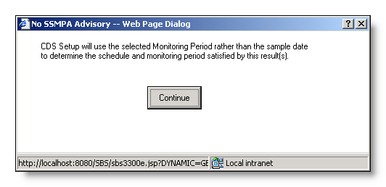
Exhibit 5-21. No SSMPA Advisory Dialog Box

Button:

Continue The Advisory dialog box will close and return the user to the invoking Maintenance page. The user may either change the monitoring period again, or leave the selected monitoring period in place. If the selected monitoring period is not changed, the software understands that the user wishes to keep the selected monitoring period and the advisory dialog box is not invoked again.

Cancel If changes have been made the standard cancel confirmation page will be presented. If no changes have been made, the page will close and return to the sample maintenance page.

Help Will invoke the system online Help facility.

Microbiological Result Maintenance
Exhibit 5-22 depicts the Microbiological Results Maintenance page. The Microbiological Result Maintenance page has two different methods of capturing information. One is based upon individual analyte selection, the second is based upon an analyte group selection whereby the analytes contained by the group are predetermined and fed to the page. This page is very similar to the General Result Maintenance page. The following design lists only the exceptions between the pages.

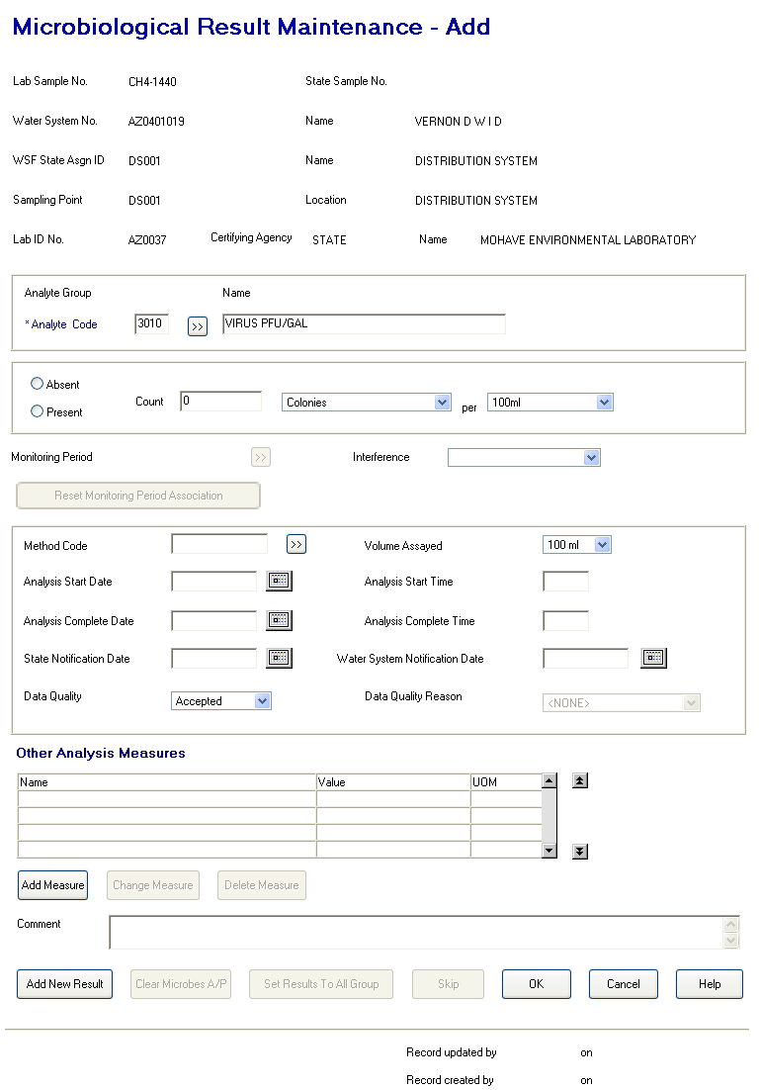

Exhibit 5-22. Microbiological Results Maintenance

Protected Fields:

All the same as the General Result Maintenance page.

Rename Lab State ID No. to Lab ID No.
Remove Lab Fed ID No.
Add Certifying Agency
(R0059:A.5.5.3.a)

Entry Fields:

All fields the same as General Result Maintenance page with the following exceptions.
This maintenance page does not have these fields: Concentration (and unit of measure), Reporting Level Type (including the less than check box), Level (and unit of measure). It does have these additional fields and/or specifications:

Analyte The analyte code for which the result is going to be entered. If the value input is not a valid analyte, the analyte maintenance list will be displayed in single-select mode sorted by ascending analyte code. The analyte maintenance list will display only microbiological analyte codes with type_code = “MOR.” A selection will be returned and populate both the analyte name and analyte code fields.

This is a required field. If it is left blank, the error message will be: Analyte Code may not be left blank.

The default Method Code for the result will be populated from the Lab Analyte Method Assignment table that is associated to the Laboratory, has as relationship to Standard Method Analyte Association that is related to the specified analyte, has default method indicator = ‘Y’, has certification indicator = ‘Y’ and has the most recent issuance date <= (analysis end date or analysis start date, or sample collection end date to be checked in this order based upon the date being not null.) (R0059:A.5.5.3.b)

[Analyte Name] The name of the analyte code when selected. Will be populated when valid analyte code is supplied.

If a value that is entered directly is not found to be a valid analyte name, the analyte maintenance list will be displayed in single-select mode sorted by ascending analyte name. The analyte maintenance list will display only microbiological analyte codes with type_code = “MOR.” A selection will be returned and populate both the analyte name and analyte code fields.

[Microbes]
Absent/Present One value may be selected to indicate if the contaminant analyte is absent (A) or present (P).

This is an optional field. If left blank and a result count is provided, it will be automatically set to present (P).

If absent is selected, the count fields will be reset to zero or spaces and protected from input.

To remove a selection, press the Clear Microbes A/P button.

Count
(represented by 3 Entry Fields)
Count is a number of organisms counted or estimated in a microbial analytical result, usually expressed as the number of organisms per unit sample. If a user does not enter a value, this field will be blank (i.e., true null). If zero is displayed, it means that the user entered zero as the count.

The types of organisms counted for a microbiological measurement. The permitted values are:

TUBES - Multiple Tube Method
COLONIES - Membrane Filter Method
(default value)
CFU - Colony Forming Units
CYSTSC - Cysts, Calculated
CYSTSO - Cysts, Observed
MPN - Most Probable Number
OBSVNS - Observations
OCYSTSC - Oocysts, Calculated
OCYSTSO - Oocysts, Observed
PFU - Plaque Forming Units

Enter the unit for the count from the dropdown list. Permitted values are:

100ml (default value)
400ml
Liter
ML
100 gal
100 L
400 gal
Field@100 Pwr
Gal
Sample Volume
Slide

These are optional fields. One may contain a value without the others but will not be allowed if the Microbe is indicated as absent.

Interference Comments regarding the analyzed sample that indicate the reason for an unquantifiable result. The lab determined that microorganisms may exist in the sample but they could not quantify the results with confidence. In this case, a lab may report that coliforms are present, but may add comments to ensure that follow-up samples are collected. Permitted entries for interference include the following:

TNTC - Too numerous to count: Using the membrane filter method, the lab could not physically or feasibly count all the coliform colonies.*

CNFG - Confluent growth: Using the membrane filter method, the lab determined that numerous colonies are overgrown across the filter, making identification and quantification of individual colonies impossible.*

TCNG - Turbid culture, no gas: Using the multiple tube fermentation method, the lab determined that microorganisms were present (turbid culture), but the normal indicator of coliform organisms (gas produced in an inverted tube) did not occur.*

* This situation sometimes indicates improper sample or analytical technique and may also indicate extremely contaminated water. This situation may (or may not) be used by the lab to indicate coliform presence.

This is an optional field. If a value is present in this field the Absent indicator cannot be the selection.

Other Analysis Measure(s) List Box

The “Other Analysis Measure(s)” list box will allow a user to record additional measures associated with an analytical result. This capability will be added specifically to enable users to record additional analytical result measures related to cryptosporidium sampling proposed in the Long-Term 2 Enhanced Surface Water Treatment Rule (e.g., percent filtered volume analyzed, number of oocysts, volume of resuspended concentrate, etc.).

List Fields:

Display four rows, allow up to 100 rows, default sort by Name ascending.

Measure Name The name of the other measure type as recorded in table Other Sample Measures (TSAOSM), field Name.

Value The numeric value of the other sample measure.

UOM The unit of measure abbreviation for the other sample measure value.

Buttons:

All fields the same as General Result Maintenance page with the following exceptions:

Reset Monitoring
Period Association This button is only enabled in change mode and only if the result is not a result to satisfy the Total Coliform Rule (A TCR result must have the following criteria: the result is for 3100, 3013, or 3014 and the sample is a routine or repeat and the sample is a “for compliance” sample and the sample is associated to a distribution system) and the result is associated to a monitoring period (either directly or via an SSMPA). When this button is pressed the following actions will occur. These changes will not be undone if the Cancel button is subsequently selected

- Disassociate the SAMPLE ANALYTICAL RESULT from the MONITORING PERIOD by setting the TSASAR.tmnmprd_is_number and TSASAR.tmnmprd_st_code to nulls.
- For each SSMPA associated to the SAMPLE ANALYTICAL RESULT (via the SSMPA_SAR_ASSOCIATION (TMNSPSRA)):
- update the d_last_updt_ts to current timestamp
- delete the SSMPA_SAR_ASSOCIATION (TMNSPSRA) record.
- For each sub-SSMPA associated to the SAMPLE ANALYTICAL RESULT (via the SPUBA_SAR_ASSOCIATION (TMNSBSRA)):
- update the d_last_updt_ts to current timestamp
- delete the SPUBA_SAR_ASSOCIATION (TMNSBSRA)

[Other Analysis Measure(s)]
Add Measure Will perform all edits as if OK button were pressed. After successfully adding or modifying the result, the software will present the Other Sample Analysis Measure maintenance page in add mode.

[Other Analysis Measure(s)]
Change Measure Will perform all edits as if OK button were pressed. After successfully modifying the sample, will present the Other Sample Analysis Measure maintenance page in change mode. This item is only available if a row has been selected in the list area.

[Other Analysis Measure(s)]
Delete Measure Will perform all edits as if OK button were pressed. After successfully modifying the sample, the software will delete the Other Sample Analysis Measure record. This item is only available if a row has been selected in the list area. No delete confirmation message is presented.

Add New Result Will perform all edits as if OK button were pressed. After successfully adding the sample result the Analyte Entry advisory (documented in above section) will be presented. If the new analyte will result in the Microbiological Result Maintenance page being presented, the following fields will be carried forward. If either the Radiological or General Result Maintenance pages will be presented, no data is carried forward.

Absent
Present
Count
Count Quantity
UOM

This button will be available in both add and change mode when a single analyte is used. When an analyte group is used, this button will be disabled until the last analyte of the analyte group has been presented.

Clear Microbes A/P Will reset the Microbes presence/absence indicator to spaces. No radio button will be indicated as being on.

OK If the Microbe is not selected as either Absent or Present and the result is not indicated as being rejected by either Data Quality of rejected or the data quality reason code, the error message will be: A TCR/Microbiological Result must show microbes either Absent or Present.

If the Interference field has a value, the Absent indicator may not be the selection. If it is, the error message will be: Absent is not a valid selection with supplied Inteference value.

Duplicate Check If a sample analytical result is found for the same sample, analyte, analytical method and count uom code (field in TSAMAR) the error message will be: Result for the same sample, analyte, method and count type already exists.

Lab Certification
Check (R2001:A.5.5.3.c)
If the sample rejection reason is blank and the SDWIS Configuration Parameter table with Configuration ID = ‘LABCERT’ and Code Table name of ‘LC_EDITCHK’ has a paramter value of ‘ERROR’, continue with the Lab Certification check.

If the data quality code is not equal to R-Rejected, use the specified Laboratory, Method code for specified analyte (analysis complete time, analysis start time, or sample collection end date, in this order of priority and dependent upon a not null value), check for a laboratory analyte method assignment with certification indicator = ‘Y’ and most recent issuance date <= the provided date that is for the analyte. If not found, error message will be: This lab was not certified for this analyte and method during sample processing. Turn the method code and date that was used in the check red, reverse video.

Add-Mode If the candidate result is for total coliform, fecal coliform, or E. coli (analyte codes 3100, 3013, 3014) and will be associated to a for-compliance sample of type routine or repeat (RT or RP), which is associated to a distribution system facility, the software will try to associate the result to the appropriate TCR monitoring period as described for the Coliform Sample Maintenance page. If an association cannot be made, the software will return the same error message.

If an appropriate TCR monitoring period is identified (refer to rules for determination documented on the Coliform Sample Maintenance page above):
- A sample analytical result will be created and associated to the analyte entered.
- If a standard method was supplied, the result will also be associated to the standard method code.
- A microbial analytical result will be created and associated to the sample analytical result. If count contains no value, the count_qty field will be set to null.
- The result will be associated to the appropriate TCR monitoring period.

If the result is not for the Total Coliform Rule (A TCR result must have the following criteria: the result is for 3100, 3013, or 3014 and the sample is a routine or repeat and the sample is a “for compliance” sample and the sample is associated to a distribution system)
- A sample analytical result will be created and associated to the analyte entered.
- If a standard method code was supplied, the result will also be associated to the standard method code.
- A microbial analytical result will be created and associated to the sample analytical result. If count contains no value, the count_qty field will be set to null.

If the individual analytes of an analyte group are being processed, the page will be presented with the next analyte in the analyte group. When the last analyte has been processed, the page will close and return to the General Sample Maintenance page.

If a single analyte has been processed, the page will close and return to the General Sample Maintenance page.

Change-Mode The Sample Analytical Result (SAR) and Microbiological Analytical Result (MAR) will be changed.

If a different analyte is chosen:
- The SAR will be re-associated to the new analyte;
- For each SSMPA associated to the Sample Analytical Result (via the SSMPA_SAR_ASSOCIATION (TMNSPSRA)):
- Update the d_last_updt_ts to current timestamp
- Update the d_userid_code to CDSSETUP
- Delete the SSMPA_SAR_ASSOCIATION (TMNSPSRA) record.
- For each sub-SSMPA associated to the SAMPLE ANALYTICAL RESULT (via the SPUBA_SAR_ASSOCIATION (TMNSBSRA)):
- Update the d_last_updt_ts to current timestamp
- Update the d_userid_code to CDSSETUP
- Delete the SPUBA_SAR_ASSOCIATION (TMNSBSRA)

If a different monitoring period is chosen:
- The SAR will be directly associated to the selected monitoring period.
- For each SSMPA associated to the Sample Analytical Result (via the SSMPA_SAR_ASSOCIATION (TMNSPSRA)):
- Update the d_last_updt_ts to current timestamp
- Update the d_userid_code to CDSSETUP
- Delete the SSMPA_SAR_ASSOCIATION (TMNSPSRA) record.
- For each sub-SSMPA associated to the SAMPLE ANALYTICAL RESULT (via the SPUBA_SAR_ASSOCIATION (TMNSBSRA)):
- Update the d_last_updt_ts to current timestamp
- Update the d_userid_code to CDSSETUP
- Delete the SPUBA_SAR_ASSOCIATION (TMNSBSRA)
- If the SAR is not a TCR result (A TCR result must have the following criteria: the result is for 3100, 3013, or 3014 and the sample is a routine or repeat and the sample is a “for compliance” sample and the sample is associated to a distribution system), the software will display the following advisory: CDS Setup will use the selected Monitoring Period rather than the sample date to determine the schedule and monitoring period satisfied by this result (Exhibit 5-21).

Other Analysis Measure Maintenance
Other Analysis Measure Maintenance (Exhibit 5-23) will allow a user to enter and maintain additional measures associated with an analysis. This page will be a dialog box. This capability will be added specifically to enable users to record analytical measures related to cryptosporidium analysis proposed in the Long-Term 2 Enhanced Surface Water Treatment Rule. An analysis can optionally have one or more additional measures.

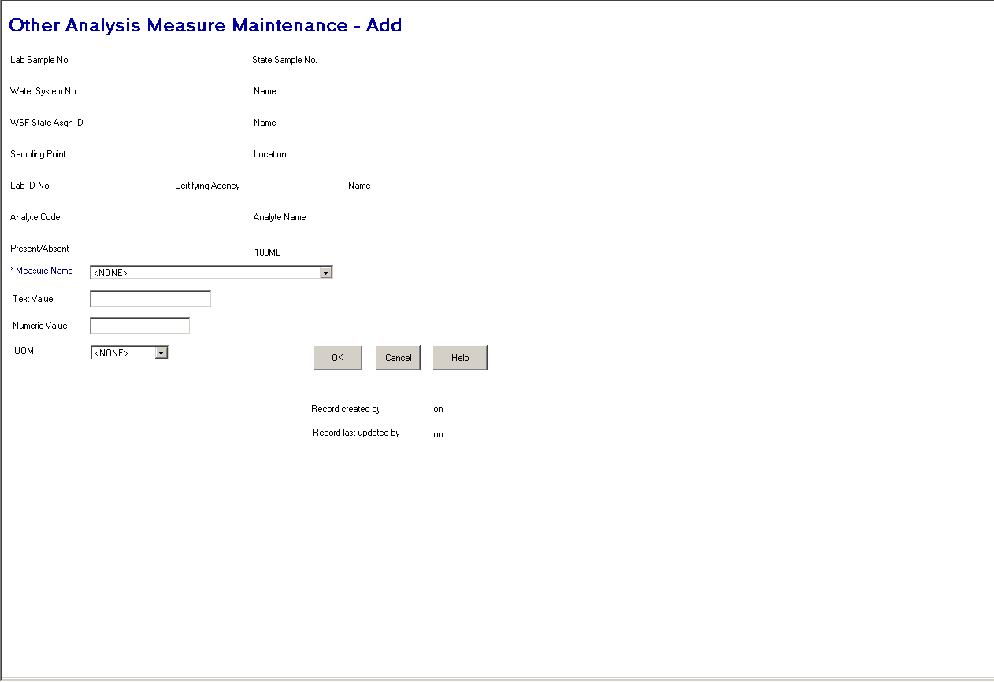
Exhibit 5-23. Other Analysis Measure Maintenance

Protected Fields:

Lab Sample No. The supplied Lab Sample No.

State Sample No. The supplied State Sample No.

Water System No. The number of the selected water system for the sample.

[Water System] Name The name of the water system.

WSF State Asgn ID The state ID number of the water system facility to which this sampling point belongs.

[WSF] Name The name of the water system facility to which the sampling point belongs.

Sampling Point The user-assigned identifying code of the sampling point.

[Sampling Point] Location The user-supplied name of the sampling point.

Lab ID No. A code assigned by the certifying authority that uniquely identifies the lab. (R0059:A.5.5.3.1.a)

Certifying Agency The agency that certified or issued the Lab ID No. (R0059:A.5.5.3.1.b)

. (R0059:A.5.5.3.1.c)

[Laboratory] Name The commonly used name of the laboratory.

Analyte Code The analyte code associated to the parent result.

Analyte Name The analyte name associated to the parent result.

Present/Absent The present/absence indicator for the parent result.

Record Created by/on The User ID and timestamp of when the Other Analysis Measure was created.

Record Last Updated by/on The User ID and timestamp of when the Other Analysis Measure was last updated.

Entry Fields:

Measure Name The name of the measure type as recorded in table Other Sample Analysis Measures (TSAOSAM), field Name. This field is required.

This will be a dropdown field. Permitted values for this field will be recorded in table Sample Analysis Measure Type (TSASAMT) and will include the following:

PERCENT FILTERED VOLUME ANALYZED
NUMBER OF OOCYSTS
VOLUME OF RESUSPENDED CONCENTRATE
VOLUME OF RESUSPENDED CONC. PROCESSED

Numeric Value The numeric value of the other sample analysis measure as recorded in table Other Sample Analysis Measure (TSAOSAM), field Value. The size of the value that can be entered will be controlled by the specifications recorded in table Sample Analysis Measure Type (TSASAMT). A numeric value is required if the data_type of the selected sample analysis measure type is “N.” If the data_type of the selected sample analysis measure type is not “N,” this field will be disabled. Zero will be treated as a value.

Text Value The text value of the other sample analysis measure as recorded in table Other Sample Analysis Measure (TSAOSAM), field Value_txt. The size of the value that can be entered will be controlled by the specifications recorded in table Sample Analysis Measure Type. A text value is required if the data_type of the selected sample analysis measure type is “T.” If the data_type of the selected sample analysis measure type is not “T,” this field will be disabled.

UOM The unit of measure abbreviation for the sample analysis measure value as recorded in table Other Sample Analysis Measure (TSAOSAM), field UOM_CODE.

This field is optional for text values and required for numeric values. When not provided for a numeric value the error message will be: UOM code is required for a numeric measure value.

The permitted values for this field will be controlled by the associations between the selected measure type and unit of measure as recorded in table Other Sample Analytical Permitted Measures (TSAOSAPM).

Buttons:

OK If a value is not supplied for Name, the error message will be: Measure Type Name must be supplied.

If the data type of the selected measure type is equal to N and Numeric Value or UOM are not supplied, the error message will be: Both a numeric value and UOM are required for this Measure Type.

If the data type of the selected measure type is equal to T and a Text Value is not supplied, the error message will be: A Text Value is required for this Measure Type.

Duplicate Check If a record is found in the database with the same Measure Name for the current result, the error message will be: Other Sample Measure already exists for current Result.

Add-Mode An Other Sample Analysis Measure will be created and associated to the result.

Change-Mode The Other Sample Analysis Measure will be changed.

The software will flow back to the previous result maintenance page in Change mode.

Cancel If changes have been made the standard cancel confirmation page will be presented. If no changes have been made the page will close and return to the result maintenance page in change mode.

Help Will invoke the system online Help facility.

Radiological Result Maintenance
Exhibit 5-24 depicts the Radiological Results Maintenance page.

The Radiological Result Maintenance page has two different methods of capturing information. One is based upon individual analyte selection, the second is based upon an analyte group selection whereby the analytes contained by the group are predetermined and fed to the page. This page is very similar to the General Result Maintenance page. The following design lists only the exceptions between the pages.

Protected Fields:

All fields same as General Results page.
Rename Lab State ID No. to Lab ID No.
Remove Lab Fed ID No.
Add Certifying Agency
(R0059:A.5.5.4.a)

Entry Fields:

All fields the same as General Result Maintenance page with following exception.

Analyte Code The analyte code for which the result is going to be entered. If the value input is not a valid analyte, the analyte maintenance list will be displayed in single-select mode in ascending analyte code order. The analyte maintenance list will display only radiological analyte codes. When a selection is made both the analyte code and analyte name fields will be populated.

This is a required field. If it is left blank the error message will be: Analyte Code may not be left blank.

The default Method Code and default Lab Reporting Level for the result will be populated from the Lab Analyte Method Assignment table that is associated to the Laboratory, has as relationship to Standard Method Analyte Association that is related to the specified analyte, has default method indicator = ‘Y’, has certification indicator = ‘Y’ and has the most recent issuance date <= (analysis end date or analysis start date, or sample collection end date to be checked in this order based upon the date being not null.) (R0059:A.5.5.4.b)

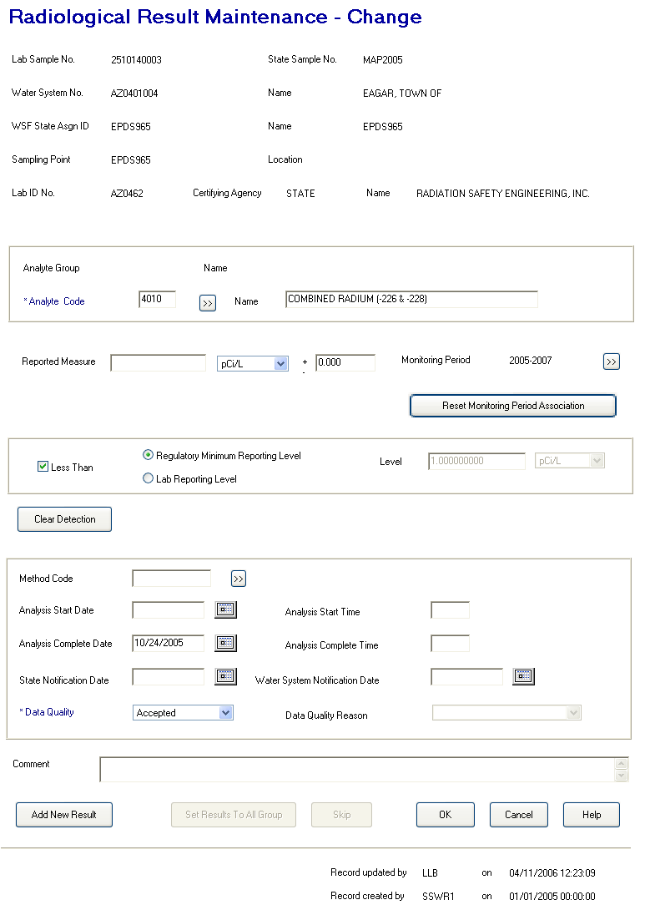

Exhibit 5-24. Radiological Results Maintenance

Reported Measure
(including unit of measure
and counting error) The result obtained from a sample analysis with its associated unit of measure in the [Unit of Measure] field. Enter the counting error in the [Counting Error] field along with the reported measure. The laboratory due to turbidity in the sample or other analytical anomalies estimates this amount of error (usually expressed as a value plus or minus the pCi/L measure).

This field will allow negative values.

The user enters the result and chooses the unit from the dropdown list. Permitted values are those rows from the Unit of Measure table for chemical or radiological result types (C or RA), sorted by the Sort Priority recorded in the Unit of Measure table. This will produce the following list of UOM Codes.

pCi/l – default
mremy
mrem
mg/L
ug/L
ng/L

This is an optional field. The default value will be pCi/l. If a result measure value is provided the Unit of Measure must be selected. If it is not, the error message will be: Analysis Result Concentration Measure Unit may not be left blank.

The result measure must be a numeric value. If it is not, the error message will be: Reported Measure may only be a valid number. If the value is greater than 99999, the error message will be: Value too Large. SDWIS can support up to 6 digits to the left of the decimal.

If the reported level is greater than the level for a result that is indicated as less than, the error message will be: Concentration MUST NOT exceed Reporting Level.

Level
(including the less than
check box) Indicates that the analytical result (Concentration) was less than the regulatory minimum reporting level or the laboratory reporting level, which must be less than or equal to the regulated maximum contaminant level (MCL) for the analyte. Results “less than” these levels are sometimes referred to as “not quantifiable” or “none detected”; selecting the “less than” checkbox and either “Regulating Minimum Reporting Level” or “Lab Reporting Level” is the equivalent of specifying “non-detect” for the analyte.

If the result is less than either level, select the box beside Less Than and then choose either Regulatory Minimum Reporting Level (MDL) or Lab Reporting Level (MRL).

If the user chooses MDL, the current analyte’s regulatory method detection limit is retrieved from the Analyte Level Rule (or TMNALRA) table and displayed in the protected level field.

If the user chooses MRL, he/she must enter a result level in the Level field that is not above the regulated MCL for the current analyte. If left blank, the error message will be: Analysis Result Level may not be left blank.

When the “less than” box is checked, a reporting level type must be selected. If it is not, the error message will be: Reporting Level Type may not be left blank.

Level is the limit established by the laboratory below which scientifically reliable results cannot be achieved. In many cases, if the lab’s detection limit is below the EPA-mandated method detection limit (MDL) then the MDL is used as the detection limit. If the lab’s detection limit is above the EPA’s MDL, then the lab’s detection limit is used.

The user enters the result and chooses the unit from the dropdown list. Permitted values are those rows from the Unit of Measure table for chemical or radiological result types (C or RA), sorted by the Sort Priority recorded in the Unit of Measure table. This will produce the following list of UOM Codes.

pCi/l – default
mremy
mrem
mg/L
ug/L
ng/L

The default value is pCi/L.
Buttons:

All buttons the same as General Result Maintenance page with the following exception.

[Method Code]
Go To If lab certification edit is enabled (reference details under the OK button), list only those standard methods approved for the laboratory and analyte. (R2001:A.5.5.4.c)

OK
Lab Certification
Check (R2001:A.5.5.4.d)
If the sample rejection reason is blank and the SDWIS Configuration Parameter table with Configuration ID = ‘LABCERT’ and Code Table name of ‘LC_EDITCHK’ has a paramter value of ‘ERROR’, continue with the Lab Certification check.

If the data quality code is not equal to R-Rejected, use the specified Laboratory,Method code for specified analyte (analysis complete time, analysis start time, or sample collection end date, in this order of priority and dependent upon a not null value), check for a laboratory analyte method assignment with certification indicator = ‘Y’ and most recent issuance date <= the provided date that is for the analyte. If not found, error message will be: This lab was not certified for this analyte and method during sample processing. Turn the method code and date that was used in the check red, reverse video.

Add New Result Will perform all edits as if OK button were pressed. After successfully adding the sample result the Analyte Entry advisory (documented in above section) will be presented. If the new analyte will result in the Radiological Result Maintenance page being presented, the following fields will be carried forward. If either the Micrological or General Result Maintenance pages will be presented, no data is carried forward.

Less Than
Reporting level type
(If reporting level type is Reporting Minimum Reporting Level then look
up level in TMNALRA and value)
- UOM
- Method Code
- Analysis date and time
- State and Water System Notification dates
- Data Quality
- Data Quality Reason

This button will be available in both add and change mode when a single analyte is used. When an analyte group is used, this button will be disabled until the last analyte of the analyte group has been presented.

Composite Sample Maintenance Pages

Composite Sample Maintenance
Exhibit 5-25 depicts the Composite Sample Maintenance page

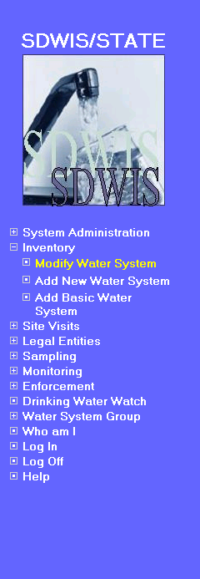 | 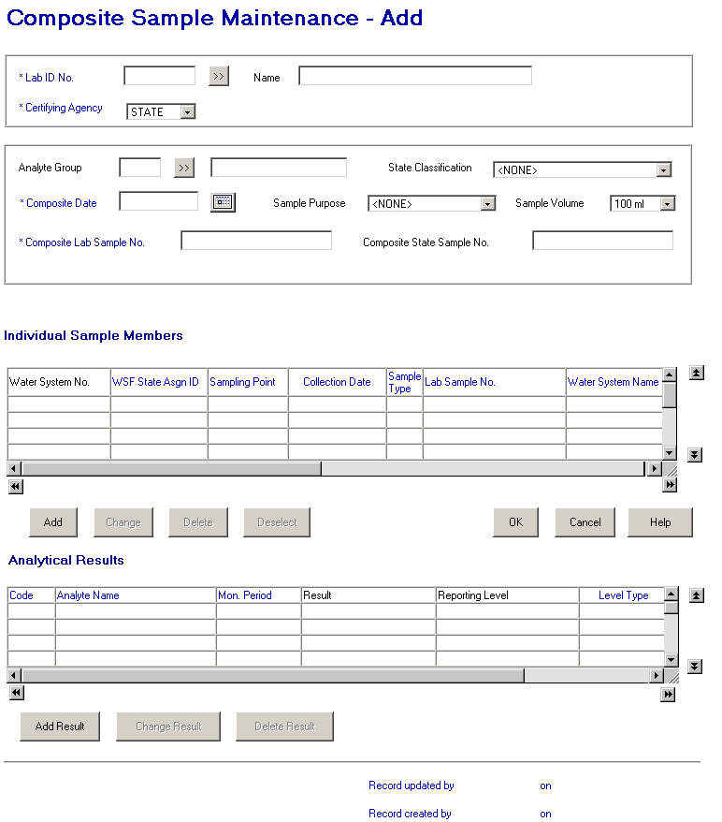

Exhibit 5-25. Composite Sample Maintenance

Entry Fields: In tab sequence.

Lab ID No. The identification number assigned to the laboratory, which performed the analysis. When a value is supplied that is not found, the lab maintenance list page will be presented. A valid value in this field will also populate the Laboratory Name.

This is a required field. If left blank, the error message will be: Laboratory may not be left blank. (R0059:A.5.5.5.a)

Certifying Agency Select a value from the dropdown list. The value will be matched against the laboratory’s Certifying Agency. The selections available via the dropdown list will be retrieved from the TINPVALS table where code_name = “CERT_AG.”

If an exact match is found using the Lab ID No. and Certifying Agency, the laboratory name will be displayed.

If none is found, the Laboratory Maintenance List will be presented in single-select mode.

Certifying Agency will be a required field. It will default to STATE. (R0059:A.5.5.5.b)

(R0059:A.5.5.5.c)

[Laboratory] Name The name of the laboratory. This field will be automatically populated when a valid value is either input or selected in Lab ID No. and Certifying Agency.

When a value is supplied that is not found the lab maintenance list page will be presented. The selection will also populate the Lab ID No. and Certifying Agency. (R0059:A.5.5.5.d)

Analyte Group [Code] The user specified four-character code for the analyte group. Selecting an analyte group in Add mode will determine the type and order of the analytes presented for entry of results. This is used for data entry only and is not stored with the sample.

This is an optional field. When valid code supplied, the analyte group name will be valued. This field is protected in the Change mode.

[Analyte Group Name] The user specified name of the analyte group.

This is an optional field. When valid name supplied, the analyte group code will be valued. This field is protected in the Change mode.

State Classification [Code] This field will allow user to assign the sample to a pre-defined sample group. The permitted values for the dropdown will be retrieved from the CODE table, code_name of ‘SMPSTCLASS’.

If left blank, will default to the state classification code of the analyte of the first sample analytical result added. . (Increase size. (R0036:A.5.5. 5.e))

This is an optional field.

Composite Date The date the sample was composited. A calendar function is available to aid input.

This is an required field. If left blank, the error message will be: The date may not be blank. Must not be a future date. The error message will be: Date must not be a future date.

Sample Purpose This will allow the state to document why sample was taken. The values entered by the System Administrator will be available in a “permitted values” dropdown list. The values will be retrieved from the CODE table, code_name of ‘SMPLPURPOS’.

This is an optional field.

Sample Volume The volume of sample after being composited. Permitted values are:

1 liter
100 ml
300 ml
400 ml
500 ml
[Spaces] (default)

Composite Lab
Sample No The sample identification number assigned by the laboratory for tracking the composite sample within the lab.

This is a required field for all new samples. If the Lab Sample No. is not supplied for a new sample, the error message is Samples must have a Lab Sample No. (Note that this is a change to the way SDWIS/STATE 8.0 works. In SDWIS/STATE 8.0, Lab Sample No. is optional for compliance samples and required for noncompliance samples.)

In change mode, if valued with other than spaces, it may be changed but may not be changed to spaces.

Composite State
Sample No. The sample identification number assigned by a state to uniquely identify a specific composite sample within the state.

This is an optional field.

Individual Sample Members List Items:

Display 4 rows, allow up to 10 rows, default sort, Water System No., WSF State Asgn. ID, Sampling Point, Collection Date, ascending.

Water System No. The number of the water system for the member sample.

WSF
State Asgn ID The water system facility State Assign ID of the sample location.

Sampling Point The sampling point code where the member sample was collected.

Collection Date The date the sample member was collected. Must not be a future date. The error message will be: Date must not be a future date.

Sample Type The sample type of the member sample.

Lab Sample No. The number assigned by the lab to the member sample.

Water System Name The name of the water system for the member sample.

WSF Name The name of the water system facility (WSF) for the member sample.

Sampling Location The name of the sampling point where the member sample was collected.

Buttons:

[laboratory]
Go To Will present the Laboratory Maintenance List. Only the ‘select’ menu will be enabled. Add/change will not be allowed for security reasons.

[analyte group]
Go To Will present the Analyte Group Maintenance List. Only the ‘select’ menu will be enabled. Add/change will not be allowed for security reasons.

[Individual Member]
Add Will present the Individual Sample Member Information page. If the composite already contains five sample members, this button will be disabled. In change mode, all changes made to the parent composite sample should be committed as if the OK buttons was selected prior to presenting the Individual Sample Maintenance page. (Event 13284:B.5.5.5.b)
[Individual Member]
Change Will present the Individual Sample Member Information page for the selected sample in the list box. In change mode, all changes made to the parent composite sample should be committed as if the OK buttons was selected prior to presenting the Individual Sample Maintenance page. (Event 13284:B.5.5.5.c)

This button will only be enabled if a selection has been made in the list box.

[Individual Member]
Deselect Will remove highlight from all selections in the Individual Sample Members list box.

This button will only be enabled if a selection has been made in the list box.

[Individual Member]
Delete Will attempt to delete the sample member. If the sample has any results associated to it, the delete request will be denied. If any associated results have an association to a violation or sample schedule, the error message will be: May not delete the result because it is associated to a violation. Otherwise the error message will be: At least one Result exists for this Sample – first delete all Results for Sample.

If no results are associated, will present the Delete Confirmation page (Exhibit 5-26).
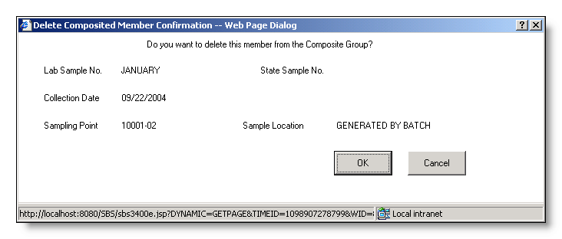
Exhibit 5-26. Delete Confirmation

Buttons:

OK Will delete the composite member sample.

Cancel Will abort the delete request and return to the Composite Sample Maintenance page.

OK Will be enabled when all required information, including at least one individual sample member has been provided.

Add-mode The parent composite sample is added when the first individual sample is created.

Change-mode The changes to the parent composite sample will be committed. (Event 13284:B.5.5.5.a)

Cancel If no changes were made, the page will close and return to either the Sample/Sample Summary Maintenance List

If changes were made, the standard confirmation page will be presented.

Help Will invoke the system online Help facility.

Analytical Results List Fields:

Display 4 rows, allow up to 100 rows, default sort analyte code ascending. The sample analytical results presented are those associated to the composite sample.

[Analyte] Code The four-digit code of an analyte.

Analyte Name The name of the analyte for which the sample was tested.

Monitoring Period Name The name of the monitoring period for the result.

Result For a Microbiological analyte, the software will display whether the analyte was present or absent plus the count of organisms (all three fields).

For a Radiological analyte, if the result is less than detect, the software will display the less-than sign (<). If it is not less-than detect, the software will display the result plus the counting error plus the unit of measure.

For all other analytes, if the result is less than detect, the software will display the less-than sign (<). If it is not less-than detect, the software will display the result plus the unit of measure.

Level Type The level type against which the detection was measured. Values are MDL (Regulatory Minimum Reporting Level) or MRL (Lab Reporting Level).

Reporting Level When MDL, this value is the reporting level set by the regulation. When it is MRL, it is the value set by the laboratory, which must be less than the regulatory level.

[Monitoring Period]
Begin Date The begin date of the monitoring period for which this sample result applies. Must not be a future date. The error message will be: Date must not be a future date.

[Monitoring Period]
End Date The end date of the monitoring period for which this sample result applies. May be a future date.

Add Result Will perform all edits as if OK button were pressed. After successfully adding or modifying sample(s), the software will present the Analytical Result Maintenance page. If an Analyte Group was selected and no results exist, pressing this button will present the Analytical Result maintenance page that corresponds to the analyte type (as specified for the Add Result button for the General Sample Maintenance page) of the first analyte in the group. Otherwise, the user will be prompted to enter an analyte on the Analyte Entry page (Exhibit 5-16). Based on the Type Code of the analyte, the software will flow to the appropriate result maintenance page.

Analyte Entry

Exhibit 5-27 depicts the Analyte Entry Selection page.

Exhibit 5-27. Analyte Entry

Entry field:

Analyte Code The four-digit analyte code for which a result will be entered for this sample.

This is a required field. When a valid value is entered, the name will be presented. If an invalid value is entered, the Analyte Maintenance List will be presented in single-select mode.

[Analyte] Name The name of the analyte. When a valid value is entered, the code will be presented. If an invalid value is entered, the Analyte Maintenance List will be presented in single-select mode.

Buttons:

[analyte]
Go To Will present the Analyte Maintenance List.

OK Using the Type Code of the selected analyte, the software will flow to the appropriate Result Maintenance page as specified below.

Analyte Type Code | Result Maintenance Page
IOC, OC, WQ, OT | General Result
RA | Radiological
MOR | Microbiological

Cancel Will close the page and return to the General Sample maintenance page.

Help Will invoke the system online Help facility.

Change Result Will present the Analytical Result maintenance page in change mode. This item is only available if a result has been selected in the list area.

Delete Result Will present the Delete Confirmation page (Exhibit 5-28).
Exhibit 5-28. Delete Confirmation

Buttons:

OK If the result has an association to a violation, the delete request will be denied.

Before deleting a result, if the result was created by CDSSETUP (d_userid = CDSSETUP), the software will present the advisory CDS Setup automatically created this result and will not recreate it if deleted. Do you wish to proceed? The advisory dialog box will have a Yes and No buttons to allow the user to confirm or cancel the delete request.

When the delete is confirmed, the following actions are performed for the selected sample analytical result associated to the composite sample. These changes will not be undone if the Cancel button is subsequently selected

- Locate each SAR associated to an individual sample member of the same Composite sample which has a matching analyte, uom_code, and detection_limit_uom_code as the composite’s sample analytical result that is selected for deletion. For each SAR found:
- For Each SSMPA associated to the SAR (via the SSMPA_SAR_ASSOCIATION (TMNSPSRA))
- update the d_last_updt_ts to the current timestamp
- update the d_userid_code to CDSSETUP.
- For Each sub-SSMPA associated to the SAR (via the SPUBA_SAR_ASSOCIATION (TMNSBSRA))
- update the d_last_updt_ts to the current timestamp
- update the d_userid_code to CDSSETUP.
- Delete the individual member’s sample analytical result (TSASAR) along with a cascade delete of all associated:
- SSMPA_ SAR_ASSOCIATION (TMNSPSRA)
- SPUBA_ SAR_ASSOCIATION (TMNSBSRA)
- OTHER SAMPLE MEASURE (TSAOSM)
- Finally the sample analytical result (TSASAR) of the composite sample is deleted along with a cascade delete of all associated:
- OTHER SAMPLE MEASURE (TSAOSM)

Cancel Will abort the delete and return to the sample result maintenance list.

Protected Fields:

Record updated
by XXXXXXXX on
MM/DD/YYYY
HH:MI:SS The User ID and the timestamp from the last time the sample record (TSASAMPL) was updated.

Record created
by XXXXXXXX on
MM/DD/YYYY
HH:MI:SDWIS/STATE The initial User ID and timestamp when the sample (TSASAMPL) record was initially added to the database.

Individual Sample Member Information
Exhibit 5-29 depicts the Individual Sample Member Information page.

Protected Fields:

Total Composite Members The number of member samples composing the composite sample.

[Water System Facility]
Name The name of the selected water system facility. Populated when a valid water system facility number is entered or a valid sampling point/location is entered.

Record updated
by XXXXXXXX on
MM/DD/YYYY
HH:MI:SS The User ID and the timestamp from the last time the sample record (TSASAMPL) was updated.

Record created
by XXXXXXXX on
MM/DD/YYYY
HH:MI:SS The initial User ID and timestamp when the sample (TSASAMPL) record was initially added to the database.

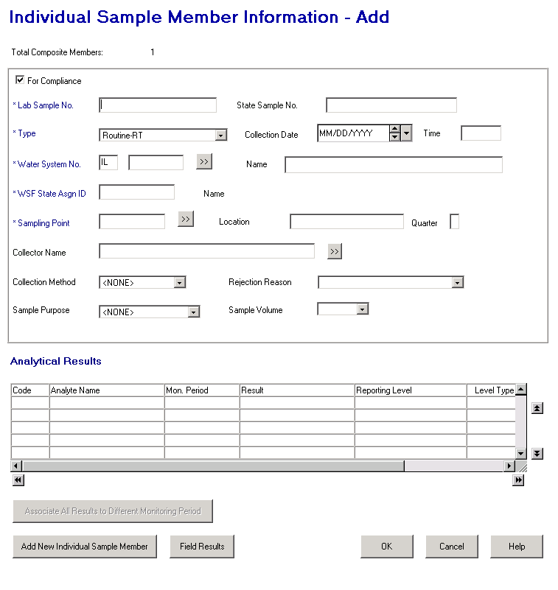

Exhibit 5-29. Individual Sample Member Information

Entry Fields:

For Compliance This check box marks the sample as being used for compliance determination. When it is checked, the sample will be used for compliance if the sample type is Routine, Repeat, or Confirmation. The default is checked. Compliance samples have different rules than noncompliance samples. These are indicated below.
Lab Sample No. The unique number assigned by the laboratory for tracking this sample.

This is a required field for all new samples. If the Lab Sample No. is not supplied for a new sample, the error message is Samples must have a Lab Sample No. (Note that this is a change to the way SDWIS/STATE 8.0 works. In SDWIS/STATE 8.0, Lab Sample No. is optional for compliance samples and required for noncompliance samples.

In change mode, if valued with other than spaces, it may be changed but may not be changed to spaces.

State Sample No. The unique number assigned by the state for tracking this sample.

This is an optional field.

Type The reason for the sample collection. Valid selections are:

RT – Routine
RP – Repeat
CO - Confirmation
BB - Batch Blanks
DU - Duplicate
FB - Field Blanks
PE - Performance Evaluation
SB - Shipping Blanks
SP – Special
SL - Split
ST - Split Blanks

This is a required field. If the sample type is entered or changed to any value other than Routine (RT), Repeat (RP), or Confirmation (CO), the software will uncheck the For Compliance checkbox. A user may recheck it (even if the Sample Type is not equal to RT, RP, or CO) but the sample will not be considered or processed by SDWIS compliance determination.

Collection Date The date the sample was collected. A calendar function is available to aid input.

This is a required field. Must not be a future date. The error message will be: Date must not be a future date. If left blank, the error message is All samples must have a Collection Date

When the composite date is provided, the collection date must be same or prior to the composite date. When it is not, the error message will be: Composite sample member collection date may not be after Composite date.

Collection Time The time the sample was collected (in local time).

This is an optional field. The value cannot be greater than or equal to 2400. If so, the error message will be: Time entries must be between 00:01 and 23:59.

Water System No. The specific Water System No., consisting of the two-character state code plus the seven-character number field.

The state code portion will default to the state_identification_code in the SYSTEM_VARIABLE entity view.

When tabbing off this field after supplying a value, the water system will be retrieved and the name displayed and the WSF State Asgn ID, sampling point, and sampling point location field and sampling point Go To button will be enabled. Any value in the WSF State Asgn ID, WSF Name, Sampling Point and Sampling Location fields will be removed.

If the supplied value is invalid, the Water System Maintenance List will be presented.

If a valid water system is entered but is not part of the user’s current Water System Group or Regulating Agency, invoke exit state error message: WS is not part of current group/agency. Change group/agency to access this WS.

This is a required field. If it is left blank, the error message will be: Water System No. must not be blank.

[Water System] Name Standard 40-character Public Water System Name may be entered completely, partially, or left blank. If the user specifies a partial string in this field, display the closest matching water system at the top of the list. (Closest matching means a match with the Water System Name, sorted alphabetically, that starts with the same text string as supplied.)

If a valid water system name is entered the Water System No. is populated and the WSF State Asgn ID, sampling point and sampling point location and sampling point Go To button will be enabled. Any value in the WSF State Asgn ID, WSF Name, Sampling Point and Sampling Location fields will be removed.

If a valid water system is entered but is not part of the user’s current Water System Group or Regulating Agency, invoke exit state error message: WS is not part of current group/agency. Change group/agency to access this WS.

If the name entered is not found, the software will flow to the Water System Maintenance List. The user may then select a value and continue.

WSF State Asgn ID The water system facility state assigned ID of the sample location. This field will be enabled when the water system is selected.

When tabbing off this field after supplying a value, the value will be retrieved and the name displayed. Any existing value in the sampling point or location will be removed.

If the supplied value is invalid, the error message will be: The WSF State Asgn ID entered does not belong to this water system.

This is an optional entry field. It will be valued with the WSF of the selected sampling point/location.

If this field is modified, the value of the [WSF] Name, Sampling Point, and Sample Location fields will be cleared.

Sampling Point The ID of the sampling point where the sample was taken. This field will be enabled when the water system is selected.

When tabbing off or clicking outside this field after supplying a value, the software will function the same as described for this field on the Coliform Sample Maintenance page with the following exception: if the sample type is a repeat or confirmation; or is a routine with the replacement indicator checked and the collection date is provided, the Original Sample Information will be presented.

Sampling Point is an optional entry field since it can be populated with entry in the Sampling Point Location field. The Sampling Point is required to complete processing of the Composite Sample. Providing a valid sampling point will also populate the WSF State Asgn ID and the Sampling Point Location fields.

[Sampling Point]
Location The name of the sampling point. This field will be enabled when the water system is selected.

When tabbing off this field after supplying a value, the software will function the same as described for this field on the Coliform Sample Mainteannce page with the following exception: if the sample type is a repeat or confirmation; or is a routine with the replacement indicator checked and the collection date is provided, the Original Sample Information will be presented.

Sampling Point Location is an optional entry field since it can be populated with entry in the Sampling Point field. Providing a valid sampling point will also populate the WSF State Asgn ID and the Sampling Point Location fields.

Quarter The quarter number (1, 2, 3, or 4) during which the radionuclide sample to be composited was taken. Quarter normally corresponds to a calendar quarter, i.e., the first quarter includes January through March, the second quarter includes April through June, etc.

This is an optional field.

Collector Name The name of the individual who collected the sample.

If the entered individual does not exist as a valid legal entity with collector_indicator_code = ‘Y,’ then set TSASAMPL informal_collector equal to entered individual.

This is an optional field.

Collection Method The standard method used to collect the sample. When a value is supplied, it must be pre-defined in the standard methods table. If the value supplied is not found, a selection list of standard methods will be presented.

This is an optional field.

Rejection Reason The reason a lab rejected a sample for further analysis. Permitted values will be:

BR - Broken
CL - Chlorine present
EH - Exceeds holding time
HS - Excessive headspace
FZ - Frozen sample
IN - Insufficient information
VO - Insufficient volume
BP - Invalid sampling point
IP - Invalid sampling protocol
LA - Lab accident
LT - Leaked in transit

This is an optional field.

Sample Purpose This will allow the state to document why sample was taken. The values entered by the System Administrator will be available in a “permitted values” dropdown list. The values will be retrieved from the CODE table, code_name of ‘SMPLPURPOS’.

This is an optional field.

Sample Volume The volume of sample collected and submitted to the laboratory. Permitted values are:

1 liter
100 ml
300 ml
400 ml
500 ml
[Spaces] (default)

Analytical Results List Fields:

Display 4 rows, allow up to 100 rows, default sort analyte code ascending. The sample analytical results presented are those associated to the individual sample member.

[Analyte] Code The four-digit code of an analyte.

Analyte Name The name of the analyte for which the sample was tested.

Monitoring Period Name The name of the monitoring period for the result.

Result For a Microbiological analyte, the software will display whether the analyte was present or absent plus the count of organisms (all three fields).

For a Radiological analyte, if the result is less than detect, the software will display the less-than sign (<). If it is not less-than detect, the software will display the result plus the counting error plus the unit of measure.

For all other analytes, if the result is less than detect, the software will display the less-than sign (<). If it is not less-than detect, the software will display the result plus the unit of measure.

Level Type The level type against which the detection was measured. Values are MDL (Regulatory Minimum Reporting Level) or MRL (Lab Reporting Level).

Reporting Level When MDL, this value is the reporting level set by the regulation. When it is MRL, it is the value set by the laboratory, which must be less than the regulatory level.

[Monitoring Period]
Begin Date The begin date of the monitoring period for which this sample result applies. Must not be a future date. The error message will be: Date must not be a future date.

[Monitoring Period]
End Date The end date of the monitoring period for which this sample result applies. May be a future date.

Buttons:

[water system]
Go To Will present the water system maintenance list. Only the Edit/Select item will be enabled. Once a valid water system is selected, the software will remove any existing value from WSF State Asgn ID, WSF Name, Sampling Point, and Sampling Location.

[sampling point]
Go To Will present the sampling point maintenance list of sampling points for the selected water system. Only the Edit/Select item will be enabled.

This button will be enabled with a valid water system has been supplied.

[collector]
Go To Will present the Legal Entity Maintenance List displaying INDIVIDUALs designated as collectors. Only the Edit/Select item will be available.

Add New Individual
Sample Member Will perform all edits as if OK button were pressed. After successfully adding the sample, the maintenance window will redisplay. The following fields will have their value retained:

Sample Type
Water System No. and Name
Water System Facility information
Sampling Point information

The Total Composite Members count will be incremented by the addition.

Associate All
Results to Different
Monitoring Period Will present the Monitoring Period Maintenance List in single-select mode. Once a monitoring period is selected, the software will do the following for each result associated to the Individual Sample Member. These changes will not be undone if the Cancel button is subsequently selected
- Associate the SAR to the newly selected monitoring period.
- For Each SSMPA associated to the SAR(via the SSMPA_SAR_ASSOCIATION (TMNSPSRA))
- update the d_last_updt_ts to the current timestamp
- update the d_userid_code to CDSSETUP.
- For Each sub-SSMPA associated to the SAR (via the SPUBA_SAR_ASSOCIATION (TMNSBSRA))
- update the d_last_updt_ts to the current timestamp
- update the d_userid_code to CDSSETUP.

Field Results Will perform all edits as if OK button were pressed. After successfully editing the sample and results, the software will flow to the Field Results page described below.

OK If both Sampling Point and Location are blank, the error message will be: Each Sample must have EITHER a Sampling Point or Sample Location.

Duplicate Check Will be performed first on the composite, then on each sample member prior to adding or updating the sample.

The duplicate check is performed when Lab Sample No. is supplied. If a record with the same Lab Sample No., Laboratory, and Collection Year/Composite Year already exists in the database, then the software will present the following error message: A sample with this same Lab Sample No. for the same Laboratory collected in the same year already exists. On clicking OK on the error message dialog box, the software will return to the maintenance page with the cursor at the end of the value entered in the Lab Sample No. field.

Add-mode When the first sample member is added, the parent composite will be added first. The composite sample will be associated to the same water system (EV13282.B.5.5.6.a) as the first member sample. The composite’s sample type will be the same as the first member sample. The composite_indicator_code will be set to ‘Y’ on both the parent composite and the individual member samples. The d_last_update_timestamp, d_initial_timestamp, and d_userid_code, and d_initial_userid will be set to current values.

When additional member samples are added, they will be associated to the parent composite sample. The composite_indicator_code will be set to ‘Y’ on the individual member sample. The d_last_update_timestamp, d_initial_timestamp, and d_userid_code, and d_initial_userid will be set to current values. If the subsequent sample members are for a different water system, then the parent composite sample will be disassociated from any water system indicating that the composite is over geography. The composite sample will retain the sample type as the first member.

If the water system or water system facility is different from existing members, an advisory will be presented: (EV13282.B.5.5.6.b)

The Water System or WSF for the composite member you are entering is different from the previous composite member(s) in the group.

This is an advisory. You can, however, proceed with the entry of the composite member using the current water system.

Buttons:

Proceed Will continue with the addition.

Cancel Will abort the add request.

The page will close and return to the Composite Sample Maintenance page. The new member sample will display in the list area.

A total of ten member samples may comprise a composite. When the tenth sample is added, the page will return to the Composite Sample Maintenance List. The ADD button will be disabled.

Change-Mode Any information about the selected member sample can be changed but is subject to all business rules as an add request.

When Collector Name is changed
From spaces to a value, if the value is a valid LEGAL_ENTITY associate the two. If not, populated the TSASAMPL informal_collector with the name.
From one value to a different value, remove the old value from TSASAMPL informal_collector or disassociate from the existing LEGAL_ENTITY. If the new value is a valid LEGAL_ENTITY associate the two. If not, populated the TSASAMPL informal_collector with the name.
From an existing value to spaces, remove the old value from TSASAMPL informal_collector or disassociate from the existing LEGAL_ENTITY
All changes should be reflected in the list area when the page returns to the Composite Sample Maintenance page.

Cancel Will return to the Composite Sample Maintenance page.

If changes have been made, the standard cancel confirmation will be presented.

Help Will invoke the system online Help facility.

MDBP Summaries
Monitoring under the Surface Water Treatment Rules, Disinfectant/Disinfection By Products Rules, and Ground Water Rule will generally be conducted onsite with sampling at a high frequency. Therefore, Water Systems will send summarized data to the primacy agency. Much of this summarized data will be entered and maintained in the new MDBP Summaries.

Model Changes for MDBP Summary
No Model changes planned for this release.

Water Treatment (WT) Summary Page Flow
The SDWIS/STATE Page will present the following options when the Sampling option is selected:

- Add Sample/Sample Summary
- Maintain Sample/Sample Summary
- MDBP Summaries
- Maintain Results Averages
- Maintain WQP Days Out of Compliance

The following options will be presented when the MDBP Summaries option is selected:

- WT Summary (B.5.6.a)
- MRDL Summary
- General MDBP Summary

Water Treatment Summary
This series of six pages is intended for the entry of summarized data that will track Water Systems’ compliance with the MDBP rules. This group will include all systems with disinfection treatment. Users will be able to use an “automated” flow from one page to what is most commonly the next page or to use a button to alter the automated flow as desired.

From the SDWIS/STATE Home Page Sampling option, if the user selects MDBP Summaries and the WT Summary option, the software will flow to the WT Summary Category Selection page (Exhibit 5-30), where the user must specify the Water System and Monitoring Period.
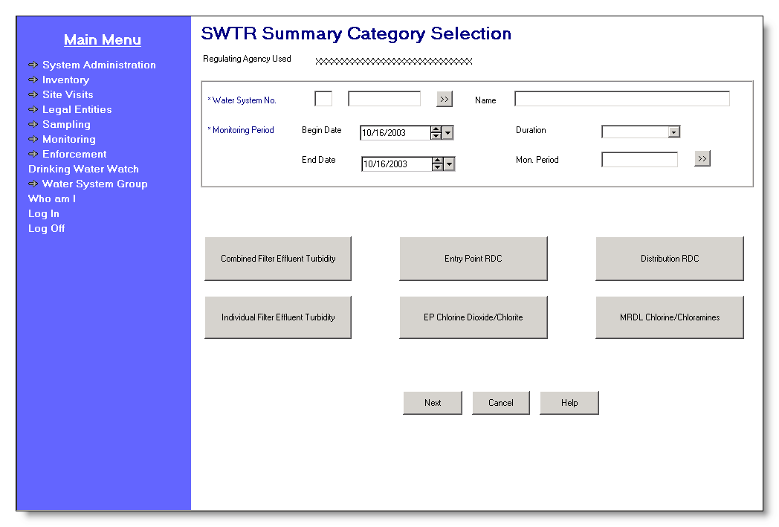

Exhibit 5-30. WT Summary Category Selection

These pages are designed so that users can move easily from one page to another, in any direction. Alternatively, users may press the Next button to follow a prescribed page flow that moves sequentially through the buttons starting with Combined Filter Effluent Turbidity, Individual Filter Effluent Turbidity, Entry Point RDC, EP [Entry Point] Chlorine Dioxide/Chlorite, Distribution RDC, and MRDL Chlorine/Chloramine.

Protected Fields:

Regulating Agency
Used/Current WS
Group Used This protected field will show the user’s current Water System
Group Name or Regulating Agency depending on which the user has made current. The software will dynamically change the prompt depending on whether Water System Group Name or Regulating Agency is current. The prompt will be “Current WS Group” if the user’s current Water System Group is valued, otherwise the prompt will be “Regulating Agency Used.”

Entry Fields:

Water System No. The specific Water System No., which consists of the two-character state code plus the seven-character number field.

The state code portion will default to the state_identification_code in the SYSTEM_VARIABLE entity view.

The cursor will be positioned in the numeric portions.

The Go To button may be pressed to select a water system from the Water System Maintenance List in single-select mode, which will display a list of water systems that are part of the current Water System Group or Regulating Agency. Once a valid water system has been entered or picked from a list, the water system name will be displayed on the page. If the user specifies a partial string in this field, display the closest matching water system at the top of the list. (Closest matching means a match with the Water System No., sorted alphabetically, that starts with the same text string as supplied.)

If a valid water system is entered but is not part of the user’s current Water System Group or Regulating Agency, invoke exit state error message: WS is not part of current group/agency. Change group/agency to access this WS.

Water System No. will be a required field.

Once a valid Water System is selected, the software will enable the [Monitoring Period] Begin Date and [Monitoring Period] Duration fields and return the cursor to the first Monitoring Period field.

[Water System]
Name Standard 40-character Public Water System Name may be entered completely, partially, or left blank. If the user specifies a partial string in this field, display the Water System Maintenance List in single-select mode with the closest matching water system at the top of the list. (Closest matching means a match with the Water System Name, sorted alphabetically, that starts with the same text string as supplied.)

If a valid water system name is entered, the Water System No. is populated.

If a valid water system is entered but is not part of the user’s current Water System Group or Regulating Agency, invoke exit state error message: WS is not part of current group/agency. Change group/agency to access this WS.

If the name entered is not found, the software will flow to the Water System Maintenance List in single-select mode. The user may then select a value and continue.

Monitoring Period The four Monitoring Period fields will be enabled only after the user values Water System No. The user may select a valid monitoring period by any of this combination: Mon. Period [Name]; Begin Date + Duration; Begin Date + End Date; Duration + End Date or by pressing the Monitoring Period Go To button.

Monitoring Period is a required field.

[Monitoring Period]
Begin Date If Begin Date and either End Date or Duration are valued, on tabbing off, the software will retrieve the monitoring period that matches the criteria and display it in all monitoring period fields. If no monitoring period exists that matches the criteria, it will invoke the Monitoring Period Maintenance List in single-select mode, sorted on Monitoring Period Begin Date descending then on Monitoring Period End Date ascending. The software will take no action if only Begin Date is valued.

[Monitoring Period]
End Date If End Date and either Begin Date or Duration are valued, on tabbing off the software will retrieve the monitoring period that matches the criteria and display it in all monitoring period fields. If no monitoring period exists that matches the criteria, it will invoke the Monitoring Period Maintenance List in single-select mode, sorted on Monitoring Period Begin Date descending then on Monitoring Period End Date ascending. The software will take no action if only End Date is valued.

Mon. Period [Name]
If the user enters a valid monitoring period name, on tabbing off, the software will retrieve the monitoring period that matches the criteria and display it in all monitoring period fields. If the user enters a partial string or an invalid monitoring period name, the Monitoring Period Maintenance List will be invoked in single-select mode, sorted on Monitoring Period Name ascending.

[Monitoring Period]
Duration The user may enter a valid monitoring period Duration. (B.5.6.3.a) If Duration and either Begin Date or End Date are valued, on tabbing off, the software will retrieve the monitoring period that matches the criteria and display it in all monitoring period fields. If no monitoring period exists that matches the criteria, the software will invoke the Monitoring Period Maintenance List in single-select mode. The software will take no action if only Duration is valued.

Once a valid Water System and Monitoring Period have been selected, the six buttons, Combined Filter Effluent Turbidity, Individual Filter Effluent Turbidity, Entry Point RDC, EP Chlorine Dioxide/Chlorite, Distribution RDC, and MRDL Chlorine/Chloramines will be enabled.

Tab Sequence:

Water System No. [the seven-character, number field], Water System No. Go To button, [Water System Name], [Monitoring Period] Begin Date, [Monitoring Period] Duration, [Monitoring Period] End Date, Mon. Period [Name], Monitoring Period Go To button, Combined Filter Effluent Turbidity button, Individual Filter Effluent Turbidity button, Entry Point RDC button, EP Chlorine Dioxide/Chlorite button, Distribution RDC button, MRDL Chlorine/Chloramines button, Next button, Cancel button, Help button.

Buttons:

[water system]
Go To Will present the Water System Maintenance List in single-select mode. If the user has typed part of the Water System No., it will be used in the search to invoke the Water System Maintenance List in single-select mode. The user may select a water system from this list.

[monitoring period]
Go To The user may use this Go To button to select a single, valid monitoring period from the Monitoring Period Maintenance page. The Go To Button will be enabled only after the user values the Water System No. field (B.5.6.3.b). As the user selects the Monitoring Period, the software will then populate the retrieved Monitoring Period Begin Date and Duration.

Combined Filter
Effluent
Turbidity When the user presses this button, the following actions will occur:

- If there is only one treatment plant (active or inactive) for the current Water System, the software will select that treatment plant (Water System Facility of type “TP”).

- If a WSF of type “TP” is not found, the following error message will be invoked: Treatment Plant WSF not found for this Water System. If more than one is found, the Water System Facility Maintenance List in single-select mode will be invoked which will display active and inactive treatment plants for the current Water System where the user must choose one.

(2) After the WSF has been selected, the software will select each Facility Analyte Level (FANL) that is linked to the current WSF and establish for turbidity (Analyte Code 0100) an average level (under the old Turbidity Rule—Level Type is equal to “AVG”), or a maximum single result level (Level Type is equal to “MAX”), and/or a level that at least 95% of the results must be less than or equal to (Level Type is equal to “95P”). This will result in the selection of one and possibly two FANL records:

- One whose field Summary Type is either “AVGT” or “MAXT.”

- One whose field Summary Type is “95PT.”

If no FANL meeting any one of these criteria is found, invoke exit state error: FANL of type AVG, MAX, or 95P not found for this WSF.

(3) If a FANL meeting these criteria is found, the software will run the selected FANL(s) through the following checks that may let the user know that a FANL exists but still cannot be used. If any of these checks is validated, an error message will be invoked.

- If one or more FANL is found but none of the FANL found are in effect on the first day of the user-selected monitoring period (FANL Effective Begin Date is on or before the Monitoring Period Begin Date), the following error message will be invoked: No FANL of type “AVG,” “MAX,” or “95P” is in effect during this monitoring period.

- If one or more FANL is found but none of the FANLs found have the field MDBP Summary Check Flag set to Y (Yes), the following error message will be invoked: No Facility Analyte Level with MDBP Summary Check Flag set to YES not found.

- If one or more FANL is found but none of the FANL found indicate a Summary Type of “AVGT,” “MAXT,” or “95PT,” invoke error exit state message: Facility Analyte Level with MDBP Summary type AVGT, MAXT, or 95PT not found.

- If one or more FANL is found that satisfies the above criteria and is in effect on the first day of the user-selected monitoring period, the software will select it and go to step (4).

(4) The software will next select:

- One MDBP Summary that is linked to the FANL whose field Summary Type is either “AVGT” or “MAXT” and is linked to the user-specified monitoring period; in addition, it will select

- One MDBP Summary that is linked to the FANL whose field Summary Type is “95PT” and is linked to the user-specified monitoring period.

(5) The software will then flow to the Combined Filter Effluent Turbidity page, displaying the selected Water System No., Water System Name, WSF State Asgn ID., WSF Name, Monitoring Period Begin Date, Monitoring Period Duration, and FANL.

- If it finds one of the first two MDBP Summaries described above, it will also display its data in the page in Change mode with the cursor in the first entry field.

- If it finds an MDBP Summary of Type “95PT,” it will display its data in the page in Change mode.

- If it does not find any of the three possible MDBP Summaries, this page will appear in Add mode.

Individual Filter
Effluent Turbidity When the user presses this button, the following actions will occur:

(1) If there is only one treatment plant (active or inactive) for the current Water System, the software will select it (WSF of type “TP”).

If WSF of type “TP” is not found, the following error message will be invoked: Treatment Plant WSF not found for this Water System.

- If more than one is found, invoke the Water System Facility Maintenance List, which will display active and inactive treatment plants for the current Water System where the user must choose one.

(2) After the WSF has been selected, the software will select the FANL that establishes a level for turbidity (Analyte Code 0100) that at least 95% of the results must be less than or equal to (LEVEL_TYPE is equal to “95P”), and that requires individual filters to be monitored

(INDIV_FILTER_MNTRNG_REQD_FLAG is equal to “Y”), and is linked to the current WSF. This will result in the selection of zero or one FANL record.

If a FANL meeting these criteria is not found, the following error message will be invoked: A FANL requiring that individual filters be monitored not found for this WSF.

(3) If a FANL meeting these criteria is found, the software will run the selected FANL through the following checks that would let the user know that a FANL may exist but still cannot be used. If any of these checks is validated, an error message will be invoked. After the user presses OK on the message.

- If the FANL found is not in effect on the first day of the user-selected monitoring period (FANL Effective Begin Date is on or before the Monitoring Period Begin Date), the following error message will be invoked: Facility Analyte Level not in effect during this monitoring period.

- If the FANL found does not have its field MDBP Summary Check Flag set to Y, the following error message will be invoked: Facility Analyte Level with MDBP Summary Check Flag set to YES not found.

- If the FANL found does not indicate a Summary Type of “95PT,” the following error message will be invoked: Facility Analyte Level with MDBP Summary type 95PT not found.

- If a FANL is found that satisfies the above criteria and is in effect on the first day of the user-selected monitoring period, the software will select it and go to step (4).

(4) The software will next select an MDBP Summary for Individual Filter Effluent Turbidities (Summary Type is “IFT”) that is linked to the selected FANL and linked to the user-specified monitoring period.

(5) The software will then flow to the Individual Filter Effluent Turbidity page, displaying the selected Water System No., Water System Name, WSF State Asgn ID., WSF Name, Monitoring Period Begin Date, Monitoring Period Duration, and FANL.

- If it finds an MDBP Summary that satisfies the criteria in Step (4), it will also display its data in the page in Change mode, with the cursor in the first entry field.

- If it does not find an MDBP Summary that satisfies the criteria in Step (4), this page will appear in Add mode.

Entry Point RDC When the user presses this button, the following actions will occur:

(1) If there is only one treatment plant (active or inactive) for the current Water System, the software will select that treatment plant (Water System Facility of type “TP”).

If a WSF of type “TP” is not found, the following error message will be invoked: Treatment Plant WSF not found for this Water System.
If more than one is found, the Water System Facility Maintenance List in single-select mode will be invoked, which will display active and inactive treatment plants for the current Water System where the user must choose one.

(2) If there is only one entry point sampling point (sampling point of Type “EP,” whether active or inactive) associated to the only treatment plant for the current Water System (WSF of Type “TP,” whether active or inactive), the software will select it.

- If not found, the following error message will be invoked: Entry point/sampling point not found for this Treatment Plant WSF.

- If more than one entry point sampling point is associated to a treatment plant, the software will invoke the Sampling Point Maintenance/Selection List, which will display Sampling Points of type EP for WSFs of type TP for the current Water System, where the user must choose one.

(3) After a treatment plant and entry point sampling point have been selected, the software will select the FANL that establishes a minimum level for either chlorine (Analyte Code 0999) or chloramine (Analyte Code 1006) for the selected treatment plant. This will result in the selection of zero, one, or two FANL records.

If a FANL meeting these criteria is not found, the following error message will be invoked: FANL for chlorine (0999) or chloramine (1006) of type MIN not found for this WSF.

(4) If a FANL meeting these criteria is found, the software will run the selected FANL(s) through the following checks that may let the user know that a FANL exists but still cannot be used. If any of these checks is validated, an error message will be invoked.

- If one or more FANL are found but none of the FANL found are in effect on the first day of the user-selected monitoring period (FANL Effective Begin Date is not on or before the Monitoring Period Begin Date), the following error message will be invoked: Facility Analyte Level not in effect during this monitoring period.

- If one or more FANL is found but none of the FANL found have its field MDBP Summary Check Flag set to “Y,” the following error message will be invoked: Facility Analyte Level with MDBP Summary Check Flag set to YES not found.

- If one or more FANL is found but none of the FANL found indicate a Summary Type of “EPRD” (i.e., federal Entry Point Residual Disinfectant Concentration) or “ SERD” (state Entry Point Residual Disinfectant Concentration), the following error message will be invoked: Facility Analyte Level with MDBP Summary Type EPRD or SERD not found.

- If one or more FANL is found that satisfies the above criteria and is in effect on the first day of the user-selected monitoring period, the software will select it and go to step (5).

(5) The software will next select:

- One MDBP Summary that is linked to the FANL whose field Summary Type is “EPRD” and is linked to the user-specified monitoring period; it will also select

- One MDBP Summary that is linked to the FANL whose field Summary Type is “SERD” and is linked to the user-specified monitoring period.

(6) The software will then flow to the Entry Point RDC page, displaying the selected Water System No., Water System Name, WSF State Asgn ID., WSF Name, Monitoring Period Begin Date, Monitoring Period Duration, and FANL.

- If it finds either one of the MDBP Summaries described above, it will also display its data in the page in Change mode with the cursor in the first entry field.

- If it does not find any of the possible MDBP Summaries, this page will appear in Add mode.

EP Chlorine Dioxide/
Chlorite When the user presses this button, the following actions will occur:

(1) If there is only one treatment plant (active or inactive) for the current Water System, the software will select that treatment plant (Water System Facility of type “TP”).

- If a WSF of type “TP” is not found, the following error message will be invoked: Treatment Plant WSF not found for this Water System.

If more than one is found, the Water System Facility Maintenance List in single-select mode will be invoked which will display active and inactive treatment plants for the current Water System where the user must choose one.

(2) If there is only one entry point sampling point (sampling point of Type “EP,” whether active or inactive) associated to the only treatment plant for the current Water System (WSF of Type “TP,” whether active or inactive), the software will select it.

- If not found, the following error message will be invoked: Entry point/sampling point not found for this Treatment Plant WSF.

- If more than one entry point sampling point is associated to a treatment plant, the software will invoke the Sampling Point Maintenance/Selection List, which displays Sampling Points of type “EP” for WSFs of type “TP” for the current Water System, where the user must choose one.

(3) After the WSF and sampling point have been selected, the software will select the FANL that establishes a maximum level (Level Type is “MAX”) for either chlorine dioxide (Analyte Code 1008) or chlorite (Analyte Code 1009) that is linked to the current WSF. This will result in the selection of zero, one, or two FANL records.

If a FANL meeting these criteria is not found, the following error message will be invoked: FANL for chlorine dioxide (1008) or chlorite (1009) of type MAX not found for this WSF.

(4) If a FANL meeting these criteria is found, the software will run the selected FANL(s) through the following checks that would let the user know that a FANL exists but still cannot be used. If any of these checks is validated, an error message will be invoked.

- If one or more FANL is found but none of the FANL found are in effect on the first day of the user-selected monitoring period (FANL Effective Begin Date is not on or before the Monitoring Period Begin Date), the following error message will be invoked: Facility Analyte Level not in effect during this monitoring period.

- If one or more FANL is found but none of the FANL found have its MDBP Summary Check Flag set to “Y,” the following error message will be invoked: Facility Analyte Level with MDBP Summary Check Flag set to YES not found.

- If a FANL record is found but does not indicate a Summary Type of “CLO2” or “CLO3,” the following error message will be invoked: Facility Analyte Level with MDBP Summary type CLO2 or CLO3 not found.

- If one or more FANL is found that satisfies the above criteria and is in effect on the first day of the user-selected monitoring period, the software will select it and go to step (5).

(5) The software will next select:

- One MDBP Summary that is linked to the FANL whose field Summary Type is “CLO2” and is linked to the user-specified monitoring period, it will also select

- One MDBP Summary that is linked to the FANL whose field Summary Type is “CLO3” and is linked to the user-specified monitoring period.

(6) The software will then flow to the to the EP Chlorine Dioxide/Chlorite page, displaying the selected Water System No., Water System Name, WSF State Asgn ID., WSF Name, Monitoring Period Begin Date, Monitoring Period Duration, and FANL.

- If it finds either one of the MDBP Summaries described above, it will also display its data in the page in Change mode with the cursor in the first entry field.

- If it does not find any of the possible MDBP Summaries, this page will appear in Add mode.

Distribution RDC When the user presses this button, the following actions will occur:

(1) If there is only one distribution system (WSF of type “DS”) for the selected Water System, whether active or inactive, the software will select it.

If a WSF of type “DS” is not found, the following error message will be invoked: Distribution WSF not found for this Water System.

- If more than one is found, invoke the Water System Facility Maintenance List displaying WSFs of type “DS” for the current Water System from which the user must choose one.

(2) After the WSF has been selected, the software will select the FANL that establishes a minimum level (Level Type is “MIN”) for chlorine (Analyte Code 0999) or chloramine (Analyte Code 1006) that is linked to the current WSF. This will result in the selection of zero, one, or two FANL records:

If a FANL meeting these criteria is not found, the following error message will be invoked: FANL for chloramine (1006) or chlorine (0999) of type MIN not found for this WSF.

(3) If a FANL meeting these criteria is found, the software will run the selected FANL through the following checks that would let the user know that a FANL exists but still cannot be used. If any of these checks is validated, an error message will be invoked.

If one or more FANL is found but none of the FANL found are in effect on the first day of the user-selected monitoring period (FANL Effective Begin Date is not on or before the Monitoring Period Begin Date), the following error message will be invoked: Facility Analyte Level not in effect during this monitoring period.

- If one or more FANL is found but none of the FANL found have its MDBP Summary Check Flag set to “Y,” the following error message will be invoked: Facility Analyte Level with MDBP Summary Check Flag set to YES not found.

If a FANL record is found but does not indicate a Summary Type of “DSRD” or “ SDRD,” the following error message will be invoked: Facility Analyte Level with MDBP Summary type DSRD or SDRD not found.

- If one or more FANL is found that satisfies the above criteria and is in effect on the first day of the user-selected monitoring period, the software will select it and go to step (4).

(4) The software will next select:

- One MDBP Summary that is linked to the FANL whose field Summary Type is “DSRD” and is linked to the user-specified monitoring period; it will also select

- One MDBP Summary that is linked to the FANL whose field Summary Type is “SDRD” and is linked to the user-specified monitoring period.

(5) The software will then flow to the Distribution RDC page, displaying the selected Water System No., Water System Name, WSF State Asgn ID., WSF Name, Monitoring Period Begin Date, Monitoring Period Duration, and FANL.

- If it finds one of the MDBP Summaries described above, it will also display its data in the page in Change mode, with the cursor in the first entry field.

- If it does not find any of the possible MDBP Summaries, this page will appear in Add mode.

MRDL Chlorine/
Chloramine When the user presses this button, the following actions will occur:

(1) If there is only one distribution system (WSF of type “DS”) for the selected Water System, whether active or inactive, the software will select it.

If a WSF of type “DS” is not found, the following error message will be invoked: Distribution WSF not found for this Water System.

- If more than one is found, invoke the Water System Facility Maintenance List, which will display WSFs of type “DS” for the current Water System, where the user must choose one.

(2) After the WSF has been selected, the software will select the FANL that establishes a maximum level (Level Type is “MAX”) for chlorine (Analyte Code 0999) or chloramine (Analyte Code 1006) that is linked to the current WSF. This will result in the selection of zero, one, or two FANL records.

If a FANL meeting these criteria is not found, the following error message will be invoked: FANL for chloramine (1006) or chlorine (0999) of type MAX not found for this WSF.

(3) If a FANL meeting these criteria is found, the software will run the selected FANL through the following checks that would let the user know that a FANL exists but still cannot be used. If any of these checks is validated, an error message will be invoked.

- If one or more FANL is found but none of the FANL found are in effect on the first day of the user-selected monitoring period (FANL Effective Begin Date is not on or before the Monitoring Period Begin Date), the following error message will be invoked: Facility Analyte Level not in effect during this monitoring period.

- If one or more FANL is found but none of the FANL found have its MDBP Summary Check Flag set to “Y,” the following error message will be invoked: Facility Analyte Level with MDBP Summary Check Flag set to YES not found.

If a FANL record is found but does not indicate a Summary Type of “MRDL,” the following error message will be invoked: Facility Analyte Level with MDBP Summary type MRDL not found.

- If one or more FANL is found that satisfies the above criteria and is in effect on the first day of the user-selected monitoring period, the software will select it and go to step (4).

(4) The software will next select one MDBP Summary whose field Summary Type is MRDL that is linked to the FANL and is linked to the user-specified monitoring period.

(5) The software will then flow to the MRDL Chlorine/Chloramine DS page, displaying the selected Water System No., [Water System] Name, WSF State Asgn ID., [WSF] Name, Analyte Code, [Analyte Code] Name, Monitoring Period Begin Date, Monitoring Period Duration, and FANL.

- If it finds the MDBP Summary described above, it will also displays its data in the page in Change mode, with the cursor in the first entry field.

- If it does not find the MDBP Summary, this page will appear in Add mode.

Next This button will not be enabled until a valid Water System and Monitoring Period have been selected. This will be the default button.

- This button will sequentially invoke the FANL selection criteria that have previously been specified for each of the six WT buttons, in order, stopping at the first FANL that can be selected. From the Water Treatment Summary Category Selection page, this button will first check for a FANL as specified for the Combined Filter Effluent Turbidity button. From any other WT page, Next will take the user to the next WT page, using the following sequence:

- Combined Filter Effluent Turbidity.
- Individual Filter Effluent Turbidity.
- Entry Point RDC.
- EP Chlorine Dioxide/Chlorite.
- Distribution RDC.
- MRDL Chlorine/Chloramine.

- When the “next” WT button FANL record is found, the logic will proceed as specified for that particular WT button.

- If no FANL records exist that meet any of the search criteria for the six buttons, invoke information exit state message: No FANL exists for any of the WT buttons for this Water System or Mon. Period. (B.5.6.3.c) Return the cursor to the Water System No. field.

Cancel Will disregard any data and return the user to the previous page.

Help Will invoke online Help for this page.

Water Treatment Summary Jump
Each of the six WT pages will have a WT Jump button that will invoke the WT Summary Jump page (Exhibit 5-31). The Water Treatment Summary Jump, which will have seven buttons (one for each WT page and one for the Water Treatment Summary Category Selection page), will allow the user to move freely in any direction among WT pages.

When the Summary Jump page is used from a Water Treatment Summary page and the page to which the user chooses to jump is in Add mode, the software will carry forward the following data from the previous page:

Date Reported.
- Lab ID No, Certifying Agency., and Laboratory Name.
- .
(R059:A.5.6.3.1.a)

Tab Sequence:

Combined Filter Effluent Turbidity button, Individual Filter Effluent Turbidity button, Entry Point RDC button, EP Chlorine Dioxide/Chlorite button, Distribution RDC button, MRDL Chlorine/Chloramines button, WT Summary Category Selection button, Help button. (B.5.6.3.1.a)

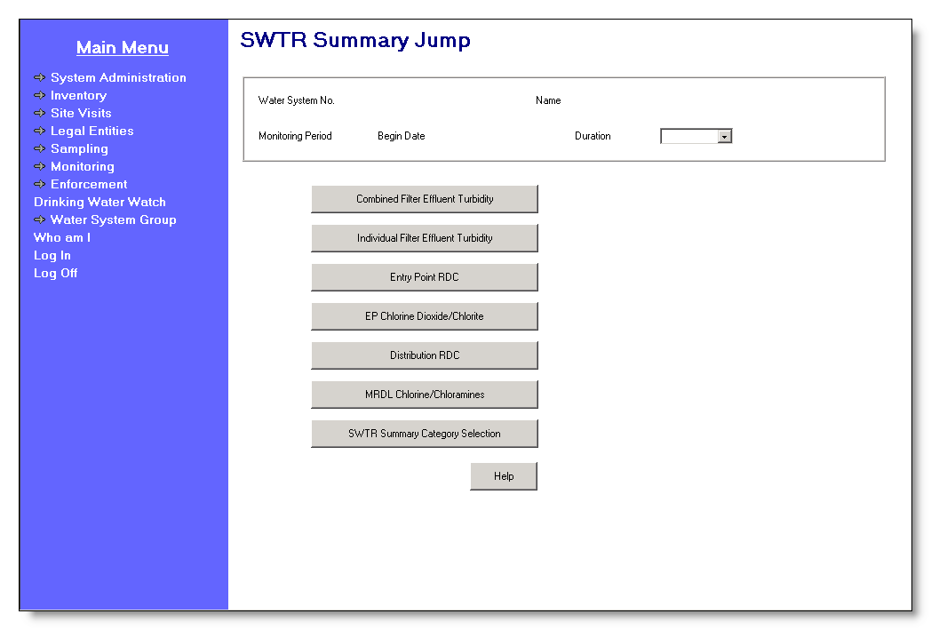

Exhibit 5-31. Water Treatment Summary Jump

Protected Fields:

Water System No. User-specified Water System No. for which the MDBP summary is reported.

[Water System]
Name Name of the selected Water System.

[Monitoring Period]
Begin Date Begin Date of the user-specified monitoring period.

[Monitoring Period]
Duration Duration of the user-specified monitoring period.

Buttons:

Combined Filter
Effluent Turbidity Pressing this button will trigger the same actions as specified for the corresponding button on the Water Treatment Summary Category Selection page.

Individual Filter
Effluent Turbidity Pressing this button will trigger the same actions as specified for the corresponding button on the Water Treatment Summary Category Selection page.

Entry Point RDC Pressing this button will trigger the same actions as specified for the corresponding button on the Water Treatment Summary Category Selection.

EP Chlorine
Dioxide/Chlorite Pressing this button will trigger the same actions as specified for the corresponding button on the Water Treatment Summary Category Selection page.

Distribution RDC Pressing this button will trigger the same actions as specified for the corresponding button on the Water Treatment Summary Category Selection page.

MRDL Chlorine/
Chloramines Pressing this button will trigger the same actions as specified for the corresponding button on the Water Treatment Summary Category Selection page.

WT Summary
Category Selection Pressing this button will return the user to the Water Treatment Summary Category Selection page displaying the Water System and monitoring period data. (B.5.6.3.1.b)

Help Will invoke online Help for this page.

Combined Filter Effluent Turbidity
The Combined Filter Effluent Turbidity page (Exhibit 5-33) will be used to enter summarized data for turbidity samples collected at the combined filter effluent in accordance with the Turbidity Rule, Surface Water Treatment Rule (SWTR), Interim Enhanced Surface Water Treatment Rule (IESWTR), and Long Term 1 Surface Water Treatment Rule (LT1SWTR).

When supporting data is in place, this page will create two MDBP Summaries.

- These data will be associated to the previously selected treatment plant and FANL (i.e., a WSF of type “TP” and a FANL record with an analyte code of “0100” and associated to an MDBP Summary).

- For each treatment plant that must meet the Turbidity Rule requirements, there should be one FANL type “AVG.” Summaries created for this scenario will be of type “AVGT.”

- For each treatment plant that must meet the other surface water treatment rules, there will typically be two FANL records; one of type “MAX” for the single sample maximum turbidity level and one of type “95P” for the turbidity level that 95% of samples must meet. Summaries created for this scenario will be of type “MAXT” and “95PT” respectively.

- To determine which of the rules applies to the treatment plant, the FANL records will be associated with a monitoring and reporting violation and a level type violation. This association will also be used to determine the appropriate violation type to be created by CDS. Exhibit 5-32, lists the federal violation types generally associated with the three turbidity rules.

The Combined Filter Effluent Turbidity page is shown in Exhibit 5-33.

Federal  Rule | FANL  Level | Level  Violation | Monitoring and Reporting  Violation
Turbidity | AVG | 01 or 02 | 03-Major
SWTR | MAX | 41 | Unfiltered WTP | 31-Major
 | 95P |  | Filtered WTP | 36-Major
IESWTR | MAX | 44 | 38-Major
 | 95P | 46

Exhibit 5-32. Violation Types for Three Turbidity Rules

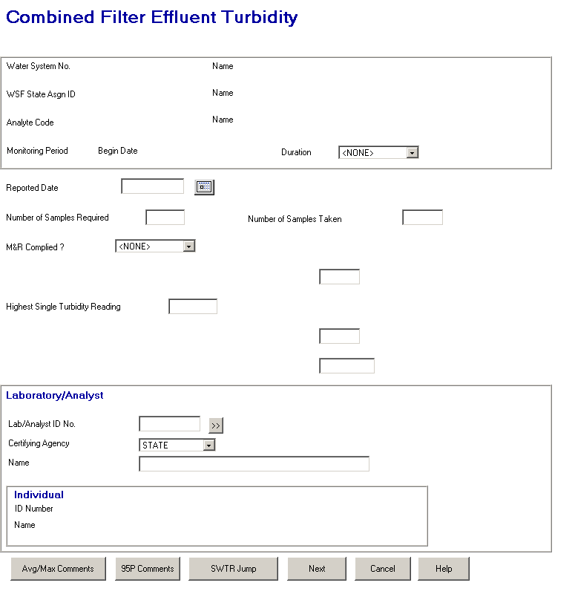

Exhibit 5-33. Combined Filter Effluent Turbidity

Protected Fields:

Water System No. User-specified Water System No. for which the MDBP summary is reported.

[Water System]
Name Name of the selected Water System.

WSF State Asgn ID State Asgn ID of the WSF for which the MDBP summary is reported.

[WSF] Name Name of the selected Water System Facility.

Analyte Code The Analyte Code specified in the associated Facility Analyte Level record.

[Analyte] Name The analyte name associated with the analyte code.

[Monitoring Period]
Begin Date Begin Date of the user-specified monitoring period.

[Monitoring Period]
Duration Duration of the user-specified monitoring period.

Individual ID
Number and Name The ID Number and Name for the individual that is associated to the MDBP Summary. This association is now obsolete with the ability to designate an Individual as a laboratory analyst. It is no longer maintainable but an existing association is presented. (R0059:A.5.6.3.2.f)

Entry Fields:

Date Reported If the previous page is the Water Treatment Summary Category page, this field will default to today’s date, otherwise it will default to Date Reported in the previous page.

Date may not be after today. The error message will be: Date must not be a future date. Return the cursor to the Date Reported field.

Data entered in this field will be stored as REPORTED_DATE in both summaries.

Number of
Samples Required This field will default to the value calculated using the Number of Samples Per Day and Number of Days to Monitoring Per Month from the associated FANL.

In particular, it will default to z, calculated as follows:

z = x * y

Where: x = FANL Number of Samples Per Day.
y = FANL Number of Days to Monitor per Month or the number of days in the monitoring period, whichever is less.

If the user changes the default, set the changed value to Number of Samples Taken field.

This field will be stored as attribute SAMPLES_REQUIRED in both summaries.

Number of Samples
Taken Defaults to the value in attribute SAMPLES_REQUIRED as calculated above. If value is changed in either add or change mode and number of samples exceeded field for the 95 NTU is greater than one, the percent of samples exceeded will be recalculated.

Stored as attribute SAMPLES_COLLECTED with both summary records.

Turbidity M&R
Complied? Permitted Values: Y=YES; NMJ=No-Major; NMN=No-Minor.

Use the following calculation to set the default value for this field:

x = (Number of Samples Taken/Number of Samples Required)* 100

If x >= 100, default to “Y.”
If x <89.9, default to NMJ.
Otherwise, default to NMN.

Store as attribute MR_COMPLIANCE_INDICATOR with both summary records. If either the number of samples required or taken fields is modified in change mode, this field will be recalculated. If this field is modified in change mode, the change will be stored with both summaries.

First Protected
Prompt/Label
[Number of
XXXXXXXXXXXX
Exceeded 999 NTU] If FANL of Control Level Type MAX or AVG is not found,

- Clear First Protected Prompt/Label.

- Clear and Protect attribute TOTAL_SAMPLES_BEYOND_MSR_LVL’s entry field.

- Disable Avg/Max Comments button.

Otherwise if found,

- If FANL Control Level Type = MAX. Set XXXXXXXXXXXX to “Number of Samples Exceeded 999 NTU.”

- If FANL Control Level Type = AVG
Set XXXXXXXXXXXX to “Number of Days Average Exceeded 999 NTU.”

- Set 999 to value in FANL CONTROL_LEVEL_TEXT.

- Enable attribute TOTAL_SAMPLES_BEYOND_MSR_LVL’s entry field and default to 0.

- Enable Avg/Max Comments button.

- The number value will be stored in attribute TOTAL_SAMPLES_BEYOND_MSR_LVL for the MAXT/AVGT summary.

Highest Single
Turbidity Reading If FANL of Control Level Type MAX or AVG is not found,

- Clear Highest Single Turbidity Reading prompt.

- Clear and Protect attribute HIGHEST_MEASURE’s entry field.

Otherwise if found,

- Display Highest Single Turbidity Reading prompt.

- Display/enable attribute HIGHEST_MEASURE’s entry field.

- This value will be needed for CCR and will not be used by CDS processes. The value will be stored in attribute HIGHEST_MEASURE of the summary associated to the MAX or AVG FANL.

Second Protected
Prompt/Label
[Number of Samples
Exceeded 999 NTU] If FANL of Control Level Type 95P is not found,

- Clear Second Protected Prompt/Label.

- Clear and Protect attribute TOTAL_SAMPLES_BEYOND_MSR_LVL’s entry field.

- Disable 95P Comments button.

Otherwise if found,

- Set XXXXXXXXXXXX to “Number of Samples Exceeded 999 NTU.”

- Set 999 to value in FANL CONTROL_LEVEL_TEXT.

- Enable attribute TOTAL_SAMPLES_BEYOND_MSR_LVL’s entry field and default to 0.

- Enable 95P Comments button.

- The number value will be stored in attribute TOTAL_SAMPLES_BEYOND_MSR_LVL for the 95PT summary.

Third Protected
Prompt/Label
[% of Samples
Exceeding 999 NTU] If FANL of Control Level Type 95P is not found,

- Clear Third Protected Prompt/Label.

- Clear and Protect attribute PERCENT_SAMPS_BYND_MSR_LVL_TXT’s entry field.

Otherwise if found,

- Set XXXXXXXXXXXX to “% of Samples Exceeding 999 NTU.”

- Set 999 to value in FANL REPORTED_MSR

- Enable attribute PERCENT_SAMPLES_BEYOND_MSR_LVL’s entry field and default value according to following calculation: value = (number of samples exceeding level/number of samples taken) * 100, with two significant digits after the decimal point.

- In change mode if TOTAL_SAMPLES_BEYOND_MSR_LVL for the 95PT summary is modified this field should be recalculated.

Store as attributes PERCENT_SAMPLES_BEYOND_MSR_LVL and PERCENT_SAMPS_BYND_MSR_LVL_TXT with 95PT summary.

Laboratory/Analyst Group Boxes:

If the previous page was the Water Treatment Summary Category page, all fields in the Laboratory/Analyst group boxes will default to spaces (except for Certifying Agency); otherwise they will default to whatever laboratory and analyst selection was made (including none) for the previous page.

Lab ID No. The Lab ID Number that the user wishes to associate to the MDBP Summary. This field will be optional.

The user may enter a valid Lab ID or use the Go To button to select a laboratory from the Lab Maintenance list in single-select mode. As the user enters/changes a value and tabs off the Lab ID Number field, the software will check that the supplied Lab ID is valid, (R0059:A.5.6.3.2.a)

If the supplied Lab ID Number does not exist in the database, the software will not supply a message but will directly invoke the Lab Maintenance List in single-select mode from where the user may select a valid Laboratory. After selection, return the cursor to [Laboratory] Name.

Certifying Agency Select a value from the dropdown list. The value will be matched against the laboratory’s Certifying Agency. The selections available via the dropdown list will be retrieved from the TINPVALS table where code_name = “CERT_AG.”

If an exact match is found using the Lab ID No. and Certifying Agency, the laboratory name will be displayed.

If none is found, the Laboratory Maintenance List will be presented in single-select mode.

Certifying Agency will be a required field. It will default to STATE. (R0059:A.5.6.3.2.b)

C

(R0059:A.5.6.3.2.c)

Name The laboratory/analyst name which the user wishes to associate to the MDBP Summary. This field will be optional.

The user may enter a valid laboratory/analyst name or use the Go To button to select a laboratory/analyst from the Lab Maintenance List in single-select mode. As the user enters/changes a value and tabs off the Name field, the software will check that the supplied Name is valid, then populate the retrieved Lab ID Number andCertifying Agency . (R0059:A.5.6.3.2.d)

If the supplied Name does not exist in the database, the software will not supply a message but will directly invoke the Lab Maintenance List in single-select mode from where the user may select a valid Laboratory/Analyst. After selection, return the cursor to [Laboratory] Name.

Tab Sequence:

Date Reported, Number of Samples Required, Number of Samples Taken, Turbidity M&R Complied? [Number of XXXXXXXXXXXX Exceeding 999 NTU], Highest Single Turbidity Reading, [Number of Samples Exceeding 999 NTU], [Percent of Samples Exceeding 999 NTU], Lab/Analyst ID No., Lab Go To button,Certifying Agency, ., Name, , Avg./Max Comments button, 95P Comments button, WT Jump button, Next button, Cancel Button, Help button. (R0059:A.5.6.3.2.d, B.5.6.3.2.a)

Buttons:

[Laboratory/Analyst]
Go To The user may use the Go To button to display the Lab Maintenance List in single-select mode. As the user makes a selection, the software will then populate the retrieved Lab ID Number, Certifying Agency and Lab Name fields. . (R0059:A.5.6.3.2.e)

(R0059:A.5.6.3.2.g)

Avg./Max
Comments Invokes a dialog box where the user can record any additional information about the average or single maximum sample summary data. Stores value as COMMENT_TEXT with MAXT/AVGT summary.

95P Comments Invokes a dialog box where the user can record any additional information about the sample summary data associated with the NTU level that 95 percent of samples must meet. Stores value as COMMENT_TEXT with 95PT summary.

WT Jump When the user presses this button, the software will: (B.5.6.3.2.b)

- Check that Reported Date is not after today. The error message will be: Date must not be a future date. Return the cursor to the Reported Date field.

- Set LEVEL_COMPLIANCE_INDICATOR according to the following algorithm:

For AVGT or MAXT summaries, if TOTAL_SAMPLES_BEYOND_MSR_LVL is greater than zero, value with NO, else value with YES.

For 95P summaries if PERCENT_SAMPLES_BEYOND_MSR_LVL rounded to a whole number is greater than 5, value with NO, else value with YES. For example, 5.4% is in compliance, 5.5% is not.

- Create or update the MAXT/AVGT and or 95P summary(ies). In change mode if any of the fields store in both summaries, date reported, number of samples received, number of samples taken, M&R complied, association to laboratory and association to individual, is modified both summaries must be updated.

- Invoke the Water Treatment Jump page.

Next When the user presses this button, the following actions will occur:

- The software will check that Reported Date is not after today. The error message will be: Date must not be a future date. Return the cursor to the Reported Date field.

- Set LEVEL_COMPLIANCE_INDICATOR according to the following algorithm.

For AVGT or MAXT summaries if TOTAL_SAMPLES_BEYOND_MSR_LVL is greater than zero, value with NO, else value with YES.

For 95P summaries if PERCENT_SAMPLES_BEYOND_MSR_LVL rounded to a whole number is greater than 5, value with NO, else value with YES. For example, 5.4% is in compliance, 5.5% is not.

- Create or update the MDBP summary(ies) and associate it with the selected FANL and user-specified monitoring period. In change mode if any of the fields store in both summaries, date reported, number of samples received, number of samples taken, M&R complied, association to laboratory and association to individual, is modified both summaries must be updated.

- The software will then apply the same actions for this button as previously specified in Subsection 5.7.2.1.

Cancel Will disregard any data and return the user to the previous page.

Help Will invoke online Help for this page.

Individual Filter Effluent Turbidity
The Individual Filter Effluent Turbidity page (Exhibit 5-34) will be used to enter summarized data for turbidity samples collected at the individual filter effluent in accordance with the Interim Enhanced Surface Water Treatment Rule (IESWTR) and Long Term 1 Surface Water Treatment Rule (LT1SWTR). When supporting data is in place, this page will create one MDBP Summary.

- This data will be associated to a WSF of type “TP” and a Facility Analyte Level (FANL) record with an analyte code of “0100" and an MDBP Summary type of “95PT.”

- For each treatment plant that must meet individual filter monitoring requirements, there should be one FANL type “95P” with the Individual Filter Monitoring Indicator valued.

- Due to the complexity of individual filter monitoring, the data stored will be answers to seven questions about the monitoring performed during the monitoring period. Each question, which may be answered with “Yes,” “No,” or Blank will be defaulted to the appropriate answer.

- There are no level violations for individual filter monitoring. If a filter exceeds a set limit, the operator must provide the primacy agency with one of three types of reports on the filter within a specified time frame. If the report is not provided within the time frame, the Water System will have a type “29” reporting violation. CDS will not create these candidate violations, although it will provide an alert to compliance officers who could then investigate the individual filter effluent turbidity levels and, if necessary, create a violation or a compliance schedule as desired.

- The FANL records will be associated with a monitoring and reporting violation and a level type violation. This association will also be used to determine the appropriate violation type to be created by CDS. Since the individual filter monitoring is a flag on the 95P FANL, the violations will be those used for the 95P FANL, which will generally be “38-Major” and “44.” The violation type for individual filter effluent turbidity monitoring will also be “38-Major.” As previously noted, there are no level violations associated with individual filter effluent monitoring.

Protected Fields:

The protected fields in this display box will be the same as those previously described for the Combined Filter Effluent Turbidity page.

Individual ID No. and Name fields become protected. (R0059:A.5.6.3.3.f)

Entry Fields:

The default settings listed with each data entry field are to be calculated prior to opening the Individual Filter Effluent Turbidity page.

Date Reported This field will be the same as the Date Reported field in the Combined Filter Effluent Turbidity page.

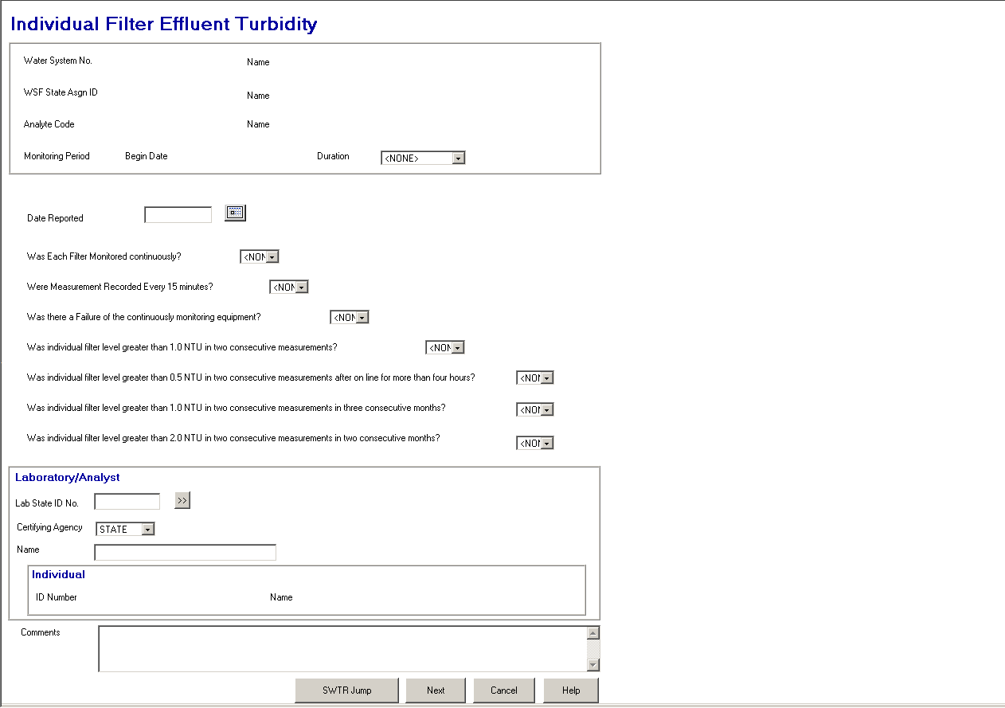

Exhibit 5-34. Individual Filter Effluent Turbidity

Question #1 Label will read: “Was Each Filter Monitored continuously?”
Permitted Values: Y=Yes; N=No; Blank.

Default to “Yes.”

Value will be stored as Q1_IFT_MONITORED_INDICATOR in the IFT summary.

Question #2 Label will read: “Were Measurements Recorded Every 15 minutes?”

Permitted Values: Y=Yes; N=No; Blank.

Default to “Yes.”

Value will be stored as Q2_IFT_RECORED_INDICATOR in the IFT summary.

Question #3 Label will read: “Was there a Failure of the continuously monitoring equipment?”

Permitted Values: Y=Yes; N=No; Blank.

Default to “No.”

Value will be stored as Q3_IFT_EQUIPMENT_INDICATOR in the IFT summary.

Question #4 Label will read: “Was individual filter level greater than 1.0 NTU in two consecutive measurements?”

Permitted Values: Y=Yes; N=No; Blank.

Default to “No.”

Value will be stored as Q4_IFT_GREATER_1_0_INDICATOR in the IFT summary.

Question #5 Label will read: “Was individual filter level greater than 0.5 NTU in two consecutive measurements after on line for more than four hours?”

Permitted Values: Y=Yes; N=No; Blank.

Default to “No.”

Value will be stored as Q5_IFT_GREATER_0_5_INDICATOR in the IFT summary.

Question #6 Label will read: “Was individual filter level greater than 1.0 NTU in two consecutive measurements in three consecutive months?”

Permitted Values: Y=Yes; N=No; Blank.

Default to “No.”

Value will be stored as Q6_IFT_GREATER_1_DUR_3_MON_IND.

Question #7 Label will read: “Was individual filter level greater than 2.0 NTU in two consecutive measurements in two consecutive months?”

Permitted Values: Y=Yes; N=No; Blank.

Default to “No.”

Value will be stored as Q7_IFT_GREATER_2_DUR_2_MON_IND in the IFT summary.

Laboratory/Analyst Information Box:

Lab/Analyst
ID No. This field will be the same as the Lab ID No. in the Combined Filter Effluent Turbidity page. The same design specifications will apply. (R0059:A.5.6.3.3.a)

Certifying Agency Select a value from the dropdown list. The value will be matched against the laboratory’s Certifying Agency. The selections available via the dropdown list will be retrieved from the TINPVALS table where code_name = “CERT_AG.”

If an exact match is found using the Lab ID No. and Certifying Agency, the laboratory name will be displayed.

If none is found, the Laboratory Maintenance List will be presented in single-select mode.

Certifying Agency will be a required field. It will default to STATE. (R0059:A.5.6.3.3.b)

. (R0059:A.5.6.3.3.c)

Name This field will be the same as the Laboratory/Analyst Name in the Combined Filter Effluent Turbidity page. The same design specifications will apply.

(R0059:A.5.6.3.3.g).

Comments User can record any additional information about the sample summary data.

Store as COMMENT_TEXT with summary.

Tab Sequence:

Date Reported, Question #1, Question #2, Question #3, Question #4, Question #5, Question #6, Question #7, Lab/Analyst ID No., Certifying Agency, Lab Go To button,., Name, Comments, WT Jump button, Next button, Cancel button, Help button. (R0059:A.5.6.3.3.d, B.5.6.3.3.a)

Buttons:

[Laboratory/Analyst]
Go To The design specifications for this button previously described on the Combined Filter Effluent Turbidity page will apply here. (R0059:A.5.6.3.3.e)

. (R0059:A.5.6.3.3.g)

WT Jump (B.5.6.3.3.b) The design specifications for this button previously described on the Combined Filter Effluent Turbidity page will apply here with one exception. For the Individual Filter Turbidity page only, just prior to creating/updating the IFT summary, set LEVEL_COMPLIANCE_INDICATOR according to the following algorithm: if Question #4, 5, 6, or 7 equals No, value NO, else value YES. Set MR_COMPLIANCE_INDICATOR according to the following algorithm: if Question #1, 2, 3 equals Null or if Question #1 or 2 equals NO or Question #3 equals YES; value NMJ-No Major, else value YES.

Next The design specifications for this button previously described on the Combined Filter Effluent Turbidity page will apply here, with one exception. For the Individual Filter Turbidity page only, just prior to creating/updating the IFT summary, set LEVEL_COMPLIANCE_INDICATOR according to the following algorithm: if Question #4, 5, 6, or 7 equals No, value NO, else value YES. Set MR_COMPLIANCE_INDICATOR according to the following algorithm: if Question #1, 2, 3 equals Null or if Question #1 or 2 equals NO or Question #3 equals YES, value NO, else value YES.

Cancel Will disregard any data and return the user to the previous page.

Help Will invoke online Help for this page.

Entry Point RDC
The Entry Point RDC page (Exhibit 5-35) will be used to enter summarized data for residual disinfectant concentration (RDC) samples collected at the entry point to the distribution system. When supporting data is in place, this page will create two MDBP Summaries.

This data will be associated to the previously selected treatment plant (WSF of type “TP”) and Facility Analyte Level (FANL) record (i.e., FANL with an analyte code of “0999”—Chlorine or “1006”—Chloramine and a level type of “MIN”). Uniqueness criteria will not allow FANL records for both chlorine and chloramine to be created with overlapping effective periods. If a treatment plant uses both disinfectants intermittently, the primacy agency must choose one to monitor.

For each treatment plant that must monitor the entry point for a federal or state RDC level, a FANL must be created. The federal level will be associated to an MDBP Summary of type “EPRD,” the state level to a summary of type “SERD.” Both FANLs must be associated to the same analyte.

To determine which rules apply to the treatment plant, the FANL records will be associated with a monitoring and reporting violation and a level type violation. This association will also be used to determine the appropriate violation type to be created by CDS. Generally, the federal M&R violation types will be “31—Major” for unfiltered treatment plants, “36 —Major” for filtered treatment plants, and type “41—No severity” as the level violation type. (There are three violation type 41 records: Single CFE exceedence, Monthly CFE exceedence, and no severity). The third one is appropriate for entry point RDC level violations.

If the state wishes to track state levels, a state level type violation must be created and associated to the FANL. Since the samples required and taken are the same for both the federal and state levels, a monitoring and reporting violation type should not be associated to the state FANL.

Since a treatment plant may have more than one entry point, the summary will be associated with an entry point sampling point.

Protected Fields:

The protected fields in this display box will be the same as previously described for the Combined Filter Effluent Turbidity page, except that two sampling point fields will have been added.

Sampling Point The state assigned ID of the selected sampling point.

[Sampling] Location The name/location of the selected sampling point.

Individual ID No.
And Name Fields become protected. (R0059:A.5.6.3.4.f)

Entry Fields:

The default settings listed beside each data entry field are to be calculated prior to opening the Entry Point RDC page.

Date Reported The design specifications for this field previously described on the Combined Filter Effluent Turbidity page will apply here.

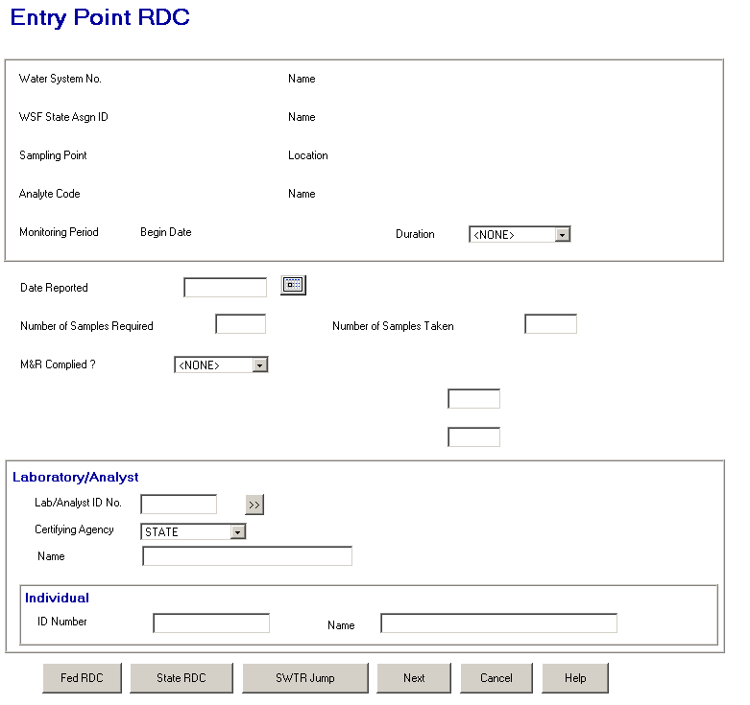

Exhibit 5-35. Entry Point RDC
Number of
Samples Required The design specifications for this field previously described on the Combined Filter Effluent Turbidity page will apply here.

Number of Samples
Taken The design specifications for this field previously described on the Combined Filter Effluent Turbidity page will apply here.

Entry Point
RDC M&R
Complied? The design specifications for this field previously described on the Combined Filter Effluent Turbidity page will apply here.

First Protected
Prompt/Label
[Number of Samples
Under 999 mg/l
Federal Level] If FANL indicating a Summary Type of “EPRD” is not found,
- Clear First Protected Prompt/Label.

- Clear and Protect TOTAL_SAMPLES_BEYOND_MSR_LVL.

- Disable Fed RDC button.

If FANL indicating a Summary Type of “EPRD” is found,

- Display “Number of Samples Under 999 mg/l Federal Level” in the First Protected Prompt/Label.

- Set 999 to the value in the FANL CONTROL_LEVEL_TEXT.

- Default the field to zero.

- Store the value in the field as TOTAL_SAMPLES_BEYOND_MSR_LVL with EPRD summary.

Second Protected
Prompt/Label
[Number of Sample
Under 999 mg/l
State Level] If FANL indicating a Summary Type of “SERD” is not found,

- Clear Second Protected Prompt/Label.

- Clear and Protect TOTAL_SAMPLES_BEYOND_MSR_LVL.

- Disable State RDC button.

If FANL indicating a Summary Type of “SERD” is found,

- Display “Number of Samples Under 999 mg/l State Level” in the Second Protected Prompt/Label.

- Set 999 to the value in the FANL CONTROL_LEVEL_TEXT.

- Default the field to zero.

- Store the value in the field as TOTAL_SAMPLES_BEYOND_MSR_LVL with SERD summary.

Laboratory/Analyst Information Box:

Lab/Analyst
ID No. This field will be the same as the Lab/Analyst ID No. in the Combined Filter Effluent Turbidity page. The same design specifications will apply. (R0059:A.5.6.3.4.a)

Certifying Agency Select a value from the dropdown list. The value will be matched against the laboratory’s Certifying Agency. The selections available via the dropdown list will be retrieved from the TINPVALS table where code_name = “CERT_AG.”

If an exact match is found using the Lab ID No. and Certifying Agency, the laboratory name will be displayed.

If none is found, the Laboratory Maintenance List will be presented in single-select mode.

Certifying Agency will be a required field. It will default to STATE. (R0059:A.5.6.3.4.b)

(R0059:A.5.6.3.4.c)

Name This field will be the same as the Laboratory/Analyst Name in the Combined Filter Effluent Turbidity page. The same design specifications will apply.

Tab Sequence:

Date Reported, Number of Samples Required, Number of Samples Taken, Entry Point RDC M&R Complied?, [Number of Samples Under 999 mg/l Federal Level], [Number of Samples Under 999 mg/l State Level], Lab/Analyst ID No., Certifying Agency, Lab Go To button, Name, , Fed RDC [Comments] button, State RDC [Comments] button, WT Jump button, Next button, Cancel Button, Help button. (R0059:A.5.6.3.4.d, B.5.6.3.4.a)

Buttons:

[laboratory/analyst]
Go To This button will be the same as the Lab Go To in the Combined Filter Effluent Turbidity page. The same design specifications will apply. (R0059:A.5.6.3.4.e)

(R0059:A.5.6.3.4.g)

Fed RDC
[Comments] This button will be hidden if the FANL of Summary Type “EPRD” is not found. Clicking on it will invoke a dialog box where the user can record any additional information about the federal RDC level summary data.

Store as COMMENT_TEXT with EPRD summary.

State RDC
[Comments] This button will be hidden if a FANL of Summary Type “SERD” is not found. Clicking on this button will invoke a dialog box where the user can record additional information about the sample summary data associated with the state RDC level summary data.

Store as COMMENT_TEXT with SERD summary.

WT Jump (B.5.6.3.4.b) The design specifications for this button previously described on the Combined Filter Effluent Turbidity page will apply here, with one exception: for the Entry Point RDC page only, just prior to creating/updating the EPRD and/or SERD summary (ies), set LEVEL_COMPLIANCE_INDICATOR according to the following algorithm: if TOTAL_SAMPLES_BEYOND_MSR_LVL is greater than zero, value with NO, else value with YES.

Next The design specifications for this button previously described on the Combined Filter Effluent Turbidity page will apply here, with one exception: for the Entry Point RDC page only, just prior to creating/updating the EPRD and/or SERD summary (ies), set LEVEL_COMPLIANCE_INDICATOR according to the following algorithm: if TOTAL_SAMPLES_BEYOND_MSR_LVL is greater than zero, value with NO, else value with YES.

Cancel Will disregard any data and return the user to the previous page.

Help Will invoke online Help for this page.

Entry Point Chlorine Dioxide/Chlorite
The Entry Point Chlorine Dioxide/Chlorite page (Exhibit 5-36), will be used to enter summarized data for daily chlorine dioxide and chlorite samples collected at the entry point to the distribution system for the Stage1 Disinfectant/Disinfection By-Products Rule (D/DBP). The D/DBP rule requires monitoring at the entry point for both analytes each day that chlorine dioxide is used as a disinfectant. When supporting data is in place, this page will create two MDBP Summaries.

This data will be associated to a WSF of type “TP” and a Facility Analyte Level (FANL) record with an analyte code of “1008”—Chlorine Dioxide or “1009”—Chlorite and a level type of “MAX,” both of which will have already been selected and will be displayed on this page. The summaries created will be of type “CLO2” for chlorine dioxide and “CLO3” for chlorite.

The FANL records will be associated with a monitoring and reporting violation and a level type violation. This association will also be used to determine the appropriate violation type to be created by CDS. Generally, the federal violation will be type “27—Major” for monitoring and reporting chlorite and type “27- Monitoring DBP with No. of Missing Samples for chlorine dioxide. For level violations, the type will be “11- Max Res Disinfect Lvl-MRDL” with no severity indicated for chlorine dioxide and “02-MCL with No. of Exceedances” for chlorite.

Monitoring for these analytes at the entry point must be conducted by a person approved by the state and may be stored as a summary. Monitoring for these analytes at the distribution system level must be conducted by a certified laboratory and should be stored individually. Therefore, distribution system sample results will not be stored in MDBP Summary but with samples and analytical results.

Monitoring at the entry point for chlorine dioxide and chlorite does not directly result in level violations. If entry point sample results exceed specified levels, additional monitoring must be conducted in the distribution system. Therefore, CDS will not generate level violations, but will give compliance officers a warning on the report that levels have been exceeded. The compliance officer will then need to ensure that the additional samples were collected.

Since a treatment plant may have more than one entry point, the summary will be associated with an entry point sampling point.

Protected Fields:

The protected fields in this display box will be the same as previously described for the Entry Point RDC page, except that the Analyte Code and [Analyte] Name fields have been omitted.

Individual ID No. and Name will become protected fields. (R0059:A.5.6.3.5.f)

Entry Fields:

The default settings listed beside each data entry field will be calculated prior to opening the Entry Point Chlorine Dioxide/Chlorite page.

Date Reported The design specifications for this field previously described on the Combined Filter Effluent Turbidity page will apply here.

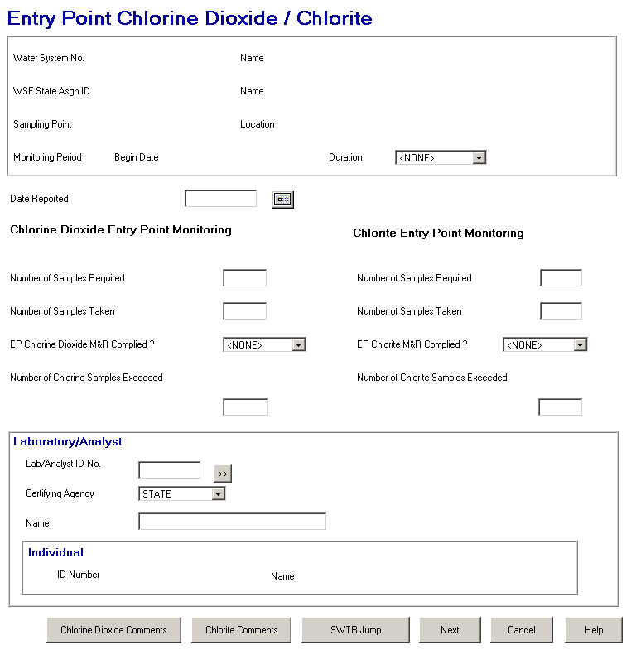

Exhibit 5-36. Entry Point Chlorine Dioxide/Chlorite

Chlorine Dioxide Entry Point Monitoring Group:

All prompts and fields located under the “Chlorine Dioxide Entry Point Monitoring” label should be hidden if FANL of Summary Type “CLO2” is not found, including the Chlorine Dioxide Comments button. All should be displayed/enabled when FANL of Summary Type “CLO2” is found.

Number of [Chlorine
Dioxide [Samples
Required] The design specifications for this field previously described on the Combined Filter Effluent Turbidity page will apply here. Store as SAMPLES_REQUIRED in “CLO2” summary record.

Number of [Chlorine
Dioxide] Samples
Taken Default to number of chlorine dioxide samples required. When the user tabs off this field, populate the EP Chlorine Dioxide M&R Complied field. Store as SAMPLES_COLLECTED with “CLO2” summary record.

EP Chlorine Dioxide
M&R Complied? The design specifications for this field previously described on the Combined Filter Effluent Turbidity page apply here. Store as MR_COMPLIANCE_INDICATOR with “CLO2” summary record.

Number of Chlorine
[Dioxide] Samples
Exceeded
[999 mg/l] Set xxxxx to value in FANL CONTROL_LEVEL_TEXT concatenated with mg/l. Enable TOTAL_SAMPLES_BEYOND_MSR_LVL entry field and default to 0. The number value will be stored in TOTAL_SAMPLES_BEYOND_MSR_LVL for the CLO2 summary.

Chlorite Entry Point Monitoring Group:

All prompts and fields located under the “Chlorite Entry Point Monitoring” label should be hidden if FANL of Summary Type “CLO3” is not found, including the Chlorite Comments button. All should be displayed/enabled when FANL of Summary Type “CLO3” is found.

Number of [Chlorite]
Samples Required The design specifications for this field previously described on the Combined Filter Effluent Turbidity page will apply here. Stored as SAMPLES_REQUIRED in “CLO3” summary record.

Number of [Chlorite]
Samples Taken Default to number of chlorite samples required. When the user tabs off this field, populate the EP Chlorite M&R Complied field. Store as SAMPLES_COLLECTED with “CLO3” summary record.

EP Chlorite M&R
Complied? The design specifications for this field previously described on the Combined Filter Effluent Turbidity page will apply here. Store as MR_COMPLIANCE_INDICATOR with “CLO3” summary record.

Number of Chlorite
Samples Exceeded
[999 mg/l] Set xxxxx to value in FANL CONTROL_LEVEL_TEXT concatenated with mg/l. Enable TOTAL_SAMPLES_BEYOND_MSR_LVL entry field and default to 0. The number value will be stored in TOTAL_SAMPLES_BEYOND_MSR_LVL for the CLO3 summary.

Laboratory/Analyst Information Group Boxes:

Lab/Analyst
ID No. This field will be the same as the Lab/Analyst ID Number in the Combined Filter Effluent Turbidity page. The same design specifications will apply. (R0059:A.5.6.3.5.a)

Certifying Agency Select a value from the dropdown list. The value will be matched against the laboratory’s Certifying Agency. The selections available via the dropdown list will be retrieved from the TINPVALS table where code_name = “CERT_AG.”

If an exact match is found using the Lab ID No. and Certifying Agency, the laboratory name will be displayed.

If none is found, the Laboratory Maintenance List will be presented in single-select mode.

Certifying Agency will be a required field. It will default to STATE. (R0059:A.5.6.3.5.b)

. . (R0059:A.5.6.3.5.c)

Name This field will be the same as the Laboratory/Analyst Name in the Combined Filter Effluent Turbidity page. The same design specifications will apply.

Tab Sequence:

Date Reported, Number of [Chlorine Dioxide] Samples Required, Number of [Chlorine Dioxide] Samples Taken, EP Chlorine Dioxide M&R Complied?, Number of Chlorine [Dioxide] Samples Exceeded [999 mg/l], Number of [Chlorite] Samples Required, Number of [Chlorite] Samples Taken, EP Chlorite M&R Complied?, Number of Chlorite Samples Exceeded [999 mg/l], Lab/Analyst ID No., Certifying Agency, Lab Go To button,., Name, , Chlorine Dioxide Comments button, Chlorite Comments button, WT Jump button, Next button, Cancel button, Help button. . (R0059:A.5.6.3.5.d,B.5.6.3.5.a)

Buttons:

[laboratory/analyst]
Go To This button will be the same as the Lab Go To in the Combined Filter Effluent Turbidity page. The same design specifications will apply. . (R0059:A.5.6.3.5.e)

(R0059:A.5.6.3.5.g)

Chlorine Dioxide
Comments This button will be hidden if FANL of Summary Type CLO2 is not found and otherwise displayed. This button will invoke a dialog box where the user can record any additional information about the Chlorine Dioxide summary data.

Store as COMMENT_TEXT with “CLO2" summary.

Chlorite
Comments This button will be hidden if FANL of Summary Type CLO3 is not found and otherwise displayed. This button will invoke a dialog box where the user can record any additional information about the Chlorite summary data.

Store as COMMENT_TEXT with “CLO3” summary.

WT Jump (B.5.6.3.5.b) The design specifications for this button previously described on the Combined Filter Effluent Turbidity page will apply here, with one exception. For the Entry Point Chlorine Dioxide/Chlorite page only, just prior to creating/updating the CLO2 and/or CLO3 summary (ies), set LEVEL_COMPLIANCE_INDICATOR according to the following algorithm: if TOTAL_SAMPLES_BEYOND_MSR_LVL is greater than zero, value with NO, else value with YES.

Next The design specifications for this button previously described on the Combined Filter Effluent Turbidity page will apply here, with one exception. For the Entry Point Chlorine Dioxide/Chlorite page only, just prior to creating/updating the CLO2 and/or CLO3 summary (ies), set LEVEL_COMPLIANCE_INDICATOR according to the following algorithm: if TOTAL_SAMPLES_BEYOND_MSR_LVL is greater than zero, value with NO, else value with YES.

Cancel Will disregard any data and return the user to the previous page.

Help Will invoke online Help for this page.

Distribution RDC
The Distribution RDC page (Exhibit 5-37) will be used to enter summarized data for residual disinfectant concentration (RDC) samples collected in the distribution system. When supporting data is in place, this page will create one or two MDBP Summaries.

This data will be associated to a WSF of type “DS” and a Facility Analyte Level (FANL) record with an analyte code of “0999”—Chlorine or “1006”—Chloramine and a level type of “MIN.” Uniqueness criteria will not allow FANL records for both chlorine and chloramine to be created with overlapping effective periods. If a Water System uses both disinfectants intermittently, the primacy agency must choose one to monitor.

One or two FANLs can be set for disinfectant residual: one that establishes a federal minimum level and a second that establishes a state minimum level. For the first, the FANL should indicate an MDBP Summary Type of “DSRD.” For a state minimum level, the FANL should indicate an MDBP Summary Type of “SDRD.” Both FANLs must be associated to the same analyte (i.e., either chlorine or chloramine). The number of required samples will be the same for both the federal and state levels and will be derived from the Total Coliform Rule (TCR) schedules; not from the FANL information.

To determine which rules apply to the treatment plant, the FANL records will be associated with an M&R (monitoring and reporting) violation type and a level violation type. This association will also be used to determine the appropriate violation type to be created by CDS. Generally, the federal M&R violation types will be “31—Major” for unfiltered treatment plants, “36—Major” for filtered treatment plants, and type “41—No severity” as the level violation type. (There are three violation type 41 records: Single CFE exceedence, Monthly CFE exceedence, and no severity.) FANLs for distribution RDC should be connected to the latter.

If the state wishes to track state levels, a state level type violation must be created and associated to the FANL. Since samples required and taken will be the same for both the federal and state levels, a monitoring and reporting violation type should not be associated to the state FANL.

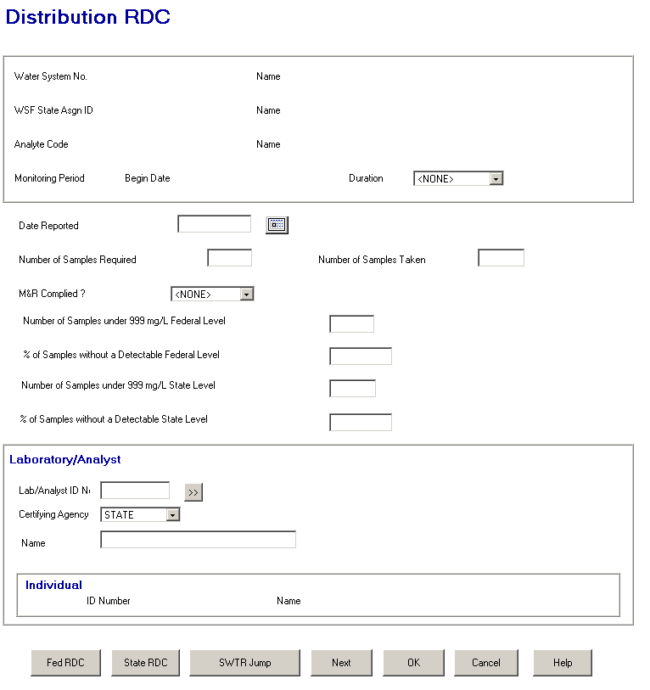

Exhibit 5-37. Distribution RDC

Protected Fields:

The protected fields in this display box will be the same as previously described for the Combined Filter Effluent Turbidity page.

Individual ID No. and Name will become protected fields. (R0059:A.5.6.3.6.f)

Entry Fields:

The default settings listed beside each data entry field will be calculated prior to opening the Distribution RDC page.

Date Reported This field will be the same as the Date Reported in the Combined Filter Effluent Turbidity page.

Number of Samples
Required This field will default to the current TCR, routine schedule (read the current RT—Routine or TR—Temporary Routine schedule). It will not include Repeat schedules when calculating the default. The user, however, can override the supplied default value (read and display the sample count for the RT/TR schedule in effect on the first day of the monitoring period).

This value entered in this field will be stored as SAMPLES_REQUIRED in both summary records.

Number of Samples
Taken
Default to Number of Samples Required. If the user changes the value in Number of Samples Required, default Number of Samples Taken to that value. Allow the user to override. When the user tabs off this field, populate the Distribution RDC M&R Complied? Field, based on a comparison of the Number of Samples Taken against the Number of Sample Required as indicated below.

In change mode when the user tabs off this field, both the percent
of samples without a detectable level should be recalculated.

Store as SAMPLES_COLLECTED with both summary records.

Distribution RDC
M&R Complied Permitted Values: Y=Yes; NMJ=No-Major; NMN=No-Minor.

Default this field to the value calculated as follows: if the Number of Samples Taken/Number of Samples Required times 100,

- Is greater than or equal to 100, default to “Yes.”
- Is less than 89.9, default to “NMJ” (No—Major M&R Violation).
- Otherwise, default to “NMN” (No—Minor M&R Violation).

The user can override the calculated value. If the user overrides the calculated value and then changes either Number of Samples Required or Number of Samples Taken, recalculate and override the user’s value.

Store as MR_COMPLIANCE_INDICATOR with both summary records.

First Protected
Prompt/Label
[Number of Samples
Under 999 mg/l
Federal Level] If FANL indicating a Summary Type of “DSRD” is not found,

- Clear First Protected Prompt/Label.

- Clear and Protect TOTAL_SAMPLES_BEYOND_MSR_LVL field.

- Disable Fed RDC button.

If FANL indicating a Summary Type of “DSRD” is found,

- Display “Number of Samples Under 999 mg/l Federal Level” in the First Protected Prompt/Label.

- Set 999 to the value in the FANL_CONTROL_LEVEL_TEXT.

- Default the field to zero.

- Store the value in the field as TOTAL_SAMPLES_BEYOND_MSR_LVL with DSRD summary.

% of Samples without
a Detectable Federal
Level If FANL of Summary Type DSRD is not found,

- Clear % of Samples without a Detectable Federal Level prompt.

- Clear and Protect PERCENT_SAMPS_BYND_MSR_LVL_TXT entry field.

Otherwise if found,

- Enable PERCENT_SAMPLES_BEYOND_MSR_LVL_TXT entry field and default value according to the following calculation: value = (number of samples exceeding level/number of samples taken) * 100, with two significant digits after the decimal point.
- Store as PERCENT_SAMPLES_BEYOND_MSR_LVL and PERCENT_SAMPS_BYND_MSR_LVL_TXT with DSRD summary.

Second Protected
Prompt/Label
[Number of Sample
Under 999 mg/l State
Level] If FANL indicating a Summary Type of “SDRD” is not found,

- ClearSecond Protected Prompt/Label.

- Clear and Protect TOTAL_SAMPLES_BEYOND_MSR_LVL.

- Disable State RDC button.

If FANL indicating a Summary Type of “SDRD” is found,

- Display “Number of Samples Under 999 mg/l State Level” in the Second Protected Prompt/Label.

- Set 999 to the value in the FANL CONTROL_LEVEL_TEXT.

- Default the field to zero.

- Store the value in the field as TOTAL_SAMPLES_BEYOND_MSR_LVL with SDRD summary.

% of Samples without
a Detectable State
Level If FANL of Summary Type SDRD is not found,

- Clear % of Samples without a Detectable State Level prompt.

- Clear and Protect PERCENT_SAMPS_BYND_MSR_LVL_TXT entry field.

Otherwise if found,

- Enable PERCENT_SAMPLES_BEYOND_MSR_LVL_TXT entry field and default value according to following calculation: value = (number of samples exceeding level/number of samples taken) * 100, with two significant digits after the decimal point.

Store as PERCENT_SAMPLES_BEYOND_MSR_LVL and PERCENT_SAMPS_BYND_MSR_LVL_TXT with SDRD summary.

Laboratory/Analyst Information Box:

Lab/Analyst
ID No. This field will be the same as the Lab ID Number in the Combined Filter Effluent Turbidity page. The same design specifications will apply. (R0059:A.5.6.3.6.a)

Certifying Agency Select a value from the dropdown list. The value will be matched against the laboratory’s Certifying Agency. The selections available via the dropdown list will be retrieved from the TINPVALS table where code_name = “CERT_AG.”

If an exact match is found using the Lab ID No. and Certifying Agency, the laboratory name will be displayed.

If none is found, the Laboratory Maintenance List will be presented in single-select mode.

Certifying Agency will be a required field. It will default to STATE. (R0059:A.5.6.3.6.b)

(R0059:A.5.6.3.6.c)

Name This field will be the same as the Laboratory Name in the Combined Filter Effluent Turbidity page. The same design specifications will apply.

Tab Sequence:

Date Reported, Number of Samples Required, Number of Samples Taken, Distribution RDC M&R Complied?, [Number of Samples Under 999 mg/l Federal Level], % of Samples without a Detectable Federal Level, [Number of Samples Under 999 mg/l State Level], % of Samples without a Detectable State Level, Lab/Analyst ID No., Certifying Agency, Lab Go To button,., Name, , Fed RDC [Comments] button, State RDC [Comments] button, WT Jump button, Next button, Cancel Button, Help button. (R0059:A.5.6.3.6.d, B.5.6.3.6.a)

Buttons:

[laboratory/analyst]
Go To This button will be the same as the Lab Go To in the Combined Filter Effluent Turbidity page. The same design specifications will apply. (R0059:A.5.6.3.6.e)

(R0059:A.5.6.3.6.g)

The following buttons are visible as long as the page has been invoked from Water Treatment Category Selection page.

Fed RDC
[Comments] This button will be hidden if FANL of Summary Type DSRD is not found and otherwise will be displayed. Clicking on this button will invoke a dialog box where the user can record any additional information about the Chlorine Dioxide summary data.

Store as COMMENT_TEXT with “DSRD” summary.

State RDC
[Comments] This button will be hidden if FANL of Summary Type SDRD is not found and otherwise displayed. Clicking on this button will invoke a dialog box where the user can record any additional information about the Chlorite summary data.

Store as COMMENT_TEXT with “SDRD” summary.

WT Jump (B.5.6.3.6.b) The design specifications for this button previously described on the Combined Filter Effluent Turbidity page will apply here, with one exception. For the Distribution RDC page only, just prior to creating/updating the DSRD summary, set LEVEL_COMPLIANCE_INDICATOR according to the following algorithm: if PERCENT_SAMPLES_BEYOND_MSR_LVL rounded to a whole number is greater than five in this summary and the summary for the previous monitoring period, value with No, else value with Yes. For example, 5.4% is equal to 5, 5.5% is greater than 5. Just prior to creating/updating the SDRD summary, set LEVEL_COMPLIANCE_INDICATOR according to the following algorithm: if TOTAL_SAMPLES_BEYOND_MSR_LVL is greater than zero, value with NO, else value with Yes.

In change mode if any of the fields store in both summaries, date reported, number of samples received, number of samples taken, M&R complied, association to laboratory and association to individual, is modified both summaries must be updated.

Next The design specifications for this button previously described on the Combined Filter Effluent Turbidity page will apply here, with one exception. For the Distribution RDC page only, just prior to creating/updating the DSRD summary, set LEVEL_COMPLIANCE_INDICATOR according to the following algorithm: if PERCENT_SAMPLES_BEYOND_MSR_LVL rounded to a whole number is greater than five in this summary and the summary for the previous monitoring period, value with NO, else value with YES. For example, 5.4% is equal to 5, 5.5% is greater than 5. Just prior to creating/updating the SDRD summary, set LEVEL_COMPLIANCE_INDICATOR according to the following algorithm: if TOTAL_SAMPLES_BEYOND_MSR_LVL is greater than zero, value with NO, else value with YES.

In change mode if any of the fields store in both summaries, date reported, number of samples received, number of samples taken, M&R complied, association to laboratory and association to individual, is modified both summaries must be updated.

Cancel Will disregard any data and return the user to the previous page.

Help Will invoke online Help for this page.

OK Pressing OK will create/update the MDBP Summary, close the page, and return user to the TCR Sample Summary Maintenance page in Change mode. (At this point, the user may view the TCR Sample Summary on the Maintenance List by pressing OK on that page.)

If the page has been invoked from TCR Sample Summary Maintenance, the WT Jump button will not be visible and the Next button will be replaced by the OK button.

MRDL Chlorine/Chloramine DS
The MRDL Chlorine/Chloramines DS page (Exhibit 5-38) will be used to enter summarized data for maximum residual disinfectant level (MRDL) samples collected in the distribution system for the Stage 1 Disinfectant/Disinfection By-Products (D/DBP) Rule. All supplies that use either chlorine or chloramine as a disinfectant are required to be monitored at the same time and location that TCR samples are collected. When supporting data is in place, this page will create one MDBP Summary.

This data will be associated to a WSF of type “DS” and a Facility Analyte Level (FANL) record with an analyte code of “0999”—Chlorine or “1006”—Chloramine and a level type of “MAX.” Uniqueness criteria will not allow FANL records for both chlorine and chloramine to be created with overlapping effective periods. If a Water System uses both disinfectants intermittently, the primacy agency must choose one to monitor.

For each distribution system that must monitor for maximum residual disinfectant levels, a FANL must be created and associated to an MDBP Summary type of “MRDL.”

The number of required samples will be derived from the TCR schedules, not from the FANL information. The FANL records will be associated with a monitoring and reporting violation and a level type violation. This association will also be used to determine the appropriate violation type to be created by CDS. Generally, the federal violation will be type “27-Major” for monitoring and reporting, and type “11-Max Res Disinfect Lvl (MRDL) Non-Acute” for level.

There will be a CDS component that will use the disinfectant residual stored with the TCR sample results to create a summary. If the user wishes to have the software create summaries, they should not enter data using this page and must press the Cancel button. Information added or modified using this page will not be overridden by the software when CDS creates summaries.

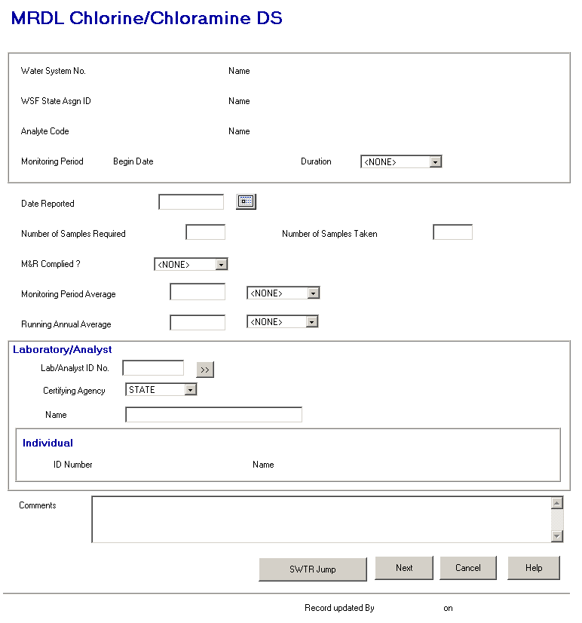

Exhibit 5-38. MRDL Chlorine/Chloramine DS

Protected Fields:

The protected fields in this display box will be the same as those previously described for the Combined Filter Effluent Turbidity page.

Individual ID No. and Name will become protected fields. (R0059:A.5.6.3.7.f)

Entry Fields:

The default settings listed beside each data entry field will be calculated prior to opening the MRDL Chlorine/Chloramine DS page.

Date Reported The specifications for this field will be the same as those for the Date Reported field in the Combined Filter Effluent Turbidity page.

Number of Samples
Required The specifications for this field will be the same as for the Number of Samples Required field in the Distribution RDC page.
Number of Samples
Taken Default to Number of Samples Required. If the user changes the value in Number of Samples Required, default Number of Samples Taken to that value. When the user tabs off this field, populate the Chlorine/Chloramine MRDL M&R Complied? field.

Store as SAMPLES_COLLECTED with summary record.

Chlorine/Chloramine
MRDL M&R
Complied? The design specifications for this field previously described on the Combined Filter Effluent Turbidity page will apply here. Store as MR_COMPLIANCE_INDICATOR with both summary records.

Monitoring Period
Average Will default to zero. Store as both a numeric field (MONITORING_PERIOD_AVG_MEASURE) for calculations and as a text field (MONITORING_PERIOD_AVG_MSR_TXT) for display purposes with summary.

Leading zeros will not be stored in the text field except when the numeric field is less than one, in which case, one zero to the left of the decimal place will be included in the text field (e.g., numeric is .1, 0.1 will be stored in the text field). Trailing zeros entered by the user will, however, be retained (e.g., if 1.20 is entered, it will be stored as 1.20 in the text field).

Running Annual
Average Will default to zero. Store as both a numeric field (RUNNING_ANNUAL_AVERAGE_MEASURE) and as a text field (RUNNING_ANNUAL_AVERAGE_MSR_TXT) for display purposes with summary.

Leading zeros will not be stored in the text field except when the numeric field is less than one, in which case, one zero to the left of the decimal place will be included in the text field (e.g., numeric is .1, 0.1 will be stored in the text field). Trailing zeros entered by the user will, however, be retained (e.g., if 1.20 is entered, it will be stored as 1.20 in the text field).

Laboratory/Analyst Information Box:

Lab/Analyst
ID No. This field will be the same as the Lab ID Number field in the Combined Filter Effluent Turbidity page. The same design specifications will apply. (R0059:A.5.6.3.7.a)

Certifying Agency Select a value from the dropdown list. The value will be matched against the laboratory’s Certifying Agency. The selections available via the dropdown list will be retrieved from the TINPVALS table where code_name = “CERT_AG.”

If an exact match is found using the Lab ID No. and Certifying Agency, the laboratory name will be displayed.

If none is found, the Laboratory Maintenance List will be presented in single-select mode.

Certifying Agency will be a required field. It will default to STATE. (R0059:A.5.6.3.7.b)

(R0059:A.5.6.3.7.c)

Name This field will be the same as the Laboratory/Analyst Name field in the Combined Filter Effluent Turbidity page. The same design specifications will apply.

.

Comments User can record any additional information about the sample summary data.

Store as COMMENT_TEXT with summary.

Tab Sequence:

Date Reported, Number of Samples Required, Number of Samples Taken, Chlorine/Chloramine MRDL M&R Complied?, Monitoring Period Average, Running Annual Average, Lab ID No., Certifying Agency, Lab Go To button,., Name, Comments, WT Jump button, Next button, Cancel button, Help button. (R0059:A.5.6.3.7.d, B.5.6.3.7.a)

Buttons:

[laboratory/analyst]
Go To This button will be the same as the Lab Go To button in the Combined Filter Effluent Turbidity page. The same design specifications will apply. (R0059:A.5.6.3.7.e)

(R0059:A.5.6.3.7.g)

The following buttons will be visible as long as the page has been invoked from the Water Treatment Category Selection page.

WT Jump (B.5.6.3.7.b) The design specifications for this button previously described on the Combined Filter Effluent Turbidity page, will apply here with one exception. For the Chlorine/Chloramine MRDL page only, just prior to creating/updating the MRDL summary, if RUNNING_ANNUAL_AVERAGE_MEASURE is greater than 0, set LEVEL_COMPLIANCE_INDICATOR according to the following algorithm: by comparison with the control level measure in the FANL using the significant digits in the FANL to determine rounding.

Next The design specifications for this button previously described on the Combined Filter Effluent Turbidity page will apply here, with one exception. For the Chlorine/Chloramine MRDL page only, just prior to creating/updating the MRDL summary, if RUNNING_ANNUAL_AVERAGE_MEASURE is greater than 0, set LEVEL_COMPLIANCE_INDICATOR according to the following algorithm: by comparison with the control level measure in the FANL using the significant digits in the FANL to determine rounding.

Cancel Will disregard any data and return the user to the previous page.

Help Will invoke online Help for this page.

If the page has been invoked from TCR Sample Summary Maintenance or the MRDL Maintenance List, the WT Jump button will not be visible and the Next button will be replaced by an OK button.

OK Pressing the OK button will create/update the MDBP Summary, close the page, and:

- If invoked from the TCR Sample Summary Maintenance page, return the user to that page in Change mode. (At this point, the user may view the TCR Sample Summary on the Maintenance List by pressing OK on that page.)

- If invoked from MRDL Maintenance List, return the user to that list.

MRDL Summary Page Flow
From the SDWIS/STATE Home Page Sampling option, if the user selects MDBP Summaries and the MRDL Summary option, the software will flow to the MRDL Summary Search page (Exhibit 5-35), where the user may specify the Water System and/or Monitoring Period. These page flows will allow a user to maintain summaries only for Water Systems that are part of their current Regulating Agency or Water System Group.

This series of pages is intended to be used to enter summarized data for tracking compliance with the Maximum Residual Disinfectant Level (MRDL) for chlorine and chloramine required in accordance with the MDBP rules. Users may access MRDL Summaries using the TCR Summary Maintenance and Water Treatment pages.

However, because other than Subpart H systems must monitor and report MRDL data, a second set of page flows will be needed. This series of pages will be used for Water Systems that are not required to report the additional turbidity and disinfectant level data required for the Water Treatment pages.

Selecting the MDBP Summaries and then MRDL Summary will invoke the Chlorine/Chloramine MRDL Summary Search page (Exhibit 5-39), where the user can specify Water System information, Monitoring Period information, both, or neither. Pressing Search will retrieve records that satisfy the search criteria and either display them on the Chlorine/Chloramine MRDL Summary Maintenance List or, if only one record satisfies the criteria, display it on the Chlorine/Chloramine Maintenance page. If no records are found to meet the selected criteria, the software will flow to the MRDL Summary Maintenance List page, displaying no records.

This page will also be used when a user selects Edit/Add on the Chlorine/Chloramine MRDL Maintenance List page. When the software flows to this page from this list page:

Its name will dynamically change to Chlorine/Chloramine MRDL Summary Add.
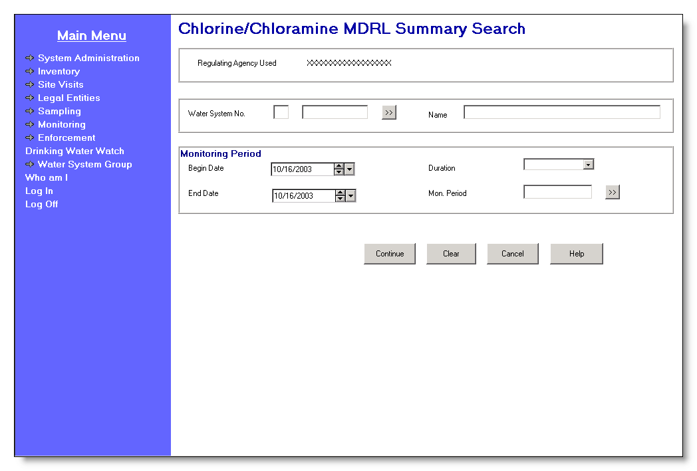

Exhibit 5-39. Chlorine/Chloramine MRDL Summary Search

Protected Field:

WS Group Used/
Regulating Agency
Used This protected field will show the user’s current Water System Group Name or Regulating Agency depending on which the user has made current. The software will dynamically change the prompt depending on whether Water System Group Name or Regulating Agency is current. The prompt will be “WS Group Used” if the user’s current Water System Group is valued, otherwise the prompt will be “Regulating Agency Used.”

Entry Fields:

Water System No. The specific Water System No., which consists of the two-character state code plus the seven-character number field.

The state code portion will default to the state_identification_code in the SYSTEM_VARIABLE entity view.

The Go To button may be pressed to select a water system from the Water System Maintenance List in single-select mode, which will display a list of water systems that are part of the current Water System Group or Regulating Agency. Once a valid water system has been entered or picked from a list, the water system name will be displayed on the page. If the user specifies a partial string in this field, display the closest matching water system at the top of the list. (Closest matching means a match with the Water System No., sorted alphabetically, that starts with the same text string as supplied.)

If a valid water system is entered but is not part of the user’s current Water System Group or Regulating Agency, invoke exit state error message: WS is not part of current group/agency. Change group/agency to access this WS.

[Water System]
Name Standard 40-character Public Water System Name may be entered completely, partially, or left blank. If the user specifies a partial string in this field, display the Water System Maintenance List in single-select mode with the closest matching water system at the top of the list. (Closest matching means a match with the Water System Name, sorted alphabetically, that starts with the same text string as supplied.)

If a valid water system name is entered, the Water System No. is populated.

If a valid water system is entered but is not part of the user’s current Water System Group or Regulating Agency, invoke exit state error message: WS is not part of current group/agency. Change group/agency to access this WS.

If the name entered is not found, the software will flow to the Water System Maintenance List in single-select mode. The user may then select a value and continue.

Monitoring Period Group Box:

Selecting a Monitoring Period will be optional when the software flows to this page from the SDWIS/STATE Home Page or when the user selects View/Search on the Chlorine/Chloramine MRDL Maintenance List. Selecting a Monitoring Period will be mandatory when the user selects Edit/Add on the Chlorine/Chloramine MRDL Maintenance List.

[Monitoring Period]
Begin Date If Begin Date and either End Date or Duration are valued, on tabbing off, the software will retrieve the monitoring period that matches the criteria and display it in all monitoring period fields. If no monitoring period exists that matches the criteria, it will invoke the Monitoring Period Maintenance List in single-select mode, sorted on Monitoring Period Begin Date descending then on Monitoring Period End Date ascending The software will take no action if only Begin Date is valued.

[Monitoring Period]
End Date If End Date and either Begin Date or Duration are valued, on tabbing off, the software will retrieve the monitoring period that matches the criteria and display it in all monitoring period fields. If no monitoring period exists that matches the criteria, it will invoke the Monitoring Period Maintenance List in single-select mode, sorted on Monitoring Period Begin Date descending then on Monitoring Period End Date ascending. The software will take no action if only End Date is valued.

[Monitoring Period]
Duration The user may enter a valid Monitoring Period Duration or use the Go To button to select a valid monitoring period. (R4000:A.5.6.4.a)The default duration will be monthly. If Duration and either Begin Date or End Date are valued, on tabbing off, the software will retrieve the monitoring period that matches the criteria and display it in all monitoring period fields. If no monitoring period exists that matches the criteria, it will invoke the Monitoring Period Selection List. The software will take no action if only Duration is valued.

[Mon. Period]
If the user enters a valid monitoring period name, on tabbing off, the software will retrieve the monitoring period that matches the criteria and display it in all monitoring period fields. If the user enters a partial string or an invalid monitoring period name, the software will invoke the Monitoring Period Maintenance List in single-select mode, sorted on Monitoring Period Name ascending.

Tab Sequence:

Water System No. [the seven-character, number field], Water System Go To button, [Water System Name], [Monitoring Period] Begin Date, [Monitoring Period] Duration, [Monitoring Period] End Date, Mon. Period [Name], Monitoring Period Go To button, Continue button, Search button, Clear button, Cancel button, Help button.

Buttons:

[water system]
Go To The user may use the Go To button to display the Water System Maintenance List in single-select mode. If the user has typed in a partial Water System No., it will be used in the search. If the user has typed in a partial Water System Name, it will be used in the search. As the user selects a Water System, the software will then populate the retrieved Water System’s Name value in the protected Water System Name field. Return the cursor to the first Monitoring Period field.

[monitoring period]
Go To The user may use the Go To button to select a valid monitoring period(R4000:A.5.6.4.b) As the user selects the Monitoring Period, the software will then populate the retrieved Monitoring Period fields.

Search This button will be enabled in Search mode. When selected, the software will retrieve MDBP summaries of type “MRDL” for analytes chlorine and chloramine for the selected Water System and/or monitoring period based on the specified criteria. The user’s current Water System Group/Regulating Agency will be used as implied search criteria in all searches. This means that the software will only retrieve summaries linked to a Water System that is linked to the user’s current Water System Group/Regulating Agency. If an exact Water System No. is entered, the software will validate that it belongs to the user’s current Water System Group/Regulating Agency. The following will be possible search permutations:

- Search by Water System No.

- Search by Monitoring Period.

- Search by Water System No. and Monitoring Period.

- Search with no filtering criteria. If the user opts not to specify anything on the search page, the user’s current Water System Group/Regulating Agency will still be used in retrieving records that will be displayed.

- If the Water System and monitoring period are both selected and no MDBP summaries meet the search criteria, invoke informational exit state message: No MRDL Summaries exist for the specified criteria. When the user clicks OK, the software will flow to Chlorine/Chloramine MRDL Summary Maintenance through the Chlorine/Chloramine MRDL Summary Maintenance List, invoking the Add menu item edit checks.

- If under any other situation, no MDBP summaries meet the search criteria, invoke informational exit state message: No MRDL Summaries exist for the specified criteria. When the user clicks OK, the software will display the maintenance list with no records listed.

- If the search retrieves a single MRDL summary record, the software will flow to the Chlorine/Chloramine MRDL Maintenance page and display the single MRDL summary record (the user does not have to select/change it).

- If the search retrieves more than one summary, the software will flow to the Chlorine/Chloramine MRDL Summary Maintenance List and display them.

Continue The button will be enable in Add mode. When selected:

(1) If either a valid water system or a valid monitoring period has not been selected, the following error message will be invoked: To add a summary, you must specify Water System and Monitoring Period. When the user selects OK, close the message and return to the Chlorine/Chloramine MRDL Summary Search/Add Page in Add mode.

(2) Once a valid Water System and monitoring period have been selected, the software will select the distribution system facility for the Water System, whether active or inactive (i.e., a Water System Facility [WSF] of type “DS”).

      - If a WSF of type “DS” is not found, the following error message will be invoked: Distribution WSF not found for this Water System. When the user selects OK, close the message and return to the Chlorine/Chloramine MRDL Summary Search/Add Page in Add mode with all the previously selected values entered.

(2) If more than one distribution system is found, the software will invoke the Water System Facility Maintenance List (that will display WSFs for the current Water System and of type DS) where the user must choose one.

(3) After a distribution system has been selected, the software will select the FANL that is linked to the current WSF and that establishes a maximum level (Level Type is “MAX”) for either chlorine or chloramine (Analyte Code 0999 or 1006 respectively).

      - If no FANL meeting these criteria is found, the software will invoke FANL for chloramine (1006) or chlorine (0999) of type MAX not found for this WSF. When the user selects OK, close the message and return to the Chlorine/Chloramine MRDL Summary Search/Add Page in Add mode with all the previously entered values entered.

(4) If a FANL meeting these criteria is found, the software will run the selected FANL through the following checks that may let the user know that a FANL exists but still cannot be used. If any of these checks is validated, an error message will be invoked. After the user presses OK on the message, close the message and return to the Chlorine/Chloramine MRDL Summary Search/Add page in Add mode with all the previously selected values entered.

(1) If the FANL is not in effect during monitoring period (FANL Effective Begin Date is not on or before the Monitoring Period Begin Date), the following error message will be invoked: Facility Analyte Level not in effect during this monitoring period.

(2) If the MDBP Summary Check Flag is not set to “Yes” for the FANL, the following error message will be invoked: Facility Analyte Level with MDBP Summary Check Flag set to YES not found.

(3) If the Summary type for the FANL is not “MRDL,” the following error message will be invoked: Facility Analyte Level with MDBP Summary type MRDL not found.

(5) If the selected FANL passes all of the above checks, the software will flow to the to the Chlorine/Chloramine MRDL Summary Maintenance page displaying the Water System No., Water System Name, WSF State Asgn ID, WSF Name, Monitoring Period Begin Date, and Monitoring Period Duration with the cursor is in the first entry field.

Clear Pressing this button will clear data from all fields on the search page.

Cancel Will disregard any data and return the user to the previous page.

Help Will invoke online Help for this page.

Chlorine/Chloramine MRDL Maintenance List
The Chlorine/Chloramine MRDL Maintenance List (Exhibit 5-40), which displays up to 1,000 records at a time, lists the MRDL summaries for chlorine and chloramine retrieved from the search criteria specified. The user will be able to select (double-click) a MRDL summary from the list to view or update, add a new MRDL summary by selecting Edit/Add, or delete an existing MRDL summary.

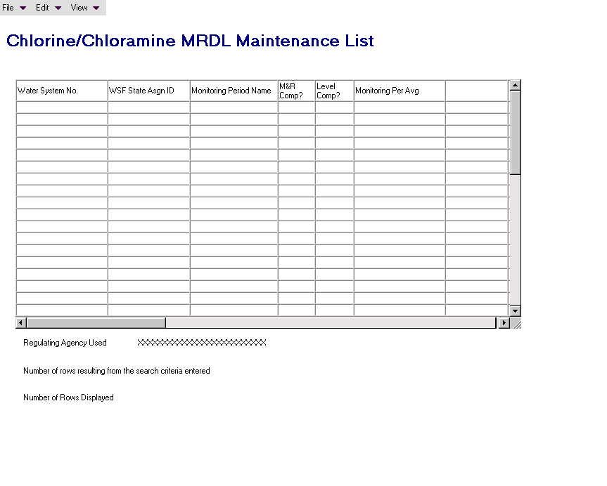

Exhibit 5-40. Chlorine/Chloramine MRDL Maintenance List

Default Sort Order: Descending monitoring period name.

List Fields:

Water System No. The Water System No. for the summary.

WSF State Asgn ID The twelve-digit identification code assigned to a water system facility (WSF).

Monitoring Period Name The name of the monitoring period associated to the summary.

M&R Comp? Indicates status of M&R Compliance.
- NMJ = No, M&R Compliance not met resulting in Major violation.
NMN = No, M&R Compliance not met resulting in Minor violation.
- YES = Yes, M&R Compliance was met.

Level Comp? Indicates status of Level Compliance.
- Y = Yes, Level Compliance was met.
- N = No, Level Compliance not met.

Monitoring Per. Avg. The average measure for the specified analyte during the
[and UOM] specified monitoring period concatenated with the Monitoring Period Average UOM Code.

Running Annual Avg. The running annual average measure for the specified
[and UOM] analyte concatenated with the Running Annual Average UOM Code.

Samples Required The number of samples required.

Sample Taken The number of samples collected.

Samples Exceeded Level The number of samples that exceeded the measure level.

%Samples Beyond Level The percentage of samples that exceeded the measure level.

Reported Date Date that the MDBP Summary is reported.

Mon Per Begin Date Begin Date of the user-specified monitoring period.

Water System Name The name of the water system.

WSF Name The name of the water system facility (WSF).

Menu Items:

File

Exit Selecting File/Exit will return the user to the SDWIS/STATE Home Page.

Edit

Add The Edit/Add option will be enabled when a record has not been highlighted. When the user selects Edit/Add, flow to the Chlorine/Chloramine MRDL Summary Search/Add page in Add mode with the same values that were previously entered in this page.

Change Selecting Edit/Change will invoke the MRDL Maintenance page with the selected record. This option will be enabled only when a record has been highlighted.

Delete Selecting Edit/Delete will display a delete confirmation dialog box for the selected record. This option will be enabled only when a record has been highlighted.

If the MRDL Summary selected for deletion is linked to a validated or preliminary violation (i.e., a violation with status of “V” or “P”), the following error message will be invoked: This MRDL Summary is linked to a violation and cannot be deleted.
View

Search Selecting View/Search will invoke the Chlorine/Chloramine MRDL Summary Search page in Search mode and value the fields on the page with the same values entered previously.

Sort Selecting View/Sort will invoke the standard Sort page.

Filter by Water System No., WSF State Asgn ID, Monitoring Period Begin Date, M&R Compliance Indicator, Level Compliance Indicator, Water System Name, or WSF Name.

Refresh Selecting View/Refresh will retrieve the unfiltered list (original search criteria).

Protected Field:

WS Group Used/
Regulating
Agency Used This protected field will show the user’s current Water System Group Name or Regulating Agency depending on which the user has made current. The software will dynamically change the prompt depending on whether Water System Group Name or Regulating Agency is current. The prompt will be “WS Group Used” if the user’s current Water System Group is valued, otherwise the prompt will be “Regulating Agency Used.”

Number of rows
resulting from search
criteria entered Shows the total number of rows that met the search criteria.

Number of rows
displayed Shows the total number of rows that are displayed in the list, which may be less than the number of rows that met the search criteria.

Chlorine/Chloramine MRDL Summary Maintenance
The Chlorine/Chloramine MRDL Summary Maintenance page (Exhibit 5-41) will be used to add and maintain Chlorine/Chloramine MRDL Summaries.

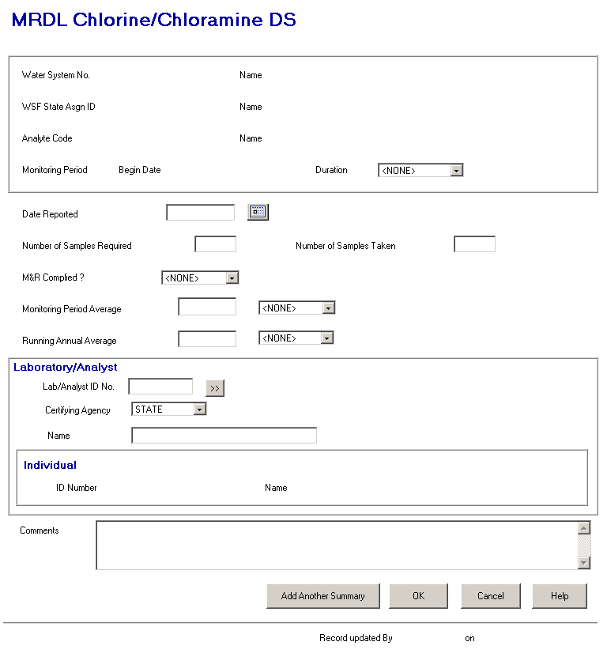

Exhibit 5-41. Chlorine/Chloramines MRDL Summary Maintenance

Protected Fields, Entry Fields, and Buttons:

All protected fields, entry fields, defaults, and buttons on this page will operate according to the specifications described for the MRDL Chlorine/Chloramine DS page in the Water Treatment Summary flow described in Subsection 5.7.2.8 except that the WT Jump button will be replaced by an Add Another Summary button and the Next button will be replaced by an OK button. Specifications for these two buttons follow.

Add Another
Summary and OK Both buttons will create or update the summary record. The following actions will apply to the Add Another Summary and OK buttons unless otherwise specified.

If an error message is invoked, after the user closes the message, the software will return to the Chlorine/Chloramine MRDL Summary Maintenance page with all previously entered data in place. The software will ensure the following:

- That the Reported Date is not a future date The error message will be: Date must not be a future date. Return the cursor to the Reported Date field when the user closes the message.

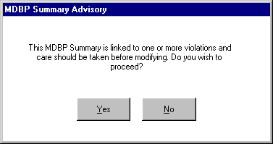
- If the MRDL Summary selected for modification is associated to one or more violations and one or more values have been changed, invoke the MRDL Summary Advisory dialog box (Exhibit 5-42) with the following message, This MRDL Summary is linked to one or more violations and care should be taken before modifying. Do you wish to proceed?

Exhibit 5-42. MRDL Summary Advisory

- If the user selects OK (or Yes on the MRDL Summary Advisory dialog box), the data will be committed to the database and the software will flow to the Chlorine/Chloramine MRDL Summary List page, displaying all the Chlorine/Chloramine MRDL Summaries for the current Water System with a default sort order of Monitoring Period Begin Date descending.

- If the user selects Add Another Summary, the data will be committed to the database and the software will flow to the Chlorine/Chloramine MRDL Summary Search/Add page in Add mode, displaying the values entered in the equivalent fields on the current maintenance page (i.e., all the fields on the dialog box should be valued), allowing the user to change the one or two values desired before entering another summary.

Cancel Will disregard any data and return the user to the previous page.

Help Will invoke online Help for this page.

General MDBP Summary Page Flow
This is the last of items under MDBP Summaries, called General MDBP Summary, which will be accessible from the SDWIS/STATE Home Page. This page flow, like the other two, will allow a user to only maintain summaries for Water Systems that are part of their current Regulating Agency or Water System Group.

The main purpose of this page will be to allow users to add and maintain data in the MDBP Summary records that are not maintained in the Water Treatment or MRDL page flows.

This page may be used to modify the Level Compliance Indicator, change the associated monitoring period, or Facility Analyte Level (FANL). Also, users may have or develop other uses for the MDBP summary tables to store data.

An example would be summaries received from systems that fluoridate. Even though fluoridation is not under the MDBP rules, the reporting required for it may fit within the model developed for the MDBP rules. To maintain MDBP summaries for “other” rules, users would need to create a new MDBP Summary Type, create new M&R and Level Violation Types (all three of which would be done in System Administration), and add appropriate FANL records. With these records in place, the Water Treatment Compliance Report will compare summaries against FANL to determine compliance.

MDBP Summary Search/Add
From the SDWIS/STATE Home Page, if the user selects the Sampling option, then MDBP Summaries and the General MDBP Summary option, the MDBP Summary Search page (Exhibit 5-43) will be invoked where the user may specify the desired search criteria. Users can specify MDBP Summary Type Information, Water System Information, and/or Monitoring Period Information.

This page will also be used when a user selects Edit/Add on the MDBP Summary Maintenance List page. When the software flows to this page from this list page:

- Its name will dynamically change to MDBP Summary Add.
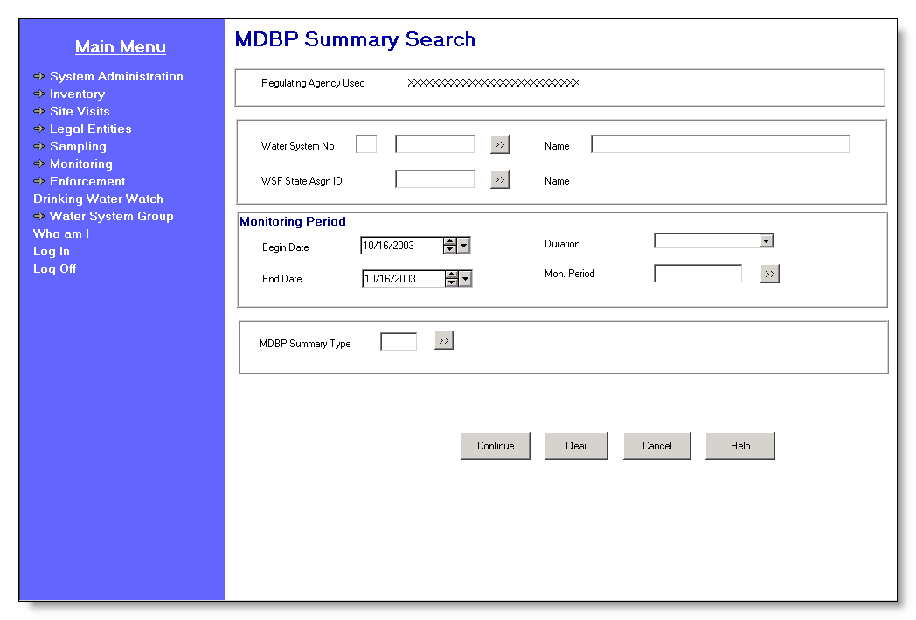

Exhibit 5-43. MDBP Summary Search/Add

Protected Field:

WS Group Used/
Regulating Agency
Used This protected field will show the user’s current Water System Group Name or Regulating Agency depending on which the user has made current. The software will dynamically change the prompt depending on whether Water System Group Name or Regulating Agency is current. The prompt will be “WS Group Used” if the user’s current Water System Group is valued, otherwise the prompt will be “Regulating Agency Used.”

Entry Fields:

Water System No. The specific Water System No., which consists of the two-character state code plus the seven-character number field.

The state code portion will default to the state_identification_code in the SYSTEM_VARIABLE entity view.

The cursor will be positioned in the numeric portion.

The Go To button may be pressed to select a water system from the Water System Maintenance List in single-select mode, which will display a list of water systems that are part of the current Water System Group or Regulating Agency. Once a valid water system has been entered or picked from a list, the water system name will be displayed on the page. If the user specifies a partial string in this field, display the closest matching water system at the top of the list. (Closest matching means a match with the Water System No., sorted alphabetically, that starts with the same text string as supplied.)

If a valid water system is entered but is not part of the user’s current Water System Group or Regulating Agency, invoke exit state error message: WS is not part of current group/agency. Change group/agency to access this WS.

[Water System]
Name Standard 40-character Public Water System Name may be entered completely, partially, or left blank. If the user specifies a partial string in this field, display the Water System Maintenance List in single-select mode. the closest matching water system at the top of the list. (Closest matching means a match with the Water System Name, sorted alphabetically, that starts with the same text string as supplied.)

If a valid water system name is entered, the Water System No. is populated.

If a valid water system is entered, but is not part of the user’s current Water System Group or Regulating Agency, invoke exit state error message: WS is not part of current group/agency. Change group/agency to access this WS.

If the name entered is not found, the software will flow to the Water System Maintenance List in single-select mode. The user may then select a value and continue.

WSF State Asgn ID The State Assigned ID of the Water System Facility. The user may enter a valid WSF or use the Go To button to select a valid Water System facility from a Water System Facility Maintenance list in single-select mode listing only Water System Facility for this water system. This field will be enabled only if the user has first picked a valid Water System and will be cleared when a previously selected water system is changed. A WSF is valid if it is for the selected Water System.

As the user tabs off this field, the software will check that the supplied State Asgn ID is valid for the selected Water System. If it is not associated with the selected Water System, the software will not supply a message but instead will directly invoke the Water System Facility Maintenance List in single-select mode from where the user may select a valid water system facility. Once a valid water system facility is entered or picked from a list, the water system facility name will be displayed on the page in the protected [WSF] Name field.

Monitoring Period Group Box:

Selecting a Monitoring Period will be optional when the software flows to this page from the SDWIS/STATE Home Page or when the user selects View/Search on the MDBP Summary Maintenance List. Selecting a Monitoring Period will be mandatory when the user selects Edit/Add on the MDBP Summary Maintenance List.

[Monitoring Period]
Begin Date If Begin Date and either End Date or Duration are valued, on tabbing off, the software will retrieve the monitoring period that matches the criteria and display it in all monitoring period fields. If no monitoring period exists that matches the criteria, it will invoke the Monitoring Period Maintenance List in single-select mode, sorted on Monitoring Period Begin Date descending, then on Monitoring Period End Date ascending. The software will take no action if only Begin Date is valued.

[Monitoring Period]
End Date If End Date and either Begin Date or Duration are valued, on tabbing off, the software will retrieve the monitoring period that matches the criteria and display it in all monitoring period fields. If no monitoring period exists that matches the criteria, it will invoke the Monitoring Period Maintenance List in single-select mode, sorted on Monitoring Period Begin Date descending then on Monitoring Period End Date ascending. The software will take no action if only End Date is valued.

[Monitoring Period]
Duration The user may enter a valid Monitoring Period Duration or use the Go To button to select a valid monitoring period. (R4000:A.5.6.5.a)The default duration will be monthly. If Duration and either Begin Date or End Date are valued, on tabbing off, the software will retrieve the monitoring period that matches the criteria and display it in all monitoring period fields. If no monitoring period exists that matches the criteria, it will invoke the Monitoring Period Maintenance List in single-select mode, sorted on Monitoring Period Begin Date descending then on Monitoring Period End Date ascending. The software will take no action if only Duration is valued.

[Mon. Period] If the user enters a valid monitoring period name, on tabbing off, the software will retrieve the monitoring period that matches the criteria and display it in all monitoring period fields. If the user enters a partial string or an invalid monitoring period name, invoke the Monitoring Period Maintenance List in single-select mode.

MDBP Summary Type Group Box:

Summary Type
The MDBP Summary Type for which the user wishes to search for MDBP Summaries. The user may enter the summary type by entering a four-character value or use the permitted value dropdown list and select from the list. As the user enters/changes a value and tabs off the Summary Type field, the software will populate the retrieved MDBP Summary Type Name value in the protected MDBP Summary Type Name field.

The permitted values for the dropdown will be retrieved from the CODE table, name = ‘TSAMDBPS1.’ The values are maintained by the System Administrator. The following values are provided with the software:

AVGT CFE Average Turbidity
MAXT CFE Maximum Turbidity
95PT CFE 95% Turbidity
IFT Individual Filter Effluent Turbidity
EPRD Entry Point RDC
SERD State EP RDC
CLO2 EP Chlorine Dioxide
CLO3 EP Chlorite
DSRD Distribution RDC
SDRD State Distribution RDC
MRDL Chlorine/Chloramine MRDL
OTHR Other

This field will be optional when the page is in Search mode and mandatory when it is in Add mode.

Tab Sequence:

Water System No. [the seven-character, number field], Water System Go To button, [Water System Name], WSF State Asgn ID, WSF Go To button, [Monitoring Period] Begin Date, [Monitoring Period] Duration, [Monitoring Period] End Date, [Monitoring Period] Name, Monitoring Period Go To button, [MDBP] Summary Type, Continue button, Search button, Clear button, Cancel button, Help button.

Buttons:

[water system]
Go To The user may use the Go To button to display the Water System Maintenance List in single-select mode. If the user has typed in a partial Water System No., it will be used in the search. If the user has typed in a partial Water System Name, it will be used in the search. As the user selects a Water System, the software will then populate the retrieved Water System’s Name value in the protected [Water System] Name field. Clear all the WSF fields and return the cursor to the first WSF State Asgn ID field.

[water system facility]
Go To The user may use the Go To button to display the Water System Facility Maintenance List in single-select mode showing WSFs for the selected Water System. As the user selects a WSF, the software will then populate the retrieved WSF’s Name value in the protected WSF Name field. Return the cursor to the first Monitoring Period field.

[monitoring period]
Go To The user may use the Go To button to select a valid monitoring period of any duration from the Monitoring Period Maintenance List in single-select mode, sorted on Monitoring Period Begin Date descending then on Monitoring Period End Date ascending. As the user selects the Monitoring Period, the software will then populate the retrieved Monitoring Period Begin Date and Duration. Return the cursor to the [MDBP] Summary Type field. (Will not be limited to Monthly and Quarterly duration (R4000:A.5.6.5.b))

Search Button will be enabled in Search mode. When selected, the software will retrieve MDBP summaries for selected Water System and/or monitoring period and/or summary type based on the specified criteria. The following are possible search permutations:

- Search by Water System No.
- Search by Water System No. and WSF.
- Search by Monitoring Period.
- Search by MDBP Summary Type.
- Search by Water System No. and Monitoring Period.
- Search by Water System No. and WSF and Monitoring Period.
- Search by Water System No. and MDBP Summary Type.
- Search by Water System No. and WSF and MDBP Summary Type.
- Search by Monitoring Period and MDBP Summary Type.
- Search by Water System No. and WSF and Monitoring Period and MDBP Summary Type.
- No criteria.

If Water System No. is specified but WSF State Asgn ID is not, the following error message will be invoked: Water system facility must not be blank. When the user clicks OK, return the user to the Search page. Place the cursor in the WSF State Asgn ID field.

- If the Water System/WSF, monitoring period, and summary type are all specified and no MDBP summaries meet the search criteria, invoke informational exit state message: No MDBP Summaries exist for the specified criteria. When the user clicks OK, the software will flow to the MDBP Summary Maintenance page, invoking the Add Mode specifications given below.

- If under any other combination of search criteria, no MDBP summaries meet the search criteria, invoke informational exit state message: No MDBP Summaries exist for the specified criteria. When the user clicks OK, display the maintenance list with no records listed.

- If the search retrieves a single MDBP summary record, the software flows directly to the MDBP Summary Maintenance page, displaying the selected MDBP Summary so that the user does not have to select/change it.

- If the search retrieves more than one summary, they will be displayed in the MDBP Summary Maintenance List.

Continue The button will be enabled in Add Mode. When selected:

(1) If either a valid Water System, water system facility, monitoring period, or summary type have not been selected, the following error message will be invoked: To add a summary, you must specify Water System, WSF, Monitoring Period, and Summary Type. When the user selects OK, close the message and return to the MDBP Summary Search/Add page in Add mode.

(2) If a valid Water System, water system facility, monitoring period, and summary type have been selected, the software will select the FANL that is linked to the current Water System, WSF, and that indicates the user-specified, summary type. This may result in the selection of zero, one, or more FANL.

- If no FANL meeting these criteria is found, the following error message will be invoked: FANL for the selected Water System, WSF and Summary Type not found. When the user selects OK, close the message and return to the MDBP Summary Search/Add page in Add mode with all the previously entered values entered.

(3) If one or more FANL meeting these criteria are found, the software will run each of the selected FANL through the following checks that may let the user know that a FANL exists but still cannot be used. If any of these checks is validated, an error message will be invoked. After the user presses OK on the message, close the message and return to the MDBP Summary Search/Add page in Add mode with all the previously entered values entered.

- If none of the selected FANLs is in effect during the user-specified monitoring period (FANL Effective Begin Date is not on or before the Monitoring Period Begin Date), the following error message will be invoked: No FANL with this Summary Type is in effect during this monitoring period.

- If one of the selected FANL is in effect during the user-specified monitoring period but its MDBP Summary Check Flag is not set to “Yes,” the following error message will be invoked: FANL with MDBP Summary Check Flag set to YES not found.

(4) If the selected FANL passes all of the above checks, the software will flow to the to the MDBP Summary Maintenance page displaying the Water System No., Water System Name, WSF State Asgn ID, WSF Name, Analyte Code, Analyte Name, Monitoring Period Begin Date, Monitoring Period Duration and Summary Type with the cursor in the first entry field.

Clear Pressing this button will clear data from all fields on the search page.

Cancel Will disregard any data and return the user to the previous page.

Help Will invoke online Help for this page.

MDBP Summary Maintenance List
The MDBP Summary Maintenance List (Exhibit 5-44), which will display up to 1,000 records at a time, will list the MDBP summaries retrieved from the search criteria specified. The user will be able to select (double-click) an MDBP summary from the list to view or update, add a new MDBP summary by selecting Edit/Add, or delete an existing MDBP summary.

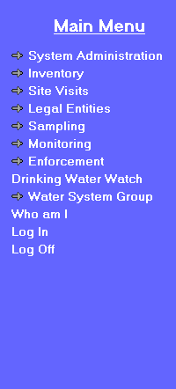 | 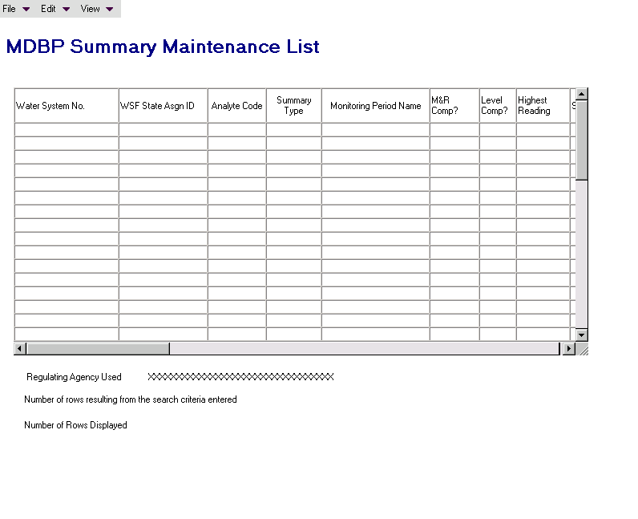

Exhibit 5-44. MDBP Summary Maintenance List

Default Sort Order: Descending monitoring period end date

List Fields:

Water System No. The Water System No. for the summary.

WSF State Asgn ID The twelve-digit identification code assigned to a water system facility (WSF).

Analyte Code The Analyte code specified in the associated Facility Analyte Level record.

Summary Type The type of MDBP Summary

Monitoring Period Name The name of the monitoring period associated to the summary.

M&R Comp? Indicates status of M&R Compliance.
- NMJ = No, M&R Compliance not met resulting in Major violation.
NMN = No, M&R Compliance not met resulting in Minor violation.
- YES = Yes, M&R Compliance was met.

Level Comp? Indicates status of Level Compliance.
- Y = Yes, Level Compliance was met.
- N = No, Level Compliance not met.

Highest Reading The highest measure during the specified monitoring period.

Sampling Point [ID] The sampling point identification code.

Samples Exceeded Level The number of samples that exceeded the measure level.

%Samples Beyond Level The percentage of samples that exceeded the measure level.

Monitoring Per. Avg. The average measure for the specified analyte during the
[and UOM] specified monitoring period concatenate the Measure Text with the Monitoring Period UOM code.

Running Annual Avg. The running annual average measure for the specified
[and UOM] analyte concatenate the Measure Text with the Running Annual Average UOM code.

Date Reported Date that the MDBP Summary is reported.

Samples Required The number of samples required.

Sample Taken The number of samples collected.

Mon Per Begin Date Begin Date of the user-specified monitoring period.

Water System Name The name of the water system.

WSF Name The name of the water system facility (WSF).

Menu Items:

File

Exit Selecting File/Exit will return the user to the SDWIS/STATE Home Page.

Edit

Add The Edit/Add option will be enabled when a record has not been highlighted.

When the user selects Edit/Add, flow to the MDBP Summary Search/Add page in Add mode with the same values that were previously entered on this page.

Change Selecting Edit/Change will display the MDBP Maintenance page with the selected record. This option will be enabled only when a record has been highlighted.

If the MDBP Summary selected for modification is associated to one or more violations, invoke advisory dialog box with the following message. This MDBP Summary is linked to one or more violations and care should be taken before modifying. Do you wish to proceed?

Select The Edit/Select menu item will be enabled only when the software flows to this page from Violation Maintenance (specifically, from Violation MDBP Summary Association). (When invoked from Violation Maintenance, Select will be the only Edit menu item available.)

Delete Selecting Edit/Delete will display a delete confirmation dialog box for the selected record. This option will be enabled only when a record has been highlighted.

If the MDBP Summary selected for deletion is linked to a validated or preliminary violation (i.e., a violation with status of V or P), the following error message will be invoked: This MDBP Summary is linked to a violation and cannot be deleted.

View

Search Selecting View/Search will invoke the MDBP Summary Search page in Search mode and value the fields on the page with the same values entered previously.

Sort Selecting View/Sort will invoke the standard Sort page.

Filter by Water System No., Water System Name, WSF State Asgn ID, WSF Name, Summary Type, Analyte Code, Analyte Name, Monitoring Period Name, Monitoring Period Begin Date, M&R Compliance Indicator, Level Compliance Indicator, or Date Reported.

Refresh Selecting View/Refresh will retrieve the unfiltered list (original search criteria).

Protected Fields:

WS Group Used/
Regulating Agency
Used This protected field will show the user’s current Water System Group Name or Regulating Agency depending on which the user has made current. The software will dynamically change the prompt depending on whether Water System Group Name or Regulating Agency is current. The prompt will be “WS Group Used” if the user’s current Water System Group is valued, otherwise the prompt will be “Regulating Agency Used.”

Number of rows
resulting from search
criteria entered
Will show the total number of rows that met the search criteria.

Number of rows
displayed Will show the total number of rows that are displayed in the list, which may be less than the number of rows that met the search criteria.

MDBP Summary Maintenance
The MDBP Summary Maintenance page, Exhibit 5-45, will be used to add or maintain general MDBP Summaries. All attributes of the MDBP summary will be available on the page. This page will have less automation and more generic labels than the Water Treatment or MRDL pages. Users may create types of MDBP Summaries through the System Administrator permitted values function. If a FANL of the same MDBP Summary type is in effect during the selected monitoring period, for the selected WSF, the software will read the FANL record for some default values.

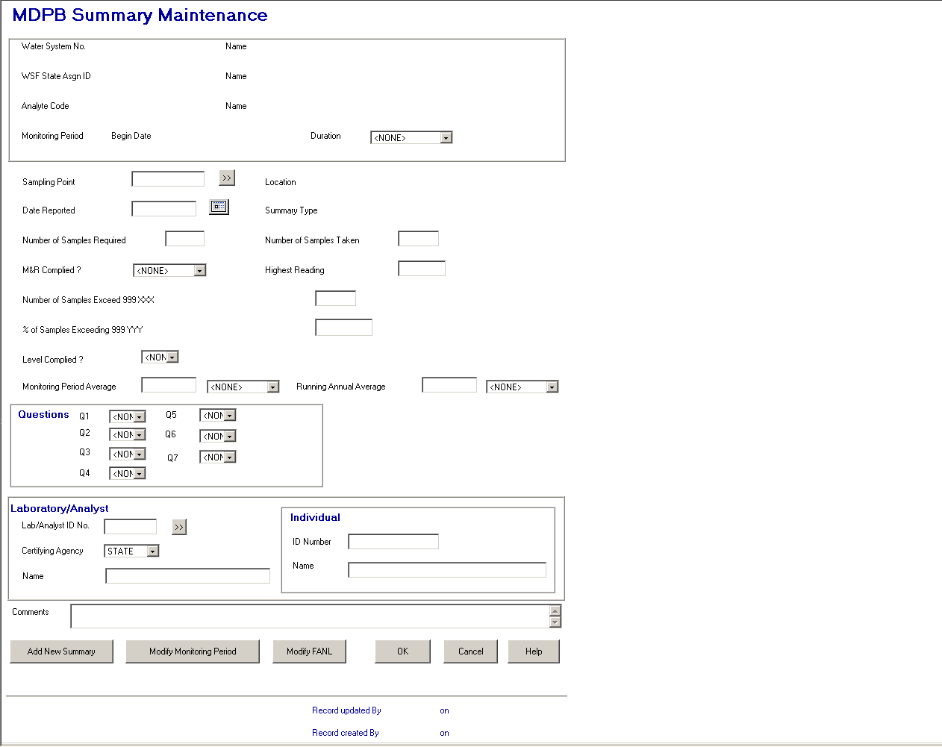

Exhibit 5-45. MDBP Summary Maintenance

Protected Fields:

The protected fields in this display box will be the same as previously described for the Combined Filter Effluent Turbidity page with the addition of the following two rows.

Individual ID No. and Name will become protected fields. (R0059:A.5.6.5.3.f)

Record updated
by XXXXXXXX on
MM/DD/YYYY
HH:MI:SS The User ID and the timestamp from the last time the water purchase record was updated.

Record created
by XXXXXXXX on
MM/DD/YYYY
HH:MI:SS The initial User ID and timestamp when the water purchaser record was initially added to the database.

Entry Fields:

Sampling Point The user may enter a sampling point that is valid for the selected WSF or use the Go To button to display the Sampling Point Maintenance List in single-select mode listing sampling points for this water system facility. As the user makes a selection, the software will then populate the retrieved Sampling Point State Asgn ID and Location.

Date Reported This field will operate the same as the Date Reported field on the Combined Filter Effluent Turbidity page.

Number of Samples
Required This field will operate the same as the Samples Required field on the Combined Filter Effluent Turbidity page.

Number of Samples
Taken This field will operate the same as the Number of Samples Taken field on the Combined Filter Effluent Turbidity page.

M&R Complied? This field will operate the same as the M&R Complied field on the Combined Filter Effluent Turbidity page.

Highest Reading Store as HIGHEST_MEASURE with summary.

First Protected Prompt/
Label [Number of
Samples Exceeded
999 XXX]
 Display “Number of Samples Exceeded 999” in the First Protected Prompt/Label.

- Set 999 to the value in
FANL CONTROL_LEVEL _TEXT.
- Default the field to zero.

Store the value in the field as MDBP Summary TOTAL_SAMPLES_BEYOND_MSR_LVL.

Second Protected Prompt
/Label [%of Samples
Exceeding 999 YYY]
- Set XXXXXXXXXXXX to “% of Samples Exceeding 999 YYY.”

- Set 999 to value in FANL CONTROL_LEVEL_TEXT.

- Set YYY to FANL CONTROL_LEVEL_TEXT_UOM.

- Enable PERCENT_SAMPLES_BEYOND_MSR_LVL entry field and default value according to the following calculation: value = (number of samples exceeding level/number of samples taken) * 100, with two significant digits after the decimal point.

- In change mode, if either the number of samples taken or number of samples beyond is modified, recalculate this field.

Store as PERCENT_SAMPLES_BEYOND_MSR_LVL and PERCENT_SAMPS_BYND_MSR_LVL_TXT with 95PT summary.

[MDBP Summary]
Level Complied? Permitted Value: Y=Yes; N=No.

If MDBP Summary Number of Samples Exceeded Level (TOTAL_SAMPLES_BEYOND_MSR_LVL) equals 0, default to Y (Yes).

Else if >0, default to N (No).

Store as MR_COMPLIANCE_INDICATOR with summary record.

Monitoring Period
Average Default to zero and store as both a numeric field for calculations (MONITORING_PERIOD_AVG_MEASURE) and as a text field (MONITORING_PERIOD_AVG_MSR_TXT) for display purposes with summary.

Leading zeros will not be stored in the text field except when the numeric field is less than one, in which case, one zero to the left of the decimal place will be included in the text field (e.g., numeric is .1, 0.1 will be stored in the text field). Trailing zeros entered by the user will, however, be retained (e.g., if 1.20 is entered, it will be stored as 1.20 in the text field).

[Monitoring Period
Average UOM] Default to the UOM for the selected FANL.

Running Annual
Average Default to zero and store as both a numeric field (RUNNING_ANNUAL_AVERAGE_MEASURE) for calculations and as a text field (RUNNING_ANNUAL_AVERAGE_MSR_TXT) for display purposes with summary.

Leading zeros will not be stored in the text field except when the numeric field is less than one, in which case, one zero to the left of the decimal place will be included in the text field (e.g., numeric is .1, 0.1 will be stored in the text field). Trailing zeros entered by the user will, however, be retained (e.g., if 1.20 is entered, it will be stored as 1.20 in the text field).

[Running Annual
Average UOM] Default to the UOM for the selected FANL.

Question Group Box:

Question #1 Label will read “Q1.”

Permitted Values: Y=Yes; N=No; Blank.

Default to blank.

This field will be stored as Q1_IFT_MONITORED_INDICATOR in the summary.

Question #2 Label will read “Q2.”

Permitted Values: Y=Yes; N=No; Blank.

Default to blank.
This field will be stored as Q2_IFT_RECORED_INDICATOR in the summary.

Question #3 Label will read “Q3.”

Permitted Values: Y=Yes; N=No; Blank.

Default to blank.

This field will be stored as Q3_IFT_EQUIPMENT_INDICATOR in the summary.

Question #4 Label will read “Q4.”

Permitted Values: Y=Yes; N=No; Blank.

Default to blank.

This field will be stored as Q4_IFT_GREATER_1_0_INDICATOR in the summary.

Question #5 Label will read “Q5.”

Permitted Values: Y=Yes; N=No; Blank.

Default to blank.

This field will be stored as Q5_IFT_GREATER_0_5_INDICATOR in the summary.

Question #6 Label will read “Q6.”

Permitted Values: Y=Yes; N=No; Blank.

Default to blank.

This field will be stored as Q6_IFT_GREATER_1_DUR_3_MON_IND in the summary.

Question #7 Label will read “Q7.”

Permitted Values: Y=Yes; N=No; Blank.

Default to blank.

This field will be stored as Q7_IFT_GREATER_2_DUR_2_MON_IND in the summary.

Lab/Analyst
ID No. This field will be the same as the Lab ID No. field in the Combined Filter Effluent Turbidity page. The same design specifications will apply. (R0059:A.5.6.5.3.a)

Certifying Agency Select a value from the dropdown list. The value will be matched against the laboratory’s Certifying Agency. The selections available via the dropdown list will be retrieved from the TINPVALS table where code_name = “CERT_AG.”

If an exact match is found using the Lab ID No. and Certifying Agency, the laboratory name will be displayed.

If none is found, the Laboratory Maintenance List will be presented in single-select mode.

Certifying Agency will be a required field. It will default to STATE. (R0059:A.5.6.5.3.b)

(R0059:A.5.6.5.3.c)

Name This field will be the same as the Name field in the Combined Filter Effluent Turbidity page. The same design specifications will apply.

Comments User can record any additional information about the sample summary data.

Store as COMMENT_TEXT with summary.

Tab Sequence:

Sampling Point, Sampling Point Go To button, Date Reported, Number of Samples Required, Number of Samples Taken, M&R Complied/, Highest Reading, No. of Samples Exceeded Limit, Percentage of Samples Exceeded Limit, Level Complied/, Monitoring Period Average concatenated with MP Avg. UOM, Running Annual Average concatenated with RAA UOM, Q1, Q2, Q3, Q4, Q5, Q6, Q7, Lab/Analyst ID No., Certifying Agency, Name, Comments, Add New Summary button, Modify Monitoring Period button, Modify FANL button, OK button, Cancel button, Help button. (R0059:A.5.6.5.3.d)

Buttons:

[sampling point]
Go To The user may use the Go To button to display the Sampling Point Maintenance List in single-select mode. As the user makes a selection, the software will then populate the retrieved Sampling Point State Asgn ID and Location. Return the cursor to the Sampling Point Location field.

[laboratory/analyst]
Go To This button will be the same as the Lab Go To in the Combined Filter Effluent Turbidity page. (R0059:A.5.6.5.3.e)

(R0059:A.5.6.5.3.g)

Add New
Summary and OK Both buttons will create or update the summary record. The following actions will apply to the Add New Summary and OK buttons unless otherwise specified.

If an error message is invoked, after the user closes the message, the software will return to the MDBP Summary Maintenance page with all previously entered data in place. The software will ensure the following:

- That the Reported Date is not a future date The error message will be: Date must not be a future date. Return the cursor to the Reported Date field when the user closes the message.

- That the Sampling Point is valid for the selected WSF. If it is not, the following error message will be invoked: Sampling Point not valid for selected WSF and return the cursor to the Sampling Point field when the user closes the message.

- If the MDBP Summary selected for modification is associated to one or more violations and one or more values have been changed, invoke advisory dialog box with the following message: This MDBP Summary is linked to one or more violations and care should be taken before modifying. Do you wish to proceed? This dialog box is shown in Exhibit 5-43.

- If the user selects OK (or Yes on the MDBP Summary Advisory dialog box), the data will be committed to the database and the software will flow to the MDBP Summary List page, displaying all the MDBP Summaries of the current summary type for the current Water System with a default sort order of Monitoring Period Begin Date descending, WSF State Asgn ID ascending.

- If the user selects Add Another Summary, the data will be committed to the database and the software will flow to the MDBP Summary Search/Add page in Add mode, displaying the values entered in the equivalent fields on the current maintenance page (i.e., all the fields on the page should be valued), allowing the user to change the one or two values desired before entering another summary.

- In add mode, the d_initial_timestamp and d_lastupdt_ts will be set to the current timestamp. The d_initial_user_cd and d_user_code will be set to the User ID of the logged in user.

Modify Monitoring
Period Will present the Monitoring Period List. Once a monitoring period is selected, the summary will be associated to it.

Modify FANL Will present the Facility Analyte Level (FANL) maintenance List listing only FANLs for CURRENT water system. Once a FANL is selected, the summary will be associated to it.

Cancel Will disregard any data and return the user to the previous page.

Help Will invoke online Help for this page.

Results Averages
The purpose of the Results Averages function is to enable users to add and maintain averages of chemical results rather than entering each individual result. This may be particularly useful where a PWS owner reports quarterly and annual averages of results for total trihalomethanes (TThm) and haloacetic acids (HAA5). This function, however, can be used to enter averages for other contaminants as well, if desired. Additionally, this function allows users to change the averages that SDWIS/STATE’s CDS Setup component has calculated when individual results are entered (SDWIS/STATE only calculates these if a sample schedule also exists and the frequency of monitoring is monthly or less frequent).

Users may “add” and maintain both Monitoring Period Averages (MPA) (e.g., the average of four TThm results for a quarter) and Running Annual Averages (RAA) for any analyte, as long as a corresponding sample schedule (calling for monthly or less frequent monitoring) and monitoring period exist and CDS Setup has been run. Technically, a user can’t “add” either of these records but for all practical purposes, it appears as though the user is adding the record. It appears this way because CDS Setup creates an MPA and RAA record even when no individual results for a given monitoring period have been entered (so long as an appropriate sample schedule and corresponding monitoring period exist in the database). An MPA that is created when there is no result has no value (i.e., the Measure field is blank) and has 0 in the Number of Results Used field. When a user comes to such a record, it gives the impression that the user is entering a new record but, in fact, the user is modifying an existing record.

Where sample results do exist and have been used by CDS Setup to calculate the MPA and RAA values, users will be able to override those values. CDS Setup will not recalculate any MPA or RAA values that users have entered using the Results Averages Maintenance pages.

Model Changes for Results Averages
No model changes planned for this release.

Results Averages Page Flow

Results Averages Search
Selecting Results Averages will invoke the Results Averages Search page (Exhibit 5-46) where the user can specify a Sample Schedule, a Monitoring Period, or both as search criteria:

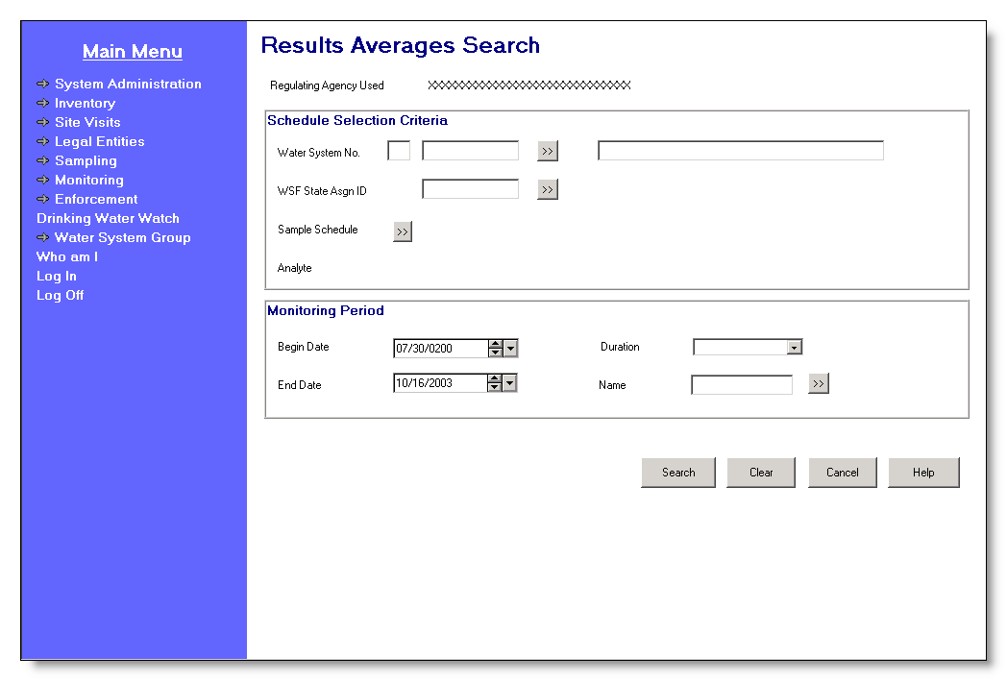

Exhibit 5-46. Results Averages Search

- Sample Schedule only (User may search on Water System No. and WSF State Asgn ID).

- Monitoring Period only.

- Sample Schedule and Monitoring Period.

All searches will be limited by the current Regulating Agency or Water System Group. The prompt will dynamically change to reflect whether the user has selected Regulating Agency or Water System Group to be current.

Protected Field:

Regulating Agency
Used/WS Group
Used This protected field will show the user’s current Water System Group Name or Regulating Agency, depending on which the user has made current. The software will dynamically change the prompt depending on whether a Water System Group or Regulating Agency is current. The prompt will be “Current WS Group” if the user’s current Water System Group is valued, otherwise the prompt will be “Regulating Agency Used.”

Analyte The Analyte Code and Name associated to the retrieved schedule’s monitoring requirement. This lets the user visually confirm that the software has retrieved the desired schedule.

Entry Fields:

Schedule Selection Criteria Group Box:

Water System No. The specific Water System No., which consists of the two-character state code plus the seven-character number field.

The state code portion will default to the State Code for the schema (developer note, default it to the state_identification_code in the SYSTEM_VARIABLE entity view).

The cursor will be positioned in the numeric portion.

The Go To button may be pressed to select a water system from the Water System Maintenance List in single-select mode, which will display a list of water systems that are part of the current Water System Group or Regulating Agency. Once a valid water system has been entered or picked from a list, the water system name will be displayed on the page. If the user specifies a partial string in this field, the software will display the closest matching water system at the top of the list. (Closest matching means a match with the Water System No., sorted alphabetically, that starts with the same text string as supplied.)

If a valid water system is entered but is not part of the user’s current Water System Group or Regulating Agency, the software will return the error message: WS is not part of current group/agency. Change group/agency to access this WS. On OK, the software will return the user to the Results Averages Search page with the Water System No. blanked out and the cursor in the Water System No. field.

[Water System
Name] Standard 40-character Public Water System Name may be entered completely, partially, or left blank. If the user specifies a partial string in this field, the software will display the Water System Maintenance List in single-select mode with the closest matching water system at the top of the list. (Closest matching means a match with the Water System Name, sorted alphabetically, that starts with the same text string as supplied.)

If a valid water system name is entered the Water System No. is populated.

If a valid water system is entered but is not part of the user’s current Water System Group or Regulating Agency, the software will invoke the exit state error message: WS is not part of current group/agency. Change group/agency to access this WS. On OK, the software will return the user to the Results Averages Search page with the Water System Name blanked out and the cursor in the Water System Name field.

If the name entered is not found, the software will flow to the Water System Maintenance List in single-select mode. The user may then select a water system and continue.

WSF State Asgn ID The State Asgn ID of the Water System facility for whose results averages are sought. This field will be protected until a Water System has been selected and will be cleared when a previously selected water system is changed. The user may enter a valid WSF State Asgn ID or use the Go To button to select one from the Water System Facility Maintenance List (in single-select mode).

As the user tabs off this field, the software will check that the supplied State Asgn ID is valid for the selected Water System. If it is not associated with the selected Water System, the software will not supply a message but instead will directly invoke the Water System Facility Maintenance List in single-select mode from where the user may select a valid water system facility. Once a valid water system facility is entered or picked from a list, the water system facility name will be displayed on the page in the protected [WSF] Name field.

Monitoring Period Group Box:

If a user selects a monitoring period without selecting a sample schedule, the software will clear out any values displayed in the Water System and Water System Facility fields so that the user understands that, if a Sample Schedule is not selected, the software will look for all results averages for all water systems (limited, of course, to water systems in the users current group) for the selected monitoring period; not just the one previously selected.

[Monitoring Period]
Begin Date If Begin Date and either End Date or Duration are valued, on tabbing off, the software will retrieve the monitoring period that matches the criteria and displays it in all monitoring period fields. If no monitoring period exists that matches the criteria, the Monitoring Period Maintenance List will be invoked in single-select mode, sorted on Monitoring Period Begin Date descending then on Monitoring Period End Date ascending. The software will take no action if only Begin Date is valued.

[Monitoring Period]
Duration The user may pick a valid Monitoring Period Duration. All permitted values for duration will be available for selection as well as spaces (so that a search can be made without selecting a monitoring period). If Duration and either Begin Date or End Date are valued, on tabbing off, the software will retrieve the monitoring period that matches the criteria and display it in all monitoring period fields. If no monitoring period exists that matches the criteria, the Monitoring Period Maintenance List will be invoked in single-select mode, sorted on Monitoring Period Begin Date descending then on Monitoring Period End Date ascending. The software will take no action if only Duration is valued.

Duration of 2W – Every 2 Weeks and 2M – Every 2 Months will be available in the drop down. (R0036:A.5.7.2.1.a)

[Monitoring Period]
End Date If End Date and either Begin Date or Duration are valued, on tabbing off, the software will retrieve the monitoring period that matches the criteria and displays it in all monitoring period fields. If no monitoring period exists that matches the criteria, the Monitoring Period Maintenance List will be invoked in single-select mode, sorted on Monitoring Period Begin Date descending then on Monitoring Period End Date ascending. The software will take no action if only End Date is valued.

[Monitoring Period]
Name If the user enters a valid monitoring period name, on tabbing off, the software will retrieve the monitoring period that matches the criteria and displays it in all monitoring period fields. If the user enters a partial string or an invalid monitoring period name, the Monitoring Period Maintenance List will be invoked in single-select mode, sorted on Monitoring Period Name ascending.

Tab Sequence:

Water System No. [the seven-character, number field], Water System Go To button, [Water System Name], WSF State Asgn ID., WSF Go To button, Sample Schedule Go To button, [Monitoring Period] Begin Date, [Monitoring Period ]Duration, [Monitoring Period] End Date, [Monitoring Period] Name, Monitoring Period Go To button, Search button, Clear button, Cancel button, Help button.

Buttons:

[Water System]
Go To Pressing the water system Go To button will invoke the Water System Maintenance List page in single-select mode. If the user has typed in a partial Water System No., it will be used in the search. If the user has typed in a Water System Name, it will be used in the search.

[Water System
Facility]
Go To Pressing this button will invoke the Water System Facility Maintenance List (in single-select mode), showing WSFs that are valid for the specified Water System. If the user has typed part of the WSF State Asgn ID, it will be used in the search. The user may select a water system facility from this list. This button will be protected until a water system has been entered.

[Sample Schedule]
Go To This button will be protected until a water system facility has been selected. Pressing this Go To button will initiate the following actions:

- The software will search for all (past, present, and future) hidden and non-hidden non-TCR sample schedules that are associated with the specified Water System and WSF. Note that schedules referencing analyte groups (i.e., Schedule Groups records) will not be selected.

- Any schedules found will be displayed on the Non-TCR Schedule Maintenance List from where the user may select a schedule. Records will be sorted as follows:

Analyte Code ascending,
Sample Type ascending,
Sample Schedule Effective Begin Date ascending.

Selecting the schedule will close the Non-TCR Schedule Maintenance List and return the user to the Results Averages Search page with the cursor at the Search button and the schedule’s analyte displayed in the protected field.

- If no schedules are found, the software will invoke the exit state information message: No Non-TCR Sample Schedules exist for the selected criteria. When the user clicks on OK, the Results Averages Search page will be displayed.

[Monitoring Period]
Go To Pressing this button will invoke the Monitoring Period Maintenance List in single-select mode, sorted on Monitoring Period Begin Date descending then on Monitoring Period End Date ascending. The user may select a Monitoring Period from this list.

Search Pressing Search will initiate the following actions:

- If neither a Sample Schedule nor a Monitoring Period were selected/retrieved, the following error message will be invoked: Must specify a Schedule or Monitoring Period to list Results Averages. The software will return the cursor to the Water System No. (number portion).

- If only a Sample Schedule was specified/retrieved, the software will select each Monitoring Period Average and Running Annual Average for the specified Sample Schedule and display them on the Results Averages Maintenance List. The records will be sorted by Analyte Code ascending and Monitoring Period Begin Date descending (note that, in this situation, there is only one water system and one water system facility). If no Monitoring Period Averages are found, the following error message will be invoked: No Monitoring Period Averages exist for this Schedule.

- If only a Monitoring Period was specified/retrieved, the software will select each Monitoring Period Average and Running Annual Average that is associated to the selected Monitoring Period for water systems that are associated to the user’s current group and display them on the Results Averages Maintenance List. The records will be sorted by Water System No., WSF State Asgn ID, and Analyte Code. If no Monitoring Period Averages are found, the following error message will be invoked: No Monitoring Period Averages exist for this period and water system group.

- If the user selects/retrieves a Sample Schedule and a Monitoring Period, the software will select the single Monitoring Period Average and Running Annual Average that is valid for both and display them on the Results Averages Maintenance page. If no Monitoring Period Average is found, the following error message will be invoked: No Monitoring Period Average exists for this schedule and period.

Clear Pressing this button will clear data from all fields on the search page.

Cancel Will disregard any data and return the user to the previous page.

Help Will invoke online Help for this page.

Results Averages Maintenance List
The Results Averages Maintenance List (Exhibit 5-47) will display up to 1,000 records at a time, listing the results averages records retrieved from the search criteria specified. The user will be able to select (double-click) a results average from the list to view or update, including one that CDS Setup has created. A user cannot technically add a record (see the discussion above) and therefore there is not an Edit/Add function on this maintenance list page. Likewise there is not an Edit/Delete function because a user cannot “delete” a record. However, a record that has been edited by a user (and therefore will no longer be calculated by the software) can be reset so that the software will recalculate the averages. Refer to the design description for the maintenance page to see how this works.

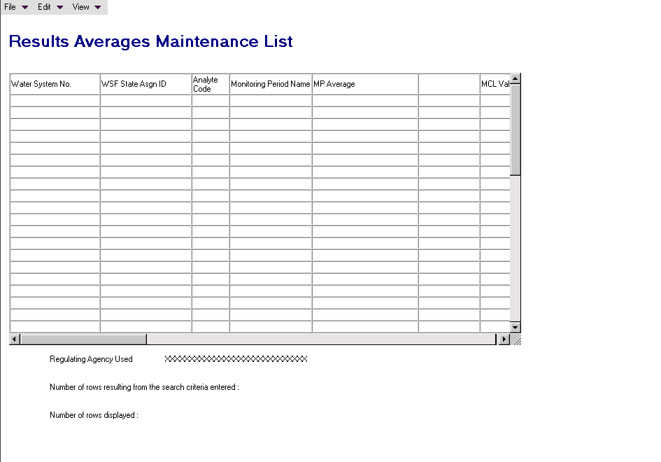

Exhibit 5-47. Results Averages Maintenance List
List Fields:

Water System No. The number of the water system.

WSF State Asgn ID The twelve-digit identification code assigned to a water system facility (WSF).

Analyte Code The Analyte Code specified in the Monitoring Period Averages record.

Monitoring Period Name The name of the monitoring period. Column name will be stacked into three rows. (R0013:A.5.7.2.2.b)

MP Average
The average for the specified analyte, monitoring period and water system facility.

MP UOM The unit of measure code of the Monitoring Period Average. (R0013:A.5.7.2.2.c)

MCL Value
The MCL Value for the specified analyte, monitoring period and waters system facility.

MCLV UOM The unit of measure code of the MCL Value. (R0013:A.5.7.2.2.d)

Water System Name The name of the water system.

Analyte Name The analyte name associated with the analyte code.

Number of Results
Used for MPA The number of results used in the calculation of the Monitoring Period Average.

Total Days
[Monitoring Period
Average Total Days] The number of days in the period that applies to the Monitoring Period Average.

Number of Results
Used for MCL Value The number of results used in the calculation of the MCL Value.

[MPA]
Monitoring Period (R0013:A.5.7.2.2.e)
Begin Date The first day of the period that applies to the Monitoring Period Average. Usually this is equal to the first day of the monitoring period but may be later, depending on the effective begin date and seasonal collection period for the sample schedule associated to the MPA.

[MPA]
Monitoring Period (R0013:A.5.7.2.2.f)
End Date The last day of the period that applies to the Monitoring Period Average. Usually this is equal to the last day of the monitoring period but may be earlier, depending on the effective end date and seasonal collection period for the sample schedule associated to the MPA.

WSF Name The name of the specified water system facility (WSF).

Default Sort Order:

The default sort order for the Results Averages Maintenance List will be Monitoring Period End Date ascending.

Menu Items:

File

Exit Selecting File/Exit will return the user to the SDWIS/STATE Home Page.

Edit

Change Selecting Edit/Change will display the Results Averages Maintenance page in Change mode with the selected monitoring record. This option will be enabled only when a record has been highlighted. When the user selects a record, the data from the Schedule and Monitoring Period that are associated with the SSMPA, which is associated with the selected MPA, will also be presented on the Results Averages Maintenance page.

View
Additional Compliance
Data Will present the Compliance Value List which presents the information used by Compliance Determination and stored on the TMNSSMPA table. This item will be enabled when a selection is made in the list box. (R0013:A.5.7.2.2.a)

Search Selecting View/Search will invoke the Results Averages Search page and carry forward the information previously entered on the Results Averages Search page.

Sort Selecting View/Sort will invoke the standard Sort page with all columns on the list available for sorting.

Filter by Selecting View/Filter will allow the user to filter by Water System No., WSF Assigned ID, Analyte Code, Monitoring Period Begin Date, Water System Name, WSF Name, or Analyte Name.
Refresh Selecting View/Refresh will retrieve the unfiltered list (original search criteria).

Protected Fields:

Regulating Agency
Used/Current WS
Group Used This protected field will show the user’s current Water System Group
Name or Regulating Agency, depending on which the user has made current. The software will dynamically change the prompt depending on whether Water System Group Name or Regulating Agency is current. The prompt will be “Current WS Group” if the user’s current Water System Group is valued, otherwise the prompt will be “Regulating Agency Used.”

Number of rows
resulting from search
criteria entered This protected field will show the total number of rows that met
the search criteria.

Number of rows
displayed This protected field will show the total number of rows
that are displayed in the list, which may be less than the number
of rows that met the search criteria.

Results Averages Maintenance
The Results Averages Maintenance page (Exhibit 5-48) will allow the user to maintain either the Monitoring Period Average (MPA) or the MCL Value or both. If a user edits an MPA, the software will not recalculate it even if a new result is added or an existing result is modified. Users, however, will be able to reset a user-modified MPA so that it is recalculated by the software. If an MPA is modified but the MCL Value is not, the software will ask the user if they want CDS setup to recalculate the MCL Value based on the changed MPA but this will not occur until CDS Setup is run.

If a user edits a MCL Value, the software will not recalculate it even if a new result is added or an existing result is modified. Users, however, will be able to reset a user-modified MCL Value so that it is recalculated by the software. If an MCL Value is modified and is dependent only on one MPA, the software will compare the entered value to the MPA to see if it is equivalent (note that the MCL Value can and usually should be rounded and the software will take this into account). Additionally, the software will compare an entered MCL Value against the analyte’s MCL to see if it is in the same units and is rounded to the same significant digits.
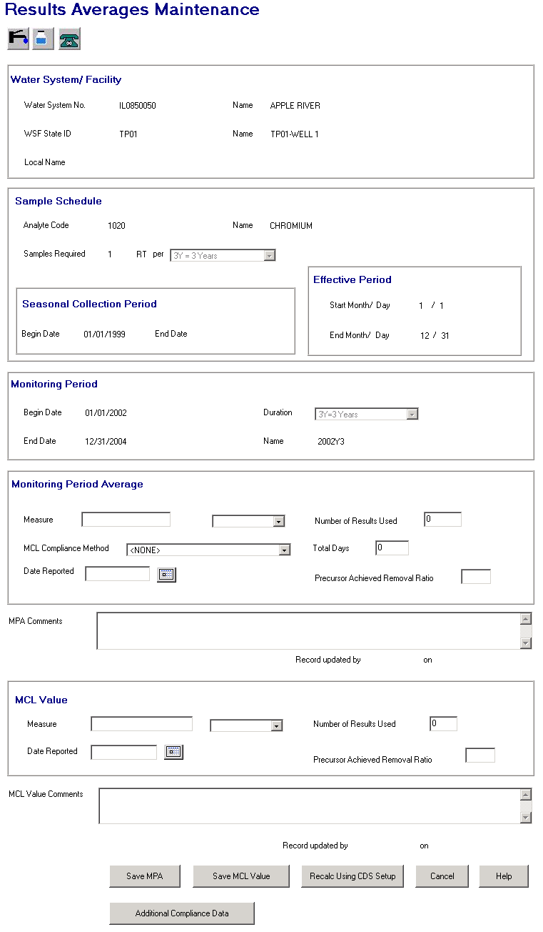

Exhibit 5-48. Results Averages Maintenance

Menu Icons:

 Clicking on this icon will invoke the Water System Information page, which will display basic inventory information for the given Water System.

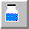 Clicking on this icon will invoke the Historical Sampling Information page, which will display compliance values for the results associated to the current MCL Value. Compliance values will be stored in a new associative table between results and SSMPA records. The information displayed will be read-only. See Section 5.7.3 for more details on this page.

 Clicking on this icon will invoke the Display Points of Contact page, which will display a protected list of legal entities and individuals (such as operators, engineers, etc.) associated with the given Water System.

Protected Fields:

Water System / Facility Group Box:

Water System No. Standard nine-character No. of Water System associated with the MPA/RAA (through SSMPA and Schedule) selected by user in Results Averages Maintenance List.

[Water System]
Name Name of selected Water System.

WSF State Asgn ID State Asgn ID of the selected water system facility.

[WSF] Name Name of selected water system facility.

[WSF] Local Name Local Name of selected water system facility.

Sample Schedule Group Box:

Analyte Code Standard four-character Code of selected analyte.

[Analyte] Name Name of selected analyte.

Samples Required There are three protected fields under Samples Required, [Sample Count], [Sample Type], and [Periodicity].

[Sample Count] Sample Count (from schedule’s monitoring requirement).

[Sample Type] Sample Type (from schedule’s monitoring requirement).

[Periodicity] Periodicity (from schedule’s monitoring requirement).

Effective Period Group Box:

Begin Date Effective Begin Date (from sample schedule).

End Date Effective End Date (from sample schedule).

Seasonal Collection Period Group Box:

Start Month Sample Schedule Start Month. Value between 1 and 12. Display 1 when null (i.e., zero or null).

Start Day Sample Schedule Start Day. Value between 1 and 31. Display 1 when null (i.e., zero or null).

End Month Sample Schedule End Month. Value between 1 and 12. Display 12 when null (i.e., zero or null).

End Day Sample Schedule End Day. Value between 1 and 31. Display 31 when null (i.e., zero or null).

Monitoring Period Group Box:

Begin Date Begin Date of selected monitoring period.

[Monitoring Period]
Duration Duration [maps to TYPE_CODE] of selected monitoring period.

[Monitoring Period]
End Date End Date of selected monitoring period.

[Monitoring Period]
Name Name of selected monitoring period.

Record updated
by XXXXXXXX on
MM/DD/YYYY
HH:MI:SS The User ID and the timestamp from the last time the MPA record was updated.

Record updated
by XXXXXXXX on
MM/DD/YYYY
HH:MI:SS The User ID and the timestamp from the last time the Calculated MCL record was updated.

Entry Fields:

Monitoring Period Averages Group Box:

CDS Setup will calculate a value for all fields in this group box. However, the user may change the value in all fields.

Measure This is the numeric value for the Monitoring Period Average (MPA) and maps to attribute MEASURE_TEXT. The value in this field is stored in both a text field (for display purposes) and a numeric field for calculations.

Leading zeros will not be stored in the text field except when the numeric field is less than one, in which case, one zero to the left of the decimal place will be included in the text field (e.g., numeric is .1, 0.1 will be stored in the text field). Trailing zeros entered by the user will, however, be retained (e.g., if 1.20 is entered, it will be stored as 1.20 in the text field).

If the value in MEASURE is 0 and the value in No. of Results Used is also 0, this field should appear as spaces.

- If the value in MEASURE is 0 and the value in No. of Results Used is> 0, this field should appear as 0.

- If the value in MEASURE is >0, this text field should reflect that value.

[UOM] This is the unit of measure associated with the measure. A user will not be able to change a unit of measure that has already been valued but will be allowed to change the unit of measure if it was previously null (i.e., spaces). After the user enters a unit of measure and then tabs out or uses the mouse to go to another field, the software will check the unit of measure entered against the unit of measure stored in the MCL Value UOM. If the MCL Value UOM is valued (i.e., something other than spaces) and the UOM for the Monitoring Period Average is not the same, the following error message will be invoked: Unit of measure must be the same as the unit of measure for the MCL Value. On OK, return the cursor to this UOM field.

Permitted Values available in the drop-down list are:
ug/L Nmt
mg/L %lum
Count %pur
Pic/l Admiu
Cm-1 Lang
C Lbs/gal
F Lbs/cft
Ntu Ct
Mrem Su
Mremy Aggr
Ph Mfl
Ng/l Umhos/cm
Ftu Obsvns
Ton Units
Cu Count/ml

No. of Results Used This is the number of analytical results used to calculate the average. It will include all routine and confirmation samples used in the calculation of the average when valued by the software.

This field is required and must be valued with a whole number and can be zero. If no value is entered or a value other than a whole number is entered, the following error message will be invoked when the user tabs off of or clicks outside of the field: The field must match pattern ZZZZ9.

Total Days This is the number of days over which the average applies. In most cases, this is equivalent to the number of days in the monitoring period. However, if the seasonal collection period recorded in the schedule falls in the monitoring period or the schedule’s begin or end date are in the monitoring period, the total number of days will be effected.

If the user changes this value from the value that CDS Setup has calculated, the following advisory will be invoked: Total Days is calculated using the sample schedule and monitoring period for this average. Are you sure you want to change this? Pressing Yes will close the dialog box and returns the user to the field with the changed value in place. Pressing No will close the dialog box and return them to the field with the CDS Setup value in place.

MCL Compliance
Method The dropdown list in this field will show either MPA—Monitoring Period Average or RAA—Running Annual Average.

Date Reported This field will be used to store the date the water system reported the average(s) to the primacy agency. CDS Setup will not value this field

Precursor Achieved
Removal Ratio If the MPA is for total organic carbon, SDWIS/STATE also will calculate the precursor achieved removal ratio in accordance with EPA’s regulations. The value calculated by SDWIS/STATE or entered here will be stored in this field (which will map to field Precursor Achvd Removal Ratio Tx in table Monitoring Period Average). The value entered on the page will be stored both in this text field and also be converted to a number that is stored in the Achvd_Removal_Ratio_No field.

Users can value this field for other analytes but it will have no meaning and will not be used by the SDWIS/STATE software.

MPA Comments A text area where comments can be added regarding the MPA.
MCL Value Group Box:

An MCL Value is the value that is used to determine compliance with a maximum contaminant level (MCL). This value is typically rounded to the same significant digits as the analyte’s MCL and, in some cases, is an average of several monitoring period averages. An MCL Value is an average of several monitoring period averages when the value is for a chronic-related contaminant (a contaminant that may cause health effects after prolonged exposure) and the monitoring frequency is more frequent than annual (e.g., quarterly). In this case, the MCL Value is typically called a running annual average by rule. When, however, the MCL Value is for an acute-related contaminant, it is not the average of several monitoring period averages. Instead, it is equivalent to a single monitoring period average, but is rounded to the same significant digits as the MCL for the contaminant. This is also true if the MCL Value is for a chronic-related contaminant that is on annual or less frequent monitoring.

Measure This is the numeric value of the MCL Value. The value in this field is stored in both a text field (for display purposes) and a numeric field (for calculations).

Leading zeros will not be stored in the text field except when the numeric field is less than one, in which case, one zero to the left of the decimal place will be included in the text field (e.g., numeric is .1, 0.1 will be stored in the text field). Trailing zeros entered by the user will, however, be retained (e.g., if 1.20 is entered, it will be stored as 1.20 in the text field).

When valued by CDS Setup:

- The text field will be blank if the numeric field is 0 and the value in No. of Results Used is also 0.

- The text field will be valued with 0.0 if the numeric field is 0 and the value in No. of Results Used is> 0.

- The text field will be valued with the text equivalent of the numeric field if the numeric field is > 0.

[UOM] This is the unit of measure associated with the measure. A user will not be able to change a unit of measure that has already been valued but will be able to value it if it was previously null (i.e., spaces). After the user enters a unit of measure and then tabs out or uses the mouse to go to another field, the software will check the valued entered against the unit of measure stored in the Monitoring Period Average UOM. If the MPA UOM is valued with other than spaces and the valued entered here is not the same, the following error message will be invoked: Unit of measure must be the same as the unit of measure for the Monitoring Period Average. On OK, the software will return the cursor to this UOM field.

Permitted Values available in the drop-down list are:
ug/L Nmt
mg/L %lum
Count %pur
Pic/l Admiu
Cm-1 Lang
C Lbs/gal
F Lbs/cft
Ntu Ct
Mrem Su
Mremy Aggr
Ph Mfl
Ng/l Umhos/cm
Ftu Obsvns
Ton Units
Cu Count/ml

Number of Results
Used This is the number of analytical results used to calculate the MCL Value. It includes all routine and confirmation samples used in the calculation of the average if valued by the software.

This field is required and must be valued with a whole number and can be zero. If no value is entered or a value other than a whole number is entered, the following error message will be invoked when the user tabs off of or clicks outside of the field: The field must match pattern ZZZZZ9.

Date Reported This field will be used to store the date the water system reported the average(s) to the primacy agency. CDS Setup will not value this field. The value will default to the date in the MPA Date Reported if one is entered by the user and this field is null at the time. The user, however, may change it.

Precursor Achieved
Removal Ratio If the MCL Value is for total organic carbon, SDWIS/STATE will also calculate a running annual average of the precursor achieved removal ratios. The value calculated by SDWIS/STATE or entered here will be stored in this field (which will map to table MCL_VALUE, field Precursor_Achvd_Removal_Ratio_Tx). The value will be stored in this text field and will also be converted to a number that will be stored in the Achvd_Removal_Ratio_No field.

Users can value this field for other analytes but it will have no meaning and will not be used by the SDWIS/STATE software.

MCL Value
Comments A text area where comments can be entered regarding the MCL Value.

Tab Sequence:

[Monitoring Period Average] Measure, [Monitoring Period Average UOM], Number of Results Used, MCL Compliance Method, [MPA] Total Days, Date Reported, Precursor Achieved Removal Ratio, MPA Comments, Running Annual Average Measure, [Running Annual Average UOM], Number of Results Used, Date Reported, Precursor Achieved Removal Ratio, MCL Value Comments, button, Save MPA button, Save MCL Value button, Recalc Using CDS Setup button, Cancel button, Help, View Additional Compliance Data button. (R0013:A.5.7.2.3.a)

Buttons:

Save MPA

The following actions will apply to the Save MPA button.

- If the user changes the value in the Monitoring Period Average Measure field, it must convert to a valid number, which includes 0, and it will be stored as described above in both a text and a numeric field (the text field will be the one displayed on this page).

- If the user enters a value with more than six digits to the left of the decimal, invoke existing exit state error message: Value too large. SDWIS can support up to 6 digits to the left of the decimal. Return the cursor to the MPA Measure field.

- If the user enters a value with more than nine digits to the right of the decimal, invoke existing exit state error message: SDWIS can support up to 9 digits to the right of the decimal. Return the cursor to the MPA Measure field.

- If the value entered converts to a number within the size 15(9) range, the software will set MPA value to the converted number.

- The number in Monitoring Period Average Total Days must be a value that is greater than or equal to 0 and less than or equal to the number of days difference between the Monitoring Period’s Begin Date and End Date (End Date—Begin Date). If the user enters a value that does not comply, the software will invoke the exit state error message: Total Days cannot exceed days between Mon. Period Start and End dates and will return the cursor to the MPA Total Days field.

- If the user removes the value in MPA Measure field, the software will set the value in the measure text field to spaces, the value in the measure numeric field to zero, and the field D_Userid_Code to CDSSETUP for the Monitoring Period Average record. It will then continue with the other Save MPA button checks.

- If the user enters a value in the MPA Measure field that satisfies the above checks, the software will ask the user: Do you want CDS Setup to calculate the MCL Value based on the MPA you entered? If the user selects YES, the software sets the MCL Value to spaces and the MCL Value User ID to CDSSETUP. If the user selects NO, the software does nothing to the MCL Value record.

- If the user changes the Precursor Achieved Removal Ratio for the MPA, it must convert to a valid number, which includes 0.

- If the user enters a value that does not convert to a valid number within the size 4(2) range (and 0 is a valid number), invoke exit state error message: Value too large. SDWIS can support up to 2 digits to the left of the decimal. Return cursor to whichever Precursor Achieved Removal Ratio field could not be converted.

- If the user enters a value with more than nine digits to the right of the decimal, invoke existing exit state error message: SDWIS can support up to 2 digits to the right of the decimal. Return the cursor to the MPA Measure field.

- If the value entered converts to a number within the size 4(2) range, the software will set MPA Precursor Achieved Removal Ratio value to the converted number.

- If MPA Measure is greater than 0, the number in MPA Total Days must be greater than 0. If the user changes the MPA Measure but leaves Total Days as 0, invoke exit state error message: Total Days cannot be 0 when MPA Measure is greater than 0. Return the cursor to the MPA Total Days field.

- If the MPA is updated, the software will update the MPA last update timestamp to the current date and time and, unless otherwise noted above, the software will set the MPA’s D_Userid_Code field to the user’s User ID. Note that CDS Setup will not override a MPA where the D_Userid_Code is other than “CDSSETUP.”

Note: The unit of measure for MPA and MCL Values will be controlled somewhat differently in SSWr1 (compared to SDWIS/STATE 8.0). If UOM is valued, it means one of the following has occurred:

- There was an MCL (in ALRA or FANL) the last time CDS Setup ran.

- A user previously edited one or both of the records (the MPA or MCL Value) when there was no MCL (in ALRA or FANL).

- There was at least one result used to create the MPA and MCL Value when there was no MCL.

Users will not be allowed to change a UOM once it has been valued in order to maintain consistency between the UOM for MPAs and UOM for MCL Values. If a user wants to change the UOM for a MPA and MCL Value that has no MCL but is based on one or more results, the user will need to press the Recalc Using CDS Setup button and then find and change the UOM to the desired UOM for the first result used to calculate the MPA. If an MCL is subsequently added for the above, CDS Setup will convert the user-entered UOM to the UOM recorded for the MCL.

Save MCL Value

The following actions will apply to the Save MCL Value button:

- If the user changes a value in MCL Value Measure, it must convert to a valid number, which includes 0, and will be stored as described above in both a text and a numeric field (the text field will be the one displayed on this page).

- If the user enters a value with more than six digits to the left of the decimal, invoke existing exit state error message: Value too large. SDWIS can support up to 6 digits to the left of the decimal. Return the cursor to the Measure field that could not be converted.

- If the user enters a value with more than nine digits to the right of the decimal, invoke existing exit state error message: SDWIS can support up to 9 digits to the right of the decimal. Return the cursor to the Measure field that could not be converted.

- If the value entered converts to a number within the size 15(9) range, the software will set MCL Value to the converted number.

- If the user removes the value in the MCL Value Measure field, the software will set the value in the MCL Value measure text field to spaces, the value in the measure numeric field to zero, and the field D_Userid_Code to CDSSETUP for the MCL Value record and then continue with the other Save MCL Value button checks.

- If the MCL Value is changed to some numeric value (i.e., not removed) and the duration of monitoring period for the MP is annual or longer or the MCL Compliance Method for the associated MPA is equal to “MPA,” then the software will check to see if the MCL Value is equivalent to the measure of the associated MPA. Equivalent means, if the MCL Value has less significant digits, it has been rounded based on the MPA following the rules that < 5 rounds down and >= 5 rounds up.

If the MCL Value is not equivalent to the MPA, the software will present the following advisory: The MCL Value is not equivalent to the MPA. Do you want to change it anyway? If the user selects YES, the software will close the dialog box and then continue with the other Save MCL Value button checks. If the user selects NO, the software will close the dialog box and return the cursor to the MCL Value Measure field.

The following are examples of equivalency. If a MPA is equal to 6.4 and the user enters the following into the MCL Value (text field):

- 6.4 – this is equivalent, no message will appear.
- 6 – this is equivalent, no message will appear.
- 6.0 – this is not equivalent, the message will appear.
- 7 – this is not equivalent, the message will appear.
- 6.5 – this is not equivalent, the message will appear.

- If the MCL Value is changed to some numeric value (i.e., not removed), the software will check to see if the MCL Value has more significant digits than the associated MPA (e.g., the MCL Value is 6.44 and the MPA is 6.4). If it does, the software will present the following advisory: The MCL Value is more precise than the MPA. Do you want to change it anyway? If the user selects YES, the software will close the dialog box and then continue with the other Save MCL Value button checks. If the user selects NO, the software will close the dialog box and return the cursor to the MCL Value Measure field.

- If the user changes the Precursor Achieved Removal Ration for the MCL Value, it must convert to a valid number, (which includes 0).

- If the user enters a value that does not convert to a valid number within the size 4(2) range (0 is a valid number), invoke exit state error message: Value too large. SDWIS can support up to 2 digits to the left of the decimal. Return cursor to the Precursor Achieved Removal Ratio field that could not be converted.

If the user enters a value with more than nine digits to the right of the decimal, invoke existing exit state error message: SDWIS can support up to 2 digits to the right of the decimal. Return the cursor to the MPA Measure field.

- If the value entered converts to a number within the size 4(2) range, the software will set the MCL Value Precursor Achieved Removal Ratio value to the converted number.

- If the MCL Value is updated, the software will update the MCL Value last update timestamp to the current date and time and, unless otherwise noted above, the software will set the MCL Value’s D_Userid_Code field to the user’s User ID. Note that CDS Setup will not override a MCL Value where the D_Userid_Code is other than “CDSSETUP.”

Recalc Using CDS Setup

Pressing this button will set the User ID of the Monitoring Period Average and MCL Value to “CDSSETUP” so that CDS Setup will reprocess both records.

View Additional Compliance Data

Pressing this button will present the Compliance Value List which presents the values used by Compliance Determination and stored in the TMNSSMPA table. (R0013:A.5.7.2.3.b)

Cancel Will disregard any data and return the user to the previous page.

Help Will invoke online Help for this page.

Compliance Value List
The Compliance Value List (Exhibit 5-49) resents a list of values used by Compliance Determination and stored in the TMNSSMPA table for a specific Results Average.
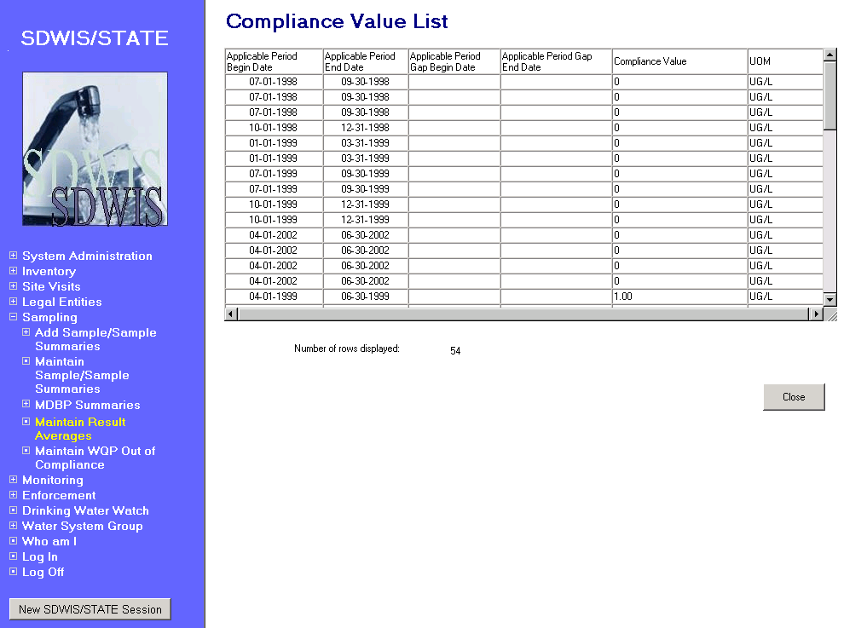
Exhibit 5-49. Compliance Value List

List Columns

Applicable Period Begin Date, Applicable Period End date, Applicable Period Gap Begin Date, Applicable Period Gap End Date, Compliance Value, and UOM.

Default Sort Order: Ascending Compliance Value

Protected Fields:

Number of rows displayed: Will show the total number of rows displayed in the list.

Buttons

Close Will close the page and return to the invoking page.

Historical Sampling Information Page
When a user clicks on the Historical Sampling Information icon, the software will display all the results and compliance values associated to the current MCL Value on the Historical Sampling Information Page (Exhibit 5-50), sorted by collection date descending. In a few cases, the analyte of the result will not be the same as the analyte for the results averages (e.g., when a gross alpha result is substituted for a radium 226 result). Therefore, the list will include analyte codes.

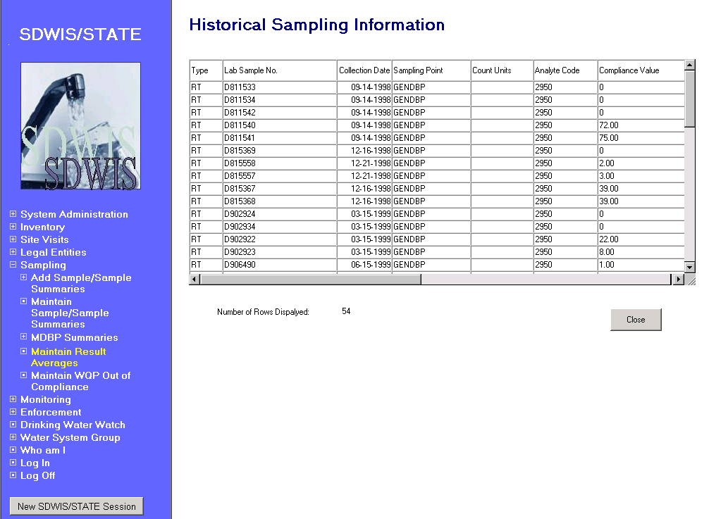

Exhibit 5-50. Historical Sampling Information

List Fields:

[Sample] Type For Samples, the two-digit type code of the sample.

Lab Sample No. A code assigned by the state certifying authority that uniquely identifies the laboratory for samples and sample summaries.

Collection Date The date the sample was collected.

Sampling Point
(stacked & centered) The sampling point of the location at which the sample was taken.

Analyte Code The four-digit code of an analyte.

Compliance Value The compliance value recorded in the table that associates a result to a SSMPA.

CV UOM The unit of measure for the compliance value, which is recorded in the table that associations a result to a SSMPA.

[Less Than Indicator] < When column marked with Y (yes) indicates the sample result was less than the value supplied as the level type.

Concentration The concentration result received from the analysis.

Conc. UOM The unit of measure in which the concentration was reported.

Level Type The level type that the detection was measured against. Values are MDL (Regulatory Minimum Reporting Level) or MRL (Lab Reporting Level).

Reporting Level When MDL this value is the reporting level set by the regulation. When it is MRL, it is the value set by the laboratory, which must be less than the regulatory level.

P/A For microbiological results, this column will display whether the organism was reported as present (P) or absent (A). If the result is not for a microbiological organism, the column will display NA (not applicable).

Count For microbiological results, this column will display the values entered into the three fields used to record a count. The fields will be concatenated and will include “/” between the second and third fields (e.g., “22 oocysts / L”).

WQP Days Out of Compliance

Model Changes for WQP Days Out of Compliance
No model changes planned for this release.

WQP Days Out of Compliance Page Flow

WQP Days Out of Compliance Search
Selecting Maintain WQP Days Out of Compliance will invoke the WQP Days Out of Compliance Search page (Exhibit 5-51) where the user can specify a Water System, a Monitoring Period, or both as search criteria:

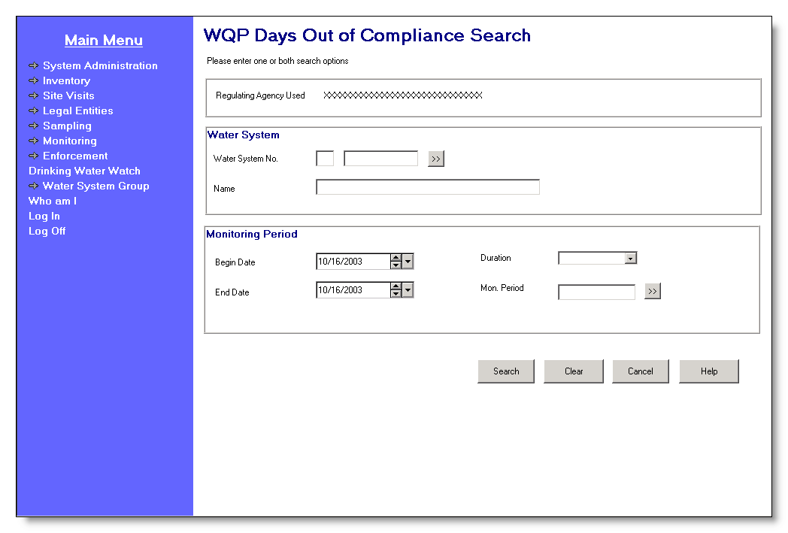

Exhibit 5-51. WQP Days Out of Compliance Search

Water System only.

Monitoring Period only.

Water System and Monitoring Period.

All searches will be limited by the current Regulating Agency or Water System Group. The prompt will dynamically change to reflect whether the user has selected Regulating Agency or Water System Group to be current.

Protected Field:

Regulating Agency
Used/WS Group
Used This protected field will show the user’s current Water System Group Name or Regulating Agency depending on which the user has made current. The software will dynamically change the prompt depending on whether Water System Group Name or Regulating Agency is current. The prompt will be “Current WS Group” if the user’s current Water System Group is valued, otherwise the prompt will be “Regulating Agency Used.”

Entry Fields:

Water System Criteria Group Box:

Water System No. The specific Water System No., which consists of the two-character state code plus the seven-character number field.

The state code portion will default to the state_identification_code in the SYSTEM_VARIABLE entity view.

The cursor will be positioned in the numeric portion.

The Go To button may be pressed to select a water system from the Water System Maintenance List in single-select mode, which will display a list of water systems that are part of the current Water System Group or Regulating Agency. Once a valid water system has been entered or picked from a list, the water system name will be displayed on the page. If the user specifies a partial string in this field, display the closest matching water system at the top of the list. (Closest matching means a match with the Water System No., sorted alphabetically, that starts with the same text string as supplied.)

If a valid water system is entered but is not part of the user’s current Water System Group or Regulating Agency, invoke exit state error message: WS is not part of current group/agency. Change group/agency to access this WS.

[Water System]
Name Standard 40-character Public Water System Name may be entered completely, partially, or left blank. If the user specifies a partial string in this field, display the Water System Maintenance List in single-select mode with the closest matching water system at the top of the list. (Closest matching means a match with the Water System Name, sorted alphabetically, that starts with the same text string as supplied.)

If a valid water system name is entered, the Water System No. is populated.

If a valid water system is entered but is not part of the user’s current Water System Group or Regulating Agency, invoke exit state error message: WS is not part of current group/agency. Change group/agency to access this WS.

If the name entered is not found the software will flow to the Water System Maintenance List in single-select mode. The user may then select a value and continue.

Monitoring Period Group Box:

[Monitoring Period]
Begin Date If Begin Date and either End Date or Duration are valued, on tabbing off, the software will retrieve the monitoring period that matches the criteria and displays it in all monitoring period fields. If no monitoring period exists that matches the criteria, the Monitoring Period Maintenance List will be invoked in single-select mode, sorted on Monitoring Period Begin Date descending then on Monitoring Period End Date ascending. The software will take no action if only Begin Date is valued.

[Monitoring Period]
Duration The user may enter a valid Monitoring Period Duration or use the Go To button to select a valid monitoring period. All durations should appear on the dropdown list, including spaces. If Duration and either Begin Date or End Date are valued, on tabbing off, the software will retrieve the monitoring period that matches the criteria and display it in all monitoring period fields. If no monitoring period exists that matches the criteria, it will invoke the Monitoring Period Maintenance List in single-select mode, sorted on Monitoring Period Begin Date descending then on Monitoring Period End Date ascending. The software will take no action if only Duration is valued.

Durations of 2W – Every 2 Weeks and 2M – Every 2 Months will be available in the drop down list. (R0036:A.5.8.2.1.a)

[Monitoring Period]
End Date If End Date and either Begin Date or Duration are valued, on tabbing off, the software will retrieve the monitoring period that matches the criteria and displays it in all monitoring period fields. If no monitoring period exists that matches the criteria, the Monitoring Period Maintenance List will be invoked in single-select mode, sorted on Monitoring Period Begin Date descending then on Monitoring Period End Date ascending. The software will take no action if only End Date is valued.

[Monitoring Period]
Name If the user enters a valid monitoring period name, on tabbing off, the software will retrieve the monitoring period that matches the criteria and displays it in all monitoring period fields. If the user enters a partial string or an invalid monitoring period name, invoke the Monitoring Period Maintenance List in single-select mode sort by Monitoring Period Name ascending.

If a monitoring period that meets the user’s criteria does not exist in the database, the software will directly invoke the Monitoring Period Selection List.

Tab Sequence:

Water System No. [the seven-character, number field], Water System Go To button, [Water System Name], [Monitoring Period] Begin Date, [Monitoring Period ]Duration, [Monitoring Period] End Date, [Monitoring Period] Name, Monitoring Period Go To button, Search button, Clear button, Cancel button, Help button.

Buttons:

[water system]
Go To Pressing this button will invoke the Water System Maintenance List in single-select mode. If the user has typed part of the Water System No., it will be used in the search to invoke the Water System Maintenance List. . If the user has typed in a partial Water System Name, it will be used in the search. The user may select a Water System from this list.

[monitoring period]
Go To Pressing this button will invoke the Monitoring Period Maintenance list in single-select mode, sorted on Monitoring Period Begin Date descending then on Monitoring Period End Date ascending. The user may select a Monitoring Period from this list.

Search Pressing this button will retrieve Water System Monitoring Period Asgmt records based on the specified criteria.

The user’s current Water System Group/Regulating Agency and the following will be used as implied search criteria in all searches for Water System Monitoring Period Asgmt records:
WQP_NO_DAYS_OUT_OF_COMPLIANCE is not null. This means that the software will retrieve only Water System Monitoring Period Asgmts linked to a water system that is linked to the user’s current Water System Group/Regulating Agency and that have a value entered in the WQP_NO_DAYS_OUT_OF_COMPLIANCE attribute. (Note that, for this numeric attribute, a true null will be used so that zero means zero and does not mean null). If an exact Water System is entered, the software will validate that it belongs to the user’s current Water System Group/Regulating Agency. The following will be possible search permutations:

- Search by Water System.
- Search by Monitoring Period.
- Search by Water System and Monitoring Period.

All Water System Monitoring Period Asgmts that meet the criteria are displayed on the WQP Days Out of Compliance List. If no records meet the criteria, the software displays an informational exit state message: No WQP Days Out of Compliance record exist in the database for criteria specified.

Clear Pressing this button will clear data from all fields on the search page.

Cancel Will disregard any data and return the user to the previous page.

Help Will invoke online Help for this page.

WQP Days Out of Compliance List
The WQP Days Out of Compliance List (Exhibit 5-52) will display up to 1000 records at a time, listing the Water System Monitoring Period Asgmt records retrieved from the search criteria specified.

Default Sort Order: Water System No., Monitoring Period Name both ascending.

List Fields:

Water System No. The number of the water system.

Monitoring Period Name The name of the user-specified monitoring period.

[Monitoring Period]
Duration Duration of the user-specified monitoring period.

[Monitoring Period]
Begin Date Begin date of the user-specified monitoring period.

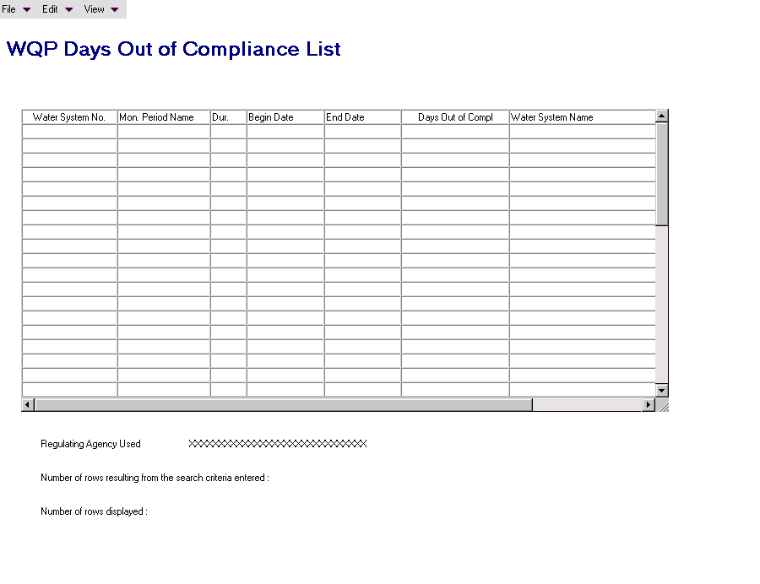

Exhibit 5-52. WQP Days Out of Compliance List

[Monitoring Period]
End Date End date of the user-specified monitoring period.

Days Out of Compliance The number of days a water system was out of compliance during a 6-month monitoring period.

Water System Name The name of the water system.

Menu Items:

File

Exit Selecting File/Exit will return the user to the SDWIS/STATE Home Page.

View

Search Selecting View/Search will invoke the WQP Days Out of Compliance Search page and carry forward the information previously entered on the WQP Days Out of Compliance Search page.

Sort Selecting View/Sort will invoke the standard Sort page with all columns on the list able to be sorted.

Filter by Selecting View/Filter will allow the user to filter by Water System No., Monitoring Period Name, Monitoring Period Duration, Monitoring Period Begin Date, Monitoring Period End Date, WQP Days Out of Compliance and Water System Name.

Refresh Selecting View/Refresh will retrieve the unfiltered list (original search criteria).

Protected Fields:

Regulating Agency
Used/Current WS
Group Used This protected field will show the user’s current Water System. Group
Name or Regulating Agency, depending on which the user has made current. The software will dynamically change the prompt depending on whether Water System Group Name or Regulating Agency is current. The prompt will be “Current WS Group” if the user’s current Water System Group is valued, otherwise the prompt will be “Regulating Agency Used.”

Number of rows
resulting from search
criteria entered This protected field will show the total number of rows that met
the search criteria.

Number of rows
displayed This protected field will show the total number of rows
displayed in the list, which may be less than the number
of rows that met the search criteria.

Field Results Maintenance
The fields in this page represent the six “field results” measures in entity Field Results (exhibit 5-53) (formerly Microbiological Sample) table TSAMCSMP. When this page opens, if the value for any of the following six numeric fields is null in the database, the Field Results page will display a blank for that field. If the database value for any of these fields is greater than or equal to 0, the Field Results page will display that number in the field.

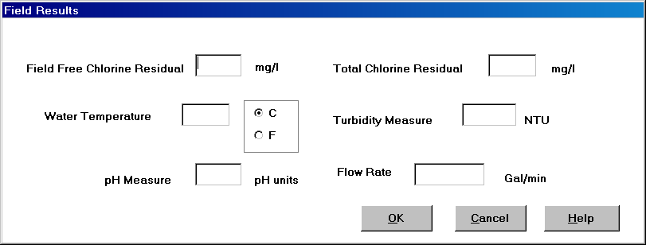

Exhibit 5-53. Field Results Page

Entry Fields:

Field Free Chlorine
Residual The measure of free and available chlorine in milligrams per liter (mg/L).

This number is defined in the database as 5(3), that is, five significant digits, three of which are to the right of the decimal. The maximum value the database can accept for this field is 99.999. The minimum value, other than 0, that the database can accept for this field is 0.001. Any number within this range is acceptable. If you enter a number with more than two decimals, the software truncates everything beyond the second decimal.

This is an optional field.

Total Chlorine
Residual The total concentration of residual disinfectant (chlorine) in milligrams per liter (mg/L) found in the water, including combined and free chlorine residual.

This number is defined in the database as 5(3), that is, five significant digits, three of which are to the right of the decimal. The maximum value the database can accept for this field is 99.999. The minimum value, other than 0, that the database can accept for this field is 0.001. Any number within this range is acceptable. If you enter a number with more than three decimals, the software truncates everything beyond the third decimal.

This is an optional field.

Water Temperature The temperature in degrees Celsius or Fahrenheit (C or F) of the water being sampled at the time and place of microbiological or chemical sample collection.

This number is defined in the database as 3(1), that is, three significant digits, one of which is to the right of the decimal. The maximum value the database can accept for this field is 99.9. The minimum value, other than 0, that the database can accept for this field is 0.1. Any number within this range is acceptable. If you enter a number with more than one decimal, the software truncates everything beyond the one decimal.

This is an optional field.

[Temperature Measure] The indication of Celsius or Fahrenheit (C or F) of the water temperature.

This is an optional field.

Turbidity Measure The turbidity of the water being sampled at the time and place of microbiological or chemical sample collection in nephelometric turbidity units (NTU).

This number is defined in the database as 5(2), that is, five significant digits, two of which are to the right of the decimal. The maximum value the database can accept for this field is 999.99. The minimum value, other than 0, that the database can accept for this field is 0.01. Any number within this range is acceptable. If you enter a number with more than two decimals, the software truncates everything beyond the second decimal

This is an optional field.

pH Measure The pH of the water being sampled at the time and place of microbiological or chemical sample collection in pH units.

While this number is defined in the database as 4(1), the maximum value the database can accept for this field is 14. The minimum value, other than 0, that the database can accept for this field is 0.1. Any number within this range is acceptable. Numbers outside of this range will receive the error message Accepted range for pH value is between 0 and 14.0 pH units. If you enter a number with more than one decimal, the software truncates everything beyond the one decimal.

This is an optional field.

Flow Rate The flow rate of the sample collection device in Gallons Per Minute (GPM). This measure is used primarily for collection and quantification of protozoa and virus samples.

This number is defined with six significant digits, up to four of which can be to the right of the decimal. The maximum value the window can accept for this field is 999.999. The minimum value, other than 0, that the window allows for this field is 0.0001. Any number within this range is acceptable. If you enter a number with more than four decimals (three if your integer is greater than 99), the software will truncate everything beyond the fourth/third decimal.

This is an optional field.

Buttons:

OK

Add-Mode If one or more of the fields is valued, a Field Result record will be created and associated to the sample.

Change-Mode The Field Result record will be changed.

Cancel If changes have been made, the standard cancel confirmation page will be presented. If no changes have been made, the page will close and return to the sample maintenance page.

Help Will invoke the system online Help facility.

