APPENDIX (to Routine Disk Diffusion Test)

Clindamycin Disk Induction Test for Staphylococcus spp.

Preanalytical considerations

A. PRINCIPLE

The clindamycin induction test is performed on Staphylococcus spp. that test resistant to erythromycin and susceptible to clindamycin using routine antimicrobial susceptibility test methods.

Resistance to macrolides (e.g. erythromycin) can occur by two different mechanisms with the resulting phenotypes noted below:

Mechanism | Determinant (gene) | Erythromycin | Clindamycin
Efflux | msrA | R | S
Ribosome alteration | erm | R | S*
 | erm | R | R (constitutive)

msrA = macrolide streptogramin (type B) resistance
erm = erythromycin ribosome methylase; encodes enzymes that confer inducible (MLS_{B}i) or constitutive (MLS_{B}c) resistance to MLS agents via methylation of the 23S rRNA
*requires induction to demonstrate resistance

MLS = macrolide lincosamide (e.g. clindamycin) streptogramin (type B)

For MLS_{B}i strains, erythromycin will induce production of the methylase, which allows clindamycin resistance to be expressed. Inducible clindamycin resistance can be detected with a simple disk approximation test, commonly referred to as the “D test”. For this test, an erythromycin disk is placed 15 mm to 26 mm (edge to edge) from a clindamycin disk in a standard disk diffusion test. Following incubation, a flattening of the zone in the area between the disks where both drugs have diffused indicates that the organism has inducible clindamycin resistance.

B. SPECIMEN
Colonies of Staphylococcus spp. as described for routine disk diffusion testing of rapidly growing nonfastidious bacteria

C. SUPPLEMENTAL MATERIALS
      - Materials as stated for routine disk diffusion testing of rapidly growing nonfastidious bacteria.
      - Disks for the following agents at the concentrations specified:
        - Erythromycin 15 µg
        - Clindamycin 2 µg

Analytical considerations
D. QC STRAINS
NCCLS is in the process of selecting QC strains for this test. In the interim, QC of the erythromycin and clindamycin disks is performed with S. aureus ATCC 25923 according to the standard disk diffusion QC procedure. Additional QC can be performed with separate in-house selected S. aureus strains that demonstrate positive and negative D test reactions.

E. PROCEDURE
1. Standard disk diffusion test
a. Follow standard disk diffusion testing recommendations for inoculum preparation, inoculation, and incubation.
b. Position erythromycin disk 15-26 mm (edge to edge) from clindamycin disk
c. Following incubation, note the appearance of the clindamycin zone closest to the erythromycin disk.
2. Purity plate variation
a. Following inoculation of MIC test, use a loop to transfer an aliquot of the final inoculum suspension to a BAP. Inoculate the first one-third of the agar surface in order to obtain confluent growth. Streak the remaining quadrants to obtain isolated colonies
b. Position erythromycin disk 15 mm (edge to edge) from clindamycin disk on the first one-third quadrant of the plate
b. Following incubation, note the appearance of the clindamycin zone closest to the erythromycin disk.

Post analytical considerations

F. REPORTING RESULTS
            - Positive for inducible clindamycin resistance
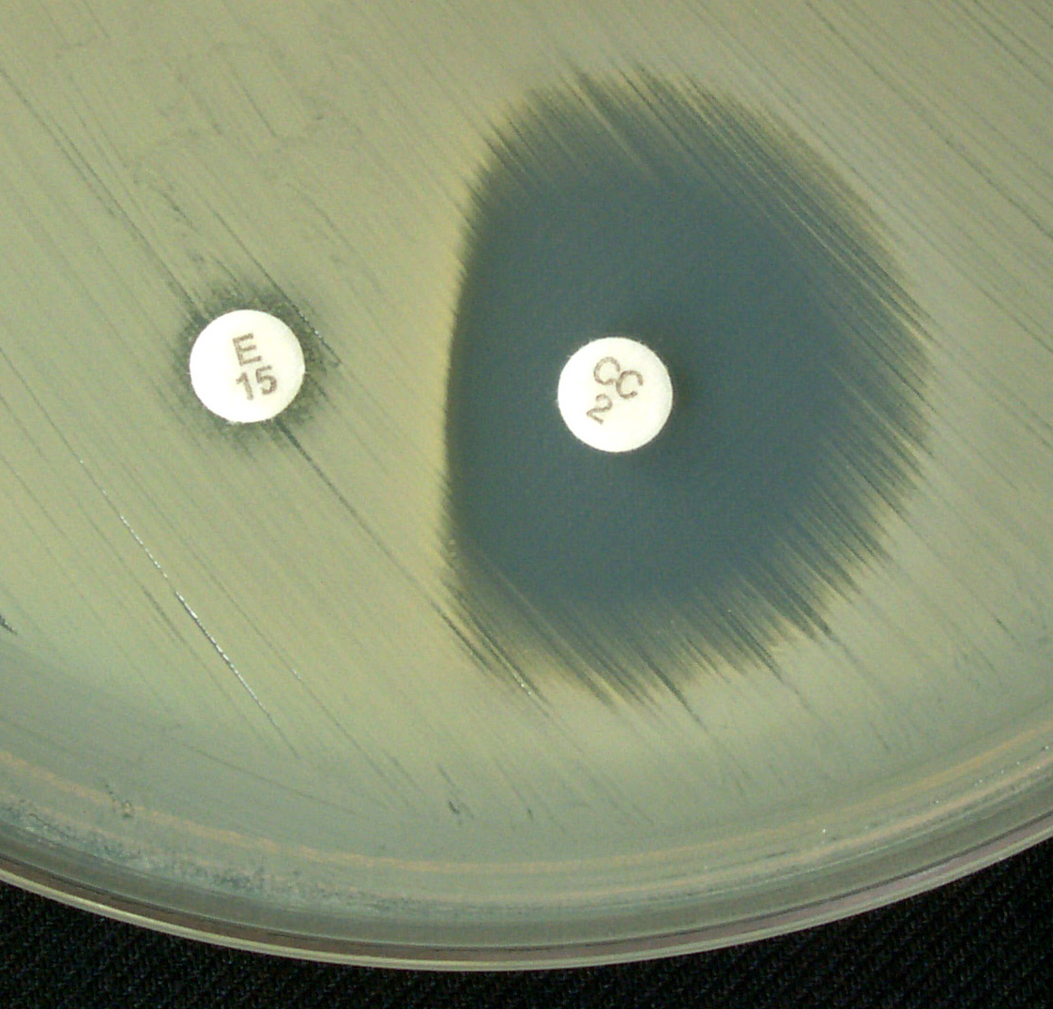
              - Demonstration of flattened clindamycin zone between the erythromycin and clindamycin disks

Inducible
Clindamycin Resistance
(erm-mediated)

b. Report clindamycin resistant. If MIC test, report clindamycin resistant without MIC value.

Optional: Add comment “This [S. aureus] is presumed to be resistant based on detection of inducible clindamycin resistance. Clindamycin may still be effective in some patients”.

            - Negative for inducible clindamycin resistance
              - No flattening of clindamycin zone
b. Report clindamycin susceptible. If MIC test, report clindamycin susceptible with MIC value.

Optional: Add comment “This [S. aureus] does not demonstrate inducible clindamycin resistance in vitro”.

G. NOTES
1. Reporting clindamycin as susceptible for Staphylococcus spp. that test erythromycin resistant and clindamycin susceptible without checking for inducible clindamycin resistance may result in inappropriate clindamycin therapy.

2. Many of the recently recognized MRSA that cause community-associated
infections have the msrA gene and the oral clindamycin may be a treatment option for
these patients.

3. The test described here is acceptable for all Staphylococcus spp. including oxacillin susceptible or oxacillin resistant S. aureus or coagulase-negative staphylococci.

References

            - Fiebelkorn, K. R., S. A. Crawford, M. L. McElmeel, and J. H. Jorgensen. 2003. Practical disk diffusion method for detection of inducible clindamycin resistance in Staphylococcus aureus and coagulase-negative staphylococci. J Clin Microbiol. 41:4740-44

      - Frank, A. L., J. F. Marcinak, P. D. Mangat, J. T. Tjhio, S. Kelkar, P. C. Schreckenberger, and J. P. Quinn. 2002. Clindamycin treatment of methicillin-resistant Staphylococcus aureus infections in children. Pediatr Infect Dis J. 21:530-34.

3. Jorgensen, J. H., S. A. Crawford, M. L. McElmeel, and K. R. Fiebelkorn. 2003. Practical method for detection of inducible clindamycin resistance of staphylococci in conjunction with performance of automated susceptibility testing. Abstract #D241, ICAAC, Chicago, IL.

4. Sanchez, M. L., K. K. Flint, and R. N. Jones. 1993. Occurrence of macrolide-lincosamide-streptogramin resistances among staphylococcal clinical isolates at a university medical center. Is false susceptibility to new macrolides and clindamycin a contemporary clinical and in vitro testing problem? Diagn Microbiol Infect Dis. 16:205-13.

