Study of the Diurnal Cycle of the Atmospheric Boundary Layer

over Salar de Uyuni.

JOSE M. GALVEZ
University of Oklahoma

ABSTRACT

The Salar de Uyuni is the largest dry salt lake in the world with a surface area of 3515 km². It is located in the South American Altiplano at 3653 m MSL and centered at 20.5°S and 67.7°W. It is believed that the impact of Altiplano lakes and dry salt lakes (salars) on the weather and climate of their surrounding areas has been and is very large. The aim of this study is to use 5-day hourly pilot balloon observations at 5 sites along the salar to describe the characteristics of the diurnal cycle of the circulations, and to set hypothesis about the mechanisms involved on the behavior of the patterns observed.

The results showed low level confluent flow over the salar during nighttime and low level diffluent flow during the rest of the day. This pattern was consistent with the theory of heat driven circulations induced by cool bodies during daytime, as the salar’s surface remains cool due to its high albedo. The salar breeze mechanism was also captured by the observations showing late morning and afternoon onshore flows with depths between 600 and 1000 meters and return flows with depths of about 2000 meters. Offshore flows were also observed on late night and early morning soundings. Other features captured by the observations suggest that other mechanisms involved on the circulation may be local katabatic winds during nighttime, afternoon intrusions of strong winds from the western slopes of the Andes, the effects of boundary layer turbulent friction on the decrease of low level wind velocities during daytime and isolated effects of afternoon convection produced over higher surrounding the salar.

1. Introduction

The South American Altiplano has a large number of lakes and dry salt lakes (salars), some of them large enough as to affect the regional atmospheric circulation. It is known that large lakes generate various types of mesoscale disturbances, which are driven primarily by the surface temperature contrast (Estoque, 1980). It is also believed that the impact of large features as Lake Titicaca or the Salar de Uyuni on the regional circulation and rainfall patterns may be large.

The Salar de Uyuni, located in the southernmost part of the Altiplano basin, is the largest dry salt lake in the world with a surface area of 3515 km². It is centered at approximately 20.5°S and 67.7°W and at a mean altitude of 3653 m ASL.

The salar consists on a flat highly reflective salty surface, which results in low incoming solar radiation absorption rates, especially as compared to the surrounding terrain. A higher thermal conductivity and diffusivity beneath the salt surface may also interact with the high albedo to generate low amounts of energy available for the partition of sensible and latent heat (Physick and Tapper, 1990). These mechanisms produce diurnal surface temperature contrasts between the salar and the surrounding terrain, which results in the production of salar breezes during the day, and terrain breezes during the night.

The aim of this study is to describe the characteristics of the diurnal cycle of the atmospheric circulations over the Salar de Uyuni and to set hypothesis about the mechanisms involved in the behavior of the observed patterns. Specifically we want to describe the strength, vertical extension, and diurnal cycle of the breezes, as well as other mechanisms involved in the regional circulation patterns. It is also intention of this study to infer the role of the salar in the spatial distribution of rainfall in the surrounding areas.

Due to the limitations of observational data and time, this investigation was able to describe only the time and vertical variations of the winds at 5 sites located among the salar. This paper poses many research questions that may be partly explained in a more complete study.

2. Dataset and methodology

The data used in this study was gathered during the South American Low Level Jet Experiment (SALLJEX). The Salar de Uyuni Experiment formed part of SALLJEX with the goal to investigate the role of Altiplano lakes and dry salt lakes in the amount and distribution of rainfall on the surrounding areas. The intensive observations period (IOP) started in 25 November 2002 and ended in 30 November 2002.

Hourly wind profiles made over a five-day period were used for the analysis. These profiles were obtained by pilot balloon soundings at five sites located along the salar. Four of the sites were located near the edges and one near the center. The main observational network deployed is shown in Fig. 1.

The methodology utilized on this study was focused on the depiction of the diurnal cycle. All the data was first edited to correct errors in the raw observations. Five-day hourly averages of the wind profiles were then performed for each site. Anomalies of these profiles were also utilized. They were achieved by subtracting the total averaged wind profile for all sites to each hourly average, which removed the mean flow. This technique improved the local circulation analyses.

The data set showed many problems still due to the lack of observations at specific times for specific sites, which resulted in a source of errors when calculating the means. Other problems resulted from measurement errors, which were sometimes hard correct. The east site showed the most contaminated data of all sites, resulting in unreliable profiles. The data set still needs to be corrected and the averages recalculated in order to achieve a more reliable study.

3. Synoptic conditions

We will briefly describe the large-scale flow pattern in order to provide some background for interpreting the results.

Easterly and northeasterly 500 mb flow (Fig. 2) was observed at the beginning of the observation period. This type of circulation aloft generates downward momentum flux into the convective boundary layer and tends to accelerate the upslope flow over the eastern slopes of the Andes, which in turn increases the low-level moisture transport from the lowlands into the Altiplano (Garreaud, 2000). This pattern was favorable for the development of isolated deep convection during the first two days of the observing period.

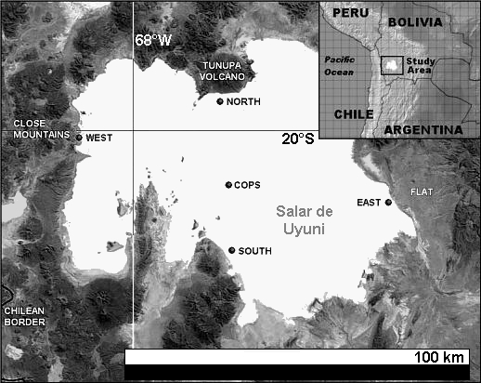

Fig. 1. Satellite image of Salar de Uyuni showing the distribution of the station network and some important features to take into account.

The upper level circulation changed towards the end of the experiment resulting in westerly winds over most of the Altiplano (Fig. 3) due to an approaching trough. This type of upper level flow resulted in drier conditions as moisture transport from the east was constrained to the eastern slope and the Altiplano was flooded by dry air originated on the western foothills of the Andes (Garreaud, 2000).

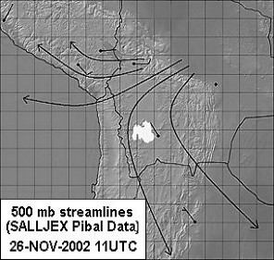

Fig. 2. 1100 UTC 26 November 2002 Streamline analysis performed using SALLJEX Pilot Balloon Data.

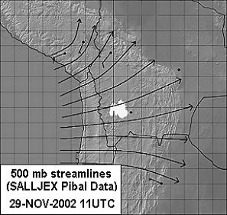

Fig. 3. 1100 UTC 29 November 2002 Streamline analysis performed using SALLJEX Pilot Balloon Data.

4. Description of the wind field

Five-day averaged wind data were utilized to prepare 200 m AGL streamline analyses (Fig. 4). They showed the presence of confluence over the salar at midnight meanwhile diffluent flow was present during the day.

The same data suggested the presence of onshore circulations during late morning and afternoon extending between 500 and 1300 m in the vertical. Weaker offshore circulations were also observed during late night, however, they were not well described due to the lack of observations during nighttime. These breezes apparently extended as far in the vertical as the diurnal onshore breezes. Strong westerly winds were observed in the afternoon, especially on the West and COPS sites. Hypothesis about the origin of these winds will be described later. Storm outflow winds were also observed on the 26th, however, this data was extracted for the calculation of the mean as these winds had relative speeds of the order of 10 m/s but the event was very isolated in time and space.

The upper level flow was consistent with the SALLJEX Network soundings showing weak easterly, northerly and northwesterly winds at the beginning of the period changing to stronger westerly winds towards the end of the period at 500 mb. The flow above 350 mb was from the northwest during the entire period with a stronger westerly component towards the end of the experiment.

Lower level winds showed some sensitivity to the upper level pattern. During periods of weak 500 mb winds the presence of the breezes was very clear, whereas during days of stronger 500 mb winds the flow at lower levels was mainly from the west. A considerable increase in velocity of the low level afternoon westerly winds was also observed towards the end of the period. All these observations suggest the presence of downward transport of momentum, which intensified as the upper level wind velocities increased.

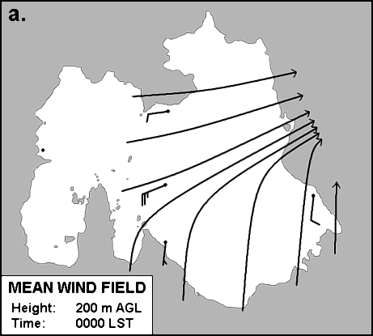

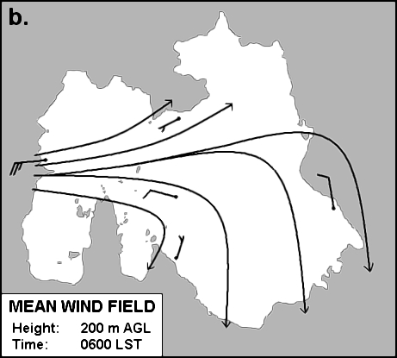

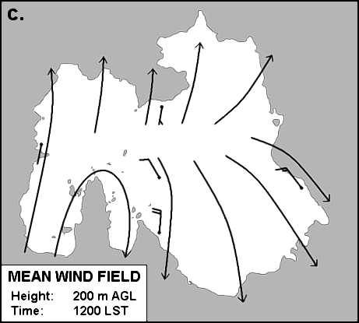
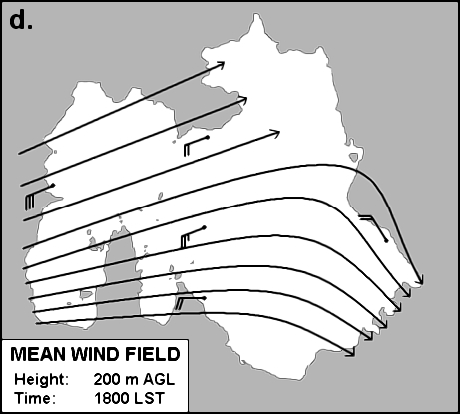

Fig. 4. Five-day averaged wind field at 0000 LST (a), 0600 LST (b), 1200 LST (c) and 1800 LST (d).

5. Discussion

The persistence of low-level diffluent flow as compared to confluent flow over the salar may have to do with the fact that the salar remains cooler than the surrounding terrain for a larger percentage of the day. GOES-8 Infrared images (Fig. 5) could be used to support this hypothesis, as surface temperature measurements were not performed other than in the salar. The fact that late November sunrises occur at 0545 LST may also promote the nocturnal land breeze mechanism to start breaking down before 0600 LST, favoring an early setup of the low level diffluent flow, however, we cannot pose a hypothesis until the calculation of divergence is performed.

Fig. 6 illustrates the theoretical relationship between the breezes and the boundary layer, where the boundary layer top should correspond to the highest crossing between the late night wind profile and afternoon one. The average depth of the observed mixed layer, however, was not easy to identify using the wind profiles. An analysis of the five-day-averaged wind anomaly profiles showed that the secondary crossing of the morning profile with the afternoon profile occurred at about 3000 m AGL. Considering that this altitude corresponds to a pressure surface of approximately 420 mb, we would agree with the results of Garreaud (2000) who documented that the average depth of the Altiplano mixed layer reaches 450 mb in average. It is important to consider that late November solar radiation is above the average due to the position of the sun. The solar zenith angle reaches values close to 0° around November the 20th over the salar. This may explain why the observations showed slightly deeper hypothetical boundary layers.

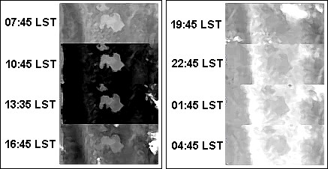

Fig. 5. 30 November 2002 GOES-8 IR4 Satellite images centered over the Salar de Uyuni.

After removing the large scale flow, our results showed circulation patterns that could be related to six hypothetical mechanisms: Salar breezes, anabatic/katabatic winds, upslope winds from the Pacific basin, diurnal boundary layer turbulent friction effects, downward transport of momentum from the upper troposphere, and isolated convection effects.

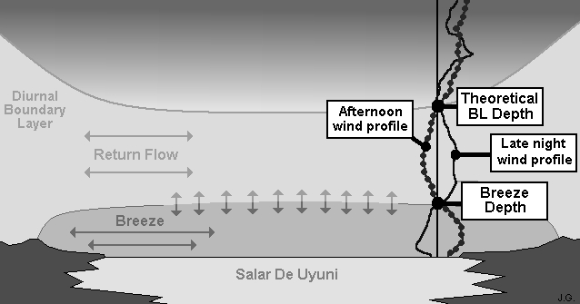

Fig. 6. Scheme showing the salar-terrain breeze mechanism induced by the Salar de Uyuni, and a theoretical relationship with the boundary layer and a profile of wind anomalies.

- Salar breezes

The salar-breeze mechanism was hard to depict in some sites partly due to errors in the data, and partly due to the presence of other mechanisms not well understood yet. Most of the locations showed a clear signal, however, especially the South, West and COPS sites. These results will be discussed, and the information obtained in the central site will be compared with the one obtained in the sites located near the edges of the salar.

Fig. 7 is an excellent example of the salar breeze mechanism. It shows the anomalies of the five-day-averaged meridional wind profiles at 3 different times of the day for the South site. A strong onshore breeze can be observed by early afternoon reaching northerly wind anomalies of almost 10 m/s at about 100 m over the surface. The vertical extension of this breeze is 1000 m AGL, which is confirmed by the late afternoon profile, even though by this time the breeze has weakened significantly.

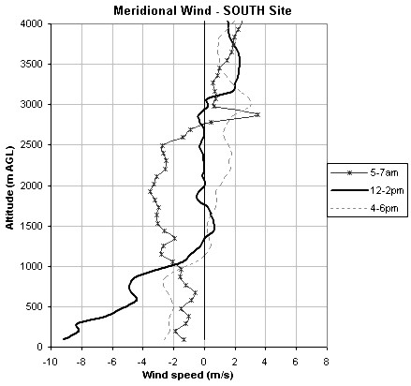
Fig. 7. Anomalies of the 5-day-averaged meridional wind (m s⁻¹) observed at the South site. The thin line with asterisks indicates the early morning wind anomalies, the thick dark line indicates the early afternoon wind anomalies and the dashed line indicates the late afternoon wind anomalies.

The return flow associated to the breezes is also apparent in this plot, occurring between 1000 and 3000 m AGL. It corresponds to a broader and weaker layer of winds.

It is important to notice that the mean flow anomaly is in average from the north along the lowest 3000 m suggesting again the presence of a prevailing diffluent flow at lower levels. The anomaly becomes from the south over this level suggesting possible presence of salar-induced circulation at larger spatial scales.

The diurnal cycle of the breezes observed in the South site can be best described using Fig. 8. The onshore flow appears after 0900 LST at lower levels and quickly expands in the vertical reaching depths above 1 km at 1100 LST. The depth of the flow starts to decrease after 1400 LST merging with the strong westerly flow observed at all sites during late afternoon. In this case this flow is weaker in comparison with the West and COPS site, and decays around 2000 LST. Even though the number of nighttime observations was very reduced, low level offshore flow was also observed at 0200 LST.

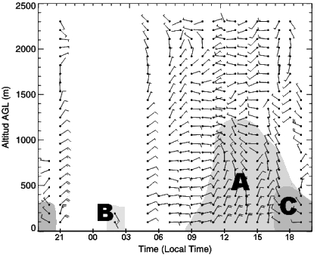
Fig. 8. Anomalies of the 5-day-averaged wind (m s⁻¹) observed at the South site. The data has been plotted utilizing wind barbs and in an hourly fashion. The hypothetical regions of breezes have been shaded for the salar-type breeze (A), land breeze (B), and strong afternoon westerlies (C).

For an analysis of the breezes observed at the West site, Fig. 9 shows the anomalies of the five-day-averaged zonal flow. The depth of the breezes is similar to the depth observed at the South site, with a higher standard deviation. The point of inflexion of the wind profiles, however, is not as obvious as compared to the South site results. It can be anywhere in between 700 and 1600 m. The area of return flow is not clear as well.

It is also important to notice a tendency of the mean flow anomaly to be onshore between 500 and 3000 m, which would again suggest the presence of larger spatial scale circulations induced by the salar with an inflexion point near 3 km. This observation is a result of subtracting the mean calculated with data from all the stations instead of using a mean calculated with data of each station. The observation of this large 3000 m AGL deep circulation induced by the salar is consistent with the South site observations.

The late afternoon wind profile, however, differs from the tendencies noticed on the other ones. A sudden increase on the wind velocities in a 700 m layer close to the surface modifies the rest of the profile, apparently due to conservation of momentum. Notice that the areas held by each curve on both the positive and negative regions of the plot appear to be similar. This change in the profile may be attributed to the incursion of upslope winds from the Pacific Basin located to the west, hypothetical mechanism that will be described later.

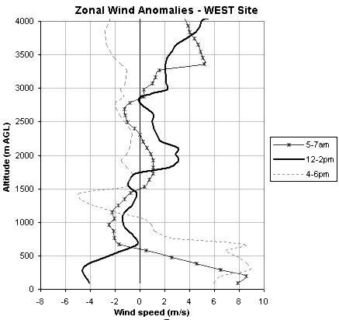
Fig. 9. Anomalies of the 5-day-averaged zonal wind (m s⁻¹) observed at the West site. The thin line with asterisks indicates the early morning wind anomalies, the thick dark line indicates the early afternoon wind anomalies and the dashed line indicates the late afternoon wind anomalies.

The diurnal cycle of the breezes observed at the West site is described in Fig. 10. The onshore breeze mechanism develops after 0900 LST rapidly reaching depths of the order of 1200 m AGL. This mechanism persists until late afternoon. After 1500 LST a strong westerly flow incursion of a depth of 700 m reaches the location, becoming persistent even after sunset. The lack of nighttime pilot balloon observations resulted on a gap between 2000 LST and 0500 LST when strong and very shallow westerly winds were observed. This strong late night-early morning flow was not observed at the other sites. A very large temperature gradient between the salar and the terrain to the west of it could explain a terrain breeze characterized by +8 m/s anomalies. The late night temperature gradients between the terrain and the salar, however, seemed to be larger at the eastern edge of the salar in comparison with the western edge, as suggested by the GOES-8 IR4 Satellite image of 0445 LST, 30 November 2002 (Fig. 6). Assuming that the satellite image is accurate enough in depicting surface temperature gradients, there should be another mechanism involved on the generation of such strong winds. Katabatic winds could be playing an important role, as sloping terrain can be found very close to the West site. These winds, however, could be originated at the cold tops of the western ridge located at 30 km to the west of the salar.

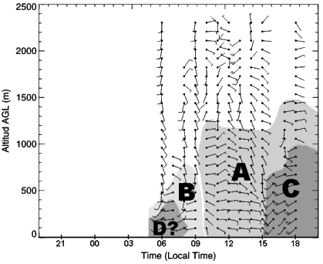
Fig. 10. Anomalies of the 5-day-averaged wind (m s⁻¹) observed at the South site. The data has been plotted utilizing wind barbs and in an hourly fashion. The hypothetical regions of breezes have been shaded for the salar-type breeze (A), land breeze (B), the strong afternoon westerlies (C), and the probable katabatic wind contribution (D).

A breeze analysis was also performed for the COPS site. Even though this site was located close to the center of the salar, it also showed a breeze signal. Fig. 11 shows the anomalies of the early morning zonal wind versus the early afternoon and late afternoon zonal wind at this location. A comparison between the first two curves reveals the presence of an easterly breeze with a shallow depth of about 400 m AGL and a broad return flow of an approximate depth of 2100 m. These results suggest that this site was located to the west of the breeze source region. This may be consistent with the fact that the widest portion of the salar is closer to the eastern side than to the western one.

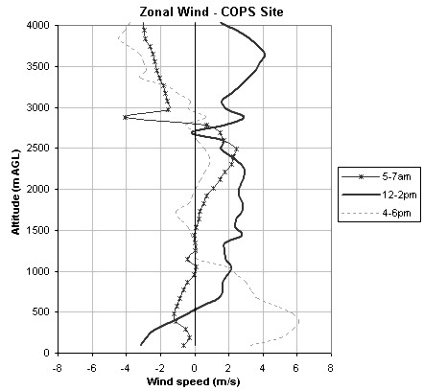
Fig. 11. Anomalies of the 5-day-averaged zonal wind (m s⁻¹) observed at the COPS site. The thin line with asterisks indicates the early morning wind anomalies, the thick dark line indicates the early afternoon wind anomalies and the dashed line indicates the late afternoon wind anomalies.

The diurnal cycle of the COPS site profiles is shown in Fig. 12. The salar breeze develops around 0900 LST, immediately reaching the maximum depth around 600 m. This breeze remains almost steady in depth and intensity until the strong westerly flow arrives after 1500 LST. This flow reaches its maximum intensity at 1900 LST, just after sunset. The flow persists during the evening and after midnight merges with the terrain breeze (C/B), making it hard to distinguish between these two. A period of transition occurs between 0600 LST and 0800 LST when solar radiation starts to heat the surrounding terrain inverting the sensible heat gradients.

It should also be noticed that the breezes observed at the COPS site are shallower than the ones observed on the sites located near the edges of the salar.

- Anabatic / katabatic winds

Although there were no strong arguments yet to explain the presence of these winds, theoretical studies complemented with results observed on the west site suggest their contribution to the regional circulation.

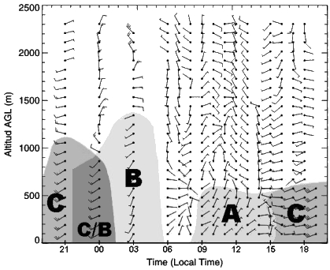

Fig. 12. Anomalies of the 5-day-averaged wind (m s⁻¹) observed at the COPS site. The data has been plotted utilizing wind barbs and in an hourly fashion. The hypothetical regions of breezes have been shaded for the salar-type breeze (A), land breeze (B), strong afternoon westerlies, (C) and an unclear interphase between C and B (C/B).

The anabatic / katabatic wind mechanism is also known as the valley / mountain breeze mechanism. It has the same physical initiation as a lake or salar breeze : A horizontal variation in the sensible heat flux near the ground. It produces downslope winds during the night and upslope winds during the day. The requirement for this type of breeze to occur is the presence of gradients in the topography.

Overall, the west site had the closest location to a mountain chain (Fig. 1), which is the western ridge of the Andes. This feature is located at 30 km to the west of the site and showed a significant surface cooling during nighttime (Fig. 5). The presence of valleys connecting the ridge with the West site region could help to transport the katabatic winds into the salar. Fig. 9 shows +8 m/s zonal flow anomalies during early morning hours. This is also reflected on the 0600 LST streamline analysis in Fig. 4b. These results may suggest the presence of a strong decaying terrain breeze, as the surface sensible heat gradient should be changing sign due to solar radiation.
There could also be a mountain channeling effect on the flow, which would induce an acceleration. This could also explain the strong early morning winds observed on the West site.

- Upslope winds from the Pacific Basin.

Unexpected and long lasting shallow strong westerly winds were observed every late afternoon and evening over the five sites, being particularly strong at the central and western site. Wind velocities generated were of the order of 15 to 20 m/s at 200 m AGL. These winds had a depth of about 700 m when entering the basin and near 1000 m when flowing over the central site. The signal of these winds was less evident on the rest of the sites, but still present.

A hypothesis was posed about the possible origin of these winds being the upslope flow along the western slope of the Andes. Ye, Segal and Pielke (1987) found that the intensity of the upslope flow increases linearly with the amount of heat energy injected at the surface into the PBL, and also increases linearly with respect to the sine of the slope. Strong solar radiation and very dry soil conditions on the area may enlarge the sensible heat flux differences within the western slopes region boundary layer. In addition, the topographic transition between the Atacama Desert and the Altiplano is very sharp, with terrain changes sometimes larger than of 3km on the vertical versus 30 km on the horizontal. Finally, the presence of a strong diurnal contrast between the cold Pacific Ocean and the dry soil of the Atacama Desert could generate strong sea breezes, which could feed the upslope wind, enhancing even more the wind speeds. The combination of the mentioned factors could produce very strong upslope winds, which would reach their maximum speeds near the upper edge of the slope (Ye, Segal and Pielke, 1987). After reaching this edge, the winds would encounter a flatter terrain and propagate through the valleys onto Salar the Uyuni. When reaching the salar, small roughness lengths would help the flow to conserve its momentum and easily propagate in straight line over larger distances.

- Surface and boundary layer turbulent friction

Boundary layer friction during daytime might be responsible for the decrease of the wind velocity within the boundary layer. During nighttime, however, the lower atmosphere tends to be stably stratified and less friction is applied to the flow. This promotes an acceleration of the flow as compared to daytime observations, which was observed at COPS site in particular.

Surface friction is also an important factor on the wind velocity. The surface of the salar is so smooth that creates a smooth wall flow. This allows the flow to propagate rapidlly and to conserve its characteristics over large distances. This may also explain that the strong westerly flow with a zonal anomaly of 8 m/s conserved its momentum reaching the central site with a zonal anomaly of 6 m/s.

- Downward transport of momentum

The upper level flow over the Altiplano has an important role on the circulation near the surface. Large-scale upper level easterly flow produces a turbulent entrainment of easterly momentum over the Andean ridge, thereby accelerating eastward upslope flow and moisture transport (Vuille, 1999; Garreaud, 1999).

It was found by the observations that during the last days of the experiment the magnitude of the afternoon westerly flow increased significantly in contrast with the first days. This may be related to an acceleration of the upslope flow due to entrainment of westerly momentum over the ridge, posing an analogy to the argument suggested by Garreaud (1999) and Vuille (1999).

- Isolated effects of convection

Western Altiplano convective events occur only during periods of daily moisture influx from the eastern interior of the continent (Garreaud, 1999; Garreaud, 2000; Vuille, 1999), which are less common than periods of dry air intrusion from the west. Being consistent with these observations, convection was present only during the first two days of observations, when the main zonal component of the 500 mb winds was easterly. The rest of the period was characterized by westerly flow and very dry conditions.

A convective storm that developed on November the 26th over Tunupa Volcano, about 10 km to the north of the north site, generated an outflow boundary which propagated towards the south along the salar. This flow was first captured by the north station producing a change on the meridional wind of -7.5 m/s in one hour, from 0.7 m/s southerly winds at 1700 LST to 6.8 m/s northerly winds at 1800 LST.

The winds associated to the storm on the 26th were removed for the calculation of the five-day means, as previously mentioned, due to the isolated characteristic of this event.

6. Concluding remarks

The prevailing flow over Salar the Uyuni was diffluent during the day and confluent near midnight. Divergence calculations are recommended in order to depict the effects of the salar in vertical circulations, as this study performed a two-dimensional analysis solely.

The results indicated the presence of onshore breezes with a depth between 700 and 1500 m AGL on the stations located near the edges of the salar, and a slightly shallower breeze with a vertical extension between 500 and 1000 m ACL near the center of the salar. These circulations may suggest the presence of subsiding flow over the salar, which would be responsible for the shallower breezes observed in the central site.

Offshore breezes with a similar depth than the onshore ones were also depicted. These breezes, however, appeared to be deeper at the central station as compared to the surrounding stations. This could also suggest the presence of a deeper nocturnal boundary layer that could be associated to rising motions over the salar. This needs to be complemented with divergence calculations though, besides that the lack of nighttime observations becomes a limitation on the interpretation of these results.

Six mechanisms involved on the circulation patterns observed over Salar de Uyuni may be the salar-breeze mechanism, the anabatic-katabatic wind mechanism, the afternoon incursion of strong westerly shallow winds originated in the western slopes of the Andes, the effects of boundary layer friction on the diurnal flow, downward transport of momentum from the upper troposphere, and isolated effects of convection in the form of local outflow boundaries.

REFERENCES

Estoque M. A. and J. Gross, 1978 : Diurnal Wind and Temperature Variations over Lake Ontario. Mon. Wea. Rev., 104, 1742-1747.

Estoque, M. A. and J. Gross, 1980: Further Studies of a Lake Breeze Part I: Observational Study. Mon. Wea. Rev., 109, 611-618.

Garreaud, R. D., 1999 : Multi-scale analysis of the summertime precipitation over the Central Andes’. Mon. Wea. Rev., 127, 901-921.
Garreaud, R, 2000 : Intraseasonal Variability of Moisture and Rainfall over the South American Altiplano. Mon. Wea. Rev, 128, 3337-3346.

Physick, W. L. and N. J. Tapper, 1990: A Numerical Study of Circulations Induced by a Dry Salt Lake. Mon. Wea. Rev., 118, 1029-1041.

Vernekar, K. G., B. Mohan, S. Saxena and M. N. Patil, 1993 : Characteristics of the Atmospheric Boundary Layer over a Tropical Station as Evidenced by Tethered Balloon Observations. Journal of Applied Meteorology, 32, 1426-1432.

Vuille, M., 1999: Atmospheric Circulation Over the Bolivian Altiplano During Dry and Wet Periods and Extreme Phases of the Southern Oscillation. International Journal of Climatology., 19, 1579-1600.

Ye, Z. J., M. Segal, and R. A. Pielke, 1987: Effects of the Atmospheric Thermal Stability and Slope Steepness on the Development of Daytime Thermally Induced Upslope Flow. Journal of the Atmospheric Sciences., Vol. 44, N°22, 3341-3354.

