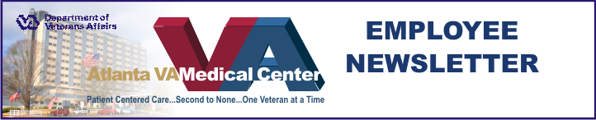

October 15, 2008
Apri

News Briefs
Director’s Town Hall Meeting- Environmental Management will host the Director’s Town Hall meeting Oct 28 at 3pm in the Pete Wheeler Auditorium.
Atlanta VA Medical Center’s Employee Appreciation Day will take place Oct 25 from 11:00am to 3:00pm in the Ambulatory Care Parking Lot.
Atlanta VAMC’s CFC Chili Cook off and Bake off will take place Oct 15 from 11:30am to 1:00pm in the Atrium.
The new Health Information Management Section Chief is Rhonda Wise, formerly the Assistant Chief of HIMS.
Respiratory Care week is October 20- 24 - Respiratory Care operates 24 hours a day seven days a week. The responsibilities of the Respiratory Therapist can range from the evaluation and set up of oxygen, set up, operation and evaluation of life support systems, establishing and maintaining an airway in an emergency situation (code 99) and providing education to our veterans on Respiratory diseases and treatments.
Occupational Health Services new telephone system - In order to improve the efficiency of our services to our employees, Occupational Health Services has implemented a new telephone system. The Main Clinic number is now 6475. There are 5 options to choose from so that your call will be directed to the appropriate area. One option allows you to leave a message for the Clinic Staff that will be answered within one business day. Point of Contact for any questions, concerns or feedback is Dr Miller at ext 3221. Voluntary Leave Transfer Program – The following are approved participants in the VLTP and are eligible to receive annual leave donations: Health Administration Service-Carol Mabry, Mario Sanders. Surgical-John Robinson, Horace Carr. Medical & Specialty Care- Jana Roakes. Atlanta Vet Center-Anita Salamon. Police-Bobby Keener.Patient Care- Gary Slater. Laboratory – Joseph Hudson.
If you wish to make a leave donation, call Freida Philpotts at ext 6306 or Marie Robinson at ext. 4376 to complete form OF-630A.
October is Energy Awareness Month. What are you doing to help reduce the medical Center’s $3.3 Million annual cost for energy and water? Some tips include: turn off lights when you leave a room; promptly report water problems or lights on when not needed; take the stairs – the elevators are run by large motors that use quite a bit of electricity; when driving GOV alternate-fuel vehicles, use E-85 fuel.
Turning off your lights when you leave can cut energy usage by 2/3 and reduce the air conditioning load as well. For more information, contact Mr. Sherwood, ext 6101.
Visit to Atlanta VAMC leaves lasting impression
By Darren Murphy

Mr. Darren Murphy, a regular visitor to Atlanta VAMC, has great things to say about Atlanta VAMC’s customer service.

Not too long ago, as I was sitting in the cafeteria of the Atlanta VA hospital, I thought about what makes my visits here such a pleasant experience. I accompany my friend here every three to four months for his appointments. We travel over four hours, passing two other VA hospitals and one private sector teaching hospital, along the way. However, my friend, who is outgoing but not particularly fond of travelling, prefers coming here. I believe I know why.
Whenever we visit, we are consistently served by genuinely, friendly helpful people. Key word is genuine. There is no scripted formula flowing out from these people. Parking lot attendants, security officers, cafeteria personnel, and front desk personnel are always hospitable and you sense it all comes from a genuine desire to serve.
The reason my friend enjoys coming here is because
See Murphy on page 2

Murphy from page one

employees fully embrace quality customer service and are passionate about helping patients.
As a part time practicing nurse in the private sector, I know a dedicated and committed hospital staff when I see one.

So keep up the great work, Atlanta VA Medical Center, and know that our nation’s heroes are counting on you. I’ve witnessed first hand your hard work and I’m confident that you will not rest on your laurels – but continue to maintain the high standards and, where possible, seek to improve in the future.

VALOR graduate reflections
By Craig Magruder
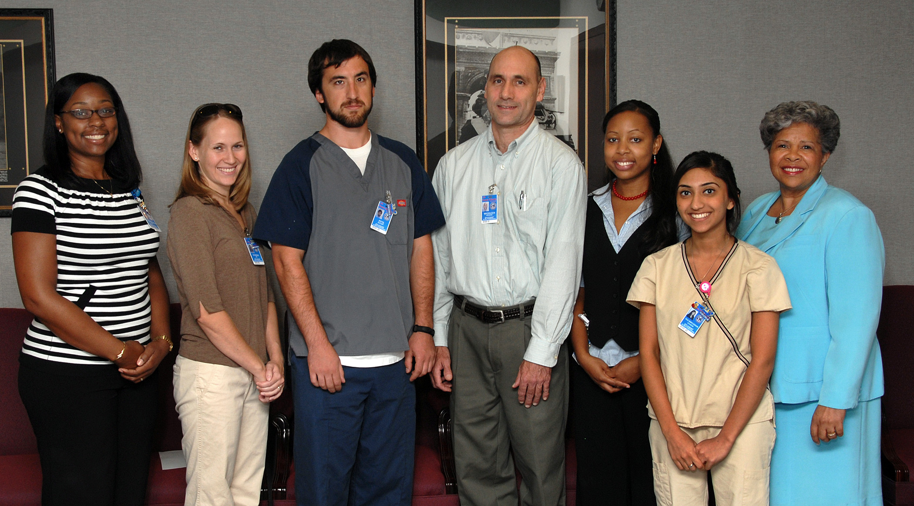
VAMC 2008 Valor class. From Left to Right: Aimee Dotson-Manion, Nursing Instructor, Amy Downing, Zachary Pitts, Craig Magruder, Martene Clark, Afsheen Gulamhussain, and Dr. Georgia Barkers.

Looking back on my participation in the Atlanta VA Medical Center 2008 VALOR program, I’m very grateful for the privilege of working with a great team of caregivers. Speaking for all my VALOR classmates, we hope we brought some value to the hospital and to our veterans. You have all taught us much.
VALOR stands for Veterans Affairs Learning Opportunities. At participating VA hospitals nationwide, the program serves as a recruiting tool, giving rising senior nursing students acute care experience under the tutelage of a nurse preceptor.
One of the core concepts that begins to develop in the VALOR program is the VA philosophy of caring for one veteran at a time. When a veteran says, “Thank you” to a nurse, it is never tiring to hear the seasoned nurse reply, “You are welcome, but I thank you.
Special thanks to Tom Badger who got us interested, Rickey Wilson and Pamela Pruitt who guided us throughout, Aimee and Jeanne who gave their all, Dr. Barkers who built the whole thing, unit managers who gave us freedom and clinical specialists who steadied the boat.

Fall Prevention pamphlet helps
patients stay on their feet
By Anne Byrne,RN
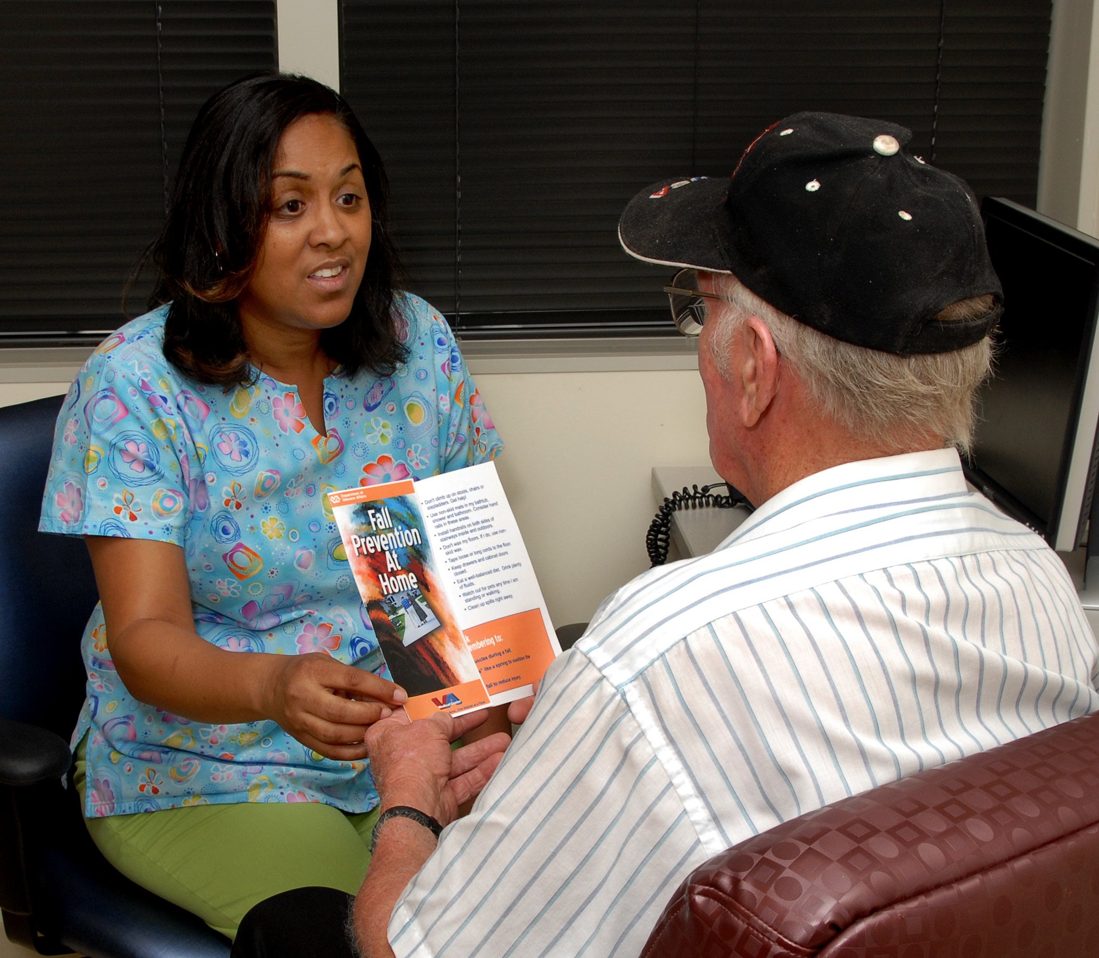
Primary Care nurse, Ms. Angela Freeman, goes over Fall Prevention Brochure with veteran. Ms. Freeman developed the brochure which helps patients recognize their risk for falling at home.

Creativity and initiative can go a long way towards keeping our veterans safe! Angela Freeman, an RN at the Decatur Clinic, saw an opportunity to provide education to our patients and their families.
In support of the National Patient Safety Goal to reduce patient injury related to falls as well as to involve patients and their loved ones in their care, Angela designed a very attractive and well thought out brochure.
This brochure helps patients recognize their risk for falling at home and provides guidance on actions patients can take to reduce their risk of falling at home. This creative brochure has added value to the education Primary Care staff provide to our veterans and is currently shared across the Atlanta VA Medical Center.

Calling it a historic occasion, the President of the Morehouse School of Medicine Dr. John E, Maupin Jr. and other senior leaders from the college visited Atlanta VAMC recently to recognize the two Morehouse psychiatry residents who started their internships at VAMC earlier last month.

