Contract Report

CIGSS Thin Film Solar Cells

Year 4, Quarter 1 Report

Report no. FSEC-CR1490-04

January 14, 2005

Prepared for
National Renewable Energy Laboratory

1617 Cole Boulevard

Golden, CO 80401

Submitted by

Neelkanth G. Dhere
Florida Solar Energy Center®

1679 Clearlake Road

Cocoa, FL 32922-5703

Cocoa, FL 32922-5703 Cocoa, FL 32922-57CC



CIGSS Thin Film Solar Cells

NREL contract no. NDJ-2-30630-03, UCF/FSEC Account no. 2012 6017
Year 4, Quarter 1 Report no. FSEC-CR-1490-04

CIGSS thin film solar cells:

CuIn_{1-x}Ga_{x}Se_{2-y}S_{y} (CIGSS) thin films were prepared at the FSEC photovoltaic materials lab in two steps. The first step consisted of deposition of CuGa-In precursors using DC magnetron sputtering on molybdenum back contact. The second step involved selenization/sulfurization of these precursors. Selenization and sulfurization were carried out using diethylselenide (DESe) as a selenium source and H₂S as sulfur source. Selenization was carried out at 400°C for 10 minutes in diluted DESe followed by sulfurization at 475°C for 20 minutes in diluted H₂S. CIGSS thin-film solar cells were completed by depositing n-type CdS layer by chemical bath deposition (CBD), ZnO/ZnO:Al window bilayer by RF magnetron sputtering and Ni-Al front contacts by e-beam evaporation.
Composition of films was analyzed by electron probe microanalysis (EPMA) and X-ray energy dispersive spectroscopy (XEDS). CIGSS films were inferred to be Cu-rich or Cu-poor on the basis of sheet resistance values. For example, values below 300 Ω taken indicated Cu-rich CIGSS films. On the other hand, values above 5 kΩ indicated Cu-poor CIGSS films. Composition-depth profiling was carried out by secondary ion mass spectrometry (SIMS) and Auger electron spectroscopy (AES) in combination with sputter-etching. Structure and morphology were studied by X-ray diffraction (XRD) and scanning electron microscopy (SEM).
A series of experiments were carried out to deposit near stoichiometric CIGSS thin films. The sheet resistance of the films was measured after every selenization/sulfurization process. Several iterations were carried out in the thickness of CuGa to achieve a slightly copper-poor stoichiometry after selenization/sulfurization. The sheet resistance was measured to be 9-10 KΩ/€. The thickness of the CIGSS absorber layer measured using DEKTAK³ profilometer was ~1.3 μm. EPMA was carried out at 10 kV and 20 kV. Atomic concentrations measured by EPMA at 20kV were Cu:In:Ga:Se:S 22.38:25.69:4.13:25.68:22 showing low gallium content. XRD pattern showed (101), (112), (200), (211), (220/204), (312), and (336) reflections from CuIn_{0.96}Ga_{0.04}Se_{1.08}S_{0.92} phase with a = 5.6872 Å and c = 11.3744 Å as well as reflections from molybdenum (Fig. 1). Both EPMA and XRD analysis were carried out at National Renewable Energy Laboratory (NREL), Golden CO. SEM micrograph showed compact grains with very little porosity (Fig. 2). Fig. 3 shows the XEDS graph of the same CIGSS film analyzed at 20 kV.

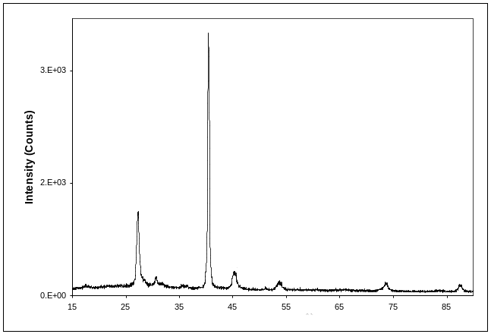

Fig. 1. XRD pattern of CIGSS thin film selenized at 400°C and sulfurized at 475°C.

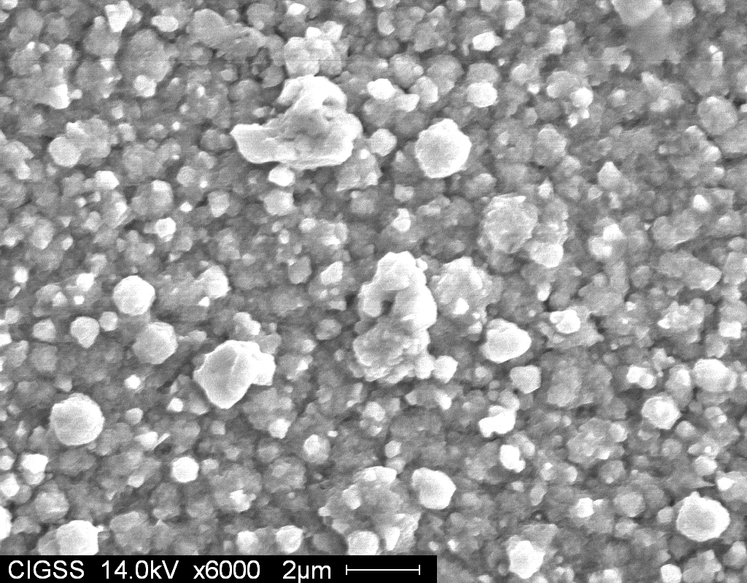

Fig. 2. SEM of CIGSS thin film at x6000 magnification.

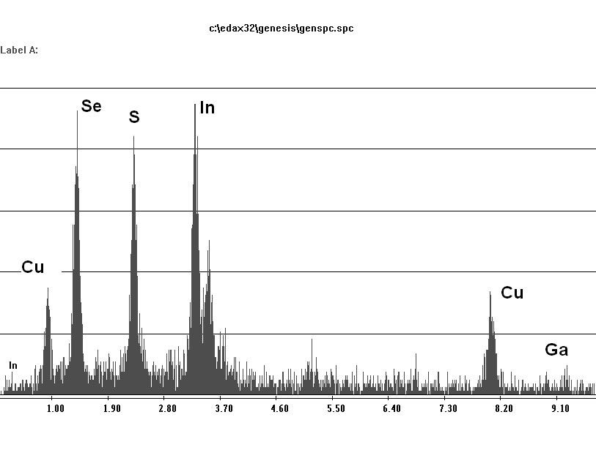

Fig. 3. XEDS graph of CIGSS thin film at 20 kV

SIMS and AES analysis were carried out to check the elemental composition/depth profile of CIGSS absorber layer. AES analysis was carried out at Major Analytical Instrumentation Center (MAIC), Gainesville FL and SIMS analysis was carried out at AMPAC’s Materials Characterization Facility (MCF), Orlando FL. AES and SIMS depth profiles showed increase in gallium concentration and decrease in indium concentration towards the molybdenum back contact. Copper and sulfur signals were constant through the bulk of CIGSS. The selenium signal was higher than sulfur which is complemented by the EPMA results that showed low gallium content (gallium has diffused towards the back contact) and high selenium concentration than sulfur (S/(Se+S) = 0.46) (Fig. 4 and Fig. 5). AES profile showed increase in sulfur concentration towards the back contact. It also indicated presence of oxygen in the bulk of absorber layer. This was attributed to a leak in the selenization/sulfurization set-up. Later the leak was detected using a mass-spectrometer leak detector. A leak found in the H₂S line was sealed. Further preparation of CIGSS thin-film solar cells is being carried out.
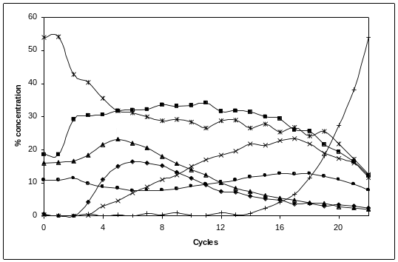
Fig. 4. AES depth profile of CIGSS thin film.

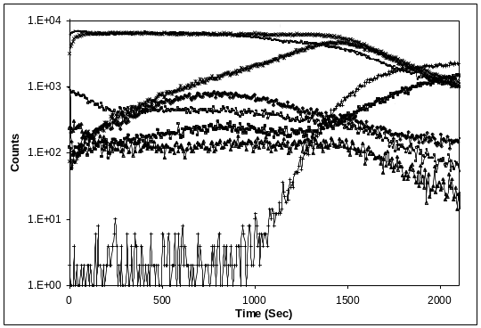

Fig. 5. SIMS depth profile of CIGSS thin film.

CIGSS thin-film solar cells were completed by the deposition of CdS using CBD technique, ZnO/ZnO:Al bilayer window by RF magnetron sputtering and Ni-Al front contact deposition by e-beam evaporation technique (Fig. 6)

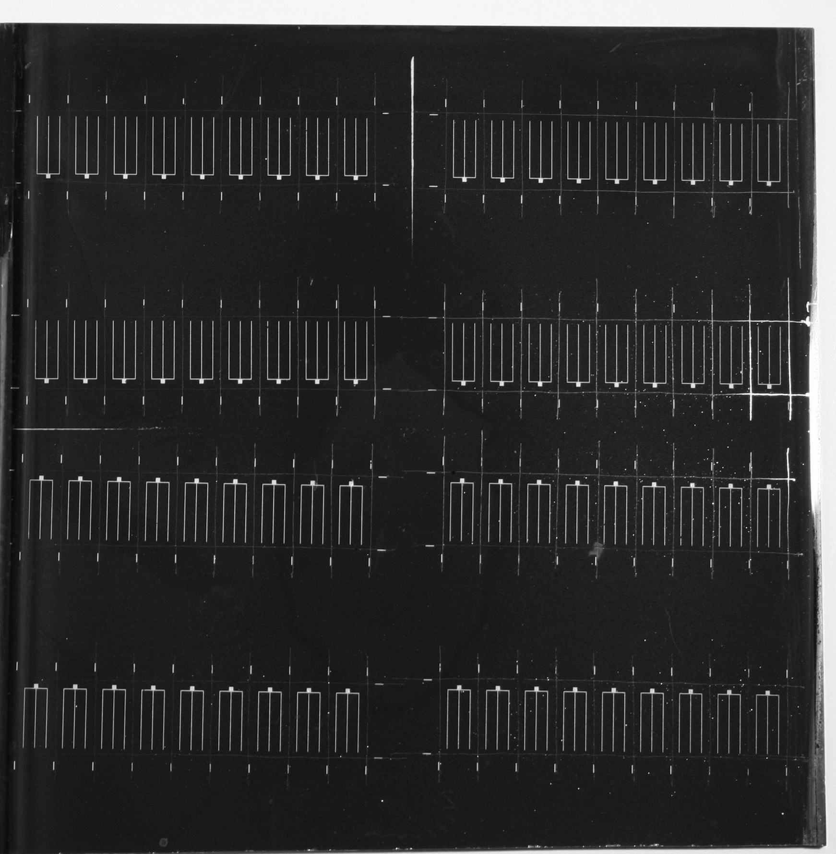

Fig. 6: Picture of CIGSS/CdS thin-film solar cell on molybdenum coated glass.

I-V Setup:

The earlier current-voltage (I-V) setup used a DAQ card (6024E) from National Instruments. Its accuracy was 16.504 mV. The current flowing through a 0.47 cm² solar cell is typically in the range of 0.01 mA. At the suggestion of Keith Emery (NREL) a new, more reliable and robust setup was designed using highly accurate power supply and multimeter.

Fig. 1 shows a block diagram of the new I-V setup.
Illumination

Multimeter

Power Supply

Computer running LABVIEW

Solar cell
GPIB cable
GPIB cable

Fig. 1: New I-V measurement setup.

The BOP 20-5D power supply from Kepco is capable of supplying +/- 20V (0-5A). Its output was connected to micromanipulator probes that were in contact with the solar cell. The 6.5 digit 34401A multimeter from Agilent Technologies (0.0015% accuracy) was connected in series with the solar cell to measure the resulting current. The power supply and multimeter (both capable of GPIB communication) were connected to a computer with an IEEE 488.2 card.
A snapshot of the I-V measurement program is shown in Fig. 2. (Note: A diode is being tested. Fill factor is not a relevant parameter in this case.) The desired range and step size were entered in the respective fields. The program can now be run in steps through the required range. The I-V plot is updated after every single measurement. After the last measurement, the program prompts the user to save the voltage, current and power data to an Excel sheet. Thus, the data can be saved for later use.

The Graphical User Interface of the program was similar to the one used earlier with the DAQ card. The Block Diagram had to be modified to a great extent to accommodate the GPIB interface instead of the DAQ card. The program has also been enhanced to display the Voc, Isc, Vmp, Imp and Fill factor of the solar cell. However, the figure shows only the dark I-V characteristic of a diode and power supplied to it.

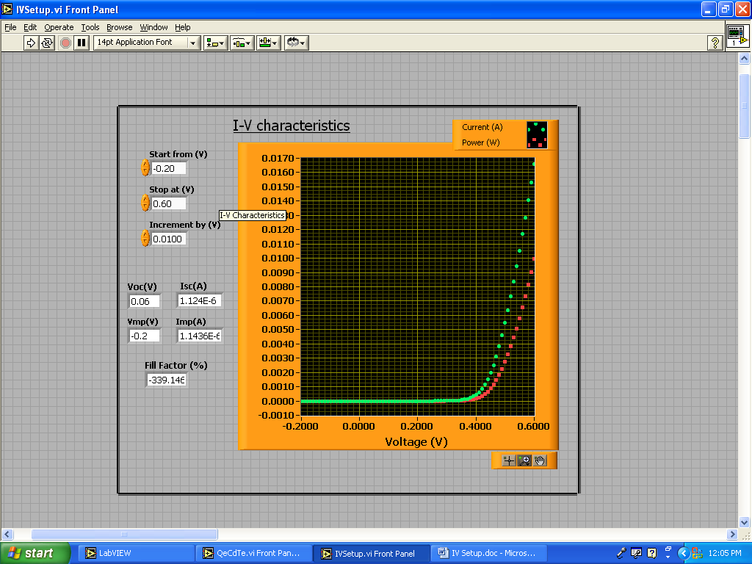

Fig. 2: Dark I-V characteristic of a diode

