Lumiracoxib (COX189)
Background Document
for Novartis Presentation to
FDA Advisory Committee
(February 16-18, 2005)

Document status: | Final
Release date: | 13 January 2005
Number of pages: | 65
Property of Novartis Pharmaceuticals Corporation
All Rights Reserved

AVAILABLE FOR PUBLIC DISCLOSURE WITHOUT REDACTION
Table of contents
List of tables 4
List of figures 6
1 Meta-analysis of lumiracoxib CV safety 8
1.1 Meta-analysis of all lumiracoxib data: Methods 8
1.1.1 Characteristics of trials, patients and interventions 8
1.1.2 Meta-analysis statistical methodology 12
1.2 Results of meta-analysis for APTC and MIs 13
1.2.1 APTC endpoint 13
1.2.2 Myocardial infarctions 14
1.2.3 Evidence from a cumulative stratified meta-analysis for APTC and MIs 14
1.2.4 Meta-analysis of all lumiracoxib data for stroke 16
1.2.5 Meta-analysis of all lumiracoxib data for peripheral vascular risk 17
1.2.6 Meta-analysis of all lumiracoxib data for MI / strokes / peripheral vascular events – combined 19
1.2.7 Summary of lumiracoxib meta-analysis data 20
2 TARGET design: Rationale for selecting two different traditional non steroidal anti-inflammatory drugs (NSAIDs) as comparators 21
3 TARGET: Comparison of lumiracoxib and ibuprofen 23
3.1 APTC endpoint - lumiracoxib vs ibuprofen 23
3.2 Clinical and silent MIs - lumiracoxib vs ibuprofen 27
3.3 Lumiracoxib has a CV adverse event profile that is no different from ibuprofen for all adjudicated thrombotic events 27
3.4 Lumiracoxib showed a significantly better blood pressure profile than ibuprofen for de novo and aggravated hypertension, and numerically less edema and congestive heart failure (CHF). 28
3.4.1 Blood pressure – least squares mean change from baseline 28
3.4.2 De novo hypertension – lumiracoxib compared to ibuprofen 29
3.4.3 Severe de novo hypertension – lumiracoxib compared to ibuprofen 30
3.4.4 Severe aggravation of hypertension 32
3.4.5 Congestive heart failure (CHF), edema and weight gain 33
3.4.6 Cases of edema reported as SAEs or leading to premature discontinuation 34
3.5 Analysis of upper gastro-intestinal events: lumiracoxib vs ibuprofen 34
3.6 Low dose aspirin population – hemoglobin changes: Lumiracoxib vs ibuprofen and naproxen: 35
3.7 Combined GI and CV endpoint – lumiracoxib vs ibuprofen 37
3.8 Summary: Lumiracoxib does not increase CV adverse events compared to ibuprofen and has a positive benefit to risk profile compared to ibuprofen. 38
4 TARGET: Lumiracoxib compared to naproxen 39
4.1 APTC endpoint - lumiracoxib vs naproxen 39
4.2 TARGET study: Clinical and silent MIs - lumiracoxib vs naproxen 41
4.3 Lumiracoxib has a CV adverse event profile that is no different from naproxen for other adjudicated CV events. 41
4.4 Lumiracoxib has a significantly better blood pressure profile than naproxen, and numerically less congestive heart failure and weight gain. 42
4.4.1 Blood pressure – Least Square Means change from baseline 42
4.4.2 Congestive cardiac failure (CHF) and weight gain 42
4.5 Combined GI and CV endpoint – lumiracoxib vs naproxen 43
4.6 Summary: Lumiracoxib compared to naproxen 43
5 TARGET: high CV risk patients – analysis of APTC and MI (silent and clinical events) 44
5.1 Patients with a previous MI: repeat CV events 45
5.2 Peripheral vascular events – ASA population 46
5.3 All thrombotic events (MI –clinical and silent, stroke, DVT and PE) –ASA population 46
5.4 Relationship between hypertension and subsequent thrombotic events 47
6 NDA database of long-term studies 48
6.1 Updated NDA long-term safety dataset: CV events 48
6.1.1 Serious cardiac events (SAEs) regardless of study drug relationship 49
6.1.2 Thrombotic ADRs and relationship to dose 49
6.1.3 Thrombotic ADRs and relationship to duration of treatment 50
6.2 Updated NDA long-term safety dataset – hypertension adverse events 52
6.3 Updated NDA long-term safety dataset – edema adverse events 52
7 How do lumiracoxib CV data compare with rofecoxib? 53
7.1 VIGOR vs TARGET (naproxen substudy and non ASA population) 53
7.1.1 APTC endpoint 53
7.1.2 Myocardial Infarcts 54
7.1.3 Venous thrombosis (deep vein thrombosis and pulmonary embolism) 55
7.1.4 Hypertension, edema and congestive heart failure (CHF) 55
7.2 Summary: VIGOR vs TARGET (naproxen substudy and non ASA population) 57
8 Celecoxib in the CLASS study compared to lumiracoxib in TARGET 58
8.1 CLASS vs TARGET: differences that could impact CV results 58
8.2 TARGET and CLASS: CV data summary 58
9 Possible explanations for the specific rofecoxib CV profile 61
9.1 Structure 62
9.2 Half–life 62
9.3 PK/PD (Distribution kinetics) 62
9.4 Inhibition of the vasoprotective prostaglandin PGI₂ 62
10 Summary 63
References 64

List of tables
Table 1-1 Trials included in meta-analysis 9
Table 1-2 Relative risk of APTC endpoint with lumiracoxib and comparators from a stratified meta-analysis 13
Table 1-3 Relative risk of MI with lumiracoxib and comparators from a stratified meta-analysis 14
Table 1-4 Relative risk of stroke with lumiracoxib and comparators from a stratified meta-analysis 17
Table 1-5 Relative risk of peripheral vascular event with lumiracoxib and comparators from a stratified meta-analysis 18
Table 1-8 Relative risk for MI / all strokes / peripheral vascular events – combined, with lumiracoxib and comparators from a stratified meta-analysis 19
Table 3-1 Confirmed or probable APTC endpoint: treatment comparisons using COX proportional hazards model (safety population) 24
Table 3-2 Lumiracoxib vs ibuprofen – confirmed/probable clinical and silent myocardial infarctions 27
Table 3-3 Adjudicated confirmed or probable thrombotic events (MI –clinical and silent, stroke, DVT and PE) 27
Table 3-4 Adjudicated Confirmed or probable peripheral vascular events (DVT or PE) 28
Table 3-5 TARGET study – lumiracoxib vs ibuprofen. Incidence of edema, CHF and weight gain (overall safety population). 33
Table 3-6 TARGET study - definite or probable UGIT complications (POBs) 35
Table 3-7 Hemoglobin (g/l) LS means for end-of-study value and its change from baseline 36
Table 3-8 Hemoglobin [g/L] LS means for 12-month value and its change from baseline 36
Table 3-9 TARGET – GI and CCV (APTC) combined endpoint 37
Table 4-1 Confirmed or probable APTC endpoint: treatment comparisons using COX proportional hazards model (safety population) 39
Table 4-2 Incidence of confirmed or probable myocardial infarction (clinical and silent) – lumiracoxib vs naproxen 41
Table 4-3 TARGET study: lumiracoxib vs naproxen. Incidence of confirmed or probable cardiovascular and cerebrovascular events (overall safety population). 42
Table 4-4 TARGET study: lumiracoxib vs naproxen. Incidence of CHF and weight gain (overall safety population). 42
Table 4-5 GI and CCV (APTC) combined endpoint 43
Table 5-1 TARGET patient characteristics – high CV risk patients 44
Table 5-2 Patients with history of CV disease: APTC and MIs (clinical and silent) 44
Table 5-3 Patients with history of coronary heart disease (Framingham risk patients excluded): APTC and MIs (clinical and silent) 45
Table 5-4 Peripheral vascular events (DVT or PE) - (Safety Population) - Aspirin use: Yes 46
Table 5-5 Thrombotic events (MI –clinical and silent, stroke, DVT and PE) - (Safety Population) - Aspirin use: Yes 47
Table 5-6 TARGET: Incidence of confirmed or probable APTC events in patient categories with hypertension 48
Table 6-1 Incidence of cardiovascular events 48
Table 6-2 Crude incidence of APTC endpoint by dose 50
Table 6-3 Crude incidence of APTC endpoint by duration 51
Table 6-5 Hypertension adverse events by category and preferred term (safety patients- all non acute pain studies) 52
Table 6-6 Edema adverse events by category and preferred term (safety patients – all non acute pain studies) 52
Table 7-1 APTC events: VIGOR vs TARGET (non aspirin population – naproxen vs lumiracoxib) 54
Table 7-2 MI events: VIGOR vs TARGET (non aspirin population – naproxen vs lumiracoxib) 54
Table 7-3 Serious venous thrombotic events: VIGOR vs TARGET (non aspirin population – naproxen vs lumiracoxib) 55
Table 7-4 VIGOR: Results of pre-specified safety analyses 55
Table 7-5 Edema discontinuations data in TARGET 56
Table 7-6 Hypertension discontinuations data in TARGET 56
Table 7-7 TARGET – lumiracoxib vs naproxen: Incidence of edema, CHF as an AE and weight increase (no aspirin population) 57
Table 8-1 TARGET vs CLASS comparison for MI and APTC event rates 59

List of figures
Figure 1-1 Cumulative stratified meta-analysis of APTC events in randomized trials comparing lumiracoxib with controls 15
Figure 1-2 Cumulative stratified meta-analysis of MI in randomized trials comparing lumiracoxib with controls 15
Figure 1-3 Cumulative meta-analysis of MI in randomized trials comparing lumiracoxib with non-naproxen NSAIDs 16
Figure 1-4 Cumulative stratified meta-analysis of stroke in randomized trials comparing lumiracoxib with controls 17
Figure 1-5 Cumulative stratified meta-analysis of peripheral vascular events in randomized trials comparing lumiracoxib with controls 18
Figure 1-6 Cumulative stratified meta-analysis for MI / all strokes / peripheral vascular events – combined, in randomized trials comparing lumiracoxib with controls 20
Figure 1-7 Cumulative meta-analysis of myocardial infarctions in randomized trials comparing rofecoxib with control 21
Figure 3-1 Lumiracoxib vs ibuprofen: cumulative incidence of confirmed/probable APTC endpoint 25
Figure 3-2 Posthoc depiction of cardiovascular events in non-aspirin users in the CLASS study (Ref: FitzGerald G) 26
Figure 3-3 De novo hypertension- lumiracoxib compared to ibuprofen 29
Figure 3-4 Severe de novo hypertension – lumiracoxib compared to ibuprofen 30
Figure 3-5 Aggravation of hypertension – lumiracoxib compared to ibuprofen 31
Figure 3-6 Severe aggravation of hypertension 32
Figure 3-7 Edema reported as SAEs or requiring premature discontinuation 34
Figure 3-8 TARGET: Combined GI and CCV endpoint Kaplan – Meier 38
Figure 4-1 Lumiracoxib vs naproxen: cumulative incidence of confirmed/probable APTC endpoint 40
Figure 8-1 APTC events in TARGET- Lumiracoxib vs ibuprofen in the no low-dose ASA population 59
Figure 8-2 Posthoc depiction of thromboembolic cardiovascular events in non-aspirin users in the CLASS study (Ref: FitzGerald G) 60

Meta-analysis of lumiracoxib CV safety

Meta-analysis of all lumiracoxib data: Methods
Rofecoxib was withdrawn worldwide from the market on 30 September 2004 due to an increased risk of adverse cardiovascular events observed in the Adenomatous Polyp Prevention on Vioxx® (APPROVe) study. This significant difference was seen beginning after 18 months of treatment and raised the question of whether these findings are associated with other drugs in the class. However a recent publication in the Lancet (Jüni et al 2004) questioned whether the cardiovascular signal was evident earlier and argued using cumulative meta-analysis methodology that the increase in myocardial infarctions with rofecoxib was evident as early as 2000, after 14,247 patients had been randomized in rofecoxib studies and 44 myocardial infarcts (MI) had occurred. The meta-analysis included only therapeutic doses of rofecoxib (12.5 mg to 50 mg od). The authors suggested that if adverse events were cumulatively analyzed, this would allow for earlier detection of clinically significant safety signals.
Novartis has performed a standard and cumulative meta-analysis of the cardiovascular safety of lumiracoxib for all doses, including supratherapeutic doses (100 mg to 1200mg od), of all completed randomized controlled trials of lumiracoxib ≥ 1 week duration.

Characteristics of trials, patients and interventions
All randomized, controlled studies that involved administration of lumiracoxib (≥1 week in duration) in chronic indications were included in the analysis (Table 1-1). Trials in acute pain models (e.g. pain due to dental surgery, arthroplasty, dysmenorrhea), drug-drug interaction studies of short duration, clinical pharmacology studies in healthy volunteers or special populations were not included on the basis that they would add little to overall patient exposure (44 patient – years compared with 9796 patient-years for patients taking lumiracoxib for treatment of the signs and symptoms of either osteoarthritis or rheumatoid arthritis). It is noteworthy that the vast majority of these studies have already been published.

Table 1-1 Trials included in meta-analysis
Reference | Study number | Treated disorder (number of patients) | Lumiracoxib dose (number of patients randomized/safety) | Control (number of patients randomized/safety) | Duration | Jadad score³¹
Schnitzer, 2004¹² | 104 | OA (n=583) | 50 mg bid (n=98/98)  100 mg bid (n=96/96)  200 mg bid (n=99/99)  400 mg od (n=99/99) | placebo (n=97/97)  diclofenac 75 mg bid (n=94/94) | 4 weeks | 5
Schnitzer in press¹³ | 105 | RA (n=571) | 50 mg bid (n=102/102)  100 mg bid (n=98/97)  200 mg bid (n=94/94)  400 mg od (n=87/87) | placebo (n=99/99)  diclofenac 75 mg bid (n=91/91) | 4 weeks | 5
Fleischmann, 2003¹⁴ | 109 | OA (n=1600) | 200 mg od (n=462/462)  400 mg od (n=463/463) | placebo (n=231/231)  celecoxib 200 mg od (n=444/444) | 13 weeks | 5
Kivitz, 2004¹⁵ | 110 | RA (n=893) | 400 mg od (n=227/227)  800 mg od (n=227/227) | celecoxib 200 mg bid (n=223/223)  ibuprofen 800 mg tid (n=216/216) | 13 weeks | 4
Geusens, 200316 | 111 | RA (n=1124) | 200 mg od (n=280/280)  400 mg od (n=281/281) | placebo (n=284/284)  naproxen 500 mg bid (279/279) | 26 weeks | 5
Tannenbaum, 2004¹⁷ | 112 | OA (n=1702) | 200 mg od (n=487/487)  400 mg od (n=491/491) | placebo (n=243/243)  celecoxib 200 mg od (n=481/481) | 13 weeks | 5
Reference | Study number | Treated disorder (number of patients) | Lumiracoxib dose (number of patients randomized/safety) | Control (number of patients randomized/safety) | Duration | Jadad score³¹
Schell, 2003¹⁸ | 112E (39 week extension to 0112) | OA (n=1235) | 200 mg od (n=411/411)  400 mg od (n=419/419) | celecoxib 200 mg od (405/405) | 39 weeks | 4
Data on file ¹⁹ | 114 | RA (n=1239) | 200 mg od (n=315/315)  400 mg od (n=313/313) | placebo (n=309/309)  celecoxib 200 mg bid (n=302/302) | 13 weeks | 5
Hawkey, 2004²⁰ | 126 | OA (n=1042) | 200 mg od (n=264/264)  400 mg od (n=260/260) | celecoxib 200 mg od (n=258/258)  ibuprofen 800 mg tid (n=260/260) | 13 weeks | 4
Berenbaum in press²¹ | 128 | OA (n=511) | 400 mg od (n=205/205) | placebo (n=204/204)  rofecoxib 25 mg od (n=102/102) | 13 weeks | 5
Wittenberg, 2003²² | 2301 | OA (n=364) | 400 mg od (n=144/144) | placebo (n=75/75)  celecoxib 200 mg bid (n=145/145) | 1 week | 5
Berenbaum in press²¹ | 2303 | OA (n=408) | 200 mg od (n=105/105)  400 mg od (n=99/99) | placebo (n=103/103)  celecoxib 200 mg bid (n=101/101) | 1 week | 5
Hawkey in press²³ | 2307 | OA (n=309) | 400 mg od (n=154/154) | rofecoxib 25 mg od (n=155/155) | 6 weeks | 4
Scott., 2003²⁴ | 2312 | RA (n=120) | 800 mg od (n=38/38)  1200 mg od (n=41/41) | naproxen 500 mg bid (n=41/41) | 4 weeks | 4
Benevolenskaya, 2003²⁵ | 2316 | OA (n=244) | 100 mg od (n=122/122) | placebo (n=122/122) | 4 weeks | 5
Reference | Study number | Treated disorder (number of patients) | Lumiracoxib dose (number of patients randomized/safety) | Control (number of patients randomized/safety) | Duration | Jadad score³¹
Grifka, 2004²⁶ | 2319 | OA (n=594) | 200 mg od (n=205/205)  400 mg od (n=193/193) | placebo (n=196/196) | 4 weeks | 5
Pavelka, 200427 | 2335 | RA (n=1151) | 200 mg od (n=458/458) | placebo (n=465/465)  naproxen 500 mg bid (n=228/228) | 13 weeks | 5
Data on file ²⁸ | 2335E (39 week extension to 2335) | RA (n=647) | 200 mg od (n=376/376) | naproxen 500 mg bid (n=271/271) | 39 weeks | 4
Beaulieu, 2004²⁹ | 2360 | OA (n=1551) | 100 mg od (n=391/391)  100 mg od with 2-week loading dose of 200 mg od (n=385/385) | placebo (n=382/382)  celecoxib 200 mg od (n=393/393) | 13 weeks | 5
Lehmann, 2004 ³⁰ | 2361 | OA (n=1684) | 100 mg od (n=420/420)  100 mg od with 2-week loading dose of 200 mg od (n=420/420) | placebo (n=424/424)  celecoxib 200 mg od (n=420/420) | 13 weeks | 5
Data on file | 2361E (39 week extension to 2361) | OA (n=1310) | 100 mg od (n=853/853) | celecoxib 200 mg od (n=457/457) | 39 weeks | 4
Schnitzer, 2004⁸ and Farkouh 2004⁹ | TARGET | OA (n=18325) | 400 mg od (n=9156/9117) | naproxen 500 mg bid (n=4754/4730)  ibuprofen 800 mg tid (n=4415/4397) | 52 weeks | 4

A total of 22 trials in the database met the meta-analysis inclusion criteria. All studies were randomized, double-blind, controlled studies. A total of 33,933 patients were included in the safety population used for the analyses; of these, 17339 patients (9796.4 patient-years exposure) were randomized to lumiracoxib and 16594 patients were allocated to controls (8824.5 patient-years exposure). Prospective adjudication for the components of Antiplatelet Trialist’s Collaboration (APTC) endpoint occurred for 15,678.7 of the total 18,620.9 patient-years exposure. This well-established endpoint included confirmed silent (electrocardiogram detected) myocardial infarctions, confirmed or probable myocardial infarction, stroke (ischemic and hemorrhagic), and cardiovascular death. All trials except two had an active comparator. Of the 14 placebo-controlled trials, the majority had a duration of 13 weeks. Four trials continued for one year (TARGET, and trials 112, 2335, and 2361 with their extensions) totaling 22,781 safety patients (16,526.1 patient-years exposure).
Fifteen trials (13 trials plus 2 extension trials) were performed in patients with osteoarthritis, with the remaining 7 trials (including 1 extension) were performed in patients with rheumatoid arthritis. Patients with osteoarthritis contributed most to patient exposure, which was driven by the large number of patients in TARGET (18,325 patients (18,244 safety patients); 13,505.8 patient-years).
Over 70% of patients were female and the majority of patients were over 55 years of age. Low-dose aspirin use for CV prophylaxis was generally allowed and greater in TARGET (24%, stratified) than the other studies (approximately 10%), while five of the smaller studies (≤ 4 weeks) did not recruit any patients on low-dose aspirin (104, 105, 2301, 2303 and 2312). Over 30% of patients had baseline hypertension (45% in TARGET) and approximately 5% had diabetes (8% in TARGET).

Meta-analysis statistical methodology
Meta-analytic models were used to analyze the APTC and myocardial infarction endpoints from the Novartis Clinical Trial Database. These models included a random effect for trial and assumed a Poisson model for the outcomes. Meta-analytic models were used to investigate the effect of type of comparator, indication, duration, external adjudication, and dose of lumiracoxib on odds ratio of treatment effect. Likelihood ratio tests were used to assess the significance of the above interaction factors. Exact Poisson methods were used to estimate the odds ratio and corresponding 95% confidence interval (CI) for each trial between the treatment groups under comparison. Estimates were not made when one or both of the treatment groups being compared had zero events; the addition of 0.5 to all cells leads to biased and imaginary estimates when the observed event counts are low. The cumulative meta-analysis was performed by fitting a series of meta-analytic models of the type described above. At each step in the cumulation, defined by chronologic dates of database lock in the development program, a random-effect meta-analysis model was fit to the data that had accumulated by that date. Meta-analytic models were fit using SAS, odds ratios and CIs per study were calculated using StatExact, and consistency of model results were tested assuming binomial, Bayes, and GEE models of the same nature in SAS, WinBugs, and S-Plus. In trials that also have an extension with no placebo group, results for lumiracoxib versus placebo are obtained from the placebo-controlled phase only.
There were 34,349 patients randomized to the studies. Of these, 33,933 were confirmed to have received study medication and constitute the safety population used for the analyses of safety outcomes. In the extension studies (0112E, 2361E and 2335E; Table 2-1), patients were re-randomized between the core and extension phases. Because the extension phases were conducted as separate studies with separate study protocols, patients enrolled in the extensions studies enter the meta-analyses twice, once each for the core and extension treatment groups, making a total of 34,668 effective patients used in the meta-analyses.

Results of meta-analysis for APTC and MIs

APTC endpoint
Of the 22 randomized controlled trials identified from the Novartis lumiracoxib clinical database, the meta-analyses found no significantly increased risk of CV events for the APTC endpoint comparing lumiracoxib with placebo, naproxen and non–naproxen NSAIDs (Table 1-2 below). As seen in TARGET, the relative risks differed directionally when lumiracoxib was compared to naproxen and non-naproxen NSAIDs. However the significance of the results was unchanged regardless of comparator, dose, prospective expert adjudication or study duration.

Table 1-2 Relative risk of APTC endpoint with lumiracoxib and comparators from a stratified meta-analysis
Comparisons | Contrasts | Risk  ratio | 95% CI for  risk ratio | Interaction  p-value
All comparators | all Lumiracoxib - all control | 1.14 | ( 0.83,1.57)
Type of control | Lumiracoxib - placebo | 0.88 | ( 0.34,2.25) | 0.6172
 | Lumiracoxib - Non Naproxen NSAID | 0.83 | ( 0.46,1.51)
 | Lumiracoxib - Naproxen | 1.49 | ( 0.94,2.36)
Duration | >3 months: Lumiracoxib - control | 1.18 | ( 0.84,1.67) | 0.6121
 | <=3 months: Lumiracoxib - control | 0.93 | ( 0.38,2.29)
External Adjudication | external: Lumiracoxib - control | 1.08 | ( 0.75,1.54) | 0.5562
 | no external: Lumiracoxib - control | 1.36 | ( 0.66,2.80)
Dose* | Lumiracoxib high dose -control | 1.17 | ( 0.84,1.65) | 0.5379
 | Lumiracoxib low dose -control | 0.99 | ( 0.57,1.71)
* Low dose is defined as up to 200 mg daily. High dose is 400 mg daily and above.

Myocardial infarctions
None of the comparisons was statistically significant. However as was seen in TARGET, the relative risks for myocardial infarction differed directionally when lumiracoxib was compared to non-naproxen NSAIDs and naproxen (Table 1-3). The significance of the results was unchanged regardless of comparator, dose, prospective expert adjudication or study duration.

Table 1-3 Relative risk of MI with lumiracoxib and comparators from a stratified meta-analysis
Comparisons | Contrasts | Risk  ratio | 95% CI for  risk ratio | Interaction  p-value
All comparators | all Lumiracoxib -all control | 1.28 | ( 0.78, 2.12)
Type of control | Lumiracoxib - placebo | 1.06 | ( 0.20, 6.69) | 0.7484
 | Lumiracoxib - Non Naproxen NSAID | 0.80 | ( 0.28, 2.25)
 | Lumiracoxib - Naproxen | 1.69 | ( 0.82, 3.48)
Duration | >3 months: Lumiracoxib - control | 1.30 | ( 0.75, 2.27) | 0.9191
 | <=3 months: Lumiracoxib - control | 1.39 | ( 0.41, 4.72)
External Adjudication | external: Lumiracoxib - control | 1.20 | ( 0.67, 2.16) | 0.7152
 | no external: Lumiracoxib - control | 1.48 | ( 0.54, 4.05)
Dose | Lumiracoxib high dose -control | 1.34 | ( 0.79, 2.29) | 0.5799
 | Lumiracoxib low dose -control | 1.07 | ( 0.46, 2.49)
* Low dose is defined as up to 200 mg daily. High dose is 400 mg daily and above.

Evidence from a cumulative stratified meta-analysis for APTC and MIs
Although the direction of the relative risks for the APTC endpoint and MI for lumiracoxib compared to naproxen and non-naproxen NSAIDs diverge in a consistent manner, we performed a cumulative meta-analysis comparing lumiracoxib with all comparators over time from 2001 to 2004. The cumulative meta-analysis analyzed more than 34 000 patients with a total of 161 APTC events including 66 myocardial infarctions. This analysis also found no significant difference at any time point (Figures 1-1 and 1-2 below). In fact, there was a trend over time from 2003 to 2004 towards a decrease in the relative risk of the APTC endpoint and myocardial infarctions as more events and patients were included.

Figure 1-1 Cumulative stratified meta-analysis of APTC events in randomized trials comparing lumiracoxib with controls
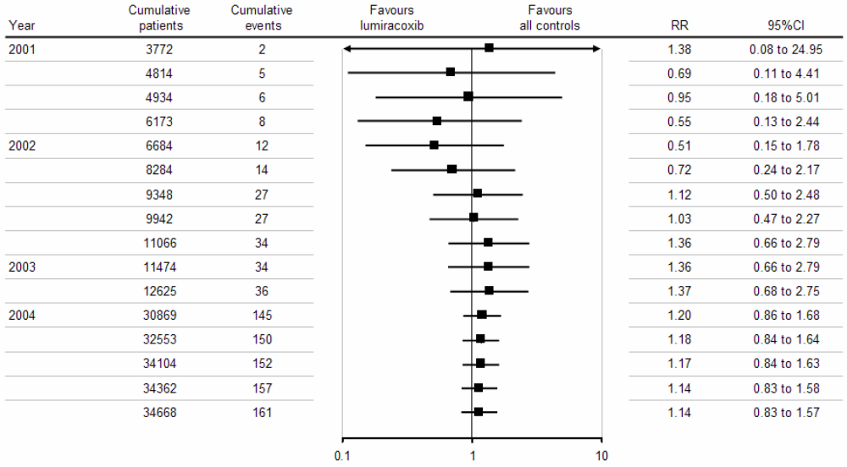

Figure 1-2 Cumulative stratified meta-analysis of MI in randomized trials comparing lumiracoxib with controls
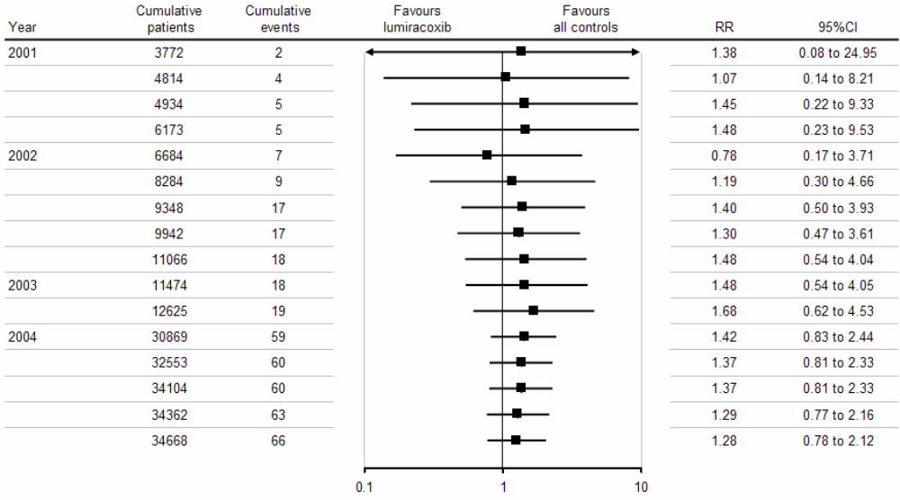
When the analysis was done excluding naproxen, the risk decreased to 1.09 (95 % CI 0.56 – 2.12) which supports our assertion that naproxen at the high dose of 500 mg bid may have a antithrombotic effect (Figure 1-3 below)

Figure 1-3 Cumulative meta-analysis of MI in randomized trials comparing lumiracoxib with non-naproxen NSAIDs
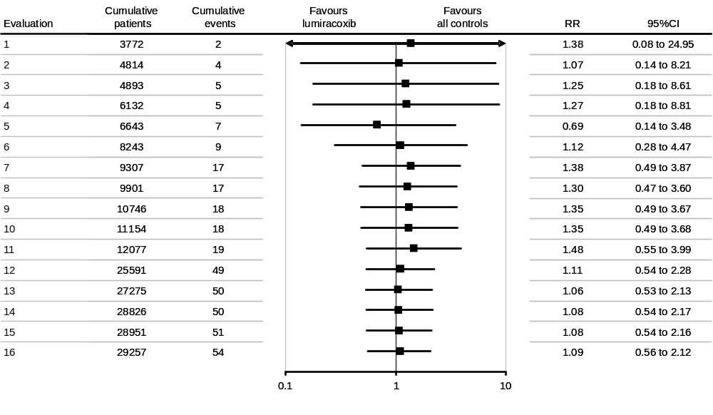

Meta-analysis of all lumiracoxib data for stroke
None of the comparisons was statistically significant. This was unchanged regardless of comparator, dose, prospective expert adjudication or study duration (see Table 1-4 below). The cumulative meta-analysis did not reveal a statistically significant difference at any point in time (see Figure 1-4 below).

Table 1-4 Relative risk of stroke with lumiracoxib and comparators from a stratified meta-analysis
Comparisons | Contrasts | Risk  ratio | 95% CI for  risk ratio | Interaction  p-value
All comparators | all Lumiracoxib - all control | 1.20 | ( 0.70, 2.07)
Type of control | Lumiracoxib - placebo | 0.89 | ( 0.15, 5.08) | 0.3174
 | Lumiracoxib - Non Naproxen NSAID | 0.91 | ( 0.35, 2.35)
 | Lumiracoxib - Naproxen | 1.46 | ( 0.70, 3.07)
Duration | >3 months: Lumiracoxib - control | 1.18 | ( 0.68, 2.06)
 | <=3 months: Lumiracoxib - control |  | not estimable
External Adjudication | external: Lumiracoxib - control | 1.06 | ( 0.59, 1.88) | 0.1424
 | no external: Lumiracoxib - control | 4.44 | ( 0.51, 38.9)
Dose | Lumiracoxib high dose - control | 1.19 | ( 0.67, 2.11) | 0.8955
 | Lumiracoxib low dose - control | 1.12 | ( 0.43, 2.92)
* Low dose is defined as up to 200 mg daily. High dose is 400 mg daily and above.

Figure 1-4 Cumulative stratified meta-analysis of stroke in randomized trials comparing lumiracoxib with controls
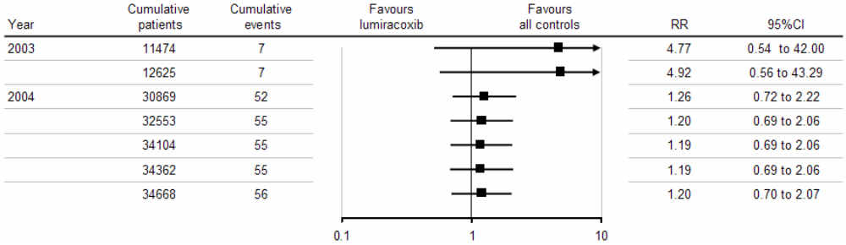

Meta-analysis of all lumiracoxib data for peripheral vascular risk
None of the comparisons was statistically significant. This was unchanged regardless of comparator, dose, prospective expert adjudication or study duration (see Table 1-5 below). The cumulative meta-analysis did not reveal a statistically significant difference at any point in time (see Figure 1-5 below).

Table 1-5 Relative risk of peripheral vascular event with lumiracoxib and comparators from a stratified meta-analysis
Comparisons | Contrasts | Risk  ratio | 95% CI for  risk ratio | Interaction  p-value
All comparators | all Lumiracoxib -all control | 1.10 | ( 0.56, 2.16)
Type of control | Lumiracoxib - placebo | 0.99 | ( 0.25, 3.97) | 0.1631
 | Lumiracoxib - Non Naproxen NSAID | 1.82 | ( 0.44, 7.53)
 | Lumiracoxib - Naproxen | 0.79 | ( 0.26, 2.42)
Duration | >3 months: Lumiracoxib - control | 1.36 | ( 0.62, 2.95) | 0.3967
 | <=3 months: Lumiracoxib - control | 0.68 | ( 0.16, 2.95)
External Adjudication | external: Lumiracoxib - control | 1.01 | ( 0.45, 2.26) | 0.7378
 | no external: Lumiracoxib - control | 1.30 | ( 0.37, 4.57)
Dose | Lumiracoxib high dose - control | 0.98 | ( 0.46, 2.09) | 0.3570
 | Lumiracoxib low dose - control | 1.55 | ( 0.61, 3.95)
* Low dose is defined as up to 200 mg daily. High dose is 400 mg daily and above.

Figure 1-5 Cumulative stratified meta-analysis of peripheral vascular events in randomized trials comparing lumiracoxib with controls
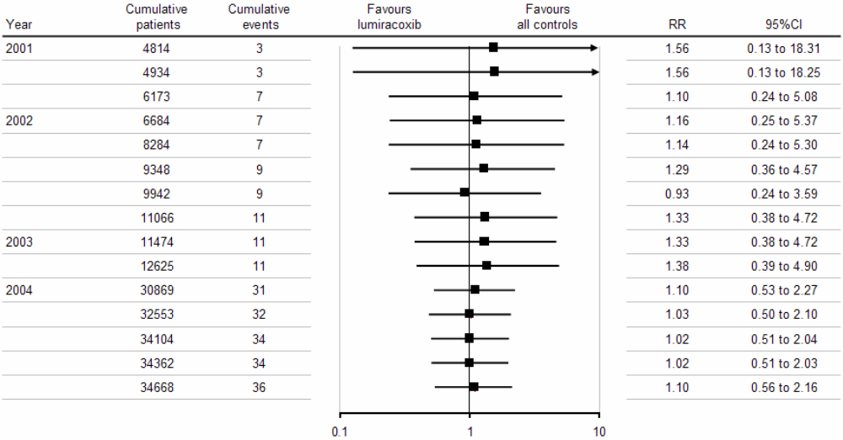

Meta-analysis of all lumiracoxib data for MI / strokes / peripheral vascular events – combined
For the combined endpoint of MIs/ strokes/ peripheral vascular events, none of the comparisons was statistically significant. This was unchanged regardless of comparator, dose, prospective expert adjudication or study duration (see Table 1-8 below). The cumulative meta-analysis did not reveal a statistically significant difference at any point in time (see Figure 1-6 below).
This analysis combines definite MIs (as analyzed in section 1.2.2), definite strokes (as analyzed in section 1.2.4), and peripheral events (as analyzed in section 1.2.5).
This endpoint differs from the APTC endpoint (CV death, non-fatal stroke, non-fatal MI) analyzed in section 1.2.1 in that it does not include CV deaths that were not also adjudicated as stroke or MI, and in that it does include peripheral events which are not considered for the standard CV APTC endpoint.

Table 1-8 Relative risk for MI / all strokes / peripheral vascular events – combined, with lumiracoxib and comparators from a stratified meta-analysis
Comparisons | Contrasts | Risk  ratio | 95% CI for  risk ratio | Interaction  p-value
All comparators | all Lumiracoxib -all control | 1.24 | ( 0.89, 1.71)
Type of control | Lumiracoxib - placebo | 0.97 | ( 0.39, 2.41) | 0.5519
 | Lumiracoxib - Non Naproxen NSAID | 1.05 | ( 0.56, 1.98)
 | Lumiracoxib - Naproxen | 1.40 | ( 0.88, 2.23)
Duration | >3 months: Lumiracoxib - control | 1.29 | ( 0.9, 1.83) | 0.6445
 | <=3 months: Lumiracoxib - control | 1.04 | ( 0.43,2.50)
External Adjudication | external: Lumiracoxib - control | 1.12 | ( 0.78, 1.62) | 0.3034
 | no external: Lumiracoxib - control | 1.69 | ( 0.82, 3.50)
Dose | Lumiracoxib high dose -control | 1.22 | ( 0.86, 1.73) | 0.9485
 | Lumiracoxib low dose -control | 1.24 | ( 0.73, 2.11)
* Low dose is defined as up to 200 mg daily. High dose is 400 mg daily and above.

Figure 1-6 Cumulative stratified meta-analysis for MI / all strokes / peripheral vascular events – combined, in randomized trials comparing lumiracoxib with controls
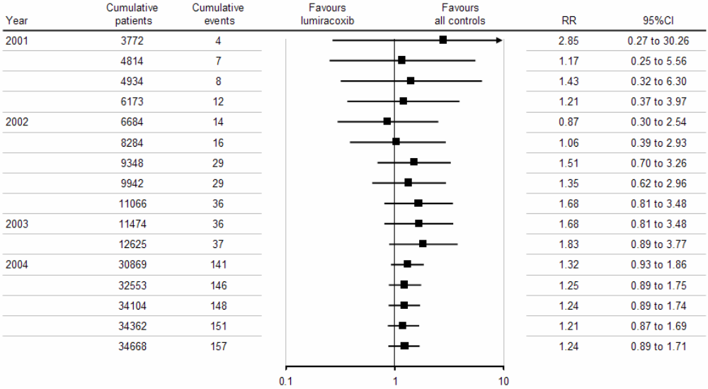

Summary of lumiracoxib meta-analysis data
The meta-analysis did not reveal a statistically significant difference between lumiracoxib and NSAIDs for:
- Myocardial infarcts (MI)
2. Stroke (ischemic and hemorrhagic)
3. APTC Cardiovascular (CV) composite endpoint, combining CV deaths, non-fatal MIs, non-fatal strokes (ischemic and hemorrhagic)
4. Pulmonary embolism (PE) and deep vein thrombosis (DVT)
5. All thrombotic events, combining MIs, strokes, PE and DVT
In contrast, Juni et al found an increased risk for myocardial infarctions in patients taking therapeutic doses of rofecoxib (12.5 – 50 mg od) (Figure 1-7 below).

Figure 1-7 Cumulative meta-analysis of myocardial infarctions in randomized trials comparing rofecoxib with control
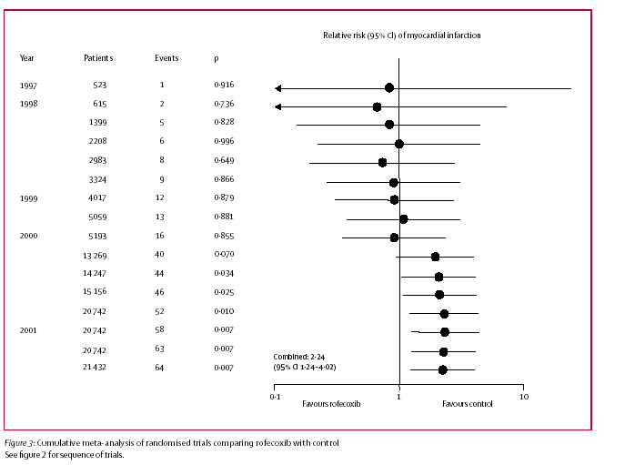

In the VIGOR study, there was a 4-5 fold statistically significant increase in MIs in patients taking rofecoxib compared to patients on naproxen. There was no statistically significant difference found in the larger TARGET outcomes study for lumiracoxib vs NSAIDs combined or vs the individual comparators (naproxen and ibuprofen) (see section below).

TARGET design: Rationale for selecting two different traditional non steroidal anti-inflammatory drugs (NSAIDs) as comparators
The study design for the Therapeutic Arthritis Research and Gastrointestinal Event Trial (TARGET) was presented to the FDA Arthritis Advisory Committee on December 7, 2001, after the Vioxx GI Outcomes Research (VIGOR) study (Bombardier C et al. 2000) had been published. Input from the FDA and the Arthritis Advisory Committee was integrated into the final study design.
In VIGOR the COX–2 selective inhibitor rofecoxib given 50 mg od was compared to naproxen 500 mg bid in approximately 8000 rheumatoid arthritis (RA) patients. While the study succeeded in showing a significant decrease in symptomatic and complicated ulcers in favor of rofecoxib, there was a difference in the rate of the composite endpoint of non-fatal myocardial infarction (MI), non-fatal stroke, and sudden death between the two groups favoring naproxen (0.8% for rofecoxib vs 0.4% for naproxen, p < 0.05). This was driven mainly by the difference in MIs in favor of naproxen (0.4% vs 0.1%, p < 0.01).
It was argued by the sponsor that a plausible hypothesis to explain this difference was that naproxen had an anti-platelet effect via COX-1 activity and was therefore antithrombotic. This antiplatelet activity was thought to be a unique feature of naproxen at the 500 mg dose when given twice daily over a long period, compared to other NSAIDs which did not have significant antiplatelet activity. The other possible hypotheses for the VIGOR findings were that they were due to a unique prothrombotic mechanism of rofecoxib or a combination of the above.
Therefore, it became of paramount public health importance to the larger scientific community, as Novartis discussed the design of the TARGET study with the FDA and the Arthritis Advisory Committee, that two NSAIDs with different COX 1 and COX 2 activity be selected to compare to lumiracoxib. This was thought then to be of importance with regard to the effect on upper gastrointestinal complications, as celecoxib in the CLASS study had failed to show a significant difference compared to ibuprofen and diclofenac combined as a primary endpoint.
It must be noted that before the VIGOR and the Celecoxib Long Term Arthritis Safety Study (CLASS) (Silverstein FE et al. 2000) were performed, traditional NSAIDs had not been studied in a rigorous clinical study of substantial duration in an arthritis patient population. CLASS and VIGOR had a median duration of 6-9 months, while TARGET had a fixed term design of 12 months and included more patients (18000 plus) than CLASS (8000 plus) and VIGOR (8000 plus) combined. As such, the TARGET study provides, to date, the largest and longest database examining the CV and other organ effects of naproxen (3534 patient-years exposure) and ibuprofen (3090 patient-years exposure) in an OA population.
Prior to these outcome studies, NSAIDs had been studied for short periods of time in randomized control trials and most of the data came from epidemiological, observational studies which have significant potential methodological bias. Besides patients using a plethora of over the counter drugs (NSAIDs), outside a clinical trial situation patients are less compliant and unlikely to take NSAIDs daily on a long term basis; rather patients typically treat themselves symptomatically. And since only aspirin binds irreversibly to the platelet COX 1 receptor, NSAIDs are unlikely to have a significant effect on platelet function if taken intermittently or at low doses.
Therefore, the contribution to the understanding of the CV and other organ systems profiles of the naproxen and ibuprofen arms from TARGET is of significant clinical and scientific value for the discussion of NSAID CV safety. The TARGET data provide and allow meaningful discussion and interpretation of the CV profile of ibuprofen compared to lumiracoxib and naproxen compared to lumiracoxib.
Finally, as we discuss the CV data, it is important to recall that COX-2s were introduced to decrease NSAID induced ulcer complications. To that end, lumiracoxib is the only remaining COX-2 that has demonstrated a reduction in complicated ulcers (79% reduction in non aspirin population) compared to NSAIDs as a primary endpoint in an outcomes study.

TARGET: Comparison of lumiracoxib and ibuprofen
Because TARGET consists of two identically designed studies conducted in parallel (Protocol 0117 compared lumiracoxib 400 mg with naproxen 500 mg bid and Protocol 2332 compared lumiracoxib 400 mg with ibuprofen 800 mg tid), we can examine the CV profile of lumiracoxib 400 mg and compare it separately to ibuprofen and to naproxen. It must be noted though that TARGET was not powered to show a difference in CV adverse events, but rather was powered for detection of the more frequent upper gastro-intestinal complications. However, the TARGET study has numerous methodological strengths that give importance to the CV data generated. These strengths include:
1. TARGET is the largest GI outcome study comparing a COX 2 selective inhibitor and NSAIDs published to date (N= 18 325);
- TARGET had a fixed term design that ensured that more than 60% of patients completed 12 months treatment;
- patients taking low dose aspirin were included (24% of the total population) and were stratified to treatment groups. This allowed the effect of low dose ASA on upper GI ulcer complications and CV thrombotic events to be examined and;
- an external, blinded cardio- and cerebrovascular committee prospectively defined and adjudicated all cases of MI (silent and clinical), strokes, CV deaths, deep vein thrombosis and pulmonary embolism. The rigor of CV disease ascertainment and analysis equals that normally found in CV outcomes studies.

APTC endpoint - lumiracoxib vs ibuprofen
The table below (Table 3-1) shows that there is a consistent trend towards numerically less adjudicated APTC events with lumiracoxib compared to ibuprofen. Although the confidence interval crosses 1 and the p values are not significant, all the hazard ratios (HR) are consistently less than one. The figure below (Figure 3-1) illustrates the time course of APTC occurrences. Although the differences are not significant, it is noteworthy that the Kaplan-Meier curves appear to separate over time in favor of lumiracoxib. It is also again worth noting that the ibuprofen substudy itself was at least the same size and had a mean duration of exposure that was longer than either CLASS or VIGOR.

Table 3-1 Confirmed or probable APTC endpoint: treatment comparisons using COX proportional hazards model (safety population)
 | Number at risk | Number (%) with events | HR | 95% CI | P-value
Overall TARGET population
Lumiracoxib | 4376 | 19 (0.43) | 0.76 | 0.41-1.40 | 0.3775
Ibuprofen | 4397 | 23 (0.52)
Non ASA population
Lumiracoxib | 3401 | 13 (0.38) | 0.94 | 0.44-2.04 | 0.8842
Ibuprofen | 3431 | 13 (0.38)
Low dose ASA population
Lumiracoxib | 975 | 6 (0.62) | 0.56 | 0.20-1.54 | 0.2603
Ibuprofen | 966 | 10 (1.04)
Source: TARGET study report

Figure 3-1 Lumiracoxib vs ibuprofen: cumulative incidence of confirmed/probable APTC endpoint
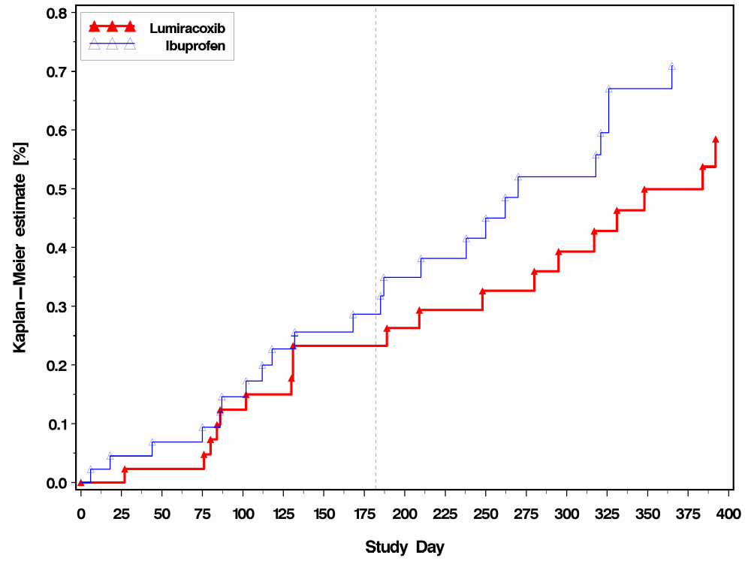
Source: TARGET study report

This may be contrasted with the CLASS study, where for celecoxib vs ibuprofen in the non-ASA population (Figure 3-2 below), patients taking celecoxib had a non-significant higher rate of serious thromboembolic events (1.4%) compared to patients on ibuprofen (0.7%). Importantly, the ibuprofen APTC cumulative rate at one year of 0.7% in TARGET is greater than the lumiracoxib rate (Figure 3-1 above) and the same as the ibuprofen rate in the CLASS study.

Figure 3-2 Posthoc depiction of cardiovascular events in non-aspirin users in the CLASS study (Ref: FitzGerald G)
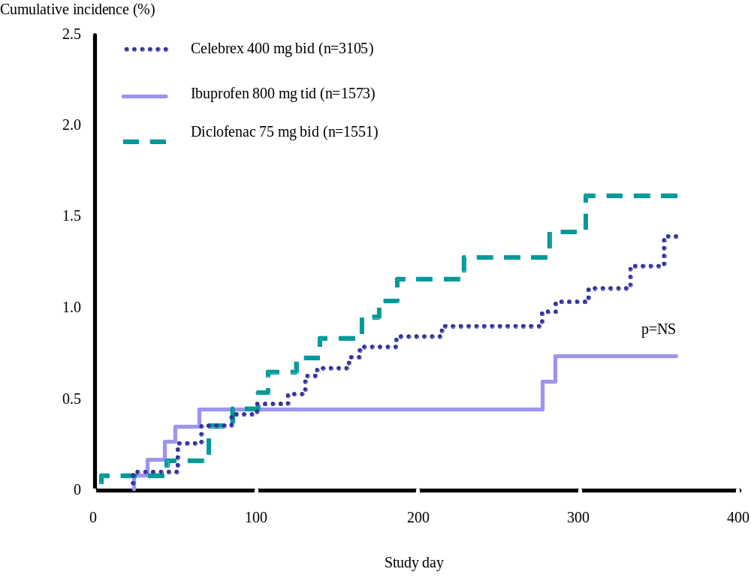

Clinical and silent MIs - lumiracoxib vs ibuprofen
The number of MIs are few and although the p values are not significant, it is worth noting again (as with the APTC endpoint above) that the hazard ratios (HR) are consistently less than 1, in a direction favoring lumiracoxib (Table 3-2).

Table 3-2 Lumiracoxib vs ibuprofen – confirmed/probable clinical and silent myocardial infarctions
 | Number at risk | Number of patients with event (rate per 100 patient-years) | HR | 95% CI | P-value
Overall TARGET population
Lumiracoxib | 4376 | 5 (0.15) | 0.66 | 0.21-2.09 | 0.4833
Ibuprofen | 4397 | 7 (0.23)
Non ASA population
Lumiracoxib | 3401 | 4 (0.16) | 0.75 | 0.20-2.79 | 0.6669
Ibuprofen | 3431 | 5 (0.21)
Low dose ASA population
Lumiracoxib | 975 | 1 (0.14) | 0.47 | 0.04-3.93 | 0.5328
Ibuprofen | 966 | 2 (0.30)
Source: Farkouh M et al. 2004 (Table 4)

Lumiracoxib has a CV adverse event profile that is no different from ibuprofen for all adjudicated thrombotic events
A similar number of adjudicated thrombotic events occurred with lumiracoxib (19 events) compared to ibuprofen (18 events) (Table 3-3).

Table 3-3 Adjudicated confirmed or probable thrombotic events (MI –clinical and silent, stroke, DVT and PE)
 |  |  | Cox proportional hazards model
 |  |  | ____
Contrast | Number of  subjects  at risk | Number of  subjects  with events | Hazard  ratio | 95% CI for  hazard ratio | p-value
- Study 2332 -
Lumiracoxib | 4376 | 19 (0.43)
Ibuprofen | 4397 | 18 (0.41)
Lumiracoxib vs Ibuprofen |  |  | 0.99 | 0.52 - 1.88 | 0.9732
Source: TARGET study report

Similarly, although the number of peripheral vascular events was low, there was no significant difference between lumiracoxib and ibuprofen (Table 3-4).

Table 3-4 Adjudicated Confirmed or probable peripheral vascular events (DVT or PE)
 |  |  | Cox proportional hazards model
 |  |  | ____
Contrast | Number of  subjects  at risk | Number of  subjects  with events | Hazard  ratio | 95% CI for  hazard ratio | p-value
- Study 2332 -
Lumiracoxib | 4376 | 6 (0.14)
Ibuprofen | 4397 | 3 (0.07)
Lumiracoxib vs Ibuprofen |  |  | 1.92 | 0.48 - 7.68 | 0.3558
Source: TARGET study report

Lumiracoxib showed a significantly better blood pressure profile than ibuprofen for de novo and aggravated hypertension, and numerically less edema and congestive heart failure (CHF).

Blood pressure – least squares mean change from baseline
In the TARGET study blood pressure (BP) measurements were done at every study visit. In the ibuprofen substudy at study end, 4312 patients taking lumiracoxib versus 4331 taking ibuprofen had BP measurements. For systolic BP, least squares mean change from baseline to study end was + 0.7 mmHg for lumiracoxib and + 2.7 mmHg for ibuprofen (p < 0.0001). For diastolic BP, least squares mean change from baseline to study end was + 0.0 mmHg for lumiracoxib and + 0.9 mmHg for ibuprofen (p < 0.0001). In TARGET, 4219 patients (46.3%) on lumiracoxib and 4061 (44.5%) patients in the NSAIDs groups (TARGET study report) were hypertensive at baseline.
Further analyses within the TARGET study assessing differences between lumiracoxib and ibuprofen for the following are presented using Kaplan – Meier curves;
- De novo hypertension
- Severe de novo hypertension (hypertension defined as SAEs or AEs leading to premature discontinuation)
- Aggravation (worsening) of baseline hypertension
- Hypertension-related AEs which are serious or lead to premature discontinuation from the study

De novo hypertension – lumiracoxib compared to ibuprofen
Patients taking lumiracoxib 400 mg od had significantly less new onset of hypertension compared to patients allocated to ibuprofen 800 mg tid (Figure 3-3 (p<0.0001)

Figure 3-3 De novo hypertension- lumiracoxib compared to ibuprofen
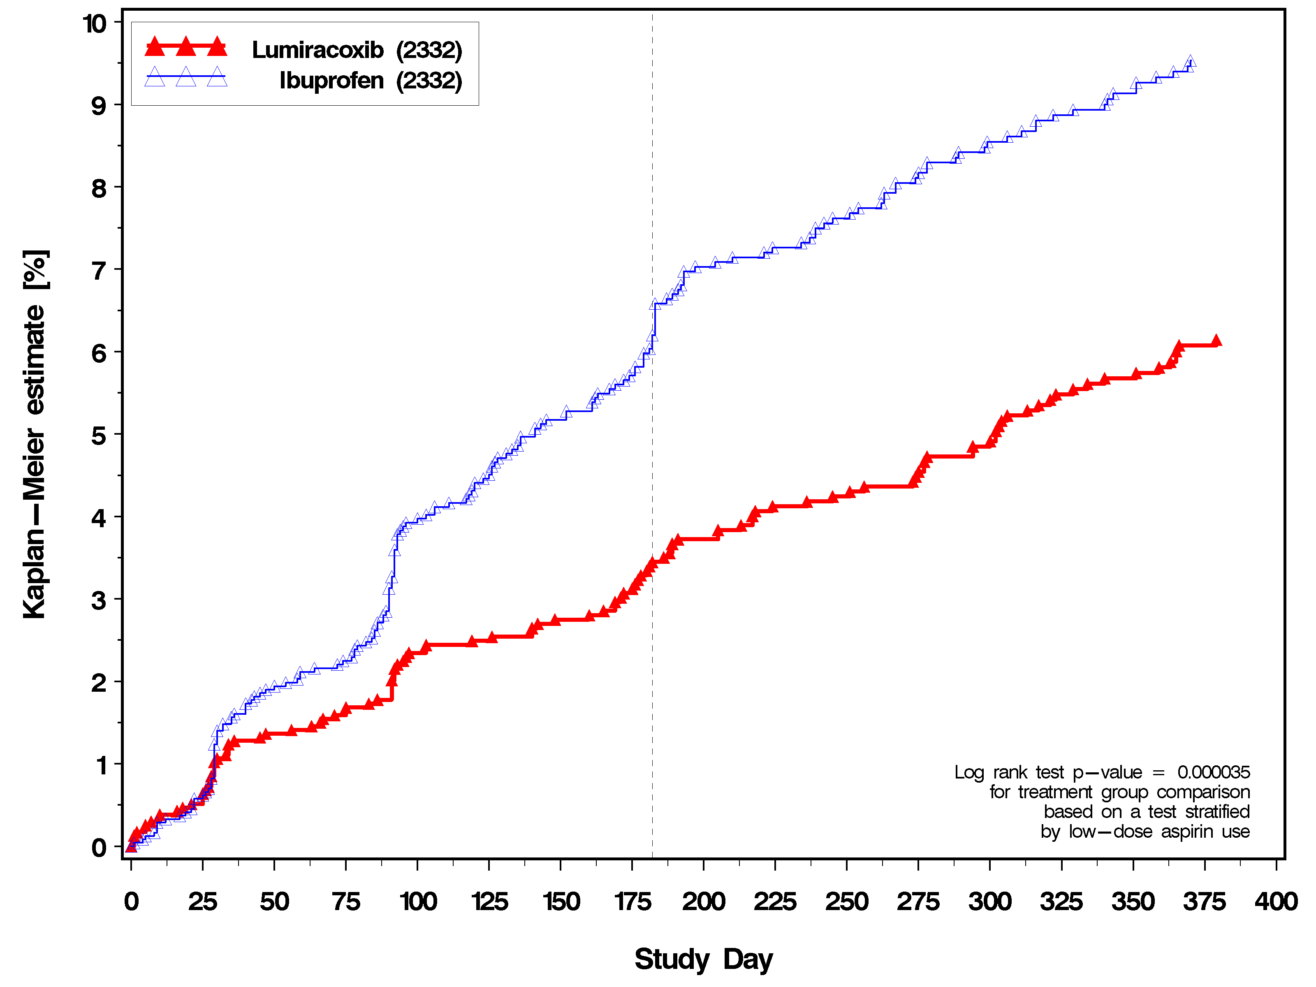

Severe de novo hypertension – lumiracoxib compared to ibuprofen
There were few cases of severe de novo hypertension as defined above. However, more patients taking ibuprofen had such events compared to patients taking lumiracoxib (p=0.6177) (Figure 3-4).

Figure 3-4 Severe de novo hypertension – lumiracoxib compared to ibuprofen
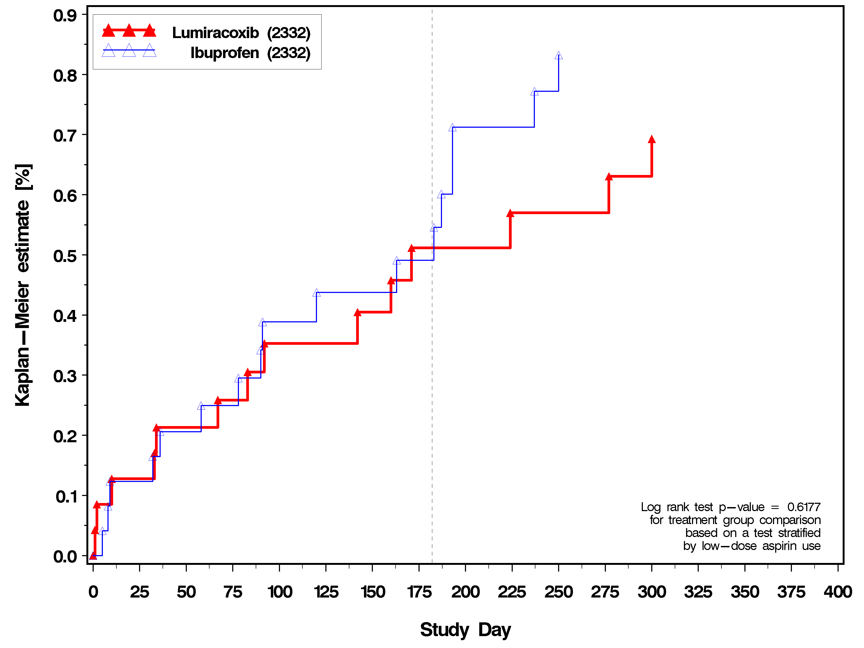

Patients taking ibuprofen were significantly more likely to have aggravation of hypertension compared to patients taking lumiracoxib (p=0.0005) (Figure 3-5).

Figure 3-5 Aggravation of hypertension – lumiracoxib compared to ibuprofen
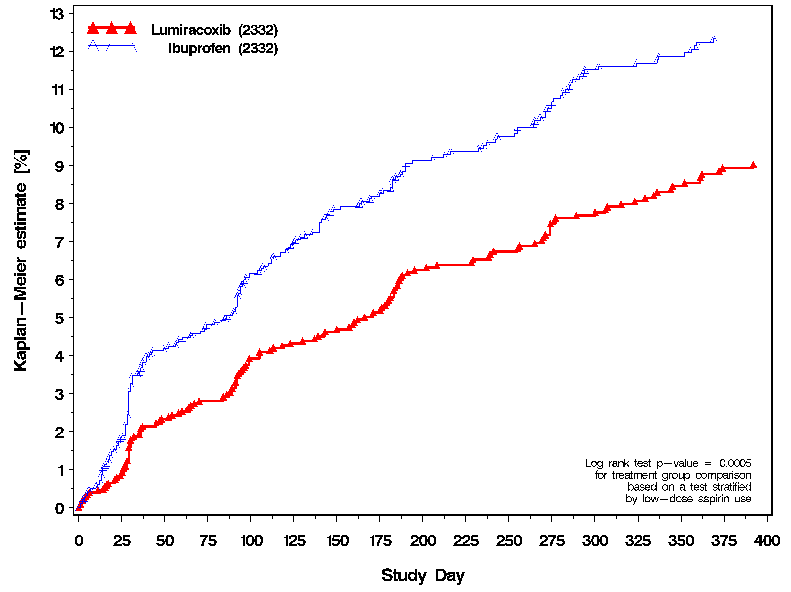

Severe aggravation of hypertension
Significantly more patients taking ibuprofen had cases of severe aggravation of their hypertension compared to patients taking lumiracoxib (p=0.01) (Figure 3-6).

Figure 3-6 Severe aggravation of hypertension
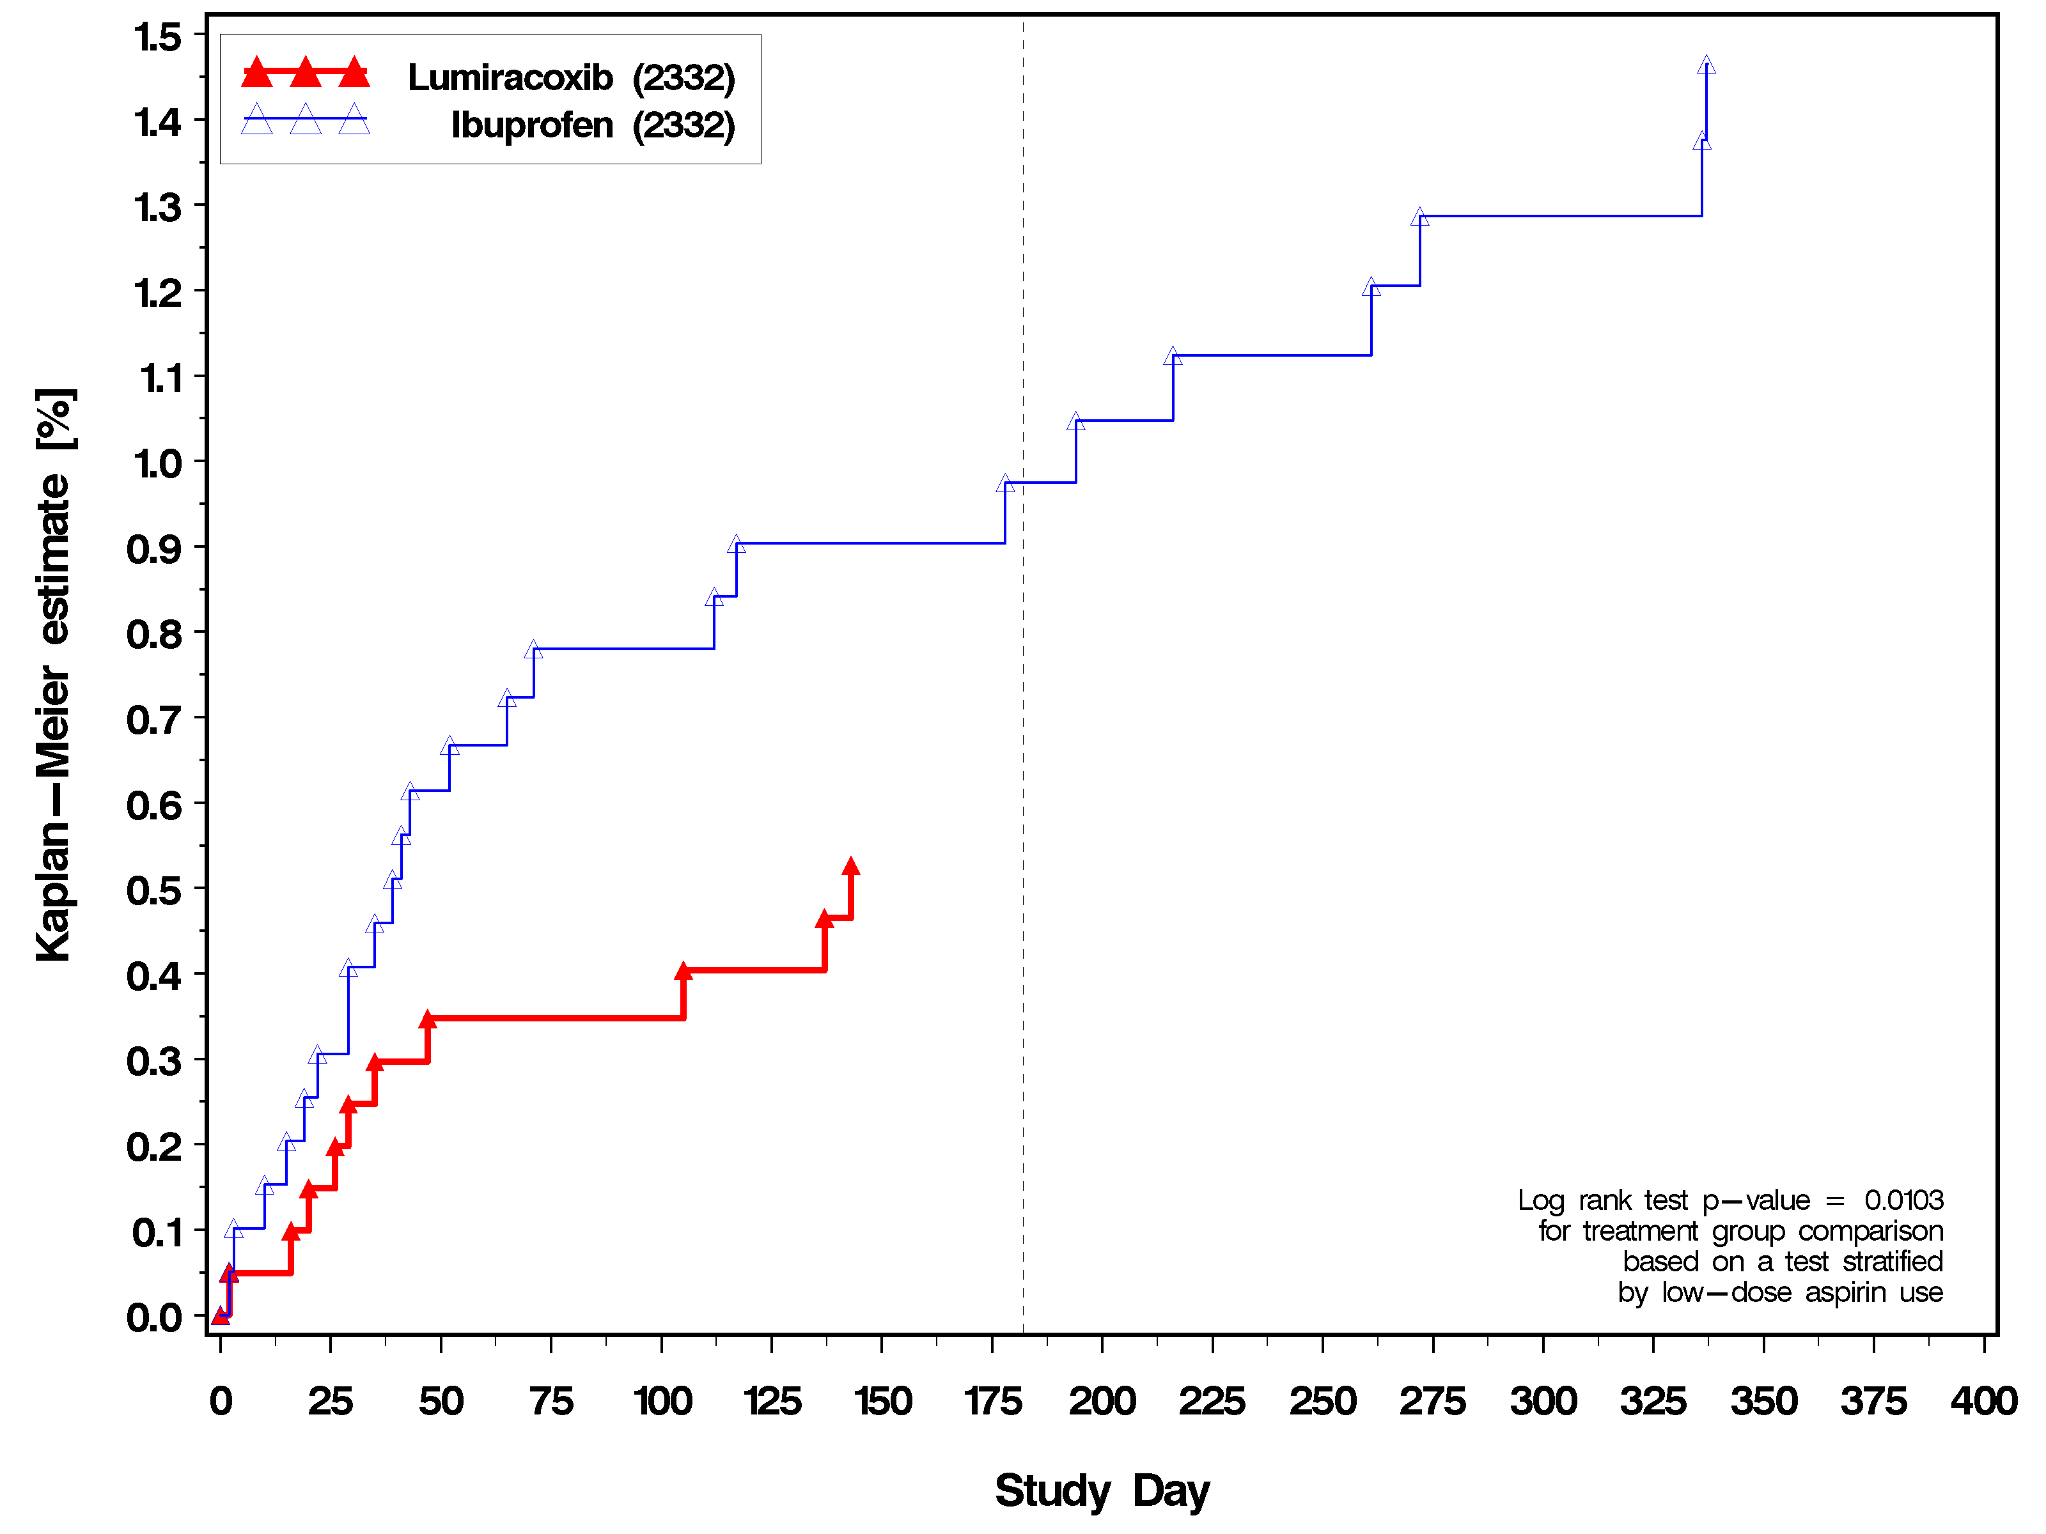

This statistically significant difference in BP may have significant clinical benefits for lumiracoxib when compared to ibuprofen over the long-term, since over 45% of patients in the TARGET study were found to be hypertensive. This is in keeping with other demographic studies in OA (Singh G et al. 2002). In fact, a recent study of OA patients found that increases in systolic BP of 1-5 mmHg were associated with 7100 - 35700 additional ischemic heart disease and stroke events over one year with corresponding costs (Year 2000 USD) of 114-569 million USD per year. They concluded that relatively small changes in systolic BP associated with use of common arthritis medications could have a significant effect on the cardiovascular profile (Singh G et al. 2003). This was confirmed in an even more recent analysis by Grover et al (2005) that modeled data from a rofecoxib study (SUCCESS VI), concluding that maintaining BP control could result in 668,000 person years of life saved with over $2.4 billion (USD) in direct health care cost savings (Grover et al, Hypertension 45:92-97, 2005).

Congestive heart failure (CHF), edema and weight gain
Lumiracoxib in TARGET was associated with numerically less edema and CHF compared to ibuprofen (Table 3-5).

Table 3-5 TARGET study – lumiracoxib vs ibuprofen. Incidence of edema, CHF and weight gain (overall safety population).
 | Lumiracoxib (N=4376) | Ibuprofen (N=4397)
 | n (%) | n (%)
Edema AEs - prespecified terms | 217 (5.0) | 245 (5.6)
CHF (post hoc analysis) | 12 (0.27) | 15 (0.34)
 | Lumiracoxib (N=4129) | Ibuprofen (N=4120)
Increase in weight from baseline > 5% | 353 (8.5) | 352 (8.5)
Source: TARGET study report

Cases of edema reported as SAEs or leading to premature discontinuation
More patients taking ibuprofen reported “severe” cases of edema compared to patients allocated to lumiracoxib (p=0.0560) (Figure 3-7).

Figure 3-7 Edema reported as SAEs or requiring premature discontinuation
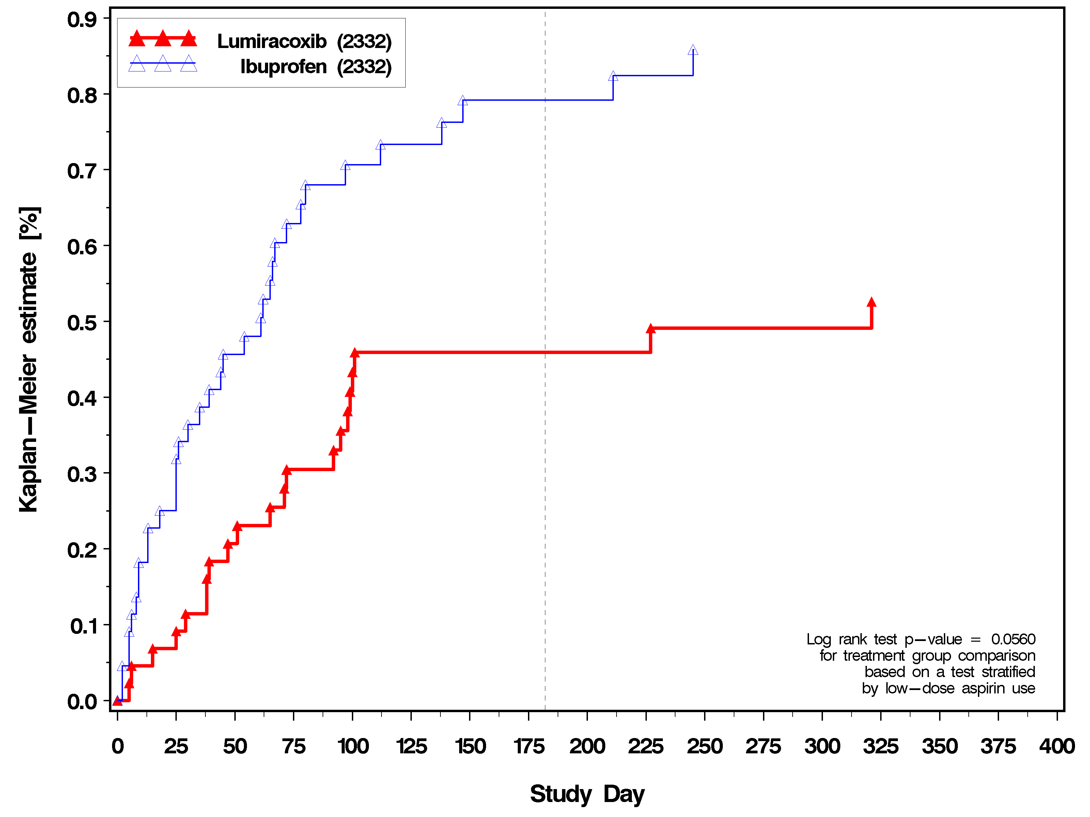

Analysis of upper gastro-intestinal events: lumiracoxib vs ibuprofen
The primary objective of the TARGET study was to determine the risk of upper gastro-intestinal ulcer complications of lumiracoxib compared to NSAIDs (ibuprofen and naproxen). Patients taking lumiracoxib had an 83% reduction in upper GI ulcer complications compared to patients taking ibuprofen in the non-aspirin population (HR 0.17, 95% CI 0.07 – 0.45, p=0.0003); a 71% reduction in the overall population (HR 0.29, 95% CI 0.14 -0.59, p=0.0006) and non-significant 8% decrease in the low dose aspirin population (Table 3-6).
The four-fold reduction in magnitude of upper GI ulcer complications seen with lumiracoxib compared to ibuprofen has important clinical implications given the societal burden of morbidity relating to ulcer complications from NSAID use.

Table 3-6 TARGET study - definite or probable UGIT complications (POBs)
 | Number at risk | Number with events | KM estimate  % (CI) at day 196 | KM estimate  % (CI) at day 392 | p-value*
TARGET (0117 + 2332)
No low-dose aspirin group
Lumiracoxib | 6950 | 14 | 0.15 ( 0.05 - 0.25) | 0.25 ( 0.12 - 0.39) | <0.0001
NSAIDs | 6968 | 64 | 0.81 ( 0.58 - 1.03) | 1.09 ( 0.82 - 1.36)
Overall patient group
Lumiracoxib | 9117 | 29 | 0.22 ( 0.12 - 0.33) | 0.40 ( 0.25 - 0.54) | <0.0001
NSAIDs | 9127 | 83 | 0.81 ( 0.61 - 1.00) | 1.09 ( 0.85 - 1.32)
Low-dose aspirin group
Lumiracoxib | 2167 | 15 | 0.47 ( 0.16 - 0.78) | 0.88 ( 0.43 - 1.32) | 0.4972
NSAIDs | 2159 | 19 | 0.82 ( 0.40 - 1.23) | 1.09 ( 0.60 - 1.58)
Study 2332
No low-dose aspirin group
Lumiracoxib | 3401 | 5 | 0.14 ( 0.00 - 0.28) | 0.19 ( 0.02 - 0.35) | <0.0001
Ibuprofen | 3431 | 28 | 0.73 ( 0.42 - 1.03) | 1.00 ( 0.63 - 1.38)
Overall patient group
Lumiracoxib | 4376 | 10 | 0.18 ( 0.05 - 0.32) | 0.28 ( 0.11 - 0.46) | 0.0003
Ibuprofen | 4397 | 33 | 0.69 ( 0.42 - 0.95) | 0.94 ( 0.61 - 1.26)
Low-dose aspirin group
Lumiracoxib | 975 | 5 | 0.32 ( 0.00 - 0.69) | 0.64 ( 0.07 - 1.21) | 0.9615
Ibuprofen | 966 | 5 | 0.55 ( 0.01 - 1.09) | 0.70 ( 0.09 - 1.31)
Modified ITT analysis excludes any event starting within 2 days of initiation of study drug.
* p value for treatment comparisons, lumiracoxib vs. comparator, from log rank test stratified by sub-study where appropriate
Source: TARGET study report

Low dose aspirin population – hemoglobin changes: Lumiracoxib vs ibuprofen and naproxen:
In the patients taking low-dose aspirin, those patients allocated to ibuprofen had significantly more hemoglobin loss at the end-of-study compared to patients taking lumiracoxib (mean hemoglobin difference of 1.17 g/L, p=0.0012) (Table 3-7). Significant loss of hemoglobin results in anemia, and may be caused by otherwise undetected internal bleeding resulting from NSAID use.

Table 3-7 Hemoglobin (g/l) LS means for end-of-study value and its change from baseline

LS means for end-of-study value and its change from baseline
General linear model with baseline value, age, and treatment as dependent variables

Selected No. of Chg f Baseline
group Comparison patients LS Mean (95% CI) LS Mean (95% CI) p-value

0117 Lumi 4615 136.3 (136.1,136.5) -2.40 (-2.62,-2.17) <0.0001
Naproxen 4598 135.4 (135.1,135.6) -3.31 (-3.54,-3.08)

0117/asa Lumi 1162 135.9 (135.5,136.4) -2.96 (-3.43,-2.48) 0.3856
Naproxen 1168 135.6 (135.2,136.1) -3.25 (-3.72,-2.78)

0117/non-asa Lumi 3453 136.4 (136.1,136.7) -2.21 (-2.47,-1.95) <0.0001
Naproxen 3430 135.3 (135.0,135.5) -3.33 (-3.59,-3.07)

2332 Lumi 4273 136.7 (136.5,136.9) -2.24 (-2.47,-2.02) <0.0001
Ibuprofen 4295 134.6 (134.4,134.9) -4.33 (-4.56,-4.11)

2332/asa Lumi 954 136.0 (135.5,136.5) -3.00 (-3.50,-2.50) 0.0012
Ibuprofen 944 134.8 (134.3,135.3) -4.17 (-4.67,-3.67)

2332/non-asa Lumi 3319 136.9 (136.7,137.2) -2.03 (-2.28,-1.78) <0.0001
Ibuprofen 3351 134.6 (134.3,134.8) -4.38 (-4.63,-4.13)

This difference in hemoglobin loss was even greater (1.78 g/L, p< 0.0001) when only patients who completed the entire 12- month study were analyzed (Table 3-8 below).

Table 3-8 Hemoglobin [g/L] LS means for 12-month value and its change from baseline
LS means for 12-month value and its change from baseline
General linear model with baseline value, age, and treatment as dependent variables

Selected No. of Chg f Baseline
group Comparison patients LS Mean (95% CI) LS Mean (95% CI) p-value

0117 Lumi 3065 136.7 (136.5,137.0) -1.98 (-2.24,-1.73) <0.0001
Naproxen 2986 135.9 (135.6,136.1) -2.85 (-3.11,-2.59)

0117/asa Lumi 726 136.6 (136.0,137.2) -2.41 (-2.98,-1.85) 0.2499
Naproxen 764 136.1 (135.6,136.7) -2.88 (-3.43,-2.33)

0117/non-asa Lumi 2339 136.8 (136.5,137.1) -1.85 (-2.13,-1.56) <0.0001
Naproxen 2222 135.8 (135.5,136.1) -2.84 (-3.14,-2.55)

2332 Lumi 2687 137.2 (136.9,137.5) -2.06 (-2.33,-1.80) <0.0001
Ibuprofen 2509 134.8 (134.5,135.1) -4.45 (-4.72,-4.17)

2332/asa Lumi 585 136.4 (135.8,137.0) -2.56 (-3.16,-1.97) <0.0001
Ibuprofen 549 134.6 (134.0,135.2) -4.33 (-4.94,-3.71)

2332/non-asa Lumi 2102 137.4 (137.1,137.7) -1.93 (-2.23,-1.63) <0.0001
Ibuprofen 1960 134.9 (134.5,135.2) -4.48 (-4.78,-4.17)
This finding in the population taking low-dose aspirin is perhaps the first significant gastro-intestinal data from a randomized controlled trial showing benefit for a COX2 selective inhibitor in the presence of low-dose aspirin. Differences in hemoglobin may represent a more sensitive indicator of adverse GI events than the primary endpoint used in TARGET (upper GI ulcer complications), which showed a trend in favor of lumiracoxib in the low-dose aspirin population. A hemoglobin difference of almost 2g/L may have a significant impact on the overall health of an elderly OA population. Since many elderly patients are on low dose aspirin, these patients are likely to have a high cardiovascular risk and it is important in this population not to increase the risk of anemia. Anemia may contribute to the development of congestive heart failure.

Combined GI and CV endpoint – lumiracoxib vs ibuprofen
When the adjudicated endpoints for GI (upper GI ulcer complications) and CV (APTC endpoint) are combined, there was a 50% reduction of these events in favor of lumiracoxib compared to ibuprofen in the overall population (HR 0.50, 95% CI 0.32 – 0.79, p = 0.0025) and a 56% reduction in the non-aspirin population (HR 0.44, 95% CI 0.26 – 0.76, p = 0.0032) (Table 3-9).

Table 3-9 TARGET – GI and CCV (APTC) combined endpoint
 | Number at risk | Number (%) with events | Hazard ratio | 95% CI | p-value*
Overall patient group
TARGET (0117 + 2332)
Lumiracoxib | 9117 | 89 (0.98) | 0.65 | 0.49 - 0.84 | 0.0014
NSAIDs | 9127 | 133 (1.46)
Study 2332
Lumiracoxib | 4376 | 30 (0.69) | 0.50 | 0.32 - 0.79 | 0.0025
Ibuprofen | 4397 | 56 (1.27)
No low-dose aspirin group
TARGET (0117 + 2332)
Lumiracoxib | 6950 | 50 (0.72) | 0.52 | 0.37 - 0.74 | 0.0002
NSAIDs | 6968 | 91 (1.31)
Study 2332
Lumiracoxib | 3401 | 19 (0.56) | 0.44 | 0.26 - 0.76 | 0.0032
Ibuprofen | 3431 | 41 (1.19)
* p value based on Wald chi-squared statistic for treatment comparison, lumiracoxib vs. comparator, stratified by age; and also by sub-study where appropriate.
Source: TARGET study report

This is further illustrated by the Kaplan-Meier curve in Figure 3-8 below.

Figure 3-8 TARGET: Combined GI and CCV endpoint Kaplan – Meier

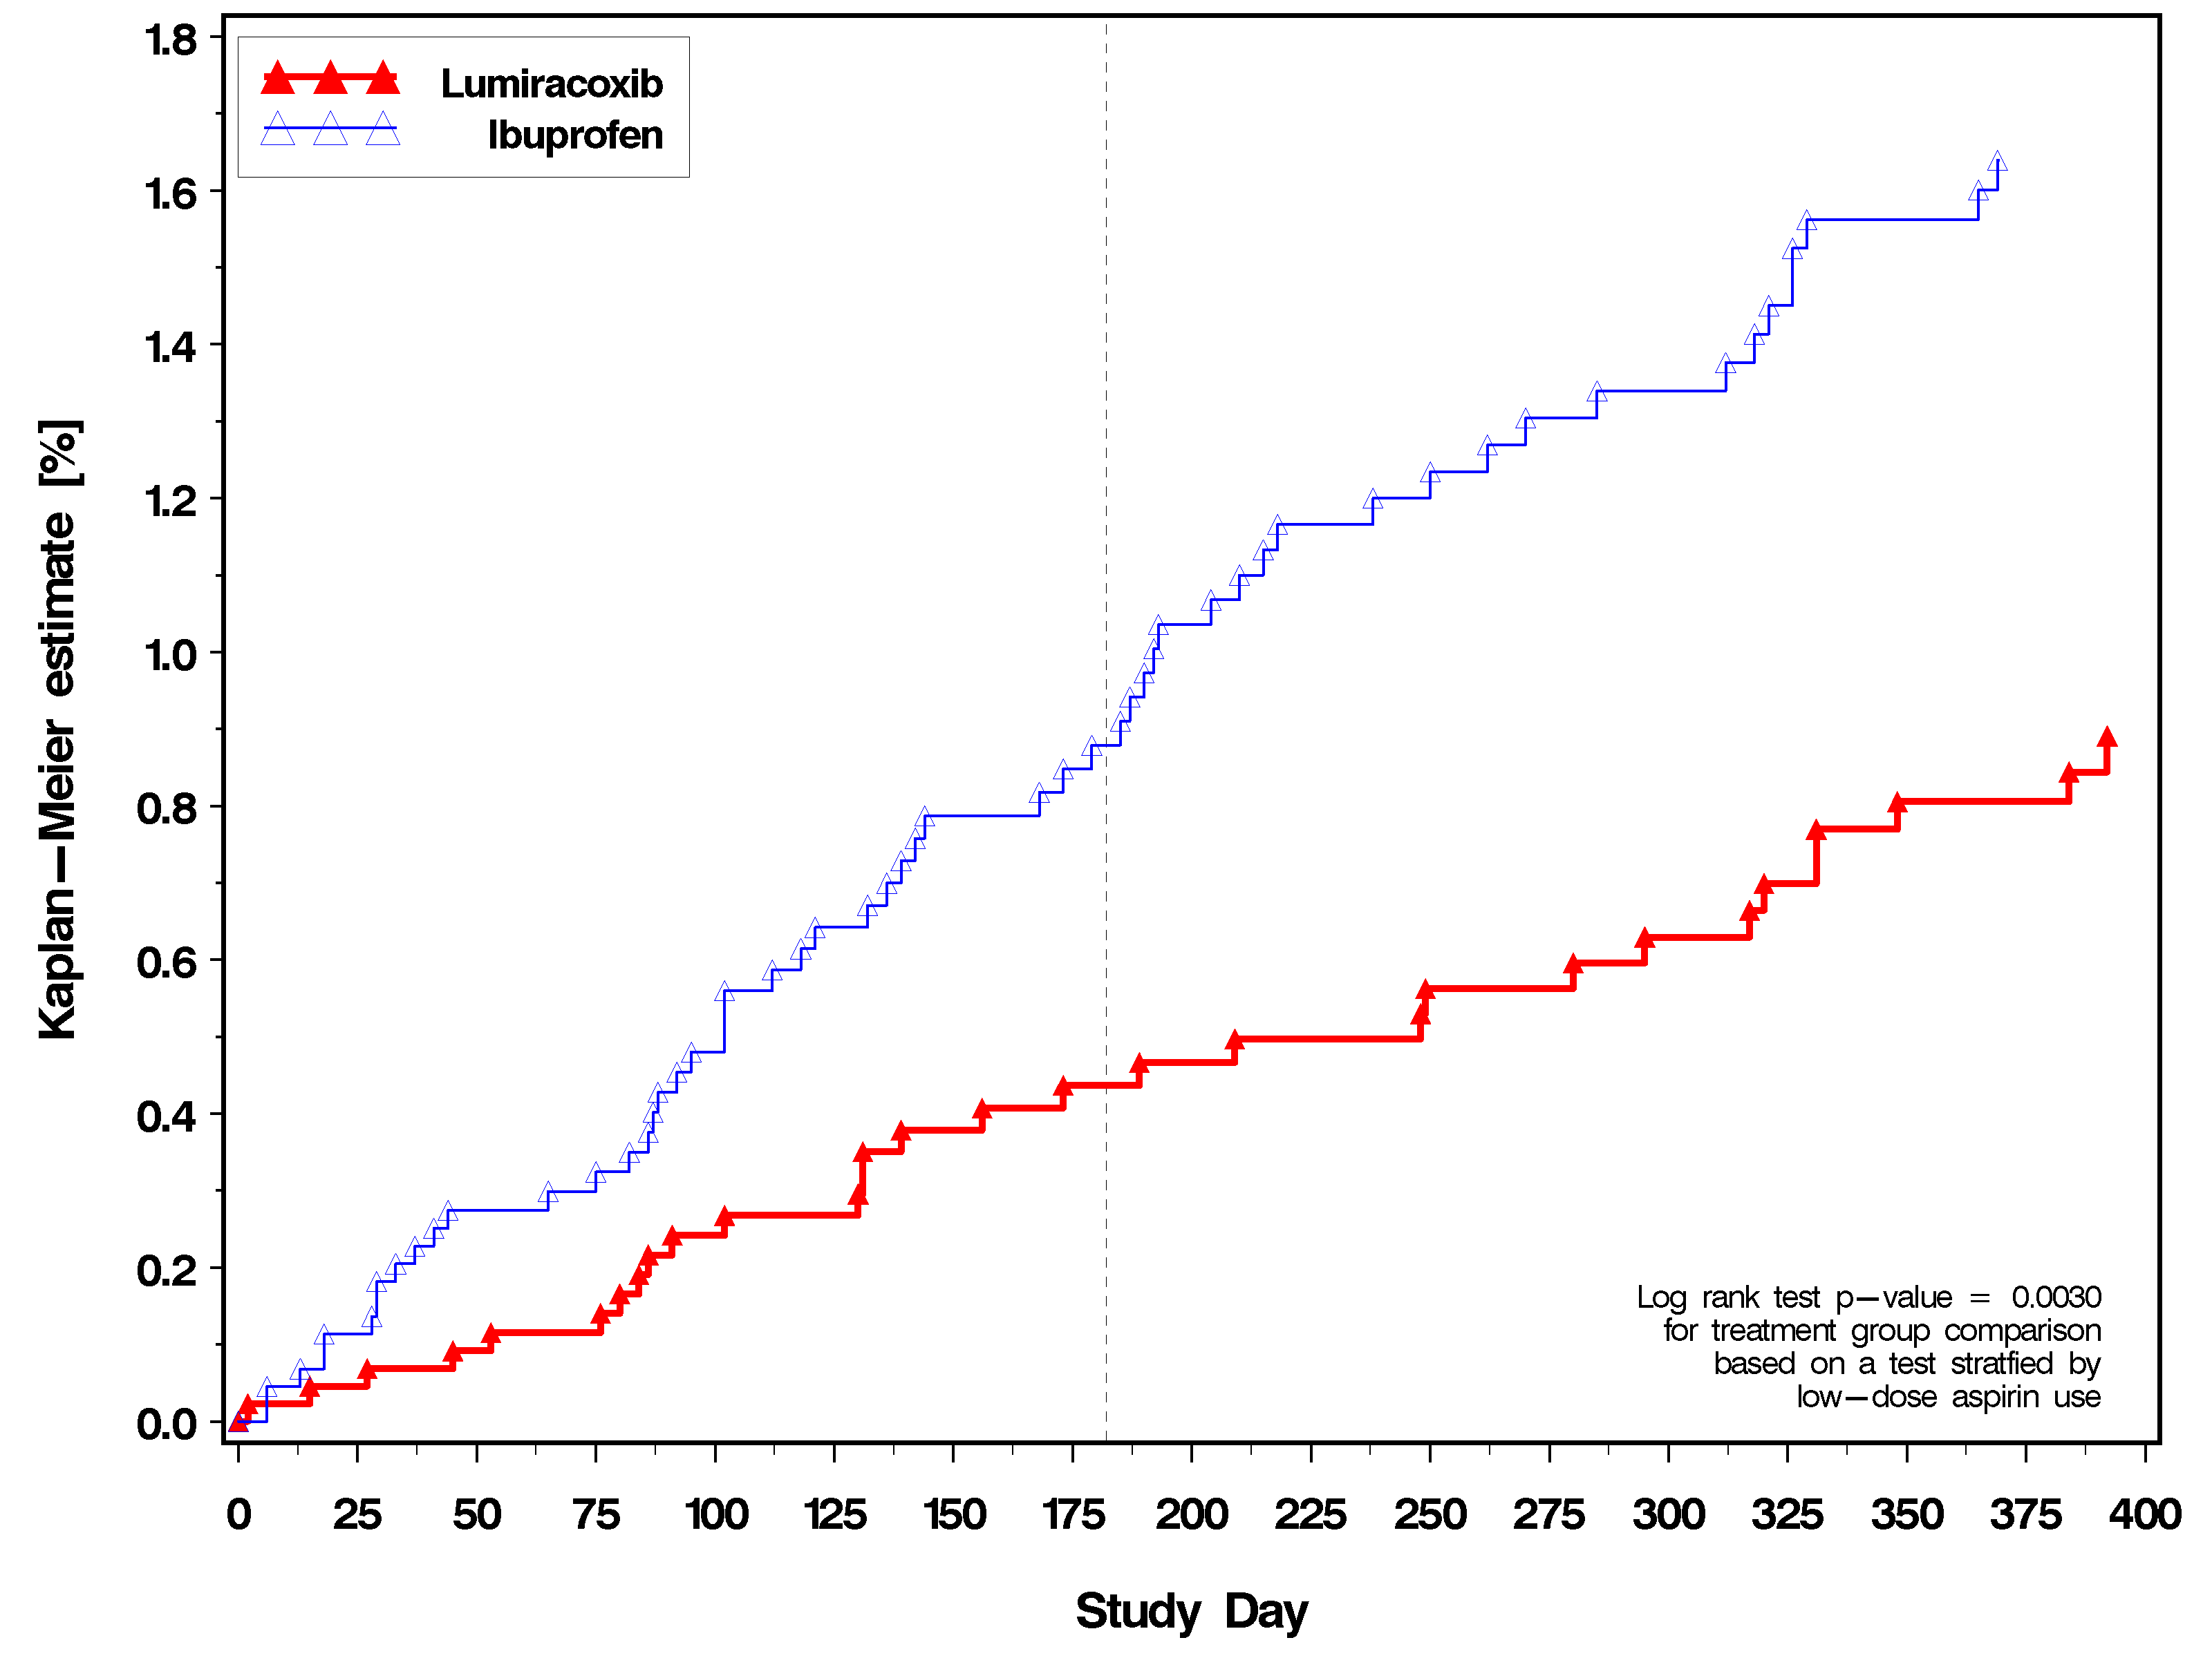

Summary: Lumiracoxib does not increase CV adverse events compared to ibuprofen and has a positive benefit to risk profile compared to ibuprofen.
From the TARGET study, which is the largest gastrointestinal outcomes study in arthritis to date to prospectively examine all major outcomes including CV, there is no evidence that lumiracoxib is associated with an increase in serious CV thrombotic events (APTC endpoint and MIs) when compared to ibuprofen. In fact, lumiracoxib had numerically fewer events than ibuprofen, indicating that lumiracoxib does not have a thrombotic CV signal. Except for the theoretical possibility of an interaction between ibuprofen and low dose aspirin, ibuprofen has not been shown to increase CV risk. Of note is that in TARGET, lumiracoxib is associated with numerically less edema and CHF and with a significantly lower mean increase in BP and less hypertension.
Ibuprofen is available in the US as an over the counter drug. In TARGET, lumiracoxib was associated with an 83% (p < 0.0001) decrease in upper gastrointestinal (GI) tract ulcer complications compared to ibuprofen. Further, patients taking ibuprofen had significantly more hemoglobin loss at the end of the study compared to patients on lumiracoxib, even in those taking low-dose aspirin for CV prophylaxis. The immense GI benefit gained by using lumiracoxib combined with the numerically fewer cardiac (CV) events, provides robust evidence that lumiracoxib has a superior benefit/risk safety profile compared to ibuprofen.
Finally, when the combined endpoint of adjudicated primary GI events and CCV (APTC) events are assessed, patients taking lumiracoxib at 4 times the recommended OA dose have a significant benefit (reduction) compared to patients on ibuprofen (50% decrease in the overall population, p = 0.0025)..

TARGET: Lumiracoxib compared to naproxen

APTC endpoint - lumiracoxib vs naproxen

Table 4-6 Confirmed or probable APTC endpoint: treatment comparisons using COX proportional hazards model (safety population)
 | Number at risk | Number (%) with events | HR | 95% CI | P-value
Overall TARGET population
Lumiracoxib | 4741 | 40 (0.84) | 1.46 | (0.89 -2.37) | 0.1313
Naproxen | 4730 | 27 (0.57)
Non ASA population
Lumiracoxib | 3549 | 22 (0.62) | 1.49 | (0.76 – 2.92) | 0.2417
Naproxen | 3537 | 14 (0.47)
Low dose ASA population
Lumiracoxib | 1192 | 18 (1.51) | 1.42 | (0.70 – 2.90) | 0.3368
Naproxen | 1193 | 13 (1.09)
Source: TARGET study report
In Table 4-1 above, although there was no statistically significant difference for the primary endpoint (APTC) between lumiracoxib and naproxen in all populations, fewer events occurred with naproxen. This is in contrast to the ibuprofen sub-study. In comparison, in the VIGOR trial rofecoxib was associated with a significant difference (OR 1.94, 95% CI 1.10 -3.44, p < 0.05) in favor of naproxen for a similar endpoint. Importantly, the VIGOR trial was of a shorter median duration and had less patient exposure.
Figure 4-1 below provides time-to-event curves for the rates of serious CV events over time (1 year) between lumiracoxib and naproxen in TARGET.

Figure 4-1 Lumiracoxib vs naproxen: cumulative incidence of confirmed/probable APTC endpoint
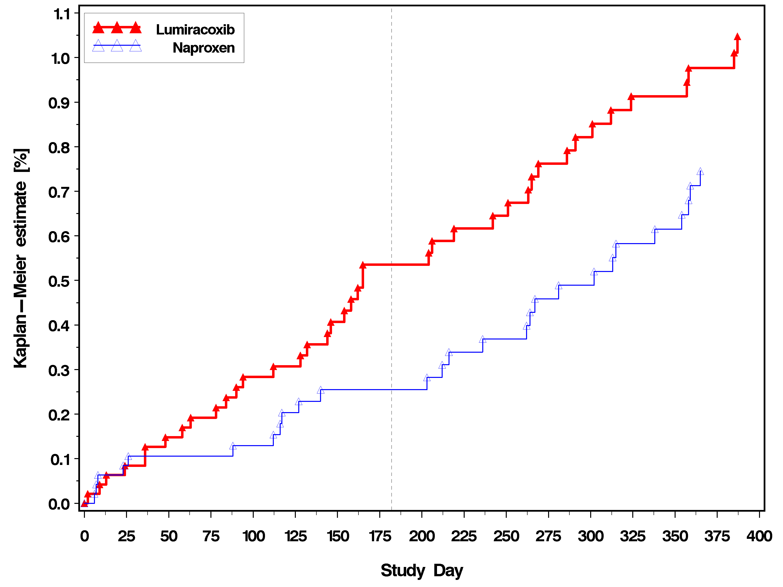
Source: TARGET study report

TARGET study: Clinical and silent MIs - lumiracoxib vs naproxen

Table 4-7 Incidence of confirmed or probable myocardial infarction (clinical and silent) – lumiracoxib vs naproxen
 | Number at risk | Number of patients with event (rate per 100 patient-years) | HR | 95% CI | P-value
Overall TARGET population
Lumiracoxib | 4741 | 18 (0.49) | 1.77 | 0.82-3.84 | 0.1471
Naproxen | 4730 | 10 (0.28)
Non ASA population
Lumiracoxib | 3549 | 10 (0.36) | 2.37 | 0.74-7.55 | 0.1454
Naproxen | 3537 | 4 (0.15)
Low dose ASA population
Lumiracoxib | 1192 | 8 (0.91) | 1.36 | 0.47-3.93 | 0.5658
Naproxen | 1193 | 6 (0.67)
Source: Farkouh M et al. 2004 (Table 4)
The data from Table 4-2 above show that there are numerically fewer MIs in the naproxen group than in the lumiracoxib group. This is in contrast to the trend in the ibuprofen substudy (less events with lumiracoxib), but is in keeping with the evidence that naproxen 500 mg bid taken continuously has antiplatelet activity via COX-1 activity. Supporting evidence for naproxen’s COX-1 activity at this dose and dosing regimen (500 mg bid) has been shown and published elsewhere (Capone et al. 2004, Weir et al. 2003, Juni et al. 2004).
This evidence in combination with the data from the Jüni et al. meta-analysis and the lumiracoxib meta-analysis further supports the hypothesis that naproxen, if given 500 mg twice daily for an extended period of time, exerts antiplatelet effects.
Confirmation of this hypothesis is in fact provided by the TARGET study results. If the hypothesis that naproxen has COX-1 antiplatelet activity at the dose and regimen is correct, the addition of a drug with COX-1 activity to the naproxen vs. lumiracoxib substudy should negate this difference in MIs (canceling the benefit of MI reduction seen in patients taking naproxen). This is shown in Table 4-2 above when the low dose aspirin population is considered: naproxen 6 events vs lumiracoxib 8 events.

Lumiracoxib has a CV adverse event profile that is no different from naproxen for other adjudicated CV events.
Besides myocardial infarctions, other CV endpoints adjudicated do not differ for naproxen vs lumiracoxib. As shown in Table 4-3 below, though the number of events is low, there is no evidence of a CV signal when lumiracoxib is compared to naproxen for these events.

Table 4-3 TARGET study: lumiracoxib vs naproxen. Incidence of confirmed or probable cardiovascular and cerebrovascular events (overall safety population).
 | Lumiracoxib (N=4741) | Naproxen (N=4730)
 | n (%) | n (%)
Cardiovascular death | 11 (0.23) | 8 (0.17)
Stroke | 16 (0.34) | 12 (0.25)
Transient ischemic attack | 2 (0.04) | 5 (0.11)
Unstable angina | 6 (0.13) | 4 (0.08)
Deep vein thrombosis | 2 (0.04) | 4 (0.08)
Pulmonary embolism | 2 (0.04) | 4 (0.08)
Source: TARGET study report

Lumiracoxib has a significantly better blood pressure profile than naproxen, and numerically less congestive heart failure and weight gain.

Blood pressure – Least Square Means change from baseline
In the TARGET study blood pressure (BP) measurements were done at every study visit. In the naproxen substudy at study end, 4,678 patients taking lumiracoxib versus 4,661 taking naproxen had BP measurements. For systolic BP, mean change (LSMs) from baseline to study end was + 0.2 mmHg for lumiracoxib and + 1.4 mmHg for naproxen (p < 0.0001). For diastolic BP, least squares mean change from baseline to study end was - 0.3 mmHg for lumiracoxib and + 0.2 mmHg for naproxen (p = 0.0002).
As shown in the HOT study (Hansson L et al, 1998) and discussed previously, this significant difference in BP may have significant clinical benefits for lumiracoxib when compared to naproxen in the long-term. Naproxen, like ibuprofen, is a widely used NSAID that is available over the counter in the US.

Congestive heart failure (CHF) and weight gain
In TARGET, lumiracoxib was associated with numerically less congestive heart failure and weight gain from baseline compared to naproxen (Table 4-4).

Table 4-4 TARGET study: lumiracoxib vs naproxen. Incidence of CHF and weight gain (overall safety population).
 | Lumiracoxib (N=4741) | Naproxen (N=4730)
 | n (%) | n (%)
CHF (post hoc analysis) | 10 (0.21) | 16 (0.34)
 | Lumiracoxib (N=4481) | Naproxen (N=4441)
Increase in weight from baseline > 5% | 364 (8.1) | 406 (9.1)
Source: TARGET study report

Combined GI and CV endpoint – lumiracoxib vs naproxen
When lumiracoxib was compared to naproxen for the primary endpoint (upper gastrointestinal ulcer complications) there was a 76% reduction in the non-aspirin population (HR 0.24, 95% CI 0.12-0.50, p =0.0001).
For the combined endpoints GI/CCV, numerically fewer patients in the overall population on lumiracoxib had events compared to naproxen (HR 0.75, 95% CI 0.53-1.05, p = 0.0961). Importantly, patients on lumiracoxib and not taking low dose aspirin had a significant 41% decrease in the combined GI/CCV events compared to patients on naproxen (HR 0.59, 95% CI 0.38 – 0.93, p = 0.0219). This would indicate that notwithstanding the numerical difference in CV events, lumiracoxib has a positive benefit-risk ratio compared to naproxen (Table 4-5).

Table 4-5 GI and CCV (APTC) combined endpoint
 | Number at risk | Number (%) with events | Hazard ratio | 95% CI | p-value*
Overall patient group
TARGET (0117 + 2332)
Lumiracoxib | 9117 | 89 (0.98) | 0.65 | 0.49 - 0.84 | 0.0014
NSAIDs | 9127 | 133 (1.46)
Study 0117
Lumiracoxib | 4741 | 59 (1.24) | 0.75 | 0.53 - 1.05 | 0.0961
Naproxen | 4730 | 77 (1.63)
No low-dose aspirin group
TARGET (0117 + 2332)
Lumiracoxib | 6950 | 50 (0.72) | 0.52 | 0.37 - 0.74 | 0.0002
NSAIDs | 6968 | 91 (1.31)
Study 0117
Lumiracoxib | 3549 | 31 (0.87) | 0.59 | 0.38 - 0.93 | 0.0219
Naproxen | 3537 | 50 (1.41)
* p value based on Wald chi-squared statistic for treatment comparison, lumiracoxib vs. comparator, stratified by age; and also by sub-study where appropriate.
Source: TARGET study report

Summary: Lumiracoxib compared to naproxen
The numerical decrease in MIs seen with naproxen is observed in the population not taking low dose aspirin. For all other adjudicated CV endpoints including the APTC endpoint, there is no difference seen between lumiracoxib and naproxen. Of note, in TARGET lumiracoxib was associated with numerically less CHF and weight gain and with a significantly lower mean increase in BP and less hypertension compared to naproxen. Naproxen is available as an over the counter drug in the US. Lumiracoxib in TARGET was shown to decrease ulcer complications by 76% when compared to naproxen (p < 0.0001). Lumiracoxib is the only remaining COX-2 inhibitor to show a significant reduction in ulcer complications as a primary outcome compared to NSAIDs.
While the TARGET study has provided more data that supports the naproxen anti-thrombotic hypothesis, naproxen does not have a general cardioprotective effect. As we have discussed above, there are other clinically relevant CV risk factors for which naproxen clearly does not provide a benefit (CHF, weight gain, hypertension).

TARGET: high CV risk patients – analysis of APTC and MI (silent and clinical events)
TARGET included more than 2200 patients with a CV history or high CV risk based on Framingham risk equations as seen in the Table 5-1 below.

Table 5-1 TARGET patient characteristics – high CV risk patients
 | Lumiracoxib (N = 9117)  n (%) | NSAIDs (N=9127)  n (%)
History of CV disease | 981 (10.8) | 899 (9.8)
Coronary artery disease | 683 (7.5) | 624 (6.8)
MI | 150 (1.6) | 138 (1.5)
Cerebrovascular disease | 177 (1.9) | 172 (1.9)
Peripheral vascular disease | 151 (1.7) | 145 (1.5)
High risk Framingham score | 160 (1.8) | 167 (1.8)
Total High CV risk | 1141 (12.5) | 1066 (11.7)
Other CV risk factors
Hypertension | 4219 (46.3) | 4061 (44.5)
Dyslipidemia | 1829 (20.1) | 1834 (20.1)
Diabetes | 744 (8.2) | 675 (7.4)
Source: TARGET study report

Table 5-2 Patients with high CV risk: APTC and MIs (clinical and silent)
* Including silent MIs
Source: TARGET study report
Treatment | N | APTC  n (%) | P value | MI*  n (%) | P - value
Lumiracoxib | 1141 | 14 (1.23) | 1.0000 | 8 (0.70) | 1.000
NSAIDs | 1066 | 13 (1.22) |  | 7 (0.66)
Lumiracoxib (0117) | 657 | 12 (1.83) | 0.5006 | 7 (1.07) | 0.7735
Naproxen | 643 | 8 (1.24) |  | 5 (0.78)
Lumiracoxib (2332) | 484 | 2 (0.41) | 0.2611 | 1 (0.21) | 0.6011
Ibuprofen | 423 | 5 (1.18) |  | 2 (0.47)
Table 5-2 shows no significant difference in the APTC endpoint or in MIs when this high CV risk population is analyzed. The same can be seen in patients with a history of coronary artery disease (Table 5-3 below).

Table 5-3 Patients with history of coronary artery disease (Framingham risk patients excluded): APTC and MIs (clinical and silent)
Treatment | N | APTC  n (%) | P value | MI*  n (%) | P - value
Lumiracoxib | 981 | 13 (1.33) | 1.0000 | 8 (0.82) | 0.7925
NSAIDs | 899 | 11 (1.22) |  | 6 (0.67)
Lumiracoxib (0117) | 588 | 11 (1.87) | 0.6469 | 7 (1.19) | 0.7741
Naproxen | 559 | 8 (1.34) |  | 5 (0.89)
Lumiracoxib (2332) | 393 | 2 (0.51) | 0.6674 | 1 (0.25) | 1.0000
Ibuprofen | 340 | 3 (0.88) |  | 1 (0.29)
* Including silent MIs, Source: TARGET study report

The fact that TARGET included over n=2200 patients who were at high CV risk establishes the study as providing CV safety data comparable to a standalone high CV risk safety study in which n=1000 patients receive lumiracoxib and n=1000 receive an active comparator. However, Novartis acknowledges that although patients that experienced a prior MI, congestive heart failure, unstable angina and other severe CV symptoms were allowed into TARGET, their enrollment was predicated on the fact that these events occurred or were diagnosed six months or more prior to enrollment. However, 288 patients with a prior MI were enrolled in TARGET. This very high risk group is analyzed further below.

Patients with a previous MI: repeat CV events
Because of the debate on CV risk, we performed a post–hoc analysis of the patients who had a myocardial infarction 6 or more months before participating in the TARGET study. A total of 288 patients had a previous MI (1.6% of TARGET patients) and in this group there were 10 APTC events that re-occurred during the study. There were numerically more APTC events in the patients randomized to naproxen (6 events) than in patients taking lumiracoxib (3 events) or ibuprofen (1 event).
Of the 10 APTC events that occurred, 4 were MIs. Numerically more MIs occurred in patients taking naproxen (3 events) than patients taking lumiracoxib (1 event). Patients with a previous MI represent the highest risk group for recurrent MIs and it is this group that would be expected to show a difference in event rates if lumiracoxib was prothrombotic. Because the number of events is small, it is possible that the differences are due to chance, but it is reassuring that the number of APTC events or MIs in the lumiracoxib group was not higher than in the patients taking naproxen.

Peripheral vascular events – ASA population
When peripheral vascular risk is analyzed by presence of aspirin use in TARGET, the results are similar to those observed in the overall population in that there is no statistical difference compared to naproxen or ibuprofen (see Table 5-4 below).

Table 5-4 Peripheral vascular events (DVT or PE) - (Safety Population) - Aspirin use: Yes
 |  |  | Cox proportional hazards model
Contrast | Number of  subjects  at risk | Number of  subjects  with events | Hazard  ratio | 95% CI for  hazard ratio | p-value
- TARGET -
Lumiracoxib | 2167 | 3 (0.14)
NSAIDs | 2159 | 5 (0.23)
Lumiracoxib vs NSAIDs (1) |  |  | 0.58 | 0.14 - 2.43 | 0.4555
- Study 0117 -
Lumiracoxib | 1192 | 1 (0.08)
Naproxen | 1193 | 3 (0.25)
Lumiracoxib vs Naproxen (2) |  |  | 0.36 | 0.04 - 3.42 | 0.3705
- Study 2332 -
Lumiracoxib | 975 | 2 (0.21)
Ibuprofen | 966 | 2 (0.21)
Lumiracoxib vs Ibuprofen (2) |  |  | 0.94 | 0.13 - 6.67 | 0.9491
Source: TARGET study report

All thrombotic events (MI –clinical and silent, stroke, DVT and PE) –ASA population
When all thrombotic events are analyzed by presence or absence of aspirin use in TARGET, the results are similar to those observed in the overall population in that there is no statistical difference compared to naproxen or ibuprofen (Table 5-5).

Table 5-5 Thrombotic events (MI –clinical and silent, stroke, DVT and PE) - (Safety Population) - Aspirin use: Yes
 |  |  | Cox proportional hazards model
Contrast | Number of  subjects  at risk | Number of  subjects  with events | Hazard  ratio | 95% CI for  hazard ratio | p-value
- TARGET -
Lumiracoxib | 2167 | 23 (1.06)
NSAIDs | 2159 | 22 (1.02)
Lumiracoxib vs NSAIDs |  |  | 1.05 | 0.58 - 1.88 | 0.8729
- Study 0117 -
Lumiracoxib | 1192 | 18 (1.51)
Naproxen | 1193 | 15 (1.26)
Lumiracoxib vs Naproxen |  |  | 1.23 | 0.62 - 2.44 | 0.5550
- Study 2332 -
Lumiracoxib | 975 | 5 (0.51)
Ibuprofen | 966 | 7 (0.72)
Lumiracoxib vs Ibuprofen |  |  | 0.67 | 0.21 - 2.12 | 0.4980
Source: TARGET study report

The lack of a difference in MIs or all thrombotic events in the population taking low dose aspirin indicates that lumiracoxib does not interfere with the anti-thrombotic effect of low-dose ASA.

Relationship between hypertension and subsequent thrombotic events
The relationship between hypertension and subsequent thrombotic events was assessed in the following hypertensive categories of patients with:
- hypertension at baseline
- aggravated hypertension (during the study),
- de novo hypertension (developing during the study),
- and a subgroup that has neither hypertension at baseline nor develops de novo hypertension.
As is shown in Table 5-6, the number of patients who had aggravated hypertension or de novo hypertension and subsequently had an APTC event was low. For patients who were hypertensive at baseline, there was no difference in the APTC event rates for patients taking lumiracoxib (0.81%) and patients on NSAIDs (0.82%). Patients who had no hypertension during the study also had similar rates. The event rates did not differ between naproxen and ibuprofen.

Table 5-6 TARGET: Incidence of confirmed or probable APTC events in patient categories with hypertension
Hypertension category | Lumiracoxib  n /N (%) | NSAIDs  n/N (%)
Baseline hypertension | 36/4469 (0.81) | 36 /4391 (0.82)
Aggravated | 4/323 (1.24) | 2/384 (0.52)
De novo | 0/250 | 3/330 (0.91)
Normotensive throughout study | 23/4648 (0.49) | 14/4736 (0.30)
Post hoc table.

NDA database of long-term studies
This section reports on the long-term safety dataset that was included in the New Drug Application (NDA), i.e. on all studies except acute pain studies and the TARGET study. Given that additional studies have been completed since the NDA was submitted, the dataset has been updated accordingly. This analysis focuses on lumiracoxib daily doses of 100 mg and 200 mg (as opposed to 400 mg as investigated in TARGET, a dose intended only for short term use in acute pain).

Updated NDA long-term safety dataset: CV events
The incidence of cardiovascular adverse events was similar for patients taking lumiracoxib and other NSAIDs (Table 6-1 below).

Table 6-1 Incidence of cardiovascular events
 | Naproxen 500 mg bid  N= 681  n (%) | Ibuprofen  800 mg tid  N=476  n (%) | Placebo  N=3234  n (%) | Lumiracoxib  100/200 mg  n=5064  n (%) | All  NSAID  N=1342  n (%)
Total prespecified AEs | 38 (5.6) | 21 (4.4) | 72 (2.2) | 211 (4.2) | 61 (4.5)
*Thrombotic events (Total) | 5 (0.7) | 2 (0.4) | 7 (0.2) | 23 (0.5) | 7 (0.5)
Edema (Total) | 19 (2.8) | 13 (2.7) | 32 (1.0) | 89 (1.8) | 34 (2.5)
Hypertension (Total) | 18 (2.6) | 7 (1.5) | 32 (1.0) | 107 (2.1) | 25 (1.9)
* Thrombotic events includes all categories of MI, stroke, DVT and cardiac death
Source: Updated NDA datasets.

Serious cardiac events (SAEs) regardless of study drug relationship
The number of patients that had a cardiac SAE was low for both lumiracoxib (100 or 200 mg daily) patients (21 events in 5064 patients – 0.4%) and patients taking NSAIDs (4 events in 1342 - 0.3%). Further analysis of the individual components comprising cardiac SAEs showed similar incidence rates.
Myocardial infarctions occurred infrequently in both groups: lumiracoxib (100 or 200 mg daily) (10 events - 0.2%) and NSAIDs (3 events - 0.2%). The incidence of pulmonary embolism and DVT in the lumiracoxib group (100 or 200 mg daily) was low and comparable to placebo (0.0% and 0.1% respectively).

Thrombotic ADRs and relationship to dose
This section addresses the relationship to dose for the occurrence of the following endpoints: APTC (CV death, stroke and MI pooled), MIs, strokes, peripheral events, and MI/ stroke/ peripheral events combined. The meta-analysis of all available events in our database for these endpoints has been presented in section 1. The table for the APTC endpoint is reproduced below (Table 6-2).
The meta-analysis shows that for all endpoints the interaction with dose categorized as low (up to 200 mg daily, i.e. maximum OA dose) or high (from 400 mg daily, i.e. acute pain dose) was not statistically significant. The crude incidence data displayed below show a non significant numerical increase of the incidence from 100 mg od to 400 mg od. However the incidence for the 400 mg od group is lower than that observed with the naproxen 500 mg bid group.
A similar picture is observed for all individual components of the APTC endpoint.

Table 6-2 Crude incidence of APTC endpoint by dose
 | Patients with APTC event |  | Total
Frequency Raw Pct | No  N  % | Yes  N  % | Total
Lumiracoxib 100 mg od | 2746  99.71 | 8  0.29 | 2754
Lumiracoxib 200 mg od | 3689  99.65 | 13  0.35 | 3702
Lumiracoxib 400 mg od | 12613  99.45 | 70  0.55 | 12683
Naproxen 500 mg bid | 5607  99.43 | 32  0.57 | 5639
Ibuprofen 800 mg tid | 4849  99.51 | 24  0.49 | 4873
Placebo | 4357  99.79 | 9  0.21 | 4366
Only groups with a meaningful number of patients are included in the in-text table.
Source: The FREQ Procedure post-text table in Appendix 9.1

Thrombotic ADRs and relationship to duration of treatment
This section addresses the relationship to duration of treatment for the occurrence of the following endpoints: APTC (CV death, stroke and MI pooled), MIs, strokes, peripheral events, and MI/ stroke/ peripheral events combined. The meta-analysis of all available events in our database for these endpoints has been presented in section 1. The table for the APTC endpoint is reproduced below (Table 6-3).
The meta-analysis (described in section 1) shows that for all endpoints the interaction with duration categorized as short (up to 3 months) or long (more than 3 months) was not statistically significant. The crude incidence table below confirms that the relative difference of incidences between active treatments is similar for up to 3 months data compared to more than 3 months.

Table 6-3 Crude incidence of APTC endpoint by duration
Duration of treatment up to 13 weeks
treatment | Patients with APTC event |  |  |  |  | Total
Frequency Raw Pct | No  N  % |  |  | Yes  N  % |  | Total
Lumiracoxib 100 mg od |  | 1735  99.83 | 3  0.17 |  | 1738
Lumiracoxib 200 mg od |  | 2293  99.87 | 3  0.13 |  | 2296
Lumiracoxib 400 mg od |  | 2731  99.85 | 4  0.15 |  | 2735
Naproxen 500 mg bid |  | 268  99.63 | 1  0.37 |  | 269
Ibuprofen 800 mg tid |  | 475  99.79 | 1  0.21 |  | 476
Placebo |  | 4074  99.80 | 8  0.20 |  | 4082

Duration of treatment longer than 13 weeks
treatment | Patients with APTC event |  |  |  | Total
Frequency Raw Pct | No  N  % | Yes  N  % |  |  | Total
Lumiracoxib 100 mg od | 1011  99.51 |  | 5  0.49 | 1016
Lumiracoxib 200 mg od | 1396  99.29 |  | 10  0.71 | 1406
Lumiracoxib 400 mg od | 9882  99.34 |  | 66  0.66 | 9948
Naproxen 500 mg bid | 5339  99.42 |  | 31  0.58 | 5370
Ibuprofen 800 mg tid | 4374  99.48 |  | 23  0.52 | 4397
Placebo | 283  99.65 |  | 1  0.35 | 284
Source: Updated NDA datasets

Updated NDA long-term safety dataset – hypertension adverse events
Patients taking lumiracoxib (100/200 mg) had a numerically lower incidence of hypertension adverse events (2.1%) compared to patients on naproxen (2.6%) (Table 6-5 below). Hypertensive rates by category did not differ.

Table 6-5 Hypertension adverse events by category and preferred term (safety patients- all non acute pain studies)

Naproxen Ibuprofen COX189 All
500mg bid 800mg tid Placebo 100/200mg NSAID
Primary System Organ Class N=681 N=476 N=3234 N=5064 N=1342
n (%) n (%) n (%) n (%) n (%)
Hypertension (E)
-Total 18(2.6) 7(1.5) 32(1.0) 107(2.1) 25(1.9)
Blood pressure diastolic 0(0.0) 0(0.0) 0(0.0) 3(0.1) 0(0.0)
increased
Blood pressure 0(0.0) 0(0.0) 1(0.0) 0(0.0) 0(0.0)
fluctuation
Blood pressure increased 2(0.3) 6(1.3) 8(0.2) 29(0.6) 8(0.6)
Blood pressure systolic 0(0.0) 0(0.0) 0(0.0) 1(0.0) 0(0.0)
increased
Hypertension 15(2.2) 0(0.0) 22(0.7) 72(1.4) 15(1.1)
Hypertensive crisis 1(0.1) 1(0.2) 1(0.0) 0(0.0) 2(0.1)
Labile hypertension 0(0.0) 0(0.0) 0(0.0) 1(0.0) 0(0.0)
Systolic hypertension 0(0.0) 0(0.0) 1(0.0) 1(0.0) 0(0.0)
Source: Updated NDA datasets

Updated NDA long-term safety dataset – edema adverse events
Patients taking NSAIDs (2.5%) had a numerically higher incidence of edema than patients on lumiracoxib (1.8%). The incidence was similar for naproxen (2.8%) and ibuprofen (2.7%). The most common presentation was peripheral edema (Table 6-6).

Table 6-6 Edema adverse events by category and preferred term (safety patients – all non acute pain studies)

Naproxen Ibuprofen COX189 All
500mg bid 800mg tid Placebo 100/200mg NSAID
Primary System Organ Class N=681 N=476 N=3234 N=5064 N=1342
n (%) n (%) n (%) n (%) n (%)
Edema (C)
-Total 19(2.8) 13(2.7) 32(1.0) 89(1.8) 34(2.5)
Face oedema 0(0.0) 1(0.2) 1(0.0) 1(0.0) 2(0.1)
Fluid retention 1(0.1) 1(0.2) 2(0.1) 5(0.1) 2(0.1)
Gravitational oedema 0(0.0) 0(0.0) 2(0.1) 0(0.0) 0(0.0)
Oedema 1(0.1) 0(0.0) 2(0.1) 4(0.1) 1(0.1)
Oedema peripheral 15(2.2) 8(1.7) 25(0.8) 67(1.3) 23(1.7)
Periorbital oedema 0(0.0) 0(0.0) 1(0.0) 2(0.0) 1(0.1)
Pitting oedema 0(0.0) 0(0.0) 0(0.0) 5(0.1) 0(0.0)
Swelling 0(0.0) 0(0.0) 0(0.0) 0(0.0) 0(0.0)
Swelling face 2(0.3) 3(0.6) 0(0.0) 5(0.1) 5(0.4)
Source: Updated NDA datasets

How do lumiracoxib CV data compare with rofecoxib?
This section tentatively compares the available data for lumiracoxib and rofecoxib in non-head-to-head studies with respect to CV safety, especially since the withdrawal of rofecoxib has raised concern about a possible ‘class effect’. Because there is no long term head to head study comparing rofecoxib to lumiracoxib, we have made the following assumptions and justifications in comparing VIGOR and TARGET:
- Since VIGOR did not allow low dose aspirin and compared rofecoxib to naproxen only, we will use the data from the lumiracoxib vs naproxen substudy in TARGET in the non aspirin population only.
- VIGOR compared RA patients while TARGET studied OA patients only. This is likely to have implications for the cardiovascular adverse event rates seen in VIGOR,, as RA is associated with a higher CV risk than OA, but the relative difference in CV adverse events between naproxen and rofecoxib (VIGOR) and between naproxen and lumiracoxib (TARGET, non ASA population only) is perhaps the best available comparison across studies. Further, as it will be shown below, the incidence of CV adverse events in absolute terms for the naproxen arms in both TARGET and VIGOR are nearly identical, supporting a similar baseline risk in the two populations and the appropriateness of the cross-study comparison.
- Both studies compared doses that were two or four times the proposed chronic doses.
- Finally, it is important to note that there was much less patient exposure in VIGOR because of the difference in patient numbers (VIGOR n=8,076 vs. TARGET n=18,325) and duration (VIGOR – median of 9 months, TARGET – fixed duration of 12 months). As such TARGET provides more robust cardiovascular safety data and the results should more closely approximate the real CV risk compared to NSAIDs.

VIGOR vs TARGET (naproxen substudy and non ASA population)

APTC endpoint
The Table below (Table 7-1) compares the APTC endpoint equivalents between VIGOR and TARGET (non aspirin population). While there was a significant difference between the COX-2 inhibitor and NSAID in the APTC endpoint in VIGOR (OR 1.94, p = 0.0233), the difference was not significant in TARGET (OR 1.57, p = 0.1883) even though TARGET was of longer duration and with greater exposure. Further, in VIGOR the APTC event rate per 100 patient–years for naproxen (0.67) closely approximates that in TARGET (0.53), supporting the comparison across studies, although the assumptions and caveats outlined above should be taken into consideration.

Table 7-8 APTC events: VIGOR vs TARGET (non aspirin population – naproxen vs lumiracoxib)
Study | Treatment | Rate per 100 patient years | Odds ratio*** | 95% CI | P-value
VIGOR* | Rofecoxib | 1.30 | 1.94 | 1.10 –3.44 | 0.0223
 | Naproxen | 0.67
TARGET** | Lumiracoxib | 0.80 | 1.57 | 0.80 – 3.07 | 0.1883
 | Naproxen | 0.53
 | Lumiracoxib | 0.51 | 0.94 | 0.44 – 2.04 | 0.8842
 | Ibuprofen | 0.54
* VIGOR: CV death, Cardiac event (non-fatal)-MI and CVA (non-fatal)
** TARGET: CV death, clinical and silent MI, hemorrhagic and ischemic stroke – non aspirin population
*** from logistic regression model
Source: VIGOR NDA 21-042/s 007 VIOXX p 13, TARGET Farkouh M et al. 2004

Myocardial Infarcts

Table 7-9 MI events: VIGOR vs TARGET (non aspirin population – naproxen vs lumiracoxib)
Study | Treatment | Rate per 100 patient years | Odds  ratio ** | 95% CI | P-value
VIGOR | Rofecoxib | 0.74 | 5.00 | 1.71 – 14.6 | 0.0033
 | Naproxen | 0.15
TARGET* | Lumiracoxib | 0.36 | 2.50 | 0.78 – 7.97 | 0.1224
 | Naproxen | 0.15
 | Lumiracoxib | 0.16 | 0.75 | 0.20 – 2.79 | 0.6669
 | Ibuprofen | 0.21
*Adjudicated clinical and silent MIs
** from logistic regression model
Source: VIGOR NDA 21-042/s 007 VIOXX, TARGET Farkouh M et al. 2004
While there is a significant difference in MIs in VIGOR (OR 5.00, p = 0.0033), the difference was not significant in TARGET (OR 2.50, p = 0.1224) (Table 7-2). Since CV events were not prospectively adjudicated in VIGOR and since Novartis lacks information on the post-hoc adjudication process in VIGOR, Novartis cannot comment on whether silent MIs were included or not in that study. However, it is noteworthy that the rate of MI events per 100 patient years for naproxen is the same in the 2 studies (0.15). With the caveats stated above, this would give weight to the comparison of MI events per 100 patients years for lumiracoxib (0.36) vs rofecoxib (0.74) even though the populations studied are different (RA vs OA).

Venous thrombosis (deep vein thrombosis and pulmonary embolism)
Although the number of events is low, when TARGET (naproxen vs lumiracoxib, non-ASA population) is compared to VIGOR, more patients taking rofecoxib had a serious venous thrombosis compared to patients allocated to naproxen. This trend was not evident in the TARGET naproxen substudy (Table 7.3 below).

Table 7-10 Serious venous thrombotic events: VIGOR vs TARGET (non aspirin population – naproxen vs lumiracoxib)
Study | Treatment | n | N | %
VIGOR | Rofecoxib | 6 | 4047 | 0.15
 | Naproxen | 1 | 4029 | 0.02
TARGET* | Lumiracoxib | 3 | 3549 | 0.08
 | Naproxen | 4 | 3537 | 0.11
* Adjudicated confirmed/probable DVTs and Pulmonary Embolism
Source: VIGOR NDA 21-042/s 007 VIOXX, TARGET study report

Hypertension, edema and congestive heart failure (CHF)
The most obvious differences in the CV profiles of rofecoxib and lumiracoxib are in their effects on BP, edema and CHF.
In VIGOR rofecoxib was worse than naproxen for edema related AEs, discontinuations due to hypertension AEs, and more patients taking rofecoxib had CHF as an AE (Table 7-4, 7-5, 7-6 and 7-7 below).

Table 7-11 VIGOR: Results of pre-specified safety analyses
 |  |  |  |  | Relative Risk
Type of AE | Treatment | N | Events | Rates | Estimate | 95%CI | P-value
Discontinuations due to edema-related AEs | Rofecoxib  Naproxen | 4047  4029 | 25  13 | 0.93  0.48 | 1.92 | 0.98- 3.75 | 0.057
Discontinuations due to hypertension-related AEs | Rofecoxib  Naproxen | 4047  4029 | 28  6 | 1.04  0.22 | 4.67 | 1.93-11.28 | <0.001
CHF AEs | Rofecoxib  Naproxen | 4047  4029 | 19  9 | 0.70  0.33 | 2.11 | 0.96-4.67 | 0.065
Source: NDA 21-042/s 007 VIOXX Table 16 page 41
The corresponding data for TARGET are provided below (Tables 7.5 and 7.6) [statistical test performed on the combined row].

Table 7-12 Edema discontinuations data in TARGET
 | Lumi | NSAIDs | Lumi | Napro | Lumi | Ibu
Anasarca | 0 | 1 | 0 | 1 | 0 | 0
Edema | 9 | 11 | 3 | 2 | 6 | 9
Edema Peripheral | 27 | 33 | 14 | 11 | 13 | 22
Pitting edema | 1 | 2 | 1 | 0 | 0 | 2
Swelling | 2 | 0 | 1 | 0 | 1 | 0
Face edema | 0 | 1 | 0 | 0 | 0 | 1
Swelling face | 2 | 3 | 1 | 1 | 1 | 2
Periorbital edema | 1 | 0 | 0 | 0 | 1 | 0
Fluid retention | 1 | 5 | 0 | 3 | 1 | 2
total | 43 | 55 | 20 | 18 | 23 | 37
Total lumiracoxib vs NSAIDs: p = 0.2651, lumiracoxib vs naproxen: p = 0.8712, lumiracoxib vs ibuprofen: p = 0.0914

Table 7-13 Hypertension discontinuations data in TARGET
 | Lumi | NSAIDs | Lumi | Napro | Lumi | Ibu
Blood pressure increased | 5 | 7 | 2 | 0 | 3 | 7
Hypertension | 25 | 44 | 9 | 15 | 16 | 29
Hypertensive crisis | 5 | 0 | 4 | 0 | 1 | 0
Labile blood pressure | 2 | 0 | 0 | 0 | 2 | 0
Systolic hypertension | 0 | 1 | 0 | 0 | 0 | 1
total | 37 | 52 | 15 | 15 | 22 | 37
Total lumiracoxib vs NSAIDs: p = 0.1364, lumiracoxib vs naproxen: p =1.000, lumiracoxib vs ibuprofen: p = 0.066

In VIGOR there was a significant increase in blood pressure with rofecoxib compared with naproxen (systolic mean: 4.6 mmHg increase from baseline with rofecoxib compared with 1.0 mmHg with naproxen; diastolic mean: 1.7 mmHg increase with rofecoxib compared with 0.1 mmHg with naproxen). In TARGET systolic and diastolic mean blood pressure changes were significantly lower with lumiracoxib than with NSAIDs (diastolic least squares mean change from baseline was -0.1 mmHg for lumiracoxib compared with +0.5 mmHg with NSAIDs; systolic +0.4 mmHg with lumiracoxib vs +2.1 mmHg with NSAIDs, both P ≤ 0.0001).
Findings from a large population based, observational cohort study showed that patients taking rofecoxib had a higher risk of congestive heart failure (CHF) than patients taking NSAIDs. Further, patients on rofecoxib were significantly more likely to be treated and or admitted for CHF (Mamdani M et al. 2004). Both COX-1 and COX-2 are expressed in the kidney and non-selective NSAIDs/COX-2 inhibitors use may affect water and salt retention in some patients which may lead to weight gain and CHF. In TARGET, patients taking lumiracoxib had numerically fewer cases of an increase in weight from baseline >5% and CHF (Table 7-7).

Table 7-14 TARGET – lumiracoxib vs naproxen: Incidence of edema, CHF as an AE and weight increase (no aspirin population)
 | Lumiracoxib (N=3549) | Naproxen (N=3537) | P-value#
 | n (%) | n (%)
CHF (post hoc analysis) | 4 (0.11) | 9 (0.25) | 0.1785
 | Lumiracoxib (N=3355) | Naproxen (N=3318)
Increase in weight from baseline > 5% | 283 (8.4) | 307 (9.3) | 0.2445
Source: TARGET study report; # Fisher’s exact test

Summary: VIGOR vs TARGET (naproxen substudy and non ASA population)
When VIGOR is compared to TARGET (naproxen substudy and non ASA population) the following differences in the CV adverse event profile between rofecoxib and lumiracoxib are observed:
- Rofecoxib is associated with a significant increase compared to naproxen in:
- The APTC endpoint (OR 1.94, p < 0.05)
- MIs (OR 5.00, p = 0.0033)
- Discontinuations due to hypertension related AEs (RR 4.67, p < 0.001). Systolic BP increase of 3.6 mmHg for patients taking rofecoxib.
- Discontinuations due to edema related AEs (RR 1.92, p =0.057)
- A numerical increase in CHF adverse events (rofecoxib 19 events vs naproxen 9 events; RR 2.11, p = 0.065) and
- A numerical difference in serious venous thrombosis (rofecoxib 6 events vs naproxen 1 event)
- In contrast, when compared to naproxen (non-ASA population), lumiracoxib was not associated with a significant difference in:
- The APTC endpoint (OR 1.57, p = 0.1883)
- Clinical and silent MIs ( OR 2.50, p = 0.1224)
- Serious venous thrombosis (lumiracoxib 3 event and naproxen 4 events); and lumiracoxib patients had
- Less CHF adverse events (lumiracoxib 4 events vs naproxen 9 events); and
- Significantly less mean increase in systolic (p < 0.0001) and diastolic BP (p< 0.0002) increases.

Celecoxib in the CLASS study compared to lumiracoxib in TARGET

CLASS vs TARGET: differences that could impact CV results
Comparison across studies is potentially affected by methodological flaws. However, the current review on COX 2 and CV safety warrants comparisons across studies as there are no long term head-to-head studies comparing COX 2s. The CLASS and TARGET studies differ in several respects that could impact on cardiovascular safety. These include the fact that;
- TARGET (>18 000 patients) was more than twice the size of CLASS (>8 000 patients)
- TARGET had a drop out rate of about 40% at the end of 1 year compared to CLASS in which more than 90% dropped out by 12 months.
- the overall patient-year exposure for lumiracoxib in TARGET was over 6800 pt-yrs and only 2320 pt-yrs for patients taking celecoxib in CLASS
- patients in TARGET were stratified to low dose aspirin (24% of population) while there was no stratification in CLASS (~ 21% on aspirin)
- TARGET included OA patients while CLASS included OA (72%) and RA (28%) patients. RA patients are thought to have a higher CV baseline risk.
- TARGET prospectively defined and adjudicated all serious CV adverse events (MI, stroke, CV death, DVT and PE), while this was done retrospectively in CLASS.

TARGET and CLASS: CV data summary
There was no significant difference in the APTC endpoint or MIs for patients taking celecoxib compared to ibuprofen and diclofenac in the CLASS study. However acknowledging the pitfalls of cross-study comparisons, patients taking lumiracoxib had fewer MIs per 100 patients years in TARGET (0.33) compared to celecoxib patients in CLASS (0.8). Also, the cumulative APTC incidence at 1 year was lower for lumiracoxib patients (0.68%) than for patients in CLASS on celecoxib (1.4%) (Table 8-1 below) using a post hoc analysis of serious thromboembolic adverse cardiac events.

Table 8-15 TARGET vs CLASS comparison for MI and APTC event rates
Study | MI rate per 100 patient years | * APTC (cumulative incidence at one year)  (non ASA population)
TARGET: Lumiracoxib 400 mg od | 0.3 | 0.7%
CLASS: Celecoxib 400 mg bid | 0.8 | 1.4%
* TARGET used prespecified APTC endpoint; CLASS analysis uses post hoc thromboembolic cardiovascular adverse events
The APTC cumulative rates for lumiracoxib in TARGET and the post hoc thromboembolic cardiovascular adverse event rate for celecoxib in CLASS are further illustrated in the Figures below (Figure 8-1 and Figure 8-2). In TARGET the event rate for patients taking lumiracoxib was lower than for patients taking ibuprofen. In CLASS this was the reverse, with patients taking ibuprofen experiencing lower rates than patients taking celecoxib. Importantly, in both studies the differences compared to NSAIDs were not statistically significant.

Figure 8-2 APTC events in TARGET- Lumiracoxib vs ibuprofen in the no low-dose ASA population

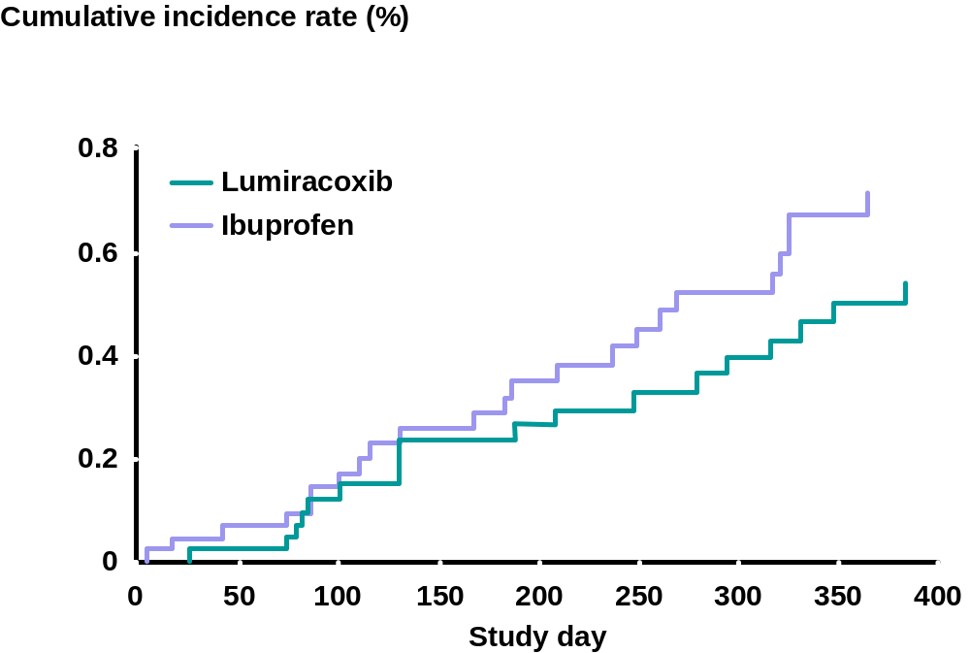

Figure 8-3 Posthoc depiction of thromboembolic cardiovascular events in non-aspirin users in the CLASS study (Ref: FitzGerald G)
The above data suggests that the degree of COX 2 selectivity probably impacts more on the extent of gastrointestinal protection than the incidence of CV adverse events. Supporting this is the fact that valdecoxib (Bextra®) has been shown in two duplicate CABG studies to significantly increase CV adverse events compared to controls. Furthermore, rofecoxib has a lower COX 2/COX 1 selectivity ratio than lumiracoxib, but it has been associated with a significant increase in MIs, APTC events, and hypertension and numerically more cases of congestive heart failure.
Finally, TARGET achieved its primary objective. Patients taking lumiracoxib had a 79% reduction in ulcer complications (non ASA population) compared to patients on NSAIDS. There was no significant difference in the primary endpoint of ulcer complications when celecoxib was compared to NSAIDs in CLASS.

Possible explanations for the specific rofecoxib CV profile
Several hypotheses have been put forward to explain the thrombotic safety issues seen with rofecoxib.
The first argument was put forth by the sponsor to explain the difference in MI events between rofecoxib and naproxen. This hypothesis was that naproxen had antithrombotic activity. While retrospective population cohort studies have questioned naproxen anti-thrombotic activity (Ray et al, 2002), several well-controlled studies have demonstrated that naproxen (500 mg bid) is capable of reducing platelet thromboxane production to an extent similar to low dose aspirin and, thus, prevent platelet aggregation (Capone et al, 2004). In a meta-analysis of randomized trials aspirin afforded a 32% reduction in first MI (Eidelman et al. 2003). In a recent meta-analysis of all naproxen observational studies, naproxen was associated with a significant 14% decrease in MIs (OR 0.86, 95% CI 0.75 – 0.99, Ref: Juni et al.). Assuming that naproxen could achieve the same level of reduction in MI as low dose aspirin (32 – 44%), this reduction may be a contributing factor but by itself appears to be inadequate to explain the 4-fold difference seen between naproxen and rofecoxib in the VIGOR trial. Yet, this reduction by naproxen would largely account for the smaller difference observed between naproxen and lumiracoxib in TARGET in the non-aspirin treated population (Section 4).
A second, not mutually exclusive possibility is that rofecoxib is prothrombotic. FitzGerald et al. (2004) have argued that inhibition of the COX-2-dependent activity in the face of unopposed platelet COX-1 activity might favor a prothrombotic state. Thus, the inclusion of low dose aspirin (COX-1 selective effect) should neutralize the risk.
There may therefore be another mechanism by which rofecoxib is exerting a prothrombotic effect. The third possibility relates to rofecoxib’s unique metabolic pathway, a pathway distinct from the one utilized by lumiracoxib. Metabolism of rofecoxib is through cytosolic reduction catalyzed by aldo-ketoreductase. In the vasculature this enzyme is responsible for detoxification of oxidized phospholipids (Srivastava et al., 2004). Reduction of oxidized lipids is a critical defense mechanism, as oxidized phospholipids are associated with atherosclerosis (Gaut and Heinecke, 2001), heart failure (Maack et al, 2003) and ischemic-reperfusion injury (Kloner and Jennings, 2001). Additionally, aldo-ketoreductase in the liver is involved in the synthesis of vasoactive hormones, including aldosterone (Krum et al, 2004). Given its long half life and micromolar blood levels, rofecoxib could act as a competitive inhibitor, preventing access of other substrates to this enzyme. The effect of rofecoxib on aldosterone levels is of interest since this hormone plays a role in fluid and sodium retention.
In contrast, lumiracoxib is metabolized by cytochrome P450 2C9, an enzyme not involved with the production of vasoactive hormones or metabolism of oxidized phospholipids.
Recently, Reddy and Corey (2004) suggested that oxidation of the conjugate base of rofecoxib to a maleic anhydride derivative may be a factor in the long-term toxicity of rofecoxib. This reactivity has not been previously been described, and does not occur in any other COX-2 inhibitor developed to date. The authors suggest that some of the anhydride may survive long enough in vivo to react with tissues. They wrote: “The consequences of this may be a low-level chronic toxicity that is cumulative and possibly dangerous over periods of many months.”

Structure
COX-2 selective inhibitors can be categorized into three chemical types. Celecoxib and valdecoxib have sulphonamide groups, rofecoxib and etoricoxib have a methylsulphone group, but lumiracoxib lacks a sulphur-containing group, possessing instead a carboxylic acid group which confers weakly acidic properties (Brune and Hinz, 2004).
A recent publication found that sulphone COX-2 inhibitors (rofecoxib and etoricoxib) increased the susceptibility of human LDL and plasma to oxidative modification compared to non-sulphone COX2 inhibitors and NSAIDs. They suggested that this may provide a mechanistic insight into the reported differences in cardiovascular risk for COX2 inhibitors (Walter MF at al Arthrosclerosis 2004).

Half–life
Lumiracoxib has the shortest plasma elimination half-life amongst all the current COX-2 inhibitors (3-6 hours), compared to rofecoxib (15-18 hours), celecoxib (6-12 hours), valdecoxib (6-10 hours) and etoricoxib (20-26 hours). A long half-life has been offered as one of the hypotheses for CV adverse events causing a sustained inhibition of COX 2-dependent prostacyclin production over a 24 hour time period. Indeed, lumiracoxib is associated with less inhibition of urinary PGI2 metabolites over 24 hours than other NSAIDs in non-head-to-head studies (Lumiracoxib Study 2349, Catella-Lawson 1999).

PK/PD (Distribution kinetics)
Lumiracoxib has been shown in RA patients (Lumiracoxib Study 0122) to have a longer mean residence time in the synovial fluid compartment compared to the vascular compartment. Less time spent in the vascular compartment may translate to less vascular prostacyclin inhibition over a 24 hour period and therefore fewer CV adverse events.

Inhibition of the vasoprotective prostaglandin PGI₂
PGI2 is a vasoactive prostaglandin responsible for suppressing platelet aggregation and acting as a vasodilator. Catella-Lawson et al (1999) have shown that rofecoxib (50 mg) reduced the production of PGI2 by 73% as measured as PGI2 metabolites in urine that was collected 0 – 6 hours following administration. This high level of PGI2 inhibition contrasts with that caused by lumiracoxib, which reduced urinary PGI2 metabolites by a maximum of 30% between 6 – 12 hours post dose and by ~15% over of the course of a day (Lumiracoxib Study 2349). In Study 2349 low dose aspirin suppressed PGI2 by ~10% - a similar reduction was noted by Capone et al (2004).

Summary
In conclusion, the data show that:
When all the available clinical trial evidence for lumiracoxib is reviewed, there is no evidence of an increased risk of cardiovascular events compared with placebo, naproxen, non-naproxen NSAIDs, or all comparators.
In addition TARGET provides data that;
- suggests that lumiracoxib has a neutral CV profile when compared to ibuprofen and has a significantly lower mean increase in systolic and diastolic BP.
- strengthens the hypothesis that naproxen is antithrombotic at the dose and dosing interval studied, and differs from ibuprofen in its CV profile. Of significance is the observation in TARGET of the absence of a relevant difference compared to naproxen in MIs when low dose ASA is coadministered (COX-1 activity).
- in high CV risk patients (n=2,207) and patients with a previous MI (n=288), no difference in the APTC endpoint nor in MIs (clinical or silent) between lumiracoxib and NSAIDs was observed.
- may indicate that naproxen may be different from ibuprofen in its CV profile, adding support to the belief that not all NSAIDs are the same in their end organ effects.
When lumiracoxib (TARGET non aspirin population) is compared to rofecoxib in non-head-to-head studies, the two COX-2 inhibitors differ notably in their CV profile. This analysis adds support to our conclusion that not all COX-2 inhibitors are the same in their physiological effects and safety profiles.
Subsequent to the rofecoxib withdrawal, lumiracoxib is the only COX-2 inhibitor to have shown in a long-term outcomes study a significant GI benefit compared to NSAIDs. This benefit is expected to be maintained at the 100 mg od dose (OA dose) as this benefit is a function of the COX-2 selectivity (or rather the COX-1 sparing effect) in the gastrointestinal tract, while the CV and overall favorable safety profile is expected to be further enhanced at the lower dose. Therefore, lumiracoxib at the recommended chronic dose of 100 mg od is expected to have an even greater positive benefit to risk safety profile in OA, compared to the 400 mg od dose studied in TARGET.

References
Antiplatelet Trialist’s Collaboration. (1994) Collaborative overview of randomised trials of antiplatelet therapy, I: prevention of death, myocardial infarction, and stroke by prolounged antiplatelet therapy in various categories of patients. BMJ 308: 81-106
Bombardier C, Laine L, Reicin A, et al. (2000) Comparison of upper gastrointestinal toxicity of rofecoxib and naproxen in patients with rheumatoid arthritis. New Engl J Med; 20:1520-1528.
Brune K and B Hinz (2004). "Selective cyclooxygenase-2 inhibitors: similarities and differences." Scand J. Rheumatol 33: 1-6.
Capone, ML, Tacconelli S, et al. (2004). "Clinical pharmacology of platelet, monocyte, and vascular cyclooxygenase inhibition by naproxen and low-dose aspirin in healthy subjects." Circulation 109(12): 1468-71.
Catella-Lawson F, McAdam B, et al. (1999). "Effects of specific inhibition of cyclooxygenase-2 on sodium balance, hemodynamics, and vasoactive eicosanoids." J Pharmacol Exp Ther 289(2): 735-41.
Eidelman R S, Hebert PR, et al. (2003). "An update on aspirin in the primary prevention of cardiovascular disease." Arch Intern Med 163(17): 2006-10.
Farkouh ME, Kirshner H, Harrington RA, et al. (2004) Comparison of lumiracoxib with naproxen and ibuprofen in the Therapeutic Arthritis Research and Gastrointestinal Event Trial (TARGET), cardiovascular outcomes: a randomized controlled trial. Lancet; 364: 675-684.
Gaut JP and JW Heinecke (2001). "Mechanisms for oxidizing low-density lipoprotein. Insights from patterns of oxidation products in the artery wall and from mouse models of atherosclerosis." Trends Cardiovasc Med 11(3-4): 103-12.
Grover SA, Coupal L, Zowall H (2005). Treating Osteoarthritis With Cyclooxygenase-2-Specific Inhibitors: What Are the Benefits of Avoiding Blood Pressure Destabilization? Hypertension;45(1): 92-97
FitzGerald GA (2004). Coxibs and Cardiovascular Disease. N Engl J Med 351;17: 1709-1711.
Jüni P, Nartey L, Reichenbach S, Sterchi R, Dieppe P, and M Egger. Risk of cardiovascular events and rofecoxib: cumulative meta-analysis. Lancet 2004;364:4999
Kloner, R. A. and R. B. Jennings (2001). "Consequences of brief ischemia: stunning, preconditioning, and their clinical implications: part 2." Circulation 104(25): 3158-67.
Krum H., Liew D, et al. (2004). "Cardiovascular effects of selective cyclooxygenase-2 inhibitors." Expert Rev Cardiovasc Ther 2(2): 265-70.
Maack C, Kartes T, et al. (2003). "Oxygen free radical release in human failing myocardium is associated with increased activity of rac1-GTPase and represents a target for statin treatment." Circulation 108(13): 1567-74.
Mamdani M, Juurlink DN, Lee DS et al. (2004) Cyclo-oxygenase-2 inhibitors versus non-selective non-steroidal anti-inflammatory drugs and congestive heart failure outcomes in elderly patients: a population-based cohort study. Lancet 363: 1751-56.
Ray, WA, CM Stein, et al. (2002). "COX-2 selective non-steroidal anti-inflammatory drugs and risk of serious coronary heart disease." Lancet 360(9339): 1071-3.
Reddy LR, and EJ Corey (2004) Tetrahedron Lett., published online Dec. 25, 2004, http://dx.doi.org/10.1016/j.tetlet.2004.12.055
Silverstein FE, Faich G, Goldstein JL, et al. (2000) Gastrointestinal toxicity with celecoxib vs. nonsteroidal anti-inflammatory drugs for osteoarthritis and rheumatoid arthritis. JAMA; 284:1247-1255.
Singh G, JD Miller, et al. (2003). "Consequences of increased systolic blood pressure in patients with osteoarthritis and rheumatoid arthritis." J Rheumatol 30(4): 714-9.
Singh G, Miller JD, Lee FH et al. (2004). Prevalence of cardiovascular disease risk factors among US adults with self-reported osteoarthritis: data from the third national health and nutrition examination survey. Am J Manag Care 2002; 8:S 383-91.
Srivastava S, Spite M, et al. (2004). "Aldose reductase-catalyzed reduction of aldehyde phospholipids." J Biol Chem.
Weir MR, Sperling RS, et al. (2003). "Selective COX-2 inhibition and cardiovascular effects: a review of the rofecoxib development program." Am Heart J 146(4): 591-604.

