

BSO Tutorial for Tax Year 2008

W-2c Online

Contains the following lessons:

- Create Forms W-2c Online
- Download Submitted Forms W-2c
- Resume Unsubmitted Forms W-2c

Lesson 1: Create Forms W-2c Online

Follow the instructions below to create up to five Forms W-2c online.

Step 1: Point your browser to the Business Services Online (BSO) Welcome page: www.socialsecurity.gov/bso/bsowelcome.htm.

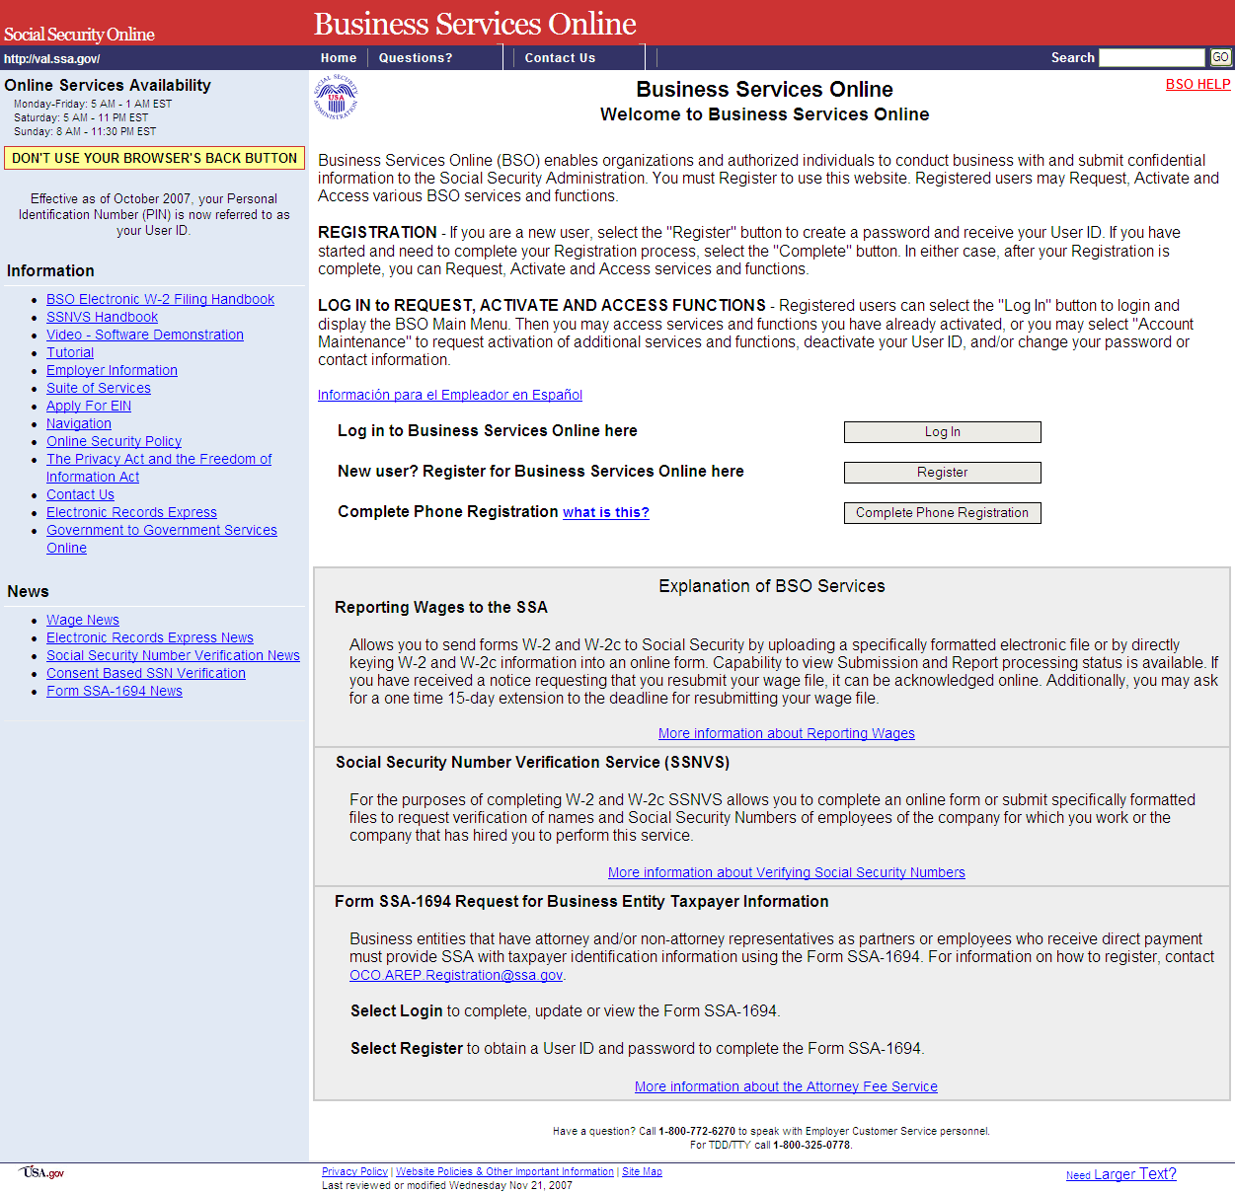

Step 2: Select the Log In button on the BSO Welcome page. The system displays the Log In to the BSO page.
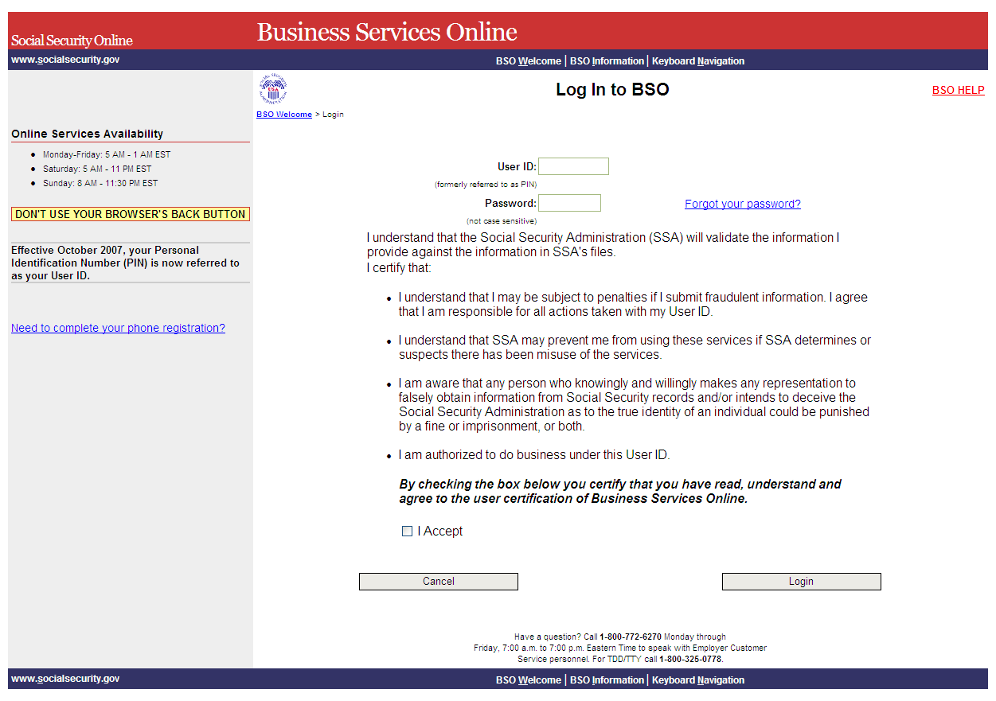

Step 3: Enter your User ID and password.
Step 4: Select the “I Accept” check box after reading the conditions defined on the Log In to BSO page. Select the Login button. The system displays the BSO Main Menu page (To return to the BSO Welcome page, select the Cancel button.).
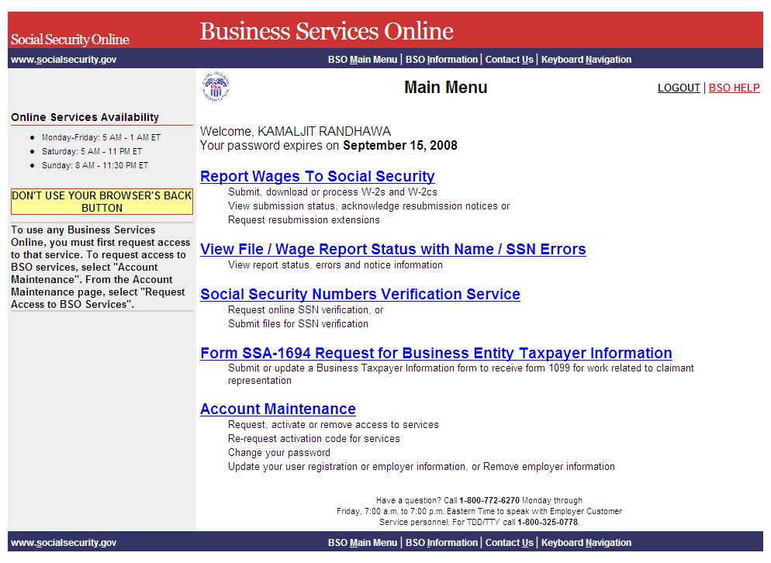
Step 5: Select the Report Wages to Social Security link.


The system displays the Report Wages to Social Security menu page.

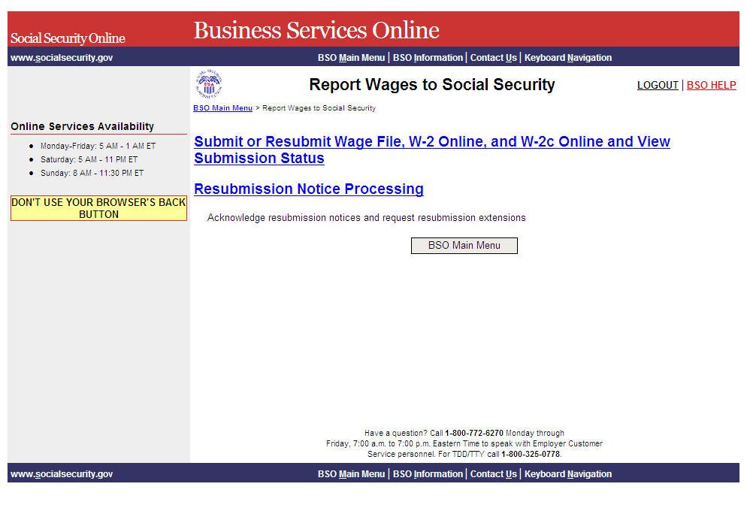

Step 6: Select the Submit or Resubmit Wage File, W-2 Online, and W-2c Online and View Submission Status link.
The system displays the Submit or Resubmit Wage File, W-2 Online, and W-2c Online and View Submission Status menu page.
(To return to the BSO Main Menus page, select the BSO Main Menu button.)

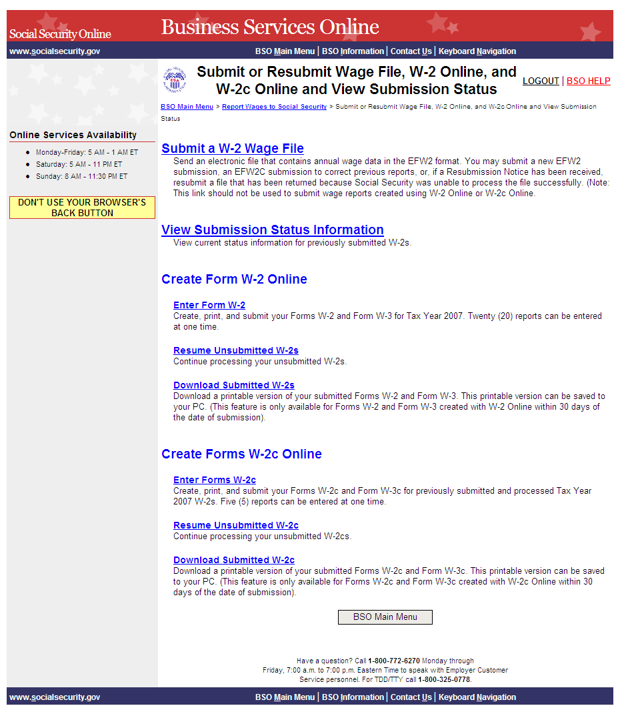

Step 7: Select the Enter Forms W-2c link.
(To return to the BSO Main Menus page, select the BSO Main Menu button.)

The system displays the Wage Reporting Attestation page.

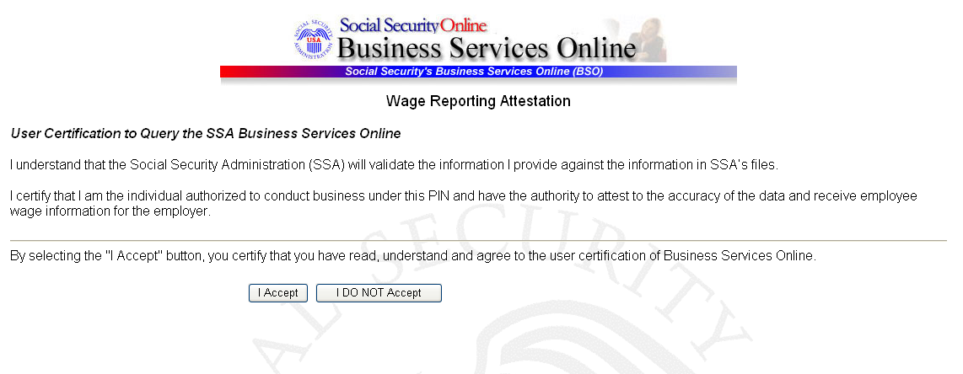

Step 8: Select the I Accept button after reading the conditions defined on the Wage Reporting Attestation page. If you do not have any saved but unsubmitted reports, the system displays the W-2c Online Information for Tax Year 2008 page.

If you have any existing unsubmitted reports, the system will display the W-2c Online Unsubmitted Reports for Tax Year 2008 page. For Tax Year 2008, you may have a maximum of 50 unsubmitted reports at one time. When you have reached the 50 'saved' report limit, you must first submit an existing report in order to be able to start a new report. If there are 49 or fewer reports, you may continue without submitting the existing reports by selecting the Start a New Report button. Refer to Lesson 3: Resume Unsubmitted W-2cs for more information.

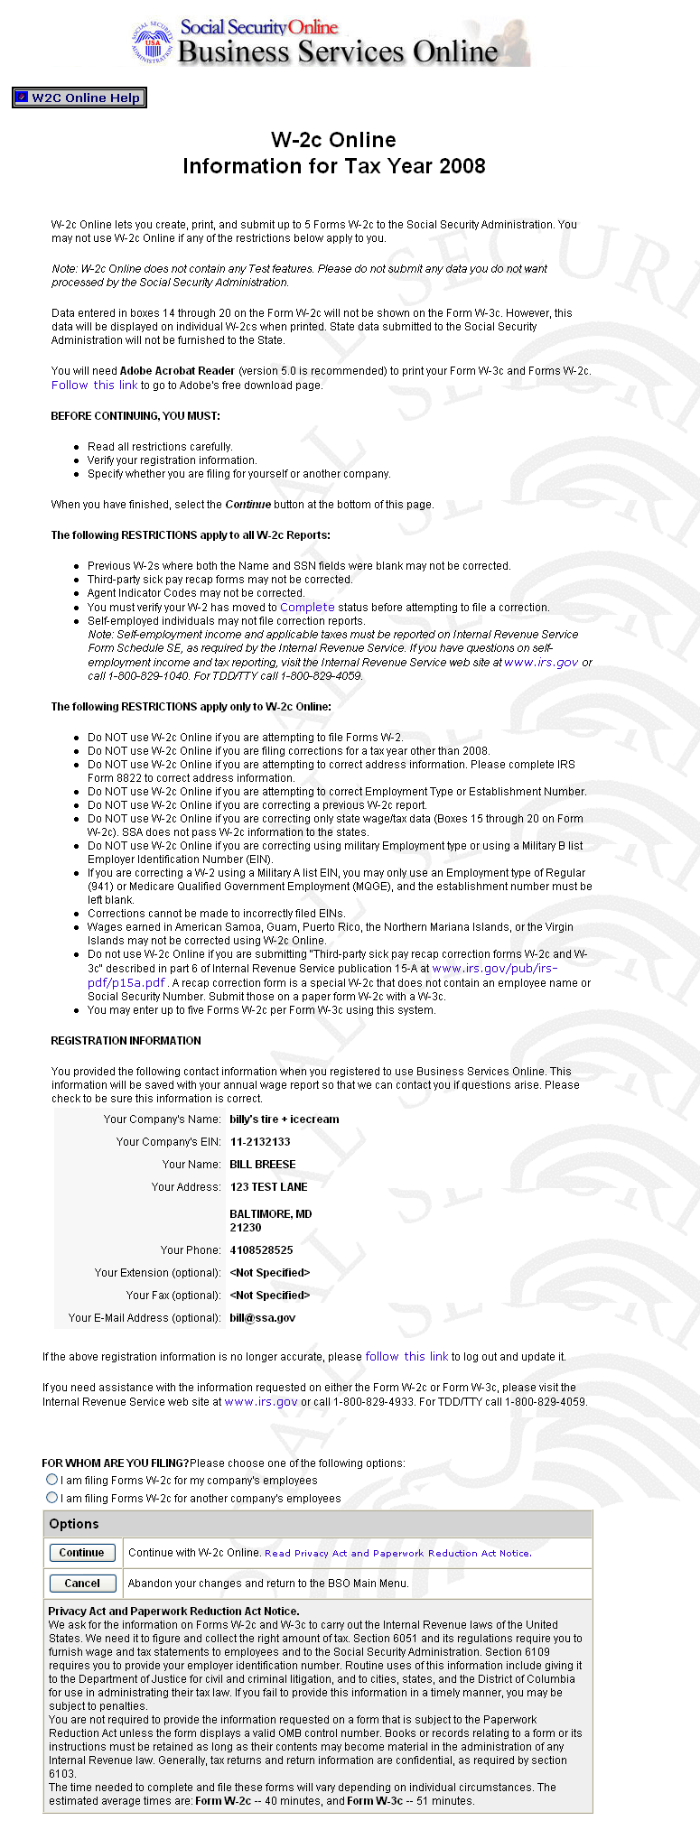

Step 9: Select the appropriate response for the FOR WHOM ARE YOU FILING? section after reviewing the Registration information.

The FOR WHOM ARE YOU FILING? radio buttons are not available for self-employed users.

Step 10: Select the Continue button after reviewing the Privacy Act and Paperwork Reduction Act notice. The system displays the W-2c Online Employer Data for Tax Year 2008 page (Otherwise, select the Cancel button to end this session and return to the BSO Main Menu page.).
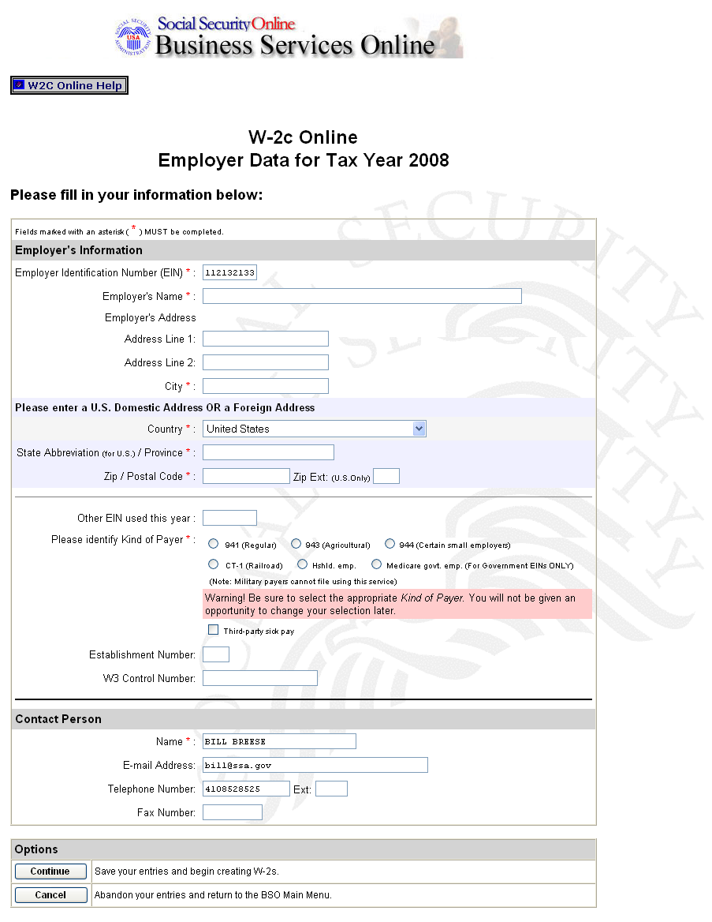
Step 11: Enter your employer information. If you are filing for your own company, the system automatically populates this information.
All fields marked with an asterisk (*) must be completed.

Step 12: Select the Continue button. The system displays the W-2c Online Form W-2c for Tax Year 2008 page (Otherwise, select the Cancel button to exit and return to the BSO Main Menu page.).

If there is one or more W-2cs saved, the system shall display the W-2c Online Data Review page. Go to Step 16.

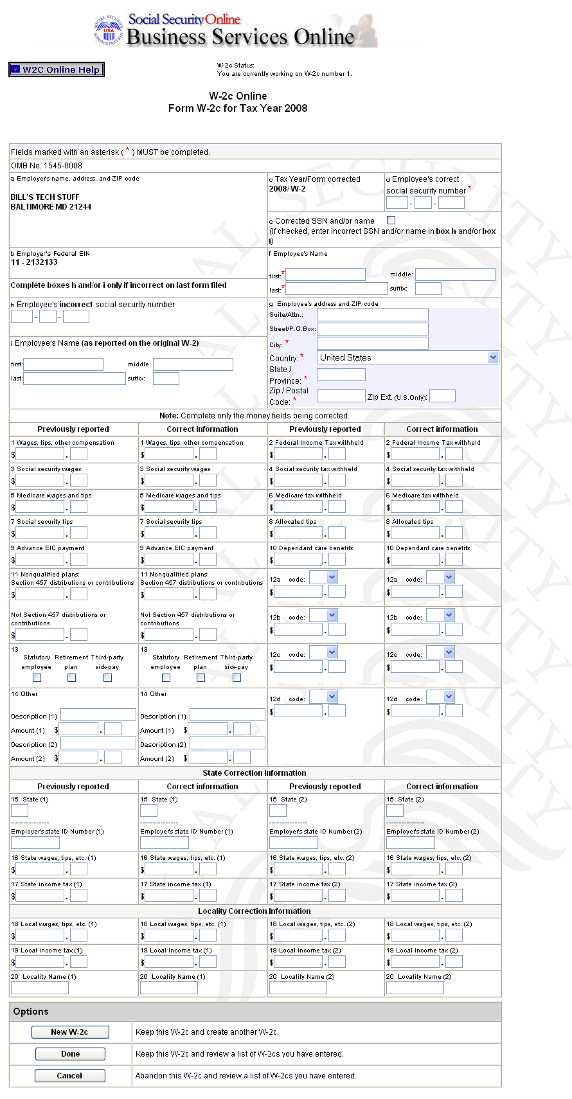

Step 13: Enter the corrections to the W-2 data in the appropriate boxes. Do not fill in the fields that were reported correctly the first time you filed Form W-2.
Step 14: Select the New W-2c button to save this W-2c information and create another W-2c. Otherwise, select the Done button to save this W-2c information and proceed to the W-2c Online Data Review for Tax Year 2008 page. You may also select the Cancel button to delete entries made to this W-2c.
You can enter a maximum of five (5) Forms W-2c per session/login. When entering your fifth W-2c, the system will no longer display the New W-2c button. You will need to initiate a new session in order to enter more Forms W-2c. There is no limit on the number of sessions.

Step 15: After you select New W-2c or Done, you may receive an alert. If so, you will need to review your data and make any corrections or select an override response for each alert. Then, select New W-2c to create a new W-2c record or select Done to proceed to the W-2c Online Data Review for Tax Year 2008 page.

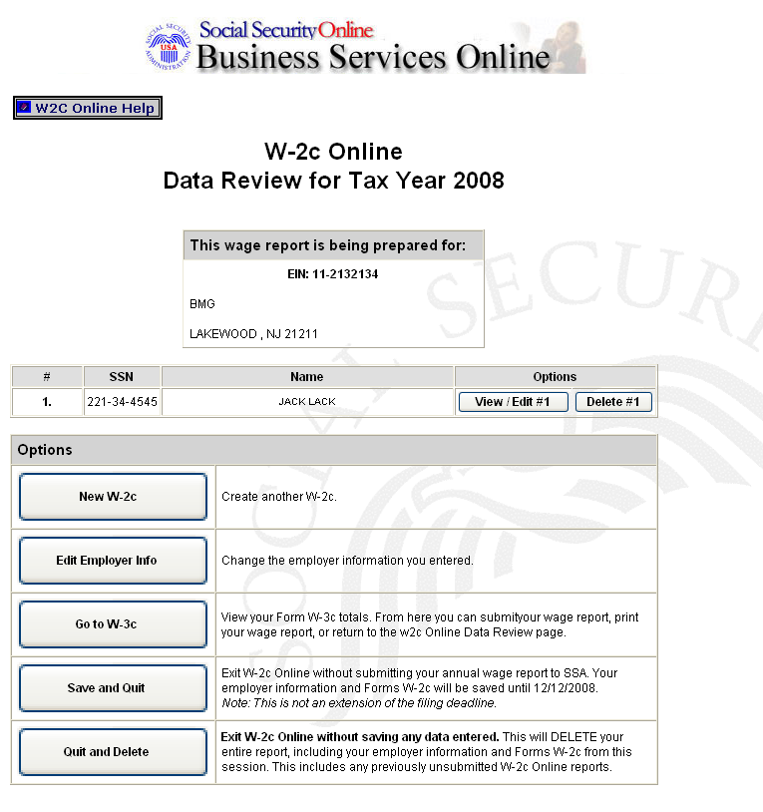

Step 16: Select the View/Edit button next to the appropriate record to view or edit the W-2c data. If you want to delete the W-2c data, select the Delete button next to the appropriate record.

Step 17: Select one of the following options: New W-2c, Edit Employer Info, Go to W-3c, Save and Quit, or Quit and Delete.

The New W-2c option will not be available if five W-2cs are already saved for the current report or if the maximum of 50 saved, unsubmitted W-2cs has been reached. The Go to W-3c option will not be available if no saved W-2cs exist for the current employer.

Step 18: Select the Go to W-3c button to submit your wage data. The system will display your W-2c Online Form W-3c for Tax Year 2008 for your review.

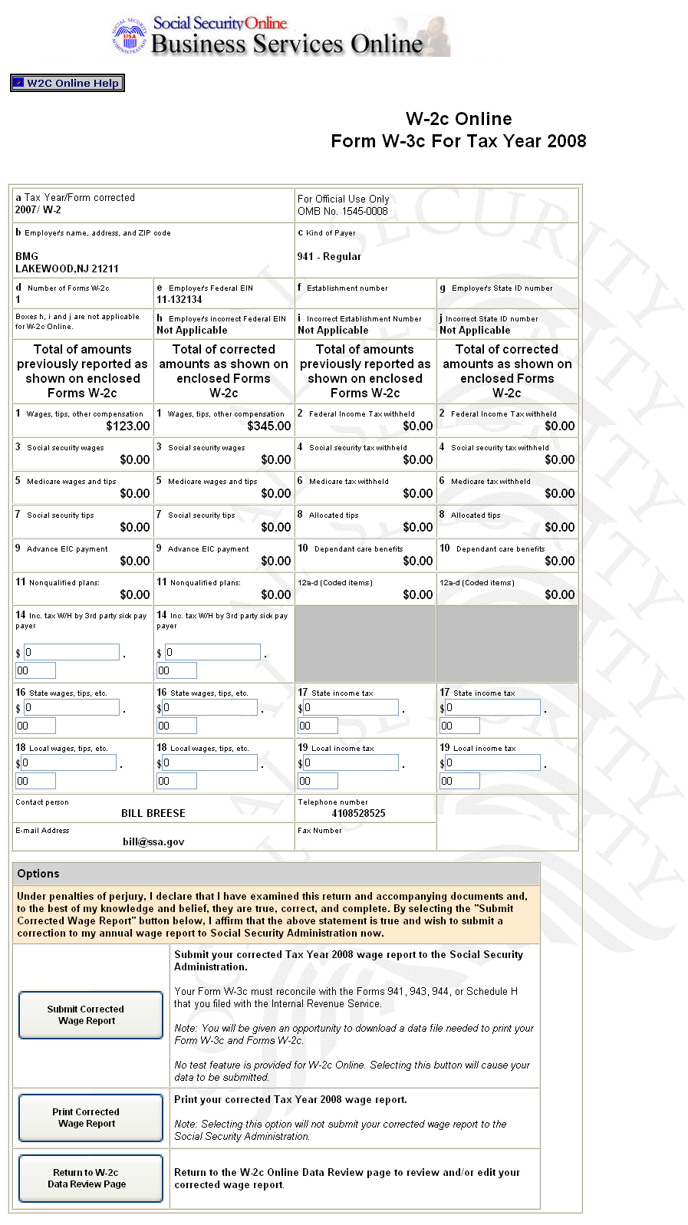

Step 19: Select one of the following options:
Submit Corrected Wage Report button to submit your wage information. Go to Step 21 for more information.
Print Corrected Wage Report button to print or preview your wage report prior to submitting it to SSA. Go to Step 25 for more information.
Return to W-2c Data Review page button to edit your data.
Step 20: Select the Submit Corrected Wage Report button on the W-2c Online Form W-3c for Tax Year 2008 page.
Step 21: If multiple Employee Identification Numbers (EIN) are associated with the submitter then a list box of EINs will appear. An EIN should be selected from the list box; otherwise, proceed to Step 23.
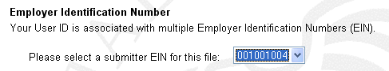

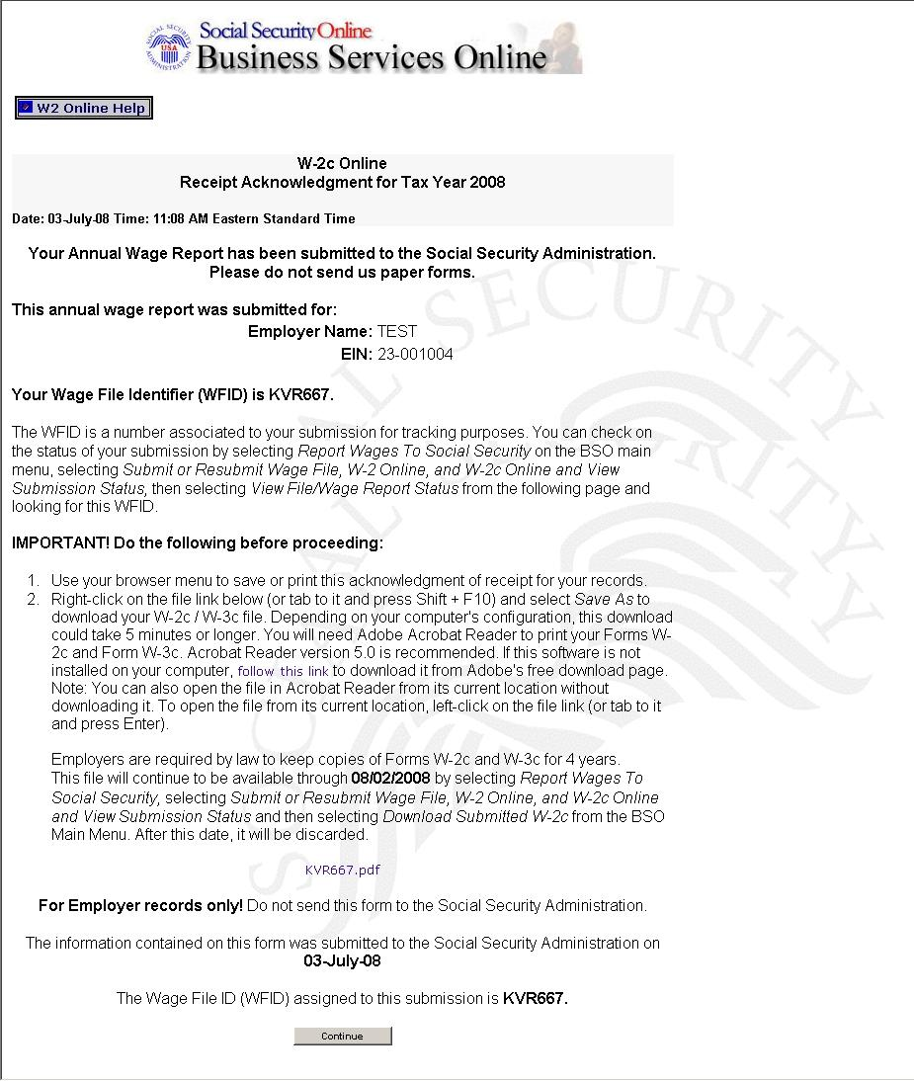

It is recommended that you select OK to print now in the pop-up box that appears when the W-2c Online Receipt Acknowledgement page is accessed.

Step 22: Right-click the file link to save the wage file.
Step 23: Select Save Target As option from the browser menu to save the file (Otherwise, select the Continue button.).
You can download your submitted corrected wage file for up to 30 days after the submission date by using the Lesson 2: Download Submitted W-2cs feature.

Step 24: Select the Continue button. The system displays the W-2c Online Thank You page.
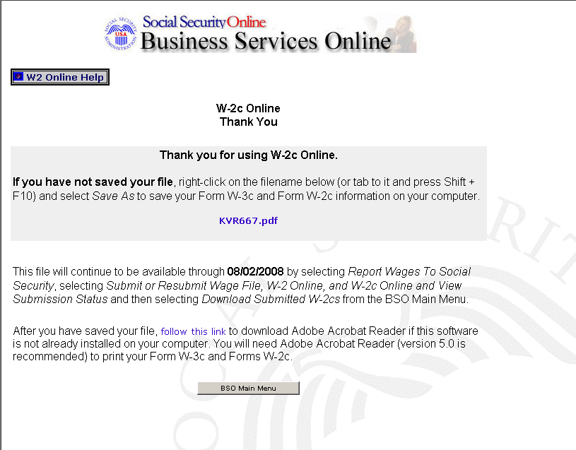

Step 25: Select the Print Corrected Wage Report button on the W-2c Online Form W-3c page to print the corrected wage report. The system displays the W-2c Online Report Print page.
(To return to the BSO Main Menus page, select the BSO Main Menu button.)
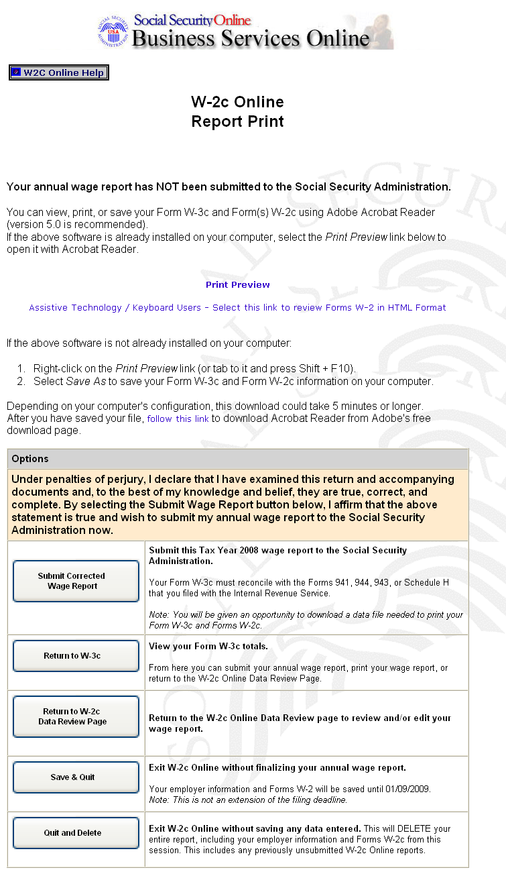

If you do not have Adobe Acrobat Reader on your computer, you can download it by selecting “follow this link” near the middle of the page.

Step 26: Select the Print Preview link. The system displays the Forms W-2c.
Step 27: Select File>Print from the menu bar or select the Print icon from the tool bar.
Step 28: Select File>Close on the menu bar after printing to close the window. The system returns you to the Print Preview page.
Step 29: The options on the W-2c Online Report Print page will allow you to submit your corrected wage file to SSA, return to the W-2c Online Form W-3c page, return to the W-2c Online Data Review page, save your data, or quit without saving your data.
Step 30: Select the Return to W-2c Data Review Page button on the W-2c Online Form W-3c page to edit your Forms W-2c data created during the current session. The system returns you to the W-2c Online Data Review page.

Lesson 2: Download Submitted Forms W-2c
Follow the instructions below to download an Adobe file containing Forms W-2c and W-3c for a W-2c Online report submitted within the last 30 days.

Adobe files are available for 30 days or until December 11, 2009.

Step 1: Point your browser to the BSO Welcome page: www.socialsecurity.gov/bso/bsowelcome.htm.
Step 2: Select the Login link on the BSO Welcome page. The system displays the Log In to BSO page.
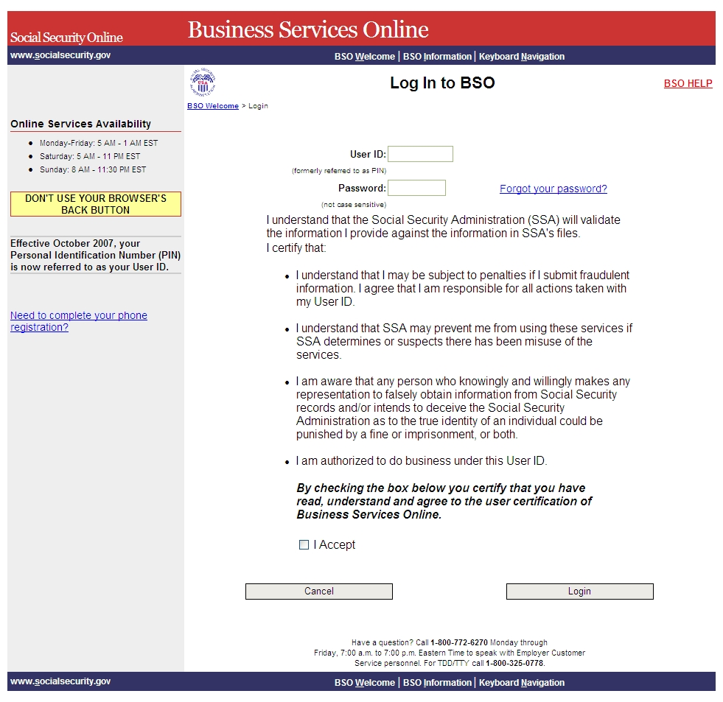

Step 3: Enter your User ID and password.
Step 4: Select the “I Accept” check box after reading the conditions defined on the Log In to BSO page. Select the Login button. The system displays the BSO Main Menu page (To return to the BSO Welcome page, select the Cancel button.).

Step 5: Select the Report Wages to Social Security link.

The system displays the Report Wages to Social Security menu page.

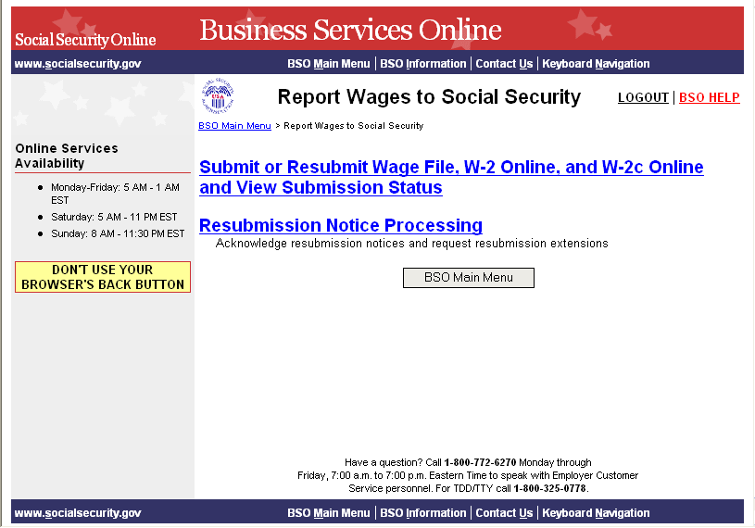

Step 6: Select the Submit or Resubmit Wage File, W-2 Online, and W-2c Online and View Submission Status link.
The system displays the Submit or Resubmit Wage File, W-2 Online, and W-2c Online and View Submission Status menu page.
(To return to the BSO Main Menus page, select the BSO Main Menu button.)
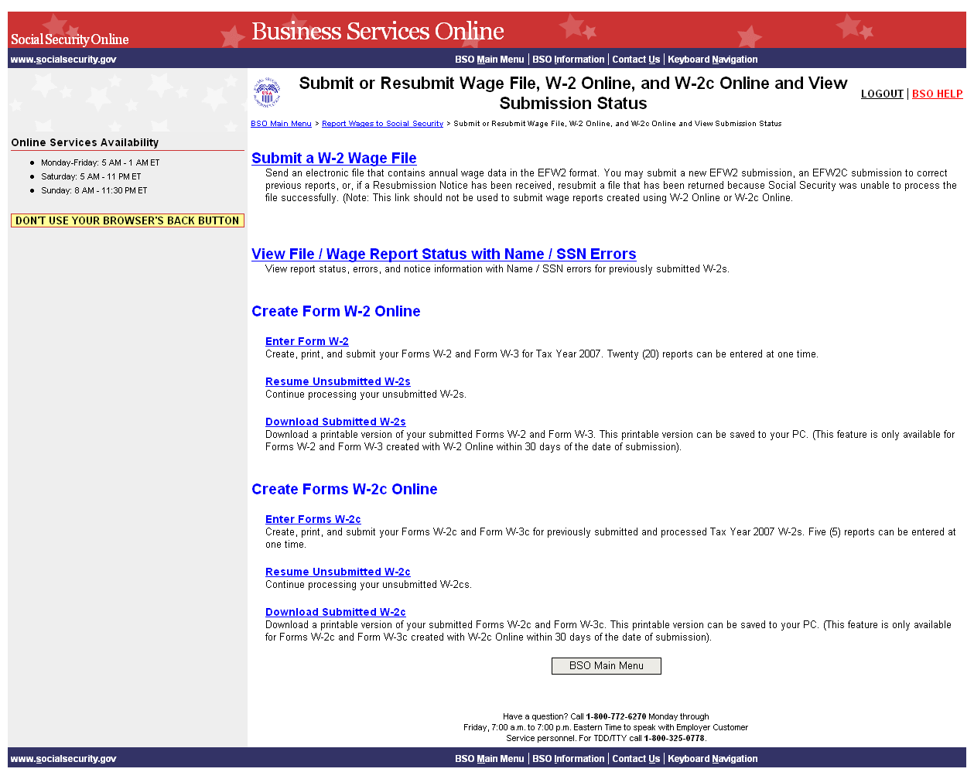

Step 7: Select the Download Submitted W-2cs link.
(To return to the BSO Main Menus page, select the BSO Main Menu button.)

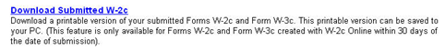

The system displays the Wage Reporting Attestation page.

Step 8: Select the I Accept button after reading the conditions defined on the Wage Reporting Attestation page. The system displays the W-2c Online Download for Tax Year 2008 page.
(To return to the BSO Main Menu page, select the I DO NOT Accept button.)

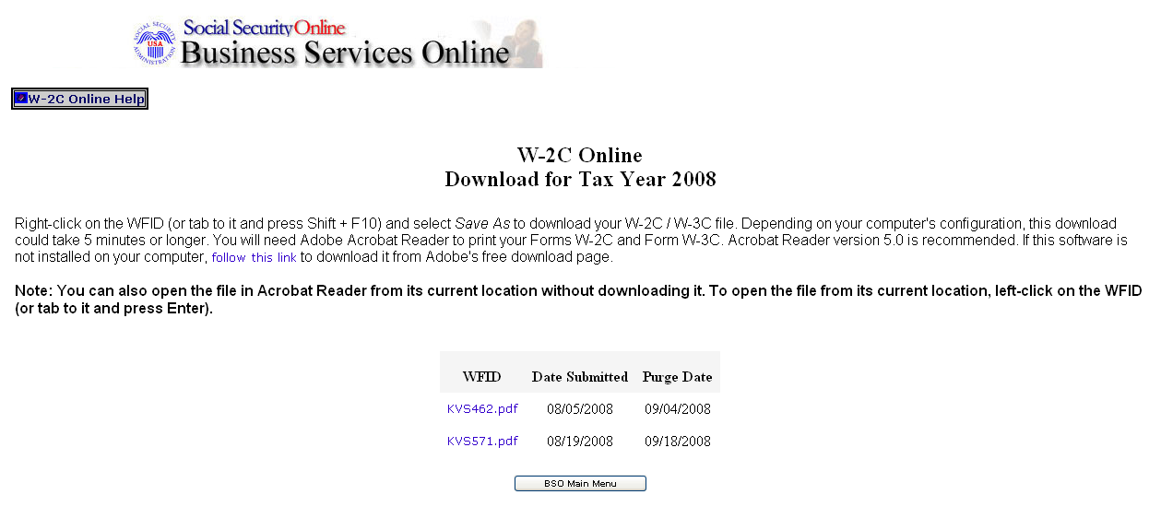

Step 9: Right-click the WFID link you wish to download.
Step 10: Select the Save Target As option from the browser menu to download the file onto your computer.
Step 11: Select the BSO Main Menu link to return to the BSO Main Menu page.

Lesson 3: Resume Unsubmitted Forms W-2c
Follow the instructions below to continue working with W-2c Online reports that you have saved but not yet submitted. The Social Security Administration (SSA) will delete any saved reports that you do not submit or update within 120 days. All unsubmitted Forms W-2c will be removed on December 11, 2009.

You may have up to 50 saved reports with five W-2cs in each report.

Step 1: Point your browser to the BSO Welcome page: www.socialsecurity.gov/bso/bsowelcome.htm.
Step 2: Select the Log In button on the BSO Welcome page. The system displays the Log In to BSO page.

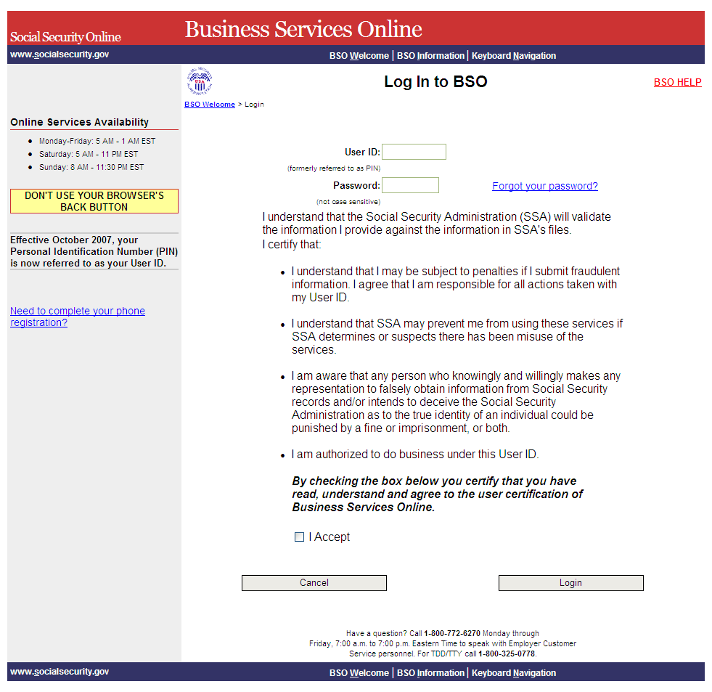

Step 3: Enter your User ID and password.
Step 4: Select the “I Accept” check box after reading the conditions defined on the Log In to BSO page. Select the Login button to display the BSO Main Menu page (To return to the BSO Welcome page, select the Cancel button.).
Step 5: Select the Report Wages to Social Security link.

The system displays the Report Wages to Social Security menu page.

Step 6: Select the Submit or Resubmit Wage File, W-2 Online, and W-2c Online and View Submission Status link.
The system displays the Submit or Resubmit Wage File, W-2 Online, and W-2c Online and View Submission Status menu page.
(To return to the BSO Main Menus page, select the BSO Main Menu button.)

Step 7: Select the Resume Unsubmitted W-2c link.
(To return to the BSO Main Menus page, select the BSO Main Menu button.)



The system displays the Wage Reporting Attestation page.

Step 8: Select the I Accept button after reading the conditions on the Wage Reporting Attestation page. The system displays the W-2c Online Unsubmitted Reports for Tax Year 2008 page.
(To return to the BSO Main Menu page, select the I DO NOT Accept button.)

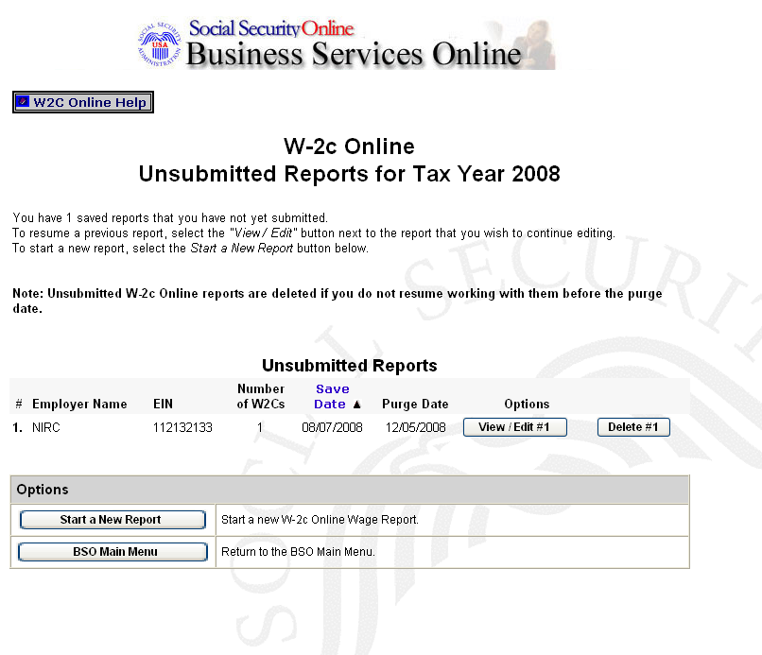

Step 9: Select the View/Edit button for the specific report to view or modify the report. The system displays the W-2c Online Data Review for Tax Year 2008 page (To delete the report, select the Delete button for the specific report.).

The New W-2c button will not be displayed if you have the maximum number of unsubmitted W-2cs (five) per report. The Go to W-3c button will not be displayed if there is no un-submitted W-2c.

Step 10: Select the Go to W-3c button. The system displays your Form W-3c. Use the options on this page to submit your wage report, print your wage report, or return to your unsubmitted Forms W-2c.

