A Data Fusion Algorithm for Mapping Sea-Ice Concentrations
from Special Sensor Microwave / Imager Data

K.C. Partington
U.S. National Ice Center
4251 Suitland Road,
Washington DC 20395
USA.

Abstract
Ice charts from the U.S. National Ice Center are used to evaluate published algorithms for generating sea-ice concentrations from SSM/I data. The same ice charts, in a form that includes information derived only from RADARSAT, OLS and AVHRR data, are used in an operational algorithm that effectively tunes a hybrid of the Bootstrap and NASA Team algorithms and principal components of the SSM/I data to the time and region associated with the ice chart. This “tuned” algorithm is then used to interpolate ice concentrations elsewhere in the ice chart where no cloud-free, high-resolution visible, infra-red or active microwave satellite data are available. The algorithm is designed to operate in near real time to assist the ice analysts in their otherwise manually-intensive task of compiling ice charts for vessels operating in ice-infested waters.

Key words
Sea-ice, ice charts, SSM/I, passive microwave, data fusion, algorithm

I. INTRODUCTION
Passive microwave data are unique in providing routine hemispheric-scale pictures of sea-ice conditions to the scientific and operational communities, and two decades of observations have now been accumulated by the Defense Meteorological Satellite Program (DMSP) Special Sensor Microwave / Imager (SSM/I) and its predecessor, the Scanning Multi-channel Microwave Radiometer. This is a sufficiently long time series to support studies related to climate-related events, such as El-Nino Southern Oscillation [1] and to extract information on systematic changes in ice conditions that may be related to climate change [2].

As well as being of scientific value, SSM/I data are also extremely important to the operational community, which has the task of supporting surface and sub-surface ocean-going vessels with timely and regular information on ice conditions [3]. Ice analysts use SSM/I data to prepare ice charts for regular dissemination to the operational community, both in the USA at the National Ice Center (NIC) and elsewhere around the world in areas where sea-ice presents a hazard. SSM/I is important to the operational community because it provides wide and complete (cloud-free) coverage on a daily basis: this is something that no other data can match at present.

Although SSM/I data are important to the operational community, they do have limitations. SSM/I-derived sea-ice products have coarse resolution (a pixel size of approximately 25 km in the 19 to 37 GHz frequency range) and so the data tend to be used after all higher resolution data sources have been exhausted. Other limitations are related to the algorithms used for converting the SSM/I brightness temperatures into ice concentrations. In contrast to active microwave, visible and infra-red satellite data, which are interpreted manually at the NIC, passive microwave data are converted to a geophysical product prior to use by the ice analysts. In general, these SSM/I algorithms do not make use of ancillary information so they are limited by the ambiguities inherent to passive microwave data. These ambiguities include confusion between weather artifacts and the presence of open water in areas of sea-ice, and confusion between melting sea-ice (for example indicated by surface melt-ponds) and areas of lower ice concentration [4]. The result of these algorithm limitations is that SSM/I data are less useful to the operational and scientific community than would be expected from the excellent coverage and the apparent transparency of clouds. In fact, with the exception of the location of the sea-ice edge, SSM/I data are used in a qualitative rather than quantitative manner in compiling ice charts.

The purpose of this paper is to show how operational ice charts provided by the U.S. National Ice Center can be used to both evaluate sea-ice concentration algorithms and can form part of an operational data fusion algorithm. Operational ice charts provide the least ambiguous form of wide coverage reference information on ice conditions, as they are based on an expert manual synthesis of observations from a wide variety of sources. These include satellite observations, knowledge of sea-ice and ocean climatology, considerations of continuity, weather predictions, model forecasts, ice charts from other ice centers and, when available, airborne and ship observations. Although ice charts are subject to error, they are compiled by experts familiar with the data sources and their ambiguities.

II. U.S. National Ice Center Ice Charts

The U.S. National Ice Center provides weekly ice charts for all ice-covered seas and achieves this by maintaining a group of highly qualified ice analysts, each with responsibility for generating ice charts in one or more regions. The analysts are supported by a senior analyst that quality controls the final product. The ice analysts undergo formal training and follow a set procedure for generating ice charts, which ensures that high quality input data takes precedence over lower quality input data. This ice analysis procedure is illustrated in Figure 1. The analyst starts by compiling background information, including the ice chart from the previous week, digital climatology data, weather predictions and output from the coupled ice-ocean forecast model, PIPS [5]. These data are used to provide the analyst with the best possible understanding of regional conditions from which to interpret the data (step 0, Figure 1). The analyst then starts with the highest available resolution of data. On occasion, this may include some air-borne or ship-borne observations, but in general these will not be available, in which case the analyst starts with RADARSAT data. The analyst will map the region covered by RADARSAT data into regions of approximately “uniform” total and partial ice concentrations. Once there is no more available RADARSAT data, the analyst will use the next highest resolution data source, normally Operational Line-scan System (OLS) data from the DMSP satellite program, which will be either visible or infra-red data depending on the time of year and hemisphere. Having provided additional ice analysis based on OLS data, the analyst will then move to NOAA AVHRR data (step 3, Figure 1). In the existing ice analysis procedure, two further steps remain. In the first step, DMSP SSM/I data are analyzed, having been translated into ice concentrations using the NASA Team or CAL/VAL algorithm, provided by the NOAA Center for Environmental Prediction (R. Grumbine, personal communication) and Fleet Numerical Modeling and Oceanography Center (J. Haferman, personal communication). These data are used to fill in remaining areas of the new ice chart. As a final step, the ice chart is quality checked by a senior analyst (step 5, Figure 1). An example of an ice chart, for the Sea of Okhotsk, is shown in Figure 2 for 7 December 1998.

III. Limitations of Conventional SSM/I ice concentration algorithms

It was shown in Figure 1 that SSM/I is the final data source used to compile ice charts, primarily because it has the lowest spatial resolution of satellite data, but also because it has some significant biases. On the other hand, SSM/I data are always available and so it remains an invaluable source of data, especially in the southern hemisphere where satellite SAR data are currently unavailable on a routine, operational basis.

SSM/I algorithms have been based largely on radiative transfer models for the surface and atmosphere, together with a mixing model that assumes that the footprint of the sensor contains only open water and sea-ice. These models include:

- the NASA Team algorithm and modification for thin ice ([6], [7]);
- the Bootstrap algorithm [8];
- the CAL/VAL (modified version of AES-York) algorithm [9];
- the Bristol Hybrid algorithm [10].

Other algorithms have also been developed. The differences lie in the choice of frequency and polarization combinations and in the precise technique used to estimate concentration from the distribution of points in the relevant feature space.

The techniques listed here all made use of one or both of the 19 and 37 GHz channels on SSM/I (with the 22 GHz channel sometimes used for data quality checking), but they generate significant differences in predictions of ice concentration. Steffen et al. [4] evaluated seven algorithms and concluded that total ice concentration can be estimated, at best, with an accuracy of 5-10% during non-melt conditions and 10-20% at other times. More recently, Comiso et al. [11] found that both the Bootstrap and NASA Team algorithms persistently under-estimated ice concentrations when compared to AVHRR, LANDSAT and SAR data. A comparison of just two algorithms is shown in Figure 3 for a random day in the Arctic during December, 1998. Table 1 shows statistics that summarize differences between these two algorithms in various regions across the Arctic and Antarctic.

Region (9 December 1998) | Season | Mean concentration difference (%) | R.m.s.  concentration difference (%) | Mean 0% ice concentration edge position difference (km)
Central Arctic | Winter | 2.6 | 3.34 | -71.0
East Greenland | Winter | 8.8 | 5.4 | -23.0
Baffin Bay | Winter | 13.5 | 6.2 | -23.0
Sea of Okhotsk | Winter | 29.0 | 8.9 | -44.0
Ross – Bellinghausen Seas | Summer | 14.5 | 5.3 | -24.0
Weddell Sea | Summer | 15.3 | 6.2 | -21.0

Table 1. Statistics related to differences in ice concentrations estimated using the NASA Team and CAL/VAL algorithms for 9 December, 1998. A positive sign indicates that the CAL/VAL algorithm shows more ice than the NASA Team algorithm.

It can be seen that differences in estimated ice concentration are substantial and vary systematically from region to region. An analysis of the different sources of error is required to understand why these differences are regionally so large and vary systematically.

A. Tie-point variations
Tie-point related errors result from natural variations in brightness temperatures associated individual type of surface. SSM/I algorithms make use of reference brightness temperatures associated with two ice types (first-year ice and multi-year ice in the northern hemisphere) and open water; these values are known as tie-points. However, all natural surfaces have variability in their emissivity and physical temperature characteristics. The open water brightness temperature, for example, will vary according to wind speed, foam and atmospheric effects. In the NASA Team algorithm, for example, the tie-point that is biased towards calm water conditions. Ice concentrations in areas of rough water will therefore be over-estimated and locally-calculated tie-points tend to be larger in terms of brightness temperature than the global value used by Cavalieri et al. [12]. The rationale for this is that the scheme maintains a relatively high dynamic range. Furthermore, Steffen and Schweiger [13] found that, in the northern hemisphere, the locally-determined first-year ice tie-points tended to be lower than the global value, which provides one explanation as to why ice concentrations in heavy pack are generally under-estimated with the NASA team algorithm.

Estimation of multi-year ice concentration represents a particular problem with SSM/I. This is reflected in the widely-varying evaluations of multi-year ice concentration derived from SSM/I. Cavalieri et al. [12] evaluated the NASA Team algorithm using aircraft under-flights in the Bering, Beaufort and Chukchi seas and found that multi-year ice concentration was over-estimated typically by 5% +/- 4%, although in areas of high multi-year ice concentration, the bias was usually reversed. This they attributed to mis-classification of older first year ice, which they suggest starts to take on the scattering characteristics of multi-year ice later in the season (partly through the properties of the overlying snow). Results from other studies are not consistent with these results, however, suggesting that multi-year ice concentrations during the freeze-up are significantly lower than end-of-summer total ice concentrations ([14], [15]). The two estimates differ by approximately 10-20%, which is approximately the amount of new first-year ice at the September minimum [16]. Investigations at the NIC have shown that the NASA Team estimates can both be gross under-estimates and over-estimates of multi-year ice concentration. NIC have found isolated areas where multi-year ice would apparently appear and then disappear (e.g. in the south Kara Sea and in the Sea of Okhotsk). NIC also compared the manually-derived 80% multi-year ice concentration line derived from a RADARSAT mosaic for the Beaufort-Chukchi sector of the Arctic during early November 1996 and found that it corresponded to the 40 to 50% multi-year ice concentration contour from the NASA Team algorithm. Comiso [14] attributes some under-estimation of multi-year ice concentration to flooding of multi-year floes by sea-water.

Steffen and Schweiger [13] and others have found that the use of local tie-points can (in some circumstances) halve the r.m.s. difference in ice concentrations derived from SSM/I and visible / infra-red sensors (AVHRR and Landsat) and the use of local tie-points is particularly important in the Arctic. However, the use of local tie-points will only partially remove the error.

B. Geophysical cross-talk errors
These errors are related to the use of data sets that are correlated to more than one geophysical parameter. In the case of sea ice concentration estimation, for example, the error could result in estimated sea-ice concentration being correlated to surface temperature. The use of radiance ratios in the NASA team algorithm enables variations in surface temperature to be removed, to first order, from having an effect on ice concentration.

C. Surface melt - related errors
These errors cause most SSM/I algorithms to under-estimate ice concentration. Errors in ice concentration tend to double to 10-20% for algorithms during summer and the errors are systematic [4]. In a sense, this is not an “error”, as it reflects the fact that SSM/I classifies surface water as “open water”. Russian drift stations show that, in mid July, as much as 45% of the ice may be covered by melt ponds [17], and this will be reflected in lower estimates of ice concentration from passive microwave data. As the sensor cannot penetrate beneath melt ponds, this problem cannot be solved in any simple manner. The problem will affect measurements as long as there is liquid water in significant quantities, such as in overlying snow cover.

D. Thin ice – related errors
Errors related to the presence of new and young ice types are not explicitly accounted for in the existing operational SSM/I ice concentration algorithms. In freeze-up conditions, there will always be a tendency for ice concentration to be under-estimated as a result of this effect. Figure 4 shows sea ice concentrations predicted for the Sea of Okhotsk on the 8 December, 1998, where a high concentration of new and young ice types (indicated by the ice chart in Figure 2) creates major discrepancies in the predictions of ice concentrations from the different algorithms. A tendency of the NASA Team algorithm to significantly under-estimate ice concentration in the Sea of Okhotsk has been noted by [18]. The differing sensitivities of the algorithms to thin ice types is confirmed in Figure 5, which shows apparent ice concentration as estimated using the four algorithms listed above with brightness temperatures obtained from controlled observations from known ice types. It can be seen that the algorithms have varied responses to the presence of thin ice, pancakes and frost flowers.

The explanation for this problem is that the emissivity of new ice can range from that of open water to first year ice (0.45 to 0.92). Steffen and Schweiger [13] found that the presence of nilas and young ice could create an under-estimate of ice concentrations from SSM/I of 9% (with global tie-points) and 4% (with local tie-points), using the NASA Team algorithm. The results shown here indicate that the errors can be much larger in areas where thin ice types predominate. A thin ice formulation of the NASA team algorithm helps to correct for these ice types ([7] and Figure 4), but the algorithm cannot deal simultaneously with multi-year ice, first-year ice and thin ice.

E. Snow-cover related errors
The effects of varying snow cover on ice concentration estimates do not appear to have been studied in detail. Nevertheless, Figure 5 does suggest that snow cover could have a marginal impact of a few percentage points on ice concentration estimates, depending on the algorithm used.

F. Atmospheric transmission errors
These errors are caused by the susceptibility of passive microwave sensors to cloud liquid water and water vapor, integrated along the path length of the radiation. These errors are currently impossible to predict reliably and so SSM/I algorithms make use of weather filters to reject ice concentrations over open ocean. Ice concentrations can be affected by both integrated atmospheric liquid water and water vapor content. Oelke [19] has used radiative transfer modeling to assess the impact of weather systems on ice concentrations derived using the NASA Team algorithm. He found that cloud liquid water content and water vapor both artificially increase total ice concentrations, but decrease multi-year ice concentration. Near surface winds tend to increase ocean emissivity and thus add to spurious ice concentrations over the open ocean. Sensitivity to the atmosphere has been the main reason why the 85 GHz channel has not been as popular for retrieving ice information as its high spatial resolution would suggest ([20], [21]). Researchers are currently working on methods to account explicitly for the atmosphere in SSM/I algorithms [22].

G.. Geocoding and resolution-related errors
These errors represent uncertainty in the location of data. The CAL/VAL algorithm, for example, uses the 37GHz channel alone to estimate ice concentrations at the ice edge and this results in an ice edge that is generally at least 20 km pole-ward of the ice edge generated by the NASA Team algorithm (which uses the 19 GHz channel). This is a season and hemisphere independent result that reflects the different resolutions associated with the 19 and 37 GHz channels, which have an effective field of view (along-track, across-track) that is (69, 43 km) at 19 GHz and (37, 28-29 km) at 37 GHz (Table 1).

In summary, there are significant deficiencies in the conventional SSM/I algorithms that make the search for climate signals and operational use problematic. The results presented here suggest that the errors are larger for some algorithms than has been suggested by other studies, at least on a regional basis. A mean difference of 29% in ice concentration for the Sea of Okhotsk from two algorithms, with maximum differences in excess of 50% is extremely large. In order to improve the estimation of ice concentrations from SSM/I, a different approach is needed than that provided by conventional SSM/I algorithms.

IV. A Data Fusion Algorithm for deriving ice concentrations from SSM/I

The issues discussed above limit the utility of conventional algorithms for operational ice monitoring and for scientific applications and it has become increasingly clear that substantial improvements in the quality of information derived from SSM/I can only be achieved by bringing in ancillary information. The conclusion from Steffen et al. [4] was that data assimilation / fusion and artificial intelligence methods (possibly making use of decision-making to operate a hybrid algorithm) offer the greatest promise for resolving ambiguities in the passive microwave algorithms.

Some researchers have already begun to explore the possibility of retrieving ice information from SSM/I in combination with other data or models, as a way to reduce the ambiguities of weather effects, etc. These include the combination of AVHRR and SSM/I to classify sea-ice, open water, land and cloud [23]; the constraint of SSM/I ice concentrations using SAR data [24] and the use of a physical model to constrain ice concentration estimates from SSM/I over time [15]. A data assimilation approach to the problem has particular potential, and in the long term appears to be the most promising way forward. In the shorter term, using other forms of data to constrain the SSM/I algorithm in a form of data fusion is easier to implement. However, if the data that are used to constrain the SSM/I are themselves ambiguous, as in the case of AVHRR (through cloud-ice ambiguities) and SAR (through water-ice ambiguities), it can be difficult to design an algorithm that is operationally practical.

The algorithm proposed here, provisionally called the SSM/I Interpolation (SI) algorithm, attempts to compensate for limitations in the conventional algorithms, and biases inherent in the sensor, by tuning the algorithm to ice concentration information available in NIC ice charts. The aim is that this would be a near real time procedure in which the ice analyst makes use of a tuned SSM/I ice concentration algorithm routinely during compilation of ice charts. The proposed context of the new algorithm is illustrated in Figure 7, which should be compared with Figure 1. The SI algorithm would replace the stage in the analysis procedure where a conventional SSM/I algorithm is employed. The analyst would generate an ice chart with closed regions at step 3 in the analysis procedure and all areas that had not been assigned ice concentrations at that point would be given a “no data” label. This is the so-called “partial” ice chart, which is based solely on reconnaissance, RADARSAT and cloud-free AVHRR and OLS data. The analyst would then run the SI algorithm on the partial ice chart and it would optimally match calculated SSM/I attributes to the ice concentrations in the partial ice chart using the procedure illustrated in Figure 8. The calculated model coefficients would then be used to “interpolate” ice concentrations for the “no data” regions remaining in the partial ice chart. The analyst would then use these interpolated ice concentrations from SSM/I to complete the ice chart.

This approach has the following advantages:

- The algorithm is tuned as frequently as ice charts are generated (weekly in most regions and twice weekly in some);
- The algorithm is tuned to the region being analyzed, effectively taking into account regional anomolies in salinity, snow conditions, etc.
- The tuning parameters can be used to help define a regional and temporal database for future and retrospective processing of passive microwave data.

The SI algorithm is a statistical least squares procedure that takes attributes derived from the SSM/I brightness temperatures and generates linear mapping coefficients that allow the SSM/I attributes to be mapped to total ice concentration, with the latter extracted from the ice charts. A critical element of the algorithm is the choice of attributes, as inappropriate attributes will make the mapping function inefficient. The attributes selected for implementation include the partial ice types calculated by the NASA Team and Bootstrap algorithms and selected principal components of the SSM/I data. The rationale for including these attributes is as follows:

- The NASA Team and Bootstrap algorithms provide independent estimates of two partial ice type concentrations. In the northern hemisphere these correspond to first-year and multi-year ice. The partial ice types from both algorithms, added together as components of a linear function, are expected to be efficient measures of ice types of young age and older (Figure 5). However, note that within the SI algorithm no assumption is made about what particular ice types these partial concentrations refer to. The fact that these partial concentrations are multiplied by linear coefficients should enable the SI algorithm to compensate for under-estimation of ice concentration in the summer melt period. The NASA Team and Bootstrap partial concentrations were selected because other algorithms are less well evaluated or do not provide as much information. The CAL/VAL algorithm, for example, generates ice concentration predictions that saturate at 100% over most of its ice extent, so was felt likely to be inefficient as an attribute for the SI algorithm. However, additional or different algorithm predictions could be added to the SI algorithm if required.

- The lower variance principal components of the SSM/I data tend to be related to the presence of thin ice. This has been demonstrated by Wensnehan et al. [25] and Grenfell et al. [26], following earlier principal components analysis [27]. Hence, these attributes are included to counter the known tendency of the NASA Team and Bootstrap algorithms to under-estimate ice concentrations in areas of thin ice. Figure 6 shows that the 3rd, 4th and 5th principal components of data from 9 December 1998 are all strongly related to the presence of new ice. The 3rd, 4th and 5th principal components of the data (in order of decreasing variance) are included as a way of picking out conditions that the NASA Team and Bootstrap algorithms fail to detect, including the presence of thin ice and snow depth effects. The 1st and 2nd principal components are not included as they express the magnitude and spectral gradient of the data, respectively, and are not expected to add to the overall level of explanation provided by the algorithm. The SI algorithm will ensure that if these low variance principal components do not add to the overall ability of the algorithm to predict ice concentration, then they will not be used (the coefficients will be very small).

Although these so-called “partial” ice charts are not routinely retained at the National Ice Center, for the purposes of this study, partial ice charts were collected for the Barents Sea for the period 2nd November 1998 to 14th December 1998. In order to make use of the NIC partial ice charts, the ice chart data had to be converted, in most cases, from a range of concentrations to a single concentration value. Ice analysts may enter a range of ice concentrations for each region of the ice chart as they are not always able to determine ice concentrations to the nearest tenth. The conversions were carried out as follows:

Ice concentration range (tenths) | Assigned value | Estimated error
0 to 1 | 5% | 5%
0 to 2 | 10% | 10%
2 to 4 | 30% | 10%
4 to 6 | 50% | 10%
6 to 8 | 70% | 10%
8 to 10 | 90% | 10%
9 to 10 | 95% | 5%
Table 2. Conversions for ranges of ice concentrations provided in ice charts to discrete ice concentration values.

In addition, the data were converted to a raster format and polar stereographic projection consistent with the SSM/I antenna temperature data provided by the NOAA Center for Environmental Prediction (R. Grumbine, personal communication). In the partial ice charts, ice concentrations were indicated by a number between 0 and 100 (indicating ice concentration as a percentage of complete ice-cover), and areas of no data were indicated by a value of –99. Implicit in this mapping procedure is the need to reduce the resolution of the ice chart data. This is achieved by a local averaging of the concentrations provided in the ice charts.

Figure 9 shows the results of applying the SI and conventional algorithms to the Barents Seas, together with the partial ice chart used to tune the SI algorithm. The subtle differences between the algorithms are difficult to see and so statistics have been derived for the SI algorithm and the conventional algorithms, by comparing the algorithms to the partial ice charts. These statistics are illustrated in figures 10 and 11. Figure 10 shows the mean difference between the partial ice chart and each algorithm as a function of date. This shows that the SI algorithm is successful in significantly removing much of the overall bias that is prevalent in the conventional algorithms. The mean bias reduces from a range of –15 to +5% for the conventional algorithms to a range between –5 and 0% for the SI algorithm. Figure 11 shows the mean absolute difference between the ice chart and each algorithm as a function of date. It can be seen in this case that the SI algorithm reduces the mean absolute difference from around the typical 10-15% of the conventional algorithms to between 5-10%. The variance due to the partial concentrations of the principal components (as opposed to the NASA Team and Bootstrap partial concentrations) varies from a minimum of 7.64% to a maximum of 48.5% and is not particularly consistent from week to week.

These results indicate that the SI algorithm is successful at tuning an SSM/I algorithm to ice chart data. Furthermore, the technique does not exhibit any obvious “unstable” behavior within the “no data” region of the partial ice chart (in other words, outside the area that was used to calculate the model coefficients). However, there are certain limitations to the technique and its evaluation reported here that need to be made explicit:

- There has been no independent verification of the performance of the technique. It has been shown that the technique is successful at closing the gap between ice chart–derived ice information and SSM/I-derived ice information. The SI algorithm will only be as good as the quality of the ice chart.

- The SI algorithm will become less stable as the proportion of the area in the partial ice chart labelled “no data” increases.

- The performance of the SI algorithm depends on a good match in time between the concentrations derived from the cloud-free visible and SAR data. If the data that are used to generate concentrations in the partial ice chart are spread over a period of more than perhaps two consecutive days, then the performance of the algorithm will degrade significantly. In the ideal situation, the algorithm would be used in helping to compile daily ice charts where there is a reliably close match in time between the ice chart and the SSM/I data. With the current weekly ice charts from NIC, there will be some error introduced into the SI algorithm by using SSM/I data recorded on one day.

V. Conclusions and Recommendations

The SI algorithm is a practical technique for use by the operational community and generates significantly improved performance over conventional algorithms when compared against ice chart information. In addition, the technique is practical for near real-time ice monitoring. The algorithm represents a new approach to the use of SSM/I data for operational ice monitoring, and has the following advantages:

- Automated tuning of the algorithm to the date and region of interest;
- No manual intervention required (beyond production of the ice chart itself);
- Some correction for sensing biases such as under-estimation of ice concentration during summer and weather effects;
- Flexibility in terms of the attributes used in the program. New attributes can be added to increase the model fit achieved by the algorithm.

The disadvantage of the algorithm is that it is only as good as the ice chart from which it is derived. Any biases in the analysis procedure will be inherited by the algorithm. This algorithm will tend to re-inforce any such biases by trying to include them through the linear coefficients. Thus, it is important that the analysis procedure is carefully monitored to minimize such effects.

The following recommendations are made:

- The algorithm should be tested with different attributes to see whether there are systematic differences in the level of performance;

- The algorithm should be tested for summer conditions when it is expected that algorithm will have some success in compensating for the more severe under-estimation of ice concentrations by conventional SSM/I algorithms;

Operational testing of the algorithm is planned at the U.S. National Ice Center.

Acknowledgements

This work would not have been possible without support from Mary-Ruth Keller, Adnan Trakic, Kyle Dedrick, Cheryl Bertoia and Paul Seymour of the U.S. National Ice Center. SSM/I data for the study were kindly provided by Robert Grumbine and Paul Chang of the National Oceanographic and Atmospheric Administration. Jeff Haferman of Fleet Numerical Modeling and Oceanography Center provided ice concentration products generated using the CAL/VAL and NASA Team algorithms.

Illustrations

Figure 1. The existing ice analysis procedure at the National Ice Center, showing the use of SSM/I data processed using a conventional algorithm. Numbers indicate steps in the ice analysis procedure referred to in the text. Defense Meteorological Satellite Program (DMSP) SSM/I ice concentrations are generated using both the NASA Team algorithm, which has been supplied by both the NOAA Environmental Prediction Center (NCEP) and the Fleet Numerical Modeling and Oceanography Center (FNMOC), and the CAL/VAL algorithm (FNMOC).

Figure 2. Example of an NIC ice chart, disseminated to users on a weekly basis for all ice-covered seas. This example shows the western Sea of Okhotsk for 7-11 December, 1998.

Figure 3. Difference between the CAL/VAL and NASA Team algorithms for 9 December 1998, in the northern hemisphere.

Figure 4. Algorithm predictions of total ice concentration for the western Sea of Okhotsk on 9 December 1998. The corresponding ice chart, compiled using nearly cloud-free OLS data, is shown in Figure 2. Total concentrations indicated by the ice chart are generally above 9/10 within the ice edge and partial concentrations of new and young ice types make up a significant percentage of the total concentration.

Figure 5. Algorithm predictions of total ice concentration as a function of ice types, with brightness temperatures derived from controlled observations. Observations of new ice (with thicknesses indicated in centimeters) are derived from Wensnehan et al. [25], recorded over growing saline ice. Observations from frost flowers, pancakes, young and multi-year ice were recorded by a ship-borne radiometer sensor operating during the North Water experiment in Baffin Bay in May, 1998 (ref.). First-year ice data with different snow thicknesses were taken from Grenfell [28]. Given that the footprints in each case contained 100% of the labeled surface type, the “true” total concentrations are 0% for open water and 100% for all ice types. All observations correspond to freezing conditions.

Figure 6. Principal components of data from controlled observations (a sub-set of those in Figure 5), where the eigen-vectors are generated using principal component analysis from the entire Arctic for 9 December 1998. The intensities are normalized from 0 to 100.

Figure 7. The proposed new ice analysis procedure, showing the formation of a partial ice chart and its use in the SSM/I Interpolation algorithm.

Figure 8. Flow diagram showing details of the SSM/I Interpolation algorithm. “PC” refers to principal component and the associated number refers to the level of overall variance explained, so that 3 would indicate the component with the 3rd highest level of variance.

Figure 9. Maps showing predictions of ice concentration from the NASA Team, Bootstrap, CAL/VAL, Bristol Hybrid and SI algorithm, for the Barents Sea. Also shown (lower right), is the partial ice chart used to “train” the SI algorithm. Blue indicates no data, red indicates 100% ice concentration and green indicates 0% ice concentration. Land is shown in white. North is towards the lower right of each map.

Figure 10. Mean difference between ice concentrations from algorithms and partial ice charts as a function of date for the Barents Sea. A positive value indicates that the algorithm predicts more ice than the ice chart.

Figure 11. Mean absolute difference between ice concentrations from algorithms and partial ice charts as a function of date for the Barents Sea.

REFERENCES

[1] A. Nicol, A. and I. Allison, The frozen skin of the Southern Ocean, American Scientist, vol. 85, pp. 426-439, 1986.

[2] F.D. Carsey, (ed.), Microwave remote sensing of sea ice, Geophysical Monograph 68, Washington DC: American Geophysical Union, ch. 1., pp. 1-6.

[3] C. Bertoia, J. Falkingham and Fetterer, F., Polar SAR data for operational sea ice mapping, in C. Tsatsoulis and R. Kwok (eds)., Analysis of SAR data of the polar oceans, Berlin and Heidelberg: Springer-Verlag,, 1998.

[4] K. Steffen, J. Key, D. Cavalieri, J. Comiso, P. Gloersen, K. St. Germain and I. Rubinstein, The estimation of geophysical parameters using passive microwave algorithms, in F.D. Carsey, (ed.), Microwave remote sensing of sea ice, Geophysical Monograph 68, Washington DC: American Geophysical Union, ch. 1., pp. 1-6, 1992.

[5] A. Cheng and R. Preller, The development of an ice-ocean coupled model in the northern hemisphere, Naval Research Laboratory technical report NRL/FR/7322-95-9627, 1996.

[6] D. Cavalieri, P. Gloersen, P. and W.J. Campbell, Determination of sea-ice parameters with the NIMBUS 7 SMMR, Jnl. Geophys. Res., vol. 89, no. D4, pp. 5355-5369, 1984.

[7] D. Cavalieri, A microwave technique for mapping thin sea-ice, Jnl. Geophys. Res., vol. 99, no. C6, pp. 12,561-12,572, 1994.

[8] J. Comiso, Characteristics of Arctic winter sea-ice from satellite passive microwave and infrared observations, Jnl. Geophys,. Res., vol. 91, no. C1, pp. 975-994, 1986.

[9] J.R. Hollinger, R. Lo, G. Poe, R. Savage and J. Pierce, Special Sensor Microwave / Imager Calibration/Validation, Final Report, Washington DC: Naval Research Laboratory, pp. 10-1 to 10-20, 1991.

[10] D. Smith, Extraction of winter total sea-ice concentration in the Greenland and Barents seas from SSM/I, Int. Jnl. Rem. Sens., vol. 17, pp. 2625-2646, 1996.

[11] J. Comiso, D. Cavalieri, C. Parkinson and P. Gloersen, Passive microwave algorithms for sea ice concentration: a comparison of two techniques, Rem. Sens. Environ., vol. 60, pp. 357-384, 1997.

[12] D. Cavalieri, J.P. Crawford, M.R. Drinkwater, D.T. Eppler, L.D. Farmer, R.R. Jentz, and C.C. Wackerman, Aircraft active and passive microwave validation of sea-ice concentration from the Defense Meteorological Satellite Program, Special Sensor Microwave / Imager, Jnl. Geophys. Res., vol. 96, no. C12, pp. 21,989-22,008 , 1991.

[13] K. Steffen and A. Schweiger, NASA Team algorithm for sea ice concentration retrieval from Defense Meteorological Satellite Program Microwave Imager: comparison with Landsat Satellite Imagery, Jnl. Geophys. Res., vol. 96, no. C12, pp. 21,971-21,987, 1991.

[14] J. Comiso, Arctic multi-year ice classification and summer ice cover using passive microwave satellite data, Jnl. Geophys. Res., vol. 95, no. C8, pp. 13.411-13,422, 1990.

[15] D. Thomas and A. Rothrock, Blending sequential scanning multi-channel microwave radiometer and buoy data into a sea-ice model, Jnl. Geophys. Res., vol. 94, no. C8, pp. 10,907-10,920, 1989.

[16] P. Gloersen, W.J. Campbell, W.J., D. Cavalieri, J.Comiso, C.L. Parkinson and H.J. Zwally, Arctic and Antarctic Sea ice 1978-1987: Satellite Passive Microwave Observations and Analysis, NASA SP-511, 200 pp., Washington DC: National Aeronautics and Space Administration, 1992.

[17] D. Thomas, Arctic sea-ice signatures for passive microwave algorithms, Jnl. Geophys. Res., vol. 98, no. C6, pp. 10,037-10,052, 1993.

[18] H. Kitahara, K. Okada and S. Nishimura, Improvement of SSM/I sea ice concentration algorithm for the Sea of Okhotsk, personal communication, 1998.

[19] C. Oelke, Atmospheric signatures in sea-ice concentration estimates from passive microwave sensors: modeled and observed, Int. Jnl. Rem. Sens., vol. 18, pp. 1113-1136, 1997.

[20] E. Svendsen, C. Matzler and T.C. Grenfell, A model for retrieving total sea-ice concentration from a spaceborne dual-polarized passive microwave instrument operating near 90 GHz, Int. Jnl. Rem. Sens., vol. 8, pp 1479-1487, 1987.

[21] D. Lubin, C. Garrity, R. Ramseier and R. Whritner, Total sea-ice concentration retrieval from the SSM/I 85.5 GHz channels during the Arctic summer, Rem. Sens. Environ., vol. 62, pp. 63-75, 1997.

[22] T. Markus and D. Cavalieri, A Revised NASA Team Sea Ice Algorithm, in preparation, 1999.

[23] J. Key, J. Maslanik and A.J. Schweiger, Classification of merged AVHRR and SMMR Arctic data with neural networks, Photogrammetric Engineering and Remote Sensing, vol. 55, pp. 1331-1338, 1989.

[24] S.G. Beaven and S.P. Gogineni, Fusion of satellite SAR with passive microwave data for sea ice remote sensing, in C. Tsatsoulis and R. Kwok (eds)., Analysis of SAR data of the polar oceans, Berlin and Heidelberg: Springer-Verlag,, 1998.

[25] M. Wensnehan, G.A. Maykut, T.C. Grenfell and D.P. Winebrenner, Passive microwave remote sensing of thin sea ice using Principal Component Analysis, J. Geophys. Res., vol. 98, no. C7, pp. 12,453-12,468, 1993.

[26] T.C Grenfell, D.G. Barber, A.K. Fung, A.J. Gow, K.C. Jezek, E.J. Knapp, S.V. Nghiem, R.G. Onstott, D.K. Perovich, C.S. Roesler, C.T. Swift and F. Tanis, Evolution of electro-magnetic signatures of sea ice from initial formation to establishment of thick first-year ice, IEEE Trans. Geosci. Rem. Sens., vol. 136, no. 5, pp. 1642-1654, 1998.

[27] D.A. Rothrock, D.R. Thomas, D.R. and A.S. Thorndike, Principal component analysis of satellite passive microwave data over sea ice, Jnl. Geophys. Res., vol. 93, no. C3, pp. 2321-2332, 1988.

[28] T.C Grenfell, Surface microwave passive microwave observations of sea-ice in the Bering and Greenland seas, IEEE Trans. Geosci. Rem. Sens., vol. GE-24, no. 3, pp. 378-382, 1986.

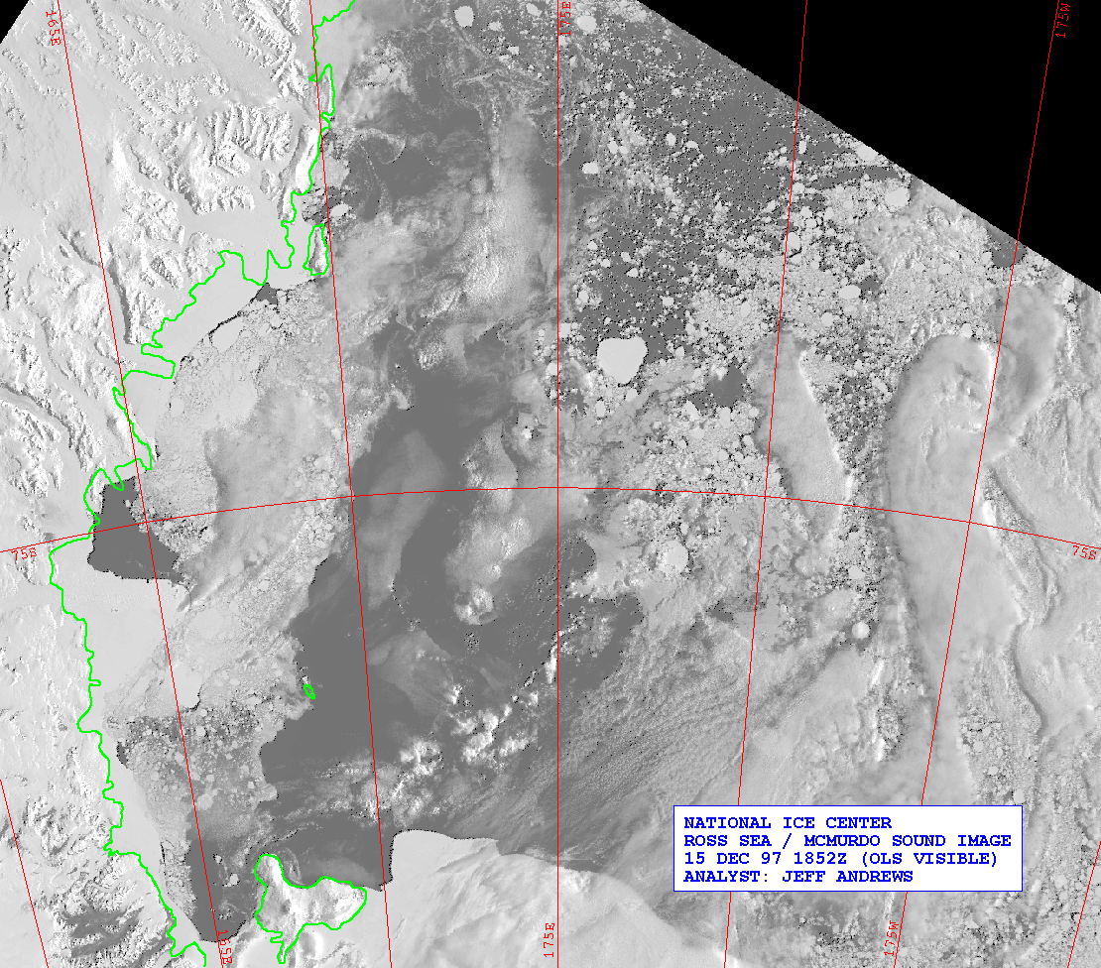
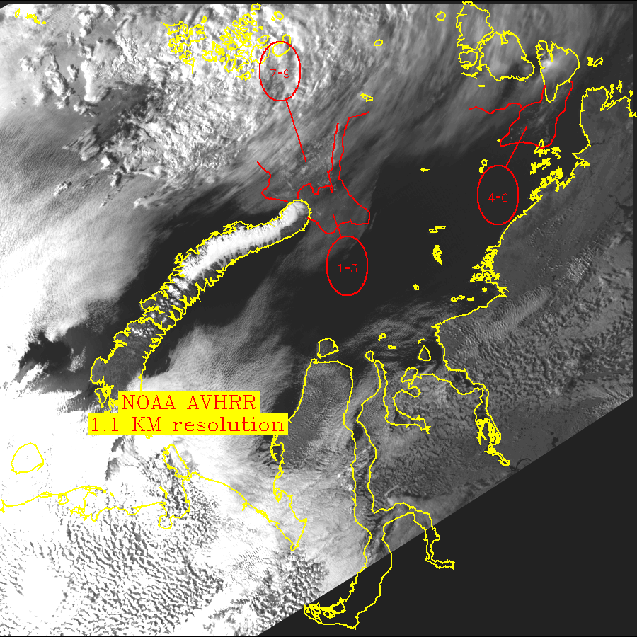
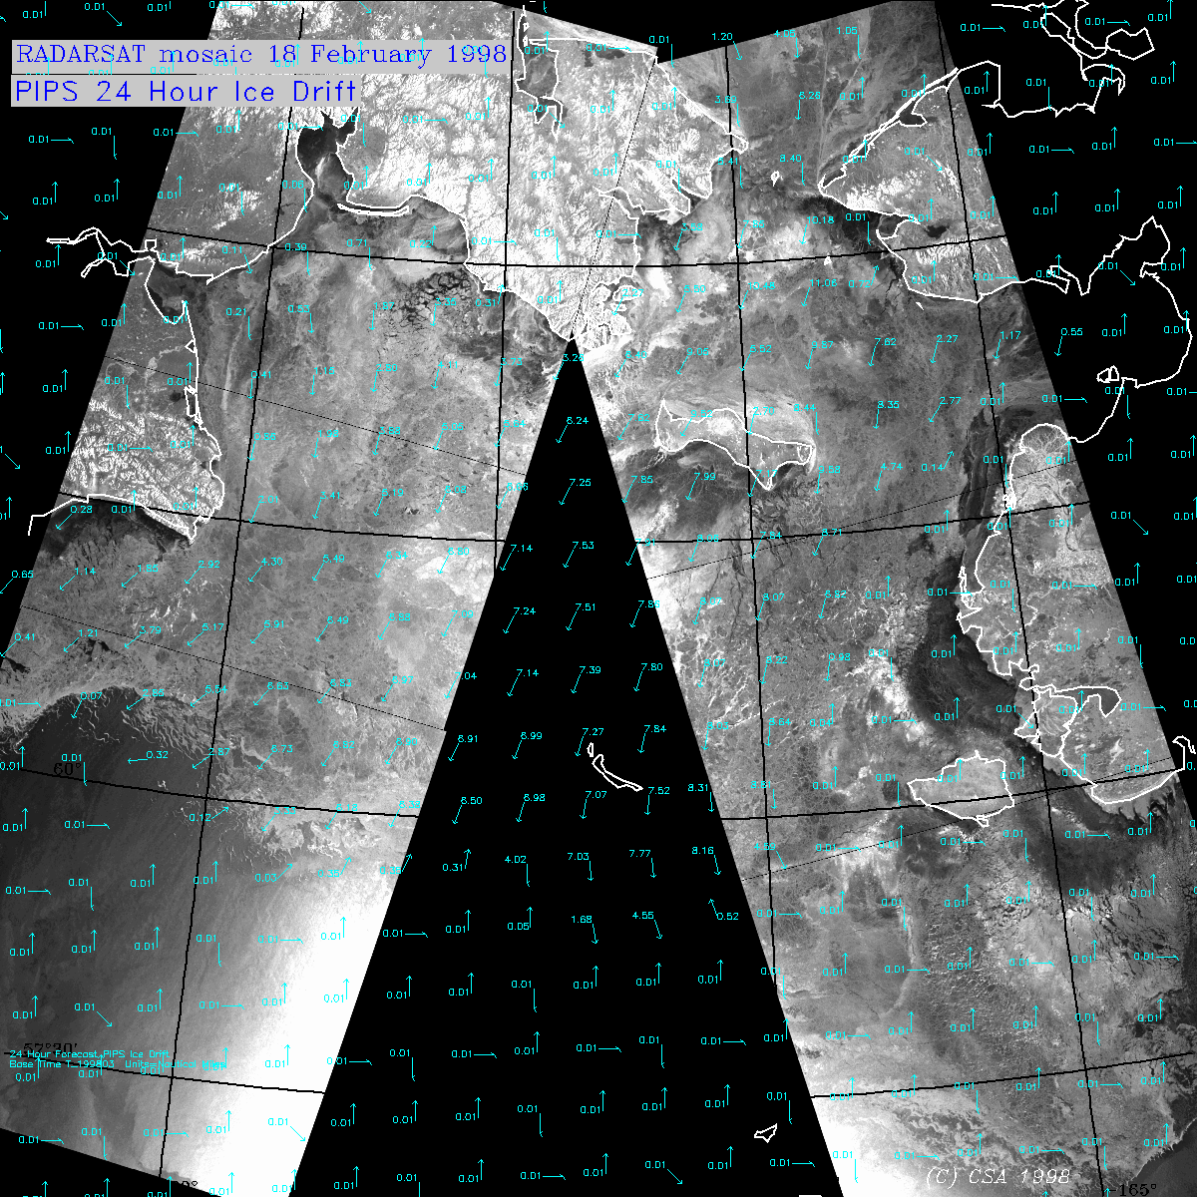
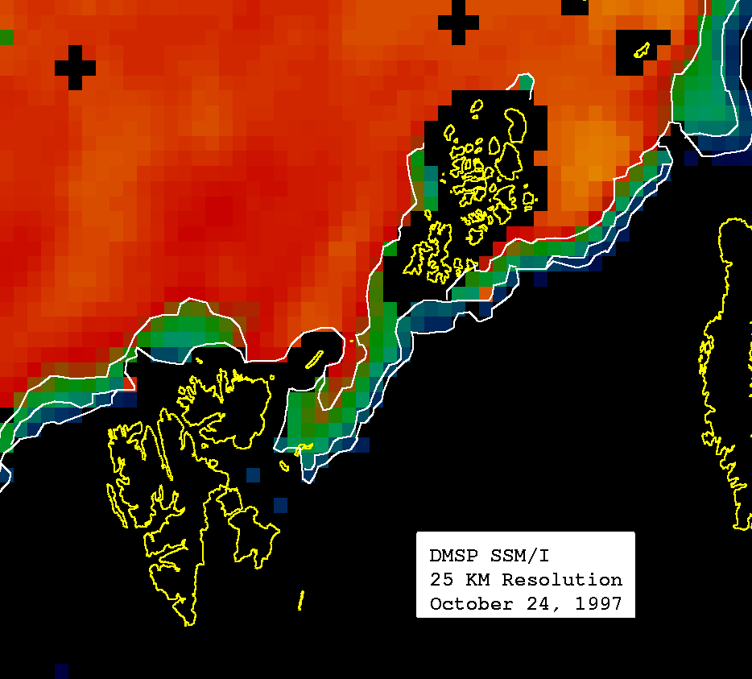
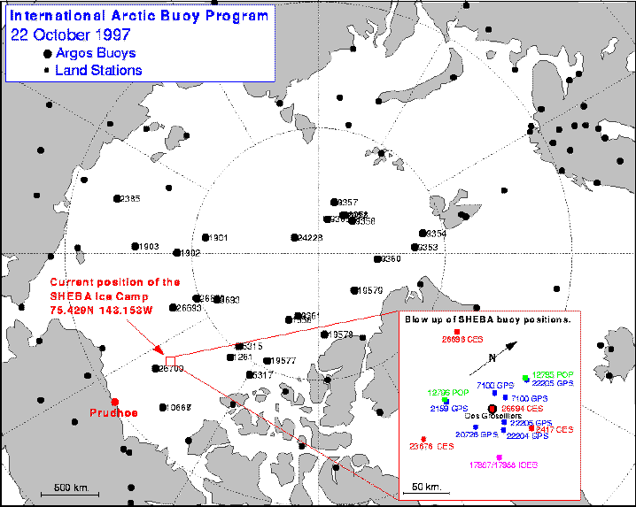
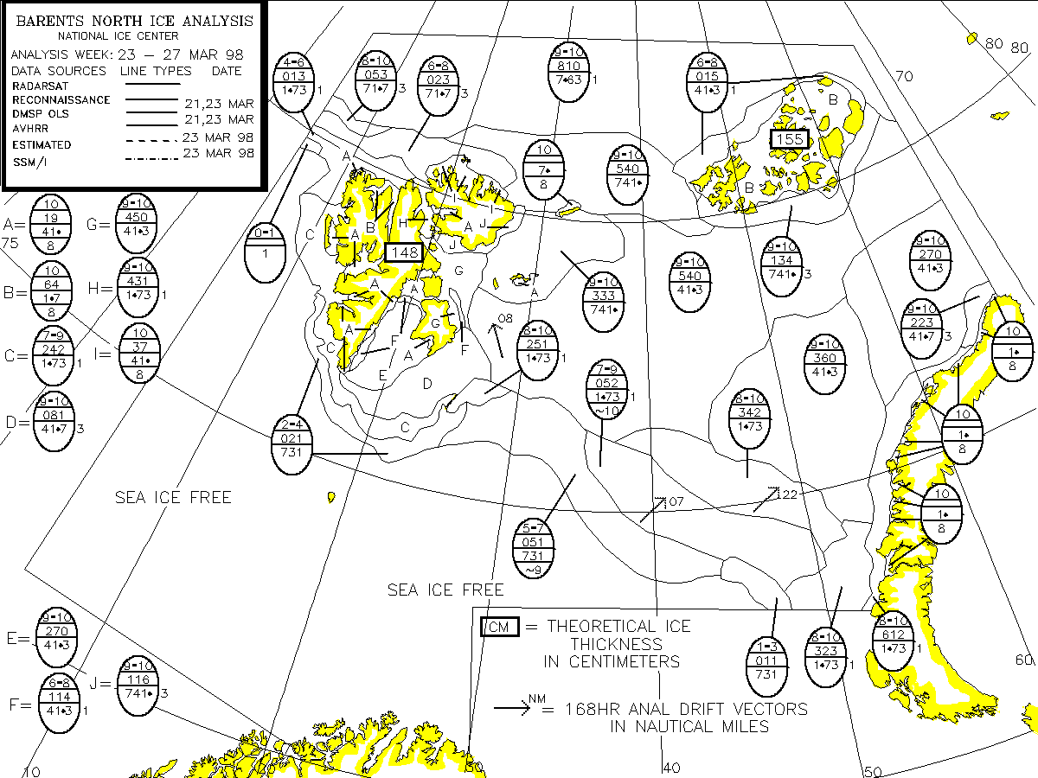
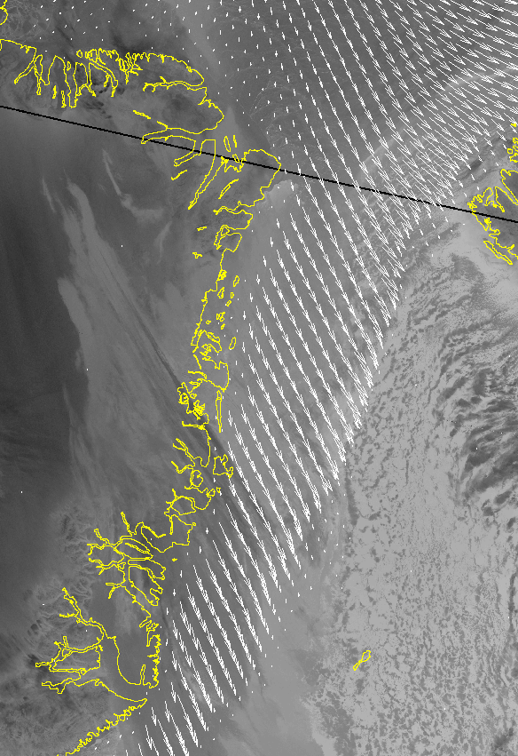
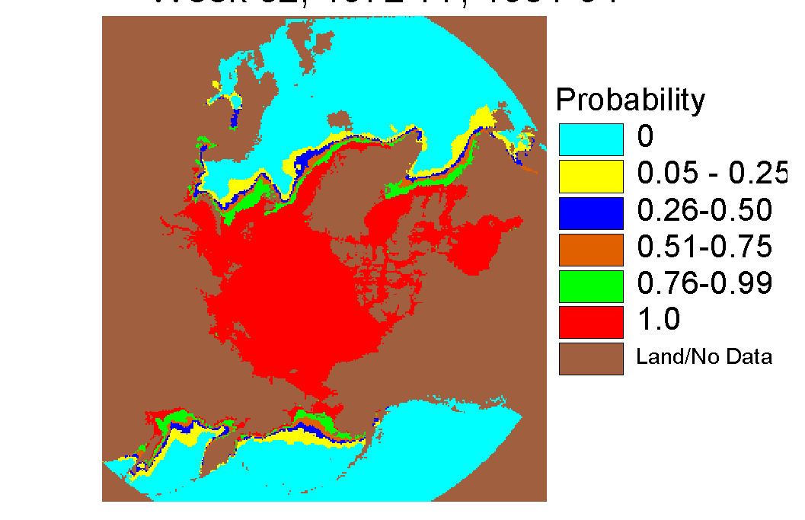
5
4
3
2
0
Climatology
DMSP OLS 2 GB/day
AVHRR 2 GB/day
RADARSAT 0.8 GB/day
DMSP SSM/I
Ice concentrations
New NIC chart
PIPS
Previous
NIC chart
Analysis
Analysis
Analysis
Analysis
Quality checking
Preparation
1
Weather

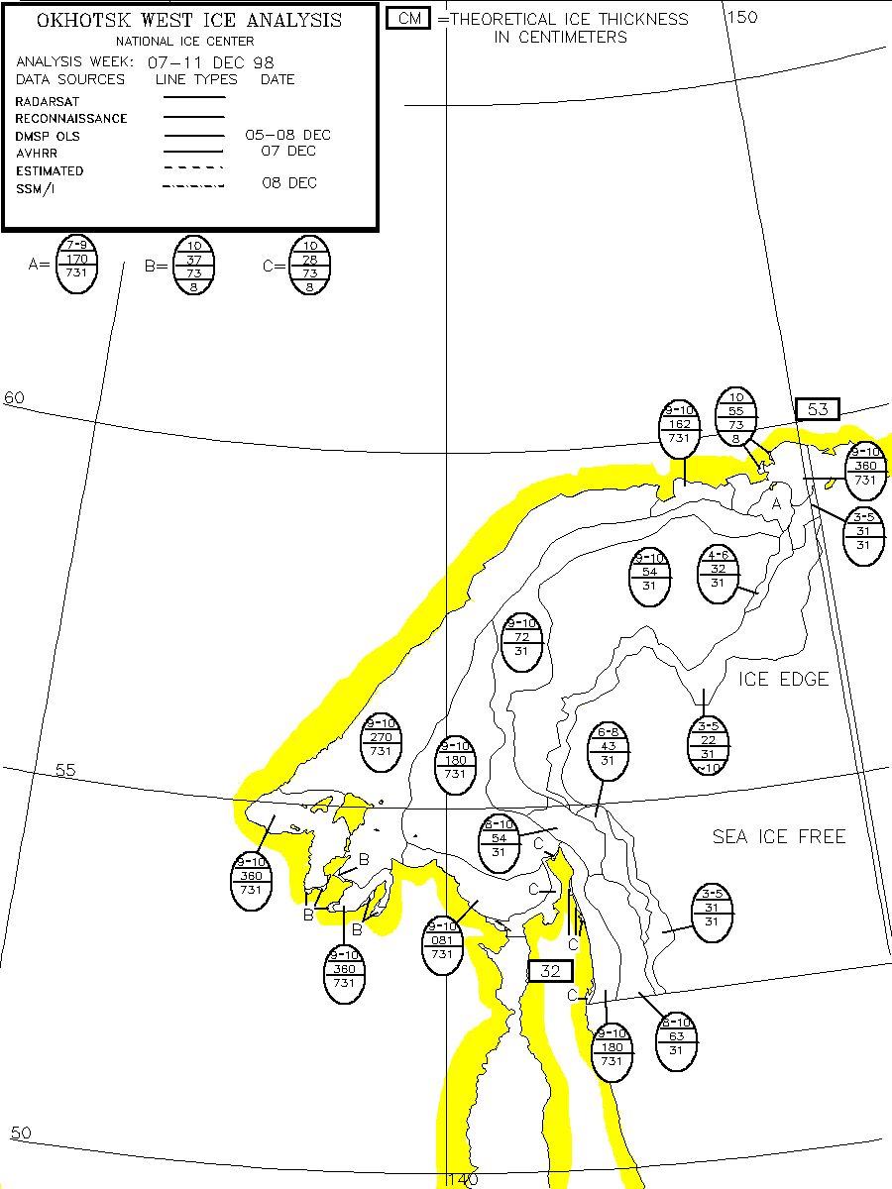
NASA Team
> CALVAL
CALVAL >
NASA Team
No difference
-5 to 0%
-10 to -5%
-15 to -10%
<-30%
-20 to -30%
-20 to -15%
+5 to 0%
+10 to +5%
+15 to + 10%
>+30%
+ 20 to + 30%
+ 20 to + 15%
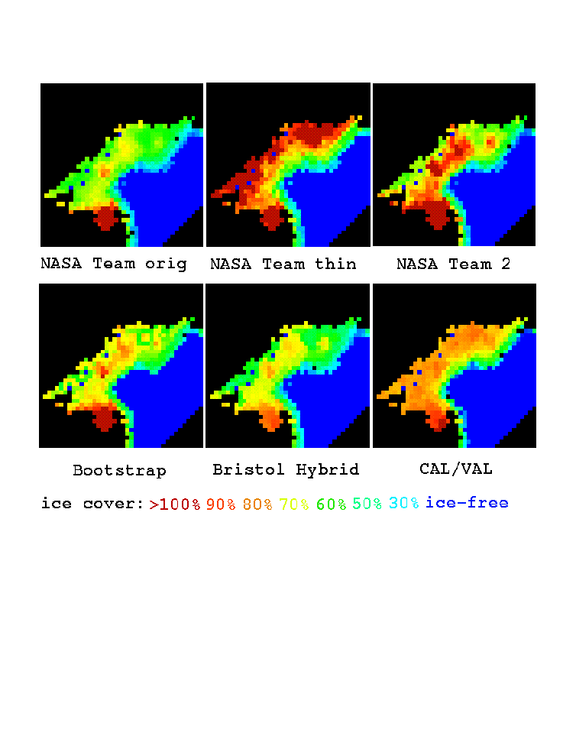

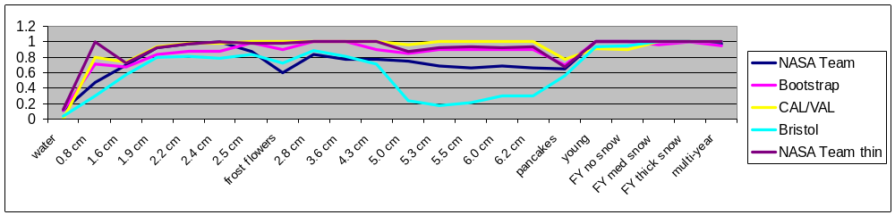
1
5
3
0
4
2
Climatology
“Partial” ice chart
DMSP OLS
2 GB/day
AVHRR 2 GB/day
RADARSAT 0.8 GB/day
New NIC chart
PIPS
Previous
NIC chart
Analysis
Analysis
Analysis
Quality checking
Preparation
SI Algorithm

SSM/I brightness
temperatures
SI Algorithm output
Weather

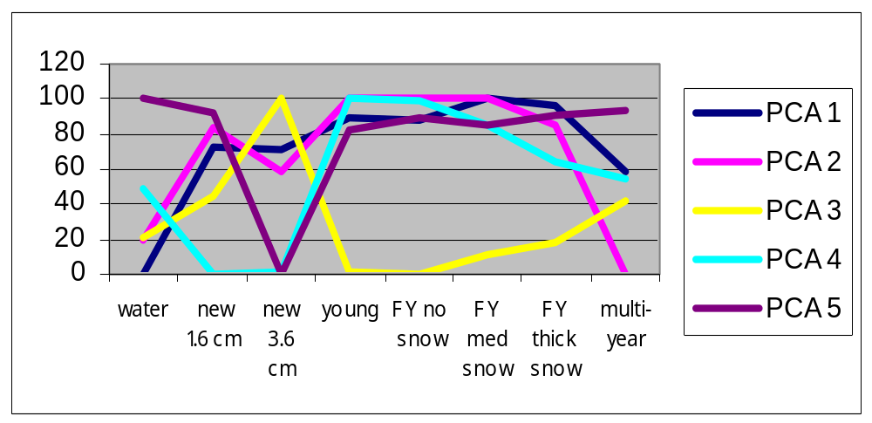

SSM/I brightness temperatures
SSM/I attribute calculations, for C_{T} = Σ(A_{i}d_{i}) for i=0,7
d₀=1
d₁= PC 3
d₂= PC 4
d₃= PC 5
d₄₋₅= NASA Team partial concentrations
d₆₋₇= Bootstrap partial concentrations
Iterative, linear least squares fit to generate A_{i} coefficients
Interpolation of ice concentration C_{T} over “no data” area of partial ice chart
Partial ice chart concentrations
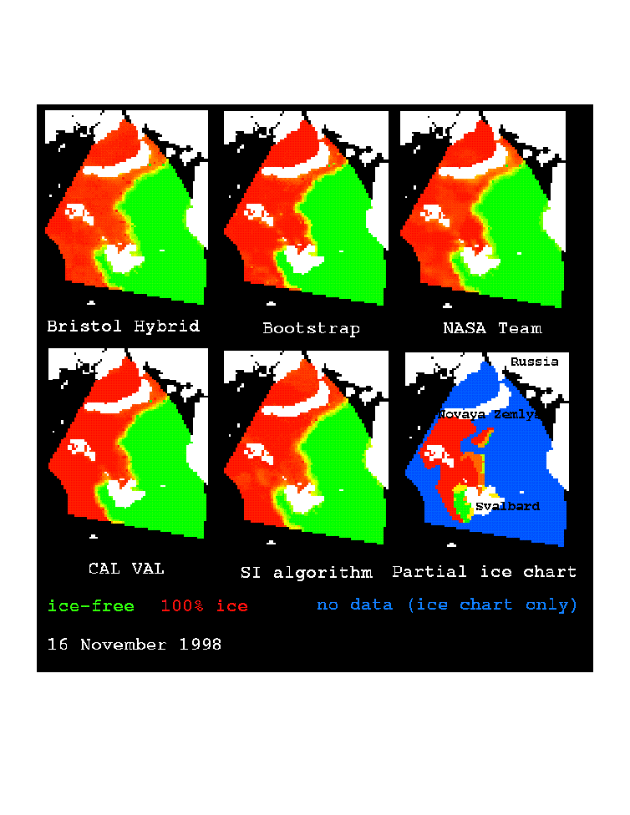

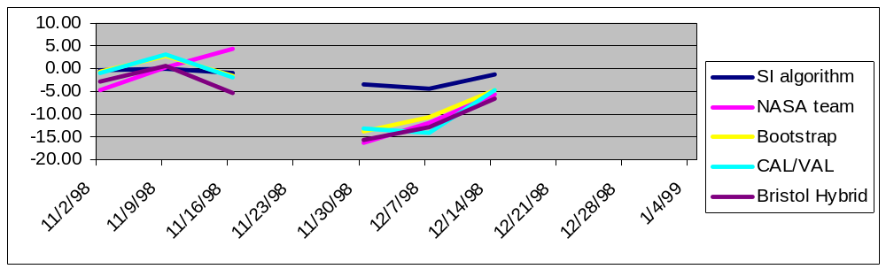

Mean concentration
difference (%),
ice chart minus
algorithm
Date

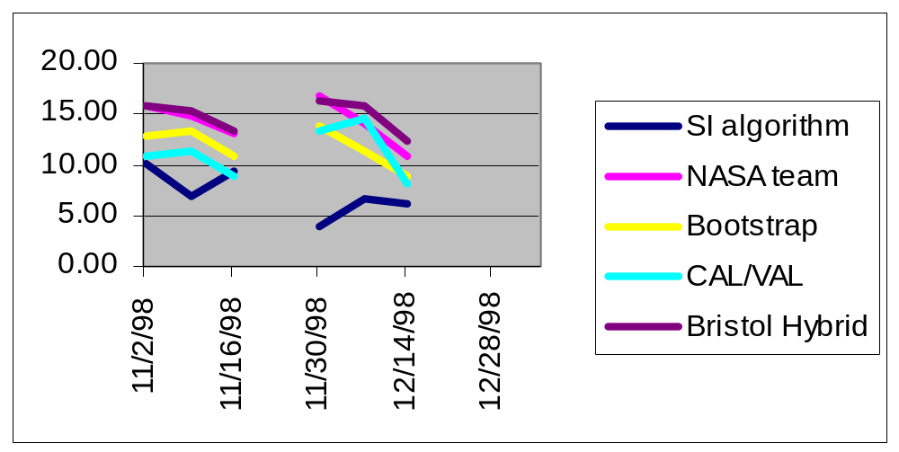

Mean absolute ice
concentration difference (%)
between ice chart and algorithm
Date
Figure 12.
Figure 13.

Ice
Concentration
(tenths)

Normalized
Intensity

Surface type

Surface type
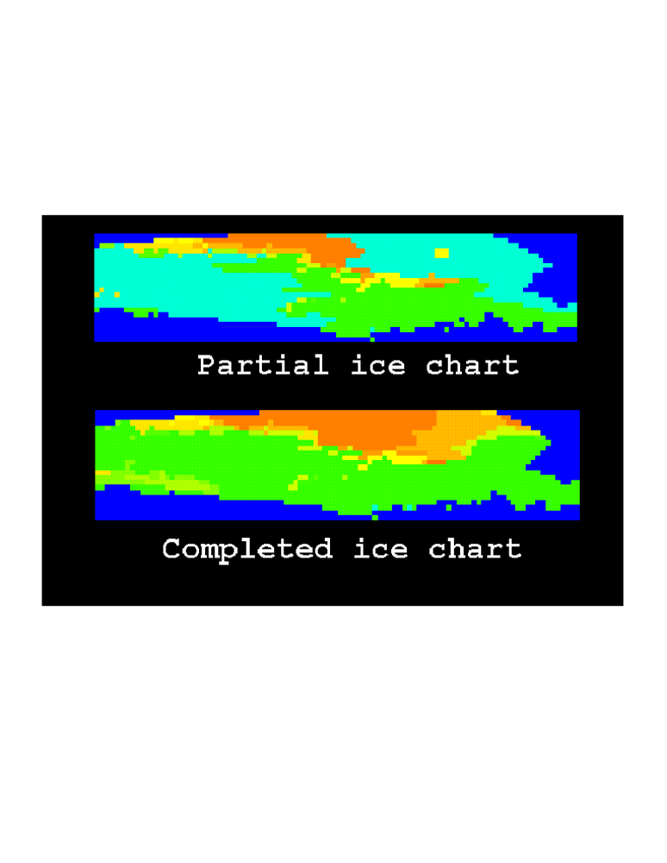
Extra figure.

