PART 8. CONTINUOUS IMPROVEMENT PROGRAM

1. Introduction
On March 7, 2003, Dr. Bryant Cramer gave a presentation on the EO-1 Continuous Improvement Program (CIP) at the 17th annual NASA Continuous Improvement and Reinvention Conference. This presentation represented GSFC’s contribution to this awards program. His presentation was very well received and as a result the EO-1 Mission received a NASA Continuous Improvement Award. The following is a photograph of Dr. Cramer receiving the award.
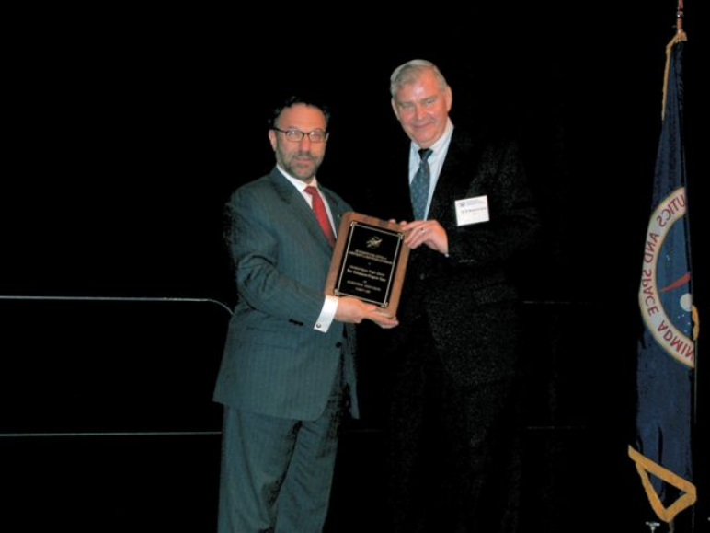
2. Overview
Let it first be emphasized that the CIP is International Standards Organization (ISO) based and it is a process focused on continually increasing the effectiveness of the management organization. The motivation for doing this is to enhance the dissemination of EO-1 imagery to enable more infusion opportunities for its technologies into future missions. In other words, the objective is to get EO-1 imagery into the hands of as many people as possible, so as to maximize infusion opportunities.

To reach this objective, the CIP was divided into four phases as shown in Figure 1. Phase 1, known as “Accelerated Mission”, started at launch and proceeded through the first six months of the mission. The goal of Phase 1 was to accelerate the rate at which the validation objectives were met. It was successful and enabled Phase 2, known as “Public Access”.

Phase 2, Public Access, had two goals: The first goal was to substantially enlarge the user community and the second goal was to substantially reduce the cost of a data collection event (DCE). A DCE is a set of three images simultaneously taken by the three instruments (ALI, Hyperion, & LEISA Atmospheric Corrector) on the EO-1 spacecraft.

Phase 3, known as “SensorWeb/Test-Bed Technology Development”, is devoted to new applications and takes advantage of the enlarged user community produced by Phase 2 to explore new opportunities for the infusion of EO-1 technologies.

Phase 4, known as “Virtual Observatory”, has the objectives to reduce the cost of EO-1 operations by increasing the use of automation and to reduce the overall price of delivered data.

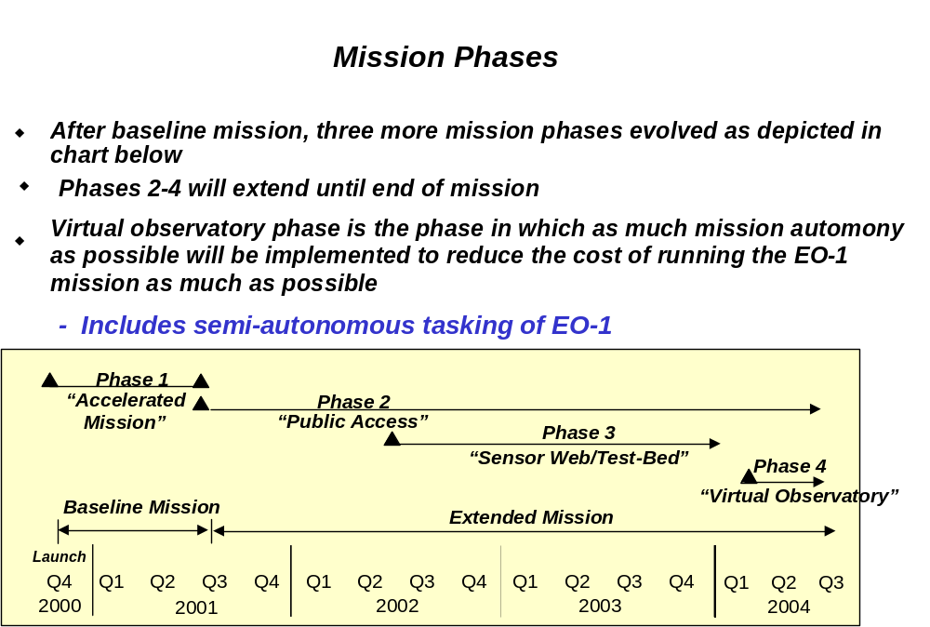Given this short overview, specific information follows on how the continuous improvement program was accomplished.

Figure 1. Continuous Improvement Program Time Line

3. Mission Description
The EO-1 Advanced Land Imager (ALI) remote sensing instrument was designed with five to ten times better signal to noise ratio than its predecessor on Landsat 7. Yet EO-1’s ALI uses one quarter the power, takes up one fourth the space, and has no moving optical parts that makes it more reliable. And all of this is accomplished for half the cost.

EO-1 also possesses the first hyperspectral imager ever flown in space. The Hyperion imager was designed with 220 spectral bands compared to 10 bands on the ALI. These additional bands provide finer detail of many scientifically significant land features. For example, features on the Earth’s surface have distinctive spectral signatures, whether they are trees in the forest, crops in the field, or minerals lying on the surface. Traditionally, these features have been imaged through multispectral imaging such as the Landsat capability. However, with hyperspectral imaging, due to its many more channels and finer spectral resolution, finer detail can now be see. And this is akin to the difference between the earlier black and white TVs and modern color television. With this capability, both the quantity and quality of these features, such as crop production, can now be estimated. With this capability, management of natural resources throughout the world can be enhanced.

The EO-1 has also demonstrated technical improvements in formation flying, on-board recording, and attitude control. EO-1 has also tested an Atmospheric Corrector instrument for measuring atmospheric disturbances inherent in space imaging data.

4. Phase 1 – Accelerated Mission
To maximize the use of these new capabilities, the first key decision was to compress the high priority objectives into the first three months of the baseline 12 months mission. Hence, this effort was named the Accelerated Mission phase. Successful completion meant that ample time would be available for more risky technology assessments. The GSFC team not only achieved these high priority objectives on schedule, but also completed 90% of all baseline objectives in less than six months.

Figure 2 explains how this was done. The Accelerated Mission process was initiated by addressing the original problem. That is, the calculated reliability of the EO-1 spacecraft, taken from a probabilistic risk assessment completed some months prior to launch, was considered. It shows that the likelihood of completing all of our validation objectives is approximately 0.75. This was judged to be marginal. The problem was then, how could the probability of completing the higher priority objectives be improved.
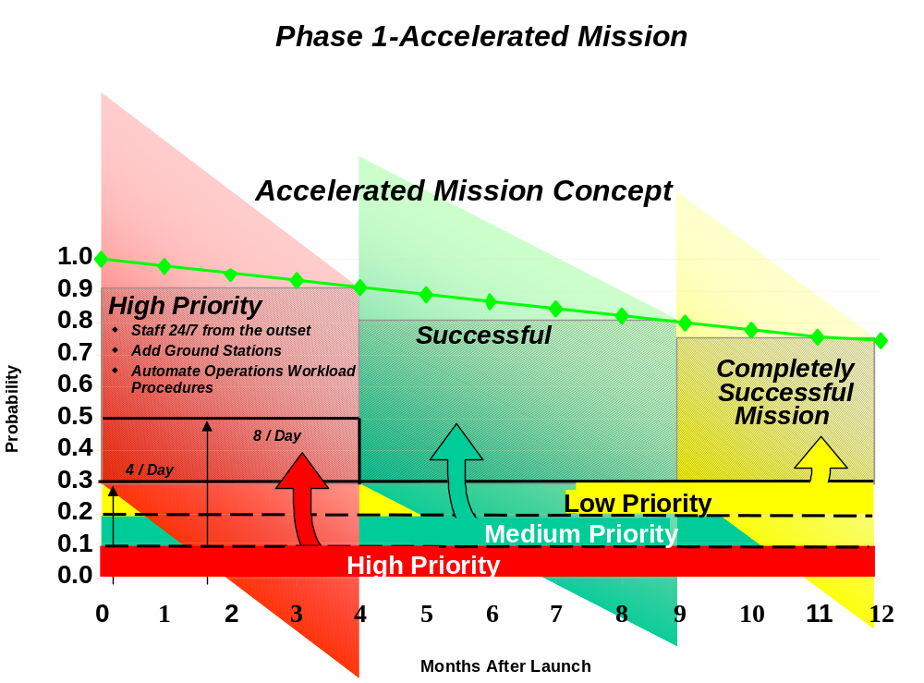
Figure 2. Accelerated Mission Concept

Such an improvement in probability was done in the following way. All of the validation objectives were prioritized into high priority, a medium priority, and a lower priority. Then the high priority objectives were segregated into the first four months of the mission so that they would enjoy the higher reliability associated with that period. The intermediate priority objectives were then segregated into the next five months, and the lowest priority objectives segregated into the last three.

In order to accomplish the high priority objectives, staffing was started at a level of 24 hrs a day and 7 days a week from the outset. For insurance, additional ground stations were added, and an activity was begun immediately to automate the operational procedures. In fact, when this approach was implemented, practically all of the high priority objectives were completed well ahead of the four months target. By the end of six months, there was completed 90% of all that was planned to do; and by the end of 12 months, there were produced over 2,500 Data Collection Events which is two and a half times the sum originally expected.

5. Phase 2 – Public Access
In November 2001, EO-1 reached the 1-year mark of its mission. Armed with its early improvements, the GSFC EO-1 team then devised new goals for the Public Access phase of the extended mission.

The key problem to be solved was to figure out how to make the mission self-sustaining. The budget was projected to go to zero at the end of the baseline mission. So to solve the problem, four areas were attacked. One, it had to be determined how to reduce the overall costs of the mission. Two, the number of scenes acquired per day had to be increased. Three, the turnaround time had to be decreased because some clients needed fast delivery for their products. Four, the total user base had to be increased.

To decrease the cost of the mission, a collaborative partnership was established with the U.S. Geological Survey (USGS). They have a site in Sioux Falls, South Dakota called the EROS Data Center (EDC) where they have an antenna and processing equipment. Therefore, EDC has the capability to downlink, process, and deliver EO-1 data much faster to clients. EDC is good at servicing remote sensing clients and GSFC is good at operating the satellite. Marriage of these two efficiencies has added up to reduced costs to the mission. Further details of this partnership are presented in Part 6.

To increase the number of images acquired per day, the image sequences had to be streamlined to take advantage of the spacecraft maneuver capability, where the spacecraft can be made to point and shoot off-path. By utilizing this capability, two images can be acquired in the same sunlight period. As a result, the number of images acquired per day increased dramatically from approximately 6 to 20.

Holding workshops and promoting the publishing of science journal articles by the Science Validation Team have increased the user base. For example, there is an IEEE Transactions publication special issue devoted entirely to the EO-1 mission science validation subject. In addition, there are a lot of remote sensing trade journals that are publishing results of the EO-1 mission.

With all of the above improvements incorporated, the overall mission cost has been reduced, numbers of acquired images have increased dramatically, people that need fast delivery are being satisfied, and the EO-1 user base has increased to the point where the mission is almost self sustaining. A single sensor image of just about anywhere on the earth can be delivered by EDC for $500.

Numerous government and industry partners are now taking part in this Public Access phase. The compacted schedule afforded by the Accelerated Mission phase provided opportunities to pursue on-orbit engineering tests that would likely never have been approved in a conventional science mission. With the advanced imaging techniques developed during the baseline phase, continued operations of the EO-1 created even more useful images and permitted new applications to further evolve at increasingly rapid rates and at very low cost.

Two examples of new applications that evolved from increased “public access” relate to the fields of forest inventory and disaster assessment. Typically, forest field workers cover 10-12 miles on the ground per day in a costly and time consuming process. By contrast the EO-1’s Hyperion imager can cover 7.5 km per second with huge potential for more accurate estimates of biomass, consistent forestry measurement from year to year, and significant savings of time and money. As a second example, the EO-1 team was called into La Plata, Maryland to supply images for supporting the area’s tornado disaster assessment activity. This example demonstrates the EO-1’s potential in performing natural hazards analysis. Future possibilities exist in agricultural development, coral reef and coastline protection, and mineral evaluation.

How was it possible to substantially increase the EO-1 product output rate while simultaneously decrease the cost of each output unit by a significant amount? How did the EO-1 team develop what could be the benchmark of mission efficiency through continuous improvement? The EO-1 Mission Management team took EO-1’s continuous improvements from the drawing board to orbit through an innovative application of a widely respected business tool known as The Balanced Scorecard model of Dr. Robert Kaplan and Dr. David Norton as published in the Harvard Business Review of February 1996. A diagram of the methodology is shown in Figure 3.

Vision
Balanced Scorecard
Feedback
Communication
Planning

Figure 3. Balanced Scorecard Methodology

The key feature about EO-1 was change. Things changed rapidly and as an example, a major instrument (Hyperion) was changed out 18 months before launch. When dealing with a team as large as 200 people at its maximum and 480 over the life of the mission, it is not easy to get them to make a major change in direction on a very short notice. So this Balanced Scorecard approach allowed communications to be streamlined and connected management strategies to day-to day activities at all levels in the organization via metrics.

Early in the mission, the management team sought to adopt a more formal approach to continuous improvement. The team liked the Balanced Scorecard technique because they maintained that managing an organization solely through financial spreadsheets is an inadequate approach. It was found that change is the prime mover that drives an organization toward its objectives in a competitive environment.

Consider the above shown four boxes as maturational milestones of an incremental improvement. Initially, the objective must be fully understood and communicated to others so they know their part. Next, finish the planning and proceed with the implementation. Then, what has been done must be periodically reviewed for feedback and the vision modified if that proves necessary.

The Balanced Scorecard tool allows one to manage all of the components of change in a coordinated way. This management tool was liked because it is simple, it is easily understandable, and it kept the mission office focused on what had to be done.

Application of the Balanced Scorecard tool started with a vision. During the first year, the GSFC team sought to accomplish the baseline mission objectives while the EO-1 systems had the greatest reliability. This early-on strategy was critical to the overall plan of creating the opportunity to perform additional technology assessments in the Phase 3 SensorWeb/Test-Bed Technology Development phase.

By the time of launch, an operations plan was established that maximized the likelihood of completing the mission. This was accomplished by time compressing the whole mission and as a result, things, that would normally be done at the end during months 11 and 12, were moved into the first three months. As a result, 90% of the mission was completed in the first 6 months.

This approach produced excess capacity that could be reinvested to develop the follow-on Test-Bed phase of the mission. The reason this was done was to maximize the investment and benefit to the public. As a result, communications were successfully streamlined to match the overall strategy with day-to-day operations and activities.

The GSFC team coordinated communication between hundreds of specialists working for numerous organizations around the world. Through electronic mail, and other informal interactions, they effectively defined the metrics that would measure EO-1’s success.

In terms of planning, the team developed action plans to optimize the key metrics and defined the necessary tasks, such as finding ways to automate the operation procedures and staff the first three months at 24 hours a day and 7 days a week.

Finally, the feedback came by measuring and evaluating the results. First year results included the fact that 90% of the baseline mission was completed by the end of the sixth month. Instead of collecting only the required 800 images, over 2000 images were successfully collected in the first 11 months.

EO-1’s continuous improvement process has been reaping benefits. As metrics clearly show in Figure 4, EO-1’s continuous improvements include a drastically reduced cost per data collection event (DCE) from $7500 to $1100 and most likely it will drop below the goal of $1000.

Phase 2 – Public Access
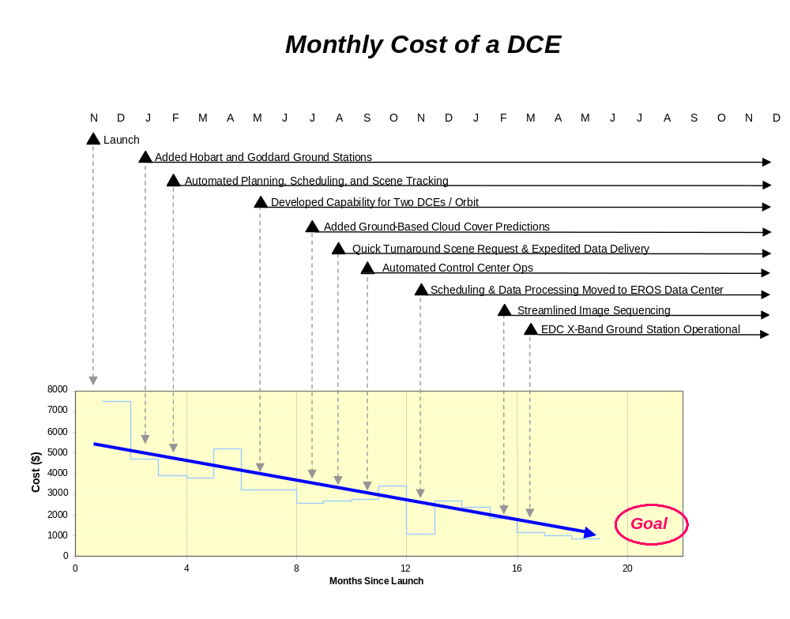

Figure 4. DCE Cost Reduction Process

Since the fourth month, successive iterations of continuous improvements show similar success in reducing mission workload through automation as shown in Figure 5 below.

Phase 2 – Public Access
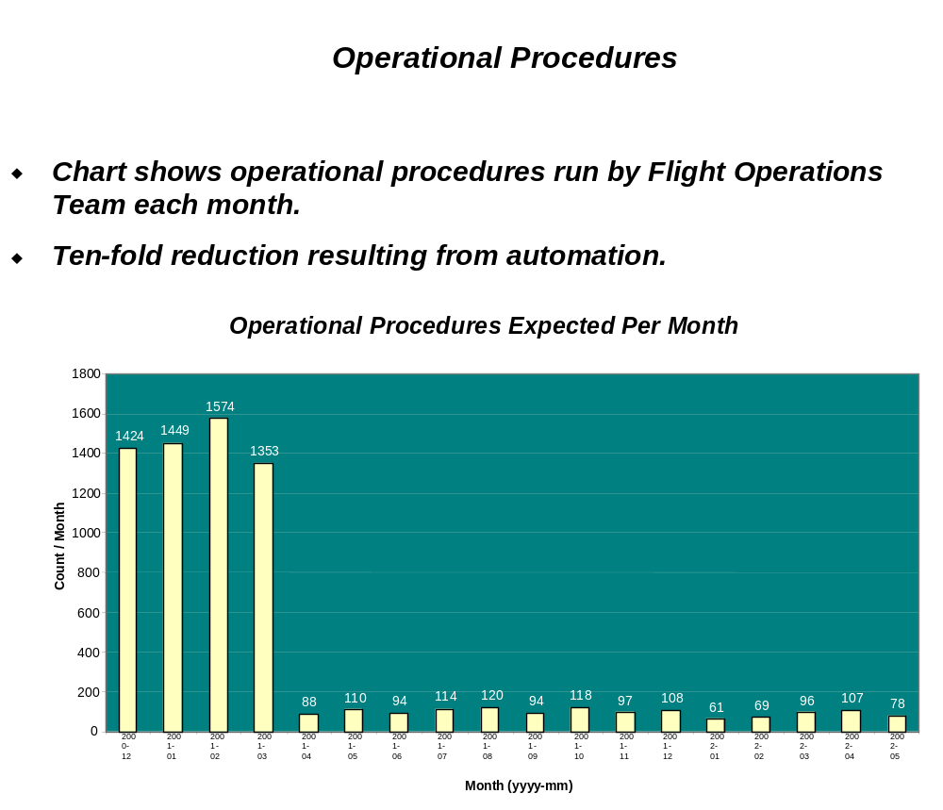

Figure 5. Results of Automating Procedures

A metric shown in Figure 6 illustrates that the GSFC team also reduced image turnaround time by more than 60 % during CY 2002 alone. During the last 7 months of CY 2001 plus all of CY 2002, multiple iterations of data collection demonstrate continuous improvement in the number of images produced by EO-1 as demonstrated in Figure 7. Another metric in Figure 8 shows that the number of users accessing these images nearly doubled during CY 2002.

Phase 2 – Public Access
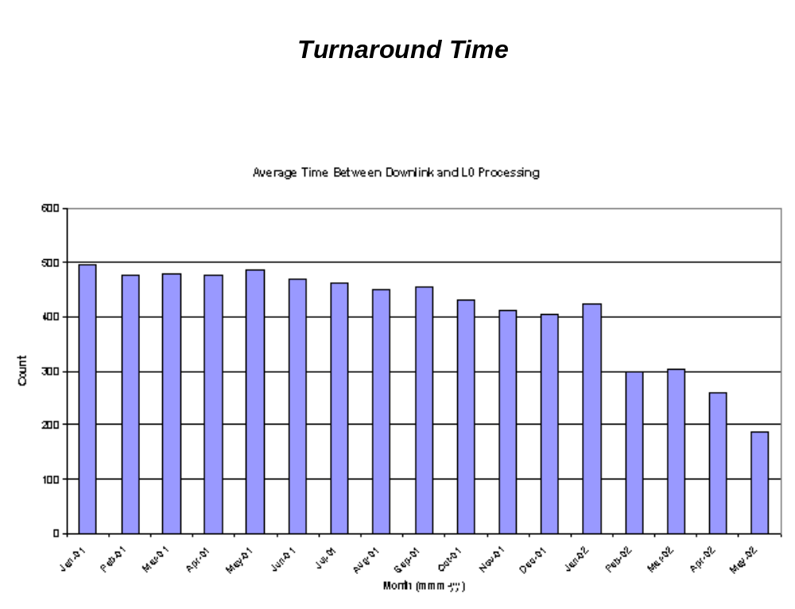

Figure 6. Turnaround Time

Phase 2 – Public Access
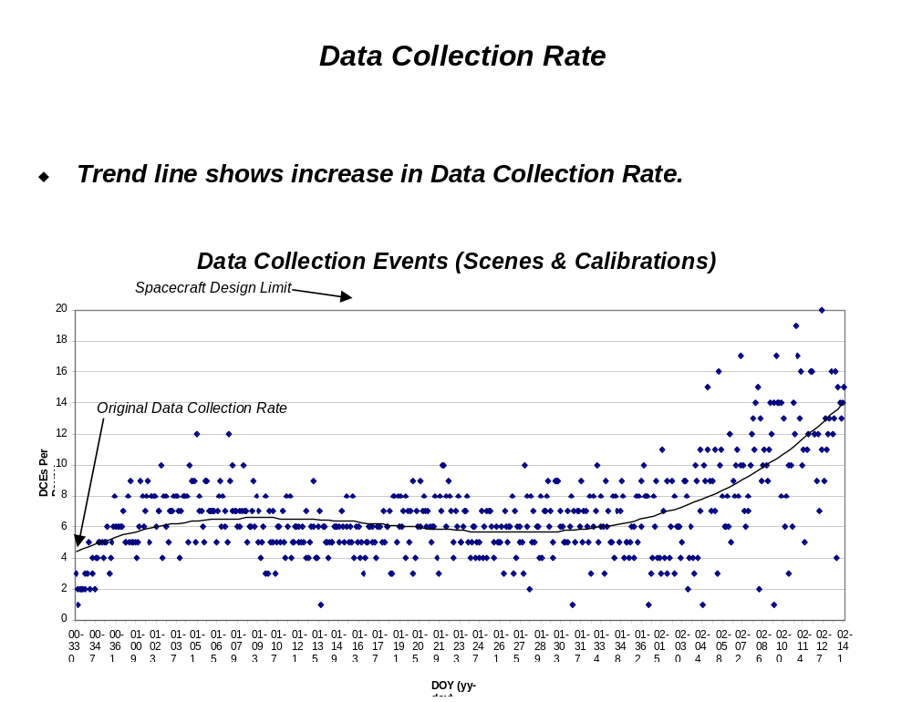

Figure 7. Data Collection Rate (DCE per Day)

Phase 2 – Public Access
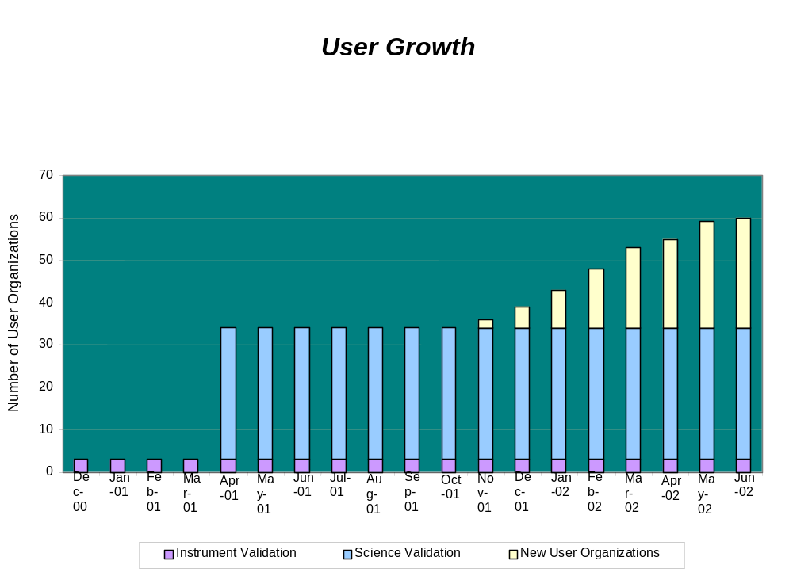

Figure 8. User Growth

6. Phase 3 – SensorWeb/Test-Bed Technology Development
Phase 3 seeks to capitalize on the expanded user community developed under the preceding Phase 2 – Public Access phase to explore new applications for EO-1 technologies. Specifically, the purpose of Phase 3, which started 19 months after launch, is to use EO-1 as a test-bed to validate some key concepts necessary to implement sensorwebs in the future. Figure 9 shows the concept validation activities thus far initiated with color-coding to show which activities are funded and which are proposed. The motivation for pursuing this phase is based on the belief that some of these new applications will develop into infusion opportunities for EO-1 technologies. For example, as shown, the EO-1 team has developed an on-board cloud detection algorithm that operates in real time that can both greatly decrease the number of cloudy images which would be subjected to unnecessary costly full processing and also increase the number of cloud free images taken by utilizing autonomous rescheduling. See Part 16 – Appendices, Item 13 for a paper that documents the successful flight validation of the cloud detection algorithm.

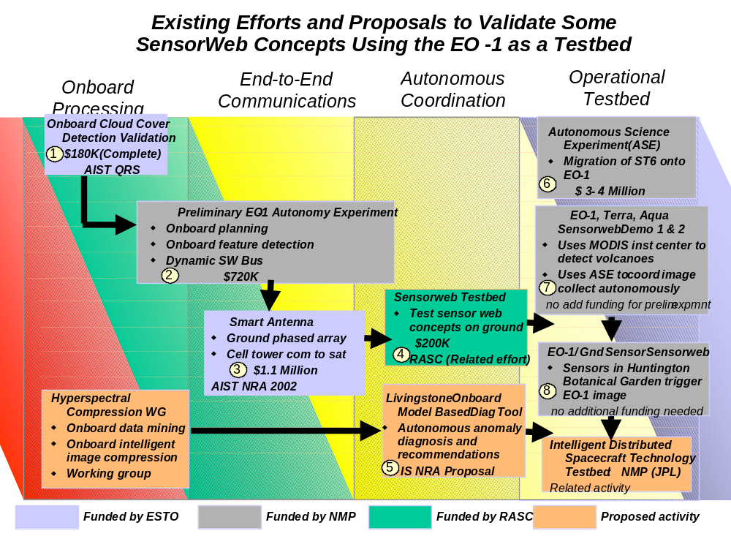Phase 3 – SensorWeb Test-Bed Technology Development

Figure 9. EO-1 Test-Bed Activities

The key capability necessary to enable the performance of the Preliminary EO-1 Autonomous Experiment is to create a mission wide, end-to-end information bus that performs like the internet. A user should be able to send a message to any software task used on the mission (whether space or ground) by naming it and the sensor web system should take care of the details. Once this end-to-end information bus is available, then progressive mission autonomy is easily created by writing scripts and using various autonomy applications on top of this messaging system. To optimize this messaging system mission-wide, the space to ground interface must be seamless and also the spacecraft-to-spacecraft interface must be seamless. An important concept is that the messaging system sits on top of any protocol whether it is TCP/IP or any other protocol For example, if you make a phone call, all that you care about is that the phone call gets to the targeted party. The phone call may be routed through the internet and two other phone systems. Finally, these capabilities can be used to group a set of unrelated satellites and for some arbitrary time declare them a functional constellation such as is the case for the “Morning Constellation” with the key difference being that they act functionally uniform as is the case with many disparate functions on the internet.

For the purposes of these activities, the messaging system is being called a “Dynamic Software Bus”. It is built on top of the existing EO-1 software bus that is a static software bus. The key added feature being added is the “Dynamic” ability to plug new applications in, whether on the satellite or on the ground and have the system recognize the application by name. Applications added to this system, such as the CASPER onboard planning system, enable the larger concept of Dynamic Resource Management whereby this distributed constellation system takes care of many of the details of allocating and managing resources. In an initial demonstration, a part of the EO-1 tasking process will be handled onboard by CASPER that will plug into the dynamic software bus that was implemented on EO-1. Figure 10 shows the conceptual layout of a mission-wide dynamic software bus. Color coding cross correlates activities related to Figure 9.
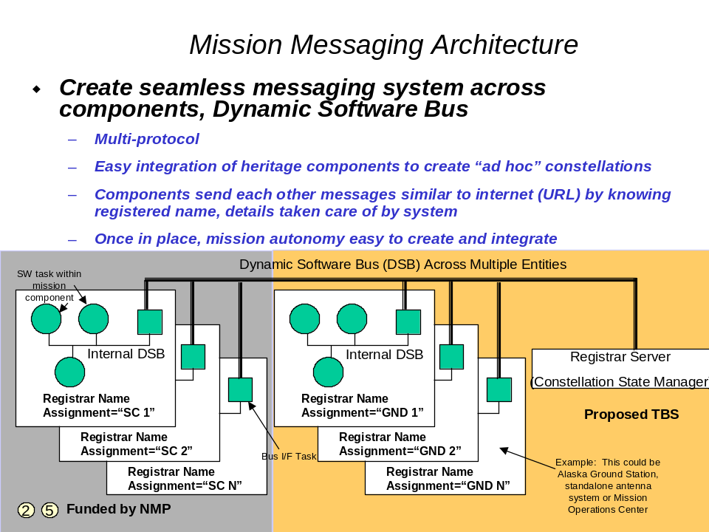

Figure 10. Mission-wide messaging system to enable progressive autonomy

Figure 11 shows how software can be added to convert the EO-1 software bus, being performed by Spacecraft Control language (SCL), into a dynamic software bus. The key capability is the ability to easily plug in new applications while EO-1 is on-orbit and having the EO-1 flight software recognize the software. Figure 12 shows the top level architecture of how CASPER, the onboard planner, is “plugged-into” the dynamic software bus.

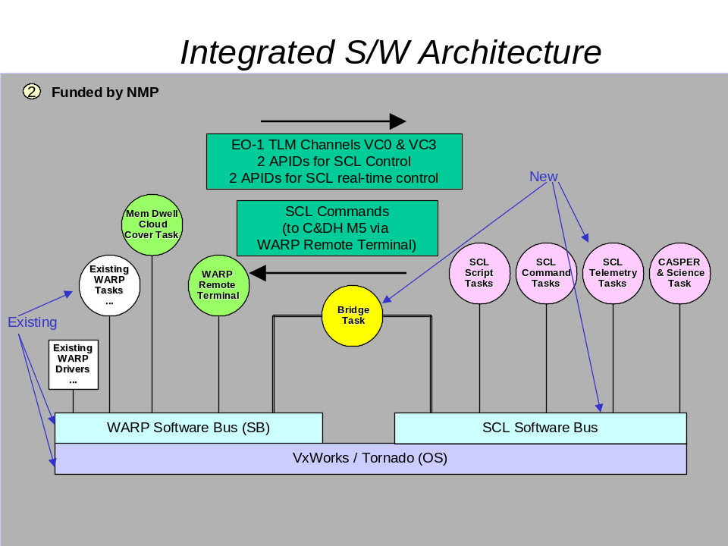
Figure 11. Depicts the adding of software to create a dynamic software bus on EO-1

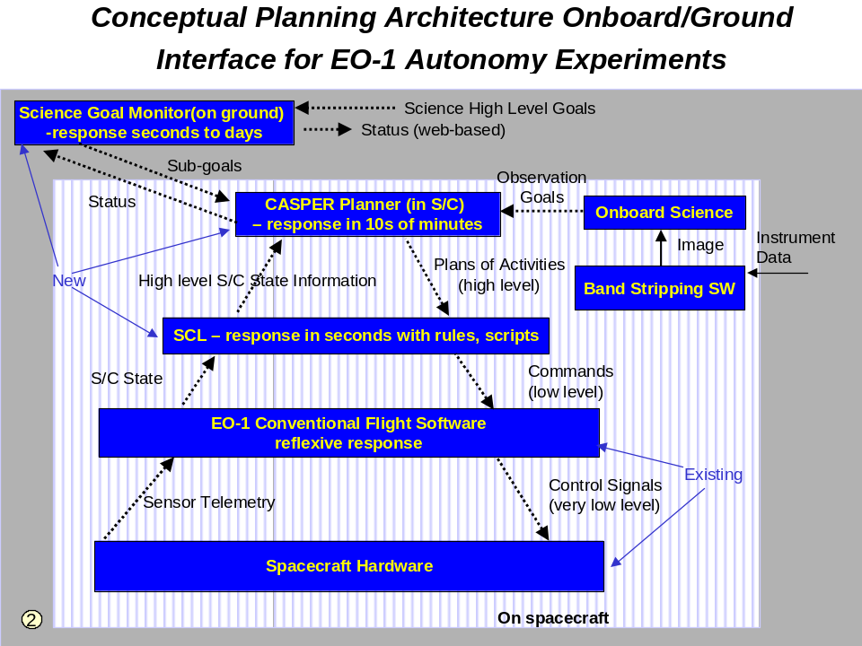

Figure 12. Depicts planning architecture being developed on top of dynamic software bus

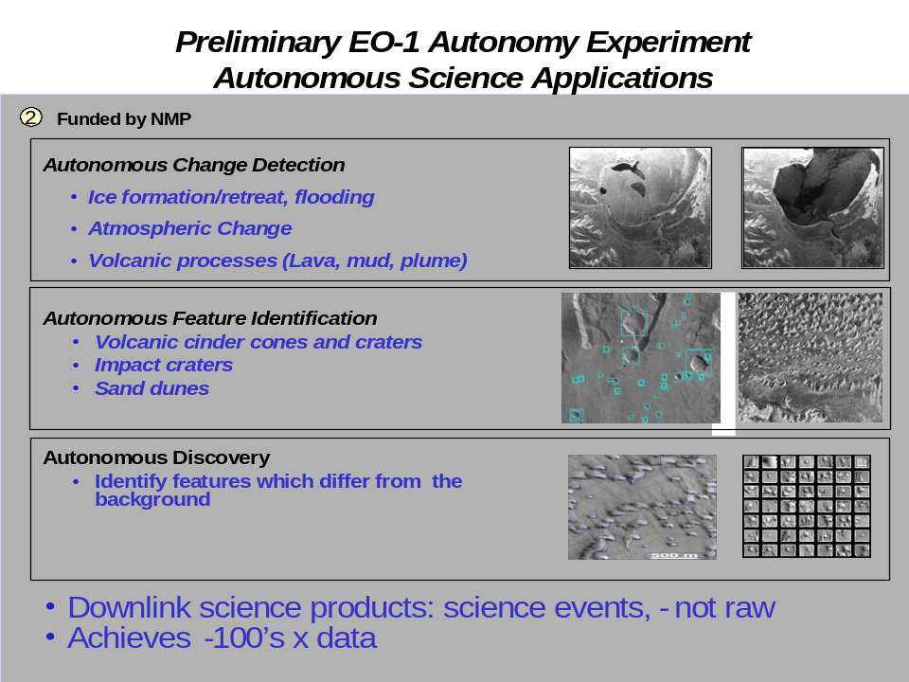
Figure 13 is a representative set of types of experiments that will be conducted once the CASPER system is installed on EO-1. Furthermore, once CASPER is onboard, some rudimentary sensor web experiments will be run whereby observations on EO-1 are triggered by some key MODIS instrument observation such as forest fires and volcanoes. EO-1 would be triggered to semi-autonomously take a closer look. JPL is also participating to have an EO-1 observation triggered by a ground sensor web if certain flood conditions occur.

Figure 13. Some of the planned types of experiments once CASPER is installed on EO-1

Another concept was studied to overcome a problem hindering the implementation of sensor webs due to the limited contacts that exist for low earth orbiting satellites. If a user wants to message a low earth orbiting satellite at present, there is a limitation of 4 –8 ea. 10 minute passes for satellites such as EO-1. This does not lend itself well to the concept of having a messaging system that can access a satellite from anywhere in the mission at any time. Therefore, there is an effort to develop a concept of inexpensive, ground-based hybrid phased array antennas that would be placed around the country and perhaps the world to provide as close to total coverage as possible, thus making the dynamic software bus for a mission more of a reality. This is especially essential if true progressive autonomy is desired whereby functionality is inserted into an ad hoc constellation mission while on-orbit. This concept is illustrated in Figure 14.

The Preliminary EO-1 Autonomy Experiment activity was conducted wherein an on-board planning system, CASPER, was installed that allowed EO-1 to perform on-board replanning to perform such things as event driven onboard planning. With successful completion of this activity as a prerequisite, a SensorWeb Demonstration activity was performed. The general concept for this technology activity is to demonstrate the ability to autonomously trigger the EO-1 into an onboard DCE replanning mode based on a scene observation made by another spacecraft instrument. As a preliminary demonstration, the TERRA MODIS instrument observation of a forest fire was used to trigger an EO-1 observation. Initially all planning was done on the ground but with all the planning steps automated as much as possible in incremental steps. Figure 15 illustrates SensorWeb Demonstration – Scenario 1 and Figure 16 illustrates SensorWeb Demonstration – Scenario 2.

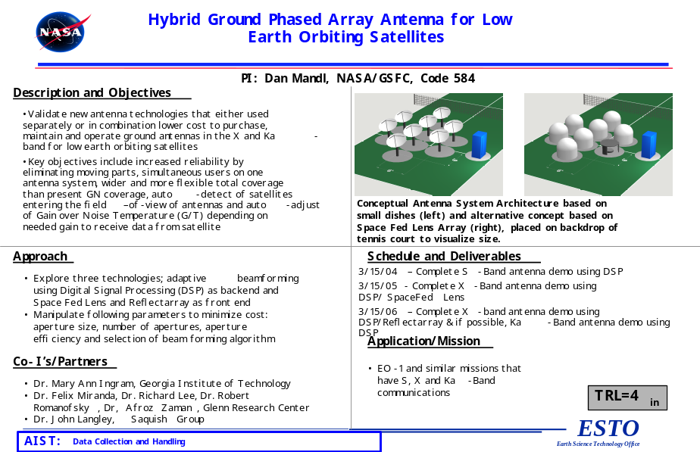

Figure 14. Hybrid Ground Phased Array Antenna Concept

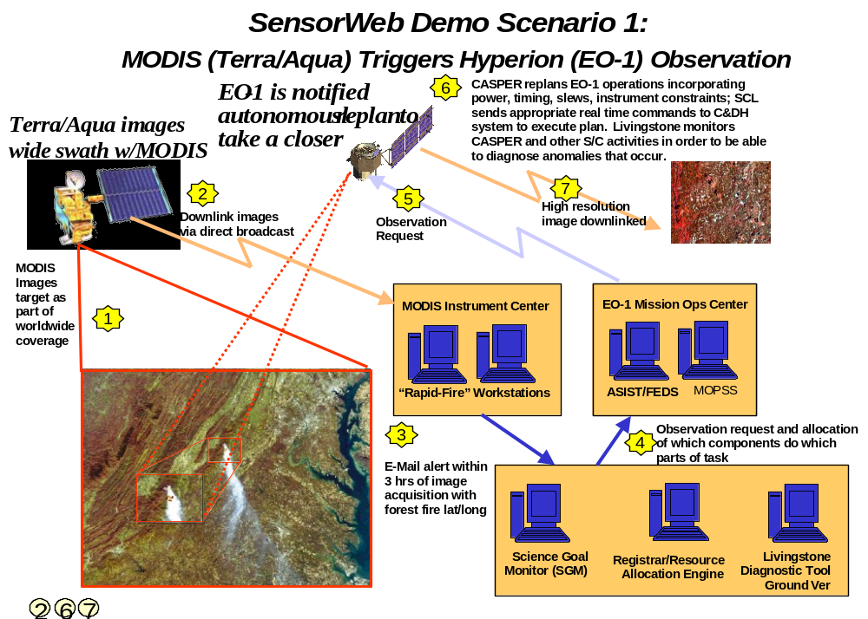Figure 15. SensorWeb Demonstration – Scenario 1

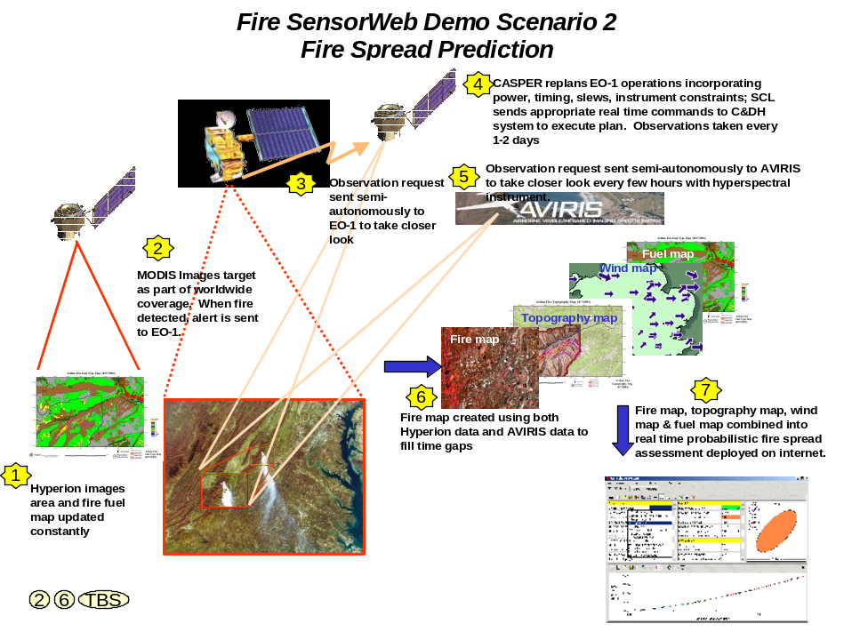

Figure 16. SensorWeb Demonstration – Scenario 2

Not only would all of this improvement technology be infused into future NASA missions, but also it will be widely disseminated to the public through the Internet, scientific publications, and through lectures and public forums.

7. Phase 4 – Virtual Observatory
Phase 4 has two objectives. One objective is to reduce the cost of EO-1 operations by increasing automation both on-board and on the ground. Examples of how to do this are to steadily reduce labor over time by incremental improvements and to run a “lights out” Flight Operations Team with minimal engineering support after June 2004. The other objective is to reduce the price of conducting new sciences studies commensurate with the operations cost reductions. The goal is to reduce the customer price for image acquisition plus delivered data from $2000 to between $500 and $700. The price breakdown goal is $300 to $500 for acquisition and $200 for data. The potential price for archived data is $100.

To streamline EO-1 operations, the following approach was adopted:
- USGS/EDC to convert to a web-based automated scheme for fulfilling user requests and to track orders and delivery.
- NASA/GSFC to implement automation for real-time operations, scene ingest, scheduling, and command load generation.
- Bullet-proof on-board autonomy.
- Fully implement Science Goal Monitor and other web-based interfaces for SensorWeb activities.
In concert with an incremental approach, EO-1 is pursuing increased mission operations autonomy by going into a more fully automated mode using both Automated Scheduling and Planning ENvironment (ASPEN) on the ground and Continuous Activity Scheduling, Planning Execution and Replanning (CASPER) flight software on EO-1. The purpose of this increased automation is to further extend the automation of operations to include the activities of the scheduling and prioritization group which consisted of the USGS National Center for Earth Resources Observations and Science (EROS); EO-1 Mission Science Office; JPL Autonomous Sciencecraft Experiment (ASE) group, which is the group conducting the Volcano Sensor Web experiments on EO-1; and the EO-1 flight operations team (FOT). Normally, this group holds a meeting once a week to plan out the following weeks’ activities by selecting them from a master list of available targets and other engineering and technology activities. In the new more fully automated mode, ASPEN will generate the weekly selected targets at JPL automatically using an internal prioritization scheme developed by the team, thus removing the scheduling group as the middleman between the customers and the actual imaging operations. ASPEN will then uplink the plan to CASPER on the spacecraft via the EO-1 Mission Operations Center (MOC) as the baseline default schedule. Possible daily changes to the schedule can originate from 3 sources – volcano sensor web replacements, Earth Phenomena Observation System (EPOS) which optimizes selections for least cloudy scenes, and last minute priority inserts from the USGS EROS or GSFC. The EPOS system is a system created by MIT Draper Labs through a NASA Earth Science Technology Office NASA Research Announcement award.
Checkout of each interface will be conducted in parallel with each of the two target selection methods, over a period of 4-5 weeks, until the automated system is proven to work.
Here are some individual items that will help clarify the needed procedure changes.
- EROS will send a subset of the Long Term Plan (LTP) records, with appropriate priorities, to JPL (and GSFC) by COB each Monday. The LTP is a list of all desired future targets for the life of the mission. These scenes will not include JPL or GSFC records/selections as those will be ingested directly by the ASPEN system at JPL.
- JPL will generate a weekly selected targets list by COB each Wednesday and send the list to everyone.
- CASPER Goal file(s), containing each day of the week's selected targets, will be uplinked to EO-1 daily as the baseline default observation schedule. These files, generated for CASPER , are abstractions of the full list of commands used to command EO-1 to take scenes. The Goals are ingested by CASPER onboard and as a result, CASPER knows how to control EO-1 to take the desired targets and make decisions on its own based on the observations. The possible daily changes, sent to ASPEN for uplink, can come from the sensor web software (for volcanoes/etc.); EROS or GSFC (priority replacements); and EPOS replacement requests based on evaluated choices for least cloudiness between conflicting scenes of equal priority.
- After each day’s activities are accomplished, the JPL ASPEN software will generate a report telling what activities have been executed on-board that includes all replacements inserted since the baseline schedule was uplinked, and will deliver this report to EROS and GSFC. EROS will update their systems to pick up the new records so they can be processed to Level 0 and deliver, via FTP, any sensor web scenes to JPL in addition to delivering all Level 0 scenes to GSFC for off-site archive backup.
Some required constraints during this initial phase of attaining a more fully automated mode are:
- No Dual scenes
- No Hobart or EDC downlinks
- Last minute replacements are required to have their priority set higher than their
- corresponding default baseline record before being uplinked.

8. Conclusions

EO-1 has experienced four phases of continuous improvement. In Phase 1, GSFC conducted 90% of the validation objectives in only half of the time allowed and went on to gather two and a half times the number of images originally expected.

In Phase 2, the cost of a data collection event (DCE) was reduced from $7500 in the first month to only $843 at the end of the 17th month. The data collection rate was increased from four to 20 DCEs per day, which is essentially the design limit of the spacecraft. And finally, a partnership was forged with the USGS that makes all of the archived EO-1 data publicly available through the Internet for the cost of reproduction and that provides the public the opportunity to order unique images of their choosing.

In Phase 3, new applications for these technologies were explored. The EO-1 Continuous Improvement Program proved to be a powerful and practical tool for enhancing the effectiveness of the EO-1 mission.

In Phase 4, a high degree of mission autonomy was implemented both at NASA/GSFC and at USGS/EDC for on-board and ground operations. This high degree of autonomy resulted in a substantial reduction in mission operations cost and a corresponding reduction in the price structure for image data.

