Guide to Mil-Std-129 Marking for GSA Shipments
TABLE OF CONTENTS

Section 1 Introduction
The Department of Defense (DOD) and Defense Logistics Agency (DLA) require specific markings on vendor related shipments. This guide details marking requirements for shipments to Military activities and consolidation points. Military Standard-129 provides details as to marking requirements on shipping and interior containers.

- 1.1 GSA agreement with DOD for uniform marking requirements.
- 1.2. GSA Marking Clause 552.211-73 MARKING (FEB 1996)
- 1.3. I notice the marking clause cites Federal Standard 123 for products delivered to civilian agencies, how does this differ from 129?
- 1.4. Where can I get an electronic copy of Mil-Std-129P (3)?
- 1.5. The term “Marking” as defined by Mil-Std-129.
- 1.6. Why is the current copy of Mil-Std-129 P (3) 154 pages in length?
- 1.7. I have found much of the information cited in Mi-Std-129 already marked by the manufacturer on their containers. Why can’t I use that information?

Section 2 ID Markings
2. Identification Markings the product container requirement
2.1. Size of markings
2.2. Conditions of surfaces to be marked.
2.3. Legibility, durability and color of markings
2.4. Methods of marking
2.5. Identification bar code machine-readable markings
2.6. Identification bar code markings
2.7. Use of labels
2.8. Labels, paper, pressure-sensitive, water-resistant
2.9. The exact placement
2.10 Specific Identification items required for unit packs and intermediate containers

Section 3 Address Markings

3.1. Address markings (see Figure 4 of Mil-Std-129).
3.2. Military (DoD) and contractor- or vendor-originated address markings (see Figure 4).
3.3. Military Shipping Label (MSL) (see Figure 4).
3.4. MSL size
3.5. MSL stock quality
3.6. MSL Format
3.7. Completing the MSL for address marking
3.8. Data content of the MSL (see Figure 4).
3.9. Is there a government database that will produce a MSL acceptable by the military and Mil-Std-129 requirements?
3.10. Direct vendor delivery (DVD).

Section 4 Hazardous Materials

4. Hazmat Employer Responsibility for Testing and Training (See 49 CFR 172.702 & 172.704
4.1 Hazardous materials.
4.2 HAZMAT marking and labeling requirements
4.3 Proper shipping name and identification number.
4.4 Marking and labeling of multipacks containing HAZMAT
4.5 Marking and labeling of air and water shipments.
4.6 Identifying containers and packagings
4.7 DOT specification and UN performance specification (certification) markings
4.8 DOT exemptions.
4.9 Certification of Equivalency (COE)
4.10 Competent Authority Approval (CAA)
4.11 Documentation for HAZMAT
4.12 Existing palletized unit loads of HAZMAT
4.13 Flash Point Information
4.14 Hazardous chemical warning label
4.15 Kits containing Hazmat
4.16 DOT-E Numbers
4.17 International Maritime Dangerous Goods Code Marking of Packages
Section 5 Foreign Military Sales
5.1 Delegation of Authority
5.2 Laws governing FMS program
5.3 Letter of Acceptance (LOA)
5.4 Regulatory Requirements
5.5 Preservation and Packing of FMS shipments
5.6 Foreign Military Sales (FMS) marking requirements
5.7 Minimum package size
5.8 Multipacks
5.8.1 Unrelated items (multipacks)
5.9 Address markings
5.10 Contractor-originated FMS shipments

Section 6 Shelf Life Marking requirements
6. Shelf Life definition
6.1 Assembled date
6.2 Cured date
6.3 Expiration date
6.4 Inspect/test date
6.5 Manufactured date
6.6 Packed date
6.7 Shelf life code (SLC)
6.8 Shelf life item
6.8.1 Type I shelf life item
6.8.2 Type II shelf life item
6.9 Supply Condition Codes for Shelf life items
6.10 Shipping tags
6.11 Shelf life markings
6.11.1 For Type I shelf life items
6.11.2 For Type II shelf life items
6.11.3 Example markings
6. 11.4 DD Form Extended shelf life notice

Section 7 Supporting Documentation

7. Mil-Std-129P (3) references DOD 4500.9, where can I access this information?
7.1. Chapter 202, Cargo Routing And Movement

7.2. Chapter 203 Shipper, Transshipper, And Receiver

REQUIREMENTS AND PROCEDURES
Section 8 Figures
Figure 1 ASSIST Database for Military Specifications & Military Standards
Figure 2 ASSIST Website Example
Figure 3 Non-Hazardous Identification Markings
Figure 4 Military Shipping Label (MSL)
Figure 5 UN Certified Packaging
Figure 6 Hazardous Material Package Marking
Figure 6A Typical Solid Hazardous Materials Marking
Figure 6 DD250 Form
Figure 7 DD250 Continuation Form
Figure 8 Packing List Illustration
Figure 9 ID Markings with Shelf Life markings
Figure 10 DD Form 2477, Extended Shelf-Life Notice

Guide to Mil-Std-129 Marking for GSA Shipments
SECTION 1 INTRODUCTION

  - . GSA agreement with DOD for uniform Marking requirements on containers.
Under an agreement with the DOD/DLA, GSA will provide our Military customer the marking information needed to track, store and ship products worldwide by citing in our GSA contracts, marking clause 552.211.73 invokes the Mil-Std-129 requirements. The clause follows in its entirety.

1.2. 552.211-73 MARKING INCLUDING SHIPPING DOCUMENTS (FEB XXXX+) 511.204
(a) General requirements. Interior packages, if any, and exterior shipping containers shall be marked as specified elsewhere in the contract. Additional marking requirements may be specified on delivery orders issued under the contract. If not otherwise specified, interior packages and exterior shipping containers shall be marked in accordance with the following standards.
(1) Deliveries to civilian activities. Supplies shall be marked in accordance with Federal Standard 123, edition in effect on the date of issuance of the solicitation.
(2) Deliveries to military activities. Supplies shall be marked in accordance with Military Standard 129, edition in effect on the date of issuance of the solicitation.
(b) Improperly marked material. When Government inspection and acceptance are at destination, and delivered supplies are not marked in accordance with contract requirements, the Government has the right, without prior notice to the Contractor to perform the required marking, by contract or otherwise, and charge the Contractor, therefore at the rate specified elsewhere in this contract. This right is not exclusive, and is in addition to other rights or remedies provided for in this contract.

1.3. I noticed the marking clause cites Federal Standard 123 for products delivered to civilian agencies, how does this differ from 129?

Other government customers use the GSA Advantage and the Global Supply Websites to purchase products from GSA. The 123 standard is different in several ways, one noted here is the 129 requirement for a military shipping label. However, a percentage of the products going into our GSA Distribution Centers are ordered by our military customers and must be marked in accordance to Mil-Std-129 requirements as identified in our contracts. Commercial vendors mark containers shipped to government agencies other than DOD/DLA agencies using the requirements of Fed-Std-123. Much of the 123 information parallels 129 requirements.

1.4. Where can I get an electronic copy of Mil-Std-129P (3)?

The following information provides the details of securing an electronic copy of the current Mil-Std-129. Earlier additions are available also on this site. Contract requirements are based on the time the contract is awarded. Use of a more current Mil-Std-129 then the time of award is encouraged. The website is http://assist2.daps.dla.mil/quicksearch/ . Open the site and click on Quick Search. See illustrations below.

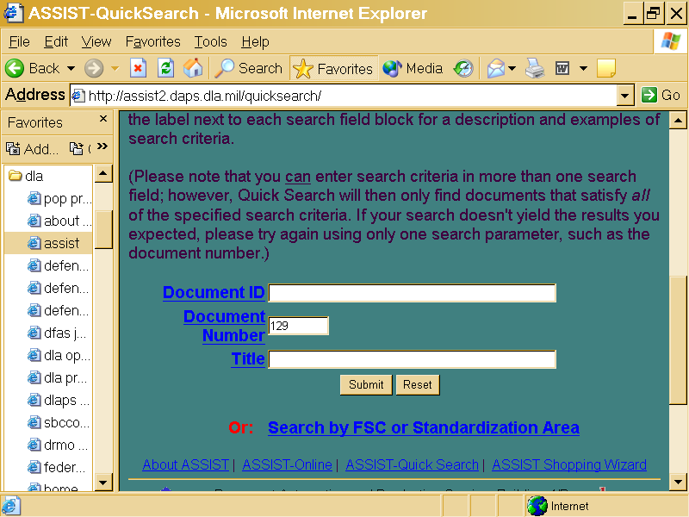

FIGURE 1, Welcome to the ASSIST (Database for Military Specifications and Military Standards) submit documents to DAPS/DoDSSP for indexing in ASSIST as usual, but also provide a means to submit with this revised module via ASSIST FeedBack and help us make this ...assist.daps.dla.mil/online/start

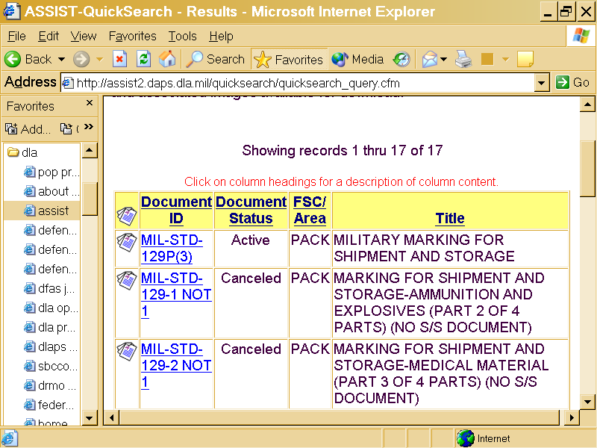

FIGURE 2 Website Example from ASSIST

1.5 The term “Marking” as defined by Mil-Std-129.

Marking is "the application of numbers, letters, labels, tags, symbols, or colors to provide identification and to expedite handling during shipment and storage."

1.6. Why is the current copy of Mil-Std-129 P (3) 154 pages in length?

DOD/DLA attempts to provide as much information as possible to a variety of military and industry readers. The document also serves as a training tool for the logistics soldier and government distribution centers workforce. The standard addresses all commodities used to support the military operations. Vehicles, aircraft, weapon systems, ammunition, medical equipment, and rations are a few of the items regarded as commodities in Mil-Std-129 and marked accordingly. In the military logistics operations Mil-Std-129 is used to identify products and packaging as an inventory management tool. The soldier is obligated as is the vendor to properly mark packaging shipped to other destinations throughout the world, Mil-Std-129 provides the necessary marking requirements. Our efforts will be to extract only the information needed to satisfy most of the GSA contract requirements and our ultimate customer, the military.

1.7. I have found much of the information cited in Mi-Std-129 already marked by the manufacturer on our containers. Why can’t I use that information in lieu of specific marking requirements?

The information you cite is found randomly on the package and may differ in several respects to 129 requirements. As example unit of issues and manufacturers SKU barcodes may not be recognized as a means of standard tracking devices found in all parts of the industry and government. In rapid distribution centers hunting for marking information is time consuming and may cause delays in getting the product to our customers. As with many small parcel carrier organizations the military has developed standard marking practices to expedite the logistics process.

SECTION 2 ID MARKINGS

2. Identification Markings the product container requirement. (See 129 Para 5.1)
The information below is extracted from Mil-Std-129P.
Figure 3 shows an example of the content and approximate placement of the identification markings on unit packs and intermediate and exterior containers. Unless specifically exempted in the contract or solicitation, these markings shall be applied to all DoD and contractor- or vendor-originated shipments.
  - Size of markings. Unless otherwise specified herein or by the cognizant activity, the lettering/markings shall be in capital letters of equal height, clearly visible, and the largest size practical for the package size within the acceptable range. When marking space permits, stenciled or pre-printed markings shall be not less than 3/32 of an inch.
2.2 Conditions of surfaces to be marked. All surfaces to be marked shall be in a condition so that markings remain permanent, legible, and nonfading. All marks not applicable to the shipment shall be obliterated. When shipping containers are consolidated into container vans for shipment to an ultimate consignee, obliteration of current address markings is not required.
  - Legibility, durability and color of markings. Markings shall be clear, legible, durable, and nonfading and sufficient to withstand normal exposure to environmental and handling conditions which the package/container might be subjected. Bar code print quality shall conform to 2.5. Unless instructed otherwise in the contract or purchase order, packages constructed of wood or lightly colored materials shall be marked using a black color and packages constructed from green or black materials shall be marked using a white or yellow color.
  - Methods of marking unit packs, intermediate and exterior containers, and loose or unpacked items. Markings shall be accomplished by any means that provides the required degree of legibility and durability. Markings may be applied by tagging, stenciling, stamping, machine printing or labeling (using preprinted labels). Although machine printing is preferred, hand printing may be used for marking packs and containers if permitted by the cognizant activity.
  - Identification bar code machine-readable markings. Identification bar code markings shall be applied by means of a label or by direct printing on the packaging material, upon authorization by the cognizant activity
  - Identification bar code markings are required for DoD and contractor- or vendor- originated shipments, unless specifically exempted in the contract. Linear (Code 39) bar code markings in accordance with ISO/IEC 16388 are required on all containers and loose or unpacked items. If identification marking bar codes are not applied directly with the identification marking, the bar codes must be printed onto label stock and affixed to the shipment in close proximity to the identification marking
  - Use of labels. Pressure-sensitive labels that meet the requirements of 2.8 may be used on containers other than wood without prior surface preparation. When pressure-sensitive labels are used on wood containers, the labeling area will be suitably prepared to ensure adhesion.
  - Labels, paper, pressure-sensitive, water-resistant. Labels shall be of a water-resistant grade of paper, film, fabric, or plastic, coated on one side with water-insoluble, permanent type adhesive. The adhesive shall adhere to metal, plastic, or fiberboard surfaces under high and low temperatures. Labels shall have an aluminum finish suitable for printing and writing on with ink without feathering or spreading, be capable of withstanding normal handling and storage conditions, and remain securely in position. Application specific performance criteria and durability requirements to ensure functionality in various climatic environments should be tailored, if required, using MIL-PRF-61002. MIL-PRF-61002 can be used as an acquisition tool when labels presently being used are not performing satisfactorily or when new conditions or applications require special label stock for those particular situations.
  - The exact placement of identification and bar code markings on specific containers may vary in configuration and format from those shown in the figures. Bar code markings are required as specified.
  - Specific Identification items required for unit packs and intermediate containers
Unless specifically exempted in the contract or solicitation, the following identification information shall be marked on all unit packs and intermediate containers, in the order listed. Additional identification markings may be required by the contract and shall be placed either below these markings or in a conspicuous location on the identification-marked side of the container. Unit packs used as exterior containers at the time of packaging shall be marked as shown in Figure 3.
a. NSN/NATO stock number. The in-the-clear NSN will include spaces or dashes and any prefix or suffix specified in the contract or solicitation. The bar coded NSN and human readable interpretation (HRI) below the bar code will not include spaces or dashes. If no NSN is assigned, then this line may be omitted.
b. CAGE code. The CAGE code of the company awarded the contract for the item being
shipped.
c. Part Number. If a PN is specified in the contract or order, then only that PN shall be shown. The PN specified in the contract may be the PN assigned by the Government procuring activity, or it may be the PN of the actual manufacturer or the PN assigned to the item by the company awarded the contract. For shipments sent directly from a subcontractor to a DoD addressee, the PN of the company awarded the contract shall be shown. The letters "PN" or "P/N" shall be used to identify this information. If the item has no PN assigned to it or if no PN is cited, then nothing is shown.
d. Item description or nomenclature. The exact name and description of an item as it appears in the contract, purchase order or requisition shall be shown. Item description may be marked on more than one line if required due to space limitations. Standard abbreviations, although not desired, may be used if marking length is excessive.
e. Quantity and UI. A non-definitive Unit of Issue shall be accompanied by a quantitative expression such as "1 RO (100 FT)."
f. Contract number or purchase order number (Procurement Instrument Identification Number (PIIN)) including four-digit delivery order or call number, modification for change order number, and lot number shall be shown. The in-the-clear contract number will include the dashes as shown in the contract, i.e., purchase order FPM-E-U4680-5F. The bar code and human readable below the bar code will not include the spaces and dashes.
g. Military preservation method and date of unit preservation are required for contracts citing Level A or B military packaging only. Commercial packaging (Level C) does not require packaging codes. (e.g., "M10-4/02" - Method 10, from MIL-STD-2073-1, was provided in April 2002). Use of the letter M in the first position indicates the pack is a military preservation method; "10" is the method number; "4/02" indicates the date of packaged. For specialized preservation codes, use the code from MIL-STD-2073-1, Table J.Ia. (e.g., “MBC-4/02” – method BC was provided in April 2002). If a military preservation method doesn’t apply, the method space will be left blank. If a preservation date doesn’t apply, the pack date will be shown.
h. Shelf-life markings, if applicable, shall be applied as specified herein. As noted in Figure 3
i. Serial number(s). When an item is assigned a serial number, that number shall be applied and preceded by the abbreviation "SER NO".
j. Hazardous materials (HAZMAT) and ammunition and explosives marking. (see figure 6). NOTE: Identification bar code marking requirements, including configurations and formats, for unit packs and intermediate containers, are in addition to hazmat marking requirements. Note: Hazmat products are not covered in detail in this guide and should adhere to the applicable modal regulations for deliveries in the US and International modal regulations for overseas shipments.

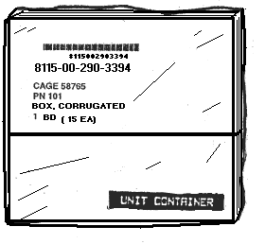
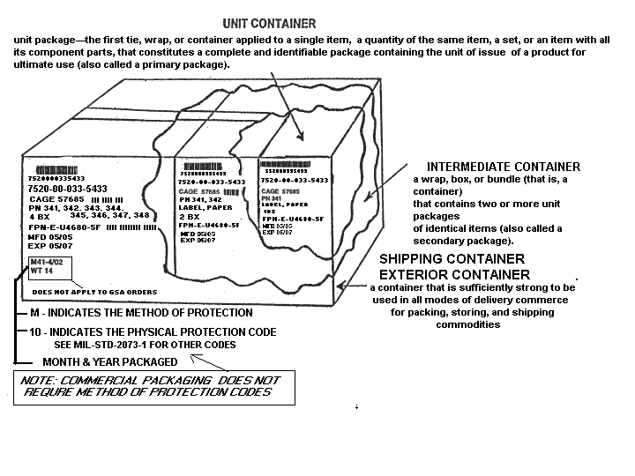
Note: see Figure 9 for Shelf Life markings

FIGURE 3 Example of non-hazardous unit pack, intermediate and exterior container identification markings (including an example of bar code markings).

SECTION 3 ADDRESS MARKINGS

3.1. Address markings. Military (DoD) and contractor- or vendor-originated address markings, to include the military shipping label (MSL) and respective bar code symbols, shall be as specified in DoD 4500.9-R, Part II and as summarized herein. The preferred location for applying address markings to shipping containers is shown in the figures in this section. Exact placement of MSLs may vary slightly from those shown.
3.2. Military (DoD) and contractor- or vendor-originated address markings (see Figure 4). Unless specifically exempted in the contract, DoD and contractor- or vendor shipping activities will apply address markings using a bar coded MSL. This includes shipments moving within CONUS or OCONUS, from CONUS to OCONUS, or conversely from OCONUS to CONUS.
3.3. Military Shipping Label (MSL) (see Figure 4). The MSL will be completed in accordance with the following information.
a. The MSL will include clear-text entries applicable to the shipment.
b. The MSL will include linear (Code 39) bar code symbols formatted in accordance with this standard in reference to ISO/IEC 16388. Three linear (Code 39) bar codes are required including the Transportation Control Number (TCN), piece number without leading zeros, and Ultimate Consignee /Mark For DoDAAC.
c. The MSL will include a 2D (PDF417) symbol in accordance with ISO/IEC 15438, formatted in accordance with 129 and Table IV of this standard, with reference to DoD 4500.9-R, Part II. The 2D (PDF417) symbol will contain Table IV specified human readable information from the printed MSL, Table IV specified DoD 4500.9-R, Part II, TCMD data (only selected data), and Table IV specified line item supply data (DD Form 1348-1A or requisition information). The applicable 2D (PDF417) symbol Data Identifier (DI) formats can be found in Table IV of this standard. ISO/IEC 15434 and ANSI MH10.8.2 are the references for Table IV.
(1) The 2D (PDF417) symbol shall contain the clear-text information on the MSL as provided for in 4.2.2.6. For contractor or vendor shipments, the TCMD information, when required, shall be coordinated between the contractor or vendor and the contracting office or administrative contracting office, per the FAR 47.305-10 and the DFARS 247.305-10 and 247.371, and applied by the contractor per FAR 52.247-52. The TCMD may contain coded information that shall be converted to in-the-clear text for printing on the MSL, for example, deletion of leading zeros from pieces, weight, cube, length, width, height, TCMD data, and conversion of alpha numeric pieces, weight, cube, and TCMD codes to numeric digits. Each shipment unit in a unitized load shall be marked with a 2D (PDF417) MSL.
(2) The 2D (PDF417) symbol line item supply data for MILSTRIP transactions is sourced from DD Form 1348-1A information as noted in Table IV. The MSL 2D (PDF417) symbol on each piece of a shipment unit will have the same line item information. For contractor or vendor shipments, this information, as available, and the DFARS 247.305-10 minimum requirements, shall be coordinated between the contractor or vendor and the contracting office or administrative contracting office. For non-MILSTRIP transactions, the available information will be limited. Ammunition shipments may also include DODIC and lot number information. For factors that determine the amount of available data to be recorded on the 2D (PDF417) symbol, see 4.2.2.6c.
3.4. MSL size. The recommended size for the MSL is 4 inches by 6 inches. The labels and bar codes in the figures have been reduced in size for ease of publication.
3.5. MSL stock quality. The quality of the MSL will be such that labels are suitable for ink printing without feathering or spreading. The MSL must withstand normal handling and shipping conditions and remain securely in position. For general bar code label requirements see 5.1.2. For HAZMAT label requirements see Title 49 CFR.
3.6. MSL format. The in-the-clear data and bar code entries shall meet required standards and shall comply with 4.2.2.4 through 4.2.2.8 and Table IV detailed format requirements. The in-the-clear data and linear (Code 39) bar code HRI shall be easily human readable. The linear (Code 39) bar codes and the 2D (PDF417) bar code symbol shall be easily machine readable. A specific MSL format is not required except for the location of the TCN (see 4.2.2.4c). Since various commodities shipped have unique data requirements, different data content will be printed on the MSL, such as for generic cargo and unit move shipments. The MSL format shall retain the applicable block titles associated with the data content... Figures 2a and 2b show examples of acceptable MSL formats that may be used as guidelines in producing a label. ANSI MH10.8.1 is the referenced standard for developing a DTR compliant MSL.
3.7. Completing the MSL for address marking. The MSL shall be completed as follows to include in-the-clear text or descriptive information, linear (Code 39) bar codes with HRI, and a 2D (PDF417) symbol.
- a. Linear (Code 39) bar code labels or 2D (PDF417) symbol labels with HRI may be affixed to the MSL as an alternative to direct printing on the MSL.

b. Data identifier (DI) codes shall not be used in conjunction with the linear (Code 39) bar codes.
c. The MSL unique transport unit identifier shall be the TCN and it shall be encoded and printed as the uppermost bar code on the top of the label. Information on TCN construction for the various types of shipments is detailed in DoD 4500.9-R, Part II, Cargo Movement, Appendix L.
d. Linear (Code 39) bar codes or 2D (PDF417) bar code symbols shall not be positioned in the same linear plane and the label layout should provide as much vertical spacing as available between the bar code symbols to reduce the possibility of scanning interference
e. The text for all entries, except as noted below, shall be no smaller than 10 lines per 1 inch (approximately a 7 point font). The preferred font size is 10 to 14 points.
(1) The “Ship To” address character height shall be no smaller than the “From” address character height and should be distinctive in appearance, for example, larger, bolder, different color, etc. The “Ship To” address shall be located below or to the right of the “From” address.
(2) The transportation priority numeral shall be bold text and shall be ¾ inch high (approximately a 72 point font).
3.8. Data content of the MSL (see Figure 4). The data content of the MSL and the instructions for completion are summarized below.
The MSL shall contain the following information:
TCN. Enter the 17-character (alphanumeric) TCN using a 1/2-inch-high linear (Code 39) bar code with HRI as the uppermost bar code on the top of the label. For consolidated shipments, place a lead TCN in this block. The lead TCN shall not duplicate any internally packed TCNs.
Transportation Account Code (TAC)/Postage. Enter the TAC or the postage data. For other than mail shipments, enter the TAC applicable to shipments moving from POE to POD, otherwise leave blank. For mail shipments, use one of the following:
(a) For metered mail, attach the stick-on metered postage values to or near this block.
(b) For permit imprint mail, enter the appropriate service/agency mail authorization.
Example: First Class Mail
Postage and Fees Paid
Defense Logistics Agency
Permit No. G-53
(3) From. Enter the Consignor DoDAAC/CAGE and in-the-clear address (up to 3 lines of 35 characters) of the shipping activity. For mail include the ZIP code.
- (4) Type Service. In-the-clear text (for example, Frt LTL, Air Expss, Expss Mail, TGBL UB, DPM HHG) for the type of transportation service to the “Ship To” address. The in-the-clear text may be derived from the TCMD Mode/Method code for the Generic Cargo MSL. Should be blank for unit move shipments.
(5) Ship to/POE. Enter the three digit air/water Port of Embarkation (POE) code, if applicable, and an in-the-clear address (three characters and 5 lines of up to 35 characters).
(6) Priority. Enter the applicable transportation priority (TP). TP 1, 2, 3, or 4 (deferred air freight) should be clearly identified in the priority block of the MSL using bold text that is 3/4 inch high. Should be blank for unit move shipments.
(7) POD. Enter three-digit air/water Port of Debarkation (POD) port designator, if applicable. In-the-clear location name may be included. Blank for classified unit move shipments. Blank for mail shipments.
(8) Project Code. Enter project code, if applicable.
(9) Ultimate Consignee/Mark For Consignee. Enter the in-the-clear complete address(s) (up to 5 lines of 35 characters) and the ½-inch-high linear (Code 39) bar code DoDAAC with HRI. Blank for classified unit move.
(10) Weight (lbs). Enter actual gross weight (numeric value of this piece). Round to next whole digit and do not zero fill.
(11) RDD. Enter the Required Delivery Date (RDD) code specified by the requisitioned, if appropriate. Blank for classified unit move.
(12) Cube (ft). Enter the actual cube (numeric value of this piece). Round to next whole digit and do not zero fill.
(13) Charges. No known requirement. Leave Blank
(14) Date Shipped. Enter an in-the-clear date (for example YDDD, YYYYDDD, DD/MM/YY, or DD-MMM-YYYY. Blank for unit move. Do not use the Date Shipped Code from DoD 4500.9-R, Part II, Appendix RR.
(15) FMS Case Number. Enter as FMS case identifier as appropriate.
(16) Piece Number. Enter the piece number (numeric value assigned to this piece) of the cargo documented by the TCN for this shipment unit and a ½-inch-high linear (Code 39) bar code. Do not zero fill. Piece Number may be expressed as "Piece Number of Total Pieces" to save space on the label -- only the Piece Number has a linear (Code 39) bar code; the word “of” and the total number of pieces are not shown in the linear (Code 39) bar code.
(17) Total Pieces. Total number (numeric value) of pieces documented by the TCN for this shipment unit. Total Pieces may be expressed as "Piece Number of Total Pieces" to save space on the label -- the Total Pieces value is not shown in the Piece Number linear (Code 39) bar code. Do not zero fill.
(18) 2D (PDF417) symbol. Includes MSL in-the-clear text data, selected TCMD data, and selected supply/unit information per 4.2.2.6.
(19) Deleted.
(20) Deleted.
(21) Deleted.
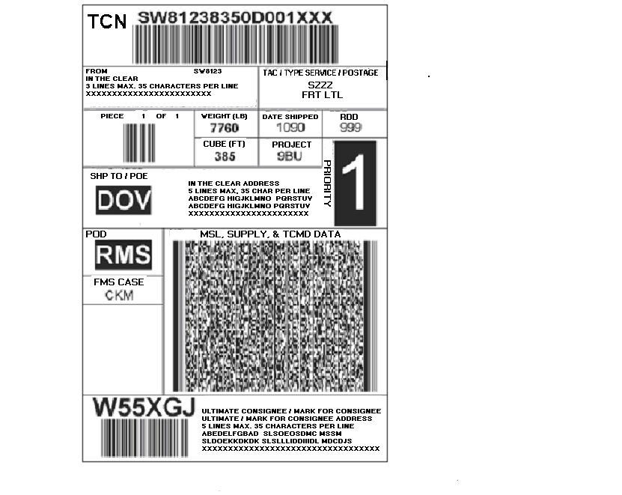
Figure 4 Military Shipping Label (MSL).

3.9 Is there a government database that will produce a MSL acceptable by the military and Mil-Std-129 requirements?

Vendors can visit the DDC website and possibly use the system to produce an acceptable MSL, especially for National Stock Numbered items. The Distribution Planning and Management System (DPMS) produces Military Shipping Labels with all required info: TCN, originator Point of Contact, mark-for address with DoDAAC For further info, go to https://www.ddc.dla.mil/DPMS or call Ed Gallagher on 717-770-4064 or Al Simpson on 717-770-5369 Excerpts from the DPMS Users Guide are as follows: DPMS is a rapidly evolving system designed to use the same transportation rating and routing logic as that used in the Distribution Standard System (DSS). DSS is currently in use as a material and shipping management tool at all DLA Distribution Centers managed by the Defense Distribution Center (DDC). DPMS further expands the use of the DSS transportation logic to participating DLA Vendors. DPMS provides routing for Direct Vendor Delivery (DVD) as well as shipments to Distribution Center stock while providing an improved level of In-Transit Visibility (ITV). The system is a web based, front-end application interfaced to the DSS mainframe. It is also capable of full EDI integration at the vendor location. The EDI version is more complex and requires more programming on the vendor’s part to integrate into their production systems. However, the payoff includes higher volume shipping capacity and eliminates human intervention in the process. Future development plans include the integration of a Commercial-Off-The-Shelf (COTS) Transportation Optimization package (Manugistics), and expansion to Military Service level contracts and other Government Agencies such as Federal Prison Industries (UNICOR) and General Services Agency (GSA).

3.10. Direct vendor delivery (DVD). Contractor- or vendor-originated DVD shipments require identification and address marking with 2D and linear bar codes in accordance with this standard. The issue/receipt bar code markings shall either be placed on or printed on labels affixed to either the DD Form 250/250c or the commercial packing list. If placed on the DD Form 250/250c, they should be in blocks 15, 16, 17, etc. In either case, these documents shall be furnished in a packing list envelope affixed to the outside of the shipping container. The following separate lines of issue/receipt bar code data, with HRI printed directly below the linear (Code 39) bar code in accordance with ISO/IEC 16388 shall be provided as three bar codes containing data as described in DoD 4500.25-1-M, Appendix 2:

SECTION 4 HAZARDOUS MATERIAL MARKING

4. Hazmat Employer Responsibility for Testing and Training (See 49 CFR 172.702 & 172.704
The Department of Transportation (DOT) have specific requirements for persons offering hazmat products for shipment both domestic and export destinations. “A hazmat employer shall ensure that each of its hazmat employees is trained in accordance with the requirements prescribed in this subpart”. “A hazmat employer shall ensure that each of its hazmat employees is tested by appropriate means on the training subjects covered in 172.704”.
4.1 Hazardous materials. An item of supply consisting of materiel that because of its quantity, concentration, or physical, chemical, or infectious characteristics, may either cause or significantly contribute to an increase in mortality or an increase in serious, irreversible, or incapacitating reversible illness; or pose a substantial present or potential hazard to human health or the environment when improperly treated, stored, transported, disposed of, or otherwise managed. (This includes all items listed as hazardous in Titles 29, 40, 49 CFR and other applicable modal regulations effective at the time of shipment.)
4.2 HAZMAT marking and labeling requirements. Depending on the mode of transportation, HAZMAT shall be marked and labeled in accordance with Title 49 CFR, ICAO Technical Instructions for the Safe Transportation of Dangerous Goods by Air, IATA Dangerous Goods Regulations, the IMO IMDG Code for water shipments, and AFMAN 24-204(I)/TM 38-250/NAVSUP PUB 505/MCO P4030.19/DLAI 4145.3 for military air shipments, as applicable. Proper shipping names (PSNs), HAZMAT North American (NA) or United Nations (UN)
identification numbers, IATA/ICAO temporary identification (ID) numbers, DOT assigned EX numbers (for ammunition items with no assigned NSN/DoDIC), HAZMAT classification warning labels, and HAZMAT UN standard container certification markings shall be placed on the exterior container, as required. Government-owned Class I (explosives) that were packaged, marked and labeled prior to 1 January 1990 and destined for surface shipment or military air shipment need not be remarked. The shipper is also responsible for completing a Shipper’s Declaration for Dangerous Goods form for every military air shipment containing dangerous goods, including hazardous materials. See InterService Manual AFMAN 24-204(I)/TM 38-250/NAVSUP PUB 505/MCO P4030.19/DLAI 4145.3 for instructions on how to properly complete the form.
4.3 Proper shipping name and identification number (see Figure 40). The PSN and NA or UN identification number shall be marked on the exterior shipping container. PSNs for n.o.s. items must be followed by a technical name in parentheses. The PSNs and identification numbers are listed in Title 49 CFR, 172.101, latest revision, and in AFMAN 24-204/TM 38-250/ NAVSUP PUB 505/MCO P4030.19/DLAI 4145.3, Attachment 4. NA numbers are not authorized for international shipments. The applicable international modal document shall be used to determine the UN PSN and identification number for international shipments.
4.4 Marking and labeling of multipacks containing HAZMAT. When a multipack contains HAZMAT, the PSNs, with applicable ID numbers, shall be marked on each applicable container in the multipack. They shall also be listed on the identification-marked side of the multipack. Applicable HAZMAT classification warning labels for each class of material contained in the multipack shall also be applied on the outside surface.
4.5 Marking and labeling of air and water shipments. Marking and labeling requirements for shipments of HAZMAT by domestic commercial air are specified in Title 49 CFR and by international air in the ICAO Technical Instructions and the IATA Dangerous Goods Regulations. When shipment is by military airlift or contract carrier, the requirements of AFMAN 24-204(I) TM 38-250/NAVSUP PUB 505/MCO P4030.19/DLAI 4145.3 shall apply. In addition, for all military air shipments, the outer container of combination packages, having inner receptacles that contain a liquid HAZMAT, shall also be marked “AIR ELIGIBLE” to verify that either the inner container(s) or the outer container meet the internal pressure requirements for air eligibility. This required marking is in addition to any applicable UN-recommended performance specification (certification) markings. When known, the tested kilopascals (kPa) may be marked below the "Air Eligible" wording. A kPa is the international unit of measure for internal pressure. The formula for converting to kilopascals is "psi X 6.89 = kPa." The words “AIR ELIGIBLE” are not required for single containers of HAZMAT because the kPa is already a part of the UN certification code. The marking and labeling requirements for the shipment of HAZMAT by vessel are specified in Title 49 CFR and in the IMO IMDG Code. The IMO IMDG Code is used for overseas shipments by vessel.
4.6 Identifying containers and packagings Containers or configurations (packagings) shall be identified as complying with containers identified in DOT regulations, or Federal or military specifications. When a container that is manufactured to a Government approved drawing, or specification has successfully passed all applicable UN-recommended performance tests, both the UN performance specification (certification) markings (see Figure 5) and applicable Government approved drawing or container specification marking shall be applied.
4.7 DOT specification and UN performance specification (certification) markings (see Figure 5). When a container complies with a UN standard, the container must be marked as required by the applicable specification (see Part 178 of Title 49 CFR).
4.8 DOT exemptions. When a DOT exemption is applicable, the DOT exemption number (e.g., DOT E-7605) shall be placed near the PSN and any other required cautionary markings. DOT exemptions shall not apply to international shipments unless the HAZMAT is exempted from UN certification marking requirements.
4.9 Certification of Equivalency (COE). When a COE has been issued, the container certification number shall be applied near the PSN and any other cautionary markings. COEs shall not apply to international shipments, unless the HAZMAT is exempted from UN certification marking requirements.
4.10 Competent Authority Approval (CAA). The competent authority, which is DOT, may grant permission to use a package without POP testing it. If required by the CAA, the approval number must appear on the package in association with the PSN and ID number. All requests for CAAs shall be documented as specified in Title 49 CFR and Joint Regulation DLAD 4145.41/ AR 700-143/AFJI 24-210/NAVSUPINST 4030.55B/MCO 4030.40B.
4.11 Documentation for HAZMAT. The shipper is responsible for the completion of a Shipper’s Declaration for Dangerous Goods form for each and every military air shipment containing dangerous goods. See the InterService Manual AFMAN 24-204(I)/TM 38-250/NAVSUP PUB 505/MCO P4030.19/DLAI 4145.3 for instructions on how to properly complete the form.
4.12 Existing palletized unit loads of HAZMAT. Existing palletized unit loads of HAZMAT in the DoD stockpile identified as having passed the UN performance specification (certification) testing requirements shall have the UN certification markings applied to placards placed on two opposite sides of the pallet load in lieu of marking each container. This rule also applies to material having different DOT and UN PSNs.
4.13 Flash point marking. All unit packs and intermediate and exterior shipping containers packed with flammable liquids (flash point of not more than 60.5 degrees Celsius (C) or 141 degrees Fahrenheit (F)) shall be marked with the flash point of the material. The flash point shall be preceded by the words "FLASH POINT" and shall be followed by the letter "C" or "F," as appropriate. The flash point marking may be shown in degrees C, F, or both and shall be applied in a conspicuous location on the identification-marked side of the container. If space is not available on the identification-marked side, the required HAZMAT markings, labeling, and the flash point marking may be placed on the opposite side. The size of the lettering shall be proportionate to the available marking space. The flash point shall be determined by using the testing methods prescribed in Title 49 CFR.
4.14 Hazardous chemical warning label. Hazardous materials shall require a chemical warning label as specified in Title 29 CFR 1910.1200, Hazard Communication Standard. When the
manufacturer's warning label has been removed or obliterated, or if the product is poured from one container into another, the DoD standard hazard warning label (DD Form 2521 or DD Form 2522 (smaller version)) shall be applied to the unit container. The warning labels are available in the CD-ROM version of the Hazardous Materials Information System (HMIS). If a container includes more than one unit pack, such as a container of six aerosol cans that have a unit issue of "one each", then the warning label shall not be applied to the individual unit packs (each aerosol can) that comprise the container until the container itself is opened.
4.15 Kits containing HAZMAT. Kits that contain hazardous components in small quantities such as adhesives, solvents, inks, paints, and other flammable liquids, or chemical kits as defined
by Title 49 CFR, shall be marked and labeled in accordance with the requirements of Title 49 CFR and the applicable international document (e.g., ICAO, IMO, etc.). When one or more components in a kit are classified as a HAZMAT, the container shall be marked and labeled as specified. The UN performance specification (certification) markings are not required when the individual kits meet the requirements of Title 49 CFR, 173.4, and the applicable modal requirements.
4.16 DOT-E Numbers. If a DOT-E number is assigned to a packaged item, it shall be plainly and
durably marked “DOT-E” followed by the specific exemption number assigned. Unless otherwise specified, rectangular containers shall have the “DOT-E” marking on a separate line from the PSN/ID number markings.
4.17 International Maritime Dangerous Goods Code Marking of Packages. Require the Proper Shipping Name preceded by the letters UN on all packaging. See the current copy of this modal regulation when shipping export by vessel for specific details and restrictions. Marking requirements shall be:
1. readily visible and legible
2. such that the information will still be identifiable on packages surviving at least three months immersion in the sea. Durability and packaging surfaces shall be taken in to consideration of these requirements.
3. displayed on a background of contrasting color on the external surface of the package.
4. located away from other packaging markings that could substantially reduce their effectiveness.
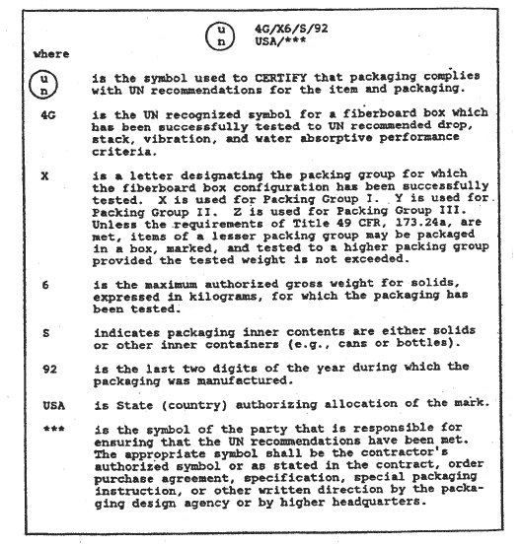
FIGURE 5 Breakdown of A Typical UN Certified Package Code
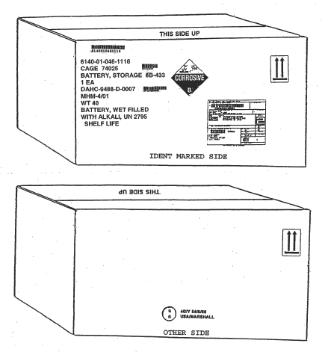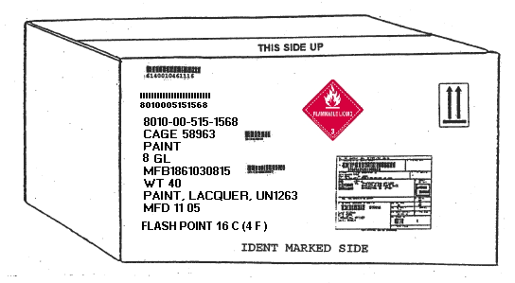

FIGURE 6 Typical Liquid Hazardous Materials Marking

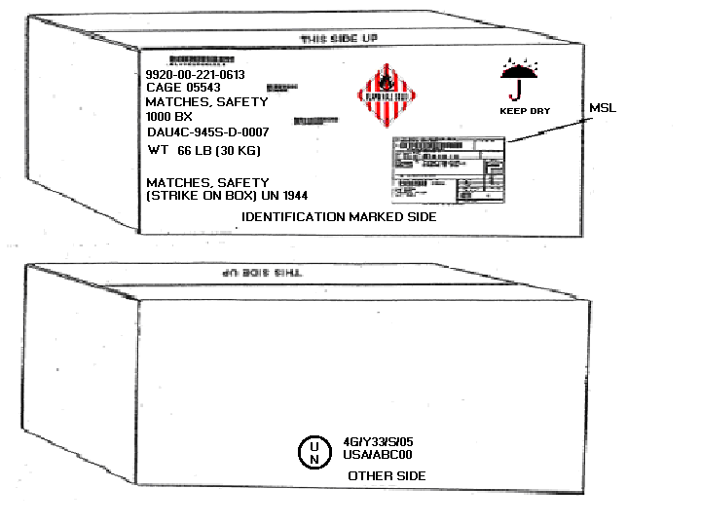

Figure 6A Typical Solid Hazardous Materials Marking

SECTION 5 FOREIGN MILITARY SALES (FMS)

5. Foreign Military Sales (FMS) Marking and Shipping Guidelines 2005

5.1 Delegation of Authority Background for FMS requirements, (DLA FMS Handbook) The Department of State has delegated supervision of the FMS program to the Department of Defense (DoD).

5.2 LAWS - with respect to the current U.S. SA program, two basic laws are involved: (1) the Foreign Assistance Act (FAA) of 1961, as amended, and (2) the Arms Export Control Act (AECA) of 1976, as amended. Both the FAA and AECA follow a succession of earlier predecessor acts that served as the basis for many of the current provisions in the FAA and AECA. These acts form the basis for SA policy. The Security Assistance Management Manual (SAMM), DoD 5105.38M, and the FMS Financial Manual, DoD 7000.14-R, Volume 15 promulgate this policy. DLA will make every effort to be responsive to SA/FMS customers when an International Logistics Control Office (ILCO) allows direct communication between their Foreign Liaison Officer (FLO) and DoD components.

5.3 Letter of Offer and Acceptance (LOA) – a foreign country or international organization submits a Letter of Request (LOR) for P&A on the items to the USG. P&A estimates are provided for planning purposes only. Once the foreign country or international organization determines they want the major end item or service, they submit a LOR for a LOA to the Security Assistance Office in their country. The case manager then develops a LOA and submits it for review and signature to the Defense Security Cooperative Agency (DSCA). A copy is also sent to the Department of State and Congress for review and approval.
The LOA is the authorized document used by the USG as an offer to sell defense articles and defense services to a foreign country or international organization. LOAs represent a bona fide offer by the USG to sell the described items identified in the LOA document. It contains all items and services anticipated to be needed for two years’ use of the major end item or weapon system. It becomes an international binding contract when accepted by an authorized representative of the purchasing country or international organization and the applicable funding is provided.
5.4 Regulatory Requirements. Foreign Military Sales requirements are governed by the Defense Security Cooperation Agency (DSCA). The DSCA website http://www.dsca.osd.mil. More detailed information in preparing the product for marking and shipment is found in Military Standard 129P (3) “Department Of Defense Standard Practice Military Marking, For Shipment And Storage”. Specific information for Foreign Military Sales (FMS) marking requirements is found in herein. Your contract clause 552.211-73, MARKING (FEB 1996) edition in effect on the date of issuance of the solicitation. Copies of Mil-Std-129 may be obtained using the ASSIST Online database at http://assist.daps.dla.mil/online/start/.
Note: Excerpts of Mil-Std-129 and DFARS Appendix F for FMS requirements are as follows:

5.5 Preservation and Packing for FMS Shipments -the standard for SA/FMS materiel preservation and packing is A/B. The logistics community revamped MIL-STD-2073-1C, DoD Standard Practice for Military Packaging, in October 1996. MIL-STD-2073-1C emphasizes the maximum use of commercial packaging for the DoD, and specifies military packaging is required only on items expected to enter the military distribution system. These exceptions include items for SA programs.

5.6 Foreign Military Sales (FMS) marking requirements. Identification and address markings for unit packs, intermediate and exterior containers, and for unpacked items shall be applied as specified in herein; Identification bar code container markings for FMS shipments are required unless otherwise specified in the contract or purchase order. Bar coding of the MSL for FMS materiel shipments is required. In addition, the following special requirements shall apply to FMS shipments.
5.7 Minimum package size. The minimum size box used for FMS shipments shall have enough surface area on the top and two sides to affix all required labels, packing lists, DD Forms 250 (Material Inspection and Receiving Report), DD Forms 1348-1A, and any other required markings without overstamping or overlapping. Identification bar codes shall be legible and readable. Nothing shall be placed or appear on the ends or bottom of the box, package, or container. A packing list is required.
5.8 Multipacks. All boxes containing multiple items (related or unrelated) shall be marked as Multipacks as specified below:
5.8.1 Unrelated items (multipacks). When containers of unrelated items comprised of mixed NSNs which do not support a specific weapon system or end item are consolidated into a shipping container, in lieu of the identification markings required, the shipping container shall be
marked with the following information in the order listed: the word "MULTIPACK" (line 1) and the gross weight (line 2). Hand printing on multipacks is permitted.
Example: MULTIPACK
WT 100
NOTES: 1. In addition to any shelf-life markings, the words "CONTAINS SHELF-LIFE ITEMS” shall be placed below the identification markings on multipacks containing shelf-life materiel.
2. For information on marking of multipacks containing hazardous materials, see Section 4
3. The words "WARRANTED ITEMS INSIDE" shall be placed immediately below the identification markings on multipacks that contain items covered by a warranty.
4. For Foreign Military Sales (FMS), all boxes containing multiple items (whether related or unrelated) shall be marked as multipacks.
5. Caution markings shall be applied as required (e.g., FRAGILE, arrows, hazardous warning labels, etc.).
6. Containers shipped to a single destination that contain individual shipments/containers for multiple consignees shall have the words "MULTIPLE DoDAACs" applied to the outside of the container.

5.9 Address markings. Military (DoD) and contractor- or vendor-originated address markings, to include the military shipping label (MSL) and respective bar code symbols, shall be as specified in DoD 4500.9-R, Part II and as summarized herein. The preferred location for applying address markings to shipping containers is shown in the figures in this section. Exact placement of MSLs may vary slightly from those shown.

5.10 Contractor-originated FMS shipments. The DD Form 250 shall be used as a packing list for contractor-originated FMS shipments in lieu of the DD Form 1348-1A, which may be used for FMS shipments originated by DoD activities. The DD Form 250 shall be prepared as specified in the Defense Federal Acquisition Regulation (DFAR) DoD Supplement, Appendix F, Part 3, F301, and Preparation Instructions. Distribution of the DD Form 250 shall be made in accordance with the DFARS, Appendix F, Part 4, and any other specific information contained in the contract or purchase order. For additional information on the DD Form 250, a sample DD 250 form is provided below.
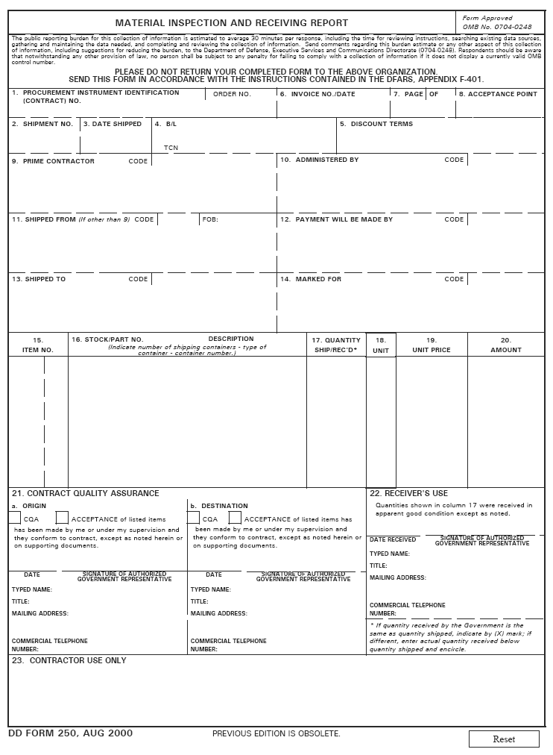
FIGURE 7 DD250 FORM
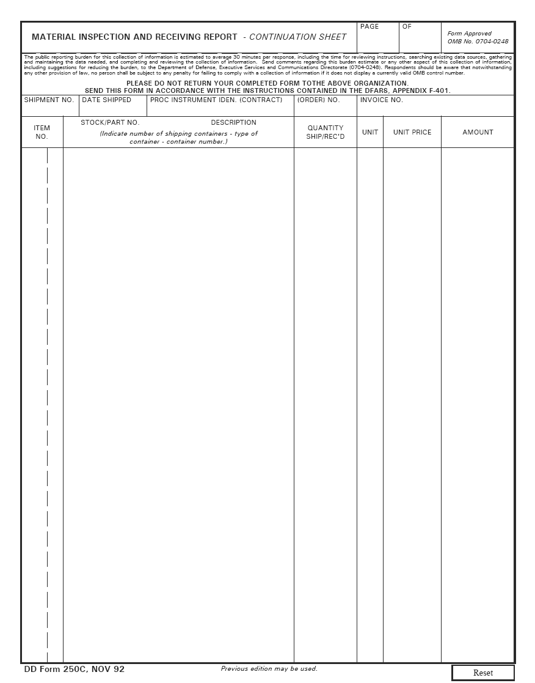
FIGURE 8 DD250 CONTINUATION FORM

PART 3--PREPARATION OF THE DD FORM 250 AND DD FORM 250C
See Appendix F of DFARS Part 4 for more detailed instructions for preparing the DD250. DFARS Appendix F may be found at http://www.acq.osd.mil/dpap/dfars/index.htm
F-301 Preparation instructions.
(a) General.
(1) Dates must use nine spaces consisting of the four digits of the year, three-position alphabetic month abbreviation, and two digits for the day. For example, 2000AUG07, 2000SEP24.
(2) Addresses must consist of the name, street address/P.O. box, city, state, and ZIP code.
(3) Enter to the right of and on the same line as the word “Code” in Blocks 9 through 12 and in Block 14—
(i) The Commercial and Government Entity Handbook (H4/H8) code;
(ii) The DoD activity address code (DoDAAC) as it appears in the DoD Activity Address Directory (DoDAAD), DoD 4000.25-6-M; or
(iii) The Military Assistance Program Address Directory (MAPAD) code.
(4) Enter the DoDAAC, CAGE (H4/H8), or MAPAD code in Block 13.
(5) The data entered in the blocks at the top of the DD Form 250c must be identical to the comparable entries in Blocks 1, 2, 3, and 6 of the DD Form 250.
(6) Enter overflow data from the DD Form 250 in Block 16 or in the body of the DD Form 250c with an appropriate cross-reference. Do not number or distribute additional DD Form 250c sheets, solely for continuation of Block 23 data as part of the MIRR.
(7) Do not include classified information in the MIRR. MIRRs must not be classified.

DD Form 250, Materiel Inspection and Receiving Report – Defense Federal Acquisition Regulations (DFARS) amended the instruction for completion of DD 250. The changes, published in October 2000, add requirements for the inclusion of the title, mailing address, and telephone number of the USG official responsible for acceptance of supplies or services. This change was required to comply with Federal Acquisition Regulation (FAR) 32.905(f)(6) which requires receiving reports supporting invoice payments include the signature, printed name, title, mailing address, and telephone number of the USG official responsible for acceptance or approval functions.

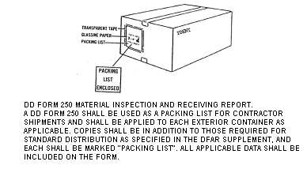

FIGURE 8 PACKING LIST
The information contained herein outlines the FMS marking and packaging requirements and does not provide detailed information in the preparation of FMS shipments. It is suggested that the contractor obtain and review the specifications and regulations cited within to properly prepare their products for FMS shipments.

SECTION 6 SHELF LIFE MARKING REQUIREMENTS

6. Shelf-life. The total period of time beginning with the date of manufacture, cure date (for Elastomeric and rubber products only), assembly, pack (subsistence only), or after visual inspection/certified laboratory test/restorative action, that an item may remain in the combined wholesale (including manufacturer’s) and retail storage systems and still remain suitable for issue to and/or consumption by the end user. Shelf-life should not be confused with service life.
6.1 Assembled date. The date items or parts are assembled into components, assemblies, sets, kits, or outfits (CASKOs), or the date various CASKOs are assembled into a larger unit.
6.2 Cured date. The date the item or materiel was altered industrially, as to vulcanize (rubber) or to treat (synthetic elastomers) with heat or chemicals to make them infusible.
6.3 Expiration date. The date by which nonextendible shelf-life items (type I) will be discarded as no longer suitable for issue/use.
6.4 Inspect/test date. The date, by which extendible shelf-life items (type II) will be subjected to visual inspection, certified laboratory tests, or restoration.
6.5 Manufactured date. The date the item, materiel, or commodity was fabricated, processed, produced or formed for use. For drugs, chemicals, and biologicals, the date of manufacture for products submitted to the Food and Drug Administration (FDA) for certification prior to release is the date of the official certification notice. For products manufactured under the license of the Agricultural Research Service (ARS), the date manufactured conforms to the definition established by the ARS. The date of manufacture will not be shown for medical items having expiration dates.
6.6 Packed date. For subsistence items only, the packed date will be the date on which the item was packaged in the unit pack, regardless of the date of packing, shipping, or additional processing.
6.7 Shelf-life code (SLC). A code assigned to a shelf-life item to identify the period of time beginning with the date of manufacture, date of cure (for elastomeric and rubber products only), date of assembly, or date of pack (subsistence only), and ending with the date by which the item must be used (expiration date) or subjected to inspection, test, restoration, or disposal action.
6.8 Shelf-life item. An item of supply that possesses deteriorative or unstable characteristics to the degree that a storage time period must be assigned to ensure that the item will perform satisfactorily in service.
6.8.1 Type I shelf-life item. An individual item of supply which is determined through an evaluation of technical test data and/or actual experience, to be an item with a definite nonextendible period of shelf-life. One exception is Type I medical shelf-life items, that may be extended if they have been accepted into and passed testing for extension in the DoD/Federal Drug Administration (FDA) Shelf-Life Extension Program (SLEP).
6.8.2 Type II shelf-life item. An individual item of supply having an assigned shelf-life time period that may be extended after completion of visual inspection/certified laboratory test, and/or restorative action.
6.9 Supply Condition Codes for Shelf-Life Items. Specific codes that provide standard criteria at the wholesale/retail level and designate the remaining shelf-life of an item from dates of manufacture, cure, assembly, pack (subsistence only), inspect, test, or restoration action. The codes indicate the classification of materiel that reflects its readiness for issue and use or to identify the action underway to change the status of materiel. DoD 4000.25-1-M provides a complete listing of these codes and their definitions as related to shelf-life items/materiel.
6.10 Shipping Tags are recommended for use when it is impractical to stencil mark or apply a label on the container or unpacked item. Shipping tags of metal, cloth, plastic, paper, or other durable material shall be used to provide the required markings when specified herein or when it is impractical to stencil mark or apply a label on a container or unpacked item. Separate tags shall be used for identification and address markings.
6.11 Shelf-life markings (see Figure 3). Shelf-life markings shall be shown as part of the item identification data on unit packs, intermediate containers, exterior containers, and unpacked items. Shelf-life markings shall include the manufactured, cured, assembled or packed date (apply one date), and the expiration or inspect/test date, as appropriate. Shelf-life items are managed and controlled in accordance with DoD 4140.27-M. Shelf-life markings are specified in solicitations or contracts, purchase orders, purchase descriptions, specifications and material standards. There are two types of shelf-life items. Type I shelf-life items have a definite nonextendible period of shelf-life. They are assigned alpha shelf-life codes (SLCs) (excluding "X"). Type II shelf-life items have an assigned shelf-life time period that may be extended after completion of visual inspection, certified laboratory test, or restorative action. Type II items are assigned numeric SLCs and "X". Time periods and SLCs are in DoD 4140.27-M. Items that are assigned a SLC of zero (non-deteriorative) do not require shelf-life markings. For definitions of the assembled date, cured date, expiration date, inspect/test date, manufactured date, and packed date.
6.11.1 For Type I shelf-life items: manufactured (MFD) date, cured date, assembled date, packed date (subsistence only) (apply one date, as appropriate), and expiration (EXP) date (see note). For items that contain rubber or synthetic elastomers, the expiration date shall be
calculated from the cured date of the rubber/elastomer. Marking shall reflect the cured date
and the expiration date.
6.11.2. For Type II shelf-life items: manufactured date, cured date, assembled date, packed date (subsistence only) (apply one date, as appropriate), and inspect/test (INSP/TEST) date
(see note). For items that contain rubber or synthetic elastomers, the inspect/test date shall be
calculated from the cured date of the rubber/elastomer. Marking shall reflect the cured date
and the inspect/test date.
6.11.3 EXAMPLE 1 (TYPE I) EXAMPLE 2 (TYPE II) EXAMPLE 3 (TYPE II)
MFD DATE 10/91 ASSEMBLED DATE 10/92 CURED DATE 4Q92
EXP DATE 10/93 INSP/TEST DATE 10/93 INSP/TEST DATE 4Q93

NOTE: The words "TYPE I" or "TYPE II" shall not be applied as part of the shelf-life markings.
For other than cure dated items (see examples 1 and 2), the manufactured date, assembled
date, packed date, expiration date, and the inspect/test date shall be expressed by the numeric month followed by the last two digits of the calendar year, with the day of the month being the last day. For cure dated items, the cured date, assembled date, expiration date, and the inspect/test date (see example 3) shall be expressed by the calendar quarter followed by the last two digits of the calendar year, with the day of the quarter being the last day. When two or more unit packs of identical items have different beginning and ending shelf-life dates, the earliest ending date, i.e. expiration or inspect/test shall be shown on the shipping container.

6.11.4 DD Form 2477 Series (Extended Shelf-Life Notice) Prior to shipment, Type II shelf-life materiel that has been extended to a new inspect/test date, shall have a DD Form 2477 applied as specified in DoD 4140.27-M. This form is for the exclusive use of the government to possibly extend the product in government storage.

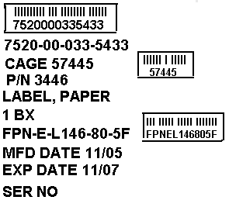
Figure 9 ID Markings with Shelf Life markings

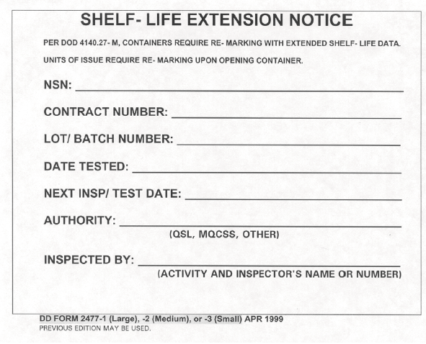
Figure 10 DD Form 2477, Extended Shelf-Life Notice.

SECTION 7 SUPPORTING DOCUMENTATION

7. Mil-Std-129P (3) references DOD 4500.9, where can I access this information?
Obtaining electronic information concerning DOD 4500.9-R, DEFENSE TRANSPORTATION REGULATION PART II CARGO MOVEMENT, may be found at http://www.transcom.mil/j5/pt/dtr_part_ii.html, the USTRANSCOM website.

7.1. CHAPTER 202, CARGO ROUTING AND MOVEMENT
This chapter provides routing and general provisions for DOD worldwide cargo movement by rail, motor, air, freight forwarder, pipeline, intermodal systems, drive-away and tow-away service, and water (inland waterway, coastal, and inter-coastal) carriers. Additional information can be found by consulting the SDDC Freight Traffic Rules Publications (MFTRPs), which is available at http://www.sddc.army.mil/ and then select Global Cargo Distribution, Domestic (more), and Publications.

7.2. CHAPTER 203 SHIPPER, TRANSSHIPPER, AND RECEIVER REQUIREMENTS AND PROCEDURES
This chapter provides the instructions and guidance necessary to route air and ocean export shipments to, from, and between locations in the CONUS and OCONUS, to include Alaska, Hawaii, and OCONUS theater areas. The instructions and procedures established within this chapter apply in OCONUS to the extent that they do not conflict with procedures established by the theater CDR. This chapter is organized in the order that shipments are normally processed through the DTS, i.e., shipper, transshipper, CCP, POE, POD, Breakbulk Point (BBP), and receiver.
7.3. CHAPTER 204, HAZARDOUS MATERIAL - GENERAL
1. All DOD personnel (military, civilians and contractors) participating in the shipment/movement of HAZMAT must comply with the rules of regulatory bodies governing the safe transportation of HAZMAT for modes of transportation. Although exceptions are noted in the 49 CFR (173.7 (b)), U.S. Government Material, for shipments for national security, all DOD personnel will comply with 49 CFR unless otherwise authorized by the DTR. For explanations pertaining to shipments for national security, see Paragraph C.4 of this chapter.
2. This chapter contains the policies, procedures, and responsibilities for movement of HAZMAT by all modes of commercial transportation and military surface transportation operated by military, DOD civilian personnel, and DOD contractor personnel. CDRs may apply more stringent requirements. Policies, procedures, and responsibilities for movement of HAZMAT by military air shipment are identified in AFMAN 24-204(I)/TM 38-250/MCO P4030.19I/NAVSUP Pub 505/DLAI 4145.3/DCMAD1, CH 3.4 (HM24), (Web site: http://www.afmcpub. wpafb.af.mil/Hazmat/. For purposes of this regulation, the terms ammunition, explosives, and munitions are synonymous. Also, the term HAZMAT includes all hazard classes of HAZMAT, including munitions.

7.4. APPENDIX L, TRANSPORTATION CONTROL NUMBER (TCN) GENERAL

1. The TCN is a 17-character data element assigned to control and manage every shipment unit
throughout the transportation pipeline. The TCN for each shipment is unique and not duplicated.
Except for a misdirected shipment, a retrograde shipment will not be re-shipped using the original
TCN. A new TCN will be created each time a shipment enters the transportation pipeline. In
many shipments, TCNs begin with a Department of Defense Activity Address Code (DODAAC).
The 17 character TCN is essentially a four-part number composed of a DODAAC, Julian date,
serial number, and suffix. The first three parts of the TCN for Military Standard Requisition and
Issue Procedures (MILSTRIP) shipments are normally the requisition number, found on such
documents as the DD Form 1348-1A, Issue Release/Receipt Document, (See Figure 202-7), DD
Form 1149 Requisition and Invoice/Shipping Document, (Figure 203-1), or a contract. For most
other shipments, the TCN is constructed in the same standard four-part format. The SEAVAN
TCN (assigned by the Water Clearance Authority (WCA)/Ocean Cargo Clearance Authority
(OCCA)) differs from the standard by inclusion of a voyage number instead of a Julian date and
by using the suffix to identify container service payment responsibility and the container type.
The personal property TCN has a totally unique construction derived from the sponsoring
member’s/employee’s Service, social security number, shipment pickup/turn-in date, and the type
of personal property being shipped. TCN construction for the various types of shipments is
detailed in the paragraphs listed below:


