UNCLASSIFIED
FOR OFFICIAL USE ONLY
UNTIL RELEASED BY
THE COMMISSION ON THE NATIONAL GUARD AND RESERVES

STATEMENT OF

GENERAL LANCE SMITH, USAF

COMMANDER

UNITED STATES JOINT FORCES COMMAND

BEFORE

THE COMMISSION ON THE NATIONAL GUARD AND RESERVES

5 OCTOBER 2006

UNCLASSIFIED
FOR OFFICIAL USE ONLY
UNTIL RELEASED BY
THE COMMISSION ON THE NATIONAL GUARD AND RESERVES
Mr. Chairman, members of the commission, thank-you for extending an invitation to me to testify today. The work that your group is doing is vitally important to this nation, our Armed Forces, and the security of the American people. The “Citizen Soldier” is as old as our Republic. They keep our military grounded and tied to the heartland, small towns, and big city neighborhoods that are the true wealth of America. Their combination of skills, both military and civilian, provides a resource base of leadership, talent and hard work that is unique in my experience. Throughout history, but especially since September 11th, 2001, our Guard and Reserve men and women have made enormous contributions and sacrifices. They have guarded convoys, hunted terrorists, led forces in combat, and participated in the elimination of Abu Masab al-Zarqawi. Their performance has been exemplary. However, we must ensure that we continue to develop and use this national asset wisely and well. Today we face a far different environment than the one which existed just over five years ago, and we must work together to ensure we will have a robust joint capable reserve component in the future.
We take great pride in sharing the accomplishments of Joint Forces Command (JFCOM), its components, and our members in the Guard and Reserve. We are a command with 1.1 million Soldiers, Sailors, Airmen and Marines, serving globally, many of them from the Guard and Reserve. We are truly a Total Force, and frankly we couldn’t do our job without their vital contributions. As we meet today, the Guard and Reserve are participating across the globe in the War on Terror while providing training and unique skills to transform the future force. They also continue to stand ready to deploy again as they did during Hurricane Katrina to provide any domestic support that is needed. This is why we’re pleased today to share why the Guard and Reserves are a vital part to winning this war on terrorism and our vision to enhance their future capability.
As we enter the sixth year of our war on terrorism that threatens America’s security, citizens, and our way of life, the Reserves and National Guard have stood steadfast along side their Active duty peers throughout. Nowhere has this been more evident than at Joint Forces Command. JFCOM has been leaning forward to promote better Reserve integration and jointness, as well as working with the Services through our components to improve mobilization processes which impede efficiency and add stress. Our goal is to promote reserve employments which are stabilized and predictable; that allows members greater flexibility in service, including volunteerism programs vice just mobilization; and ensures better training of the individual and reduces stress on the members, their families, and employers.
We count on Reserve and National Guard men, and women not only at our headquarters and subordinate commands, but also in our role as the Global Force Provider to the geographic combatant commands. JFCOM has made organizational changes that allow us to maximize the capabilities that the National Guard and Reserves have to offer. We created the Joint Reserve Directorate, which was stood up in the weeks that followed September 11th in order to give the Joint Forces Commander one point of access to ensure we assign the right RC person to the right job at the right time.
At any given time nearly 200 Reserve Component (RC) members are on duty with JFCOM around the globe. Our RC personnel are integrated fully within the command in all areas of employment. Within our headquarters staff, we are proud to have Flag and General Officers of every RC, representing each of the Services, serving in vital positions of our staff – Maj Gen Bill Rajczak, from the Air Force Reserve, as our Deputy for Joint requirements and Integration; Maj Gen John McLaren, from the Army Reserve, as Vice Commander of the Joint Warfighting Center; as well as Brig Gen Jacobsen from the Army National Guard, and Rear Admirals Wendi Carpenter and Greg Timberlake from the Navy Reserve in other leadership positions. We regularly count on Guard and Reserve senior leaders to not only ensure we are fully engaging and developing our reserve component to put us on the right track for success, but also that JFCOM is meeting it’s responsibilities to the other unified commands.
Across our headquarters in Norfolk, we have Guard and Reserve personnel in drill status in every directorate, such as the Standing Joint Force Headquarters which currently relies on Gurardsmen and Reservists working alongside their active duty counterparts to provide expertise, training and subject matter experts as part of a standing Joint force able to deploy worldwide when a crisis occurs. We have the same talented mix of the total force in our subordinate commands such as the Joint Communications Support Element, Joint Public Affairs Support Element, Joint Transformation Command Intelligence, and others. These units routinely deploy teams to Iraq and Afghanistan and to support recovery efforts during natural disasters as they did last year in Pakistan after the earthquake. Across the board, reservists are providing expertise in Joint experimentation, modeling and simulation, business acumen for organizational alignments, capitalizing on new technology, and training our forces. They are providing in-depth analysis to enhance our organization, build the right training vision and produce the future coherent Total Force.
Our vision for appropriate Reserve forces is to prepare them to seamlessly participate effectively in joint operations. Joint Forces Command and the Services should provide training for Reserve Forces in the same manner that they train Active Duty forces. As our experience over the last six years demonstrates, our Reserve forces operate equally with our Active Duty forces as an integral part of Joint operations—so we are currently working with the Services, the Combatant Commands and our Components to set improved training standards for the Total Force.
Our Component Commands—Air Combat Command from the Air Force, the Navy’s Fleet Forces Command, United States Army Forces Command, and Marine Forces Command—all provide robust Guard and Reserve units and personnel to the war on terror, and stand ready for action for homeland support. They work hard to ensure that these forces are Joint trained and ready. We are working to make enhanced training available across the spectrum wherever it is needed in the Total Force.
Joint Forces Command achieves great synergy by fully integrating the reserve forces into our training—from senior leader courses such as CAPSTONE and KEYSTONE to mission rehearsal exercises. This also benefits the Services, the Combatant Command, and the individual Reserve and Guard members. We provide enhanced Joint training to the Services’ rotational and pre-deployment training programs. For the Army, this includes training of deploying tactical brigades at the National Training Center, Joint Readiness Training Center, and Joint Multinational Readiness Center, as well as importing joint training to the Battle Command Training Program for deploying tactical staffs. For the Air Force, this joint training, specifically at Red, Blue, and Green Flag exercises, better prepares Air Expeditionary Forces, close air support capable squadrons, and Air Operations Centers for execution of their missions in Iraq and Afghanistan. JFCOM’s Joint National Training Capability (JNTC) also supports Navy Fleet exercises, in port and at sea, and Marine Corps training rotations at Twenty Nine Palms. We are also actively engaged with the leaders of the reserve components to ensure they have the fidelity and range architecture to integrate fully into the JNTC plan.
We are also using Joint National Training Center to support Guard training. Our methodology uses our accreditation/certification process to provide this support. In Calendar Year 2007, we plan to develop collaborative understanding of the joint enhancements required at key National Guard training programs. Through this process, we will design in the required joint context to ensure Guard members receive the same training as Active duty members.
The Department of Defense Training Transformation Implementation Plan was built to ensure the National Guard Bureau is integral to the development of several capabilities. These include initiatives to improve training simulations and training range infrastructure, create a mission rehearsal and joint training capability, and develop a robust joint training research and development program.
Near term efforts include a fiscal year 2007 plan to connect the ARCNet (USAF reserve network) and then the GuardNet, the National Guard’s national network for distributed education and training, with the Joint Training and Experimentation Network (JTEN). This will enable the Air Reserve and later the Guard to access the entire array of joint training tools such as the live, virtual, constructive training environment, and will maximize investment efficiencies for the entire joint training community. This distributed infrastructure allows weekend Guard training audiences to “plug in” from home station to our worldwide joint training environment – supporting our goal to “train like we fight.” Finally, our support to the important Joint Task Force–State training program is making efforts to assist the states to ensure their troops receive the same quality and fidelity of training. This is truly transformational because it allows the National Guard to collaborate, experiment and exercise in a collective manner with their Active counterparts and as we expand this capability with our coalition partners we will start to see a truly integrated trained Total Force.
In January 2006, JFCOM became the Office of Primary Responsibility for the Joint Knowledge Development and Distribution Capability (JKDDC). JKDDC and JNTC are two of the three major initiatives that make up DoD’s Training Transformation effort. As you can see from Figure 1 we have increased our web-based training programs significantly and the programs are aimed at increasing joint training for the Total force.
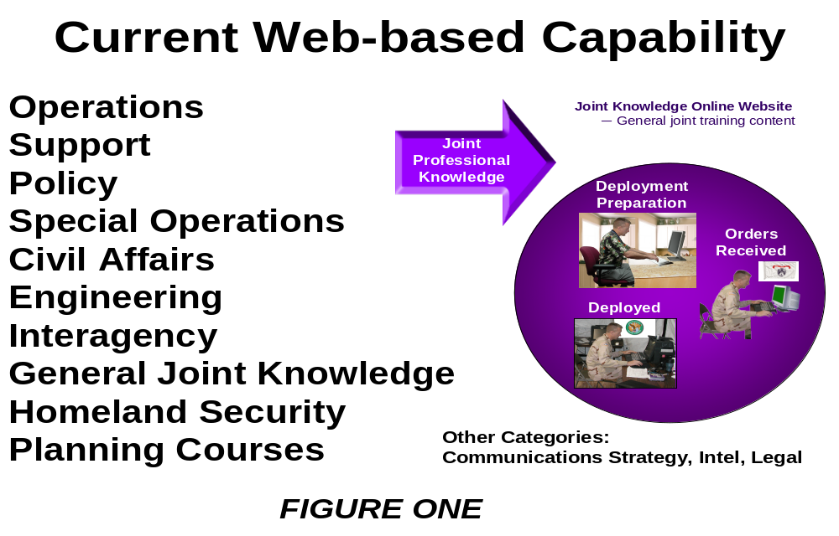
Course development is underway and our main effort is to develop education products that will serve the joint training requirements of the Total force. Our key to effective Joint Training is detailed in Figure 2 with the JKDDC web portal that will allow Guard and Reservists to understand their training requirements, see their predeployment readiness tasks, provide interactive training software and research and truly be an enhancer from predeployment, through deployment and ultimately provide feedback post deployment. We believe that cultural and basic language training education tools are essential to success in the current conflict and these are the type of online Joint tools that are paramount as we develop this capability. This portal will also have sections that emphasize what the individual augmentee needs to accomplish to be ready, allow them to provide feedback, and constantly give them a status update so they can check their readiness against actual deployment requirements.
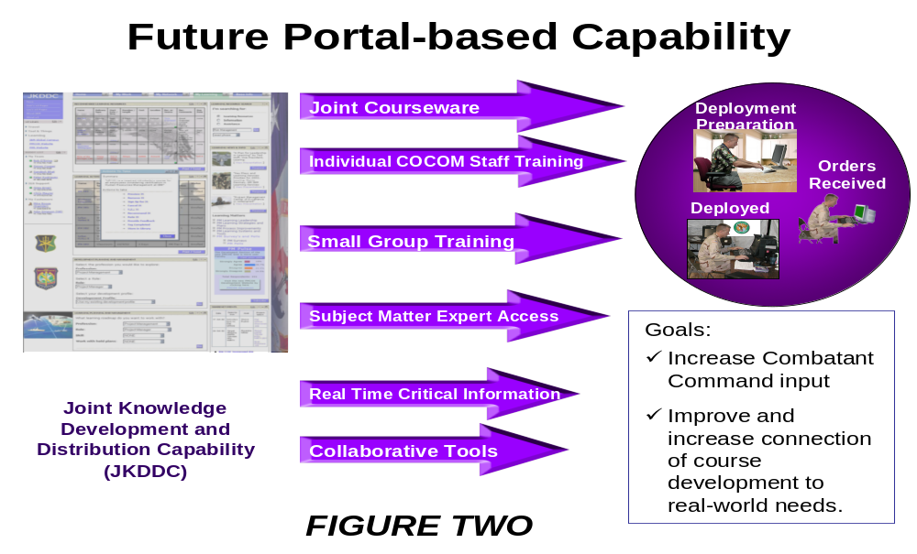
Training is a major driver for changing the culture of the force to properly employ new technologies, to implement process improvements based on lessons learned and to deal with the evolving security environment. The JNTC initiative is a key contributor to achieving future joint training capacity in order to support the transforming Total Force and enhance interoperability with our multinational and interagency partners.
There are challenges. First, we must provide trained and ready joint forces to the Combatant Commanders to fight not only the Global War On Terrorism, but support other possible conventional contingencies. We must also be capable of generating forces to respond to major disasters when directed to do so. JFCOM must ensure joint training and readiness needs of those forces. Providing sufficient numbers of mission-ready, joint trained and equipped forces for the missions assigned to the geographic combatant commanders will continue to be a challenge. However, we can say that over the last few years in our role as managing conventional forces globally we have worked with the offices of the Secretary of Defense and through our Components, the Services and the Total Force to achieve better visibility on the Total Force and to understand the current operations tempo while trying to provide some level of stability where possible. We will continue to work with the offices of the Secretary of Defense to develop tools such as the Defense Readiness Reporting System that allow us to properly source the Total Force while improving stability, and predictability for everyone.
Second, we must continue transforming our Total Force for the future while prosecuting current campaigns. Although challenging, it is important to balance the needs of the Combatant Commanders for current operations with the need to modernize and modularize Joint and Service forces to increase their capability to meet the 21st Century security challenges. We can tell you that the organizations, the capabilities and the way that we are training and fighting this conflict have improved significantly over the last three years for the Total Force, and it will continue to improve. Third, we need to ensure the requirements and acquisition processes can rapidly provide solutions to meet combatant commanders’ short term joint needs. We need to improve our ability to quickly implement solutions to joint lessons learned and integrate promising concepts and technologies without significantly disrupting existing programs within the execution years.
On 1 October 2006, JFCOM assumed responsibility for joint individual augmentees. Since 9/11 the daily requirement for individual augmentees serving in Joint Task Force organizations has increased significantly with about 27% of those requirements filled by reserve component personnel. The number of individual augmentees in operational Joint Task Force Headquarters staffs now approaches 50% of the total manning. Because more than 80% of major military operational contingencies have less than one month of planning time before execution, it is imperative to rapidly form the JTF Headquarters with trained and qualified personnel. This increases the need for these individuals to be trained in an environment that provides joint context before being assigned to augment the headquarters staff.
Historically, individual augmentee manning requirements have been largely filled through an ad hoc approach. Active duty personnel are often sourced from operational Service units; however, this practice is disruptive and negatively impacts Service unit mission capability, cohesion, and readiness. The nature of individual augmentee sourcing (as compared to unit sourcing) results in less initial cohesiveness, due to a lack of pre-existing relationships, which degrades teamwork and readiness at the Joint Task Force headquarters. Furthermore, inconsistent periods of assignment create excessive personnel turnover, undermining Joint Task Force Headquarters capability and continuity. Many individual augmentees lack sufficient joint or Joint Task Force related experience, and have received little or no training to allow them to arrive in theater with the requisite skills required. By the time an individual augmentee reaches peak effectiveness and knowledge in his or her assignment, it is often time to be replaced with another individual augmentee.
There are several ways to address these shortfalls. We may wish to establish Joint Reserve Units at COCOM and Service headquarters that are trained to man Joint Task Force headquarters. More short courses and flexible delivery mechanisms for Joint Professional Military Education phase II for Guard and Reserve personnel would also be helpful. Finally, we have to establish a designation for the reserve component as “Joint Qualified” or as a Joint Specialty Officer (JSO) that allows these individuals to be tracked.
As the Joint Force integrator, JFCOM is responsible for recommending changes in doctrine, organization, training, material, leadership and education, personnel, and facilities to integrate Service, defense agency, interagency and multinational capabilities. In this capacity, we have provided, and continue to provide, capabilities that empower the total force. The Reserve Component brings an excellent blend of military expertise that coupled with civilian skill sets make them even more valuable in developing such capabilities as modeling and simulation analysis tools, information technology integration, and joint command and control enablers. We must also be mindful that this value represents a sacrifice for employers and communities.
As the Joint Force Provider, JFCOM has combatant command over a large portion of the conventional forces to include most of the National Guard and Reserves. We provide them as trained and ready joint-capable forces to the other Combatant Commanders when directed by the Secretary of Defense. This includes recommendations on appropriate allocation of forces to meet requirements with the appropriate level of capability with the least amount of acceptable risk. United States Joint Forces Command must have visibility on the capabilities and readiness levels of the available forces to make the best recommendations possible.
One critical area where proper allocation of the Guard and Reserve is critical is Homeland Security. Following Hurricane Katrina, JFCOM resources, such as the Standing Joint Force Headquarters and the Joint Center for Operational Analysis and Lessons Learned, deployed to the affected area to coordinate relief and evaluate the response and follow on actions. Based on this analysis, we believe the National Guard should remain a dual-missioned force available for both State and Federal Support missions. However due to our Joint Force Provider responsibility, JFCOM must have visibility on all National Guard operations to include those executed under US Code Title 32 and those in a state active duty status. Visibility will allow for analysis and recommendations on the implications on current/future operational commitments and impacts on personnel and equipment availability and readiness. The use of the National Guard equipment, even if reimbursed by the state, will have readiness impact such as engine hours and maintenance schedules.
JFCOM has a responsibility to be able to provide properly organized, trained and equipped Joint forces globally to include the National Guard and Reserves. Some of the units with a Joint designation are the Joint Reserve Units, Joint Force Headquarters-State, Civil Support Teams, Chemical Biological Radiological Nuclear Environment Enhanced Response Force Package, National Guard Reaction Forces, and Critical Infrastructure Protection-Mission Assurance Assessments. JFCOM, working with the services, NORTHCOM and the National Guard Bureau, have committed to meeting the unique requirements of the Reserve Component to improve the readiness of these Joint units.
To better support disaster and humanitarian relief operations and improve the efficiency of the Total Force, JFCOM has worked with the offices of Secretary of Defense to develop a capability we’ve named HARMONIE, a web based portal and domain on the internet where all agencies involved in these critical mission—both government and nongovernment—can exchange information. With this capability, crisis responders, whether they are at the local, state, or national level can immediately stand up web pages and connect to other users, thus giving them increased awareness. We’ve also developed a National Security Agency certified Cross-Domain chat capability that facilitates communication between groups as different levels of security and information access. Both HARMONIE and the Cross Domain chat solutions were used in STRONG ANGEL III, a disaster response exercise involving 600 military members, Defense Department employees and contractors, first responders, nongovernmental organization representatives and technologists.
Further, we are applying our Modeling and Simulation resources and experience to improve Total Force response. We are learning how to better model Norfolk, Virginia, or Portland, Oregon, or any American city in the same manner we have modeled overseas urban environments for irregular warfare training, but in this instance we can experiment with ramifications caused by hurricanes or other natural disasters. This allows us to test different preparation scenarios as well as post disaster recovery plans. This is a unique capability we offer the Homeland Security environment and one we take seriously.
In JFCOM we pride ourselves on the ability to integrate Guard and Reserve forces and facilities. This is where much of the expertise and the experience to address a large aspect of Homeland Security lay. This is business as normal based on availability of the force and focus of the work. We continue to strengthen ties between JFCOM and NORTHCOM to better refine disaster response plans and procedures. Prior to and during hurricane season the JFCOM and NORTHCOM Commanders met to analyze trends, alert units to possible missions, review lessons learned from last year and conduct exercises to ensure readiness.
We are working to improve Joint Command and Control across the Total Force. Joint Command and Control below the COCOM level currently depends on the ad hoc creation of headquarters elements – both personnel and equipment – and sufficient time to train the new unit in command and control functions, forge them into a coherent team, and employ them in the operational area. At the operational level, we organize, train, and equip primarily as Service headquarters, but we nearly always operate as an integrated task force of joint, interagency, and multinational capabilities. This is most always a Joint Total Force of individuals. In order to ensure effective operations across the spectrum, we must improve the formation and sustainment of Joint Task Force headquarters capable of commanding and controlling integrated operations (with forces from all services / components, interagency, and multinational partners) not only to respond to domestic natural disasters, but to meet worldwide rotational and contingency requirements as well. During Hurricane Katrina we deployed the Deployable Joint Command and Control system which provided integrated Command and Control for military responders. We are developing other more agile systems and information tools that will improve Joint Task Force crisis response. As the Joint Force Experimenter we are working to mature concepts into capabilities to improve crisis response and better situation awareness. We have started to partner with state government in Virginia to test these concepts and look forward to making these capabilities available to others.
Joint Forces Command remains committed to winning the global war on terrorism, securing peace in Iraq and Afghanistan, and combating weapons of mass destruction, while enhancing current joint warfighting capabilities and transforming to meet the challenges we face now and in the future. However, we could not continue our mission within Joint Forces Command, nor could we support the other combatant commands, without the operational capabilities and skills of the Reserve and National Guard. Thank you for the opportunity to talk about Joint Forces Command; our accomplishments, capabilities, challenges and future vision to empower, enhance and improve the Total Force. We appreciate your efforts on behalf of the National Guard and Reserves.

