CHAPTER 13
INTERNATIONAL EMERGENCY MANAGEMENT
Students of emergency management are exposed to a great deal of information on what is being done in the United States and, to a lesser degree, the English speaking world. However, they are often unaware of the different approaches to emergency management used in other regions. This chapter identifies some of the ways in which countries differ systematically in their hazard vulnerability, economic resources, government organization, quality of the built environment, civil society, role of the military, and role of international organizations. The chapter then turns to six case studies of emergency management capabilities in East Asia, South Asia, South America, Oceania, and Europe.

Introduction
Research on emergency management suffers from the same problems as much social science research; most of it has been done in the English speaking countries and much of the remaining work has been done in former colonies of these nations (Heady, 1996). Students of emergency management are thus exposed to a great deal of information on what is being done in the English speaking world, yet are often unaware of the different approaches to emergency management used in other regions. A few scholars have examined the applicability of emergency management principles developed in rich countries to other areas. They have concluded that the principles of an all hazards, integrated, and comprehensive approach covering all phases of emergency management and integrating relevant agencies, together with a focus on building community resilience at the local level, are viable and useful in a wide variety of settings (Martin, et al., 2001). However, resources, both human and technical, are frequently lacking for the development of adequate programs (Vatsa & Joseph, 2003).
One reason to study policies and programs used in other countries is that, increasingly, countries are learning and borrowing policies from each other (Dolowitz & Marsh, 2000). Globalization has had two important effects. First, it has exposed all countries to an increasingly competitive economic system. Second, advances in the technology of communications have made it possible for policymakers to communicate quickly and easily. Because of these changes, policymakers increasingly look beyond their national borders for ideas on how to address problems at home.
Governments are not the only institutions looking for ideas abroad. NGOs of all sorts are also engaged in learning from a wide range of institutions outside of their host countries’ borders (Stone, 2000). Indeed, many NGOs such as Greenpeace are multinational organizations, that routinely engage in cross-national policy transfer. Corporations, independent policy institutes, and less well organized transnational social movements can also engage in cross-national policy transfer.
The transfer of policy across national borders is complicated by the presence of “national policy styles” (Howlett, 1991). These policy styles are based on the different characteristics of the governments involved, as well as the ways in which the governments relate to civil society. As a result, policy transfers are not always successful. Dolowitz and Marsh (2000) identified three ways in which policy transfers can fail.
- Uninformed transfers fail because the borrowing country does not understand the policy it is adopting;
- Incomplete transfers fail because the borrowing country does not transfer the necessary elements of the policy; and
- Inappropriate transfers fail because there are too many differences between the social, political and economic contexts of the two countries.
Factors That Cause Variation in Policy Choices
Countries can be compared on the basis of many characteristics including regime type (roughly on a continuum from totalitarian to democratic), political culture (traditionalistic, moralistic, and individualistic), orientation toward modernity (Inglehart, 1997; Barber, 1997), and level of economic development (Gross Domestic Product per capita1, Human Development Index2, or Gini coefficient3) Yet, administrative structures are relatively similar across a broad range of countries because the function of an administrative structure has an effect on the shape it takes (Peters, 1995). In addition, organizational models are frequently shared among groups of countries. For example, former colonies frequently have administrative structures that closely resemble those of their former colonial masters. Countries that share membership in a multinational organization such as the European Union (EU) frequently come to share forms of administrative organization in order to simplify crossnational cooperation. In disaster management, the influence of the UN through programs such as the International Decade for Natural Disaster Reduction (IDNDR) and its successor program, the International Strategy for Disaster Reduction (ISDR) has contributed to the diffusion of common models, while encouraging countries to adapt these models to their own realities. Regional emergency management organizations such as the Organization of American States (OAS), the Pan American Health Organization (PAHO), the Centro de Coordenación para la Reducción de los Desastres Naturales en América Central (CEPREDENAC), and the Asian Disaster Preparedness Center (ADPC) have also influenced the evolution of emergency management across a wide variety of nation states.
When comparing emergency management policies, the most relevant dimensions of comparison must include the “propensity for disaster, local and regional economic resources, organization of government, and availability of technological, academic, and human resources, … level of local responder training, resilience of infrastructure, public opinion of the government’s ability to manage the crisis, and the availability of specialized assets” (Haddow & Bullock, 2003, pp. 165-166). In other words, the most relevant dimensions of comparison arise from what emergency managers know as hazard vulnerability (recall Chapter 6) and local capability (recall Chapter 3). The rest of this chapter will consider the dimensions listed above, but will also examine the role of the military in society, the development of civil society, and other factors affecting the various programs throughout this chapter. These factors are linked in complex ways to produce a unique profile of hazard vulnerability and emergency management in each country.

Hazard Vulnerability
As Chapter 6 indicated, hazard vulnerability varies according to hazard type and level of exposure. Frequently, a country’s types and levels of hazard exposure influence its organizational structure and the quality of its emergency management organizations. Countries with high levels of hazard exposure have often been found to have “disaster cultures” enabling them to adapt and respond to recurrent events. Their emergency management organizations can also show a high level of adaptation to particular hazards. For example, countries facing frequent typhoons have developed more sophisticated programs and policies than those that do not. Bangladesh has developed a system of evacuation platforms because of the very flat terrain, and Taiwan has put a great deal of money into typhoon warning research.
An example of the way in which hazard exposure and experience can shape national emergency management programs occurred in Central America after Hurricane Mitch in 1998. Prior to the arrival of this devastating hurricane, most countries of the region had devoted little attention to emergency management. They had established basic “civil defense” programs, usually associated with the military and concentrating on disaster response. However, there was little or no attention paid to the connections between economic development programs and the production of hazard vulnerability. After the hurricane, the governments of the affected countries began to change their national development programs to a sustainable development paradigm. These emphasized the linkages between social factors, environmental degradation, and hazard vulnerability (Lavell, 2002).

Economic Resources
Emergency management is low on the priority list in poorer countries, as indeed it is elsewhere. Whole societies live on the brink of economic collapse, so other problems such as the provision of basic education and public health services seem to be of more immediate concern. Thus, emergency management is often an afterthought that rises on the public agenda only after a disaster occurs. In the meantime, poverty and uncontrolled rapid urbanization generate large concentrations of vulnerable populations in high risk urban areas. Moreover, the lack of attention to the links between environment and human settlements has delayed the development of a better understanding of sustainable development and increased the incidence of disasters in rich and poor countries.
The quality of emergency management in a country is related to the amount of resources available nationally for emergency management and to the amount of resources available from outside a country. Many poor countries struggle with high levels of foreign debt, often incurred by undemocratic regimes. To compound the problem, some of these countries devoted much of their national budget to the military. This left little money for improving the country’s human capital through education and health care. Emergency management was left far down the list of discretionary spending programs. Sometimes this situation has been exacerbated by structural adjustment programs imposed by multinational lending agencies such as the World Bank and the International Monetary Fund. Nonetheless, some countries have been able to use funds from donor nations and international lending agencies to improve their emergency management capabilities.
Hazard insurance availability varies from one country to the next. Few countries have systems with market penetration as widespread as the National Flood Insurance Program of the US In part, this is because participation in the NFIP is a condition for getting a mortgage. Many foreign countries lack disaster insurance programs or, if they do have one, premiums are too high for the majority of the population to afford them. In these countries, businesses might have disaster insurance, but few homeowners do. National governments might want to require homeowners to purchase hazard insurance but cannot do this by requiring hazard insurance as a condition of mortgage approval, as in the US. The reason this option is unavailable is that many fewer people in these countries borrow money to buy a house. In many cases, people first buy the land and then build each room of the house as they save enough money to purchase the construction materials. As a result, these governments lack the mechanism the US government uses to intervene in the housing market.
Haddow and Bullock (2003) mention the availability of “specialized assets” as a factor affecting emergency management. These specialized assets may include items needed during response operations such as heavy equipment, trained Urban Search and Rescue (USAR) teams, hazmat capabilities, technical expertise such as GIS, and training facilities. Such resources are not available universally, but often are shared regionally through organizations such as the Caribbean Community’s Caribbean Disaster Emergency Response Agency (United Nations International Strategy for Disaster Reduction, 2002). USAR teams, in particular, are eager to participate in emergency response efforts no matter where they occur. They can provide valuable assistance, on the job training, and assistance with the psychologically difficult task of body retrieval—although it is rare that they are able to arrive quickly enough to accomplish rescues during the critical first hours. This is due to the logistics of moving large numbers of people and their equipment, as well as to legal and political problems with such movements. In some cases, flyover rights have been denied to USAR teams, and the entry of search dogs without the normal quarantine or veterinary procedures frequently causes problems. Thus, there is increasing interest in local development of hazmat and USAR capabilities, using foreign teachers if necessary, or sending a first generation of practitioners to study abroad and bring back the needed knowledge for a train-the-trainers approach.

Organization of Government
One of the most important issues affecting emergency management is the degree of political centralization in a particular country. The control of policies, programs, and resources by the highest (national) level limits the ability of local governments to mount a rapid emergency response or to develop appropriate hazard mitigation programs. Emergency management is a service, like police and fire protection, that is delivered over a dispersed area. Consequently, it benefits from a significant degree of decentralization, allowing local governments to manage the service delivery (Peters, 1995, p. 161)
An excessive emphasis on major disasters tends to lead to overcentralization because it is assumed there will be a need for governmental coordination over the very large areas affected. Unfortunately, this also requires communication of information through multiple layers of government—which delays response and recovery operations. In reality, small frequent events cause more deaths and economic losses than larger ones. When small events occur, local governments can respond with more agility and effectiveness if they do not need to await instructions and resources from the central government. Thus, empowering local governments and their populations to deal with local events is very effective, but is frequently resisted by the national governmental authority because it reduces central control. Frequent small events also point to the connections between patterns of development and hazard vulnerability, which can increase calls for more public participation in national goal setting. This also threatens a status quo that benefits entrenched elite groups.
The location of emergency management agencies in all levels of government is related to these agencies’ effectiveness and also to the emphasis given to different aspects of hazard vulnerability. An agency that is charged with responding to disasters, but has a low status in government, will have difficulty in finding and delivering the needed resources in a timely manner. Emergency managers benefit when they receive input from scientific agencies, such as those who map the national territory or deliver weather forecasts, but they are often isolated from such valuable input by their location in government.
The level of professionalization within the emergency management agency varies a great deal across countries. When an agency has a high political profile and adequate resources, it is more able to attract and keep well qualified and dedicated personnel. Few countries have an adequate supply of well trained emergency management professionals, however. This situation is of great concern, and a number of countries are addressing the lack of personnel by beginning training programs at the university and postgraduate level. Istanbul Technical University in Turkey and the Autonomous University of Nicaragua have recently developed multidisciplinary programs in emergency management that include both physical and social science components, and there are other examples worldwide.

Quality of the Built Environment
The quality of a country’s infrastructure, housing, and business and industrial installations affects the level of its disaster exposure and the type of emergency management program required to meet its needs. For example, the better the quality of the construction, the less need there is for urban search and rescue techniques after earthquakes. Similarly, good roads make it easier to evacuate large numbers of people from flood and hurricane zones. However, it does not necessarily follow that countries with higher quality infrastructure have uniformly lower hazard vulnerability. Countries with large numbers of high rise office and apartment buildings have an increased need for highly developed firefighting capabilities, as do those with large chemical manufacturing installations.

Civil Society
Civil society is the aggregate of organizations that are independent of the government. It includes religious groups, civic clubs such as the Rotary International, political parties, and other groups organized around specific interests. The opinion that mass publics have of their government’s abilities in general can affect the degree of trust they will place in government agencies’ pronouncements about its emergency management efforts. When publics are well informed and have strong beliefs in their rights as citizens, they are likely to demand more competence from government emergency responders and other emergency management agencies. NGOs and CBOs are ways in which civil society seeks to change governmental priorities or supplement weak governmental powers with its own capabilities. True civil society groups are not organized by government agencies, as is the case with the local neighborhood fire brigades in Taiwan, but are grass roots organizations that emerge independently of government to meet specific needs such as flood mitigation in a local watershed. They can exert substantial influence and can even contribute to processes of regime change, as the Communidades Eclesiais de Base (CEBs) in Latin America did. For this and other reasons, governments might be wary of strengthening civil society.
Civil society is often strengthened during disaster response and recovery operations, especially when government agencies prove inadequate to the task and emergent organizations arise to take on seemingly intractable problems. Such organizations were created in Mexico City after the 1985 earthquake (Velázquez, 1986) and in Kobe, Japan after the Great Hanshin earthquake of 1995 (Shaw & Goda, 2004). In addition, existing organizations are strengthened as they extend their missions to take on new disaster related tasks (Dynes, Quarantelli & Wenger, 1990).

The Role of the Military in Society and Emergency Management
The armed forces are involved in emergency management to some degree almost everywhere. The military has a high degree of organization, and in some countries that is enough to differentiate it from other governmental agencies and NGOs. In addition, the armed forces usually have more resources of the type needed for disaster response. These resources include communications (radios), transportation (airplanes and trucks), fuel (gasoline trucks), power (electric generators), water (water trucks), shelter (tents), health care (mobile hospitals), and food. Equally important is the organization into groups of large numbers of strong young men who are accustomed to taking orders.
There is another reason for the strong influence of the military in emergency management, however. This has to do with the nearly universal roots of emergency management in civil defense—that is, the organization, training, and equipping of nonmilitary personnel to repel invaders. In many countries, the military retains a strong influence on emergency management organizations. This usually leads to a strong emphasis on disaster response using command and control models. The problem is not that there are clear lines of authority. Rather, it is that little or no opportunity exists for civilian input and little attention is given to other emergency management needs such as disaster recovery and hazard mitigation. In other countries, the military is part of the emergency management system but is under civilian control. In such cases, it cannot respond unless its presence has been requested. The option is preferred, if only to avoid overdependence on the military and risking a slide into an authoritarian government during a period of national weakness. The term “civil defense” is frequently used for emergency management agencies, but this does not always imply a historic link to the national armed forces (Nikoluk, 2000).

The Role of International Organizations
Countries vary widely in their approaches to foreign aid, including policies on when and how to send help to disaster areas or become involved in mitigation projects. Some countries have adopted a reactive approach and confine themselves to offering assistance with search and rescue or postdisaster clean up. By contrast, others have adopted a more developmentalist perspective and assist in the formation of intergovernmental institutions and programs. Major goals from this perspective are to reduce the incidence of disasters and to increase the capacity of poor countries in responding to emergencies.
Many regional and international institutions are devoted to promoting improved emergency management practices. Noteworthy among them are the United Nations and its International Strategy for Disaster Reduction (UNISDR), the organization formed to carry on the goals of the U.N. International Decade for Disaster Reduction. The UNISDR, together with the Government of Japan, the World Meteorological Association, and the Asian Disaster Reduction Center, published Living with Risk: A Global Review of Disaster Reduction Initiatives online in 2002. This resource, (www.unisdr.org/eng/about_isdr/bd-lwr-2004-eng.htm) is a valuable compendium of information on emergency management worldwide.
In addition to the UN with its global range, there are regional organizations supporting emergency management programs. The Organization of American States has supported the development of disaster resistant schools, hospitals, and road networks through its Natural Hazards Project, a division of the Unit for Sustainable Development and Environment. The Centro de Coordenación para la Prevención de Desastres Naturales en América Central (CEPREDENAC) is an intergovernmental organization dedicated to the development of emergency management in Central America and the Dominican Republic. La Red is a network of Latin American social scientists that publishes scholarly work on disasters in the region, highlighting the issues of social vulnerability and sustainable development. The Pan American Health Organization, the regional office of the World Health Organization, has emphasized retrofitting hospitals and strengthening public health programs to improve emergency management practices throughout the region. It also publishes an influential newsletter, Disasters: Preparedness and Mitigation in the Americas, which can be found at the web site, (www.paho.org/english/dd/ped/newsletter.htm). Other regions around the world have similar organizations, such as the Asian Disaster Preparedness Center based in Bangkok, Thailand, that provide mutual aid, regional discussions of watershed management, and technology transfer.
The following sections of this chapter offer illustrative examples of emergency management programs and practices in a selection of countries. These examples are offered in order to show the wide variety of problems and solutions facing the varied populations of the globe as they confront hazardous environments.

Examples of Emergency Management Programs

Preparedness: Landslide Evacuation in São Paulo, Brazil
Brazil is a federal republic with strong states and wide regional variation in topography, soils, vegetation, and climate. Historically, the population centers have been in the mountainous coastal region. The interior plains states experienced increasing development only after construction of a new capital city, Brasília, in the 1960s. Brazil is fortunate in its lack of exposure to major earthquakes or hurricanes, two of the most catastrophic natural disasters in South America. However, it does experience frequent natural disasters from floods, droughts, landslides, and wildfires. There are also significant technological hazards, due to the high degree of industrialization in central and southern regions. Brazil has a significant nuclear industry as well.
Emergency management in Brazil has developed to reflect the structure of the government and the types of hazards to which it is exposed. At the federal level, the 1988 Constitution mandated the “planning and promotion of defense against public calamities, especially drought and floods” (Ministério da Integração Nacional, 1999). Following several major disasters, including floods, landslides, and fires in high rise buildings, the state of São Paulo created its State Coordinator of Civil Defense and established a framework of regional and municipal emergency management offices (Marcondes, 2003). These offices vary in quality and some municipalities have yet to establish their civil defense committees.
The Plano de Prevenção da Defesa Civil (Civil Defense Preparedness Plan, CDPP) was developed by the São Paulo State Coordinator of Civil Defense Office as part of its effort to meet the goal of natural disaster reduction during the IDNDR (UN Resolution 44/236). Landslides are the most common cause of deaths from natural disasters in Brazil. Several factors contribute to this situation, including environmental factors such as the varied topography, high levels of rainfall, and soil types that are prone to slipping. Social factors, which are even more important, include high poverty levels, rapid urbanization, lack of adequate housing in safe areas, and lack of education about the causes of natural disasters (Macedo, Ogura & Santoro, 2002).
The CDPP was developed as a cooperative effort among technical agencies, state and local governments, and local emergency management professionals. It is based on the monitoring of watersheds for rainfall levels, soil saturation, and weather forecasts. The first step in implementing this plan was risk analysis and mapping of the state, undertaken by the Geological Institute of the State of São Paulo and the Institute for Technological Research at the University of São Paulo. They determined that the Serra do Mar, a mountain range that follows the coastline and is undergoing rapid urbanization, was the most vulnerable region of the state. Consequently, landslide risk areas in the Serra were mapped and local governments were involved in the risk analysis to collect data on landfills and dumps, cuts, surface drainage patterns, landslide scars, and the number and location of houses (Scachetti, no date).
During the Southern Hemisphere’s summer rainy season, roughly from December through March, emergency managers in the Serra do Mar activate the system and enter the Observation stage. During this stage of operations, rainfall is closely monitored. These data are collected at computerized collection stations scattered throughout the region and transmitted by satellite to the state Coordinator’s Office. When rainfall reaches a critical level, defined by the Critical Precipitation Coefficient (CPC, hourly rainfall intensity divided by antecedent accumulated rainfall for the past 84 hours and multiplied by a coefficient for the local area), the Attention stage is activated. During this stage, field observers trained by local or state emergency managers search the area for ground instability features. These include cracks at the upper part of slopes, bulges at the bottom of slopes, color and quantity changes of springs, falling of small stones, small ground failures, and cracks in the walls of houses. When these signs are present, the Critical stage is entered. During this stage, inhabitants of the houses at immediate risk are evacuated. If conditions persist or deteriorate, an Emergency is declared, and all inhabitants of the risk area are evacuated. The plan includes a significant public education component, with the State Coordinator of Civil Defense Office and municipal governments producing a wide variety of print and video materials. These include graphic and verbal descriptions of ground instability features, as well as lists of what to do and whom to call in case features indicating a dangerous situation are noted. Figure 13-1 shows a sample of the public education materials developed by CEDEC.
The CDPP, which was instituted in 1988, has been highly successful in reducing the number of deaths due to landslides in the Serra do Mar. There were 48 deaths in two cities alone (Cubatão and Ubatuba) in 1986 and 39 in Cubatão and Santos during 1987. During the first year of the systems’ operation, 17 people died, and during the years from 1989 to 1999, most years saw 0-3 deaths, with two years having 7 and 9 deaths (1995 and 1996, respectively). The system has been so successful that it is being implemented in another landslide prone region of the state, the Serra da Mantiqueira in the Paraíba Valley (Ridente, et al., 2002).
Figure 13-1. Public Education Material.
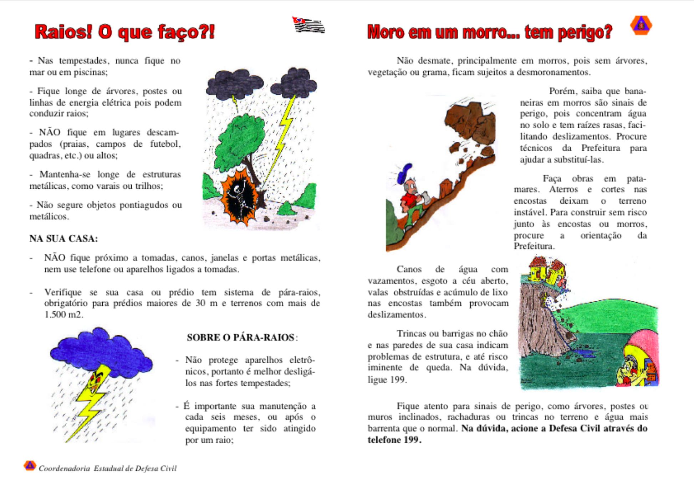
Source: Governo do Estado de São Paulo, 2000.

Location of Emergency Management: Restructuring in New Zealand
New Zealand has significant exposure to floods, earthquakes, tsunamis, and cyclones. Contrary to the popular image of New Zealanders as sheep farmers, the population is 85% urban. Consistent with a worldwide wave of decentralization efforts, New Zealand has made significant changes in its legal framework for city governance since the middle of the 20th Century. Beginning in the 1970s, the national government undertook many reform efforts, several of which affected emergency management. These reforms have followed a general government restructuring aimed at localizing and privatizing government functions where possible, and increasing governmental transparency and accountability overall.
The Local Government Act of 1974 and its 1996 amendment have increased the responsibilities of local governments and authorized them to produce and implement plans. Of particular interest are financial and environmental management plans that enable local governments to better control the quality of life in their communities. Sustainability concerns drove the Resource Management Act of 1991, which promoted performance based environmental management by local authorities. The act specifically refers to natural hazards and hazardous substances, thus integrating emergency management into land use planning and development. Acts specifically aimed at emergency management include the Hazardous Substances and New Organisms Act of 1996, the Building Act of 1991, and the Biosecurity Act of 1993, among others. Figure 13-2 shows the relationships between factors driving changes in emergency management and the agencies, methods, and goals of change.
Figure 13-2. Emergency Management Drivers.
Rationale for emergency management
Central govern-ment role:
• Lead thinking
• Ensure systems are in place

• Social and economic goals
• Risk management
• Communities choosing appropriate levels of risk
Enable communities to maximize gains and minimize losses
Drivers:
• Sustainability and resilience
• Holistic management
• Governance and partnerships
• Economic efficiency
Community responsibility:
• Local government role
• Other relevant agencies

Source: Britton (2001)
The last major disaster in New Zealand was the Napier earthquake of 1931. As is common in all countries, the long time that had elapsed since the previous major event had allowed a certain level of complacency to arise (Britton, 2001). The Loma Prieta and Northridge earthquakes were instrumental in shaking this complacency, and the government undertook a thorough review of emergency management legislation and agencies in the mid 1990s. One of the main reasons for the review was the belief that emergency management in New Zealand must shift away from a deterministic and reactionary orientation toward the use of hazard assessment and risk identification to promote the incorporation of hazard reduction and emergency management directly into land use management and urban development. This effort included reports (the Law Commission Report, 1991), conferences in Wellington during May and November, 1994, and workshops (involving 26 emergency relevant organizations in 1994) that together produced some fundamental changes in emergency management policies and practices.
The review process identified several problems with the country’s emergency management system. These included the unrealistically high public expectations of aid following disasters, coupled with reduced central and local government capacity following the public sector reforms of the 1990s. To address these problems, New Zealand’s emergency management sector needed to improve its ability to adapt to change, learn from other countries’ experiences, and better coordinate administrative resources. In addition, the review process culminated in the recommendation of a comprehensive outlook, incorporating all phases of emergency management and all hazards, that should replace the existing response focused approach.
As a result of the review process, a new Ministry of Emergency Management (MEM) was created in 1999 with three operational units. The first of these, the Sector Development and Education Unit, was given responsibility for conceptual development and the translation of these concepts into working models and practices. It also is responsible for evaluating emergency management effectiveness. The second, the Policy Unit, is responsible for framing strategic emergency management policies and integrating the MEM with the work of other governmental agencies. This unit took the lead responsibility in developing a new bill giving a more adequate legislative foundation to national emergency management. The third unit, Sector Support, works with local governments and emergency services that are the point of service delivery to ensure its effectiveness.
Legislation developed by their MEM was introduced into Parliament during November, 2000, to reconfigure New Zealand’s emergency management practices, processes, and structures. The integration of emergency management with other community goals such as growth, development and sustainability is a major principle of the new legislative framework. The goal is to “improve and promote community resilience and continuity through comprehensive, integrated, and risk based emergency management” (Britton & Clarke, 2000, p. 147).
Emergency management was declared a “core function” of central and local governments in 1997. Consistent with the principle that emergencies are best dealt with at the local level as much as possible, the new legislation established a system of Emergency Management Groups (EMGs) throughout the country. These groups are composed of several existing local authorities with emergency management responsibilities, resulting in fewer than 20 EMGs incorporating 86 local and regional authorities (Britton & Clark, 2000). The designers believe that effectiveness will be increased by grouping local authorities because there will be more resources available. Moreover, the regional coverage of the groups will allow for regional approaches to mitigation, preparedness, and response.
Through its reform process, New Zealand has sought a balance between centralization and localization of emergency management. Policy, strategic, and support functions remain at the national level while local and regional authorities are given wide latitude for risk assessment, mitigation, preparedness, and response functions. The current statutes emphasize sustainable management of the physical and social environment. They also use performance standards to avoid, mitigate, and remedy adverse effects of social and economic activities.

Reconstruction and Recovery: India
India is a large country with a population that is highly vulnerable to disaster impacts caused by poverty and crowded, substandard living conditions. The country suffers from frequent droughts and floods in addition to earthquakes, tropical cyclones and, recently, tsunami. In spite of the pervasiveness of the drought problem, famine has not been as serious a problem as in some other countries. This appears to be due, in part, to the famine relief systems begun under British colonial rule, the existence of a free press that can publicize government failures, and a transportation system that allows for rapid large migrations (Sen, 1981). The political system is federal, and primary responsibility for disaster relief and reconstruction is delegated to state governments. The national government supports their efforts with financial and logistical support and also arranges for assistance from outside agencies such as the World Bank and the Asian Development Bank.
As in many poor countries (and not so poor ones as well), emergency management has been primarily reactive, concentrating on the relief of high levels of distress after major disasters. There are few slack resources available for planning, preparedness, and mitigation efforts, so it is doubly important to include emergency management planning as an integral part of reconstruction programs (Vatsa & Joseph, 2003). External agencies are in a position to achieve this objective by requiring disaster preparedness and hazard mitigation to be built into any reconstruction efforts they fund, although they do not always exercise this influence.
In September 1993 a M6.4 earthquake struck the southeastern part of Maharashtra state. The epicenter was near Killari, a village about 500 km east of Mumbai, the state capital. The earthquake caused about 8000 deaths and 16,000 injuries, inflicted extensive damage to 1500 villages, and completely destroyed 70 more. Although the state of Maharashtra is the financial center of India and has a progressive, decentralized, and competent government, outside resources were needed to help deal with the disaster’s effects. The outcome was a $358 million reconstruction project funded primarily by the World Bank in conjunction with the Government of Maharashtra, the United Nations Development Program, and others.
The Maharashtra Emergency Earthquake Reconstruction Program (MEERP) was initially focused on reconstruction and rehabilitation, so it did not include the development of a disaster management plan. One component of the program, the Technical Assistance, Training and Equipment component, was given the task of supporting disaster management. However, no specific goals or timetables were set. The first step towards developing a disaster management plan was a workshop held in May 1995, almost a year after the MEERP began. It was recommended that the government of Maharashtra prepare disaster management plans for the state and four districts, to be used as demonstration projects. In addition, the state was advised to establish 15 functional committees to develop the program. For various reasons, no immediate steps were taken. When activity began in January 1996, the Disaster Management Council was created and given the responsibility for plan development. The number of districts involved was increased to six, and the number of committees was reduced to five, organized along hazard lines. No committee was created to deal with droughts, because it was felt that the state already had adequate drought management plans.
The five hazard committees were useful in establishing a broad framework for hazard assessment and response, but the state government developed the actual plan in consultation with national and international consultants who provided the needed substantive and political expertise. In the end, the newly created Center for Disaster Management in the state training institute developed plans for all 31 of the state’s districts rather than just the original six because UNDP contributed additional funding. In addition, the Center developed a separate plan for the city of Mumbai, because of this city’s size and administrative complexity.
The external funding and support facilitated the rapid development of technical and administrative institutions for hazard management. It also raised the prestige of those involved in developing disaster management plans. However, the state government must maintain its support for this nascent policy expertise and its associated programs in order to make sure the effort has a long term payoff. In the short term, disaster management planning gave the state of Maharashtra a level of expertise that other Indian states used in later disasters. Moreover, the Maharashtra project increased awareness at the national level of the need for disaster management and planning throughout the country. However, it was a top down, institutionally driven effort, which raises questions about the long term commitment of local governments to plan implementation.
The Maharashtra disaster management planning project contrasts with another effort, the Patanka New Life Project, funded by a consortium of government agencies and NGOs from India, Nepal, and Japan after the Gujarat earthquake in 2001. This project was designed as a model for community rehabilitation, with a strong focus on teaching new skills that could mitigate the effects of future events. The project was designed with input at each stage from the community selected, Patanka Village in the Patan district of Gujarat state. Its main goals were to rehabilitate lives of residents by providing safer houses, better infrastructure, and “greater livelihood security”. It also used a shake table demonstration to build local capacity for earthquake safe construction (Shaw, Gupta & Sharma, 2003).
The project involved a three stage process that was developed and implemented over a two year period. The process began with a workshop in March 2001 and continued beyond the end of 2002 with the creation of a new mason’s guild. Stage One established the principles for the project, with a project team (representatives of NGOs, the state emergency management agency, local engineers and masons) taking the lead responsibility for this activity (see Table 13-1).
Stage Two implemented the Community Action and Implementation plans developed during the consultations in Stage One. There were three steps: needs assessment, capacity building, and implementation. The project team worked closely with local leaders to win community trust and develop strong local leadership to promote sustainable development activities that would continue after the project itself ended. In order to build local hazard mitigation capacity, local masons were trained in building techniques that would allow them to continue using traditional, affordable materials while building more earthquake resistant homes. This allowed them to continue their traditional livelihoods, contributing to the Stage Three goals of ensuring the sustainability of the social systems established during the project. It also enabled the community to take care of its own development needs and create a resilient community.
The success of this type of intervention depends on close communication and cooperation at every stage between the project team and the community. The community must “own” the project in order for it to succeed in achieving its goals. Although foreign donors provided financial, technical, and logistic support, the project was developed with a view to local needs and perceptions from the beginning. This ensured its thorough integration with the community.

Mitigation: Land Use Planning in Colombia
Colombia is a unitary republic with 32 political subdivisions called departments. It has a high degree of vulnerability to several hazards, including volcanoes, earthquakes, floods, and landslides. Figure 13-3 shows earthquake damage that occurred in 1999. Under its centralized form of government, Colombia’s national government wields many powers that are delegated to the states in the US In the late 1980s, Colombia began a major restructuring of its emergency management systems. In 1988, Law Nº 46 required the “efficient and opportune” management of human, technical, administrative, and economic resources necessary to provide for disaster prevention and response. Decree Law Nº 919 of 1989 organized the National System of Disaster Prevention and Response and established the national level structures needed to implement the law. In 1997 a Decree Law (Nº 93) set forth a National Plan addressing the prevention, response, reconstruction, and “development” phases of emergency management. It also addressed economic and legal issues, education, and community participation, the integration of information technology and communication systems across national, regional, and local levels, inter-sectoral and inter-institutional coordination, and scientific research, as well as program evaluation and fiscal control. The National Plan was finally approved by the National Committee in 1997 (Martínez, et al., 1997).
Table 13-1. Checklist for Sustainable Community Recovery.
Stage I | Stage II |  | Stage III
Establish Principles | Needs Assessment | Capacity Building | Local Institutional Strengthening
Rehabilitation linked to development | Dialogue | Training of masons, labor | Integration with government development schemes
Rehabilitation to be participatory | Training and demonstration | Building community confidence in disaster resistant practices | Creating assets for security
To follow minimum established standards | Community feedback | Strengthening institutional structures at community level | Ensuring means for continuous capacity building process
Rehabilitation aimed at reducing vulnerability | Damage assessments | Social mobilization | Providing new opportunities for growth
Promote empowerment | Identifying suitable options | Social calendar
To be flexible | Preparation of local plans | Joint action
Cooperation among stakeholders | Community preferences | Prepare sector specific action plans
Improve quality of life | Mechanism for joint action with the community | One-on-one dialogue
Strategic planning | Identifying areas of capacity building | Flexible approach
Mission | Meeting with community, involving government | Guidance and supervision of ongoing construction
Aims and objectives | Adapting government guidelines | Role clarification and transparency
Establish team | Identifying confidence building measures | Establishing infrastructure for local storage of raw materials
 | Making the first move to forge trust with the community | Establishing systems for monitoring and evaluation of construction work
Source: Shaw, Gupta & Sharma, 2003
The National Plan has three goals: disaster reduction/prevention, effective disaster response, and rapid recuperation of affected areas. The first of these goals specifically includes development planning at the sectoral and regional level, as well as land use planning at the municipal level. The law recommends a number of programs, including integrated environmental policy and disaster prevention. Information on threats, risks, and vulnerabilities should be incorporated into national, regional, and local environmental profiles. Moreover, environmental management plans and local urban development must incorporate this information. Basic sanitation infrastructure and other preventive measures for biological and industrial hazards should be established, along with watershed management and wildfire reduction plans.
In pursuit of these objectives, the Territorial Development Law (Nº 388 of 1997) includes a number of provisions related to natural hazard risk assessment, land use planning, and urban development. The legislation provides detailed directions on the elements to be included in land use plans. First, urban planning actions are defined to include the identification and placement of infrastructure that provides for the treatment of hazardous waste, identification of areas unsuitable for human occupation due to its exposure to natural hazards or other unhealthy conditions, and the identification of areas in need of recuperation and management in order to prevent disasters (Article 8).
Figure 13-3. Earthquake damage, Armenia Colombia, 1999
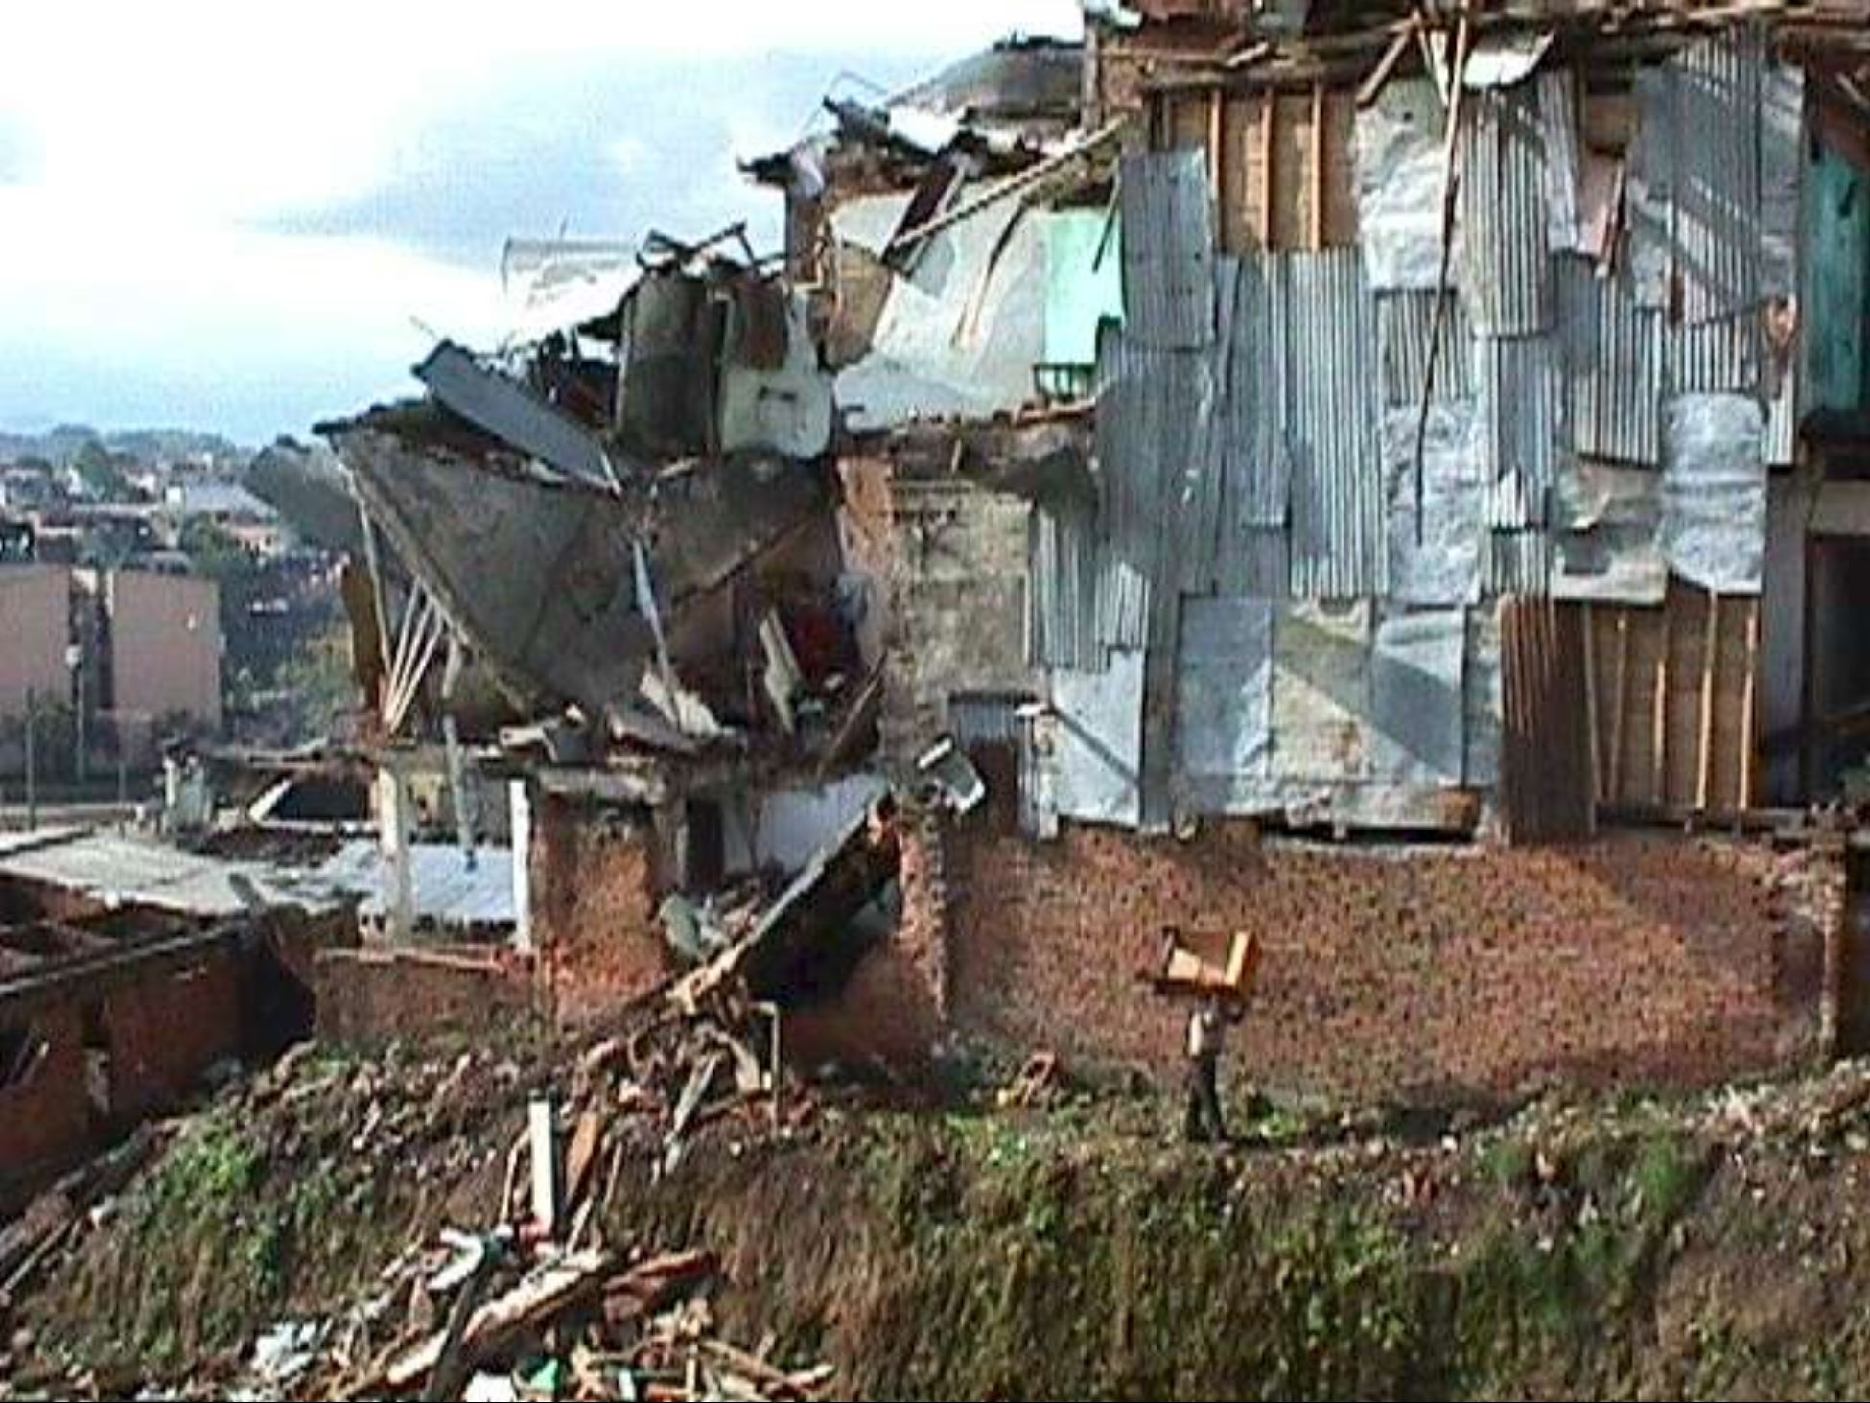
Source: World Vision International.
In addition, municipalities and districts are to consider measures related to the conservation and protection of the environment such as mapping zones subject to risk of natural hazards and developing management strategies for such areas (Article 10). Both urban and rural land use plans are to include identification of risk areas (Articles 13 and 14) and their designation as protected areas not subject to development. Expropriation is to be allowed for the purposes of resettlement of populations living in risk areas (Article 58) and fines are set for the illegal occupation of risk areas (Article 104). Responsibility for keeping risk areas free of settlements is given to the chief executives of municipalities and districts (Article 121).
Under the provisions of the Territorial Planning Law, local governments are to develop, implement, and enforce their own plans, but the plans must contain all the required elements and follow the guidance of the national government’s law. It is remarkable that the requirements of this law are more stringent than those that many states in the US place on their local governments. Colombia’s Territorial Planning Law is particularly interesting in the way it incorporates hazard mitigation directly into the fabric of local land use planning.

Addressing Hazmat through Land Use Planning: Europe’s Seveso Directives
Management of chemical hazards in the US has been based on the principle of the community’s Right to Know as outlined in SARA Title III. The constriction of free access to critical information about chemical hazards after the 9/11 terrorist attacks has exposed the fragility of this right and the weakness of a policy relying on knowledgeable citizens to manage chemical hazards in their communities. The European Union has taken a slightly different approach, as outlined in its Seveso Directives. While incorporating many of the community Right to Know provisions in SARA Title III, the Seveso Directives go further in requiring the active dissemination of information to the public and the use of land use planning to manage chemical hazards (Eijndhoven, et al., 1994; Parker, 1999).
The Seveso accident, after which the directives are named, occurred in Seveso, Italy, in 1976. At that time, a chemical plant manufacturing pesticides and herbicides released a cloud containing tetrachlorodibenzoparadioxin (TCDD, or dioxin) into the surrounding environment. There were no immediate fatalities, but kilograms of this extremely hazardous substance were deposited over about ten square miles of land and vegetation, resulting in the evacuation of 600 families and the treatment of some 2000 people for dioxin poisoning. This incident resulted in the adoption of the first Seveso Directive by the European Council in 1982. Seveso I was amended in response to the Bhopal, India accident in 1984 and the Sandoz warehouse accident in Basel, Switzerland in 1986. Finally, a review of the directive in 1993 resulted in an expanded Seveso Directive called Seveso II being adopted in December 1996 and becoming effective in February 1999.
The goal of Seveso II is to prevent hazardous materials accidents and, if they do occur, to limit their health, safety, and environmental consequences through restrictions on the storage and processing of hazardous materials. Establishments that hold small quantities of these substances are controlled by other legislation relating to health, safety and the environment. “Lower tier” establishments with more than the minimum quantities and “upper tier” establishments that hold larger quantities of hazardous materials are covered by requirements appropriate to the quantities involved. Seveso II does not cover nuclear safety issues, the transport of hazardous materials, temporary storage areas, or pipeline transport (European Commission, 2003) although the implementation of Seveso II guidance on land use planning “might start a process among the planning authorities which in the long term could generally result in taking into account transportation risk in an appropriate manner” (Christou, Amendola & Smeder, 1999). The chemical industry has already adopted voluntary programs for the prevention of chemical transport accidents and for cooperating with local authorities on emergency preparedness and response.
Seveso II requires the operators of each establishment to develop internal emergency plans and supply them to local authorities who use them to develop external emergency plans. Internal plans must be developed in consultation with plant personnel and external plans must be developed in consultation with the public. Information is to be shared with the public, not just passively by making it available upon request, but by actively distributing literature about actions to be taken in case of an accident. Accidents must be reported to the Community Documentation Center on Industrial Risks at the Major Accident Hazards Bureau of the European Union. (mahbsrv.jrc.it/). This Web site has guidance documents for safety management systems, safety reports, inspections, public information, and land use planning. Although these documents do not constitute legal requirements, they do represent the views of all the E.U. member states.
By requiring the integration of major accident hazards into the land use planning process, Seveso II establishes a legal framework in member states for maintaining appropriate distances of establishments that use hazardous materials from residential, public use, or environmentally important areas. Member states are to place controls on the siting of new establishments, modifications to existing establishments, and new developments (including roads) in the vicinity of existing establishments that might lead to an increased risk of hazard exposures.
Member states have exhibited varying degrees of progress in their implementation of the Seveso II Directive. Many northern European countries have already developed land use planning procedures for hazardous facilities, but southern European countries have lagged behind. There are three basic approaches that have been adopted: tables of “appropriate distances” based on experience with hazardous materials and land use compatibility, a “consequence based” approach that uses assessments of the possible consequences of accidents, and a “risk based” approach that integrates the probability of an accident’s occurrence with the consideration of possible consequences in calculating vulnerable zones. In addition, some countries are still developing their hazardous materials management systems. These approaches are not mutually exclusive and could be applied to various categories of establishments. The use of the different approaches to calculate the necessary zones might or might not lead to very different results, depending on the inclusion of other considerations such as cost effectiveness in the analysis (Christou, et al., 1999).
The first approach is used in Germany and Sweden. In Germany, the limited zones require no risk to humans or the environment from hazardous facilities. The “consequence based” approach is used in France and the French speaking area of Belgium and uses the same basis for calculating vulnerable zones as in US emergency planning. The risk based approach is used in the Netherlands, the United Kingdom and the Flemish speaking region of Belgium, as well as in such non-EU countries as Australia and Switzerland. Table 13-2 shows the zoning scheme developed by the Health and Safety Executive of the United Kingdom in fulfillment of its obligations under the Seveso II Directive.
Civil Society: The Chi Chi earthquake in Taiwan
Taiwan’s democracy developed from the ground up, beginning in the 1980s with the legalization of opposition political parties and continuing through the election of the first opposition president in the 2000 elections (Rigger, 1999). In late summer of the year before these historic elections, a strong earthquake hit the north central part of the island. The M7.6 earthquake caused over 2,400 deaths and more than 11,000 injuries requiring medical attention. It also destroyed or damaged many thousands of buildings and caused economic losses estimated at $14 billion (US), or 3.3% of GDP.
Taiwan had developed a sophisticated seismic network that provided information on the location, magnitude and shaking intensities of the earthquake to central government officials within two minutes of the earthquake’s impact at 1:47 a.m. on September 21, 1999. This activated the national emergency management system, so representatives of essential agencies assembled in Taipei to constitute the Central Disaster EOC. Unfortunately, this group was hampered by a lack of detailed information from the impact area. Although the central government immediately knew the earthquake’s magnitude and epicenter, damage to roads and communications links caused major delays in the transmission of information about actual effects and local needs to the central government. Because Taiwan’s government is highly centralized, the lack of resources and experience at the local government level acted together with the central government’s lack of information about local needs to hamper the response and recovery effort.
Table 13-2. U.K. Health and Safety Executive Siting Policy within Consultation Zones.
Category of Development | Inner Zone Individual Risk Exceeds 10⁻⁵ | Middle Zone Individual Risk Exceeds 10⁻⁶ | Outer Zone Individual Risk Exceeds 0.3x10⁻⁶
Highly vulnerable or very large public facilities (schools, hospitals, old persons’ accommodation, sports stadium) | Advice against development | Specific assessment necessary (advice against if >25 people) | Specific assessment necessary
Residential (housing, hotel, holiday accommodation) | Advice against development (>25 people) | Specific assessment necessary (advice against if >75 people) | Allow development
Public attractions (substantial retail, community and leisure facitilies) | Specific assessment necessary (advice against if >100 people) | Specific assessment necessary (advice against if >300 people) | Allow development
Low density (small factories, open playing fields) | Allow development | Allow development | Allow development
Source: Christou, et al. (1999).
Nonetheless, the response at the disaster site was massive and, eventually, effective. There were many totally and partially collapsed buildings, leading to a tremendous need for urban search and rescue (USAR). Fortunately, there are many volunteer mountaineering groups specializing in wilderness rescue located in the areas that were hit hardest by the earthquake. These groups, such as the International Association of Search and Rescue of the Republic of China (IASAR/ROC), activated their members immediately and worked together with local firefighters and an influx of foreign search and rescue teams that followed. Most of the more than 5000 live rescues were performed by local volunteers and firefighters before the foreign teams could even arrive. As often happens after disasters, logistical, geopolitical, and bureaucratic problems delayed the outsiders’ arrival. This reinforces the importance of local response capabilities and the need for local and national governments to plan for the integration of local volunteers in the crucial first hours after a major disaster.
The IASAR/ROC was founded in 1981 and now has about 10,000 members organized into local teams of 50-90 people. The paid staff is small, about eight people at the central office in Taoyuan and one each in the division offices around the island. Members pay annual dues of about $60 (US) and receive subsidies from local businesses and religious groups to buy equipment and pay for training. They had experience with mountain rescues and also had participated in rescue efforts alongside a team from the US the year before the earthquake, when a high rise in Taipei collapsed. This effort had given them exposure to the USAR techniques that were needed to respond to the 9/21 earthquake (Prater & Wu, 2002).
The educational infrastructure of the affected area was severely damaged, and government resources were insufficient to repair the nearly 800 primary and secondary schools that were damaged and destroyed. In Nantou County, where the epicenter was located, 75% of the schools had to close. Here, as in other disasters, NGOs stepped in to fill the gaps. The Taiwan branch of the International Red Cross committed funds to rebuild 14 primary and middle schools at a cost of $15 million (US).
Local governments, churches, and other organizations rebuilt some schools, but many were rebuilt by the Buddhist Compassion Relief Tz’ Chi Foundation. This group, founded by a Taiwanese Buddhist nun, has a long history of responding to disasters worldwide and was in the process of assisting in the relief and reconstruction effort after Turkey’s Kocaeli earthquake when its own country was hit. Members of the organization immediately set up vegetarian soup kitchens to supplement the nonvegetarian meals served by other volunteer groups. Tz’ Chi members also began collecting equipment, clothes and money for the victims. The organization provided tents and more substantial temporary housing, but their most extensive recovery effort was the reconstruction of 53 schools. Their effort was unique because it featured one-of-a-kind, locally appropriate and environmentally sensitive architectural designs for each school, instead of using a single design for all schools. Architects met with the community members and studied the school sites to develop designs that incorporated local cultural motifs and environmental features, as well as meeting the communities’ educational needs. The designs were required to be earthquake resistant and incorporate natural ventilation and lighting to keep students comfortable while using a minimum amount of energy. Figure 13-4 shows the reinforcement being installed before pouring concrete for one of the new schools.
The government’s social services were also stretched to the limit and beyond after the Chi Chi earthquake. The Presbyterian Church in Taiwan developed a program to supplement Nantou County’s six professional social workers (for a population of 544,762) by helping minority communities with their unique recovery needs (Prater & Wu, 2002). There are few minorities in Taiwan, but there are several thousand members of aboriginal tribes. These live in isolated villages in the mountainous areas of central Taiwan that were heavily damaged by the earthquake. Community Recuperation Centers were created to provide these communities with counseling, day care for children and seniors, help with navigating the bureaucracy to acquire recovery assistance, and economic development projects. In many cases, local workers were hired and given the necessary training to staff the centers. The response and recovery efforts of these volunteers, both individuals and groups, provided significant assistance in promoting the full recovery of households in earthquake impact zone.

Web sites
- European Union (EU): europa.eu.int
- International Decade for Natural Disaster Reduction (IDNDR)/International Strategy for Disaster Reduction (ISDR): www.unisdr.org
- Organization of American States (OAS): www.oas.org
- Pan American Health Organization (PAHO): www.paho.org
- Centro de Coordenación para la Reducción de los Desastres Naturales en América Central (CEPREDENAC): www.cepredenac.org
- Asian Disaster Preparedness Center (ADPC): www.adpc.net
- La Red: www.desenredando.org.
Figure 13-4. Rebuilding Begins in Taiwan

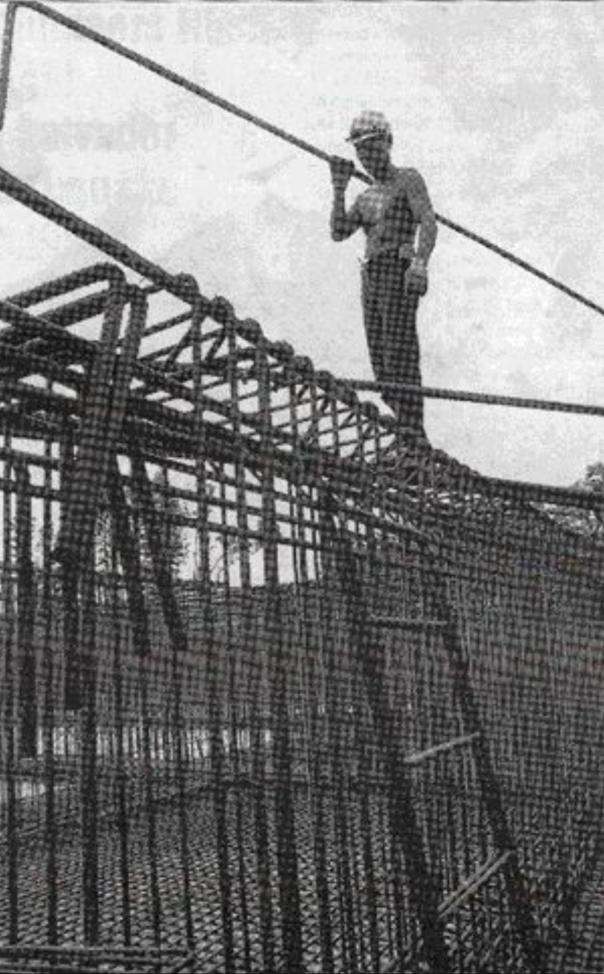
Source: Buddhist Compassion Relief Tz’ Chi Foundation

1 GDP/capita: Gross Domestic Product is a measure of the total value of goods and services produced within a territory. For purposes of comparison, it is usually expressed in per capita terms, to adjust for different numbers of people living within the territories in question.
2 HDI: The Human Development Index is a combination of life expectancy at birth, literacy and school enrollment rates, and GDP/capita. Detailed information on how to calculate HDI values is available at hdr.undp.org/.
3 Gini Index: Measures inequality over the entire distribution of income or consumption, with 0 representing a perfectly equal distribution and 100 representing perfect inequality. In other words, in a country with a Gini index of 0 everyone would have the same amount of income or consume the same amount of goods. Details on the Gini index can be found at hdr.undp.org.

