
UNITED STATES ENVIRONMENTAL PROTECTION AGENCY
WASHINGTON D.C., 20460

Registration Review

Ecological Risk Assessment
Problem Formulation for:

FOMESAFEN

Prepared By:

Paige Doelling Brown, Ph.D., Fisheries Biologist
James Hetrick, Ph.D., Senior Chemist
Environmental Risk Branch 1
Environmental Fate and Effects Division
Office of Pesticide Programs

Approved By:

Nancy Andrews, Ph.D., Branch Chief
Environmental Risk Branch 1
Environmental Fate and Effects Division
Office of Pesticide Programs

Stressor Source and Distribution

The source of the stressor considered in this document is sodium salt of fomesafen.

Fomesafen is an herbicide. It is applied as a foliar spray (both pre-emergent and post-emergent) for control of broad-leaved weeds, grasses, and sedges. Fomesafen is a diphenylether. It disrupts the cell membrane of the plant (www.syngentacroprotection-us.com) by penetrating into the cytoplasm and causing formation of peroxides and free electrons (www.abcbids.org). The specific mode of action is inhibition of protoporphyrinogen oxidase (www.weeds.iastate.edu). Fomesafen generally acts quickly, and does not translocate. It has both foliar and soil activity. Other herbicides in this group include aciflourfen, lactofen, and oxyfluorfen.

Fomesafen is highly persistent in soil (63-527 days, dependent on soil type) resulting in a potential for accumulation in terrestrial environments. The label suggests not planting sensitive crops in a fomesafen-treated field for a 3-18 month period, due to the persistence of fomesafen in the soil. Additionally, it is highly mobile, and is expected to leach into groundwater and be transported from the site via runoff into surface waters. Based on physical properties, bioaccumulation and long-range transport are not expected to be of concern. It is extremely toxic to terrestrial plants, especially dicots, but of fairly low acute toxicity to fish and wildlife. Some chronic reproductive effects have been noted in mammals, and may also occur in birds. No major degradates of toxicological concern have been identified.

Integration of Available Information

The risk assessments available in the docket, and which serves as the basis for this problem formulation, include the following:

- Ecological Risk Assessment in Support of Docket Preparation for Registration Review of Fomesafen (DP 306023), January 18, 2006

Ecological Effects

Available Toxicity Studies

Toxicity endpoints are established based on data generated from guideline studies submitted by the registrant, and from open literature studies that meet the criteria for inclusion into the ECOTOX database maintained by EPA/ORD. EFED policy is to use the most sensitive endpoint for each taxa evaluated. In aquatic systems, taxa evaluated include aquatic plants, invertebrates, and fish. Fish serve as a surrogate for aquatic-phase amphibians. Where data are available, separate endpoints are used for freshwater and estuarine/marine organisms. In terrestrial systems, taxa evaluated include birds and mammals. Bird endpoints are generally derived from guideline studies on bobwhite quail and/or mallard duck. Bird data is used as a surrogate for reptiles and terrestrial-phase amphibians. Mammal data is derived from guideline studies conducted on laboratory rats, mice, or rabbits.

Aquatic Guideline Data

Fomesafen was originally registered for use in the 1980s. Guideline studies from that time were available for aquatic invertebrates and fish, both freshwater and marine/estuarine. Although some of the studies were conducted on formulated product, and would not be acceptable under current standards, they were classified as core or supplemental under the guidelines at the time they were submitted. When necessary, endpoints were re-calculated and/or data were converted to express toxicity on the basis of active ingredient. Details of conversion are included in Appendix E. Aquatic plant data were submitted by the registrant (upon request by EFED), during the development of this risk assessment. Although the Data Evaluation Review (DER) process has not yet been completed for these studies, they have been provisionally classifed as Supplemental, and the toxicity data has been incorporated into the assessment. Overall, fomesafen is slightly toxic to practically nontoxic to invertebrates and practically non-toxic to fish on an acute basis (Table 1). Chronic data were also available, and are presented in Table 2.

Table 1 Acute Aquatic Data from Registrant-submitted Studies
Species | LC₅₀ (ppm) | 95% C.I. (ppm) | NOAEC (ppm) | Classification  (MRID)

Freshwater Organisms
Green alga¹ (Selenastrum capricornutum) | 0.12  (biomass) | 0.05-0.34 | 0.02 | Supplemental  (46673804)  Technical
Water flea  (Daphnia magna) | 376  (practically nontoxic) | 323-437 | 117 | Core^{2, 3}  (163169)  Formulation
Rainbow Trout  (Onchorynchus mykiss) | 126  (practically nontoxic) | 117-135 | 80 | Core^{2, 3}  (103023)  Formulation

Estuarine/ Marine organisms
Marine diatom¹ (Skeletonema costatum) | 1.51  (biomass) | ND | 0.94 | Supplemental  (46673806)  Technical
Mysid shrimp  (Mysidopsis bahia) | 25  (slightly toxic) | 19-38 | ND | Core²  (135647)  Technical
Sheepshead minnow  (Cyprinodon varigetus) | >163  (practically nontoxic) | ND | >163 | Core^{2, 3}  (135651)  Formulation
¹Provisional data and classification, pending final review. ²Data are from studies originally reviewed and classified in 1984, some of which used formulated product. ³For purposes of this risk assessment, test concentrations were adjusted for percent a.i. if necessary, and endpoints were re-calculated using TOXANAL software. ND-not determined.

Table 2 Chronic Aquatic Data from Registrant-submitted Studies
Species | NOAEC (ppm) | LOAEC  (ppm) | Endpoints Affected | Classification¹  (MRID)

Freshwater Organisms
Water flea  (Daphnia magna) | 50 | 100 | Reduced growth,  Total # of offspring | Core  (135642)  Formulation

Estuarine/ Marine organisms
Mysid shrimp  (Mysidopsis bahia) | 0.7 | 1.7 | Parental mortality | Core  (135648)  Formulation
Sheepshead minnow²  (Cyprinodon varigetus) | 12.2 | 20.1 | Reduced larval survival | Core  (135644)  Formulation
¹Data are from studies originally reviewed and classified in 1984, some of which used formulated product. ²For purposes of this risk assessment, test concentrations were adjusted for percent a.i.

Aquatic Data from ECOTOX

The ECOTOX database was accessed, and no toxicity data for fomesafen were located.

Terrestrial Plant Guideline Data

Terrestrial plant guideline studies were submitted during the development of this risk assessment. Data are shown below (Table 3), but are considered provisional pending final data evaluation review. Fomesafen is effective, both pre- and post-emergent, against a variety of plants, although dicots appear to be more sensitive than monocots for both endpoints. The product is marketed as a control for broad-leafed weeds. In some cases, calculated EC₂₅s were below the concentrations tested, so a NOAEC was not determined. The most sensitive endpoint, used in the risk assessment, is the vegetative vigor EC₂₅ for radish (0.0016 lb ai/A).

Table 3 Terrestrial Plant Guideline Data
Species | Common name | Class | EC₂₅  (lb ai/A) | NOAEC  (lb ai/A)) | Classification¹  (MRID)
Vegetative Vigor
Raphanus sativus | Radish | D | 0.0016 | 0.00098 | Supplementary  (46673802)
Echinochloa crus-galli | Barnyard grass | M | 0.31 | 0.25 | Supplementary  (46673802)
Seedling emergence
Lycopersicon esculentum | Tomato | D | 0.005 | ND | Supplementary  (46673801)
Allium cepa | Onion | M | 0.089 | ND | Supplementary  (46673801)
¹ Provisional classification, pending final data evaluation review.

Efficacy data (MRID 135656) were part of the data package submitted. The efficacy data included pre-emergence and post-emergence treatment of 24 plant species, at two concentrations (0.25 and 1.0 kg ai/ha). The two concentrations bracket the currently proposed rates (0.42 and 0.54 kg ai/ha). The plant species tested included both monocots (11 species) and dicots (13 species). Both crop (7 species) and non-crop (17 species) plants were evaluated. With the exception of soybeans, all plants tested experienced >20% “damage” when treated pre-emergence, with a significant number (65%) experiencing >80% damage when treated with the lower concentration (0.25 kg ai/ha). Applied post-emergence, fomesafen is slightly less effective, with “damage” typically in the 0-40% range for monocots and 40-80% range for dicots. The report did not specify how damage was quantified.

Avian and Small Mammal Guideline Data

Guideline studies were available for birds (both dose and dietary), and small laboratory mammals (dose). On the basis of both dose and dietary values, fomesafen is practically non-toxic to birds and slightly toxic to mammals (Table 4). Endpoints for female guinea pigs and mallard ducks were used to develop risk quotients.

Table 4 Avian and Small Mammal Guideline Data from Acute Studies
Species | LC₅₀ (ppm) | 95% C.I. (ppm) | NOAEC (ppm) | Classification¹  (MRID)

Acute dose
Mallard duck | >5,000  (practically non-toxic) | ND | ND | Core  (163168)
Rat | F 1499  M 1858  (slightly toxic) | (1302-1749)  (1420-2546) | 1219  975 | Minimum  (164901)
Mouse | F 745  M 766  (slightly toxic) | (512-1286)  (525-1341) | 487  312 | Minimum  (164901)
Guinea Pig | F 607  (slightly toxic) | ND | 244 | Minimum  (164901)

Acute dietary
Bobwhite quail | >20,000  (practically non-toxic) | ND | 13,333 | Core  (103022)
Mallard duck | >20,000  (practically non-toxic) | ND | 20,000 | Core  (163384)
¹Data are from studies originally reviewed and classified in 1984.
ND-Not determined

Chronic guideline studies (Table 5) were available for birds (mallard duck and bobwhite quail) and small laboratory mammals (rat). Bird guideline studies did not establish a LOAEC, only determining that there were no effects at the highest (mean-measured) concentration tested. This contributes significant uncertainty to the evaluation of chronic risk to birds. The mallard duck NOAEC (46 ppm) is used in the determination of chronic risk to birds, but it may overestimate the risk to birds. In some cases, calculated exposure is near or above the maximum tested concentration.

Table 5 Avian and Small Mammal Guideline Data from Chronic Studies
Species | NOAEC (ppm) | LOAEC  (ppm) | Endpoint Affected | Classification¹  (MRID)
Bobwhite quail | 51 | ND | None | Core  (135640)
Mallard duck | 46 | ND | None | Core  (135639)
Rat | 250 | 1000 | Number of pups born live, number of pups surviving | Acceptable  (144862)
¹Data are from studies originally reviewed and classified in 1984.
ND-Not determined

Terrestrial Insect Data

Guideline tests for honeybees were submitted (MRID 135651, Core), as was a field chronic effects study on earthworms (MRID 135652). The acute oral LD50 for honeybees was >50 μg ai/bee, and the acute contact LD₅₀ was >100 μg ai/bee. The field test for earthworms included two applications of fomesafen, applied at one-year intervals. Fields were treated with 0.5 kg ai/ha and 5.0 kg ai/ha. No adverse effects on total numbers, total weights, or numbers of individual species were noted at the 0.5 kg ai/ha treatment level. A significant change in numbers of one species of earthworm (Allolobophura nocturna) was noted at the higher treatment level, but authors attributed this to modifications in grass cover caused by the herbicide treatment rather than direct toxic effects.

Studies were also submitted (MRID 135656) for eight species of invertebrates, from the orders Acarina, Hemiptera, Diptera, Lepidoptera, Coleoptera, and Nemotoda. Fomsafen was applied to multiple life stages at concentrations of 250 and 500 ppm. The greatest level of mortality in these tests was 9%. Aphids (Aphis fabae) experienced mortality rates of 9% at concentrations of 250 ppm and 500 ppm.

Terrestrial Data from ECOTOX

The ECOTOX database was accessed, and no toxicity data for fomesafen were located.

Incident Reports

EFED maintains EIIS, a database containing reported incidents of damage to non-target species caused by pesticide use. There are a total of 28 reported incidents for fomesafen, 27 of which are damage to agricultural crops. Incidents reported cover a range of 9 years (1994-2002), but many of them (54%) were reported in 2002. Corn was the crop most frequently reported damaged, accounting for 21 out of the 24 cases for which the specific crop was reported. In some cases (5) the fomesafen was applied directly to the damaged crop, and the legality was classified as misuse or accidental misuse. In other cases (17) the damaged was caused by drift, legality of application unknown. The certainty that the incident was related to fomesafen use was generally classified as probable. Other crops damaged included green peas, cotton, and soybeans under registered use conditions.

There is one report of a fish kill. In this incident, there was a report of approximately 200 fish (channel catfish, crappie, largemouth bass, and redear sunfish) dying following a legal application to a soybean site. The certainty of the kill being related to fomesafen runoff is classified as possible. Application was in accordance with registered use.

Exposure Characteristics

Major routes of fomesafen dissipation are leaching, runoff, and microbial degradation. Because fomesafen is persistent and mobile in soil, it is expected to move from the application site into groundwater and surface water. Additionally, off-site movement of fomesafen is expected through spray drift from aerial and ground spray. The high persistence of fomesafen is expected to contribute to year-to-year accumulation in terrestrial and aquatic environments.

Fomesafen is stable to abiotic hydrolysis. It undergos slow photodegradation in water
(t_{1/2}= 49 to 289 days). Fomesafen is persistent (t_{1/2}=9 to 99 weeks) in aerobic soil and aquatic environments. However, it degrades rapidly (t_{1/2}< 20 days) in anaerobic environments. The major degradation product of fomesafen is 5-(2-chloro-α,α,α-trifluoro-p-tolyloxy)-N-methylsulphonyl-panthranilamide (fomesafen amine). A minor degradation product is 5-(2-chloro-α,α,α-trifluoro-p-tolyloxy) anthranilic acid (fomesafen amino acid). Neither degradate has been identified as a toxicological concern.

Fomesafen is expected to be very mobile in soil. Simple partitioning coefficients range from 0.51 in loamy coarse sand to 2.45 in sandy clay loam soil. Regression analysis indicates fomesafen sorption is not dependent on soil organic matter content. Aged soil column leaching studies indicate degradation products of fomesafen are not mobile in soils; less than 0.06% of applied radioactivity was detected in the leachate samples.

Field dissipation studies in NC, IL, MS, AR, AL, TX, LA, SD, MN, KY, IA and MO indicate fomesafen is moderately persistent to persistent (t_{1/2}= 50 to 150 days ) in surface soils under actual use conditions. Fomesafen was detected at depths up to 30 inches in the soil profile. Fomesafen amine was the only degradation product identified in field dissipation studies. Prospective ground water monitoring in NC indicates fomesafen moved through the soil profile into medium and deep ground water.

Fomesafen has a low potential for bioaccumulation in fish tissues. Bioaccumulation factors for fosmesafen were 0.7 for whole fish, 0.2 for edible tissues, and 5.2 for nonedible tissue. Bioaccumulated residues were depurated during a 14-day depuration period.

Characteristics of Ecosystems Potentially at Risk

For typical crop applications, the ecosystem at risk is the field itself, in terms of organisms that might be sprayed during application, organisms affected by accumulation of fomesafen in the soil; and the adjacent aquatic and terrestrial environments affected due to runoff, spray drift, or groundwater contamination. In water bodies receiving runoff from agricultural fields, pelagic and benthic elements are considered. Terrestrial organisms assessed include non-target plants, insects, amphibians, reptiles, birds, and mammals. Because fomesafen is an herbicide, potential affects on non-target plants have been addressed at length.

Fomesafen is being proposed as a pre-plant, pre-emergence, and post-emergence herbicide for use on broadleaf weeds, grasses, and sedges, in snap beans, dry beans, and cotton. Methods of application are ground spray (0.5 lb ai/A, cotton) and aerial spray (0.375 lb ai/A, dry beans, snap beans, and cotton). Application is limited to once a year, or in alternate years, depending on location. Application rates are regionally specific. Maps 1, 2, and 3 show the locations of these crops according to USDA crop data.

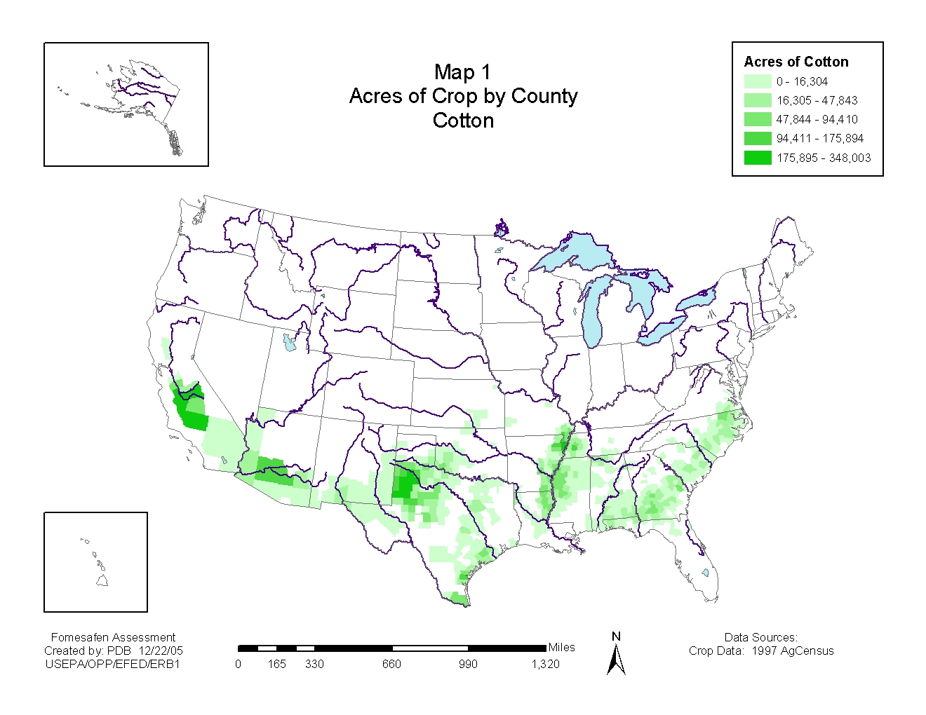
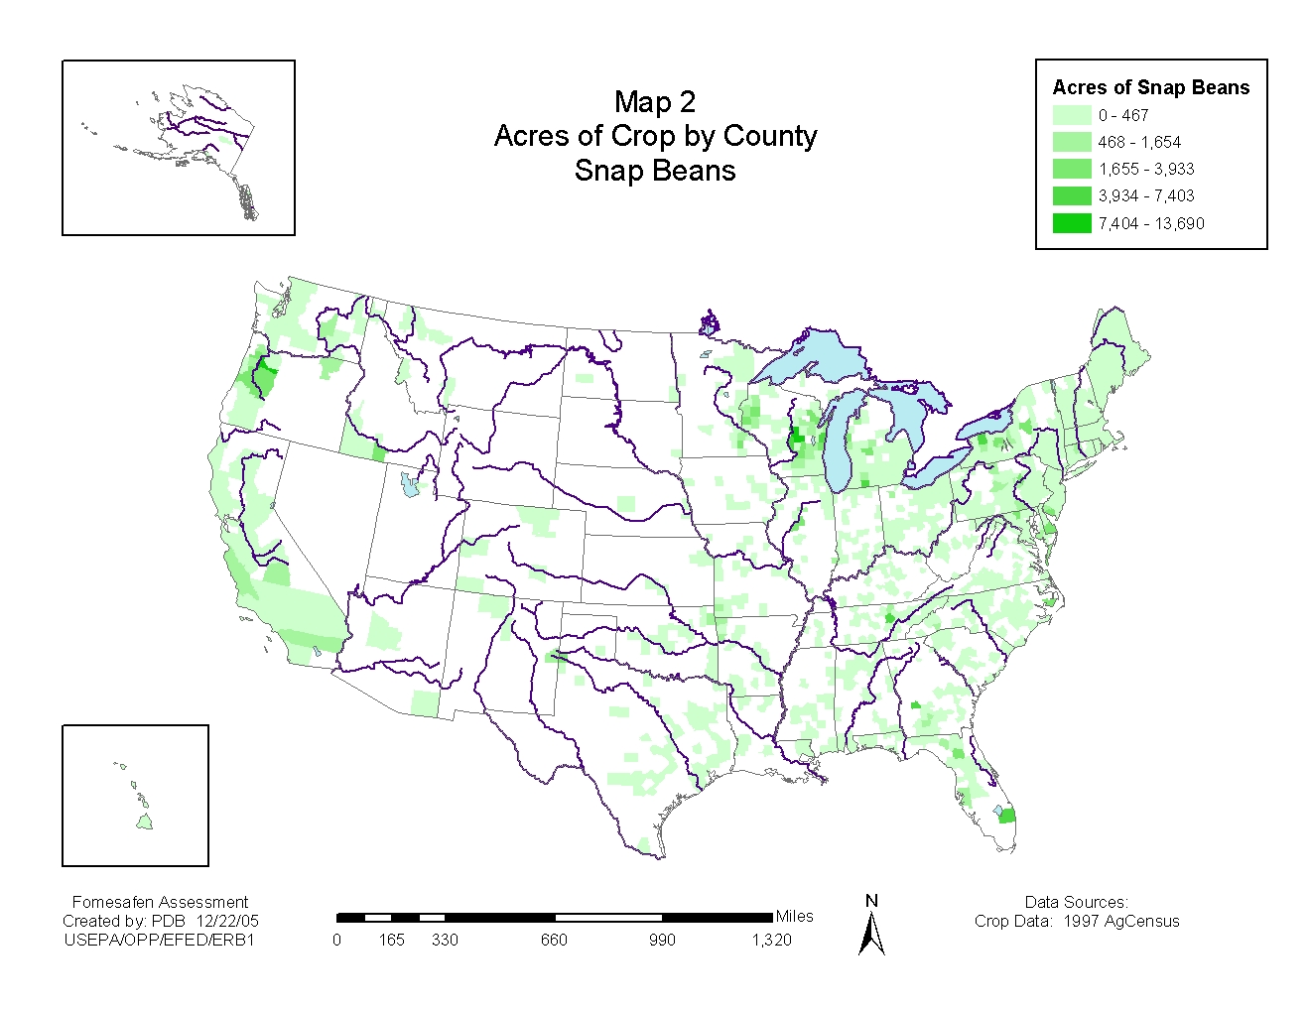

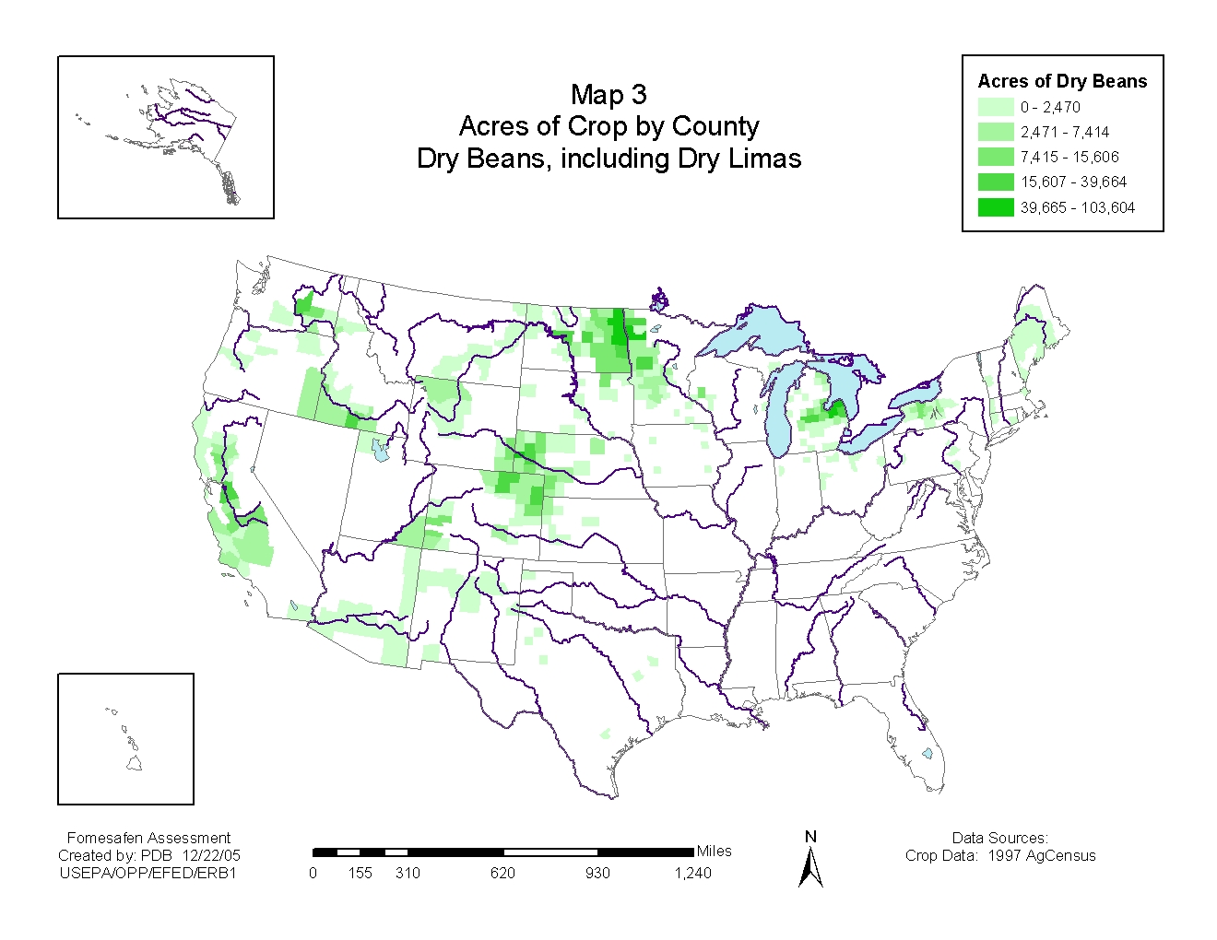

Assessment Endpoints

Assessment endpoints are defined as “explicit expressions of the actual environmental value that is to be protected.” Defining an assessment endpoint involves two steps: 1) identifying the valued attributes of the environment that are considered to be at risk; and 2) operationally defining the assessment endpoint in terms of an ecological entity (i.e., a community of fish and aquatic invertebrates) and its attributes (i.e., survival and reproduction). Therefore, selection of the assessment endpoints is based on valued entities (i.e., ecological receptors), the ecosystems potentially at risk, the migration pathways of pesticides, and the routes by which ecological receptors are exposed to pesticide-related contamination. The selection of clearly defined assessment endpoints is important because they provide direction and boundaries in the risk assessment for addressing risk management issues of concern. Changes to assessment endpoints are typically estimated from the available toxicity studies, which are used as the measures of effects to characterize potential ecological risks associated with exposure to a pesticide, such as paclobutrazol.

To estimate exposure concentrations, the ecological risk assessment considers a single application at the maximum application rate to fields that have vulnerable soils. The most sensitive toxicity endpoints are used from surrogate test species to estimate treatment-related direct effects on acute mortality and chronic reproductive, growth and survival assessment endpoints. Toxicity tests are intended to determine effects of pesticide exposure on birds, mammals, fish, terrestrial and aquatic invertebrates, and plants. These tests include short-term acute, sub-acute, and reproduction studies and are typically arranged in a hierarchical or tiered system that progresses from basic laboratory tests to applied field studies. The toxicity studies are used to evaluate the potential of a pesticide to cause adverse effects, to determine whether further testing is required, and to determine the need for precautionary label statements to minimize the potential adverse effects to non-target animals and plants.

Evaluation of ecological effects focuses initially on direct effects to the groups of organisms residing in the ecosystems at risk, based on ratios of the estimated environmental concentration (EEC) to a designated toxicity endpoint for a surrogate test organism. If pre-established levels of concern (LOCs) are exceeded for direct effects, indirect effects to endangered species (e.g. food chain, decrease in community diversity) are evaluated based on the group of organisms exceeding the LOC.

Direct
Direct effects evaluated are the survival, growth, and reproduction of various taxa of organisms potentially exposed to fomesafen. Taxonomic groups evaluated include aquatic plants (algae and vascular), aquatic invertebrates, aquatic vertebrates, terrestrial plants, terrestrial invertebrates, birds, and mammals. Both acute and chronic effects are considered.

Indirect
When herbicides are applied, indirect effects may include a decline in primary productivity, or change in composition of plant communities proximate to the treated area or systems (wetlands and water bodies) receiving runoff from the site. If LOCs are exceeded for any taxa, potential indirect effects to endangered species are assessed.

Conceptual Model

In order for a chemical to pose an ecological risk, it must reach ecological receptors in biologically significant concentrations. An exposure pathway is the means by which a pesticide moves in the environment from a source to an ecological receptor. For an ecological exposure pathway to be complete, it must have a source, a release mechanism, an environmental transport medium, a point of exposure for ecological receptors, and a feasible route of exposure. The conceptual model (Figure 1) depicts the potential pathways for ecological risk associated with fomesafen use. The conceptual model provides an overview of the expected exposure routes for organisms within the fomesafen action area.

Figure 1 - Conceptual Model for Fomesafen
Fomesafen applied to crop
Stressor
Source
Runoff
Direct application
Spray drift
Receptors
Birds
Mammals
Terrestrial
insects
Individual organisms
Reduced survival
Reduced growth
Reduced reproduction
Food chain
Reduction in primary productivity
Reduction in prey
Shift in community composition
Habitat integrity
Reduced cover
Community change
Attribute
Change
Aquatic
plants
invertebrates
vertebrates
Terrestrial
plants
Soil accumulation, leaching and runoff
Soil
invertebrates

Risk Hypothesis

• Fomesafen deposited on plant surfaces may affect growth, survival, or fecundity of birds and/or small mammals ingesting the affected vegetation.
• Fomesafen accumulating in soil may be toxic to non-target plants.
• Fomesafen in runoff from treated areas may kill aquatic plants, aquatic invertebrates, or fish.
• Fomesafen in runoff from treated areas may reduce populations of aquatic plants, aquatic invertebrates, or fish, causing changes in the community.
• Fomesafen in runoff from treated areas may accumulate in sediments, resulting in chronic impacts to the benthic community.
• Fomesafen is expected to move from the application site by leaching into groundwater and runoff into surface water. Use of water resources with fomesafen occurrence as an irrigation source water may adversely impact non-target plants.

Analysis Plan Options

The registration review screening level risk assessment is based on an overview document compliant risk assessment for fomesafen use on cotton, dry beans, and snap beans (Ecological Risk Assessment in Support of Docket Preparation for Registration Review of Fomesafen (DP 306023), January 18, 2006. .

Measures of Exposure

Aquatic Exposure

Tier II EFED aquatic exposure models use the linked Pesticide Root Zone Model and Exposure Analysis Model System (PRZM-EXAMS). PRZM uses the chemical’s physical and environmental fate properties and the site characteristics to predict the concentration of pesticide in runoff and entrained sediment from the field. EXAMS estimates the concentration of pesticide in an edge-of-field small water-body receiving runoff from the field. The water-body has no outflow with a constant volume (20 million liters), and is intended to represent an upper-end occurrence concentration.

PRZM-EXAMS Modeling for Surface Water

The aquatic exposure assessment for fomesafen was conducted to assess use on soybeans and cotton. Soybeans were used a surrogate for dry beans and snap beans, as EFED currently has no standard scenarios for these crops. Standard scenarios were selected to assess runoff potential from vulnerable use sites in MS (soybean and cotton), NC (cotton), and TX (cotton). Input parameters for fomesafen were selected according to EFED Input Parameter Guidance for PRZM/EXAMS1. Input parameters are shown in Table 6.

Table 6 Input Parameters for PRZM-EXAMS Modeling of Fomesafen on Cotton and Soybeans
Parameter | Value | Comments | Source
Application Rate (kg a.i./ha)- Cotton | 0.42 | Aerial Spray | Label¹
Application Rate (kg a.i./ha)- Cotton | 0.56 | Ground Spray | Label¹
Application Rate (kg a.i/ha)- Soybean | 0.42 | Aerial Spray | Label¹
Molecular Weight (grams/mole) | 420 |  | EPA 2020220
Solubility (mg/L) | 1200 | @pH= 7; 20⁰c | MRID 45048207
Vapor Pressure (torr) | <7.5x10⁻⁷ | @ 50ºC | HSDB
Henry’s Constant (atm m³/mol) | 7.5 x10⁻¹³ | Estimated | HSDB
Kd (L/kg) | 0.68 | Lowest non-sand K_{d} | Acc No. 259413
Aerobic Soil Metabolism Half-life (days) | 428.8 | Upper 90th percentile of mean² | Acc No. 071059  Acc. No. 00135660
Aerobic Aquatic Metabolism Half-life (days) | 115.7 | Upper 90th percentile of mean³ | Acc. No. 72158
Anaerobic Aquatic Metabolism Half-life (days) | Stable | Conservative Assumption | No Data Available
Photodegradation in Water (days) | 289 | @pH=7 | MRID 40451101
Hydrolysis Half-life (days) | Stable | @pH=7 | Acc No. 071059
1-Reflect application rates on the REFLEX 2LC, REFLEX 2.5 and REFLEX labels
2-Calculated from half-lives of 187.6, 630, 57, 693, 349.3, 527.1, 207 days using a mean of 387.84 days and standard deviation of 242.90 days.
3- Calculated from half-lives of 139.9, 60.9, 92.4, and 115.5 days using a mean of 102 days and standard deviation of 33.44 days.

For aerial applications (Table 7), peak 1 in 10 year estimated environmental concentrations (EECs) ranged from 7.5 ppb (soybeans, MS) to 12.2 ppb (cotton, TX). Chronic 1-in-10 year (21-day average and 60-day average) EECs ranged from 6.4 ppb (soybean, MS, 60-day average) to 11.4 ppb (cotton, MS &TX, 21-day average).

Table 7 PRZM-EXAMS EECs for Fomesafen at 0.375 lb a.i/A¹
Region | Crop | State | Peak | 4 days | 21 days | 60 days
Region | Crop | State | μg/L (ppb)
1 | Soybean | MS | 7.462 | 7.382 | 7.133 | 6.443
1 | Cotton | MS | 12.102 | 11.964 | 11.411 | 10.115
1 | Cotton | NC | 9.856 | 9.728 | 9.201 | 8.067
1 | Cotton | TX | 12.201 | 12.045 | 11.437 | 9.973
1-Concentrations were derived for 0.375 lb ai/A using aerial applications

Peak 1-in-10 year EECs for ground spray applications (Table 8) ranged from 10.6 ppb (cotton, NC) to 15.1 ppb (cotton, MS). Chronic 1 in 10 year (21-day average and 60-day average) concentrations ranged from 8.6 ppb (cotton, MS, 60-day average) to 14.2 ppb (cotton, MS, 21-day average).

Table 8 PRZM-EXAMS EECs for Fomesafen at 0.50 lb ai/A
Region | Crop | State | Peak | 4 days | 21 days | 60 days
Region | Crop | State | μg/L
1 | Cotton | MS | 15.106 | 14.939 | 14.249 | 12.621
1 | Cotton | NC | 10.609 | 10.471 | 9.905 | 8.680
1 | Cotton | TX | 14.63 | 14.445 | 13.713 | 11.954
1- Concentrations were derived for 0.50 lb ai/A using ground spray

SCIGROW Modeling for Ground Water

Because fomesafen is mobile and persistent in soil, a screening level groundwater assessment using SCIGROW (ver. 2.3) was conducted to estimate the concentration of fomesafen in shallow groundwater, which could potentially be used for crop irrigation. Input parameters for SCIGROW are listed in Table 9. A groundwater monitoring study was submitted (MRID 42247001), but the shallow groundwater wells were dry during the study. Fomesafen was detected in soil porewater at concentrations of 1 μg/L (at 4 months), up to 17 μg/L (at 1 month). It was detected at a concentration of 1 μg/L in the medium- to deep-depth wells.

Table 9 Input Parameters for SCIGROW Modeling for Fomesafen
Parameter | Value | Comments | Source
Application Rate (kg a.i./ha)- Cotton | 0.56 |  | Label¹
K_{oc} (L/kg) | 68 | Estimated² | Acc No. 259413
Aerobic Soil Metabolism Half-life (days) | 387.84 | Mean³ | Acc No. 071059  Acc. No. 00135660
1-Reflect maximum application rates on the REFLEX 2LC, REFLEX 2.5 and REFLEX labels
2-Koc estimated using Kd/SOC=Koc; where Kd=0.68 and SOC=1% SOC percentage
3-Calculated from half-lives of 187.6, 630, 57, 693, 349.3, 527.1, 207 days using a mean of 387.84 days and standard deviation of 242.90 days.

Based on the SCIGROW estimate, the concentration of fomesafen in shallow ground water in sand soils is not expected to exceed 6.68 μg/L. A groundwater monitoring study was submitted (MRID 42247001), but the shallow groundwater wells were dry during the study. Fomesafen was detected in soil porewater at concentrations of 1 μg/L (at 4 months), up to 17 μg/L (at 1 month). It was detected at a concentration of 1 μg/L in the medium- to deep-depth wells.

Because fomesafen is expected to leach to groundwater, EFED has calculated the maximum application rate of fomesafen from two inches of irrigation water, using the following equations. This calculation assumes that two inches (0.167 ft) of irrigation water is required for optimum plant growth. The calculations are as follows:

43,560 ft²/A* 0.167 ft irrigation water= 7,274 ft³ for 2 inches of irrigation water/A

7,274 ft³ irrigation water/A* 28.316846 liter/ft³=205,991.13 liters of irrigation water/A

205,991.13 liter of irrigation water/A *EEC g/L = fomesafen g/A

(fomesafen g/A)/ (10⁶) = fomesafen grams/A*1lb/454 grams=fomesafen lbs ai/A.
Based on two inches of irrigation and the SCIGROW estimate, the application rate of fomesafen is estimated at 0.003 lbs ai/A. Using the concentrations of 1 mg/L and 17mg/L (from the groundwater study) as outer bounds, concentrations of fomesafen in irrigation water could range from 0.0004-0.0077 lbs ai/A.

Soil Accumulation

Because of the persistence of fomesafen in soil, a screening level assessment was conducted to quantify the accumulation of fomesafen residues in soil. A first-order decay model (A=A_{o}e^{-kt}) was used to estimate fomesafen soil concentrations. The time period in the model (t) was set to 730 days to represent alternate years applications. The upper 90th percentile of the mean half-life (t_{1/2}=428 days; k=0.00161950 days⁻¹) was used to represent the microbial mediated decay rate of fomesafen in soil. The starting concentration (A₀ ) was set at the label recommended application rate of 0.375 lbs ai/A for aerial applications and 0.5 lbs ai/A for ground applications. The modeling scenario assumes that 100% of fomesafen residue is applied to the soil as recommended for a pre-emergent application. The model scenario also assumes that microbial degradation is the only route of dissipation from the application site. These assumptions are expected to exaggerate predicted formesafen soil concentrations.

Figure 2 illustrates the fomesafen concentrations in soil reach a plateau after approximately 10 years regardless of the application rate. Application rates of 0.375 lbs/A can theoretically result in a maximum fomesafen concentration of 0.14 mg/kg. Higher application rates of 0.5 lbs ai/A can theoretically result in a maximum fomesafen concentration of 0.19 mg/kg.

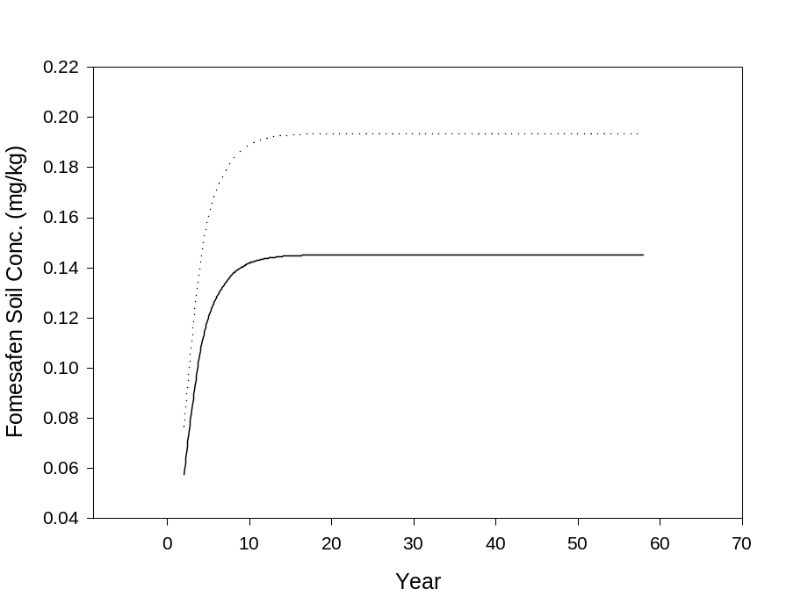
Figure 2 - Estimate of Fomesafen Loading in the Surface Soil (0-15 cm depth) from alternate year applications of 0.375 lbs/A (solid line) and 0.5 lbs/A (dotted line)

Terrestrial Exposure

Avian

For birds, dose estimates for the 0.2 lb ai/A application rate range from 0.87 mg/kg bwt (1000g frugivores, granivores, and insectivores) to 54.7 mg/kg bwt (20 g herbivores) (Table 10). At the 0.37 lb ai/A application rate, estimated doses range from 1.64 (1000g frugivores, granivores, and insectivores) to 102 (1000g fruit and pods). Dose estimates for the 0.49 lb ai/A application rate range from 2.14 mg/kg bwt (1000g frugivores, granivores, and insectivores) to 134 mg/kg bwt (20 g herbivores).

Table 10 Bird Dose Estimates
Feeding Categories | Kenaga Upper Bound Dose (mg/kg bwt)
Feeding Categories | Small  (20 g) | Medium  (100 g) | Large  (1000 g)
0.2 lb ai/A Appllication Rate (Alternative)
Short grass | 54.67 | 31.17 | 13.96
Tall grass | 25.06 | 14.29 | 6.40
Broadleaf plants/small insects | 30.75 | 17.54 | 7.85
Fruits/pods/seeds/large insects | 3.42 | 1.95 | 0.87
0.375 lb ai/A Application Rate
Short grass | 102.5 | 58.45 | 26.17
Tall grass | 46.98 | 26.79 | 11.99
Broadleaf plants/small insects | 57.66 | 32.88 | 14.72
Fruits/pods/seeds/large insects | 6.41 | 3.65 | 1.64
0.50 lb ai/A Application Rate
Short grass | 133.93 | 76.38 | 34.19
Tall grass | 61.39 | 35.01 | 15.67
Broadleaf plants/small insects | 75.34 | 42.96 | 19.23
Fruits/pods/seeds/large insects | 8.37 | 4.77 | 2.14

Small Mammals

For mammals dose estimates for the 0.2 lb ai/A application rate range from 0.10 mg/kg bwt (1000g granivore) to 45.8 mg/kg bwt (20 g short grass) (Table 11). At the 0.37 lb ai/A application rate, estimated doses range from 0.19 (1000g granivore) to 85.8 (20 g short grass). Dose estimates for the 0.49 lb ai/A application rate range from 0.25 mg/kg bwt (1000g granivore) to 112 mg/kg bwt (20 g short grass).

Table 11 Mammal Dose Estimates
Feeding Categories | Kenaga Upper Bound Dose (mg/kg bwt)
Feeding Categories | Small  (15 g) | Medium  (35 g) | Large  (1000 g)
0.2 lb ai/A Appllication Rate (Alternative)

Herbivores/Insectivores
Short grass | 45.76 | 31.63 | 7.33
Tall grass | 20.98 | 14.50 | 3.36
Broadleaf plants/small insects | 25.74 | 17.79 | 4.13
Fruits/pods/seeds/large insects | 2.86 | 1.98 | 0.46

Granivores
Fruits/pods/seeds/large insects | 0.64 | 0.44 | 0.10
0.375 lb ai/A Application Rate

Herbivores/Insectivores
Short grass | 85.81 | 59.30 | 13.75
Tall grass | 39.33 | 27.18 | 6.30
Broadleaf plants/small insects | 48.27 | 33.36 | 7.73
Fruits/pods/seeds/large insects | 5.36 | 3.71 | 0.86

Granivores
Fruits/pods/seeds/large insects | 1.19 | 0.82 | 0.19
0.50 lb ai/A Application Rate

Herbivores/Insectivores
Short grass | 112.12 | 77.49 | 17.97
Tall grass | 51.39 | 35.52 | 8.23
Broadleaf plants/small insects | 63.07 | 43.59 | 10.11
Fruits/pods/seeds/large insects | 7.01 | 4.84 | 1.12

Granivores
Fruits/pods/seeds/large insects | 1.56 | 1.08 | 0.25

Plants

TerrPlant has two basic exposure scenarios. The first is an adjacent upland area, which is exposed to the pesticide via drift and dissolved concentrations in sheet runoff. The second is an adjacent semi-aquatic (wetland) area, which is exposed to the pesticide via drift and to dissolved concentrations in channelized runoff. Drift is calculated as a percentage of the application rate (1% for ground, and 5% for aerial, airblast, or spray chemigation) and is not adjusted for distance from the application site. The amount of dissolved pesticide in the runoff component is estimated based on solubility of the active ingredient. TerrPlant estimates are shown in Table 12.

Table 12 Terrestrial Plant Exposure
Application Method | Total Loading (Runoff +Drift) (lb ai/A) |  | Drift EEC (lb ai/A)
Application Method | Upland areas | Wetland areas | All areas

Use at 0.375 lb ai/A
Aerial | 0.0263 | 0.0938 | 0.0188
Ground | 0.0113 | 0.0788 | 0.0038

Use at 0.50 lb ai/A
Aerial | 0.0343 | 0.1225 | 0.0245
Ground | 0.0147 | 0.1029 | 0.0049

Summary of Risks

Aquatic Risks

Fomesafen appears to be of relatively low toxicity to aquatic organisms, both animals and plants in freshwater and estuarine/marine systems (Table 13). Both acute and chronic effects were considered. Fomesafen may indirectly affect aquatic systems by damaging plants in adjacent wetland or riparian zones Modification of the vegetation in wetlands or riparian zones could cause decreased allochthonous input, increased sediment input, destabilization of the stream bank, or changes in the structural components (plant). Effects on waterbody-associated plant communities can be minimized by ensuring an adequate offset distance is maintained between the application site and the wetland or riparian zone. Appropriate distance is dependent on application rate, application methods, and weather conditions.

Table 13 Summary of Aquatic RQs
Taxa | Acute RQ | Chronic RQ¹ | Endangered Species RQ²
Use on Beans at 0.375 lb a.i./A (MS scenario, aerial application)
FW Aquatic Plants | 0.06 | NA¹ | 0.33
FW Aquatic Invertebrates | <0.001 | <0.001 | <0.001
Fish | <0.001 | NC | <0.001
SW Aquatic Plants | 0.01 | NA¹ | 0.008
SW Aquatic Invertebrates | <0.001 | 0.01 | <0.001
SW Fish | <0.001 | <0.001 | <0.001
Use on Cotton at 0.375 lb a.i./A (MS scenario, aerial application)
FW Aquatic Plants | 0.10 | NA¹ | 0.53
FW Aquatic Invertebrates | <0.001 | <0.001 | <0.001
FW Fish | <0.001 | NC | <0.001
SW Aquatic Plants | 0.01 | NA¹ | 0.013
SW Aquatic Invertebrates | <0.001 | 0.02 | <0.001
SW Fish | <0.001 | <0.001 | <0.001
Use on Cotton at 0.5 lb a.i./A (MS scenario, ground application)
FW Aquatic Plants | 0.13 | NA¹ | 0.66
FW Aquatic Invertebrates | <0.001 | <0.001 | <0.001
FW Fish | <0.001 | NC | <0.001
SW Aquatic Plants | 0.01 | NA¹ | 0.016
SW Aquatic Invertebrates | <0.001 | 0.02 | <0.001
SW Fish | <0.001 | 0.001 | <0.001
¹ There are no chronic aquatic plants tests. ² Endangered species RQ for plants are calculated based on NOAEC. Endangered species RQ for animals are calculated in the same way as acute risk values, but compared to a different LOC. NA – not applicable, NC – Not calculated, data not available.

Terrestrial Risks

Avian

At the proposed application rate of 0.5 lb ai/A, no acute dose- or dietary-based LOCs are exceeded for birds (Table 14). Chronic LOCs for birds in three out of the four food categories (short grass, tall grass, and broadleaf plants/small insects) are exceeded.

Table 14 Avian RQ Summary 0.5 lb ai/A
Risk quotients based on Kenaga upper bound EECs | Acute dose-based RQs |  |  | Acute dietary-based RQs | Chronic RQs
Risk quotients based on Kenaga upper bound EECs | 20g | 100g | 1000g | All birds | All birds
Short grass | 0.05 | 0.02 | 0.01 | 0.01 | 2.56 ^{c}
Tall grass | 0.02 | 0.01 | 0.00 | 0.00 | 1.17 ^{c}
Broadleaf plants/small insects | 0.03 | 0.01 | 0.00 | 0.00 | 1.44 ^{c}
Fruits/pods/seeds/lg insects | 0.00 | 0.00 | 0.00 | 0.00 | 0.16 ^{c}
ª exceeds acute risk LOC (0.5)
^{b} exceeds endangered species acute risk LOC (0.1)
^{c} exceeds chronic risk LOC (1.0)

At the proposed application rate of 0.375 lb ai/A, no acute dose- or dietary-based RQs exceed any LOCs (Table 15). The chronic LOC is exceeded for birds consuming the food categories of short grass and broadleaf plants/small insects.

Table 15 Avian RQ Summary: 0.375 lb ai/A
Risk quotients based on Kenaga upper bound EECs | Acute dose-based RQs |  |  | Acute dietary-based RQs | Chronic RQs
Risk quotients based on Kenaga upper bound EECs | 20g | 100g | 1000g | All birds | All birds
Short grass | 0.04 | 0.02 | 0.01 | 0.00 | 1.96 ^{c}
Tall grass | 0.02 | 0.01 | 0.00 | 0.00 | 0.90
Broadleaf plants/small insects | 0.02 | 0.01 | 0.00 | 0.00 | 1.10 ^{c}
Fruits/pods/seeds/lg insects | 0.00 | 0.00 | 0.00 | 0.00 | 0.12
ª exceeds acute risk LOC (0.5)
^{b} exceeds endangered species acute risk LOC (0.1)
^{c} exceeds chronic risk LOC (1.0)

Small mammals

At the proposed application rate of 0.50 lb ai/A, dose-based RQs exceed the endangered species LOC for two size classes of mammals (15g and 35 g) consuming short grass (Table 16). Using the dose-based RQ, chronic LOC is exceeded for mammals consuming the food categories of short grass (all weights), tall grass (15g, 35g), and broadleaf plants/small insects (15g, 35g). No chronic dietary based-RQs exceed any LOCs.

Table 16 Small Mammal RQ Summary: 0.50 lb ai/A
Risk Quotients based  on Kenaga  upper bound EEC | Acute  dose-based RQs |  |  | Chronic  dose-based RQs |  |  | Chronic dietary-based RQs
Risk Quotients based  on Kenaga  upper bound EEC | 15 g | 35 g | 1000 g | 15 g | 35 g | 1000 g | All mammals
Short grass | 0.13 ^{b} | 0.11 ^{b} | 0.06 | 4.08 ^{c} | 3.49 ^{c} | 1.87 ^{c} | 0.47
Tall grass | 0.06 | 0.05 | 0.03 | 1.87 ^{c} | 1.60 ^{c} | 0.86 | 0.22
Broadleaf plants/  small insects | 0.07 | 0.06 | 0.03 | 2.30 ^{c} | 1.96 ^{c} | 1.05 ^{c} | 0.26
Fruits/pods/seeds/  lg insects | 0.01 | 0.01 | 0.00 | 0.26 | 0.22 | 0.12 | 0.03
Seeds (granivores) | 0.00 | 0.00 | 0.00 | 0.06 | 0.05 | 0.03 | NA
ª exceeds acute risk LOC (0.5)
^{b} exceeds endangered species acute risk LOC (0.1)
^{c} exceeds chronic risk LOC (1.0)

At the proposed application rate of 0.375 lb ai/A, no acute dose-based RQs for mammals exceed any LOCs, although the RQ for small (15g) mammals consuming short grass equals the endangered species LOC (Table 17). Using the dose-based RQ, the chronic LOC is exceeded for mammals consuming the food categories of short grass (all weights), tall grass (15g, 35g), and broadleaf plants/small insects (15g, 35g).

Table 17 Small Mammal RQ Summary: 0.375lb ai/A
Risk Quotients based  on Kenaga  upper bound EEC | Acute  dose-based RQs |  |  | Chronic  dose-based RQs |  |  | Chronic dietary-based RQs
Risk Quotients based  on Kenaga  upper bound EEC | 15 g | 35 g | 1000 g | 15 g | 35 g | 1000 g | All mammals
Short grass | 0.10^{b} | 0.08 | 0.05 | 3.12^{c} | 2.67 ^{c} | 1.43 ^{c} | 0.36
Tall grass | 0.05 | 0.04 | 0.02 | 1.43 ^{c} | 1.22 ^{c} | 0.66 | 0.17
Broadleaf plants/  small insects | 0.06 | 0.05 | 0.03 | 1.76 ^{c} | 1.50 ^{c} | 0.80 | 0.20
Fruits/pods/seeds/  lg insects | 0.01 | 0.01 | 0.00 | 0.20 | 0.17 | 0.09 | 0.20
Seeds (granivores) | 0.00 | 0.00 | 0.00 | 0.04 | 0.04 | 0.02 | NA
ª exceeds acute risk LOC (0.5)
^{b} exceeds endangered species acute risk LOC (0.1)
^{c} exceeds chronic risk LOC (1.0)

Plants

For both proposed uses of fomesafen, ground application at 0.5 lb ai/A and aerial application at 0.375 lb ai/A, total loading RQs exceeded the acute plant risk LOC (1) for both monocots and dicots in adjacent wetland areas but not in upland areas (Table 18). Drift-based RQs were exceeded for dicots in all adjacent areas. LOC exceedences for acute risk to endangered plants followed the same pattern, but were of greater magnitude. RQs based on the two alternative ground application scenarios (0.375 lb ai/A and 0.2 lb ai/A) were also generated. At both these rates, there were no exceedences for monocots. RQs for both total loading to wetland areas and drift only exceeded the acute risk and endangered species acute risk LOCs for dicots.

Table 18 Terrestrial Plant Risk Quotients Based on TerrPlant
Application Method | Total Loading RQ (Seedling emergence) |  | Total Loading RQ (Seedling Emergence) |  | Drift RQ  (Vegetative vigor)
Application Method | Upland areas |  | Wetland areas |  | All areas
Application Method | Monocot | Dicot | Monocot | Dicot | Monocot |  | Dicot

Acute risk

Use at 0.2 lb ai/A (alternative)
Ground | 0.07 | 0.08 | 0.47 | 0.53 | 0.01 |  | 2.04 ª

Use at 0.375 lb ai/A
Aerial | 0.29 | 0.33 | 1.05 ª | 1.19 ª | 0.06 |  | 11.72 ª
Ground (alternative) | 0.13 | 0.14 | 0.88 | 1.00 ª | 0.01 |  | 2.34 ª

Use at 0.5 lb ai/A
Ground | 0.17 | 0.19 | 1.16 ª | 1.30 ª | 0.02 |  | 3.06 ª

Endangered species acute risk

Use at 0.2 lb ai/A (alternative)
Ground | 0.07 | 0.08 | 0.47 | 0.53 |  | 0.01 | 1.25 ª

Use at 0.375 lb ai/A
Aerial | 0.29 | 0.33 | 1.05 ª | 1.19 ª |  | 0.08 | 19.13 ª
Ground (alternative) | 0.13 | 0.14 | 0.88 | 1.00 ª |  | 0.02 | 3.83 ª

Use at 0.5 lb ai/A
Ground | 0.17 | 0.19 | 1.16 ª | 1.30 ª |  | 0.02 | 5.00 ª

ª Exceeds or equals LOC of 1

Future Decisions

The Agency does not foresee requiring any additional ecological effects or environmental fate data listed in 40 CFR Part 158 prior to support current assessments. The Agency is re-reviewing environmental fate studies for fomesafen. These studies were re-reviewed because there was no documented assessment of degradation kinetics. The re-reviewed studies are not expected to alter the interpretation on the persistence of fomesafen in aquatic and soil environments. More importantly, the Agency needs to conduct an endangered species assessment due to the high phytoxicity of fomesafen.

1 Guidance for Selecting Input Parameters in Modeling the Environmental Fate and Transport of Pesticides. Version II, 2/28/02.

