UTAH RURAL DEVELOPMENT
DIRECTORY

State Office - 801-524-4331
State Director: John R. Cox
Mailing Address:
Federal Bldg.
125 So. State St., Rm. 4311
Salt Lake City, UT 84138

Area I - Tremonton Office – 435-257-5404
Area Director: Robert Milianta
91 South 100 East
Tremonton, UT 84337

Vernal Local Office – 435-789-2100
Rural Development Manager: Juanita LaRose
80 North 500 West
Vernal, UT 84078

Area II – Richfield Office – 435-896-8250
Area Director: Glen Wood
340 North 600 East
Richfield, UT 84701

Cedar City Local Office – 435-586-7274
Rural Development Manager: Margie Stones
2390 West HWY 56, Ste. 13
Cedar City, UT 84720

Manti Local Office – 435-835-4111
Rural Development Manager: Donna Birk
50 South Main St., Ste. 6
Manti, UT 84642

Area III - Provo Office – 801-377-5580
Area Director: Debbie Cook
302 East 1860 South
Provo, UT 84606

Monticello Local Office – 435-587-2473
Rural Development Manager: Liz Black
32 South 100 East
“USDA is an equal opportunity provider, employer and lender.” To file a complaint of discrimination write to USDA, Director, Office of Civil Rights
1400 Independence Avenue, S.W. Washington, DC 20250-9410 or call (800) 795-3272 (voice) or (202) 720-6382 (TDD)
Monticello, UT 84535

http://www.rurdev.usda.gov/ut
Over $106 Million From USDA Rural Development in Fiscal Year (FY) 2005 Impacted Rural Utah:
Community Facilities Direct Loans | $2,502,280
Community Facilities Grants | $107,000
Community Facilities Guaranteed Loans - CF | $3,168,000
Child Care Initiative Grants | $69,600
Economic Impact Initiative Grants | $753,250
Direct Home Ownership Loans | $40,888,382
Guaranteed Home Ownership  Loans - SFH | $37,418,171
Rural Home Repair Loans | $223,952
Rural Home Repair Grants | $160,786
Housing Preservation Grant | $50,000
Technical Assistance Grants | $2,388,880
Direct Rural Rental Housing Loans/Grant | $2,923,700
Rural Rental Assistance | $7,201,116
Water and Environmental Loans | $1,273,000
Water and Environmental Grants | $1,643,740
Native American Water & Environmental Grants | $448,000
Solid Waste Management Grants | $107,100
Community Connect/  Broadband Grants | $512,655
Business and Industry Loan Guarantees | $2,446,400
Rural Business Opportunity Grant | $50,000
Rural Business Enterprise Grants | $417,680
Intermediary Relending Loan Program | $750,000
Renewable Energy and Energy Efficiency Program | $500,000
TOTAL FY05 IMPACT | $106,003,692

LEVERAGING of federal, state and local dollars and allowed for a greater number of rural Utah residents communities to be served.

John R. Cox, State Director
125 South State Street
USDA Rural Development
Rm. 4311 Federal Building
Salt Lake City, Utah 84138

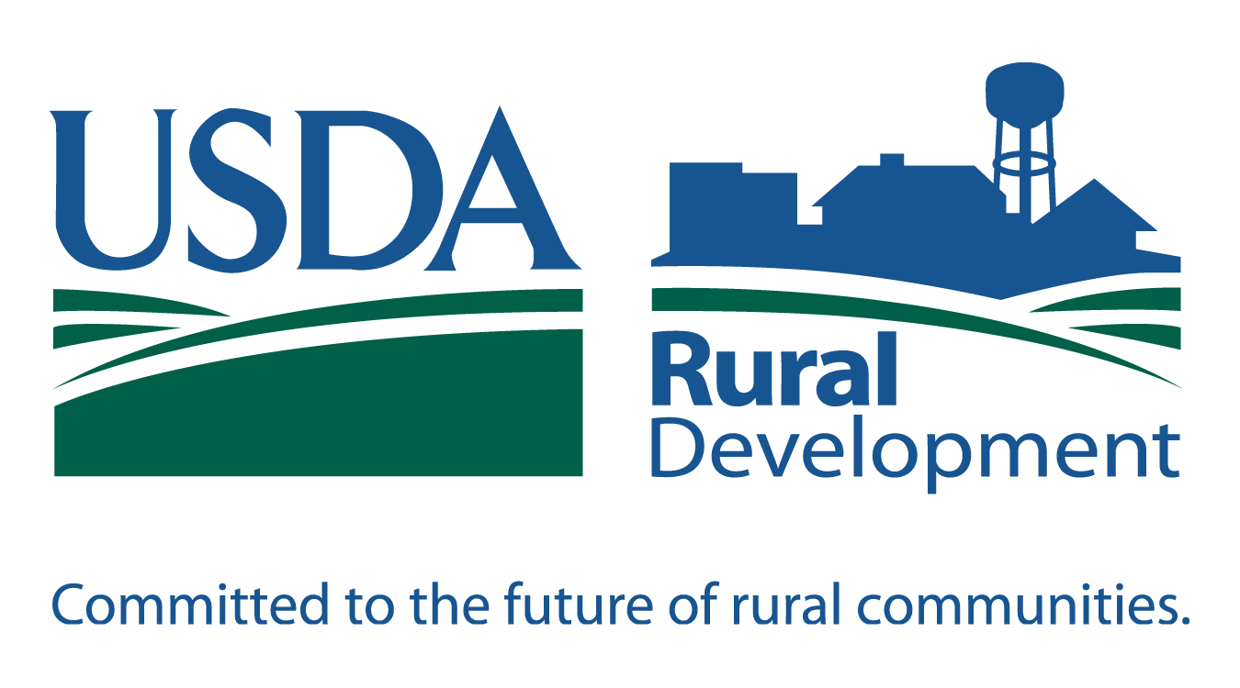

USDA
Rural Development
Utah

2005 ANNUAL REPORT

Fiscal Year 2005 was another successful year for our Utah rural communities.
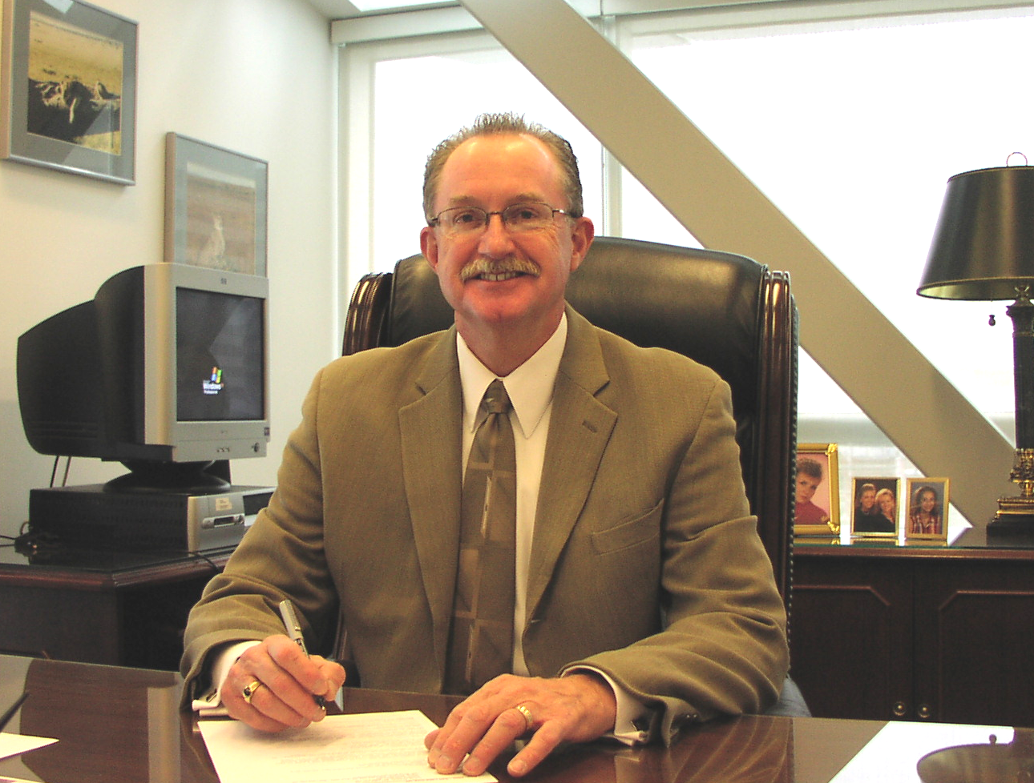
This year,
Utah Rural Development provided nearly $106,004,000
in financial assistance. These funds helped provide jobs, quality housing, clean drinking water, and modern essential community facilities and services. This assistance improved the quality of life and increased economic growth for nearly 115,000 rural residents and businesses across our great state of Utah.

Rural Development is the only agency within USDA that can help with almost any rural need from housing and agriculture, health care and public safety, water and wastewater systems, education, broadband, distance learning and telemedicine, to assisting start-up businesses and reviving old ones.

Our staff truly exemplifies our agency’s commitment to the future of rural communities as they go about helping our rural communities gain access to economic opportunities and the infrastructure development that is so vital to future growth.
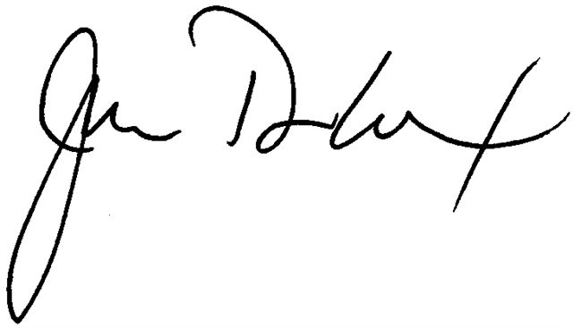

JOHN R. COX, STATE DIRECTOR
COMMUNITY FACILITY PROGRAMS
$6,600,130 in FY05

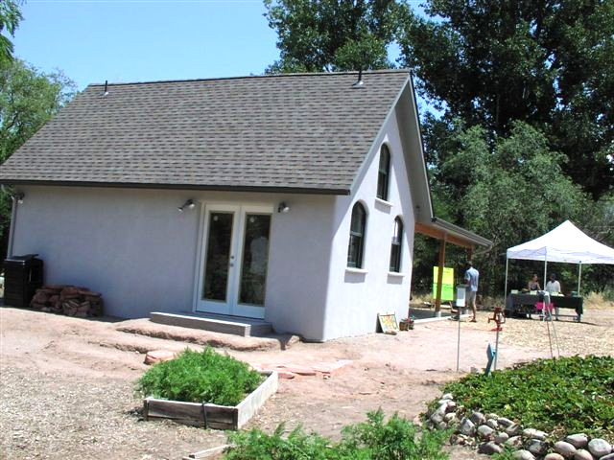
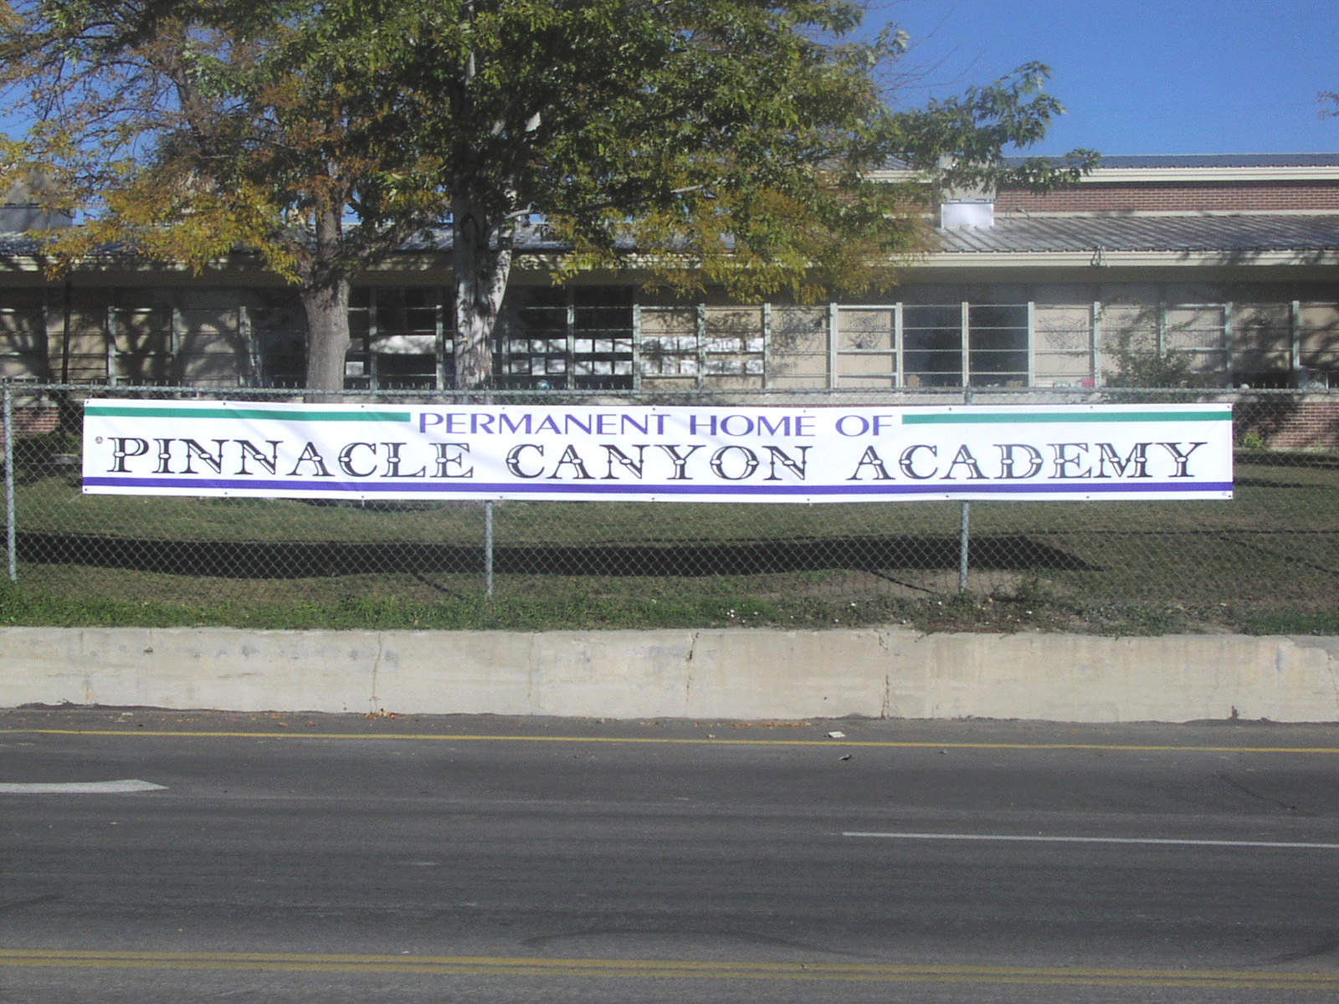
Community Facilities (CF) Direct and Guaranteed Loans and Grants construct, enlarge, and improve community facilities that provide essential services and purchase equipment in rural areas. In FY05, $2,502,280 in direct loans, $3,168,000 in guaranteed loans, and $176,600 in CF grants (including $69,600 Child Care Initiative grants) provided 10 essential community facilities, serving nearly 35,000 rural residents, saving 20 rural jobs and creating 5.

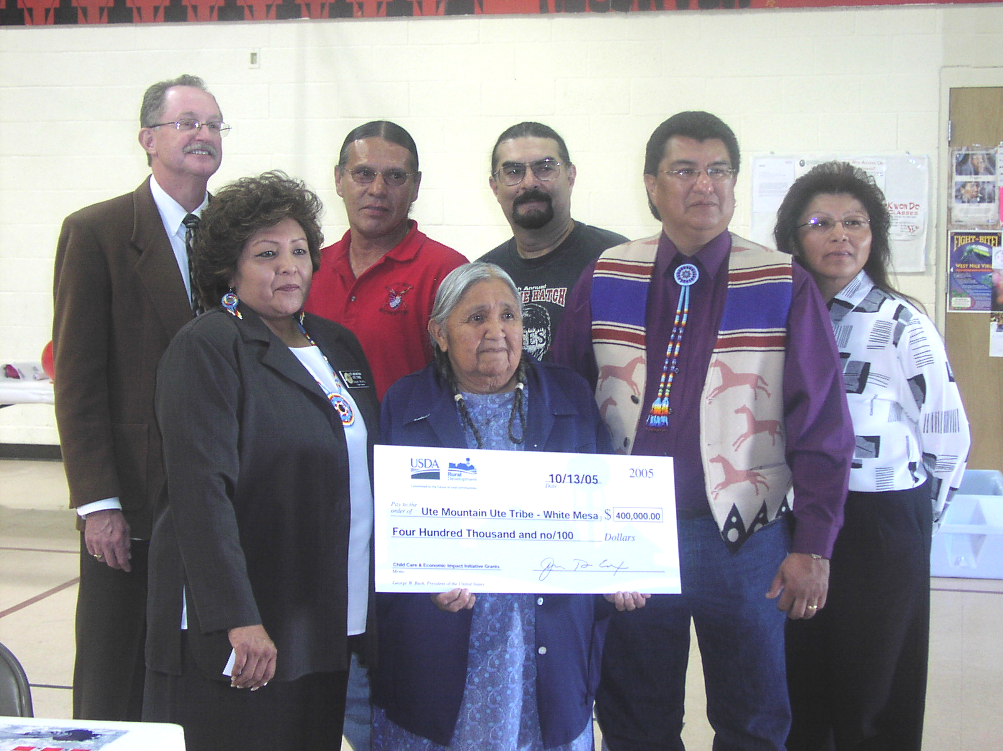
Economic Impact Initiative Grants provided needed community facilities in rural communities that had extreme high unemployment and severe economic depression. $753,250 provided for12 essential community facilities, including medical equipment, a fire station, school bus, senior citizens center, community center, emergency response center, police station, vehicles and equipment, a dump truck, school parking lot and restroom facilities. Over 36,000 individuals in 9 communities were benefited.

FY05 USDA RURAL DEVELOPMENT COMMUNITY DEVELOPMENT AWARD WINNER

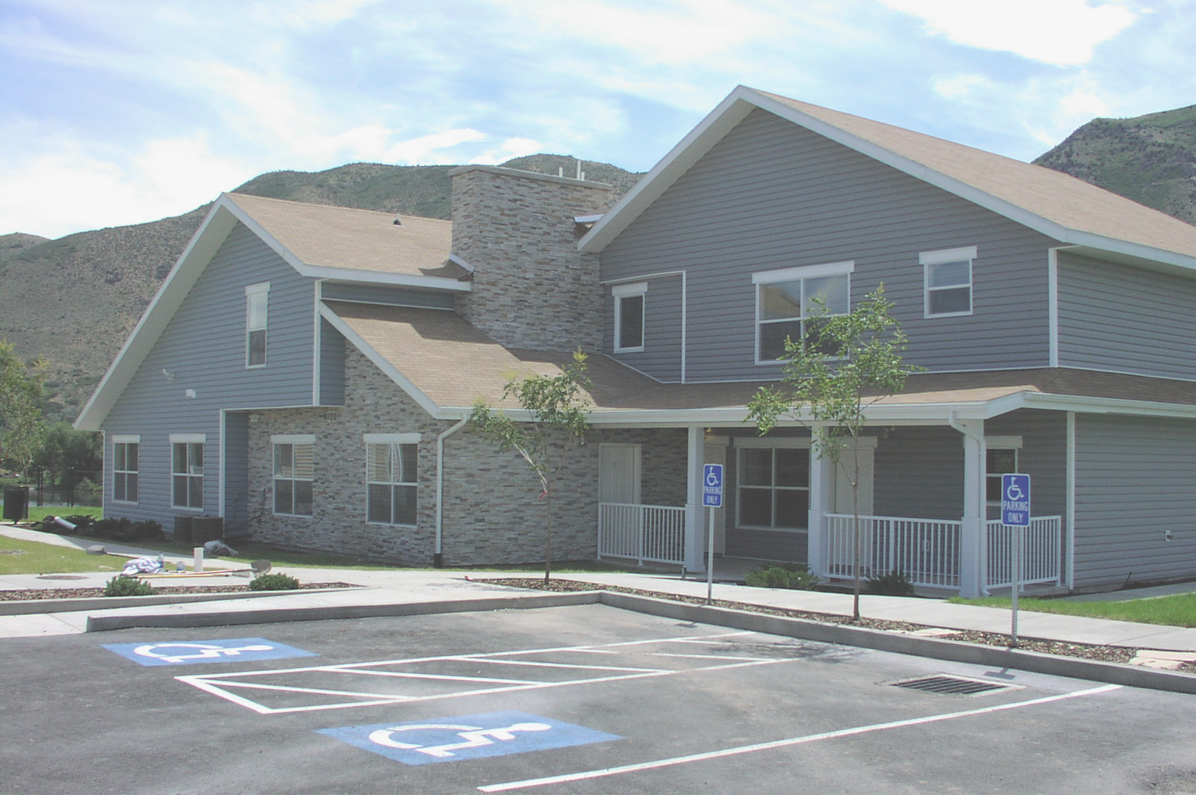
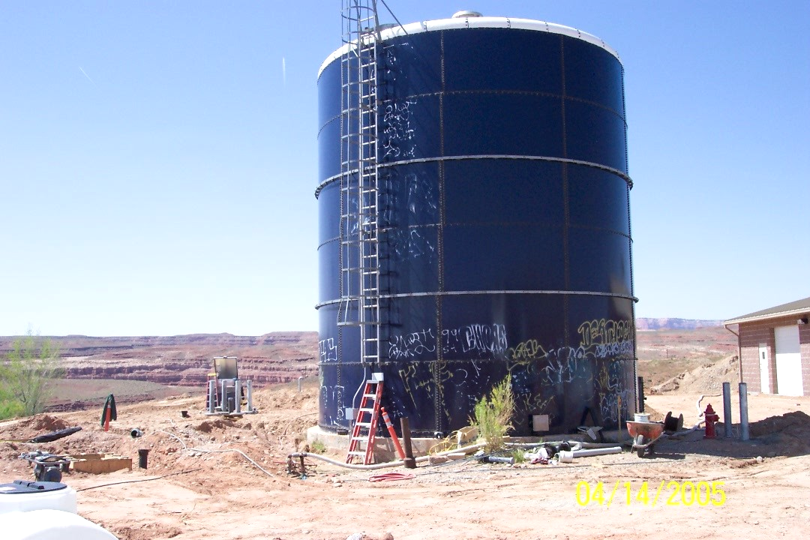
Rural Development proudly recognized Mexican Hat Special Service District as the recipient of the 2005 Rural Development Award for their newly constructed reverse osmosis water treatment plant, well and storage tank. The $1,600,000 project was made possible with a combined funding package received from Utah Division of Drinking Water, Utah Permanent Community Impact Board (PCIB) and USDA Rural Development.

FY05 IMPACT – Community programs assisted 71,000 individuals within 14 communities.
 HOUSING PROGRAMS
$91,359,487 in FY05

Single Family Housing Loans/Grants
Direct loans for new construction and to purchase existing homes: $40,888,382. Repair loans and grants to modernize and repair existing homes: $384,238. Guaranteed loans for new and existing homes: $37,418,117. Grants to nonprofits to administer Mutual Self Help programs: $2,356,880. Other grants for home repairs and homeownership counseling: $82,000.
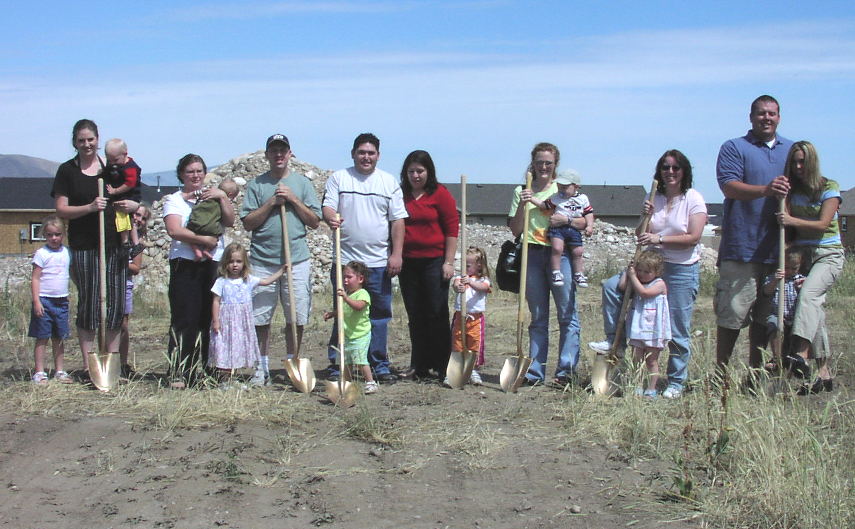
Multi-Family Housing Loans: $2,923,700.
Rental Assistance: $7,306,116.
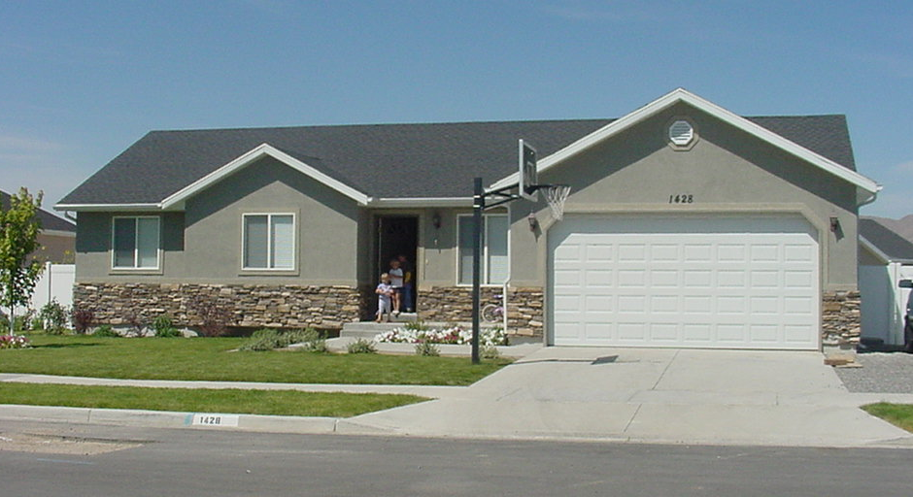
Direct Loans: Rural Development has developed partnerships with nonprofit housing groups and with Olene Walker Housing Fund to provide opportunities for individuals to build 65% of their own home and benefit from sweat equity. Over the past 5 years, 340 homes have been successfully completed. Eleven families successfully participated in the leverage loan program. Another great partnership idea! With general contractor expertise, 502 direct loans allow individuals to purchase existing or construct new homes. 284 households have benefited from this program. Technical Assistance Grants: Nonprofit organizations received $2,438,880 to administer special initiative programs. These programs included Mutual Self Help and counseling prior to home ownership and post ownership counseling. Repair Loans and Grants: 67 rural households received assistance to repair homes and remove health and safety hazards. Guaranteed Rural Housing (GRH) Loans: 303 rural households are becoming successful homeowners through the GRH program. Rural Development provides a 90% guarantee to lenders that provide 100% loans for 30 years.
Multi-Family Housing (MFH) Programs: Over 2,000 MFH units are occupied throughout the state. The $7,201,116 of rental assistance allowed 468 households to receive assistance with rental payments.

FY05 IMPACT – Housing programs assisted 790 individual rural households with homeownership financing, and 468 households with rental needs.
 BUSINESS & COOPERATIVE PROGRAMS $4,164,080 in FY05
RBCS Summary Info
Business and Industry (B&I) Loan Guarantee Program:
$2,446,400
Rural Business Enterprise Grant Program:
$417,680
Rural Business Opportunity Grant Program:
$50,000
Intermediary Relending Program:
$750,000
Renewable Energy and Energy Efficiency Program:
$500,000

B&I Guaranteed Loans:
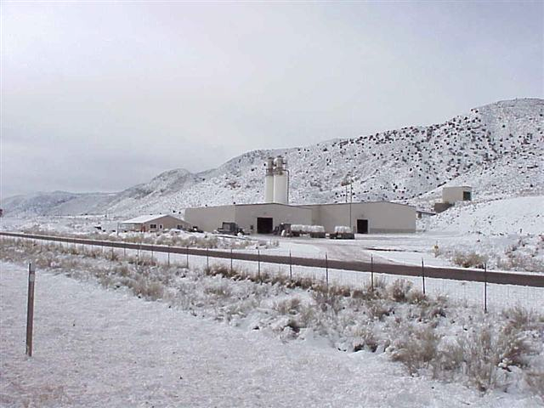
$2,446,400 assisted 65 businesses, creating 9 rural jobs and saving 405 via business startup, business acquisition, and business expansion.

Rural Business Enterprise Grants:
$417,680 assisted 30 entities in rural areas, creating more than 53 jobs and saving 10. This was accomplished by providing lending capital to a Native American revolving loan program; by funding infrastructure needed for multiple small and emerging businesses; and by funding technical assistance for a wind energy project.

Rural Business Opportunity Grant:
$50,000 assisted 17 businesses to save 12 rural jobs and create 90 new jobs. This was accomplished by funding business expansion training requirements.

Intermediary Relending Program:
$750,000 established a revolving loan program with the potential of initially assisting 20 rural businesses and creating 24 jobs.

Renewable Energy and Energy Efficiency Program:
$500,000 assisted a wind energy project that will assist 14 businesses, and will initially save 3 jobs.

FY05 IMPACT – Rural Development business programs assisted 150 rural businesses and created
or saved 600 rural jobs.
 RURAL UTILITIES ROGRAMS
$3,984,495 in FY05

Water and Environmental Loans and Grants develop and repair drinking water and sanitary sewer systems, including solid waste disposal and storm drainage in rural areas.

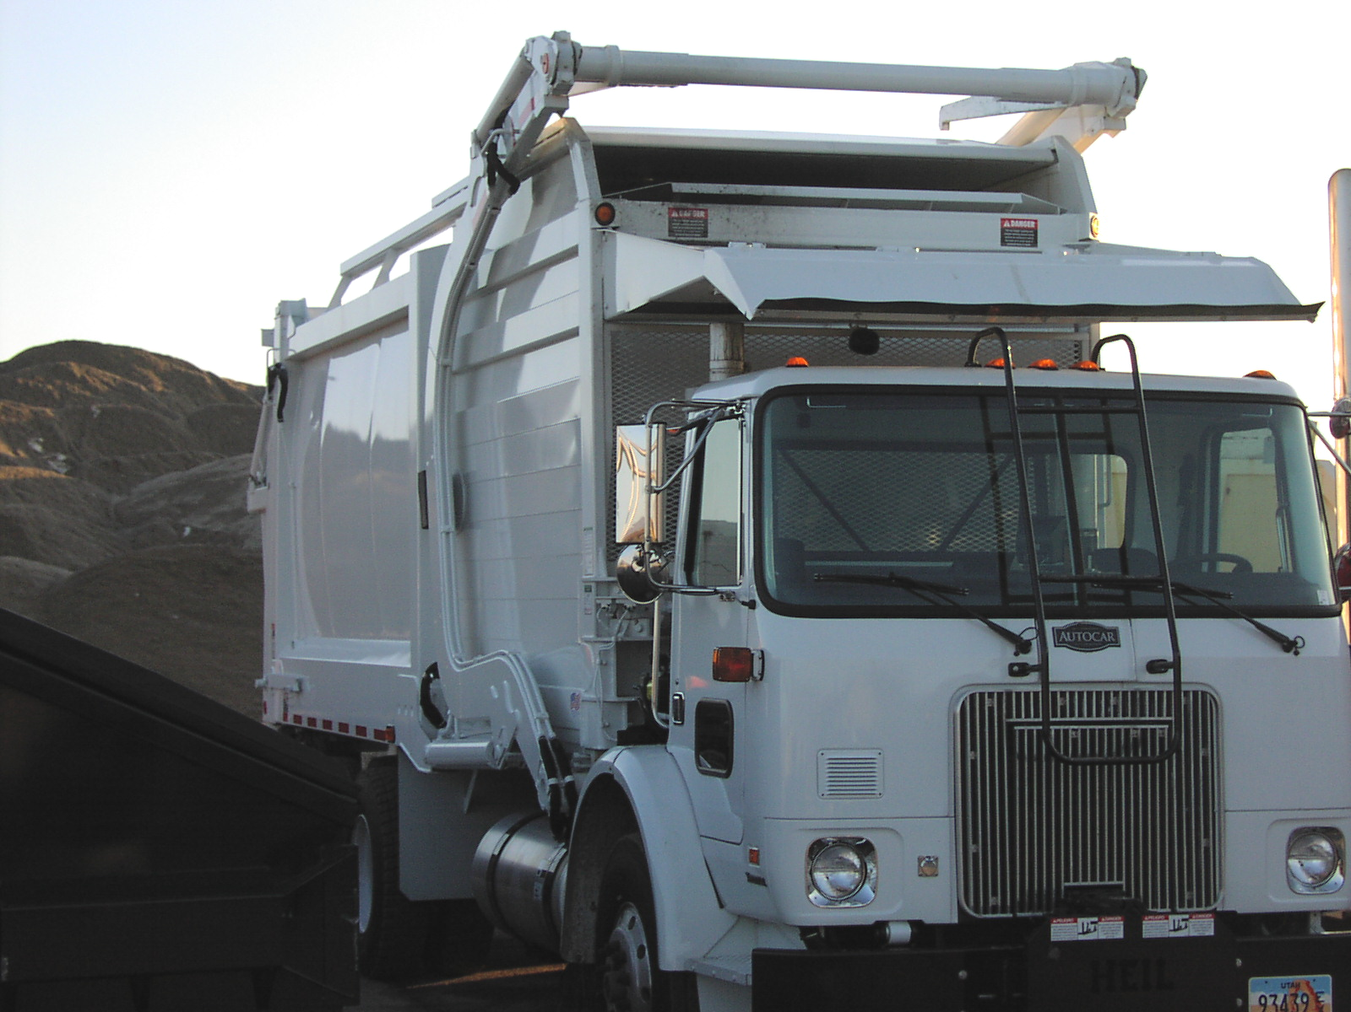
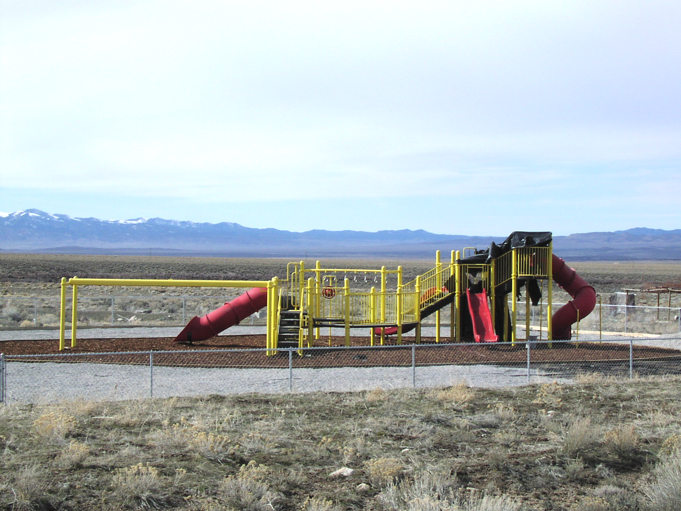
$1,273,000 loans and $2,091,740 grants (inclusive of $448,000 Native American grants) assisted in 6 water, 1 sewer,

and 2 solid waste disposal projects. These loans and grants helped nearly 22,000 rural residents in 15 communities.

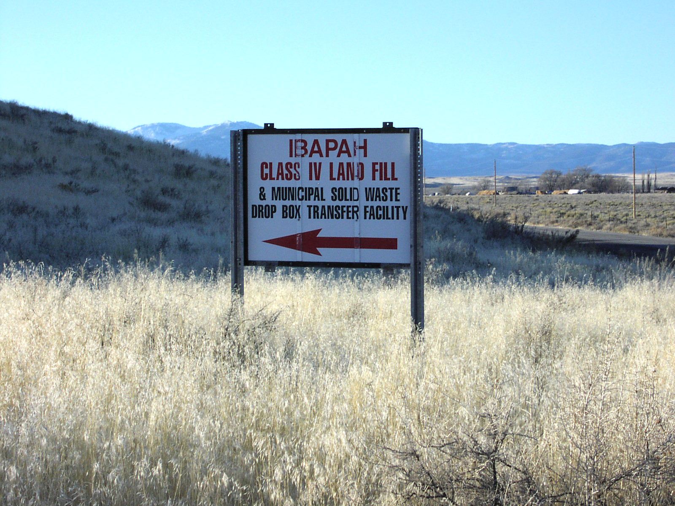
Solid Waste Management Grants are a source of technical assistance for rural communities to reduce water pollution and/or improve planning and management of solid waste sites. $107,100 in grants assisted over 15,000 residents in 15 communities.

Community Connect Broadband Grants provide funds to previously non served communities to facilitate high speed broadband service with public access to a community center with computer work stations. This service enhances economic growth, educational, health care and public safety services. A $512,655 grant assisted 250 people in a remote area of Hanksville Town who were without broadband services.

FY05 IMPACT – Rural Development utilities programs provided assistance to 37,250 individuals within 21 communities.

