EXHIBIT V
Raw Data, with Maps, Study from February and March 2006 issues of
The Flute Network, Zip Code and Date Received

This investigation was undertaken in order to get a feel for the actual experience our subscribers were having in receiving their issues of Flute Network via Standard Mail Nonprofit Letter mail service. We had requested that our subscribers let us know both *when* they received their February and March issues (individually and specifically) and the zip code by which they received it/them.
Information sent in reply was received here via email, via USPS mail, and phone messages, and kept in hard copy format in our files. Zip codes were then listed on a calendar by the date as reported for “when that issue of their Flute Network was received” by pen and paper, and then inputted into a website which graphically represented the distribution of zip codes across the country (many thanks go to the folks at www.frappr.com for allowing us to use their services and website for this in-house purpose!) A “Group Map” was generated for each pertinent date, and the specific zip codes (for where we were notified that an issue was received) were entered as “members” for each date map at frappr.com. All of the maps and information were then downloaded and incorporated into a MS Word file, and ultimately converted to pdf for filing purposes in this Testimony.
A complete set of these map pages with their respective member lists follow.
The February issue entered the USPS Mail system at the Waynesville, NC Post office on February 9. (Day One of delivery is therefore considered to be Feb. 10)
The March issue entered the USPS Mail system at the Waynesville NC Post Office on March 9. (Day One of delivery of this issue is therefore considered to be March 10)
In each of the maps/pages to follow, the Waynesville NC Post Office where our Flute Networks enter the USPS mail system is consistently indicated as “Jan Pritchard – Waynesville (NC)” (this made it easier for us to work with the frappr.com format and maps).
For the information pertaining to the February 2006 issue, there is a Blue Pin indicating that location of that Waynesville Post Office, with Red Pins indicating the zip codes where the February issues were received on each specific date. For the March issues the colors are reversed - i.e., the Red Pin indicates the Waynesville (NC) Post Office, while the Blue Pins represent the receiving zip codes. This method was selected to assist the viewer in easily knowing which Flute Network issue is being referred to in the data represented.
Only those days for which we have specific information are included here – days that are not represented in this collection are days for which we have no information about Flute Networks being received.
Without “insider information” about the particular paths that Flute Networks travel as they move across the country as Standard Nonprofit Letter mail during the course of their delivery, the most striking initial conclusion from the accumulated raw data and resultant maps as provided by our subscribers is: there is no actual pattern to it that we can tell. There was also very little consistency in delivery times across the country between the two months (neither between points, nor in terms of overall delivery).
That being said, however, there are still some rather startling particulars in the raw data worthy of note: (1) it took 13 and 14 days for the February issue to go from Waynesville NC to Hawaii, but the March issue took 37 and 48 days to arrive in Hawaii; and (2) for both the February and the March issues - going from Waynesville NC to the north Georgia towns of Snellville and Cumming, it took the February issue 74 and 75 days to arrive, respectively, and it took 47 days for the March issue in both towns. (Granted – there may be some geographical challenges to drawing any meaningful straight lines between those areas, however - that these two spots which are otherwise comparatively close to the entry Post Office should take so long in delivery defies all reasonable logic. Further – regarding the addresses in Cumming, Georgia as having received both their February and their March issues on the same day, I placed a call to this person to find out if perhaps they had been having their mail held [as a possible explanation for that], and was told that they had indeed been home the entire time and had no idea why these pieces of their mail had been delivered in such a way.)

FEBRUARY ISSUE – entered USPS mail on Feb. 9th, 2006.

Feb 13 rec’d Feb issue (day 4 – Monday)
This was the first date reported for receipt.

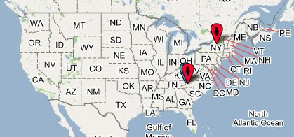

Jan Pritchard Waynesville, NC – Blue pin – location of entry.

28731 Flat Rock, NC 28731

13504 Utica, NY, USA

* End of list for this day

****************************************************************
Feb 18 rec’d Feb issue (day 9 – Saturday)

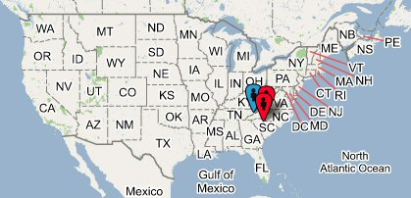

Jan Pritchard Waynesville, NC – blue pin

29063 Irmo, SC 29063

28227 Charlotte, NC 28227

* End of list for this day

Feb 20 rec’d Feb issue (day 11 – Monday)

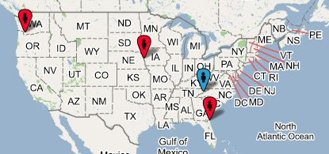

Zip Feb issue rec’d on Feb 20

Jan Pritchard Waynesville (NC) – blue pin

68144 Omaha, NE 68144,

97206 Portland, OR 97206,

32258 Jacksonville, FL 32258,

* End of list for this day

Feb 21 rec’d Feb issue (day 12 – Tuesday)

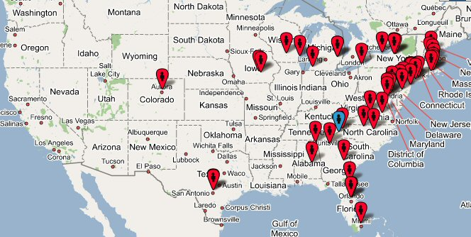

Zip rec’d Feb issue on Feb 21

Jan Pritchard | Waynesville, NC, USA
02067 | Sharon, MA 02067, USA
28608 | Boone, NC, USA
07070 | Rutherford, NJ 07070, USA
32701 | Altamonte Springs, FL 32701, USA
33013 | Hialeah, FL 33013, USA
11733 | East Setauket, NY 11733, USA
36104 | Montgomery, AL 36104, USA
98126 | Seattle, WA 98126, USA
02809 | Bristol, RI 02809, USA
18104 | Allentown, PA 18104, USA
21738 | Glenwood, MD 21738, USA
50219 | Pella, IA 50219, USA
78229 | San Antonio, TX 78229, USA
53402 | Racine, WI 53402, USA
32703 | Apopka, FL 32703, USA
37212 | Nashville, TN 37212, USA
16505 | Erie, PA 16505, USA
05043 | East Thetford, VT 05043, USA
13078 | Jamesville, NY 13078, USA
78216 | San Antonio, TX 78216, USA
78292 | San Antonio, TX, USA
49120 | Niles, MI 49120, USA
19067 | Morrisville, PA 19067, USA
19610 | Reading, PA 19610, USA
30401 | Swainsboro, GA 30401, USA
17837 | Lewisburg, PA 17837, USA
02840 | Newport, RI 02840, USA
35986 | Rainsville, AL 35986, USA
28754 | Mars Hill, NC 28754, USA
13104 | Manlius, NY 13104, USA
01742 | Concord, MA 01742, USA
18938 | New Hope, PA 18938, USA
27410 | Greensboro, NC 27410, USA
24595 | Sweet Briar, VA 24595, USA
53705 | Madison, WI 53705, USA
27612 | Raleigh, NC 27612, USA
21093 | Lutherville Timonium, MD 21093, USA
21251 | Baltimore, MD 21251, USA
05156 | Springfield, VT 05156, USA
97068 | West Linn, OR 97068, USA
32207 | Jacksonville, FL 32207, USA
10019 | New York, NY 10019, USA
17551 | Millersville, PA 17551, USA
80230 | Denver, CO 80230, USA
11714 | Bethpage, NY 11714, USA
08071 | Pitman, NJ 08071, USA
30534 | Dawsonville, GA 30534, USA
48306 | Rochester, MI 48306, USA
20912 | Takoma Park, MD 20912, USA
19406 | King Of Prussia, PA 19406, USA
48306 | Rochester, MI 48306, USA
02879 | Wakefield, RI 02879, USA
13214 | Syracuse, NY 13214, USA
10040 | New York, NY 10040, USA
23832 | Chesterfield, VA 23832, USA
52577 | Oskaloosa, IA 52577, USA
07753 | Neptune, NJ 07753, USA
17043 | Lemoyne, PA 17043, USA
14620 | Rochester, NY 14620, USA
08848 | Milford, NJ 08848, USA
32825 | Orlando, FL 32825, USA
01469 | Townsend, MA 01469, USA
13903 | Binghamton, NY 13903, USA
03302 | Concord, NH, USA

*End of Feb. 21 list
Feb 22 rec’d Feb issue (day 13 – Wednesday)

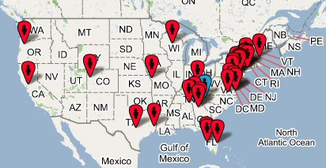

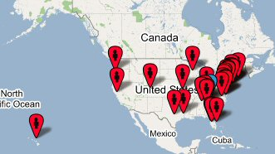

Zip codes rec’d Feb issue on this date:

Jan Pritchard | Waynesville, NC, USA – blue pin
30518 | Buford, GA 30518, USA
07006 | Caldwell, NJ 07006, USA
23608 | Newport News, VA 23608, USA
11801 | Hicksville, NY 11801, USA
19436 | Gwynedd, PA 19436, USA
78133 | Canyon Lake, TX 78133, USA
77706 | Beaumont, TX 77706, USA
27850 | Littleton, NC 27850, USA
37343 | Hixson, TN 37343, USA
40515 | Lexington, KY 40515, USA
97389 | Tangent, OR 97389, USA
07502 | Paterson, NJ 07502, USA
33478 | Jupiter, FL 33478, USA
96790 | Kula, HI 96790, USA
48303 | Bloomfield, NJ, USA
30306 | Atlanta, GA 30306, USA
66210 | Overland Park, KS 66210, USA
35763 | Owens Cross Roads, AL 35763, USA
12572 | Rhinebeck, NY 12572, USA
20785 | Hyattsville, MD 20785, USA
01970 | Salem, MA 01970, USA
34209 | Bradenton, FL 34209, USA
54449 | Marshfield, WI 54449, USA
19406 | King Of Prussia, PA 19406, USA
19104 | Philadelphia, PA 19104, USA
23464 | Virginia Beach, VA 23464, USA
94611 | Oakland, CA 94611, USA
34293 | Venice, FL 34293, USA
19533 | Leesport, PA 19533, USA
21211 | Baltimore, MD 21211, USA
23464 (b) | Virginia Beach, VA 23464, USA
23226 | Richmond, VA 23226, USA
81520 | Clifton, CO 81520, USA
10573 | Port Chester, NY 10573, USA
07006 | Caldwell, NJ 07006, USA

*End of Feb. 22 list.
Feb 23 rec’d Feb issue (day 14 – Thursday)

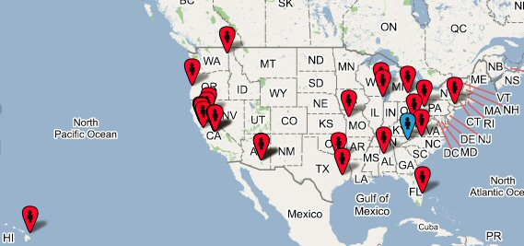

Jan Pritchard | Waynesville (NC) – blue pin
97459 | North Bend, OR 97459, USA
95959 | Nevada City, CA 95959, USA
93728 | Fresno, CA 93728, USA
93704 | Fresno, CA 93704, USA
95628 | Fair Oaks, CA 95628, USA
77009 | Houston, TX 77009, USA
10024 | New York, NY 10024, USA
75156 | Mabank, TX, USA
60607 | Chicago, IL 60607, USA
94903 | San Rafael, CA 94903, USA
85719 | Tucson, AZ 85719, USA
94703 | Berkeley, CA 94703, USA
48236 | Grosse Pointe, MI 48236, USA
94804 | Richmond, CA 94804, USA
94556 | Moraga, CA 94556, USA
95032 | Los Gatos, CA 95032, USA
96721 | Hilo, HI 96721, USA
33411 | West Palm Beach, FL 33411, USA
27104 | Winston Salem, NC 27104, USA
99208 | Spokane, WA 99208, USA
25303 | Charleston, WV 25303, USA
93727 | Fresno, CA 93727, USA
94609 | Oakland, CA 94609, USA
53132 | Franklin, WI 53132, USA
15221 | Pittsburgh, PA 15221, USA
85711 | Tucson, AZ 85711, USA
35473 | Northport, AL 35473, USA
94702 | Berkeley, CA 94702, USA
85719 | Tucson, AZ 85719, USA
64014 | Blue Springs, MO 64014, USA

*End of Feb. 23 list.
Feb 24th rec’d Feb issue (day 15 – Friday)

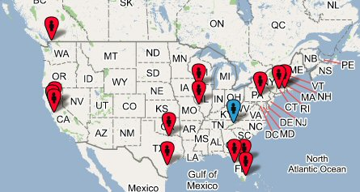

Feb 24th rec’d zip codes

Jan Pritchard | Waynesville (NC) – blue pin
52803 | Davenport, IA 52803, USA
06606 | Bridgeport, CT 06606, USA
34684 | Palm Harbor, FL 34684, USA
95616 | Davis, CA 95616, USA
78412 | Corpus Christi, TX 78412, USA
75065 | Lake Dallas, TX 75065, USA
17013 | Carlisle, PA 17013, USA
06355 | Mystic, CT 06355, USA
63141 | St Louis, MO 63141, USA
33156 | Miami, FL 33156, USA
32940 | Melbourne, FL 32940, USA
95050 | Santa Clara, CA 95050, USA
94547 | Hercules, CA 94547, USA
98225 | Bellingham, WA 98225, USA

* End of list for this day

Feb 25 rec’d Feb issue (day 16 – Saturday)

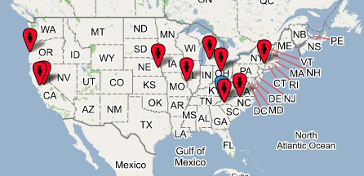

Feb 25 rec’d zip codes

Jan Pritchard | Waynesville (NC) – Blue pin
63131 | St Louis, MO 63131, USA
94610 | Oakland, CA 94610, USA
43065 | Powell, OH 43065, USA
97420 | Coos Bay, OR 97420, USA
27515 | Chapel Hill, NC, USA
12533 | Hopewell Junction, NY 12533, USA
68522 | Lincoln, NE 68522, USA
49024 | Portage, MI 49024, USA
95207 | Stockton, CA 95207, USA
29617 | Greenville, SC 29617, USA

* End of list for this day

Feb 27 rec’d Feb Issue (day 18 – Monday)

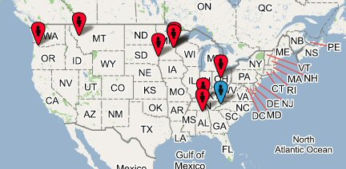

Feb 27 rec’d zip codes

Jan Pritchard | Waynesville (NC) – blue pin
43201 | Columbus, OH 43201, USA
55005 | Bethel, MN 55005, USA
55405 | Minneapolis, MN 55405, USA
57104 | Sioux Falls, SD 57104, USA
97132 | Newberg, OR 97132, USA
35057 | Cullman, AL 35057, USA
37069 | Franklin, TN 37069, USA
55422 | Minneapolis, MN 55422, USA
59803 | Missoula, MT 59803, USA

* End of list for this day
Feb 28 rec’d Feb issue (day 19 – Tuesday)

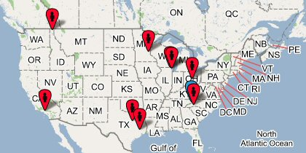

Feb 28 rec’d Feb issue by zip code:

Jan Pritchard | Waynesville (NC) – blue pin
83864 | Sandpoint, ID 83864, USA
43068 | Reynoldsburg, OH 43068, USA
76708 | Waco, TX 76708, USA
60187 | Wheaton, IL 60187, USA
90274 | Palos Verdes Peninsula, CA 90274, USA
29614 | Greenville, SC 29614, USA
77080 | Houston, TX 77080, USA
60805 | Evergreen Park, IL 60805, USA
55044 | Lakeville, MN 55044, USA

* End of list for this day

March 1 – Feb issue rec’d (day 20 - Wednesday)

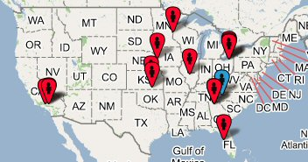

Zip rec’d Feb issue March 1

Jan Pritchard | Waynesville (NC)
91750 | La Verne, CA 91750, USA
33704 | St Petersburg, FL 33704, USA
74604 | Ponca City, OK 74604, USA
67220 | Wichita, KS 67220, USA
44106 | Cleveland, OH 44106, USA
30082 | Marietta, GA 30062, USA
91765 | Diamond Bar, CA 91765, USA
90272 | Pacific Palisades, CA 90272, USA
44141 | Brecksville, OH 44141, USA
55082 | Stillwater, MN 55082, USA
44221 | Cuyahoga Falls, OH 44221, USA
62246 | Greenville, IL 62246, USA
68104 | Omaha, NE 68104, USA
30062 | Marietta, GA 30062, USA

* End of list for this day
March 2 rec’d Feb issue (day 21 - Thursday)

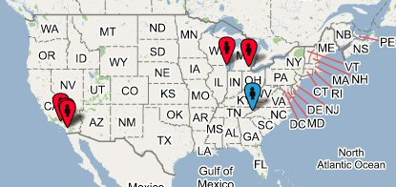

Zip codes rec’d Feb issue March 2

Jan Pritchard Waynesville (NC) – blue pin

92126 San Diego, CA 92126

43623 Toledo, OH 43623

92056 Oceanside, CA 92056

90505 Torrance, CA 90505

60625 Chicago, IL 60625

* End of list for this day

March 3 rec’d Feb issue (day 22 - Friday)

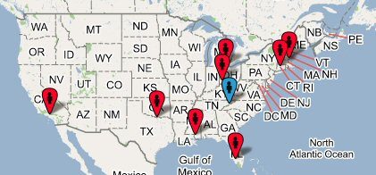

Zip codes rec’d Feb issue March 3

Jan Pritchard Waynesville (NC) - Blue pin

02421 Lexington, MA 02421

90274 Palos Verdes Peninsula, CA 90274

43402 Bowling Green, OH 43402

45244 Cincinnati, OH 45244

76210 Denton, TX 76210

70461 Slidell, LA 70461

06510 New Haven, CT 06510

34116 Naples, FL 34116

* End of list for this day

March 4 rec’d Feb issue (day 23 - Saturday)

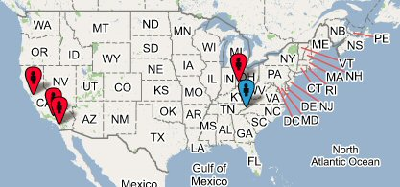

Zip code rec’d Feb issue March 4

Jan Pritchard | Waynesville (NC) – blue pin
45243 | Cincinnati, OH 45243, USA
94087 | Sunnyvale, CA 94087, USA
92037 | La Jolla, CA 92037, USA
90046 | Los Angeles, CA 90046, USA

* End of list for this day
March 6 rec’d Feb issue (day 25 - Monday)

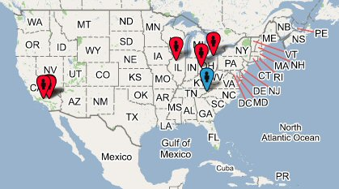

Zip rec’d Feb issue March 6

Jan Pritchard Waynesville (NC) – blue pin

92407 San Bernardino, CA 92407

91335 Reseda, CA 91335

45429 Dayton, OH 45429

92352 Lake Arrowhead, CA 92352

44118 Cleveland, OH 44118

61625 Peoria, IL

* End of list for this day
March 7 rec’d Feb issue (day 26 - Tuesday)

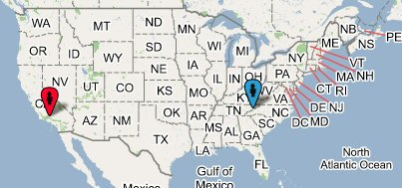

Zip rec’d Feb issue March 7

Jan Pritchard Waynesville (NC) - blue pin

93065 Simi Valley, CA 93065

* End of list for this day

***********************************************************************
March 8 rec’d Feb issue (day 27 - Wednesday)_

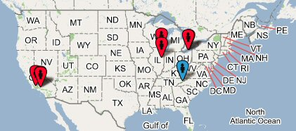

Jan Pritchard Waynesville (NC) – blue pin
60563 Naperville, IL 60563
91342 Sylmar, CA 91342
44118 Cleveland, OH 44118
61821 Champaign, IL 61821
93108 Santa Barbara, CA 93108
44124 Cleveland, OH 44124
91401 Van Nuys, CA 91401

* End of list for this day

March 9 Feb issue rec’d (day 28 – Thursday)

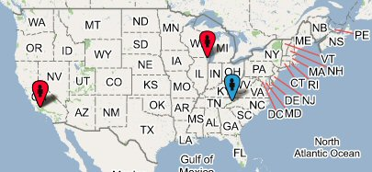

Zip rec’d Feb issue March 9

Jan Pritchard Waynesville (NC) – blue pin

93120 Santa Barbara, CA

93105 Santa Barbara, CA 93105

60616 Chicago, IL 60616, USA

* End of list for this day

Next report of receipt of a February issue was April 24th… see next page

April 24 rec’d February issue (day 74 - Monday)

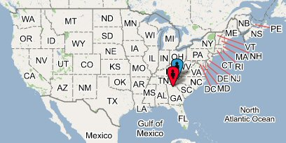

Zip rec’d February issue April 24

Jan Pritchard Waynesville(NC) – blue pin

30078 Snellville, GA 30078

* End of list for this day

********************************************************
Last report of receipt of a February issue:
April 25 rec’d February issue (day 75 – Tuesday)

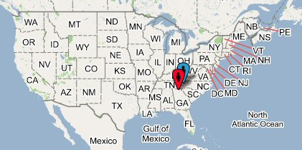

Zip rec’d Feb issue April 25

Jan Pritchard Waynesville (NC) – blue pin

30040 Cumming, GA 30040

* End of list for this day

END OF FEBRUARY DATA.

MARCH ISSUE – Entered USPS in Waynesville, NC on March 9th, 2006.

March 10 – March issue of Flute Network as recd (day 1)

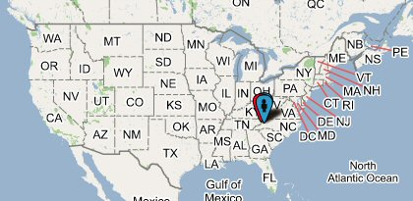

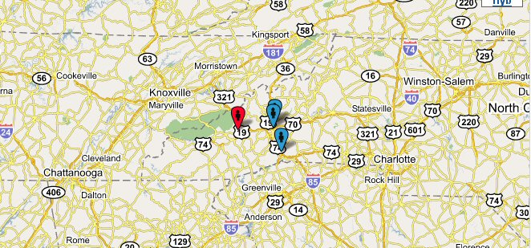

Zip recd March issue

Jan Pritchard Waynesville (NC) - Red pin

28731 Flat Rock, NC 28731

28805 Asheville, NC 28805

28803 Asheville, NC 28803

* End of list for this day
Next reported date of receipt: March 15 recd March issue (day 6 – Wednesday)

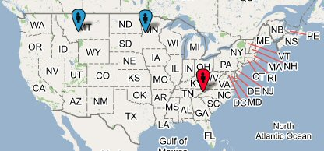

Zip recd March issue day 6

Jan Pritchard Waynesville (NC) – red pin
56267 Morris, MN 56267
59718 Bozeman, MT 59718
* End of list for this day

***********************************************************
March 16 recd March issue (day 7 – Thursday)

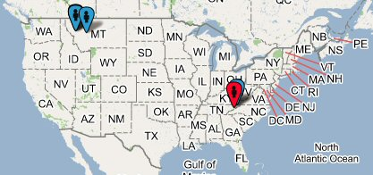

Jan Pritchard Waynesville (NC) – Red pin

59808 Missoula, MT 59808

59803 Missoula, MT 59803

28754 Mars Hill, NC 28754

59601 Helena, MT 59601

59804 Missoula, MT 59804

* End of list for this day

March 17 recd March issue (day 8 – Friday)

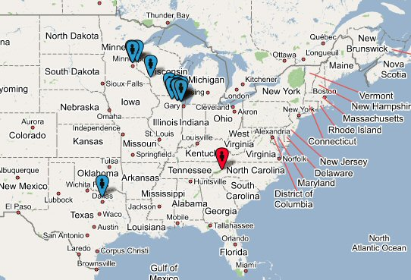

Zip recd March issue

Jan Pritchard | Waynesville (NC)
60187 | Wheaton, IL 60187, USA
60563 | Naperville, IL 60563, USA
60137 | Glen Ellyn, IL 60137, USA
55442 | Minneapolis, MN 55442, USA
75244 | Dallas, TX 75244, USA
60640 | Chicago, IL 60640, USA
60805 | Evergreen Park, IL 60805, USA
60115 | Dekalb, IL 60115, USA
54601 | La Crosse, WI 54601, USA
55082 | Stillwater, MN 55082, USA
61107 | Rockford, IL 61107, USA
60074 | Palatine, IL 60074, USA
55405 | Minneapolis, MN 55405, USA

* End of list for this day

March 18 recd March issue (day 9 – Saturday)

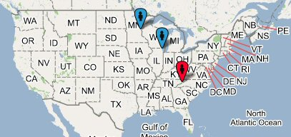

Zip recd March issue

Jan Pritchard Waynesville (NC) – Red pin

60181 Villa Park, IL 60181

55005 Bethel, MN 55005

* End of list for this day

*******************************************************************

March 20 recd March issue (day 11 – Monday)

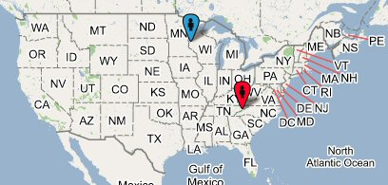

Zip recd March issue

Jan Pritchard Waynesville (NC) – Red pin

54002 Baldwin, WI 54002

* End of list for this day
March 21 recd March issue (day 12 – Tuesday)

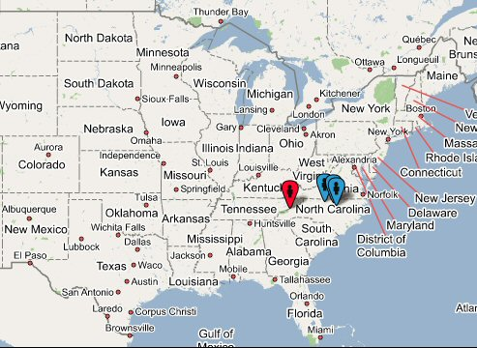

Zip recd March issue

Jan Pritchard Waynesville (NC) – Red pin

27511 Cary, NC 27511

27403 Greensboro, NC 27403

27514 Chapel Hill, NC 27514

* End of list for this day

March 22 recd March issue (day 13 – Wednesday)

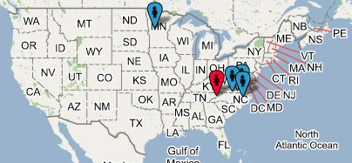

Zip recd March issue

Jan Pritchard Waynesville (NC) – Red pin
27410 Greensboro, NC 27410
28504 Kinston, NC 28504
56308 Alexandria, MN 56308
27850 Littleton, NC 27850
* End of list for this day

*****************************************************************

March 23 recd March issue (day 14 – Thursday)

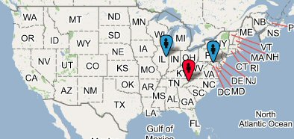

Zip recd March issue on March 23

Jan Pritchard Waynesville – Red pin
61821 Champaign, IL 61821
22102 Mc Lean, VA 22102
* End of list for this day
March 25 recd March issue (day 16 – Saturday)

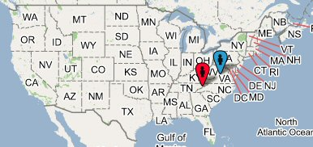

Zip recd March issue

Jan Pritchard Waynesville (NC) – Red pin
24595 Sweet Briar, VA 24595
* End of list for this day
***********************************************************************

March 27 recd March issue (day 18 – Monday)

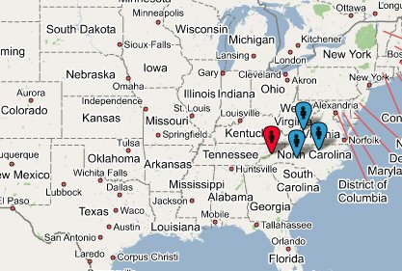

Zip recd March issue on March 27

Jan Pritchard Waynesville (NC) – Red pin
24153 Salem, VA 24153
27612 Raleigh, NC 27612
28215 Charlotte, NC 28215
* End of list for this day

March 28 recd March issue (day 19 – Tuesday)

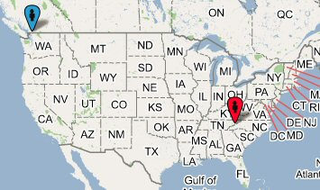

Zip recd March issue

Jan Pritchard Waynesville (NC) – Red pin
98225 Bellingham, WA 98225
* End of list for this day

***********************************************************************

March 29 recd March issue (day 20 – Wednesday)

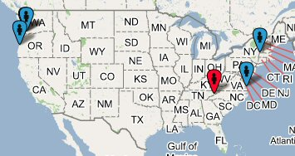

Zip recd March issue

Jan Pritchard Waynesville (NC) – Red pin
01238 Lee, MA 01238
97007 Beaverton, OR 97007
97219 Portland, OR 97219
23464 Virginia Beach, VA 23464
97459 North Bend, OR 97459
* End of list for this day

March 30 recd March issue (day 21 – Thursday)

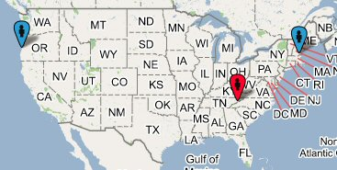

Zip recd March issue on March 30

Jan PritchardWaynesville (NC) – Red pin
97420 Coos Bay, OR 97420
01730 Bedford, MA 01730
* End of list for this day

************************************************************************

March 31 recd March issue (day 22 – Friday)

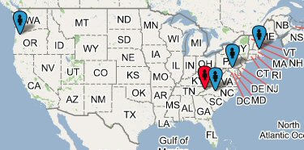

Zip recd March issue

Jan Pritchard Waynesville (NC) – red pin
02458 Newton, MA 02458
21738 Glenwood, MD 21738
28215 Charlotte, NC 28215
97389 Tangent, OR 97389
* End of list for this day

April 1 recd March issue (day 23 – Saturday)

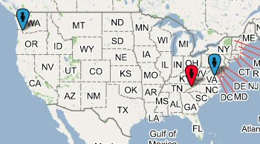

Jan Pritchard Waynesville (NC) – Red pin
97229 Portland, OR 97229
23226 Richmond, VA 23226
* End of list for this day

***********************************************************************
April 3 recd March issue (day 25 – Monday)

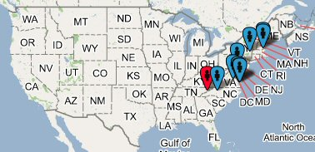

Jan Pritchard | Waynesville (NC) – Red pin
23608 | Newport News, VA 23608, USA
23462 | Virginia Beach, VA 23462, USA
23832 | Chesterfield, VA 23832, USA
01810 | Andover, MA 01810, USA
21209 | Baltimore, MD 21209, USA
02421 | Lexington, MA 02421, USA
28035 | Davidson, NC, USA
23507 | Norfolk, VA 23507, USA
12466 | Port Ewen, NY 12466, USA
* End of list for this day

April 4 recd March issue (day 26 – Tuesday)

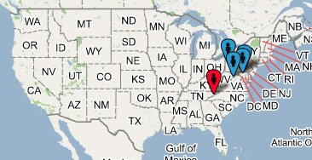

Zip recd March issue on April 4
Jan Pritchard Waynesville (NC) – Red pin
20710 Bladensburg, MD 20710
21093 Lutherville Timonium, MD 21093
22812 Bridgewater, VA 22812
15255 Pittsburgh, PA
*End of list for this day
********************************************************************
April 5 recd March issue (day 27 – Wednesday)

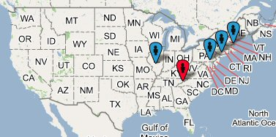

Jan Pritchard Waynesville (NC) – Red pin
62246 Greenville, IL 62246
10573 Port Chester, NY 10573
21047 Fallston, MD 21047
01970 Salem, MA 01970
* End of list for this day

April 6 recd March issue (day 28 – Thursday)

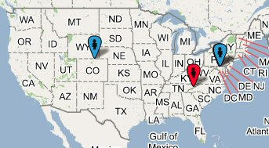

Zip recd March issue April 6
Jan Pritchard Waynesville (NC)- Red pin
20902 Silver Spring, MD 20902
80538 Loveland, CO 80538
20853 Rockville, MD 20853
* End of list for this day

**********************************************************************

April 7 recd March issue (day 29 – Friday)

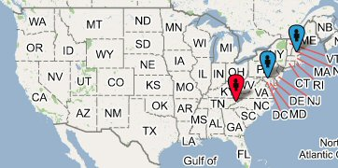

Zip recd March issue on April 7

Jan Pritchard Waynesville (NC) – Red pin

03060 Nashua, NH 03060

20901 Silver Spring, MD 20901

* End of list for this day

April 8 recd March issue (day 30 – Saturday)

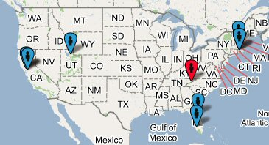

Zip recd March issue

Jan Pritchard | Waynesville (NC) – Red pin
94609 | Oakland, CA 94609
32701 | Altamonte Springs, FL 32701
01469 | Townsend, MA 01469
84121 | Salt Lake City, UT 84121
34116 | Naples, FL 34116
02879 | Wakefield, RI 02879
94583 | San Ramon, CA 94583, USA
02879b | Wakefield, RI 02879, USA
94801 | Richmond, CA 94801, USA

* End of list for this day

April 10 recd March issue (day 32 – Monday)

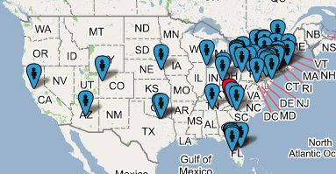

Zip recd March issue on April 10

19807 | Wilmington, DE 19807, USA
29617 | Greenville, SC 29617, USA
Jan Pritchard | Waynesville (NC) – Red pin
33704 | St Petersburg, FL 33704, USA
13903 | Binghamton, NY 13903, USA
26062 | Weirton, WV 26062, USA
06482 | Sandy Hook, CT 06482, USA
08201 | Absecon, NJ 08201, USA
78133 | Canyon Lake, TX 78133, USA
67220 | Wichita, KS 67220, USA
81520 | Clifton, CO 81520, USA
68522 | Lincoln, NE 68522, USA
13104 | Manlius, NY 13104, USA
44118 | Cleveland, OH 44118, USA
44221 | Cuyahoga Falls, OH 44221, USA
32934 | Melbourne, FL 32934, USA
81101 | Alamosa, CO 81101, USA
19406 | King Of Prussia, PA 19406, USA
05401 | Burlington, VT 05401, USA
34222 | Ellenton, FL 34222, USA
20151 | Chantilly, VA 20151, USA
19025 | Dresher, PA 19025, USA
34461 | Lecanto, FL 34461, USA
94618 | Oakland, CA 94618, USA
19436 | Gwynedd, PA 19436, USA
32277 | Jacksonville, FL 32277, USA
16417 | Girard, PA 16417, USA
02835 | Jamestown, RI 02835, USA
15705 | Indiana, PA, USA
75042 | Garland, TX 75042, USA
29108 | Newberry, SC 29108, USA
44120 | Cleveland, OH 44120, USA
02144 | Somerville, MA 02144, USA
11771 | Oyster Bay, NY 11771, USA
32611 | Gainesville, FL, USA
44022 | Chagrin Falls, OH 44022, USA
45244 | Cincinnati, OH 45244, USA
41011 | Covington, KY 41011, USA
14450 | Fairport, NY 14450, USA
45429 | Dayton, OH 45429, USA
19406b | King Of Prussia, PA 19406, USA
10023 | New York, NY 10023, USA
75028 | Flower Mound, TX 75028, USA
11754 | Kings Park, NY 11754, USA
10708 | Bronxville, NY 10708, USA
10024 | New York, NY 10024, USA
18042 | Easton, PA 18042, USA
10036 | New York, NY 10036, USA
30534 | Dawsonville, GA 30534, USA
20170 | Herndon, VA 20170, USA
14580 | Webster, NY 14580, USA
16866 | Philipsburg, PA 16866, USA
06606 | Bridgeport, CT 06606, USA
13214 | Syracuse, NY 13214, USA
46322 | Highland, IN 46322, USA
18938 | New Hope, PA 18938, USA
06606b | Bridgeport, CT 06606, USA
43201 | Columbus, OH 43201, USA
19533 | Leesport, PA 19533, USA
44224 | Stow, OH 44224, USA
49112 | Edwardsburg, MI 49112, USA
32909 | Palm Bay, FL 32909, USA
33803 | Lakeland, FL 33803, USA
30316 | Atlanta, GA 30316, USA
85205 | Mesa, AZ 85205, USA
34238 | Sarasota, FL 34238, USA
44124 | Cleveland, OH 44124, USA
33756 | Clearwater, FL 33756, USA
08848 | Milford, NJ 08848, USA
12123 | Nassau, NY 12123, USA
35763 | Owens Cross Roads, AL 35763, USA
54476 | Schofield, WI 54476, USA
78703 | Austin, TX 78703, USA
11714 | Bethpage, NY 11714, USA
19119 | Philadelphia, PA 19119, USA
78216 | San Antonio, TX 78216, USA
49120 | Niles, MI 49120, USA
18104 | Allentown, PA 18104, USA
14618 | Rochester, NY 14618, USA
37377 | Signal Mountain, TN 37377, USA
19610 | Reading, PA 19610, USA

* End of April 10 list, receipt of March issue

April 11 recd March issue (day 33 – Tuesday)

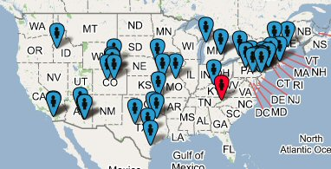

80906 | Colorado Springs, CO 80906, USA
92126 | San Diego, CA 92126, USA
Jan Pritchard | Waynesville (NC) --- Red pin
11801 | Hicksville, NY 11801, USA
78666 | San Marcos, TX 78666, USA
18929 | Jamison, PA 18929, USA
19406 | King Of Prussia, PA 19406, USA
74133 | Tulsa, OK 74133, USA
14063 | Fredonia, NY 14063, USA
49613 | Arcadia, MI 49613, USA
68104 | Omaha, NE 68104, USA
78412 | Corpus Christi, TX 78412, USA
04537 | Boothbay, ME 04537, USA
85719 | Tucson, AZ 85719, USA
66061 | Olathe, KS 66061, USA
92115 | San Diego, CA 92115, USA
17837 | Lewisburg, PA 17837, USA
76901 | San Angelo, TX 76901, USA
17551 | Millersville, PA 17551, USA
80226 | Denver, CO 80226, USA
16877 | Warriors Mark, PA 16877, USA
81211 | Buena Vista, CO 81211, USA
80003 | Arvada, CO 80003, USA
16877b | Warriors Mark, PA 16877, USA
07950 | Morris Plains, NJ 07950, USA
80303 | Boulder, CO 80303, USA
17403 | York, PA 17403, USA
48309 | Rochester, MI 48309, USA
40522 | Lexington, KY, USA
19067 | Morrisville, PA 19067, USA
75208 | Dallas, TX 75208, USA
08053 | Marlton, NJ 08053, USA
75156 | Mabank, TX, USA
83709 | Boise, ID 83709, USA
06706 | Waterbury, CT 06706, USA
48307 | Rochester, MI 48307, USA
65203 | Columbia, MO 65203, USA
02809 | Bristol, RI 02809, USA
85710 | Tucson, AZ 85710, USA
82009 | Cheyenne, WY 82009, USA
05043 | East Thetford, VT 05043, USA
85215 | Mesa, AZ 85215, USA

* End of April 11 receipt of March issue

April 12 recd March issue (day 34 – Wednesday)

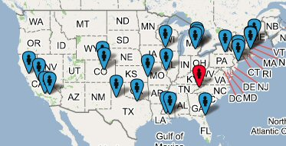

Jan Pritchard | Waynesville (NC)
92407 | San Bernardino, CA 92407, USA
07753 | Neptune, NJ 07753, USA
52002 | Dubuque, IA 52002, USA
76021 | Bedford, TX 76021, USA
70403 | Hammond, LA 70403, USA
79413 | Lubbock, TX 79413, USA
70461 | Slidell, LA 70461, USA
92728 | Fountain, CO, USA
02481 | Wellesley Hills, MA 02481, USA
93727 | Fresno, CA 93727, USA
80003 | Arvada, CO 80003, USA
02421 | Lexington, MA 02421, USA
48103 | Ann Arbor, MI 48103, USA
32259 | Jacksonville, FL 32259, USA
10024 | New York, NY 10024, USA
48341 | Pontiac, MI 48341, USA
16933 | Mansfield, PA 16933, USA
48423 | Davison, MI 48423, USA
91042 | Tujunga, CA 91042, USA
63131 | St Louis, MO 63131, USA
66762 | Pittsburg, KS 66762, USA
04106 | South Portland, ME 04106, USA
94523 | Pleasant Hill, CA 94523, USA

* End of list for this day

**********************************************************

April 13 rec’d March issue (day 35 – Thursday)

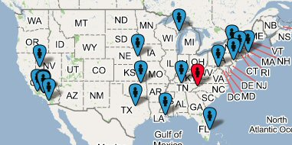

76708 | Waco, TX 76708, USA
Jan Pritchard | Waynesville (NC) – Red pin
68588 | Lincoln, NE, USA
33478 | Jupiter, FL 33478, USA
70070 | Luling, LA 70070, USA
91001 | Altadena, CA 91001, USA
74132 | Tulsa, OK 74132, USA
92105 | San Diego, CA 92105, USA
54202 | Baileys Harbor, WI 54202, USA
08619 | Trenton, NJ 08619, USA
91207 | Glendale, CA 91207, USA
13820 | Oneonta, NY 13820, USA
06482 | Sandy Hook, CT 06482, USA
91390 | Santa Clarita, CA 91390, USA
89447 | Yerington, NV 89447, USA
37211 | Nashville, TN 37211, USA
91342 | Sylmar, CA 91342, USA
02840 | Newport, RI 02840, USA
93120 | Santa Barbara, CA, USA
22630 | Front Royal, VA 22630, USA

* End of list for this day

***************************************************************

April 14 rec’d March issue (day 36 – Friday)

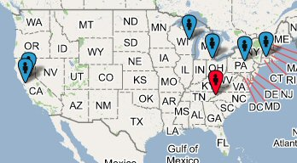

Zip rec’d march issue April 14

Jan Pritchard | Waynesville (NC) – Red Pin
17837 | Lewisburg, PA 17837, USA
94306 | Palo Alto, CA 94306, USA
54915 | Appleton, WI 54915, USA
06416 | Cromwell, CT 06416, USA
43402 | Bowling Green, OH 43402, USA
92637 | Laguna, CA, USA

* End of list for this day

April 15 rec’d March issue (day 37 – Saturday)

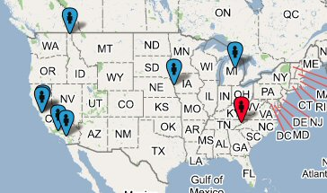

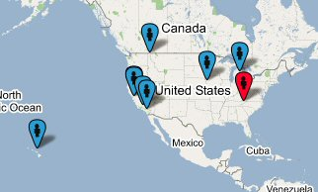

Zip rec’d April 15

Jan Pritchard | Waynesville (NC)
95125 | San Jose, CA 95125, USA
48642 | Midland, MI 48642, USA
92057 | Oceanside, CA 92057, USA
96790 | Kula, HI 96790, USA
95060 | Santa Cruz, CA 95060, USA
68144 | Omaha, NE 68144, USA
91362 | Thousand Oaks, CA 91362, USA
83864 | Sandpoint, ID 83864, USA

* End of list for this day

April 17 rec’d March issue (day 39 – Monday)

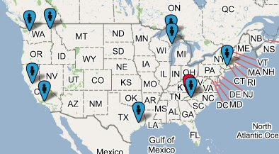

Zip rec’d March issue April 17th

Jan Pritchard | Waynesville (NC) – Red pin
06840 | New Canaan, CT 06840, USA
77006 | Houston, TX 77006, USA
99224 | Spokane, WA 99224, USA
49855 | Marquette, MI 49855, USA
94566 | Pleasanton, CA 94566, USA
91301 | Agoura Hills, CA 91301, USA
29614 | Greenville, SC 29614, USA
98418 | Tacoma, WA, USA
54202 | Baileys Harbor, WI 54202, USA

* End of list for this day
April 18 rec’d March issue (day 40 – Tuesday)

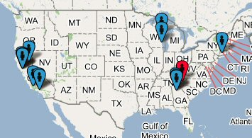

Zip rec’d March issue on April 18th

Jan Pritchard | Waynesville (NC) – Red pin
30312 | Atlanta, GA 30312, USA
94903 | San Rafael, CA 94903, USA
30236 | Jonesboro, GA 30236, USA
94903b | San Rafael, CA 94903, USA
94952 | Petaluma, CA 94952, USA
93117 | Goleta, CA 93117, USA
94930 | Fairfax, CA 94930, USA
30062 | Marietta, GA 30062, USA
53132 | Franklin, WI 53132, USA
54115 | De Pere, WI 54115, USA
90403 | Santa Monica, CA 90403, USA
11733 | East Setauket, NY 11733, USA
90731 | San Pedro, CA 90731, USA
95959 | Nevada City, CA 95959, USA

* End of list for this day

April 19 rec’d March issue (day 41 – Wednesday)

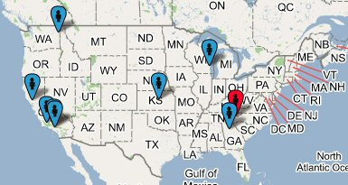

Zip rec’d March issue April 19th

30253 | Mcdonough, GA 30253, USA
Jan Pritchard | Waynesville (NC) – Red pin
99205 | Spokane, WA 99205, USA
99567 | Chugiak, AK 99567, USA
67502 | Hutchinson, KS 67502, USA
94957 | Ross, CA 94957, USA
90026 | Los Angeles, CA 90026, USA
93108 | Santa Barbara, CA 93108, USA
53045 | Brookfield, WI 53045, USA
90803 | Long Beach, CA 90803, USA

* End of list for this day

April 20 recd March issue (day 42 – Thursday)

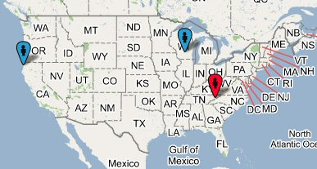

Zip rec’d March issue

Jan Pritchard | Waynesville (NC) – Red pin
95519 | Mckinleyville, CA 95519
99709 | Fairbanks, AK 99709
53706 | Madison, WI 53706

* End of list for this day

*********************************************************************

April 21 recd March issue (day 43 – Friday)

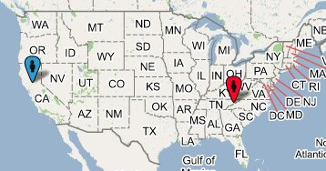

Zip rec’d March issue April 21

Jan Pritchard Waynesville (NC) – Red pin

95616 Davis, CA 95616

* End of list for this day

April 22 rec’d March issue (day 44 – Saturday)

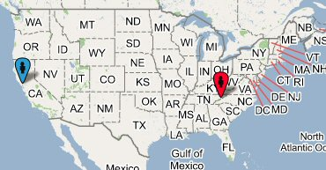

Zip rec’d March issue

Jan Pritchard Waynesville (NC) – Red pin

94127 San Francisco, CA 94127

* End of list for this day

***********************************************************************

April 24 rec’d March issue (day 46 – Monday)

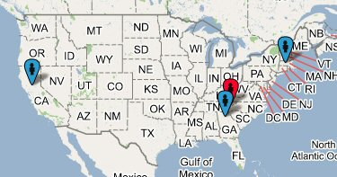

Zip rec’d March issue April 24

Jan Pritchard | Waynesville (NC) – Red pin
95616 | Davis, CA 95616
06278 | Ashford, CT 06278
30094 | Conyers, GA 30094

* End of list for this day

April 25 recd March issue (day 47 – Tuesday)

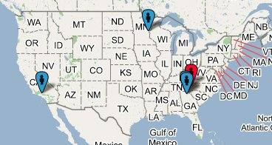

Zip rec’d March issue

Jan Pritchard | Waynesville (NC) – Red pin
30078 | Snellville, GA 30078
30040 | Cumming, GA 30040
55005 | Bethel, MN 55005
90403 | Santa Monica, CA 90403

*End of list for this day

********************************************************************
April 26 rec’d March issue (day 48 – Wednesday)

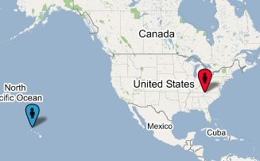

Zip rec’d March issue April 26

Jan Pritchard Waynesville (NC) – Red pin

96746 Kapaa, HI 96746

* End of list for this day

April 29 rec’d March issue (day 51 – Saturday)

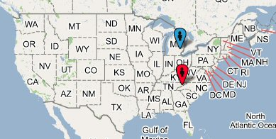

Zip rec’d March issue

Jan Pritchard Waynesville (NC) – Red pin

48167 Northville, MI 48167

* End of list for this day

END OF MARCH ISSUE DATA

END OF RAW DATA

Respectfully submitted – Jan Spell Pritchard

