In 1984 when Dr. Paul Ronney reported seeing "these ridiculous [little] balls of flame" in his drop tower experiments, some of his colleagues didn't believe him. No one had ever seen them before. They didn't spread away from their ignition source. "They've been pretty well accepted now," Dr. Ronney says, but back then the idea of a stable flame that burned in a contained ball was a pretty strange idea. But the inauspicious little "flame ball" has proven to be one key to opening up the science of combustion, which studies the transformation of chemical energy contained in fuels to heat and light.

It turned out flame balls (or something like them) had been predicted in1944 by Soviet physicist Yakov Zeldovich. But Zeldovich thought the phenomenon, like balancing a pen on its point, was possible in theory but too unstable to exist in reality. And indeed flame balls can exist only within a very narrow window of conditions, one of the requirements being microgravity, which means they would not have been observed under normal conditions on Earth.

Flame balls are the weakest flames we have, burning at the edges of the extinction limits in the weakest of fuel mixtures. Compared to a birthday candle's 50 to 100 watts, a flame ball produces only 1 to 2 watts of thermal power.

Their existence depends on diffusion: instead of its flame spreading outward, a flame ball's fuel and oxygen diffuse in. The blue ball of flame is the light given off by the chemical reaction of hydrogen or methane burning. In a flame ball, that reaction occurs in a thin reaction zone delicately balanced between heat and spent fuel diffusing out and fresh fuel and oxygen diffusing in. When the hydrogen or methane fuel burns, it leaves vaporized water and CO₂, which diffuse out and collect inside the flame ball. Flame balls only exist in microgravity in the absence of the rising of hot gas in gravity that would overwhelm their delicate diffusion processes. (I don’t know if I’d use the term “razor-thin” to describe the reaction zone but it is thin compared to the radius of the flame ball)
[Photo credited to USC. Dr. Paul Ronney can provide more specific credit.] (I drew the original version of this – it’s been re-worked many times since by various artists, but the information content hasn’t changed at all)

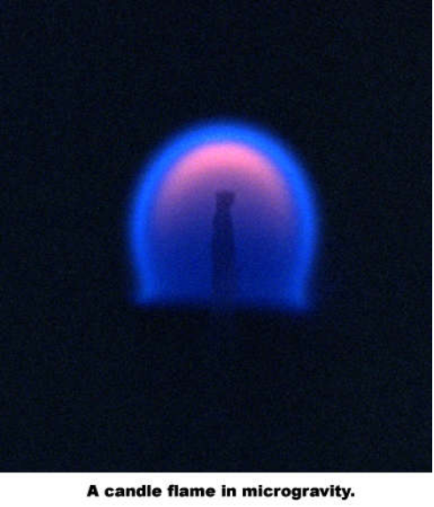The familiar teardrop shape of a candle is actually an effect caused by gravity. In a flame in gravity, hot, light, spent air rises and draws fresh, cold air in behind it, fueling the fire. This is called "buoyancy" and is what causes the flame to shoot up into the tear shape. In microgravity, a candle flame does not look like a teardrop at all. (Note: you don’t need microgravity to see cellular flames (at low Lewis number) or spiral flames (at high Lewis number). Gravity does affect the patterns that you see, but the “engine” driving the pattern formation is Lewis number effects, not gravity. I mentioned these as other examples of what can happen when the Lewis number is not close to 1 (where nothing interesting happens).

[Pix to right is candle flame in microgravity from NASA website]

A little buoyancy increases a flame's burn rate. You use this effect when you fan a kindling fire to make it burst into larger flame. But too much buoyancy extinguishes a flame (as when you blow out a candle). Scientists didn't realize how strongly buoyancy affected combustion until it was taken away in microgravity. Buoyancy effects in gravity mask other physical processes that affect combustion. As Professor Gerard M. Faeth from the University of Michigan has observed, just as the obscuring effects of air made it difficult to see the stars until astronomy was able to move outside of the atmosphere, so gravity masks the underlying processes in combustion science. Professor Faeth is performing a combustion experiment related to the generation of soot on STS-107 [could link to STS-107 science website here http://microgravity.grc.nasa.gov/sts-107/].

In microgravity, you eliminate the turbulence and buoyancy effects and unmask other effects that we need to understand to fine tune how we control combustion in manufacturing, transportation, heating, fire safety, and pollution. For many years combustion models have been able to predict successfully that a flame's burning rate decreases as the fuel mixture strength decreases. What the models couldn't explain was why burning stopped before the mixture strength or burning rate reached zero. Another factor was influencing the burn rate. Using the microgravity of drop tower experiments (where an experiment is dropped from a tall tower to simulate low gravity), researchers discovered that heat lost through radiation also affected combustion.

But scientists still underestimated the importance of radiation effects masked by gravity. Ground- and flight-based experiments were too short. (Flame balls were discovered during a 2.2-second experiment.) In April 1997 Dr. Ronney worked with Dr. Karen Weiland at NASA Glenn Research Center and others to fly the Structure of Flame Balls at Low Lewis-number (SOFBALL) experiment on the space shuttle (STS-83) in the Microgravity Sciences Laboratory-1 (MSL-1). Because of a fuel cell problem, the experiment was flown again in July on MSL-1R on STS-94.
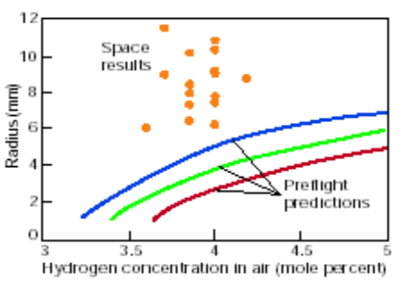
In microgravity, we found out we didn't know as much as we thought we did about combustion. As shown in the chart on the left, the experimental data from the SOFBALL and other experiments didn't match up with the curves predicted by combustions models beforehand at all. "We found that under a different set of circumstances, [microgravity], we couldn't predict the results very well quantitatively," says Ronney. "Diffusion of transport and radiation were not modeled as accurately as we thought." Dr. Ronney's experiment in microgravity demonstrated the importance of loss of heat from radiation, which will limit the burning of a flame in the absence of buoyancy.

The biggest discovery from MSL-1 and 1R was the long life of flame balls[hyperlink to flame ball joke]. Existing combustion computer models predicted that flame balls would be smaller and either extinguish or drift into the chamber walls in a few minutes. Instead the flame balls were two to three times larger than predicted and burned for over 8 minutes until the experimental system automatically extinguished them, demonstrating the limitation of models of lean combustion. [Pix of Janice from NASA website.] [Note: LSP stands for Laminar Soot Processes. EMS stands for Experiment Mounting Structure.]

The experiments collected new data and raised some new questions. How low a fuel mixture could be sustained if it weren't extinguished by buoyancy effects? What are the ultimate limits for lean operation or "weak" combustion that is friendly to the environment?

Considering that combustion powers our automobiles, generates our electricity, and heats our homes, we know very little about it. We know that automobile engines waste fuel and energy when running a fuel-rich mixture. When you mix more air with less fuel, you get more efficient "lean" burning, which is better for the environment because it emits less pollutants. But it also causes engine misfiring and rough operation. "Until recently, we really didn't even understand why strong mixtures would burn and weak wouldn't," said Dr. Ronney, "Or why a moderate amount of turbulence makes a flame burn faster, but if it is too high, the…flame is extinguished completely."

Combustion is difficult to study because of the many complex factors involved. Two key issues of combustion are not well understood in models: 1.) their chemical reaction (or burn rate) and 2.) the transport of fresh fuel and air in and spent combustion products out. For turbulent flames that leap and change shape, modeling their chemical reaction and transport is very difficult. Researchers could model complicated transport mechanisms, including buoyancy, assuming simple chemical reaction, or they could model complex chemical reaction rates with simple transport mechanisms, but not both.

Flame balls are a relatively new tool for gaining new understanding of weak combustion processes. Existing only in microgravity, flame balls further simplify the combustion problem by being the simplest form of burning. Their diffusion-controlled combustion process is a means to study how low you can go, or the effects of chemistry and transport at the limits of lean combustion. "Flame balls are a completely different kind of flame structure," says Dr. Ronney. "Their behavior is inverted from every other kind of flame – for example they need severe heat losses[hyperlink to file algebra] simply to exist.." Also, flame balls can occur only in mixtures with low Lewis number [hyperlink to file Lewis Number] that are too weak to support conventional flames. They exist in a very narrow range of conditions that allows them to be stable without growing in size, or propagating, like conventional flames. As Ronney explains it, it is almost as if the flame ball's last line of defense as it approaches the limits of combustion is to draw itself into a simple ball.

And the fact that they burn in a sphere reduces their dimensions to one—the radius of the flame (which is the same in all directions), so you can focus on the dimensions of chemistry and transport by diffusion.

This makes flame balls to combustion scientists what the fruit fly is to geneticists, says Dr. Ronney. It's not that you want more and better fruit flies (or flame balls), but they provide a simple model for testing hypotheses.

The flame ball experiments looked at some basic principles of combustion at the limits of low-concentration fuels. Because the science is so fundamental, it touches on many aspects of combustion. It affects the fields of combustion physics—the simplest interaction of chemistry and transport; spacecraft design—the design of systems that handle hydrogen or biological products (food, waste, lab animals) that produce hydrogen and other combustible gases; and automotive engineering—the design of lean-burning engines using hydrogen or hydrocarbon fuels.

Because flames act differently in space, fire safety is also different. For example, because on Earth buoyancy transports combustion products away from a flame, if you see a fire, you might run over and stomp it out or use a fire extinguisher. In microgravity, rushing over and stomping on a flame might accelerate combustion, at least temporarily, because you are creating an airflow that did not exist before, which initially increases the flame's burn rate. In addition, you might cause the flame to jump to something else when it wouldn't have otherwise. (good explanation)

Flames in space tend to be larger, and the heat they give off extends farther. On Earth, you can hold your hand pretty close to the side of a candle before you feel the heat. You would feel it sooner in space. This could make fires spread more rapidly if the flame was next to something flammable, or, if the flame was next to something not flammable, make it easier to extinguish the flame because it loses heat more rapidly. Generally flames in space will spread less rapidly. But this may not help you if you can't detect them, as with flame balls that give off no smoke and little or no visible light. And no one knows yet what happens if a loose flame ball runs into something. Will it ignite it?

[Pix from NASA website]

The experimental combustion data from STS-83 and –94 have been used to enhance combustion models. But it is just the first step in understanding and modeling combustion processes.

In 2002, two of the combustion experiments and one new one, the Water Mist Fire Suppression Experiment (Mist), will be flown on STS-107 on the Combustion Module-2, an upgraded version of the module that flew on STS-3 and –94. On STS-107 the flame balls will be allowed to burn for 1,500 to 10,000 seconds (25 to 167 minutes (almost 2.8 hours)). Because they are so sensitive to motion, the shuttle will drift during the experiments instead of using its reaction control thrusters to maintain its position.

The hope is to get better models that will be able to predict what will happen in experiments correctly. If the experiments can prove, for example, that it is the radiation or loss of heat that extinguishes flames before they reach a zero burn rate on low-concentration fuel, it might enable researchers to extend the "lean" combustion in cars or jet engines by coating the combustion cylinders with something that reflects radiation to reduce heat loss.

Dr. Ronney feels scientists are close to converging on the ability to understand and predict lean combustion. There are many other aspects of flame to explore that promise cleaner and more efficient combustion processes here on Earth (affecting emissions in cars and coal-burning plants; fire and explosion hazards in mine shafts, oil refineries, and chemical plants; and arson investigation, to name a few). The shuttle experiments will set the stage for expanded, long-term experiments aboard the International Space Station with the Fluids and Combustion Facility (FCF) that will be installed in Destiny, the U.S. laboratory module.

