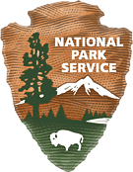
Guilford Courthouse
National Park Service
U.S. Department of the Interior

Guilford Courthouse
National Military Park
A History of Guilford Courthouse National Military Park

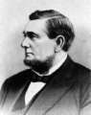
The creation of the battlefield park was largely due to the vision, the energy, and the devotion of David Schenck (1835-1902). A lawyer by profession and a Superior Court Judge, Schenck moved with his family to Greensboro from Lincoln County in the early 1880s to accept the position of General Counselor for the Richmond and Danville Rail Road Company, a position he described as being “ideal”, for it provided him a handsome salary and most pleasing to him, periods of free time. Taking advantage of the latter advantage, Schenck wasted few opportunities to drive his horse and buggy the five miles north of the city for the sole purpose of studying the battlefield over which the armies of Greene and Cornwallis clashed on March 15, 1781. On one of these visits in October 1886 Schenck recorded in his diary that he had decided to purchase the site of the battle, as he wrote, in order “…to redeem the battlefield from oblivion.” It was late in the day before he returned home, but such an irresistible urge to carry out his plan spurred him to immediate action, and before the twilight had faded, he had bargained to purchase thirty acres of land.
In a few days following his initial purchase, Schenck succeeded in imparting some of his enthusiasm for the preservation of the battlefield to a group of his closest friends, and together they determined to place the bold enterprise on a firm basis. This group incorporated under the name of the Guilford Battle Ground Company and petitioned the North Carolina State Legislature for a charter. An act of incorporation was passed by the legislature and ratified on March 7, 1887 with the sated purpose that the corporation would exist “for the benevolent purpose of preserving and adorning the grounds on and over which the battle of Guilford Court House was fought” and th “erection thereon of monuments, tombstones, or other memorials to commemorate the heroic deeds
David Schenck
1835-1902
Known as “Judge” Schenck for his years on the legal bench, he conceived the idea to preserve the Guilford Courthouse battlefield in 1887. He then created the Guilford Battle
Ground Company and served as its President for the next 15 years.
of the American patriots who participated in this battle for liberty and independence.” These actions by David Schenck and the members of the Guilford Battle Ground Compnay (GBGC) marked one of the earliest steps in the United States to preserve a battlefield of the American Revolution.
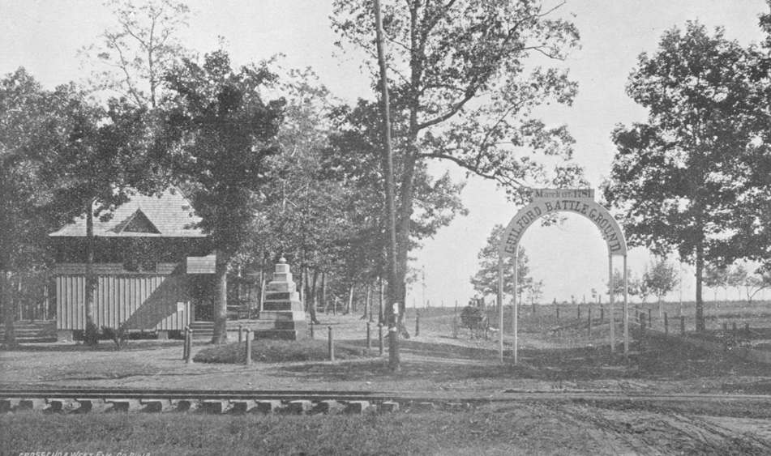
In May 1887, the stockholders enumerated in the charter held their first meeting, organized the structure of the company and elected David Schenck to the presidency, a position he held until his death in 1902. The GBGC then set out to work vigorously to carry out the purposes for which it had been formed. Shares of stock were sold at $25 a share and, as money began to come in from sales, it was used to purchase more land to add to the thirty acres owned by Schenck. At the outset, it seems to have been an accepted indication of good citizenship in the Greensboro community to own one or more shared of GBGC stock and, in 1893, stock was owned by one hundred individuals and corporations around the state. As it obtained land, the GBGC proceeded to develop the battlefield to their intentions. The “wilderness of briars and brambles” described by Schenck in his diary entries began to be cleared and the first monuments were erected (the first was to local soldier Captain Arthur Forbis in 1887). During the thirty years of the GBGC’s existence, between twenty and thirty monuments were erected and dedicated. Some were placed by the GBGC itself, some by individuals or families, and others by governmental units, including the United Sates and the State of North Carolina. One of these was the erection on the gounds of the monument to General Nathanael Greene by the US Governments in 1915. The GBGC also opened a small museum and acquired for display to the public a number of 18th and 19th century artifacts found on the field and by donation and purchase from individuals and government agancies. This collection could be viewed by the public for the price of five cents admission the the “Battle Ground Museum”, a handsome structure built near the center of the the “battle ground”, a name still used locally to designate the park. The GBGC also constructed several spring houses in the park for the refreshment of visitors and dammed up a spring fed creek to create Lake Wilfong in the middle of the park. During their thirty years, the GBGC would obtain about 150 acres of the battlefield including the tradition site of the courthouse building that gave its name to the battle in 1781.
“Guilford Battle Ground”, a photograph taken ca. 1893, showing the Battle Monument (left, center) and Schenck’s Battle Ground Museum. The open ridge to the right would become the site for the Greene Monument erected in 1915.
In addition to its program for the development of the battlefield, the Guilford Battle Ground Company desired to make ite property a historic shrine to the North Carolina patriots of the Revolutionary War struggle. To this end they wished the site to be a repository for the remains of patriotic and distinguished individuals important in the state’s part in the war. The remains of six persons were secured and re-interred on the battlefield. Among these were William Hooper and John Penn, two of North Carolina’s three signers of the Declaration of Independence; Joseph Winston, a North Carolina militia officer and senator; and Jesse Franklin, a North Carolina soldier and governor.

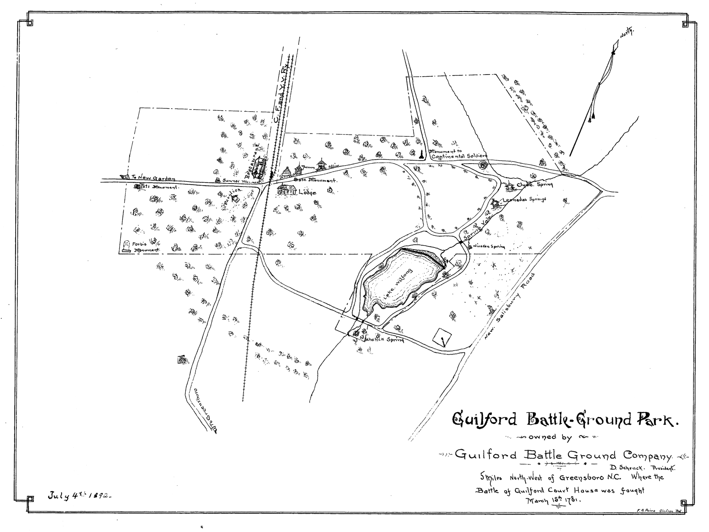
Under the auspices of the GBGC, annual patriotic celebrations wre held on the grounds, and on these occasions, usually the Fourth of July, th epeople of the surrounding country gathered almost en masse to picnic, hear famous speakers or witness the unveiling and dedication of a new monument. People traveled to the grounds by horse, or later by automobile, on foot, or by train excursion on the Old Cape Fear and Yadkin Valley Rail Road that ran through the park (the line later was absorbed by Southern Railway who abandoned it in the 1980s). To take care of the numbers arriving by train a platform station was constructed along the tracks within site of the museum. A large open air pavilion was also constructed west of the railroad tracks to shelter from the hot summer sun the hundreds of local citizens who had gathered for the huge picnic and speeches that became so much a part of the festivities.
“Guilford Battle-Ground Park”, a map drawn in 1892 showing the battlefield property owned by the Guilford Battle-ground Company. Despite their stated purpose to restore the battlefield to its 1781 appearance, five years into its preservation the GBGC had purchased less than 150 acres and had built roads, a ball field, constructed three spring houses, cottages, and dammed up a creek to from Lake Wilfong.
An effort to have its property recognized as of national significance and to have it delcard a national preserve was inaugurated by the Guilford Battle Ground Company in 1910. Several bills to effect the transfer of the property to the Federal government were introduced in Congress by local representatives, but it was not until March 2, 1917, that the legislation creating the Guilford Courthouse National Military Park was enacted making it the first battlefield of the American Revolution so preserved by the Federal Government. Promptly after the passage of the act, the GBGC deeded its land haolding (125 acres) to the United States, wound up its affairs, and went out of existence.
From 1917 to 1933 to park was under the administration of the United States War Department. Battlefield commissioners, appointed by the Secretary of War, handled the day to day operations of the park, the planting of decorative shrubbery and trees, and the mowing of well-kept lawns. The War Department commissioners also continued to tradition of erecting and dedicating monuments on the battlefield. However, the “beautification” projects of the commissioners were not always seem as signs of preservation of the battlefield. Trees and decorative plantings were placed where such flora did not grow in 1781. One of the commissioners had several of the monuments’ statued painted black an dgold, an attempt to help improve their aging appearance, but a practice not looked on favorably by government officials in Washington or by many visitors. Descrriptions of the park in the 1920s reveal scenes more in keeping with a manicured city cemetery than a nationally important battlefield of the American Revolution.
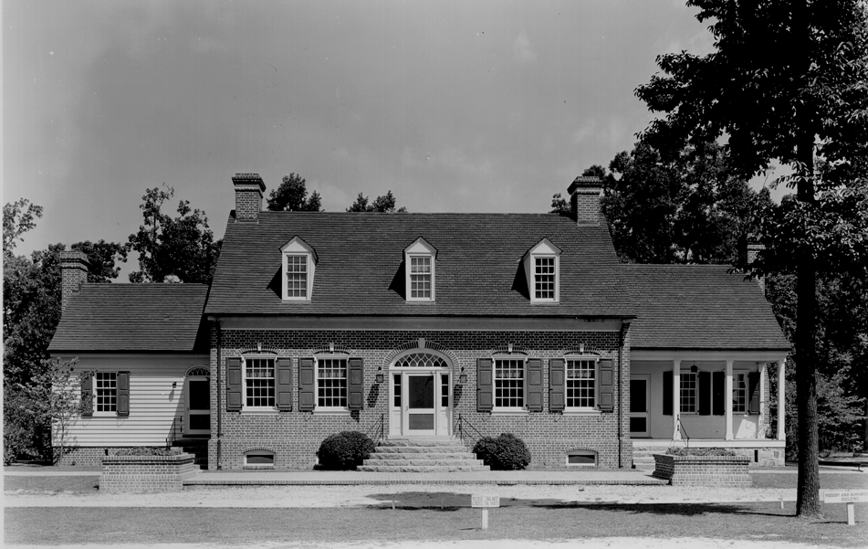
In 1933, by an act of Congress, all battlefields under the care of the War Department, including Guilford Courthouse National Military Park, were transferred to the US Department of the Interior to be administered by the National Park Service. After the transfer the park underwent changes to restore the battlefield to it proper historic setting instead of the landscape maintained during the commisssioner period. Lake Wilfong, dating from the earlier GBGC period, was drained and many old buildings were torn down. To gather information on the battlefield and its history, several research historians were hired. As a result many changes were made to begin the process of bringing the grounds back to the open woodland over which the American and British forces fought. On a very hot July 4, 1931, the park was the site of a large re-enactment of the battle staged by paper-costumed North Carolina National Guardsmen who fough each other as patriot and redcoat. In 1937, along with developmental changes to provide the park visitor with information about the battle, a new visitor center and trails were built and new interpretive markers were placed on the battlefield. To update the park to the age of the automobile, new roads were constructed. Out of consequence, these new roads necessitated the removal of two large stone arches to Gernerals Davidson and Nash (these were never re-erected). Unfortunately for the park’s improvement and expansion efforts, World War II began, preventing the continuance of planned projects and large land acquisition for two decades.
One of the many improvements by the National Park Service in 1937 was the construction of a new museum and park headquarters. This building remained the park’s visitor center until 1975 when the present center replaced it. It was razed in October 1975. This structure confused many visitors who thought this was the “old court house”.
One non-NPS improvement during this period that greatly benefited the park over the years was the construction of the US220 bypass in the late 1940s. This removed from the park a major national route that has and continues to expand and improve. After 1950 the park began developmental projects which attempted to improve the park for the grwoing number of

visitors freed by the retraints of the war years. Several new items were obtained for the museum, including a Revolutionary War era drum. Only two small parcels of property were purchased. A new history handbook of the park and battle was prepared for sale. Observances of the battle were marked by special programs and the Fourth of July remained a day to visit the “battleground”, although no new monuments had been erected since 1932. Despite all these changes the landscape of the park was still not the historical scene of the 1780s.
In the late 1960s the park seized upon an opportunity to increase in size. Over eighty acres of battlefield land was purchased or exchanged with the City of Greensboro. The third line field, allowed to grow up with trees and underbrush during the past two decades was cleared. A lake on the creek near the courthouse site was never refilled once it broke its dam in 1964. As more visitors began to come to the park, especially after hours, the park was compelled to install security gates. To assist the small staff with the questions of history and to develop interpretive programs, a park historian position was created and several seasonal interpreters were hired.
Plans for the Bicentennial of the American Revolution in 1975 were the focus of the 1970s. An increase in funding and staff enabled the park to provide new programs for the growing number of visitors. In 1975 a new visitor center with new trails and exhibits were dedicated just in time for the national two hundredth anniversary celebrations. The Bicentennial served to heighten interest in the American Revolution with a resultant rise in park visitation.
In 1981 the park’s contribution to the ongoing national celebration was the observance of the bicentennial of the battle of Gyilford Courthouse in March. Over 15,000 spectators witnessed a grand creation of the battle staged by 1400 “troops” dressed in period uniforms. Unable to accommodate these numbers, the park and an organization of local citizens arranged to “fight the battle” on property owned by Jefferson-Pilot Insurance Compnay, two miles from the park. After this big event, the history of the battle was the focus of numerous park constumed interpretive programs.
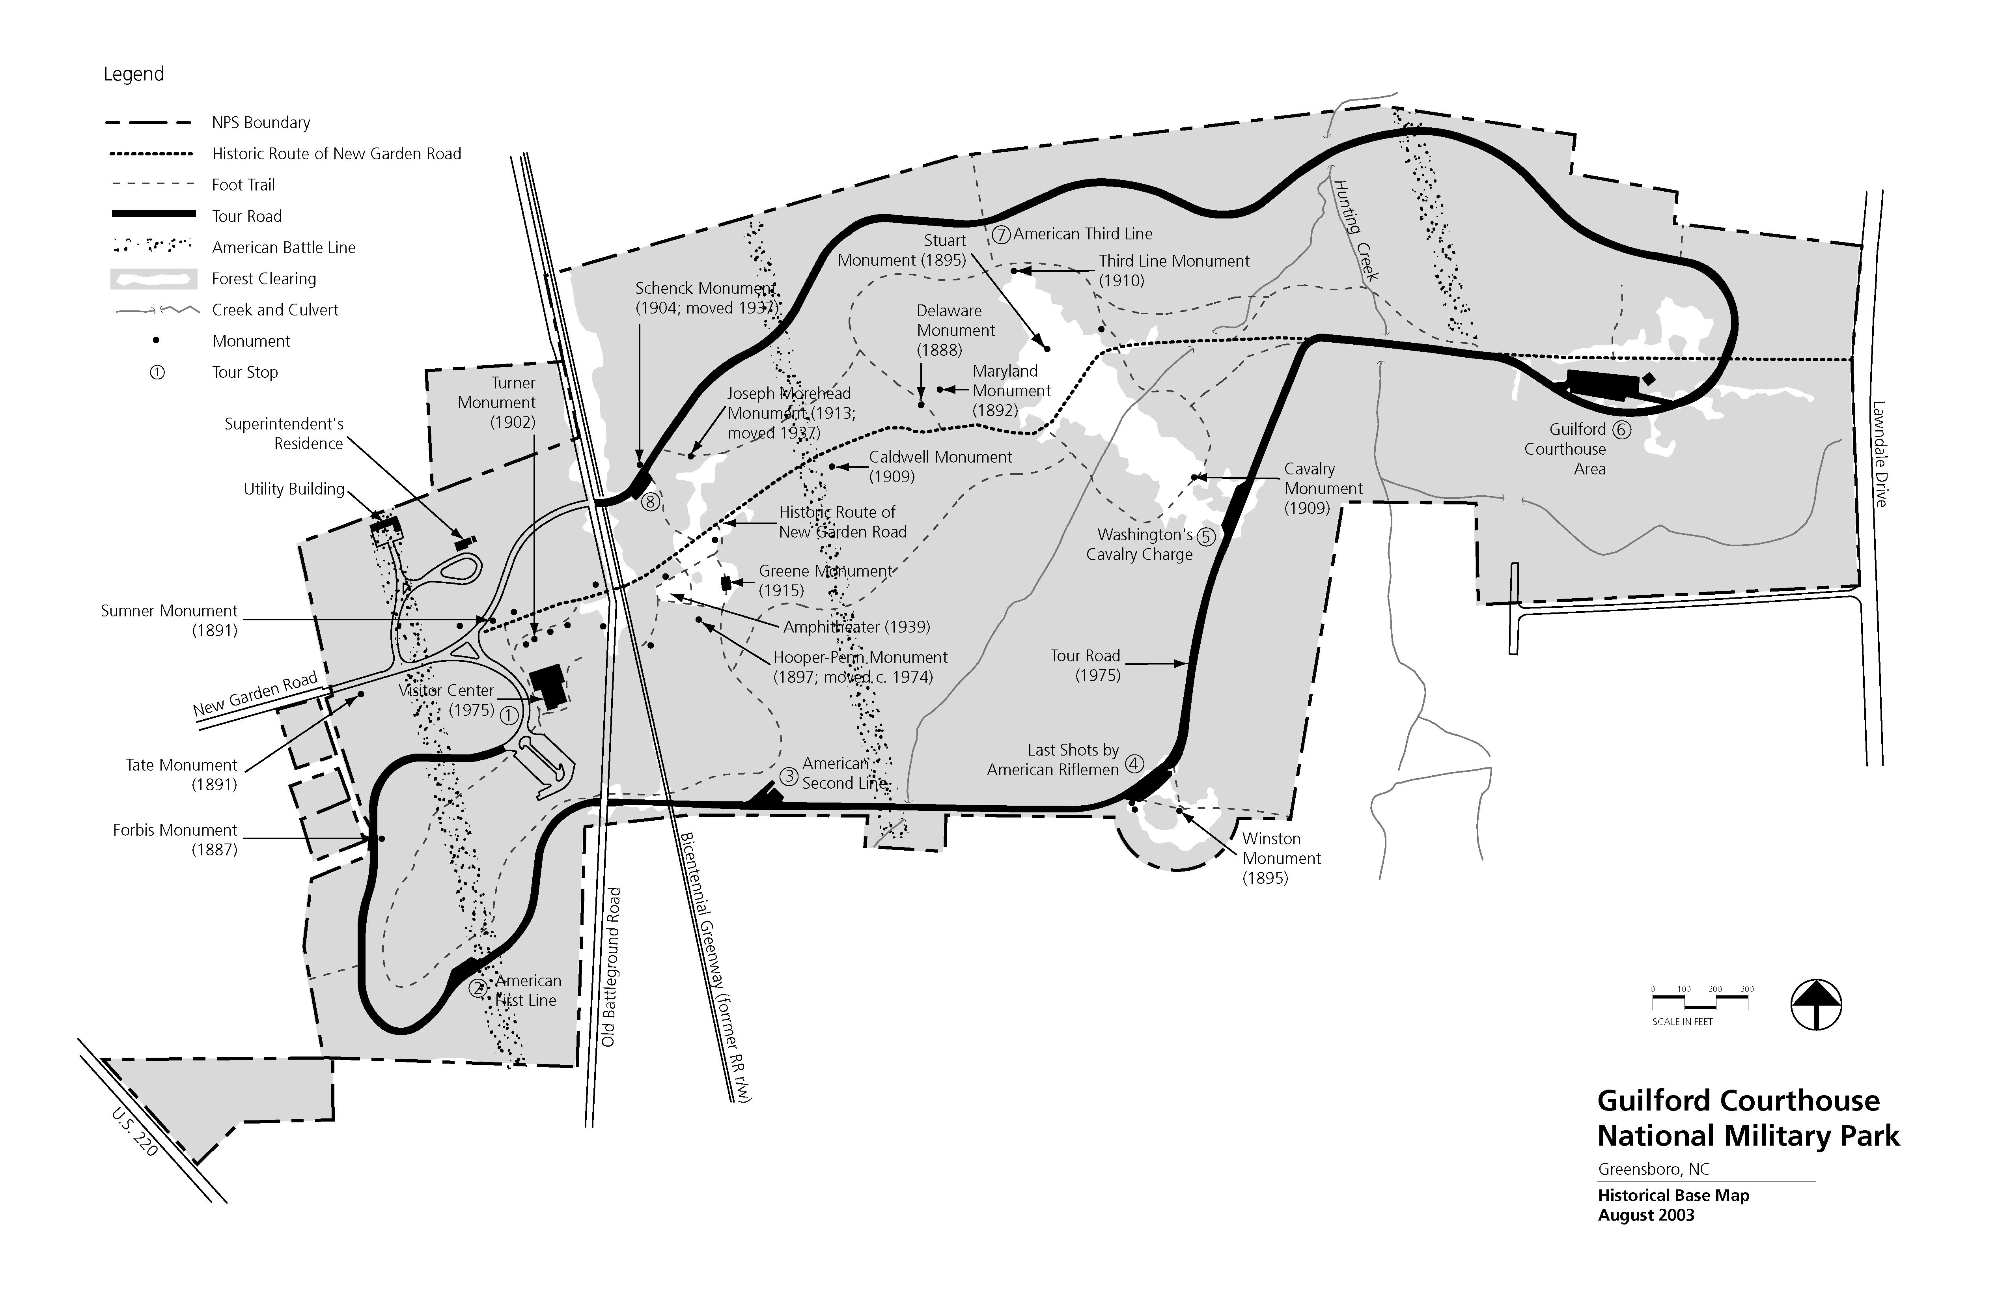
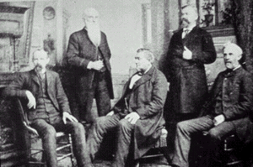
Since the 1960s the park has had to face a major threat – surrounding development and its consequences. From the park’s beginning in the 1880s the battlefield setting had been primarily rural, but in less than a hundred years that setting had changed to a suburban one. By the time the City of Greensboro annexed the land around the park in 1987, new housing and business construction was already flourishing. Re-zoning brought businesses and shopping centers to the land historic to the battlefield. This growth brought more traffic, more park use, and a subsequent widening of nearby roads and streets. Park use increased as the park became a beckoning green oasis for hundreds of new neighbors living in houses and apartments built right up to its boundaries. By the year 2000 the park had changed little in size over twenty years. Modern historical research proves that the battlefield is five times larger than the 220+ acres of the park. Beginning that year, new parcels of land were added to the park and these and undisturbed surrounding properties in private and city-held hands were all designated a National Historic Landmark. In 2001 a major historical change to the battlefield and its interpretation was the correction of an error made by the park’s founders in 1887. Long recognized by National Park Service and academic historians that the 1887 third line was too far west, the park corrected this error by moving the marking and interpretation of that position 450 yards to the east matching both topographical features of a British officer’s map drwan on the field and various period accounts.
Guilford Courthouse National Military Park Historical Base Map 2003, showing the relocated American third line. The moving of the location and interpretation of this line farther to the east in 2001 constitutes a major important historical improvement to the battlefield and its interpretation.
The challenge for Guilford Courthouse National Military Park in the new century is to continue the legacy of the park founders who dreamed of the preservation and restoration of the March 15, 1781 battlefield and making its historical significance secure; and of the Congress that in 1917 created a national historical treasure to be saved for future generations. To partner in that effort is a new park friends group, a revitalized Guilford Battlegournd Company, named after the original organization that was created in 1887 to “redeem the battlefield from oblivion.”

“The Visionaries”: Directors of Guilford Battle Ground Company, ca 1887.
(GBGC President David Schenck seated at center)

EXPERIENCE YOUR AMERICA
EXPERIENCE YOUR AMERICA

