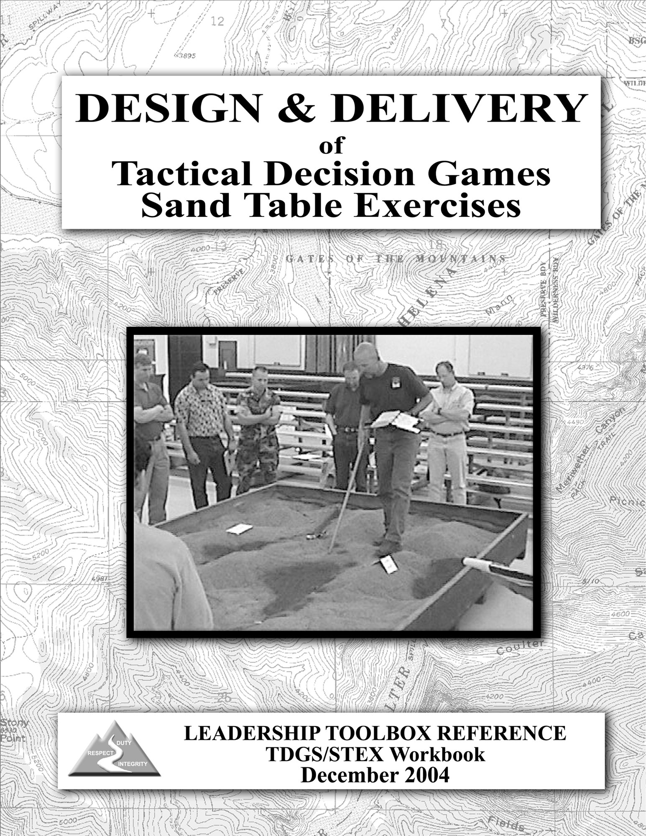

Preface

The intent of this workbook is to assist facilitators in the design and delivery of Tactical Decision Games (TDGS) and Sand Table Exercises (STEX). The first part of this workbook focuses on the design of specific exercises, while the second part focuses on delivery techniques that will enhance the success and effectiveness of the exercises. TDGS/STEX properly designed and delivered, will allow firefighters on your unit to practice situational assessment, to consider and select courses of action, and to practice communicating those decisions.

This is a product of an ongoing training and information exchange between the National Interagency Fire Center and the U.S. Marine Corps University. The Leadership Committee of the NWCG Training Working Team sponsored this project. Project team members were:

Scott Anderson Bureau of Land Management – NIFC
Rich Caballero Bureau of Land Management – NIFC
Jim Cook U.S. Forest Service – NIFC
Brian Eldredge Bureau of Land Management – NIFC
Mike Ellsworth Bureau of Land Management – Boise District
Chad Fisher National Park Service – NIFC
Curtis Heaton U.S. Fish and Wildlife Service
Mark Koontz National Park Service – NIFC
Ted Mason Bureau of Land Management – NIFC
Dennis Pratt U.S. Forest Service - Sawtooth National Forest
Larry Sutton Bureau of Land Management – NIFC
Greg Vergari U.S. Forest Service – Payette National Forest

Based on “The How To of Tactical Decision Games” by Major John F. Schmitt, United States Marine Corps, 1994. Marine Corps University publications.

Contents

Introduction 3

Part I – Design

Designing Tactical Decision Games 6

How TDGS Work 6

How to Design a TDGS 9

TDGS Standard Format 11

Part II - Delivery

Delivering Tactical Decision Games 13

The Facilitator Role 13

Facilitation Techniques 16

Appendix A

Example TDGS/STEX #1 19

Example TDGS/STEX #2 23

Example TDGS/STEX #3 27

Example TDGS/STEX #4 31

Example TDGS/STEX #5 35

Appendix B – TDGS/STEX Facilitator Guide 39

Appendix C – STEX Props & Accessories 41

Appendix D – Sand Table Example 42

Introduction: Why Play When There's Work To Do?

Time: July 10, 1530 hours
Place: West facing, brush and grass covered slope in the foothill country near Prescott, Arizona.
Weather: Temperature 92º; Winds are up-slope 5 to 8 mph; Sky is mostly clear with some developing cumulus clouds.
Situation: You are the leader of a six-person squad tasked with patrolling and holding a lined section of a 150 acre wildland fire that started three hours ago. Your Crew Boss has expressed confidence in your ability to hold that section. Squad members are hot and tired but remain enthusiastic after two hours of initial attack hotline activity. The Squad has reassembled after containing spot fires generated by embers from reburn activity within the original containment line. You observe continued reburn activity. Your lookout reports two and possibly three new spot fires 100' and 150' directly down slope from your position.

What is your selected course of action? Make a decision within the next 10 seconds.

Did you make the call? Did you want more information? Did you look for the right answers in the following paragraphs? Did you dismiss this as just another paper fire that isn't the real thing because you've seen the real thing and you know what to do here?

Analytical Decision-making

Most of us are familiar and comfortable with the concept of making a well-reasoned decision based on carefully gathered facts balanced with assigned values and weighed against expected outcomes. We gain certainty that through methodical analysis we have arrived at the best possible decision. This analytical decision-making model should work well if the facts are not variable, the decision-making environment is held constant, there are no time constraints, and human factors are limited to our personal values. The essential factors in analytical decision-making are careful analysis and reasoning power. If only you could get everyone to be quiet and you could get away for a while to make that 10 second decision.

Intuitive Decision-making

If you were able to make a 10 second decision in the scenario presented above, chances are you exercised your experience gained on the fireline and the skill of intuitive decision-making. The essential factor in intuitive decision-making is experience. That experience allows recognition of similarities to previous situations. A pattern of typical cause and effect develops to allow a decision that does not require analysis or reason. The more experience gained in applying a variety of patterns, the more likely you'll know what to do.

Tactical Decision Games

There is no substitute for experience of the real thing, but it can be hard to come by and tragically unforgiving. Fortunately there exists a supplement to the school of hard knocks. Pattern recognition skills can be improved, and tactical decision-making can be practiced and refined. Tactical decision games (TDGS) are basically role-playing paper exercises and in the case of sand table exercises (see below) can incorporate three dimensional terrain models. The reason for doing TDGS is to provide firefighters with an opportunity to 1) practice the decision-making process, and 2) practice communicating that decision to others. TDGS provide a simple, adaptable, and effective method of repeatedly challenging a firefighter with tactical situations that include limitations of time and information. By requiring a solution to the situation and the ability to communicate it in the form of clear instructions, the firefighter will gain precious experience and skill in actual tactical decision-making.

Recent course development for wildland firefighter training has included: Lessons Learned: Fatality Fire Case Studies, Human Factors on the Fireline, Followership to Leadership, and Fireline Leadership. These courses have appropriately focused attention on the variable that traditional fire suppression courses have overlooked and the one variable that will always determine the outcomes of fire suppression activity; human factors and the decisions they influence. TDGS are a logical step in blending the skills and tactics taught in conventional wildland fire courses and lessons learned from the newest body of human factors coursework.

Because the purpose of a TDGS is to build breadth of experience in decision-making and communication, it is important to employ this process frequently at the crew level. In addition to developing individual decision-making skills, the practice will allow crewmembers to learn from each other and to gain an understanding of how each crewmember makes decisions. Each game played, like every fire experienced, will add to the collective reservoir of experience in the wildland fire community.

The Sand Table Exercise

The Sand Table Exercise (STEX) is a tactical decision game that employs a three-dimensional terrain model with various props to represent either assets or liabilities. Advantages of the STEX over the two-dimensional maps other exercises employ include: enabling the learners to "experience" the terrain features of their problem; engaging learners by engineering a learning environment that fosters proximity; eye contact; free movement, and presents the learner an almost irresistible attraction to get their hands on the problem. Another benefit is the lesson of perspective that many fireline firefighters don't have the opportunity to experience or learn. The sand table impresses the importance of “top-sight", the ability to see how individual pieces of the problem fit into and affect the whole, thus preparing squad and crew level firefighters for tactical and strategic command. The sand table presents some challenge of portability but when conditions and logistics allow, it is the medium of choice for TDGS.

The sand table concept may be used as a visual aid to support other training methods such as storytelling, topographic map interpretation, and small-unit after action reviews. Sand tables also can provide a common frame of reference for planning sessions, briefings, and critiques.
PART I
Designing Tactical Decision Games

How TDGS Work

- TDGS are Simple…Keep them Simple.

- Role-Playing: The players are put in the role of a leader of a given unit, in a given situation, with given resources, and a given scenario.
- Limited Information: The players will not have as much information about the scenario as they might like. This is an important feature of TDGS; uncertainty, confusion, and complications are basic characteristics of tactical decision-making.
- Limited Time: The players will have limited time to make a decision, since this is also a feature of making tactical decisions.
- Face a Dilemma: The scenario puts the players in a situation requiring some sort of decision; a problem requiring a solution. Despite the above limitations, the players must come up with a workable solution.
- After Action Review (AAR): The players analyze or discuss their solution as a means of drawing out the lesson of the experience.

- The Primary Objectives of TDGS

- Exercise Decision-Making Skills in a Tactical Context: This is the fundamental objective!
- Practice Communicating Decisions: Players must communicate decisions by giving clear text instructions while using all the appropriate elements listed in the standard briefing checklist outlined in the Incident Response Pocket Guide (IRPG). It is recommended that the players adhere to the appropriate elements of the briefing checklist found in the IRPG.
- Provide Vicarious Experience to Develop Pattern Recognition Skills: Experience is the only way to develop the pattern recognition skills that are essential for effective decision-making. Since actual fire experience may be limited and involves certain risk, TDGS provide a safe alternative.

- Additional Benefits

In addition to the primary objectives, TDGS offer several secondary benefits:
- Illustrate Tactical Concepts: Effective use of fire suppression methods and techniques, resource capabilities, resource deployment, etc. can be explained as part of the post scenario discussion.
- Develop Implicit Understanding: By building a sense of teamwork and a shared way of thinking among members of a unit, TDGS become a way of working out informal SOPs or contingencies.

- The "Rules" of TDGS

There are only three Rules:
- Time Limit: Since fireline tactics are usually a time-compressed activity, a time limit is essential. Players should feel as though they have less time than they need to make a decision.
- Decisions as Instructions: Briefings and clear text instructions are the correct way to express tactical decisions, so TDGS solutions should take the same form. Players must communicate decisions by giving clear text instructions, and using all the appropriate elements listed in the standard briefing checklist outlined in the IRPG. It is recommended that the players adhere to the appropriate elements of the briefing checklist format in the IRPG. It is important that all the appropriate elements are mentioned. There is a difference between a briefing and tactical instructions. Tactical instructions may be given as an element of a briefing or as a supplement to a previous briefing. Players will be expected to explain their decision afterward, but the rule is “decide first, then discuss.” The objective is to encourage decisiveness and have the decision maker communicate the decision using real life communication methods
- No Textbook or Facilitator Solutions: There are a number of ways to solve any tactical problem, so there should not be any "textbook" answers. What decision a player made is less important than why they made it. In fact, since creativity is a prized trait in tacticians, unusual solutions should be encouraged and recognized.

- TDGS Formats

- Seminar: A group of players, led by a designated facilitator, using predetermined learning objectives, solve the problem (as individuals), and then discuss and compare solutions. The ideal group is anywhere from 4-12 players.
- Simulations: A more advanced version where a fire situation evolves along a timeline. Players represent various resources and must respond to changing situations. The facilitator uses their judgment to assess outcomes of individual solutions and coordination of solutions. The facilitator controls evolution with the purpose of generating new tactical challenges (inputs).

- Delivery Platforms for TDGS

- TDGS can be delivered using various platforms such as sand tables (STEX), solid terrain models, computer generated terrain animations, terrain photographs, topographical maps, and sketch maps.

- Advantages of the Seminar Format.

- Interactive: The seminar format allows the opportunity for discussions about tactical issues and concepts. Players get immediate feedback on their solutions from the facilitator and peer group.
- Sitting in the Hot Seat: Players feel the pressure of having their tactical skills on public display. Most firefighters are naturally competitive and will be motivated to perform well in a group setting.
- Learn from Others: There are a number of ways to solve any tactical problem. Players have the opportunity to see how others solved the same problem and can incorporate those lessons into their own tactical repertoire.
- Practice Giving Instructions: During TDGS, as in real-life situations, tactical decisions must be expressed in the form of clear instructions. Giving clear, concise instructions is a skill that improves with practice. The seminar provides a practice field for giving instructions.
- More Fun: The seminar, if done properly, is simply a more interesting and satisfying experience. The more interesting the experience, the better the learning.

- Limitations

TDGS are a very useful training and education tool, but they have limitations to be aware of:
- One Move: Except in the simulation version, TDGS represent a single "snapshot in time" and require the players to make only one move. Therefore TDGS do not capture the on-going interactive nature of the fireground.
- Don't Have to Execute: TDGS are a simulation of a fire environment. In reality, what matters is the execution, which is something TDGS don't require. It is important to realize that execution is one of the things that make tactics so difficult.
- Works Best at the Initial Attack/Extended Attack/Division Level: That is not to say they don’t work above or below those levels, but they are more difficult to design and facilitate. The higher the scenario complexity the more difficult it becomes to attain the learning objectives.

How to Design TDGS

You are creating exercises that may be put on the shelf for other people to facilitate. A standard format can be found at the end of this section. Example STEX/TDGS can be found at the end of this workbook.

- Determine Your Target Audience

- Should include general level for which STEX/TDGS is suitable (e.g., crew level supervisors, district duty officers, etc). It could also be ICS position-specific (e.g., Engine Boss, Division Supervisor, etc).

- Create Your Training Objective

- It is essential that TDGS are set up with specific training objectives in mind. Remember that the primary objective for TDGS is to have the players practice making decisions and then communicate their decisions in real life instructional context to subordinates. For example:

“Given the scenario below, the players will determine how the fire can be safely approached and then verbally communicate their decision to the appropriate individuals.”

- Create Your Scenario

- Design a Problem, Not a Solution
  - Start with a Problem in Mind: It is usually better to start with a problem and allow the players to create solutions than it is to start with a solution and work backward to create a scenario to support it. In the latter case, the scenario usually turns out to be obvious and contrived - almost like a leading question for which there is only one "right" answer. The problem you start with must lead players directly to the decision-making and communication training objectives you have identified for your TDGS session.
  - Create Uncertainty
    - Lack of Information: Some information is simply missing.
    - Ambiguity: Information is unclear, inconclusive, or even contradictory.
  - Create Friction: Things don’t always go as planned or expected. Challenging TDGS incorporate a healthy dose of Murphy's Law. Units get lost; communications break down; equipment fails; and/or fire behavior changes dramatically. Consider the experience level of players when designing complexities so that you don't set players up for failure.
- Introduce the Problem in the Briefing Format
  - "Here is the Mission": Provide the situational factors, i.e., weather conditions, fuel types, commander’s intent, etc. The player then comes up with a plan to accomplish the mission. This is the simpler form of TDGS.
  - "Now What?": This type of TDGS involves the above, plus more. As the player begins to execute the plan some unforeseen event occurs which changes the whole scenario. The object is to react to the new situation in a way that is consistent with the higher commander's intent or established policy. One way to create a "Now What?" TDGS is to create a "Here's the Mission" TDGS, solve it yourself, and develop some things to go wrong with the execution of the solution. These are referred to as “Murphy’s Law Suggestions”.
- Potential Sources for TDGS
  - History: Use historical fire case studies found in available training courses. Use Incident Action Plans from previous fires. Use local fire history or evidence of local fire scars as a basis for development.
  - Own Experience: Caveat. With this and the above source, don't fall into the trap that historical ending or personal solutions are the "right" solutions. Be prepared to learn as much as the players. Remember the third rule of TDGS – “No Textbook or Facilitator Solutions”
  - Random Topographic Selection: Select a piece of terrain from local surroundings or from topographical maps that represents a typical local fire suppression challenge. Apply a situation to your chosen terrain. This can be effective in familiarizing initial attack forces with local response areas, initial attack SOPs, and pre-attack planning.
  - Task Books: Select an audience specific task book and design a scenario where the decision point leads to task accomplishment.

- Review and Evaluate

- Design Evaluation into TDGS: In addition to the After Action Review (AAR) players use to analyze their decision making process and draw tactical decision-making lessons, consider an AAR of the TDGS process itself to derive lessons for designing and facilitating future games.
TDGS Standard Format

Initial Facilitator Information—NOT TO BE SHARED WITH STUDENTS

Title: Descriptive Title

Author(s):
Include names of developers along with agency/unit contact information. There is a twofold purpose for this. One is to give contact info if people have questions on the TDGS/STEX, the other is to give credit where it’s due.

Target Audience:
Should include general level for which TDGS/STEX is suitable. Does not have to be ICS position-specific, but could be. For example: Single Resource Boss & IC Type 4

Training Objective:
Needs to be stated as an objective, i.e., what do you want the exercise to accomplish. Should not just be a topic, such as “Downhill Line Construction” or “Initial Attack Size-up.” For example: Given the following scenario, players should determine requirements for posting lookouts. Players should verbally communicate their decisions to the appropriate individuals. This can be used as a drill to discuss Standard Firefighting Order #5 (“L” in LCES) and Watch Out Situation #12.

Resources Referenced:
This section would include a listing of all resources referred during the scenario. For example:
- 1 - Type 2 Handcrew (Primary Role Player)
- 1 - Hotshot Crew
- 3 - Type 3 Engines

________________________________________________________________________

SCENARIO INFORMATION TO BE SHARED WITH STUDENTS

Facilitator Briefing To Student(s):
This section is a description of the scenario with all the necessary information for the student(s) to accomplish the training objective. This should be delivered in the same format as it would be if the person was being briefed on an upcoming assignment. Use the Briefing Checklist format in the IRPG (Situation, Mission/Execution, Communications, Service/Support, Risk Management, Questions/Concerns).

Care should be taken to limit the information given to student(s), since it is rare in real life that 100% accurate information is available to decision makers when needed.

The first sentence of this briefing should tell the players what role they are in. For example: You are the Crew Boss of a Type 2 Handcrew assigned to the Horse Fire. The last sentence in the briefing to the students should cue them that a decision needs to be made. For example: You have 3 minutes to assess the situation and prepare any communication contacts you think are necessary.

________________________________________________________________________

ADDITIONAL INFORMATION FOR FACILITATOR ONLY

Facilitator “Murphy’s Law” Suggestions:
These can be used as “what ifs” at any time during the scenario to raise the stress level of the leader. For example:
- Engine 3-1 breaks down in the middle of the only access road
- The wind shifts or increases

Facilitator’s Notes:
The Facilitator’s Notes should provide the person facilitating the TDGS enough detailed information so they can effectively prepare for various decisions and actions taken by the decision maker. The Facilitator’s Notes should also prepare the facilitator to lead an After Action Review of the exercise given various exercise outcomes. The first sentence of these notes should describe the intent of focus of the TDGS. For example: This TDGS should focus on the Single Resource Boss responsibility to utilize lookouts to ensure the safety of their crew.

________________________________________________________________________

After Action Review:
Conduct an AAR with focus on the training objective. Use the AAR format found in the Incident Response Pocket Guide to facilitate the AAR. There are four basic questions in the AAR.
- What was planned?
- What actually happened?
- Why did it happen?
- What can we do next time?
Remember, TDGS shouldn’t have a single solution. Keep the focus of the AAR on what was done and why.

PART II
Delivering Tactical Decision Games

The Facilitator Role

1. The Facilitator’s Responsibilities

- Prepare for the Exercise: The facilitator must have a thorough knowledge of the scenario being presented and be prepared to address a variety of possible decisions made by the players.
- Select Delivery Platform: For example: sand table (STEX), solid terrain model, computer generated terrain animation, terrain photograph, topographical map, or sketch map.
- Orient the Players: Orient the group to the map or sand table and explain the meaning of all props. Answer questions the players may have about the Sand Table layout. The facilitator should answer questions about the Sand Table layout which the players would reasonably have knowledge of, but the facilitator should not eliminate all uncertainties. "Sorry, I don't know the answer to that" is a reasonable answer to many questions.

2. TDGS Set-up

- Describe the Scenario: Provide information on terrain, weather, fuels, fire behavior (intensity, rate, and direction of spread), and overall strategy set by the incident commander or other management guidance. Go from general to specific. It is important to model good briefing procedures. For example: if the TDGS is a squad leader level problem, describe the division situation, then the crew situation, and then the squad's situation. Put the players in the decision-makers role. Do not pre-identify who will be in the hot seat. Tell the players what resources they have available. Give the players enough information to make the necessary decisions for the given situation, but don’t make their decision for them.
- Cue the Dilemma: The last event described should be the event that puts the finishing touches on the dilemma; it needs to be the thing that makes clear that a decision must be made.

- Choose Player(s) to Present Solutions: Generally, it is better to select a player to present solutions than to ask for volunteers. Players should not feel like they can escape the challenge by simply not volunteering. They should feel like they have as much chance as anybody else does, since this adds to the stress. The facilitator should attempt to identify players who try to make excuses or actively try to avoid presenting a solution and ensure their involvement.

3. Let the Games Begin

- Enforce the “Time Limit” Rule: Time compression creates stress.
- Enforce the “Decisions as Instructions” Rule: Assign other players roles as the recipients of instructions or communications. Players must simulate giving their instructions either face-to-face or over the radio. Do not allow “I would have done this…” statements. Encourage the use of the briefing checklist format found in the IRPG as a guide when communicating their decisions and giving instructions to new incoming resources.

4. Conduct an AAR

- Question the Thought Process: One of the most important things the facilitator does is probe the player's thought process in order to get the player to explain their rationale. Useful questions include:
  - "Describe your overall assessment of the situation?"
  - "What were your assumptions about the situation?"
  - "What is your biggest concern about your plan?"
  - “What information was critical to you and why?”
  - "What would you have done if...?"

- Draw-out Lessons: Finally, the facilitator should summarize the lessons that the session has illustrated. Use the AAR format found in the IRPG to increase player familiarity with that reference.

5. The Traits of a Good Facilitator

- Enthusiastic Delivery: This is perhaps the most important trait. If the facilitator is enthusiastic about the subject, enjoys TDGS, and believes in the value of TDGS as a learning tool, their feelings will be contagious to the players.
- Prepared and Tactically Knowledgeable: In order to lead the discussion and provide a useful review, the facilitator must know the subject matter. This skill is especially important since there is no single correct “textbook” solution to these problems. The facilitator should be familiar with the particular scenario and be able to discuss it intelligently. Usually, the best way to gain that familiarity is to have designed the scenario or to have played it. The facilitator should not have a “correct” tactical answer to the problem in mind. There should, in fact, be no real right answer. By the facilitator endorsing one tactic over another, we run the risk of inadvertently giving the players a “textbook” solution to a problem. This may lead the player into thinking that given a similar situation; certain tactics are the only possible solution for that particular scenario. The facilitator needs to remember that we are not teaching tactics but rather a decision making process. The facilitator needs to reinforce the timely decision-making, not tactics, so the players will gain ownership in the process. While recognizing that there may be several right answers that could actually work on the ground, facilitators must be able to identify plans that would obviously fail or are not safe or tactically sound. Preparing discussion points for common solutions and for obviously unsound or unsafe solutions is recommended.
- Adapt to the Unexpected: Since there is no “textbook” solution to TDGS, the facilitator must be able to maintain his/her own situational awareness in order to adapt to unexpected changes. No two seminars (even using the same TDGS) will turn out remotely the same. Players will invariably come up with unexpected questions or solutions. The discussion will present unexpected opportunities to provide impromptu lessons about key tactical concepts. The facilitator must be able to adapt quickly to unforeseen circumstances resulting from player developed plans or contingencies. For example, in an initial attack scenario the player incident commander resolves the scenario by calling for retardant instead of calling for additional engines identified in the scenario briefing. The facilitator must be prepared to provide additional inputs (either constraints or additional objectives) if necessary to involve these additional resources.
- Keep It Interesting: The facilitator keeps the session interesting by keeping the discussion moving briskly, by involving as many of the players as possible, and by making relevant and useful points. Without trivializing the subject matter, it is generally a good idea to “leave them wanting more”. In other words, not to beat each point to death but to break off discussion before the saturation point. A good sign is when the players are still debating as they leave the TDGS.
- Don’t Dominate the Discussion: A good facilitator does not lecture, but has the ability to help the players recognize the lessons themselves, facilitating learning rather than trying to impart it. In general, the less talking the facilitator must do the better the session is going.
- Review Without Being Critical: Offering constructive criticism is essential. While there may be no absolute right or wrong answers, some solutions have more merit than others and the facilitator must be able to make those judgments. At the same time, the facilitator should offer reviews in ways that do not embarrass any player in front of the group. A blend of candor and tact is required.
- Manage the Group: This means the ability to get as many people involved in the discussion as possible. The facilitator should prevent individuals from dominating the discussion. This is especially important when the group consists of widely different experience levels. It is important to set a tone of open candor, regardless of seniority.
  - “Timeouts” may be essential, at times, to keep the group focused on the learning objectives. This technique should not be frequently used. The facilitator should clarify the situation and resume action as quickly as possible.
  - TDGS are time compressed scenarios. Provide frequent “time tags” to keep the clock ticking. It is a good practice to tell the players how much time you want to have elapsed after any significant movement of resources.
  - Control the movement of resources on the table. This is your training event, if you let the players start moving resources at their discretion you can easily lose the ability to achieve your training objective(s).
  - Be prepared to mitigate “ad libs” from role players that divert the game from its intended training objective. Some players get very involved in their subordinate roles and may provide unsolicited inputs.

Facilitation Techniques

1. The Art of Asking Questions

- Active Listening: It is important that a facilitator knows when to ask questions, how to ask and answer questions, and how to defer questions or bounce them off the rest of the group. In essence the facilitator must combine appropriate questions with active listening.
- Socratic Teaching Method: The Socratic method of teaching is an effective technique to consider when delivering TDGS/STEX. This method is effective because one of the most important things the facilitator does is probe the player's thought process in order to get the player to explain their rationale. The Webster’s Dictionary defines Socratic as:

Of or relating to Socrates, his followers, or his philosophical method of systematic doubt and questioning of another to elicit a clear expression of something supposed to be implicitly known by all rational beings.

- Avoid Leading Questions: This will cause the player to believe there is a “textbook” answer you are looking for. Examples of questions to avoid:
- "Wouldn’t this have been a more effective course of action?"
Suggested change: “Did you evaluate any other alternatives?”
- "Do you really think that will work?"
Suggested change: “On a scale of 1 to 10, what do you think is your probability of success? Explain?”
- “So by using air tankers, you really think you can still use direct attack on this flank?”
Suggested change: “What would you do if the airtanker drops missed the target?”
- “Don’t you think that hill is too steep for a dozer?”
Suggested change: “What information did you use in choosing a dozer for this assignment? Is there anything else you should consider before using a dozer?”
- It’s About Decision-making: Remember that TDGS are exercises in decision-making, not an academic test on choosing a predetermined “correct” tactic from a list of alternatives. Your questions should help the players focus on their decision-making thought process. They should help the players clarify what information inputs are consciously and subconsciously important to them and how that information was used in the decision-making process.

2. Teaching to the Objective

- Training Objectives: It is essential that TDGS are set-up with specific training objectives in mind. Remember that the primary objective for TDGS is to have the player’s practice making decisions and then communicating their decisions in real life instructional context to subordinates. It is the facilitator’s responsibility to ensure that the exercise and discussions do not stray away from the purpose of the training. The facilitator should refrain from lecturing and allow the participants to teach each other. Be prepared to ask thought provoking questions when the discussion slows down and to cut discussion when the point has been made and requires no additional discussion. Guide the discussion, keeping the focus on the objectives in a logical sequence. Avoid detailed examination of events not directly related to major training objectives.

- Tactical Objectives: Not to be confused with training objectives, the tactical objectives relate to the implementation of the decided course of action by the leader. The tactical objectives should be given to the subordinates by the decision maker as tactical instructions. Facilitators should understand that the players may accomplish the training objective even though their chosen tactical objectives are less than optimal.

For example, the training objective may be for the player to decide between an offensive or defensive suppression tactic on a fire given a certain scenario and communicate the decision to subordinates. The player may effectively make a decision and communicate it to his/her crew despite the fact that it is not the most effective tactic for this given scenario. In this case the facilitator may want to comment by saying, “You were very decisive and your communication of the decision was good, but could you explain what information you used in choosing your offensive tactic in this scenario? Is there anything else you considered before making your decision?”

3. Briefing & Clear Instructions

- Communication Using the Briefing Checklist: The briefing format outlined in the IRPG and clear text instructions are a good way for fireline leaders to convey their decisions to others. Although this standard format helps to organize information, the content and substance are what is important in giving clear instructions. It is recommended that players adhere to the appropriate elements of the briefing checklist found in the IRPG.

There is a difference between a briefing and a tactical instruction. A tactical instruction may be given as an element of a briefing or as a supplement to a previous briefing. Obviously, the decision maker does not need to reiterate known situational information every time a tactical instruction is given.

Appendix A

Initial Facilitator Information—NOT TO BE SHARED WITH STUDENTS

Title: EXAMPLE TDGS/STEX #1

Author(s): Design and Delivery of Tactical Decision Games & Sand Table Exercises development group

Target Audience:
Squad Boss, Single Resource Boss

Training Objective:
Given the scenario below, the players will decide how the fire can be safely approached. Players should verbally communicate their decisions to the appropriate individuals.

Resources Referenced:
- 1 Crew level supervisor (Hot seat role)
- 1 second season firefighter
- 2 first season firefighters
- 1 chainsaw, 2 backpack pumps, hand tools, 1 two-way radio

------------------------------------------------------------------------------------------------------------

SCENARIO INFORMATION TO BE SHARED WITH STUDENTS

Facilitator Briefing To Student(s):
You are the leader of an initial attack module (SELECT: Engine, IHC squad, Helitack crew, or SMJ stick) being ordered for a dry lightning storm that has ignited several fires in your response area. The module has not worked together for very long but you know they have been trained well…you did it yourself. This is the module’s first fire and everyone is excited about getting out and fighting some fire. The module consists of four firefighters—yourself, one second season firefighter, and two rookie firefighters. You are equipped with one chainsaw, two backpack pumps, a full compliment of hand tools, and a two-way radio.

The Fire Management Officer is swamped; several of the new fires appear to be growing larger. He calls you in and gives you the specific location information for the fire. His instructions are, “Keep this one small. I’ll try to get you some help if you need it, but for now you are on your own. Call dispatch with a size up and keep me posted. Hey! Let’s be careful out there.”
As you travel to the fire (SELECT: Mode of travel consistent with the module type) you note the weather and fuel conditions (DESCRIBE: Typical local conditions for mid-season and map distance scale). Also during your travel out to the fire you hear the Aerial Recon tell dispatch that your fire looks to be about ½ acre in size with some flame showing. After walking about ½ mile from your drop off point traveling south through a saddle, you and your module are finally able to see the smoke from the fire. It is below you and to your right. (DESCRIBE: How the smoke column looks.) The time is 1000. Now what? Take 2 minutes to assess the situation and prepare any communication contacts you think are necessary.

------------------------------------------------------------------------------------------------------------

ADDITIONAL INFORMATION FOR FACILITATOR ONLY

Facilitator “Murphy’s Law” Suggestions:
The “Murphy’s Law” suggestions listed below can be added as “What ifs” at any time during the scenario to raise the stress level of the leader. You can also use one of your own:
- The fuels make foot travel difficult or fuels are continuous cured grass
- Time of day is late in the burning period
- Cannot see any sign of the fire during the approach
- Wind shifts or increases
- Other crewmembers voice differing opinions
- The facilitator role plays a concerned dispatcher or FMO demanding feedback

Facilitator’s Notes:
This TDGS should focus on the functions of squad/crew level decision making and communication. In this scenario the student has been presented with mid-season fire conditions, multiple new fire starts in the area, and direction to keep this fire small. The student must weigh the unknown fire behavior and approaching a fire from above against the risk management process. The decision point comes when the student reaches the saddle and can see the smoke from the fire below the crew’s position. There is additional pressure on the student from the FMO since he/she has been told to keep the fire small and that they are on their own for now.

If the student uses the Risk Management Process found in the IRPG they will realize there are tactical watch outs involved with being above the fire but that these concerns can be mitigated using items from the Fire Orders, LCES, and the Downhill Checklist. Even if the student doesn’t use the IRPG most will understand that standing in a saddle above a fire is a precarious situation.

In this TDGS the student’s actual plan (i.e. the exact route of approach) is of less importance than the reason why he/she is taking that route. Discussion in the AAR should focus on why the student chose that route and any supporting actions such as posting a lookout and briefing the squad. Once the “why” has been confirmed the discussion can move to the “how?”

Assuming that there are several options on how to approach this fire the AAR may cover items such as:
- How comfortable were the crew members with the decided course of action?
- Did the crew members feel they had been adequately briefed on the situation and hazards of approaching the fire?

Whatever the decided course of action ask other participants how they would have approached the fire and why. At some point in during the conversation bring out the Incident Response Pocket Guide and ask the students what guidance they used, or could have used, from the IRPG.

------------------------------------------------------------------------------------------------------------

After Action Review:

Conduct an AAR with focus on the training objective. Use the AAR format found in the Incident Response Pocket Guide to facilitate the AAR. There are four basic questions in the AAR.
- What was planned?
- What actually happened?
- Why did it happen?
- What can we do next time?
Remember, TDGS shouldn’t have a single solution. Keep the focus of the AAR on what was done and why.

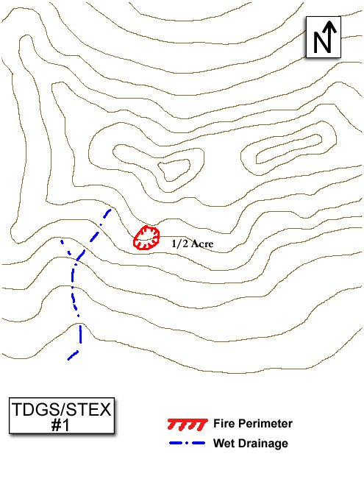

Initial Facilitator Information—NOT TO BE SHARED WITH STUDENTS

Title: EXAMPLE TDGS/STEX #2

Author(s Design and Delivery of Tactical Decision Games & Sand Table Exercises development group

Target Audience:
Task Force Leader, IC Type 4, IC Type 3

Training Objective:
Given the scenario below, the players will decide between an offensive strategy or a defensive strategy. Players should verbally communicate their decisions to the appropriate individuals.

Resources Referenced:
- 1 - Task Force Leader (Hot seat role)
- 3 - Type 3 Engines
- 1 - Water Tender
- 1 - Interagency Hotshot Crew (IHC)
- 1 - Type 2 Handcrew

------------------------------------------------------------------------------------------------------------

SCENARIO INFORMATION TO BE SHARED WITH STUDENTS

Facilitator Briefing To Student(s):
You are a Task Force Leader in charge of severity Task Force Alpha. The task force was formed yesterday and is a real mixed bag of experience. These resources have never worked together before and you think this may be a tough assignment. The task force is made up of three Type 3 Engines; one Type two Water Tender; one Hotshot Crew; and one Type 2 Handcrew.

The ordering unit has been experiencing new fire starts from lightning over the previous two days. The local FMO meets you first thing in the morning giving you travel and communication instructions and the run down on the fire situation: “My I.A. forces are shot. I had to pull my folks off the Fish Creek Fire due to fatigue. I want to turn it over to you as the Incident Commander with Task Force Alpha as your resources. We caught several of the new starts last night, but this Fish Creek Fire worries me. I’m getting concerned about those structures. I’ve ordered air tankers but who know when we’ll see them. I’ll try to get out to the fire this afternoon. Keep me informed on your progress and good luck.”
As you travel to the fire you note the weather and fuel conditions (DESCRIBE: Typical local conditions for mid-season and map distance scale). As you get near the location given to you by the FMO you see smoke at the top of a hill south of the road (DESCRIBE: How the smoke column looks). An individual alongside the road flags you down. It is the Initial Attack IC. She tells you the following: the fire is about 30 acres with a couple of small spot fires; the fire settled down real well after midnight; they got line around about 25% of the fire’s edge; the fuels in front of the fire provide good spread potential; and there is a small community north of the fire. Your task force has followed you out to the fire and they are impatiently awaiting your orders. The time 1000 hours. Now what? Take 5 minutes to assess the situation and prepare any communication contacts you think are necessary.

------------------------------------------------------------------------------------------------------------

ADDITIONAL INFORMATION FOR FACILITATOR ONLY

Facilitator “Murphy’s Law” Suggestions:
The “Murphy’s Law” suggestions listed below can be added as “What ifs” at any time during the scenario to raise the stress level of the leader. You can also use one of your own:
- An engine breaks down
- Time of day is later in the burning period
- A new fire start is discovered nearby
- Wind shifts or increases
- Two of the engine crews are very inexperienced
- The Hotshot Superintendent is adamant about burning out the road immediately

Facilitator’s Notes:
This TDGS should focus on the functions of task force/incident commander level decision making and communication. In this scenario the student has been presented with mid-season fire conditions, multiple new fire starts in the area, and a potential wildand urban interface situation. There is further pressure as the TFLD is being asked to assume the role of IC and he/she is not familiar with the local area. The new IC must decide between an offensive strategy, a defensive strategy, or some combination thereof before assigning resources.

The FMO expressed concern about the structures so there is some implied pressure for a defensive strategy with structure protection as the number one priority. If the IC follows the implied direction they will decide to use a defensive strategy and deploy resources accordingly.

However, there was no explicit direction that a defensive strategy be assumed; the FMO just expressed concern over the structures. The information from the Initial Attack IC is that 25% of the fire has been lined. Without knowing the exact composition of the IA forces the new IC may assume that he/she has more resources than the Initial Attack IC did and therefore employ an offensive strategy and continue to line the fire.

In this TDGS the student’s actual plan (i.e. assuming an offensive vs. defensive strategy) is of less importance than the reason why he/she made that choice and the direction given to their resources. Discussion in the AAR should focus on why the student chose a particular option. Once the “why” has been confirmed the discussion can move to the “how” at which point resource deployment decisions can be discussed.

During the AAR items for discussion may also include:
- Ask the new IC how he/she felt about changing roles from TFLD to IC?
- How did the FMO’s briefing influence his/her strategy decision?
- How did their unfamiliarity with the local area influence their decision?
- How well was commander’s intent communicated to the assigned resources?

Whatever the decided course of action, ask other participants how they would have approached the situation and why. This may be a good time to discuss rules of engagement or to use the IRPG to discuss Risk Management from the perspective of choosing an offensive vs. defensive strategy.

------------------------------------------------------------------------------------------------------------

After Action Review:
Conduct an AAR with focus on the training objective. Use the AAR format found in the Incident Response Pocket Guide to facilitate the AAR. There are four basic questions in the AAR.
- What was planned?
- What actually happened?
- Why did it happen?
- What can we do next time?

Remember, TDGS shouldn’t have a single solution. Keep the focus of the AAR on what was done and why.

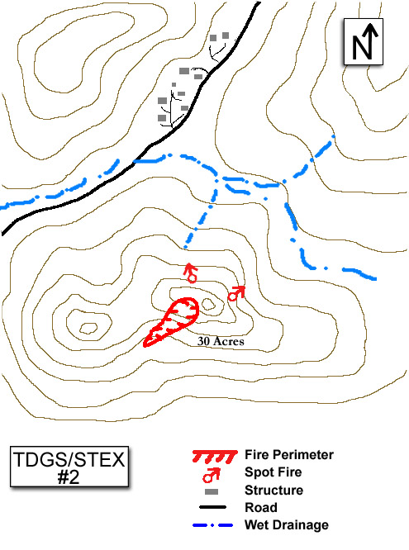
Initial Facilitator Information—NOT TO BE SHARED WITH STUDENTS

Title: EXAMPLE TDGS/STEX #3

Author(s): Design and Delivery of Tactical Decision Games & Sand Table Exercises development group

Target Audience:
Division/Group Supervisor

Training Objective:
Given the scenario below, the player will determine the appropriate level of engagement for the assigned resources. Players should verbally communicate their decisions to the appropriate individuals.

Resources Referenced:
- 1 - Division/Group Supervisor (Hot seat role)
- 1 - Strike Team Leader-Engine
- 1 - Strike Team Type 3 Engines
- 2 - Type 2 Water Tenders
- 1 - Interagency Hotshot Crew (IHC)
- 1 - Type 2 Handcrew (without chainsaws)
- 1 – Type 2 Dozer
- 1 - Safety Officer
- 1 - Field Observer
- 1 - Type 1 Helicopter

------------------------------------------------------------------------------------------------------------

SCENARIO INFORMATION TO BE SHARED WITH STUDENTS

Facilitator Briefing To Student(s):
You are a Division/Group Supervisor assigned to Division A of the Fish Creek Fire. Your Division has the following resources assigned: one Strike Team of Type 3 engine with a Strike Team Leader; two Type 2 Water Tenders; one Hotshot crew; one Type 2 Handcrew without chainsaws; one Type 2 Dozer; a Safety Officer; a Field Observer; and your division has been given top priority for a Type 1 Helicopter.

Several large fires have resulted from last week’s lightning storm. The Fish Creek Fire is one of those fires. The fire is threatening a small community and resources are stretched thin throughout the region. The Operations Section Chief picked you up for a recon flight. It was quick and Ops seemed very concerned about your division. “You’ve got to hold Division A! We’ve got some strong south winds predicted today. If we lose that road…well, I don’t think I need to say anything more. I’m really counting on you to hold that road and protect those structures and the community farther to the north. I can get you a little time with the air tankers but we have to release them to initial attack at 1200. That Type 1 helicopter is yours to use.” Ops looked you in the eye and said, “You and your folks are the only chance we have to hold this thing. I will try to get you whatever resources you need.”

As you travel to the fire in you vehicle you note the weather and fuel conditions (DESCRIBE: Typical local condition for mid-season and map distance scale.) From the transfer of command meeting you know the fire is 3000 acres. It is 10% contained with good spread potential as Red Flag conditions are forecast for that afternoon for winds exceeding 25 mph out of the south. The fire is threatening the small community just north of your division and another large and affluent community two miles north of the fire (INIDCATE LOCATION: Off table/map). You have just arrived in the vicinity of the small community just north of the fire about 10 minutes ahead of the rest of your division resources. You can see the fire edge south and upslope from your location (DESCRIBE: How the smoke column looks). As far as you can tell you are the only one around. The time 1000 hours. Now what? Take 5 minutes to assess the situation and prepare any communication contacts you think are necessary.

------------------------------------------------------------------------------------------------------------

ADDITIONAL INFORMATION FOR FACILITATOR ONLY

Facilitator “Murphy’s Law” Suggestions:
The “Murphy’s Law” suggestions listed below can be added as “What ifs” at any time during the scenario to raise the stress level of the leader. You can also use one of your own:
- You get a flat tire and cannot drive around
- The Red Flag Warning is cancelled
- The water tender operators have no PPE
- A nervous homeowner arrives

Facilitator’s Notes:
This TDGS should focus on the functions of Division/Group Supervisor level decision making and communication. In this scenario the student has been presented with mid-season fire conditions, several large fires in the area, and a wildand urban interface situation. The Operations Section Chief has also created pressure for this Division Supervisor by emphasizing that Division A must be held and that he is willing to try and send more resources if necessary. The Division Supervisor must decide if the situation is defensible and assign resources accordingly.

There is very real pressure from the Operations Section Chief to take actions to protect structures. It will be easy for the Division Supervisor to go straight into a tactical mode without gaining thorough Situation Awareness via the Risk Management Process. Remember that the first objective of this exercise is to decide if the situation is defensible. The second objective is to assign their resources. If the student immediately begins to assign resources he/she may assign someone to scout escape routes and safety zones. Other things to consider are whether structure triage is conducted, if the Type 1 helicopter and airtankers are actually ordered for use on the division. The student may choose to hold all of the ground resources in their current location while scouting is done, or he/she may order aerial resources to begin operations while a size up is completed. Different students are going to take different actions and some may choose that the situation is not defensible and move their resources to a safety zone.

In this TDGS the student’s actual decision (i.e. defensible vs. non-defensible) is of less importance than the reason why he/she made that choice and the direction given to their resources. During the AAR items for discussion may also include:
- In this scenario the Division Supervisor is a member of the overhead team assigned to the fire since he/she was at the in-briefing. How would the situation be different if the Division Supervisor was not a regular member of the team and didn’t know the Ops Section Chief personally?
- How can the DIVS relay the importance of the situation to their resources without applying the same type of pressure the Ops. Section Chief did to the Division Supervisor?
Whatever the decided course of action, ask other participants if they felt the situation was defensible and why. This may be a good time to discuss rules of engagement, wildland urban interface watch out situations, structure assessment, and structure protection.

------------------------------------------------------------------------------------------------------------

After Action Review:
Conduct an AAR with focus on the training objective. Use the AAR format found in the Incident Response Pocket Guide to facilitate the AAR. There are four basic questions in the AAR.
- What was planned?
- What actually happened?
- Why did it happen?
- What can we do next time?
Remember, TDGS shouldn’t have a single solution. Keep the focus of the AAR on what was done and why.

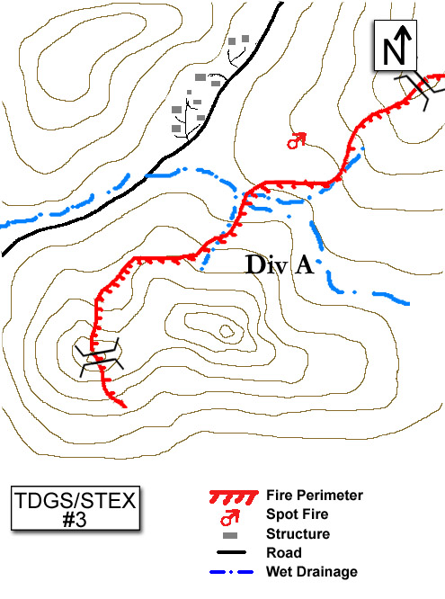
Initial Facilitator Information—NOT TO BE SHARED WITH STUDENTS

Title: EXAMPLE TDGS/STEX #4

Author(s): Design and Delivery of Tactical Decision Games & Sand Table Exercises development group

Target Audience:
IC Type 3, IC Type 4, Helicopter Boss

Training Objective:
Given the scenario below, the player will decide how they should manage the entire incident. Players should verbally communicate their decisions to the appropriate individuals.

Resources Referenced:
- 1 IC Type 3 (Hot seat role)
- 1 Agency Contract Helicopter
- 2 Helitack Firefighters
- 1 Strike Team of Type 4 Engines
- 1 Rural Fire Department Engine
- 1 Military Officer (Captain) and assorted military vehicles

------------------------------------------------------------------------------------------------------------

SCENARIO INFORMATION TO BE SHARED WITH STUDENTS

Facilitator Briefing To Student(s):
You are an IC Type 3 responding to the Round Mountain Fire. This is a new fire start in your local area. The fire is 7 miles southwest of a small town. You are enroute in an agency contract helicopter and have two other helitack firefighters on board. You fly toward the fire along a dirt road that departs the main highway near the town and leads to the southwest into the bottom of a valley below where the fire is located. The road continues on past the fire. A Strike Team of Type 4 Engines has been ordered and is on the way. Their E.T.A. is 15 minutes to the main highway turnoff. From the air you see there is a narrow bridge on the firt road between the main highway and the fire. You have questions abou the bridge’s load limit and its ability to support fire engines loaded with water.

As you approach the fire you see there is a wide valley bottom with ample safe places to land the helicopter. Being a local firefighter you are aware of the weather and fuel conditions (DESCRIBE: Typical local conditions for mid-season and map distance scale). In your recon over the fire you estimate the size to be about 10 acres. You can see an active flame front on about half of th fire perimeter (DESCRIBE: How the smoke column looks and/or the observed fire behavior). You see there is a Rural Fire Department engine company on scente; two of the individuals from the engine company are wearing short pants and no boots. They are fighting the fire. You also notice what appear to be soldiers attempting to put out the fire. Various military vehicles are parked near the fire. You are circling over the fire and have no radio communication with anyone currently on the fire. The time 1000 hours. Now what? Take 5 minutes to assess the situation and prepare any communication contacts you think are necessary.

------------------------------------------------------------------------------------------------------------

ADDITIONAL INFORMATION FOR FACILITATOR ONLY

Facilitator “Murphy’s Law” Suggestions:
The “Murphy’s Law” suggestions listed below can be added as “What ifs” at any time during the scenario to raise the stress level of the leader. You can also use one of your own:
- You are advised by the locals that the bridge can barely support a pickup truck
- Time of day is later in the burning period
- An ambulance appears on scene with lights and sire running
- There are no air tankers available
- A squad of soldiers is working directly upslope of an active spot fire
- A civilian vehicle is seen driving rapidly away for the fire area

Facilitator’s Notes:
This TDGS should focus IC Type 3 level decision making and communication. In this scenario the student has been presented with mid-season fire conditions, non-agency personnel taking suppression action on the fire, and an inability to communicate with those resources. The agency IC is faced with the dilemma of managing an entire incident vs. taking suppression action on the fire.

The IC may utilize the helicopter, the helitack crewmembers, and himself to join in the suppression efforts. This would be consistent with most firefighter’s propensity toward tactical involvement.

If the IC decides to manage the entire incident he/she has to establish contact with the Rural Fire Department and the military personnel. He/she will face a challenge with communications as the three entities have separate communications equipment. The use of non agency personnel, PPE requirements, and qualifications are all issue the IC will have to deal with.

In this TDGS the student’s actual decision (i.e. take suppression action vs. manage the entire incident) is of less importance than the reason why he/she made that choice and how he/she communicated that decision. Discussion in the AAR should focus on why the student chose a particular option. Once the “why” has been confirmed the discussion can move to the “how” of communicating the developing the situation.

During the AAR items for discussion may also include:
- Establishing yourself as the IC and appropriate notifications
- Establishing unified command and the appropriate notifications
- What is meant by “Bias for action”

Whatever the decided course of action, ask other participants if their priority would have been suppressing the fire or managing the incident and why. This may be a good time to discuss local unit relationships with cooperators, non-agency personnel, non-agency personal protective equipment use, or other local issues.

------------------------------------------------------------------------------------------------------------

After Action Review:
Conduct an AAR with focus on the training objective. Use the AAR format found in the Incident Response Pocket Guide to facilitate the AAR. There are four basic questions in the AAR.
- What was planned?
- What actually happened?
- Why did it happen?
- What can we do next time?

Remember, TDGS shouldn’t have a single solution. Keep the focus of the AAR on what was done and why.

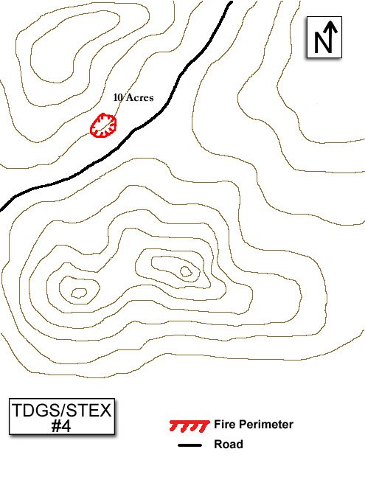
Initial Facilitator Information—NOT TO BE SHARED WITH STUDENTS

Title: EXAMPLE TDGS/STEX #5

Author(s): Design and Delivery of Tactical Decision Games Sand Table Exercises development group.

Target Audience: Strike Team Leader, Task Force Leader

Training Objective:
Given the scenario below, the player will decide how to handle a downhill line construction assignment. Players should verbally communicate their decisions to the appropriate individuals.

Resources Referenced:
- 1 Strike Team Leader-Crew (Hot seat role)
- 2 Interagency Hotshot Crews
- 2 Dozers

------------------------------------------------------------------------------------------------------------

SCENARIO INFORMATION TO BE SHARED WITH STUDENTS

Facilitator Briefing To Student(s):
You are the Strike Team Leader for two Type 1 Handcrews, made up of two crews that frequently work together and you are the Crew Superintendent of one of the crews. You have been dispatched to the Peak Fire. When your Strike Team arrived at the ICP you were sent directly out to the Fireline with instructions to report to Division A at Drop Point 3. The fire escaped initial attack yesterday afternoon and this sis the first operational period on the incident for both your Strike Team and the Incident Management Team that has taken over the fire. When you link up with the Division A Supervisor, you find out that the fire is about 1500 acres and broken into four divisions. At this time you also get a briefing on the weather and fuel conditions (DESCRIBE: typical local conditions for mid-season and map distance scale). Your instructions from Division A are as follows: “Division A is the priority on the fire. By holding this side of the fire we think we can keep it out of some country where it would become very difficult to catch it. I need you to drive your crews up to the top of the Division, tie into the end of the completed dozer line on the ridge top, and start punching handline down the ridge from the radio tower site. Only handcrews can work that upper section below the main ridge. There are two dozers due here anytime now at Drop Point 3. When they arrive I will have them start working up from the bottom since its good dozer ground there. There is plenty of parking at the radio tower site and it should be a good safety zone. I’d like to have this line tied together by the end of the shift; I think the fire will allow us that much time. Give me a call when you start in on your line construction.”

As you drive up toward the radio tower site you see the fire has laid down (DESCRIBE: How the smoke column looks). Arriving at the radio tower site, you get the vehicles parked and size up the area as a safety zone. You walk over and locate the ridge and looking down you are unable to see any fire activity, but visibility is obscured by lots of drift smoke. The time is 1000 hours. Now what? Take 5 minutes to assess the situation and prepare any communication contacts you think are necessary.

------------------------------------------------------------------------------------------------------------

ADDITIONAL INFORMATION FOR FACILITATOR ONLY

Facilitator “Murphy’s Law” Suggestions:
The “Murphy’s Law” suggestions listed below can be added as “What ifs” at any time during the scenario to raise the stress level of the leader. You can also use one of your own:
- The parking area is small and marginal for a safety zone
- The fire approaches Division A faster than expected
- The dozers never arrive on Division A
- Technicians for one of the radio stations are on-site and very anxious about the fire
- Loss of radio communication with the Division A supervisor

Facilitator’s Notes:
This TDGS should focus on Strike Team Leader/Task Force Leader level decision making and communication. In this scenario the student has been presented with mid-season fire conditions and a downhill line construction assignment on the highest priority division of the incident. The Strike Team Leader must decide how to handle the downhill line construction and deploy his/her resources.

The Strike Team Leader has the advantage that they are working with their own crew and a crew that they are familiar with from past assignments. Therefore they know what they can and cannot expect from the crew leadership and in terms of line production.

If the Strike Team Leader chooses to scout the proposed line themselves he/she may choose to take the crew superintendents with them.

They may request to begin line construction from the bottom of the ridge and work to the top or split their crews and have line production from both directions.

In this TDGS the student’s actual decision (i.e. accepting the downhill line construction assignment vs. offering alternatives) is of less importance than the reason why he/she made that choice and the direction given to their resources. Discussion in the AAR should focus on why the student chose a particular option. Once the “why” has been confirmed the discussion can move to the “how” at which point resource deployment decisions can be discussed.

During the AAR items for discussion may also include:
- What qualities should a lookout possess?
- Did the student reference the IRPG? What sections?

Whatever the decided course of action, ask other participants for their perspective. This may be a good time to discuss the importance of an anchor point, potential fire behavior, how to offer alternatives to an assignment when the initial one seems questionable, or how to properly refuse risk.

------------------------------------------------------------------------------------------------------------

After Action Review:
Conduct an AAR with focus on the training objective. Use the AAR format found in the Incident Response Pocket Guide to facilitate the AAR. There are four basic questions in the AAR.
- What was planned?
- What actually happened?
- Why did it happen?
- What can we do next time?

Remember, TDGS shouldn’t have a single solution. Keep the focus of the AAR on what was done and why.

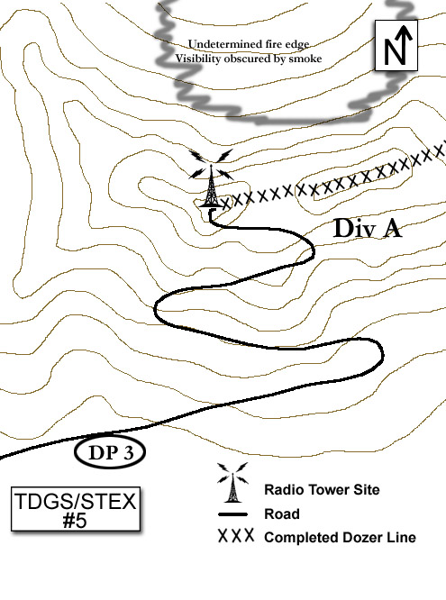
Appendix B

TDGS/STEX Facilitator Guide
(Print and laminate this guide)
Prior to Exercise
- Prepare the sand table with desired terrain features, oriented to actual compass points. Designate directions and the scale of the table width and length.
- Provide sufficient props to represent the scenario and allow players to demonstrate solutions through resource movement.
- On a white board or flipchart, provide fire information that can not be observed in a classroom, i.e., RH, wind speed and direction, temperature, date and time.
- Ensure players have note taking materials and the Incident Response Pocket Guide.
- Orient the players to the sand table.
- Define "Rules" of the game.
- Time limit
- Decisions issued as clear instructions (briefings, radio communication, etc)
- No "textbook" solution

During Exercise
- Introduce the scenario. Avoid reading, issue as a briefing. Maintain eye contact with players.
- Anticipate and answer reasonable additional questions, but do not prolong scenario briefing.
- Signal start of time limit.
- Are you still answering questions or "coaching"? Stop it!
- Signal time is up.
- Select a player to provide a solution, do not rely on volunteers.
- Direct selected player to issue decision as instructions to other players assigned to "subordinate roles”. Consider using stick-on labels with assigned roles.
- Is the decision being delivered as instructions? No theoretical "would have", "should have", or "could have" discussions allowed!
- Remember to provide time tags frequently, use time-outs when necessary, and to control the movement of resources on the table.
- Select players for additional solutions, repeat process.
- Recognize when the learning objective(s) has been met and end the game.

After Action Review
- Question the players thought process:
  - Describe your overall assessment of the situation?
  - What were your assumptions about the situation?
  - What is your biggest concern about your plan?
  - What information was critical to you and why?
  - What would you have done if...?

- Are you dominating the discussion? Stop it!
- Are you managing the entire group? Make sure all players are engaged!
- Draw out lessons. Summarize and accentuate them. Facilitate and moderate constructive criticism and encourage debate.
- Resist offering “Your Solution” unless that is the best avenue for a positive lesson. Your influence could wrongly infer there is only one right answer and inhibit independent solutions.

Post Exercise
- Review the intent of TDGS and STEX:
- Exercise decision-making skills in a tactical context.
- Practice communicating decisions.
- Provide experience to develop pattern recognition skills.
- Illustrate tactical concepts.
- Develop implicit understanding within the group.
- Reinforce lessons learned by offering an historical account of a similar scenario.
- Encourage evaluation of your performance as facilitator.
- Solicit suggestions for future STEX.
- Encourage continued debate and re-play. Make the sand table accessible for free-play.
Appendix C

STEX Props & Accessories

A number of props and accessories may be used for Sand Table Exercises. The possibilities are unlimited. The short list provided below will get you started:

- Incident Response Pocket Guides (IRPG) 1 per player

- Box of multi-colored poker chips 1 Box
(Paper icons for various resources can be adhered to them using various colors of the chips to denote air, personnel, and fire equipment type resources)

- Small wood blocks (to represent structures) 6-10

- Polyester or cotton batting (to represent smoke) 1 Small bag

- Toy plastic figures (Micromachine fire trucks & dozers, Assortment
soldiers to represent firefighters/crews, etc.)

- Toy helicopters and airplanes (can be attached to soft wire) 1-2 of each

- Yarn or P-cord (appropriate colors) to represent roads, 10 ft. each color
fireline, streams, etc.).

- “Will-be-back” clock (to show time elapsing) 1 each

- 12” x 3” Arrow (to indicate wind direction) 1 each

- Flipchart or chalk board to display pertinent information 1 each

- Masking tape to display scale of table and N/E/W/S 2 rolls
(Use 1½” or 2” wide and tape to edge of table, also can
be used for temporary role player position labels)

- Card stock for labeling divisions, role player prompts, etc. Assortment

- Tarp (to cover sand from varmint/cat use during storage) 1 each

Appendix D

Sand Table Example

The sand table illustration below is an example of the basic design currently being used. You are encouraged to build a table to suit your unit’s specific needs. It is important to understand that the table must be built to support approximately 200-300 pounds of sand; therefore, it is critical that you consult a qualified carpenter.

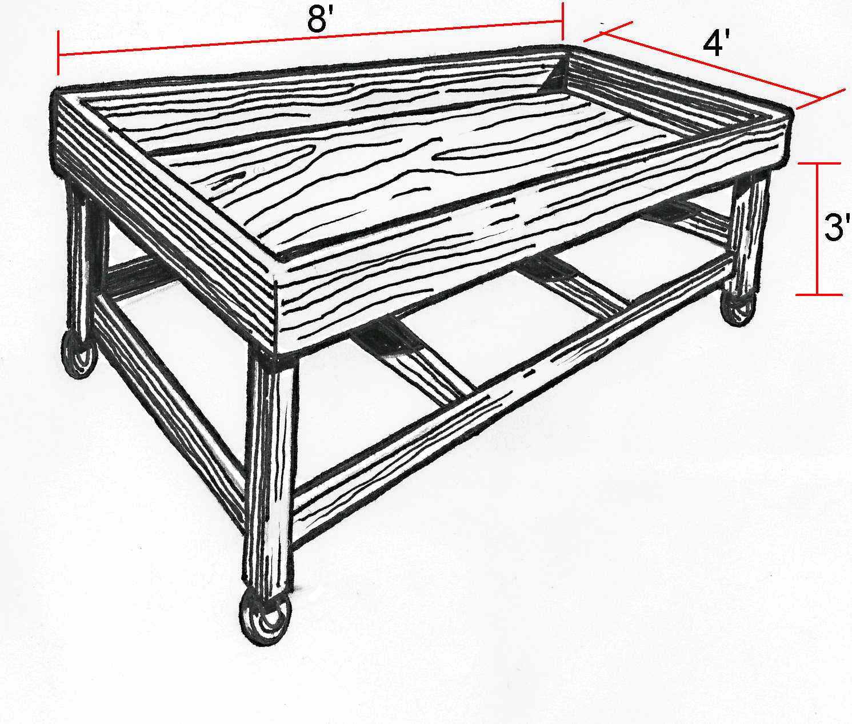

For more table designs and variations: http://www.fireleadership.gov/toolbox/documents/Sand_Table_Showroom.pdf

