Program Plan for
Building a Sustained Ocean Observing System for Climate

National Oceanic and Atmospheric Administration
Office of Oceanic and Atmospheric Research
Climate Program Office
Climate Observation Division

Updated 25 June 2008

Executive Summary

The purpose of this document is to describe the global ocean observing system that is needed to support climate forecasting and assessment, how the initial contributions to the system are being operated and funded, and NOAA’s plans for developing and sustaining this essential ocean component of the climate observing system over the long term.

Observation is the foundation for all climate information. NOAA needs, in particular, a global ocean observing system to fulfill both its climate and weather forecast missions. The memory of the global atmosphere is eight days, whereas the memory of the ocean is at least a hundred years. So any forecast of weather conditions beyond one week, or at most two, needs the ocean. Under many storm conditions even short-term weather forecasts are improved by including ocean-atmosphere interaction. The longer the time-scale of concern, the more important the ocean becomes. Predictions of climate conditions in the next decades depend essentially on ocean data.

Ocean observations are needed not only to drive forecast models, but also to assess the changing state of the climate. Hundreds of research papers cited in the Fourth Assessment Report of the Intergovernmental Panel on Climate Change (IPCC) depended upon ocean data.

Although many impacts of climate variability are felt locally, climate is a global phenomenon. It is critical that the United States establish a global ocean observing system now, and commit to sustaining it, so that the Nation and the world will have the best possible information from which to initiate climate projections, and so that future generations will have the information necessary to resolve questions about long-term trends in climate.

The system detailed herein is the Global Component of the U.S. Integrated Ocean Observing System (IOOS). IOOS consists of both a Global Component and a Coastal Component. Implementation of the Global Component is the subject of this plan. The Global Component has been designed to meet climate requirements, and NOAA’s climate mission is the primary driver for implementation. But this global ocean observing system also supports weather prediction, global and coastal ocean prediction, marine hazard warning systems (e.g., tsunami warning), transportation, marine environment and ecosystem monitoring, and naval applications. Many non-climate users also depend on the baseline composite system that is nominally referred to as the sustained global ocean observing system for climate.

Implementation of the in situ elements of the global ocean observing system is the responsibility of the Climate Observation Division of NOAA’s Climate Program Office. The goal of the Division is to build and sustain an observing system that will respond to the long-term observational requirements of the operational forecast centers, international research programs, and major scientific assessments. The primary objectives are to provide the observational basis for understanding and forecasting changes in sea surface temperature (e.g., El Niño), sea level, sea ice, ocean carbon sources and sinks, the ocean’s storage and global transport of heat and fresh water, and the ocean-atmosphere exchange of heat and fresh water. As technology develops, other ecosystem and living marine resource variables will be included.

Present ocean observations are not adequate to deliver this information with confidence. The fundamental deficiency is lack of global coverage by the in situ networks. Present international efforts constitute only about 60% of what is needed. NOAA’s contribution is 24%, with other agencies and nations contributing the other 36%.

A global observing system by definition crosses international boundaries, with potential for both benefits and responsibilities to be shared by many nations. Working in partnership with other nations and other agencies is a central precept of NOAA’s ocean climate observation strategy. All of NOAA’s contributions to global ocean observation are coordinated internationally in cooperation with the Joint WMO/IOC Technical Commission for Oceanography and Marine Meteorology (JCOMM).

Implementation of the in situ component global ocean observing system is managed by the Climate Observation Division as 11 subsystems. A 12th subsystem is Earth-observing satellites. The in situ elements are designed to work in concert with satellite capabilities, but operation of the satellites does not fall under the mandate of the Climate Observation Division. Each subsystem brings its unique strengths and limitations; together they build the whole; they are interdependent and must go forward together as a system. The subsystems are:
- Tide Gauge Stations
- Surface Drifting Buoys
- Tropical Moored Buoy Network
- Ships of Opportunity
- Argo Profiling Floats
- Ocean Reference Stations
- Ocean Carbon Networks
- Arctic Ocean Observing Network
- Dedicated Ships
- Satellites
- Data and Assimilation subsystems
- Management and Product Delivery

There are presently 7723 in situ platforms maintained globally by the international community. NOAA supports 3860 of this total. The annual operating cost for NOAA’s contribution will be $56.6 million in FY 2008. To achieve complete global coverage will ultimately require an annual operating budget of $142.0 million for NOAA’s contribution, assuming that NOAA continues to contribute about half of the global effort as the system advances. NOAA has historically contributed approximately half.

The observing system is being implemented by 22 centers of expertise at NOAA laboratories, centers, cooperative institutes, universities, and business partners. In 2007, 54% of the funding allocated to the Climate Observation Division was directed to cooperative institutes and university partners, 42% was directed to the NOAA laboratories and centers, and 4% was directed to business partners. It is anticipated that a similar distribution of funding will occur in 2008 and the out years.

NOAA is committed to building and sustaining the global ocean observing system for climate. The system is at present, however, just 60% complete, when compared to the initial design targets. These targets have been endorsed nationally by the CCSP and IOOS, and internationally by GOOS, GCOS, JCOMM, GEOSS, the WCRP, the UNFCCC, and the G8. The GCOS Second Report on the Adequacy of the Global Observing System for Climate in Support of the UNFCCC concludes that “the ocean networks lack global coverage and commitment to sustained operations … Without urgent action to address these findings, the Parties will lack the information necessary to effectively plan for and manage their response to climate change.”

The road map is clear. NOAA’s commitment is clear. But there is still much to be done. Global coverage cannot be achieved with existing resources. Additional resources will be needed to complete and sustain a global ocean observing system that is adequate for understanding and predicting Earth’s ever-changing climate.
Table of Contents

Section Page

Executive Summary 2
1.0 Background: Congressional Submission budget narrative 6
2.0 Introduction 10
2.1 Ocean Climate Observation 10
2.2 Goals and Objectives 11
2.3 Requirement Drivers 11
2.4 Sampling Requirements 12
2.5 Implementation Plan 14
2.6 Partnerships are Central 14
3.0 Implementing the Global Ocean Observing System for Climate 15
3.1 Status of the System overall 16
3.2 Status of the subsystems 17
3.2.1 Tide Gauge Stations 18
3.2.2 Surface Drifting Buoys 20
3.2.3 Tropical Moored Buoy Network 22
3.2.4 Ships of Opportunity 24
3.2.5 Argo Profiling Floats 27
3.2.6 Ocean Reference Stations 29
3.2.7 Ocean Carbon Networks 31
3.2.8 Arctic Ocean Observing Network 33
3.2.9 Dedicated Ships 35
3.2.10 Satellites 36
3.2.11 Data and Assimilation subsystems 40
3.2.12 Management and Product Delivery 43
4.0 Cost 48
5.0 Performance Measures 51
5.1 Percentage of in-situ global ocean observing system implemented 52
5.2 Reduce the error in global measurement of sea surface temperature 52
5.3 Reduce the error in global measurement of sea level change 53
5.4 Reduce the error in global measurement of ocean heat content 53
5.5 Reduce the error in global measurement of ocean carbon 54
5.6 Number of ocean climate state variables reported 54
5.7 Performance Measure profiles and application to Outputs/Outcomes 56
6.0 Conclusion 60
Appendix
A. Foundation Documents 61
B. List of Acronyms 62
1.0 Background

The global ocean observing system for climate is summarized in NOAA’s Congressional Submission budget narrative as follows:

B. Observing Systems

The Climate Observation Division of the Climate Program Office is responsible for establishing and maintaining the sustained global ocean observing system necessary for climate research and prediction as well as long-term monitoring for climate change detection and attribution. Through the Climate program, NOAA provides the major U.S. contribution to the Global Component of the Integrated Ocean Observing System (IOOS) – the U.S. contribution to the Global Ocean Observing System (GOOS) and the ocean baseline of the Global Earth Observation System of Systems (GEOSS). All of NOAA’s contributions to the global ocean observing system are coordinated internationally in cooperation with the Joint WMO/IOC Technical Commission for Oceanography and Marine Meteorology (WMO: World Meteorological Organization. IOC: Intergovernmental Oceanographic Commission of the United Nations Educational, Science, and Cultural Organization). This international observation system is based on measuring a set of core variables (for example: ocean temperature, surface winds, salinity, sea level, carbon dioxide) that have been agreed nationally and internationally as necessary to provide the information needed by the United States and the other nations of the World to effectively plan for and manage their response to climate variability and change.

The major elements of the global ocean observing system are listed below. Satellites are also critical elements of this composite system, but they are listed elsewhere in the NOAA and NASA budgets. It must be emphasized that all of these elements working together provide the needed system. They are interdependent. Each element brings its unique strengths and limitations. Together they build the whole. For example: the Argo Profiling Floats measure the upper ocean’s heat content which is directly related to our changing climate and is reflected in sea level change; global sea level is measured by satellite altimeters which must be continuously calibrated using the Tide Gauge Stations; the ocean’s heat is transferred to the atmosphere at the sea surface (it is sea surface temperature that directly influences the Earth’s climate and our daily weather); the sea surface temperature is measured by the Surface Drifting Buoys and Moored Buoys; Ships of Opportunity and the Dedicated Ships are necessary to observe the atmosphere over the ocean and it is they that deploy the Buoys and Floats at sea; the Argo Float measurements must be calibrated by systematic deep ocean observations from the Dedicated Ships in conjunction with the Ocean Carbon surveys. The entire system must go forward together; none of the elements can do the job by itself.

This system was designed to meet climate requirements, but it also provides the global ocean backbone needed to support weather and storm prediction, global and coastal ocean prediction, marine hazards warning, transportation, marine environment and ecosystem monitoring, and naval applications:

- Argo Profiling Floats: These floats provide the subsurface measurements of ocean temperature and salinity that are necessary, along with the satellite altimeter measurements, to monitor global sea level change and changes in the ocean’s heat storage. This is an international effort with 18 nations plus the European Union currently providing floats.

- Surface Drifting Buoys: Sea surface temperature is the single most important ocean variable for the global heat, water, and carbon cycles. A global array of 1,250 surface drifting buoys is maintained by NOAA and 14 international partners to calibrate satellite observations and reduce errors in global measurement of this critical ocean climate variable. The drifters also measure surface currents globally and provide sea surface data under hurricanes to help improve predictions of hurricane intensity and landfall.

- Tide Gauge Stations: Sea level rise is one of the most immediate impacts of climate change. NOAA in cooperation with 66 nations is implementing the Global Climate Observing System (GCOS) sea level reference network of 170 geodetically located tide gauge stations. The stations measure sea level change at the coast and are used to calibrate the satellite measurements of the deep ocean. They report in near-real-time and are also used for the tsunami warning system, storm surge, navigation, and other coastal marine services.

- Tropical Moored Buoys: The Earth’s tropics are the ocean’s major capacity for heat exchange with the atmosphere. The Pacific El Niño influences global climate and weather patterns. Together with international partners, NOAA is working to instrument all three tropical oceans - the Pacific, Atlantic, and Indian Ocean - for continuous real-time measurement of ocean-atmosphere exchanges that affect the way our climate varies from year to year.

- Ocean Reference Stations: NOAA, in cooperation with the National Science Foundation and international partners, is implementing a sparse global network of the highest quality ocean reference station moorings. The surface and subsurface measurements from these Reference Stations have been a cornerstone of the documentation of long term changes in the ocean-atmosphere exchange and provide “ground truth” for improvement of forecast models. This network also monitors major ocean currents (for example, the Gulf Stream) to identify changes in circulation that could provide possible indications of abrupt climate change.

- Ships of Opportunity (SOOP): The global atmospheric and oceanic data from Ships of Opportunity have been the foundation for understanding long-term changes in marine climate and are essential input to climate and weather forecast models. The Ships of Opportunity are also the system’s workhorse for deployment of the Drifting Buoys and Argo Floats.

- Ocean Carbon Networks: Projecting decadal to centennial global climate change is closely linked to assumptions about feedback effects between the ocean and atmosphere related to sequestering of carbon in the ocean and additional input of carbon dioxide into the atmosphere. The SOOP fleet and NOAA in cooperation with the National Science Foundation and international partners are implementing an ongoing ocean carbon inventory surveying the globe once every ten years, supplemented by autonomous carbon dioxide sampling instruments on the ships and the moored buoys to measure the air-sea exchange of carbon dioxide seasonally.

- Arctic Ocean Observing System: Over the past 20 or more years, significant changes have been noted in the Arctic, such as thawing of permafrost, earlier break-up of ice on rivers, and thinning of the ice cover on the Arctic Ocean. NOAA is joining with other Federal agencies and international collaborators to begin a long-term effort to quantify the flux of fresh water from the Arctic to the North Atlantic. The initial steps will be made through deployment of moorings at critical locations in the Arctic.

- Dedicated Ships: Ocean research vessels from NOAA and university partners are essential elements of the support infrastructure necessary to sustain the ocean observing system. The dedicated ships provide the highest quality reference data sets, the platforms for the ocean carbon surveys, and platforms for deployment of the Moored and Drifting Buoys and the Argo Floats.

- Data Management, Data Assimilation, and Analysis: A robust and scalable Data Management and Communications (DMAC) infrastructure is essential to the vision of a sustained and integrated ocean observing system. Standards and protocols are essential to enable interoperability across all global and coastal ocean observing systems. Data must be retained and made available for analyses and for assimilation into models to understand and forecast climate change, and for efficiently managing observing system operations and improvements. Thus, the advancement of assimilation techniques and the scientific analysis of ocean data are also important elements of the global ocean observing system. [End]

The purpose of this plan is to describe in detail the ocean observing system that is summarized above, how it is operated and funded, and NOAA’s plans for developing and sustaining this essential ocean component of the climate observing system over the long term.

Figure 1. The subsystems that make up the Sustained Ocean Observing System for Climate are illustrated from lower left to upper right: Dedicated Ships, Ships of Opportunity, Ocean Reference Stations, Tide Gauge Stations, Arctic Ocean Observing Network, Tropical Moored Buoy Network, Surface Drifting Buoys, Argo Profiling Floats, and Continuous Satellite Missions for sea surface temperature, sea surface height, surface vector winds, ocean color, and sea ice. Not illustrated are the Data & Assimilation Subsystems, and Management & Product Delivery, which provide the overarching system integration.

2.0 Introduction

2.1 Ocean Climate Observation

Ocean waters cover 70 percent of the Earth’s surface. The ocean is the memory of the climate system and is second only to the sun in effecting variability in the seasons and long-term climate change. The ocean has potential to store 1000 times more heat than the atmosphere and 50 times more carbon. Eighty-five percent of the rain and snow that water our Earth comes directly from the ocean. Prolonged drought is influenced by persistent patterns of ocean temperature. Ocean regimes such as El Niño change weather and storm patterns around the world. Sea level rise is one of the most immediate impacts of climate change, and the key to the possibility of rapid climate change may lie in deep ocean circulation.

Observation is the foundation for all climate information. NOAA needs, in particular, a global ocean observing system to fulfill both its climate and weather forecast missions. The memory of the global atmosphere is eight days, whereas the memory of the ocean is at least a hundred years. So any forecast of weather conditions beyond one week, or at most two, needs the ocean. Under many storm conditions even short-term weather forecasts are improved by including ocean-atmosphere interaction. The longer the time-scale of concern, the more important the ocean becomes. Predictions of climate conditions in the next decades depend essentially on ocean data.

Ocean observations are needed not only to drive forecast models, but also to assess the changing state of the climate. Hundreds of research papers cited in the Fourth Assessment Report of the Intergovernmental Panel on Climate Change (IPCC) depended upon ocean data. One example involved the global carbon budget; at present it is believed that the ocean absorbs about half of the carbon that mankind puts into the atmosphere. Only with sustained ocean observations will we know if this will continue, and if resulting ocean acidity will continue to increase.

Although many impacts of climate variability are felt locally, climate is a global phenomenon. It is critical that the United States establish a global ocean climate observing system now, and commit to sustaining it, so that the Nation and the world will have the best possible information from which to initiate climate projections, and so that future generations will have the information necessary to resolve questions about long-term trends in Earth’s ever changing climate.

At present, NOAA is the world leader in implementing the in situ elements of the global ocean observing system for climate. NOAA’s Climate Observation Division sponsors the majority of the Global Component of the U.S. Integrated Ocean Observing System (IOOS), which is the U.S. contribution to the international Global Ocean Observing System (GOOS) and the ocean baseline of the Global Earth Observation System of Systems (GEOSS). NOAA sponsors nearly half of the platforms presently deployed in the global ocean (3860 of 7723) with 72 other countries providing the remainder. NOAA has historically contributed about half of the international system, and has been a leader in fostering an international systems approach to the implementation of GOOS.

The ocean observing system, while expanding in coverage, is not yet complete. The global system is currently at just 60% of the initial design. The demand for ocean data and the products/forecasts derived from these data require that NOAA, working cooperatively with other agencies and nations, complete deployment as soon as possible. Implementation of the in situ system is the responsibility of NOAA’s Climate Observation Division.

2.2 Goal and Objectives

The goal of the Climate Observation Division is to build and sustain a global climate observing system that will respond to the long term observational requirements of the operational forecast centers, international research programs, and major scientific assessments. The focus is on building the in situ ocean component. The Division’s objectives are to:
- document long term trends in sea level change;
- document ocean carbon sources and sinks;
- document the ocean’s storage and global transport of heat and fresh water; and
- document ocean-atmosphere exchange of heat and fresh water.

2.3 Requirement Drivers

The ocean climate observing system must have the capability to deliver continuous instrumental records and global analyses of:
- Sea level to identify changes resulting from climate variability and change;
- Ocean carbon content every ten years and the air-sea exchange seasonally;
- Sea surface temperature and surface currents to identify significant patterns of climate variability;
- Sea surface pressure and air-sea exchanges of heat, momentum, and fresh water to identity changes in forcing function driving ocean conditions and atmospheric conditions;
- Ocean heat and fresh water content and transports to: 1) identify changes in the global water cycle; 2) identify changes in thermohaline circulation and monitor for indications of possible abrupt climate change; and 3) identify where anomalies enter the ocean, how they move and are transformed, and where they re-emerge to interact with the atmosphere; and
- Sea ice extent, concentrations, and thickness to identify changes resulting from, and contributing to, climate variability and change.

Present ocean observations are not adequate to deliver these products with confidence. The fundamental deficiency is lack of global coverage by the in situ networks. Present international efforts constitute only about 60% of what is needed. The Second Report on the Adequacy of the Global Observing System for Climate in Support of the UNFCCC concludes that “the ocean networks lack global coverage and commitment to sustained operations…Without urgent action to address these findings, the Parties will lack the information necessary to effectively plan for and manage their response to climate change.”

Nationally, the U.S. Climate Change Science Program (CCSP) Strategic Plan expresses need for “complete global coverage of the oceans with moored, drifting, and ship-based networks;” and the Joint Subcommittee on Ocean Science and Technology (JSOST) First U.S. Integrated Ocean Observing System (IOOS) Development Plan which lists as a primary objective: “Continue implementing the global ocean-climate component of the IOOS.” NOAA’s Climate Observation Division program is the core of the Global Component of the U.S. IOOS.

U.S. IOOS consists of both a Global Component and a Coastal Component. The Coastal Component is not explained by this report; the Global Component the subject of this report. The Global Component has been designed to meet climate requirements, and NOAA’s climate mission is the primary driver for implementation. But this global ocean observing system also supports weather prediction, global and coastal ocean prediction, marine hazard warning systems (e.g., tsunami warning), transportation, marine environment and ecosystem monitoring, and naval applications. Many non-climate users also depend on the baseline composite system that is nominally referred to as the sustained global ocean observing system for climate.

2.4 Sampling Requirements

The Requirement Drivers listed in Section 2.3 are ocean-specific “outcomes” that must be attained in order to achieve the Goals and Objectives (Section 2.2) of this plan. The sampling requirements for these outcomes have been documented by international GOOS and GCOS. Table 1 lists the requirements as presented at the international OCEANOBS 99 Conference in Saint-Raphael, France. It represents the best estimates of the international community at this time.

The Proceedings of OCEANOBS 99 and the final report from the conference, Observing the Ocean in the 21st Century, outline implementation strategies for achieving these sampling requirements. Additionally, for documenting sea level variability and change, the implementation strategy is further defined in the International Sea Level Workshop Report, 1998; and for documenting ocean carbon sources and sinks the implementation strategy is defined in the Large Scale CO₂ Observing Plan: In Situ Oceans and Atmosphere (LSCOP), 2002. See Appendix A: Foundation Documents. The latter plan is for the United States only, but is a vital component of the Global Ocean Observing System (GOOS) as outlined by the Integrated Global Carbon Observing system Implementation Plan. The scientific objectives are also important for international research programs such as the Surface Ocean and Lower Atmosphere Study (SOLAS) and Integrated Marine Biogeochemistry and Ecosystem Research (IMBER) program, which are coordinated with other ocean carbon studies through the International Ocean Carbon Coordination Project. These programs will be implemented in the United States as components of the U.S. SOLAS and the Ocean Carbon and Climate Change (OCCC) programs.

Sampling Requirements for the Global Ocean
Code | Application | Variable | Hor. Res. | Vert. Res. | Time Res. | # samples | Accuracy
A | NWP, climate, mesoscale ocean | Remote SST | 10 km | - | 6 hours | 1 | 0.1-0.3°C
B | Bias correction, trends | In situ SST | 500 km | - | 1 week | 25 | 0.2-0.5°C
C | Climate variability | Sea surface salinity | 200 km | - | 10 days | 1 | 0.1
D | Climate prediction and variability | Surface wind | 2° | - | 1-2 days | 1-4 | 0.5-1 m/s in components
E | Mesoscale, coastal | Surface wind | 50 km | - | 1 day | 1 | 1-2 m/s
F | Climate | Heat flux | 2° x 5° | - | month | 50 | Net: 10 W/m²
G | Climate | Precip. | 2° x 5° | - | daily | several | 5 cm/month
H | Climate change trends | Sea level | 30-50 gauges + GPS with altimetry, or several 100 gauges + GPS | - | monthly means |  | 1 cm, giving 0.1 mm/yr accuracy trends over  1-2 decades
I | Climate variability | Sea level anomalies | 100-200 km | - | 10-30 days | ~10 | 2 cm
J | Mesoscale variability | Sea level anomalies | 25-50 km | - | 2 days | 1 | 2-4 cm
K | Climate, short-range prediction | Sea ice extent, concentration | ~30 km | - | 1 day | 1 | 10-30 km  2-5%
L | Climate, short-range prediction | Sea ice velocity | ~200 km | - | daily | 1 | ~ cm/s
M | Climate | Sea ice volume, thickness | 500 km | - | monthly | 1 | ~30 cm
N | Climate | Surface pCO₂ | 25-100 km | - | daily | 1 | 0.2-0.3 µatm
O | ENSO prediction | T(z) | 1.5° x 15° | 15 m over 500 m | 5 days | 4 | 0.2°C
P | Climate variability | T(z) | 1.5° x 5° | ~ 5 vertical modes | 1 month | 1 | 0.2 °C
Q | Mesoscale ocean | T(z) | 50 km | ~ 5 modes | 10 days | 1 | 0.2°C
R | Climate | S(z) | large-scale | ~ 30 m | monthly | 1 | 0.01
S | Climate, short-range prediction | U(surface) | 600 km | - | month | 1 | 2 cm/s
T | Climate model valid. | U(z) | a few places | 30 m | monthly means | 30 | 2 cm/s

Table 1: From The Action Plan for GOOS/GCOS and Sustained Observation for CLIVAR by Needler et al. – OCEANOBS 99. This is a summary of the sampling requirements for the global ocean, based largely on OOSDP (1995), but with revisions as appropriate. These are a statement of the required measurement network characteristics, not the characteristics of the derived field. The field estimates must factor in geophysical noise and un-sampled signal. Some projections (largely unverified) have been included for GODAE.

2.5 Implementation Plan

In response to the Second Adequacy Report, the international Global Climate Observing System (of the World Meteorological Organization) produced the Implementation Plan for the Global Observing System for Climate in support of the UNFCCC (GCOS-92). GCOS-92 was published in October 2004. It has been endorsed by the UNFCCC and by the Group on Earth Observations (GEO). The United States Group on Earth Observations (US GEO) Strategic Plan for the U.S. Integrated Earth Observation System notes: "As the U.S. plan for climate observations moves forward, it should strive to build on the GCOS Implementation plan.” The CCSP Observations Working Group has endorsed the “GCOS Implementation plan as a blueprint for guiding climate observation activities.”

NOAA’s advancement of the global ocean observing system is guided by the Climate Observation Division’s multi-year Program Plan for Building a Sustained Ocean Observing System for Climate, which is updated annually. This NOAA plan is in complete accord with GCOS-92 and provides the framework for NOAA contributions to the international effort. All of the work supported by NOAA is directed toward implementation of this international plan and the projects are being implemented in accordance with the GCOS Ten Climate Monitoring Principles. NOAA presently contributes nearly half of the total international effort. The intended outcome of the implementation plan is a sustained global system of complementary in situ, satellite, data, and modeling subsystems adequate to accurately document the state of the ocean and to force climate models.

2.6 Partnerships are central

A global observing system by definition crosses international and institutional boundaries, with potential for both benefits and responsibilities to be shared by many. Working in partnership with other nations and other agencies is a central precept of NOAA’s ocean climate observation strategy. All of NOAA’s contributions to global ocean observation are coordinated internationally in cooperation with the Joint WMO/IOC Technical Commission for Oceanography and Marine Meteorology (JCOMM). To facilitate international coordination and cooperation, the Climate Observation Division’s Program Manager for Data Buoys and Ship-based Systems serves on the JCOMM Management Committee as Observations Program Area Coordinator. Nationally, the Climate Observation Division is co-located with the NOAA IOOS Program to facilitate coordination across NOAA, and with the Interagency Office for Integrated and Sustained Ocean Observation (Ocean.US) to facilitate coordination across all the federal ocean agencies.

3.0 Implementing the Global Ocean Observing System for Climate

Implementation of the NOAA contribution to the global ocean observing system is managed by the Climate Observation Division as 10 networks or subsystems. An eleventh overarching subsystem is Program Management and Product Delivery.

Satellites also provide critical contributions to global ocean observation. A discussion of the satellite contributions is included herein. But operation of the satellites does not fall under the mandate of the Climate Observation Division. Additionally, the Tropical Atmosphere Ocean (TAO) array and the Voluntary Observing Ship (VOS) project are central elements of the global ocean observing system; and a discussion of these elements is included; but the TAO and VOS projects are managed separately by the National Data Buoy Center. This report focuses on implementation of the in situ system elements that are managed by the Climate Observation Division.

The system is illustrated in Figure 2, and the ongoing work in each of the subsystems is summarized in the sections below. Each subsystem brings its unique strengths and limitations; together they build the whole; they are interdependent and must go forward together as a system. For example, the global Argo array of profiling floats is a primary tool for documenting upper ocean heat content; yet deployment of the floats in the far corners of the ocean cannot be achieved without the ships-of-opportunity and dedicated ships; and the Argo array cannot do its work without global over-flight by continued precision altimeter space missions; the Argo measurements must be continually calibrated by deep ocean measurements from the dedicated ships conducting the global ocean carbon inventory surveys, and the deep ocean below the reach of Argo floats can only be sampled by ship-based systems; while the measurements taken by all networks will be rendered effective only through the data and assimilation subsystems.

The status, priorities, and milestones for the individual subsystems are discussed in the sections that follow. For each subsystem the priority tasks are listed in tabular form. The tables show the international goal in the right-hand column and NOAA’s target contributions to the international system in the other columns. The bottom lines of the tables give the representative milestones that are used to track international progress. NOAA’s contributions listed within the tables will depend directly on availability of future funding. The milestones are based on present internal program planning and budgeting. The associated costs are summarized in Section 4.0. Relative emphases in completing the several components of the observing system will depend on the relative priorities assigned to the network tasks in the context of the overall requirements of climate services.

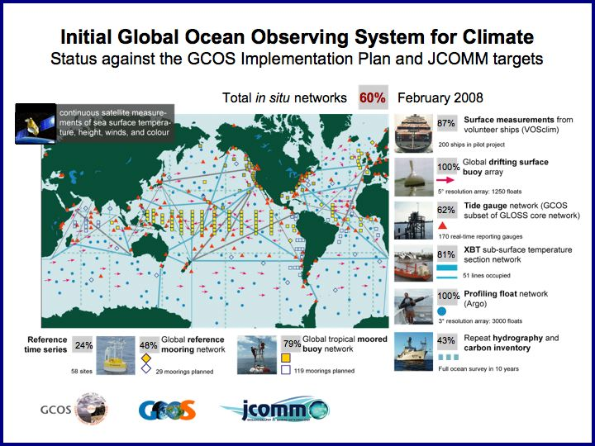

Figure 2: A schematic of the initial composite ocean observing system, including the current status against the targets of JCOMM and the GCOS Implementation Plan (GCOS-92), maintained by the international GOOS Project Office. The statistics were calculated by NOAA’s Office of Climate Observation as a national contribution to the international effort. Of the total 60% index shown, NOAA’s contribution is 24%.

3.1 Status of the System overall

The international global ocean climate observing system overall has advanced from 45% complete in FY 2003 to 60% complete in FY 2008. There are presently 7723 in situ platforms maintained globally by the international community. NOAA supports 3860 of this total.

Table 2: Progress toward global implementation as measured by the Percent Complete Index.

The system total “percent complete” is an index that has been developed for tracking progress toward implementation of the initial system design. There are 17 platforms and sensors that have been identified as initial targets for tracking purposes; they do not constitute an exhaustive list of observing system assets; but they provide representative milestones to help gauge progress toward global coverage. The system total index is simply the average of the 17 individual percentages; no effort has been made to weight the various components of the observing system in calculating this index. Of the present 60% system total index, NOAA contributes 24% with one other U.S. agency (the National Science Foundation) and 72 other nations contributing the remaining 36% (The National Science Foundation contributes 1%; together with NOAA’s 24%, the U.S. contribution to the international effort totals 25%; and the other nations’ contributions total 35%). The spreadsheet that is used to track this index and the contributions by countries is maintained by NOAA at www.oco.noaa.gov.

  - Status of the subsystems

The following sections, Sections 3.2.1 through 3.2.12, provide an overview of each subsystem of the composite ocean observing system. The tables within each section summarize the current status and recent progress of that subsystem, and give both the international goals and NOAA’s contributions to the international effort. In the tables, NOAA’s contributions are shown in plain text, and the international progress and goals are shown in bold text (the right-hand column and bottom row are the international progress and goals).

    - Tide Gauge Stations

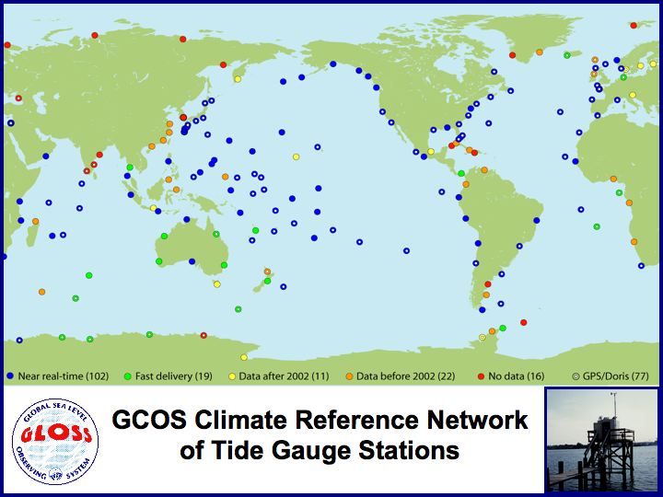

Figure 3: Tide Gauge Stations. The task is to upgrade all 170 stations to be geo-centrically located (white dots) and reporting in near real time (blue icons).

Tide gauges are necessary for accurately measuring long-term trends in sea level change and for calibration and validation of the measurements from satellite altimeters, which are assimilated into global climate models for predicting climate variability and change. Many tide stations need to be upgraded with modern technology particularly in less developed countries. Permanent GPS receivers are being installed at a selected subset of stations, leading to a geocentrically located subset of 170 GCOS Climate Reference Stations. These 170 Climate Reference Stations will also be upgraded for real-time reporting, not only for climate monitoring, but also to support marine hazard warning (e.g., tsunami warning). In cooperation with the JCOMM Global Sea Level Observing System (GLOSS), NOAA will help sustain the global tide gauge network for validation of satellite retrievals, validation of climate model results, documentation of seasonal to centennial variability in the El Niño Southern Oscillation, Indian Ocean and Asian-Australian monsoons, tropical Atlantic variability, North Atlantic Oscillation, North Pacific variability, high latitude circulation, western boundary currents, and circulation through narrow straits and chokepoints, and in support of navigation and other marine services as well.

The global sea level network provides one of the best examples of why international partnerships are so critical to climate observation. NOAA supports tide gauge station operations in 32 different counties and collects near-real-time data from 102 stations world-wide (the goal is 170 stations). The multi-national system is coordinated through the JCOMM Global Sea Level Observing System (GLOSS) Group of Experts. U.S. international operations are managed by NOAA’s Joint Institute for Marine and Atmospheric Research at the University of Hawaii. Stations in the United States and U.S. territories are operated by NOAA’s Center for Operational Ocean Products and Services. Near-real-time data are distributed by the GLOSS data assembly center operated at the University of Hawaii, and historical data are archived and distributed by NOAA’s National Oceanographic Data Center.

This subsystem contributes to climate services by providing the long term records needed to 1) document sea level change: 2) document heat uptake, transport, and release by the ocean (sea surface height contributes to the measurement of ocean heat content); and 3) document the ocean’s overturning circulation (gradients of sea surface height across straights and choke-points are used to calculate large-scale ocean currents). Taking into account the status of the several components of this subsystem (see table below), the subsystem overall is estimated to be about 62% complete at present, with NOAA contributing 16%.

NOAA Contributions | FY06 | FY07 | FY08 | FY09 | NOAA Goal | International Goal
Operational GLOSS stations | 26 | 26 | 26 | 26 | 26 | 290
GPS installations  at GCOS stations | 20 | 21 | 21 | 21 | 84 | 170
Real-time reporting GCOS stations | 34 | 48 | 48 | 48 | 84 | 170
GPS data processing |  |  |  |  | X | X
Technology development |  |  |  |  | X | X
International real-time reporting stations | 85 | 102 | 112 | 127 | 170 | 170

Table 3: Milestones for implementing the subsystem of Tide Gauge Stations.

3.2.2 Surface Drifting Buoys

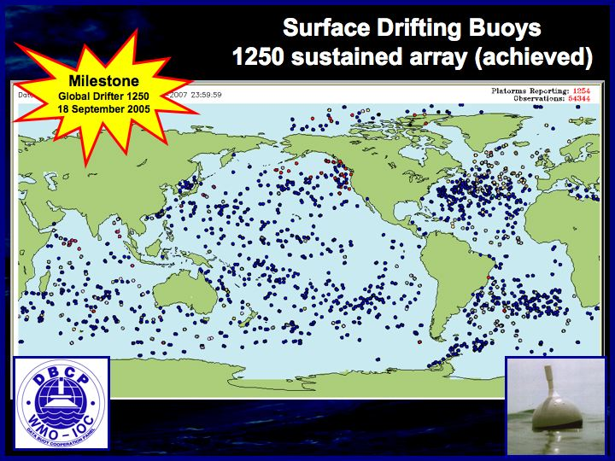

Figure 4: Surface Drifting Buoy Array. A major milestone was reached in September 2005 when the global drifter array achieved its initial design goal of 1250 data buoys in sustained service and became the first component of the Global Ocean Observing System to be fully deployed.

Standard global SST analyses are derived from satellite retrievals, but the satellite measurements must be continuously tuned using surface in situ measurements. The design for the global surface drifting buoy array (GCOS-92) calls for 1250 buoys to be maintained world wide, spaced approximately 500 km apart in order to adequately tune the satellites measurements. The drifter array also provides the primary source of global ocean surface circulation measurements which are necessary to validate climate and ocean forecast models. Drifters equipped with barometers provide critical near-real-time observations of atmospheric pressure for numerical weather prediction, as well as for documenting global scale trends in climate variability (the drifters report hourly via satellite communications). Specially equipped “hurricane drifters” are now routinely air-dropped in the path of hurricanes approaching the U.S. coast in order to improved hurricane intensity and landfall predictions. NOAA, together with international partners, is working to augment the drifter array with subsets of buoys for wind, pressure, salinity, and temperature profile measurement capabilities. The global drifting buoy array reached its initial design goal of 1250 data buoys in sustained service in 2005. The next challenge is to equip all buoys with barometers (presently about 500 are maintained with barometers), and to install salinity sensors on a subset of 300 buoys (none presently), particularly in the sub-polar regions for analysis of fresh water input from melting ice sheets and changes in thermohaline circulation.

NOAA’s global drifter program is managed jointly by the Atlantic Oceanographic and Meteorological Laboratory (AOML), and the Joint Institute for Marine Observations at Scripps Institution of Oceanography. Twelve other countries contribute to this subsystem under the framework of the JCOMM Data Buoy Cooperation Panel. Near-real-time data are distributed on the Global Telecommunications System and by the Global Drifter Program Data Assembly Center at AOML, and historical data are archived and distributed by NOAA’s National Oceanographic Data Center.

This subsystem supports climate services by providing measurements needed to 1) document heat uptake, transport, and release by the ocean; 2) document ocean carbon sources and sinks (sea surface temperature affects the rate of transfer of CO₂ between the ocean and atmosphere; 3) document the air-sea exchange of water and the ocean’s overturning circulation, and 4) document sea level change by providing the sea surface atmospheric pressure measurements that are essential for calculating sea surface height from satellite altimeter measurements. The global drifter array has achieved it’s 100% design goal of 1250 buoys in sustained service; taking into account the status of the several partially-completed components of this subsystem, however (see table below), the subsystem overall is estimated to be about 79% complete at present, with NOAA contributing 49%.

NOAA Contributions | FY06 | FY07 | FY08 | FY09 | NOAA Goal | International Goal
Operational buoys in service* | 1021 | 965 | 1000 | 1000 | 1000 | 1250
Hurricane drifters | 62 | 40 | 40 | 40 | 50 | 50
Add barometers | 215 | 258 | 270 | 270 | 600 | 1250
Add salinity sensors | 12 | 5 | 0 | 0 | 300 | 300
Technology development | X | X | X | X | X | X
International array size* | 1294 | 1258 | 1250 | 1250 | 1250 | 1250

Table 4: Milestones for implementing the subsystem of Surface Drifting Buoys.
*Actual number of operational buoys in service at any particular time is often slightly different from the “required” uniform spatial distribution of 1250 buoys because of the complexity of continually re-seeding the array while anticipating when the batteries will expire in the buoys that are already deployed, and attempting to achieve the necessary spatial distribution within constantly varying ocean surface circulation.

3.2.3 Tropical Moored Buoy Network

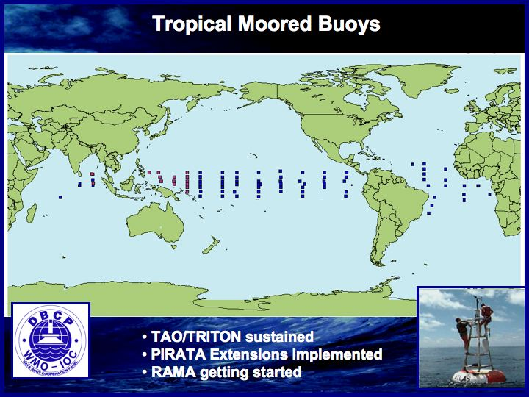

Figure 5: Tropical Moored Buoy Network

Most of the heat from the sun enters the ocean in the tropical/sub-tropical belt. The advanced understanding of the role of the tropics in forcing mid-latitude weather and climate was learned primarily through the observations of the tropical moored buoy array (TAO/TRITON) in the Pacific. A similar array in the Atlantic basin (PIRATA) now also contributes to better understanding, model output evaluation, improved forecasts, and improved ability to discern the causes of longer-term changes in the Oceans. The next challenge is to advance the tropical moored array across the Indian Ocean, in cooperation with international partners. The RAMA (Research African-Asian-Australian Monsoon Array) will complete global coverage of the Earth’s tropical oceans; there are presently eight moorings in operation; the RAMA system design is for 43. In addition to monitoring the air-sea exchange of heat and water, the moored buoys provide platforms for supporting instrumentation to measure the air-sea exchange of carbon dioxide in the tropics.

The TAO/TRITON array in the Pacific Ocean is operated by NOAA’s National Data Buoy Center (NDBC) in cooperation with Japan. PIRATA in the Atlantic is operated jointly by NOAA’s Atlantic Oceanographic and Meteorological Laboratory (AOML) and NOAA’s Pacific Marine Environmental Laboratory (PMEL), in cooperation with Brazil and France. The Indian Ocean RAMA is being implemented by PMEL in cooperation with Japan, France, India, and Indonesia. Near-real-time data are distributed on the Global Telecommunications System; near-real-time data from TAO/TRITON are available from NDBC; near-real-time data from PIRATA and RAMA are available from PMEL. Historical data are archived and distributed by the NOAA National Oceanographic Data Center and the NOAA National Climatic Data Center.

This subsystem supports climate services by providing both ocean and atmospheric observations to 1) document heat uptake, transport, and release by the ocean; 2) document carbon sources and sinks; and 3) document the air-sea exchange of fresh water. This subsystem overall is estimated to be about 79% complete at present, with NOAA contributing 64%.

NOAA Contributions | FY06 | FY07 | FY08 | FY09 | NOAA Goal | International Goal
TAO/Triton array | 55 | 55 | 55 | 55 | 55 | 70
PIRATA | 16 | 18 | 17 | 17 | 18 | 18
Indian Ocean (RAMA) | 6 | 8 | 11 | 11 | 35 | 47
Add salinity sensors | 33 | 55 | 55 | 55 | 55 | 55
Add flux capability | 7 | 9 | 10 | 11 | 13 | 15
Technology development | X | X | X | X | X | X
International network size | 91 | 97 | 103 | 112 | 131 | 131

Table 5: Milestones for implementing the subsystem of Tropical Moored Buoys.
3.2.4 Ships of Opportunity

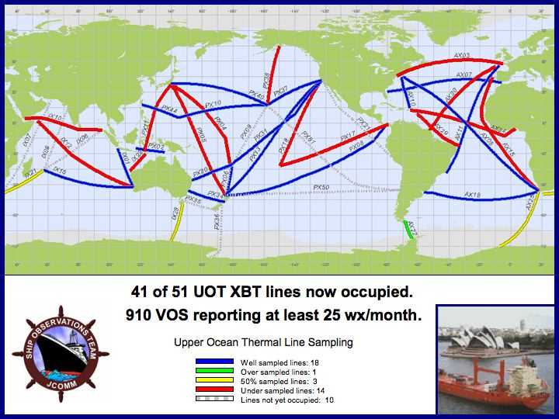

Figure 6: Ships of Opportunity

The global atmospheric and oceanic data from Ships of Opportunity (SOOP) have been the foundation for understanding long-term changes in marine climate and are essential input to climate and weather forecast models. The SOOP are commercial carriers that transit scientifically important trans-oceanic routes; they volunteer to take ocean measurements using NOAA-supplied instruments, or host NOAA technicians on-board during the transits to take the measurements. Improved instrument accuracy, automated reporting, and improved information about how the observations were taken are being implemented to enhance the quality of these data, reducing both systematic and random errors. NOAA is working to improve meteorological measurement capabilities on the global SOOP fleet for improved marine weather and climate forecasting in general, and is concentrating on a specific subset of 51 high accuracy SOOP lines to be frequently repeated and sampled at high resolution for systematic upper ocean temperature (using Expendable Bathy-Thermograph probes – XBTs) and atmospheric measurement. This climate-specific subset provides measurements of the upper ocean thermal structure, sea surface temperature and chemistry, and surface meteorology of high accuracy. Additionally, the SOOP fleet is the primary vehicle for deployment of the drifting arrays – surface drifting buoys and Argo profiling floats.

Seven countries contribute to the operation of this subsystem. NOAA’s Atlantic operations are managed by the Atlantic Oceanographic and Meteorological Laboratory, and NOAA’s Indo-Pacific operations are managed by the Joint Institute for Marine Observations at Scripps Institution of Oceanography. Data are archived and distributed by NOAA’s National Oceanographic Data Center.

Closely aligned with the Ships of Opportunity program is the Volunteer Observing Ship (VOS) program, which is managed in the U.S. by NOAA’s National Data Buoy Center. This network is maintained primarily for weather observations at sea, but the observational data are used extensively for climate studies as well, particularly for assessment of long-term trends, since ships have been recording weather observations for over 150 years. All maritime nations participate. There are about 910 VOS that now report regularly, data from 435 of those are processed by NOAA. A subset of 250 ships is targeted by JCOMM for registry in the VOSClim project to provide enhanced data reports especially for climate observation.

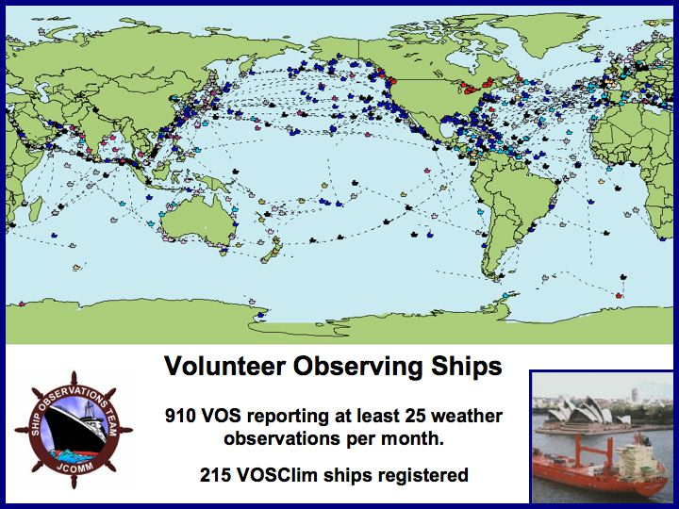

Figure 7: Volunteer Observing Ships report weather observations that are used in weather now-casting and forecasting, analysis of sea surface temperature, and for analysis of climate-scale trends over the global ocean.

The SOOP and VOS subsystems support climate services by providing ocean and atmosphere measurements needed to 1) document heat uptake, transport, and release by the ocean; 2) document ocean carbon sources and sinks (carbon sampling instrumentation is detailed under a separate task below); and 3) document the air-sea exchange of water and the ocean’s overturning circulation. Taking into account the status of the several components of this subsystem (see table below), the subsystem overall is estimated to be about 67% complete at present, with NOAA contributing 24%.

NOAA Contributions | FY06 | FY07 | FY08 | FY09 | NOAA Goal | International Goal
Total XBTs dropped | 12544 | 15823 | 16000 | 16000 | 20000 | 24000
High resolution lines occupied | 12 | 12 | 12 | 12 | 15 | 26
Frequently repeated lines occupied | 7 | 7 | 7 | 7 | 8 | 25
Add flux/salinity to HRX | 4 | 5 | 5 | 5 | 15 | 26
VOSClim ships registered | 12 | 12 | 12 | 12 | 50 | 250
Auto-met package in service | 0 | 0 | 0 | 0 | 50 | 250
Technology development |  |  |  |  | X | X
International lines | 41 | 41 | 41 | 41 | 51 | 51

Table 6: Milestones for implementing the subsystem of Ships of Opportunity.

3.2.5 Argo profiling floats

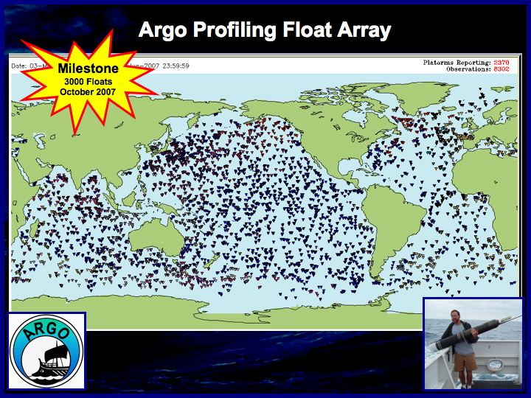

Figure 8: Argo array of Profiling Floats. A major milestone was reached in October 2007 when the Argo array achieved its initial design goal of 3000 active floats deployed.

The heat content of the upper 2000 meters of the world’s oceans, and the transfer of that heat to and from the atmosphere, are variables central to the climate system. Global sea level change is directly related to the ocean’s heat content – as the ocean’s temperature rises the water expands and thus sea level rises. The Argo array of profiling floats is designed to provide essential broad-scale, basin-wide monitoring of the upper ocean heat content. The initial goal of three thousand floats in active service was achieved in October 2007. The U.S. contribution is approximately one-half of this international project. Glider technology is now being developed to augment standard drifting Argo floats in the boundary currents and targeted deep circulation regions, where station-keeping by standard floats is not possible. The measurements from the Argo array to date have now demonstrated the need for climate observations below 2000 meters in order to measure the total global heat storage in the ocean; designing and building deep diving floats is the next technology challenge.

Twenty-two counties and the European Union contribute to the international Argo program. The U.S. project is being implemented jointly by five NOAA institutions: the Atlantic Oceanographic and Meteorological Laboratory, the Pacific Marine Environmental Laboratory, the Cooperative Institute for Climate and Oceanographic Research at Woods Hole Oceanographic Institution, the Joint Institute for Marine Observations and Scripps Institution of Oceanography, and the Joint Institute for Study of the Atmosphere and Ocean at the University of Washington. Near-real-time data is distributed by the Argo Global Data Assembly Center operated at the Navy Fleet Numerical Meteorology and Oceanography Center and historical data is archived and distributed by NOAA’s National Oceanographic Data Center.

This subsystem supports climate services by providing measurements needed to 1) document heat uptake, transport, and release by the ocean; 2) document global sea level change, and 3) document the air-sea exchange of heat and water and the ocean’s overturning circulation. The Argo array has reached its initial design goal of 3000 floats in active service, with NOAA contributing 58%.

NOAA Contributions | FY06 | FY07 | FY08 | FY09 | NOAA Goal | International Goal
Argo floats in service* | 1263 | 1741 | 1500 | 1500 | 1500 | 3000
Gliders | 2 | 3 | 3 | 3 | 50 | 100
Deep diving floats | 0 | 0 | 0 | 0 | 500 | 1000
Oxygen sensors | 0 | 0 | 0 | 0 | 400 | 800
Technology development | X | X | X | X | X | X
International Argo array size* | 2557 | 3055 | 3000 | 3000 | 3000 | 3000

Table 7: Milestones for implementing the subsystem of Argo Profiling Floats.
*The actual number of floats in service at any particular time will vary slightly from the “required” uniform spatial distribution of 3000 floats because of the complexity of continually re-seeding the array while anticipating when the batteries will expire in the buoys that are already deployed.

3.2.6 Ocean Reference Stations

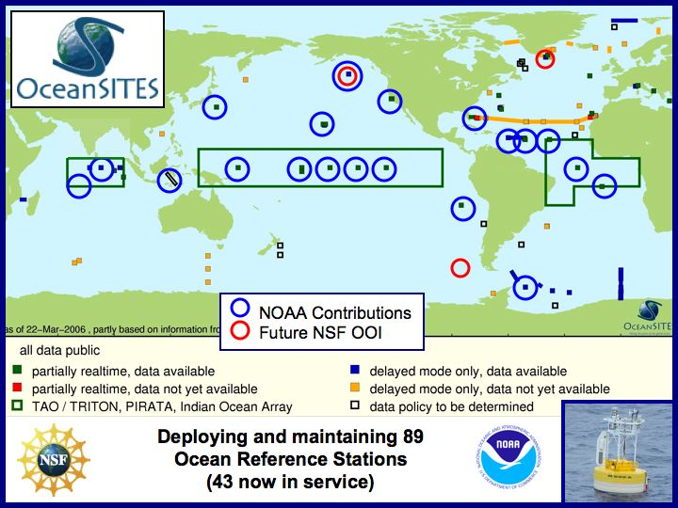

Figure 9: Ocean Reference Stations

NOAA, together with international partners, is implementing a global network of ocean reference station moored buoys to provide the most accurate long-term climate data records of oceanic and near-surface atmospheric parameters in key ocean regimes. NSF’s Ocean Observatories Initiative (OOI) will provide a major piece of the infrastructure needed for this network, establishing high-capability moored stations, particularly in high latitude ocean locations. NOAA’s contribution includes the tropical regions where a subset of the TAO/TRITON, PIRATA, and RAMA networks are being upgraded to reference station quality, and includes several other long time series sites.

Monitoring the transport within the ocean is a central element of documenting the overturning circulation of fresh water and heat and carbon uptake and release; heat and carbon are often released to the atmosphere in regions of the ocean far distant from where they enter. Long-term monitoring of key choke points, such as the Indonesian through-flow, and of boundary currents along the continents, such as the Florida Current, must be sustained to measure the primary routes of ocean heat, carbon, and fresh water transport. Additionally, boundary currents such as the California Current have a major impact on marine ecosystems; changing climate regimes in the ocean basins are reflected in changing boundary currents which in turn transfer the ocean climate’s influence to fisheries and ecosystems.

Monitoring thermohaline circulation is a central element of documenting the ocean’s overturning circulation and a critical need for helping scientists understand the role of the ocean in potential rapid climate change. It is essential that the ocean observing system maintain watch at a few control points at critical locations. Sustained deployment of long-term bottom-mounted and subsurface moored arrays and repeated temperature, salinity, and chemical tracer surveys from research vessels will form the backbone of this network.

The Ocean Reference Station subsystem is one of the most challenging because of the expense of maintaining highly accurate instruments in remote ocean regions. Yet this network is essential for evaluation of climate model outputs. The system design is for 89 locations; 43 are presently in operation.

The global effort is being implemented through coordination by the JCOMM-affiliated OceanSITES program. The NOAA contributions are managed by the Atlantic Oceanographic and Meteorological Laboratory, the Pacific Marine Environmental Laboratory, the Cooperative Institute for Climate and Ocean Research at Woods Hole Oceanographic Institution, the Cooperative Institute for Climate Applications Research at Columbia University, and the Joint Institute for Marine Observations at Scripps Institution of Oceanography.

This subsystem supports climate services by providing ocean and atmosphere measurements needed to 1) document heat uptake, transport, and release by the ocean; 2) document ocean carbon sources and sinks (carbon sampling instrumentation is detailed in the next section below); and 3) document the air-sea exchange of water and the ocean’s overturning circulation. Taking into account the status of the several components of this subsystem (see table below), the subsystem overall is estimated to be about 36% complete at present, with NOAA contributing 14%.

NOAA Contributions | FY06 | FY07 | FY08 | FY09 | NOAA Goal | International Goal
Flux moorings* | 4 | 4 | 5 | 5 | 8 | 21
Full depth stations | 5 | 5 | 5 | 5 | 8 | 44
Transport sections | 1 | 3 | 3 | 3 | 6 | 10
Tropical flux stations | 7 | 8 | 8 | 9 | 12 | 12
Technology development |  |  |  |  | X | X
*International reference stations | 43 | 46 | 47 | 49 | 87 | 87

Table 8: Milestones for implementing the subsystem of Ocean Reference Stations.
*These do not include the flux stations in the tropical moored buoy arrays.

3.2.7 Ocean Carbon Networks

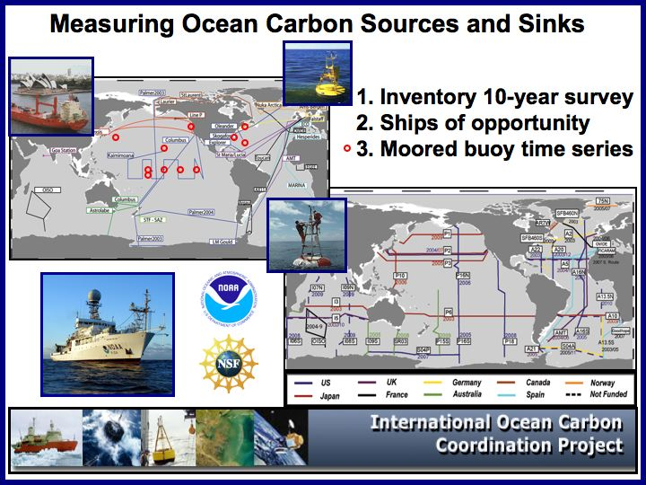

Figure 10: Ocean Carbon Networks

Understanding the global carbon cycle and the accurate measurement of the regional sources and sinks of carbon are of critical importance to international policy decision-making as well as to forecasting long term trends in climate. Projections of global climate change are closely linked to assumptions about feedback effects between the atmosphere, the land, and the ocean. To understand how carbon is cycled through the global climate system, ocean measurements are critical. NOAA is working to add autonomous carbon dioxide sampling to the moored arrays and the Ships of Opportunity fleet to analyze the seasonal variability in carbon exchange between the ocean and atmosphere, and in partnership with NSF is implementing a program of systematic global ocean surveys that will provide a complete carbon inventory once every ten years. The ships used to conduct the carbon inventory survey sample the complete ocean water column from top to bottom for temperature and salinity – these measurements are essential to calibrate the measurements from the Argo array, and to document changes in the deep ocean beyond the reach of present Argo float technology. This work is dependent on implementation of the ship lines and moored and drifting arrays.

Nine countries cooperatively contribute to this effort under the umbrella of the International Ocean Carbon Coordination Project. The U.S. contribution is a collaboration of NOAA laboratories, cooperative institutes, NSF funded universities, and the Department of Entergy Carbon Dioxide Information Analysis Center (CDIAC). The NOAA centers of expertise are at the Atlantic Oceanographic and Meteorological Laboratory, the Pacific Marine Environmental Laboratory, the Joint Institute for Marine Observations at Scripps Institution of Oceanography, the Joint Institute for Study of the Atmosphere and Ocean at the University of Washington, the Cooperative Institute for Climate Applications Research at Columbia University, the Cooperative Institute for Climate Studies at Princeton University, and the Cooperative Institute for Marine and Atmospheric Studies at the University of Miami.

This subsystem supports climate services by providing measurements to: 1) document ocean carbon sources and sinks; and 2) document heat uptake, transport, and release by the ocean. Taking into account the status of the several components of this subsystem (see table below), the subsystem overall is estimated to be about 43% complete at present, with NOAA contributing 25%.

NOAA Contributions | FY06 | FY07 | FY08 | FY09 | NOAA Goal | International Goal
Inventory cruises, cumulative | 4 | 6 | 8 | 10 | 18 | 37
Time series moorings | 8 | 11 | 11 | 11 | 23 | 60
Coastal flux moorings | 2 | 4 | 4 | 4 | 12 | 12
Surface CO2 on SOOP | 7 | 9 | 9 | 9 | 20 | 42
Technology development |  |  |  |  | X | X
Inventory cruises, cumulative International total | 17 | 20 | 22 | 26 | 37 | 37

Table 9: Milestones for implementing the subsystem of Ocean Carbon Networks.

3.2.8 Arctic Ocean Observing Network

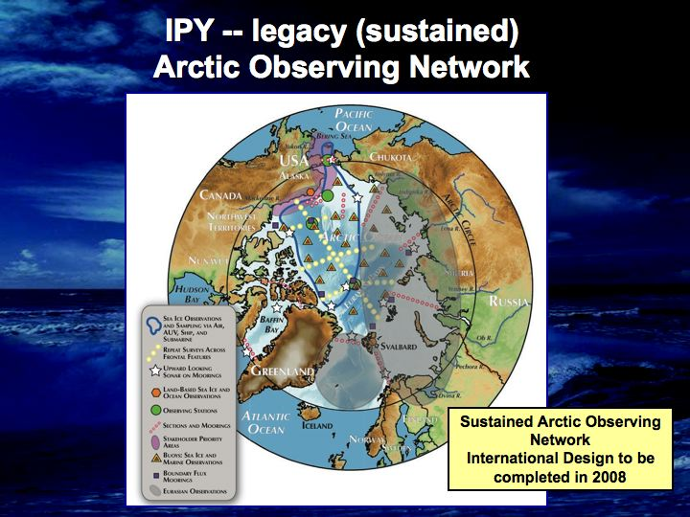

Figure 11: Conceptual Sustain Arctic Observing Network. The design will be finalized in 2008 by the international community.

Given the sensitivity of the Arctic environment to climate variability and change, it is in this region that early indications of the future progression of climate change are first being detected. A program of sustained observations of this area is being conducted through dedicated and shared ship-based cruises, permanent oceanographic moorings and gliders, ice buoys, supplemented by acquisition and analysis of historical data sets. The long-term goal is to detect climate-driven physical and ecological change, especially due to changes in sea ice extent and duration, and in ocean density and circulation that together may lead to changes in global ocean heat transport, productivity, and food web structure. In addition to ice beacons, ice-tethered buoys and bottom-mounted moorings are also deployed to monitor the drift of Arctic sea ice and to determine its thickness. This record of changes in sea ice extent and thickness, together with satellite observations of sea ice extent, provide the estimates of changes in sea ice volume. Given the rapid retreat of the sea ice cover in the summer and the increased presence of seasonal sea ice in the winter, a new deployment strategy using open ocean drifters as well as seasonal buoys that can survive through melt and freeze up cycles will be required in order to maintain a basin-wide distribution of buoy observations.

Over the past 20 or more years, NOAA has contributed with other government agencies through the U.S. Interagency Buoy Program (USIABP) to the support sea ice beacons and ice mass balance buoys purchasing, deployment, and data management. These data buoys, reporting through the National Ice Center’s Argos Program, form an essential part of the International Arctic Buoy Programme (IABP) tracking changes in the sea ice extent and age as well as providing pressure and temperature observations for numerical weather prediction. NOAA is also joining with other Federal agencies and international collaborators to begin a long-term effort to quantify the flux of fresh water from the Arctic to the North Atlantic. The initial steps will be made through deployment of moorings at critical locations in the Arctic.

In 2008, NOAA working with the NSF and international partners will develop an implementation plan for transitioning observational advances established by the research programs during the present International Polar Year (IPY) into a Sustained Arctic Observing Network (SAON). It is envisioned that NOAA will provide the programmatic focus within the United States for maintaining the SAON over the long term.

NOAA’s contributions to this subsystem are managed at the Pacific Marine Environmental Laboratory, the Environmental Sciences Research Laboratory, the National Ice Center, the Cooperative Institute For Arctic Research at the University of Alaska, the Joint Institute for Study of the Atmosphere and Ocean at the University of Washington, and through grants to several other universities.

Information from the Arctic Ocean is critical for improvement of global climate models, for development of a regional Arctic climate model, and for weather prediction. This subsystem supports climate services by providing ocean and ice measurements needed to document heat uptake, transport, and release by the ocean. The initial design for the Sustained Arctic Observing Network will be completed in 2008, but a preliminary estimate is that this subsystem is about 29% complete at present.

NOAA Contributions | FY06 | FY07 | FY08 | FY09 | NOAA Goal* | International Goal*
Ice buoys/ ice-tethered stations | 5 | 3 | 3 | 3 | 25 | 40
Arctic moorings | 3 | 8 | 8 | 8 | 10 | 15
Ship transects | 1 | 1 | 1 | 1 | 6 | 12
Coastal Climate Observatories | 2 | 2 | 2 | 2 | 4 | 6
International total, buoys, stations, transects | 18 | 21 | 21 | 38 | 73 | 73

Table 10: Milestones for implementing the subsystem of Arctic Ocean Observing Networks.
* Estimates. The initial design will be completed in 2008.

3.2.9 Dedicated Ships

Research vessel and dedicated ship support from the NOAA fleet and the UNOLS fleet for deployment of the moored and drifting arrays, and for deep ocean surveys, is an essential component of the global climate observing system. The deep ocean cannot be reached by SOOP and Argo; yet quantification of the carbon and heat content of the entire ocean column is needed to solve the climate equations. In addition to providing the survey and deployment platforms for the autonomous arrays, the research fleet maintains sensor suites on a small core of vessels as the highest quality calibration points for validation of the other system measurements. With the rapidly rising cost of oil, funding of ship operations is rapidly becoming a major challenge. Still, continuity in the climate record must be maintained.

This work is supported by the NOAA Office of Marine and Aviation Operations, with the Climate Observation Division supplementing the costs for fuel. Additionally, the Division provides charter funding for four projects on UNOLS ships and three cooperative projects with other countries.

This subsystem supports climate services by providing multi-use platforms for the ocean and atmosphere measurements needed to 1) document heat uptake, transport, and release by the ocean; 2) document ocean carbon sources and sinks; and 3) document the air-sea exchange of water and the ocean’s overturning circulation. The 100% requirement for ship days at sea to support NOAA’s contributions to the global ocean observing system is estimated to be 882 days; the present effort of 492 days is 56% of the requirement.

NOAA Contributions (days at sea) | FY06 | FY07 | FY08 | FY09 | NOAA Goal
Kai’imimoana TAO/TRITON operations | 222 | 240 | 240 | 235 | 240
TAO/TRITON additional | 40 | 40 | 40 | 40 | 45
PIRATA | 35 | 30 | 30 | 30 | 70
Carbon survey | 57 | 0 | 65 | 0 | 70
Coastal flux maps | 0 | 61 | 0 | 60 | 37
Reference stations | 54 | 48 | 61 | 54 | 176
Drifting arrays | 0 | 0 | 0 | 0 | 120
Western Boundary Current | 34 | 50 | 34 | 34 | 44
Weddell Sea moorings | 4 | 3 | 4 | 4 | 20
Arctic hydrographic sections | 18 | 20 | 18 | 35 | 60
Total NOAA contribution | 468 | 492 | 492 | 492 | 882

Table 11: Milestones for implementing the subsystem of Dedicated Ships.

3.2.10 Satellites

The Climate Observation Division program does not support satellite systems, but measurements from space are essential for climate observation and the in situ systems are designed to complement satellite capabilities. The initial ocean observing system for climate depends on space based global measurements of 1) sea surface temperature, 2) sea surface height, 3) ocean surface vector winds, 4) ocean color, and 5) sea ice.

Sea surface temperature: Satellite measurements of sea surface temperature are included in NOAA’s operational satellite program and the NPOESS program. Satellite data provide high-resolution sea surface temperature data. Both infrared and microwave satellite data are important. Microwave sea surface temperature data have a significant coverage advantage over infrared sea surface temperature data, because microwave data can be retrieved in cloud-covered regions while infrared cannot. However, microwave sea surface temperatures are at a much lower spatial resolution than infrared. In addition microwave sea surface temperatures cannot be obtained within roughly 50 km of land. A combination of both infrared and microwave data are needed because they have different coverage and error properties. Drifting buoy and other in situ data are critically important in providing calibration and validation in satellite data as well as providing bias correction of these data. Satellite biases can occur from orbit changes, satellite instrument changes and changes in physical assumptions on the physics of the atmosphere (e.g., through the addition of volcanic aerosols). Thus, drifting buoy and other in situ data are needed to correct for any of these changes. This task supports climate services by providing measurements needed to 1) document heat uptake, transport, and release by the ocean; and 2) document ocean carbon sources and sinks (sea surface temperature affects the rate of transfer of CO₂ between the ocean and atmosphere.

Sea surface height: Observations of sea level – the surface topography of the oceans – from satellite altimetry were initiated by the TOPEX/Poseidon mission in 1992, are being continued with Jason today, and will be extended by the Ocean Surface Topography Mission (OSTM/Jason-2) when launched in June, 2008 – missions implemented jointly by the French Space Agency (CNES) and NASA.
Looking to the future, NOAA and EUMETSAT – its operational counterpart in Europe – are working with NASA and CNES to transition satellite altimetry from a research capability into a sustained operational capability. They specifically are proposing to extend the Jason series of satellite altimeters beyond OSTM/Jason-2 by implementing a joint operational Jason-3 as a clone of OSTM/Jason-2. The involvement of both research and operational agencies in this effort reflects the view that the transition of satellite altimetry to operational status is ready to proceed.
Observations of the surface topography or surface pressure field from altimeters and the upper-ocean density field observed by the global array of Argo profiling floats are oceanic analogues to the surface pressure field from barometers and the density field from radiosondes and satellite profilers for the atmosphere. These two state variables, together with appropriate boundary conditions – the surface stress field from satellite scatterometers and air-sea flux fields derived from observations collected by buoys moored in the open ocean – are required to provide a dynamical basis for understanding and ultimately forecasting how physical processes in the global oceans:
  - Fuel hurricanes and winter storms,
  - Influence coastal variability and flooding,
  - Affect marine ecosystems and fisheries,
  - Impact seasonal and interannual droughts, and
  - Play a role in the changing climate as manifest in global sea-level rise.
With NOAA providing half of the overall effort, the international Argo program achieved global coverage of the ice-free oceans with 3,000 profiling floats in November 2007, and the 20+ countries involved are supporting the continuing collection of observations of the upper-ocean density field. However, continuing the record of surface topography beyond OSTM/Jason-2 requires the launch of Jason-3 at the end of 2012; this will provide an opportunity for the required 6-month overlap during the fifth year of the 5-year planned lifetime for OSTM/Jason-2. Once resources are secured for Jason-3, as has been done with Argo, attention can be directed toward funding for a scatterometer and completion of the set of air-sea flux buoys.

Ocean surface vector winds:

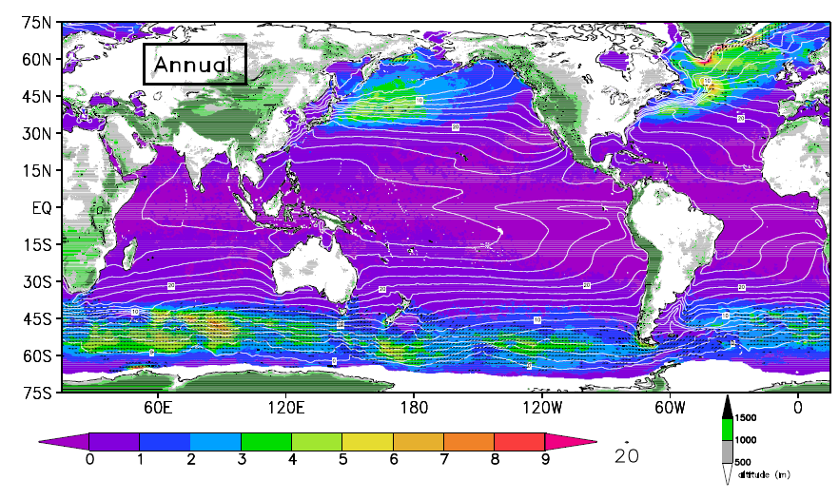
Figure 12. Annual high wind frequency climatology derived from 0.25 x 0.25 deg QuikSCAT wind data. Spatial variability of the high-wind frequency is associated with SST and coastal orography. Plot shows the frequency (color) along with SST climatology (contour), orography (shading over land), and the dominant direction of the high winds.

Winds over the ocean are the largest source of momentum for the ocean surface, and as such they affect the full range of ocean movement - from individual surface waves to complete current systems. Ocean surface vector winds (OSVW) also play a key role in regulating the earth’s water and energy cycles by modulating air-sea exchanges of heat, moisture, gases (such as carbon dioxide), and particulates. This modulation regulates the interaction between the atmosphere and the ocean, which establishes and maintains both global and regional climates.

The tropical Pacific Ocean and overlying atmosphere react to, and influence each other. Easterly surface winds along the equator control the amount and temperature of the water that upwells (moves or flows upward) to the surface. This upwelling of cold water determines sea-surface temperature distribution, which affects rainfall distribution. This in turn determines the strength of the easterly winds - a continuous cycle.

OSVW are required to compute air-sea fluxes and are used in numerical modeling of the ocean and atmosphere for weather and wave forecasts, biophysical interactions and climate studies. As such, characterization and quantification of the role of the global ocean as a planetary heat and carbon sink depends critically on the accurate representation of the global OSVW.

As one of most important dynamic atmospheric parameters OSVW has been traditionally observed from in situ platforms. Complementary ocean surface wind speed has been operationally observed from multiple satellites, starting from the single Defense Meteorological Satellite Program satellite F08 in July 1987 to the present 6 or more U.S. satellites alone. However the value and capability of satellite-based ocean surface vector winds has been clearly demonstrated with now over 8 years of nearly continuous OSVW data from the NASA QuikSCAT mission. QuikSCAT was designed by NASA to observe the tropical oceans, predict El Niño and other irregular climatic variations, and make climate predictions readily available for planning purposes. The 90% daily coverage of the world's oceans by QuikSCAT has also proven invaluable to NOAA's operational weather forecasting and warning mission.

The first high-resolution, observationally-based, online interactive atlas of global OSVW, has been created from QuikSCAT measurements. This atlas provides highly accurate, global information on wind statistics throughout Earth's oceans. These data are especially important in regions of the world where there are few ships and buoys to gather data. The resolution of the data is equivalent to having data from about 150,000 ocean buoys distributed uniformly across the global oceans.

Researchers have also compiled seven years of QuikScat data to create a never-before-available monthly atlas of how frequently high winds blow over the open ocean all over the world (Figure 12). High winds play an important role in Earth's climate. They remove heat from the ocean, leading to the formation of "deep water" cold, salty, dense water that helps drive global ocean circulation patterns. They also help exchange gases, such as carbon dioxide, between the oceans and the atmosphere, mix different types of ocean water, and pump nutrients up from the deep sea for plankton to feed on.

The National Research Council report “Earth Science and Applications from Space: National Imperatives for the Next Decade and Beyond” has recommended that the satellite scatterometer OSVW mission be transitioned to NOAA. NOAA is presently working to develop a plan for a sustained OSVW capability that is equal to or better than what is being provided today by QuikSCAT.

This subsystem supports climate services by providing measurements needed to 1) document heat uptake, transport, and release by the ocean; 2) document ocean carbon sources and sinks (ocean surface vector winds modulates air-sea exchanges of gases such as CO₂) and 3) document the air-sea exchange of water and the ocean’s overturning circulation.

Ocean color: Satellite-based ocean color observations have been demonstrated to be invaluable in climate studies by improving our understanding of ocean biology and biogeochemistry and the significant role of the ocean in the global carbon cycle (e.g., coupled with the atmosphere - CO₂ drawdown by phytoplankton, as well as land - terrestrial loadings into coastal waters). Ocean color data also provides the necessary information for the impacts of climate change on coastal and ocean ecosystems, including influences of climate on eutrophication, harmful algal blooms, primary productivity, fisheries, and protected habitats. However, it appears more than likely that there will be a break in the climate quality ocean color time-series as the NASA SeaWiFS and MODIS-Aqua missions are well into extended mission operations and the Visible/Infrared Imager/Radiometer Suite (VIIRS) on the NPOESS Preparatory Project (NPP) does not appear capable of providing climate-quality ocean color data for the U.S. research and applications communities. Efforts are now required to ensure that VIIRS on the operational NPOESS C1 platform will provide the necessary climate quality ocean color data streams, which also includes the need for a robust supporting calibration/validation program. Ocean color satellite sensors are unique in that laboratory and on-board sensor calibrations cannot meet the accuracy requirements for NOAA science applications. The needed level of uncertainty can only be achieved using vicarious-calibration. The Marine Optical Buoy (MOBY) has provided in situ vicarious calibration data since July 20, 1997 and has been the primary reference standard for climate quality ocean color data. All measurements are traceable to NIST radiometric standards and MOBY will transfer this standard between the first days of SeaWiFS, through the MODIS era, and into VIIRS linking all the ocean color sensors into one continuous observation. In addition, MOBY provides the capability to link foreign ocean color sensors into this climate data record. This task supports climate services by providing measurements needed to document ocean carbon sources and sinks.

Sea ice: Sea ice monitoring in both Polar Regions has been conducted since the 1970’s using originally passive microwave satellite observations for the most. Modern ice monitoring and charting utilizes a combination of passive and active microwave, visible and infrared satellite data. Of these, high resolution active microwave synthetic aperture radar (SAR) sensors are key in providing all-weather day and night detailed characterization of sea ice conditions. The use of relatively lower spatial resolution scatterometer data for sea ice monitoring and classification has also been successfully demonstrated with the exploitation of QuikSCAT. The NASA ICESat laser altimeter mission, although limited in temporal coverage, has also demonstrated the capability for sea ice thickness mapping from space from an active sensor, particularly over the Arctic region. While NOAA and NPOESS will continue to support passive microwave, visible and infrared sensors, there are no plans for active sensors such as those mentioned above. A proposal to develop a QuikSCAT extended ocean surface vector wind follow-on mission is under consideration by NOAA. Based on recommendations from the National Research Council’s Decadal Survey Report, NASA has also developed plans for the DESDynI (Deformation, Ecosystem Structure, and Dynamics of Ice) mission using an interferometric SAR (InSAR) and multiple beam lidar instruments, and for an ICESat II follow-on mission. Although the present availability of SAR data is very limited due to commercial pricing, plans are under development for NOAA and other U.S. government agencies to collaborate with the Canadian Space Agency in the RADARSAT-Constellation and with the European Space Agency in Sentinel-1 constellation, both future SAR operational missions planned to begin in the 2012-2013 time frame.

3.2.11 Data and Assimilation Subsystems

A robust and scalable data management infrastructure is essential to the vision of a sustained ocean observing system. The data streams generated by the Global Component depend on the Data Management and Communications System (DMAC) of the U.S. Integrated Ocean Observing System (IOOS). The Climate Observation Division contributes to the advancement of DMAC in partnership with the NOAA IOOS Program. The DMAC plan integrates data transport, quality control, data assembly, limited product generation, metadata management, data archeology, data archival, data discovery, and administration functions. Uniform access to data will be addressed through the concept of “middleware” connectivity – a common set of standards and protocols that connects all data sources to data users. The middleware approach shields end users from many of the traditional barriers that have been associated with climate data access, including file formats, the distributed location of data, and the large size of some data sets.

The GODAE server system presently operated by Navy’s Fleet Numerical Meteorology and Oceanography Center (FNMOC) in Monterey provides web access to aggregated and quality-controlled real-time data streams and is a primary assembly center for real-time global measurements (a complementary service is provided by IFREMER in France). The GODAE experimental period ended in 2007. The international GODAE server system is central to the sustained integrated ocean observing system and the server functions that have been developed during GODAE must be continued. The Climate Observations Division provided partial support for GODAE server operations in 2008 to maintain the service through this transition year until the Division, working with Navy and the IOOS Program, develops an implementation plan for sustaining the GODAE server functions either at FNMOC or some other location in the U.S.

For climate forecasting, the combined fields from many different networks are used as initial conditions to begin the forecast. These combined fields, or analyses, are also used to document what the ocean and atmosphere are doing at present and what they did in the past, thus providing a record of the changing climate. By routinely comparing models and data, shortcomings in the observing system can be identified and both the models and forecasts can be improved. To utilize effectively the ocean observations, NOAA is developing and implementing assimilation systems, primarily at NOAA’s National Centers for Environmental Prediction and at NOAA’s Geophysical Fluid Dynamics Laboratory. The Climate Observation Division provides partial support for developing assimilation techniques for ocean initialization of seasonal climate forecasts, and decadal forecasts of ocean heat uptake, thermohaline circulation, and developing the capability for monitoring changes in oceanic carbon sources and sinks.

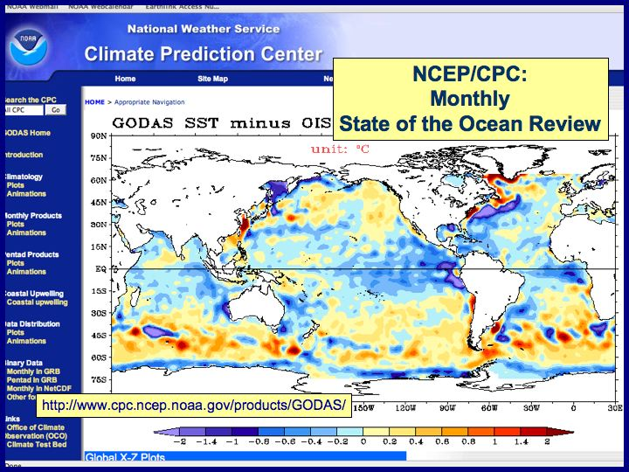

Figure 13: Satellite and in situ observations are combined in data assimilation models to produce a best-estimate of the state of the ocean. The state of the ocean is then used to drive the forecast models that are used for climate and weather prediction. The output from the NOAA Global Ocean Data Assimilation System (GODAS) is publicly reviewed in monthly briefings by the NOAA Climate Prediction Center to evaluate the ever-changing state of the ocean.

Central to delivering data from the drifting buoys, moored buoys, and Argo floats, is real-time transmission of data from sea to shore-side processing centers via satellite communications. NOAA satellites provide two environmental data collection capabilities, the Argos Data Collection and location System (DCS) and the GOES Data Collection System (DCS). The Argos DCS is on NOAA polar orbiting satellites and provides global capability to collect in situ observations and locate those platforms. The GOES DCS instrument is on the Geostationary NOAA satellites and provides data collection capabilities for the western hemisphere. The GOES DCS currently supports in situ platforms providing key observational networks for the US Geological Survey, National Weather Service, and the National Ocean Service. Future planning for Sustained Global Ocean Observing System for Climate must coordinate satellite collection requirements with DCS system evolution. Changes in capacity, data through put, data timeliness are examples of parameters that can be addressed on future satellite capabilities.

NOAA’s Climate Observation Division is the largest single government user of the Argos system in the world today. Data from the ocean climate platforms is received, processed, and distributed by a subsidiary of the French government, CLS America, in Largo MD; this service is supported through user fees. The Climate Observation Division pays the user fees for all of the NOAA platforms reporting as components of the global ocean observing system.

The data management and communications work is being coordinated internationally with the World Meteorological Organization’s WMO Information system (WIS). Data management is a part of all the subsystem projects, with principal system-wide integration and assimilation activities occurring at NOAA’s Pacific Marine Environmental Laboratory, National Centers for Environmental Prediction, and Geophysical Fluid Dynamics Laboratory.

This work supports climate services by providing the integrating data, synthesis, assimilation, and analysis infrastructure for the ocean measurements, both in situ and space based, needed to: 1) document long-term trends in sea level change; 2) document heat uptake, transport, and release by the ocean; 3) document ocean carbon sources and sinks; and 3) document the air-sea exchange of water and the ocean’s overturning circulation.

    - Management and product delivery

The subsystems are being implemented by 22 distributed centers of expertise within NOAA and the external community. The contributions of these centers are noted above in each of the sub-system sections. Operations are detailed by the project managers in their individual annual reports, which are compiled each year into the Annual Report on the State of the Ocean Observing System for Climate. The Annual Report is available at www.oco.noaa.gov. Global ocean observing system work at these centers of expertise is supported through directed funding from the Climate Observation Division.

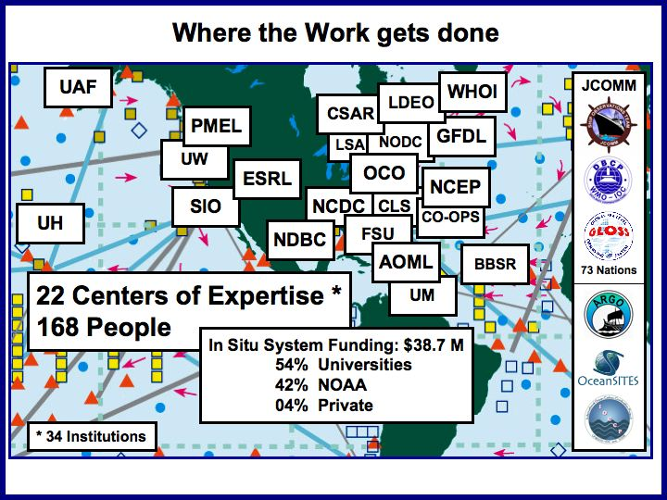

Figure 14: Centers of Expertise. The system is being implemented by 22 distributed centers of expertise within NOAA and the external community:
- NOAA Atlantic Oceanographic and Meteorological Laboratory (AOML), Miami FL
  - Surface drifting buoy, Argo, ships of opportunity, ocean carbon, and ocean reference station operations; global data assembly center operations; data analysis
- NOAA Pacific Marine Environmental Laboratory (PMEL), Seattle WA
  - Tropical moored buoy, Argo, ocean carbon, and ocean reference station operations; technology development; data analysis; data management; observing system research
- NOAA Environmental Sciences Research Laboratory (ESRL), Boulder CO
  - Ocean reference station and dedicated ship operations; data analysis
- NOAA Geophysical Fluid Dynamics Laboratory (GFDL), Princeton NJ
  - Data assimilation and analysis
- University of Hawaii (UH), Joint Institute for Marine and Atmospheric Research (JIMAR), Honolulu HI
  - Tide gauge station operations; global data assembly center operations; data analysis
- Scripps Institution of Oceanography (SIO), Joint Institute for Marine Observations (JIMO), La Jolla CA
  - Surface drifting buoy, Argo, ships of opportunity, and ocean reference station operations; technology development; data analysis
- Woods Hole Oceanographic Institution (WHOI), Cooperative Institute for Climate and Ocean Research (CICOR), Woods Hole MA
  - Ocean reference station and ships of opportunity operations; technology development; data analysis
- University of Washington (UW), Joint Institute for Study of the Atmosphere and Ocean (JISAO), Seattle WA
  - Argo and Arctic ocean observing system operations; data analysis; observing system research
- University of Miami (UM), Cooperative Institute for Marine and Atmospheric Studies (CIMAS), Miami FL
  - Ocean carbon, dedicated ship operations; data analysis
- Columbia University, Lamont Doherty Earth Observatory (LDEO), Cooperative Institute for Climate Applications Research (CICAR), Palisades NY
  - Ocean reference station operations; data analysis
- University of Alaska at Fairbanks (UAF), Cooperative Institute For Arctic Research (CIFAR), Fairbanks AK
  - Arctic ocean observing system operations; data analysis
- NOAA National Climatic Data Center (NCDC), Asheville NC
  - Data management; observing system research; data analysis
- NOAA National Oceanographic Data Center (NODC), Silver Spring MD
  - Data management; data analysis
- NOAA National Geophysical Data Center (NGDC), Boulder CO
  - Data management
- NOAA National Data Buoy Center (NDBC), Stennis MS
  - Tropical moored buoy operations; data assembly center operations
- NOAA Center for Operational Ocean Products and Services (CO-OPS), Silver Spring MD
  - Tide gauge station operations; data management; data analysis
- NOAA National Centers for Environmental Prediction (NCEP), Camp Springs MD
  - Data assimilation; data analysis
- Florida State University (FSU), Center for Ocean-Atmosphere Prediction Studies (COAPS), Tallahassee FL
  - Data assembly center operations; data analysis
- CLS America (CLS), Largo MD
  - Satellite communications system operations; data processing and management
- Bermuda Biological Station for Research (BBSR), Bermuda
  - Ocean carbon data analysis
- NOAA Laboratory for Satellite Altimetry (LSA), Silver Spring MD
  - Sea level data analysis
  - NOAA Climate Observation Division, Office of Climate Observation (OCO), Silver Spring MD
  - System-wide monitoring, evaluation, evolution, coordination, review, and reporting.

To weld the distributed efforts together into the single vision, the Division has established the Project Office for Climate Observation (OCO) to accomplish integrative tasks that span all subsystems. The platform managers monitor and evaluate the performance of their individual networks, while the project office is building the capability to monitor and evaluate the performance of the system as a whole, and to take action to evolve the in situ subsystems for overall effectiveness and efficiency in meeting climate observation objectives. The OCO provides a central point of contact within NOAA for coordination with the other agencies and nations involved in global observing system implementation. The office receives and acts on feedback from the observing system customers - the operational forecast centers, international research programs, and major scientific assessments. The OCO management plan is based on six tasks:

Task 1 -- System Monitoring: The OCO monitors the status of the globally distributed networks to anticipate gaps and overlaps in their combined capabilities. Real-time reports from all platforms are being centralized so that up-to-date status can be displayed at all times. The office is working to report system statistics and metrics, routinely and on demand.

Task 2 – Evaluation: A team of expert scientists both internal and external to NOAA has been established to continually evaluate the effectiveness of the networks for production of ocean analyses and the adequacy of the analyses (see Requirement Drivers above) for meeting the system objectives. The job of the team of experts is to develop and evaluate analysis/synthesis products, recommend product improvements, recommend where additional sampling is needed or redundancies are not needed, recommend better utilization of existing and new in situ and satellite data, and assess the impacts of proposed changes to the system.

Task 3 – Taking action to evolve the in situ subsystems: System monitoring and evaluation are useless unless there is responsive action taken to build the system, fix problems, and improve sampling strategies. Decisions must be made to implement the best solutions to conflicting requirements (multiple partners and customers have differing missions and will inevitably have differing requirements), to re-deploy existing resources to best improve the system, to select the highest priorities for system extensions and funding of new ideas, and to agree on quid pro quo with interagency and international partners. The OCO is charged with evolving the system for maximum effectiveness and efficiency, through directed funding.

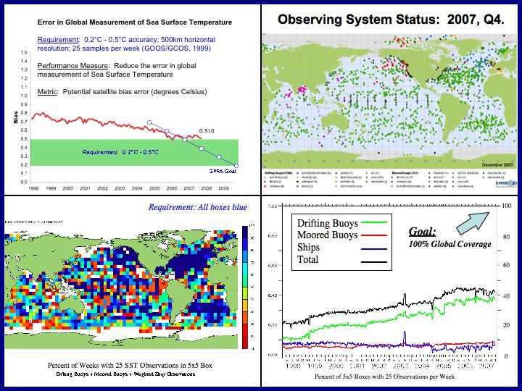

Figure 15: Quarterly Observing System Status reports are developed and used by the Office of Climate Observation (OCO) to monitor progress and evaluate the effectiveness of the system for observing essential climate variables (ECVs). This example for December 2007 shows that 43% of the ocean is presently being observed adequately for measurement of sea surface temperature to the required accuracy.

Task 4 – Intra-agency, Interagency, and International Coordination: National and international coordination is essential to success in building the global ocean observing system for climate. The OCO is co-located with the NOAA IOOS Program Office for Intra-agency coordination, and is co-located with the Ocean.US national office for coordination with the other Federal ocean agencies. One Division employee is assigned to the JCOMM secretariat at the Intergovernmental Oceanographic Commission in Paris in for international coordination. Additionally, the Chief of the Division serves as Observations Program Area Coordinator for JCOMM, and many of the sponsored project managers participate in the technical panels and expert teams of JCOMM.

In addition to dedicated infrastructure needed for the Division to operate its project office, dedicated infrastructure is also needed for operation of the interagency and intergovernmental planning and implementation coordination organizations. These interagency/international organizations rely on funding from the member counties and agencies for their support. The Division has historically provided approximately half of the funding needed to maintain the existing international secretariats, science and implementation panels, and capacity building efforts of GOOS, GCOS, and the JCOMM. This support is essential for doing business cooperatively in coordination with many international partners. As a central component of sustaining the long-term global climate observing system, support for the national/international coordination/implementation infrastructure is being institutionalized via the OCO.

Task 5 – Annual Report on the State of the Ocean and the Ocean Observing System for Climate: The organizing framework to bring the multiple elements of the composite ocean observing system together is the routine delivery of an Annual Report on the State of the Ocean and the Ocean Observing System for Climate. The theme of the Annual Report is describing the current state of the ocean, how it compares with the past, and how observations can be improved to better initialize and validate models for prediction or long term projections. Prior to 2007, the authors of OCO’s State-of-the-Ocean section of the Annual Report were also contributing the ocean articles to the annual special edition of the Bulleting of the American Meteorological Society (BAMS) State of the Climate publication. In 2007, in order to eliminate the somewhat duplicate effort by the authors, the State-of-the-Ocean section of the OCO Annual Report was eliminated, noting that the BAMS special editions provide this annual analysis instead. The OCO Report now is simply the Annual Report on the State of the Ocean Observing System for Climate. These reports are available from www.oco.noaa.gov.

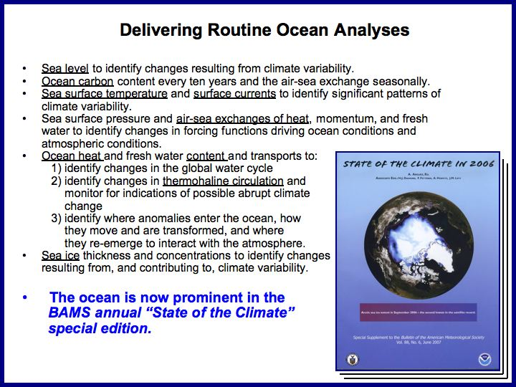

Figure 16: Product delivery. The OCO-sponsored team of experts are the principle authors of the ocean chapter of the annual BAMS State of the Climate special edition.

Task 6 – User feedback and external review:

Climate Observing System Council: The execution of the Climate Observation Division program is subject to normal management review in accordance with NOAA’s Requirements-Based Management Process. Additionally, for specific programmatic advice and guidance, the Climate Observing System Council (COSC) has been established to review the program’s contribution to the international Global Climate Observing System and to recommend effective ways for the program to respond to the long-term observational needs of the operational forecast centers, international research programs, and major scientific assessments. The Council is comprised of 10 members both internal and external to NOAA who individually offer their expert advice; the members are not expected to develop consensus opinions. The Council meets at least annually to bring to the Division a broad view on national and international climate research and operational activities, and to review the status of the system, the accomplishments, the priorities, the future plans, and the balance of activities within the context of NOAA’s overarching climate service requirements.

Annual System Review: The Climate Observation Division hosts a three-day Annual System Review meeting each year in the May time-frame for community-wide input to program management and strategic planning. The meeting is open to all interested stakeholders, partners, and data users. In particular, the OCO project managers, the COSC, partner program managers from other agencies and counties, and system users such as NCEP, GFDL, the International Research Institute for Climate and Society, and the U.S. CLIVAR Project Office are invited to collectively review the state of the observing system and provide recommendations for future direction. This annual process establishes a formal mechanism for implementing a “user-driven” observing system and for regular review of the system’s performance in meeting the requirements of operational and research data users, and for providing formal recommendations for system improvement and evolution.

4.0 Costs

The costs for operating NOAA’s contributions to the global system are summarized in Table 12 below. In FY 2008, the annual operating cost will be $56.6 million. Within NOAA’s present budget structure, the global ocean observing system for climate is funded from three separate line items:

- OAR, Climate Research, Laboratories and Cooperative Institutes
- OAR, Climate Research, Competitive Research Programs
- NWS, Local Warnings and Forecasts

Table 12 shows the recent funding history and projections through FY 2009. The present funding level provides for operation of the global system at 60% capability. NOAA provides 24% of this international capability and other agencies and nations provide 36%. In the United States, the only other agency that provides a significant contribution to the in situ system is the National Science Foundation, adding 1% for a total U.S. contribution of 25%. The other countries provide 35%.

The right-hand column of Table 12 shows the estimate of the annual operating cost that would be needed to maintain NOAA’s contribution to the system at 100% capability -- $142.0 million. This estimate assumes that NOAA will continue to contribute approximately half of the international effort as the system advances. NOAA has historically contributed approximately half.

Note: NOAA’s goal is to contribute approximately half of the international effort. Although the calculations of the 60% index indicate that NOAA provides just 24%, which is less than half of the 60% index, NOAA presently contributes 3860 of the 7723 active platforms in the ocean, which is almost exactly half. The discrepancy is an artifact of the way the index is calculated. The index calculation includes sensors as well as platforms. The index is not derived from an exhaustive list of observing system assets, but is used as a representative indicator to track progress. Regardless of this discrepancy between the index and the platform count, it can be said that NOAA presently provides nearly half of the system, and NOAA’s goal is to continue to provide international leadership by sponsoring approximately half of the complete global ocean observing system for climate.

Table 12 shows that over the past three years, NOAA’s observing system budget has increased at an average rate of about $1 million per year. At this rate it will take in excess of 50 years to achieve an annual operating budget of $142.0 million, which is the estimate for NOAA’s contribution to complete implementation of the initial system. The growing demand for climate information may, however, necessitate acceleration of funding in order to complete the system sooner rather than later. If funding levels were to be accelerated, the soonest NOAA could complete its contribution would be 2014. This schedule is based on an analysis of the “executable gap.” The executable gap is limited by NOAA’s ability to implement new system expansions with available management and infrastructure capabilities. The maximum budget increase per year that could be accommodated, the executable gap, is estimated to be $16.8 million. A steady ramp up of $16.8 million increase per year for the next five years therefore describes the optimum multi-year plan to reach 100% capability as soon as possible (see Figure 17 below). NOAA does not have this accelerated ramp presently programmed.

It is estimated that NOAA’s target of $142.0 million would provide approximately an 81% solution, even if the other agencies and countries did not increase their present contributions; i.e., the global system would be 81% complete, measured against the initial design. NOAA’s strategy, however, is to continue work actively in the international arena to encourage other nations to advance their contributions as NOAA advances its contribution. Implementation of the initial Global Ocean Observing System, as defined in GCOS-92, is a priority of the UNFCCC and is a commitment of the G8. It has been endorsed by the Group on Earth Observations (GEO) as the ocean baseline of the Global Earth Observation System of Systems (GEOSS). NOAA provides international leadership in particular through ongoing and continuous work within the Observations Coordination Group of the JCOMM.

The funding level in Table 12 for 2009 is still an estimate. Actual funding for 2009 has not yet been allocated. The funding for the global ocean observing system does not reside within a dedicated budget line, so the actual allocations are balanced each year against other NOAA priorities within the three budget lines listed above.

In 2007, 54% of the funding allocated to the Climate Observation Division was directed to cooperative institutes and university partners, 42% was directed to the NOAA laboratories and centers, and 4% was directed to private industry. It is anticipated that a similar distribution of funding will occur in 2008, 2009, and the out years.

Table 12: Annual operating costs for NOAA’s contribution to the Global Ocean Observing System.

In Table 12, a line for NOAA Laboratory Infrastructure is included. This is the basic infrastructure that is essential for supporting observing system implementation, and is accounted by NOAA as part of the Global Ocean Observing System budget. This cost includes rent, utilities, and equipment at AOML and PMEL for the offices, laboratories, shops, and warehouse facilities that support observing system implementation; it includes the cost of operating machinery and support vehicles; and it includes the salaries for scientists, engineers, technicians, and administrative staff at AOML and PMEL that are not billed directly to any single subsystem but support system implementation overall.

Milestones for the individual subsystems are tabulated in Section 3.2. Figure 17 illustrates representative milestones from the subsystems, and projects overall progress toward system completion, based on current programming. Current programming will advance the system from 60% to 63% complete.

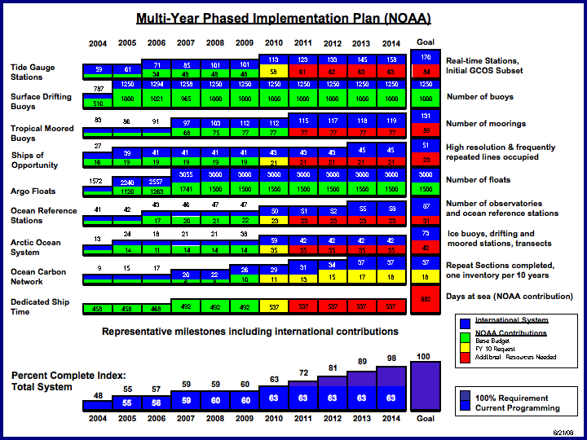

Figure 17: Multi-year phased implementation plan. Note: at the time of this update, the FY 2010 budget request (reflected by the yellow boxes) is under consideration but has not been approved.

5.0 Performance Measures

Based on the sampling requirements in Table 1 and the implementation strategies defined in the foundation documents listed in Appendix A, the system’s effectiveness in meeting the objectives will be gauged by the performance measures listed below. The goal is to reduce measurement errors to limits acceptable for documenting climate scale changes in the ocean. The reduction of measurement error depends directly on achieving complete global coverage by the in situ networks, in conjunction with continuous satellite missions. The present number of data buoys, floats, ships, and tide gauge stations is not adequate. Global coverage can be achieved only by deploying additional platforms to fill the gaps.

The “outcome” performance measures detailed below will quantitatively demonstrate why 100% global coverage is necessary to adequately document climate variability and change in the ocean. These performance measures, including the percentage of global coverage, will provide a quantitative way to evaluate the effectiveness of the ocean observing system for delivering climate outcomes.

5.1 Increase the percentage of in-situ global ocean observing system implemented

- PM short title: Global Ocean Observing System - GOOS Implemented
- Indicator: % Implemented against international plan
- Unit of Measure: Cumulative total % completed. (Based on combined units deployed for all observing system networks)
- Type: Outcome
- Baseline FY/Target: FY 03/45%
- Targets FY 07-15: Refer to Tables below.
- 100% FY/Target: FY 15/100%
- Reporting Frequency: Quarterly
- Source of data: Office of Climate Observation (OCO)
- Person Reporting Progress on the Target: Derrick Snowden, OCO
- Approving Individual: Mike Johnson, OCO
- State of Development: Well Developed.
- Explanation: This measure documents NOAA’s progress in deploying an internationally agreed upon ocean observing system for climate. The original target for international and U.S./NOAA 100% completion was FY 10. Target completion is now FY 15. The delay is due to funding profiles less than the executable gap, which is $16.8M/yr. The maximum rate of execution (executable gap) is limited by the ability to augment implementation work with existing infrastructure.
- Verification: The data is verified by the NOAA OCO working in partnership with the GOOS Project Office at UNESCO in Paris.
- Baseline/Target Metadata: This measure is calculated by tracking observing system network deployments (most networks are tracked online) and comparing progress against the planned deployments for each network. This performance measure is an index that has been developed for tracking progress toward implementation of the initial system design. There are 17 platforms and sensors that have been identified as initial targets for tracking purposes; they do not constitute an exhaustive list of observing system assets; but they provide representative milestones to help gauge progress toward global coverage. The index is the average of the 17 individual percentages; no effort has been made to weight the various components of the observing system in calculating this index.

5.2 Reduce the error in global measurement of sea surface temperature

- PM short title: Sea Surface Temperature
- Indicator: Reduce Error (Potential satellite bias error.)
- Unit of Measure: Degrees Celsius (ºC)
- Type: Outcome {Global sea surface temperature analysis (maps)}
- Baseline FY/Target: FY 03/0.7ºC
- Targets FY 07-15: Refer to Tables below.
- 100% FY/Target: FY 12/0.3ºC
- Reporting Frequency: Quarterly
- Source of Data: Office of Climate Observation (OCO)
- Person Reporting Progress on the Target: Richard W. Reynolds, NCDC
- Approving Individual: Mike Johnson, OCO
- State of Development: “Well Developed”
- Explanation: The 100% target can be reached by the end of FY 12 with an augmented budget profile; the target cannot be reached with the current budget profile. Sea surface temperature is the single most important ocean variable for determining the heat and water cycles. It is also a critical variable for determining global ocean carbon fluxes. Achieving an acceptable error target of 0.3 ºC (within the acceptable range specified by GCOS) is the number one priority of the ocean program.
- Verification: The data are verified by the NOAA National Climatic Data Center.
- Baseline/Target Metadata: The difference between satellite measurements and surface measurements is calculated for all 1000 kilometer square regions of the global ocean surface. The differences for all regions are then averaged. The average difference produces a single indicator number for the global ocean. That indicator is calculated monthly and graphed in a time series.

5.3 Reduce the error in global measurement of sea level change

- PM short title: Sea Level
- Indicator: Reduce Error (Difference between tide gauge measurements and satellite altimeter measurements of sea level trend.)
- Unit of Measure: mm/yr
- Type: Outcome
- Baseline FY/Target: FY 06/5.1 mm/yr
- Targets FY 07-15: Refer to Tables below.
- 100% FY/Target: FY 11/2 mm/yr
- Reporting Frequency: Quarterly
- Source of Data: Office of Climate Observation (OCO)
- Person Reporting Progress on the Target: Mark Merrifield, UHSLC
- Approving Individual: Mike Johnson, OCO
- State of Development: Developed/Experimental
- Explanation: This new outcome-based performance measure provides a quantifiable metric for evaluating the effectiveness of the tide gauge network.
- Verification: Data are verified by the University of Hawaii Sea Level Center.
- Baseline/Target Metadata: N/A

5.4 Reduce the error in global measurement of ocean heat content

- PM short title: Ocean Heat
- Indicator: Reduce Error (difference between in situ upper ocean heat and altimetry-derived heat)
- Unit of Measure: Joules/m²x10⁹
- Type: Outcome
- Baseline FY/Target: FY 02/2.8 Joules/m²x10⁹
- Targets FY 07-15: Refer to Tables below.
- 100% FY/Target: FY 15/0.5 Joules/m²x10⁹
- Reporting Frequency: Quarterly
- Source of Data: Office of Climate Observation (OCO)
- Person Reporting Progress on the Target: Claudia Schmid, AOML
- Approving Individual: Mike Johnson, OCO
- State of Development: Developed- Experimental – routine quarterly reporting underway.
- Explanation: This new outcome-based performance measure will provide a quantifiable metric for evaluating the observing system’s ability to deliver fundamental climate information.
- Verification: Data are verified and quality controlled by AOML.
- Baseline/Target Metadata: N/A

5.5 Reduce the error in global measurement of ocean carbon sources and sinks

- PM short title: Ocean Carbon
- Indicator: Uncertainty in seasonal CO₂ flux maps
- Unit of Measure: Petagrams of carbon per year (Pg C yr ⁻¹)
- Type: Outcome
- Baseline FY/Target: FY07/TBD
- 100% FY/Target: TBD
- Reporting Frequency: Quarterly
- Source of Data: Office of Climate Observation (OCO)
- Person Reporting Progress on the Target: Chris Sabine, PMEL
- Approving Individual: Mike Johnson, OCO
- State of Development: Being developed. The first global flux maps were developed in 2006. Efforts are currently underway to make robust assessments of unbiased uncertainty.
- Explanation: This measure directly evaluates NOAA’s progress in reducing the uncertainty in estimates of ocean carbon uptake, and is the first step toward achieving an accurate evaluation of the sources and sinks of carbon in the world's ocean. The stated goals for reducing uncertainty will only be achieved with an enhanced in situ ocean carbon network.
- Verification: Data will be verified by PMEL and AOML.
- Baseline/Target Metadata: N/A

5.6 Number of ocean climate state variables reported

- PM short title: Ocean State Variables Reported
- Indicator: Essential Ocean Variables Reported (15 essential climate variables listed in the international GCOS Adequacy Report: a) surface: sea surface temperature, sea surface salinity, sea level, sea state, sea ice, currents, ocean color, carbon dioxide partial pressure; b) sub-surface: temperature, salinity, currents, nutrients, carbon, ocean tracers, phytoplankton)
- Unit of Measure: Cumulative Total Number reported.
- Type: Output (Scientific information derived from observation of the global ocean.)
- Baseline FY/Target: FY 03/2
- Targets FY 07-15: Refer to Tables below.
- 100% FY/Target: FY 15/15
- Reporting Frequency: Annual
- Source of data: Office of Climate Observation (OCO)
- Person Reporting Progress on the Target: Joel Levy, OCO
- Approving Individual: Mike Johnson, OCO
- State of Development: “Well Developed”
- Explanation: 100% Target is FY 15 for regularly reporting the 15 essential ocean variables. All climate variables need to be analyzed routinely, with error bars, even before the observing system is completed, to reduce the measurement errors to acceptable limits. Consequently this PM contributes to “a predictive understanding of the global climate system on time scales of weeks to decades with quantified uncertainties sufficient for making informed and reasonable decisions.” The essential climate variables describe the ocean’s contribution to Earth’s climate. The variables are reported annually in the ocean chapter of the State of the Climate BAMS Special Edition. The BAMS articles quantify uncertainties in our present understanding of the climate, and thus help quantify how well the global ocean observing system is doing its job and how the system needs to evolve in order to reduce the uncertainties.
- Verification: Peer review prior to publication. Analyses that are not scientifically sound will not be published.
- Baseline/Target Metadata: N/A

  - Performance Measure profiles and application to Outputs and Outcomes

100% Budget Profile Performance Measures
Performance Measure  & Unit of Measure | FY07 | FY08 | FY09 | FY10 | FY11 | FY12 | FY13 | FY14 | FY15
Reduce the error in global measurement of sea surface temperature (degrees Celsius) | 0.53 | 0.53 | 0.53 | 0.50 | 0.40 | 0.30 | 0.30 | 0.30 | 0.30
Reduce the error in global measurement of sea level change  (mm/yr) | 5.1 | 4.3 | 3.5 | 2.7 | 2.0 | 2.0 | 2.0 | 2.0 | 2.0
Reduce the error in global measurement of ocean carbon sources and sinks (PgC/yr) | TBD | TBD | TBD | TBD | TBD | TBD | TBD | TBD | TBD
Reduce the error in global measurement of ocean heat storage  (Joules/m²x10⁹) | 2.1 | 1.7 | 1.7 | 1.4 | 1.1 | 0.9 | 0.8 | 0.7 | 0.5
Deployed global observing systems (percent complete) | 59 | 59 | 60 | 60 | 72 | 81 | 89 | 98 | 100
Number of ocean climate state variables reported | 6 | 8 | 8 | 9 | 11 | 12 | 13 | 14 | 15

Table 13: 100% Requirement Budget Profile Performance Measures. This table shows the executable ramp – if adequate funding were available, the performance measures could advance at this rate. This budget profile is not presently programmed.

Current Program Budget Profile Performance Measures
Performance Measure  & Unit of Measure | FY07 | FY08 | FY09 | FY10 | FY11 | FY12 | FY13 | FY14 | FY15
Reduce the error in global measurement of sea surface temperature (degrees Celsius) | 0.53 | 0.53 | 0.53 | 0.50 | 0.50 | 0.50 | 0.50 | 0.50 | 0.50
Reduce the error in global measurement of sea level change  (mm/yr) | 5.1 | 4.3 | 3.5 | 2.7 | 2.7 | 2.6 | 2.6 | 2.6 | 2.6
Reduce the error in global measurement of ocean carbon sources and sinks (PgC/yr) | TBD | TBD | TBD | TBD | TBD | TBD | TBD | TBD | TBD
Reduce the error in global measurement of ocean heat storage  (Joules/m²x10⁹) | 2.1 | 1.7 | 1.7 | 1.4 | 1.1 | 1.1 | 1.1 | 1.1 | 1.1
Deployed global observing systems (percent complete) | 59 | 60 | 60 | 63 | 63 | 63 | 63 | 63 | 63
Number of ocean climate state variables reported | 8 | 8 | 8 | 9 | 11 | 12 | 12 | 12 | 12

Table 14: Current Program Budget Profile Performance Measures. This table shows the estimated advancement of system performance given the budget profile that is presently programmed. The target system performance cannot be achieved at this rate.

 | Outcomes
Performance Measures | Sea level | Ocean carbon | SST, surface currents | Air-sea exchange | Ocean heat & transport | Sea ice
Reduce the error in global measurement of sea surface temperature |  | X | X | X | X | X
Reduce the error in global measurement of sea level change | X |  |  |  | X
Reduce the error in global measurement of ocean carbon sources and sinks |  | X
Reduce the error in global measurement of ocean heat storage | X |  |  |  | X | X
Deployed global observing systems (percent complete) | X | X | X | X | X | X
Number of ocean climate state variables reported | X | X | X | X | X | X

Table 15: Performance measure linkages to outcomes. This table illustrates how the performance measures are applied to the evaluation of the observing system’s effectiveness in delivering the specified outcomes.

 | Performance Measures
OUTPUT Capacity | SST | Sea  Level | Ocean  Carbon | Ocean  Heat | System  Percent | Variables  Reported
Tide Gauge Stations |  | X |  |  | X
Drifting Buoy Array | X | X | E | X | X
Tropical Moored Buoy Network | X | X | X | X | X
Ships of Opportunity | X | X | X | X | X
Argo Profiling Float Array |  | X | E | X | X
Ocean Reference Stations | X | X | X | X | X
Ocean Carbon Networks |  |  | X | X | X
Arctic Observing System | X | X | E | X | X
Data and Assimilation | X | X | E | X | X
Analysis and Product Delivery | X | X | X | X | X | X

Table 16: Sub-system linkages to the Performance Measures. The ocean observing system is a composite of complementary networks (sub-systems), each one contributing its unique strengths; most serve multiple purposes. This table illustrates how the performance measures apply to monitoring the effectiveness of the individual subsystems. (E: exploratory phase -- its utility is currently being investigated in research projects).

6.0 Conclusion

NOAA is committed to building and sustaining the global ocean observing system for climate, in cooperation with national and international partners. The system is at present, however, just 60 percent complete, when compared to the initial design targets documented in the GCOS-92 implementation plan. These design targets have been endorsed nationally by the CCSP and IOOS, and internationally by GOOS, GCOS, JCOMM, GEOSS, the WCRP, the UNFCCC, and the G8. The GCOS Second Report on the Adequacy of the Global Observing System for Climate in Support of the UNFCCC concludes that “the ocean networks lack global coverage and commitment to sustained operations … Without urgent action to address these findings, the Parties will lack the information necessary to effectively plan for and manage their response to climate change.” The road map is clear. NOAA’s commitment is clear. But there is still much to be done. Global coverage cannot be achieved with existing resources. Additional resources will be needed to complete and sustain a global ocean observing system that is adequate for understanding and predicting Earth’s ever-changing climate.

Appendix A

Foundation Documents

Observing the Oceans in the 21st Century, edited by Chester J. Koblinsky and Neville R. Smith, 2001, GODAE Project Office, Bureau of Meteorology, Melbourne, Australia, ISBN 0642 70618 2.

OCEANOBS 99, proceedings of the International Conference on the Ocean Observing System for Climate, GCOS/GOOS/WCRP Ocean Observations Panel for Climate and the CLIVAR Upper Ocean Panel, Saint-Raphael, France, October 1999.

International Sea Level Workshop Report, GCOS/GOOS/WCRP Ocean Observations Panel for Climate and the CLIVAR Upper Ocean Panel, April 1998, GCOS #43, GOOS #55, ICPO #16.

A Large Scale CO₂ Observing Plan: In Situ Oceans and Atmosphere (LSCOP), a contribution to the implementation of the U.S. Carbon Cycle Science Plan by the In situ Large-Scale CO₂ Observations Working Group, April 2002.

Implementation Plan for the Global Observing System for Climate in support of the UNFCCC (GCOS-92), the Global Climate Observing System, October 2004, GCOS #92, WMO/TD #1219.

Appendix B

List of Acronyms

AOML Atlantic Oceanographic and Meteorological Laboratory
BAMS Bulletin of the American Meteorological Society
BBSR Bermuda Biological Station for Research
CCSP Climate Change Science Program
CICAR Cooperative Institute for Climate Applications Research
CICOR Cooperative Institute for Climate and Ocean Research
CIFAR Cooperative Institute For Arctic Research
CIMAS Cooperative Institute for Marine and Atmospheric Studies
CNES Centre National d’Etudes Spatiales
COAPS Center for Ocean-Atmosphere Prediction Studies
COD Climate Observation Division
CO-OPS Center for Operational Ocean Products and Services
CPO Climate Program Office
DBCP Data Buoy Cooperation Panel
DMAC Data Management and Communications
ECV Essential Climate Variable
EUMETSAT European Organization for the Exploitation of Meteorological Satellites
ESRL Environmental Sciences Research Laboratory
FNMOC Fleet Numerical Meteorology and Oceanography Center
FRX Frequently Repeated XBT line
FSU Florida State University
G8 Group of Eight leading industrialized nations
GCOS Global Climate Observing System
GCOS-92 GCOS Implementation Plan for the Global Observing System for Climate in support of the UNFCCC
GEO Group on Earth Observations
GEOSS Global Earth Observation System of Systems
GFDL Geophysical Fluid Dynamics Laboratory
GLOSS Global Sea Level Observing System
GODAE Global Ocean Data Assimilation Experiment
GOOS Global Ocean Observing System
HRX High Resolution XBT line
IFREMER French Research Institute for Exploration of the Sea
IOC Intergovernmental Oceanographic Commission
IOCCP International Ocean Carbon Coordination Project
IOOS Integrated Ocean Observing System
JCOMM Joint WMO-IOC Technical Commission for Oceanography and Marine Meteorology
JIMAR Joint Institute for Marine and Atmospheric Research
JIMO Joint Institute for Marine Observations
JISAO Joint Institute for Study of the Atmosphere and Ocean
LDEO Lamont Doherty Earth Observatory
LSA Laboratory for Satellite Altimetry
MODIS Moderate Resolution Imaging Spectroradiometer
NASA National Aeronautics and Space Administration
NCDC National Climatic Data Center
NDBC National Data Buoy Center
NESDIS National Environmental Satellite and Data Information Service
NGDC National Geophysical Data Center
NOAA National Oceanic and Atmospheric Administration
NODC National Oceanographic Data Center
NOS National Ocean Service
NPOESS National Polar-orbiting Operational Environmental Satellite System
NPP NPOESS Preparatory Project
NSF National Science Foundation
NWS National Weather Service
OAR Office of Oceanic and Atmospheric Research
Ocean.US The National Office for Integrated and Sustained Ocean Observations
OCO Office of Climate Observation
OSTM Ocean Surface Topography Mission
OSVW Ocean Surface Vector Winds
PM Performance Measure
PMEL Pacific Marine Environmental Laboratory
SAR Synthetic Aperture Radar
SeaWiFS Sea-viewing Wide Field-of-view Sensor
SIO Scripps Institution of Oceanography
SOOP Ships of Opportunity Program
SOT Ship Observations Team
UAF University of Alaska at Fairbanks
UH University of Hawaii
UM University of Miami
UNESCO United National Educational, Scientific, and Cultural Organization
UNFCCC United Nations Framework Convention on Climate Change
UNOLS University-National Oceanographic Laboratory System
UOT Upper Ocean Thermal workshop
US GEO United States Group on Earth Observations
UW University of Washington
VIIRS Visible/Infrared Imager/Radiometer Suite
VOS Volunteer Observing Ships
VOSClim VOS Climate project
WCRP World Climate Research Program
WHOI Woods Hole Oceanographic Institution
XBT Expendable Bathy-Thermograph

UNFCCC = United Nations Framework Convention on Climate Change

