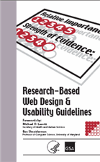

Updated 2006 book provides latest research-based guidance for building
best-in-class Web sites

Although recent findings show the public increasingly interacting with government
Web sites, a common problem is that people can’t find what they’re looking for. In
other words, the sites lack usability. The Research-Based Web Design and Usability
Guidelines aid in correcting this problem by providing the latest Web design guidance
from the research and other forms of evidence.

This unique publication, developed jointly between the U.S. Department of Health and Human Services and the U.S. General Services Administration, has been updated from its earlier version to include over 40 new or updated research guidelines, bringing the total to 209. Primary audiences for the book are: Web managers, designers, and all staff involved in the creation of Web sites. Topics in the book include: home page design, page and site navigation, graphics and images, effective Web content writing, and search. A new section on usability testing guidance has been added.

Experts from across government, industry, and academia have reviewed and contributed to the development of the Guidelines. And, since their introduction in 2003, the Guidelines have been widely used by government, private, and academic institutions to improve Web design.

Each guideline offers:  - A brief statement of the guideline.  - Comments that further explain the research/supporting information.  - Citations to relevant Web sites, technical and/or research reports supporting the guideline.  - A score indicating the ‘Strength of Evidence’ that supports the guideline. These scores range from ‘Strong Research Support,’ indicating that there is at least one formal, rigorous study with contextual validity and agreement among experts to ‘Weak Research,’ indicating limited evidence and disagreement among experts.  - A score indicating the ‘Relative Importance’ of the guideline to the overall success of a Web site. These scores range from 1-5 and are intended to help guide you in prioritizing the implementation of these guidelines.  - One or more graphic example of the guideline in practice. | 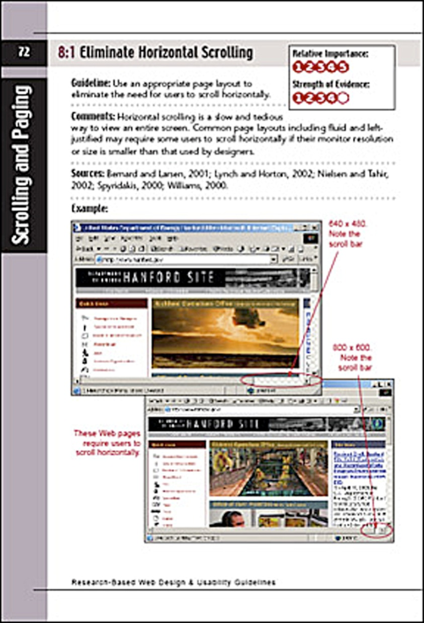


TO ORDER:
Copies are available from the U.S. Government Printing Office. The price is $25 per copy
if shipped in the U.S. The international price is $35.

Call: 1-866-512-1800 (Toll Free)  202-512-1800 (DC Area)
Visit the GPO Web site at http://bookstore.gpo.gov
(Direct URL: http://bookstore.gpo.gov/actions/GetPublication?stocknumber=017-022-01599-4)

Copies are also available through Web Managers University at http://www.firstgov.gov/webcontent/resources/training/university.shtml

