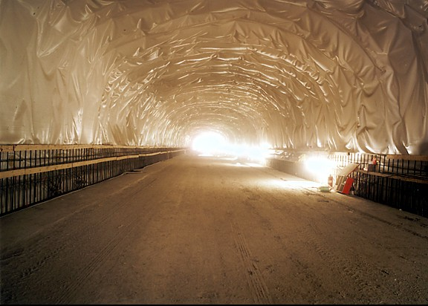
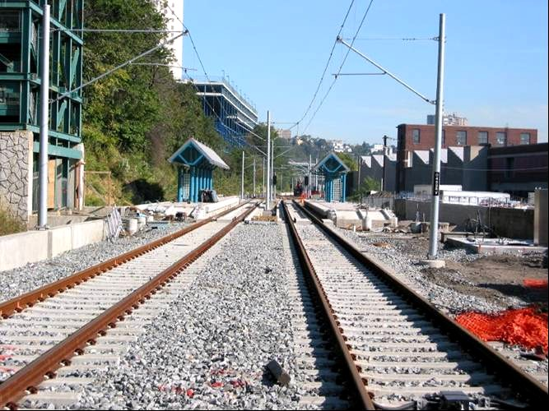
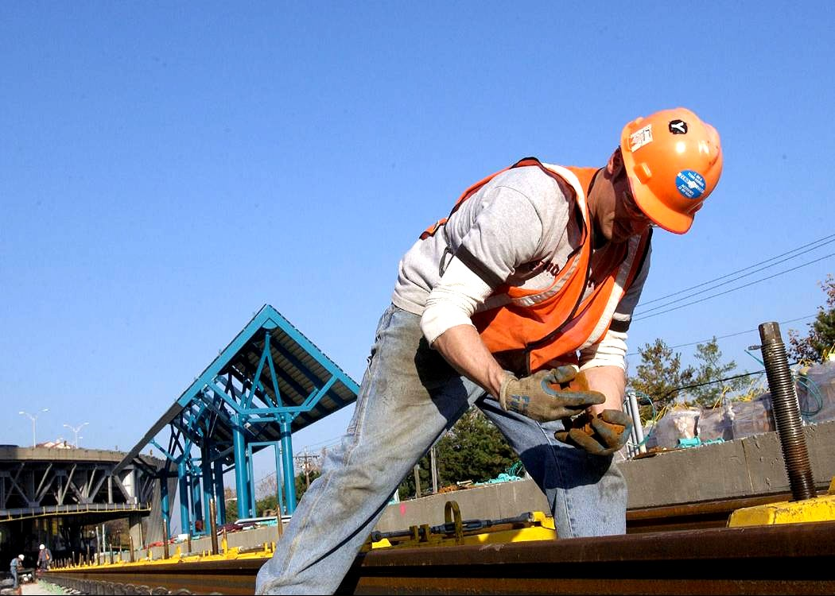
Hudson-Bergen Light Rail
22nd Transit Construction Roundtable May 2 – 4, 2004

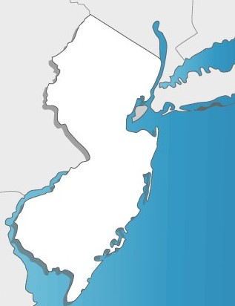

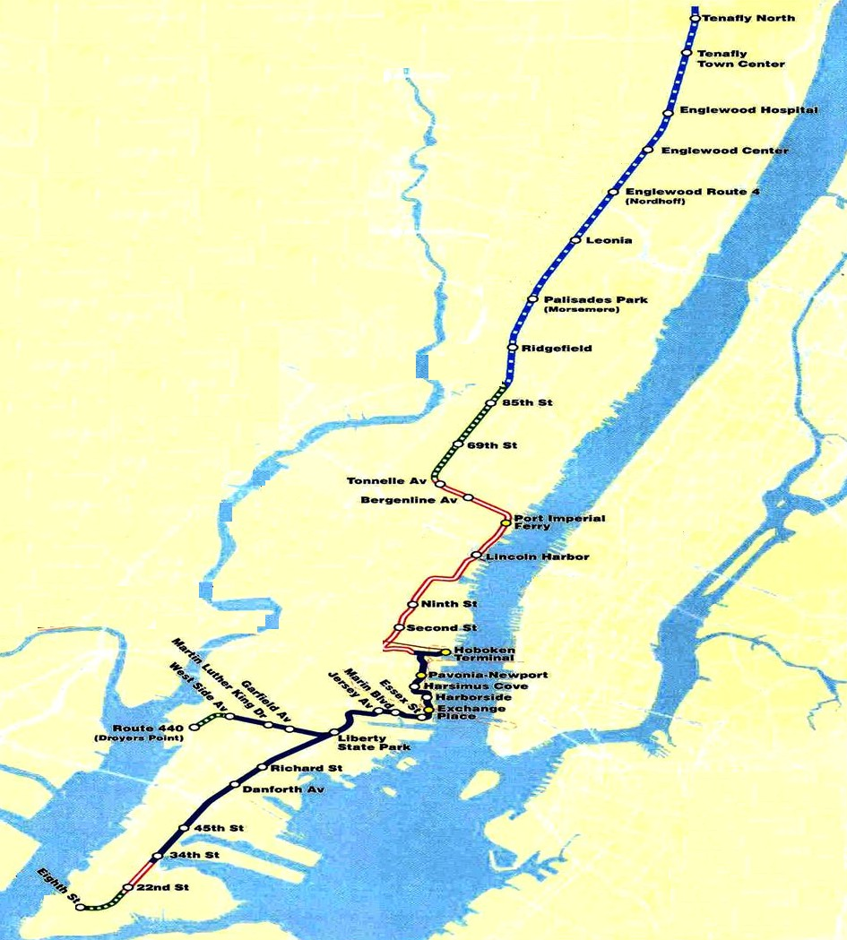
HBLR Segments 1-2-3

Bergen County

Manhattan
Hudson County

[Map of New Jersey Hudson Bergen Light Rail]

Hudson Bergen Light Rail
Three major light rail segments
Serving major metropolitan area.
Hudson and Bergen counties population 1.5 million.

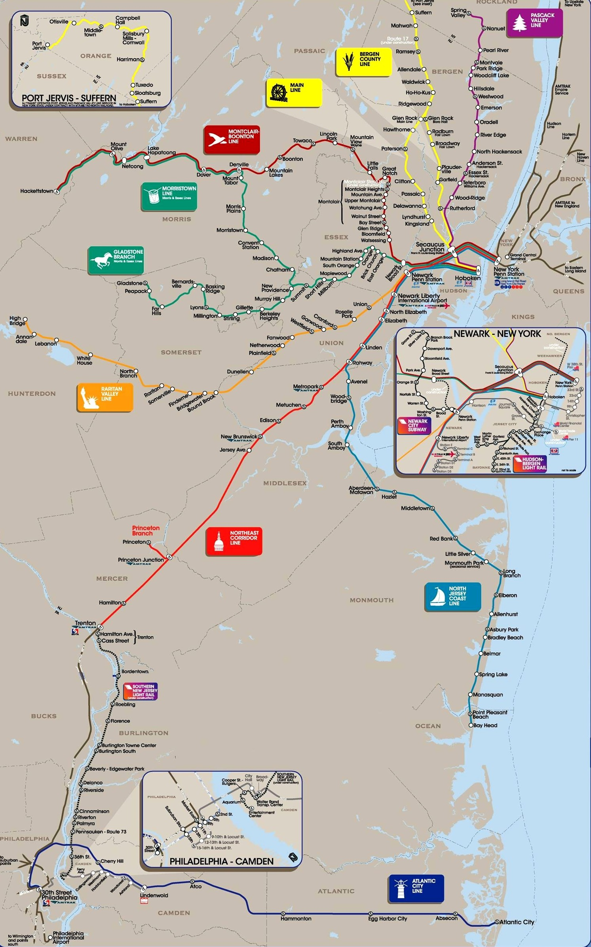

Hudson-Bergen Light Rail

Hudson-Bergen Light Rail

[Map of New Jersey Transit lines; Northeast Corridor (red), Raritan Valley (gold), Gladstone Brush (green), Morristown Line (green), Montclair-Boonton Line ( maroon), Main Line (yellow), Bergen County Line (yellow), Pascack Valley (purple), HUDSON-BERGEN Light Rail (black), North Jersey Coast line (teal), and Atlantic City line (blue)]

Hudson Bergen Light Rail

NJ TRANSIT or PATH rail connection.

Trans-Hudson ferry connection.

Rail and ferry connection.

Bergen County

Manhattan
Hudson County
Minimum Operable Segments

[Map of Hudson Bergen Rail various conections, NJ Transit or Path rail connection (blue), Trans-Hudson ferry connection (green), and Rail and Ferry connection (red)]
1-2-3

Intermodal Connections

Record of decision 1996

9 miles.

Service began April 2000.

3 communities.

16 stations.

2900 new parking spaces.
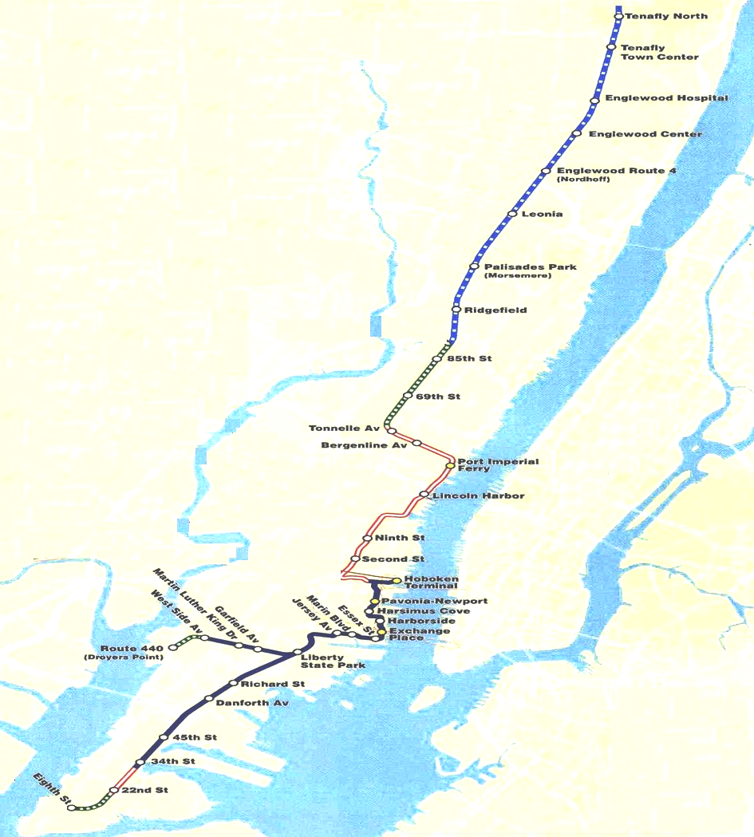

Bergen County

Manhattan

Hudson County

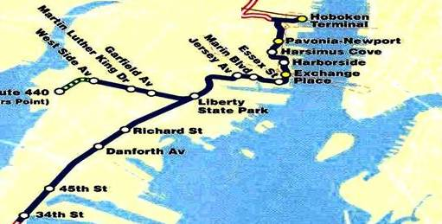

1
Minimum Operable Segment

[Map of Hudson Bergen Light Rail]

Hudson Bergen Light Rail

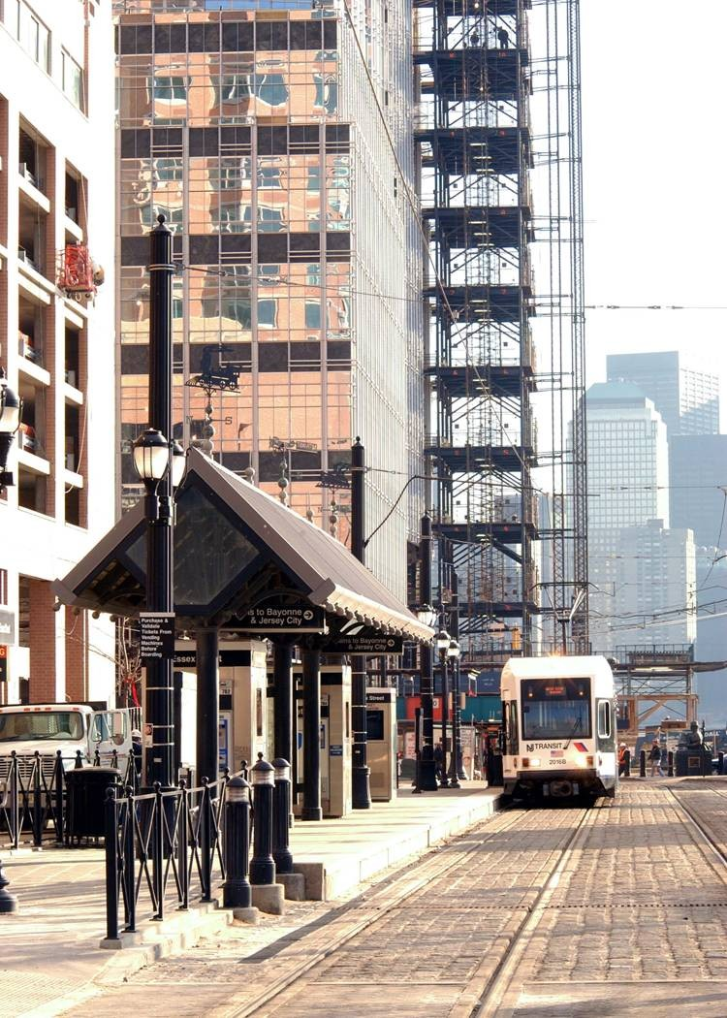
15 million new commercial sq. ft.

500 new hotel rooms.

10,000 new housing units.

Bergen County

[Photograph of Hudson Bergen Light Rail]
Manhattan
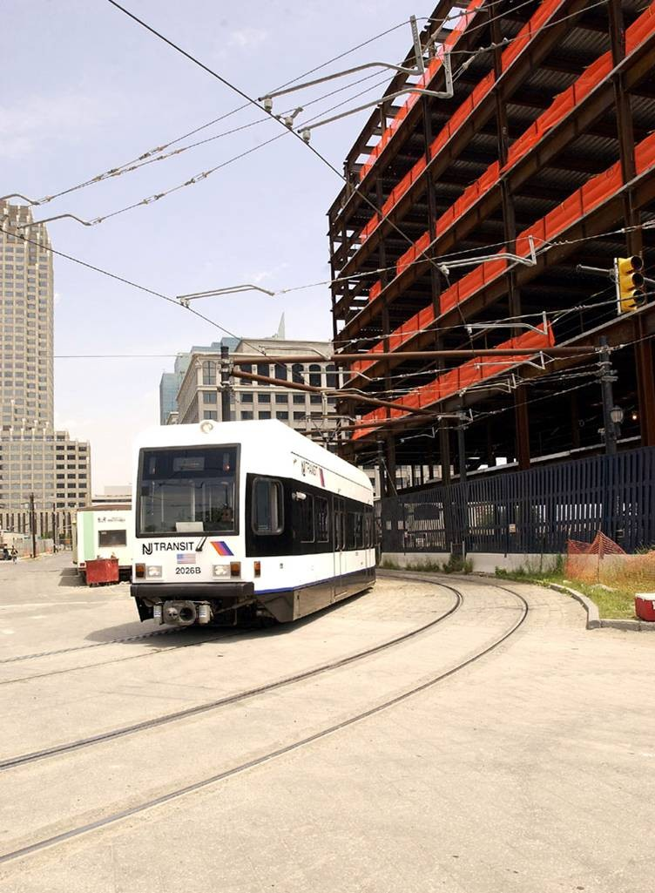

Hudson County

[Map of Hudson Bergen Light Rail]

[Photograph of Hudson Bergen Light Rail]

First Segment – Urban Waterfront

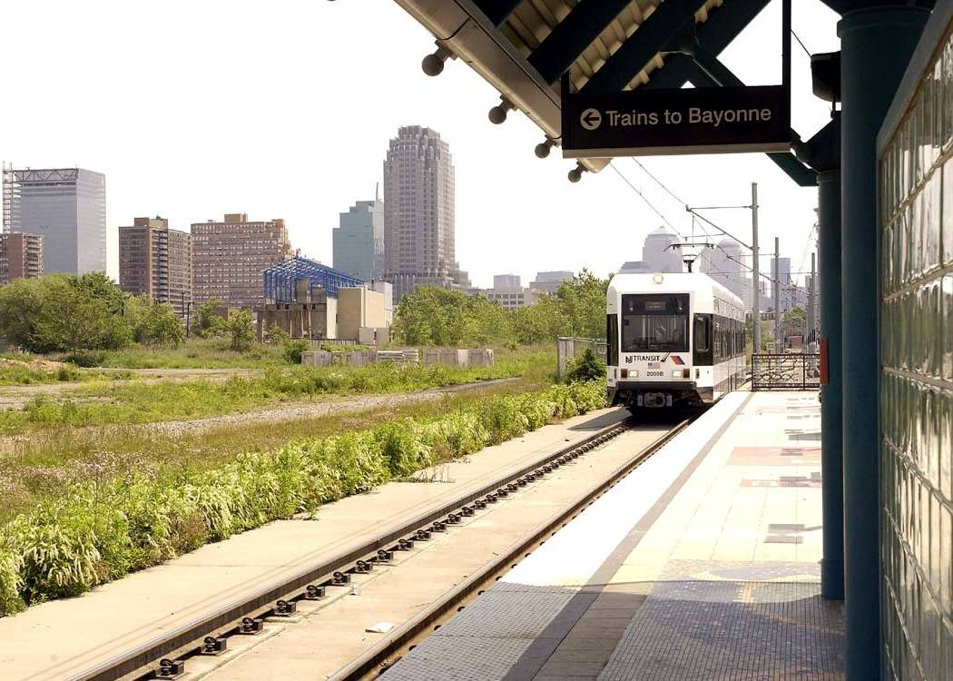

Bergen County

Manhattan

Hudson County

[Photograph of Hudson Bergen Light Rail to Bayonne]

Low income communities.

High use of public transit.

“Brownfields” redevelopment.

[Map of Hudson Bergen Light Rail]

First Segment – Urban Infill

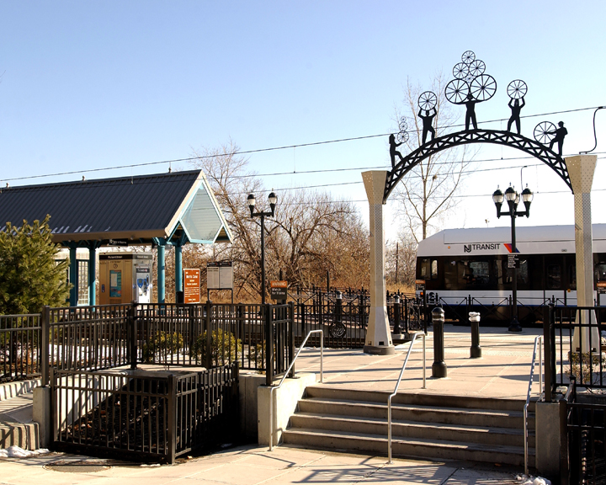

Bergen County

Manhattan

Hudson County

[Photograph on Hudson Bergen Light Rail Neighborhood Station]

Low impact design.

Locally-designed artwork.

Landscaping.

[Map of Hudson Bergen Light Rail]

First Segment – Neighborhood Stations

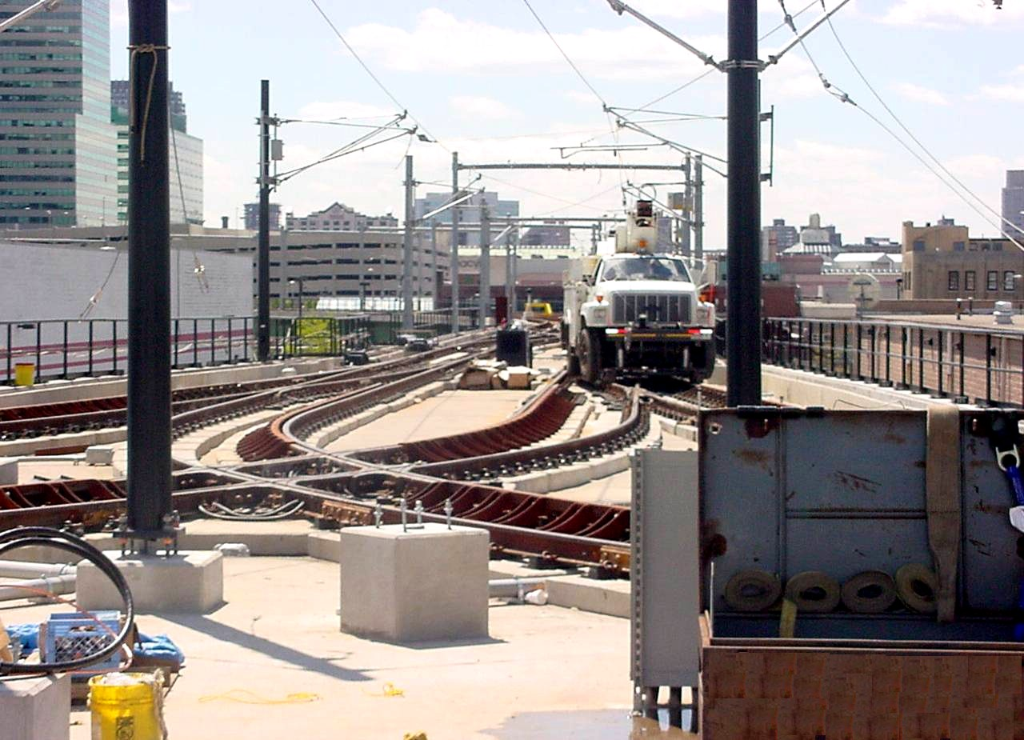

Bergen County

Manhattan

Hudson County

[Photograph of Newport Viaduct Wye]

Elevated “wye” provides for service into Hoboken Terminal and north to Weehawken.
[Map of Hudson Bergen Light Rail]

First Segment – Newport Viaduct

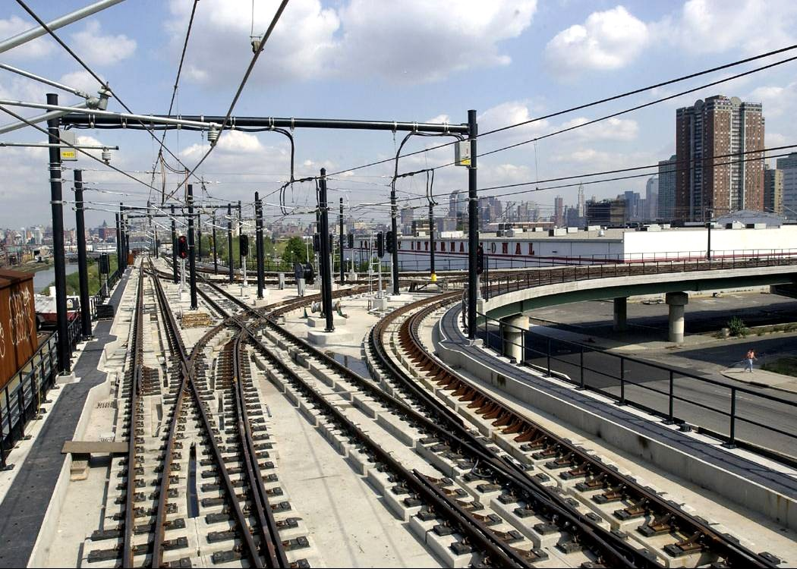

Bergen County

Manhattan

Hudson County

[Photograph of Wye looking east towards Hoboken Terminal]

The “wye”, looking east towards Hoboken Terminal.

[Map of Hudson Bergen Light Rail]

First Segment – “Wye”

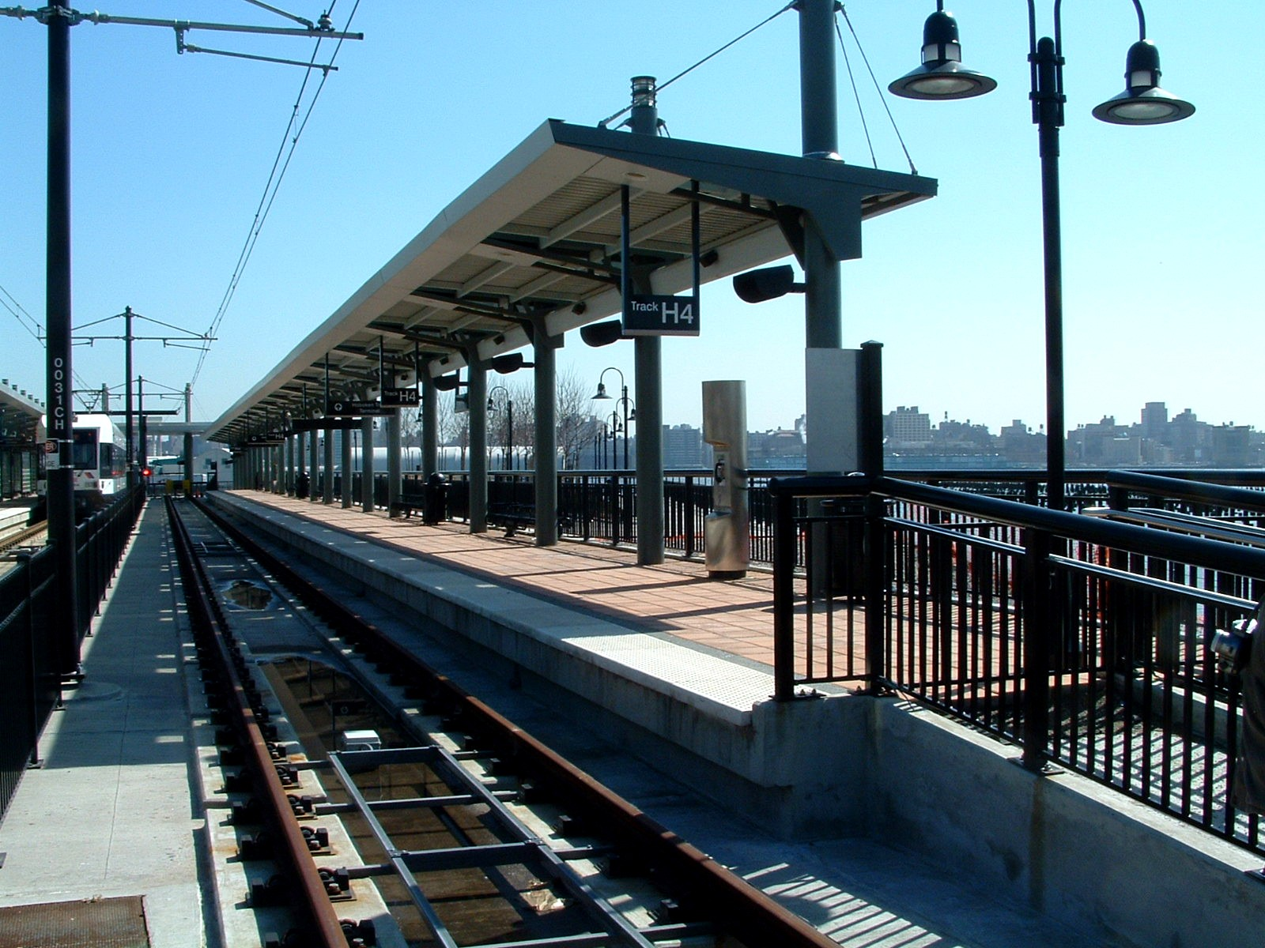
Bergen County

Manhattan

Hudson County

[Photograph of Hudson Bergen Light Rail Hoboken Terminal Station]

HBLR Hoboken Terminal Station.

[Map of Hudson Bergen Light Rail]

First Segment – Hoboken Terminal

6 miles.

Under construction.

7 communities.

7 stations.

1000 new parking spaces.

Bergen County

Manhattan
Hudson County

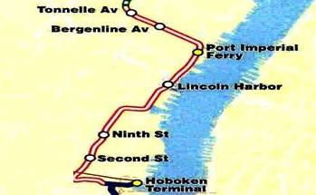

2

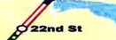

[Map of Hudson Bergen Light Rail]

Minimum Operable Segment

Hudson Bergen Light Rail

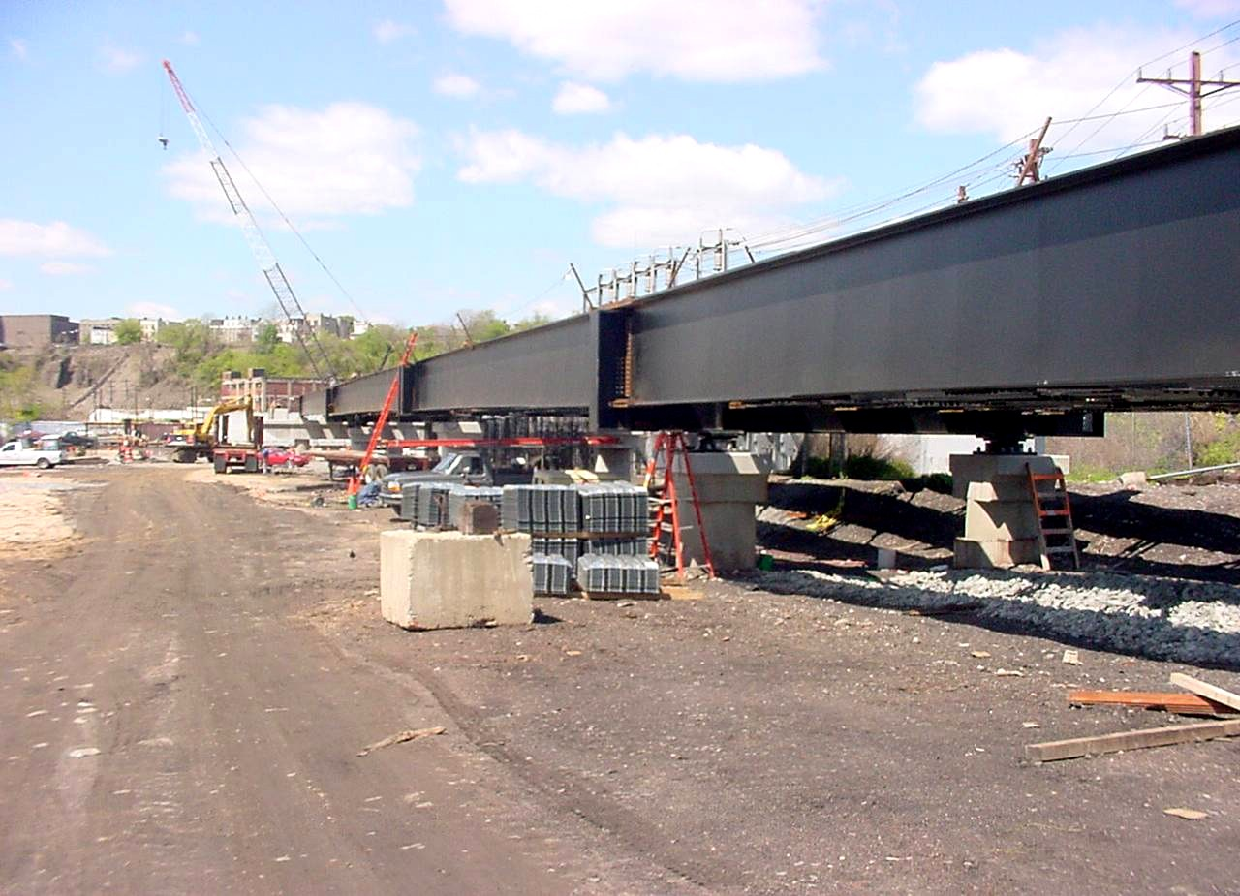

Bergen County

Manhattan
Hudson County

[Photograph of Jersey City Viaduct with steel in place for Hudson Bergen Light Rail]
Viaduct steel in place.

[Map of Hudson Bergen Light Rail]

Second Segment – Jersey City Viaduct

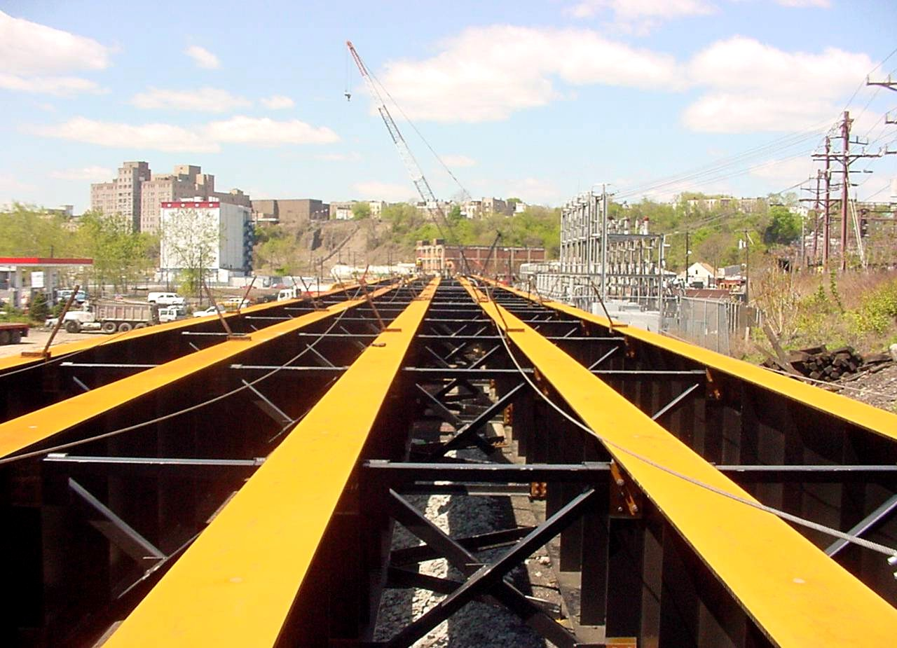

Bergen County

Manhattan
Hudson County

[Photograph of steel Viaduct from Hoboken Terminal to the Westside]

Viaduct from Hoboken Terminal to the westside of Hoboken under construction.

[Map of Hudson Bergen Light Rail]

Second Segment – Jersey City Viaduct

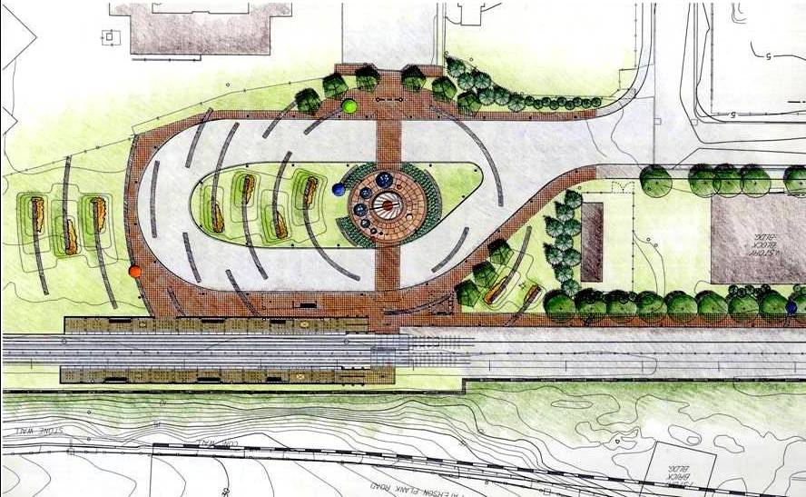
2nd Street Station on Jersey City/Hoboken border.

[Overview illustration of 2nd street Station on Jersey City/Hoboken border]

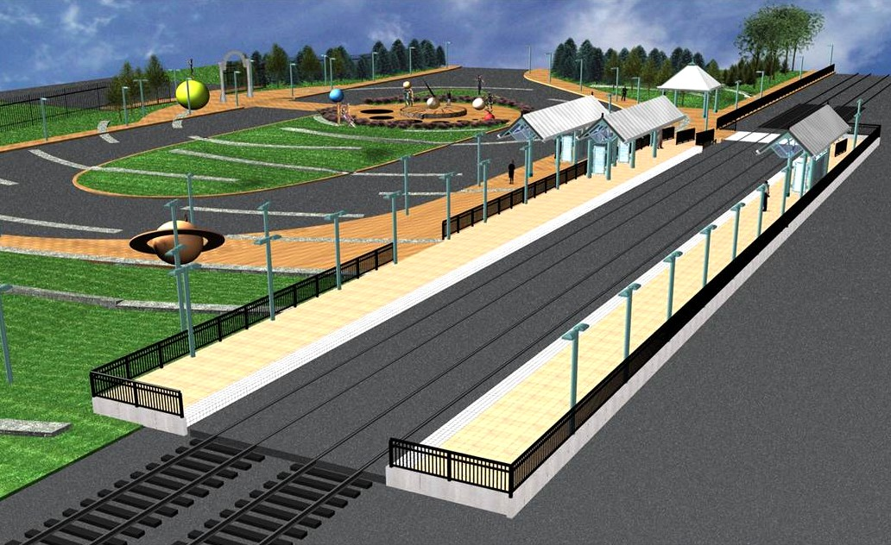
Bergen County

Hudson County
Manhattan

[Close-up illustration of 2nd street Station on Jersey City/Hoboken border]

[Map of Hudson Bergen Light Rail]

Second Segment – 2nd Street Station

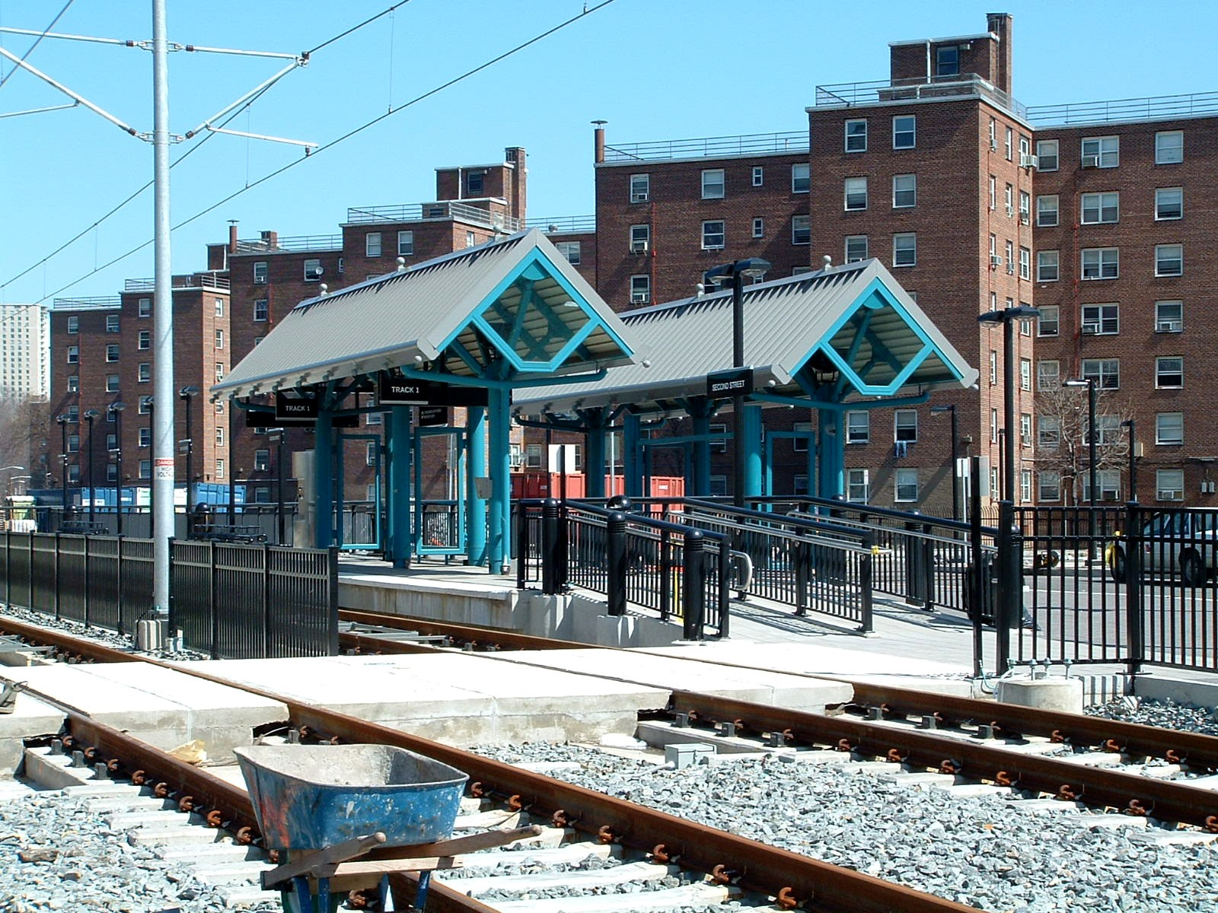

Bergen County

Manhattan
Hudson County

[Photograph of 2nd Street Station under construction]

2nd Street Station under construction.

[Map of Hudson Bergen Light Rail]

Second Segment – 2nd Street Station

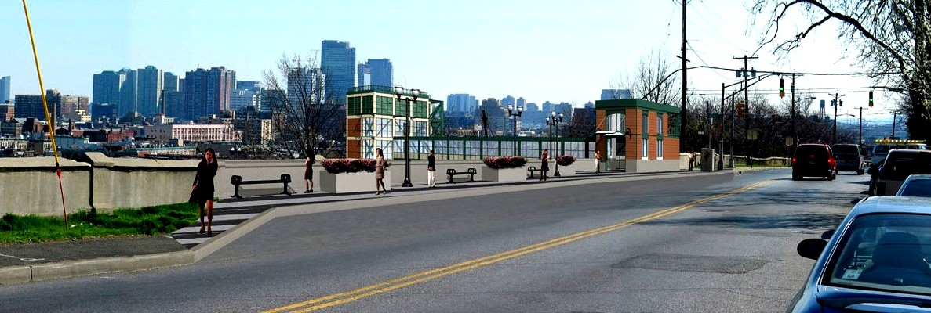

[Photograph of 9th Street Station passenger elevator Jersey City Heights access]

9th Street Station passenger elevator Jersey City Heights access.

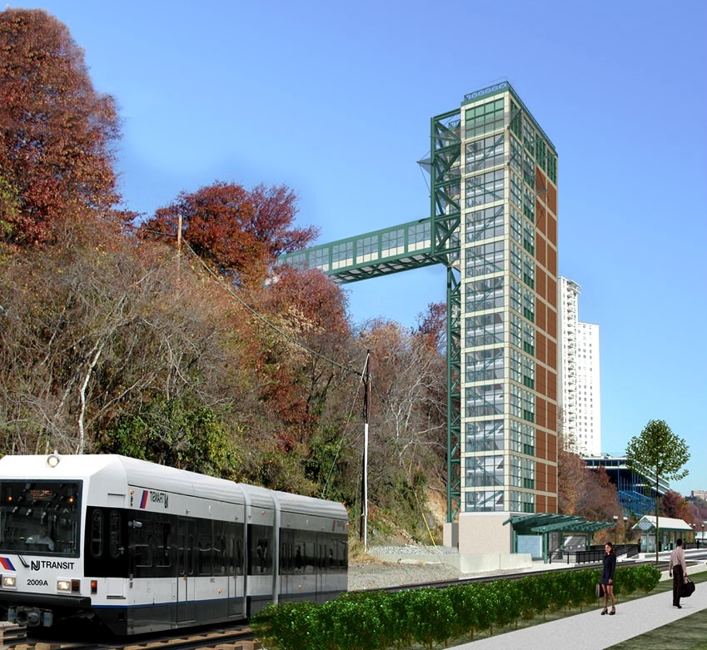

Bergen County

Manhattan
Hudson County

[Photograph of 9th Street Station passenger elevator and platform]

9th Street Station passenger elevator and platform.

[Map of Hudson Bergen Light Rail]

Second Segment – 9th Street Station Elevator

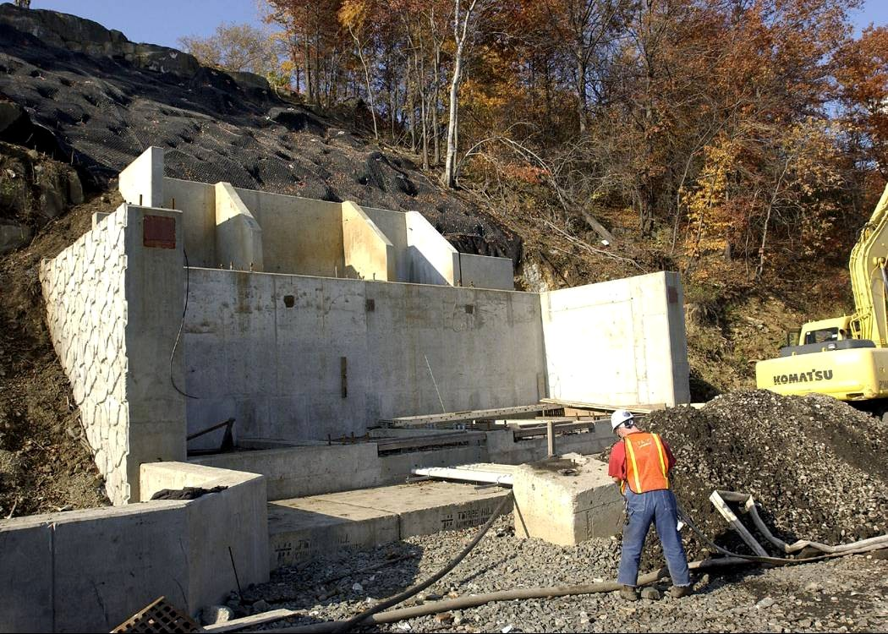

Bergen County

Manhattan
Hudson County

[Photograph of 9th Street Station elevator under construction]

Passenger elevator concrete footing.

[Map of Hudson Bergen Light Rail]

Second Segment – 9th Street Station Elevator

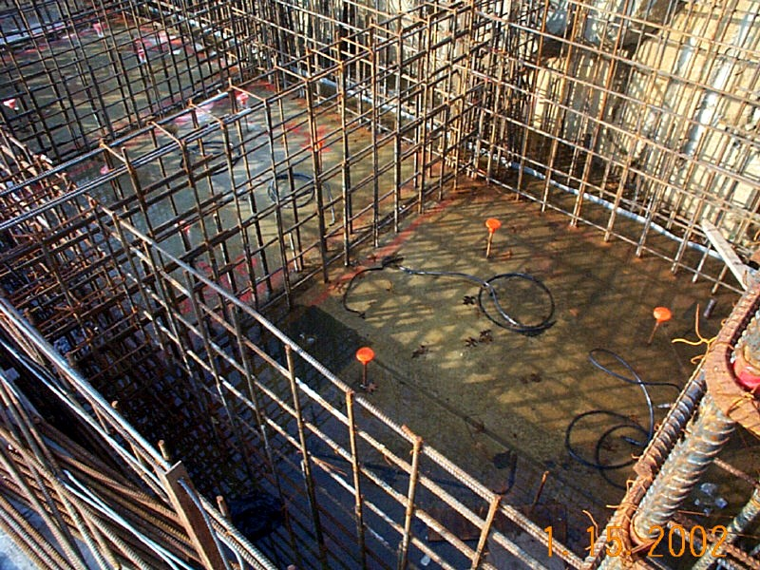

Bergen County

Manhattan
Hudson County

[Photograph of 9th Street Station passenger elevator rebar installation]

Passenger elevator rebar installation.

[Map of Hudson Bergen Light Rail]

Second Segment – 9th Street Station Elevator

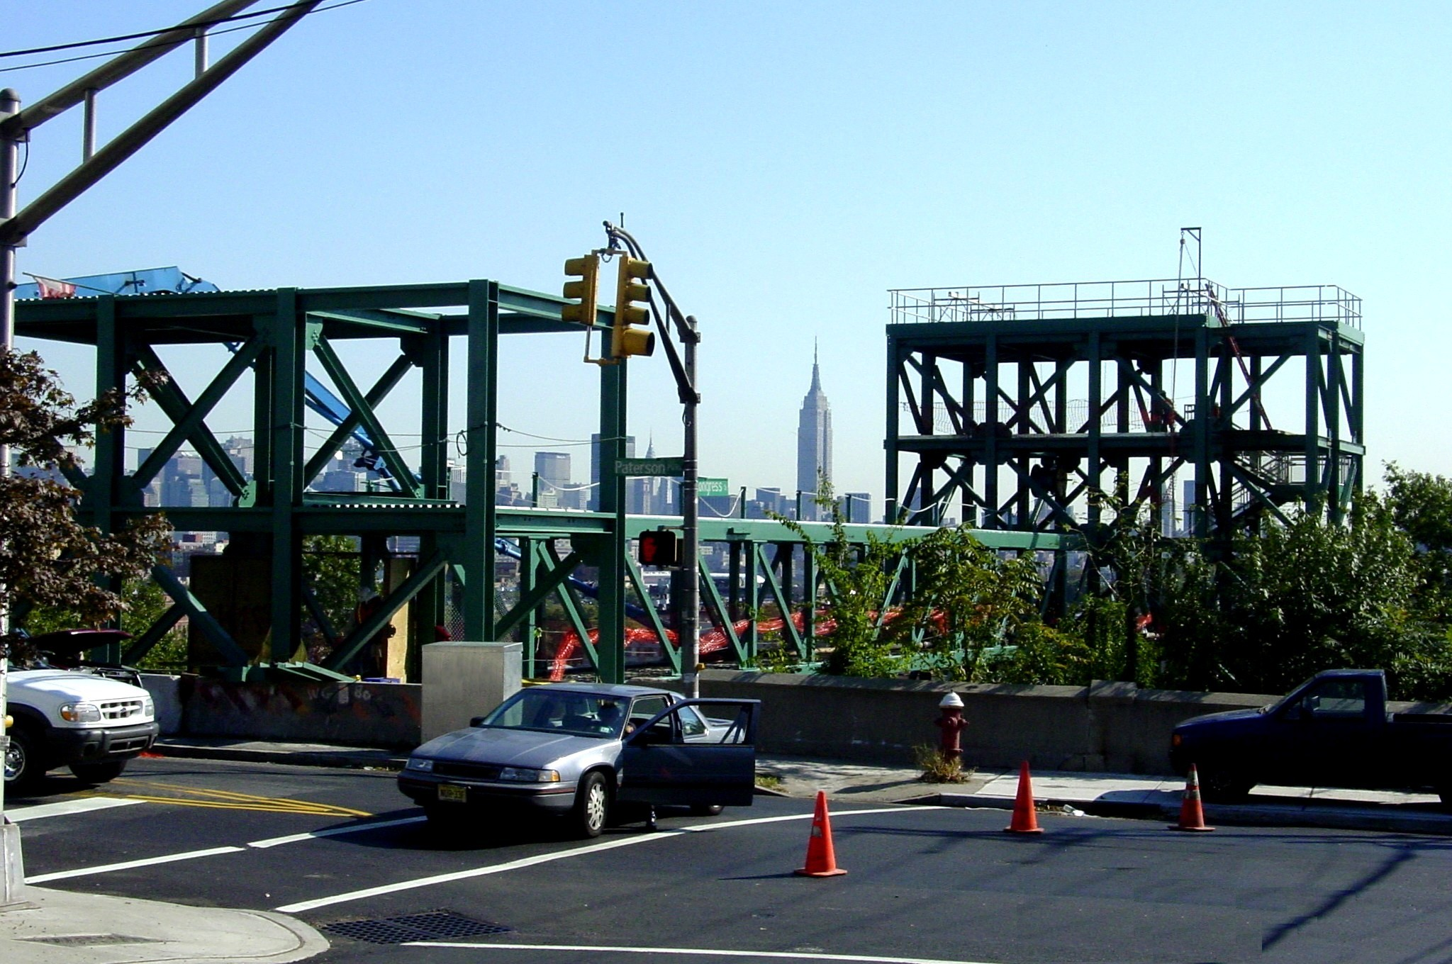

Bergen County

Manhattan
Hudson County

[Photograph of 9th Street Station passenger elevator steelwork]

Passenger elevator steelwork at Jersey City Heights.

[Map of Hudson Bergen Light Rail]

Second Segment – 9th Street Station Elevator

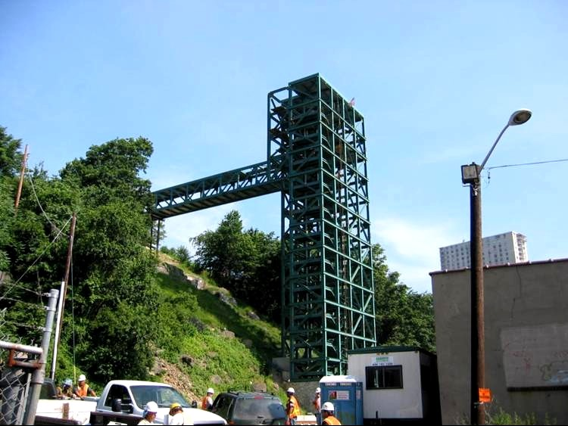

Bergen County

Hudson County
Manhattan

[Photograph of 9th Street Station passenger elevator tower steelwork view form Hoboken Terminal]

Passenger elevator tower steelwork. View from Hoboken.

[Map of Hudson Bergen Light Rail]

Second Segment – 9th Street Station Elevator

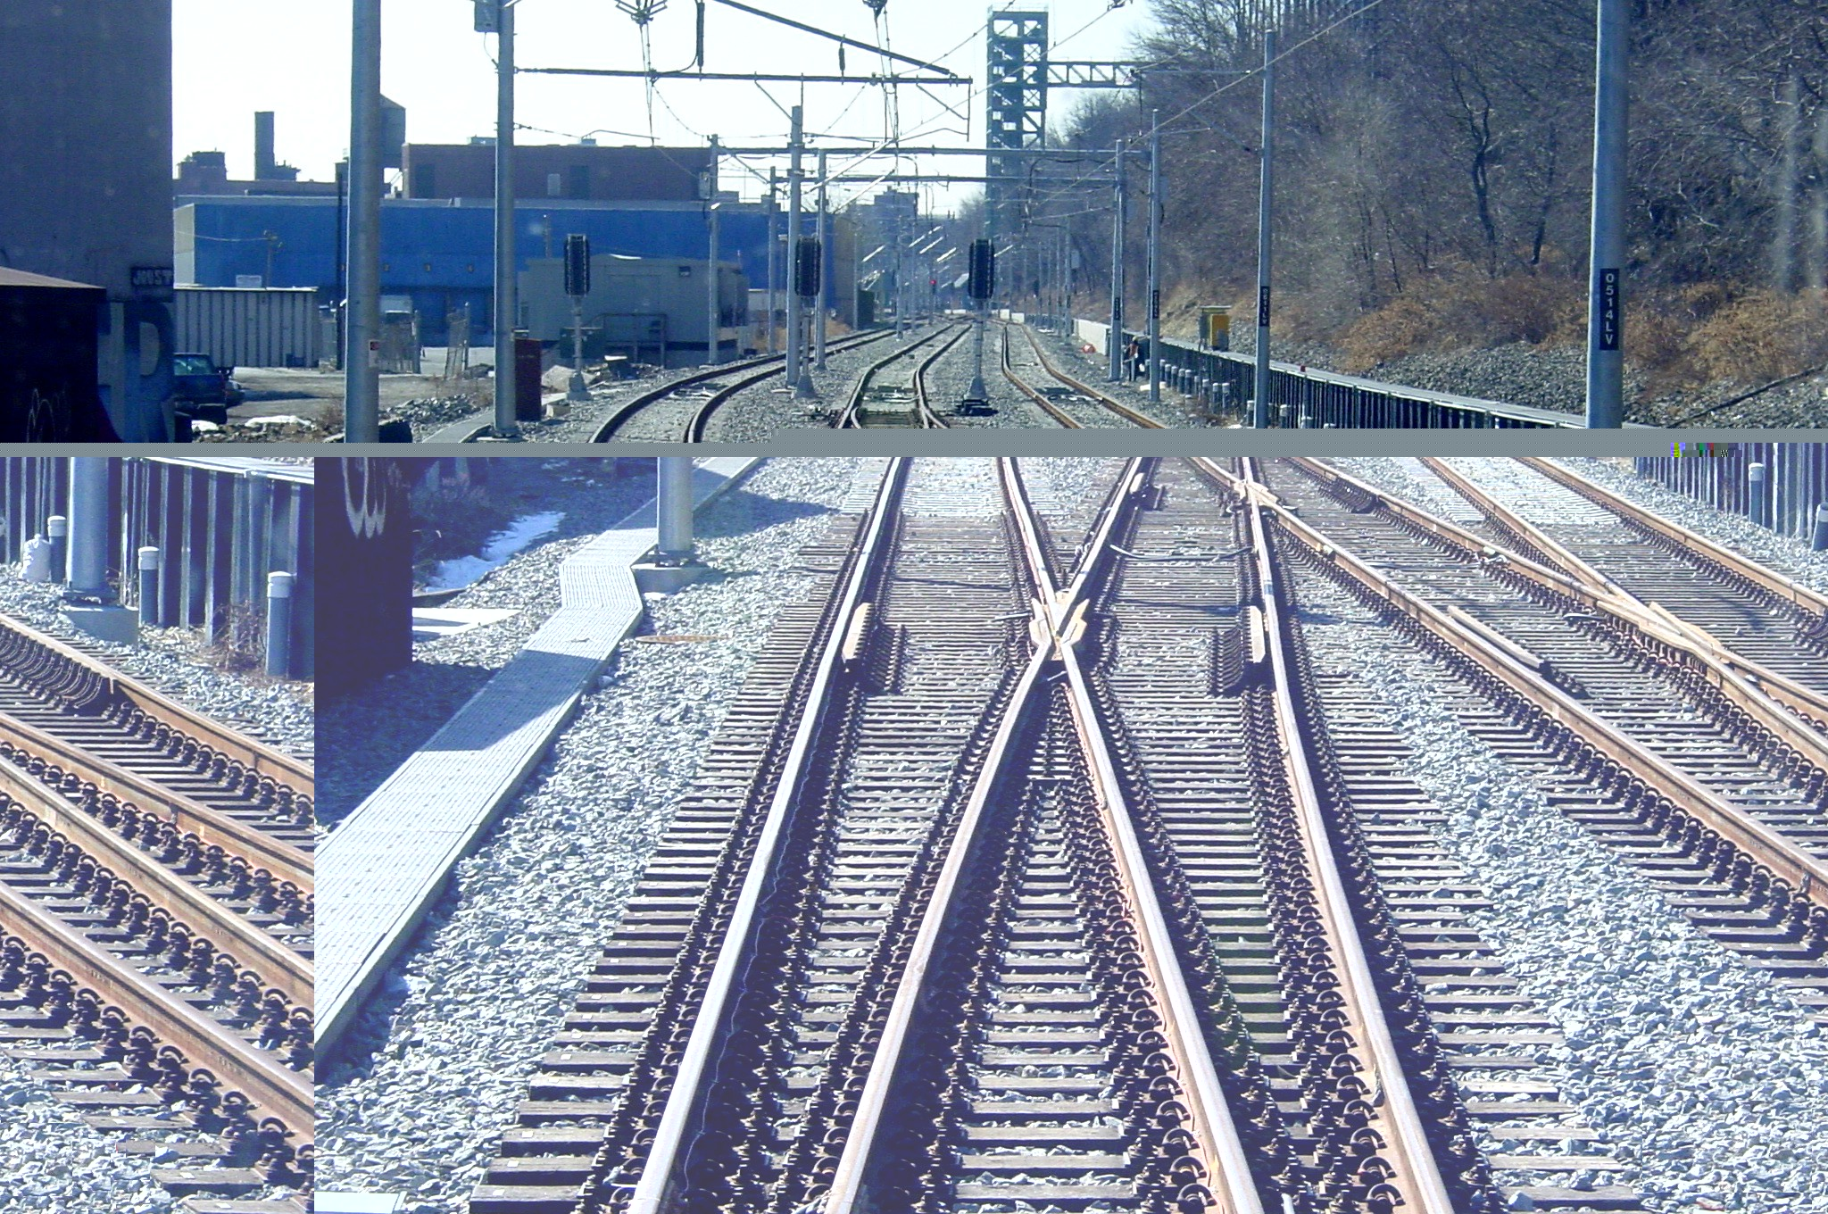

Bergen County

Hudson County
Manhattan

[Photographs of additional tracks installed for flexibility]

Additional track installed to provide operational flexibility.

[Map of Hudson Bergen Light Rail]

Second Segment – Three Roads

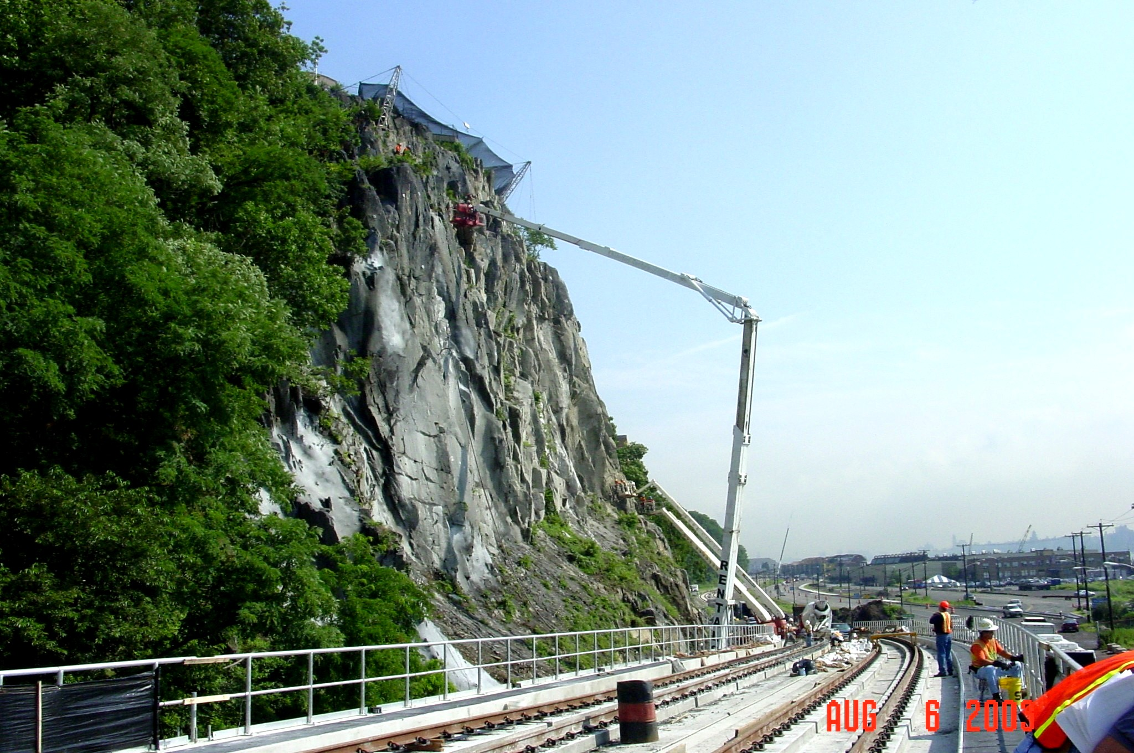
Bergen County
Manhattan

Hudson County

[Photograph of Palisades rock slope near Light Rail tracks]

Preservation of Palisades rock slope using specialized techniques.

[Map of Hudson Bergen Light Rail]

Second Segment – Kings Bluff

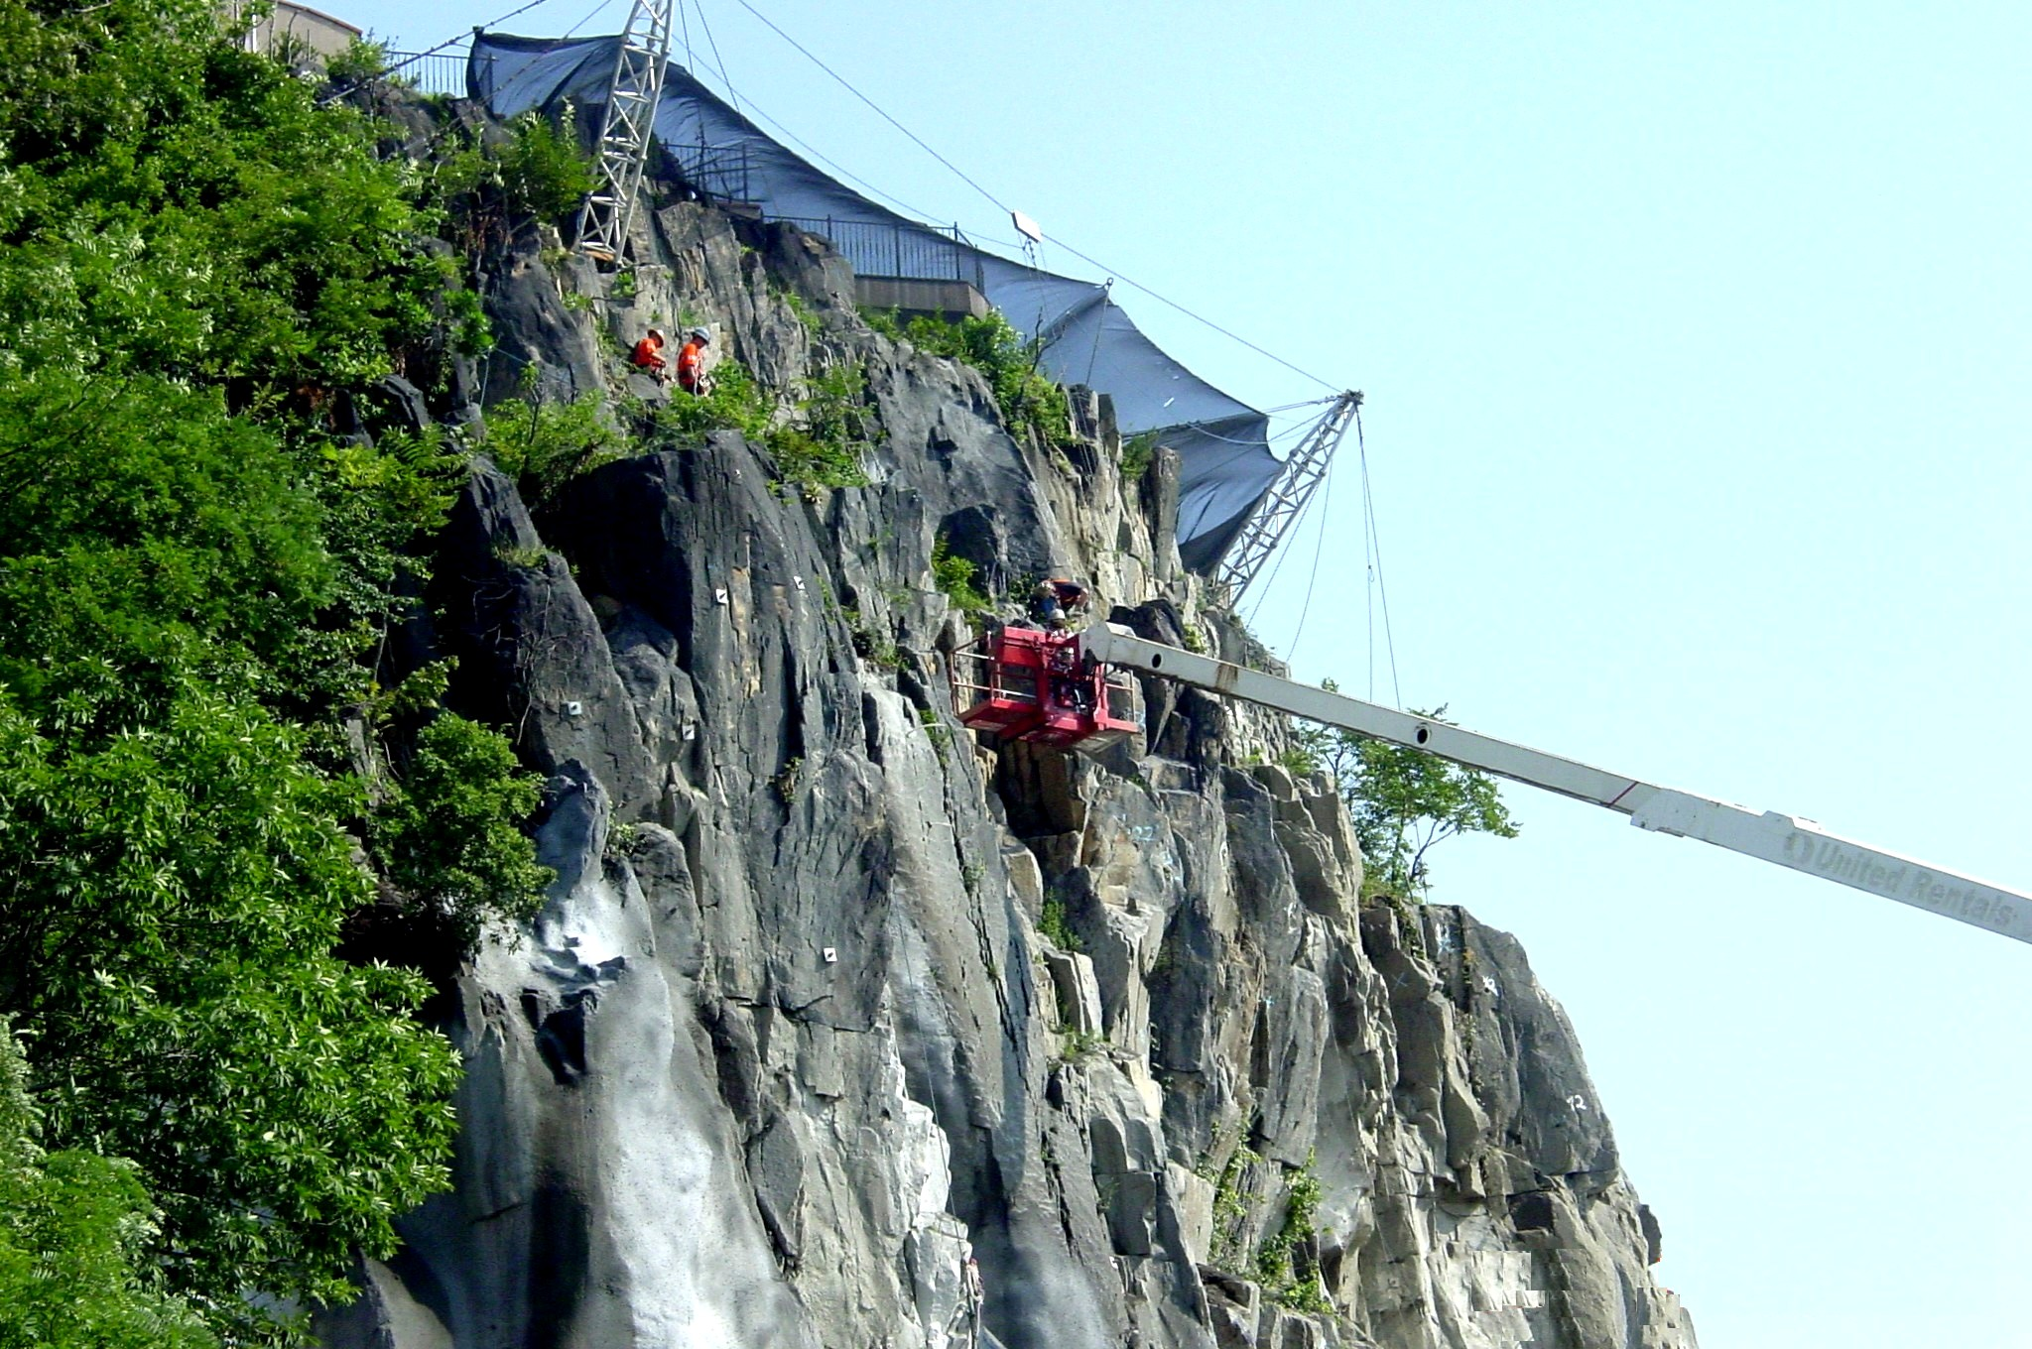

Bergen County

Manhattan
Hudson County

[Photograph of Tyrolean System installing rock bolts and anchors]

Installation of rock bolts and anchors using Tyrolean System.

[Map of Hudson Bergen Light Rail]

Second Segment – Kings Bluff

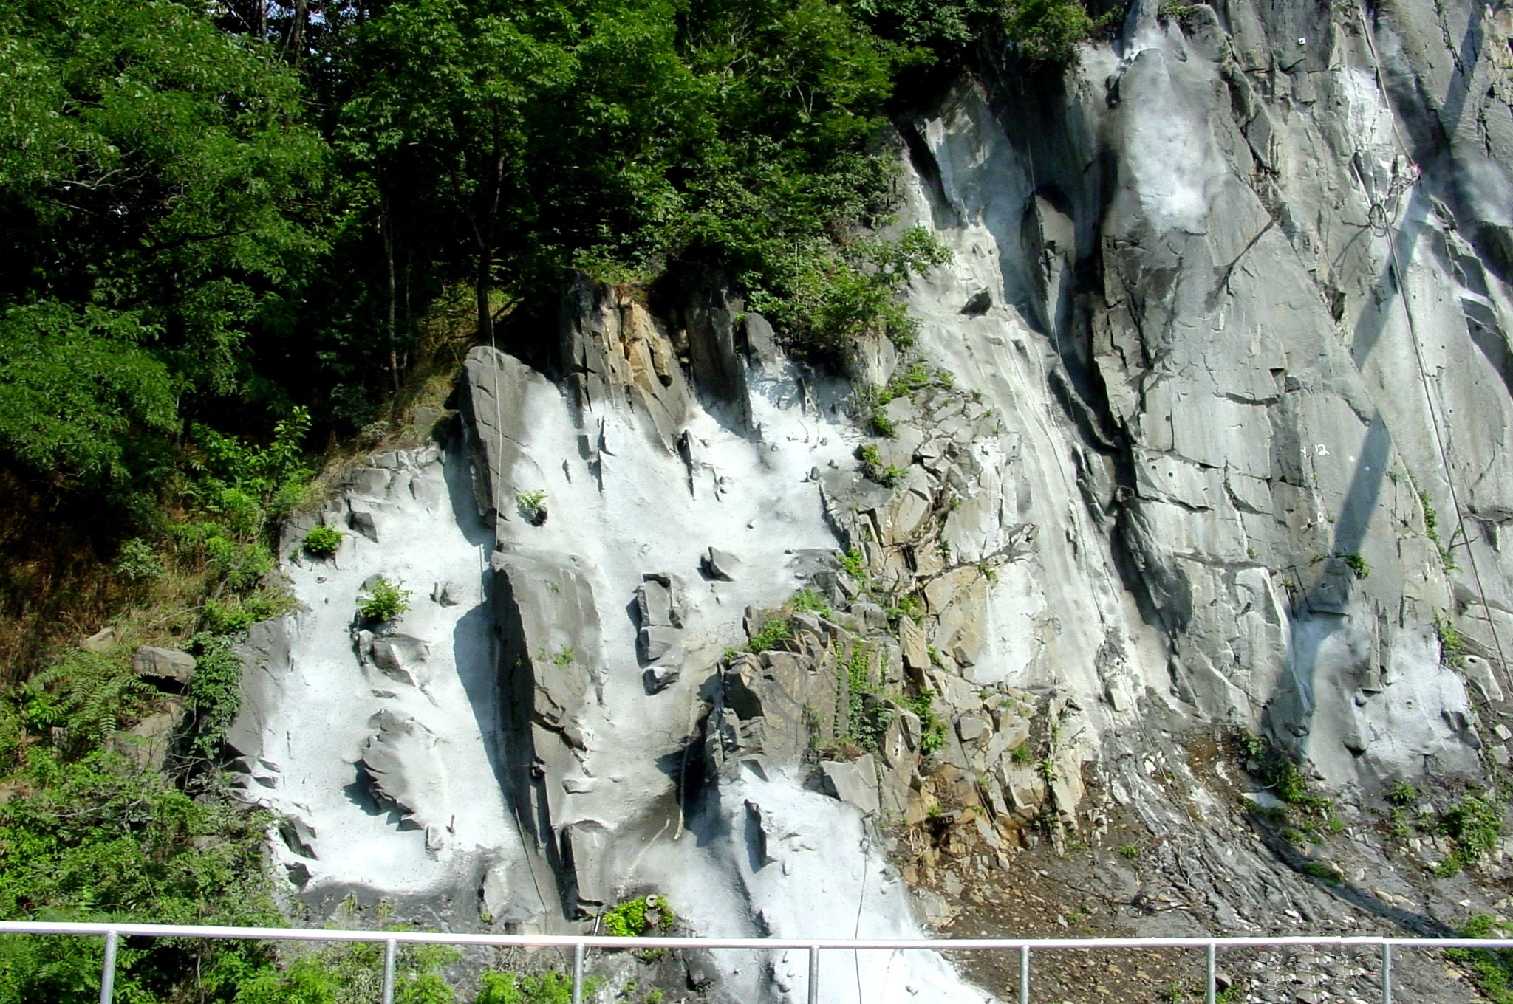
Bergen County

Hudson County
Manhattan



[Photograph of cliff face prior to shotcrete restoration]

Cliff face prior to shotcrete restoration.
[Map of Hudson Bergen Light Rail]

Second Segment – Kings Bluff

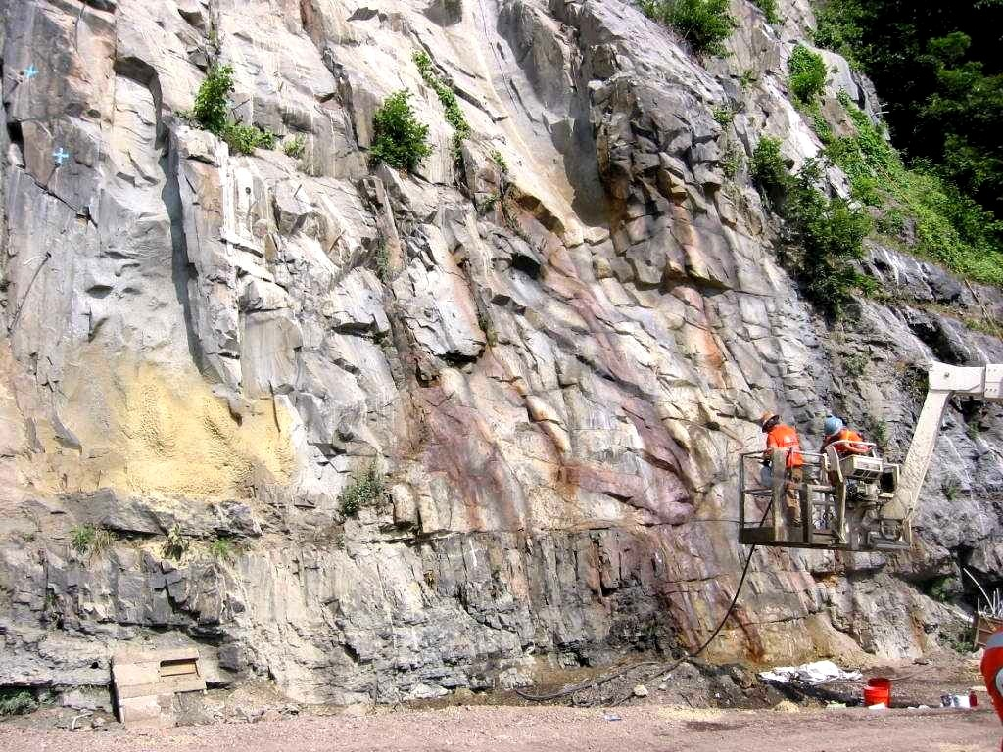

Bergen County

Manhattan

Hudson County

[Photograph of restored shotcrete to the cliff face]

Finishing the shotcrete used to stabilize the cliff face and restore a natural appearance.

[Map of Hudson Bergen Light Rail]

Second Segment – Kings Bluff

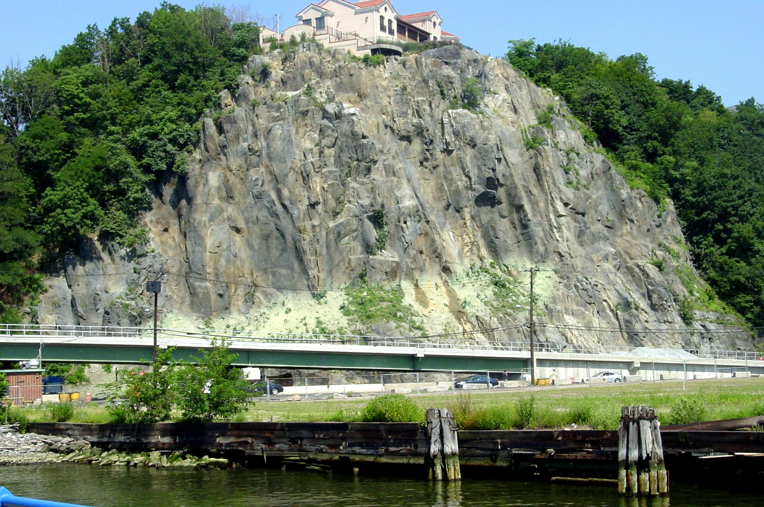

Bergen County

Manhattan

Hudson County

[Photograph of finished cliff face protecting Light Rail line]

The finished product protects the light rail line from rock falls while preserving an important natural landmark.

[Map of Hudson Bergen Light Rail]

Second Segment – Kings Bluff

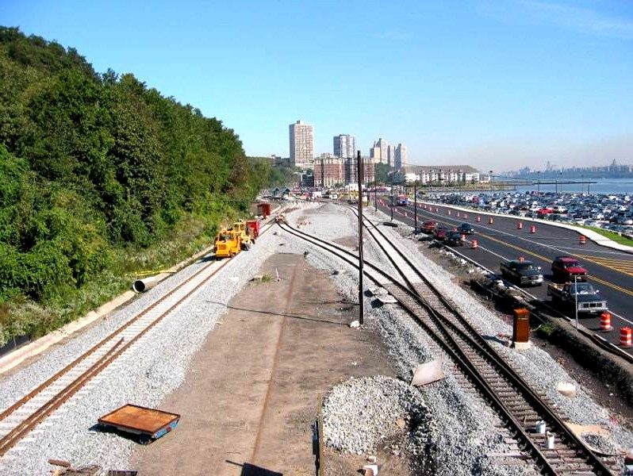

Bergen County

Manhattan
Hudson County

[Photograph of crossover tracks near Port Imperial Ferry Terminal]

Crossovers approaching Port Imperial Ferry Terminal.

Second Segment – Ferry Connection

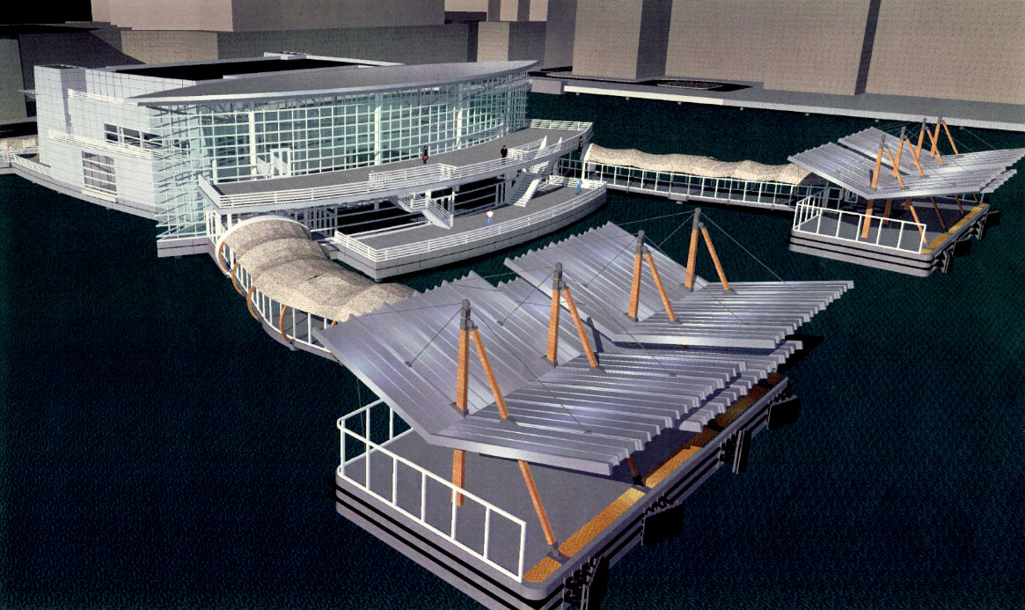

Bergen County

Manhattan
Hudson County

[Illustration of proposed Ferry Terminal]

Proposed Ferry Terminal located across from light rail station.

[Map of Hudson Bergen Light Rail]

Second Segment – Ferry Terminal

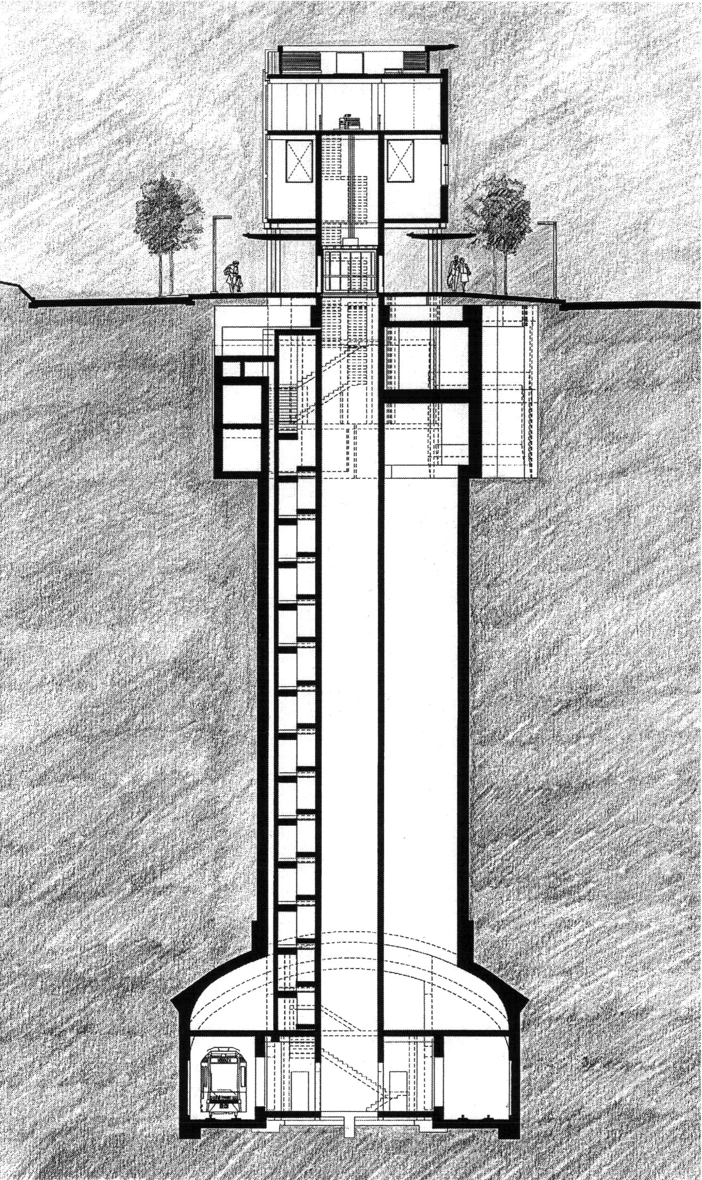
Weehawken Tunnel cross-section.
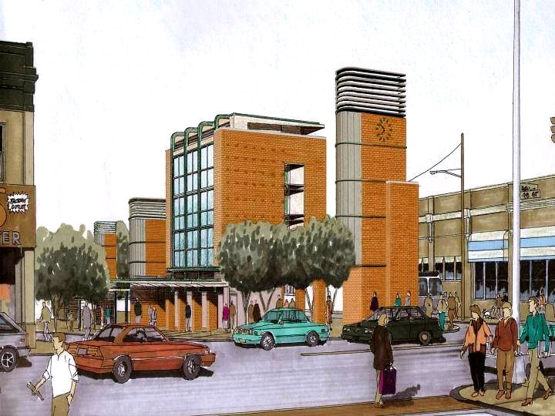

[Illustration of Weehawken Tunnel cross-section]

[Illustration of Bergenline Station Head House]
Bergenline Station Head House.
Weehawken Tunnel platform.

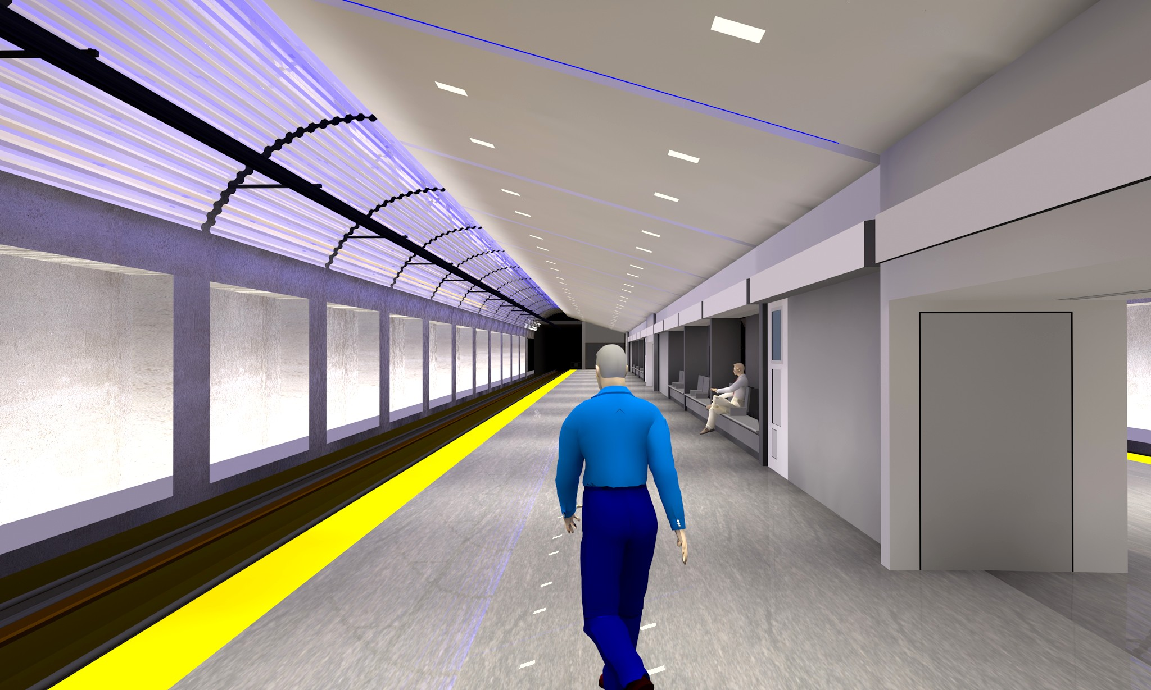

[Illustration of Weehawken Tunnel platform]
Weehawken Tunnel portal.
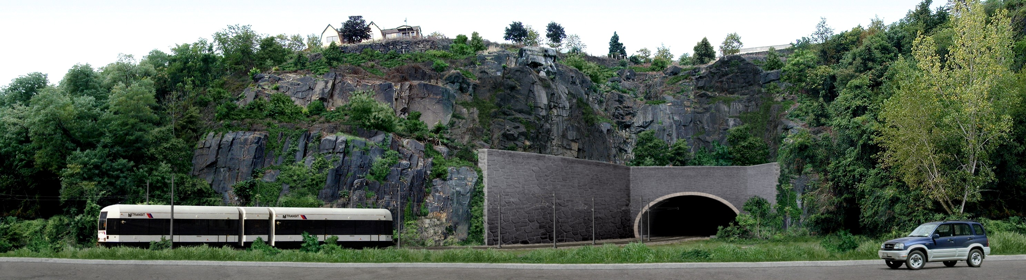

[Illustration of Weehawken Tunnel portal]

Second Segment – Tunnel and Station

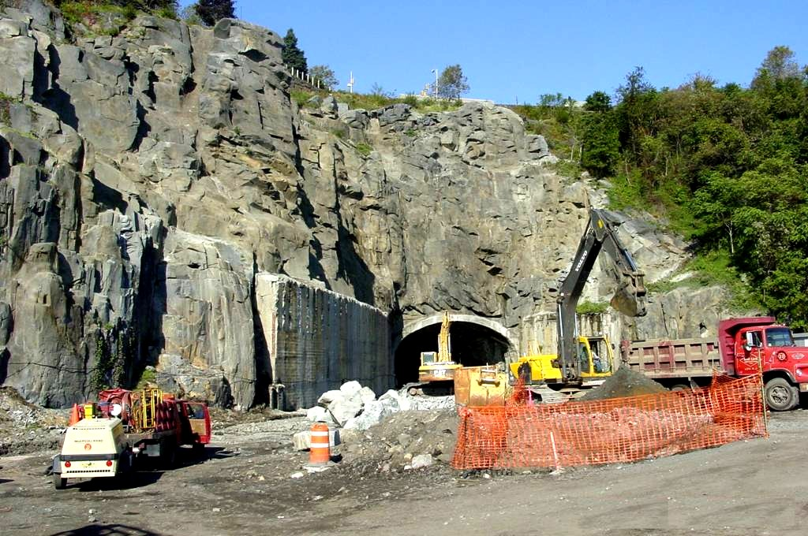

Bergen County

Manhattan

Hudson County

[Photograph of widening Weehawken Tunnel and rock slope]

Widening 1890’s Tunnel and rock slope reinforcement.

[Map of Hudson Bergen Light Rail]

Second Segment – Weehawken Tunnel

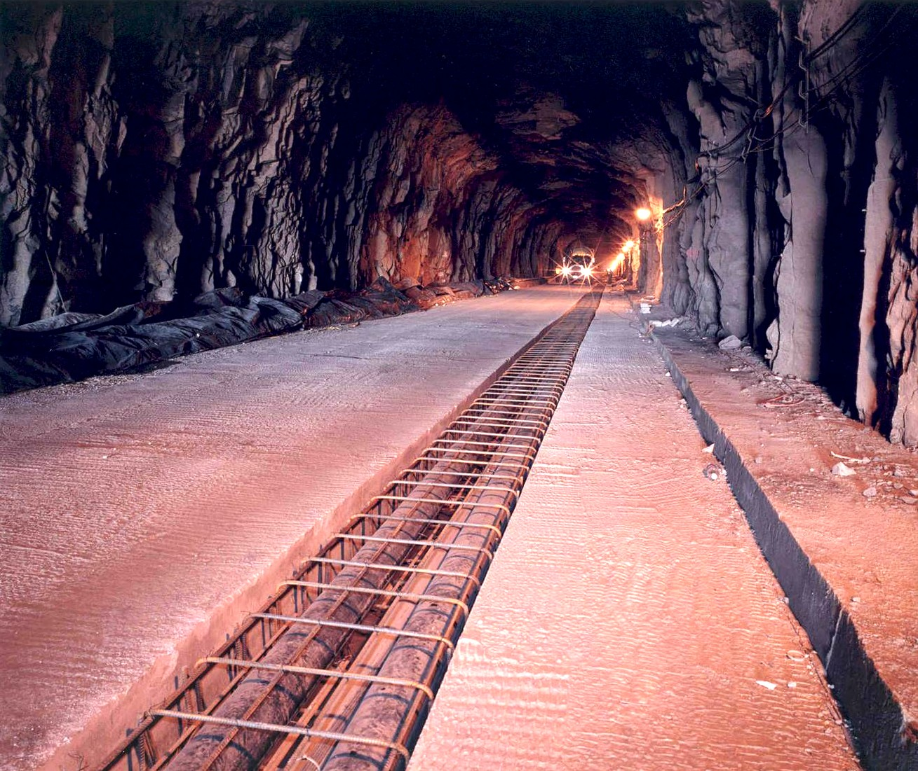

Bergen County

Manhattan
Hudson County

[Photograph of Weehawken tunnel trench for utility installations]

Trenching for utility installations.

[Map of Hudson Bergen Light Rail]

Second Segment – Weehawken Tunnel

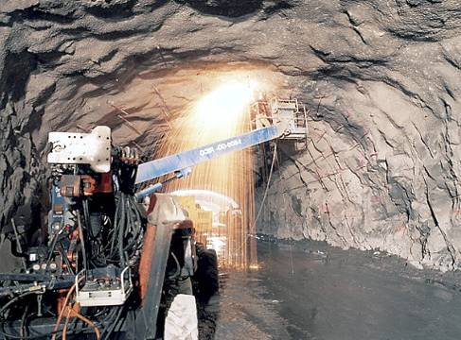

Bergen County

Manhattan
Hudson County

[Photograph shows machine shaping interior rock surface in Weehawken Tunnel]
Shaping interior rock surface.

[Map of Hudson Bergen Light Rail]

Second Segment – Weehawken Tunnel

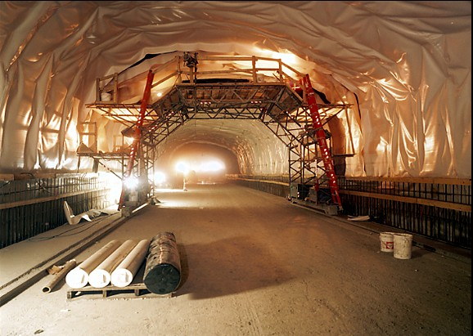

Bergen County

Manhattan
Hudson County

[Photograph of Waterproof membrane installed in Weehawken Tunnel]

Waterproof membrane installed prior to installation of concrete liner.

[Map of Hudson Bergen Light Rail]

Second Segment – Weehawken Tunnel

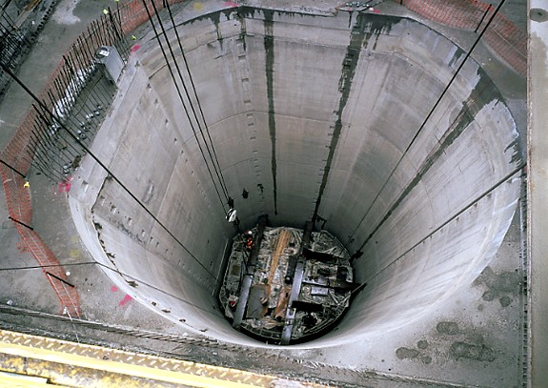

Bergen County

Manhattan
Hudson County

[Photograph shows Weehawken Tunnel shaft for access to station below]

Shaft for access to station below. View from Bergenline Avenue Plaza.

[Map of Hudson Bergen Light Rail]

Second Segment – Weehawken Tunnel

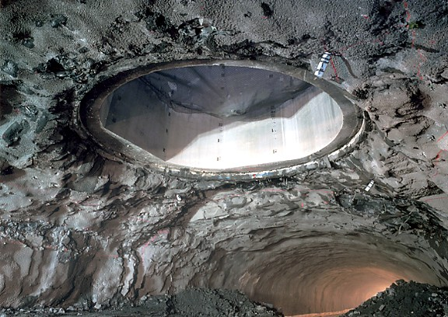

Bergen County

Manhattan
Hudson County

[Photograph of Weehawken Tunnel shaft]

The shaft will contain stairs and elevators between the Plaza and the station platform.

[Map of Hudson Bergen Light Rail]

Second Segment – Weehawken Tunnel

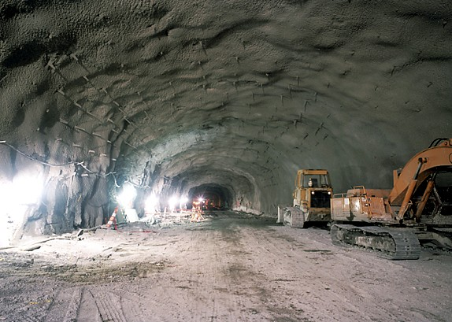

Bergen County

Manhattan

Hudson County

[Photograph of Weehawken Tunnel expansion construction]

Expansion of the existing tunnel to accommodate station and installation of temporary rock bolt and shotcrete support.

[Map of Hudson Bergen Light Rail]

Second Segment – Weehawken Tunnel

13 miles.

Environmental Impact Statement.

Conceptual engineering complete.

7 communities.

10 stations.

4000 new parking spaces.
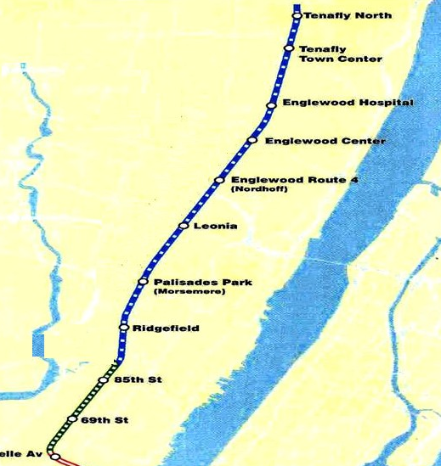

Bergen County

Manhattan

Hudson County

3

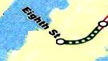

[Map of Hudson Bergen Light Rail]

Minimum Operable Segment
Hudson Bergen Light Rail

