MARS Simulation of MI Worst Case Accident Dose Rates in NuMI Carrier Tunnel

Review and Approval Record 3/25/03

________________________________ _______________________
Prepared by : N. Grossman Date

________________________________ _______________________
Prepared by : M. Kostin Date

________________________________ _______________________
NuMI Project Manager Date

________________________________ _______________________
NuMI Radiation Safety Coordinator Date

________________________________ _______________________
NuMI ESH Coordinator Date

________________________________ _______________________
Approved by : J. D. Cossairt Date

________________________________ _______________________
Approved by : W. Griffing (SRSO) Date

________________________________ _______________________
Approved by : M. Gerardi (RSO) Date

________________________________ _______________________
Approved by : R. Dixon (BD Head) Date

NuMI-NOTE-SIM-865

MARS Simulation of MI Worst Case Accident Dose Rates in NuMI Carrier Tunnel
S. Striganov, M. Kostin, N. Grossman
6/26/2002
Updated 3/19/03 by N. Grossman, M. Kostin

Summary:
A 30 foot concrete wall was installed in the Main Injector in order to allow contractors to work in the NuMI Stub extension, Carrier Tunnel and downstream with Main Injector beam operating. The NuMI Service Building & Outfitting (SB&O) contractor will finish their work in the NuMI carrier tunnel (and upstream) in June of 2003. MARS studies have been performed that show that after removal of the 30 foot wall in the Main Injector, dose rates downstream of the Carrier Tunnel downstream wall (see location 2 Figure 1) are low enough to allow the area be classified as Continuous Occupancy; no precautions area with respect to radiation levels.

Background:
There is a 30-foot concrete wall in the Main Injector, shown in Figure 1. The plan is to remove this wall during the summer 2003 shutdown, after the SB&O contractor is finished with their work in the regions upstream of the end of the Carrier Tunnel. In order for the contractor to be able to continue work downstream of the Carrier Tunnel downstream wall (location 2 in Figure 1), without any restrictions, several conditions must be met. The area must be classified as Continuous Occupancy, no precautions area with respect to radiation levels with the 30-foot shield wall in the MI removed. Per the Fermilab Radiological Control Manual, this requires a normal radiation level below 0.05 mrem/hr and an accident level below 1 mrem/hr.

The door at location 1 will be interlocked to the MI beam, until the SB&O work in the target area has been completed or the stairs in the target shaft have been installed by the end of the summer 2003 shutdown. This allows the contractor emergency egress through the carrier tunnel to the Main Injector. If the stairs in the Target Shaft are installed before the MI beam is enabled, the downstream door could be a captured key door (captured by MI) since the stairs up the shaft allow emergency egress.

The only radiation source is the MI. Normal operational rates at location 2 due to MI operation are negligible due to the combination of the horizontal angle of extraction down the NuMI beamline and the vertical angle down to the end of the carrier tunnel. . Thus the concern is a worst case MI accident at the “entrance” to the NuMI beamline, maximizing the beam loss directed down the NuMI beamline.

The geometry was setup in MARS to determine what the dose rates would be at location 1 and 2 due to a worst case MI accident under three scenarios. Scenario A assumed no wall at location 1, scenario B assumed an 2.5 inch thick light concrete wall at location 1, and scenario C assumed an 8 inch thick light concrete wall at location 1. In all three scenarios the dose rates were calculated at location 1 (downstream of the wall at location 1 if a wall was present), location 2 downstream of a 2.5-inch thick light concrete wall, and location 2 downstream of an 8-inch thick light concrete wall.

Update 2/2003:
The SB&O contract has an 8-inch CMU wall at location 1 and location 2. The low dose rates are desired on the downstream side of the 8-inch CMU wall at location 2. The geometry was setup in MARS to determine what the dose rates would be at location 2 due to a worst case MI accident.
0
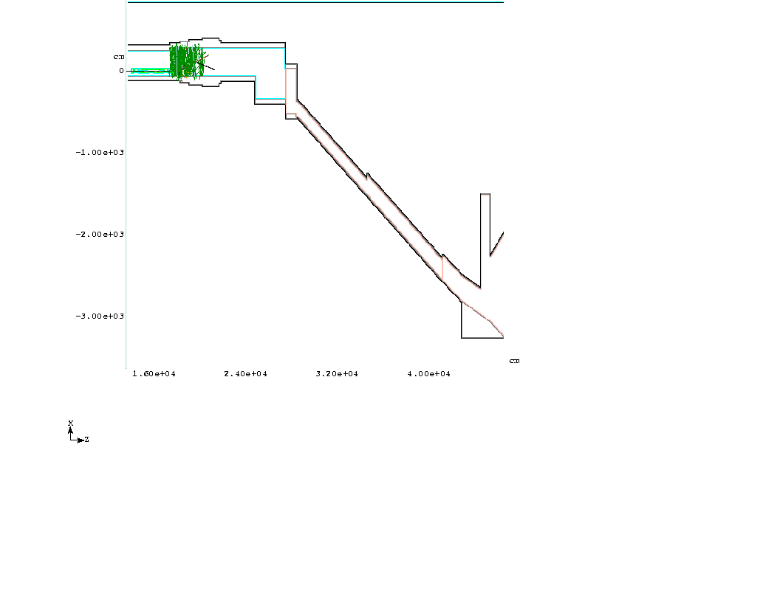
1
2
NuMI Stub
NuMI Stub Extension
Carrier Tunnel

Start of NuMI Pre Target
30’ wall
Figure 1: Elevation View of MARS Geometry and Accident Event

MARS Setup:
The MARS geometry used the MI beam and components near the NuMI extraction area. No NuMI devices were in the geometry, since during the SB&O portion of the NuMI civil construction, there will be minimal NuMI devices installed and the NuMI beamline will not be operational. Figures 1 and 2 show the geometry and accident events in two different views. The worst-case accident was determined to be when there was no field in the 6th dipole after LAM3 (IDD018). This is not possible due to the cycle time of the MI beam, and thus is an unrealistic worst-case accident scenario. Significant additional programming would be needed to determine the worst-case realistic accident scenario and thus that was not pursued at this time. Thus this worst-case scenario is extremely conservative as a MI dipole can only change current by ~20 amps due to a magnet coil short in one cycle of the MI.

The intensity used was 2x10¹³ protons/pulse. The light concrete used was MARS standard concrete with a density of 135 lbs/cf. A 2.5 inch thick light concrete wall was assumed to correspond to an 8-inch thick CMU wall, based on drawings of CMU blocks. The 8 inch thick light concrete wall was assumed to be similar to an 8-inch thick CMU wall filled with grout.

More realistic worst-case accident scenario update 2/2003:
The accident scenario of a beam loss due to a magnet failure is impossible since a magnet cannot be completely turned off in ~5 msec (the cycle time of the MI). Also the reaction time of the abort system is ~50 μsec, so that the beam is aborted before it is all lost locally.

The most probable place for a loss is on one of the quadrupoles, elements where beam amplitude is maximal. The beam is lost over many turns due to a continuous amplitude growth from beam instability. The beam is still assumed to be completely lost over many turns, although, most likely, the abort system would not allow that. NuMI-NOTE-SIM-889 discusses these loss scenarios.

6/2002 Results:
The results are given in the table below. Uncertainties are ~25%.

Table 1: Results Under Magnet Coil Short Scenario
Scenario | Dose Rate at Location 1 (mrem/pulse) | Dose Rate at Location 2,  2.5 inch thick wall at location 2 (mrem/pulse) | Dose Rate at Location 2,  8 inch thick wall at location 2 (mrem/pulse)
A (no wall at location 1) | 10.1 | 1.5 | 1.7
B (2.5 inch wall at location 1) | 13.4 | 1.1 | 1.3
C (8 inch wall at location 1) | 14.2 | 0.76 | 0.75

One can see that the wall at location 1 increases the dose rate just downstream at 1, but decreases the dose rate downstream at location 2. An 8-inch wall is needed at location 1 in order to get below 1 mrem/pulse at location 2. Whether the wall at location 2 is 2.5-inch thick concrete or 8-inch thick concrete does not appear to make much of a difference. An interlocked detector would be used in the NuMI stub (one is there currently), to trip off the beam after such an accident pulse. A coil short would take a long time to repair and thus assuming the 0.75 mrem/pulse is the worst-case mrem/hr accident scenario seems reasonable. Under these circumstances (8 inch wall at location 1 and second wall at location 2, either 2.5 inch or 8 inches thick), with MI operational and the 30-foot shield wall in the MI removed, no limitations would be required of workers downstream of location 2.

2/2003 Updated Results:
Main Injector Safety Envelope:
The MI safety envelope has been updated to 3x10¹³ protons/pulse. Thus the values in Table 1 need to be scaled up by a factor of 1.5.

The dose rate at the location 0 for the two scenarios: the coil short scenario and the more realistic many turn loss scenario were determined. The ratio was ~115/1. Thus one can scale down the results in the Table 1 by this amount.

The contractor is installing an 8” thick CMU wall at locations 1 and 2. These walls are about equivalent to a 2.5” thick concrete wall. The estimated dose rates at these two walls and near the start of the NuMI Stub (location 0) are shown in Table 2. Uncertainties are ~25%.

Table 2: Results @ 3E13 ppp
Scenario | Dose Rate at Location 0 (mrem/pulse) | Dose Rate at Location 1 (mrem/pulse) | Dose Rate at Location 2 (mrem/pulse)
Coil Short | 456,450 | 20.1 | 1.65
Multi-turn Loss Scenario | 4200 | 0.18 | 0.02

Summary 2/2003
The coil short scenario, as discussed previously, is not realistic. During the summer 2003 shutdown the 30’ wall in the MI will be removed. Table 2 shows that the accident dose rates under a conservative accident scenario of a multi-turn loss on a magnet in the MI near the entrance of the NuMI Stub are projected to be 0.02 mrem/pulse in the location where the contractor may be working. The requirement for continuous occupancy is 1 mrem/hr. The MI abort and/or the NuMI Stub detectors should cause the MI beam to be aborted well before 100% of the beam is lost, thus well before reaching 0.02mrem/pulse, and certainly not allowing one to come near 1 mrem/hr.

There are three interlocked detectors in the NuMI stub, just downstream of location 0, set to trip off the MI beam after such an accident pulse as discussed in this document. These detectors should detect losses like those shown in Table 2 easily, and the beam should be aborted.

Therefore the SB&O contractor can work downstream of the second wall (location 2), without any radiation safety training, once the 30’ concrete wall is removed from the MI. In fact, they could also work up to the end of the first wall, at the end of the lined section of the carrier tunnel (location 1), as the dose rates there are still a factor of 5 below what is needed to be continuous occupancy, assuming one aborts beam after a full lost pulse. Thus the interlocked gate could be located at location 1, allowing the contractor emergency egress into the Main Injector, if needed.

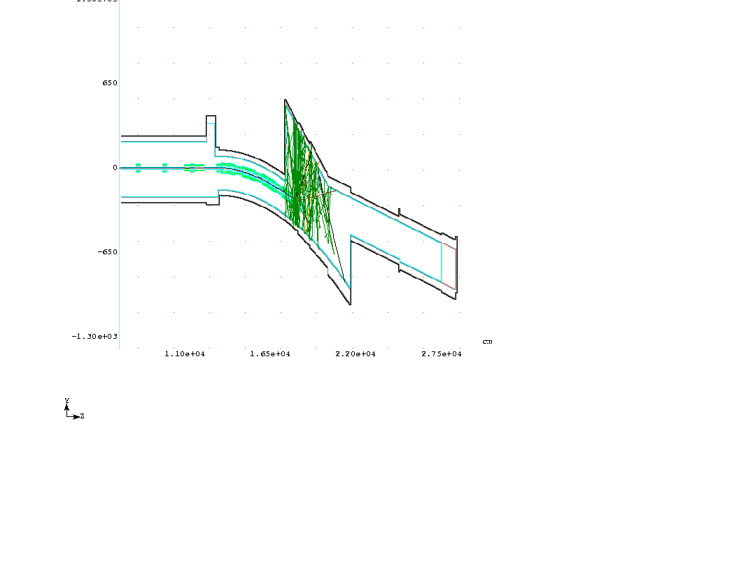
Figure 2: Plan View of MARS Geometry and Accident Event

