8. Drift and Diffusion in Materials, Wire Chambers
“Time is a sort of river of passing events,...and this too will be swept away.”...Marcus Aurelius
Wire chambers are perhaps the most commonly used detection devices in present high energy physics experiments. A chamber consists, conceptually, of a gas volume in which the gas is ionized by the passage of a charged particle. Ionization has been discussed in Section 6. The ionization then drifts (and diffuses) in an electric (and perhaps magnetic) field toward an electrode (wire). Subsequent collection and amplification of the signal charge on the anode and the charge induced on the cathode creates a detectable signal. Since the radius of curvature of a charged particle in a magnetic field depends on momentum (Section 7), measurement of points on the trajectory determines 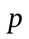 the vector momentum. We can then make a second redundant momentum measurement using “destructive” measurement techniques (see Sections 11-13).
In this Section we develop a general treatment suitable for “unity gain” devices, e.g. liquid argon calorimetry, or devices with gain, e.g. proportional wire chambers. We first introduce the drift velocity, mobility and the diffusion coefficient. The signal capacitively induced on the two electrodes is then considered both for a unity gain device and for a device with gain. The methods used here are later applied, in the following Section, to silicon devices.

8.1 Thermal and Drift Velocity
We begin by considering the drift of the produced ionization in a uniform electric field and the accompanying diffusion of the localized ionization. First, we note that gas molecules of mass M have a thermal velocity 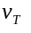 due to the thermal kinetic energy T_{T}, which is of order kT, where k is Boltzman's constant and T is the absolute temperature. The numerical value of k is given in Table 1.1.
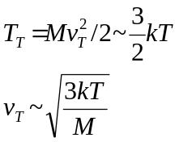 (8.1)
The thermal velocity goes like 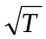. Numerically, we find that the thermal velocity of N₂ at room temperature is of order 105 cm/sec or 0.1 cm/μsec. Other light molecular gas velocities at standard temperature and pressure (STP) are in the range of (0.1 to 1.0) cm/μsec. In comparison, escape velocity on earth is ~ 1.1 cm/μsec. This fact explains why there are no light gases such as helium in our atmosphere. Fluctuations in the thermal velocity allow light gases to attain escape velocity and they are lost to the atmosphere.
For an electron, given the 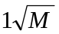scaling, we expect that typical thermal velocities would be of order ~(4 - 40) cm/μsec. Note that the thermal energy scale is well below the scale of the binding energies (see Section 1) which are relevant to atomic excitations, so we can consider the atoms to be inert “billiard balls”.
Let's consider next the situation where we have an applied electric field,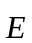, in addition to the random thermal motion. Between collisions, ions and electrons are accelerated by . The integral of the acceleration is the drift velocity v_{d}. The parameter is defined to be the mean time between collisions. Since the mean free path 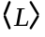 is the mean distance between collisions, is approximately 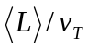. The average drift velocity is 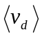.
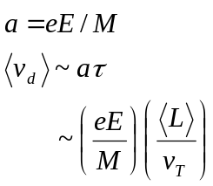 (8.2)
The drift velocity 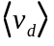, which is imposed on top of the randomly oriented thermal velocity, is proportional to the applied field. We assume that the main velocity components are caused by the random thermal motion and not by the applied electrical field, which is assumed to be only a small perturbation to the thermal motion.
As we discussed in Section 1, the inverse mean free path is proportional to the collision cross section, . For atomic collisions at low energy scales, the collision cross section is of order the geometric cross section 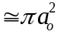. The total elastic cross section for e on CH₄ as a function of e kinetic energy is shown in Fig. 8.1.
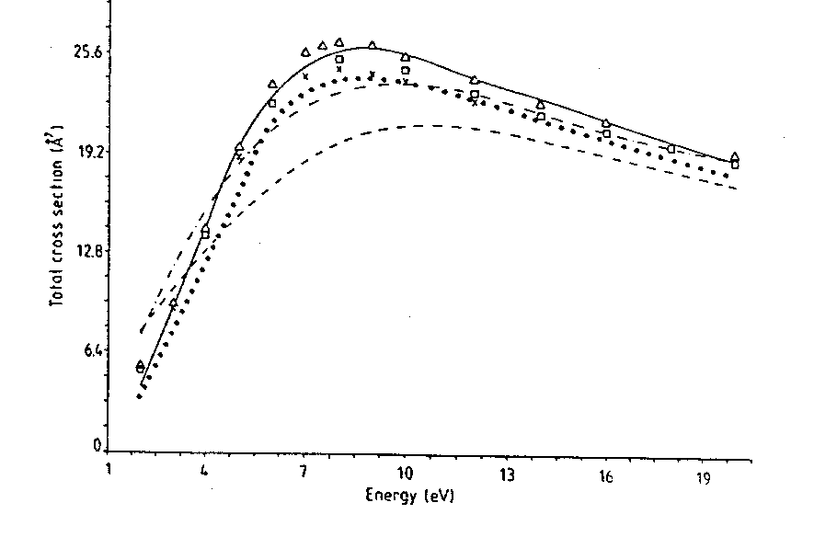
Fig. 8.1: Cross section for e on CH₄ as a function of the e energy in eV.
The scale is set by the geometric cross section, 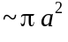 with 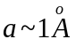. Since the signal current induced on an electrode is proportional to the drift velocity (see Eq. 8.7) and since the drift velocity is larger for electrons than ions, we concentrate mostly on electrons in what follows.
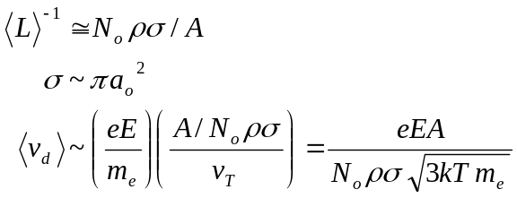 (8.3)

8.2 Mobility
The drift velocity is proportional to the applied electric field and inversely proportional to the collision cross section and the thermal velocity. Therefore, in this very simple-minded picture, we expect that the drift velocity per unit electric field divided by density would be a constant which is called the mobility. The electric field per unit of pressure, P, or per unit of density, , with respect to STP is called the reduced electric field. The mobility , is defined to be the drift velocity per unit reduced electric field 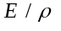.
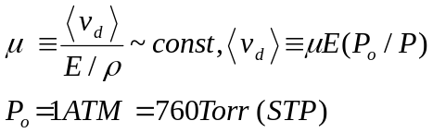 (8.4)
The measured ion mobilities for different gases are reasonably constant over most of the periodic table and are 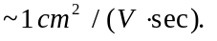
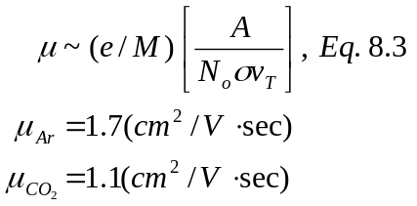 (8.5)
In methane the electron drift velocity in a field of 1 kV per cm is about 12 cm/sec. For comparison, the speed of sound in air at STP is about 0.033 cm/sec. Note that the drift velocities are, in fact, less than the electron thermal velocities, something we had initially assumed.
Shown in Fig. 8.2 are measurements of the electron drift velocity in cm/sec as a function of a reduced electric field for gaseous argon - methane gas mixtures. We see the expected linear rise of the drift velocity with electric field. The values of the drift velocity at a 1 kV/cm applied field are ~10 cm/sec. For comparison, the electron drift velocity in liquid argon, as shown in Fig. 8.3, at the same field is ~0.15 cm/sec indicating a lower mobility in the liquid.

We also see, looking at Fig. 8.2, another phenomenon. The linear rise with field no longer holds at high electric fields. At those fields the drift velocity becomes comparable to the electron thermal velocity, which we said, is of order (4-40) cm/sec. Our assumptions are then no longer valid, because we assumed that the drift velocity was a small perturbation on the random thermal motion. Of some practical use is the experimental fact that a 50:50 mixture of argon: ethane has a “saturated” drift velocity. By this we mean that the electron drift velocity is essentially independent of the field when E > 0.5 kV/cm. This gas mixture is widely used in “drift chambers” since, if E is kept high, the velocity is a constant, so that a drift time measurement is a linear measure of the distance from the point of particle passage to the anode wire. (See Fig. 8.7.)
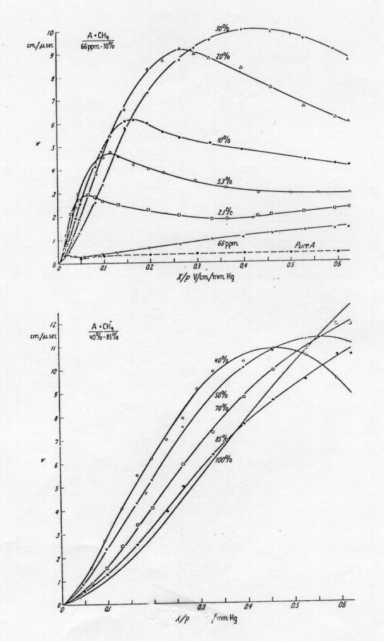
Fig. 8.2: Drift velocity in cm/μsec as a function of "reduced" field, E/P. a) A + CH4 gas mixtures, with fraction of CH4 ≤ 30%. b) A + CH4 gas mixtures, with fraction of CH4 > 40%. (From Ref. 2, with permission.)
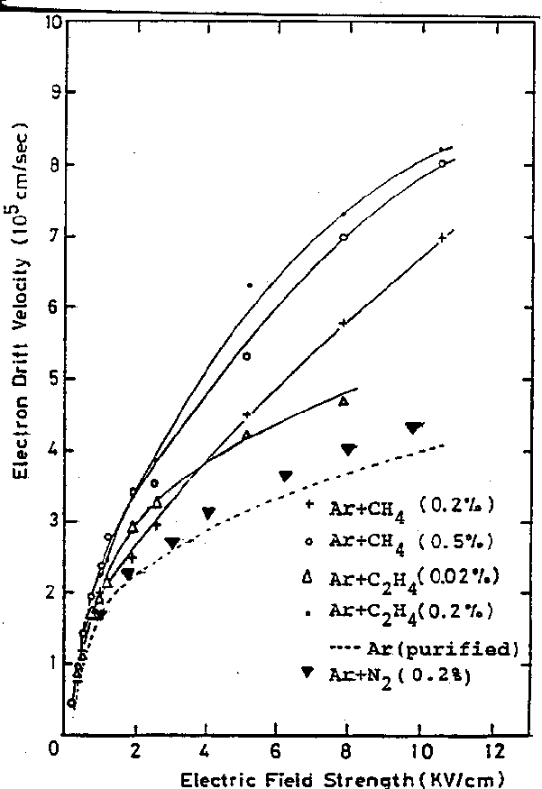
Fig. 8.3: Plot of electron drift velocity as a function of electric field in liquid argon. (From Ref. 9, with permission.)

8.3 Pulse Formation in “Unity Gain” Detectors
Let us now turn to the signal formation in a “unity gain” detector. The ionization produced by the passage of a charged particle is drifted to, and collected on, the electrodes which apply the electric field. There is no charge gain, as there is in a photomultiplier tube (see Section 2). For a parallel plate configuration with spacing d and applied voltage V₀, a field, E = V₀/d, exists in the gas or liquid located between the electrodes. Assume, initially, that a high energy charged particle passes perpendicular to the electrodes and uniformly ionizes the medium between them.
Using the relationship between capacity, C, voltage, V, and electrode charge, Q, Q = CV, the energy stored in the electric field is U = CV²/2 = Q²/2C ~ QV. The motion of the ionization charge in the field with time, q(t), capacitively induces a current pulse on the electrodes, I(t). We ignore the ions, because the size of the current pulse is proportional to the drift velocity. The change in field energy dU due to the drift of the ionization is equal to the work done, Fdx, by the field on the drifting charges.
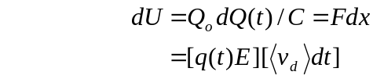 (8.6)
The charge Q(t) induced on the electrodes is proportional to the ionization charge q(t) in the electrode gap and the drift velocity . Note that this treatment is quite general, having used only energy conservation. Thus it can be used later in the discussion of wire chambers and Si detectors. The expression for I(t) is

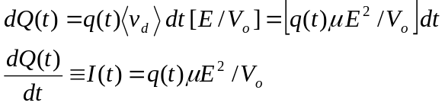 (8.7)
The charge/length initially in the gap is q_{s}/d = Ne/d where q_{s} is the total signal charge. Note that N is the number of independent “events”, just as, for example, N is the number of photo-electrons which is statistically distributed (Section 2). Therefore, the fractional spread in the output signal due to the statistical variation of N, dN, is given by 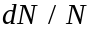 ~ 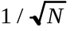. The characteristic time for all the charge to be swept up by the electrodes is 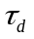. For example, for a 1 cm gap filled with argon-methane and a 1 kV applied voltage, this time is 100 nsec.
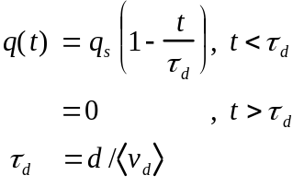 (8.8)
The charge q(t) in the gap is q_{s} at t = 0 and decreases linearly to zero at t = . The induced current behaves similarly, I(0) = q_{s}/, I() = 0. The total induced charge is Q(0) = 0, Q() = q_{s}/2, since half the induced charge appears on the other electrode, which we have assumed to be grounded.
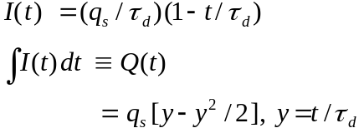 (8.9)
Sometimes all the charge is located at a single point, x_{o}, in the gap, for example, due to a short range decay which ranges out almost immediately or a Compton recoil electron due to a scattering of an x ray from Fe⁵⁵ decay (see Section 10). In that case Q(t) is different from the case where charge is spread throughout the gap.
In the “point” ionization case, with total charge q_{s} = e.
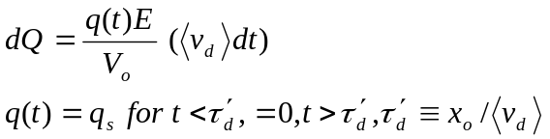 (8.10)
The current in this case is constant in time, and the charge collected on the electrodes increases linearly with time up to 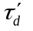, i.e. 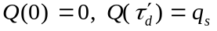(x_{o}/d).
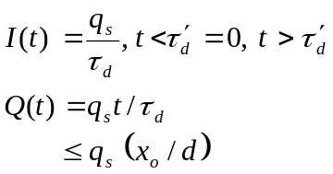 (8.11)
For example, a d = 1 mm gap in liquid argon has a collection time for a typical electric field of = 0.25 . The collected charge, Q(t) as a function of time is shown in Fig. 8.4 for point ionization, provided by short range irradiation, and for line ionization provided by traversal of minimum ionizing particles. Clearly linear and quadratic behavior is seen, respectively, with a time scale set by 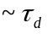. The signal noise, which is seen on the traces of Fig. 8.4, will be discussed in Section 9.
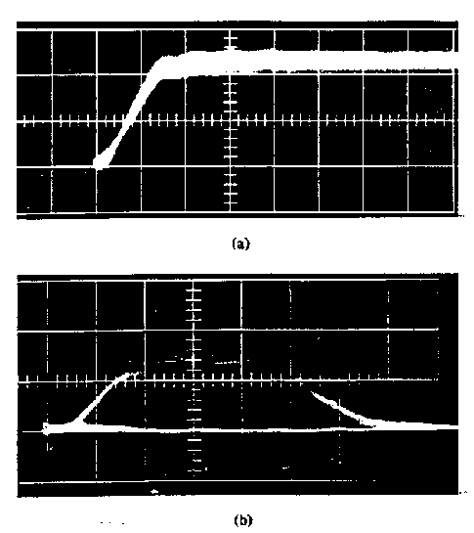
Fig. 8.4: Collected charge in a liquid argon detector as a function of time, a) point
ionization, 100 nsec/division b) line ionization, 200 nsec/division. (From Ref 9, with permission.)

8.4 Diffusion and the Diffusion Limit
Diffusion of the drifting charge is due to multiple scattering. This diffusion process sets a fundamental limit to the accuracy of position measurements in ionization chambers. Consider charge drifting with a velocity in field E for time t or distance x. The distribution, dN, of transverse coordinate, x_{T}, is defined by the diffusion coefficient D, with units of cm²/sec, [D] = [L²/T].
The diffusion equation is well known in classical physics in the study of heat. For a density 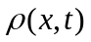, the equation without external forces being applied is 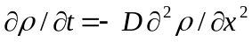. A one dimensional solution in the case that particles appear instantaneously and tightly localized spatially at x = 0 at t = 0 is:

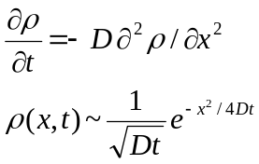 (8.12)
The solution is a Gaussian distribution of particles with a width; 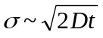 which grows with time as 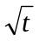. In the case where there is a uniform applied electric field the mean moves with a drift velocity brought about by the replacement, 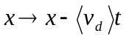 in Eq. 8.12. This is a stochastic process, as indicated by the fact that the rms of the distribution goes as 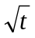. Recall the similar multiple scattering behavior, 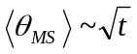.
We assert that dimensional arguments lead to the conclusion that D ~ <L> showing the relation between diffusion, thermal velocity, and collision mean free path. The rms of the diffusion distribution is

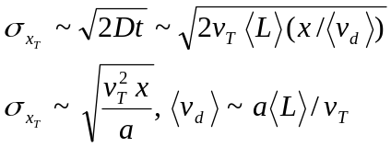 (8.13)
We use the relationship between v_{T} and the thermal energy kT and between a and the applied field E. This “thermal limit” for diffusion shows the competition between random thermal energy, 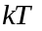, and the imposed drift field with energy eV_{o}.
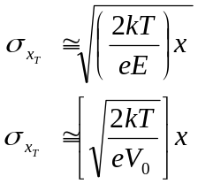 (8.14)
A plot of 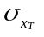 as a function of reduced electric field is shown in Fig. 8.5. The expected behavior, 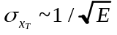, is roughly followed by the data at low electric fields. At higher electric field our assumption about small drift velocity, 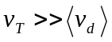 breaks down. We ignore here the difference between transverse and longitudinal diffusion. A typical value of at a drift field of 1 kV/cm is ~(100-300) for a 1 cm drift distance. Therefore a drift chamber with 1 cm spacing between wires cannot achieve a position resolution better than ~100 μm. This limitation is intrinsic.
An example of the geometry of a drift tube, with “field shaping” electrodes which are used to provide a drift field of > 0.5 kV/cm, is shown in Fig. 8.6. Also shown are the equipotentials. By design there is a reasonably uniform electric field across most of the drift space. The relationship of drift distance to drift time for this structure is shown in Fig. 8.7 for cosmic ray traversals at two angles of incidence, 0o and 45o. In this example a mixture of argon and carbon dioxide is used as the drift gas. The phenomenon called “saturation” also roughly obtains in this gas mixture for drift fields greater than about 0.5 kV/cm. This implies a linear relationship between the drift distance and the measured drift time (the time between particle passage and the collection of the ionization on the wire). We see from Fig. 8.7 that this is roughly the case for drift distances up to 5 cm with a maximum drift time of about 800 nsec. The average drift velocity is about 6.2 cm/.

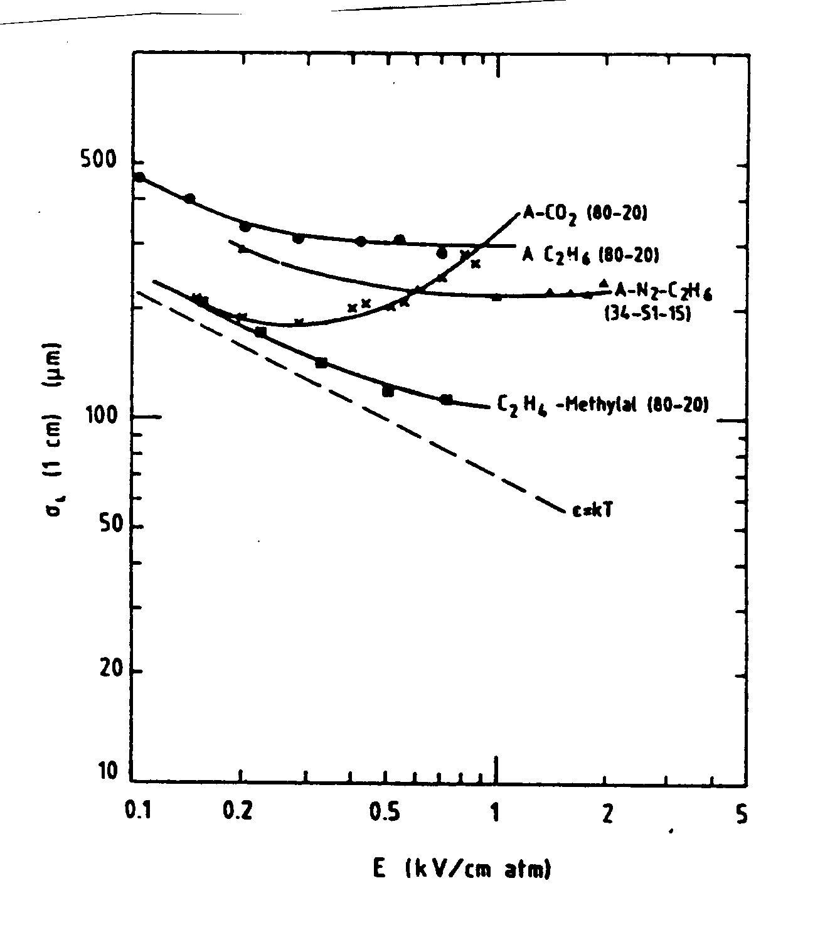
Fig. 8.5: Measured values of the longitudinal diffusion coefficient 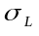 as a function of applied reduced electric field for different commonly used gases compared to the thermal limit, 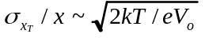, indicated by the dashed line. (From Ref. 5, with permission.)

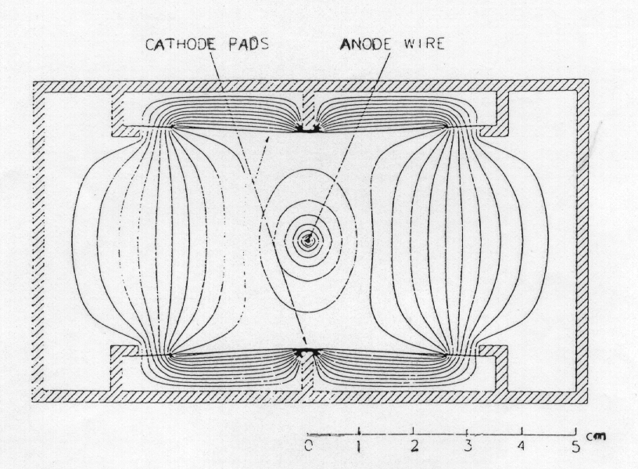
Fig. 8.6: Transverse dimensions and equipotentials for a large area drift tube with field shaping. (From Ref. 11, with permission.)

As a numerical example, electrons in gaseous Ar in a drift field of 1 kV/cm have a drift velocity of ~ 5 cm/. In a 1 cm drift distance the transverse diffusion distance is ~1000 , while in pure C0₂ it is only 100 . In the mixture Ar:C0₂ = 80:20 it is 300 (see Fig. 8.5). The width of the lines in Fig. 8.7 gives some indication of the spatial resolution. Diffusion limits the resolution for the longest drift distances. The observed resolution is ~ 100 near the wire and ~ 400 at the maximum 5 cm drift distance.
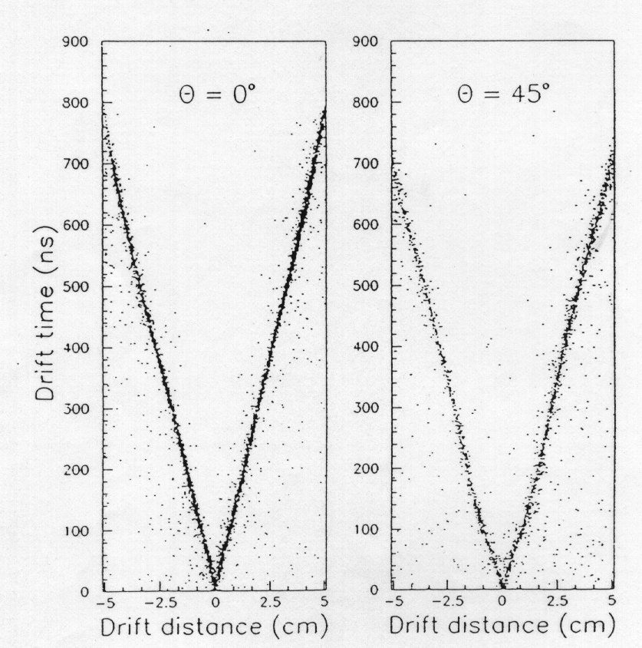
Fig. 8.7: Relationship of drift distance to drift time for the structure shown in Fig. 8.6 for particles incident at 0o and 45o. (From Ref. 11, with permission.)

8.5 Motion in and 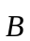 Fields, with and without Collisions
So far we have only considered random thermal motion and motion in an applied electric field. In Section 7 we have also discussed free motion in a purely magnetic field. We concluded that the path was circular with a “cyclotron frequency”, 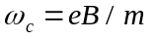 (Table 1.1). Now we consider the more complex case of free motion in a region where there are simultaneous electric and magnetic fields. The dynamics in the absence of collisions is controlled by the Lorentz force equation. (CGS units here.)
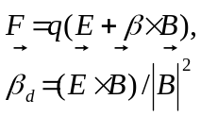 (Eq. 8.15)
The general case of non-relativistic motion in a vacuum with an arbitrary angle θ between and is treated in Appendix G. In the special case that the electric and magnetic fields are transverse to one another we can see that in a direction transverse to both the electric and magnetic fields, the force is 0 if 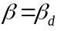. A particle can thus move at a constant drift velocity, 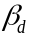, perpendicular to crossed electric and magnetic fields in vacuum. This is the principle of electrostatic separation where we prepare a beam of particles of fixed momentum by bending in a magnet, focussing parallel, and then collimating (see Section 7). We then put the beam through a “separator” which has crossed electric and magnetic fields. Only particles of the right mass, and therefore the right velocity, , will be undeflected whereas the unwanted particles will be physically deflected and subsequently can be removed, again by collimation. This technique is a form of “destructive” particle identification.

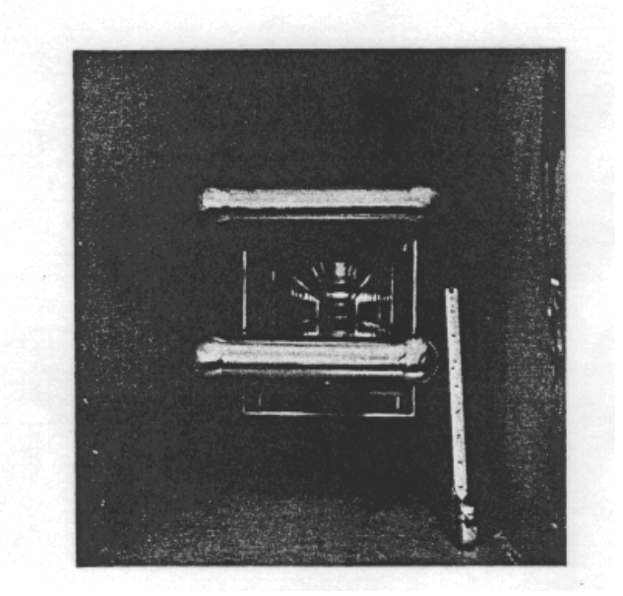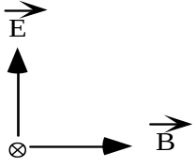
Fig. 8.8: Photo of an electrostatic beam separator. The plates are charged to establish the electric field. The vacuum tank surrounding the plates is made of soft iron and acts as the pole tips of the magnet supplying the magnetic field. The line of sight is the beam axis, . (From Ref. 10, with permission.)

A photo of a working “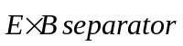” is shown in Fig. 8.8. It is hard to maintain a voltage greater than a megaVolt in air due to corona and other discharge effects. Typical operating parameters are E ~ 1 MV/cm and β = 0.5. To achieve that drift velocity a magnetic field of 7 kG is required.
In the case where there are collisions, in a medium such as a gas, they can be approximated as an effective frictional force that is characterized by a mean time between collisions . The non-relativistic relationship between the frictional force 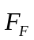 and momentum follows because force is the time rate change of momentum.
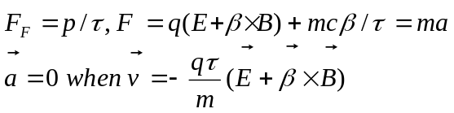 (8.16)
We can solve Eq. 8.16 for the situation where the force is zero and we have a uniform drift velocity. The drift velocity 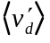 is now a function of the charge, mass, fields and .
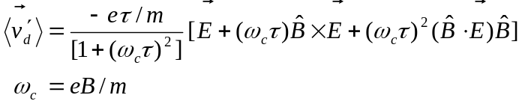 (8.17)
The drift velocity has, in general, components along the , , and 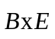 directions.
The vectors appropriate to drifting in perpendicular electric and magnetic fields are shown in Fig. 8.9. The “Lorentz angle”, φ_{L}, is defined to be the angle which the drift velocity 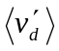 makes with the applied electric field. In the vacuum case 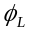 is 90o as it is perpendicular to both 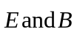. In general the drift velocity for perpendicular and fields is in the and 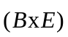 plane.
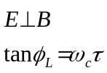 (8.18)
The quantity 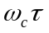 is a measure of the rotation angle of the momentum in the B field between collisions. Therefore if 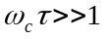 we expect small collisional effects. If , the angle becomes 90o and we recover the case of the vacuum drift velocity. For a mean free path between collisions of 10 μm (gas) with a 10 cm/μsec drift velocity (argon-methane), τ is ~ 1psec and ωτ is 0.17 or φ_{L} is ~ 11 degrees. Note that there are serious practical consequences. Wire chambers operated in magnetic fields often have their electrode structure modified to follow the Lorentz angle.
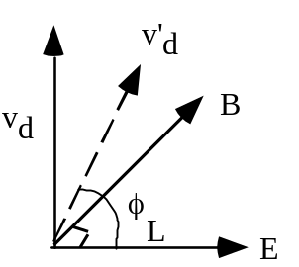

Fig. 8.9: Vectors for drift in perpendicular electric and magnetic fields. The Lorentz angle φL is in the 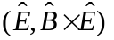 plane.

In general, the drift velocity is less than the velocity appropriate to the 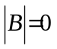 case because of the additional helical path length. 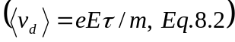.

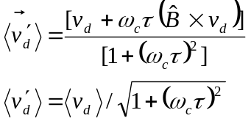 (8.19)
The effective diffusion coefficient in the direction perpendicular to B is lowered by a factor 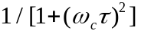 due to the tight helical orbits. This effect is sometimes used to improve the position resolution for long drift distances where diffusion errors dominate.

8.6 Wire Chamber Electrostatics
We now consider a simplified description of a “wire chamber”. We consider only the simplest case of a cylindrical tube with outer radius b coaxial with a small diameter wire of radius a, Fig 8.10. A particle is localized to a position resolution ~b if ionization is detected on a given wire assuming a linear array of such tubes as is shown in Fig. 8.10. This is a simple problem in two dimensional electrostatics. We use Gauss' law (CGS units). In terms of λ, the charge per unit length on the wire, we find the electric field and the potential V.
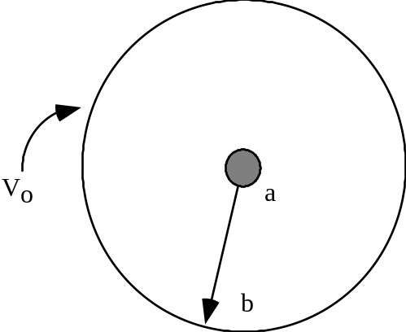

Fig. 8.10: Cylindrical proportional tube of outer radius b at voltage V_{o} and inner (wire) of
radius a at voltage zero.

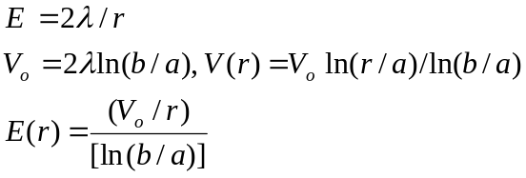 (8.20)
The passage of a charged particle causes ionization. The electrons then drift towards the anode. Near the wire the high electric fields cause a multiplication of the electrons by collisions since at a small radius the energy gain can exceed the ionization potential, I, of the gas (see Section 1). The newly created electrons in turn will be accelerated and cause ionization. This is a runway process similar to what we already discussed in the operation of a photomultiplier tube. Note that the “gas gain” follows from the change in the number of electrons dN(r) at a given position r in the multiplication process. This change depends on the number of electrons present N(r) and the multiplication factor, per unit length. The parameter is the inverse of the distance over which a multiplication occurs. It is called the first Townsend coefficient and is identifiable as the inverse mean free path for ionization, 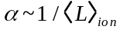.
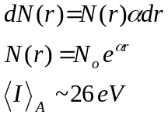 (8.21)
The amplification or “gas gain” is 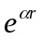. A typical gas gain might be 10⁵. Above that level we approach the “Geiger region” which is a true runaway process where the whole tube is discharged. We concentrate in what follows on the “proportional region” where the output signal is ~ proportional to the input signal. The transition region between these operational modes occurs experimentally for ~ 20 pairs or for gas gain ~ 10⁸.

8.7 Pulse Formation in a Wire Chamber
The time development of the signal is different from that of the “unity gain” ionization chamber we discussed previously. The electrons from the primary ionization are multiplied by the high fields near the wire, E(r) ~ 1/r, and are collected on the anode. The ions remain, “sheathing” the wire and moving slowly toward the cathode. The motion of all the charges in the applied field causes a change of system energy and a resultant capacitively induced signal, dV.
Suppose the multiplication takes place at N wire radii, i.e. r = Na. The voltage signal on the anode is due to the motion of the electrons, 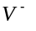, and the ions, 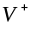. If q_{s} is the source charge and C is the capacity, then dU = C V_{o} dV = q_{s}Edr (see Eq. 8.6). The induced voltage due to electron and ion motion is;
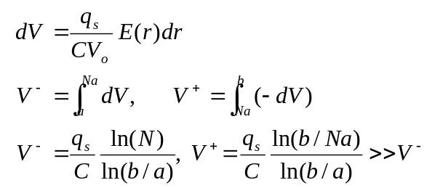 (8.22)
Clearly, in the case of the wire chamber the signal due to the ions, V⁺, dominates, basically because they move all the way to the cathode. Therefore, the ion motion is responsible for the majority of the anode signal. The electron contribution will be ignored from now on.
The signal can be found using the technique already applied to unity gain devices. Assuming a constant ion mobility, , dr = E(r)dt. Thus, dr = 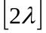dt/r (t). Assume that the ions all appear at r = a at t = 0 due to the final multiplication.
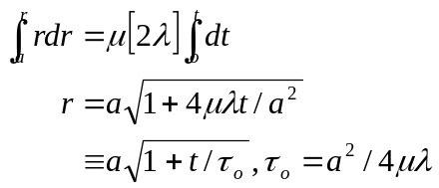 (8.23)
The fact that the fields goes as 1/r implies that the ion position r goes as ~ 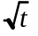. Using the general equation, Eq. 8.7, we can then find the current induced on the wire.
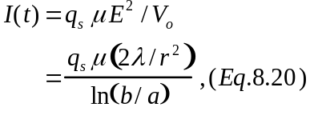 (8.24)
Substituting in the expression for r(t) we find I(t) in terms of time t.
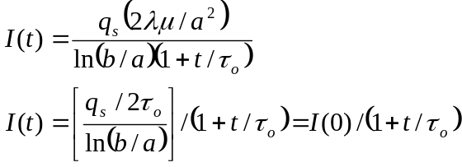 (8.25)
The key parameter 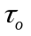 is the characteristic time for the pulse to form. It can be thought of as roughly the time it takes for the ions to move away one wire radius, a, towards the cathode under the influence of the electric field, E(a) = 2/a, which exists near the surface of the anode wire.
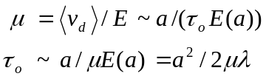 (8.26)
We define C to be the capacity per unit length of the anode while the capacity is C and the capacity/unit length = C. The relationship of voltage, charge and capacity is V = Q/C = λ /C. From Eq. 8.20 we find C = 1/[2 ln(b/a)] so that C is dimensionless in CGS units. It can be thought of as ε in ε_{o} units (Table 1.1). Typically for wire chambers, C ~ (0.01 - 0.1) pF/cm, CV_{o} ~ λ ~ 5 x 10⁻¹⁰ Coulomb/cm = 500 pC/cm. Recall that (Table 1.1), ε_{o} = 8.85 pF/m in MKS units.
The charge Q is derived by integrating Eq. 8.25. The signal voltage follows using V = Q/C.
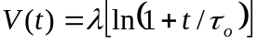 (8.27)
As a numerical example consider a 1 cm radius tube strung with a 20 micron radius wire, b = 1 cm, a = 20 μm. The field is about 160 kV/cm at the surface of the wire, λ = 180 pC/cm, and the pulse formation time is a few nsec for argon ions. This is the kind of speed that we observe in the rise time of pulses from proportional chambers. (See photo Section 9.)
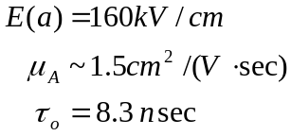 (8.28)

8.8 Mechanical Considerations
A photograph of a real proportional wire chamber, PWC, not operated as a simple linear array of coaxial tubes but as a planar series of detecting wires is shown in Fig. 8.11. This particular chamber has a 1 mm spacing between the wires and the wires are about 20 cm long. The cathode is a plane of aluminum foil. This chamber has been used to measure the position of particles to an accuracy ~0.5 mm in prepared beams at Fermilab. A photograph of a large area drift chamber is shown in Fig. 8.12. In this case there is a large spacing, about 2 centimeters, between the anode detection wires. If we want precise position localization with this “drift chamber” we need to accurately measure the drift time (Fig. 8.7).
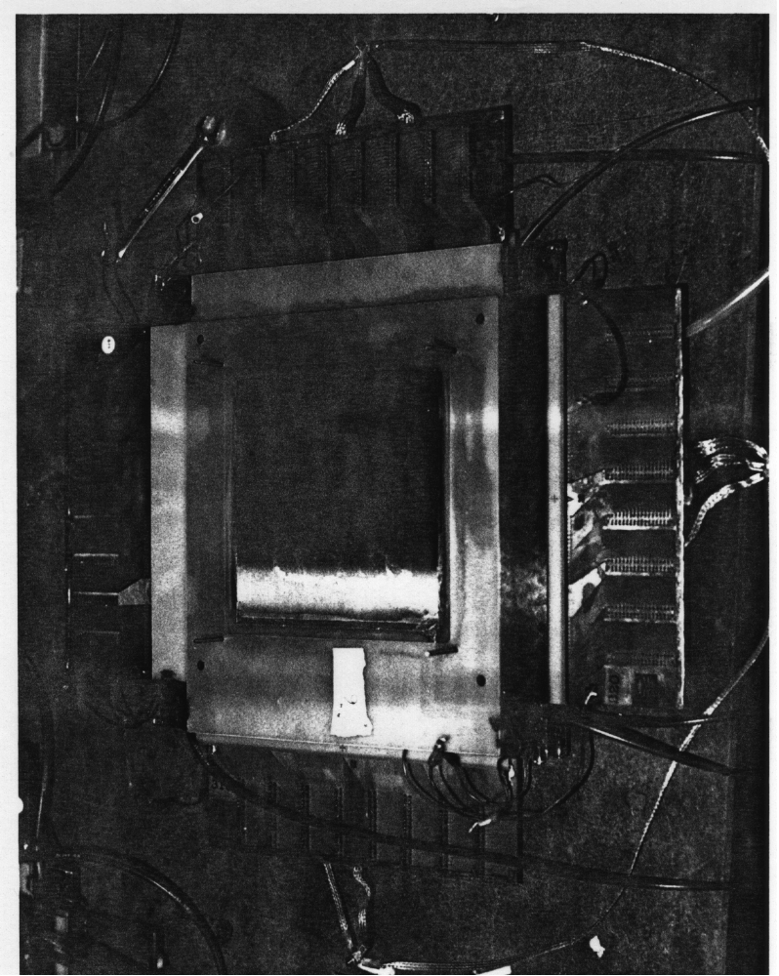
Fig. 8.11: Photo of a PWC with 1 mm wire spacing and without wire supports. The connectors for the readout electronics are evident. (Photo - Fermilab.)

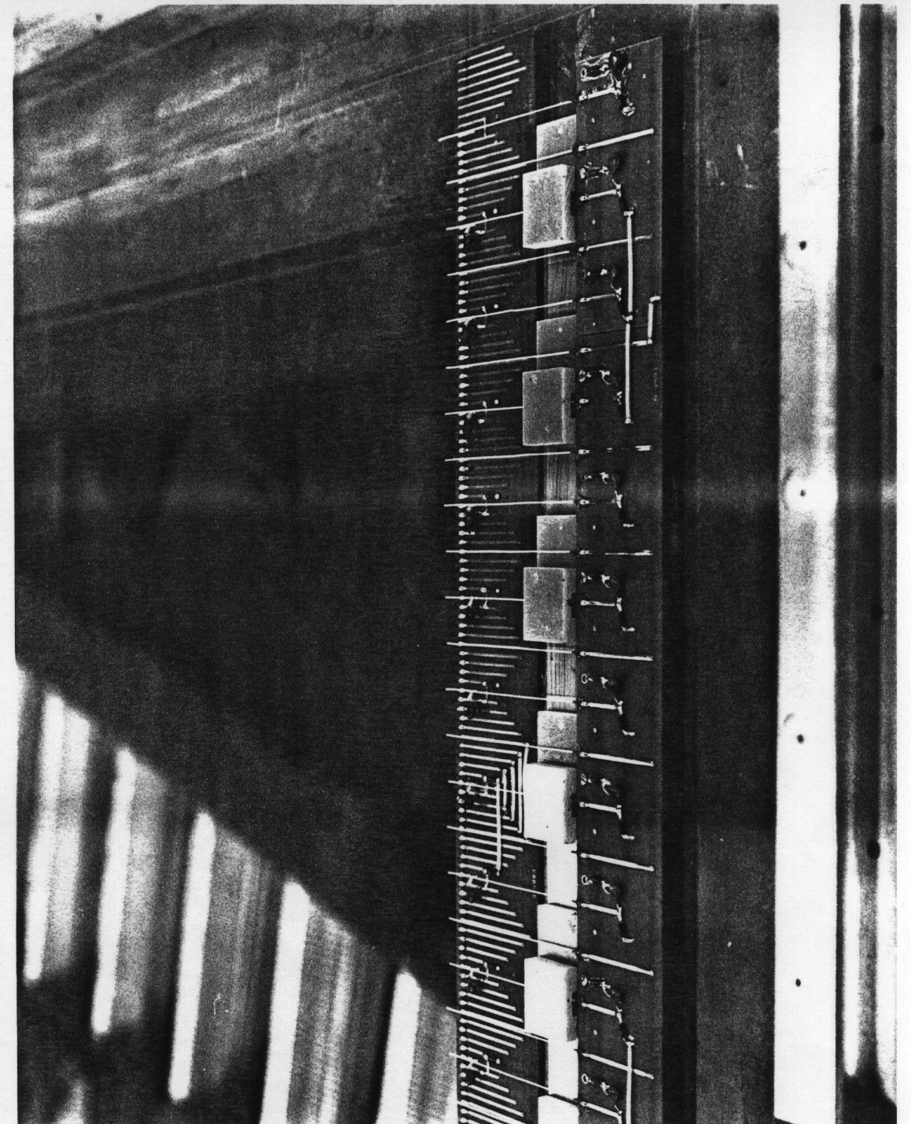
Fig. 8.12: Photograph of a large area drift chamber. Note the large spacing between anode detection wires. (Photo - Fermilab.)

Constructing proportional wire chambers with parallel wires, we need to keep track of the fact that the wires are charged to a typical value of 2 x 10-10 C/cm. The wires all being charged the same, will repel. There will be a deflection unless the wires are maintained under a certain tension, T. The tension has to be greater than the repulsive force between the wires if the PWC is to be “stable”. Crudely, for a wire spacing, d, wire length L and a charge per unit length λ the stability condition is;
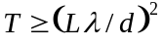 (8.29)
For example with a 20 diameter wire, a PWC built with a 1 mm spacing, d, having a typical charge per unit length of 2 x 10-10 C/cm has a maximum unsupported wire length L of about 13 cm for a wire tension T yield strength of about 50 grams. The natural limit to T for a given wire diameter comes at or below elongation or breaking tension, T_{max}. Clearly there is a competition between high spatial resolution, d small, rapid pulse formation time 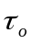, (large - small a), and the ability to make a stable large area chamber, (small - large d - large a). Typically, the existence of these incompatible requirements is evaded by supporting the wires mechanically in some fashion at a separation between supports which is less than the maximum length allowed for stability. In this way we can build a large area, finely spaced, high speed, proportional wire chamber.
A schematic of the spatial pattern for typical wire chamber instability is shown in Fig. 8.13. For tension too small, the wires repel one another, and the uniform plane of wires which is desired is not a stable configuration. The distorted plane is a configuration with reduced energy (charges farther apart) so that unless sufficiently restrained, the system will adopt this configuration. These wires in motion are unstable, and such a chamber cannot be operated reliably.
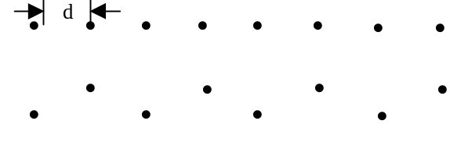
Fig. 8.13: Schematic of a wire chamber wire array for both an unperturbed and an unstable condition.

A typical fast amplifier configuration used to process the signal pulse which forms on the anode is shown in Fig. 8.14. The detector current source signal i_{s} appears as a voltage output V_{o} proportional to the source current i_{s}, V₀ = i_{s} R. Some algebra for this and other operational amplifier circuits is given in Appendix I. Front end electronics is relegated to this Appendix, and references are given in Section 13 while front end noise is discussed in Section 9.
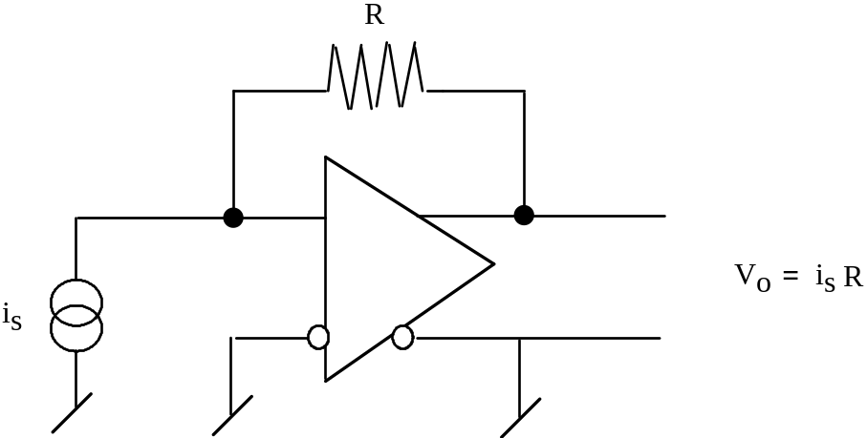

Fig. 8.14: Schematic of a “transimpedence amplifier”. The voltage output is proportional to the source current.

8.9 The Induced Cathode Signal
So far we have not discussed the cathode signal. The almost instantaneous appearance of charge near the anode wire capacitively induce charge on the cathode. Therefore, we have a second detectable signal. Note that we are free to cut the cathode into whatever shape we wish, as long as all parts of it are maintained at the same voltage. This freedom of design has made cathode readout popular.
The geometric situation is shown in Fig. 8.15 where a source charge, q_{s}, appears effectively on the anode wire located at a perpendicular height a above the cathode pad. The sudden appearance of the source charge induces a surface charge, , on the cathode pad. We can evaluate σ at an arbitrary location labeled by radius vector r by using the “method of images”, placing an image charge -qs at the virtual symmetric point below the pad and evaluating the resultant dipole-like 1/r³ behavior of . The image charge technique is a method often employed to satisfy the electrostatic boundary condition that there be no electric field parallel to the conductor.
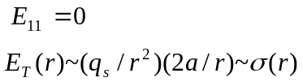 (8.30)
The resulting field is perpendicular to the pad surface by construction. By Gauss’ law the perpendicular field (CGS) is also the induced surface charge density, 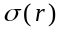. The surface charge density, if sampled on several different cathode electrodes, allows us to infer the centroid location
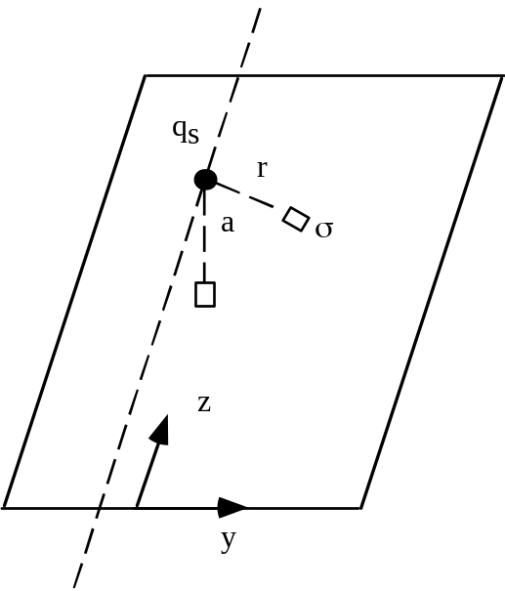 a
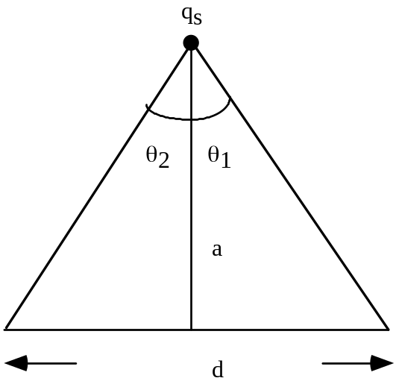 b
Fig. 8.15: a) Geometry for deriving the induced surface charge on a pad, σ, for source charge qs at height = a above the pad. b) Geometry for infinitely long strip electrode of width d.

of the instantaneous charge which has appeared on the anode. This technique offers a rather precise second coordinate measurement if pulse amplitudes are well measured. For example anode wires may have associated cathode strips at right angles. Wire pulses then localize in 1 coordinate, while strip centroids yield the second orthogonal coordinate.
As an example, we can use the geometry shown in Fig. 8.15 and integrate over a strip which is infinite in the z direction and is of width d in the y direction. We find that the charge induced on the pad, q_{p}, is simply related to the source charge, q_{s}, and the angles of the wire subtended by the pad boundaries. In the limit that we come very close to the pad, a<<d, the ratio of q_{p} to q_{s} approaches 1/2, as expected by geometry, since half the charge is induced below the wire, half above. In general, the induced charge is approximately proportional to the angle subtended by the pad ~ (θ₂ - θ ₁ ).
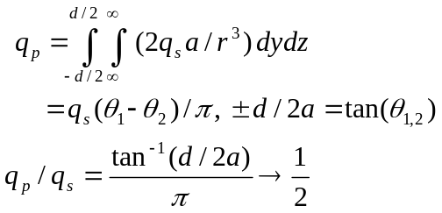 (8.31)
An example of an application of “pads” is to use the induced charge on two different pad electrodes to infer the location of the charge along the wire. We use the drift time to infer the location transverse to the wire. We can therefore achieve full three dimensional readout in a single plane. A concrete example of such a detector is shown in Fig. 8.16 where the inner, Q_{B}, and outer pad, Q_{A}, charges are both measured. The charge ratio is a measure of the position along the wire. Data taken with an external high resolution device yields a precise value for the position along the wire. When this is compared to the charge ratio, as in Fig. 8.16, we see that we can get quite good spatial resolution by the use of induced pad charges. As a rule of thumb the technique is noise limited to a resolution ~1% of the geometric feature size of the pads. That limit is evident in the line width visible in Fig. 8.16.
Other uses of the induced charge exploit the complete freedom to configure the cathodes and their geometry. For example, in gas calorimetry we use the cathode signals so as to easily make projective “towers” which match the outgoing paths of particles from a collision (see Fig. I.1). Because layers of calorimetric readout (see Section 11 - 13) occur at different depths, each tower layer has a different size, which is easily achieved by cutting a different pad on the readout circuit board.

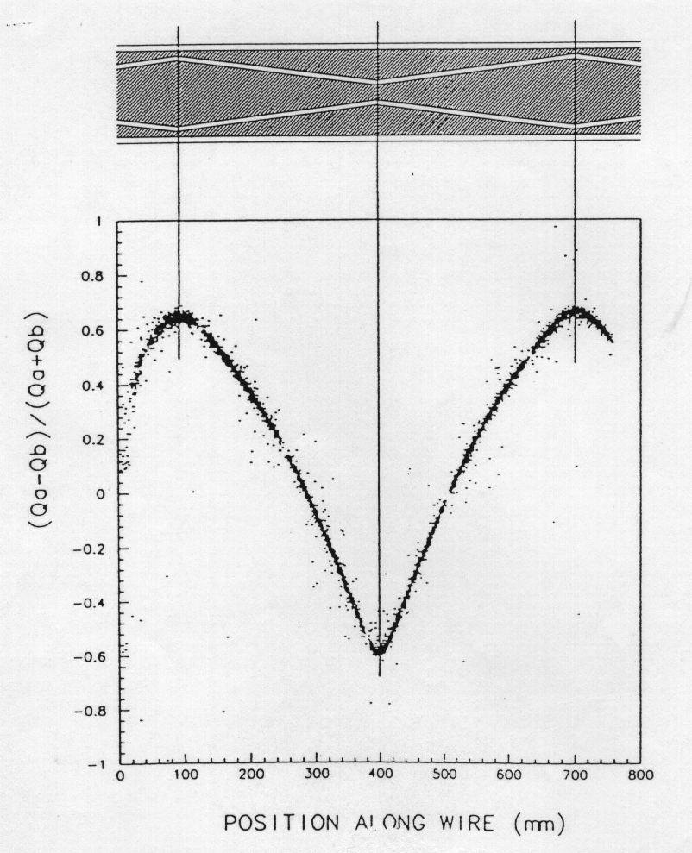
Fig. 8.16: Relationship of the pad charge ratio to the position along the wire for the structure shown in Fig. 8.6. (From Ref. 11, with permission.)

References
Section 8: Drift and Diffusion in Materials, Wire Chambers

[1] Drift and Diffusion of Electrons in Gases: A Compilation, A. Peisert, F. Sauli, CERN 84-08 (1984).
[2] Principles of Operation of Multiwire Proportional and Drift Chambers, F. Sauli, CERN 77-09 (1977).
[3] Signal, Noise and Resolution in Position-Sensitive Detectors, V. Radeka, IEEE Transactions on Nuclear Science, 21 51 (1974).
[4] Spark, Streamer, Proportional and Drift Chambers, P. Rice-Evans, RicheLieu (1974).
[5] High Resolution Electronic Particle Detectors, G. Charpak, F. Sauli, Annual Review of Nuclear and Particle Science, 34 285 (1984).
[6] Basic Data on Plasma Physics, S.C. Brown, Wiley (1959).
[7] Atomic and Molecular Radiation Physics, L.G. Christophorou, Wiley (1971).
[8] Electrons in Gases, J. Townsend, Hutchinson (1947).
[9] Experimental Techniques in High Energy Physics, T. Ferbel, Addison-Wesley Publishing Co., Inc. (1987).
[10] L. Yuan and C.W. Wu, Methods of Experimental Physics.
[11] S. Abachi et al., The D0 Detector, Nucl. Inst. and Meth. A338 185 (1994).
Table of Contents

8. Drift and Diffusion in Materials, Wire Chambers 1
8.1 Thermal and Drift Velocity 1
8.2 Mobility 3
8.3 Pulse Formation in “Unity Gain” Detectors 6
8.4 Diffusion and the Diffusion Limit 9
8.5 Motion in and Fields, with and without Collisions 12
8.6 Wire Chamber Electrostatics 15
8.7 Pulse Formation in a Wire Chamber 17
8.8 Mechanical Considerations 19
8.9 The Induced Cathode Signal 22
References 26

