APPLICATION REVIEW

AND DETERMINATION OF PRELIMINARY COMPLIANCE

FOR:

Barrick Goldstrike Mines, Inc.

Western 102 Power Generation Facility

Reno-Tahoe Industrial Park
Storey County, Nevada

Operating Permit to Construct convert to Class I Operating Permit Application AP4911-2189



BY

STATE OF NEVADA

DEPARTMENT OF CONSERVATION AND NATURAL RESOURCES
DIVISION OF ENVIRONMENTAL PROTECTION
BUREAU OF AIR POLLUTION CONTROL

Rod Moore
Staff Engineer

September 26, 2006

1.0 INTRODUCTION

On June 19, 2006, Barrick Goldstrike Mines, Inc. (Barrick) submitted an application to the Nevada Division of Environmental Protection - Bureau of Air Pollution Control (NDEP-BAPC), to convert their current Operating Permit to Construct (AP4911-1364) to a new Class 1 Air Quality Operating Permit. The facility is located at the Tahoe-Reno Industrial Park located in Storey County, Nevada approximately 25 km east of Reno on the south side of the Truckee River. The Standard Industrial Classification (SIC) number for the process is 4911, Electrical Services, described as “Establishments engaged in the generation, transmission, and/or distribution of electric energy for sale.” The North American Industry Classification System (NAICS) number is 221112, described as “Electric power generators, fossil fuel.” The project consists of 14 Wartsila lean-burn natural gas reciprocating engines that turn generators to develop power. Each engine is attached to an 8.2 MW electric generator. Combined gross facility output is estimated at 115 MW.

Current emission estimates indicate that the Barrick plant will be a Class 1 stationary source (emissions of criteria pollutants are greater than 100 tons/year). The controlled pollutant emissions of PM₁₀, PM, Carbon Monoxide and Volatile Organic Compounds are greater than 100 tons per year each.

The facility is an area source for the single HAP formaldehyde, with estimated emissions at 9.94 tons/yr, just below the 10 TPY major source threshold (for any single HAP). Similarly, the total combined HAP emissions of 22.45 TPY are less than the 25 TPY major source threshold (for all HAPs combined).  The project’s source category has a 250 TPY threshold to be designated a major stationary source for PSD applicability. The potential to emit of the following NSR regulated pollutants (PM₁₀, NO_{X}, CO, SO₂ and VOCs) are below the 250 TPY threshold.
  Applicant Proposed Facility-wide PTE.
  Pollutant | TPY
  PM | 158.76
  PM₁₀ | 158.76
  NO_{x} | 93.80
  CO | 152.32
  VOC | 149.52
  SO₂ | 35.56
  HAPs (all) | < 25.0
  Formaldehyde | < 10.0

Potential emission rates are accomplished with control technologies achieving very high emissions reduction rates for Reciprocating Internal Combustion Engines (RICEs). Of special interest and discussion in this review is the potential for formaldehyde to exceed the applicant proposed PTE of 9.94 TPY and to trigger the source as a major HAP source. Major source status for formaldehyde would require the facility to be subject to the recently promulgated 40 CFR Part 63, Subpart ZZZZ NESHAP MACT for RICEs. Applicability to the Subpart ZZZZ would mandate additional monitoring and a continuous parametric monitor system for each RICE.

1.0 INTRODUCTION (Continued)

The Western 102 project is located in Hydrographic Basin HA-83, an air management area triggered for PSD and increment consumption. HA-83 is a designated PSD-triggered air management area consuming increment for NO_{x}, PM₁₀ and SO₂. Basin 83 was first triggered by the Sierra Pacific Power Company, Tracy Generating Station Pinion Pine Power Generating Project March 11, 1994. Several large facilities currently reside in this area and both a Nevada Ambient Air Quality Standards (NAAQS) analysis and PSD increment analysis will be performed for the Barrick Western 102 facility and discussed in this review.

Location of Barrick Western 102 facility. Interstate 80 located directly North above the Truckee River. Other nearby sources are indicated.
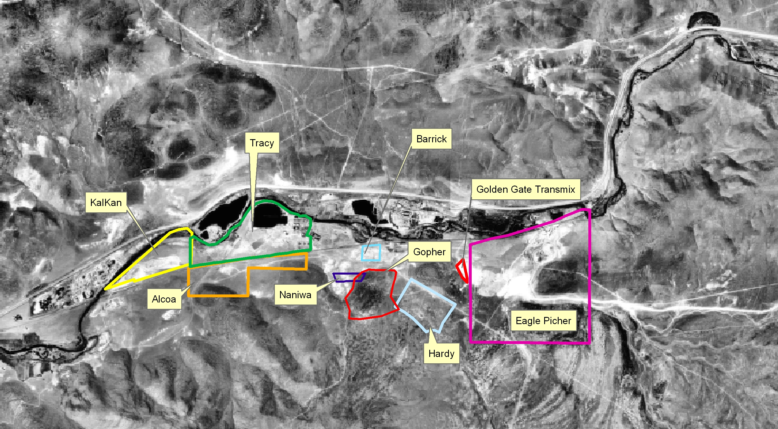

2.0 DESCRIPTION OF FACILITY

Pipeline quality natural gas is used by 14 reciprocating internal combustion engine (RICE) gensets to produce electricity for various Barrick facilities in Nevada. Each engine is a 4-stroke lean-burn (4SLB) design with a comprehensive computer management system that controls air/fuel ratio, ignition timing and various vital engine functions. The lean-burn design utilizes a pre-combustion chamber for each cylinder that pre-mixes the air-fuel mixture, which is then spark plug ignited. The engines have 20 cylinders each and turbochargers that provide forced induction. The engines operate at 720 RPM and displace approximately 726 liters each.

Each engine has its own selective catalyst reduction (SCR) system for the reduction of NO_{x} and an oxidation catalyst system for the reduction of CO, VOC and HAPs. The engine computer management system also monitors and manages the SCR to make sure the proper amount of ammonia/urea is fed to the catalyst at proper catalyst bed temperature to achieve the manufacture guaranteed emissions reductions. The manufacturer’s guarantee for emissions reductions are: 94% for NO_{x}, 94% for CO, 79% for VOCs and 97% for formaldehyde.

The engines are cooled by closed-loop cooling systems that do not emit to the atmosphere. The systems consist of large outdoor radiators with cooling fans. The turbo-charged compressed air/fuel mixture is after-cooled with outdoor radiators and cooling fans to keep intake charge temperatures low.

Each engine has a computer display console that warns the attendants of cautionary or critical operating conditions. Critical conditions such as over-heating or uncontrollable ignition detonation result in automatic shutdown of the affected engine. The units do not have CEMs or COMs.

The lack of Continuous Emissions Monitoring (CEMs) and Continuous Opacity Monitoring (COMs) was of great concern to NDEP-BAPC because there is no continuous measurement of exhaust stack emissions. There was also no automatic shutdown for emission control failures or poor emission control efficiency. However, the various engine and emission control systems are computer-controlled and designed to be configurable. To make sure that the engines’ controls are always functioning correctly, the NDEP-BAPC has created a permit requirement for the facility to custom-configure the computer systems. The configured system will include an alarm that will sound when either an incorrect catalyst bed temperature or incorrect ammonia/urea injection is detected. The system alarm will sound for up to one hour until an attendant addresses the alarm. If during the one hour period the attendant does not respond or cannot rectify the problem, the affected engine will shut itself off.

2.0 DESCRIPTION OF FACILITY (Continued)

The engines are all housed within a single metal building. Each engine has an individual exhaust stack that exits horizontally through the building, through the SCR and oxidation catalyst and then turns-up vertically. Stacks are 3.75 feet in diameter and 54 feet tall. The stacks are grouped in units of 3 or 4 stacks on an open scaffold support structure. Each engine displaces 726 liters with a flow rate of 110,000-120,000 pounds per hour at a temperature of ~750°F.

Engines may be individually started or stopped with power demands to create a specific MW output in 8.2 MW increments. The engines are started from a “warm state.” A warm state is created by an engine block heater that keeps the engine warmer than ambient temperatures. The warm state prevents thermal stresses associated with cold-starting an engine. The applicant states that the engines will never be cold-started. The engines may be started-up remotely without an attendant onsite. From a warm start, an engine takes approximately 15 minutes to reach steady-state operation with the emission controls working at their advertised (peak) efficiency.

The control catalyst technologies play a critical role in the facility’s potential to emit (PTE). The applicant distinguishes between cold and warm catalyst starts. The catalysts heat quickly (~15 minutes) but cool very slowly (~ 3 days). A warm catalyst start occurs when the catalyst is 200°C or hotter. A cold catalyst start occurs when the catalyst is below 200°C. Once an engine is shutdown the catalyst system essentially remains "closed" with no ambient air introduced and the catalyst is heavily insulated. The conductive loss through the catalyst housing is very slow. Test results at a facility demonstrated that 16 hours after an engine shutdown that the catalyst was at 600°F. Thirty-six hours later the catalyst was still above 200°F.

Wartsilia provided warm and cold catalyst start emission factors derived from: 1) factory tests; 2) fuel tests and 3) partial load steady-state tests. It also appears that this data was interpolated on a graph. Barrick proposes 420 cold catalyst startups and 1,120 warm catalyst startups per year for all 14 units. This translates to 30 cold catalyst starts and 80 warm catalyst starts per year for each engine.

The effectiveness and lifespan of the catalyst materials may vary. According to Wartsila the catalyst manufacturer provides a 16,000-24,000 hour warranty (1.8-2.7 years). However, field results demonstrate that with proper maintenance that catalyst life may be 36,000-48,000 hours (4.1-5.5 years). A Wartsila engine facility in Arvada, Colorado noted that catalyst efficiency began to decrease after approximately three years of service. The technology at the Arvada facility is approximately 4 years older than the proposed project and is employed on the smaller, 18 cylinder natural gas model engines.

Barrick proposes to operate the facility 8,760 hours per year as a base (power generation) plant. This is not so typical of RICE plants that are typically used as peaking plants. Used as a base facility, maintenance will be more frequent and without CEMs it may be difficult to ascertain if controls are slipping or failing. It is apparent the catalyst performance and maintenance should be carefully monitored, especially after approximately three years of service.
2.0 DESCRIPTION OF FACILITY (Continued)

On an annual basis, each engine will be tested for PM, PM₁₀, NO_{X}, CO, VOC and formaldehyde. SO₂ shall be calculated from the sulfur content in the natural gas. These tests will be used to verify the manufacturer’s emission factors and then to create emission factors specific for each engine.

3.0 DISCUSSION OF PROCESS

  - Pipeline Quality Natural Gas
Barrick will combust pipeline quality natural gas only for each of the 14 engines. Natural gas consists of a high percentage of methane (generally above 85 percent) and varying amounts of ethane, propane, butane, and inert gases. The average gross heating value of natural gas is approximately 1,020 British thermal units per standard cubic foot (Btu/scf), usually varying from 950 to 1,050 Btu/scf. Combustion processes of natural gas typically yield particulate emissions below 10 microns in size, low SO₂ emissions, notable CO, NO_{x} and VOC emissions and some HAPs. The permit will require the use of natural gas with a maximum sulfur content of 100 grains per dry standard cubic foot (or less).

3.2 RICE Engine Types
Natural gas-fired reciprocating engines are separated into three design classes: 2-cycle (stroke) lean-burn, 4-stroke lean-burn, and 4-stroke rich-burn. Two-stroke engines complete the power cycle in a single crankshaft revolution as compared to the two crankshaft revolutions required for 4-stroke engines. All engines in these categories are spark-ignited.

The Wartsila engines are lean-burn 4-stroke engines. Lean-burn engines may operate up to the lean flame extinction limit, with exhaust oxygen levels of 12 percent or greater. The air to fuel ratios of lean-burn engines range from 20:1 to 50:1 and are typically higher than 24:1. The exhaust excess oxygen levels of lean-burn engines are typically around 8 percent, ranging from 4 to 17 percent.

  - Pollutants Emitted from RICEs
The primary criteria pollutants from natural gas-fired reciprocating engines are oxides of nitrogen (NO_{x}), carbon monoxide (CO), and volatile organic compounds (VOC). The formation of nitrogen oxides is exponentially related to combustion temperature in the engine cylinder. The other pollutants, CO and VOC species, are primarily the result of incomplete combustion. Particulate matter (PM) emissions include trace amounts of metals, non-combustible inorganic material, and condensable, semi-volatile organics which result from volatized lubricating oil, engine wear, or from products of incomplete combustion. Sulfur oxides are very low since sulfur compounds are removed from natural gas at processing plants. However, trace amounts of sulfur containing odorant are added to natural gas at city gates prior to distribution for the purpose of leak detection.

3.3.1 NOX
90-95% of the nitrogen oxides that form from a combustion process are in the form of nitrogen dioxide (NO₂) and sometimes nitrous oxide (N₂O). There are two main mechanisms in which NO_{x} is formed in a reciprocating engine. The first mechanism is due to nitrogen in the air (thermal NO_{x}), the second is due to nitrogen in the fuel (organic or fuel NO_{x}). Most types of natural gas have little or no fuel bound nitrogen.

Essentially all NO_{x} formed in natural gas-fired reciprocating engines occurs through the thermal NO_{x} mechanism. The rate of NO_{x} formation through the thermal NO_{x} mechanism is highly dependent upon the stoichiometric ratio, combustion temperature, and residence time at the combustion temperature. Maximum NO_{x} formation occurs through the thermal NO_{x} mechanism near the stoichiometric air-to-fuel mixture ratio since combustion temperatures are greatest at this air-to-fuel ratio.

3.3.2 CO
Carbon monoxide is emitted from RICEs due to incomplete combustion. Incomplete combustion occurs with an incorrect fuel/air mixture or low combustion temperatures. CO emissions are a function of temperature and decrease with higher combustion temperatures. CO results when there is insufficient residence time at high temperature to complete the final step in hydrocarbon oxidation.

There is a conflict in terms of temperature for CO and NO_{x} emissions. High temperatures will produce more NO_{x} and less CO, while lower temperatures will produce less NO_{x} and more CO.

3.3.3 SO_{x}
SO_{x} are primarily SO₂ but may also include SO₃. SO₂ comes from the combustion of fuels with sulfur in them. Sulfur compounds occur naturally in fuels derived from petroleum. Sulfur burning in a fuel contributes to its energy input, but is undesirable because it corrodes combustion equipment and emits SO_{x}. Sulfur compounds can also be found in natural gas in the form of hydrogen sulfide.

3.3.4 Hydrocarbons (VOCs and aldehydes)
Hydrocarbons (HCs) are compounds made of carbon and hydrogen atoms, and fuels are mostly made up of different hydrocarbons. Hydrocarbon emissions are a concern because volatile hydrocarbons can contribute to the formation of ozone. Potential sources of HCs from RICEs are unburned hydrocarbons in the exhaust. Engine misfire and deposits from fuel are sources of HC emissions. Partially oxidized HC compounds can form aldehyde HAPs such as formaldehyde. Aldehydes may be generated from the quenching of the flame on the walls of the cylinder and in other low temperature areas of the engine. Aldehydes can also form from photochemical reactions involving HCs and oxygen.

3.3.5 PM/PM₁₀ Emissions
Most of the PM emissions from a RICE result from incomplete combustion and burning of the lubricating oil. Lubricating oil contributes 50 to 280 times as much material to particulate matter than fuel. A small amount of oil consumption can have a large effect on emissions. Fuel with high aromatic and sulfur content will have more PM emissions. Emissions of PM from natural gas-fired reciprocating engines are generally minimal and comprise fine filterable and condensable PM.

  - Factors That Affect RICE Emissions

The emission factors provided by Wartsila are quite low for a RICE. Extensive literature research did not yield any emission factors as low as those of Wartsila. The main factors that affect emissions from RICEs include atmospheric conditions, air/fuel ratio, charging method, ignition timing, combustion cycle, load, speed, fuel and valve and combustion chamber design.

The Wartsila engines benefit from extensive design, field-testing and computer management systems. Key components such as air/fuel ratio, ignition timing, combustion cycle, load and speed are managed by a computer system that maintains ideal performance and emissions. Each engine cylinder has individually adjustable parameters. The computer system has the ability to adjust itself or “to learn” new engine management parameters to retain the ideal operating conditions through varying fuel quality, environmental conditions and engine wear. The computer management systems are setup onsite by the manufacturer and are then “locked” and cannot be modified by the facility.

Characteristics such as valve and combustion chamber design include a proprietary pre-mix combustion chamber and ignition system. Years of field-testing in maritime freight applications and a long production history have given Wartsila substantial expertise with large RICEs.

Atmospheric conditions that may affect emissions such as temperature and humidity are also controlled by pre-warming the engines and by having the engines housed in a climate-controlled building atmosphere. The implementation of turbochargers with after-cooling provides for a constant atmospheric charge (temperature and pressure) into the engines regardless of climate and elevation.

3.5 RICE Emission Factors

When estimating a proposed facility’s PTE, it is standard practice to use approved emission factors until initial stack performance tests may be performed. The development and selection of emission factors to estimate PTE can be difficult because there are so many RICE engines available of varying age, design and emission controls. When the USEPA developed the AP-42 emission factor for RICE’s combusting natural gas, they generated a total of 71 emissions test reports containing 469 emissions tests. When developing the emission factors, the USEPA attempted to define dependant variables and predictive algorithms.

3.5.1 Emission levels of NOx, CO, total hydrocarbons, and formaldehyde were compared against engine size and operating load. Within the scatter of the data, size showed no consistent effect on the emission levels of NO_{x}, CO, total hydrocarbons, or formaldehyde for any of the engine types. Load showed the highest effect on NO_{x} and CO emissions. However, the EPA was not able to develop an algorithm that relates NO_{x} or CO to load. For all other pollutants, load showed some effect on emission levels; however, the trends were not consistent nor were they significant compared to the data scatter.

3.5.2 PM Emission Factors
For a limited number of tests, PM measurements were conducted. For 4SLB engines, these PM measurements include filterable PM₁₀, inorganic condensable PM, and organic condensable PM. To provide a total PM₁₀ emission factor, these three PM fractions were added together.

3.5.3 CO₂ and SO₂ Emission Factors
Emission factors for CO₂ were calculated by mass balance. This approach was also taken for calculating SO₂. Since the carbon and sulfur content in pipeline-quality natural gas is fairly consistent, EPA believes this is the best method for calculating CO₂ and SO₂ emission factors. For CO₂, it was assumed that 99.5% of the fuel carbon was converted to CO₂. For SO₂, a 100% conversion of fuel sulfur was assumed. The CO₂ emission factor was based on a carbon weight percent in natural gas of 75% and the SO₂ emission factor was based on a sulfur concentration in natural gas of 2,000 grains per million standard cubic feet.

3.5.4 Wartsila Emission Factors
Wartsila provided emission factors for criteria pollutants and formaldehyde derived from approved EPA test methods, except for the speciation of HAPs. Emission factors for speciated HAPs were provided from AP-42. Given the comprehensive engine control systems, Wartsila maintains that their provided emission factors are representative for any operating environment regardless of climate and altitude.

  - RICE Control Technologies
Three generic control techniques have been developed for reciprocating engines: parametric controls (timing and operating at a leaner air-to-fuel ratio); combustion modifications such as advanced engine design for new sources or major modification to existing sources (clean-burn cylinder head designs and pre-stratified charge combustion); and post combustion catalytic controls installed on the engine exhaust system. Post-combustion catalytic technologies include selective catalytic reduction (SCR) for lean-burn engines, nonselective catalytic reduction (NSCR) for rich-burn engines, and CO oxidation catalysts for lean-burn engines.

3.6.1 Lean Burn Technology
The Wartsila engines are of a lean burn design. The focus of lean burn technology is to operate with the leanest fuel/air mixture that will not pre-detonate or create excessive CO emissions. Wartsila accomplishes this with precise computer engine controls and a pre-combustion chamber. In the Wartsila engine with larger bore sizes, it is difficult or impossible to ignite a very lean mixture. Therefore an attached pre-combustion chamber that has 5-10% of the volume of the engine cylinder is filled with a rich fuel/air mixture that is easy to ignite and then propagate through the rest of the cylinder, burning the very lean air/fuel mixture. This lean burn provides a cleaner exhaust for the add-on emission controls and utilizes less fuel.

3.6.2 SCR Control
Each Wartsila engine employs an SCR control device. Selective catalytic reduction is a post-combustion technology that is effective in reducing NO_{x} in exhaust from lean-burn engines. An SCR system consists of ammonia storage, feed, and injection system, and a catalyst and catalyst housing. Selective catalytic reduction systems selectively reduce NO_{x} emissions by injecting ammonia (either in the form of liquid anhydrous ammonia or aqueous ammonium hydroxide) into the exhaust gas stream upstream of the catalyst.

Nitrogen oxides, NH₃, and O₂ react on the surface of the catalyst to form N₂ and H₂O. For the SCR system to operate properly, the exhaust gas must be within a particular temperature range (typically between 450 and 850°F). The temperature range is dictated by the catalyst. Exhaust gas temperatures greater than the upper limit (850°F) will pass the NO_{x} and ammonia un-reacted through the catalyst. Ammonia emissions, called NH₃ slip, are a key consideration when specifying a SCR system. SCR is most suitable for lean-burn engines operated at constant loads, and can achieve efficiencies as high as 90%. For engines that typically operate at variable loads, such as engines on gas transmission pipelines, an SCR system may not function effectively, causing either periods of ammonia slip or insufficient ammonia to gain the reductions needed.

The US EPA conducted two sets of upstream and downstream tests on SCR performance. These tests were conducted on one 4-stroke lean-burn engine. The average NO_{x} reduction efficiency across the SCR unit was 77%. This reduction efficiency compared well with the results of the SCR analysis conducted by GRI, which reported average NO_{x} reductions across SCR units for natural gas-fired reciprocating engines of 80%. It should be noted that Wartsila claims a 97% reduction for their engine and SCR.

3.6.3 NSCR Control
This control technology is not applicable to the lean-burn Wartsila Engines. NSCR is non-selective catalytic reduction. A NSCR technology controls two or more different pollutants at once. The NSCR technique is effectively limited to engines with normal exhaust oxygen levels of 4 percent or less. This includes 4-stroke rich-burn naturally aspirated engines and some 4-stroke rich-burn turbocharged engines. Lean-burn engines can not be retrofitted with NSCR control because of their lower exhaust temperatures.

3.6.4 Catalytic Oxidation Control
The Wartsila engines each employ an oxidation catalyst. Limited emissions data were available for simultaneous measurements of uncontrolled and controlled emissions from engines equipped with oxidation catalysts (CO, VOC and HAP oxidation catalyst). Oxidation catalyst performance increases with increased engine exhaust temperatures. For natural gas fired engines, 2-stroke engines typically have lower exhaust temperatures than 4-stroke engines. Therefore, it is expected that higher emission reductions would be achieved from 4-stroke engines as compared to 2-stroke engines.

From the gathered emissions data and catalyst manufacturer’s information, CO catalyst performance for 4SLB natural gas-fired engines is expected to be higher than 90% reduction. Wartsila claims a 97% reduction for their engine and oxidation catalyst.

3.7 Emission Catalysts  3.7.1 Combination of Controls  The Western 102 project utilizes the Wartsila lean-burn engine with the Ultra Low Emissions (ULE) system. The ULE system is comprised of a SCR and oxidation catalyst specifically calibrated to the Wartsila engine application. The ULE system provides substantial emissions reductions, but the system adds additional up-front cost and maintenance. Both the SCR and oxidation catalysts have a limited lifespan.  3.7.2 Catalyst Testing  The EPA believes initially high levels of emissions reduction may be attributed to fresh or “green” catalyst conditions. It may be suggested that catalyst performance testing be performed after a suitable catalyst break-in period to represent typical catalyst operating behavior. Likewise, it has been suggested that brand-new or rebuilt engines should be run bypassing the controls until the engines are broken-in. New engines have more oil blow-by and misfires that may damage the catalyst systems.  Catalyst performance has been observed to decrease over time due to catalyst decay. Catalyst decay may result from excessive temperature differentials, catalyst masking and catalyst poisoning.
  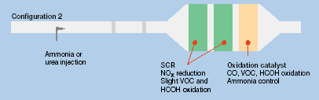
  Wartsila Ultra-low Emissions Control System combines an SCR and oxidation catalyst.
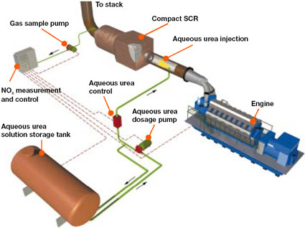
Wartsila SCR systems.

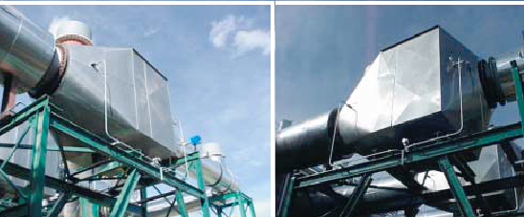
Wartsila SCR and oxidation catalyst system.

3.7.3 Catalyst Masking and Poisoning
Masking agents are particulates, ammonium salts, sulfur, chlorine, chloride and other substances that deposit on the surface of the catalyst and inhibit catalyst activity by forming a barrier between the exhaust gas and the catalyst. Masking agents can usually be removed by cleaning. Over 90% of the catalyst activity can be regained by removing masking agents. Catalyst poisoning is permanent. Poisoning is usually caused by the fuel or lubrication oil. Natural gas is usually free of poisoning agents. Any lubricating oil that burns can create emissions that foul the catalyst. Oils with high ash or phosphorous content are more likely to create catalyst poisoning. The leading edge of the catalyst is more subject to erosion and masking if particulate is present.

The chemical reactions that occur in the SCR occur over a small temperature range, generally between 600-800°F. If the temperature drops below this range, excessive amounts of ammonia will release out the exhaust stack; if too high the catalyst and ammonia will decompose.

High sulfur fuels may form SO₂ in the SCR and react with the catalyst and ammonia to create ammonium salts that quickly erode SCR surfaces. Natural gas has little or no sulfur, but may contain hydrogen sulfide that will contribute to ammonium salt formation. Ammonium salt formation may also be deterred by raising the inlet gas temperature above the ammonium bisulfate formation temperature and controlling ammonia slip.

Ammonia is necessary for the chemical reactions in the SCR to work. Ammonia is on the USEPA’s list of extremely hazardous substances. Ammonia is typically released (slipped) from the SCR exhaust because excess ammonia is required due to inefficient distribution across the catalyst. As a catalyst ages the ammonia slip increases.

Urea is a chemical that comes in the form of a powder that can be used in place of ammonia for SCR. The temperature range for efficient NO_{x} reduction with Urea is higher than the exhaust temperature of most engines, so urea injection is limited to systems where there is supplemental firing applied to the exhaust stream.

3.8 Formaldehyde

Special attention is given in this Technical Support Document with regards to the chemical compound formaldehyde. Formaldehyde is listed as a Hazardous Air Pollutant (HAP) by the EPA and in the Western 102 facility it is of concern because the facility proposes to emit formaldehyde at a rate of 9.94 TPY, which is just below the major source threshold for any single HAP. HAPs are chemicals that can cause adverse effects to human health or the environment. Congress has identified over 188 of these pollutants, including substances that cause cancer, neurological, respiratory, and reproductive effects.

The 1990 amendments to the Clean Air Act (CAA) mandated significant new air quality programs and substantially enhanced some existing ones. Title I of the CAA includes the provisions for attaining the NAAQS for criteria pollutants, and provisions for controlling emissions of hazardous air pollutants (HAPs). The provisions in Title I that address the control of HAP emissions, or air toxics, are found in Section 112. Section 112 of the CAA includes provisions for the promulgation of NESHAP, or maximum achievable control technology (MACT) standards, as well as several related programs to enhance and support the NESHAP program.

Formaldehyde is normally present at low levels, usually less than 0.06 ppm (parts per million), in both outdoor and indoor air. When present in the air at levels at or above 0.1 ppm, acute health effects can occur including watery eyes; burning sensations in the eyes, nose and throat; nausea; coughing; chest tightness; wheezing; skin rashes; and other irritating effects. In chronic doses formaldehyde is considered carcinogenic and mutagenic. Individuals with pre–existing diseases of retina, kidneys, liver or cardiovascular system may have increased susceptibility to the toxic effects of formaldehyde. The target organs are the eyes, kidneys, liver, cardiovascular system, and skin.

Formaldehyde is a probable human carcinogen. The U.S. EPA classifies it as a Group B1 carcinogen and the International Agency for Research on Cancer (IARC) classifies it as a Group 2A carcinogen. Studies identified increased incidences of lung and nasopharyngeal cancer.

3.8.1 The Characteristics of Formaldehyde in RICEs
The available data for HAPs, including formaldehyde, in regards to RICEs is low. More data is available correlating the behavior of HAPs and turbines. Of note IC engines typically create more NO₂ than turbines and studies suggest that higher NO₂ levels yield less accurate HAP measurements with certain procedures. The following items seem predominant across available documents on the topic:

- HAPs do not show a clear dependence on engine load.
- Regarding major source criteria, formaldehyde is the only likely compound to reach 10 TPY and will likely be triggered before the 25 TPY threshold for all HAPs combined.
- Formaldehyde is formed as a normal intermediate that is typically created in the later stages of combustion.
- Formaldehyde measurements during combustion are 5-10X higher than those measured from exhaust gas.
- Engine maintenance is shown to reduce formaldehyde emissions.
- Acetylhede factors are 1/7th of formaldehyde factors.
- Attempts to predict formaldehyde based on measurement of CO, NO_{x} or NMHC have generally failed.

3.8.2 Formaldehyde Test Methods
Several methods exist for determining formaldehyde in gas streams, including colorimetric analysis, chromatography (gas, liquid and ion), and spectrometric. However, only a few are considered accurate and specific enough to demonstrate compliance with federal or state air requirements. The USEPA generally accepts three methods for determining formaldehyde emissions: 1) EPA Method 0011 of SW-846; 2) California Air Resource Board (CARB) Method 430; and 3) EPA Method 320 of 40 CFR Part 63.

EPA Method 0011 and CARB Method 430
EPA Method 0011 and CARB Method 430 are very similar methods. Both use a liquid solution of dinitrophenylhydrazine (DNPH) to absorb formaldehyde from the gas stream and convert it to a stable chemical derivative that can be quantified using high performance liquid chromatography (HPLC). These methods utilize traditional "wet" stack sampling procedures to collect an integrated sample that is then analyzed at an off-site laboratory. This approach yields a "snapshot" measurement of average formaldehyde concentration over a specific interval of time. Some disadvantages of this method are:
reagent shipping and shelf life are problems, questions exist as to the accuracy for lean burn sources and results are determined off-site.
Method 320: Fourier Transform Infrared spectrometer
EPA Method 320 is a generic method using Fourier transform infrared spectroscopy (FTIR). This technology uses sophisticated computer analysis of infrared spectra of the gas stream to determine its composition. The analysis is direct and on-site, and provides near real-time and semi-continuous measurements of the gas composition.
Some advantages of the Method 320 are: extensive supporting data - used extensively in AP-42 data collection, it has been validated for formaldehyde testing on reciprocating engines (July 1995) and it speciates most aldehydes (can provide acetaldehyde number). Some disadvantages are: cost, expensive equipment and additional test time, and it requires more setup time per source than other technologies

AP-42 Emission factors for 4SLB Rice combusting natural gas were derived with the measurement technique FTIR (Fourier Transformation Infra-red), a direct spectrographic measurement. EPA claims another popular method, DNPH may represent a negative bias due to oxygen and nitrogen, but it is still an accepted Method. Therefore, EPA chose FTIR measurement to develop the AP-42 emission factor.

3.8.3 Choosing a Formaldehyde Test Method
The most relevant problem with the DNPH methods is their lack of reliability in gas streams containing significant amounts of NO₂. Research suggests that NO₂ scavenges the DNPH from the sample solution, thus making it unavailable to collect the formaldehyde and producing a negative bias in the results. Data suggests that the interference may be insignificant if the NO₂ concentration is below approximately 50 ppm.

Due to the nature in which FTIR works, interference from other gas species is not a problem with this method. The most significant disadvantage with this method is cost, due to the requirement for more specialized instrumentation and highly trained personnel to conduct the analysis. However, this cost is somewhat offset by the larger and more useful set of data that the method gives.
USEPA personnel have stated that the soon-to-be proposed gas turbine MACT rule will likely endorse both CARB Method 430 and EPA Method 320 for formaldehyde measurements. The EPA has, however, voiced their concern over the potential NO₂ interference with the CARB method. For this reason, there may be some language in the rule that more favorably recommends the use of the FTIR method.
For the Barrick Western 102 facility, either EPA Method 0011 of SW-846 or EPA Method 320 of 40 CFR 63 would be suitable. Since the NO₂ after the SCR is less than 50 ppm and since speciation of aldehydes is not desired, either test method would be acceptable. NDEP-BAPC will let the applicant decide and then review the proposed testing protocol prior to testing.

4.0 APPLICABLE REGULATIONS

Applicable regulations are those regulatory requirements that apply to a stationary source or to emission units contained within the stationary source. In Nevada’s program, the regulations governing the emissions of air pollutants from which the applicable requirements originate are derived from four categories of regulations. These four categories consist of the requirements contained in the Nevada Revised Statutes (NRS), the Nevada Administrative Code (NAC), the Approved State Implementation Plan (ASIP) and the Code of Federal Regulations (CFR, contained within various Parts within Title 40).

4.1 STATE STATUTES AND ADMINISTRATIVE CODE
The Nevada Revised Statutes (NRS) and the Nevada Administrative Code (NAC) require that where state regulations are more stringent in comparison to Federal regulations, the State regulations are also applicable. The Barrick facility will be subject to NAC and NRS.

    - NEVADA REVISED STATUTES
The Nevada Revised Statutes (NRS) are the statutory authority for the adoption and implementation of administrative regulations. Barrick is subject to NRS requirements stipulated in NRS 445B.100 through 445B.640, which refer to the control of air pollution. The NRS specifies the State Environmental Commission as the governing body given the power to adopt administrative regulations. Because the NRS is the enabling statutory authority, very few specific requirements are contained in the statutes. Rather, the NRS provides broad authority for the adoption and implementation of air pollution regulations.

4.1.2 NEVADA ADMINISTRATIVE CODE
The Nevada Administrative Code (NAC) are administrative regulations that contain specific requirements relating to the control of air pollution. Barrick is also subject to NAC 445B.001 through 445B.3689, inclusive, that govern the control of air pollution from regulated facilities in Nevada. The State Environmental Commission adopts these regulations.

4.2 NEVADA APPLICABLE SIP (ASIP)
The Applicable State Implementation Plan (ASIP) is a document that is prepared by a State or local air regulatory agency and is required to be submitted to the USEPA for approval. Title I of the Clean Air Act is the statutory authority for the USEPA regulations that require a State to submit a SIP. The contents of the SIP are intended to show how a State, through the implementation and enforcement of the regulations contained in the SIP, will either show how attainment of the National Ambient Air Quality Standards (NAAQS) will be achieved or how a State will continue to maintain compliance with the NAAQS. Nevada’s most recent ASIP, approved by USEPA, is based on State regulations codified in 1982. Nevada submitted an updated ASIP to the USEPA in early 2006. The USEPA has provided limited approval of the revised ASIP regulations and there have not been any major changes that may affect the permitting process, since the codified regulations of 1982.

In general, the regulations contained in the ASIP closely parallel the current NAC regulations. However, because the ASIP is based on older air quality regulations (at this time), compliance with all of the current NAC regulatory requirements does not necessarily ensure compliance with all of the current ASIP regulatory requirements. All of the equipment considered in this application must meet, at minimum, the standards set forth in the ASIP. Specifically, the emission standards contained in ASIP 445.731 for particulate matter, ASIP article 8.2 for sulfur emissions, SIP 445.721 for opacity and 12.1 for the ambient air quality standards must not be exceeded. The proposed Barrick facility does not exceed applicable ASIP standards.

ASIP PM Calculations (445.731)
Y=1.02X^-0.231
Y=(1.02)(77^-.231)
Y=(1.02)(0.367)
Y=0.374 pounds per MMBtu/hr
The maximum allowable PM emission is 0.374 lbs/MMBtu/hr.

ASIP Sulfur (Article 8.2.1)
This value is derived from a reference table. For units with a heat input greater then 10 MMBtu but less than 100 MMBtu the maximum allowable sulfur emission is 70 pounds per hour.

ASIP Opacity Standard (445.721)
No owner or operator shall discharge any air contaminant for a period or periods aggregating more than 3 minutes in any one hour opacity equal or greater to 20%.

ASIP Ambient Air Quality Standards (12.1)
Applicant and NDEP-BAPC testing demonstrates no exceedance of State standards.

4.3 CODE OF FEDERAL REGULATIONS
The Code of Federal Regulations (CFR) are regulations adopted by the USEPA and published in the Federal Register pursuant to the authority granted by Congress in the Clean Air Act. The CFR addresses multiple topics, including but not limited to: permitting requirements, performance standards, testing methods and monitoring requirements.

4.3.1 NEW SOURCE PERFORMANCE STANDARDS
The U.S. EPA has promulgated maximum emission standards and/or monitoring/recordkeeping methods for selected source categories. These standards are contained in Title 40 of the CFR, Part 60, and are known as the New Source Performance Standards (NSPS). The NSPS are considered the maximum emissions that may be emitted from a source, unless the NAC, ASIP or PSD provisions are more stringent.

The Barrick Western 102 Power project is not subject to NSPS requirements.

4.3.2 PREVENTION OF SIGNIFICANT DETERIORATION REGULATIONS (PSD)
40 CFR Part 52.21 specifies that PSD review is required for any new major stationary source or any major modification to an existing major stationary source. A major stationary source is defined as any pollutant emitting activities, which belong to the same two-digit Source Industry Classification and:

1. Emits 100 tons/yr or more of any regulated NSR pollutant as one of the listed categories of sources listed in 40 CFR 52.21; or
- Emits 250 tons/yr or more of any regulated NSR pollutant and belongs to any other category source.

The Barrick Western 102 facility is not subject to the provisions of PSD, because the Western 102 facility is not of the listed categories of sources subject to a PTE of any regulated NSR pollutant of 100 tpy major stationary source threshold, and the PTE of any regulated NSR pollutant is less than the 250 tpy major stationary source threshold required for “other” sources.

The Barrick Western 102 facility may revise their operations in future modifications and increase the emissions of any regulated NSR pollutant until that time that the 250 tpy major stationary source threshold of NSR regulated pollutants is surpassed.

From that point on, any future modifications to the facility that increase the emissions of any regulated NSR pollutant above the applicable significant emissions threshold will require a Full PSD/NSR review of the source.

Because HA-83 has been triggered earlier for PM₁₀, NO_{x} and SO₂, emissions from the Western 102 facility will consume increment and an analysis for PSD increment consumption is mandatory.

    - NATIONAL EMISSION STANDARDS FOR HAZARDOUS AIR POLLUTANTS
The federal National Emission Standards for Hazardous Air Pollutants (NESHAP) provisions are contained in 40 CFR Parts 61 and 63. Proposed standards are to be implemented August 14, 2004 for RICE HAPs under 40 CFR Part 63, Subpart ZZZZ. A proposed facility must be a major source for HAPs for applicability to this requirement. Currently the applicant estimates a PTE of 9.94 tpy for formaldehyde; which is slightly below the 10 tpy threshold that would define it as a major source for any single HAP. Periodic performance tests shall be performed on an annual basis for each engine to demonstrate compliance with the permitted emission limits.

The applicant proposes control technologies for CO and HAPs using an oxidation catalyst with reduction rates similar to those required in Subpart ZZZZ. The main difference between the applicants proposed control operations and Subpart ZZZZ is that the Subpart requires the use of a Continuous Parametric Monitoring System to measure catalyst bed temperatures.

COMPLIANCE ASSURANCE MONITORING
The USEPA has promulgated requirements for sources to provide detailed monitoring plans that will ensure compliance with all applicable requirements. These monitoring requirements are contained in 40 CFR Part 64. Section 64.2 specifies that these monitoring requirements apply to a “pollutant- specific emission unit at a major source” if all of the following are satisfied:

- The unit is subject to an emission limit or standard;
- The unit uses a control device to achieve compliance with any such emission limitation or standard; and
- The unit has the potential pre-control device (uncontrolled) emission equal to or greater than 100% of the amount, in tons per year, required for a source to be classified as a major source.

40 CFR Part 64.5(a) requirements specify that for all pollutant-specific emission units (PSEU) with the potential to emit (taking into account control devices to the extent appropriate under the definition of this term in Part 64.1) the applicable regulated air pollutant in an amount equal to or greater than 100% of the amount, in tons per year, required for a source to be classified as a major source (i.e., a “LARGE” PSEU), the owner or operator shall submit a CAM Plan at the following times:
  - On or after April 20, 1998, the owner or operator shall submit information as part of an application for an initial Part 70 permit if, by that date, the application either: Has not been filed; or Has not been determined to be complete by the permitting authority.
  - On or after April 20, 1998, the owner or operator shall submit a CAM Plan as part of an application for a Significant permit revision, but only with respect to those pollutant-specific emissions units for which the proposed permit revision is applicable.
  - The owner or operator shall submit a CAM Plan as part of the application for Renewal of a Part 70 permit.

40 CFR Part 64.5(b) requirements specify that for all other PSEU’s NOT subject to Part 64.5(a) (i.e., “OTHER” PSEU), the owner or operator shall submit a CAM Plan as part of an application for Renewal of a Part 70 permit.

The proposed facility meets the requirements of criteria 1-3 above. Each of the 14 Generators have the potential to emit of regulated NSR pollutants at the following annual major source threshold emissions rates, based on an “Uncontrolled” scenario, and each generator is therefore identified as a PSEU:
NOx = 112 ton/yr, (> 100 tpy, criteria pollutant)
CO = 181 ton/yr, (> 100 tpy, criteria pollutant)
Formaldehyde = 24 ton/yr, (> 10 tpy, individual HAP)

The facility is subject to 40 CFR Part 64.5(b) and will be required to submit a CAM Plan for each PSEU upon renewal of this initial Class I Air Quality Operating Permit.

4.3.5 ACID RAIN PROGRAM
The Clean Air Act Amendments of 1990 (Title V) established a requirement to reduce the emissions of pollutants contributing to acid rain (SO₂ and NO_{x}). The USEPA is responsible for developing regulations and implementing the requirements of the acid rain provisions of the Clean Air Act. Currently the acid rain program applies to units that generate 25.0 MW or greater each. The proposed units at Barrick are below this threshold, producing approximately 8.2 MW. Therefore the Barrick facility will not be subject to the Acid Rain Program. This determination was confirmed by US EPA Region 9 (Roger Kohn) via e-mail on 7/1/04.

4.3.6 ACCIDENTAL RELEASE PROGRAM
The Chemical Accident Prevention Provisions are contained in 40 CFR, Part 68. The Western 102 facility is required to comply with the Chemical Accident Prevention Provisions, if the facility stores any chemicals regulated by 40 CFR, Part 68, in quantities greater than their respective threshold quantity. The applicant has stated that they will not store urea/ammonia in quantity or concentration that makes them applicable to Chemical Accident Prevention Provisions (draft comments letter 7/27/04).

4.3.7 PROTECTION OF STRATOSPHERIC OZONE
The Protection of Stratospheric Ozone Provisions is contained in 40 CFR, Part 82. The Western 102 Station is required to comply with 40 CFR, Part 82, if the facility operates any equipment or store any products regulated by 40 CFR, Part 82. The permit application states that 40 CFR Part 82 requirements are not applicable because the facility does not service its own air conditioning equipment or store any regulated products.

4.3.8 EMERGENCY EPISODES PLAN
NAC 445B.230.1 requires a plan for the reduction of emissions from any facility that is able to cause or permit the emission of 100 tons or more per year of a regulated pollutant from a stationary source. The facility is required to prepare and submit to NDEP-BAPC a plan for reducing or eliminating emissions in accordance with the episode stages of alert, warning and emergency as defined in the air quality plan for the State of Nevada.

On April 15, 2004 Barrick submitted an emergency episodes plan (EEP) for the Western 102 facility as part of the original OPTC application.

4.4 DUST CONTROL PLAN
The NDEP-BAPC requires that permit holders who disturb 20 acres or more of topsoil must submit a dust control plan as one of the necessary measures to prevent particulate matter from becoming airborne (ASIP 445.734). The dust control plan is a written plan signed by a facility’s responsible official that outlines the methods a facility will use to minimize fugitive dust. The Western 102 facility will not disturb more than 20 acres.

5.0 EMISSIONS INVENTORY

5.1 Emissions Inventory Summary
The proceeding tables, Tables 5.1.1-5.1.5, are NDEP-BAPC calculations of estimated emissions from the Barrick Class I permit application. A comparison of Barrick calculations against NDEP-BAPC calculations determined that there is little significant variance between the two sets of calculations.

Table 5.1.1 below represents 30 cold catalyst starts at 15 minutes per start. This is 7.5 hours of the total 8,760 annual operating hours per each engine.

Table 5.1.1 - Cold Catalyst Starts (partial control reduction)
Pollutants | Cold Catalyst Starts
Pollutants | # of starts (yr) | Op. Hours | cold catalyst factor ( lb/15min ) | steady factor (lb/45 min) | lbs/hr cold+steady (1 engine) | tpy (1 engine) | lbs/hr (14 engines) | tpy (14 engines)
PM | 30 | 7.50 | 0.6468 | 1.94 | 2.59 | 0.04 | 36.22 | 0.54
PM10 | 30 | 7.50 | 0.6468 | 1.94 | 2.59 | 0.04 | 36.22 | 0.54
CO | 30 | 7.50 | 7.9400 | 1.81 | 9.75 | 0.15 | 136.55 | 2.05
NOX | 30 | 7.50 | 4.8500 | 1.11 | 5.96 | 0.09 | 83.50 | 1.25
SO2 | 30 | 7.50 | 0.1444 | 0.43 | 0.58 | 0.01 | 8.09 | 0.12
VOC | 30 | 7.50 | 2.6500 | 1.81 | 4.46 | 0.07 | 62.49 | 0.94
Total HAPs | 30 | 7.50 | 1.6900 | 0.26 | 1.95 | 0.03 | 27.30 | 0.41
Formaldehyde | 30 | 7.50 | 1.3200 | 0.11 | 1.43 | 0.02 | 20.02 | 0.30

Table 5.1.2 below represents 80 warm catalyst starts at 15 minutes per start. This is 20 hours of the total 8,760 annual operating hours per engine.

Table 5.1.2 - Warm Catalyst Starts (partial control reduction)
Pollutants | Warm Catalyst Starts
Pollutants | # of starts (yr) | Op. Hours | warm catalyst factor ( lb/15min ) | steady factor (lb/45 min) | lbs/hr warm+steady (1 engine) | tpy (1 engine) | lbs/hr (14 engines) | tpy (14 engines)
PM | 80 | 20.00 | 0.6468 | 1.94 | 2.59 | 0.10 | 36.22 | 1.45
PM10 | 80 | 20.00 | 0.6468 | 1.94 | 2.59 | 0.10 | 36.22 | 1.45
CO | 80 | 20.00 | 4.8500 | 0.18 | 5.03 | 0.20 | 70.44 | 2.82
NOX | 80 | 20.00 | 3.0900 | 0.11 | 3.20 | 0.13 | 44.82 | 1.79
SO2 | 80 | 20.00 | 0.1444 | 0.43 | 0.58 | 0.02 | 8.09 | 0.32
VOC | 80 | 20.00 | 1.7600 | 0.18 | 1.94 | 0.08 | 27.18 | 1.09
Total HAPs | 80 | 20.00 | 1.2500 | 0.03 | 1.28 | 0.05 | 17.86 | 0.71
Formaldehyde | 80 | 20.00 | 0.8800 | 0.01 | 0.89 | 0.04 | 12.47 | 0.50

Table 5.1.3 below represents all of the steady-state operation hours. Subtracting the cold and warm catalyst starts this is 8,732.5 steady-state operating hours per year.
Table 5.1.3 - Steady State Operations (full control reduction)
Pollutants | Steady State Operation
Pollutants | # of starts (yr) | Op. Hours | factor (lb/MMBtu) | MMBtu | lbs/hr (1 engine) | tpy (1 engine) | lbs/hr (14 engines) | tpy (14 engines)
PM | 0 | 8,732.50 | 0.0336 | 77.00 | 2.59 | 11.30 | 36.22 | 158.15
PM10 | 0 | 8,732.50 | 0.0336 | 77.00 | 2.59 | 11.30 | 36.22 | 158.15
CO | 0 | 8,732.50 | 0.0314 | 77.00 | 2.42 | 10.56 | 33.85 | 147.79
NOX | 0 | 8,732.50 | 0.0193 | 77.00 | 1.49 | 6.49 | 20.81 | 90.84
SO2 | 0 | 8,732.50 | 0.0075 | 77.00 | 0.58 | 2.52 | 8.09 | 35.30
VOC | 0 | 8,732.50 | 0.0314 | 77.00 | 2.42 | 10.56 | 33.85 | 147.79
Total HAPs | 0 | 8,732.50 | 0.0045 | 77.00 | 0.35 | 1.51 | 4.85 | 21.18
Formaldehyde | 0 | 8,732.50 | 0.0019 | 77.00 | 0.15 | 0.64 | 2.05 | 8.94

Table 5.1.4 below shows the total of cold catalyst starts, warm catalyst starts and steady state operations combined to represent the total potential operations for 1 year.

Table 5.1.4 - Total Emissions for all 14 Engines Including Cold & Warm Catalyst Starts
Pollutants | Totals for All 14 Engines
Pollutants | lbs/hr | tpy
PM | 108.66 | 160.14
PM10 | 108.66 | 160.14
CO | 240.83 | 152.66
NOX | 149.13 | 93.89
SO2 | 24.26 | 35.75
VOC | 123.51 | 149.82
Total HAPs | 50.01 | 22.30
Formaldehyde | 34.54 | 9.94

Table 5.1.5 below exhibits the facility-wide total for all operations including non-permit items. There are 3 non-permit items: 1) emergency generator, 1) emergency fire pump and 1) facility HVAC heater.
Table 5.1.5 - Facility-Wide Total - Requested Emission Cap

Pollutants
Pollutants | Annual Emissions  tpy
PM | 158.76
PM10 | 158.76
CO | 152.32
NOX | 93.80
SO2 | 35.56
VOC | 149.52
Total HAPs | < 25.0
Formaldehyde | < 10.0

5.2 Emissions Inventory: Formaldehyde Discussion

The applicant provided a facility-wide PTE for formaldehyde of 9.94 tons per year. This value is so close to the major source threshold of 10.0 tons per year for any individual HAP that it bears investigation. The 9.94 ton/year value was created with a Wartsila factor that was generated from stack testing of similar units currently in operation.

Table 5.2.1 below demonstrates the AP-42 formaldehyde calculation based on MMBtu/hr. The final value, with the Wartsila guaranteed 97% control, yields 7.48 tpy; a value much lower than the applicants requested 9.94 tpy. Wartsila has stated that stack tests typically yield formaldehyde values much lower than the manufacturer’s guarantee. This sentiment was echoed by the Arvada, Colorado Wartsila facility that achieved performance test values notably lower than the manufacturer’s guarantee.

Table 5.2.1

AP-42 Factor Calculations
Formaldehyde emission calculations for a Warstila engine using AP-42 factors:

0.0528 lb/MMBtu is the emission factor value used in AP-42.
77 MMBtu/hr * 0.0528 lb/MMBtu = 4.07 lbs/hr.
4.07 lbs/hr * 8,760 hours = 35,614.66 lbs/yr = 17.8 TPY
14 engines * 17.8 TPY = 249.3 TPY
249.3 tpy * 97% control reduction = 7.48 TPY

Table 5.2.2 and Table 5.2.3 below demonstrate calculations using the Wartsila-provided emission factors. These factors were provided in two forms: as a kWh-based uncontrolled factor and a kWh-based controlled factor. Assumably the control factor is based on the controlled factor with the addition of the 97% reduction rate. The two factors appear to be different, yielding values of 10.8 vs. 9.5 tpy, respectively. This is a fairly substantial difference, but it appears that the application requested value of 9.94 tpy is in the center of the value range.

Table 5.2.2

Wartsila Factor Calculations
0.307 g/kWh is the Warstila uncontrolled factor, then the guaranteed 97% reduction is applied:

KWh = 8,700
0.307 * 8,700 = 2670.9 g/hr = 5.88832 lbs/hr
5.88832 lbs * 8,760 hr = 5181.6832 lbs/yr = 25.791 TPY
25.791 TPY * 14 engines = 361.074 TPY
361.074 TPY * 97% reduction = 10.832 TPY

Table 5.2.3
Wartsila Factor Calculations
0.008 g/kWH is the Wartsila controlled factor (should incorporate 97% catalyst reduction):

KWh = 8,700
0.008 * 8,700 = 70.08 g/hr = 0.1544998 lb/hr
0.1544998 lb * 8,760 hr = 1,353.418 = 0.677 TPY
0.677 TPY * 14 engines = 9.478 TPY

5.2 Emissions Inventory: Formaldehyde Discussion (Continued)

Table 5.2.4 below provides a third party estimation of potential formaldehyde emissions. Similar to the AP-42 emissions factor, the APT factor estimates 7.7 TPY for formaldehyde with the 97% manufacturer’s reduction control. Of note, the APT group found that the typical oxidation catalyst control yielded an 86.3% reduction; notable lower than Wartsila’s guaranteed 97%. Applying the observed APT control efficiency of 86.3% yields a much higher facility PTE value of 35.14 TPY; much higher than the 10 TPY major source threshold.

Table 5.2.4

APT Formaldehyde Factor Calculations
A third party, APT, derived a formaldehyde factor similar to AP-42 for LB RICE with value of: 0.0543 lb/MMBtu. APT test data demonstrated an 86.3% reduction for LB RICEs (across 31 tests) with an oxidation catalyst.

0.0543 lb/MMBtu/hr * 77.0 MMBtu = 4.1811 lbs/hr
4.811 lbs/hr * 8,760 hr = 36,626.44 lbs/yr = 18.31 TPY * 14 engines = 256.3 TPY
18.31 TPY * 97% reduction = 0.55
0.55 TPY * 14 engines = 7.7 TPY
18.31 TPY * 86.3% reduction = 2.51 TPY
2.51 TPY * 14 engines = 35.14 TPY

These calculations exemplify the importance and sensitivity of the emission factor for facility formaldehyde PTE estimates.

To further investigate the relationship between PTE and control reduction rates, calculations were performed to determine what amount of emission reductions would be needed for formaldehyde to be less than 10 TPY using various available published emission factors. As displayed in Table 5.2.5 below, the required emissions reduction ranges from 95.9% to 97.3% based on the available AP-42, Wartsila and APT uncontrolled factors.

Table 5.2.5
REQUIRED CONTROL EFFICIENCY TO MEET 10 TPY USING AP-42 FACTORS:  249.3 - (249.3r) = 10  r = 95.9% | REQUIRED CONTROL EFFICIENCY TO MEET 10 TPY USING WARTSILA FACTORS:  361.1 – (361.1r) = 10  r = 97.3% | REQUIRED CONTROL EFFICIENCY TO MEET 10 TPY USING APT FACTORS:  256.3 – (256.3r) = 10  r = 96.1%

These brief calculations demonstrate that the Wartsila manufacturer’s guarantee of 97% formaldehyde reduction is quite high; definitely above average. It may be argued that the rather sophisticated computer engine management system, pre-mix combustion chamber and other design variables assist the catalyst for above-average formaldehyde reduction. This has been confirmed by an existing Wartsila facility in Arvada, Colorado.

5.2 Emissions Inventory: Formaldehyde Discussion (Continued)

The NDEP-BAPC had some general discussion with Barrick and Wartsila regarding concerns of formaldehyde emissions. Wartsila stated that typically stack tests for formaldehyde on their engines yield emissions 50-66% lower than the manufacturer's provided guarantee, thus providing a safety buffer. Barrick states that their submitted formaldehyde PTE rate of 9.94 tons/year is very conservative and therefore is not likely to exceed the 10-ton/year threshold that would trigger the facility as a major source for HAPs. These estimates shall be easily verified by the required periodic performance testing in the Operating Permit that requires each engine to be tested for formaldehyde emissions on an annual basis. These empirical tests will provide a more definitive emission factor specific to the engines and their operating conditions.

6.0 AMBIENT AIR IMPACT

The purpose of the ambient air quality analyses is to demonstrate that the emissions from the project will not cause or contribute to a violation of any applicable federal or state ambient air quality standards.

6.1 CLASSIFICATION OF AIR BASIN  Barrick Western 102 facility is located in the (Tracy Segment of the Truckee River Basin), Air Quality Hydrographic Basin HA83. Basin HA83 has been triggered for PSD increment consumption. Basin 83 was first triggered (i.e., Minor Source Baseline Date) by the Sierra Pacific Power Company, Tracy Generating Station Pinion Pine Power Generating Project March 11, 1994. The basin is triggered for PM₁₀, NO_{x} and SO₂.  The purpose of the air quality analyses is to demonstrate that the emissions from the process will not cause or contribute to a violation of any applicable federal or state ambient air quality standards.  For this facility’s OPTC rollover to Class I, two ambient air impact studies were required: one to demonstrate compliance with the Nevada Ambient Air Quality Standards (NAAQS), and one to demonstrate compliance with the allowable PSD increment consumption. | 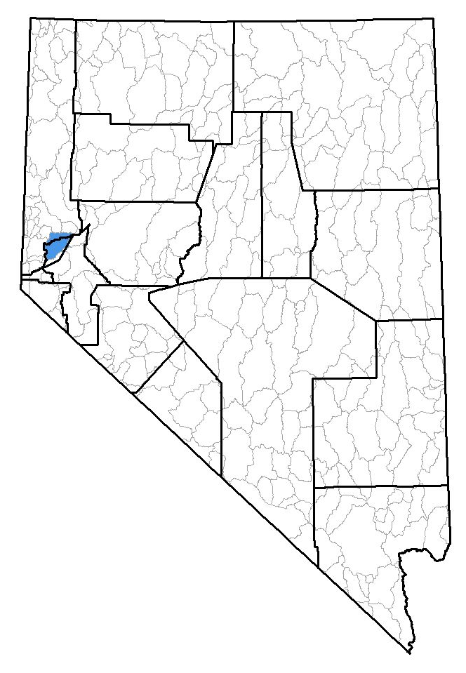
 | Location of Basin 83, located primarily in Storey County with a small portion of the basin located in Washoe County.

6.2 METHOD OF NAAQS AIR QUALITY MODELING ANALYSIS

The EPA approved model AERMOD was used to determine the air quality impacts in order to demonstrate no exceedance of the NAAQS. The NAAQS modeling was performed using a 30m USGS DEM terrain sample and four years of on-site hourly meteorological data collected near the Tracy Power Plant and provided by the BAPC. Receptors were placed from the center of the facility at 25m intervals within the property boundary, and then at 50m intervals for 125 meters and then at 100m intervals for 250 meters. Models were run for PM₁₀, NO_{x}, SO₂ and CO for all averaging periods. The Scheffe model was used to model ozone generation.

6.3 METHOD OF PSD INCREMENT MODELING ANALYSIS
The increment modeling was generated using the model AERMOD and the Increment Tracking System (ITS). The ITS is a modeling tool developed by the NDEP-BAQP/BAPC to model increment availability across an entire air management basin. ITS utilizes the same source input file as the NAAQS AERMOD modeling, but employs a wider scale terrain and meteorological data with more receptors. The ITS is able to overlay the modeling results from each facility in an Air Management Basin to determine the amount of increment available.  It has been indicated by the NDEP-BAQP that both the NAAQS and PSD increment models must be run because the interaction of all the model variables are too complex to guess. Acceptable results in one model are not necessarily indicative of acceptable results in the other. The BAPC engineer Greg Remer performed the increment analysis and summary report. | Model view of engine building, property fence, engine exhaust stacks and receptor grid. Engine building located in center of property fence. Engine exhaust stacks on the right side of the engine building
 | 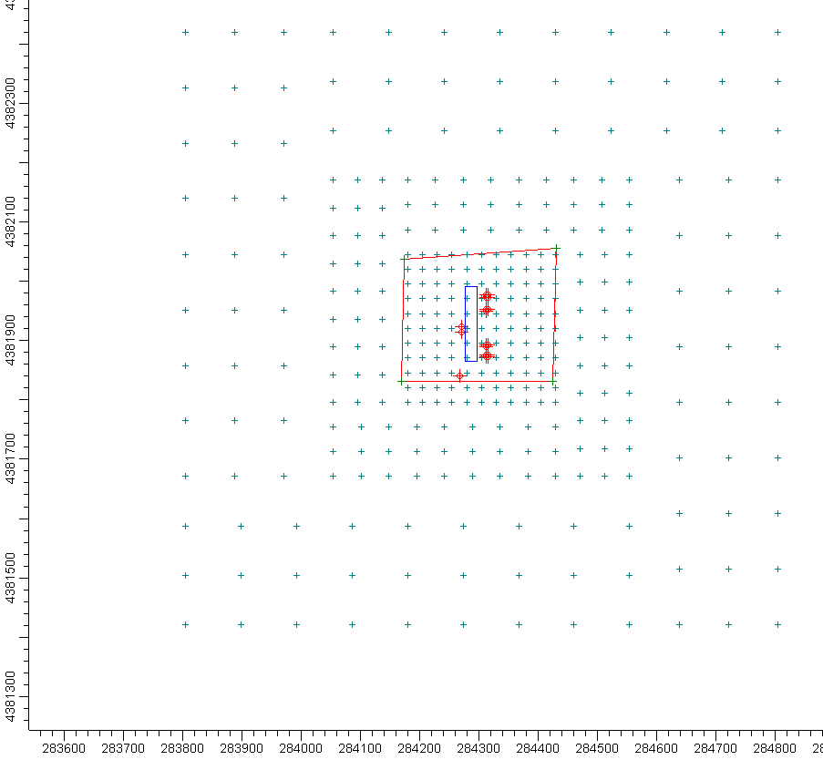
 | Model illustration (at scale) of engine building and engine exhaust stack clusters.
 | 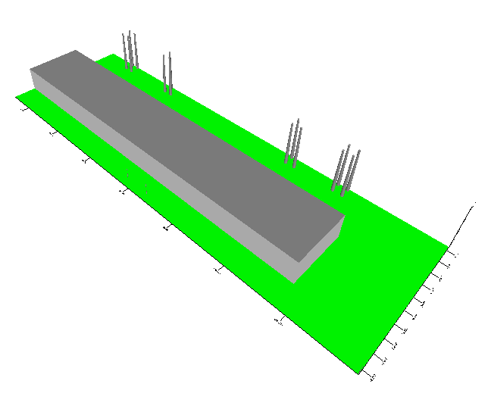

  - NAAQS MODEL RESULTS

Table 6.4.1 – Barrick NAAQS Model Results
Pollutant | Averaging Period | NAAQS Standard (μg/m³) | Background* + modeled = Total (μg/m³) | % of NAAQS Standard
PM₁₀ | 24-hr | 150.0 | 32.0 + 13.4 = 45.4 | 30.3
PM₁₀ | Annual | 50.0 | 32.0 + 2.0 = 34.0 | 68.0
CO | 1-hr | 40,500.0 | 6,634.2 + 1,184.8 =7,819.0 | 22.3
CO | 8-hr (<5,000 ft ASL elevation) | 10,500.0 | 4,597.4 + 214.0 = 4,811.4 | 45.8
NO_{x} | Annual | 100.0 | 57.4 + 1.1 = 58.5 | 58.5
SO₂ | 3-hr | 1,300.0 | 0 + 18.9 = 18.9 | 1.5
SO₂ | 24-hr | 365.0 | 0 + 4.1 = 4.1 | 1.1
SO₂ | Annual | 80.0 | 0 + 0.5 = 0.5 | 0.6
Ozone | 1-hr | 235.0 | 179.6 + 29.5 = 209.1 | 88.9

* Background concentrations measured at the Reno, Nevada monitoring station, located approximately 16 miles west of the Western 102 Project for the years 2000 & 2001. Station ID = 32-031-0016 NAMS/SLAMS/SPMS

  - WIND ROSE/SURROUNDING TERRAIN

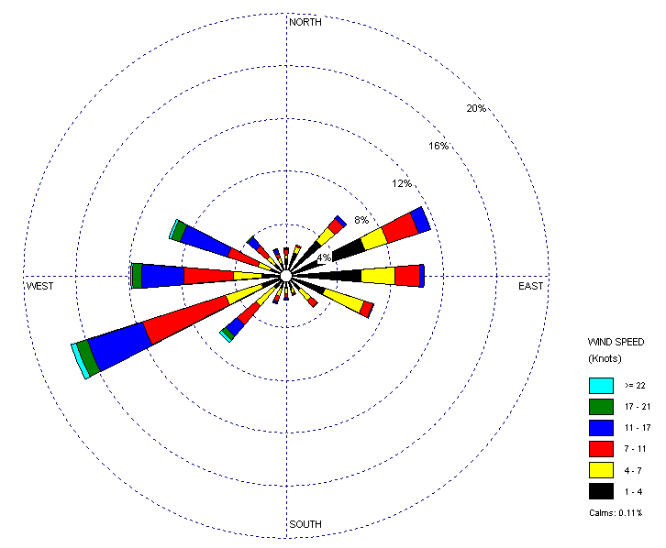 | 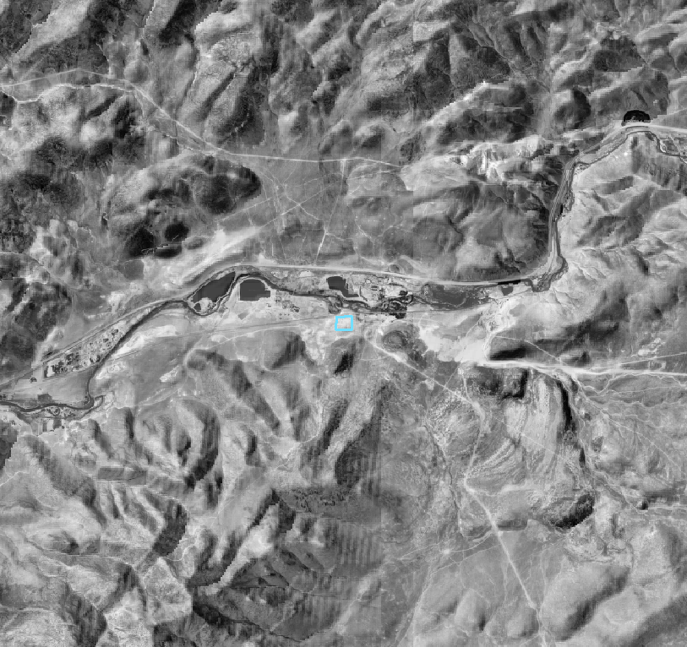
Wind rose diagram displaying the magnitude and direction of wind. Orientation is “direction blowing from.” | Terrain surrounding the proposed Barrick facility that affects modeling. Facility is the square in the center of the image.
6.6 INCREMENT TRACKING MODEL RESULTS

Increment was analyzed on a paired-in-time basis at each receptor in the HA83 study receptor grid. Increment impacts were evaluated for PM₁₀ and NO₂ only. SO₂ was not analyzed, since a paired-in-time re-analysis of the increment impacts for HA 83 has not yet been completed. Based on the modeling information provided, Barrick’s 102 Power project OPTC rollover to Class I will not contribute to or cause an exceedance of the NO_{x} increment standard. Likewise, the project did not cause an exceedance of the PM₁₀ 24-hour increment standard. However, the original increment study identified 9 existing receptors that previously indicated an exceedance of the PM₁₀ 24-hour increment standard. The following tables present a summary of the results of the analysis for Barrick and indicate the top 3 Barrick contributions to these receptors that indicate existing PM₁₀ exeedances.

PM₁₀ Results
Class 2 Increment Standard = 30 µg/m³ (24-hour averaging period)
Class 2 Increment Standard = 17 µg/m³ (annual averaging period)
Met Year | Avg. Period | Increment Receptors |  |  |  | Barrick Contrib | Max. Barrick  Conc.
Met Year | Avg. Period | Rec No | X Coord | Y Coord | Total Conc. | Barrick Contrib | Max. Barrick  Conc.
2000 | 24 | 1035 | 275000 | 4373000 | 99.71429 | 0.00012 | --
2000 | 24 | 2922 | 302500 | 4388500 | 63.25147 | 0.83405 | --
2000 | 24 | 2984 | 303500 | 4389000 | 52.89966 | 0.0788 | --
2000 | 24 | 2983 | 303000 | 4389000 | 43.87201 | 0.57946 | --
2000 | 24 | 1036 | 275500 | 4373000 | 41.90667 | 0.00017 | --
2000 | 24 | 2119 | 287000 | 4382000 | 39.97998 | 0.21441 | --
2000 | 24 | 1034 | 274500 | 4373000 | 37.46125 | 0.07686 | --
2000 | 24 | 2982 | 302500 | 4389000 | 35.9462 | 0.82111 | --
2000 | 24 | 3044 | 303000 | 4389500 | 32.97115 | 0 | --
2000 | 24 | 3836 | 284749.906 | 4382000 | -0.89012 | 10.0879 | 10.0879
2000 | Annual | 1035 | 275000 | 4373000 | 3.44537 | 0.03488 | --
2000 | Annual | 3848 | 284999.906 | 4382250 | -346.30447 | 1.89301 | 1.89301
2001 | 24 | 1035 | 275000 | 4373000 | 189.09564 | 0.00924 | --
2001 | 24 | 1034 | 274500 | 4373000 | 59.8154 | 0.01439 | --
2001 | 24 | 1036 | 275500 | 4373000 | 49.66788 | 0 | --
2001 | 24 | 2922 | 302500 | 4388500 | 30.35289 | 0.16571 | --
2001 | 24 | 3453 | 283899.906 | 4382000 | -15.9363 | 8.18919 | 8.18919
2001 | Annual | 1035 | 275000 | 4373000 | 8.31272 | 0.03277 | --
2001 | Annual | 2119 | 287000 | 4382000 | -326.5257 | 1.83068 | 1.83068

NO₂ Results
Class 2 Increment Standard = 25 µg/m³ (annual averaging period)
Met Year | Avg. Period | Increment Receptors |  |  |  | Barrick Contrib | Max. Barrick  Conc.
Met Year | Avg. Period | Rec No | X Coord | Y Coord | Total Conc. | Barrick Contrib | Max. Barrick  Conc.
2000 | Annual | 1640 | 272500 | 4378000 | 29.42385 | 0.01744 | --
2000 | Annual | 3848 | 284999.906 | 4382250 | 19.12705 | 1.15209 | 1.15209
2001 | Annual | 1640 | 272500 | 4378000 | 26.0893 | 0.01721 | --
2001 | Annual | 3848 | 284999.906 | 4382250 | 18.03848 | 1.1121 | 1.1121

As can be seen in the preceding table, the top three contributions to existing PM₁₀ exceeding receptors (#2922, 2984 and 2982) all occur using the 2000 meteorology. However, upon further analysis of the impact contributions, the exceedances at these three receptors are due to the influences of area sources. In fact the area contributions result in more than 100% of the total increment impact at the three receptors. The lower total increment concentration is the result of point sources actually expanding increment at these receptors. NDEP-BAPC is concerned that the area source inventory methods used in the increment study do not correctly allocate emissions spatially. As a result, it is possible that the increment results due to the area inventory influences are not spatially correct. In addition, there is also concern that the model software does not treat fugitive area sources accurately. These issues were discussed in the Bureau’s Air Quality Monitoring Report for the Assessment of PSD Increment in the Fernley Area and Truckee River Corridor. The study report discussed various methods for adjusting the concentrations. The NDEP-BAPC has not yet chosen a methodology. The fugitive inventory methods and model treatment are also being discussed national forums and their resolution will impact Nevada. Although the increment contribution from the area source inventory is the cause of the exceedances at the receptors of concern, NDEP-BAPC does not believe that adequate information exists to reliably determine that the operation of the Western 102 power project will significantly impact receptors that exceed the increment standard, at this time.

8.0 CONCLUSIONS

The Wartsila engine systems are a new process type of combustion engines for the State of Nevada. The NDEP-BAPC has not previously permitted a Wartsila engine with the Ultra-low Emissions system. While internal combustion engines are not in themselves a new technology, the sophisticated computer management systems and high efficiency exhaust controls exceed any other engine system performance documented in available literature. Calculations performed in Section 5 above, demonstrate the sensitive relationship of control efficiency to facility potential to emit and highlight the very high control efficiencies required for the proposed Barrick facility to avoid major stationary source classification.

Realizing that the facility did not have CEMs or COMs, the NDEP-BAPC was concerned with how the facility would know if a control efficiency was deteriorating. Even a slight drop in efficiency could have a significant impact on facility emissions.

To remedy these concerns, the Operating Permit includes 4 components to help provide assurance:
1. Annual performance source testing of each engine. This testing will verify the manufacturer’s emission estimations.
2. The Operating Permit requires Barrick to check each engines system console daily for maintenance messages and to schedule any required repairs. If the engines remain in proper repair they should not have any unexpected emission increases.
3. The Operating Permit requires an alarm to be configured into the control system computers to alert an attendant if emission control parameters are out of specification, and to initiate an automatic shutdown within 1 hour if not remedied. This prevents a malfunctioning control from going unnoticed.
4. Long-term engine re-testing. The subsequent operating permit will include re-testing of the engines to verify that they remain operating within permitted limits.

9.0 RECOMMENDATIONS

Based on the above review and supporting data and analyses, the Barrick OPTC rollover to Class I Air Quality Operating Permit will not result in an exceedence of any applicable ambient air quality standards. As a result, I recommend that the conditions specified in the Class I facility-wide Air Quality Operating Permit be issued with all appropriate restrictions.

Rod Moore Date
Permitting Branch

Matthew DeBurle Date
Supervisor, Class I Permitting

Attachment (1) Facility and Vicinity Map
Attachment (2) Emission Inventory Calculations
Attachment (3) Dispersion Modeling Results
Attachment (4) Proposed Operating Permit

Attachment 1

Facility and Vicinity Map

Attachment 2

Emissions Inventory Calculations

Attachment 3

Dispersion Modeling Results

Attachment 4

Proposed Operating Permit

Summary of Subpart ZZZZ RICE MACT

Table 2A - Required Emission Limitations:
2. 4SLB stationary RICE
a. Reduce CO emissions by 93 percent or more; or
b. Limit concentration of formaldehyde in the stationary RICE exhaust to 14 ppmvd or less at 15 percent O2.

Table 2B – Operational Limits
1. 2SLB and 4SLB stationary RICE and CI stationary RICE requirement to reduce CO emissions and using an oxidation catalyst; or 2SLB and 4SLB stationary RICE and CI stationary RICE complying with the requirement to limit the concentration of formaldehyde in the stationary RICE exhaust and using an oxidation catalyst.

a. Maintain your catalyst so that the pressure drop across the catalyst does not change by more than two inches of water at 100 percent load plus or minus 10 percent from the pressure drop across the catalyst that was measured during the initial performance test; and

b. Maintain the temperature of your stationary RICE exhaust so that the catalyst inlet temperature is greater than or equal to 450[deg]F and less than or equal to 1350[deg]F.

Table 3 – Performance Tests
2SLB and 4SLB stationary RICE and CI stationary RICEs reducing CO emissions and not using a CEMS are required to conduct subsequent performance tests semiannually.\1\

\1\ After you have demonstrated compliance for two consecutive tests, you may reduce the frequency of subsequent performance tests to annually. If the results of any subsequent annual performance test indicate the stationary RICE is not in compliance with the CO or formaldehyde emission limitation, or you deviate from any of your operating limitations, you must resume semiannual performance tests.

Table 6 - Recordkeeping
- 2SLB and 4SLB stationary RICE and CI stationary RICE
a. Reduce CO using an oxidation catalyst, and using CPMS.
i. Conducting emissions and semiannual performance tests for CO to demonstrate that the required CO percent reduction is achieved \1\;and

ii. Collecting the catalyst inlet temperature data according to Sec. 63.6625(b); and

iii. Reducing these data to 4-hour rolling averages; and

iv. Maintaining the 4-hour rolling averages within the operating limitations for the catalyst inlet temperature; and

v. Measuring the pressure drop across the catalyst once per month and
demonstrating that the pressure drop across the catalyst is within the operating limitation established during the performance test.

Table 7 – Compliance Reporting
1. Compliance report according to the requirements in Sec. 63.6650(b). Semiannually according to the requirements in Sec. 63.6650(b).
a. If there are no deviations from any limitations or operating limitations that apply to you, a statement that there were no deviations from the emission limitations or operating limitations during the reporting period. If there were no periods during which the CMS, including CEMS and CPMS, was out-of-control, as specified in Sec. 63.8(c)(7), a statement that there were not periods during which the CMS was out-of-control during the reporting period; or;
b. If you had a deviation from any emission limitation or operating limitation during the reporting period, the information in Sec. 63.6650(d). If there were periods during which the CMS, including CEMS and CPMS, was out-of-control, as specified in Sec. 63.8(c)(7), the information in Sec. 63.6650(e); or
c. If you had a startup, shutdown or malfunction during the reporting period, the information in Sec. 63.10(d)(5)(i).

2. An immediate startup, shutdown, and malfunction report if actions addressing the startup, shutdown, or malfunction were inconsistent with your startup, shutdown, or malfunction plan during the reporting period. By letter within7 working days after the end of the event unless you have made alternative arrangements with the permitting authorities. (Sec. 63.10(d)(5)(ii))
a. Actions taken for the event; and By fax or telephone within 2 working days after starting actions inconsistent with the plan.
b. The information in Sec. 63.10(d)(5)(ii).

3. Report annually according to the requirements in Sec. 63.6650.
a. The fuel flow rate of each fuel and the heating values that were used in your calculations, and you must demonstrate that the percentage of heat input provided by landfill gas or digester gas, is equivalent to 10 percent or more of the gross heat input on an annual basis; and
b. The operating limits provided in your federally enforceable permit, and any deviations from these limits; and
c. Any problems or errors suspected with the meters.

