Poster Presentation 4-17

Combinatorial Approaches for Developing New Catalysts for Polyols

Johnathan .E. Holladay, Danielle S. Muzatko, John G. Frye and James F. White

Pacific Northwest National Laboratory, Richland, WA 99352
Phone: (509) 375-2025 email: john.holladay@pnl.gov

Formation of ethylene glycol (EG) and propylene glycol (PG) from sugars offers potential renewable resources for solvents, deicers, antifreeze and other products. The mechanism for hydrogenolysis is complex. At the minimum it involves dehydrogenation, accompanied with isomerization, retro-aldol (C-C cleavage), dehydration (C-O cleavage) and re-hydrogenation. Numerous precious metals and mixed metal systems on various supports along with various base or acid promoters have been used to catalyze the reaction. The complexity of the mechanism and the variety of metals, supports and promoters possible in optimal catalytic systems makes combinatorial methodology ideal for advanced catalyst development.

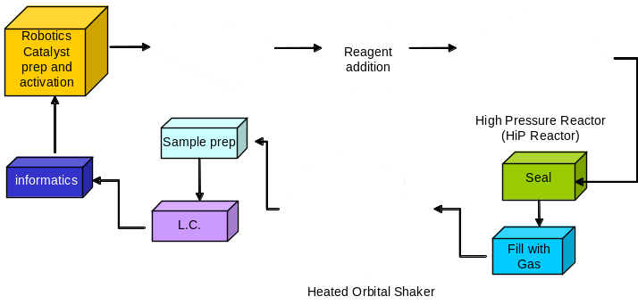

We have employed high-throughput combinatorial techniques for advanced catalyst discovery. The combinatorial approach has allowed us to rapidly prepare and screen in excess of 4,000 individual experiments in a matter of months. Surprising results were found on preferred supports, metal combinations and promoters. Catalysts systems screened included one or two central metals with up to two additional promoter metals (i.e. up to quaternary metal systems). The exact catalyst compositions will not be presented at this time. Rather, the presentation will focus on the process of catalyst discovery using mechanism-based design and statistical tools.

