Accident |  | Alaska Airlines MD-83
Location | Pacific Ocean off the coast of Southern California
Date | January 31, 2000
Summary | Alaska Airlines Flight 261 with 2 pilots, 3 cabin crew, and 83 passengers departed Puerto Vallarta (PVR), Mexico to Seattle, WA with a scheduled stop in San Francisco, CA.  Visual meteorological conditions prevailed for the flight that operated under an instrument flight rules flight plan.  The airplane was functioning normally during the initial phase of flight but the horizontal stabilizer (Figure 1) stopped responding to autopilot and pilot commands after the airplane passed through 23,400 feet.  The pilots recognized the longitudinal trim system (Figure 2) was not functioning but could not determine why.  The airplane takeoff (TO) weight was 136,515 pounds, well below TO and climb limits. The airplane maximum landing weight was 130,000 pounds so the airplane would need to remain in flight for 45 minutes to burn enough fuel to reach the max landing weight.  The flight crew did not elect to return to PVR. Neither the Alaska Airlines MD-80 Quick Reference Handbook Stabilizer Inoperative nor the company Runaway Stabilizer Emergency Checklist required landing at the nearest suitable airport.  The flight crew manually flew the airplane and contacted Alaska Airlines dispatch and maintenance control when they got close to the US border, approximately two hours after departure.  At altitude and higher cruise speed, manually flying the airplane was not difficult for the crew.
Summary  (continued) | The crew discussed the malfunctioning trim system and current and expected weather at Los Angeles (LAX) and San Francisco (SFO) with Alaska's dispatch and maintenance. Although the crew elected not to return to Puerto Vallarta, they decided to land at LAX rather than continue to SFO. The weather conditions at SFO, crosswinds, along with the increased landing speed required, and over flying a suitable airport (LAX) may have influenced their decision.  After flying manually for two hours, the crew tried to use the autopilot several times and it disengaged each time.  The flight crew was troubleshooting the trim system by using the trim handles and control wheel trim switches while in contact with the dispatch and maintenance personnel. See Figure 3 and Figure 4. The Alaska Airlines MD-80 Stabilizer Inoperative checklist states, "do not use the autopilot" if the trim systems are inoperative.  While the flight crew was troubleshooting the system, the primary trim motor moved the jackscrew and freed the jammed acme nut allowing the horizontal stabilizer to move leading edge up, until it reached the lower mechanical stop, initiating a dive from the cruise altitude of 31,050 feet.  The crew made control inputs to bring the nose up, deployed the speed brakes to retard the rapidly increasing airspeed, and recovered from the dive at approximately 24,000 feet.  After the flight crew recovered from the initial dive, the crew deployed the slats and flaps to slow the airplane in preparation for an emergency landing at LAX; the airplane remained stable and controllable. See Figure 5 to view the flight path.  The slats and flaps were retracted and the airspeed increased. The captain then ordered redeployment of the slats and flaps. The Cockpit Voice Recorder (CVR) recorded a discernable noise; the airplane rapidly pitched nose down in the final dive and crashed into the ocean. See Figure 6 to view the radar altitude data and selected excerpts from the CVR.  Radar detected several small primary returns consistent with parts of the vertical stabilizer being torn from the airplane.  Visit the NTSB website to view the "Longitudinal Trim System Description and Failure Sequence" animation which shows how the horizontal stabilizer works and the sequence of events following the acme nut thread failure: http://www.ntsb.gov/events/2000/aka261/presentations/presentations.htm.
Summary  (continued) | After the accident, severely worn and sheared remnants of the acme nut threads were recovered wrapped around the acme screw. See Figure 7, Figure 8, and Figure 9.  Approximately 90 percent of the thread thickness had worn away before the remainder of the threads sheared off. See Figure 10, Figure 11, and Figure 12.  The pilots knew the longitudinal trim system was jammed but did not know why. The worn threads of the acme nut was sheared off and jammed the acme screw.  When the crew operated the trim system, the jam was freed causing the initial dive. The acme screw did not completely separate during the initial dive. With the acme nut severely worn and changes in the airplane configuration, it finally separated resulting in the final dive.
Accident Board Findings | Now let's take a look at the findings from the National Transportation Safety Board (NTSB) Aircraft Accident Report.  Probable Cause of the Accident  The safety board determined "the probable cause of the accident was a loss of airplane pitch control resulting from in-flight failure of the horizontal stabilizer trim system jackscrew assembly's acme nut threads. The thread failure was caused by excessive wear resulting from Alaska Airlines insufficient lubrication of the jackscrew assembly." See Figure 13.  Contributing to the Accident  "Alaska Airlines' extended the lubrication interval and the Federal Aviation Administration's (FAA) approval of the extension, which increased the likelihood that a missed or inadequate lubrication would result in excessive wear of the acme nut treads and Alaska Airlines' extended end play check interval and the FAA's approval of the extension, which allowed the excessive wear of the acme nut treads to progress to failure without the opportunity for detection." See Table 1 for a comparison of the manufaturer recommended jackscrew assembly lubrication interval schedule with the Alaska Airlines schedule.  Note: While not specifically mentioned in the NTSB findings, the acme nut grease fitting passage, which allows the grease to reach the jackscrew and acme nut threads, was found plugged with dry residue.
Accident Board Findings (continued) | Alaska extended the jackscrew assembly endplay check interval and FAA approval of such allowed excessive wear of the acme nut threads to progress to failure without detection. See Table 2 from the NTSB report. Also contributing to the accident was the absence of a fail-safe mechanism on the MD-80 horizontal stabilizer jackscrew trim system to prevent the catastrophic effects of total acme nut thread loss.  The following information is not directly quoted from the NTSB but is information found in various sections of the report, Factual, Analysis, Conclusions, and Recommendations.  Let's take a closer look at some pertinent information contained in various Sections (Factual Information, Analysis, Conclusions, Recommendations, and Board Member Statements) of the NTSB report.  Flight Crew Decision-Making  The decision not to return to Puerto Vallarta was understandable. There is no requirement in the AFM to land at the nearest suitable airport following a jammed or malfunctioning horizontal stabilizer. The crew's decision to land at LAX was appropriate.  However, the flight crew's use of the autopilot while the horizontal stabilizer was jammed was not appropriate. The crew should not have tried to troubleshoot the system by using the autopilot and trim motors. Once a stable airplane-landing configuration was obtained, landing at LAX should have followed immediately.  Jackscrew Assembly Maintenance  Alaska Airlines, with FAA approval, increased the lubrication interval from 500 flight hours to every 8 calendar months. For this system, wear is a function of aircraft usage not calendar time. Also, an increased interval decreases the tolerance for missed or inadequate lubrication.  The FAA airworthiness directive after the accident reduced the lubrication interval to 650 flight hours with an endplay check required every 2,000 flight hours. There is no mechanism in place to prevent similar unsafe interval extension for other maintenance tasks.
Accident Board Findings (continued) | The endplay check to determine the airworthiness of the jackscrew assembly was required at every other C check. However, the C check interval was extended. Had the endplay check not been extended, excessive wear of the acme nut threads could have been identified prior to failure. Since the endplay check is required to determine an airworthy system, the safety margin that allows for two complete missed inspections before failure should be required.  The ability to adequately perform the lubrication on the airplane is suspect due to the size of the access panels. Also, this lubrication procedure is a required inspection item, which would require inspector's signoff before the task is completed.  Horizontal Stabilizer Trim System Design and Certification  The dual-thread design of the acme screw nut does not provide redundancy with respect to wear. The design of the jackscrew assembly did not account for the loss of the acme nut threads as a catastrophic single-point failure mode.  View the NTSB report on this accident at: http://www.ntsb.gov/publictn/2002/AAR0201.pdf.
Accident Board Recommendations | - The NTSB issued 16 safety recommendations with their final report and 8 recommendations prior to the final report. The subject areas covered (engineering related) for the 16 recommendations include:  - Pilot actions on the use of procedures not included in the checklist or AFM with inoperative or malfunctioning control systems.  - Revise and mandate the maintenance procedures for greasing the jackscrew assembly.  - Increase the size of the access panel to accomplish the lubrication procedures.  - Evaluate maintenance task that could affect critical aircraft components to assure the original design assumptions are taken into account and are supported by technical data.  - Require ACO concurrence on changes to maintenance task on critical systems before the PMI approves.  - Establish endplay check intervals based on real data which account for wear rate.
Accident Board Recommendations (continued) | - If practicable, require a fail-safe mechanism to prevent catastrophic effects of total failure of the acme nut threads on DC-9, MD-80/90, and B-717 airplanes.  - Modify certification regulations, policies and procedures so new horizontal stabilizer trim systems are not certified if they have a single-point catastrophic failure mode.  - Review and revise certification regulations/guidance to ensure wear-related failures are addressed, to the maximum extent possible, so that they will not be catastrophic.  The subject areas that were Flight Standards related include:  - Surveillance of the operators.  - Lubrication inspection and documentation.  - Jackscrew overhaul capability, documentation, and equipment.  - Require operators to measure and record on airplane endplay measurements whenever a jackscrew is replaced.  The prior subject areas covered for the 8 recommendations include:  - Require Boeing to revise the lubrication and endplay check procedures for the horizontal stabilizer trim system for DC-9, MD-80/90, and B-717 airplanes (engineering related).  - Require maintenance training for lubrication and end play check (Flight Standards related).  - Require approval of changes to lubrication procedures.  - Provide notification to operators on use of inappropriate greases.  - Survey operators on intermix of greases.  - Convene a industry conference on greases.  Note: While the type of grease and grease intermix was an issue early on in the investigation, the NTSB final report, paragraph 3.1 Findings, #21, stated, "Alaska Airlines' use of Aeroshell 33 for lubrication of the jackscrew assembly… were not factors in the excess wear of the accident acme nut treads." Finding #23 stated, "The excessive and accelerated wear of the accident jackscrew assembly nut treads was the result of insufficient lubrication, which was directly causal to the Alaska Airlines flight 261 accident." The type of grease and grease intermix turned out to be a red herring for this accident.

Unsafe Conditions | Inadequate lubrication resulted in failure of the horizontal stabilizer jackscrew assembly acme nut threads.
Design and Safety Assumptions | Some of the key design and safety assumptions that played role in this accident are listed below.  - The jackscrew assembly would function as designed with proper lubrication. The acme nut grease fitting would perform as designed and not be clogged/plugged. The acme nut threads would not shear/fail in-flight due to its double thread fail-safe design.  - The wear rate of the acme nut thread was linear. (Assuming that the appropriate lubrication occurs at proper intervals.)  - Worn jackscrew assemblies would be identified by endplay maintenance checks and removed from service prior to significant structural deterioration. Therefore, a completely worn acme screw was not considered in the safety analysis as a failure mode. Also, failure analysis assumes that a jackscrew would be jammed in any acme screw mechanical failure mode.  - The flight crew would follow aircraft flight manual (AFM) procedures for a jammed or malfunctioning horizontal stabilizer and not troubleshoot the system to free the jam or correct a malfunctioning system.  - Horizontal stabilizer runaway limits and airplane testing were based on autopilot/motor failures not acme nut thread failure.
Precursors | Analysis of the accident reveals three major precursors:  - Failure to adequately maintain the pitch trim system resulted in failure of the acme nut threads, a jammed jackscrew, and the eventual the loss of pitch control.  The Possible Catastrophic Effects from the Failure to Maintain the Pitch Trim System  The DC-8, in 1969, with a similar design had an incident of a jammed stabilizer due to worn jackscrew threads, lack of lubrication and corrosion.  In 1995 the MD-11 had excessive wear of the acme nut due to improper screw thread surface finish. AD 98-16-01 was issued that stated "If not corrected, this condition in conjunction with a failure of the opposite jackscrew assembly, could result in a free horizontal stabilizer that would cause the loss of airplane pitch control".
Precursors (continued) | A 1997 DC-8 incident occurred and the acme nut threads were completely stripped.  While the DC-8 and MD-11 have a dual jackscrew design versus the single jackscrew design of the DC-9/MD-80, the criticality of a jackscrew nut failure was known. There was no special emphasis on the need for maintenance of the system because of the criticality. This precursor is very subtle and linking the information from the DC-8 and MD-11 dual jackscrew design to the single jackscrew design of the DC-9/MD-80 airplanes would not be easy to recognize.  - Flight crew taking actions not specified in the Airplane Flight Manual or Operating Manual.  Knowing the airplane had a pitch control problem, the flight crew should have landed at the nearest suitable airport. Continuing to troubleshoot the jammed horizontal stabilizer trim system resulted in the final loss of horizontal stabilizer structural integrity, and the airplane became uncontrollable.  There have been other accidents where the flight crew performed procedures outside of published procedures, such as the National Airlines DC-10 accident in Albuquerque in which the flight crew was experimenting with the auto-pilot/auto-throttle electrical signals and were pulling circuit breakers.  Also, an Eastern Airlines L-1011 crashed in the Everglades as the flight crew were attempting to troubleshoot a warning light problem and not paying attention to the airplane flight path until it was too late and the airplane crashed.  - Schedule and maintenance concerns by the operator's ground personnel added pressure to the flight crew trying to make safety decision during flight.
Airworthiness Directives Issued | One airworthiness directive was issued as a result of this accident, AD 2000-15-15, which superceded AD 2000-03051. View AD 2000-03051 at: http://www.airweb.faa.gov/Regulatory_and_Guidance_Library/rgAD.nsf/0/6E28E61948DF0C1A86256A08006BFD14?OpenDocument&Highlight=2000-15-15.
Airworthiness Directives Issued (continued) | In addition, the FAA Commercial Airplane Certification Process Study (CPS) was a direct result of this and the TWA B747 accidents.  The report focused on numerous process categories, including human factors in airplane design, operation and maintenance, flight critical systems and structures, safety data management, maintenance/operations coordination, major repair and modification, and safety oversight.  The certification process study report's findings and observations directly relate to all lessons learned from this accident. View a summary of the findings in CPS at: http://www.aia-aerospace.org/issues/subject/faa/faa_cert_study.pdf.  It might be appropriate to consider creation of a regulatory device to include some maintenance tasks, such as lubrication of the jackscrew assembly. Any escalation would require ACO involvement, not just reliance on the operator's reliability program. This would be similar to the Airworthiness Limitations Instructions/Section (ALI/ALS) of the maintenance manual and Certification Maintenance Requirements (CMR) items.
Lessons Learned | There are a number of important lessons to be learned from this accident.  Single point failure of any critical flight control system component that can lead to a catastrophic event must be carefully evaluated and should not be allowed by design. The ACO engineer review of critical flight control components (Failure Mode and Effect Analysis) should consider maintenance tasks required to maintain the airworthiness of the airplane.  During design and certification there should be coordination between AIR/AFS/OEM in the generation of maintenance requirements for some areas; changes to those maintenance requirements should also require that same coordination. The effects of changes to the maintenance program upon the airplane and the OEM design assumptions must be considered.  Extending maintenance intervals and/or changing from flight hours to only calendar time for wear related components must be carefully evaluated prior to implementation. The rate of wear must be considered.  Flight crews should land the airplane as soon as possible if a critical flight control system malfunctions or jams, and not take any actions beyond what is specified in AFM procedures.
Lessons Learned (continued) | As with most major catastrophic accidents, the FAA is under immediate pressure from the public and press to take some type of action to assure the existing fleet is safe. It is necessary for the ACO engineer to recognize FAA needs and be aware of other factors/influences/pressures (public, political,) beyond determining the cause of the accident.  The ACO engineer needs to provide technical support to assure correct FAA response to those other factors as well as identify and take action to prevent recurrence of the accident. The ACO engineer must understand the context of questions being posed to be able to provide the best possible technical support.

Category | Environmental Mechanical Aging Aircraft  Avionics Propulsion Human Factors  Electrical Auxiliary, other Maintenance, Operations  Interior Airframe Regulations, policies, standards  Environment Software
Application of Lessons Learned | Design & Certification Regulation, Policy, etc.  ADs, TCs, etc. Other: __________________  Maintenance  Continued Operational Safety
Key Words | Stabilizer, Pitch Control, Jackscrew, Acme Nut, Trim System, Lubrication, Maintenance Checks.
Potential Databases | NTSB PTRS  ASRS SDR  ATOS Other __________________  CSET

Figure 1: MD-80 Horizontal and Vertical Stabilizer Tail Structure
(Select here to return)

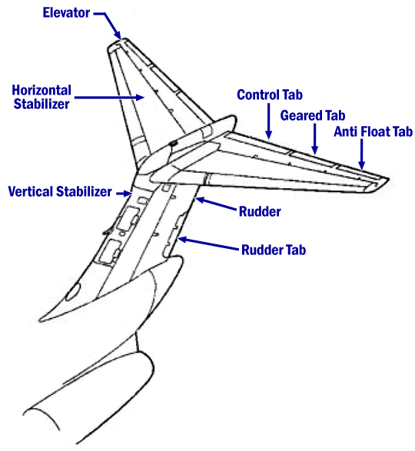
Figure 2: Installation of Jackscrew Assembly
Within the Horizontal and Vertical Stabilizers
(Select here to return)

The longitudinal trim system allows the pilot to stabilize the airplane with zero control forces, or allows the autopilot to control pitch. For the MD-83, the systems consists of a single jackscrew and nut, located near the top of the vertical stabilizer, with primary and alternate motors that drive the jackscrew assembly. The jackscrew nut (acme nut) is fixed, and rotation of the jackscrew through the acme nut moves the horizontal stabilizer to trim the airplane. The acme nut is intended as the "wear point" in the system, and requires regular lubrication and inspection. The jackscrew is retained at the lower end by an end cap and at the upper end by a fixed stop.

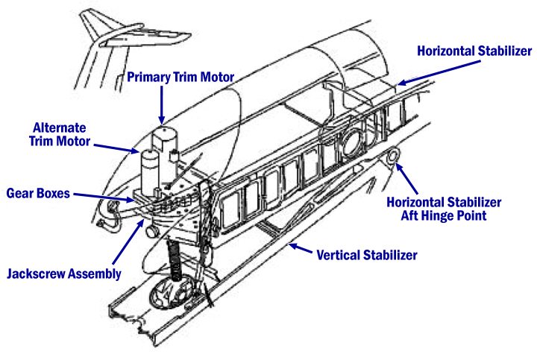
Figure 3: Cockpit Switches, Handles, and Indicator for the Longitudinal Control System
(Select here to return)

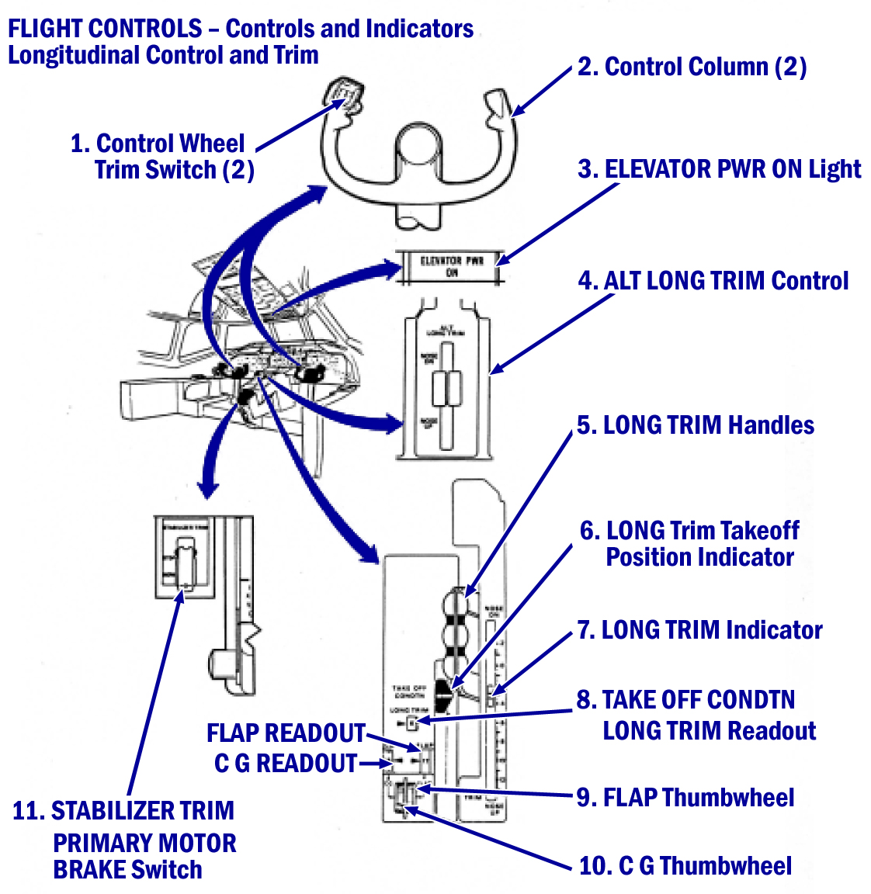
Figure 4: Detailed Schematic of the Longitudinal Trim Actuating Mechanism
(Select here to return)

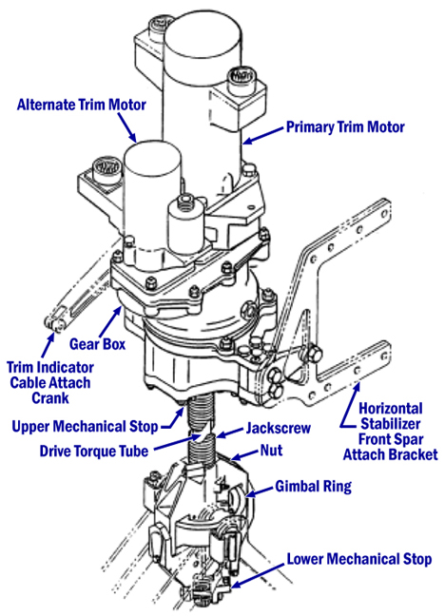
Figure 5: Alaska MD-83 Flight Path
(Select here to return)

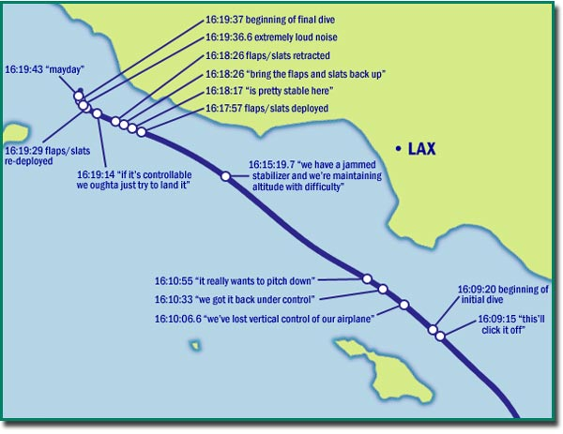
Figure 6: Alaska MD-83 Altitude
(Select here to return)

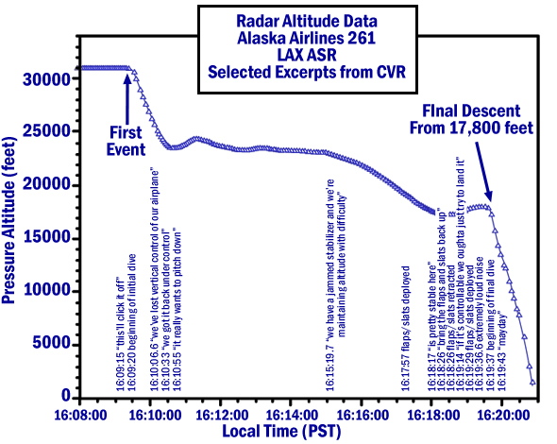
Figure 7: Acme Screw Immediately After it was Brought on Board the Recovery Ship
(Select here to return)

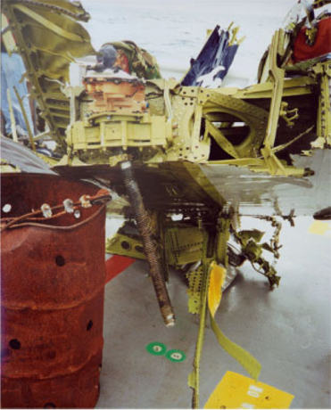

Figure 8: Acme Screw Showing Stripped Gimbal Nut Thread Material
(Select here to return)

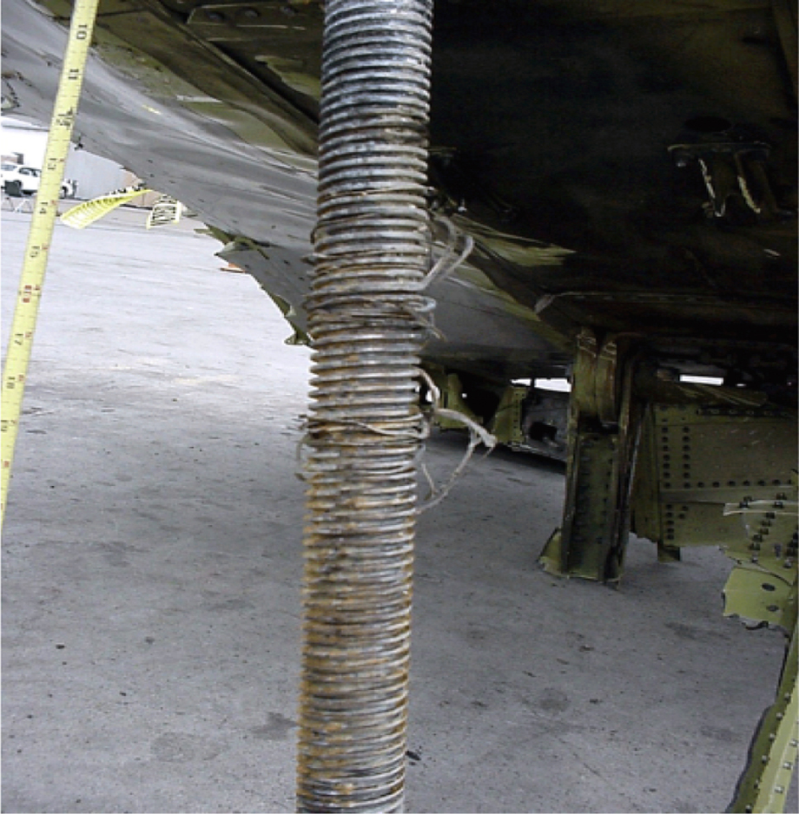

Figure 9: Gimbal Nut Thread Material Around Acme Screw
(Select here to return)

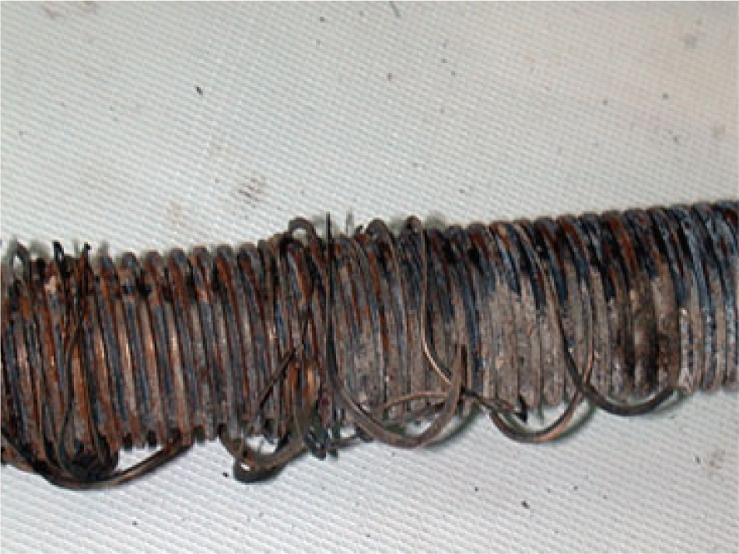
Figure 10: Acme Nut Assembly Showing Missing Internal Threads
(Select here to return)

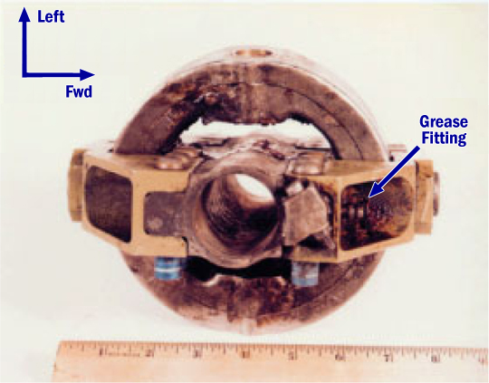
Figure 11: Closer View of the Interior of the Acme Nut
(Select here to return)

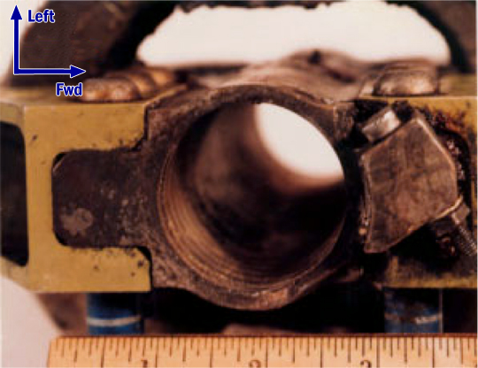
Figure 12: Cross-Section of Greased Passageway and Counterbore of Acme Nut
(Select here to return)

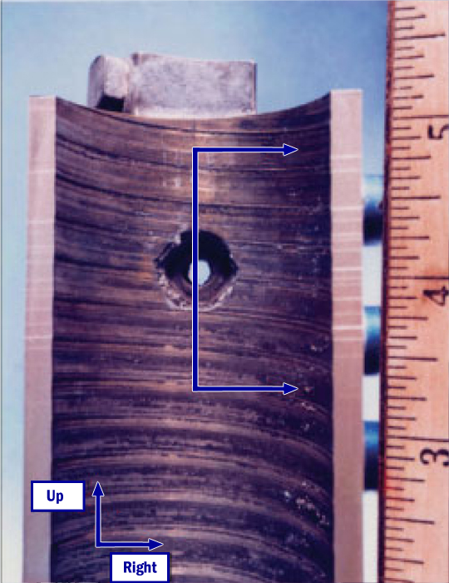
Figure 13: Graphical Depiction of the Stages of
Acme Nut Thread Wear to the Point of Fracture
(Select here to return)

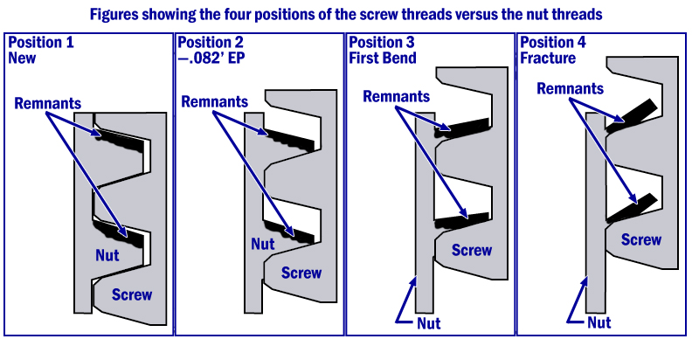

Table 1: Comparison of Manufacturer-Recommended Jackscrew Assembly
Lubrication Intervals with Alaska Airlines’ Intervals
(Select here to return)

This table is from the NTSB accident report and shows a comparison of the manufacturer-recommended jackscrew assembly lubrication intervals with the lubrication intervals actually used by Alaska Airlines.

The Manufacturer/Maintenance Steering Group (MSG)/Maintenance Review Board (MRB)/On Airplane Maintenance Planning (OAMP) extensions were based on reliability data from the carriers and the manufacturer. The Manufacturer recommended lubrication interval of 600 to 900 flight hours was not considered during the MSG decision-making process.
MSG-2 MRB | MSG-2 OAMP | MSG-3 MRB | MSG-3 OAMP
Not included in logic diagram | 600 to 900 flight hours | C Check  (3,600 flight hours or 15 months, whichever comes first.) | C check  (3,600 flight hours)

Alaska  Airlines  1985 | Alaska  Airlines  1987 | Alaska  Airlines  1988 | Alaska  Airlines  1991 | Alaska  Airlines  1994 | Alaska  Airlines  1996 to April  2000 | Alaska Airlines  April 2000 to  present*
Every other  B check  (700 flight  hours) | B check  (500 flight  hours) | Every  eighth A  check  (1,000  flight  hours) | Every  eighth A  check  (1,200 flight  hours) | Every  eighth A  check  (1,600 flight  hours) | Time-controlled  task card -  8 months maximum  (About 2,550  flight hours) | 650 flight  hours
*All carriers currently meet this requirement.

Table 2: Comparison of Manufacturer-Recommended End Play Check
Intervals with Alaska Airlines’ Intervals
(Select here to return)
Task  Description | Original Douglas-Recommended  Interval | MSG-2 MRB  and OAMP | MSG-3 MRB | MSG-3 MRB
C Check | 3,600 flight hours | 3,500 flight hours or 15 months,  whichever comes first | 3,600 flight hours or 15 months,  whichever comes first) | 3,600 flight  hours
End Play Check | Every other C  Check  (5,000 flight  hours) | Every other C check  (7,000 flight hours or 30 months, whichever comes first) | Every other C check  (7,200 flight hours or 30 months, whichever comes first) | Every other C check  (7,200 flight hours or 30 months, whichever comes first)

Task  Description | Alaska  Airlines 1985 | Alaska  Airlines 1988 | Alaska Airlines  1996 to April  2000 | Alaska Airlines Currently
C Check | 2,500 flight  hours | 13 months  (About 3,200  flight hours) | 13 months  (About 4,775  flight hours) | 15 months
End Play Check | Every other C  Check  (5,000 flight  hours) | Every other C  Check  26 months  (About 6,400  flight hours) | Every other C  Check  26 months  (About 6,400  flight hours) | 2,000 flight  hours*
*All carriers currently meet this requirement.

