DCN OSDNDEPP 3.0

NPOESS Data Exploitation (NDE)

Project Plan v.3
November 26



Prepared by:

U.S. Department of Commerce
National Oceanic and Atmospheric Administration (NOAA)
National Environmental Satellite, Data, and Information Service (NESDIS)
Office of System Development (OSD)

intentionally blank page

INTRODUCTION

i. Executive Summary
The NPOESS Data Exploitation (NDE) Project will link the civilian environmental satellite information users to data collected by the National Polar-orbiting Operational Environmental Satellite System (NPOESS). NPOESS products will start replacing the data from existing Polar-orbiting Operational Environmental Satellites (POES) systems in 2010 and will continue providing NOAA’s polar-orbiting satellite observations until approximately 2020.
To reduce the risks associated with the introduction of NPOESS’ innovative technologies, an NPOESS Preparatory Project (NPP) satellite will be placed in orbit, starting to supply prototypical NPOESS products in late 2009. Initial funding for the NDE project commenced in October of 2005 with essential system upgrades within NESDIS to prepare for NPP. The NPOESS program will continue beyond the year 2020 to ensure continuous service from a complete constellation of two operational NPOESS satellites. The NDE project will continue in parallel throughout the entire period of the NPOESS program.
NPOESS provides a new generation of remote sensing and satellite technology. NPOESS data volumes will peak at about 6 terabytes per day in 2016 (tbc). This will require more than a 100-fold increase in NOAA data management capacity. The data will be delivered much more quickly than current satellite observations, arriving within 30 minutes of observation. Both the volume expansion and the improved timeliness require NOAA to upgrade its satellite product generation and distribution infrastructure in major ways.
NPOESS’ improved sensors will provide data at higher resolution and in spectral bands previously unavailable. Applications of these data promise to have significant impacts on the accuracy of weather forecast models and the analysis of both sea and land surfaces for daily analyses and retrospective climate studies.
NDE will be conducted as a demonstration project in which the procedures it establishes will be evaluated as candidates for wider adoption as best practices. NDE will employ an enterprise project approach, developing functionality to be shared across NOAA systems to reduce costs, risks, and to minimize redundancy. NDE will use the latest proven methods, tools and techniques to establish key elements of NOAA’s 21st Century satellite data management capability.

ii. Preface
This document is the NOAA/NESDIS publication of the NOAA NPOESS Data Exploitation (NDE) Integrated Project Plan. It describes the concepts that will guide NOAA’s management and control of activities in support of the distribution, additional processing, and utilization of NPOESS instrument data. The document sets forth the basis for plan decisions as well as the plans themselves.
Through the winter of 2005-6, the NPOESS program was reviewed using the analytical framework of the Nunn-McCurdy amendment. These studies resulted in decisions regarding the number of satellites, launch dates, and instrument packages. The impact of these NPOESS program adjustments are expressed in Section 6 Project Schedule

This is NDE Project Plan Version 3.0 (DCN OSDNDEPP 3.0)
Updates and revisions to this document will be produced and controlled by NOAA/NESDIS/OSD.

iii. Table of Contents
INTRODUCTION iv
i. Executive Summary iv
ii. Preface iv
iii. Table of Contents vi
iv. Table of Figures vii
vi. Applicable Documents and References x
vii. 2007 Revisions xi
1. OVERVIEW 1
1.1 Short Description 1
1.2 Assumptions and Constraints 2
2 PROJECT SCOPE 2
2.1 Project Mission, Goals, and Objectives 3
2.2 NDE as a Transition Project 4
2.3 Project Context 6
2.3.1 The Interface Data Processing Segment (IDPS) 6
2.3.2 Customers 7
2.3.3 Integrated Program Office (IPO) 8
2.4.4 Mission Management Center (MMC) 8
2.4.5 Comprehensive Large Array-data Stewardship System (CLASS) 8
2.3.6 Product Developers 8
2.3.7 Management 9
3 PROJECT ORGANIZATIONAL VIEWS 10
3.1 NOAA Operating Branches 10
3.2 NESDIS 10
4 ROLES AND RESPONSIBILITIES 14
4.1 NDE Project Manager 14
4.2 NDE System Architect 15
4.3 ESPC’s System Development Team 16
4.4 Product Development Manager 17
4.5 Product Development Teams 18
4.6 Systems Integration Coordinator 19
4.7 Product Integration Teams 20
5 PROJECT DESCRIPTION 21
5.1 Project Approach 21
5.2 Customer Coordination Phase 22
5.3 Design Phase 23
5.4 Development Phase 24
5.5 Test Phase 25
5.6 Transition Phase 25
6. PROJECT SCHEDULE 27
6.1 NPP and NPOESS Launch Schedule 27
6.2 Payload Considerations 27
6.3 Life Cycle Scheduling 30
6.4 NPP Development Cycle 31
6.5 C1 Development Cycle 35
6.5.1 Systems Development 35
6.5.2 Product Development 36
6.5.3 Concluding the Cycle 36
6.6 Potential Out-Year Build Cycles 37
7 ACQUISITION STRATEGY 38
7.1 Product Development 38
7.2 System Development 40
7.3 Infrastructure Acquisition, Operations, and Maintenance 41
8 PROJECT PROCESSES 44
8.1 Planning Processes 44
8.1.1 Five-Year Planning 44
8.1.2 Integrated Project Planning 44
8.1.3 Transition Planning 45
8.2 Initiating Processes 45
8.3 Controlling Processes 45
8.3.1 Work and Schedule Management 45
8.3.2 Scope and Requirements Management 46
8.4 Execution Processes 49
8.4.1 Deliverables and Configuration Management 49
8.4.2 Team Management 49
8.5 Facilitating Processes (TBC) 50
8.5.1 Risk and Issues Management 50
8.5.2 Vendor & Contract Management 51
8.5.3 Stakeholder Communication Processes 51
9 FIVE-YEAR SPEND PLAN 53
APPENDIX A: ACRONYMS AND ABBREVIATIONS 54
APPENDIX B: DEFINITIONS 57
APPENDIX C: RELATIONSHIPS WITH NOAA ENTITIES 58

iv. Table of Figures
Figure 1: Project Context 6
Figure 2: NOAA Organization Chart 10
Figure 3: NESDIS Organization Chart 11
Figure 4: NESDIS Office Roles 13
Figure 5: NDE Organization Chart 14
Figure 6: Project Phases 21
Figure 7: Satellite Launch Schedule 27
Figure 8: Instrument-to-Satellite Cross Reference 28
Figure 9: NDE Project Development Cycles 30
Figure 10: NPP Development Cycle 31
Figure 11: Organization of IT Delivery Tasks for NPP 32
Figure 12: C1 Development Cycle 35
Figure 13: Phase 1 NPP Products 39
Figure 14: NPP Phase 2 Products 40
Figure 15: O&M Handover Schedule 43
Figure 16: SPSRB Processes 47
Figure 18: Relationships with NDE NOAA 58

v. Document Organization

1. INTRODUCTION - introduces NDE and provides background information.

2. PROJECT SCOPE
- Describes the NOAA Goals the project supports through the accomplishment of project objectives
- Explains the context of the project
- Describes the organizational relationships

3. ROLES AND RESPONSIBILITIES
- Program and Project Management
- System Architect
- Enterprise Tool Development
- Product Development
- Operations
- Transition

4. PROJECT DESCRIPTION
- Explains the Project Approach
- Describes the NPOESS Launch Schedule and Satellite Payloads
- Provides a project schedule
- Describes the first five sub-projects as “Development Cycles”

5. ACQUISITION STRATEGY.
- How resources are to be acquired and deployed to achieve project objectives: Management, Development, Architecture, Infrastructure, Transition

6. PROJECT PROCESSES
- Describes both Strategic Planning and Implementation Planning Processes
- Describes Processes for: Project Initiation, Execution, Control, Communication, and Facilitation

7. FIVE-YEAR SPEND PLAN
- Five-Year Budget
- Product Development Allocations

vi. Applicable Documents and References

- NOAA’s NPOESS Data Exploitation Charter http://projects.osd.noaa.gov/nde
- NPOESS IPO, Integrated Operational Requirements Document I (IORD II), version 6, 2002.
- Information Processing Division National Polar-Orbiting Operational Environmental Satellite System (NPOESS) Concept Of Operations, Baseline Issue, June 20, 2002, Version 1 http://216.33.118.202/EPSData/DOC/Synopses/3055/NOAA-CEMSCS-04-04-2003/AppendixE.pdf
- National Oceanic And Atmospheric Administration
Information Quality Guidelines, September 30, 2002, http://www.noaanews.noaa.gov/stories/iq.htm
- Concept of Operations (CONOPS) for the National polar-orbiting Operational Environmental Satellite System (NPOESS) Program, Version 1.2, September 15, 2003, NPOESS DATA EXPLOITATION (NDE) SYSTEM REQUIREMENTS, 13 August 2004
- NPOESS DATA EXPLOITATION (NDE) Concept of Operations, V2, March 14, 2006 NDE Public Documents Web Page
- NDE’s ESPC Requirements, June 2005, NDE Public Documents Web Page
- Policy On Transition Of Research To Application, NAO 216-105, Issued: 05/31/05; Effective: 05/17/05
- NPOESS Data Exploitation (NDE) Risk Management Plan, Version 1.0, 14 July 2006
- NDE System Requirements Specification, Version 1.0, July 2007 NDE Public Documents Web Page

vii. 2007 Revisions
vi. Applicable Documents and References
- Added Risk Management Plan
- Added System Requirements Specification

2.1 Project Mission, Goals, and Objectives:
Inserted Non-Operational objectives

2.3 Project Context
- Added 2 new external entities and accompanying text:
  - 2.3.6 Product Developers, providing algorithms, receiving standards
  - 2.3.7 Management, receiving reports
- Deleted 2.3.6 JCSDA as an external entity

3.1 NOAA Operating Branches
- Copied in current official NOAA org chart.
- Revised text to reflect replacement of “Line Office” by “Operating Branch”

3.2 NESDIS
Updated NESDIS Organization Chart (new executive names)

4.6 Systems Integration Coordinator
Position description of new member of NDE Management Team

4.7 Product Integration Teams
Described NPP/NPOESS product integration teams in NOAA Operating Branches

5.1 Project Approach
Rewrote:
- Deleted “spiral” language
- Made distinctions between product development and system development clearer
- Revised Phase Diagram
  - Changed name of “Construction” Phase to “Development Phase”
  - Showed 2 releases into Transition Phase: 1 for Products, one for Systems
  - Showed algorithms as inputs from outside the project

5.2 Customer Coordination Phase
Made distinctions between product development and system development clearer

5.3 Design Phase
Made distinctions between product development and system development clearer

5.4 Development Phase
Made distinctions between product development and system development clearer
5.5 Test Phase
Made distinctions between product development and system development clearer

5.6 Transition Phase
Made distinctions between product development and system development clearer

6.1 NPP and NPOESS Launch Schedule
Show project end date on table

6.2 Payload Considerations
Revised lists of xDRs to reflect JARG decisions

6.3 Life Cycle Scheduling
- Updated Gantt chart
- Identified project ending after FY16
- Deleted Prototyping Build Cycle

6.3 NPP Development Cycle
- Adjusted dates on Gantt Chart
- Updated Gantt chart
- Rewritten to show 5 incremental system builds
- Added section on Systems Engineering
- Added section on System Services

6.5 C1 Development Cycle
- Updated Gantt chart
- Edited Gantt chart row reference

6.6 Potential Out-Year Build Cycles
- State that a post implementation review is not planned

7. ACQUISITION STRATEGY
Changed from future to present tense

7.1 Product Development
- Deleted old product delivery table.
- Inserted 2 new tables: Phase 1 and Phase 2 Products, revised table descriptions

7.2 System Development
Changed from future to present tense

8.3.2.3 Requirements Management
Added paragraph about the System Requirements Specification

8.5.1 Risk and Issues Management
Inserted, modified Executive Summary from Risk Management Plan

OVERVIEW

Short Description
The National Polar-orbiting Operational Environmental Satellite System (NPOESS) will replace the National Oceanic and Atmospheric Administration (NOAA) Polar-orbiting Operational Environmental Satellite (POES) Program and the Department of Defense (DoD) Defense Meteorological Satellite Program (DMSP). In the next decade, NPOESS will provide environmental remote sensing capability for both civilian and military applications. In addition, the European Organization for the Exploitation of Meteorological Satellites (EUMETSAT) will operate polar-orbiting satellites under their Meteorological Operational (METOP) program that will complement NPOESS data.
NOAA’s National Environmental Satellite, Data, and Information Service (NESDIS) operates United States’ environmental satellites, including command and control, ground systems, data processing, and distribution to end-users of the data.
NPOESS will provide data to four central processing facilities, called “Centrals,” via its Interface Data Processing Segment (IDPS) and to remote field terminals via direct satellite-to-ground communications links. The Centrals will be responsible for providing NPOESS global coverage System Mission Data (SMD) to environmental satellite users. Field terminals will provide real-time access to regional coverage data feeds directly from NPOESS satellites.
NESDIS will operate the NOAA Central. The Air Force Weather Agency (AFWA), Fleet Numerical Meteorology and Oceanography Center (FNMOC), and Naval Oceanographic Office (NAVOCEANO) will operate the other three Centrals. The distribution of the NPOESS products to the civilian community will be the responsibility of the NPOESS Data Exploitation (NDE) system at the NOAA Central.
The NDE system will receive data from the NPOESS IDPS, distribute it as received according to user needs, process and package it to meet user requirements, ensure appropriate information is archived, distribute data to authorized users, and provide customer service. NDE will have a system management capability that supports management and control of the operational system. In addition, NDE will have a development test-bed capability that will permit development, modification, and system testing without risk to the operational system.
NOAA and other civilian users may need to update their systems to use the new polar satellite data provided by NPOESS. Without NDE or equivalent data conversion to use NPOESS’ Hierarchical Data Format (HDF) version 5 (HDF5) data, NOAA systems like Numerical Weather Prediction and the Advanced Weather Interactive Processing System (AWIPS) will be unable to exploit the NPOESS products. The new data may have performance impacts as well. As existing instruments are decommissioned, the polar satellite community must transition to NPOESS data. NDE will support the transition.
NDE will address the data conversion and other key requirements needed to continue mission critical applications as well as identify new requirements to improve operations due to new instrumentation and capability. This project plan will provide the structure and framework to guide the NDE project through its lifecycle.

Assumptions and Constraints
The design of NPOESS embodies significant change in the way polar satellite data are collected and processed. The foremost assumptions shaping this project, therefore, are based on the NPOESS program.
NESDIS Systems Must Be Upgraded
NPOESS will provide new and improved remote sensing data in comparison to existing polar satellites. It will have new high resolution instruments and a new ground station architecture that will provide more data at a faster rate. By 2016, when the 2 satellite NPOESS constellation is operational (tbc), NPOESS will make about 6 terabytes of data available to NESDIS every day. The products will be available for assimilation into user systems within minutes of observation instead of hours.
These changes are so extensive that NESDIS must implement fundamental and widespread improvements to its data management systems, telecommunications infrastructure, and distribution networks in order to successfully deliver NPOESS products.
NPOESS Products Must Be Enhanced
NPOESS products satisfy the requirements of the U.S. Department of Commerce and the U.S. Department of Defense. Each of the Centrals will be provided with data in accordance with the Integrated Operational Requirements Document (IORD-II, dated January 14, 2002). A fundamental design assumption of NPOESS is that each Central will modify and redistribute the products to satisfy the needs of its customers. NDE will manage two categories of product enhancement: “tailoring” and “NOAA-unique product” development.
In tailoring activities, versions of NPOESS Data Records are provided in alternative formats and views. For example, all of the NPOESS products will be delivered to NESDIS in Hierarchical Data Format 5 (HDF5), a standard used by only a few of NESDIS’ customers. NDE will reformat the data for these customers before dissemination. Other forms of tailoring include alternative map projections, coverage areas, aggregations, grids, and compression approaches. Whenever possible, NDE will provide the software to enable the end users to do the tailoring on their own systems.
NESDIS currently provides its customers with approximately 270 environmental data products derived from polar satellite observations. Many of these products are different views of the same data. When fully operational, NPOESS satellites will deliver over 150 products. NESDIS’s mission requires an extension of similar tailoring capabilities into the NPOESS era.
NOAA-unique product development is necessary to support missions that are specific to NOAA, as opposed to data used by all Centrals. NOAA-unique products are augmented environmental products constructed from NPOESS Data Records. They will be generated by procedures (e.g., algorithms) that use NPOESS Data Records (xDRs) as a basis of products containing data values that are different from those in the xDRs as received from NPOESS. NOAA-unique products may be generated by combining products from different data sources to provide other environmental information.

2 PROJECT SCOPE
The NDE project consists of an interdependent group of people who engage in processes to develop an NDE system that will include all of the associated equipment, facilities, material, computer programs, firmware, technical documentation, services, and personnel required for operations and support.

2.1 Project Mission, Goals, and Objectives
NDE’S primary mission is to provide products derived from NPOESS observations to NOAA’s operational and climate communities and other civilian customers. In order to fulfill the mission, NDE will acquire the resources necessary to achieve the following objectives:
NDE’s operational objectives are to:
- Disseminate NPOESS Data Records to customers
- Generate and disseminate tailored NPOESS Data Records (versions of NPOESS Data Records in previously agreed alternative formats and views)
- Generate and disseminate NOAA-unique products (augmented environmental products constructed from NPOESS Data Records)
- Deliver NOAA-unique products and associated metadata to the NOAA Long-Term Archive
- Provide services to customers, including a Help Desk, NDE product training, product enhancement, and implementation support across NOAA
- Coordinate NPOESS-related activities across NOAA
- Assist with planning for the implementation of NPOESS data by user systems
- Ensure end-user preparedness for NPOESS data
- Develop a sustainable system that meets its customer needs
- Provide software for NPOESS Data Record format conversion and other data manipulations
NDE’s non-operational objectives are to:
- Provide developers with tools to simplify the transition of system elements from research and development environments to operations
- Provide NESDIS with reusable elements and centralization to reduce costs and risks
- Provide NESDIS managers with metrics to inform decision making

These objectives are aligned with NOAA’s strategic goals. Within the Ecosystem Mission Goal, for example, ocean color and sea-surface temperature (SST) products are needed for public health (harmful algal blooms), protected species, fisheries management (commercial and recreational), and coastal zone management (pollution, spills/dumping, toxins, nutrification) efforts.
Within the Weather and Water Mission Goal, as well as in support of the Commerce and Transportation Goal, Environmental Data Records (EDRs) are needed to support real-time assessments and short-to-medium range warnings of environmental conditions that may endanger human safety and health, and safe transportation. For example, atmospheric EDRs such as temperature, moisture and cloud optical properties are used in the NWS Advanced Weather Interactive Processing System (AWIPS) by the weather forecast offices to support real-time assessments of convective activity which provides critical information used in issuing severe weather warnings, including aircraft turbulence to the aviation community.
Land EDRs are used to assess vegetation and drought conditions and provide critical information for sustaining and assessing changes in the health of the Nation’s agriculture industry. Furthermore, land EDRs provides information on fire location and burn areas that are critical to the United States Forest Service to manage forest fires. These EDRs are also used in emission models to assess the impact of fire emissions on air quality.
Ocean color and sea-surface temperature (SST) imagery facilitates the operational assessment of currents and eddies, directly supporting, for example, recreational boaters, the offshore oil/minerals industry, and tropical cyclone analyses, as well as Department of Defense requirements (e.g. the acoustical environment for submarines). Also, ocean vector winds products are used by the National Weather Service’s National Centers for Environmental Prediction (NCEP) Ocean Prediction Center (OPC) and the weather forecast offices for the development of high wind and wave warnings, as well as input for the operational wave forecast modeling. NPOESS products will be used in such areas as the National Ice Center (NIC) for iceberg and ice edge detection, as well as by the offshore oil/mineral industry as previously noted.
Within the Climate Mission Goal, EDRs are required for the formulation of Climate Data Records (CDRs) and the assessment of seasonal-to-interdecadal variability (such as ocean color and SST for El Niño, Pacific Decadal Oscillation, atmospheric temperature, water vapor and cloud, etc).
In summary, the examples given above clearly demonstrate NOAA’s extensive need for NPOESS products in addition to direct radiance assimilation used for numerical weather prediction. Furthermore, with NPOESS latency of 28 minutes or less (observation time to product distribution) the utilization of NPOESS products for real-time assessments will increase.
NDE is also a project that cuts across the mission goals, playing an important part in NOAA’s continuing effort to improve its Core Capabilities. NDE will serve as a demonstration project, developing new methods and procedures while implementing technologies intended for use by systems across the NOAA enterprise. NDE will be the forerunner for NESDIS projects that must achieve these mandated objectives:
- Integrating Global Environmental Observations and Data Management
- Ensuring Sound, State-of-the-Art Research
- Developing, Valuing, and Sustaining a World-Class Workforce

2.2 NDE as a Transition Project
In 2005, NOAA issued policies and procedures to address the challenges of managing the transition of research products into operational environments. NDE has been identified as a “Transition” project because its resources are dedicated to both sides of the problem. The project provides funding and management oversight for research projects that are discovering operational applications for NPP and NPOESS observations. The project also funds and manages the acquisition of the developmental, testing and operational information systems in which the data management and the dissemination of the observations to operational centers will be accomplished.

The policies provide the NOAA Executive Council (NEC) with “a mechanism for systematically reviewing all research annually in order to identify research to be transferred, establish a structure for managing research deemed ready for transfer, and delineat(ing) the roles and responsibilities necessary for those at NOAA to accomplish such transfers.” Accordingly NDE has established the NDE Transition Team whose members represent the NOAA research and operational communities that are associated with NPP and NPOESS. The team’s initial task is the formulation of the “NDE Transition Plan” using a template and guidance provided by the NOAA Transition Board (NTB). A draft of that document will be submitted for review by the end of September, 2006.

Future releases of this document (“NDE Project Plan”) will reflect the content of the Transition Plan and will provide a link to it in Section 8.1.3 as one of several processes used by NDE for planning.

2.3 Project Context
Figure 1, a Project Context diagram, depicts the major interfaces between NDE and other entities.
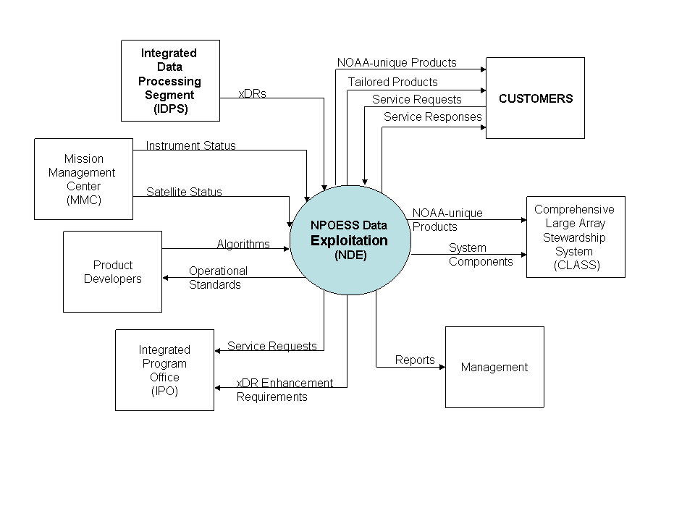
Figure 1: Project Context

2.3.1 The Interface Data Processing Segment (IDPS)
IDPS is an automated system that provides NDE with Data Records from the NPOESS satellites IDPS will provide four types of Data Record (xDRs). These record types are categorized as follows.

Raw Data Record (RDR) – An RDR is the IDPS first phase product. It is a full resolution digital sensor data file, time referenced, with radiometric and geometric calibration coefficients appended, but not applied, to the data. Aggregates (sums or weighted averages) of detector samples are considered to be full resolution data if the aggregation is normally performed to meet resolution and other requirements. [Sensor data will be unprocessed with the following exceptions: time delay and integration, detector array non-uniformity correction (i.e., offset and responsivity equalization), and data compression.]
Temperature Data Record (TDR) – A TDR is an intermediate IDPS product created from the application of algorithms to microwave sensor RDRs. It consists of geolocated, antenna temperatures with all relevant calibration data counts and ephemeris data. TDRs also provide an audit trail from the raw data (RDR) to the TDR.
Sensor Data Record (SDR) – A SDR is an intermediate IDPS product resulting from the application of an algorithm to non-microwave sensor RDRs. It consists of geolocated and calibrated brightness temperatures/radiances with associated ephemeris data. SDRs provide an audit trail from the raw data (RDR) to the SDR.
Environmental Data Record (EDR) - An EDR is the end product of complete IDPS processing. It is a collection of data that represents one or more related environmental variables, generally referenced to the source location. Environmental variables are reported in physically significant units at the source, and geometrically referenced with respect to the Earth or another appropriate coordinate reference system.
Each EDR will include metadata, data that describes and provides context for the subject data.
Intermediate Product (IP) - An IP is produced by the IDPS during the process of generating an EDR. Although not specified in the IORD, a selected group of IPs will be made available as end products on the IDPS.
The IDP system is managed by a contractor with government supervision provided by the IPO.

2.3.2 Customers
The NDE project is organized to provide environmental products derived from NPOESS instruments to two categories of customers: civilian users and government organizations.
Civilian users are a broad group, encompassing educational institutions, research organizations, industry, and the general public. This category includes foreign governments with whom NOAA has satellite data sharing agreements.
Government agencies include the following:
- National Weather Service (NWS)
- National Ocean Service (NOS),
- Office of Oceanic and Atmospheric Research (OAR),
- National Marine Fisheries Service (NMFS)
- NOAA United States Mission Control Center (USMCC)
- Department of Agriculture (NESDIS)
- Federal Aviation Administration (FAA)
- Department of State
- National Aeronautic and Space Administration (NASA)
Foreign government customers include:
- United Kingdom Meteorology Office (UKMetO)
- European Center for Medium range Weather Forecasting (ECMWF)
- MeteoFrance
- Japan Meteorological Agency (JMA)
- German Meteorological Service
- Australian Board of Meteorology
NOAA customers will be the recipients of data from NPOESS in negotiated data formats. They will, in some cases, receive products that have been tailored by NDE. These tailored products provide alternative views of the data record to facilitate assimilation by the customers’ systems.
NDE will receive Search and Rescue Satellite Aided Tracking (SARSAT) distress signals from the NPOESS satellites. The signals will be routed to NOAA’s U.S. Mission Control Center (USMCC) in Suitland, Maryland without any tailoring.
Outside of NOAA, the primary customers of NPOESS products will be in the Department of Agriculture (DoA), the Federal Aviation Administration (FAA), and the Department of State.
NDE will process and respond to various kinds of service requests from Customers. The goal is a smooth and seamless transition into the NPOESS era.

2.3.3 Integrated Program Office (IPO)
This is an umbrella management organization with responsibility for providing, launching, and controlling the NPOESS satellites as well as the ground systems necessary for capturing, processing, and delivering the data to NDE.
In the context of NDE, the IPO oversees a change control function. It will receive NDE Service Requests and xDR enhancement requirements and will need to respond to NDE Service Requests.

2.4.4 Mission Management Center (MMC)
The MMC is managed by a contractor with IPO supervision. It is responsible for the command and control of the NPOESS satellites. Its primary system, the Enterprise Management System, will provide NDE with information about changes to the spacecraft that might influence the values of the data (e.g., calibration and validation).

2.4.5 Comprehensive Large Array-data Stewardship System (CLASS)
Comprehensive Large Array-data Stewardship System (CLASS) acquires and develops a long-term archive (LTA) of all NOAA environmental products from its satellites, polar or geostationary, and from in situ sources. In the context of NDE, its mission is to archive NOAA-unique products that NDE has created by augmenting NPOESS products. All of NDE’s system components (source code, documentation, etc.) used in product generation will also be archived to support future reprocessing and research.
CLASS will have a separate interface to the IDPS at the NOAA Central for archiving xDRs and associated data. The interface shown in the diagram is solely for NDE’s NOAA-unique products.

2.3.6 Product Developers
NDE will provide the community of scientists who conduct research into applications of satellite sensor observations with operational information and associated technology standards. These standards apply to the algorithm programming languages that can execute in NDE, to the reusable objects that NDE makes available to accomplish common tasks, to the documentation required for configuration management and continuous improvement of the code, and to testing requirements. By providing these standards, NDE reduces the effort and risk associated with converting research code to reliable end user applications.

2.3.7 Management
NOAA managers make decisions informed by facts associated with operational product generation and dissemination. The NDE systems will have the ability to capture performance and quality metrics by instrument, by satellite, by orbit, by location, by time, by product, and by customer. NDE will store these data and provide regular reports. The system will also provide managers with an ad hoc report request capability allowing them to choose the parameters to be included in statistical analyses.

3 PROJECT ORGANIZATIONAL VIEWS

3.1 NOAA Operating Branches
The primary NOAA government customers for satellite data products, the Operating Branches of NOAA, are shown in the lowest tier of the NOAA organization chart in Figure 2.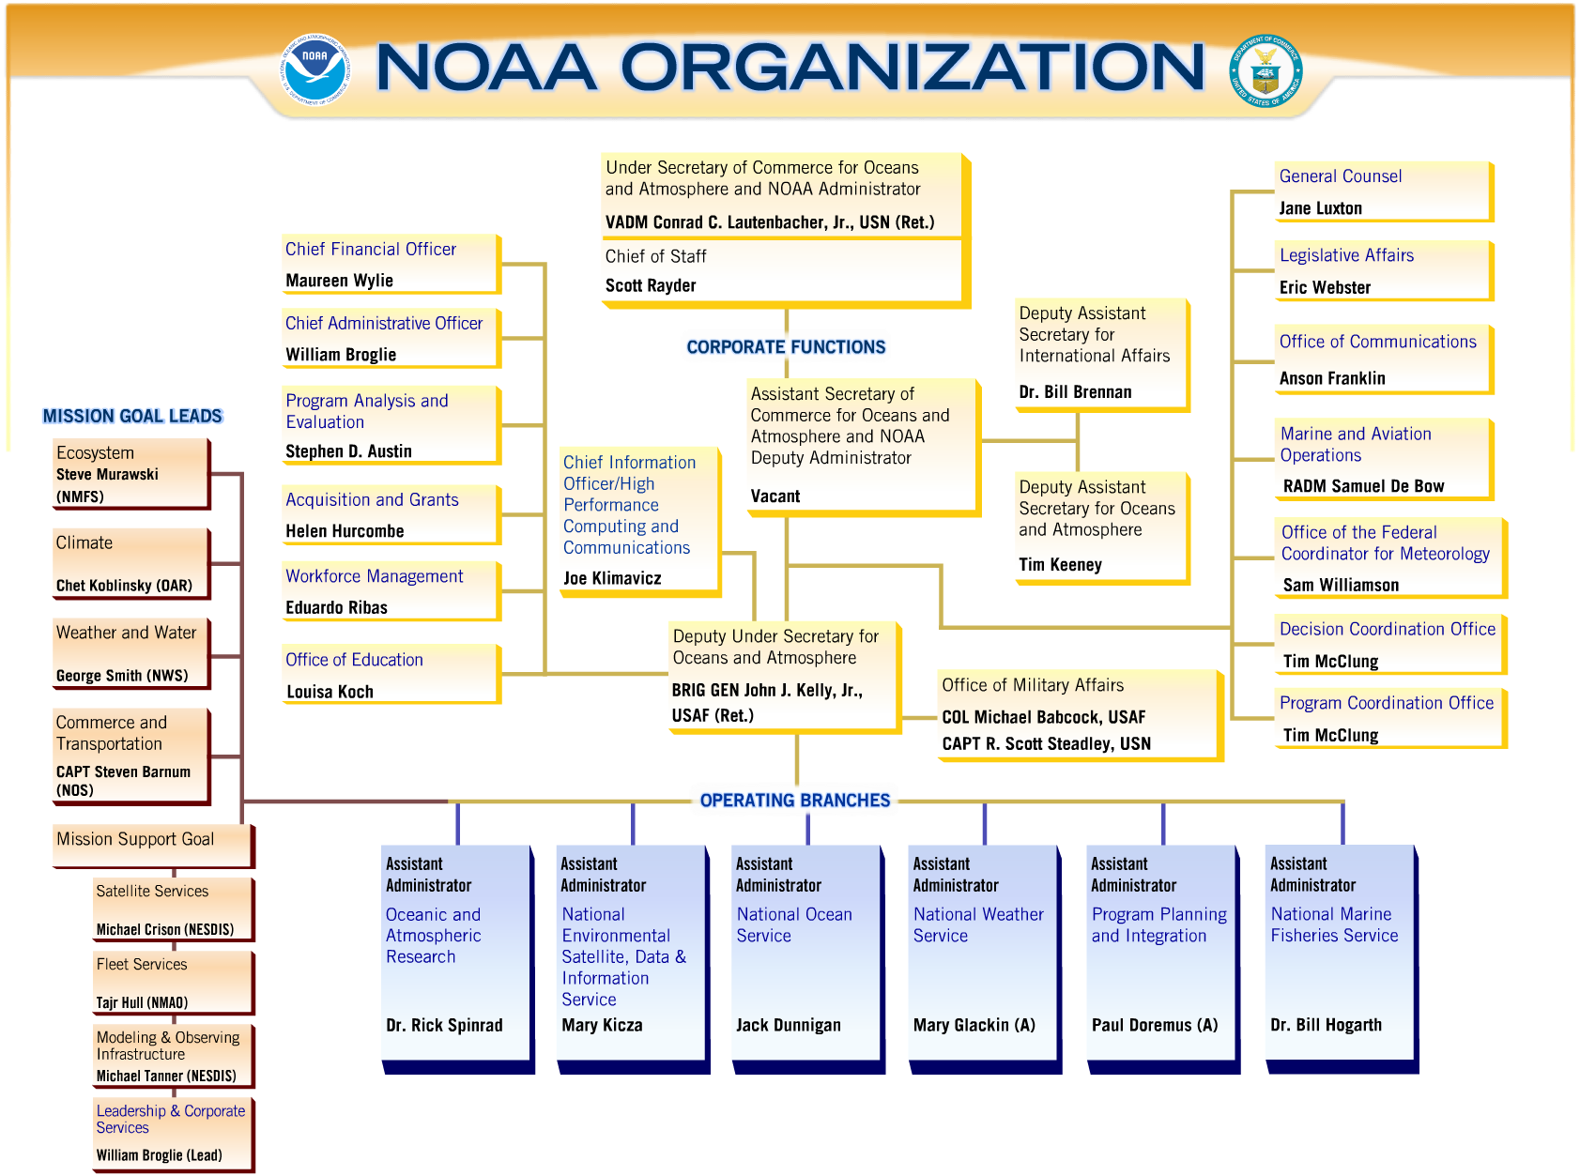
Figure 2: NOAA Organization Chart

3.2 NESDIS
As shown in Figure 3, three Offices within NESDIS will carry out the majority of NDE project tasks: the Office of Satellite Data Processing and Distribution (OSDPD), the Center for Satellite Applications and Research (STAR), and The Office of Systems Development (OSD).

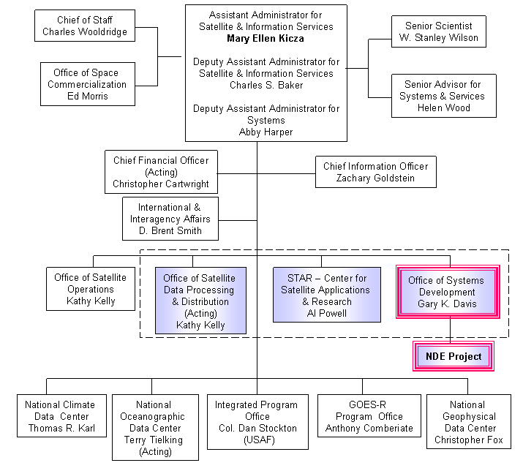
Figure 3: NESDIS Organization Chart

3.2.1 OSDPD
The Office of Satellite Data Processing and Distribution (OSDPD) acquires and manages the resources that will comprise the NOAA NPOESS operational data processing and dissemination infrastructure. The framework for these efforts is the Environmental Satellite-data Processing Center (ESPC). OSDPD manages and controls ESPC, relying on a System Development Team that collaborates with the NDE System Architect as well as OSDPD Management to assist with important design and development activities.
ESPC’s responsibilities include:
- Management of the NDE product generation, distribution, system test, and development infrastructures
  - Procure, install, and integrate all necessary NDE infrastructure elements in a timely fashion
  - Manage scheduled upgrades of infrastructure elements
  - Operate NDE product generation applications within agreed performance parameters (e.g., Customer Service Agreements [CSAs])
  - Perform unscheduled maintenance of any system element if such changes are determined to be necessary in order for the system to function according to previously agreed requirements
  - Provide Customer Service including:
- Help Desk
- Service Request Management
- Customer liaison with product specialists
- Directing customers to NDE training
  - Provide Order Management services including:
- Providing the means for Customers to select products
- Providing the means for Customers to select tailoring options
- Ensuring the timely dissemination of ordered products
- Tracking Orders
- Operation of the System Test Environment
  - Implement a stand-alone System Test Environment
- Replicate all significant characteristics of the Operational Environment
- Provide a temporary backup environment in which products can be generated and distributed to customers in the event of operational environment failure
- Evaluate candidate system elements for operational fitness, performing appropriate
    - Parallel tests
    - Stress Tests
    - Regression Tests
  - Certify candidate system elements for operational fitness

3.2.2 STAR
NESDIS’ Center of Satellite Applications & Research (STAR) conducts research on the use of satellite data for monitoring meteorological, climatological and oceanographic environmental characteristics. Scientists working for STAR develop algorithms, develop software designs, write software specifications, guide product quality assurance, and advise the IPO regarding their long experience with polar satellite products. They are organized as 3 Divisions:
- Satellite Meteorology and Climatology Division, conducts research on the use of satellite data for monitoring meteorological, climatological and environmental characteristics.
- Satellite Oceanography Division of NESDIS/STAR provides the primary research and development support for oceanic remote sensing within NOAA.
- Cooperative Research Programs, through which university and other external scientists can collaborate with the STAR scientists.

3.2.3 OSD
Overall responsibility for managing the NDE Project rests with the Office of Systems Development (OSD). OSD oversees procurement and acquisition tasks, develops the plans, schedules and budgets that shape the project, monitors and controls project progress, coordinates the activities of the other participating agencies, and represents the project to external organizations.

Figure 4 illustrates the fundamental responsibilities of the NESDIS Offices to the NDE project, three overlapping domains: Science, Data Processing, and Management.

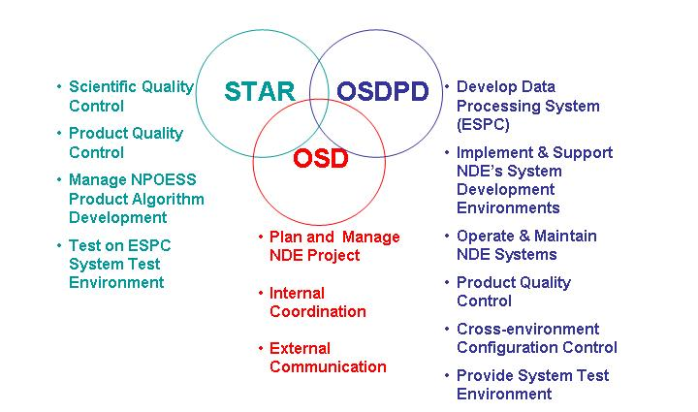
Figure 4: NESDIS Office Roles

4 ROLES AND RESPONSIBILITIES
Figure 5 depicts the organization of the NDE Project. The roles and responsibilities of each manager and team are described below.

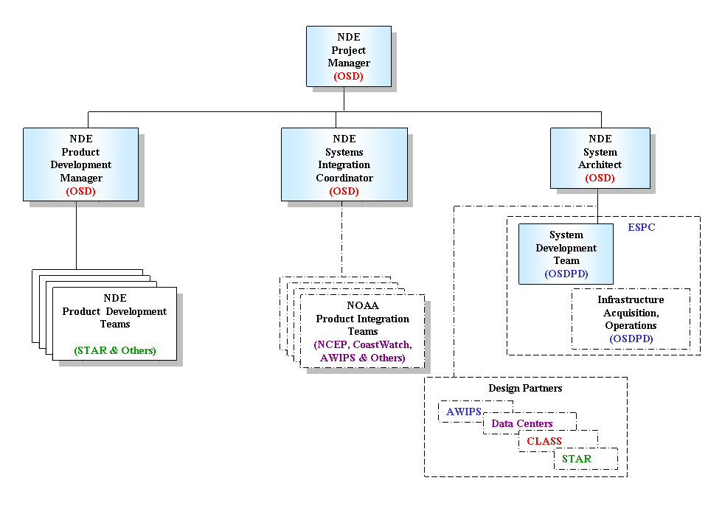
Figure 5: NDE Organization Chart

4.1 NDE Project Manager
The NDE Project Manager’s responsibilities include:
- Financial Management:
  - Submission of NDE budget requests to NESDIS, NOAA, DOC, and OMB
  - Accounting of NDE financial resources
  - Disbursement of NDE funds to contractors, STAR, OSDPD, and other NOAA organizations supporting the project
- Project Control
  - Selection of Product Development projects
  - Coordination of Milestone Review and Approval procedures
  - Supervision of Team Leaders (other than PD Teams)
  - Monitoring Work Schedules and Team performance
  - Coordination of cross-Team activities
- NOAA Program Support
  - Participate in the definition of ESPC requirements
  - Participate in the selection of ESPC contractors
  - Provide status reports to OSD’s Polar Program Manager
- Status on organizational activities (e.g., procurements) / Schedules
- Budget inputs/spend plans
  - Provide liaison to the Integrated Program Office (IPO)
- Provides participants to key NPOESS activities, such as Program and Document Reviews, Key Meetings, Customer Forum
- NOAA community outreach
  - Provide briefings on NPOESS activities/progress
  - Solicit participation in NDE developments
- Prepare and conduct regular NDE meetings
  - Status of the NDE Project
  - Reports of Management Activities
  - Reports from Matrixed Teams

4.2 NDE System Architect
The NDE System Architect reports directly to the NDE Project Manager. The associated responsibilities include the following:
- Cooperates with OSDPD and STAR on the development of contract packages to implement NDE system architecture and ensures the contract packages are properly processed.
- Participates in routine contractor updates on NDE program efforts.
- Advises ESPC’s NDE System Development Team
  - Communicates NDE’s system design expectations to the team (i.e., standards, best practices, technology directions, etc.)
  - Approves project plans
  - Reviews and approves deliverables identified on the plans
  - Monitors project status
  - Participates, with ESPC management, in determining corrective actions to be taken in the event of project problems (i.e., schedule slippages, budget overruns, substandard deliverables, etc.)
  - Participates, with ESPC management, in follow-on activities to assess the effectiveness of corrective actions
- Advises the ESPC’s NDE System Development Team regarding Software Engineering methods:
  - Repeatable framework for project planning and control
  - Guidance on best practices and standards
  - Guidance for customer involvement and other roles and responsibilities
- Advises the ESPC’s NDE System Development Team regarding Software Engineering tools, in order to:
  - Promote use of graphics in models
  - Provide environment for requirements validation and tracking
  - Provide repository of reusable objects
- Advises the ESPC’s NDE System Development Team regarding software development technologies, in order to:
  - Reduce risks associated with technology upgrades
  - Increase the population of skilled practitioners
  - Promote private sector advancements
- Communicates NDE’s infrastructure requirements to ESPC to ensure timely installation of tools and equipment.
  - Performance
  - Capacity
  - Dates needed
- Coordinates NDE’s integration of NESDIS-wide data processing capabilities
  - Monitor the activities of NESDIS data processing development efforts (e.g., Collaborative Environment Teams) by:
- Comprehensive Large Array-data Stewardship System (CLASS)
- STAR system upgrade teams
- System upgrade activities taking place at the NESDIS Data Centers:
    - National Climatic Data Center (NCDC)
    - National Ocean Data Center (NODC)
    - National Geophysical Data Center (NGDC)
  - Identify opportunities for NDE to adopt the practices and capabilities being developed by the other teams
  - Communicate NDE plans to the other teams
- Agree upon system standards
- Present standards to NESDIS’ Information Technology Architecture Team (ITAT) for approval
  - Ensure compatibility between algorithm development environments, the System Test environment, and the ESPC operational environments (i.e., accelerate Research to Operations)
  - Participate in Team-level quality control reviews as appropriate
- System Quality Control
  - Participates in NDE Standards Committee activities
- Agree upon system standards
- Present standards to NESDIS’ Information Technology Architecture Team (ITAT) for approval
  - Ensures compatibility between algorithm development environments, the System Test environment, and the ESPC operational environments (i.e., accelerate Research to Operations)
  - Participates in Team-level quality control reviews as appropriate
- Develop/revise the NDE documents for Milestone reviews (SRR, PDR, CDR, etc.)
  - Integrated Project Plan
  - Architecture
  - Requirements
  - Concept of Operations
- Tracks the evolution of system features from requirements through operations
- Advises the NDE Project Manager on the risks and costs associated with new requirements

4.3 ESPC’s System Development Team
This team consists of contractors who have been engaged to design and develop the NESDIS Environmental Satellite-data Processing Center (ESPC). The NDE Project has provided ESPC with its requirements in the following categories:
- Software Engineering
- Product Generation
- Systems Management
- Infrastructure
- Data Retention and Archive
- Customer Service
- External Interface
- Communications and Distribution
Within ESPC, this team will be established to design and develop a data processing system to meet the stated NDE requirements. The team will function according to the terms of OSDPD’s ESPC contract. The NDE System Architect (4.2 above) will provide guidance and supervision of the NDE System Development Team to ensure the timely delivery of system capabilities consistent with the stated requirements. Accordingly, this team will:
- Specify “enterprise” data processing resources to be shared by NDE’s product applications. Such resources include:
  - Database management systems (DBMS)
  - Work management and scheduling systems
  - Libraries
  - Object repositories
  - Object repository content
- Shared data objects (i.e., lookup tables, ancillary data)
- Shared procedural objects (i.e., utilities, called-modules, subroutines, etc.)
- Specify an architecture for NDE’s product generation applications, focusing on
  - Opportunities for reuse, and the sharing of capabilities among diverse NOAA observing systems
  - Performance measures (i.e., test criteria) for executables
  - Information hiding (i.e., invocation of algorithms, functions, reference tables, etc. as modules)
- Participate, with ESPC Management, in the selection of NDE data processing system components specified in the architecture (above)
- Define NDE System Test Certification Standards
  - Regression Test Acceptance Criteria
  - Regression Test Acceptance Specifications
  - Stress Test Acceptance Criteria
  - Stress Test Specifications
  - NDE Test Bed Configuration
- Test Data
- Enterprise (Shared) Objects: Shared Procedures, Shared Tables, Utilities, etc.
- Provide assistance, on request, to Product Development Teams
  - Information on Operational Standards
  - Information on System Test and escalation procedures
  - Review of source code

4.4 Product Development Manager
The NDE Product Development Manager will:
- Identify NDE product development projects to exploit NPOESS data in support of NOAA’s strategic missions
  - Collect information about product requirements from NOAA customers who represent the Programs of the NOAA Mission Goal Teams
  - Develop integrated views of NDE Products in the context of NOAA’s Observing Systems Architecture (NOSA)
  - Obtain agreement from NDE stakeholders on product development priorities and prioritization methods
  - Identify and communicate to stakeholders the constraints that bear on prioritization decisions, such as budget, schedule, dependent projects, technology, and scientific capabilities.
  - Select development efforts that satisfy agreed prioritization criteria
  - Obtain management approval of the selected projects
- Provide guidance and direction to Product Development Teams
  - Obtain funding to finance NDE product development through NDE Project budget
  - Provide guidance to candidate product developers regarding criteria to be applied in selecting recipients of NDE Product Development funding
  - Evaluate the proposals of candidate product developers according to the announced selection criteria
  - Select the product developers
  - Provide funding to NDE product development teams
  - Monitor the status of NDE product development projects
  - Ensure product development teams produce the deliverables, both documentary and executable, required by OSDPD
  - Provide guidance and correction, as appropriate, to product developers
  - Ensure product development plans are appropriate documented.
- Review and approve all contract packages related to product development
- Track and report to NDE Project Manger product development budget execution

4.5 Product Development Teams
A Product Development Team’s objective will be the specification and development of algorithms that will operate within the ESPC to provide an operational product. The Product Development Teams conduct research on the use of satellite data for monitoring meteorological, climatological and oceanographic environmental characteristics. Each Team will conduct applied research on the use of NPOESS satellite data for the analysis of significant meteorological and surface-based phenomena. Tasks within the scope of each Product Development Team’s responsibility include:
- Development of algorithms for NOAA-unique products and for product tailoring:
  - Collection and documentation of user requirements
  - Specification of algorithm designs
  - Development of algorithm test plans
  - Development of algorithm code
  - Unit and string testing of algorithms
  - Submit executables for System Testing by OSDPD
  - Evaluate data quality during System Testing
  - Correct errors detected during System Testing
- Configuration Management
  - Participate (with OSD and OSDPD) in NDE Standards Committee activities
- Agree upon system standards
- Present standards to NESDIS’ Information Technology Architecture Team (ITAT) for approval
- Agree on metadata implementation of NDE products
  - Develop and manage documentation consistent with NESDIS standards
  - Develop executable system components (i.e., algorithms, functions, reference tables, etc.) using NESDIS standard technologies (i.e., Computer languages, DBMS/Object repositories, procedure libraries, documentation libraries, etc.)
- Develop Data Quality evaluation and reporting methods for use during normal operations based upon
  - Gross error checks for data that fall outside of physically realistic ranges (e.g. a minimum, maximum, or maximum change)
  - Comparisons made with other independent sources of the same measurement
  - Examination of individual time series and statistical summaries
  - Application of sensor drift coefficients determined by a comparison of pre- and post-deployment calibrations
  - Visual inspection of the data
  - Timely notification of output quality problems to OSDPD System Management (NOTE: The Office of Research and Applications (STAR) (Section 2.3.2) plays an important role in the Quality Control of input from NPOESS. However, because these instrument calibration and product validation activities are funded and managed by the IPO within the NPOESS Program, they are outside the scope of this document.)

4.6 Systems Integration Coordinator
Teams will be established and deployed to Operating Branches (Section 3.1) to support effective implementation of NPP and NPOESS products by NOAA’s end users. The NDE Systems Integration Coordinator is responsible for the establishment and performance of these teams. The associated roles include:
- Coordination with the Program Managers of the NOAA Goal Teams to:
  - Identify the NOAA organizations that will participate in NPOESS data exploitation
  - Identify staff within the target organizations to serve as points of contact with NDE
  - Ensure that resources from target organizations are allocated appropriately to perform NPOESS data exploitation activities
- Establish Integration Teams:
  - Ensure that NOAA Operating Branch personnel assigned to the NDE project have well defined and appropriate roles
  - Develop performance-based contractual relationships with qualified professional services firms to provide personnel to perform NDE-related tasks in end user organizations
- Provide guidance and direction to Integration Team leaders:
  - Ensure that the Integration Teams are fully informed of relevant NDE policies and procedures
  - Ensure that the Integration Teams are performing tasks consistent with the objectives of the NDE Project
  - Monitor and evaluate the performance of Integration Team members
- Provide guidance and oversee the relationships between NOAA and the professional services firm(s) by whom the contracted personnel are employed
  - Ensure that the assignments provided to the contractors are consistent with the objectives of the NDE Project
  - Monitor the performance of contract personnel assigned to NDE
  - Inform contractor management of NOAA’s level of satisfaction with contractor performance during status meetings held at least once a month.
  - Ensure that contractor management takes timely and appropriate action to remedy problems brought to their attention

4.7 Product Integration Teams
The scope of NDE includes support to NOAA’s end user organizations to ensure effective integration of the products on their systems. NDE will fund NOAA NPOESS Integration Teams that will coordinate transition activities across all organizations. Budget responsibilities for upgrades will have been agreed during the conclusion of each Customer Coordination Phase (Section 5.2).
- Integration Teams will analyze target systems
  - provide information to users about the products that will be made available
  - determine product training requirements
  - determine user interface requirements for product orders and delivery
  - advise users regarding any technology upgrades that might be required in order for their systems to assimilate the products
  - assist users to develop submissions to NDE requesting PD support
- Integration Teams will design system upgrades :
  - Specify the manner of product delivery for each product and user organization (i.e., networks, subscription, GUI)
  - Specify training materials to be developed
  - Develop the Training Plan(s)
  - Develop the Transition Plan(s)
  - Specify System Test Plans for Product Order/Delivery
- Integration Teams will assist with upgrades of target systems:
  - Oversee development of product training materials and product training plans
  - Develop customer product ordering/change/tracking capabilities
  - Conduct Unit and String Tests of product ordering/change/tracking capabilities
- Integration Teams will participate in transition activities:
  - Work with Customers to refine their Transition Plans, including: product training plans and product ingest test plans
  - Submit product ordering/change/tracking elements and documentation to System Test for Certification
  - Rework any errors in product ordering/change/tracking elements detected during System Testing. Rework any errors
- Integration Teams will provide Customer Service
  - Be on call to the Customer Services personnel to assist with the resolution of product dissemination and product training problems

5 PROJECT DESCRIPTION

5.1 Project Approach
NDE will use a development approach characterized by two, interdependent activity streams: IT development and data product development. The data product Development Cycles will coincide with the NPP and NPOESS launch schedules. The IT Development Cycles will be timed to so that integration of the product generation algorithms can be accomplished to provide products to Customers for evaluation as soon as possible following a launch. Each cycle will end by providing Customers with a set of NDE products, or a Product Release.
For System Development, NDE will use a life cycle model characterized by iterative and incremental development. Each Development Cycle will end by providing a System Release.
The Cycles will be organized into five overlapping phases: Customer Coordination, Design, Development, Test, and Transition. Each phase is to produce a pre-defined set of deliverables (e.g., work products) as described in Section 5.2 to 5.6 below. There will be a checkpoint at the end of each phase where deliverables will be reviewed and approved. The checkpoint will mark the transition from one phase to the next. The phase structure of a Development Cycle is illustrated in Figure 6.
New product generation algorithms are developed outside NDE. The algorithms are integrated with NDE to support system testing using IDPS data.
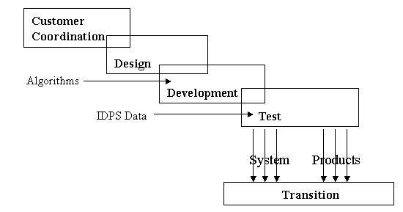
Figure 6: Project Phases
After the capabilities that constitute an NDE System Release are successfully tested, a Transition Phase begins. During Transition, the NDE IT capabilities are ready for turnover to NESDIS operations.

Product development takes place in parallel with NDE, but independently. NDE will synchronize System Development Phases (above) with the decision procedures of the Satellite Products and Services Review Board (SPSRB) (Figure 13). Customers will determine whether a Product Release is ready for Transition to an Operating Branch.

An NDE Development Cycle may begin with a Design Phase so long as the requirements driving the design have been approved at the conclusion of a previous Customer Coordination Phase. Projects may be established after a Design Phase, beginning with a Development Phase, in order to deliver significant increments or upgrades to the system. This can be accomplished so long as the specifications and test plans have been approved at the conclusion of a Design Phase.
Multiple projects using the same life cycle model can be carried out in parallel, albeit with different start and end dates.

5.2 Customer Coordination Phase
Required IT Deliverables:
  - System (data processing) requirements,
  - Infrastructure upgrade requirements,
  - Project Plan for System Development

Required IT Reviews: A structured phase completion review is required (e.g., System Requirements Review for system development [SRR,
Customers can submit change requests and new requirements to NDE. They will be accepted at any time, and NDE will actively solicit these requests during Customer Coordination. A Configuration Control Board, chaired by the NOAA NDE Project Manager, will review the change requests, determine new requirements, discuss them with customers, plan for their implementation, and determine whether to schedule the change for a future Project or for a Build within the current Project.
During a Customer Coordination Phase the Customers, through participation in the Satellite Product and Services Review Board (SPSRB), will determine their product priorities, NOAA-unique product requirements, including long-term archive, and which tailoring options they would prefer. The NDE Project developers in ESPC are not responsible for the development of these products. However, because they are ultimately responsible for ensuring that the products can be generated and distributed using NDE capabilities, they work closely with the algorithm developers to develop test and integration plans and to cooperate in the implementation of the algorithms in NDE.
With the assistance of the NDE Systems Integration Coordinator (Section 4.6) Customers will assess their infrastructures to determine whether upgrades will be necessary to assimilate NPOESS products. Customers will decide on a preferred delivery method and determine whether changes to their telecommunications will be necessary. NDE and its customers will develop joint plans to support the implementation of new products. This includes training on NOAA-unique products, tailoring options, and help for use of products and NDE-supplied software tools. Budget responsibilities for these upgrades will be agreed during the conclusion of each Customer Coordination Phase.
NDE will work within established Satellite Products and Services Review Board (SPSRB) and Archive Requirements Working Group (ARWG) processes, as appropriate, to coordinate the development of new products, enhancement to existing products, and provide for long-term archive services of suitable NDE Unique Products.

5.3 Design Phase
A Design Phase will be initiated once the NDE Project Manager is reasonably confident of the completeness of requirements captured during the Customer Coordination Phase. The decision to initiate any phase is a project management prerogative exercised in consideration of many factors. In the case of a Design Phase, the criteria will include:
  - Whether the scope of required changes have been defined
  - Whether the requirements are supported by a business case (i.e., benefits, goals, risks, etc.)
  - Whether the requirements are defined at an appropriate level of detail to support tracking through the project life cycle
  - Whether resources are available to deliver the change
During a Design Phase, scientists will develop processing specifications and/or algorithm prototypes. System developers will design the overall system, the software, and other operational elements that will be necessary to execute the algorithms in an operational environment. The overlap of the Customer Coordination Phase and the Design Phase (Figure 6) supports the concept of design approval by NESDIS’ stakeholder organizations: OSDPD, STAR, and OSD.
Required IT Deliverables:
- System Specifications, including
  - Algorithm specifications
  - Unit, User Acceptance, and String Test criteria
  - Data processing specifications with Unit, User Acceptance, and String Test criteria
  - Internal Interface Specifications (between NDE subsystems)
  - External Interface Specifications (between NDE and external systems)
  - Product tailoring specifications with Unit, User Acceptance, and String Test criteria
- Architecture
  - Assessment of architectural requirements and associated changes
  - Infrastructure component specifications
- Purchase Orders for Infrastructure components (System Test Environment and Operational Environment)
- Training Requirements
- Implementation/Transition Requirements
- Preliminary Test Plans
- Updated Integrated Project Plan for the Development Cycle

Optional IT Deliverables:
  - Data processing system prototypes,
  - Product tailoring prototypes

Reviews: During the course of the Phase, frequent detail design reviews and technical walkthroughs are recommended.
A Critical Design Review (CDR) is required for phase completion. A CDR is an opportunity for the Government to closely observe the System Development Team’s hardware and software design. The System Development Team is expected to describe all design changes since the conclusion of the previous (Customer Coordination) Phase. The team may also provide a hardware or hands-on demonstration of some of the preliminary designs to better illustrate important aspects.

5.4 Development Phase
A Development Phase will begin after the following conditions are satisfied:
  - Review and approval of Design Phase deliverables
  - IDPS provides xDRs to NDE to support validation of operational products
Required IT Deliverables:
  - Data processing components that have successfully completed Unit and String Testing
  - Revised specifications (Algorithm and Data Processing)
  - System Test Plans
  - Integration and Unit Test Reports
  - Preliminary Test Cases and Test Procedures
  - Installed and Tested System Test Environment Equipment
  - Installed and Tested Operational Environment Equipment
  - Implementation/Transition Plans
  - Updated Integrated Project Plan for the Development Cycle

Optional IT Deliverables:
  - Test tools and drivers
  - Training Materials
  - Training Test Plans

Product Deliverables (with the cooperation of the external algorithm developers):
  - Algorithms that have successfully completed Unit and Integration Testing
  - Product tailoring components that have successfully completed Unit and Integration Testing

IT Reviews: For the NDE System, successful completion of Unit and Integration Testing will precede a formal Test Readiness Review of the required deliverables (above). This Review affords Users and NESDIS’ operations management the opportunity to anticipate their resource commitments for System Testing and their infrastructure readiness for Transition to operations. This review has particular significance for configuration management because all system components and documents should be placed under the strictest controls at the completion of the Development Phase.
There is an overlap shown between the Design Phase and the actual Development of elements in Figure 6 because the Unit and Integration Testing that takes place during a Development Phase may identify a need to redesign or rework some system elements.

5.5 Test Phase
During this Phase, a variety of system tests are executed to verify that the NDE system correctly performs all required product generation and dissemination functions as well as other essential functions, including start-up and shut-down procedures, interfaces between software and hardware components, back-up and recovery procedures, security measures, and interfaces to external systems. Other tests demonstrate that NDE can ingest and process the required volumes of satellite data from ESPC and the IDPS and can perform within specified parameters of speed and memory. The behavior of NDE under extreme and worst-case conditions will be determined. User and operations procedures along with the software and hardware used by these personnel are tested.
Acceptance testing is performed by and for the Government. The Acceptance Test is a formal demonstration that the system meets the Government’s requirements. System testing covers a wider scope, in that all internal design details, such as communication links, must be rigorously exercised as well.
A Test Phase may be successfully completed if only IT capabilities are delivered. Projects of this type are those established strictly for the purposes of adding IT capabilities to the NDE environment.
There is an overlap between the Testing and Development Phases because errors detected in system testing may require reconstruction and redesign. The overlap (Figure 6) is also meant to indicate that one set of Configuration Management (CM) standards for system components are applied during both the Development and the Test Phases.
Required IT Deliverables:
  - Revised specifications (all elements)
  - Installed and Tested Operational Equipment
  - System Test Logs, Test Reports
    - Infrastructure Threads
    - Performance
  - Trained Users
  - Trained Operations Staff

Product Deliverables (with the cooperation of the external algorithm developers):
- Operational Products
- Science Algorithm Test Logs, Test Reports

Reviews:

5.6 Transition Phase
NDE works with end-user organizations to coordinate preparations to integrate the NPOESS products into their operations. The preparations are based on the requirements collected during the Customer Coordination phases and the preparatory activities of the Test phases, during which trial versions of the products were used to prototype enhanced end user operations.
NDE transfers operations and maintenance (O&M) responsibility for product generation and distribution to OSDPD at the Transition Phase. OSDPD will operate and perform essential maintenance to the systems within the context of its Environmental Satellite-data Processing Center (ESPC). ESPC will continue a close relationship to NDE by making system performance metrics and customer service metrics available during subsequent Customer Coordination phases to assist with project planning.
Reviews: Operational Readiness Review (ORR)

6. PROJECT SCHEDULE

6.1 NPP and NPOESS Launch Schedule
The NPOESS satellite launch schedule provides the NDE project with its fundamental planning structure. Each launch will be followed by a qualification period of on-orbit testing that might last as long as six months. Once certified as operational, each satellite is expected to continue service for about 5 ½ years. There are no plans to extend the NDE Project after September 30th, 2016.
The first satellite in the program will be unique in that it will not be certified as operational. The purpose of the first satellite is to mitigate the risks presented by all of the new technologies that will be implemented for NPOESS, not to provide operational products. In 2009, the risk-reduction NPOESS Preparatory Project (NPP) satellite will be launched. NDE will use products from the NPP satellite to develop product prototypes, a distribution network, and the core of its product packaging systems.
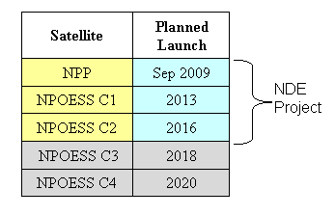
Figure 7: Satellite Launch Schedule

6.2 Payload Considerations
The NPOESS space segment consists of a new suite of instruments. As a result of the Nunn-McCurdy analysis, to reduce costs, some of the NPOESS instruments will be built with fewer capabilities than had been originally planned. Other sensors fall into a Government Furnished Equipment (GFE) category (i.e., if a user wants the sensor to fly, they have to provide funding for the sensor). In the list below, such a reduced capability is described in [brackets].

- Visible-Infrared Imager Radiometer Suite (VIIRS)
- Cross-Track Infrared Sounder (CrIS)
- Advanced Technology Microwave Sounder (ATMS)
- Microwave Imager Sounder [Deployment will be on C2 and C3]
- Ozone Mapping and Profiling Suite (OMPS) [Limb profiler is considered a GFE capability and is only currently scheduled to fly on NPP]. NPP, C1 and C3 will have only the nadir profiler capability
- Space Environment Monitor (SEM) [Reduction in the number of sensors. Reintroduction of the dropped sensors is being analyzed for later satellites.]
- Advanced Data Collection System (ADCS)
- Search And Rescue Satellite Aided Tracking (SARSAT)
- CERES (C1 only)

Government Furnished Equipment sensors that are waiting user funding include:
- OMPS Limb Profiler
- Earth Radiation Budget Sensor (ERBS)
- Aerosol Polarimetry Sensor (APS)
- Altimeter (Alt)
- Survivability Sensor (SS)
- SESS

The actual sensor complement for a particular orbit will be selected to provide optimum satisfaction of the system requirements. Current plans, which are subject to change, call for the following deployments.
SATELLITE | NPP |  | C1 | C2 | C3 | C4
LAUNCH | Oct
LAUNCH | 2009 |  | 2013 | 2016 | 2019 | tbd
NODAL TIME | 1330 |  | 1330 | 530 | 1330 | 530
* VIIRS | X |  | X | X | X | X
* M/W Imager/Sounder |  |  |  | X | X | X
* CrIS | X |  | X |  | X
* ATMS | X |  | X |  | X
OMPS Nadir | X |  | X |  | X
OMPS Limb | X
SEM |  |  | X |  | X
SARSAT |  |  | X | X | X | X
ADCS |  |  | X |  | X
CERES |  |  | X
TBD (Satellite to be assigned)
ERBS
ALT
SESS
TSIS
APS
SUS
Figure 8: Instrument-to-Satellite Cross Reference

An * indicates a mission-critical instrument: Replacement will be provided within 6 months in case of failure.
A characteristic of the NDE development approach is that additional Development Cycles can be initiated at any time during the execution of the Project. The need to plan another Development Cycle is most likely to become apparent during a Customer Coordination Phase, as the scope of a Product Release is being analyzed. However, if the need for a new Development Cycle becomes apparent at any point, NDE’s Project Manager will initiate a Customer Coordination Phase and use its framework to fully develop a plan for a new Development Cycle.

External events can also trigger new Development Cycles. If necessary, NESDIS will respond to changes in satellite payload, changes to satellite launch schedules, accelerations in technological advancement, changes in government priorities, changes to related projects, and so on. When appropriate, in response to such changing circumstances, additional Development Cycles will be planned.
NDE Development Cycles will have as a high priority the routing of NPOESS data records, as received from the IDPS, directly to customers. Equally important will be the tailoring and NOAA-unique product generation will have lower priority and will be provided based on agreements reached during each Customer Coordination Phase.
Table 3 shows product introductions based on two categories, “core products” and “other products.” Core products are those NESDIS currently provides from POES, DMSP, and EOS satellites. Other products are those that do not replace current products and/or will be developed from instruments with which NESDIS has little or no experience. NDE, in order to support the continuity of its customers’ missions, places a higher priority on efforts required to deliver core products. If the instrument payloads change from the IPO’s current baseline, NDE will re-plan the product development activities appropriately.
The high rate of new data product introductions from NPP and NPOESS represents a significant change in the pace of product introductions from past satellites. Implementation of all of these products within two years of introduction will require increases in NOAA’s product research and development capacities commensurate with the increased number of products. Alternatively, NOAA will prioritize the products in order to develop generation capabilities that support the most important mission needs.

6.3 Life Cycle Scheduling
Figure 8 depicts the highest level planning structures of the Project: The NPP Development Cycle and the C1 Development Cycle.

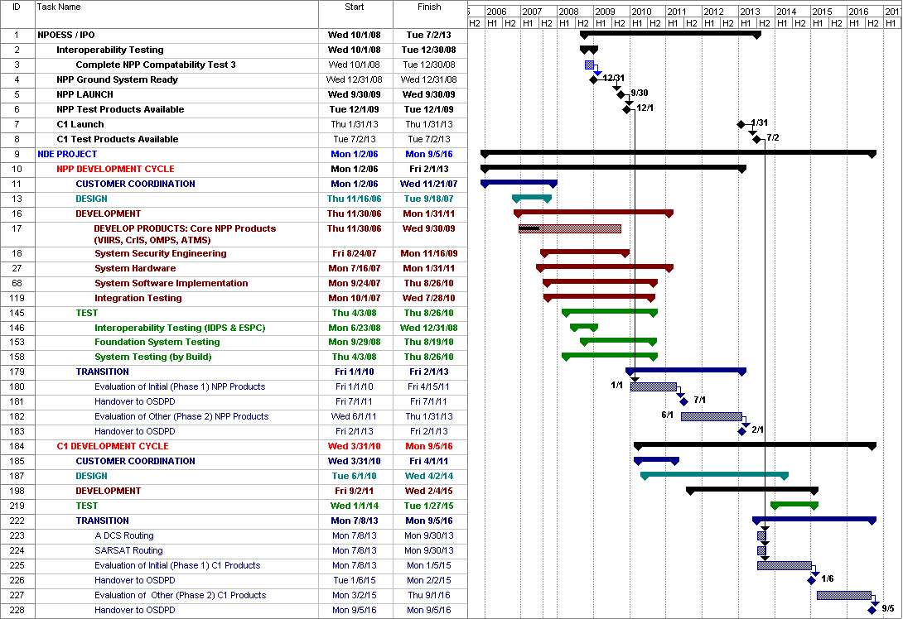
Figure 9: NDE Project Development Cycles

6.4 NPP Development Cycle
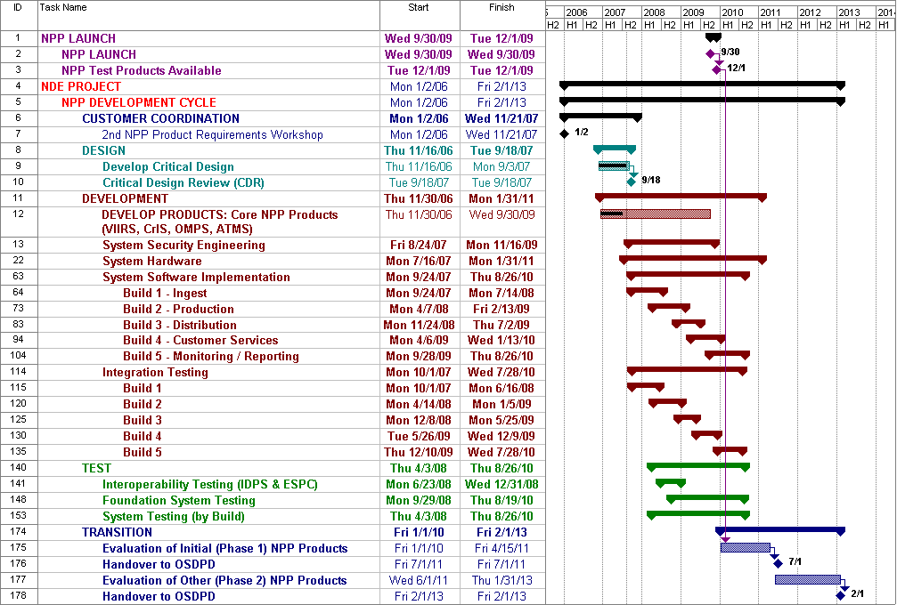
Figure 10: NPP Development Cycle

A significant proportion of the effort to be expended during the NPP Development Cycle will be devoted to establishing new data processing capabilities in NESDIS. Although the primary objective is to prepare the infrastructure for NPP, the work is being undertaken with a broader, enterprise perspective such that the capabilities established will be, to the greatest extent possible, reusable by other polar and geostationary satellite systems.
The NPP Development Cycle is the framework for the design, Development and testing of the NDE System as a whole, conceived as three similar, but distinct, environments: Development, System Test, and Operations.
The Development Phase of the NPP Development Cycle will be managed as a standalone project organized as incremental “mini” builds supported by systems engineering and systems services. The Phase is timed to provide an infrastructure that can continue providing POES-equivalent products during the NPP Risk Reduction Mission. The result will be NDE’s the first NDE System Release, the foundation system that will be extended and refined for the NPOESS C1 mission and later satellites.
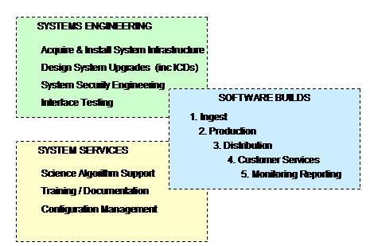
Figure 11: Organization of IT Delivery Tasks for NPP

Software Builds
During the NDE Design Phase, it was determined that the lowest risk approach to delivery was to develop the system in increments of increasing complexity. Each increment, or “build,” is organized to be tested as an integrated configuration and installed, after Integration Testing, in the System Test Environment. There will be 5 Builds:
- Ingest – communicates with the NPOESS IDPS and MMC, recognizes the arrival of all the data necessary for a product generation algorithm to execute successfully, manages xDRs and finished products in Storage Area Network (SAN), accepts NDE products after the algorithms have completed them
- Production – invokes the algorithms, provides them with the necessary inputs, either tailors an EDR by altering the user view or generates a NOAA-unique product, writes finished products to the SAN
- Distribution – determines the operational mode of the system so that product access can be restricted during national emergencies, places completed products in the appropriate staging area to support a Customer’s delivery (push-or-pull) preference, creates an invoice and a product delivery notification
- Customer Services – captures information about Customers, allows Customers to order products, provides a mechanism for Product Area Leads (PALs) to define products, provides a means to approve Customer orders, captures a Customer’s product delivery requirements and product tailoring preferences
- Monitoring/Reporting - captures information about algorithm performance, system performance, and product quality in NDE logs and provides management reports on a scheduled or ad hoc basis
Systems Engineering
1. The acquisition and installation of hardware and other infrastructure elements is incremental, with successive efforts planned for four distinct environments: the IT Development Environment, a Science Algorithm Development and Integration Environment (SADIE), a System Test Environment, and, for the NPOESS satellites to be launched after NPP, the Production Environment. Acquisition and installation of the COTS, GOTS, and Open Source software that function in each of the environments is managed as Systems Engineering tasks.
2. Detail Design work will be undertaken at the inception of each Software Build. These efforts will result in specifications for each system elements to be included in the Build. These specifications will be placed under version control and will permit more effective resource allocation.
3. System Software Engineering work will ensure NDE’s compliance with ESPC’s security controls. ESPC’s controls satisfy the Certification and Accreditation (C&A) requirements adopted by NESDIS to comply with the National Institute of Standards (NIST) Guidelines. Because NDE operates inside the ESPC security perimeter, its focus will be on scheduling and allocation of resources to support periodic ESPC C&A activities.
- Two kinds of interface testing will be necessary: internal and external. Because NDE operates within ESPC, the system’s ability to communicate and interact with its host environment will be tested for each Build. Front-end external system interoperability concentrates on NDE’s connections with its primary data provider, the NPOESS’ IDPS. Proving interoperability with IDPS is a critical milestone that is targeted to take place a year prior to the launch of NPP. Back-end interface testing, to ensure that products are disseminated to Customers in a timely and efficient manner, will be undertaken on a customer-by customer basis. The first tests will be concerned with the interface to NCEP.

System Services
- NDE will work closely with algorithm developers to minimize efforts to adapt their product generation code to perform in the NDE production environment. Much of this will be preparatory, with NDE collaborating with the science teams in definitions of IT standards, test plans, and the mechanics of the configuration management (CM) procedures to enable migration of the algorithms through each environment.
- NDE will develop Operator Instructions and deliver training to ESPC operators. These materials will be developed for the NPP era during which products will be generated in the System Test Environment with operator support available on an 8 x 5 basis. The Operator Instructions and training for NPOESS, when the system will execute in the Production Environment with 24 x 7 support, are to be developed late prior to C1 launch.
- NDE’s Configuration Management (CM) activities include definition of the policies, procedures, and technologies for documentation management, documentation standards, and management of the system elements that will, as a set (e.g., configuration), comprise NDE’s NPP Production System. These are developed in collaboration with ESPC and STAR, both of which are developing new CM capabilities.

6.5 C1 Development Cycle
Figure 12: C1 Development Cycle
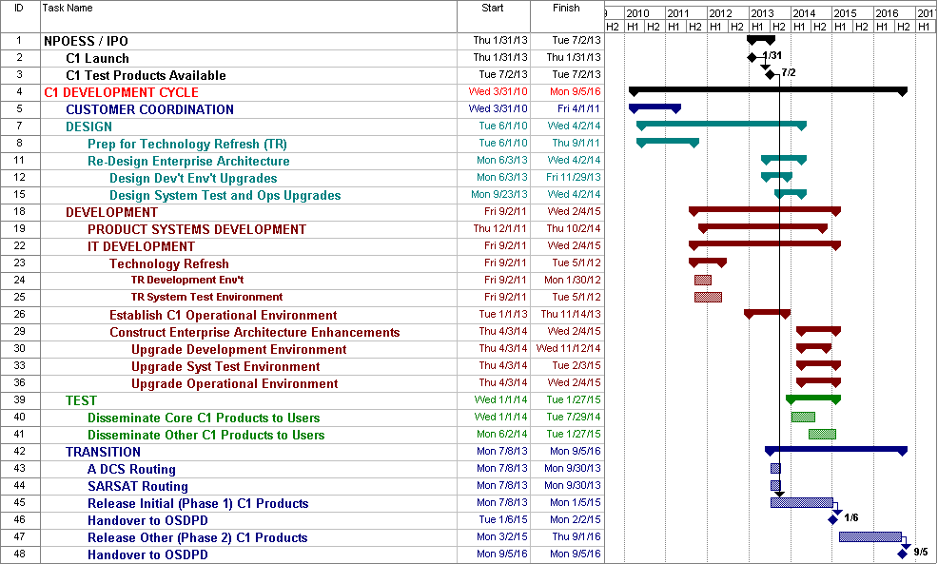

6.5.1 Systems Development
During the Customer Coordination Phase, Project Management and Customers conduct detailed analyses of the Customer Service metrics logged during the NPP Phase. For example, knowledge of how many problems were reported for particular products is likely to influence the Product Development priorities. Knowledge of which customers submit trouble tickets will influence planning for Customer Coordination activities. Trend analyses of Service Requests could indicate changes in customer capabilities related to such factors as volume increases or timeliness of product delivery. In short, the analysis of metrics associated with Customer Service (trouble tickets, service requests, ordering patterns, and the like) will provide NDE Project Management with powerful indicators to guide future Project Planning.
The prior Development Cycle, NPP’s, saw the establishment of a dual purpose satellite data processing capability, called the NDE System Test Environment. During NPP, System Test will have provided quasi-operational conditions so that ESPC and STAR developers will have a robust, configuration-controlled environment in which their software can be tested. System Test will also provide the infrastructure for the regular operations necessary to receive NPP data from the IDPS, generate the NDE value-added products, and disseminate them to customers. This is in keeping with NPP’s risk reduction mission. The C1 Development Cycle, in contrast, is designed to establish operational capabilities that take advantage of the lessons learned during NPP. It is anticipated that much of the infrastructure called System Test during NPP, will be renamed and its capabilities extended as the C1 Operational Environment (Figure 10, Row 26).
Several years will have elapsed since the NDE/ESPC System was designed. Anticipating the rapid pace of technological advancement, the C1 Development Cycle dedicates effort to both refreshing the technologies implemented in prior years (Figure 10, Rows 8, 23) and to the likelihood that some fundamental design assumptions will have to be reconsidered to take advantage of new technologies that are likely to have become available during the intervening period (Figure 10, Rows 11, 30).

6.5.2 Product Development
Much product development (e.g., science algorithm development) is accomplished external to the NDE System Development, but there must be close cooperation with the external algorithm developers so that NDE will be able to provide NESDIS’ customers with the important product advancements offered by this satellite. Many of the products to be developed during this Development Cycle will extend the product applications begun on the VIIRS-only versions of products developed during the NPP Development Cycle.
Upgrades to NESDIS and customer systems will be specified during Design and implemented during the Construction Phase.
Customer hardware, software, and human resources will be upgraded based on the cooperative analysis of their systems conducted during the Programmatic Studies of Customer Coordination phase.
During the Test Phase, user systems begin to exploit C1 products on a simulated operational basis. The core product prototypes will be made available to test in customer environments.
NDE will work closely with customers during Transition, providing sufficient Customer Service resources to support all customer transition activities including provision of product training. Some of the VIIRS-derived products will be introduced as the C1 Release of core products. The other VIIRS-derived products (those not essential to continue current POES, DMSP, or EOS missions) will be part of a second release (row 45) along with new products from the Space Environment Monitor (SEM).

6.5.3 Concluding the Cycle
The Phase 2 product release will be associated with handover of sustained engineering, operations, and maintenance responsibilities to OSDPD and STAR.
From a Project Management perspective, the conclusion of this Development Cycle will be an opportunity to refine the project approach and to update the Integrated Project Plan. The methodology and work breakdown structure (WBS) will be re-evaluated and altered based on lessons learned.

6.6 Potential Out-Year Build Cycles
The C2 satellite’s payload may include the microwave instruments necessary to complete the NPOESS on-orbit design. The C3 launch is tentatively scheduled for 2018. However, the C2 and C3 dates are well beyond the 5 year budget horizon of current NOAA budget procedures (see Section 5.1).
Through the year 2020, the NDE project will continue as NESDIS’ means for planning and executing activities necessary to assist NOAA and other civilian users to realize the full potential of NPOESS. Beyond 2020, other means may be available.
An NDE Post Implementation Review is not planned at this time.

7 ACQUISITION STRATEGY
The NDE project manages budgets for three categories of acquisition: Product Development, Systems Development, and Systems Integration. (Project Organization Chart)

7.1 Product Development
A recent survey of NOAA users identified preliminary requirements for over fifty NOAA-unique products. The same survey identified over 150 product tailoring tasks. These tentative product requirements are based on only a preliminary understanding of NPOESS’ potential. Years of investigation and experimentation are anticipated in order for the full potential of the sensor data to be exploited. As these understandings are achieved, the requirement for NPOESS products is expected to grow significantly. The NDE project must focus and direct scientific and engineering tasks in order to satisfy the needs of the NOAA user community and other customers of NPP and NPOESS sensor products.
A key element of NDE’s acquisition strategy, therefore, is the establishment of centralized procedures for the analysis, prioritization, selection, and funding of NPOESS product development tasks. A year prior to each execution year, the NDE project manager will evaluate and prioritize new product capabilities required based on the results of the most recently completed Customer Coordination phase. The NDE project manager will issue a request for product development proposals related to the prioritized needs. The proposals will be reviewed by an NDE Management Board at the NDE Annual Management Review. Following the annual review the NDE project manager will determine the funding allocation recommendation. The Polar Program Manager will then issue the funding allocation memo for projects to be funded in the next fiscal year. All projects to be funded will develop a project plan briefing. All contract or grant packages will be reviewed by OSD before funds can be committed.
Continuation funding for projects will be reviewed at the annual review process described above and they are also reviewed at the Annual Polar Product Review. Tasks spanning multiple years will demonstrate achievement of planned, tangible milestones in order to receive continued funding.
Much prioritization was accomplished during the period of time that user requirements were captured by the IPO for the IORD. Certain EDRs have been designated as Key Performance Parameters (KPPs). Products in this category have been identified by the user community in the IORD as the most important deliverables from the NPP/NPOESS program.
- Atmospheric Vertical Moisture Profile
- Atmospheric Vertical Temperature Profile
- Imagery
- Sea Surface Temperature
- Sea Surface Winds
- Soil Moisture
Another prioritization factor has to do with continuing the POES mission. The final satellite in that program, N’, like NPP, is scheduled for 2009 launch. If it should fail, there must be a backup in orbit to continue supplying operational products to NOAA. A MetOp satellite, the European component of the POES constellation, because it is already a POES satellite, will be the primary backup. Although not officially designated as the N’ backup, NPP will be in a position to provide observations if needed.
Figures 13 and 14 show the proposed set of product introductions from January 2010 through June 2011. Table 4a shows the “Phase I” products, those that are currently funded and will provide continuity for current NOAA missions. Table 4b shows the “Phase II” products, those that are the enhanced products comprised of additional NUPs and xDRs not linked to mission continuity. NOAA-Unique Products are in the yellow cells, tailored products are shown in the blue cells.
Phase 1 (Jan 2010 – Jun 2011): Legacy mission continuity replacement products comprised of currently funded NUPs and xDRs
CrIS Thinned Radiances | SST Anomalies | Ozone Total Column
CrIS Cloud Cleared Radiances | Coral Reef Degree Heating | Snow Cover
Total Precipitable Water (ATMS) | Coral Reef Bleaching | Imagery
Snow Cover (ATMS) | Total Ozone (CrIS) | Ocean Color/Chlorophyll
Precipitation Type/Rate (ATMS) | Carbon products | Vegetation Index
Surface Emissivity (ATMS) | SST (AVHRR-like) | Active Fires
Cloud Liquid Water (ATMS) | Aerosol (AVHRR-like) | Atmospheric Temperature Profile
Sea Ice Cover/Concentration (ATMS) | ATMS Radiances | Atmospheric Moisture Profile
Snow Water Equivalent (ATMS) | CrIS Radiances | Aerosol Optical Thickness
Ice Water Path (ATMS) | VIIRS Radiances | Surface Type & Vegetation Cover
Land Surface Temperature (ATMS) | OMPS Radiances | Surface Albedo
Temperature Profiles (ATMS) | Cloud Mask | Cloud Cover/Layers
Moisture Profiles (ATMS) | Sea Surface Temperature (SST)
Blended SST | Ozone Profile
Figure 13: Phase 1 NPP Products

Phase 2 (Jun 2011 – Jan 2013): Enhanced products comprised of additional NUPs and xDRs not linked to mission continuity
NOAA-UNIQUE PRODUCTS | TAILORED PRODUCTS
Polar Winds (VIIRS) | Aerosol Particle Size
Clear Sky Radiances (VIIRS) | Cloud Top Temperature
Vegetation Health | Cloud Top Pressure
Vegetation Moisture | Land Surface Temperature (VIIRS)
Drought Indices | Cloud Base Height
Vegetation Thermal Conditions | Cloud Effective Particle Size
Leaf Area Index | Cloud Optical Thickness
Fire Potential | Cloud Top Height (VIIRS)
Near Coast Ocean Color | Ice Surface Temperature
Integrated xDRs at CrIS Resolution | Net Heat Flux
Cloud Liquid Water Path (VIIRS) | Sea Ice Characterization (VIIRS)
Cloud Ice Water Path (VIIRS) | Suspended Matter
Cloud Top Temperature (VIIRS) | Atmospheric Pressure Profile
Figure 14: NPP Phase 2 Products

7.2 System Development
The NDE System Development Manager funds a team of software developers to identify and deliver shared data processing capabilities. These capabilities are necessary in order to reduce the risks associated with developing and operating many product generation applications in a single environment. NOAA simply cannot afford to treat each NPOESS product generation system as a unique challenge. Rather, NDE seeks to establish a common tool set that will allow the scientific product development teams to focus on the science, using functionality available to all of them to perform the more mundane data processing tasks.
These capabilities will operate within NESDIS’ ESPC. NDE cooperates closely with ESPC Management. ESPC, with NDE funding, uses its contract vehicles to procure the technologies that enable both the development and the operation of the enterprise capabilities. In this relationship, the NDE System Architect provides the requirements and directs the funds for technologies such as:
- Relational Data Base Management System (RDBMS)
- Object Repositories
- Fourth Generation Languages
- Test Tools
- Configuration Management Systems
- Work Management Tools Schedulers
- Help Desk Software
- Reporting tools
- Process/Project Management tools
- Etc.
As the initial, primary users of these technologies, the ESPC’s NDE System Development Team will assist ESPC operations staff to configure, install, and test the products in the appropriate environments.

7.3 Infrastructure Acquisition, Operations, and Maintenance
The OSDPD capability that will address the technological challenges of both NPOESS and the next generation of geostationary satellites is called the Environmental Satellite-data Processing Center (ESPC). The NDE environments within NESDIS for which ESPC must acquire hardware and associated software include:
- Algorithm development/test
- Enterprise tool development/test
- System test (also serving as backup for normal operations in emergencies)
- Normal operations
- Distribution networks and telecommunications
- Disaster recovery
The NDE Architect will be responsible for providing requirements and specifications for all of the technologies needed for these environments. The NDE Project Manager will direct funds to OSDPD for these purposes.
Most of this equipment will be installed and managed by ESPC at the National Satellite Operations Facility (NSOF) in Suitland, Maryland. Depending on decisions to be made in the context of NDE’s System Architecture, as well as ESPC’s design efforts with regard to shared data processing and STAR’s collaborative algorithm development environments, some development equipment may be installed at remote sites. ESPC will provide authorized developers with high speed access to NSOF development resources (test databases, CM tools, documentation libraries, procedure libraries, etc.).
ESPC is responsible for the security of NDE’s Operational, System Test, and Development capabilities. ESPC will establish and enforce security procedures to ensure the data integrity of all operational and developmental applications that run under its auspices, including NDE’s. ESPC provides protection from access to NDE’s automated resources by unauthorized users. ESPC will withhold specified NPOESS datasets from unauthorized users when so ordered by the Secretary of Commerce (e.g., data denial). Aside from these data denial requirements (TBD), NDE has no security requirements different from those ESPC will provide for all of the applications that operate under its auspices.
ESPC will provide maintenance and support for a selected Database Management System (DBS) as well as of the data content to be established on that system. NDE is committed to sharing this essential resource with all of NOAA. The NDE System Architect will coordinate the creation of data models by the various development organizations (CLASS, STAR, ESPC, NCDC, NGDC, NDE product developers, etc.). The Architect’s coordination activities will focus on the identification of as many opportunities to share and reuse the maximum number of data entities and/or object classes. This coordination of conceptual data models is the foundation of NDE’s “enterprise approach.” In turn, ESPC’s database administrators (DBAs) will be responsible for maintaining the integrity of the operational forms of the models – the data itself.
ESPC will develop an ability to recover from disruptions of NDE product deliveries and services resulting from disasters. NDE has no disaster recovery requirements different from those ESPC will provide for all of the applications that operate under its auspices.
ESPC will provide customer services including:
- Product order tracking
- Management of trouble reports (logging and appropriate follow-up)
- Routing of customer product inquiries to qualified specialists
At the present time, NDE has no customer service requirements different from those ESPC will provide for all of the applications that operate under its auspices. However, NDE may levy the following customer service requirements on ESPC if requested during Customer Coordination Phases of NDE Development Cycles:
- Product order placement
- Service request management such as:
  - Capturing enhancement requests
  - Managing the resolution process for determining whether to undertake an enhancement
  - Conducting customer satisfaction surveys
  - Maintaining a database of customer requests to enable reporting by customer, by product, by request type, by status, and by date
- Management of online product training materials and other distance learning capabilities
- Extending operator working hours to provide customer assistance beyond eight hours on week days
ESPC will negotiate Service Level Agreements (SLA) with all of its product customers.
These agreements will guarantee levels of performance in terms of product deliveries, availability of access to system resources, and the availability of support from ESPC, either from operators or from automated Help applications. ESPC will establish similar agreements with selected NOAA offices chosen as representative of those who will use ESPC resources to develop products, including NDE’s. At the present time, NDE anticipates no performance baselines different from those ESPC will provide for all of the applications that operate under its auspices.
The NPP satellite’s products offer ESPC opportunities to prototype some of the high performance computing, high volume data management, and product distribution capabilities that will be required for ESPC. The first geostationary satellite to carry the new technologies, GOES R, is not scheduled for launch until 2014 - around the same time that C1 is expected to be operational. NDE, therefore, is the first project that will deliver the next generation of satellite products using ESPC capabilities.
Important aspects of the relationship between NDE and ESPC can be illustrated in terms of Configuration Management (CM) and System Testing. New or enhanced algorithms, for example, will be run in a System Test environment that simulates ESPC operations. In order for an algorithm to be certified as Operational, it must perform without causing errors (regression testing) or degrading performance (stress testing) when using the same configuration of enterprise resources (the DBMS, object repositories, shared procedures, etc.) as those running in the ESPC operational environment. The algorithm will be submitted for System Testing as part of a package that might also include additional test data, enhanced versions of shared elements, documentation for new test procedures, and (in all cases) updated documentation for each of the enhanced components to be certified. New or enhanced enterprise tools will, likewise, be required to undergo the same level of system testing.
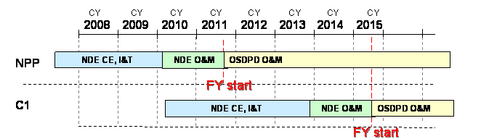
Figure 15: O&M Handover Schedule

ESPC will acquire and maintain the System Test environment. The human resources necessary to operate the System Test environment will also be ESPC’s. However, the certification requirements to be implemented by the ESPC System Test personnel will be provided by the NDE System Architect. The ESPC System Test personnel will, in turn, be responsible for articulating the Operational and System Test standards and providing assistance to the development teams with their work to implement the standards within their applications. Initial funding for the staff needed to perform these development support roles will be provided by NDE. Eighteen months after the establishment of the System Test Environment, OSDPD will assume responsibility for funding the Operations and Maintenance (O&M) of the System Test environment.
NDE and OSDPD will share funding responsibilities for NDE-related technologies as illustrated by Figure 12. NDE’s commitment begins 24 months prior to the launch of each of the 1st four satellites. Accordingly, NDE will provide funding for the capital expenses (CE) and the integration and testing (I&T) for all hardware, COTS, and telecommunications capabilities necessary to process the data from the satellite. Following a similar schedule, NDE will also provide funding for technologies needed to conduct development and testing for the products provided by the satellites. NDE will fund operations and maintenance (O&M) for all of these categories of technology for eighteen months after the launch of each satellite. OSDPD will assume funding responsibilities for O&M when NDE’s eighteen month commitment is completed. OSDPD senior management will be the owner/lessor of record for all NDE-related technology acquisitions.

8 PROJECT PROCESSES
The NDE Project functions in relationship to many other organizations in NESDIS and NOAA. A graphical representation of those relationships is provided as Appendix C.

Planning Processes

8.1.1 Five-Year Planning
Annually, NDE provides five-year budgetary information in support of NOAA’s Project Planning, Budgeting, and Evaluation System (PPBES). The PPBES procedures are ongoing, with annual cycles. PPBES is a hierarchical system that successively discovers commonalities between projects to eliminate redundancy. The process is based on the notion that each project must support at least one of NOAA’s mission Goals. Within each Goal, sets of projects are organized as Programs. The NDE project reports to PPBES within a Science and Technology Infusion (STI) program for the Goal Team that is responsible for serving society’s needs for “Weather and Water” information. (As demonstrated in “Section 2.1: Project Mission, Goals, and Objectives” NDE supports all four of NOAA’s mission goals. Its placement within Weather and Water is based on the fact that the NWS has historically been the primary consumer of environmental polar satellite data.). During July and August, NDE provides its plans to the STI Program Manager for an execution year 2 ½ years hence. (For a fiscal execution year beginning October 1, 2008, NDE provides planning data in July and August 2005.)
The PPBES’s office of Program Planning and Integration (PPI) reviews all program plans for an execution year to discover shortfalls and to determine whether to fund critical needs with uncommitted resources. This takes place during the month of April. During May and June, final review and approval of procurement plans for the execution year and the years following takes place.
NDE also provides five-year plans within a format prescribed by the Office of Management and Budget (OMB) called the “OMB Exhibit 300.” These documents are submitted by NOAA to the Department of Commerce (DOC).
This document, the NDE Integrated Program Plan (IPP), is also reviewed by the NESDIS Executive Board (NEB) during its Five-Year Planning efforts. Of particular interest to them is Section 9’s Five-Year Spend Plan. NDE submits the IPP to the NEB for review in September.

8.1.2 Integrated Project Planning
This document is called the Project Plan. It reflects NDE management’s intentions for deploying the resources needed to satisfy requirements. Of necessity, a project with the scope of NDE will require a variety of planning documents (Test Plans, Training Plans, Development Plans, etc.). Before the start of each budget year, therefore, approval of the Project Plan (this document) by a Review Board composed of managers of stakeholder organizations is an essential approval process. NDE management will continuously maintain the currency of the Project Plan by monitoring the Product Development Teams and the NDE/ESPC System Development Team.

8.1.3 Transition Planning
To be inserted as a hyperlink to the “NDE Transition Plan” in accordance with NAO 216-105, “POLICY ON TRANSITION OF RESEARCH TO APPLICATION”, 05/31/05

Initiating Processes
Certain start-up activities deal with setting up a Development Cycle to ensure that it can be effectively managed. Start-up activities include the following:
- Engagement of Stakeholders - mobilizes the core project leadership and ensures that major stakeholders are fully informed and aligned with the objectives, approach, and deliverables
- Confirmation of Project Management Processes - establishes the project management processes for the Development Cycle:
  - Stakeholder and Communications Management
  - Scope and Requirements Management
  - Deliverables and Configuration Management
  - Team Management
  - Risk and Issues Management
  - Work and Schedule Management
  - Vendor and Contract Management
- Project Infrastructure Establishment - ensures that the infrastructure required by each of the NDE teams for the Cycle is secured and available to support the work and schedule defined by the Integrated Project Plan.
- Establishment of the teams - mobilizes the government staff and contractors who will do the work of the Development Cycle.

Controlling Processes

8.3.1 Work and Schedule Management
The NDE Project Manager will require that each of the Product Development Teams, and the NDE System Development Team, provide and maintain a Work Schedule consisting of:
- A Task List organized hierarchically (e.g., Work Breakdown Structure [WBS])
- Estimated Effort and Cost for each task
- Resources, either by skill type or by person name, assigned to the tasks
- Start and end dates for each task
- Checkpoints (end dates of more important tasks)
- Alternative views of the schedule
  - Gantt
  - Critical Path (Dependencies)
The NDE Project Manager will require each of the Product Development Teams and the NDE/ ESPC Team to provide Status Reports on a predetermined schedule. The Product Development Teams will provide Status Reports once every four months. The NDE/ESPC Team will report status monthly.
Team Leaders will provide the Status Reports advising NDE Project Management of the likelihood of completing scheduled tasks on time. Status Reports will be exception-oriented, emphasizing anticipated schedule slippages. Team leaders will describe:
- Reasons for anticipated slippages (e.g., issues)
- NDE Project Management actions that might be taken to resolve the issues
If immediate management action is required, Team Leaders will contact NDE Project Management prior to their scheduled Status Reports.
NDE Project Management will maintain an Issues Log that includes the dates, descriptions, and status of the matters to be resolved. “Open” issues will be handled as aggressively as possible to change their status to “closed.”
NDE Project Management will maintain a summary level Work Schedule derived from the WBSs of the Product Development Teams and the NDE/ESPC Team. NDE Project Management will use the summary plan to report such measures as Earned Value and Tasks Completed to senior management.

8.3.2 Scope and Requirements Management

8.3.2.1 Satellite Products and Services Review Board (SPSRB)

The NDE project will participate in an established method for evaluating product decisions through the membership of its Product Development Manager in the NESDIS Satellite Products and Services Review Board (SPSRB). The SPSRB is responsible for providing the oversight and guidance necessary to effectively manage product life cycles; from development, transition, operations, enhancements and, ultimately, product decommissioning. Product Oversight Panels (POPs), consisting of research scientists and end users with specialized product expertise, advise the SPSRB on matters relating to product prioritization, fitness of products for escalation to operational status, and the risks associated with development. SPSRB is responsible for determining how best to use NPOESS observations to continue critical NOAA missions, particularly those that exploit pre-NPOESS observations from POES, DMSP, and EOS.
The NDE Product Development Manager advises the NDE Project Manager about product development/enhancement projects that have been approved by the SPSRB and/or by a NESDIS management review process. The NDE Project Manager then determines whether to allocate NDE funds to support the selected product development efforts. Figure 13 (below) shows NDE in the context of the SPSRB as an instance of a “Resource Identification” procedure. NDE is an integral part of the SPSRB process because it is primary funding source for NPOESS product development. The NDE Product Development Manager will rely on the SPSRB’s procedures as a means of documenting and evaluating projects that can most beneficially exploit NPOESS observations.
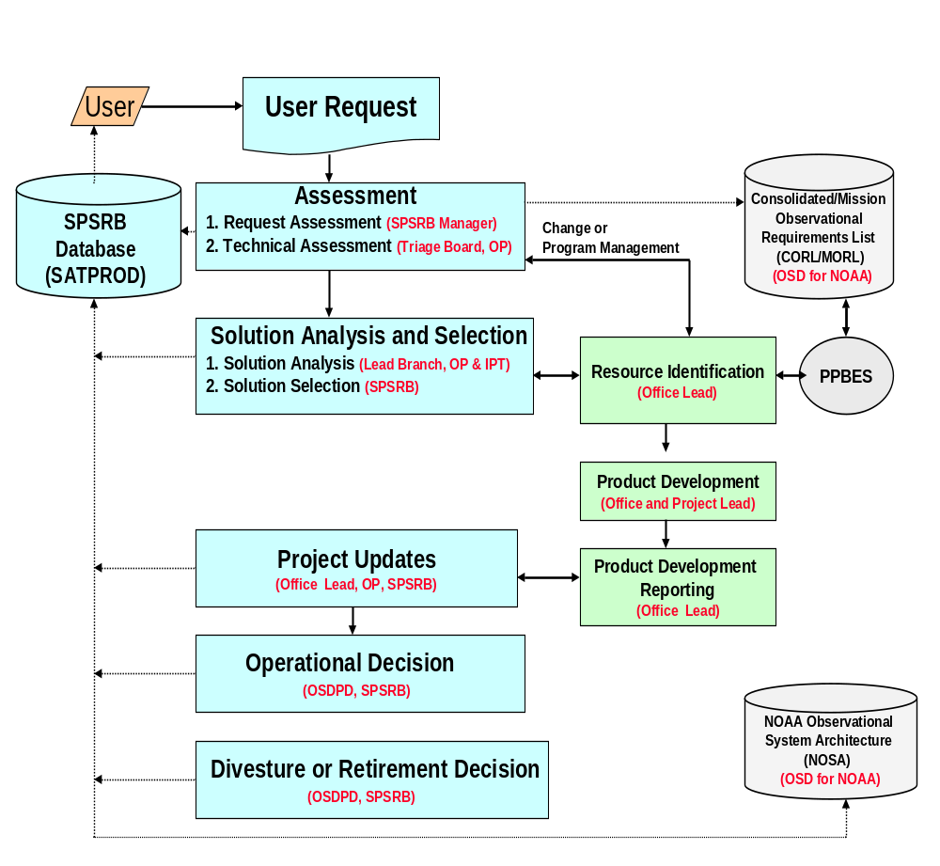
Figure 16: SPSRB Processes

8.3.2.2 NDE Management Board
Guidance and direction are provided to the Project Manager once a year by the NDE management Board. The members of this Board include representatives for directors of OSD, OSDPD, and STAR as well as representatives from those Mission Goals and Programs most closely associated with satellite products (Appendix D). NOAA management uses the annual review to ensure a coordinated implementation across the NOAA enterprise. The Board will review all NDE procurement plans and recommend adjustment as appropriate. The NDE Management Board review will occur several months prior to the beginning of the fiscal year, so there will be sufficient time to adjust procurement plans. The Board may also be convened at other points during the year to review milestone deliverables and provide guidance on project direction. The NDE Management Board process will ensure that future procurement activities and associated spending plans are coordinated among NOAA offices.
The roles and responsibilities of the NDE Management Board include:
- Reviewing and prioritizing strategies for NDE acquisition, development, and implementation
- Reviewing NDE spending plans
- Ensuring NDE procurement activities within their offices are submitted and progress is properly tracked by management
- Monitoring progress and resolving conflicts (for example, balancing requirements and priorities between NDE, the Satellite Acquisitions Program, and the Polar Satellite Acquisitions Program).
- Identifying and agreeing sponsors for sub-projects and working groups (If a need for work outside the NDE purview is discovered, the board will help to establish the action teams by assigning someone at their level to get it done. Examples could be teaming with agencies outside NESDIS or NOAA such as NASA.)
The NDE management Board’s annual guidance will be based on its evaluation of:
- NDE Project status
- NPOESS product development priorities and plans
- ESPC development priorities and plans
- Detailed procurement plans for the upcoming fiscal year
- Acquisition strategy for the remainder of the project

8.3.2.3 Requirements Management
The NDE System Architect is responsible for minimizing developmental duplication and ensuring that project resources are used to satisfy approved requirements. The Architect maintains a Requirements Tracking System (RTS) that will consist of a database associating each requirement with the following:
- Project Categories (product generation, customer service, dissemination, etc.)
- Requesting organizations
- Approval status
- Priority
- Contact information
- Development status
- Associated system features
- Test specifications
- Test plans
- Test status
The ESPC’s System Development Team (Section 4.3 ESPC’s System Development Team ) has established procedures to evaluate candidate requirements in terms of suitability for inclusion within NDE’s scope. Representatives of the ESPC Team submit requests for changes to the project’s scope through these procedures. The ESPC System Development Team will evaluate the request. The Team advises NDE Project Management of its recommendations, including cost estimates and risk assessments. For each request, appropriate recommendations are:
- New Requirement Approved
- New Requirement Rejected
- Existing Requirement to be Revised

The NDE System Architect captures and tracks all changes to the requirements in a document called the System Requirements Specification. The first activity of each IT Build is a detailed design review that provides, along with Configuration Item definitions, modifications to the existing requirements baseline. During detailed planning for the Build, each detailed requirement is physically linked to the System Requirement from which it was derived and to each of the downstream tests with which it will be associated.

Execution Processes

8.4.1 Deliverables and Configuration Management
For each task in the Work Breakdown Structure (Section 8.3.1) submitted for approval by NDE Project Management, the Team Leader provides a written description of the expected work product (e.g., deliverable). The team member(s) responsible for the task receive the descriptions when they are assigned the work. Discussions between Team Leaders and Team Members regarding a deliverable’s quality, level of detail, and preferred tools takes place at time of assignment.
The Team Leaders are responsible for the quality of all work products. They have discretion, therefore, to conduct as many Quality Control reviews of work products as they feel are appropriate. The time and effort required to conduct these reviews, as well as any anticipated rework that is likely to be identified during the course of the reviews, is shown on the Work Schedules submitted to NDE Project Management. In other words, quality planning is an element of Work Schedule development.
To reduce the effort associated with defining and explaining the work products, industry standard System Development Life Cycle (SDLC) methodologies may be used.
Configuration Management (CM) has many dimensions. Section 8.3.2.3 (above) describes control of executable system components and the specifications associated with them. Here, the control of milestone deliverables is addressed.
NDE Project Management will provide an outline that shows the relationship between the components that make up the milestone review documents that the NDE Management Board will review at the conclusion of Development Cycle phases. For example, at the commencement of the Customer Coordination Phase for any Development Cycle, NDE Project Management team will develop a System Requirements Review (SRR) documentation outline (e.g., documentation tree) and a table of contents for each document. Minimally, milestone documentation will consist of final versions of the Integrated Project Plan the System Requirements Specification, and the NDE Concept of Operations.
NDE Project Management maintains consistency of format and content between these documents, between Development Cycles, and between the Phases of a Development Cycle. Strict configuration control will be exercised over documents with SMB signatures; revisions require SMB approval and signature.

8.4.2 Team Management
There are four permanent, government NDE Team Managers:
- Project Management
- Product Development
- System Architecture
- Systems Integration
Every manager will supervise one or more Teams. Each Team will have a Team Leader. A Team Leader’s responsibilities include:
- Defining work products
- Developing Work Schedules
- Reporting status
- Defining skill sets required by Team Members in order to produce work products
- Monitoring the performance of Team Members
- Arranging assistance for Team Members in the performance of their tasks
- Delivering work products of predefined quality on schedule
- Reporting Team Member performance to the managers responsible for performance evaluations
- Recommending changes of team membership (additions, removals, transfers, etc) for assigning personnel to Teams

Facilitating Processes (TBC)

8.5.1 Risk and Issues Management
Details of NDE’s approach to risk and issues management are captured in the NDE Risk Management Plan, first developed in 2006 and currently being revised based upon a recent survey of stakeholder. A methodology employing interviews with remote sensing and ground systems experts and a risk survey was used to identify and prioritize these risks. The risk survey, analysis and planning were used to develop risk handling approaches and mitigation strategies and tactics.
High level risks were identified as: schedule delays, quality problems, system performance, and resource limitations (lack of trained staff, tools, funding, etc.), particularly as they pertain to developing a sustainable product generation system. Moderate priority risks pertain to developing a reliable system that provides required capabilities and is recoverable after a catastrophic event. Loss of system productivity due to abuse or malicious activity was identified as a less likely risk with potentially high impact.
Current NDE plans address many of the identified risk mitigation activities:
- Risk management planning,
- Implementation of earned value management,
- Developing lifecycle cost estimates,
- Budgeting,
- Resource planning,
- Design for reliability, and
- Monitoring changing security requirements
The following risk mitigation activities complement NDE’s current plans:
- Develop and implement a quality management plan to address system and data quality, quality assurance, and quality control.
- Develop and implement NDE continuity plans that are coordinated among participating organizations.
- Coordinate development of preliminary (pre-launch) data with the IPO and instrument designers

8.5.2 Vendor & Contract Management
Vendor and Contract Management will use standard Contract Officer (CO) and Contract Officer Representative (COR) processes.

8.5.3 Stakeholder Communication Processes
The NPOESS Data Exploitation (NDE) Stakeholder Communications Team is a matrixed organization with staff drawn, as needed, from many NOAA departments. These teams provide the most important lines of communication between the organizations in which they are employed and the NDE Project. (Figure 6.5) They provide a valuable advice to the NDE Project because they are cross-functional, each with expertise in specialized topics of importance to the Project. Conversely, they provide a valuable service to NOAA by conveying NPOESS questions, issues, and status back to their organizations.
Members may serve on multiple Communication Teams. Members will also be asked to fulfill some of the roles and responsibilities described in Section 6 (below). (Multiple affiliations are typical of a matrixed organization.)
The stakeholder communication teams are kept advised of NDE activities via e-mail and at regular NDE Team Meetings. Each stakeholder communication team leader has the option of assigning and coordinating the efforts of their team members to perform special NDE tasks or respond to Action Items on those occasions when the NDE Project Manager asks them to do so.
The following Stakeholder Communication Teams have been formed. (Team mission statements are described in the NDE Charter http://projects.osd.noaa.gov/nde/prog_mgt.htm) (see Figure 14).
- Architecture and Infrastructure Team
- Archive & Access Team
- Budget Analysis Team
- Direct Broadcast Services Team
- Documentation Team
- External Affairs Team
- Facilities Team
- International Affairs Team
- Instrument Characterization Team
- IPO Interface Team
- Operating Branch Interface Team
- NOAA-unique Product Validation and Development Team
- NOAA Product Tailoring, Distribution, and Communications Team
- System Test and Evaluation Team
- Web Site Team

Office of Satellite Data Processing
& Distribution
(OSDPD)
NOAA Polar Program
Manager

National
Data Centers
(NCDC, NGDC, NODC)

Office of Satellite Operations
(OSO)
NDE
Project
Manager

Office of Research
& Applications
(STAR)
NDE
Stakeholder
Communication Teams
Integrated
Program
Office
(IPO)
NOAA
Agencies
(NWS, OAR, NOS, NMFS)
Office of Systems Development
(OSD)

Contract
Officer
Comprehensive Large-Array Data Stewardship System
(CLASS)
Figure 16: NDE Stakeholder Communication Teams

9 FIVE-YEAR SPEND PLAN
To be provided by NDE Project Manager

APPENDIX A: ACRONYMS AND ABBREVIATIONS
ADCS | Advanced Data Collection System
AFWA | Air Force Weather Agency
APS | Aerosol Polarimeter Sensor
ATMS | Advance Technology Microwave Sounder
AWIPS | Advanced Weather Interactive Processing System
C1 | NPOESS First Satellite
C2 | NPOESS Second Satellite
C3 | NPOESS Third Satellite
CASE | Computer Assisted Software Engineering
CDR | Climate Data Records
CDR | Critical Design Review
CE | Capital Expenses
CLASS | Comprehensive Large Array-data Stewardship System
CM | Configuration Management
CMIS | Conical Scanning Microwave Imager/Sounder
CO | Contract Officer
CONOPS | Concept of Operations
COOP | Continuity of Operations Plan
COR | Contract Officer Representative
CM | Configuration Management
CrIS | Cross-Track Infrared Sounder
CrIMS | Cross-Track Infrared Sounder + Advance Technology Microwave Sounder
DBA | Data Base Administrator
DBMS | Data Base Management System
DCS | Data Collection System
DMSP | Defense Meteorological Satellite Program
DoA | Department of Agriculture
DOC | Department of Commerce
DoD | Department of Defense
DOS | Department of State
DRO | Direct Readout
ECMWF | European Center for Medium-range Weather Forecasting
EDR | Environmental Data Record
EOS | Earth Observing System (NASA)
ERD | Entity Relationship Diagram
ESPC | Environmental Satellite-data Processing Center
EUMETSAT | European Organization for the Exploitation of Meteorological Satellites
FAA | Federal Aviation Administration
FNMOC | Fleet Numerical Meteorology and Oceanography Center
FOC | Final Operational Capability
HDF | Hierarchical Data Format
HDF5 | Hierarchical Data Format version 5
I&T | Integration and Test
IDPS | Interface Data Processing Segment
IORD | Integrating Operational Requirements Document
IPO | Integrated Program Office
IPP | Integrated Program Plan
ITAT | Information Technology Architecture Team
JARG | Joint Agency Requirements Group
JCSDA | Joint Center for Satellite Data Assimilation
KPP | Key Performance Parameter
LTA | Long-term Archive
METOP | Meteorological Operational
MMC | Mission Management Center
NAVOCEANO | Naval Oceanographic Office
NCDC | National Climatic Data Center
NCEP | National Centers for Environmental Prediction
NDE | NPOESS Data Exploitation
NEB | NOAA Executive Board
NGDC | National Geophysical Data Center
NIC | National Ice Center
NMFS | National Marine Fisheries Service
NOAA | National Oceanic and Atmospheric Administration
NODC | National Ocean Data Center
NOS | National Ocean Service
NPOESS | National Polar-orbiting Operational Environmental Satellite System
NPP | NPOESS Preparatory Project
NSOF | NOAA Satellite Operations Facility
NWS | National Weather Service
O&M | Operations and Maintenance
OAR | Office of Atmospheric Research
OMB | Office of Management and Budget
OPC | Ocean Prediction Center
STAR | Office of Research Applications
OSD | Office of Systems Development
OSDPD | Office of Satellite Data Processing and Distribution
PD | Product Development
PDR | Preliminary Design Review
PIR | Post Implementation Review
POES | Polar-orbiting Operational Environmental Satellite
POP | Product Oversight Panel
PPBES | Project Planning, Budgeting, and Evaluation System
PPI | Plan For Product Implementation
PPI | Program Planning and Integration
PSDI | Product Systems Development and Implementation
R2O | Research To Operations
RDBMS | Relational Data Base Management System
RDR | Raw Data Record
RTS | Requirements Tracking System
SARSAT | Search and Rescue Satellite Aided Tracking
SDLC | System Development Life Cycle
SDR | Sensor Data Record
SDS | Scientific Data Stewardship
SMB | Senior Management Board
SPSRB | Satellite Products and Services Review Board
SRR | System Requirements Review
SST | Sea-Surface Temperature
STI | Science and Technology Infusion
SUAG | Senior Users Advisory Group
TBC | To Be Confirmed
TDR | Temperature Data Record
UKMetO | United Kingdom Meteorology Office
USMCC | United States Mission Control Center
VIIRS | Visible/Infrared Imager Radiometer Suite
WBS | Work Breakdown Structure
xDR | any NPOESS Data Record

APPENDIX B: DEFINITIONS

Acceptance Testing  (aka User Acceptance Testing) | the process of verifying that the system is functional, robust, and meets the business/science needs by piloting the system with business/science users
String testing | the testing of a collection of units that have a logical relationship or flow from the user’s perspective
System Testing | the process of verifying that the system is completely functional and robust enough for user interaction and use. System testing covers many different aspects including functional testing, volume/performance testing, and multi-user testing.
Unit testing | the testing of a particular, discrete function of the application..

APPENDIX C: RELATIONSHIPS WITH NOAA ENTITIES
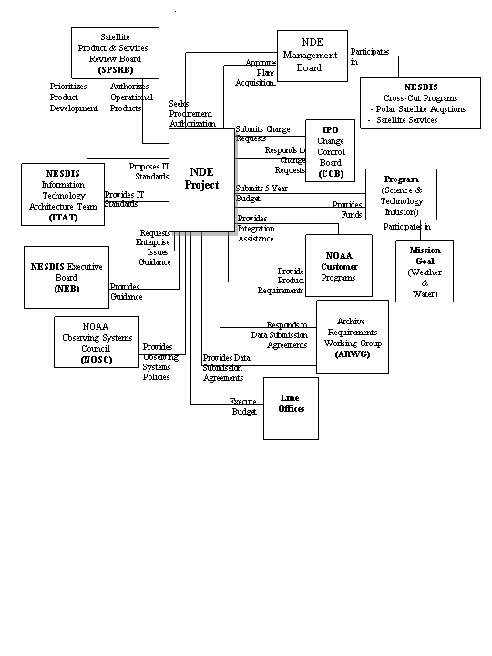
Figure 17: Relationships with NDE NOAA

Approval Page

Document Numbers:  NOAA/NESDIS  (TBD) Series | NO-1  July28, 2005  DCN OSDNDEPP 1.0
Document Title Block:
NPOESS Data Exploitation (NDE)
Project Plan
PROJECT: NPOESS Data Exploitation | DOCUMENT RELEASE DATE: (v1.0 August 10, 2005)
APPROVALS
Approved by: Office of Systems Development DATE  NAME: Mike Mignogno, Polar Program Manager | Approved by: Office of Systems Development DATE  NAME: H. James Silva, NDE Project Manager
Approved by: NDE Management Board DATE  NAME: | Approved by:  NAME:
  NAME: | Date: / /
  NAME: | Date: / /
  NAME: | Date: / /
  NAME: | Date: / /
  NAME: | Date: / /
  NAME: | Date: / /
  NAME: | Date: / /
  NAME: | Date: / /
Approved by: DATE  NAME: | Approved by: DATE  NAME:
Approved by: DATE  NAME: | Approved by: DATE  NAME:
RELEASE APPROVAL: DATE

NAME:

Document Change Notice

DCN NO.: 1 |  | DATE: |  | PROGRAM : SYSTEM: Polar NPOESS Data Exploitation |  | PAGE NO.: 1 of 1
DOCUMENT TITLE:
NPOESS Data Exploitation Project Plan

NOAA/NESDIS (TBD) Series

DOCUMENT NO.: OSDNDEPP 1.0
CHANGE PAGE HISTORY
No. | Page Number(s) |  | Update Instructions (Insert / Delete / Replace)* |  | Reason for Change
1
COMMENTS:

NOTES:
*EXAMPLES: An Insert change pages 6.2-6 through 6.2-9 following page 6.2-5"
A Replace pages 3.4-1 through 3.4-10 with change pages 3.4-1 through 3.4-10b@
A Replace page 4.5-24 with change page 4.5-24; delete pages 4.5-25 through 4.5-30"

Version Description Record

DOCUMENT TITLE:
NPOESS Data Exploitation Project Plan

Non-NOAA Polar Satellite Series

DOCUMENT NUMBER:  Baseline: TBD  Current: Same |  |  | SYSTEM: TBD |  | DOCUMENT BASELINE ISSUE DATE:
DOCUMENT CHANGE HISTORY
DCN No. | Revision/Update Nos. | Date |  | DCN No. | Revision/Update Nos. | Date
1

NOTES:

Distribution List

Loc. | Organization | Name | Address | Copies
National Oceanic and Atmospheric Administration (NOAA)
NOAA Library and Floor Locations
Office of Systems Development (OSD)
Office of Satellite Data Processing & Distribution (OSDPD)

Office of Research Applications (STAR)
NOAA / Support Contractors
NOAA / Systems Contractors
System Components

Report No. 97-311 DEPARTMENT OF DEFENSE AUTHORIZATION ACT, 1982 The language of the amendment calls for the termination of weapons programs whose total costs grew by more than 25 percent above original estimates (unless they were certified as critical systems by the Secretary of Defense) or if the cost growth was attributable to certain specified changes in the program. These thresholds were reached in the NPOESS program by the fall of 2005. NPOESS came under the jurisdiction of the amendment because DoD is a project owner and because the NPOESS data supports weapons systems.
POLICY ON TRANSITION OF RESEARCH TO APPLICATION, NAO 216-105, Issued: 05/31/05; Effective: 05/17/05
National Oceanic And Atmospheric Administration Information Quality Guidelines, September 30, 2002 http://www.noaanews.noaa.gov/stories/iq.htm
- These are provided to NDE by the algorithm developers who are external to the NDE System Development Project(s).

