PDUFA IV Information Technology Plan
DRAFT

1.0 Introduction 3
2.0 Purpose 3
3.0 Vision 5
4.0 Goals and Objectives 5
4.1 Department Goals 5
4.2 FDA Strategic Goals and Objectives 5
4.2.2 Information Management/Information Technology Strategy 6
5.0 PDUFA IV IT Strategy 6
5.1 Business Modernization and Transformation 8
5.1.1 Business Process Improvement 9
5.2 Target Architecture 9
5.3 Guidance, Policy and Regulation 12
5.4 Data Standards 14
6.0 Programs 19
6.1 Pre-Market Activities 19
6.2 Post-Market Activities 26
7.0 Appendices 29
7.1 PDUFA IV Metrics 29
7.2 PDUFA Information Management/IT Goals and Objectives 30
7.3 PDUFA IV Goals Mapped to FDA Initiatives 32
7.4 Business Review Boards 5-year Goals, Priorities and Current Projects 34
7.5 Summary Schedule 35
7.6 Acronym List 36

1.0 Introduction
As a part of the Department of Health and Human Services (DHHS), the Food and Drug Administration’s (FDA’s) mission is to advance the public health by helping to speed innovations that make products more effective, safer, and more affordable, and to monitor products for continued safety after they are in use. Decisions made by the FDA affect every single American every day. Consumers spend more than 20 percent of all consumer expenditures on FDA regulated products. Operating as a modern, scientifically up-to-date, responsive, and efficient Agency, the FDA can provide better protection for consumers and more effectively promote their health.
In the last decade, the FDA has achieved great success in reforming and modernizing its regulatory processes and responsibilities as a result of changes and improvements driven by the requirements of the Prescription Drug User Fee Act (PDUFA), the 1997 FDA Modernization Act (FDAMA), and other legislation. The additional resources provided by user fees, when combined with appropriations, have enabled the FDA to modernize its information technology infrastructure and begin a monumental transformation from a paper-based to an electronic work environment. With the reauthorization of PDUFA, the FDA plans to make even greater progress during the PDUFA IV timeframe (FY2008 – FY2012), building on the foundation established in previous years.
The Prescription Drug User Fee Act, or as it is commonly called, PDUFA, allows the Agency to help fund the review of new human drugs through fees paid by the sponsors/applicants that develop and market human drugs and therapeutic biologics. PDUFA was first enacted in 1992, and has been reauthorized, each time for five years, in 1997, 2002, and 2007. The drugs user fee program was reauthorized by the Food and Drug Administration Modernization Act of 1997, by the Public Health Security and Bioterrorism Preparedness and Response Act of 2002, and recently by the FDA Amendments Act of 2007.
PDUFA authorizes the FDA to collect fees from companies that produce certain human drug and biologic products. To market a new drug or biologic, a company must submit an application along with a fee. In addition, companies are assessed annual fees for each prescription drug product marketed and for each manufacturing location of the product. Under PDUFA, industry provides funding that is added to the FDA's appropriated budget, and the FDA commits to certain performance goals. More information on the PDUFA program and performance goals is available at http://www.fda.gov/oc/pdufa/.
The PDUFA III re-authorization included the Electronic Applications and Submission Goals that included FDA’s commitment to implement the electronic Common Technical Document (eCTD) and a common solution for the secure exchange of content including secure email and electronic submissions. The FDA met these requirements by implementing a review system for the evaluation of submissions in the eCTD format http://www.fda.gov/cder/regulatory/ersr/ectd.htm and the implementation of the Electronic Submissions Gateway (ESG) http://www.fda.gov/esg/. In addition, the FDA implemented the first phase of the electronic labeling rule in the Center for Drug Evaluation and Research (CDER) that will be expanded to the Center for Biologics Evaluation and Research (CBER) http://www.fda.gov/oc/datacouncil/spl.html.
The PDUFA IV agreement builds upon the progress made in PDUFA III and will commit the FDA to develop, implement, and maintain new information systems consistently across all organizational divisions participating in the process for human drug review throughout the product lifecycle. To help meet this goal, there is an ongoing effort to document the business processes in CBER and CDER, building upon the FDA Business Process Framework developed in 2004 and updated in 2006. As part of the PDUFA IV commitment, the FDA is publishing this PDUFA Information Technology (IT) Plan for comment to allow the public to provide feedback as the FDA moves towards a fully electronic standards-based submission and review environment. At the end of the comment period the FDA will review the comments, update the plan, and publish the final version no later than May 30, 2008.

2.0 Purpose
This Plan demonstrates how the FDA will improve the automation of business processes and acquire and maintain information systems to achieve the objectives defined in the PDUFA IV Commitment Letter transmitted from the Secretary of Health and Human Services to Congress http://www.fda.gov/oc/pdufa4/pdufa4goals.html . This plan also provides a future-state vision for the FDA standards and technical infrastructure supporting the process for the review of human drugs throughout the product lifecycle. Specifically, this Plan details how the FDA intends to:
- strengthen and improve information management within the new drug and biologic products review processes;
- strengthen the IT infrastructure to improve capacity for post market safety data management and analysis;
- improve the FDA’s ability to communicate, share, and disseminate information more clearly within the Agency and with other government organizations, the regulated industry, and the American Public; and
- seek more efficient and effective means for supplying technology tools and services to the FDA user community.

This plan will help guide the direction and implementation of IT projects initiated to meet Agency program objectives and specific PDUFA IV IT goals. Among the principal IT planning documents to be developed by the Agency during the PDUFA IV timeframe, this plan will be the mechanism to communicate the steps the FDA plans to take to achieve its objectives to stakeholders, both internal and external to the Agency.
The CDER and the CBER have collaborated with the Office of the Chief Information Officer (OCIO) and the Office of Planning (OPL) in the Office of the Commissioner (OC) to develop this FDA PDUFA IV Information Technology Plan. Together, these offices will address a key objective of PDUFA IV: applying technology to the FDA regulatory review process in the most efficient and effective way possible to ensure reviewers have the information and tools that will allow them to make more informed and timely decisions.
The FDA considers the first year of the PDUFA IV timeframe to be a period of considerable transition. The Agency must resolve many near-term planning activities and strategic investment decisions prior to committing resources to future, long-range systems development plans for the out years of PDUFA IV. For example, due to a variety of external pressures, the FDA is conducting studies to determine a strategy for modernizing IT infrastructure and services. Similarly, the FDA is working to shift its IT decision-making and governance to an Agency-wide, less de-centralized model. This governance structure will institute an enterprise approach to automating common or special purpose IT solutions by defining roadmaps for each business process area that will be further refined into discrete IT solutions. Further, the FDA must resolve technical and policy issues in order to establish standard, Agency-wide solutions for secure exchange of information with Industry. In the first 12 to 24 months of PDUFA IV, the FDA will focus on completing these plans to ensure that they are developed, published, and widely understood. Once these foundational plans are implemented, the FDA will be in a position to expand planning of specific systems development and infrastructure projects into the PDUFA IV out-years.
Therefore, the purpose of this document is to communicate the FDA’s long-range goals under PDUFA IV, and to present tactical strategies for accomplishing near-term objectives toward those goals. The intent of this plan is to:
- communicate the link between IT efforts and the expected business outcomes and benefits;
- communicate vision and strategies the FDA will follow for meeting the goals and objectives;
- ensure the FDA’s ability to baseline plans and measure future progress;
- communicate the framework that governs PDUFA IV IT decision-making;
- provide an understanding for how this plan links to other Agency and Departmental planning documents; and
- track progress using objective measures.

The purpose of this draft plan is to solicit comments from the public. The FDA will review and analyze the comments, make revisions to the IT Plan, and complete and publish the final version of the IT Plan no later than May 30, 2008. The Plan will be revised periodically over the course of PDUFA IV as strategies and approaches are defined and clarified.
The FDA will conduct an annual assessment of progress against the plan and publish on the FDA website a summary of the assessment within two months after the close of each fiscal year. Updates to the plan will be published as the FDA deems necessary to achieve the objectives defined in PDUFA Information Technology Goals. The FDA will publish on its web site draft revisions to the IT plan, solicit comments from the public on those draft revisions, and consider the public comments before completing and publishing updates to the IT plan.

3.0 Vision
The FDA is committed to achieve the long-term goal of an automated standards-based information technology environment for the exchange, review, and management of information supporting the process for the review of human drug applications throughout the product lifecycle. The FDA vision is a fully electronic submission and review environment of all regulatory documents and data; and the elimination of future paper-based submissions. While FDA does not expect to completely achieve this vision during the PDUFA IV timeframe, meeting the PDUFA IV Information Technology commitments will allow the Agency and regulated stakeholders to make tremendous progress towards implementing the vision.

4.0 Goals and Objectives
This section presents the strategic goals and objectives of the various governing layers within which FDA operates. First, it presents the goals, objectives, and strategic planning progress of the Department of Health and Human Services. FDA Agency level goals and objectives, under the leadership of the FDA Commissioner, are then presented. Next, specific information management/information technology goals and objectives for the FDA are presented. It is important to understand how the PDUFA Program, and in particular, the PDUFA Information Technology Goals are linked to the HHS and FDA strategic goals. Accomplishment of these goals will be critical to the success of the Agency and Departmental goals.

4.1 Department Goals
The Department of Health and Human Services recently published its Strategic Plan for FY 2007 – 2012. Complete details can be found at the following link: http://www.hhs.gov/strategic_plan/. FDA directly supports 3 of the 4 HHS strategic goals:
Goal 1: Improve the safety, quality, affordability and accessibility of health care, including behavioral health care and long-term care.
Goal 2: Prevent and control disease, injury, illness and disability across the lifespan, and protect the public from infectious, occupational, environmental and terrorist threats.
Goal 4: Advance scientific and biomedical research and development related to health and human services.

4.2 FDA Strategic Goals and Objectives
The FDA published its most recent Strategic Action Plan in the Fall of 2007, (http://www.fda.gov/ope/stratplan07/stratplan07.htm). FDA’s strategic goals and objectives address the entire life cycle of FDA-regulated products. Information management is an important theme that cuts across numerous goals and objectives.
Goal 1: Strengthen FDA for Today and Tomorrow
- Strengthen the scientific foundation of FDA’s regulatory mission.
- Cultivate a culture that promotes transparency, effective teamwork, and mutual respect, and ensures integrity and accountability in regulatory decision making.
- Enhance partnerships and communications.
- Strengthen FDA’s base of operations. (Includes action items to improve FDA’s information management infrastructure.)
Goal 2: Improve Patient and Consumer Safety
- Strengthen the science that supports product safety.
- Improve information systems for problem detection and public communication about product safety.
- Provide patients and consumers with better access to clear and timely risk-benefit information for medical products.
- Provide consumers with clear and timely information to protect them from food-borne illness and promote better nutrition.

Goal 3: Increase Access to New Medical and Food Products
- Increase the number of safe and effective new medical products available to patients.
- Improve the medical product review process to increase the predictability and transparency of decisions using the best available science.
- Increase access to safe and nutritious new food products.

Goal 4: Improve the Quality and Safety of Manufactured Products and the Supply Chain.
- Prevent safety problems by modernizing science-based standards and tools to ensure high-quality manufacturing, processing, and distribution.
- Detect safety problems earlier and better target interventions to prevent harm to consumers.
- Respond more quickly and effectively to emerging safety problems, through better information, better coordination and better communication.

4.2.2 Information Management/Information Technology Strategy

The Office of Chief Information Officer is realigning operations to support the Agency goals and objectives. A critical factor in achieving these goals and objectives requires data interoperability. The IT strategy considers both short- and long-term initiatives to provide the mechanisms to establish an appropriate environment that facilitates data interoperability and identifying data assets. A planned infrastructure will incorporate standards at many levels, including application development, terminology, content exchange and content where appropriate. The underlying standards will be promoted from a central organization to ensure all Centers are reusing code effectively as well as managing master data elements and data sources in a similar fashion.

5.0 PDUFA IV IT Strategy
The PDUFA IV IT strategy is one component of the overall FDA IT strategy. In order to accomplish the goals in the PDUFA commitment letter, the FDA through the PDUFA Review Board, has developed the PDUFA IV IT Strategy, which incorporates efforts that are currently underway to improve general IT processes and practices, alongside efforts that have been developed specifically to satisfy PDUFA-driven goals. By doing so, overall efficiency is increased and the FDA’s ability to further enhance the Agency mission is enabled. The FDA is committed to achieve the long-term goal of an automated standards-based IT environment for the exchange, review, and management of information supporting the process for the review of human drug applications and continued risk and benefit assessment throughout the product life cycle. To realize this goal, the Agency’s strategy is to evaluate current business processes, IT Applications, and the overall IT architecture to define a target enterprise architecture that will achieve the IT goals defined in the PDUFA IV Commitment Letter.
The formation of the FDA Bioinformatics Board (BiB) in February 2006 addressed a growing number of business automation challenges facing FDA, and was intended to ensure that Agency planning for future business automation meets the needs of FDA programs while satisfying external demands on the Agency.
The BiB works under a strategic framework for automation established by the Commissioner and implemented by the FDA Management Council. The BiB coordinates and oversees all activities and decisions related to business automation planning, acquisition, and implementation throughout FDA, and ensure that the activities related to its charge are communicated to all levels of the Agency. The BiB also ensures coordination of activities among FDA representatives to the Federal Health Architecture program and other federal health informatics initiatives, the FDA Regulation Policy Council, the FDA Data Standards Council, and the Enterprise Architecture Review Board, particularly with regard to business process planning and regulatory policies. The BiB reports directly to the FDA Management Council.
Business Review Boards (BRBs) that correspond to the core business areas identified in the Agency’s common business process model serve as standing subcommittees of the BiB. In addition, a BRB to support the scientific computing and computational science work of the FDA has been established. Each BRB supports the BiB in its respective areas of expertise.
The business areas include the following:
- Pre-Market Review
- Product Quality
- Post-Market Safety
- Scientific Computing /Computational Science
- Administrative Services

The BRBs are supported by a multidisciplinary team which ensures that every information management project takes a comprehensive view. The disciplines in this team include:
- Regulation policy analysis and development
- Strategic and performance planning
- Business process modeling and analysis
- Data standards development and adoption
- Information technology
- Finance

The structure of the BiB and BRBs are depicted in a diagram on the next page.

The structure of the BiB is depicted below in Figure 2
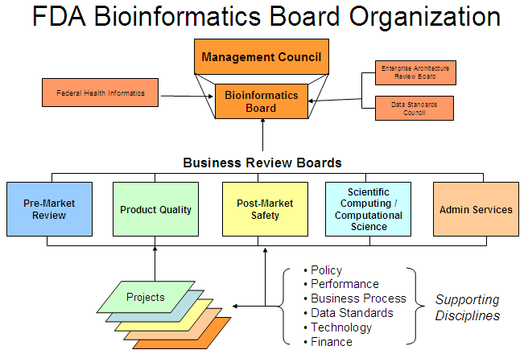

For more information regarding the Bioinformatics Board Organization, the charter can be found at: http://www.fda.gov/smg/vol3/2000/2010_7.html
The Data Standards Council charter is located at: http://www.fda.gov/smg/vol3/2000/2010_3.html

5.1 Business Modernization and Transformation
The FDA has embarked on a business modernization and transformation effort to improve how the Agency achieves its mission. The FDA initiated Agency-wide business process planning in 2003 to articulate the FDA’s mission-critical activities and to develop a strategically-aligned common business model. With support from external consultants, the FDA analyzed current regulatory business processes and supporting management and administrative processes, which led to the development of a common FDA business process framework that was ratified by the FDA’s Management Council in 2005. The business process framework describes work processes at a high level, using general language and concepts that demonstrate the commonality of core mission functions among all of the FDA product centers and other programs and organizational units. In addition, analyses of business processes were completed to assess the importance of: business process vs. capability to perform, and importance vs. IT system capability.
The business process framework was revised in 2006 to improve alignment with the FDA’s new strategic goal framework. This alignment helps ensure FDA’s business process improvement initiatives support the Agency’s strategy. The FDA adopted a consistent methodology for modeling business processes for Agency-wide initiatives. Having a consistent methodology enables the FDA to evaluate and assess business processes coherently throughout the Agency.
The BiB, through the work of the BRBs, engaged in business process modeling to better define cross-Agency opportunities. Strategic roadmaps have been developed by the BRBs and integrated together to meet the FDA’s vision of modern, integrated systems, cutting edge analytic tools, access to high quality data, and effective communication vehicles necessary to achieve the FDA’s mission of protecting and promoting public health.
Appendix 7.4 lists each of the BRBs 5-year goals, priorities, and current projects.

5.1.1 Business Process Improvement
While considering the role of information technology and automation, the FDA’s general approach to business process improvement is to:

- identify a target area for improvement
- establish performance goals
- model the business processes using the Agency-wide standard methodology; and
- identify opportunities for improvement through analysis and collaborative problem-solving

This approach includes active involvement of senior management and operational business owners who understand and champion business process improvement initiatives that improve the effectiveness and efficiency of FDA. An important component of these activities will be a continuing focus on the quality management aspects of FDA operations.

5.2 Target Architecture
The Target Enterprise Architecture (EA) for the FDA will provide a business-driven plan that describes the desired end-state for the FDA’s business architecture, data architecture, applications architecture, technical architecture, security architecture, and standards profile. The primary purpose of the Target EA is to effectively plan a course for achieving the FDA’s strategic vision and goals. It is one element in a broader set of interrelated activities that collectively enable the FDA managers and staff to define a vision, develop strategies and plans for achieving the vision, make resource decisions, implement strategies and evaluate performance.
By defining the end-state from several distinctive perspectives (e.g. business, data, etc.), the Target EA will also provide stakeholders with a view into the complex relationships that exist among these different perspectives. For example, the Target EA will provide insight into how a particular need translates into a set of target FDA business processes, and how those business processes will be supported by a common set of technologies.
The FDA has numerous information systems, executes overlapping business and information processes, and relies on a number of technologies that are expensive to maintain. To reduce costs and streamline operations, the FDA is migrating toward a more service-oriented and component-based approach to architecture. This approach, consistent with government and industry best practice, will enable the FDA to “build once, use often.” In other words, by separating out the functionality or capabilities of a business process or application into discrete pieces, components can be shared and reused across the enterprise. As a result of this approach, the FDA Target EA will:
- Improve Program Performance – The overarching benefit of the Target EA is that it provides opportunities to improve the efficiency and effectiveness of the FDA’s programs. It ensures that data is optimized in support of the business, and applications and technology solutions are driven by business needs. It also allows FDA to more readily share services/data across organizational and functional lines.

- Improve Interoperability – The Target EA establishes enterprise-wide standards that promote platform and vendor independence, enabling greater interoperability across disparate applications, both internal and external.

- Improve Utilization of Resources – The Target EA reduces system development and operation and maintenance costs by eliminating duplicative investments, promoting sharing of common services, and establishing Agency-wide standards.

- Accelerate System Implementation – The Target EA equips the Agency’s system developers and architects with an inventory of component-based services from which to choose that provide well defined functionality, thus maximizing reuse and portability of previously developed processes, components, code, etc.

- Simplify Investment Decisions – The Target EA provides a view from strategy to business function to technology, allowing decision-makers to be able to more quickly assess the relative value of initiatives, and to identify duplicative and misaligned initiatives.

- Reduce IT Diversity and Complexity – The Target EA simplifies the FDA’s IT environment by promoting standards and the sharing and reuse of common technologies.

The FDA EA program intends to accomplish this by addressing the EA in segments: Post-Market, Pre-Market, Product Quality, Scientific, and Administrative. The corporate governance structure of the FDA Bioinformatics Board and the subordinate Business Review Boards will be leveraged to architect these segments.
The Agency’s approach to target architecture development will follow OMB’s “Analyze-Architect-Implement” model. Under the “Analyze” phase, the Agency is executing three parallel initiatives to analyze and assess current regulatory business processes and the IT systems that support them. These enterprise initiatives are:
- Business Modernization / Transformation (BMT) – This initiative is described above in Section 5.1.
- IT Assessment – The FDA is conducting an IT Application Assessment to identify potential Agency-wide applications. This initiative is using a set of agreed upon criteria to assess existing IT Applications. It is sponsored through the Agency’s Office of the CIO and assesses the IT applications from two perspectives, business value and technical viability. The outcome of the assessment will be recommendations and supporting analysis that identify systems to be enhanced to satisfy common business needs, systems to be expanded and/or maintained to satisfy special purposes, and systems to be retired from the Agency’s IT portfolio. The primary focus of the assessment will be the Agency’s pre-market activities.
- Electronic Platform (e-platform) – On December 18, 2006, the FDA held a Part 15 hearing requesting public comment on transitioning to an all-electronic submissions environment and an electronic platform (http://www.fda.gov/ohrms/dockets/dockets/06n0464/06n0464.htm). The FDA requested the public to comment on the following issues related to an all-electronic environment.
  - The feasibility issues related to the electronic submission of pre-market submissions and other regulatory information; and
  - The issues related to the concept and feasibility of an electronic platform that would facilitate the exchange of clinical research information and other regulatory product information, the role of a public/private partnership helping the creation and assessment of such an electronic platform, and the management of the platform after its creation by a private entity with the relevant technological expertise.

The table below provides an update on the e-platform activities and two ongoing efforts that have a potential to become components of an e-platform.

E-Platform Initiatives

Project Name and Description | Current Status | Strategy / Milestones
E-platform: a common electronic platform for the exchange of clinical research data (i.e., the data normally collected during the course of a clinical trial, as well as the submission, receipt, and management of regulatory product information) | In March 2007 the FDA and NIH jointly issued a request for information (RFI) on the formation of a public-private partnership whose goal it would be to establish and maintain the e-platform (http://www.fbo.gov/servlet/Solicitation/R/HHS/FDA/DCASC/e-Platform-RFI). Public comments and responses to the RFI have been reviewed. | A strategy to move forward is being developed in collaboration with the NIH and the NCI with plans to finalize strategy in the first quarter of 2008.
FIREBIRD, Federal Investigator Registry of Biomedical Informatics Research Data, is a partnership between the National Cancer Institute (NCI) and the FDA to create an infrastructure to support the electronic dissemination of clinical research information. FIREBIRD enables investigators to register online with clinical trial sponsors, allows sponsors to electronically maintain and manage 1572 registrations, and eliminates the paper-based, manual process for 1572 forms by providing the FDA with electronic access to the information. | Pilot completed and limited production implementation in 2007, for NCI/Division of Cancer Prevention DCP and investigator community  Begin requirements gathering for FDA functionality | Complete harmonized FDA requirements for CDER, CBER and CDRH. Functionality includes 1572 data extraction, inspection data entry, query and reporting capabilities, integration with Center application tracking systems, and data migration from existing clinical investigator and bioresearch monitoring systems.
CP – The Collaboration Portal will provide a web-based collaboration platform where applicants and the FDA can review and negotiate SPL-based labels. This online collaboration should enhance the FDA’s ability to approve final labeling at the time of the application approval. | Requirements completed and development underway with CRADA partner | Prototype will be tested by FDA and industry users starting January 2008. If approved by business stakeholders, Release 1.0 will be in Production late 2nd quarter of 2008.

As these enterprise initiatives progress, the FDA governance process (e.g., Bioinformatics Board, PDUFA Review Board, Business Review Boards, etc.) will evaluate the aggregate recommendations and collaborate with the FDA Chief Information Officer (CIO) to define the enterprise target architecture. This Plan reflects what is known today and be updated periodically to reflect the priorities and direction of the FDA governance bodies. The following diagram graphically depicts the plan’s dependencies on two of these initiatives.

Figure 3 depicts PDUFA IV planning and analysis and how it is coordinated with planning activities across the Agency

IT Assessment (~10-12 Months)
Internal PDUFA IV
IT Plan Development
Public Comment
Revisions Cycle
P4 IT Plan
- BPI
- Data Stds
- Regs
- Functions

Jan 2007
Dec 2007
May 2008
Develop Strategic Business Area 5-year Roadmaps
Integrate Business specific Roadmap into Agency Roadmap
Prioritize, sequence and Plan

Once the enterprise target architecture is defined and business has prioritized and sequenced the Agency’s priorities, the Office of the CIO will design the IT solutions that will implement the business needs within the target architecture. As the enterprise architecture matures, FDA will focus on the development of common IT solutions that support multiple process areas (e.g., Application Submissions, Review Workflow/Tracking, Electronic Document Repositories, etc.). FDA recognizes that specific business needs exist that may not be satisfied through common software and will develop IT solutions that support these specific needs.
The Agency will leverage the outcome from the IT Assessment and other business process modeling efforts to determine which solutions can be built upon with new or additional functionality, maintained as an ongoing IT investment (steady state) or retired from service. Once this assessment has taken place, the Agency will refine the PDUFA IV IT Plan to reflect greater detail.

5.3 Guidance, Policy and Regulation
During the PDUFA III timeframe from fiscal years 2002 through 2007, the FDA developed regulations and published guidance to improve the consistency of electronic submission of regulatory documents and data. During this timeframe, there was a significant increase in the number of submissions sent to the Agency electronically. The increase in the number of electronic submissions received by the FDA can be directly attributed to the PDUFA III strategy to implement the Electronic Common Document (eCTD) submission format, the implementation of the FDA Electronic Submissions Gateway (ESG), and the implementation of the Electronic Labeling Rule (ELR) and the Physicians Labeling Rule (PLR). The development and publishing of guidance to industry and regulation changes were critical to the success of these initiatives.
During PDUFA IV, the FDA will continue to work with Industry to increase the number of submissions sent to the Agency electronically. The FDA will develop regulations and guidance to improve the consistency of data organization, to improve submission processing, to improve access to documents and data, and to improve the evaluation of submission information. The FDA will continue the work that has already begun to establish an electronic architecture for enhanced information management. This directly supports the FDA strategy for implementing an all-electronic environment.
Format and data standards are integral to the receipt of electronic submissions. The FDA will continue to work with our stakeholders to coordinate the implementation of standards through public meetings, pilot testing, external training and tutorial sessions. As standards are approved through the various standard organizations and adopted internally, the FDA will update our guidance and modify our regulations to utilize the new standards.
This section describes the FDA’s strategy for managing all policy throughout its life cycle. All important FDA policy is documented in the form of (1) regulation, (2) guidance, or (3) Manual of Policies and Procedures (MaPP) and Standard Operating Procedure and Policy (SOPP).

Regulation, Rule
A Regulation or Rule is a policy that is legally binding and enforceable. It is promulgated under the procedures set forth in the Administrative Procedure Act (5 U.S.C. 551), usually with notice and comment rulemaking.
The Unified Agenda of Federal Regulatory and Deregulatory Actions, (also know as the semi-annual regulatory agenda) is published in the spring and fall of each year. Since 1978, Federal agencies have been required by Executive Orders to publish agendas of regulatory and deregulatory activities. The Regulatory Plan, which is published as part of the fall edition of the Agenda, identifies regulatory priorities and contains additional detail about the most important significant regulatory actions that agencies expect to take in the coming year. More information can be found at the following link: http://www.fda.gov/oc/industry/unifiedagenda/agenda.html.
The FDA is working on the following proposed rules pertaining to electronic submissions:
- Electronic Registration and Drug Listing Rule
- Submission of Standardized Electronic Study Data from Clinical Studies Evaluating Human Drugs and Biologics

Guidance
A Guidance document is a nonbinding recommendation or guidance that is intended primarily to assist industry or other regulated entities. A Guidance document refers to any written communication that describes or explains an Agency or Center policy on a regulatory issue (See 20 CFR 10.115(b)). The term guidance generally refers to guidance for regulated entities (e.g., the pharmaceutical industry). In some instances, Centers have developed reviewer guidance or guidance for industry and reviewers. Guidance documents do not include (1) FDA reports; (2) general information documents provided to consumers; (3) documents relating solely to internal FDA procedures (e.g., where there is no external interaction); (4) speeches, journal articles, editorials, press materials or media interviews; (5) warning letters; (6) memoranda of understanding; or (7) other communications or actions taken by individuals at the FDA directed to individual persons or firms.
Guidance documents must be developed according to good guidance practices. The Food and Drug Administration Modernization Act of 1997 (FDAMA) amends the Federal Food, Drug, and Cosmetic Act by incorporating aspects of good guidance practices, including the provision for public participation in the development of significant guidance documents and the opportunity for public comment upon issuance of all guidance. In response to FDAMA, the FDA codified its policies and procedures for the development and issuance of guidance documents in 21 CFR 10.115 in September 2000.
Guidance documents provide assistance to the regulated industry and the FDA by clarifying requirements imposed by Congress or promulgated by the FDA and by explaining how industry and the FDA may comply with those statutory and regulatory requirements. Guidance documents are prepared to establish clarity and consistency in the FDA policies, regulatory activities, and inspection and enforcement procedures. Guidance documents provide industry with specific details that often are not included in the relevant statutes and regulations, and are intended to assist the pharmaceutical industry in carrying out its obligations under laws and regulations on subjects such as the processing, content, evaluation, and approval of drug and biologic product applications and the design, production, manufacturing, and testing of regulated products. These documents also provide specific review and enforcement approaches to help ensure that the FDA's employees implement the FDA's mandate in an effective, fair, and consistent manner. Guidance documents do not establish legally enforceable rights or responsibilities and, as such, are not binding on the Agency or the public. Rather, they explain how the Agency believes the statutes and regulations apply to regulated activities and reflect the FDA's current thinking on the subject addressed in the document.
The Agency recognizes the importance of maintaining a transparent guidance development process. Therefore, the Agency has implemented various practices intended to obtain input at the earliest stages of guidance document development and abide by good guidance practice (GGP) regulation (21 CFR 10.115).
- The Agency is required to annually publish in the Federal Register an Agency guidance agenda with the goal of soliciting comment on Agency intentions to develop guidance.
- CDER and CBER maintain Guidance Agendas on their Internet sites listing the Guidance documents they intend to issue in the current year. This enables the public to see what the Centers are working on. The link to the CDER Guidance Agenda is http://www.fda.gov/cder/guidance/ and the link to the CBER Guidance Agenda is http://www.fda.gov/cber/guidelines.htm.
- The Agency may solicit or accept early input on the need for a new or revised guidance, or assistance in the development of a particular guidance document, from individual governmental and/or nongovernmental groups (e.g., National Institutes of Health, consumer groups, trade associations, patient groups, public interest groups).
- The Agency may participate in meetings with these various parties to obtain each party's views on priorities for developing guidance documents.
- The Agency may hold meetings and workshops to obtain input from interested parties on the development or revision of guidance documents on a particular subject area.
- The Agency may hold a public workshop to discuss a draft and/or present a draft to an advisory committee when there are highly controversial or unusually complex new scientific issues.
- The Agency may issue a notice in the Federal Register soliciting public input before developing draft guidance.

Comments will be accepted at any time pertaining to all final guidance documents. Comments on guidance documents in use should be submitted to the Division of Dockets Management or to the relevant division. Guidance documents will be revised in response to such comments, as appropriate.

Policy, Procedure
Policies and procedures primarily intended to provide direction to reviewers or other staff within the Centers on how they are to do their work will be issued in a MaPP or SOPP. Instructions and templates for the proper development, formatting, processing, routing, and use of policy documents are published and utilized for each of the Centers. These instructions and templates provide consistency in the policies and procedures that are published, and decrease the time to develop, review and implement the policies and procedures in the Centers.

5.4 Data Standards
The FDA recognizes the importance of, and is committed to, using data standards for regulatory submissions wherever possible. For the purposes of this discussion, data standards can be divided into two broad categories: exchange standards and terminology standards. Exchange standards provide a consistent way to exchange information between organizations and computer systems. Exchange standards help ensure that the both sending and the receiving system both understand unambiguously what information is being exchanged. For example, Structured Product Labeling (SPL) is an exchange standard for product information. Terminology standards, on the other hand, provide a consistent way to describe concepts. For example, Unique Ingredient Identifiers (UNII) provides a consistent way to describe substances in products.
This section describes the FDA’s strategy for managing data standards throughout their life-cycle. The important principles in standards management at the FDA are described below. From the FDA’s perspective, standards should:
- Use voluntary consensus based standards developed in accredited standards development organizations in place of government unique standards unless such standards are either inconsistent with applicable laws and procedures.

- Align with existing health information technology initiatives, laws, regulations, and mandates (e.g. executive orders) and

- Coordinate with other standards currently in use.

The FDA recognizes that not all of the principles can be met in all cases. The FDA will strive to adhere to as many principles as possible when selecting a standard for implementation. The discussion that follows applies equally to both exchange and terminology standards, unless otherwise noted.
The life-cycle of a data standard can be divided into the following steps:
- Needs Assessment and Requirements Gathering
- Development, Adoption and Maintenance
- Implementation

Needs Assessment and Requirements Gathering
An FDA business component identifies the need for a standard and identifies a business sponsor to represent the business community during subsequent phases.
The appropriate Business Review Board reviews the need and, if it concurs, raises it to the Bioinformatics Board for review.
Upon concurrence, the Bioinformatics Board instructs the Data Standards Council to identify a standard that will meet the business need.
The Data Standards Council works with the business sponsor to create a working group of the FDA subject matter experts to gather business requirements.
The end-product or deliverable at the conclusion of this phase is a document that describes the business needs or defines the business processes that the standard is intended to support (e.g., scenarios, use cases, or storyboards) in sufficient detail to begin standards development and adoption.

Development, Adoption, and Maintenance
The Data Standards Council first attempts to identify an existing standard that will meet the business need. Priority is given to standards that adhere to the principles described previously. If a standard is not already available, then the DSC begins development activity. The DSC identifies and works with a well-recognized standards development organization (SDO), when appropriate to develop and adopt the standard. Priority is given to accredited, open consensus SDOs. Examples of SDOs are:
- Accredited, open consensus SDO
- International Standards Organization (ISO)
- American Nation al Standards Institute (ANSI)
- Health Level Seven (HL7)
- National Council for Prescription Drug Programs (NCPDP)
- Others
- Clinical Data Interchange Standards Consortium (CDISC)
Global regulatory standards groups (ICH, VICH, GHTF)

In instances where work with these organizations are inconsistent with applicable FDA processes or otherwise impractical or inappropriate, then the DSC may develop the standard. During this phase, the FDA tests the standard to ensure that the standard is capable of meeting the business requirements. The figure below depicts the interactions of various FDA components during this phase.

Figure 4: Standards Development and Adoption at the FDA
Bioinformatics Board
Identify data exchange or terminology standard need
Standard Development Organization
Working group of the FDA experts
Data Standards Council
Coordinate adoption or development

For new health information exchange standards, the FDA works within HL7. The FDA also encourages other business experts, such as CDISC, ICH, other government agencies, and international regulatory bodies to bring their business requirements to HL7 to ensure interoperability among health information exchange standards.

Figure 5: Developing Health Information Exchange Standards within HL7
CDISC
FDA
Data
Council
CHI/
HITSP
Global Regulatory
Research data standards
International Regulatory Standards
(e.g., ICH, VICH, GHTF)
Government healthcare and research standards
HL7
International healthcare and research standards
ISO
TC215

For terminology standards, the FDA uses existing terminologies whenever possible (rather than create new terminologies). Priority is given to terminologies that adhere to the principles described previously. The FDA recognizes its role in maintaining certain terminologies (e.g., Unique Ingredient Identifier).
The Development and Adoption phase ends when the Data Standards Council has identified or developed a standard with the appropriate conformance specifications that meets the business requirements.
The DSC works with the FDA business community and the appropriate SDO or terminology standards maintenance organization to update the standard as needed.

Implementation
The DSC presents to the Bioinformatics Board the standard that meets the business needs described during the Needs Assessment and Requirements Gathering process. The BiB seeks the advice of the appropriate BRBs in determining whether to implement a standard.
If the BiB decides to implement, then it directs the appropriate BRB to develop and execute an implementation plan, with appropriate BiB oversight and DSC interaction throughout the process. This will often require updating existing systems or developing new systems in close coordination with the Office of the CIO.
The DSC works with the business community to transition to new standards as technology advances and previous standards become outdated.
For terminology standards, the FDA partners with the National Cancer Institute Enterprise Vocabulary Services (EVS). The NCI EVS hosts the FDA terminologies and makes them freely available to the public.
In general, the implementation of standards can be difficult due to the vast number of stakeholders using or planning to use a standard. Therefore, there is a great deal of uncertainty about specific timelines.
The FDA is committed to working throughout the standards development and implementation process describe below with the business community to bring important improvements in information management that provide significant performance benefits and improve public health and safety. The DSC standards efforts underway are illustrated in the following two graphics. More specifics about each standard is outlined in Section 6.0.

Figure 6: Data Exchange Standards Process
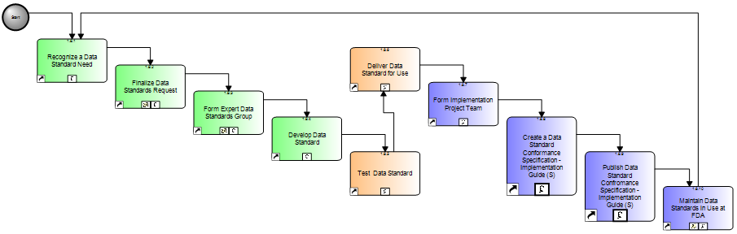
* SPL (Release 3)
* Annotated ECG
* RPS (Release 1)
*SPL (Release 4 - Listing)
* ICSR (Release 2)
*SPL (Release 4 - Listing)
* Structure Product Labeling (SPL) (Release 4 - Devices)
* Product Stability Data
* CDISC HL7
* Regulatory Product Submission (RPS) (Release 2)

* Individual Case Safety Report (ICSR) for Adverse Events (Release 3)

Figure 7: Terminology Standards Process
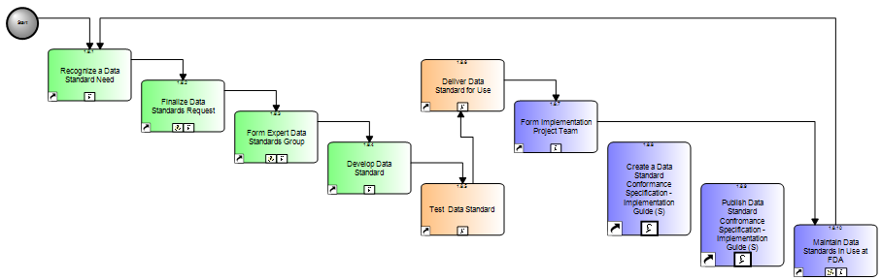
* SPL Terminologies
* SRS
* SRS - Vaccines
* SRS - Polymers
* ICSR Terminologies
* RPS Terminologies

* Substance Registration System (SRS) - Allergenic
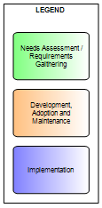

An important measure of success is how well the standard is implemented according to a well-described, well-designed, publicly available implementation plan.
Another important measure of a successful standard is the extent to which the standard improves existing business processes. This measure depends on the existence of business performance metrics and data before and after standards implementation.

Data Standards Investment Strategy
As previously described, the life-cycle management of data standards at the FDA is a complex process that requires careful planning, execution, and assessment. Not surprisingly, effective data standards management at the FDA requires a coordinated investment strategy across various FDA components to achieve success. Overall, the FDA must achieve:
- An adequate number of FTEs dedicated to data standards management, as well as
- Sufficient funding to support data standards projects

During needs assessment, the Bioinformatics Board and the associated Business Review Boards play a dominant role in assessing the FDA’s needs for a new standard. The Data Standards Council provides a data standards liaison to the BRBs to provide guidance and/or mitigate risks related to existing or new standards work within the DSC or relevant Standards Development Organizations.
During requirements gathering, development, adoption, and maintenance of a data standard, the DSC plays the dominant role. The DSC staffing consists of core experts in data standards development and volunteers/representatives from the various programs with expertise in the respective business processes. The DSC support activities associated with this phase of data standards management include;

- Interaction with standards development and standards maintenance organizations
- Exchange standards development
- Data standards requirements gathering / use case development
- Modeling requirements and use cases (e.g., modeling to HL7 Reference Information Model)
- Testing model against requirements and use cases to include development of visualization tools (e.g., stylesheets, XForm) documentation and coordination assistance
- Balloting (e.g., ballot preparation, presentation and reconciliation)
- Accreditation
- Conformance specifications (implementation guide)
- Terminology standards development
- Standards maintenance (e.g., Unique Ingredient Identifier, NCI Enterprise Vocabulary Services)
- Training and implementation support
- Support for training or other related IT development activities associated with standards adoption and implementation (e.g. data type specification, message instance examples or data standards harmonization)

During the Implementation phase, the Bioinformatics Board and the Office of the Chief Information Officer play the dominant role in data standards implementation, with substantial support from the Data Standards Council and the Office of Planning. Implementation activities include;
- Business and IT impact analyses
- Development or enhancement of an IT system to use the standard
- Business process re-engineering
- Training
- Change management
- Outreach activities to the FDA stakeholders

6.0 Programs
This section is divided into two sub-sections; Pre-Market Activities and Post Market Activities. The purpose of this section is to describe the current IT environment at a high-level and to show the FDA’s current vision for the PDUFA IV target environment. As stated in previous sections, there are a number of ongoing planning activities that may impact how (e.g. the role of the e-Platform) and when (i.e. ensuring alignment with Agency strategic goals) the FDA is moving towards an automated standards-based IT environment. Although the FDA is continuing to address the strategy to fully implement the standards-based environment, the FDA has made a number of important strategic decisions in moving towards this vision and the initiatives described below reflect those decisions and the direction of the PDUFA Program. The division of this section into Pre-Market and Post-Market has been done for readability purposes, the FDA’s plans and governance structure has been setup to ensure that information is shared throughout the product life-cycle. Examples of this are FDA Electronic Submissions Gateway and the FDA Common EDR initiative, these are described in the Pre-Market section but the scope of these efforts includes all regulatory documents.

6.1 Pre-Market Activities
In the past, most Centers in the FDA have developed and implemented software developed by their Center IT organizations. During the PDUFA III timeframe the FDA implemented the FDA Electronic Submissions Gateway across the Agency and implemented the eCTD Review System, but both CBER and CDER continue to have separate systems to track and report on PDUFA goals and timelines. Many times there are separate systems to track PDUFA goals (e.g. meeting request). The diagram below represents the current environment at a high-level without providing the details on all the current systems supporting CBER and CDER.

Figure 8: E Submission Tracking and Archiving Premarket Current State

Gateway
CBER EDR
Review Systems

eCTD
eBLA
eIND
CDER EDR
Review Systems
Labeling Review System

The Pre-Market target diagram represents FDA’s current approach in developing and implementing an automated standards-based IT environment that will support the Agency’s strategic goals and enable the FDA to meet the PDUFA IT Goals.

Figure 9: E Submission Tracking and Archiving Premarket Target State based on Standards Based Submissions

Gateway
FDA Common EDR
Review Systems
RPS SDTM SPL
Public Access
The table below describes the various initiatives and activities that are being performed or planned to move towards the target IT environment. The table describes the project, gives some background on the current status, discusses the FDA strategy and milestones for the project, and provides information on the PDUFA IT Goals that the project supports.

Project Name and Description | Current Status | Strategy / Milestones
Regulated Product Submission, RPS, is a Health Level Seven (HL7) standard to facilitate the processing and review of regulated product information. The next generation of processing the eCTD format will be transitioned to the RPS standard. The FDA plans on using the RPS standard to meet the PDUFA goal to cross-reference to previously submitted electronic materials through standardized automated links and to standardize the two-way communication between the sponsor and the FDA by incorporating these requirements into RPS Release 2. Release 2 will incorporate the following requirements;  - Two-way communication  - Minutes and general correspondence (related to two-way communication) including pre-submission information  - Referencing  - in backbone (Master Files, Other submission/application, Pre-submission)  - Hyperlink content to other content  - Provide information about the submission (e.g. information currently collected on application forms)  - information about the product  - Contact Information  As of January 1, 2008 CDER will only accept electronic submissions in the eCTD format. To facilitate the transition to the CTD format FDA will start accept CTD submissions based on the RPS standard for a limited set of submissions. These submissions have been part of a paper submission with the electronic portion submitted in the eNDA format. Applicants and sponsors will be permitted to submit RPS using the CTD format for the following types of submissions;  - SPL to a paper NDA/BLA  - Electronic datasets to a paper IND/NDA/BLA  - Single Investigator IND  FDA will provide applicants/sponsors access to web-based forms to create and submit the submission types above. This strategy will allow the PDUFA program to start to transition to the RPS standard and permit current applicants/sponsors using the eNDA format or paper to move to the CTD format. | Release 1 of the RPS standard was passed in May 2007. | - Implement/accept RPS submissions in the first quarter of 2008 for;  - SPL submissions to a paper NDA/BLA.  - Electronic datasets to a paper IND/NDA/BLA.  - Single Investigator IND.  - RPS Release 1 HL7 Implementation Guide ready for ballot in 2nd quarter of 2008.  - Target for addressing PDUFA requirements RPS DSTU Release 2 – HL7 ballot 3rd quarter of 2008.  Additional RPS activities:  - The Office of Combination Products (OCP) is finalizing the common format for combination product submissions, leveraging the CTD format and the PMA & 510(k) submission formats. The goal is to complete the submission format in the first quarter of 2008 and to test the submission format in 2008.  - CDRH has defined the submission format for Premarket Approval (PMA) and Premarket Notification 510(k) applications and plans on testing the RPS standard during 2008.  - CFSAN is currently working on guidance for Food Additive Petition and Color Additive Petition submissions and plans on testing and accepting production submissions in 2008.
The FDA Electronic Submissions Gateway (ESG), an FDA-wide solution that enables the secure submission of electronic regulatory submissions has been in production since May 2006, the ESG provides the single point of entry for the receipt and processing of all PDUFA submissions.  Both CBER and CDER fully automated the electronic submission process by implementing automated systems to expedite the processing and increase the availably of properly formatted ESG submissions. The electronic submission process encompasses the receipt, acknowledgment of receipt and any processing errors (to the sender), routing, notification (to a receiving Center or Office), and providing access to the review team of the electronic submission. | In FY2007, the ESG received and processed over 147,000 pre-market and post-market submissions. Most of these submissions were post-marketing safety reports, during the last six months of FY2007 the ESG was processing over 13,800 post-market safety reports per month. In the pre-market area, the ESG was averaging over 1100 submissions per month. Information on the ESG process and requirements is at: http://www.fda.gov/esg | - In the first quarter of 2008 the FDA plans to upgrade the ESG, by providing a method to include the Center & Submission Type attributes in the AS2 Routing ID. This upgrade will enable the FDA to phase out the AS1 submission method for drug safety reporting.  - As stated in the PDUFA IT Goals, the FDA will extend the capability of the secure single point of entry to include two-way transmission of regulatory correspondence. The FDA has had preliminary planning discussions on expanding the ESG functionality to meet this goal. The FDA does not plan on expanding the ESG functionality in 2008.
eCTD review system – The current FDA eCTD review system was implemented in 2005, and allows reviewers to review submissions submitted in the ICH eCTD format. The review system provides search capabilities and reviewers are able to track the progress of the eCTD submission review at the section level. The eCTD review system functionality includes a validation component that provides a log of the submission errors. | The current review system is in operations and maintenance, with the latest release providing the FDA with the capability to integrate the eCTD review system with the CBER and CDER submission tracking databases. | - The current activity is focused on the validation component of the software. The FDA plans to use this to validate individual eCTD submissions and to gather statistics on the number of submissions in compliance with FDA standards, along with a distribution of the submission failures by problem type. The FDA has implemented this functionality at the end of 2007.  - In relation to the RPS strategy, the FDA plans on using the eCTD review system to review RPS based submissions.
Workflow tracking and information management system -  Is a flexible, integrated, fully electronic workflow tracking and information management systems to receive, log, track, assign, process, and manage official submissions with internal and external stakeholders. The system maintains the official submission records and will manage and track all communications and documentation concerning a submission. | Release 1.0 on 1/28/2006, for Therapeutic Biologic Product INDs  Release 1.4 on 1/29/2007 for Safety Issues  Releases 1.1 through 1.6 also provided system enhancements and bug fixes | - Release 2.0 on 11/13/2007, for all CDER INDs, Master Files and Emergency Use Authorizations plus system enhancements and bug fixes.  - Release 3.0 end of 2008 for all CDER NDAs and ANDAs.  - Release 3.x after 2008 for CBER and CDER BLAs.
FIREBIRD – Please refer to the e-Platform Initiatives in Section 5.2.
Information and Computer Technologies for the 21st Century, ICT21, investment will enable the FDA, through the development of an Agency-wide bioinformatics initiative, to strengthen product development and approval, improve manufacturing and product quality, strengthen post-approval surveillance and safety, support electronic prescribing, and improve clinical decision support. The FDA expects to see mature electronic health records, personal health records, and networks that connect them. To meet these challenges and requirements, the FDA must modernize its capacity and communication capabilities by establishing a standardized approach for delivering IT services through this Agency-wide bioinformatics initiative to fulfill its core public health responsibilities and respond to emerging challenges. | Completed Baseline Assessment  Completed Phase 1 of Bioinformatics Transfer Plan | - Establish and implement Program Management Office.  - Complete detailed Alternatives Analysis.  - Complete Phase 2 of Bioinformatics Transfer Plan.  - Complete Bioinformatics design.  - Complete First Phase of Bioinformatics Platform migration.
FDA’s Common Electronic Document Room (EDR) initiative is intended to establish one common, Agency-wide, standards-based EDR as a single platform database for all FDA-regulated product documents. Having a single platform database that contains all documents related to the FDA-regulated products will improve access to all FDA documents, data, and metadata across center lines, thus enhancing the ability of Agency pre-market reviewers and others to perform their jobs. In addition, having an Agency-wide EDR offers the opportunity to reduce redundancy and related costs and complexities associated with maintaining multiple electronic document rooms.  Benefits/Strategy: A Common EDR provides the FDA with the capability to streamline the submission process, provide reviewers’ additional collaboration capabilities, provide reviewers access and search for information across traditional organizational boundaries, and position the FDA to share and interact with external networks/systems as an Agency (e.g. e-Platform). | Concept proposal approved by the Bioinformatics Board  Project Charter  IT Project Team was formed to define the document the current (as-is) environment. | - Current activity is to define the scope of the Common EDR.  - Development and Testing of the Common EDR Functionality – 4th quarter of 2008.  - Full Implementation – 3rd quarter of 2009.
The Facts@FDA program is part of the broader US effort to achieve electronic prescribing and other e-health information technology initiatives: ELIPS, e-List, CP, and SRSID
Electronic Labeling Review System – The Electronic Labeling Review System receives and processes electronic labeling information through the Structured Product Label (SPL) standard format. The labels received by the FDA in SPL format are available on the Internet at DailyMed, part of the National Library of Medicine (NLM).  The Data Warehouse (DW) functionality provides users ad-hoc report and query capability on transmitted SPLs. | Release 1.0 on October, 2005 to support receipt, store, review, and transmission of SPLs to NLM.  Release 3.0 on February, 2007 to support PLR SPLs.  DW release 1.0 on October, 2006 provides initial query and report capability via an Agency Reporting tool. | - Address the system performance issue. Continue with operation and maintenance.  - Interface with the workflow and information management system to access (migrated) NDAs and ANDAs.
Electronic Listing – Electronic listing will provide the ability to automate drug listing information and validation processes. The SPL data elements from the labels will be extracted and reused. The listing information will be available to the public through DailyMed and other electronic means. | Requirements completed and development underway with CRADA partner | - Prototype will be tested by FDA and industry users starting 1st quarter of 2008. If approved by business stakeholders, Release 1.0 will be in Production in 2nd quarter of 2008.
CP (Collaboration Portal) – Please refer to the e-Platform Initiatives in Section 5.2

Substance Registration System – The overall purpose of the joint FDA/USP Substance Registration System is to support health information technology initiatives by generating Unique Ingredient Identifiers (UNII) for substances in drugs, biologics, foods and devices. The UNII is a non-proprietary, free, unique, unambiguous, non-semantic, alphanumeric identifier based on a substance’s molecular structure and/or descriptive information. | Release 1.0 on September, 2005 to support registration and review of substances and ingredient names. This release provides Unique Ingredient Identifier (UNII) standard terminology for use in SPL.  Release 1.4 allows all FDA personnel to query and view approved substances. | - Continue with operation and maintenance.  - Interface with the workflow and information management system release 2.0 to access (migrated) Drug Master File.

The diagram and table below describes the FDA’s direction in moving towards XML based exchange messages to submit clinical and preclinical information to the FDA. The diagram is the FDA current thinking on how the process might work by leveraging the CDISC efforts by the end of PDUFA IV, September 30, 2012. As stated in the Guidance, Policy and Regulation section (5.5) the FDA is currently working on a proposed rule that would require the electronic submission of clinical data to the FDA. The FDA is also working with the National Coordinator for Health Information Technology within the Office of the Secretary of the Department of Health and Human Services to coordinate FDA efforts with the Federal Government effort to develop and implement an interoperable electronic medical record by 2014.
Figure 10: PDUFA IV Target Clinical Data Flow
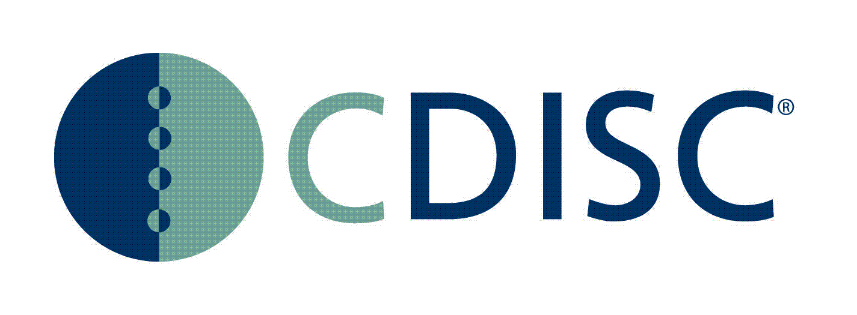
MedWatch AE Reports (ICSR)
Janus
FDA/NCI
Analytical Data
Warehouse
FDA Reviewers
Trial Design

Sponsor
Data
Warehouse
(ODM)
Data Checker
and Loader
Review
Tools
Sponsor
Site Data
Archive
(ODM)
Site
Interchange:
HL7 output file
CDISC Content and Interchange

CDISC Content
CDASH
SDTM
ADaM

Project Name and Description | Current Status | Strategy / Milestones
Clinical/Preclinical Data Standards & Initiatives –
The FDA receives massive amounts of clinical research data in extremely disparate formats using a variety of proprietary standards. This makes it extremely difficult, if not impossible, to do cross-study and application reviews. The FDA has been working towards a standardized approach to capture, receive, and analyze clinical study data. The standardization of clinical data is vital to the FDA strategic initiatives to integrate pre-marketing clinical trial data and post-marketing safety data to improve public health and patient safety. The goal of these efforts are to;
- Enhance FDA regulatory decision making and address complex public health questions through improved data management through;
  - Standardize data - exchange and terminology standards to facilitate data aggregation, analysis, data mining and signal detection
  - Improved access to aggregate data
  - User friendly tools for review
- Support of the FDA Critical Path Initiatives supporting regulatory research
  - Safer, effective products
  - More efficient product development

The foundation for the standardized clinical content is the Clinical Data Interchange Standards Consortium (CDISC) Study Data Tabulation Model (SDTM). The SDTM will also include nonclinical requirements based on the Standard for Exchange of Nonclinical Data (SEND) models that is being harmonized with the SDTM. The CDISC content will be sent to FDA as an XML message using the Health Level Seven (HL7) Reference Information Model (RIM) and harmonized with the Biomedical Research Integrated Domain Group (BRIDG) Model.

SDTM version 3.1.1 submissions are accepted by FDA. A draft implementation guide for SDTM 3.1.2 is currently under review by CDISC and FDA. FDA and CDISC are in the process of forming a communications team that will ensure SDTM meets FDA’s scientific requirements.
CDISC - HL7 Project - The FDA plans to transition to HL7 exchange messages for submission of all study data. This initiative is based on the outcomes of the CDISC Content to HL7 Message Exploratory Project. The objective of the Exploratory Project was to;  - Harmonize the SDTM into the BRIDG model (see below).  - To identify HL7 exchange message content for submission to a regulatory authority that addresses; a) study summary (clinical trial registry), b) eligibility criteria, c) trial design (including parts I and II: arms, elements visits, planned assessments, and planned intervention(s)), d) statistical analysis plan, e) collected data/study data tabulations and f) derived data/analysis datasets, all of which are currently defined by the CDISC standard. | CDISC Content to Message Project initiation was approved by the HL7 Regulated Clinical Research Information Management (RCRIM) Technical Committee 11/2007. | - The FDA is proposing the development of four messages that map to content areas identified above.  - Study Design  - Study Participation  - Subject Data  - Individual Case Safety Reporting (ICSR)  - This process also includes the completion of the BRIDG Model harmonization, to ensure that all content has been identified and harmonized with the model before achieving normative status.
BRIDG Model - The Biomedical Research Integrated Domain Group, BRIDG Model, is a domain analysis model representing protocol-driven biomedical/clinical research. The BRIDG Model is a collaborative effort of stakeholders from the Clinical Data Interchange Standards Consortium (CDISC), the HL7 Regulated Clinical Research Information Management Technical Committee (RCRIM TC), the National Cancer Institute (NCI), and the FDA to produce a shared view of the dynamic and static semantics that collectively define the shared domain of clinical and pre-clinical protocol-driven research and its associated regulatory artifacts. In the case of the BRIDG model, the domain is defined as:  Protocol-driven research and its associated regulatory artifacts, i.e. the data, organization, resources, rules, and processes involved in the formal assessment of the utility, impact, or other pharmacological, physiological, or psychological effects of a drug, procedure, process, or device on a human, animal, or other biologic subject or substance plus all associated regulatory artifacts required for or derived from this effort.  The BRIDG Model serves to bridge standards, as well as organizations and various communities, including academic research institutions and pharmaceutical product development organizations and related service and technology providers. It is also bridging the gap between clinical research and healthcare. | As of Release 1.1, in October 2007, the content has been drawn from six projects:  - Study Data Tabulation Model (SDTM) – CDISC  - caXChange/LabHub (including Periodic Reporting of CT Laboratory Results and Lab Model) -- NCI/HL7/RCRIM TC/CDISC  - Regulated Product Submission (RPS) -- HL7 RCRIM TC  - Cancer Trial Object Model (CTOM) – NCI (approximately 50% of the total content)  - Trial Design Model (TDM) – CDISC  Patient Study Calendar, Phase II (PSC) – NCI | - As mentioned above, any content identified as part of the CDISC - HL7 Project will be harmonized with the BRIDG Model in coordination with the BRIDG scheduled releases.
The JANUS data warehouse for both animal and human study data is being developed by the National Cancer Institute (NCI) with the FDA participating through its Interagency Oncology Task Force activities. The NCI and the FDA are collaborating to implement a common, standards-based electronic infrastructure for regulatory data and document submission, review, and analysis. The standard for the submission of study data for Janus is the Clinical Data Interchange Standards Consortium (CDISC) Study Data Tabulation Model (SDTM) which includes the standard for animal toxicity data being developed by CDISC’s SEND Team. SEND data is designed to work with data viewer (ToxVisionTM) developed through CRADA with PharmQuest, Inc. (PharmQuest is now Pointcross) | Memorandum of Understanding with NCI signed in March 2007.  Established Janus Change Control Board (CCB) with representation from NCI, FDA, CDISC, and industry.  Implementation of Phase 2 pilot, which integrates two reviewer tools (WebSDM, JReview) with the Janus repository. Phase 2 involves development of a data validation and import facility, loading of validated SDTM datasets into Janus repository, and creation of analytical views based on used cases using reviewer tools. Phase 2 completed in the 4th quarter 2007. | - Plan for and implement a Phase 3 pilot that includes extensions of the Janus logical data model and a service-oriented architecture designed to support the submission of HL7 messages and leveraging of NCI’s Enterprise Vocabulary Service (EVS) to begin to address controlled vocabulary issues.  - Establish two-way data exchange between FDA and NCI using FDA’s electronic gateway.  - Have the CDISC-HL7 messages completed and accepted as HL-7 draft standards for trial use Draft Standard for Trial Use (DSTU).
Standard for Exchange of Nonclinical Data (SEND) Pilot - CDER is conducting a pilot project to test, in a regulatory setting, the electronic submission of nonclinical study data using the CDISC Standard for Exchange of Nonclinical Data (SEND). The purpose of this pilot is to test the ability of a new electronic data format to support nonclinical review activity. The pilot also will involve a collaboration of FDA, available pilot participants, and the SEND team to update and create a new draft SEND implementation guide that will harmonize SEND with SDTM. FDA anticipates that a successful pilot will enable CDER to routinely accept nonclinical study data electronically in SEND format, instead of paper or portable document format (PDF), in investigational new drug applications (INDs), new drug applications (NDAs), and biologics licensing applications (BLAs). | CDER recently completed a related pilot project (phase 1) that asked for volunteers from industry to submit sample nonclinical datasets in the SEND format outside of a regulatory setting (68 FR 3885; January 27, 2003). The phase 1 pilot also evaluated data validation and analysis tools specifically designed to validate datasets according to the current SEND standard and to enable a reviewer to efficiently display and evaluate data from animal toxicity studies submitted in the SEND format. The phase 1 pilot resulted in development of a SEND Implementation Guide (Version 2.3; November 2005), which is available on the CDISC Website (http://www.cdisc.org/models/send/ v2.3/SENDV2.3Implementation Guide.pdf). The SEND Implementation Guide describes the process for formatting nonclinical data from single and repeat-dose animal toxicity and carcinogenicity studies for submission purposes. The pilot also resulted in the development of specialized software tools for validating, displaying, and analyzing SEND-formatted nonclinical data. | - The 3-year pilot project is to test the CDISC SEND model with the long-term goal of replacing the existing paper/PDF based listings of nonclinical study data.  - For this 3-year phase 2 pilot, full study reports of the following types of animal toxicity studies will be requested for submission to an existing IND in the appropriate CDER review division: (1) Repeat-dose toxicity studies of 14 days duration to 12 months duration in any species, (2) lifetime carcinogenicity studies in rats or mice, or (3) 6-month carcinogenicity studies in transgenic mice. Studies should include toxicokinetic data, if available. Depending on the ongoing efforts of the SEND Consortium to expand the SEND implementation guide, additional nonclinical study types may be piloted in the future. If so, FDA will post on the FDA SEND Web page an updated list of study types the Agency will accept in this and any future pilots. We anticipate that a successful phase 2 pilot, which includes implementation of any needed changes to the SEND implementation guide and/or the data validation, viewing, and analysis tools, will allow CDER to routinely accept specific types of nonclinical study data provided electronically as SAS transport file (XPT version 5) datasets based on the SEND format. In the case of carcinogenicity studies, a successful phase 2 pilot will enable submission of the entire carcinogenicity study data in the electronic SEND format, thus eliminating the need for a separate submission of the electronic tumor dataset (i.e., tumor.xpt).
Electronic Case Report Form eCRF Pilot - The purpose of the eCRF pilot project is to obtain experience with the CDISC Operational Data Model (ODM) based CRFs, with the goal of replacing the existing portable document format (PDF)-based CRFs derived from clinical trials that use EDC and, therefore, lack paper CRFs. A successful pilot will allow CDER and CBER to routinely accept CRFs from studies that employ electronic data capture (EDC) in ODM format in marketing applications submitted in electronic format. | Six pilot participants have been identified and a pilot schedule is being developed. | - Based on our experience, PDF-based CRFs from clinical trials that employ EDC are not ideal to support all review activity. Although the PDF-based CRFs for trials that use EDC can provide a record of the observations collected during the trial (i.e., the data) and additional information about what was collected (metadata), they typically do not provide an audit trail. CDER and CBER are interested in adopting a new, standard format that can replace the PDF-based CRF and that can reliably provide all three components of the CRF in an electronic format: Data, metadata, and audit trail.  - The ODM is an XML-based standard that facilitates the electronic exchange of clinical trial data, metadata, and audit trail. We are working with CDISC to develop the capabilities within CDER and CBER to review CRFs using ODM. CDISC employed the current production version (Version 1.2) of the ODM on the CDISC Web site, and we performed some initial testing of limited CRF data in ODM. To help in this development, we are launching this pilot project and seeking sponsors willing to provide CRFs in ODM format to test our capabilities to review these files. However, data supplied during the pilot project will not replace any regulatory requirements for submitting CRFs.  At this time, the pilot has not defined set timeframes for the submission/analysis of eCRFs.
CDISC CDASH (Clinical Data Acquisition Standards Harmonization) - The project goal is to develop a set of "content standards" (element name, definition, and related metadata) for a basic set of global data collection fields (also known as CRF, or Case Report Form, variables) that will support clinical research studies.  The initial scope of the project is the development of 16 CRF content ‘safety data/domains’; Adverse Events, (Prior and) Concomitant Medications, Comments, Demographics, Disposition/End of Study, Drug Accountability, ECG, Exposure, Inclusion and Exclusion Criteria, Lab, Medical History, Physical Examination, Protocol Violations, Subject Characteristics, Substance Use, and Vital Signs. These safety domains are common to all therapeutic areas. The initial scope is not the physical layout of the CRF or terminology; terminology is incorporated through collaboration with the CDISC Terminology Team.  Basic data collection fields identified by CDASH project work streams are mapped into the Study Data Tabulated Model (SDTM) and are compliant with the SDTM Implementation Guide (SDTM IG).  FDA’s role in this effort is to ensure that the CRF regulatory requirements are being addressed. | These ‘safety data/domains’ were divided into four separate packages or work streams. The CDASH project has addressed all of the ‘safety data/domain’ areas and FDA has provided comments on all four packages to ensure that regulatory requirements will be met. | - The next steps are for the CDASH project team to assemble the comments on each of the packages. After there is agreement on the content the CDASH ‘safety data/domain’ information will be released for public comment in the first quarter of 2008.
CDISC ADaM - Analysis Data Model-The ADaM datasets are designed to provide a clear and unambiguous communication of the content, source and quality of the datasets supporting the statistical analyses performed in a clinical study. They provide a standard for transferring analysis datasets between sponsors and FDA. | ADaM datasets have been pilot rested by CDER review staff.
Terminology - Terminology binding and RIM harmonization will be done following the HL7 Development Framework and applicable stakeholder processes.

6.2 Post-Market Activities
As outlined in the Pre-Market Activities section, most Centers in the FDA have developed and implemented software developed by their Center IT organization to track and analyze spontaneous post-market safety reports. The CDER Adverse Event Reporting System (AERS) has been the exception to this rule. Although the drug safety reports are submitted to and processed by CDER, both CBER and CDER use the same AERS application to view the ICSR and the same data warehouse to perform analysis on the safety reports. Within the PDUFA program there is a separate reporting mechanism for the submission of vaccine adverse reports; this process is handled by the Center for Disease Control (CDC) with the information transferred to CBER for analysis.

Figure 11: E Submission Tracking and Archiving Postmarket Current State


Gateway
ICH/
ICSR
CDER
AERS
CDER/CBER
Data Warehouse
Review System
Analysis System
VAERS
Vaccine Reports
CBER EDR
Review System

The Post-Market target diagram represents FDA’s future approach in developing and implementing an automated standards-based IT environment that will support the Agency’s strategic goals and enable the FDA to meet the PDUFA drug safety IT Goals. As described below the FDA is taking an Agency approach in capturing, tracking, and analyzing drug safety reports through the MedWatch Plus initiative.

Figure 12: E Submission Tracking and Archiving Postmarket Target State

VAERS
Vaccine Reports
Review System
Gateway
FDA Common EDR
HL7/
ICSR
MedWatch Plus Portal
Mandatory Reports
FAERS
Analysis System
Review System
Public Access

Project Name and Description | Current Status | Strategy / Milestones
The MedWatch ^{Plus} initiative will enable the FDA to improve the timeliness, accuracy, and usability of its product safety surveillance data by significantly reducing delays and errors associated with manual data entry and coding of paper reports. It will provide a user-friendly internet portal for anyone to report an adverse event resulting from a FDA-regulated product. The portal will be supported by an Agency-wide repository of adverse event reports (FAERS) with integrated safety signal management and analytical tools. | High-level MW+ Requirements completed.  MOU with NIH to develop intelligent questionnaire for the Internet portal.  High-level and Detailed Business and IT requirements completed for FAERS.  Acquisition active as of 9/24/2007. | - Complete MedWatch ^{Plus} requirements definition.  - Award MedWatch ^{Plus} integration contract.  - Select FAERS COTS toolset.  - Rollout CDER/CBER FAERS release.  - Rollout CDRH/Office of Combination Products release.  - Complete MedWatch Plus portal.  - Integrate MedWatch ^{Plus} portal with FAERS.
Sentinel System - The FDA, in coordination with other Federal agencies, recommends assembling an integrated “virtual” national medical product safety system -- the Sentinel System -- which would enable the electronic flow of safety information to and from the point of care. The system will build on existing public and private efforts through multiple, broad-based, public-private collaborations. | Sentinel public meeting held March 7 and 8, 2007 with over 400 pages of transcripts posted to public docket. | - Strengthen capability to draw data from sources like electronic health records and medical claims.  - Establish the ability of the FDA to query other systems quickly and securely for relevant product safety information.  - Establish methodologies to use Sentinel data to support epidemiology and other safety studies.

The modernized post-market safety related IT systems will ensure the best collection, evaluation, and management of the vast quantity of safety data that may be received by the FDA as noted below in figure 13. Improvement in the infrastructure will support access to and the analyses of externally linked databases, as well as enhancement of the FDA’s AERS and safety signal detection and management tools. The MedWatch Plus initiative will result in a common FDA portal for electronic receipt of adverse event reports from the public and will provide direct electronic transfer of these reports to the database and data analysis tools.
In addition to the enhancement and modernization of the drug safety systems, the FDA will be expanding CBER’s and CDER’s acquisition/access and analyses of externally-linked databases for purposes of targeted, or active, post-marketing surveillance. The figure below includes both passive surveillance data sources, and active surveillance data sources that FDA will use to ensure drug safety.

Figure 13: Sources of both Passive and Active Surveillance Data for FDA Drug Safety Activities 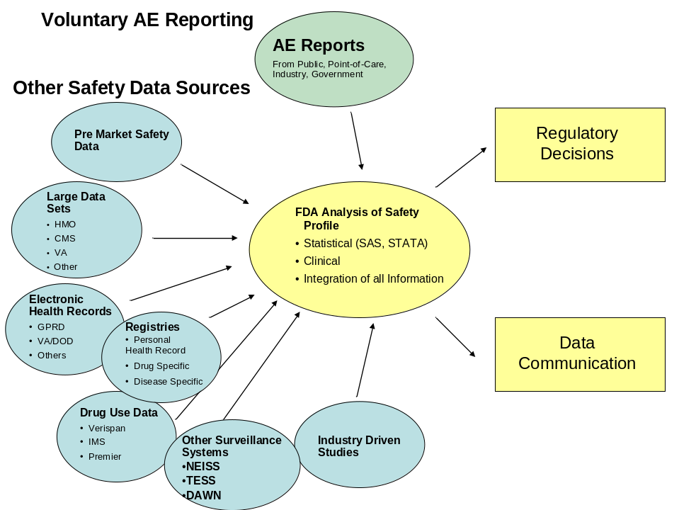

7.0 Appendices

7.1 PDUFA IV Metrics
The PDUFA IV Information Technology Performance Goals Metrics and Measures subsection (Section XIV, D) states, ‘FDA will measure progress toward achievement of the objectives defined in PDUFA IT Goal A.’ One of the measures the FDA has agreed to track and report on is spending on common IT systems, item 3 under the Metrics and Measures subsection. It states ‘Annual spending on maintenance of legacy IT systems and IT systems that are common across the organizational divisions participating in the process for the review of human drug applications.’ The FDA will report on the progress towards a common PDUFA IT environment by reporting on the percentage of funding used for Common IT Systems and Legacy IT Systems. Each of these categories is defined below.
Common IT Systems – Development & maintenance spending on software applications, tools, and other products that both CDER and CBER use or plan to use to receive, track, and review PDUFA submissions. In addition, enterprise architecture activities and IT infrastructure consolidation activities are incorporated into this category of spending.
Legacy IT Systems – Development & maintenance spending on software applications that are used by a single Center and that overlaps with software functionality performed by another Center. These systems are not part of the target enterprise architecture.
The FDA will report on progress towards a fully electronic submission process by reporting on NDA, BLA, and IND submissions that are totally electronic and submitted through the FDA Electronic Submissions Gateway. The FDA will provide overall progress towards this objective including information based on the type of submissions. In addition, electronic standards based submissions will be reported that fail to comply with FDA electronic submission standards across categories of failure or problem type.

7.2 PDUFA Information Management/IT Goals and Objectives
INFORMATION TECHNOLOGY GOALS (Section XIV)
A. Objectives
1. FDA is committed to achieve the long-term goal of an automated standards-based information technology (IT) environment for the exchange, review, and management of information supporting the process for the review of human drug applications throughout the product life cycle. Towards this goal, FDA will work toward the accomplishment of the following objectives by the end of FY 12:
a) Develop and periodically update an IT plan, as defined in Sections B) and C) below, covering a rolling five-year planning horizon.
b) Develop, implement, and maintain new information systems consistently across all organizational divisions participating in the process for the review of human drug applications, and in compliance with the IT plan, the FDA’s program-wide governance process, the FDA’s target enterprise architecture, and with HHS enterprise architecture standards. The consistency of development, implementation, and maintenance of new information systems will be determined by the FDA based on considerations of program efficiency and effectiveness. Emphasis will be placed on the consistency of interactions with regulated parties and other external stakeholders.
c) Update technical specifications and IT-related guidance documents as necessary to reflect consistent program-wide implementation of new information systems supporting electronic information exchange between FDA and regulated parties and other external stakeholders.
d) Extend the capability of the secure electronic single point of entry to include two-way transmission of regulatory correspondence.
e) Establish an automated standards-based regulatory submission and review environment for INDs, NDAs, and BLAs, and their supplements, that enables the following functions over the life cycle of the product:
(1) Electronic IND, NDA, and BLA submissions received by FDA can be archived to enable retrieval through standardized automated links;
(2) Electronic IND, NDA, and BLA submissions can include cross-references to previously submitted electronic materials through standardized automated links; and
(3) Archived electronic IND, NDA, and BLA submissions can be retrieved through standardized automated links.

f) Establish a system for electronic exchange and management of human drug labeling information in a modular manner (e.g., at the label section level) that is based on FDA standards and that enables revision tracking.
g) Establish standards-based information systems to support how FDA obtains and analyzes post-market drug safety data and manages emerging drug safety signals, as described in Section VIII addressing the enhancement and modernization of the FDA drug safety system.

B. Communications and Technical Interactions
1. FDA will develop and periodically update a five-year IT plan for improving the automation of business processes and acquiring and maintaining information systems to achieve the objectives defined above in PDUFA IT Goal A. The plan will include measurable or observable milestones toward achievement of those objectives.
2. The IT plan will be reviewed and approved through the appropriate FDA governance process to ensure it conforms to the Agency’s overall long-term automation strategy.
3. The IT plan will be drafted, published on the FDA web site, and updated as follows:
a) FDA will publish a draft of the IT plan by December 31, 2007. At that time, FDA will solicit and consider comments from the public on the draft IT plan. The public comment period will be at least 45 calendar days. FDA will complete revisions to the IT plan and publish the final version no later than May 30, 2008.
b) FDA will conduct an annual assessment of progress against the IT plan and publish on the FDA web site a summary of the assessment within 2 months after the close of each fiscal year.
c) FDA will publish updates to the IT plan as FDA deems necessary to achieve the objectives defined in PDUFA IT Goal A. FDA will publish on the FDA web site draft revisions to the IT plan; solicit comments from the public on those draft revisions; and consider the public comments before completing and publishing updates to the IT plan.
4. The FDA and industry stakeholders will meet on a quarterly basis to discuss ongoing implementation of the IT plan, status of IT metrics as available, and potential impacts that future activities may have on stakeholders. These meetings will also be used to discuss potential FDA revisions to the IT plan based on operational experience.

C. Standards and IT Plan
The IT plan referenced in PDUFA IT Goal B will provide a vision for FDA standards and technical infrastructure supporting the process for the review of human drug applications and will address the following:
1. A description of the scope and approach for an evaluation and design of the target enterprise architecture necessary to achieve the objectives defined in PDUFA IT Goal A.
2. The business processes targeted for automation to achieve business-driven objectives.
3. Which electronic data standards, including the associated Standards Development Organization, are being considered for adoption or development. (Note: The FDA’s process for adopting or developing standards includes the consideration of existing open consensus standards prior to the development of new standards. FDA participates in international Standards Development Organizations and supports global harmonization of data standards through open structured processes.)
4. Implementation of information systems that are based on the electronic data standards.
5. Training for system users, stakeholder adoption, and communications for transitioning to new or reengineered information systems supporting the process for the review of human drug applications.
6. A description of FDA’s processes for
a) evaluating business processes for electronic information exchange between FDA and regulated parties or external stakeholders;
b) evaluating, adopting or developing electronic data standards for information exchange between FDA and regulated parties or external stakeholders; and
c) developing, piloting, and deploying information systems that use those standards in supporting the process for the review of human drug applications.

D. Metrics and Measures
FDA will measure progress toward achievement of the objectives defined in PDUFA IT Goal A. Measures will include:
1. The number and percentage of IND, NDA, and BLA submissions received in valid electronic format in compliance with FDA standards, categorized by types of submissions. Increasing the number and percentage of IND, NDA, and BLA submissions received in valid electronic format is a goal that is supported by the FDA and industry stakeholders. Achievement of this goal requires the cooperation of regulated industry. To support the assessment of this goal, the following information will be tracked and reported at least annually:
a) Total number of submissions categorized by type of submission;
b) Total number of submissions in valid electronic format in compliance with FDA standards
c) Total number of submissions received through the secure electronic single point of entry versus other methods; and
d) Total number of submissions received substantially on paper.
2. Total number of standards-based electronic submissions that fail to comply with FDA electronic submission standards, along with a distribution of these submission failures across categories of failure or problem type.
3. Annual spending on maintenance of legacy IT systems and IT systems that are common across the organizational divisions participating in the process for the review of human drug applications.
4. Other measures and milestones to be identified in the IT plan addressed under Sections B and C above.
Drug Safety Goals (Section VIII)
A. Development of 5-year plan, and Communications and Technical Interactions
1. The FDA will develop and periodically update a 5-year plan describing activities that will lead to enhancing and modernizing FDA’s drug safety activities/system. The activities described in the 5-year plan will include:
c) Expanding CBER/CDER’s database acquisition and use for the purposes of targeted post-marketing surveillance and epidemiology;
e) Improving post-market IT systems (e.g., AERS 2, safety tracking system, and opportunities for linked data management).

B. Conduct and support activities designed to modernize the process of pharmacovigilance
3. Expanding Database Resources: A critical part of the transformation of the drug safety program is maximizing the usefulness of tools used for adverse event signal detection and risk assessment. To achieve this end, data other than spontaneous reports, including population-based epidemiological data and other types of observational data resources will be used and evaluated. Access to these types of data will expand the FDA’s capability to carry out targeted post-marketing surveillance, look at class effects of drugs, and potentially carry out signal detection using data resources other than reports from AERS system. PDUFA funds will be used to obtain access to additional databases and program staffing with epidemiologists and programmers who are able to use these new resources.
D. Other Activities
FDA will establish the following standards-based information systems to support how FDA obtains and analyzes post-market drug safety data and manages emerging drug safety information:
1. Enhanced adverse event reporting system and surveillance tools;
2. IT infrastructure to support access and analyses of externally-linked databases; and
3. Workflow tracking system.

7.3 PDUFA IV Goals Mapped to FDA Initiatives
(On next page)
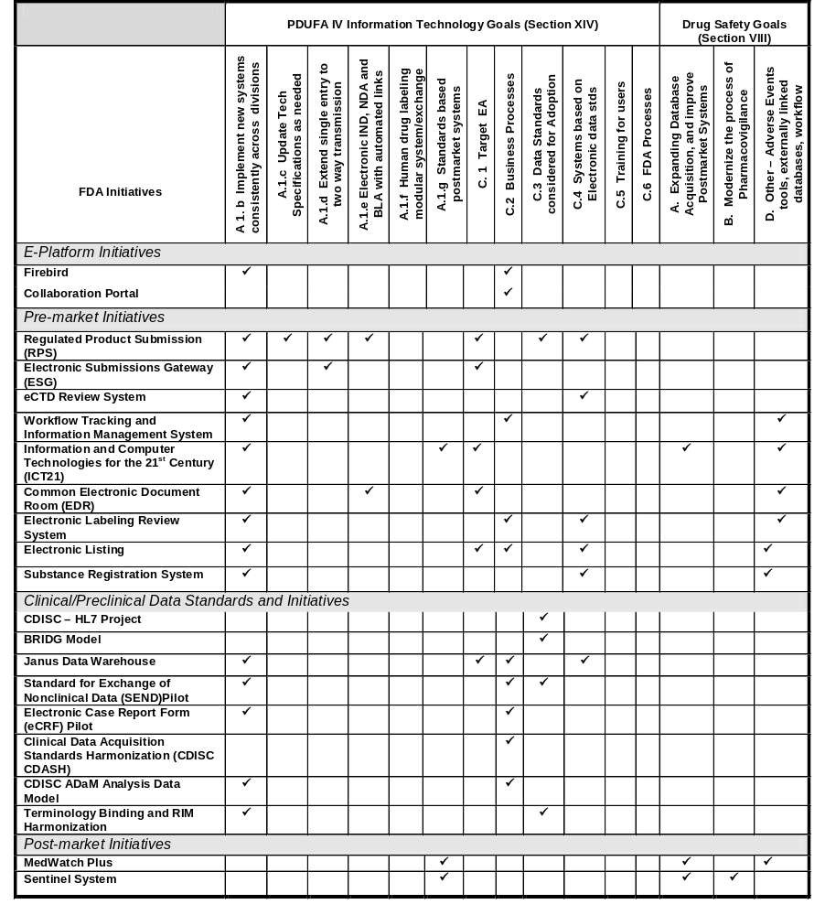 Note: Goals section ‘B. Communications and Technical Interactions’ and ‘D. Metrics and Measures’ are not included on the goals listed above. Both goals are discussed in the plan and do not directly map to programs.

7.4 Business Review Boards 5-year Goals, Priorities and Current Projects

Post-Market Safety
5-year goal:
- Strengthen capability to rapidly identify, assess and mitigate safety problems

Priorities:
- Develop electronic receipt capabilities (i.e. improve receipt of spontaneous reporting, create a usable receipt interface, adopt, develop & implement data standards HL7 ICSR & SPL)
- Enhance exploratory data analysis (i.e., strengthen signal detection & management of spontaneous reports)
- Harmonize terminologies (i.e. create or adopt common terminology reference sources, implement terminology standards for all FDA product)
- Improve knowledge base systems (i.e. Increase capacity to archive and search data & information, implement MedWatch plus – FAERS)
- Create supporting rule making (i.e. modify & update regulatory documentation (rules & guidance) to reduce / eliminate paper submissions)
Major Project(s):
- MedWatch plus, including MedWatch plus portal project and FDA Adverse Event Reporting System (FAERS)

Product Quality and Compliance
5-year goal:
- Assure product quality and compliance through timely access to and better use of accurate FDA-related entity information across the Agency (entities are firms, facilities, points of contact, products, components/ingredients)

Priorities:
- Implement Harmonized Business Processes and Systems for Identification and Tracking of FDA-Related Firms and Facilities across the Agency
- Implement Harmonized Business Processes and Systems for Identification and Tracking of FDA-Regulated Products and Components/Ingredients across the Agency
- Provide Single Portal Access to Comprehensive Entity Information
- Harmonize FDA and Customs and Border Protection (CBP) Processes in order to Ensure Import Data Quality and Completeness
- Enhance Automation of Import Screening Processes
Major Project(s):
- Harmonized Inventory of FDA-Related Entities, including registration and listing.

Pre Market Review
5-year goal:
- Implement a standards-based end-to-end fully electronic receipt, review, dissemination and archival environment

Priorities:
- Create or Adopt Standardized Structure and Formats for Data and Documents
- Adopt HL7 Regulatory Product Submission (RPS) Standard for all FDA Regulated Products
- Improve and Automate Electronic Receipt Functions
- Improve Search Tools and Capabilities
- Improve Automation of Workflow
- Improve Document Management
Major Project(s):
- Common Electronic Document Room (EDR)
- Regulated Product Submission (RPS)

Administrative Services
Priorities:
- Human resources
- Payroll
- Budget formulation and planning
- Tracking systems
- Travel
They are now in the process of identifying priority initiatives.
Scientific Computing / Computational Science
The SC/CS BRB has recently formed and is in the process of identifying current best practices and areas that need improvement. They will define their priorities in early 2008.

7.5 Summary Schedule

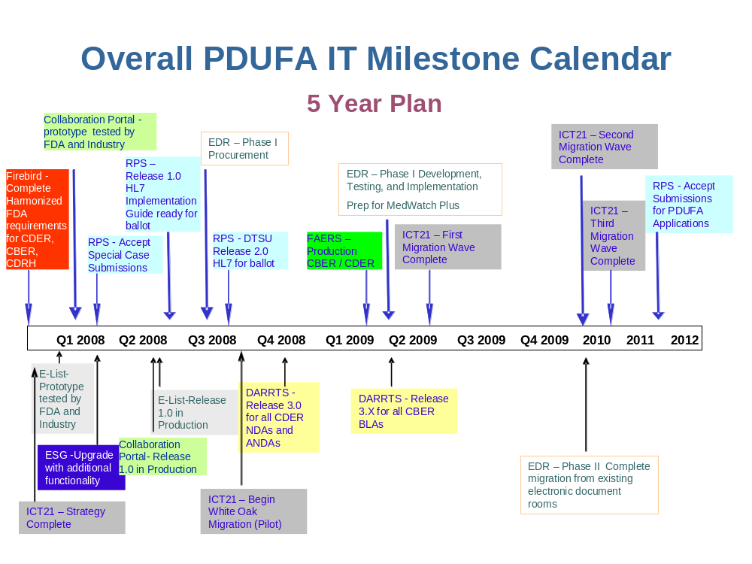

7.6 Acronym List
(ICH, VICH, GHTF) | Global regulatory standards groups
ADaM | Analysis Data Model
AERS | Adverse Events Reporting System
ANSI | American Nation al Standards Institute
BiB | Bioinformatics Board
BMT | Business Modernization / Transformation
BRBs | Business Review Boards
CBER | Center for Biologics Evaluation and Research
CDASH | Clinical Data Acquisition Standards Harmonization
CDC | Center for Disease Control
CDER | Center for Drug Evaluation and Research
CDISC | Clinical Data Interchange Standards Consortium
CIO | Chief Information Officer
CRADA | Cooperative Research and Development Agreement
DHHS | Department of Health and Human Services
DSC | Data Standards Council
DT | Developmental Test
EA | Enterprise Architecture
eCTD | electronic Common Technical Document
EDSR | Electronic Document Submission and Review
ELR | Electronic Labeling Rule
EPLC7 | Enterprise Performance Life Cycle
ESG | Electronic Submissions Gateway
EVS | Enterprise Vocabulary Services
FASTAR | FDA Advanced Submission Tracking and Review Framework
FDA | Food and Drug Administration
FHA | Federal Health Architecture
FMAMA | FDA Modernization Act
FTE | Full Time Equivalent
GGP | Good Guidance Practice
HL7 | Health Level Seven
ICSR | Individual Case Safety Report
IM | Information Management
ISO | International Standards Organization
IT | Information Technology
MaPP | Manual of Policies and Procedures
NCI | National Cancer Institute
NCPDP | National Council for Prescription Drug Programs
OC | Office of the Commissioner
OCIO | Office of the Chief Information Officer
ODM | Operational Data Model
OMB | Office of Management and Budget
OPL | Office of Planning
ORA | Office of Regulatory Affairs
OT | Operational Test
PDUFA | Prescription Drug User Fee Act
PLR | Physicians Labeling Rule
SDLC | System Development Lifecycle
SDO | Standards Development Organization
SDTM | Study Data Tabulation Model
SEND | Standard for Exchange of Nonclinical Data
SIT | System Integration Test
SOPP | Standard Operating Procedures and Policies
SPL | Structured Product Labeling
SQT | System Qualification Tests
UNII | Unique Ingredient Identifiers
VCS | Voluntary Consensus Standard

OMB Circular A-119
An example of a standard widely used within FDA, which is not a VCS, is the portable document format (PDF) standard for electronic documents. Although a proprietary standard, it is in widespread use and no comparable VCS currently exists that meets the business requirements.

