Elizabeth Public School District
Allowability of Title I, Part A Expenditures

FINAL AUDIT REPORT

Statements that managerial practices need improvements, as well as other conclusions and recommendations in this report, represent the opinions of the Office of Inspector General. Determinations of corrective action to be taken will be made by the appropriate Department of Education officials.

In accordance with the Freedom of Information Act (5 U.S.C. § 552), reports issued by the Office of Inspector General are available to members of the press and general public to the extent information contained therein is not subject to exemptions in the Act.

ED-OIG/A02G0020
October 2007

Our mission is to promote the efficiency, effectiveness, and integrity of the Department’s programs and operations. |  | U.S. Department of Education  Office of Inspector General  New York, New York

(This page intentionally left blank)

UNITED STATES DEPARTMENT OF EDUCATION
OFFICE OF INSPECTOR GENERAL

32 Old Slip, 26th Floor, Financial Square
New York, New York 10005
Telephone (646) 428-3860 Fax (646) 428-3868

October 9, 2007

Lucille E. Davy
Commissioner of Education
New Jersey Department of Education
Office of the Commissioner
100 River View Plaza
P.O. Box 500
Trenton, NJ 08625

Dear Commissioner Davy:

Enclosed is our final audit report, Control Number ED-OIG/A02G0020, entitled Elizabeth Public School District Allowability of Title I, Part A Expenditures. This report incorporates the comments you provided in response to the draft report. If you have any additional comments or information that you believe may have a bearing on the resolution of this audit, you should send them directly to the following Education Department official, who will consider them before taking final Departmental action on this audit:

Kerri L. Briggs
Assistant Secretary
Office of Elementary and Secondary Education
U.S. Department of Education
400 Maryland Avenue, SW
Washington, DC 20202

It is the policy of the U. S. Department of Education to expedite the resolution of audits by initiating timely action on the findings and recommendations contained therein. Therefore, receipt of your comments within 30 days would be appreciated.

In accordance with the Freedom of Information Act (5 U.S.C. § 552), reports issued by the Office of Inspector General are available to members of the press and general public to the extent information contained therein is not subject to exemptions in the Act.

Sincerely,

/s/

Daniel P. Schultz
Regional Inspector General for Audit
Enclosure
TABLE OF CONTENTS

Page

EXECUTIVE SUMMARY Error! Bookmark not defined.
BACKGROUND Error! Bookmark not defined.
AUDIT RESULTS Error! Bookmark not defined.
FINDING NO. 1 – Elizabeth Could Not Provide Adequate Support for $822,796 of Title I Expenditures Error! Bookmark not defined.
NJDOE’s Comments. Error! Bookmark not defined.
OIG Response……… Error! Bookmark not defined.
FINDING NO. 2 – Elizabeth Charged $618,392 of Unallowable Expenditures to Title I Error! Bookmark not defined.
NJDOE’s Comments.. Error! Bookmark not defined.
OIG Response……… Error! Bookmark not defined.
FINDING NO. 3 – Elizabeth Used $505,737 of Title I Funds to Supplant Non-Federal Funds Error! Bookmark not defined.
NJDOE’s Comments. Error! Bookmark not defined.
OIG Response……… Error! Bookmark not defined.
FINDING NO. 4 – Elizabeth Did Not Maintain Proper Internal Controls Error! Bookmark not defined.
NJDOE’s Comments. Error! Bookmark not defined.
OBJECTIVE, SCOPE, AND METHODOLOGY Error! Bookmark not defined.
Enclosure…………… 2

EXECUTIVE SUMMARY

The objective of our audit was to determine if the Elizabeth Public School District’s (Elizabeth) Title I, Part A (Title I) expenditures, distributed through the New Jersey Department of Education (NJDOE), were allowable in accordance with applicable laws and regulations. Our audit period was July 1, 2004, through June 30, 2005.

We randomly and judgmentally sampled $2,289,094 of $8,265,724, in Title I funds Elizabeth expended during our audit period and found that Elizabeth did not fully comply with applicable laws and regulations. We found that Elizabeth charged $822,796 in unsupported salary and non-salary expenditures to Title I. Further, Elizabeth used $618,392 of its Title I funds for unallowable purposes. Elizabeth also used $505,737 in Title I funds to supplant non-federal funds for its after-school program. In addition, we concluded that Elizabeth did not maintain effective internal controls over its Federal funds.

We recommend that the Assistant Secretary for Elementary and Secondary Education instruct NJDOE to require Elizabeth to:
- Provide support for the $822,796 in salary and non-salary Title I expenditures, or return the funds, with applicable interest, to the U.S. Department of Education (ED).
- Implement procedures that provide for the proper disbursement of and accounting for Title I expenditures for teacher tutor salaries.
- Follow the Governance Manual policies regulations bylaws (Governance Manual) by requiring the return of receiving requestors (receiving reports) to the District office upon receipt of goods and services.
- Return the $12,939 for unallowable computer equipment and vendor expenditures, plus applicable interest, to ED.
- Implement procedures to ensure the Business Office is advised of changes that may impact Federal grants.
- Ensure that equipment purchased with Title I funds is properly labeled and used for Title I purposes.
- Implement controls to ensure that only allowable Title I expenditures are allocated to Title I.
- Provide support that demonstrates that Title I funds were not used by Elizabeth to supplant non-federal funds or return the $505,737 in 2004-2005 Title I funds, with applicable interest, to ED.
- Implement internal control procedures to provide reasonable assurance that Elizabeth manages Title I in accordance with laws and regulations, including adequate segregation of duties.
- Update the Governance Manual to include current changes to internal control procedures and ensure Elizabeth personnel adhere to procedures outlined in the Governance Manual.

We recommend that the Assistant Secretary for Elementary and Secondary Education:
- Consider Elizabeth’s claim that it inadvertently failed to indicate in its application the option to grandfather the three non-Title I schools and determine whether Elizabeth should return the $605,453 in unallowable expenditures, plus applicable interest, to ED.

We also recommend that the Assistant Secretary for Elementary and Secondary Education instruct NJDOE to:
- Review Elizabeth’s non-salary Title I expenditures for the period July 1, 2004, through June 30, 2005, not included in our sample to determine if the expenditures were adequately supported and require Elizabeth to return any unsupported funds with applicable interest to ED.
- Determine the 2005-2006 Title I funds used to supplant non-federal funds that were outside the scope of our audit, and require Elizabeth to return the Title I funds used to supplant non-federal funds, with applicable interest, to ED.

We provided a draft of this report to NJDOE. We reviewed NJDOE’s response, dated August 31, 2007; however, our findings remain unchanged. In its response, NJDOE concurred with 10 of 13 recommendations, partially agreed with 2 recommendations, and disagreed with 1 recommendation. We revised two recommendations based on the comments received. We have summarized NJDOE’s comments and our response after each finding. A copy of NJDOE’s comments is attached. However, due to the voluminous number of attachments included with NJDOE’s comments, we have not included them in this enclosure. A copy of NJDOE’s comments and attachments will be forwarded, under separate cover, to the Assistant Secretary for Elementary and Secondary Education.

BACKGROUND

For the 2004-2005 school year, Elizabeth had 27 schools serving over 21,000 students. In fiscal year (FY) 2005, Elizabeth received $11.5 million in Elementary and Secondary Education Act of 1965, as amended by the No Child Left Behind Act of 2001 (ESEA) funding. Of this amount, Title I accounted for $8.3 million. For the 2004-2005 school year, 15 of the 27 Elizabeth schools were approved to receive Title I funds. All schools approved for Title I funds were schoolwide programs.

Title I grants are provided through State educational agencies (SEAs) to local educational agencies (LEAs) to help ensure that all children have the opportunity to obtain a high-quality education and reach proficiency on challenging state academic standards and assessments. Eligible schoolwide schools are able to use their Title I funds, in combination with other Federal, State, and local funds (blended funds), to upgrade the entire educational program of the school and to raise academic achievement for all students. Except for some of the specific requirements of the Title I program, funds that are used in a schoolwide program may not be subject to the statutory or regulatory requirements of programs providing the funds as long as the schoolwide program meets the intent and purpose of those programs.

AUDIT RESULTS

We found that Elizabeth did not fully comply with applicable laws and regulations regarding its Title I expenditures. Elizabeth could not provide support for $822,796 in salary and non-salary expenditures. In addition, expenditures of $618,392 were unallowable and $505,737 in Title I funds were used to supplant non-federal funds. Further, we found that Elizabeth did not maintain proper internal controls in relation to obtaining and maintaining documents, proper approval of purchases, and approval of principal timecards.

FINDING NO. 1 – Elizabeth Could Not Provide Adequate Support for $822,796 of Title I Expenditures

Unsupported Salaries for Teacher Tutors

Elizabeth did not adequately support $666,681 in salaries for teacher tutors that it charged to Title I. As part of our random sample, we reviewed a journal entry for ($445,101) representing a transfer of teacher tutor salaries from Title I to Title II, Part A (Title IIA). Elizabeth budgeted approximately 15 teacher tutors to Title I and 27 teacher tutors to Title IIA. However, Elizabeth could not specifically identify which teacher tutor salaries were charged to Title I and which were charged to Title IIA.

Elizabeth originally recorded all teacher tutor salaries as charges to Title I. Once the budgetary limit for Title I teacher tutors was reached, a journal entry was posted to transfer the salary overages to Title IIA. Elizabeth only transferred to Title IIA, the amount of salaries that exceeded the $666,681 budgeted to Title I. Since Elizabeth used this accounting methodology to record teacher tutor salaries, it could not identify each specific teacher tutor salary that should have been charged to Title I or IIA.

During our audit period, Elizabeth employed 43 teacher tutors, whose salaries were charged to Title I and Title IIA. An Elizabeth official stated all 43 teacher tutors were employed at Title I schools. However, we found 16 of the 43 teacher tutors worked at non-Title I schools. Based on the accounting methodology Elizabeth used, there was no assurance that salary expenditures charged to Title I for teacher tutors were actually for Title I teachers. We concluded that if all teacher tutors were employed at Title I schools, then adjusting entries to the teacher tutor salary account would not have caused a questionable charge to Title I. However, because some teacher tutors worked at non-Title I schools and Elizabeth did not ensure proper disbursement of, and accounting for, Title I salaries, we could not determine whether the $666,681 charged to Title I for teacher tutors included charges for teacher tutors working at non-Title I schools. Therefore, the $666,681 in Title I salaries charged for teacher tutors was unsupported.

Unsupported Non-Salary Expenditures

Elizabeth did not adequately support $157,763 in non-salary Title I expenditures. Elizabeth used receiving reports to verify the receipt of goods and services. However, Elizabeth was unable to provide 16 of 48 receiving reports in our sample to support the charges for supplies, textbooks, and educational services. Of the total unsupported amount, $154,392 was from our random and judgmental samples of District Title I expenditures. We also found $3,371 of schoolwide Title I expenditures allocated to School 6 was unsupported. This occurred because District officials did not properly supervise school officials and enforce policies and procedures set forth in the Governance Manual for the receipt of goods and services. As a result, there was no assurance that the $156,115 of expenditures related to the goods and services were actually received.

The General Education Provisions Act [20 U.S.C. § 1232f (a)], requires each recipient of Federal funds... shall keep records which fully disclose the amount and disposition by the recipient of those funds, the total cost of the activity for which the funds are used, the share of that cost provided from other sources, and such other records as will facilitate an effective financial or programmatic audit.

Office of Management and Budget (OMB) Circular A-87 § C.1.j, states that to be allowable under Federal awards, costs must be adequately documented.

According to the ESEA § 9306 (a)(5), an applicant [Elizabeth] that submitted a plan or application for ESEA programs [Title I] would use such fiscal control and fund accounting procedures as would ensure proper disbursement of, and accounting for, Federal funds paid to the applicant under each such program.

According to the Governance Manual, the originating department should submit a signed receiving [report] to the District as a receipt for items or services received.

Elizabeth did not properly account for teacher tutor salaries in accordance with regulations. Furthermore, there was no assurance that goods and services were received. As a result, Elizabeth could not adequately support $822,796 in Title I expenditures.
Recommendations
We recommend that the Assistant Secretary for Elementary and Secondary Education instruct NJDOE to:
  - Require Elizabeth to provide support for the $822,796 in salary and non-salary Title I expenditures, or return the funds, with applicable interest, to ED.
  - Require Elizabeth to implement procedures that provide for the proper disbursement of and accounting for Title I expenditures for teacher tutor salaries.
  - Require Elizabeth to follow the Governance Manual by requiring the return of receiving reports to the District office upon receipt of goods and services.
  - Review Elizabeth’s non-salary Title I expenditures for the period July 1, 2004, through June 30, 2005, not included in our sample to determine if the expenditures were adequately supported and require Elizabeth to return any unsupported funds to ED.

NJDOE’s Comments

In its response to the draft report, NJDOE did not fully concur with Finding 1 and recommendation 1.1, and agreed with recommendations 1.2, 1.3, and 1.4. NJDOE reviewed subsequent information, which was also provided to the OIG, and concluded that teacher tutor salaries were supported. NJDOE stated that the teacher schedules and after-the-fact certifications were sufficient support for the $666,681 in Title I charges for teacher tutors. NJDOE noted that ED guidance issued in May 2006, stated that time and effort reporting for non-consolidated funds required semi-annual certifications and there was no similar guidance prior to May 2006 that addressed this issue in a schoolwide program.

NJDOE agreed that $3,371 of the unsupported $157,763 should be returned since it was expended at non-Title I schools, but stated that the contemporaneous receiving reports Elizabeth provided supported the remaining $154,392. NJDOE stated that these secondary forms, which were signed by Elizabeth personnel prior to payment, should be considered sufficient support. NJDOE further noted that the missing original documents should not warrant the return of funds when the program goals were satisfied.

OIG Response

We considered NJDOE’s response to Finding 1 and recommendation 1.1; however, our position remains unchanged. Elizabeth provided “after-the-fact certifications” for some teacher tutors to verify that they worked solely on the Title I program. Teacher tutors were not part of the schoolwide program. In addition, the guidance relevant to the 2004-2005 school year was OMB Circular A-87, Attachment B, Paragraph 8.h.3, first effective June 9, 2004. This guidance states that employees whose salaries are charged solely to a particular Federal program are required to sign certifications on a semi-annual basis. Since the semi-annual certifications were not signed at the time services were rendered, we were unable to determine whether these teachers actually provided these services. Therefore, the “after-the-fact certifications” were insufficient support for the $666,681 of Title I funds expended for teacher tutors. Furthermore, NJDOE’s response did not address the accounting methodology used by Elizabeth that resulted in the improper accounting of teacher tutor salaries. Therefore, the $666,681 remains unsupported.

OIG also maintains that the $157,763 of Title I non-salary expenditures was unsupported. As stated in our report, we concluded that the $3,371 was unsupported because receiving reports were not provided. NJDOE stated that the $3,371 was unsupported because it was spent at non-Title I schools. The contemporaneous receiving reports that NJDOE referred to in its response were copies of invoices provided by vendors and signed by Elizabeth personnel as verification of receipt. For $154,252, the OIG was not provided signed invoices or any other alternative documentation to support that the services were rendered. On the documentation we reviewed, we noted that invoices were signed, but not dated, for the remaining $3,371. We could not determine whether the receipt of goods and services was verified prior to payment. Therefore, the $157,763 of Title I non-salary expenditures was not adequately supported.

FINDING NO. 2 – Elizabeth Charged $618,392 of Unallowable Expenditures to Title I

$605,453 of Title I Funds Expended for Non-Title I Schools

Elizabeth improperly allocated Title I expenditures of $605,453 to Schools 14, 18, and 26 that were not eligible to receive Title I funds in FY 2005. We compared the statement of blended fund resources that was reported in the Elizabeth 2005 Comprehensive Annual Financial Report (CAFR) to the list of Title I schools approved by NJDOE and found that Elizabeth inappropriately budgeted $637,861 for three schools that were not eligible Title I schools. Of this amount, Elizabeth expended $605,453 in Title I funds for the three non-Title I schools.

According to Elizabeth, the three schools were eligible Title I schoolwide schools in the 2003-2004 school year. The Grants Office at Elizabeth was aware that the three schools lost eligibility as Title I schools for FY 2005, but failed to communicate this to the Business Office. The Business Office prepared the 2005 CAFR assuming that the schools maintained their Title I eligibility and erroneously allocated Title I resources within the blended fund to the three non-Title I schools. Although these schools were eligible Title I schoolwide schools for the 2003- 2004 school year, they did not meet the poverty level requirements for Title I eligibility in FY 2005. Elizabeth later contended that it had the authority to use its discretion in designating as eligible, any school in which at least 35 percent of the children were from low-income families, and it could have extended eligibility for an additional year to any school that lost its eligibility status. However, Elizabeth did not use its discretion to designate as Title I or extend Title I eligibility to the three ineligible schools in its Consolidated Grant Application to NJDOE in accordance with Federal regulations. Therefore, we concluded that the three schools were ineligible to receive Title I funds for FY 2005.

$7,696 of Title I Funds Expended for Computer Equipment

Elizabeth did not ensure that equipment purchased with Title I funds was labeled as Federal equipment and used for Title I purposes. As part of our random sample of non-salary expenditures charged to Title I by the District, we reviewed a purchase of four computers totaling $7,696. Elizabeth identified in its financial system that Title I funds were charged for the purchase of the equipment. However, this system did not interface with the District system for tracking inventory. Upon inspection of the computers, we found the computers were not labeled as Federal equipment. Elizabeth did not follow its procedures to ensure that equipment purchased with Title I funds was labeled as Federal equipment.

According to District officials, the computer equipment was assigned to four employees who were employed to provide professional development to middle school math and science teachers. We interviewed two of the employees who stated that they were math coaches. The employees stated that they provided professional development to all math teachers within the district. Accordingly, all students in the district, whether they were Title I or non-Title I students, received the benefit of the equipment. We found that the computers were not used primarily for the benefit of Title I programs and students, and therefore, the $7,696 expenditure was unallowable.

$5,243 of Title I Expended for Vendor Purchases at Non-Title I Schools

During our analysis of the Elizabeth financial expenditure records, we judgmentally sampled $267,183 in non-salary District expenditures. We found Title I funds of $5,243 were expended at six schools that were not approved as Title I schools in the Elizabeth approved Consolidated Grant Application. The expenditures were for the purchase of various school supplies. However, Elizabeth was unable to explain why it charged the supplies to Title I. Accordingly, Title I students did not obtain the benefit of $5,243 in non-salary expenditures that were not allocable to Title I and are therefore, unallowable.

ESEA § 1113 (a)(1) states that an LEA may use Title I funds received only in eligible school attendance areas. ESEA § 1113 (a)(2)(B) defines an eligible school attendance area as one “... in which the percentage of children from low-income families is at least as high as the percentage of children from low-income families served by the [LEA] as a whole.”

According to ESEA § 1113 (a)(3),

If funds allocated... are insufficient to serve all eligible school attendance areas, a [LEA] shall – (A) annually rank... eligible school attendance areas in which the concentration of children from low-income families exceeds 75 percent from highest to lowest according to the percentage of children from low-income families; and (B) serve such eligible school attendance areas in rank order.

Further, ESEA § 1113 (a)(4) states that the remaining funds should be used to serve eligible school attendance areas from highest to lowest for the entire LEA according to the percentage of children from low income families.

According to the Governance Manual, “... all equipment shall be clearly marked to identify the grant under which it was acquired.”

Elizabeth improperly expended Title I funds for ineligible schools. Elizabeth did not follow procedures in its Governance Manual regarding the labeling of equipment and did not ensure equipment purchased with Title I funds primarily benefited Title I programs and students. As a result, Elizabeth charged $618,392 of unallowable expenditures to Title I.

Recommendations
We recommend that the Assistant Secretary for Elementary and Secondary Education:
  - Consider Elizabeth’s claim that it inadvertently failed to indicate in its application the option to grandfather the three non-Title I schools and determine whether Elizabeth should return the $605,453 in unallowable expenditures, plus applicable interest, to ED.
  - Instruct NJDOE to require Elizabeth to return the $12,939 in unallowable computer equipment and vendor expenditures, plus applicable interest, to ED.
  - Instruct NJDOE to require Elizabeth to implement procedures to ensure the Business Office is advised of changes that may impact Federal grants.
  - Instruct NJDOE to require Elizabeth to ensure that equipment purchased with Title I funds is properly labeled and used for Title I purposes.
  - Instruct NJDOE to require Elizabeth to implement controls to ensure that only allowable Title I expenditures are allocated to Title I.

NJDOE’s Comments

NJDOE concurred with Finding 2 and recommendations 2.2, 2.3, and 2.4, but disagreed with recommendation 2.1. NJDOE stated that Elizabeth inappropriately expended Title I funds at three ineligible schools; however, they believe that the return of funds is a penalty that is too severe. In addition, Elizabeth responded to NJDOE that its Title I grants manager inadvertently failed to indicate on the its application the option to grandfather the three schools. Regarding recommendation 2.1, NJDOE stated that it had provided technical assistance on Title I ranking methods and school eligibility using the LEA discretion option to Elizabeth. The District has also been notified that it must use Title I funds only in eligible Title I schools listed on the NCLB Consolidated Application.

OIG Response

We considered NJDOE’s response in relation to recommendation 2.1, and revised our recommendation to state that ED should consider Elizabeth’s claim that it inadvertently failed to indicate in its application the option to grandfather the three schools. NJDOE agreed that three ineligible schools were inappropriately funded with Title I. NJDOE approved 15 schools for Title I based on Elizabeth’s approved NCLB Consolidated Application. However, Elizabeth funded 18 schools with Title I. According to 34 C.F.R. § 200.78, an LEA must allocate funds to schools identified as eligible and selected to participate under ESEA § 1113. The $605,453 in Title I funds expended at the three ineligible schools was unallowable, because these schools were neither identified as eligible nor selected to participate based on the NCLB Consolidated Application. Since these funds were expended at ineligible schools, they were not made available to approved Title I schools. The $605,453 of Title I funds should have been allocated to, and expended at, properly approved Title I schools in accordance with Elizabeth’s Consolidated Application and ESEA. Allowing LEAs to expend Title I funds at schools that have not been approved by the SEA, is a breakdown in the approval process that places Federal funds at risk of misuse.

In addition, NJDOE did not provide additional documentation to support that the $7,696 of Title I funds expended for computer equipment and the $5,243 of Title I expended for vendor purchases at Non-Title I schools were allowable. Therefore, the $12,939 is unallowed and should be returned with interest, to ED.

FINDING NO. 3 – Elizabeth Used $505,737 of Title I Funds to Supplant Non-Federal Funds

Elizabeth used Title I funds to provide services to Title I students that were also provided to non-Title I students using non-federal funds. In total, $988,355 was incurred by Elizabeth for an after-school program. Of this amount, $505,737 in salary and non-salary expenditures was charged to Title I. Therefore, the $505,737 of Title I funds expended during our audit period were used to supplant non-federal funds.

In January 2006, Elizabeth received notice from NJDOE that its 2005-2006 District-wide after-school program did not qualify as a Title I supplemental educational services (SES) program. NJDOE stated the program was offered at all of its schools and therefore was not supplemental to other District activities. Elizabeth officials disagreed with this finding in a letter dated February 6, 2006. Elizabeth officials explained that in the 2003-2004 school year the District began providing supplemental services, in the form of an after-school program, to students at schools in need of improvement. Based on the success of the program, the supplemental services were expanded and implemented District-wide in an effort to provide beneficial services to more Elizabeth students. In a letter dated March 6, 2006, NJDOE maintained that Elizabeth used Title I funds in FY 2006 to support a District-wide after-school program that was in violation of Federal regulations because it did not meet the definition of a Title I SES program and it did not comply with supplement not supplant requirements. On January 25, 2007, Elizabeth signed an agreement with NJDOE to implement an SES program in compliance with Federal regulations. However, Elizabeth stated that it did not use Federal funds to supplant non-federal funds because it met the exception to the supplement not supplant requirement in ESEA § 1120A(d).

According to Elizabeth officials, the after-school program funded with Title I was offered to low-income, low-achieving students at Title I schools in need of improvement. Elizabeth was unable to provide supporting documentation to demonstrate the criteria used for the students who were offered after-school services at Title I schools not in need of improvement funded with blended funds and non-Title I schools funded with State and local funds. Since there is insufficient support regarding the criteria used to provide after-school services, we could not determine whether the after-school program in the Title I and non-Title I schools was comparable. Therefore, the exception to the supplement not supplant requirements cannot be applied.

According to ESEA § 1120A(b)(1), “A [SEA] or [LEA] shall use Federal funds received under this part only to supplement the funds that would, in the absence of such Federal funds, be made available from non-Federal sources for the education of pupils participating in programs assisted under this part, and not to supplant such funds.”

Elizabeth used Title I funds to supplant non-federal funds for an after-school program. Therefore, the $505,737 of Title I funds expended for the after-school program was unallowable.

Recommendations
We recommend that the Assistant Secretary for Elementary and Secondary Education instruct NJDOE to:
3.1 Require Elizabeth to provide support that demonstrates that Title I funds were not used by Elizabeth to supplant non-federal funds or return the $505,737 in 2004-2005 Title I funds, with applicable interest, to ED.
3.2 Determine the 2005-2006 Title I funds used to supplant non-federal sources that were outside the scope of our audit, and require Elizabeth to return the Title I funds used to supplant non-federal funds, with applicable interest, to ED.

NJDOE’s Comments

NJDOE did not concur with Finding 3, partially agreed with recommendation 3.1, and agreed to comply with recommendation 3.2. NJDOE stated that Elizabeth’s SES program at all but two schools met the exception to the supplement not supplant requirement under ESEA § 1120A(d) and 34 C.F.R. § 200.79(b)(1).

In its response, NJDOE cited ESEA § 1120A(d), the exception clause to the supplement not supplant requirement, which states that supplemental state and local funds may be excluded when a program meets the intent and purposes of Title I.

NJDOE also cited 34 C.F.R. § 200.79(b)(1), which states that a program meets the intent and purposes of Title I if the program:
(i) is implemented in a school in which the percentage of children from low-income families is at least 40 percent;
(ii) is designed to promote schoolwide reform and upgrade the entire educational operation of the school to support students in their achievement toward meeting the State’s challenging academic achievement standards that all children are expected to meet;
(iii) is designed to meet the educational needs of all children in the school, particularly the needs of children who are failing, or most at risk of failing, to meet the State’s challenging student academic achievement standards.
(iv) uses the State’s assessment system under ESEA § 200.2 to review the effectiveness of the program.

NJDOE stated that Elizabeth provided documentation sufficient to support that all but two schools met the exception to the supplement not supplant requirement under ESEA § 1120A(d) and 34 C.F.R. § 200.79(b)(1). The poverty level at the two schools that were below the 40 percent threshold required by 34 C.F.R. § 200.79(b)(1)(i), preventing them from qualifying for the exception. However, NJDOE held that the District met all four components of the exception for all other schools. According to NJDOE, at most, the $51,996 expended at the two schools that did not meet the 40 percent threshold should be unallowable due to supplanting.

OIG Response

We considered NJDOE’s response along with its attachments, and revised recommendation 3.1. We recognize that the supplement not supplant requirement and its exception are complicated matters that may require further review during audit resolution. While NJDOE stated that Elizabeth’s SES program met the exception to the supplement not supplant requirement under ESEA § 1120A(d) and 34 C.F.R. § 200.79(b)(1), the attachments provided did not clearly identify that this was the case.

The attachments provided did not clearly identify the criteria used for the students who were offered after-school services. Although the attachments stated that the after school programs targeted children who were “most in need of academic assistance,” and suggested that low-income children were accommodated, they did not provide sufficient support to make a final determination. In addition, the documents provided to us during our audit were not consistent with the information provided to NJDOE by Elizabeth. Therefore, we cannot determine what student population was actually served.

An SES after-school program targets low-income students. Given this, an after-school program that properly followed the ESEA rules for SES may not meet the exception criteria under 34 C.F.R. § 200.79(b)(1)(iii), because an SES program is not designed to meet the needs of all children in the school. Instead, the SES program is designed to target low-income children and give priority to the lowest-achieving eligible children. According to an Elizabeth official, its SES after-school program was offered to low-income, low-achieving students at Title I schools in need of improvement. Therefore, it did not appear that Elizabeth’s SES after school program met the intent and purpose of Title I under the criteria at 34 C.F.R. § 200.79(b)(1).

FINDING NO. 4 – Elizabeth Did Not Maintain Proper Internal Controls

Elizabeth did not effectively maintain internal controls over its Federal programs to assure Federal funds were managed in compliance with laws and regulations. During our audit, we reviewed the system of internal controls, policies, procedures, and practices applicable to the administration of Title I by Elizabeth. Our assessment disclosed internal control weaknesses which adversely affected the administration of Title I funds expended by Elizabeth.

Missing Requisitions and Receiving Reports

Elizabeth was unable to provide 4 original purchase requisitions and 16 receiving reports from our sample of 48 records. Requisitions are the documents used by school officials to request permission from the District to purchase goods or services. The requisitions were for the purchase of various school supplies and textbooks. Elizabeth stated the four requisitions could not be located because the file boxes stored at the warehouse were damaged, and the documents were lost. Elizabeth provided electronic versions of the requisitions. However, the electronic versions did not show approval signatures or dates, and therefore, we could not determine whether the purchase of the supplies and textbooks were properly approved.

Receiving reports are the documents signed by school officials to certify that the requested goods or services were received. However, school officials did not always return signed receiving reports to the District Accounts Payable Office when goods or services were received. In these cases, Accounts Payable personnel would send school officials copies of invoices. We were told that school officials were requested to sign the invoices and return them to the District office as proof of receipt of goods or services. We found that school officials signed invoices for 11 of the 16 missing receiving reports. However, 8 of the 11 signed invoices were not dated. Therefore, there was no assurance that school officials ensured that goods were actually received and used for their intended purpose.

The District did not follow the policies and procedures set forth in the Governance Manual since it did not properly maintain documentation of purchased goods and services. Moreover, the section of the Governance Manual regarding purchasing procedures had not been updated since 1991. According to District officials, employees did not use the Governance Manual as a reference tool for guidance on procedures. Due to the missing requisitions and receiving reports, there was no assurance that the purchase of supplies, textbooks, and services were properly approved and used for their intended purpose.

Services Rendered Prior to Approval

From our judgmental sample of $261,940 of non-salary District expenditures, we found that Elizabeth permitted a vendor to provide services, totaling $172,269, for two contracts prior to approval by the Elizabeth Board of Education. The two contracts, both to Union County Educational Services Commission, were to provide educational services to students for the 2004-2005 school year. The Elizabeth Board of Education was to approve the contracts through signed resolutions. We reviewed the resolutions and found the contracts were approved two and three months after services started.

In addition, we reviewed $1,556,258 in our random sample of School 6 non-salary expenditures. We found that School 6 received services for 7 of 19 non-salary expenditures prior to proper approval. The expenditures, totaling $4,925, were for the services of charter buses for various school field trips. In most cases, services were provided two to three months before approval. The amount of the services allocable to Title I was $345.

The District and school officials did not follow proper procedures, as established by the Governance Manual, for the proper approval of contracts and services.

Time Distribution Not Documented and Title I Certification Not Maintained

From our random sample of District Title I charges for salary and journal entries expenditures, we found that Elizabeth did not provide time distributions and semi-annual employee Title I certifications to adequately support $58,296 in salaries. We reviewed timecards for 10 employees who received $20,892 in salaries charged to Title I for time worked beyond the regular school day. However, the employees did not document on the timecards the portion of time dedicated to Title I, as required. In addition, for one salary sample of $37,404, one employee did not sign a semi-annual certification. The employee was a teacher tutor whose sole salary was chargeable to Title I by the District and therefore, was required to sign a certification. As a result, a total of $58,926 in salaries charged to Title I were not adequately supported. The $20,892 in unsupported salaries was included in the amount of Title I funds used to supplant non-federal funds in Finding 3, and $37,404 was included in Finding 1 for unsupported teacher tutor salaries.

Elizabeth did not require teachers to specifically indicate cost codes on timesheets or sign semi-annual Title I certifications. The Elizabeth Human Resources office was unaware that Title I teachers were required to sign semi-annual certifications. Elizabeth did not comply with Federal requirements regarding teacher timecards and semi-annual certifications and therefore, there was no assurance that the teachers actually worked for the Title I program.

Principals Certified Their Own Timesheets

According to the Generally Accepted Accounting Principles For New Jersey School District: A Technical Systems Manual (New Jersey State Technical Manual), LEAs are responsible to establish effective internal controls over payroll transactions. However, we found that Elizabeth did not have procedures in place that required principal timecards to be certified by a supervisor. Our sample of 23 employees, whose salaries were charged to Title I by the District, included three principals who were compensated for working hours beyond the regular school day. These principals improperly signed their own timecards to certify that the hours recorded were correct. School employees prepared timecards when they worked hours beyond the regular school day, as approved by the Elizabeth Board of Education. All timecards were approved by the school principal prior to being submitted to the District office for payment. A principal who signed his or her own timecard indicated a lack of segregation of duties, because there was no independent verification of hours worked. As a result, there was no assurance that the hours recorded were accurate.

According to OMB Circular A-133 §___. 300, “The auditee shall... (b) Maintain internal control over Federal programs that provides reasonable assurance that the auditee is managing Federal awards in compliance with laws, regulations, and the provisions of contracts or grant agreements that could have a material effect on the each of its Federal programs.”

OMB Circular A-87 § C.1.j, states that to be allowable under Federal awards, costs must be adequately documented.

According to the Governance Manual section on Purchasing Procedures, dated December 12, 1991, purchase orders should originate through the requisition. Proper approval from department officials and district officials is necessary to process the requisition into a purchase order; the vendor should provide the service or deliver the items before sending the voucher and invoice to the district to request payment. In addition, the department receiving such services or items should submit a signed receiving requestor to the district. Both the voucher and receiving requestor are needed at the district level to release a payment to the vendor for their service or product.

According to the Governance Manual, the purchase of extraordinary, unspecifiable services “must still follow the normal purchase procedure and be initiated by a requisition.” In addition, the Governance Manual states that the “Board of Education must approve all purchases over the bid threshold by resolution of the Board.”

According to OMB Circular A-87, Attachment B, Paragraph 8.h.(3) an employee who works solely on a single cost objective must furnish a semi-annual certification to support the activities charged to that cost objective.

According to OMB Circular A-87, Attachment B, Paragraph 8.h.(4), an employee who works on multiple activities must maintain time distribution records. Further, Circular A-87, Attachment B, Paragraph 8.h.(5) states that time distribution records must (a) reflect an after-the-fact distribution of actual activity; (b) account for the total activity for which the employee is compensated, (c) be prepared at least monthly; and (d) be signed by the employee.

Further, OMB Circular A-133 Compliance Supplement, Part 6 (March 2004), provides a description of the components of internal control and examples of characteristics common to compliance requirements:
Control Activities are the policies and procedures that help ensure that
management’s directives are carried out....
- Adequate segregation of duties provided between performance, review, and recordkeeping of a task.

According to the New Jersey State Technical Manual, the LEA should establish an internal control structure to ensure that payroll transactions are recorded accurately and timely in the accounting records. In addition, the manual encourages the LEA to establish a policy that “Time records, sign-in sheets and reports of leave should be reviewed by supervisors and approved.”

Elizabeth lacked proper controls in maintaining requisitions and obtaining receiving reports, providing services prior to proper approval, documenting time distribution, and maintaining Title I certifications. Elizabeth did not have procedures regarding principals signing their own timesheets. These weaknesses in internal controls could lead to the misuse of ED funds.

Recommendations
We recommend that the Assistant Secretary for Elementary and Secondary Education instruct NJDOE to require Elizabeth to:
4.1 Implement internal control procedures to provide reasonable assurance that Elizabeth manages Title I in accordance with laws and regulations, including adequate segregation of duties.
4.2 Update the Governance Manual to include current changes to internal control procedures.
4.3 Ensure Elizabeth personnel adhere to procedures outlined in the Governance Manual.

NJDOE’s Comments

NJDOE concurred with the Finding and recommendations.

OBJECTIVE, SCOPE, AND METHODOLOGY

Our objective was to determine if Elizabeth’s Title I expenditures, distributed through NJDOE, were allowable in accordance with applicable laws and regulations for the period July 1, 2004, through June 30, 2005.

We stratified our sample of salary and non-salary expenditures and journal entries into District charges to Title I and Title I schoolwide expenditures charged within the blended fund. We selected our schoolwide sample from School 6 expenditures, because it had the highest amount of expenditures according to the CAFR for FY ending June 30, 2005.

We randomly sampled and reviewed a net total of $2,021,911 in schoolwide expenditures and District charges to Title I. Of this amount, the schoolwide sample consisted of $836,993 in salaries for 20 instructional and non-instructional staff, $1,555,133 in non-salary expenditures for 18 records, and $5,166 in journal entries for four records charged to the blended fund for School 6. We also reviewed District-level Title I charges of $54,459 in salaries for 10 instructional and non-instructional staff, $8,070 in non-salary expenditure for 5 records, and a net total of ($437,910) in journal entries for 10 records.

In addition, we judgmentally selected $267,183 in non-salary District charges to Title I. Of this amount, $5,243 was charged to Title I for non-Title I schoolwide schools per the 2005 CAFR. We also chose $261,940 in District charges to Title I for goods and services provided by three vendors that accounted for the highest percentage of non-salary District-level charges to Title I.

We examined:
- Elizabeth’s approved Consolidated Grant Application to NJDOE, including the Entitlement Web-Enabled Grant application and the parallel paper application for FY year 2005;
- County review of Elizabeth’s 2005 Parallel Consolidated Grant application;
- Elizabeth’s CAFR Report for FYs 2004, 2005, and 2006;
- Correspondence between NJDOE and Elizabeth related to a review of Title I for the 2005-2006 school year;
- Board minutes for meetings held between July 1, 2004, and June 30, 2006;
- Employee ledger reports, timecards, and personnel files for our random and judgmental samples;
- Cancelled payroll checks related to our random and judgmental sample of employees;
- Purchasing packages which included requisitions, vouchers, receiving reports, and invoices for purchase transactions included in our random and judgmental samples;
- Cancelled checks related to transactions in our sample of vendor purchases; and
- Supporting documentation for journal entries randomly selected for testing.

We interviewed:
- Key officials at NJDOE to obtain an understanding of the SEA award process, award monitoring, and payment of Title I awards to LEAs;
- Elizabeth’s District personnel to obtain an understanding of internal controls over payroll, vendor purchases, disbursements, record keeping, and the administration of Title I;
- The principal at School 6 to obtain an understanding of the roles of school-level employees in the payroll and purchasing process and to determine if internal control procedures established by the District were followed; and
- A representative from ED’s Office of the General Counsel to gain an understanding of supplanting.

To ensure the completeness and accuracy of the data, we obtained and extracted from Elizabeth’s financial system, all Title I expenditures for the period July 1, 2004, through June 30, 2005. We sampled from a population of Title I salary and non-salary expenditures to arrive at our findings as described above. Based on the tests, we determined that the data was sufficiently reliable to support the findings, conclusions, and recommendations and using the data would not lead to an incorrect or inaccurate conclusion.

We conducted our fieldwork in the offices of the New Jersey Department of Education in Trenton, New Jersey, and the Elizabeth Public School District in Elizabeth, New Jersey. The audit was conducted from September 13, 2006, through March 12, 2007.

Our work disclosed significant deficiencies in Elizabeth’s internal controls for assuring and documenting that it met the requirements of Title I for administration of Federal awards. These deficiencies are discussed in the Audit Results section of this report. Our audit was performed in accordance with generally accepted government auditing standards appropriate to the scope of the review described above.
Enclosure
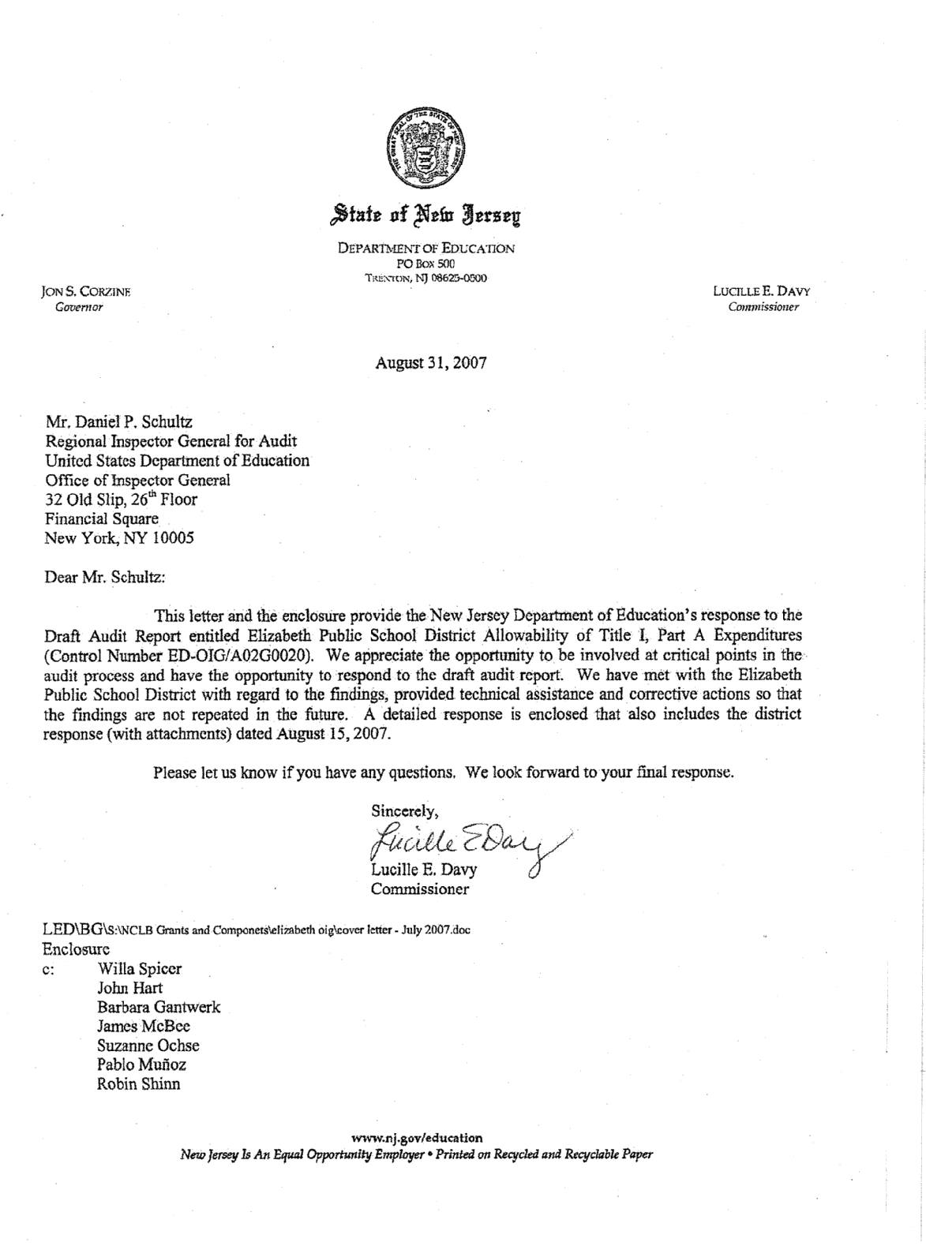
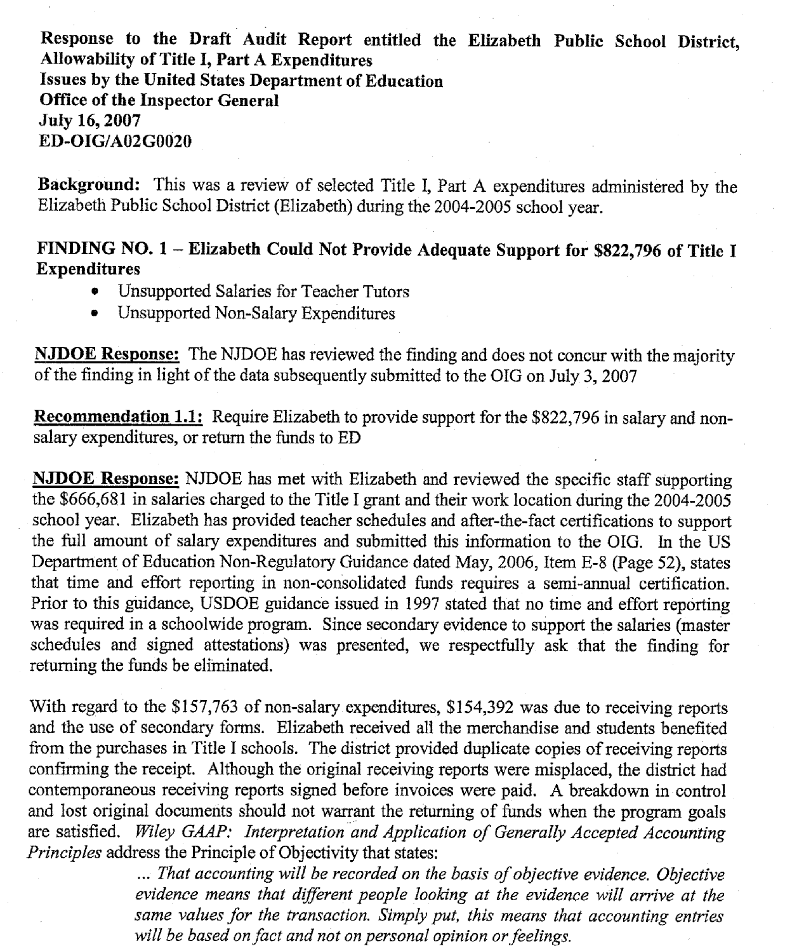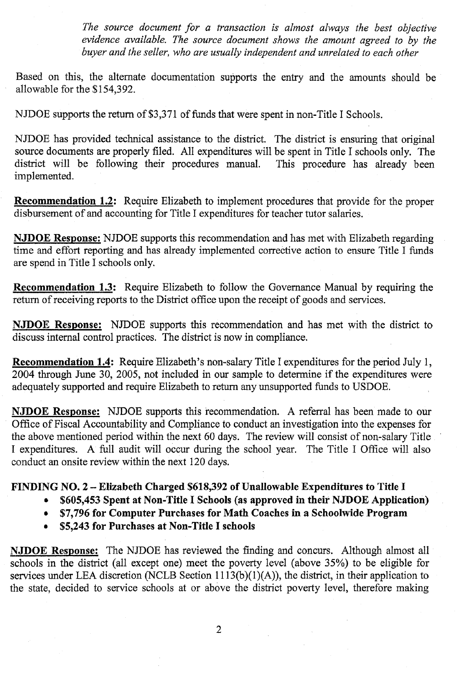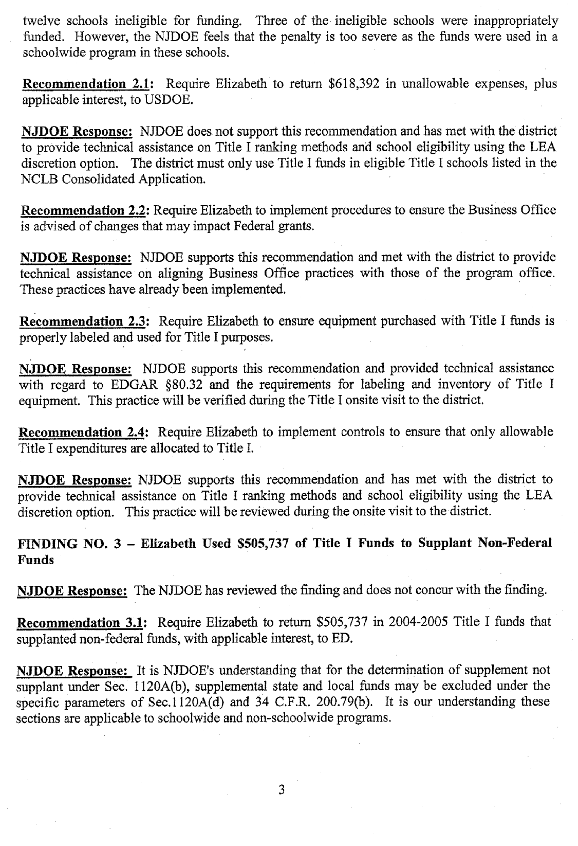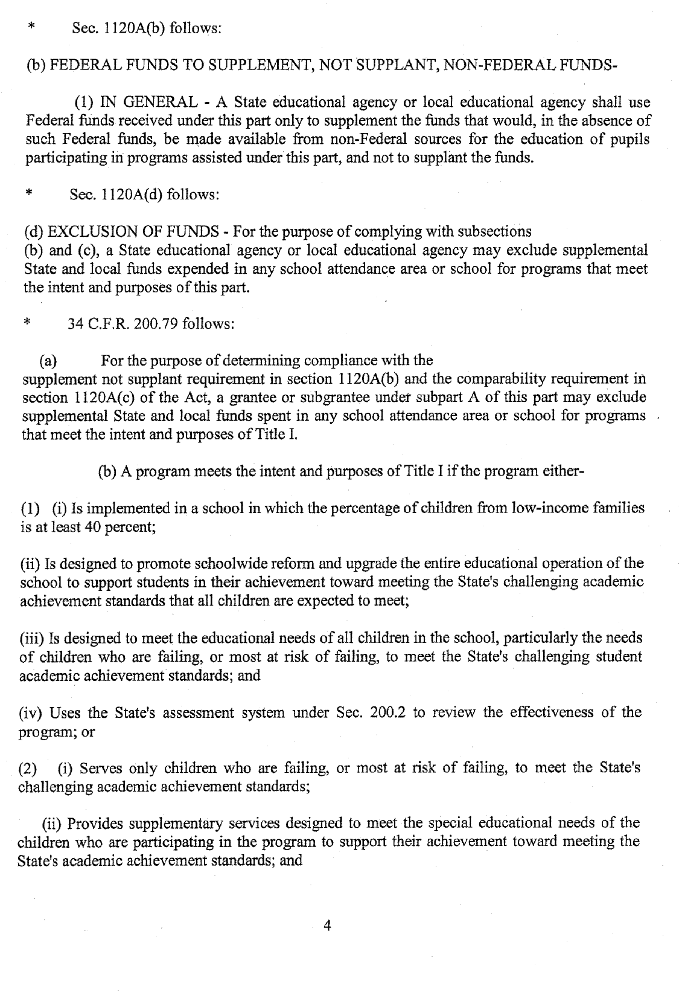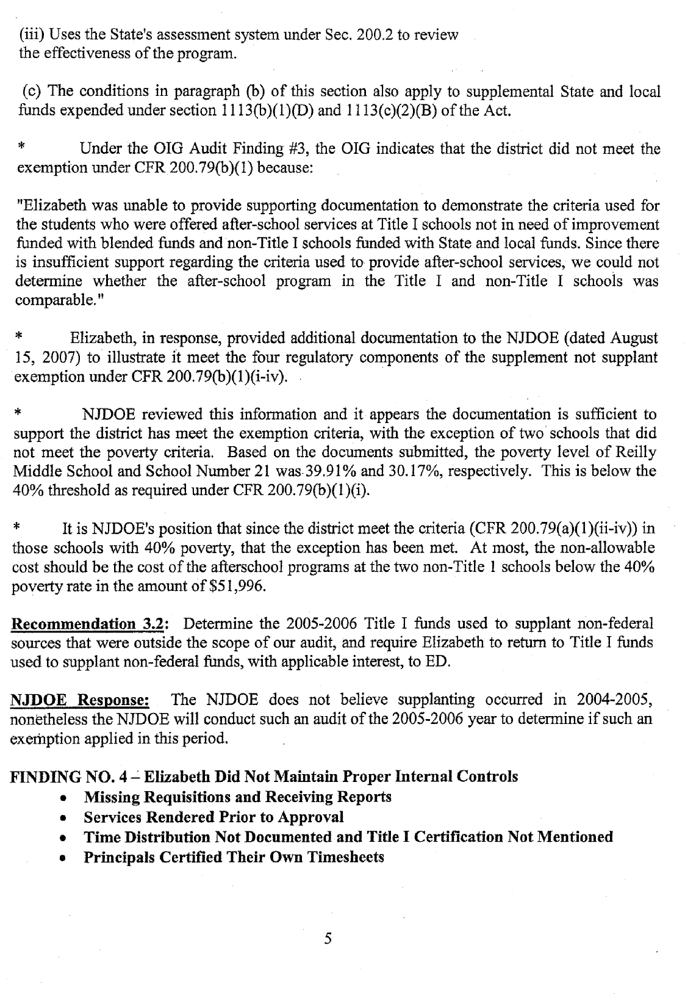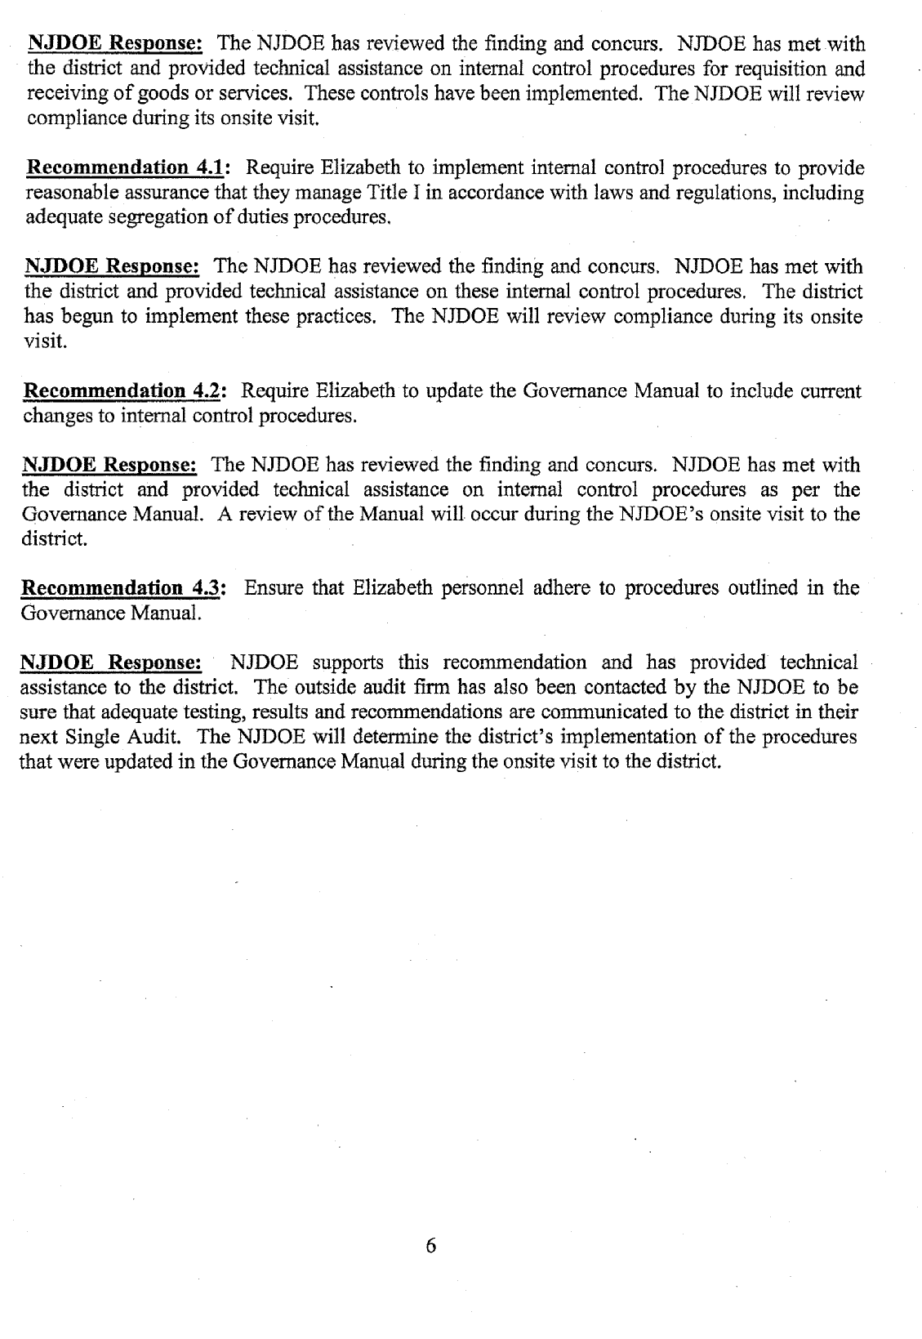

The Governance Manual details the policies, procedures and bylaws for the Elizabeth Public Schools.
District refers to the staff working or expenditures initiated in Elizabeth’s central office.
Elizabeth received funds for five ESEA programs in addition to Title I.
Title IIA funds are used to increase student achievement by improving the quality of teachers and principals and by increasing the number of highly qualified teachers.
We did not determine whether the teacher tutor salaries charged to Title IIA were an allowable expense since this was outside of the scope of our audit.
Of this amount, $1,648 was included as unallowable costs in Finding 2, resulting in $156,115 of net unsupported expenditures.
School 6 is a Pre-Kindergarten to 8th grade school named Marquis de Lafayette.
This amount represents the $666,681 for unsupported teacher tutors salaries and the net unsupported expenditures of $156,115.
This amount was not included as part of our random and judgmental sample.
The CAFR is an annual report of financial statements, budget and expenditure, prepared by Elizabeth as a representation of the financial position and operations of the District during the school year.
Elizabeth ranked its schools at or above the district average poverty level of 60.34 percent to determine its eligible Title I schools for FY 2005.
For the purpose of determining compliance with the supplement requirement in ESEA § 1120A(b), an LEA may exclude supplemental State or local funds expended in any school attendance area or school for programs that meet the intent and purposes of Title I.
Districts participating in whole school reform must record the revenues and expenditures of all schools participating in whole school reform separately in character class 15. Character class 15 is the blended fund.
We sampled and reviewed schoolwide transactions charged to the blended fund totaling $2,397,292. However, according to the 2005 CAFR, actual expenditures allocated to Title I was determined based on the revenue percentage that Title I represented in comparison to the total resources included in the blended fund. For FY 2005, 7 percent of actual total blended fund expenditures at School 6 were allocated to Title I.
We sampled five salary journal entries totaling ($446,725) and five non-salary journal entries totaling $8,815 charged to Title I by the District.

