

Testimony Before
The House Committee on Agriculture
Subcommittee on Livestock, Dairy and Poultry

May 8, 2007

Submitted by Gene Baur, MPS
President of Farm Sanctuary

PO Box 150 · Watkins Glen, NY 14891
(P) 607-583-2225· (F) 607-583-2041

Mr. Chairman, members of the committee, thank you for holding this hearing to discuss farm animal welfare, and thank you for this opportunity to testify before you here today.

My name is Gene Baur. I have a master’s degree in agricultural economics from Cornell University and I am the president and co-founder of Farm Sanctuary, an organization with more than 150,000 supporters concerned about the way animals are treated on farms. Farm Sanctuary works to prevent inhumane farming practices, and we operate farm animal shelters in New York and California where we currently care for more than 1,000 farm animals who have been rescued from abuse. I have more than 20 years of hands on experience caring for animals and working to improve their care.

As evidenced by the increasing attention in the mainstream media, methods used to produce our food and the treatment of farm animals are topics of growing concern across the U.S. and around the world. Farming today is very different than it was just one generation ago, and consumers are beginning to take notice and ask questions. Roughly 10 billion farm animals will be raised and slaughtered for food in the U.S. this year, and most will have been confined indoors, unable to enjoy the sun or sky, fresh air or grass beneath their feet. Instead, they are crowded by the thousands into warehouse-like buildings, amid the ever present stench of their own waste.

Methods used to raise animals on modern farms are unsettling to citizens, and as people learn more about them, they are demanding reforms. Recently, Smithfield, the U.S.’s largest pork producer, announced plans to phase out intensive confinement systems (i.e. gestation crates). Other businesses, including Strauss Veal, the nation’s largest veal producer, and the world renowned chef, Wolfgang Puck, have similarly announced their intention to improve the way farm animals are treated. Concerns about farm animal welfare are now reaching voters. Two states, Florida and Arizona, outlawed certain cruel farming systems through citizens’ initiatives, and others are poised to join them.

How we treat animals says a lot about us, and who we are as a people and a society. When it comes to farm animals, we have much room for improvement. According to Dr. Temple Grandin, an industry consultant and the nation’s leading livestock handling expert, too often “bad has become normal.”

Expressing concerns about our disregard for animals in agriculture, Sen. Robert Byrd rose on the floor of the U.S. Senate and said:

Our inhumane treatment of livestock is becoming widespread and more and more barbaric. Six-hundred-pound hogs—they were pigs at one time—raised in 2-foot-wide metal cages called gestation crates, in which the poor beasts are unable to turn around or lie down in natural positions, and in this way they live for months at a time. On profit-driven factory farms, veal calves are confined to dark wooden crates so small that they are prevented from lying down or scratching themselves. These creatures feel; they know pain. They suffer pain just as we humans suffer pain. Egg-laying hens are confined to battery cages. Unable to spread their wings, they are reduced to nothing more than an egg-laying machine…Animal cruelty abounds. It is sickening. It is infuriating. Barbaric treatment of helpless, defenseless creatures must not be tolerated even if these animals are being raised for food—and even more so, more so. Such insensitivity is insidious and can spread and is dangerous. Life must be respected and dealt with humanely in a civilized society.

Animals on large scale industrial farms, often called “factory farms,” are crowded together in barren environments where they cannot express or engage in natural behaviors. They have been genetically altered to maximize growth and productivity, and they are routinely given antibiotics, hormones and other additives to ward off disease and further enhance production-driven goals.

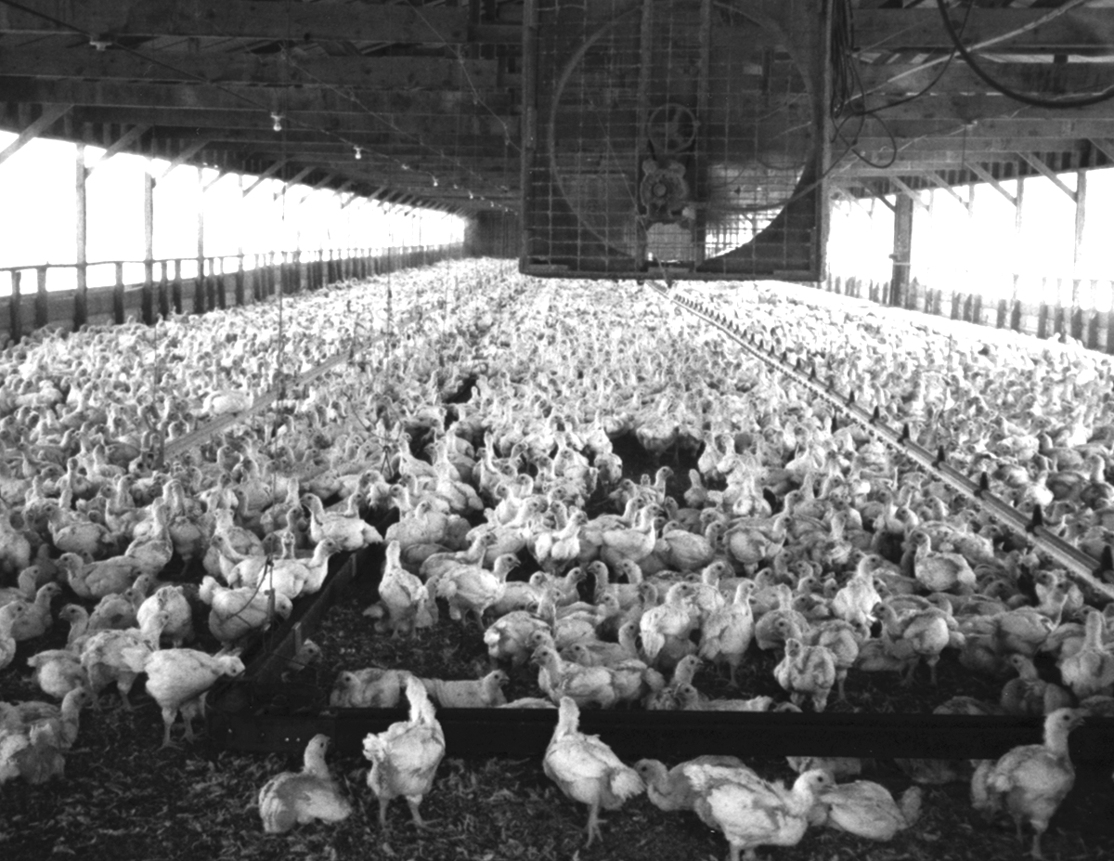
Chickens raised for meat are packed by the tens of thousands in “grower sheds.” They have been genetically altered to grow twice as fast and twice as large as normal, reaching slaughter weight at just 6 weeks of age. The animals are pushed to their biological limits and millions die every year before reaching the slaughterhouse because their hearts and lungs cannot sustain their abnormal size and growth rate. The birds’ legs and joints have difficulty supporting their unwieldy bodies, and often fail, leaving the birds crippled and in pain. Deaths and suffering are tolerated as acceptable economic losses since the financial benefits associated with using faster-growing birds are greater than the losses.

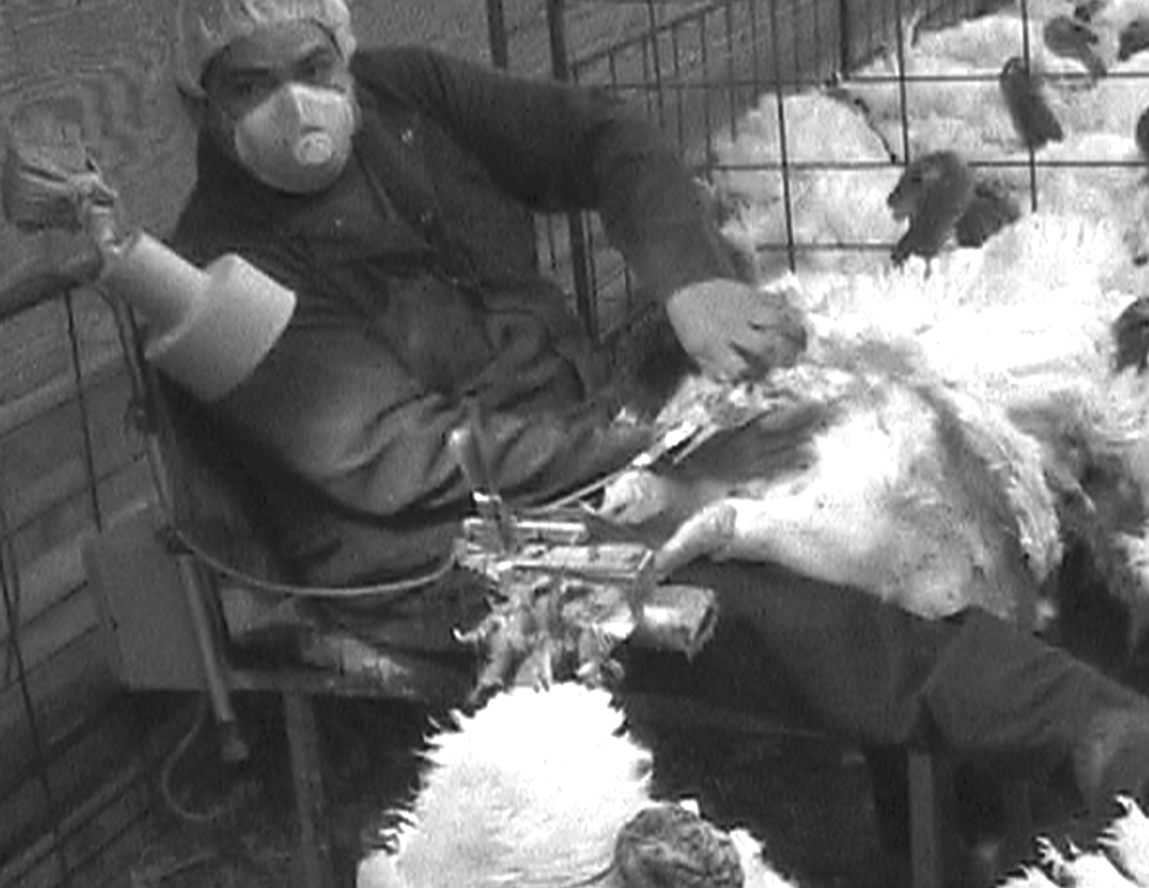
Like chickens, turkeys have been genetically altered to grow fast and large, and they also experience coronary risks and crippling leg and joint disorders. Commercially raised turkeys have been anatomically altered to have more breast meat because it is the most in demand and profitable. This anatomical manipulation has made it impossible for turkeys to mount and reproduce naturally, and the industry now relies on artificial insemination as the sole means of reproduction. At turkey breeding facilities, workers manually stimulate the male turkeys’ sex organs, causing them to ejaculate. The semen is then inserted into the breeding hens.

Like male turkeys, bulls and boars are manually stimulated by farm workers in order to bring about ejaculation and semen collection. Such behavior could be considered beastiality and a violation of law if not performed in the name of agricultural production.

Contrary to what people may assume, farm animals are excluded from the federal animal welfare act and from many state anti-cruelty laws by exemptions given to agricultural practices considered to be “accepted” by the farming industry itself. Giving an industry such authority to set its own legal standards is unprecedented and inappropriate, and has led to intolerable, but legalized, animal cruelty.

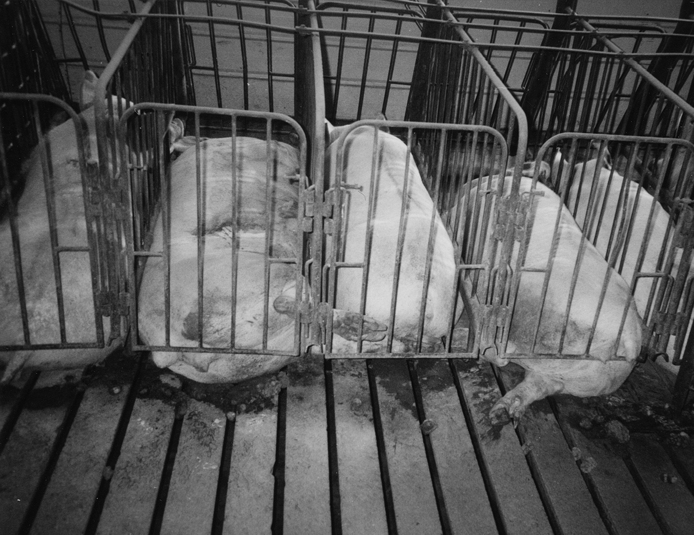
Most pigs raised in the U.S. spend their entire lives indoors, unable to go outside and root in the soil as they naturally would. They are slaughtered at 6 months old, while their mothers, breeding sows, are used in production for several years. The sows are pregnant and confined in 2-foot-wide “gestation crates” where they can’t walk, exercise or even turn around for most of their lives. They are moved to farrowing crates, and similarly confined in a 2-foot-wide space, to give birth and nurse their young. Piglets are taken from their mothers at about 3 weeks of age to be raised for slaughter, while the sows are re-impregnated and returned to gestation crates to begin another cycle. While the crates may support certain production-related goals, scientific research has also shown that the confined sows experience both physical and psychological disorders.

Agribusiness representatives, including animal science professors, veterinarians and facility managers, may assert that they know and understand animals better than anybody else because they study and raise them, but I would suggest a different opinion. While agricultural scientists have figured out how to make animals grow fast and how to produce many offspring, achieving such goals has little to do with understanding animals beyond these production-oriented objectives.

Among the rationalizations commonly used to justify confining sows in crates is that the enclosures supposedly prevent sows from sitting on and crushing their young. However, in the current system, about 15 percent of piglets die before weaning age and approximately half of those are killed when the sow accidentally steps or sits on them. Ignoring this evidence, agriculture spokespeople continue arguing that the crates prevent piglets from being crushed by their mothers.

In place of understanding animals and their natures and engaging in husbandry as humans have for generations, today’s agriculturalists have come to rationalize cruel farming practices with faulty assumptions. Modern animal agriculture has focused on increasing production efficiencies, but operates with a very limited understanding and perspective about farm animals and their well being. When comparing animal welfare in different systems used for breeding sows, for example, researchers have tended to compare one bad system (eg. gestation crates) with another (eg. crowded group housing), concluding that they each have problems.

Sometimes, agricultural scientists have even gone as far as to equate animal production and profitability with animal welfare. Thankfully, that simplistic and self-serving rationalization is being recognized as inaccurate. And, there is now a burgeoning interest in studying the cognition and sentience of animals, including farm animals. With this exploration I’m sure will come greater understanding and empathy.

I recall speaking with a manager of a university swine farm about the prevalence of intensive hog farming techniques and the use of crates for breeding sows. He responded by acknowledging that “pigmanship,” which I took to mean an understanding of animals and husbandry, is missing on today’s commercial pig farms. He went on to lament the fact that most people, including pig farmers, have never seen a sow build a nest. Ironically, we are now raising more animals in the U.S. than ever before, but we understand and appreciate them less than ever. The animals have come to be treated as production units, rather than as living, feeling creatures.

I have observed first hand how budding agriculturalists can become desensitized and learn to ignore their human tendency to empathize with animals in pain. I was in an animal science class at Cornell University, and we were shown how to cut off tails and notch the ears of newborn piglets. The painful, bloody procedures are performed without any painkillers.

At first, most people in the class were uncomfortable watching, let alone performing these mutilations. But with assurances and encouragement by the instructor, the students stepped forward, hardened their hearts, and started clipping chunks out of the piglets’ ears and cutting off their tails. As each student performed the mutilations, others in the group became more comfortable with it. I could see how behaviors that were naturally repugnant became the accepted norm.

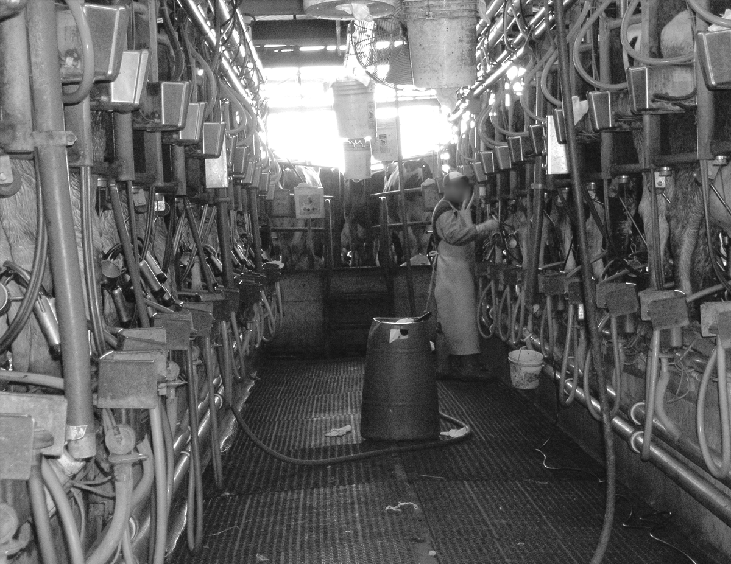
Today’s dairy cows have been genetically selected to produce 10 times more milk than they would in nature. The cows’ bodies are severely taxed, and most last only three or four years in production before being sent to slaughter. In a healthy environment, cows can live in excess of 25 years.

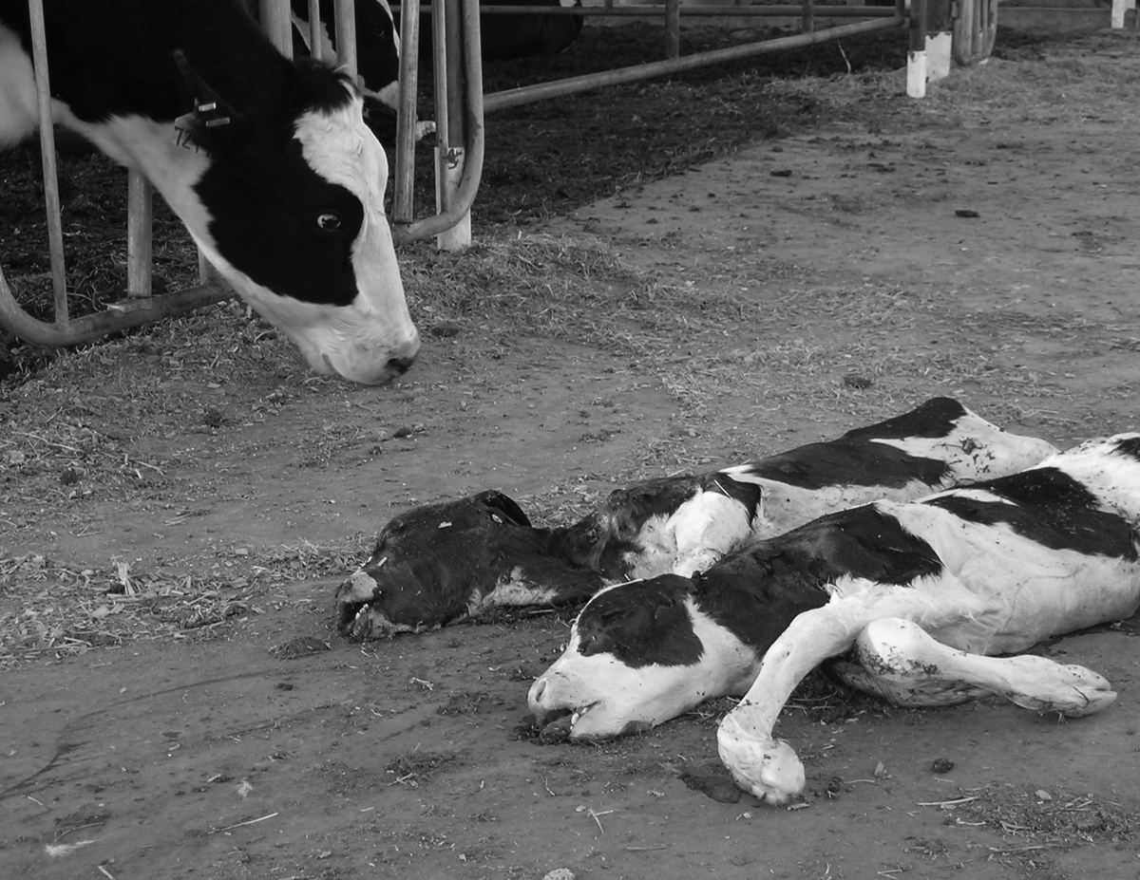
For cows to begin lactating and producing milk, they must give birth. Modern cows have a baby approximately once every 13 months and live a constant cycle of impregnation, birth and re-impregnation. Immediately after her calf is born, he/she is removed from their mother. As one would expect, this is a stressful event for both mother and baby.

Amazingly, proponents of separating calves from their mothers have said that doing so is good for the calves and helps prevent the spread of disease. While calves’ health may be at risk on certain disease-ridden farms, perhaps we should ask, “How have we come to this?” Cows are traditionally known for their maternal natures and it’s illogical and hard to accept the notion that separating calves from their mothers is really better for them. I believe this idea is more likely a rationalization that is used to legitimize our questionable behavior. And the claim is even more dubious given that in some cases the day-old calves are taken directly to slaughter.

The marketing and slaughter of downed animals, those too sick even to stand, was defended for years by the dairy industry as a way to help detect disease and promote human and animal health. Such rationalizations have a hollow ring. The best way to accomplish these goals is clearly to take better care of the animals and to prevent them from becoming so sick that they can’t stand in the first place.

Raising animals in stressful, unnatural conditions exacerbates the presence of illnesses, diseases and pathogens, which can potentially impact human health. The discovery of mad cow disease has shown how production-oriented, cost-cutting measures (i.e. using the rendered remains of cattle to feed cattle) can have broader negative impacts on the health of animals and people. The irresponsible use of antibiotics, which increase short term efficiency and productivity, has resulted in the development of antibiotic resistant bacteria, which now threaten human health. While industrial farming may appear productive and efficient on the surface, it comes with various other costs to our well being, while also harming rural communities and the environment.

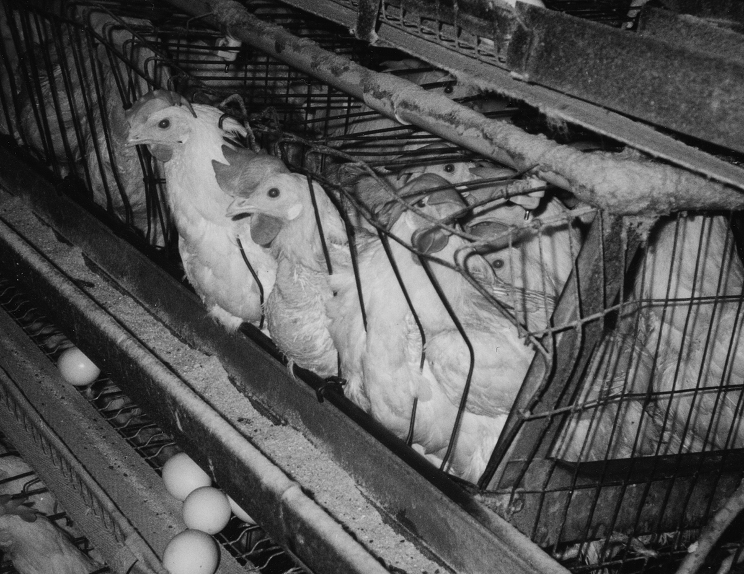
Among the most intensely confined of all farm animals today are egg laying hens who live in battery cages, small wire enclosures that are lined up in rows and stacked in tiers in huge factory warehouses that commonly house 80,000 birds. The hens are kept this way for about a year, unable to perch, scratch in the dirt or stretch their wings. Instead, they stand on wire mesh floors and constantly push up against cage mates and the hard wire walls of their enclosures. Each bird is allotted about as much space as the size of an 8½-by-11-inch piece of paper.

The lack of exercise combined with the intense demands of egg production (each hen lays more than 260 eggs per year), causes birds to suffer from osteoporosis, and broken bones are common. When the birds’ productivity drops off, they are deemed “spent hens” and killed. They may be used for low grade chicken meat products, but it’s becoming economically inefficient and increasingly difficult to find slaughterhouses willing to kill hens for human food, and sometimes they end up in landfills. There have even been incidents when unwanted hens were killed in a wood chipper prior to their disposal.

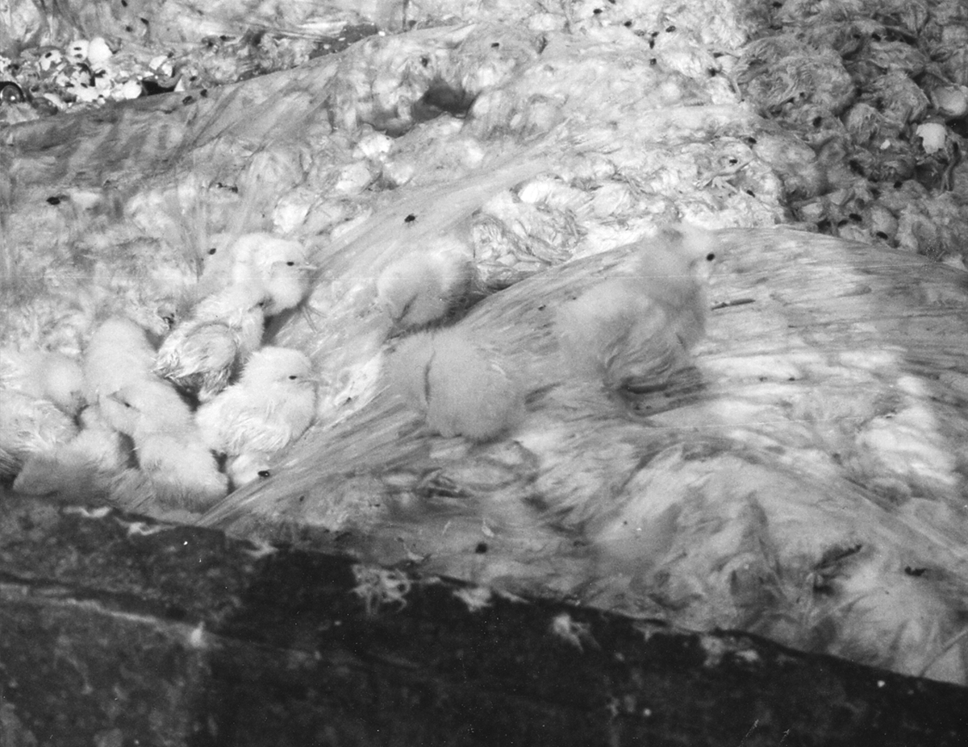
Like unwanted hens, unwanted male chicks born at hatcheries that produce laying hens are killed immediately after hatching, sometimes by suffocation in garbage bags and dumpsters. These young males are considered economically useless because they will never lay eggs and they don’t grow fast enough to be raised profitably for meat. Compared to their female counterparts, perhaps they are the lucky ones. What does it say about our farming system when an early death is the most humane option, or when an entire population of baby animals is killed as a matter of course?

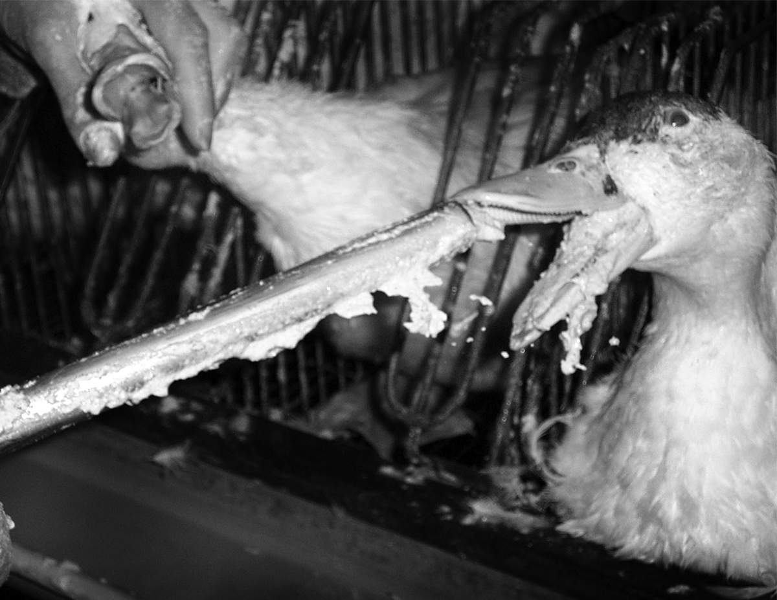
The production of foie gras (French for “fatty liver”) is another example of a cruel food production practice. It involves force feeding ducks or geese by shoving a pipe down their throats, forcing in large amounts of food to cause their livers to expand 10 times their normal size. The enlarged, diseased liver is then sold as an expensive appetizer. Foie gras production, like various other cruelties through the years, has been defended as a tradition. But as we learn and society evolves, we come to challenge and question the appropriateness of certain traditions and assumptions.

As our views change and evolve, so do our laws. At one time, slavery was legal in the U.S., but it is now outside the bounds of socially acceptable conduct. The same goes for child labor and other abuses of humanity. In the case of animals raised for food, laws are currently out of line with societal values, and I encourage members of this body to support legislation (such as H.R. 1726, The Farm Animal Stewardship Purchasing Act), which reflects our moral obligation to treat other animals with respect and compassion.

Commenting on the vast cruelty of industrialized animal farming, author Ruth Harrison wrote:

If one person is unkind to an animal it is considered to be cruelty, but where a lot of people are unkind to animals, especially in the name of commerce, the cruelty is condoned and, once large sums of money are at stake, will be defended to the last by otherwise intelligent people.

Thankfully, our society is now beginning to examine the way farm animals are being raised, and with this growing interest and awareness, I believe change is imminent.

I appreciate your time and attention, and I am happy to respond to any questions you may have.

Thank you.

Gene Baur
PO Box 150
Watkins Glen, NY 14891
gbaur@farmsanctuary.org
607-583-2225 ext. 227

Presentations and Legislative Testimony
- Dairy Policy Summit: “Defining the Next Frontier,” Manitowoc, Wisconsin,
October 24 and 25, 2006
- Testimony at a standing-room-only Congressional hearing at the Rayburn House Office Building in Washington, DC. conducted by The Congressional Friends of Animals Caucus to address factory farming issues, discuss remedies and raise awareness about animal welfare, environment destruction and the disintegration of family farms, June 29, 2006
- Young Dairy Leaders Institute, Tampa, FL, February 2, 2006
- Testimony in support of Alderman Moore’s proposed ordinance to ban the sale of foie gras in Chicago, before a hearing of the City Council Committee on Health at Chicago City Hall, Tuesday, September 13, 2005 and October 25, 2005
- Testimony in support of Senate Bill 498 before the Joint Committee on Environment, Natural Resources and Agriculture, September 12, 2005
- Testimony in support of Senate Bill 552 before the Massachusetts Joint Committee on the Environment, Natural Resources and Agriculture, June 20, 2005
- Farm Animal Wellness Seminar Expert Panel, University of Wisconsin Veterinary School, March 26, 2005
- Testimony in support of Senate Bill 413 before the Illinois Senate Executive Committee, March 9, 2005
- Presentation before the U.S.D.A.: “Animal Rights and Human Responsibility,” September 20, 2004
- Testimony in support of Senate Bill 1520, before the California Assembly Committee on Business and Professionals, June 22, 2004
- Testimony in Support of Senate Bill 417, before the Maryland Senate Committee on Education, Health and Environmental Affairs, March 16, 2004
- Testimony in support of Assembly Bill 1948, before the New Jersey General Assembly Committee on Agriculture and Natural Resources, May 13, 2002
- Testimony in support of the federal Downed Animal Protection Act before the U.S. House Agricultural Subcommittee on Livestock, Sept. 28, 1994; and also in February, 1992
- NY City bar association on animal issues, and have spoken at various law schools including Columbia, NYU, Cordozo, UCLA, Loyola, (may be others too); I spoke at the Young Dairy Leaders Conference in FL a couple years ago, and at another industry conference in Wisconsin in 2006
- Testimony in support of Senate Bill 692, before the California legislature, 1993-1994.

Published Works by Gene Baur
- Upcoming book to be published in March, 2008 by Simon and Schuster
- “Animal Welfare Regs Would ‘Codify Cruelty,’” New Jersey Farmer, May 20, 2003
- “Primer on Animal Rights: Leading Experts Write about Animal Cruelty and Exploitation,” Edited by Kim W. Stallwood, June 2002
- “Diseased Animals Are Being Marketed for Food,” USA Today. Volume: 130. Issue: 2682. March, 2002
- Co-wrote script for “Life Behind Bars” factory farming film with Mary Tyler Moore, 2001
- “Agribusiness wise to consider animal welfare,”
Feedstuffs, October 25, 1999
- “Battered Birds, Crated Herds,” 1996

Offices Held
- Steering Committee, Arizonians for Humane Farms, 2005-2006
- Chair, Summit for the Animals, 2005, 1994
- Board Member, Summit for the Animals, 2004-2006, 1994-1997
- Steering Committee, Floridians for Humane Farms, 2000-2002
- Vice Chair, Humane USA, 2000 to present
- Co-founder and President, Farm Sanctuary, 1986 to present

Education
B.A., Sociology, Cal State Northridge – 1985
M.P.S., Agricultural Economics, Cornell University – 1996

Awards
Courage of Conscience Award, The Peace Abbey, 1996



