A NATION ONLINE:

How Americans Are Expanding
Their Use of the Internet

February 2002

U.S. DEPARTMENT OF COMMERCE
Economics and Statistics Administration
National Telecommunications and Information Administration

I am pleased to release A Nation Online: How Americans Are Expanding Their Use of the Internet. This report provides comprehensive information on Americans’ connectivity to the Internet, broadband services, and computers. Increasing numbers of Americans have integrated these technologies into their daily lives and are using them in a variety of places and for a wide range of activities.
The expanding use of new technologies continues to strengthen our economy. More Americans can now engage in online commerce, obtain e-government services, and access valuable information. Broadband connections are also on the rise. These high-speed connections will make it easier for people to engage in distance learning programs or telemedicine and to access a whole new array of entertainment and services that are on the horizon.
As these connections open new economic opportunities for more Americans, it is important that all segments of our Nation are included in this ongoing information revolution. I am heartened by this report’s findings that all groups of individuals are using these technologies in increasingly greater numbers.
Our young people are real leaders in the use of new information technologies. The vast majority of our youth are now Internet users. This development holds special promise for our economic future: today’s children who gain comfort and aptitude with new information technologies will be tomorrow’s skilled workers and innovators for our country.
These developments promise to bring economic growth and vitality to our Nation, and I am pleased that we are able to report on these exciting milestones.

Donald L. Evans

FOREWORD

Kathleen B. Cooper
Under Secretary for Economic Affairs
Administrator, Economics and Statistics Administration

Nancy J. Victory
Assistant Secretary for Communications and Information
Administrator, National Telecommunications and Information Administration

A Nation Online: How Americans Are Expanding Their Use of the Internet provides an insightful look at how Americans are increasing their connectivity to information technologies. We are fortunate to be able to base our findings on the September 2001 U.S. Census Bureau’s Current Population Survey – a survey of approximately 57,000 households and more than 137,000 individuals across the United States. As such, the data in this study are among the most broad-based and reliable datasets that have been gathered on Internet, broadband, and computer connectivity.

The ongoing collection and reporting of such data are critical for those of us in public policy. As more and more commercial activity, government services, and health and educational material are offered online, access to the Internet has become increasingly important. These data can help us track which Americans use the Internet and can access such information and services. The Census data, for example, shed light on which households subscribe to the Internet and broadband services, which household members actually go online, which schoolchildren are using the Internet and computers at schools and at home, which Americans are using these technologies at work and at home, and how usage outside the home is affecting whether Americans go online at home.

We hope that this information will be useful to a wide variety of policymakers and service providers, such as educators, government officials, and content providers. These data will help all of us determine how we can reach Americans more effectively and take maximum advantage of the opportunities available through new information technologies.

A NATION ONLINE: How Americans Are Expanding Their Use Of The Internet
National Telecommunications Economics and Statistics
and Information Administration Administration
Nancy J. Victory, Assistant Secretary Kathleen B. Cooper, Under Secretary
for Communications and Information for Economic Affairs

Joint Project Team
NTIA ESA
Kelly K. Levy, Associate Administrator, Lee Price, Deputy Under Secretary for
Office of Policy Analysis and Development Economic Affairs

James McConnaughey, Senior Economist Patricia Buckley, Senior Policy Advisor

Wendy Lader, Senior Policy Analyst Sabrina Montes, Economist

Sallianne Schagrin, Telecommunications George McKittrick, Economist
Policy Analyst
Jeffrey Mayer, Director, Office of
Sandra Castelli, Telecommunications Policy Development
Policy Analyst

Jeffrey Joyner, Senior Counsel

Keri Nusbaum

U.S. Bureau of the Census
Demographic Surveys Division Demographic Statistical Methods Division
Ronald R. Tucker Alfred Meier
Greg Weyland
Tim J. Marshall Technologies Management Office
Adelle Berlinger Andrew Stevenson
L. Dinah Flores
Kerry Akiyama Population Division
Eric Newburger

Acknowledgments
NTIA and ESA would like to thank Milton Brown, Clyde F. Ensslin, Maureen Lewis, Steve Saleh, Josephine Scarlett, Kathy Smith, and Mary Smith of NTIA, and Elizabeth (E.R.) Gregory of ESA for their contribution to this report.

table of contents

EXECUTIVE SUMMARY 1
Chapter 1: Overview 3
Chapter 2: Computer and Internet Use 10
Key Demographic Factors in Computer and Internet Use 11
Income 11
Employment Status 13
Age 14
Gender 15
Educational Attainment 17
Urban or Rural Location of the Household 20
Race / Hispanic Origin 21
Chapter 3. Online Activities 30
Primary Uses by the U.S. Population 30
Activities Among Those Individuals Online 31
Gender 32
Age 32
Race 33
Income 34
Chapter 4: How and Where America Goes Online 35
Connection Types: The Expansion of Broadband 35
Spread of New Devices 37
Location of Use 38
Chapter 5: The Digital Generation: How Young People Have Embraced Computers and the Internet 42
Computer and Internet Use 42
The Impact of Schools on Internet and Computer Use 44
How Young People Are Using the Internet 52
Concerns About Children’s Online Use 53
Chapter 6: The Digital Workplace 57
Introduction 57
Computer Use at Work by Occupation 58
Computer Use at Work by Gender and Age 59
Types of Computer Uses at Work 59
Internet Use at Work 61
The Work – Home Connection 62
Chapter 7: Computer and Internet Use Among People with Disabilities 65
People with Disabilities 65
Under 25 66
25 to 60 year olds 67
Over 60 Year-Olds 70
The Interaction of Disability with Computer and Internet Use 71
Chapter 8: The Unconnected 73
The Offline Population 73
The Importance of Cost to Households Never Connected to the Internet 75
Why Households have Discontinued Internet Access 76
The Effect of Confidentiality Concerns 77
Content Concerns 77
The Role of Network Effects 78
Chapter 9: Reductions in Inequality for Computer and Internet Use 85
How a Gini Coefficient for Computer and Internet Use is Computed 85
CONCLUSION 91
METHODOLOGY 92

EXECUTIVE SUMMARY
Few technologies have spread as quickly, or become so widely used, as computers and the Internet. These information technologies are rapidly becoming common fixtures of modern social and economic life, opening opportunities and new avenues for many Americans. A Nation Online: How Americans Are Expanding Their Use of the Internet shows the rapidly growing use of new information technologies across all demographic groups and geographic regions. Not only are many more Americans using the Internet and computers at home, they are also using them at work, school, and other locations for an expanding variety of purposes.
In the last few years, Americans’ use of the Internet and computers has grown substantially.
- The rate of growth of Internet use in the United States is currently two million new Internet users per month.
- More than half of the nation is now online. In September 2001, 143 million Americans (about 54 percent of the population) were using the Internet — an increase of 26 million in 13 months. In September 2001, 174 million people (or 66 percent of the population) in the United States used computers.
Children and teenagers use computers and the Internet more than any other age group.
- Ninety percent of children between the ages of 5 and 17 (or 48 million) now use computers.

- Seventy-five percent of 14-17 year olds and 65 percent of 10-13 year olds use the Internet.

- Family households with children under the age of 18 are more likely to access the Internet (62 percent) than family households with no children (53 percent), and non-family households (35 percent).
- Computers at schools substantially narrow the gap in computer usage rates for children from high and low income families.
Internet use is increasing for people regardless of income, education, age, races, ethnicity, or gender.
- Between December 1998 and September 2001, Internet use by individuals in the lowest-income households (those earning less than $15,000 per year) increased at a 25 percent annual growth rate. Internet use among individuals in the highest-income households (those earning $75,000 per year or more) increased from a higher base but at a much slower 11 percent annual growth rate.
- Between August 2000 and September 2001, Internet use among Blacks and Hispanics increased at annual rates of 33 and 30 percent, respectively. Whites and Asian American and Pacific Islanders experienced annual growth rates of approximately 20 percent during these same periods.
- Over the 1998 to 2001 period, growth in Internet use among people living in rural households has been at an average annual rate of 24 percent, and the percentage of Internet users in rural areas (53 percent) is now almost even with the national average (54 percent).
- The highest growth rate among different types of households is for single mothers with children (29 percent).
- People with mental or physical disabilities (such as blindness, deafness, or difficulty walking, typing, or leaving home) are less likely than those without such disabilities to use computers or the Internet.
While 80 percent of Americans access the Internet through dial-up service, residential use of broadband service is rapidly expanding.
- Between August 2000 and September 2001, residential use of high-speed, broadband service doubled—from about 5 to 11 percent of all individuals, and from 11 to 20 percent of Internet users.
Americans are going online to conduct an expanding range of activities.
- Forty-five percent of the population now uses e-mail, up from 35 percent in 2000. Approximately one-third of Americans use the Internet to search for product and service information (36 percent, up from 26 percent in 2000).
- Among Internet users, 39 percent of individuals are making online purchases and 35 percent of individuals are searching for health information.
Use of the Internet and computers at work has contributed to higher use levels at home.
- The presence of someone who uses a computer or the Internet at work in a household is associated with substantially higher computer ownership or Internet use for that household, by a margin of about 77 percent to 35 percent.
With more than half of all Americans using computers and the Internet, we are truly a nation online. At work, schools, and libraries, as well as at home, the Internet is being used by a greater number of Americans.
Chapter 1: Overview
Americans’ use of information technologies grew at phenomenal rates in 2001. This past year saw a rapid increase in computer and Internet use, not only in homes, but also at the workplace, schools, and other locations. Broadband connections, available principally through cable modems and digital subscriber lines (DSL), are making higher-speed connections available to an increasing number of Americans and expanding options for online usage.
The Department of Commerce’s Census Bureau surveyed approximately 57,000 households containing more than 137,000 individuals in all 50 states and the District of Columbia and found a rapid diffusion of these technologies. At the time of the survey, September 2001,
60.2 million U.S. homes (or 56.5 percent) had a personal computer. Seven of every eight households with computers (88.1 percent) also subscribed to the Internet. As a result, more than half of U.S. households (53.9 million homes, or 50.5 percent) had Internet connections. As shown in Figure 1-1, this remarkable rise to over 50 percent household penetration of both computers and the Internet occurred very quickly.
Figure 1-1: Percent of U.S. Households with a Computer and Internet Connections,
Selected Years
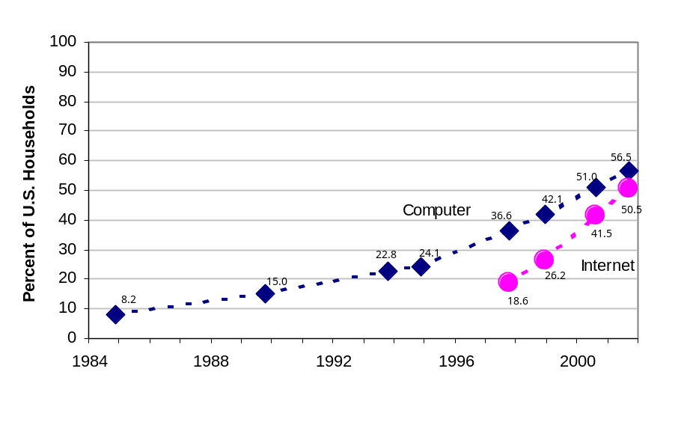
Source: NTIA and ESA, U.S. Department of Commerce, using U.S. Census Bureau Current Population Survey Supplements

On an individual (rather than household) basis, as of September 2001 two-thirds (66.8 percent) of the people in the United States used a computer at home, school and/or work. The vast majority of those who used computers (80.6 percent) were also connecting to the Internet. These two factors taken together contributed to a substantial rise in Internet use. By September 2001, 143 million people in the United States (or 53.9 percent) were using the Internet, up from 116.5 million people (or 44.5 percent) in August 2000. The widespread increase in information technologies in the United States has occurred across all 50 states. As Figure 1-2 shows, in August 2000, few states had more than 50 percent of their population using the Internet. By September 2001, most states had at least half of their population online. Table 1-1 provides a state-by-state breakdown of individual Internet use.
Figure 1-2: The Rapid Increase in Internet Use in the United States Across States

August 2000 | September 2001
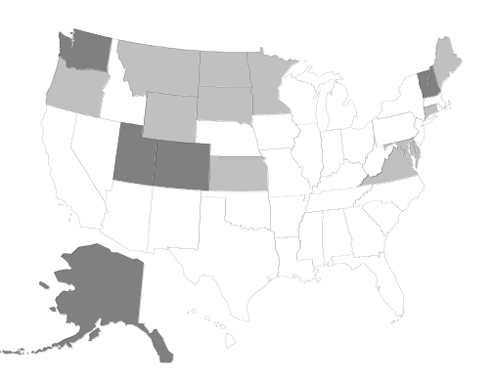 | 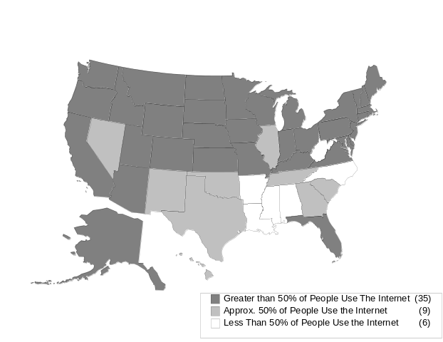
Source: NTIA and ESA, U.S. Department of Commerce, using U.S. Census Bureau Current Population Survey Supplements
The rapid diffusion of the Internet is not a unique U.S. phenomenon. According to data compiled by the Organization for Economic Cooperation and Development (OECD) from various nations, the rise in Internet use is truly a global phenomenon (Figure 1-3).

Figure 1-3: Individuals Using the Internet from any Location,
Selected Countries, 1999 and 2000

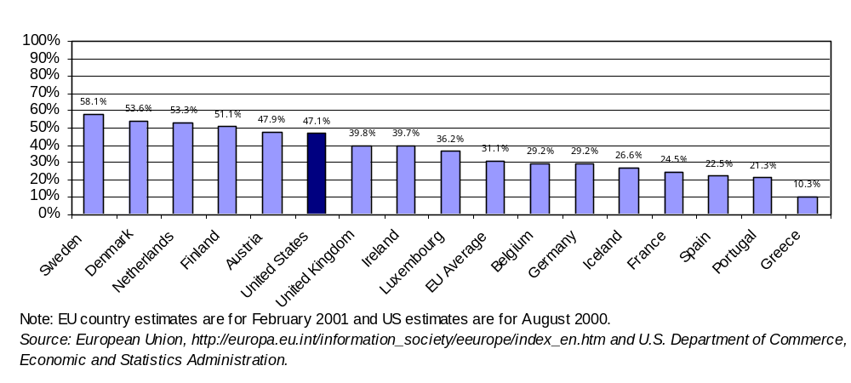
Note: EU country estimates are for February 2001 and US estimates are for August 2000. Source: European Union, http://europa.eu.int/information_society/eeurope/index_en.htm and U.S. Department of Commerce, Economic and Statistics Administration.
The spread of new technologies, such as the Internet, can be described by a variety of metrics – such as the percent of households connected (Figure 1-1) and the percent of the population connected (Figure 1-2). Figure 1-4 shows how selecting a different basis of measurement can affect the results: in September 2001, 50.5 percent of households had Internet connections; 56.7 percent of the total U.S. population lived in households with these connections; a lower 43.6 percent of Americans were using the Internet in their homes; while 53.9 percent of the total population used the Internet at some location.
This report features data on individuals more than data on households, for several reasons. First, focusing on individuals permits us to study such factors as age, gender, education, and employment status in determining computer and Internet use. Second, Internet access is more frequently occurring outside the home, at such locations as work, schools, and libraries. And finally, a small but growing number of Internet connections are increasingly occurring over personal devices, such as wireless phones and personal digital assistants, in addition to the computer. For some variables, such as the type of home Internet connection and reasons for non-subscribership, the household remains the unit of measurement because that is the level at which the question was most appropriately asked. For purposes of historical comparisons with earlier data available only on a household basis, we also use current household data.
Figure 1-4: Different Perspectives on Internet Access and Use 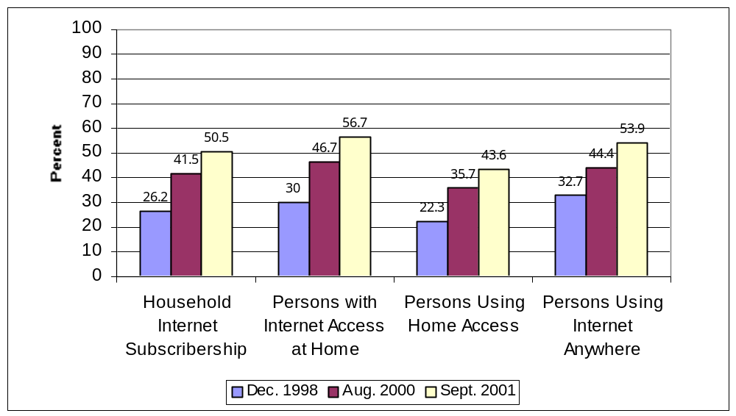
Source: NTIA and ESA, U.S. Department of Commerce, using U.S. Census Bureau Current Population Survey Supplements
This report examines computer and Internet use from a number of perspectives.
Chapter 2 provides an overview of the expanding use of computers and the Internet and how different demographics, such as income or age, are associated with rates of use.
Chapter 3 looks at online activities. It also examines the relationship of a variety of demographic factors to online activities.
Chapter 4 reports on how and where people are going online; the expanding use of broadband connections; and the small but growing number of people using secondary devices, such as mobile cell phones to access the Internet. Chapter 4 also examines a particularly significant development in the past year: the increasing use of the Internet outside the home.
Chapters 5 and 6 focus on particular “outside the home” locations: work and school. Chapter 5 examines how schools provide access to computers and the Internet for students, enabling children of all socio-economic backgrounds to use these technologies. As a result, children and young adults are among the highest users of new technologies, integrating the Internet in their schoolwork and other activities. Chapter 6 focuses on how use at the workplace has affected the presence and use of computers and the Internet at home.
Of course, not all Americans are using computers or the Internet at high rates. Chapter 7 examines how one such group—those with disabilities—still trails behind the national average in terms of use. Chapter 8 discusses more generally the population that is not online and considers some possible reasons for their lack of connectivity.
Finally, Chapter 9 examines changes in Internet and computer use for subgroups of the population over time. Using a standard methodology to gauge inequality, our research shows that inequality among various groups is decreasing. As these trends continue, we expect that new information technologies will become more widely shared by an ever-expanding number of Americans.
Table 1-1. Internet Use by Percent of State Population

State | Total Population, Age 3+ (Thousands) | Percent Who Are Internet Users  (90 Percent Confidence Interval)*
United States | 265,180 | 53.6 — 54.1
Alabama | 4,271 | 43.3 — 49.0
Alaska | 593 | 66.0 — 71.6
Arizona | 4,641 | 50.4 — 55.8
Arkansas | 2,544 | 41.4 — 47.1
California | 33,108 | 50.9 — 53.3
Colorado | 4,004 | 57.3 — 62.9
Connecticut | 3,170 | 55.3 — 61.9
District of Columbia | 509 | 42.0 — 48.6
Delaware | 732 | 55.1 — 61.6
Florida | 15,075 | 50.5 — 53.5
Georgia | 7,550 | 47.7 — 52.8
Hawaii | 1,150 | 47.6 — 54.1
Idaho | 1,244 | 53.0 — 58.5
Illinois | 11,486 | 49.5 — 53.0
Indiana | 5,733 | 52.6 — 58.4
Iowa | 2,769 | 55.3 — 61.2
Kansas | 2,509 | 55.0 — 61.0
Kentucky | 3,785 | 50.3 — 56.1
Louisiana | 4,141 | 40.6 — 46.2
Maine | 1,233 | 57.2 — 63.6
Maryland | 5,115 | 58.4 — 64.3
Massachusetts | 5,993 | 54.5 — 58.8
Michigan | 9,553 | 54.6 — 58.2
Minnesota | 4,742 | 60.7 — 66.2
Mississippi | 2,642 | 38.9 — 44.7
Missouri | 5,192 | 54.3 —60.3
Montana | 866 | 54.7 — 60.4
Nebraska | 1,632 | 52.4 — 58.4
Nevada | 1,902 | 49.2 —54.9
New Hampshire | 1,194 | 60.2 — 66.7
New Jersey | 7,944 | 58.1 — 61.8
New Mexico | 1,754 | 46.9 — 52.6
New York | 17,510 | 51.6 — 54.3
North Carolina | 7,200 | 45.0 — 49.3
North Dakota | 591 | 53.4 — 59.5
Ohio | 10,877 | 53.2 — 56.8
Oklahoma | 3,161 | 46.8 — 52.5
Oregon | 3,358 | 58.2 — 64.1
Pennsylvania | 11,356 | 53.3 — 56.7
Rhode Island | 943 | 53.3 — 60.0
South Carolina | 3,728 | 44.6 — 50.7
South Dakota | 690 | 55.9 — 61.6
Tennessee | 5,209 | 49.5 — 55.5
Texas | 19,576 | 49.7 — 52.6
Utah | 2,061 | 58.7 — 64.0
Vermont | 590 | 57.3 — 63.6
Virginia | 6,653 | 55.7 — 61.2
Washington | 5,661 | 58.3 — 64.2
West Virginia | 1,712 | 43.9 — 49.5
Wisconsin | 5,070 | 54.1 — 59.9
Wyoming | 460 | 59.3 —65.2
* Specific point estimates are subject to sampling error (see Methodology Section). This Table reports the 90 percent confidence interval to avoid inaccurate and misleading rankings of states by Internet use point estimates. With a probability of 90 percent the “true” percent of Internet use falls within this range.

Chapter 2: Computer and Internet Use
Increasingly, we are a nation online. Individuals continue to expand their use of computers and the Internet. As of September 2001, 174 million people or 65.6 percent of the U.S. population were computer users. One hundred forty three million people or 53.9 percent of the population used the Internet (Tables 2-1 and 2-2 and Figure 2-1).
Figure 2-1: Internet Use From Any Location, Percent of Persons Age 3 +
Computer Use 1997, 2001 | Internet Use 1997, 1998, 2000, 2001
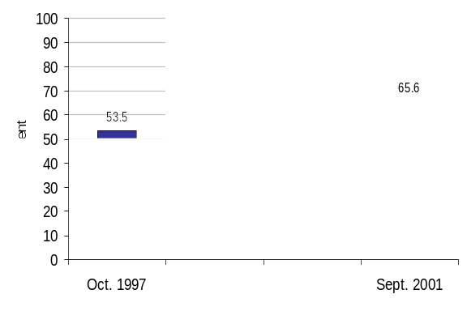 | 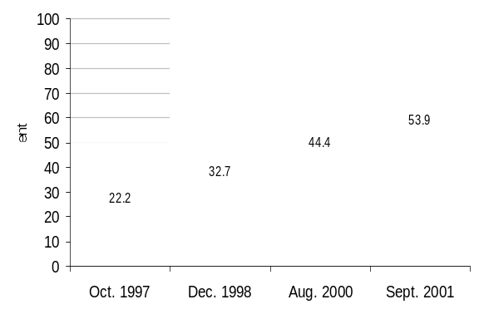
Source: NTIA and ESA, U.S. Department of Commerce, using U.S. Census Bureau Current Population Survey Supplements
Both computer and Internet use have increased substantially in the past few years. Since 1997 computer use has grown at a rate of 5.3 percent on an annualized basis. Internet use has grown at a rate of 20 percent a year since 1998. In the 13 months before September 2001, over 26 million more people went online.
The demographic profile of computer and Internet users provided in this chapter reveals that growth in computer and Internet use is broadly based. In every income bracket, at every level of education, in every age group, for people of every race and among people of Hispanic origin, among both men and women, many more people use computers and the Internet now than did so in the recent past. Some people are still more likely to be Internet users than others. Individuals living in low-income households or having little education, still trail the national average. However, broad measures of Internet use in the United States suggest that over time Internet use has become more equitable (See Chapter 9).
Demographic Factors in Computer and Internet Use
Income
Family income remains an indicator of whether a person uses a computer or the Internet. Individuals who live in high-income households are more likely to be computer and Internet users than those who live in low-income households. This relationship has held true in each successive survey of computer and Internet use.
Nonetheless, both computer and Internet use have increased steadily across all income categories over time (Figure 2-2). While notable differences remain in Internet use across income categories, Internet use has grown considerably among people who live in lower income households. Among people living in the lowest income households (less than $15,000 annually), Internet use had increased from 9.2 percent in October 1997 to 25.0 percent in September 2001.
Figure 2-2: Computer and Internet Use From Any Location by Family Income,
Persons Age 3 +
Computer Use 1997, 2001 | Internet Use 1997, 1998, 2000, 2001
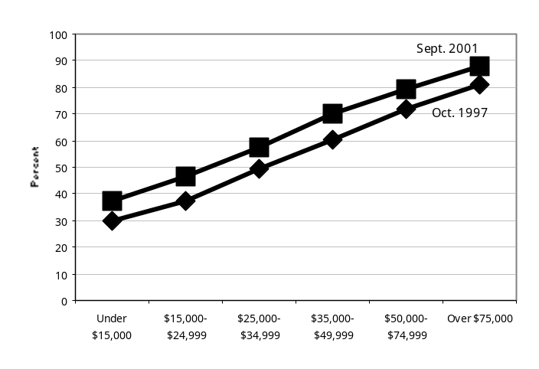 | 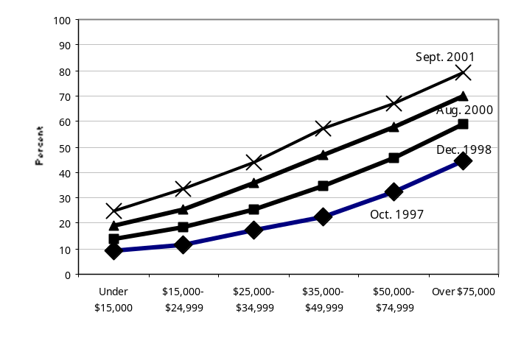

Source: NTIA and ESA, U.S. Department of Commerce, using U.S. Census Bureau Current Population Survey Supplements
Internet use is growing faster among people in lower family income brackets (Figure 2-3, Table 2-3). Internet use among people who live in households where family income is less than $15,000 grew at an annual rate of 25 percent between December 1998 and September 2001. Over the same period Internet use grew at an annual rate of 11 percent among people living in households where family income was $75,000 or more.
Figure 2-3: Growth in Internet Use by Family Income, Percent of Persons Age 3 + (Annual Rate)
December 1998 to September 2001
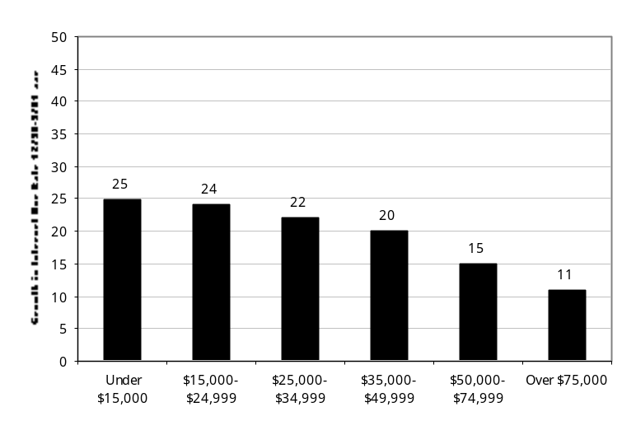
Source: NTIA and ESA, U.S. Department of Commerce, using U.S. Census Bureau Current Population Survey Supplements
Not only did the Internet use rate grow faster for those living in lower income households, but growth also accelerated between August 2000 and September 2001 relative to December 1998 to August 2000. For people living in households in the two lowest income brackets, the Internet use rate grew faster between August 2000 and September 2001 than between December 1998 and August 2000. This acceleration in the growth of Internet use did not occur among people living in higher income households (Table 2-3).
Employment Status
Both the employed and the not employed (either unemployed or not in the labor force) saw growth in computer and Internet use rates since 1997 (Figure 2-4).
People who are employed are more likely to be both computer and Internet users. In 2001, 73.2 percent of employed people (age 16 and older) were computer users and 65.4 percent were Internet users. In contrast, only 40.8 percent of people who were not employed were computer users and 36.9 were Internet users.
Figure 2-4: Computer and Internet Use From Any Location by Employment Status, Percent of Persons Age 16 +
Computer Use 1997, 2001 | Internet Use 1997, 1998, 2000, 2001
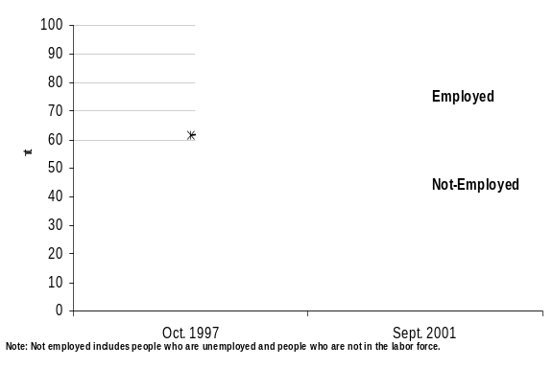 | 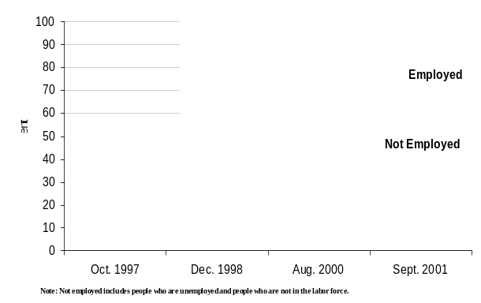
Source: NTIA and ESA, U.S. Department of Commerce, using U.S. Census Bureau Current Population Survey Supplements
Age
Increases in computer and Internet use have occurred across the entire age distribution. Since December 1997, the entire age distribution has shifted upward with each new survey.
Computer and Internet use are strongly associated with the age of the individual. As Figure 2-5 shows, children and teenagers were the most likely to be computer users. Computer use is also relatively high—about 70 percent in 2001—among people in their prime workforce years (generally people in their 20s to their 50s). Those above this age range are less likely to be computer users. This pattern is consistent in both 1997 and 2001.
Rates of Internet use show a similar pattern that holds true for each year of data. Internet use rates climb steadily as age increases for children through young adults, level off at relatively high rates for people between ages 26 and 55, and then fall among people at higher ages.
Figure 2-5: Computer and Internet Use at Any Location Age Distribution (3 year moving average),
Percent of Persons Age 3 to 80
Computer Use 1997, 2001 | Internet Use 1997, 1998, 2000, 2001
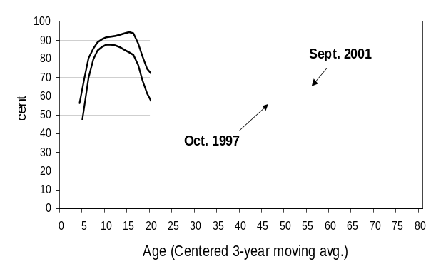 | 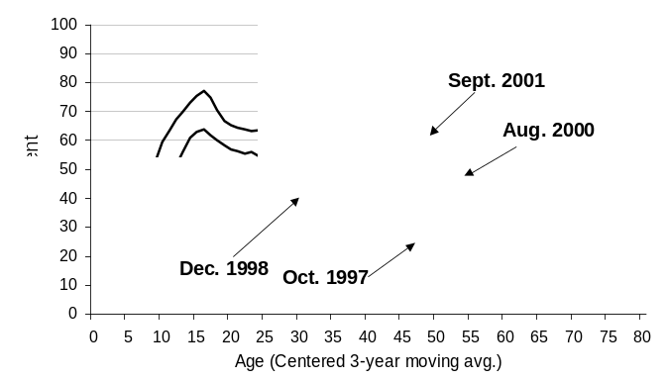
Source: NTIA and ESA, U.S. Department of Commerce, using U.S. Census Bureau Current Population Survey Supplements
One would expect to see the current plateau for Internet use among those age 25 to 55 extend to older ages over time because the overall upward shift in the age distribution shown in Figure 2-5 is composed of two components. The first is an absolute increase in Internet use by people and the second is a cohort effect. The cohort effect describes the fact that the people who are in the 55-year-old age cohort in September 2001 are not the same people who were in this age group in earlier surveys. The 55 year olds of September 2001 were mostly 51 year olds when Census first asked about Internet use in October 1997. People who used the Internet when they were younger will likely continue to do so as they age.
Gender
Males and females have had approximately equal rates of computer use since 1997. In 1997, males were more likely than females to be Internet users. Between October 1997 and August 2000, this difference disappeared. Since August 2000, males and females have had virtually identical rates of Internet use (Figure 2-6). In September 2001, the Internet use rate was 53.9 percent for males and 53.8 percent for females.
The annual growth rates from August 2000 to September 2001 were similar: 19 percent growth at an annual rate for males and 20 percent for females (Table 2-3).
Figure 2-6: Computer and Internet Use Anywhere by Gender, Percent of Persons Age 3+
Computer Use 1997, 2001 | Internet Use 1997, 1998, 2000, 2001
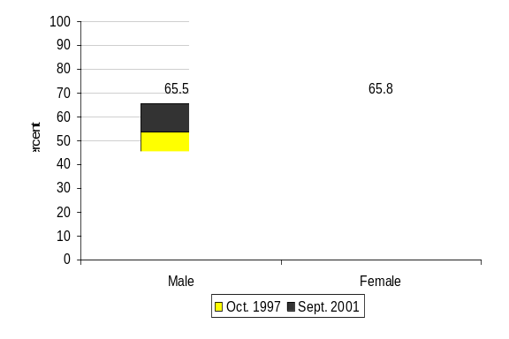 | 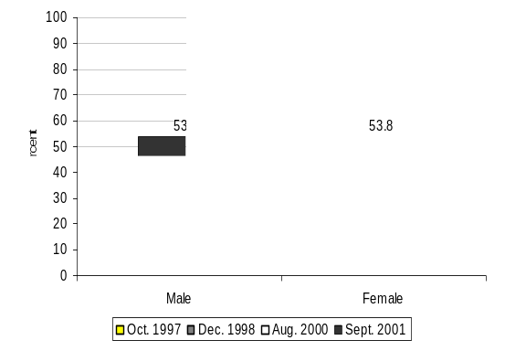
Source: NTIA and ESA, U.S. Department of Commerce, using U.S. Census Bureau Current Population Survey Supplements
Although the aggregate rates of use and growth by gender have equalized, there are still gender-related differences in Internet use within various age groups (Figure 2-7). Women, from approximately age 20 to age 50, are more likely to be Internet users than men. From about age 60 and older, men have higher rates of Internet use than women.
Figure 2-7: Computer and Internet Use Distribution by Age & Gender, Sept. 2001, Percent of Persons Age 3 to 80
Computer Use | Internet Use
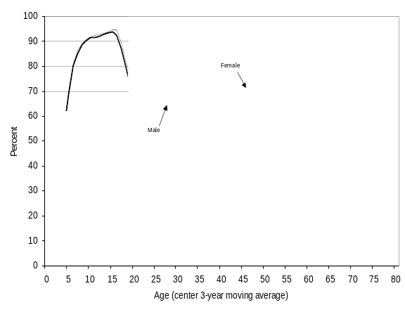 | 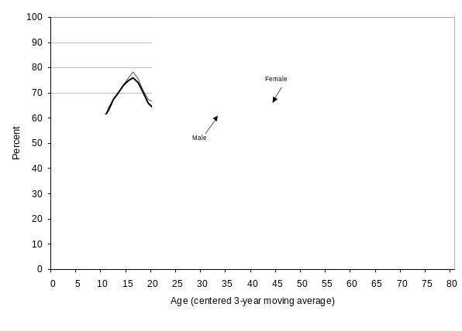
Source: NTIA and ESA, U.S. Department of Commerce, using U.S. Census Bureau Current Population Survey Supplements
Gender can also be considered in the context of household type. In previous years people who lived in single parent households (where children under the age of 18 are present) headed by women were less likely to be Internet users. The Internet use rate among people living in female-headed single parent households grew dramatically between August 2000 and September 2001, and the differential between Internet use rates between people living in male and female single parent households has largely disappeared.
However, as Figure 2-8 shows, people who live in households headed by married couples (where children under the age of 18 are present) are more likely than people who live in other household types to be both computer and Internet users.
Figure 2-8: Computer and Internet Use Anywhere by Type of Household, Persons Age 3 +
Computer Use, 1997, 2001 | Internet Use, 1997, 1998, 2000, 2001
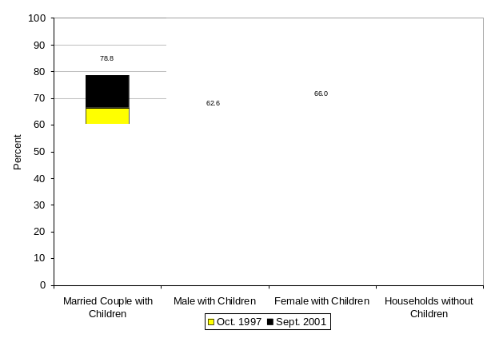 | 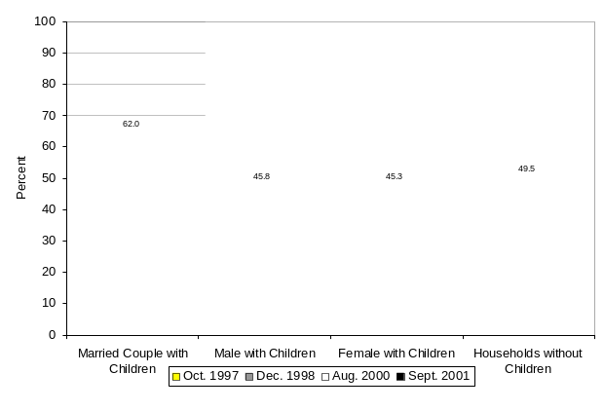

Source: NTIA and ESA, U.S. Department of Commerce, using U.S. Census Bureau Current Population Survey Supplements
Educational Attainment
Educational attainment also factors into computer and Internet use. The higher a person’s level of education, the more likely he or she will be a computer or Internet user.
As shown in Figure 2-9, adults (age 25 and above) with education beyond college were the most likely to be both computer and Internet users each year of the survey. Those with Bachelor’s degrees trailed close behind. At the opposite end of the spectrum are those adults whose highest level of education is less than high school. In September 2001, the computer use rate for the latter was 17.0 percent and the Internet use rate was 12.8.
Internet use has grown rapidly among those with lower levels of educational attainment. Internet use for adults with a Bachelor’s degree and adults with and education level beyond a Bachelor’s degree grew at annual rates of 13 and 9 percent, respectively from December 1998 to September 2001. Internet use among those with only a high school diploma grew at an annual rate of 30 percent over the same period (Table 2-3).

Figure 2-9: Internet Use Anywhere by Educational Attainment, Percent of Persons Age 25 +
Computer Use, 1997, 2001 | Internet Use, 1997, 1998, 2000, 2001
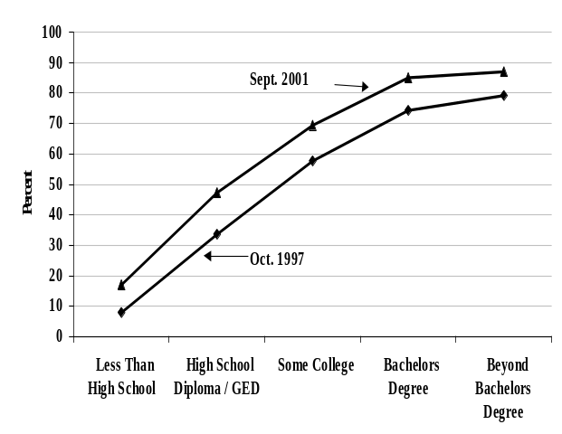 | 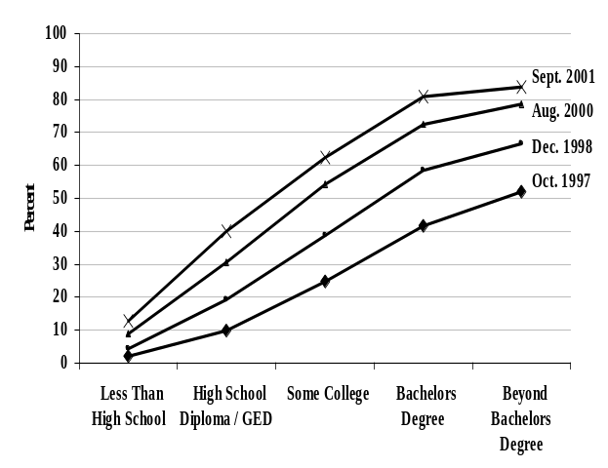

Source: NTIA and ESA, U.S. Department of Commerce, using U.S. Census Bureau Current Population Survey Supplements
Box 2-1: Interrelated Demographic Factors
Descriptive statistics, such as those in this chapter, are not sufficient to determine why a certain group of individuals has higher or lower rates of computer and Internet use. One of the reasons is that demographic characteristics are often interrelated.
An individual’s occupation (which is discussed in Chapter 6) is often associated with a certain level of education. People with higher incomes often have higher levels of education. Thus, the statistics describing how people living in low income households, or who have low levels of education, or a given occupation are less likely to be Internet users may be capturing a more complicated interaction between the demographic characteristics. For example, income and education are strongly correlated. Thus, the relationship between Internet use and educational attainment could simply reflect the fact that people with higher levels of education tend to have higher incomes.
On closer examination, however, we find that income and education have independent effects on Internet use. Figure 2-10 shows the Internet use rates for each of six income categories broken into four levels of educational attainment. Thus, the entire population 25 years of age or more is assigned to one of 24 income/education categories. As Figure 2-10 shows, people who have lower levels of education but live in households with a high family incomes are less likely to be Internet users than those who have high levels of education and live in households with low family income.
Figure 2-10: Income and Education Have In dependent Effects on Internet Use, Age 25+

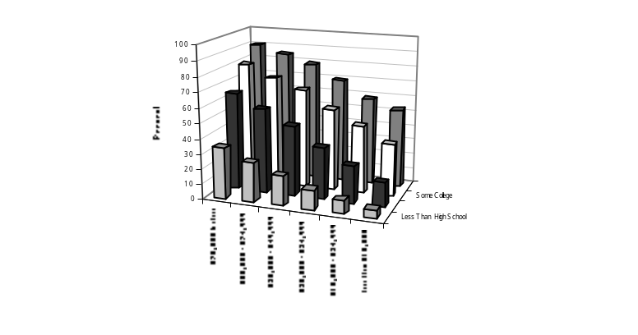
Source: NTIA and ESA, U.S. Department of Commerce, using U.S. Census Bureau Current Population Survey Supplements
Both higher income and more education are themselves correlated with occupations that tend to have greater Internet use at work. As Chapter 6 demonstrates, a person’s use at work has an important relationship to whether the Internet is at home, independent of income.
Urban or Rural Location of the Household
In September 2001, people living in each urban/rural category—non-central city urban, central city urban, and rural—had higher rates of Internet use than in previous years (Figure 2-11).
Figure 2-11: Internet Use Anywhere by Geographic Location of Household, Percent of Persons Age 3+
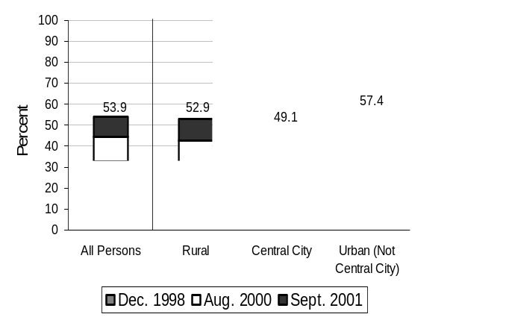
Source: NTIA and ESA, U.S. Department of Commerce, using U.S. Census Bureau Current Population Survey Supplements
Over the 1998 to 2001 period, growth in Internet use among people living in rural households has been particularly strong (24 percent at an average annual rate). Use of the Internet by people in rural households now approaches the national average (Table 2-3). Internet use among people living in central city urban households has also grown, although not as rapidly (19 percent at an average annual rate). Internet use among people who live in non-central city urban households has grown at a slightly slower rate (18 percent at an average annual rate). Even with the slowest growth rate, however, people living in non-central city urban households used the Internet at a rate greater than the other two geographic categories in September 2001.
Race / Hispanic Origin
Since 1997, rates of computer and Internet use by individuals have increased for each broad race/Hispanic origin category.
Differences in computer and Internet use across these broad race and Hispanic origin categories persist. In each survey, Whites and Asian American and Pacific Islanders have had higher rates of both computer and Internet use than Blacks and Hispanics (Figure 2-12, Table 2-2). In September 2001, the computer use rates were highest for Asian American and Pacific Islanders (71.2 percent) and Whites (70.0 percent). Among Blacks, 55.7 percent were computer users. Almost half of Hispanics (48.8 percent) were computer users. During the same year, Internet use among Whites and Asian American and Pacific Islanders hovered around 60 percent, while Internet use rates for Blacks (39.8 percent) and Hispanics (31.6 percent) trailed behind.
On the other hand, Internet use has increased across all race and groups and growth in Internet use rates was faster for Blacks and Hispanics than for Whites and Asian American and Pacific Islanders (Table 2-3). From December 1998 to September 2001, Internet use among Blacks grew at an annual rate of 31 percent. Internet use among Hispanics grew at an annual rate of 26 percent. Internet use continued to grow among Asian American and Pacific Islanders (21 percent), and Whites (19 percent), although not so rapidly as for Blacks and Hispanics. Although not so dramatic, Blacks and Hispanics also have had somewhat faster growth in computer use than Whites and Asian American and Pacific Islanders (Table 2-1).
Growth in Internet use rates for Blacks and Hispanics also accelerated in the 2000 to 2001 period. Between August 2000 and September 2001, growth in Hispanic Internet use increased to 30 percent from the 24 percent annual rate of growth from December 1998 to August 2000. Growth in Internet use among Blacks increased to a 33 percent annual rate between August 2000 and September 2001, from the 30 percent annual rate of growth between December 1998 and August 2000. Growth rates among Whites and Asian American and Pacific Islanders were comparable during both periods.

Figure 2-12: Internet Use Anywhere by Race/Hispanic Origin, Percent of Persons Age 3 +
Computer Use 1997, 2001 | Internet Use 1997, 1998, 2000, 2001
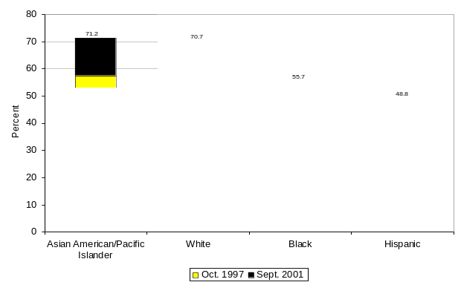 | 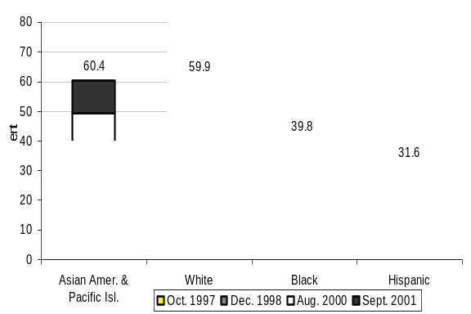
Source: NTIA and ESA, U.S. Department of Commerce, using U.S. Census Bureau Current Population Survey Supplements
The race and ethnic origin categories used in this analysis are broad aggregations of what can be very disparate sub-groups. Individual sub-groups may have higher or lower levels of Internet use than the aggregate. Box 2-2 provides an example of a sub-group of the Hispanic population (those not speaking English in the home) that has much lower levels of Internet use than the aggregate Hispanic population. It is likely that each broad category has sub-groups with rates of computer and Internet use that differ dramatically from the aggregate.
Box 2-2: Example of Differential Internet Use in a Race/Hispanic Origin Sub-Group
Internet use among Hispanics differs considerably depending on whether Spanish is the only language spoken in the household, which is the case for about one in nine of Hispanic households. In September 2001, 14.1 percent of Hispanics who lived in households where Spanish was the only language spoken used the Internet. In contrast, 37.6 percent of Hispanics who lived in households where Spanish was not the only language spoken used the Internet.
The forces influencing Internet use for these two sub-groups of the Hispanic category are not necessarily clear-cut. One could point to metrics that suggest a predominance of English language sites on the Internet. The Organization for Economic Cooperation and Development, for example, reports that more than 94 percent of links to pages on secure servers were in English in July 2000. Yet, this metric reflects only one use of the Internet—commerce—and provides no information on how much of other Internet traffic (e-mail and other online communications) is English only.
Furthermore, there can be considerable demographic differences among sub-groups. For example, individuals living in Spanish language-only households are more likely to have lower family incomes than those who live in non-Spanish language-only households. The income distribution of individuals living in Spanish language-only households is in fact strikingly different from that for other Hispanics and from the overall income distribution (Figure 2-14). Levels of educational attainment for individuals living in the Spanish-only households also differ from non-Spanish only Hispanic households and other households.
Figure 2-13: The Spanish Language Only Sub-Groups of the Hispanic Category Have a Strikingly Different Income Distribution Than Other Hispanics and the Population at Large, 2001
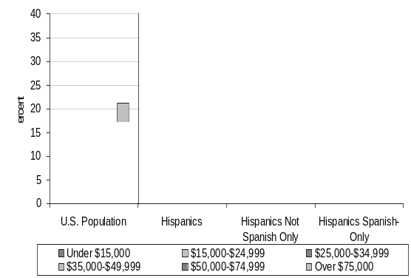
Source: NTIA and ESA, U.S. Department of Commerce, using U.S. Census Bureau Current Population Survey Supplements.
Table 2-1: Computer Use From Any Location by Individuals Age 3 and Older,
October 1997 and September 2001
 | Oct. 1997 |  | Sept. 2001 |  | Percent of People Who Are Computer Users |  | Growth in Use Rate  (annual rate)
 | Computer Users  (thousands) | Total  (thousands) | Computer Users  (thousands) | Total  (thousands) | Oct. 1997 | Sept. 2001 | Oct. 1997 to Sept. 2001
Total Population | 136,900 | 255,689 | 174,051 | 265,180 | 53.5 | 65.6 | 5.3
Gender
Male | 66,978 | 124,590 | 84,539 | 129,152 | 53.8 | 65.5 | 5.2
Female | 69,921 | 131,099 | 89,512 | 136,028 | 53.3 | 65.8 | 5.5
Race/ Origin
White | 105,957 | 184,295 | 130,848 | 186,793 | 57.5 | 70.0 | 5.2
Black | 13,854 | 31,786 | 18,544 | 33,305 | 43.6 | 55.7 | 6.5
Asian Amer. & Pac. Isl. | 5,306 | 9,225 | 7,600 | 10,674 | 57.5 | 71.2 | 5.6
Hispanic | 10,729 | 28,233 | 15,690 | 32,146 | 38.0 | 48.8 | 6.6
Employment Status
Employed ª | 80,687 | 130,857 | 98,819 | 135,089 | 61.7 | 73.2 | 4.5
Not Employed ^{a, b} | 18,074 | 72,911 | 31,487 | 77,268 | 24.8 | 40.8 | 13.5
Family Income
Less than $15,000 | 13,182 | 44,284 | 11,681 | 31,354 | 29.8 | 37.3 | 5.9
$15,000 - $24,999 | 12,115 | 32,423 | 12,464 | 26,649 | 37.4 | 46.8 | 5.9
$25,000 - $34,999 | 16,360 | 33,178 | 16,495 | 28,571 | 49.3 | 57.7 | 4.1
$35,000 - $49,999 | 23,440 | 38,776 | 25,233 | 36,044 | 60.4 | 70.0 | 3.8
$50,000 - $74,999 | 30,043 | 41,910 | 35,465 | 44,692 | 71.7 | 79.4 | 2.6
$75,000 & above | 29,542 | 36,572 | 49,672 | 56,446 | 80.8 | 88.0 | 2.2
Educational Attainment
Less Than High School ^{c} | 2,331 | 29,114 | 4,672 | 27,484 | 7.9 | 17.0 | 21.5
High School Diploma / GED ^{c} | 19,256 | 57,487 | 27,118 | 57,386 | 33.5 | 47.3 | 9.2
Some College ^{c} | 24,595 | 42,544 | 31,551 | 45,420 | 57.8 | 69.5 | 4.8
Bachelors Degree ^{c} | 20,640 | 27,795 | 25,965 | 30,588 | 74.3 | 84.9 | 3.5
Beyond Bachelors Degree ^{c} | 10,970 | 13,863 | 14,151 | 16,283 | 79.1 | 86.9 | 2.4
Age Group
Age 3 – 8 | 14,412 | 24,445 | 16,877 | 23,763 | 59.0 | 71.0 | 4.9
Age 9 – 17 | 30,188 | 35,469 | 34,356 | 37,118 | 85.1 | 92.6 | 2.2
Age 18 – 24 | 14,528 | 24,973 | 19,361 | 27,137 | 58.2 | 71.3 | 5.3
Age 25 – 49 | 58,745 | 101,853 | 71,491 | 101,890 | 57.7 | 70.2 | 5.1
Male | 27,577 | 50,177 | 33,647 | 50,020 | 55.0 | 67.3 | 5.3
Female | 31,168 | 51,676 | 37,844 | 51,871 | 60.3 | 73.0 | 5.0
Age 50 + | 19,026 | 68,949 | 31,965 | 75,272 | 27.6 | 42.5 | 11.6
Male | 9,654 | 31,252 | 15,547 | 34,438 | 30.9 | 45.1 | 10.2
Female | 9,372 | 37,697 | 16,418 | 40,834 | 24.9 | 40.2 | 13.1
Household Type In Which the Individual Lives ^{d}
Married Couple w/Children <18 Years Old | 68,855 | 103,791 | 81,897 | 104,337 | 66.3 | 78.5 | 4.4
Male Householder w/Children <18 Years Old | 3,163 | 6,284 | 4,632 | 7,400 | 50.3 | 62.6 | 5.7
Female Householder w/Children <18 Years Old | 14,288 | 27,327 | 19,160 | 29,032 | 52.3 | 66.0 | 6.1
Family Household without Children <18 Years Old | 33,001 | 77,612 | 46,400 | 81,996 | 42.5 | 56.6 | 7.6
Non-Family Household | 16,589 | 39,381 | 21,913 | 42,333 | 42.1 | 51.8 | 5.4
Source: U.S. Bureau of the Census, Current Population Survey supplements, October, September 2001.
Notes: ª Age 16 and older. ^{b} Unemployed and not in the labor force. ^{c} Age 25 and older. ^{d} Excludes group quarters, such as dorms and military barracks.

Table 2-2: Internet Use From Any Location by Individuals Age 3 and Older,
October 1997, December 1998, August 2000, and September 2001
 | Oct. 1997  (thousands) |  | Dec. 1998  (thousands) |  | Aug. 2000 (thousands) |  | Sept. 2001 (thousands) |  | Internet Use  (percent)
 | Internet Users | Total | Internet Users | Total | Internet Users | Total | Internet Users | Total | Oct. 1997 | Dec. 1998 | Aug. 2000 | Sept. 2001
Total Population | 56,774 | 255,689 | 84,587 | 258,453 | 116,480 | 262,620 | 142,823 | 265,180 | 22.2 | 32.7 | 44.4 | 53.9
Gender
Male | 30,311 | 124,590 | 43,033 | 125,932 | 56,962 | 127,844 | 69,580 | 129,152 | 24.3 | 34.2 | 44.6 | 53.9
Female | 26,464 | 131,099 | 41,555 | 132,521 | 59,518 | 134,776 | 73,243 | 136,028 | 20.2 | 31.4 | 44.2 | 53.8
Race/ Origin
White | 46,678 | 184,295 | 69,470 | 184,980 | 93,714 | 186,439 | 111,942 | 186,793 | 25.3 | 37.6 | 50.3 | 59.9
Black | 4,197 | 31,786 | 6,111 | 32,123 | 9,624 | 32,850 | 13,237 | 33,305 | 13.2 | 19.0 | 29.3 | 39.8
Asian Amer. & Pac. Isl. | 2,432 | 9,225 | 3,467 | 9,688 | 5,095 | 10,324 | 6,452 | 10,674 | 26.4 | 35.8 | 49.4 | 60.4
Hispanic | 3,101 | 28,233 | 4,897 | 29,452 | 7,325 | 30,918 | 10,141 | 32,146 | 11.0 | 16.6 | 23.7 | 31.6
Employment Status
Employed ^{b} | 37,254 | 130,857 | 56,539 | 133,119 | 76,971 | 136,044 | 88,396 | 135,089 | 28.5 | 42.5 | 56.6 | 65.4
Not Employed ^{b, d} | 9,012 | 72,911 | 14,261 | 73,891 | 21,321 | 73,891 | 28,531 | 77,268 | 12.4 | 19.5 | 28.9 | 36.9
Family Income
Less than $15,000 | 4,069 | 44,284 | 5,170 | 37,864 | 6,057 | 32,096 | 7,848 | 31,354 | 9.2 | 13.7 | 18.9 | 25.0
$15,000 - $24,999 | 3,760 | 32,423 | 5,623 | 30,581 | 7,063 | 27,727 | 8,893 | 26,650 | 11.6 | 18.4 | 25.5 | 33.4
$25,000 - $34,999 | 5,666 | 33,178 | 8,050 | 31,836 | 11,054 | 31,001 | 12,591 | 28,571 | 17.1 | 25.3 | 35.7 | 44.1
$35,000 - $49,999 | 8,824 | 38,776 | 13,528 | 39,026 | 16,690 | 35,867 | 20,587 | 36,044 | 22.8 | 34.7 | 46.5 | 57.1
$50,000 - $74,999 | 13,552 | 41,910 | 19,902 | 43,776 | 25,059 | 43,451 | 30,071 | 44,692 | 32.3 | 45.5 | 57.7 | 67.3
$75,000 & above | 16,276 | 36,572 | 24,861 | 42,221 | 36,564 | 52,189 | 44,547 | 56,446 | 44.5 | 58.9 | 70.1 | 78.9
Educational Attainment
Less Than High School ª | 516 | 29,114 | 1,228 | 29,039 | 2,482 | 28,254 | 3,506 | 27,484 | 1.8 | 4.2 | 8.8 | 12.8
High School Diploma/GED ª | 5,589 | 57,487 | 10,961 | 57,103 | 17,425 | 56,889 | 22,847 | 57,386 | 9.7 | 19.2 | 30.6 | 39.8
Some College ª | 10,548 | 42,544 | 16,603 | 43,038 | 24,201 | 44,628 | 28,321 | 45,420 | 24.8 | 38.6 | 54.2 | 62.4
Bachelors Degree ª | 11,503 | 27,795 | 16,937 | 28,990 | 21,978 | 30,329 | 24,726 | 30,588 | 41.4 | 58.4 | 72.5 | 80.8
Beyond Bachelors Degree ª | 7,195 | 13,863 | 9,635 | 14,518 | 12,104 | 15,426 | 13,633 | 16,283 | 51.9 | 66.4 | 78.5 | 83.7
Age Group (and Labor Force)
Age 3 – 8 | 1,748 | 24,445 | 2,680 | 24,282 | 3,671 | 23,962 | 6,637 | 23,763 | 7.2 | 11.0 | 15.3 | 27.9
Age 9 – 17 | 11,791 | 35,469 | 15,396 | 35,821 | 19,579 | 36,673 | 25,480 | 37,118 | 33.2 | 43.0 | 53.4 | 68.6
Age 18 – 24 | 7,884 | 24,973 | 11,356 | 25,662 | 15,039 | 26,458 | 17,673 | 27,137 | 31.6 | 44.3 | 56.8 | 65.0
Age 25 – 49 | 27,639 | 101,853 | 41,694 | 101,836 | 56,433 | 101,946 | 65,138 | 101,890 | 27.1 | 40.9 | 55.4 | 63.9
Male | 14,679 | 50,177 | 20,889 | 50,054 | 27,078 | 50,034 | 30,891 | 50,020 | 29.3 | 41.7 | 54.1 | 61.8
Female | 12,960 | 51,676 | 20,806 | 51,781 | 29,356 | 51,913 | 34,247 | 51,871 | 25.1 | 40.2 | 56.5 | 66.0
Age 50 + | 7,712 | 68,949 | 13,669 | 70,852 | 21,758 | 73,580 | 27,895 | 75,272 | 11.2 | 19.3 | 29.6 | 37.1
Male | 4,560 | 31,252 | 7,356 | 32,248 | 10,989 | 33,561 | 13,757 | 34,438 | 14.6 | 22.8 | 32.7 | 39.9
Female | 3,152 | 37,697 | 6,313 | 38,604 | 10,769 | 40,019 | 14,138 | 40,834 | 8.4 | 16.4 | 26.9 | 34.6
Geographic Location of Household In Which the Individual Lives
Rural | n/a | n/a | 19,274 | 65,828 | 28,889 | 67,980 | 35,751 | 67,642 | n/a | 29.3 | 42.5 | 52.9
Urban | n/a | n/a | 65,313 | 192,625 | 87,591 | 194,640 | 107,072 | 197,537 | n/a | 33.9 | 45.0 | 54.2
Urban Not Central City | n/a | n/a | 41,881 | 116,091 | 56,773 | 118,641 | 69,342 | 120,724 | n/a | 36.1 | 47.9 | 57.4
Urban Central City | n/a | n/a | 23,432 | 76,534 | 30,818 | 75,999 | 37,730 | 76,813 | n/a | 30.6 | 40.6 | 49.1
Household Type In Which the Individual Lives
Married Couple w/Children <18 Years Old | 27,664 | 103,791 | 41,462 | 110,295 | 57,122 | 112,920 | 64,714 | 104,337 | 26.7 | 37.6 | 50.6 | 62.0
Male Householder w/Children <18 Years Old | 1,143 | 6,284 | 1,995 | 7,866 | 2,825 | 8,186 | 3,389 | 7,400 | 18.2 | 25.4 | 34.5 | 45.8
Female Householder w/Children <18 Years Old | 4,041 | 27,327 | 6,219 | 27,877 | 9,866 | 30,034 | 13,140 | 29,032 | 14.8 | 22.3 | 32.9 | 45.3
Family Household without Children <18 Years Old | 15,240 | 77,612 | 21,660 | 72,155 | 29,199 | 70,521 | 41,397 | 81,996 | 19.6 | 30.0 | 41.4 | 50.5
Non-Family Household | 8,293 | 39,381 | 13,220 | 40,199 | 17,442 | 40,884 | 20,136 | 42,333 | 21.1 | 32.9 | 42.7 | 47.6
Source: U.S. Bureau of the Census, Current Population Survey supplements, October 1997,December 1998, August 2000, September 2001. Notes: ª Age 25 and older. ^{b} Age 16 and Older. ^{c} Both people who are unemployed and people not in the labor force.

Table 2-3: Percent Difference and Growth Rates, Internet Use From Any Location by Individuals Age 3 and Older, October 1997, December 1998, August 2000, and September 2001
 | Internet Use  (percent) |  |  |  | Percentage Point Difference |  |  |  | Growth in Use Rate  (annual rate)
 | Oct. 1997* | Dec. 1998 | Aug. 2000 | Sept. 2001 | 1997 to 1998* | 1998 to 2000 | 2000 to 2001 | 1998 to 2001 | 1997 to 1998* | 1998 to 2000 | 2000 to 2001 | 1998 to 2001
Total Population | 22.2 | 32.7 | 44.4 | 53.9 | n/a | 11.7 | 9.5 | 21.2 | n/a | 20 | 20 | 20
Gender
Male | 24.3 | 34.2 | 44.6 | 53.9 | n/a | 10.4 | 9.3 | 19.7 | n/a | 17 | 19 | 18
Female | 20.2 | 31.4 | 44.2 | 53.8 | n/a | 12.8 | 9.7 | 22.5 | n/a | 23 | 20 | 22
Race/ Origin
White | 25.3 | 37.6 | 50.3 | 59.9 | n/a | 12.7 | 9.7 | 22.4 | n/a | 19 | 18 | 19
Black | 13.2 | 19.0 | 29.3 | 39.8 | n/a | 10.3 | 10.5 | 20.7 | n/a | 30 | 33 | 31
Asian Amer. & Pac. Isl. | 26.4 | 35.8 | 49.4 | 60.4 | n/a | 13.6 | 11.1 | 24.7 | n/a | 21 | 21 | 21
Hispanic | 11.0 | 16.6 | 23.7 | 31.6 | n/a | 7.1 | 7.9 | 15.0 | n/a | 24 | 30 | 26
Employment Status
Employed ^{b} | 28.5 | 42.5 | 56.6 | 65.4 | n/a | 14.1 | 8.9 | 23.0 | n/a | 19 | 14 | 17
Not Employed ^{b, d} | 12.4 | 19.5 | 28.9 | 36.9 | n/a | 9.4 | 8.1 | 17.4 | n/a | 27 | 26 | 26
Family Income
Less than $15,000 | 9.2 | 13.7 | 18.9 | 25.0 | n/a | 5.2 | 6.2 | 11.4 | n/a | 21 | 30 | 25
$15,000 - $24,999 | 11.6 | 18.4 | 25.5 | 33.4 | n/a | 7.1 | 7.9 | 15.0 | n/a | 22 | 28 | 24
$25,000 - $34,999 | 17.1 | 25.3 | 35.7 | 44.1 | n/a | 10.4 | 8.4 | 18.8 | n/a | 23 | 22 | 22
$35,000 - $49,999 | 22.8 | 34.7 | 46.5 | 57.1 | n/a | 11.9 | 10.6 | 22.5 | n/a | 19 | 21 | 20
$50,000 - $74,999 | 32.3 | 45.5 | 57.7 | 67.3 | n/a | 12.2 | 9.6 | 21.8 | n/a | 15 | 15 | 15
$75,000 & above | 44.5 | 58.9 | 70.1 | 78.9 | n/a | 11.2 | 8.9 | 20.0 | n/a | 11 | 12 | 11
Educational Attainment
Less Than High School ª | 1.8 | 4.2 | 8.8 | 12.8 | n/a | 4.6 | 4.0 | 8.5 | n/a | 55 | 41 | 49
High School Diploma / GED ª | 9.7 | 19.2 | 30.6 | 39.8 | n/a | 11.4 | 9.2 | 20.6 | n/a | 32 | 27 | 30
Some College ª | 24.8 | 38.6 | 54.2 | 62.4 | n/a | 15.7 | 8.1 | 23.8 | n/a | 23 | 14 | 19
Bachelors Degree ª | 41.4 | 58.4 | 72.5 | 80.8 | n/a | 14.0 | 8.4 | 22.4 | n/a | 14 | 11 | 13
Beyond Bachelors Degree ª | 51.9 | 66.4 | 78.5 | 83.7 | n/a | 12.1 | 5.3 | 17.4 | n/a | 11 | 6 | 9
Age Group (and Labor Force)
Age 3 – 8 | 7.2 | 11.0 | 15.3 | 27.9 | n/a | 4.3 | 12.6 | 16.9 | n/a | 22 | 74 | 40
Age 9 – 17 | 33.2 | 43.0 | 53.4 | 68.6 | n/a | 10.4 | 15.3 | 25.7 | n/a | 14 | 26 | 19
Age 18 – 24 | 31.6 | 44.3 | 56.8 | 65.0 | n/a | 12.6 | 8.5 | 21.0 | n/a | 16 | 13 | 15
Age 25 – 49 | 27.1 | 40.9 | 55.4 | 63.9 | n/a | 14.4 | 8.6 | 23.0 | n/a | 20 | 14 | 18
Male | 29.3 | 41.7 | 54.1 | 61.8 | n/a | 12.4 | 7.6 | 20.0 | n/a | 17 | 13 | 15
Female | 25.1 | 40.2 | 56.5 | 66.0 | n/a | 16.4 | 9.5 | 25.8 | n/a | 23 | 15 | 20
Age 50 + | 11.2 | 19.3 | 29.6 | 37.1 | n/a | 10.3 | 7.5 | 17.8 | n/a | 29 | 23 | 27
Male | 14.6 | 22.8 | 32.7 | 39.9 | n/a | 9.9 | 7.2 | 17.1 | n/a | 24 | 20 | 23
Female | 8.4 | 16.4 | 26.9 | 34.6 | n/a | 10.6 | 7.7 | 18.3 | n/a | 35 | 26 | 31
Geographic Location of Household In Which the Individual Lives
Rural | n/a | 29.3 | 42.5 | 52.9 | n/a | 13.2 | 10.4 | 23.6 | n/a | 25 | 22 | 24
Urban | n/a | 33.9 | 45.0 | 54.2 | n/a | 11.1 | 9.2 | 20.3 | n/a | 19 | 19 | 19
Urban Not Central City | n/a | 36.1 | 47.9 | 57.4 | n/a | 11.8 | 9.6 | 21.4 | n/a | 18 | 18 | 18
Urban Central City | n/a | 30.6 | 40.6 | 49.1 | n/a | 9.9 | 8.6 | 18.5 | n/a | 18 | 19 | 19
Household Type In Which the Individual Lives
Married Couple w/Children <18 Years Old | 26.7 | 37.6 | 50.6 | 62.0 | n/a | 13.0 | 11.4 | 24.4 | n/a | 20 | 21 | 20
Male Householder w/Children <18 Years Old | 18.2 | 25.4 | 34.5 | 45.8 | n/a | 9.1 | 11.3 | 20.4 | n/a | 20 | 30 | 24
Female Householder w/Children <18 Years Old | 14.8 | 22.3 | 32.9 | 45.3 | n/a | 10.5 | 12.4 | 23.0 | n/a | 26 | 34 | 29
Family Household without Children <18 Years Old | 19.6 | 30.0 | 41.4 | 50.5 | n/a | 11.4 | 9.1 | 20.5 | n/a | 21 | 20 | 21
Non-Family Household | 21.1 | 32.9 | 42.7 | 47.6 | n/a | 9.8 | 4.9 | 14.7 | n/a | 17 | 11 | 14
Source: U.S. Bureau of the Census, Current Population Survey supplements, October 1997, December 1998, August 2000, September 2001. Notes:*The October 1997 question on Internet use was worded considerably differently than the questions used in the following years. The use rates calculated from the October 1997 data are likely correct in terms of their order of magnitude. Growth rates have, however, not been calculated because the implied precision of the year-to-year comparisons would be inaccurate. ª Age 25 and older. ^{b} Age 16 and Older. ^{c} Both people who are unemployed and people not in the labor force.

Chapter 3: Online Activities
As increasing numbers of Americans are going online, they are engaging in a wide variety of online activities. Nearly half (45.0 percent) of the population now uses e-mail. The September 2001 survey asked respondents to report on activities in 16 areas, compared to the nine activities measured in the August 2000 survey. This year’s survey revealed that activity levels for the original nine categories continued to grow, while also reporting strong activity levels for the newly added categories.
Primary Uses by the U.S. Population
The chief uses of the Internet remained the same in September 2001 as in August 2000, but occurred at much higher levels (Figure 3-1). The predominant use continued to be e-mail or instant messaging. In September 2001, nearly half of the population used e-mail (45.2 percent, up from 35.4 percent in 2000). Searching for information also ranked high: approximately one-third of Americans used the Internet to search for product and service information (36.2 percent, up from 26.1 percent in 2000), and to search for news, weather, and sports information (33.3 percent, up from 19.2 percent in 2000).
In addition, many more Internet users reported making online purchases or conducting online banking. The August 2000 survey combined these two categories and found that 13.3 percent of online users were engaged in both activities. The September 2001 survey, however, asked about these activities separately and found that 21.0 percent made online purchases and 8.1 percent conducted banking online.
Figure 3-1: Online Activities, 2000 and 2001
as a Percentage of Total U.S. Population, Persons Age 3 +
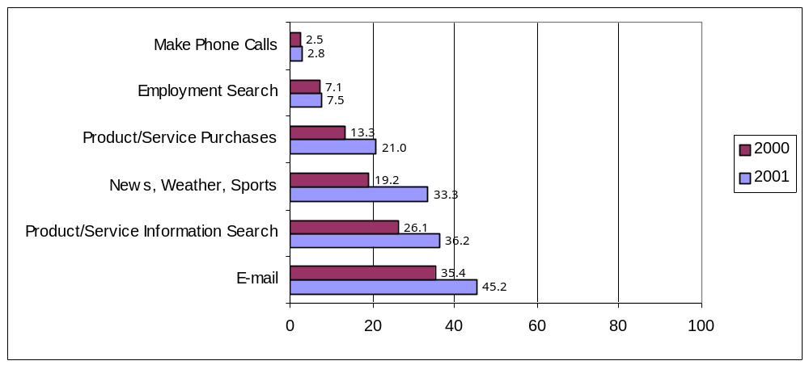
Source: NTIA and ESA, U.S. Department of Commerce, using U.S. Census Bureau Current Population Survey Supplements

Activities Among Those Individuals Online
Looking more specifically at Internet users, e-mail easily outdistances all other online activity (Figure 3-2). Online users are also connecting to the Internet in large numbers to search for information, whether it is product/services, health, or government services. The Internet is also a source for news and sports for many online users. To the extent that product/service purchases, online trading, and online banking represent consumers engaged in e-commerce, that activity is fairly strong and growing.
Figure 3-2: Activities of Individuals Online, 2001
As a Percentage of Internet Users, Persons Age 3 +
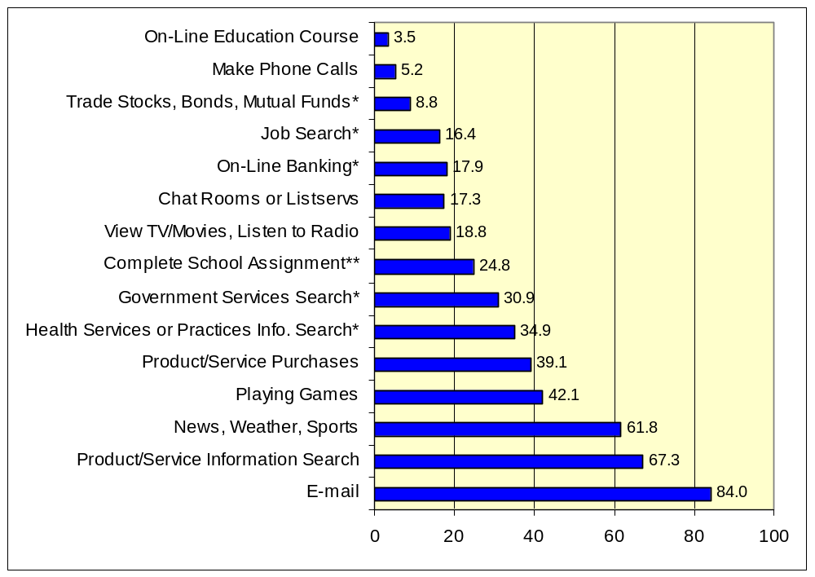
*These online activities surveyed individuals age 15 and over only. **This activity was asked of all respondents. If the response was restricted to individuals enrolled in school, the percentage of Internet users completing school assignments would increase to 77.5 percent.
Source: NTIA and ESA, U.S. Department of Commerce, using U.S. Census Bureau Current Population Survey Supplements
Whether an Internet user engages in a certain activity varies by some, but not all, demographic factors. For example, geography has little impact on the selection of activity. The proportions of Internet users engaged in specific online activities varies little across regions, and was similar regardless of whether the Internet user lived in a rural, urban, or central city area. Household type also showed little, if any, differences. Gender, age, race, and income, however, do have some relationship with Internet users’ selection of online activities, as discussed below.

Gender
Male and female Internet users engage in some online activities at different rates. More men than women used the Internet to check news, weather, and sports (67.1 percent versus 56.7 percent respectively), but more women went online to find information on health services or practices (39.8 percent contrasted with 29.6 percent for men). A higher proportion of male Internet users use the Internet for financial purposes as compared with females: they were more than twice as likely as females to trade online (12.6 percent of males compared to 5.3 percent of females), and males were slightly more likely to bank online than female users (19.3 percent versus 16.5 percent).
A larger percentage of male Internet users reported using the Internet for entertainment-oriented activities. A higher proportion of males versus females played games online (45.3 percent versus 39.1 percent, respectively) and viewed television or movies or listened to the radio (21.9 percent versus 15.9 percent, respectively).
Men and women responded similarly for the remaining categories surveyed. For example, 82.8 percent of male Internet users e-mailed, compared to 85.1 percent of female Internet users; 16.9 percent of male Internet users searched online for jobs, compared to 16.0 percent of female Internet users; and 18.4 percent of male Internet users participated in online chat rooms or list servs, compared to 16.3 percent of female Internet users.
Age
An Internet user’s age also affects online use and activities. Those 55 and older were least likely to use the Internet in many of the surveyed categories, such as playing games, job searching, participating in chat rooms or list servs, viewing television or movies, listening to the radio, or trading online. On the other hand, this age group was more likely (42.7 percent) than any other age group to check health information online. And those 55 and older showed equally strong e-mail use as any other adult age group.
Internet users in the 25-34 age group were the most likely to bank online (26.1 percent), followed by the Internet users in the 35-44 age group (21.3 percent), the 45-54 age group (17.7 percent) and the 55 and above age group (13.0 percent).
Online shopping is particularly common among 25-34 years old Internet users. About half of the people in this age group (53.0 percent) used the Internet for online shopping, as did 51.2 percent of the 35-44 year olds.
An in depth look at Internet users under the age of 25 is presented in Chapter 5.
Figure 3-3: Selected Online Activity by Age, 2001
As a Percent of Internet Users, Persons Age 25 +
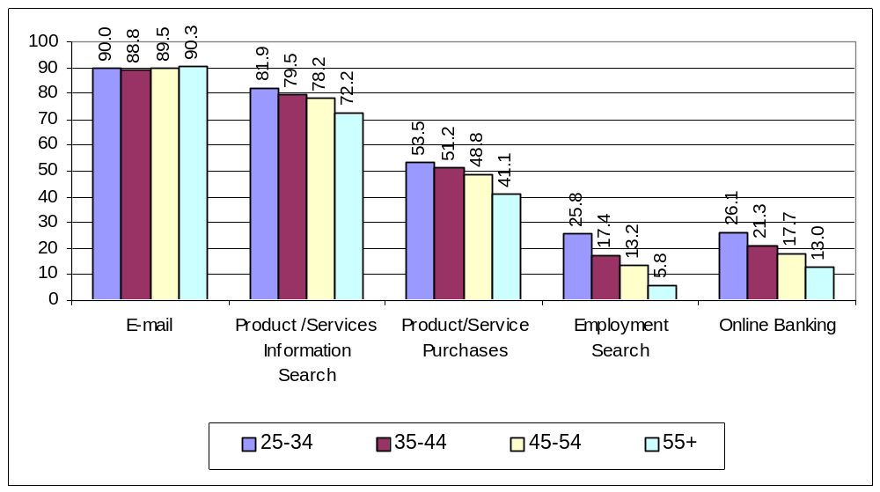
Source: NTIA and ESA, U.S. Department of Commerce, using U.S. Census Bureau Current Population Survey Supplements
Race
Internet users of different racial and Hispanic backgrounds are increasingly using the Internet for a number of online activities. Differences exist among these various groups regarding their levels of online activities (Figure 3-4). A smaller proportion of Black and Hispanic Internet users e-mail, search for news, conduct searches for product/service information or make online purchases.
Figure 3-4: Selected Online Activity by Race/Hispanic Origin, 2001
As a Percent of Internet Users, Persons Age 3 +
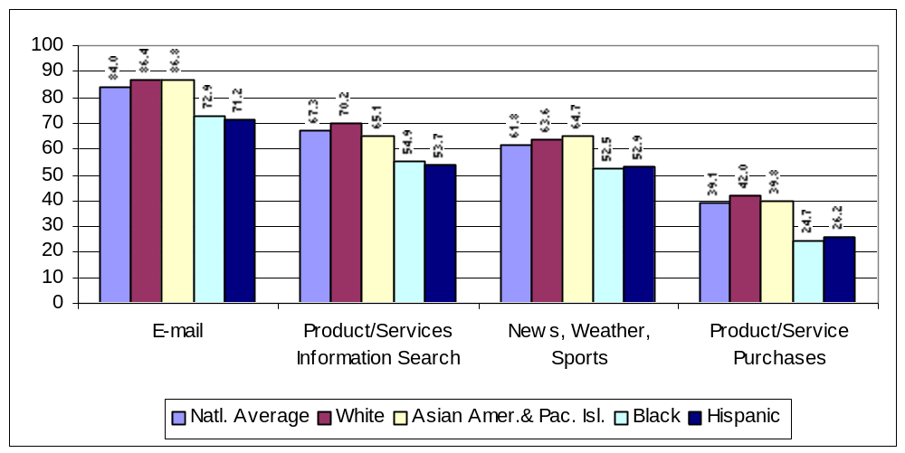
Source: NTIA and ESA, U.S. Department of Commerce, using U.S. Census Bureau Current Population Survey Supplements
Income
Comparing income levels and online activities reveals a general pattern that shows broader use as income increases. The proportion of Internet users in the highest income level (households earning more than $75,000 a year) exceeds all other income groups in eight of the 16 online categories surveyed. As demonstrated in Table 3-1, these individuals were more likely to use the Internet to: search for health services or product information; search for government services or agency information; purchase products or services; search for products and services; bank, trade, or e-mail; or search for news, sports, or weather.
Table 3-1: Online Activities of Internet Users by Household Family Income, 2001
Percent of Internet Users Age 3 +
 | Under 15,000 | 15,000-24,999 | 25,000-34,999 | 35,000-49,999 | 50,000-74,999 | Over 75,000
E-Mail/Instant Messaging | 72.0 | 75.5 | 78.7 | 81.3 | 85.0 | 89.1
Playing Games | 47.0 | 48.6 | 45.7 | 44.5 | 42.9 | 37.5
News, Weather, Sports | 53.5 | 55.5 | 57.2 | 58.3 | 63.2 | 67.0
Product/Service Information Search | 54.9 | 58.0 | 63.3 | 64.2 | 68.5 | 73.5
Complete School Assignments | 37.1 | 27.3 | 25.1 | 22.9 | 23.3 | 24.6
Job Search | 23.0 | 20.6 | 20.5 | 17.4 | 16.0 | 14.6
Chat Rooms or Listservs | 23.0 | 20.0 | 18.8 | 16.9 | 16.5 | 16.5
Health Services or Practices Info. Search | 29.5 | 29.9 | 32.7 | 32.9 | 35.1 | 38.9
Government Services Search | 28.1 | 27.2 | 28.0 | 29.6 | 29.6 | 35.1
Product/Service Purchases | 26.1 | 26.8 | 31.4 | 35.0 | 39.4 | 49.1
View TV/Movies, Listen to Radio | 20.0 | 19.1 | 19.1 | 18.6 | 18.5 | 19.8
Online Banking | 12.8 | 12.1 | 14.4 | 15.6 | 18.0 | 23.0
Online Education Course | 4.0 | 3.2 | 3.1 | 3.6 | 3.5 | 4.0
Trade Stocks, Bonds, Mutual Funds | 3.2 | 2.9 | 4.9 | 6.3 | 8.1 | 13.8
Make Phone Calls | 6.7 | 6.3 | 5.2 | 5.9 | 4.8 | 5.1

Source: NTIA and ESA, U.S. Department of Commerce, using U.S. Census Bureau Current Population Survey Supplements

Chapter 4: How and Where America Goes Online
Internet users are expanding how and where they go online. Faster connection speeds through digital subscriber lines (DSL) and cable are now available to more users as these technologies continue to expand their geographical reach. New devices offer the opportunity for access without a computer and increased mobility of use. Most striking, however, is the growth in the number of people who use the Internet from more than one location.
Connection Types: The Expansion of Broadband
Most individuals who use the Internet at home make that connection via a regular “dial up” telephone line (80.0 percent), with cable modems being the second most common way to connect (12.9 percent), followed by DSL (6.6 percent).
Figure 4-1: Home Internet Connection Type, 2001
as a Percent of Individuals Using the Internet at Home
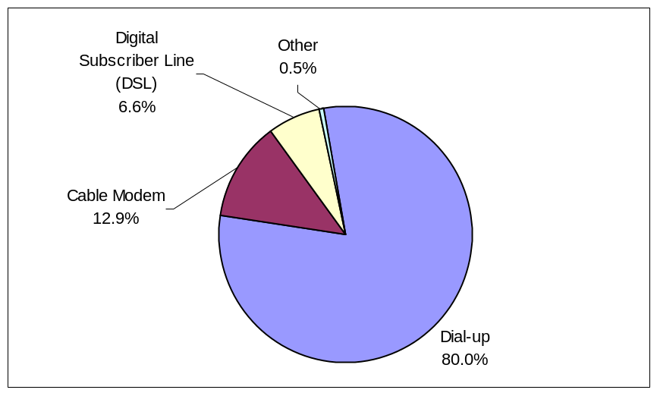

Source: NTIA and ESA, U.S. Department of Commerce, using U.S. Census Bureau Current Population Survey Supplements
Generally referred to as “broadband,” cable modems and DSL allow for higher speed access than is available through dial-up. The use of these services in residential settings has rapidly increased over the past year. In August 2000, only 5.0 percent of all individuals or 11.2 percent of home Internet users claimed to have something faster than a dial-up service in their homes. As of September 2001, those figures had risen to 10.8 percent of the population or 20.0 percent of individuals who use the Internet at home.
This strong growth of approximately 116 percent over a 13-month period coincides with the growing availability of these services. Until very recently, broadband was only available in selected areas of the country. For example, the Federal Communications Commission (FCC) reported that high-speed subscribers were present in 75 percent of the nation's zip codes at the end of December 2000 as compared to 56 percent at the end of 1999. The deployment of broadband occurred first in higher density areas. According to the FCC, high-speed subscribers were present in 97 percent of the most densely populated zip codes at the end of December 2000 as compared to 45 percent of zip codes with the lowest population densities. As shown in Figure 4-2, differences by population density continued to carry over into 2001 with rural areas trailing urban areas and central cities.
Figure 4-2: Higher-Speed Internet Connection by Geographic Area
as a Percent of Total U.S. Internet Households
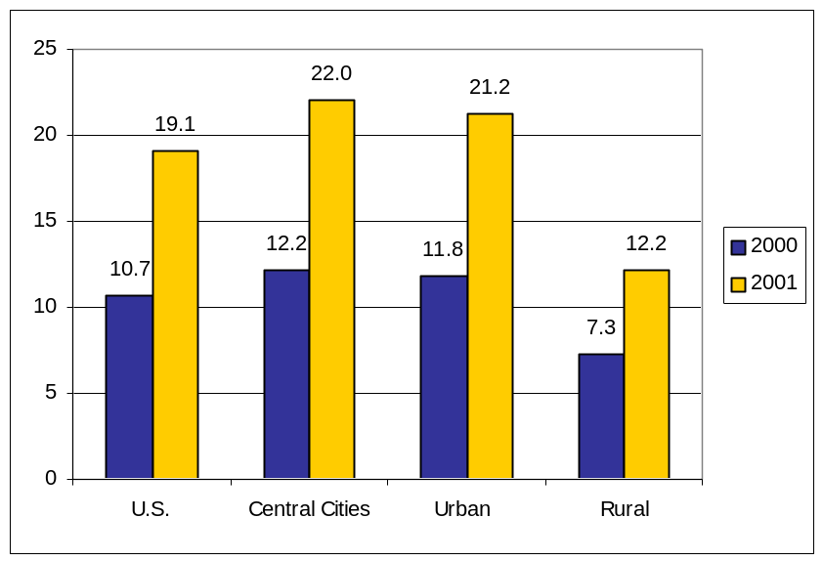
Source: NTIA and ESA, U.S. Department of Commerce, using U.S. Census Bureau Current Population Survey Supplements

The growth in broadband subscribership compares favorably to the deployment rates of other communications technologies and services. Broadband deployment reached 8 percent of U.S. households in early 2001—an adoption speed that outstrips other technologies such as color television, cell phones, pagers, and VCRs.
Figure 4-3: Rate of Deployment of Selected Technologies
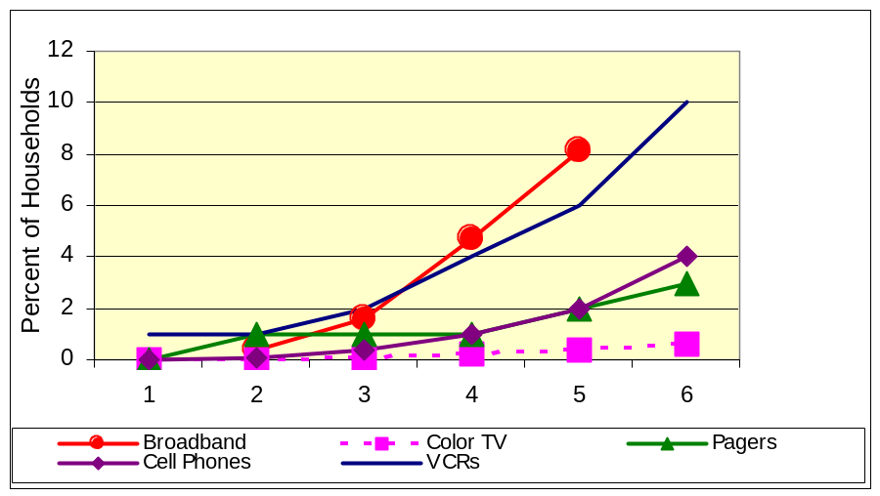
Source: eBrain Market Research and the National Cable and Telecommunications Association
Because cable and DSL Internet are more costly than dial-up services, the proportion of Internet users subscribing to these broadband services varies in expected ways, with individuals in high-income households, for example, having higher subscribership rates than individuals in lower income households.
Individuals with broadband access at home had a modestly greater likelihood of engaging in the activities shown in Figure 3-2. For example, although 84 percent of Internet users send e-mail, that figure rises to 87 percent for broadband users specifically. The only activity reflecting a large difference between broadband users and the Internet-using population, in general, is in the viewing of television or movies or listening to the radio. In September 2001, 28.2 percent of broadband users engaged in these activities, compared to 18.8 percent of Internet users generally.
Spread of New Devices
The vast majority of Internet users in the United States still access the Internet through a desktop or laptop computer. Although the number of people using alternative Internet access devices is increasing, the survey revealed that people who use them typically also have a computer. In September 2001, only 1.5 percent of the households that had home Internet access did not also have a computer.
The only category of alternative Internet access device owned by more than 2 percent of households is Internet-enabled cell phones or pagers (4.8 percent) and virtually all of these households also have computers. Only 1.8 percent of households include a household member who has an Internet accessible personal digital assistant (PDA) or other handheld device, and 0.6 percent of households have Internet access through a television-based system. The television-based systems are the only category of alternative access devices where a substantial proportion of subscribing households do not also have a computer (44.4 percent), but this category accounts for 0.6 percent of total households.
Location of Use
Increased use of mobile Internet devices may eventually make the question of location less important. For now, however, when most access still occurs through less than portable personal computers, where people use the Internet may have implications for the quality of access they enjoy (i.e., the degree of availability or access they actually have) or the type of activities they undertake online. For example, home Internet access may be thought of as a higher quality type of access because it is available (theoretically) 24 hours a day, seven days a week, while school or library access periods are limited to specific hours and often with time limits per session.
As shown in Figure 4-4, the most significant change between December 1998 and September 2001 is the substantial increase in the proportion of people who use the Internet both at home and from some other location. At the end of 1998, only 6.5 percent of the population used the Internet both at home and from some other location. In just under three years, that figure had almost quadrupled to 24.5 percent. That a growing number of people connect from multiple locations could indicate that the Internet is increasingly viewed as a basic communication and information tool, closer in nature to the telephone than the desktop computer.
Figure 4-4 also gives information as to the change in the proportion of the population using the Internet in each category: at home and from some other location. In December 1998, 22.3 percent of the population used the Internet at home (15.8 percent plus 6.5 percent). Home use had grown to 43.6 percent by September 2001. Similarly, Internet use from a location outside the home grew from 17.0 percent to 34.8 percent over the same period.
Figure 4-4: Internet Use by Location
as a Percent of U.S. Population, 1998 and 2001
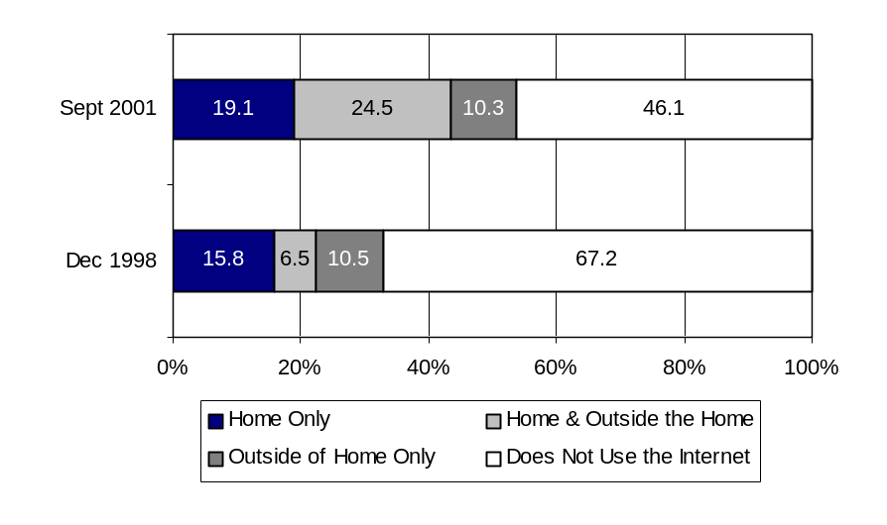
Source: NTIA and ESA, U.S. Department of Commerce, using U.S. Census Bureau Current Population Survey Supplements
“Outside the home” covers a variety of locations. The September 2001 survey asks specifically about Internet use at six locations: work, school, public libraries, community centers, someone else’s house, and “somewhere else.” Figure 4-5 shows that no single category of “outside the home” comes close to Internet use at home in terms of utilization by a proportion of the U.S. population. However, percent of the total population may not be the most useful basis on which to consider location of use. For example, the 51.9 million people who use the Internet at work represent 19.6 percent of the population, but 38.4 percent of those who work. Similarly, the 31.5 million who use the Internet at school account for only 11.9 percent of the total population, but 44.8 percent who attend school. Chapters 5 and 6 focus specifically on these school and work subgroups.
Figure 4-5: Internet Use by Specific Location
as a Percent of U.S. Population

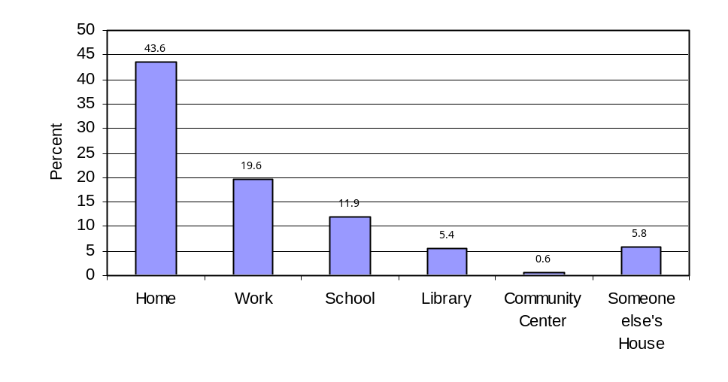
Source: NTIA and ESA, U.S. Department of Commerce, using U.S. Census Bureau Current Population Survey Supplements
Of the universe of Internet users, 10.0 percent of Internet users access the Internet at a public library. This proportion remained virtually constant between August 2000 and September 2001. Over one-half of the population that uses the Internet at a public library is under age 25. Additionally, 14.0 percent of Internet users do not use the Internet at home, school, or work.
Internet use at public libraries varies by race and income: only 8.6 percent of Whites that use the Internet use the public library as an access point, while the comparable figures for Blacks and Hispanics are 18.7 percent and 13.8 percent, respectively. Among Asian Americans and Pacific Islanders, 11.6 percent of Internet users accessed the Internet at public libraries.
As shown in Figure 4-6, most of the people who use the Internet at public libraries also use the Internet at other locations. Among racial and ethnic groups, 12.7 percent of Whites, 19.4 percent of Blacks, and 16.0 percent of Hispanics using the Internet at libraries do not also access the Internet from home, work or school. Only 6.6 percent of Asian American and Pacific Islanders who use the Internet at a public library do not also use the Internet from some other location.

Figure 4-6: Public Library Internet Users, by Race and Sources of Other Access
as a Percent of Internet Users that Use Internet Facilities at Public Libraries

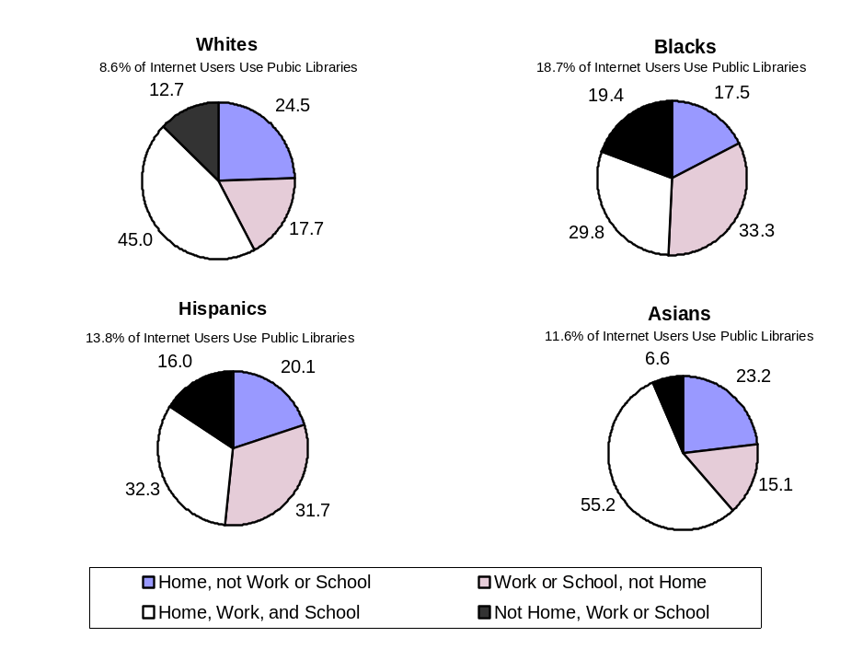

Source: NTIA and ESA, U.S. Department of Commerce, using U.S. Census Bureau Current Population Survey Supplements
Internet access at public libraries is more often used by those with lower incomes than those with higher incomes. Just over 20 percent of Internet users with household family incomes of less than $15,000 a year use public libraries, and 6.1 percent of Internet users in this income category do not use the Internet at home, work, or school. As household income rises, not only does the proportion of public library Internet users decline, but also the percentage of Internet users without alternative access points also declines.
Figure 4-7: Public Library Internet Users by Income and Location of Other Access
as a Percent of Internet Users
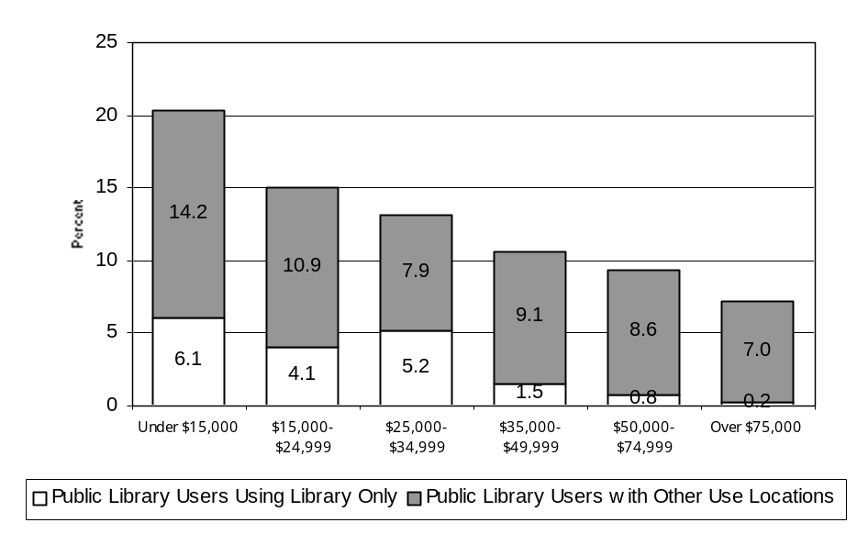
Source: NTIA and ESA, U.S. Department of Commerce, using U.S. Census Bureau Current Population Survey Supplements
Chapter 5: The Digital Generation: How Young People Have Embraced Computers And The Internet
Children and young adults have embraced new information technologies in large numbers. More than any other age group, these younger age groups use computers and the Internet widely for many of their daily activities.
This chapter explores the increasingly large number of children and young adults who have computers and online access, where they get access outside the home, and how they use the Internet. We focus on children in lower elementary school (ages 5-9), later elementary and junior high school (ages 10-13), and high school (ages 14-17), as well as young adults (ages 18-24). This year’s survey also asked parents about concerns about exposing children to online content, and whether that has affected their decisions to go online or to maintain Internet access.
Computer and Internet Use
As noted in Chapter 2, children and young adults under 25 are significant users of new information technologies. By the age of 10, young people are more likely to use the Internet than adults at any age beyond 25. The high rate of use among children and young adults is reflected in higher rates of Internet connectivity within family households with children, as well as in high use rates among these age groups both at home and outside the home.
Family households with children under age 18 are far more likely to have computers than families without children: 70.1 percent, compared to 58.8 percent. They are also more likely to have Internet subscriptions: 62.2 percent versus 53.2 percent. The presence of children is also associated with modestly higher rates of broadband connectivity through DSL or cable modem: 18.4 percent for families with children, compared to 16.9 percent for those without children (Figure 5-1).
Figure 5-1: Access Among Families With and Without Children, 2001
as a Percentage of U.S. Households
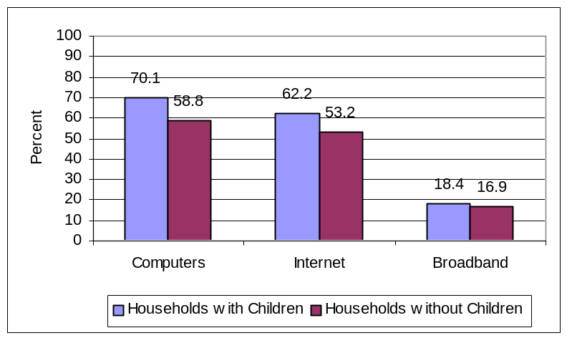
Source: NTIA and ESA, U.S. Department of Commerce, using U.S. Census Bureau Current Population Survey Supplements
Individual computer and Internet use among all groups of children and young adults has also soared in the last few years. With regard to computer use, 89.5 percent of all school-aged children (between the ages of 5-17) use computers. Within the same age range, 58.5 percent use the Internet. Internet use is particularly high for teens and pre-teens. More than three-quarters (75.6 percent) of 14-17 year olds and 65.4 percent of 10-13 year olds use the Internet at some location, up from 51.2 and 39.2 percent in 1998 (Figure 5-2).
Among 18-24 year olds, Internet use is heavily affected by whether or not they attend school or college. Among those in school or college, 85.0 percent use the Internet, compared to 51.5 percent of those who are not in school.
Figure 5-2: Internet Use at Any Location, 1998 and 2001
as a Percent of U.S. Population
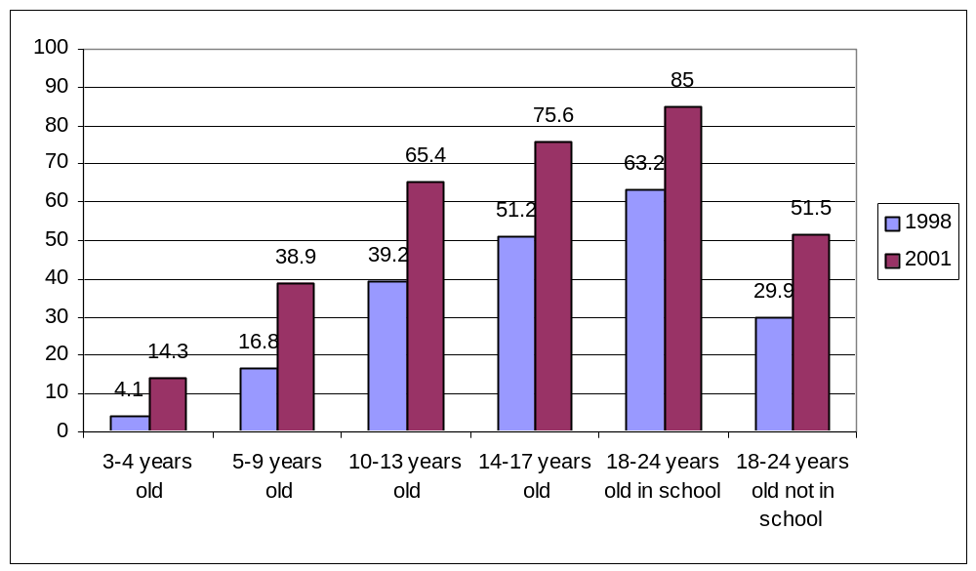
Source: NTIA and ESA, U.S. Department of Commerce, using U.S. Census Bureau Current Population Survey Supplements
In addition to much higher overall use, children and young adults are also far more likely to use the Internet outside the home than they were in previous years. In fact, “outside home” use is nearly equivalent to “at home” use for almost every age group (and exceeds “at home” use for 18-24 year olds in school or college). For example, as Figure 5-3 demonstrates, nearly equal percentages of teenagers used the Internet outside the home (60.7 percent) as at home (61.4 percent). This contrasts with 1998 levels for teenagers of 26.9 percent “outside home” use, compared to 32.9 percent at home. Similarly, in 1998, 19.2 percent of 10-13 year olds used the Internet outside the home, compared to 25.4 percent at home.
Figure 5-3: Internet Use Among Children At Home/Outside Home/Any Location, 2001
as a Percent of U.S. Population
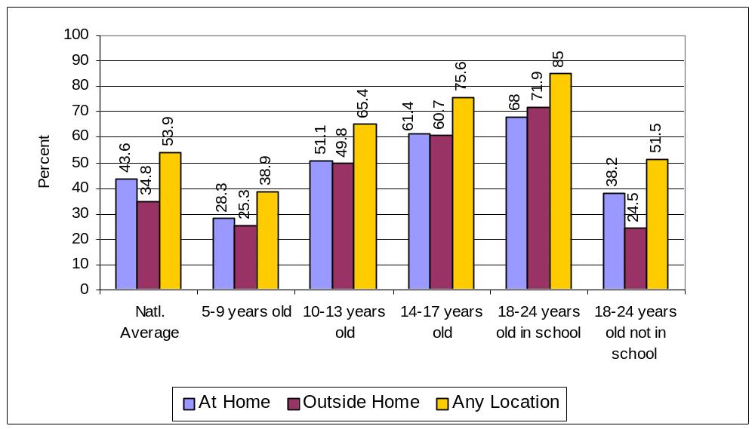
Source: NTIA and ESA, U.S. Department of Commerce, using U.S. Census Bureau Current Population Survey Supplements
The high rate of Internet use outside the home among young people 10 years old and up is considerably different from the overall national figures for all ages, and is largely accounted for by use at schools, as discussed in the following section.
The Impact of Schools on Internet and Computer Use
Most “outside home” use is at schools, where children and young adults use computers and the Internet at high levels. As shown in Figure 5-4, young people are using computers at high levels, even in elementary school. For example, almost every young adult (95.9 percent) between ages 18 and 24, who attends school or college, uses a computer: 86.1 percent in school (20.8 percent only at school and 65.3 percent both at home and school), and 74.5 percent at home (9.2 percent only at home and 66.3 percent both at home and school). Even among 5 to 9 year olds, a large portion (84.3 percent) are using computers at home, at school, or both.
Figure 5-4: Computer Use by Age and Location, 2001
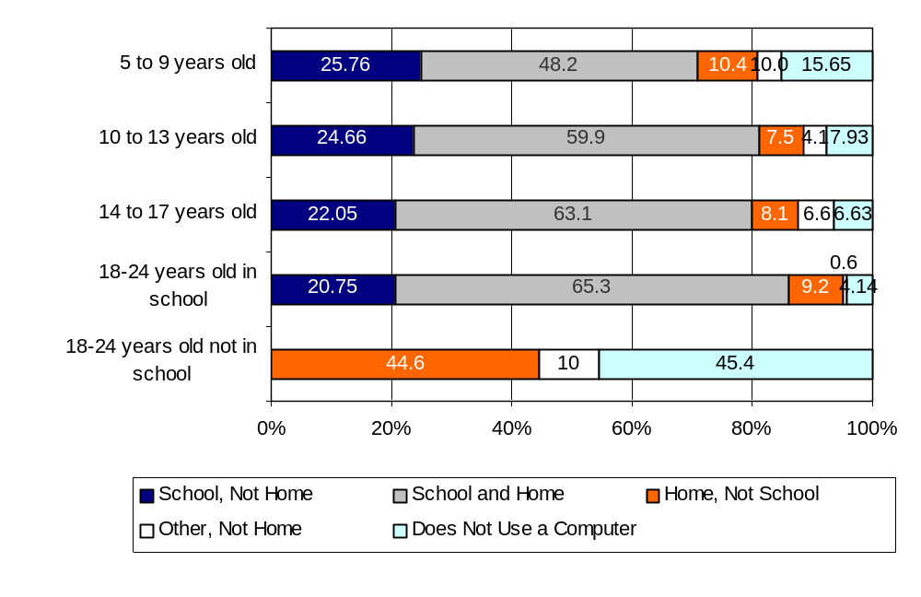
Source: NTIA and ESA, U.S. Department of Commerce, using U.S. Census Bureau Current Population Survey Supplements
Figure 5-5 also indicates the widespread use of the Internet by young people both at home and at school, although Internet use is not yet at the same high levels as computer use. For example, more than three-quarters of 14-17 year olds use the Internet at home, at school, or both: 55.4 percent use the Internet at school (42.8 percent both at home and school, and 12.6 percent only at school), while 61.4 percent use it at home (42.8 percent both at home and school, and 18.6 percent only at home). Even three out of eight 5-9 year olds (or 37.6 percent) use the Internet at home and/or school.

Figure 5-5: Internet Use by Age and Location, 2001
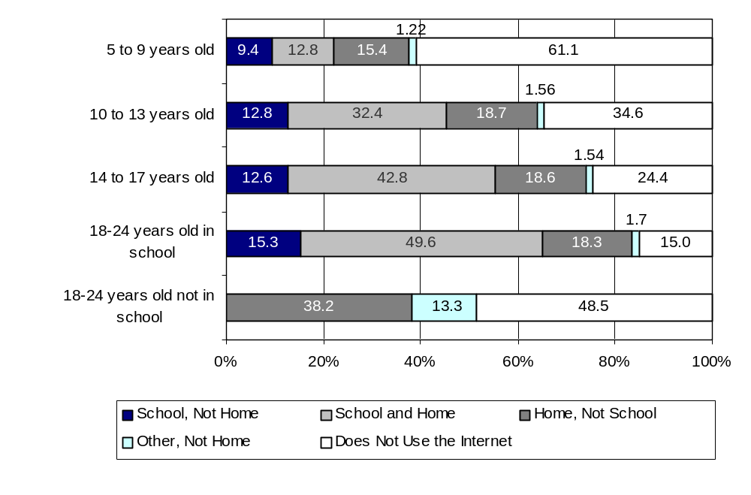
Source: NTIA and ESA, U.S. Department of Commerce, using U.S. Census Bureau Current Population Survey Supplements
Figures 5-6, 5-7, and 5-8 show the significance of having computers at school in bringing technology to children of various backgrounds. Figure 5-6 shows that 80.7 percent of children (ages 10-17) in the lowest income category use computers at school, little different from the 88.7 percent of children at the highest income level. School helps to equalize the disparity that would otherwise exist in computer and Internet use among the various household income categories. In the lowest income category, 33.1 percent of children use computers at home, in contrast to 91.7 percent of children in the highest income category. The gap in computer use narrows, however, from almost 60 points between the highest and lowest income children’s use at home to a 12 point gap in computer use when home and school are combined.
Figure 5-6: Computer Use Among 10 to 17 Year-Olds
By Income and Location, 2001
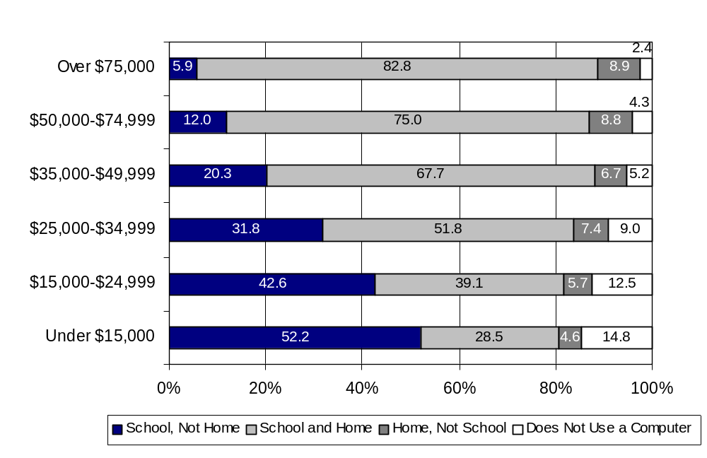
Source: NTIA and ESA, U.S. Department of Commerce, using U.S. Census Bureau Current Population Survey Supplements
Similarly, as shown in Figure 5-7, Hispanic and Black children – who have lower computer use rates at home – approach computer use rates of Whites and Asian American and Pacific Islanders largely due to their computer use in school. A far higher percentage of Hispanic (38.9 percent) and Black (44.7 percent) children rely solely on schools to use computers than do Asian and Pacific Islanders (11.1 percent) and White children (15.1 percent). Because of the availability of school computers, overall computer use rates among children of different racial and ethnic backgrounds is comparable: 84.2 percent for Hispanic children, 88.8 percent for Black children, 94 percent for Asian and Pacific Islander children, and 95.4 percent for White children.

Figure 5-7: Computer Use Among 10 to 17 Year-Olds
By Race/Hispanic Origin and Location, 2001
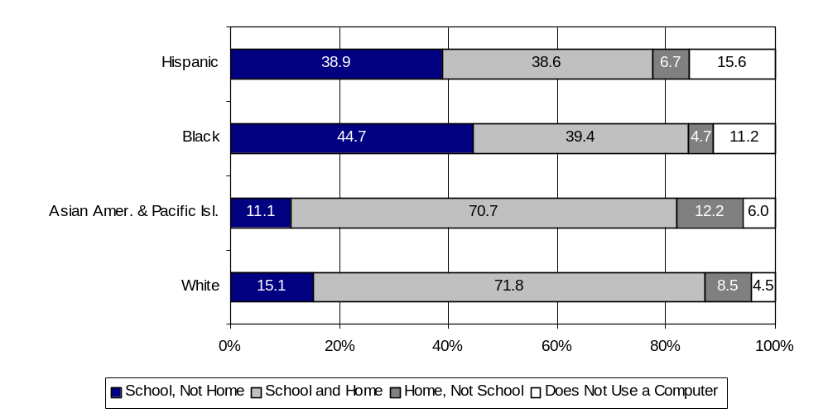
Source: NTIA and ESA, U.S. Department of Commerce, using U.S. Census Bureau Current Population Survey Supplements
Finally, Figure 5-8 shows that overall computer use rates for children of single parents – who have lower use rates at home – approach those of children from two-parent families due to computer use at school. More than twice as many children from single-parent families use computers only at schools as do children in two-parent families: 40.7 percent of children in female-headed households, 32.0 percent in male-headed households, and 16.6 percent in households with two parents. Because of school use, children from different family types have comparable overall computer use rates: 88.8 percent for children in female-headed households, 90.7 percent for children in male-headed households, and 94.4 percent of children in dual-parent households.
Figure 5-8: Computer Use Among 10 to 17 Year-Olds
By Household Type and Location, 2001

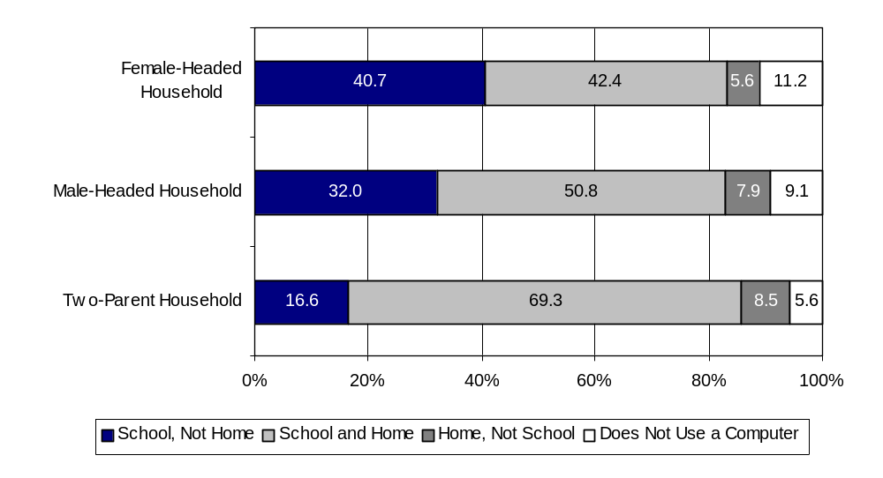
Source: NTIA and ESA, U.S. Department of Commerce, using U.S. Census Bureau Current Population Survey Supplements
Schools also provide an important resource for Internet use for all children, regardless of their background. The levels of school-only Internet use, however, are not as high as the levels of school-only computer use. As a result, the availability of the Internet at schools does not compensate for disparities in home use to the same degree as computer use in schools.
As shown in Figures 5-9, 5-10, and 5-11, substantial differences in overall Internet use remain between children of different backgrounds. Figure 5-9 demonstrates that nearly four times as many children (ages 10-17) go online only at school when they live in a household in the lowest income category (20.8 percent) than at the highest income level (5.0 percent). However, overall school use still varies widely: 34.3 percent for children in the lowest income category, compared to 62.7 percent for children who live in the highest income households. Additionally, home Internet use is much higher for those who live in high income households: 82.5 percent for children in families earning $75,000 and higher, compared to 21.4 percent for children in families earning $15,000 and below. For these reasons, overall Internet use among children has a wider differential by income than computer use. Children in families at the lowest income level have an overall Internet use rate about half that of children at the highest income level: 45.7 percent, compared to 87.5 percent.
Figure 5-9: Internet Use Among 10 to 17 Year-Olds By Income and Location, 2001
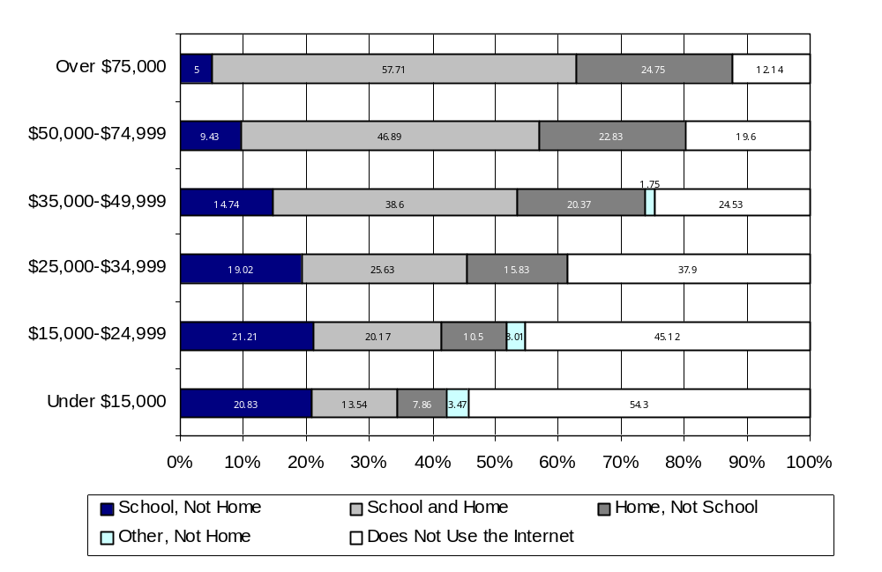
Source: NTIA and ESA, U.S. Department of Commerce, using U.S. Census Bureau Current Population Survey Supplements
Figure 5-10 demonstrates that there are also significant differences in online use among children of different races and ethnicities. School-only and home use rates are relatively lower for Hispanic and Black children, resulting in overall use rates of 47.8 and 52.3 percent, respectively. Asian American and Pacific Islander and White children, by contrast, are far more likely to use the Internet either at home only, or at home and school, resulting in higher overall Internet use levels of 79.4 and 79.7 percent, respectively.
Figure 5-10: Internet Use Among 10 to 17 Year-Olds
By Race/Hispanic Origin and Location, 2001
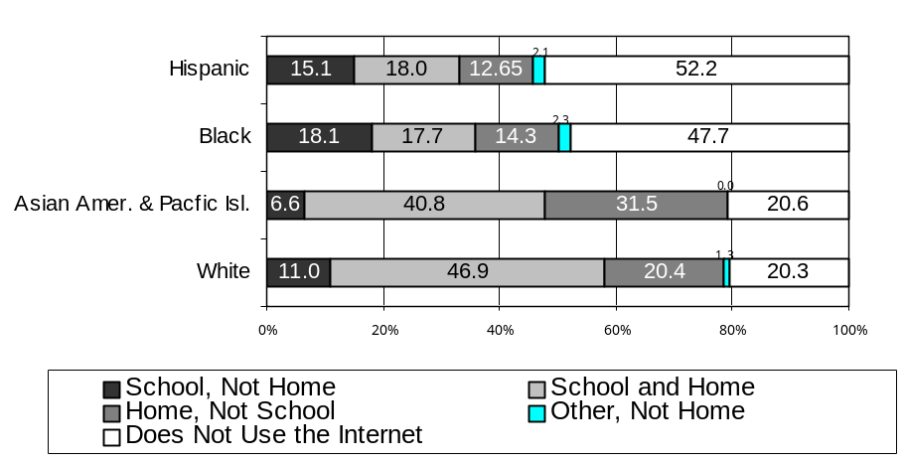
Source: NTIA and ESA, U.S. Department of Commerce, using U.S. Census Bureau Current Population Survey Supplements
Finally, Figure 5-11 shows similar patterns for children from households of different family types. Children in single-parent families are less likely to use the Internet at home (36.5 percent in female-headed households and 45.1 percent in male-headed households) than are children in two-parent families (64.2 percent). Because Internet use at school does not compensate for this difference, overall Internet use rates remain higher for children in two-parent families.
Figure 5-11: Internet Use Among 10 to 17 Year-Olds By Household Type, 2001
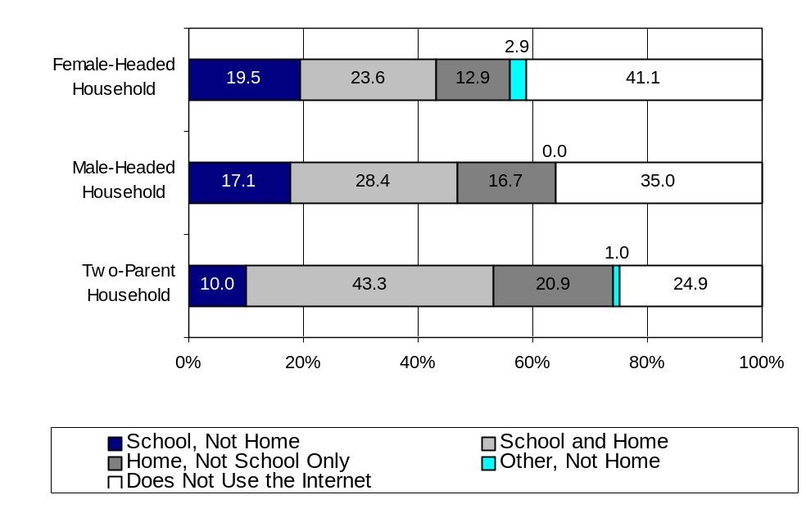
Source: NTIA and ESA, U.S. Department of Commerce, using U.S. Census Bureau Current Population Survey Supplements
While the vast majority of children and young adults uses the Internet either at home or school, there are some who use the Internet at other locations outside the home. This is captured in the “other only” category in Figures 5-9, 5-10, and 5-11. Approximately 12 percent of 10 to 17 year olds use the Internet at the library and a similar percentage use the Internet at a friend's house. (one-third of this group overlaps—i.e., they use the Internet at both the library and a friend's house). However, as shown in the figures above, only a very small percentage of Internet users in this age group rely solely on Internet access outside of home and school—2.1 percent—although this does vary by family income, race/Hispanic origin, and household type, as discussed in Chapter 2.
Using the Internet from a location other than home or school also varies by whether the student has Internet access at home. For example, 16.6 percent of Internet users in the 10-17 age bracket use the Internet at a public library. This percentage, however, rises to 29.3 percent among kids who use the Internet at school, but not at home. And although there are large differences in public library use among the various segments of this group (see Figure 5-12), overall public library use remains high for students who use the Internet at school, but not at home.

Figure 5-12: Internet Use at Public Libraries by Students
Who Use the Internet at School, But Not at Home, Ages 10 to 17, 2001

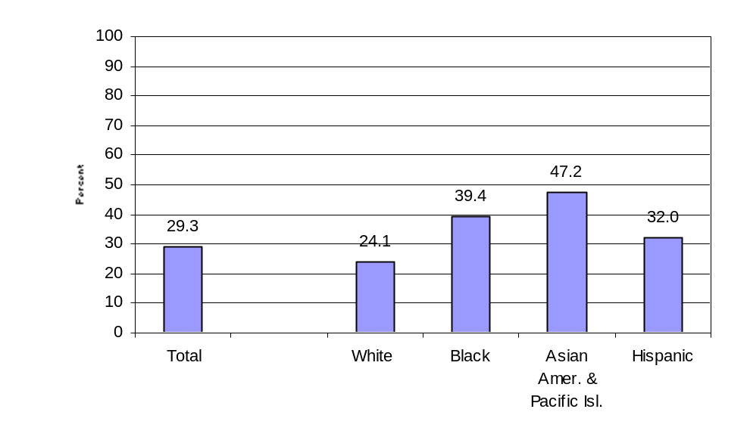
Source: NTIA and ESA, U.S. Department of Commerce, using U.S. Census Bureau Current Population Survey Supplements
How Young People Are Using the Internet
Children and young adults have embraced the Internet in conducting their daily activities, and therefore, use the Internet in ways that differ from older adults. While older adults tend to use the Internet to check for news, sports, weather, or research products and services, children and young adults are more likely to use the Internet to complete school assignments or play games. And while very high percentages of all age groups – adults and children alike – use e-mail, older children and young adults are doing so at much higher levels.
As shown in Figure 5-13, children and young adults are most likely to use the Internet for schoolwork. More than half of all children over age 10, and three-quarters of all young adults (18 to 24 year olds) in school, use the Internet for this purpose. Nearly one-fifth of all elementary school students are also using the Internet for schoolwork.
Children and young adults also use the Internet for communication and entertainment. E-mail is a close second to schoolwork among teenagers and young adults. A very high percentage of all teenagers (62.1 percent) and young adults in school (75.0 percent) use e-mail, compared to 45.2 percent of the overall U.S. population. These two age groups also go online in higher percentages than other age groups to engage in chat rooms and to listen to the radio or watch TV or movies.
Generally, as children grow older, they use the Internet for more types of activities. The one exception is playing games, which peaks among 14-17 year olds. While Internet use is generally lower among 5-9 year olds, 25 percent of this age group uses the Internet to play games.
These patterns show that the Internet has become integrated into children’s daily routines, which involve school, entertainment, communication, and play. As children get older, they become far more likely to use the Internet to engage in such activities. As a result, teenagers and young adults in school are now among the highest Internet users.
Figure 5-13: Major Activities Among Children and Young Adults, 2001
As a Percentage of U.S. Population under 25 years old
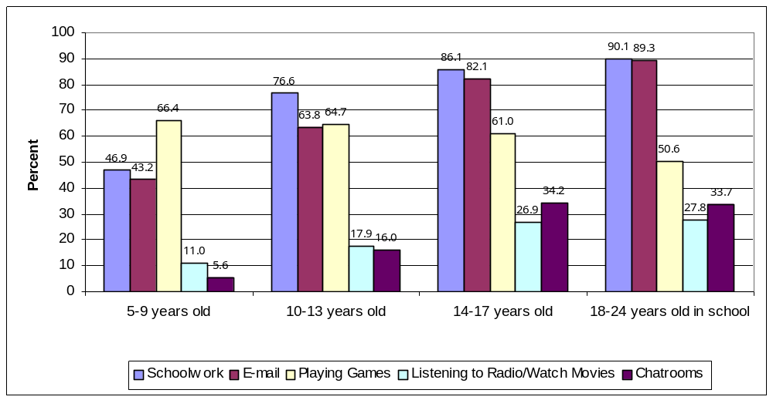
Source: NTIA and ESA, U.S. Department of Commerce, using U.S. Census Bureau Current Population Survey Supplements
Concerns About Children’s Online Use
With the Internet becoming an increasingly common daily activity for children, there has been a heightened interest regarding the possible exposure of children to unsafe or inappropriate content online. Despite such concerns, it is clear that children are still using the Internet in increasingly high numbers. As discussed below, it is also apparent that these concerns are not a significant reason underlying a household’s decision to forego or to discontinue Internet access. Nevertheless, because these concerns have been raised, the September 2001 survey asked for the first time whether parents were more concerned about exposure of children to material on the Internet or to material on television.
On a nationwide basis, a majority of respondents (68.3 percent) said that they were more concerned about their children’s exposure to material over the Internet. A lower percentage said they felt equally concerned about the propriety of Internet and television content (26.1 percent), and a small fraction (5.6 percent) said they felt less concerned about the Internet than television.
The concern about exposing children to inappropriate online content does not, however, result in lower levels of Internet use at home. More people who expressed concern about the Internet than television had Internet subscriptions at home (51.8 percent), than those who were more concerned about television (44.8 percent) or felt equally about the Internet and television (46.9 percent)
Additionally, even though more respondents stated concern about the Internet than television, this concern was seldom a factor when households opted to discontinue an Internet subscription or made the decision not to subscribe. When households that had discontinued Internet access were asked why, “concerns about how children use it” was one of the least cited factors (2.5 percent nationwide, compared to “too expensive” at 21.8 percent or “don’t want it” at 20.0 percent). Married couples with children under 18 were more likely, however, to list concerns about children as their reason for discontinuing access (6.6 percent), as were male-headed households (5.3 percent) and female-headed households (4.8 percent).
Similarly, only 1 percent of households nationwide that never had an Internet subscription cited “concerns about how children use it” as a reason (compared to 53.6 percent that cited “don’t want it” and 23.8 percent that cited “too expensive”). Again, married couples with children under 18 were slightly more likely to cite this reason (5.3 percent), as were single mothers (1.9 percent) and single fathers (1.4 percent), although still at very low levels.
In sum, while survey respondents generally expressed more concern about the effect of the Internet than television on children, this concern does not appear to have prompted families to discontinue or reject Internet access at home compared to other factors.

Table 5-1: Has Computer at Home and Uses Internet at Home,
by Children 3-17 Years Old, 2001
 | Total 3-17 Years Old | Home computer | Home Internet Use | Outside Home Internet Use
 | Number | Percent | Percent | Percent
Total | 60,881 | 70.7 | 41.2 | 38.9
AGE
3-4 years | 7,868 | 61.7 | 11.5 | 5.4
5-9 years | 20,096 | 68.0 | 28.3 | 25.3
10-13 years | 16,895 | 88.5 | 51.1 | 49.8
14-17 years | 16,022 | 75.7 | 61.4 | 60.7
GENDER
Male | 31,183 | 70.3 | 41.1 | 38.7
Female | 29,699 | 71.1 | 41.2 | 39.0
RACE/HISPANIC ORIGIN
White non-Hispanic | 38,170 | 82.7 | 50.2 | 44.5
Black | 9,477 | 45.8 | 24.7 | 31.8
Asian Pacific Islander | 2,591 | 81.3 | 51.6 | 37.3
Hispanic (of any race) | 9,923 | 46.6 | 20.1 | 24.5
HOUSEHOLD TYPE
Married-couple household | 42,835 | 79.1 | 46.6 | 40.0
Male householder | 3,093 | 57.2 | 33.0 | 37.8
Female householder | 14,166 | 49.0 | 26.8 | 35.9
Nonfamily household | 669 | 55.0 | 31.7 | 32.7
FAMILY INCOME
Under $15,000 | 7,323 | 33.3 | 14.3 | 25.9
15,000-24,999 | 6,108 | 48.0 | 21.4 | 31.5
25,000-34,999 | 6,765 | 59.7 | 28.9 | 33.6
35,000-49,999 | 8,632 | 75.7 | 42.4 | 41.7
50,000-74,999 | 10,840 | 86.9 | 52.1 | 44.0
75,000+ | 13,604 | 94.9 | 63.4 | 48.3
Not reported | 7,596 | 62.6 | 37.1 | 34.4
Source: NTIA and ESA, U.S. Department of Commerce, using U.S. Census Bureau Current Population Survey Supplements

Table 5-2: Has Computer at Home and Uses Internet at Home by Young Adults 18-24 Years Old, Attending School or College, 2001
 | Total 18-24 Years Old | Home computer | Home Internet Use | Outside Home Internet Use
 | Number | Percent | Percent | Percent
In School or College | 11,034 | 80.7 | 68.0 | 71.9
Not in School or College | 16,103 | 52.4 | 24.0 | 13.3
GENDER
Male | 5,195 | 81.9 | 69.4 | 73.7
Female | 5,833 | 89.1 | 66.8 | 70.3
RACE/HISPANIC ORIGIN
White non-Hispanic | 7,499 | 86.5 | 74.3 | 76.2
Black | 1,450 | 58.9 | 47.0 | 59.7
Asian Pacific Islander | 730 | 89.6 | 77.5 | 72.5
Hispanic (of any race) | 1,288 | 66.8 | 49.7 | 61.1
HOUSEHOLD TYPE
Married-couple household | 3,346 | 88.3 | 73.8 | 69.3
Male householder | 264 | 66.7 | 53.8 | 69.3
Female householder | 1,059 | 60.0 | 46.5 | 58.7
Non-family household | 1,854 | 78.6 | 68.6 | 81.4
FAMILY INCOME
Under $15,000 | 1,550 | 69.2 | 56.1 | 73.9
15,000-24,999 | 902 | 68.7 | 53.8 | 65.2
25,000-34,999 | 1,004 | 68.4 | 56.1 | 73.0
35,000-49,999 | 1,173 | 81.8 | 37.5 | 67.8
50,000-74,999 | 1,766 | 87.7 | 34.5 | 74.0
75,000+ | 3,147 | 93.8 | 83.0 | 75.6
Not reported | 1,493 | 71.2 | 62.8 | 64.7
Source: NTIA and ESA, U.S. Department of Commerce, using U.S. Census Bureau Current Population Survey Supplements
While school is the primary location where children use computers and the Internet outside the home, for adults that location is the workplace, which is discussed in the next chapter.
Chapter 6: THE Digital Workplace
Introduction
The workplace provides an important venue for many adults to use computers and the Internet. As of September 2001, about 65 million of the 115 million adults who were employed and age 25 and over use a computer at work. About 48 million of these adults (the vast majority of the 53 million in this group who use the Internet outside the home) connect to the Internet and/or use e-mail at work.
In the last four years, the percentage of adults who use computers at work rose modestly while the percentage using the Internet and/or e-mail at work grew appreciably, especially in the 13 months between August 2000 and September 2001. During this 13-month period, use of the Internet at work among employed adults age 25 and over increased from 26.1 percent to 41.7 percent.
Figure 6-1: Use Computer, Internet / E-Mail at Work,
As a Percent of Employed Persons Age 25 and Over
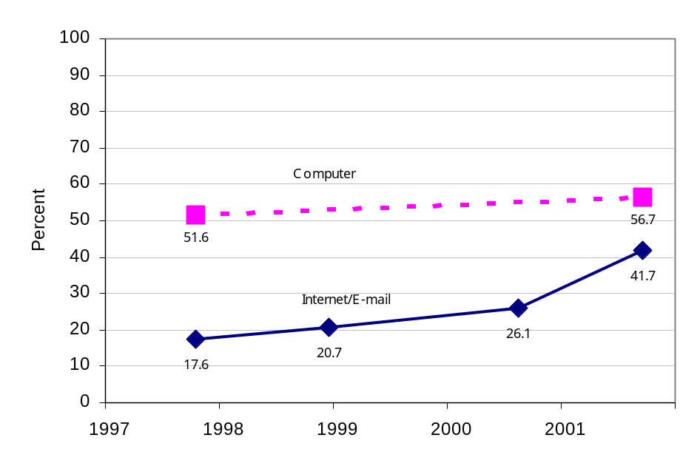
Source: NTIA and ESA, U.S. Department of Commerce, using U.S. Census Bureau Current Population Survey Supplements
Computer Use at Work by Occupation
In general, use of a computer at work correlates with occupations in which workers have higher educational attainment and, to a lesser extent, with gender.
Table 6-1: Employed Persons Age 25 and Over, by Occupation
 |  |  |  | Use a computer at main job
 | Employed (000s) | Median Education | Percent women | 000s | Percent
Total | 115,065 | SC | 46.3 | 65,190 | 56.7
Managerial and professional specialty | 39,412 | CD | 50.2 | 31,723 | 80.5
Technical, sales, and administrative support | 31,482 | SC | 62.9 | 22,205 | 70.5
Precision production, craft, and repair | 13,083 | HS | 8.4 | 4,152 | 31.7
Service | 13,678 | HS | 61.6 | 3,478 | 25.4
Operators, fabricators, and laborers | 14,504 | HS | 24.3 | 3,006 | 20.7
Farming, forestry, and fishing | 2,905 | HS | 20.3 | 625 | 21.5
CD – college degree, SC – some college but no degree, HS – high school diploma or GED
Source: NTIA and ESA, U.S. Department of Commerce, using U.S. Census Bureau Current Population Survey Supplements
The proportion of people using a computer at work was 80.5 percent for people in managerial and professional specialty occupations and was 70.5 percent for people in technical, sales, and administrative support occupations. The median educational attainment in these fields is a college degree or some college. About three-quarters of employed women work in these two occupations in contrast with just over one-half of men.
At the other end of the spectrum, only about one in five persons used a computer at work in the occupation categories for operators, fabricators, and laborers as well as for farming, forestry, and fishing. The median educational attainment in these fields is a high school diploma. Women account for less than ten percent of those employed in these occupations.

Computer Use at Work by Gender and Age
Because of the occupational differences, the share of women who use a computer at work exceeds the share of men who do by a margin of 62.9 percent to 51.3 percent. This difference persists across all ages. For both men and women, the percentage that use a computer at work fluctuates within a narrow range until the mid- to late 50s, at which point computer use at work for both genders declines steadily.
Figure 6-2: Use of a Computer at Work by Gender and Age
Percent of Employed Persons, 2001
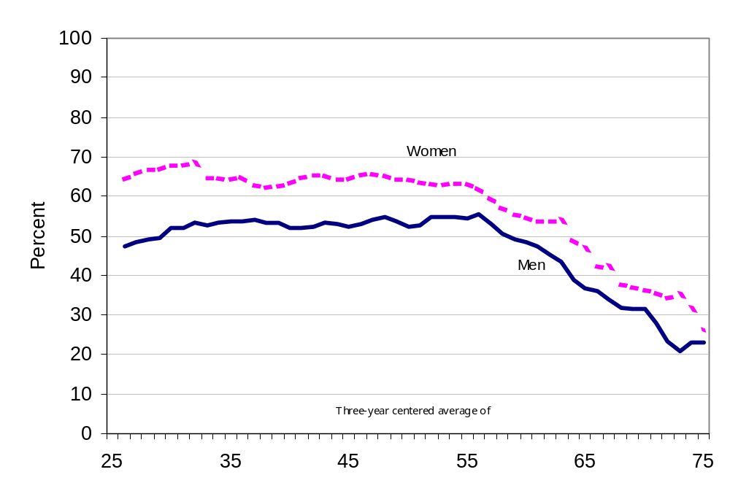
Source: NTIA and ESA, U.S. Department of Commerce, using U.S. Census Bureau Current Population Survey Supplements
Types of Computer Uses at Work
Workplace use of computers involves a number of tasks, led by connecting to the Internet, word processing, and spreadsheets and databases. Calendar and scheduling, graphics and design, and programming are less commonly used applications.
Figure 6-3: Computer Activities at Work,
as a Percent of Employed Persons Age 25 and Over, 2001
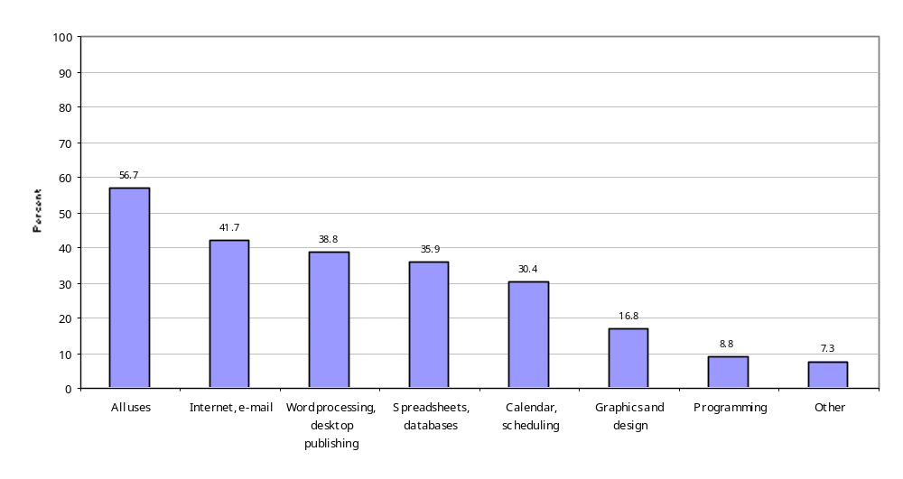

Source: NTIA and ESA, U.S. Department of Commerce, using U.S. Census Bureau Current Population Survey Supplements
Not surprisingly, the ranking of computer activities at work by occupation tends to follow the order for general use of a computer at work. Workers in managerial and professional specialties, as well as technical, sales, and administrative support, are the most active users of the Internet and e-mail, word processing, spreadsheets and databases, and calendar and scheduling.
Table 6-2: Top Four Computer Uses by Occupation, Percent of Employed Persons 25 and Over
 | Internet, e-mail | Word processing, desktop publishing | Spreadsheets, databases | Calendar, scheduling
Total | 41.7 | 38.8 | 35.9 | 30.4
Managerial and professional specialty | 66.8 | 63.2 | 56.6 | 48.8
Technical, sales, and administrative support | 49.2 | 45.5 | 43.1 | 34.7
Service | 13.9 | 14.3 | 11.8 | 12.3
Precision production, craft, and repair | 19.0 | 14.8 | 16.6 | 14.6
Operators, fabricators, and laborers | 9.2 | 7.6 | 8.7 | 7.0
Farming, forestry, and fishing | 14.6 | 13.0 | 13.2 | 9.2
Source: NTIA and ESA, U.S. Department of Commerce, using U.S. Census Bureau Current Population Survey Supplements
Internet Use at Work
The proportion of employed persons age 25 and over who use the Internet and/or e-mail at work increased from 26.1 percent in August 2000 to 41.7 percent in September 2001, a vigorous 54 percent annual rate of growth.
As with computer use, the distribution by age and gender of employed persons age 25 and over who use the Internet at work varies. Women are more likely than men to use the Internet/e-mail at work: 44.4 percent compared with 39.3 percent. This margin in favor of women is about half of the margin for computer use.
Also similar to computer use, the proportion of men and women who use the Internet at work remains reasonably steady between the ages of 25 and 55, when Internet use at work drops. The margin in favor of women persists until the mid-50s, at which point it essentially disappears.

Figure 6-4: Use Internet / E-mail at Work by Gender and Age,
as a Percent of Employed Persons, 2001
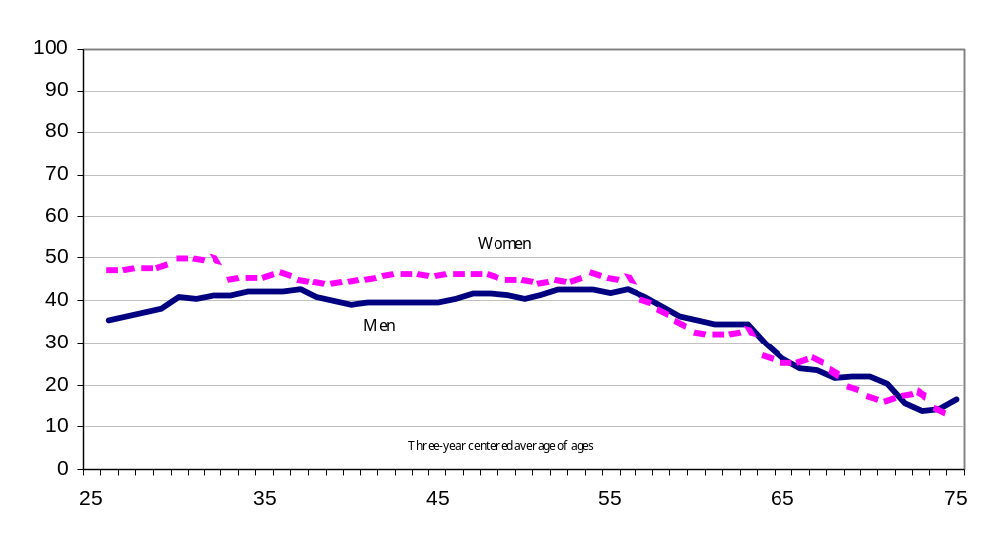

Source: NTIA and ESA, U.S. Department of Commerce, using U.S. Census Bureau Current Population Survey Supplements
Occupations already more likely to be using the Internet at work tended to experience the largest gains in Internet/e-mail use between 2000 and 2001 on a percentage point basis. In terms of growth rates, however, farming, forestry, and fishing and service occupations posted the largest advances.
Figure 6-5: Internet / E-mail Use at Work by Occupation,
as a Percent of Employed Persons Age 25 and Over, 2001
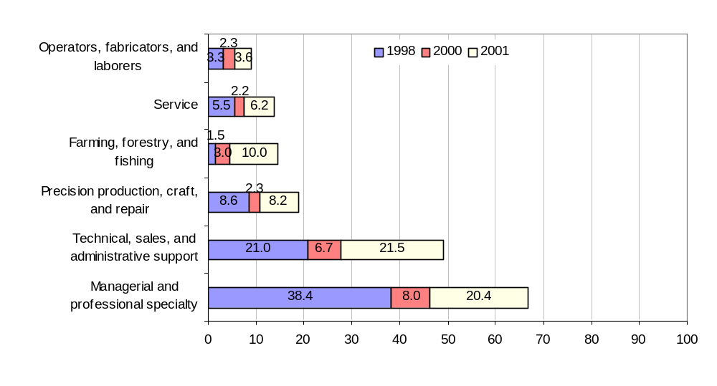
Source: NTIA and ESA, U.S. Department of Commerce, using U.S. Census Bureau Current Population Survey Supplements
Even with recent gains, striking differences in Internet use at work by occupation remain, particularly in male-dominated fields. While information technology undoubtedly can play a role in many fields of work, there are some occupations where it may be of little or no value or take a different form than a desktop computer connected to the Internet. In addition, further advances in the state of the art in computers in terms of reliability, portability, and ease of use may be necessary before they are practical in occupations characterized by lower levels of educational attainment.
The Work – Home Connection
Approximately 24 million of the 65 million employed adults who use a computer at work also do work on a computer at home. This underscores a critical connection between the workplace and home: exposure to a computer and the Internet in the workplace makes it substantially more likely for a computer and the Internet to be used at home.
Undoubtedly, there are cases where enthusiastic home users introduce computers and the Internet to a workplace more likely, however, use at work lends to use at home. Use at work not only acquaints someone with the utility of the technology, it also provides an opportunity to climb a sometimes frustrating learning curve in an environment with technical support. This acquired knowledge can then be taken home and shared with other members of a household.
The presence of someone who uses a computer or the Internet at work in a household is associated with substantially higher computer ownership or Internet use for that household, by a margin of about 77 percent to 35 percent.
Table 6-3: Computer Ownership and Internet Access by Presence of Work Users,
Percent of U.S. Households, 2001
 | Percent of U.S. Households with:
 | Computer | Internet access
All households | 56.5 | 50.5
Does any household member use at work:
Yes | 77.9 | 76.8
No | 35.9 | 34.8
Source: NTIA and ESA, U.S. Department of Commerce, using U.S. Census Bureau Current Population Survey Supplements
The much greater likelihood of household access associated with workplace use not only occurs in the aggregate but also is evident across all age groups, income brackets, educational levels, and race/Hispanic origin. The margin is especially large in groups that lag behind the national average, reflecting the small proportion of these households that contain someone who uses the Internet at work.
Table 6-4: Internet Access of Selected Households by Presence of Work Users,
as a Percent of U.S. Households, 2001
 |  | Someone in household uses Internet at work
 | Total | Yes | No
All households | 50.5 | 76.8 | 34.8
Income, Under $15,000 | 17.7 | 57.2 | 14.8
Less than high school education | 18.2 | 54.2 | 14.5
Income, $15,000 – 24,999 | 28.3 | 52.2 | 23.8
Black | 30.9 | 59.1 | 20.7
Hispanic | 32.0 | 63.1 | 22.1
Age 55 and over | 33.9 | 71.6 | 25.5
Other than income, characteristics are for reference person of household
Source: NTIA and ESA, U.S. Department of Commerce, using U.S. Census Bureau Current Population Survey Supplements
These results point to the need for caution in interpreting the direct effect of single variables such as income on Internet use at home. When we consider only households in which someone is using the Internet at work, at least half of those households have Internet at home even in the lowest income categories or in households in which no one completed high school. Among households with less than $15,000 in income, the few households with someone using the Internet at work are four times as likely to have the Internet at home as those without such a person. The steep slope for income or education alone is thus misleading because it represents a weighted average of households that differ in at least one fundamental way.
Figure 6-6: Household Internet Access by Family Income,
as a Percent of U.S. Households, 2001
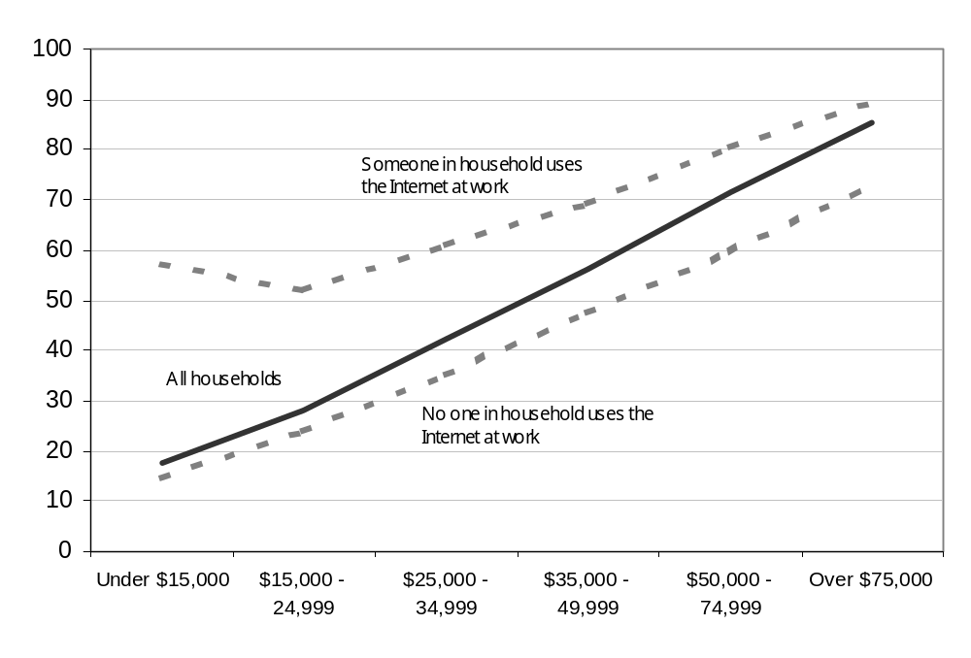
Source: NTIA and ESA, U.S. Department of Commerce, using U.S. Census Bureau Current Population Survey Supplements

Figure 6-7: Household Internet Access by Education,
as a Percent of U.S. Households, 2001
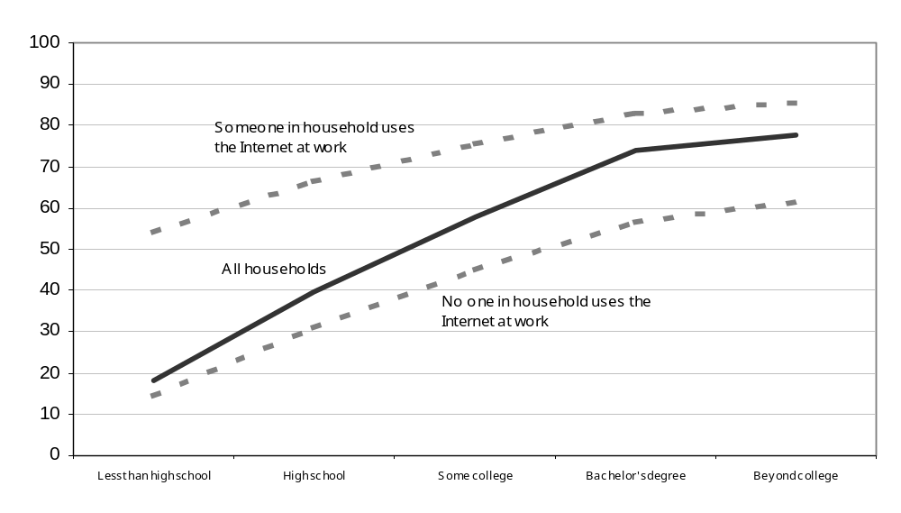
Source: NTIA and ESA, U.S. Department of Commerce, using U.S. Census Bureau Current Population Survey Supplements
Chapter 7: Computer and Internet Use
Among People with Disabilities
As demonstrated in earlier sections, computer and Internet use is becoming increasingly commonplace in homes, schools, and on the job. People of all ages, races, and ethnicities are moving more and more of their activities online. Having access and the ability to use these tools is especially important to members of our community who have difficulties due to physical or mental constraints. The tremendous communications capabilities of the Internet could provide an important tool to help people with disabilities to overcome certain of the challenges they face. However, the data show that people with disabilities are less likely than the population as a whole to use computers or the Internet.
People with Disabilities
The September 2001 supplement marks the first time that questions about specific types of disability have been included in the set of computer and Internet use questions on the Current Population Survey (CPS). These questions do not attempt to quantify the number or the proportion of people in the population who have a disability. Rather, these questions were posed in order to examine how specific types of disabilities impact computer and Internet use. The questions, as asked, are shown in Box 7-1. They cover long-lasting severe vision, hearing, mobility, and manual dexterity problems, as well as a question concerning any physical or mental condition that makes it difficult to leave the house.
Box 7-1: CPS Supplement Questions Concerning Specific Types of Disabilities
Do you have any of the following long-lasting physical conditions:
(Asked of everyone in the household age 3 and above)
A) Blindness or a severe vision impairment even with glasses or contact lenses?
B) Deafness or a severe hearing impairment even with a hearing aid?
C) A physical condition that substantially limits your ability to walk or climb stairs?
D) A condition that makes it difficult to type on an ordinary typewriter or traditional
computer keyboard?

Do you have difficulty going outside the home alone, for example, to shop or visit a doctor’s
office, because of a physical or mental health condition lasting six months or longer?
(Asked of everyone in the household age 15 and above)
Approximately 8.5 percent of the population has at least one of the five disabilities covered in the survey. As shown in Table 7-1, the incidence of each of the various types of disabilities rises sharply with age. For example, while only 1.3 percent of children under 15 have at least one of the disabilities examined here, almost 30 percent of the population aged 65 and older has at least one of these limitations. Because this pattern is the reverse of that followed by Internet use (which rises sharply at the younger end of the spectrum and then declines at older age levels, see Figure 2-5 in Chapter 2), it is important to consider the question of computer and Internet use by people with disabilities within relevant age categories. However, the relatively few respondents who have these disabilities at the lower end of the age range and the relatively few respondents who use computers and the Internet at the upper end of the age range severely limit the degree of disaggregation that can be undertaken. Therefore, this analysis is limited to three broad groups: individuals under 25, 25 to 60 year-olds, and those over 60.
Table 7-1: Age Distribution of Specific Disabilities
as a Percent of Population, 2001

 | 3-14 | 15-24 | 25-34 | 35-44 | 45-54 | 55-64 | 65 and Over
Multiple Disabilities | 0.4 | 0.6 | 1.0 | 2.0 | 3.8 | 6.3 | 15.0
Blind or Severe Vision Impairment | 0.3 | 0.4 | 0.4 | 0.5 | 0.6 | 0.7 | 1.4
Deaf or Severe Hearing Impairment | 0.3 | 0.3 | 0.3 | 0.5 | 0.6 | 0.9 | 2.4
Difficulty Walking | 0.2 | 0.4 | 1.0 | 1.9 | 2.7 | 5.7 | 7.1
Difficulty Typing | 0.1 | 0.3 | 0.4 | 0.6 | 0.6 | 0.8 | 0.9
Difficulty Leaving Home | Not Asked | 0.5 | 0.5 | 0.7 | 0.9 | 1.1 | 2.2
None of These Disabilities | 98.7 | 97.6 | 96.4 | 93.8 | 90.7 | 84.6 | 71.1

Source: NTIA and ESA, U.S. Department of Commerce, using U.S. Census Bureau Current Population Survey Supplements

Under 25 Year-Olds
Less than 2 percent of the population between ages 3 and 24 reported having at least one of the disabilities considered in this report. Table 7-2 contains the only relevant data on computer and Internet use that can reliably be presented for this age group. Although “Internet Use at Home” is lower among those with disabilities, Internet use from other locations brings those with either severe vision or hearing impairments up to the level of the population in general and substantially improves the connectivity situation of individuals in the other disability categories. While a reasonable assumption would be that many of these young people have Internet access through their school, this cannot be demonstrated with this survey data because of the small number of observations in this category.
Table 7-2: Computer and Internet Use Among 3 to 24 Year-Olds By Disability Status, 2001
 | Size of Population in Category  (in Thousands) | Percent of Population  (percent) |  | Has a PC at Home  (percent) | Uses the Internet at Home  (percent) | Uses the Internet from Any Location  (percent)
Multiple Disabilities | 436 | 0.6 |  | 65.0 | 26.8 | 43.6
Blind or Severe Vision Impairment | 267 | 0.4 |  | 61.2 | 30.6 | 56.3
Deaf or Severe Hearing Impairment | 198 | 0.3 |  | 76.4 | 26.6 | 56.5
Difficulty Walking | 275 | 0.4 |  | 64.0 | 32.4 | 45.8
Difficulty Typing | 185 | 0.2 |  | 63.9 | 35.4 | 48.6
None of These Disabilities | 75,299 | 98.2 |  | 68.5 | 43.8 | 56.9
Total Answering | 76,659 |  |  | 68.4 | 43.5 | 56.7
% not answering | 12.9

Source: NTIA and ESA, U.S. Department of Commerce, using U.S. Census Bureau Current Population Survey Supplements

25 to 60 Year-Olds
Among individuals between the ages of 25 and 60, the likelihood of having at least one of the five disabilities considered here increases to 7.3 percent. As shown in Table 7-3 below, with the exception of those individuals with severe hearing impairment, those who have at least one of these disabilities are less likely than those without a disability to live in a home with a personal computer. And even in homes with a computer, people who have at least one of these disabilities are less likely to use the computer or the Internet.
Table 7-3: Computer and Internet Use at Home Among 25 to 60 Year-Olds
By Disability Status, 2001
 | Size of Population in Category  (in Thousands) | Percent of Population  (percent) |  | Has a Computer at Home  (percent) |  | Of Those Who Have a  PC at Home
 |  |  |  |  |  | Uses a the PC at Home  (percent) | Uses the Internet at Home  (percent)
Multiple Disabilities | 3,111.2 | 2.6 |  | 45.4 |  | 67.8 | 56.4
Blind or Severe Vision Impairment | 660.1 | 0.6 |  | 63.7 |  | 74.9 | 61.7
Deaf or Severe Hearing Impairment | 591.4 | 0.5 |  | 70.1 |  | 74.5 | 68.0
Difficulty Walking | 2,643.7 | 2.3 |  | 51.6 |  | 74.3 | 63.7
Difficulty Typing | 661.8 | 0.6 |  | 58.6 |  | 78.7 | 65.8
Difficulty Leaving Home | 891.4 | 0.8 |  | 49.8 |  | 77.1 | 66.7
None of These Disabilities | 109,174.8 | 92.7 |  | 69.4 |  | 83.4 | 75.1
Total | 117,734.3 | 100 |  | 68.2 |  | 82.8 | 74.4
% not answering | 13.4
Source: NTIA and ESA, U.S. Department of Commerce, using U.S. Census Bureau Current Population Survey Supplements

People who have at least one of the listed disabilities are much less likely to be Internet users than those without any of these disabilities. Further, even among Internet users, the Internet activities of people with disabilities are somewhat different. As shown in Table 7-4, people with disabilities are more likely than the population in general to use the Internet to play games and search for health information.
Table 7-4: Internet Activities of 25 to 60 Year-Olds
By Disability Status, 2001
 | Internet Use from Any Location  (percent) | Among Internet Users
 |  | E-Mail or Instant Messaging | Play Games | Search for Product or Service Info. | Purchase Online | News, Weather Sports info | Health Info | Gov.  Info
Multiple Disabilities | 30.3 | 84.9 | 39.8 | 76.8 | 41.6 | 68.0 | 56.1 | 39.1
Blind or Severe Vision Impairment | 51.5 | 86.8 | 46.6 | 81.9 | 53.1 | 73.2 | 38.7 | 30.9
Deaf or Severe Hearing Impairment | 54.8 | 84.3 | 36.5 | 72.6 | 48.1 | 69.4 | 33.6 | 32.9
Difficulty Walking | 39.8 | 85.0 | 41.6 | 75.5 | 44.4 | 66.9 | 48.2 | 34.9
Difficulty Typing | 49.2 | 87.6 | 36.2 | 79.8 | 54.8 | 63.5 | 51.9 | 41.8
Difficulty Leaving Home | 40.4 | 84.9 | 31.5 | 73.2 | 45.2 | 64.5 | 50.6 | 38.1
None of These Disabilities | 63.1 | 88.3 | 32.0 | 78.5 | 50.4 | 70.2 | 39.1 | 34.4
Total | 61.4 | 88.2 | 32.3 | 78.4 | 50.2 | 70.1 | 39.6 | 34.5
Source: NTIA and ESA, U.S. Department of Commerce, using U.S. Census Bureau Current Population Survey Supplements

In an earlier section of this report (see Chapter 6), rates of computer and Internet use were shown to vary substantially by employment status. As shown in Figure 7-1, while people with severely limited sight and hearing have employment rates approaching that of the population that does not have one of these disabilities, people in the other disability categories are much less likely to be employed.

Figure 7-1: Employment Rates Among 25 to 60 Year-Olds
by Disability Status, as a Percent of U.S. Population, 2001
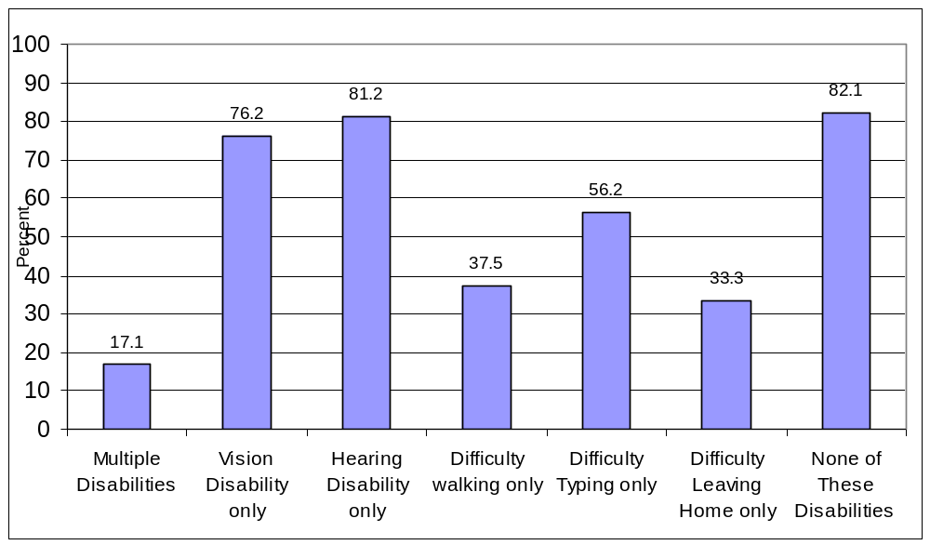
Source: NTIA and ESA, U.S. Department of Commerce, using U.S. Census Bureau Current Population Survey Supplements
People who are not employed fall into one of two major categories: unemployed (which means that one is in the labor force, but is not employed) and out of the labor force (not looking for a job). The CPS records those not in the labor force as retired, disabled, or other. Overall, 78.6 percent of the population between ages 25 and 60 is employed, 3.1 percent is unemployed, 2.6 percent is retired, 4.9 percent is “disabled,” and 10.8 percent fall into the “other” category.
The data are sufficient to provide a comparison of persons who gave “disability” as the reason they were not in the labor force for some of the disability categories. Of the disabilities considered here, it is not surprising that those with more than one of the disabilities were the most likely to be out of the labor force for reasons of disability. People with mobility issues (both the “difficulty walking or climbing stairs” and the “inability to leave the house to go to an appointment”) also had high rates of being out of the labor force due to disability. As shown in Figure 7-2, 1.8 percent of individuals who replied negatively to the five specific disability questions contained in Box 1 are not in the labor force due to a disability. People with vision or hearing issues are much less likely to be out of the labor force because of their disability.
Figure 7-2: “Not in the Labor Force Because of Disability”
Among 25 to 60 Year-Olds by Disability Status, 2001
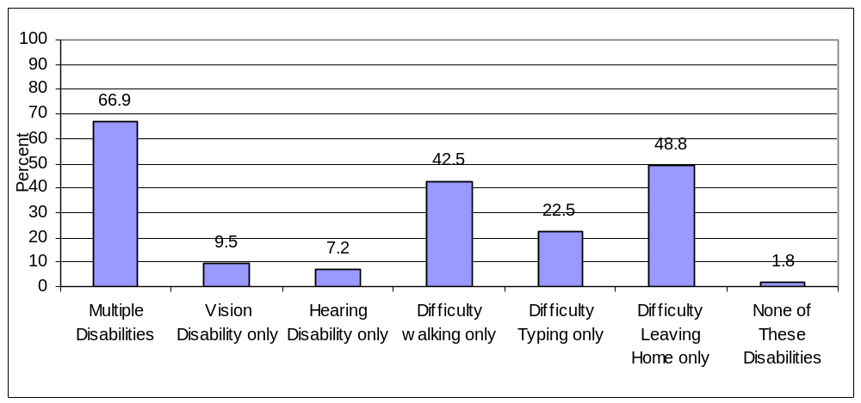
Source: NTIA and ESA, U.S. Department of Commerce, using U.S. Census Bureau Current Population Survey Supplements
On the job, people with either a vision or hearing disability or with multiple disabilities are less likely to use a computer at work than others (Table 7-5). Even among those that do use a computer, substantial differences remain in the extent to which they connect to the Internet or use e-mail. One interesting finding is that the disability category showing the highest rate of on-the-job computer use are those persons who report “having a condition that makes it difficult to type on an ordinary typewriter or traditional computer keyboard.” This group has work computer use rates similar to that of the population without one of these disabilities. However, given the fact that 22.5 percent of people in this category are employed in administrative positions where the incidence of repetitive motion disorders such as carpal tunnel syndrome may be high, makes this finding less surprising.

Table 7-5: Computer and Internet Use at Work Among Employed 25 to 60 Year-Olds
By Disability Status, 2001
 | Uses a Computer at Work (percent) | Of Those Who Use a Computer at Work: Uses the Internet at Work  (percent)
Multiple Disabilities | 48.1 | 68.2
Blind or Severe Vision Impairment | 52.1 | 69.6
Deaf or Severe Hearing Impairment | 50.3 | 57.5
Difficulty Walking | 55.4 | 69.0
Difficulty Typing | 58.6 | 67.9
Difficulty Leaving Home | 57.6 | 71.9
None of These Disabilities | 58.4 | 74.0
Total | 58.2 | 73.8

Over 60 Year-Olds
In general, those over age 60 are less likely than other age groups to have a computer in their home or to use the PC or the Internet in the home and for those with a disability the use rates are even lower (Table 7-5). In addition, people in this age group are much less likely to use the Internet outside of the home. For example, the difference between Internet use from home and Internet use from any location was 13.4 percent among those between 3 and 24 who have difficulty walking or climbing stairs (a rise from 32.6 percent to 46.0 percent). The comparable change was only 2.0 percent for the population over 60 with a similar disability (14.1 percent who use the Internet from home to 16.1 percent who use the Internet from any location).
The Interaction of Disability with Computer and Internet Use
The charts and tables above are suggestive that people with disabilities tend to use computers and the Internet at rates below the average for the population. From these tables, however, it is not possible to discern whether other factors, such as education or income, are actually the variables driving the disparity, rather than the fact of the disability. However, statistical analysis indicates that even when income, education, and age are accounted for, people with disabilities considered here are less likely than those without disabilities to be Internet users.

Table 7-5: Computer and Internet Use at Home Among Those Over 60
By Disability Status, 2001
 | Size of Population in Category  (in Thousands) | Percent of Population  (percent) | Has a Computer at Home  (percent) | Of Those Who Have a  Computer at Home |  | Uses the Internet from Any Location
 |  |  |  | Uses a the Computer at Home  (percent) | Uses the Internet at Home  (percent)
Multiple Disabilities | 4,927.2 | 13.5 | 22.2 | 31.4 | 23.8 | 6.2
Blind or Severe Vision Impairment | 446.7 | 1.2 | 30.2 | 42.6 | 27.5 | 9.6
Deaf or Severe Hearing Impairment | 771.6 | 2.1 | 35.4 | 56.5 | 45.7 | 17.8
Difficulty Walking | 2,592.9 | 7.1 | 28.7 | 62.9 | 49.3 | 16.1
Difficulty Typing | 327.9 | 0.9 | 24.9 | 62.3 | 52.3 | 13.5
Difficulty Leaving Home | 712.2 | 2.0 | 25.7 | 33.2 | 25.2 | 7.2
None of These Disabilities | 26,767.1 | 73.2 | 39.4 | 67.0 | 56.7 | 25.4
Total | 36,545.6 |  | 35.8 | 62.8 | 52.5 | 21.3
% not answering | 11.4
Source: NTIA and ESA, U.S. Department of Commerce, using U.S. Census Bureau Current Population Survey Supplements

Chapter 8: The Unconnected
The earlier chapters of this report have chronicled changes in the connected population: who they are, where they are, what they are doing online, what devices and connection types they are using, and where they are using the Internet. There is a sizable segment of the U.S. population (as of September 2001, 46.1 percent of persons and 49.5 percent of households), however, that does not use the Internet. This chapter profiles this “unconnected” population and explores some of the reasons why it may not be online.
The Offline Population
Table 8-1 at the end of this chapter presents the complement to Table 2-2—descriptive statistics for those individuals who do not use the Internet. As the analysis in Chapter 2 shows, Internet use has expanded dramatically in the United States, but a number of groups are more likely not to be Internet users. These non-users include:
- People in households with low family incomes — 75.0 percent of people who live in households where income is less than $15,000 and 66.6 percent of those in households with incomes between $15,000 and $35,000.
- Adults with low levels of overall education—60.2 percent of adults (age 25 +) with only a high school degree and 87.2 percent of adults with less than a high school education.
- Hispanics—68.4 percent of all Hispanics and 85.9 percent of Hispanic households where Spanish is the only language spoken.
- Blacks—60.2 percent of Blacks.
Earlier chapters have examined the change in the online population focusing on the growth in the number of users or home connections. We gain a different perspective by looking at the rate of decrease in the population that is not online. In other words, we compare the change in the online population with the group initially not online instead of the group initially online.

Consider the non-Internet-using population by educational attainment, for example. Among people at least 25 years old with a high school education, the share not using the Internet declined from 69.4 percent in August 2000 to 60.2 in September 2001. Over the same period and age level, the share of those with a college education who were not using the Internet shrank from 27.5 percent to 19.2 percent (Figure 8-1). Thus, high school graduates had a slightly larger point change (9.2 percentage points) than college graduates (8.3 percentage points). Because so many more high school graduates were not Internet users in August 2000, the 9.2 percentage point change over the next 13 months represented a 12 percent annual rate of decline in non-Internet-users (Table 8-2). On the other hand, so few college graduates were non-Internet-users in 2000 that their 8.2 percentage point change reflected a 28 percent annual rate of decline in non-Internet-users. When Chapter 2 examined those same point changes from the perspective of the growth in Internet users, high school graduates had a larger growth rate of Internet users than college graduates (27 percent vs. 11 percent) (See Table 2-3).

Figure 8-1: Individuals Not Using the Internet, By Selected Educational Attainment Level,
August 2000 and September 2001
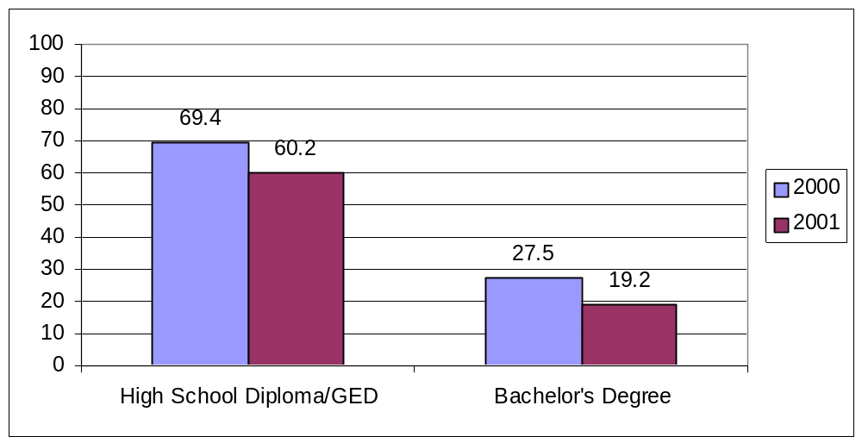
Source: NTIA and ESA, U.S. Department of Commerce, using U.S. Census Bureau Current Population Survey Supplements

The Importance of Cost to Households Never Connected to the Internet
The cost of Internet access matters much more to households with lower incomes than to those with higher incomes. The September 2001 survey asked households without Internet subscriptions the question, “What is the main reason that you don’t have the Internet at home?” Survey results indicated that the largest specific response was that the cost was “too expensive.” This response was volunteered by one-fourth of these households, but much more often by lower income households than by higher income households.

Figure 8-2 shows the relationship between costs, income, and adoption of home Internet connections. With successively higher income categories, fewer households report that cost is a barrier and more households are making their first connections to the Internet at home. Households with incomes below $15,000 volunteered cost as the barrier to home Internet subscriptions 34.7 percent of the time. Among households in that income category, the share of the population without home Internet subscriptions declined by only 6 percent between August 2000 and September 2001. At the other end of the spectrum, only 9.6 percent of households with incomes of at least $75,000 said that they were deterred by cost. That income level saw a 34 percent reduction in the share of households without home Internet between August 2000 and September 2001.

Figure 8-2- Adoption Rate and Internet “Too Expensive” by Income
Percent of U.S. Households without Internet
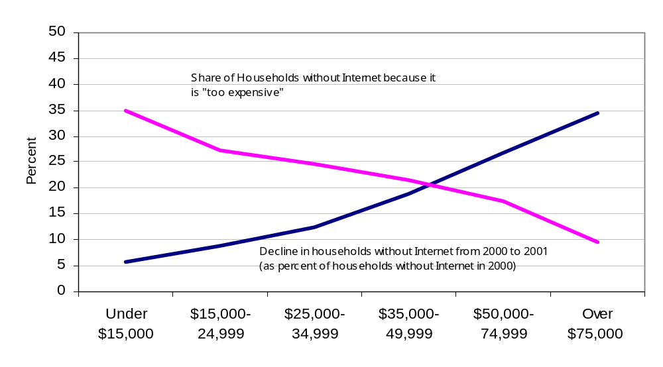
Source: NTIA and ESA, U.S. Department of Commerce, using U.S. Census Bureau Current Population Survey Supplements
Among specific responses, cost rated highly across a number of demographic groups of non-Internet households. In particular, respondents for married couples or single-parent families with children, and heads of households that were younger than 45 years of age, less educated, or unemployed all identified “too expensive” as the most important reason for non-connectivity at a much higher level than the national figure of 25.3 percent.

Why Households have Discontinued Internet Access
Those households that have discontinued Internet access numbered 3.6 million, or 3.3 percent, of all U.S. households as of September 2001. Among this group of unconnected persons, cost was the most frequently cited reason for disconnecting (Figure 8-3). Households with incomes less than $50,000 identified “too expensive” as the primary reason for discontinuing their Internet connection (26.9 percent of such households). Cost was more important in households with only high school degrees (24.6 percent) than in households with college degrees (13.7 percent). Those household heads younger than 45 rated cost (24.2 percent) more highly than household heads 45 years or older (19.0 percent). Geographic differentials existed: households in rural areas cited cost less often (19.9 percent) than households in central cities (25.5 percent).
The lack of a computer or problems with the home computer also accounted for many persons discontinuing their use (Figure 8-3). Although people have concerns about their children’s exposure to inappropriate material on the Internet (see discussion at the end of this chapter), this was seldom the reason cited by people who no longer subscribed to the Internet.

Figure 8-3 Reasons for U.S. Households Discontinuing Internet Access
Percent Distribution, 2001
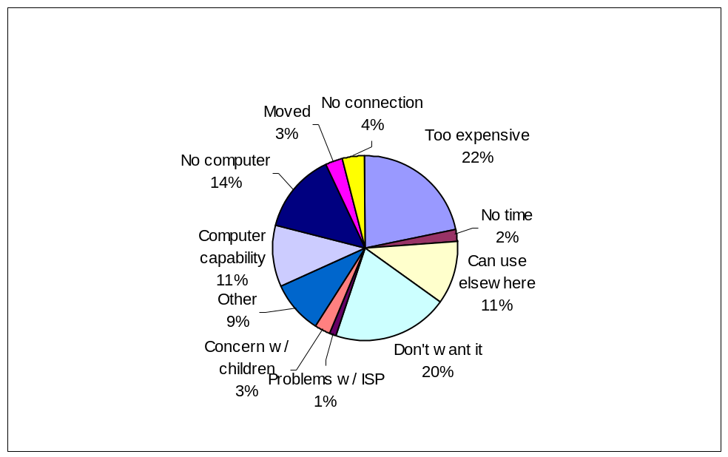
Source: NTIA and ESA, U.S. Department of Commerce, using U.S. Census Bureau Current Population Survey Supplements

The Effect of Confidentiality Concerns
Some households may choose not to have a home Internet connection because of confidentiality concerns. The September 2001 survey asked respondents if they were more or less concerned about their confidentiality over the Internet as compared to the telephone. It is important to note that although respondents reported being more concerned about their confidentially over the Internet, the question was phrased in such a way that respondents did not rate the degree of concern but rather whether they were more or less concerned.
About half (50.9 percent) of respondents were more concerned about their confidentiality over the Internet compared with the telephone. About one-third (41.4 percent) of respondents reported their concerns were the same for both media, and 7.7 percent of respondents reported feeling less concern about confidentiality over the Internet compared to on a telephone.
In terms of age, persons under 25 years old were the least concerned about their confidentiality over the Internet (36.0 percent), compared with those 55 years of age or older who were the most concerned (54.8 percent). A majority of respondents in the two age groups under 35 reported that they were either neutral or more concerned about the telephone. In contrast, a majority of respondents over 35 were more concerned about the Internet than were either neutral or more concerned about the telephone. Examining gender revealed that females and males shared a similar level of concern about confidentiality over the Internet: 51.8 percent compared to 50.1 percent, respectively. Looking at household types, male-led households were least likely to be concerned about confidentiality over the Internet (41.4 percent), while female-led households were most concerned (54.9 percent). Male-led households were also most likely to respond that there was no difference in confidentiality between the two media (52.5 percent), compared to 38.0 percent of female-led household who reported that there was no difference.
Content Concerns
Some households, particularly those with children under the age of 18, may choose not to have a home Internet connection because of the concern that the children may access inappropriate material. As discussed in Chapter 5, the September 2001 survey found that among households with children, 68.3 percent responded that compared with material on television, they were more concerned about the kind of material children may be exposed to on the Internet. This concern, however, did not translate into lower rates of Internet access among this group. Among those that thought the Internet was a source of more concern than television, 51.8 percent had Internet in the home as compared to 48.2 percent who did not subscribe to the Internet. Those who were less concerned (5.6 percent) or had similar concerns (26.1 percent) actually constituted a lower proportion of Internet households.
The Role of Network Effects
“Network effects” may be another factor determining whether people connect to the Internet. Typically, the adoption of a technology that has “network effects” begins slowly. At some point a successful technology will reach a tipping point and adoption will accelerate rapidly. As the technology saturates the market, the adoption rate slows, since most people who want the technology already have it.
Generally, the adoption of a technology does not take place uniformly across the entire economy or the entire population. The penetration rate for fax machines, for example, is much higher among businesses than among households. The fax never rivaled the telephone or mail for household communications, whereas businesses found considerable value in the near instant transmission of documents. Under this concept, if a person’s family, friends, and broader community are Internet users, there would be increased incentive for them to go online. On the other hand, if few of a person’s family, friends, or community were online, there would be less of an incentive to go online. In looking at the relationship of home Internet to variables such as income, education, race or Hispanic origin, we may be picking up in part the probability of family, friends, and community to be online.
In sum, there are a number of reasons as to why a substantial proportion of U.S. households do not currently use the Internet. Some reasons, such as those related to “network effects,” can be surmised from adoption patterns of new technologies. Other reasons were provided as rationale in the September 2001 survey. Cost (“too expensive”) rates highest among lower-income households, particularly for those that have decided to discontinue Internet access at home, and highly among many demographic groups of non-Internet households. In contrast, confidentiality issues (even where households express greater concerns about the Internet than television) and concerns about how children use the Internet do not appear to be significant reasons why households stay or go offline.
Table 8-1: Non-Internet Use From Any Location by Individuals Age 3 and Older,
October 1997, December 1998, August 2000, and September 2001
 | Oct. 1997  (thousands) |  | Dec. 1998  (thousands) |  | Aug. 2000 (thousands) |  | Sept. 2001 (thousands) |  | Non-Internet Use  (percent of population)
 | Non-Internet Users | Total | Non-Internet Users | Total | Non-Internet Users | Total | Non- Internet Users | Total | Oct. 1997 | Dec. 1998 | Aug. 2000 | Sept. 2001
Total Population | 198,914 | 255,689 | 173,866 | 258,453 | 146,140 | 262,620 | 122,357 | 265,180 | 77.8 | 67.3 | 55.6 | 46.1
Gender
Male | 94,279 | 124,590 | 82,899 | 125,932 | 70,882 | 127,844 | 59,572 | 129,152 | 75.7 | 65.8 | 55.4 | 46.1
Female | 104,635 | 131,099 | 90,966 | 132,521 | 75,258 | 134,776 | 62,785 | 136,028 | 79.8 | 68.6 | 55.8 | 46.2
Race/ Origin
White | 137,617 | 184,295 | 115,510 | 184,980 | 92,725 | 186,439 | 74,851 | 186,793 | 74.7 | 62.4 | 49.7 | 40.1
Black | 27,589 | 31,786 | 26,012 | 32,123 | 23,226 | 32,850 | 20,068 | 33,305 | 86.8 | 81.0 | 70.7 | 60.2
Asian Amer. & Pac. Isl. | 6,794 | 9,225 | 6,221 | 9,688 | 5,229 | 10,324 | 4,223 | 10,674 | 73.6 | 64.2 | 50.6 | 39.6
Hispanic | 25,133 | 28,233 | 24,556 | 29,452 | 23,593 | 30,918 | 22,005 | 32,146 | 89.0 | 83.4 | 76.3 | 68.4
Employment Status
Employed ^{b} | 93,603 | 130,857 | 76,580 | 133,119 | 59,073 | 136,044 | 46,693 | 135,089 | 71.5 | 57.5 | 43.4 | 34.6
Not Employed ^{b, d} | 63,899 | 72,911 | 58,890 | 73,151 | 52,570 | 73,891 | 48,736 | 77,268 | 87.6 | 80.5 | 71.1 | 63.1
Family Income
Less than $15,000 | 40,215 | 44,284 | 32,694 | 37,864 | 26,039 | 32,096 | 23,506 | 31,354 | 90.8 | 86.3 | 81.1 | 75.0
$15,000 - $24,999 | 28,662 | 32,423 | 24,958 | 30,581 | 20,664 | 27,727 | 17,756 | 26,649 | 88.4 | 81.6 | 74.5 | 66.6
$25,000 - $34,999 | 27,512 | 33,178 | 23,786 | 31,836 | 19,947 | 31,001 | 15,980 | 28,571 | 82.9 | 74.7 | 64.3 | 55.9
$35,000 - $49,999 | 29,953 | 38,776 | 25,498 | 39,026 | 19,177 | 35,867 | 15,457 | 36,044 | 77.2 | 65.3 | 53.5 | 42.9
$50,000 - $74,999 | 28,358 | 41,910 | 23,874 | 43,776 | 18,392 | 43,451 | 14,621 | 44,692 | 67.7 | 54.5 | 42.3 | 32.7
$75,000 & above | 20,296 | 36,572 | 17,360 | 42,221 | 15,625 | 52,189 | 11,900 | 56,446 | 55.5 | 41.1 | 29.9 | 21.1
Educational Attainment
Less Than High School ª | 28,598 | 29,114 | 27,811 | 29,039 | 25,773 | 28,254 | 23,977 | 27,484 | 98.2 | 95.8 | 91.2 | 87.2
High School Diploma/GED ª | 51,898 | 57,487 | 46,142 | 57,103 | 39,463 | 56,889 | 34,539 | 57,386 | 90.3 | 80.8 | 69.4 | 60.2
Some College ª | 31,995 | 42,544 | 26,435 | 43,038 | 20,427 | 44,628 | 17,099 | 45,420 | 75.2 | 61.4 | 45.8 | 37.6
Bachelors Degree ª | 16,291 | 27,795 | 12,054 | 28,990 | 8,351 | 30,329 | 5,863 | 30,588 | 58.6 | 41.6 | 27.5 | 19.2
Beyond Bachelors Degree ª | 6,668 | 13,863 | 4,884 | 14,518 | 3,322 | 15,426 | 2,650 | 16,283 | 48.1 | 33.6 | 21.5 | 16.3
Age Group (and Labor Force)
Age 3 – 8 | 22,697 | 24,445 | 21,602 | 24,282 | 20,291 | 23,962 | 17,126 | 23,763 | 92.8 | 89.0 | 84.7 | 72.1
Age 9 – 17 | 23,678 | 35,469 | 20,425 | 35,821 | 17,094 | 36,673 | 11,638 | 37,118 | 66.8 | 57.0 | 46.6 | 31.4
Age 18 – 24 | 17,088 | 24,973 | 14,306 | 25,662 | 11,419 | 26,458 | 9,464 | 27,137 | 68.4 | 55.7 | 43.2 | 34.9
Age 25 – 49 | 74,214 | 101,853 | 60,142 | 101,836 | 45,513 | 101,946 | 36,752 | 101,890 | 72.9 | 59.1 | 44.6 | 36.1
Male | 35,498 | 50,177 | 29,165 | 50,054 | 22,956 | 50,034 | 19,128 | 50,020 | 70.7 | 58.3 | 45.9 | 38.2
Female | 38,716 | 51,676 | 30,975 | 51,781 | 22,557 | 51,913 | 17,624 | 51,871 | 74.9 | 59.8 | 43.5 | 34.0
Age 50 + | 61,237 | 68,949 | 57,183 | 70,852 | 51,822 | 73,580 | 47,377 | 75,272 | 88.8 | 80.7 | 70.4 | 62.9
Male | 26,692 | 31,252 | 24,892 | 32,248 | 22,572 | 33,561 | 20,681 | 34,438 | 85.4 | 77.2 | 67.3 | 60.1
Female | 34,545 | 37,697 | 32,291 | 38,604 | 29,250 | 40,019 | 26,696 | 40,834 | 91.6 | 83.6 | 73.1 | 65.4
Geographic Location of Household In Which the Individual Lives
Rural | n/a | n/a | 46,554 | 65,828 | 39,091 | 67,980 | 31,891 | 67,642 | n/a | 70.7 | 57.5 | 47.1
Urban | n/a | n/a | 127,312 | 192,625 | 107,049 | 194,640 | 90,465 | 197,537 | n/a | 66.1 | 55.0 | 45.8
Urban Not Central City | n/a | n/a | 74,210 | 116,091 | 61,868 | 118,641 | 51,382 | 120,724 | n/a | 63.9 | 52.1 | 42.6
Urban Central City | n/a | n/a | 53,102 | 76,534 | 45,181 | 75,999 | 39,083 | 76,813 | n/a | 69.4 | 59.4 | 50.9
Household Type In Which the Individual Lives
Married Couple w/Children <18 Years Old | 76,127 | 103,791 | 68,833 | 110,295 | 55,798 | 112,920 | 39,623 | 104,337 | 73.3 | 62.4 | 49.4 | 38.0
Male Householder w/Children <18 Years Old | 5,141 | 6,284 | 5,871 | 7,866 | 5,361 | 8,186 | 4,011 | 7,400 | 81.8 | 74.6 | 65.5 | 54.2
Female Householder w/Children <18 Years Old | 23,286 | 27,327 | 21,658 | 27,877 | 20,168 | 30,034 | 15,892 | 29,032 | 85.2 | 77.7 | 67.2 | 54.7
Family Household without Children <18 Years Old | 62,373 | 77,612 | 50,495 | 72,155 | 41,322 | 70,521 | 40,599 | 81,996 | 80.4 | 70.0 | 58.6 | 49.5
Non-Family Household | 31,088 | 39,381 | 26,979 | 40,199 | 23,442 | 40,884 | 22,196 | 42,333 | 78.9 | 67.1 | 57.3 | 52.4
Source: U.S. Bureau of the Census, Current Population Survey supplements, October 1997, December 1998, August 2000, September 2001.
Notes: ª Age 25 and older. ^{b} Age 16 and Older. ^{c} Individuals who live in households in which the answer to the question “Is Spanish the only language spoken by all members of the household who are 15 years of age or older?” was yes. ^{d} Both people who are unemployed and people not in the labor force.

Table 8-2: Percent Difference and Growth Rates Non-Internet Use From Any Location by Individuals Age 3 and Older, October 1997, December 1998, August 2000, and September 2001
 | Non-Internet Use  (percent of population) |  |  |  | Percentage Point Difference |  |  |  | Decline in Non-Use Rate  (annual rate)
 | Oct. 1997* | Dec. 1998 | Aug. 2000 | Sept. 2001 | 1997 to 1998* | 1998 to 2000 | 2000 to 2001 | 1998 to 2001 | 1997 to 1998* | 1998 to 2000 | 2000 to 2001 | 1998 to 2001
Total Population | 77.8 | 67.3 | 55.6 | 46.1 | n/a | -11.6 | -9.5 | -21.1 | n/a | 11 | 16 | 13
Gender
Male | 75.7 | 65.8 | 55.4 | 46.1 | n/a | -10.4 | -9.3 | -19.7 | n/a | 10 | 16 | 12
Female | 79.8 | 68.6 | 55.8 | 46.2 | n/a | -12.8 | -9.7 | -22.5 | n/a | 12 | 16 | 13
Race/ Origin
White | 74.7 | 62.4 | 49.7 | 40.1 | n/a | -12.7 | -9.7 | -22.4 | n/a | 13 | 18 | 15
Black | 86.8 | 81.0 | 70.7 | 60.2 | n/a | -10.3 | -10.4 | -20.7 | n/a | 8 | 14 | 10
Asian Amer. & Pac. Isl. | 73.6 | 64.2 | 50.6 | 39.6 | n/a | -13.6 | -11.1 | -24.7 | n/a | 13 | 20 | 16
Hispanic | 89.0 | 83.4 | 76.3 | 68.4 | n/a | -7.1 | -7.9 | -14.9 | n/a | 5 | 10 | 7
Employment Status
Employed ^{b} | 71.5 | 57.5 | 43.4 | 34.6 | n/a | -14.1 | -8.9 | -23.0 | n/a | 16 | 19 | 17
Not Employed ^{b, c} | 87.6 | 80.5 | 71.1 | 63.1 | n/a | -9.4 | -8.1 | -17.4 | n/a | 7 | 11 | 8
Family Income
Less than $15,000 | 90.8 | 86.3 | 81.1 | 75.0 | n/a | -5.2 | -6.2 | -11.4 | n/a | 4 | 7 | 5
$15,000 - $24,999 | 88.4 | 81.6 | 74.5 | 66.6 | n/a | -7.1 | -7.9 | -15.0 | n/a | 5 | 10 | 7
$25,000 - $34,999 | 82.9 | 74.7 | 64.3 | 55.9 | n/a | -10.4 | -8.4 | -18.8 | n/a | 9 | 12 | 10
$35,000 - $49,999 | 77.2 | 65.3 | 53.5 | 42.9 | n/a | -11.9 | -10.6 | -22.5 | n/a | 11 | 18 | 14
$50,000 - $74,999 | 67.7 | 54.5 | 42.3 | 32.7 | n/a | -12.2 | -9.6 | -21.8 | n/a | 14 | 21 | 17
$75,000 & above | 55.5 | 41.1 | 29.9 | 21.1 | n/a | -11.2 | -8.9 | -20.0 | n/a | 17 | 28 | 22
Educational Attainment
Less Than High School ª | 98.2 | 95.8 | 91.2 | 87.2 | n/a | -4.6 | -4.0 | -8.5 | n/a | 3 | 4 | 3
High School Diploma / GED ª | 90.3 | 80.8 | 69.4 | 60.2 | n/a | -11.4 | -9.2 | -20.6 | n/a | 9 | 12 | 10
Some College ª | 75.2 | 61.4 | 45.8 | 37.6 | n/a | -15.7 | -8.1 | -23.8 | n/a | 16 | 17 | 16
Bachelors Degree ª | 58.6 | 41.6 | 27.5 | 19.2 | n/a | -14.0 | -8.4 | -22.4 | n/a | 22 | 28 | 25
Beyond Bachelors Degree ª | 48.1 | 33.6 | 21.5 | 16.3 | n/a | -12.1 | -5.3 | -17.4 | n/a | 23 | 23 | 23
Age Group (and Labor Force)
Age 3 – 8 | 92.8 | 89.0 | 84.7 | 72.1 | n/a | -4.3 | -12.6 | -16.9 | n/a | 3 | 14 | 7
Age 9 – 17 | 66.8 | 57.0 | 46.6 | 31.4 | n/a | -10.4 | -15.3 | -25.7 | n/a | 11 | 31 | 20
Age 18 – 24 | 68.4 | 55.7 | 43.2 | 34.9 | n/a | -12.6 | -8.3 | -20.9 | n/a | 14 | 18 | 16
Age 25 – 49 | 72.9 | 59.1 | 44.6 | 36.1 | n/a | -14.4 | -8.6 | -23.0 | n/a | 15 | 18 | 16
Male | 70.7 | 58.3 | 45.9 | 38.2 | n/a | -12.4 | -7.6 | -20.0 | n/a | 13 | 15 | 14
Female | 74.9 | 59.8 | 43.5 | 34.0 | n/a | -16.4 | -9.5 | -25.8 | n/a | 17 | 20 | 19
Age 50 + | 88.8 | 80.7 | 70.4 | 62.9 | n/a | -10.3 | -7.5 | -17.8 | n/a | 8 | 10 | 9
Male | 85.4 | 77.2 | 67.3 | 60.1 | n/a | -9.9 | -7.2 | -17.1 | n/a | 8 | 10 | 9
Female | 91.6 | 83.6 | 73.1 | 65.4 | n/a | -10.6 | -7.7 | -18.3 | n/a | 8 | 10 | 9
Geographic Location of Household In Which the Individual Lives
Rural | n/a | 70.7 | 57.5 | 47.1 | n/a | -13.2 | -10.4 | -23.6 | n/a | 12 | 17 | 14
Urban | n/a | 66.1 | 55.0 | 45.8 | n/a | -11.1 | -9.2 | -20.3 | n/a | 10 | 16 | 12
Urban Not Central City | n/a | 63.9 | 52.1 | 42.6 | n/a | -11.8 | -9.6 | -21.4 | n/a | 12 | 17 | 14
Urban Central City | n/a | 69.4 | 59.4 | 50.9 | n/a | -9.9 | -8.6 | -18.5 | n/a | 9 | 13 | 11
Household Type In Which the Individual Lives
Married Couple w/Children <18 Years Old | 73.3 | 62.4 | 49.4 | 38.0 | n/a | -13.0 | -11.4 | -24.4 | n/a | 13 | 22 | 17
Male Householder w/Children <18 Years Old | 81.8 | 74.6 | 65.5 | 54.2 | n/a | -9.1 | -11.3 | -20.4 | n/a | 8 | 16 | 11
Female Householder w/Children <18 Years Old | 85.2 | 77.7 | 67.2 | 54.7 | n/a | -10.5 | -12.4 | -23.0 | n/a | 8 | 17 | 12
Family Household without Children <18 Years Old | 80.4 | 70.0 | 58.6 | 49.5 | n/a | -11.4 | -9.1 | -20.5 | n/a | 10 | 14 | 12
Non-Family Household | 78.9 | 67.1 | 57.3 | 52.4 | n/a | -9.8 | -4.9 | -14.7 | n/a | 9 | 8 | 9
Source: U.S. Bureau of the Census, Current Population Survey supplements, October 1997, December 1998, August 2000, September 2001.
Notes:*The October 1997 question on Internet usage was worded considerably differently than the questions used in the following years. The use rates calculated from the October 1997 data are likely correct in terms of their order of magnitude. Growth rates have, however, not been calculated because the implied precision of the year-to-year comparisons would be inaccurate. ª Age 25 and older. ^{b} Age 16 and Older. ^{c} Both people who are unemployed and people not in the labor force.

Table 8-3: Main Reasons for No Internet Use at Home, by Selected Characteristics of Reference Person
(Numbers in Thousands) Total USA, 2001
 | Total Households | Don’t Want It |  | Too Expensive |  | Can Use Elsewhere |  | Concerned About Children Using It
 |  | No. | % | No. | % | No. | % | No. | %
All Households | 49,197 | 26,100 | 53.05 | 12,443 | 25.29 | 2,010 | 4.09 | 456 | 0.93
Family Income
Under $5,000 | 2,214 | 852 | 38.47 | 941 | 42.47 | 65 | 2.95 | 6 | 0.25
$5,000 - $9,999 | 4,906 | 2,409 | 49.09 | 1,647 | 33.58 | 72 | 1.47 | 20 | 0.42
$10,000 - $14,999 | 5,537 | 2,847 | 51.41 | 1,809 | 32.68 | 77 | 1.39 | 15 | 0.26
$15,000 - $19,999 | 3,750 | 1,953 | 52.08 | 1,032 | 27.53 | 77 | 2.05 | 35 | 0.94
$20,000 - $24,999 | 4,374 | 2,264 | 51.75 | 1,168 | 26.69 | 145 | 3.30 | 41 | 0.93
$25,000 - $34,999 | 6,300 | 3,263 | 51.79 | 1,569 | 24.90 | 281 | 4.46 | 71 | 1.12
$35,000 - $49,999 | 5,519 | 2,858 | 51.79 | 1,194 | 21.64 | 372 | 6.74 | 87 | 1.58
$50,000 - $74,999 | 3,976 | 2,056 | 51.71 | 707 | 17.78 | 314 | 7.91 | 59 | 1.48
$75,000 | 2,293 | 1,236 | 53.88 | 219 | 9.55 | 330 | 14.41 | 50 | 2.17
Not Reported | 10,326 | 6,363 | 61.62 | 2,157 | 20.89 | 277 | 2.68 | 72 | 0.70
Age
Under 25 years old | 3,212 | 972 | 30.26 | 1,384 | 43.10 | 235 | 7.30 | 12 | 0.38
25-34 years old | 6,970 | 2,262 | 32.46 | 2,803 | 40.21 | 497 | 7.13 | 109 | 1.56
35-44 years old | 7,954 | 2,971 | 37.35 | 2,841 | 35.71 | 444 | 5.58 | 214 | 2.69
45-54 years old | 7,815 | 3,752 | 48.00 | 2,263 | 28.96 | 414 | 5.30 | 89 | 1.13
55+ years old | 23,246 | 16,143 | 69.44 | 3,152 | 13.56 | 421 | 1.81 | 33 | 0.14
Race
White Not Hispanic | 32,586 | 19,276 | 59.15 | 6,105 | 18.74 | 1,476 | 4.53 | 288 | 0.88
Black Not Hispanic | 8,676 | 3,563 | 41.06 | 3,366 | 38.80 | 272 | 3.14 | 66 | 0.76
AIEA Not Hispanic | 455 | 180 | 39.52 | 158 | 34.85 | 20 | 4.37 | 5 | 1.01
API Not Hispanic | 1,023 | 470 | 45.90 | 274 | 26.78 | 70 | 6.88 | 12 | 1.18
Hispanic | 6,456 | 2,611 | 40.45 | 2,539 | 39.33 | 172 | 2.66 | 85 | 1.32
Gender
Male | 23,620 | 13,022 | 55.13 | 5,244 | 22.20 | 1,021 | 4.32 | 249 | 1.06
Female | 25,577 | 13,077 | 51.33 | 7,200 | 28.15 | 990 | 3.87 | 206 | 0.81
Educational Attainment
Elementary: 0-8 years | 5,985 | 3,468 | 57.95 | 1,505 | 25.15 | 67 | 1.11 | 24 | 0.40
Some High School: no diploma | 7,579 | 4,052 | 53.46 | 2,241 | 29.58 | 135 | 1.78 | 73 | 0.97
High School Diploma/GED | 18,612 | 10,164 | 54.61 | 4,772 | 25.64 | 569 | 3.06 | 165 | 0.88
Some College | 10,939 | 5,315 | 48.59 | 2,875 | 26.28 | 566 | 5.18 | 132 | 1.21
Bachelors Degree or more | 6,082 | 3,101 | 50.98 | 1,050 | 17.26 | 673 | 11.07 | 62 | 1.02
Household Type
Married Couple w/Children <18 Years Old | 6,556 | 2,331 | 35.56 | 2,388 | 36.43 | 285 | 4.35 | 319 | 4.87
Male Householder w/Children <18 Years Old | 1,112 | 370 | 33.24 | 489 | 44.00 | 30 | 2.70 | 12 | 1.11
Female Householder w/Children <18 Years Old | 5,030 | 1,176 | 23.38 | 2,766 | 55.00 | 177 | 3.53 | 76 | 1.51
Family Household without Children <18 Years Old | 15,423 | 9,648 | 62.56 | 2,740 | 17.77 | 541 | 3.51 | 36 | 0.23
Non-Family Household | 21,076 | 12,575 | 59.66 | 4,059 | 19.26 | 977 | 4.63 | 13 | 0.06
Employment
Employed | 25,078 | 11,040 | 44.02 | 7,459 | 29.74 | 1,699 | 6.77 | 356 | 1.42
Unemployed | 1,406 | 412 | 29.28 | 668 | 47.47 | 42 | 2.99 | 24 | 1.73
Not in Labor Force | 22,713 | 14,648 | 64.49 | 4,317 | 19.01 | 269 | 1.19 | 76 | 0.33
Region
Northwest | 9,088 | 5,116 | 56.29 | 2,094 | 23.05 | 321 | 3.53 | 72 | 0.80
Midwest | 11,557 | 6,085 | 52.65 | 2,684 | 23.23 | 538 | 4.66 | 106 | 0.92
South | 19,088 | 10,357 | 54.35 | 5,175 | 27.11 | 735 | 3.85 | 170 | 0.89
West | 9,463 | 4,523 | 47.80 | 2,490 | 26.31 | 416 | 4.39 | 107 | 1.14

 | Computer Capability |  | No Computer in Household |  | Lack of Knowledge |  | Other
 | No. | % | No. | % | No. | % | No. | %
All Households | 520 | 1.06 | 2,917 | 5.93 | 1,032 | 2.1 | 3,718 | 7.56
Family Income
Under $5,000 | 12 | 0.53 | 156 | 7.03 | 42 | 1.89 | 142 | 6.42
$5,000 - 9,999 | 12 | 0.26 | 250 | 5.09 | 204 | 4.16 | 291 | 5.94
$10,000 - $14,999 | 51 | 0.93 | 346 | 6.26 | 127 | 2.29 | 265 | 4.79
$15,000 - $19,999 | 36 | 0.96 | 265 | 7.07 | 122 | 3.26 | 230 | 6.12
$20,000 - $24,999 | 62 | 1.41 | 312 | 7.13 | 100 | 2.29 | 284 | 6.48
$25,000 - $34,999 | 67 | 1.07 | 474 | 7.52 | 124 | 1.97 | 451 | 7.16
$35,000 - $49,999 | 88 | 1.59 | 379 | 6.88 | 92 | 1.67 | 448 | 8.12
$50,000 - $74,999 | 85 | 2.15 | 298 | 7.5 | 51 | 1.27 | 405 | 10.2
$75,000 & above | 45 | 1.97 | 104 | 4.53 | 27 | 1.19 | 282 | 12.31
No Reported | 62 | 0.6 | 333 | 3.23 | 143 | 1.38 | 920 | 8.9
Age
Under 25 years old | 39 | 1.23 | 317 | 9.85 | 21 | 0.67 | 232 | 7.21
25-34 years old | 99 | 1.43 | 588 | 8.44 | 80 | 1.14 | 532 | 7.64
35-44 years old | 146 | 1.84 | 570 | 7.16 | 104 | 1.31 | 664 | 8.35
45-54 years old | 91 | 1.16 | 463 | 5.93 | 133 | 1.71 | 610 | 7.8
55+ years old | 144 | 0.62 | 979 | 4.21 | 693 | 2.98 | 1,680 | 7.23
Race |  |  |  |  |  |  | .
White | 360 | 1.11 | 1,833 | 5.62 | 599 | 1.84 | 2,649 | 8.13
Black | 57 | 0.66 | 585 | 6.74 | 173 | 2 | 594 | 6.84
AIEA Not Hispanic | 9 | 2.08 | 31 | 6.82 | 12 | 2.55 | 40 | 8.81
API Not Hispanic | 16 | 1.59 | 44 | 4.3 | 43 | 4.18 | 94 | 9.19
Hispanic | 77 | 1.2 | 424 | 6.57 | 206 | 3.19 | 342 | 5.29
Gender |  |  |  |  | .
Male | 268 | 1.14 | 1,334 | 5.65 | 516 | 2.18 | 1,966 | 8.32
Female | 252 | 0.98 | 1,583 | 6.19 | 516 | 2.02 | 1,752 | 6.85
Education
Elementary: 0-8 years | 32 | 0.54 | 234 | 3.91 | 284 | 4.75 | 370 | 6.19
Some High School: no diploma | 61 | 0.81 | 412 | 5.43 | 186 | 2.46 | 417 | 5.51
High School Diploma/GED | 156 | 0.84 | 1,160 | 6.23 | 347 | 1.87 | 1,280 | 6.88
Some College | 151 | 1.38 | 806 | 7.37 | 130 | 1.19 | 964 | 8.82
Bachelors Degree or more | 120 | 1.98 | 306 | 5.03 | 84 | 1.38 | 686 | 11.29
Household Type
Married Couple w/Children <18 Years Old | 149 | 2.28 | 448 | 6.83 | 88 | 1.35 | 547 | 8.34
Male Householder w/Children <18 Years Old | 30 | 2.66 | 101 | 9.08 | 22 | 2.01 | 58 | 5.2
Female Householder w/Children <18 Years Old | 72 | 1.43 | 458 | 9.12 | 30 | 0.59 | 274 | 5.45
Family Household without Children <18 Years Old | 127 | 0.82 | 734 | 4.76 | 355 | 2.3 | 1,242 | 8.05
Non-Family Household | 143 | 0.68 | 1,176 | 5.58 | 537 | 2.55 | 1,598 | 7.58
Employment
Employed | 382 | 1.52 | 1,775 | 7.08 | 327 | 1.31 | 2,039 | 8.13
Unemployed | 5 | 0.33 | 137 | 9.71 | 34 | 2.45 | 85 | 6.04
Not in Labor Force | 133 | 0.59 | 1,006 | 4.43 | 670 | 2.95 | 1,594 | 7.02
Region
Northwest | 71 | 0.78 | 461 | 5.07 | 161 | 1.77 | 792 | 8.72
Midwest | 133 | 1.15 | 768 | 6.65 | 259 | 2.24 | 983 | 8.51
South | 160 | 0.84 | 951 | 4.98 | 395 | 2.07 | 1,127 | 5.9
West | 156 | 1.64 | 738 | 7.8 | 218 | 2.3 | 816 | 8.62

Chapter 9: Reductions in Inequality
for Computer and Internet Use

In discussions of changing computer and Internet use, a common question is whether inequality has been rising or declining. While previous chapters in this report show that inequality remains, this chapter shows that inequality has been declining by the standard measure of inequality used by economists. Just as income inequality declines when incomes grow faster among those with lower incomes, inequality in computer and Internet use declines when use rises faster among those with lower rates of use. Earlier chapters have noted that higher rates of growth in both computer and Internet use have been occurring among those groups with lower rates of use, such as those with lower income, with less education, from racial groups with low rates, or over 60 years of age.
Different rates of computer and Internet use result from such factors as income, education, use at school, and use at work in different occupations. Income still matters because computers and Internet subscriptions still cost a significant amount of money. On the other hand, income becomes less a factor as prices of computers and Internet subscriptions decline. For school-age children, we found substantial differences in home access to computers and the Internet according to household income. When school and library use are taken into account, however, differences in computer and Internet use among children were much smaller. Among adults, higher levels of education are associated both with greater income and with occupations that tend to use computers and the Internet at work. Once again, we found that computers and the Internet were becoming more common in occupations with lower rates of use.
How a Gini Coefficient for Computer and Internet Use is Computed
To analyze the distribution of computer and Internet use, we have adapted the standard methodology for assessing the distribution of income. In the case of income inequality, households are ranked according to their income and a Lorenz curve is drawn (starting with the lowest incomes) to indicate the cumulative income received by the cumulative population up to that point. For example, Figure 9-1 depicts the distribution of U.S. money income in 2000. Since the bottom 40 percent of the population received 12.5 percent of income, the Lorenz curve goes through (0.4, 0.125).
Figure 9-: Lorenz Curve of Household Money Income, 2000
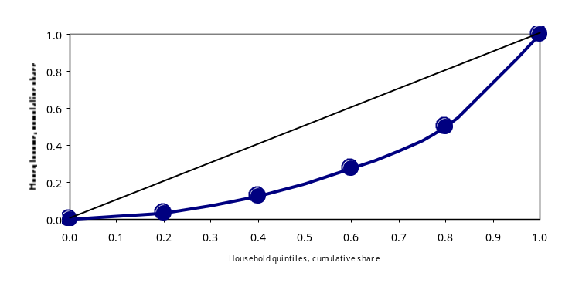
The most widely used measure of inequality, the Gini coefficient, derives from the Lorenz curve. A Gini coefficient of 0 means that income is equally distributed among the population, while a value of 1 means essentially one person has all the income while everyone else has none. The Gini coefficient measures the area between the straight line connecting (0,0) and (1,1) and the Lorenz curve connecting those two points, as a proportion of the triangle formed by (0,0), (1,0), and (1,1). The Gini coefficient equals zero in the case of absolute equality because the Lorenz curve would lie along the straight line from (0,0) to (1,1). In a situation of absolute inequality (in which only one person had all income), the Lorenz curve would run from (0,0) along the X axis until virtually (1,0) and then abruptly rise to (1,1).
The standard approach to measuring income inequality differs from our approach to measuring inequality of computer and Internet use in one key aspect. In the case of income distribution, virtually every household has income that is reported at a very specific level. In our case, we divide the population into distinct groups (such as by income, education, or occupation) and compute the number of users within each group. Note also that we cannot measure intensity of use. In most of the calculations in this chapter, a person who occasionally uses the Internet at the library is counted the same as someone using a broadband connection for hours a day.
Figure 9-2 shows the distribution of household computer ownership by family income in 1984 and 2001. In 1984, the lowest 42 percent of households by income accounted for only 12 percent of computer users. By 2001, the lowest income 45 percent of households included about 27 percent of computer users. With lower income people accounting for a much higher share of computer users in 2001, the curve for 2001 “bows out” much less than the curve for 1984. The Lorenz curve for 1984 divides the lower right triangle almost in half, for a Gini efficient that year of .438. By 2001, the area between the curve and diagonal was less than a quarter of the triangle, for a Gini coefficient of .229 in 2001. (By comparison, the Gini coefficient for the distribution of money income among households indicated greater inequality, rising from .415 in 1984 to .460 for the most recent year, 2000.)
Figure 9-: Lorenz Curve for Households with Computers vs. Income
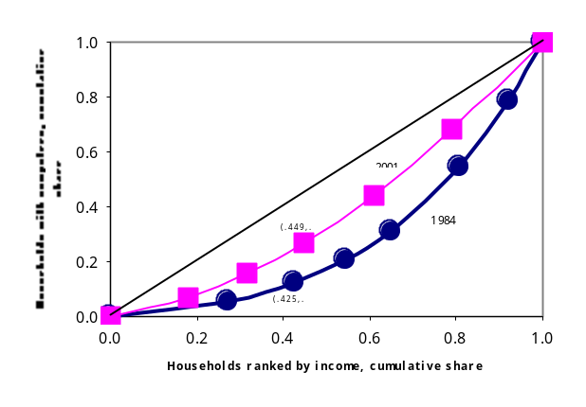

Figure 9-: Gini Coefficients for Households with Computers, Selected years
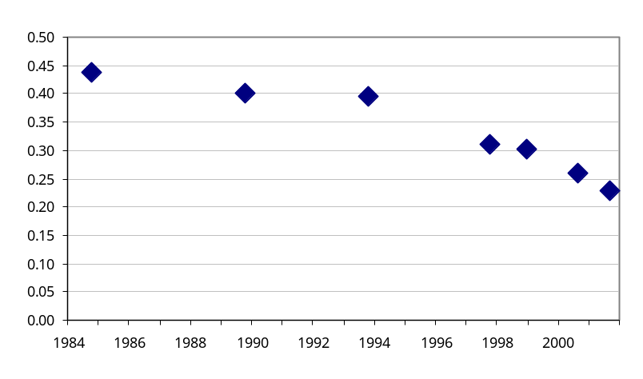
Figure 9-3 traces the descent of the Gini coefficient for household computer ownership beginning in 1984 and continuing through available data points to 2001. The figure shows that, even though significant disparities remain, the distribution of computers among households has moved continuously in the direction of less inequality. Most of the decline occurred in the second half of the period. (By contrast, the Gini coefficient for household money income dispersion went in the other direction, rising from .415 in 1984 to .460 in 2000)
Internet use figures have a shorter history. Even so, whether measured against income, education, family type, or race/Hispanic origin, the distribution of Internet use at home has moved in the direction of lower inequality. Figures 9-4 and 9-5 depict the reduction of inequality between 1998 and 2001 in Internet use at home based on income and education categories. In the case of income groups, the Gini coefficient declined from .361 in 1998 to .254 in 2001. For educational attainment groups, the measures of inequality for the two years were almost identical, falling from .364 to .262.
Figure 9-: Lorenz Curve - Internet Use at home vs. Family income Figure 9-: Lorenz Curve - Internet Use at home vs. Education
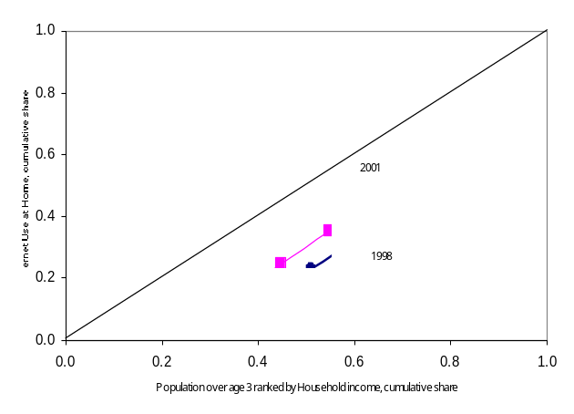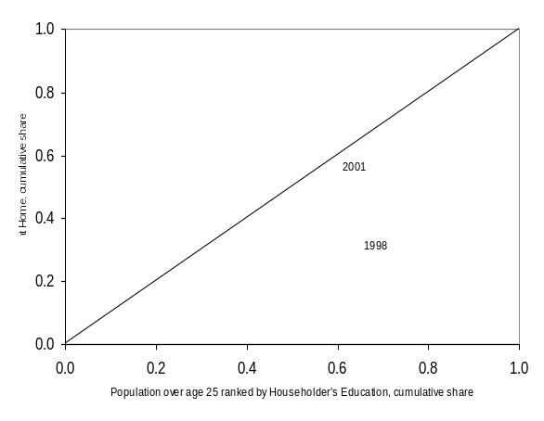
The Gini coefficient may also be used to calibrate the effects of work and school on inequality. Chapter 6 found that when someone in the household used the Internet at work, there were much smaller disparities in home Internet rates between high and low income households. That lower inequality is reflected by a Gini coefficient of only .083 among households with Internet users at work versus .298 among households in which no one uses the Internet at work.
Chapter 6 also noted that the rates of Internet use varied substantially by occupation, but were rising in some occupations that had been lower in 1998. The Gini measure confirms that, with a reduction of inequality by occupation falling from .374 in 1998 to .303 in 2001.
Similarly, Chapter 5 showed a substantial equalizing effect of school on both computer and Internet use compared to use at home. Among 10 to 17 year olds in 2001, the Gini coefficient for home computer use was .164 among income groups, but was only .026 for home and school computer use combined. In the case of Internet use, the disparity in home use was larger (.217) and the effect of schools was smaller (down to .126).
The measure of inequality for broadband fell from 2000 to 2001, but remains notably higher than the measure for household Internet subscriptions generally. The Gini coefficient for household broadband declined from .395 in August 2000 to .374 in September 2001. The Gini coefficient for household Internet subscriptions overall decreased from .309 to .270 over the same period. Because home broadband service costs substantially more than regular dial-up Internet service, it should come as no surprise that broadband is distributed more towards higher income groups than dial-up service.

These analyses show that substantial changes have occurred since the introduction of both home computers and the Internet when the initial user community tended to be dominated by those who had higher incomes or had them at work or both. The jobs involving computers and the Internet tended to require more education. As a result, inequality based on income and education was substantial. Over time, however, declining prices, increased availability in schools and libraries, and wider applications in many occupations have combined to reduce inequality in both computer and Internet use.
Table 9-1: Selected Gini Coefficients

Population, Age 3 and Above: |  | 1998 | 2001
 | Use Internet At Home by Income | .361 | .254
 | Use Internet At Home by Householder Education | .364 | .262
Population, Age 10-17: |  | 1998 | 2001
 | Use Internet at Home by Family Income | .367 | .217
 | Use Internet Anywhere by Family Income | .202 | .115
 |  | At Home, 2001 | At Home or School, 2001
 | Use Computer by Family Income | .164 | .026
 | Use Internet by Family Income | .217 | .126
Employed Persons, Age 25 and Over: |  | 1998 | 2001
 | Use Internet at Work by Occupation | .374 | .303
All Households: |  | 2000 | 2001
 | Internet Connection of Any Type by Family Income | .309 | .270
 | Broadband Connection by Family Income | .395 | .374
 |  | Someone in Household Uses Internet at Work, 2001 | No one in Household Uses Internet at Work, 2001
 | Internet Connection by Family Income | .083 | .298

CONCLUSION

The Internet has become a tool that is accessible to and adopted by Americans in communities across the nation. Approximately two million more people become Internet users every month, and over half of the population is now online. Those who have been the least traditional users –people of lower income levels, lower education levels, or the elderly – are among the fastest adopters of this new technology. As a result, we are more and more becoming a nation online: a nation that can take advantage of the information resources provided by the Internet, as well as a nation developing the technical skills to compete in our global economy.

The expanding use of the Internet at schools, work, and libraries has played a significant role in this development. Young people are now active users of this technology. This report has demonstrated that the presence of computers and Internet access at schools is making these resources available to children who lack them at home. This means that our children will gain the skills and familiarity with new technologies that will allow them to find jobs in our new economy.

In addition, many more Americans than in years past are using computers and the Internet at work. Certain jobs that previously involved only manual labor, for example, now involve some use of information technologies. Proficiency with these technologies has become increasingly important, and adults are gaining such proficiency as more use information technologies at work and find new opportunities for using them at home.

Our nation has passed a significant milestone now that the majority of Americans use computers and the Internet for their daily activities. This trend is enriching our world, facilitating our work lives, and providing a skill set needed for a growing economy.

METHODOLOGY
This report utilizes data from the Department of Commerce’s U.S. Census Bureau, taken from the Census Bureau’s September 2001 Current Population Survey (CPS) of approximately 57,000 sample households. The survey took place during the week of September 16-22, 2001, and generated response rates of 93.5 percent for the basic CPS and 92.1 percent for the Internet and Computer Use Supplement.
The households surveyed were selected from the 1990 Decennial Census files with coverage in all 50 states and the District of Columbia. The sample is continually updated to account for new residential construction. The Census divided the United States into 2,007 geographic areas, each typically comprised of a county or several contiguous counties. A total of 754 geographic areas were selected for the 2001 CPS survey.
For each household, Census Bureau interviewers spoke to a person (called the “respondent”) who was at least 15 years old and was considered knowledgeable about everyone in the household. For purposes of collecting data at the household level (such as type of connection to the Internet), the respondent provided information pertaining to the “householder” or “reference person,” who is an adult in the household who either owns or has signed for the rent on the residence. For purposes of collecting data at an individual level, the respondent provided responses for him or herself and proxy responses for all other members of that household. The survey, therefore, provided information on 137,259 individuals (age 3 and older).
The Census Bureau cross-tabulated the information gathered from the CPS according to specific variables, such as income, race, education level, household type, and age as well as by geographic categories, such as rural, urban, and central city, plus state and region. The Census Bureau determined that some of the data were statistically insignificant for meaningful analysis because the sample from which they were derived was too small.
All statistics are subject to sampling error, as well as non-sampling error such as survey design flaws, respondent classification and reporting errors, data processing mistakes and undercoverage. The Census Bureau has taken steps to minimize errors in the form of quality control and edit procedures to reduce errors made by respondents, coders, and interviewers. Ratio estimation to independent age-race-sex-Hispanic population controls partially corrects for bias attributable to survey undercoverage. However, biases exist in the estimates when missed people have characteristics different from those of interviewed people in the same age-race-sex-Hispanic group.
The data used in this report are freely available in a Public Use File maintained by the Census Bureau. See www.census.gov.

For a more extensive discussion on the U.S. Census Bureau’s survey methods in the Current Population Survey Supplement, see the Methodology section at the end of this report.
Households with at least one computer plus Internet connectivity total 53.0 million. A number of households also have more than one Internet access device. See Chapter 4 for a more detailed discussion.
Other studies or reports that have identified this general trend among various countries include, but are not limited to, the Asian Pacific Economic Cooperation (APEC) Working Group on Telecommunications and Information (TEL), Interim Response of the TEL to Leaders’ Declaration Concerning Internet Issues, 24th Meeting, Jejii Island, Korea, Doc. No. DCSG/2, September 29, 2001 (www.apectelwg.otg/apec/atwg); Conference Board of Canada, Canada in 2nd Place on Connectedness Index, February 13, 2001 (www.conferenceboard.ca/press/2001/connectedness); International Telecommunication Union (ITU), World Telecommunication Development Report 2001, Geneva, ITU, 2001; OECD, The Digital Divide: Diffusion and Use of ICTS, DSTI/ICCP/IE (2000)/Final, January 2002.
For additional information on household connectivity, see www.esa.doc.gov or www.ntia.doc.gov. These charts may be useful for international comparisons when households are the unit of measurement.
Although the Current Population Survey Supplements (on which this report and reports in the Falling Through the Net series are based) have tracked computer penetration rates in the United States, they have done so on a household basis; i.e., respondents have been asked to report whether there was a computer in the household. The 2001 survey, however, included questions on whether a person uses a computer. Because questions on individual computer use have not been asked since the October 1997 Current Population Survey Supplement, data on computer use by individuals are not available for 1998 and 2000. The 1997 survey also used somewhat different phrasing for both the computer and Internet use questions. In 1997, respondents were asked about their use of “Internet and other online services” and their use of “personal or home computers, laptops, mini computers or mainframe computers.” In 2001, respondents were asked about their use of the “Internet” and about their use of “personal computers and laptops.” The computer use questions are roughly similar, although the 2001 data would likely be somewhat higher if respondents had been specifically instructed to include the use of “mini computers or mainframe computers” in their response. The Internet use question likely provides a correct order of magnitude for Internet use. The difference in the question’s phrasing, however, makes the comparison of growth rates between 1997 and other years somewhat problematic. All growth rates are calculated beginning with the 1998 survey results.
The individuals who were in a given income bracket in October 1997 are not necessarily the same people in that bracket in September 2001. The family income level of any household changes over time as the income earners make more or less money according to personal and economic circumstances. Thus, the composition of income brackets changes over time.
“Household. A household consists of all persons--related family members and all unrelated persons--who occupy a housing unit and have no other usual address. A house, an apartment, a group of rooms, or a single room is regarded as a housing unit when occupied or intended for occupancy as separate living quarters. A householder is the person (or one of the persons) in whose name the housing unit is owned or rented. Family. A family is defined as a group of two or more persons residing together who are related by birth, marriage, or adoption; all such persons are considered as members of one family. Families are classified either as married-couple families or as families maintained by women or men without spouses. A family maintained by a woman or a man is one in which the householder is either single, widowed, divorced, or married, spouse absent.” Current Population Survey Concepts, (http://www.bls.census.gov/cps/bconcept.htm).
Educational attainment is shown for people age 25 and older to reduce the likelihood that the individual is still in school.
The "urban" category includes those areas classified as being urbanized (having a population density of at least 1,000 persons per square mile and a total population of at least 50,000) as well as cities, villages, boroughs (except in Alaska and New York), towns (except in the six New England states, New York, and Wisconsin), and other designated census areas having 2,500 or more persons. A "central city" is the largest city within a "metropolitan" area, as defined by the Census Bureau. Additional cities within the metropolitan area can also be classified as central cities if they meet certain employment, population, and employment/residence ratio requirements. “Urban, not central city” equals the “urban” category less the “central city” category. All areas not classified by the Census Bureau as urban are defined as rural and generally include communities of less than 2,500 persons.
The Current Population Survey is designed primarily to measure accurately national employment on a monthly basis. The survey design is such that measures for certain sub-populations are also accurate. However, this is not the case for all sub-populations. Although the survey includes questions to identify the race/Hispanic category “American Indian Alaska Native,” the survey design is such that data for this sub-population is unreliable. This category is therefore not reported in this analysis.
Persons categorized as Hispanic are those who indicated that their origin was Mexican-American, Chicano, Mexican, Puerto Rican, Cuban, Central or South American, or other Hispanic. People of Hispanic origins can be of any race. People who have indicated that they are of Hispanic origin are grouped as Hispanic and excluded from the race categories. Thus, "Whites" should be read as "Whites, non-Hispanic" and "Blacks" should be read as "Blacks, non-Hispanic."
The Current Population Survey asks the question “Is Spanish the only language spoken by all members of the household who are 15 years of age or older?” Although this phrasing is restrictive, because it excludes households where Spanish may be the predominant rather than the exclusive language spoken in a household, the results suggest ways in which the aggregate results for people claiming membership in the “Hispanic” ethnic category mask a variety of experiences in using the Internet.
Organization for Economic Cooperation and Development, Understanding the Digital Divide, 2001. p.23. (www.oecd.org/dsti/sti/prod/digital_divide.pdf)
This study asked respondents about the two most common broadband technologies available in the United States, digital subscriber line (DSL) and cable modems plus any “other” higher-speed Internet access used at home. These technologies usually feature broadband capabilities, although some applications or connections may possess speeds lower than the 200 kilobits per second—either in both directions or only upstream— that the Federal Communications Commission defines as “full broadband.” See In the Matter of Local Competition and Broadband Reporting, Report and Order, CC Docket No.99-301 (rel. March 30, 2000) at ¶ 22.
Homes with broadband have, on average, a higher number of individual Internet users. For example, on a household basis, Internet connection through something other than dial-up increased from 10.7 percent to 19.1 percent between August 2000 and September 2001 among those households with home Internet connection—lower percentages than recorded on an individual basis.
Http://www.fcc.gov/Bureaus/Common_Carrier/News_Releases/2001/nrcc0133.html
Although it uses a different definition of “broadband” than is used in this report, Figure 4-3 provides a useful illustration of the relative deployment speeds of some familiar communications technologies. See supra note 14 for discussion of broadband definition.
This is not universally the case in other countries. In Japan, for example, 30 million people access the Internet through NTT DoCoMo’s i-Mode using a handheld device. Although iMode does not have full Internet capability, it is widely used in Japan to access the subset of Internet information available to subscribers. See http://www.NTTdocomo.com.
The questions on Internet access devices were asked only of the household. No information is available on actual use of these devices on a per person basis.
The sample size of households that have Internet-enabled cell phones or pagers, but no computer, is too small for a reliable estimate to be reported.
December 1998 is used as a basis of comparison rather than August 2000. The data from the August 2000 survey reflected the fact that students were generally not in school when the survey took place, and there appeared to be a downward bias on Internet use outside of the home.
Figure 5-2 compares the September 2001 survey results to December 1998 Census survey data, which provided a more complete data set on student use than the August 2000 survey taken during the summer vacation.
The percentages in the two oldest categories do not add to 100% because 0.6% of the individuals in school between the ages of 18 and 24 use a computer at work, but not at home or school and 0.1% of those between 14 and 17 use a computer at work, but not at home or school.
Figures 5-6 through 5-11 refer specifically to 10 to 17 year-olds. Similar patterns hold within the two component groups, 10 to 13 and 14 to 17, and for the two age groups not shown here, 5 to 9 and 18 to 24 in school. See Tables 5-1 and 5-2 for details.
Rather than specify “mother” and “father,” non-two parent households headed by a female or male could also include an aunt, uncle, grandparent, or non-relative such as a foster parent.
While the survey captured which medium caused parents greater concern, it did not capture the level of concern. The respondent might state that he or she felt “more concerned” about the Internet, but the survey does not measure whether the concern is slight or extreme.
In contrast, only about 4 million of the 62 million adults who are age 25 and over and not employed used the Internet outside the home.
In October 1997, questions about computer use at work covered mainframes, minis and personal computers, while in September 2001 questions focused on desktop and laptop computers. The wording of questions about Internet use at work in 1997, 1998, 2000 and 2001 differed somewhat as well. See Figure 1-1.
The previous report, Falling Through the Net: Toward Digital Inclusion, published in October 2000, did include a section on “Internet Access and Computer Use Among People with Disabilities.” The data for that section, however, came from another survey, the Survey of Income and Program Participation, which, in the fall of 1999 asked different questions to identify persons with disabilities from those used in the September 2001 CPS supplement. The CPS does allow respondents to choose “disability” as a reason for not being in the work force. However, as this section shows, most people with a disability do not fall into this category. The September supplement to the CPS through 2005 is scheduled to include questions on both computer/Internet use and on disability. Thus, future reports should be able to document changes in computer and Internet use among people with disabilities.
For example, on average only 25.4 percent of the population aged 3 and above with at least one of the first four types of disabilities (difficulty leaving home not included because it was only asked of age 15 and above) use the Internet at any location. Part of the reason this percentage is so much lower than the 53.9 percent average for the population as a whole, is that the population of people with disabilities is heavily weighted toward an older population that is less likely to use the Internet.
The population totals for the age groups in this section are less than for the CPS supplement in general because this section is necessarily limited to those respondents who answered the questions concerning disability.
These are the percentages for the subset of the population that answered the disability question—13.4 percent of the respondents in this age category did not answer these questions. However, the distribution of this subset does not differ in any meaningful way from the population as a whole. For example, the comparable figure for percent employed in the 25 to 60 age group is 78.6 percent when calculated for the population as a whole.
It is not possible to consider the employed/unemployed rates among those with at least one of the disabilities considered here because of limited sample size.
In order to explore this question, a logit regression was run with Internet use from any location as the dependent variable and disability status (dummy variables for each of the disability questions, excluding difficulty leaving home), race dummies, and ordered variables for age, income, and education. A variety of income and education variables were considered and results were robust. The disability variables were uniformly negative and significant, except for one case where dummy variable for multiple disabilities was insignificant.
A person’s level of education is correlated to his/her income. People with low overall levels of education are more likely to live in households with lower family incomes. Levels of educational attainment have also increased over time; thus, age and education may be negatively correlated at the higher age levels.
Tables 8-2a and 8-2b provide summary data by demographic category for those responding households that have never been connected to the Internet and those that have disconnected, respectively.
Approximately one-half of the households who had never subscribed to the Internet at home responded with the ambiguous catchall “don’t want it.” That response could come from people who have not connected for a combination of specific reasons in addition to those persons who can see no use for it under any conditions, including zero cost.
The specific question reads: “Compared to providing information over the telephone, how concerned are you about providing personal information over the Internet? Are you: (1) more concerned (2) less concerned (3) about the same.”
“Network effects” (also called “network externality”) centers on the notion that the addition of another subscriber in a network increases the value of access to existing or potential subscribers,
This pattern is characterized by an “S” curve. For a more detailed discussion, see U.S. Department of Commerce, Falling Through The Net: Toward Digital Inclusion, pp. 2-4.

