Venipuncture
For use with vacutainer tubes
Always use universal safety precautions.

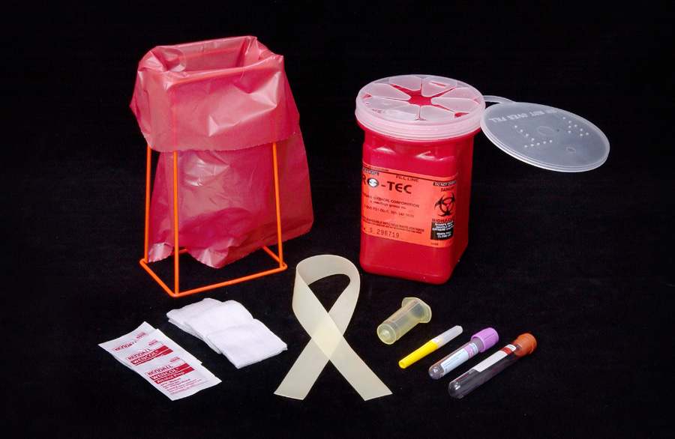 |  |  | 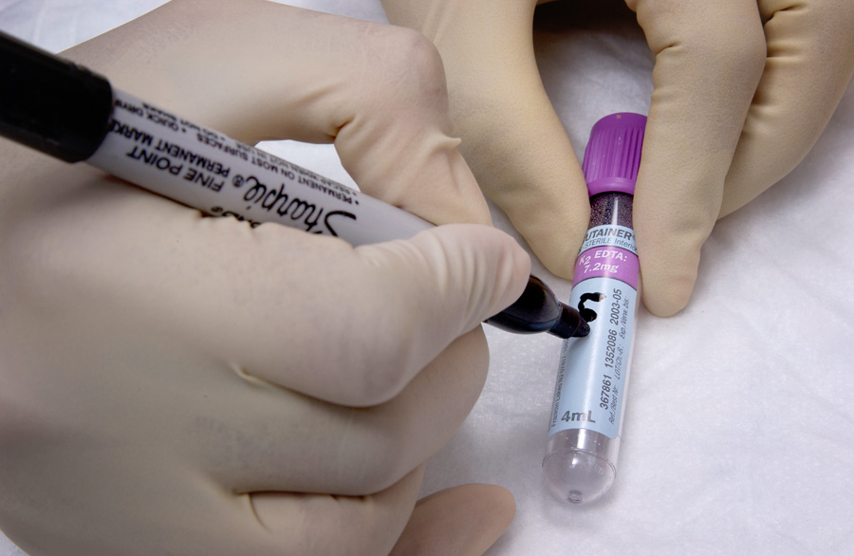 |  |  | 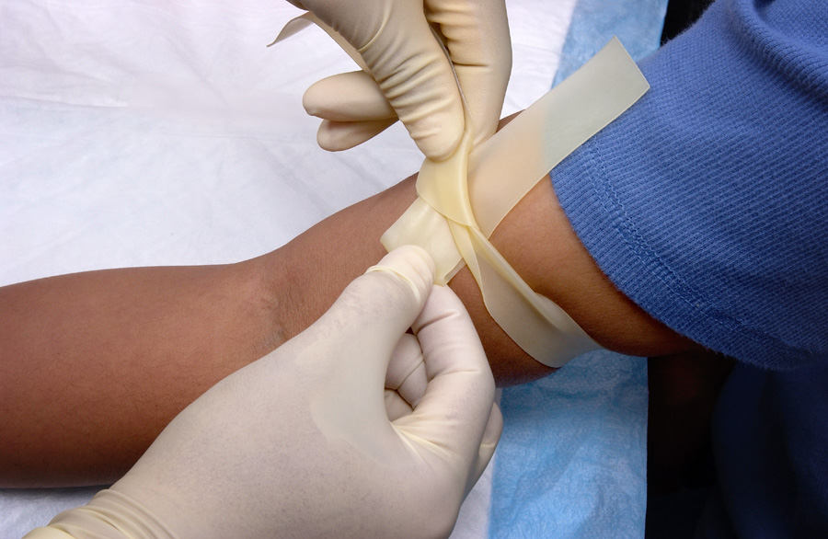
- Collect supplies. |  |  | - Label tube with the client identification number. |  |  | - Put tourniquet on client about 3-4” above venipuncture site.
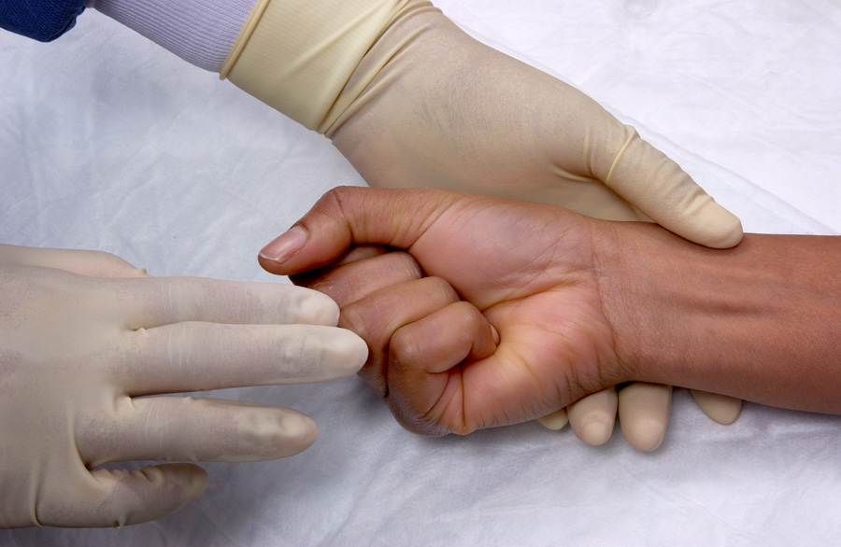 |  |  | 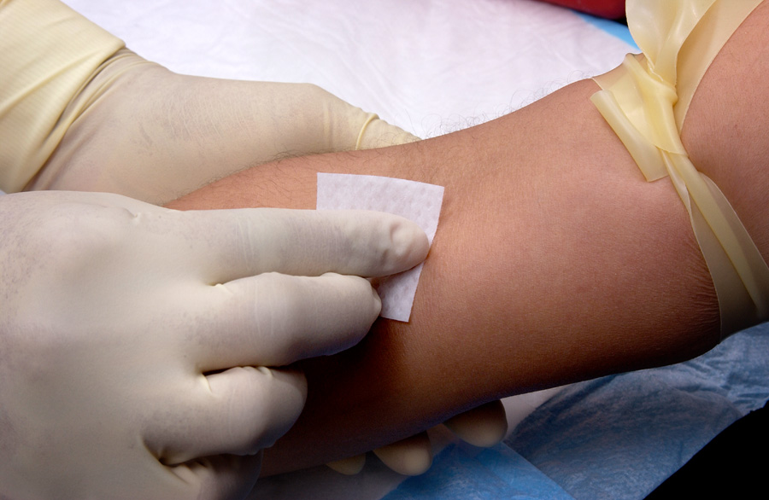 |  |  | 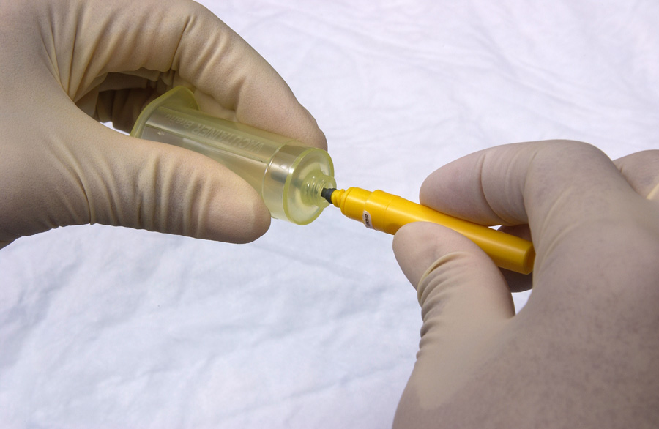
- Have client form a fist so veins are more prominent. |  |  | - After palpating the path of the vein, clean the venipuncture site with alcohol using a circular motion. Allow the area to dry. |  |  | - Assemble needle and vacuum tube holder.
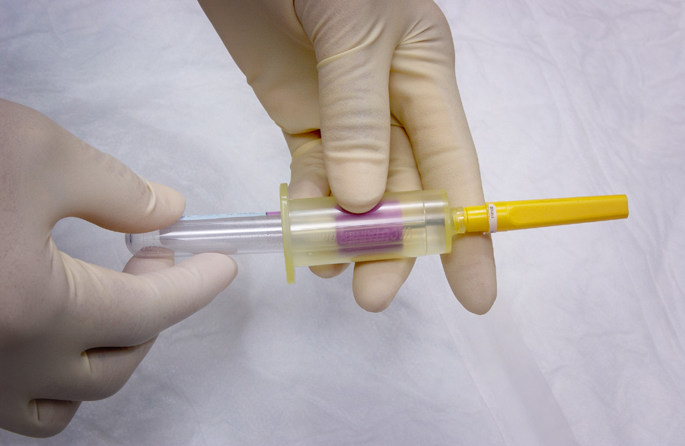 |  |  | 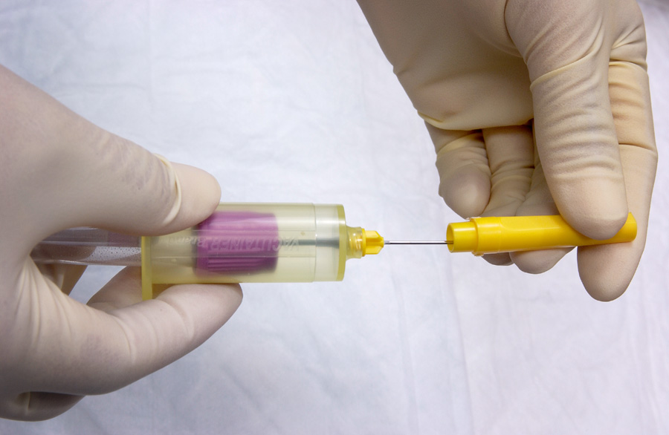 |  |  | 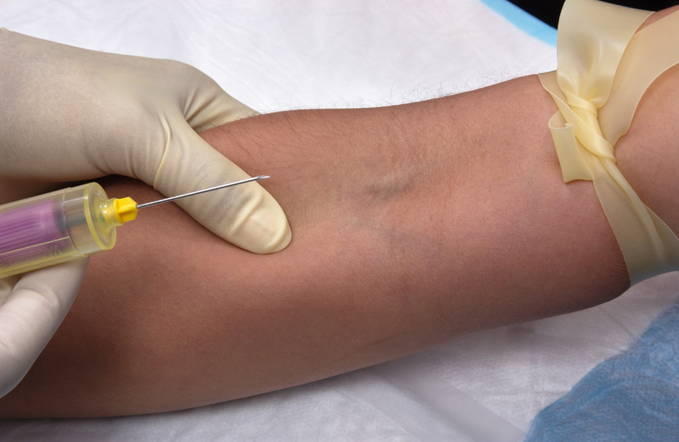
- Insert the collection tube into the holder until the tube reaches the needle. |  |  | - Remove cap from needle. |  |  | - Use your thumb to draw skin tight about 1- 2” below the venipuncture site. Hold skin tight through Step 10.
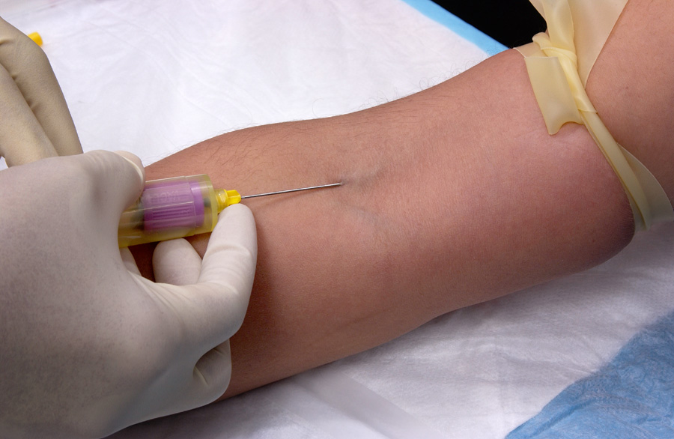 |  |  | 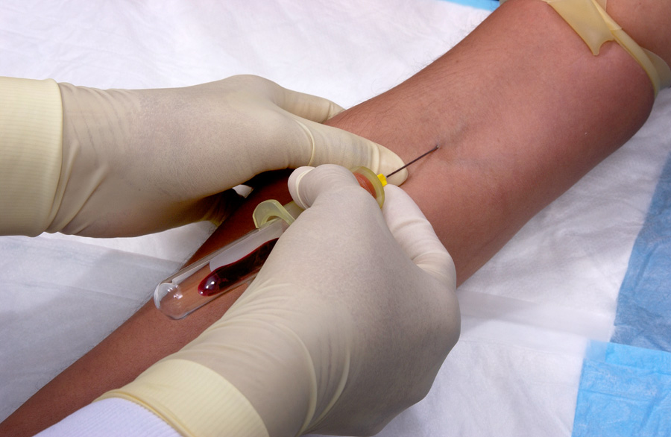 |  |  | 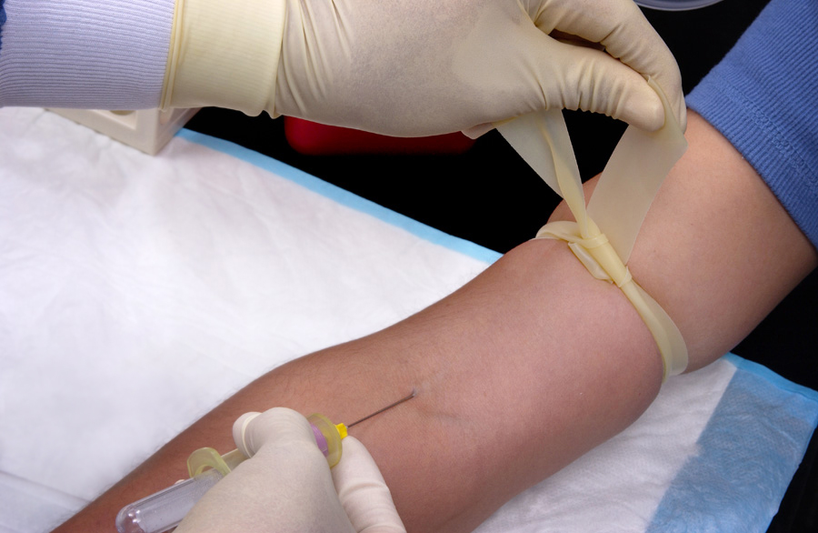
- Insert the needle, bevel side up, into the vein. |  |  | - Push the vacutainer tube completely onto the needle. Blood should begin to flow into the tube. |  |  | - Release the tourniquet.
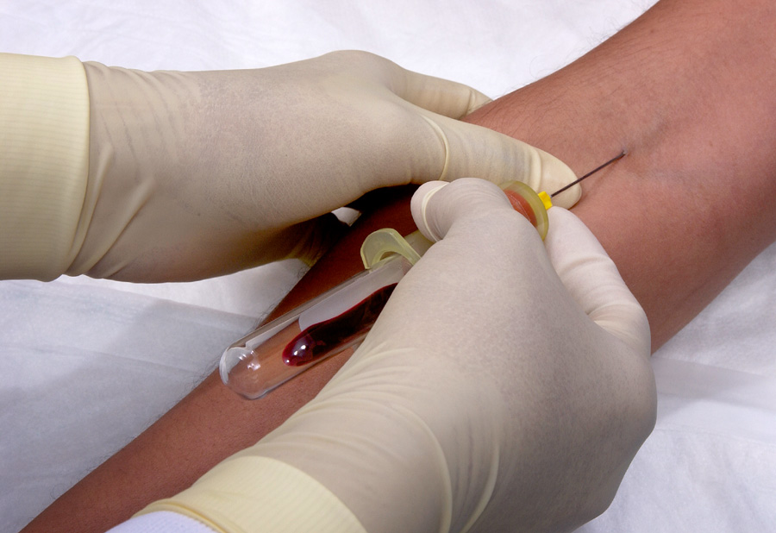 |  |  | 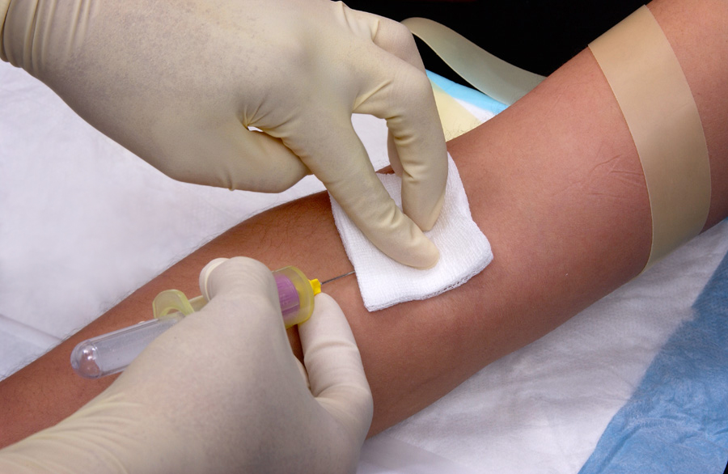 |  |  | 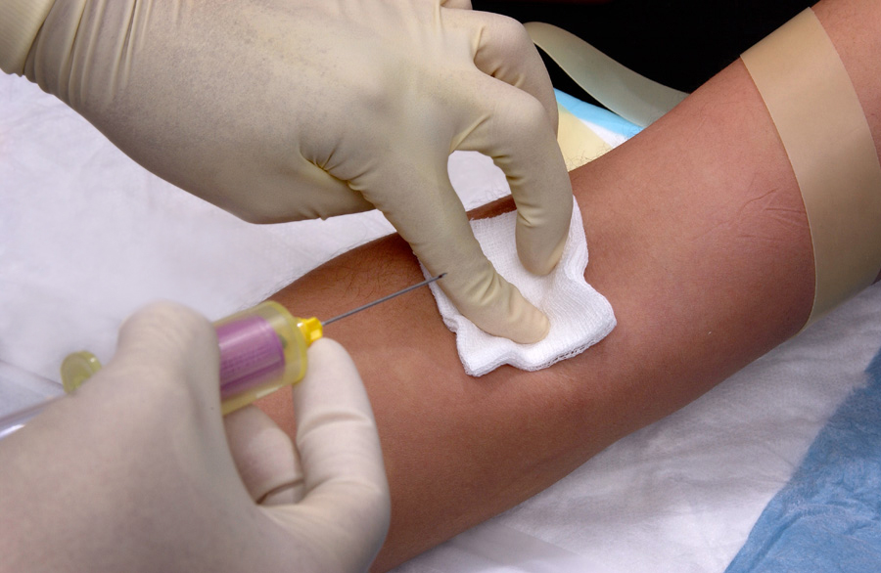
- Fill the tube until it is full or until vacuum is exhausted. |  |  | - After opening client’s hand, place dry gauze over the venipuncture site. |  |  | - Apply mild pressure to the pad and slowly remove the needle.
 | 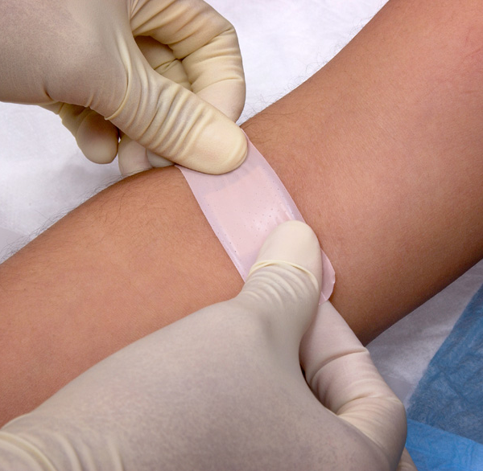 | 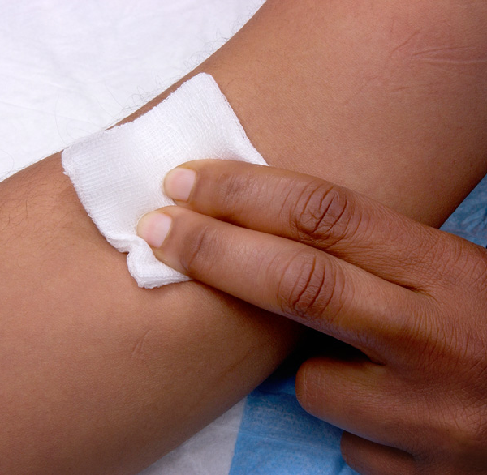 |  |  | 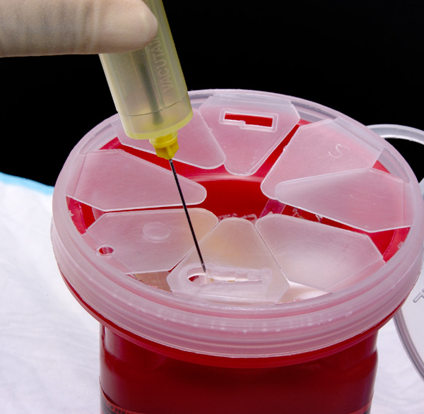 |  | 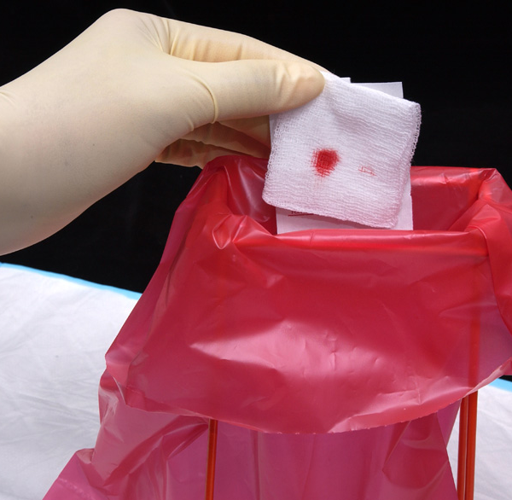
 | - Apply bandage or continue applying mild pressure until bleeding has stopped. |  |  |  | - Properly dispose of all contaminated  supplies.

 | Use of trade names and commercial sources is for identification only and does not imply endorsement by WHO, the Public Health Service, or by the U.S. Department of Health and Human Services (2005). | 

