May 21-23, 2005
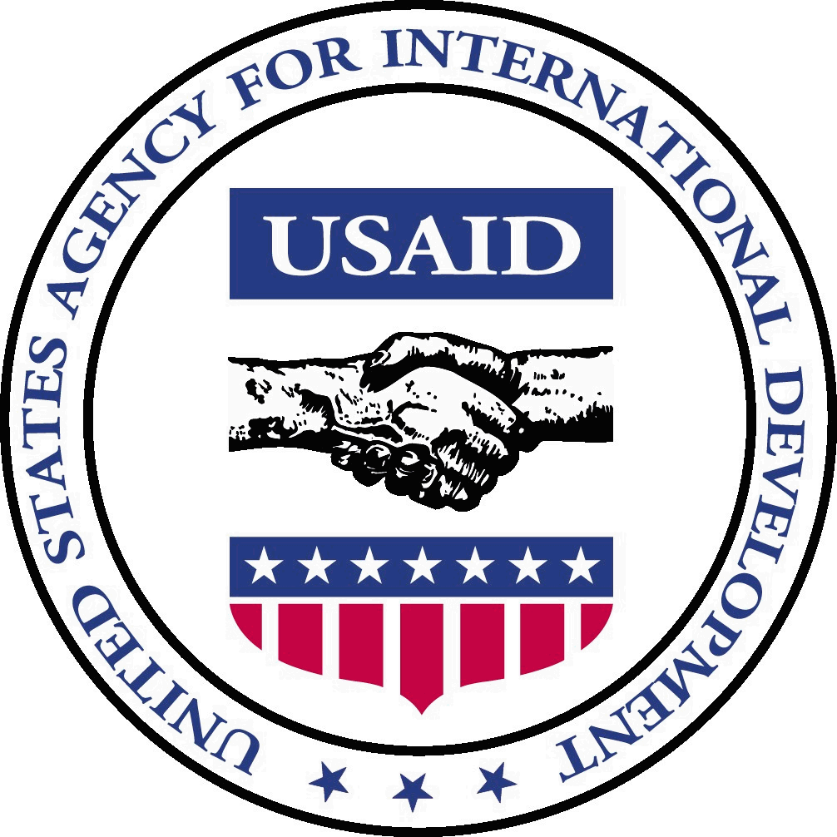 USAID/Manila
PRESS CLIPPINGS

Office of Program Resources Management (632) 552-9907

“USAID/Philippines does not vouch for the accuracy or the opinions of the articles provided in this press clipping service and assume no responsibility for their content. Please contact USAID/Philippines at webmaster@usaid-ph.gov if you have any questions about USAID programs and projects.”

STRATEGIC OBJECTIVE #3
(Desired family size and improved health sustainably achieved)

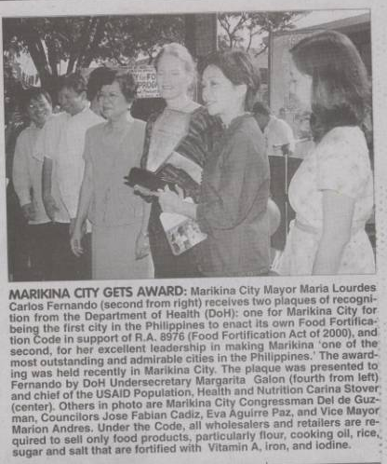

(Source: Philippine Star, 5/21/05, page K4)

STRATEGIC OBJECTIVE #12 (SO12)
(Conflict Reduced in Mindanao and Other Areas Vulnerable to Violence)

Want to understand rido?

(Source: MindaNews Online – 5/22/05)
DAVAO CITY (MindaNews/22 May) – Want to understand rido? Should it be translated into “blood feud,” “family feud” or “clan feud?” Is it s a major
contributor to the bigger conflict in Mindanao? Does it eat a huge chunk of a town’s meager budget?

Find out more about rido in a conference here on May 31 and June 1 aimed at presenting the findings of 11 researches to “deepen our understanding” of the
“dynamics of rido and its relation to peace interventions, conflict management and security situation.”

The conference, “Taking rido seriously: Top level participatory analysis of clan and community conflicts in Mindanao” is being convened by the Mindanawon
Initiatives for Cultural Dialogue, with USAID support through The Asia Foundation.

Venue of the two-day conference is the Marco Polo hotel.

“This academic and executive-level activity carries crucial elements in understanding various degrees of clan conflicts, family feuds among communities, and tribal warfare in Mindanao particularly in Regions 9
(Western Mindanao), Region 10 (Northern Mindanao), Region 11 (Southwestern Mindanao), and the Autonomous Region in Muslim Mindanao,” Fr. Albert Alejo, SJ, executive director of Mindanawon, said in his letter-invitation.

“The results of 11 researches will be discussed and validated in this conference to deepen our understanding the dynamics of rido and its relation to peace interventions, conflict management and security situation,” he said. The researches are “Dynamics and Management of Rido: Study of Rido in the Province of Maguindanao” by Prof. Abhoud Syed Lingga of Institute of Bangsamoro Studies; “The Celebrated Cases of Rido (Endemic Clan Conflict)
in Maguindanao and North Cotabato” by the United Youth for Peace and Development in Cotabato City; “Understanding Interethnic Rido Resulting to Tribal Conflict in the Boundaries of North Cotabato and Bukidnon: Towards Creative Conflict Management and Resolutions” by the Consortium of Bangsamoro Civil Society in Cotabato City); “Management of Clan Conflict & ‘Rido’ Among the Tausugs, Maguindanao, Maranao, Sama and Yakan Tribes” by the Ateneo de Zamboanga University Research Center and Notre Dame University Research Center in Zamboanga City and Cotabato City, respectively.

The other researches are “Incidences of Clan Conflict and Conflict Management: Survey of Feuding Families and Clans in Selected Provinces of Mindanao” by Dr.
Jamail Kamlian, Mindanao State University –Iligan Institute of Technology ; “Inventory of Existing Rido in Lanao del Sur 1994-2004” by Dr. Moctar I. Matuan,
Mindanao State University in Marawi City; “Big Wars, Small Wars: Interplay of large-scale and community armed conflicts in Central Mindanao” by Jose Jowel
Canuday of the Mindanawon Initiatives for Cultural Dialogue in Davao City; “Conflict Resolution Among Meranao in Baloi, Lanao del Norte” by Monalinda E.
Doro of the Research Institute for Mindanao Culture in Cagayan de Oro City; “Choices of Response to Inter-Kin Group Conflict in Northern Mindanao” by Drs. Erlinda M. Burton and Moctar I. Matuan, Research Institute for Mindanao Culture in Cagayan de Oro City and “The Rido Report” by Newsbreak Magazine.

Town mayors, military officials and other government fficials and representatives of non-government organizations, are expected to attend the conference,.
(MindaNews)

Innove, USAID team up to improve quality of education in Mindanao

By Mary Ann Ll. Reyes
(Source: Philippine Star Internet Edition – 5/23/05)

Innove Communications and the United States Agency for International Development (USAID) have joined hands to improve the quality of education in the Autonomous Region of Muslim Mindanao (ARMM) and in neighboring conflict-affected areas in Mindanao (CAAM) through the implementation of various education improvement programs.
In a memorandum of understanding signed recently, both parties agreed to expand and accelerate the effective use of computer and Internet technology in at least 300 selected public secondary schools in the region under the "CLIC/Innove Partnership Program" for ARMM and CAAM schools.
Specifically, USAID, through its Computer Literacy and Internet Connection (CLIC) project being implemented under the Growth with Equity in Mindanao (GEM) program, will provide Internet connection to the target schools until Dec. 2006 and will supply the local area network, computers, software, printers, training and education.
Innove, for its part, will offer free installation of Internet connection hardware and a one-year Internet subscription, a reduction of subsequent Internet fees by 50 percent in the second year onward, and a donation of three computers to selected schools.
Innove, a Globe Telecom subsidiary, will also help previously-connected CLIC schools to migrate to the latest Internet technology as needed.
Innove and USAID said that by sharing resources, skills and expertise, they will be able to extend the benefits of their individual programs to a greater number of schools in ARMM and CAAM, thereby, supporting the efforts of the National Government to expand computer literacy and information technology preparedness among students and teachers in the area.
The two organizations also plan to initiate similar activities that will expand the training opportunities for teachers and students, as well as assist schools in implementing a sustainability plan.
"We are committed to supporting the socioeconomic development of Mindanao. And one critical area of concern which warrants assistance from the business community is education, particularly in ARMM and CAAM which are suffering from poor literacy rate caused by poverty, limited access to schools, long-standing armed conflict and an historically unstable peace and order situation," said Gil B. Genio, Innove’s chief executive officer.
He added: "Through innovative partnerships like what we have with USAID, we hope to upgrade the skills of both the teachers and students and equip them with basic information and communications technology (ICT) skills and competencies that will allow them to become globally competitive."
On the other hand, US Amb. Francis Ricciardone, a former US school teacher, noted that computer and Internet skills would give the students an expanded opportunity to find high quality employment and to become global entrepreneurs.
"Narrowing the digital divide between schools in Mindanao and elsewhere - both in the Philippines and the rest of the world - is important and vital, both as a means of equalizing educational opportunity and expanding access to worldwide information and as a tool for economic development and global citizenship," Ricciardone said.



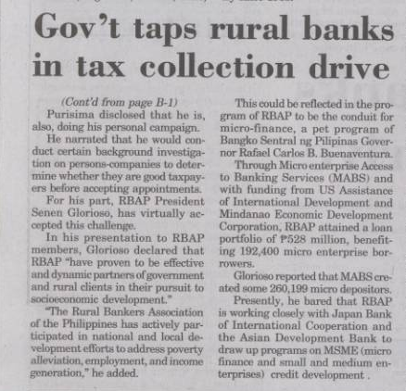

(Source: Manila Bulletin, 5/22/05, page B1-B2)

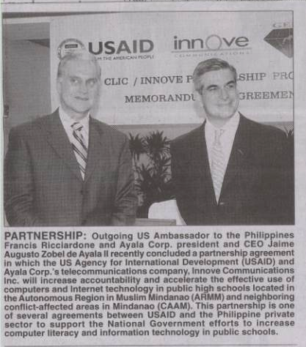
(Source: Philippine Star, 5/23/05, page B5)

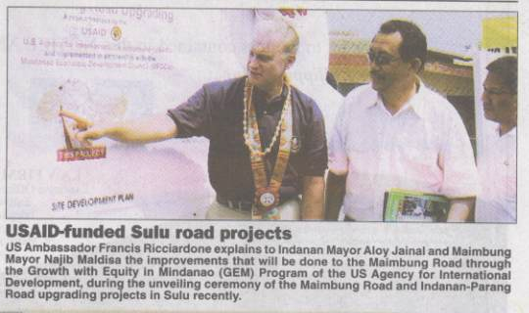
(Source: Philippine Star, 5/23/05, page A26)

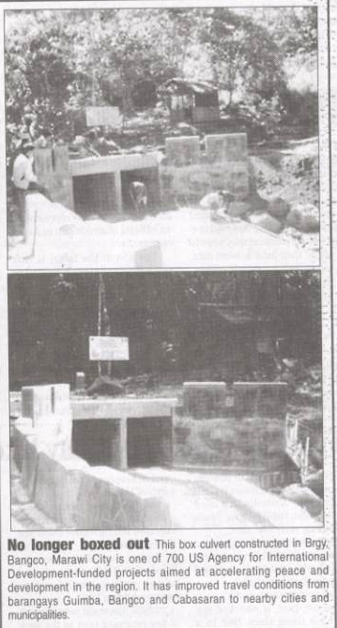

(Source: The Daily Tribune, 5/23/05, page 11)

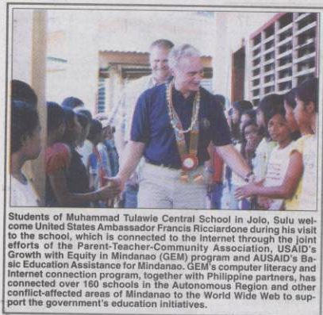

(Source: Philippine Star, 5/22/05, page 18)

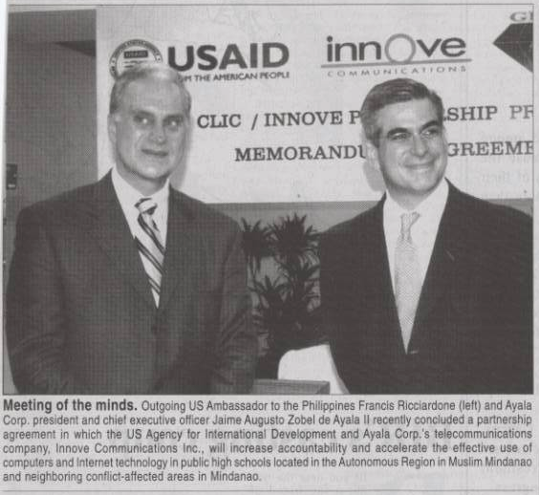

(Source: Manila Standard Today, 5/23/05, page B3)

