A Study of Plasma Phenomena Using the Tomographic 3-Dimensional Reconstruction Techniques Developed for the
Solar Mass Ejection Imager (SMEI)


B.V. Jackson, P.P. Hick
Center for Astrophysics and Space Sciences

University of California San Diego

ABSTRACT

We are developing tomographic techniques for analyzing remote sensing observations of heliospheric density and velocity structure as observed in Thomson scattering (e.g. using the HELIOS photometer data) for eventual use with Solar Mass Ejection Imager (SMEI) observations.

We have refined the tomography program to enable us to analyze time-dependent phenomena, such as the evolution of corotating heliospheric structures and more discrete events such as coronal mass ejections. Both types of phenomena are discerned in our data, and are reconstructed in three dimensions. We use our tomography technique to study the interaction of these phenomena as they move outward from the Sun for an event sequence in late November 1977 that has been studied by multiple spacecraft in-situ observations [Burlaga et al., 1980]. The tomographic analysis from the HELIOS photometers shows a brightness increase associated with the density enhancement behind a shock. We generalize these shock observations using observations of density enhancements behind shocks from other HELIOS photometer remote-sensing observations.

This work was supported by NASA grants NAG5-8504 and NAG5-9423.

Introduction

The heliosphere is such a large region that it is not cost effective to place spacecraft at the necessary locations within it to provide information about its overall physical parameters. The challenge is therefore to accurately provide as many of the detailed physical parameters by remotely sensed heliospheric observations as possible. In addition, the techniques that provide the best overall three-dimensional depiction also provide a way to map these features in real time in order to show heliospheric structures prior to their arrival at Earth.
Heliospheric remote sensing observations, such as interplanetary scintillation (IPS) and Thomson scattering observations, provide global information about the 3D structure of the heliospheric velocity and density. Each observation represents the integrated effect of contributions from the solar wind everywhere along a line of sight (Figure 1).
Heliospheric tomography combines information from many different lines of sight, sampling the solar wind from many different perspectives, for an unbiased reconstruction of the solar wind density and velocity distribution. For heliospheric observations different perspectives are obtained, not only from solar rotation, but also due to the large range of elongations covered from solar wind outflow.

Time-Dependent Tomography

In order that the tomographic reconstruction map CMEs and other time-varying heliospheric features, the iterative least-squares algorithm used to determine a 3D model from a single point in space must use radial solar wind outflow almost exclusively to provide perspective views. The iterative procedure minimizes the differences between the actual remote sensing observations and the values obtained by integrating through a model that varies with time – “time-dependent” tomography.
We relate all lines of sight within the volume accessed to a single source surface below the lowest line of sight. Where the lines of sight cross on the source surface from the three-dimensional space above it, we can reconstruct the solar wind model (Figure 2a and 2b example). The model time steps and spatial resolution (that must be commensurate with the quantity and quality of data used) have so far been limited to intervals as short as 8 hours and resolution elements as small as 5°×5°. We currently require that at least more than one line of sight crosses near the source surface resolution element (usually set digitally at 20°×20° for the Nagoya, Japan IPS data and 10°×10° for the HELIOS photometer data) in order to reconstruct the solar wind structure at that heliographic latitude and longitude.

Solar Wind Model

In our reconstructions to date we have assumed strictly radial outward solar wind flow. The kinematic models we reconstruct assume that solar wind mass is conserved and that the interactions between high and low speed wind also conserve momentum. The solar wind model relates all lines of sight within the volume accessed to a single source surface below the lowest line of sight and accords each line of sight segment a weighted influence on this surface. Where several lines of sight cross on the source surface from the three-dimensional space above it, the solar wind model can be reconstructed iteratively using tomographic inversion techniques.
The source surface at the lower boundary of the kinematic model thus forms a boundary condition for the model. Although the model digital resolution is currently set at 10°×10° heliographic latitude and longitude and time steps of one day for the HELIOS photometer data, a set of Gaussian filters relate different resolution elements to one another in space and time, and thus the size structures reconstructed are dependent on these filters.
The kinematic model is only one possible solar wind model that we could have used in our reconstruction, and in fact we currently work to provide an interface that can accommodate 3D-MHD physics into our tomographic representation.
Solar Wind Model Displays

We show solar wind model reconstruction in two dimensions in the form of Carrington rotation 1661-62 maps at a given solar distance and time in the examples of Figure 3a-d. We have chosen to display these day by day transient structure changes in the heliosphere at the solar surface in the form of density variations from one day to the next. The solar wind model we use relates brightness changes to model density according to the equations relating solar brightness to electron brightness found in Billings [1966]. We use spacecraft average in situ observations of density at HELIOS during the rotation in question to provide a calibration of the solar wind total density at the time of the observation.
We can also display these same models used for Figure 3a-b and 3c-d as three-dimensional projections observed from a distance in Figure 4a-b. In the views chosen, the Sun is centered with the Earth a blue dot shown from the perspective view of an observer situated at 3 AU, 30° above the ecliptic plane in the direction approximately 45 degrees west of the Sun-Earth line. The view includes the oval Earth orbit for reference.
Global Comparisons

Perhaps the best global comparisons of the tomography can be found by fitting to other’s ideas of the heliosphere studied by classical techniques. Figure 5 is a map of the heliosphere as presented by Burlaga [1980] and is the same time interval reconstructed by time-dependent tomographic techniques using the HELIOS photometer data shown in Figure 3a-b and Figure 4a. The tomography accurately reconstructs most aspects of the gross heliospheric structure including:

- The corotating structure

- The CME to the solar southwest

- The fuzzy density enhancement interpreted as the shock that passed the HELIOS spacecraft on approximately 24 November.

How well to we do?

Other than the reconstruction of well-studied intervals such as depicted in Figures 3, 4 and 5 there is no easy way to determine how well the tomography works over the total extent of the heliosphere since spacecraft sample only relatively minor portions of the three dimensional solar wind values we reconstruct.
However, the overall consistency between observed and model brightness is shown in Figure 6 that gives a typical comparison for the HELIOS 2 photometer data from November 14 – December 25, 1977. The observed brightness has been edited to remove a zodiacal light model, de-glitched to remove proton flux spikes, and presented with a running mean 8-day base removed. The observed data are noisy relative to the time-dependent model that smoothly approximates it.
We are able to determine the solar wind model values at the position of HELIOS and Earth, and these can be compared with in situ measurements at HELIOS and Earth. These comparisons show a correlation in density change that can be as good as 0.8 – 0.9 over month-long periods when in situ measurements are degraded to the temporal resolution of the tomographic model. Work in kinematic model definition (filtering and density fall-off with heliocentric distance) play an important part in these current analysis schemes.

The Density Enhancements Behind Shocks

The HELIOS photometers observed the density enhancements behind shocks. Figure 7a shows an example on April 23, 1979 of the in situ enhancement behind a shock from a list of these events [R. Schwenn (private communication, 1986]. This enhancement of density is observed as a brightness increase (Figure 7b) in two different sectors of the HELIOS photometer in different colors of light. To check the extent of these density enhancements relative to the Sun-spacecraft line, the enhancement columnar density is plotted in Figure 8 in different color light. Every density enhancement on the ordinate (parallel to the y-axis) measured in situ as it passes the spacecraft is observed to be at least as extensive measured remotely 90° from the Sun-spacecraft line and plotted in the abscissa direction. This implies that the structures that pass the spacecraft behind shocks are somewhat more extensive perpendicular to the Sun-spacecraft line than along it. There is no evidence within the errors in measurement that shocks are anything other than the color of Thomson scattered sunlight from electrons. This implies that no fine dust is charged and swept up by the shock front.
Conclusions

The HELIOS photometers observed many of the large heliospheric structures that have been analyzed to date using in situ observations. These features are readily observed in their entirety in terms of density in the time-dependent tomographic modeling that has been developed for the Solar Mass Ejection Imager (SMEI) spacecraft scheduled for launch later this year. SMEI will provide 1000 times more data than available from the HELIOS spacecraft with far more photometric precision along each line of sight, and this translates to a heliospheric resolution of at least a factor of ten better in all four dimensions than depicted in the analyses shown.
The STEREO heliospheric imagers view only a portion of the heliosphere. These same structures should also be observed in the STEREO heliospheric images. From their vantage points, and provided the images from this instrument retain a calibrated photometric precision, they can be used in a similar way. These images can be used both in collaboration with the SMEI analyses and to provide views of the same structures simultaneously in order to remove the ambiguities in three-dimensional heliospheric modeling techniques.

Figure 1. A line of sight is defined by the location of the observer (heliocentric coordinates α, r) and the orientation of the line of sight relative to the observer-Sun line (phase angle -φ and elevation angle τ). ε is the elongation of the line of sight. The solar wind outflow V is assumed to be radial.

(a)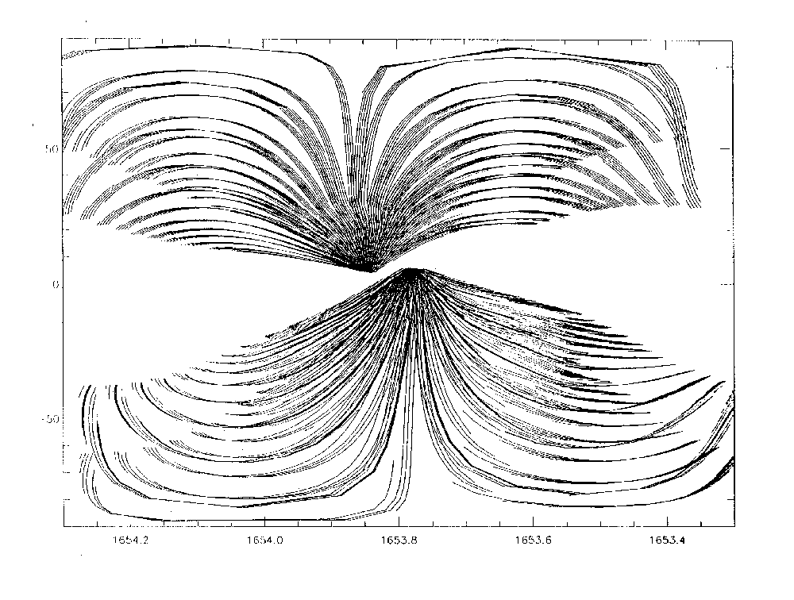 (b)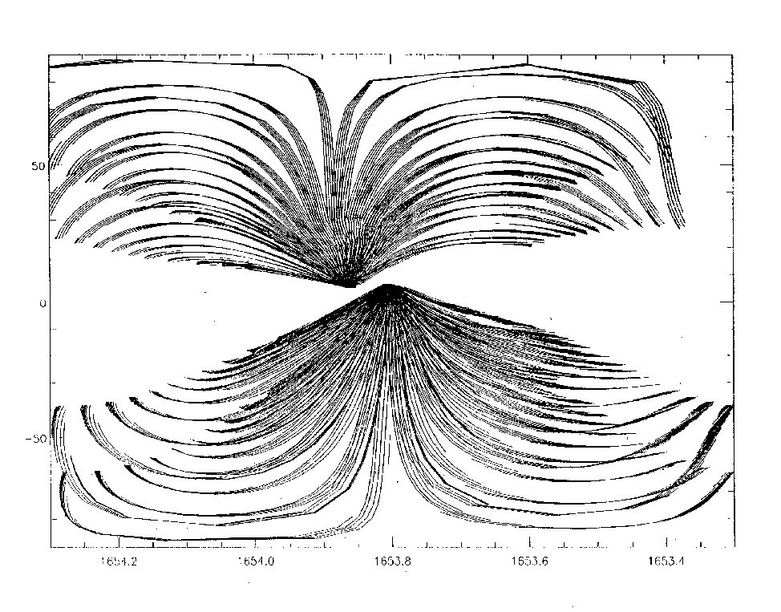

Figure 2a-b. Line of sight projections on a solar wind source surface for two consecutive days of Carrington rotation 1653 data sets of HELIOS 2 (northern latitudes) and HELIOS 1 (southern latitude) photometer observations.
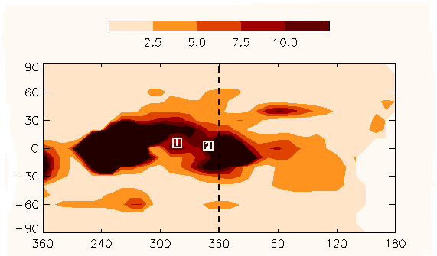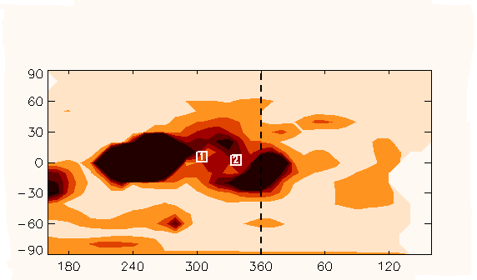
(a) (c)
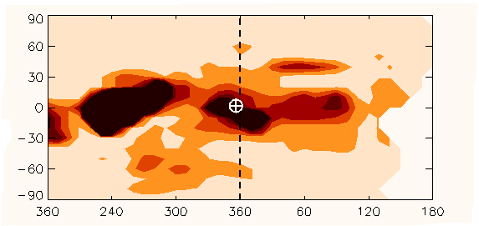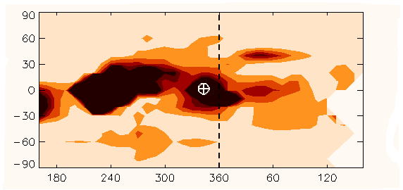
(b) (d)
Figure 3. Carrington maps reconstructed from HELIOS 1 and 2 photometer observations during rotation 1661-2 (longitudes 180° - 180°). Two heights are shown at 0.6 (a,c) and 1.0 A.U. (b,d) at times separated by one day (the differences between (a and c, and b and d). Heliographic spatial resolution is tailored to the HELIOS data set and the numbers of lines of sight per day available (about 180 from either spacecraft photometer set). The brightnesses have been converted to density (contoured on the maps) using the formulae found in Billings, [1966] and by calibration with average in situ spacecraft densities during the time interval. The HELIOS 1 spacecraft was at 0.67 AU and the HELIOS 2 spacecraft at 0.62 AU (see figure) during the time of the observations. An r^{-2.2} density gradient has been removed from the maps.
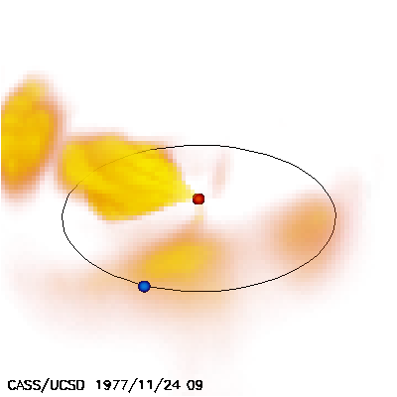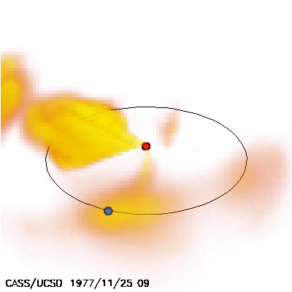
(a) (b)

Figure 4a-b. Three-dimensional projections of the heliosphere from an observer’s perspective situated at 3 AU, 30° above the ecliptic plane ~45° west of the Sun-Earth Line. The projections are made at 9 UT November 24, and 9 UT November 25, exactly the same times as the maps of Carrington Rotation 1661-2 displayed in Figure 3a-d. An r^{-2.2} density gradient has been removed from the data.

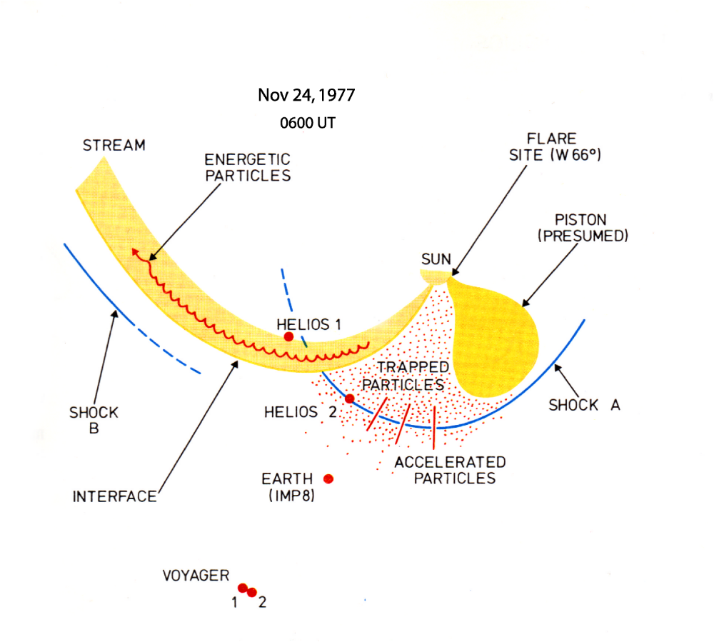Figure 5. Heliospheric depiction using in situ measurements from multi-spacecraft observations before after and during November 24, 1977 (from Burlaga [1980]).

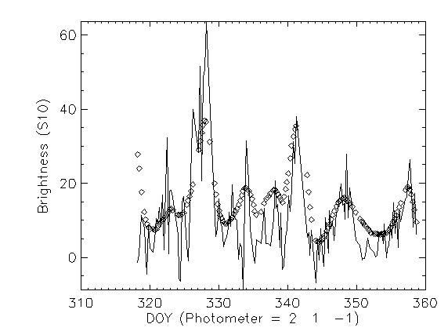
Figure 6. Sample Helios 2 photometer data from November 14 – December 25, 1977. The observed brightness has been edited to remove a zodiacal light model, de-glitched to remove proton flux spikes, and presented with a running mean 8-day base removed. The observed data are noisy relative to the time-dependent model that smoothly approximates it.

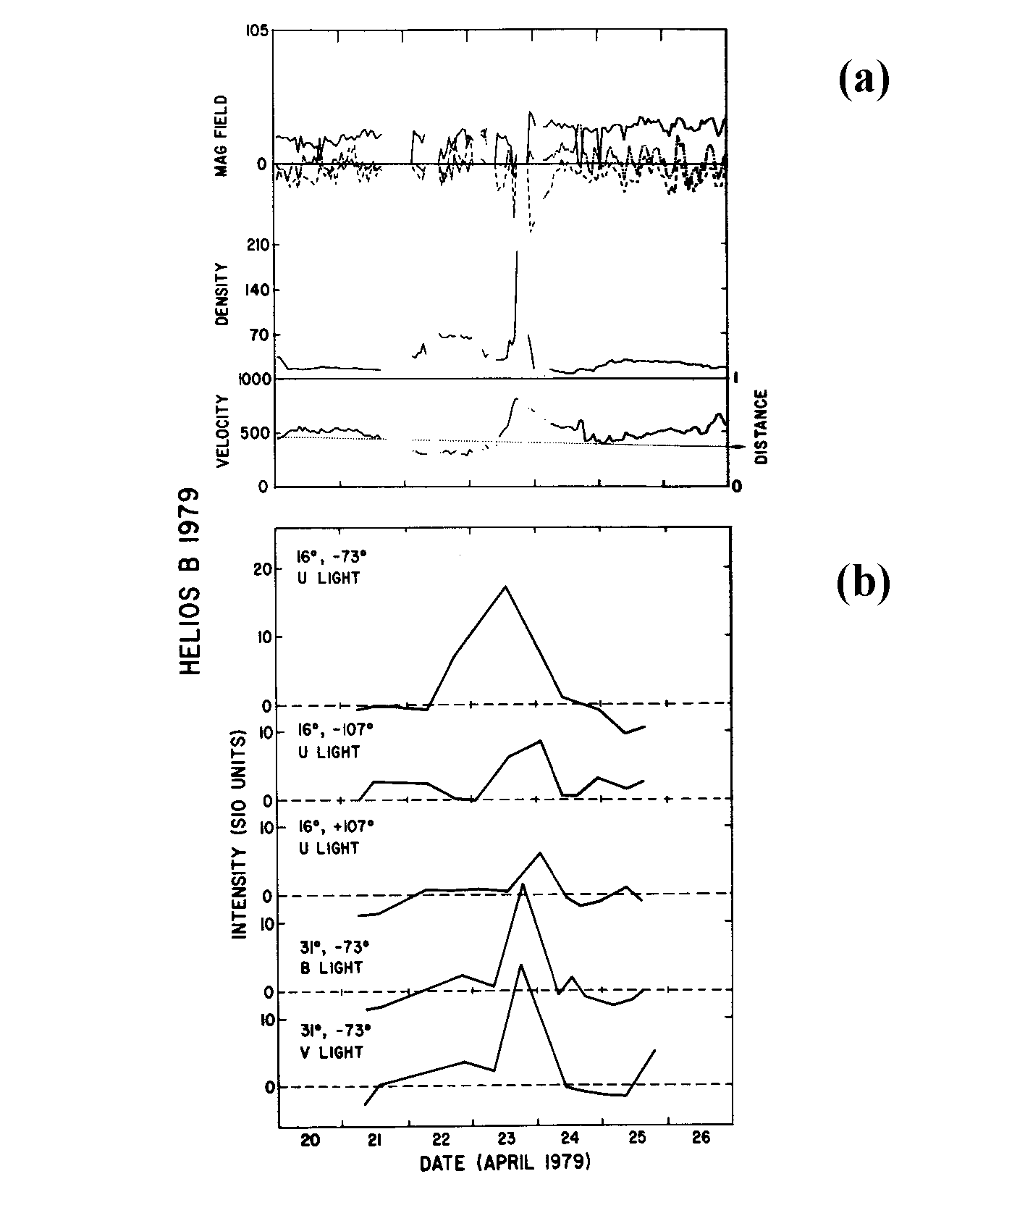
Figure 7. Observations of a density enhancement behind a shock on April 23, 1979. a) Helios 2 magnetic field, proton density and velocity in situ observations. b) Observations approximately 90° from the Sun-spacecraft line from Helios 2 photometer observations. Longitudes of the sector centers relative to the Sun (- to the west) and colors are listed.

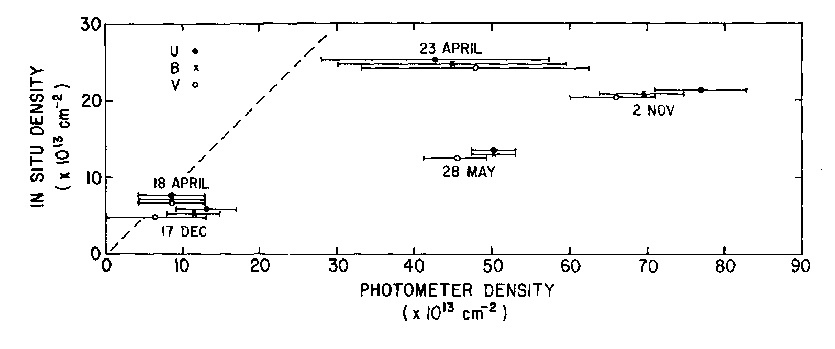
Figure 8. In situ columnar density versus columnar density determined from the three-color photometry from the HELIOS spacecraft. For each density enhancement behind a shock the photometer columnar density is presented in three colors. All dates refer to shocks during the year 1979 except December 17 (1976). If the density enhancement had the same extent perpendicular to the Sun-spacecraft line as convected past the spacecraft, it would fall along the dashed line on the left side of the figure.

References:

Billings, D.E., A Guide to the Solar Corona, p. 150, Academic, New York (1966).

Burlaga et al., J. Geophys. Res., 85, 2227, 1980

