Relationship between onset thresholds, trigger types, and rotation shear for the m/n=2/1 neoclassical tearing mode in a high-β  spherical torus

S.P. Gerhardt¹, D.P. Brennan², R. Buttery³, R. J. La Haye⁴, S. Sabbagh⁵, E. Strait⁴, M. Bell², R. Bell¹, E. Fredrickson¹, D. Gates¹, B. LeBlanc¹, J. Menard¹, D. Stutman⁶, K. Tritz⁶, H. Yuh⁷

¹ Princeton Plasma Physics Laboratory, Princeton, New Jersey, USA
² University of Tulsa, Tulsa, Oklahoma, USA
³ EURATOM/UKAEA Fusion Association, Culham Science Centre, Abingdon, Oxon, OX14 3DB, United Kingdom
⁴ General Atomics, P.O. Box 85608, San Diego, California 92186-5608, USA
⁵ Columbia University, New York, New York, USA
⁶ The Johns Hopkins University, Baltimore, Maryland, USA
⁷ Nova Photonics, Princeton, New Jersey, USA

Abstract The onset conditions for the m/n=2/1 neoclassical tearing mode (NTM) are studied in terms of neoclassical drive, triggering instabilities, and toroidal rotation or rotation shear, in the spherical torus NSTX [M. Ono, et al., Nuclear Fusion 40, 557 (2000)]. There are three typical onset conditions for these modes, given in order of increasing neoclassical drive required for mode onset: triggering by energetic particle modes, triggering by edge localized modes, and cases where the modes appear to grow without a trigger. In all cases, the required drive increases with toroidal rotation shear, implying a stabilizing effect from the shear.

PACS #s: 52.35.Py, 52.55.Fa

1: Introduction
The neoclassical tearing mode (NTM) [1] is a beta-limiting instability in tokamaks: when a magnetic island forms, rapid parallel transport causes pressure flattening across the magnetic island, leading to a reduction in the pressure driven bootstrap current which then further increases the island size. NTMs are likely to be a dominant performance limiting instability in large tokamaks like ITER if mitigation techniques are not implemented [2]. Experimental results in NSTX and MAST [3] show that these modes also exist in an ST [4] despite more favorable field-curvature effects [5], and must be accounted for in ST performance predictions as well.
There are many issues in extrapolating our present understanding to larger and more slowly rotating plasmas, either at conventional aspect-ratio or in a ST, two of which are addressed in this letter: i) what instabilities can trigger the nominally metastable NTM, and ii) what is the role of rotation or rotation shear in setting the onset threshold? With regard to triggers, many advanced operational scenarios in the ST or conventional tokamak rely on sawtooth avoidance (with q_{min}>1) or control [6] to avoid triggering these modes; however, other modes such as fish-bones [7] or edge localized modes (ELMs) [8] have been seen to trigger NTMs in conventional aspect ratio tokamaks. With regard to rotation, its role in setting the 2/1 NTM onset threshold in DIII-D was presented in Ref. [8], which utilized that device’s unique ability to control the plasma rotation through the co-/counter- neutral beam injection mix. It was found that with all other parameters fixed, the value of β_{N} (β_{N}=βaB_{T}/I_{P}) at mode onset was reduced as the plasma rotation slowed. While that data analysis indicated that the toroidal rotation shear at q=2, rather than the rotation magnitude, was likely the relevant parameter, the strong co-linearity between rotation and rotation shear in the data set made it difficult to separate the relative contributions.
It is the purpose of this letter to utilize results from the National Spherical Torus Experiment (NSTX) [9] to provide insight into these issues. NTMs are triggered by both energetic particle modes (EPMs) and ELMs; in other cases, the modes grow with no apparent trigger. A large database of NSTX discharges has been formed, containing a wide variety of toroidal rotation profiles and a factor of three variation in the NTM onset threshold. These different onset types yield different initial mode frequencies; however, no trend of the onset threshold with the mode frequency in the E_{r}=0 frame has been found in the database (E_{r} is the radial electric field), which seems to discard ion polarization current effects [10] as providing a rotation dependence for the onset. Additionally no strong trend is found between NTM onset threshold and the absolute value of toroidal rotation. However, there is observed a strong trend of increasing onset threshold with increasing toroidal rotation shear at q=2. For fixed shear, the EPM triggered cases tend to be struck at the lowest values of NTM drive, with ELM triggers occurring at higher drive and the triggerless varieties at the highest drive. These results are the first ever study of seeding mechanisms for the 2/1 NTM in an ST plasma, and provide the strongest evidence yet that rotation shear, rather than rotation itself, plays a key role in determining the 2/1 mode onset threshold.

2: Definitions and data set selection

The formulation in the NTM problem in this letter is based on the Modified Rutherford Equation (MRE) [11], written as:
$\frac{t_{R}}{r_{s}^{2}}\frac{\text{dw}}{\text{dt}}=D'+\frac{C_{\text{BS}}m_{0}L_{q}}{B_{q}}{dj}_{\text{BS}}\left(\frac{w}{w^{2}+w_{d}^{2}}−\frac{{\text{ww}}_{\text{pol}}^{2}}{w^{4}+w_{b}^{4}}\right)−\frac{6D_{R}w}{w^{2}+w_{d}^{2}}$ (1)
Here, Δ’ is the classical tearing stability index. The term proceeding the parenthesis represents the drive due to the lost bootstrap current (δj_{BS}) inside the magnetic island. For the analysis described here, the missing bootstrap current is calculated from the formulas in Ref. [12] as
${dj}_{\text{BS},\text{Sauter}}=\frac{I\left(y\right)p_{e}\left(L_{\text{31}}\frac{1}{p_{e}}\frac{{\text{dp}}_{e}}{dy}+L_{\text{32}}\frac{1}{T_{e}}\frac{{\text{dT}}_{e}}{dy}\right)}{\sqrt{\left\langle B^{2}\right\rangle }}$ , (2)
where the terms I(ψ), L₃₁, and L₃₂ are defined in that reference. The D_{R} term represents the stabilizing effects of field line curvature, and provides a stronger stabilizing contribution in an ST than at conventional aspect-ratio.
The terms w_{d}, w_{pol}, and w_{b} describe stabilizing effects relevant to small islands (see Ref [La Haye 2006] and references therein). Of particular interest in this rotation-oriented study is the w_{pol} term, a characteristic size for the polarization current effect [Wilson 1996] given by:
$w_{\text{pol}}^{2}{µρ}_{i,q}^{2}\frac{Ω\left(Ω−w_{i}^{}\right)}{w_{e}^{2}}$ (3)
Here, Ω=ω_{Mirnov}-ω_{Er=0} is the frequency of the mode in the E_{r}=0 frame and ω_{e,i}* are the diamagnetic drift frequencies of electrons and ions; this term is predicted to be stabilizing for 0<Ω< ω_{i}*, but destabilizing in the regime Ω<0, indicating a means for rotation to impact the stability at onset.
Rotation can enter the NTM problem through at least three additional routes [Buttery 2008]: i) the absolute value of toroidal rotation may play a role through coupling to error fields and the resistive wall, ii) differential rotation between surfaces can modify coupling to triggers and iii) both rotation shear and differential rotation may modify the classical tearing stability, through either Δ’ or inner-layer effects . Here, the toroidal rotation shear here is defined as 2πL_{s}τ_{A}(dF_{T}/dr) [Buttery 2008], where F_{T} is the toroidal rotation frequency in Hz, L_{s}=qL_{q}/ε, L_{q}=q/(dq/dr), ε  is the difference in magnetic fields strengths between the inboard and outboard midplane normalized to their sum, and τ_{A}=R₀(m_{o}m_{i}n_{i})^{1/2}/B_{T0}. The derivative with respect to minor radius is defined as $\begin{matrix}\frac{d}{\text{dr}}=\frac{1}{a}\frac{d}{dρ}, & ρ=\sqrt{\frac{y−y_{\text{edge}}}{y_{\text{axis}}−y_{\text{edge}}}}\end{matrix}$, where ψ is the poloidal flux and a is the minor radius defined as half the distance between the inboard and outboard separatrix points on the midplane.
The results presented here come from the high-elongation (κ), high-triangularity (δ) lower-single-null plasma used for both the morning reference discharge and many experiments [Gates 2006]. In particular, all discharges in this letter come from a data set with 900kA<I_{P} (plasma current)<1000kA, 2.1<κ<2.4, 0.6<δ<0.8, 0.55<l_{i} (internal inductance)<0.8. All quantities are derived from equilibria constrained by external magnetics, the magnetic field pitch angle at 12 points along the midplane, and the requirement that the magnetic surfaces be surfaces of constant electron temperature, as measured by a 30-point Thomson scattering system. There are no sawteeth, with q_{min}>1 through the duration of the discharge. All data were collected during the 2007 run campaign, and combined into a database with 56 discharges falling within the I_{P}, κ, δ range noted above. Although the shape parameters and I_{P} range are fairly restricted in this database, a large variety of rotation profiles are present due to a wide range of applied non-resonant magnetic field n=3 rotation braking [13].

3: Examples of triggers

A common set of features distinguishes these modes in NSTX. The Fourier analysis of the magnetic signals implies a toroidal mode number equal to 1. Although the mode frequency immediately at onset may not match the q=2 rotation frequency inferred from charge exchange and equilibrium reconstruction, the two frequencies quickly approach each other and the saturated mode frequency closely tracks the q=2 rotation thereafter. Flat spots become visible in the electron temperature profile at the q=2 surface, and the rotation profile becomes hollow inside of q=2. These common characteristics, visible for every case discussed in this letter, constitute the rules used to identify the mode.
There are, however, multiple mechanisms responsible for the onset of the mode. NTM growth has been observed in NSTX from at least three mechanisms: chirping EPMs, ELMs, and “triggerless” cases where the mode appears to grow with no discernable trigger. Examples of each case are illustrated in Fig 1, where each row corresponds to a different discharge and trigger type. The mode frequency and amplitude are determined by following the zero-crossings of the filtered odd-n Mirnov signal.
The lowest row shows an example EPM trigger case. The mode is observed to strike at 0.605 seconds, at the same time as a rapid drop in the D-D neutron rate. Spectrogram analysis shows that there are chirping MHD modes present at this neutron rate drop, as well as at the preceding drops around t=0.55 seconds. Note that the mode frequency at turn-on is close to, but slightly greater than, the q=2 rotation frequency; other examples of this onset mechanism have the initial mode frequency slightly less than the q=2 rotation frequency.
The center row shows a case where the mode is triggered by the ELM at 0.51 sec. When it first strikes, the mode frequency is significantly less than the q=2 rotation frequency, as might be anticipated when the trigger-perturbation comes from the plasma edge. These modes often grow from very low amplitude; the presence of a large ELM at the onset time and the low initial mode frequency are the distinguishing feature of this onset mechanism.
The details of the mode triggering in these cases are not understood, as the eigenfunctions of the underlying instabilities and their non-linear interactions are not understood. However, it appears possible that these are examples of “mixed seeding” [14], where the modes are weakly linearly unstable at onset, but the initial island is provided by another instability. Verification of this hypothesis requires calculations of Δ’, a challenging endeavor [15] that is only now beginning for NSTX plasmas.
The top row illustrates a case where there are no clear NTM triggers present. Both the D_{α} and neutron emission show no features when the mode strikes, and there are no trigger signatures on the multi-chord ultra-soft X-ray (USXR) system. The mode is struck very near the q=2 frequency, and subsequently tracks it closely. NTMs without a trigger have been observed in the past [16, 7, 17]; a likely yet untested hypothesis in the present case is that the modes are linearly unstable at onset.

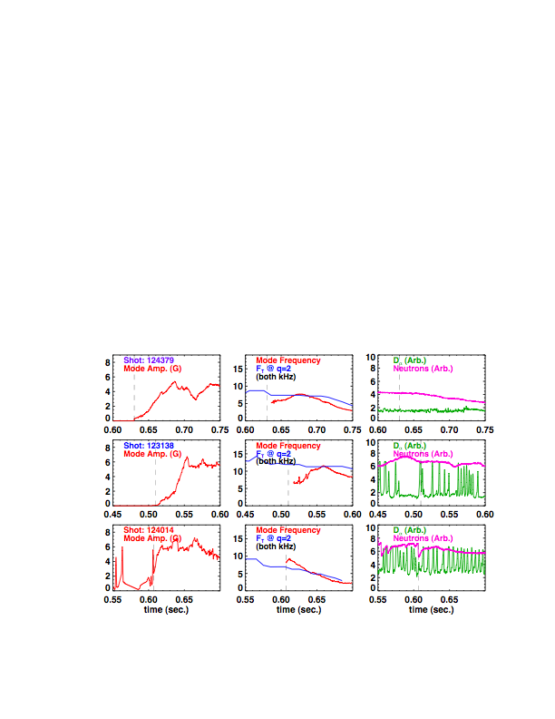
Fig 1. Time traces of typical trigger types. Each row corresponds to a single discharge exhibiting a type of mode trigger: EPM trigger in the bottom row, ELM trigger in the middle row, and “triggerless” in the top row . The columns illustrate the mode amplitude, frequency of the mode and q=2 surface rotation, and the neutron emission and divertor D_{α}.

The mode eigenfunction has been studied with the 30-chord USXR detector system. This system typically sees the inversion layer associated with the magnetic island, and use of a 2/1 island model and the inverted USXR data is capable of reproducing the measured emission fluctuations from chords whose tangency radius is near q=2. However, the emission from the plasma core is typically inconsistent with a pure even-m eigenfunction (for instance, the measured emission is odd across the magnetic axis), implying the presence of a coupled odd-m mode, likely 1/1. Any effect of this inner mode on the 2/1 mode stability is not reflected in an analysis based on equation 1. Note that the coupling of m/n NTMs to m-1/n modes has been observed in TFTR [16] and ASDEX-Upgrade [7], and predicted by theory [18].

4: Onset threshold vs. rotation and trigger type

As noted in the introduction, the mode frequency at onset may be an important parameter in determining the onset threshold. Fig. 2a) illustrates this initial mode frequency, compared to the toroidal rotation frequency of the q=2 surface. The trends discussed for the three example cases in Fig. 1 hold up for the larger database. When the mode is triggered by an ELM, the mode frequency at onset is always significantly slower than the q=2 surface rotation frequency. The cases with EPM triggers can rotate either faster of slower than the q=2 surface. Those cases with no visible triggers are typically observed to grow with a frequency slightly less than the q=2 surface rotation. For reference, the inset in Fig. 2a shows the mode and q=2 surface rotation frequencies at a later time, when the mode amplitude has saturated; the frequency match is then quite good.
Given that the modes most often travel more slowly than the q=2 surface and the arguments in Sect. 2, it appears that the polarization term might be a candidate for providing a rotation dependence in the onset drive. The method used here to assess this physics is essentially that in Ref. [19]; and the NTM-drive at onset is plotted against the E_{R}=0 rotation in Fig 2b. However, similar to observation in DIII-D [8], the NTM drive at onset is entirely uncorrelated with the early E_{r}=0 frame rotation. Mechanisms that involve other parameters, such as the absolute rotation magnitude (impacting wall/error field interactions), or differential rotation between surfaces and rotation shear (impacting classical tearing stability), must be responsible for setting the onset threshold.

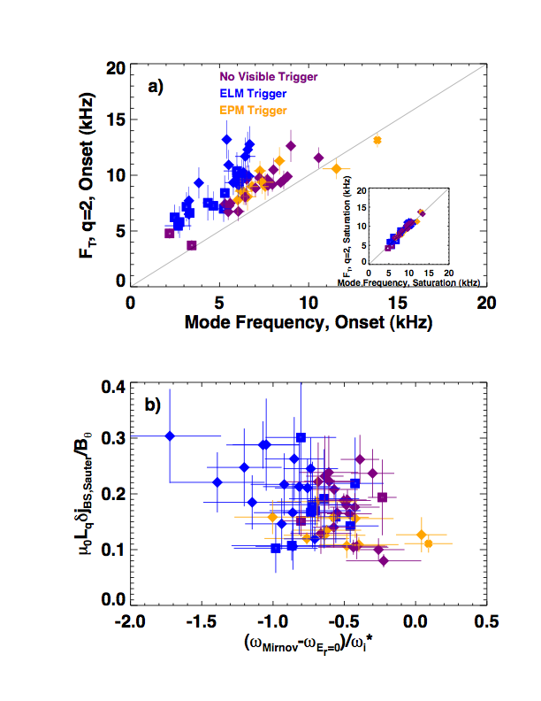

Fig 2. a) Mode frequency onset compared to the q=2 frequency at onset, with a similar figure for the mode frequency at saturation in the inset, and b) the approximate mode frequency in the E_{r}=0 frame, normalized to the ion-diamagnetic drift frequency.

The NTM drive at mode onset is plotted against the q=2 rotation frequency in Fig. 3a. Also indicated in the figure are linear regression coefficients, used as a measure of the trend. In this case, the dataset as a whole shows no trend (r²=0.1); only the ELM triggered modes show some correlation with rotation magnitude. However, a correlation becomes immediately clear, and improved for each onset mechanism, when plotted against rotation shear, as in Fig 3b). Inspection of the raw data and associated linear regression fits show that for fixed rotation shear, the EPM cases in orange are typically triggered at lower values of bootstrap drive. The ELM triggered cases in blue are triggered at intermediate levels of drive, and the “triggerless” cases in purple occur at the highest drive levels. The required drive increases as the local rotation shear is increased, with reasonable correlation coefficients for the EPM and ELM triggered modes and for the data set as a whole. There is significantly more scatter for the “triggerless” cases, possibly due to effects not related to rotation shear such as proximity to the ideal kink limit [17]; however, even in this case, the correlation is better with rotation shear than rotation. The slopes of the best-fit lines are, within error bars, equal, implying that rotation shear is not entering directly through the triggering physics, and must therefore be influencing the underlying NTM stability. Importantly, both the trigger type and rotation-shear effects are important in discerning the underlying trend.

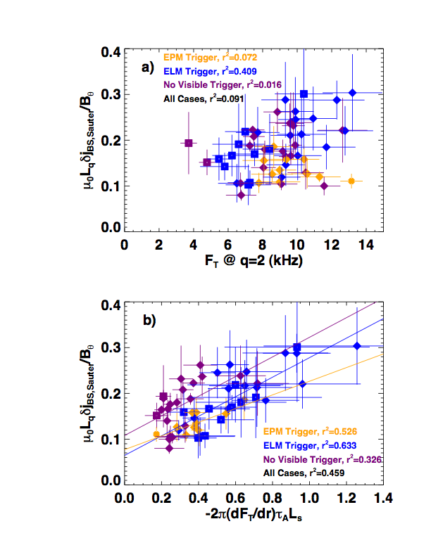
Fig 3. Onset bootstrap drive at mode onset vs. a) rotation and b) rotation shear. Linear correlation coefficients (r²) are indicated in each frame, sorted by trigger type.

Some simulations and measurements of tearing-mode onset with flow shear have indicated that differential rotation between adjacent rational surfaces [20] can be stabilizing, or that differential rotation with respect to the triggering surface reduces the seed island size [21]. The onset NTM drive data above has also been plotted against the differential rotation between q=2 and each of the core rotation, q=3 rotation, and edge rotation; none of these measures are as clearly correlated with the onset drive as the local rotation shear. Rather, the present data appears to support the notion that rotation shear couples to magnetic shear to modify the intrinsic classical stability of the tearing mode [22,23,24].

5: Conclusions

In summary the present results demonstrate multiple mechanisms that can lead to 2/1 NTM onset in a spherical torus, even with q_{min}>1. For fixed rotation shear, energetic particle modes can trigger NTMs at lower values of drive, edge localized modes at intermediate values of drive, and triggerless modes are struck at the highest drive values. Importantly, the inclusion of a wide variety of discharges, including many with magnetic braking, allows the roles of rotation and rotation shear to be examined. Within each subset of trigger types, it is shown that the NTM drive at onset, and thus the intrinsic stability, increases with increasing rotation shear, but is not strongly correlated with the absolute magnitude of rotation. These results are the clearest evidence yet that rotation shear, and not the absolute value of rotation, plays an important role in determining the onset threshold, possibly through the role of the classical tearing stability in governing mode onset. Future devices without strongly driven rotation may thus be more susceptible to 2/1 modes, but modifications to the current profile may be able to partially compensate for the reduced rotation shear.

6: Acknowledgements
This research was funded by the United States Department of Energy. RJB was funded jointly funded by UK Engineering and Physical Sciences Research Council and the European Communities.

7: References

[1] R.J. La Haye, Phys. Plasmas 13, 055501 (2006).
[2] T.C. Hender, et al, Nuclear Fusion 47, S128 (2007).
[3] R. J. Buttery, et al, Phys. Rev. Lett 88, 125005 (2002).
[4] Y.K.M. Peng and D.J. Strickler, Nuclear Fusion 26, 769 (1986)
[5] S. Kruger, C.C. Hegna, and J.D. Callen, Phys. Plasmas 5, 455 (1998)
[6] O. Sauter, et al., Phys. Rev. Lett 88, 105001 (2002).
[7] A. Gude, S. Gunter, S. Sesnic, and the ASDEX Upgrade Team, Nuclear Fusion 39, 127 (1999).
[8] R. J. Buttery, et al, Phys. Plasmas 15, 056115 (2008)
[9] M. Ono, et al., Nuclear Fusion 40, 557 (2000).
[10] H.R. Wilson, et al., Plasma Phys. Control. Fusion 38, A149 (1996).
[11] P.H. Rutherford, Phys. Fluids 16, 1903 (1973).
[12] O. Sauter, C. Angioni, and Y.R. Lin-Liu, Phys. Plasmas 6, 2834 (1999).
[13] W. Zhu, et al., Phys. Rev. Lett 96, 225002 (2006)
[14] D. Brennan, S. E. Kruger, T.A. Gianakon, and D.D. Schnack, Nuclear Fusion 45, 1178 (2005).
[15] D. Brennan, et al., Phys. Plasmas 9, 2998 (2002).
[16] E. Fredrickson, Phys. Plasmas 9, 548 (2002).
[17] D. Brennan, et al., Phys. Plasmas 10, 1643 (2003).
[18] D. Brennan, et al., Phys. Plasmas 14, 06108 (2007).
[19] R. J. La Haye, C. C. Petty, E. J. Strait, F. L. Waelbroeck, and H. R. Wilson, Phys. Plasmas 10, 3644 (2003).
[20] D. Chandra, A. Sen, P. Kaw, M.P. Bora, and S. Kruger, Nuclear Fusion 45, 524 (2005).
[21] R. J. Buttery, et al., Proceedings of the 28th EPS Conference on Controlled Fusion and Plasma Physics, Portugal, 2001, European Physical Society Conference Abstract (Institute of Physics, Bristol, 2001), Vol. 25, p.5.011.
[22] R. Coelho and E. Lazzaro, Phys. Plasmas 14, 012101 (2007).
[23] A. Sen, et al., Neoclassical tearing modes in the presence of sheared flows, 32nd EPS Conference on Plasma Physics, Tarragona, Spain (2005)
[24] R.J. La Haye, The stabilizing effect of flow shear on m/n=3/2 magnetic island width in DIII-D, submitted to Physics of Plasmas.

