MARCH 2005

Asia/Asians
Seventeen million square miles of real estate make Asia the world's largest continent and home to 3.3 billion people, three-fifths of the world's population. Besides the world's highest peak (Mt. Everest) and its lowest point (the Dead Sea), Asia's topography includes high plateaus, great peninsulas, deserts, swamps, offshore islands, the longest rivers, largest lakes, and greatest mountain ranges of the world. The climate ranges from torrid heat to arctic cold and from torrential rains to extreme aridity.
Asia can be divided into six regions, each with distinctive physical, cultural, economic, and political characteristics. Southwest Asia consist of Asia Minor, Arabia and the Fertile Crescent. South Asia refers to Afghanistan and the Indian subcontinent. Southeast Asia consists of the southeast peninsula, the East Indies, and the Philippines. East Asia includes China, Mongolia, Korea, and the islands of Taiwan and Japan. Russian Asia comprises the northern third of the continent and includes the vast region of Siberia and the Russian Far East. Central Asia includes a group of independent former republics of the Soviet Union.
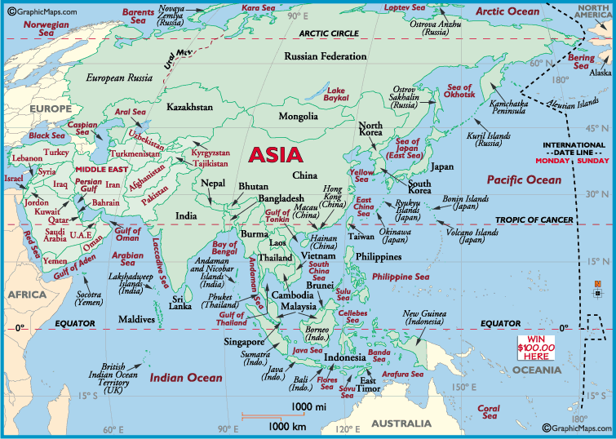
Continent Size: 44,579,000 sq km (17,212,000 sq miles) Percent of Earth's Land: 30% Population: 3,701,000,000 (2003 est)
Asian and Pacific Islander Population Profile: The Census Bureau of the U.S. Commerce Department conducted a Current Population Survey (CPS) in March, 2000. Not to be confused with the 2000 Census, the CPS provides data on age, marital status, family type and size, education, labor force participation and employment status, occupation, income and earning, poverty, and tenure (owner/renter). Highlights of the Asian and Pacific Islander CPS include:
- 80% of Asian and Pacific Islander family households were maintained by married couples and 42% of these households had incomes of $75,000 or more.
- 44% of Asian and Pacific Islanders age 25 and over had a bachelor's degree or higher and 86% had at least a high school diploma in 2000.
- In 1999, Asian and Pacific Islanders had a record-low poverty rate of 10.7%
- There were 2.5 million Asian and Pacific Islander families; women maintained 13% with no spouse present and men 7% with no spouse present.
- Asian and Pacific Islander families tend to be relatively large; 23% of Asian and Pacific Islander married-couples families had five or more members.
- 53% of Asian and Pacific Islander households owned their own homes.

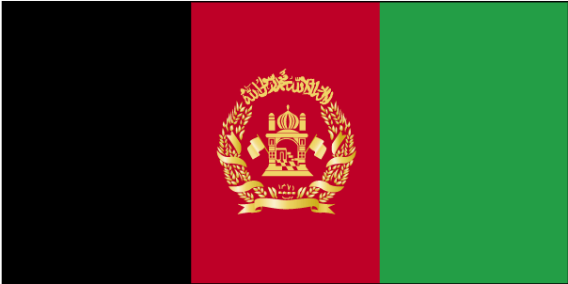

COUNTRY NAME: Islamic Republic of Afghanistan (Afghanistan)

GOVERNMENT TYPE: Islamic republic

CAPITAL: Kabul

PROFILE: Afghanistan's recent history is a story of war and civil unrest. The Soviet Union invaded in 1979, but was forced to withdraw 10 years later by anti-Communist mujahidin forces. The Communist regime in Kabul collapsed in 1992. Fighting that subsequently erupted among the various mujahidin factions eventually helped to spawn the Taliban, a hardline Pakistani-sponsored movement that fought to end the warlordism and civil war which gripped the country. The Taliban seized Kabul in 1996 and were able to capture most of the country outside of Northern Alliance srongholds primarily in the northeast. Following the 11 September 2001 terrorist attacks, a US, Allied, and Northern Alliance military action toppled the Taliban for sheltering Osama BIN LADIN. In late 2001, a conference in Bonn, Germany, established a process for political reconstruction that ultimately resulted in the adoption of a new constitution and presidential election in 2004. On 9 October 2004, Hamid KARZAI became the first democratically elected president of Afghanistan. The new Afghan government's next task is to hold National Assembly elections, tentatively scheduled for April 2005.

LOCATION: Southern Asia, north and west of Pakistan, east of Iran

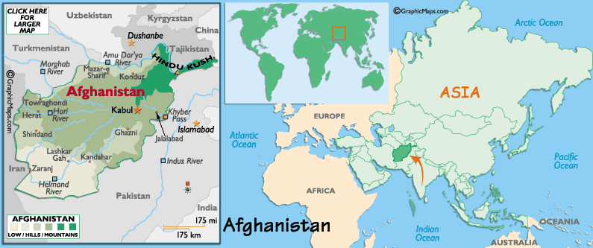

POPULATION: 28,513,677 (July 2004 est.)

ETHNIC GROUPS: Pashtun 42%, Tajik 27%, Hazara 9%, Uzbek 9%, Aimak 4%, Turkmen 3%, Baloch 2%, other 4%

RELIGION: Sunni Muslim 80%, Shi'a Muslim 19%, other 1%

CLIMATE/TERRAIN: arid to semiarid; cold winters and hot summers, mostly rugged mountains; plains in north and southwest

LANGUAGES: Pashtu (official) 35%, Afghan Persian (Dari) 50%, Turkic languages (primarily Uzbek and Turkmen) 11%, 30 minor languages (primarily Balochi and Pashai) 4%, much bilingualism

EDUCATION/LITERACY: definition: age 15 and over can read and write
total population: 36%, male: 51%, female: 21% (1999 est.)

ECONOMY: Afghanistan's economic outlook has improved significantly over the past two years because of the infusion of over $2 billion in international assistance, dramatic improvements in agricultural production, and the end of a four-year drought in most of the country. However, Afghanistan remains extremely poor, landlocked, and highly dependent on foreign aid, farming, and trade with neighboring countries. It will probably take the remainder of the decade and continuing donor aid and attention to raise Afghanistan's living standards up from its current status among the lowest in the world. Much of the population continues to suffer from shortages of housing, clean water, electricity, medical care, and jobs, but the Afghan government and international donors remain committed to improving access to these basic necessities by prioritizing infrastructure development, education, housing development, jobs programs, and economic reform over the next year. Growing political stability and continued international commitment to Afghan reconstruction create an optimistic outlook for maintaining improvements to the Afghan economy in 2004. The replacement of the opium trade - which may account for one-third of GDP - is one of several potential spoilers for the economy over the long term.

AGRICULTURAL PRODUCTS: opium, wheat, fruits, nuts, wool, mutton, sheepskins, lambskins

INDUSTRIES: small-scale production of textiles, soap, furniture, shoes, fertilizer, cement; handwoven carpets; natural gas, coal, copper

CURRENCY: afghani (AFA)
BRIEF HISTORY: A study of the history of Afghanistan reveals how a nation can be effected by its geography. For centuries Afghanistan remained a gateway to the Indian subcontinent and who ever wanted to conquer the region and take possession of its vast treasures had to deal with Afghanistan before setting his foot on the subcontinent. Over the centuries people from different regions settled in Afghanistan and made it their home land. People came from such culturally divergent countries such as Iran, Middle East, Anatolia, Greece, Macedonia, China, India, Mongolia, Central Russia and settled there. They added diversity to the population but rarely lived in peace.
It is difficult to believe that the history of this small and poor country is dotted with such famous names as Darius the Great, Alexander, Chandragupta Maurya, Ashoka, Kanishka, Menander, Attila the Hun, Genghis Khan, Timur, Mahmud Ghazni, Mahmud Ghori, Babur, Humayun, Akbar, Nadir Shah. It is also interesting to note that those who came to Afghanistan rarely managed to hold on to their victories or keep the land under their possession for long.
Because of its strategic location, some times Afghanistan became a buffer between two hostile nations. It happened during the Mughal and the British rule. Some times it also provided sanctuary to the fleeing rebels or the vanquished rulers from the central plains of India. It happened many times during the Muslim and Mughal rule. At the height of its glory, the British army fought two serious wars in Afghanistan. Both times they suffered heavy causalities. In recent times the Russians fought in Afghanistan for 10 long years and withdrew having exhausted all the available alternatives to bring the mountains under their control.
5000 BC - 2500 BC: Indus Valley Civilization. Although no excavations have been made and no archaeological evidence exists as on date, we strongly believe that the Indus people were familiar with this region and might have established some settlements there. Reader's attention is drawn to the fact that the North Dravidian languages namely Kurukh, Malto, and Brahui, are spoken by more than 2 million speakers in Pakistan, Afghanistan, and the border areas of India to this day.
2500 BC- 1000 BC Expansion of the Aryan base. The original inhabitants of this region were pushed towards eastern India where new schools of thoughts and a new imperial culture would emerge in course of time.
328 BC: The invasion of Alexander the Great.
303 BC: The defeat of Seleucus 1 by Chandragupta Maurya.
250 BC: The reign of Ashoka
250 -128 B.C. : Greaco-Bactrian kingdom at Balkh.
AD 127-41: Ptolemy's mention of Kabul as Kabura.
50 - 250 A.D : Emergence of the Kushana power under Kanishka.
225 - 600 A.D : Sassanids occupy and establish their rule.
652-664 AD: Invasion of the Arabs and the first contact with Islam.
8th - 10th century : The reign of Hindushahis who ruled Kabul and eastern part of Afghan territory.
997-1150 AD: The rule of Ghaznavids
998-1030 AD : The reign of Mahmud Ghazni. Probably the best period for Afghanistan.
1219-1222 AD: The invasion of Mongols under Genghis Khan and destruction of cities and agriculture.
1227 AD: Death of the tyrant: Genghis Khan
1370 AD: Timor Len crowned in Balkh
16th Century: Babur invades and rules from Kabul
1747AD :Ahmad Shah Sadozai Durani comes to power supported by Pashthun tribal council.
1775 AD :Timor Shah shifted the capital from Kabul to Kandahar.
1818 AD: Civil War leading to the division of Afghanistan into two political entities until 1835
1838 AD: Said Jamal-ul Din Afghan credited with the Pan-Islamic movements in the region
1839-42 AD: First Anglo Afghan war
1826-63 AD: consolidation of power by Dost Muhammad Khan
1868-1879 AD: Amir Shir Ali Khan
1878-80 AD: Second Anglo Afghan war
1880-1901AD: Rule of Dost Muhammad's grandson, Abdur Rahman Khan
1919-29 AD: Amanullah Shah
1921 AD: End of British involvement in Afghan affairs
1933 to 1973 AD: The long reign of Zahir Shah
1973 to 1978 AD: Zahir Shah's political reforms fail and his cousin Mohammad Daud Khan seizes power in a nearly bloodless coup. Zahir Shah went into exile in Europe.
April 1978: Marxist coup. Mohammad Daud was killed in the coup. The People's Democratic party of Afghanistan (PDPA) headed by Nur Mohammad Taraki comes to power.
1979: End of Taraki. He was removed from power. Hafizullah Amin his lieutenant takes over and kills Taraki.
December 1979: Soviet Russia marches into Afghanistan. Amin was executed and replaced by Barbak Kamal.
Early 1980's: Mujahideen's capture vast territories supported by foreign powers.
1986: Soviet decision to withdraw from Afghanisthan in phases. Barbak Kamal replaced by Najibullah Government.
Feb. 15, 1989: The Russians finally withdraw. However Najibullah continues while the battle with Mujahideen goes on.
April 1992: Occupation of Kabul by Mujahideen and declaration of Islamic state. Soon a power struggle ensued in the new government between the two factions: one led by Burhanuddin Rabban and the other led by Gulbuddin Hekmatyar. Rabbani became the president in December 1992 by a constituent assembly while Hekmatyar became prime minister under a March 1993 peace accord. The two groups continued fight resulting in heavy casualties.
1995 The rise of the Taliban in the southern, Pathan region.
Sept. 24, 1996 : The Taliban captured Kabul.
(The following information is reproduced from the CIA Factbook)
Present Position: The Taliban were able to capture most of the country, aside from Northern Alliance strongholds primarily in the northeast, until US and allied military action in support of the opposition following the 11 September 2001 terrorist attacks forced the group's downfall. In late 2001, major leaders from the Afghan opposition groups and diaspora met in Bonn, Germany and agreed on a plan for the formulation of a new government structure that resulted in the inauguration of Hamid KARZAI as Chairman of the Afghan Interim Authority (AIA) on 22 December 2001.
The AIA held a nationwide Loya Jirga (Grand Assembly) in June 2002, and KARZAI was elected President by secret ballot of the Transitional Islamic State of Afghanistan (TISA). The Transitional Authority has an 18-month mandate to hold a nationwide Loya Jirga to adopt a constitution and a 24-month mandate to hold nationwide elections.
In December 2002, the TISA marked the one-year anniversary of the fall of the Taliban. In addition to occasionally violent political jockeying and ongoing military action to root out remaining terrorists and Taliban elements, the country suffers from enormous poverty, a crumbling infrastructure, and widespread land mines.
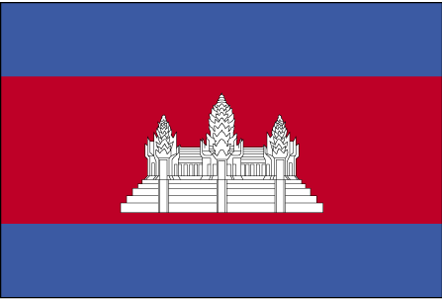

COUNTRY NAME: Kingdom of Cambodia (Cambodia)

GOVERNMENT TYPE: multiparty democracy under a constitutional monarchy established in September 1993
CAPITAL: Phnom Penh
PROFILE: Most Cambodians consider themselves to be Khmers, whose Angkor Empire extended over much of Southeast Asia and reached its zenith between the 10th and 13th centuries. Subsequently, attacks by the Thai and Cham (from present-day Vietnam) weakened the empire ushering in a long period of decline. In 1863, the king of Cambodia placed the country under French protection; it became part of French Indochina in 1887. Following Japanese occupation in World War II, Cambodia became independent within the French Union in 1949 and fully independent in 1953. After a five-year struggle, Communist Khmer Rouge forces captured Phnom Penh in April 1975 and ordered the evacuation of all cities and towns; at least 1.5 million Cambodians died from execution, enforced hardships, or starvation during the Khmer Rouge regime under POL POT. A December 1978 Vietnamese invasion drove the Khmer Rouge into the countryside, led to a 10-year Vietnamese occupation, and touched off almost 13 years of civil war. The 1991 Paris Peace Accords mandated democratic elections and a ceasefire, which was not fully respected by the Khmer Rouge. UN-sponsored elections in 1993 helped restore some semblance of normalcy and the final elements of the Khmer Rouge surrendered in early 1999. Factional fighting in 1997 ended the first coalition government, but a second round of national elections in 1998 led to the formation of another coalition government and renewed political stability. The July 2003 elections were relatively peaceful, but it took one year of negotiations between contending political parties before a coalition government was formed. Nation-wide local elections are scheduled for 2007 and national elections for 2008.

LOCATION: Southeastern Asia, bordering the Gulf of Thailand, between Thailand, Vietnam, and Laos

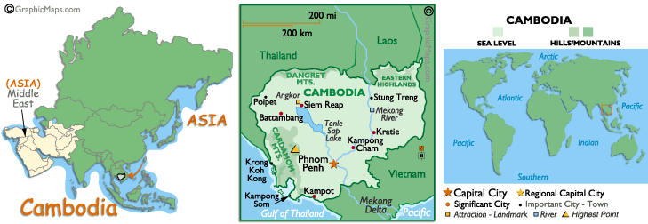

CLIMATE/TERRAIN: tropical; rainy, monsoon season (May to November); dry season (December to April); little seasonal temperature variation. Mostly low, flat plains, mountains in southwest and north.

NATURAL RESOURCES: oil and gas, timber, gemstones, some iron ore, manganese, phosphates, hydropower potential

POPULATION: 13,363,421
note: estimates for this country take into account the effects of excess mortality due to AIDS; this can result in lower life expectancy, higher infant mortality and death rates, lower population growth rates, and changes in the distribution of population by age and sex than would otherwise be expected (July 2004 est.)

ETHNIC GROUPS: Khmer 90%, Vietnamese 5%, Chinese 1%, other 4%

RELIGION: Theravada Buddhist 95%, other 5%

LANGUAGES: Khmer (official) 95%, French, English

EDUCATION/LITERACY: definition: age 15 and over can read and write
total population: 69.4%, male: 80.8%, female: 59.3% (2002)

ECONOMY: Cambodia's economy slowed dramatically in 1997-1998 due to the regional economic crisis, civil violence, and political infighting. Foreign investment and tourism fell off. In 1999, the first full year of peace in 30 years, progress was made on economic reforms. Growth resumed and has remained about 5.0% during 2000-2003. Tourism was Cambodia's fastest growing industry, with arrivals up 34% in 2000 and up another 40% in 2001 before the 11 September 2001 terrorist attacks in the US. Cambodia expects 1 million foreign tourists in 2004. Economic growth has been largely driven by expansion in the clothing sector and tourism. Clothing exports were fostered by the U.S.-Cambodian Bilateral Textile Agreement signed in 1999. Even given Cambodia's recent growth, the long-term development of the economy after decades of war remains a daunting challenge. The population lacks education and productive skills, particularly in the poverty-ridden countryside, which suffers from an almost total lack of basic infrastructure. Fear of renewed political instability and a dysfunctional legal system coupled with government corruption discourage foreign investment. The Cambodian government continues to work with bilateral and multilateral donors to address the country's many pressing needs. The major economic challenge for Cambodia over the next decade will be fashioning an economic environment in which the private sector can create enough jobs to handle Cambodia's demographic imbalance. About 60% of the population is 20 years or younger; most of these citizens will seek to enter the workforce over the course of the next 10 years.

AGRICULTURAL PRODUCTS: rice, rubber, corn, vegetables, cashews, tapioca

INDUSTRIES: tourism, garments, rice milling, fishing, wood and wood products, rubber, cement, gem mining, textiles

CURRENCY: riel (KHR)
BRIEF HISTORY: Very little is known about prehistoric Cambodia, although archeological evidence has established that prior to 1000 BC Cambodians subsisted on a diet of fish and rice and lived in houses on stilts, as they still do today. From the 1st to the 6th centuries, much of Cambodia belonged to the Southeast Asian kingdom of Funan, which played a vital role in developing the political institutions, culture and art of later Khmer states. However, it was the Angkorian era, beginning in the 8th century that really transformed the kingdom into an artistic and religious power.
Forces of the Thai kingdom of Ayudhya sacked Angkor in 1431, leaving the Khmers plagued by dynastic rivalries and continual warfare with the Thais for a century and a half. The Spanish and Portuguese, who had recently become active in the region, also played a part in these wars until resentment of their power led to the massacre of the Spanish garrison at Phnom Penh in 1599. A series of weak kings ruled from 1600 until the French arrived in 1863. After some gunboat diplomacy and the signing of a treaty of protectorate in 1863, the French went on to force King Norodom to sign another treaty, this time turning his country into a virtual colony in 1884.
Following the arrival of the French, a relatively peaceful period followed (even the peasant uprising of 1916 was considered peaceful). In 1941 the French installed 19-year-old Prince Sihanouk on the Cambodian throne, on the assumption that he would prove suitably pliable. This turned out to be a major miscalculation as the years after 1945 were strife-torn, with the waning of French colonial power aided by the proximity of the Franco-Viet Minh War that raged in Vietnam and Laos. Cambodian independence was eventually proclaimed in 1953, the enigmatic King Norodom Sihanouk going on to dominate national politics for the next 15 years before being overthrown by the army.
In 1969, the United States carpet-bombed suspected communist base camps in Cambodia, killing thousands of civilians and dragging the country unwillingly into the US-Vietnam conflict. American and South Vietnamese troops invaded the country in 1970 to eradicate Vietnamese communist forces but were unsuccessful; they did manage, however, to push Cambodia's leftist guerillas (the Khmer Rouge) further into the country's interior. Savage fighting soon engulfed the entire country, with Phnom Penh falling to the Khmer Rouge in April 1975.
Over the next four years the Khmer Rouge, under Pol Pot's leadership, systematically killed an estimated two million Cambodians (targeting the educated in particular) in a brutal bid to turn Cambodia into a Maoist, peasant-dominated agrarian cooperative. Currency was abolished, postal services were halted, the population became a work force of slave laborers and the country was almost entirely cut off from the outside world. Responding to recurring armed incursions into their border provinces, Vietnam invaded Cambodia in 1978, forcing the Khmer Rouge to flee to the relative sanctuary of the jungles along the Thai border. From there, they conducted a guerilla war against the Vietnamese-backed government throughout the late 1970s and 80s.
In mid-1993, UN-administered elections led to a new constitution and the reinstatement of Norodom Sihanouk as king. The Khmer Rouge boycotted the elections, rejected peace talks and continued to buy large quantities of arms from the Cambodian military leadership. In the months following the election, a government-sponsored amnesty secured the first defections from Khmer ranks, with more defections occurring from 1994 when the Khmer Rouge was finally outlawed by the Cambodian government.
The uneasy coalition of Prince Ranariddh's National United Front and Hun Sen's Cambodian People's Party fell violently apart in July 1997, and when the dust settled Hun Sen assumed sole leadership of Cambodia. Elections in mid-98 returned Hun Sen to this position, despite grumbling from opposition candidates about dodgy electoral practices. While his democratic credentials are far from impressive, the one-eyed strong man has proved to be something of a stabilizing force for Cambodia.
Pol Pot's death in April 1998 from an apparent heart attack was greeted with anger (that he was never brought to trial) and skepticism (he has been reported dead many times before). The UN has pulled out of trials of other surviving 'top level' Khmer Rouge leaders on war crimes charges because the independence of the tribunals is doubtful.
Future stability is tied to improving the country's long-suffering economy, eradicating the entrenched culture of corruption, reducing the size of the military and answering the troubled question of royal succession.
Prime Minister Hun Sen's Cambodian People's Party won elections in 2003, but political stalemate lasted until June 2004, when Hun Sen found a coalition partner and could resume his prime ministership. In October 2004, King Sihanouk announced his intention to abdicate on account of ill health and annoyance at the country's political infighting.

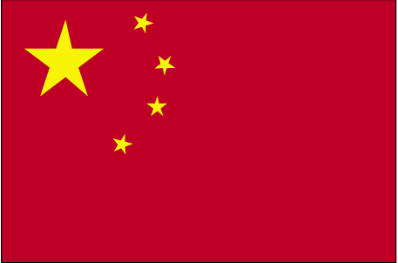

COUNTRY NAME: People’s Republic of China (China)

GOVERNMENT TYPE: Communist Republic

CAPITAL: Beijing

PROFILE: For centuries China stood as a leading civilization, outpacing the rest of the world in the arts and sciences, but in the 19th and early 20th centuries, the country was beset by civil unrest, major famines, military defeats, and foreign occupation. After World War II, the Communists under MAO Zedong established an autocratic socialist system that, while ensuring China's sovereignty, imposed strict controls over everyday life and cost the lives of tens of millions of people. After 1978, his successor DENG Xiaoping and other leaders focused on market-oriented economic development and by 2000 output had quadrupled. For much of the population, living standards have improved dramatically and the room for personal choice has expanded, yet political controls remain tight.

LOCATION: Eastern Asia, bordering the East China Sea, Korea Bay, Yellow Sea, and South China Sea, between North Korea and Vietnam

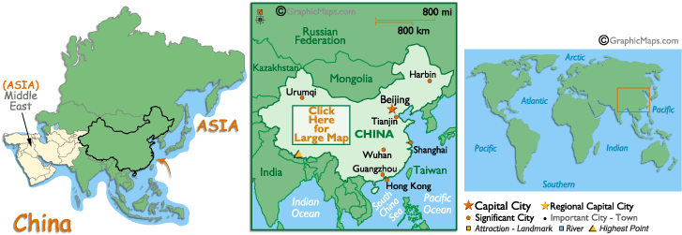

CLIMATE/TERRAIN: extremely diverse; tropical in south to subarctic in north. Mostly mountains, high plateaus, deserts in west; plains, deltas, and hills in east.

POPULATION: 1,298,847,624 (July 2004 est.)

ETHNIC GROUPS: Han Chinese 91.9%, Zhuang, Uygur, Hui, Yi, Tibetan, Miao, Manchu, Mongol, Buyi, Korean, and other nationalities 8.1%

RELIGION: Daoist (Taoist), Buddhist, Muslim 1%-2%, Christian 3%-4%
note: officially atheist (2002 est.)

LANGUAGES: Standard Chinese or Mandarin (Putonghua, based on the Beijing dialect), Yue (Cantonese), Wu (Shanghaiese), Minbei (Fuzhou), Minnan (Hokkien-Taiwanese), Xiang, Gan, Hakka dialects, minority languages (see Ethnic groups entry)

EDUCATION/LITERACY: definition: age 15 and over can read and write
total population: 90.9%, male: 95.1%, female: 86.5% (2002)
NATURAL RESOURCES: coal, iron ore, petroleum, natural gas, mercury, tin, tungsten, antimony, manganese, molybdenum, vanadium, magnetite, aluminum, lead, zinc, uranium, hydropower potential (world's largest)

ECONOMY: In late 1978 the Chinese leadership began moving the economy from a sluggish, inefficient, Soviet-style centrally planned economy to a more market-oriented system. Whereas the system operates within a political framework of strict Communist control, the economic influence of non-state organizations and individual citizens has been steadily increasing. The authorities switched to a system of household and village responsibility in agriculture in place of the old collectivization, increased the authority of local officials and plant managers in industry, permitted a wide variety of small-scale enterprises in services and light manufacturing, and opened the economy to increased foreign trade and investment. The result has been a quadrupling of GDP since 1978. Measured on a purchasing power parity (PPP) basis, China in 2003 stood as the second-largest economy in the world after the US, although in per capita terms the country is still poor.

Agriculture and industry have posted major gains especially in coastal areas near Hong Kong, opposite Taiwan, and in Shanghai, where foreign investment has helped spur output of both domestic and export goods. The leadership, however, often has experienced - as a result of its hybrid system - the worst results of socialism (bureaucracy and lassitude) and of capitalism (growing income disparities and rising unemployment). China thus has periodically backtracked, retightening central controls at intervals. The government has struggled to (a) sustain adequate jobs growth for tens of millions of workers laid off from state-owned enterprises, migrants, and new entrants to the work force; (b) reduce corruption and other economic crimes; and (c) keep afloat the large state-owned enterprises, many of which had been shielded from competition by subsidies and had been losing the ability to pay full wages and pensions. From 80 to 120 million surplus rural workers are adrift between the villages and the cities, many subsisting through part-time, low-paying jobs. Popular resistance, changes in central policy, and loss of authority by rural cadres have weakened China's population control program, which is essential to maintaining long-term growth in living standards. Another long-term threat to growth is the deterioration in the environment, notably air pollution, soil erosion, and the steady fall of the water table especially in the north. China continues to lose arable land because of erosion and economic development. Beijing says it will intensify efforts to stimulate growth through spending on infrastructure - such as water supply and power grids - and poverty relief and through rural tax reform. Accession to the World Trade Organization helps strengthen its ability to maintain strong growth rates but at the same time puts additional pressure on the hybrid system of strong political controls and growing market influences. China has benefited from a huge expansion in computer internet use. Foreign investment remains a strong element in China's remarkable economic growth. Growing shortages of electric power and raw materials will hold back the expansion of industrial output in 2004.

AGRICULTURAL PRODUCTS: rice, wheat, potatoes, sorghum, peanuts, tea, millet, barley, cotton, oilseed, pork, fish

INDUSTRIES: iron and steel, coal, machine building, armaments, textiles and apparel, petroleum, cement, chemical fertilizers, footwear, toys, food processing, automobiles, consumer electronics, telecommunications

CURRENCY: yuan (CNY), note:: also referred to as the Renminbi (RMB)
BRIEF HISTORY: The Chinese claim a history of 5000 years. The first dynasty, the Xia, is yet to be archaeologically verified but is accepted as lasting from 2200 to 1700 BC, and is described in legends as having been preceded by a succession of god-like sovereigns who bestowed the gifts of life, hunting and agricultural knowledge. The existence of ensuing dynasties is similarly hazy, but clarity increases with each era, revealing agricultural societies who practiced ancestor worship.
The Zhou period (1100-221 BC) saw the emergence of Confucianism and the establishment of the 'mandate of heaven' whereby the right to rule was given to the just and denied to the evil and corrupt, leading to the later Taoist view that heaven's disapproval was expressed through natural disasters such as earthquakes, floods and insect plagues.
The Chinese were united for the first time during the Qin dynasty (221-207 BC). The dynasty standardized the writing system and completed construction of the Great Wall. The ensuing Han dynasty (206 BC-220 AD) featured much military conflict and the creation of the Three Kingdoms. Curiously, these war-torn centuries also saw the flowering of Buddhism and the arts.
Unity arose out of the chaos under the Sui dynasty (581-618) and was consolidated under the Tang (618-907), commonly regarded as the most glorious period of Chinese history. Military conquests re-established Chinese control of the silk routes and society was 'internationalized' to an unprecedented degree. Buddhism flourished under the Tang, splitting into two distinct schools: the Chan (Zen) and Pure Land (Chinese Buddhist).
The Song dynasty (960-1279) was marked by a revival of Confucianism and urban and commercial revolutions - it was during the 13th century that Marco Polo commented on the grand scale of China's prosperous cities. Genghis' grandson Kublai Khan's Yuan dynasty (1271-1368) established a capital at what is now Beijing and militarized the nation's administration. The novice Buddhist Hongwu established the Ming dynasty (1368-1644), with capitals at Beijing and Nanjing.
The Portuguese were the first Europeans to arrive in China, anchoring off the coast in 1516. A trade mission was established in Macau by 1557, but it was not until 1760 that other powers gained secure access to Chinese markets via a base in Guangzhou. Trade flourished, but in China's favor, as British purchases of silk and tea far outweighed Chinese purchases of wool and spices. In 1773 the British decided to balance the books by encouraging the sale of opium. By 1840 the Opium Wars were on.
The resulting treaties signed in British favor led to the cession of Hong Kong and the signing of the humiliating Treaty of Nanking. A subsequent land-grabbing spree by Western powers saw China carved up into spheres of influence. The Chinese agreed to the US-proposed free-trade Open Door Policy and all of China's colonial possessions soon evaporated, with Vietnam, Laos and Cambodia falling to the French, Burma to the British, and Korea and Taiwan to Japan.
The first half of the 20th century was a period of utter chaos. Intellectuals searched for a new philosophy to replace Confucianism, while warlords attempted to grab imperial power. Sun Yatsen's Kuomintang (KMT, or Nationalist Party) established a base in southern China and began training a National Revolutionary Army (NRA). Meanwhile, talks between the Soviet Comintern and prominent Chinese Marxists resulted in the formation of the Chinese Communist Party (CCP) in 1921. Hopes of the CCP aligning with the KMT were dashed by Sun Yatsen's death and the rise from the KMT of Chiang Kaishek in Beijing, who favored a capitalist state supported by a military dictatorship.
The Communists were split between those who focused on urban revolt and those who believed victory lay in uniting the countryside. Mao Zedong established his forces in the mountains of Jinggang Shan, and by 1930 had marshaled a guerrilla army of 40,000. Chiang mounted four Communists extermination campaigns, each time resulting in Communist victories. Chiang's fifth campaign was very nearly successful because the Communists ill-advisedly met the KMT head-on in battle. Hemmed in, the Communists retreated from Jiagnxi north to Shaanxi - the Long March of 1934. En route the Communists armed peasants and redistributed land, and Mao was recognized as the CCP's paramount leader.
In 1931 the Japanese had taken advantage of the chaos in China to invade Manchuria. Chiang Kaishek did little to halt the Japanese, who by 1939 had overrun most of eastern China. After WWII, China was in the grip of civil war. On 1 October 1949 Mao Zedong proclaimed the foundation of the People's Republic of China (PRC), while Chiang Kaishek fled to Taiwan. The USA continued to recognize Chiang as the legitimate ruler of China.
The PRC began its days as a bankrupt nation, but the 1950s ushered in an era of great confidence. The people were bonded by the Korean War, and by 1953 inflation had been halted, industrial production was restored to prewar levels, the redistribution of land had been carried out and the first Five Year Plan had been launched. The most tragic consequence of the Party's dominance was the 'liberation' of Tibet in 1950. Beijing oversaw the enforced exile of the Tibetan spiritual leader and initiated the genocide of a precious culture. Today, the destruction is by no means over.
The next plan was the Great Leap Forward, aimed at jump-starting the economy into first-world standards. Despite oodles of revolutionary zeal, the plan was stalled by inefficient management, coupled with floods, droughts and, in 1960, the withdrawal of all Soviet aid. The Cultural Revolution (1966-70) attempted to draw attention away from these disasters by increasing Mao's personal presence via his Little Red Book of quotations, the purging of opponents and the launch of the Red Guard. Universities were closed, intellectuals were killed, temples were ransacked and reminders of China's capitalist past were destroyed.
Beijing politics were divided between moderates Zhou Enlai and Deng Xiaoping and radicals and Maoists led by Mao's wife, Jiang Qing. The radicals gained the upper hand when Zhou died in 1976. Hua Guofeng, Mao's chosen successor, became acting premier. Public anger at Jiang Qing and her clique culminated in a gathering of protesters in Tiananmen Square, and a brutal crackdown led to the disappearance of Deng, who was blamed for the 'counter-revolutionary' gathering. Deng returned to public life in 1977, eventually forming a six-member Standing Committee of the CCP.
With Deng at the helm, and the signing of the 1984 Sino-British Joint Declaration, China set a course towards economic reconstruction, although political reform was almost nil. General dissatisfaction with the Party, soaring inflation and increased demands for democracy have led to widespread social unrest, typified by the demonstrations of 1989 that resulted in the bloody Tiananmen Square massacre.
With the handover of Hong Kong and Macau, China's 'one country, two systems' plan shifted up a gear. Jiang Zemin's leadership charted a new course based on economic growth, and his successor Hu Jintao is set to follow the path of economic modernization more aggressively still. Continued civil rights abuses, official corruption and the stagnant rural economy are the sharpest thorns in the country's side, but membership of the World Trade Organization is a great leap forward - though probably not one Chairman Mao would have envisaged.
The biggest barrier to the 'One China' model is the tiny rogue island of Taiwan, which has agreed in principle to the model but paradoxically interprets it in its idiosyncratic, Taiwanese way. China has retorted with rhetoric about 'brothers and sisters' and, just to prove that all families have their problems, have backed it up with a show of military muscle. It's the equivalent of a Chinese burn administered by an older and stronger brother.
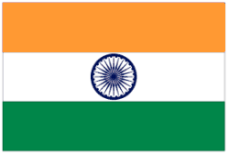
COUNTRY NAME: Sovereign Socialist Secular Democratic Republic India (India)
CAPITAL: New Delhi
PROFILE: The Indus Valley civilization, one of the oldest in the world, dates back at least 5,000 years. Aryan tribes from the northwest invaded about 1500 B.C.; their merger with the earlier inhabitants created the classical Indian culture. Arab incursions starting in the 8th century and Turkish in the 12th were followed by European traders, beginning in the late 15th century. By the 19th century, Britain had assumed political control of virtually all Indian lands. Indian armed forces in the British army played a vital role in both World Wars. Nonviolent resistance to British colonialism under Mohandas GANDHI and Jawaharlal NEHRU led to independence in 1947. The subcontinent was divided into the secular state of India and the smaller Muslim state of Pakistan. A third war between the two countries in 1971 resulted in East Pakistan becoming the separate nation of Bangladesh. Fundamental concerns in India include the ongoing dispute with Pakistan over Kashmir, massive overpopulation, environmental degradation, extensive poverty, and ethnic and religious strife, all this despite impressive gains in economic investment and output.
GEOGRAPHY: Southern Asia, bordering the Arabian Sea and the Bay of Bengal, between Burma and Pakistan.
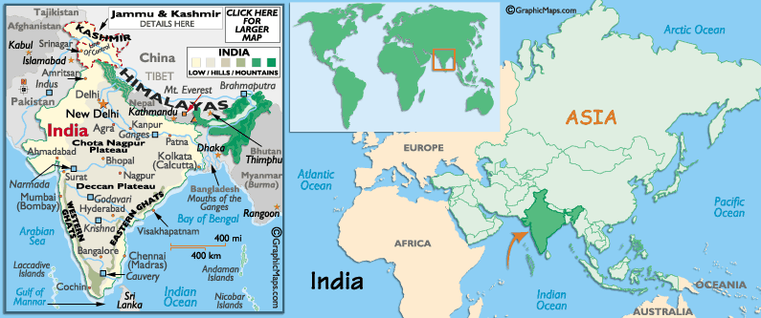
POPULATION: 1,065,070,607 (July 2004 est.)
ETHNIC GROUPS: Indo-Aryan 72%, Dravidian 25%, Mongoloid and other 3% (2000).
LANGUAGES: English enjoys associate status but is the most important language for national, political, and commercial communication; Hindi is the national language and primary tongue of 30% of the people; there are 14 other official languages: Bengali, Telugu, Marathi, Tamil, Urdu, Gujarati, Malayalam, Kannada, Oriya, Punjabi, Assamese, Kashmiri, Sindhi, and Sanskrit; Hindustani is a popular variant of Hindi/Urdu spoken widely throughout northern India but is not an official language.
RELIGION: Hindu 81.3%, Muslim 12%, Christian 2.3%, Sikh 1.9%, other groups including Buddhist, Jain, Parsi 2.5% (2000)
EDUCATION/LITERARY: definition: age 15 and over can read and write
total population: 59.5%, male: 70.2%, female: 48.3% (2003 est.)
GOVERNMENT: Federal Republic, 28 states and 7 union territories*; Andaman and Nicobar Islands*, Andhra Pradesh, Arunachal Pradesh, Assam, Bihar, Chandigarh*, Chhattisgarh, Dadra and Nagar Haveli*, Daman and Diu*, Delhi*, Goa, Gujarat, Haryana, Himachal Pradesh, Jammu and Kashmir, Jharkhand, Karnataka, Kerala, Lakshadweep*, Madhya Pradesh, Maharashtra, Manipur, Meghalaya, Mizoram, Nagaland, Orissa, Pondicherry*, Punjab, Rajasthan, Sikkim, Tamil Nadu, Tripura, Uttaranchal, Uttar Pradesh, West Bengal.

CLIMATE: varies from tropical monsoon in south to temperate in north.

TERRAIN: upland plain (Deccan Plateau) in south, flat to rolling plain along the Ganges, deserts in west, Himalayas in north.

NATURAL RESOURCES: coal (fourth-largest reserves in the world), iron ore, manganese, mica, bauxite, titanium ore, chromite, natural gas, diamonds, petroleum, limestone, arable land.

NATURAL HAZARDS: droughts; flash floods, as well as widespread and destructive flooding from monsoonal rains; severe thunderstorms; earthquakes.
BRIEF HISTROY: India's extraordinary history is intimately tied to its geography. A meeting ground between the East and the West, it has always been an invader's paradise, while at the same time its natural isolation and magnetic religions allowed it to adapt to and absorb many of the peoples who penetrated its mountain passes. No matter how many Persians, Greeks, Chinese nomads, Arabs, Portuguese, British and other raiders had their way with the land, local Hindu kingdoms invariably survived their depradations, living out their own sagas of conquest and collapse. All the while, these local dynasties built upon the roots of a culture well established since the time of the first invaders, the Aryans. In short, India has always been simply too big, too complicated, and too culturally subtle to let any one empire dominate it for long.
True to the haphazard ambiance of the country, the discovery of India's most ancient civilization literally happened by accident. British engineers in the mid-1800's, busy constructing a railway line between Karachi and Punjab, found ancient, kiln-baked bricks along the path of the track. This discovery was treated at the time as little more than a curiosity, but archaeologists later revisited the site in the 1920's and determined that the bricks were over 5000 years old. Soon afterward, two important cities were discovered: Harappa on the Ravi river, and Mohenjodaro on the Indus.
The civilization that laid the bricks, one of the world's oldest, was known as the Indus. They had a written language and were highly sophisticated. Dating back to 3000 BC, they originated in the south and moved north, building complex, mathematically-planned cities. Some of these towns were almost three miles in diameter and contained as many as 30,000 residents. These ancient municipalities had granaries, citadels, and even household toilets. In Mohenjodaro, a mile-long canal connected the city to the sea, and trading ships sailed as far as Mesopotamia. At its height, the Indus civilization extended over half a million square miles across the Indus river valley, and though it existed at the same time as the ancient civilizations of Egypt and Sumer, it far outlasted them.
The first group to invade India was the Aryans, who came out of the north in about 1500 BC. The Aryans brought with them strong cultural traditions that, miraculously, still remain in force today. They spoke and wrote in a language called Sanskrit, which was later used in the first documentation of the Vedas. Though warriors and conquerors, the Aryans lived alongside Indus, introducing them to the caste system and establishing the basis of the Indian religions. The Aryans inhabited the northern regions for about 700 years, then moved further south and east when they developed iron tools and weapons. They eventually settled the Ganges valley and built large kingdoms throughout much of northern India.
The second great invasion into India occurred around 500 BC, when the Persian kings Cyrus and Darius, pushing their empire eastward, conquered the ever-prized Indus Valley. Compared to the Aryans, the Persian influence was marginal, perhaps because they were only able to occupy the region for a relatively brief period of about 150 years. The Persians were in turn conquered by the Greeks under Alexander the Great, who swept through the country as far as the Beas River, where he defeated King Porus and an army of 200 elephants in 326 BC. The tireless, charismatic conqueror wanted to extend his empire even further eastward, but his own troops (undoubtedly exhausted) refused to continue. Alexander returned home, leaving behind garrisons to keep the trade routes open.
While the Persians and Greeks subdued the Indus Valley and the northwest, Aryan-based kingdoms continued developing in the East. In the 5th century BC, Siddhartha Gautama founded the religion of Buddhism, a profoundly influential work of human thought still espoused by much of the world. As the overextended Hellenistic sphere declined, a king known as Chandragupta swept back through the country from Magadha (Bihar) and conquered his way well into Afghanistan. This was the beginning of one India's greatest dynasties, the Maurya. Under the great king Ashoka (268-31 BC), the Mauryan empire conquered nearly the entire subcontinent, extending itself as far south as Mysore. When Ashoka conquered Orissa, however, his army shed so much blood that the repentant king gave up warfare forever and converted to Buddhism. Proving to be as tireless a missionary as he had been as conqueror, Asoka brought Buddhism to much of central Asia. His rule marked the height of the Maurya empire, and it collapsed only 100 years after his death. After the demise of the Maurya dynasty, the regions it had conquered fragmented into a mosaic of kingdoms and smaller dynasties. The Greeks returned briefly in 150 BC and conquered the Punjab, and by this time Buddhism was becoming so influential that the Greek king Menander forsook the Hellenistic pantheon and became a Buddhist himself. The local kingdoms enjoyed relative autonomy for the next few hundred years, occasionally fighting (and often losing to) invaders from the north and China, who seemed to come and go like the monsoons. Unlike the Greeks, the Romans never made it to India, preferring to expand west instead.
In AD 319, Chandragupta II founded the Imperial Guptas dynasty, which conquered and consolidated the entire north and extended as far south as the Vindya mountains. When the Guptas diminished, a golden age of six thriving and separate kingdoms ensued, and at this time some of the most incredible temples in India were constructed in Bhubaneshwar, Konarak, and Khahurajo. It was time of relative stability, and cultural developments progressed on all fronts for hundreds of years, until the dawn of the Muslim era.
Arab traders had visited the western coast since 712, but it wasn't until 1001 that the Muslim world began to make itself keenly felt. In that year, Arab armies swept down the Khyber pass and hit like a storm. Led by Mahmud of Ghazi, they raided just about every other year for 26 years straight. They returned home each time, leaving behind them ruined cities, decimated armies, and probably a very edgy native population. Then they more or less vanished behind the mountains again for nearly 150 years, and India once again went on its way.
But the Muslims knew India was still there, waiting with all its riches. They returned in 1192 under Mohammed of Ghor, and this time they meant to stay. Ghor's armies laid waste to the Buddhist temples of Bihar, and by 1202 he had conquered the most powerful Hindu kingdoms along the Ganges. When Ghor died in 1206, one of his generals, Qutb-ud-din, ruled the far north from the Sultanate of Delhi, while the southern majority of India was free from the invaders. Turkish kings ruled the Muslim acquisition until 1397, when the Mongols invaded under Timur Lang (Tamerlane) and ravaged the entire region. One historian wrote that the lightning speed with which Tamerlane's armies struck Delhi was prompted by their desire to escape the stench of rotting corpses they were leaving behind them.
Islamic India fragmented after the brutal devastation Timur Lang left in Delhi, and it was every Muslim strongman for himself. This would change in 1527, however, when the Mughal (Persian for Mongol) monarch Babur came into power. Babur was a complicated, enlightened ruler from Kabul who loved poetry, gardening, and books. He even wrote cultural treatises on the Hindus he conquered, and took notes on local flora and fauna. Afghan princes in India asked for his help in 1526, and he conquered the Punjab and quickly asserted his own claim over them by taking Delhi. This was the foundation of the Mughal dynasty, whose six emperors would comprise most influential of all the Muslim dynasties in India.
Babur died in 1530, leaving behind a harried and ineffective son, Humayun. Humayun's own son, Akbar, however, would be the greatest Mughal ruler of all. Unlike his grandfather, Akbar was more warrior than scholar, and he extended the empire as far south as the Krishna river. Akbar tolerated local religions and married a Hindu princess, establishing a tradition of cultural acceptance that would contribute greatly to the success of the Mughal rule. In 1605, Akbar was succeed by his son Jahangir, who passed the expanding empire along to his own son Shah Jahan in 1627.
Though he spent much of his time subduing Hindu kingdoms to the south, Shah Jahan left behind the colossal monuments of the Mughal empire, including the Taj Majal (his favorite wife's tomb), the Pearl Mosque, the Royal Mosque, and the Red Fort. Jahan's campaigns in the south and his flare for extravagant architecture necessitated increased taxes and distressed his subjects, and under this scenario his son Aurungzebe imprisoned him, seeking power for himself in 1658.
Unlike his predecessors, Aurungzebe wished to eradicate indigenous traditions, and his intolerance prompted fierce local resistance. Though he expanded the empire to include nearly the entire subcontinent, he could never totally subdue the Mahrattas of the Deccan, who resisted him until his death in 1707. Out of the Mahrattas' doggedness arose the legendary figure of Shivagi, a symbol Hindu resistance and nationalism. Aurungzebe's three sons disputed over succession, and the Mughal empire crumbled, just as the Europeans were beginning to flex their own imperialistic muscles.
The Portuguese had traded in Goa as early as 1510, and later founded three other colonies on the west coast in Diu, Bassein, and Mangalore. In 1610, the British chased away a Portuguese naval squadron, and the East India Company created its own outpost at Surat. This small outpost marked the beginning of a remarkable presence that would last over 300 years and eventually dominate the entire subcontinent. Once in India, the British began to compete with the Portuguese, the Dutch, and the French. Through a combination of outright combat and deft alliances with local princes, the East India Company gained control of all European trade in India by 1769.
How a tiny island nation, thousands of miles away, came to administer a huge territory of 300 million people is one of history's great spectacles. A seemingly impossible task, it was done through a highly effective and organized system called the Raj. Treaties and agreements were signed with native princes, and the Company gradually increased its role in local affairs. The Raj helped build infrastructure and trained natives for its own military, though in theory they were for India's own defense. In 1784, after financial scandals in the Company alarmed British politicians, the Crown assumed half-control of the Company, beginning the transfer of power to royal hands.
In 1858, a rumor spread among Hindu soldiers that the British were greasing their bullets with the fat of cows and pigs, the former sacred animals to Hindus and the latter unclean animals to Muslims. A year-long rebellion against the British ensued. Although the Indian Mutiny was unsuccessful, it prompted the British government to seize total control of all British interests in India in 1858, finally establishing a seamless imperialism. Claiming to be only interested in trade, the Raj steadily expanded its influence until the princes ruled in name only.
The Raj's demise was partially a result of its remarkable success. It had gained control of the country by viewing it as a source of profit. Infrastructure had been developed, administration established, and an entire structure of governance erected. India had become a profitable venture, and the British were loath to allow the Indian population any power in a system that they viewed as their own accomplishment. The Indians didn't appreciate this much, and as the 20th century dawned there were increasing movements towards self-rule.
Along with the desire for independence, tensions between Hindus and Muslims had also been developing over the years. The Muslims had always been a minority, and the prospect of an exclusively Hindu government made them wary of independence; they were as inclined to mistrust Hindu rule as they were to resist the Raj. In 1915, Mohandas Karamchand Gandhi came onto the scene, calling for unity between the two groups in an astonishing display of leadership that would eventually lead the country to independence.
The profound impact Gandhi had on India and his ability to gain independence through a totally non-violent mass movement made him one of the most remarkable leaders the world has ever known. He led by example, wearing homespun clothes to weaken the British textile industry and orchestrating a march to the sea, where demonstrators proceeded to make their own salt in protest against the British monopoly. Indians gave him the name Mahatma, or Great Soul. The British promised that they would leave India by 1947.
Independence came at great cost. While Gandhi was leading a largely Hindu movement, Mohammed Ali Jinnah was fronting a Muslim one through a group called the Muslim League. Jinnah advocated the division of India into two separate states: Muslim and Hindu, and he was able to achieve his goal. When the British left, they created the separate states of Pakistan and Bangladesh (known at that time as East Pakistan), and violence erupted when stranded Muslims and Hindu minorities in the areas fled in opposite directions. Within a few weeks, half a million people had died in the course of the greatest migration of human beings in the world's history. The aging Gandhi vowed to fast until the violence stopped, which it did when his health was seriously threatened. At the same time, the British returned and helped restore order. Excepting Kashmir, which is still a disputed area (and currently unsafe for tourists), the division reached stability.
India's history since independence has been marked by disunity and intermittent periods of virtual chaos. In 1948, on the eve of independence, Gandhi was assassinated by a Hindu fanatic. His right-hand man, Jawarhalal Nehru, became India's first Prime Minister. Nehru was a successful leader, steering the young nation through a period of peace that was contrasted by the rule of Lal Bahadur Shastri, who fought Pakistan after it invaded two regions of India. Shastri died in 1966 after only 20 months in power, and he was succeeded by Nehru's daughter, Indira Gandhi.
With the name Gandhi (though no relation to Mahatma), Indira was a powerful, unchallenged leader, and opposition remained negligible until she abused her power by trying to suppress the press. When the rising opposition began to threaten her power, she called a state of emergency and continued to reform the nation, actually making some positive economic and political changes despite her questionable tactics. Her most unpopular policy was forced sterilization, and she was eventually defeated at the polls in 1977 by Morarji Desai of the Jenata party. She won back power in '79, however, but was later assassinated in 1984 by a Sikh terrorist. Although India's political climate remains divisive, the country has attained apparent stability in recent years. Today, India seems poised to realize its potential as an international economic power.
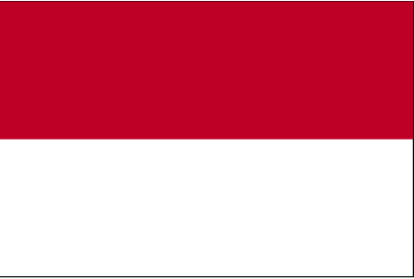

COUNTRY NAME: Republic of Indonesia

CAPITAL: Jakarta

PROFILE: Indonesia is the world's largest archipelago; it achieved independence from the Netherlands in 1949. Current issues include: alleviating widespread poverty, implementing IMF-mandated reforms of the banking sector, effecting a transition to a popularly-elected government after four decades of authoritarianism, addressing charges of cronyism and corruption, holding the military and police accountable for human rights violations, and resolving growing separatist pressures in Aceh and Papua.

GEOGRAPHY: Located in South Asia, archipelago of more than 17,000 islands (6,000 inhabited); straddles Equator; strategic location astride or along major sea lanes from Indian Ocean to Pacific Ocean. The country spans almost 2 million square kilometers between Asia and Australia. It's positioned across a region of immense volcanic activity, and Indonesia has some 400 volcanoes, with at least 70 still active. This tropical country and its many islands (including Bali) is one of the most beautiful (and popular) exotic tourism destinations on the planet.

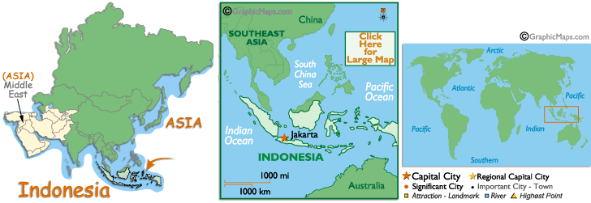

POPULATION: 238,452,952 (July 2004 est.)

CLIMATE/SEASON: Tropical; hot, humid; more moderate in highlands.
TERRAIN: mostly coastal lowlands; larger islands have interior mountains
Elevation extremes: lowest point: Indian Ocean 0 m; highest point: Puncak Jaya 5,030 m

FLORA AND FAUNA: Straddling the equator and marking the interface between the Asian and Australasian worlds, Indonesian has the richest flora and fauna of any country is South East Asia. Although it accounts for only 1.3% of the earth land area, Indonesia supports 10% of the worlds flowering plants (25,000 species), 12% of mammal species (500) 16% of the worlds amphibian and reptile species, 17% of bird species (1,600) and 25% of the world’s species of fish (8,500). In total there are 816 endemic species of fauna – animals found nowhere else in the world except Indonesia – including 210 mammal species, 430 bird, and 150 reptile.

AGRICULTURE: rice, cassava (tapioca), peanuts, rubber, cocoa, coffee, palm oil, copra, poultry, beef, pork, eggs.

INDUSTRIES: petroleum and natural gas, textiles, apparel, footwear, mining, cement, chemical fertilizers, plywood, rubber, food, tourism.

LANGUAGES: Bahasa Indonesia (official, modified form of Malay), English, Dutch, local dialects, the most widely spoken of which is Javanese

RELIGION: Muslim 88%, Protestant 5%, Roman Catholic 3%, Hindu 2%, Buddhist 1% (1998)

UNIT OF CURRENCY: Indonesian rupiah (IDR) (1US dollar equals - 9,311.19 Rupiah (2002)

GOVERNMENT: Republic.

CONTITUTION: August 1945, abrogated by Federal Constitution of 1949 and Provisional Constitution of 1950, restored 5 July 1959

LEGAL SYSTEM: based on Roman-Dutch law, substantially modified by indigenous concepts and by new criminal procedures code; has not accepted compulsory ICJ jurisdiction

SUFFRAGE: 17 years of age; universal and married persons regardless of age

VOLCANOES: Indonesia has more active volcanoes than any other country – 13% of the world’s total. It has also experienced more eruptions known to have affected people and their activities (156) than any country. Over the last 20 years an estimated 175,000 people have died form volcano activity in Indonesia and between 1985 and 1995 alone the country experienced no fewer than 38 eruptions.

EDUCATION/LITERACY: definition: age 15 and over can read and write, total population: 88.5%, male: 92.9%, female: 84.1% (2003 est.)

HEALTH: Indonesia is inevitable exposed to health risks not encountered in North America, Western Europe or Australian. Medical care is very variable, medical culture is quite different from the other neighboring countries, although there are some good hospitals in Jakarta and other main cities. The likelihood of finding a doctor who speaks English and a good standard of care diminishes very rapidly as you move away from the cities.

BRIEF HISTORY: Although hundreds of ethnic groups have been know as the indigenous of Indonesia for hundreds and thousands of years, Indonesia did not exist in its present form until the turn of the 20th century.
Of the so-called natives of Indonesia, archaeologists have speculated that the first people to populate Indonesia migrated from mainland China some 1,000 years ago and inhabited a stretch of islands along the equator, later known as Nusantara.
Over the centuries they built and refined their statecraft in the form of kingdoms and principalities. Sharing similar characteristics with other Southeast Asian kingdoms, these Nusantara kingdoms based their conception of state more on people than on space or territory. But intercourse with the western world changed the course of history in Nusantara.
In 1511, the Portuguese conquered Malacca, located on the Malay peninsula, which was then still an inseparable part of Nusantara. The Dutch followed in 1512 and landed on Banten shore in Java. At first, the Dutch came more as traders under the trading umbrella of the Royal East Indies Company (Vereniging Oost Indische Compagnie, VOC). For the next two centuries, the Dutch conducted business with the natives, although in many cases the trade was not on equal terms. Often, trade was accompanied by violent pacification processes.
Then the VOC went bankrupt and the Dutch government took over the business in Nusantara (called the East Indies by the Dutch). Starting from about the mid-seventh century and lasting until the arrival of the Japanese in 1942, was the "real colonization" called "high colonialism" in literature. The period was disrupted briefly when the British took over colonial rule in 1811 to 1814. Among other things that the natives learned from colonization was statecraft based on territorial conception rather than on people.
In the early 20th century, the natives of Nusantara learned that as diverse as their ethnicities were, they could imagine themselves as a unified community. Nationalism had grown in a process that Benedict Anderson, a doyen of Indonesian studies, calls an "imagined community". During the first half of 20th century Nusantara, its people built an imaginary nation called Indonesia -- the name itself was borrowed from the West. By the end of the 1930s, it was clear that the end of Dutch colonialism in Indonesia was only a matter of time.
During World War II, 1942-1945, the Japanese occupied Indonesia. Although short-lived, the occupation enabled Indonesians to arm themselves for the very first time. Shortly after Japan's defeat in WWII, Sukarno and Hatta proclaimed Indonesia an independent state, and they became the founding fathers of the new country. The largest archipelago in the world, with over 17,000 islands -- only 3,000 of which are inhabited -- has emerged into a new Indonesia.
When the Dutch returned and tried to reestablish colonial rule, armed Indonesians resisted. The Dutch were forced to recognize an independent Indonesia in 1949.
The new Indonesia adopted a federal system of governance for a short time. But for a longer period, within a five-year span (1950-1955), leaders of the new country were eager to adopt a liberal system of government. Although there is no proof that the system ruined the economy, it was clear that the elite's political stability was shaky. The longest serving prime minister was only two years in office.
The government then held a general election in 1955, the first and only democratic general election Indonesia ever had. But feeling that the country was still unstable two years after the election, president Sukarno, backed by the Army, declared the 1950 Provisional Constitution void and reintroduced the 1945 Constitution. The latter provided an ample opportunity for Sukarno, popularly known as Bung Karno (Comrade Sukarno), to balance three political powers -- the Indonesian Communist Party, the Army and himself.
In the first half of the 1960s, Bung Karno leaned toward the left. On domestic politics, he was trying hard to balance the communists and the Army; on the international stage he was establishing himself as leader of a new world, free from Cold War antagonism. But economic decline and mounting conflicts, especially between communists and non-communists, the latter of which was backed by the Army, caused him to lose control over the situation.
On Sept. 30, 1965, an abortive coup occurred. There are two conflicting versions of events surrounding the attempted coup. The official Army version insists that the Indonesian Communist Party (PKI) was behind the coup attempt, while the communist version asserts that the coup was an internal matter of the Army. In fact, several members of PKI's central bureau were involved, as well as many Army officers and personnel.
The abortive coup cost Indonesia dearly. It took the lives of seven high-ranking Army generals, followed by a pogrom of communists -- a moderate estimate ranges between 300 thousand and 500 thousand alleged members of PKI. Soeharto, who then was a major general and commander of the Army Strategic Reserves Command, took over leadership and deposed Bung Karno from his presidential seat.
In 1966, Soeharto received a letter known as the March 11 Letter of Instruction which reportedly transferred state power from Sukarno to him.
In 1967, Soeharto unseated Sukarno as president in the special session of the Provisional People's Consultative Assembly (MPRS).
Consolidating his power under a new regime called the New Order, Soeharto launched a "regime cleansing" against the Old Order.
Together with Hamengkubuwono IX, the sultan of Yogyakarta, and Adam Malik -- the three were known as the triumvirate -- Soeharto divided the tasks for economic and political reconstruction. Sultan Hamengkubuwono was assigned to lead efforts for economic recovery, Adam Malik was assigned to redirect Indonesia's foreign policy toward the West, and Soeharto himself was "assigned" to rebuild the lamentable domestic politics.
Soeharto was determined to change Indonesia's course, from its emphasis on politics to prioritizing economic development. He set up the trilogy of development: political stability, economic growth and equality.
To gain political legitimacy, perceived as a prerequisite to economic growth, the government conducted a general election in 1971. The election, however, was far from democratic. Soeharto introduced the "floating mass" concept that banned political parties from operating at village level.
From the 1971 election and throughout the New Order period, the Functional Group (Golongan Karya, or Golkar) served as Soeharto's main political machinery. Golkar legally operated not as a political party, although in fact it was a party. Golkar ran in the 1971 elections against 10 other political parties -- including PKI and Masyumi which were two of the four biggest parties in 1955 but which had been out of political scene -- and won 62 percent of the vote.
In 1974, Soeharto forced all political parties to merge into three: Golkar, the United Development Party (PPP) and the Indonesian Democratic Party (PDI). Again, legally speaking Golkar was not a political party. Five more elections were conducted every five years. During those years, Soeharto tightly controlled politics; not even the slightest room was available for opposition.
There were several cases of serious opposition during the New Order regime. The first came rather as a blow in 1974, when students protested against Japanese investments. Added by political rivalry between Gen. Soemitro and Maj. Gen. Ali Moertopo, student protests in Jakarta turned into riots. The movement ended with the removal of Soemitro from his powerful position as deputy commander of the Armed Forces and chief of staff of the Operation Command for the Restoration of Security and Order (Kopkamtib).
The second serious opposition movement came in 1978. Again it came from students, who protested Soeharto's bid for a second term in office, which would be decided upon by the People's Consultative Assembly in its General Session in March 1978.
Several retired Army officers backed the students, while factionalism was apparent within the Armed Forces. Soeharto moved fast to crush the movement. Hundreds of opposition and student leaders were arrested, dozens of newspapers and magazines were closed down. The movement lost its momentum, and after that Soeharto enjoyed an incontestable position.
If Golkar served as Soeharto's main political machinery, the Army functioned as guardian of the state. And since the state was personalized around Soeharto alone, the Army also served to protect him. Under its dual function role doctrine -- the doctrine argues that the duties of a professional Indonesian Armed Forces includes attending to nonmilitary business, especially if it has to do with politics -- the military intervened in almost all sectors of public life. At its peak, the number of military personnel serving in nonmilitary affairs reached over 40,000. Later, history witnessed excesses of the doctrine.
Some businesspeople, many of whom were of Chinese descent, enjoyed state protection and sometimes two-digit economic growth; some grew to become tycoons and magnates. The privileges that these businesspeople enjoyed sparked resentment from other communities. As a result, racial tension grew.
But Chinese businesspeople were not the only ones to enjoy state protection and preference. Some indigenous businesspeople also enjoyed similar privileges. In general, what Kunio Yoshihara calls "ersatz capitalism", or pseudo-capitalism, grew. Those "capitalists" were not real capitalists.
Then the financial crisis came. It first hit in mid-1997, and many believe it was a direct result of Thailand's economic crisis. The crisis worsen with the scheduling of the People's Consultative Assembly's General Session in March 1998, with the main agenda being to "elect" a "new" national leadership. It eventually turned into a political crisis too. But Soeharto was determined to run for his seventh consecutive five-year term in office. Supported by his political machine, Soeharto, as expected, became president again.
The economic and political crises made the political climate like a house of cards. Lacking sensitivity, Soeharto filled his new Cabinet with cronies, and appointed one of his daughters minister of social affairs. Less than two months after the formation of the new Cabinet, political tension mounted to an unbearable level. On May 12, four Trisakti University students were shot dead following a peaceful demonstration.
The shootings immediately sparked the emotions of the masses. To the majority of people, the New Order regime had become soulless. Within a week, Indonesia experienced one of its most tumultuous periods in history. For three days, from May 13 through to May 15, six of the country's largest cities were hit by massive riots, probably the largest riots in Indonesia's history. Days later, hundreds of thousand students and members of the public poured into the streets. Chanting and demanding total reform, thousands marched to the legislative building in Jakarta and occupied it for several days.
This forced Soeharto to step down. Instead of returning the presidential mandate to the People's Consultative Assembly (MPR) he gave the mandate to vice president B.J. Habibie. The new president is weak, but his weakness is one of his strengths. Everyone close to him feels that they can use him, and thus balancing the power is everyone's interest. The government scheduled another general election on June 7, 1999, only two years after the last election.
Forty-eight political parties, instead of three, competed for 462 seats in the House of Representatives, with the remaining 38 seats going to the military. The election was the first democratic poll since 1965, and the results should have a long-term effect on domestic political stability. The Indonesian Democratic Party of Struggle (PDI Perjuangan) won a majority in the House (DPR) with 35 percent of seats, followed by Golkar, the United Development Party (PPP), the National Awakening Party (PKB), the Crescent and Stars Party (PBB) and the National Mandate Party (PAN).
Despite its position as a simple majority party, PDI Perjuangan lost the political battle to install chairwoman Megawati Soekarnoputri as president. In a tight race against a strategic coalition of Golkar and the Axis Force, a coalition of various Islamic parties, PDI Perjuangan also lost the strategic posts of speakers of the House and People's Consultative Assembly. After losing out on the presidency, Megawati was elected as vice president.

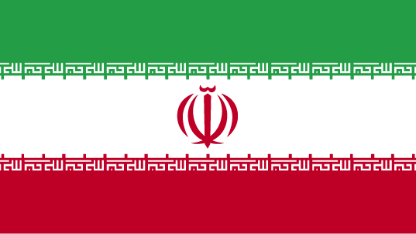

COUNTRY NAME: Islamic Republic of Iran (Iran)

GOVERNMENT TYPE: Theocratic republic

CAPITAL: Tehran

PROFILE: Known as Persia until 1935, Iran became an Islamic republic in 1979 after the ruling monarchy was overthrown and the shah was forced into exile. Conservative clerical forces established a theocratic system of government with ultimate political authority nominally vested in a learned religious scholar. Iranian-US relations have been strained since a group of Iranian students seized the US Embassy in Tehran on 4 November 1979 and held it until 20 January 1981. During 1980-88, Iran fought a bloody, indecisive war with Iraq that eventually expanded into the Persian Gulf and led to clashes between US Navy and Iranian military forces between 1987-1988. Iran has been designated a state sponsor of terrorism for its activities in Lebanon and elsewhere in the world and remains subject to US economic sanctions and export controls because of its continued involvement. Following the elections of a reformist President and Majlis in the late 1990s, attempts to foster political reform in response to popular dissatisfaction have floundered as conservative politicians have prevented reform measures from being enacted, increased repressive measures, and consolidated their control over the government.

LOCATION: Middle East, bordering the Gulf of Oman, the Persian Gulf, and the Caspian Sea, between Iraq and Pakistan

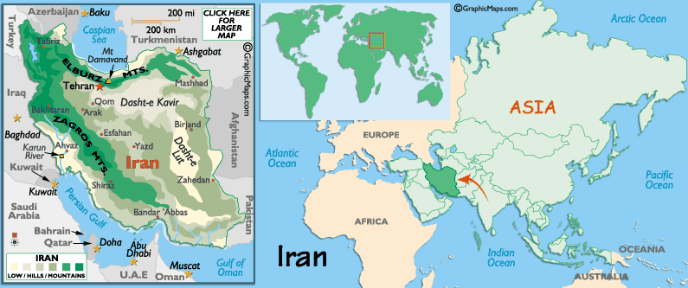
CLIMATE/TERRAIN: mostly arid or semiarid, subtropical along Caspian coast, rugged, mountainous rim; high, central basin with deserts, mountains; small, discontinuous plains along both coasts.

NATURAL RESOURCES: petroleum, natural gas, coal, chromium, copper, iron ore, lead, manganese, zinc, sulfur

POPULATION: 69,018,924 (July 2004 est.)

ETHNIC GROUPS: Persian 51%, Azeri 24%, Gilaki and Mazandarani 8%, Kurd 7%, Arab 3%, Lur 2%, Baloch 2%, Turkmen 2%, other 1%

RELIGION: Shi'a Muslim 89%, Sunni Muslim 9%, Zoroastrian, Jewish, Christian, and Baha'i 2%

LANGUAGES: Persian and Persian dialects 58%, Turkic and Turkic dialects 26%, Kurdish 9%, Luri 2%, Balochi 1%, Arabic 1%, Turkish 1%, other 2%

EDUCATION/LITERACY: definition: age 15 and over can read and write
total population: 79.4%, male: 85.6%, female: 73% (2003 est.)

ECONOMY: Iran's economy is marked by a bloated, inefficient state sector, over reliance on the oil sector, and statist policies that create major distortions throughout. Most economic activity is controlled by the state. Private sector activity is typically small-scale - workshops, farming, and services. President KHATAMI has continued to follow the market reform plans of former President RAFSANJANI, with limited progress. Relatively high oil prices in recent years have enabled Iran to amass some $22 billion in foreign exchange reserves, but have not eased economic hardships such as high unemployment and inflation. In December 2003 a major earthquake devastated the city of Bam in southeastern Iran, killing more than 30,000 people.

AGRICULTURAL PRODUCTS: wheat, rice, other grains, sugar beets, fruits, nuts, cotton; dairy products, wool; caviar

INDUSTRIES: petroleum, petrochemicals, textiles, cement and other construction materials, food processing (particularly sugar refining and vegetable oil production), metal fabricating, armaments

CURRENCY: Iranian rial (IRR)
BRIEF HISTORY: The first distinct people to emerge on the Iranian plateau were probably the Elamites, who established a city at Shush in the far south-west. The Aryans came to the region in the second millennium BC, bringing with them some agricultural and domestic skills. It wasn't until the middle of the 6th century BC, when the Achaemenian king Cyrus the Great ruled the region, that Persian history was documented. The Achaemenian Dynasty is recognised as the founder of the Persian Empire, leading to the eventual creation of Iran.
In the 4th century BC Alexander the Great invaded Persia after conquering most of Greece, Egypt, Turkey and Iraq. Despite three conciliatory offers from Darius III for a negotiated peace, Alexander entered Shush. From there, he took some time to cross the mountains to the east, but eventually entered Persepolis. After Alexander's death in 323 BC, the empire was divided into three squabbling dynasties, with Persia controlled by the Macedonian Seleucids. But the Seleucids had problems controlling the numerous feisty ethnic minorities, in particular the nomadic Parthians who came to control most of Persia until the 3rd century AD. The Sassanians came from the central regions of Persia not under direct control of the Parthians. They were an industrious Zoroastrian gang who promoted urban development and encouraged trade, but who eventually fell to squabbling and were overrun by the Arabs in 637.
The Arabs ruled until 1050, converting most of the population to Islam and introducing the new Persian script and Islamic culture. They were brought down by a Turkish dynasty, which captured Esfahan in 1051. Despite numerous rebellions, the Turks hung onto power until they were swept clean away by Genghis Khan's rampaging Mongols in the early 13th century. When the Mongols ran out of leaders in the late 14th century, the Timurid Dynasty filled the breach, but was then pressured by Turkmen tribes, Ottoman Turks and European colonialists such as Portugal.
The ensuing Safavid Dynasty (1502-1722) was one of the great Persian empires. The brilliant Shah Abbas I and his successors enshrined Shi'ism and rebuilt Esfahan, but the dynasty's decline was hastened by Afghan invasions in the early 18th century. The Afghans couldn't hold power and Iran was ruled by a succession of variously mad, bad and benevolent rulers until the even badder Agha Muhammed Khan, a eunuch, united the Turkish Ghajars in 1779 and went on to establish a capital in Tehran. The Ghajar kings ruled a relatively peaceful Iran until 1921, managing to remain neutral during WWI, but were not able to prevent a partial occupation by British forces keen to ensure a constant supply of oil.
One of the last Ghajar kings introduced the idea of elections and a legislative assembly (called the Majlis), but it wasn't until the charismatic Persian Reza Khan came along in 1923 that the idea stuck. Reza became prime minister, and commenced the huge task of dragging the country into the 20th century. Iran (the name was officially adopted in 1934) was again neutral during WWII but Britain and Russia established spheres of influence there to shut out Germany. In 1941, Reza was forced into exile in South Africa and his son, Mohammed Reza, succeeded him. After the war, the USA helped persuade the Russians to leave, the young Shah regained absolute power and Iran became firmly aligned with the West.
Over the next 30 years, there was a build up of resistance to Reza, who had adopted the title of Shah, and his regime of repression and modernization. As the economy went from bad to worse under the Shah's post oil-boom mismanagement, the growing opposition made its presence felt with sabotage and massive demonstrations. The Shah's responses became increasingly desperate and brutal, US support wavered, and he finally fled on 16 January 1979. A couple of weeks later, the acknowledged leader of the Shah's opponents, Ayatollah Khomeini, returned from exile to be greeted by adoring millions. The Ayatollah's fiery brand of nationalism and Islamic fundamentalism led to the efficient establishment of a clergy-dominated Islamic Republic, where the USA was styled as the 'Great Satan' and Israel fared not much better.
Not long after the Ayatollah was proclaimed Emam (leader), Iraqi President Saddam Hussein made an opportunistic land grab in Khuzestan province. It was a disastrous move, embroiling the two countries in a hideous war that killed hundreds of thousands before an unsatisfactory ceasefire was negotiated in 1988. The Western powers and the USSR supported Iraq, using 'lesser of two evils' logic, and weapons were only sold to Iran at vastly inflated prices.
On 4 June 1989, Ayatollah Khomeini died, leaving an uncertain legacy. Two months later Hojjat-ol-Eslam Rafsanjani was elected president, a post which had previously been largely ceremonial, and Khomeini's position as Supreme Leader was taken by the former president, Ayatollah Ali Khamenei. A trade embargo was implemented against Iran by the USA, who alleged that Iran had sponsored terrorist groups throughout the region and destabilized the peace process in the Middle East.
Following the 1997 landslide election of the moderate Iranian President Mohammed Khatami, many hoped that relations with the outside world would improve. However, relations with Germany (and most of Europe) hit rock bottom in 1997 after a German court ruled that the Iranian government had been involved in the assassination of Iranian Kurds in Germany several years earlier. Iran's international position was further destabilized when the US president George W. Bush lumped it into his 'axis of evil'.
Khatami's re-election encouraged Iranian reformers, but real power still remained with the Islamic clerics despite reformist rumblings and international pressure. In the 2004 elections the conservatives won control of parliament in a process marked by controversy - the hard-line Council of Guardians had disqualified many reform-minded candidates prior to the poll.
In 2003, Iran came under pressure from the International Atomic Energy Agency over its nuclear energy program. Subsequent IAEA inspections that year concluded there was no evidence that Iran had a nuclear weapons program.
Then in 2003 the country was hit by one of the catastrophic earthquakes to which it has historically been prone. Centered around the city of Bam in southeastern Iran, it killed 40,000 people and left the city in ruins.

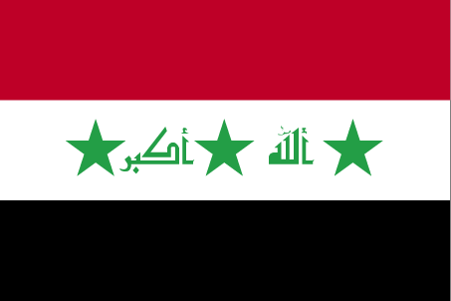

COUNTRY NAME: Republic of Iraq

GOVERNMENT TYPE: none; note - the Iraqi Interim Government (IG) was appointed on 1 June 2004, held a free election on January 30, 2005.

CAPITAL: Baghdad

PROFILE: Formerly part of the Ottoman Empire, Iraq was occupied by Britain during the course of World War I; in 1920, it was declared a League of Nations mandate under UK administration. In stages over the next dozen years, Iraq attained its independence as a kingdom in 1932. A "republic" was proclaimed in 1958, but in actuality a series of military strongmen ruled the country, the latest was Saddam Husayn. Territorial disputes with Iran led to an inconclusive and costly eight-year war (1980-88). In August 1990, Iraq seized Kuwait, but was expelled by US-led, UN coalition forces during the Gulf War of January-February 1991. Following Kuwait's liberation, the UN Security Council (UNSC) required Iraq to scrap all weapons of mass destruction and long-range missiles and to allow UN verification inspections. Continued Iraqi noncompliance with UNSC resolutions over a period of 12 years resulted in the US-led invasion of Iraq in March 2003 and the ouster of the regime. Coalition forces remain in Iraq, helping to restore degraded infrastructure and facilitating the establishment of a freely elected government, while simultaneously dealing with a robust insurgency.

LOCATION: Middle East, bordering the Persian Gulf, between Iran and Kuwait
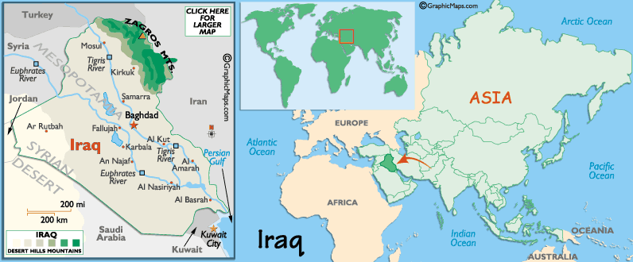

CLIMATE/TERRAIN: Mostly desert; mild to cool winters with dry, hot, cloudless summers; northern mountainous regions along Iranian and Turkish borders experience cold winters with occasionally heavy snows that melt in early spring, sometimes causing extensive flooding in central and southern Iraq. Mostly broad plains; reedy marshes along Iranian border in south with large flooded areas; mountains along borders with Iran and Turkey.

NATURAL RESOURCES: petroleum, natural gas, phosphates, sulfur

POPULATION: 25,374,691 (July 2004 est.)

ETHNIC GROUPS: Arab 75%-80%, Kurdish 15%-20%, Turkoman, Assyrian or other 5%

RELIGION: Muslim 97% (Shi'a 60%-65%, Sunni 32%-37%), Christian or other 3%

LANGUAGES: Arabic, Kurdish (official in Kurdish regions), Assyrian, Armenian

EDUCATION/LITERACY: definition: age 15 and over can read and write
total population: 40.4%, male: 55.9%, female: 24.4% (2003 est.)

ECONOMY: Iraq's economy is dominated by the oil sector, which has traditionally provided about 95% of foreign exchange earnings. In the 1980s financial problems caused by massive expenditures in the eight-year war with Iran and damage to oil export facilities by Iran led the government to implement austerity measures, borrow heavily, and later reschedule foreign debt payments; Iraq suffered economic losses from that war of at least $100 billion. After hostilities ended in 1988, oil exports gradually increased with the construction of new pipelines and restoration of damaged facilities. Iraq's seizure of Kuwait in August 1990, subsequent international economic sanctions, and damage from military action by an international coalition beginning in January 1991 drastically reduced economic activity. Although government policies supporting large military and internal security forces and allocating resources to key supporters of the regime have hurt the economy, implementation of the UN's oil-for-food program beginning in December 1996 helped improve conditions for the average Iraqi citizen. Iraq was allowed to export limited amounts of oil in exchange for food, medicine, and some infrastructure spare parts. In December 1999, the UN Security Council authorized Iraq to export under the program as much oil as required to meet humanitarian needs. The drop in GDP in 2001-02 was largely the result of the global economic slowdown and lower oil prices. Per capita food imports increased significantly, while medical supplies and health care services steadily improved. Per capita output and living standards were still well below the pre-1991 level, but any estimates have a wide range of error. The military victory of the US-led coalition in March-April 2003 resulted in the shutdown of much of the central economic administrative structure, but with the loss of a comparatively small amount of capital plant. The rebuilding of oil, electricity, and other production is proceeding steadily at the start of 2004 with foreign support and despite the continuation of severe internal strife. A joint UN and World Bank report released in the fall of 2003 estimated that Iraq's key reconstruction needs through 2007 would cost $55 billion. In October 2003, international donors pledged assistance worth more than $33 billion toward this rebuilding effort.

AGRICULTURAL PRODUCTS: wheat, barley, rice, vegetables, dates, cotton; cattle, sheep

INDUSTRIES: petroleum, chemicals, textiles, construction materials, food processing

CURRENCY: New Iraqi dinar (NID) as of 22 January 2004
BRIEF HISTORY: Iraq's mantle as the 'cradle of civilisation' is more than well-deserved. The region once known as Mesopotamia gave birth to the Sumerian, Akkadian, Aramean Babylonian and Aramean Assyrian civilisations, and thus played crucial roles in the development of agrarian society, codes of writing, religion and art.
The region subsequently fell into a decline and came under the tutelage of various Persian and Seleucid dynasties for some centuries. The region rose in importance for a second time however with the rise of Islam. Muslim Arabs stormed Mesopotamia in AD 656 as part of their rampage throughout the region. The strategic importance of the region's waterways played a key part in the political consolidation of the vigorous new monotheistic parvenu. By 762, the Abassid Caliphate had moved to Baghdad, which - as the descendant of nearby Babylon - soon came to rival its progenitor's historical fame as one of the world's great centers of power, religion, art and learning. Baghdad remained a site of contestation for some time. The area now known as Iraq was dominated in the late 1300s and early 1400s by the Black Sheep Turkmen, until the rival White Sheep Turkmen took over in 1466. Finally the Ottomans established suzerainty over the region and incorporated it into their Istanbul-centric empire in 1534.
Britain took control of Iraq following the collapse of the Ottoman empire, and the country became independent in 1932. On 14 July 1958, the monarchy was overthrown in a military coup and Iraq became a republic, ushering in a period of instability characterized by a series of coups and countercoups that continued throughout the 1960s.
The Arab-Israeli conflict of 1967 caused Iraq to turn to the Soviet Union for support, accusing the USA and UK of supporting Israel. On 17 July 1968, a bloodless coup by the Ba'ath Party, a secular socialist party founded in Syria in 1942, put General Ahmad Hassan al-Bakr in power. The 1970s represented a period of relative stability. In 1975, Iraq and Iran decided to settle their differences, and a boundary line was drawn down the middle of the Shatt al-Arab waterway.
The period also saw a rapprochement between the Kurds and Iraqi authorities, conflict between whom had been simmering since 1961. Iraq became a more stable country, and the economy improved on the back of growing oil revenues.
In 1979 Saddam Hussein replaced Al-Bakr as president, the revolution in Iran took place and relations between the two countries quickly sank to an all-time low. Iraq reignited the Shatt al-Arab waterway dispute. The Sunni-dominated Iraqi government was increasingly concerned about the threat of an Iran-style Shia-majority revolution in his own country.
Clashes took place along the border during 1980 and full-scale war broke out on 22 September when Iraqi forces entered Iran. The eight years of war that followed were brutal and bloody, all for little territorial gain. On the waters of the Guld, oil and other supply ships were destroyed. In March 1988 Kurdish guerrillas occupied government-controlled territory in Iraqi Kurdistan; in response, the Iraqi government killed thousands of civilians, forcing many more to escape to Iran and Turkey, and allegedly used chemical weapons.
Hostilities ceased in August 1988. In the eight years of war, a million lives had been lost on both sides, and Iraq's economic burden was estimated at more than US$100 billion. As Iraq started to emerge from the ravages of the war, relations with neighboring Kuwait began to sour. In July 1990, Hussein accused the Kuwaitis (with some justification) of waging 'economic warfare' against Iraq by attempting to artificially hold down the price of oil, and of stealing oil from the Iraqi portion of an oilfield straddling the border.
Arab attempts to mediate a peaceful end to the dispute failed and on 2 August 1990 Iraq invaded Kuwait, thinking it enjoyed tacit US approval. Though the UN condemned the move, Iraq annexed the emirate as its 19th province.
Western countries, led by the USA, imposed a trade embargo and more than half a million troops from 27 countries flooded into Saudi Arabia as the diplomatic stand-off over Kuwait deepened.
Despite frantic last-minute attempts by international leaders to broker a deal, the UN's 15 January deadline for withdrawal passed, the Iraqis did not budge. A barrage of Tomahawk cruise missiles signaled the start of the Gulf War. Allied (mostly US) aircraft began a five week bombing campaign over Iraq and Kuwait. In contrast, the subsequent ground offensive lasted only 100 hours. While there were relatively few casualties on the Allied side, estimates of civilian and military deaths on the Iraqi side range from 10,000 to more than 100,000.
A ceasefire was announced on 28 February 1991. The Security Council demanded the eradication of all weapons of mass destruction (WMD) and WMD-development programs before UN sanctions would be lifted.
The elite remnants of the Iraqi army turned their guns on Kurdish and Shiite uprisings in the north and south, leading the Allied forces to impose two 'no-fly' zones. As malnutrition increased and medical care became inadequate throughout Iraq, the oil-for-food plan was introduced in 1996. Meanwhile, the US and UK used the no-fly zones to launch regular bombing raids into Iraqi territory.
Though its people continued to suffer, Iraq dropped out of the Western media's gaze until the terrorist attacks in the US on September 11, 2001. The US-led war on terror initially focused on Afghanistan, but it wasn't long before Iraq was once more enemy number one on the White House hit-list. Though UN inspection teams found little to indicate a weapons of mass destruction program, Washington deemed that Iraq had run out of time. In the face of strong international condemnation, the 'coalition of the willing' invaded Iraq on 20 March 2003.
The Iraqi forces more or less capitulated. On April 9 2003, US forces took central Baghdad, Saddam's statue was toppled and with it went his regime. The resultant power-vacuum saw the country tip over into chaos. The transition to a new Iraqi government was slow, costly and often violent, with numerous Shia militia insurgencies, car bombings, ambush attacks on coalition troops and kidnappings of foreign civilians taking a high toll on all and sundry.
An interim government took charge in June 2004, but Iraq was a long way from stabilizing. The country's future remained very much in the balance.
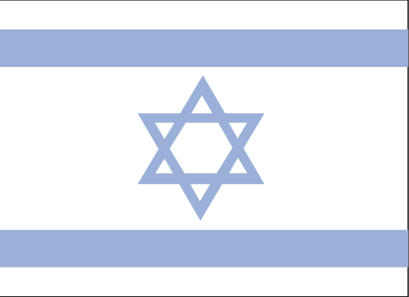

COUNTRY NAME: State of Israel (Israel)

GOVERNMENT TYPE: Parliamentary democracy

CAPITAL: Jerusalem; note - Israel proclaimed Jerusalem as its capital in 1950, but the US, like nearly all other countries, maintains its Embassy in Tel Aviv.

PROFILE: Following World War II, the British withdrew from their mandate of Palestine, and the UN partitioned the area into Arab and Jewish states, an arrangement rejected by the Arabs. Subsequently, the Israelis defeated the Arabs in a series of wars without ending the deep tensions between the two sides. The territories occupied by Israel since the 1967 war are not included in the Israel country profile, unless otherwise noted. On 25 April 1982, Israel withdrew from the Sinai pursuant to the 1979 Israel-Egypt Peace Treaty. Israel and Palestinian officials signed on 13 September 1993 a Declaration of Principles (also known as the "Oslo accords") guiding an interim period of Palestinian self-rule. Outstanding territorial and other disputes with Jordan were resolved in the 26 October 1994 Israel-Jordan Treaty of Peace. In addition, on 25 May 2000, Israel withdrew unilaterally from southern Lebanon, which it had occupied since 1982. In keeping with the framework established at the Madrid Conference in October 1991, bilateral negotiations were conducted between Israel and Palestinian representatives and Syria to achieve a permanent settlement. On 24 June 2002, US President Bush laid out a "road map" for resolving the Israeli-Palestinian conflict, which envisions a two-state solution. However, progress toward a permanent status agreement has been undermined by Palestinian-Israeli violence ongoing since September 2000. The conflict may have reached a turning point with the election in January 2005 of Mahmud Abbas as the new Palestinian leader following the November 2004 death of Yasser Arafat.

LOCATION: Middle East, bordering the Mediterranean Sea, between Egypt and Lebanon

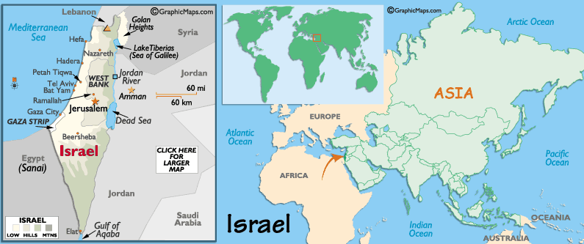

CLIMATE/TERRAIN: Temperate; hot and dry in southern and eastern desert areas, Negev desert in the south; low coastal plain; central mountains; Jordan Rift Valley

NATURAL RESOURCES: timber, potash, copper ore, natural gas, phosphate rock, magnesium bromide, clays, sand

POPULATION: 6,199,008
note: includes about 187,000 Israeli settlers in the West Bank, about 20,000 in the Israeli-occupied Golan Heights, more than 5,000 in the Gaza Strip, and fewer than 177,000 in East Jerusalem (July 2004 est.)

ETHNIC GROUPS: Jewish 80.1% (Europe/America-born 32.1%, Israel-born 20.8%, Africa-born 14.6%, Asia-born 12.6%), non-Jewish 19.9% (mostly Arab) (1996 est.)

RELIGION: Jewish 80.1%, Muslim 14.6% (mostly Sunni Muslim), Christian 2.1%, other 3.2% (1996 est.)

LANGUAGES: Hebrew (official), Arabic used officially for Arab minority, English most commonly used foreign language

EDUCATION/LITERACY: definition: age 15 and over can read and write
total population: 95.4%, male: 97.3%, female: 93.6% (2003 est.)

ECONOMY: Israel has a technologically advanced market economy with substantial government participation. It depends on imports of crude oil, grains, raw materials, and military equipment. Despite limited natural resources, Israel has intensively developed its agricultural and industrial sectors over the past 20 years. Israel imports substantial quantities of grain but is largely self-sufficient in other agricultural products. Cut diamonds, high-technology equipment, and agricultural products (fruits and vegetables) are the leading exports. Israel usually posts sizable current account deficits, which are covered by large transfer payments from abroad and by foreign loans. Roughly half of the government's external debt is owed to the US, which is its major source of economic and military aid. The bitter Israeli-Palestinian conflict; difficulties in the high-technology, construction, and tourist sectors; and fiscal austerity in the face of growing inflation led to small declines in GDP in 2001 and 2002. The economy grew at 1% in 2003, with improvements in tourism and foreign direct investment. In 2004, rising business and consumer confidence - as well as higher demand for Israeli exports - boosted GDP by 2.7%.

AGRICULTURAL PRODUCTS: citrus, vegetables, cotton; beef, poultry, dairy products

INDUSTRIES: high-technology projects (including aviation, communications, computer-aided design and manufactures, medical electronics), wood and paper products, potash and phosphates, food, beverages, and tobacco, caustic soda, cement, diamond cutting

CURRENCY: new Israeli shekel (ILS); note - NIS is the currency abbreviation; ILS is the International Organization for Standardization (ISO) code for the NIS
BRIEF HISTORY: Thickly literary, packed full of household names, and always tumultuous, Israel's history seeps from the past into the present, in a country where everyday interactions are shaped by thousand-year-old conflicts. It all began around 1800 BC when Abraham led a group of nomads from Mesopotamia and settled in the mountains of Canaan. By 1023 BC the Israelites had formed a kingdom, led by Saul and then David, who captured Jerusalem and made it his capital. In around 950 BC, David's son Solomon built one of Judaism's most important sites, the First Temple of Jerusalem. The Temple was destroyed in 586 BC by the invading Babylonians, but was eventually rebuilt. The unstoppable Roman Empire took Israel in 63 BC and placed it under the control of a series of consuls, including Herod the Great and Pontius Pilate. This is when Jesus was believed to have lived and preached in Israel. The increasing insanity of the Empire under Caligula prompted a Jewish uprising, which lasted four years but was finally crushed when the Temple was again destroyed. After a second revolt, Jerusalem itself was razed, a new city (Aelia Capitolina) built on its ruins, and the province of Palestine decreed. This defeat marked the end of the Jewish state and the beginning of the Diaspora, the scattering of the Jewish people.
In 331 AD Emperor Constantine became a Christian and gave his official stamp of approval to the previously illegal religion. Suddenly everyone wanted to know about the Holy Land, and a rash of buildings, including the churches of the Holy Sepulchre and the Nativity, sprang up all over Israel to mark sites of religious importance. But Christianity's hold over the country was not to last long - in 638 AD Jerusalem fell to Caliph Omar and was declared a Holy City of Islam, on the grounds that the Prophet Mohammed had ascended to heaven from atop the Temple Mount. Christians around the world raised their hackles at this desecration, and by 1099 they'd scrounged an army together and occupied Jerusalem, murdering everyone they could get their hands on and beginning nearly 100 years of Christian rule. But by 1187 the Muslims again had the upper hand - after decades of Christian/Muslim scuffling, the Islamic Mamluks knocked over the last Crusader stronghold in 1291.
The next 500 years were some of the quietest Israel has seen. Empires rose and fell, and control of the country changed hands with monotonous regularity, but very little of the fighting took place on Israeli soil - for the average Israelite, it was business as usual. The only blip occurred in the 16th century, when the Ottoman Empire took over the reins and Suleyman the Magnificent rebuilt Jerusalem's city walls. By the mid-19th century the Ottomans were losing their grip and world interest once again focused on Israel. Britain opened a consulate in Jerusalem, and in 1839 Sir Moses Montefiore, a British Jew, began promoting the idea of a Jewish state. In 1878 the first Jewish colony was founded, and before long the first Aliyah, or wave of immigrants, had started. At the same time, the Arab population of Palestine was becoming strongly nationalistic and anti-European, which did not bode well for the new arrivals.
At the time of WWI, Britain promised Arabs they'd recognize an Arab state, and Jews they'd support a Jewish homeland in Palestine. When the war ended, Britain was given a mandate to rule the country, and as Europe moved towards WWII, Britain decided to stop all migration to Israel. Desperate illegal immigrants continued to arrive, and the Arab population responded violently. By 1947 the situation had reached an impasse, Britain gave up its mandate and a resolution was passed to divide the country between Arabs and Jews. On 14 May 1948 Israel came into being. Egypt, Syria, Jordan and Lebanon invaded soon after but were defeated and when a ceasefire was declared in May 1949, Israel had extended the territory under its control in Palestine. Citizenship was offered to any Jewish person wishing to immigrate and the country began to fill with new arrivals.
In 1956, in response to Egyptian moves to take control of the Suez, Israeli, British and French armies invaded Egypt's Sinai Peninsula. Under strong international pressure, Israel handed back the Sinai and British and French troops withdrew.
Hostilities continued to percolate between Israel, Egypt, Syria, Jordan and Lebanon. On June 5, 1967 Israel reacted preemptively to the threats surrounding it and launched attacks against Arab troops along its borders. In the ensuing 'six day war' Israel extended its territory into the Golan Heights, the West Bank, the Gaza Strip and the Sinai Peninsula. In response, the Palestine Liberation Organization (PLO), founded in 1964, reformed under Yasser Arafat. The PLO claimed to be the sole representative of the Palestinian people and it vowed to regain their land and destroy the Israeli state.
In 1979, after having unsuccessfully attempted to regain the Sinai from Israel in the Yom Kippur war (1973), Egypt signed a mutual recognition pact with Israel and the Sinai was handed back. Tensions with Lebanon and Syria deteriorated and in 1981, Lebanon was invaded and the Golan Heights were formally annexed. Israel withdrew in 1985 but the area along its border in south Lebanon remained an occupied 'security zone' until 2000. A peace deal with Jordan was signed.
In 1987 a Palestinian popular uprising, the intifada, aimed at ending the encroachment of Jewish settlements in the West Bank and Gaza. It employed guerrilla warfare against Israeli forces. In 1993, the Oslo Peace Accord put mutual recognition between Israel and the PLO on the agenda. It also offered limited Palestinian self-rule in the West Bank and Gaza. The chances of success were scuttled when, in 1995, Rabin was assassinated. His replacement, Binyamin Netanyahu, toed a hard line in negotiations. During his time, Israeli settlements spread in the West Bank and Gaza and terrorist activity increased.
Ehud Barak was elected in 1999 promising to withdraw from the 'Security Zone' in southern Lebanon, where Israeli troops and Hezbollah guerrillas had been lobbing artillery at one another. As troops began evacuating in May 2000, the Hezbollah moved in rapidly and forced Israeli soldiers into a chaotic retreat under heavy fire. Nevertheless, it seemed that with Barak at the helm, Israel was closer to resolving its disputes with the Palestinians than at any time since 1967. At Camp David, far-reaching proposals were put on the table in exchange for a guarantee of safety and security and a cessation of terrorist violence. The Palestinians rejected the offer, with a stalemate on the status of Jerusalem, the right of return of Palestinian refugees and the need for a final settlement. The opportunity missed, the situation rapidly deteriorated. Following a provocative visit by Ariel Sharon to the al-Aqsa/Temple Mount complex in Jerusalem, vicious fighting broke out in the West Bank between Palestinian Authority police and Israeli soldiers. This left many dead and wounded, the fallout resulting in 300 dead by the end of 2000.
In 2001, hardliner Ariel Sharon replaced Barak, marking a shift in policy. The events of September 11 hardened the Israeli mood further as Palestinian aggression was dubbed the 'second intifada'. Sharon's pursuit of what were called Palestinian terrorists did little to stymie the wave of Palestinian suicide bombings.
Both sides blamed the other for each outbreak of bloodshed. As Palestinian suicide bombers killed or wounded scores of innocent people, the Israelis clamped down on the Palestinians, launching assaults against what it deemed were terrorist cells, and claiming innocent lives in the process - the ratio of Palestinian to Israeli casualties was about three to one.
Living conditions in the Palestinian Territories declined. The ageing Arafat resisted attempts to loosen his grip on power and was increasingly isolated. Israeli settlers on Palestinian land grew to number more than 250,000. Construction of a 'security fence' - more of a wall isolating Palestinians - was ruled illegal by the UN High Court and helped shred the much-vaunted US roadmap to peace.
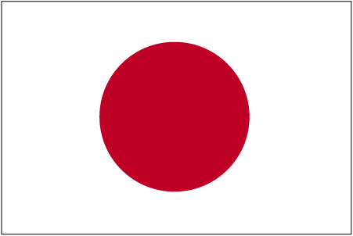

COUNTRY NAME: Japan

GOVERNMENT TYPE: Constitutional monarchy with a parliamentary government

CAPITAL: Tokyo

PROFILE: In 1603, a Tokugawa shogunate (military dictatorship) ushered in a long period of isolation from foreign influence in order to secure its power. For 250 years this policy enabled Japan to enjoy stability and a flowering of its indigenous culture. Following the Treaty of Kanagawa with the United States in 1854, Japan opened its ports and began to intensively modernize and industrialize. During the late 19th and early 20th centuries, Japan became a regional power that was able to defeat the forces of both China and Russia. It occupied Korea, Formosa (Taiwan), and southern Sakhalin Island. In 1933 Japan occupied Manchuria and in 1937 it launched a full-scale invasion of China. Japan attacked US forces in 1941 - triggering America's entry into World War II - and soon occupied much of East and Southeast Asia. After its defeat in World War II, Japan recovered to become an economic power and a staunch ally of the US. While the emperor retains his throne as a symbol of national unity, actual power rests in networks of powerful politicians, bureaucrats, and business executives. The economy experienced a major slowdown starting in the 1990s following three decades of unprecedented growth, but Japan still remains a major economic power, both in Asia and globally. In 2005, Japan began a two-year term as a non-permanent member of the UN Security Council.

LOCATION: Eastern Asia, island chain between the North Pacific Ocean and the Sea of Japan, east of the Korean Peninsula

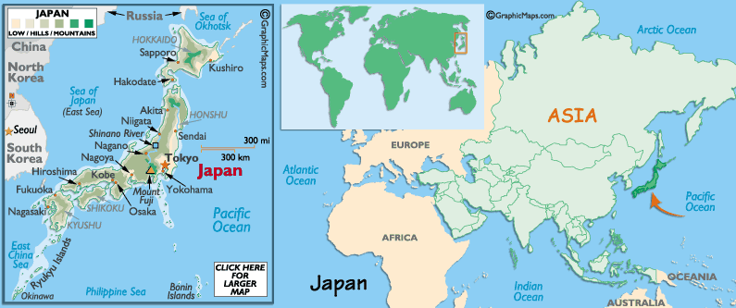

CLIMATE/TERRAIN: varies from tropical in south to cool temperate in north, mostly rugged mountains.

POPULATION: 127,333,002 (July 2004 est.)

ETHNIC GROUPS: Japanese 99%, others 1% (Korean 511,262, Chinese 244,241, Brazilian 182,232, Filipino 89,851, other 237,914), note: up to 230,000 Brazilians of Japanese origin migrated to Japan in the 1990s to work in industries; some have returned to Brazil (2004)

RELIGION: observe both Shinto and Buddhist 84%, other 16% (including Christian 0.7%)

LANGUAGES: Japanese

EDUCATION/LITERACY: definition: age 15 and over can read and write total population: 99%, male: 99%, female: 99% (2002)

NATURAL RESOURCES: negligible mineral resources, fish

ECONOMY: Government-industry cooperation, a strong work ethic, mastery of high technology, and a comparatively small defense allocation (1% of GDP) helped Japan advance with extraordinary rapidity to the rank of second most technologically-powerful economy in the world after the US and third-largest economy after the US and China. One notable characteristic of the economy is the working together of manufacturers, suppliers, and distributors in closely-knit groups called keiretsu. A second basic feature has been the guarantee of lifetime employment for a substantial portion of the urban labor force. Both features are now eroding. Industry, the most important sector of the economy, is heavily dependent on imported raw materials and fuels. The much smaller agricultural sector is highly subsidized and protected, with crop yields among the highest in the world.

Usually self-sufficient in rice, Japan must import about 50% of its requirements of other grain and fodder crops. Japan maintains one of the world's largest fishing fleets and accounts for nearly 15% of the global catch. For three decades overall real economic growth had been spectacular: a 10% average in the 1960s, a 5% average in the 1970s, and a 4% average in the 1980s. Growth slowed markedly in the 1990s, averaging just 1.7%, largely because of the after effects of overinvestment during the late 1980s and contractionary domestic policies intended to wring speculative excesses from the stock and real estate markets. Government efforts to revive economic growth have met with little success and were further hampered in 2000-2003 by the slowing of the US, European, and Asian economies. Japan's huge government debt, which totals more than 150% of GDP, and the ageing of the population are two major long-run problems. Robotics constitutes a key long-term economic strength with Japan possessing 410,000 of the world's 720,000 "working robots." Internal conflict over the proper way to reform the ailing banking system continues.

AGRICULTURAL PRODUCTS: rice, sugar beets, vegetables, fruit, pork, poultry, dairy products, eggs, fish
INDUSTRIES: among world's largest and technologically advanced producers of motor vehicles, electronic equipment, machine tools, steel and nonferrous metals, ships, chemicals, textiles, processed foods

CURRENCY: yen (JPY)
BRIEF HISTORY: Japan's earliest settlers were fishers, hunters and gatherers who slogged over the land bridges from Korea to the west and Siberia to the north. It's also thought that seafaring migrants from Polynesia were part of the ethnic blend. By AD 300, the sun-worshipping Yamato kingdom had loosely unified the nation through conquest and alliance. Buddhism was introduced from China in the mid-6th century and soon became the state religion. Rivalry between Buddhism and Shintō, the traditional religion of Japan, was diffused by presenting Shintō deities as manifestations of Buddha.
With the empire more or less stable, particularly after the conquest of the indigenous Ainu in the 9th century, Japan's emperors began to devote more time to leisure and scholarly pursuits and less time to government. Important court posts were dominated by the noble but corrupt Fujiwara family. Out in the provinces, a new power was on the rise: the samurai, or warrior class, readily turned to arms to defend its autonomy, and began to muscle in on the capital, Heian (modern-day Kyoto). The Taira clan briefly eclipsed the Fujiwara, and were ousted in turn by the Minamoto family in 1185. After assuming the rank of shōgun (military leader), Minamoto Yoritomo set up his HQ in Kamakura, while the emperor remained the nominal ruler in Kyoto. This was the beginning of a long period of feudal rule by successive samurai families which lingered until imperial power was restored in 1868.
The feudal centuries can be chunkily split into five main periods. The Kamakura Period (1185-1333) saw repeated invasions by Kublai Khan's Mongol armies. Japan managed to stave off the Mongols, but a weakened leadership lost the support of the samurai. Emperor Go-Daigo presided over the beginning of the Muromachi Period (1333-1576), until a revolt masterminded by the disgruntled warrior Ashikaga Takauji saw him flee to the hills. Ashikaga and his descendants ruled with gradually diminishing efficiency and Japan slipped into civil war and chaos. The various factions were pacified and unified during the Momoyama Period (1576-1600) by Oda Nobunaga and his successor Toyotomi Hideyoshi. The quick spread of Christianity during the Christian Century (1543-1640) was tolerated at first, then ferociously quashed as the interloping religion came to be seen as a threat. During the Tokugawa Period (1600-1867), Tokugawa Ieyasu defeated Hideyoshi's young heir and set up his headquarters at Edo (now Tokyo). The emperor continued to exercise purely nominal authority in Kyoto while the Tokugawa family led Japan into a period of national seclusion. Japanese were forbidden to travel overseas or to trade abroad and foreigners were placed under strict supervision. The rigid emphasis of these times on submitting unquestioningly to rules of obedience and loyalty has lasted, some would say, to the present day.
By the turn of the 19th century, the Tokugawa government was stagnant and corrupt. Foreign ships started to probe Japan's isolation with increasing insistence, and famine and poverty weakened support for the government. In 1868 the ruling shōgun, Tokugawa Yoshinobu, resigned and Emperor Meiji resumed control of state affairs, seeing Japan through a crash course in Westernization and industrialization. In 1889 Japan created a Western-style constitution, the tenets of which seeped into national consciousness along with a swing back to traditional values. Japan's growing confidence was demonstrated by the ease with which it trounced China in the Sino-Japanese War (1894-5) and Russia in the Russo-Japanese War (1904-5). Under Meiji's son, Yoshihito, Japan sided with the Allies in WWI. Rather than become heavily involved in the conflict, however, Japan took the opportunity, through shipping and trade, to expand its economy at top speed. Emperor Hirohito ascended to the throne in 1926. A rising tide of nationalism was quickened by the world economic depression that began in 1930. Popular unrest led to a strong increase in the power of the militarists: Japan invaded Manchuria in 1931 and entered into full-scale hostilities against China in 1937.
Japan signed a tripartite pact with Germany and Italy in 1940 and, when diplomatic attempts to gain US neutrality failed, the Japanese launched themselves into WWII with a surprise attack on Pearl Harbor on 7 December 1941. At first Japan scored rapid successes, pushing its battle fronts across to India, down to the fringes of Australia and out into the mid-Pacific. The Battle of Midway opened the US counterattack, puncturing Japanese naval superiority and turning the tide of war against Japan. By August 1945, with Japan driven back on all fronts, a declaration of war by the Soviet Union and the release of atomic bombs on Hiroshima and Nagasaki, it was all over. Emperor Hirohito announced unconditional surrender. Japan was occupied until 1952 by Allied forces who aimed to demilitarize the country and dismantle the power of the emperor. A recovery program enabled the economy to expand rapidly, and Japan became the world's most successful export economy, generating massive trade surpluses and dominating such fields as electronics, robotics, computing, car production and banking.
With the arrival of the 1990s, the old certainties seemed to vanish: Japan's legendary economic growth slowed to a virtual standstill; the conservative Liberal Democratic Party (LDP) was swept out of power and then back in again the next year; a massive earthquake in 1995 brought Kobe to its knees (a disaster made worse by a government that was slow to react); and to top it off, a millennial cult with doomsday ambitions engineered a poison gas attack on the Tokyo subway system.
Things began to look up with the appointment of Keizo Obuchi, who took over after Prime Minister Hashimoto was ousted by a voter backlash over the shrinking economy. Obuchi ushered in a few brief years of economic vitality, but the job took its toll and he died while still in office from a massive stroke. His successor, LDP stalwart Yoshiro Mori, held the dubious honor of possessing the lowest approval rating of any leader in recent Japanese history, until he announced his resignation in early April 2001. Mori's successor was the eccentric Junichiro Koizumi, who brought a beguiling mix of nationalism and reform to Japan's top job. Promising to end the culture of high-level nepotism that had in part led to the deflation, he distinguishes himself with his charisma and dashing haircut. His energies seem to be paying off: Japan's economy’s ever-so-slowly climbing out of its deflationary hole in the ground.
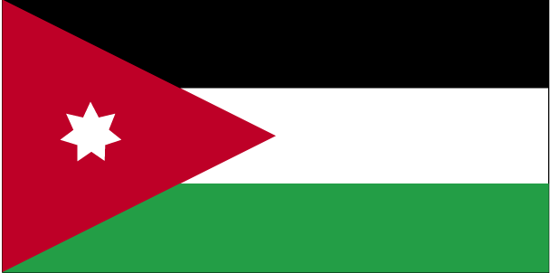

COUNTRY NAME: Hashemite Kingdom of Jordan (Jordan)

GOVERNMENT TYPE: Constitutional monarchy

CAPITAL: Amman

PROFILE: For most of its history since independence from British administration in 1946, Jordan was ruled by King Hussein (1953-99). A pragmatic ruler, he successfully navigated competing pressures from the major powers (US, USSR, and UK), various Arab states, Israel, and a large internal Palestinian population, despite several wars and coup attempts. In 1989 he reinstituted parliamentary elections and gradual political liberalization; in 1994 he signed a formal peace treaty with Israel. King Abdullah II - the eldest son of King Hussein and Princess Muna - assumed the throne following his father's death in February 1999. Since then, he has consolidated his power and undertaken an aggressive economic reform program. Jordan acceded to the World Trade Organization in 2000, and began to participate in the European Free Trade Association in 2001. After a two-year delay, parliamentary and municipal elections took place in the summer of 2003. The Prime Minister and government appointed in October 2004 declared their commitment to accelerated economic and political reforms and the new cabinet includes an unprecedented four women as ministers.

LOCATION: Middle East, northwest of Saudi Arabia

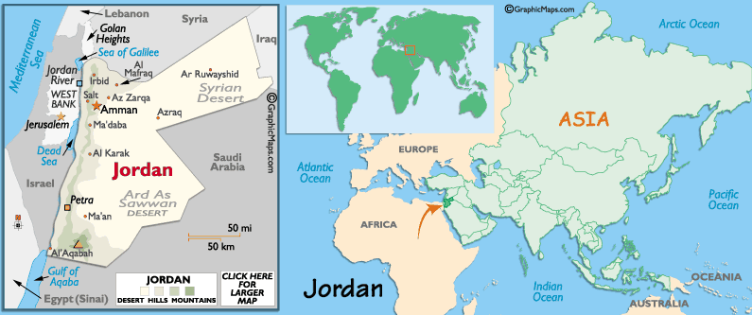

CLIMATE/TERRAIN: mostly arid desert; rainy season in west (November to April). mostly desert plateau in east, highland area in west; Great Rift Valley separates East and West Banks of the Jordan River

NATURAL RESOURCES: phosphates, potash, shale oil

POPULATION: 5,611,202 (July 2004 est.)

ETHNIC GROUPS: Arab 98%, Circassian 1%, Armenian 1%

RELIGION: Sunni Muslim 92%, Christian 6% (majority Greek Orthodox, but some Greek and Roman Catholics, Syrian Orthodox, Coptic Orthodox, Armenian Orthodox, and Protestant denominations), other 2% (several small Shi'a Muslim and Druze populations) (2001 est.)

LANGUAGES: Arabic (official), English widely understood among upper and middle classes

EDUCATION/LITERACY: definition: age 15 and over can read and write
total population: 91.3%
male: 95.9%
female: 86.3% (2003 est.)

ECONOMY: Jordan is a small Arab country with inadequate supplies of water and other natural resources such as oil. Debt, poverty, and unemployment are fundamental problems, but King ABDALLAH, since assuming the throne in 1999, has undertaken some broad economic reforms in a long-term effort to improve living standards. 'Amman in the past three years has worked closely with the IMF, practiced careful monetary policy, and made substantial headway with privatization. The government also has liberalized the trade regime sufficiently to secure Jordan's membership in the WTrO (2000), a free trade accord with the US (2000), and an association agreement with the EU (2001). These measures have helped improve productivity and have put Jordan on the foreign investment map. The US-led war in Iraq in 2003 dealt an economic blow to Jordan, which was dependent on Iraq for discounted oil (worth $300-$600 million a year). Several Gulf nations have provided temporary aid to compensate for the loss of this oil; when this foreign aid expires, the Jordanian government has pledged to raise retail petroleum product prices and the sales tax base. Other ongoing challenges include fiscal adjustment to reduce the budget deficit, broader investment incentives to promote job-creating ventures, and the encouragement of tourism.

AGRICULTURAL PRODUCTS: wheat, barley, citrus, tomatoes, melons, olives; sheep, goats, poultry

INDUSTRIES: phosphate mining, pharmaceuticals, petroleum refining, cement, potash, light manufacturing, tourism

CURRENCY: Jordanian dinar (JOD)
BRIEF HISTORY: Until the early 20th century, Jordan was part of Palestine, most of which is now the State of Israel. The area is home to one of the oldest civilizations in the world - archaeological finds from the west bank of the Jordan River have been dated at around 9000 BC. From 3000 BC the area was inhabited by the Canaanites and Amorites, and after them the armies of Sargon, king of Sumer and Akkad. Around 1800 BC Abraham led a group of nomads from Mesopotamia and settled in the mountains of Canaan (which roughly corresponds to present-day Israel). By 1023 BC the Israelites had formed a kingdom, led by Saul and then David, who captured Jerusalem and made it his capital. The unstoppable Roman Empire took Israel in 63 BC and placed it under the control of a series of consuls, including Herod the Great and Pontius Pilate. It was at this time that Jesus was believed to have lived and preached in the area. The increasing insanity of the Empire under Caligula prompted a series of Jewish uprisings, which lasted for years but were finally crushed when Jerusalem was razed and the province of Palestine decreed. This defeat marked the end of the Jewish state and the beginning of the Diaspora, the scattering of the Jewish people.
In 331 AD Emperor Constantine became a Christian and gave his official stamp of approval to the previously illegal religion. Suddenly everyone wanted to know about the Holy Land, and a rash of buildings, including the churches of the Holy Sepulchre and the Nativity, sprang up all over Palestine to mark sites of religious importance. But Christianity's hold over the country was not to last long - in 638 AD Jerusalem fell to Caliph Omar and was declared a Holy City of Islam, on the grounds that the Prophet Mohammed had ascended to heaven from atop the Temple Mount. Christians around the world raised their hackles at this desecration, and by 1099 they'd scrounged together a crusading army and occupied Jerusalem, murdering everyone they could get their hands on and beginning nearly 100 years of Christian rule. But by 1187 the Muslims again had the upper hand - after decades of Christian/Muslim scuffling, the Islamic Mamluks knocked over the last Crusader stronghold in 1291.
The next 500 years were some of the quietest Palestine has seen. Empires rose and fell, and control of the country changed hands with monotonous regularity, eventually coming to rest in the hands of the Ottoman Empire. Much of desert Jordan sidestepped all this change and remained a Bedouin stronghold.
When the Ottoman Empire collapsed after WWI, Britain took control of Palestine and created the state of Transjordan, under the rule of King Abdullah.
In 1948 Israeli Arabs and Jews went to war with one another. While everyone was distracted, Transjordan snapped up the West Bank and part of Jerusalem, then renamed itself Jordan. In 1953 King Hussein took the throne and Jordan entered a boom period, with a rise in tourism and plenty of aid flowing in from the USA. The Six Day War of 1967 put paid to Jordan's burgeoning tourist industry when Israel retook the West Bank and half of that huge drawcard, Jerusalem. In six days Jordan lost its money spinner and its agricultural land, and replaced them with a few thousand refugees as Palestinians streamed in from the Occupied Territories. By the 1970s, the PLO component of the refugee population was threatening King Hussein's power, and a bloody internal war began, ending when most of the radicals moved to Lebanon.
In 1994 Jordan and Israel signed a peace treaty, agreeing to drop economic barriers and cooperate on security and water. This has raised concerns among Palestinians that they will be eased out of the region, as Israel and Jordan divide the spoils between themselves. At the same time, Jordan has been increasing its links with Yasser Arafat's Palestine National Authority and working toward agreements with them. In recent years Jordan has also restored relations - cut during the 1991 Gulf War - with Kuwait and Saudi Arabia. King Hussein had begun moving the country towards democracy; the Islamic Action Front (with its links to the Muslim Brotherhood and fairly fundamentalist policies) has been the most successful party so far, but his death in February 1999 has left the future uncertain. King Hussein had named his eldest son, King Abdullah II, successor to the throne just weeks before dying, although the Constitution stipulates that both parents of the king must be Arab and Muslim by birth (Abdullah's mother was a British citizen who embraced Islam prior to marrying King Hussein).
King Abdullah, the sort of monarch who enjoys dressing up as a taxi driver and talking with his subjects incognito, has the growing support of the international community as well as most Jordanians, including the large and influential Palestinian community. Under his reign, Jordan has moved closer to Israel with a 2002 deal to pipe water from the Red Sea to the shrinking Dead Sea at a cost of 800000000, and a 2004 deal to develop a desert science centre on their mutual border. At the same time, ties with Egypt and Syria have been strengthened.
The first independent elections in 2003 saw a majority of seats go to independent royalist candidates. There were signs, however, that Jordan's 'each-way bet' foreign policy was under pressure. In October 2002 a senior US diplomat was assassinated in Amman, and the Jordanian embassy in Baghdad was bombed in August 2003, killing 11 people. The following month the central bank reversed its decision to freeze Hamas bank accounts.
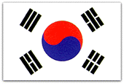

COUNTRY NAME: Republic of Korea (South Korea)

CAPITAL: Seoul

PROFILE: The Korean peninsula extends southward from the eastern end of the Asian continent. The peninsula is roughly 1,030 km (612 miles) long and 175 km (105 miles) wide at its narrowest point. Mountains cover 70% of Korea’s land mass, making it one of the most mountainous regions in the world. The lifting and folding of Korea’s granite and limestone base has created breathtaking landscapes of scenic hills and valleys. The mountain range that stretches the length of the east coast plunges steeply into the East Sea, while along the southern and western coasts, the mountains descend gradually to the coastal plains that produce the bulk of Korea’s agricultural crops, especially rice.

GEOGRAPHY: Eastern Asia, southern half of the Korean Peninsula bordering the East Sea and the Yellow Sea.

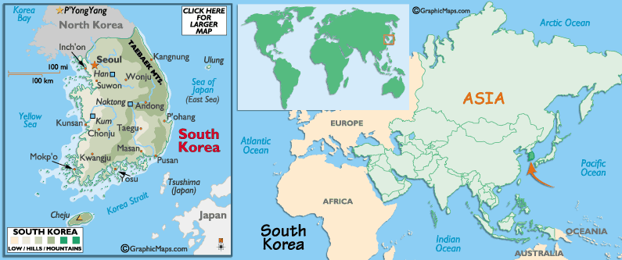

POPULATION: 48,598,175 (July 2004 est.)

CLIMATE/SEASONS: Korea's climate is regarded as a continental climate from a temperate standpoint and a monsoonal climate from a precipitation standpoint. The climate of Korea is characterized by four distinct seasons: spring, summer, fall, and winter.

FLORA: The national flower of Korea is the mugunghwa, rose of Sharon, blossoms graces the entire country. Various flowers, including the picturesque cherry blossom, azaleas, forsythia, bamboos, chrysanthemum, peonies, lilies, orchids, roses, evergreen and deciduous trees cover the nation's mountains and fields in Spring to Fall.

FAUNA: Korean (Siberia) tiger, bovine, goat, swine, horses, fish, water fowls, etc.

LANGUAGES: Korean (Hangeul). Hangeul written in syllabic units made up of two, three, or four letters. English is widely taught in schools.

RELIGION: Christian 49%, Buddhist 47%, Confucianist 3%, Shamanist, Chondogyo (Religion of the Heavenly Way), and other 1%

UNIT OF CURRENCY: South Korean Won (KRW). 1 US dollar equals approximately 1,150 Korean Won.

GOVERNMENT: Republic. Administratively, the Republic of Korea consists of nine provinces ; the capital Seoul; and the six metropolitan cities of Busan, Daegu, Incheon, Gwangju, Daejeon and Ulsan. In total, there are 77 cities and 88 counties.

CONSTITUTION: Adapted on 17 July 1948. Legal system combines elements of continental European civil law systems, Anglo-American law, and Chinese classical thought. Suffrage is 20 years of age; universal.

PRINCIPAL RIVERS: Nakdonggang, 522 km (313 miles); Hangang, 782 km (289 miles); Geumgang, 396 km (238 miles).

AGRICULTURE: rice, root crops, barley, vegetables, fruit; cattle, pigs, chickens, milk, eggs and fish.

INDUSTRIES: electronics, automobile production, chemicals, shipbuilding, steel, textiles, clothing, footwear, food processing. Exports: electronic products, machinery and equipment, motor vehicles, steel, ships; textiles, clothing, footwear; fish, $165 billion.

EDUCATION/LITERACY: age 15 and over can read and write, total population: 98.1%, male: 99.3%, female: 97% (2003 est.)

CULTURE: Pottery, Traditional Music, Traditional Dance, Traditional Clothing, Traditional Houses, Sports, Movies, Museums, Paintings and Writing.

NATURAL RESOURECS: coal, tungsten, graphite, molybdenum, lead, hydropower potential

LAND USE: arable land: 17.44%, permanent crops: 2.05%, other: 80.51% (1998 est.)

LOCAL DIET/TRADITIONAL FOOD: Cereals, rice, barley, everyday side dishes are mainly made of vegetables. Preservation foods such as Kimchi, pickles, salt-fermented seafoods, soybean-based sauces, fish, seaweeds, mountain-greens, shellfish, garlic, ginger, onions and other spices.
BRIEF HISTORY: Archaeological findings have indicated that the first settlements on the Korean Peninsula occurred 700,000 years ago.
According to the Koreans, the first of their kin was born in 2333 BC. Scientists with slightly less respect for Korean mythology believe Korea was first inhabited around 30,000 BC, when tribes from central and northern Asia stumbled on the peninsula. Under constant pressure from China, these tribes banded together to found Korea's first kingdom - Goguryeo - in the 1st century AD.
The next four centuries were known as the Three Kingdoms Period; Goguryeo (north), Baekje (southwest) and Silla (southeast). The period was marked by a remarkable flowering of the arts, architecture, literature and statecraft. It was also during this period that the formative influence of Buddhism took hold, established in Goguryeo and Baekje in the late 4th century and in Silla in the early 6th century. By 700 AD the Silla Kingdom of Korea was hitting its cultural stride, littering the country with palaces, pagodas and pleasure gardens and influencing the development of Japan's culture. But in the early 13th century the Mongols reached Korea and gave it their customary scorched-earth treatment. When the Mongol Empire collapsed, the Choson Dynasty took over and a Korean script was developed.
In 1592 Japan invaded, followed by China - the Koreans were routed and the Chinese Manchu Dynasty moved in. Turning its back on the mean and nasty world, Korea closed its doors to outside influence until the early 20th century.
Japan invaded the peninsula in 1904, and officially annexed it in 1910. The Japanese, who hung on until the end of WWII, were harsh masters, and anti-Japanese sentiment was strong. After the war, the USA occupied the south of the peninsula, while the USSR took over the north. Elections to decide the fate of the country were held only in the south, and when the south declared its independence, the north invaded. The ensuing war lasted until 1953 (or is still continuing, if you count MASH re-runs).
By the time the war ended, two million people had died and the country had been officially divided. After a few years of semi-democracy in the South, martial law was declared in 1972. The next 15 years roller-coastered between democracy and repressive martial law, hitting a stomach-heaving low in 1980 when 200 student protesters were killed in the Gwangju massacre. By the late 1980s the country was at flashpoint - student protests were convulsing the country and workers all over Korea were walking off the job to join them. Among the demands were democratic elections, freedom of the press and the release of political prisoners. The government wasn't budging and civil war looked imminent until, to everyone's jaw-dropping surprise, President Chun suddenly decided that everything the protesters were asking for was alright by him.
In 1988 - the year Seoul hosted the Olympic Games - elections were held and Roh Tae-woo, another military figure, was elected president. Student protests continued apace, but, contrary to expectations, Roh significantly freed up the political system. Relations were re-established with China and the Soviet Union. In 1992, Roh was replaced by Kim Young-sam and his Democratic Liberal Party. Kim's hobby horse was corruption, and during his term of office several politicians were prosecuted for abusing the system. Most notably, ex-presidents Chun and Roh were brought to book for their role in the Gwangju massacre. Roh was sentenced to 22 years, Chun to death, but in December 1997, Kim granted them a presidential pardon and the two were released from prison. 1997 was a very bad year for South Korea's economy, with the won taking a tumble and tourism dropping dramatically. In February 1998, former dissident Kim Dae-jung became president, the first time a non-conservative had headed the country in its 50 years of independence. Kim promised to introduce economic and democratic reforms and improve relations with North Korea.
By mid-1998 the South Korean economy was actually shrinking - something that hadn't occurred for nearly two decades. Rising bankruptcies and soaring unemployment led to large-scale labour unrest, but the economy is now on the move again.
Making good on promises of more neighbourly relations with North Korea, Kim made an historic visit to shake the hand of reclusive North Korean leader, Kim Jong Il, in June 2000. As a sign of good faith he allowed the North Korean government to arrange for his security. In October 2000 he was awarded the Nobel Peace Prize, and as part of a partnership with Japan and the USA continues to pursue a policy of cooperation with North Korea. In December 2001 he became the first Asian leader to speak before the European Parliament in Strasbourg.
A naval battle early the following year against North Korea that left four dead (and claimed an estimated 30 North Korean victims) highlighted the fragility of the rapprochement. In December 2002, Roh Moo-hyun won the presidency, but by early 2004 he was hanging on to power by a thread. Parliament voted to impeach him, but its decision was reversed by the Constitutional Court. Meanwhile, a site for the country's new capital city was chosen in the Yeongi-Kongju area and the US announced plans to reduce its troop numbers by a third.
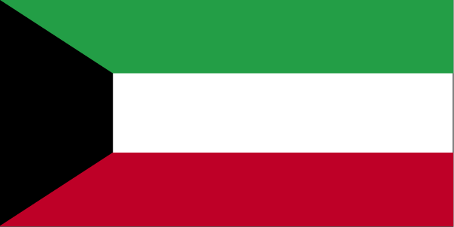

COUNTRY NAME: State of Kuwait (Kuwait)

GOVERNMENT TYPE: Nominal constitutional monarchy

CAPITAL: Kuwait

PROFILE: Britain oversaw foreign relations and defense for the ruling Kuwaiti AL-SABAH dynasty from 1899 until independence in 1961. Kuwait was attacked and overrun by Iraq on 2 August 1990. Following several weeks of aerial bombardment, a US-led, UN coalition began a ground assault on 23 February 1991 that liberated Kuwait in four days. Kuwait spent more than $5 billion to repair oil infrastructure damaged during 1990-91.

LOCATION: Middle East, bordering the Persian Gulf, between Iraq and Saudi Arabia

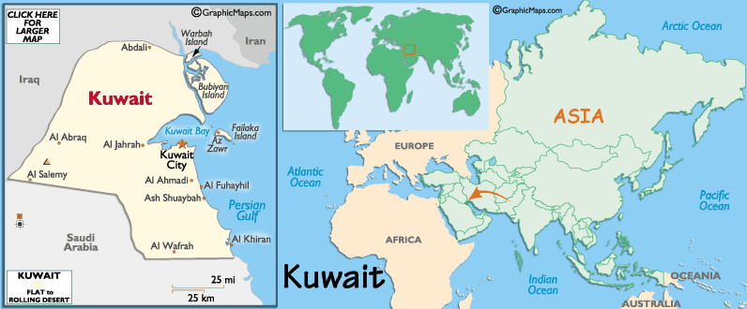

CLIMATE/TERRAIN: Dry desert; intensely hot summers; short, cool winters. Flat to slightly undulating desert plain

NATURAL RESOURCES: petroleum, fish, shrimp, natural gas

POPULATION: 2,257,549
note: includes 1,291,354 non-nationals (July 2004 est.)

ETHNIC GROUPS: Kuwaiti 45%, other Arab 35%, South Asian 9%, Iranian 4%, other 7%

RELIGION: Muslim 85% (Sunni 70%, Shi'a 30%), Christian, Hindu, Parsi, and other 15%

LANGUAGES: Arabic (official), English widely spoken

EDUCATION/LITERACY: definition: age 15 and over can read and write
total population: 83.5%
male: 85.1%
female: 81.7% (2003 est.)

ECONOMY: Kuwait is a small, rich, relatively open economy with proved crude oil reserves of about 98 billion barrels - 10% of world reserves. Petroleum accounts for nearly half of GDP, 95% of export revenues, and 80% of government income. Kuwait's climate limits agricultural development. Consequently, with the exception of fish, it depends almost wholly on food imports. About 75% of potable water must be distilled or imported. Kuwait continues its discussions with foreign oil companies to develop fields in the northern part of the country.

AGRICULTURAL PRODUCTS: Practically no crops; fish

INDUSTRIES: Petroleum, petrochemicals, desalination, food processing, construction materials

CURRENCY: Kuwaiti dinar (KWD)
BRIEF HISTORY: The headland now occupied by Kuwait City was settled only 300 years ago. In the early 18th century, Kuwait was nothing more than a few tents clustered around a storehouse-cum-fort. Eventually the families living around the fort divided among themselves the responsibilities attached to the new settlement. The Al-Sabah family, whose descendants now rule Kuwait, were appointed to handle local law and order. The small settlement grew quickly. By 1760, when the town's first wall was built, Kuwait's dhow fleet was reckoned to be 800 and its camel caravans traveled regularly to Baghdad and Damascus.
By the early 19th century, Kuwait was a thriving trading port. But trouble was always, literally, just over the horizon. It was often unclear whether Kuwait was part of the Ottoman Empire or not, though official Kuwaiti history is adamant that the sheikhdom was always independent of the Ottomans. During the second half of the 19th century, the Kuwaitis generally got on well with the Ottomans. They skillfully managed to avoid being absorbed into the empire as the Turks sought to solidify their control of eastern Arabia (then known as Al-Hasa). They did, however, agree to take the role of provincial governors of Al-Hasa.
That decision led to the rise of the pivotal figure in the history of modern Kuwait: Sheikh Mubarak al-Sabah al-Sabah, commonly known as Mubarak the Great, who reigned from 1896 to 1915. Mubarak was deeply suspicious of Turkey and was convinced that Constantinople planned to annex Kuwait. He overthrew and murdered his brother, the emir, did away with another brother and installed himself as ruler. In 1899 Mubarak signed an agreement with Britain: in exchange for the British navy's protection, he promised not to give away territory to, take support from or negotiate with any other foreign power without British consent. Britain's motive for signing the treaty was a desire to keep Germany, then the main ally and financial backer of Turkey, out of the Gulf. The Ottomans continued to claim sovereignty over Kuwait, but they were now in no position to enforce it.
Kuwait spent the early 1920s fighting off the army commanded by Abdul Aziz bin Abdul Rahman Al-Saud, the founder of modern Saudi Arabia. In 1923 the fighting ended with a British-brokered treaty. As a result, an oil concession was granted in 1934 to a US-British joint venture known as the Kuwait Oil Company (KOC). The first wells were sunk in 1936, and by 1938 it was obvious that Kuwait was virtually floating on oil. The outbreak of WWII forced the KOC to suspend operations, but when oil exports took off after the war so did Kuwait's economy. As the country became wealthy, health care, education and the general standard of living improved dramatically.
On 19 June 1961, Kuwait became an independent state. Elections for the first National Assembly were held the following year. Although representatives of the country's leading merchant families won the bulk of the seats, radicals had a toehold in the government from its inception. In August 1976, the cabinet resigned, claiming the assembly had made day-to-day governance impossible. The emir suspended the constitution, dissolved the assembly and asked the crown prince (who, by tradition, also serves as prime minister) to form a new cabinet. New elections were not held until 1981, but the assembly's new majority proved just as troublesome as the last and parliament was dissolved again in 1986.
Despite political and economic tensions, by mid-1990 the country's (and the Gulf's) economic prospects looked bright, particularly when the eight-year Iran-Iraq war ended. So it came as a shock when on 16 July 1990 Iraq sent a letter to the secretary-general of the Arab League accusing Kuwait of exceeding its OPEC quota and of stealing oil from the Iraqi portion of an oil field straddling the border. Iraqi president Saddam Hussein threatened military action. Over the next two weeks a series of envoys bent over backwards to offer Iraq a graceful way out of the dispute. But it was to no avail: Iraqi tanks were in Kuwait City before dawn on 2 August, and by noon they had reached the Saudi frontier. The emir and his cabinet fled to Saudi Arabia.
The United Nations quickly passed a series of resolutions calling on Iraq to withdraw from Kuwait. The Iraqis responded with the claim that they had been invited in by a group of Kuwaiti rebels who had overthrown the emir. On 8 August Iraq annexed the emirate. Western countries, led by the US, began to enforce a UN embargo on trade with Iraq, and in the months that followed more than half a million foreign troops flooded into Saudi Arabia.
At the end of November, the US and the UK secured a UN resolution authorizing the use of force to drive Iraq out of Kuwait if the Iraqis did not leave voluntarily before 15 January 1991. The deadline passed, the Iraqis didn't budge and within hours waves of Allied (mostly US) aircraft began a five-week bombing campaign of Iraq and Kuwait. The ground offensive, when it finally came, was something of an anticlimax: Iraq's army disintegrated in a mere 100 hours. At the end of February, Allied forces arrived in a Kuwait City choked by clouds of acrid black smoke from the hundreds of oil wells the Iraqis had torched as they retreated.
The government set about not simply rebuilding Kuwait, but rebuilding it exactly as it had been before the invasion. Meanwhile, a heated debate began over the country's political future. In keeping with a promise the opposition had extracted from the emir during the occupation, elections for a new National Assembly took place in October 1992. The opposition shocked the government by winning over 30 of the new parliament's 50 seats, and opposition MPs secured six of the 16 seats in the Cabinet, though the Al-Sabah family retained control of the key defence, foreign affairs and interior ministries. By the second anniversary of the invasion, Kuwait had largely succeeded in erasing the physical scars of war and occupation, although tensions with Iraq remained high.
In 1994, Kuwait convicted several Iraqis on charges of attempting to assassinate former US president George Bush when he visited the emirate the previous year. The plot, according to the Kuwaitis, was uncovered and foiled at the last minute.
Today, many resources are being used to remove land mines and clean up environmental damage left over from the Iraqi retreat, subsidized by the UN to the tune of US$5.9 billion. Ten percent of oil revenues are, by law, put into a trust to prepare for the day that Kuwait's massive oil reserves dry up. Also on the political agenda are women's rights: in May 1999, the Emir decreed that women would for the first time be able to vote and run for office in the 2003 general elections, subject to approval by the parliament. It was not approved. That same year saw Kuwait hit the world's centre stage once again, when great numbers of mainly US and British troops gathered in the emirate in readiness for the invasion of Iraq. As a result, pro-Islamic groups gained ground in parliamentary elections later that same year.
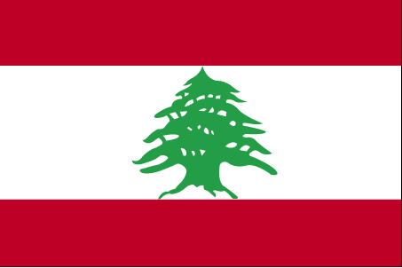

COUNTRY NAME: Lebanese Republic (Lebanon)

GOVERNMENT TYPE: Republic

CAPITAL: Beirut

PROFILE: Lebanon has made progress toward rebuilding its political institutions since 1991 and the end of the devastating 15-year civil war. Under the Ta'if Accord - the blueprint for national reconciliation - the Lebanese have established a more equitable political system, particularly by giving Muslims a greater say in the political process while institutionalizing sectarian divisions in the government. Since the end of the war, the Lebanese have conducted several successful elections, most of the militias have been weakened or disbanded, and the Lebanese Armed Forces (LAF) have extended central government authority over about two-thirds of the country. Hizballah, a radical Shia organization, retains its weapons. Syria maintains about 16,000 troops in Lebanon, based mainly east of Beirut and in the Bekaa Valley. Syria's troop deployment was legitimized by the Arab League during Lebanon's civil war and in the Ta'if Accord. Damascus justifies its continued military presence in Lebanon by citing Beirut's requests and the failure of the Lebanese Government to implement all of the constitutional reforms in the Ta'if Accord. Israel's withdrawal from southern Lebanon in May 2000, however, encouraged some Lebanese groups to demand that Syria withdraw its forces as well. The passage of UNSCR 1559 in early October 2004 - a resolution calling for Syria to withdraw from Lebanon and end its interference in Lebanese affairs - further emboldened Lebanese groups opposed to Syria's presence in Lebanon.

LOCATION: Middle East, bordering the Mediterranean Sea, between Israel and Syria

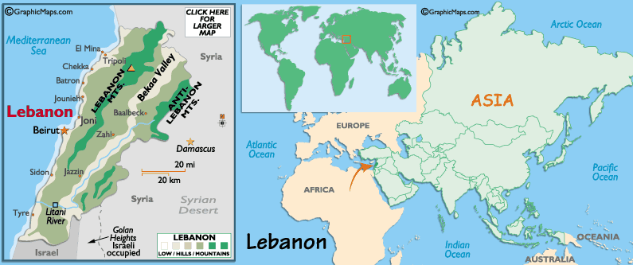
CLIMATE/TERRAIN: Mediterranean; mild to cool, wet winters with hot, dry summers; Lebanon mountains experience heavy winter snows. Narrow coastal plain; El Beqaa (Bekaa Valley) separates Lebanon and Anti-Lebanon Mountains

NATURAL RESOURCES: limestone, iron ore, salt, water-surplus state in a water-deficit region, arable land

POPULATION: 3,777,218 (July 2004 est.)

ETHNIC GROUPS: Arab 95%, Armenian 4%, other 1%

RELIGION: Muslim 59.7% (Shi'a, Sunni, Druze, Isma'ilite, Alawite or Nusayri), Christian 39% (Maronite Catholic, Melkite Catholic, Armenian Orthodox, Syrian Catholic, Armenian Catholic, Roman Catholic, Protestant), other 1.3%
note: seventeen religious sects recognized

LANGUAGES: Arabic (official), French, English, Armenian

EDUCATION/LITERACY: definition: age 15 and over can read and write
total population: 87.4%
male: 93.1%
female: 82.2% (2003 est.)

ECONOMY: The 1975-91 civil war seriously damaged Lebanon's economic infrastructure, cut national output by half, and all but ended Lebanon's position as a Middle Eastern entrepot and banking hub. Peace enabled the central government to restore control in Beirut, begin collecting taxes, and regain access to key port and government facilities. Economic recovery was helped by a financially sound banking system and resilient small- and medium-scale manufacturers. Family remittances, banking services, manufactured and farm exports, and international aid provided the main sources of foreign exchange. Lebanon's economy made impressive gains since the launch in 1993 of "Horizon 2000," the government's $20 billion reconstruction program. Real GDP grew 8% in 1994, 7% in 1995, 4% in 1996 and in 1997, but slowed to 1.2% in 1998, -1.6% in 1999, -0.6% in 2000, 0.8% in 2001, 1.5% in 2002, and 3% in 2003. During the 1990s, annual inflation fell to almost 0% from more than 100%. Lebanon has rebuilt much of its war-torn physical and financial infrastructure. The government nonetheless faces serious challenges in the economic arena. It has funded reconstruction by borrowing heavily - mostly from domestic banks. In order to reduce the ballooning national debt, the re-installed HARIRI government began an economic austerity program to rein in government expenditures, increase revenue collection, and privatize state enterprises. The HARIRI government met with international donors at the Paris II conference in November 2002 to seek bilateral assistance restructuring its domestic debt at lower rates of interest. While privatization of state-owned enterprises had not occurred by the end of 2003, massive receipts from donor nations stabilized government finances in 2002-04.

AGRICULTURAL PRODUCTS: citrus, grapes, tomatoes, apples, vegetables, potatoes, olives, tobacco; sheep, goats

INDUSTRIES: banking; food processing; jewelry; cement; textiles; mineral and chemical products; wood and furniture products; oil refining; metal fabricating

CURRENCY: Lebanese pound (LBP)
BRIEF HISTORY: Lebanon was the biblical 'land of milk and honey', and conquerors have always been attracted to its abundant natural resources, the safe anchorages on the coastline and the defensive possibilities of the high mountains. This has turned the country's history into a who's who of interlopers, pillagers and big-noters.
The shores of Lebanon attracted settlers from about 10,000 BC onwards, and by about 3000 BC their villages had evolved into prototype cities. By around 2500 BC the coast had been colonized by people who later became known as the Phoenicians, one of the Mediterranean's greatest early civilizations. The Phoenicians never unified politically: they dominated as a result of enterprise and intellectual endeavors emanating from a string of independent city states. They ruled the sea with their superior vessels and navigational skills, were exceptional craftspeople and created the first real alphabet.
In the 9th century BC, the Assyrians clomped in, breaking the Phoenician's monopoly on Mediterranean trade. They yielded to the Neo-Babylonians, who were in turn overcome by the Persians (whom the Phoenicians regarded as liberators). The Phoenicians finally declined when Alexander the Great swept through the Middle East in the 4th century BC and Phoenicia was gradually Hellenised. In 64 BC, Pompey the Great conquered Phoenicia and it became part of the Roman province of Syria. Beirut became an important centre under Herod the Great and splendid temples were built at Baalbek.
As the Roman empire crumbled, Christianity gained momentum and Lebanon became part of the eastern Byzantine Empire in the 4th century AD, with its capital at Constantinople (modern Istanbul). The imposition of orthodox Christianity didn't sit well, and when Muslims brought the word of Allah from the south, they faced little resistance in Lebanon.
The Umayyuds, the first great Muslim dynasty, held sway in Lebanon for about a century, but faced opposition from indigenous Jews and Christians, especially the Syrian Maronite sect who took refuge around Mount Lebanon. After the Umayyuds fell to the Abbasids in 750, Lebanon became a backwater of the Persian-flavoured Abbasid Empire. This empire lasted until the 11th century before being tipped out by the Fatimid dynasty, who struggled on until the rise of the Crusaders. The Crusaders had their sights set on Jerusalem, but marched down the Syrian and Lebanese coast, linking up with the Maronites, before savaging the Holy City.
The Muslim Ayyubids got their claws into Syria, Egypt, western Arabia and parts of Yemen until they were overthrown by the strange soldier-slave kings known as Mamluks, who ruled Lebanon from the end of the 13th century for the best part of 300 years. The Mamluks faded with the rise of the Ottoman Empire and Lebanon's tribal leaders - the Tanukhid emirs (Druze) of central Lebanon and the Maronites - formed conflicting alliances with various local factions.
The Ottoman Sultan Selim I conquered Lebanon in 1516-17 but was temporarily undermined by Fakhreddine (Fakhr ad-Din II, 1586-1635). Fakhreddine was not only ambitious, he was also wily and politically smart, talents that allowed him to unite, for the first time, the area that became known as modern Lebanon. In fact he was a little too smart for his own good, and his paymasters executed him. Fakhreddine was followed by his nephew Ahmad Maan, who was not quite the talent his uncle was, although he did play the game well enough to be 'awarded' an emirate by the Ottomans. When Ahmad Maan died, power passed to the Shihab family, who reigned until 1840, when internal power struggles brought the age of emirs to an end.
In 1842, the Ottomans divided Mount Lebanon into two administrative regions, one Druze and the other Maronite. That they immediately set to squabbling was anticipated and encouraged by the Ottomans, who practised a 'divide and rule' policy. By 1845, there was open war, not only between Druze and Maronite, but also between peasants and their supposed feudal leaders.
The Ottomans, under pressure from Europe, created a single Lebanese administrative unit under an Ottoman Christian governor and the feudal system was abolished. The system worked, producing stability and economic prosperity until WWI, when Lebanon came under Turkish military rule and suffered a serious famine. Following the Allied victory in 1918, Lebanon came under French rule.
During WWII Lebanon became fully independent and developed into a major trade centre. Lebanon's fatal flaw was that power rested with the right-wing Christian population while the Muslims (almost half the population) felt they were excluded from real government. Add large numbers of displaced Palestinians and there were all the ingredients for conflict. Civil war broke out in 1975 between a predominantly Muslim leftist coalition and Christian right-wing militias. Over the next 20-plus years, insanely complicated civil and international wars, and high-profile hostage-taking, were pretty much standard fare.
An eye-glazing summary follows: the Syrians intervened at the request of the Lebanese president to force an uneasy peace between Muslims and Christians, the Israelis marched in and set up a surrogate militia to protect northern Israel from the Palestine Liberation Organization (PLO), and the UN sent in peacekeepers to quell internal Christian-Muslim fighting. Israel laid siege to Beirut in 1982, with the stated aim of eradicating the PLO. Israel also supported Christian militias who massacred Palestinian civilians. The PLO was partially evacuated by the USA, and a Multinational Force (MNF) of US and Western European troops was deployed to protect Palestinian and Muslim civilians. When the Israelis withdrew, fighting broke out between Druze Muslim militias and Christian forces, and between Lebanese army units and Muslim militiamen. The MNF suffered heavy casualties and withdrew in early 1984.
The Syrians slowly brought the Muslim areas of Lebanon under their control, but in 1988 Lebanon's new military government sought to expel Syria. The attempt failed and fighting continued until Elias Hrawi, a moderate Maronite in good standing with Syria, seized the presidential reins. By 1992 all foreign hostages were released and Syrian troops began to withdraw. In August 1992 parliamentary elections were held for the first time in 20 years, and Muslim fundamentalists of the Iranian-backed Hezbollah party won the largest number of seats. Rafiq Hariri became the new prime minister. Prime minister Hariri was replaced in 1998 by Selim al-Hoss, and returned to power in 2000. Bickering between President Emile Lahoud and Hariri centres on issues of public spending and privatisation. This frosty relationship sets the scene for a showdown ahead of November 2004 elections.
Skirmishes between Hezbollah and Israeli soldiers continued through 1993, culminating in Operation Grapes of Wrath (1996) - an Israeli bombardment of 80 villages in southern Lebanon. Trouble flared up again in April 1996 when Israel launched more air strikes on southern Lebanon and Beirut. International response condemned Israel, and the UN swiftly negotiated a cease-fire. The long war cost some 150,000 Lebanese lives and left the country in a ruinous state.
Lebanon's infrastructure and economy remained at the mercy of greater, regional forces. Over previous decades, many of the players in Middle Eastern affairs had used Lebanon as their battleground, be it the PLO, the Syrians, the Iranians, the Israelis or the UN.
The Israelis withdrew from the 'security zone' in southern Lebanon in May of 2000, despite Syria's concerns with the Israeli-occupied Golan Heights. As troops began evacuating, the Hezbollah moved in rapidly and forced Israeli soldiers into a chaotic retreat. The withdrawal was celebrated within Lebanon. Hezbollah engineers soon restored power and water to civilians who'd gone without during the occupation.
Tensions with Israel remained high; in 2002, Israel protested Lebanon's diversion of water from the Wazzani River, which provides 10% of Israel's drinking water. International pressure on Syria to withdraw from Lebanon continued but with little effect: in September 2004 parliament - dominated by Syrian allies - voted to extend the president's term by three years.

COUNTRY NAME: Lebanese Republic (Lebanon)

GOVERNMENT TYPE: Republic

CAPITAL: Beirut

PROFILE: Lebanon has made progress toward rebuilding its political institutions since 1991 and the end of the devastating 15-year civil war. Under the Ta'if Accord - the blueprint for national reconciliation - the Lebanese have established a more equitable political system, particularly by giving Muslims a greater say in the political process while institutionalizing sectarian divisions in the government. Since the end of the war, the Lebanese have conducted several successful elections, most of the militias have been weakened or disbanded, and the Lebanese Armed Forces (LAF) have extended central government authority over about two-thirds of the country. Hizballah, a radical Shia organization, retains its weapons. Syria maintains about 16,000 troops in Lebanon, based mainly east of Beirut and in the Bekaa Valley. Syria's troop deployment was legitimized by the Arab League during Lebanon's civil war and in the Ta'if Accord. Damascus justifies its continued military presence in Lebanon by citing Beirut's requests and the failure of the Lebanese Government to implement all of the constitutional reforms in the Ta'if Accord. Israel's withdrawal from southern Lebanon in May 2000, however, encouraged some Lebanese groups to demand that Syria withdraw its forces as well. The passage of UNSCR 1559 in early October 2004 - a resolution calling for Syria to withdraw from Lebanon and end its interference in Lebanese affairs - further emboldened Lebanese groups opposed to Syria's presence in Lebanon.

LOCATION: Middle East, bordering the Mediterranean Sea, between Israel and Syria

CLIMATE/TERRAIN: Mediterranean; mild to cool, wet winters with hot, dry summers; Lebanon mountains experience heavy winter snows. Narrow coastal plain; El Beqaa (Bekaa Valley) separates Lebanon and Anti-Lebanon Mountains

NATURAL RESOURCES: limestone, iron ore, salt, water-surplus state in a water-deficit region, arable land

POPULATION: 3,777,218 (July 2004 est.)

ETHNIC GROUPS: Arab 95%, Armenian 4%, other 1%

RELIGION: Muslim 59.7% (Shi'a, Sunni, Druze, Isma'ilite, Alawite or Nusayri), Christian 39% (Maronite Catholic, Melkite Catholic, Armenian Orthodox, Syrian Catholic, Armenian Catholic, Roman Catholic, Protestant), other 1.3%
note: seventeen religious sects recognized

LANGUAGES: Arabic (official), French, English, Armenian

EDUCATION/LITERACY: definition: age 15 and over can read and write
total population: 87.4%
male: 93.1%
female: 82.2% (2003 est.)

ECONOMY: The 1975-91 civil war seriously damaged Lebanon's economic infrastructure, cut national output by half, and all but ended Lebanon's position as a Middle Eastern entry port and banking hub. Peace enabled the central government to restore control in Beirut, begin collecting taxes, and regain access to key port and government facilities. Economic recovery was helped by a financially sound banking system and resilient small- and medium-scale manufacturers. Family remittances, banking services, manufactured and farm exports, and international aid provided the main sources of foreign exchange. Lebanon's economy made impressive gains since the launch in 1993 of "Horizon 2000," the government's $20 billion reconstruction program. Real GDP grew 8% in 1994, 7% in 1995, 4% in 1996 and in 1997, but slowed to 1.2% in 1998, -1.6% in 1999, -0.6% in 2000, 0.8% in 2001, 1.5% in 2002, and 3% in 2003. During the 1990s, annual inflation fell to almost 0% from more than 100%. Lebanon has rebuilt much of its war-torn physical and financial infrastructure. The government nonetheless faces serious challenges in the economic arena. It has funded reconstruction by borrowing heavily - mostly from domestic banks. In order to reduce the ballooning national debt, the re-installed HARIRI government began an economic austerity program to rein in government expenditures, increase revenue collection, and privatize state enterprises. The HARIRI government met with international donors at the Paris II conference in November 2002 to seek bilateral assistance restructuring its domestic debt at lower rates of interest. While privatization of state-owned enterprises had not occurred by the end of 2003, massive receipts from donor nations stabilized government finances in 2002-04.

AGRICULTURAL PRODUCTS: citrus, grapes, tomatoes, apples, vegetables, potatoes, olives, tobacco; sheep, goats

INDUSTRIES: banking; food processing; jewelry; cement; textiles; mineral and chemical products; wood and furniture products; oil refining; metal fabricating

CURRENCY: Lebanese pound (LBP)
BRIEF HISTORY: Lebanon was the biblical 'land of milk and honey', and conquerors have always been attracted to its abundant natural resources, the safe anchorages on the coastline and the defensive possibilities of the high mountains. This has turned the country's history into a who's who of interlopers, pillagers and big-noters.
The shores of Lebanon attracted settlers from about 10,000 BC onwards, and by about 3000 BC their villages had evolved into prototype cities. By around 2500 BC the coast had been colonized by people who later became known as the Phoenicians, one of the Mediterranean's greatest early civilizations. The Phoenicians never unified politically: they dominated as a result of enterprise and intellectual endeavors emanating from a string of independent city states. They ruled the sea with their superior vessels and navigational skills, were exceptional craftspeople and created the first real alphabet.
In the 9th century BC, the Assyrians clomped in, breaking the Phoenician's monopoly on Mediterranean trade. They yielded to the Neo-Babylonians, who were in turn overcome by the Persians (whom the Phoenicians regarded as liberators). The Phoenicians finally declined when Alexander the Great swept through the Middle East in the 4th century BC and Phoenicia was gradually Hellenized. In 64 BC, Pompey the Great conquered Phoenicia and it became part of the Roman province of Syria. Beirut became an important centre under Herod the Great and splendid temples were built at Baalbek.
As the Roman Empire crumbled, Christianity gained momentum and Lebanon became part of the eastern Byzantine Empire in the 4th century AD, with its capital at Constantinople (modern Istanbul). The imposition of orthodox Christianity didn't sit well, and when Muslims brought the word of Allah from the south, they faced little resistance in Lebanon.
The Umayyuds, the first great Muslim dynasty, held sway in Lebanon for about a century, but faced opposition from indigenous Jews and Christians, especially the Syrian Maronite sect who took refuge around Mount Lebanon. After the Umayyuds fell to the Abbasids in 750, Lebanon became a backwater of the Persian-favored Abbasid Empire. This empire lasted until the 11th century before being tipped out by the Fatimid dynasty, who struggled on until the rise of the Crusaders. The Crusaders had their sights set on Jerusalem, but marched down the Syrian and Lebanese coast, linking up with the Maronites, before savaging the Holy City.
The Muslim Ayyubids got their claws into Syria, Egypt, western Arabia and parts of Yemen until they were overthrown by the strange soldier-slave kings known as Mamluks, who ruled Lebanon from the end of the 13th century for the best part of 300 years. The Mamluks faded with the rise of the Ottoman Empire and Lebanon's tribal leaders - the Tanukhid emirs (Druze) of central Lebanon and the Maronites - formed conflicting alliances with various local factions.
The Ottoman Sultan Selim I conquered Lebanon in 1516-17 but was temporarily undermined by Fakhreddine (Fakhr ad-Din II, 1586-1635). Fakhreddine was not only ambitious, he was also wily and politically smart, talents that allowed him to unite, for the first time, the area that became known as modern Lebanon. In fact he was a little too smart for his own good, and his paymasters executed him. Fakhreddine was followed by his nephew Ahmad Maan, who was not quite the talent his uncle was, although he did play the game well enough to be 'awarded' an emirate by the Ottomans. When Ahmad Maan died, power passed to the Shihab family, who reigned until 1840, when internal power struggles brought the age of emirs to an end.
In 1842, the Ottomans divided Mount Lebanon into two administrative regions, one Druze and the other Maronite. That they immediately set to squabbling was anticipated and encouraged by the Ottomans, who practised a 'divide and rule' policy. By 1845, there was open war, not only between Druze and Maronite, but also between peasants and their supposed feudal leaders.
The Ottomans, under pressure from Europe, created a single Lebanese administrative unit under an Ottoman Christian governor and the feudal system was abolished. The system worked, producing stability and economic prosperity until WWI, when Lebanon came under Turkish military rule and suffered a serious famine. Following the Allied victory in 1918, Lebanon came under French rule.
During WWII Lebanon became fully independent and developed into a major trade centre. Lebanon's fatal flaw was that power rested with the right-wing Christian population while the Muslims (almost half the population) felt they were excluded from real government. Add large numbers of displaced Palestinians and there were all the ingredients for conflict. Civil war broke out in 1975 between a predominantly Muslim leftist coalition and Christian right-wing militias. Over the next 20-plus years, insanely complicated civil and international wars, and high-profile hostage-taking, were pretty much standard fare.
An eye-glazing summary follows: the Syrians intervened at the request of the Lebanese president to force an uneasy peace between Muslims and Christians, the Israelis marched in and set up a surrogate militia to protect northern Israel from the Palestine Liberation Organization (PLO), and the UN sent in peacekeepers to quell internal Christian-Muslim fighting. Israel laid siege to Beirut in 1982, with the stated aim of eradicating the PLO. Israel also supported Christian militias who massacred Palestinian civilians. The PLO was partially evacuated by the USA, and a Multinational Force (MNF) of US and Western European troops was deployed to protect Palestinian and Muslim civilians. When the Israelis withdrew, fighting broke out between Druze Muslim militias and Christian forces, and between Lebanese army units and Muslim militiamen. The MNF suffered heavy casualties and withdrew in early 1984.
The Syrians slowly brought the Muslim areas of Lebanon under their control, but in 1988 Lebanon's new military government sought to expel Syria. The attempt failed and fighting continued until Elias Hrawi, a moderate Maronite in good standing with Syria, seized the presidential reins. By 1992 all foreign hostages were released and Syrian troops began to withdraw. In August 1992 parliamentary elections were held for the first time in 20 years, and Muslim fundamentalists of the Iranian-backed Hezbollah party won the largest number of seats. Rafiq Hariri became the new prime minister. Prime minister Hariri was replaced in 1998 by Selim al-Hoss, and returned to power in 2000. Bickering between President Emile Lahoud and Hariri centres on issues of public spending and privatization. This frosty relationship sets the scene for a showdown ahead of November 2004 elections.
Skirmishes between Hezbollah and Israeli soldiers continued through 1993, culminating in Operation Grapes of Wrath (1996) - an Israeli bombardment of 80 villages in southern Lebanon. Trouble flared up again in April 1996 when Israel launched more air strikes on southern Lebanon and Beirut. International response condemned Israel, and the UN swiftly negotiated a cease-fire. The long war cost some 150,000 Lebanese lives and left the country in a ruinous state.
Lebanon's infrastructure and economy remained at the mercy of greater, regional forces. Over previous decades, many of the players in Middle Eastern affairs had used Lebanon as their battleground, be it the PLO, the Syrians, the Iranians, the Israelis or the UN.
The Israelis withdrew from the 'security zone' in southern Lebanon in May of 2000, despite Syria's concerns with the Israeli-occupied Golan Heights. As troops began evacuating, the Hezbollah moved in rapidly and forced Israeli soldiers into a chaotic retreat. The withdrawal was celebrated within Lebanon. Hezbollah engineers soon restored power and water to civilians who'd gone without during the occupation.
Tensions with Israel remained high; in 2002, Israel protested Lebanon's diversion of water from the Wazzani River, which provides 10% of Israel's drinking water. International pressure on Syria to withdraw from Lebanon continued but with little effect: in September 2004 parliament - dominated by Syrian allies - voted to extend the president's term by three years.
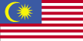

COUNTRY NAME: Malaysia

CAPITAL: Kuala Lumpur

GEOGRAPHY: Southeastern Asia, peninsula bordering Thailand and northern one-third of the island of Borneo, bordering Indonesia, Brunei, and the South China Sea, south of Vietnam.

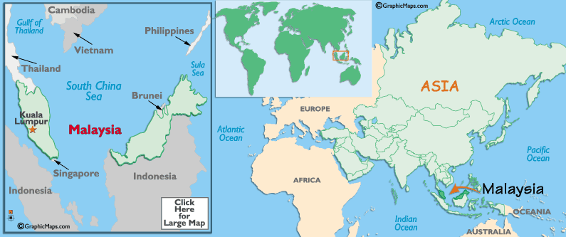

POPULATION: The estimated population of Malaysia is 23,522,482 (July 2004 est.) This encompasses several major ethnic groups: Malay and other indigenous 58%, Chinese 24%, Indian 8%, others 10% (2000).

PEOPLE/CULTURE: Malaysia's cultural mosaic is marked by many different cultures, but several in particular have had especially lasting influence on the country. Chief among these is the ancient Malay culture, and the cultures of Malaysia's two most prominent trading partners throughout history--the Chinese, and the Indians. These three groups are joined by a dizzying array of indigenous tribes, many of which live in the forests and coastal areas of Borneo. Although each of these cultures has vigorously maintained its traditions and community structures, they have also blended together to create contemporary Malaysia's uniquely diverse heritage.
GOVERNMENT: Malaysia’s form of government is a constitutional monarchy, with the unusual provision that the office of the King is not hereditary but is for a fixed term of five years and on a rotational system among the Rulers from the States. It provides that for the purposes of the appointment of the King, the order of precedence among the nine Rulers (based on the length of time the Rulers had reigned in their States) at the time of Independence, be followed. The constitutional form of government relies on a British-styled parliament with a prime minister.
LANGUAGES: Bahasa Melayu (official), English, Chinese dialects (Cantonese, Mandarin, Hokkien, Hakka, Hainan, Foochow), Tamil, Telugu, Malayalam, Punjabi, Thai.

RELIGION: Muslim, Buddhist, Daoist, Hindu, Christian, Sikh; note - in addition, Shamanism is practiced in East Malaysia

CLIMATE: Tropical; annual southwest (April to October) and northeast (October to February) monsoons.

AGRICULTURE: (Natural Resources, Crops, etc): Peninsular Malaysia - rubber, palm oil, cocoa, rice; Sabah - subsistence crops, rubber, timber, coconuts, rice; Sarawak - rubber, pepper; timber

LOCAL DIET/TRADITIONAL FOOD: Malaysia is deservedly well-known for its delightfully diverse foods. The cuisines of India, China, and Polynesia blend nicely with the traditional dishes of the Malays, some of which are contemporary versions of ancient recipes carried to the region by Arabian traders. Rice is the staple food and occurs in many varieties, as well as being ground into rice flour to produce noodles and cakes. Curries, seafood dishes, vegetarian meals, and highly local “hawker foods” combine to make Malaysia a gustatory paradise.

PRIMARY EXPORTS: Commodities valued at about $95.2 billion were exported in 2002. These included electronic equipment, petroleum and liquefied natural gas, wood and wood products, palm oil, rubber, textiles, chemicals.

UNIT OF CURRENCY: The unit of currency is the Malaysian ringgit. The value of the ringit has been fixed at 3.8 ringgit to the U.S. dollar for the past half decade.

EDUCATION/LITERACY: Approximately 90 per cent of Malaysians aged 15 are literate. Malaysia has a well organized system of public education, augmented by numerous private parochial schools. Classes may be taught in Bahasa Malaysia, Chinese (Mandarin), Indian dialects (primarily Tamil), or English, but all students must study Bahasa Malaysia as a required course.

Schools are organized along the lines of the British School System, with rigorous examinations required in order to move from one level to the next. Tertiary education is provided by a system of 15 universities and numerous technical colleges and institutes.

BRIEF HISTORY: Situated in the heart of Southeast Asia at one of the world's major crossroads, Malaysia has always been pivotal to trade routes from Europe, the Orient, India and China. Its warm tropical climate and abundant natural blessings made it a congenial destination for immigrants as early as 5,000 years ago when the ancestors of the Orang Asli, the indigenous peoples of Peninsular Malaysia, settle here, probably the pioneers of a general movement from China and Tibet. They were followed by the Malays, who brought with them skills in farming and the use of metals. Around the first century BC, strong trading links were established with China and India, and these had a major impact on the culture, language and social customs of the country. Evidence of a Hindu-Buddhist period in the history of Malaysia can today be found in the temple sites of the Bujang Valley and Merbok Estuary in Kedah in the north west of Peninsular Malaysia, near the Thai border. The spread of Islam, introduced by Arab and Indian traders, brought the Hindu-Buddhist era to an end by the 13th century. With the conversion of the Malay-Hindu rulers of the Melaka Sultanate (the Malay kingdom which ruled both side of the Straits of Malaka for over a hundred years), Islam was established as the religion of the Malays, and had profound effect on Malay society.

The arrival of Europeans in Malaysia brought a dramatic change to the country. In 1511, the Portuguese captured Malaka and the rulers of the Melaka Sultanate fled south to Johor where they tried to establish a new kingdom. They were resisted not only by the Europeans but by the Acehnese, Minangkabau and the Bugis, resulting in the sovereign units of the present-day states of Peninsular Malaysia. The Portuguese were in turn defeated in 1641 by the Dutch, who colonized Melaka until the advent of the British in the Dutch exerted any profound influence on Malay society. The British acquired Melaka from the Dutch in 1824 in exchange for Bencoolen in Sumatra. From their new bases in Malaka, Penang and Singapore, collectively known as the Straits Settlements, the British, through their influence and power, began the process of political integration of the Malay states of Peninsular Malaysia.
After World War II and the Japanese occupation from 1941-45, the British created the Malayan Union 1946.This was abandoned in 1948 and the Federation of Malaya emerged in its place. The Federation gained its independence from Britain on 31 August 1957.In September 1963, Malaya, Sarawak, Sabah, and initially Singapore united to form Malaysia, a country whose potpourri of society and customs derives from its rich heritage from four of the world's major cultures - Chinese, Indian, Islamic and Western.

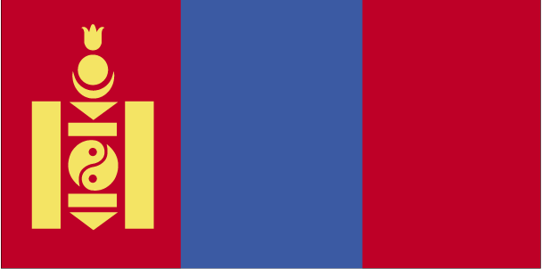
COUNTRY NAME: Mongolia

GOVERNMENT TYPE: mixed parliamentary/presidential

CAPITAL: Ulaanbaatar

PROFILE: The Mongols gained fame in the 13th century when under Chinggis KHAN they conquered a huge Eurasian empire. After his death the empire was divided into several powerful Mongol states, but these broke apart in the 14th century. The Mongols eventually retired to their original steppe homelands and later came under Chinese rule. Mongolia won its independence in 1921 with Soviet backing. A Communist regime was installed in 1924. During the early 1990s, the ex-Communist Mongolian People's Revolutionary Party (MPRP) gradually yielded its monopoly on power to the Democratic Union Coalition (DUC), which defeated the MPRP in a national election in 1996. Since then, parliamentary elections returned the MPRP overwhelmingly to power in 2000 and produced a coalition government in 2004.

LOCATION: Northern Asia, between China and Russia

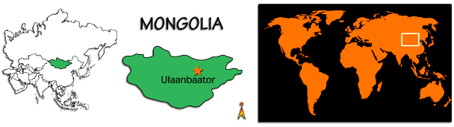

CLIMATE/TERRAIN: desert; continental (large daily and seasonal temperature ranges), vast semi-desert and desert plains, grassy steppe, mountains in west and southwest; Gobi Desert in south-central

POPULATION: 2,751,314 (July 2004 est.)

ETHNIC GROUPS: Mongol (mostly Khalkha) 94.9%, Turkic (mostly Kazakh) 5%, other (including Chinese and Russian) 0.1% (2000)

RELIGION: Buddhist Lamaist 50%, none 40%, Shamanist and Christian 6%, Muslim 4% (2004)

LANGUAGES: Khalkha Mongol 90%, Turkic, Russian (1999)

EDUCATION/LITERACY: definition: age 15 and over can read and write
total population: 97.8%, male: 98%, female: 97.5% (2002)

NATURAL RESOURCES: oil, coal, copper, molybdenum, tungsten, phosphates, tin, nickel, zinc, fluorspar, gold, silver, iron

ECONOMY: Economic activity traditionally has been based on agriculture and breeding of livestock. Mongolia also has extensive mineral deposits; copper, coal, molybdenum, tin, tungsten, and gold account for a large part of industrial production. Soviet assistance, at its height one-third of GDP, disappeared almost overnight in 1990-91 at the time of the dismantlement of the USSR. Mongolia was driven into deep recession, prolonged by the Mongolian People's Revolutionary Party's (MPRP) reluctance to undertake serious economic reform. The Democratic Union Coalition (DUC) government embraced free-market economics, eased price controls, liberalized domestic and international trade, and attempted to restructure the banking system and the energy sector. Major domestic privatization programs were undertaken, as well as the fostering of foreign investment through international tender of the oil distribution company, a leading cashmere company, and banks. Reform was held back by the ex-Communist MPRP opposition and by the political instability brought about through four successive governments under the DUC. Economic growth picked up in 1997-99 after stalling in 1996 due to a series of natural disasters and declines in world prices of copper and cashmere. In August and September 1999, the economy suffered from a temporary Russian ban on exports of oil and oil products, and Mongolia remains vulnerable in this sector. Mongolia joined the World Trade Organization (WTrO) in 1997. The international donor community pledged over $300 million per year at the Consultative Group Meeting, held in Ulaanbaatar in June 1999. The MPRP government, elected in July 2000, was anxious to improve the investment climate; it also had to deal with a heavy burden of external debt. Falling prices for Mongolia's mainly primary sector exports, widespread opposition to privatization, and adverse effects of weather on agriculture in early 2000 and 2001 restrained real GDP growth. Despite drought problems in 2002, GDP rose 4.0%, followed by a solid 5.0% increase in 2003. The first applications under the land privatization law have been marked by a number of disputes over particular sites. Russia claims Mongolia owes it $11 billion from the Soviet period; any settlement could substantially increase Mongolia's foreign debt burden.

AGRICULTURAL PRODUCTS: wheat, barley, potatoes, forage crops, sheep, goats, cattle, camels, horses

INDUSTRIES: construction materials; mining (coal, copper, molybdenum, fluorspar, and gold); oil; food and beverages; processing of animal products

CURRENCY: togrog/tugrik (MNT)
BRIEF HISTORY: Archeological digs have uncovered human remains in the Gobi and other regions of Mongolia dating back nearly 500,000 years. Despite Mongolia's short summers, wheat growing has co-existed for thousands of years with nomadic herding, which the Mongols took up after they tamed horses, yaks and camels.
The name 'Mongol' was first recorded by the Chinese during the Tang dynasty (618-907 AD). At that time Mongolia was dominated by a Turkic people called the Uighurs. The Uighurs were influenced by Christianity and, after taking control of Mongolia, went on to save the ailing Tang rulers of China from an internal revolt. The Uighurs controlled most of Mongolia until 840 AD, when they were defeated by the Kyrgyz, who now live in the Chinese province of Xinjiang.
The Mongols had little inclination to ally with other nomadic peoples of northern Asia. They remained little more than a loose confederation of rival clans until the late 12th century, when a 20-year-old Mongol named Temujin emerged and managed to unite most of the Mongol tribes. In 1189 he was given the honorary name of Genghis Khan, meaning 'universal king'. The Genghis Khan imprinted in the memory of the west bears little relation to the Chinggis Khaan revered by Mongolians. Not only the spelling is different: to Europeans, the name epitomizes merciless warmongering; to the Mongolians, it embodies strength, unity, law and order. Genghis set up his capital in present-day Kharkhorin, and launched his vital cavalry - built on Mongolia's prized takhi horses - against China and Russia. By the time of his death in 1227, the Mongol empire extended from Beijing to the Caspian Sea.
Genghis' grandson, Kublai Khan (circa 1216-94), completed the subjugation of China, ending the Song dynasty (960-1279) and becoming emperor of China's Yuan dynasty (1271-1368). Kublai soon realized, though, that the Mongol empire had reached the limits of its expansion. Instead of looking for more wars to fight, he concentrated on keeping the vast empire together. This was the height of the Mongols' glory: the empire stretched from Korea to Hungary and as far south as Vietnam, making it the largest empire the world has ever known.
After Kublai Khan's death in 1294, the Mongols became increasingly dependent on the people they ruled. They were deeply resented as an elite, privileged class exempt from taxation, and the empire became ridden with factions vying for power. The Mongols were expelled from Beijing by the first emperor of the Ming dynasty in the mid 14th century. The collapse of the Yuan dynasty caused over 60,000 Mongols to return to Mongolia. Their unity dissolved and frequent clan warfare and a long period of decline followed. Manchu rule over China was reasonably benign until around 1800; thereafter the Qing emperors became increasingly corrupt and despotic.
In 1911 China's Qing dynasty crumbled. The Mongols quickly saw their opportunity and independence from China was declared on 1 December 1911, with a theocratic government under the leadership of the 8th Jebtzun Damba (Living Buddha). On 25 May 1915, the Treaty of Kyakhta, which granted Mongolia limited autonomy, was signed by Mongolia, China and Russia.
The Russian Revolution of 1917 shocked Mongolia's aristocracy. Taking advantage of Russia's weakness, a Chinese warlord sent his troops into Mongolia in 1919 and occupied the capital. In early 1921, retreating White Russian anticommunist troops entered Mongolia and expelled the Chinese. The brutality of both the Chinese and Russian forces inflamed the Mongolians' desire for independence. As the Russian Bolsheviks were steadily advancing against the White Russian forces in Siberia, Mongolian nationalists asked the Bolsheviks for help. Together they recaptured Ulaan Baatar in July 1921. The country's Buddhist leader was retained as a figurehead and the newly formed Mongolian People's Party (the first political party in the country's history, and the only one for the next 69 years) took over the government. On 26 November 1924, the Mongolian People's Republic (MPR) was declared and Mongolia became the world's second communist country.
Mongolian communism remained fairly independent of Moscow until Stalin gained absolute power in the late 1920s. The Stalinist purges that followed swept Mongolia into a totalitarian nightmare, with the government's campaign against religion being particularly ruthless. In 1937 a reign of terror was launched against the monasteries, and thousands of monks were executed. It's believed that by 1939 some 27,000 people had been executed, three per cent of Mongolia's population at the time.
As the Soviet regime faltered in the early 1980s, Mongolia came under the leadership of Jambyn Batmonkh, a decentralizer heartened by the Soviet reforms under Mikhail Gorbachev. Batmonkh instigated a cautious attempt at perestroika and glasnost in 1986. By 1989 full diplomatic relations were established with China. The unraveling of the Soviet Union resulted in decolonization by default. Few in Mongolia were ready for the speed of the collapse or prepared to seize the moment.
In March 1990, large pro-democracy protests erupted in the square in front of the parliament building in Ulaan Baatar and hunger strikes were held. Things then happened quickly: Batmonkh lost power; new political parties sprang up; and hunger strikes and protests continued. In May the government amended the constitution to permit multiparty elections but, ironically, rural areas voted overwhelmingly to stay under the protective shelter of the communist party. The communist party were forced into making concessions that snowballed into the election of the Mongolian Democratic Coalition on 30 June 1996, ending 75 years of unbroken communist rule.
Over the next few years, successive Mongolian governments pursued Western-style policies of reform and privatization and courted foreign investment, but by 1998 poverty was still on the rise. Mongolia joined the World Trade Organization in 1997 but membership didn't make much of an immediate dent in the country's wide-scale poverty and famine. A couple of particularly harsh winters in 2000 and 2001 impacted badly on the nomadic Mongolian way of life and brought the country to its knees.
Foreign aid - including low-interest loans from the UN in 2001 and a massive annulment of Russian debt in 2004 - relieved some of the economic burden but Mongolia was still struggling with the fiscal implications of its new-found freedom. Meanwhile, forays into the world of international diplomacy saw a visit from the Dalai Lama in 2002 bitterly condemned by China and 300 troops sent to Iraq in 2003 as part of a peacekeeping force.
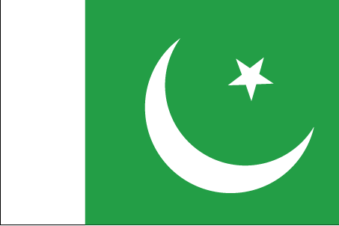

COUNTRY NAME: ISLAMIC REPUBLIC OF PAKISTAN

CAPITAL: Islamabad

PROFILE: Pakistan displays some of Asia’s most magnificent landscapes as it stretches from the Arabian Sea, its southern border, to some of the world’s most spectacular mountain ranges in the north. Pakistan is also home to sites that date back to the world’s earliest settlements rivaling those of ancient Egypt and Mesopotamia.

GEOGRAPHY: Located in South Asia, Pakistan shares an eastern border with India and a north-eastern border with China. Iran makes up the country’s south-west border, and Afghanistan runs along its western and northern edge. The Arabian Sea is Pakistan’s southern boundary with 1,064 km of coastline.

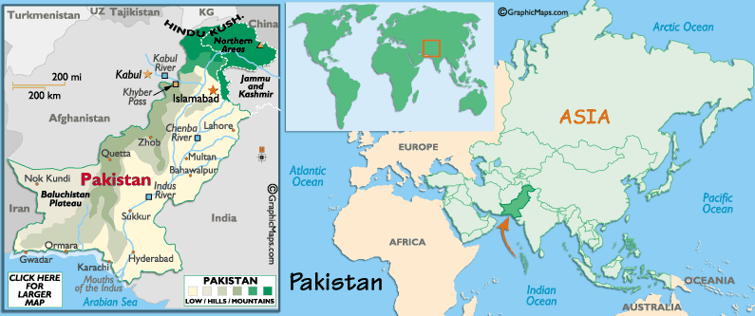

POPULATION: 159,196,336 (July 2004 est.)

CLIMATE/SEASONS: All four seasons; Home to the world's second highest peak, K2, Pakistan is among the world's premier mountain trekking destinations, with ample stretches of the mighty Himalayas.

FLORA: Pine, Oak, Poplar, Deodar, Maple, Mulberry

FAUNA: The Pheasant, Leopard, Deer, Ibex, Chinkara, Black Buk, Neelgai, Markhor, Marcopolo, Sheep, Green Turtles, River and Sea Fish, Crocodiles, Water Fowl.
LANGUAGES: Urdu (National Language) Punjabi 48%; Sindhi 12%; Siraiki (a Punjabi variant) 10%; Pashtu 8%; Urdu (official) 8%; Balochi 3%; Hindko 2%; Brahui 1%; English (official and lingua franca of Pakistani elite and most government ministries)

RELIGION: Islam (Ethnic Composition: 95% Muslims, 5% Christian, Hindu and others)

UNIT OF CURRENCY: Pakistan Rupee (1US dollar equals approximately 55 Pakistani Rupees).

GOVERNMENT: Federal Republic. Parliamentary form of government.

CONSTITUTION: The parliament consists of two houses; the Senate (Upper House) and the National Assembly (Lower House). The Senate is a permanent legislative body and symbolizes a process of continuity in the national affairs. It consists of 87 members. The four provincial assemblies, Federally Administered Tribal Areas, and Federal Capital, form its electoral college. The National Assembly has a total membership of 342 elected through adult suffrage.

PRINCIPAL RIVER: The Indus River, the longest river in southwest Asia, flows 1900 miles before emptying into the Arabian Sea. After leaving the Tibet Plateau, the river flows onto the Punjab Plains where it receives its major tributary, the Panjnad (five streams), which carries the united waters of the Jhelum, Chenab, Ravi, Beas, and Sutlej. The largest flow of the Indus occurs between June and late September, the summer monsoon season. The waters are used primarily for irrigation of agricultural crops; dams have been built to provide flood control and hydroelectricity.

AGRICULTURE: Major crops are Wheat, Cotton, Rice and Sugarcane.

INDUSTRIES: Textiles, cement, fertilizer, steel, sugar, electronic goods, shipbuilding; Exports: Cotton, textile goods, rice, leather items, carpets, sports goods, fruits, handicrafts, sea food (fisheries)

EDUCATION/LITERACY: Literacy rate is 42.7%- Primary Schools: 150,963; Middle Schools: 14,595; High Schools: 9,808; Arts and Science Colleges: 798; Professional Colleges: 161; Universities: 35

HEALTH: Hospitals: 830; Beds: 86,921; Doctors (registered): 74,229; Dentists (registered): 2,938; Nurses (registered): 22,810

BRIEF HISTORY: While Pakistan as a country is relatively new, the Indus River region is known as a cradle of civilization. Archaeologists have found fossils of Homo sapiens in the area which date back 50,000 years. An urban society known as the Indus Civilization developed around 3,000 BC and flourished for a period of about fifteen hundred years. One of the reasons for the rise and the prosperity of the Indus Civilization was its situation right along a natural trade route between central Asia and the Indian subcontinent. While this position encouraged the rise of an urban trading society, it also encouraged wave after wave of invasion, making Pakistan's history a mind-boggling tapestry of successive conquests.

The first of these incursions was that of the Aryans, who arrived from Central Asia around 1,700 BC, displacing the Indus Civilization and bringing Hinduism to the region. Twelve hundred years later, the Aryans yielded in turn to the armies of Cyrus the Great, and the Indus region became a part of his Achaemenid Persian Empire. The next conqueror to arrive was Alexander the Great, who passed through the Khyber Pass in 326 BC, built a fleet of ships, and sailed down the Indus to conquer what is now the Punjab state. It was in the Punjab that Alexander's soldiers refused to go any further east, prompting an enormously difficult march homeward through the harsh desert regions of Baluchistan, Afghanistan, and Iran.
Alexander's successors, the Seleucids, survived for about a century, until they capitulated to Ashoka, emperor of the great Mauryan Empire of India. It was Ashoka who, in an act of remorse for the suffering caused by his many conquests, brought Buddhism to Pakistan (and to much of Asia). The Mauryans were then succeeded by the Bactrians, the Saka (Scythian nomads), the Parthians, and, in the 2nd century AD, by the Kushans. Kanishka, the greatest of the Kushan kings, ruled from Peshawar over an empire that stretched across much of India. Islam was introduced in the 8th century and quickly spread throughout the region. The Turkish rulers of Afghanistan invaded Pakistan as they began their conquest of India. Pakistan then passed under the control of the Muslim sultans of Delhi.

Early in the 16th century, Pakistan became part of the Mughal Empire. Under the emperors Akbar, Jahangir and Shah Jahan, art and architecture flourished. By the early 19th century, the Sikhs had consolidated their power and declared Lahore their capital. Within a few decades, however, the Sikhs were defeated in battle by the English, and Pakistan became part of the British Raj. When India prepared for independence from the British in the 1940s, Muslim Indians pushed for their own independent state, and the republic of Pakistan came into being on August 14, 1947 as a Muslim homeland.
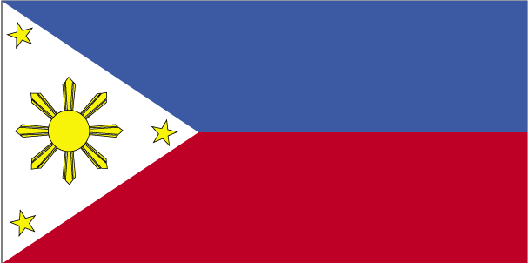

COUNTRY NAME: Republic of the Philippines

CAPITAL: Manila

PROFILE: The Philippines is an archipelago of 7,107 islands and islets. The first people to inhabit the Philippine Islands migrated from various regions of Asia and the pacific around the 3rd Century BC. A Filipino civilization emerged from the mixture of cultures around the 5th Century AD. From the 13th to the early 16th century, the region was ruled by independent tribes of peoples. The Philippines was discovered by the Spaniards in 1521 and became a colony of Spain for about 333 years beginning in 1565. The Philippines was ceded to the US in 1899 and the Americans ruled the country as a US territory for 48 years. In 1942, World War II broke out and the Japanese occupied the Philippines for three years. After the war, the Philippines received its independence in 1946.

GEOGRAPHY: Southeastern Asia archipelago just above the equator between the Philippine Sea and the South China Sea; south of Taiwan; north of Indonesia and Malaysia.

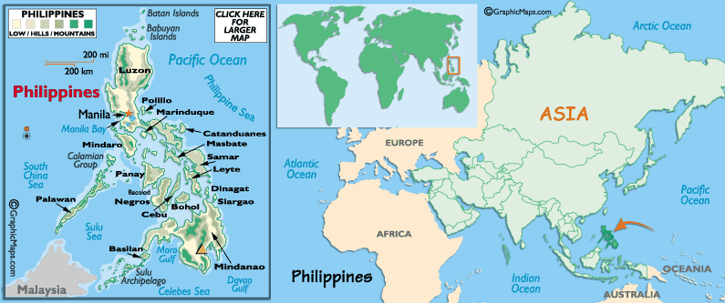

POPULATION: 86,241,697 (July 2004 est.)

CLIMATE: Tropical marine; northeast monsoon (November to April); southwest monsoon (May to October).

LANGUAGES: Two official languages - Filipino (based on Tagalog) and English; eight major dialects - Tagalog, Cebuano, Ilocano, Ilonggo, Bicolano, Waray, Pampango, and Pangasinense.

RELIGION: Roman Catholic 83%, Protestant 9%, Islam 5%, Other 3%
GOVERNMENT: Republic with three branches of government; President is both chief of state and head of government; Bicameral congress consisting of Senate and House of Representatives; Supreme Court Justices appointed by the president.

NATURAL RESOURCES: timber, petroleum, nickel, cobalt, silver, gold, salt, copper

PRIMARY EXPORT: electronic equipment, machinery and transport equipment, garments, coconut and other agricultural products, chemicals

UNIT OF CURRENCY: Philippine Peso

EDUCATION/LITERACY: definition: age 15 and over can read and write, male: 92.5%,
female: 92.7% (2002)

ECONOMY: The Philippines was less severely affected by the Asian financial crisis of 1998 than its neighbors, aided in part by annual remittances of $6-7 billion from overseas workers. From a 0.6% decline in 1998, GDP expanded by 2.4% in 1999, and 4.4% in 2000, but slowed to 3.2% in 2001 in the context of a global economic slowdown, an export slump, and political and security concerns. GDP growth accelerated to 4.4% in 2002 and 4.2% in 2003, reflecting the continued resilience of the service sector, gains in industrial output, and improved exports. Nonetheless, it will take a higher, sustained growth path to make appreciable progress in poverty alleviation given the Philippines' high annual population growth rate and unequal distribution of income. The MACAPAGAL-ARROYO Administration has promised to continue economic reforms to help the Philippines match the pace of development in the newly industrialized countries of East Asia. The strategy includes improving the infrastructure, strengthening tax collection to bolster government revenues, furthering deregulation and privatization of the economy, enhancing the viability of the financial system, and increasing trade integration with the region. Prospects for 2004 will depend on the economic performance of two major trading partners, the US and Japan, and on increased confidence on the part of the international investment community.

BRIEF HISTORY: The first inhabitants of the Philippines arrived around 250,000 years ago, probably migrating over a land bridge from the Asian mainland. The Negrito people arrived 25,000 years ago, but they were driven back by several waves of immigrants from Indonesia, followed by maritime immigrations of Malayan people. In 1380, the Arab-taught Makdum arrived in the Sulu archipelago and began to establish what became a powerful Islamic sphere of influence over the next hundred years.
Ferdinand Magellan arrived in 1521 and claimed the archipelago for Spain. Magellan was killed by local chiefs who quite naturally disapproved of this notion. Roy Lopez de Villalobos followed in 1543 and named the territory Filipinas after King Philip II of Spain. Permanent Spanish occupation began in 1565, and by 1571 the entire country, except for the strictly Islamic Sulu archipelago, was under Spanish control.
A Filipino independence movement grew in the 19th century and Filipinos fought on the side of the Americans in 1898 during the Spanish-American War. When the Spanish were defeated, General Aguinaldo declared the Philippines independent. The USA, however, had other plans, and promptly purchased the islands from the Spanish for US$20 million.
The USA eventually recognized the Filipinos' desire for independence and Manuel L Quezon was sworn in as President of the Philippine Commonwealth in 1935 as part of a transitional phase pending full independence. Japan invaded the Philippines in 1942, brutally interrupting this process and ruled until the USA re-invaded two years later. The Philippines received full independence in 1946.
Ferdinand Marcos was elected president in 1965, declared martial law in 1972 and ruled virtually as a dictator until 1986. His regime was attacked by both communist and Muslim guerrillas, and he was accused of ballot-rigging and fraud. The assassination of prominent opposition figure Benigno 'Ninoy' Aquino Jr in 1983 sparked massive anti-government protests. A snap election in 1986 saw the opposition parties rally around Aquino's widow, Cory. Both parties claimed victory, but Aquino was widely believed to have polled most votes. She initiated a program of non-violent civil unrest which resulted in Marcos fleeing the country.
Aquino re-established the democratic institutions of the country, but failed to tackle economic problems or win over the military and the powerful Filipino elite. US strategic influence in the country diminished following the 1991 Mt Pinatubo eruption which destroyed the US Clark Airbase, and after the Philippine Senate refused to ratify the lease on the Subic Bay Naval Station. Aquino survived seven coups in six years and was succeeded by her defence minister, Fidel Ramos, in 1992. Ramos aimed to revitalize the economy, attract foreign investment, cleanse corruption and expand provision of utilities.
The Philippines government and the Moro National Liberation Front (MNLF) signed a peace accord in September 1996 ending, formally at least, the MNLF's 24-year struggle for autonomy in Mindanao. The peace agreement foresaw the MNLF being granted considerable autonomy in many of the island's provinces. Peace in the area remains elusive, however, following the rise of a splinter group, the militant Moro Islamic Liberation Front (MILF), which opposes the agreement. The government continues to conduct military operations in MILF-held areas in Basilan and Sulu.
In 1998, Ramos was replaced as president by the Philippines' answer to Bruce Willis, Joseph Estrada. Estrada, a former movie star elected more because of the popularity of his on-screen persona than because of any political experience, promised a lot economically and delivered it - straight into his own pocket. He was impeached and brought to trial in late 2000 on charges of taking bribes from gambling syndicates, and using the proceeds to line his own dens and build extravagant houses for his mistresses. When Estrada and his political allies tried to derail the trial by blocking prosecutors' access to his financial accounts, the people decided they'd had enough and staged mass demonstrations in the streets of Manila.
Estrada finally threw in the towel on 19 January 2001 and the next day his former vice-president, Gloria Arroyo, was sworn in as the new president of the Philippines. In an inauguration speech which must have sounded eerily familiar to the people of the Philippines, Arroyo promised to wipe out poverty and corruption; she refused to grant Estrada an amnesty for his crimes with the intention of letting the courts decide his fate. He stands accused of perjury and of dishonestly amassing four billion pesos.
Since then, Arroyo's presidency has been sorely tested. Various separatist movements in the south have been linked to global terrorism, prompting the US to send military assistance. A military coup attempt on 27 July 2003 underscored the tensions below the surface in the country. A standoff lasting 20 hours ended when Arroyo issued a five-hour ultimatum. In June 2004 she won a second term as president.

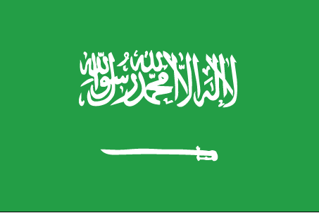

COUNTRY NAME: Kingdom of Saudi Arabia

GOVERNMENT TYPE: Monarchy

CAPITAL: Riyadh

PROFILE: In 1902, Abd Al-Aziz bin Abd al-Rahman Al Saud captured Riyadh and set out on a 30-year campaign to unify the Arabian Peninsula. Today, the monarchy is ruled by a son of Abd Al-Aziz, and the country's Basic Law stipulates that the throne shall remain in the hands of the aging sons and grandsons of the kingdom's founder. Following Iraq's invasion of Kuwait in 1990, Saudi Arabia accepted the Kuwaiti royal family and 400,000 refugees while allowing Western and Arab troops to deploy on its soil for the liberation of Kuwait the following year. The continuing presence of foreign troops on Saudi soil after Operation Desert Storm remained a source of tension between the royal family and the public until the US military's near-complete withdrawal to neighboring Qatar in 2003. The first major terrorist attacks in Saudi Arabia in several years, which occurred in May and November 2003, prompted renewed efforts on the part of the Saudi government to counter domestic terrorism and extremism, which also coincided with a slight upsurge in media freedom and announcement of government plans to phase in partial political representation. A burgeoning population, aquifer depletion, and an economy largely dependent on petroleum output and prices are all ongoing governmental concerns.

LOCATION: Middle East, bordering the Persian Gulf and the Red Sea, north of Yemen

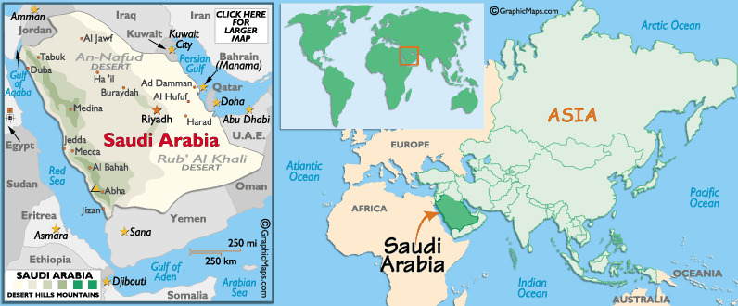

CLIMATE/TERRAIN: Harsh, dry desert with great temperature extremes, mostly uninhabited, sandy desert.

NATURAL RESOURCES: petroleum, natural gas, iron ore, gold, copper

POPULATION: 25,795,938
note: includes 5,576,076 non-nationals (July 2004 est.)

ETHNIC GROUPS: Arab 90%, Afro-Asian 10%

RELIGION: Muslim 100%

LANGUAGES: Arabic

EDUCATION/LITERACY: definition: age 15 and over can read and write
total population: 78.8%, male: 84.7%, female: 70.8% (2003 est.)

ECONOMY: This is an oil-based economy with strong government controls over major economic activities. Saudi Arabia has the largest reserves of petroleum in the world (25% of the proved reserves), ranks as the largest exporter of petroleum, and plays a leading role in OPEC. The petroleum sector accounts for roughly 75% of budget revenues, 45% of GDP, and 90% of export earnings. About 40% of GDP comes from the private sector. Roughly five and a half million foreign workers play an important role in the Saudi economy, for example, in the oil and service sectors. The government in 1999 announced plans to begin privatizing the electricity companies, which follows the ongoing privatization of the telecommunications company. The government is encouraging private sector growth to lessen the kingdom's dependence on oil and increase employment opportunities for the swelling Saudi population. Priorities for government spending in the short term include additional funds for education and for the water and sewage systems. Economic reforms proceed cautiously because of deep-rooted political and social conservatism.

AGRICULTURAL PRODUCTS: wheat, barley, tomatoes, melons, dates, citrus; mutton, chickens, eggs, milk

INDUSTRIES: crude oil production, petroleum refining, basic petrochemicals, cement, construction, fertilizer, plastics

CURRENCY: Saudi riyal (SAR)
BRIEF HISTORY: Parts of what is now eastern Saudi Arabia were first settled in the fourth or fifth millennium BC by migrants from what is now southern Iraq. The Nabateans had the biggest of the early empires, stretching as far as Damascus around the first century BC.
In the early 18th century the Al-Saud, the ruling family of modern Saudi Arabia, were the ruling sheikhs of the oasis village of Dir'aiyah, near modern Riyadh. When they formed an alliance, in the mid-18th century, with Mohammed bin Abdul Wahhab, the result was Wahhabism, the back-to-basics religious movement that is still Saudi Arabia's official form of Islam. By 1806, the converting armies of Wahhabism had conquered most of modern Saudi Arabia as well as a large part of southern Iraq.
None of this went down well in Constantinople, as western Arabia was, at least in theory, part of the Ottoman Empire. In 1812 the empire retook western Arabia, and by the end of the 19th century the Al-Saud had retreated to Kuwait, where they were given sanctuary.
Enter stage left one of the great Al-Saud leaders, known as Ibn Saud, who brewed up an irresistible combination of piety, strategy and diplomacy and retook Riyadh and then, in 1925, Jeddah.
In 1938, Chevron found commercial quantities of oil in Saudi Arabia, and when WWII started, oil production really took off. By 1950 the kingdom's royalties were running at about 1000000.00 a week, and by 1960, 80% of the government's revenues came from oil. The Arab oil embargo, in 1973-74, increased the price of oil fourfold and Saudi Arabia became something of a world power. As the government raked in the cash, a building boom began and Saudi Arabia became one immense construction site. But the oil boom attracted a lot of interest from outside the country, and Saudi Arabia's relations with its neighbors became increasingly strained. The massacre of 400 Iranian pilgrims at the 1987 hajj resulted in Iran boycotting the pilgrimage for several years.
When Iraq invaded Kuwait in 1990, the Saudis started getting nervous, and asked the USA to send troops to defend the kingdom. Although Saudi Arabia was not invaded, the crisis stirred up demands for political change, and in 1993 the king set up a Consultative Council - members are appointed by the king and can comment on proposed laws.
The days of easy oil money are just a fond memory and the country's population is growing rapidly (the average Saudi woman bears six children), presenting Saudi Arabia and the aging King Fahd with an impressive challenge. Two generations of generous public assistance haven't inculcated the country's youth with the strongest work ethic, either.
In 1999, the first high-end tour groups entered the difficult-to-visit nation, but visas remain officially restricted to business travelers, Muslims making the annual pilgrimage to Mecca and Medina, and those few lucky folk able to convince a Saudi national to sponsor their visit.
The terrorist attacks in the US in September 2001 were something of a landmark event for Saudis too. The involvement of Saudi nationals and the rumors of state sponsorship of terrorism tainted the monarchy. The US military pulled out of the country in 2003 hoping to ease tensions in the kingdom.
Popular discontent within the country at the House of Saud - especially in relation to undemocratic nature and its ties with the US - saw Islamic fundamentalism terror groups become more active. The liberalization of aspects of the criminal justice system in 2002 was greeted with cynicism. In 2003, suicide bombers reportedly linked to al-Qaeda killed 35 people in Riyadh.
The reform movement gathered momentum in late 2003, prompting the monarchy to announce municipal elections to be held within a year and that to grant the Consultative Council the power to propose legislation without royal consent, but to little effect. In 2004, numerous foreigners were kidnapped and executed, and violence marred the Hajj pilgrimage - 251 pilgrims were killed in a stampede.
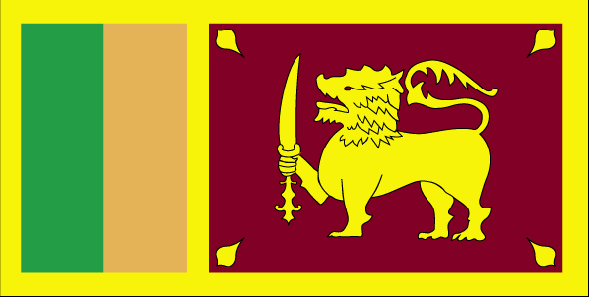
COUNTRY NAME: Democratic Socialist Republic of Sri Lanka (Sri Lanka)

CAPITAL: Columbo, note - Sri Jayewardenepura Kotte is the legislative capital.
PROFILE: The Sinhalese arrived in Sri Lanka late in the 6th century B.C., probably from northern India. Buddhism was introduced beginning in about the mid-third century B.C., and a great civilization developed at the cities of Anuradhapura (kingdom from circa 200 B.C. to circa A.D. 1000) and Polonnaruwa (from about 1070 to 1200). In the 14th century, a south Indian dynasty seized power in the north and established a Tamil kingdom. Occupied by the Portuguese in the 16th century and by the Dutch in the 17th century, the island was ceded to the British in 1796, became a crown colony in 1802, and was united under British rule by 1815. As Ceylon, it became independent in 1948; its name was changed to Sri Lanka in 1972. Tensions between the Sinhalese majority and Tamil separatists erupted into war in 1983. Tens of thousands have died in an ethnic conflict that continues to fester. After two decades of fighting, the government and Liberation Tigers of Tamil Eelam formalized a cease-fire in February 2002, with Norway brokering peace negotiations.
GEOGRAPHY: Sri Lanka, located south of India, has an area of approximately 65,000 sq km, which is slightly larger than West Virginia. The terrain is mostly low, flat to rolling plain, with mountains in the south central interior.
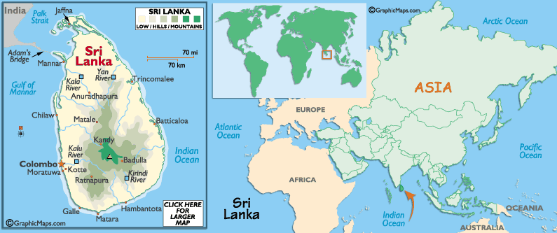

POPULATION: 19,905,165
note: since the outbreak of hostilities between the government and armed Tamil separatists in the mid-1980s, several hundred thousand Tamil civilians have fled the island; as of yearend 2000, approximately 65,000 were housed in 131 refugee camps in south India, another 40,000 lived outside the Indian camps, and more than 200,000 Tamils have sought refuge in the West (July 2004 est.) The life expectancy at birth is 73 years, the literacy rate is 92%, and the population growth rate is 0.8%. Education is totally free but university admission is highly competitive. Sri Lanka has one of the highest Physical Quality of Life Index for developing countries.
EDUCATION/LITERACY: definition: age 15 and over can read and write
total population: 92.3%, male: 94.8%, female: 90% (2003 est.)
CLIMATE: Primarily two seasons. It rains heavily during the tropical monsoon seasons: northeast monsoon (December to March); southwest monsoon (June to October).
LANGUAGES: Sinhala (official and national language) 74%, Tamil (national language) 18%, and other 8%. English is commonly used and is spoken competently by many.
RELIGION: Buddhist 70%, Hindu 15%, Christian 8%, and Muslim 7%.
MAJOR FESTIVALS: Sinhala and Tamil New Year (April 13/14), Wesak (Lord Buddha’s birthday on the full moon day in the month of May), Thaipongal (Tamil harvest festival on January 13-15), Christmas and Ramadan (ninth month of the Muslim year).
UNIT OF CURRENCY: Sri Lankan Rupee (1US dollar equals approximately Rs.100 Sri Lankan).
GOVERNMENT: A republic, after the most recent constitution adopted in August 1978. The President, who is the chief of state and head of government, is elected directly by the people. The Parliament elected under a modified proportional representation system selects the Prime Minister. In 1960, Sri Lanka elected Mrs. Bandaranayke, the word’s first democratically elected woman Prime Minister.
ECONOMY: The foundation for economic development was laid in the second half of the 19th century, when coffee and tea plantations were established in the hill country surrounding Nuwara Eliya. The national economy is heavily dependent upon agricultural exports. Tea is by far the principal export crop. Others are rubber, coconuts, and spices, especially cinnamon. The principal ports are Colombo and Galle. Breeding grounds of the pearl oyster are located in the Gulf of Mannar off the northwest coast.
More than 80 percent of the people work on small subsistence farms, where the main food crop is rice. Rice output grew in the 1980s as a result of the expansion of land available for cultivation and from the impact of the Green Revolution. The nation has been self-sufficient in rice since the mid-1980s.
Sri Lanka is rich in industrial rocks and minerals such as graphite, mica, silica sand, quartz, feldspar, and gemstones. The nation is the world's largest producer of graphite, a form of carbon that is used in the making of pencils. Long known as a land of gems, the island has dozens of varieties of precious and semiprecious gemstones. Mined around Ratnapura, the gems include sapphires, rubies, aquamarines, moonstones, topazes, garnets, amethysts, and zircons.
The island state of Sri Lanka was known as Ceylon until 1972. Like India, it was for a long time a colony of Great Britain; and like India it developed a strong nationalist movement early in the 20th century. A Ceylon National Congress was formed in 1919. In response to pressure the British government allowed a new constitution to be issued in 1920, which satisfied some nationalist demands for self-government.
A second constitution in 1931 opened the political process by granting some political power to the residents of Ceylon. The experience in democracy that this constitution provided led to more demands for independence. A third constitution in 1945 enlarged the areas of self-government, but Britain still managed foreign policy and defense. Finally, in 1947, the Ceylon Independence Act made the island a free state within the Commonwealth.
BRIEF HISTORY: Sri Lanka's first settlers were the nomadic Veddahs. Legend relates them to the Yakkhas, demons conquered by the Sinhalese around the 5th or 6th century BC. A number of Sinhalese kingdoms, including Anuradhapura in the north, took root across the island during the 4th century BC. Buddhism was introduced by Mahinda, son of the Indian Mauryan emperor Ashoka, in the 3rd century BC, and it quickly became the established religion and the focus of a strong nationalism. However, Anuradhapura was not impregnable. Repeated invasions from southern India over the next 1000 years left Sri Lanka in an ongoing state of dynastic power struggle.
The Portuguese arrived in Colombo in 1505 and gained a monopoly on the invaluable spice trade. By 1597, the colonisers had taken formal control of the island. However, they failed to dislodge the powerful Sinhalese kingdom in Kandy which, in 1658, enlisted Dutch help to expel the Portuguese. The Dutch were more interested in trade and profits than religion or land, and only half-heartedly resisted when the British arrived in 1796. The Brits wore down Kandy's sovereignty and in 1815 became the first European power to rule the entire island. Coffee, tea, cinnamon and coconut plantations (worked by Tamil laborers imported from southern India) sprang up and English was introduced as the national language.
Then known as Ceylon, Sri Lanka finally achieved full independence in 1948. The government adopted socialist policies, but promoted Sinhalese interests, making Sinhalese the national language and effectively reserving the best jobs for the Sinhalese, partly to address the imbalance of power between the majority Sinhalese and the English-speaking, Christian-educated elite. It prompted the Tamil Hindu minority to press for greater autonomy in the main Tamil areas in the north and east.
The country's ethnic and religious conflicts escalated as competition for wealth and work intensified. When Bandaranaike was assassinated in 1959 trying to reconcile the two communities, his widow, Sirimavo, became the world's first female prime minister. She continued her husband's socialist policies, but the economy went from bad to worse. A Maoist revolt in 1971 led to the death of thousands. One year later, the country became a republic and made Sri Lanka its official name.
In 1972 the constitution formally made Buddhism the state's primary religion, and Tamil places at university were reduced. Subsequent civil unrest resulted in a state of emergency in Tamil areas. Sinhalese security forces faced off against young Tamils, who began the fight for an independent homeland. Junius Richard Jayewardene was elected in 1977 and promoted Tamil to the status of a 'national language' in Tamil areas. He also granted Tamils greater local government control, but violence escalated.
When Liberation Tigers of Tamil Eelam (LTTE) secessionists massacred an army patrol in 1983, Sinhalese mobs went on a two-day rampage, killing several thousand Tamils and burning and looting property. This marked the point of no return. Many Tamils moved north into Tamil-dominated areas, and Sinhalese began to leave the Jaffna area. Tamil secessionists claimed the northern third of the country and the eastern coast. They were clearly in the majority in the north but proportionately equal to the Sinhalese and Muslims in the east. Violence escalated, with both sides guilty of ethnic cleansing.
By 1985, there were 50,000 internal refugees, 100,000 Tamil exiles in India, no tourism, slumping tea prices and dwindling aid (because of human rights abuses). Government gains in 1987 led to Tamil unrest in India, prompting concerns of an Indian invasion. The two governments agreed that the Sri Lankan Army would retreat and an Indian Peace Keeping Force (IPKF) would maintain order in the north and disarm the Tigers. The agreement led to Sinhalese and Muslim riots in the south over the government 'sell-out' and Indian 'occupation'. Sri Lanka became a quagmire of inescapable violence.
A 1989 Sinhalese rebellion broke out in the south and the Marxist JVP orchestrated a series of strikes and political murders. The country was at a standstill. When the government's talks with the JVP failed, it unleashed death squads that killed JVP suspects and dumped their bodies in rivers. A three-year reign of terror resulted in at least 30,000 deaths. The IPKF withdrew in 1990. The Tigers had agreed to a ceasefire but violence flared almost immediately when a breakaway Tamil group unilaterally declared an independent homeland.
Prime Minister Rajiv Gandhi was assassinated by a Tamil suicide bomber in 1991 and Premadasa suffered the same fate in 1993. Chandrika Bandaranaike Kumaratunga became prime minister in 1994, and president in 1995, and for the second time her mother Sirimavo Bandaranaike became prime minister.
In early 1995, the Tamils broke a truce and the government responded with a massive military operation that seemed to put Sri Lanka on the path to peace. But the Tigers regrouped and, by mid-1996, had launched damaging attacks on government troops stationed in northern Sri Lanka and terrorist strikes in Colombo.
The massacre in mid-October 2000 of 26 unarmed Tamil prisoners by a crowd of Sinhalese in the hill country town of Bandarawela resulted in violent demonstrations and retaliatory attacks.
Chandrika Kumaratunga won a second term in office in December 1999. Days before the vote, the president and People's Alliance coalition leader was the target of a LTTE suicide bomb attack in which she lost the sight in one eye. In December 2001, Ranil Wickramasinghe, who lost the 1999 elections, became prime minister when the United National Party swept parliamentary elections. This could have led to deadlock between Parliament and the executive in dealing with high inflation, high unemployment, poor infrastructure and, of course, the 18-year-old civil war, but unexpectedly promising peace talks with the LTTE have facilitated cooperation in the political process.
Peace talks brokered by a Norwegian delegation inspired a one-month cease-fire beginning 24 December 2001 (the first in seven years), renewed in January 2002. With the lifting of a seven-year-old embargo on LTTE-controlled territory, it seemed peace was not a pipe dream. But the peace process stalled in 2003, and fears that it may collapse entirely were raised in mid-2004 when a suicide bomber blew herself up in a government building in Colombo.
Devastated by a powerful earthquake-triggered tsunami (or tidal wave) on December 26, 2004, the tropical island of Sri Lanka has a most interesting and volatile history
First populated by the Sinhalese, it was eventually occupied by the Portuguese in the 16th century and by the Dutch in the 17th century. Then, in 1796, it was ceded to the British, becoming a crown colony in 1802. Long known as Ceylon, it became independent in 1948, with its name changed to Sri Lanka in 1972.
Tensions between the Sinhalese majority and Tamil separatists erupted into war in 1983. Tens of thousands have died in an ethnic conflict that continues to fester, and the once thriving tourism industry continues to suffer.
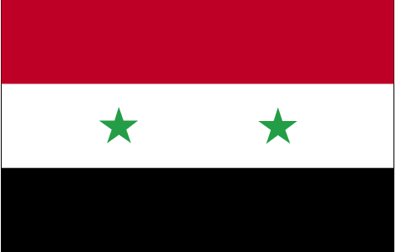

COUNTRY NAME: Syrian Arab Republic (Syria)

GOVERNMENT TYPE: Republic under military regime since March 1963

CAPITAL: Damascus

PROFILE: Following the breakup of the Ottoman Empire during World War I, Syria was administered by the French until independence in 1946. In the 1967 Arab-Israeli War, Syria lost the Golan Heights to Israel. Since 1976, Syrian troops have been stationed in Lebanon, ostensibly in a peacekeeping capacity. Over the past decade, Syria and Israel have held occasional peace talks over the return of the Golan Heights.

LOCATION: Middle East, bordering the Mediterranean Sea, between Lebanon and Turkey

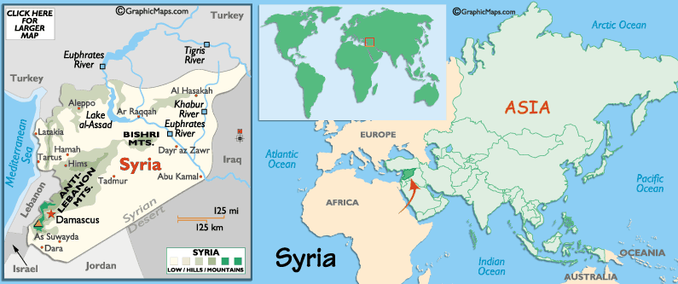

CLIMATE/TERRAIN: Mostly desert; hot, dry, sunny summers (June to August) and mild, rainy winters (December to February) along coast; cold weather with snow or sleet periodically in Damascus. Primarily semiarid and desert plateau; narrow coastal plain; mountains in west

NATURAL RESOURCES: petroleum, phosphates, chrome and manganese ores, asphalt, iron ore, rock salt, marble, gypsum, hydropower

POPULATION: 18,016,874
note: in addition, about 40,000 people live in the Israeli-occupied Golan Heights - 20,000 Arabs (18,000 Druze and 2,000 Alawites) and about 20,000 Israeli settlers (July 2004 est.)

ETHNIC GROUPS: Arab 90.3%, Kurds, Armenians, and other 9.7%

RELIGION: Sunni Muslim 74%, Alawite, Druze, and other Muslim sects 16%, Christian (various sects) 10%, Jewish (tiny communities in Damascus, Al Qamishli, and Aleppo)

LANGUAGES: Arabic (official); Kurdish, Armenian, Aramaic, Circassian widely understood; French, English somewhat understood

EDUCATION/LITERACY: definition: age 15 and over can read and write
total population: 76.9%
male: 89.7%
female: 64% (2003 est.)

ECONOMY: Syria's predominantly statistic economy lately has been growing more slowly than its 2.4% annual population growth rate. Recent legislation allows private banks to operate in Syria, although a private banking sector will take years and further government cooperation to develop. Factors, including the war between the US-led coalition and Iraq, probably drove real annual GDP growth levels back below 1% in 2003 following growth of 3.5% in 2001 and 4.5% in 2002. A long-run economic constraint is the pressure on water supplies caused by rapid population growth, industrial expansion, and increased water pollution.

AGRICULTURAL PRODUCTS: wheat, barley, cotton, lentils, chickpeas, olives, sugar beets; beef, mutton, eggs, poultry, milk

INDUSTRIES: petroleum, textiles, food processing, beverages, tobacco, phosphate rock mining

CURRENCY: Syrian pound (SYP)
BRIEF HISTORY: Historically, Syria included Jordan, Israel and Lebanon, as well as the area now known as Syria. Although the modern state of Syria is a creation of the 20th century, the region can lay claim to having one of the oldest civilizations in the world. The Mesopotamian Akkadians were the first to covet the area, followed by the Egyptians; then the Hittites came to town. Evidence of the first alphabets have been found at the ancient site of Ugarit. The country was in a top strategic spot, and its coastal towns became important Phoenician trading posts. The region became a prize for every neighboring warmonger for over 400 years. Later, Syria was a pivotal part of the Persian, Greek, then Roman empires. After Byzantium went pear-shaped, the Islamic Umayyads (who for a time made Damascus the capital of the Muslim world) were followed in 750 by the Abbasids, who moved to Baghdad, starting a period of decline. The Crusaders arrived and spread their patented brand of mayhem until their defeat at the hands of Nureddin (Nur ad-Din), whose son, Saladin (Salah ad-Din), brought prosperity back to the region. They were followed by the Mamluks and Mongols until finally, in 1516, the Ottomans took over.
Syria prospered under Ottoman rule except for a brief period in the 19th century when the Egyptians came a-conquerin'. They were soon sent packing and the Ottoman Turks, along with Lebanon, dished it out to France when the Turkish Empire broke up after WWI. The Syrians weren't too pleased with this arrangement (they had been an independent nation from 1918-20) and staged an insurrection in 1925-26 that resulted in the French bombing Damascus.
In 1932 Syria had its first parliamentary elections, and although the candidates had been picked by the French, they refused to accept France's proposed constitution for the country. In 1939 France granted Turkey the Syrian province of Alexandretta, further sharpening feeling against the imperial overlords. France promised independence in 1941 but didn't come through with it until 1946.
Civilian rule didn't last long in Syria: in 1954, after several military coups, the Ba'athist section of the army took over the country. The Ba'ath Party was founded in 1940 by a Christian teacher and was committed to a form of pan-Arabism under which Syria would forfeit its sovereignty. This led to the formation of a United Arab Republic with Egypt in 1958, but several people thought this wasn't such a hot idea, and another series of military coups trundled across the country. By 1966 the Ba'ath were back in power, but the celebrations were curtailed by the 1967 Six Day War with Israel and the 1970 Black September hostilities with Jordan. While everyone was otherwise occupied, Defense Minister Hafez al-Assad seized power.
After 1971, Assad held onto the presidency with a mixture of ruthless suppression and guile, and used his position to maneuver Syria into a position of power in the Middle Eastern peace process. In 1999, he was elected to a fifth seven-year term with a predictable 99.9% of the vote. Although falling oil prices instigated much hand-wringing throughout the Middle East, Assad's astute exploitation of the Gulf War in the early 1990s brought improvements in the Syrian economy. During the war, Syria joined the anti-Iraq coalition and got into the USA's good books in an effort to get off Washington's list of states supporting international terrorism.
In 1997, Syria was removed from the US list of drug-trafficking states, while Assad moved to strengthen ties with the fledgling EU, Turkey and the USA. Attempts to diversify the oil-reliant economy, primarily with investment in agricultural products, have had mixed success. In early 2000, US State Department officials discussed removing Syria from the terrorism list, admitting that even according to US Intelligence, the country hadn't sponsored any terrorist activity since 1986. The chaotic withdrawal of Israeli troops from South Lebanon in May 2000, occurring under fire from the allegedly Syrian-sponsored Hezbollah, would have probably delayed further talks under the best of circumstances. President Assad died on 10 June 2000 and his son Bashar was sworn in for a seven-year term in July 2000.
Bashar al-Assad has shown greater reformist and moderate tendencies than his father, including releasing dozens of political prisoners and a visit to Turkey to mend decades of poor relations. However, its links to militant extremists and a legacy of corruption and government control mean that greater reform still remains a dream for the majority of Syrians.
Internationally, Syria's hard-line stance vis-à-vis Israel over the return of the Golan Heights and alleged support for extremist organizations such as Hezbollah continues to stand in the way of improved relations with the West.
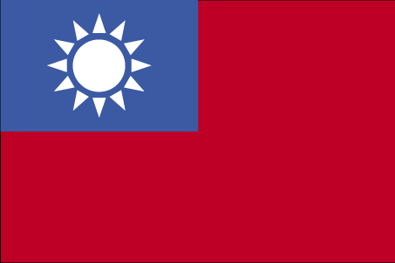

COUNTRY NAME: Republic of China (Taiwan)

CAPITAL: Taipei

PROFILE: In 1895, military defeat forced China to cede Taiwan to Japan. Taiwan reverted to Chinese control after World War II. Following the Communist victory on the mainland in 1949, 2 million Nationalists fled to Taiwan and established a government using the 1946 constitution drawn up for all of China. Over the next five decades, the ruling authorities gradually democratized and incorporated the native population within the governing structure. In 2000, Taiwan underwent its first peaceful transfer of power from the Nationalist to the Democratic Progressive Party. Throughout this period, the island prospered and became one of East Asia's economic "Tigers." The dominant political issues continue to be the relationship between Taiwan and China - specifically the question of eventual unification - as well as domestic political and economic reform.

LOCATION: Taiwan is 394 kilometers long and 144 kilometers at its widest point. It is shaped like a yam and covers a total area of nearly 36,000 square kilometers. Located off the eastern coast of China, Taiwan is the largest island between Japan and the Philippines. The Taiwan Strait separates Taiwan and China.

GEOGRAPHY: Eastern Asia, islands bordering the East China Sea, Philippine Sea, South China Sea, and Taiwan Strait, north of the Philippines, off the southeastern coast of China.

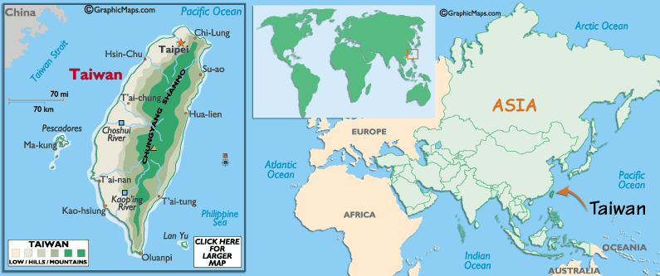

POPULATION: Taiwan's total population numbered 22,749,838 (July 2004 est.) Taiwan's population density was 623 persons per square kilometer, making it the second highest in the world after Bangladesh.

PEOPLE: Dating back 12,000 to 15,000 years ago, Taiwan's earliest inhabitants came from at least two places, southern China and Austronesia. These early settlers, which now compose Taiwan's indigenous peoples, make up less than two percent of the population. In the 16th century, people from China's coastal provinces of Fujian and Guangdong began immigrating to Taiwan in large numbers to build a new homeland away from war and famine. This group of immigrants today constitutes about 85 percent of the population, with the Fujianese outnumbering the Hakka by a ratio of approximately three to one. When the Kuomintang (KMT) retreated to Taiwan in 1949, it brought a new influx of Chinese immigrants to Taiwan. These late Chinese immigrants and their descent make up roughly 13 percent of the population.

TYPE OF GOVERNMENT: Taiwan is a constitutional republic. The government is divided into central, municipal, and county/city levels, each of which has specifically defined powers. The central government consists of the Office of the President and five branches (called "yuan"), namely the Executive Yuan, Legislative Yuan, Judicial Yuan, Examination Yuan, and Control Yuan.

OFFICIAL LANGUAGE (S): Taiwan is currently drafting a language equality law aimed at preserving the 14 major languages in Taiwan: Mandarin, Taiwanese, Hakka, and 11 indigenous languages.

RELIGION: Taiwan's society has been dominated by ancestor worship, Taoism, and Buddhism but has never excluded the addition and development of other indigenous and foreign religions.

CLIMATE: Taiwan's climate is subtropical, with an average annual temperature of 21.7 deg C (71.2 deg F) in the north and 24.1 deg C (75.7 deg F) in the south. Summers, which last from May through September, are usually hot and humid, with daytime temperatures ranging from 27 deg C to 35 deg C (80 deg - 90 deg F). Winters, which run from December through February, are short and mild. Snowfalls only occur on the island's higher elevations.

AGRICULTURE: Rice is Taiwan's most valuable crop, followed by betel nuts, pineapples, mangoes, sugar cane, watermelons, tea, bamboo shoots, pears, and peanuts. Taiwanese people are now eating more wheat-based foods and dairy products while consuming less rice.

LOCAL DIET/TRADITIONAL FOOD: Taiwan’s traditional diet itself is light, simple, easy to prepare, and often liberally spiced with ginger. Because Taiwan is an island, Taiwanese food features plenty of seafood. Taiwan's centralized location in Asia gives the hungry tourist a wide variety of different Asian cuisines to sample from, including Thai, Malay, Japanese, Korean, Indian, and Filipino, as well as Chinese.

PRIMARY EXPORT(S): Taiwan's main export commodities are electrical machinery and mechanical appliances. In 2001, Taiwan was the world's 14th largest exporter.

UNIT OF CURRENCY: Taiwan’s unit of currency is the New Taiwan Dollar (NT$ or NTD). The exchange rate is around NT$33.5 to US$1 in April 2004.

EDUCATION: Nine years of education has been compulsory since 1968, and a wide range of other educational options exists in Taiwan for citizens of all ages.

BRIEF HISTORY: Taiwan, isolated and poorly developed, had been a neglected island before the 17th century. But during the age of exploration and maritime conquest by Europeans, Taiwan attracted the world’s attention because of its strategic location and natural resources. The Dutch (1624) and the Spanish (1628) colonized parts of northern and southern Taiwan. Cheng Chen-gong, who was loyal to the fallen Ming dynasty, defeated the Dutch in 1662 and set up a government on Taiwan to defy the Manchus, who had established the Ching dynasty in China.

The Manchus conquered Taiwan in 1683 and ruled it until 1895, when Taiwan was ceded to Japan after the First Sino-Japanese War. At the end of World War II, the Republic of China (ROC) was given permission to occupy Taiwan by the Allied forces. When the Chinese Communist Party established the People's Republic of China (PRC) in 1949, the ROC government, led by the Kuomintang (KMT), retreated to Taiwan, where it maintained jurisdiction over Taiwan, Penghu, Kinmen, Matsu, and numerous other islets. The two sides of the Taiwan Strait have since been governed as separate territories and developed separate identities.

In the realm of political development, Taiwan has grown into a free and vibrant democracy. The government was forced to lift the martial law in 1987 and launch a series of political reforms to expand the democratic process. In 1996, the people of Taiwan completed their first direct presidential election. The presidential election of 2000 ended five decades of government under the KMT and peacefully transferred power to the victorious Democratic Progressive Party (DPP). Taiwan has since then established itself as a powerful working model for democracy.
Democratic progress -- combined with an entrepreneurial and highly educated populace, impartial government regulation, and constantly improving infrastructure -- has enabled Taiwan to surge ahead and establish itself as a global economic powerhouse. Its competitive and dynamic free-market economy has brought unprecedented prosperity to all levels of society. In January 2002, Taiwan joined the WTO and became an official partner in the world trading system. The government is now vigorously promoting a knowledge-based economy and industrial modernization to transform Taiwan into a "green silicon island" of high value-added production.

In 2004, the Taiwanese president, Chen Shui-Bian, was reelected largely due to the support generated from the growing consciousness of Taiwan identity among the people. Taiwanese are prepared to move forward to rectify the official country name as Taiwan and to develop and institute a new constitution that will enhance Taiwan’s competitiveness in world society.
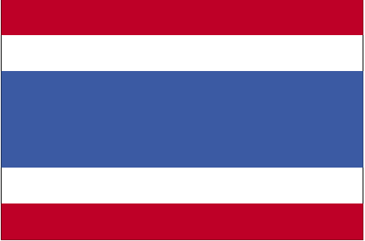

COUNTRY NAME: Kingdom of Thailand

GOVERNMENT TYPE: Constitutional Monarchy

CAPITAL: Bangkok

PROFILE: A unified Thai kingdom was established in the mid-14th century. Known as Siam until 1939, Thailand is the only Southeast Asian country never to have been taken over by a European power. A bloodless revolution in 1932 led to a constitutional monarchy. In alliance with Japan during World War II, Thailand became a US ally following the conflict. Thailand is currently facing armed violence in its three Muslim-majority southernmost provinces.

LOCATION: Southeastern Asia, bordering the Andaman Sea and the Gulf of Thailand, southeast of Burma

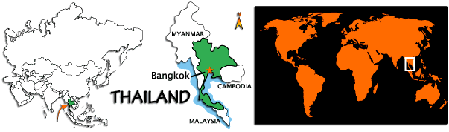

CLIMATE/TERRAIN: Tropical; rainy, warm, cloudy southwest monsoon (mid-May to September); dry, cool northeast monsoon (November to mid-March); southern isthmus always hot and humid. Central plain; Khorat Plateau in the east; mountains elsewhere

NATURAL RESOURCES: tin, rubber, natural gas, tungsten, tantalum, timber, lead, fish, gypsum, lignite, fluorite, arable land

POPULATION: 64,865,523
note: estimates for this country explicitly take into account the effects of excess mortality due to AIDS; this can result in lower life expectancy, higher infant mortality and death rates, lower population and growth rates, and changes in the distribution of population by age and sex than would otherwise be expected (July 2004 est.)

ETHNIC GROUPS: Thai 75%, Chinese 14%, other 11%

RELIGION: Buddhism 95%, Muslim 3.8%, Christianity 0.5%, Hinduism 0.1%, other 0.6% (1991)

LANGUAGES: Thai, English (secondary language of the elite), ethnic and regional dialects

EDUCATION/LITERACY: definition: age 15 and over can read and write
total population: 92.6%
male: 94.9%
female: 90.5% (2002)

ECONOMY: Thailand has a free-enterprise economy and welcomes foreign investment. Exports feature textiles and footwear, fishery products, rice, rubber, jewelry, automobiles, computers and electrical appliances. Thailand has recovered from the 1997-98 Asian Financial Crisis and was one of East Asia's best performers in 2002. Increased consumption and investment spending and strong export growth pushed GDP growth up to 6.3% in 2003 despite a sluggish global economy. The highly popular government has pushed an expansionist policy, including major support of village economic development.

AGRICULTURAL PRODUCTS: rice, cassava (tapioca), rubber, corn, sugarcane, coconuts, soybeans

INDUSTRIES: tourism, textiles and garments, agricultural processing, beverages, tobacco, cement, light manufacturing such as jewelry, electric appliances and components, computers and parts, integrated circuits, furniture, plastics, world's second-largest tungsten producer, and third-largest tin producer

CURRENCY: baht (THB)
BRIEF HISTORY: Thailand, or Siam as it was called until 1939, has never been colonized by a foreign power, unlike its south and Southeast Asian neighbors. Despite periodic invasion by the Burmese and the Khmers, and brief occupation by the Japanese in WWII, the kingdom has never been externally controlled for long enough to dampen the Thai's individualism.
The earliest civilization in Thailand is believed to have been that of the Monks in central Thailand, who brought a Buddhist culture from the Indian subcontinent. In the 12th century, this met a Khmer culture moving from the east, the Sumatran-based Srivijaya culture moving north, and citizens of the Thai state of Nan Chao, in what is now southern China, migrating south. Thai princes created the first Siamese capital in Sukhothai and later centres in Chiang Mai and, notably, Ayuthaya.
The Burmese invaded Siam in 16th and 18th centuries, capturing Chiang Mai and destroying Ayuthaya. The Thais expelled the Burmese and moved their capital to Thonburi. In 1782, the current Chakri dynasty was founded by King Rama I and the capital was moved across the river to Bangkok.
In the 19th century, Siam remained independent by deftly playing off one European power against another.
The 20th century brought great change to Thailand. In 1932, a peaceful coup converted the country into a constitutional monarchy and in 1939 Siam became Thailand. During WWII, the Thai government sided with the Japanese. After the war, Thailand was dominated by the military and experienced more than twenty coups and countercoups interspersed with short-lived experiments with democracy. Democratic elections in 1979 were followed by a long period of stability and prosperity as power shifted from the military to the business elite.
In February 1991 a military coup ousted the Chatichai government, but bloody demonstrations in May 1992 led to the reinstatement of a civilian government with Chuan Leekpai at the helm. This coalition government collapsed in May 1995 over a land-reform scandal but replacement prime minister Banharn Silpa-archa was no better. Dubbed a 'walking ATM' by the Thai press, he was forced to relinquish the prime ministership just over a year later after a spate of corruption scandals. Ex-general and former deputy PM Chavalit Yongchaiyudh headed a dubious coalition until late 1997, when veteran pragmatist Chuan Leekpai retook the reins.
In 1997 the Thai baht pretty much collapsed, dragging the economy (and many other Southeast Asian economies) down in a screaming heap. In August the International Monetary Fund stepped in with a bailout package of austerity measures, which - although it slowed Thailand's growth dramatically and hit the poor hardest - seemed to have turned things around by early 1998. By the turn of the new century, Thailand's economy had stopped going into free fall, but rebuilding had only just begun. Genuine attempts to weed out corruption seem underway, but the poverty-stricken of Thailand are still wary of promises and agitating for more reforms.
The relatively new Thai Rak Thai Party (Thais Love Thais), led by Thaksin Shinawatra, emerged as a force in Thai politics and saw many sitting MPs defect to its ranks. In parliamentary elections held in January 2001, Thai Rak Thai trounced Prime Minister Chuan Leekpai's democrats. Although Thaksin has thus far been able broadly to deliver on his promises, he has faced opposition from anti-reform elements within his own Thai Rak Thai party, as well as accusations of corruption during his time as deputy prime minister in 1997. One worrying recent development has been Thaksin's widespread suppression of the Thai media. As owner of Thailand's only independent TV station, he sacked 23 journalists during the election that brought him to power, and has since come down heavily on all forms of political commentary on radio or TV. Thaksin also instigated the recent 'war on drugs', which has left thousands dead, many apparently victims of a shoot-to-kill policy by the Thai police.
Thailand's future economic growth will depend partly on its ability to remain peaceful over the next few years. Tourism is now one of the largest sectors of the Thai economy, but the industry has already suffered huge losses due the 2003 epidemic of Severe Acute Respiratory Syndrome (SARS), even though Thailand remained free of the disease throughout the crisis. The recent arrest of members of the Islamic fundamentalist group Jemaah Islamiyah has worrying implications for the future safety of the kingdom. However, Thais continue to glide through it all with their customary calm.
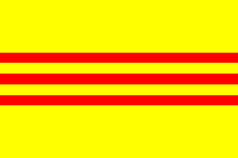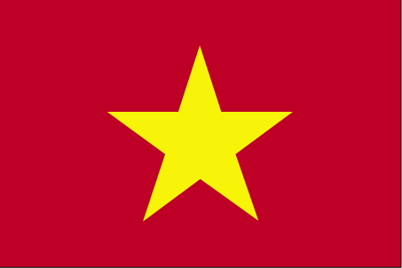
COUNTRY NAME: Socialist Republic of Vietnam (Vietnam)
CAPITAL: Hanoi
PROFILE: The conquest of Vietnam by France began in 1858 and was completed by 1884. It became part of French Indochina in 1887. Independence was declared after World War II, but the French continued to rule until 1954 when they were defeated by Communist forces under Ho Chi Minh, who took control of the North. US economic and military aid to South Vietnam grew through the 1960s in an attempt to bolster the government, but US armed forces were withdrawn following a cease-fire agreement in 1973. Two years later, North Vietnamese forces overran the South. Despite the return of peace, for over two decades the country experienced little economic growth because of conservative leadership policies. Since 2001, Vietnamese authorities have committed to economic liberalization and enacted structural reforms needed to modernize the economy and to produce more competitive, export-driven industries. The country continues to experience protests from the Montagnard ethnic minority population of the Central Highlands over loss of land to Vietnamese settlers and religious persecution.
LOCATION: Southeastern Asia, bordering the Gulf of Thailand, Gulf of Tonkin, and South China Sea, alongside China, Laos, and Cambodia
GEOGRAPHY: Vietnam is a long and narrow country, lying completely in the tropical zone. Its landmass forms the shape the letter S on the east side of the Indochinese Peninsula in Southeast Asia. Vietnamese eastern border consists of more than 3,000 km of coastline, facing the East Sea and the Pacific Ocean. To the north, Vietnam shares its border with China, while to the west, with Cambodia and Laos.
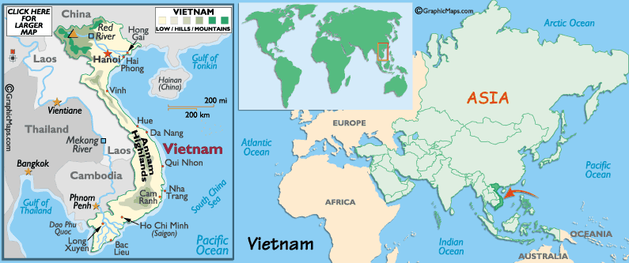
POPULATION: 82,689,518 (July 2004 est.) Vietnamese 85%-90%, Chinese, Hmong, Thai, Khmer, Cham and mountain groups.
CLIMATE/SEASONS: Tropical in south; monsoonal in north with hot, rainy season (mid-May to mid-September) and warm, dry season (mid-October to mid-March)
FLORA: The monsoon tropical climate, sunshine and rain have given Vietnam and abundant and diversified vegetation. The Vietnamese territory lies at the convergence of atmospheric currents and has received a great number of seeds from the north, west and south, that is why the forests have many strains and species of vegetation. Vietnam has over 800 wood species many of which are precious due to their hardness, solidity, beautiful grains and colors. The famous wood species comprise iron wood, oak, teak; thitka on limestone mountains; wood with beautiful grains such as mahogany, calamander, barian kingwood, aqilaria, species of peumou, yellow wood pedo-carpus fleuryi, comphor-trees also abound. The virgin forests have a reserve of wood of over 300 cubic meters per hectares.
FAUNA: A variety of ancient tropical fauna and about 200 species of animals, 800 species of birds, 100 species of amphibians and over 150 species of reptiles. 1,000 species live in the seas and rivers and 200 species live in fresh water Animals living in fresh waters comprise 250 fish species; brackish water and coastal areas are the habitat of 1,000 species of fishes, 300 species of crabs, 40 species of shrimps and lobsters, 300 species of oysters and sea snails, clams, sea slugs, sea turtles, pearl oysters and 300 species of seaweeds.
LANGUAGE(S): Vietnamese (official), English (increasingly favored as a second language), some French, Chinese, and Khmer; mountain area languages (Mon-Khmer and Malayo-Polynesian).
RELIGION: Buddhist, Hoa Hao, Cao Dai, Christian (predominantly Roman Catholic, some Protestant), indigenous beliefs and Muslim.
UNIT OF CURRENCY: Vietnamese Dong (VND). The exchange rate as of May, 2004, 1 US Dollar = 16,243.0 Vietnamese Dong, 1 Vietnamese Dong (VND) = 0.00006156 US Dollar (USD).
GOVERNMENT: Communist state. The Chief of state: President Tran Duc LUONG (since 24 September 1997) , The head of government: Prime Minister Phan Van KHAI (since 25 September 1997); Cabinet appointed by the president on the proposal of the prime minister and ratification of the National Assembly.
CONSTITUTION: 15 April 1992. Suffrage: 18 years of age, universal. Legal system is based on communist legal theory and French civil law system.
PRINCIPAL RIVER: Northern Vietnam has large plains lying in the river basins of the Red, Lo, and Chay Rivers, which flow in a northeast-to-southwest direction into Bac Bo Gulf. In order to cultivate land and earn their living, inhabitants of the north built dikes over the centuries, resulting in today's system of dikes that are thousands of kilometers long along the river banks. Southern Vietnam has the Mekong River, which originates in China, and flows through Laos and Cambodia before entering Vietnam. In Vietnam, the river splits into nine tributaries before flowing into the East Sea, which is the reason the Vietnamese call it the Cuu Long (Nine Dragons) River.
NATURAL RESOURCES: Phosphates, coal, manganese, bauxite, chromate, offshore oil and gas deposits, forests, hydropower.
AGRICULTURE: Paddy rice, corn, potatoes, rubber, soybeans, coffee, tea, bananas, sugar; poultry, pigs and fish.
INDUSTRIES: Food processing, garments, shoes, machine-building, mining, cement, chemical fertilizer, glass, tires, oil, coal, steel and paper.
EXPORTS: Crude oil, marine products, rice, coffee, rubber, tea, garments and shoes.
EDUCATION/LITERACY: In 1997, there were 22 million pupils all over the country. Among them, 13.2 million in primary schools (accounting for 58%), 4.3 million in secondary schools, and 26,000 in colleges and universities. The literacy rate in Vietnam was high (92% of the population). 8% was illiteracy, among them 80% living in remote areas and 60% female.
HEALTH: With the assistance of humanitarian organizations and of WHO, the Vietnam has been constructing the public hospitals and the health stations all over the country. Also thousands of private surgeries and clinics are available. The traditional Oriental medicine, acupuncture and acupressure, the practice of exercising to care for one's health, therapeutic exercises, etc., are being encouraged and practiced. The campaigns for family planning, against AIDS, the controls of drug addiction are highly visible and publicized.
BRIEF HISTORY: The archaeological excavations carried out recently have proved the presence of human beings in the territory of Vietnam since the Paleolithic Age or the Old Stone Age (300,000 - 500,000 years). In the Neolithic Age (New Stone Age), Hoa Binh - Bac Son cultures (about 10,000 BC) had witnessed the development of agriculture and animal husbandry, including even the technique of paddy rice cultivation.
The Vietnamese as an ethnic group had been formed and developed early in the Red river and Ma river delta situated in northern part of the present-day Vietnam. People moved from highland and mountainous areas to the plains, developed new lands for cultivation. They constructed a system of irrigation dams and dykes to tame the mighty Red River.
In the Bronze Age, a unique and distinct civilization had been formed that reached a high level in technical skill as well as art - the brilliant Dong Son culture. The recent ethnological, historical and archaeological studies and researches have asserted the existence of the Hung Kings' period in Van Lang Kingdom (later Au Lac Kingdom) about 1000 years BC. In 200 BC, Au Lac Kingdom was invaded and annexed into the giant empire of the Han Chinese feudalism.
In the 10th century AD, the Vietnamese had won their freedom and built up an independent state named Dai Viet. Buddhism and Confucianism entered Dai Viet and brought with them many popular cultural features and distinct forms.
In the 17th and 18th century, feudalism in Vietnam was weakened. Peasants ceaselessly rose up in revolts that led to the Tay Son movement (1771-1802). Tay Son overthrew all regional feudal lordship that divided the country into two parts, united the country and chased away the Qing (Manchus) invaders from China, simultaneously implemented many social and cultural reforms. However, with foreign aid, Nguyen Anh soon took over the ruling power and the Nguyen Dynasty was established, which was the last royal dynasty in Vietnam.
In the middle of 19th century (1858), French colonialists began to invade Vietnam. In1884, French colonists established a protectorate and a colonial government that controlled the whole territory of Vietnam. In the early days, resistant movements of the Vietnamese people under the leadership of intellectual patriots like the literate, cultured people and scholars broke out everywhere, but they all failed in the end.
Nguyen Ai Quoc, who later became President Ho Chi Minh led the Vietnamese people to rise up against French colonization and Japanese occupation and established the Democratic Republic of Vietnam on 2nd September 1945.
Being confronted with France and the United States, the Vietnam fought the nine-year war of resistance (1945-1954) against France. 1954 Geneva Agreement on Vietnam, the country was temporarily partitioned into North Vietnam and South Vietnam by the 17th parallel. The northern part of Vietnam (the Democratic Republic of Vietnam with its capital Hanoi) was placed under the control of the Vietnam Workers' Party. The southern part (the Republic of Vietnam), which was controlled by a pro-French administration and later, a pro-American administration, had its capital in Sai Gon.
In order to maintain the Sai Gon regime, the United States increased its military aid, in the middle of the '60s, half-million American troops and their allied troops were sent to South Vietnam in direct military intervention. From 5th of August 1964, they started bombarding North Vietnam. In 1973, Washington signed the Paris Agreement on the restoration of peace in Vietnam and the withdrawal of all American troops from Vietnam.
In the spring of 1975 the southern part of Vietnam was liberated and the country was united as one. On 25th April 1976, the Democratic Republic of Vietnam was renamed into the Socialist Republic of Vietnam, which governs both northern and southern parts in its territory. In 1977, Vietnam became a member of the United Nations.

Intentionally left blank page

Pacific Islands/Pacific Islanders
Measured at its maximum dimensions, the Pacific Ocean is 9,000 miles long and 11,000 miles wide; approximately 20,000 islands are scattered throughout the Pacific Ocean. Early explorers once described this part of the world as the South Seas and the South Sea Islands. Today, South Seas is used synonymously with the term Ocenia which includes Polynesia-the central and southern most Pacific islands; Melanesia-the southwest Pacific islands; and Micronesia-the western Pacific islands. The largest Pacific islands, such as Taiwan, Japan, Hong Kong, and the Malay Archipelago, are structurally part of the Asian continent because they rise from the continental shelf. Oceania islands, on the other hand, are clearly not part of the Asian continent because they are either high volcanic islands or low coral islands. These geographic distinctions explain the use of the all-inclusive designation 'Asian Pacific Islander' versus 'Asian'.
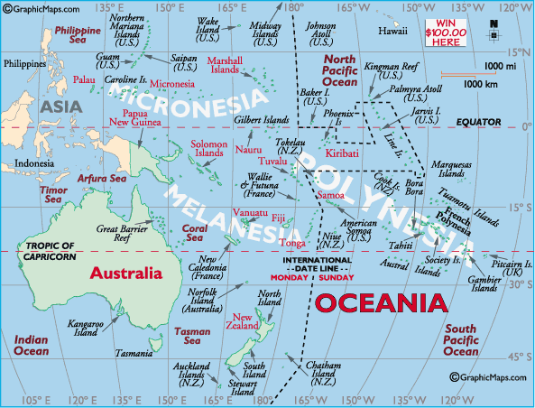
(Hawaii, Johnson Atoll and Midway Islands are located for reference only, and are not a part of Oceania.)
Melanesia includes the independent countries of Fiji and Vanuatu, as well as the Solomon Islands and New Caledonia. Micronesia islands are all part of the same volcanic zone, and include the Marshall Islands, the nations of Micronesia (FSM), Palau, Kiribati and Nauru. In addition, it includes Guam, Saipan, the Northern Mariana Islands, as well as Wake Island. Polynesia contains numerous island groups, including all of French Polynesia and the Austral, Gambier, Marquesas, Society and Tuamoto islands. In addition, the Cook Islands, Easter Island, Niue, the Pitcairn Islands, Tuvalu, and Wallis and Futuna.
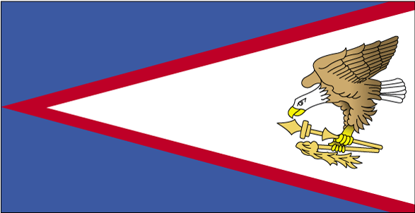

COUNTRY NAME: American Samoa, unincorporated and unorganized territory of the US
CAPITAL: Paga Pago

PROFILE: American Samoa and its small group of islands were first settled by the Polynesians some 3,000 years ago. In 1722 they were discovered by Jacob Roggeveen, a Dutch explorer.
In 1900 it became an unorganized U.S. territory, and in fact, it's today the only U.S. territory located south of the Equator. These rugged islands (fringed by reefs) have narrow coastal plains. All are volcanic in origin. The beautiful city of Pago Pago (the capital), pronounced (pãng'ó pãng'ó), has a magnificent harbor ringed by densely forested mountains. The outer islands are widely considered some of the most beautiful in the South Pacific.

LOCATION: Total land area of 199 sq km (76.8 sq miles), latitude/longitude: 14º 20S, 170º 00W,

GEOGRAPHY: Oceania, group of islands in the South Pacific Ocean, about half way between Hawaii and New Zealand.

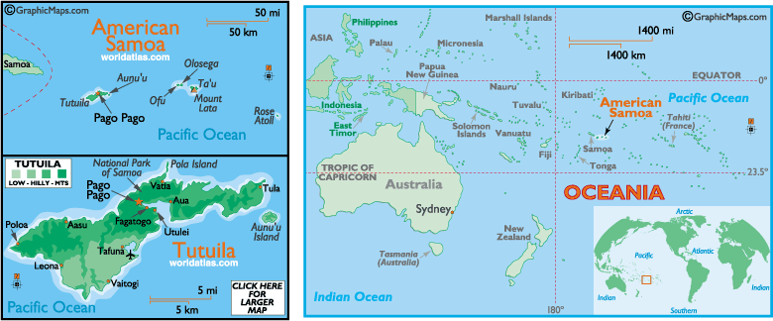

CLIMATE: tropical marine, moderated by southeast trade winds; annual rainfall averages about 3 m; rainy season from November to April, dry season from May to October; little seasonal temperature variation.

TERRAIN: five volcanic islands with rugged peaks and limited coastal plains, two coral atolls (Rose Island, Swains Island).

POPULATION: 60,100 (July 2004 est.)

NATURAL RESOURCES: pumice, pumicite.

ETHNIC GROUPS: Samoan (Polynesian) 89%, Caucasian 2%, Tongan 4%, other 5%

LANGUAGES: Samoan, English

RELIGION: Christian Congregationalist 50%, Roman Catholic 20%, Protestant and other 30%

ECONOMY: This is a traditional Polynesian economy in which more than 90% of the land is communally owned. Economic activity is strongly linked to the US, with which American Samoa conducts most of its foreign trade. Tuna fishing and tuna processing plants are the backbone of the private sector, with canned tuna the primary export. Transfers from the US Government add substantially to American Samoa's economic well-being. Attempts by the government to develop a larger and broader economy are restrained by Samoa's remote location, its limited transportation, and its devastating hurricanes. Tourism is a promising developing sector.

AGRICULTURE: bananas, coconuts, vegetables, taro, breadfruit, yams, copra, pineapples, papayas; dairy products, livestock.

UNIT OF CURRENCY: US Dollar

PORTS/HARBORS: Aunu'u (new construction), Auasi, Faleosao, Ofu, Pago Pago, Ta'u.

BRIEF HISTORY: Linguistic and cultural evidence suggest that the first Samoa inhabitants migrated from the West, possibly by way of Indonesia, Vanuatu, Fiji and Tonga, to the eastern tip of Tutuila near the present village of Tula around 600 B.C.. It is believed that there was at least an 800 year history of contact with Fiji and Tonga, before the Samoan islands were "officially" discovered by Dutch Explorer Jacob Roggeveen in 1722.
Initial contact with the outside world came with the introduction of Christianity by John Williams of the London Missionary Society. The adoption of Christianity by the ranking chiefs proved to be successful, for within 40 years, Samoans were sending missionaries to Melanesia.
Traditional Samoan society is based on a chieftain system of hereditary rank, and is known as the "Samoan Way" or fa'a Samoa way of life. Despite the inroads of modern, Western Civilization, local cultural institutions are the strongest single influence in American Samoa. The fa'a Samoa way of life stems from the aiga, the extended family with a common allegiance to the matai, the family chief who regulates the family's activities. Religious institutions are very influential in the community and the village minister is accorded a privileged position, equal in status to a chief or matai. The Fa'a Samoa also reflects a communal lifestyle with non-public ownership and 90% of the communal lands controlled by the family matai.
American Samoa has been a territory of the United States since the signing of the April 17, 1900 Deed of Cession. The Pago Pago Harbor area was the site of the coaling station and a naval base. During the late 1930's, the strategic importance of American Samoa proved valuable in its aggressive retaliation with the Japanese Empire. In 1940, the Port of Pago Pago became a training and staging area for the U.S. Marine Corps. During the War Years, the United States built roads, airstrips, docks and medical facilities exposing island residents to the American way of life. It was also then that American Samoans enlisted in the U.S. Marine Corps, thereby establishing a home guard unit. In 1945, the Marines left the island territory to resume its peaceful lifestyle.
Since World War II, American Samoa has developed into a modern, self-governing political system. The government is divided into three branches, similar to the United States. The Executive Branch is led by the Governor and Lieutenant Governor, the Legislative Branch is led by the local legislature, consisting of the House of Representatives, who are elected by popular vote and the Senate, who are represented by the village matai. The judicial branch is part of the U.S. judicial system, and American Samoa has a non-voting representative elected to the U.S. Congress.


COUNTRY NAME: Cook Islands

CAPITAL: Avarua

PROFILE: Named after Captain Cook, who sighted them in 1770, the islands became a British protectorate in 1888. By 1900, administrative control was transferred to New Zealand; in 1965 residents chose self-government in free association with New Zealand. The emigration of skilled workers to New Zealand and government deficits are continuing problems.

LOCATION: Oceania, group of islands in the South Pacific Ocean, about one-half of the way from Hawaii to New Zealand.

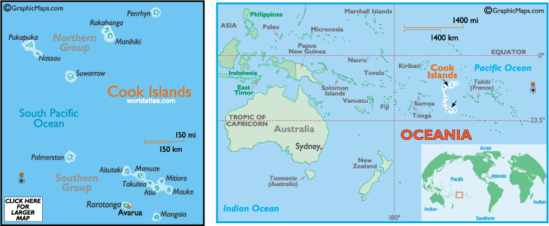

POPULATION: 21,200 (July 2004 est.)

CLIMATE: Tropical; moderated by trade winds

PEOPLE/CULTURE: Cook Islander

TYPE OF GOVERNMENT: Self-governing in free association with New Zealand;
parliamentary democracy

OFFICIAL LANGUAGE (S): Cook Island Maori & English

PRIMARY EXPORT(S): Copra, papayas, fresh and canned citrus fruit, coffee; fish;
pearls and pearl shells; clothing

UNIT OF CURRENCY: N.Z. Dollar
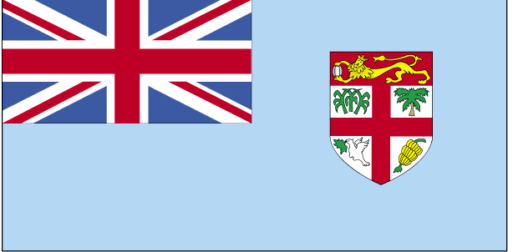
COUNTRY NAME: Fiji

CAPITAL: Suva, Viti Levu

PROFILE: Fiji became independent in 1970, after nearly a century as a British colony. Democratic rule was interrupted by two military coups in 1987, caused by concern over a government perceived as dominated by the Indian community (descendants of contract laborers brought to the islands by the British in the 19th century). A 1990 constitution favored native Melanesian control of Fiji, but led to heavy Indian emigration; the population loss resulted in economic difficulties, but ensured that Melanesians became the majority. Amendments enacted in 1997 made the constitution more equitable. Free and peaceful elections in 1999 resulted in a government led by an Indo-Fijian, but a coup in May 2000 ushered in a prolonged period of political turmoil. Parliamentary elections held in August 2001 provided Fiji with a democratically elected government and gave a mandate to the government of Prime Minister Laisenia QARASE.

LOCATION: Oceania, island group in the South Pacific Ocean, about two-thirds of the way from Hawaii to New Zealand

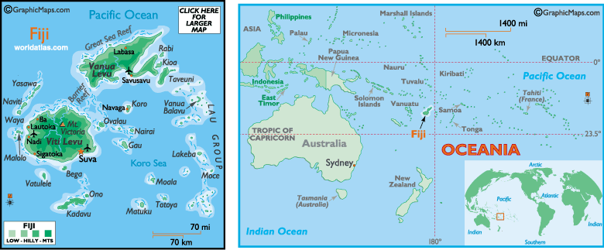

POPULATION: 880,874 (July 2004 est.)
CLIMATE: Tropical marine; only slight seasonal temperature variation
PEOPLE/CULTURE: Fijian & Indian
TYPE OF GOVERNMENT: Independent republic with Parliamentary system and Great Council of Chiefs
OFFICIAL LANGUAGE (S): Fijian, English, & Hindustani
PRIMARY EXPORT(S): Sugar, garments, gold, timber, fish, molasses, coconut oil
UNIT OF CURRENCY: Fijian Dollar
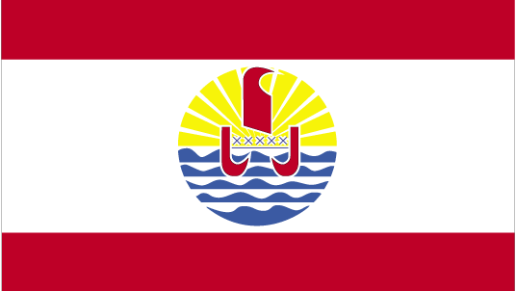

COUNTRY NAME: French Polynesia

CAPITAL: Papeete

PROFILE: The French annexed various Polynesian island groups during the 19th century. In September 1995, France stirred up widespread protests by resuming nuclear testing on the Mururoa atoll after a three-year moratorium. The tests were suspended in January 1996.

LOCATION: Oceania, archipelago in the South Pacific Ocean, about one
half of the way from South America to Australia.

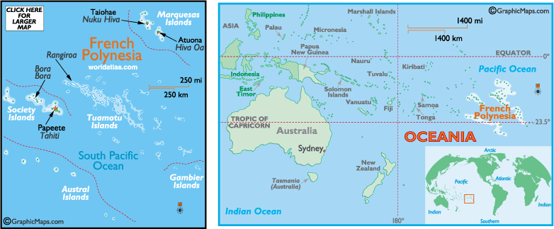

POPULATION: 266,339 (July 2004 est.)

CLIMATE: Tropical, but moderate

PEOPLE/CULTURE: Tahitian & French

TYPE OF GOVERNMENT: French Overseas Territory with internal autonomy; democratically elected multi–party political system

OFFICIAL LANGUAGE (S): Tahitian & French

PRIMARY EXPORT(S): Cultured pearls 50%, coconut products, mother-of-pearl, vanilla, shark meat

UNIT OF CURRENCY: French Pacific franc
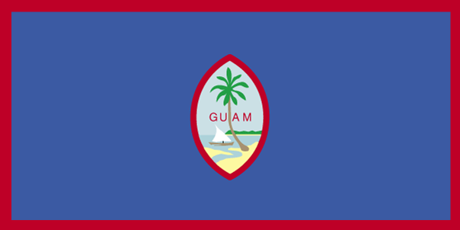

COUNTRY NAME: Guam, an unincorporated territory of the United States, claimed 1898

CAPITAL: Hagatna

PROFILE: Guam was ceded to the US by Spain in 1898. Captured by the Japanese in 1941, it was retaken by the US three years later. The military installation on the island is one of the most strategically important US bases in the Pacific.

LOCATION: Oceania, island in the North Pacific Ocean, about three-
quarters of the way from Hawaii to the Philippines

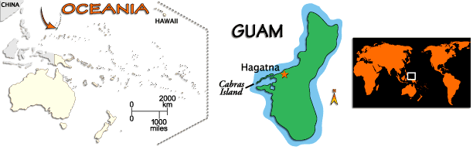

POPULATION: 166,090 (July 2004 est.)

CLIMATE: Tropical marine; generally warm and humid, moderated by northeast trade winds; dry season from January to June, rainy season from July to December; little seasonal temperature variation
PEOPLE/CULTURE: Chamorro

TYPE OF GOVERNMENT: Organized, unincorporated territory of the U.S. The
government has three branches as set up by Congress via the Organic Act in 1950.

OFFICIAL LANGUAGE (S): Chamorro, Japanese, & English

PRIMARY EXPORT(S): Mostly transshipments of refined petroleum products;
construction materials, fish, food and beverage products

UNIT OF CURRENCY: U.S. Dollar
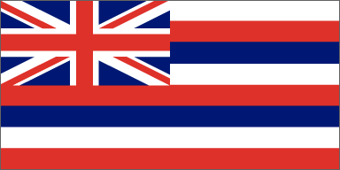

STATE OF HAWAII: Hawaii is named for the traditional home of the Polynesians, Hawaii or Hawaiki, called "Owhyhee".
CAPITAL: Honolulu

PROFILE: Hawaii was once an independent kingdom. (1810 - 1893) The flag was designed at the request of King Kamehameha I. It has eight stripes of white, red and blue that represent the eight main islands. The flag of Great Britain is emblazoned in the upper left corner to honor Hawaii's friendship with the British. Hawaii was the 50th state in the USA; it became a state on August 21, 1959.

GEOGRAPHY: 10,932 square miles. Hawaii is comprised of 8 main islands, is located in Polynesia near the center of the Pacific Ocean just below the Topic of Cancer, is considered one of the most remote spots on earth, and is 2,930 miles west of San Francisco, California.

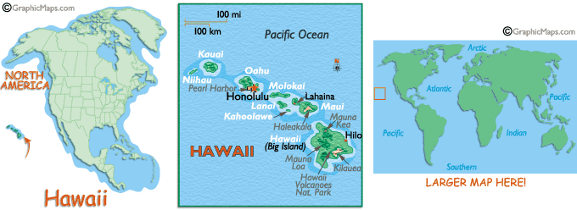

POPULATION: 1,211,537 (as of 2000)

MAJOR RIVERS/LAKE: Wailuku River (on the island of Hawaii), Anahulu River (on the island of Oahu), Salt Lake
BORDERING BODY OF WATER: Pacific Ocean
STATE MOTTO: "Ua mau ke ea o ka aina I ka pono" - The life of the land is perpetuated in righteousness
STATE SONG: Hawaii Ponoi (meaning Hawaii's Own)
BIOLOGY: Hawaii has a variety of plant and animal life. Many species are rare and endangered including the Nene Goose (official State Bird) and the Humpback Whale (official State Marine Mammal). Vegetation zones include coastal, dryland forest, mixed open forest, rain forest.

CLIMATE: Most of Hawaii has 2 seasons: “summer between May and October and “winter” between October and April. Average rain fall ranges from 20 to 160 inches. Average temperature ranges from 70 to 85 degrees F.

CULTURAL HISTORY: Hawaii is a multicultural society with major immigration from Polynesia, United States, China, Japan, Portugal Puerto Rico, Korea, Philippines.

ECONOMY: Hawaii’s cost of living is one of America’s highest, its per capita personal income below average. In fact, Hawaii’s cost of living for a family of our is estimated to be approximately 27% higher than the US average for a comparable standard of living. IN 1999, Hawaii’s average per capita personal income of $27,544 was 3.5% below the US average - the price of living in paradise!

MAJOR INDUSTRIES/SOURCES OF INCOME: Includes tourism, Federal Defense spending, agriculture. Hawaii is working to diversify its economy with a focus on industries such as science and technology, health and wellness tourism, diversified agriculture, ocean research and development, and film and television production.
BRIEF HISTORY: The exact date is unknown and probably will remain so forever. But sometime after the beginning of the Christian era, Polynesians first set foot on these islands. Linguistic and cultural evidence suggest that the first inhabitants came from the Marquesa Group, to the north of Tahiti.
During the 13th and 14th centuries, waves of immigrants from Tahiti overwhelmed and absorbed the original people. Since the earliest Hawaiians were possibly somewhat smaller than the later immigrants, they may form the basis for the legends of the menehunes, who were pictured by the later Hawaiians as hardworking elves.
Captain James Cook, the great Pacific explorer, happened upon the islands during his third voyage in 1778. Hawaii's long isolation ended at that moment. Soon, King Kamehameha the Great embarked on his successful campaign to unite the islands into one kingdom. At about the same time, Hawaii assumed importance in the east-west fur trade and later as the center for the Pacific whaling industry. In 1820, the brig Thaddeus from Boston arrived with the first missionary families.
Change came at a rapid pace as both education and commerce assumed growing importance. The old Hawaiian culture disappeared rapidly under the onslaught of new ways, new peoples, and new diseases, to which the previously isolated Hawaiians were all too susceptible. Whaling and the provisioning of the whaling fleet brought new money to the island economy. At times, as many as 500 whaling ships wintered in Hawaiian ports, principally Lahaina and Honolulu.
In 1835, the first commercial production of sugar cane began and this crop took on ever-increasing economic importance, especially after the decline of the great whaling fleets. Native Hawaiians did not take kindly to the tedious labor of a plantation worker and, in any case, the native population had been seriously depleted by disease. Thus, there began the importation of labor from Asia and the Philippines and other areas of the world. It is this varied population that gave rise to the immense variety of Hawaii's present inhabitants.
Threatened constantly by European nations eager to add Hawaii to their empires, sugar planters and American businessmen began to seek annexation by the United State. This, too, would give them the advantages of a sugar market free of tariff duties. Finally, a treaty of reciprocity was negotiated in 1875 and this brought new prosperity to Hawaii. American wealth poured into the islands seeking investment.
Political control by Hawaiian royalty and the growing influence of Americans began to cause conflict. In 1889, there was an uprising of the native islanders against the constitution which had been forced on King Kalakaua two years earlier. The rebellion was suppressed.
In 1893, with Queen Liliuokalani on the throne, the Americans formed a Committee of Safety and declared the monarchy ended. In 1894, the Republic of Hawaii was established. On August 12, 1898, the government of the Republic transferred sovereignty to the United States. Hawaii became a territory of the United States in 1900.
The pattern of growth then began to accelerate even more rapidly. The U.S. Navy set up its giant Pacific headquarters at Pearl Harbor and the Army built a huge garrison at Schofield Barracks. Pineapple, other crops, cattle ranching, and tourism slowly began to take on greater importance in the island economy.
The attack on Pearl Harbor marked America's entry into World War II and Hawaii and its citizens played a major role in the conflict.
The postwar period saw many rapid changes with the descendants of plantation laborers rising to the highest prominent in business, labor, and government.
Hawaii proved eager to take on the full responsibilities of statehood. Under the leadership of Hawaii's last delegate to Congress, John A. Burns, the 86th Congress approved statehood and the bill was signed into law by President Dwight D. Eisenhower on March 18, 1959. Hawaii was admitted as the 50th state of the union on August 21, 1959.



COUNTRY NAME: Marshall Islands
CAPITAL: Majuro Atoll

PROFILE: After almost four decades under US administration as the easternmost part of the UN Trust Territory of the Pacific Islands, the Marshall Islands attained independence in 1986 under a Compact of Free Association. Compensation claims continue as a result of US nuclear testing on some of the atolls between 1947 and 1962. The Marshall Islands hosts the US Army Kwajalein Atoll (USAKA) Reagan Missile Test Site, a key installation in the US missile defense network.

LOCATION: Oceania, group of atolls and reefs in the North Pacific Ocean, about one-half of the way from Hawaii to Australia.

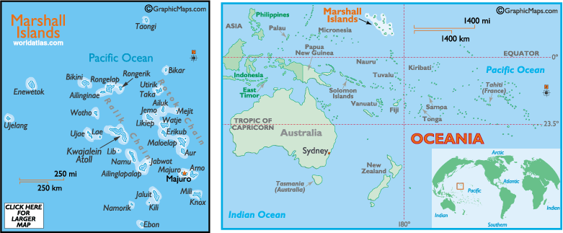

POPULATION: 57,738 (July 2004 est.)
CLIMATE: Wet season from May to November; hot and humid; islands border typhoon belt.

PEOPLE/CULTURE: Marshallese

TYPE OF GOVERNMENT: Independent nation in free association with the United States

OFFICIAL LANGUAGE (S): Marshallese & English

PRIMARY EXPORT(S): Copra cake, coconut oil, handicrafts, fish

UNIT OF CURRENCY: U.S. Dollar
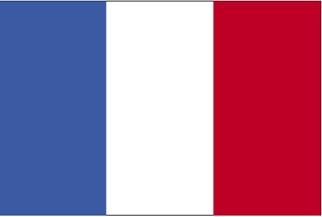

COUNTRY NAME: New Caledonia

CAPITAL: Noumea

PROFILE: Settled by both Britain and France during the first half of the 19th century, the island was made a French possession in 1853. It served as a penal colony for four decades after 1864. Agitation for independence during the 1980s and early 1990s has dissipated.

LOCATION: Oceania, islands in the South Pacific Ocean, east of Australia

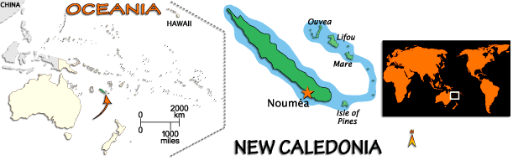

POPULATION: 213,679 (July 2004 est.)

CLIMATE: Tropical; modified by southeast trade winds; hot, humid

PEOPLE/CULTURE: Melanesian

TYPE OF GOVERNMENT: French Overseas Territory with internal autonomy.
Democratically elected territorial congress, multi-party political system

OFFICIAL LANGUAGE (S): Melanesian & French

PRIMARY EXPORT(S): Ferronickels, nickel ore, fish

UNIT OF CURRENCY: French Pacific franc


COUNTRY NAME: Niue

CAPITAL: Alofi

PROFILE: Niue's remoteness, as well as cultural and linguistic differences between its Polynesian inhabitants and those of the rest of the Cook Islands, had caused it to be separately administered. The population of the island continues to drop (from a peak of 5,200 in 1966 to about 2,100 in 2004), with substantial emigration to New Zealand, 2,400 km to the southwest.

LOCATION: Oceania, island in the South Pacific Ocean, east of Tonga

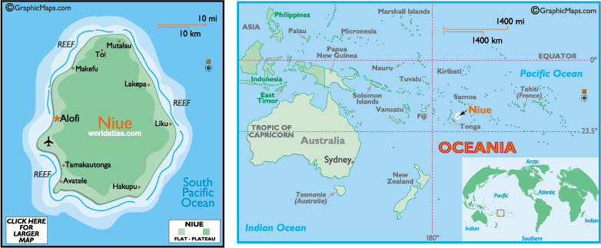

POPULATION: 2,156 (July 2004 est.)

CLIMATE: Tropical; modified by southeast trade winds

PEOPLE/CULTURE: Niuean

TYPE OF GOVERNMENT: Self-governing democracy in free association with New Zealand. Niue operates internal affairs; New Zealand responsible for foreign affairs and defense.

OFFICIAL LANGUAGE (S): Niuean & English

PRIMARY EXPORT(S): Canned coconut cream, copra, honey, vanilla, passion fruit products, pawpaws, root crops, limes, footballs, stamps, handicrafts

UNIT OF CURRENCY: N.Z. Dollar

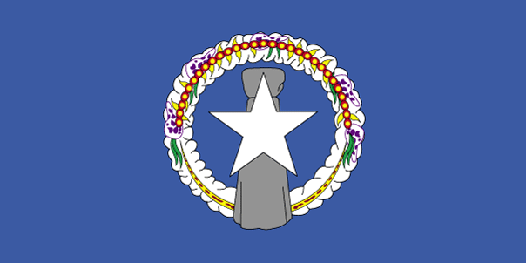

COUNTRY NAME: Northern Mariana Islands

CAPITAL: Saipan

PROFILE: Under US administration as part of the UN Trust Territory of the Pacific, the people of the Northern Mariana Islands decided in the 1970s not to seek independence but instead to forge closer links with the US. Negotiations for territorial status began in 1972. A covenant to establish a commonwealth in political union with the US was approved in 1975. A new government and constitution went into effect in 1978.

LOCATION: Oceania, islands in the North Pacific Ocean, about three-quarters of the way from Hawaii to the Philippines

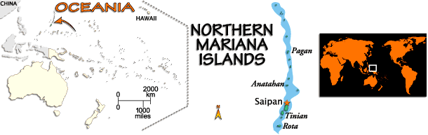

POPULATION: 78,252 (July 2004 est.)

CLIMATE: Tropical marine; moderated by northeast trade winds, little
seasonal temperature variation; dry season December to June, rainy season July to October

PEOPLE/CULTURE: Chamorro & Carolinian

TYPE OF GOVERNMENT: Commonwealth in union with the United States; a U.S.-style
government with three branches established with rights and responsibilities negotiated in the 1978 Commonwealth Covenant

OFFICIAL LANGUAGE (S): Chamorro, Carolinian, & English

PRIMARY EXPORT(S): Garments

UNIT OF CURRENCY: U.S. Dollar
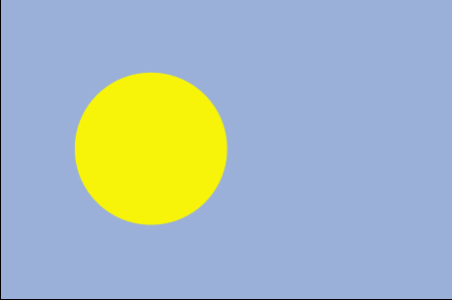

COUNTRY NAME: Republic of Palau

CAPITAL: Koror

PROFILE: After three decades as part of the UN Trust Territory of the Pacific under US administration, this westernmost cluster of the Caroline Islands opted for independence in 1978 rather than join the Federated States of Micronesia. A Compact of Free Association with the US was approved in 1986, but not ratified until 1993. It entered into force the following year, when the islands gained independence.

LOCATION: Oceania, group of islands in the North Pacific Ocean, southeast of the Philippines

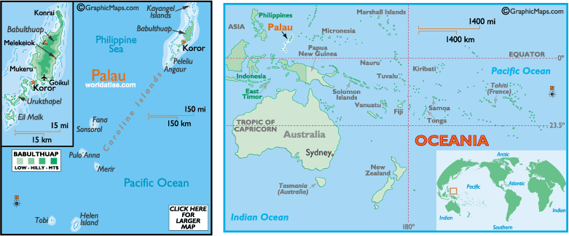

POPULATION: 20,016 (July 2004 est.)

CLIMATE: Wet season May to November; hot and humid

PEOPLE/CULTURE: Palauan

TYPE OF GOVERNMENT: Independent nation in free association with the United States

OFFICIAL LANGUAGE (S): Palauan & English

PRIMARY EXPORT(S): Shellfish, tuna, copra, garments

UNIT OF CURRENCY: U.S. Dollar
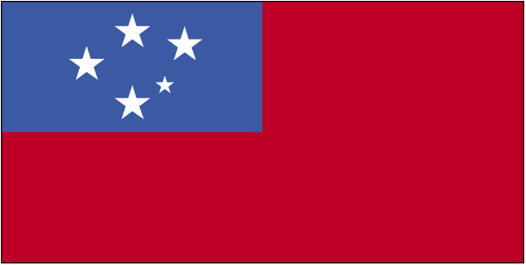
COUNTRY NAME: Samoa

CAPITAL: Apia

PROFILE: New Zealand occupied the German protectorate of Western Samoa at the outbreak of World War I in 1914. It continued to administer the islands as a mandate and then as a trust territory until 1962, when the islands became the first Polynesian nation to reestablish independence in the 20th century. The country dropped the "Western" from its name in 1997.

LOCATION: Oceania, group of islands in the South Pacific Ocean, about one-half of the way from Hawaii to New Zealand.

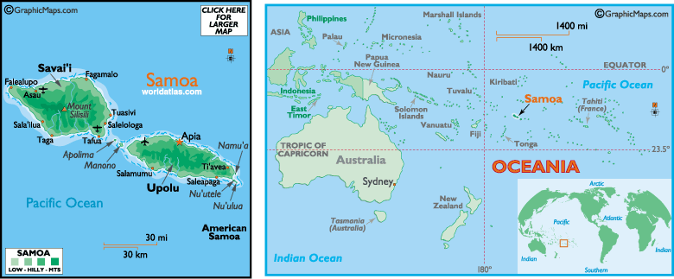

POPULATION: 177,714 (July 2004 est.)

CLIMATE: Tropical; rainy season (October to March), dry season (May to October)

PEOPLE/CULTURE: Samoan

TYPE OF GOVERNMENT: Parliamentary

OFFICIAL LANGUAGE (S): Samoan & English

PRIMARY EXPORT(S): Fish, coconut oil and cream, copra, taro, automotive parts, garments, beer

UNIT OF CURRENCY: Samoan Tala
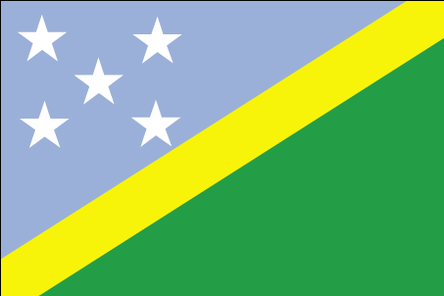
COUNTRY NAME: Solomon Islands

CAPITAL: Honiara

PROFILE: The UK established a protectorate over the Solomon Islands in the 1890s. Some of the bitterest fighting of World War II occurred on these islands. Self-government was achieved in 1976 and independence two years later. Ethnic violence, government malfeasance, and endemic crime have undermined stability and civil society. In June 2003, Prime Minister Sir Allen KEMAKEZA sought the assistance of Australia in reestablishing law and order; the following month, an Australian-led multinational force arrived to restore peace and disarm ethnic militias. The Regional Assistance Mission to the Solomon Islands (RAMSI) has been very effective in restoring law and order and rebuilding government institutions.

LOCATION: Oceania, group of islands in the South Pacific Ocean, east of Papua New Guinea.

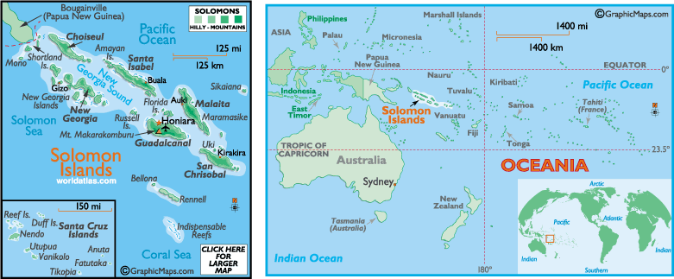

POPULATION: 523,617 (July 2004 est.)

PEOPLE/CULTURE: Melanesians

TYPE OF GOVERNMENT: Independent member of British Commonwealth. Democratically elected government, multi–party system.

OFFICIAL LANGUAGE (S): Solomon Islands Pidgin & English
PRIMARY EXPORT(S): Timber, fish, copra, & palm oil
UNIT OF CURRENCY: Solomon Islands dollar

COUNTRY NAME: Tonga

CAPITAL: Nukualofa

PROFILE: The archipelago of "The Friendly Islands" was united into a Polynesian kingdom in 1845. It became a constitutional monarchy in 1875 and a British protectorate in 1900. Tonga acquired its independence in 1970 and became a member of the Commonwealth of Nations. It remains the only monarchy in the Pacific.

LOCATION: Oceania, archipelago in the South Pacific Ocean, about two-
thirds of the way from Hawaii to New Zealand

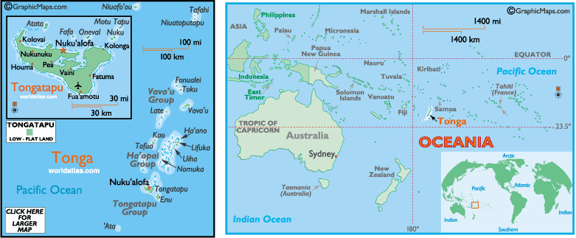

POPULATION: 110,237 (July 2004 est.)

CLIMATE: Tropical; modified by trade winds; warm season (December to
May), cool season (May to December)

PEOPLE/CULTURE: Tongan

TYPE OF GOVERNMENT: Constitutional Monarchy

OFFICIAL LANGUAGE (S): Tongan & English

PRIMARY EXPORT(S): Squash, fish, vanilla beans, root crops

UNIT OF CURRENCY: Paanga

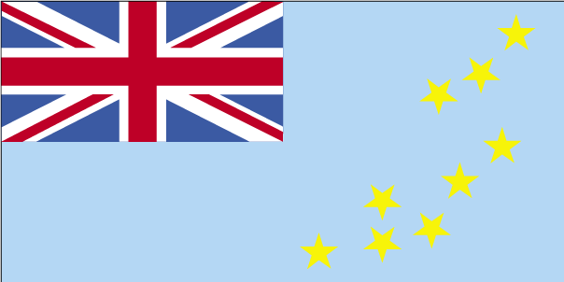
COUNTRY NAME: Tuvalu

CAPITAL: Funafuti

PROFILE: In 1974, ethnic differences within the British colony of the Gilbert and Ellice Islands caused the Polynesians of the Ellice Islands to vote for separation from the Micronesians of the Gilbert Islands. The following year, the Ellice Islands became the separate British colony of Tuvalu. Independence was granted in 1978. In 2000, Tuvalu negotiated a contract leasing its Internet domain name ".tv" for $50 million in royalties over the next dozen years.

LOCATION: Oceania, island group consisting of nine coral atolls in the
South Pacific Ocean, about one-half of the way from Hawaii to Australia

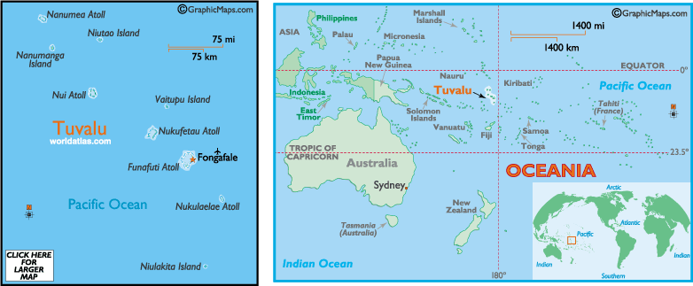

POPULATION: 11,468 (July 2004 est.)

CLIMATE: Tropical; moderated by easterly trade winds (March to November); westerly gales and heavy rain (November to March)

PEOPLE/CULTURE: Tuvaluan

TYPE OF GOVERNMENT: Independent, Westminster-style parliamentary democracy

OFFICIAL LANGUAGE (S): Tuvaluan & English

PRIMARY EXPORT(S): Copra, fish

UNIT OF CURRENCY: U.S. Dollar
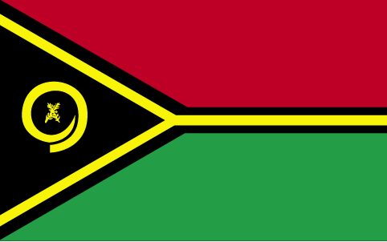
COUNTRY NAME: Vanuatu

CAPITAL: Port Vila

PROFILE: The British and French, who settled the New Hebrides in the 19th century, agreed in 1906 to an Anglo-French Condominium, which administered the islands until independence in 1980.

LOCATION: Oceania, group of islands in the South Pacific Ocean, about three-quarters of the way from Hawaii to Australia

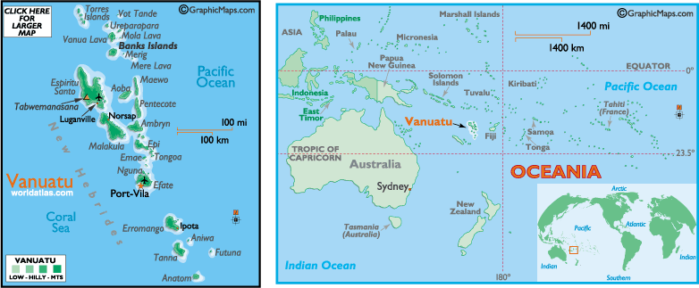

POPULATION: 202,609 (July 2004 est.)

CLIMATE: Tropical; moderated by southeast trade winds

PEOPLE/CULTURE: Melanesian, Ni-Vanuatu

TYPE OF GOVERNMENT: Independent republic, member of British Commonwealth; democratically elected government, multi-party system

OFFICIAL LANGUAGE (S): Bislama, French, & English

PRIMARY EXPORT(S): Copra, beef, cocoa, timber, kava, coffee

UNIT OF CURRENCY: Vatu

