LBNL-59540

Fuel Efficient Stoves for Darfur camps of Internally Displaced Persons
Report of Field trip to North and South Darfur, Nov. 16 - Dec.17, 2005

Christina Galitsky*, Ashok Gadgil†, Mark Jacobs† and Yoo-Mi Lee†

Energy Analysis Department* and Indoor Environment Department†
Environmental Energy Technologies Division
Ernest Orlando Lawrence Berkeley National Laboratory
University of California
Berkeley, CA 94720

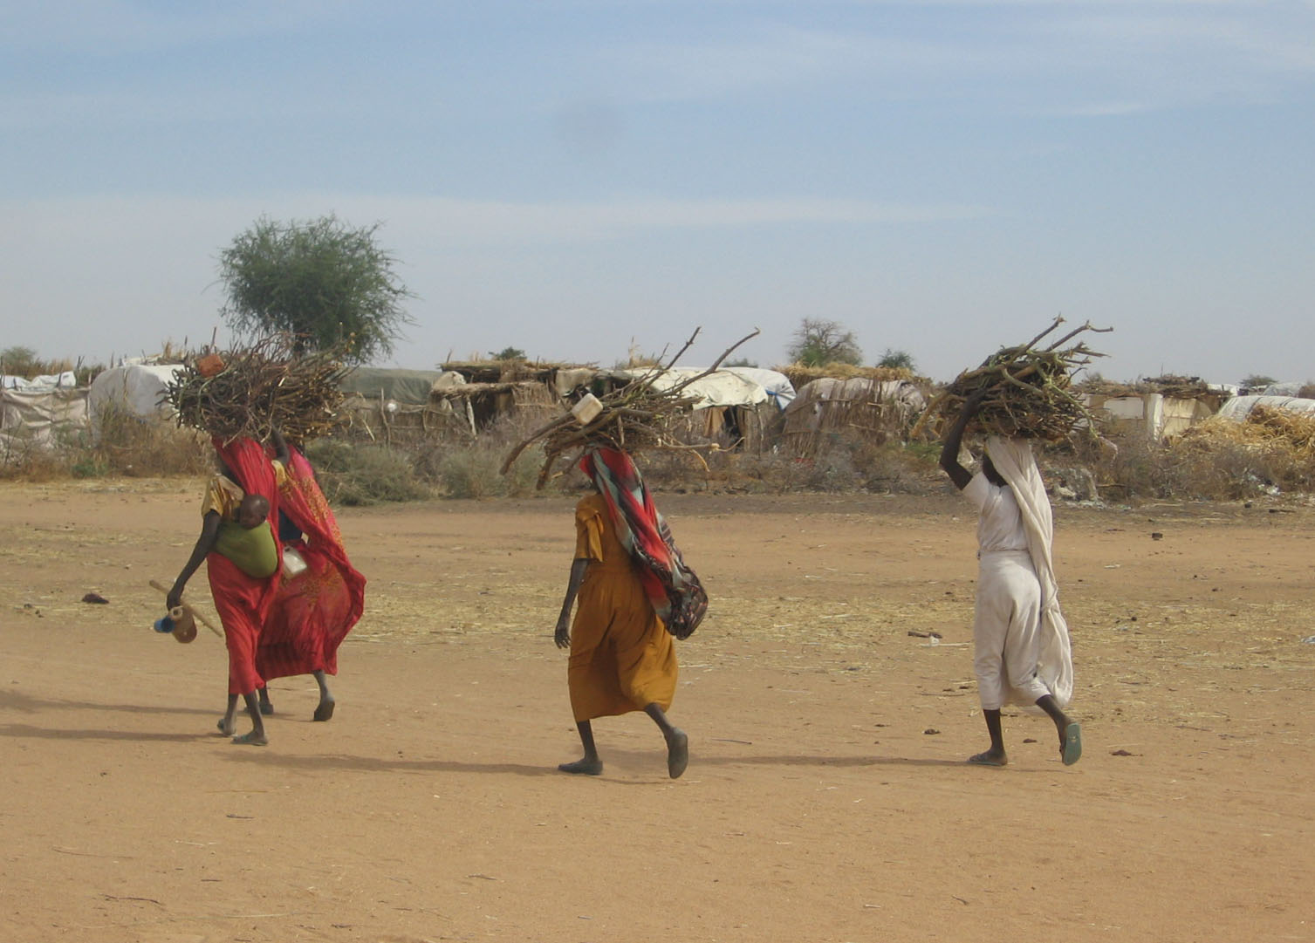

February 2006

This work was partly funded by CHF International (through a contract with the U.S. Agency for International Development Office of Foreign Disaster Assistance. The work was performed at LBNL under U.S. Department of Energy Contract under No. DE-AC02-05CH11231.

Fuel Efficient Stoves for Darfur camps Internally Displaced Persons
Report of Field trip to North and South Darfur, Nov. 16 - Dec.17, 2005

Executive Summary

Approximately 2.2 million internally displaced persons (“IDPs”) in Darfur are living in dense camps scattered in arid areas with low fuelwood productivity. Unsustainable harvesting of fuelwood by the IDPs has created ever increasing zones of denudation, that now (in November 2005) have reached several kilometers from the camp boundaries. Leaving the safety of the camps to fetch fuelwood from farther and farther away imposes great risk and hardship on the IDP women.

Three different metal fuel efficient stove (“FES”) designs were tested in Darfur IDP camps for their suitability to substantially reduce the fuelwood needs of IDPs. The mud-and-dung “ITDG” stoves being promoted under the current FES program were also examined and tested. A modified design of the ITDG mud-and-dung stove, “Avi,” was developed, built and tested.
Systematic informal surveys of IDP households were undertaken in North and South Darfur to understand the household parameters related to family size, food, fuel, cooking habits, cooking pots, expenditure on fuel, and preferences related to alternative ways to spend time/money if fuel could be saved.

Surveys found that a significant fraction of families are missing meals for lack of fuel (50% in South Darfur, and 90% in the North Darfur camps visited by the mission). About 60% of women in South Darfur, and about 90% of women in North Darfur camps purchase fuelwood. Selling some of the food rations to purchase fuel to cook meals was significant (40%) in South Darfur and has become common (80%) in North Darfur.

The LBNL mission found that two of the metal stoves and the mud-and-dung Avi can significantly reduce fuelwood consumption using the same fuel, pot, cooking methods, and food ingredients used by Darfur IDPs. The most suitable design for Darfur conditions would be a modified “Tara” stove. With training of the cooks in tending the fire, this stove can save 50% fuel for the IDPs. The stove costs less than $10 (US) to produce in Darfur, and saves fuelwood worth $160 annually at local market prices.

For programmatic and administrative reasons, the LBNL mission do not recommend a mud-and-dung stove, for which control of quality and dimensional accuracy is expensive and cumbersome to administer, particularly in a rapid large rollout effort. A light metal stove, on the other hand, can be rapidly produced in large numbers locally in Darfur, with good quality control exercised on the material and dimensions of the stoves right at the workshop where it is produced.

LBNL mission also recommends immediate trials of 50 Tara stoves in a pilot technical rollout, 500 Tara stoves in a pilot social rollout, in parallel with a technical effort to modify the Tara design to make it better suited for Darfur camp conditions. The mission also recommends a program for manufacturing, disseminating the metal stoves, and educating the IDPs in fuel-efficient cooking practices. Monitoring of the stove quality, dissemination effort and training should be an integral part of the program, with systematic summaries planned with 10,000, 50,000 and 100,000 stoves have been disseminated. In the above pilot rollouts as well as in the final implementation, it is important to continue to pay attention to training of the cooks in tending the cooking fire in the stoves, and offer continued social reinforcement to this training (e.g., through periodic competitions to cook normal meals with the least fuelwood use.)

1. Introduction
The mission to investigate alternatives to current cooking methods used by Darfur Internally Displaced Persons (“IDPs”), to investigate possible fuel savings (and associated reduction in risk and hardship to IDP women), was undertaken as a part of the BOLD II proposal from CHF International to US Agency for International Development – Office of Foreign Disaster Assistance (USAID-OFDA). Prior to the work contracted to LBNL by CHF International, we made significant progress with obtaining, modifying, and testing various metal fuel efficient stoves at LBNL with funding support from several generous individual donations and support from the Environmental Energy Technologies Division of LBNL, and our own personal efforts and funds. Based on the experience with efficient mud stoves dissemination programs in India, we were reluctant to recommend it for IDPs in Darfur, although we decided to keep an open mind to that possibility (see below about the “Avi” stove).

Five principal factors influence fuelwood consumption in a cookstove: The five factors are: (1) the cook’s fuel tending habits, (2) the fuel, (3) the stove, (4) the pot, and (5) the food (i.e., the raw ingredients and the method of cooking). We found meager (or even sometimes incorrect) information about many of these factors as they relate to IDP life in Darfur, so our testing at LBNL was limited to the standard water-boiling tests in flat bottom standard pots defined per international protocol for testing generic biomass stoves. It turns out that water boiling is irrelevant and flat bottom pots are ill-suited to the cooking methods used in Darfur. However, the mission members expected some of these surprises, and were able to accommodate the new information quickly into a revised work plan. Our goal all along was to test and demonstrate fuel efficient cookstoves using local cooks, local fuel, pots and food ingredients, to make local food being daily prepared by the IDPs, without a change in the taste or perceived quality of the cooked food, but with significant fuelwood savings.

The mission took place between November 16 and December 17, 2005. For the majority of the trip, two members (Mark Jacobs and Yoo-Mi Lee) of the team were based in El Fasher, North Darfur, and the other two members (Ashok Gadgil and Christina Galitsky) were based in Nyala, South Darfur. Three different designs of metal fuel efficient stoves (FES) were brought to Darfur and tested there. This was necessary because the performance of the stove depends on the five main factors mentioned above, several of which could not be reproduced outside Darfur. The three models of metal FES transported to Darfur for testing were: (1) the Tara stove, designed by Development Alternatives in Delhi, India, (2) the Rocket Stove designed and built by Aprovecho from near Portland, Oregon, and (3) a modified version of the Priyagni Stove, “LBNL-Priyagni” (the original Priyagni was obtained from ARTI, Pune, India, and modified by LBNL scientists).
These three stoves were tested and/or demonstrated side-by-side against current cooking method used by Darfur’s IDPs, at five different IDP camps: Abu Shouk, Assalam, and Zam Zam in North Darfur and Kalma and Otash camps in South Darfur. Informal, systematic surveys were conducted at Otash Camp in South Darfur and Abu Shouk, Assalam, and Zam Zam camps in North Darfur. These surveys were intended to provide critically important information regarding the magnitude of fuelwood use, fuel access and methods to obtain it, fuel prices, kinds and amounts of food cooked, size and shapes of pots used for cooking, family size, and household opinions/preferences regarding alternatives activities envisaged from time/money freed up if FES were made available. Based on local food and cooking methods, test results, and feedback from the IDPs, we determined the “best fit” FES stove to be the Tara (although we do suggest some minor design changes before large scale dissemination). Finally, the team researched local availability of materials and skills, local manufacturing capabilities and approximate costs of locally manufacturing the Tara stove.

1.1 Broad Objective
The main objectives of the team were to (1) compare alternative fuel efficient cookstoves with the three stone fires currently used for cooking in the Darfur region and (2) gather data on IDP’s food, cooking methods, food, fuel use, fuel gathering activities, resource availability for local stove manufacture, and relevant aspects of the culture of the region specifically in regards to stove usage. These survey data were centrally important to address questions relevant to a future FES introduction program, such as: How much fuelwood does a household currently use? How much fuelwood will a family save with a good metal FES? Will this reduce their fuel-collection hardships and risk or will they collect the same amount of wood and sell the excess for more cash? What will they do with the saved time and/or money from the use of an FES?

1.2 Specific Objectives
- Collection of data on current amount of food and type, cooking methods, fuel usage, pot sizes, family sizes, and fuel gathering activities of IDPs
- Assessment of current mud-and-dung based “improved cookstove” attributed by ITDG (this organization, formerly the “Intermediate Technology Development Group,” recently changed its name to “Practical Action.” The stoves are still called ITDG stoves in Darfur.)
- Demonstrations and tests of three alternative metal FES relative to currently used stoves at camps in North and South Darfur
- Assessment of which, if any, of the three introduced FES could be introduced successfully in Darfur
- Assessment of availability of local Sudanese and/or Darfur resources (materials and skills) that might be used to build the selected FES design
- Assessment of any shortcomings identified in the selected design, the significance of the shortcomings, and possible remedial measures
- Recommend future course of action.

1.3 Outline of the rest of the report
The rest of the main report summarizes the findings of technical testing, the informal systematic surveys, and the assessment of the local capabilities. In addition, since the team found it nearly impossible to obtain access to much of the relevant background information before actually reaching the Darfur IDP camps, we have provided such information for use by future investigators in the Appendices. The structure of the report is as follows: Section 2 provides an overview of the visit and our methods. Section 3 provides our findings. Section 4 gives the conclusions. And Appendices A, B and C provide supplementary background information on other stoves, cooking methods, other variables affecting fuel consumption such as training of the cooks in tending the fires.
2. Visit Overview and Methodology
The mission consisted of four team members who all arrived in Khartoum on November 17, 2005, then split into two teams of two members each, one team heading to South Darfur, and the other to North Darfur. Below we describe each of these visits individually, though there is some overlap.

Owing to the uncertainty in shipping schedule and possible difficulties with Sudanese customs, FES were sent to Darfur via multiple routes. Some of the FES were shipped directly from India, some shipped from Berkeley, CA, some from Portland, OR, and the rest carried as personal baggage from India and the U.S. This was a fruitful approach as both teams ended up with at least a few FES models to work with right from the start.

Both the South Darfur (SD) team and the North Darfur (ND) team arrived in Khartoum on November 17, 2005 and remained in the capital until November 20, 2005. During that period the teams met with CHF International to discuss and plan their upcoming trips to Darfur, obtained necessary internal visas and paperwork to enter Darfur, and visited a metal workshop to make modifications to one of the FES designs (Priyagni) to be demonstrated in Darfur. The change was warranted to incorporate round-bottom pots (“Tungutungus”), which we learned, on arriving in Khartoum, are the norm in the IDP camps for cooking most of their meals. Without the on-the-fly design change, the performance of the Priyagni FES would certainly have been mediocre or even abysmal. With the change, the modified stove (shorthand name: “LBNL-Priyagni”) performed quite well in the field.

2.1 South Darfur
On November 20, 2005, the SD team flew to Nyala, South Darfur, where they met with the local CHF Nyala staff members to set up translators, drivers, and staff assistance for the next 11 days. The team also met with government officials from the Humanitarian Aid Commission (“HAC”) of Sudan and obtained the additional permit required to enter Kalma Camp. One question we were asked earlier was whether the FES introduction was a worthwhile effort – if the risks and hardships faced by the IDP women during firewood collection (as reported in the previous year, 2004), had substantially disappeared or were about to disappear. The SD team met with several NGOs to understand the situation regarding current risk and hardship for the IDPs brought on by fuel wood collection. The NGOs included the International Rescue Committee (IRC), Medicines San Frontiers (MSF, also known as Doctors without Borders), Medicines Du Monde (MDM), the Norwegian Refugee Council (NRC), the International Committee of the Red Cross (ICRC), the Spanish Red Cross, and USAID OFDA. The team learned that the risks and hardship faced by the IDP women in collecting fuelwood has pretty much remained unchanged over the past year – if anything, the problems have only increased owing to the increased travel (about 3 hours one way) now needed to reach fuel-gathering areas compared to that (2 hours one way) needed a year ago in South Darfur camps.

Over the next 11 days, the SD team mostly devoted its time to cooking demonstrations and designing and undertaking an informal, systematic survey of the IDPs. Three cooking demonstrations were held, each on a different day, one in each of the CHF International’s Women’s Centers – two in Kalma Camp and one in Otash Camp. At least one day preceding each demonstration, a meeting was held with the local IDP camp leaders, “sheikhs”, to explain the purpose of the demonstration and how it would be carried out. These explanations were repeated to the IDP women and men in attendance at the demonstrations immediately before starting the demonstrations.

For each demonstration, one to two metal FES were compared to the three-stone fire (the latter is called the “laddaya” and is the current method used for cooking). In the demonstration at the Kalma-I Women’s Center, the current mud stove or “ITDG mud stove,” was also compared.

Before the start of each cooking comparison, a number of bundles of fuelwood were prepared with participation of IDP men in the audience. Each bundle weighed 250 grams, and was tied with a string or straw. Equal number (usually 8 or 10) of these bundles were placed in front of each of the stoves to be tested. While IDP men cut the wood for preparing the 250 gram piles, the women participants were asked to prepare the food for the meals – pounding the dried meat, tomatoes and okra, and chopping the onions. Then, using fuel wood from the bundles, teams of IDP women cooked equal amounts of food simultaneously on nearby stoves. Each team received equal measured amounts of the raw food ingredients (and water), and used the pots normally used by the IDPs, thus providing a live, simultaneous and transparent comparison of stove performance for the collected audience. These demonstration tests were conducted at each of the three CHF women’s centers and observed with great attentiveness and interest by hundreds of local camp leaders and IDP women. Following each demonstration was a question and answer session. During that time, the SD team asked the local leaders and women which stoves they liked, what concerns they had and what they thought would be a fair price for the FES. These data are discussed in Section 3, below.

During the 11-day stay in South Darfur, the SD team also conducted a systematic informal survey of 50 IDP families. The households were chosen at equally spaced intervals along the winding lanes and walkways within the Otash camp. The process was not perfect, because the lanes and walkways are not well laid out, but the team did as well as possible under the circumstances. As per local customs and traditions, the SD team started with the camp leader’s household and then used a random number generator to pick the next house. The remaining households were chosen by dividing the total number of families (approximated) and spacing equally the remaining yet to be chosen houses in each of the four sectors in Otash camp. With winding “roads” and occasional empty shelters (on at least one occasion because their occupants had left to collect fuelwood) this task proved difficult to perform exactly; however, absentees were noted and the randomness retained by selecting the nearest occupied house to a selected empty one.

The informal surveys included approximately 30 questions regarding family sizes, types and quantities of meals and tea prepared per day, fuel usage and type of fuel (wood, charcoal, dung, paper, etc. and sizes of wood used), fuel gathering activities, amount of family resources dedicated to buying or bartering for fuel, income generation activities, and current stove and pot(s) usage. The SD team also obtained answers to a hypothetical question of what the IDPs would do with the time or monetary savings generated if they were to obtain an FES that used only half as much fuel as the currently used three-stone fire. After all questions were prepared in English and translated into Arabic, they were translated back into English with a different translator to ensure fidelity in translation. When the “back translated” question did not match the original question, the Arabic translation was repaired and checked again. The final accepted Arabic questionnaire was faxed to the ND team for their use. All questioning was done in presence of a local community leader and through at least one translator (most of the time two translators were present) and all questions were asked of an “adult” female in the household. In one small part of the survey, covering the Dinka community in Otash camp, we had at least two translators as the Dinka do not speak Arabic.

On arrival at Nyala, we saw for the first time the ITDG mud stove made of mud and donkey dung, and widely promoted in Darfur IDP camps as a fuel efficient stove, with about 50,000 units built by Fall of 2005. We had earlier read about this stove and seen some photos of it in the Aprovecho report about FES in Darfur (reference 1). On inspection, the actual stove has obvious and serious flaws – only to be confirmed by our testing, discussed in Section 3, below. We believe it likely that the ITDG stove initially had a decent design, and that successive transfers of the design from person to person has led to cumulative design degradation and oversimplifications till the stove as disseminated is practically worthless. On November 28, after discussions with Suneel Kumar (a structural engineer and the then-acting chief of CHF Nyala office) on how to improve the ITDG mud stove, Dr. Gadgil designed a retrofit which would cost about US $0.50 in materials, and about 30 minutes in effort. These changes were immediately incorporated the next day into one ITDG stove by another member of CHF International Nyala staff, Mr. Avi Hakim. The standard ITDG design as promoted in Darfur IDP camps and the modified stove, named “Avi”, are shown side-by-side in Figures 1 and 2. The Avi stove tests very well, in both efficiency and smokeless operation; however it is not recommended for rapid wide scale dissemination in Darfur IDP camps for reasons discussed below. The improved stove pictured here employs a cast iron grate (bought in India for approximately $0.50 US) placed over an opening cut out of the bottom. When this stove is set upon three bricks that lift it off the ground, air flows to the solid fuelwood, substantially improving combustion efficiency. The grate could also be made from pieces of locally available 0.5 cm diameter steel rod, cut into 18 cm lengths, costing approximately the same - 100 SDD (Sudanese Dinar, equal to about $0.40 US in November 2005). The grate improves combustion efficiency and reduces smoke generation. The new design also includes vertical ventilation channels carved into the inner walls of the stove and three mud knobs added to the top to permit combustion air flow even when a tight-fitting large pot or a flat metal plate is being used for cooking. In the current ITDG design, either of these would otherwise throttle air exhaust and choke the fire. The newly improved stove, “Avi” was later tested by the ND team, and their impressions are reported in Section 2.2 and 3.3, below.

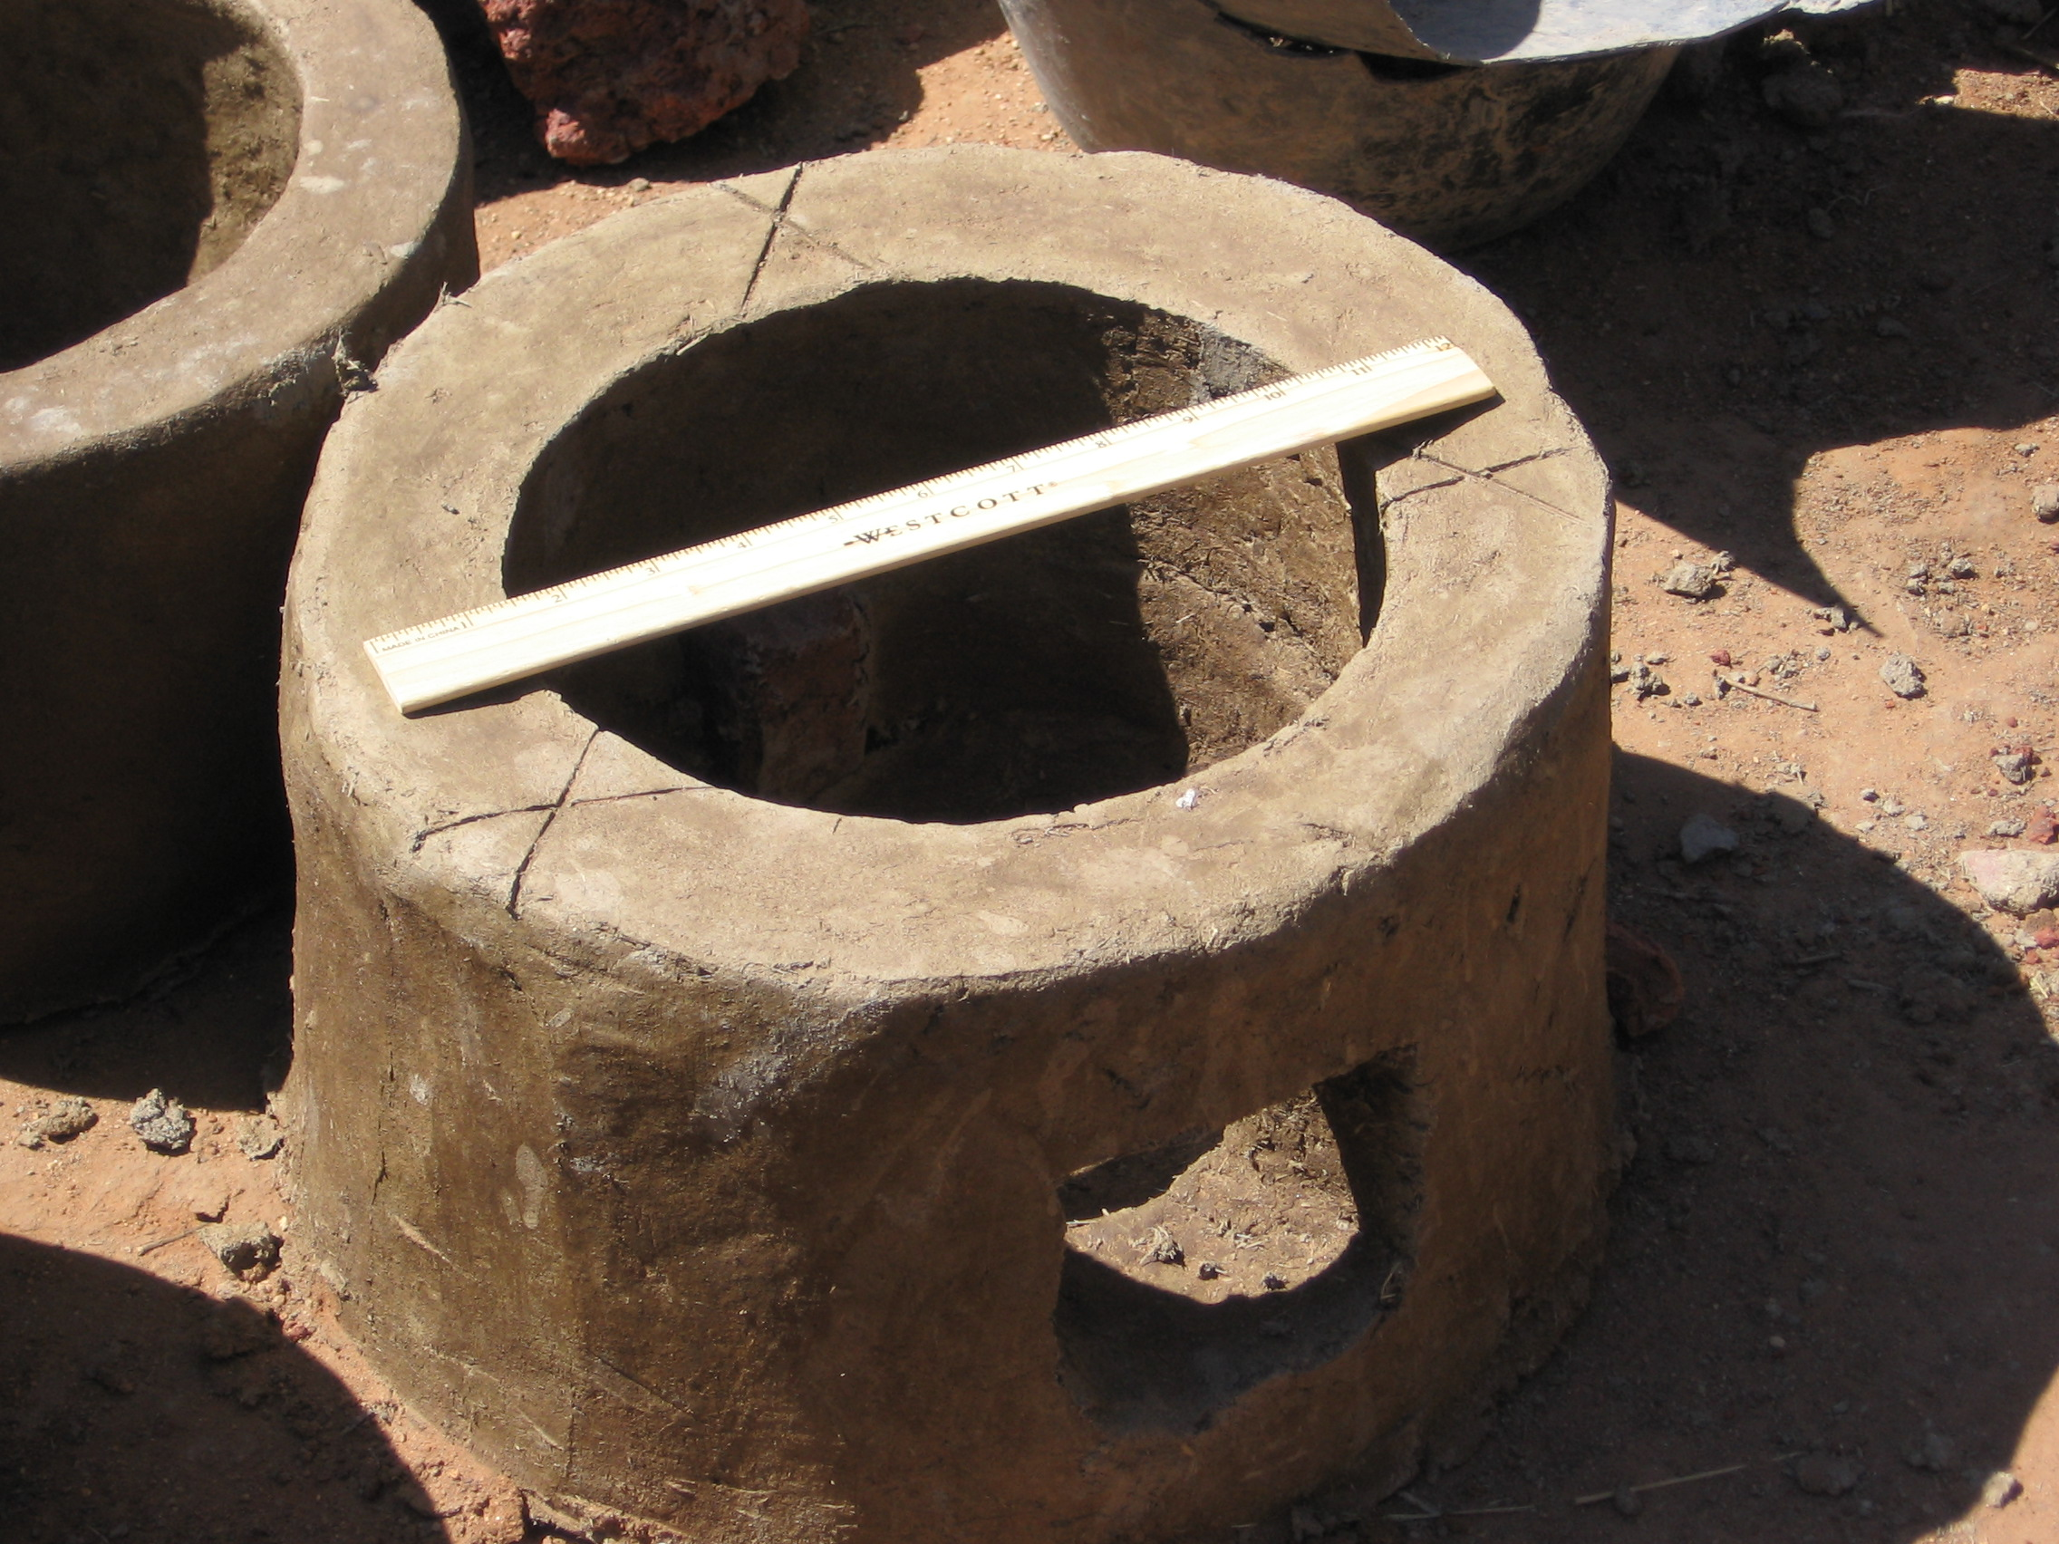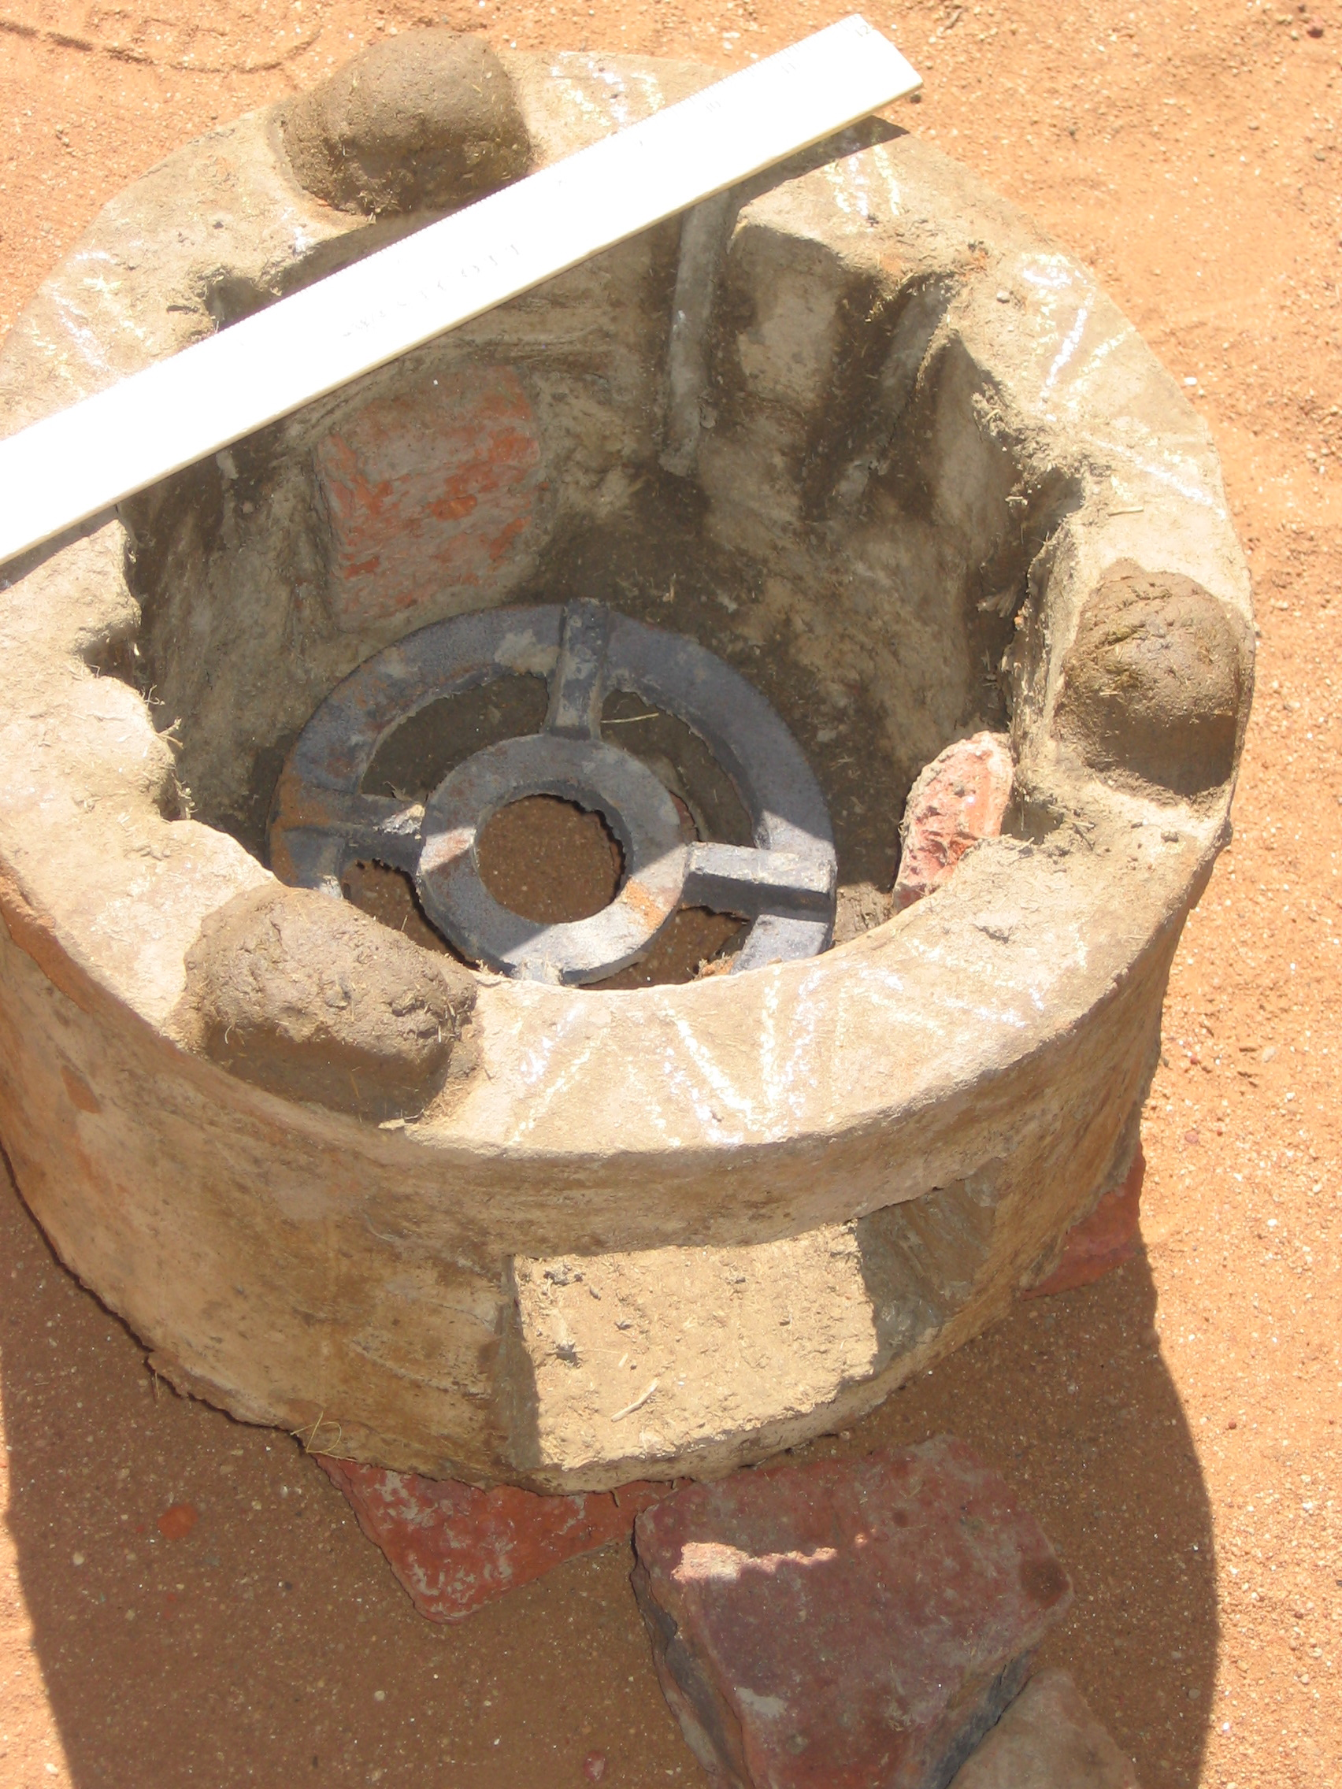
Figure 1: Standard CHF Stove Figure 2: Improved “Avi” Stove

On Sunday Nov. 22, the SD team was invited to give a presentation of its preliminary findings to the UN Office of Coordination of Humanitarian Affairs (UN-OCHA) in Nyala. This presentation and discussion was attended by close to 25 representatives from various NGOs attended at the invitation of UN-OCHA. On November 29-30, the ND team joined the SD team in Nyala. At the markets, the full team explored local capacities in Nyala for producing the most appropriate FES, determined both by the IDPs to be the most suitable for their cooking conditions and by the availability of source materials for making the stove, as well as the logistical and organizational aspects of wide scale rapid stove dissemination in the IDP camps. The SD team left on November 30 for Khartoum.

In the final two days at the end of the mission, the SD team met with CHF International staff in Khartoum to discuss findings and next steps. Along with CHF Sudan mission director, Denis Dragovic, the SD team also met with the World Food Program (WFP) to discuss the possibility of providing FES partially in lieu of fuel wood to North Darfur and to better understand the situation in North Darfur (discussed below in Section 2.2 and 3.3). Because there is almost no fuelwood left to collect in North Darfur, WFP is planning to supply the IDP camps in the North with fuelwood in addition to the food that they currently supply. Making FESs available to the IDPs will be highly cost effective in terms of reducing fuelwood needed, and will also reduce the pressure on the ecosystems from which the wood is harvested.

2.2 North Darfur
From November 21 through December14, Mark Jacobs and Yoo-Mi Lee visited three IDP camps around El Fasher, North Darfur: Abu Shouk, Assalam, and Zam Zam. They examined the supply and demand for biomass cooking fuel in the camps and studied the ways in which a well-designed, well-implemented efficient stove program might alleviate the suffering caused by the shortage of fuel.

The ND team observed the cooking of meals and informally interviewed the adult women of more than 80 families, including 59 with whom they had more detailed discussions. The interviews and the discussions covered topics concerning the fuel for cooking meals, the source of that fuel, and the effect of fuel scarcity on their lives, family budget, and ability to feed themselves, their eating patterns and preferences, the type of food available to them, cooking habits, tools, and techniques, the type of cookstove they use, and how and when they use it.

The team also informally interviewed a number of participants in the wood-supply chain, to understand the economics and the logistics of transporting and selling a large amount of firewood to an area that is essentially without fuelwood resources of its own. These included small operators, who cut, bundle and transport less that 300kg at a time by horse-cart; truck drivers who bring in as much as 60 cubic meters to the area at a time; and the retailers of wood, in the camps and in the town of El Fasher.

Part of the information gathering process included meetings with the NGOs, multilateral agencies, and consultants who are working in the camps as managers or project personnel to get their perceptions of the problems caused for the IDPs by the wood shortage as well as the studies, programs, and other proposed solutions addressing this issue. The ND team learned about how NGO programs are implemented in the camp, so that the team could account for programmatic and administrative issues when assessing appropriate fuel efficient stove alternatives. In meetings with CHF International directors and program managers, as well as representatives of other NGOs, the team presented their research methodology and tentative program ideas for feedback.

Testing in North Darfur
In the process of evaluating various stove designs for use in Darfur, the ND team conducted 34 separate tests of fuel efficiency and cooking speed on nine different designs. The team also ran five demonstrations for audiences of IDP women, local leaders, and NGO staff to illustrate the relative fuel savings of various stove designs compared to the traditional three-stone fire typically used within the camps. In each demonstration the traditional staple food of Darfur was prepared simultaneously on four or five stoves of different designs. However, the ND team feels that their test results should not be taken at face value since some variables (such as training of the cooks in tending the fires, and wind conditions) varied greatly and in an uncontrolled manner between tests. So, only the ND team’s general findings from these tests are reproduced below.

Lectures and Demonstrations in the IDP Camps
At each public demonstrations, the ND team also gave a lecture on how to tend an efficient fire. The premise of the lectures was that this might be useful in alerting the women that different methods of tending the fire can affect the amount of fuelwood needed to perform the same cooking task and this requires learning fire tending skills different from those they practice.

Avi Stove Testing
The ND team also built and tested several Avi stoves. The team found that the Avi stove performs well in the cooking tests as an FES. However the team believes that it shares the same challenges as the ITDG mud stove in terms of successful wide dissemination. Based on our assessment of the ITDG mud stove program, both the ND and SD teams believe that hundreds of thousands of IDP women cannot be rapidly trained and supervised to successfully build the Avi stove accurately. It is a mistake to believe that just because mud-dung is easily formed into the basic shape of a stove, therefore to produce a stove is easy. The difference between a high-performing and an ineffective stove can be a matter of a slight change in a critical dimension. These details can be easily “lost in translation” as the stove design is transmitted from dozens of field staff to hundreds of IDP trainers from whom it must be conveyed to hundreds of thousands of IDP women each being trained to build her own stove.

3. Findings

  - Overview
The situation between North and South Darfur is different in one significant respect: there is no fuel wood left in North Darfur at all. Even root balls have been dug up during 2005 for use as fuel wood. Many of our initial survey questions on fuel collection, therefore, did not apply to the North, although they did in the South. Many more women in the North were facing worse health problems and malnutrition because they had no fuel to cook the food they did have, and no place from which to collect it, or enough money to buy it at the higher North Darfur fuelwood prices. Hence, we have split this section into South Darfur and North Darfur and then further into subsections to describe our findings for each area.

Also, the ND team comes from a legal and financial background, in contrast to the science and engineering background of the SD team. This is inevitably reflected in the assessments and style of reporting of the two teams. The leader, Ashok Gadgil, of the overall effort considers both viewpoints valid and valuable, and so both have been retained despite their different styles and emphases.

  - South Darfur

3.2.1 Systematic Informal Surveys
Table 1 shows a summary of the cooking habits of the IDPs in South Darfur based on our informal survey results. Numerical answers to quantitative questions are summarized as arithmetic means with standard deviations. For questions with yes/no for answers, the majority response and the percent of people giving that answer are given.

Some of the data collected and compiled in Table 1 is intended to be useful to help modify an FES applicable to Darfur. Other data are useful to estimate impact of FES dissemination in the IDP camps. For example, data show that currently about 90% of the IDPs surveyed use a three-stone fire for most or all of their cooking needs and they burn about 5 kg of fuel wood per day. The average household size is seven. Estimates of two million IDPs thus implies about 300,000 IDP households in Darfur, using 1,500,000 kg of fuelwood daily. Hence, if an FES with an efficiency twice that of the three-stone fire (i.e., a relative efficiency of 2.0, when normalized with the efficiency of the current cooking method) is successfully adopted by all IDP households using a three-stone fire, the resulting annual savings in fuelwood would be about 260,000,000 kg, worth about US$ 104 million annually (at the prevailing price of US$ 0.40 per kg fuelwood in South Darfur in November 2005. Prices in North Darfur were higher, but we use the lower price for a conservative estimate.) Note that a fraction of fuelwood is collected, a fraction is bought from middlemen, and a fraction is traded among the refugees including a risk premium in the fuelwood price. So, these monetary savings are only at the shadow price.

Annual fuel savings are estimated at the technical potential with the following equation:

Annual savings = (current household use/day) * (365 days/yr) * (1-1/(relative efficiency)) *
(Number of IDPs/IDPs per household) * (Fraction using 3-stone fires)

Putting numbers into the above equation yields:

We note that “Technical Potential” assumes 100% saturation (among the 90% of the IDP households currently using three-stone fires for cooking), and no “takeback” effect. This latter effect, “takeback”, refers to increased use of services (in this case cooking) owing to the availability of higher efficiency appliance. For example, with higher efficiency of stoves, IDPs would stop missing meals for want of fuel, and thus some increase in fuelwood consumption will result from increased number of meals. Also, if less fuelwood is needed, they would sell less food to obtain the fuelwood, leaving more food to be cooked, leading again to more meals being cooked.

Table 1: Cooking Habits of IDPs in Otash Camp, South Darfur.
 | Mean (except where noted) | Standard Deviation
Total number of family members | 7 | 2.4
Number of meals eaten per day | 3 | 1.0
Flour cooked per meal (kg) | 1.7 | 0.7
Amount of time to cook one meal (hrs) | 1.3 | 0.5
Amount of firewood used for one meal (kg) | 2.0 | 1.0
Amount spent on wood per day (SDD) | 170 | 230
Diameter of wood (cm) | 3.6 | 1.6
IDPs using three-stone fires for meals (%) | 90% | na
Number of times tea made per day | 3 | 0.6
IDPs that use charcoal for cooking or tea (%) | 70% | na
Amount of charcoal used per day (kg) | 0.8 | 0.8
na = not applicable – yes/no questions only
SDD= Sudanese Dinars, exchange rate approximately 230 SDD = $1 US in November 2005

Table 2 shows the wood collection activities of the IDPs in Otash, South Darfur. Of the surveyed women that currently collect wood, about 50% would collect less wood if they had an FES that required less wood. Only 26% of the women with whom we spoke collected wood, however, this number is underestimated because some of the IDPs were out collecting wood at the time of the interviews and their houses had to be skipped. Thirty-eight percent of the IDPs interviewed said they have sold food to buy wood to cook the rest of the food they did have; 47% said they have at some point missed a meal due to lack of fuel only, not food. In addition to the data in the table we asked the following question (paraphrased) to the women that purchase (i.e., do not collect) wood: “if you obtained an FES, what would you do with the money you save using the FES?”. The majority of women responded that they would use it to improve meals for their children or family. For those that would save time instead of money, we posed the same question replacing “money” with “time”. As shown in Table 2, about half the women would use that increased available time to collect wood to sell; most of the other 50% stated that they would do other income generating activities such as making grass mats or crafts, work in the nearby town of Nyala or use the time to rest. We note here that charcoal is almost exclusively used for making tea. It is very expensive, and would be unaffordable for cooking the main meals. Charcoal is commonly produced quite inefficiently – leading to a large loss of energy during its production from fuelwood.
Table 2: Fuel wood collection and related behaviors of IDPs in Otash Camp, South Darfur.
 | Percentage of IDPs interviewed (%, except as noted)
Women who collect wood | 26† (36**)†
Women who buy wood | 60† (52**)†
Hours per week spent collecting wood (of those who collect) (average) | 25‡
Women who collect who also sell wood | 38
Women (who collect) who would collect less wood if they had an FES | 50
IDPs that have sold food to buy fuel | 38*
IDPs that have missed a meal because they had food but no fuel | 47
.
**These are estimated assuming that the women from the absentee households (total, 8) were collecting wood; we in effect are assuming we have interviewed 58, and not just 50 households. We present these numbers to provide an upper estimate on the percentage of women that do collect wood.
† These numbers do not sum to 100% because some IDPs burn other fuels such as charcoal or dung.
‡The average of the sum of the products of time spent collecting wood per day multiplied by the number of days per week that wood is collected is 25; the average number of hours per day spent collecting is 6.6 and the average number of times per week is 3.5, generating a product of the averages equal to 23. We report the former in the Table.
*Some IDPs have no food card so they do not receive food rations to sell for wood.

The SD team also collected data on pot sizes for later potential adaptation of an FES to specific Darfur IDP use. There were four main pot types observed in use in the camps in South Darfur, all cast-aluminum round bottom pots. Table 3 summarizes our findings on pot dimensions. In addition to the cast aluminum round bottom pots, occasionally we also found flat bottom aluminum pots and flat iron plates being used for making a pastry-like bread called “kisra”. The flat bottom aluminum pots were distributed to the IDPs at one time by the ICRC, they are suitable for making tea (or boiling water and gruel), but unsuited for making the staple meals being cooked by the IDPs. The flat steel plate is a common traditional Darfur cooking utensil, but is ill-suited for cooking under refugee conditions. Less than 20% of the surveyed households possessed the flat bottom aluminum pots and only 3% of the surveyed households showed us the flat plate. Because these were found in relatively few households compared to the round bottom cast-aluminum pots, we do not report the data in Table 3. Under field conditions our measurements of pot dimension were subject to errors. The measurements were analyzed after plotting them as a histogram to determine the actual values around which the data were clustered. The data reported in Table 3 are obtained from an analysis of these histograms.
Table 3: Approximate pot sizes and dimensions in South Darfur.
 | Estimated Diameter (cm) | Median Arc Length (cm) **
Smallest | 16 | 21
Small | 19 | 28
Medium | 23 | 32
Large | 28 | 39
**Arc length is defined as the arc length measured around the round bottom, the arc terminating at two diametrically opposite points on the side of the pot, the points being selected to lie on the pot at its largest circumference.

3.2.2 Stove Demonstrations
Three stove demonstrations were performed in South Darfur, one each at the Women’s Centers in Otash and Kalma (I and II). Because conditions varied between (though not within) demonstrations (for example, amount of oil and onions added to the sauce each day or the hourly wind conditions), only stoves used within a single demonstration should be compared. The absolute chemical energy value of the fuelwood can be found only with a laboratory equipped with a bomb calorimeter, not available under field conditions. So, all fuel efficiency results are reported in relative terms, using the three-stone fire as the base case. Figure 3 plots the fuel usage as a percentage of the fuel used by the three-stone fire within the respective demonstration. We emphasize that we cooked the food of the IDPs in their pots using their fuel wood and all cooking was performed by IDP women. The fires in the FES stoves were also managed by the IDP women; however, we did provide continuous instruction for tending the fires in the FES stove. The comparisons, therefore, are between a three-stone fire and a well tended FES with training provided to the IDP cooks in tending the fires. We did not demonstrate/compare any of our FES without the training component, against the three-stone fire. As seen in Figure 3, the Tara stove used, on average, less than 60% of the fuel used in a three-stone fire, an efficiency improvement, on average, of 43% over the traditional methods. The time needed for cooking on the Tara was about the same as that needed over the three-stone fire. The LBNL-Priyagni used less fuel than the three-stone fire, but did not save as much fuel as did the Tara stove. The LBNL-Priyagni was tested side-by-side in only one of the three demonstrations. The LBNL-Priyagni was demonstrated solo once, and performed well and was well liked. However, since it was not a side-by-side comparison, we have excluded those data from this report. In the side-by-side test, when the cooks using the LBNL-Priyagni were barely supervised, LBNL-Priyagni cooked in about the same time as (only 3% faster than) the three-stone fire, and used 80% of the fuel used in the three-stone fire. (This again emphasizes the great importance of training the IDP women in tending the fires).

Both the metal FES stoves produced noticeably little smoke compared to the three-stone fire. After the three-stone fire, the ITDG mud stove was the worst performer, using almost 90% of the fuel that the three-stone fire consumed, and emitting significantly more smoke. It also took the longest time to cook the food, significantly longer than the three-stone fire.

Using a pot fitted to the FES being used or altering the FES so that it fits the pots used in Darfur will likely also dramatically improve the efficiencies (see Section 5, below for details of our recommendations).

The demonstrations were well attended – hundreds of women and local leaders attended, stayed the entire two to three hours, asked questions and were enthusiastic about the possibility of using metal FES stoves. Some women reported the following (besides the fuel savings) when asked why they expressed a strong preference for the metal FES being demonstrated:
- The highly desirable reduction in exposure to smoke from using the FES. Note that the poorest of the IDPs are resorting to cooking with low-grade shrubs that give off highly irritating toxic smoke, so reduction in smoke exposure is important.
- The improved safety of Tara – the traditional three-stone fire has uncontrolled flames, which they said was a scorching hazard to them. They could not sit and cook, but had to squat and constantly move because of the flames coming off the fire. The uncontrolled flames are also a serious fire hazard for the crowded straw huts in which the cooking takes place. (About 200 hutments got burnt down in a part of Kalma camp from such an accident just before the team arrived in Nyala.)
- The FES, owing to its controlled fire, allowed women to sit down while cooking. One older woman remarked that this was more comfortable to her, pointing to her knees which hurt from squatting.

Figure 3: Wood usage of stoves as percentage of demonstration’s three-stone fire
Note: In Demo 3, we were less rigorous in our training and supervision of the tending of the fire by the cooks, and confusion in pre-demonstration preparations led to a mid-cooking interruption for the Tara cooking team of about 10 minutes to wash the pot for preparing asssida. This could explain the anomalous higher fuel consumption of Tara stove in that test (73%) compared to the first two test results (50% and 47%). Note again that all fuel use is normalized to that of the three-stone fire.

When asked at the end of the demonstrations what is a reasonable price of the stove, most IDPs in South Darfur estimated a fair value in the range 2500-3000 SDD ($11 to $13 November 2005 US).

3.2.3 Local Resource Capabilities for Manufacturing of FES
Most of the research on resource capabilities was done by the ND team (see Section 3.3.3); however, a brief evaluation by both teams of the capabilities in Nyala town markets led to promising results. Several small metal-work businesses already exist in Nyala. Arc welding equipment, and sheet metal and steel stock is locally available in Nyala market. The expertise to fabricate the Tara FES is nominal and should be available in any metal work shop with minimal training and oversight. The teams located one local metal shop who is already working with CHF International’s Nyala office to locally fabricate benches from steel stock for the CHF women’s centers in the camps. The teams confirmed that this shop has the ability to provide all the materials to make the Tara stove, and a Tara prototype was locally fabricated after the SD team left Nyala, for the visiting ND team visiting Nyala at that time. For more information and further research on this topic in both North and South Darfur, see Section 3.3.3.

3.3 North Darfur

3.3.1 Systematic Informal Surveys

Wood Scarcity as a Food Security Issue
In the camps of North Darfur, wood is a scarce, expensive commodity and families are going hungry as a consequence. Wood also represents a significant portion of the domestic budget.

The average family in the Abu Shouk, Zam Zam, and Assalam camps is able to eat two meals a day, and many report being able to eat three, based on their WFP rations and whatever supplemental food they may buy with their earnings, if any. They report that it takes one full bundle of wood, costing 100 SDD ($0.40 November 2005 US), to cook each meal. Hence most families spend 200 or 300 SDD ($0.90 to $1.30 November 2005 US) each day on wood. That is approximately the sum a woman might earn were she to find a menial labor job in town, and walk the 10 km to and back from town each day to perform the job, or what a man might earn if he could find day-labor on a nearby farm.

More than 80% of the women with whom we spoke reported that they sold food (from their WFP rations) to buy wood. A similar percentage reported that their family missed an average of three meals per week when they had food but lacked cooking fuel. Those who said they did not miss meals either burned straw or had a significant source of income from a family member outside the camp.

Alternative Fuels
The ND team met with Dr. Ahmed Hassan Hood of Energy Research Institute, Khartoum, who was in El Fasher completing a study of the feasibility of alternatives to biomass fuels for the camps. Dr. Hood stated that propane and kerosene are substantially more expensive to procure, and are just as expensive to distribute, as firewood. Both these fuels require specialized appliances to burn them – an additional expense. Kerosene also represents a significant fire hazard in the straw-and-tarpaulin hutments of the camps.

Charcoal is readily available for purchase in the camps, and approximately 25% of the households use it as a minor fuel, principally for brewing tea. It is relatively expensive at approximately 1 SDD ($0.004 November 2005 US) per five grams, and somewhat difficult to use in the common cooking applications. Furthermore, we note that the production of charcoal is extremely fuel-intensive. A majority of chemical energy of wood is not retained in the charcoal that is produced from the wood – it is more efficient and beneficial to burn the wood itself in an FES stove.

Some NGOs have considered the distribution of wood in the camps as a non-food relief item. Oxfam briefly implemented such a pilot program in 2004 in Kass, but it was discontinued as a result of program costs and logistical difficulties.

Wood Supply and Demand
In the absence of readily available fuel sources in and around the camps, most families purchase the wood with which they cook. Most of the wood is trucked into the region in huge lorries from great distances, primarily from the Jebel Mara area, 160 km to the southwest.

The wood, consisting of tree branches – but not, insofar as we could determine, logs split from the trunks – is harvested by freelancers, who have no particular authorization or entitlement to be operating in the forests. They will load an empty truck with approximately 40 to 45 cubic meters of wood, approximately 6,000 – 6,750 kg, reportedly for 150,000 SDD ($650 November 2005 US). The truckers reportedly will pay a tax on this wood to the Government of Sudan’s Department of Forestry of approximately 20%, or 30,000 SDD ($130 November 2005 US), upon reaching El Fasher. (The ND team did not obtain an estimate of the cost of petrol or diesel for the trucks for each round-trip excursion). The truckers sell their loads to resellers in El Fasher for 300,000 SDD ($1,300 November 2005 US).

Each truckload translates into approximately 4,000 to 6,000 bundles of wood, with each bundle selling in the camps for 100 SDD ($0.40 November 2005 US), making the full retail value of each truckload approximately 400,000 to 600,000 SDD ($1,700 to $2,600 November 2005 US).

Wood also arrives in smaller shipments, brought to the camps by horse cart. Woodcutters from Um Sidir deliver wood to Abu Shouk and Assalam; it is a 150 km, seven day journey to the northern camps for these wood merchants. Woodcutters from Hamada deliver to Zam Zam; and it is three days’ travel from Hamada to Zam Zam by horse cart. On way, these merchants reportedly pay taxes to guards of Ministry of Forest and at military check points. Each cartload amounts to 130-150 bundles, which they will sell for 100 SDD ($0.40 November 2005 US) each.

The cost of one bundle of wood in the camps is remarkably uniform at 100 SDD ($0.40 November 2005 US). A larger bundle consisting of bigger, longer, heavier pieces is available at 500 SDD ($2 November 2005 US) but buying in bulk like this does not appear to offer any discount.

Although the price of a bundle of wood is uniform at SDD 100, the quantity of wood in a bundle is not uniform. There are two basic types of small bundles (equal to 100 SDD or $0.40 November 2005 US). The first consists of three or four sticks, measuring 2 – 5 cm in diameter, 1.3 – 1.6 meters long. The bundles appear to contain approximately the same amount of wood, even though the size and number of the sticks may vary. The second bundle consists of pieces of wood split from larger pieces. These bundles tend to be shorter in length, usually running between 0.6 and 0.8 meters. They contain four or five pieces of wood with an average diameter of 6 - 8 cm. Both types of bundles vary substantially when assessed by mass, measuring between 1.6 and 2.1 kg. The first type of bundle, composed of narrower whole sticks, seems to average around 1.8 kg. The split wood tends to be found in slightly heavier bundles, with the median somewhere around 2.0 kg. Bundles in Zam Zam tend to be heavier than those in Abu Shouk and Assalam by 20 - 25%.

The quality of wood also varies. The split wood is generally quite dense. The IDP women express dislike for this wood, saying that it does not burn well. We found that this wood is indeed more difficult to light and sustain a fire with unless further split into pieces of narrower diameter: 4 – 5 cm diameters or less. If the wood is pared in this manner, it burns quite readily, and seems to burn very hot. The simple (unsplit but thin) sticks are much less dense, and burn quite easily.

The Food
The diet of the families of the camps is quite uniform, governed by a combination of tradition and the nature of food aid supplied by WFP. The staple food is assida and mulah. Assida is a dense, glutinous, semi-moist flour-and-water preparation, cooked over high heat until the water is completely absorbed and the starches coalesce. It is served warm, with the mulah poured over the top. Mulah is a sauce, traditionally prepared from sautéed onion, garlic, okra, dried meat, (or yogurt in place of meat), dried tomato, rock salt, and chili.

Assida and mulah are both made over high-powered fires, and the preference of the cooks for high heat is understandable given the nature of these food items. The mixing of assida is done with a long-levered tool call a muswat. The whisking of mulah, (which mixes the ingredients and keeps them evenly heated, and also eliminates the potential boil-over when combining ingredients), is done with a slightly shorter, but similar implement called a mufraka. Both techniques entail vigorous activity by the cook. The stirring of the congealing assida with the meter-long muswat, in particular, imparts substantial lateral force onto the pot, applied mostly in a horizontal direction, tending to slide or lift the pot from the three-stone fire (or other stove).

Assida and mulah are made in separate pots, and served together as a single dish, and both components must be hot. Assida creates a sticky, glutinous mixture that is nearly burned onto the bottom of the pot. It is extremely difficult to clean the pots with water and scrubbing, although much of it will come off with a good, long soaking. The preferred method of cleaning the pot is to simply let it dry in the sun. The remaining thin layer of assida stuck to the pot shrinks and cracks as it dehydrates, practically peeling itself from the pot-bottom. The residue of mulah is oily and slimy and must be cleaned with soap and water.

It is worthwhile to note here that our discussions with the field personnel of NGOs confirmed what is known about food preferences of displaced communities everywhere: the IDPs very strongly desire to eat only the kinds of food to which they are traditionally accustomed. It would a very difficult and uphill task to try to change their food choices, and cooking style to accommodate existing fuel efficient stoves. It would be much easier to accomodate the stoves to their food choices and cooking style.

Pot Sizes
Families invariably have at least two pots, with one dedicated to assida and the other for mulah. Lentils and a thin soup of the WFP corn-soya flour mixture can be made in either. (This soup is rarely cooked in South Darfur camps except for children and sick adults. However, it seems to be a more common, although decidedly a minor, component of meals in North Darfur.) The mulah pot tends to be smaller than the assida pot, since the volume of mulah is considerably less than that of the assida. In North Darfur, the ND team found it not uncommon for the cooking area of a family’s compound to include two three-stone fires, to better accommodate the different pot sizes. In South Darfur surveys, we never saw two different three-stone fires in a single hutment.

Three general categories of pots were found in common use in the camps. The preferred pot in North and South Darfur is a round-bottomed cast aluminum pot. The next best pot, according to the women with whom we spoke in North Darfur, is a round-bottomed pot stamped from sheet aluminum. These are much lighter than the cast aluminum pot, though of the same rough shape. The SD team never observed this (stamped sheet metal aluminum) pot in visiting 50 different hutments and surveying all cooking pots in these 50 households. The least preferred pots were the flat-bottomed pots made of sheet aluminum, though these are quite common since they were distributed by Oxfam and are less expensive than the other pots if purchased in the markets. On high powered fires, the food cooked in flat bottom aluminum sheet pot could get scorched or burned in places. Women who own round-bottom pots use the flat bottom pots for food storage rather than for cooking. In fact, when asked how many pots they own, these women rarely included their flat bottom pot(s) in their answers.

Each of the three types of pots comes in a variety of sizes. The most common assida pot is a 24 cm diameter cast aluminum; 22 cm, 26.5 cm, and 28 cm diameter models are also common. The most common mulah pot is a 17.5 cm diameter cast aluminum. A 20 cm diameter cast aluminum pot is also widely used.

Cooking
Cooking in Darfur IDP camps is done on the ground in a traditional three-stone fire; depending on the time of the year, the cooking can be done outdoors or indoors. The outdoors cooking takes place in semi-open spaces during the dry (and less windy) times of the year, and indoor during the rains and months with brisk winds. Both ND and SD teams learned
that the wind can be quite severe during the summer months and in the rainy season. However, the ND team only experienced a mix of calm, windless days, light breezes, and moderately strong gusts during the three week stay. The ND team notes that even slight winds appear to have a substantial effect on cooking performance and fuel efficiency when burning wood. (SD team did not perform outdoor cooking tests and have no observations on this aspect of FES performance.) Few of the indoor cooking environments we observed offer substantial shelter against strong winds.

Fuel
The IDPs tend to use wood as-purchased. While long sticks are broken into shorter lengths to feed the three-stone fire, nothing is done to split the wood lengthwise, which would help improve fuel efficiency. Although only 20% of the women to whom we spoke own an axe, all (100%) said they had easy access to one. Much of the gathered fuelwood in South Darfur is small-diameter sticks, but some is more than 4cm in diameter. In North Darfur, almost all fuelwood is purchased, and a significant amount of it would benefit from lengthwise splitting into small diameter pieces.

3.3.2 Stove Demonstrations in North Darfur
The ND team has provided qualitative impressions of their tests and demonstrations in North Darfur. The ND team is reluctant to quantify fuel savings in this report, irrespective of which stove is under discussion. The variables in conducting stove efficiency tests in North Darfur – including wind conditions, quality and size of the wood used, and attentiveness of the fire-tender – were difficult to control. Therefore, the ND team does not believe that much quantitative importance should be attached to their demonstration results. The ND team reports unequivocally, however, that in not one of our tests did the ITDG mud stove out-perform the three-stone fire by the two-to-one margin claimed by ITDG. Every other engineered stove that was tested also outperformed the ITDG mud stove in the tests, in all but the windiest conditions.

The data obtained at these demonstrations are collected and entered as a single spreadsheet. In the interest of space and compactness, the spreadsheet is not attached to this draft report, but is available on request. Summary figures from the demonstration data are provided in Appendix C.

3.3.3 Local Resource capabilities for manufacturing of “Tara” FES
One of the prime benefits of the Tara is that it can be made in large, easily distributed quantities extremely quickly. The basic components – steel sheet for the stove-body, steel mesh for the grate, and steel bar for the pot holding brackets – are easily obtained, even in El Fasher.

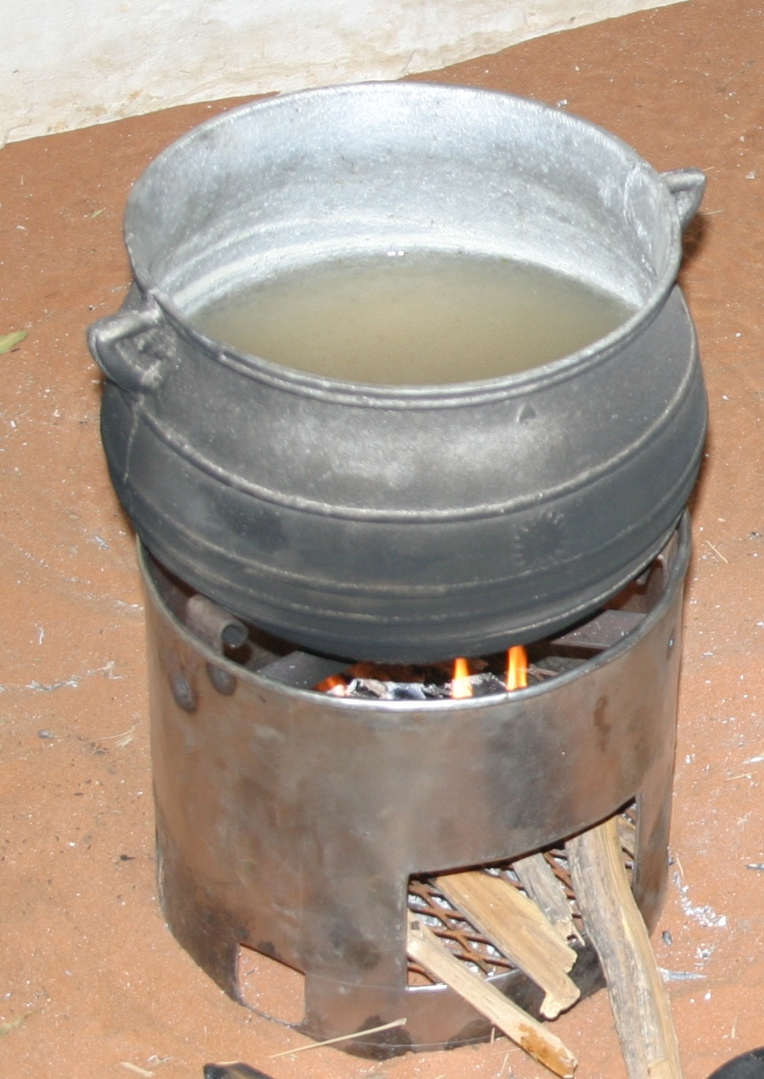
Material costs are much lower in Khaurtoum and punch-press equipment is commonplace there. The ND team found that there was more than adequate metal working skill and capacity in El Fasher to assemble the Tara from its component parts, both in town and in the camps themselves. In fact, the entire manufacturing process could be handled quite well by the local labor pool, except that the production very slow in comparison to a centralized production approach based on punch press and rapid assembly line. If the fabrication were to be based entirely locally, it would require each cut and fold to be made by hand, with hand-tools making the process very labor intensive and slow.

Figure showing a Tara FES built in El Fasher by local craftsmen

CHF International logistics personnel in Khartoum have offered to investigate Khartoum resources for sourcing the materials, the punch-press operations, and the necessary tool making. The ND team commissioned three Tara stove prototypes from a local sheet-metal worker in an El Fasher market, at a cost of 2000 SDD ($9 November 2005 US) each. He produced these to specifications, doing all the work by hand. The cost of mass-producing these stoves is estimated to be as little as one-third of this figure.

4. Conclusions

Our systematic informal surveys show that families in North Darfur are going hungry as a result of the lack of available cooking fuel. In the South, many families are skipping meals because of a lack of fuel wood, and others are facing risk and hardship in order to collect fuelwood. A fuel efficient stove program could help to alleviate these problems by significantly reducing fuelwood demand, decreasing the number of trips by IDP women to collect fuelwood outside the camps, and eventually allowing the vegetation near the camps to regenerate.

Through our surveys and testing, we established the need for a substantially more fuel-efficient stove that could withstand the vigorous cooking methods of the IDPs, be resistant to operation in breezy conditions, and ideally be manufactured locally (in country). We conclude that the most appropriate stove for use in Darfur would be a modified Tara stove. Based on the average of our demonstrations in South Darfur, we found the Tara stove with training of the cook, used 67% of the fuel used by three-stone fire. We believe that with proper training and the modifications proposed in Section 5, fuel consumption relative to the three-stone fire can be as low as 50%.

Informal systematic surveys in South Darfur showed an average IDP household uses about 5 kg of fuelwood per day and has seven members. With a 50% reduction in fuelwood use – a reasonable estimate for the improved modified Tara stove – an average household in South Darfur could be expected to save over 900 kg in fuelwood annually. If all IDPs used the improved stoves, the savings would be enormous – about 260 million kg of fuelwood annually. Given that the IDPs who buy fuelwood spend about 200 SDD (about $0.90 November 2005 US) on it each day, with the improved Tara, they would save about 36,500 SDD (about $160 November 2005 US) annually per family, leading to a substantial increase in their disposable income that they could spend on other necessities (better nutrition, clothing, improved shelters etc.). Other IDPs (in South Darfur) who currently collect and sell wood would realize comparable (but non-monetized) benefits in reduced risk-exposure and reduced hardship, leading to improved wellbeing. Some of these IDPs could be integrated into the stove program to recoup the loss of their incomes from reduced sales of collected fuelwood.

Our current best estimates for the cost of producing an improved Tara stove is less than 1000 SDD ($4 November 2005 US) per stove when mass-produced. (Custom-made single Tara stoves cost 2000 SDD (about $9 November 2005 US) from a local sheet metal worker in El Fasher.) If the cost of social marketing and program administration doubles the mass production cost to $8, the stoves will still pay for themselves in less than three weeks.

The Tara stoves are likely to have their grate burn out (oxidized into rust) each year, since it is made of sheet metal or metal mesh, rather than cast iron or thicker grade steel. Replacing the grate annually would cost much less than the $4 cost of the full stove.

North Darfur
Information from the ND team is mainly qualitative and was based on informal observations and interviews.

We believe that all the IDP women could be taught better fire-making techniques and be persuaded to utilize them until they became habitual. The key, we think, is to tailor the curriculum and the presentation to the specific needs and challenges of the IDP community. For example, in the “ITDG Mud FES” program training, we observed that many of the women paid no attention to the instruction that was being given. Upon further inquiry, we found that the women in question spoke no Arabic, the language in which the lesson was proceeding; they spoke only Fur.

The IDPs gave every indication that they are willing to learn. The women we spoke with acknowledged the problem of lack of training in building efficient fires, and expressed interest in learning new fire-making skills. And after very brief lectures on better fire-building, about half the women were observed using the newly taught methods. It is difficult to assess how long this change would last. More systematic repeated training and follow up assessment, positive reinforcements (such as, e.g., periodic competitions held in the Women’s Centers, giving prizes to the most fuel-efficient cooks among the competitors) might be necessary until the skills are internalized.

5. Recommendations

We recommend four follow-up actions.

1. The Tara FES design needs to be slightly modified and tested for the specific conditions of use in Darfur. Two changes are needed. First, the Tara needs to be altered to accommodate the vigorous cooking style employed by the IDPs in Darfur. Figure 4 shows the method used in several of our demonstrations, where one woman held the stove in place and at least one other woman stirred the doughy assida. While effective, this method is unreasonable to expect from the IDP women, who often, if not always, cook by themselves. In addition, they are accustomed to cooking over a three-stone fire where stability of their pot and stove is excellent. To address this matter the FES itself needs to provide more mechanical stability to the pot without sacrificing any aspect of its performance, and without raising its production cost excessively. Several ideas for low cost improvements are already being discussed by the mission.
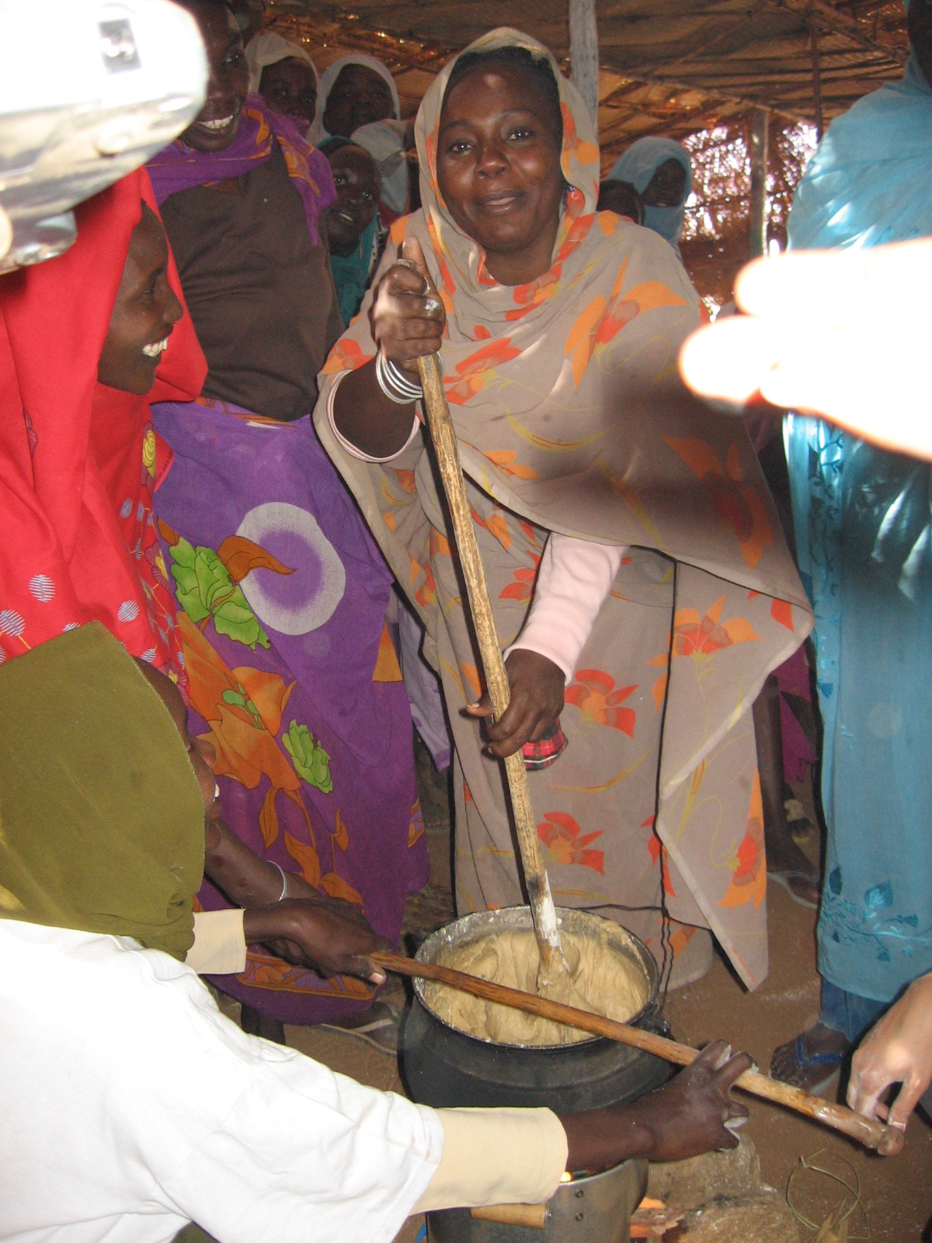
Stabilizing the pot with a horizontal stick for stirring of the assida
Figure 4: Vigorous stirring on the Tara currently requires too many cooks

The second modification to the Tara Stove must address the issue of performance in presence of a breeze. We found that IDPs cook outside approximately half the year. The other half they cook indoors; however, their shelters does not offer much protection from the blustery weather during the windy season. The current FES needs modifications so as to not lose its high performance under conditions of light breeze – something that was repeatedly observed in North Darfur tests. We propose adding a collar to the top of the stove to address the issue of wind and provide better air flow and heat transfer to the pot. We will also explore an inexpensive wind shield. This adjustment may also improve the current efficiency of the Tara under less windy conditions. In any case, this modification must not conflict with the improved mechanical support for the pot. Modifications and testing can be performed at LBNL.

2. A 50-stove limited technical trial should be conducted to test the user feedback of the modified Tara stove. This can be performed in parallel with step 1, above, while making changes to the current Tara stove. In the 50-stove limited rollout it is necessary to look for any other flaws or short-comings in the FES design for use in Darfur IDP camps, that are not already identified, so that they can be addressed as well, before initiating a larger rollout towards distributing the stoves to all 300,000 households.

3. A further 500-stove limited social rollout should be conducted, to determine (1) how the stoves can most successfully be distributed in an acceptable manner using the financing scheme that best works in the IDP camps and (2) how to instruct most effectively the IDPs on using the stoves efficiently. The mission has discussed with CHF Sudan staff various methods for distribution of stoves to the IDPs in a financially viable way. We also recommend setting up (and assessing) an education program to instruct the IDPs on efficient building of fires in the stoves. We also suggest that the educational component be a prerequisite before an IDP can purchase an FES.

4. We recommend setting up a manufacturing, dissemination and education program with monitoring and feedback planned when 10,000 stoves, 50,000 stoves, 150,000 stoves and 300,000 stoves have been distributed. This will enable the improvement of the program as the rollout continues, so that the final rollouts and instructions will catch any errors before propagation and be superior to the initial rollouts. LBNL staff (not part of the Nov 2005 mission) has expertise in assessment of effectiveness such programs.

6. Acknowledgements
The authors wish to thank the many organizations and individuals without whom our mission would not have been successful. We are grateful for the support from a number of individuals who provided initial financial support to get the work started well before funds could be formally brought in from CHF International. We are grateful for program development funding support from EETD, with advanced the work further quickly. We thank first and foremost our hosts and co-funders, CHF International’s Sudan Khartoum, Nyala and El Fasher offices, for providing translators, staff time, transportation, guidance, and other logistical support essential to the mission. We also thank the many organizations who took time out of their busy schedules to meet with us and provide information, including UN OCHA, IRC, MSN, MDM, the Spanish Red Cross, WFP, IRC, NRC, ICRC, and U.S. AID OFDA. Finally, we thank Sudan’s HAC (Nyala and El Fasher), for giving us the opportunity to work in the camps in North and South Darfur.

We thank Jeiwon Deputy for her organizational support from early days of the project, all the way including help with editing of this report. In addition to the funding from CHF International via a contract to LBNL, this work was co-funded by generous donations of funds, time, and effort from several individuals, some at LBNL and others outside. We are grateful to these persons for their support, and the confidence placed in us. Finally we thank internal reviewers at LBNL, Drs. Phil Price and Buvana Jayaraman for their comments and suggestions for improvements.

A note on the appendices. Much of the material in the appendices is likely to be well known to field staff in Darfur. We have nevertheless chosen to include this material in the report since (we hope that) our readers might include many who are not field staff, or have not in the past focused on cookstoves for Darfur IDPs.

Appendix A

Background note: Fuel Scarcity in North Darfur

There are two essential reasons for the shortage of fuel in North Darfur. First, there are no major forests or other sources of wood from trees in any proximity (within 100 km) of the IDP camps around El Fasher. Any wood that comes to the area must be transported over long distances by small and mid-size commercial operators.

Second, there is no such thing as agricultural “waste” in North Darfur. The stalks from millet and sorghum crops are dried after the grain harvest, and reaped for use as fencing and roofing material. The dung from cattle and donkeys is used either as admix to earth for brick-making and plaster-work, or to fire the kilns of the ceramic-makers. It also has value as manure.

As a consequence the only available biomass that can be collected for use as cooking fuel in North Darfur is the scrubby brush and small shrubs (oushar, tundu, and makhet) which grow as weeds in the desert landscape. Because the IDPs have dug out even the root systems of that shrubbery, to be dried and used as cooking fuel, the brush does not regenerate come the rainy season.

The only productive land around El Fasher is on the farming tracts. IDPs who attempt to collect fuel – even “valueless” materials like oushar, tundu, and makhet –risk being harshly beaten and run-off by the landowners. The farmers can not distinguish between IDPs who have come to collect “valueless” shrubs from other IDPs who occasionally endeavor to steal straw of millet and sorghum – this latter material is saleable and thus valuable to farmers. Women who resort to the stealing of straw for fuel tell us that they flee from these expeditions empty-handed one time in three.

Most of the women we found who still collect fuel, in both Zam Zam and Abu Shouk camps, do so in the exact same location: Golo, an area to the south of El Fasher, to the west of the road which runs to Zam Zam. This area is approximately 6 km from Zam Zam, and 16 km from Abu Shouk. It is even farther from Assalam, which probably explains why the women from there, and some of the women in the northeastern area of Abu Shouk, collect in an insecure area north of those camps. In any event, the collection of scrub fuel is an all-day project, typically requiring seven to ten hours to gather and return with a single headload. These are not only long, difficult days; they represent time spent away from other domestic chores or income-producing activity.

In considering all that the IDPs risk and endure to collect brush and roots, it is important to remember that the material that they are gathering is of extremely low value, even as cooking fuel. At present, a family of four to six members requires 1.6 to 2.2 kg of proper wood to cook a single meal; that is typically three or four 1.5 meter sticks. That same meal requires an entire headload of tundu, makhet, or oushar. In other words, the load a woman gathers as the product of a full day’s hard labor, is not enough to meet her family’s fuel needs for even a single day.

There is some health risk in collecting oushar. The plant contains a milky white sap which is reported to be a skin irritant. If introduced to the eyes, it reportedly can cause blindness. In the rural villages, oushar is eradicated by adults to prevent children from accidentally coming into contact with the sap. Furthermore, the smoke from burning oushar is reported to be noxious and toxic, and might present an additional health risk to the cook and her nearby children.

Appendix B

Background Note by ND team on Other Stoves: the IDTG and the AVI in Darfur

ITDG FES Stove Program
The ND team encountered only three ITDG FES in the encampments of IDP families during the two weeks of field visits. One ITDG FES sat in the cooking area next to a still-used three-stone fire. It did not fit any of the pots in the household, though it was still useable – though it would not have saved any fuel owing to poor fit to the pots. The second FES we noticed abandoned in a corner, stuffed with trash. When we asked its owner what type of stove she used, she replied, “a three-stone fire.” What about the FES? “I cannot use it,” she said, “it will not burn.” Sure enough, it did not fit any of her pots and would have been impossible to use. The third FES had been turned upside-down, and was being used as a low stool (bambur) on which the women sit to cook – in this case over a three-stone fire.

One of the benefits of the ITDG design, and one reason it was supposed to be self-propagating among the beneficiary community, is that it is low-cost, utilizing materials that are readily available to the IDPs. But while the clay-mud, donkey dung, water, and bricks used to make the ITDG stove are locally available, only the bricks and the water appear to be easily obtained in sufficient quantities in North Darfur camps visited by the ND team. The mud is quite heavy, and must be brought in by truck from a riverbed several kilometers away. The donkey dung, if collected, has other, more valuable commercial uses, including brick-making, manure, and kiln-fuel. Obtaining these materials in sufficient quantity requires the logistical wherewithal of outside agencies.

We also learned that there are about 50,000 of the mud-and-dung ITDG stoves spread throughout the Darfur IDP camps. As mentioned earlier, the stove design, as observed in the field, is seriously flawed. We also got the impression that the “cookstove trainers” in CHF Women’s Camps in Otash and Kalma had little idea of principles of good cookstove design. However, these women cookstove trainers were all uniformly highly enthusiastic about the metal FES they saw and tried during our visits.

Furthermore, we learned that the women who would come to the Women’s Centers to build the ITDG FES used to be paid to come there. Earlier the IDP women would be paid to come for five days; at that time they came in large numbers. Later, it was reduced to two days, and then the payments were altogether stopped. This caused a very sharp reduction in the number of women coming to be trained to build the ITDG stoves – further suggesting that the value of the ITDG stove perceived by the IDP women might have been primarily in the modest income they would earn while they attended the training – not in the utility of the stove itself.

The Avi Stove

The Avi shares the same challenges as the ITDG mud stove in terms of successful rapid and large-scale implementation.

In our opinion, production of the Avi stove should be done by IDP women who have been trained as specialists to build high-quality stoves, and who are paid for this work. Even then, we believe that quality control will be a significant challenge for the program. We strongly recommend three measures if the Avi is selected for production and dissemination. (1) mark (imprint while wet) each stove with a unique sign of its artisan, (2) conduct routine performance testing of the stoves from each artisan every month, and (3) do not give away any of the stoves, (i.e., give them only for cash or barter, or labor) thus ensuring that they are actually perceived to be some value by the IDPs. Because of the time it takes to build and dry each stove, it will be difficult to produce large numbers of Avi stoves quickly. The roll-out of the Avi program is therefore a longer-range solution given the large populations in the camps in need of more efficient stoves.

So far as we could assess, the unit material cost for Avi (based on data from CHF and Practical Action) would be about 1000 SDD ($4 November 2005 US). However, field data will be a better guide to estimate unit costs for future production of Avi stoves.

Appendix C

Background Notes by ND Team on Cooking Demonstrations in North Darfur Camps:

We found that two extraneous factors influenced the fuel savings in our tests: (1) the skill and discipline of the fire-tender, and (2) the wind conditions. The mission team will try to address the latter with an engineering solution. However, the first must be addressed by training. As we explained to the women, a skillful cook can build a very good three-stone fire, and an unskilled one can build a very bad fire using a very good stove.

We gave "how to build an efficient fire" lectures before the assida cooking demonstrations. As a result, most -- but not all -- of the fires we observed were well-tended. In particular, the three-stone fires at Zam Zam and at the second Abu Shouk demonstrations were the very best we have observed, in demonstrations or in visits to homes in the camps, during our entire stay. The fires in the first Abu Shouk Demonstration were by far the worst, with the women aggressively feeding fuelwood into the stoves, despite our coaching to be patient and frugal with fuelwood.

In each of the demonstrations, the women using the Tara stoves complained of instability during the final vigorous kneading of the assida over the fire. We observed them using various techniques to stabilize the stove, including asking someone to hold it with their foot and using a stick of wood through one of the bottom air holes and standing on it. They reported needing to tip the pot on its side to ensure that it remained on the stove during mixing. This is a technique they also use with the three-stone fire, but they were required to tip it almost to the point of spilling the assida to stabilize the pot to their satisfaction with the Tara.

The ND team tested both the metal rocket stove and built and tested a mud rocket stove. These are not discussed here since they do not provide adequate support for the pot during the hot kneading of assida over the fire.

The ITDG Mud and the Avi stoves' opaque stove-bodies and low position of the fuel-entry portal make it difficult for the users to check the status of their fires. As a consequence, these stoves were tended more poorly than the others; and the three-stone fire and the Tara were tended much better. Some women asked for a larger opening in the stove body to make checking the fire easier.

The mud stoves -- ITDG and Avi -- offered the best pot stability for the mixing of assida.

The demonstration at Assalam was quite windy. The wind was steady, not gusty. This made lighting the fires somewhat challenging. As a consequence, we do not have cook times for the ITDG Mud and Avi stoves.

One other factor skewed the results at Assalam: the wood we purchased from the market in El Fasher did not burn well. The women recognized this wood immediately and predicted it would be a difficulty. It was. But once it was ignited, it seemed to burn quite hot.

The December 10 demonstration at Abu Shouk West took place inside a tented, but well ventilated, area. The day was breezy, but the enclosure minimized the influence of any wind.

The woman cooking on the Tara at the December 10 demonstration at Abu Shouk West, did not follow our suggestions about building an efficient fire, and stuffed the magazine with wood. The results were predictably poor: fast cooking times but large consumption of wood.

Figures below summarize our test results. As explained in the main text, the actual numbers should not be taken as ultimate factual test performance data, owing to several uncontrolled variables in the tests.

Adult here defined as a woman or girl who partakes in the preparation of food and/or gathering (if any) of firewood who would be easily able to answer our informal survey questions.
The educational component of the rollout in steps three and four should not be underestimated. We emphasize that the comparisons in Sections 3 and 4 were done with FES and cooks that had a lot of continuous instruction from the mission.

