New Millennium Project Office

Mission Procedures Document
Volume 1-Operations Concept
for the Earth Observing (EO)-1 Mission

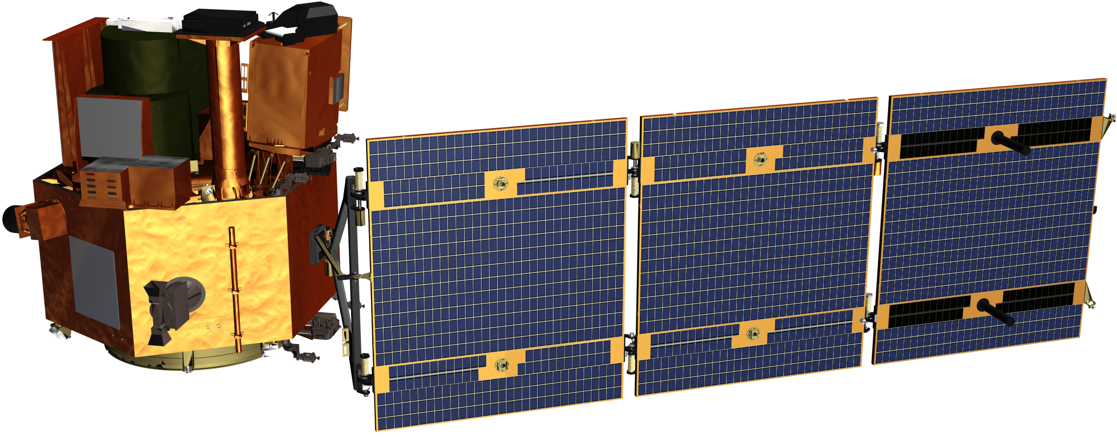

January 6, 1999
Chapter Status (X = worked extensively, D = Draft , P = Placeholder)
Chapter 1 X Chapter 8 D
Chapter 2 X Chapter 9 X
Chapter 3 X Chapter 10 X
Chapter 4 D Chapter 11 D
Chapter 5 X
Chapter 6 P
Chapter 7 D



National Aeronautics and Goddard Space Flight Center
Space Administration Greenbelt, Maryland
EO-1 Mission Operations Concept
December 1998
Prepared by: | ______________________________________  Dan Mandl  EO-1 Mission Director | ___________  Date
Reviewed by: | _______________________________________  Pete Spidaliere  EO-1 Systems Engineer | ___________  Date
Approved: | _______________________________________  Dale Schulz  EO-1 Project Manager | ___________  Date
Concurred by: | _______________________________________  Nicholas Speciale  EO-1 Technologist | ___________  Date
Concurred by: | _______________________________________  Ralph Welsh  ALI Systems Engineer | __________  Date
Concurred by: | _______________________________________  Nick Speciale  LEISA/AC Systems Engineer | __________  Date
Concurred by: | _______________________________________  Bill Browne  Hyperion Systems Engineer | _________  Date

EO-1 Mission Operations Concept Acronym List

AC Atmospheric Corrector
ACDS Attitude Control and Data System
ACS Attitude Control System
AFSCN Air Force Space Control Network
AGS Alaska Ground Station, Poker Flat, Alaska
ALI Advanced Land Imager
AOS Acquisition Of Signal
ASIST Advanced System for Integration and Spacecraft Test
ATC Absolute Time Command

BCR Battery Charge Regulator
BER Bit Error Rate
C&DH Command and Data Handling
C&T Commands and Telemetry
C-C Carbon-Carbon
CCB Configuration Control Board
CCR Configuration Change Request
CCR Carbon-Carbon Radiator
CCSDS Consultative Committee for Space Data Standards
CDR Critical Design Review
CEI Contract End Item
CIS Copper Iridium Diselinide
CGS Core Ground System
CM Configuration Management
CMD Command
CMO Configuration Management Officer
CMS Command Management System
COMM Communication
COP Command Operating Procedure
CTE Coefficient of Thermal Expansion
DCE Data Collection Event
DMR Detailed Mission Requirements
DPAF Dual Payload Attachment Fitting
DRAM Dynamic Random Access Memory
DPS Data Processing System
EDAC Error Detection And Correction
EDC EROS Data Center
EEPROM Electrically Erasable Programmable Read-Only Memory
EGS EO-1 Ground System
EIRP Effective Isotropic Radiated Power
EO-1 Earth Orbiter 1
EOSDIS Earth Observing System Data and Information System
EPS Electrical Power Subsystem
EROS Earth Resources Observation System
ETM+ Enhanced Thematic Mapper Plus
FDF Flight Dynamics Facility
FDSS Flight Dynamics Support System
FODB Fiber Optic Data Bus
FOM Flight Operations Manager
FOT Flight Operations Team
FOV Field Of View
FPD Flight Procedures Document
FSW Flight Software
Gbps Giga Bits Per Second
GMT Greenwich Mean Time
GPS Global Positioning System
GRI Ground Reference Image
GSD Ground Sample Distance
GSE Ground Support Equipment
GSFC Goddard Space Flight Center
GSI&T Ground System Integration and Test
HOPC Hyperion Operations and Processing Center
H/S Health and Safety
HK Housekeeping
HW Hardware
I&T Integration and Test
ICD Interface Control Document
Isp Specific Impulse
Kbps Kilo Bits Per Second
L&EO Launch and Early Orbit
L/V Launch Vehicle
LEISA Linear Etalon Imaging Spectrometer Array
LFSA Advanced Lightweight Flexible Solar Array
LL Lincoln Lab
LOS Loss Of Signal
LP ?? DAAC EOSDIS Land Processes Distributed Active Archive Center
LTP Long Term Plan
LZP Level Zero Processing
M5 Mongoose 5 Processor
Mbps Mega Bits Per Second
MCC Mission Command and Control System
MIPS Million Instructions Per Second
MIT Massachusetts Institute of Technology
MOC Mission Operations Center
MOPSS Mission Operations Planning and Scheduling System
MOR Mission Operations Review
MOSP Mission Operations Support Plan (delete??)

MPD Mission Procedure Document
MS Multi-Spectral
N/A Not Applicable
NASA National Aeronautics and Space Administration
NASDA National Space Development Agency of Japan
NISN NASA Integrated Services Network
NCC Network Control Center
NMP New Millennium Program
NMPO New Millennium Program Office
NORAD North American Aerospace Defense command
NRA NASA Research Announcement ?
OBC On Board Computer
OCD Operations Concept Document
ODB Operational Data Base
Ops Operations
ORR/FOR Operations Readiness Review/Flight Operations Review
PAN Panchromatic
PDB Project Data Base
PODS Precision Orbit Information System
PPF Payload Processing Facility
PPT Pulsed Plasma Thruster
PSE Power Supply Electronics
PWR Power
RAM Random Access Memory
RCS Reaction Control System
RF Radio Frequency
ROM Read Only Memory
RPM Revolutions Per Minute
RSN Remote Service Node
RT Remote Terminal
RT Real Time
RTC Relative Time Command
RTS Relative Time Sequences
S/A Solar Array
S/C Spacecraft
SAC-C Satellite de Aplicaciones Cientificas - C
SAFS Standard Autonomous Fileserver
SAI Swales Aerospace, Incorporated
SCA Sensor Chip Assemblies
SCC Spacecraft Command Center
SDC Science Data Center
SFDU Standard Formatted Data Units
SGS Svalbard, Norway (Spitzbergen)
SiC Silicon Carbide
SLC Satellite Launch Complex
SMO Science Mission Office
SN Space Network
SOMO Space Operations Management Office
SOW Statement Of Work
SPS Single Point Solution
SSR Solid State Recorder
STOL Systems Test and Operations Language
SVF Science Validation Facility
SW Software
SWG Science Working Group
SWIR Short Wave Infra-Red
TBC To Be Confirmed
TBD To Be Determined
TBS To Be Supplied
TCP/IP Transmission Control Program/Internet Protocol
TCS Thermal Control System
TDRSS Tracking and Data Relay Satellite Subsystem
TEC Thermal Electric Cooler
TLM Telemetry
TOTS Transportable Orbital Tracking Station
UPS User Planning System
USAF United States Air Force
USGS United States Geological Survey
V/T Voltage/Temp
VAFB Vandenberg Air Force Base
VNIR Visible/Near Infra-Red
WARP Wideband Advanced Recorder Processor
WBS Work Breakdown Schedule
WOTIS Wallops Orbital Tracking Information System
WR Western Range
WSC White Sands Complex
WSG Wallops Scheduling Group
Table of Contents
1 Introduction 1
1.1 Overview 1
1.2 Purpose 1
1.3 Scope 1
1.4 Document Organization 2
1.5 Reference Documents 2
2 EO-1 Mission Description 4
2.1 Mission Objectives 4
2.2 Orbit Description 5
2.3 Mission Phases 6
2.4 Mission Profile 6
3 System Description 8
3.1 Space Segment Description 8
3.1.1 Spacecraft Overview 8
3.1.2 Instruments Overview 10
3.1.3 Technology Overview 15
3.2 Ground Segment 18
3.2.1 Overview 18
3.2.2 Ground Network 19
3.2.5 Mission Operations Center (MOC) 23
3.2.6 Science Validation Facilities (SVF) 29
3.2.7 Science Data Distribution and Archive 29
3.2.8 Launch Segment 30
4 Launch and Early Orbit Operations 31
4.1 Launch and Early Orbit Overview 31
4.2 Launch Site Communications Flow 31
4.3 Launch Site Payload Processing Operations 32
4.4 Launch and Early Orbit 33
4.4.1 Countdown 34
4.4.2 Ascent and Separation 35
4.4.3 Initial On-Orbit Operations (1st 5 Orbits) 36
4.4.4 Initial On Orbit Operations (Rest of 1st day) 37
4.4.5 Early Orbit Operations (Rest of 1st week) 38
4.4.6 Early Orbit Operations (Weeks 2 and 3) 39
4.4.7 Other Early Orbit Activities 39
4.4.8 Orbit Formation Operations 39
4.4.9 Instrument Checkout 40
4.3 On Orbit Operations Organization 43
5 Integrated Normal Operations 46
5.1 Normal Operations Overview 46
5.2 EO-1 Operations Philosophy 46
5.3 Planning and Scheduling 47
5.4 Science Operations 51
5.4.1 Image DCE 54
5.4.2 Solar Calibration DCE 56
5.4.3 Lunar Calibration DCE 57
5.5 Ground Support Operations 60
5.6 Telemetry Processing and Distribution 61
5.7 Flight Dynamics Operations 65
5.7.1 Orbit Determination 65
5.7.2 Orbit Maneuver Planning 66
5.7.3 Slew Planning 67
5.8 Data Processing Operations 68
5.9 Automation 69
5.10 Timelines for Integrated Normal Operations 70
6 Extended Mission Operations 73
6.1 Extended Mission 73
7 Contingency Operations 74
7.1 Contingency Operations Introduction 74
7.2 Spacecraft Anomalies 74
7.2.1 FDC 74
7.2.2 TSM 74
7.2.3 RTS 74
7.2.4 Ground detection of spacecraft anomalies 74
7.2.5 Ground responses to anomalies 75
7.3 Ground Anomalies 75
7.3.1 Real-time communication anomalies 76
7.3.2 Planning Contingencies 76
7.3.3 Data Decom and distribution anomalies 76
7.4 Anomaly identification and contingency operations process 76
8 Spacecraft Operations 78
8.1 Spacecraft Operations 78
8.2 Command and Data Handling 78
8.3 RCS / Attitude Control Subsystem 78
8.4 Power Subsystem Electronics (PSE) 79
8.5 Communications Subsystem 80
8.6 Thermal Control Subsystem 80
8.7 Wide-band Data Recorder Processor (WARP) Operations 80
9 Instrument Operations 84
9.1 ALI Operations 84
9.2 LEISA/AC Operations 85
9.3 Hyperion Operations 86
9.3.1 Experiment States and Modes 86
9.3.2 Hyperion States 86
9.3.3 Hyperion Modes 87
9.3.4 Cryocooler Operations 89
10 Technology Operations 90
10.1 Technology Overview 90
10.2 X-Band Phased Array Antenna (XPAA) 90
10.3 Carbon-Carbon Radiator (CCR) 92
10.4 Advanced Light Weight Flexible Solar Array (LFSA) 93
10.5 Pulsed Plasma Thruster (PPT) 93
10.6 Enhanced Formation Flying (EFF) 95
11 Mission Management 97
11.1 Flight Operations Team 98
11.2 Transition to On-Orbit Mission Management– Dan Mandl 99
11.3 Anomaly Management 99
11.4 Software and Database Management 100
11.4.1 Flight Software 100
11.5 Database Management 101
11.6 Configuration Management 101
11.6.1 Reviews and Audits 102
11.7 Testing and Training 102

Figure 2-2 EO-1 Constellation Flying w/Landsat 7 6
Figure 2-3 EO-1 Mission Profile (missing milestones) 7
Figure 2-5 Pictorial Science Mission Overview 7
Figure 3-1 EO-1 Spacecraft 8
Figure 3-3 EO-1 Spacecraft Avionics Configuration 9
Figure 3-5 ALI & ETM+ Comparison 11
Figure 3-7 Linear Etalon Imaging Spectral Array / Atmospheric Corrector (LEISA/AC) 13
Figure 3-9 TRW Hyperion Instrument 13
Figure 3-11 EO-1 Spacecraft Technologies(get updated picture) 15
Figure 3-13 XPAA Technology 16
Figure 3-15 Carbon-Carbon Radiator 16
Figure 3-17 Advanced LFSA 17
Figure 3-19 PPT Technology 17
Figure 3-21 EFF Technology 18
Figure 3-23 EO-1 Ground System Elements 19
Figure 3-25 SAFS Data Flow 22
Figure 3-27 Network Connections to the MOC for Normal Operations 23
Figure 3-29 Network Diagram for L&EO 24
Figure 3-31 CGS Architecture 25
Figure 3-32 CMS Architecture(Randy H. to update) 26
Figure 3-33 Data Processing System Data Flow(Mike Forman to Update) 26
Figure 3-34 MOPSS Architecture(Randy to update as needed) 27
Figure 3-36 FDSS Architecture 29
Figure 4-1 Launch Site Communications Interfaces – TO BE UPDATED 32
Figure 4-2 Launch Site Processing Flow 33
Figure 4-3 EO-1 Initial Acquisitions 36
Figure 4-5 EO-1 Operations Roles and Responsibilities 44
Figure 4-7 EO-1 Operations Flow 45
Figure 5-1 Typical Mission Planning Flow 48
Figure 5-3 Representative EO-1 Mission Time-line 49
Figure 5-5 Representative Combined Ground Image Diagram (End –to –End) 55
Figure 5-7 EO-1 Representative Combined Ground Image Diagram (Detailed) 56
Figure 5-9 Lunar Calibration 58
Figure 6-1 Ground System Data Flow-Extended Operations (Unfunded at this time) 73
Figure 7-1 Anomaly Detection and Correction Flow 75
Figure 8-1 WARP Operations 82
Figure 9-1 Hyperion State Transition Diagrams 87

Table 2-1 EO-1 Technologies 5
Table 3-1 EO-1 Related Instrument Characteristics 11
Table 3-2 ALI Spectral Coverage 12
Table 3-3 EO-1 Ground Communication Summary 21
Table 5-1 Instrument DCE Summary Table 53
Table 5-2 Instrument Solar Calibration Highlights (To Be Reviewed) 57
Table 5-3 Lunar Scan Data Collection Profile 59
Table 5-4 EO-1 Virtual Channel Usage (TO BE UPDATED) 62
Table 8-1 WARP Hardware Modes and Mode Transition Diagrams 81
Table 9-1 Idle State Modes 88
Table 9-2 Active State Modes 88
Table 9-3 Component Status by Mode 89

EO-1 Operations Concept Document

Introduction

Overview
One of the key responsibilities of NASA’s Earth Science Enterprise is to ensure the continuity of future LANDSAT data. The New Millennium Program’s first Earth orbiter (EO-1), managed by the Goddard Space Flight Center (GSFC) will validate revolutionary technologies contributing to the reduction in cost and increased capabilities of future land imaging missions. Three revolutionary land imaging instruments, the Advanced Land Imager (ALI), the Atmospheric Corrector (LEISA/AC) and the Hyperion on EO-1 will collect multi-spectral and hyperspectral scenes over the course of its one year mission in coordination with the Enhanced Thermatic Mapper (ETM+) on LANDSAT 7. Breakthrough technologies in lightweight materials, high performance integrated detector arrays and precision spectrometers will be demonstrated in these instruments. Future NASA spacecraft will be an order of magnitude smaller and lighter than current versions. The EO-1 mission will provide for the on-orbit validation of several spacecraft technologies to enable this transition. Key technology advances in communications, power systems, propulsion systems, thermal technology and data storage are also included on the EO-1 Purpose

Purpose
The purpose of the EO-1 Mission Procedure Document (MPD) Volume 1 is to establish an operations concept framework on which flight operations planning will be based. It provides a collection of currently available operations-related information in a single source, to aid in both the spacecraft and ground systems development planning. This document will serve as a baseline reflecting how the space and ground segments operate and will interact to achieve the mission objectives. Volume 2, Detailed Operations Plan, will contain the procedures, facilities, timelines, and management processes necessary to run the mission.

Scope
The EO-1 MPD, Volume 1, reflects the operations concepts within the EO-1 system. Reference will be made to specific documents that describe in more detail space and ground segment operations and interfaces. The information contained in this document will be expanded upon to develop the delta Mission Operations Review (MOR), the Flight Operations Review (FOR), Interface Control Documents, and is the bases for the MPD, Volume 2.
This document focuses on EO-1 operations. It is intended to provide a high level description of how the Flight Operations Team (FOT) envisions EO-1 operations. The operations concepts assume a high reuse of MIDEX data systems. Any requirements presented in this document are for information purposes only. Readers should refer to the Detailed Mission Requirements (DMR) document for more specific information on ground architecture.

Document Organization
The EO-1, MPD is comprised of 11 sections. A brief description of each follows:
Section-1: The introduction provides an overview of the EO-1 mission, the purpose and scope of the document, and how the document is organized. Also included in this section is a list of reference documents.
Section-2: Provides the reader with an overview of the EO-1 mission, science, and technology validation objectives. In addition, the EO-1 Orbit, on orbit mission phases, and high-level operations profile is discussed.

Section-3: This section describes the space, ground, and launch segment elements utilized by EO-1. It provides an overview of the spacecraft, three instruments and seven technologies that comprise the EO-1 mission. Also described are the ground support elements composed of the Ground Network, Mission Operation Center (MOC) real-time and off-line systems, Space Network (SN), Science Validation Facility (SVF) and the distribution and Archiving function.
Section-4: Discussed are Launch and Early Orbit (L&EO) operation activities including spacecraft and instrument on-orbit verification and checkout. Also discussed are the on-orbit personnel organization and roles and responsibilities.
Section-5: This section provides a description of Normal operations phase integrated operations. Discussed are the EO-1 Operations philosophy, science imaging and calibration, ground contact support operations, telemetry processing and distribution, flight dynamics operations, and automation.
Section 6: This section provides a description of extended operations.
Section 7: This section provides a description of EO-1 contingency operations.
Section 8: This section provides a description of spacecraft operations.
Section 9: This section provides a description of instrument operations.
Section 10: This section provides a description of technology operations.
Section 11: This section provides a description of mission management.

Reference Documents
There are many documents that have been or will be written that deal with the operations of the EO-1 System. The EO-1 MPD has been developed using a combination of mission, spacecraft, science, and ground system documentation, in addition to interviews with subsystem and instrument engineers, science representatives, and system developers. Specific governing and reference documents used in this process include the following:
- EO-1 Ground Operations System Design Review/Mission Operations Review (November 1997), Document Number?
- Detailed Mission Requirements (August 1998), NMP/EO1- DMR01
- Data Management Plan (July 1998), NMP/EO1-DMP01
- EO-1 WARP Flight Software WARP to Ground System Interface Control Document for Playback Data Formats Revision C (July 1997), Document Number?
- EO-1 Spacecraft to Ground Interface Control Document (July 1998), Document Number?
- EO-1 ICD for Radiometric Calibration Processing & Performance Assessment Processing Between NASA GSFC and the Massachusetts Institute of Technology Lincoln Laboratory Version 1.3.3 (February 1998), Document Number?
- EO-1 Ground System Integration and Test Plan (January 1998), 501-XXX/EO-1 GSI&T Plan
- EO-1 ICD Between Science Validation Facility (SVF) & Mission Operations Center (MOC) (July 1998), Document Number?
- Ground System Test Plan Draft (Date?), NMP/EO1-I&T01
- Mission Operations Support Plan (September 1998), NMP/EO1-MOSP-01
- S/C to ALI Instrument ICD (April 1997), SAI-ICD- EO1-ICD-XXX
- Spacecraft Description and Operations Users’ Manual (TBD) Swales Aerospace Inc.
- Standard Autonomous File Server (SAFS) (Date?), Wallops Flight Facility
Add EO-1 Documentation Tree
Get additional input from Bruce

EO-1 Mission Description

Mission Objectives
The planned orbit of the EO-1 spacecraft is associated with that of Landsat 7. The Landsat 7 orbit has an altitude of 705 km at an inclination of 98.2 degrees. It is sun-synchronous with a nominal equatorial crossing of 10 AM. The EO-1 spacecraft will fly in a sun-synchronous orbit at the same altitude but approximately 1-minute behind Landsat 7.
The duration of the mission is 12 months, which includes sufficient time to complete the technology and science validation objectives. Beyond this period, the mission would enter extended operations depending on funding and spacecraft and instrument operability. The hardware must meet a one-year life requirement and the spacecraft is required to provide at least 18 months of expendables.
The goal of the EO-1 mission is to validate the technology and science components shown in 1.

Technology | Objective | Validation
Hyperion | The Hyperion Instrument will demonstrate the capability of hyperspectral imaging spectroscopy for both science and application demonstrations and support ALI and AC validation. | Image data collection
Advanced Land Imager (ALI) | The ALI will demonstrate a low cost, lower mass multispectral imaging capability which could support future Landsat missions. | Image data collection
Linear Etalon Imaging Spectrometer Array/Atmospheric Corrector (LEISA/AC) | LEISA/AC will demonstrate a moderate resolution (250m GSD) hyperspectral imagery to support correction of land imagery due to atmospheric absorption. | Image data collection
X-Band Phased Array Antenna (XPAA) | XPAA will demonstrate a lightweight; high efficiency X-band Phased Array Antenna for down-linking stored EO-1 science instruments data. | On-orbit validation of the XPAA will consist of taking communication link measurements at the Wallops Ground Station and measuring (BER) through analysis of science data Reed-Solomon error statistics.
Enhanced Formation Flying (EFF) | EFF will demonstrate autonomous on-board relative navigation and formation flying control algorithms. | Demonstrate ability of EFF software to autonomously plan, execute, and calibrate routine s/c maneuvers to maintain EO-1 in formation with Landsat 7. Run first in semi-autonomous mode, then autonomously.
Pulse Plasma Thruster (PPT) | PPT will demonstrate that the pitch wheel can be replaced with a thruster that uses Teflon propellant. | Validation will consist of demonstrating that PPT can replace pitch wheel. Will take at least ten images before using PPT and ten during use for purposes of comparison
Light Weight Flexible Solar Array (LFSA) | The LFSA will demonstrate a light weight solar blanket and shockless shaped hinge deployment mechanism to achieve 2 to 3 times the specific power over conventional solar arrays. | The validation goal of the LFSA is to achieve greater than 100 Watts/kg specific power efficiency ratios compared to conventional solar arrays. Today’s average; is less than 40 Watts/kg. Many of the validation objectives will be achieved with the delivery of the LFSA to spacecraft integration and testing. These objectives include obtaining necessary specific power measurements and multiple deployments of the shaped hinge mechanisms. On orbit validation will consist of trending I/V and temperature values to characterize the degradation of the array over the lifetime of the mission due to effects of atomic oxygen (NICK is this true?) and UV radiation on the solar array cells
Carbon Carbon Radiator (CCR) | CCR is designed to have superior thermal radiating properties over conventional materials. The CCR is a passive structural element and is monitored through six thermistors as part of the Spacecraft State of Health information sent to the ground. | EO-1 will validate CCR by replacing one of six aluminum 22” x 27” panels with one using the Carbon-Carbon composite materials. CCR orbit validation will consist of measuring mechanical and thermal properties of the panels and trending over the lifetime of the EO-1 mission
Table 2-1 EO-1 Technologies

  - Orbit Description
The EO-1 orbit is designed to permit the spacecraft instruments to perform co-fly imaging with the Landsat-7 spacecraft. This means that EO-1 would arrive at the descending node of its orbit one minute later in Mean Local Time (MLT) than Landsat-7 reached the same designated spot in its orbit. Additionally, EO-1 was to fly 1 minute plus or minus 6 seconds behind Landsat-7 in the along track direction. This time difference with Landsat-7 is approximately equivalent to 450 kilometers +/- 45 kilometers. Figure -1 shows the EO-1 orbit for constellation flying with Landsat 7.

The EO-1 Project will make use of the Worldwide Reference System (WRS) for the purpose of defining and identifying scene locations. Specifically WRS-2, used on Landsat 4, 5, and 7 will be used. Under the WRS-2 grid, the entire earth's surface has been divided into rectangles approximately 185 km by 170 km each. This WRS consists of a grid of 233 fixed ground track paths and 248 rows. The path identifies the orbit within the 233 orbit 16 day repeat cycle, and the path specifies the latitude within the orbit. This is how a user requests data by using the path number and the row number to locate a scene. Further definition and detail on the WRS-2 grid is provided in the Landsat-7 Science Data User’s Handbook (http://ltpwww.gsfc.nasa.gov/IAS/handbook/handbook_htmls/chapter5/chapter5.html).
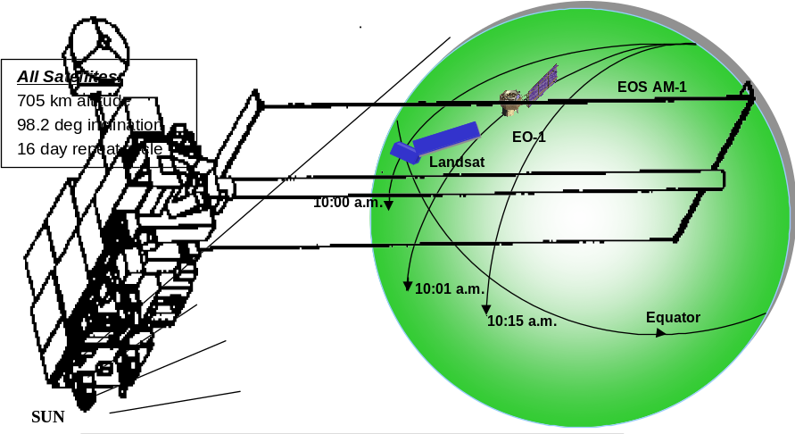
Figure 2-2 EO-1 Constellation Flying w/Landsat 7

Mission Phases
The EO-1 operations life cycle spans from the early planning stages before launch through one year (including a 60 day checkout period) with a possible one year extended operations which at present is unfunded. EO-1 mission operations will be planned around the following three mission phases, each having its own success criteria and focus:
- Launch and Early Orbit Activities (L&EO) - The L&EO phase begins at launch and extends up to approximately 60 days. The emphasis during this phase is on EO-1 launch, spacecraft checkout, establishment of Landsat-7 co-fly profile, instrument power on, instrument check-out, and calibration.
- Normal - This phase is a combination of formation flying and nominal operations. The normal operations phase is the primary mission phase and will nominally span up through one year. The point at which mission operations will transition to this phase is approximately launch +60 days. It is during this phase that imaging and technology validation data is collected.
- Extended Operations - This phase is the last phase of the mission. At some point a government decision will be made to terminate or extend the mission. For this phase, success criteria are simply the successful execution of continued operations. This phase is currently unfunded.

Mission Profile
Figure 2-3 shows the EO-1 technology validation and imaging mission timeline. The timeline includes the relative occurrences of imaging and validation of the various technologies over the basic life one year life of the mission. 3 is a pictorial representation of the mission. Depictehsare the relative swaths of the instruments for Landsat and EO-1. Also, it is the intention of the scientists to compare the Hyperion images with a similar instrument flown on an Avaris underflight. Note that-3 also depicts the formation flying with Landsat and the resultant intention to produce paired scenes.
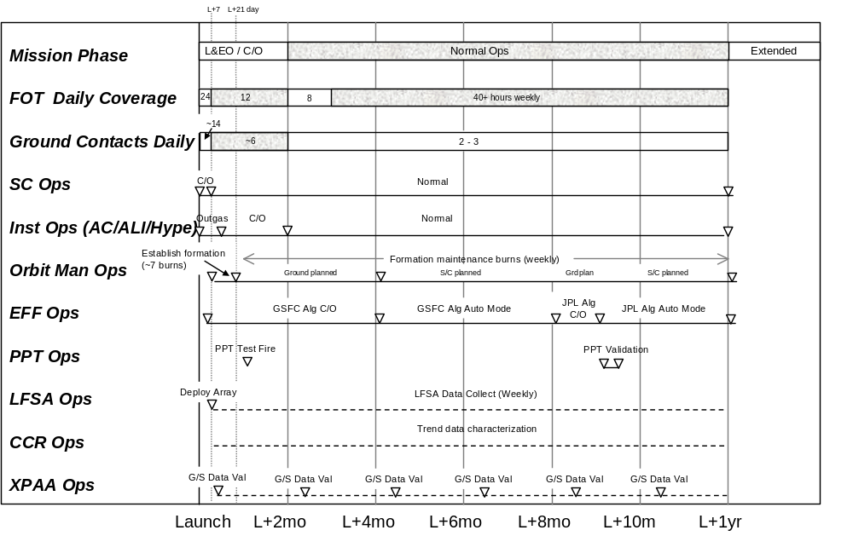
Figure 2-3 EO-1 Mission Profile (missing milestones)

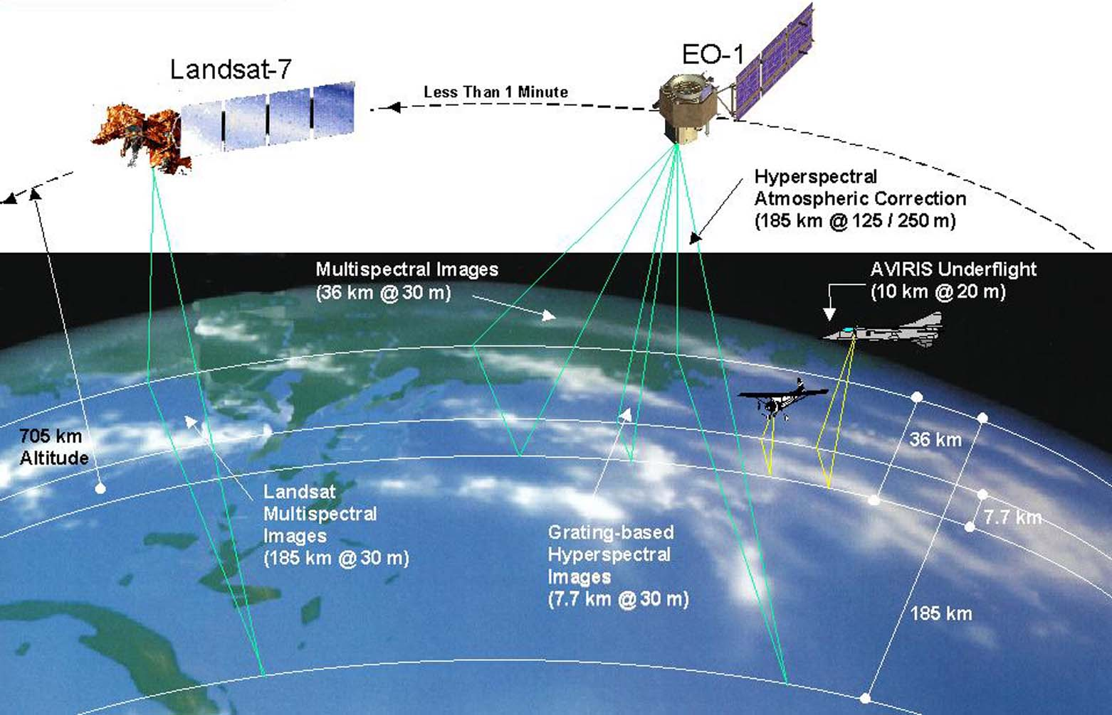
Figure 2-5 Pictorial Science Mission Overview

System Description

Space Segment Description
The following subsections provide an overview of the EO-1 spacecraft subsystems. A more detailed description of the spacecraft subsystems operation is discussed in Section 5 as well as in the Spacecraft Description and Operations Users’ Manual provided by the spacecraft manufacturer. The Spacecraft Description and Operations Users’ Manual will list all spacecraft related constraints and restrictions that the EO-1 Flight Operations Team (FOT) will have to follow during operations.

Spacecraft Overview
This section provides an overview of the EO-1 spacecraft bus. A more detailed description of the bus and its operation are discussed in Section 5.3. The EO-1 spacecraft is shown in 1. The EO-1 spacecraft bus is being provided through a contract with Swales Aerospace, Inc. (SAI), with Litton Amecom as the key avionics subcontractor. As the prime contractor, Swales is responsible for total integration of the EO-1 observatory and is qualifying the spacecraft bus through NASA's Rapid Spacecraft Development Office (RSDO).
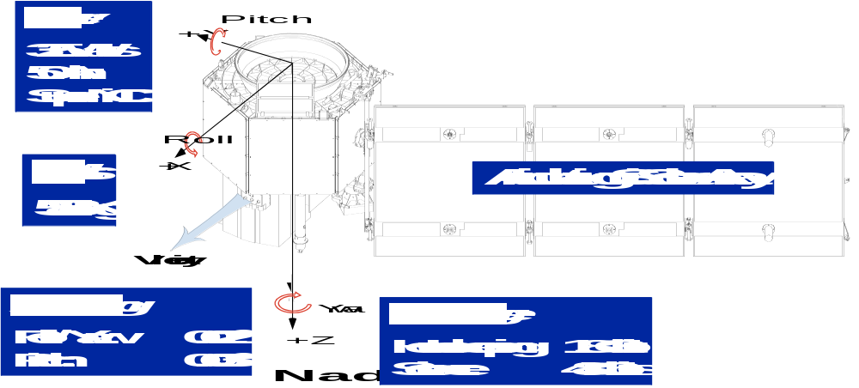
Figure 3-7 EO-1 Spacecraft

Figure 3-1 - Add box “Communications up to 2 Mbps downlink S-Band and 105 Mbps X-band downlink)
The EO-1 spacecraft bus will have some heritage with the MIDEX spacecraft bus design and key avionics will also be used on the Microwave Anisotropy Probe (MAP) Mission. Figure 3-9 reflects the avionicseconfiguration that comprises the spacecraft. EO-1 utilizes essentially a single string design. EO-1 utilizes a 1773 data bus which allow various processors to communicate through a remote terminal (RT) and remote service node (RSN) interfaces.
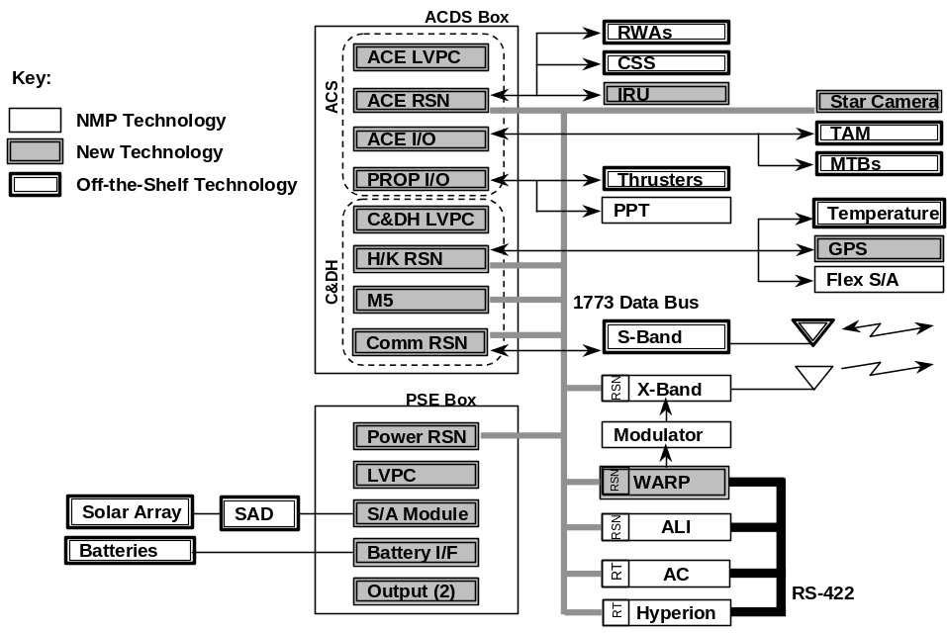
Figure 3-9 EO-1 Spacecraft Avionics Configuration

Command and Data Handling
C&DH subsystem is comprised of hardware and software elements performing services of command reception, validation and distribution, telemetry processing, data storage, stored command processing, clock maintenance, and time distribution. GPS receiver outputs are used to synchronize the spacecraft clock.

Attitude Control Subsystem (ACS)
The ACS will provide the spacecraft with the sensors and actuators needed to establish and maintain a safe, stable attitude for payload operations under normal and anomalous conditions. EO-1 has the added responsibility of maintaining a stable location with respect to Landsat 7 (Enhanced Formation Flying). Using ground uplinked Landsat 7 orbit information, the EO-1 spacecraft is capable of autonomously planning, performing, and calibrating formation flying maneuvers.

Power Subsystem Electronics (PSE)
The PSE provides the ability to generate, store, switch, and distribute power as needed by the spacecraft. Launch vehicle interface support, and special test interfaces are also provided.
Power is supplied by a single silicon photovoltaic array with a peak power output of about 600 watts. This array articulates about the spacecraft Y-axis at the orbital rate with an unwind occurring during each eclipse. The array boom is slightly angled to compensate for the solar beta angle. The accompanying super nickel-cadmium battery has a capacity of 50 Ah and is composed of 22 cells in series. The power system electronics is based on a flexible design that accommodates a variety of arrays and batteries and is controlled over a 1773 fiber optic data bus.
This power system supplies 325w (EO-1 end-of-life orbital average) to the spacecraft on a 28-volt (nominal) bus, which separately supplies essential and non-essential loads.

Communications Subsystem (COMM)
The COMM subsystem will be designed to provide an interface between the EO-1 spacecraft and the ground. Both a forward and return link communications service for telemetry, command, and tracking operations will be implemented incorporating S- and X-band RF links. The X-band Phased Array Antenna (XPAA) provides a steerable downlink that is used to downlink science data at 105Mbps. S-band will be used for command, State of Health (SOH) data recovery, and as a back up to the X-band science downlink. Two semi omni antennas, one each on nadir and zenith decks provide near omni S-band coverage.

Thermal Control Subsystem (TCS)
The TCS maintains the spacecraft components and equipment within the thermal requirements of the mission. There are two types of components included in the thermal subsystem design- passive and active. Passive components include thermal blankets, louvers, thermal coatings, radiators, and some temperature sensors. Active components include heater elements, thermostats, and Proportional Thermal Controllers (PTC).

Reaction Control Subsystem (RCS)
The RCS provides the capability required for orbit maintenance, and attitude control during orbit maneuvers. Actual thruster pulsing is controlled by ground and ACS provided commands. The EO-1 will use a Hydrazine Monopropellant used for orbit maintenance, formation flying, and correcting insertion errors. EO-1 will have enough Hydrazine for a minimum of 18 months of on-orbit operations with de-orbit reserve.

Wide-band Recorder Processor (WARP) Description
WARP is the science recorder for ALI, LEISA/AC, and Hyperion instrument data. The ACDS Mongoose 5 processor (M5) is used to provide continuous storage of State of Health (SOH) data. WARP stores SOH data only during science operations.
WARP contains 48 Gbits of memory of which 45Gbits is usable for data storage. WARP supports storage at an aggregate rate of up to 700+ Mbps and playback through either X- or S-band. X-band playback is at 105 Mbps. S-band playback is at 2 Mbps.

Instruments Overview
The following sections provide an overview of the three primary EO-1 science instruments. A more detailed description of the instrument operation is discussed in Section 5.2. The EO-1 Mission will fly three advanced land imaging instruments-the Advanced Land Imager, the Atmospheric Corrector, and the Hyperion.
‘Paired’ data collected by these three imaging instruments, Landsat 7 ETM+, aircraft flown instruments and other ground and space based instruments will be used to validate each EO-1 instrument’s performance. A comparison of EO-1 related instruments’ characteristics is provided in Table 3-2.
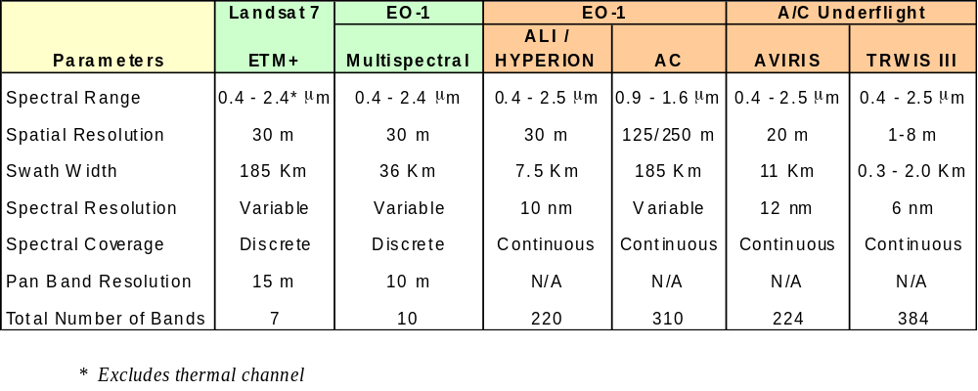
Table 3-2 EO-1 Related Instrument Characteristics

      - Advanced Land Imager (ALI)
The ALI instrument is a high resolution, multi-spectral imager that will demonstrate revolutionary technology as a possible replacement for the LANDSAT ETM+ instrument. A comparison of the two instruments is shown in 2.
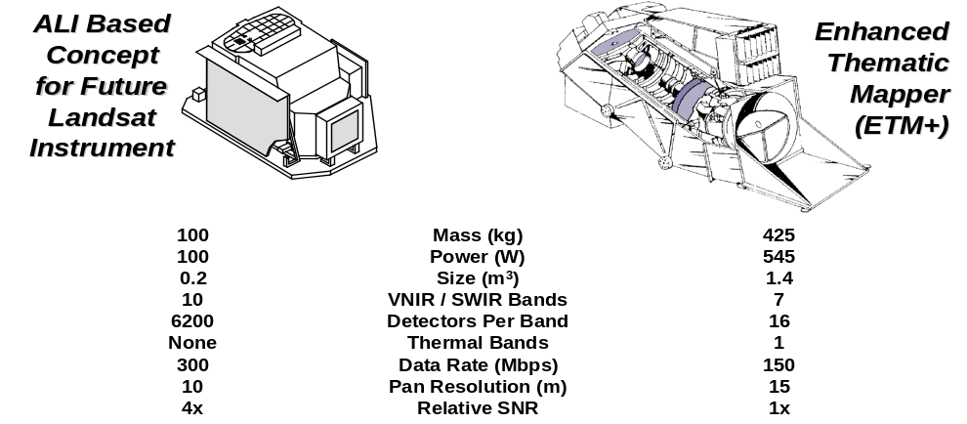
Figure 3-11 ALI & ETM+ Comparison

The ALI incorporates three key technologies: multi-spectral imaging, silicon carbide optics, and wide field of view optics. These technologies enable it to meet or exceed LANDSAT ETM+ performance.

Multi-Spectral Imaging Capability
The key technologies to be validated on the ALI are high-integrated advanced sensor chip arrays (SCAs) which work in a pushbroom manner vs. conventionally scanned methods. The SCAs on ALI provide the multi-spectral capability of the instrument. The spectral coverage for ALI is shown in 3.

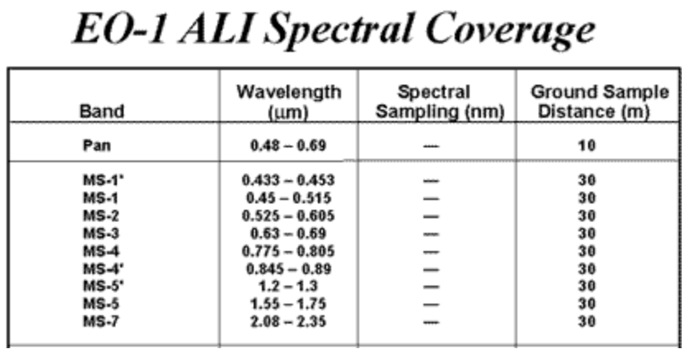
Table 3-3 ALI Spectral Coverage

        - Silicon Carbide Optics
Lightweight Silicon Carbide is a revolutionary lightweight material used in fabricating the four ALI mirrors. Silicon Carbide provides superior thermal and strength characteristics while maintaining dimensional stability over a wide range of temperatures.

Wide Field of View Optics
Telecentric optics that are compact, high-resolution, and contain no moving parts; ideal for push-broom instrumentation. (CHECK w/ Matt Jurotich for better wording) . . .

Linear Etalon Imaging Spectrometer Array (LEISA)/Atmospheric Corrector (AC)
The LEISA/AC, shown in 4, is a moderate spatial, high spectral resolutionhimager that operates in .85 to 1.6 micron bandwidth. It can be used to correct remotely sensed ground image data, which has been corrupted by atmospheric variability. LEISA/AC consists of an Optics module and an electronics module. The Optics module has 3 camera heads. Each camera head has a 2D array of 256 x 256 IR pixels operating at near room temp. A 2D spatial image is made to vary spectrally in one dimension by means of a Linear Variable Ethalon (LVE) placed directly over the detector array. The LEISA/AC line of sight is co-aligned with respect to ALI and is centered about the +Z s/c axis. LEISA/AC calibration pipes are used to collect sun light during solar calibration operations. These are oriented 90 degrees from the ALI / LEISA/AC boresite along the +X s/c axis. Each pixel’s Ground Sample Distance (GSD) is 250m x 250m. Each camera will have a 5 x 5 degree Field of Regard. The combined 15 degree cross track Field of View (FOV) will encompass a 185 km swath on the ground, the same as that of the Landsat 7 ETM+.

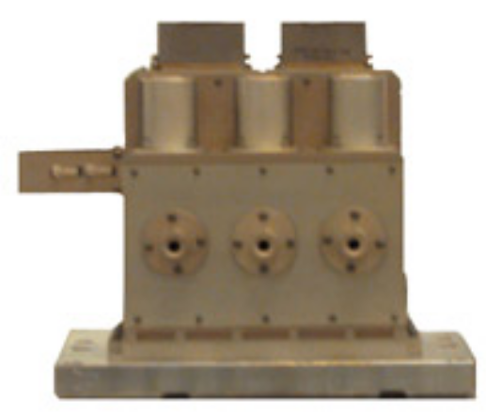
Figure 3-13 Linear Etalon Imaging Spectral Array / Atmospheric Corrector (LEISA/AC)

      - Hyperion
The Hyperion instrument shown in Figure 3-15 is a push broom design that provides hyperspectral images.
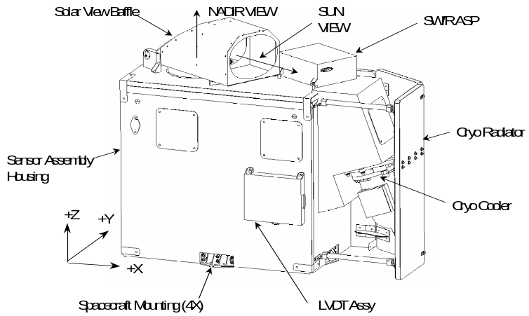
Figure 3-15 TRW Hyperion Instrument

The Hyperion is mounted to the spacecraft on the +Z panel with the optical boresite tilted 4.84 degrees off nadir in the Y-Z plane to align it with the in board Sensor Chip Assembly (SCA) of the ALI. Hyperion contains two imaging systems: visible/near infrared (VNIR) and short-wave infrared (SWIR) grating spectrometers. These systems use a common fore optic and image with a ground sample distance of 30 meters and an image width of 7.5 km. The VNIR and SWIR spectrometer imagers operate concurrently to produce images that cover the spectral region between 0.4 µm and 2.5 µm with a spectral resolution of 10 nm. Image data is stored in the Wideband Advanced Recorder/Processor (WARP) and downlinked for processing. Calibration is provided for each image collection, and includes both dark and white files. Solar, lunar, and earth observing vicarious calibrations will complement lamp based onboard calibrations. The spacecraft provides pointing stability to minimize blurring of images.

Data Collection
Hyperion takes “frames” of data, where each frame provides all spectral bands for a single spatial line of an image. There are 250 spatial pixels, and 220 bands, 160 of these for SWIR data, and 60 for VNIR. An image, or cube, or hypercube, consists of 600 frames of data. Frames are collected at the rate of 223.4 per second, so that an image or cube takes about 3 seconds to collect. SWIR and VNIR data are stored in the WARP in separate files, such that a 3-minute collection will store about 40 Gbits, with about 28 Gbits SWIR and 12 Gbits VNIR data. Focal plane data are transferred as defined in the Hyperion to Spacecraft ICD to the WARP at a peak rate of 400 Mbps and stored for later downlink.
A Hyperion Data Collection Event (DCE) is defined as a single collection of data for either science imaging or for an external calibration (solar, ground, or lunar). All instrument functions needed to support the collection, such as internal calibrations and cover opening and closing, are considered part of the DCE. A typical science imaging DCE will take about 9 cubes over 27 seconds, and will correspond to a Landsat image. A typical external calibration will take a single cube of data over 3 seconds.

Functional Description
The Hyperion consists of a main Hyperion Sensor Assembly (HSA), the Hyperion Electronics Assembly (HEA) box, and the Cryocooler Electronics Assembly (CEA). The sensor assembly, which contains the optical bench, optics, focal planes, focal plane electronics and cryocooler, has an enclosure that closely controls the temperature of the optical components. The HEA provides the command, control and data interface between the sensor assembly and the spacecraft, and controls the cryocooler for the SWIR focal plane.
The HSA is rigidly attached to nadir-facing deck of the spacecraft payload module. It has no pointing mechanism of its own. The spacecraft points the Hyperion instrument by maneuvering, as needed, so that the Hyperion line of sight passes over the target. The field of regard is determined by the spacecraft’s pointing capability. Under normal operating conditions the spacecraft will have a lateral pointing capability of ±22° (TBR).
A movable door covers the Hyperion optics aperture in the HSA. This door is commanded from the ground and has three operational positions. When not taking images, the cover door is closed to maintain the instrument temperature and provide contamination control. The cover is commanded to the fully open position (135º) for imaging, and to about 37° for solar calibration.
There are four types of on orbit calibration: solar, lunar, ground (vicarious), and internal. For solar calibration, the sun is aligned with the solar baffle, and sunlight is reflected off the diffuse coating on the inside of the door and into the optics. For both lunar and vicarious calibration, targets are observed directly. In vicarious calibration, earth images are correlated with simultaneous ground and atmospheric measurements. During internal calibration, the cover is closed for the zero reference measurement before and after data collection. The internal calibration reflects light from two variable-control, luminosity tungsten halogen lamps into the field of view. The sun calibration is used to periodically check the degradation of the lamps. For spectral calibration, atmospheric absorption lines (for SWIR) and solar spectrum (for VNIR) are employed.

Technology Overview
The following provide a description of the technologies to be validated. Validation plans for each of the technologies will need to be executed within the one-year nominal on-orbit lifetime. Technology validation timelines are discussed in Section 5-5.
Shown in Figure 3-17 are the EO-1 mission spacecraft technologies a they appear mounted on thecspacecraft.
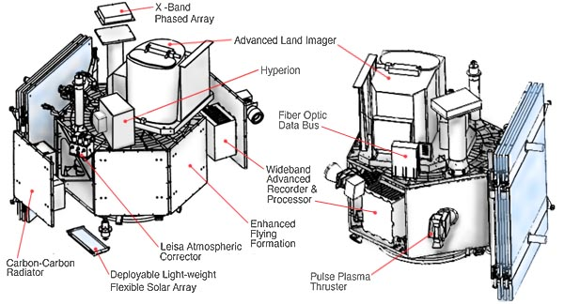
Figure 3-17 EO-1 Spacecraft Technologies(get updated picture)

3.1.3.1 X-Band Phased Array Antenna (XPAA)
The EO-1 X-band Phased Array Antenna, shown in 7, is composed of a flat grid of many radiating elements whose transmitted signals combine spatially to produce the required antenna directivity or gain. The phases of the radiating signals combine spatially to produce the required antenna directivity or gain. The phases of the radiating elements is varied by computer to point the beam in the desired direction. The XPAA is a critical subsystem that provides the 105 Mbps QPSK modulated downlink of science data to the ground during the one-year nominal on-orbit lifetime of the EO-1 mission. For EO-1, the XPAA composed of a 64-element array controlled by an embedded Remote Service Node that interfaces to the spacecraft bus via a 1773 interface.
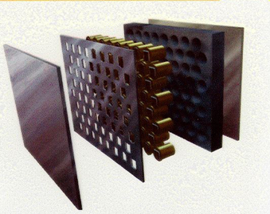
Figure 3-19 XPAA Technology

3.1.3.2 Carbon-Carbon Radiator (CCR)
The Carbon Carbon Radiator, shown in 8, is a special composite material that uses carbon for both the fiber and matrix and has advantages of high thermal conductivity and strength over conventional aluminum or copper based radiator.
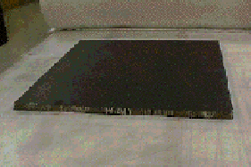
Figure 3-21 Carbon-Carbon Radiator

3.1.3.3 Advanced Light Weight Flexible Solar Array (LFSA)
The EO-1 will flight validate the LSFA which has the goal of providing over 100w/kg specific power versus 40 watts/kg over conventional photovoltaic array systems. The unique features of the LFSA, shown in 9, are the use of copper indium Diselinide (CulnSe2 or CIS) solar cells and shape memory alloys for the hinge and deployment systems. The combination of these technologies provides significant improvement in the power to weight ratios. The shockless deployment could improve the spacecraft dynamics during deployment and is also much safer than conventional solar array systems using conventional pyrotechnics for deployment. The ability of the shaped hinges to reset will enhance future testing of the solar arrays. The LFSA will be mounted on the Zenith deck of the EO-1 Spacecraft and deployed shortly after the EO-1 achieves its nominal operational state. LFSA measured current, voltage thermistor values will be transmitted to the ground as part of the Spac3craft State of Health information and provide need on-orbit performance information for the array.
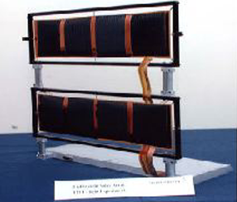
Figure 3-23 Advanced LFSA

3.1.3.4 Pulsed Plasma Thruster (PPT)
The Pulse Plasma Thruster (PPT), shown in 0, uses Teflon propellant and is capable of delivering high specific impulse (900-1200 sec), very low impulse bits (10 – 1000uN-s) at low average power (<1 to 100W). The PPT consists of a coiled spring to feed the Teflon propellant, an igniter plug to initiate a small trigger discharge and an energy storage capacitor and electrodes. Plasma is created by the ablation of the Teflon propellant from discharge to the storage capacitor across the electrodes. The plasma is accelerated by Lorenz force in the induced magnetic field to generate thrust.

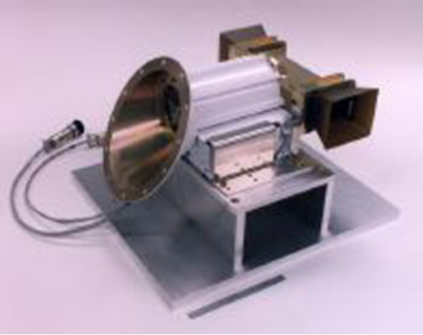
Figure 3-25 PPT Technology

3.1.3.5 Enhanced Formation Flying (EFF)
The EFF technology, features flight software that is capable of autonomously planning, executing, and calibrating routine spacecraft maneuvers to maintain satellites in their respective constellations and formations, as shown in Figure 3-27. Initially, ground s/w will be used to plan initial maneuvers and then to verify on-board planned maneuvers. This technology allows EO-1 to fly in formation approximately 1 minute behind LANDSAT 7.

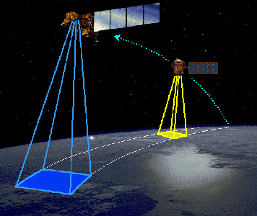
Figure 3-27 EFF Technology

3.2 Ground Segment

Overview
The EO-1 ground data system consists of the NASA Integrated Services Network, the Ground Network, the EO-1 MOC (including the Core Ground System (CGS), Data Processing System (DPS), Mission Operations Planning and Support System (MOPSS), and the Flight Dynamics Support System (FDSS). It also includes the Science Validation Facility (SVF) and the Mission Science Office (MSO) located at GSFC, the Tracking and Data Relay Satellite System (TDRSS) including the White Sands Complex (WSC), and the Stennis Space Center (SSC) supported by TRW. Coordination with Landsat 7 MOC located at GSFC will be performed to support formation flying. Interfaces will exist with instrument representatives at Hyperion Operations and Processing Center (HOPC) and Massachusetts Institute of Technology (MIT)/Lincoln Lab (LL). Further detail on the ground architecture is available in the EO-1 Detailed Mission Requirements (DMR) document.
Described in Figure 3-29 is the overall connectivity of the ground data system elements for normal mission operations.
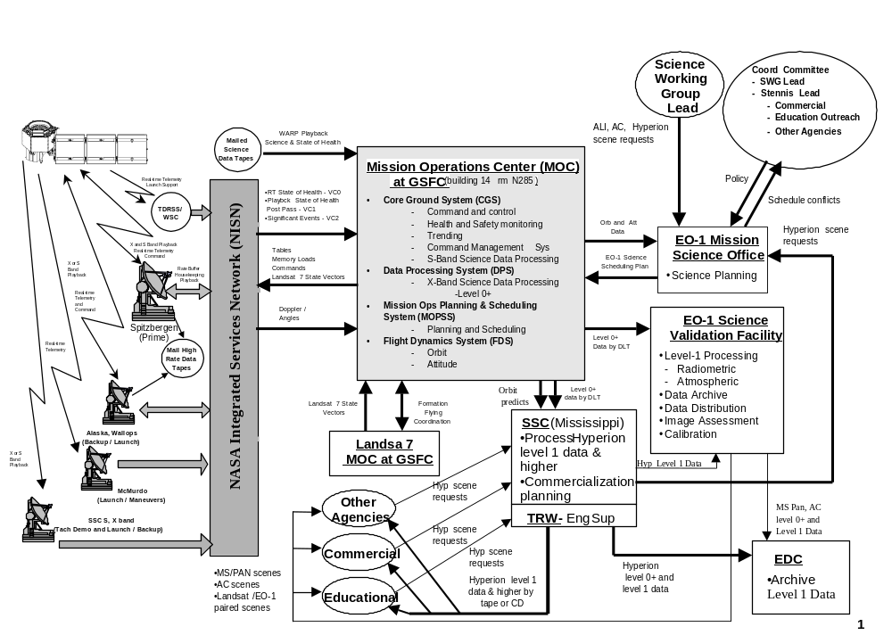
Figure 3-29 EO-1 Ground System Elements

    - Ground Network
This section describes the Ground Network necessary to support the EO-1 mission. Operational support highlights are as follows:
- Up to every orbit support (1st 3 days)
- Phasing to 6 supports daily (1st 60 days)
- 2-3 supports daily (routine operations)
- additional supports for contingency and special support
Ground stations will receive telemetry in both X-band and S-band. The GS will receive up to 80 Gbits of X-band science data each day at 105 Mbps. The GS will record the received X-band data on Ampex tapes, mail to GSFC, and store raw data for 30 days. GS will receive S-band at selected rates up to 2 Mbps.
The GS will route S-band Housekeeping data via RT virtual channels to GSFC in real time, nominally record up to 200 Mbytes of stored SOH data each day, and FTP recorded data to GSFC within one hour. Raw housekeeping data will be stored for up to 30 days. Backup science data (up to 5 Gbits per day) can be transmitted through the S-Band at up to a 2 Mbps downlink rate. This data will be stored and electronically transferred similarly to stored SOH data.
In addition to the ground stations, the ground network contains NASA Integrated Services Network (NISN), Wallops Orbital Tracking Information System (WOTIS) and the Standard Autonomous File Server (SAFS). These elements will be described in the following sections.
      - Ground Stations
Ground station coverage for EO-1 will utilize the three Wallops 11 meter subnet antennas located at Svalbard Ground Station (SGS), Spizbergen, Norway; the Alaska Ground Station (AGS), Poker Flat Alaska; and the Wallops Ground Station (WGS), Wallops Island, Virginia. In addition, the McMurdo Ground Station (MGS), McMurdo, Antarctica will be used for S-band coverage for launch, maneuver, and contingency operations. The Wallops 11 meter subnet antennas will utilize 11.3 meter, Solid Parabolic dual optics antenna for EO-1 tracking, telemetry, and commanding (TTC) and provide both X- and S-band capabilities. 11 meter subnet antennas will be capable of simultaneous S-band uplink, S-Band downlink, X-Band downlink, and Doppler Tracking. (There is no EO-1 requirement for ranging).It is envisioned that these stations will be able to support satellite contacts autonomously with periods where unattended operations will occur. These sites will provide monitor blocks to the MOC during station contacts to assist in monitoring of station status.

Other projects which plan to utilize the 11 meter subnet antennas include: Landsat 7, EOS AM-1, and QuikScat. EO-1 will be competing with these other projects for ground contact time. The SGS has been identified as the prime station for EO-1 because its high latitude provides frequent coverage opportunities, and allows science data downlink to occur without interruption to science collections that primarily are planned during day side crossings of the U.S. EO-1 does not support concurrent science collection and downlink. Coverage from other 11 meter subnet antennas will be provided if Spitzbergen coverage is unavailable.
The ground stations will be capable of supporting EO-1 commands and telemetry operations. All commands will be up-linked in real-time through the station and all real time telemetry received will be forwarded to the MOC in real-time as well as being captured. Typically, science data and stored engineering data on the WARP will be downlinked via X-Band and then recorded to an Ampex tape. Tapes would be shipped to the MOC twice a week. Also, real-time engineering data and stored engineering data will be downlinked via the S-band. The real-time data is forwarded to the MOC while the stored engineering data is automatically recorded on the local site SAFS and then later forwarded to the GSFC SAFS. Table 3-4 summarizes the ground stations used and their capabilities.

 | WGS 11.3-meter | AGS 11.3-meter | SGS 11.3-meter | MGS 10 meter
Location | Wallops Island, VA | Poker Flat, AK | Svalbard, Norway | McMurdo, Antarctica
Latitude | 37° 55’ 30” N | 65° 07’ 00” N | 78º13’49.125”N | 77° 50’ 21” S
Longitude | 75° 28’ 35” W | 147° 27’ 42” W | 15º23’34.228”E | 193° 19’ 59” W
Altitude | -16.29 m | 430.34 m | 455meters | 150.00 m
G/T | 23.0 dB/K (S-band)  35.0 dB/K (X-band) | 23.0 dB/K (S-band)  36.0 dB/K (X-band) | 23.0 dB/K (S-band)  36.0 dB/K (X-band) | 21.1 dB/K (S-band)  32.5 dB/K (X-band)
Gain | 46.0 dBm (S-band rec)  58.0 dBm (X-band rec)  44.6 dBm (S-band Xmit) | ? dBm (S-band rec)  ? dBm (X-band rec)  ? dBm (S-band Xmit) | ? dBm (S-band rec)  ? dBm (X-band rec)  ? dBm (S-band Xmit) | 46.0 dBm (S-band rec)  58.0 dBm (X-band rec)  44.6 dBm (S-band Xmit)
RF Beamwidth (Xmit) | 0.93 deg | ? | ? | ?
EIRP (Xmit) | 94.0 dBm | 96.0 dBm | 93.0 dBm | 93.0 dBm
Data Storage Capability | AMPEX tape (X-Band data)  Disk (S-Band data) | AMPEX tape (X-Band data)  Disk (S-Band data) | AMPEX tape (X-Band data)  Disk (S-Band data) | Sony Tape (X-Band data)* Disk (S-Band data)
Data Links to GSFC* | Channelized T-1  Shared RT & PB transfers at rates up to 500 kbps (TBC) | Channelized T-1  Shared RT & PB transfers at rates up to 500 kbps (TBC) | Channelized T-1  Shared RT & PB transfers at rates up to 500 kbps (TBC) | 100 Kbps RT link  TDRSS wideband link available part time
Data Transfer Plan | RT (RT SOH VCs)  PB (S-band sci, PB SOH)  AMPEX tape (X-band data) | RT (RT SOH VCs)  PB (S-band sci, PB SOH)  AMPEX tape (X-band data) | RT (RT SOH VCs)  PB (S-band sci, PB SOH)  AMPEX tape (X-band data) | RT (RT SOH VCs)
Planned Usage | L&EO / Back up | L&EO / Back up | Prime (all phases) | L&EO /Contingency /Maneuver
Planned Support | S Band TLM - 1 Mbps (nominal), 2 & 32k, 2 Mbps  X Band TLM – 105 Mbps  CMD - 2kbps THRUPUT  doppler / angle data | S Band TLM - 1 Mbps (nominal), 2 & 32k, 2 Mbps  X Band TLM – 105 Mbps  CMD - 2kbps THRUPUT  doppler / angle data | S Band TLM - 1 Mbps (nominal), 2 & 32k, 2 Mbps  X Band TLM – 105 Mbps  CMD - 2kbps THRUPUT  doppler / angle data | S Band TLM – 2 & 32k  CMD - 2kbps THRUPUT  doppler / angle data
NOTES : Data from sites routed to GSFC via WFF. WFF to GSFC have several T-1 links & network connections (TBC)
MGS X-Band support not baselined
Table 3-4 EO-1 Ground Communication Summary

3.2.2.2 Wallops Orbital Tracking Information System (WOTIS)
The purpose of the WOTIS is to provide scheduling support from the above mentioned ground stations. The Space to Ground ICD contains the process of managing the requests and the formats of information that is passed back and forth from the MOC. The Wallops Scheduling Group (WSG) staffs WOTIS 5 days per week, 8 hours per day. Schedule updates during these times will be processed by the WSG. Emergency requests outside of these periods will be coordinated with station operators available around the clock at Wallops.

NASA Integrated Services Network (NISN)
NISN is the element responsible for providing data and voice communications between elements throughout the ground system. Both real-time and off line data sent to and from the ground stations and the MOC are in IP protocol. NISN is a NASA institutional service provided by SOMO.

Standard Autonomous File Server (SAFS)
The SAFS, developed by the Wallops Flight Facility (WFF), is used to create an operational system that will provide automated management of downlinked telemetry data. This data can be retrieved by FTP once e-mail notification has been received. shows the SAFS data flow.

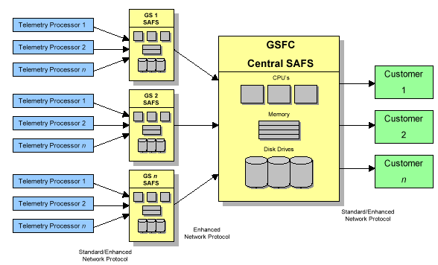
Figure 3-31 SAFS Data Flow

For a more detailed discussion of SAFS, please refer to the SAFS Overview Document.

Space Network (SN)
The SN is the real-time support network utilizing the TDRS communications satellites. The network includes ground stations in White Sands, NM. The TDRS spacecraft, along with their ground terminals, are used for the throughput transmission of real-time telemetry (2 kbps) to the EO-1 MOC. There is no requirement for commanding the EO-1 spacecraft using TDRSS. Personnel at the ground terminals will provide assistance (through the NCC) during anomalous communications conditions. TDRSS will provide L&EO support to EO-1.

Network Control Center (NCC)
The NCC is an institutional element of the Space Operations Management Office (SOMO) developed and operated under NASA Code 451. The NCC is located at GSFC and provides scheduling, configuration control, performance monitoring, and real-time operations support for all network elements of the Space Network (SN).

Mission Operations Center (MOC)
The EO-1 MOC facility is the hub of the ground system. It is located in Building 14 Room N285 at Goddard. The MOC houses the hardware and software systems necessary for the successful execution of real-time spacecraft operations and off-line scheduling and analysis activities.
All command and control functions of the spacecraft will take place from the MOC. From the MOC, the Flight Operations Team (FOT) will ensure that spacecraft conditions are monitored and controlled. Along with ensuring the health and safety of the spacecraft, the FOT will schedule and execute science data capture, retrieval and level 0+ processing (standard level 0 processing plus make scenes imageable).
Figure 3-33 and Figure 3-35 depict network connections to the MOC for normal and L&EO operations. Hardware used to support EO-1 processing at the launch site will be shipped back and used in the EO-1 MOC to support L&EO and normal operations activitie

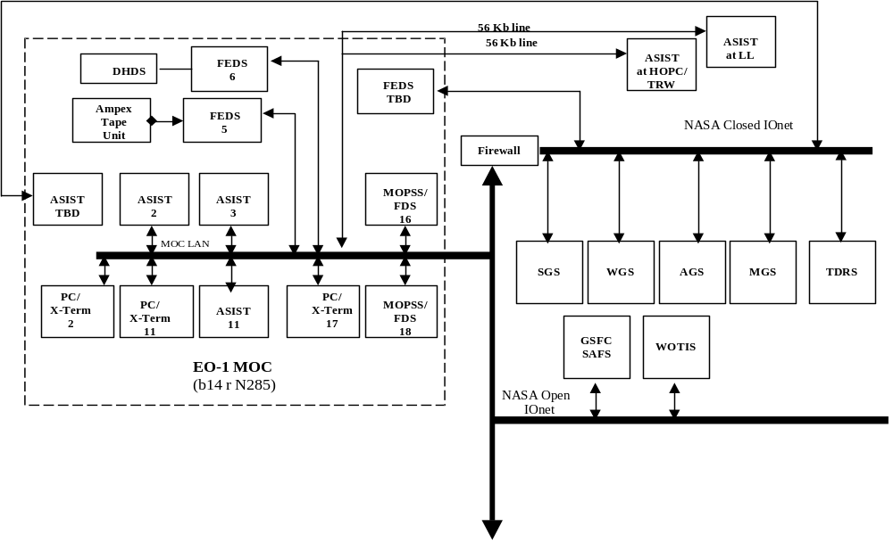

Figure 3-33 Network Connections to the MOC for Normal Operations

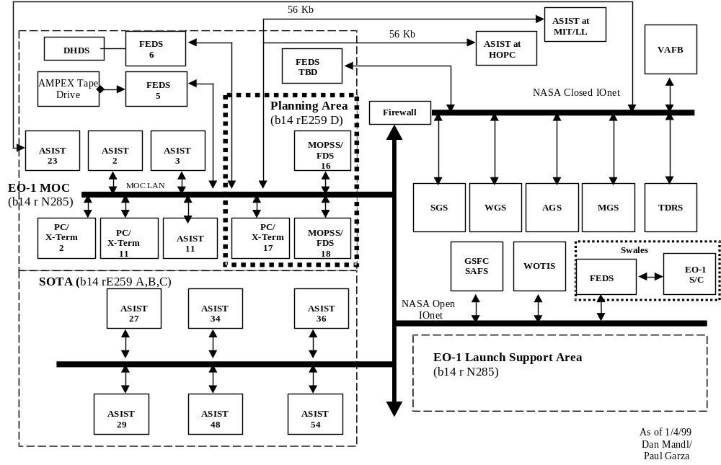

Figure 3-35 Network Diagram for L&EO

3.2.5.1 Core Ground System (CGS)
The CGS consist of the Front-End Data System (FEDS), Advanced Spacecraft Integration and Systems Test (ASIST), the Command Management System (CMS), and the Generic Trending Analysis System (GTAS).
- FEDS is the interface to the ground stations which handles all of the real-time and post pass processing of packets and IP protocol, and AMPEX taped data processing.
- Data storage
- Playback stored data
- Uplink commanding verification
- Decommutation of telemetry
- Limit checking
- Pseudo telemetry
- Database maintenance
- STOL procedures
- UNIX scripts

- ASIST is being utilized to enable the FOT to:
- Command and control system software
- Generate real time displays
- Provide state monitoring and response
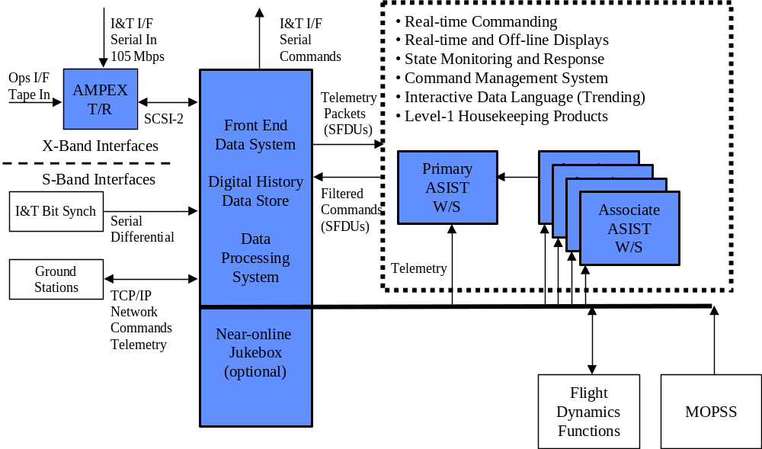
Figure 3-37 CGS Architecture

- CMS is used to:
- Help maintain the Spacecraft Command Processor ground reference image
- Accepts activity plans from the MOPSS
- Relative Time Sequence (RTS) management
- Create, edit, generate, and delete SCP loads
- Generate reports

- GTAS (TBC) is used for trending EO-1 spacecraft and technology activities. It provides for fully interactive visual data. It is based around IDL, which has heritage with the science community.

3.2.5.2 The Data Processing System (DPS)
The DPS is software that runs on top of the FEDS that provides the capability to do level 0+ processing on the EO-1 science data. Data is ingested via an Ampex tape typically. The data is then sorted by files and in the case of science data is descrambled and ordered by spectral band. This data is then passed to the SVF for archive and further processing. The DPS processing flow will be diagrammed in . . .
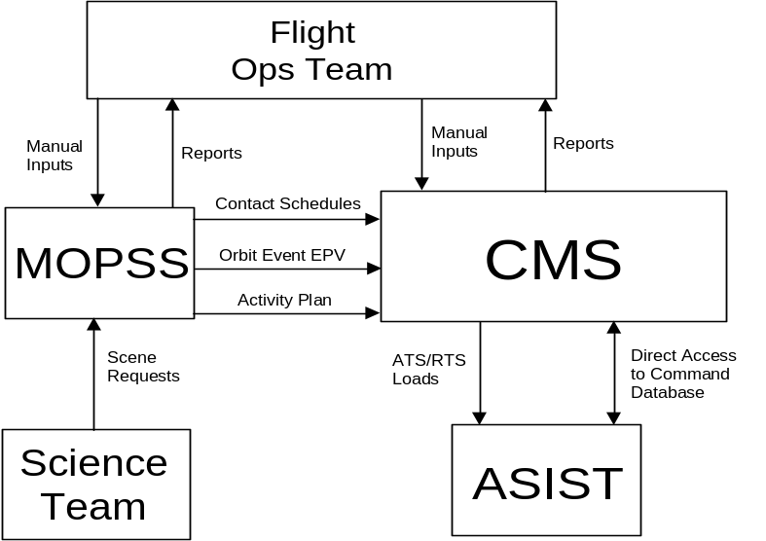
Figure 3-38 CMS Architecture(Randy H. to update)

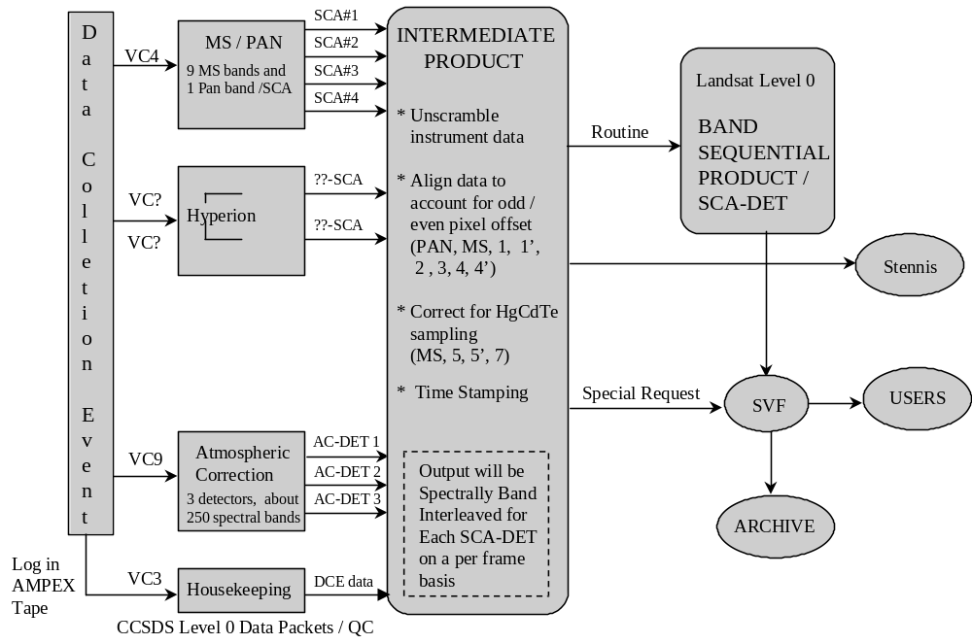
Figure 3-39 Data Processing System Data Flow(Mike Forman to Update)

3.2.5.3 Mission Operations Planning/Scheduling System (MOPSS)(Bruce to update)
The MOPSS will be used by the FOT and SVF to support generation of the EO-1 Integrated Activity Plan. This tool is a legacy system used to support similar planning for the L7 mission which has been modified for EO-1. Reuse of existing L7 capabilities has been leveraged upon in the development of this system for EO-1. This system supports the ingest of various inputs (ground contact schedules from WOTIS; orbit event and contact in view predicts, orbit maneuver and calibration slew predicts from FDSS, Landsat 7 orbit vectors, scene requests from the SVF, and other operator inputs) to create a constraint free multi-day activity plan. MOPSS will schedule activities relating to instrument calibration and imaging, orbit maintenance, ground contact and housekeeping operations, and technology validation operations. MOPSS interfaces are as described in Figure 3-40.
MOPSS will produce graphical timelines and hardcopy reports. The data generated by MOPSS is sent to the CGS in the form of an activity plan. The CGS uses this to create a command load for execution by the spacecraft.

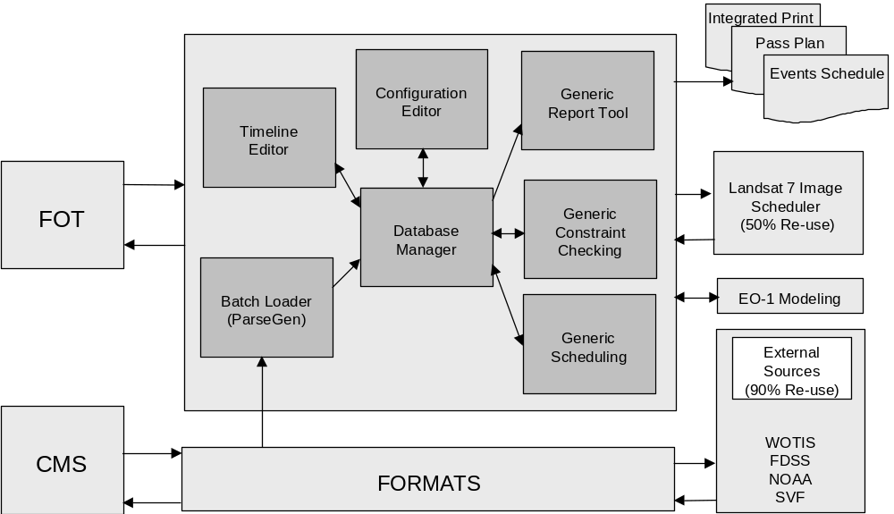
Figure 3-40 MOPSS Architecture(Randy to update as needed)

3.2.5.4 Flight Dynamics Support System (FDSS)
The FDSS provides attitude and orbital products to support the MOPSS and other FOT activities. The main functions are:
- Attitude determination
- Orbit determination
- Prediction generation
- Slew planning
- Orbit maneuver planning
- Alignment/calibration support
NASA GSFC Code XXX.X will provide software development and operations support for the EO-1 Project. These efforts will culminate in an operational system using COTS, legacy, and mission unique software loosely referred to as the Flight Dynamics Support System (FDSS). This system will execute on HP and NT workstations and will reside and be operated within the MOC. This system will support: orbit determination, flight dynamics predict generation (orbit event, ground station in view predicts), ground attitude determination, orbit maneuver / formation flying planning, and attitude slew planning for instrument solar and lunar calibration slews, and ACS calibration slews. Output planning products generated by the FDSS will be electronically transferred and ingested by the MOPSS to support operations planning and scheduling. Principal software packages to be used by EO-1 include : Precision Orbit Determination System (PODS) for performing orbit determination using either GPS or tracking data, Satellite Tool Kit for flight dynamics predict generation, FDF legacy software Attitude Determination System, AUTOCON-G for performing formation flying / orbit maneuver planning, and mission unique software to perform cal slew planning. A version of AUTOCON (AUTOCON-F) will reside on-board EO-1 and will be used to plan and perform maneuvers on-board. In addition, FDF provided algorithms will be embedded within MOPSS to provide momentum management and nadir offset slew planning for imaging DCEs.

FDF personnel will provide testing, initial on-orbit operations, and on-call contingency support as needed. FDF personnel will plan burns to calibrate thrusters and establish L7 co-fly profile. This work will transition to the FOT once nominal formation maintenance operations are established.

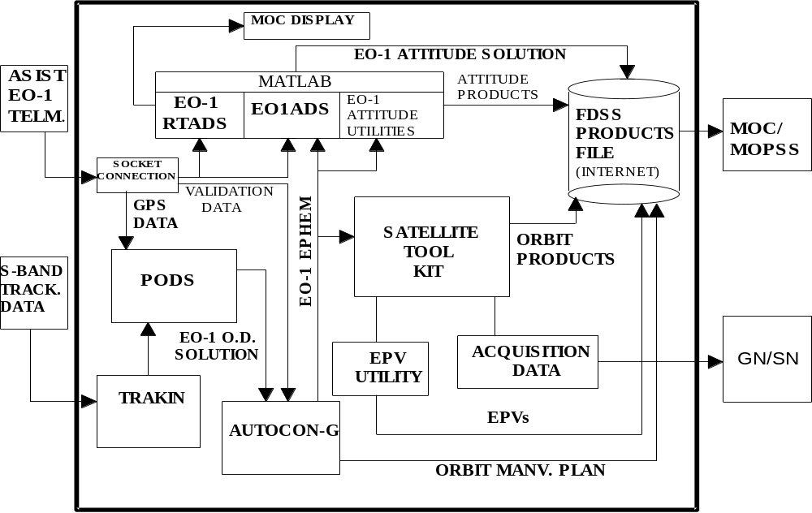
Figure 3-42 FDSS Architecture

3.2.6 Science Validation Facilities (SVF)
The Science Validation Facility (SVF) is located in GSFC/NASA Code 923, and shares some computer equipment with the Landsat-7 Project Science Office (LPSO) Image Assessment System (IAS). The main functions of the SVF are to assess, process, and manage the flow of selected data. The SVF archives data, provides science validation analysis, and distributes data for the Mission Science Office (MSO). Upon demand from NRA-selected Science Validation Investigators, the SVF produces ALI Calibration Pipeline (level 1) data.
The SVF will receive level 0+ data from the MOC and Hyperion level 1 data from SSC. All level 0+ data will be archived to DLT tapes. Image assessments and quality checks will be made on the ALI and AC data. The ALI data will be processed to level 1 data at the request of NRA-selected Science Validation Investigators. The Calibration Pipeline software provided by MIT/LL processes the ALI data to level 1 data. The SVF will distribute requested ALI and AC (both level 0+ and level 1) data and Hyperion level 1 data to the investigators.

3.2.7 Science Data Distribution and Archive
The NMP EO-1 Science Working Group (SWG), located within the Landsat 7 Mission Science Office, will establish all data collection and production rules and priorities for NMP EO-1 operations. The SWG will assess and recommend the methodologies necessary to achieve Level 0 data and produce Level 1 data on demand. Interagency support is to be provided through the Department of the Interior and the U.S. Geological Survey (USGS), which handle long term data archive and distribution at the Earth Resources Observation System (EROS) Data Center (EDC).

3.2.8 Launch Segment
The EO-1 spacecraft is scheduled to be launched from the Vandenberg Air Force Base (VAFB) Launch Complex aboard a Delta 7320. The launch vehicle carries two payloads; EO-1 and SAC-C the Argentine Satellite de Aplicaciones Cientificas-C. The launch will occur December 22, 1999.

Add section for EDC and LS I/F

Launch and Early Orbit Operations

Launch and Early Orbit Overview
The following chapter discusses launch site communications, payload processing, while focusing on launch and early orbit operations, and the launch and early orbit operations organization.

Launch Site Communications Flow
Launch to occur at Western Range, Vandenberg, California. Launch site communications requirements will be defined in the EO-1 Payload Requirements Document developed by Kennedy Space Center. See that document (when available) for launch site communications requirements. Figure 4-44 (TO BE UPDATED) is representative of the interfaces that will exist at the launch site for EO-1. Spacecraft processing will be done at the following facilitie :
- Payload Processing Facility, Building 836 – Functional testing prior to mate with launch vehicle
- Hazardous Processing Facility(?), Building 1610 – Mate to launch vehicle
- Satellite Launch Complex –2 (SLC-2) – where launch occurs
Spacecraft GSE to stay at Building 836. Command and telemetry interfaces between SLC-2 and Building 836 to be provided to support launch operations. In addition, interfaces between GSFC and SLC-2 will be required.
Communications at SLC-2 are provided through an RF hat coupler linked to Building 7000/7011 via an RF interface and via a TO umbilical which is available through lift off and is linked to Building 7000/7011 via a land line interface. An S-Band RF test via the hat coupler is planned from the pad prior to fairing installation. There after this interface is no longer available. Both SLC-2 data interfaces are direct digital connections. (Several analog measurands available through the TO umbilical are processed by the umbilical console located at the base of the pad will also be available) Interface through Delta COMM system is not supported (i.e., no muxed EO-1 telemetry in Delta telemetry stream).

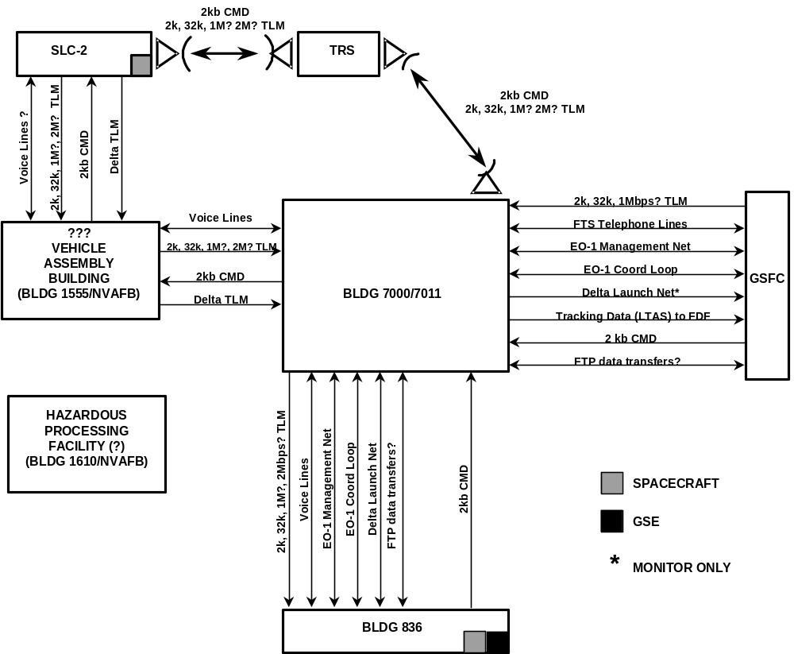
Figure 4-44 Launch Site Communications Interfaces – TO BE UPDATED

  - Launch Site Payload Processing Operations

Launch site payload processing operations will be the responsibility of Swales Aerospace. The EO-1 launch site processing flow will be as diagrammed in Figure 4-45

MOC to support an End to End test with spacecraft at Building 836.
Plan is to bring full complement of Spacecraft Engineers for initial launch site operations. After initial operations completed, only launch essential personnel to remain. This allows small team of engineers to provide support at launch from GSFC and to reduce travel expense. Engineers to support launch site activities from MOC at GSFC.

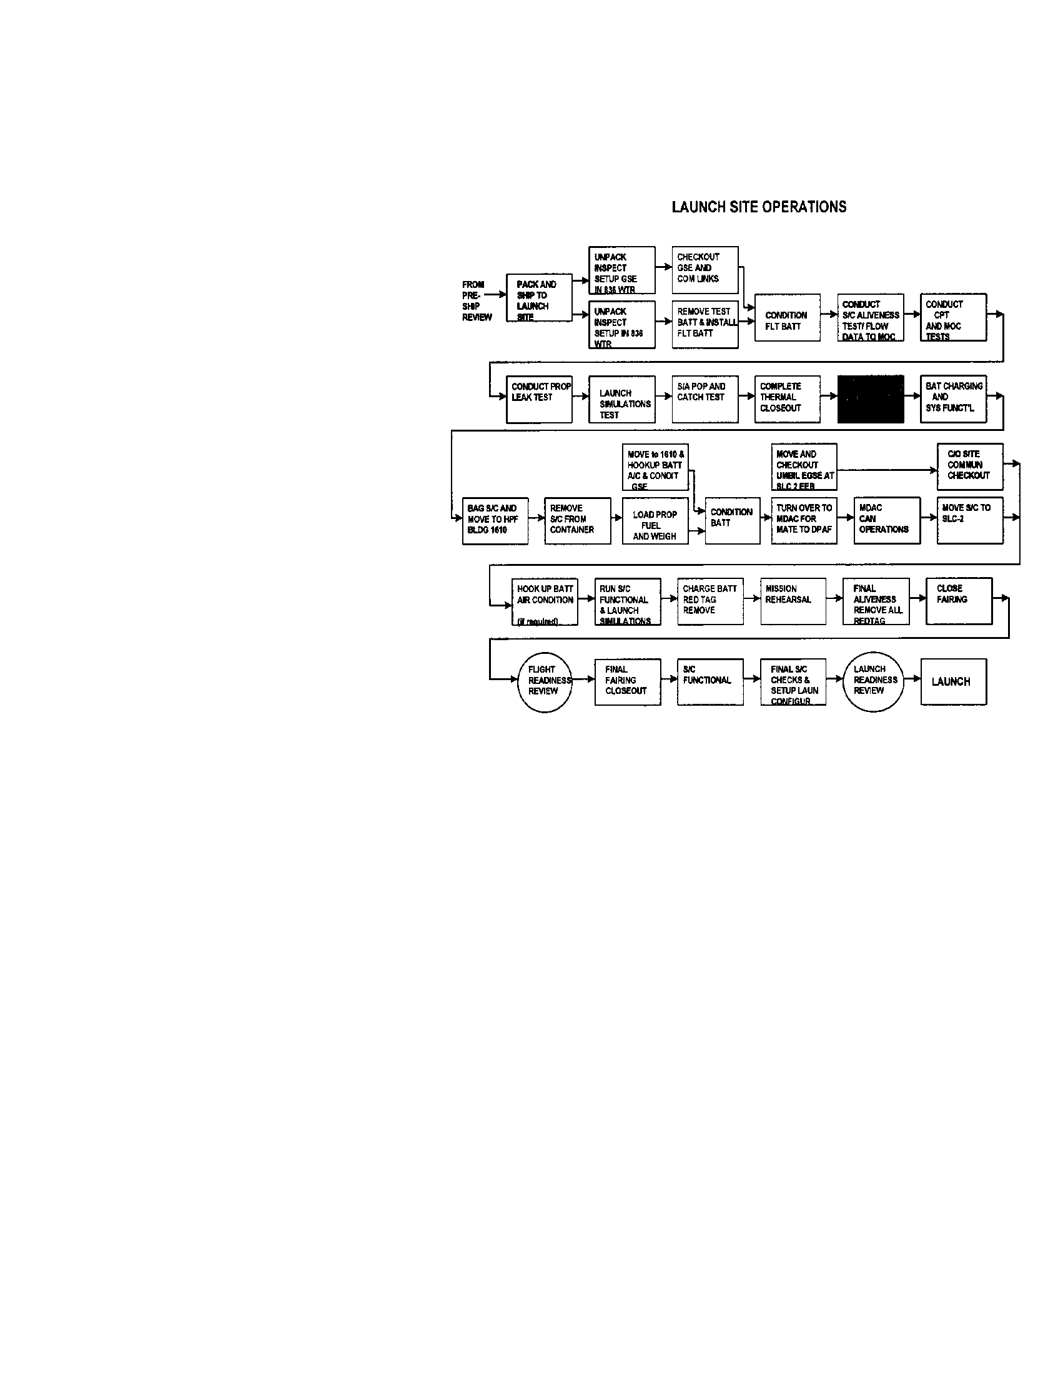
Figure 4-45 Launch Site Processing Flow

4.4 Launch and Early Orbit
Launch & Early Operations (L&EO) activity begins at launch and extends up to approximately 60 days after launch. Specialists from the EO-1 spacecraft development team will be on call for the duration of L&EO. Instrument manufacturer representative will be at GSFC and on call for the duration of the L&EO as outlined in section 4.4.9. FOT personnel will be provided to cover 24 hour operations for the 1st week of operations while the check out and verification is being performed on the spacecraft (30-60 days). There after the FOT will provide 12 hour coverage daily with extended coverage possible in the event of anomaly or special operations. The emphasis during this phase is on EO-1 launch, spacecraft checkout, orbit formation establishment, instrument functional checkout, and instrument performance check out.
High level L&EO operations schedule as outlined in the remainder of this section is as follows :

- Launch Countdown
- Launch, separation, and deployment activities
- On-orbit checkout
- First 5 orbits: verify spacecraft health
- Rest of first day: confirm basic spacecraft performance: ACS, C&DH, RF, Power
- First week: Full subsystem tests; gather calibration data.
- Rest of first month: Confirm all operational scenarios, establish orbit formation, and perform first functional tests of payloads.
- Second month: Perform performance verification of payloads.
Checkout operations involve the review of subsystem performance, and the commanding of subsystem modes and configurations necessary for conduct of the mission so as to assure operability and determine performance levels. Checkout activities will occur for a set amount of time each day, centered on real time contact times with available ground stations. Time for contingencies and re-planning will be set aside each day.
Following launch, responsibility transitions to the Project supported by the FOT, Swales, Instrument reps, Technology Validation Teams, MSO representatives and ground systems support personnel. L&EO Operations will be conducted based on check out plans provided by Swales Aerospace (for the spacecraft), Instrument manufacturers (for the instruments), and technology validation teams (for each technology). L&EO rehearsals will be conducted prior to launch to demonstrate operations plan, procedure, and personnel readiness.

4.4.1 Countdown
Launch countdown operations will commence 24 hours prior to launch (TBC) and will be controlled by Boeing. Swales representatives at launch site will be responsible for monitoring status of EO-1 payload and providing GO/No-GO input for the spacecraft. Voice and telemetry will be distributed to the EO-1 MOC at GSFC. The Project with FOT input will provide GO/No-GO input for ground systems. Launch countdown operations will be performed in accordance with procedure SAI-PROC-316. Launch recycle and short-term scrub operations are included in the Launch Countdown Procedure.
The launch Countdown Procedure conducts a final functional check of the spacecraft and sets the launch mode configuration. Battery trickle charge requirements are maintained from the completion of the electrical integration to Launch Vehicle until approximately T-20 minutes prior to launch. Detailed description of the launch configuration is provided in SAI-PLAN-258, Configuration for Launch, Ascent, and Safemode.
The following provides an overview of launch configuration:
- Comm system: RSN, S-band transponder (not transmitting) – ON
- C&DH: Main processor (M5) - ON
- ACS: Processor (ACE RSN), gyro, magnetometer, torquer bars - ON
- Spacecraft heaters, including damper heaters - ON
- Instrument survival heaters- ON
- Actuators for s/a release (HOPs) power service (enabled). – ON
- (The HOPs will not activate without an additional FIRE command.)
- RCS latch valve power - ON
- All instruments and payloads - OFF
- Solar-array drive - OFF
- Reaction wheels, Star tracker, and GPS - OFF
- Warp - OFF
- ACS in B-Dot mode with commands overridden
- PSE timer to turn on RWA and ECU at L+ 65 minutes
- ACE timer to go to safemode if loose contact with M5 for 66 minutes
- Torquer-bar commands overridden until L +66 minutes
- Initial ephemeris loaded
- ATS loaded with launch load to control transmitter and telemetry output operations for 1st TBS orbits
- Telemetry stored at high rate (~65 kb/s)
- Downlink rate set to 2 kb/s
What are GO/No GO criterion ? Where are they documented ?

4.4.2 Ascent and Separation
EO-1 will separate first from the launch vehicle with SAC-C being released about 31 minutes later (Is this still valid?). Separation is scheduled to occur 58m20s after lift off. The launch vehicle will be oriented such that the outer solar-array panel is pointed toward the sun during coast phase. At ~12 minutes after lift off, the fairing is ejected and EO-1 S-band downlink at 2kbps begins from ATC command. TDRSS will be used to monitor EO-1 status during ascent, separation, and initial operations. The launch vehicle will place EO-1 into a sun-synchronous 705 kilometer orbit +/- 10 kilometers with an inclination of 98.2 degrees +/- 0.04 degrees. This orbit should be approximately that of Landsat-7 with EO-1 Mean Local Time at the descending node being one minute later than that of Landsat-7. To help achieve the one minute separation with Landsat-7, the EO-1 launch window will be limited to one minute.
After EO-1 deployment, the launch vehicle will perform a plane change to place SAC-C at a descending node MLT of 10:15 AM. Based on current information about the Landsat-7 launch date (as of 9/15/98), a 12/99 EO-1 launch would be targeting the EO-1 descending node MLT to about 10:05 AM.
EO-1 separation activities will be launch vehicle and satellite controlled through timer and/or stored command activities. The separation activities will begin with spacecraft separation from the launch vehicle second stage and end with the spacecraft in a stable sun pointed attitude under autonomous control. Spacecraft operations in this phase are all autonomous, controlled by the spacecraft, including verification and retry of solar array deployment. As such, under nominal operations conditions, separation activities will not require ground intervention.
After separation from the launch vehicle, the spacecraft is in B-dot attitude mode. Once the gyro rates are sufficiently small, the spacecraft can transition autonomously to Sun Acquisition mode where the array can be autonomously deployed. If EO-1 stays in the B-dot mode too long, array deployment can be commanded from that attitude. Once the array is deployed and EO-1 is in the Sun Acquisition mode, it will be rotated to an index position. EO-1 will remain in this attitude for some time to recharge the batteries and to allow the ground team to evaluate spacecraft health and safety.

4.4.3 Initial On-Orbit Operations (1st 5 Orbits)
The principal objective of the 1st 5 orbits will be to establish ground communication with EO-1 and to verify spacecraft health.
Figure 4-46 is a graphical representation of the initial acquisitions.

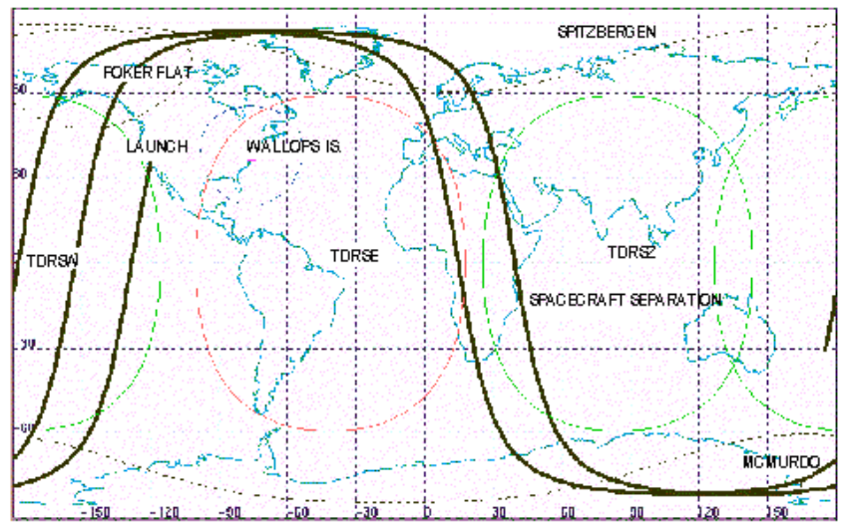
Figure 4-46 EO-1 Initial Acquisitions

TDRSS coverage should be available at separation. First ground station acquisition should occur at TBS at L + TBS minutes. The transmitter should be on for these initial acquisitions from stored command at a 2 kbps downlink rate.

Specific objectives of the 1st 5 orbits include :

- Monitor satellite through TDRSS at 2 kb/s.
- Data storage continues at the high rate, approximately 65 kb/s.
- Verify that potentiometers indicate that the solar array autonomously deployed and moved to the index position.
- At first ground contact (Spitzbergen), issue a playback command to verify that spacecraft can receive and process ground commands.
- Verify that angular momentum is decreasing (ACS is in b-dot mode).
- Monitor transition to sun-acquisition mode, which occurs autonomously when momentum is sufficiently damped. It may take two orbits of b-dot damping, depending on tip-off velocities. Uses coarse sun sensors.
- Verify PSE function: battery charging when solar arrays in the sun; transition to battery power during eclipse.
- Verify that EO-1 is power-positive during an orbit.
- Monitor ACS components: RWA, TAM, MTB, IRU, and CSS.
- Turn on GPS and AST (by ground command)
- Verify AST producing correct attitude.
- Verify SHM control signals from the ACE.
- Disable launch TSMs and enable TSMs that were disabled for launch.

Initial On Orbit Operations (Rest of 1st day)
Principal objective for the rest of day 1 will be to begin confirmation of basic spacecraft performance. Specifically this will involve:
- Verify that EO-1 has a valid GPS fix: position and velocity. It takes up to one orbit to get a lock; takes 1-2 days for ground to verify GPS performance.
- Issue command for ACS to use AST and GPS information.
- Initialize Kalman filter and begin convergence.
- C&DH functional tests: commanding, counters, load dump, memory scrub, all tasks operating nominally, RTs responding, bus errors?, DRAM errors?, LVPC current.
- Verify GPS time code availability and correctness.
- Verify momentum management: RWA speeds near zero.
- Verify battery health: battery-state-of-charge; check VT curve, taper, end-of-night parameters, C/D calculations, battery temperature.
- Verify PSE functions: s/a switching, FDC operating, OM and LVPC currents nominal
- Enable use of GPS time signal and verify distribution (GPS to HK RSN, M5 C&DH).
- Verify storage filter tables: normal (4 kb/s) and high rate (65 kb/s).
- Verify real-time downlink filter tables: low (2 kb/s) and high (32 kb/s).
- Assess thermal-control system: temperatures and heater duty cycle

    - Early Orbit Operations (Rest of 1st week)
Principal objective for the rest of 1st week will be to complete confirmation of basic spacecraft performance. Specifically this will involve:
- Verify s-band downlink rates, 2 kb/s, 32 kb/s, and 1 Mb/s.
- Enable coherency on S-band for ground verification of GPS position.
- Checks of ACS algorithms and kalman filter: monitor covariance, determine gyro biases, compare AST and TRIAD solutions, etc. (Need several orbits of high-rate data.)
- Transition to Earth Pointing / Mission-Idle Mode (M5 ACS).
- Monitor solar-array tracking and transition to digital counter.
- Switch to normal data-storage rate (4 kb/s) when not performing specific tests.
- Turn on, and verify aliveness of the WARP and X-band PAA (day 2)
- Verify X-band downlink: correct commanding from ACDS, first check of performance (test data from WARP)
- Perform 90-degree attitude slews for IRU calibration. Ground analyzes data.
- Turn on, and verify liveness of the ALI, AC, LFSA, and Hyperion (day 3).
- Perform MTB pulses over 10-minute period to calibrate TAM. Ground analysis.
- Verify 2 Mb/s s-band downlink rate using WARP data.
- Enable SHM control of spacecraft for at least one orbit. Starting from mission-idle mode (nadir pointing), test both the transition to safe mode and the stability of the ACE controller (day 4).
- Monitor safehold performance: ACS, TSMs, and RTSs.
- Return to nadir pointing.
- ALI/WARP initial tests: ALI test pattern and WARP data acquisition and storage.
- During contact with ground, perform short delta-V burn (10 seconds; could also fire thrusters one at a time) to verify thruster functions and ACS performance during thruster-control mode. Pitch maneuver is probably not required for this test. Ground analysis (takes 12 to 24 hours).
- Perform longer firing of all thrusters to get the thrust scale factor. Pitch maneuver required. Could be done in conjunction with first orbit-adjust burn.
- Perform delta-V burn to correct errors from orbit insertion.
- Verify TSM task operating correctly.

Early Orbit Operations (Weeks 2 and 3)
Principal objective for the weeks 2 and 3 will be to begin confirmation of instrument performance and to begin orbit formation establishment operations. Specifically this will involve:

- Activate launch-release mechanism for ALI aperture cover.
- Hyperion/WARP initial tests with calibration lamps; cryocooler not yet operating.
- Activate launch-release mechanism for LFSA panels.
- Deploy LFSA panels.
- Test of ALI using internal calibration lamp
- Test WARP/AC interface: take initial AC images, without stopping solar arrays.
- Enable EFF and verify that it is operating in the background.
- Turn on Hyperion cryocooler.
- Take Hyperion images with internal calibration lamps and cold SWIR.
- Check operation of ALI and Hyperion aperture doors (after one or two weeks, so that satellite has time to out-gas).
- H&S assessment of all satellite systems
- Perform initial delta-V burns to rendezvous with Landsat 7.

Other Early Orbit Activities
Principal objective for the later period of L&EO will involve:
- Test spacecraft set-up for imaging: spin-up reaction wheels, stop solar array, etc. (use RTSs and ATSs).
- ALI mechanism: test sun-calibration motors
- ALI performance tests: take images
- Hyperion performance tests: take images
- Ground assessment of instruments (ALI, LEISA/AC, and Hyperion), LFSA, and CCR performance
- Sun calibration of instruments
- ALI/ACS alignment calibration: images and ground evaluation by FDF and science team.
- Lunar calibration: ACS maneuvers and instrument images.
- Test firing of PPT to verify function.

Orbit Formation Operations
Begin around week 2, operations will commence to establish the EO-1 / Landsat-7 formation. Generally this will involve: establishing EO-1 orbit, performing a calibration burn, and performing a sequence of burns to establish the EO-1 formation.

Calibration and formation establishment burns to be planned by FDSS and EFF representatives subject to Project approval. Burn planning to transition to FOT after nominal formation maintenance profile established.
Orbit maneuvers performed as described in section 5.7.2.
In being co-manifested with SAC-C, EO-1 was asked to accept the initial conditions of a sun-synchronous orbit of 705 kilometers altitude at the ascending node, a near circular eccentricity and inclination of 98.2 degrees. Generally, these trajectory targets will allow EO-1 to maneuver to its co-fly goals with Landsat-7. However, if the launch of EO-1 places it up to a worst case of half an orbit out of phase with Landsat-7, then an altitude somewhat lower than 705 km. would have saved propulsion system propellant during the early orbit acquisition maneuvers. EO-1 may have to raise or lower the altitude, drift to the appropriate location with respect to Landsat-7 and restore the orbit altitude to 705 kilometers. A lower initial altitude would have eliminated the need for significant maneuvering to start EO-1 drifting toward Landsat-7.
Key activities :
- Establish good orbit solution (initially via doppler data provided by GS, later using GPS)
- Turn on AUTOCON-F in passive mode to allow ground check out of flight s/w burn planning- ~Day 4
- Perform test slew (in view of ground station)
- Perform slew and test / cal burn (in view of ground station)
- Calculate thruster performance and alignment coefficients (and upload to s/c ?) – FDSS, EFF, S/C ACS personnel
- Perform formation establishment burns
- Burn plan generated using AUTOCON-G
- ~ 7 burns required to establish formation
- L7 MOR providing L7 orbit solution daily
- Perform formation maintenance maneuvers – ~weekly

4.4.9 Instrument Checkout
Following completion of spacecraft check out by ~ day 7, emphasis will change to performing orbit maneuvers to establish the EO-1 / L7 formation and performing EO-1 instrument check out. It is envisioned that Instrument check outs will be completed by ~day 60. Instrument check out will be performed as per plans developed by Instrument manufacturer representatives and approved by the Project and spacecraft manufacturers. During the first 30 days of instrument check out, it is envisioned that Instrument manufacturers will have representatives resident at the MOC and available at home facilities. Continued support should be available from their home facility during later period of instrument check out. These home facilities will be : the Hyperion Operations and Processing Center (HOPC) in El Segundo, California for Hyperion, at GSFC for LEISA / AC, and at MIT / LL, in Cambridge, Massachusetts for ALI.
During the Instrument Checkout phase, in addition to X-Band science downlinks, special operations will be performed to retrieve collected science data stored on the WARP via the 2 Mbps S-Band downlink service. This will allow limited duration instrument data collections to be downlinked, retrieved electronically to the MOC, processed, and available for analysis at the MOC, or transfer to external facilities, in a timely fashion. (Electronic X-Band science data recovery from ground stations is not supported). PB SOH data should be available in the MOC within 1-2 hours of downlink. Science data should be available in the MOC within 2-4 hours. When MOC is staffed, science data processing will probably require another hour to complete before it is available for further processing, analysis, and distribution. Science data volumes for S-band downlink should be limited to ~100 Mbytes to allow retrieval during a single downlink contact. This equates to ~4 second Hyperion data collect, ~8 second ALI or AC data collect, or ~2 second combined data collect. For X-Band downlinks, WGS will be preferentially scheduled to allow faster recovery of taped X-Band to GSFC.
Part of the Instrument checkout will involve demonstrating Ground operations interfaces, procedures, and ‘routine’ operations personnel. For this reason, and to simplify ground system design and reduce operational interfaces, the MSO / SVF will be utilized to process and schedule Instrument team requests.

ALI Checkout
ALI check out will be performed based on plans provided by MIT / LL, and approved by the EO-1 Project. ALI will utilize a phased turn on and check out process. It will consist of ALI housekeeping equipment turn on and check out, internal calibrations, door operations checkout, and finally external calibrations. Dark, lamp, ground reference, solar, lunar calibration operations will be used to validate ALI spectral, spatial, etc performance. Specific check out activities will be as follows :
- Turn on ALI RSN
- Verify operability of housekeeping equipment and ALI thermal control systems
- Perform ALI dark calibration data collections
- Perform ALI lamp calibration data collections
- Verify functionality of ALI cover
- Perform ALI ground image data collections of ground calibration targets
- Perform ALI solar calibration data collections
- Perform ALI lunar calibration data collections
See the Data Collection Event (DCE) Operations and ALI Operations sections for further detail regarding ALI operations, and how ground images, solar cal, and lunar cals are performed.
Need to add :
- activity frequency
- develop an estimated ALI checkout timeline
Issues :
- how much time for outgassing ?

LEISA/AC Checkout
LEISA / AC operation will have similarities to other instrument check outs, but should be more straightforward in that LEISA/AC does not have an instrument cover or cal lamps, and it is a simpler instrument. Specific activities
- Turn on AC
- Verify operability of housekeeping equipment
- Perform AC dark earth calibration data collections
- Perform AC ground image data collections of ground calibration targets
- Perform AC solar calibration data collections
- Perform AC lunar calibration data collections
See the Data Collection Event (DCE) Operations and LEISA / AC Operations sections for further detail regarding AC operations, and how ground images, solar cal, and lunar cals are performed.
Need to add :
- activity frequency
- develop an estimated AC checkout timeline

      - Hyperion Checkout
The following procedures will be executed during early orbit checkout to validate the operation of the Hyperion instrument.
- Command spacecraft to power up instrument from survival to initialization state. Verify state of health by reading temperatures and voltages. Monitor instrument telemetry for TBD time.
- Command instrument to dark calibration mode. Turn on the Focal Plane Electronics (FPE) and the Analog Signal Processors (ASP).
- VNIR check out: Acquire dark VNIR frames and compare with the data from integration and test to make sure that the dark frame looks reasonable.
- SWIR 'warm' check out: Acquire a SWIR image while checking out VNIR, compare this 'warm' image with the ones taken on ground to ensure that SWIR 'warm' image is consistent with laboratory measurements.
- Calibration Lamp checkout: Turn on the calibration lamp and acquire calibration frames. Compare with laboratory measurements acquired during integration and test.
- Keep calibration lamps on at full power for 2 (TBR) minutes each separately. This is in preparation for the initial water bake out.
- Turn off the FPE and ASPs.
- Cover check out: Exercise the cover to make sure that it is operational
- Bake out: Keep the cover open at solar calibration position for 24 (TBR) hours to get rid of residual water
- Turn on FPE and ASPs.
- VNIR image: acquire VNIR image of the earth. This image can be used to check the band center wavelengths by comparing the atmospheric absorption lines measured with theoretical expectation. The broadening of the absorption lines can also be used to check for any deterioration in focus.
- Close cover and turn off FPE and ASPs.
- Turn on Cryocooler and monitor its power draw and temperature to determine initial water load. It will take TBD number of days for cool down to operating temperature.
- Command instrument to Dark Cal mode. Turn on FPEs and ASPs.
- SWIR checkout: acquire dark SWIR frames (at operating temperature) and compare with laboratory data.
- SWIR and VNIR Calibration Lamp frames at operating temperature
- Solar calibration
- SWIR and VNIR image of the earth
- Acquire SWIR and VNIR image of a calibration site (TBD) on earth.
- Lunar Calibration
Upon completion of these steps, the instrument is ready for use in normal mission operations.

On Orbit Operations Organization
EO-1 on orbit operations will be conducted by an integrated team consisting of the Project; spacecraft, instrument, and technology representatives; MSO and ground system representatives; and the FOT. Roles and responsibilities will be outlined in 3.
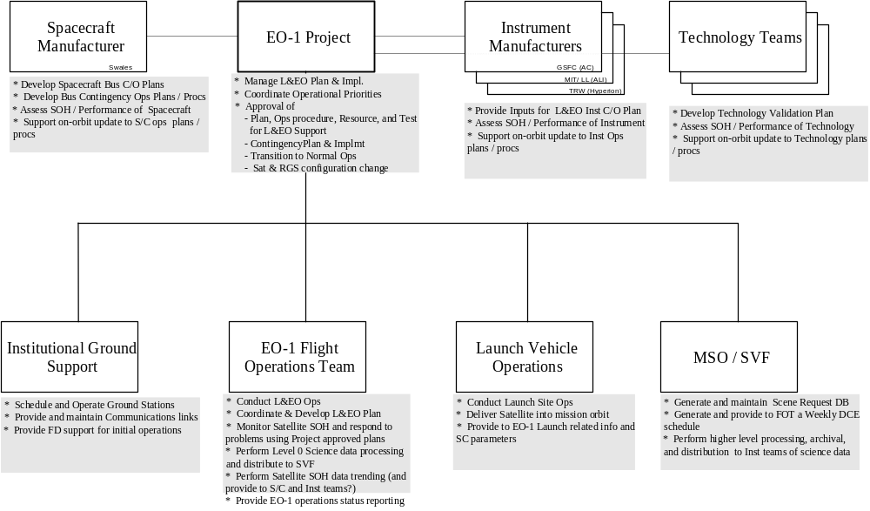
Figure 4-48 EO-1 Operations Roles and Responsibilities

The Project will be directing operations during the early orbit period. For nominal, routine operations, the FOT will conduct planning and pass operations per agreed to plans with minimal oversight. For special and contingency operations, the FOT will perform operations per direction provided by the Project. The Project will make use of spacecraft, instrument, technology, ground systems, and operations expertise to assist making decisions. The Project decision making model will be as diagrammed in 4.

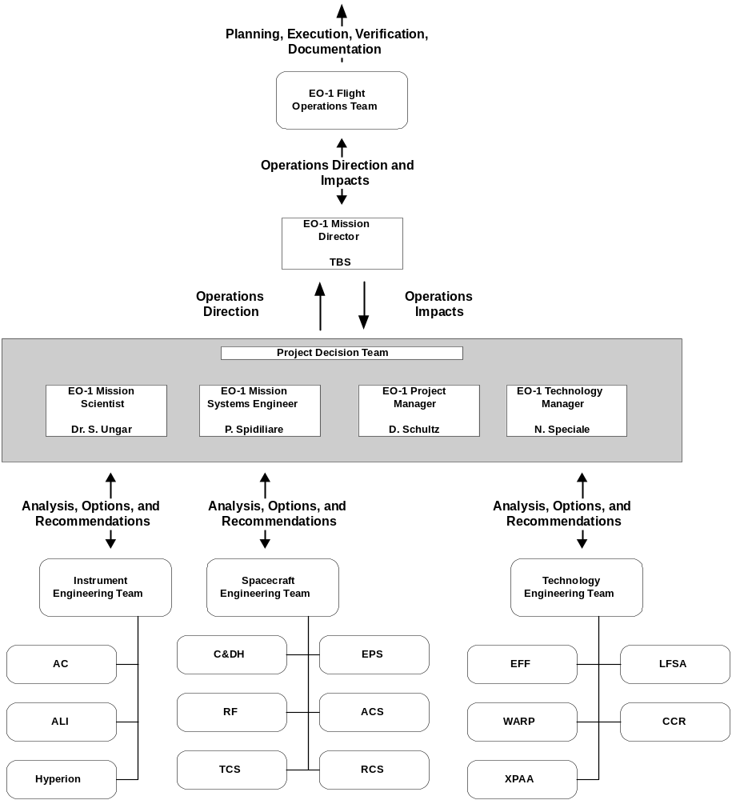
Figure 4-50 EO-1 Operations Flow

Integrated Normal Operations

Normal Operations Overview
This chapter will focus on integrated operations necessary for the Normal Operations phase. It will discuss operations philosophy, nominal operations, how these operations get planned, performed, and data recovered, processed, and distributed. Specifically this chapter will address :
- EO-1 Operations Philosophy
- Planning and Scheduling
- Science Operations
- Ground Support Operations
- Telemetry Processing and Distribution
- Flight Dynamics Operations
The principal spacecraft activities required to support EO-1 Normal Operations are outlined in X. These operations will involve the following :
- Performance of Instrument Data Collection Events – up to 4 / day
- Performance of Instrument Solar Calibration Events - ~weekly (Hyperion), monthly (ALI, AC)
- Performance of Orbit Maneuvers to maintain L7 co-fly profile - ~weekly
- Uplink of L7 orbit vector for EFF calculation of co-fly profile– (contained in each Absolute Time Command [ATC] load)
- Performance of Ground Contacts (2 per day) to allow :
- Command operations
- R/T and P/B SOH data retrieval and satellite monitoring
- Science data downlink via X-Band
- *(Additional contacts may be used to support Orbit Maneuver, and Solar and Lunar Calibration monitoring and Contingency Operations)
- Performance of Technology Validation Operations
- Uplink of ATC loads to support spacecraft operational activities

EO-1 Operations Philosophy
EO-1 is a technology demonstration mission, and as such, is budgeted, staffed, and will be operated in a manner consistent with a technology mission. Principally, this implies some data losses will occur, some compromise in optimal scene selection will exist, some operations will be performed prime shift (when DCEs might otherwise occur) to allow FOT monitoring, recoveries from anomalies will not proceed at round the clock pace, and traditional FOT services may need to be rationed. This rationing may include turn around of replanning and reprocessing requests, specialized trending requests, and extensive reporting. Highlights as follows:
- Operations will be conducted based on plans and procedures agreed to by the Project and documented in the TBS (equivalent to Instrument User’s Guide, Bus User Manual).
- EO-1 FOT will staff the MOC 8 hours per day, 5 days per week for nominal operations. The FOT will provide additional coverage to support contingency and special operations.
- EO-1 is investigating deploying web based tools that allow the FOT to monitor available data remotely.
- Spacecraft / Instruments will monitor key telemetry and initiate safing autonomously as needed.
- In the event it becomes necessary for spacecraft or instrument health, the FOT will execute pre-loaded safing RTSs, and will notify Project and instrument representative of anomalies and responses.
- In the event of a spacecraft initiated safing action, mission will be interrupted while staff is notified, isolates problems, and can return mission to nominal operations.
- Some ground contacts will be supported in an unattended mode. EO-1 is attempting to develop the following capabilities to support this need :
- Capability for ASIST to configure the MOC and perform an ‘as planned nominal’ contact as per a time tagged schedule generated by planning system or FOT. If available, this might include routine SPACECRAFT COMMANDING (i.e., ATC loads, recorder dumps).
- Anomaly monitoring system that would monitor planned operations and notify the FOT (i.e., page the FOT) in the event of a pass related failure (i.e., unable to acquire telemetry, unable to complete command objectives, etc) or anomalous telemetry (limit flag, spacecraft event occurrence, etc).
- While attempting to preserve flexibility, will attempt to simplify and streamline operations to reduce risk, and system and operations development efforts.
- Will not perform cloud cover assessment as part of the planning process
- Will attempt to coordinate operations plans on weekly as opposed to daily basis. (This includes instrument planning).
- Will perform science data management via stored command. Except for specially scheduled data collections, data not successfully received by the ground will be lost.

Planning and Scheduling
Mission planning flows and timelines will be as outlined in the Typical Operations Flow diagram, figure X-x, and the Typical Operations Timeline, in figure X-x. Planning and scheduling of EO-1, which is described below, will involve the following :
- Establishing operational priorities
- Generating a ground contact schedule
- Developing Weekly Instrument Activity (ground DCE) plans
- Developing Solar and Lunar Cal plans and operations inputs
- Developing Orbit Maneuver plans and operations inputs to maintain EO-1 / L7 co-fly
- Creating an Integrated Activity plan and building Stored Command products

A Weekly Operations Coordination meeting attended by the FOT, Mission Director, MSO / SVF rep, Technology rep will be used to establish and review the weekly operations plans for the next 3 upcoming weeks. Goals of this meeting will be:
- Establish times and details of solar and lunar calibration requirements for week 3.
- Establish projected times for Orbit maneuvers for week 3.
- Review and coordinate updates to SVF provided ground image scene plan for weeks 2 and 3.
- Review and coordinate desired changes to WSG provided ground contact schedule for weeks 2 and 3.
- Establish times and details of Technology validation operations for week 3.
- Coordinate needed updates to plans for week 2.
- Distribute and sign off on week 1 activity plan and initial stored command loads.

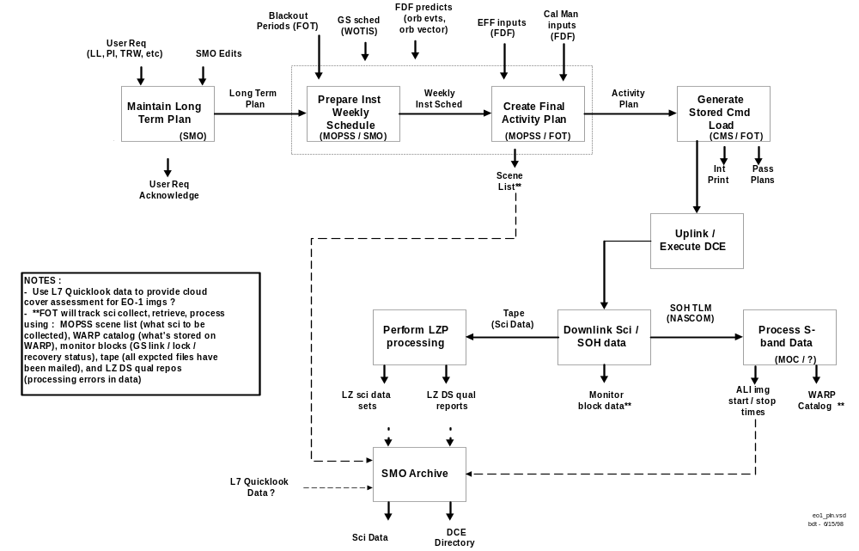

Figure 5-52 Typical Mission Planning Flow

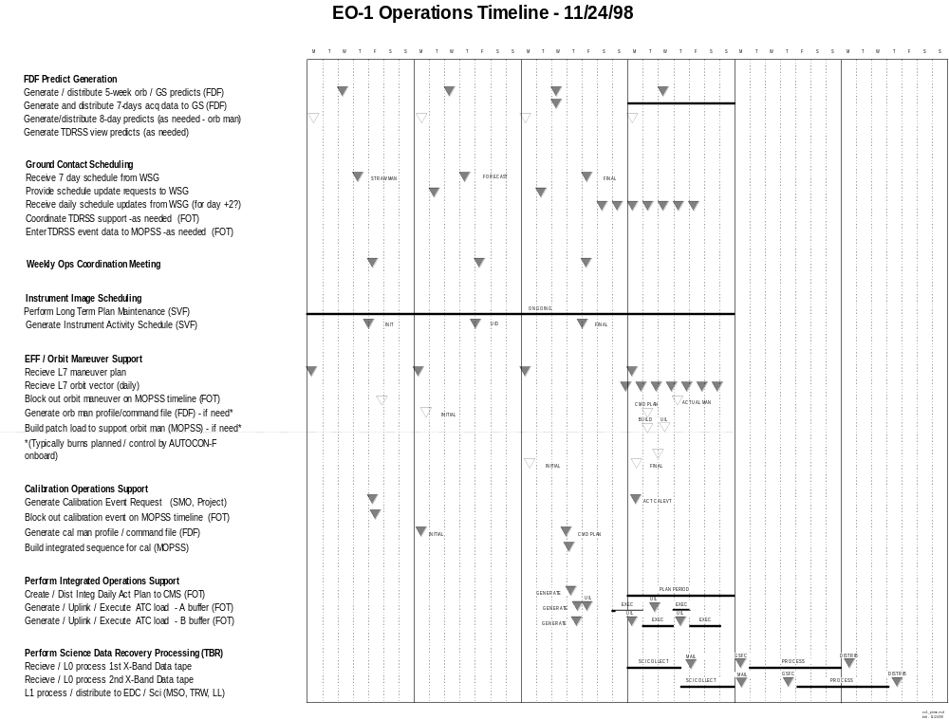
Figure 5-54 Representative EO-1 Mission Time-line

The generation of the Ground Station support schedule will be performed by the WSG as follows. The EO-1 MOC will generate 5 week predicts (specific format TBS) to be used by WSG to determine EO-1 in view periods for scheduling. The WSG will utilize ‘generic’ scheduling requirements provided by EO-1 outlining to develop a ‘strawman’ schedule for week 3. These requirements will specify minimum allowable pass durations and minimum elevations, and specific contacts and station configuration to be scheduled. General requirements (subject to update) will be as follows :
- Provide concurrent S / X-Band downlink support from 1st available Wallops 11 meter subnet contact following last U.S. (contiguous 48 state) day side crossing.
- Provide concurrent S / X-Band downlink support ~14 hours later from 11 meter subnet contact meeting duration and minimum elevation requirements

The WSG provides 3 further updates to support schedules. A forecast schedule for week 2 period, an operational weekly schedule for week 1, and daily schedules daily 2 days prior to the actual day. The FOT will review planned operations and provide to WSG an updated schedule request (i.e., full schedule, not just adds and deletes) if changes are desired to the ‘strawman’ or ‘forecast’ schedule. This would include additional support (32 kbps McMurdo support for southern hemisphere orbit maneuvers) and changes to ‘generic’ coverage. Because EO-1 will not necessarily be power positive for all planned activities on an orbital basis, ground contacts should be scheduled as soon after science collections completed to allow science downloads to be performed quickly. This improves power balance in that, following science downlink, WARP can be commanded to low power mode. This means, though, that data not successfully received on the ground prior to transitioning WARP to Low Power, is lost. Specific scenarios where orbital power balance may not exist are as follows :
- EO-1 DCE – ground, and solar or lunar cal
- EO-1 Orbit Maneuver
Development of the Instrument Weekly activity plan will be the responsibility of the SVF. The SVF will maintain a database of ground DCE requests provided by users. The SVF will determine which of the available targets should be imaged and provides a weekly imaging activity plan to the MOPSS. This activity plan provides requests with necessary attributes from which MOPSS can schedule operations to support the image collection and associated operations. The SVF will have performed constraint checks to ensure images can be supported – instrument on time limits observed, space exists on the WARP for data storage, necessary slews can be performed and adequate momentum biasing can be supported. The MSO will provide input to the SVF in setting imaging priorities and resolving priority disputes. The MOPSS, in the process of developing the integrated activity plan, also provides similar constraint checking.
The Integrated Operations plan will be nominally developed weekly using MOPSS based on ground contact schedule provided by WSG, instrument weekly plan provided by SVF, instrument calibration sequence command inputs provided by FDSS (as described in section 5.7.3), and technology validation plans as identified in the Weekly Coordination meeting. The integrated operations for the week starting Sunday midnight (Monday morning) will be developed on the prior Thursday. MOPSS provides a timeline editor and schedules operations based on operational inputs described above and rule bases, knowledge bases, and activity definitions developed primarily prior to launch and modified on orbit as needed which define based on operational inputs which activities, with what attributes, and under what conditions get scheduled. MOPSS will provided constraint checking and notifies the operator when constraints exist. Constraint checking will include resource availability and identified flight constraints. MOPSS in the process of developing an Integrated Activity Plan also generates an Image Summary Report that identifies attributes of all scheduled images. This report is used to track data collection, downlink, retrieval to GSFC, and processing and distribution status of science data. MOPSS generated Integrated Activity Plan is then provided to CMS for building of ATC command loads, pass execution procedures, and developing of planning reports. Pass execution procedures generated by CMS are ASIST executable procedures that are used to start ASIST procedures and ASIST generated commanding to configure MOC and to control necessary MOC commanding during a ground contact. The CMS based on populated activity definitions and trigger functions expands the Integrated Activity Plan to stored commands, and commands and procedures for realtime uplink during ground contacts; and segments stored commands into stored command loads. In addition, the CMS also generates an Integrated print that outlines event data, scheduled activities, and realtime and stored command activity. This is used by the FOT to verify operations have been correctly scheduled.
Anticipated daily ATC command usage is estimated to be ~260 commands / day (TBC). EO-1 provides 2 ATC buffers which each support 600 ATC commands. 15 ATC IDs will be reserved for EFF / orbit maneuver operations. During EFF autonomous operations periods, the EFF task will interface with the stored command processor task to directly insert commands into the active ATC buffer. The operations plan will be to routinely plan to build and uplink ~4 ATC loads per week, each with a maximum duration of ~2 days. A switch command at the end of each load will be used to continue execution from the next ATC buffer. ATC loads to one buffer will be loaded as load in other buffer is executing. To simplify ground software and planning, typically, updates to uploaded ATC loads will built for the same operational period as the base load. For loads that are already active, a full ‘new’ load is sent to the inactive buffer, operation is switched to the inactive buffer, and the ‘pending’ ATC load is replanned and reloaded (if necessary) to the inactive buffer. The spacecraft Stored Command Processor will skip any commands with epochs in the past. For periods when ground provided orbit maneuver commands are used, a patch will be created and uploaded to the ‘EFF reserved’ ATC IDs in the active buffer.

Science Operations
Science operations consist of validating the ability of the ALI, LEISA/AC, and Hyperion to produce calibrated multispectral and hyperspectral images of the earth’s surface. Science operations are primarily the responsibility of the SVF in conjunction with the SMO. The primary objective is to evaluate the EO-1 instrument suite for representative operating conditions and target environments.
The SMO will also determine the potential for improving land surface identification by applying LEISA/AC atmospheric water vapor corrections to Landsat-7 ETM+ observations.
NASA Stennis/TRW provides all Hyperion processing and distributes Hyperion Level-0 data to all Commercial and DoD interests. They also distribute processed Hyperion data to the SVF, as well as Commercial and DoD interests.
The operation of EO-1 will center around the performance of imaging instrument data collections. Imaging instrument data collections will be performed in response to requests submitted by scientists and instrument engineers processed and coordinated by the SVF / SMO. Two general types of data collections will be requested : images and calibration data collections. As a result of a request, 1 or more instruments will each perform 1 or more primary observations and 0 to 4 supporting observations. A data collection event is thus defined to be all primary observations and any supporting observations pertaining to a requested data collection. In general a data collection event will consist of all observations made during a single turn on of an instrument(s) (i.e., not OFF or IDLE). Deviations to this rule include :
- AC will be separately commanded on within 2 orbits before or after a primary observation to collect a dark earth calibration supporting observation. (Multiple data collection events may use data from a single AC dark earth calibration).
- 2 or more data collection events could occur during a single instrument(s) turn on. This would occur if additional targets can be imaged by extending instrument(s) on times. In this case, generally 1 set of supporting observations would be used for each of these DCEs.
TABLE 5-1 provides a matrix defining types of DCEs, how frequently they are planned to occur, how much science data and WARP files will be generated, and how many maneuvers are necessary to support. The following sections will provide further detail describing each DCE scenario : image, solar cal, lunar cal, and internal cal DCE.
The performance of each DCE will involve a coordinated effort between the instruments, WARP, ACS, EPS, and the stored command processor. Operational highlights from an integrated perspective for each DCE type are provided in the following sections. Please refer to individual instrument / subsystem operations sections provided in Section 3 for further detail and additional constraints relating to performance of DCEs.
The number of DCEs that will be performed on a daily basis will be constrained by the following :
- the number of targets EO-1 flies over in a given day
- limitations in the spacecraft’s ability to point / settle on new targets quickly
- limitations on when adequate momentum can be provided
- limitations on instrument per turn on and cumulative duty cycles
- the volume of data collected and # of WARP files used each DCE
- the volume of data and # of files that can be stored on the WARP
- the number and times of EO-1 X-band downlinks
- spacecraft power availability
- conflicts with other operations (technology demos, orbit maneuvers, contingencies)
- staffing limitations (which cause operations which must be observed to occur during the day, recoveries, etc)
- # of ATC commands needed

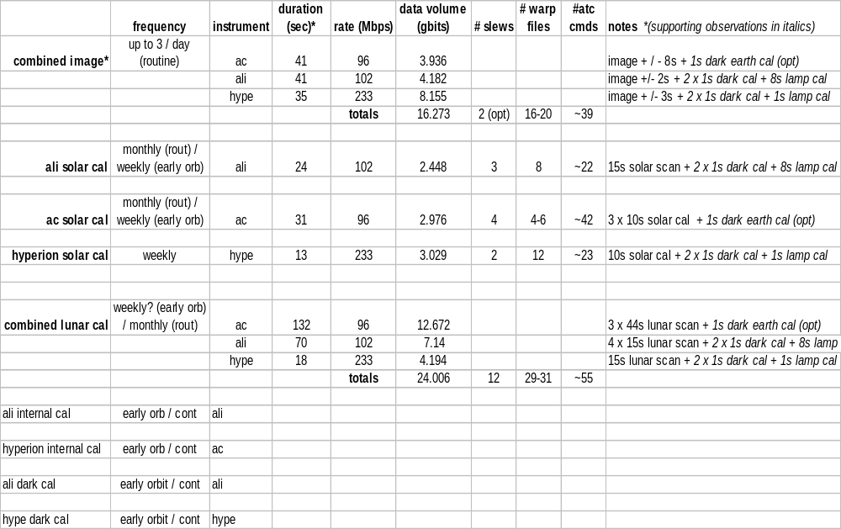
*NOTE : Individual and dual instrument images will also be supported based on the Combined image scenario.
Table 5-5 Instrument DCE Summary Table

Image DCE
Image DCEs will be performed based on user provided image requests. A user Image Request form will look similar to that provided in the Operational Forms Appendix of the MPD. User’s specify where an image is to occur, what instruments will be on, when it should occur, how many times it should occur, and whether data can be automatically released following its download. The following types of image requests will be supported :
- L7 paired scene where imaging is started / stopped when the spacecraft flies over the specified Worldwide Reference System (WRS) grid point. The user can further specify that the spacecraft be maneuvered such that the spacecraft, instrument, or a particular Sensor Chip Assembly be off pointed from nadir to a user specified angle.
- ‘Hyperion’ scene where user specifies the latitude and latitude of the scene center, the desired duration of the image, and which reference boresite is to be pointed to the target : the spacecraft, an instrument, or a particular sensor chip assembly.
- L7 ‘Stereo’ scene where the spacecraft is pointed to allow a particular instrument or Sensor Chip Assembly to image the same target as L7 flies over it.
Support for different image DCEs will be based on timelines and sequences used for a baseline ‘paired L7’ combined image. Planned permutations to this combined ‘paired’ scene will include: various permutations of instruments on, various image durations, and multiple data collects during an instrument turn on. Representative timelines for a combined Ground Image DCE are as illustrated in figures 5-X and 5-X. Detailed representative timelines are provided in the ‘Timelines’ Appendix section. Performance of a DCE will be controlled via stored command. The sequence of events involved in performing an imaging DCE will be as follows :

- Bias wheels to ensure wheel speeds during image set to ensure improved ACS performance
- Perform slew to provided pointing to specified target (if required)
- Stop Solar Array to avoid SA induced jitter during image
- Configure instrument and allow warm up prior to image
- Perform data collects during target fly over.
- Additional data collected to ensure data collected over entire target area
- AC collects additional data to ensure all bands collected over entire target area
- Collect supporting calibration observations
- ALI / AC dark and lamp cal data
- AC dark earth cal
- Open WARP files ensure data is stored
- Transition instruments back to IDLE modes, restart SA tracking, etc following image completion
- Downlink science data at next scheduled ground contact
- Release downlinked science data files stored on WARP to allow further science data to be stored
- Science data typically mailed to MOC twice weekly to allow science data processing and distribution by SVF
Please note data stored on the WARP must be released before that area of memory can be reused for further data collections. Due to staffing limitations and to simplify operations, unless otherwise requested and justified, the baseline will be to downlink all stored science data each X-Band support, and release these files prior to the next scheduled image.
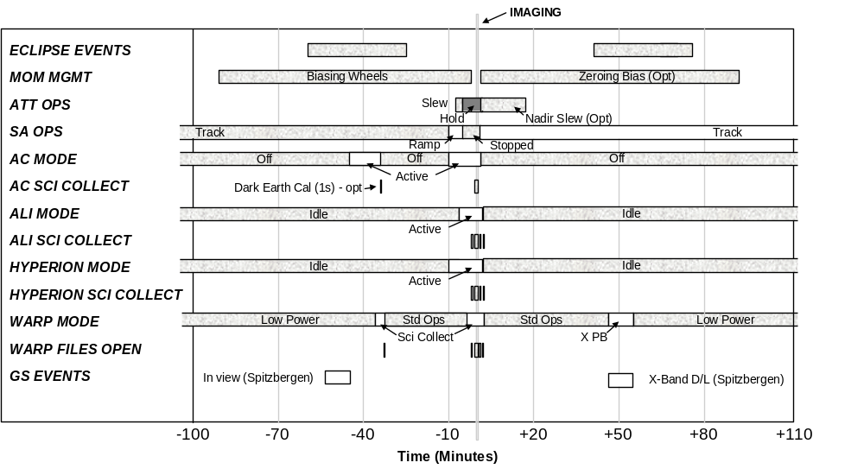
Figure 5-56 Representative Combined Ground Image Diagram (End –to –End)

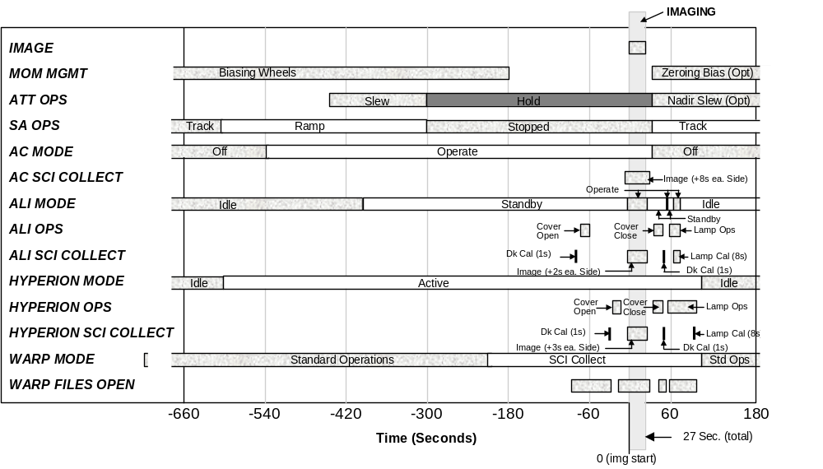
Figure 5-58 EO-1 Representative Combined Ground Image Diagram (Detailed)

Additional notes regarding Image DCE performance :
- No cloud cover assessment done during the planning process. Considering requesting L7 Quicklook reports from EDC which for each L7 image collected provides a cloud cover assessment. This cloud cover data could be used by MSO / SVF to remove 'satisfied' 'paired scene' requests from being scheduled again pending retrieval / processing / analysis of EO-1 images.
- EO-1 will not utilize L7 scheduled scene list as input for selecting EO-1 paired scenes. The majority of images EO-1 will collect will be U.S. scenes. L7 typically collects all U.S. targets it flies over. For non-U.S. scenes, the MSO / SVF will coordinate with L7 science office to ensure non-U.S scenes are given sufficient priority to ensure L7 will perform these 'paired' scenes.
- Unlike L7, EO-1 provides a pointing capability, whereas L7 always points nadir during scene collects. EO-1 will support spacecraft nadir pointing images, images where a particular sensor is pointed within the current WRS path, and images where a particular sensor is pointed within the adjacent WRS path. This ensures that EO-1 could image any target at least every 9 days. See the L7 Science Data User's Manual for further detail regarding L7 orbit and swathing pattern. (Because EO-1 flies in formation with L7, their orbit is essentially our orbit.

    - Solar Calibration DCE
AC, ALI, and Hyperion each wish to use the Sun as a calibration source. Unfortunately instrument boresites for solar calibration are not the same as those for ground and lunar calibration images. Because these boresite are not co-aligned, it is not easy to slew from one instruments boresite to another, separate solar calibrations will be performed for each instrument. Table 5-2 describes instrument boresites for ground /lunar and solar viewing, and describes the general process for performing a solar calibration for each instrument. Representative detailed integrated timelines for each type of solar calibration are provided in the ‘Timelines’ Appendix.
Table 5-2 Instrument Solar Calibration Highlights (To Be Reviewed)
Instrument | Ground / Lunar Cal Boresite | Solar Cal Boresite | Solar Calibration Highlights
ALI | +Z axis, offset ~6 °towards +Y axis in Y-Z plane | +Z axis, offset ~7 °towards -Y axis in Y-Z plane | Hyperion cover remains closed.  ALI door closed, spectralon deployed, and movable subaperture cover used to control attenuation of sun light on ALI focal plane  Spectralon deployed in front of secondary mirror used to diffuse light to all ALI SCA during solar viewing  Spectralon alignment changes instrument boresite to ensures sun does not illuminate detectors if door accidentally opened during solar cal  ALI solar cal will involve slew / hold to sun, ALI data collect w/ subaperture fully opened / closed (~30s)
AC | +Z axis | +X axis | Three Calibration pipes oriented in velocity direction used to collect AC solar cal data.  AC solar cal will involve slew / hold each AC solar cal boresite to sun, AC data collect
Hyperion | +Z axis, offset ~4.84 °towards +Y axis in Y-Z plane | +X axis, offset 30° towards –Y axis in X-Y plane (TBC) | ALI cover remains closed  Sun light reflected off back of Hyperion cover opened ~37° to illuminate focal plane.  Cover / instrument aligned for North pole solar cal collection.  Hyperion solar cal will involve slew / hold to sun (needed to correct beta angle changes), Hyperion data collect w/ cover in Solar Cal position
Table 5-6 Instrument Solar Calibration Highlights (To Be Reviewed)

Lunar Calibration DCE
AC, ALI, and Hyperion each wish to use the moon as a radiometric calibration source and as a means of measuring each instruments Modulation Transfer Function. Because performing a lunar calibration will require significant planning, may cause the spacecraft to be unable to fully recharge its battery, other imaging operations can not be supported during this cal, and instrument boresites are closely aligned, a combined lunar cal will be performed. Lunar scan calibrations will be performed monthly during routine operations with the intent to perform during the same lunar phase. Data collections of lunar crossings are performed as they provide a pseudo ‘knife edge’ test to be performed and allow measurements that reduce atmospheric variability factors.
The goal for performing a lunar calibration will be to scan each sensor chip assembly in the along track direction fully across the moon. While slewing across the moon, a constant slew rate should be maintained, and slews for different SCAs of the same instrument should be performed at the same rate. Figure 5-1 and Table 5-3 provides pictorial and tabular representations of what a lunar calibration raster scan profile will be. EO-1 will perform a slew and inertial hold to a point very near the moon such that a pitch slew can be performed which slews ALI SCA #1 across the moon. An ALI SCA #1 data collect is then performed as follows. A ramp –coast – ramp pitch slew will be performed which allows EO-1 to be sped up to the coast rate, an ALI data collect is performed while the moon scans across ALI SCA #1, the slew is completed after a ramp down, and EO-1 assumes inertial hold pointing. A yaw slew is performed to allow an ALI SCA #2 data collect to occur in a similar manner but in the opposite direction. The spacecraft is repositioned and an ALI SCA #3 data collect is performed. Following this, the spacecraft is repositioned to allow a larger slew to perform an AC #1, ALI SCA #3, and Hyperion data collect. Lastly data collects are performed for the other AC SCAs. Larger slews are required to support AC data collects due to the fact that different AC spectral bands do not image the same ground location. Thus, in order to scan each band across the moon a larger slew is required.
A representative integrated timeline for a combined lunar calibration is provided in the ‘Timelines’ Appendix section.

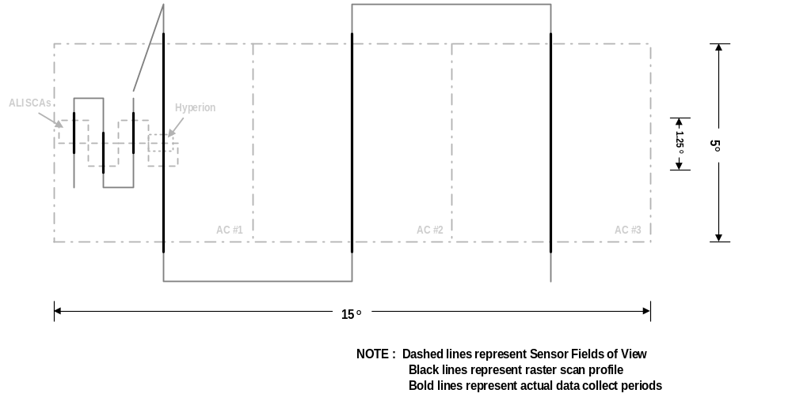
Moon apparent size is .5 degrees
Figure 5-60 Lunar Calibration

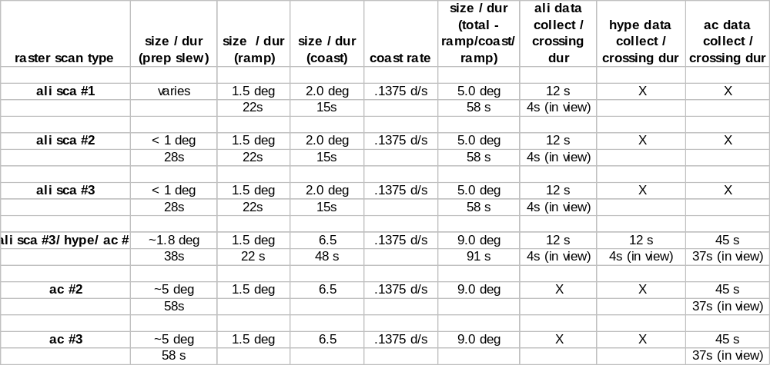
Table 5-7 Lunar Scan Data Collection Profile

  - Ground Support Operations
Communication events will be scheduled with EO-1 spacecraft to allow :
- Recovery of science data
- Recovery of RT and PB SOH data
- Monitoring of SC health and status via RT SOH
- Command Operations
- Collection and recovery of Doppler tracking data
A command link will be scheduled whenever real-time support is scheduled. Commands can be up-linked to the spacecraft in real-time or as part of a memory or table load.
All real-time telemetry and command operations will be conducted from the MOC at GSFC. EO-1 normally requires two ground station passes per day. These passes will require simultaneous S-band up-link, S-band down-link, X-band down-link, and Doppler tracking. S-band downlink data rate is nominally scheduled to 1 Mbps downlink that allows for the recovery of RT and PB SOH data. Additional ground station passes may be required for launch and early orbit operations, special operations (maneuvers and calibration events),and/or contingency operations. Ground station contacts will last approximately 10-15 minutes in duration, with a forward link throughout, and in coherent mode. Two passes are needed each day to collect sufficient WARP data and to monitor spacecraft status.
Telemetry recovery will occur as described in section 5.6, Telemetry Processing and Distribution.
Most command operations will be performed using stored commands. This is done because commanding will be necessary outside of available downlink periods, and to ensure that necessary commanding occurs (i.e., automated process to establish command link may not be established – MOC and ground stations will not always be manned). Goal will be define end item verifiers with the ASIST database such that each command can be verified by ASIST to ensure its successful execution. EO-1 supports Command Operating Procedure – 1(COP-1) protocol commanding to ensure that commands are correctly received, in order by the spacecraft.
The following is a high level description of pre-pass operations performed by the FOT:
- Initialize all MOC equipment needed for real-time operations (this activity may be needed only once per day)
- Perform readiness/configuration check and run set-up procedures on all hardware and software (set-up procedure may exist as a predefined command/directive procedure)
- Ensure that station hardware/software and all data lines are ready. This may include sending a test command to the station to confirm command path
- Ensure there is time built into set-up schedule to handle any configuration problem prior to acquisition of signal (AOS)
The following is a high level description of pass operations performed by the FOT:
- Confirm RF and data acquisition at the ground station through out the pass
- Verify health and status of spacecraft
- Confirm expected configuration of spacecraft
- Uplink and verify any necessary spacecraft or instrument commands (RT, ATC, RTC)
- Confirm telemetry data downlink and recovery at Ground Station and MOC
- Identify and respond to anomalous conditions at ground station, spacecraft, or MOC, as per documented contingency procedures
The following is a high level description of post-pass operations to be performed by the FOT:
- Perform “clean up” operations as needed. This may include closing out and archiving files, filing electronic reports to supporting elements, etc
- Begin processing and evaluation of collected dump data if appropriate
- Perform trending of playback data when it is available
Commanding and ranging will be simultaneous with the S-band housekeeping telemetry. For the MOC and FOT real-time operations consist of establishing a viable communications link to the spacecraft and using this link for command and control. Health and safety monitoring of the spacecraft, bus and payload commanding (both real-time and stored commands), and housekeeping data capture (real-time and recorded telemetry) will be supported.

  - Telemetry Processing and Distribution
EO-1 provides both an S- and X-band downlink capabilities. S-Band is used for SOH data recovery, command uplink, and Doppler tracking. X-Band is used for science data downlink. S-Band supports a 2 kbps uplink, and downlink at 2 Kbps, 32 Kbps, 1 Mbps (nominal), and 2 Mbps. X-Band supports a 105 Mbps downlink. S-Band antenna coverage is provided by 2 semi omni antennas, 1 each on the nadir and zenith decks, which provide near omni coverage. X-Band coverage is provided by a steerable phased array that is steerable to +/- 65 degrees of the +Z axis (nadir). For nadir pointing, the X-band should provide coverage while in view of the ground stations. Generally the spacecraft will be commanded (from stored command) to nadir pointing attitudes prior to X-Band downlink to avoid the need for special analysis for each support to determine if and when X-band link will exist.
EO-1 is a CCSDS Advanced Orbiting Systems (AOS) compliant system. The following telemetry virtual channel assignments and expected daily data volumes will be as follows :
Include updated SOH VC usage. . .
VC | Description | Volume Downlinked Daily
VC0 | Realtime State of Health | 40 Mbits
VC1 | Playback Spacecraft State of Health (VR 1) | 800 Mbits
VC2 | Recorded Significant Events (VR 2) | << 8 Mbits
VC3 | Recorded Special TLM [GPS] (VR3) | ?
VC3 | Playback State of Health from WARP | ~180 Mbits
VC 6-9 | X-Band WARP Science Playback | 80 Gbits
VC 6-9 | S-Band WARP Science P/B (contingency only) | <5 Gbits
VC62 | WARP generated fill data | Low volume
VC63 | WARP generated fill data (X-Band)  Comm RSN generated fill data (S-Band) | < 40 Gbits  <90 Mbits
Table 5-8 EO-1 Virtual Channel Usage (TO BE UPDATED)

VCs 0, 1, and 2 are processed by the ACDS M5 and are only downlinked via S-band. VCs 6-9 are stored on the WARP and are routinely downlinked via X-band, but if necessary (i.e., early orbit) could be downlinked via S-band. Direct downlink of science data is not supported. All science data must be stored to the WARP prior to downlink. This implies no concurrent science collection and downlink.
Under nominal operations, telemetry will be downlinked in both X and S-band, simultaneously. However either link can be used separately.
The ground stations will be responsible for acquiring the telemetry downlink. Routinely, the downlink will be configured and turned on and off from stored command. In the event of certain contingency situations, the ground stations need to be able to support blind acquisitions (i.e., downlink not on) or alternate rate acquisitions (i.e., safing event causes spacecraft to be configured to an alternate rate). In the event of an ACDS M5 cold start (, safe mode transition, other?), the downlink will be configured for 1 Mbps operations, the transmitter time out TSM disabled, and the transmitter commanded on – TBC.
Specifically the ground stations will provide the following support :
- Acquire S-band downlink and log data to the local site SAFS
- Perform frame sync, and route selected RT VCs (0 & 2) to the MOC in RT
- PB non-RT data stored to the local site SAFS to the GSFC SAFS within 1 hour
- Acquire the X-band downlink and log to AMPEX tape
- Mail X-band tapes to GSFC twice weekly
- Archive X-band data for 30 days and S-band data for 7 days - TBC
- Provide contact summary report post pass indicating telemetry data collection summary statistics for S- and X-band.
- Provide station status blocks to MOC in RT. To include ground station status (S-, X- band lock status, antenna mode, AGCs), and per VC S-band telemetry data statistics.
- Provide RT and offline troubleshooting and recovery support in the event of station anomaly. (Typically stations will operate in an unmanned configuration- TBC)
Real-time SOH telemetry will be used to assess the health and safety of the spacecraft, help ensure that onboard operations are proceeding as planned, and confirm the execution of real-time commands. Real-time SOH telemetry is generated continuously and will be available when S-Band downlink occurs. SOH data is also stored continuously to a recorder in the ACDS M5. Stored SOH data is used to support trending and anomaly investigation. Contents of data stored are selectable between high and low rate filter tables. High rate (~65 kbps) is used during DCE, maneuver, and slew operations, while low rate (~4 kbps) is used at other times. Stored SOH playback is performed when commanded and will be scheduled to occur each support. Additional commands will be needed to release stored SOH prior to the SOH recorder completely filling. This will generally be done from stored commanded. Further planning will be done to ensure that data during critical periods (i.e., spacecraft anomalies) is not overwritten prior to successfully capturing on the ground – details TBS. Science data downlink will be commanded via stored command to occur during all X-band contacts. Science data recovery commands are required to ‘point’ the X-band downlink to a particular ground site, and to queue files for downlink, and to release files so that WARP data storage memory in use is freed to allow further data collections to occur. For nominal operations, only ground supports where adequate X-band in view durations to perform a full WARP dump will be scheduled for science downlink, all WARP files will be queued for downlink each support, and all files will be released after scheduled downlink and prior to the next DCE.
Telemetry data will arrive in the MOC in the form of real-time telemetry, stored data available via the GSFC SAFS, and X-band tapes mailed by the sites. The MOC, staffed by the FOT will be responsible for the recovery and processing of this downlinked telemetry data. Specifically the MOC will :
- Configure the MOC to support RT operations
- Acquire and log, using the FEDS, RT data provided by the stations in RT
- Use available RT data via ASIST to monitor spacecraft status and verify operations :
- Ground station lock is maintained via status block
- Spacecraft health is nominal using RT data (DB defined limit checks, configuration monitors, etc)
- RT and stored commanding operations successfully execute using RT telemetry
- WARP data collections, downlink, and release occurring as planned using RT data (i.e., WARP catalog dump, X-band status) and status block (X-band status).
- PB SOH operations occurring as planned using RT data and status block (VC 1 statistics showing increments)
- Perform telemetry data subset collection and distribution to FDSS WS to support orbit determination and attitude verification operations
- Process all PB SOH data to monitor for limit violations
- Process PB SOH data to generate and perform agreed to distribution of trend data sets and reports. (Generally, for special processing, external entities will be given access to available data to reduce FOT work load.)
- Receive, log, and Level-0+ process received X-band data tapes provided by the stations
- Distribute Level-0+ processed data (DLTs – TBC) to SVF
- Retain X-band data tapes in MOC (or ship to SVF ?) – TBD
- Investigate lost or corrupted data
- Generate telemetry processing status reports
NOTE : Telemetry will be decommutated and displayed on the MOC screens in display pages designed by the Spacecraft I&T, Project, and FOT representatives. The telemetry will be color coded and checked against limits contained in the Operational Database (ODB). Each telemetry point will have specific limits associated with it and these limits can be adjusted or disabled by an FOT member with appropriate access privileges. The limit checking function will change the color associated with any telemetry point that reaches defined limit boundaries.
SVF will perform further processing and distribution as outlined in section 3.2.6.
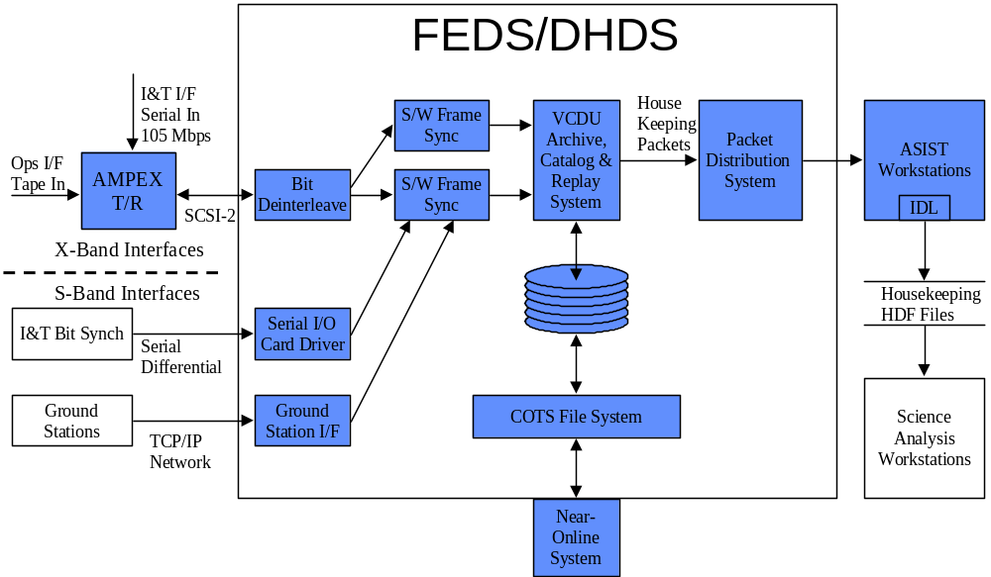
Fig X.X FEDS Architecture – SOH data processing
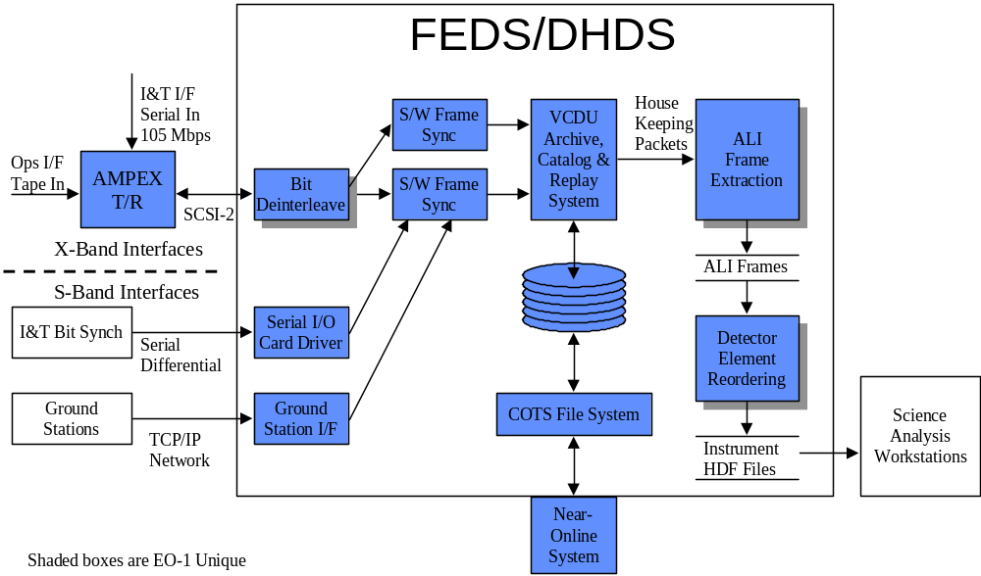
Fig X.X DPS Architecture – Science Data Processing

  - Flight Dynamics Operations

Orbit Determination
The orbit determination process for EO-1 consists of two possible options. The primary method of orbit determination utilizes the Global Positioning System (GPS). An onboard Loral receiver provides three possible types of GPS data: the raw GPS measurements; the Single Point Solution (SPS) state vectors; and an onboard filtered version of the SPS. When these data options are available, they will be sent to the ground in the EO-1 telemetry. The Flight Dynamics Support Subsystem (FDSS) in the EO-1 Mission Operations Center (MOC) has no plans to utilize the raw GPS measurements. These will be extracted from telemetry by ASIST and written to a temporary file for access by those evaluating the various EO-1 technologies. When EO-1 spacecraft operations are nominal, the ACDS will receive an orbit solution directly from the onboard GPS receiver. The SPS or the filtered SPS, sent down in telemetry, will be used in the MOC FDSS to provide a source for backing up the onboard GPS orbit determination solution if the onboard system fails or finds it difficult to recover following an orbit maneuver. When the SPS or filtered GPS solutions are downlinked to the MOC, the FDSS can smooth these solutions to remove noise. This process will be accomplished in the Precision Orbit Determination System (PODS) where a drag coefficient will also be recovered. The smoothed EO-1 state vector and the drag coefficient will be used to generate an Extended Precision Vector (EPV) for possible uplink to EO-1.
A backup orbit determination option to the GPS uses ground based S-Band tracking from one or more of the Wallops Network of stations consisting of Wallops; Spitzbergen; Poker Flat and McMurdo. If the onboard GPS is functioning nominally, the S-Band will be primarily used to verify the GPS during the early mission and occasionally during the mission lifetime. Based on an orbit determination error analysis study, it was shown that the GPS can be verified on the ground or permanently backed up by the ground based S-band tracking data using the following scenario. A single S-Band station such as Spitzbergen would provide two 10 minute passes of Doppler data daily. This pair of daily passes would be collected into a three day data arc for ground based orbit determination in the PODS software. The 3-sigma accuracy is sufficient to uplink state vectors to the OBC and/or to plan Enhanced Formation Flying maneuvers.

Orbit Maneuver Planning
EO-1 has Enhanced Formation Flying (EFF) requirements to maintain a co-fly profile with L7. Specifically EO-1 will fly in an orbit such that EO-1’s ground track matches L7 within a + 3 km across track and 60 + 6 second along track error. This formation will be established during the early orbit period, and so during the Normal Operations phase only orbit maintenance maneuvers will be necessary. In order to maintain co-fly profile, EO-1 maneuvers on the order of weekly will be necessary. Specifically an EO-1 orbit maneuver will involve the following :
- Turn on Catalyst Bed heaters and RCS system
- Perform attitude slew and nadir offset hold to orient thrusters along desired thrust vector
- Slew and halt solar array at parking orientation (to provide improved thruster calibration) prior to orbit burn
- Perform thruster burn. (Thrusters off modulation to provide attitude control)
- Turn off Cat Bed heaters
- Perform Earth Acquisition slew to return to nadir pointing attitude
- Re-enable solar array tracking
Specific details and timeline for nominal orbit maneuver is provided in the ‘Timelines’ appendix to this MPD, Volume 1 document.
To support EFF operations, the following software is used: AUTOCON-G which provides maneuver planning, calibration, and fuel usage computations and operates on the ground, and AUTOCON-F which is the flight version of AUTOCON-G utilizing lower fidelity environmental models and operating within the EFF flight software task on-board. AUTOCON-G supports the use and selection of user provided maneuver targeting algorithms input; L7 and EO-1 orbit solutions, and drag coefficients used to assess co-fly profile; and script files which are used to define under what conditions and when maneuvers should be performed. AUTOCON-G outputs are a maneuver plan and maneuver command sheet. These are provided to the planning system for inclusion in stored command loads that are used to perform the maneuver sequence outlined above. The AUTOCON-F provides comparable capabilities to the AUTOCON-G. It utilizes the EFF task to provide I/O to other tasks for the computation of EO-1 orbit solutions using ACS provided propagated orbit or GPS data; receipt of ground uplinked data including L7 orbit solution, script file updates, and other loads as needed; to telemeter available data to the ground; and to interface with the stored command processor to issue commands to control the actual orbit maneuver operation (when in Autonomous mode).
The EO-1 Mission Profile diagram, figure 2-4, outlines the different operating modes for EFF operations. Currently 2 targeting algorithms are planned for on-orbit use : 1 provided by GSFC and 1 provided by JPL. For initial normal operations, EFF will operate in semi-autonomous mode using the GSFC algorithm. Then, the GSFC algorithm will be operated in autonomous mode. And later, operations will switch to use of the JPL algorithms in semi-autonomous and finally in autonomous mode. In semi-autonomous mode, AUTOCON-F is active, uplinks of L7 orbit data daily and script updates as needed will be performed, and AUTOCON-F generates maneuver plans and sequences. These are used to verify AUTOCON-F, but the ground actually plans and uplinks maneuver sequences. In autonomous mode, AUTOCON-F is active, L7 orbit data is uplinked daily, script updates are uplinked as needed, and AUTOCON-F generates maneuver plans and sequences, and issues commands to the stored command processor to perform actual burn sequence.
Script files will be used to attempt to drive maneuver occurrence to specific days and general time periods. This will allow FOT staffing and ground coverage during initial maneuvers, and allows maneuver periods to be blacked out on planning timeline to ensure imaging operations are not scheduled during these operations. Initially burns will be done during normal working hours when ground coverage is available to allow FOT monitoring of these operations. Later as confidence in these operations improves, burns may be moved to off shift periods to avoid conflicts with imaging operations.
Because during Autonomous operations, AUTOCON-F will control on-board when maneuvers actually occur, a TSM will be developed to ensure that instrument covers remain closed during maneuver operations. This will provide contamination control and provide protection from pointing instruments in a potentially dangers orientation.
Close coordination with L7 will be needed to maintain co-fly profile. L7 MOC will provide orbit solutions daily and burn plans weekly. L7 currently is planning to burn weekly. Generally, EO-1 will need to perform a maneuver within 2 days (TBC) of L7 in order to maintain co-fly profile. It is envisioned that L7 will fix when a burn to occur well in advance (i.e., what day and general time frame) and will vary its duration as needed. This would avoid EO-1 need to continuously replan burns due to ‘slipping’ L7 maneuvers and to miss imaging opportunities because these periods were blacked out to support maneuver operations.

    - Slew Planning
The EO-1 ACS will support both nadir and inertial slews. Inertial Slews will be used to support attitude calibrations (early orbit), and instrument solar and lunar calibrations. Nadir offset slews will be used to re-orient instrument during ground imaging and during orbit maneuvers to orient thruster along desired thrust vector. AUTOCON as part of orbit maneuver planning will calculate necessary slew profile to support an orbit maneuver. Tools that reside within MOPSS will compute necessary offset slew angles for ground images for inclusion in command loads.
For solar and lunar calibrations, an FDSS provided slew planning tool will be used to generate slew profiles to support instrument solar and lunar calibration operations. See the Solar and Lunar DCE sections earlier in this chapter for further detail on instrument pointing requirements for these operations. Outputs of this tool will a calibration slew command sheet which provides start times, slew angles, and detector in view times for each leg of these calibrations. In addition it will provide inputs regarding any momentum biasing which must be done in order to provide improved jitter control during slews. In addition this tool will provide an inertial pointing profile time history. This profile will be ingested by STK to ensure that line of sight pointing constraints are observed during performance of the slew. Specific line of sight pointing constraints are TBS but could include such things as not pointing spacecraft or instrument radiators towards the sun within certain tolerances for longer than specified durations. Calibration maneuver command sheets will provide the inputs from which MOPSS will schedule all calibration related commanding. This would include such things as attitude slews, solar array halting, instrument turn ons, cover openings, data gate and WARP file opening and closings, and the like.
3 weeks prior to their occurrence, instrument solar and lunar calibration requirements will be identified and coordinated at the Weekly Coordination meeting. These periods will be blacked out on the operations timeline to ensure other imaging operations are not scheduled at the same time. FDSS will generate the final slew profile several days prior to the actual calibration event, and the load is built and uplinked there after.
Initially calibration operations will be done during normal working hours when ground coverage is available to allow FOT monitoring of these operations. Later as confidence in these operations improves, these operations may be moved to off shift periods to avoid conflicts with imaging operations.

  - Data Processing Operations
This section outlines steps performed by the FOT to process a Ground Station produced Ampex science data tape.

Ampex tape assumptions:
- It will contain a minimum of 1 and a maximum of 6 40 gigabit down linked data sets each of that can consist of several DCEs.
- There will be no electronic labeling of data other than time (non s/c)
- A paper label will list contents of tape according to time of acquisition. Tape will be delivered by some form of express mail

Tape received at GSFC and delivered to FOT.
- The tape shall be inspected by the FOT member on duty for visible damage and completeness of ancillary data.
- FOT member logs AMPEX tape into DPS database. Pertinent time segment data for this will be transcribed from the paper label as well as an FOT assigned processing number and DCE #’s included in the down link obtained from FOT records for each segment of the down linked data on the AMPEX tape.
- The tape shall be mounted on the AMPEX tape recorder/player designated for the input to DPS processing
- The DPS shall read the AMPEX tape, verify that the data related to dump times is accurate to within ? minutes (elapsed or start/stop??), and output these segment times for visual confirmation with the label by the FOT member.
- If the results agree, full DPS processing shall begin (R/S decode, de-randomize etc.) until data within a particular time segment is processed (multiple DCEs). A time summary consisting of groups of continuous time periods within the segment will be matched to the spacecraft time plan of the planned DCEs. This information and a copy of the frame data shall be archived in the FOT area. The DCE information shall be carried through the band sequential processing step and made part of the deliverable SVF product.
- For each down linked time segment, the FOT will verify that that the DCE time segment is complete. The output product (DLT or electronic File) may consist of more than one down linked segment and in all cases consist of an integral number of DCEs for all file types.
- FOT will notify the SVF when the product is available for pick up or electronic delivery and confirm delivery.

Automation

5.10 Timelines for Integrated Normal Operations
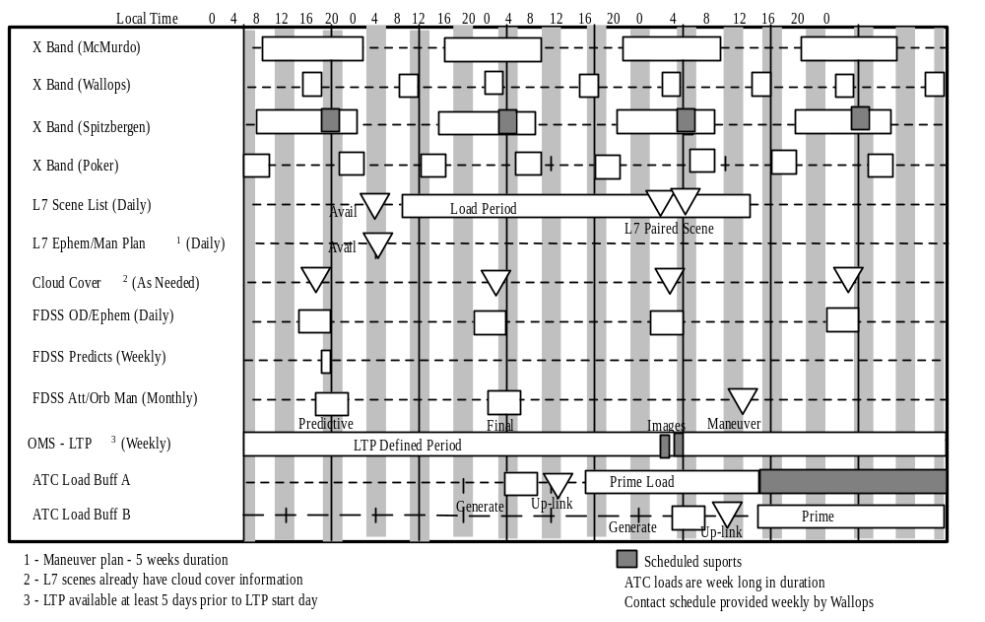
Fig X,X Typical Daily Planning Timeline (need to update)

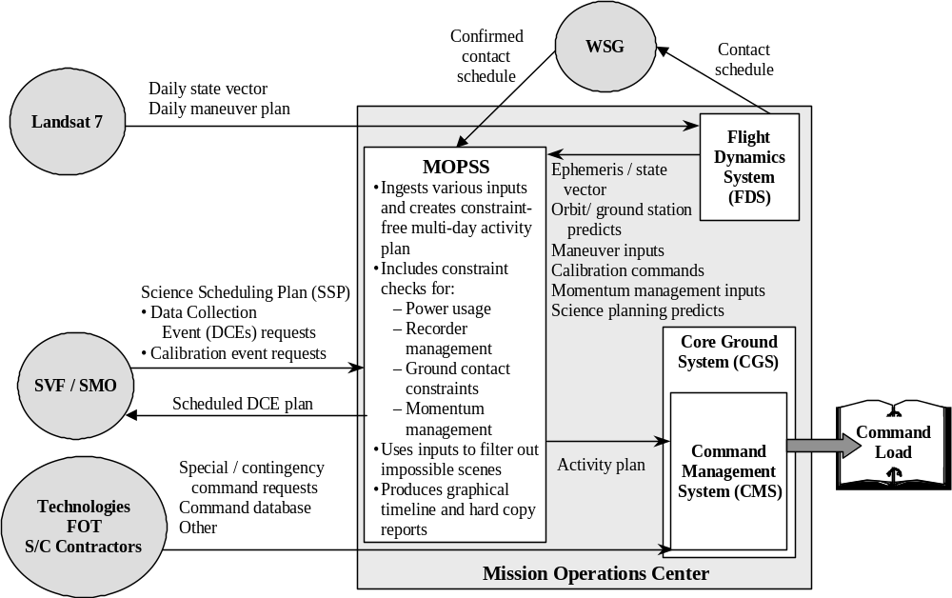

Fig X.X Typical Planning Flow (needs to be updated)

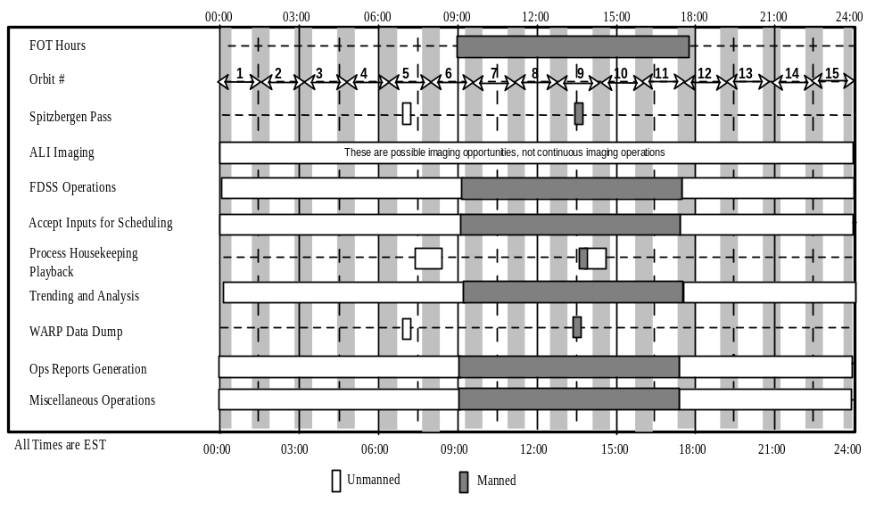
Fig X.X Daily Activities (Update as needed, placeholder for now)
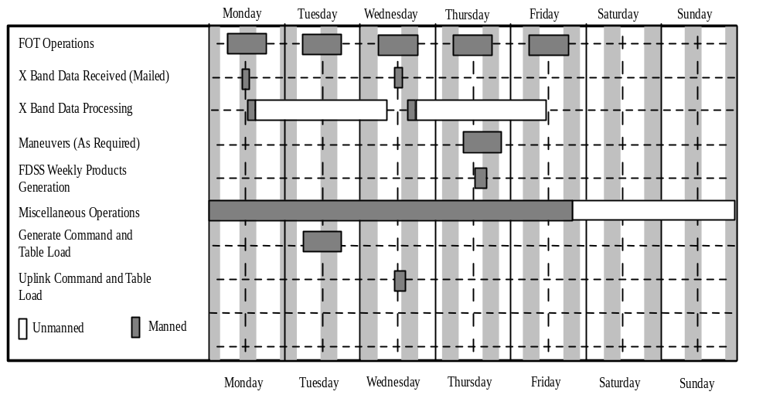
Fig X.X Weekly Activities (Update as needed, placeholder for now)

Extended Mission Operations

Extended Mission
After one year of operations the S/C modes will consist of Orbit adjust, Normal, Safe, and technology validations. During this period, the PPT will be utilized more extensively (due to contamination concerns early in the mission) for full implementation of EFF. Also, more instrument data gathering will be accomplished. Extended operations are not yet funded.
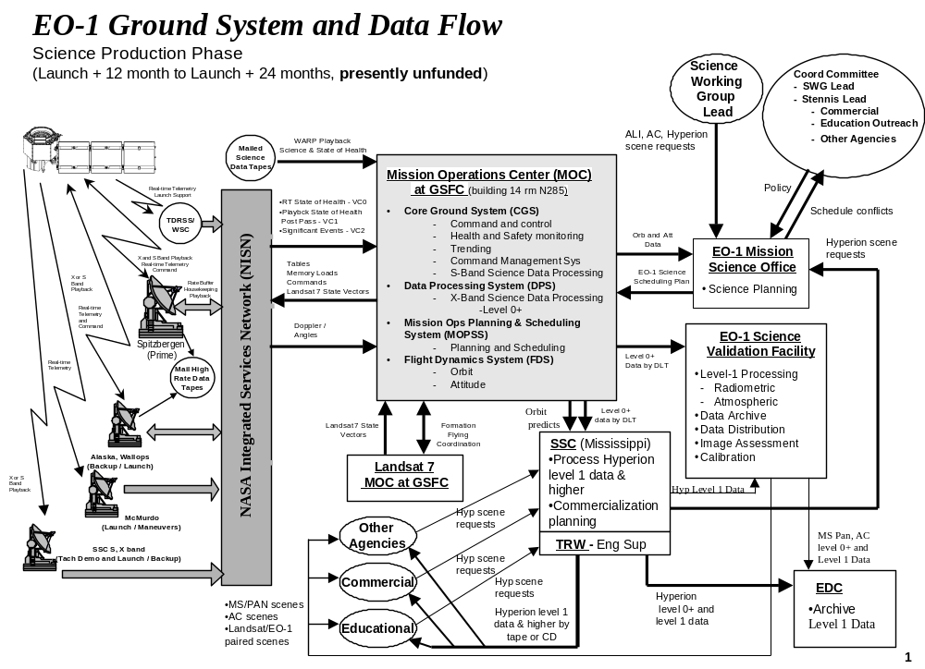
Figure 6-62 Ground System Data Flow-Extended Operations (Unfunded at this time)

Contingency Operations

  - Contingency Operations Introduction
There are two types of contingencies to consider, Spacecraft and Ground system. These contingencies will be considered separately.

7.2 Spacecraft Anomalies
The spacecraft has several methods to detect anomalies and react to them autonomously. Anomalies not caught on-board may be detected by the ground system.

    - FDC
Several of the Remote Terminals on the 1773 bus have individual Fault Detection and Correction functions. These are designed at the subsystem level for monitoring key subsystem parameters and taking actions within the subsystem. These are coded in the flight software and need FSW patches to update them.
Current FDC functions are summarized in the FDC appendix. One example of an FDC is the PSE monitor for low voltage. If that voltage falls below a preset point, the PSE will shed all loads except the reset defaulted on loads.

TSM
Telemetry and Statistics Monitors will be the first line of defense for catching anomalies and reacting to them. There are a possible 256 TSMs. These are listed later in the appendix. Each TSM has a response when parameters are out of tolerance. Typically they are to trigger an event message or trigger an RTS. RTSs are defined below.

RTS
Relative Timed Sequences are stored on the spacecraft and are used to group commands that are used numerous times. They are also used as the mechanism of responding to on-board anomaly response. There are 256 slots containing up to 300 bytes of command data. These are mapped out in the appendix.

Ground detection of spacecraft anomalies
If an anomaly is not caught onboard then the first way it might be caught on the ground is through yellow and red limits. It is expected that limits will be set tight so that limits will be tripped before a danger condition arises. SSR and real-time data will be screened for trending purposes and out of view limit trips.

Ground responses to anomalies
In almost all cases the final resolution to an anomaly will be performed on the ground. The spacecraft will be returned to a nominal operating mode as soon as prudently possible, and nominal operations will be resumed.
Insert flow chart here
The process for resolving spacecraft anomalies will follow the best practices of other GSFC missions. The Mission Director is in charge of the level to which to escalate the problem. They will have the final call before anomaly resolution is considered complete. Documentation and failure analysis will also be at the discretion of the Mission Director.
See figure 7.1 for a graphical description of the anomaly detection and correction flow.
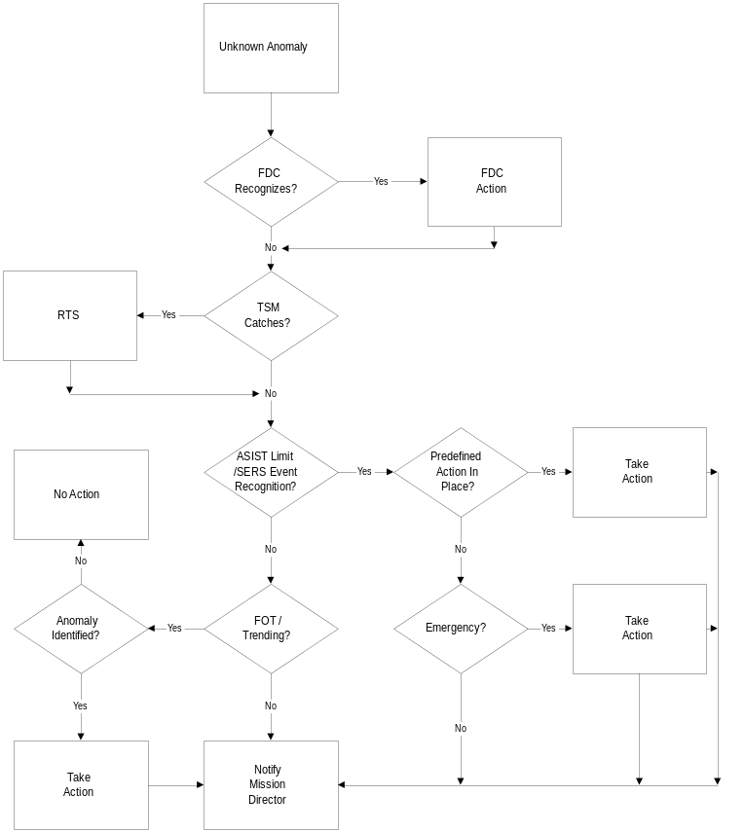
Figure 7-64 Anomaly Detection and Correction Flow

Ground Anomalies
Ground anomalies are defined as problems that occur on the ground support equipment used for operations of the spacecraft. These are broken into three main categories. Planning, real-time and post pass data analysis and distribution.

Real-time communication anomalies
Real-time communications anomalies will be separated into commanding anomalies and telemetry gathering anomalies.
Commanding anomalies require more definitive contingency operations. Depending on the operation, the loss of commanding could result in no action or could lead to spacecraft emergency being declared. The degree of importance will depend on the specific situation and will be determined at the time when the commanding operations are planned.
Contingency operations associated with loss of telemetry will follow the flow chart in the contingency operations appendix. This flow chart will be used to separate spacecraft causes from ground causes. In the case of a ground cause of telemetry loss, contingency operations will focus on minimizing both housekeeping and science data loss.

Planning Contingencies
Spacecraft loads are planned once every three days. This gives the FOT three days to solve planning issues. In the event that planning products are not available, minimal loads with only the transponder on and off commands can be built by hand.
All software problems will result in the generation of a DR on the affected software system. Hardware problems will be called in for maintenance. Redundant systems are available and shared disks result in no loss of continuity.

Data Decom and distribution anomalies
Post pass/offline anomalies will be separated into hardware and software anomalies.
Software anomalies will be brought to the attention of the software developers.
Hardware anomalies will be worked with the responsible controller of the hardware. Troubleshooting will be led by the FOT. Once the responsible hardware is identified, it will be replaced with a redundant unit or fixed.

Anomaly identification and contingency operations process
The anomaly resolution process will follow best practices used on other GSFC missions. All normal as well as contingency operations are under the direction of the EO-1 Mission Director. Emergency situations may call for immediate action, however best efforts will be made to notify the Mission director before action is taken. The general assumption is that all reasonable faults are monitored by the spacecraft through an FDC or TSM. This is due to the low number of real time passes and the staffing profile for the FOT. This also captures the knowledge of the spacecraft development team. It is the purpose of this document and it’s associated appendices to identify possible faults and appropriate responses, prior to their occurrence in an effort to minimize these unforeseen, emergency situations.
The Mission Director will determine the resources that will be involved in resolving the anomaly. The spacecraft builder will maintain all their documentation for a three-year period. Engineering support from the spacecraft builder will last for Launch plus 60 days after that support will be tasked on an as needed as available basis.
A fault isolation flow diagram will be developed for several generic symptoms.
An Anomaly database will be maintained to capture past anomalies to build an experience base. The SERS system provides a method of keeping these occurrences on file. This data will be periodically backed up for long term retrieval. The SERS system will document the failure as detected through event files. The investigating operations engineer will also attach electronic files as needed to the anomaly report to be kept on file. This file is accessible on the internet. Access is controlled through a password and account.
Health and safety data will be kept on line for 90 days for ease of anomaly investigation. After 90 days the data will be transferred to 4mm tape for possible retrieval.
The EO-1 FOT will trend data routinely and be continually assessing spacecraft performance. However in the event of an anomaly, subsystem experts may be needed. They will, of course, need data. These engineers will be given access to the MOC FEDS to FTP data for analysis. If the engineers don’t have access to an ASIST workstation then the FOT will perform the data decom and create sequential files for transfer and analysis as manpower and priorities permit.

Spacecraft Operations

Spacecraft Operations

This section provides information regarding spacecraft subsystem operations, with a special emphasis on those areas requiring real-time monitoring, trending and performance analysis, routine ground intervention, or possibly special interaction in the event of a spacecraft anomaly. The MPD will contain much of the detail on the responsibilities and functions mentioned below. It will show the step by step instructions on how to operate the spacecraft and ground system. It will be written in a latter stage of pre mission operations. In addition to all the operations implied within this section, the FOT will be responsible for any and all trending necessary to characterize and sustain the health and continued operations of the spacecraft. The TBD Manual describes the spacecraft subsystems in detail and will also list all spacecraft related constraints and restrictions that the FOT will have to follow during operations.

Command and Data Handling
The primary operations during which the ground system will interact with the C&DH subsystem include table and memory operations, stored command processing, and recorder management. Some of the responsibilities of the autonomous MOC system and FOT are listed below. They are separated by subsystem component and are in addition to the normal trending that will be done. Some high level C&DH functions may include but are not limited to the following:
- Support the upload of ? (daily, weekly, ?, check with Alicia) Absolute Time Command (ATC) loads
- Manage and configure autonomous Error Detection and Correction (EDAC) on-board the spacecraft
- Recognize, react to, and report any autonomous spacecraft configuration changes brought about by the EDAC software
- Manage Relative Time Sequence (RTS) table. Spacecraft and ground tables must match and be properly tested
- Manage recorder's capacity with ground modeling. The FOT must always know the status and configuration of the recorders’ memory

RCS / Attitude Control Subsystem
Much of the attitude control functions on the spacecraft is automated and requires little if any ground intervention. Trending will be done in order to assess the subsystem and component performance. Also, the formation flying experiment will require ground calculation of maneuvers. Some of the responsibilities of the MOC system and FOT are listed below. They are separated by subsystem component and are in addition to the normal trending that will be done.
The reaction control subsystem will perform orbit maintenance maneuvers and Formation Flying maneuvers. Catalyst bed heaters will be controlled from the ground and it is essential that they be on (and the catbeds reach a set, minimum temperature) prior to any thruster use. Nominally, both primary and redundant heaters will be used so if one fails while out of ground contact, the thrusters will remain warm. In addition, there will be survival heaters in the subsystem to keep all “wet” areas at acceptable temperatures. These heaters remain ON at all times. Latch valves within the system may be closed only through ground command, but once on-orbit they will not be cycled under nominal operations and will be left in the OPEN position. The primary components of the ACS include the following:
- Gyros
- Reaction Wheels, Three Axis Magnetometer, RCS
The FOT will be responsible for monitoring the following:
- Trending of the reaction control subsystem
- Manage the smooth transition to and from those ACS modes which require ground intervention to be switched
- Follow all established procedures and restrictions when performing maneuvers
- Ensure that at no time are any attitude position or rate limits exceeded for the current ACS mode
- EFF

Power Subsystem Electronics (PSE)
The PSE is largely controlled on-board. Aside from trending of solar array, battery, and general subsystem performance, there will be few routine operations associated with the PSE during nominal On-Orbit operations. FOT responsibilities for PSE operations include:
- Conforming correct system performance through real-time monitoring and offline trending
- Updating operation parameters as analysis indicates
- Planning operations to ensure energy balance is maintained and depth of discharge limits are not violated
- Scheduling commands to halt solar arrays during imaging to reduce jitter
- Activities (setting of some FSW parameters) required during ascent and after any Mongoose V resets
Contingency operations will be developed for anomalous solar array deployment, low power situations, autonomous load shedding recovery, and there may be some operations that involve commanding the array during initial orbit and early orbit checkout period.
During normal operations there will few operations associated with the batteries. Currently the Battery Charge Regulator (BCR) has eight voltage/temperature (V/T) levels and four current levels, which can be selected by the FSW or the FOT to tailor the charge and voltage state of the battery. Nominally, these V/T and charge current levels will be autonomously selected by the FSW, and selection by the FOT will occur only during special or contingency operations. The FOT will perform duty cycle checks of the instrument and WARP to confirm power constraints are observed.

Communications Subsystem
The Communications subsystem provides the interface between the EO-1 spacecraft and the ground. This subsystem will provide forward and return link communications services for telemetry, command, and tracking operations. Some of the responsibilities of the MOC system and FOT are listed below. They are separated by communication band and are in addition to the normal trending that will be done to assess subsystem performance.
- S Band
- Perform Housekeeping telemetry playback
- Setting the proper S-band mode (coherent vs. non-coherent, etc.) must be selected prior to each contact and will be built into the stored command load by the scheduler. These settings may be changed by the FOT or MOC during the pass
- The FOT must establish and follow guidelines/procedures to operate the S-band system when it switches to its “AUTO-ON” mode during spacecraft contingency operations. It is very important that the FOT fully understand this mode and the operations associated with it. Specific procedures are to be developed that address operations of the S-band system in the Auto-On mode
- X Band
- Perform science data telemetry playback
- The X band antenna must be calibrated on a periodic basis
- Configuration of the X-band system must be maintained following established guidelines
- Support XPAA validation (See Ken Perko)

Thermal Control Subsystem
Thermal control subsystem operations are very limited. Trending and characterization of the spacecraft thermal behavior throughout the orbit will be a prime effort of thermal control subsystem operations.
The FOT will follow all established procedures and restrictions when performing maneuvers. Specifically, when commanding the propulsion/ACS and ensure that at no time are any attitude position or rate limits exceeded for the current ACS mode.

Wide-band Data Recorder Processor (WARP) Operations
The WARP is provided to support the collection and storage of EO-1 science data. WARP uses a file system to manage data on the WARP. Typical operation for WARP will involve opening and closing files to support the collection of science and SOH data during science collections, queuing files for downlink, releasing files to allow memory to be reallocated for data storage, and monitoring data collection, recovery, release, and integrity.. The WARP's file management system and other instrument characteristics have created several operational constraints that are outlined here, along with further discussion of WARP system and operations.
The WARP can be operated in several hardware modes which have various combinations of cards powered and unpowered. These modes are shown in Table 5-1 below.

Board | RSN only | Low Power | Standard Ops  (Idle / Data Storage) | Standard Ops  (S-Band PB) | Sci Collect  (Idle) | Sci Collection  (4 channel) | X-band PB  (XPB)
Mongoose V | off | ON | ON | ON | ON | ON | ON
Memory I/F | off | ON | ON | ON | ON | ON | ON
RF Exciter | off | off | off | off | off | off | ON
LVPC/ESN | ON | ON | ON | ON | ON | ON | ON
Memory (2) | off | off | ON | ON | ON | ON | ON
RS-422 Input | off | off | off | off | ON | ON | off
POWER USAGE | 6 | 17w | 41w | 59w | 62w | 83w | 113w
Table 8-9 WARP Hardware Modes and Mode Transition Diagrams
Hardware mode usage is as follows :
- RSN only : L&EO, Contingency (i.e., SHM)
- LP : when no files stored on WARP. (Stored files lost when LP commanded. Extra command / warm up required to configure memory prior to beginning science collection)
- SO : Typical mode when not imaging, performing PB. Stored files retained. Mode also used to perform S-band PB.
- SC : Mode used while collecting science data only
- XPB: Mode used while performing X-band playback
WARP records data to files and supports storage of up to 63 files. Commands are provided to open, close, and release the WARP files. Each data stream (MS/PAN, LEISA/AC, SOH, Hyperion VNIR and Hyperion SWIR) is recorded to a different file.
Currently a single open command is provided which allows the user to select which data streams are stored. The user specifies a 16 bit file id to be assigned to each file when it is opened. (XFF FF for does not store). All files stored on WARP at any particular instant must have unique file ids. (Can re-use a file id next week, but not next image if previous file was not released). A close all files (stop record) command is sent to stop recording.
The instruments (ALI, LEISA/AC, and Hyperion) actually provide a command controllable data gate to enable / disable the flow of science data to the WARP as shown in Figure 5-5. These commands will be sent while WARP files open to control when science data is recorded.
The ALI science stream does not contain time data. ALI will telemeter data gate open / close times in the SOH stream. The ground will use this information to determine image start / stop for ALI. (LEISA/AC, Hyperion, and SOH stream already contain time information.) Because ALI science data does not contain time data, they have requested that each ALI data collect segment be stored to a different file. Because WARP does not provide a close individual data files commands, this has had the following implications :
- data collections of all instruments must be synchronized
- number of files stored per DCE has increased considerably. Currently can only support 3 combined image DCEs prior to a downlink being necessary. (See DCE Operations section for further detail regarding number of files / sizes of various DCE scenarios).
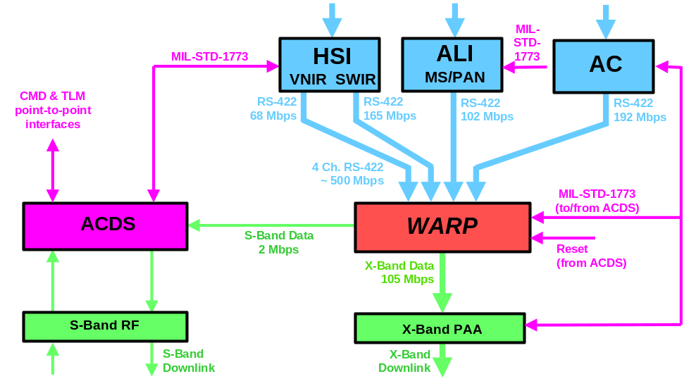
Figure 8-66 WARP Operations

For X-band PB, each WARP file is down linked either on the I or Q channel. Commands are provided to support queuing of files for X-band playback :
- Queue an individual file by file id to I or Q
- Queue all files (and the WARP autonomously manages file queuing). Purge files from queue individually or collectively by file id (xFF FF to release all files)
NOTES :
- WARP takes ~8+ minutes to perform full PB via X-band
- Because each file is completely played back on the I or Q channel, if more data is routed to one channel than the other, PB duration is increased, and limits the size / duration of an individual instrument DCE. (Each channel has a rate of 52.5 Mbps)
- Routinely ‘Queue all files’ command will be used to simplify X-Band PB operations.
Similar commands exist to support S-band PB (although only 1 channel exists)
NOTES : Filled WARP takes many passes to perform full PB (~400 minutes) via S-band
WARP files are released individually or collectively by file id (xFF FF to release all files) via command. WARP provides capability to release (delete) part of file - useful to PB long file in S-band PB mode. WARP files can be replayed multiple times if necessary.
NOTE: To simplify planning and operations, following an X-Band downlink, all files will be released prior to the next DCE.
WARP memory is partitioned into contiguous logical blocks. Each has a length of 929,616 bytes + RS overhead. At BOL, the WARP can have 6,620 logical blocks.
WARP files are maintained (and take up available memory) until released. When released, used logical blocks added to free space list. WARP dynamically allocates memory for each file. WARP allocates a logical block to each file for data storage when it is opened. Additional logical blocks opened for each file as needed. WARP maintains a linked list of logical block usage for each file. WARP also maintains a linked list of free space to determine where to record.
WARP provides a file directory downloadable as a table dump indicating attributes of stored files (data type [MS/PAN, SOH, LEISA/AC, etc), file id, size, open / close time, etc). Stored WARP data is RS encoded. Statistics are maintained and transmitted in the SOH stream to support identification of correctable and uncorrectable errors, and to support the identification of bad memory addresses and segments. The capability is provided to map around bad memory segments.

Instrument Operations

ALI Operations
The ALI modes of operation are defined to be :
- IDLE -ALI is in a Thermal Control Mode
- Focal Planes controlled to 220 K
- Telescope maintained at stable temperature
- STANDBY - Focal Planes are operating, but not gathering science data
- Minimum of 4 minutes required for Focal Plane Thermal Equilibration
- Sufficient time in the 4 minutes to set up experiment parameters
- Frame Rate, Integration Time, Start/Stop Times
- OPERATE - Focal Planes transmitting data to WARP
- Same power environment as standby
- SAFEHOLD –No electrical power to ALI
- S/C operation diagnostics and maintenance
- ALI survival temp maintained by s/c
ALI will generate 2 types of data – SOH data and MS/PAN science data. SOH data is routed (while ALI RSN on) to the ACDS M5 for storage and RT down link. Science data is routed to the WARP for storage. ALI SOH data is also stored to the WARP while science collections occurring. SEE WARP OPS for further details regarding collection and storage of data on the WARP.
Actual ALI science data storage is controlled (i.e., started and stopped) using an ALI data gate open / close command which enables data flow from the ALI to the WARP.
Time tag data is not provided in the ALI science stream. ALI telemeters in the SOH stream a latched time when the data gate latch state is changed which is used to establish DCE start / stop times. Further discussion and implications provided in WARP Operations section.
Routine ALI operations consist of the following :
- ALI is normally in IDLE mode (ALI RSN on, ALI FPA off) w/ Aperture Door CLOSED
- ALI Aperture door generally open only for DCEs
- While ALI in IDLE, ALI generated SOH data is provided by the ALI RSN
- ALI is turned on to support ground image collection, to perform internal, deep space, solar, and lunar cals.
- ALI turn on is limited to 20 minutes per orbit
- A 4 minute warm up period should be provided prior to any science collection listed above
The following additional operations are performed for each DCE :
- Momentum biasing done to ensure wheel speeds w/in acceptable thresholds of desired speeds – typically started ~1 orbit prior to image - may not be needed for all images. This is not required for Hyperion
- Solar Array is ramped to 0 and stopped prior to the image to reduce jitter. SA control re-enabled after image completed.
- Roll maneuver may be done prior to the image to orient MS/PAN detector to view a particular portion of L7 swath. Depending on next image time, nominal roll re-established after image complete
ALI will perform solar and lunar observations to characterize the performance of ALI. For solar calibration, an inertial slew is used to point the ALI solar cal boresite towards the sun. A solar cal observation will involve deploying a diffuser in front of the secondary mirror, and performing an ~30 second observation during which a subaperture on the ALI door is fully opened and closed to provide varying levels of spectral irradiance. Operational monitoring should be provided to ensure that the ALI door does not open during this operation. A lunar cal will involve collecting MS/PAN data as each MS/PAN Sensor Chip Assembly (SCA) is slewed across the moon. See the DCE Operations section for further details regarding ALI solar and lunar calibration operations.
Typically will try to use ALI provided MACRO commands (see LBernotas presentation for details), RTSs to reduce the volume of stored commands required to support ALI DCEs. For a list of RTS Assignments, see Appendix X. Appendix X provides ALI science collection sequences and timelines for images and cals.

LEISA/AC Operations
LEISA/AC is normally off (in STBY mode w/ heater on). While LEISA/AC is in STBY, LEISA/AC generated SOH data is not available. LEISA/AC is turned on to support ground image collection, to perform dark earth, solar, and lunar cals. While LEISA/AC is turned on:
- It is limited to 20 minutes on time in any 70 minute period
- A 9 minute warm up period should be provided prior to any science collection
LEISA/AC science data during ground image collection should be stored on WARP 8 seconds prior to an image until 8 seconds after to ensure all LEISA/AC bands are collected throughout the image area. (Similar extended collections should be performed during lunar raster scans).
Note: This is because grating used to spectrally resolve light on focal plane is actually imaging different locations on ground for each band.
For each LEISA/AC DCE, 1 second of dark cal (dark earth) LEISA/AC science data should be collected w/in 2 orbits before or after an image.
Note: 1 dark cal collection may suffice for multiple images.
Actual LEISA/AC science storage is controlled (i.e., started and stopped) using an LEISA/AC data gate open / close command which tells WARP data is valid. (LEISA/AC is flowing science data to WARP continuously while on. WARP only stores data when data gate opens [i.e., LEISA/AC marks valid]).
LEISA / AC will use the sun and moon to provide instrument calibration data. LEISA/AC has 3 detector heads each w/ a 5 x 5 degree field of regard. To support AC lunar calibration operations, each detector head should be slewed across the moon. For solar cals, cal pipes 90 degrees offset from the LEISA/AC / ALI boresite oriented along the +X axis are used to view the sun. 3 slews should be performed which allow solar dwell data to be collected for each optical head.
NOTE: AC does not have a movable door. AC boresite should not be pointed towards the sun such that a glue line extending in the across track direction of the AC focal plane does not view the sun for longer than 1 minute.
AC can be turned on in 32 possible configurations depending on frame rate, sensitivity, and thermal set point selected. Science collection requests will allow user to specify which configuration AC should be configured to for the DCE. RTSs which turn on AC in a specific configuration will be used to perform AC turn on.
See DCE Operations Section for further discussion on AC DCE related operations. See Appendix X for LEISA/AC science collection sequences and timelines for images and cals.

Hyperion Operations
This section provides a description of the operations concept for the Hyperion instrument. It provides the ground and flight procedures necessary to operate the Hyperion instrument, and the end-to-end flow from Hyperion data collection to generation of Level 1 data products.

Experiment States and Modes
Hyperion is operated according to a hierarchy of states and modes. A state is defined as a condition of the instrument, where the condition indicates a set of functions that can be performed while in that state. Modes describe the functions that can be performed in a given state. Each state has an allowable set of modes, and each mode is allowable for certain states only. Hyperion has five states and eleven modes of operation as defined below.

Hyperion States
The states in which the Hyperion instrument will operate are the following:
- Off. In this state, all components are powered off. The Hyperion can only remain in this state for 1 (TBR) hours on orbit.
- Survival. All electrical systems are powered off with the exception of survival heater power. The cryocooler is powered off. This state is designed to minimize power consumption of the Hyperion instrument without damage to any of the components.
- Initialization. This state is used during instrument checkout. The instrument control processor is powered on, and it is capable of exercising any operational mode defined below.
- Idle. This is the nominal operating state of the Hyperion instrument when it is not active for imaging or calibration. In this state, sufficient power is delivered to the instrument to allow the control processor to function, heaters to be operational, the cryocooler temperature to be regulated, telemetry data to be collected, and commands to be received.
- Active. All components of the Hyperion are powered on and capable of functioning. In this state, the instrument can be used for imaging or calibration.
Figure 9-68 presents the state transition diagram. Hyperion transitions between states according to a command or an event. For those states where the instrument cannot receive commands (survival or off), the instrument controller is powered “on” by the spacecraft (the event), and it automatically boots to take control of the instrument. Transition into and out of idle and active states are nominally by command. Spacecraft anomalies (event) will transition the instrument to survival state, or in case of an extreme power anomaly, into the off state.
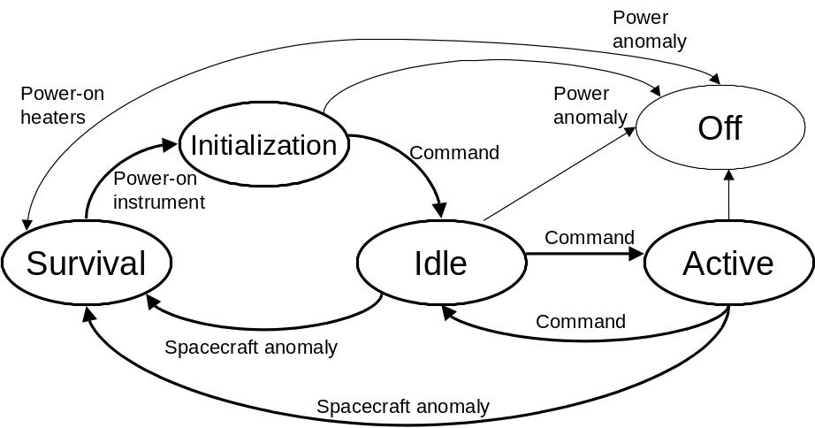
Figure 9-68 Hyperion State Transition Diagrams

9.3.3 Hyperion Modes
The operational modes define functions the instrument can perform in certain states. Table 9-10 describes the modes that are supported in the idle state, and 2 describes the active state modes. All active state modes are checked out in the initialization stat

Mode | Purpose
Commanding | Capable of receiving commands from spacecraft and issuing to Hyperion components
Telemetry | Capable of collecting Hyperion component telemetry, formatting into packets, and transmitting to spacecraft over 1773 interface
Cryocooler operations | Cryocooler electronics operational, and maintaining SWIR focal plane temperatures
Table 9-10 Idle State Modes

Mode | Cover Position | Data collect | Comment
Standby | Closed | None | Default mode for active state
Dark calibration | Closed | Minimum 100 frames | Performed as close as possible to imaging, before and after
Lamp calibration | Closed | Minimum 100 frames | Performed after second dark calibration; two radiance levels
Solar calibration | Open 37 degrees | Minimum 1 second  Nominal 1 cube | Performed over North Pole only to keep cover out of ALI keep-out zone; yaw maneuvers required
Lunar calibration | Fully open (135º) | Minimum: 1 second  Nominal: 1 cube | Performed on dark side of earth; off-track spacecraft pointing required
Ground calibration | Fully open (135º) | Minimum 1 second  Nominal 1 cube | Ground target selected
Imaging | Fully open (135º) | Minimum 1 second  Nominal 9 cubes | Nominal data collect is equivalent to Landsat scene, and takes 27 seconds.
Table 9-11 Active State Modes
Table 9-12 summarizes the component status and power levels for each mode and state.

Hyperion  Component | State and Modes: on - Y (power level), off - N
Hyperion  Component | Initialization |  | Idle | Active |  |  |  |  | Survival
Hyperion  Component | at power-on | at end of checkout | Idle | Standby | Dark cal | Cover Ops | Imaging¹ | Lamp cal | Survival
HEA | Y (16) | Y (16) | Y (16) | Y (33) | Y (33) | Y (33) | Y (33) | Y (33) | N
CEA | Y (14) | Y (14) | Y (14) | Y (14) | Y (14) | Y (14) | Y (14) | Y (14) | N
Cooler | N | Y (23) | Y (23) | Y (23) | Y (23) | Y (23) | Y (23) | Y (23) | N
ASPs | N | N² | N | Y (29) | Y (29) | Y (29) | Y (29) | Y (29) | N
Cover motor | Y (15)³ | N² | N | N | N | Y (15) | N | N | N
Lamps | N | N² | N | N | N | N | N | Y (41) | N
Heaters | Y (3.8) | Y (3.8) | Y (3.8) | Y (3.8) | Y (3.8) | Y (3.8) | Y (3.8) | Y (3.8) | Y (23.9)
Power (Watts) | 33.8  48.8³ | 56.8 | 56.8 | 102.8 | 102.8 | 117.8 | 102.8 | 143.8 | 23.9
1. Includes solar, lunar, and ground calibration
2. Function checked out during Initialization
3. 15 seconds to close cover
Table 9-12 Component Status by Mode

Cryocooler Operations
After re-setting default values for operating temperature and safety trips, and establishing the vibration control algorithm parameters for the zero-gravity environment, both functions performed during checkout, the cryocooler should operate without further commands. Updates to cryocooler operations can be made with software patches, which are estimated to be about 2 kbits in size. If the instrument is put into its survival state by the spacecraft, the cryocooler parameters will need to be re-set when the instrument is re-cycled into its initialization state upon power-on. If the cryocooler processor has a reset occur, the user-defined parameters for temperature, piston end-point limits, and vibration control algorithm, will have to be reset by command.

10 Technology Operations

10.1 Technology Overview
EO-1 will fly 10 technologies. 5 of these technologies are instrument related. Instrument related operations are described in chapter 9. The following chapter describes operations to be performed on-orbit to perform EO-1 technology validations for non-science instrument technologies.

Other discussions of technologies exist in section 2.1 which describes technology demonstration objectives, section 3.1.3 which provides an overview of technologies, section 5.4 which describes DCE related operations, and section 5.7.2 which describes orbit maneuver (i.e., EFF) operations.

Validation of each EO-1 technology will be the responsibility of its technology lead. For each technology, technology leads have developed technology validation plans. These plans outline tests to be performed pre-launch and on-orbit. Specifically they outline necessary commanding, operational constraints, and specific data to be provided to validation teams which is needed to support validations. During the pre-launch development phase, the FOT will meet with each technology lead to ensure technology validation requirements and operational needs (including monitoring and safing) are understood, and to ensure necessary development, preparations, and testing for on-orbit operations can be performed prior to launch. For on-orbit operations, a weekly Operations Coordination meeting will be used to determine which technology validations operations are to be scheduled. These operations are then planned by the FOT based on plans outlined in the Technology Validation plan and coordinated prior to launch, and further input provided by technology validation teams. Technology validation teams will provide support in the MOC during as many technology validation operations as necessary. Data collected during technology validation operations is then retrieved, agreed upon further processing performed, and finally distributed to science validation teams.

How do science validation teams report the status / success of their validations ?

Specific operations in support of each non-science technology follow.

X-Band Phased Array Antenna (XPAA)
The EO-1 X-band Phased Array Antenna is composed of a flat grid of many radiating elements whose transmitted signals combine spatially to produce the required antenna directivity or gain. The phases of the radiating elements is varied through commands provided by the M5 ACS task to point the beam in the desired direction. The XPAA is a critical subsystem that provides the 105 Mbps QPSK modulated downlink of science data to the ground during the one-year nominal on-orbit lifetime of the EO-1 mission. For EO-1, the XPAA composed of a 64-element array controlled by an embedded Remote Service Node that interfaces to the spacecraft bus via a 1773 interface.

Top level XPAA validation objectives are as follows:
- Demonstrate that phased array technology has benefits to small spacecraft architecture and operations
- Demonstrate that phased array technology is mature and reliable for use in space environment
- Minimize impact on phased array complexity / cost
- Constrain impacts to spacecraft system (mission team)

Validation will be performed through: acceptance / I&T measurements, telemetered spacecraft in-flight measurements, and ground station measurements.

Operation of the XPAA will be as follows. The XPAA will be launched with power off. The XPAA RSN will be powered on during L&EO and will nominally remain on for the duration of the mission. With the RSN on, command processing and status telemetry is available. Commands are issued as necessary to cycle on hardware to support downlinks. Downlinks typically occur for all science data downlinks (nominally 2 / day). Special trending reports provided to the XPAA validation team are not planned. Performance will be routinely inferred through monitoring and trending of downlink operations, and through use of science data processing metrics. Monitoring of each downlink will be performed at 3 levels: SOH telemetry will be used to confirm downlink from spacecraft; ground status data will be used to confirm received signal levels, data lock status, and record operations; and data reception and quality monitoring is performed during MOC level 0 processing of taped data. Any problems encountered during these processes will be identified and isolated. XPAA team analysis support will be requested as necessary. In addition to routine operations outlined above, downlinks will be scheduled periodically (every 2-3 months) such that a downlink to WGS can occur while the XPAA team is at the ground station to monitor operations. In addition to these science data downlinks, additional special downlinks to WGS will be requested during which the antenna remains ‘pointed’ along the nadir axis. Typically, the XPAA is ‘steered’ to a commanded site whose geodetics are stored on-board. A table load will be required to allow downlink to a site whose geodetics are not available on-board. After MOC level 0 processing completed, X-band data tapes (before Reed-Solomon decoding) from these Wallops downlinks will be provided to the validation team. Specific validation objectives from these Wallops downlinks include :
- Validate the communications link error performance of this type of phased array. Measure and tabulate basic bit error rate (BER) and error burst length data during science downlinks.
- Validate the antenna pattern scan performance of the phased array. Ground measurements of antenna scan performance will be compared with relative measurements made at the ground station while the spacecraft is on orbit
- Validate the performance and reliability of the software and controller of the array
- Validate the basic functioning of the array (particularly thermal) over the mission lifetime. Array function after turn on at temperature extremes is an issue.

One quirk regarding design of the XPAA is worth noting. The XPAA is designed to process M5 ACS software provided pointing commands every second. In the event these commands are unavailable for several minutes, the XPAA will assume communication with the M5 is unavailable, and will begin continuous periodic power on of the XPAA hardware and downlink initiation ‘pointed’ along the nadir axis. Additional TSMs will probably be needed to override the 45 watt load that while downlink is active. This may involve powering off the XPAA RSN.
The following identifies the key on-orbit XPAA activities:
- Perform regularly scheduled science data downlinks.
- Perform XPAA checkout – Launch + ~2 weeks
- Turn on XPAA RSN and confirm proper housekeeping status (temperature, currents, etc)
- Perform X-band science data downlink to WPS
- Downlink to WPS to allow X-band team on-site Ground Station performance monitoring (every 2-3 months)
- Perform routine science data downlink
- Perform special nadir pointed downlink
- Provide X-band data tapes (prior to R-S DECODE) to XPAA Validation team
- Provide Ground Station status data (AGC, etc), X-band data tape, Spacecraft R-S error telemetry from WPS downlink for X-band team analysis (every 2-3 months)
- Monitor system performance and investigate problems for each X-band downlink:
- signal levels at GS
- R-S errors at GS
- Science data quality problems

- Need to check if GS will collect and store desired measurements.
- Get TSM added to ensure XPAA hardware is powered off after downlink completed
- What telemetry is available to support individual element steering ?

10.3 Carbon-Carbon Radiator (CCR)
The Carbon Carbon Radiator is a special composite material that uses carbon for both the fiber and matrix and has advantages of high thermal conductivity and strength over conventional aluminum or copper based radiator. The CCR contains no active components and, as such, no command operations are required.
The following identifies the key on-orbit CCR activities:
- (The CCR is an entirely passive technology. No command operations required).
- Trend data will be provided to validation team - Weekly
- thermal data
- beta angle data (TBD)
- attitude history data (TBD)

How often do they want data ? What parameters ? Under what conditions ?

10.4 Advanced Light Weight Flexible Solar Array (LFSA)
The LFSA is designed to provide very high power output relative to its weight. Because of the LFSAs small size, its actual power output is minimal, probably less than 1 Watt. The LFSA will be mounted on the Zenith deck of the EO-1 Spacecraft and is deployed shortly after the EO-1 achieves its nominal operational state. This is done by commanding the release of a stow pin, which in turn allows shaped memory hinges and deployment systems to deploy the LFSA. The entire deployment should take ~30 seconds and will be done during orbit day while instruments operations are not occurring. During normal operations, an I-V Curve Sweep will be performed weekly. This will involve sending commands which: selects the Data Storage filter table to the table which records the necessary LFSA data, start I-V Curve Sweep mode, change the mode back to normal, and re-select the normal data storage filter. The amount of time the I-V Curve Sweep mode should be on is 10 seconds. These operations will be performed via stored command. These operation will be performed in sunlight, with the preference that the spacecraft be in a position where the sun is at an optimal angle on the array (i.e., near 90°). The above actions, upon special request, may be performed up to several times in one orbit. The FOT will provide weekly to the LFSA validation team, LFSA raw and calibrated data gathered during I-V curve collects in tabular and plot forms. The mnemonics needed are TBD. In addition, the LFSA group will need to know the actual sun angle when the data was taken. The FOT will provide information from which to derive sun angle within +5°. Specifics regarding how plots, tabular data, and sun angle (SETH ?) will be generated are under assessment.

The following identifies the key on-orbit LFSA activities:
- Command deployment of LFSA array – ~launch + 2 weeks
- Perform LFSA I-V Curve Sweep data collect – Weekly
- Perform additional I-V Curve Sweep data collects (up to 3 / orbit) – as requested
- Provide LFSA validation team a time history of LFSA telemetry during data collect – weekly
- Provide data from which LFSA validation team can derive sun angle during data collect – weekly.

10.5 Pulsed Plasma Thruster (PPT)
The PPT consists of a single PPT module containing two opposing electrode / fuel bar assemblies. Positive or negative torque is produced by discharge through appropriate electrode pair. Existing momentum wheel control scheme used to compute spacecraft control torques. The ACS sends PPT commands once every 1 Hz cycle. Variable impulse is achieved by varying capacitor charge time within 1 Hz cycle.

The primary objective of the PPT is to demonstrate that the PPT can reliably control the pitch axis and meet the EO-1 mission objectives while the spacecraft is taking science data in normal science mode. Validation of the PPT operation will be done from analysis of on-orbit data. This will include:
- Demonstrate the control capability – using ACS and PPT telemetry
- Confirm benign plume / spacecraft interaction and EMI effects – S/C telemetry and science images
- Verify PPT performance – using ACS and PPT telemetry

PPT operations will be performed based on plans coordinated between the FOT and PPT validation team pre-launch. PPT operations will be performed at 2 different points in the mission. A PPT test firing to demonstrate the PPT is functional will be performed during the 1st week of the mission. Later, a period of two weeks 9 or 10 months into the mission will be set aside for PPT control mode to perform the technology validation. While the PPT is active, PPT personnel will be co-located with the FOT in the MOC to observe the initial turn on, to coordinate required operations and commanding, and to help with any unexpected problems.

The PPT test firings will be coordinated with instrument turn on operations. The PPT test firings will involve: powering on the PPT, sending single shot ground PPT fire commands, and powering off the PPT after firings completed. During test firings, the ACS will remain in wheel control mode. Data during these operations will be provided to the technology validation team for assessment.
During the 2 week PPT control mode assessment, the sequence of operations will be as follows: establish PPT performance baseline with ACS in Wheel Control mode, establish operations in PPT control with instruments stowed, and finally perform instrument data taking with PPT control. To establish the all wheels performance baseline, the ACS is left in Wheel control mode while the instruments are stowed, the PPT is powered on, and the PPT is fired via ground commands. Using PPT, gyro, and other ACS data collected during these firings, torque magnitude and alignments is determined. If necessary, flight software control parameters (transformation matrix, PPT thrust constants, control law coefficients, etc) are updated via table load (as provided by PPT validation team). Following this, the first PPT control with instruments stowed is performed. This involves: disabling X & Z magnetic torquer bars (roll and yaw remain under wheel control), and commanding PPT transition mode. After commanding this transition, the flight software leaves the pitch wheel in control of momentum and reacts to PPT firing and slows down. At acceptable wheel speed, control is autonomously switched to PPT and wheel runs down to zero by friction. An evaluation of data collected under PPT control mode is performed and adjustments made to control parameters if needed. Further evaluation and parameter updates will be performed as necessary. When performance is acceptable, imaging operations can be performed. The goal will be to collect several images while PPT control is active. After these images are performed, wheel control mode will be re-enabled, and the PPT will be commanded off. Transition to Wheel control is managed in a manner similar to a transition to PPT control mode in that PPT remains in control while the pitch wheel the proper pitch wheel speed is established. The time EO-1 will remain in PPT control mode will be limited in that the ACS control modes allowable with PPT control are mission idle and science imaging. This limits ACS to nadir pointing attitudes. Wheel control mode will be required to allow off pointing images, instrument solar or lunar calibrations, and orbit maneuvers to occur.
FDCs will be developed to monitor attitude and systems performance while under PPT control. If these FDCs or the FOT detects unacceptable performance, control will be transitioned to wheel control, and the PPT can be powered off. Some additional operation may be required during PPT validation periods to manage FDC operations. This could involve performing table loads to broaden allowable pointing performance errors during initial PPT operations and or issuing commands to disable FDC checks that do not apply during PPT controlled modes.
The following identifies the key on-orbit PPT activities:
- Perform PPT test firings with ACS in wheel control mode – Launch + ~1 week
- Configure for 2 week PPT control mode validation period – Launch + ~9 months
- Establish PPT performance baseline with ACS in Wheel Control mode
- Establish operations in PPT control with instruments stowed
- Perform instrument data taking with PPT control
- Perform FDC maintenance operations to support PPT operations as required
- Perform table uploads to PPT control parameter as provided by PPT team
- Distribute TBS PPT / ACS related telemetry data to the Tech validation team – Weekly (during validation activities)

10.6 Enhanced Formation Flying (EFF)
EO-1 science validation necessitates that EO-1 fly in close formation behind Landsat-7. A mission level 1 requirement states that EO-1 will demonstrate the capability to fly over the same ground track as LandSat-7 within 3 km at a nodal separation interval of nominally 1 minute during which time an image is collected. The EFF technology will be used to provide this capability. EFF consists of the following software systems: Autocon-G, Autocon-F, and EFF. Autocon is a Satellite automation and control tool used to plan maneuvers consisting of ground (Autocon-G) and flight (Autocon-F) versions. EFF is the EO-1 flight interface to AutoCon-F. It supplies Autocon with data and places maneuver commands in stored command processor. Specifically EFF system validation will involve:
- EFF- Shall Provide the Autonomous Capability of Flying Over the Same Groundtrack of Another Spacecraft at Fixed Separation Times.
- Autonomy- Shall Provide on-Board Autonomous Relative Navigation and Formation Flying Control for the EO-1 and LandSat-7.
- AutoCon Flight Control System - Shall Provide Autonomous Formation Flying Control Via AutoCon.
- Ground Track - EO-1 Shall Fly the Same Ground Track As LandSat-7.
- Separation - EO-1 Shall Maintain a 1-Minute in-Track Separation Between EO-1 and LandSat-7.

The EO-1 Mission Profile diagram, figure 2-4, outlines the different operating modes for EFF operations. EFF / Orbit maintenance operations will have 3 distinct phases : ground planned trim burns performed early orbit to establish EO-1 formation with Landsat-7, ground planned burns to maintain formation, and on-board planned burns to maintain formation. Formation establishment operations are described in the Launch and Early Orbit, Orbit Maintenance section, section 4.2.6, and should nominally be completed in the 1st 30 days of on-orbit operations. Formation maintenance burns will nominally occur weekly (TBC) in order to maintain the orbit relative to Landsat-7. Through out the mission in order to maintain the formation with Landsat-7, Landsat-7 MOC will provide the EO-1 MOC the Landsat-7 orbit solution daily and a maneuver plan weekly.
Currently 2 targeting algorithms are planned for on-orbit use: 1 provided by GSFC and 1 provided by JPL. EFF will be turned on around day 4 to allow check out of EFF / Autocon-F using the GSFC targeting algorithm to begin. The ground will continue to plan burns until checkout of EFF / Autocon-F can be completed around day 90. At that point, operations switch to spacecraft planned burns with the ground verifying and monitoring flight operations. On-board planned burns will continue for several months using the GSFC target algorithm. Around month 9, operations revert back to ground planned burns using the JPL algorithm. About 1 month will be used to verify operation of Autocon-F / EFF using the JPL targeting algorithm. After check out completes, operations switch to on-board planned burns using the JPL algorithm. Further detail regarding formation maintenance operations are described in section 5.7.2.

The following identifies the key on-orbit EFF activities:
- EFF turned on in idle mode - ~Day 4
- Establish EO-1 orbit formation – Day 4 – 30
- Perform ground planned formation maintenance burns using GSFC targeting algorithm – Day 30 – 90
- Perform Autocon-F / EFF checkout using GSFC targeting algorithm – by Day 90
- Perform on-board planned formation maintenance burns using GSFC targeting algorithm – Day 90 - 270
- Perform ground planned formation maintenance burns using JPL targeting algorithm – Day 270-300
- Perform Autocon-F / EFF checkout using GSFC targeting algorithm – by Day 300
- Perform on-board planned formation maintenance burns using GSFC targeting algorithm – Day 300-365
- Receive L7 orbit vector from L7 MOC - daily
- Receive L7 orbit maneuver plan from L7 MOC– weekly

11 Mission Management
The NMP EO-1 Project Office is responsible for development of the NMP EO-1 system through development and acquisition of individual flight and ground segments. The NMP/EO-1 Mission organization is shown in Figure 11-1.

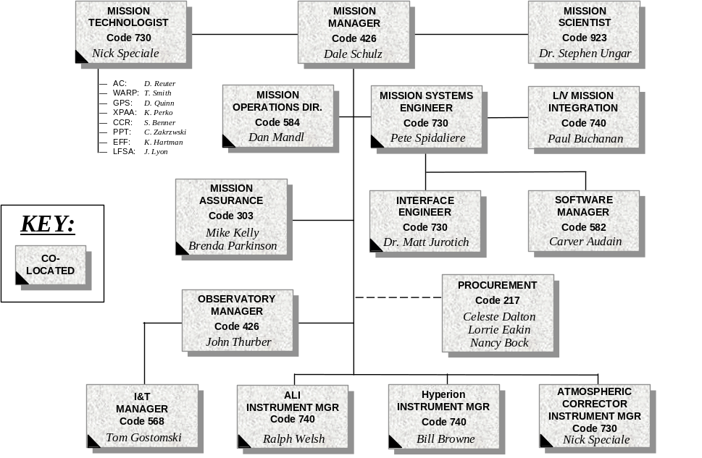

Figure 11-1 NMP EO-1 Pre-launch Mission Organization

The NMP EO-1 Project is also responsible for coordinating support of other elements composed of the institutional systems required for mission operational support.

TBD
Figure 11-2 Post-launch Mission Organization

TBD
Figure 11-3 Staffing Profile

11.1 Flight Operations Team
The Flight Operations Team (FOT) will ensure that spacecraft conditions are monitored and controlled. The FOT will be responsible for any and all trending necessary to characterize and sustain the health and continued operations of the spacecraft. The FOT, using MOC tools, will facilitate resource scheduling and interface with the appropriate elements required to conduct mission operations and meet the mission objective. The FOT organization is shown in
Figure 8-4.

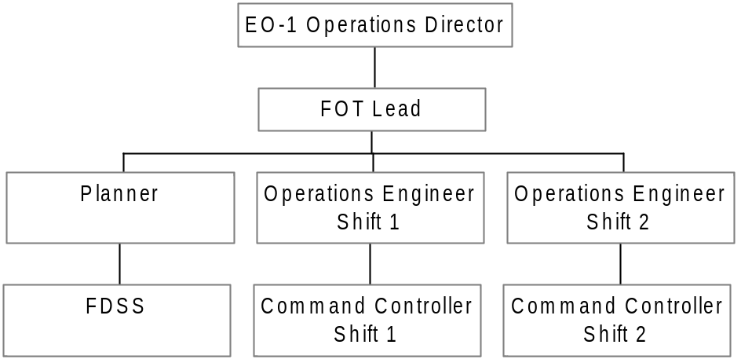

Figure 8-4 FOT Organization

The FOT will utilize the necessary computing systems, hardware, software, facilities, equipment, and personnel to accomplish the following functions:
- Operational control and command management
- Data capture
- Level-zero data plus (+) processing (Standard Level 0 + descrambling image)
- Flight dynamics (orbit and attitude) determination and control, including end to end on orbit calibration of the attitude control subsystem and instrument
- Coordination and scheduling the supporting ground stations and NISN
- Ground system test and simulation
- Assessment of quality of image samples, and generation of radiometric, atmospheric, and geometric calibrated data products Mission Direction
The primary objective of Mission Direction is to establish the procedures, guidelines, and staffing necessary to execute efficient, safe operation of the EO-1 satellite. Oversight of Flight Operations will be the responsibility of the Mission Director. Mission Direction activities will include the following:
- Establish standard and contingency operating procedures for flight operations
- Provide necessary administrative support for flight operations
- Establish appropriate MOC/FOT staffing levels and shift definition
- Provide operational and anomaly reports
- Maintain all MOC facilities to ensure uninterrupted satellite operations
- Provide initial and continuing training and certification of all MOC/FOT personnel
- Provide interface to supporting elements
A detailed description of Mission Direction activities will be provided in the Mission Procedures Document.

Transition to On-Orbit Mission Management– Dan Mandl
The FOT will conduct the following activities through project management:
- Plan Mission Operations, to meet Mission Requirements -- This will include all the planning activities leading up to launch, system activation and evaluation, and transition to on-orbit mission operations.
- Manage Data Collection -- This will include developing and maintaining a plan that defines image collection and setting data collection priorities.

Anomaly Management
Beginning with end-to-end systems testing during pre-launch, the project, Flight Operations and spacecraft contractor elements will jointly implement a problem management system. This overall system will include a Flight Operations-focused set of anomaly resolution procedures developed by the FOT and subsystem engineers at GSFC. Problems will be resolved at the lowest possible level. Problems will be documented and tracked using electronic databases that will be searchable via the Internet. Contingency plans will be developed for potential failures in each element and each interface. The steps used in the anomaly resolution process are as follows:
- When a problem happens, it is isolated to either the Spacecraft/MOC or supporting systems
- The FOT will identify, as best possible, the problem, notify the Mission Director, initiate a Problem Report, and execute Contingency Plan, if appropriate
- The Mission Director will review initial evidence, assign an Investigator / Analyst, and elevate attention to the problem, if necessary
- The Investigator / Analyst will review the evidence, get more evidence if necessary, and record in the Problem Database
- The Originator / Manager / Investigator then defines the desired outcome, which may include eliminating the problem, resuming normal operations, and / or defining appropriate metrics to measure a successful solution
- The Investigator identifies root cause(s) and proposes solution(s) for a system, equipment and / or, procedures
- The Flight Operations Manager prioritizes, plans, and tests proposed solution(s), which may be temporary and/or permanent
- The affected team will refine and implement solution(s), which may include Equipment change, Software update(s), Procedure change(s), and convening the appropriate CCB if required
- The Flight Operations Manager will measure progress and hold any gains by, for example, trending appropriate monitor points
- Finally, the result is recorded and communicated to the Mission Director. In doing so, the Problem Report is finalized, and logged into Problem Database

Software and Database Management
All software and databases used in operations are critical for the successful, safe operation of the system and must be maintained and controlled to ensure that they contain the most up to date information and agree in areas where they interface.

Flight Software
Initial flight versions of the Flight and Safe-Hold software, developed by Hammers Company, will be utilized by the FOT to validate pre-launch. The spacecraft contractor will provide on-orbit maintenance of the flight software following flight validation. Post-launch configuration control, and validation of any and all updates to the software will be the responsibility of TBD.. The flight S/W maintenance elements include Mongoose, WARP, XPAA, ALI, and Hyperion. The following sections will address how each set of software will he handled. Additional information on the exchange of data and files between the MOC and the spacecraft contractor is to be described in the Spacecraft Contractor to MOC ICD.
SWALES, Inc. will generate any changes to the flight software that are necessary and ensure that the changes produce the desired results without negatively impacting the rest of the software. The changed software is then passed on to the FOT where the FOT/MOC verify the address space, command syntax, number of bytes in the file, and the load checksum.
After the software load has been successfully up-linked to the spacecraft, the Mongoose V contents are dumped and the Ground Reference Image (GRI) is updated. A copy of the dump is sent to the SC manufacturer.

FOT/MOC Software
The software for the MOC system will be integrated by the MOC builder and validated pre-launch. The MOC development team will provide the majority of software in the MOC. A maintenance responsibility of the software packages is via vendor and developer support. The elements requiring this support are the CGS, MOPSS, FDSS and DPS. Support mechanisms will be described in the following sections: (TBS)

Database Management
The I&T team will perform the initial development of the Project Database (PDB) command and telemetry specifications. After launch, maintenance, control, and distribution (the PDB is needed by the MOC) of the PDB will be the responsibility of the FOT. The PDB contains definitions of all spacecraft commands and telemetry parameters that will be needed by the ground system. In addition, the PDB contains information that allows the MOC software to locate each telemetry parameter in the data stream, perform limit checking, and perform end item verification on every real-time command sent to the spacecraft.
There is not Operational Database (ODB), the PDB is what is used on orbit. (Joe Howard to add more description as needed ).

Configuration Management
During on-orbit Mission Operations, configuration management will be implemented by leveraging what was used during the system development phases. The configuration items (CI) controlled and the CM officers in authority will change appropriately, but the management philosophy should transition to operations with little change.
Configuration management for the operational EO-1 system includes the functions of configuration identification, configuration control, configuration status and accounting, and configuration audits. Other areas where configuration control will be required include:
- Relative Time Command Sequence Database (contained within CMS)
- Advanced Spacecraft Integration and System Test (ASIST) Procedures
Configuration identification will initially be accomplished at transition from development to operations by the functional and physical configuration audits of the operational EO-1 Configuration Items (CI).
The following configuration management philosophy applies:
- During operations, the EO-1 CCB will consist of the EO-1 Ground Systems Manager, Mission Director, Mission Technologist, and EO-1 Systems Engineer. These positions will constitute the sole configuration control entity for the EO-1 system. This ensures maximum control of system documentation. Approval of a controlled baseline or configuration change request (CCR) will be the sole responsibility of this CCB.
- Only documents that define a configuration affecting the form, fit, or function of the EO-1 system will compose the controlled baselines. These documents are to be specified by the CCB.
- Completed staff action, including technical coordination with all affected parties, will be accomplished prior to boarding a controlled baseline or CCR.

Reviews and Audits
Configuration audits will be accomplished during the operational life cycle as directed by the Mission Director. These will occur periodically and whenever required by major system modifications.

Testing and Training
A training plan and certification plan will be developed before launch and early orbit is complete. Each FOT member will be certified in as many subsystems as possible.
Due to the staffing profile and short lifetime of the mission, it is expected that only experienced persons will be a part of the FOT. For extended operations the certification and training plan will be modifie

