STOCK ASSESSMENT AND FISHERY EVALUATION REPORT

FOR THE WEATHERVANE SCALLOP

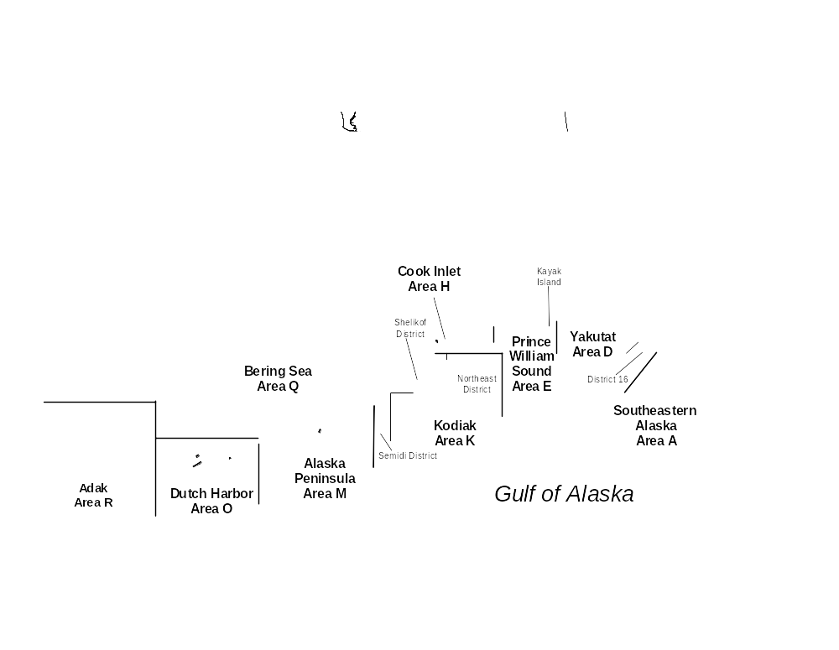
FISHERY OFF ALASKA
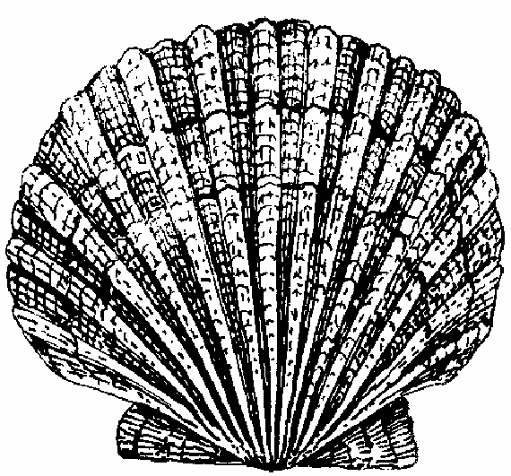

Compiled by

The Scallop Plan Team

With contributions by:
Kenneth J. Goldman, Richard L. Gustafson, Gretchen Harrington, Scott Miller, Gregg Rosenkranz, Herman Savikko, Diana Stram, Charles E. Trowbridge and Jie Zheng

March 2009

North Pacific Fishery Management Council
605 West 4th Avenue, Suite 306
Anchorage, Alaska 99501

Table of Contents

Table of Contents i
List of Tables ii
List of Figures iii
1 Introduction 1
1.1 Responses to Comments from the SSC and Summary of New Information Included in the SAFE Report 1
1.2 Historical Overview of the Scallop Fishery 5
1.3 Weathervane Scallop Biology 6
1.4 Economic Overview of the Scallop Fishery 6
2 Overview of Scallop Fishery and Management 9
2.1 Management 9
2.2 Stock Assessments and GHLs 10
2.3 Fishery 12
2.4 Observer Program 12
2.5 Crab Bycatch Limits 13
2.6 Scallop License Limitation Program 17
2.7 Voluntary Scallop Cooperative 18
2.8 Overfishing Definition 18
3 Stock Status 20
3.1 Yakutat Registration Area 20
3.2 Prince William Sound Registration Area 27
3.3 Cook Inlet Registration Area, Kamishak District 31
3.4 Kodiak Registration Area, Northeast District 34
3.5 Kodiak Registration Area, Shelikof District 37
3.6 Kodiak Registration Area, Semidi District 40
3.7 Alaska Peninsula Registration Area 41
3.8 Bering Sea Registration Area 43
3.9 Dutch Harbor Registration Area 46
3.10 Adak Area 46
4 Ecosystem Considerations 47
4.1 Habitat 47
4.2 Bycatch 47
4.3 Trawl Survey Information on Scallop Stocks 48
5 Recent Regulatory Actions 50
6 Literature Cited 51
Appendix A. Economic Factors In The Scallop Fishery Off Alaska 53
Appendix B. Annual Management Report for the Commercial Weathervane Scallop Fisheries in the Westward District 2004/05 69

List of Tables
Table 1 Historic Statewide Commercial Weathervane Scallop Revenue Statistics, 1967–2004/05 8
Table 2 Statewide crab bycatch limits in percentage of crab abundance estimates (where available) or number of crabs. 15
Table 3 Bycatch of snow crabs (number crabs) in Bering Sea fisheries, 1995–2007. 16
Table 4 Bycatch of Bristol Bay red king crabs (numbers of crab) in Bering Sea fisheries, 1995–2006. 16
Table 5 Bycatch of Tanner crabs (number of crabs) in Bering Sea fisheries, 1995-2006. 17
Table 6 Alaska weathervane scallop harvest and Maximum Sustainable Yield from FMP, 1993/94–2007/08 seasons. 19
Table 7 Yakutat Area D scallop fishery summary statistics. 21
Table 8 Yakutat District 16 scallop fishery summary statistics. 24
Table 9. Standardized Kayak Island dredge survey summary. Standardized areas are 78.99 nm² for the East bed and 48.66 nm² for the West bed. Table provides biomass estimates using catchability coefficients (q) of 1 and 0.83 (which stems from preliminary work on dredge catchability) 27
Table 10 Prince William Sound Area E scallop fishery summary statistics. 28
Table 11 Standardized Kamishak Bay dredge survey summary. Standardized areas are 90.2 nm² for the North bed and 68.0 nm² for the South bed. 31
Table 12 Cook Inlet, Kamishak District scallop fishery summary statistics. 32
Table 13 Kodiak Northeast District scallop fishery summary statistics. 34
Table 14 Kodiak Shelikof District scallop fishery summary statistics. 37
Table 15 Kodiak Semidi District scallop fishery summary statistics. 40
Table 16 Alaska Peninsula Area scallop fishery summary statistics. 41
Table 17 Bering Sea Area scallop fishery summary statistics. 43
Table 18 Dutch Harbor Area scallop fishery summary statistics. 46

List of Figures
Figure 1 Alaska weathervane scallop fishing registration areas. 3
Figure 2 Scallop fishing locations (dark polygons) outside Cook Inlet during the 2003/04 season. 4
Figure 3 Statewide scallop harvest (pounds shucked scallop meats) and MSY levels from the FMP. 19
Figure 4 Barplots of Yakutat Area D scallop fishery statistics. 22
Figure 5 Shell height histograms from resampling Yakutat Area D observer data, 1998/99–2006/07 seasons. 23
Figure 6 Barplots of Yakutat District 16 scallop fishery statistics. 25
Figure 7 Shell height histograms from resampling Yakutat District 16 observer data. Insufficient data were collected to produce plots for the 2003/04 and 2007/08 seasons. 26
Figure 8 Barplots of Area E scallop fishery statistics. 29
Figure 9 Shell height histograms from resampling Area E observer data, 2000/01–2006/07. Insufficient data were available to produce plots for earlier seasons. 30
Figure 10 Barplots of Area H scallop fishery statistics. 33
Figure 11 Barplots of Kodiak Northeast District scallop fishery statistics. 35
Figure 12 Shell height histograms from resampling Kodiak Northeast District scallop observer data, 1999/2000–2006/07. 36
Figure 13 Barplots of Kodiak Shelikof District scallop fishery statistics. 38
Figure 14 Shell height histograms from resampling Kodiak Shelikof District scallop observer data, 19992000–2006/07. 39
Figure 15 Barplots of Alaska Peninsula scallop fishery statistics. 42
Figure 16 Barplots of Bering Sea scallop fishery statistics. 44
Figure 17 Shell height histograms from resampling Bering Sea scallop observer data, 1999/2000–2006/07. 45
Figure 18 Map showing scallop fishing areas, areas closed to scallop fishing by regulation, and locations where weathervane scallops were captured during NMFS trawl surveys in the eastern Gulf of Alaska 48
Figure 19 Map showing scallop fishing areas, areas closed to scallop fishing by regulation, and locations where weathervane scallops were captured during NMFS and ADF&G trawl surveys in the Kodiak Area. 49
Figure 20 Map showing scallop fishing areas, areas closed to scallop fishing by regulation, and locations where weathervane scallops were captured during NMFS and ADF&G trawl 50

Introduction
The National Standard Guidelines for Fishery Management Plans published by the National Marine Fisheries Service (NMFS) require that a stock assessment and fishery evaluation (SAFE) report is prepared and reviewed annually for each fishery management plan (FMP). The SAFE report summarizes the current biological and economic status of the fishery and analytical information used in fishery management such as guideline harvest levels (GHLs) and harvest strategies. The report is assembled by the scallop plan team with contributions from the State of Alaska Department of Fish and Game (ADF&G), the National Marine Fisheries Service (NMFS), and the North Pacific Fishery Management Council (NPFMC). The SAFE report is presented to the Council on an annual basis and is also available to the public.

The Scallop Plan Team met in Anchorage on February 19-20, 2009 to review the status of the weathervane scallop stocks, to discuss additional issues of importance in scallop management, and to compile the annual SAFE report. The Plan Team review was based on presentations by staff of the NPFMC, NMFS and ADF&G with opportunity for public comment and input. Members of the Plan Team who compiled the report were Gregg Rosenkranz, Diana Stram, Gretchen Harrington, Scott Miller, Jie Zheng [add two new members names; Gustafson and Ryan Burt]and Herman Savikko.

The scallop fishery in Alaska’s Exclusive Economic Zone (EEZ; 3-200 miles offshore) is jointly managed by the state and federal government under the FMP. Most aspects of scallop fishery management are delegated to the State of Alaska, while limited access and other federal requirements are under jurisdiction of the federal government. The FMP was developed by the NPFMC under the Magnuson Stevens Act and approved by NMFS on July 26, 1995. The NPFMC updated and adopted a revised FMP in [add date].

Although the FMP covers all scallop stocks off the coast of Alaska including weathervane scallops (Patinopecten caurinus), pink or reddish scallops (Chlamys rubida), spiny scallops (Chlamys hastata), and rock scallops (Crassadoma gigantea), the weathervane scallop is the only commercially exploited stock at this time. Commercial fishing for weathervane scallops occurs in the Gulf of Alaska, Bering Sea, and Aleutian Islands. Scallop registration areas used by ADF&G in management of the fishery are shown in Figure 1, and general fishing locations are shown in Figure 2.

In 1996, optimum yield (OY) was established as 0 to 1.8 million pounds of shucked scallop meats. A more conservative approach was taken in 1998, when OY was defined as 0 to 1.24 million pounds of shucked scallop meats. Statewide scallop harvests have not exceeded OY, and scallop stocks are not overfished.

Responses to Comments from the SSC and Summary of New Information Included in the SAFE Report

Comments on the 2008 SAFE provided by the SSC and responses are below followed by a summary of new infromation included in this report.

Comment: The SSC requests that next year’s SAFE report include an explanation in the management chapter (section 2.1) describing the process by which changes to GHLs are determined each year. Additionally, the SSC requests that an explanation be provided for all GHL changes that have been made for each registration area, to be included in the Stock Status chapter for each registration area.

SPT response: The SPT has requested information on GHLs, GHL determination, and changes to GHLs from ADF&G management biologists from the three ADF&G regions with scallop fisheries. Section 2.2 has been created with subsections for each region that have minimal information at present but will serve as placeholders until responses are received and the information incorporated into the SAFE. Information on recent changes to GHL levels has been added to individual registration area sections where available and addtional information will be added when it is received.

This SAFE Report includes updated information through the 2007/2008 fishing season. New information included in this report since the previous report (NPFMC 2006) includes the following:

- Updated observer program summary data through 2007/2008 fishing season;
- Overview section on fishery management added;
- Clarification regarding definition of GHRs and GHLs;
- Many sections moved, reorganized, and rewritten;
- Updated information on recent regulatory actions with respect to the scallop fishery.

Figure 1 Alaska weathervane scallop fishing registration areas.

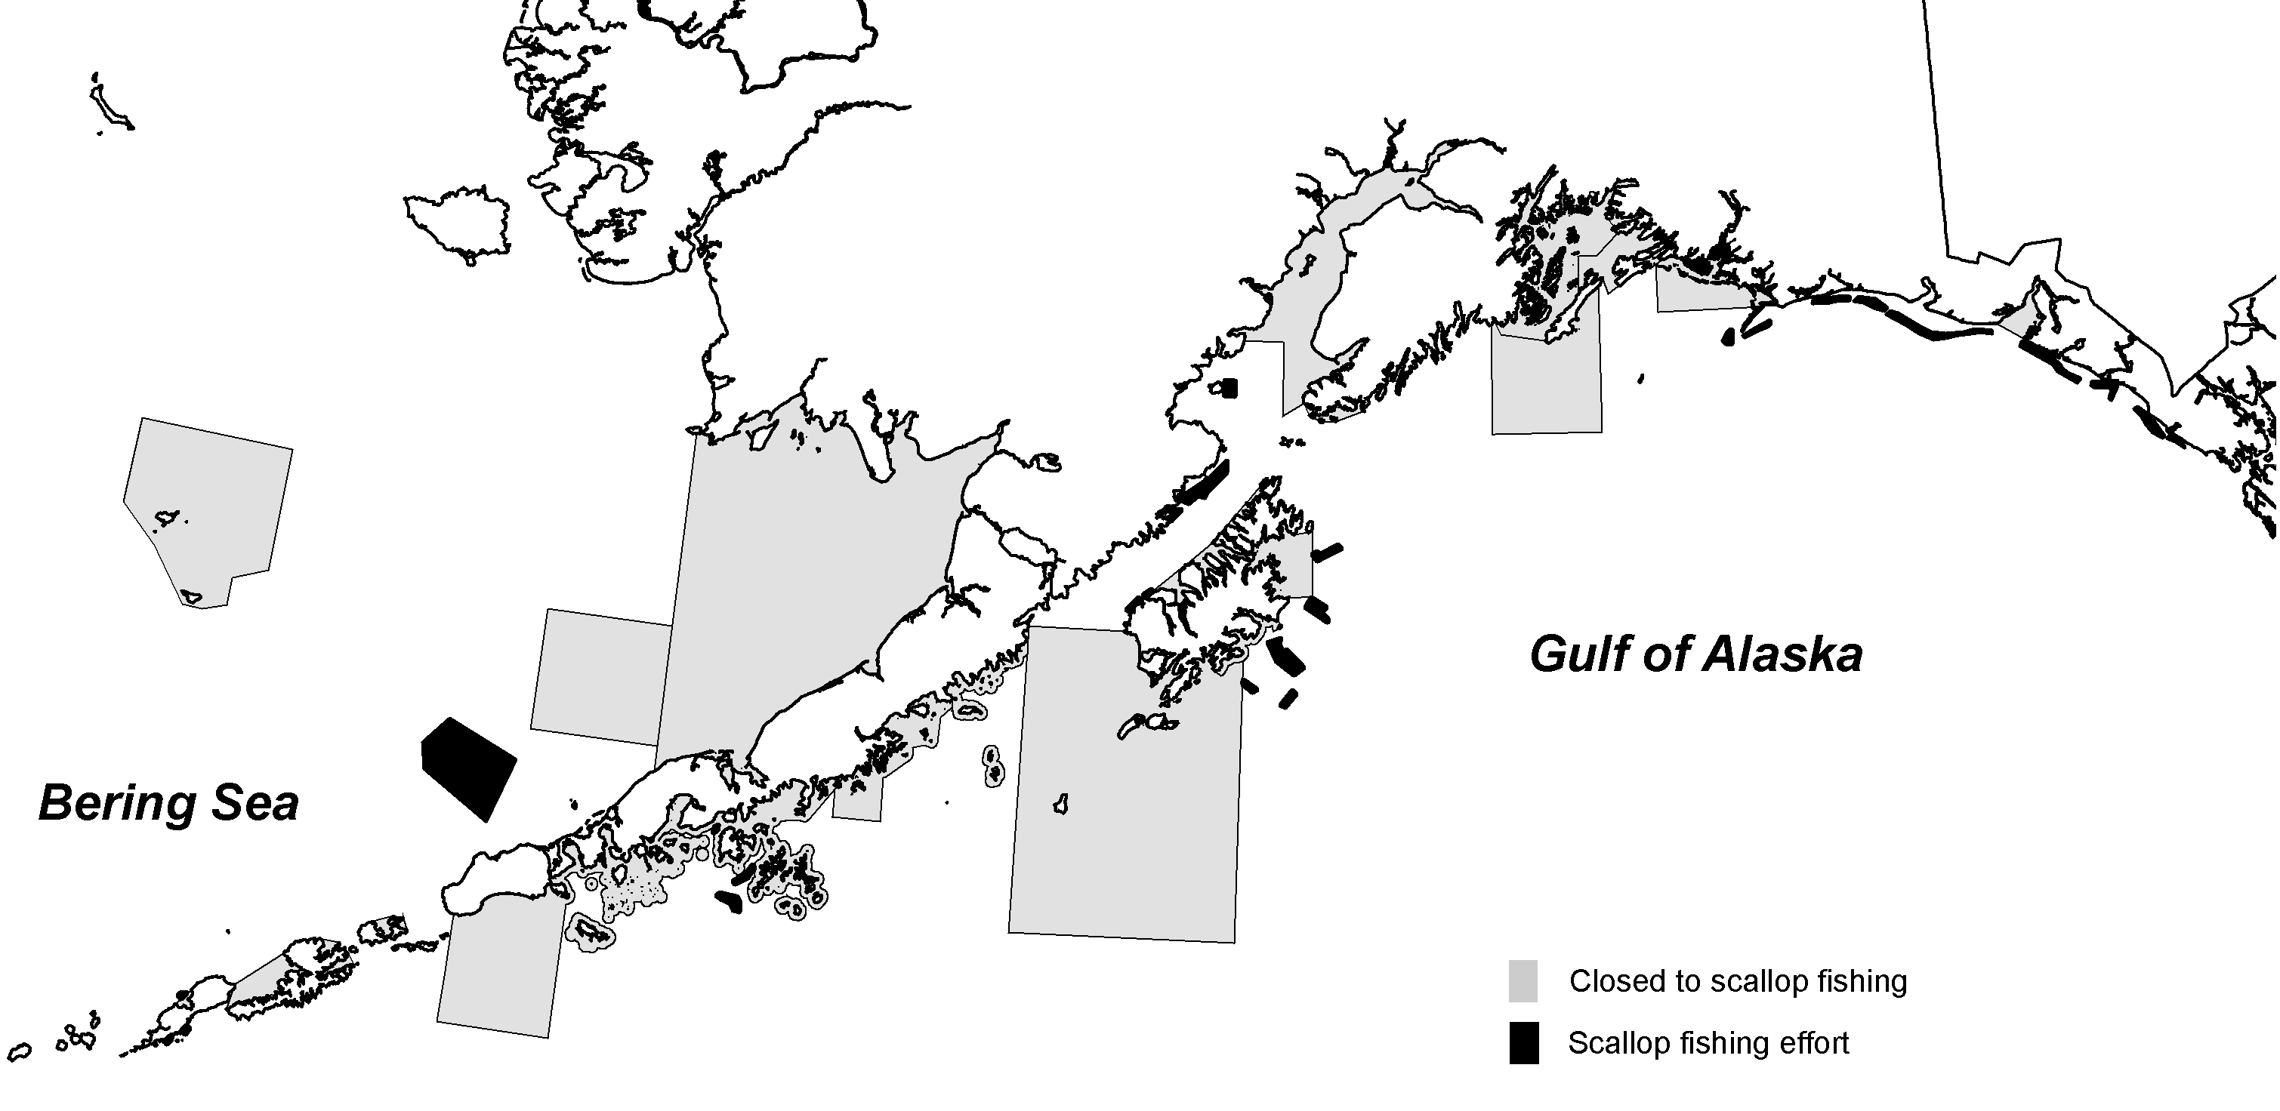
Figure 2 Scallop fishing locations (dark polygons) outside Cook Inlet during the 2003/04 season.

Historical Overview of the Scallop Fishery

Alaska weathervane scallop Patinopecten caurinus populations were first evaluated for commercial potential in the early 1950s by government and private sector investigators. Interest in the Alaska fishery increased in the late 1960s as catches from U.S. and Canadian sea scallop Placopecten magellanicus fisheries on Georges Bank declined. Commercial fishing effort first took place in Alaska during 1967 when two vessels harvested weathervane scallops from fishing grounds east of Kodiak Island. By the following year, 19 vessels including New England scallopers, converted Alaskan crab boats, salmon seiners, halibut longliners, and shrimp trawlers, entered the fishery.

From the inception of the fishery in 1967 through mid May 1993, the scallop fishery was passively managed with minimal management measures. Closed waters and seasons were established to protect crabs and crab habitat. When catches declined in one bed, vessels moved to new areas. While this may have been acceptable for a sporadic, low intensity fishery, increased participation inevitably led to boom and bust cycles (Barnhart 2003).

In the early 1990s, the Alaska weathervane scallop fishery expanded rapidly with an influx of boats from the East Coast of the United States. Concerns about overharvest of scallops and bycatch of other comercially important species such as crabs prompted the ADF&G Commissioner to designate the weathervane scallop fishery a high-impact emerging fishery on May 21, 1993. This action required ADF&G to close the fishery and implement an interim management plan prior to reopening. The interim management plan contained provisions for king and Tanner crab bycatch limits (CBLs) for most areas within the Westward Region. Since then, crab bycatch limits have been established for the Kamishak District of the Cook Inlet Registration Area and for the Prince William Sound Registration Area. The commissioner adopted the regulations and opened the fishery on June 17, 1993, consistent with the measures identified in the interim management plan. The interim management plan included a provision for 100% onboard observer coverage to monitor crab bycatch and to collect biological and fishery data. In March 1994, the Alaska Board of Fisheries (BOF) adopted the interim regulations identified as the Alaska Scallop Fishery Management Plan, 5 AAC 38.076.

From 1967 until early 1995, all vessels participating in the Alaska scallop fishery were registered under the laws of the State of Alaska. Scallop fishing in both state and federal waters was managed under state jurisdiction. In January 1995, the captain of a scallop fishing vessel returned his 1995 scallop interim use permit card to the State of Alaska Commercial Fisheries Entry Commission in Juneau and proceeded to fish scallops in the EEZ with total disregard to harvest limits, observer coverage, and other management measures and regulations. In response to this unanticipated event, federal waters in the EEZ were closed to scallop fishing by emergency rule on February 23, 1995. The initial emergency rule was in effect through May 30, 1995, and was extended for an additional 90 days through August 28, 1995. The intent of the emergency rule was to control the unregulated scallop fishery in federal waters until an FMP could be implemented to close the fishery. Prior to August 28, NPFMC submitted a proposed FMP which closed scallop fishing in the EEZ for a maximum of one year with an expiration date of August 28, 1996. The final rule implementing Amendment 1 to the FMP was filed July 18, 1996 and published in the Federal Register on July 23, 1996. It became effective August 1, 1996, allowing the weathervane scallop fishery to reopen in the EEZ. Scallop fishing in state waters of the Westward Region was delayed until August 1, 1996 to coincide with the opening of the EEZ. The state continued as the active manager of the fishery with in-season actions duplicated by the federal system (Barnhart 2003).

In March 1997, NPFMC approved Amendment 2, a vessel moratorium under which 18 vessels qualified for federal moratorium permits to fish weathervane scallops in federal waters off Alaska. By February 1999, the Council recommended replacing the federal moratorium program with an LLP, which became Amendment 4 to the FMP. The Council’s goal was to reduce capacity to approach a sustainable fishery with maximum net benefits to the Nation, as required by the Magnuson-Stevens Act. NPFMC’s preferred alternative created a total of nine licenses with no area endorsements; each vessel is permitted to fish statewide. However, vessels that fished exclusively in the Cook Inlet Registration Area where a single 6-foot dredge was the legal gear type during the qualifying period were also limited to fishing a single 6-foot dredge in federal waters outside Cook Inlet. The NPFMC later modified the gear restriction in Amendment 10 to allow these vessels to fish 2 dredges with a combined maximum width of 20 feet. Amendment 10 was approved on June 22, 2005. NMFS published final regulations on July 11, 2005, which were effective August 10, 2005. NMFS implemented Amendment 10 by reissuing the two LLP licenses with the larger gear restriction.

Weathervane Scallop Biology
This section is currently a placeholder; the SPT hopes to expand it with input from the new ADF&G scallop biologist after the position is filled. The goal will be to summarize what is known about weathervane scallop biology and to delineate the most important directions for future research.

Alaska weathervane scallops spawn between May and early July. Spermatozoa and eggs are released directly into the water where fertilization occurs. Fertilized eggs settle to the bottom and hatch into larvae within several days; they then rise in the water column and drift with prevailing currents for about a month while undergoing metamorphosis. Scallops then settle to the bottom as juveniles and may attach to the substrate with byssal threads. A combination of large-scale (overall spawning population size and oceanographic conditions) and small-scale (site suitability for settlement) processes influence recruitment of scallops.

Economic Overview of the Scallop Fishery

An overview of historic Alaska weathervane scallop harvest and wholesale revenue is presented in Table 1. This data is reprinted from Kruse et al. (2005) and updated with information from annual scallop harvest information (Barnhart, 2006). Vessel participation and numbers of landings in this fishery have varied considerably over time. Participation increased rapidly from an historic low of 2 vessels in 1967 to 19 in both 1968 and 1969. Similarly, only 6 landings occurred in 1967 but by 1969, 157 landings were made and that year is the historical peak in participation, landings, and catch and among the years with highest first wholesale gross revenue.

Following 1969, participation, landing, and catch trended downward through 1976. In 1977 and 1978 the fishery was open but fishermen opted not to fish. In 1980 there were 8 participants making 56 landings totaling more than 600,000 pounds of scallop meats. In the following years, participation, landings, and catch trended upwards until 1983 before cycling downward. There followed an upward trend in landings and catch through the mid 1990s. Since the mid 1990s, participation, landings, and catch have stabilized somewhat with catch consistently between 500,000 and 850,000 pounds each year, however, the 2004/05 catch of 431.596 pounds is the lowest level in nearly a decade. Vessel participation has been limited in recent years by the formation of the voluntary cooperative in May 2000, and by the implementation of the LLP in 2001. The Federal LLP limits the participation to 9 permit holders. Since 2000, no more than 8 vessels have participated and in recent years it has been even fewer.

Table 1 also provides historical statewide average price per pound of landed scallop meats as well as a consumer price index based inflation adjusted price. Total gross revenue is then calculated using landed pounds of meats multiplied by the adjusted price. Adjusted price converts the landed prices by year to year 2002/03 values so that comparisons can be made in current dollar values, after accounting for inflation. The 2002/03 base has been retained in this analysis for comparability with the original source of the data.

It is important to note that landed scallop meats have been processed (shucked) and frozen at sea. Prior to 1996 almost all scallop meats were placed in muslin bags and iced (not frozen) at sea. Thus, although landed price is often referred to as an ex-vessel price, in this case it is actually a first wholesale price in that the landed product is a primary processed product. Thus, gross revenue is identified as first wholesale value here.

Adjusted price generally trended upwards during the late 1960s and through the 1970s. Following the three years of closure, prices rose dramatically to nearly $7.5 per pound, possibly in response to shortage of weathervane scallops caused by the closures. Historic prices peaked in 1983 at $8.56 per pound before trending downward through the mid 1990s, upward during the late 1990s and then back downward from 1999 through 2002-03 when adjusted prices averaged $5.25 per pound. This trend may be directly related to U.S. east coast scallop stock conditions and related market prices and the dependence of market prices in the Alaska scallop fishery on east coast markets is a topic for further research.

First wholesale revenue in this fishery has varied considerably over the years as both price and landings have varied. The peak value in the fishery occurred in 1992 when about $8.8 million was earned. Since that time, total first wholesale revenue in the fishery has trended downward along with landings, catch, and prices. In 2002-03, the fishery yielded about $2.7 million in total first wholesale revenue. The downward trend continued with the 2003-04 and 2004-05 seasons yielding $2.6 million and $2.3 million respectively. The 2004-05 season returned the lowest level of total revenue in the Alaska scallop fishery since 1988.

Table 1 Historic Statewide Commercial Weathervane Scallop Revenue Statistics, 1967–2004/05
Year | Vessels | Landingsª | Catch (lbs meats)^{b} | Average Price/Lb. | Inflation Factor | Adjusted Price | Wholesale Value
1967 | 2 | 6 | 778^{c} | $0.70 | 0.219 | $3.20 | $2,487
1968 | 19 | 125 | 1,677,268 | $0.85 | 0.228 | $3.73 | $6,252,973
1969 | 19 | 157 | 1,849,947 | $0.85 | 0.238 | $3.57 | $6,606,954
1970 | 7 | 137 | 1,440,338 | $1.00 | 0.249 | $4.02 | $5,784,490
1971 | 5 | 60 | 931,151 | $1.05 | 0.260 | $4.04 | $3,760,418
1972 | 5 | 65 | 1,167,034 | $1.15 | 0.268 | $4.29 | $5,007,795
1973 | 5 | 45 | 1,109,405 | $1.20 | 0.285 | $4.21 | $4,671,179
1974 | 3 | 29 | 504,438 | $1.30 | 0.313 | $4.15 | $2,095,110
1975 | 4 | 56 | 435,672 | $1.40 | 0.339 | $4.13 | $1,799,235
1976 | 7 | 21 | 264,788 | $1.59 | 0.359 | $4.43 | $1,172,738
1977-78 | No Fishery
1979 | 1 | 4 | 24,826 | NA | NA | NA | NA
1980 | 8 | 56 | 616,717^{c} | $3.60 | 0.484 | $7.44 | $4,587,151
1981 | 18 | 101 | 924,441 | $4.00 | 0.529 | $7.56 | $6,990,102
1982 | 13 | 120 | 913,996 | $3.25 | 0.561 | $5.79 | $5,294,986
1983 | 5 | 30 | 192,310 | $5.00 | 0.584 | $8.56 | $1,646,490
1984 | 6 | 52 | 383,512 | $4.00 | 0.607 | $6.59 | $2,527,262
1985 | 7 | 47 | 615,564 | $4.00 | 0.627 | $6.38 | $3,927,043
1986 | 8 | 74 | 667,258 | $4.25 | 0.639 | $6.65 | $4,437,944
1987 | 4 | 54 | 599,947^{d} | $3.45 | 0.661 | $5.22 | $3,131,342
1988 | 4 | 47 | 341,070 | $3.68 | 0.685 | $5.37 | $1,832,318
1989 | 7 | 55 | 534,763 | $3.87 | 0.714 | $5.42 | $2,898,505
1990 | 9 | 144 | 1,481,136 | $3.43 | 0.750 | $4.57 | $6,773,729
1991 | 6 | 136 | 1,136,649 | $3.82 | 0.777 | $4.92 | $5,588,159
1992 | 8 | 136 | 1,785,673 | $3.96 | 0.796 | $4.97 | $8,883,499
1993e | 7 | 51 | 568,077 | $5.15 | 0.816 | $6.31 | $3,585,290
1993/94 | 15 | 111 | 984,583 | $5.15 | 0.816 | $6.31 | $6,213,974
1994/95 | 15 | 104 | 1,240,775 | $5.79 | 0.833 | $6.95 | $8,624,354
1995/96 | 10 | 29 | 410,743^{d} | $6.05 | 0.853 | $7.09 | $2,910,834
1996/97 | 9 | 30 | 732,424 | $6.30 | 0.876 | $7.19 | $5,267,433
1997/98 | 9 | 31 | 818,913 | $6.50 | 0.895 | $7.26 | $5,947,413
1998/99 | 8 | 35 | 822,096 | $6.40 | 0.908 | $7.05 | $5,794,509
1999/00 | 10 | 22 | 837,971 | $6.25 | 0.927 | $6.74 | $5,649,751
2000/01 | 8 | 20 | 750,617 | $5.50 | 0.958 | $5.74 | $4,309,388
2001/02 | 6 | 26 | 572,838 | $5.25 | 0.984 | $5.34 | $3,056,300
2002/03 | 6 | 28 | 509,455 | $5.25 | 1.000 | $5.25 | $2,674,639
2003/04 | 4 | 32 | 500,379 | $5.25 | 1.016 | $5.17 | $2,585,620
2004/05 | 5 | 22 | 431,594 | $5.50 | 1.028 | $5.35 | $2,308,681
a Prior to and including 1995, number of landings equals number of fish tickets. After 1995,
the number of landings equals number of deliveries (off-loads). A delivery typically
includes multiple tickets, normally one per week.
b Pounds of shucked scallop meats.
c Unshucked scallop deliveries were converted to shucked meats using a 10% conversion factor.
d Includes illegal harvest.
e January 1 through June 30

Overview of Scallop Fishery and Management

The scallop fishery is managed jointly by NMFS and ADF&G under the Federal Fishery Management Plan (FMP) for the Scallop Fishery off Alaska. Most management measures under the FMP are delegated to the State for management under Federal oversight. ADF&G management of the weathervane scallop fishery covers both state and federal waters off Alaska. The following sections provide background on the fishery and its managment, including registration areas, season, guideline harvest ranges (GHRs), guideline harvest levels (GHLs), the onboard observer program, crab bycatch limits (CBLs), and the LLP.

Management
Registration Areas. The State of Alaska Scallop Fishery Management Plan established 9 scallop registration areas in Alaska for vessels commercially fishing scallops (Figure 1). These include the Southeastern Alaska Registration Area (Area A);Yakutat Registration Area (Area D and District 16); Prince William Sound Registration Area (Area E); Cook Inlet Registration Area (Area H); Kodiak Registration Area (Area K), which is subdivided into the Northeast, Shelikof and Semidi Districts; Alaska Peninsula Registration Area (Area M); Dutch Harbor Registration Area (Area O); Bering Sea Registration Area (Area Q); and Adak Registration Area (Area R). Scallop seasons have never been opened in Area A, and effort occurred in Area R during 1995 only.

Seasons. The regulatory fishing season for weathervane scallops in Alaska is July 1 through February 15 except in the Cook Inlet Registration Area. In the Kamishak District of Cook Inlet, the season is August 15 through October 31, and in all other districts of Cook Inlet, the season is from January 1 through December 31 under conditions of an exploratory permit. Scallop fishing in any registration area in the state may be closed by emergency order prior to the end of the regulatory season. Scallop GHLs and CBLs are typically announced by ADF&G approximately one month prior to the season opening date.

Guideline Harvest Ranges. Although the FMP overfishing definition (2.8) is based on the statewide scallop stock, statewide estimates of stock size are not available and not likely to be obtained due to limited stock assessment resources. Estimates of stock size only exist for Central Region scallop beds as fishery independent assessments of those beds has been ongoing since 1996 and data are used to set GHL’s. ADF&G manages the fishery by registration areas and districts. Regulatory GHRs for traditional scallop fishing areas were first established by the State of Alaska in 1993 under the Interim Management Plan for Commercial Scallop Fisheries in Alaska. Regulatory GHRs (lbs of shucked scallop meats) were set at 0–250,000 lbs for Yakutat, 0–50,000 lbs for Prince William Sound, 0–20,000 lbs for the Kamishak District of Cook Inlet, 0–400,000 lbs for Kodiak, and 0–170,000 lbs for Dutch Harbor. These area GHR ceilings were determined by averaging historic catches from 1969 to 1992 excluding years when there was no fishing or a “fishing-up effect” occurred (Barnhart 2003).

Prior to the August 1, 1996 re-opening of the weathervane scallop fishery, the State of Alaska established GHRs for non-traditional registration areas, including 0–200,000 lbs for the Alaska Peninsula, 0–600,000 lbs for the Bering Sea, 0–35,000 lbs for District 16, and 0–75,000 lbs for Adak. The combined total of the upper limits from traditional and non-traditional areas was 1.8 million lbs, which was defined as maximum sustainable yield (MSY) in Amendment 1 to the federal FMP.

In 1998, the scallop plan team recommended a more conservative definition of MSY. Based on average landings from 1990–1997 excluding 1995 when the fishery was closed for most of the year, MSY was subsequently established in Amendment 6 of the FMP at 1.24 million lbs, with optimum yield (OY) defined as the range 0–1.24 million pounds. To accommodate the new definition, regulatory GHR ceilings were reduced by the State of Alaska from 400,000 to 300,000 lbs for Kodiak, from 170,000 to 110,000 for Dutch Harbor, and from 600,000 to 400,000 lbs for the Bering Sea. Hence, MSY and the regulatory GHR ceiling written into Alaska law are both 1.24 million lbs.

Inseason data. Observers that are required on all vessels fishing for scallops in Alaska outside Cook Inlet monitor the fishery during the season and transmit data to ADF&G at least thrice weekly. Fishing may be closed in any area before the GHL is reached due to concerns about localized depletion, trends in CPUE, or bycatch rates. Inseason data are also used by the scallop industry to avoid areas of high bycatch.

Stock Assessments and GHLs
Management of the Alaska scallop fishery is handled by ADF&G biologists from the three regions where scallop fishing occurs. Scallop fishing is prohibited in large areas of coastal Alaska known to contain scallops (4.3), and onboard observers are required on all vessels operating outside Cook Inlet. Dredge surveys are conducted only in Central Region and data are used to set GHLs. The scallop observer program data are the primary information source for setting GHLs in all other areas. These data consist of time series of scallop harvest and fishing effort, including catch per unit effort (CPUE), fishing locations, size structure of the catch, discard of scallops, and crab bycatch. Spatially explicit catch and effort data that cannot be displayed in the SAFE report due to State of Alaska confidentiality requirements are examined by ADF&G staff each year when GHLs are set.

ADF&G and the SPT recognize inherent weaknesses in using fishery data for management purposes. CPUE may be an unreliable index of scallop abundance due to factors such as market conditions, weather on the grounds, tides, gear efficiency, bycatch avoidance, captain and crew performance, etc. Industry participants have noted that the time of year when fishing occurs can drastically affect CPUE due to differences in weather and sea state between summer and winter. Size composition data from the commercial catch are affected by choice of fishing locations and gear selectivity and hence may not be representative of the true size composition of any scallop population.

Concerns such as these led ADF&G to begin exploring underwater video techniques for scallop stock assessment in 2000. A towed camera sled system constructed in 2007 that records high resolution images of the bottom on computer hard drives while towing 3–5 knots (Rosenkranz et al. 2008) is currently being used to conduct pilot scallop surveys. ADF&G is developing a plan to conduct more camera sled surveys around the state.

Southeast Alaska Region. No regular assessment surveys are conducted in the Southeast Alaska Region. GHLs for Yakutat Area D and District 16 are set prior to each fishing season after examination of recent observer program data. The fishery is managed by Joe Stratman from the Petersburg office.

Central Region. ADF&G conducts biennial dredge surveys in the Kamishak District of the Cook Inlet Registration Area and near Kayak Island in the Prince William Sound Registration Area. Data from these surveys are used to set GHLs. In the Kamishak District fishery, observers are not required, but vessels are limited to a single 6 ft dredge, and ADF&G staff is regularly deployed as observers when fishing occurs. The Cook Inlet fishery is managed by Charlie Trowbridge from the Homer office and the Kayak Island fishery is managed by Bob Berceli in Cordova.

Surveys through 2006: Central Region conducts fishery-independent, area-swept, dredge surveys with a systematic sampling design. From 1996 through 2006, this systematic survey design was accompanied by an adaptation for delineating the edge of the scallop beds. Sampling stations were defined by overlaying a checker-board grid of 1,855 m² (1.0 nmi²) squares over a chart of the study area (see Figures 1 & 2). A systematic design was used in which every other station was designated for sampling after the primary sampling unit (light or dark squares) was randomly selected to give an equal probability of selecting either set of grid cells. The vessel skipper, in cooperation with the project leader, determined the specific tow location within each sample station. The dredge was towed for a distance of approximately 1,855 m (1.0 nmi) within the sample station. To delineate the scallop bed margin, stations (light or dark) were added diagonally when catches along the edge of the initial sampled stations exceeded a threshold level of 9.1kb (20 lb). The edge of a scallop bed was considered delineated when catch in a given station was below the threshold amount.

Surveys since 2007: The 2007 Kamishak Bay and 2008 Kayak Island surveys were set to standardized areas, which will continue to be used. The survey designs were done in a manner that enables all previous years of survey data to be standardized and comparable; all historical survey catch data was entered into ARC GIS and a polygon was drawn around all stations where the catch exceeded the threshold of 9.1 kg/nm (20 lbs). Ancillary stations will be conducted outside these standardized areas to look for changes in bed size. Central Region staff also developed an additional aspect to the survey design whereby data from the systematic dredge survey can be compared to the video assessment method that continues to be developed and used by statewide scallop staff in Kodiak. The survey design accomplishes; 1) comparison of a systematic video survey to Central Region’s systematic dredge survey; and 2) comparison of both the systematic video and systematic dredge surveys to a full/complete line transect video survey. These comparisons will be critical if Central Region moves to full video assessment of scallops in the future as there is a need to have a statistically valid and efficient survey design for the towed camera system and have future data comparable to current dredge data. If Central Region does move to full video assessment to obtain abundance information, some dredging (from a sub-sample of stations) will still need to be conducted in order to obtain meat weights, and scallop shells for assessing age.

Guideline Harvest Limits (GHLs) in Central Region: Regular assessments have been conducted biennially on Central Region scallop beds at Kamishak Bay and at Kayak Island since 1996. Data from the assessments are used to set GHLs which are then in effect for the subsequent two seasons. Following several surveys designed to establish the extent of the beds, the department standardized the survey area for each bed beginning in 2007 for Kamishak and in 2008 for Kayak. The Kayak Island estimate was adjusted using a dredge catchability of 0.83, which is based upon the relative catchability from a small amount of dredge/video comparison work conducted there in 2004. No similar comparison has been conducted at Kamishak. The department has applied a 5% harvest rate to the final survey estimates of abundance and used whole weight to meat weight conversions to assign the GHL for each area. Typically, the fishery remains open until the GHL is achieved. However, through its emergency order authority the department may close a season or area in response to declines in CPUE or even apparent die-offs as occurred at Kamishak in 2002. Additionally, in setting GHLs the department may consider such factors as a narrow size or age distribution or truncation of sizes observed within an area.

Westward Region. No regular assessment surveys are conducted in Westward Region. Nick Sagalikin from the Kodiak office manages the Kodiak and Alaska Peninsula fisheries, and Forrest Bowers in the Dutch Harbor office manages the Bering Sea, Dutch Harbor, and Adak fisheries. Kodiak Northeast District and Shelikof District GHLs have remained relatively stable since the late 1990s. Management staff set CPUE benchmarks for some areas prior to the season, and if CPUE falls below these levels, all data are reviewed and the fishery may be closed or allowed to continue. GHLs for many of the areas are divided between statistical areas to prevent overharvesting.

Fishery
Scallop vessels in the Alaska fishery are 58–124 feet length overall, with maximum 1,200 horsepower. Standard New Bedford style scallop dredges are used in the fishery. On average, a 15-foot dredge weighs a minimum of 2,600 pounds and a 6-foot dredge weighs about 900 pounds. The frame design provides a rigid, fixed dredge opening. Attached to and directly behind the frame is a steel ring bag consisting of 4-inch (inside diameter) rings connected with steel links; 4 inch or larger rings are required by state law. A sweep chain footrope is attached to the bottom of the mesh bag. The top of the bag consists of 6-inch stretched mesh polypropylene netting which helps hold the bag open while the dredge is towed along the ocean floor. A club stick attached to the end of the bag helps maintain the shape of the bag and provides for an attachment point to dump the dredge contents on deck. Steel dredge shoes that are welded onto the lower corners of the frame bear most of the dredge’s weight and act as runners, permitting the dredge to move easily along the substrate. Each dredge is attached to the boat by a single steel wire cable operated from a deck winch.

Scallop fishing operations involve the following steps: (a) dredge deployment; (b) dredge towed for 50 to 60 minutes on the bottom at an average speed of 4.7 knots; (c) dredge retrieved; (d) dredge contents emptied on deck; (e) retained scallops sorted from the catch and bycatch discarded overboard; (f) baskets of retained scallops moved from the deck to the shucking area; (g) gear prepared for the next set; (h) gear deployed; aand (i) shuck, wash, grade, package and freeze scallop meats. The scallop meat is the single adductor muscle that is removed from the scallop by crew members using specialized hand-held scallop knives. Scallop meats represent approximately 8-12% of the round weight depending on area and season (Barnhart and Rosenkranz 2003). Scallop meats are graded by size and sold primarily to domestic seafood markets, with a smaller amount going to foreign markets (Kruse et al. 2005).

Observer Program
The primary purposes of the onboard scallop observer program are to collect biological and fishery data and to monitor bycatch. ADF&G requires observers on all trips of all vessels fishing scallops outside Cook Inlet in both state and federal waters. Observers are briefed and debriefed by ADF&G staff in each management area where fishing occurs prior to and after deployment.

Dredge hauls are sampled to collect data on retained scallop catch, crab and halibut bycatch, scallop discards, and catch composition. Detailed logbooks completed by vessel operators are checked by observers and submitted to ADF&G along with other observer data forms. Observers send summary reports to ADF&G fishery managers thrice weekly or more frequently during the season by radio or email. Data are entered, stored, and maintained by ADF&G staff in Kodiak. Observer data are used for inseason management and in setting seasonal GHLs. Scallop observer data are released to the public in reports prepared by ADF&G (e.g., Barnhart and Rosenkranz 2003).

Onboard observer coverage is funded by industry through direct payments to independent contracting agents. Scallop observers are trained at the University of Alaska North Pacific Fisheries Observer Training Center in Anchorage. Observer training manuals (e.g., Banrhart 2003) are prepared by ADF&G staff.

Observer cost for vessels limited to a single 6-ft dredge in federal waters was addressed in Amendment 10, section 6.8 of the Scallop FMP. The Council determined that given existing observer requirements and their associated costs, the single 6-ft dredge restriction created a disproportionate economic hardship when fishing in federal waters (NPFMC 2004). Amendment 10 allows two vessels to fish with two 10-ft dredges to capture a larger share of the total catch, thus allowing them to offset observer costs and perhaps enhance their economic viability.

Crab Bycatch Limits
Bycatch of crabs in the scallop fishery is controlled through the use of Crab Bycatch Limits (CBLs) that are based on condition of individual crab stocks. CBLs were first instituted by the state in July 1993. Methods used to determine CBLs in 1993 and 1994 were approved by the BOF and the NPFMC and, with few exceptions, remain unchanged. Annual CBLs are established preseason by ADF&G for areas with current crab resource abundance information (surveys). For areas without crab abundance estimates, CBLs may be set as a fixed number of crabs that is not adjusted seasonally.

In the Kodiak, Alaska Peninsula, and Dutch Harbor Registration Areas, the CBLs are set at 0.5% or 1.0% of the total crab stock abundance estimate based on the most recent survey data (Table 2). In registration areas or districts where red king crab or Tanner crab abundance is sufficient to support a commercial crab fishery, the cap is set at 1.0% of the most recent red king crab or Tanner crab abundance estimate. In registration areas or districts where the red king crab or Tanner crab abundance is insufficient to support a commercial fishery, the CBL is set at 0.5% of the most recent red king crab or Tanner crab abundance estimate. Bycatch caps are expressed in numbers of crabs and include all sizes of crabs caught in the scallop fishery.

In the Kamishak District of the Cook Inlet Registration Area, the Tanner crab bycatch limit is set at 0.5% of the total crab stock abundance from the most recent dredge survey and the red king crab limit is fixed at 60 crabs. In 2001, ADF&G set Tanner crab bycatch caps in the Prince William Sound Registration Area at 0.5% of the Tanner crab population estimate from the 2000 scallop survey. This resulted in bycatch limits of 2,700 and 8,700 for the east and west harvest areas. These levels have remained in place for all subsequent years.

CBLs in the Bering Sea (registration Area Q) have evolved from fixed numbers in 1993 to a three tier approach used in the current fishery. In 1993, Bering Sea CBLs were set by ADF&G to allow the fleet adequate opportunity to explore and harvest scallop stocks while protecting the crab resource. CBLs were established at 260,000 Chionoecetes spp. and 17,000 red king crabs. In 1995, ADF&G recommended that CBLs be established at 0.003176 percent of the best available estimate of C. opilio (snow crab) and 0.13542 percent of the best available estimate of Tanner crab abundance in Registration Area Q. That equated to about 300,000 snow and 260,000 Tanner crabs based on 1994 crab abundance estimates in Registration area Q. In Amendment 1 of the federal scallop FMP, the NPFMC approved the CBLs established by ADF&G. The NPFMC also recommended that king crab bycatch limits be set within a range of 500 to 3,000 annually. Beginning with the 1996/97 fishing season ADF&G took a conservative approach and set the red king crab limit in Registration Area Q at 500 red king crabs annually.

From the 1996/97 through 1998/99 fishing seasons the CBL for Chionoecetes sp. in the Bering Sea was established annually by applying the percentages established for snow and Tanner crab limits in Amendment 1 of the FMP. In 1998, consistent with the Tanner crab rebuilding plan in the Bering Sea, crab bycatch limits were modified.

The current three tier approach was established utilizing the bycatch limits established in Amendment 1 of the FMP, 300,000 snow crab and 260,000 Tanner crab. The three tiers include (1) Tanner crab spawning biomass above minimum stock size threshold (MSST); bycatch limit is set at 260,000 crabs, (2) Tanner crab spawning biomass below MSST; bycatch limit is set at 130,000 crabs, and (3) Tanner crab spawning biomass is below MSST and the commercial fishing season is closed; Tanner crab limit is set at 65,000 crabs. A similar three tier approach was taken with the snow crab bycatch caps. The three tiers include (1) snow crab spawning biomass above the MSST; bycatch limit is set at 300,000 crabs, (2) snow crab spawning biomass below MSST; bycatch limit is set at 150,000 crabs, and (3) snow crab spawning biomass below MSST and the commercial fishing season is closed; the snow crab limit is set at 75,000 crabs.

Table 2 Statewide crab bycatch limits in percentage of crab abundance estimates (where available) or number of crabs.

Area/District | Red King Crab | C. bairdi | C. opilio
Yakutat District 16 | NEª | NE | NA^{b}
Yakutat Area D | NE | NE | NA
Prince William Sound | NE | 0.5% | NA
Cook Inlet Kamishak District | 60 crab | 0.5% | NA
Kodiak Northeast District | 0.5% or 1.0% | 0.5% or 1.0% | NA
Kodiak Shelikof District | 0.5% or 1.0% | 0.5% or 1.0% | NA
Kodiak Semidi District | NE | NE | NA
Alaska Peninsula | 0.5% or 1.0% | 0.5% or 1.0% | NA
Bering Sea | 500 crab^{c} | 3 tier approach | 3 tier approach
Dutch Harbor | 0.5% or 1.0% | 0.5% or 1.0% | NA
Adak^{d} | 50 | 10,000 crab | NA
ª Not established.
^{b} Not applicable.
^{c} Fixed CBL.
^{d} Bycatch limit established to provide scallop fleet opportunity for exploratory fishing while protecting crab resources.

Bycatch of snow crabs, Tanner crabs, and Bristol Bay red king crabs by scallop fisheries in comparison with groundfish and directed crab fisheries are shown in Tables 3–5. Bycatch of snow, king, and Tanner crabs during the Bering Sea scallop fishery tends to be much lower than for other Bering Sea fisheries. Scallop fishery closures due to attainment of CBLs have decreased over the years, in part due to decreased crab abundance (Barnhart and Rosenkranz 2003). ADF&G closely monitors bycatch rates during scallop seasons and has used a rate of one crab per pound of scallop meats as a benchmark since 1993. Bycatch may affect harvest and CPUE in the Bering Sea scallop fishery as vessel operators move or cease fishing when bycatch rates meet or exceed this benchmark.

Table 3 Bycatch of snow crabs (number crabs) in Bering Sea fisheries, 1995–2007.
Year | Directed  crab pot | Groundfish trawl | Groundfish fixed gear | Scallop dredge | Total
1995 | 48,734,000 | 5,165,555 | 230,233 | 0 | 54,129,788
1996 | 56,570,785 | 3,643,612 | 267,395 | 104,836 | 60,586,628
1997 | 75,005,446 | 5,276,208 | 554,103 | 195,345 | 81,031,102
1998 | 51,591,453 | 4,122,648 | 549,139 | 232,911 | 56,496,151
1999 | 47,093,200 | 1,544,747 | 269,778 | 150,421 | 49,058,146
2000 | 5,020,800 | 2,207,279 | 270,000 | 105,602 | 7,603,681
2001 | 6,123,100 | 1,293,143 | 215,000 | 68,458 | 7,699,701
2002 | 15,823,300 | 882,967 | n/a | 70,795 | n/a
2003 | 22,140,336 | 615,012 | 86,313 | 16,206 | 22,857,867
2004 | 4,800,043 | 1,693,101 | 140,428 | 3,843 | 6,637,415
2005ª | 4,530,514 | 3,292,520 | 124,171 | 5,211 | 7,952,425
2006 |  |  |  | 8,543
2007 |  |  |  | 19,367
ª From the 2005/2006 rationalized BB red king crab fishery (Oct 15 2005 to January 15 2006) but little or no catch or effort from January 1-15. This does not include any bycatch from the rationalized 2005/2006 Tanner crab fishery.

Table 4 Bycatch of Bristol Bay red king crabs (numbers of crab) in Bering Sea fisheries, 1995–2006.
Year | Directed  crab pot | Groundfish trawl | Groundfish fixed gear | Scallop dredge | Total
1995 | 0 | 44,934 | 3,257 | 0 | 48,191
1996 | 605,000 | 30,967 | 75,675 | 0 | 711,642
1997 | 985,000 | 50,711 | 25,579 | 0 | 1,061,290
1998 | 4,593,800 | 42,003 | 7,017 | 146 | 4,642,966
1999 | 957,800 | 84,709 | 8,968 | 1 | 1,026,178
2000 | 1,701,000 | 70,787 | 39,754 | 2 | 1,653,542
2001 | 2,419,100 | 58,552 | 19,000 | 0 | 2,496,652
2002 | 1,677,800 | 89,955 | 27,477 | 2 | 1,795,234
2003 | 5,808,200 | 91,937 | 13,531 | 0 | 5,913,668
2004 | 2,470,868 | 78,742 | 15,014 | 0 | 2,564,624
2005ª | 5,724,919 | 111,249 | 19,723 | 2 | 5,855,893
2006 |  |  |  | 10
2007 |  |  |  | 1
ª This is from the pre-rationalized opilio fishery and the rationalized 2005/2006 BB red king crab fishery. This does not include bycatch during 2005 from the 2005/2006 EBS snow crab or directed Tanner crab fishery.

Table 5 Bycatch of Tanner crabs (number of crabs) in Bering Sea fisheries, 1995-2006.
Year | Directed crab pot | Groundfish Trawl | Groundfish fixed gear | Scallop dredge | Total
1995 | 15,897,300 | 2,212,181 | 87,674 | 0 | 18,197,155
1996 | 4,588,000 | 1,836,031 | 279,560 | 17,000 | 6,930,591
1997 | 4,865,900 | 1,917,736 | 50,218 | 28,000 | 6,861,854
1998 | 4,293,800 | 1,477,816 | 46,552 | 36,000 | 5,854,168
1999 | 1,995,100 | 901,619 | 43,220 | n/a | n/a
2000 | 491,000 | 1,002,074 | 140,453 | 53,614 | 1,539,141
2001 | 626,400 | 950,331 | 80,000 | 48,718 | 1,705,449
2002 | 1,282,600 | 1,086,286 | 98,848 | 48,053 | 2,515,787
2003 | 626,000 | 897,340 | 105,094 | 31,316 | 1,659,750
2004 | 334,593 | 800,794 | 38,592 | 15,303 | 2,849,032
2005 | 708,290 | 1,569,613 | 122,167 | 15,529 | 2,415,599
2006 |  |  |  | 45,204
2007 |  |  |  | 35,288

Scallop License Limitation Program
Commercial weathervane scallop fishing in federal waters off Alaska is limited by a federal license limitation program (LLP), while participation in state waters (0-3 nautical miles) is limited by a vessel-based limited entry program. The LLP limits participation in the statewide scallop fishery in Federal waters to nine vessels.

The Federal Scallop License Limitation Program (LLP) became effective in 2001. The NPFMC created the scallop LLP under Amendment 4 to the FMP to limit the number of participants and reduce fishing capacity. The LLP license is required on board any vessel deployed in the weathervane scallop fishery in federal waters off Alaska. NMFS granted 7 vessel owners licenses to fish statewide outside Cook Inlet. Originally, NMFS granted two vessel owners licenses to fish statewide utilizing a single 6-foot dredge. In August, 2005, NMFS implemented Amendment 10 to the FMP, which modified the gear restriction to allow these two licenses to be used on vessels with up to two 10-foot dredges statewide. All 9 licenses allow vessel owners to fish inside Cook Inlet with a single 6-foot dredge. Vessel length is limited to that of the qualifying period.

All vessels fishing inside the Cook Inlet Registration Area are limited by state regulation to a single dredge not more than 6 feet in width. Unless otherwise restricted by the LLP, vessels fishing in the remainder of the state may simultaneously operate a maximum of 2 dredges that are 15 feet or less in width.

In 1997, the Alaska legislature approved legislation (AS 16.43.906) establishing a scallop vessel moratorium in state waters. In 2001, the legislature authorized a 3-year extension of the moratorium set to expire July 1, 2004. During the 2002 legislative session, passage of CSHB206 resulted in significant changes to the state’s limited entry statutes. The changes authorized use of a vessel-based limited entry program in the weathervane scallop and hair crab fisheries. However, the program has a sunset provision. The vessel entry permits issued for the statewide weathervane scallop fishery will expire on December 31, 2008 unless statutory authority is extended. Eight vessel owners received permits to fish for weathervane scallops in state waters.

Two vessels with multiple LLP permits as well as state vessel-based limited entry permits have harvested most of the scallop catch outside Cook Inlet over the past several seasons. Three vessels 80 feet or less LOA typically participate in the Cook Inlet Registration Area fishery. Occasionally, one or more of these vessels participate in the scallop fishery outside of Cook Inlet.

More information on the scallop LLP can be found on the NMFS Alaska Region web page at http://www.fakr.noaa.gov/ram/smp.htm.

Voluntary Scallop Cooperative

In May 2000, six of the nine LLP owners formed the North Pacific Scallop Cooperative under authority of the Fishermen's Cooperative Marketing Act, 48 Stat. 1213 (1934), 15 U.S.C. Sec. 521. The cooperative is self-regulated and is neither endorsed nor managed by ADF&G or NMFS. The cooperative regulates individual vessel allocations within the GHR and crab bycatch caps under the terms of their cooperative contract. Non-coop vessels are not bound by any contract provisions. The cooperative does not receive an exclusive allocation of the scallop harvest. Some owners opted to remove their boats from the fishery and arranged for their shares to be caught by other members of the cooperative. Since formation of the cooperative, harvest rates have slowed and fishing effort occurs over a longer time period each season

Vessel owners within the cooperative have taken an active role in reducing crab bycatch. Vessel operators provide confidential in-season fishing information to an independent consulting company contracted by the cooperative. This firm reviews crab bycatch data, fishing locations, and scallop harvest, which allows for real time identification of high crab bycatch areas. When these areas are identified, the fleet is provided with the information and directed to avoid the area.

More information on the voluntary scallop cooperative can be found in the EA/RIR/IRFA for Amendment 10 to the Scallop FMP available on the Council website at:
http://www.fakr.noaa.gov/npfmc/analyses/analyses.htm

Overfishing Definition

Overfishing is a level of fishing mortality that jeopardizes the long-term capacity of a stock or stock complex to produce MSY on a continuing basis. MSY is defined as the largest long-term average catch that can be taken from a stock under prevailing ecological and environmental conditions. Amendment 6 to the scallop FMP established MSY for weathervane scallops at 1.24 million lbs of shucked meats based on the average catch from 1990-1997 excluding 1995. Optimum Yield (OY) was defined as 0–1.24 million lbs, and the overfishing control rule was defined as a fishing rate in excess of the natural mortality rate, which has been estimated as F_{overfishing} = M = 0.13 (12% per year) statewide. At this time, abundance is estimated for only two of the nine registration areas and a determination of MSST cannot be made. The fishery is managed conservatively with harvest levels well below MSY. Figure 3 shows statewide scallop catch and MSY levels both prior to amendment 6 and following inception of the new MSY level in 1996. Since 1996, catches have averaged between 39% to 66% of MSY (Table 6, Figure 3,). Control rules for other Alaskan scallop species have not been developed as no commercial harvests occurs.

Table 6 Alaska weathervane scallop harvest and Maximum Sustainable Yield from FMP, 1993/94–2007/08 seasons.
 | Harvest
Season | (lbs meat) | MSY | % MSY
1993/94 | 984,583 | 1,800,000 | 55
1994/95 | 1,240,775 | 1,800,000 | 69
1995/96 | 410,743 | 1,800,000 | 23
1996/97 | 732,424 | 1,800,000 | 41
1997/98 | 818,913 | 1,800,000 | 45
1998/99 | 822,096 | 1,240,000 | 66
1999/2000 | 837,971 | 1,240,000 | 68
2000/01 | 750,617 | 1,240,000 | 61
2001/02 | 572,838 | 1,240,000 | 46
2002/03 | 509,455 | 1,240,000 | 41
2003/04 | 492,000 | 1,240,000 | 40
2004/05 | 425,477 | 1,240,000 | 34
2005/06 | 525,357 | 1,240,000 | 42
2006/07 | 487,473 | 1,240,000 | 39
2007/08 | 458,313 | 1,240,000 | 37

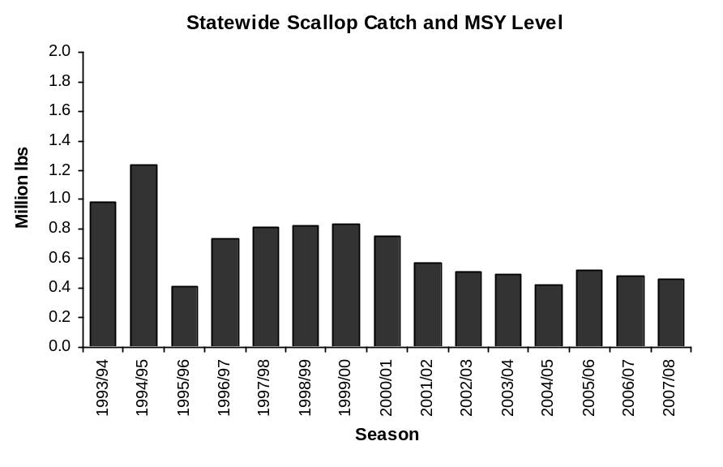
MSY

Figure 3 Statewide scallop harvest (pounds shucked scallop meats) and MSY levels from the FMP.

Stock Status
The following sections provide summaries of recent scallop fishery performance for each registration area.
Dredge survey summary data are provided for Prince William Sound and the Cook Inlet Registration Area. In other areas, dredge surveys are not performed. Fishery CPUE and data from the scallop observer program are the primary information sources. ADF&G camera sled image data have been collected in several management areas, but these data have not yet been used for fishery management purposes.

Yakutat Registration Area
Alaska state regulations limit the combined Yakutat Area D and District 16 scallop harvest to 250,000 lbs of scallop meats per season. Prior to the 2007/08 season, GHLs were set at 0–150,000 lbs for Area D and 0–21,000 lbs for District 16 (Tables 7–8) .

Two co-op vessels participated in the 2007/08 fishery and harvested 125,960 lbs of scallop meats from Yakutat Area D and 180 lbs of scallop meats from Yakutat District 16. Fishery data from recent seasons are presented in Tables 7–8 and Figures 3–5.

For Yakutat Area D, 2007/08 CPUE was 48 lbs meat/dredge hr, close to the 2000/01–2006/07 average of 46 lbs meat/dredge hr (Table 7). SH histograms (Figure 5) indicate that a significant numbers of scallops in the 90–110 mm SH range were discarded during the fishery. ADF&G modeling work on scallop shell age data shows that growth of scallops in the eastern Gulf of Alaska is considerably slower than for Kodiak scallops with an estimated asymptotic size of 136 mm SH compared to 166 mm SH for scallops from the Kodiak area.

Effort in Yakutat District 16 during the 2007/08 season was minimal with a total of 8 tows and catch of 180 lbs of scallop meats (Table 8, Figure 6). No 2007/08 SH histogram was constructed due to small sample sizes, but data from recent years are shown in Figure 7.

Table 7 Yakutat Area D scallop fishery summary statistics.
 | Number | GHL | Dredge | Catchª | CPUE (lbs meat
Season | vessels | (lbs meat) | hoursª | (lbs meat) | per dredge hr)
1993 | 7^{b} | 250,000 | 1,999 | 139,057 | 70
1994 | 10^{b} | 250,000 | 4,130 | 246,862 | 60
1995 | 8^{c} | 250,000 | 4,730 | 237,417 | 50
1996 | 4 | 250,000 | 4,438 | 238,736 | 54
1997 | 4 | 250,000 | 3,956 | 243,810 | 62
1998/99 | 8 | 250,000 | 4,154 | 242,929 | 58
1999/00 | 3 | 250,000 | 3,840 | 249,681 | 65
2000/01 | 3 | 250,000 | 4,241 | 195,699 | 46
2001/02 | 2 | 200,000 | 2,406 | 103,800 | 43
2002/03  5 | 2 | 200,000 | 2,439 | 122,718 | 50
2003/04  5 | 2 | 200,000 | 3,360 | 160,918 | 48
2004/05 | 2 | 200,000 | 2,132 | 86,950 | 41
2005/06 | 2 | 200,000 | 5,089 | 199,351 | 39
2006/07 | 2 | 150,000 | 2,817 | 150,950 | 53
2007/08 | 2 | 150,000 | 2,601 | 125,960 | 48
ª Confidential data released by vessel operators.
^{b} One additional vessel fished by waiver without an observer; data not included.
^{c} Two additional vessels fished by waiver without observers; data not included.

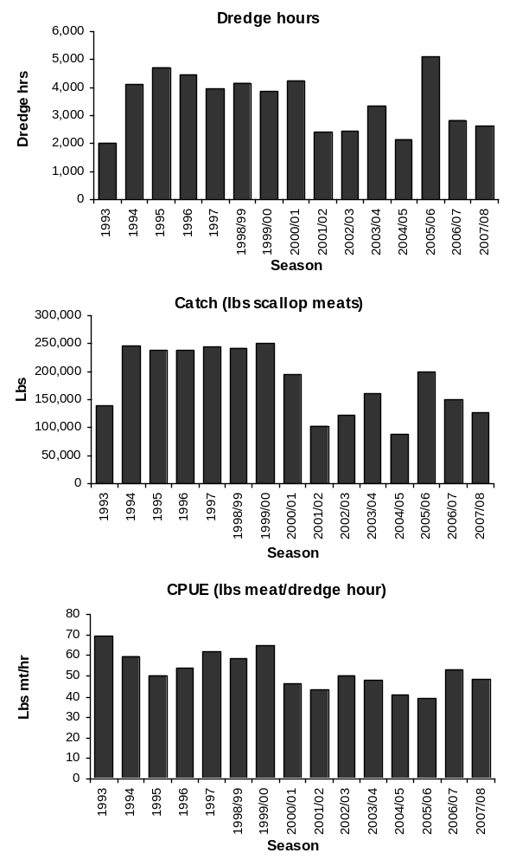

Figure 4 Barplots of Yakutat Area D scallop fishery statistics.

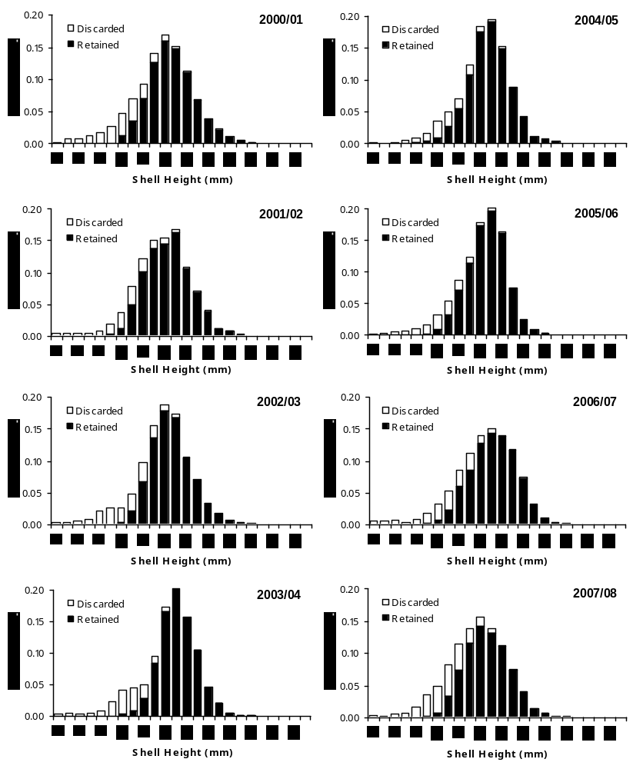

Figure 5 Shell height histograms from resampling Yakutat Area D observer data, 1998/99–2006/07 seasons.
Table 8 Yakutat District 16 scallop fishery summary statistics.
 | Number | GHL ceiling | Dredge | Catchª | CPUE (lbs meat
Season | vessels | (lbs meat) | hoursª | (lbs meat) | per dredge hr)
1993 | 1 | 35,000 |  | confidential
1994 | 7^{b} | 35,000 | 408 | 22,226 | 54
1995 | 6^{b} | 35,000 | 1,095 | 33,302 | 30
1996 | 2 | 35,000 | 917 | 34,060 | 37
1997 | 4 | 35,000 | 561 | 22,020 | 39
1998/99 | 2 | 35,000 | 702 | 34,153 | 49
1999/00 | 2 | 35,000 | 674 | 34,624 | 51
2000/01 | 3 | 35,000 | 476 | 30,904 | 65
2001/02 | 2 | 35,000 | 417 | 20,398 | 49
2002/03  5 | 2 | 35,000 | 100 | 3,685 | 37
2003/04  5 | 2 | 35,000 | 18 | 1,072 | 59
2004/05 | 2 | 35,000 | 419 | 24,430 | 58
2005/06 | 2 | 35,000 | 407 | 13,650 | 34
2006/07 | 2 | 21,000 | 309 | 13,445 | 44
2007/08 | 1 | 21,000 | 6 | 180 | 30
ª Confidential data released by vessel operators.
^{b} One additional vessel fished by waiver without an observer; data not included.

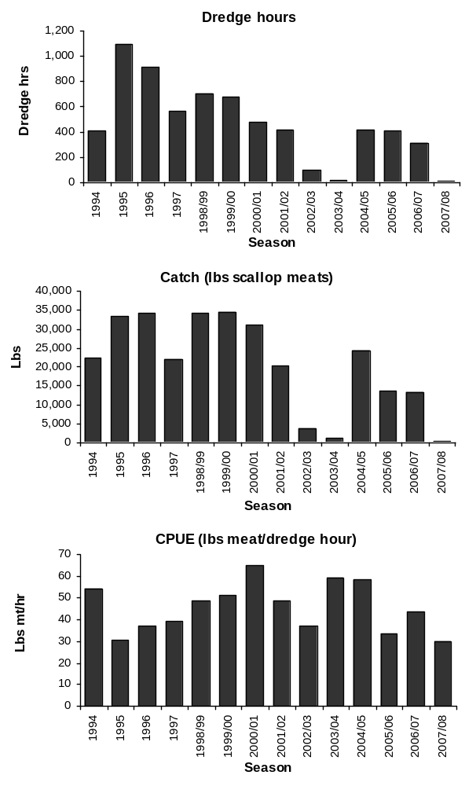

Figure 6 Barplots of Yakutat District 16 scallop fishery statistics.

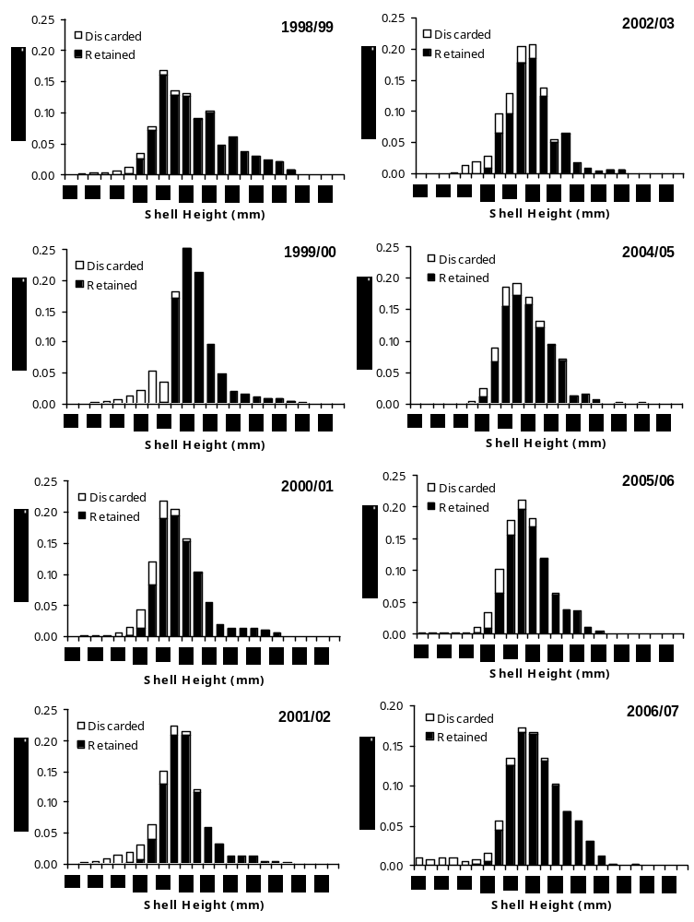

Figure 7 Shell height histograms from resampling Yakutat District 16 observer data. Insufficient data were collected to produce plots for the 2003/04 and 2007/08 seasons.

Prince William Sound Registration Area
Scallop dredge surveys are conducted biennially in the Prince William Sound Registration Area (Area E) near Kayak Island (Figure 1and Figure 2). In 2008, the survey was set to a standardized area. A total of 47 successful 1nm dredge tows were made during the 2008 Kayak Island survey (37 in the East bed and 10 in the West bed). The slightly fewer number of tows in this year was due to inclement weather conditions. Catch in the east bed was 4,356 weathervane scallops weighing 1,340 kg (2,954 lb). Catch abundance ranged from 0 to 654 scallops/nm resulting in a mean among all stations of 117.7 scallops/nm. Standardized catches by weight ranged from 0 to 199.7 kg/nm (440.3 lb/nm) with a mean catch among all stations fished of 36.2 kg/nm (79.8 lb/nm). Catch in the west bed was 1,058 weathervane scallops weighing 196 kg (432 lb). Catch abundance ranged from three to 374 scallops/nm resulting in a mean among all stations of 105.8 scallops/nm. Standardized catches by weight ranged from 0.01kg (0.02 lb/nm) to 71.5 kg/nm (157.6 lb/nm) with a mean catch among all stations fished of 19.6 kg/nm (43.2 lb/nm). Abundance and biomass estimates from all Kayak Island surveys are given in Table 9. Preliminary efforts using underwater video techniques to evaluate survey dredge catchability in 2004 provided a mean catchability coefficient (q) of 0.83, which has been applied since 2006 (Table 9). The goal is to further assess dredge catchability and better estimate q, thereby increasing accuracy of survey estimates and resulting in more appropriate harvest limits by using a q-value less than one.

Two catcher processors participated in the 2006/07 Area E fishery and harvested approximately 37,000 lbs of scallop meats (Table 10). Fishery data from recent seasons are presented in Table 8 and Figures 7–8.

Two vessels participated in the 2007/08 Area E fishery and harvested approximately 37,000 lbs of scallop meats (Table 10). Area E CPUE was 90 lbs meat dredge hr for the 2007/08 season (Table 10, Figure 8).

Plots of Prince William Sound SH distributions from the commercial fishery (Figure 9) show the range of shell heights caught in the fishery has been very consistent over the years.
Table 9. Standardized Kayak Island dredge survey summary. Standardized areas are 78.99 nm² for the East bed and 48.66 nm² for the West bed. Table provides biomass estimates using catchability coefficients (q) of 1 and 0.83 (which stems from preliminary work on dredge catchability)
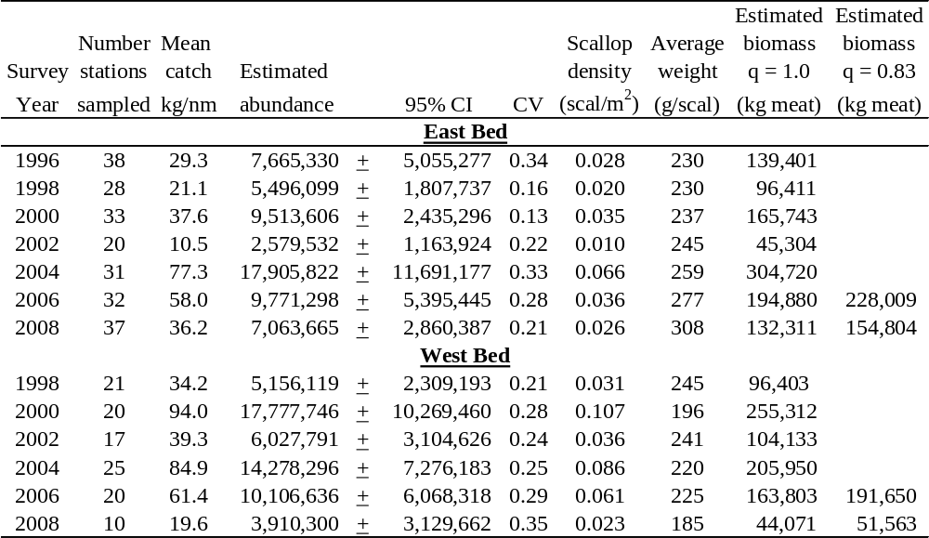

Table 10 Prince William Sound Area E scallop fishery summary statistics.
 | Number | GHL | Dredge | Catchª | CPUE (lbs meat
Season | vessels | (lbs meat) | hoursª | (lbs meat) | per dredge hr)
1993 | 7 | 50,000 | 638 | 63,068 | 99
1994 |  | Closed
1995 | 3 | 50,000 |  | 108,000^{b}
1996 |  | Closed
1997 | 1 | 17,200 | 171 | 18,000 | 105
1998/99 | 2 | 20,000 | 179 | 19,650 | 110
1999/00 | 2 | 20,000 | 149 | 20,410 | 137
2000/01 | 3 | 30,000 | 221 | 30,266 | 137
2001/02 | 1 | 30,000 | 263 | 30,090 | 114
2002/03 | 2 | 20,000 | 122 | 15,641 | 121
2003/04 | 1 | 20,000 | 216 | 19,980 | 93
2004/05 | 2 | 50,000 | 614 | 49,320 | 80
2005/06 | 3 | 50,000 | 491 | 49,205 | 100
2006/07 | 2 | 37,000 | 334 | 36,990 | 111
2007/08 | 2 | 37,000 | 428 | 37,105 | 87
ª Confidential data released by vessel operators.
^{b} Total includes illegal fishing by one vessel; effort data not available.

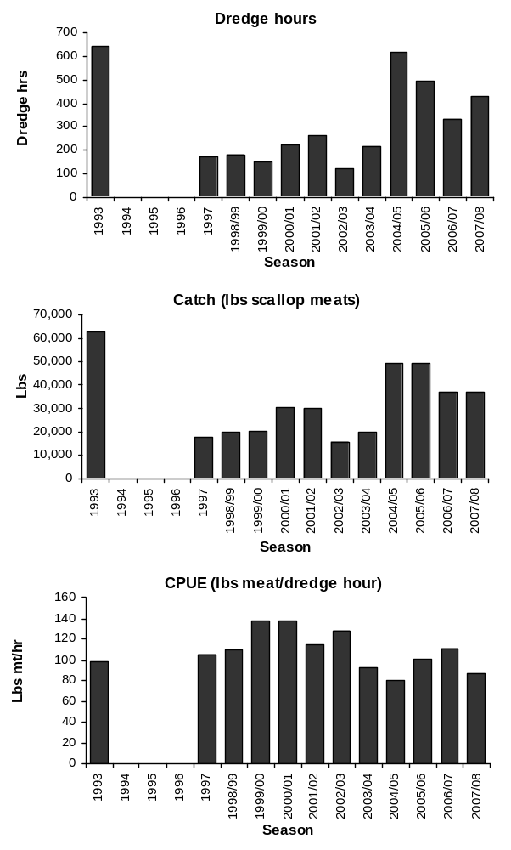

Figure 8 Barplots of Area E scallop fishery statistics.

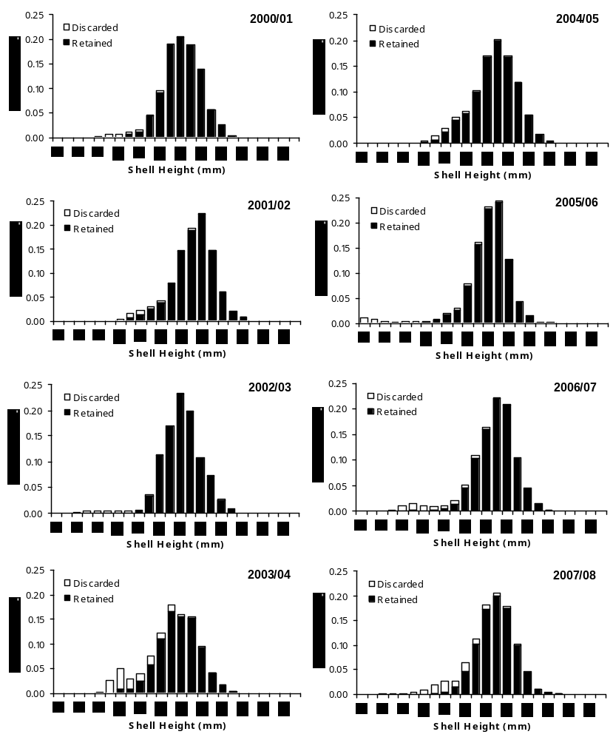

Figure 9 Shell height histograms from resampling Area E observer data, 2000/01–2006/07. Insufficient data were available to produce plots for earlier seasons.

Cook Inlet Registration Area, Kamishak District
Scallop dredge surveys are conducted biennially in the Cook Inlet Registration Area (Area H) in Kamishak Bay (Figure 1and Figure 2).The Cook Inlet scallop fishery is prosecuted in the Kamishak District by vessels that are limited to one 6-foot dredge. The third-party contract observer requirement is waived by the ADF&G fishery manager provided that participants accommodate an ADF&G observer when requested. Other areas of Cook Inlet were explored briefly but are not currently fished (Trowbridge and Bechtol 2003). Much of Cook Inlet is closed to scallop dredging (Figure 2).

A total of 74 successful 1nm dredge tows were conducted during the 2007 Kamishak Bay weathervane scallop survey (43 in the north bed and 31 in the south bed). Catch in the north bed was 3,175 weathervane scallops weighing 1,122 kg (2,474 lb). Catch abundance ranged from 0 to 305 scallops/nm resulting in a mean among all stations of 73.8 scallops/nm. Standardized catches by weight ranged from 0 to 84.8 kg/nm (187.1lb/nm) with a mean catch among all stations fished of 26.1 kg/nm (57.5lb/nm). Catch in the south bed was 3,580 weathervane scallops weighing 728 kg (1,606 lb). Catch abundance ranged from 0 to 453 scallops/nm resulting in a mean among all stations of 115.5 scallops/nm. Standardized catches by weight ranged from 0 to 108.0 kg/nm (238.1 1lb/nm) with a mean catch among all stations fished of 23.5 kg/nm (51.8 lb/nm). Abundance and biomass estimates from all Kamishak Bay surveys are given in Table 11.

The guideline harvest regulation specified by state regulation for the Kamishak District is 10,000 to 20,000 pounds of shucked meats.

During the 2004/05 season, 3 vessels participated in the fishery harvesting 6,117 lbs of scallop meats (Table 12). Participation and CPUE in this small fishery vary widely (Table 12, Figure 10) and no vessels have fished these scallop beds in the past two years.

Table 11 Standardized Kamishak Bay dredge survey summary. Standardized areas are 90.2 nm² for the North bed and 68.0 nm² for the South bed.
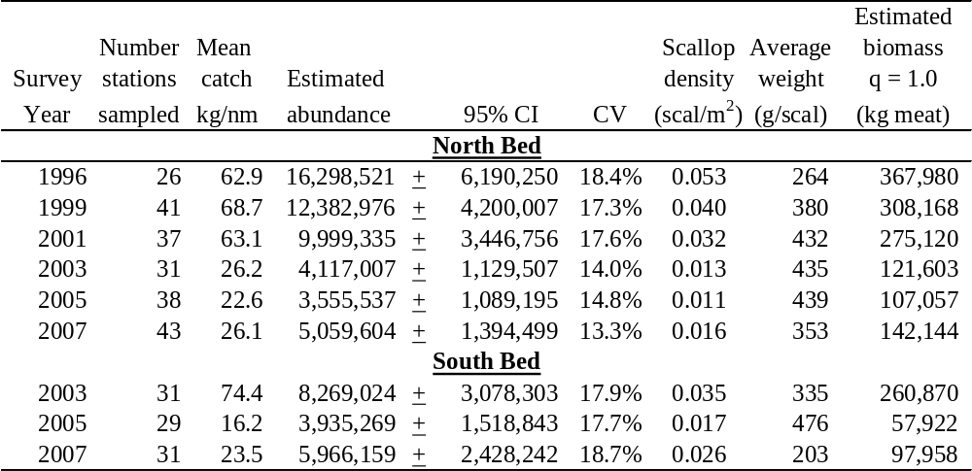
Table 12 Cook Inlet, Kamishak District scallop fishery summary statistics.
 | Number | GHL | Dredge | Catchª | CPUE (lbs meat
Season | vessels | (lbs meat) | hours | (lbs meat) | per dredge hr)
1993 | 3 |  | 529 | 20,115 | 38
1994 | 4 |  | 454 | 20,431 | 45
1995 |  | closed
1996 | 5 |  | 534 | 28,228 | 53
1997 | 3 | 20,000 | 394 | 20,336 | 52
1998 | 1 | 20,000 | 390 | confidential
1999 | 3 | 20,000 | 333 | 20,315 | 61
2000 | 3 | 20,000 | 276 | 20,516 | 74
2001 | 2 | 20,000 | 406 | confidential
2002 | 3 | 20,000 | 311 | 8,591 | 28
2003 | 2 | 20,000 | 862 | confidential
2004 | 3 | 20,000 | 364 | 6,117 | 17
2005 | 2 | 7,000 | 199 | confidential
2006 | 1 | 7,000 | 10 | confidential
2007
ª Includes estimated dead loss.

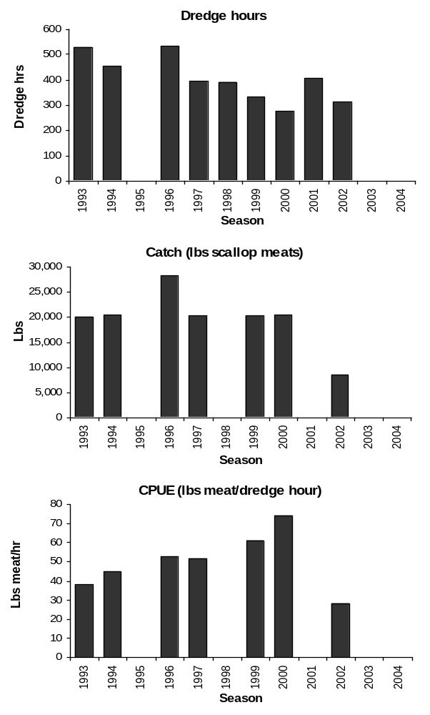
Figure 10 Barplots of Area H scallop fishery statistics.

Kodiak Registration Area, Northeast District

Two cooperative vessels harvested about 75,000 lbs of scallop meats from the Northeast District of the Kodiak Management Area during the 2007/08 season. Summary statistics from recent fishery data are presented in Table 13 and Figures 11–12.

The Northeast District GHL was raised to 90,000 lbs for the 2006/07 and 2007/08 seasons through addition of 15,000 lbs that could be harvested only from an exploratory area north of Cape Izhut (58.1° N latitude). This area lies east of Afognak and Marmot Islands and north of areas fished since inception of the observer program in 1993. Scallops were last harvested in this area during the 1980s.

Northeast District catches and CPUE have remained remarkably stable since the 2000/01 fishing season (Table 12, Figure 11). Less than 100 lbs scallops meats were harvested from 25 dredge hours of effort in the exploratory area during he 2007/08 season.

Large portions of the Northeast District that contain scallops are closed to scallop dredging (Figure 2). These closures were recommended by ADF&G and adopted by the Alaska BOF over 30 years ago due to concerns about red king crab bycatch and gear conflicts.

The weathervane scallop population in the Northeast District of the Kodiak Registration Area has never been surveyed and no abundance estimates are available.

Table 13 Kodiak Northeast District scallop fishery summary statistics.
 | Number | GHL | Dredge | Catchª | CPUE (lbs meat
Season | vessels | (lbs meat) | hours | (lbs meat) | per dredge hr)
1993/94 | 10 | NA | 6,940 | 155,187 | 22
1994/95 | 7 | NA | 1,773 | 35,207 | 20
1995/96 |  | closed
1996/97 | 3 | NA | 581 | 11,430 | 20
1997/98 | 3 | NA | 2,604 | 95,858 | 37
1998/99 | 4 | NA | 2,749 | 120,010 | 44
1999/00 | 3 | 75,000 | 1,384 | 77,119 | 56
2000/01 | 4 | 80,000 | 1,101 | 79,965 | 73
2001/02 | 3 | 80,000 | 1,142 | 80,470 | 70
2002/03  5 | 2 | 80,000 | 1,350 | 80,000 | 59
2003/04 | 2 | 80,000 | 1,248 | 79,965 | 64
2004/05 | 2 | 80,000 | 1,227 | 80,105 | 65
2005/06 | 3 | 80,000 | 1,759 | 79,990 | 45
2006/07 | 2 | 90,000 | 1,168 | 75,150 | 64
2007/08 | 2 | 90,000 | 1,170 | 75,105 | 64
ª Confidential data released by vessel operators.
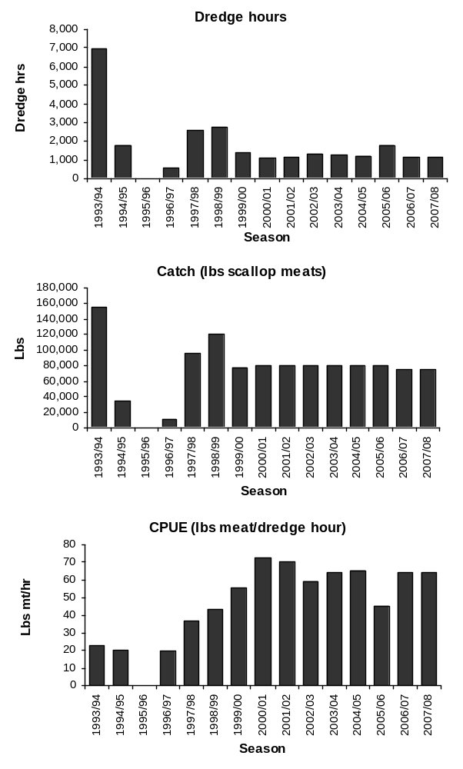

Figure 11 Barplots of Kodiak Northeast District scallop fishery statistics.
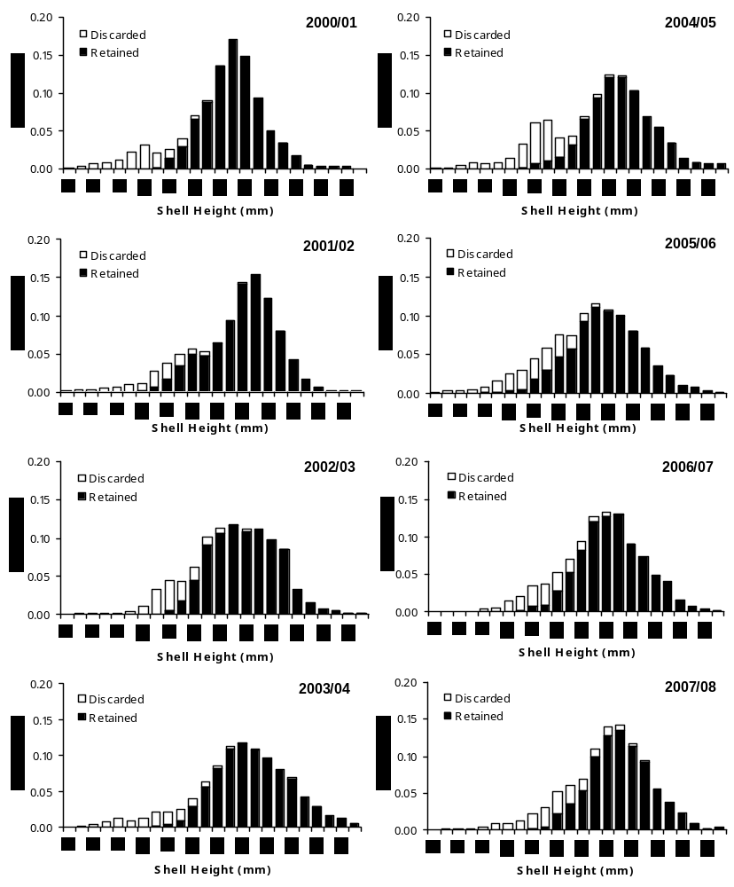

Figure 12 Shell height histograms from resampling Kodiak Northeast District scallop observer data, 1999/2000–2006/07.

Kodiak Registration Area, Shelikof District

The 2007/08 Shelikof District GHL was set at 170,000 lbs, an increase of 10,000 lbs due to increasing catch rates in the southern portion of the bed for the 2005/06 and 2006/07 seasons. Two cooperative vessels and a smaller vessel that deployed a single 10 ft dredge participated in the 2007/08 fishery and harvested about 170,000 lbs. Summary statistics from recent fishery data area presented in Table 13 and Figures 13–14.

Shelikof District CPUE decreased to 58 lbs meat/dredge hr for the 2007/08 season (Table 13, Figure 13). ADF&G attributes this decline at least in part to participation of the additional vessel that deployed a smaller dredge. ADF&G does not account for dredge width in CPUE calculations. CPUE has been 50 lbs meat/dredge hr or higher in each season since 2003/04. Significant numbers of scallops <120 mm SH were discarded during the 2007/08 season (Figure 14).

To protect depressed red king crab and Tanner crab populations, the BOF closed Kodiak’s westside bays to scallop fishing in1990; weathervane scallops are known to inhabit these closed waters (Figure 2).

Table 14 Kodiak Shelikof District scallop fishery summary statistics.
 | Number | GHL | Dredge | Catchª | CPUE (lbs meat
Season | vessels | (lbs meat) | hoursª | (lbs meat) | per dredge hr)
1993/94 | 5 | NA | 2,491 | 105,017 | 42
1994/95 | 11 | NA | 8,662 | 314,051 | 36
1995/96 |  | closed
1996/97 | 3^{b} | NA | 3,491 | 219,305 | 63
1997/98 | 4 | NA | 5,492 | 258,346 | 47
1998/99 | 8 | NA | 4,081 | 179,870 | 44
1999/00 | 6 | 180,000 | 4,304 | 187,963 | 44
2000/01 | 5 | 180,000 | 2,907 | 180,087 | 62
2001/02 | 4 | 180,000 | 3,398 | 177,112 | 52
2002/03  5 | 3 | 180,000 | 3,799 | 180,580 | 48
2003/04 | 2 | 180,000 | 3,258 | 180,011 | 55
2004/05 | 2 | 180,000 | 3,467 | 174,622 | 50
2005/06 | 2 | 160,000 | 2,280 | 159,941 | 70
2006/07 | 3 | 160,000 | 2,183 | 162,537 | 74
2007/08 | 3 | 170,000 | 2,937 | 169,968 | 58
ª Confidential data released by vessel operators.
^{b} One additional vessel fished but data were not available.

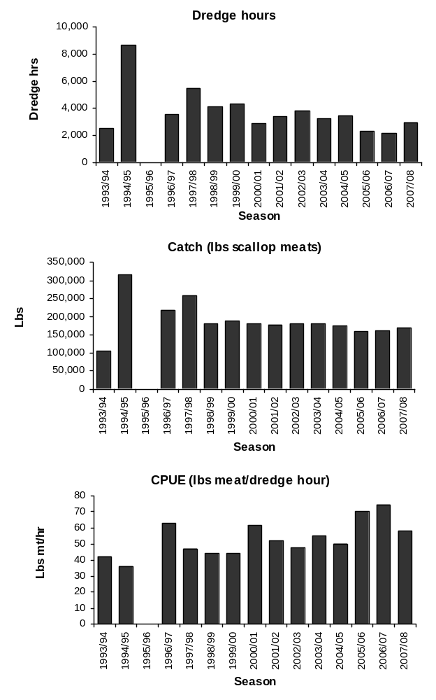

Figure 13 Barplots of Kodiak Shelikof District scallop fishery statistics.

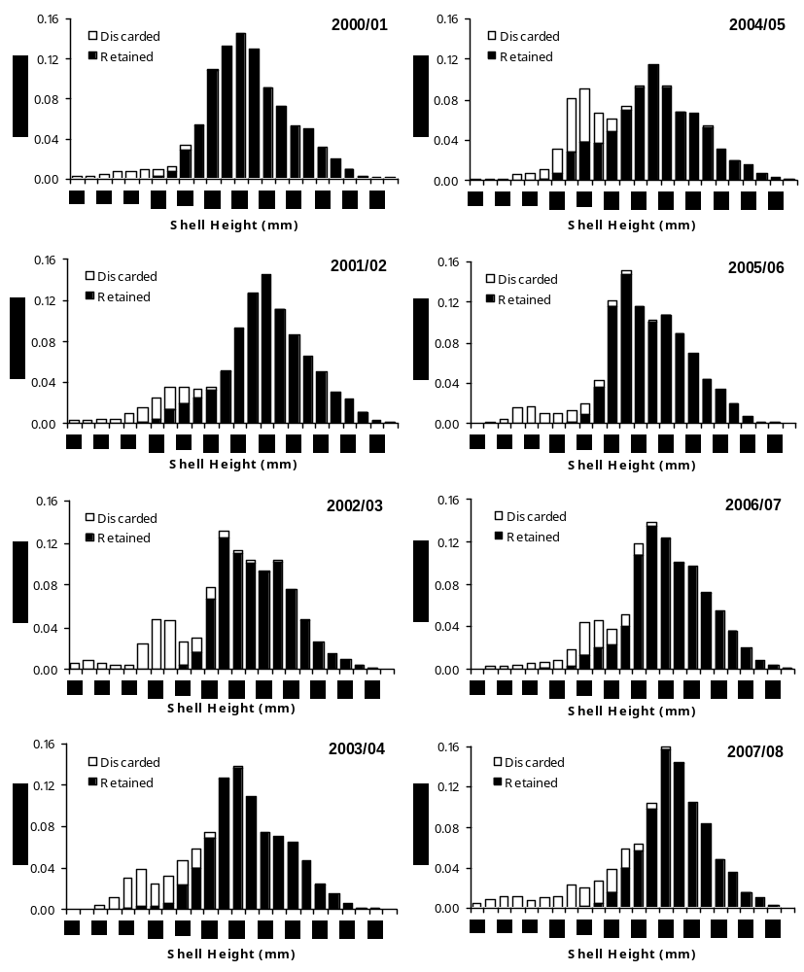

Figure 14 Shell height histograms from resampling Kodiak Shelikof District scallop observer data, 19992000–2006/07.

Kodiak Registration Area, Semidi District

Traditional scallop fishing areas of the Semidi District are located in state waters that were closed to scallop dredging by the BOF in 2000 (Figure 2). Other parts of the district remain open to fishing, but no effort has occurred since the 1999/00 season (Table 15).

Table 15 Kodiak Semidi District scallop fishery summary statistics.
 | Number | GHL | Dredge | Catchª | CPUE (lbs meat
Season | vessels | (lbs meat) | hoursª | (lbs meat) | per dredge hr)
1993/94 | 6^{b} | NA | 1,819 | 55,487 | 32
1994/95 | 2 | NA | 272 | confidential
1995/96 |  | closed
1996/97 | 3 | NA | 1,017 | 37,810 | 37
1997/98 | 1 | NA | 349 | 6,315 | 18
1998/99 | 2 | NA | 106 | 1,720 | 16
1999/00 | 1 | NA | 45 | 930 | 21
ª Confidential data released by vessel operators.
^{b} Two additional vessel fished but data are not available.

Alaska Peninsula Registration Area

Scallop fishing in the Alaska Peninsula Registration Area (Area M) was traditionally concentrated in a small region near the Shumagin Islands between 160° and 161° W longitude. Area M was closed for the 2001/2002 and 2002/03 seasons due to concerns about potential localized depletion (Table 16, Figure 15).

For the 2003/04 and 2004/05 seasons, the area between 160° and 161° W longitude remained closed to promote stock rebuilding, while the remainder of the area was opened with a 10,000 pound GHL. For the 2005/06 season, the area between 160° and 161° W. longitude opened with a GHL of 10,000 lbs, the remainder of the area was opened with a GHL of 10,000 lbs, and no effort occurred. During the 2006/07 season, two cooperative vessels fished traditional areas and adjacent waters on an experimental basis and found poor scalloping, indicating that no effort for a 5-yr period had no beneficial effect on the population.

Table 16 Alaska Peninsula Area scallop fishery summary statistics.
 | Number | GHL | Dredge | Catchª | CPUE (lbs meat
Season | vessels | (lbs meat) | hoursª | (lbs meat) | per dredge hr)
1993/94 | 8 | NA | 1,847 | 112,152 | 61
1994/95 | 7 | NA | 1,664 | 65,282 | 39
1995/96 |  | closed
1996/97 | 2 | 200,000 | 327 | 12,560 | 38
1997/98 | 4 | 200,000 | 1,752 | 51,616 | 29
1998/99 | 4 | 200,000 | 1,612 | 63,290 | 39
1999/00 | 5 | 200,000 | 2,025 | 75,535 | 37
2000/01 | 3 | 33,000 | 320 | 7,660 | 24
2001/02 |  | closed
2002/03  5 |  | closed
2003/04 |  | 10,000
2004/05 |  | 10,000
2005/06 |  | 20,000
2006/07 | 2 | 25,000 | 64 | 155 | 2
2007/08 |  | 10,000
ª Confidential data released by vessel operators.

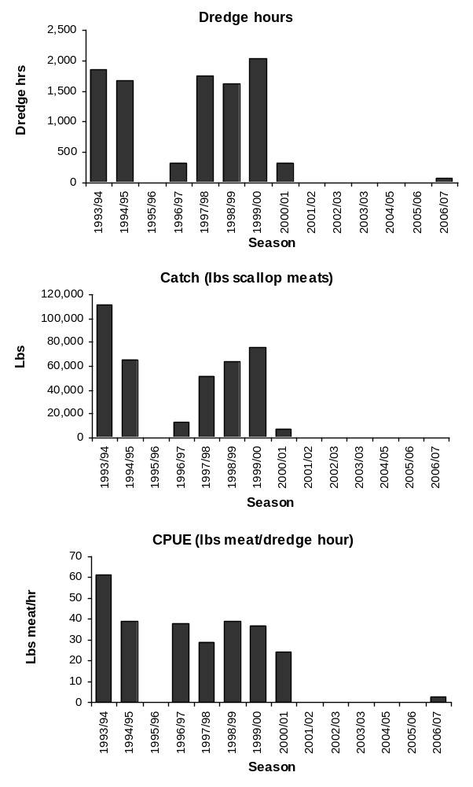

Figure 15 Barplots of Alaska Peninsula scallop fishery statistics.

Bering Sea Registration Area

Scallop fishing in the Bering Sea Registration Area (Area Q) occurs north of Unimak Island (Figure 1 and Figure 2), Two cooperative vessels participated in the 2007/08 fishery and harvested 49,995 lbs of shucked scallop meats (Table 17, Figure 16–17).

Large Bering Sea scallop catches landed during the early 1990s (Table 16, Figure 16) do not appear to be sustainable. The GHL was reduced to 50,000 lbs for the 2005/06 season. Experimental scallop video research conducted in the Bering Sea in 2003 showed that the stock is distributed over a wide, poorly defined area at low densities.

Although incidental catches of Chionoecetes crabs in the Bering Sea scallop fishery have remained below CBLs in recent years, concerns about Chionoecetes bycatch rates often alter fleet behavior in the fishery. Scallop vessels frequently move to avoid high crab bycatch areas, which may in turn reduce CPUE and profitability. Dredging operations create feeding opportunities for crabs and juvenile flatfish, so when a profitable scalloping area is found, bycatch rates tend to increase over time and may force the vessel to move. Industry attributes harvests that have fallen below the upper end of the GHR in recent seasons to bycatch avoidance.

Large portions of the eastern Bering Sea shelf and the Pribilof Islands Habitat Conservation Area are closed to scallop fishing to protect red and blue king crab habitat and to provide for habitat conservation (Figure 2).

Table 17 Bering Sea Area scallop fishery summary statistics.
 | Number | GHL | Dredge | Catchª | CPUE (lbs meat
Season | vessels | (lbs meat) | hoursª | (lbs meat) | per dredge hr)
1993/94 | 9 | NA | 5,764 | 284,414 | 49
1994/95 | 8 | NA | 11,113 | 505,439 | 45
1995/96 |  | closed
1996/97 | 1 | 600,000 | 2,313 | 150,295 | 65
1997/98 | 2 | 600,000 | 2,246 | 97,002 | 43
1998/99 | 4 | 400,000 | 2,319 | 96,795 | 42
1999/00 | 2 | 400,000 | 3,294 | 164,929 | 50
2000/01 | 3 | 200,000 | 3,355 | 205,520 | 61
2001/02 | 3 | 200,000 | 3,072 | 140,871 | 46
2002/03  5 | 2 | 105,000 | 2,038 | 92,240 | 45
2003/04 | 2 | 105,000 | 1,020 | 42,590 | 42
2004/05 | 1 | 105,000 | 275 | 10,050 | 37
2005/06 | 1 | 50,000 | 602 | 23,220 | 39
2006/07 | 1 | 50,000 | 1,138 | 48,246 | 43
2007/08 | 2 | 50,000 | 1,084 | 49,995 | 46
ª Confidential data released by vessel operators.

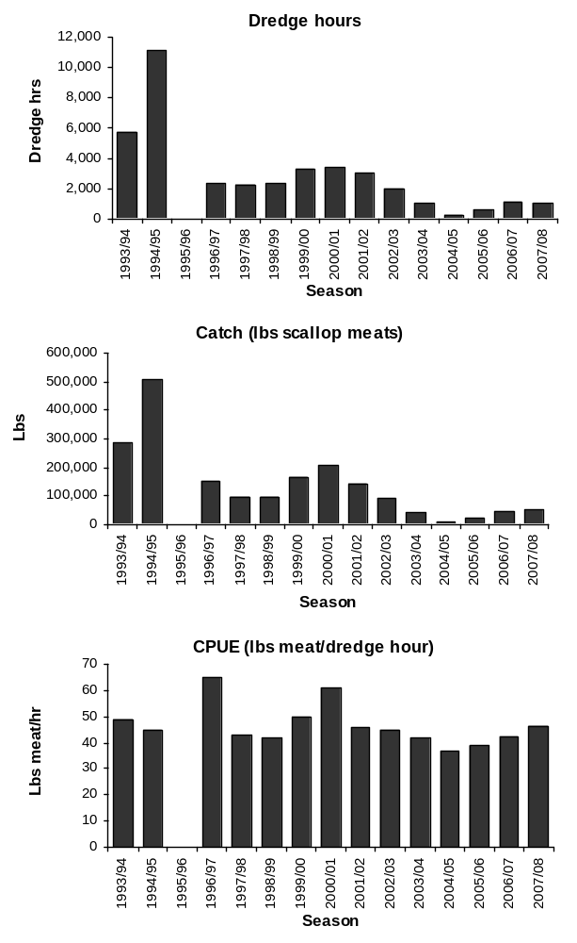

Figure 16 Barplots of Bering Sea scallop fishery statistics.
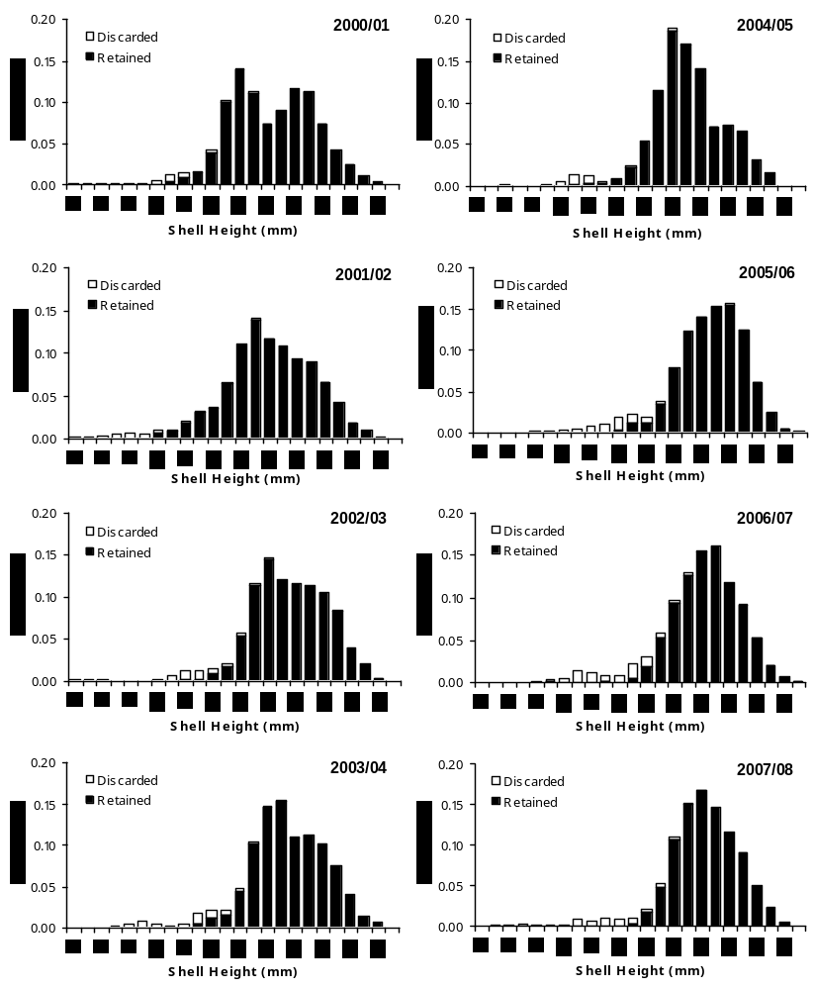

Figure 17 Shell height histograms from resampling Bering Sea scallop observer data, 1999/2000–2006/07.

Dutch Harbor Registration Area
The Dutch Harbor Registration Area (Area O) was opened during 2002/03 for the first time since the 1999/00 season. One vessel fished briefly and harvested about 6,000 lbs of scallop meats, with CPUE that was low but comparable to CPUE from earlier seasons (Table 18). Managers decided in 2003 to close the area for at least 3 additional years to allow for stock rebuilding. Productive scallop grounds that contributed significantly to the overall harvest were closed to scallop fishing before 1986, primarily as a protective measure for crab nursery areas (Figure 2).

The weathervane scallop population in the Dutch Harbor Registration Area is not surveyed and no estimate of abundance has been made. There are currently no plans to survey this population.

Table 18 Dutch Harbor Area scallop fishery summary statistics.
 | Number | GHL | Dredge | Catchª | CPUE (lbs meat
Season | vessels | (lbs meat) | hoursª | (lbs meat) | per dredge hr)
1993/94 | 2 | 170,000 | 838 | confidential | 46
1994/95 | 3 | 170,000 | 81 | 1,931 | 24
1995/96 | 1 | 170,000 | 1,047 | 26,950 | 26
1996/97 |  | 170,000
1997/98 | 1 | 170,000 | 171 | 5,790 | 34
1998/99 | 4 | 110,000 | 1,025 | 46,432 | 45
1999/00 | 1 | 110,000 | 273 | 6,465 | 24
2000/01 |  | closed
2001/02 |  | closed
2002/03  5 | 1 | 10,000 | 184 | 6,000 | 33
2003/04 |  | closed
2004/05 |  | closed
2005/06 |  | closed
2006/07 |  | closed
2007/08 |  | closed
ª Confidential data released by vessel operators.

Adak Area
ADF&G records indicate that scallops were harvested from the Adak Registration Area in 1979, 1992, and 1995. Few vessels participated making catch and effort data confidential. Little is known about scallop populations in this area. The Petrel Bank between 51º30’ N. latitude and 54º30’ N. latitude, west of 179º W. longitude and east of 179º East longitude was closed in 1991 due to concerns about king crab bycatch during the Chlamys (pink scallop) fishery. ADF&G opens the area each season with a GHL of 0–75,000 pounds, but no vessels have participated since 1995.
The weathervane scallop population in the Adak Registration Area is not surveyed and no estimate of abundance has been made. There are currently no plans to survey this population. The continental shelf adjacent to the Aleutian Islands is narrow, providing limited weathervane scallop habitat.

Ecosystem Considerations
The Ecosystem Considerations section was added to the SAFE in 2006. The SPT is continuing to organize and improve the section. A wealth of information on climate effects on ecosystems and ecosystem trends contained in the GOA Groundfish Plan Team Ecosystems Considerations document is equally relevant to the scallop fishery and may be accessed at http://www.fakr.noaa.gov/npfmc/SAFE/SAFE.htm

Habitat
The Alaska weathervane scallop fishery occurs in continental shelf waters at depths 40–150 m in three main areas: the eastern Gulf of Alaska between Prince William Sound and Cape Spencer, around Kodiak Island, and in the eastern Bering Sea (Figure 2). Because the fishery footprint is confined to these areas and many areas of similar habitat are closed to scallop dredging, we expect the effects of the fishery on the GOA and Bering Sea ecosystems to be minor.

Commercial concentrations of weathervane scallops occur along the Alaska coast in elongated beds oriented in the same direction as prevailing currents. Image data from ADF&G camera sled tows show that benthic habitats where scallop fishing occurs in the Bering Sea, eastern GOA, and Shelikof Strait, consist predominately of fine sediments (silt, mud, and sand), with sediments regularly suspended by tidal currents. Areas of harder bottom with larger sediment sizes are found alongside scallop fishing areas, particularly inshore from where fishing occurs. ADF&G is beginning to use camera sled data to document and map habitat in the vicinity of scallop fishing areas. ADF&G hopes to study habitat in closed areas inhabited by scallops in the future as well.

Essential Fish Habitat (EFH) descriptions for weathervane scallops are being revised under Amendment 9 to the Scallop FMP. There is no available life history information for other scallop species (pink, spiny and rock scallops). More information on EFH designations may be found at: http://www.fakr.noaa.gov/habitat/efh.htm.

Bycatch
Scallop fishery bycatch is closely monitored by the onboard observer program (2.4). Bycatch in the scallop fishery includes prohibited species such as red king crab, Tanner crab, snow crab, and Pacific Halibut, other commercially important species of fish and invertebrates, miscellaneous non-commercial species, and natural and man-made debris. Although a variety of marine vertebrates, invertebrates, and debris are caught incidentally in scallop dredges, weathervane scallops predominate catches.

During the 1996/97–2004/05 seasons, the five most frequently caught species or items, statewide, by percent weight, from haul composition sampling were: weathervane scallops 77%, numerous species of starfish 5%, natural debris (kelp, wood, etc.) 5%, empty bivalve shells 4%, and several species of skates 2%. Gorgonian (hard) corals are infrequently encountered by scallop observers; since 1996, corals have been observed in only 11 of the 15,836 tows sampled for catch composition and bycatch. Summaries of haul composition sampling are presented in observer reports prepared by ADF&G (e.g., Barnhart and Rosenkranz 2003).

Trawl Survey Information on Scallop Stocks

Trawl surveys for fisheries stock assessment are conducted annually in the Gulf of Alaska and the Bering Sea by NMFS and ADF&G. Although these surveys target crab and groundfish and the gear is not designed to efficiently capture scallops, weathervane scallops are caught in some areas and survey data provide information on the range of the species.

In the eastern GOA (Figure 18), weathervane scallops have been captured during trawl surveys offshore from traditional scallop fishing grounds and in closed waters adjacent to Prince William Sound. Around Kodiak Island (Figure 19), trawl surveys have captured scallops in closed waters south of the island and in many bays and inlets. Along the south side of the Alaska Peninsula, trawl survey data indicate that most scallop habitat lies in coastal waters that are closed to scallop fishing, while scallops have been captured during trawl surveys over a large swath of the eastern Bering Sea shelf (Figure 20).

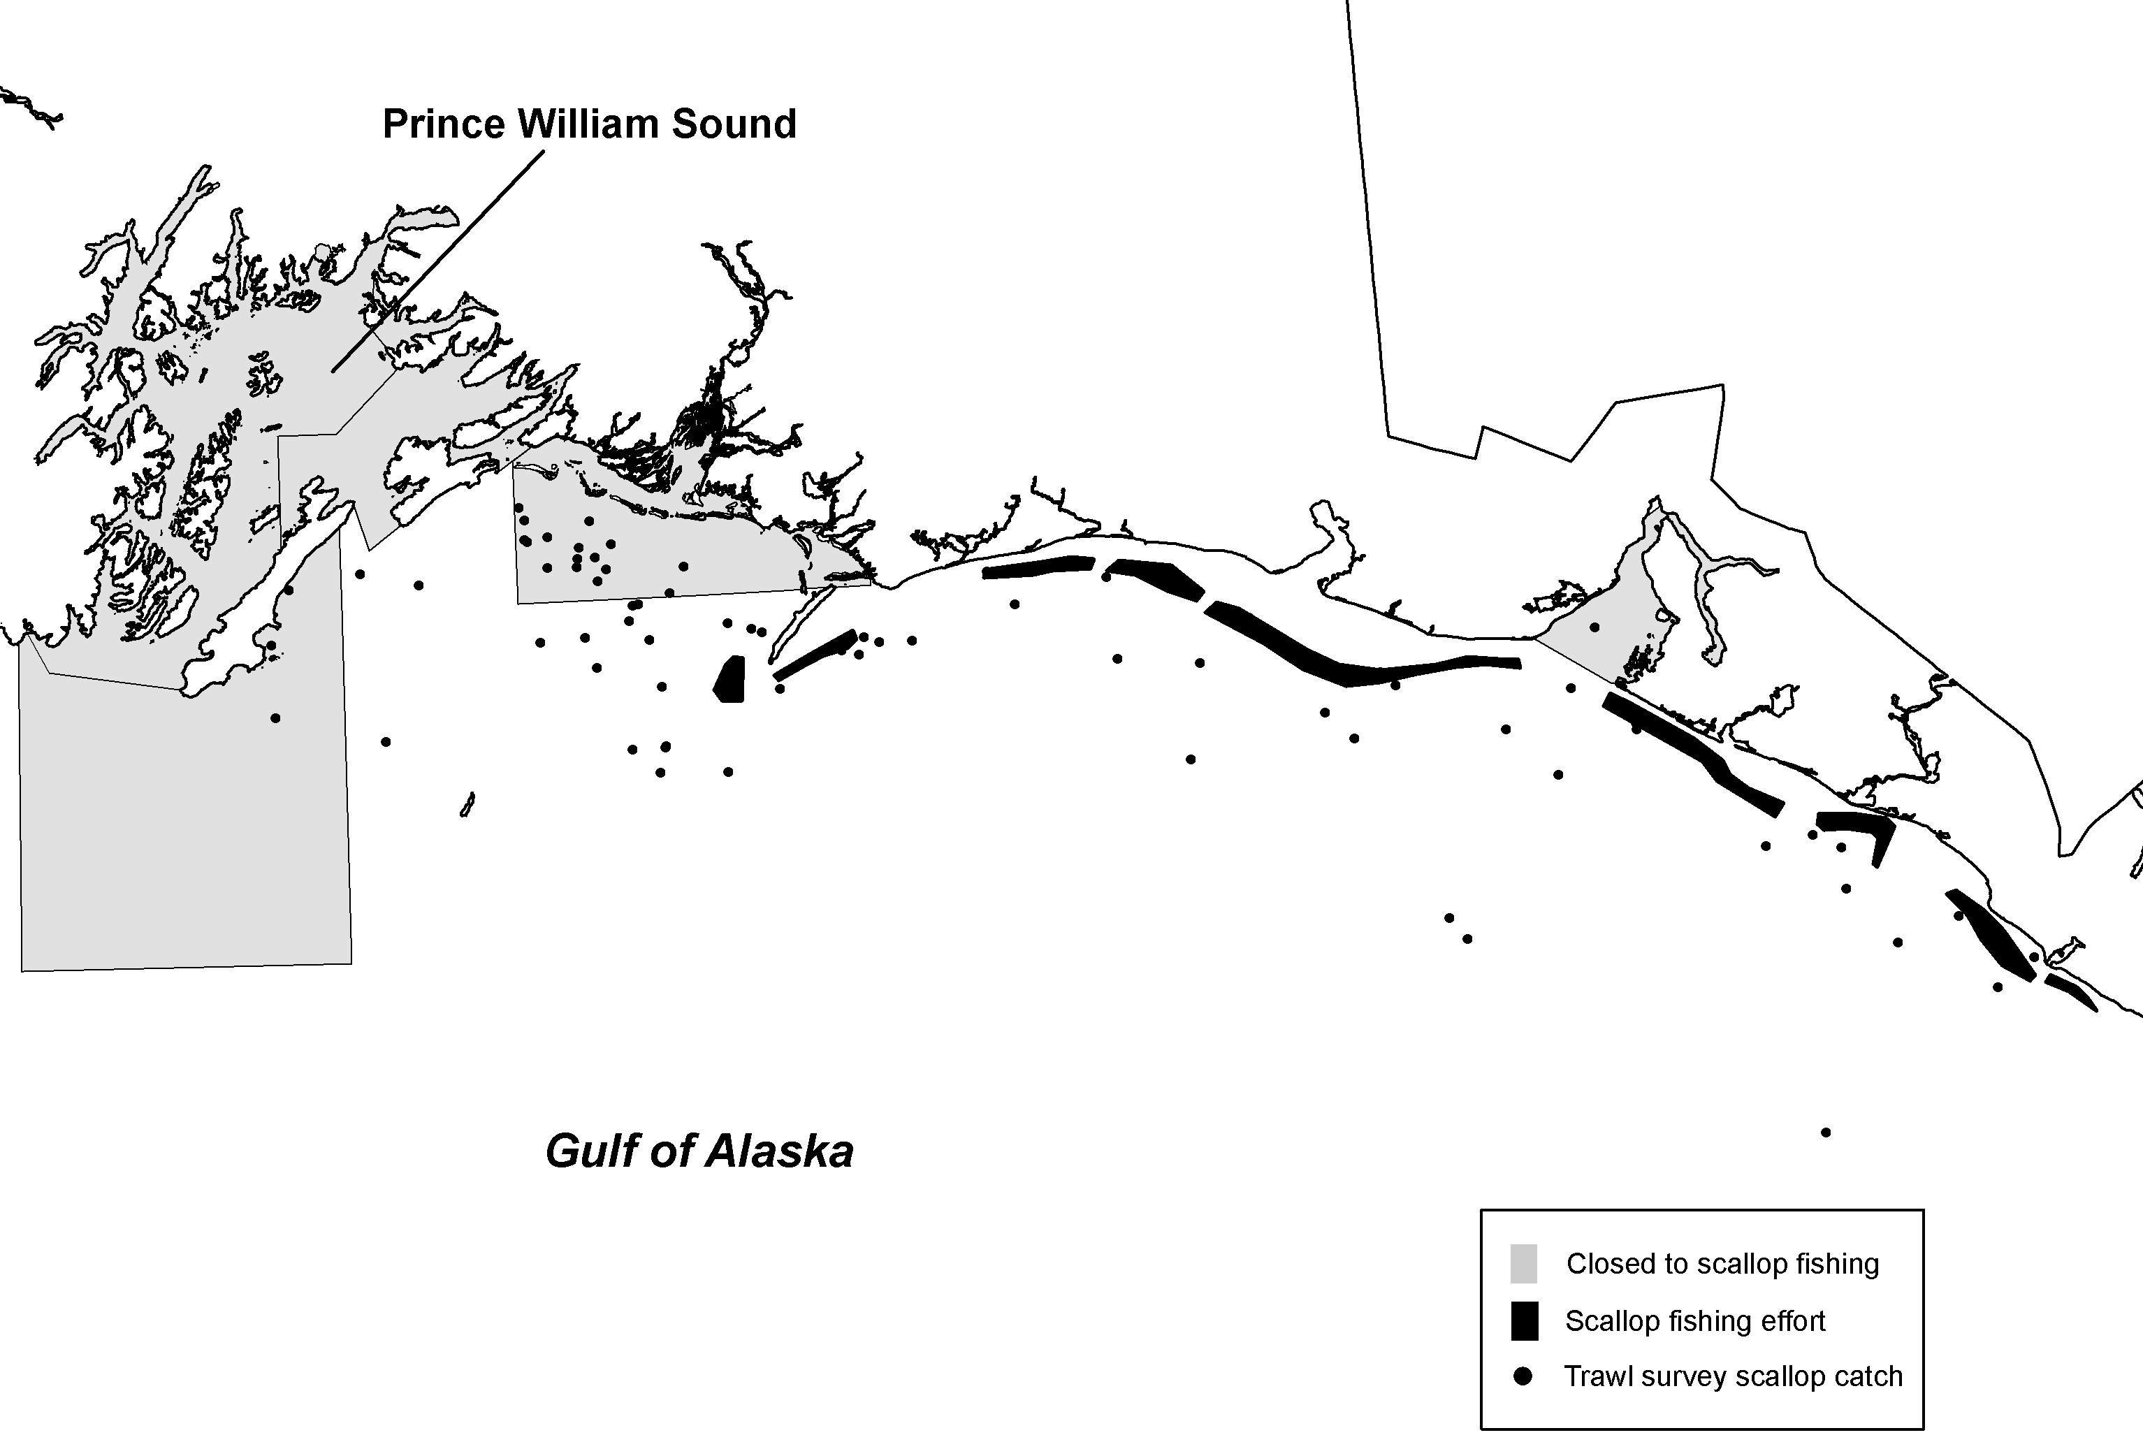

Figure 18 Map showing scallop fishing areas, areas closed to scallop fishing by regulation, and locations where weathervane scallops were captured during NMFS trawl surveys in the eastern Gulf of Alaska

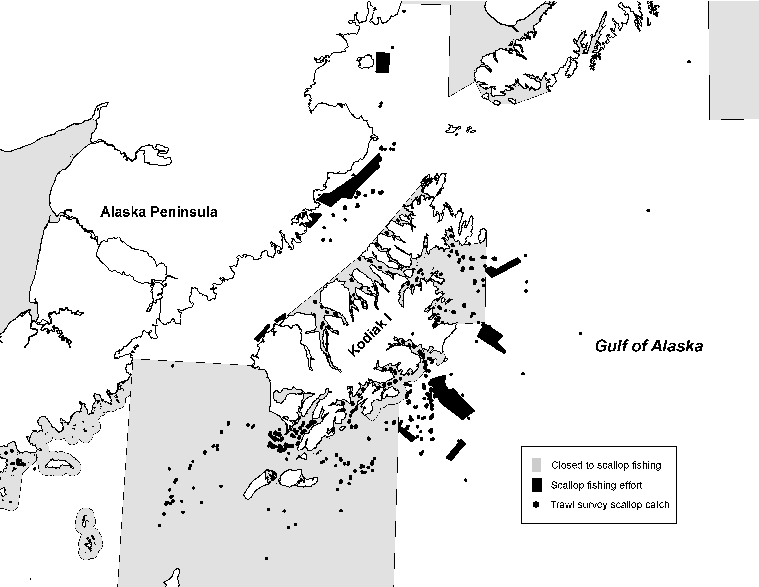
Figure 19 Map showing scallop fishing areas, areas closed to scallop fishing by regulation, and locations where weathervane scallops were captured during NMFS and ADF&G trawl surveys in the Kodiak Area.
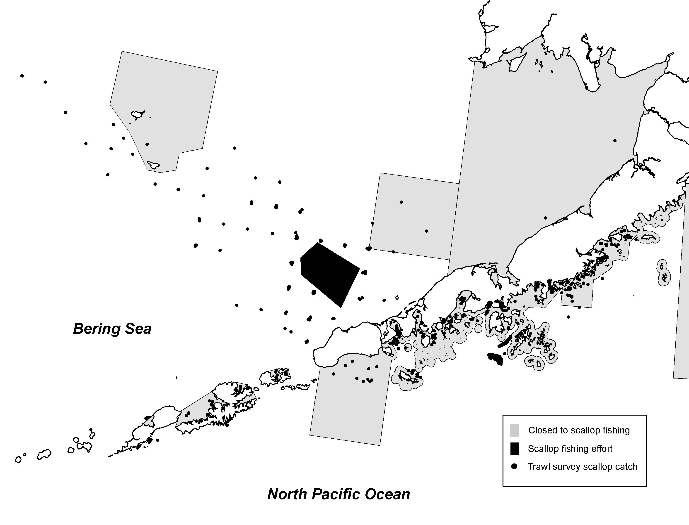
Figure 20 Map showing scallop fishing areas, areas closed to scallop fishing by regulation, and locations where weathervane scallops were captured during NMFS and ADF&G trawl

Recent Regulatory Actions

During the 2002 legislative session, passage of CSHB206(RLS) resulted in changes to the limited entry statutes authorizing use of a permanent vessel-based limited entry program in the weathervane scallop fishery. In 2004, eight vessel owners received permits to fish for weathervane scallops in state waters. Vessel entry permits issued for the statewide weathervane scallop fishery will expire on December 31, 2008 unless statutory authority is extended. If statutory authority is not extended, the state water fishery will revert to an open access fishery. A bill has been introduced to the Alaska legislature, House Bill #16 (HB16) to extend the sunset date to December 30, 2013. Additional details on this bill and the progress of it can be accessed at http://www.legis.state.ak.us/basis/start.asp.

Literature Cited

Barnhart, J.P. 2003. Weathervane scallop fishery in Alaska with a focus on the Westward Region, 1967-2002. Alaska Department of Fish and Game, Division of Commercial Fisheries, Regional Information Report 4K03-5, Kodiak
Barnhart, J. P., and G. Rosenkranz. 2003. Summary and analysis of onboard observer-collected data from the 1999/2000 through 2001/2002 statewide commercialweathervane scallop fishery. Alaska Department of Fish and Game, Division of Commercial Fisheries, Regional Information Report 4K03-9, Kodiak.
Barnhart, J.P. 2004. Weathervane scallop observer manual. Alaska Department of Fish and Game, Division of Commercial Fisheries, Regional Information Report 4K04-39, Kodiak.
Barnhart, J.P. and S.J. Carpenter. 2003. Warm-water annual checks in weathervane scallops, Patinopecten caurinus. 14th International Pectinid Workshop Abstracts w Programs, April 2003, p.122.
Bechtol, W.R. 2000. Preliminary evaluation of multiple data sources in an age-structured model for weathervane scallops in Kamishak Bay, Alaska. Alaska Department of Fish and Game, Division of Commercial Fisheries, Regional Information Report 2A00-03, Anchorage.
Bechtol, W.R. 2003. Assessment of weathervane scallops near Kayak Island, Alaska, 2000. Alaska Department of Fish and Game, Division of Commercial Fisheries, Regional Information Report 2A03-22, Anchorage.
Bechtol, W.R. and R. Gustafson. 2002. A survey of weathervane scallops in Kamishak Bay, Alaska, 1998 and 1999. Alaska Department of Fish and Game, Division of Commercial Fisheries, Regional Information Report 2A02-21, Anchorage.
Berceli, R., W.R. Bechtol, and C.E. Trowbridge. 2003. Review of the Dungeness crab, shrimp, and miscellaneous shellfish fisheries in Prince William Sound. Alaska Department of Fish and Game, Division of Commercial Fisheries, Regional Information Report 2A03-08, Anchorage.
Carpenter S.J. and Barnhart J. 2000. Seasonality and physiological changes observed in the carbon and oxygen isotope ratios in modern weathervane scallops (Patinopecten caurinus) from the Alaskan Coast. Geological Society of America Annual Meeting Abstracts w. Programs, v. 32, p. 93.
Kandianis, Mark. 2006. Public testimony at the 2006 Scallop Plan Team meeting, February 24, 2006, Anchorage, AK.
Kandianis, Theressa. 2007. Public testimony at the 2007 Scallop Plan Team meeting, February 23, 2007, Anchorage, AK.
Kruse, G. H., Barnhart, J.P. and G.E. Rosenkranz. 2005. Management of the data-limited weathervane scallop fishery in Alaska. Pages 51-68 In G.H. Kruse, V.F. Galucci, D.E. Hay, R.I. Perry, R.M. Peterman, T.C. Shirley, P.D. Spencer, B. Wilson, and D. Woodby (eds.). Fisheries assessment and management in data-limited situations. Alaska Sea Grant College Program, University of Alaska Fairbanks. 958 pp.
Rosenkranz, G.E. 2002. Mortality of Chionoecetes crabs incidentally caught in Alaska's weathervane scallop fishery. Crabs in Cold Water Regions: Biology, Management, and Economics. Alaska Sea Grant College Program Report AK-SG-02-01 University of Alaska, Fairbanks.
Rosenkranz, G., S. Gallager, R. Shepard, and M. Blakeslee. Development of a high-resolution benthic imaging system for coastal fisheries reserach in Alaska. In review. Fisheries Research.
NPFMC. 2003. Stock Assessment and Fishery Evaluation (SAFE) Report for the Scallop Fishery off Alaska. Compiled by the Scallop Plan Team. North Pacific Fishery Management Council, 605 West 4th Ave, Ste 306. Anchorage, AK 99587.
NPFMC. 2004. EA/RIR/IRFA for Amendment 10 to the FMP for the Scallop Fishery Off Alaska to modify the License Limitation Program. North Pacific Fishery Management Council, 605 West 4th Ave, Ste 306. Anchorage, AK 99587.
Stone, Jim. 2007. Public testimony at the 2007 Scallop Plan Team meeting, February 23, 2007, Anchorage, AK.
Trowbridge, C.E., and W.R. Bechtol. 2003. Review of commercial fisheries for Dungeness crab, shrimp, and miscellaneous shellfish in Lower Cook Inlet: Report to the Alaska Board of Fisheries. Alaska Department of Fish and Game, Division of Commercial Fisheries, Regional Information Report 2A03-09, Anchorage.

Appendix A. Economic Factors In The Scallop Fishery Off Alaska

Appendix B. Annual Management Report for the Commercial Weathervane Scallop Fisheries in the Westward District 2004/05

