Module GF001: Financial Statement Template Module

Module Overview
This module allows verifying agencies to build templates for their financial statements which will later be reclassified to the Closing Package Financial Statements. These statements are listed below:
Balance Sheet
Statement of Net Cost
Income Statement
Statement of Changes in Net Position
Statement of Custodial Activity
Verifying agencies will use this module to crosswalk the audited financial statements line item descriptions to the USSGL accounts and to identify the attributes for each line item.

Detail Line Feature List

Line Field Name | Functional Description | Attributes |  | Setting Options
Description | The description field is a text field used to describe the agency financial statement line items | - Description is a required field for lines with all account types except type “T” for title lines.  - For “T” account types, the user has the option of entering a description or leaving the field blank.  - The maximum length is 240 characters.  User must include spacing and indentations when entering the line description. |  | Description will accept any value or combination of values.
Account Type | Account type defines each financial line in terms of its classification in the financial statement template.  Users should select an account type that best describes the line item on the financial statement template. |  | - Account Type is a required field.  - Account types are selected by the user through a list of values (LOV) or manually by entering the value.  - The type of financial statement selected in the STMT (Financial Statement) field determines what account types will be displayed in the account type lookup.  - When an account type is selected, the related normal balance is also selected and automatically populated into the balance field.  - The account type selection determines if the “SGL” and /or the “CALC” push buttons are active or inactive.  - When account type “C” is selected, the “CALC” push button is active so calculations can be created for the related line.  - The selection of any account type other than (T, C, and V) will enable the “SGL” button. .In the case of account type “T” being selected, both the “SGL” and “CALC” push buttons become inactive. |  | The GFRS system administrator is responsible for creating the account types that are associated with each financial statement. If there are questions concerning the account types available to the FPA in the LOV, please contact your FRD representative immediately.
Normal Balance | Normal balance is the regular balance of a line item and is either debit or credit. Normal balance is used in later modules to translate manually entered values to appropriate stored balances. |  | - The Normal balance field does not accept any data entry. Normal balance is mandatory attribute driven by account type. When an account type is selected, the corresponding Normal Balance is automatically populated into the Normal Balance field.  - Normal balance is a required field except when the account type is set to “C” or “T.” |  | There are three possible settings for the Normal balance field:  C = Credit Balance Normal  D = Debit Balance Normal  N = No Balance Normal
F/N | Federal /Non Federal “F/N” (Federal/ Non-Federal) defines a template as having intergovernmental balances or not. |  | - The F/N indicator defines each line item as if it related to Federal (F), not related to Federal (N) or related to both (B).  - F/N is a required field except when the account type is set to “T” or “C.” |  | The LOV for the field has three possible selections:  F = Federal  N = Non-Federal  B = Both Federal and Non-Federal
Current Period Display Sign | Current period display sign is an attribute for each line that defines how the current period amount for the line should be displayed on all reports generated from the system. |  | - Display sign is a required field except for lines with an account type of “T” & “C.”  - The default setting for display sign is “+” but the selection can be either “+” or “-.” |  | The lookup for the Display Sign field are:  + Positive  - Negative
Prior Period Display Sign | Prior period display sign is an attribute for each line that defines how the prior period amount for the line should be displayed on all reports generated from the system. |  | - Display sign is a required field except for lines with an account type of “T” & “C.”  - The default setting for display sign is “+” but either “+” or “-.” |  | The lookup for the Display Sign field are:  + Positive  - Negative

Opening GF001
A module is an independent branch of the system available to users based on their role type.
Double-click on the GFRS (Governmentwide Financial Report System) menu to expand the menu and display the modules from which the user can select.
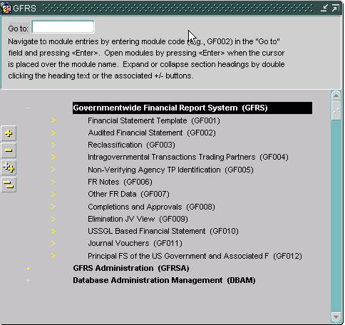

- Double-click on the Financial Statement Template Module (GF001). The user can also type ‘GF001’ in the ‘Go To:’ field and hit the ENTER key twice.

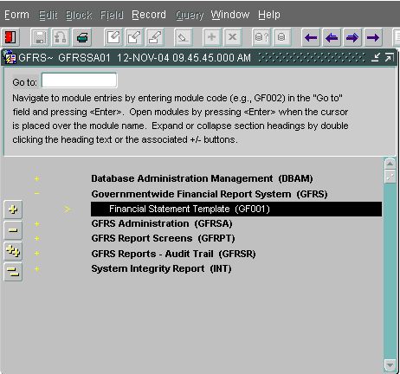

Retrieving a Financial Statement Template
- Upon entry into the module, the system will retrieve any statements that have already been created in the system for the entity(s) to which the user has access. Data will be populated in the form. The user will have access to all entities to which the System Administrator has granted him access.
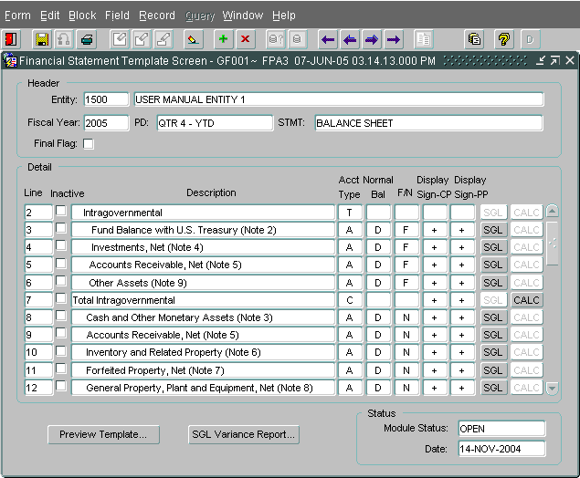


- To retrieve an existing financial statement, place the cursor in the STMT field and use the up and down arrows on the keyboard to scroll through the existing statements for that entity. If the user needs to see the templates for a different entity, click the ENTER QUERY button in the toolbar, double-click in the Entity field, select the entity from the LOV, and then click the EXECUTE QUERY button in the toolbar. Use the up and down arrows in the STMT field to find the correct template.
- To create a new financial statement template, place the cursor on the entity field and press “Insert” on the toolbar or use the Record - Insert function from the menu bar. The form will be blank. (Note: It is not normal for the entity to create a new financial statement unless a reporting requirement has changed or the entity is brand new.)
- Double-click on the entity field. A list of values (LOV) will appear on the screen showing the entities to which the user has access. Select one of the entities with a mouse click and press “OK.”
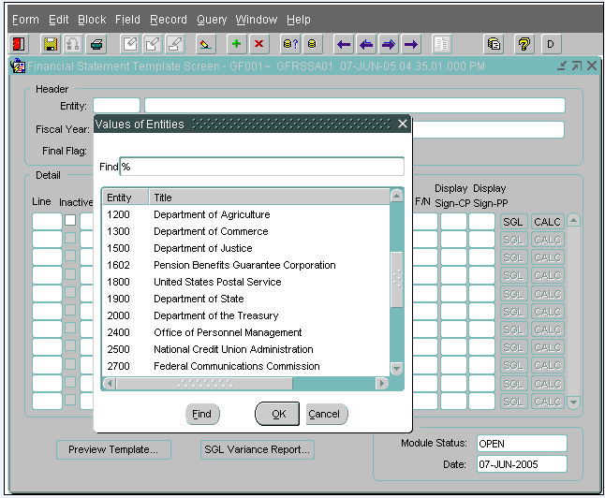

- Press the TAB key from the ENTITY field and the cursor will move to the Fiscal Year field. The values displayed in the Fiscal Year and PD fields are defined by the System Administrator. These values cannot be changed by the user.
- Press the TAB key to move the cursor from the Fiscal Year field to the STMT field. Select one of the financial statements from the STMT field using the LOV. The user will be able select a financial statement based on the statements required for that entity as defined by the System Administrator.
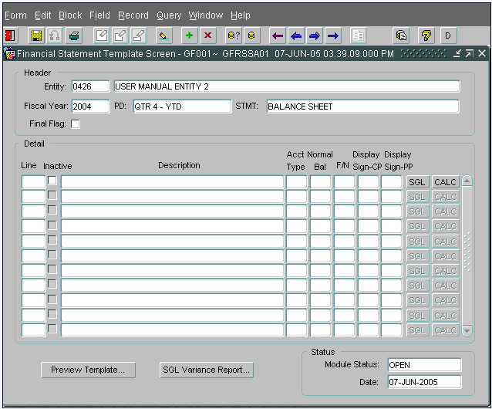

- Press the TAB key after a financial statement selection has been made. The cursor will move to the FINAL FLAG field. The statement cannot be finalized at this time because no line items have been created. Hit the tab key to navigate to the first line of the statement.

Creating a Line item with Attributes
- To create the first line item description on a statement, click on the line field or press the tab key twice from the statement field and the system will automatically populate the LINE field with line number. Line numbers are unique, sequential, system-generated numbers that order the lines of the financial template for display purposes.
- Enter a financial statement line description. The description field can be left blank by using an account type of “T” (Title). A blank line will not require any data input in GF002. Line descriptions must be manually indented for display purposes. Refer to section 1.2 for a description of account types.
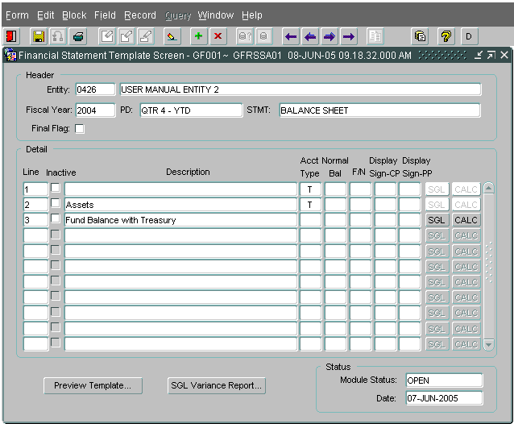

- Tab from the Description field to the Account type field and double click on the field or use (Ctrl + L) to activate the list of values (LOV). Select one of the appropriate account types from the list of values (LOV). The financial statement type selected in the header determines what Account Types are available for selection in the list of values (LOV). The account types are created by the FRD system administrator.
- Account Type selection determines if the CALC and SGL buttons are enabled or disabled: Selection of account type “T” will disable both the CALC and SGL push buttons. When “C” is selected as an Account Type, the SGL push button is disabled and the CALC push button is enabled. For all other account type selections, the SGL button will be enabled and the CALC button disabled.
- Once the Account Type has been selected from the LOV, both the account type and normal balance will be populated with the selected values. Normal Balance is assigned to the account type by the FRD administrator and has three value possible settings:
“D” (Normal Debit Balance)
“C” (Normal Credit Balance)
“N” (No Normal Balance)
6. Press the TAB key or use the mouse to navigate to the Federal/Non-Federal attribute field. From the LOV, select an F/N attribute for the template line item. The three possible selections are:
“F” (Federal, associated with intra-governmental balances & trading partners)
“N” (Non-Federal, not associated with intra-governmental balances and trading partners)
“B” (Both, Both Federal and Non-Federal amounts)
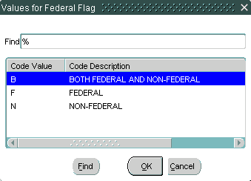

- Press the TAB key to navigate to the Display Sign – CP field. The “Display Sign – CP field” tells the system how the amount should be displayed on REPORTS ONLY for the current period. The display sign has no effect on the way the amounts are displayed in later modules. The DISPLAY SIGN defaults to ‘+’. The user has the option to display the amount as a credit by changing the display sign to ‘-‘. To change the display sign, double-click on the field to display the list of values and select the appropriate sign.
- Press the TAB key again to navigate to the Display – Sign PP (Display sign – prior period). Display Sign - PP tells the system how the amount should be displayed on REPORTS ONLY for the prior period. As with Display sign – CP, the “display sign PP” has no effect on the way the amounts are displayed in later modules. The DISPLAY SIGN defaults to ‘+’. The user has the option to display the amount as a credit by changing the display sign to ‘-‘. To change the display sign, double-click on the field to display the list of values and select the appropriate sign.
8. Before pressing the SGL or calculation button, press the save icon on the tool bar . . The save button should be pressed to update the line numbering. The system will automatically save a user’s work when the user creates a new line item and moves to the next line item. The user must save any work done within the same line before exiting the system.

Creating a USSGL Crosswalk for a Financial Statement
Financial statement lines with specific account types must be linked to USSGL accounts by using the SGL Account Mapping Screen. The selection of USSGL accounts for each template line translates the agency financial statement information into standardized USSGL format for reporting of FACTS I ATB data.
USSGL accounts are required for all line items with account types other than “T”, “V”, and “C.”
Selection of SGL attributes is based on the SGL reference table created in FACTS I, which automatically interfaces with GFRS. All possible SGL attribute combinations are based on this table.
For Federal Standard General Ledger (SGL) accounts, the Trading Partner field will default to ALL. For Non-Federal SGL accounts, the Trading Partner field will default to NONE. When applicable, all Budget Sub-Function (BSF) and Adjusted Trial Balances Code (ATB CODE) fields will default to ALL. The user has the option to double-click and select a specific Trading Partner, BSF code, or ATB CODE from the list of values when applicable.

- Press the SGL button on the main GF001 form to open the SGL Account Mapping screen.
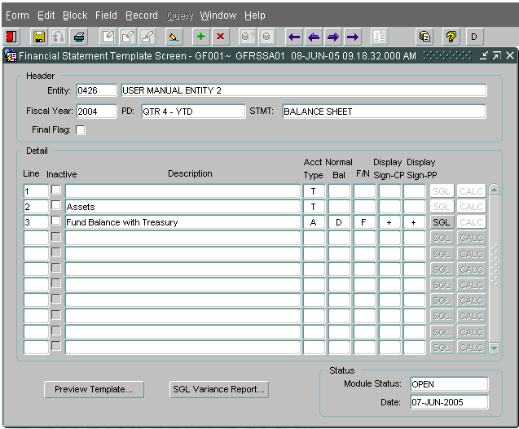

- To select an SGL account, double-click (or press CTRL + L) on the SGL field to open the list of values. SGL accounts can also be selected by manually entering the SGL account number into the SGL field.

  - When “F” (Federal) is selected for the F/N attribute of the line item, the SGL LOV is populated with SGL accounts with F/N attributes of “U” (Undefined), “F” (Federal) and “B” (both Federal and Non-Federal).
  - When “N” (Non-Federal) is selected for the F/N attribute of the line item, the SGL LOV is populated with SGL accounts with F/N attributes of “U” (Undefined), “N” (Non-Federal) and “B” (both Federal and Non-Federal).
  - When “B” (Both Federal and Non-Federal) is selected for the F/N attribute of the line item, the LOV will be populated with SGL accounts with federal flags of “B” (Both Federal and Non-Federal, “N” (Non-Federal), “U” (Undefined) and “F” (Federal).
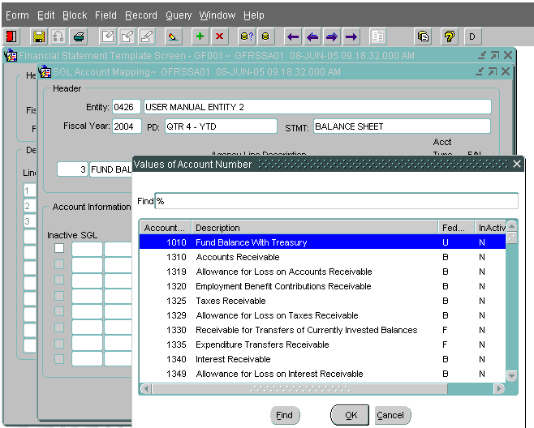

- The user should use the mouse or the up/down arrow keys on the keyboard to select an SGL and hit OK to close the LOV screen.

- Attribute values are automatically populated once the SGL account is selected. Users can navigate to other attribute fields by pressing the tab key or using the mouse. To view the available attributes, a user can double-click on the field to view the LOV.

- Any attribute that is BLANK requires user input. The user must assign an attribute before assigning another SGL account.

- To change an attribute from ALL (default value) to a specific attribute, the user should double-click on the field to retrieve the list of values. In the example below, the user is changing the Trading Partner from ALL to Entity 20.

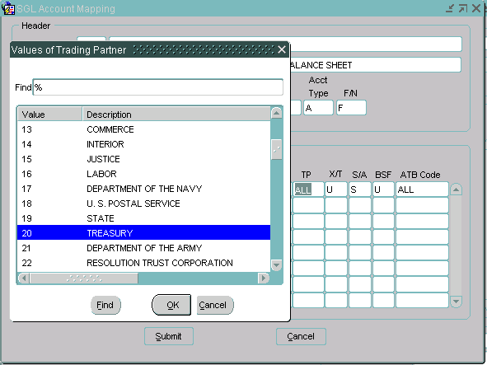
Double – click to retrieve the LOV

- Values for the Exchange/Non Exchange Revenue field (X/T field) can be selected from the X/T LOV for an SGL account. The X/T LOV has three sections “X” (Exchange Revenue), “T” (Non-Exchange Revenue) and “U” (Undefined).

- The S/A attribute will default to the attribute assigned in the SGL table. In some cases, the user may need to assign a specific attribute. One of the three values in the lookup must be selected “A” (Non-Custodial), “S” (Custodial) and “U” (Undefined).

- Individual Budget Sub Function (BSF) codes can be selected for revenue and expense accounts. To select a value other than the default setting, double-click on the Budget Sub Function (BSF) field to open the LOV.

- The ATB code is populated with a default setting of ALL. Users can select a single ATB codes from the ATB LOV on the ATB Code field.

An example of an ATB LOV is shown below:
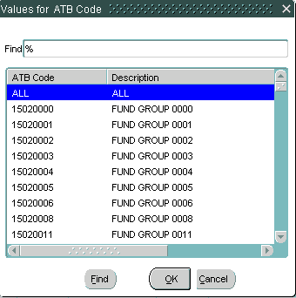

- Once the user has assigned all relevant USSGL accounts and attributes, press the “Submit” push button to save the changes and close the SGL mapping screen. The system will validate that there are no duplicate records and that all necessary attributes have been assigned. If the user does receive an error, he must return to the SGL assignment screen, delete the duplicate record (or assign the missing attribute) and hit SUBMIT again.

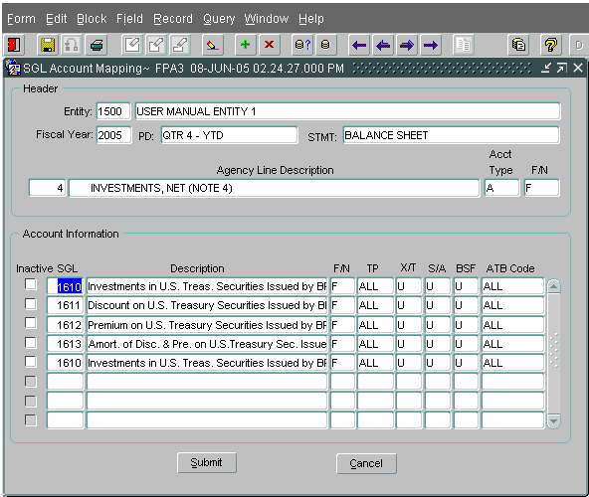

An example of a duplicate record error is shown below:
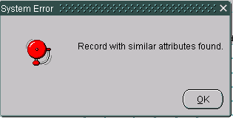

- Once the user returns to the main GF001 screen, click the SAVE icon and proceed to the next line.

Defining a Calculation
Calculation lines can be included in a financial statement template to add and/or subtract financial line items and create totals or subtotals in the financial statement. Selection of “C” (calculation) as an account type designates the line to perform a calculation. By pressing the “CALC” push button, the calculation screen is displayed. Financial statement lines that are to be included in the calculations are selected from the LOV and entered as a line in the calculation.
Calculations are performed using normal balance as the operation.
(Debits = Addition, Credits = Subtraction)
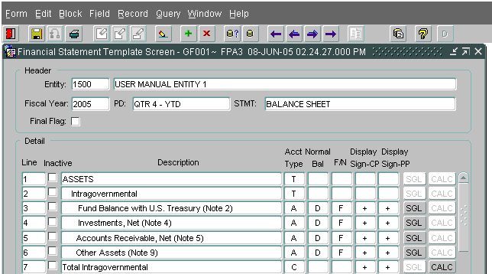
Select “C” for the account type and press the “CALC” button to set up the calculation.

- Double-click on the Line field in the calculation screen to display the LOV. The LOV will display all of the template lines that can be included in the calculation. Select the line to be included in the calculation and press “OK.” Lines must be selected one at a time.

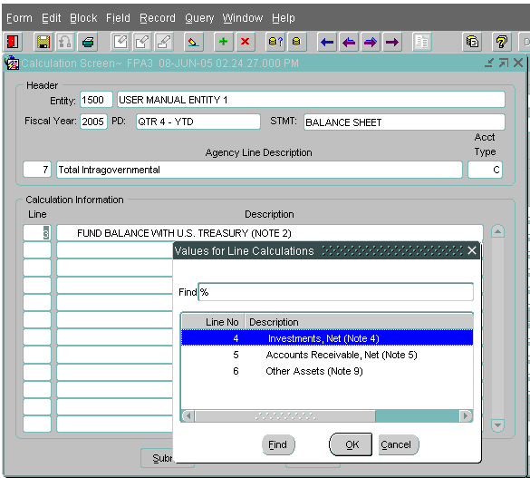

- The system will only allow the users to select one line at a time. If a user selects a line multiple times for inclusion in the calculation in the calculation, the user will receive the error message displayed below when clicking the SUBMIT button:
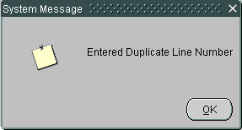
- Once all of the line items have been selected for the calculation, press “Submit.” The system will return the user to the Financial Statement Template form.

SGL Variance Report
The SGL variance report displays all of the SGL accounts and related attributes that have been used in the agency’s financial statement templates, as well as a list of SGL accounts and attributes that were not used (but were available to the user).

- On the GF001 Financial Statement Screen, press the “SGL Variance Report” button to run the report. The user must decide if the report will be run for ALL template SGLs or the current template only. Choose the correct radio button and click “Run Report.”
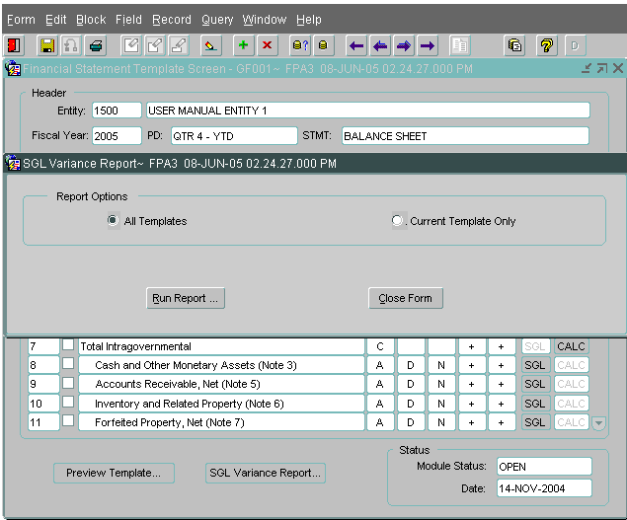
- The system will display a message telling the user to check messages for report output. Click “OK” to close the message.

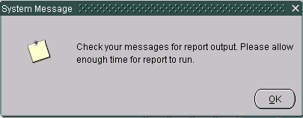
- To view the report, click on the Message Retrieval icon in the tool bar .

- The message retrieval screen will be displayed. Click on the VIEW button next to the report to be viewed. The most recent report will always appear at the top of the list. Each report has a date and time stamp for easy retrieval.

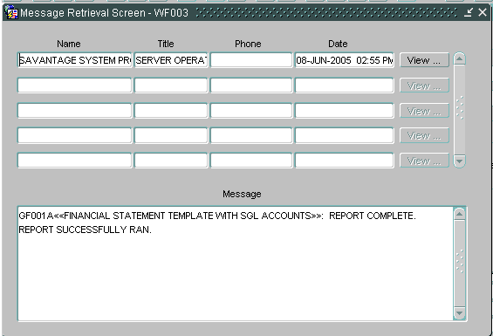
- The SGL Variance report is displayed below in preview mode. To print the report, press the print button on the toolbar . To save the report to the user’s local computer, press the SAVE icon on the toolbar .
- The user can either print the report by clicking on the PRINT icon , or can save the report to a local computer by clicking on the SAVE icon .

Flagging a Financial Statement Final

When the user has entered all lines on a financial statement in GF001, the Final Flag field must be checked for that statement to proceed to GF002: Audited Agency Financial Statement module. Checking the Final Flag field changes the status of the template from “Open” to “Approved.” When a template status is approved, the template can no longer be modified in the GF001 screen as long as the final flag remains checked. Only approved financial statement templates in the GF001 screen are available in the GF002 screen (Audited Financial Statements).
When the user attempts to flag a statement final, the system will perform several validations that may prevent the user from completing the task. Those validations are:

- All active lines that require SGL accounts must have at least one active SGL account assigned to the line.
- All Calculation lines must have at least one line assigned to the calculation.
- All lines with account types other than “T” must have line descriptions.
- All line attributes must be defined.

If all validations pass, the user can activate the final flag by clicking on the box.

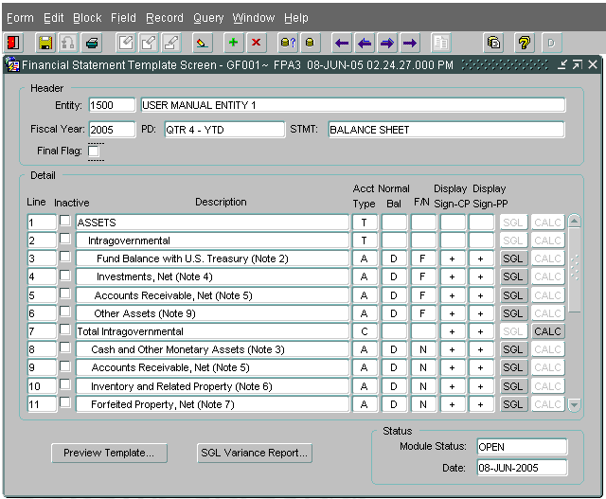

- If the statement contains a line item with missing SGL accounts, the user will receive the message below. The user must click OK and return to the line stated in the error message to assign SGL accounts as appropriate.

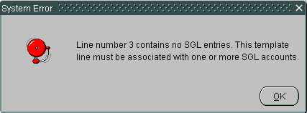

- If the statement contains a line item with a missing calculation, the user will receive the error message below. The user must click OK and return to the line stated in the error message to assign line items to the calculation as appropriate.
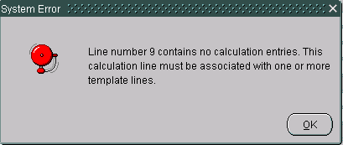
- Once the template passes all validations, the final flag will be checked and the module status field displays a status of “Approved.” The user can then access the statement in GF002.
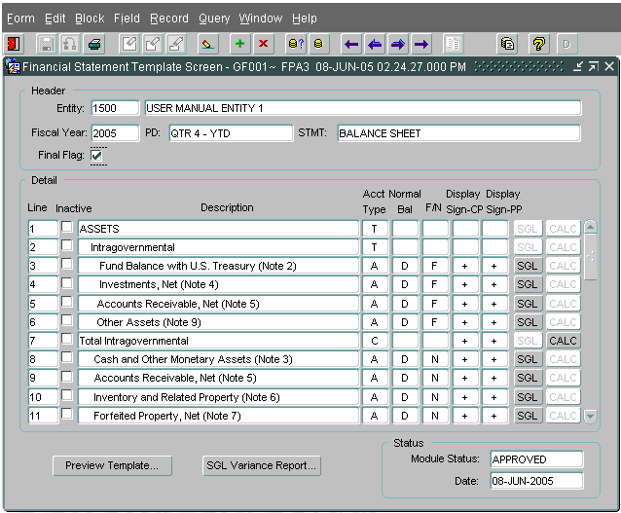

Inserting a new Line in a Template
New lines can be inserted into existing statements. Verify that the final flag is not checked (no changes can be made to the template if the final flag is checked).

- If necessary, un-check the final flag check box to change the template status from “APPROVED” (un-modifiable) to “OPEN” (modifiable).
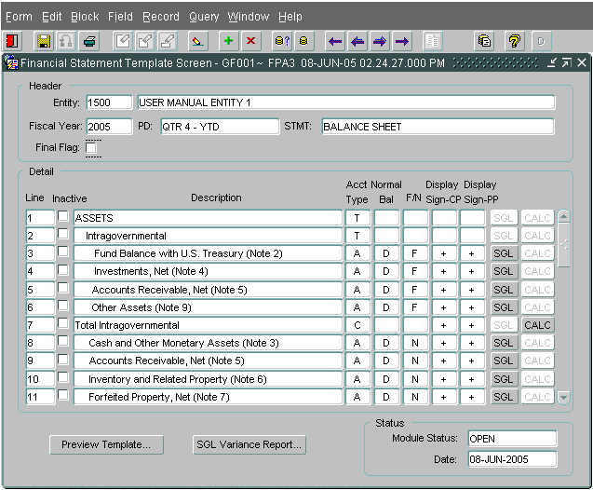
- Place the cursor (by using the tab key or mouse-click) on the line directly above the row to be inserted.
- Click the INSERT button on the toolbar to insert the line. A new line will be created with a system generated line number. The line will be inserted directly under the line where the cursor is located at the time the insert button is pressed. The example below shows a line inserted below the Other Assets (Note 9) line. Note: the line numbering will not update until the new line is saved to the database by the user.
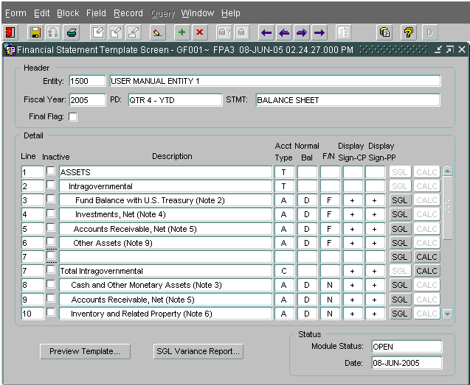
This is the inserted line.
- Tab into the description field and enter a description for the line (description is not required if the account type “T” ((Title)) is selected).

- Tab into the Account type field and double-click to display the LOV. Select one of the account types from the LOV.

- Tab into the F/N field and select a value.

- Tab into the current period display sign CP field and change the value if necessary.

- Tab to the prior period display sign field.

- Before entering the SGL mapping screen press the save button on the tool bar to save the changes. The save button must be pressed to re-order the line numbers of the financial template.

- If the line created is for a calculation, press the “CALC” push button and enter the template lines that are to be included in the calculation. (See section 1.6)

- For all lines with account types that require SGL information (all account types except “T” & ”C”), press the “SGL” push button to complete the SGL mapping form.
- Once all of the template line information has been entered, click the Save button on the tool bar.

- Click on the final flag check box to finalize the revised template. The new lines entered into the template are validated for completeness. If any line is incomplete, the user will not be able to save the template. Once the final flag has been checked for a template, the Module status field will display “APPROVED.”

Deleting a Line from the Financial Statement
Single or multiple lines can be deleted from existing templates only if there was no amount entered for that line within the last thirteen months. If there is a previously reported amount, the system will not allow the user to delete the line. The user will need to mark the line as “Inactive” (Refer to section 1.12 for “Inactive” lines.) To delete a line, the Final Flag must be unchecked.

- If necessary, uncheck the final flag for the statement that needs to be modified. The status will return to OPEN.
- Place the cursor on the line to be deleted.

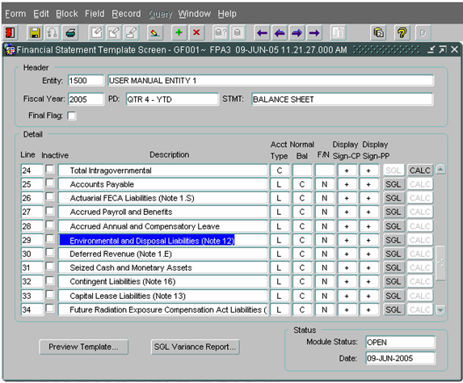
- Click the delete button on the tool bar to delete the line.

NOTE: Line item will only be deleted from the template when the prior period amount is zero and there have been no amounts entered in any months between the prior period and the current period.

- When the “X” delete button has been pressed, a message will appear on the screen “Are you sure you want to delete this line?” Click “OK” to acknowledge the message.
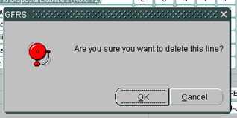
- Once line # 29 is deleted from GF001 the system reorders all line numbers.
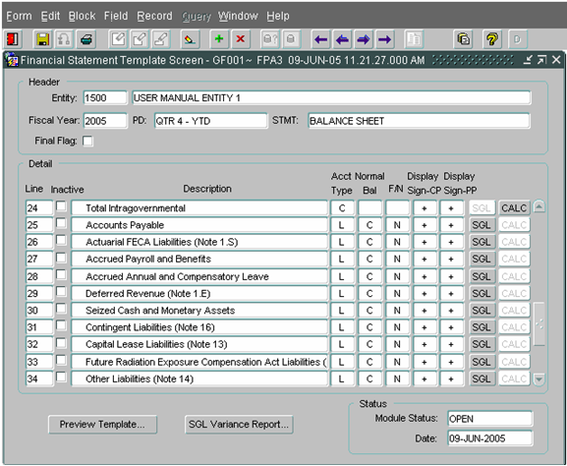

- When the “X” delete button has been pressed, a message may appear on the screen “The line cannot be deleted because amounts were entered against this line in GF002 within the past twelve months. Mark the line inactive instead.” Click “OK” to acknowledge the message and mark the line inactive. (Reference section 1.12 for “Inactive” line.)

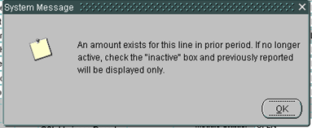

- Once the deletion has been processed, if there are no more changes the final flag box can be checked. The user will click the final flag field to change the module from “OPEN” (Editable) to “APPROVED” (not editable).

Inactivating and Reactivating a Line Item

Users should mark lines inactive if both of the following conditions have been met:
- Amounts have been entered against the line for any of the twelve months preceding the current period in GF002 and
- No amounts have been entered against the line item in the current period in GF002
Lines can be automatically marked as inactive if the line has an account type that has been marked inactive by a System Administrator in the Financial Reports Division. In this event, the associated SGLs will be deleted and the line cannot be activated by the user and must remain inactive. A new line can be added using an active account type in GFRS.
- If the final flag is checked, uncheck the final flag for the statement that needs to be modified. The status of the Statement will return to OPEN.
- All SGLs must be deleted from the line in order to mark it inactive. Click on the SGL button and delete all associated SGLs. Click the SUBMIT button on the SGL assignment form.
- Click the “Inactive” checkbox for the line item to be deleted. User should be able to successfully mark the line inactive. If the conditions above are not met, the system will display a message to the user instructing him to delete the line instead.

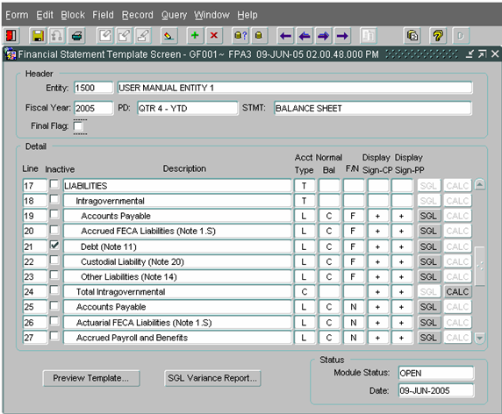
- Click the final flag field to change the module from “OPEN” (Modifiable) to “APPROVED” (Non-modifiable).

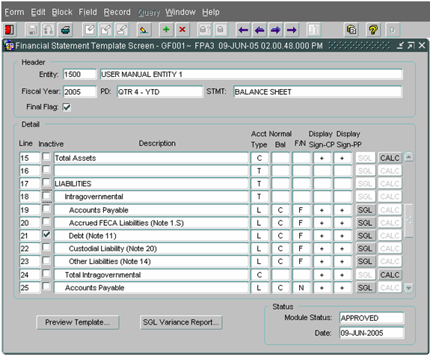

- If the user has marked the statement as final and need to modify again, the user will need to reopen the statement. Unlock the final flag box for the statement that needs to be modified. The status will return to OPEN.
- Once the user has entered the GF003 Reclassification module, the user will not be able to change lines from active to inactive or vice versa. When in doubt as to whether a line should be marked inactive or not, leave it as active and enter zero for it in GF002.

