

AGRICULTURE - NATURAL RESOURCE MANAGEMENT PROGRAM
Wula Nafaa

ANNUAL REPORT
OCTOBER 2005 – SEPTEMBER 2006
September, 2006
This publication was produced for United States Agency for International Development by International Resources Group (IRG)

AGRICULTURE - NATURAL RESOURCE MANAGEMENT PROGRAM
WULA NAFAA

ANNUAL REPORT
OCTOBER 2005 – SEPTEMBER 2006

USAID/Senegal Contract
No. 685-C-00-03-00008-00


International Resources Group
1211 Connecticut Avenue, NW, Suite 700
Washington, DC 20036
202-289-0100 Fax 202-289-7601


www.irgltd.com

Notice:
The points of view expressed by the authors in this publication do not necessarily reflect those of USAID or the government of the USA.
Table Of Contents
Acronyms ii
1. Executive Summary 1
2. Introduction 3
2.1. Program objectives and strategy 3
3. Economic Benefits Component 7
3.1. Targeted results and planned activities 7
3.1.1. General considerations 7
3.1.2. Results targeted 7
3.1.3. Activities planned for 2005-2006 8
3.2. Progress achieved 9
3.3. Constraints, opportunities, and priorities for 2006-2007 30
3.3.1. Constraints 30
3.3.2. Opportunities 30
3.3.3. Priority actions 31
4. Rights and Responsibilities Component 32
4.1. Targeted results and planned activities 32
4.1.1. General Considerations 32
4.1.2. Targeted results 32
4.1.3. Activities planned for 2005-2006 33
4.2. Progress achieved 34
4.3. Constraints, opportunities, and priorities for the next year 44
5. Policy Component 45
5.1. Targeted results and planned activities 45
5.1.1. General considerations 45
5.1.2. Targeted results 45
5.1.3. Activities planned for 2005-2006 45
5.2. Progress achieved 47
5.3. Constraints, opportunities, and priorities for the next year 54
6. CROSSCUTTING ACTIVITIES 56
6.1. Coordination and management 56
6.2. Small grant funds 57
6.3. Training and communication 59
6.3.1. Training 59
6.3.2. Communication 60
6.4. Monitoring, Evaluation, Reporting, and Analysis 61
6.4.1. Monitoring - Evaluation activities in the regions of Tamba, Kolda, and Ziguinchor 62
6.4.2. Analysis and Reporting activities 62
Annex 1. Documents produced in the year 63
Annex 2. Progress on local conventions 64
Annex 3. Training and Communication 65
Annex 4. Indicators Revised May 2006 68

Acronyms

ACDI | Agence Canadien pour le Développement International
AG/GRN  AG/NRM | Agriculture/Gestion des Ressources Naturelles /Natural Resource Mgmt
AG/RN | Agriculture/Ressources Naturelles
ANT/ NTA | Agriculture Non Traditionnelle
BDS | Business Development Services
BFC | Baobab Fruit Company (www.baobabfruitco.com)
BIC | Bureau Inventaire et Cartographie
CAC | Cellule d’Animation et de Concertation
CdeC | Cadre de Concertation
CIVD | Comité Inter Villageois de Développement
CL | Convention Locale
CLUSA | Cooperative League of United States of America
CMS | Crédit Mutuel du Sénégal
CODESRIA | Conseil pour le Développement de la Recherche en Sciences Sociales en Afrique
CR | Communauté Rurale
CVGD | Comité Villageois de Gestion et de Développement
DAPF | Division Aménagement et Productions Forestières
DEFCCS | Direction des Eaux et Forêts, Chasse et Conservation des sols
DGF | Division de Gestion de la Faune
D&R | Droits et Responsabilités
DFI | Digital Freedom Initiative
FFN | Fonds Forestier National
GCRN | Gestion Communautaire des Ressources Naturelles
GIE | Groupement d’Intérêt Economique
GLP | Groupe local de Pilotage
GPB | Groupement de producteurs de Baobab
GPF | Groupement de Promotion Féminine
GPFonio | Groupement de Producteurs de Fonio
GPL | Groupement de Producteurs de Laalo
GRN | Gestion des Ressources Naturelles
HACCP | Hazard Analysis Critical Control Points (Analyse/Contrôle des points critiques)
IREF | Inspection Régionale des Eaux et Forêts
IRG | International Resources Group
MEPN | Ministère de l’Environnement et de la Protection de la Nature.
OCB | Organisation Communautaire de Base
OS | Objectif Stratégique
PMP | Plan de suivi des réalisations
PTA | Plan de Travail Annuel
RE | Retombées Economiques
RN | Ressources naturelles
RTS | Radio Télévision du Sénégal
SAGIC | Support for Accelerated Growth and Increase Competitiveness for Trade
S-E | Suivi-Evaluation
SERA | Suivi, Evaluation, Restitution et Analyse
SFD | Structure de Financement Décentralisée
SIG | Système d’Information Géographique
TDR | Termes de Référence
TR | Table Ronde
USAID | United States Agency for International Development
USFS | United States Forest Service
WN | Wula Nafaa (Programme AG/GRN)
ZIC | Zone d’Intérêt Cynégétique
ZPC | Zone de Production Contrôlée

Executive Summary
This fourth annual report presents the activities carried out from October 2005 to September 2006, activities oriented toward achieving contract results of the Agriculture and Natural Resources Management Program or Wula Nafaa (WN) in Senegal. Wula Nafaa is funded within the framework of two Strategic Objective (SO) Agreements developed between USAID and the Government of Senegal. SO1 – Sustainable increases in private sector income-generating activities in selected sectors; and SO2 – Improved local delivery of services and sustainable use of resources in targeted areas. The overall program objective is to contribute to poverty reduction and sustainable local development by increasing the incomes of rural producers and local communities through the empowerment of local authorities and the promotion of integrated, decentralized, participatory resource management.
This year has seen implementation of the vision of “the new team” at Wula Nafaa, put in place mid-2005. Several overlapping activities were consolidated; new worksites were opened, the most important of which are community forests where management plans are being drawn up; and the planning and carrying out of training programs for producer groups in various market chains. Training has targeted partners as well as personnel of WN. Functional literacy has been fulfilling its important role in many aspects of the program.
During the year, Rights and Responsibilities component has integrated the protection of natural resources with management of open lands and participatory management of forests. Emphasis has been placed on making management plans for community forests, regenerating the forest, and increasing productivity. Implementation of the management plan for Koulor in Tambacounda Region has begun; the management plan for Saré Bidji in Kolda Region is about to be finalized.
The major events for the year include the establishment of a village-based charcoal market chain originating in Koulor and Missirah and the recruitment of a charcoal market facilitator based in Dakar.
The following market chains have seen increased revenues this year: mbepp gum, baobab, madd, jujube, honey, thatch, palm oil, cashew nuts, and charcoal.
Since 2003, WN has put a special emphasis on making its activities sustainable so that they may continue after the program funding ends. Thus it has continued to develop and improve networks and partnerships of skilled and dynamic enterprises in selected markets for products addressed.
The policy component has concentrated on forest taxation and revenues this year. Thus WN has associated the Forestry Fiscal Working Group established by the Forest Service with the support of ACDI. Four studies have been sponsored to assist the Working Group to initiate changes in revenue and taxation issues.
As for staff management, several facilitators left the program and others have been hired to fill the vacant posts. In February, the Washington based project manager visited and helped improve financial management in WN, especially in the small grants department.
The general assembly this year provided a chance to evaluate our new vision and to establish the basis for elements of the coming year’s workplan.
Finally, WN has strengthened partnerships with other development projects via the signing of several protocols.

Introduction
This fourth annual report will present activities from October 2005 through September 2006 for the Agriculture/Natural Resource Management Program (“Wula Nafaa” or WN) in Senegal. In January 2003, USAID/Senegal awarded a contract to International Resources Group (IRG) for the provision of long and short-term technical assistance as well as other services aimed at ensuring that the objectives and results of the AG/NRM Program were achieved.
The program is financed by USAID/Senegal and functions under the trusteeship of the Ministry of the Environment and Nature Protection (MEPN) and USAID/Senegal.
This report contains summaries of progress and results achieved during the fourth year of the program. The principal activities and accomplishments will be presented in detail for each of the main program components: Economic Benefits and Enterprise Development; Rights and Responsibilities; Policy; and Crosscutting Activities found in the chapter on Training, Small Grants, and Monitoring-Evaluation-Reporting-Analysis.
The report also contains a résumé of specific supporting activities such as the mobilization of field facilitators, communications, coordination with other projects, and management.
Finally, some success stories will be presented in different chapters.

Program objectives and strategy
WN is funded under two Strategic Objective (SO) Agreements between USAID and the Government of Senegal:
SO1 – Sustainable increases in private sector income-generating activities in selected sectors, and
SO2 – Improved local delivery of services and sustainable use of resources in targeted areas.
The program was conceived to draw maximum benefit from potential synergies from the two strategic objectives and improved NRM, notably from interactions between “Nature, Wealth and Power” (NWP). In treating together the needs and opportunities tightly bound to the management, the economic benefits and the strengthening of local rights related to natural resources, the program seeks to correct weak points inherent in previous sector-based approaches to agricultural development and NRM. It also seeks to achieve sustainable impacts in reducing poverty and in economic development, based on improved NRM and improved local governance.
The “NWP approach” targets to support simultaneously activities that:
- Lead to increasing productivity of the resources base and to biodiversity conservation (the improved management of Nature)
- Bring significant economic growth, beneficial to local communities and to national accounts (increased Wealth as an incentive to sound resource management)
- Contribute to making rural community members into citizens rather than project-dependent subjects, thus leading to a more democratic, more decentralized, and more vibrant society (strengthening of Power and of good governance so as to ensure transparent decision-making and fair and equitable distribution of benefits).
The program’s overall objective is to contribute to poverty reduction and to sustainable local development, by increasing the income of rural producers and of local communities through the empowerment of local authorities and the promotion of integrated, decentralized, participatory resource management.
The program is composed of two major components concerned with:
- The development of small and medium-sized enterprises based on increasing and suitable production of non-traditional agricultural and natural resources, and on the creation of economic benefits for rural communities (Economic Benefits Component)
- The empowerment of local producer groups and rural communities, the clarification of their rights and responsibilities, and the strengthening of their role in decentralized natural resource management (Rights and Responsibilities Component)
Thus the program uses a private sector/enterprise development approach as well as increased support for improved local governance and the implementation of decentralization policies. This approach is developed in tandem with support targeting to intensify and diversify rural production systems and improve NRM by placing a special emphasis on community-based management of forest and wildlife resources. The program applies a market-based approach and provides support for the development of business partnerships in order to increase the number and scale of operations of small and medium sized enterprises based on AG/NRM products. Results are monitored to determine increases in household incomes and the distribution of economic benefits at the local level.
These economic incentives are reinforced by support for improved local governance and the effective transfer of rights and responsibilities to rural communities and to local producer groups thus permitting local communities to gain greater control over land use and NR that are the bedrock of their rural production systems. The program is also providing information, training and support for other capacity-building activities. The objective is to facilitate a progressive move away from the easy access and relatively uncontrolled and non-sustainable utilization of natural resources in rural areas, to a situation where the resources are locally controlled, with planned and sustainable use by means of a variety of planning tools, legal agreements, and other procedures to ensure local rights and promote the adoption of improved NRM practices. Examples of success stories will be presented throughout this report.
WN is committed to the need to address policy reforms and support policy implementation on the ground and in the field. The AG/NRM program is organized to stimulate sustainable economic development at both the local and regional levels, based on economic interest of rural producers, local empowerment, improved organization and increased capacity of rural enterprises, reduction of legal and regulatory barriers and the establishment of other positive enabling conditions. Such “enabling conditions” are being put in place to promote a series of inter-related objectives in the areas of decentralized NRM, diversification and sustainable intensification of rural production, enterprise development and increased marketing of a wide variety of AG/NR products coming from targeted regions.
The program is taking full advantage of lessons learned from over a decade of assistance to the AG/NRM sectors. WN represents a new and innovative approach to development assistance that is not project-oriented or sector-based. The program is devoting a substantial effort to monitoring and analysis of program impacts, results and “success stories” through the Monitoring, Evaluation, Reporting, and Analysis (MERA) Component. In May 2006, the indicators for project evaluation were revised; some targets were lowered and others were broken down into several separate indicators. These are presented in Annex 4.
The WN team works with a multitude of partners from both the public and private sectors, aiming to promote synergy and close collaboration. WN has recruited 30 community-based facilitators that promote enterprise development and capacity building as well as empowerment of local communities. Equally, WN is developing a number of lateral activities in Training and Communication, even though they are not included as a distinct component, given the priority being accorded to community mobilization, capacity building, knowledge transfer and behavior change.
The program established a Small Grants Program in January 2004. Following two consultancies with CLUSA, an approach to introducing the credit program was given final approval by USAID. This will permit every village producer group to access credit once a feasibility study is completed for its proposal. Progress with respect to this activity, together with other program support activities related to Coordination and Management are discussed in the concluding sections of the Annual Report.

NOTE terminology used by WN:
Non-Traditional Agricultural Products (NTA) |  | Natural Resource-based Products  (NR)
- honey/beeswax  - palm oil | - fonio  - cashew nuts | - gum mbepp or laalo  - baobab/ bouye  - thatch/hay | - jujube  - madd  - charcoal

Economic Benefits Component

Targeted results and planned activities

General considerations
The main goal of the Economic Benefits component is to help generate cumulative revenues for small enterprises and rural producer groups. This is done by expanding production and improving marketing of non-traditional natural-resource-based and agricultural products. The success of the component will be measured by quantifying the increase in profits of existing and new enterprises, as evidenced by their production levels and their improvement in natural resource management practices. During the life of the program, the Economic Benefits team will strive to reduce constraints on opportunities for profit by reinforcing the market chains for their products which include annual crops, wood, charcoal, and various non-wood forest products in Eastern Senegal and Casamance.
The objective of the component is to ensure that the producers and targeted enterprise group members will be organized, will benefit from training on demand and capacity-building, and will take on a larger role in the management of agricultural and resource management which they use and on which they depend for life and well-being. In the process, the program will identify and support the most dynamic and enterprising of the rural producer groups as well as private sector players in the product marketing chains selected for WN zones. This will permit the producer groups to evolve into long-lasting and well-managed community enterprises.

Results targeted
Activities for the Economic Benefits Component of WN are based on nine Contractual Results, whose indicators correspond to the following:
- Number of new or existing NR-based enterprises that show increased, measurable revenues in areas targeted by the AG/NRM program (50% of group enterprises assisted),
- Number of new or existing non-traditional agriculture (NTA) based enterprises that show increased, measurable revenues in areas targeted by the AG/NRM program (50% of group enterprises assisted),
- Number of enterprises based on NR or non-traditional agriculture that can show a measurable increase in revenues in WN zones, AND that have done at least one of the following: applied training in business plans and marketing strategies; adopted improved production, harvest, and value-adding techniques; or negotiated with external partners,
- Number of enterprise groups receiving initial training given by WN facilitators,
- Number of groups assisted by WN in various capacities,
- Number of market surveys and studies to identify potentially marketable AG/NRM products,
- Number of grading schemes and value-added processes developed to increase revenue and profitability of producers,
- Level of revenues per enterprise group assisted, and
- Volume / number of products marketed by enterprise group assisted.

Activities planned for 2005-2006
Increase revenues for enterprises based on natural resource harvest
- Continue to help producer groups and market chain networks already established (gomme mbepp, baobab, madd) to improve their management, quality control, and long-term production;
- Begin targeting new market chains in charcoal and cashew nuts by organizing producers and facilitating commercialization;
- Continue to facilitate commercialization of secondary market products (jujube (Ziziphus mauritiana) and nététou (Parkia biglobosa).
Increase revenues of enterprises based on non-traditional agriculture
- Continue work in the market chains of fonio, apiculture, palm oil, and cashew while stimulating production and signing contracts promoting good harvest practices;
Increase revenues of “dynamic” enterprises
- Stimulate the development and capacity building of emerging enterprises by training in management and elaboration of commercialization strategies, value adding, and signing of contracts;
- Strengthen producer networks in quality control and put in place facilities for value adding and produce grading;
- Identify service providers (dynamic enterprises from Dakar or big towns) to link with producer groups in Kolda, Tambacounda, and Ziguinchor;
- Build capacity in emerging marketing enterprises (website design, visits to marketing fairs);
- Research of markets for appropriate packaging and labeling.
Capacity building
- Techniques for drying mbepp gum and baobab fruit; value-adding to fonio, cashew, palm oil, wax, and processed cashews; techniques for cashew sorting;
- Functional literacy;
- Techniques for marketing and business management;
- Initiation to micro-finance and credit management, especially at the level of market networks;
- Stakeholder forum on beekeeping.
Market studies
- Market studies on wax, thatch, “virgin” palm oil, and market chains of Bignogna.
Signing of contracts
- New contracts are to be signed with Baobab Fruit Company, Setexpharm, fonio processors, and other buyers;
- First contracts are to be signed with enterprises based on palm oil, beeswax, and cashew.

Progress achieved
Result 1 : Increase in the number of new or existing NR-based enterprises that show measurably higher revenues in areas targeted by the AG/NRM program
This result will be presented in detail product by product, with a summary table at the end.
BAOBAB
184 baobab producer enterprises in Ziguinchor, Tambacounda, and Kolda increased their revenues from 6,203,550 FCFA to 14,276,190 FCFA, an increase of 130%. This was made possible by :
- The push for commercial cooperatives and the improvement in their negotiating skills in Ziguinchor;
- An increase by 20% in prices for baobab;
- The increase in volume of fruit sold out of Bignona where the potential is strong but commercialization has been weak;
- The continued marketing relationship between baobab producers of Bala zone and Baobab Fruit Company (in spite of depressed international prices, the price offered by BFC remains about 40% higher than shelled baobab fruit sold on the local market);
- Producers started sorting/ grading baobab fruit this year, enabling a price increase of 75%;
- This improvement in the quality of baobab fruit powder has caused emerging enterprises to win the confidence of processors in Dakar and to receive larger orders.

MBEPP GUM
46 producer enterprises of mbepp gum (laalo) at Kolda and Tambacounda increased their revenues from 2,336,800 F CFA to 4,710,365 F CFA, that is by 102%. This was made possible by :
- Support to commercial cooperatives and the improvement in their negotiating skills in Kolda and Ziguinchor;
- The initiation of new producer enterprises of mbepp cum in Kolda region;
- The processing and commercialization of gum into powder in Kolda;
- The signature of new contracts between producers in Tambacounda and Setexpharm.

Exchange visit to India
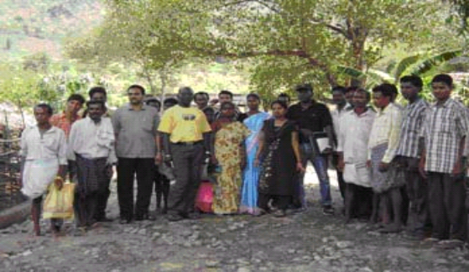
Two representatives from partners in commercialization and resource management of mbepp gum (Amath Diop of Setexpharm and Samba Ndiaye of ISRA) traveled to India, principal producer company of mbepp gum (Karaya),. There they met producer groups, exporting enterprises, and ONGs. The objective of the trip was to deepen the knowledge of Senegalese gum market chain actors in improved regeneration, harvest, postharvest treatment, grading, commercialization, and hygiene.
Members of the visiting team presented their reports with recommendations that guided WN and Setexpharm in directing their first training on gum quality improvement, in September 2006. Samba Ndiaye is in the process of developing some tools adapted for use by local producers in techniques from India for better gum harvest
Amath Diop et Samba Ndiaye avec les producteurs de gomme mbepp en Inde

JUJUBE
8 producer enterprises of jujube fruit at Koussanar and Mako increased their revenues from 1,303,135 FCFA to 2,386,200 FCFA or by 83%. This was made possible by:
- The push for commercial cooperatives and the improvement in their negotiating skills in Mako and Koussanar;
- A 25% increase in prices.
THATCH AND HAY
38 grass enterprises at Saraya and Bandafassi increased their revenues from 1,654,300 FCFA to 2,795,600 FCFA, or by 69%. This increase is due to the increase in total volume sold, made possible by a reduction in bush fires and an increase in productivity.
MADD FRUIT
380 madd enterprises in Kédougou, Kolda, and Ziguinchor increased their revenues from 24,557,600 FCFA to 43,867,200 FCFA or by 79%. This was made possible by:
- Support for commercial cooperatives and improvement in their negotiating skills in Ziguinchor;
- A price increase of 43%;
- Contract facilitation with the Bana-Bana transporters from the collection point in Diégoune;
- An increase in volume sold in Bignona, which has strong potential but weak markets.
CHARCOAL
Through technical training, 25 charcoal producing enterprises in Tambacounda increased their revenues from “none” to 99,000 FCFA. These enterprises were newly formed.

Charcoal: a sure source of revenues during the dry season
Charcoal is one of the most lucrative forest-based activities in the Tambacounda region. The network of marketers who hire local Sourga workers to fulfill their allotted quotas do not encourage the local people to go into the charcoal business, because the revenues are so low.
The 2005-2006 workyear saw the initiation of Wula Nafaa intervention in the Community Forest of Koulor and the Zone de Production Contrôlée of Missirah. This entailed the organization of 306 producers into 17 Producer Groups (GPC), two exchange visits between 34 potential producers in Koulor/Missirah and experienced producers in Nétéboulou (trained by PROGEDE), and the commencement of charcoal-making operations.
WN organized a charcoal-making training session for 25 workers representing 11 GPC in use of the Casamance Kiln. The participants marketed 200 sacks of charcoal and earned 180,000 FCFA, of which 25% was given to NRM Committees charged with overseeing the implementation of the management plan.
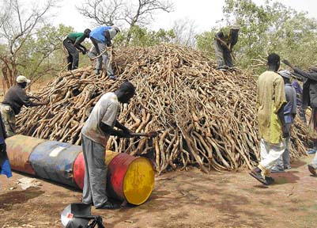
Producing and marketing charcoal requires investment monies; the GPC don’t have funds nor access to credit. WN has facilitated pre-financing using the Forestry Fund belonging to the 6 GPC of Missirah, in accordance with the Forest Service. For Koulor, WN will facilitate accessing credit for the 11 GPC working there.
For these people, revenues from charcoal can greatly contribute to poverty reduction. According to Moussa Diop from the village of Ndiobene, “With Wula Nafaa we have learned two things: the charcoal-making trade, and the money we can earn from it.”
Charcoal producer training

TOTAL REVENUE INCREASE FOR NR ENTERPRISES
681emerging NR-based enterprises using mbepp gum, baobab fruit, thatch, jujube, and charcoal wood have increased their revenues from more than 36.055 million FCFA to over 68 million FCFA, for a global increase of over 32 million FCFA or 89%.

Indicator for Result 1: | Number of new or existing NR-based enterprises that show increased, measurable revenues in areas targeted by the AG/NRM program
Target for 2005-2006: | 500
Principal Activities | Progress achieved | # targets reached | # ongoing targets
Facilitate the elaboration of contracts between producers, processors and retailers | - 22 contracts signed between mbepp producer groups of Koussanar and Bala and Setexpharm  - 20 contracts signed between baobab producer groups of Bala and Baobab Fruit Co. | 681
Development of producer networks to increase bargaining leverage | - 198 producer groups established in Kolda, Ziguinchor, and Tamba in mbepp, baobab, jujube, nété, paille, madd, and charcoal  - 1 Federation of charcoal producers put in place in Missirah  - 82 enterprises trained in organizational dynamics | 681
Training on value-added/processing technologies. | - 12 producer groups trained in charcoal production  - 4 enterprises in Kolda trained in reparation of jujube into cakes  - 15 enterprises in Kolda trained in processing gum mbepp into powder  - 1 enterprise in Tamba trained in baobab grading  - 20 enterprises in Kolda, Kedougou, and Tamba trained in processing baobab to powder | 681
Training on literacy/ numeracy and business skill development | - 19 enterprises NR at Kedougou and Kolda trained in accounting, business management, or marketing | 681
Facilitation of communication among sub sector actors and stimulation of BDS provision | - 1 evaluation and planning meeting facilitated between BFC and the producers  - Mbepp gum producers and partners participated at a workshop organized by FRAME  - 1 meeting on drawing up contracts between Setexpharm and producers facilitated  - Elaborated a communication strategy on the mbepp market chain, with Manobi - a SIM furnisher  - 1 Study tour to Dakar undertaken for 7 baobab powder enterprises to firm up contacts for eventual contract signing and for a better understanding of the transport costs | 681
Market research and promotion of new sub sectors | - Study on the market for ecotourism in WN zones  - Analysis of the supply for the thatch market in WN zones  - Study of the market for touloukouna (Carapa procera) | 681
Promotion of better, more sustainable production techniques | - 35 GPL from Kolda received training on improved techniques for gum harvest  - Study tour to India to learn better harvest and regeneration techniques for mbepp (Sterculia) | 681
Credit | - Updated collaborative protocols with banks (using a consultant)  - Sought 2 signatures for credit protocols with 2 SFD | 681
Improvement in value-adding techniques | - Trained 25 producers on the utilization of the Casamance kiln | 681
Cumulative total: |  | 681

Result 2: Increase in the number of emerging or existing non-traditional agriculture (NTA) based enterprises that show measurably higher revenues in areas targeted by the AG/NRM program
HONEY
57 honey and beeswax enterprises in Salémata and Kolda increased their revenues from 333,650 FCFA to 2,353,200 FCFA, an increase of 605%. This was made possible by:
- The continued functioning and support of marketing cooperatives;
- Capacity building in negotiation skills in Salémata and Kolda’;
- An increase of 25% in the price ;
- The reactivation of certain producers who had abandoned the activity;
- An increase in the volume sold.
PALM OIL
12 enterprises based on palm oil in Sédhiou increased their revenues from 7,334,325 FCFA to 10,888,640 FCFA, an increase of 48%. This increase was made possible by:
- The facilitation of producer group development;
- Capacity building in negotiation skills;
- A price increase of 10% for the 2004-2005 season;
- A reduction in certain production costs; and
- A sizeable increase in the volume sold.
CASHEW
166 cashew enterprises in Sédhiou and Ziguinchor increased their revenues from 20,938,750 FCFA to 40,353,540 FCFA, an increase of 93%. This was made possible by:
- The facilitation of producer group development;
- Capacity building in negotiation skills;
- The increase in volume sold in site of a global decrease in price (to cover this 43% reduction in price, the producers were informed of the necessity to emphasize the marketed volume, especially in Bignona and Kolda, where last year certain producers did not sell much);
- A better nut grading process for local processing added an extra 10% to their value.
FONIO
68 fonio producer enterprises in Kédougou and Kolda increased their revenues from 2,040,250 FCFA to 6,085,935 FCFA, or by 198%. This increase was made possible by:
- Increase in the volume of fonio marketed;
- Increase in the production level of pre-cooked fonio to satisfy new outlets for the product;
- A better added value in pre-cooked fonio which means a price increase of 35% to producers compared to the unprocessed fonio sold on the local market;
- Increasing demand for a product previously rarely sold; and
- The negotiation of contracts between producers and processors.

TOTAL REVENUE INCREASES FOR NTA ENTERPRISES
303 emerging NTA enterprises in honey/beeswax, fonio, cashew, and palm oil increased their revenues from 30,646,975 FCFA to 59,681,320 FCFA, that is a 95% increase overall.
TOTAL NUMBER OF EMERGING ENTERPRISES USING NR OR NTA CURRENTLY IN THE AG/NRM PROGRAM
A total of 984 emerging enterprises working with WN have increased their revenues from 66,702,360 FCFA to 127,815,874 FCFA or by 92% (nearly doubled). This corresponds to WN reaching its set targets at a rate of 98%. This year the program put its focus on the cashew market chain; the reduction in the global price contributes to missing the target by 2%.
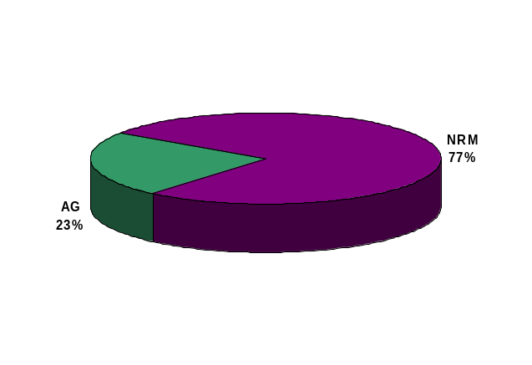
The chart shows the predominance of NR enterprises compared to NTA. This is explained by the fact that only fonio was the only NTA, and Tamba was the only region, targeted by WN at the start of the program in 2003 - both limiting factors for NTA.
NR
77%
NTA
23%
A fall in world cashew prices this year has reduced the potential that market carried in newly-added Ziguinchor region. Agricultural products contributed at least 30% of total producer revenues, and this proportion is increasing.
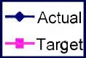
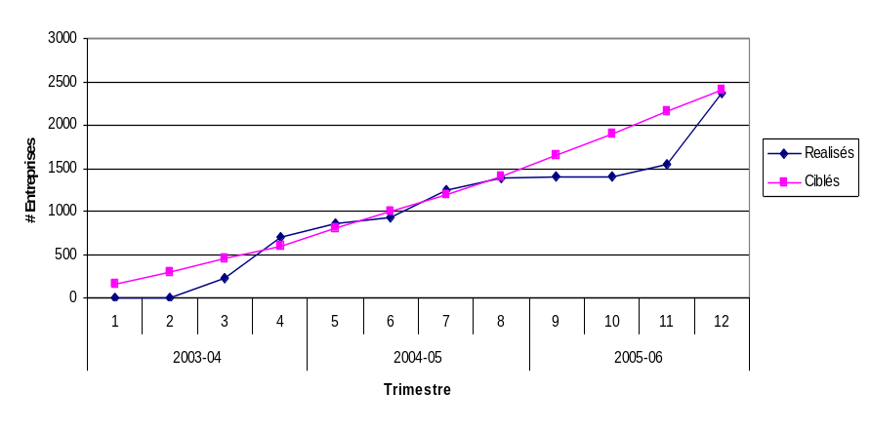
New or existing NTA-based enterprises in areas targeted by the AG/NRM program that show measurably higher revenues (Result 2 - Economic Benefits)
Indicator for Result 2: | Number of emerging or existing NTA-based enterprises that show measurably higher revenues in areas targeted by the AG/NRM program
Target for 2005-2006: | 500
Principal Activities | Progress achieved | # targets reached | # ongoing targets
Facilitate the elaboration of contracts between producers, processors and retailers | - 22 contracts signed between fonio producer groups and processors at Kedougou | 303
Development of producer networks to increase bargaining leverage | - 66 fonio, honey, wax, and cashew producer groups established in Kolda, Zig, and Kedougou  - 13 emerging enterprises trained in organizational dynamics | 303
Training on value-added/processing technologies. | - 7 enterprises in Kolda and Kedougou received training in processing for pre-cooked fonio  - 8 enterprises in Kolda and Kedougou received training in beeswax production  - 7 enterprises in Ziguinchor received training in grading cashew nuts  - 4 enterprises in Kolda received training in processing cashew nuts | 303
Training on literacy/ numeracy and business skill development | - 20 enterprises NTA at Kédougou and Kolda received training in accounting, enterprise management, or marketing | 303
Facilitation of communication among sub sector actors and stimulation of BDS provision | - Study tour to Dakar undertaken by 7 fonio enterprises to sign contracts, make contacts, and learn about the costs of transport  - 3 planning meetings facilitated between cashew producers and buyers in the Dept of Sédhiou  - 1 discussion forum facilitated between oil palm producers and climbers to reduce production costs (Sédhiou)  - 1 contact meeting facilitated between ACASEN and processing facilities in Ziguinchor  - 1 planning meeting with contract signing between producers and buyers of cashew in the Dept of Sédhiou | 303
Market research and promotion of new sub sectors | - Facilitated relations between 11 cashew processing units in Ziguinchor and ACASEN  - 1 market study on beeswax done  - 1 Discussion forum on cashew facilitated in Ziguinchor  - 1 draft report on the palm oil market completed | 303
Promotion of better, more sustainable production techniques | - 11 GPF from Kédougou went on an exchange tour to lead producers to improve fonio yield  - 7 GPFo from Kédougou received technical training on increasing fonio yield  - 10 lead fonio producers in Kédougou and Kolda established fonio demonstration plots | 303
Facilitating access to credit | - Revitalized collaboration protocols with banks (via a consultant)  - Pursued signatures on credit protocols with 2 SFD  - GIE Koba Club granted credit to fonio producer ladies | 303
Improvement in value-adding techniques | - 6 fonio machines installed and training held | 303
Cumulative total: |  | 303

Result 3: Number of new or existing (emerging) enterprises based on NR or NTA products that demonstrate measurably higher revenues in WN intervention zones, AND that have applied training to do any of the following: develop business plans and marketing strategies; implement improved production, harvest, or value adding techniques; negotiate with external partners.
BAOBAB
13 baobab producer enterprises in Kédougou, Tamba, and Dakar raised their revenues from 20,276,660 FCFA to 33,359,440 FCFA; that is an increase of 65%. This was made possible by:
- A continuation of business relations between producers of Bala and Baobab Fruit Company, resulting in producers receiving a 40% higher price compared to locally-sold baobab fruit;
- Producers with new grading capabilities were able to achieve a 75% price increase;
- Improvement in the quality of baobab powder allowed emerging local enterprises to win the confidence of processing companies in Dakar, translating into bigger orders, increasing the volume sold by 17% this year.
MBEPP GUM
25 gum producing enterprises in Koussanar and Maleme Niani increased their revenues from 54,167,115 FCFA to 129,744,050 FCFA, or by 140%. This was made possible by:
- The reinforcement of marketing cooperatives and negotiating skills in Koussanar;
- Formalizing relationships between gum producers in Koussanar and Bala and the national export enterprise Setexpharm, resulting in a price increase of 40% to new producers;
- A domino effect in which local producers increased production levels because of the increase in gum prices; and
- The fixing of a price related to the quality of graded gum/
JUJUBE
One jujube producer enterprise in Koussanar increased its revenues from 226,725 FCFA to 287,215 FCFA, or by 27%. This was made possible by:
- Processing jujube into cakes, which increased the price by 30%;
- An increase in demand for the jujube in cake form in certain zones.
FONIO
8 fonio producing/processing enterprises in Kedougou increased their revenues from 3,482,425 FCFA to 6,314,445 FCFA, or by 81%. This was made possible by:
- An increase in the volume of commercialized fonio;
- The growth of precooked fonio production levels to fulfill new markets;
- A stronger value added premium for precooked fonio which resulted in an increase of about 35% over the price of unprocessed fonio on the local market;
- The increased commercialization of a product that was formerly little sold;
- The negotiation of contracts between producers and processors;
- The quality of the fonio delivered to dynamic enterprises in Dakar is good enough to compete with Mali fonio.
This great demand which is now documented has encouraged an important member of the federation of fonio processors to grant 12 loans of $1,000 each to producer groups at a 10% interest rate, so that they can cover themselves the costs of what it would take to assure a regular supply.
Finally, the AG/NRM program is also working with the producers to increase yields. Fonio yields could potentially reach one ton per hectare, but the average is currently 300-400 kg. WN is helping some “pilot farmers” to set up demonstration plots to show other producers how to increase yields by using simple cultivation techniques.
The production in Kédougou has increased by 73.5% since 2003.

MIXED ENTERPRISES
One madd and baobab processing enterprise in Dakar increased its revenues from 6,838,995 FCFA to 8,719,940 FCFA, an increase of 28%. This was made possible by:
- The training held on making a website to improve visibility;
- A subsidy for putting in place a HAACP system;
- WN facilitation of providing regular supplies of baobab and madd.

TOTAL DYNAMIC ENTERPRISE REVENUES
48 dynamic mbepp, baobab, fonio, jujube, and mixed product enterprises increased their revenues from 84,991,920 FCFA to 178,425,085 FCFA, or by 110%.
For 2005-2006, the WN program reached 96% of its target. The factors that prevented reaching a full 100% were a late start on recruiting the Dakar-based facilitator, and the length of the process of transitioning from emerging to dynamic enterprises.

Fonio overview
Fonio is a locally grown cereal that is well adapted to Senegalese cuisine. It is also considered to be healthy, low in natural sugars and easy to digest. If fonio is pre-cooked by processors it is also very easy to prepare at the consumer level. It has a small niche local gourmet market, yet until recently this market was modest. This is perhaps not surprising as the production of fonio in Senegal is small (estimated at 1100 tons), and producers mostly grow it for subsistence rather than sale. According to a study carried out by the AG/NRM program, only 27.8% of all fonio cultivated is sold.
If production were encouraged without ensuring that demand was in place, it is likely that farmers would not be able to sell all their produce; prices would be unstable and the motivation to cultivate would not be sustainable. If demand were stimulated without supply, then the consumers and downstream processors will abandon the product, as producers will not be able to meet the stimulated demand. Thus the AG/NRM program has taken a value chain approach to this market question, and is working at all levels to increase supply.
One of the principle constraints in the fonio supply chain is the fact that it is very difficult to de-hull fonio which limits production capacity. Carried out by hand, it takes approximately 1 hour to process 2 kg of fonio. The AG/NRM program has worked on reducing the processing time by providing grants to 6 key producer groups to attain fonio machines, in order to increase their de-hulling capacity and volumes. To ensure that the grants were sustainable, the program also has worked to train a local mechanic to provide repair services to fonio groups, as a BDS provider.
This year the AG/NRM program has worked with regional processors to form a marketing federation. This has allowed them to attain an economy of scale necessary to supply Dakar buyers with a sufficient amount of fonio to interest consumers and to guarantee a regularity of delivery. The program facilitated a visit by the federation to Dakar to meet buyers and elaborate informal contracts to supply at least 1.5 tons of pre-cooked fonio per month in the upcoming year.
With1.5 tons per month as a goal, processors have held a series of meeting with farmers to determine the volumes needed to meet the market demand and to fix pricing. Contracts with 15 producer groups were drawn up to supply the processing federation with at least 24 Tons of fonio for this year.
The large demand has encouraged the fonio processing federation, through one of its largest members, to provided 12 fonio producers groups with $ 1000 worth of credit, at 10% interest rate, in order to take care of initial production cost and ensure a healthy supply.
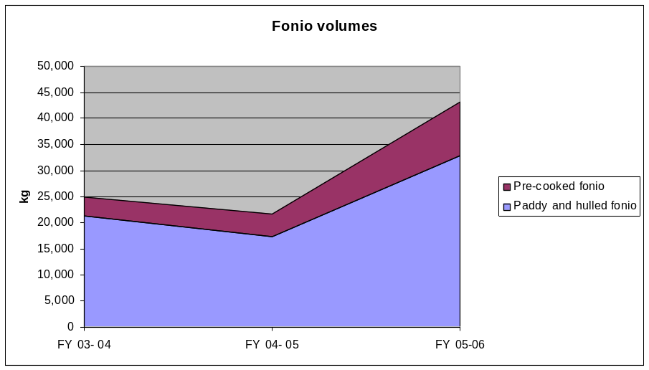
Finally, the AG/NRM program is also working with producers to increase their yields. Yields of fonio can reach 1 Ton per hectare but the average is closer 300-400 kg per hectare. The AG/NRM program is working with “lead farmers” through demonstration plots to show other farmers how to increase yield, using simple cultural techniques.
Production in Kedougou has increased by 73.5% since 2003

Now producers are assured of a buyer; the market is assured of a continual supply of product; and hopefully Senegalese consumers can start to learn more about the delights of fonio.
Idjatou Barry, a fonio producer in Dindefelo says that “three years ago there was no market for our fonio. Now the fonio that I farm is like money in a bank: I can sell it at any time to take care of my family needs.”

Indicator for Result 3: | Number of new or existing NR or NTA based enterprises in areas targeted by the  AG/NRM program that show increased, measurable revenues AND have  applied training to develop business plans and marketing strategies, adopted  improved production, harvesting and/or value-added processing techniques,  and negotiated joint ventures with external partners.
Target for 2005-2006: | 45 enterprises
Principal Activities | Progress achieved | # targets reached | # ongoing targets
Capacity building for dynamic enterprises based in Dakar | - Training in website for 3 dynamic enterprises in Dakar  - 10 enterprises in transformation from emerging to dynamic diagnosed by the Dakar facilitator  - Identified service contractors who can help the 10 dynamic Dakar enterprises realize their business plans  - Retreat held to discuss the importance of business plans with the 10 transforming enterprises in Dakar  - Identified wholesalers and processors for madd, nététou, charcoal, fonio, and baobab in Dakar | 48
Network development for producers that increases the efficiency of negotiations | - 2 Baobab Federations put in place in Tambacounda and Dakar  - 1 Federation of fonio processors pout in place at Kédougou  - Diagnosis of the producer networks in Tamba, Kédougou, and Ziguinchor | 48
Literacy and numeracy training for enterprise development | - 58 producer and processing GIE networks received literacy training | 48
Facilitation of product supply to market | - 3 exchange visits facilitated between baobab powder, precooked fonio, and madd producers and their respective buyers in Dakar with the goal of improving raw material supply | 48
Improvement in value-adding techniques | - Subsidy to Maria Distribution for putting in place a HAACP system  - Credit allocated to 6 cashew processing units in Ziguinchor  - Subsidy for putting in a jujube processing unit in Koussanar | 48
Market research and promotion of new sub sectors | - Study tour to India on grading and quality control for mbepp gum | 48
Reinforcement of skills of producer enterprises that are transitioning into dynamic enterprises | - 3 NTA-based enterprises trained in dynamic organization  - 13 NR-based enterprises trained in dynamic organization | 48
Cumulative total: |  | 48

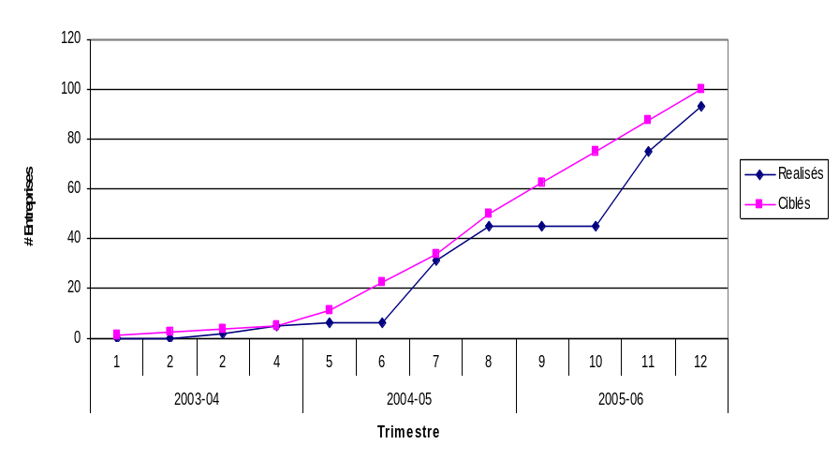
NTA- or NR- based (emerging) enterprises that had a measurable increase in revenues AND applied training received from WN (Result 3 - Economic Benefits)

When you sum the emerging and the dynamic enterprises together, a cumulative total of 1,032 that market any combination of mbepp gum, baobab, fonio, jujube, cashew, palm oil, honey, madd, or charcoal have increased their revenues from 151,546,680 FCFA to 306,240,960 FCFA, by 102%.
Since the beginning of the program, revenues on the whole have increased by 332,669,520 FCFA.
The following graphic depicts the progression of the 190% increase compared to last year.

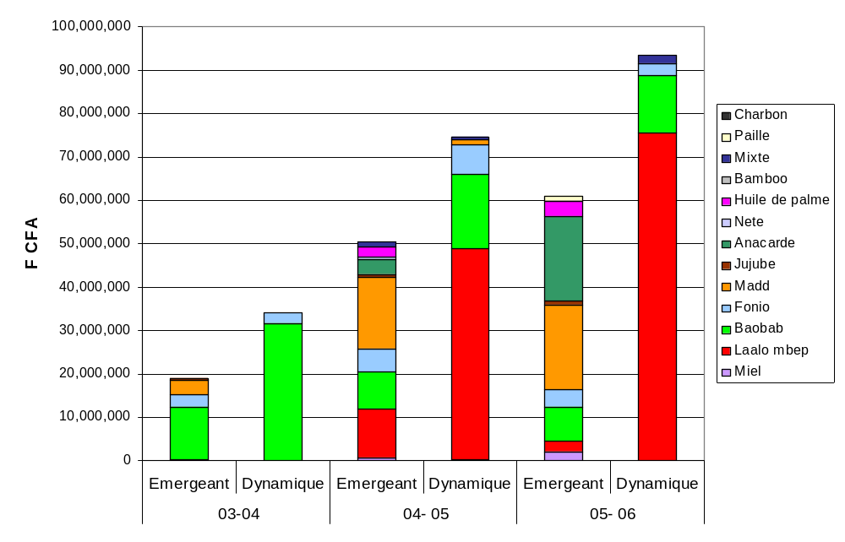

Increase in revenues by market product and by type of enterprise since 2003

Measured Indirect Revenues
As do all goal-oriented programs, AG/GRN defines its interventions in terms of well-identified targets. In order to justify results, it is usual to show cause and effect, particularly when using “indicators of impacts” such as “revenues are increased”. In order to guarantee true objectivity, we can only measure increase in revenues of economic operators with whom we work, and these revenues are documented on verifiable survey forms.
At some point, it becomes clear that a program’s results are not limited to a target group with whom it works. Good ideas end up being adopted elsewhere. An example of this is in the work of AG/GRN on madd fruit in Kédougou in 2004. The program worked with well-chosen communities that organized themselves into producer groups and learned to negotiate better prices for madd. This innovation turned into a “drop of oil” very quickly. By 2005, most rural communities in Kédougou were debating on a minimum price to accept for madd. This highlights a very simple idea: that the economic impact of such a program is not limited to the value of the product, nor to a specific geographic area. The impact is rather related to more extensive ideas: price increase, cost reduction, organizational dynamics, and spreading new and appropriate value-adding technology.
Measuring this type of impact -- the “drop of oil” -- is difficult to do and to justify; how to quantify the true impact of AG/GRN on the macro- or micro- economic level?
To evaluate its indirect impacts, AG/GRN uses official statistics on production and documented information on prices and costs to calculate regional revenues by subsector. The following graph depicts the regions’ increases in revenues in Tambacounda and Kolda from 2003 to 2005, with 3.3% inflation subtracted out (the “real” increase), for most of the subsectors targeted by AG/GRN in its first two years. (Year 2006 has been excluded because all data for this production year are not yet in.)
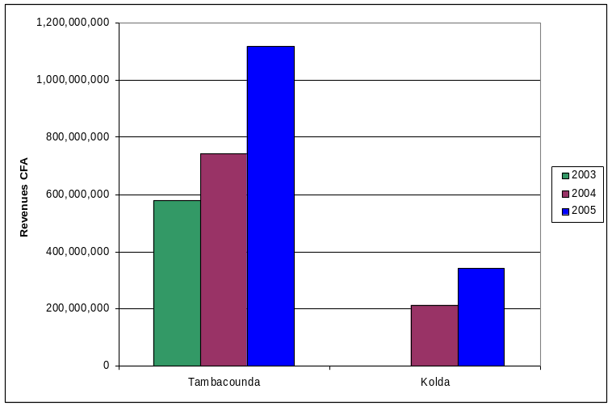
From these data, we see that producer revenues in subsectors targeted by AG/GRN increased considerably since the start of the program (2003 in Tamba, 2004 in Kolda). It is reasonable to assert that this increase has been stimulated by the program.
Using these indirect indicators, it can be shown that the increase in producer revenues in Tamba and Kolda regions from 2003 to 2005 for the six target subsectors were 616,467,555 FCFA or $U.S. 1,272,602.
The direct [verifiable] impact of the program during the first two years was 178,122,839 FCFA in revenue increases. Thus, the [non-verifiable] indirect impact in the first 2 years was about four times larger than our own economic evaluations show.

Result 4: Increase in the number of enterprise groups benefiting from initial training by WN facilitators
630 enterprises have been trained: 282 during producer group organizational meetings; 111 in group organizational dynamics; 87 in processing techniques, 97 in management and literacy; and 53 in production and harvest techniques.
In total, 2,634 women and 4,723 men were trained. This year AG/GRN went beyond its target.

Indicator for Result 4: | Number of enterprise groups benefiting from initial training by the facilitators.
Target for 2005-2006: | 400
Principal Activities | Progress achieved | # targets reached | # ongoing targets
Development of producer networks to increase bargaining leverage | - 198 mbepp, baobab, jujube, nété, thatch, madd, and charcoal producer groups established in Kolda, Ziguinchor, and Tamba  - 2 federations of baobab processors established in Salémata (4 enterprises) and Tamba (8 enterprises)  - 1 federation of fonio producers put in place in Kédougou  - 1 federation/union of charcoal producers put in place in Missirah  - 82 NR-based emerging enterprises trained in organizational dynamics  - 13 NR-based dynamic enterprises trained in organizational dynamics  - 66 fonio, honey/wax, and cashew producer groups established in Kolda, Ziguinchor, and Tamba  - 13 emerging NTA-based enterprises trained in organizational dynamics  - 3 dynamic NTA-based enterprises trained in organizational dynamics | 630
Training in value-added/ processing technologies | - 12 charcoal producer groups trained in techniques of prod.  - 4 enterprises in Kolda received training in processing jujube into cakes  - 15 enterprises in Kolda received training on processing mbepp gum into powder  - 6 baobab enterprises received training in HACCP  - 1 enterprise in Tamba received training in grading baobab  - 20 enterprises in Kolda, Ziguinchor, and Tamba received training in processing baobab into powder  - 7 enterprises in Kolda and Kédougou received training in processing for pre-cooked fonio  - 8 enterprises in Kédougou and Kolda received training on production of beeswax  - 7 enterprises in Ziguinchor received a training on sorting cashew nuts  - 4 enterprises in Kolda received training on processing cashew nuts | 630
Training in literacy/ numeracy and business skill development | - 20 NTA-based enterprises in Kédougou and Kolda received training in accounting, business management, or marketing  - 19 NR-based enterprises at Kédougou and Kolda received training in accounting, business management, or marketing  - 3 dynamic enterprises in Dakar received training in website design  - 58 producer networks and processing GIE received literacy training | 630
Promotion of improved/sustainable production techniques | - 35 GPL in Kolda received training in improved gum harvest techniques  - 11 GPFo in Kédougou went on a technical exchange tour with lead producers to improve fonio yield  - 7 GPFo from Kédougou received technical training on increasing fonio yield | 630
Cumulative total (since start of program): |  | 1,683

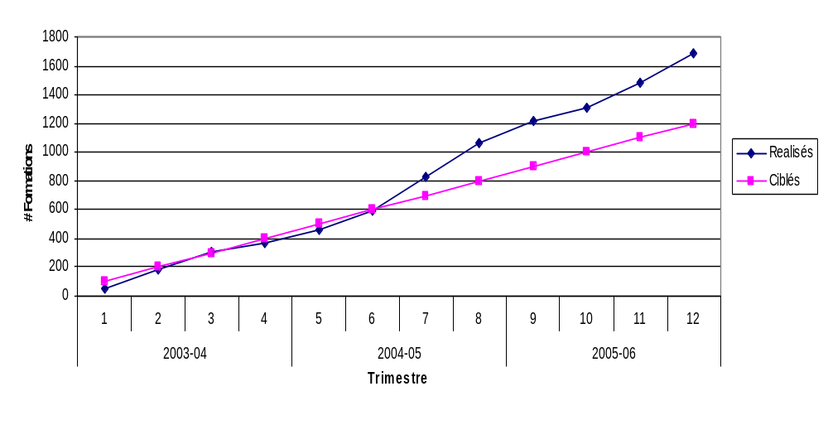
Enterprise groups benefiting from initial training by the facilitators (Result 4 - Economic Benefits)

Result 5. Increase in the cumulative number of enterprise groups trained by WN

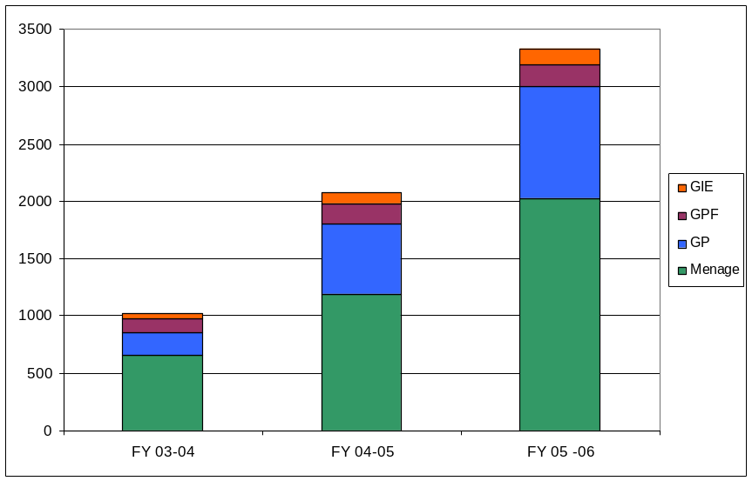
3,327 enterprises were supported by AG/GRN from 2003 to today, with a total of 2,031 family enterprises, 189 women’s groups (GPF), 132 Economic Interest Groups (GIE), and 975 producer groups (GP).
Types of enterprises assisted by the AG/NRM Program
In the quarter just ended, 826 new enterprises have been assisted. For 2005-2006, the program has exceeded its targets for Result 5.
Indicator for Result 5: | Cumulative number of enterprise groups assisted by WN
Target for 2005-2006 : | 1800
Principal Activities | Progress achieved | # targets reached | # ongoing targets
Businesses who:  i) Received Wula Nafaa (WN) training  ii) Had contracts facilitated by WN  iii) Increased revenues thanks to WN assistance | See discussion above | 826
Cumulative total for the year: |  | 1250
Cumulative total since beginning of program: |  | 3327
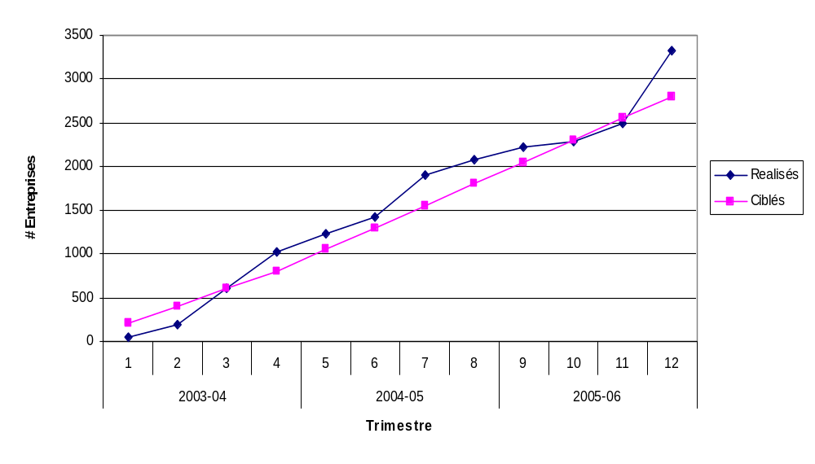
Cumulative number of enterprise groups assisted by AG/NRM Program
(Result 5 - Economic Benefits)

Result 6: Increase in the number of market surveys and studies to identify potentially marketable AG/NRM products

WN achieved its goal for Result 6 this year. Market studies on beeswax, touloukouna or Carapa procera oil, ecotourism, and thatch were completed. A draft of the palm oil study is available.
Recommendations in the studies for touloukouna and for ecotourism guided the program’s decision to abandon these possible markets. On the other hand, the thatch and wax studies indicated that there is a potential market for these products, albeit modest, but still important enough to justify an intervention by the program.

Indicator for Result 6: | Number of market surveys and studies to identify potentially marketable AG/NRM products
Target for 2005-2006 : | 4
Principal Activities | Progress achieved | # targets reached | # ongoing targets
Comparative financial analyses and market studies for NR and agricultural products | - Market study on ecotourism  - Analysis of the thatch/hay supply  - Market study on beeswax  - Market study on touloukouna oil  - Draft study on palm oil | 4 | 1
Cumulative total: |  | 4 | 1
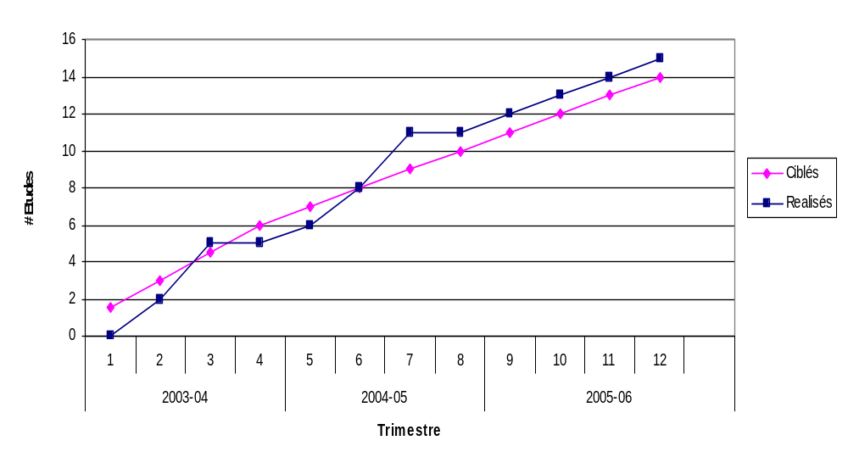
No. of market surveys and studies to identify marketable AG/NR products (Result 6 - Economic Benefits)

Result 7: Increase in the number of grading schemes and value-added processes developed to increase revenue and income per unit of production to producers
Training in several value-adding activities has given access to higher revenues to producer groups. Topics included grading cashew nuts, processing the nuts in Ziguinchor, producing powder from mbepp gum in Kolda, and charcoal-burning in Tambacounda. The targeted number of processes was achieved this year.

Indicator for Result 7: | Number of grading schemes and value-added processes developed to increase revenue and income to producers per unit of production
Target for 2005-2006: | 4
Principal Activities | Progress achieved | # targets reached | # ongoing targets
Training in added-value/transformation processes | - Charcoal production  - Sorting raw cashews  - Mbepp gum powder  - Cashew nut processing for market | 4
Cumulative total : |  | 4

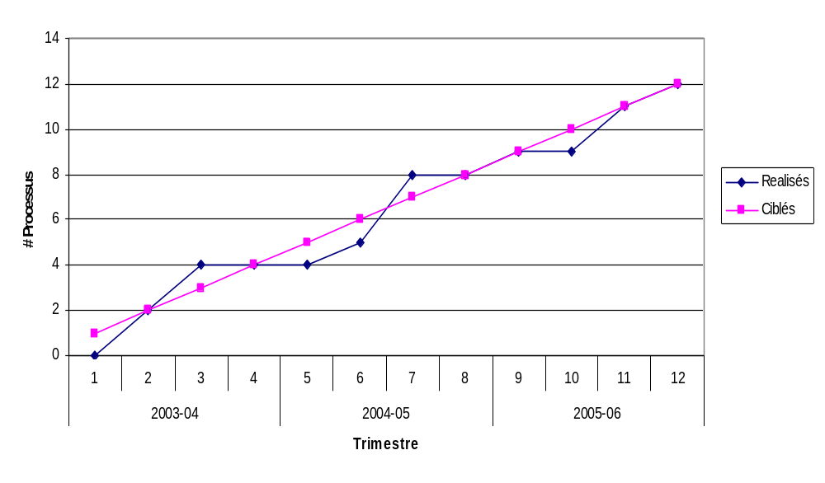
Grading and value-adding processes developed to increase profit to producers (Result 7 - Economic Benefits)

Result 8: Increase in the level of revenues earned by enterprise group assisted

Revenues increased 102% over the previous year. It is difficult to analyze all enterprises’ revenue increases since the beginning of the program in 2003 because the first year was partial, and continuing enterprises can only increase their revenues up to certain point. The charts below show the evolution of the total revenue generated by all producer groups during preceding years.
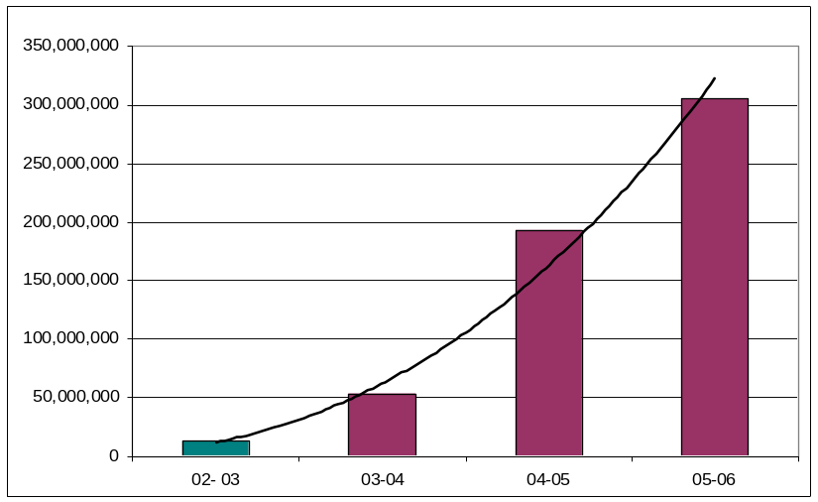
Total revenues for groups working with WN since 2002-2003
This graphic does not give information on the number of enterprises involved, nor on their individual revenue increases. As an alternative view, the graphic below will show the evolution of the mean revenue per enterprise since 2003.
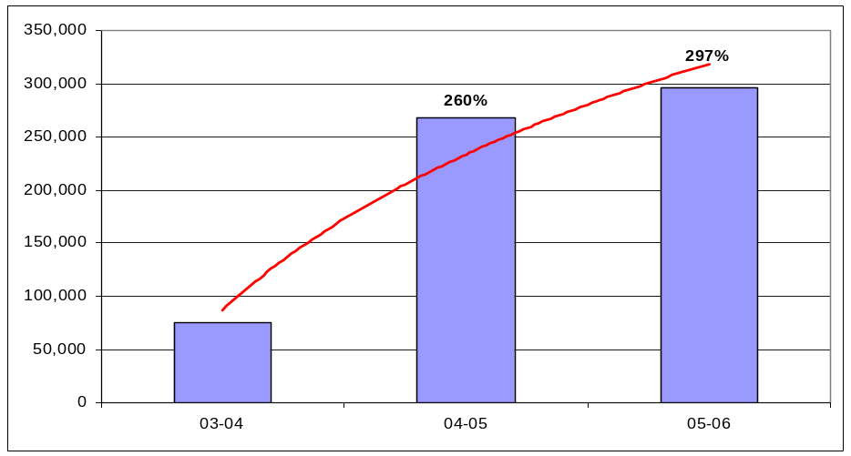
Mean revenue per enterprise working with WN 2002-2006

Indicator for Result 8 : | Level of revenues earned by assisted group enterprises
Target for 2005-2006: | Cumulative 225%
Principal Activities | Progress achieved | # targets reached | # ongoing targets
Enterprises assisted so that their revenues increase: | - Cashew 92%  - Fonio (emerging) 198%  Fonio (dynamic) 81%  - Palm oil 48%  - Honey 1339%  - Baobab (emerging) 130%  - Jujube 83%  - Mbepp gum (emerging) 102%  - Mbepp gum (dynamic) 140%  - Madd 79%  - Thatch/hay 69%  - Baobab (dynamic) 64%  - Mixed 27%  - Total 2005-2006 102% | 102%
From previous year: |  | 184%
Cumulative total : |  | 297%

Result 9: Increase in volumes of products marketed by enterprise group assisted
Taken together, volumes of WN-assisted products increased this year. Individual increases were achieved for most products, between 16.7% (Baobab pulp) and 383.5% (cashew). Products that decreased in volume are honey and palm oil (because of reduced output), and nété (because the principal partner had financing difficulties).

Indicator for Result 9: | Increase in volume of products marketed by enterprise group assisted
Targeted 2005-2006 : | 40%
Principal Activities | Progress achieved | # targets reached | # ongoing targets
See above | - Fonio shelled/raw 32 904 kg + 90.6%  - Fonio precooked 10 163 kg + 131.9%  - Madd 878 460 kg + 17.2%  - Honey 2 626 Litre - 21.1%  - Baobab in shell 323 194 kg + 54.9%  - Baobab powder 6 441 kg + 16.7%  - Jujube raw/sorted 30 747 kg + 38.8%  - Jujube cake 508 kg + 263.4%  - Mbepp 286 689 kg + 103.2%  - Cashew 223 283 kg + 383.5%  - Wax 807 kg + 19.4%  - Palm oil 18 828 Litre - 26.1%  - Nete 288 kg - 94.4%  - Charcoal 10 000 kg N/A  - Thatch/hay 8 955 bundles N/A | Increase in total volume compared to last year = 49.2%
Cumulative total : |  | 49.2%
Result 10 (Non-contractual result): Value of exports
MBEPP GUM
91,015 kilograms of mbepp gum from WN-associated producers were sold to Setexpharm for export, and 195,674 kg were sold to bana-banas of which 2/3 were destined for export. Total export volume was 221,451kg. The value of this gum FOB (Free On Board, including exporter’s costs and taxes) is $885,857 (or 466,846,815 FCFA) on the basis of $4 per kg.
BAOBAB
80,398 kg of baobab in the husk from supported producers were sold. If the pulp represented is 17% of this weight, and if the price is 11.5 euros per kg, the value of the baobab pulp FOB was $199,616 (105,197,724 FCFA).
TOTAL
The total worth of the gum and baobab pulp exported is estimated at $1,085,474 (572,044,539 FCFA).

Result 11 (Non-contractual result): Number of new jobs provided
Although the AG/NRM program is not formally required to track the number of new jobs it creates, it has calculated this statistic using criteria similar to those used in other USAID-financed projects.

Product | Cashew | Fonio | Palm oil | Honey | Baobab | Char-coal | Gum mbepp | Madd | Thatch | Total
Number employed | 88 | 138 | 2 | 62 | 222 | 25 | 67 | 290 | 6 | 900

Constraints, opportunities, and priorities for 2006-2007

Constraints
For 2006-2007 year, access to credit will remain a major challenge in the development of dynamic and emerging local enterprises. This is true especially for packaging (baobab powder, fonio), transport costs for certain products (charcoal, madd), and large-scale supply of raw material for processors (fonio, baobab, cashew, and others).
The impact of the program in Dakar is rather limited because of our late recruitment of a facilitator. Another limitation is that the dynamic enterprises have no business plans, which makes quick and targeted intervention difficult. For these reasons, WN first made a diagnosis and began the process of assisting with business plans that would define each enterprise’s principal need for assistance.
The fall in prices of cashew and baobab in the husk, which are dependent on the world market, has contributed greatly to the reduction in producers’ revenues. Baobab fell by 21%; cashew nuts fell by 42%. This has pushed producers in Kolda and Ziguinchor to conserve their stocks while waiting for a better offer.
Following the discussion forums held on palm oil, an effort was made to reduce costs of processing and marketing, but this has not had a great impact. In fact, revenue growth was limited to 20% over last year.

Opportunities
The establishment of federations of fonio and baobab powder processors enabled enterprise members to achieve economies of scale and to get regular markets in Dakar, assuring that they will have steady revenues. This in turn stabilizes and strengthens the market chains for their products.
The charcoal market is one of the most lucrative in forestry in Tambacounda and Kolda regions. The management plan of Koulor and the signed protocol of the ZPC of Missirah will help local community members, instead of outsiders, to do the charcoal producing and marketing in their areas. This taking charge of the market by local people will contribute to better management and valuation of the resource.
The WN program has always counted on collaboration with partners to increase efficiency of certain activities. This year, WN has worked together with the newly-arrived SAGIC program on the cashew market chain. In addition, at the request of Enterprise Works, a protocol was signed for the long-term support of cashew processing enterprises. In the mbepp gum market, WN collaborates with Manobi, a supplier of electronic Market Information Systems, to resolve the problems of communication between producers and buyers of mbepp gum.

Priority actions
For WN, the 2006-2007 year will be characterized by a reinforcement of networks to assure a better supply of services to producer groups such as commercialization, training, and information, so that the long-term survival of these enterprises can be guaranteed.
WN will emphasize the strengthening of relationships between producers and buyers through formal contracts, periodic meetings, and market information sharing, all the while maintaining vertical liaisons so that the value of the product will be preserved all along its way to the markets.
WN will facilitate the development of solid dynamic enterprises, the catalysts for agricultural and forestry product markets. These enterprises will assure the provision of services (credit, information, purchases) to producers and buyers; will help stimulate production; will increase value adding at the local level; and will act as focal points between different actors in the market chain.
The key to succeeding with these priorities is the involvement of managing organizations and of the Rural Community to assure oversight and a managed, rational utilization of resources. The program will work to reinforce the synergy between these three structures.
The major focus of WN for 2006-2007 will be assuring the longevity of its accomplishments.

Rights and Responsibilities Component

Targeted results and planned activities

General Considerations
The Rights and Responsibilities component seeks to promote better, sustainable, and decentralized community management of natural resources by means of the transfer of responsibility as well as by validating legal rights, management authority, and relevant capacities. The approach is based on territory-wide areas such as the Communautés Rurales or Rural Communities (RC).
Agricultural, pastoral, and silvicultural resources are interdependent but require different types of management. The best utilization of the land and vegetation features in a given territory must be envisioned according to the potential use of each combination on one level, and according to the whole territory’s characteristics on another level. Land use planning must take into account the possibility for balancing existing activities with the needs of different user groups; but this can only be done if communities have permanent control of the resources. The community must be capable of managing the resource, and this implies that community members have power to control its use and/or to limit its access according to a certain number of principles upon which irrevocable consensus has been reached.
In this framework, several activities have been developed in the course of this year:
- support to villages and their organizations engaged in managing the land, protecting natural resources, and increasing productivity (maintaining the production capacity of vegetation formations so that harvested resources will not reduce their capital, by means of tree nursery and plantation activity; and improving agricultural yields, as practiced in fonio demonstration plots);
- support for local conventions to be developed in the Rural Communities; and
- Provide assistance to communities writing and implementing forest management plans.

Targeted results
Key results that are being targeted by the component during the life of the program consist of increases in the elements listed below:
- Number of communities/CBOs that have undertaken community-led activities to increase productivity of NR in a sustainable manner;
- Number of communities/CBOs that have engaged in formal co-management relationships with actors and institutions external to the community to increase productivity of NR;
- Number of hectares that are under legally recognized, community-based and sustainable NRM plans known as local conventions;
- Number of hectares that are under legally recognized, community-based and sustainable NRM plans in Community Forests;
- Number of communities receiving training in NR monitoring, enforcement of local codes, or conflict management;
- Number of communities or CBOs that develop natural resource management plans that are overseen by the communities; protocols; agreements; or local codes that govern access, use, and protection of NR; and
- Number of regional units whose skills in mapping and inventory of NR is improved.

Activities planned for 2005-2006
Training and strengthening of rights and responsibilities of rural communities in natural resource management
- Training in laws related to NRM and decentralization for targeted rural communities in Ziguinchor
- Followup training in Kolda and Tambacounda rural communities in NRM laws
- Support to translation and distribution of the most relevant laws
- Informational exchange visits within Senegal and in the sub-region
Open land and community forest management
- Implementation of local conventions’ land management plans for rural communities in the regions of Kolda and Tambacounda
- Development of local conventions for rural communities in Ziguinchor
- Development and implementation of participatory community forest management plans for Koulor, Sare Bidji and Balmadou
- Identification of opportunities to adopt best practices in NRM that increase productivity
Joint Management of Classified Forests:
- Reaching agreement on the process of writing operational forest management plans, adapted to the local context and needs; and support to rational management of targeted forest stands
- Development, approval, and implementation of local codes for the classified forests of Balmadou, Pata (Kolda) and Tendouck (Ziguinchor)

Progress achieved

Result 1: Increase in the number of communities/CBOs that have undertaken activities to increase productivity of NR

This year, WN contributed to the increase in revenues of villagers in its intervention zones by favoring certain market chains (Baobab (Adansonia digitata), mbepp gum (Sterculia setigera), madd (Saba senegalensis), and cashew (Anacardium occidentale). It follows that these resources should be well-managed, but even more, that the production capacity of the plant communities in which these products are harvested should be maintained. This is why the RR component has instigated a tree nursery and tree planting program this year. Its success on the ground will depend on the area of plantations installed -- whether in agricultural fields, pasturelands, forest stands, or other areas of protection; and on individual initiatives taken by rural entrepreneurs who get involved in market chains being supported by WN.
Plant production has occurred in 6 locations as follows:
Salémata (8 nurseries) | Malème Niani (3 nurseries)
Dakately (2 nurseries) | Koussanar (5 nurseries)
Saraya (1 nursery) | Sinthiou Malème (1 nursery)
A total of 23,948 seedlings were produced as follows:
Mbepp - 3,177 | Cashew - 18,494
Cadd - 2,073 | Jujube - 131
In fonio marketing, the promotion of appropriate techniques to increase yield required putting demonstration plots in place. Fonio is currently in grain formation and producers are doing the final weeding.

Indicator for Result 1: | Number of communities/CBOs that have undertaken activities to increase productivity of NR
Target for 2005-2006: | 600
Principal Activities | Progress achieved | # targets reached | # ongoing targets
Support to villagers and local organizations involved in land management | - 11 CBO in the RC of Koussanar and Sinthiou Malème planted trees  - Put in place 13 village nurseries to regenerate species targeted in WN program market chains  - Early burning activities instead of firebreaks in 12 villages  - Seeding done in nurseries  - Firebreaks built in 11 villages in the RC of Sakar  - Identified producers and sites for demonstration fields of fonio at Kédougou and Kolda, in 6 RC  - Planted nursery seedlings in 16 villages in the departments of Tamba and Kédougou  - Produced fonio in demonstration plots in 8 villages | 11  13  12  18  1  16  8
Cumulative total : |  | 90

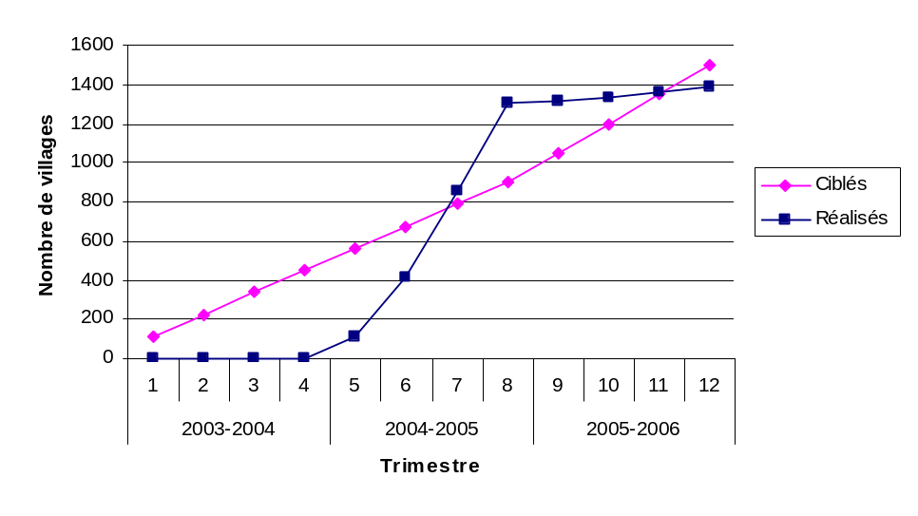
Communities/CBOs that have undertaken activities to increase productivity of NR (Result 1 - Rights and Responsibilities)

Result 2: Increase in the number of communities/CBOs that have engaged in formal co-management relationships with actors and institutions external to the community to increase productivity of NR
The year just finished marked a consolidation of extension work on local codes in the Tambacounda region. Concrete actions in NR protection and the fight against illegal NR exploitation were undertaken in seven RCs: Koussanar, Malème Niani, Sinthiou Malème, Kothiary, and Koulor.
Forest guards were trained in their roles and responsibilities in the RC of Koussanar, Sinthiou Malème, Kothiary, and Malème Niani.
In the classified forest of Balmadou, five RCs (Tanaff, Niagha, Kolibantang, and Karantaba) already have village NR management committees. Different Rural Councils decided to participate in forest management and sent their requests to the departmental Forest Service in Sédhiou, as prescribed in the forestry code. Up to now, they are still waiting the reaction to their request.
Indicator for Result 2: | Number of communities/CBOs that have engaged in formal co-management relationships with actors and institutions external to the community to increase productivity of NR
Target for 2005-2006: | 7
Principal Activities | Progress achieved | # targets reached | # ongoing targets
Handling requests for the management of classified forests, and evaluation of local codes  Writing and applying the local code for the Pata forest  Writing and applying the local code for the Balmadou forest | - Comanagement of the classified forest of Diatouman was deliberated by the RC of Saré Bidji  - Followup of the application of the local code for the classified forest of Pata was done by communities of the RCs of Ndorna and Pata  - A request to comanage the classified forest was sent to the departmental forest service of Sédhiou for approval by the RC | 1 | 6
Cumulative total : |  | 1 | 6
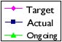
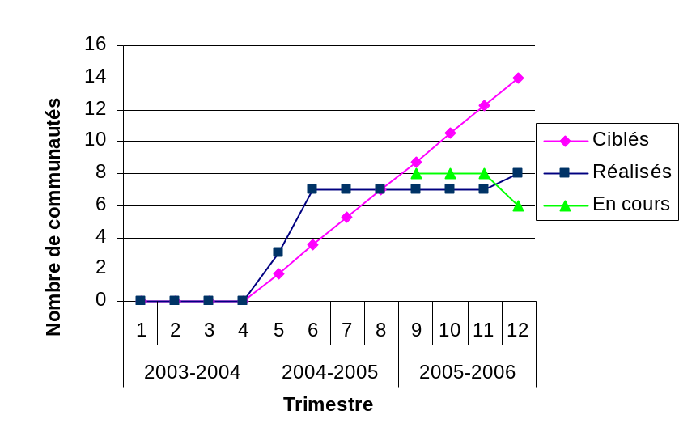
Communities/ CBOs that have engaged in formal co-management relationships with actors external to the community to increase productivity of NR (Result 2 - Rights and Responsibilities)
Result 3: Increase in the number of hectares that are covered by legally recognized, community-based and sustainable NRM plans through local conventions
The local convention that regulates access to natural resources and their proper management contributes to conflict avoidance and consensual management; it is an indispensable tool for rural populations. It deals with how to use collectively-owned resources; it describes all in one place the management experiences and knowledge of local society.
WN has helped put in place 24 of these local conventions, of which 12 are in Tambacounda region, 8 in Kolda, and 4 in Ziguinchor. Annex 2 depicts the steps taken in developing the local convention and the level reached by each rural community thus far.
Indicator for Result 3: | Number of hectares that are covered by legally recognized, sustainable community managed NRM plans through conventions locales
Target for 2005-2006: | 1,277,967 ha (3 000 000 ha by 2008)
Principal Activities | Progress achieved | # targets reached | # ongoing targets
Writing and implementation of Local Conventions | - Drafted Local Conventions in Ziguinchor (Mangagoulack, Diégoune, Tengory, and Balingore); Kédougou (Khossanto, Dakately); and Kolda (Simbandi Brassou, Diendé, Karantaba, Linkéring)  - The Local Conventions of Tanaff, Djirédji, and Bambaly were approved  - The Local Conventions of Kédougou (Tomboronkoto, Bandeafassi, Saraya, Missirah Sirimana, Salémata), Tamba (Kothiary, Goudiry, Sinthiou Malème, Malème Niani, Koussanar) and Kolda (Sakar) were activated | 2,457,993 ha | 611,813 ha
Cumulative total : |  | 2,457,993 ha
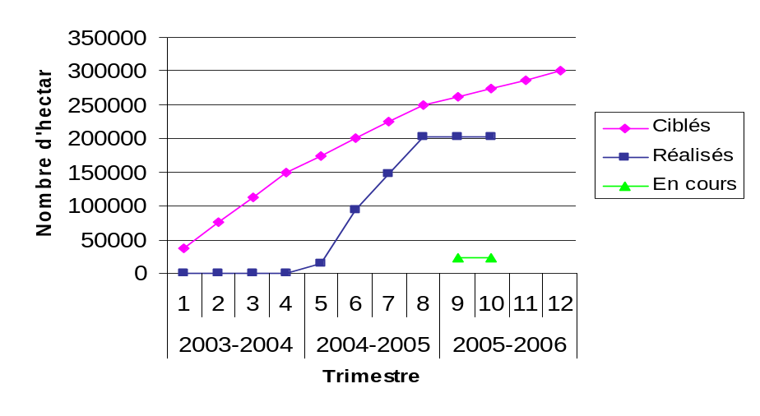
Hectares covered by legally recognized, sustainable community-based NRM plans through local conventions (Result 3 - Rights and Responsibilities)
Local Conventions: a new experience in natural resource management by local populations
The national workshop on local conventions organized at Mbodiène (Mbour) showed that local conventions allow communities to establish rules and assure they are followed. The conventions are the preferred way for Rural Communities to develop local laws to manage their natural resources on a sustainable basis.
The Mbodiène workshop validated the WN approach to helping communities draw up and implement their local conventions. The approach includes:
- An emphasis on spreading information on the local convention throughout the communities and the external partners that it affects;
- Providing a translation of the local convention into local language for the best possible understanding of it;
- Providing means to support followup activities to put the local conventions into motion; and
- Assuring the involvement of all the stakeholders, in particular government technical services.
In addition, the workshop concluded that the WN approach to develop Local Conventions is more comprehensive in comparison to other methods presented at the Mbodiène workshop.
Indeed, decentralization structures that were previously considered obstacles to community involvement have now become part of the whole process.
The positive impacts of the WN approach to local conventions are such that it should extended to other areas with an accompanying monitoring and followup component.

Result 4 : Increase in the number of hectares that are covered by legally recognized community-based natural resource management plans for community forests
The community forest of Koulor has its management plan in place and its stakeholders have begun implementation (see box below).
The management plan for the community forest of Saré Bidji is nearly completed; the technical presentation has been done in the villages of the rural community. The remaining steps are the rural council’s deliberation and approval by the Sous-Préfet.
For the community forest of Missirah, local organizations that will manage mapped blocks are operational and charcoal production under a management plan has begun.

Forest Management: the Community Forest of Koulor
Management of the 39,214 hectares of the community forest of Koulor has been placed under the charge of the communities in the area, whose members can read maps and fully understand the plan’s content. Charcoal production has been taken over by local people. 30 management structures were trained in appropriate charcoal production techniques and participate in marking parcel boundaries and individual trees to be cut.
Revenues generated by management activities are shared among stakeholders as follows:
Forest management fund 70%
CIVGF 10%
Rural Council (CR) 10%
Village 10%
The management fund is composed of funds derived from revenue-producing activities as defined by the management plan. The management fund is to be used to support activities linked to the plan. For each forest placed under a community-based management plan, a forest management fund will be established.
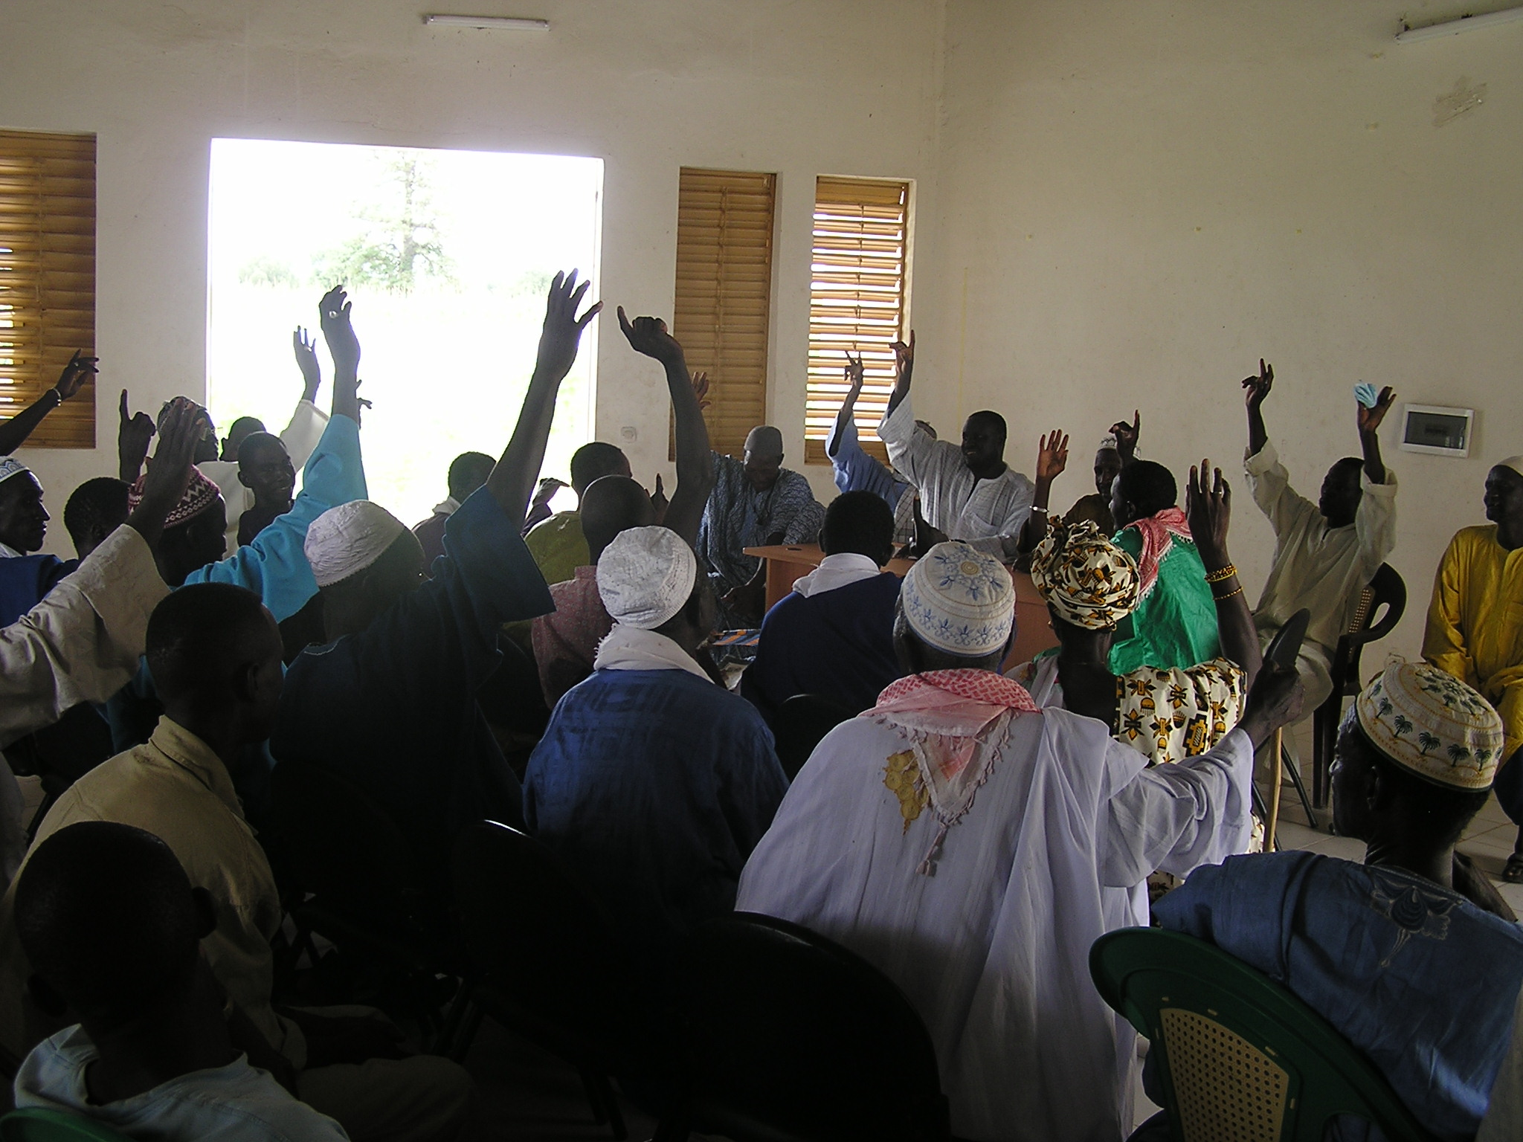
In the past, charcoal production has been considered an activity for the lower classes; today, it is a sought-after profession. Potentially-interested producers counted in WN areas when the idea first came up had no true heart for the activity; now, they have become true professionals, willing to supply the quota of 1,500 quintaux (3,000 sacks) that has been awarded by the Forest Service as a pilot activity.
General meeting on the Koulor Management Plan

Indicator for Result 4: | Number of hectares covered by legally recognized Community Forest Mgmt Plans
Target for 2005-2006: | 80,859 ha
Principal Activities | Progress achieved | # targets reached | # ongoing targets
Meetings and approval on the Koulor management plan  Put in place management blocks and parcels in Saré Bidji Forest  Put in place management organizations in Missirah Zone of Controlled Production | - Management plan for Koulor brought back to the villages, validated, and approved  - Management organizations and Missirah ZPC charcoal producers put in place  - Management blocks in Saré Bidji verified with communities; technical part of the management plan finalized  - Formal request for communities to comanage classified forest of Balmadou was made by the population | 39,214 ha | 18,000 ha  19,807 ha  22,800 ha
Cumulative total : |  | 39,214 ha | 60,607 ha

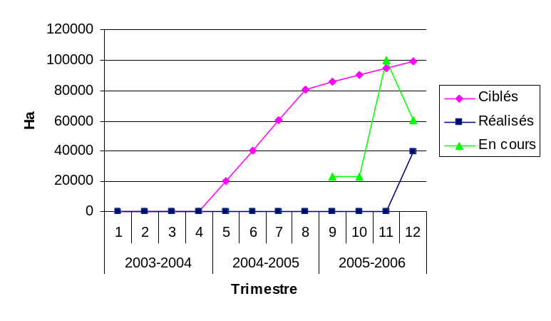
Hectares covered by legally recognized Community Forest Management Plans (Result 4 - Rights and Responsibilities)

Participatory Forest Management: the simplified approach of Wula Nafaa
Senegal has been managing its forests since 1945. But since that time less than a dozen plans have been written, and these at an exaggerated cost in time and money. In the end, the plans were complicated and difficult to implement.
Wula Nafaa has pushed through a new approach to forest management, whence the originality of the Koulor Community Forest management plan. The plan covers some 39 000 hectares and includes input from more than 20 villages living around the forest. A clear, consensual, and concise step-based approach was developed with the Senegalese Forest Service (in collaboration with USFS), which supervises or carries out the technical aspects of fieldwork. To further gain time, inventory results from similar forest types measured by PROGEDE were used in calculating sustainable cuts.
The step-by-step approach is being refined and will provide a model for forest management plans throughout Senegal.
Result 5: Increase in the number of communities receiving training in NR monitoring, enforcement of local codes, or conflict management
A highlight of this year has been establishing management structures in the communities:
- 3 management committees for blocks in Missirah;
- 1 animation structure for the local convention of Balingore;
- 1 Community Forest Management Committee (“CCGF”) in Koulor;
- 1 Inter-Village Management and Development Committee (“CIVGD”) in Djiréji;
- 1 Inter-Village Management and Development Committee (“CIVGD”) in Bambali;
- 1 Village Management and Development Committee (“CVGD”) in Diendé;
- 2 animation structures for the local conventions at Diégoune and Tenghory.

Indicator for Result 5: | Number of communities receiving training in NR monitoring, enforcement of local codes, and conflict mgmt
Target for 2005-2006: | 25
Principal Activities | Progress achieved | # targets reached | # ongoing targets
Training of villagers in setting up production and management structures | - 45 committees put in place in the rural communities of Tanaff, Niagha, Karantaba, Djiredji, Banbaly, and Sinthiou Malème  - Management organizations established in the rural communities of Koussanar, Simbandi Brassou, Tanaff, and Sinthiou Malème  - Rural communities of Mangagoulack and Tenghory put in place their animation structure for the local convention and went on to outline the rules for their areas  - Groups were trained in tree production techniques in 12 villages of Kédougou and Tambacounda regions  - Continuation of the establishment of local steering groups in Malème Niani  - Continuation of putting up animation structures for the local conventions of Tanghory and the start of this process in Diégoune  - Put in place the CIVGF and the CVGF of Koulor  - Sponsored a CAC to develop the local convention for Linkéring  - Put together a followup committee for the local convention at Sakar  - Continue putting in place the CVGD of Simbandi Brassou  - Put in place the CVGD and CIVGD of Diendé  - Put in place animation structures for local conventions in Balingore, Diégoun, and Tenghory  - Put in place block management committees and monitoring units in Missirah  - Put in place the CCGF for Koulor  - Put in place the CIVGDs in Bambali and Diredgji | 6  4  2  12  1  2  1  1  1  2  2  1  1  2
Cumulative total : |  | 38
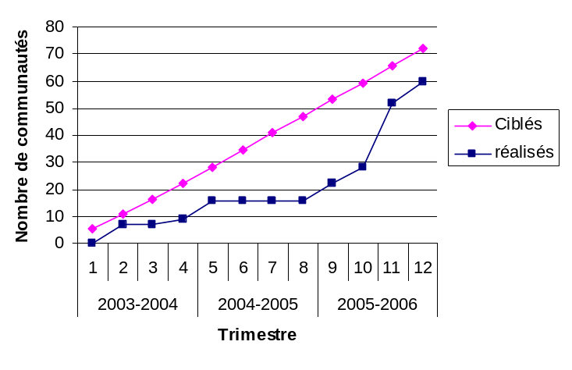
Communities receiving training in NR monitoring, enforcement of local codes, or conflict management

Result 6: Increase in the number of communities/CBOs that have developed NR management plans, protocols, agreements, and local codes governing access, use, and protection of NR

The rural communities of Koussanar, Malème Niani, Kothiary, and Sinthio Malème (Tambacounda region) have finished writing their workplans for implementing local conventions with stakeholder participation. The Rural Communities of Sinthiou Malème and Koussanar have held workshops on the process for recovering and using revenues resulting from activities in the local convention.
The rural communities of Linkéring (Kolda) and Mangagoulack (Ziguinchor) have produced the first draft of their local convention. This document has been made available to the technical services to ensure they conform to Senegalese law. The rural communities of Tenghory and Diégoune have gone on to the synchronization of drafted rules at the community level. Finally, meetings have been held for the rural communities of Djirédji, Bambali, and Tanaff.
Thus we have five rural communities in the process of drawing up their local conventions: Mangagoulack, Tenghory, Diégoune, Balingore, and Linkéring.
Indicator for Result 6: | Number of communities that have developed NR management plans, protocols, agreements, and local codes governing access, use, and protection of NR
Target for 2005-2006: | 17
Principal Activities | Progress achieved | # targets reached | # ongoing targets
Support for the preparation, adoption, and application of local conventions and local codes at the Rural Community level  Implementation of Local Conventions | - Put in place animation structures for local conventions in Diégoune, Tenghory, Diendé, and Missirah  - Community members drafted the local conventions of Linkéring and Mangagoulack  - Outlined rules for the local conventions of Diégoune and Tenghory  - Held meetings on local conventions in Djirédji, Bambali, and Tanaff  - Drew up workplans for local conventions in Kothiary, Sinthiou Malème, Malème Niani, and Koussanar  - Validated and approved management plan for Koulor  - Wrote and presented the technical part of the mgmt plan of Saré Bidji  - Continued the process of writing a local convention for Khossanto, Dakately (Kédougou), Karnataba, and Simbandi Brassou (Kolda) | 3  1 | 12
Cumulative total : |  | 4 | 12

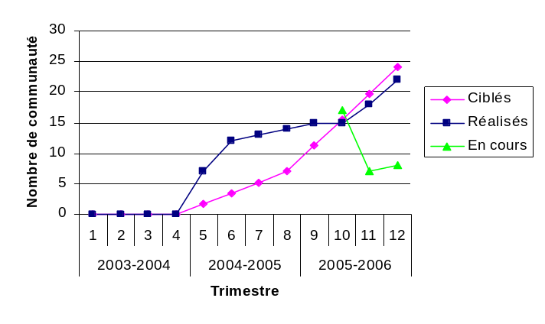
Communities/CBOs that have developed CBNRM plans, protocols, agreements or local codes governing access, use, protection of NR (Result 6)
Result 7: Strengthened resource assessment and mapping/GIS capabilities at the regional level
In the course of its interventions, WN has foreseen the reinforcement of skills in the forest service offices of regional IREFs in Tambacounda, Kolda, and Ziguinchor, through their inventory and mapping units (BIC), and in supplying computer equipment. Two review sessions on GIS concepts were held in Tamba and Kolda; in Ziguinchor it was a matter of doing computerized mapping for the first time.
The BICs in the IREFs are now sufficiently supplied to carry out mapping activities in their regions.
Indicator for Result 7: | Number of regional mapping/GIS and inventory capabilities strengthened
Target for 2005-2006: | 2
Principal Activities | Progress achieved | # targets reached | # ongoing targets
Reinforcement of skills in the IREFs of Tamba, Kolda, and Ziguinchor | - Trained or re-trained officers in mapping at local offices  - Provided BICs computer materials and equipment | 3
Cumulative total : |  | 3

Constraints, opportunities, and priorities for the next year
An emphasis will be placed on consolidating achievements of the preceding years of developing and testing processes and methods for participatory management and local conventions. The component will look for a more timely adoption of activities by local populations. The 2006-2007 priorities among these activities are as follows:
- Start implementing the Koulor community forest management plan;
- Keep working toward the implementation of the management plan for the ZPC Missirah;
- Validate, approve, and implement the management plan for Saré Bidji community forest;
- Draw up a management plan for the classified forests of Paniates and Tendouck;
- Implement the local conventions in the region of Tambacounda;
- Draw up and implement the local conventions for the regions of Kolda and Ziguinchor;
- Organize some workshops on governance and community land management in the Rural Communities of Missirah, Koulor, Sinthiou Malème (Tamba region), Sakar, and Saré Bidji (Kolda region).
The WN program started out working on co-management of classified forests and implementing local codes; however, as field experience mounted, it became obvious that the orientation should be toward community forest management since the process is less bureaucratic and more dependent on communities. Thus the emphasis is now placed on community forest establishment and the writing of local conventions to describe how the surrounding communities will manage and protect the resources together.
A constraint in the development of the different resource management documents and processes has always been the complexity that enters in when several partners must be involved. Local community members trying to survive every day may progress towards a project goal more slowly than other technical partners who work towards expected results that are written down for their sector. There are plenty of moments when activities can not be conducted as planned.
A constraint which affected the number of villages that increased their NR productivity was a common one in rural farming: late and irregular rains. Several locations suffered spotty rains this year, causing participants to prioritize around those events even more than usual, making some WN activities lower on their list.
The staff has noticed that motivation for involvement in natural resource activities was higher in villages close to forests chosen for WN interventions. This phenomenon has an impact on the extent of the results achieved.

Policy Component

Targeted results and planned activities

General considerations
The ultimate aim of all the activities of the Policy Section of WN is to reduce barriers to sustainable natural resource management. The barriers can be legal, regulatory, or administrative. Reducing their blocking effects will benefit rural communities and local people, especially in economic and ecological terms.
Since the departure of M Marks of Winrock in February 2006, the Policy Section is the responsibility of the team leader and his deputy. This new team continues to follow up and develop the activities begun by M Marks. In addition, it has widened the approach to include other challenges faced by the program. This has involved two specific elements: the participation of WN as a member of the steering committee on reforming institutional forest finance and taxation in Senegal, and following activities proposed by the focus group in Tambacounda to promote good governance, land use planning, and resolution of extensive grazing issues.

Targeted results
The section’s objectives are linked to four contractual results, namely:
- Reduction in the legal, regulatory, and administrative barriers that hamper sustainable natural resource management;
- Setting up long-term and useful discussion forums among Rural Communities, regional and national government structures, and the private sector;
- Provision of evaluations, studies, and political analyses to support the national Policy Agenda;
- Development of tools and information systems to support the policy section, including capacity building in resource valuation and in mapping/GIS at the regional level.

Activities planned for 2005-2006

Reduction of barriers
Forest Finance: Requests to the DEFCCS were to be made by the RCs and through the Discussion Forums on how to access the Fonds Forestier National and devolved funding for NRM as per the new forestry laws. Discussion Forums, together with WN, were also to develop strategies for claiming the RCs’ shares of tax revenues from forest products, and to produce reports and analyses on how they could achieve this goal. Finally, meetings with the IREFs and with DEFCCS were to clarify and rectify discrepancies in tax rates on various types of forest products and transporters.
Hunting leases: Reports and analyses on this longstanding problem were to be used to develop briefings to inform USAID, Senior Council for Hunting, and the Discussion Forums and to gather feedback on the new Hunting Code, lack of returns to communities from hunting licenses, and updating tax levels which have not changed in 20 years.
Transhumance (migrant herding): Discussion forums were to continue on herding problems with input from the Livestock Department. Training tools were to be developed and implemented with communities. Local conventions should have a new tax inserted after agreement between herders and communities on the amount.
Wood-based market chains: The charcoal quota in managed and unmanaged forests was to be the main target of policy activities in this subheading. Discussions with the DEFCCS and in Discussion Forums were to provide impetus to level the playing field for local producers to sell without going through the usual middlemen. In principle, Senegal law allows this activity so it has been a question of applying the law in an equal and transparent way.
Local capacity-building: Training materials for setting up local lobbying groups were to be developed and tested together with IREFs and ARDs in the CRs.

Consultation processes among communities, government agencies and services, and private sector
Several forums and roundtable discussion were to be organized and supported by WN. Topics include fund allocations from FFN, taxation, and licenses; facilitating feedback between stakeholders; and assuring that dialogue between different levels of government occurs.

Preparation and dissemination of supporting documents for policy reform
Studies, requests, and analysis topics to be covered included hunting leases, the charcoal quota system, revision of certain laws, access to FFN, species classification, action plans for barrier reduction, household surveys from Kolda and Ziguinchor, and Rapid Evaluations.

Development of tools and information systems
The regional mapping offices in Tamba, Kolda, and Ziguinchor were to be set up and supported with training, then produce maps in their regions. A database for Ziguinchor policy was to be developed.

Progress achieved
Result 1: Reduction in the legal, regulatory, or administrative barriers to sustainable natural resource management
Indicator for result 1: | Number of legal, regulatory, or administrative barriers to sustainable management of natural resources reduced
Target for 2005-2006 : | 6
Principal activities | Progress realized | # targets reached | # ongoing targets
Reduced barriers in organized hunting concessions: |  | 1  1 | 1  1  1  1  1
1. Lack of widespread knowledge of the new version of the Hunting Code | - Code is at the level of the General Assembly  - Note was taken during regional workshop on ZIC | 1  1 | 1  1  1  1  1
2. No monetary return coming back to communities from hunted areas | - Attended national workshop on licensed hunting concessions  - To be treated at the national workshop | 1  1 | 1  1  1  1  1
3. Need for a new system of hunting concessions for the next round of contract awarding | - Waiting on the establishment of a committee on hunting concessions | 1  1 | 1  1  1  1  1
4. The level of taxation on hunting concessions has not changed in 20 years | - Waiting on the establishment of a committee on hunting concessions | 1  1 | 1  1  1  1  1
5. Zero shares of fines coming to the Comm Rural from infractions committed in their territories | - Waiting on the establishment of a committee on hunting concessions | 1  1 | 1  1  1  1  1
Reduction of 6 barriers to increasing revenues to local communities: |  | 1  1 | 1  1  1  1  1
1. Difficulty for the CR to access the Fonds Forestier National | - Participation on fiscality Committee on forest finance that was established (Djigo and Diouf report)  - TDR made for writing new fiscality laws  - Studies done on timber and TER for writing new laws on fiscality  - Study on forest fiscality (Djigo) | 1  1 | 1  1  1  1  1
2. Lack of shares from forest taxes coming back to the CR |  | 1  1 | 1  1  1  1  1
3. Certain taxes imposed on transporters do not conform to the law |  | 1  1 | 1  1  1  1  1
4. No difference in tax is applied to products from managed versus unmanaged forests |  | 1  1 | 1  1  1  1  1
5. No distinction made between baobab in fruit or powder form in the forest product tax system | - A protocol has been drafted by WN and the IREF of Tamba and sent to the Direction Forestière -- suggesting reducing by 40% the tax on unshelled baobab tonnage, to be put in the protocol to ensure production  - TDR made for writing new texts on fiscality | 1  1 | 1  1  1  1  1
Reduction of 6 barriers to the integration of herders in local land management: |  |  | 1  1  1
1. Absence of a pastoral code | - Participated in a subregional workshop on migrant herding |  | 1  1  1
2. Lack of knowledge of the applicable laws | - To be revisited at the national workshop on migrant herding (transhumance) |  | 1  1  1
3. Absence of a local system of taxing for the right to pasture animals | - To be revisited at the national workshop on migrant herding (transhumance) |  | 1  1  1
4. Lack of herder knowledge of existing conventions locales | - Participated in a workshop on local conventions |  | 1

Indicator for result 1 (continued): | Number of legal, regulatory, or administrative barriers to sustainable management of natural resources reduced
Principal activities | Progress realized | # targets reached | # ongoing targets
Reduction of several barriers in wood resource revenue issues: |  | 1 | 1
1. Problems in charcoal exploitation | - Study on monitoring offtake completed  - Mgmt plan for Koulor approved  - Put in place CCGF of Koulor  - Mgmt plan presented back to Saré Bidji | 1 | 1
2. Lack of access to the charcoal market by local populations | - Forest Mgmt Plan approved for Koulor and approval for 1500 quintaux of charcoal to be exploited | 1 | 1
3. Equality of taxation of wood products whether coming from managed or unmanaged forests | - Committee on Forest Fiscality established (see report by Djigo et Diouf)  - Studies on sawtimber and monitoring offtake during forest harvest |  | 1
4. Lack of control and monitoring of sawtimber exploitation |  |  | 1
Reduction of 4 barriers related to the lack of local skills: |  | 1 | 1
1. Lack of knowledge of NRM laws | - Copy and distribution of the laws | 1 | 1
2.. No administrative or financial procedures followed by CVG (Village Management Committees) | - Put in place procedures that will be used in model sites  - TDR written for rural community studies on land status, pastoralism, good governance, and land use | 1 | 1
3. No land use or zoning maps in the CR | - Contract with CSE signed to develop land use and zoning maps and help the RCs to put them into use |  | 1
4. Forest guards with no power | - Trained and employed forest guards |  | 1
Reduction in barriers linked to proper monitoring and control of forest product harvest:
1. Too many checkpoints | - To be treated in a workshop on forest fiscality |  | 1
2. Differing measurement units | - To be treated in a workshop on forest fiscality |  | 1
Cumulative total for the year |  | 6 | 22

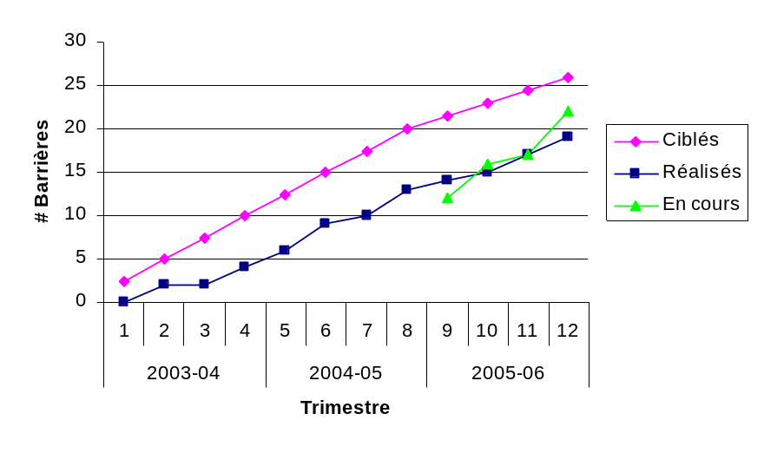
Reduced legal, regulatory, or administrative barriers to local sustainable management of natural resources (Result 1 - Policy)

Result 2 : Establishment of consultative forums among local communities, national and regional offices, and the private sector that are verifiable and continuing
This result uses various dialogue processes, called Discussion Forums, Consensus-building Framework (Cadre de concertation or CdeC), or Round Table (TR), for in-depth discussions with participants of their problems, solutions, expectations, etc., especially regarding sustainable development of NR. The dialogue operates on national, regional and community levels; subjects are specific or general. Consensus-building activities represent the most important source of information in identifying barriers to be lowered.
The organized meetings give impetus to reaching consensus among all partners, in particular at the local level, before field activities begin. From there, regional-level presentations feed into national-level workshops to be organized on topics such as migrant herding and forest taxing and finance (fiscality).
MODEL SITES TO ADDRESS PASTORALISM, LANDUSE PLANNING AND LOCAL GOVERNANCE ISSUES
During the course of the year, three serious issues were identified as common barriers to all rural communities where the project is involved. These are: issues related to pastoralism, land use planning and local governance.
- Pastoralism. Problems related to pastoralism exist at two levels: conflicts between farmers and nomadic herders; and conflicts between farmers and local herders.
- Land use planning. The notion of land use planning and the need for land use planning/administrative maps as a practical tool, was overlooked as a necessary step to aid in the formulation of natural resource management plans (Local Conventions) for Rural Communities.
- Local Governance. Despite much investment and effort by USAID in local governance under the DG-FELO Project, there remain serious problems especially with how Rural Councils govern. Although there are differences between the Rural Councils in terms of the way they function, there are serious common problems that need to be addressed if the Councils are to ever govern correctly. These include: lack of funds, lack of administrative procedures, lack of vision, disconnect between the Council and the population and lack of transparency.
In response to these barriers, WN worked with a consultant to analyze each issue and coordinate a focus group workshop in Tambacounda with representatives from government, Rural Communities and a group of qualified experts involved in pastoralism, land use planning and local governance.
Based on the results of the focus group workshop and the ensuing report, WN will focus efforts in five Rural Communities (three in Tambacounda and two in Kolda) as model sites as a first step to test innovative approaches that will be evaluated, refined and expanded to all Rural Communities in the program. The Centre de Suivi Ecologique will focus on land use planning, and local experts will be contracted to address local governance and pastoralism.

Indicator for Result 2: | Number of Consultative Forums and dialogues opened among local communities, national and regional offices, and the private sector that are verifiable and continuing
Target for 2005-2006: | 6 community-level Forums, 7 national or regional Forums
Principal Activities | Progress achieved | # targets reached | # ongoing targets
Community level Discussion Forums/Round Tables/CdeC:
Organizational | - 3 CdeC in the Rural Community of Kédougou to draft and implement annual workplans (Salémata, Missirah, Sirimana, and Saraya)  - 1 CdeC in Kédougou to develop, synchronize, and validate outlines of rules for a Local Convention (Dakately)  - 2 CdeC in the Rural Community of Kolda on Local Conventions (Simbandi Brassou and Tanaff)  - 1 CdeC and intercommunity exchange (Pata)  - 1 CdeC to exchange ideas and plan management activities (Saré Bidji)  - 4 CdeC in the Rural Communities of Kolda for different steps of Local Conventions (Bambaly, Diendé, Djiredji, Karantaba)  - 2 CdeC in Tambacounda to develop, synchronize, and validate outlines of rules for a Local Convention (Sinthiou Malème, Koussanar)  - 4 CdeC in Ziguinchor to develop, synchronize, and validate outlines of rules for a Local Convention (Balingore, Diégoune, Mangagoulack, Tenghory)  - 1 CdeC in Linkéring for the launch of the Local Convention writing  - 3 CdeC on cashew at Tanaff, Diendé, and Djirédji  - 1 CdeC on palm oil in Diendé | 3  1  2  1  1  4  2  4  1  3  1
Regional level Discussion Forums/Round Tables/CdeC:
Markets / Interest Groups | - Workshop in Bakel on migrant herding (transhumance)  - Restitution in Tamba of the study on institutionalized fraud  - CdeC to review how to implement the recommendations in the evaluation of concession hunting in Tamba region  - Regional forum on participatory forestry in Tamba  - CdeC to develop an action plan to implicate the private sector in the ZIC wildlife zone of Kédougou  - Linguère and Kaolack workshops on migrant herding  - Focus Group in Tamba on good governance  - RT on cashew in Ziguinchor | 1  1  1  1  1  2  1  1
National level Discussion Forums/Round Tables/CdeC:
Markets / Interest Groups | - Presentation in Dakar of the sawtimber study and the study on monitoring/control of harvested forest products  - Established national-level policy discussion group on forest management  - Supported the CdeC steering committee on forest fiscality under the DEFCCS  - Presentation of Jesse Ribot charcoal study  - Attended national workshop on concession-based hunting | 2  1  1  1  1
Cumulative total : |  | 38

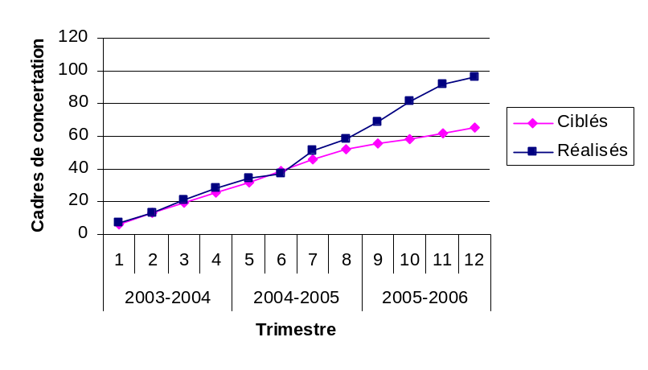
Number of Consultative Forums or Round Table discussions and dialogue among local communities, national and regional offices, and the private sector that are verifiable and continuous (Result 2 - Policy)

Result 3: Production and dissemination of evaluations, empirical studies, and analyses on policy that contribute to the proposed reforms

Indicator for result 3: | Number of assessments, supporting field studies, policy analyses supporting the policy component produced and disseminated
Target for 2005-2006 : | 7
Principal Activities | Progress achieved | # targets reached | # ongoing targets
Governance | - Report on the Tamba workshop on governance, extensive grazing, and land use planning | 1
Forest Fiscality (taxation and revenue system) | - Study on sawtimber  - Study on forestry sector fraud  - Document synthesizing recommendations for the Focus Group on this topic | 1  1  1
Cumulative total for the year: |  | 7

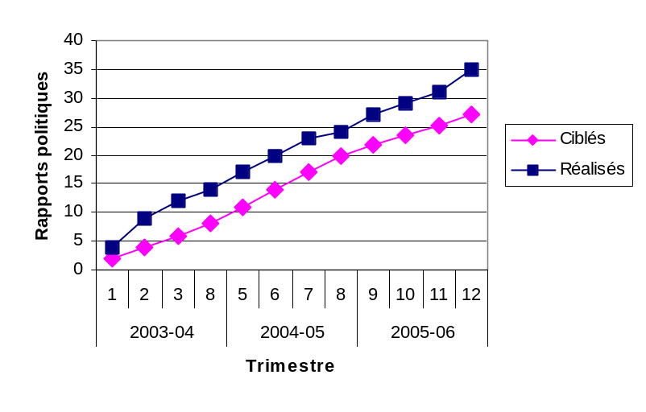
Evaluations, empirical studies, and policy analyses produced and disseminated that contribute to proposed reforms (Result 3 Policy)

The Study on Monitoring, Oversight, and Control of Forest Harvesting
Improving forest revenue management is still a main priority for the new forest policy. In principle, if natural resources are properly valued and their revenues managed correctly, it will contribute to the sustainability of their exploitation.
In order to establish a better forest revenue system, a series of studies has been carried out on practices used in the monitoring and inspection of forest harvest operations. The Senegalese Forest Service as trustee has received funding through the USAID project Wula Nafaa to carry out one of the studies, which will complement another being carried out by the Civil Forum by a USAID team working on governance.
The study has documented the way in which taxation and revenue laws are applied, particularly in oversight, monitoring, and verification of harvest operations, access to the resources, harvest methods and amounts, transport and commercialization, and destination of various forest products. Proposals and recommendations were made for concrete actions that would improve these applications, detailing how to reduce fraud and other barriers that threaten the long-term availability of natural resources and the fair distribution of potential revenues that come from them -- revenues that should be shared between the state, the collectivities, the concession holders, and local populations.
Study results were presented in two stages in Tambacounda, including one for the technical services (Forest Service, National Parks staff, and NR projects) and the local collectivities (Commune, Rural Community), and another for the body of workers who get the product from the forest to the market.
An important point mentioned was the high number of control posts between Kolda and Dakar, and that transporters are required to stop at each one. The stops cause great delays and increase charges and opportunities for fraud on the way to market.
The numerous issues raised and the consensus on how to address them will be presented for validation at a national-level workshop.

Result 4: Development of tools and information systems to support the Policy Section

Indicator for result 4: | Number of tools and information systems developed to support the Policy Section
Target for 2005-2006 : | 2
Principal Activities | Progress achieved | # targets reached | # ongoing targets
Reinforcement of the Cartography Bureaux at the IREFs of Ziguinchor, Kolda and Tambacounda | - Training of Cartography Bureaux by CSE in Tamba, Kolda and Ziguinchor | 1
Information system provided to DEFCCS Management Division | - TDR written up |  | 1
Guide on participatory management of forests produced | - Temporarily halted until later in the year; TDR written |  | 1
Cumulative total for the year: |  | 1 | 2

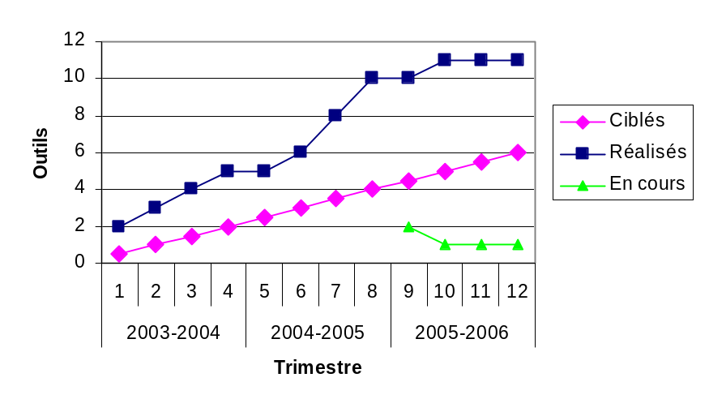
Tools and information systems developed in support of the Policy Section (Result 4 - Policy)

Constraints, opportunities, and priorities for the next year
With the help of the steering committee on forest taxation and revenue reforms, the two studies programmed on sawtimber and monitoring/control were completed and presented. Terms of Reference are being drawn up for a focus group on the subject; the group should come up with a proposal for decrees on the reform of currently-practiced forest fiscality.
For questions linked to governance, extensive grazing, and land use planning, consultants have already been selected to conduct an in-depth diagnosis in two Rural Communities (Koulor and Missirah) based on results from a workshop held in Tambakounda. Once this diagnosis is completed, training modules and technical assistance will be provided in the Koulor and Missirah; the modules will be evaluated and applied in three other RC (Sinthiou Malème, Saré Bidji et Sakar). Considering the amount of time remaining in the program, this strategy will permit WN to support the five RCs concerned in a practical way, leaving repeatable models for intervention on decentralized management of natural resource management.
“Exit Strategy?”
Essential indicators for ensuring the durability of Wula Nafaa achievements
One year and a half before the end of the program, the preoccupying question is whether the development tools put into place and the achievements of WN presented in this report are sustainable. It follows that the main challenge in the next months will be to answer this question. Even though it seems like it is only now that it is arising, it has been the driver of all the strategies and actions of WN since the beginning.
Recall that the indicators of success in natural resource management programs revolve around linking “nature, wealth, and power” together. These are the concepts that have provided the focus for WN’s strategy.
Nature
The key indicator could be considered to be “NR tools such as local conventions and management plans drafted, implemented, and managed collectively and correctly”. Through 24 Local Conventions, 5 Local Codes, and 2 community forest management plans covering tens of thousands of hectares, the program has sought to catalyze local regulation of and access to natural resources in an unprecedented way; the same breakthrough can be claimed for the attention given to regenerating the most-used species whose survival was being threatened by poor harvest practices and overuse. That the Rural Councils have taken on the drafting of these management tools, and that the local communities have engaged in monitoring and management through legal structures and organizations, represent huge steps in achieving the Nature-based indicator. Still, to maintain durability of these achievements, it is important to define and develop a systematic process of implementing the NR management tools provided -- a process that works with the participation of the technical services.
Wealth
The key indicator would be “Strengthened networks of organized producers who can function autonomously as they work to increase their revenues, and whose activities respect the rules and principles established by the community to rationally manage the resources they harvest.” This is currently measured on the ground by (1) the level of organization and skills within each network; (2) the strength of the commercial relationships between actors in the market chain; (3) whether there are functional relationships with the Rural council and other local NR management structures; and (4) whether there is enough competent human resources capable of providing the technical assistance required. Out of the 50-odd networks of producers currently assisted by WN, the majority have begun reinforcing the competitiveness of their organizations, now that they have spent much time developing business relationships. These networks of madd, fonio, baobab, mbepp gum, cashew, honey, and other products have basically mastered the process for researching markets and dealing directly with buyers for signed contracts.
Power
Key indicator: “Rural Councils and their suborganizations who are aware of their powers in the natural resource management domain, skilled in the use of those powers, and responsible in the sense that they respect democratic rules and govern well.” The approach developed by WN to put natural resource management tools in place calls on local institutions and stakeholders to take responsibility for them. In the thirty-odd Local Communes covered by these tools, the Rural Councils and the villages are beginning to truly grasp what their duties are in NRM. At the same time, efforts have been made to reach out to the technical services, to help them better perceive and exercise their roles in the context of decentralized NRM.

CROSSCUTTING ACTIVITIES
The three technical sections of the program were supported by certain crosscutting activities: coordination and management; small grants; training and literacy classes; and Monitoring-Evaluation-Restitution-Analysis. None of these components directly targets the contractual results of Wula Nafaa, but they contribute in a global way to the achievement of these results. The following subchapters describe the most important achievements of each crosscutting activity.

Coordination and management
The year 2005-2006 has been characterized by significant advances in the technical sections of WN, especially as regards forest management and improvement of the market chains of products supported by WN. Thus we have reinforced administrative staff with accounting and secretarial trainees.
Weekly planning meetings, thematic technical meetings, and staff participation in facilitator’s planning meetings have all helped to better coordinate activities.
This year for the first time, the annual General Assembly was held in Ziguinchor, which allowed most of the staff to discover this beautiful region. While the objective of the 2005 assembly was to have the new Team Leader explain his new vision for the program and how to achieve its goals, this year’s assembly had the objective of evaluating progress on achieving the goals and adjusting the program appropriately. The assembly was a success in terms of validating the significant advances made in previous problem areas, particularly in the development of forest management plans, facilitator coordination, and synergy between program sections.
In terms of the facilitators, true progress has been documented in field activities, supported by better collaboration with the Forest Service and other government technical agencies. Changes have been made in their distribution and coordination, due to some of them resigning or contracts ending with 2005, and due to new recruits. Three new facilitators were recruited since 17 January 2006: One was sent to Kédougou (Dénifello); one to Kolda (Niagha); and one to Dakar (as a support to the Economic Benefits component).
The Tambacounda facilitators renewed their contracts for another two years (CDD which ends 17 July 2007) and those in Kolda renewed for one year (CDD which ends 21 July 2007). This is a result partly of the legal code and partly of the length of the WN program. On this note, WN administration is considering the best formula to adopt when contracts reach their end date and in relation to the length of the program.
As for the synergy between program sections, in addition to the positive results obtained from activities in the managed zones, WN foresees setting up pilot or model management sites in five Communautés Rurales, based on good governance, optimum land use (which includes forest management, local conventions, and market chain development), and proper pasture management.

General Assembly of 26 and 27 July 2006 at Ziguinchor
The 2006 General Assembly held at Ziguinchor was a true success as recognized by all participants, owing to the richness of the program, the seriousness and variety of the many broad debates, the smart conduct of different presenters, and the excellent logistics.
Participants were required to present the current status of their part of the WN program, and provide:
- an evaluation of the previous assembly;
- an evaluation of the procedural manual;
- an evaluation of the “new” vision of the program;
- suggestions on the process of establishing Local Conventions.
Then, while emphasizing our achievements, the difficulties we encounter, and immediate challenges, we launched ourselves into the near future where we discerned the main points for the Annual Workplan of 2007 and beyond.
Social interactions that are inherent to any enterprise did not lack at the meeting. In addition, recommendations were made on medical care of employees (IPM), work conditions (worn-out equipment), and reinforcing the solidarity of “The Team”.
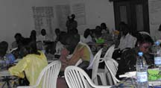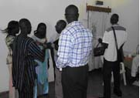
Intense moments both of reflection and of relaxation at Wula Nafaa’s General Assembly

Small grant funds
The small grant fund was conceived to complement the different components in the execution of their target-oriented activities. Grant-financed activities must be sustainable, so that they will eventually become self-financing from their own resulting revenue increases. This is why most grants have been for studies, research and institutional support.
Since subsidies can also serve as collateral, the program is in the process of finalizing agreements with the Caisse Nationale de Crédit Agricole du Sénégal (CNCAS) and the Crédit Mutuel du Sénégal (CMS) for putting a credit system in place with these funds. While waiting for this formal agreement to start, WN has facilitated a reimbursable fund that will allow recipients to prepare for their requests.
The activities that received grants this year are:
- Three computers and a printer for the inventory and mapping offices of the IREFs in Tamba, Kolda, and Ziguinchor;
- Training and purchase of materials for tree nurseries and seeds for regeneration of forest species in market chains treated in the WN program (Koussanar, Malème Niani, Missirah; Salémata, Dakately, Saraya);
- Research on the processing, preparation, and packaging of local products for export sales by the GIE of Jeunes Filles Entrepreneuses (Young Girls’ Entrepreneuses) in Kaolack;
- A market study on palm oil by the association Action Sud de Ziguinchor, a Round Table on cashew, a feasibility study on touloukouna oil and one for sawtimber, a study and a training on processing nététou, and a seed training for Ziguinchor facilitators;
- The processing unit for baobab and jujube for the GiE Gadafaro in Koussanar;
- The drafting of a strategy for the promotion and sale of ténéra palm to plant in Ziguinchor region;
- A Study on the sighting of a constructed processing unit and the training of GIE Maria Distribution personnel following HACCP guidelines;
- A loan for the association of cashew processors to buy nuts from producers; and
- A construction project at the IREF of Ziguinchor to house and secure the inventory and mapping office.

The main event for the grant program this year was a visit by the program manager from Washington, D.C. The following subjects were discussed:
- Planning for the foreseeable demands of the program so that the budget could be reorganized and
- Making legal documentation on grant subsidies available.
In summary, small grant activity was oriented toward partnering with the technical services and assuring regeneration favoring forest products targeted by WN. The program prefers to use the reimbursable or rolling funds when it comes to familiarizing grantees/clients with credit practices that will soon be in place at commercial institutions to assist them with long-term commercial activities.

Training and communication

Training
Capacity-building of local stakeholders, beneficiaries, and technical service partners has been a “permanent” activity of Wula Nafaa in 2006. The importance of this activity is due to several reasons. First, putting in place a stepwise process for writing Local Conventions and management plans in several local partner communities must be supported by a long term input by local stakeholders and technical services. Second, the enterprises taken under the wing of WN have begun to ramp up their production and marketing, which requires a continual upgrading of skills to increase supply and competitiveness. Finally, the WN facilitators themselves need occasional training so that they may keep up the vital technical assistance that WN provides to beneficiaries.
This is part of the “new vision” defined by the new management team, with clear terms of reference for the training component head: training is now to be a part of all capacity-building activities of WN both before and after activities are implemented. Modules used are now to be well-defined and of high quality. A systematic check is made of the quality of training provided by facilitators and hired specialists.
An important innovation introduced this year was to develop the year’s training needs directly from the 2005-2006 workplan. This provided a strategic guide for capacity building that fit perfectly into the Rights and Responsibilities and the Economic Benefits components. The specific activities carried out are listed in Annex 3. In addition to these, other training activities took place as facilitators transferred technical skills that were then repeated among enterprise group members themselves.
Facilitators worked together with local partners in preparing and organizing training activities. In some cases, enterprise network members provided their own office materials for training sessions, thus maintaining a self-perpetuation aspect to the skills acquired. Whenever possible, local expertise has been used and this has maintained positive partnerships.
Experiences with the Forest Service, PROGEDE project, the GIE undergoing literacy training, CAM Partners of Kolda and Action Sud of Bignona have been mutually beneficial. This partnering strategy should continue as the participants have felt motivated and recognized after it.
The training component has assisted with the WN-organized round table forums, workshops, and focus group activities wherein topics and challenges in natural resource management were discussed.

Looking ahead to 2007
Two themes will orient the strategy for the coming year:
- reinforcement and consolidation of knowledge and skills acquired by clients, and
- documentation of training models used so that producers and enterprise networks as well as management committees, elected officials, decision-makers, and other stakeholders can adapt the same materials to other cases on their own.
The next pilot activity with program partners will be to integrate good governance, pasturing issues, and land use issues at the level of 5 local collectivities. It will be an opportunity to develop methods for resolving many issues common to other collectivities as well.

Communication
A lack of communication can be the cause of conflict and misunderstanding when the program tries to implement activities in partner local collectivities. This has motivated WN to ensure a strategy for achieving and maintaining good information networks with its partners.
WN collaborated well with the press in all its activity zones, which allowed regular media coverage throughout Senegal in the form of radio emissions, television files, and newspaper articles. This indeed contributed toward avoiding misunderstandings in project areas. For example, in Missirah’s charcoal production zone, where the implementation of management activities had divided the Forest Service, the Rural Council, and the producers so badly that they no longer understood each other, WN sponsored the press to relay information through a forum that allowed each party to explain itself and finally to reach consensus on resource exploitation.
Another example was in the wildlife zone of Falémé, where a WN-sponsored workshop on the poor state of the zone was brought to the attention of local villages and national decision-makers.
Fonio promotion was assisted by public information provided by WN.
WN has benefited from a formal protocol that exists between Senegalese television RTS and the IREFs in Tamba and Ziguinchor. This relationship was used to keep villagers and elected persons up to date on process during the drafting of various Local Conventions and management plans. The lack of a protocol between RTS and the IREF of Kolda has cooled press coverage of Saré Bidji activity.
Details of the year’s activities are presented in Annex 3.

Looking ahead to 2007
WN will continue to translate and disseminate laws and management tools into local language. Also it will produce a televised documentary on the activities and achievements of WN focusing on enterprises and management plans for Koulor and Saré Bidji. The rapport with USAID and the Ministry of Environment will be consulted to conform to their methods of reporting, since it will reflect on their roles as well.

Literacy training: an unavoidable step in the design of sustainable development
Wula Nafaa has always kept in mind the sustainability and durability of its activities. This goal can only be reached by providing a functional literacy course to those of its beneficiaries who are basically unable to read well and do business math. The course leads producers to better master the production, processing, and marketing techniques of forest products; it also enables them to better draw up and implement the Local Conventions and forest management plans.
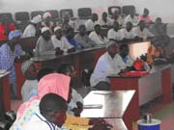
Initiated in the 2003-2004 workplan, literacy training had not completely reached its goals. It is only in the most recent workplan that a clear plan of action and goals have been set. The new strategy has resulted in training 106 network members and the 27 facilitators in Tamba and Kolda in simple techniques of administrative management and accounting for enterprises. The task of the training component is to put these courses into pulaar, mandingue, and the other most common languages of the zones of WN, based on the modules denominated as “GERME” (Gérer Mieux votre Entreprise, or “Better Manage your Business”).
Concrete results have been achieved; now network members can correctly maintain their administrative documents, calculate costs, and sign protocols and contracts in local languages. These tools will remain even after the end of WN program.
This activity will be extended to local elected officers by the translation and distribution of natural resource management tools in local languages, thus making it more likely to be adopted by stakeholders.
Literacy training for business network members

Monitoring, Evaluation, Reporting, and Analysis
This MERA component has targeted two series of major activities: (1) continuing to monitor in Tambakounda and Kolda; starting monitoring in Ziguinchor; and (2) assuring that certain activities are properly analyzed and reported back to stakeholders.

Monitoring - Evaluation activities in the regions of Tamba, Kolda, and Ziguinchor
As planned, the MERA manual and some of the data collection sheets were revised. Facilitators were updated on MERA activities, especially on how to fill in the new data sheets.
After recruiting new facilitators for Ziguinchor, and before the intense phase of initiating activity, the MERA system was installed. The new facilitators were trained in their roles, using the manual developed for MERA, the data collection sheets, the socioeconomic questionnaire, a session of collecting information in the field, and a quality control component which involved visiting each and every facilitator (except the one in Dakar). Besides verifying data collected, it has been necessary to adjust the methods used to collect them and to harmonize the method among the three zones.

Analysis and Reporting activities
Several important activities fall under this heading including those that support the management and reporting for the entire program. For this year:
- Reviewed the MERA manual and the information collection sheets
- Improved the timing and delivery of WN reports thanks to a close collaboration between the MERA component and other components
- With help from CSE, supported the Rights and Responsibilities Component as it developed large-scale maps for classified and community forests where it is active (Tendouck, Boutolate, Diégoune[Ziguinchor]); Saré Bidji [Kolda])
- Trained the mapping and inventory units of the IREFs with help from CSE
- Supported the Rights and Responsibilities Component with socio-economic studies and their analysis for forest management plans
- Analyzed a part of the household surveys for Kolda

Annex 1. Documents produced in the year
Economic Benefits
- Evaluation of the potential for Wula Nafaa to intervene in the ecotourism sector in Tambakounda
- Agreement protocol between WN and the Caisse Nationale de Crédit Agricole du Sénégal (CNCAS)
- Intern’s report on the potential to market Thatch/Hay in Kédougou and Sédhiou/ Balla Danfakha
- Training report on the creation and administration of a website with the CMS Mambo, DFI
- Report on the round table on cashew by Ousseynou Sané
- Report on beeswax by Souleye Cissé
Rights and Responsibilities
- Agreement protocol between WN and the IREFs of Tamba, Kolda, and Ziguinchor for forest management in these regions
- Agreement protocol between WN, the IREF of Tambakounda, and the Rural Community of Missirah to work in the Zone of Controlled Production (ZPC)
- Animation guide for writing the Local Convention
- The Wula Nafaa approach to natural resource management
- Strategy for putting tree nurseries in place
- Strategy for writing forest management plans
Policy
- Policy notes for the USAID director (concession-based hunting and access to the national Forestry Fund; Malcolm Marks, Oct. 2005)
- Synthesis of the workshop on proposed ideas to implement recommendations of the study on concession-based hunting (by Valence Manga, Nov. 2005)
- Forum on participatory forest management, Tambakounda (by Djibi Ka, Nov. 2005)
- Proposal for a strategy for managing and implementing the next concessions in Senegal
- Development of a consensual accord on elements of forest fiscality and a good organization of forest exploitation in Senegal
- Study on Zone d’Intérêt Cynégetique ZIC, by Suzanne Ganon of the US Forest Service team
- Forest Fiscality report by Alpha Djigo and Ndoffene Diouf
- Report on the workshop on governance, herding, and land use planning in Tambakounda, by Suzanne Ganon
- Study on monitoring, oversight, and control of forest exploitation, by Alpha Djigo
- Study on the market chain for sawtimber - to reform the status quo of forest fiscality in Senegal, by Alassane Ngom, Coumba Ndoffene Diouf, and Gerry Groesnick
MERA
- Analysis of the household survey questionnaires in Kolda: Sources and amounts of household income (draft)
Annex 2. Progress on local conventions

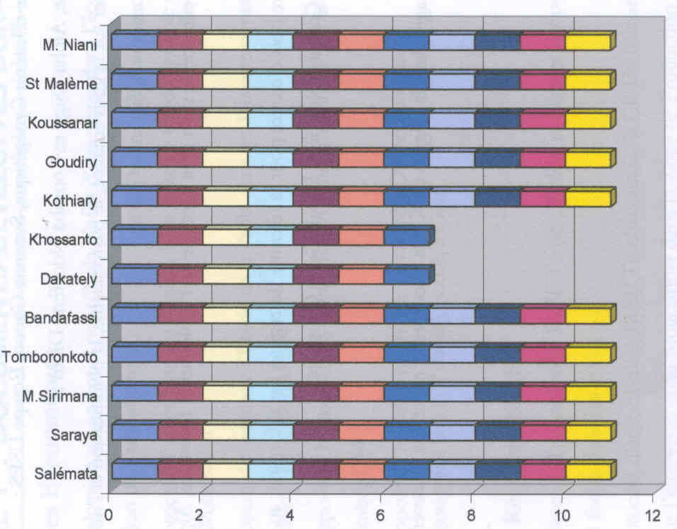
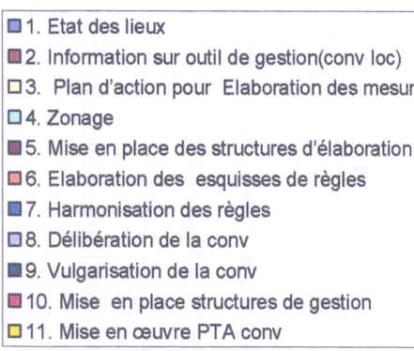
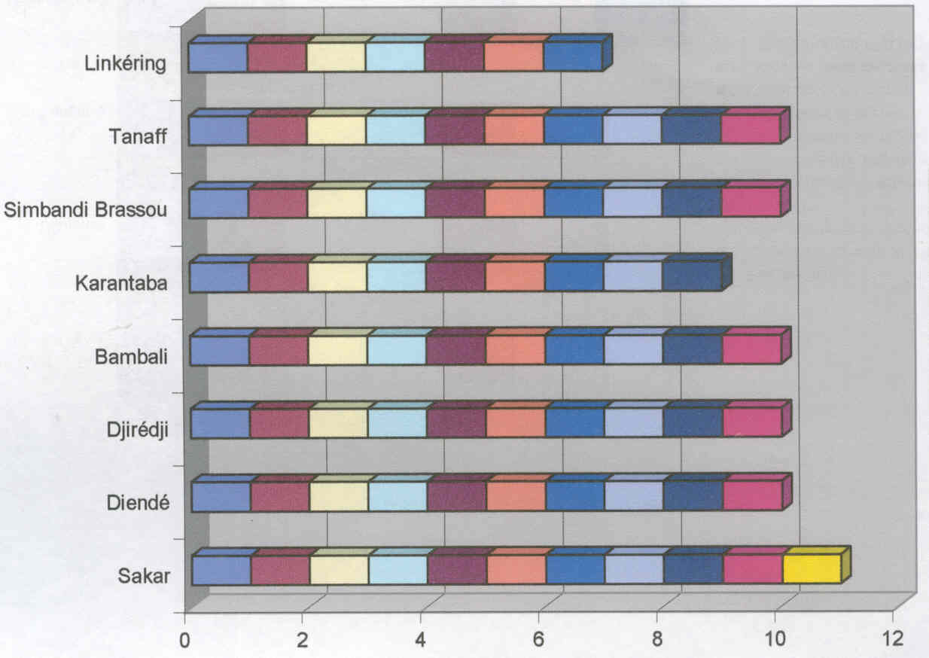
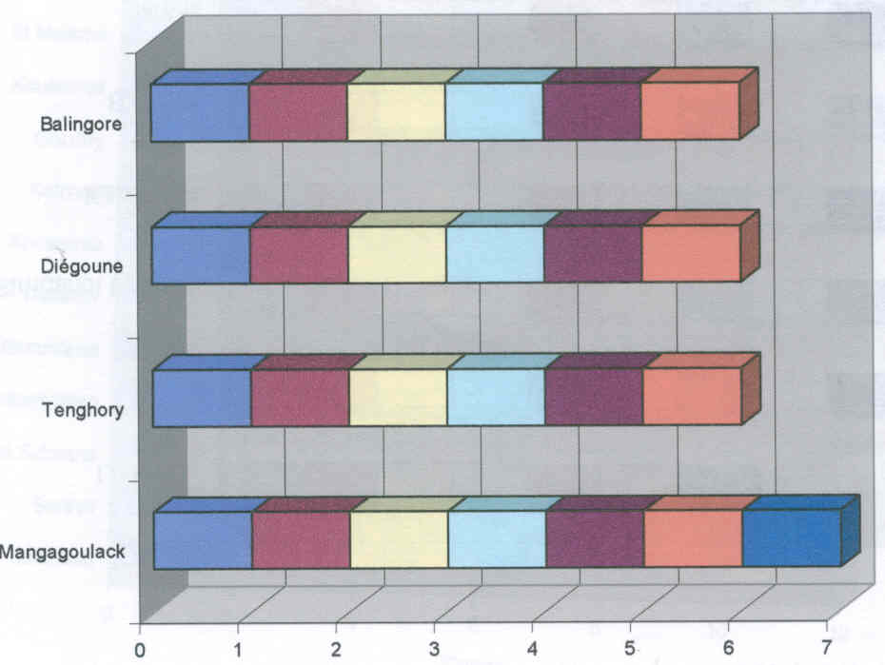
Rural
Community
Steps
TAMBAKOUNDA
KOLDA
ZIGUINCHOR
LEGEND OF STEPS
Rural
Community
Rural
Community
Steps
Steps

Preparatory docs/meetings
Information disseminated on loc. conv.
Action plan for quantitative study
Land use stratifying
Put in place committees to draft L.C. and workplan
Outline rules for the whole area
Harmonize rules among subzones
Meet on L.C. content
Present content to different subzones
Put in place management structures
Put into practice the annual workplan
Annex 3. Training and Communication

COMMUNITY TRAINING
Training topics | Dates | Place | Com-ponent | Participants | Trainers | Output | Results; Quality
Forest guards of the CIVD of Koussanar and Sinthiou Malème | 22 - 24 Jan. 06 | Koussanar | RR | 60 guards | Dibocor and Malang | Report | Guards have mastered their roles and responsibilities
Literacy for members of network enterprises | 17-28 April 06 | Tamba  Kolda  Kédougou | EB | 106 participants  31women  75 men | GIE EDOA for Tamba ;  GIE Château d’Eau for Kolda ;  GIE EGNIRE for Kédougou | Report | Network members have mastered management and accounting techniques in local language
Charcoal producers: Casamance kiln | 6-25 June 06 | Koulor | RR and EB | 25 producers | Chérif Keita of ROGEDE | Report | Producers can make charcoal in a Casamance kiln

FACILITATOR AND TECHNICAL SERVICES TRAINING
Training topics | Dates | Place | Com-ponent | Participants | Trainers | Output | Results; Quality
“GERME” (business mgmt) | 17 -22 October 05 | Kolda | EB | Facilitators of Kolda | Groupe Cam partners | Report | A support to enterprises
Steps to write a local convention | 12 au 14 October 05 | Ziguinchor | D/R | Facilitators de Ziguinchor | WN team |  | A good understanding of the steps by facilitators and chefs de Brigade Forest Service
Refresher course on new grant policy | 2 Oct. 05 | Tamba | Small grants | Facilitators of Tamba | Head of WN small grants unit | Report | A better understanding of the strategy of WN for small grants
Refresher course on MERA | 13-16 October 05 | Kédougou | MERA/  Policy | Facilitators of Kédougou | Malcolm/ Sadio | Followup /monitoring forms updated | Facilitators informed of MERA matters and updates
Refresher course on MERA | 18-22 October 05 | Kolda | SERA/ Policy | Facilitators of Kolda | Malcolm/Sadio | Followup /monitoring forms updated | Facilitators informed of MERA matters and updates
Refresher course on MERA | 26-30 October 05 | Ziguinchor | SERA/ Policy | Facilitators of Ziguinchor | Malcolm/ Sadio | Followup /monitoring forms updated | Facilitators have the info and tools needed for proper data collection

FACILITATOR AND TECHNICAL SERVICES TRAINING continued
Training topics | Dates | Place | Com-ponent | Participants | Trainers | Output | Results; Quality
Forestry agents get mapping training | 7-17 December 05 | Tamba | MERA | Agents of Forest Service in Ziguinchor, Kolda and Tambakounda | Samba Ndao of CSE | Report | Agents learned mapping techniques in GIS to support WN activities and others
Training of trainers for forest guards | 17-20 Jan. 06 | Tamba | RR | 15 facilitators,  9 chefs de brigades (Forest Service),  4 conseillers | Chef secteur of Kédougou and Malang Mballo | Report t and forms | Facilitators and agents can now carry out their own training sessions
Facilitators trained in cashew processing | Feb. 06 | Kolda | EB | Facilitators Sédhiou zone | Groupe Cam partner | Report | Facilitators know the procedures for processing cashew
Training of new facilitators | 6- 11 Feb. 06 | Tamba | Coordination Facilitators | Facilitator/ Dakar,  Facilitator/ Niagha,  Facilitator/ Cokoye | Djiré/ Ka | Report | New facilitators know WN and their roles and responsibilities
Facilitators trained in literacy in local languages of Tamba and Kédougou | 11-14 July 06 | Tamba | Training component | 16 facilitators | GIE EDOA | Report | Facilitators familiarized with writing and accounting in local languages
Facilitators trained in literacy in local languages of Kolda | 22-26 Aug. 06 | Kolda | Training component | 16 facilitators | GIE Château d’Eau | Report | Facilitators familiarized with writing and accounting in local languages
Facilitators trained in GERME in Ziguinchor | 29 Aug. - 5 Sept. 06 | Bignona | EB | 3 facilitators from Ziguinchor,  1 from Kolda,  1 from Kédougou,  1 from Tamba, 1 from  Dakar | Action Sud Bignona | Report | Facilitators have mastered mgmt techniques for small enterprises and are able to advise producer networks

STAFF TRAINING
Training topics | Dates | Place | Com-ponent | Participants | Trainers | Results; Quality
Computer use | Jan. and Feb. 06 | Tamba | MERA | Staff WN | Ndao and Sadio | Better maintenance of our computers
Driver training | 12 Dec. 05 | Tamba | Training | WN drivers | Mr Sarr | Better upkeep of vehicle docs; supports admin

COMMUNICATION ACTIVITIES 2005-2006
ACTIVITY | DATE | PLACE | ACTORS /PARTICIPANTS | RESULT /IMPACT
Update of WN brochure | Aug. 05 | Dakar and Tamba | COP and team | Program has a good face to present to the public
Radio emission on the launch of activities in Ziguinchor | 17 Aug. 05 | RTS Ziguinchor | DCOP, IREF, Responsible for communication, Responsible for Marketing,  Facilitators, Coordination facilitators | Positive information for listeners on the objectives and approach of WN  (cassette available)
Radio emission on bush fires in Tamba | 12 Dec. 05 | RTS Tamba | DCOP, IREF, Responsible R/R component,  Responsible Communication,  Présidents of Environment Commissions of Koulor and Koussanar,  Assistant to facilitators of Tamba | People informed about bush fires and how to fight them as well as the rules that apply to early burning  (cassette available)
Support to the head of Communication at USAID for taking photos of forest guard activities | 24Jan. 06 | Koussanar and surroundings | Forest guards, Facilitators | Photos taken of guards’ work for better resource and pasture management
Press coverage of meeting on drawing up rules at Mangagoulak | 23 Feb. 06 | RTS Ziguinchor | Stakeholders in the drafting of the local convention of Mangagoulak | A better-informed populace
Press coverage of meeting on the wildlife zone in Kédougou | 1er Mar. 06 | RTS Tamba  Walfadjri Kédougou, Dunya Kédougou | Mission USA, DEFCCS, Wula Nafa  Collectivités locales, interested parties | National opinion is better informed of the situation in the ZIC
Press coverage of meeting on the ZPC of Missirah | 5 Mar. 06 | RTS Tamba  Walfadjri Tamba  BBC  Sud FM Tamba | All stakeholders in the ZPC | Widely-spread information on the ZPC and resolution of the lack of communication between producers, Rural Council, and Forest Service
Press coverage of meeting at the end of literacy training in Kolda | 27 Apr. 06 | RTS Kolda | Members of networks, WN heads of components | People are better informed of their impacts of training that can end up as drops of oil
Press coverage of training on charcoal production | 23Jun. 06 | RTS Tamba | Producers, Conseil Rural, WN, IREF | Techniques of the kiln are more widely known
Press coverage by RTS Ziguinchor of GERME training | 30 Aug. 06 | RTS Ziguinchor  community Radio of Bignona | Trainers, participants, and head of information component | People are informed of the objective of the training and how it affects their enterprises
Press coverage of meetings on synchronization of local conventions in Tenghory/ Diègoune | 7-8 Sept. 06 | RTS Ziguinchor | Locally-elected reps, population, technical services, facilitators | People are better informed of the positive impact the local convention can have on natural resources

Annex 4. Indicators Revised May 2006

Community Benefits Output Targets and Indicators
Contract Result Indicators | Year 1 | Year 2 | Year 3 | Year 4 | Year 5 | Total
1. Number of new or existing NR-based enterprises that show increased, measurable revenues in areas targeted by the AG/NRM program (50% of group enterprises assisted) | 0 | 300 | 400 | 500 | 400 | 1600
2. Number of new or existing non-traditional agriculture based enterprises that show increased, measurable revenues in areas targeted by the AG/NRM program (50% of group enterprises assisted) | 0 | 300 | 400 | 500 | 400 | 1600
3. Number of new or existing NR or NTA based enterprises in areas targeted by the AG/NRM program that show increased, measurable revenues AND have applied training to develop business plans and marketing strategies, adopted improved production, harvesting or value-added processing techniques, or negotiated joint ventures with external partners. | 0 | 5 | 45 | 50 | 50 | 150
4. Number of enterprise groups benefiting from initial training by the facilitators. | 0 | 400 | 400 | 400 | 200 | 1400
5. Cumulative number of enterprise groups assisted by the program | 0 | 800 | 1800 | 2800 | 3400 | 3400
6. Number of market surveys and studies to identify potentially marketable AG/NRM products. | 2 | 6 | 4 | 4 | 4 | 20
7. No. of grading schemes and value-added processes developed to increase producer revenue/income per unit production. | 0 | 4 | 4 | 4 | 4 | 16
8. Level of revenues earned by assisted group enterprises | 0 | 100% | 175% | 225% | 250% | 250%
9. Volumes marketed by assisted group enterprises | 10% | 20% | 30% | 40% | 50% | 50%
NRM Rights and Responsibilities Output Targets and Indicators

Contract Result Indicators | Year 2003-2004 | Year 2004-2005 | Year 2005-2006 | Year 2006-2007 | Year 2007-2008 | Total
1. Increased number of communities/CBOs that have undertaken community-led activities to increase productivity of NR sustainably | 150 | 450 | 900 | 1500 | 2000 | 2000
2. Number of communities/CBOs that have engaged in formal co-management relationships (joint ventures, etc.) with actors and institutions external to the community to increase productivity of NR sustainably | 0 | 0 | 7 | 7 | 0 | 14
3. Number of hectares that are covered by legally recognized community managed sustainable NRM plans (Conventions Locales) | 0 | 0 | 1,791,839 | 1,277,967 | 0 | 3,069,806
4. Number of hectares that are covered by legally recognized Forest Management Plans | 0 | 0 | 0 | 80,859 | 18,392 | 99,251
5. Number of communities receiving training in NR monitoring, enforcement of local codes and conflict management | 8 | 22 | 25 | 25 | 10 | 90
6. Number of communities/CBOs that have developed CBNRM plans, protocols, agreements and local codes governing access, use and protection of NR | 0 | 0 | 7 | 17 | 0 | 24
7. Resource assessment and Mapping/GIS capabilities strengthened at the regional level | 0 | 1 | 2 | 2 | 1 | 6

Policy Output Targets and Indicators

Contract Result Indicators | Year 2003-2004 | Year 2004-2005 | Year 2005-2006 | Year 2006-2007 | Year 2007-2008 | Total
1. Reduced legal, regulatory or administrative barriers to local, sustainable management of NR | 2 | 10 | 10 | 6 | 6 | 34
2. Number of verifiable, sustained processes of consultation between and among Senegalese communities and sub-national / national governmental offices and the private sector | 3 | 26 | 26 | 13 | 12 | 80
At the community level | 1 | 20 | 20 | 6 | 6 | 53
At the national / subnational levels | 2 | 6 | 6 | 7 | 6 | 27
3. Number of assessments, supporting field studies, policy analyses contributing to progress in addressing the policy reform agenda prepared and disseminated | 2 | 8 | 12 | 7 | 4 | 33
4. Number of tools & information systems developed in support of the policy component | 0 | 2 | 2 | 2 | 2 | 8

1. See the entire report on Nature Wealth and Power: Emerging Best Practices for revitalizing rural Africa, September, 2002. USAID/AFR/SD in collaboration with IRG, WRI, Winrock International, CIFOR.
2. This overall objective was formulated by the National Coordinator for the AG/NRM program and presented during the launching workshop in May 2003.
The season for palm oil extends past the month of September, therefore some of the data from 2004-05 is accounted for in the 2005-2006 report.
Johnson, A. D., Sy. M. S., & Gaye, M. « FRAME, Etude de cas sur les Produits Naturelles : le Laalo Mbepp au Sénégal..» FRAME, 2005.
Fall, Mamadou. «Etude de Marché sur la Poudre de Pain de Singe (fruit de Adansonia digitata).» Wula Nafaa. 2005.
Gruenwald, Joerg & Galizia, Mathias. «Market Brief in the European Union for Selected Natural Ingredients Derived from Native Species: Adansonia digitata L. Baobab» United Nations Conference on Trade and Development (UNCTAD). 2005.
See criteria for this indicator in other USAID-financed projects: workers must spend at least two weeks per year to be considered employed.
Senegalese producers who do not live in the area being harvested
1. Depending on the specific nature of the contract result / output target, the total column may be an additive sum of the targets achieved in each year of the program (e.g. number of enterprises showing increased revenues, number of grading schemes developed, number of communities receiving training in NR monitoring), or the cumulative total achieved during the life of the program (e.g. number of facilitator mobilized, number of CBOs engaged in co-management, number of hectares covered by plans).
Depending on the specific nature of the contract result / output target, the total column may be an additive sum of the targets achieved in each year of the program (e.g. number of enterprises showing increased revenues, number of grading schemes developed, number of communities receiving training in NR monitoring), or the cumulative total achieved during the life of the program (e.g. number of facilitator mobilized, number of CBOs engaged in co-management, number of hectares covered by plans).
Depending on the specific nature of the contract result / output target, the total column may be an additive sum of the targets achieved in each year of the program (e.g. number of enterprises showing increased revenues, number of grading schemes developed, number of communities receiving training in NR monitoring), or the cumulative total achieved during the life of the program (e.g. number of facilitator mobilized, number of CBOs engaged in co-management, number of hectares covered by plans).

