A Possible New Operational Mode at the ALS

Pseudo Single Bunch

Greg Portmann, Slawomir Kwiatkowski, Dave Plate, Jim Julian, Dave Robin

April 2008

1.4 mAmps
10 mAmps
By vertically kicking only the camshaft bunch,
a pseudo single bunch operation could be obtained.

Abstract
Typically storage ring light sources operate with the maximum number of bunches possible with a gap for ion clearing. By evenly distributing the beam current the overall beam lifetime is maximized. The Advanced Light Source (ALS) has 2 nanoseconds between bunches and typically operates with 276 bunches out of a possible 328. For experimenters doing timing experiments this bunch separation is too small and they would prefer to see only one or two bunches in the ring. The ALS allocates four weeks every year for dedicated 2-bunch operation. In order to provide more flexible operations and substantially increase the amount of operating time for time-of-flight experimenters, it is being proposed to kick one bunch on a different vertical closed orbit. By spatially separating the light from this bunch from the main bunch train in the beamline, one could potentially have single bunch operation all year round. By putting this bunch in the middle of the ion clearing gap the required bandwidth of the kicker magnets is reduced. Using one kicker magnet running at the ring repetition rate (1.5 MHz), this bunch could be permanently put on a different closed orbit. Using multiple kicker magnets, this bunch could be locally offset at an arbitrary frequency.

Introduction
The concept of using a camshaft bunch started many years ago and originated out of the needs of time-of-flight experimenters. To our knowledge no accelerator in the world has taken the next step to kick the camshaft bunch on a different closed-orbit to create a pseudo single bunch mode. Accelerators like the APS and ESRF can achieve similar functionality by installing choppers in the beamlines. However, even with state-of-the-art choppers this solution requires relatively large gaps in the bunch train, so it’s presently only feasible on large accelerators. It also requires each beamline to purchase a chopper that is relatively expensive and often difficult to use and maintain. At the ALS the largest gap in the bunch train is presently 104 nanoseconds, which is out of reach for x-ray choppers.

There are a number of beamlines at the ALS interested in exploring a pseudo single bunch operational mode. A major reason is that in this mode experiments using the camshaft bunch would not have to use gated detectors. The ability to use integrating detectors increases the variety and quality of the experiments that can be done. For instance, the combination of the pseudo single bunch mode and a chopper with an open time of turn allows for an effective single bunch operation at 1-10 kHz.

* This work was supported U.S. Department of Energy under Contract No. DE-AC03-76SF00098 and DE-AC03-76SF00515.

Possible Operational Modes
By kicking the camshaft bunch on a different closed-orbit, it may be possible to create a pseudo single bunch operation during a multi-bunch user run. There are a number of different ways the orbit of the camshaft bunch can be shaped depending on the number and location of the fast kicker magnets. The easiest thing to do is install one kicker magnet and place the camshaft bunch on a different global closed-orbit. This may not be optimal for all single bunch or multi-bunch users, but it would be a relatively easy thing to do to experiment with the method. Another obvious thing to do is locally bump the camshaft bunch in one part of the ring. This would isolate the disturbance to a relatively small section of the ring. A third option is to install kicker magnets all around the ring and profile the orbit much like global orbit correction.

Global Orbit Distortions

Single Kicker Magnet
The ALS is a 12 sector, triple bend achromat with 4.5 meter straight sections for insertion devices. Using 1 fast kicker magnet running at 1.5 MHz the camshaft bunch can be permanently put on a different closed orbit. A convenient location of the kicker would be to install it where one of the 3rd harmonic cavities has been removed – approximately 18 meters from the center of straight one. Fig. 1 shows the change in the closed orbit for the camshaft bunch for a 60 μradian kick. As shown in the figure, this configuration would be suitable for a number of beamlines. Many of the outer bend beamlines and some of the insertion device and center bend beamlines would see a sizeable separation. Fig. 2 presents the same data for the first three sectors with the beam sizes included.

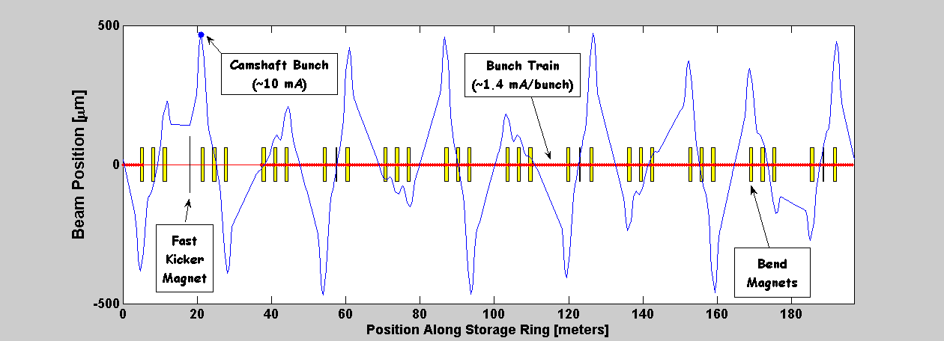
Fig. 1. 1- Kick Magnet.

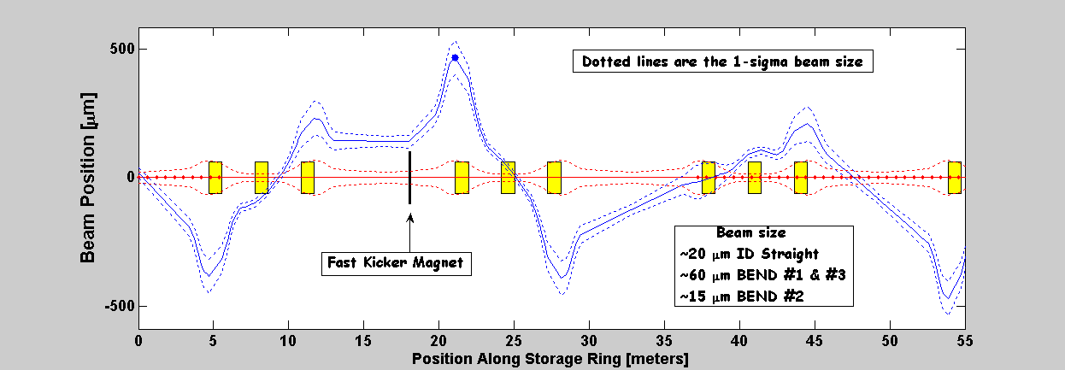
Fig. 2. 1- Kick Magnet – First 3 Sectors.

Reduce the Repetition Rate by 1.5/n MHz
If a beamline is not a favorable location with respect to a single kicker magnet in Sector 2 (Fig. 1), it may not be the end of story. Being able to test this method on the bend magnet beamlines is extremely important. Instead of adding more kicker magnets, one can get interesting orbits by kicking at an integer fraction of the revolution frequency, 1.52MHz/n. Fig. 3-5 show the closed orbits for kicking at 762, 508, 381, 305, … kHz. Notice that it takes n-turns for the orbit to close.
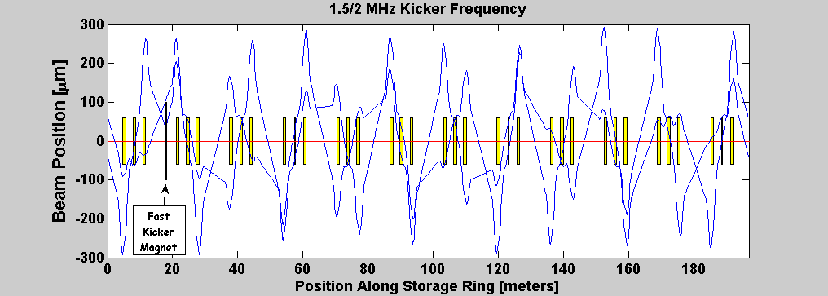
Fig. 3. Kick Every Other Turn.

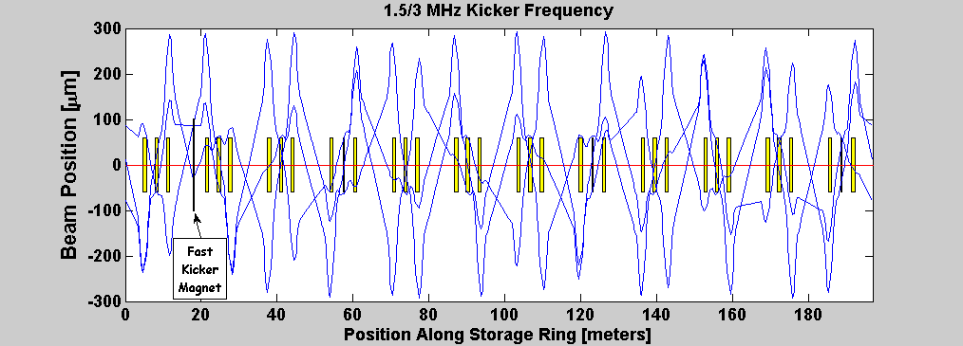
Fig. 4. Kick Every Third Turn.

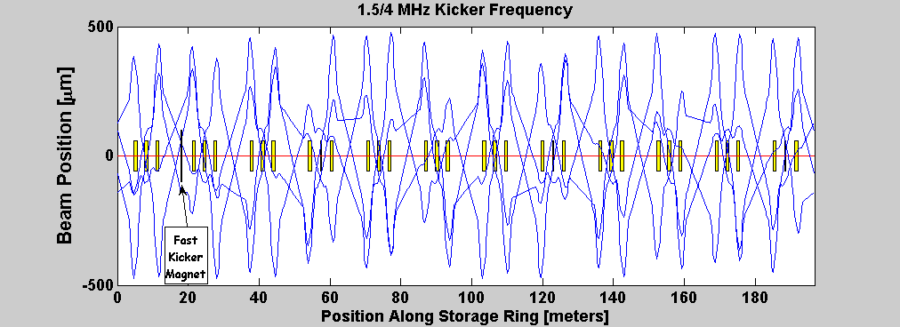
Fig. 5. Kick Every Forth Turn.

The picture gets quite confusing if one skips too many turns before kicking, however, this method can extend the reach of a single kicker magnet. For instance, a user in straight section six sees mostly an angle change in Fig. 1 but would see reasonable positional changes if kicking every other or every fourth turn.

Since the vertical fractional tune in the ALS is .2, kicking every fifth turn will create a resonance. Basically, the 1/sin(πν) term for a closed orbit change due to corrector blows up. If the tune were exactly .2, the bunch would be kicked out of the accelerator. However, if the tune is changed a small amount off .2, the kick will be just off resonance and a large amplification of the bump can be potentially achieved. Fig. 6 shows the result for a vertical tune of 9.188. This factor of 3 amplification comes from 1/sin(9.2π)= -1.7 and 1/sin(5*9.188π)=-5.33 or 3.14 times the kicker for free. There are two problems with using a resonance to amplify the kick strength. First, all the different orbits in Fig. 6 may be a bit difficult to work with. That said, many of the beamlines would see one track which shows a large positional separation from all the other tracks. Second, the size of the orbit kick is directly dependent on the tune and the more amplification one tries to achieve the more sensitive it becomes to tune variation. For test purposes, one could also move the vertical tune to be on near resonance when kicking every 4th turn.

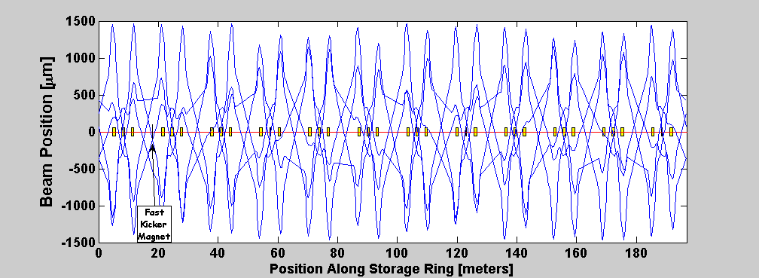
Fig. 6. Kick Every Fifth Turn.

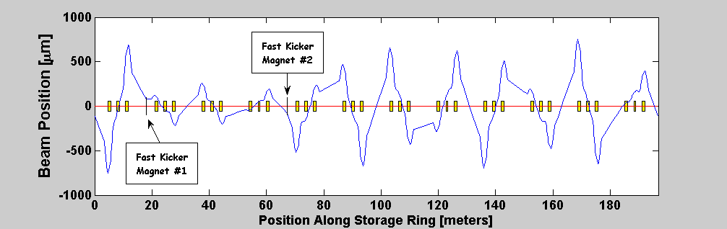
Fig. 7. Kickers in Sector 2 & 5.

Another possible location for a fast kicker magnet is the downstream end of the sector 5 wiggler. The shape of closed-orbit will essentially be the same as in Fig. 1-6 except that sector 5 takes the place of sector 2 in the figures. If we installed kickers in both locations the kicks would superimpose. Fig. 7 shows a +60 μradian kick in kicker magnet #1 and -60 μradian in kicker #2. This produces favorable offsets in the sector 6 & 8 straight sections as well as large offsets in some of the outer bend magnet beamlines. However, the added cost of installing two kickers may not be warranted when Fig. 1-6 show other solutions that produce reasonable offsets.

Can one kicker magnet be run at low frequencies, like 1 kHz? While this would be of interest to a number of experimenters, it will produce some interesting but probably not useful beam characteristics. When kicking relatively slowly, a transient will be introduced which defuse in phase space (beam blowup) then finally damps back to the closed-orbit of the main bunch train.

Advantages of using a single magnet
- Takes less than .5 m in the storage ring
- Reaches a large number of users per kicker magnet
- Operational simplicity

Disadvantages
- Fixed frequency – 1.5 MHz or a close fraction there of, like 1.5/n where n is 1, 2, … .
- Fixed beam path may not be optimal for all users (or non-users). The separation of the camshaft bunch from the main bunch train will vary depending on the beamline location.

Global Orbit Profiling
By adding more kicker magnets, one could more precisely shape the global orbit of the camshaft bunch. This is similar to global orbit correction except the corrector magnets only select one bunch.

Local Orbit Bumps
If it’s important to limit the separation of the camshaft from the main bunch train to a section of the accelerator, local bumps can be used. Three or four magnet bumps are easy to create and are commonly used in orbit control. The bump size could extend over a relatively small section, like an arc or a straight section and neighboring arcs (Fig. 8-9 respectively), or they can extend over many sectors. Very localized bumps, like over one straight section, will not be considered because they require large kick strength.

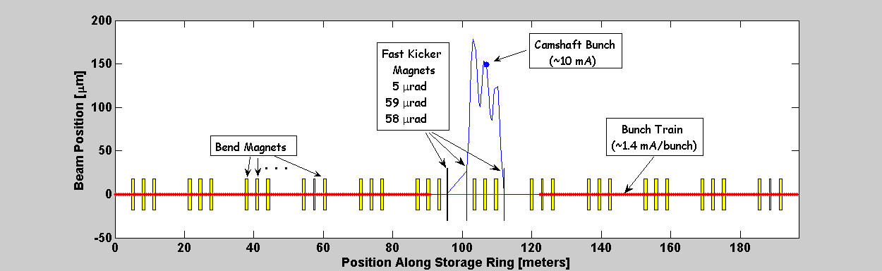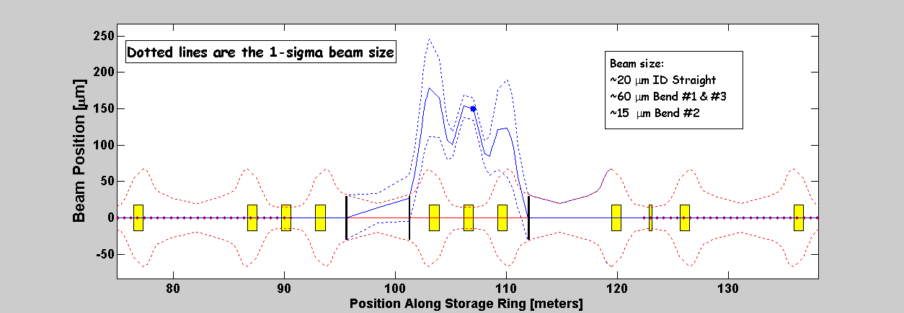
Fig. 8. Arc Sector Bump.

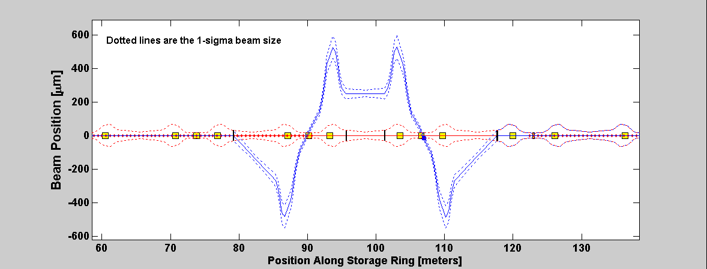
Fig. 9. Straight Section Bump.

There are a myriad of possible bump shapes that one could think about to reach various combinations of beamlines. Given that this system is being designed for a mature light source, it is going to be a challenge to reach all interested users using local bumps.

An advantage of using local bumps is that when the bump magnets are turned on a new closed-orbit is obtained immediately. Hence, it can be turned on or off at any time without creating an orbit transient. For beamlines collecting data timed to a laser running at kilohertz frequencies, it is quite attractive to run the local bump at the same frequency.

Advantages of local bumps
- Flexible frequency
- Profile beam path for a specific group of users without perturbing the beam for all users.

Disadvantages of local bumps
- Requires more space in storage ring
- Multiple magnets increases cost
- Frequency choices < 1.5 MHz will cause a variable background and beam current for users within the bump. However, this could also be an advantage since the percent contamination reduces with the repetition rate.
- Potentially more kick strength required for small bumps.
- The number of users utilizing each local bump might be relatively small.
- More complicated timing.

Beamline User Input
Before the final specification can be put together, more input is needed from the user community. The three basic issues are kick size (displacement), repetition rate, and contamination. There are also potential negative effects on storage ring operations.

Kick Size (displacement and/or angle)
The kick size is the required displacement or angle separation of the kicked bunch from the main bunch train. The present design calls for a 5-10 beam sigma displacement. This requirement could possibly be verified by scanning a closed-orbit bump in normal multi-bunch mode.

One of the challenges here is that every beamline is different and the quality of the optics plays a big role in determining the required separation. Experimental data from BL 5.3.1 is shown in Fig. 10 for a beam sigma of .1 mm. Due to imperfect optics the beam profile distribution is only Gaussian to about 3.5 sigma. So there is only nominal improvement in bunch purity by kicking the beam past about 5 sigma. This beamline is looking for a 10⁻³ reduction of the signal from the main bunch train. Similar experiments on BL 6.0 in the vertical plane are presently being done. This will determine the necessary separation for the femtosecond slicing experiments. Experiments to determine the necessary displacement for BL 6.1 will be done in the near future. One advantage of not separating the beams too much is that the beamline optics would not have to be realigned to switch between operational modes.
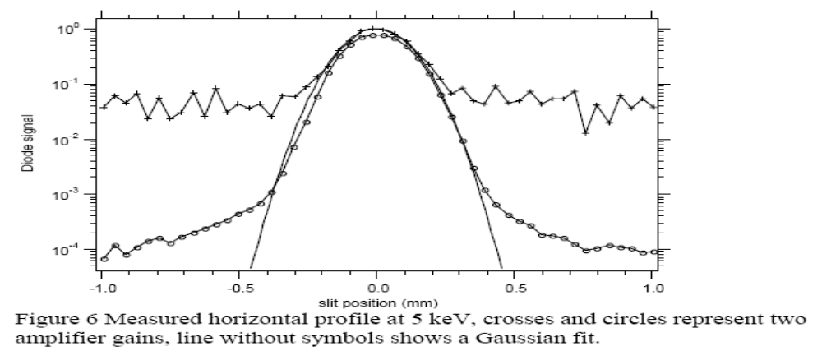

Fig. 10. Measured horizontal profile at BL 5.3.1 at 5 keV. The crosses and circles represent two amplifier gains and the line without symbols shows a Gaussian fit (Data provided by Robert Schoenlein).

Repetition Rate
The upper bound on the repetition rate is the revolution frequency of the electrons – 1.5 MHz. Certain user experiments may require lower rates. For instance, experiments using lasers tend to be in the 1-10 kHz range. When using local bumps it is possible to run at any fraction of the revolution rate.

Contamination
This is a serious question about whether or not the multi-bunch users can handle this new beam profile?
- Contamination effects due to changes in the background radiation (not a Gaussian beam profile anymore). Slitless beamlines may be particularly vulnerable to contamination issues.
- Effects of small periodic changes to the beam current in the main bunch train in the local bump case with frequencies less than 1.5 MHz.
- …
Understanding this area better needs attention.

Storage Ring
Potential storage ring operational problems need to be studied and simulated.
- BPM orbit will change with the kick size and current of the camshaft bunch. Top-off injection will greatly relieve this problem but there are still some logical issues to deal with.
- Ringing in the kicker would add noise to the bunch train and possibly a beam size increase due to diffusion.
- …

Fast Kicker Magnet Design
The main parts of the fast kicker are the pulser and the magnet. The magnet has not been designed yet but will be a stripline kicker similar to the fast feedback kickers which were designed at the ALS. The pulser circuit provides the voltage to the kicker. The goal of the pulser is to supply high voltage when the camshaft bunch is present and zero volts the rest of the time. There was some hope of purchasing the pulser from industry but the 1.5 MHz requirement puts too big a heat load on all commercial units that we could fine. For beamline requiring only 10 KHz or less repartition rate, there may be an off-the-shelf commercial unit with fast enough rise/fall time to meet the specifications. However, running at low frequencies can only be done using local bumps.

A candidate design for the pulser running at 1.5 MHz (or less) and providing a 60 μradian kick (1.15 KV) has been completed, [1]. Fig. 11 shows the pulse shape. If the gap in the bunch train is reduced in the future, the length of the flat top will need to be reduced. It is unclear at this point if the 60 μradian kick can still be obtained with a smaller gap.

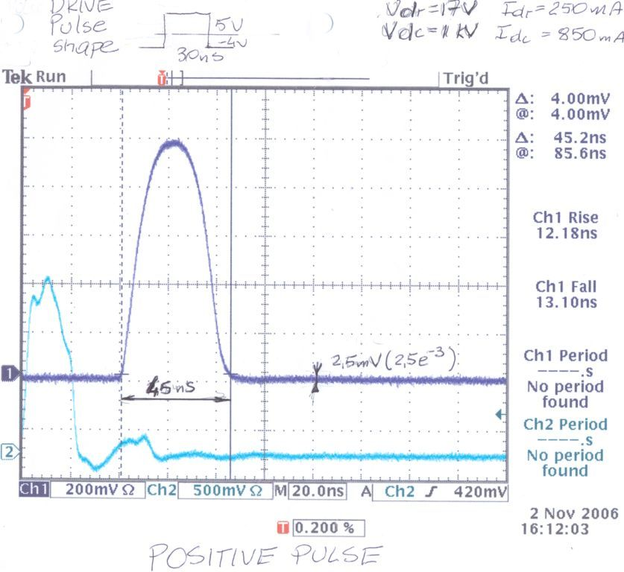
Fig. 11. Fast Kicker Pulse.

Vacuum Chamber
Some thought and effort needs to be put into the vacuum chamber design and where the kicker magnets can be installed in the ring. Unfortunately, due to the ALS vacuum chamber geometry, it is only possible to install new equipment in the straight sections. This puts a severe limitation on kicker locations. Since space is so limited, only .5 meters has been allocated for the magnet and transitions. The candidate location to install the test system is the downstream end of sector 3 straight where two of the 3rd harmonic cavities have been removed. There is some space downstream of the wiggler in sector 5 which would also be a possible location for a test kicker.

For this project to be viable beyond a 1 or 2 magnet kicker system, a more creative solution to storage ring space limitations must be found. One possibility is to install the kicker magnets in the same vacuum chamber with the corrector magnets used in orbit feedback. Magnetic testing would need to be done to determine if the addition of a kicker magnet will appreciable change the frequency response of the corrector magnet. If the answer is favorable, it would be possible to install kicker magnets at a number of places in the future. There are 22 such corrector magnets; however, the downstream corrector is much more appealing since there is a small neighboring spool piece which is needed to extend the kicker length and provide space for the feedthroughs. This small spool piece is used at two places for BPM buttons and scrapers so there are 9 locations left.

A Real Test
Depending on the operational mode and the location of the beamline with respect to the kick, there can be negative effects on beamlines using the multi-bunch beam. Since there are many beamlines with unique optics, it’s difficult to predict the impact on every beamline. Since it is nearly impossible to understand the benefits and possible problems for users and for the accelerator without actually trying the scheme, a prototype magnet is presently being designed and should be ready for installation by the end of 2006. This magnet will provide at least a 60 μradian kick to the electron beam at 1.9 GeV at a repartition rate of 1.5 MHz (or less). The possible changes to the closed orbit are shown in Fig. 1-6. The main goal is to study the benefits and contamination issues of this method. If contamination turns out not to be a problem, the system can also be run during user shifts.

General Project Goal
Install a fast kicker magnet in sector 2 straight section where the third harmonic cavities were removed. The downstream end of the wiggler in sector 5 is the only other possible location. Both locations have vacuum chambers which are relative easy to modify, but the vacuum chamber geometry in sector 2 is more favorable. The magnet will provide at least a 60 μradian kick to the electron beam at 1.9 GeV at a repartition rate of 1.5 MHz (or less). The possible changes to the closed orbit are shown in Fig. 1-6. The main goal is to study the benefits and contamination issues of this method.

Experimental Results
On January 3, 2008 a kicker magnet was installed in Sector 2. Fig. 12 shows the measured and model differences orbits for 750 volts on the kicker and 55 μradian kick in the model when kicking every turn (1.52 MHz). Therefore, at the maximum pulser voltage of 1 KV the angular change should be ~73 μradian.

First Results
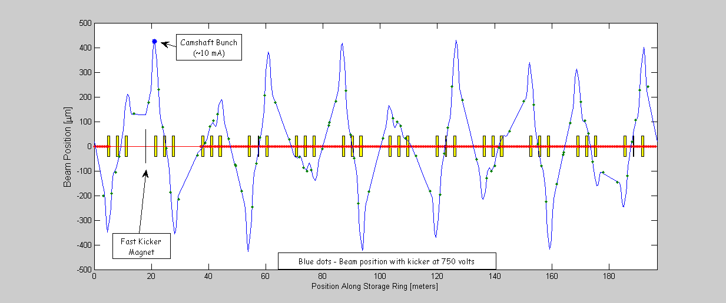
Fig. 12. First results with 750 volts on the kicker at 1.52 MHz, 55 μradian kick in the model.

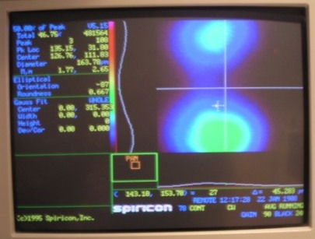
Fig. 13. Single bunch, 750 volts on the kicker, 1.52/2 MHz.

Fig. 13 shows the image on the synchrotron light monitor (BL 3.1) when kicking a single bunch at half the revolution frequency. Fig. 14 shows the model orbits for the same case.

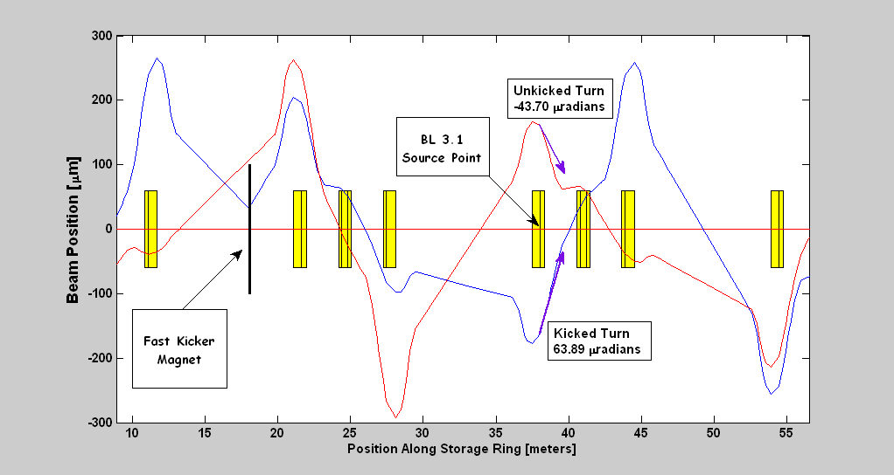
Fig. 14. Model orbits for kicking a single bunch at 1.52/2 MHz.

More Experiments

The beam position monitor (BPM) system is the main tools for understand the behavior of the kicker magnet. The ALS has two types of BPM monitors – multi-turn (slow) and single turn (fast). The slow system measures the center of charge over many turns and is quite accurate – submicron. The fast system measures 1024 consecutive orbits but it’s not particularly accurate – large noise as well as gain & offset problems. A substantial effort has been put into calibrating the multi-turn BPM system, so that is the system that will be used to calibrate the kick angle. However, when kicking at less than the revolution frequency the turn-by-turn BPMs become very useful.

Kicking Every Turn
Fig. 15 shows the measured and model horizontal and vertical difference orbits for a 1 KVolt kick. The small errors between the model and measured data are likely due to the mismatch of the coupling and dispersion function between the machine and the model. Since the agreement in the vertical plane is very good, the model can used predict the change in orbit at the beamline source points. Fig. 16 shows the turn-by-turn data for no kick, 200 volts, and 1000 volts. Since this data has a lot of noise, a histogram is used. The kick amplitude is not very linear, particularly below 500 volts.

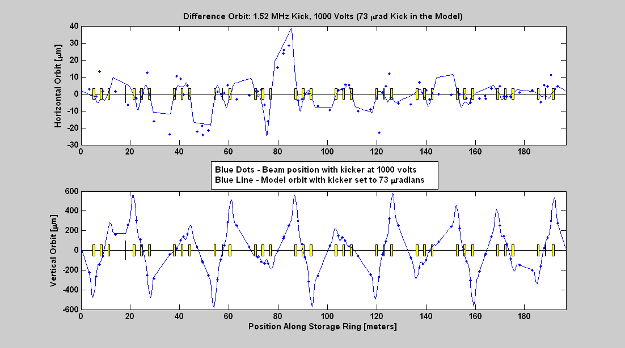
Fig. 15. 1 KVolt on the kicker at 1.52 MHz, 73 μradian kick in the model.

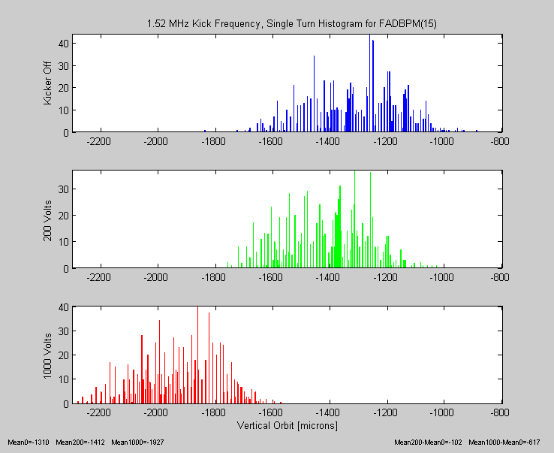
Fig. 16. Single Turn Orbits when Kicking Every Turn for Different Kick Strengths

Kicking Every Fifth Turn

Pass sequence order:
1. Blue
2. Green
3. Red
4. Cyan
5. Magenta

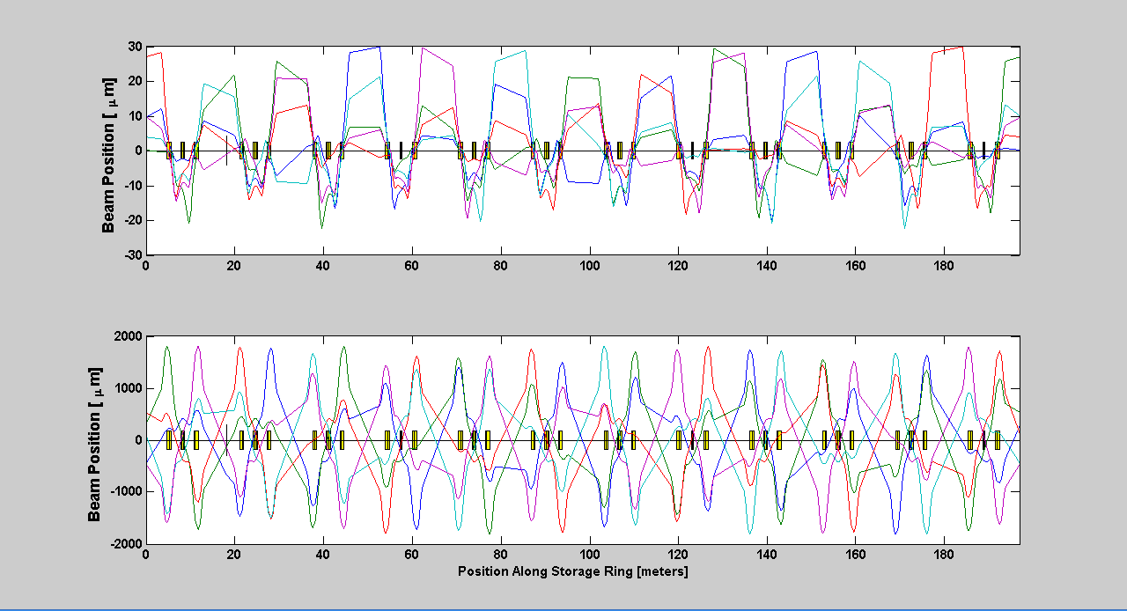
Fig.17. Model Orbits when Kicking Every Fifth Turn

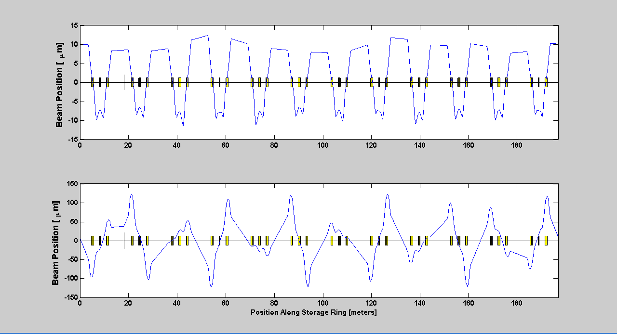
Fig. 18. Average of the 5 Orbits in the Model (ie, what the BPMs will measure)
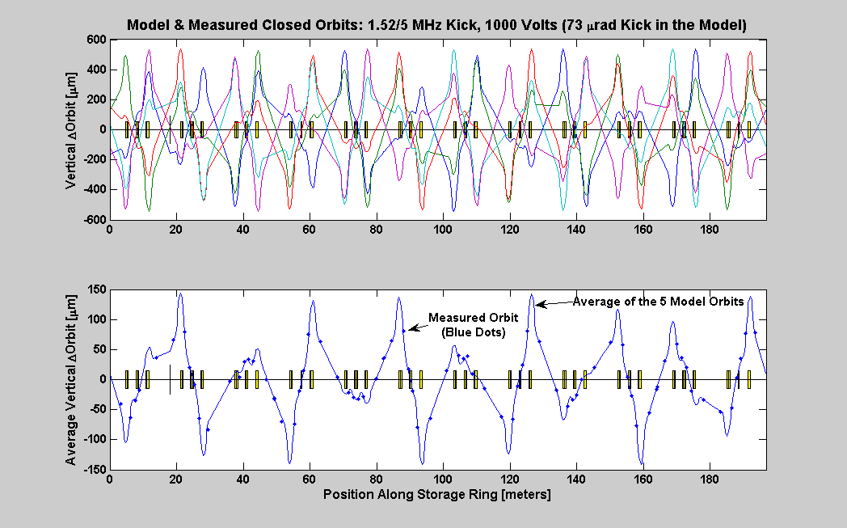
Fig. 19. The Slow BPMs Measure the Center of Charge (Average of the 5 Orbits). The Measured Data Shows Very Good Agreement to the Average of the 5 Model Orbits.

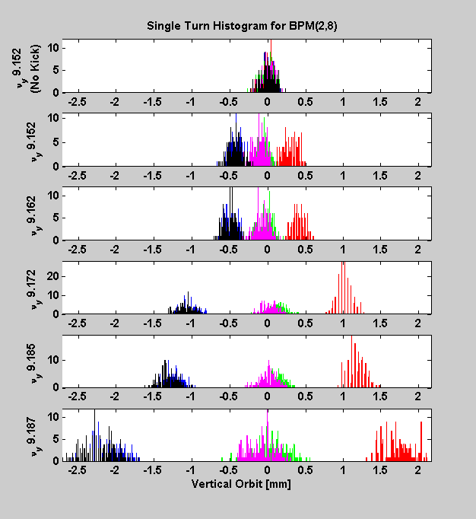
Fig. 20. Single Turn Orbits when Kicking Every Fifth Turn, 1 KV Kick Amplitude

Beamline 6.0
The closest fast BPM is just upstream of BL 6.0 – number [5 9] (the 9th BPM in sector 5).
Fig. 21 shows the single turn BPM data and Fig. 22 shows the predicted separation of the five passes in model. The agreement is quite good. Since the tune was not measured during the measurement of Fig. 21 and the BPMs are not well calibrated, it’s actually better than expected. Once again, since the model and accelerator show very good agreement, the model can used to predict the orbit behavior at any location in the ring (i.e., where monitors don’t exist). Fig. 23 shows the predicted separation of five passes at the beamline 6.0.

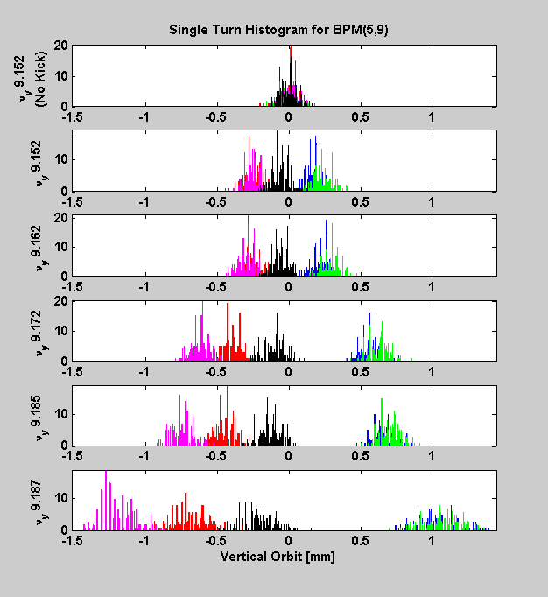
Fig. 21.

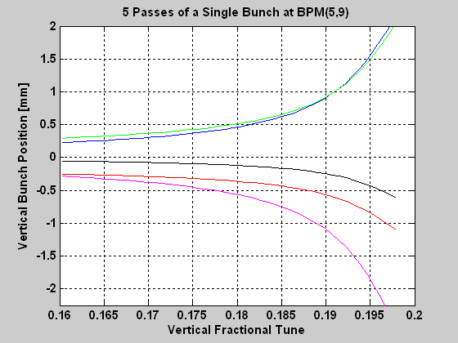
Fig. 22.

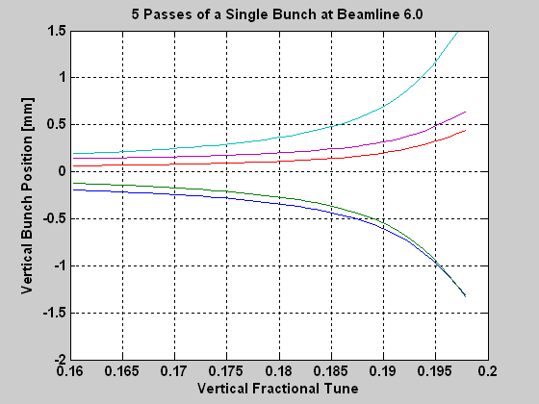
Fig. 23.

c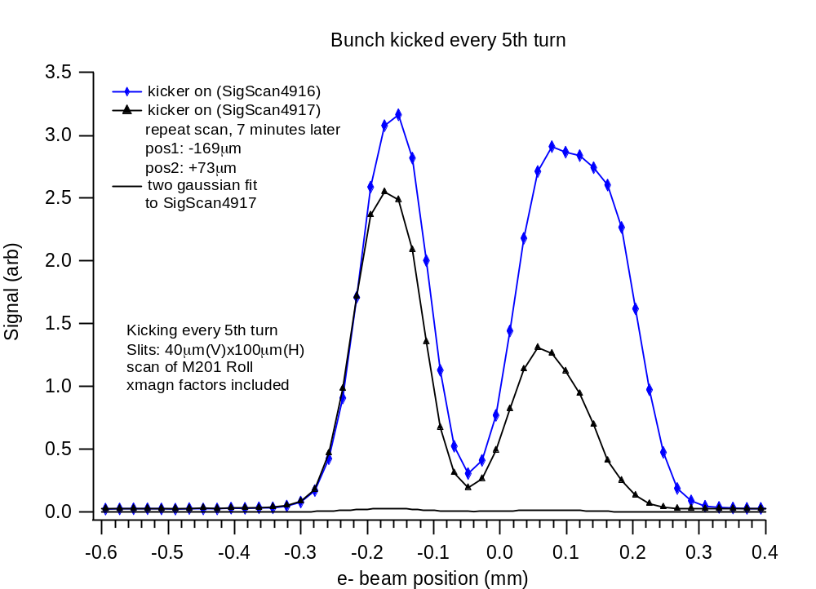
Fig. 24. BL 6.0 Data (P. Heimann & M. Hertlein)

Appendix I – Beamline Data for 1.5 MHz Kick
Fig. A1-1. Position for 73 μradian kick.

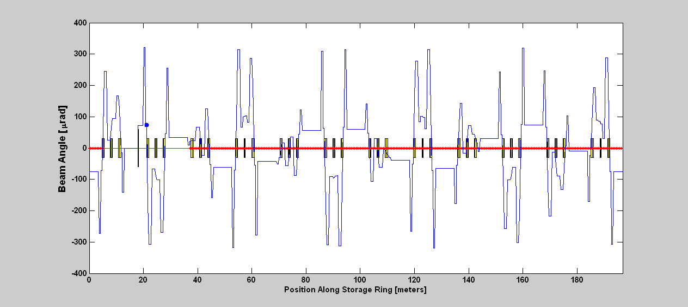
Fig. A1-2. Angle for 73 μradian kick.

Center of  Straight | Position  [μ] | Angle  [μradian]
1 | 22.7 | -75.4
2 | 171.8 | -0.9
3 | -153.1 | 34.6
4 | -99.4 | -62.1
5 | 141.8 | -43.0
6 | 116.6 | 55.9
7 | -108.1 | 59.1
8 | -147.8 | -38.8
9 | 90.0 | -64.8
10 | 157.8 | 30.1
11 | -44.4 | 73.5
12 | -170.6 | -8.8

Beamline | Position  [μ] | Angle  [μradian]
1.1 | -446.2 | 134.3
1.2 | -111.9 | 47.6
1.3 | -85.2 | 79.8
1.4 | 243.1 | 124.0
2.1 | 537.3 | -174.8
2.2 | 68.3 | -80.8
2.3 | 31.0 | -97.0
3.1 | -1.5 | 24.6
3.2 | 123.1 | 43.8
3.3 | 132.7 | 2.0
4.1 | -537.7 | 180.3
4.2 | -28.4 | 102.0
4.3 | -16.0 | 102.0
5.1 | -68.4 | -1.2
5.2 | -128.6 | -32.2
5.3 | -133.1 | 10.6
6.1 | 523.4 | -180.1
6.2 | 15.9 | -96.6
6.3 | -24.4 | -95.2
7.1 | 219.5 | -50.8
7.2 | 133.2 | 4.2
7.3 | 126.1 | -38.1
8.1 | -459.9 | 164.1
8.2 | 24.0 | 100.6
8.3 | 36.4 | 100.6
9.1 | -281.6 | 72.9
9.2 | -131.6 | 8.4
9.3 | -119.5 | 49.5
10.1 | 418.9 | -154.3
10.2 | -39.3 | -95.8
10.3 | -75.6 | -77.0
11.1 | 402.6 | -117.5
11.2 | 120.3 | -36.1
11.3 | 97.6 | -71.7
12.1 | -302.5 | 119.5
12.2 | 72.4 | 81.8
12.3 | 82.4 | 81.8

Appendix II – Beamline Data for 1.5/2 MHz Kick
Fig. A2-1. Position for 73 μradian kick.

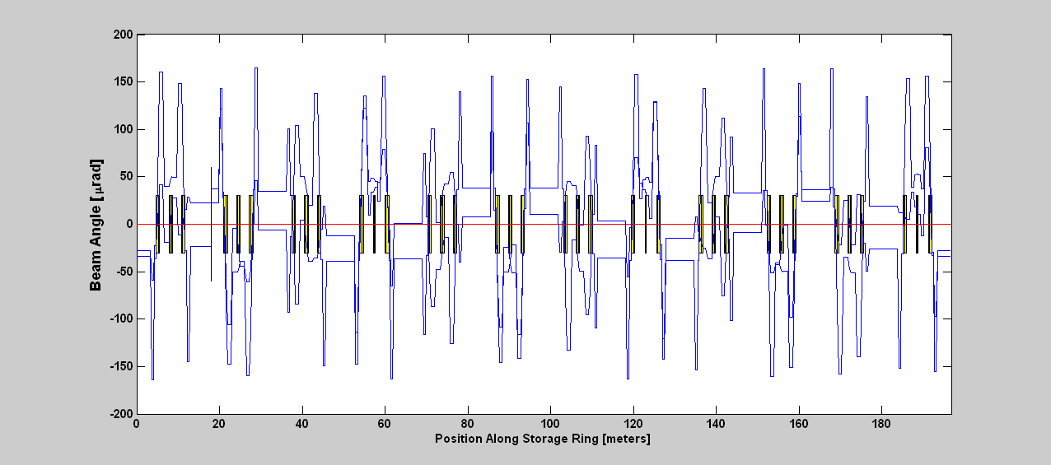
Fig. A2-2. Angle for 73 μradian kick.

Acknowledgements
We would like to acknowledge Brian Kincaid who suggested this approach many years ago.

References
[1] G. Portmann, J. Kirz, S. Kwiatkowski, D. Plate, D. Robin, W. Barry, “A New Operational Mode at the ALS: Pseudo Single Bunch," 37th ICFA Advanced Beam Dynamics Workshop on Future Light Sources, Hamburg, Germany, May 2006.
[2] S. Kwiatkowski, W. Barry, J. Julian, R. Low, D. Plate, G. Portmann, D. Robin , “Camshaft Bunch Kicker Design for the ALS Storage Ring” EPAC’06.
[3] G. Portmann, S. Kwiatkowski, D. Plate, J. Julian, R. Low, K. Baptiste, W. Barry, D. Robin, “Creating a Pseudo Single Bunch at the ALS,” PAC, June 2007.

