NASA Science Mission Directorate

Earth-Sun System Applied Sciences Program
Ecological Forecasting Program Element
FY2005-2009 Plan

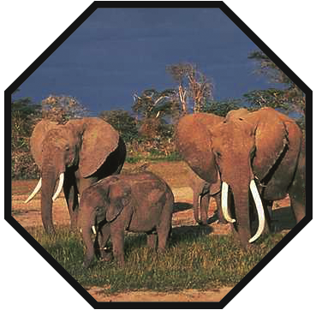
February 11, 2005 edit (v1.6)

 | Expanding and accelerating the realization of economic and societal  benefits from Earth-Sun System science, information, and technology

NASA Science Mission Directorate
Earth-Sun System Division
Applied Sciences Program

Applied Sciences for the Ecological Forecasting Program Element

This document contains the Ecological Forecasting Program Element Plan for FY 2005-2009. This plan derives from direction established in the NASA Strategic Plan, Earth Science Enterprise Strategy, Space Science Enterprise Strategy, Earth Science Applications Plan, and OMB/OSTP guidance on research and development. The plan aligns with and serves the commitments established in the NASA Integrated Budget and Performance Document.

The program manager and the Applied Sciences Program leadership have reviewed the plan and agree that the plan appropriately reflects the goals, objectives, and activities for the program element to serve the Applied Sciences Program, the Earth-Sun System Division, NASA, the administration, and society.

William W. Turner Date
Program Manager, Ecological Forecasting
Applied Sciences Program
NASA Earth-Sun System Division

Lawrence Friedl Date
Lead, National Applications
Applied Sciences Program
NASA Earth-Sun System Division

Ronald J. Birk Date
Director, Applied Sciences Program
NASA Earth-Sun System Division
NASA Earth-Sun System Division: Applied Sciences Program
Ecological Forecasting

Table of Contents

I. Purpose and Scope 1
II. Goals and Objectives 4
III. Decision Support Tools 4
IV. Program Management, Project Management and Partners 6
V. Application Activities 8
A. Project Activities 8
B. Solicitations (current in FY2005) 10
C. Congressionally Directed Activities 11
D. Supporting Efforts 11
E. Additional Activities and Linkages 12
VI. Budget FY 2004-2009 14
VII. Schedule and Milestones 15
VIII. Performance Measures 16
IX. Appendices 18
A. Integrated System Solutions Diagram 18
B. Roadmap 19
C. Applied Sciences Program Budgets FY2005-09 20
D. Related NASA and Partner Solicitations and Grants 22
E. Acronyms and Websites 25

NASA Science Mission Directorate – Applied Sciences Program

Ecological Forecasting Program Element Plan: FY 2005 - 2009

I. Purpose and Scope

This plan describes the goals and direction of the Ecological Forecasting Program Element for fiscal years (FY) 2005 through 2009 by detailing the purpose of the program and our strategy to fulfill the Ecological Forecasting mission with the resources available. The plan describes the program’s scope, including NASA’s role in partnerships, the focus on decision support tools, and the types of science research results we seek to extend. Within the Earth-Sun System Division, this plan functions as a program management tool, describing the program structure, functional mechanisms, performance measures, and general principles that the Ecological Forecasting activity will follow. The plan includes projects in which scientific research results can be applied to decision making with related socioeconomic benefits.

The Ecological Forecasting Program Element is one of twelve elements in the Science Mission Directorate Applied Sciences Program. NASA and the Applied Sciences Program collaborate with partner organizations to enable and enhance the application of NASA’s scientific research results to serve national priority policy and management decision support tools. The desired outcome is for partner organizations to use project results, such as prototypes and benchmark reports, to enable expanded use of Earth-Sun science products and enhance their decision support capabilities.

Ecological forecasting is an important scientific paradigm for the 21st Century. It uses Earth observation data and models to predict the impacts of environmental change on the ecosystems that support the existence of life on Earth. It also links the physical world of climate and geology to the living world of biology and ecology. As the Committee on Environment and Natural Resources (CENR) of the President’s National Science and Technology Council said in its call for improved ecological forecasts, “Ecological forecasts predict the effects of biological, chemical, physical, and human-induced changes on ecosystems and their components.” Indeed, ecological forecasting requires a scientific synthesis across the domains of physics, geology, chemistry, biology, and psychology. The goal is reliable forecasts that allow decision makers access to science-based tools in order to project changes in living systems. These forecasts should incorporate knowledge of uncertainties and estimates of error and allow those making decisions to compare the outcomes of alternative policies. Analogues from the physical sciences include short-term weather forecasts and longer-term predictions of climate phenomena, such as El Nino events.

From the perspective of the NASA Applied Sciences Program, such forecasts are important to those attempting to promote economic growth while still sustaining the natural ecosystems that provide us with cost-free services, such as clean air, fresh water, fertile soils, biodiversity, and the removal of waste products. Forecasts allow planners, developers, and resource managers to project the impacts to ecosystems of their actions, as well as the effects of other phenomena such as major storm events. Ecological models ingest data resulting from NASA research observations and measurements and generate forecasts for decision support systems (DSS) developed by NASA’s partners. These models span spatial scales from molecular to global and assimilate information across long time scales to hone and test the accuracy of predictions. There are limits to the forecasts but discovering the reasons for these limits enhances our overall understanding of the ecosystems involved. NASA is currently involved in both international and domestic partnerships under the Ecological Forecasting Program Element.

A topic as broad as ecological forecasting requires the establishment of priorities. An overarching priority for the Ecological Forecasting Program Element is the growing number of DSS addressing the conservation of biodiversity. These decision support tools are proliferating in the government, not-for-profit, academic, and private sectors. This proliferation is at least partly in response to concerns raised by researchers that extinction rates for known groups of organisms now equal those occurring during mass extinction events documented in the geologic record. The World Conservation Union (IUCN) has been tracking the status of species and populations threatened with extinction for the past four decades. Current summary statistics in the IUCN Red List of Threatened Species show growing numbers of threatened and endangered species in the best-studied groups. Biodiversity loss is a global change of particular urgency as lost species and ecosystems cannot be recovered. Under this overarching priority, the following criteria help establish which potential partnerships are appropriate for NASA support.

- Presence of a partner institution with an existing or planned DSS, which is able to accept or adapt NASA’s observations and forecasts resulting from research and development
- Importance of the ecosystem services involved (e.g., priority locations might be those especially rich in biodiversity or vital to the maintenance of fresh water or healthy fisheries)
- Existence of a NASA research program that allows the extension of Earth-Sun science research results into DSS of particular user communities

Currently, the Ecological Forecasting Program Element focuses on supporting DSS for the following project activities:

- Regional-scale sustainable conservation and development, e.g.: ongoing work in Central America;
- Management of protected areas, such as national parks, reserves, and refuges; and,
- Management of marine fisheries.

Integrated Systems Solutions:
NASA’s approach to ecological forecasting for decision support builds upon Earth-Sun science research results. These results are typically data sets or models derived from observations of the Earth system acquired through various research and analysis program activities. For Ecological Forecasting, relevant observations include those of the land surface, oceans, and atmosphere, as well as measures of topography, primary productivity, vegetation structure, and soils. NASA and/or its partners then apply these data to ecological and other models. The models generate predictions for DSS of partner organizations. The DSS, in turn, produce positive value and benefits for society. (See Appendix A for the Integrated Systems Solutions diagram for Ecological Forecasting.)

Scope within NASA and Applied Sciences Program

The program encourages and the plan includes linkages to the NASA Strategic Plan, Earth Science Strategy, and science research activities, such as Observing System Simulation Experiments (OSSE), Project Columbia, Joint Center for Satellite Data Assimilation (JCSDA), Earth-Sun System Gateway, and the Transition from Research to Operations Network (R2O). The program also promotes use of, contributions to, or promotion of U.S. Government initiatives, such as Global Information Grid (GIG); Federal Enterprise Architecture (FEA); State Enterprise Architecture (SEA); national laboratories; and, international commitments that influence the design, direction, and activities of the program. (See Section V.E for additional information on these activities and linkages.)

The FY05 President’s Budget for the NASA Applied Sciences Program* specifies $54M annually for FY05-FY09 for the National Applications ($24M) and Crosscutting Solutions ($30M) activities. While directly managing a subset of the $24M National Applications budget, the Ecological Forecasting Program (like all the national applications) benefits from the annual $30M in Crosscutting Solutions (see Crosscutting Solutions Program Element Plan). The Ecological Forecasting Program Element also leverages and extends research results from the entire $2.3B per year supporting Earth-Sun system science.

Additional information about the NASA Applied Sciences Program can be found at http://science.hq.nasa.gov/earth-sun/applications.

* The Application component of the Earth Science Applications Theme in the NASA FY05 Integrated Budget & Performance Document.

II. Goals and Objectives

The goal of the Ecological Forecasting Program Element is:

To extend NASA Earth-Sun science results to support our partners’ development of operational ecological forecasting systems for sustainable development.

Ecological Forecasting addresses the first elements of the NASA vision statement: to improve life here and the agency’s mission: to understand and protect our home planet. It directly addresses the overarching goal of the Applied Sciences Program: to bridge the gap between Earth system science research results and the adoption of data and prediction capabilities for reliable and sustained use in decision support. The Ecological Forecasting Program Element draws upon the Science Mission Directorate’s research program for its Earth observation data. The models, which are the sine qua non of ecological forecasting, arise from the research program, the efforts of our partners, and other research activities. The Applied Sciences Program supports the integration of observation data and models into decision support tools. The Ecological Forecasting Program Element works with NASA’s partners to enable DSS that will prove useful to decision makers, resource managers, and members of the general public concerned with the impacts of natural and human-induced environmental changes on living systems. Specific areas of focus for DSS are: regional scale conservation and development efforts (e.g., the Mesoamerican Biological Corridor), the management of protected areas in the U.S. and abroad, and the management of marine fisheries.

III. Decision Support Tools

Regional Visualization and Monitoring System for Mesoamerica (SERVIR):
Since 1999, NASA has worked with Central American partners to support their development of the Mesoamerican Biological Corridor (MBC). Located at the junction of North and South America and characterized by significant changes in elevation, Central America is a biological crossroads with seven to eight percent of the planet’s biodiversity in less than one half of one percent of its land mass. In addition, off its shores lies the second largest system of coral reefs on the planet. In 1997, the leaders of the seven nations of Central America (Belize, Costa Rica, El Salvador, Guatemala, Honduras, Nicaragua, and Panama) announced an unprecedented multinational effort to integrate their conservation efforts across international boundaries and promote sustainable development throughout the region. The MBC is a series of national parks, other protected areas, and lands subject to special management regimes extending from southern Mexico to the Colombian border. NASA has partnered with the U.S. Agency for International Development (USAID), the World Bank, and the Central American Commission for Environment and Development (CCAD) to promote the development of a Regional Visualization and Monitoring System known as SERVIR. SERVIR will operate a series of nodes located in the U.S. and each of the Central American countries. Through it, Central American managers can use observational spacecraft imagery to detect wild fires and major changes in land cover, track rainfall and weather patterns, and monitor coastal margins and coral reefs throughout the region. Models can help users understand the poorly known connection between changes in land cover and climate variation. SERVIR combines observational spacecraft imagery from the TRMM, Terra, Aqua, OrbView-2, and Landsat spacecrafts with environmental and socioeconomic data by means of a geographic information system. It also generates visualization products for decision makers and the public. NASA is funding SERVIR through an award under the Research, Education and Applications Solutions Network (REASoN) Cooperative Agreement Notice (CAN).

Protected Area Management (PAM):
PAM is an umbrella designation covering several DSS under development by NASA’s institutional partners. A shared focus on providing decision support tools for managers of national parks and other protected areas links these DSS. World population is expected to increase 50 percent by 2050, resulting in escalating demands for ecosystem services by approximately 9 billion people. Protected areas are increasingly important for the conservation of biodiversity. They are also vital for the maintenance of other ecosystem services, such as fully functioning watersheds. In addition, protected areas provide direct economic benefits to surrounding communities. The U.S. National Park Service (NPS) estimates that expenditures and job creation in and around U.S. protected areas have economic impacts equivalent to $10.6 billion per year (estimate derived for 2001 from National Park Service Money Generation Model 2).

Marine Fisheries Forecasting (MFF):
The U.S. National Oceanic and Atmospheric Administration (NOAA) is exploring the integration of remote sensing data into marine fisheries models. NASA is funding research efforts along these lines. A DSS for forecasting marine fisheries must link physical oceanography and climate data with ecosystem models to understand the effects of climate oscillations on certain coastal and pelagic fisheries. Many fisheries around the world are in decline. Fisheries managers can use knowledge of the drivers of marine productivity, gained from remote sensing, to improve sustainable fisheries management. MFF leverages progress being made in several research projects funded under the Interdisciplinary Science in the NASA Earth Science Enterprise solicitation. Relevant research projects focus on modeling the impacts of climate events (e.g., El Nino), fishing pressure, and other ecological disturbances on ecosystems and species distributions. This work may lead to a partnership between the Ecological Forecasting and Coastal Management Program Elements.

IV. Program Management, Project Management and Partners

Management Assignments
A. Program Manager
Mr. Woody Turner
Earth-Sun System Division
Science Mission Directorate
NASA Headquarters
Washington, DC 20546-0001

Responsibilities:
- Program development, including program plans and budgets
- Development of and implementation of interagency agreements and partnerships with other organizations
- Development and implementation of solicitations for Ecological Forecasting Program tasks
- Primary responsibility for metrics, performance goals and other performance evaluation criteria
- Liaison for relevant U.S. Government interagency initiatives, e.g.: the U.S. Climate Change Science Program (CCSP), the Global Earth Observation System of Systems (GEOSS)—particularly its societal benefit areas of ecosystems and biodiversity, the Congo Basin Forest Partnership (CBFP) and President’s Initiative Against Illegal Logging, etc.

B. Project Manager for SERVIR
Mr. Daniel Irwin
NASA National Space Science and Technology Center (NSSTC)
320 Sparkman Drive
Huntsville, AL 35805

Responsibilities:
- Coordination of activities of project partners
- Development of metrics for project success
- Meeting project milestones
- Management of project laboratory at NASA NSSTC
- Coordination with primary project facility in Panama
- Presentations on project to audiences around the world

C. Project Manager for PAM
Dr. Gary Geller
M/S: 171-264
Jet Propulsion Laboratory
4800 Oak Grove Drive
Pasadena, CA 91109-8099

Responsibilities:
- Exploring and evaluating the remote sensing needs of protected area managers and other conservation practitioners in potential partner organizations
- Identifying solutions that leverage remote sensing to address the needs of protected area managers and other conservation practitioners
- Establishment of project goals, milestones, and other measures of success
- Coordination of various activities under this project

D. Project Manager for MFF
Woody Turner (Acting)
NASA Headquarters

Responsibilities:
- Exploring and evaluating the remote sensing needs of marine fisheries managers and other organizations monitoring fisheries
- Identifying solutions leveraging remote sensing to address these needs
- Establishment of project goals, milestones, and other measures of success

Key Partners:
Ecological Forecasting relates to several other NASA Applied Sciences Program Elements. In particular, it can draw upon the knowledge gained and the techniques and DSS developed by the Coastal Management, Invasive Species, Public Health, Water Quality, and Carbon Management Program Elements. These and other program elements should derive benefits from the models and decision support tools of Ecological Forecasting.

Key partners and relevant DSS identified under the Ecological Forecasting program element include (relevant DSS in parentheses):
A. Government agencies and programs:
- USAID (SERVIR)
- U.S. Department of Agriculture/U.S. Forest Service (PAM)
- U.S. Department of State (PAM)
- U.S. Department of the Interior/U.S. Fish & Wildlife Service, National Park Service, U.S. Geological Survey (PAM)
- U.S. Department of Commerce/National Oceanic and Atmospheric Administration (MFF)
- U.S. Department of Energy/Oak Ridge National Laboratory (SERVIR)
- CCSP (SERVIR, PAM, MFF)
- Interagency Working Group on Earth Observations (IWGEO) (SERVIR, PAM, MFF)
B. NASA Centers:
- Marshall Space Flight Center-MSFC (SERVIR)
- Ames Research Center-ARC (PAM via Terrestrial Observation and Prediction System)
- Jet Propulsion Laboratory-JPL (PAM)
- Goddard Space Flight Center-GSFC (PAM)
C. Universities:
1) University of Maryland (PAM)
2) Michigan State University (PAM)
- California State University Monterey Bay (PAM)
- University of Washington (PAM)
- University of Alabama, Huntsville (SERVIR)
- University of Arkansas (SERVIR)
D. Other Organizations:
- CCAD (SERVIR)
- The World Bank (SERVIR)
- NatureServe (PAM)
- Conservation International (PAM)
- World Wildlife Fund (PAM)
- Wildlife Conservation Society (PAM)
- The Wilderness Society (PAM)
- American Museum of Natural History (PAM)
- Smithsonian Institution’s Conservation and Research Center (PAM)
- Conservation Biology Institute (PAM)
- The Nature Conservancy (PAM)
- United Nations Environment Programme (PAM)
- GEOSS (SERVIR, PAM, MFF)

V. Application Activities

A. Project Activities
SERVIR:
The past year has been an active one for SERVIR. The Water Center for the Humid Tropics of Latin America and the Caribbean (CATHALAC), located within Panama’s City of Knowledge (a former U.S. military base in what was the U.S. Canal Zone), agreed to host the primary node for SERVIR under the leadership of CATHALAC Director Emilio Sempris. In August 2004, NASA Tom Sever and Dan Irwin’s team opened the U.S. SERVIR node at the National Space Science and Technology Center in Huntsville, AL. In the fall of 2004, the NASA team shipped hardware for the primary Central American node to CATHALAC, where it has been assembled within a refurbished facility. And in December 2004, the Director of CATHALAC and the Executive Director of CCAD completed an agreement specifying the roles of each organization within SERVIR. This agreement also allows other institutions to participate in SERVIR. One important example is the Inter-American Biodiversity Information Network (IABIN). Located in the same facility as SERVIR, IABIN is a clearinghouse for regional biological information. Its participation should foster ecological forecasting within SERVIR by enhancing access to biological data for combination in models with physical data. Plans call for a formal dedication of the primary Central American SERVIR node in February 2005.

PAM:
Activities and DSS tools under the PAM framework include: (1) the nongovernmental organization NatureServe’s Vista DSS for resource managers and community planners, which NASA is funding under a REASoN CAN award; (2) the Terrestrial Observation and Prediction System (TOPS) tool of ARC, another recipient of a REASoN CAN award; (3) support for a joint effort by domestic and international conservation organizations, the University of Maryland Global Land Cover Facility, the United Nations Environment Programme (UNEP) and its World Conservation Monitoring Centre (WCMC) to benchmark the effectiveness of remote sensing as a monitoring tool for conservation under the auspices of the international Convention on Biological Diversity; (4) signing an agreement with the NPS to foster the use of remote sensing in its Inventory and Monitoring Program, as well as its educational activities; (5) drafting an agreement with IUCN-The World Conservation Union to integrate geospatial data into its global environmental databases using tools such as the JPL-based Protected Area Archive; (6) making NASA assets available to global forestry initiatives of the Administration (CBFP and the President’s Initiative Against Illegal Logging); and (7) providing spacecraft imagery to users measuring environmental change through time.

NatureServe is completing Version 1.0 of its Vista DSS and anticipates a release early in 2005. Over the past year, funding support for Vista has risen through awards to NatureServe from other U.S. Government agencies as well as a grant from the Doris Duke Charitable Foundation. NatureServe, in conjunction with the U.S. Forest Service, has identified the Bridger Teton National Forest as the first testbed for Vista under the NASA REASoN activity. If Vista performs well at Bridger Teton, the likelihood of its being adopted as a planning tool for other National Forests increases appreciably.

The TOPS activity at NASA ARC will focus its first DSS on fuel load modeling for the Wildland Fire Assessment System operated by the National Interagency Fire Center in Boise, ID.

Agreements with NPS and The World Conservation Union are underway to support the PAM project. The NPS agreement was completed in January 2005 and the agreement with The World Conservation Union should be finalized in late 2005 or early 2006.

The Subsidiary Body on Scientific, Technical and Technological Advice (SBSTTA) of the Convention on Biological Diversity (CBD) has asked the NASA/NGO Working Group to work with the UNEP WCMC and the Food and Agriculture Organization of the United Nations on a report regarding remote sensing-based indicators for assessing progress toward the CBD 2010 target. For reference, the World Summit on Sustainable Development in 2002 endorsed the call “…to achieve by 2010 a significant reduction of the current rate of biodiversity loss….” This goal is now known as the “2010 target.” NASA is working with a group of conservation nongovernmental organizations (NGOs) to produce this international report by the end of 2005. These NGOs are: The Nature Conservancy, Conservation International, World Wildlife Fund, Wildlife Conservation Society, The Wilderness Society, the Conservation Biology Institute, the American Museum of Natural History, the Smithsonian Institution’s Conservation and Research Center, the UNEP Global Resource Information Database, and the University of Maryland Global Land Cover Facility. Most of these organizations have ongoing observation programs in and around protected areas throughout the world. This effort is essentially a “what works and what is still needed” analysis for protected areas. Through their on-the-ground connections to protected area managers in the countries within which they work, the NGOs can communicate the results of their efforts to managers and policy makers at home and abroad.

Further activities for 2005 include discussing the remote sensing requirements of the U.S. Fish and Wildlife Service’s National Wildlife Refuge System with Fish and Wildlife officials. The Refuge System is engaged in a conservation planning process to define priorities for future land acquisitions.

MFF:
Making appropriate contacts at NOAA is a key first step in exploring the potential for NASA research activities to improve NOAA models. These contacts did not materialize in 2004 but hopefully 2005 will prove more productive in this regard.

B. Solicitations (current in FY2005)

The list below includes only applications activities and does not contain research activities being funded under the Interdisciplinary Science in the NASA Earth Science Enterprise and EOS solicitations, which are managed by the Program Scientist for Biological Diversity and leveraged by the Ecological Forecasting Program Element. This list does not include those REASoN activities funded by the Research Division.

1. SERVIR
Budget: $2,726,500 over 5 years (includes FY03), under the REASoN CAN
Lead Center: MSFC Principal Investigator (PI) is Tom Sever
Other Partners: University of Alabama, Huntsville & University Research Foundation (URF)
Deliverable: Decision support system SERVIR for managing the MBC

2. NatureServe Decision Support Tool for Western Land Managers
Budget: $1,000,000 over 4 years (includes FY03), under the REASoN CAN
Lead Center: HQ PI is Dennis Grossman of NatureServe
Deliverable: Decision support tool for the Greater Yellowstone Area (GYA)

3. Enhancement of TOPS
Budget: $2,400,000 over 5 years (includes FY03), under the REASoN CAN
Lead Center: ARC PI is Keith Golden
Other Partners: University of Washington
Deliverable: Decision support tool for terrestrial vegetation & hydrology

4. CBFP monitoring funding
Budget: $449,999 expected from USAID, believed to be multi-year funding but future years’ funding contingent upon USAID decision
Lead: University of Maryland PI is Chris Justice
Deliverable: Remote sensing-based monitoring system for the tropical forests of Central Africa and capacity building under CBFP – part of the President’s Initiative Against Illegal Logging

5. FY2005 Applied Sciences Decisions Solicitation (Ecological Forecasting
component)
Budget: level of support based on projects awarded, funding to begin in FY2005
Lead Center: HQ
Deliverable: First round of high-quality Ecological Forecasting proposals

C. Congressionally Directed Activities
There are no Congressionally-directed activities in the Ecological Forecasting Program Element for FY05.

D. Supporting Efforts
1. Additional FTE for SERVIR to support remote sensing analysis and web-based
GIS
Budget: $130,000 for 3 years from Ecological Forecasting Program
Element funds
Lead Center: MSFC PI is Tom Sever or someone on his team
Deliverable: Ability to address additional, unforecasted work resulting from popularity of SERVIR and additional demands on investigators’ time, also includes additional requests from HQ

2. Project Manager for PAM
Budget: $142,000 for FY05, rising in the out years, from Ecological Forecasting Program Element funds
Lead Center: JPL PI is Gary Geller
Deliverable: 0.85% of his time for overall coordination and management of this element of the program

3. Additional reporting for PAM and SERVIR
Budget: $35,000 for FY05-07 and $40,000 for FY08-09 from Ecological Forecasting program element funds
Lead Center: GSFC PI is Tom Hood
Deliverable: Assistance with PAM and SERVIR Project Plans and evaluation, verification, and benchmark (EVVB) reporting

4. Protected Area Archive
Budget: $375,000 over 5 years from Ecological Forecasting Program Element funds
Lead Center: JPL PI is Gary Geller
Other Partners: World Conservation Union (IUCN), perhaps United Nations Educational, Scientific and Cultural Organization (UNESCO), USAID and NPS
Deliverable: Web-based portal introducing parks & protected area managers to remote sensing tools featuring their management areas

5. Project Manager for MFF
Budget: $73,000 in FY05, rising in the out years, from Ecological Forecasting Program Element funds
Deliverable: Management of the project

6. Support for other EVVB Reports
Budget: $845,000 over 5 years ($25,000 in FY05) from Ecological Forecasting Program Element funds
Deliverable: Reports for SERVIR, MFF, and help with PAM reports

7. Workshops and symposia
Budget: $80,000 in FY05 and $75,000 in FY06-09 from Ecological Forecasting Program Element funds
Lead Center: HQ
Other Partners: National Council for Science and the Environment (NCSE), NPS, ARC, Society for Conservation Biology (SCB), Ecological Society of America (ESA)
Deliverable: Environmental forecasting workshop, NPS indicator development workshop, ecological modeling workshop, and outreach at major U.S. ecological meetings

8. Heinz Center State of the Nation’s Ecosystem Report
Budget: $150,000 over 3 years from Ecological Forecasting Program Element funds
Lead Center: HQ
Other Partners: Research Program
Deliverable: Commitment to OSTP

E. Additional Activities and Linkages

In general, the NASA Ecological Forecasting Program Element is following program direction to emphasize the link to the following activities:

The Crosscutting Solutions Program—This program consists of functional elements that contribute to all of the National Applications activities. The intention is to have the performance of these functions leverage accomplishment, and therefore the apparent resource investment, to the greatest extent possible into the National Applications partnerships. These functions are: Geoscience Standards and Interoperability, Human Capital Development, Integrated Benchmark Systems, and Solutions Networks. Examples of leveraged activities are:

- The Earth-Sun System Gateway is a “portal of portals” providing an access point through an Internet interface to all web-enabled NASA research results.
- Rapid Prototyping Center—a proposed center at Stennis to support NASA and partners in testing and verification of Earth-Sun science results in decision support tools
- Transition from Research to Operations Network (R2O) is a network that focuses on systematically transitioning the results of research to operational uses.
- DEVELOP is a student-based program for rapidly prototyping solutions for state and local applications and helping students develop capabilities related to applied Earth-Sun science.

NASA and Science Mission Directorate Priorities
The Ecological Forecasting Program Element leverages, utilizes, and contributes to priority activities of NASA and the Federal government, including:
- Federal Enterprise Architecture (FEA) is a business and performance-based framework to support cross-agency collaboration, transformation, and government-wide improvement.
- The Global Information Grid (GIG) is the first stage of a U.S. military global, high-bandwidth, internet protocol-based communications network (a.k.a., ‘internet in space’).
- The Joint Center for Satellite Data Assimilation (JCSDA) is a multi-agency collaboration to accelerate and improve the quantitative use of research and operational observational spacecraft data in weather and climate prediction models. NOAA, NASA, Navy, Air Force, and NSF (through UCAR) collaborate in JCSDA.
- Metis is a visual modeling software tool for planning, developing, and analyzing agencies' enterprise architectures. The Applied Sciences Program is using Metis to identify possible linkages between observations, models, and decision support tools to support the IWGEO and NASA/NOAA R2O activities.
- Observing System Simulation Experiments (OSSEs) use simulated observations to assess the impacts of future observational spacecraft instruments on weather and climate prediction, and OSSEs provide opportunities to test new designs and methodologies for data-gathering and assimilation.
- Project Columbia is a NASA-wide project to develop a new, fast supercomputer (using an integrated cluster of interconnected processor systems) to support the Agency’s mission and science goals, including enhanced predictions of weather, climate, and natural hazards.

VI. Budget FY 2004-2009

Institution | PI | Title/Subject | FY04 | FY05 | FY06 | FY07 | FY08 | FY09
MSFC | Sever | REASON: A Regional Monitoring & Visualization System for the Mesoamerican Biological Corridor | $600,000 | $600,000 | $600,000 | $370,000 | $0.0 | $0.0
NatureServe | Grossman | REASON: Delineating Ecological Systems & Advanced Decision Support Tools for Land Use Planning | $200,000 | $250,000 | $250,000 | $0.0 | $0.0 | $0.0
ARC | Golden | REASON: An Agent-Based Interface to Terrestrial Ecological Forecasting | $500,000 | $500,000 | $500,000 | $500,000 | $0.0 | $0.0
UMD/NASA | Justice | USAID funding: Monitoring & capacity building for Congo Basin Forest Partnership (reevaluated annually) | $449,999 | $449,999 | -- | -- | -- | --
 |  | Subtotal | $1,749,999 | $1,799,999 | $1,350,000 | $870,000 | -- | --
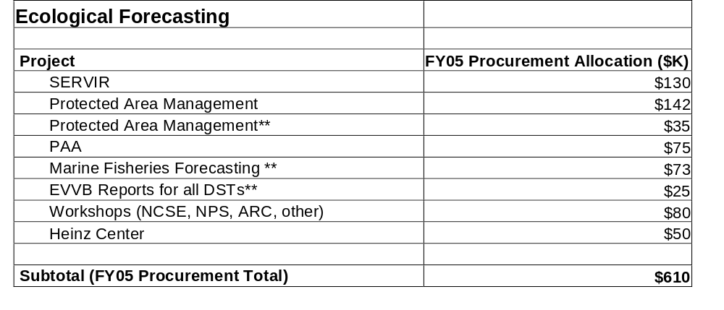
MSFC | SERVIR | Additional FTE for RS Analysis | $0.0 | $130,000 | $130,000 | $130,000
Conservation Biology Institute | Strittholt | CBD Study for 2010 Target | $500,000 | $0.0 | $0.0 | $0.0 | $0.0 | $0.0
JPL | Geller | PAM Project Management | $0.0 | $142,000 | $230,000 | $240,000 | $250,000 | $260,000
GSFC | Hood | PAM Reporting | $0.0 | $35,000 | $35,000 | $35,000 | $40,000 | $40,000
JPL | Geller | Protected Area Archive | $50,000 | $75,000 | $100,000 | $100,000 | $50,000 | $0.0
TBD | TBD | MFF Management | $0.0 | $73,000 | $180,000 | $180,000 | $190,000 | $190,000
TBD | TBD | EVVB Reports for DSS | $0.0 | $25,000 | $200,000 | $200,000 | $200,000 | $220,000
HQ | TBD | Workshops (NCSE & NPS in 2/05, ARC in 3/05, PIs 5/05, SCB 7/05 or ESA 8/05) | $0.0 | $80,000 | $75,000 | $75,000 | $75,000 | $75,000
HQ | Heinz Cen. | State of Nation’s Ecosystems Report | $0.0 | $50,000 | $50,000 | $50,000 | $0.0 | $0.0
 |  | Subtotal | $550,000 | $610,000 | $1,000,000 | $1,010,000 | $805,000 | $785,000
 |  | TOTAL | $2,299,999 | $2,409,999 | $2,350,000 | $1,880,000 | $805,000 | $785,000

VII. Schedule and Milestones

Fiscal Year 2005:
- Complete U.S. and primary Central American SERVIR nodes (lead: MSFC) 1st Quarter
- Release core DSS functionality for addressing resource management & conservation issues in the GYA (lead: NatureServe) 2nd Quarter
- Inaugurate SERVIR primary node in Panama (leads: MSFC & HQ/Turner) 2nd Quarter
- Selection of “Decisions” awardees (leads: HQ/Applied Sciences Program Managers) 2nd Quarter
- Finalize Agreement with National Parks Service (NPS) (lead: HQ/Turner) 2nd Quarter
- Discuss with NOAA their needs for improved fisheries management, looking for overlaps with research programs of Barber, Roffer, Morrison, Muller-Karger, Helmuth, & Deysher (leads: HQ/Turner & Friedl) 3rd Quarter
- Complete draft of IUCN agreement (lead: HQ/Turner) 3rd Quarter
- Baseline requirements of fire managers for TOPS wildfire risk assessment tool (lead: ARC/TOPS Team) 3rd Quarter
- Primary SERVIR Central American node operational (lead: MSFC) 4th Quarter
- Hold first joint meeting of biodiversity research & Ecological Forecasting program element investigators (lead: HQ/Turner) 4th Quarter
- Complete report on utility of remote sensing for providing indicators of progress toward CBD 2010 target (lead: NASA/NGO Group) 4th Quarter
- Identify appropriate data sets for MFF (leads: HQ/Turner & Friedl) 4th Quarter

Fiscal Year 2006:
- Sign agreement with IUCN (lead: HQ/Turner) 1st Quarter
- Assessment of TOPS performance as integrated within wildfire risk assessment tool (lead: ARC/TOPS Team) 3rd Quarter
- Evaluate SERVIR DSS products with Central American decision makers (lead: MSFC) 3rd Quarter
- Benchmark report from Vista DSS (lead: NatureServe Team) 4th Quarter
- Work with NOAA to prototype Science Mission Directorate products as inputs to a MFF DSS (leads: HQ/Turner & Friedl) 4th Quarter

Fiscal Year 2007:
- SERVIR validation and benchmark report
- Integrate early results from the research programs of Waring, Hansen, Stohlgren, Smith, Morisette, Nair, Smith & Dubayah into PAM efforts (lead: HQ/Turner)
- Identify final SERVIR products (lead: MSFC)
- Evaluate the potential for NASA products to support partner DSS employing Population and Habitat Viability Assessment models (lead: HQ/Turner)
- Validation of NASA products as inputs to MFF DSS (leads: HQ/Turner & Friedl, with Center support)

Fiscal Year 2008:
- Benchmark SERVIR with partners in Central America (lead: MSFC)
- Assist NOAA with benchmarking MFF DSS (leads: HQ/Turner & Friedl, with Center support)
- Benchmark a prototype PAM DSS (lead: Conservation NGOs)
- Work with U.S. Fish & Wildlife Service in addressing requirements for Population and Habitat Viability Assessment models (lead: HQ/Turner)

VIII. Performance Measures

Program Management and Performance Measures:
The Ecological Forecasting management team uses performance measures to track progress, identify issues, evaluate projects, make adjustments, and establish results of the program element. The program’s Goals and Objectives state broadly what the program intends to achieve. These measures help monitor progress within and across specific activities to ensure the program meets its goals and objectives. The management team analyzes these measures retrospectively in order to make adjustments proscriptively to the program approach and objectives.

The measures are in two categories. Program Management Measures are internally focused to assess the activities within the program. Performance and Results Measures are externally focused to assess if the program activities are serving their intended purposes. In general, the Program Manager uses these measures to evaluate the performance of activities conducted and sponsored by the program, especially the projects. The Applied Sciences Program uses this information in preparing Integrated Budget & Performance Document (IBPD) directions and Program Assessment Rating Tool (PART) responses.

In addition to the stated measures, the Program Manager periodically requests an assessment of Ecological Forecasting’s plans, goals, priorities, and activities through external review. The Ecological Forecasting team uses these measures along with comparisons to programmatic benchmarks to support assessments of the Applied Sciences Program (e.g. internal NASA reviews and OMB PART). Specifically, the Program Manager uses comparisons to similar activities in the following programs (i.e. program benchmarks) to evaluate its progress and achievements:
- Environmental and Societal Impacts Group at the National Center for Atmospheric
Research
- Global Monitoring for Environment and Security (GMES)

Connections to FY05 IBPD Performance Measures:
This Program Element also addresses FY05 Performance Measure Outcomes.

Outcome 1.2.1: Through 2012, benchmark the assimilation of observations provided from 20 of the 80 sensors on NASA Earth Observation Satellites
- FY05-08 - SERVIR applies measures from the MODIS, ETM+, SeaWiFS, SRTM, and MISR sensors, as well as data from assorted TRMM, and other, sensors.

Outcome 1.2.2: By 2012, benchmark the assimilation of 5 specific types of predictions resulting from the Earth System Modeling Framework of 22 NASA Earth system science models
- FY05-09 - Ecological Forecasting draws upon both global and regional climate models incorporating the atmosphere, oceans, and land surfaces. It also utilizes and generates new ecosystem models (e.g., ecological niche models, population and habitat viability assessment models, biogeography models, trophic models, biogeochemistry models) that use climate and land cover elements as inputs.

Outcome 1.2.3: By 2012, benchmark the assimilation of observations and predictions resulting from NASA Earth Science research in twelve decision support systems serving national priorities and missions of federal agencies
- By FY08, the Ecological Forecasting Program Element plans to have evaluated and benchmarked inputs to 3 DSS: SERVIR and DSS for PAM and MFF.

Outcome 3.1.1: By 2012, in partnership with Department of Homeland Security, Department of Defense, and the State Department, deliver 15 observation sets and 5 model predictions for climate change, weather prediction and natural hazards to 5 national and 5 global organizations to evaluate 5 scenarios
FY05-09 - The Ecological Forecasting Program Element is involved with both national and international DSS activities, including a partnership with the U.S. Department of State under the PAM activity.

IX. Appendices

A. Integrated System Solutions Diagram

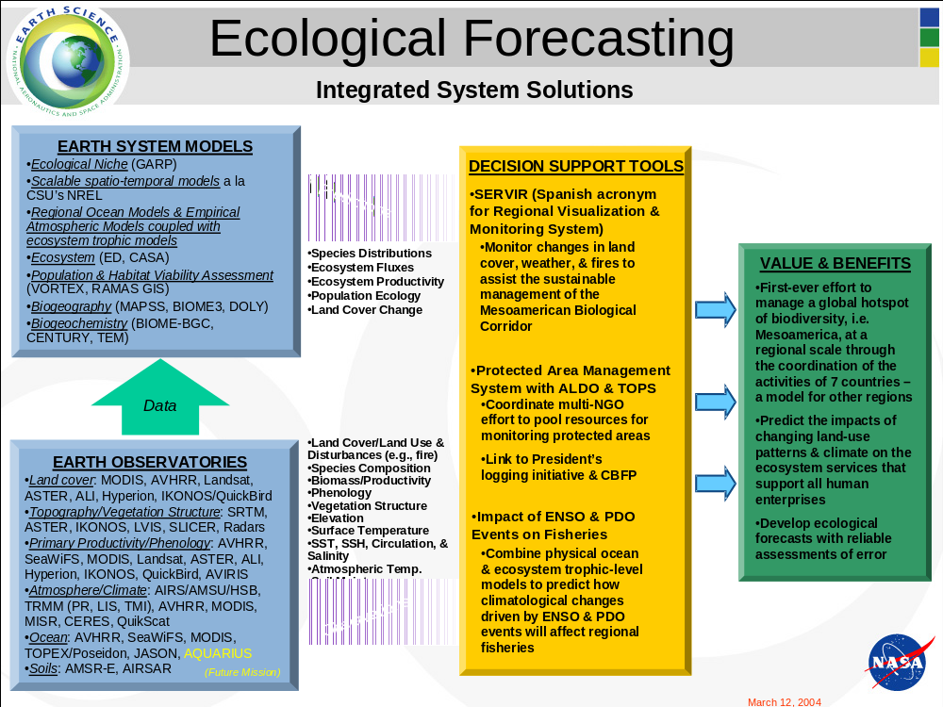

B. Roadmap

This roadmap for the Ecological Forecasting Program Element brings together relevant space missions, resulting data sets, and the models required to generate outputs for decision support. It shows the steps along the path to reaching a major target for this Program Element – operational Ecological Forecasting systems supporting environmental and natural resource management for sustainable development. In doing so, it builds directly upon the roadmaps for the other Science Focus Areas. Of these, the Carbon Cycle and Ecosystems Focus Area roadmap is especially relevant as some of the technological advances called for here originate on that roadmap.

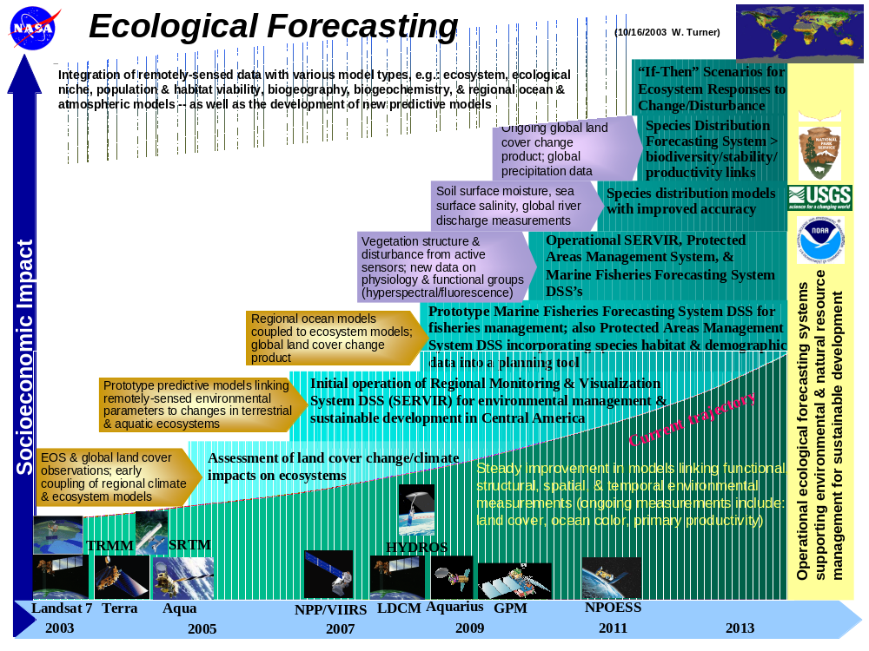

C. Applied Sciences Program Budgets FY2005-09

The overall program budget allocations are given below to provide the context in which this National Application is conducted. The allocations are based on Agency and program priorities and are subject to change according to the availability of funds and programmatic strategies. All values are in $ thousands.

Table 1: Applied Sciences Procurement Allocation – FY05

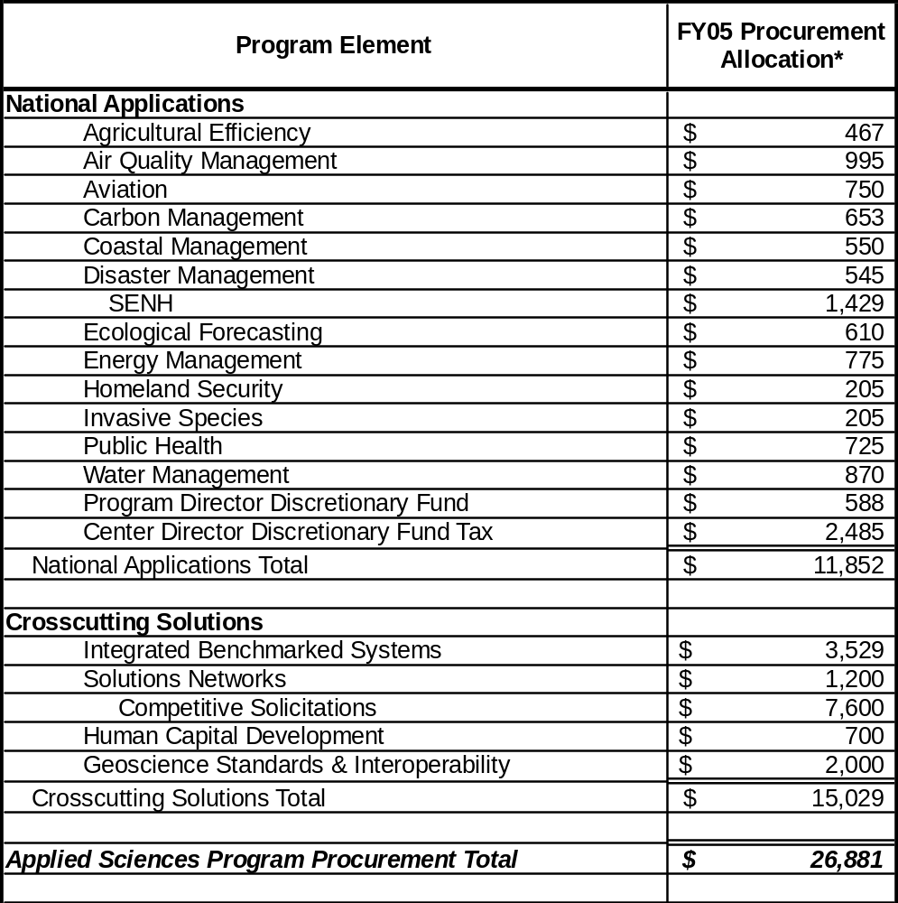

Table 2: National Applications Estimated Procurement Allocation Run-Out – FY05-09

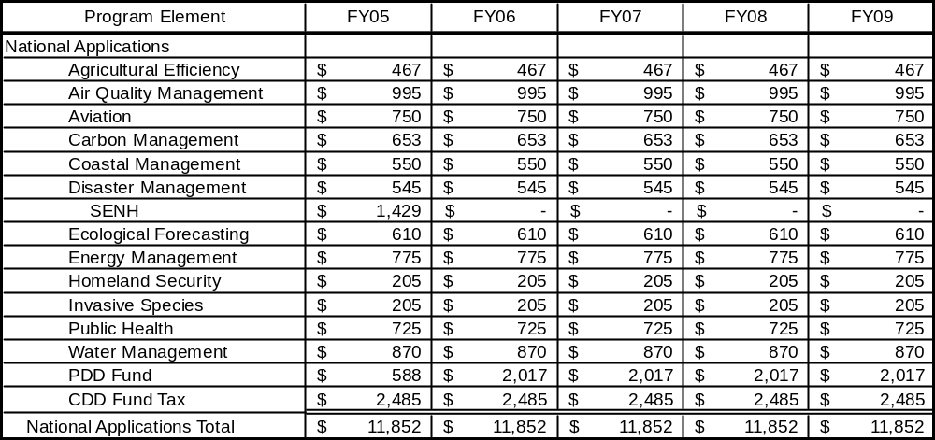

Table 3: Applied Sciences Program NASA Institutional Allocations – FY05

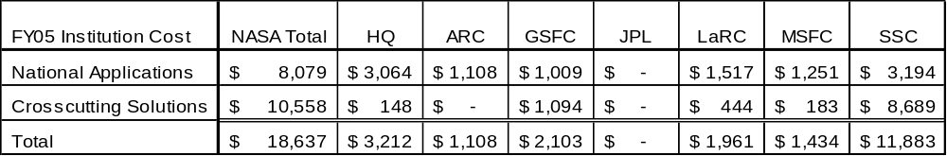

D. Related NASA and Partner Solicitations and Grants

EOS Interdisciplinary Science

PI | Title | Institution | Award Years
Nair, Udaysankar | Near Global Biogeography of Tropical Montane Cloud Forests | UAH | 3 (04-06)
Barber, Richard | Impact of Pacific Climate Variability on Ocean Circulation, Marine Ecosystems and Living Resources: A Multi-Scale Modeling and Data Assimilation Approach to Forecasting | Duke Univ. | 3 (04-06)
Deysher, Larry | Monitoring of Global Change in Temperate Reef Communities Using Satellite Remote Sensing Technologies | Ocean Imaging | 3 (04-06)
Dubayah, Ralph | Characterizing Forest Structure for Assessments of Carbon Cycling and Biodiversity: An Integrated Approach Using Lidar Remote Sensing, Field Studies, and Ecosystem Modeling | Univ. Maryland | 3 (04-06)
Shugart, Herman | Hydrologic and Nutrient Controls on the Structure and Function of Southern African Savannas: a Multi-scale Approach | Univ. Virginia | 3 (04-06)
Smith, James | The Distribution and Abundance of Bird Species--Towards a Satellite, Data Driven Avian Energetics and Species Richness Model | NASA/ GSFC | 3 (04-06)
Helmuth, Brian | Climate Change and Intertidal Biogeography: Coupling Remote Sensing Data to Thermal Physiology Across a Cascade of Scales | Univ. South Carolina | 3 (04-06)
Roffer, Mitchell | Study of Ocean Environmental Parameters to Forecast the Effects of Climate Variability on Pelagic Fish Resources | Roffer’s Ocean Fishing Forecast. Service | 3 (04-06)
Smith, Thomas | Quantifying Patterns of Biodiversity in a Changing Climate: Integrating Biological Point and Process Data with Remotely Sensed Environmental Variables | UCLA | 3 (04-06)
Stohlgren, Thomas | Fingerprinting Native and Non-Native Biodiversity in the United States, Phase 1: The Western U.S. | USGS | 3 (04-06)
Morrison, John | Connectivity and Upwelling Dynamics In the Galapagos Marine Reserve (GMR) | NCSU | 3 (04-06)
Andrefouet, Serge | Environmental Assessments of Coral Reef Ecosystems: Interdisciplinary Research Using EOS Platforms and Numerical Models | Univ. of South Florida | 3 (04-06)
Simard, Marc | Large scale assessment of landscape changes and recovery in forest structure of mangrove wetlands subject to human, freshwater diversion, and natural disturbances (hurricanes, other severe storms, sea level change) using enhanced SRTM data | JPL | 3 (04-06)

EOS Recompetition

PI | Title | Institution | Award Years
Waring, Richard | Predicting Tree Species Diversity Across the Contiguous U.S.A. from Seasonal Patterns in Photosynthesis Derived with Satellite-Driven Models | Oregon State | 3 (04-06)
Morisette, Jeffrey | Value Added Products from Vegetation and Precipitation Time-Series Data Sets in Support of Invasive Species Prediction | GSFC | 3 (04-06)
Hansen, Andrew | Testing Biophysical and Land Use Controls on Biodiversity Using MODIS and AMSR-E Products | Montana State | 3 (04-06)
Muller-Karger, Frank | EAGLE-EYE: Ecological Assessment of Generalized Littoral Environments - an Integrated EOS DB/Real-Time MODIS Science Applications Project | Univ. of South Florida | 3 (04-06)

Earth Science Fellowships

PI | Title | Institution | Award Years
Anderson, Jeanne | The Integration of AVIRIS and LIDAR Data for Remote Detection of Forest Structure, Species Composition, and Land-Use Legacies in the White Mountains of New Hampshire | University of New Hampshire | up to 3 (04-06)
Ashton, Isabel | Biological invasions and alterations of the global carbon balance | Stony Brook University | up to 3 (04-06)
Burnicki, Amy | Spatial and Temporal Patterns of Error in Land Cover Change Analyses: Identifying and Propagating Uncertainty for Ecological Monitoring and Modeling | University of Michigan, Ann Arbor | up to 3 (04-06)
Hayes, Daniel | Mapping Regional Carbon Stocks and Monitoring Carbon Emissions from Land Cover and Land Use Change Along the Mesoamerican Biological Corridor | Oregon State | up to 3 (04-06)
Hollister, Emily | Land Use and Land Cover Changes in Temperate Savannas: Impact of Woody Plant Encroachment and Prescribed Fire on Ecosystem Carbon Storage | Texas A&M | up to 3 (04-06)
Laurent, Edward | Using the Precision of Landsat Imagery to Extrapolate Pattern-Process Relationships of Wildlife Across Landscapes: GRAIN and HABICLASS | Michigan State | up to 3 (04-06)
Mauz, Kathryn | Characterizing Phenological Transitions in the Neotropical Deciduous Forest, West Mexico: Integrated Analysis of Satellite Remote Sensing, Ecophysiological, and Climate Time Series | University of Arizona | up to 3 (04-06)
Tien, Kai-Jen | Linking Changes in Dynamic Vegetation to Passive Microwave Remote Sensing | University of Florida | up to 3 (04-06)
Van Holt, Tracy | Twenty Years of Land-cover and Land-use Change Effects on Nearshore Marine Resources in Southern Chile | University of Florida | up to 3 (04-06)
Wang, Weile | Tracing Causality and Feedback Relations between Land Surface Temperatures and Vegetation Activity in Twenty-Years of Remote Sensing Data | Boston U. | up to 3 (04-06)
Anderson, Clarissa | A Model for Remotely Detecting the Dynamics and Toxicity of Pseudo-Nitzschia Blooms in the Santa Barbara Channel | University of California Santa Barbara | up to 3 (05-07)
Gramling, Joel | The Evaluation of Productivity-Diversity Relationships Across Two Distinct Ecological Communities with Respect to Global Climate Change Using Local and Landscape Scale Data | The University of North Carolina Chapel Hill | up to 3 (05-07)
Kennedy, Christina | Impacts of Land Cover and Land Use Change on Bird Communities of the Mayan Forests of the Southern Yucatan Peninsula | University of Maryland College Park | up to 3 (05-07)
Loboda, Tatiana | Impacts of Climate and Land Use Change on the Frequency of Catastrophic Fires and the Siberian Tiger | University of Maryland College Park | up to 3 (05-07)
Morzillo, Anita | Application of Remotely-Sensed Imagery to Meet the Needs of Wandering Wildlife and Human Activity | Michigan State University | up to 3 (05-07)
Murphy, Kevin | A Multi-Sensor Approach To Identifying Trends of Anthropogenic and Natural Change in Orangutan Habitat | University of Maryland | up to 3 (05-07)
Neuenschwander, Amy | Austin Characterization of the Interaction Between Water and Vegetation in the Okavango Delta, Botswana | University of Texas | up to 3 (05-07)
Williams, Alton | From Cellulose to Selling Out: Tree Ring Isotopes Can Identify the Culprits Behind Meso-Climate Change in a Tropical Cloud Forest | University of California Santa Barbara | up to 3 (05-07)

Additional REASoN Awards

PI | Title | Institution | Award Years
Skole, David | A Global Tropical Information Center | Michigan State | 5 (03-08)
Watson, Frederick | Systems Integration and Visualization of Yellowstone | Cal State Monterey Bay | 5 (03-08)
Townshend, John | Global Land Cover Facility | Univ. of Maryland | 5 (03-08)

New Investigator Program Awards

PI | Title | Institution | Award Years
Brown de Colstoun, Eric | Consequences of Land Cover/Use Changes on National Parks | GSFC | 3 (04-06)
Drake, Jason | Multidimensional Characterization of Southern Pine Forest Structure and Integrity | University of Georgia | 3 (04-06)
Graham, Catherine | Remote Sensing and Biodiversity in a Changing Climate | State University of New York Stony Brook | 3 (04-06)
Hochberg, Eric | Empirical Radiative Transfer Corrections for Deterministic Coral Reef Remote Sensing | University of Hawaii | 3 (04-06)
Sanderson, Eric | Monitoring of Large Wildlife Directly Through High Spatial Resolution Remote Sensing: Experimental and In Situ Approaches | Wildlife Conservation Society | 3 (04-06)

E. Acronyms and Websites

AIRS Airborne Infrared Sounder
ALI Advanced Land Imager
AMSR-E Advanced Microwave Scanning Radiometer-EOS (Japanese)
AMSU Advanced Microwave Sounding Unit
ARC Ames Research Center
ASTER Advanced Spaceborne Thermal Emission and Reflectance
Radiometer
AVHRR Advanced Very High Resolution Radiometer
CAN Cooperative Agreement Notice
CASA Carnegie-Ames-Stanford Approach
CATHALAC The Water Center for the Humid Tropics of Latin America and the Caribbean
CBD Convention on Biological Diversity
CBFP Congo Basin Forest Partnership
CCAD Central American Commission for Environment and Development
CCSP Climate Change Science Program
CENR Committee on Environment and Natural Resources
CO₂ Carbon Dioxide
DAAC Distributed Active Archive Center (Data Active Archive Center)
DFRC Dryden Flight Research Center
DHS Department of Homeland Security
DOA Department of Agriculture
DOC Department of Commerce
DOD Department of Defense
DOE Department of Energy
DOI Department of the Interior
DOT Department of Transportation
DSS Decision Support Systems
DST Decision Support Tool
ENSO El Niño - Southern Oscillation
EO-1 Earth Observing-1
EOS Earth Observing System
EPA Environmental Protection Agency
EROS Earth Resources Observation System
ESA Ecological Society of America
ESE Earth Science Enterprise
ESMF Earth Science Model Framework
ETM+ Enhanced Thematic Mapper Plus
EVI Enhanced Vegetation Index
EVVB evaluation, verification, and benchmark
FEA Federal Enterprise Architecture
FPAR Fraction of Absorbed Photosynthetically Active Radiation
FWS Fish and Wildlife Service
GCM Global Climate Model
GCOS Global Climate Observing System
GEO ad hoc Group on Earth Observations
GEOSS Global Earth Observation System of Systems
GIG Global Information Grid
GIO Geospatial Interoperability Office
GIS Geographic Information System
GMES Global Monitoring for Environment and Security
GOES Geostationary Operational Environmental Satellite
GOS Geospatial One Stop
GRC Glenn Research Center
GRID Graphic Retrieval and Information Display
GSFC Goddard Space Flight Center
GYA Greater Yellowstone Area
HYDROS Hydrosphere State Mission
IABIN Inter-American Biodiversity Information Network
IBPD Integrated Budget and Performance Document
IUCN World Conservation Union
IWGEO Interagency Working Group on Earth Observations
JCSDA Joint Center for Satellite Data Assimilation
JPL Jet Propulsion Laboratory
JSC Johnson Space Center
LaRC Langley Research Center
LIDAR Light Detecting and Ranging
LST Land Surface Temperature
MBC Mesoamerican Biological Corridor
MFF Marine Fisheries Forecasting
MISR Multi-angle Imaging Spectroradiometer
MM5 Mesoscale Model
MOA Memorandum of Agreement
MODIS Moderate Resolution Imaging Spectroradiometer
MOU Memorandum of Understanding
MSFC Marshall Space Flight Center
MSS Multi-Spectral Scanner (Landsat 1)
NASA HQ NASA Headquarters
NASA National Aeronautics and Space Administration
NCAR National Center for Atmospheric Research
NCSE National Council for Science and the Environment
NDVI Normalized Difference Vegetation Index
NGO Nongovernmental Organization
NMFS National Marine Fishery Service
NOAA National Oceanic and Atmospheric Administration
NPOESS National Polar-Orbiting Operational Environmental Satellite System
NPP NPOESS Preparatory Project
NPS National Park Service
NRA NASA Research Announcement
NSF National Science Foundation
NSSTC NASA National Space Science and Technology Center
OES Office of Earth Science
OMB Office of Management and Budget
OSTP Office of Science and Technology Policy
PAM Protected Area Management
PART Program Assessment Rating Tool
PI Principal Investigator
QuikSCAT Quick Scatterometer
R2O Research to Operations Network
RAMS Regional Atmospheric Modeling System
REASoN Research, Education, and Applications Solutions Network
RS Remote Sensing
SAR Synthetic Aperture Radar
SBSTTA Subsidiary Body on Scientific, Technical, and Technological Advice
SCB Society for Conservation Biology
SeaWiFS Sea-viewing Wide-Field-of-view Sensor
SERVIR Regional Visualization and Monitoring System for Mesoamerica
SMD Science Mission Directorate
SRTM Shuttle Radar Topography Mission
SSC Stennis Space Center
SSS Sea, Surface, Salinity
SST Sea Surface Temperature
SUNY State University of New York
TERRA 1st EOS spacecraft
TM Thematic Mapper
TOMS Total Ozone Mapping Spectrometer
TOPEX /POSEIDON Satellite from JPL with Five Instruments
TOPS Terrestrial Observation & Prediction System
TRMM Tropical Rainfall Measurement Mission
UCAR University Corporation for Atmospheric Research
UNEP United Nations Environment Programme
UNESCO United Nations Educational, Scientific and Cultural Organization
URF University Research Foundation
USAID United States Agency for International Development
USDA US Department of Agriculture
USFS US forest Service
USGCRP US Global Change Research Program
USGS United States Geological Survey
V&V Verification & Validation
VIRS Visible Infrared Scanner
VIIRS Visible/Infrared Imager/Radiometer Suite
WCMC World Conservation Monitoring Centre
WMO World Meteorological Organization
WSSD World Summit on Sustainable Development

WEBSITES:

http://science.hq.nasa.gov/earth-sun/applications

http://science.hq.nasa.gov

http://www.reefbase.org

Committee on Environment and Natural Resources. Ecological Forecasting: Agenda for the Future. available on-line at: (http://www.nbii.gov/about/pubs/efbrochure/index.html)
available on-line at: (http://www.redlist.org/)

