Reliability of High Strain Ionomeric Polymer Transducers Fabricated Using the Direct Assembly Process

Barbar Akle, Saila Nawshin, and Donald Leo
Center for Intelligent Material Systems and Structures
Department of Mechanical Engineering
Virginia Tech, Blacksburg, Virginia
Abstract
Ionomeric polymer transducers have received considerable attention in the past several years. These actuators, sometimes referred to as artificial muscles, have the ability to generate large bending strain and moderate stress at low applied voltages. As sensors, ionic polymer transducers generate an electric response due to a mechanical strain. Typically, ionic polymer transducers are composed of Nafion-117 membranes with platinum electrodes and are saturated with water diluents. Recently the authors have developed a novel fabrication technique named the Direct Assembly Process (DAP), which allowed improved control of the electrode morphology and composition. The DAP consists of spraying two high surface area metal-ionomer electrodes on a Nafion membrane. The benefits of the DAP process over previous methods is the ability to control the thickness of the electrode, the ability to control the composition of the electrode layer of the transducer, and the ability to be used with a wide variety of diluents. In past work we have demonstrated that platinum, ruthenium dioxide, and single-walled carbon nanotubes can be used as the electrode material with diluents such as water, formamide, and ionic liquids. In this work we will present a reliability study of transducers fabricated using the DAP. Water-hydrated transducers dehydrate and stop moving within 5 minutes while operating in air under the application of +/-2V. Ionic liquid based transducers are demonstrated to operate in air for over 400,000 with little loss in performance, and are reliable up to 1 million cycles with a performance loss of less than 43%. The main source of degradation is the adhesion of the conductive surface to the high surface area electrode. This is enhanced in this study by using a PUU linking polymer that has good adhesion properties to gold. Large voltage and large strain are proven to decrease the life of the transducer. Formamide based samples are stable for 3 days under a 1V actuation signal, while only reliable for 3 h to 4 h under a 2V actuation signal. Solvent evaporation is the main reason for degradation in formamide samples and it is increased at 2V indicating some electrochemical activity at such high voltages. Finally the initial drop in performance and the fluctuation in the generated strain are shown to be due to the loss of humidity absorbed from ambient air and the fluctuation in this ambient humidity respectively.

Ionic Polymer Transducer, Direct Assembly Process, Reliability, Actuator

Introduction
Ionic polymers membranes are materials that exhibit ionic conductivity and ion selectivity. Several researchers have shown that these polymer membranes can function as electromechanical actuators and sensors [1-3]. An ionic polymer transducer is made of an ionomeric membrane (typically Nafion, a product of DuPont) sandwiched between two conductive electrodes. In this state the membrane will bend toward the anode when a voltage (typically less than 5 V) is applied across its thickness. Similarly, the polymer will generate charge when deformed. Ionic polymer transducers have the advantage of being able to generate large strains [1, 4] under small applied voltages, are compliant and thus compatible with conformal structures, and have a very high sensitivity to motion when used in charge sensing mode.

Transducers fabricated from ionomeric polymers suffer from several key limitations, however. Most notable is dehydration and the corresponding loss in performance of these materials when operated in air. Also, the process for plating the membranes with the platinum and gold electrodes is relatively expensive, time-consuming, and produces inconsistent transducers. Efforts to overcome these issues have been hindered by the fact that the performance of the membranes is intimately linked to the morphology of the metal electrodes [5]. Bennett and Leo [6] have previously shown that the hydration problem can be overcome by using ionic liquids as the solvent in these transducers.

Recently Akle et al.[7] developed a method called the Direct Assembly Process (DAP) for fabricating transducers with controlled electrode dimensions and morphology. In this method large surface area electrodes are painted on an ionomer membrane. An alternative method that has been used by a number of researchers, the impregnation-reduction approach, is a method by which the metallic electrode is chemically deposited on the membrane [8]. Although this method is effective, the process does not enable direct control on the electrode morphology and limits the type of electrode particulate that can be placed on the membrane [4]. In contrast, the DAP method allows direct control over the thickness of the electrode and enables a larger variety of electrode compositions and transducer diluents [provide reference]. Transducers fabricated using the direct assembly process have been shown to generate strains on the order of 10% under a +/-2V potential, compared to less than 1% for transducers fabricated using the impregnation–reduction method [7].
In this paper we study the reliability of ionic polymer transducers fabricated using the direct assembly process. The diluents incorporated in this study are formamide and 1-ethyl-3-methylimidazolium trifluoromethanesulfonate (EMI-Tf) ionic liquid. The reliability of the transducers is analyzed in terms of the peak strain of the sample and the applied voltage. Surface of degraded transducers are imaged and analyzed using a Scanning Electron Microscope (SEM). Enhancing the reliability of the transducers by modifying the fabrication process is also presented.
Experimental procedures

In this section the Direct Assembly Process fabrication technique is presented, and the electromechanical characterization setup is discussed.

Direct Assembly Process

The direct assembly process is employed in the fabrication of the hybrid transducers. In this method, a bare Nafion membrane is first exchanged from the proton counterion form into one of the alkali metal forms (Li⁺ was used for this study). This is to prevent charring of the membrane during the drying step, which has been witnessed when Nafion membranes in the acid form are heated for extended periods of time. After ion exchange, the membrane is dried in an oven at 150 C under vacuum for 12 h. The dry membrane is then immersed in the corresponding solvent. For ionic liquids the ionomer is placed in a neat EmI-Tf ionic liquid and heated to 150 C for 4.5 h. The uptake of ionic liquid during the immersion step is 60 % by the dry weight of the membrane. Formamide is easier to imbibe in the Nafion membrane; an uptake of more than 100% is obtained in 1h at 60 C.
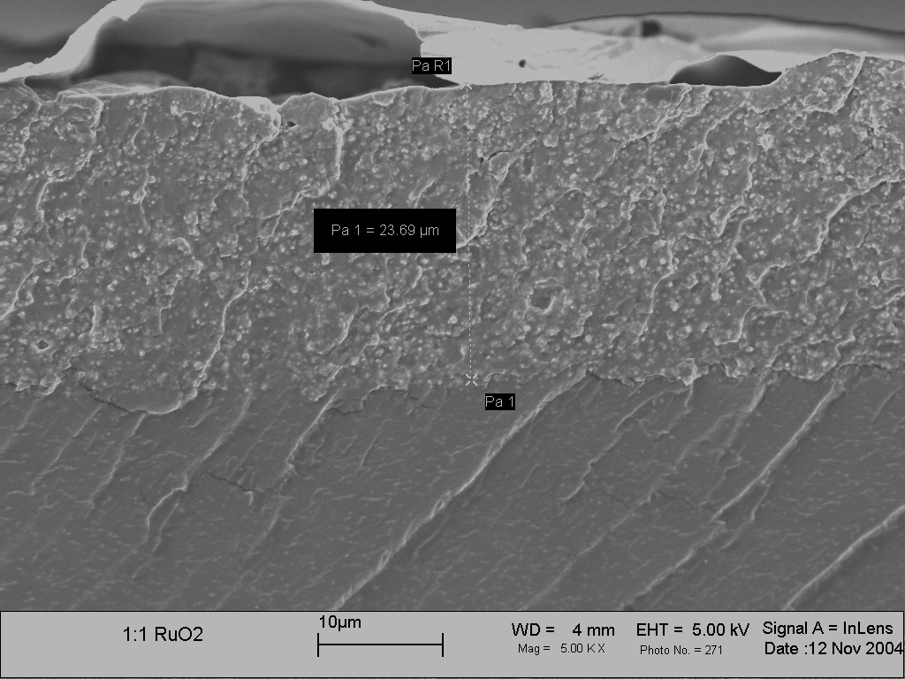
HS Electrode
Ionomer membrane
Linking Nafion or PUU
Gold Leaf
High surface area electrode
Ionomer membrane
10µm
Gold leaf
Figure 1: (a) schematic of am ionic polymer transducer assembled using the direct assembly process. (b) SEM image of the upper electrode of an ionic polymer transducer.

After the solvent is imbibed into the membrane, the electrodes are applied using a conductive powder painting technique. A polymer / conductor solution is prepared containing a mixture of 5% Nafion dispersion, isopropyl alcohol (IPA), de-ionized water, and the conducting powder. In this study RuO₂ particles are utilized due to there large suface-area, and good electrical conductivity. Previous work [7] demonstrates that RuO₂ based transducers generates the most strain in a repeatable and feasible manner. This solution is painted directly onto each surface of the solvent containing Nafion membrane. The alcohol solvents and water are removed by heating the membrane under an infra-red lamp during the painting process; typically a total of twenty layers are applied to each side of the membrane. After the application of the ionomer/conducting powder composite, the sample is sandwiched between two 100nm thin conductive gold foils and the five layers of the composite are fused together by a hot-pressing process. A thin layer of IPA-diluted Nafion solution is applied on both electrodes to enhance the binding of the gold layer to the actuator – see Figure 1(a). Later in this study, the Nafion Layer is replaced with a thin layer linear amine-terminated poly(urethane urea) (PUU) elastomer. For the membranes that are swollen with the ionic liquid, hot-pressing is done at 4 MPa and 180 C for approximately 10 to 20 s depending on the composition of the electrode for ionic liquid solvated samples. For formamide-solvated transducers a 4 MPa pressure and a temperature of 160 C is applied for less than 5 sec. The gold foils used are a Falcon-Brand 24 carats gold leafs. Incorporating the gold foils on the surface decreased the surface resistance from greater than 100 kΩ/cm for the RuO₂ layers to less than 1 Ω/cm. The samples where freeze cut and imaged by field-emission scanning electron microscopy (FE-SEM) using a LEO 1550 microscope operating at 5 kV accelerating voltage. The degradation of the surface is imaged by the SEM without cutting the samples. A typical SEM image of the electrode in an ionic polymer transducer made using the DAP method is shown in Figure 1(b).

Electromechanical Characterization

The materials fabricated in this work are characterized as electromechanical transducers using a custom built characterization setup. The samples used for these tests are 3 mm x 30 mm rectangular transducers held in a cantilevered configuration in a clamp with fixed gold electrodes (see Figures 2 (a) and (b)). The free length of the transducer is approximately 19 mm. The thickness of the transducer varies between approximately 0.15 mm and 0.25 mm depending on the thickness of the applied electrode and that of the membrane. A potential V_{i} is applied across the ionic polymer transducer in the form of a sine wave of Frequency 0.2 Hz up to 1 Hz. The magnitude was also varied from 1V up to 3V. The displacement x(t) at any point along the length is measured with a Canon PowerShot G6 camera. A grid with a spacing of 0.6mm is placed under the tip of the moving tip. Short movies where taken for 30sec and the number of grid points are counted between the peak-peak displacement of the polymer. Interpolating between the grid points the overall resolution of the system is calibrated to be 0.3mm (see Figure 2(a)). The current i(t) induced in the polymer due to the applied voltage v(t) is also measured by measuring the voltage drop across a small (0.1 Ω) resistor—see Figure 2(a). Monitoring the current provides us a mechanism to detect the source of degradation in performance. This is done by monitoring the capacitive and resistive properties of the transducers with number of cycles.

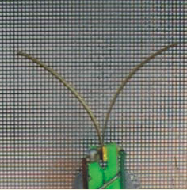
-
+
i(t)
R
2
v_{o}
+
-
0.1Ω
R
1
v_{i}
IPT
x(t)
x(t)
(a)
(b)
Figure 2: (a) Electromechanical characterization setup, attached to a current measuring circuit (b) Sample overlay of two frames

The free deflection x(t) (in the time domain) is used with equation (1) to compute the bending strain as a function of time or frequency. In equation (1), ε is strain, h is the thickness of the sample, and L_{f} is the free length of the sample. This equation assumes that the transducer bends with a constant curvature; experimental results demonstrate that this is an appropriate assumption for the experiments performed in this paper [4].

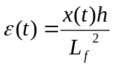 (1)

The gain of the current measuring circuit shown in Figure 2 is computed according to
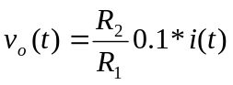. (2)

The impedance is computed by measuring the applied voltage and induced current. Using a Fourier transform the ratio of the voltage and current are computed in the frequency domain according to
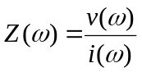. (3)

Results and Discussion

The experimental results of the transducers built using the direct assembly process discussed earlier are presented in this section. First we will present and compare the reliability results of Formamide and EMI-Tf saturated samples. Next, the reliability as a function of operating frequency, peak strain, and magnitude of the potential are also presented and discussed. SEM images of the surface are obtained and are used to analyze the source of deterioration. Finally the linking polymer is changed to PUU, and reliability results are compared to similar sample with Nafion Linking polymer.

Reliability of Formamide solvated transducers
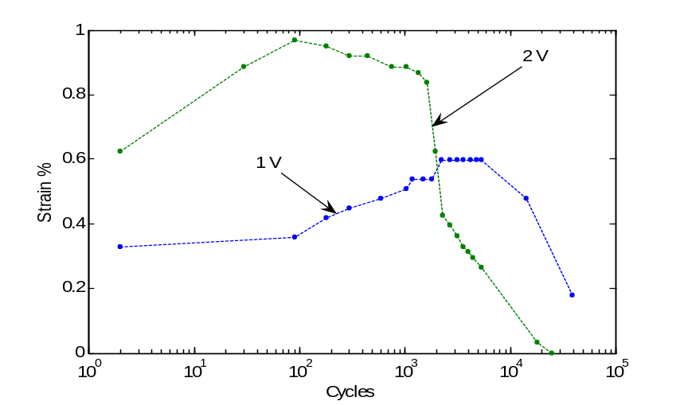
Figure 3: Actuation strain of formamide saturated samples under 1 V and 2 V actuation and operated at a frequency of 0.2Hz.

A possible mechanism of degradation of actuation performance in ionic polymer transducers is the reduction in ionic conductivity that occurs due to loss of solvent. This degradation mechanism causes the loss of actuation in water hydrated samples when operated in air [6]. Water hydrated samples lose most of its performance in less than 1000 cycles when operated in air under a frequency of 1Hz and a potential of 2V. In this study we measure the reliability of formamide saturated ionic polymer transducers. Formamide samples degraded relatively fast compared to ionic liquids, but kept moving around 1000 cycles longer than that of water samples for the small number of actuators tested. Under 2V and 0.2Hz formamide samples started to significantly degrade after around 2000 cycles, which corresponds to 3h of actuation as shown in Figure 3. A formamide sample tested with 1V potential actuated until 25000 cycles without any significant loss in performance. This corresponds to approximately 35 h of actuation.

Solvent loss due to actuation was confirmed by measuring the weight of the transducer at the beginning of the experiment and at the conclusion of the experiment. At the start of the study the weight of the sample which is tested under 1V dropped from 0.0423g to 0.0263g, while the 2V tested sample dropped from 0.403g to 0.0235g. This is a weight loss of approximately 38%.

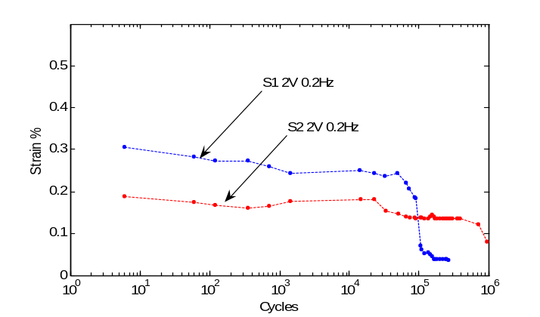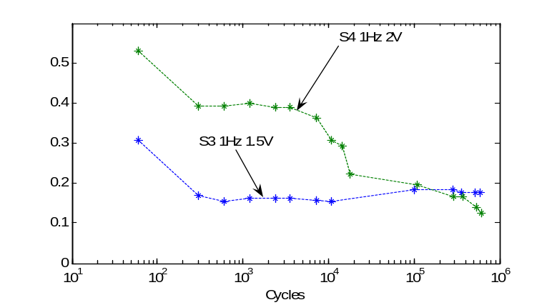
Figure 4: Reliability as a function of (a) peak strain, and (b) as a function of voltage

Reliability of EMI-TF solvated transducers

Three ionic polymer transducer membranes are prepared for this experiment. All the samples are made using the same EMI-Tf ionic liquid saturated Nafion 117 ionomeric membrane. The electrode is sprayed from the same mix with a sample having an electrode thickness of 30µm compared to another with a 10µm thick electrode. Table 1 shows the nomenclature and architecture of these samples. Akle et al [7] demonstrated that the peak strain increase with electrode thickness. Samples S3 and S4 are cut from the same transducer; S3 is tested under 1.5V while S4 is tested under 2V. Shown in Figure 4(a), is the reliability of samples S1 and S2 under 2V and 0.2Hz. It is clear from Figure 4(a) that a larger strain is causing a faster deterioration in the actuation performance. The applied potential had a major effect on the reliability –see Figure 4 (b). This might be due to the increased strain since there is no significant loss in sample weight. Notice that sample S4 degraded significantly after 15,000 cycles compared to over 100,000 for that of sample S1. This is explained by the fact that the peak strain in sample S4 is almost double that of S1.

Table 1: Sample architecture
 | Membrane | Electrode Thickness | Test Conditions
S1 | 180 μm Nafion/EMI-TF | 30 μm RuO₂/Nafion | 2V and 0.2Hz
S2 | 180 μm Nafion/EMI-TF | 10 μm RuO₂/Nafion | 2V and 0.2Hz
S3 | 180 μm Nafion/EMI-TF | 30 μm RuO₂/Nafion | 1.5V and 1Hz
S4 | 180 μm Nafion/EMI-TF | 30 μm RuO₂/Nafion | 2V and 1Hz

Observing the initial drop in the performance during the first 100 actuation cycles (see Figure 4(b)) motivated us to study the effect of humidity on these tests. An experiment with controlled humidity is performed to study this initial drop effect and the fluctuations in the strain output throughout the experiment. The sample tested in this experiment is similar in architecture to samples S3 and S4.
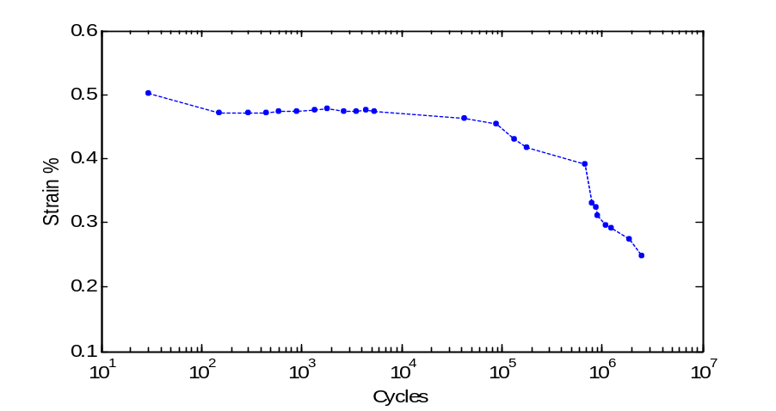
Figure 5: Reliability of an ionic liquid sample under zero humidity condition.

In this experiment the testing apparatus is placed in a sealed clear box with silicon humidity absorbents. The humidity was less than 4% for the duration of the experiment, and the camera was placed outside the clear box. The tested sample was operated under 2V and 1Hz.
As shown in Figure 5, the initial drop is significantly lower compared to the initial drop in all the other open air reliability experiments (see Figure 4(b)). Also the data is smoother, with much less fluctuations. This indicates that the initial drop in the reliability curve is due to the loss of some of the absorbed water, and the fluctuation is due to the changes in the ambient humidity.

Solvent evaporation of EMI-TF in the transducer is assessed in this study. Ionic liquid has an immeasurably low vapor pressure. Ionic liquid samples where dried in the oven under 70C and vacuum for 24 h before the reliability test started. The weight is measured immediately after the sample is taken out of the oven. After few weeks of actuation the same drying process took place to neglect the effect of room humidity, and the weight is measured again. In all the ionic liquid samples the weight difference was non significant (< 1%).

All the results so far demonstrated that the actuators solvated with ionic liquids exhibited reduced actuation strain after typically 200000 cycles. It was found by visual inspection during the tests that the actuators developed brown islands on the gold electrodes (see Figure 6(a)). This result motivated us to study the surface properties of the transducers to correlate the growth of the dark regions on the electrode with the reduction in actuation strain.
A LEO 1550 field-emission scanning electron microscopy (FE-SEM) operating at 5 kV accelerating voltage was used to study of an ionic liquid saturated transducer fabricated using the DAP after being actuated for 400000 cycles at 2V and 2Hz (see Figure 6(b)).
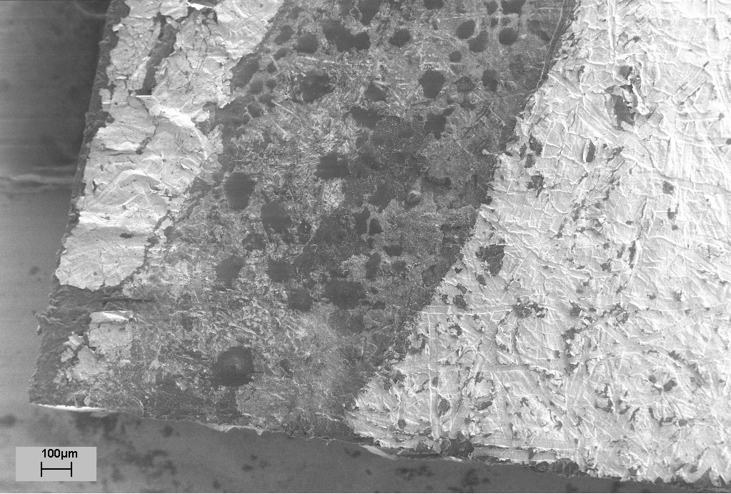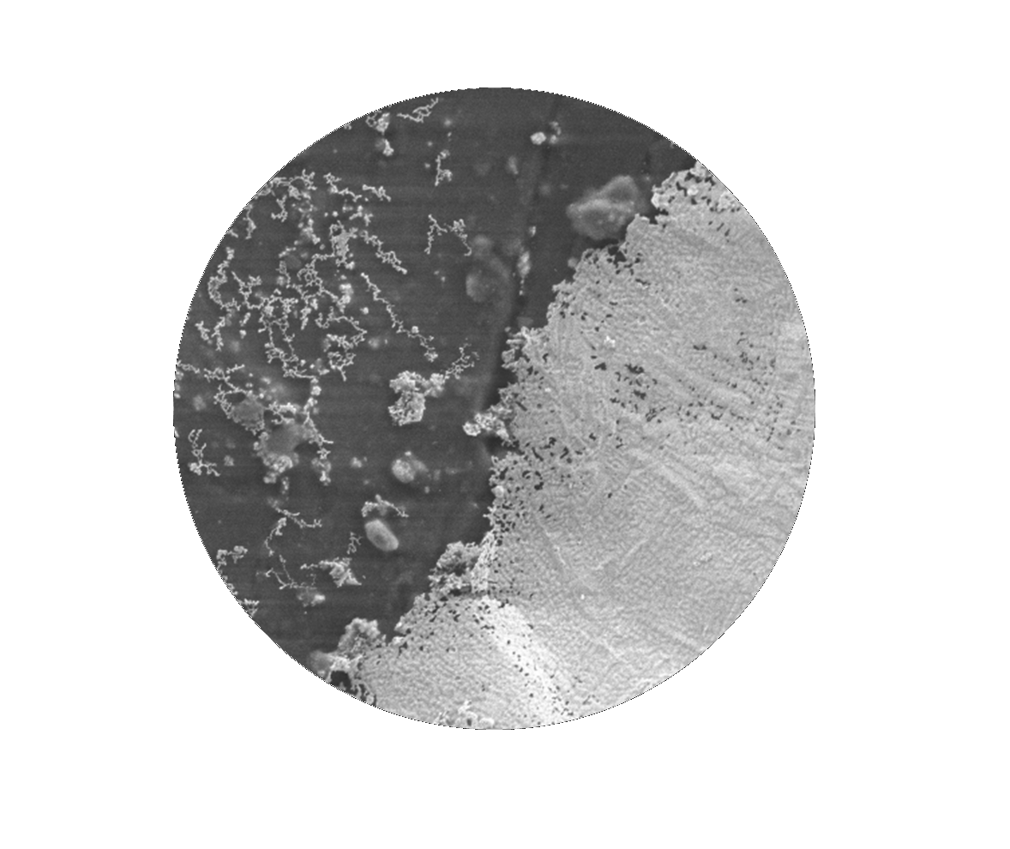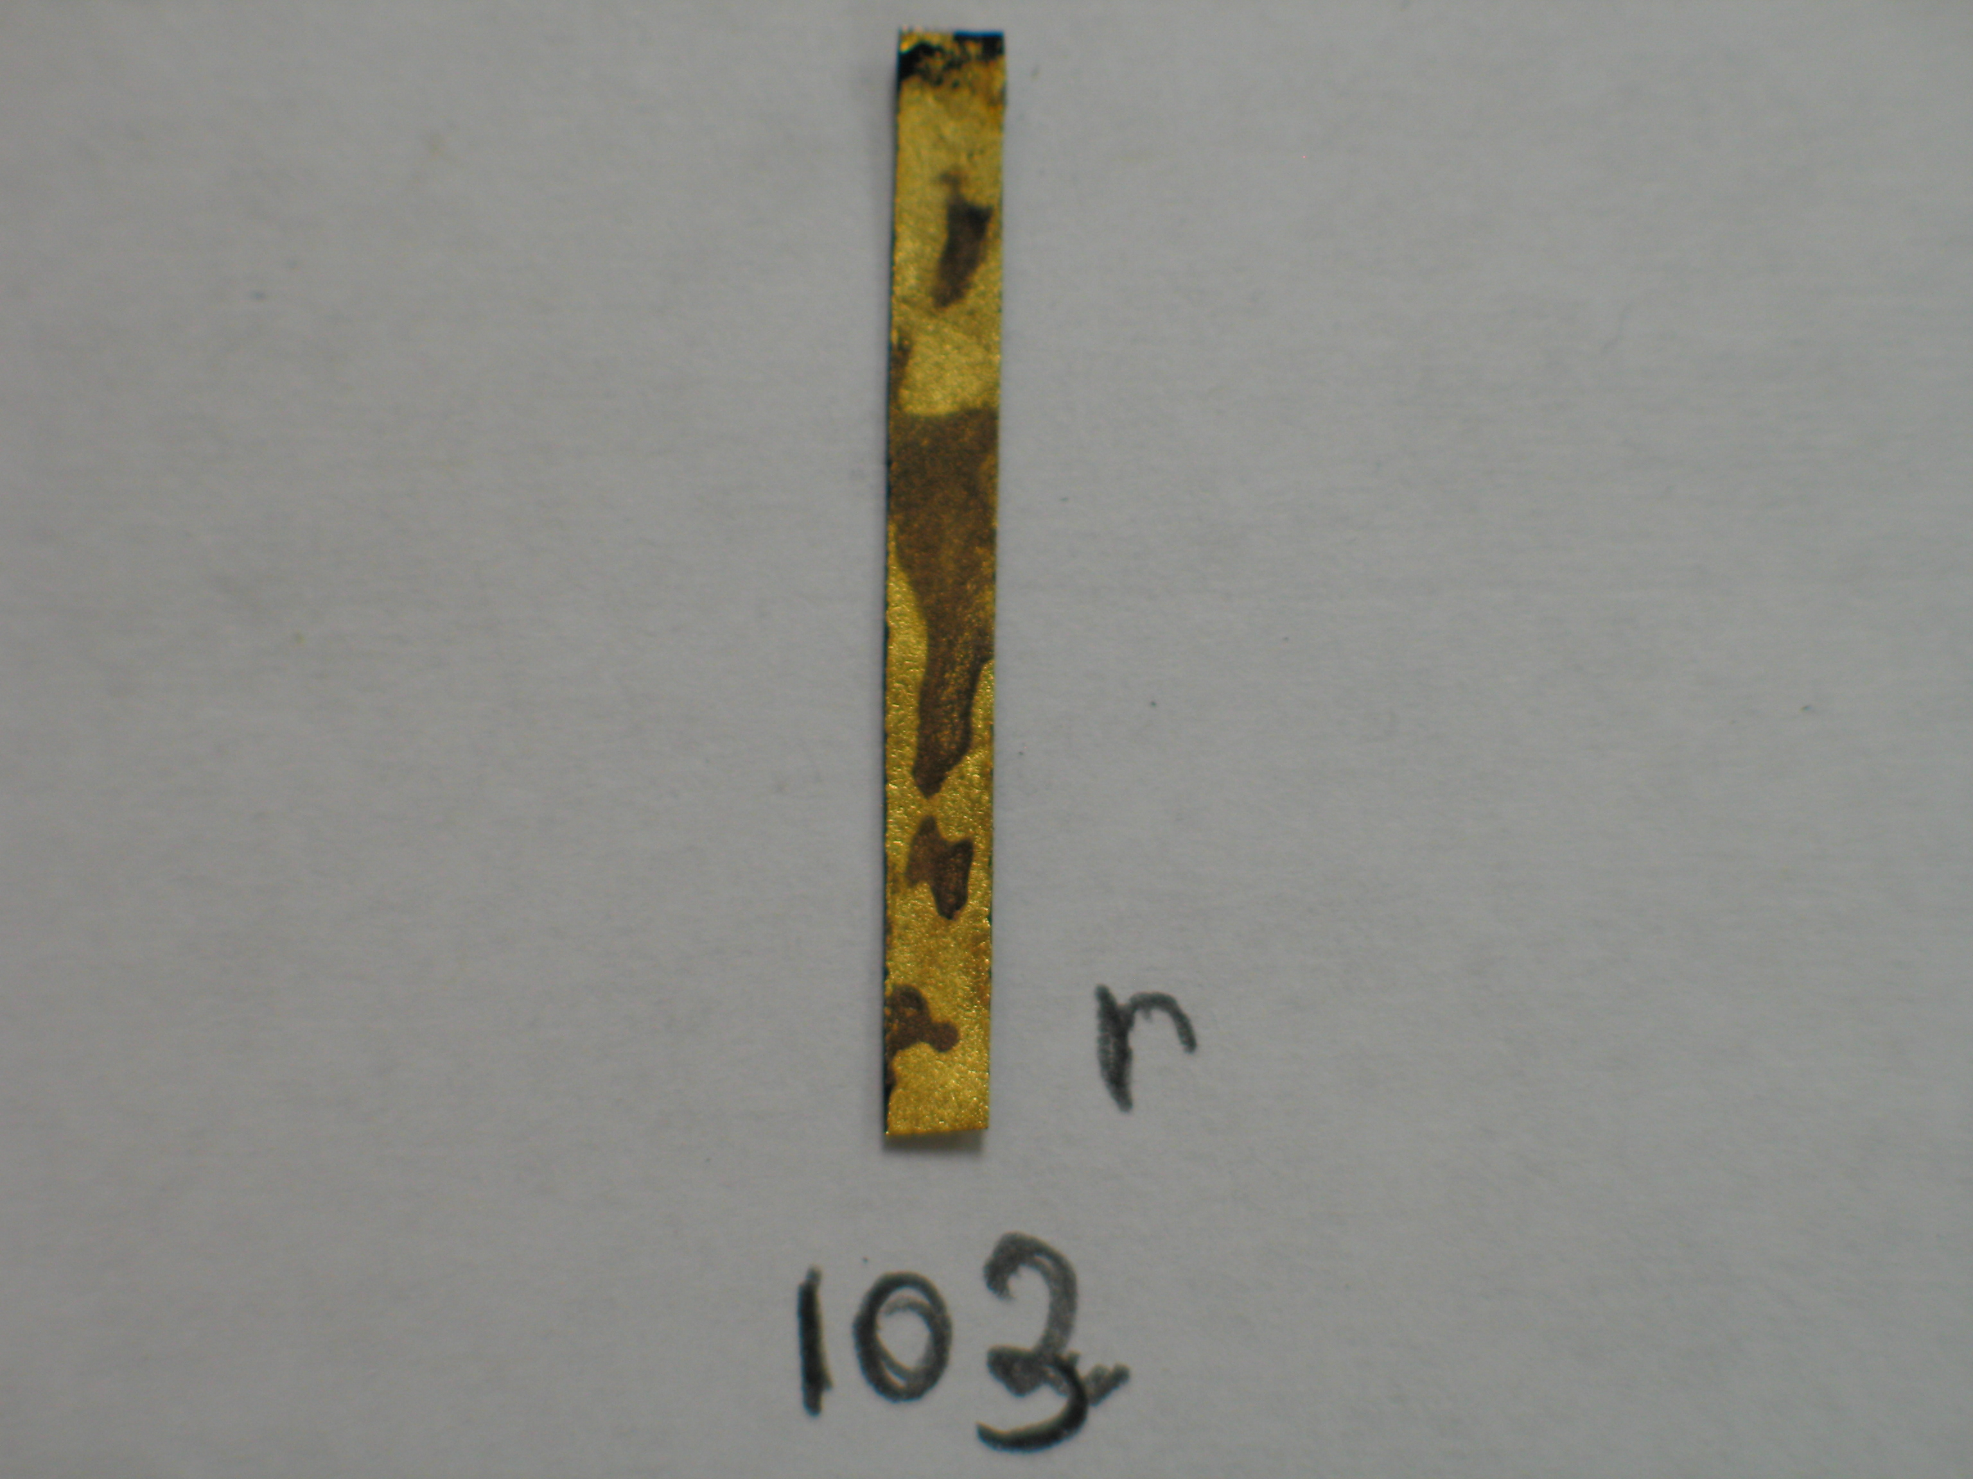
Au
RuO₂ -Nafion electrode
(a)
(b)
Figure 6: (a) Image of a degraded ionic polymer transducer (b) Surface SEM Image of an ionic polymer transducer after 400,000 actuation cycle at 2V.

The light areas in the SEM image shown in Figure 3 represent the gold and the dark area is the high surface area RuO₂-Nafion electrode. This clearly demonstrates that the gold leaf is delaminating from the electrode. The onset of cracking and delamination of the gold leaf could be noticed in the part to the left of the SEM image. This is a mechanical fatigue process due to the repetitive elongation and contraction of the Nafion underneath the gold leaf. The delaminating gold could be also noticed in Figure 1(b) which represents the cross section of a similar transducer. These SEM images indicate that the weak adhesion between the Nafion and the gold leaf is causing the gold to delaminate, and hence the surface conductivity of the transducer will deteriorate until the surface becomes an open circuit when complete delamination occurs. These results demonstrate that the primary mechanism for degradation in the actuation strain of the ionic liquid samples is mechanical fatigue at the interface between the deposited electrode and the gold leaf.

Modifying the Linking Polymer for Increased Adhesion

From the previously mentioned results, it is believed that the reason for degradation in EMI-Tf ionic liquid saturated samples is the loss of the gold leaf on the surface of the polymer. This conclusion is supported by the SEM images and other reliability results, especially that the peak strain is well correlated with the number of actuation cycles. Furthermore the EMI-TF ionic liquid is well known to be highly stable under 2V and this is proven in this paper by measuring the insignificant weight loss in degraded samples. Linking the gold leaf to the ionic polymer helps this conductive layer to stick uniformly to the polymer surface. In this experiment two samples, one with PUU linking and the other with Nafion where assembled. The samples are originally cut from the same transducer membrane before the gold is added.

PUU is chosen in this work because it contains amine and amide groups which react with gold to form a good adhesion [9]. The PUU used in this study is proven to have excellent gold adhesion properties [10, 11]. Furthermore, this linear polymer has a melting temperature Tm=120 C, which is below the temperature we heat to press the transducer. This will enable good adhesion between the PUU and the high surface area electrode.

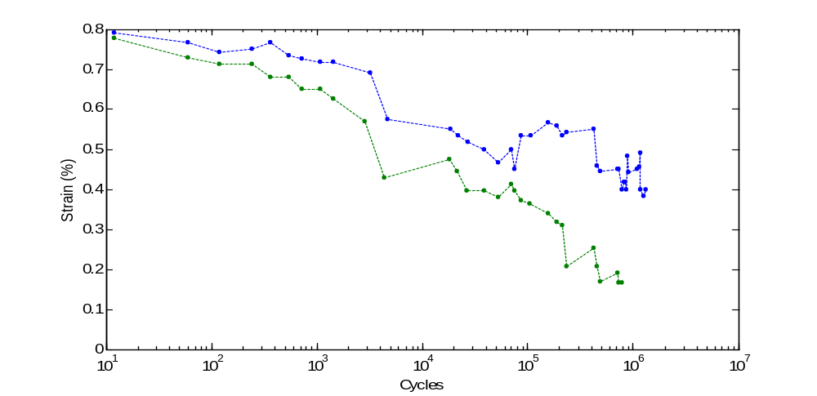
70000 cycles
1.35 million cycles
Figure 7: Tip strain of two ionic polymer transducers one with a PUU and another with a Nafion linking degrading as a function of cycles.

Shown in Figure 7 is the reliability of the two samples under 0.2 Hz and 2V. At the beginning of the experiment both PUU linked and Nafion linked samples started close to 0.78% strain with the PUU linked transducer performed around 0.02% strain more. This indicated that the addition of the PUU linking layer didn’t degrade the performance of the transducer. However, the reliability result clearly demonstrates that PUU linked polymer has much better reliability compared to the Nafion linked transducer. As soon as actuation starts a noticeable difference of 0.1% strain is realized only after 1000 cycles. The PUU sample lost less than 43% of its performance in over a million cycles under 0.2Hz and 2V, while it maintained 50% of its original peak strain after 1.35 million cycles. The Nafion linked polymer lost 50% of the original transduction after 70000 cycles. This is an improvement by a factor of 18. Finally, we note that 1.35 million cycles under 0.2Hz corresponds to approximately 78 days of continuous operation.

Conclusions
This study demonstrates that ionic polymer transducers made using the Direct Assembly Process are reliable up to 1 million cycles with a performance loss of less than 43%. The main source of degradation is the adhesion of the conductive surface to the high surface area electrode. This is enhanced in this study by using a PUU linking polymer that has good adhesion properties to gold. Large voltage and large strain are proven to decrease the life of the transducer. Formamide based samples are stable for 3 days under a 1V actuation signal, while only reliable for 3 to 4 h under a 2V actuation signal. Solvent evaporation is the main reason for degradation in Formamide samples and it is increased at 2V indicating some electrochemical activity at such high voltages. Finally the initial drop in performance and the fluctuation in the generated strain are shown to be due to the loss of humidity absorbed from ambient air and the fluctuation in this ambient humidity respectively.

Acknowledgements
The authors thank Serkan Unal and Timothy E. Long, Dept. of Chemistry, Virginia Tech for providing the PUU materials. This work was supported by the U.S. Army Research Laboratory and U.S. Army Research Office under contract / grant number DAAD19-02-1-0275 Macromolecular Architecture for Performance (MAP) MURI.

References
- Mohsen Shahinpoor, Y Bar-Cohen, J.O. Simpson, and J. Smith. Ionic polymer metal composites (IPMCs) as biomimetic sensors, actuators and artificial muscles - a review. Smart Materials and Structures, 7(6):R15–R30, 1998.
- K Sadeghipour, R Salomon, and S Neogi. Development of a novel electrochemically active membrane and smart material based vibration damper. Smart Materials and Structures, 1:3445–3447, 1992.
- K. Oguro, Y. Kawami, and H. Takenaka. Bending of an ion-conducting polymer film- electrode composite by an electric stimulus at low voltage. Journal of Micromachine Society, 5:27–30, 1992.
- Barbar J. Akle, Matthew D. Bennett, and Donald J. Leo. High-strain ionomeric ionic liquid electroactive actuators. In Press: Sensors and Actuators A: Physical, 2005.
- Barbar J. Akle, Michael A. Hickner, Donald J. Leo, and James E. McGrath. Correlation of capacitance and actuation in ionomeric polymer transducers. Journal ofMaterial Science, 40:3715–3724, 2005.
- Bennett, M., and Leo, D., “Ionic liquids as solvents for ionic polymer transducers.” Sensors and Actuators A: Physical, accepted.
- Akle J. Barbar, Bennett Matthew, Leo J. Donald, Kenton B. Wiles and McGrath E. James, “Direct assembly process: a novel fabrication technique for large strain ionic polymer transducers” In Press: the Journal of Materials Science.
- Kwang J Kim and Mohsen Shahinpoor. Ionic polymer-metal composites: manufacturing techniques. Smart Materials and Structures, 12(1):65–79, 2003.
- K. R. Brown and M. J. Natan, “Hydroxylamine Seeding of Colloidal Au Nanoparticles in Solution and on Surfaces,” Langmuir, vol. 14, pp. 726-728,1998.
- L. Supriya, B. J. Akle, D. J. Leo, and R. O. Claus, Assembly of Au electrodes on polymeric sensors and actuators using a poly(urethane urea) linking agent, IEEE Sensors Journal, In press.
- L. Supriya and R. Claus, Surface patterning using self-assembled monolayers: A 'bottom-up' approach to the fabrication of microdevices. Smart Materials and Structures, submitted.

