Design of an Improved Ion Chamber for the SNS

R. L. Witkover† and D. Gassner
Brookhaven National Laboratory, †TechSource, Inc., Santa Fe, NM
Abstract. Ion chambers are in common use as beam loss monitors at many accelerators. A unit designed and used at FNAL and later at BNL was proposed for the SNS. Concerns about the ion collection times and low collection efficiency at high loss rates led to improvements to this unit and the design of an alternate chamber with better characteristics. Prototypes have been tested with pulsed beams. The design and test results for both detectors will be presented.

BACKGROUND

The ion chambers (IC’s) designed for the FNAL Tevatron by Shafer in 1982 and built by Troy-Onics, have been used at both FNAL and BNL. These are simple in design, consisting of a hollow nickel inner electrode and a nickel foil cylinder outer electrode in a glass enclosure filled with argon. During testing of the chambers for use in RHIC at BNL it was found that detector response varied unacceptably using the preferred bias voltage polarity. Normally, from space charge considerations, electrons are collected on the inner electrode. The IC’s were tested with a Cs-137 source which produced 1 Rad/hr at the chamber. The signal current, measured as the bias voltage is varied, is characterized by a rapid increase which quickly rolls over (“knee”) into a flat region (“plateau”) as the field becomes high enough that all charge produced is collected. Ion chambers operate in this plateau region. At higher voltage, the electric field is sufficient to cause multiplication and the chamber enters the proportional region. Results for the first 40-50 RHIC production IC’s varied widely with many having extended “knees” and early onset of the proportional region. Test results obtained from FNAL for the original detectors did not show this behavior. It is possible that the original FNAL detectors, built 15 years earlier, did not exhibit this problem but subsequent vendor technicians may have unknowingly changed details of the construction. However the detectors were not usable as delivered.

At BNL, conditioning using a Tesla coil and “spot-knocking” showed some success but required significant time per unit. It was suggested that the opposite bias polarity would improve uniformity. Tests showed excellent unit-to-unit reproducibility when ions, rather than electrons, were collected on the inner electrode, so it was decided to use the “unconventional” field polarity for RHIC. The major consequences were lower collection efficiency (saturation) for high dose rate losses, and slower signal risetimes, which were not expected to be problems in RHIC. For SNS, however, this drop in efficiency would be significant for the worst-case 1% local loss, and a rise time comparable to the pulse width would be unacceptable.

SIGNAL RISE TIME CONSIDERATIONS

With a 1 msec pulse width, signal rise time is important in the SNS. Electrons are collected in a few microseconds with either bias polarity, but the heavier ions take much longer moving to the inner electrode. At 2000 V the ion collection time would be close to 700 μsec. If the losses were constant the signal would continue to rise over the 1 msec Linac pulse as the slow ions arrived, followed by a tail for another 700 μsec after the pulse. While the electron signal would allow rapid beam abort for large fast losses, the waveform during the pulse would require unfolding.

Electron and ion charges are generated equally, but will produce equal voltages only for a parallel plate geometry. For cylindrical geometry, using the relative capacitance of a line charge to the 2 electrodes, Shafer showed that the fraction of current due to electrons at the inner electrode (anode) is:
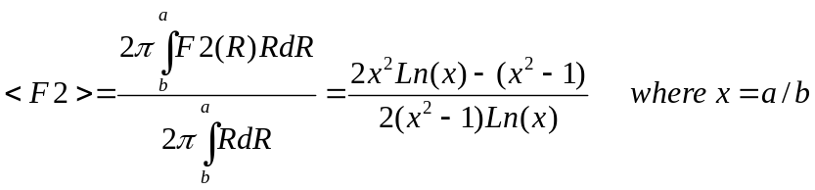 (1)
For the FNAL ion chambers, a = 0.75” and b= 0.125” and <F2>= 0.749 . That is, the fast electron signal will be 3 times the slow ion current with the conventional polarity but only 1/3 for the reverse-bias polarity. This was observed in tests in the RHIC transfer line. Clearly, the FNAL chambers would be unsuitable for SNS unless the conventional bias polarity could be used.

The positive ion transit time is given by:

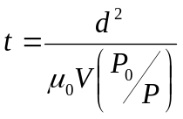 (2)
where:
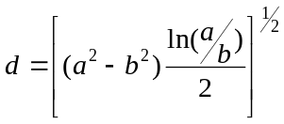 d = Effective electrode separation [cm] for cylindrical geometry
(3)

μ₀ = Ion mobility at STP [ cm²/(V-sec)]
V = Applied Voltage [V]
P₀ = Atmospheric pressure
P = Working pressure

The transit time can be reduced by decreasing the electrode gap but with increased gradient corona may occur. A design was proposed in which the radii were closer together and the chamber lengthened to keep the same volume. Keeping the original outer electrode radius, a = 0 .75” but increasing the inner radius to b= 0.5”, the ion collection time at 3 kV bias would be reduced from 560 μsec to 72 μsec. The calculated results are shown in Figure 1. “Negative bias” refers to negative voltage on the outer electrode. Clearly the “positive bias” case is not suitable for SNS. The FNAL chamber with negative bias might be acceptable since the electrons contribute 75% of the signal within a few microseconds. The new design provides the best response.

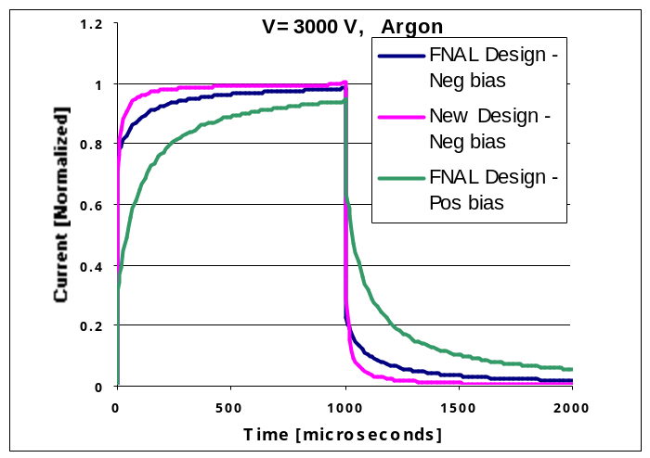
Figure 1. Calculated signal for SNS Linac pulse on original FNAL and new BLM.

COLLECTION EFFICIENCY

While the equations describing the collection efficiency have been known since Thomson described them in 1899, they have never been explicitly solved. Approximate solutions for the simpler parallel plate geometry can be applied to cylindrical if an “equivalent” gap (eq. 3) is used. Boag and Wilson solved the equations assuming the ionization distributions were second and third order polynomials, and that the radiation was constant. Their result, which gives a good fit for efficiency > 0.7 is given by:
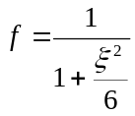 (4)
where:
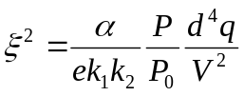 (5)

e is the electron charge,
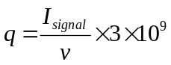α is the first Townsend recombination coefficient,
k₁ is the electron mobility,
k₂ is the ion mobility,
q is the ionization change density:

where I_{signal} is the signal current generated in the ion chamber by the beam loss and
v is the active volume of the ion chamber. For the FNAL IC, the sensitivity is 70 nA/rad/sec, and the volume is 110 cm³ so for the accepted upper limit of 1 % local loss, the dose rate is 9.2 krad/sec during the linac pulse.

Consider a chamber with argon gas:

α = 1 x 10⁻⁶ [cm³/sec]
k₁ = 1.8 [cm²/(V-sec)]
k₂ = 1.3 [cm²/(V-sec)]
V = 3000 [Volts] (Negative bias)
P = 725 [mTorr]

Then

 | FNAL | New Design
Outer Radius [cm] | 1.905 | 1.905
Inner Radius [cm] | .3175 | 1.27
Active Length [cm] | 10 | 17.4
Volume [cm³] | 110.84 | 110.21
Effective Gap [cm] | 1.991 | 0.6436
Ionization Density [esu/cm³-sec] | 16850 | 16850
Ion Transit Time [μsec] | 564 | 72.2
Electron Fraction (neg on outer) | .7495 | .5669
Collection Efficiency | .357 | .971

While the efficiency calculation for values <0.7 may not be accurate, clearly the new chamber would be superior to the original, both in ion transit time and collection efficiency, but, since the electrode gap is smaller, great care must be taken with the high voltage design. Guard electrodes would be required to decouple the signal electrode from leakage. The design would be more difficult to manufacture than the simple FNAL detector, with higher detector cost. Note that the electron fraction is 0.567, with 43% of the signal coming from the now ions.

Boag also found a solution for the pulsed radiation case when the loss occurs in a time short compared with the ion transit time. For this case and the above parameters the FNAL chamber efficiency is 21% and the new design is 60%. This might apply to the first 5-10 mini-pulses for SNS but the static case solution might better describe the efficiency late in the pulse.

THE NEW ION CHAMBER DESIGN

The design of the new ion chamber is shown in Figure 2. Voltage gradients have been reduced by rounding the electrode ends. Guard electrodes divert leakage from the HV electrode to ground and assure the signal collector is in a uniform electric field region. They also prevent ions at the chamber ends from contributing to the signal resulting in longer transit times. Three prototypes units have been made. The first was limited to 3 kV when filled with argon due to HV feedthrough breakdown, but when filled with nitrogen was able to reach 5 kV. It was then installed in the transport line between BNL Linac and Booster. Units 2 and 3 were built with feedthroughs rated for higher voltage and with improved ceramic design. The radius of curvature of the ends of the guard rings and signal electrodes were also increased. These units have been tested to 4.5 kV with argon. Prototype 2 has been installed in the BNL Booster extraction line for tests with short pulse beams similar to SNS Ring extraction.
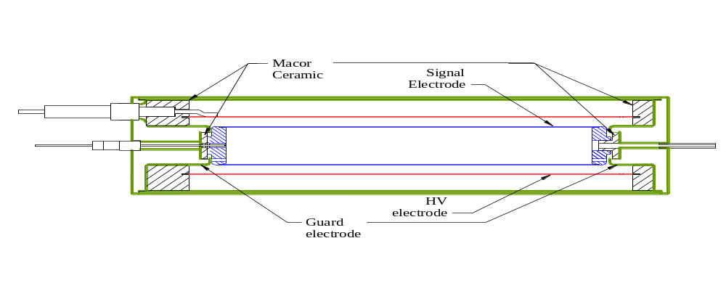
Figure 2. Drawing of new design BLM prototype.

IMPROVEMENTS TO THE FNAL DETECTOR

As an alternative to designing a new chamber, the original was studied to see if modifications could be made to improve its performance. The difficulties with the conventional (negative) bias polarity in the FNAL IC were believed to be due to high field points at the tip of the inner electrode and at the supports for the outer electrode, since these are where breakdown occurs when the voltage is raised. Changes were made to the outer electrode to eliminate crimping at the flared end of the outer electrode at the support pin attachment locations. Figure 3a shows the original outer electrode crimped inward by the support rods. Figure 3b shows a modified chamber with the outer electrode slotted to allow the support to pass the flared end without bending it inward.
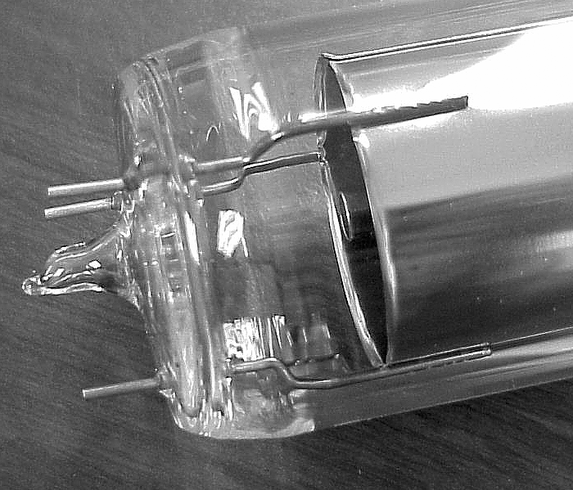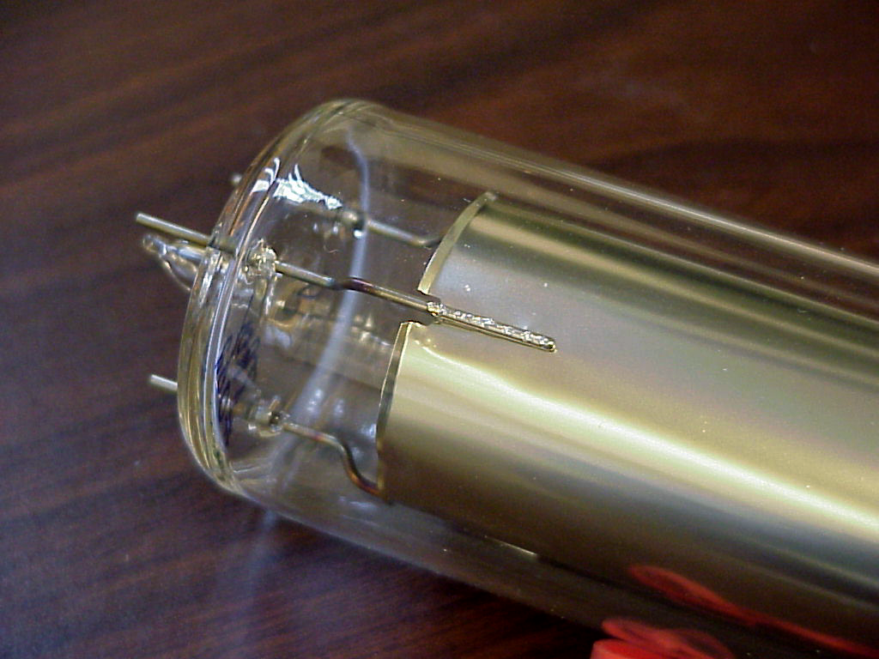
Figure 3a. Original FNAL Outer electrode Figure 3b. Slotted outer electrode

So far 5 chambers have been modified in this way. Tests indicate that this has significantly improved the unit to unit response. Figure 4a shows the cesium source tests of 5 of the first RHIC chambers with conventional bias polarity. Figure 4b shows results for 5 units with modified (slotted) outer electrodes. The uniformity is clearly improved with the slotted electrodes.

It was felt that some of the voltage limitation may have been due to sharp edges at the open end of the hollow center electrode. Several chambers were built with the slotted outer and a rounded solid tip inserted in the end of the electrode. Tests of these units did not show a significant improvement from the slotted outer electrode alone. While these modifications seem to have improved the production uniformity, the ion transit time and high dose rate saturation are still a problem for SNS. If the design could be improved to allow higher operating voltage then the ion transit time would decrease and collection efficiency increase. The improvement is somewhat less than linear with voltage, so this might not be very productive.
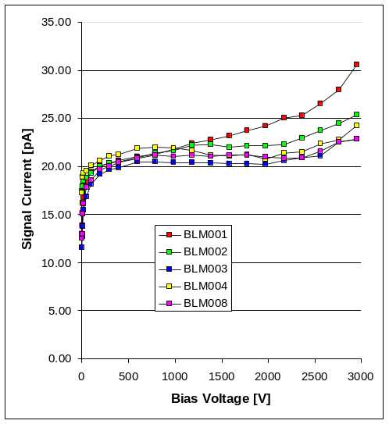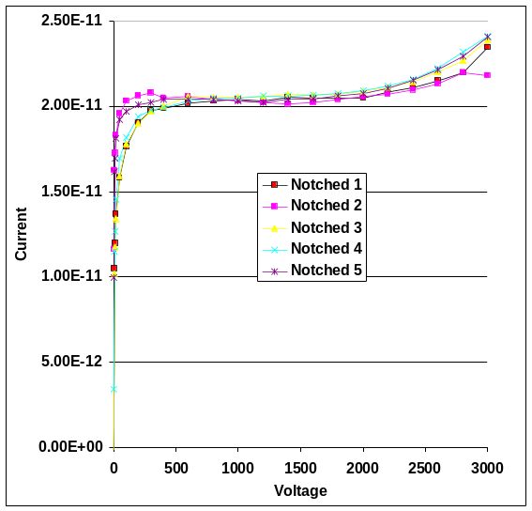
Figure 4a. Original FNAL IC test data Figure 4b. Modified (slotted) FNAL data

TESTS WITH BEAM

A non-modified FNAL IC and Prototype 1 were installed together in the BNL Linac-to-Booster (LTB) line, approximated 1 foot from the beam line, where high dose rate losses from the 200 MeV H-minus beam could be observed. Two sets of data runs were made. In the first a high sensitivity multi-channel integrator module of the type used in the source testing of the chambers was used to condition the signals. They were modified to have a 470 Ohm input so rise times of several μsec could be observed on a LeCroy digital scope. The bias voltage was varied to determine the collection efficiency curves for both bias polarities. The beam current waveform was also captured. Figure 5 shows the results of this run. Clearly the positive bias (non-preferred) FNAL response shows low efficiency, especially at lower bias voltage. The data for the negative bias shows large excursions, while summation of the beam current data does not show more than a few percent variation between data points, implying beam motion. The data for Prototype 1 appears fairly flat throughout the entire voltage scan. Calculations indicate that the FNAL chamber should be 77% efficient while Prototype 1 should be 92% at 3 kV for negative bias at this loss level. Dedicated runs are planned to study the efficiency at various dose rate levels.

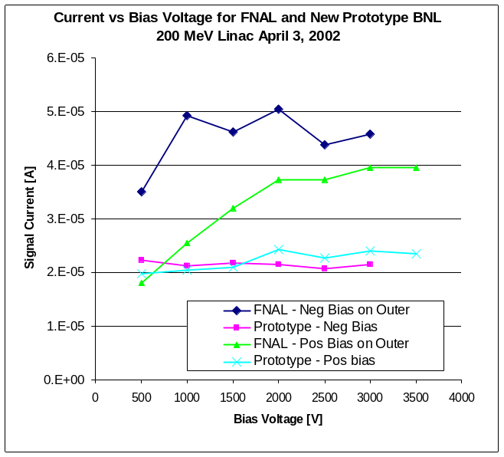
Figure 5. Measured bias curve (collection efficiency) for 200 MeV Linac beam. Aproximately 1000 W/m loss.

A second run was made using the prototype analog front end (AFE) circuitry designed for SNS. This circuit has a current amplifier first stage using a Burr-Brown OPA627BM opamp with outputs from a unity gain (50 kHz BW) buffer, a “leaky integrator” and a filtered (1 kHz) slow amplifier. Data from the fast output and the beam current transformer is shown in Figures 6a and 6b.

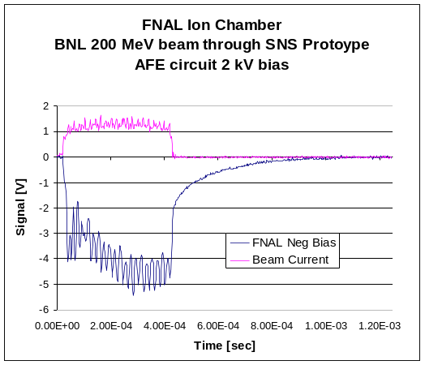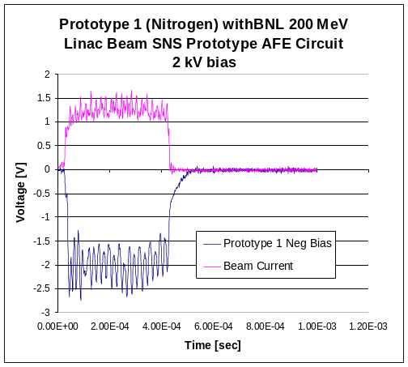
Figure 6a. FNAL IC Beam Test. Figure 6b. Prototype 1 IC beam test

The signal from the FNAL chamber (Figure 6a) can be seen to have a very long tail following the pulse, due to the slower ions being collected after the beam. They are also arriving during the pulse, causing the gradual rise rather than directly following the beam current (also see Figure 1). The apparent noise during the pulse is actually modulation of the beam current to tailor the stacking in the Booster. The signal from the Prototype ion chamber has a much faster ion collection time, as expected.

CONCLUSIONS
Improvements have been made to the original FNAL detector design which result in more uniform characteristics of the production units. These changes allow the use of the conventional bias polarity (center electrode is anode) without conditioning of the chambers. However, concern over collection efficiency (saturation) resulting in departure from linearity at high dose rates may preclude its use in SNS. The slow ion transit times are comparable to the SNS pulse width, requiring unfolding to obtain the true time behavior.

The new chamber design appears to yield significantly faster ion transit time and higher collection efficiency at high dose rate, as predicted. However, higher fabrication costs and the uncertainties of bringing a new design to production need to be weighed against the benefits to the SNS application. A firm specification of linearity at high dose rate is needed before the detector choice can be made.

Acknowledgments
The authors wish to acknowledge the contributions of C. J. Liaw in the mechanical design, Dave Kipp is assembling the prototype chambers and Paul Ziminski in testing the chambers with the cesium source. The prototype circuit used in the beam tests was built and tested by Chaofeng Mi. Anthony Curcio (BNL) was invaluable in the installation and setup of the beam tests.

References

R. E. Shafer, et al., The Tevatron Beam Position and Beam Loss Monitoring Systems”, Proc. 12th Int’l Conf on High Energy Accel., FNAL (1983) p609
Troy-Ionics, Inc., Kenvil, NJ
Witkover, R. L., Michnoff, R. J. and Geller, J. M., "RHIC Beam Loss Monitor System Initial Operation", Proceedings of the 1999 PAC, NY, 1999, 2247
Shafer, R. E., Private communication
Boag, J. W. in “Radiation Dosimetry, Vol. II”, F. Attix, et al, eds.,Academic Press (1966), p22
R. Witkover,” Proposal for a Quasi-Parallel Plate, Cylindrical Geometry Ion Chamber for SNS”, November 7, 2001, unpublished
Boag, J. W. and Wilson, T., “The saturation curve at high radiation intensity”, Brit. J. Phys., 3 222-9, (1952) and Loc. Cit (5), p16
Boag, J. W., “the Dosimetry of Ionizing Radiation”, Vol. 2, Ed. By K. R. Kase, B. E. Bjamgard and F. H. Attix, Academic Press, (1987), p 191
Witkover, R. L. and Gassner, D., “Preliminary Design of the SNS Beam Loss Monitoring System”, To be published in these proceedings.

