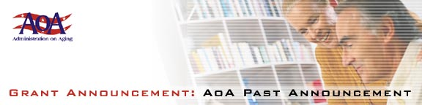

Statewide Senior Legal Hotlines

Pension Counseling and Information Projects -- Deadline: August 3, 2001

[Federal Register: June 18, 2001 (Volume 66, Number 117)][Notices][Page 32825]
From the Federal Register Online via GPO Access [wais.access.gpo.gov]
[DOCID:fr18jn01-97]
-----------------------------------------------------------------------
DEPARTMENT OF HEALTH AND HUMAN SERVICES
Administration on Aging
[Program Announcement AoA-01-07]
Fiscal Year 2001 Program Announcement: Availability of Funds and
Notice Regarding Applications

AGENCY: Administration on Aging, HHS.

ACTION: Request for applications for Pension Counseling and Information Projects to create new, or continue or expand a sufficient number of pension counseling and information programs to provide outreach, information, counseling, referral, and other assistance regarding pension and other retirement benefits, and rights related to such benefits.

-----------------------------------------------------------------------

SUMMARY: The Administration on Aging (AoA) announces that under this program announcement it will hold a competition for grant awards for two (2) to three (3) projects at a federal share of approximately $100,000 to $150,000 per year for a period of three years. Since 1993, the AoA has supported 10 model pension counseling and information projects throughout the country. This program announcement is designed to build on that effort in order to begin to expand the program into a national program of pension counseling services, as prescribed in title II, section 215 of the Older Americans Act (42 U.S.C. 3001 et seq.), as amended in 2000, Pub. L. 106-501.

The deadline date for submission of applications is August 3, 2001.
Eligibility for grant awards is limited to State or area agencies on aging, nonprofit organizations, including faith-based organizations, with a proven record of providing services related to retirement of older individuals, services to Native Americans, or specific pension counseling.

Application kits are available by writing to the Administration on
Aging, Office of Program Development, Department of Health and Human
Services, 330 Independence Avenue, SW., Room 4266, Washington, DC
20201, or by calling Nancy Wartow at (202) 619-058 or on the web at
http://www.aoa.gov/t4/fy2001.

Dated: June 13, 2001.
Norman L. Thompson,
Acting Principal Deputy Assistant Secretary for Aging.
[FR Doc. 01-15287 Filed 6-15-01; 8:45 am]
BILLING CODE 4154-01-U

