Trek Across the Moon from Crater Grimaldi to Sea of Crises
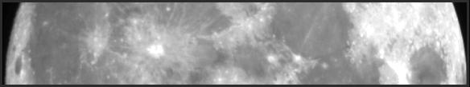

Grimaldi  Crater  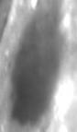 | Ocean of Storms (part of)  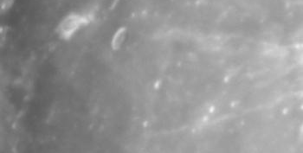  Oceanus Procellarum | Kepler Crater 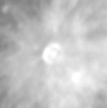 | Sea of Islands 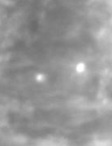  Mare Insularum

Copernicus Crater  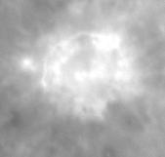 | Bay of Billows or Seething Bay  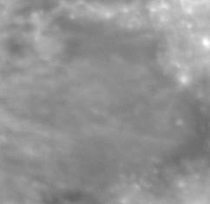  Sinus Aestuum |  | Sea of Vapors  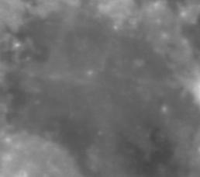  Mare Vaporum | Manilius Crater  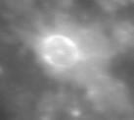  Menelaus Crater  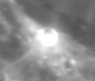

Sea of Serenity (part of)  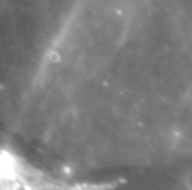  Mare Serenitatis | Sea of Tranquility (part of)  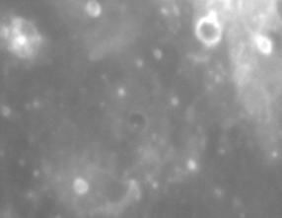  Mare Tranquillitatis | Marsh of Sleep  (part of)  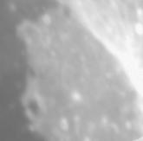  Palus Somni | Sea of Crises (part of)  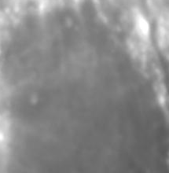  Mare Crisium

Construction Project: Mosaic pictures to ‘Take a Trek’ across the surface! Supplies: Scissors, tape, printouts of following pages.
Procedure: Cut out each Moon picture. Study the features and find the ones that are the same in two pictures. Overlay the pictures and tape together. Keep adding more pictures to create a strip across the Moon from one side to the other.
Observing Project: Watch for the Moon day and night. Record and sketch what you see. Use your eyes, binoculars or a telescope.
Image Processing Project: Use a computer and image processing software such as Makali’i, HOU, Salsa J, MicroObservatory, or MIRA AL, etc. to manipulate these images to show the details in each image your own way. Print and tape together; display on a poster; label the features. Study other images of the moon found in the HOU database to see how these features look in other phases.
Research Project Print this first page, check out library books and/or use a computer connected to the internet.
- CalSky Moon Map http://www.calsky.com/cs.cgi/Moon/2?
- InConstant Moon http://www.inconstantmoon.com/cyclopedia.htm
- Selenography of the Moon (Study of Features and Surface) http://en.wikipedia.org/wiki/Selenography
- By David Levy: SKYWATCHING ISBN 0-7835-4751-x, and ADVANCED SKYWATCHING ISBN 0-7835-4941-5
- By Jeremy Cook: The Hatfield Photographic LUNAR ATLAS ISBN 1-85233-018-x
- By Michael T. Kitt: THE MOON, an observing guide for backyard telescopes ISBN 0-913135-09-7
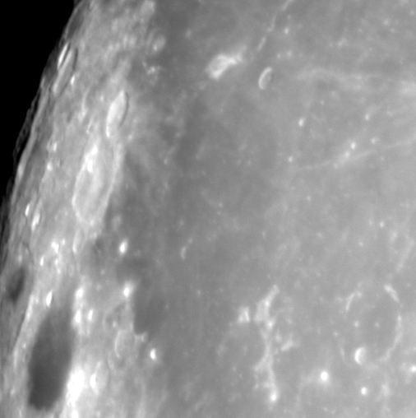

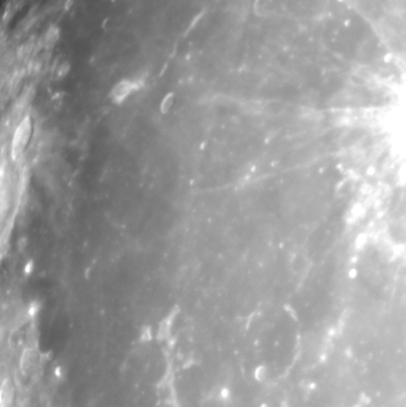

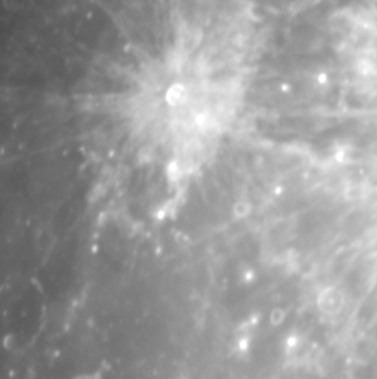

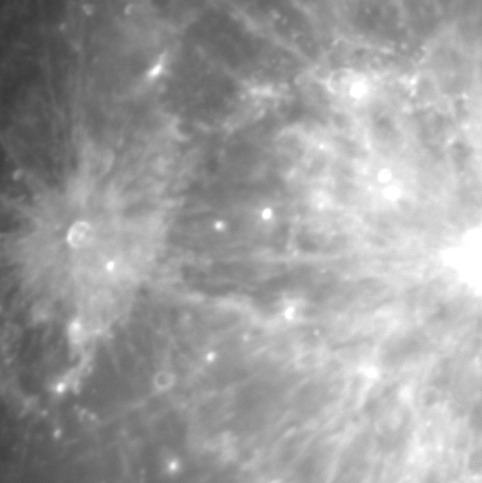
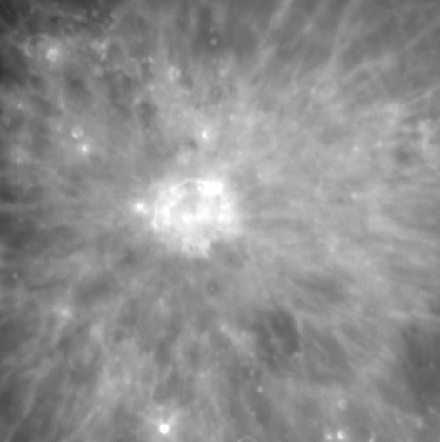
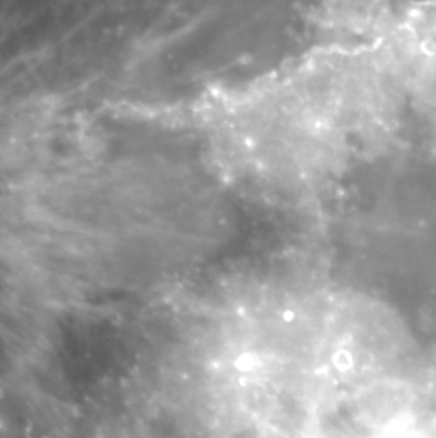
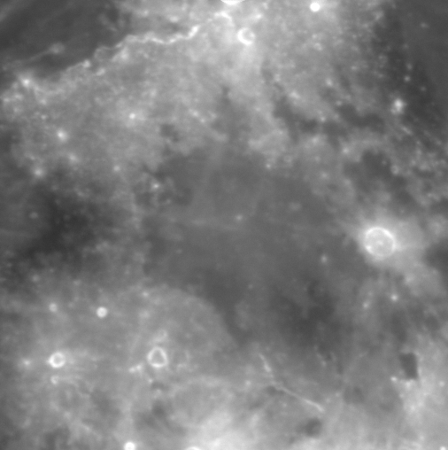

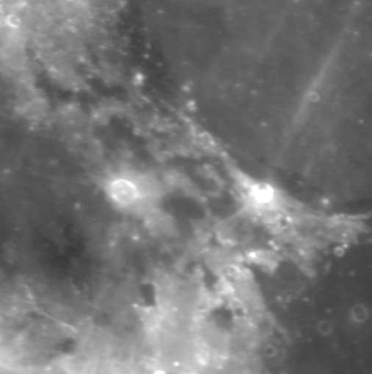
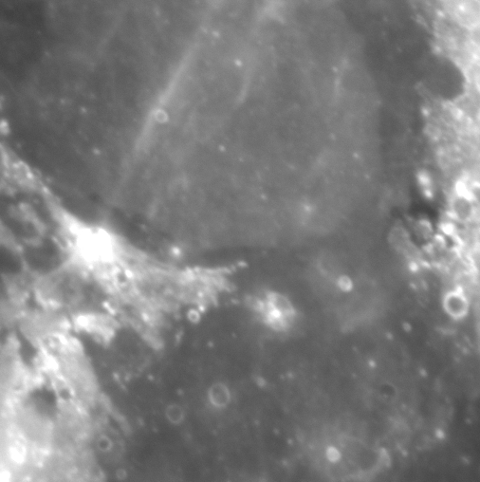

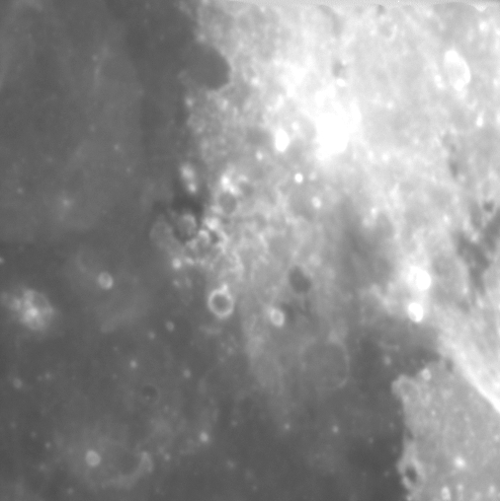
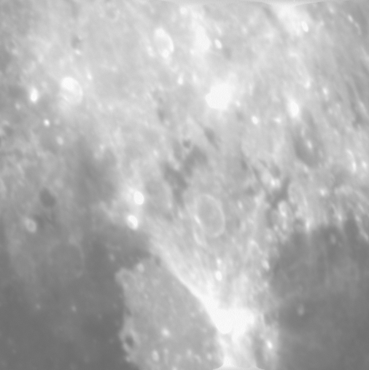

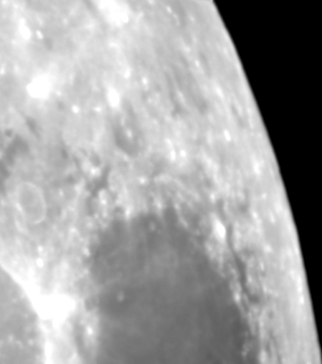
Images: http://handsonuniverse.org
Hands-On Universe, Activities, Explorations: http://sunra.lbl.gov/~vhoette/Explorations/images/MoonTreks/

Moon images were taken with the 24 inch telescope at Yerkes Observatory on Nov. 24, 2007 by Rich DeCoster and Vivian Hoette. Haze and clouds blocked nearly all the stars; only the Moon and Mars were visible. The nearly full Moon is so bright that the clouds were an advantage, acting like a neutral density filter. An Omega visual (v) filter was used, with most of the exposures being 1/20th of a second with an Apogee AP7p CCD camera, MaxIm software. Each image is about 5 arc minutes, each pixel being 0.62 arc seconds.

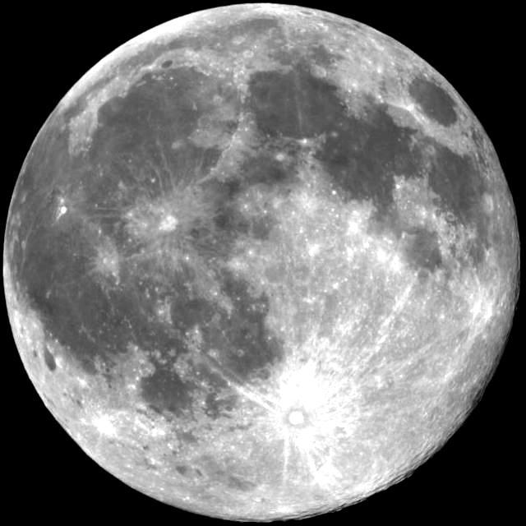

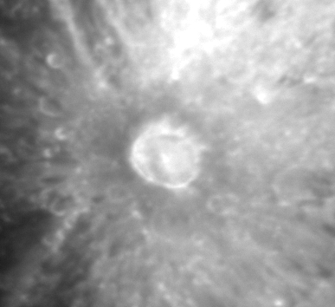
Above: 14.9 day Moon (just past full) February 7, 2003

Moon Phase Images:
http://hou.lbl.gov/~vhoette/Explorations/images/MoonPhases/ The above picture and other whole disk Moon pictures were taken with the Yerkes Observatory Rooftop 8 inch telescope. Each picture is composed of two images put together in a mosaic.

Left: Tycho Crater taken on November 24, 2007. Tycho is the crater towards the south or ‘bottom’ of the picture above.

