Detection and Analysis of Fast-Flux Service Networks
Final Paper for CS294-28
Scott Campbell Steve Chan

Abstract

Fast Flux Distribution Networks (FFDN) represent an effective way for well organized criminal organizations to present a highly available and secure web presence. We present a methodology to detect and analyze such networks and show that there is a significant degree of overlap between compromised systems suggesting a high degree of organization and centralized control.

1.0 Introduction
Maintaining a highly available and secure web presence is a problem faced by all web professionals. For professional web criminals, the problem is compounded by the fact that their work is considered illegitimate by the powerful forces of government, businesses, IT administrators and end users – resulting in constant and determined adversarial pressure. While sites containing legitimate content can rely on well known techniques such as Round Robin DNS or Content Distribution Networks (CDNs), such reliable techniques are too easy to trace and take down. In response, the organized crime community - further known as miscreants - developed Fast Flux DNS. The exact origins of this technique are unclear, but they are related to the methods used by legitimate web sites. There are a number of references dating back to November, 2006 [PBP] but little before that can be found.
FastFlux DNS rotates large numbers of compromised hosts through domains and hostnames used for spam, phishing, malicious content distribution and related activities - the large numbers of hosts associated with any given hostname, as well as the rotation of new addresses into these hostnames, makes it much harder to protect against these activities using traditional IP address based defenses. Research into fast flux service networks is still nascent, however a small number of recent papers have examined the problem and one paper has offered a solution for detecting FFDNs. We review the work, and implement the proposed detection algorithm, using it as a starting point for further investigation. In reviewing this work, we feel that an important distinction between dispersion and flux needs to be made, and we claim that the existing work implicitly equates dispersion with flux, and can be improved by introducing flux into the algorithm.

Note that we are not looking at the mechanism of FFDN member creation, nor examining the larger bot C&C networks or communication protocols. Our scope is the identification and measurement some basic characteristics of live FFDN traffic and using this information to improve detection of compromised systems and malicious domains.

2.0 Background

According to the Honeynet Project description [HNP], there are two basic forms of Fast Flux DNS activity. We will cover just a general discussion of the techniques since [HNP] provides an excellent technical description, and is considered a standard technical reference by most other papers. The first type is called Single Flux. Single flux networks take advantage of the same techniques that round robin and CDN networks use by delivering multiple IP addresses for each resource query, but the set of addresses provided come from a huge pool of compromised systems. When you resolve a name such as test.example.com, the fast flux domain returns a number of A records from a larger set of compromised hosts called flux-agents. The responses tend to have a short TTL, reducing the effects of caching and provides resistance to any single member of the pool being taken off line. These systems act as relays for HTTP or SMTP traffic, allowing a great deal of screening to protect the expensive and hard to replace core infrastructure required for large scale computer crime.

The second type of Flux Network is called Double flux. The general structure is similar in form to the Single Flux form - in fact the end user will not notice any real difference in behavior or results. The innovation for this technique is to replace the static authoritative name servers with a dynamic set of nameservers operating on compromised hosts. This pool of name servers adds another layer of misdirection and hence protection. When a user requests name resolution for a host such as flux.example.com, the top level domain .com is queried for the authoritative name server for example.com. The name server returned for the example.com domain is actually part of the fast-flux network itself with the IP address associated with that name changing frequently. In other words, the record always points to ns.example.com, but the IP address for ns.example.com changes frequently. Lookups from the name server are the same as the single flux version.

In doing data analysis, we came upon a set of extremely short lived A-record lookups whose initial characteristics triggered the FFDN test, but never returned in the passive bro analyzer and whose domain never successfully resolved for the active querying mechanism. We have chosen to create a distinction between an A-record whose lookups exhibit flux in the classic sense of the word, and those whose characteristics are merely sufficient to trigger the detector. In the case of the transient records we will describe them as dispersive in that the resolving data is dispersed across a large number of ASNs and IP addresses. We use the term flux in a sense of transport phenomena - the amount of flow through a unit area per unit time[FLUX]. In this case we are thinking more about the amount of change in IP addresses over time. The recognition of the change over time element is a critical distinction that we think has been left out of a number of analyses.

3.0 Related Work
In researching the general topic of Fast Flux networks, we found that there was a significant volume of literature describing how they work and who was using them, but the number of analysis related papers was extremely small. We break down the related literature into studies relating to measurements and analysis of the networks themselves, descriptive works relating to Fast Flux, and DNS related analysis.

The closest match that we found to the work that we are doing was done by Holz et al [HOLZ]. In this paper a first order approximation is presented to identify Fast Flux networks as well as the notion of fluxiness which is used to differentiate CDNs and FFDNs. In addition the idea to extract a large volume of high value data by directly querying name servers for known FFDN A-records, and comparing results for web traffic from web servers on those addresses is looked at as well. This paper provided us with a great deal of theory and method. Primary differences include significant modifications to the presented algorithm, taking into account the inter relation between ASN and IP, and the use of live traffic to generate our data set rather than lists of known good and bad records.

The description of Fast Flux networking as described by the Honey Net Project in [HNP] is probably the single most cited technical description of the techniques workings. While the descriptive nature of the work is still outstanding, it is mostly qualitative rather than quantitative. This is by no mean a criticism, but is a differentiation between it and our work.

In [SSAC] a nice overview of Fast Flux technique is provided along with descriptions of miscreant motivation and the relation of Fast Flux to Phishing and 'Domain Tasting' (domains that are registered, but are canceled during the Add Grace Period). The paper concludes that there is no connection. A significant part of the paper looks at possible mitigation techniques as well as how domain name registration mechanics might be used against Fast Flux network operators.

In [BZ], a passive DNS monitoring system is described and data analysis results were presented. Passive DNS monitoring system on live traffic is similar to our approach, however the system described was not real time, and captured data for later, offline analysis. In the results section, several candidate FFDN domains were pointed out, and a clear FFDN domain was discussed, highlighting the fact that the hosts in the domain were dispersed across the internet, typically residing in home DSL networks. The paper however was focused on passive DNS monitoring and analysis, and not on FFDN.

4.0 Fast Flux Detection Algorithm
During the initial tool development, we used the detection algorithm described by Holz et al. [HOLZ].

$${\text{flux}}_{A}(n_{A},n_{\text{ASN}})=1\text{.}\text{32}⋅n_{A}+\text{18}\text{.}\text{54}⋅n_{\text{ASN}}$$
Equation 1

The idea behind the use of this design seems correct in that an abnormally large number of ASNs referenced in an A-record lookup should arouse suspicion. When the return value of the function exceeds some threshold value, the A-record is considered Fast Flux. See [HOLZ] for a complete description of the rational behind the numeric constants.

On using the formula on live data we discovered a number of shortcomings. While the plainer solution (the optimal Hyperplane) is sufficient for the data sets that were looked at in the coefficient calculations, it can not express any sort of relationship between the n_{A} and n_{ASN} terms. By adding this term we see:

$${\text{flux}}_{A}(n_{A},n_{\text{ASN}})=\left(\frac{n_{\text{ASN}}}{n_{A}}\right)\left(1\text{.}\text{32}⋅n_{A}+\text{18}\text{.}\text{54}⋅n_{\text{ASN}}\right)$$
Equation 2
The rationale for adding the additional term is that CDN networks tend to include a higher degree of redundancy in their infrastructure since they are building it out on purpose. Such redundancy would typically take the form of multiple IP addresses per ASN. FFDN do not have an opportunity to plan out their infrastructure, so the IP addresses tend to be more evenly distributed across ASN space.

Comparing the results between eq1 and eq2 for a known CDN (figure 1)
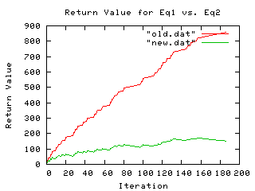
Figure 1
we see that the modifications to eq1 seem to provide some significant degree of relief to differentiating the CDN vs. FFDN problem. Nonetheless there are still significant false positives because of the pervasive use of CDNs, the sheer number of discrete ASNs will override the quotient given enough time.

Based on the method description in Holz, the derivation of eq1 is based on a comparison of known fast flux and legitimate domains. The legitimate domains are taken from the Open Directory Project[OPEN] and the Alexa Top 500 list [ALEXA]. We think that eq1 seems to have difficulty with live traffic because CDNs do not typically live in either a list of known good search links, or in the main destination of highly popular URLs. Since they are infrastructure, the CDN links are not directly exercised by these URLs, but are embedded in the content of these top sites. Because CDNs such as Akamai exhibit the same static behavior as FFDNs, it is necessary to include other variables in the analysis.

4.1 Coefficient Selection
A reasonable question can be made at this point. Having modified the behavior of the algorithm, why would we keep the same coefficients?

As a first approximation to an individual measurement, we think that the coefficients represent a reasonable beginning. The underlying insight that the number of ASNs are a key indicator of how widely dispersed a domain is across the internet at large still holds. An A-record’s ASN count should therefore have significantly more weight than the number of returned IP addresses, which eq1 provides. It is only when you begin taking multiple measurements that you discover eq1 does not address the more complex dynamics and so ought to be replaced with eq2. In future work we plan to re-evaluate the constants.

4.2 Adding Additional Terms

We strongly believe that there are additional terms that could be added to eq2 which would provide more resolution regarding CDN vs. FFDN dynamics. There are two in particular which would be beneficial.
- Time to threshold: The time it takes between the initial lookup and a triggering of the fast flux algorithm is different between many large CDN providers and FFDNs. For all of the identified FFDNs, the initial contact dt was zero. For the larger CDNs this number ranged from tens to tens of thousands of seconds. This distinction was not true for some of the smaller CDNs and some purposefully distributed services such as freenode.net.[FREE]
- Tracking a domain’s NS Behavior: Taken over time, the distribution of IP addresses in the authoritative NS list for a domain is both dynamic and variable for many FFDNs. This is particularly true for mainstream CDNs, but seems to be the case for some less formal services such as freenode as well.

Taking into account the distribution of NS record information as well as the time till threshold, we propose a new version of the detection algorithm. Since we are interested in both single and double flux detection, we decouple the A-record based part from the NS-record part. Decouple means that the general form will look like:

$${\text{flux}}_{\text{TOTAL}}={\text{flux}}_{A}+{\text{flux}}_{\text{NS}}$$
Equation 3

With the detailed version looking like:

${\text{flux}}_{\text{TOT}}=\left[\frac{n_{\text{ASN}}}{n_{A}}\right]\left[\left(\sum_{i∈\text{AREC}}{\frac{1}{{Δt}_{i}}}\left({\text{An}}_{\text{ASNi}}+{\text{Bn}}_{\text{Ai}}\right)\right)+{\text{Cn}}_{\text{ASN}}+{\text{Dn}}_{A}\right]$Equation 4

The important things to note here is the time dependence for A-record flux updates so that the initial data has more weight than later ones. The coefficients C and D are for the NS record data. Calculations for single flux networks will only be strongly effected by the time based terms. Double flux networks will be effected by all terms.

We have not implemented eq4 yet, but intend to use some variation of it in future work.

5.0 Method
The general form of the experiment took place in two parts. The first part consists of using the Bro intrusion detection system to identify FFDN candidates consisting of domains and hosts using two different variations of the FFDN detection equation as described in Holz. The second involves an active querying mechanism that takes a list of hosts and domains and performs queries on them periodically.

5.1 Bro Algorithm Implementation I
For this version, a literal interpretation of the eq1 was initially used, focusing exclusively on A-record lookups. After a short analysis of the results, eq2 was implemented to help combat false positives. Since the data volume is quite high, a number of things are implemented in order to manage state over long run times. The first and most natural is removing any record in the main state table which still has only 1 ASN after a timeout period. In this case the timeout was set to 60 minutes.

To help limit the set of candidate records, a maximum TTL is used to exclude records unlikely to be interesting. DNS lookup results must have a short TTL in order to allow the rapid rotation of compromised hosts into the FFDN pool. Because of this operational requirement for FFDNs, a maximum TTL was set to 10 minutes. This is consistent with the methodology proposed by Holz in that they also limited records to TTLs smaller than 1800 seconds. We selected a higher value, possibly at the cost of some false positives by looking at the TTL distribution of normal records.

In addition a white list was created in order to remove the most common legitimate domains that trigger the threshold value for eq2. For the purposes of data gathering for this paper, no such white list was used.

A number of tests were also proposed but not used in the data gathering. The most interesting of these is the "reverse lookup" test that takes the set of IP addresses returned in an A-record. If any of the reverse lookups for the IP addresses does not match the domain in the original A-record, a warning is produced flagging the significant possibility of a false positive.

Data is recorded in two forms: the alarm data contains the following information: time, domain, number of ASN at threshold, number of IP at threshold and the time between initial contact and matching threshold. An example record looks like:

May 11 10:39:56 FastFluxA threshold exceeded for load53.com ASN:6 Arec: 6 dt: 0.0

For the transactional records, we have the following data: time, domain, current weight based on eq2, number ASN, number IP, TTL for that returned record, IP address provided. An example record looks like:

May 5 16:40:31 v1.panthercdn.com 7.5 ASN: 1 A: 3 TTL: 20.0 secs 66.114.48.46

We recognise that this filtering might be used as a way to avoid detection and generate false negatives. Given that behavioral characteristics (like short TTL values) force operators of FFDNs to behave in certain ways, we feel that the likelihood of this is quite small.

5.2 Bro Algorithm Implementation II
The second implementation looks at 2 different forms of aggregating DNS records to see how examining groups of DNS records compare to examining individual DNS records, as well examining the "fluxiness" of different sets of the DNS records associated with the domain. The first set of records examined are the records associated with the actual DNS servers, the NS records and the A records associated with them. All the addresses and the ASNs associated with them are pooled and changes in the content of this pool are tracked. These records are typically modified only in "double flux" domains, and the implementation uses the minimum TTL between the NS and A records to repeatedly schedule queries against the domain looking for changes. The second group of records we look at is the entire set of A records for a domain - for these records we don't store any information about individual addresses, but instead pool the set of ASNs for all the addresses and track changes in this pool. This second pool is tracked passively - the module does not initiate any DNS queries against the domain.

We use a simple scalar value to track changes in these two pools - for the DNS NS/A record pool, we simply apply the Holz eq1 scoring formula to the pool as a whole. For the ASNs in a domain, we use a simple count of the ASNs seen. The scoring used for the DNS NS/A pool is arbitrary, as there is no clear "correct" method to score this, however eq1 seems no more or less appropriate and we are mostly interested in the rate of change. Using eq1 gives us a basis of comparison against the original Holz algorithm.

The module generates a notice when the score for a domain exceeds a threshold - for the DNS NS/A pool, we use the value given by Holz, of 142.38. For the ASN pool, we use a score of 5 ASN's as the threshold for logging a domain as interesting. Note that these two threshold scores are inconsistent with each other, 5 ASNs does not necessarily correspond to the typical number of ASNs seen to arrive at a 142.38 score with eq1. The threshold of 5 ASNs was chosen based on some of our own initial observations that many fast flux domains seem to have a minimum of 5 DNS A records and 5 ASNs.

To track the changes in the scoring of the different pools, we store the history of the scores for each domain. Because multiple records may be returned in a single DNS response packet, we store score updates at a 1 second resolution, instead of per record seen. After a score has been updated, we queue a write of the domain's current status and history to the log with a delay of 2 seconds. This 2 second delay is meant to allow for processing of all records in a DNS response to have been completed before writing anything to the logs. Here is a sample log entry with information about the NS address pool and the overall ASN list for a domain:

1210650497.610464 ffdns_state ops-oms.org ( 208.250.65.126 165.158.1.2) ( AS701 AS7911) nsttl:36000 attl:86400 lookups:4 score: 39.72 firstseen:1210635300 lastupdate:1210635300 lastseen:1210635300
1210650497.610464 ffdns_flux_history ops-oms.org 1210635300/39.72
1210650497.610464 ffdns_domainasn ops-oms.org ( _AS6505_ _AS6471_ AS701 _AS1251_ AS7911) attl:86400 firstseen:1210635300 lastupdate:1210650495 lastseen:1210650495
1210650497.610464 ASN_count_history ops-oms.org 1210635300/3 1210643154/4 1210650495/5

In order to manage state, we periodically delete the state associated with a domain. This pruning occurs when the score for a domain has not changed in the last 4.33 hours. We arrived at this timeout interval by examining the update times across all DNS records seen in a 13 hour sample of traffic, and finding that just over 95% of all domains that have score changes (the vast majority of domains are not updated at all) are updated within 4.33 hours of the first sighting of DNS records for the domain. In the data seen, this same period of 4.33 hours covers at least 90% of the subsequent update intervals. The pruning of the record is by either one of 2 events - when DNS query initiated by the module completes or times out, or when a record for a domain is seen. If the domain's score has been unchanged for the past 4.33 hours, and the score has not crossed the threshold for being interesting, the record is deleted from memory and the domain is placed into a set of domains to be ignored for the next 12 hours. The premise of this interval is to avoid tracking any "one off" domains.
5.3 Active Querying Mechanism
When an A-record is identified as a FFDN, the value is fed into an active tool that runs a lookup on the A-record based on the current information in an open OpenDNS [ODNS] resolver. OpenDNS was used because it is reasonably anonymous and a well trusted source of recursive lookup data. The current version runs every 5 minutes. Data is recorded every time a new IP address is returned for the A-record lookup. Timestamp data is embedded into the filename to provide a simple way to track address updates.

6.0 Data Analysis
In what follows, we present a number of observations regarding data gathered by tools described in the previous sections.

Data sources include the following:
(1) A large National Laboratory with approximately 10 thousand systems averaging 8-12 million discrete DNS transactions per day. 5 weeks data.

(2) A mid size High Performance Computing facility, composed of approximately 8 thousand systems, averaging 6-800,000 DNS transactions per day. 4 weeks data.

(3) Large University with N thousand systems and people. The feed saw around 75% of the total DNS transactions over a 36 hour period. For privacy reasons we did not see any other data besides the policy output (which did not provide the total number of transactions).

6.1 NS record Overlap and Flux
We observed several instances of domains being flagged by eq2 as FFDN candidates at the same time as the domains authoritative NS records. This is exactly what we would expect for an A-record being served from a double flux network.

In order to look at this in some detail we will take two sample domains which happen to trigger on this form. There is nothing particularly unusual about these two domains as they were picked at random from a pool of approximately a dozen. As expected, the most unusual characteristic is the large variation in the domains name server locations and identifications. Even for any of the CDNs we observed, the NS records remained static over large time spans and are clearly located within network blocks under the administrative control of the parent domain. The second is the significant overlap seen in the addresses assigned to the various NS records and the base domains.

As already mentioned, there is nothing exceptional for this pair of domains except that they had a regular form of 'example.com' for the initial A-record lookup, and 'ns1.example.com' (etc) for the authoritative name servers. In the case of this pair of domains, the initial identification was derived from the Bro implementation 1 and the larger mass of data was extracted from the active query technique described in 5.2. Here the IP variation is not only huge, but the majority of the results are apparently non-production systems. Looking up the registered name servers for the domain indicate that the ns{1,2,3} systems are considered authoritative for the main domain in question. Results for each of the domains are as follows:
Shared IPs Between Domain Records
log67.com |  |  |  | 979
ns1 |  |  | 148 | 30 / 20%
ns2 |  | 1581 | 22 /15% | 266 / 27%
ns3 | 192 | 115/60% | 59 /40% | 40 / 21%
 | ns3 | ns2 | ns1 | log67.com
Table 1
logid92.net |  |  |  | 937
ns1 |  |  | 930 | 533/20%
ns2 |  | 167 | 6 / 4% | 18/27%
ns3 | 1659 | 44/26% | 120/13% | 27221%
 | ns3 | ns2 | ns1 | logid92.net
Table 2
Sparse testing of Akamai as a sample CDN shows that the diversity of the NS records is significant across both in terms of ASN and geography, but the addresses involved reside in administrative domains of service and content providers, and appear to be static. This is particularly true as compared to the above domains. We note that this is one possible test that can be done in order to infer the difference between most legitimate CDNs and FFDNs.

A simple way to look at how disperse the distribution of records are is to look at the number of unique ASNs that a domain and it's authoritative NS records live in. For the same pair of domains we see:
ASN Count for Returned IP Set
A-Record | #ASN | A-Record | #ASN
log67.com | 149 | logid92.net | 150
ns1.log67.com | 118 | ns1.logid92.net | 57
ns2.log67.com | 73 | ns2.logid92.net | 140
ns3.log67.com | 148 | ns3.logid92.net | 61
Table 3
Looking at other domains, we can get an idea of how much dispersion there is, as well as bring out the distinction between dispersion and flux. Two domains that are highly dispersed are akamai.net, a CDN and the dyndns.org domain, which serves as an outsourced DNS service for systems that may be mobile. The dyndns.org domain is interesting because it consists of an ad hoc collection of dispersed hosts that are customers of the service, somewhat similar to the ad hoc collection of dispersed hosts that compromised members of FFDNs.
The list of ASNs seen in appendix 1 for the dydns.org domain show the AS value, as well as flux. The third column is the time in seconds between when that ASN was seen and when the domain was first observed by the detector. As you can see, the dydns.org spans 34 ASNs, the last one, AS35776, was detected over 40000 seconds after the domain was first seen. Examining the times until a new ASN is observed, we see the median, average and standard deviation are 25475, 21249.18 and 13006.35 respectively.

In contrast, the akamai.net domain has 51 identified ASNs, with a median time until ASN observation of 905 seconds. The final ASN is also observed roughly 40000 seconds after the first ASN. The median, average and standard deviations for the observation times are 829, 3938.373 and 8000.39.

The following table compares the two summary statistics for the two domains. We see that for every statistic, dydns.org has a higher value than akamai.net, indicating that dydns.org has a greater rate of change than akamai.net. This is an indication of the greater flux in the dyndns.org domain versus akamai.net.

Measurement | Dyndns.org | akamai.net
Median | 25475 | 829
Average | 21249.18 | 3938.373
Std. Dev. | 13006.35 | 8000.39
Table 4

As a graphical representation of this flux, the following graph of the domain to ASN data has edges that are color coded to the time until observation. The transition from violet to yellow indicates increasing time until observation of the ASN. It is easy to see that akamai.net reveals most of its ASNs early on, while dydns.org has many more ASNs appearing later. Both domains are dispersed, in fact, akamai.net is more dispersed than dyndns.org, however akamai.net is more static.

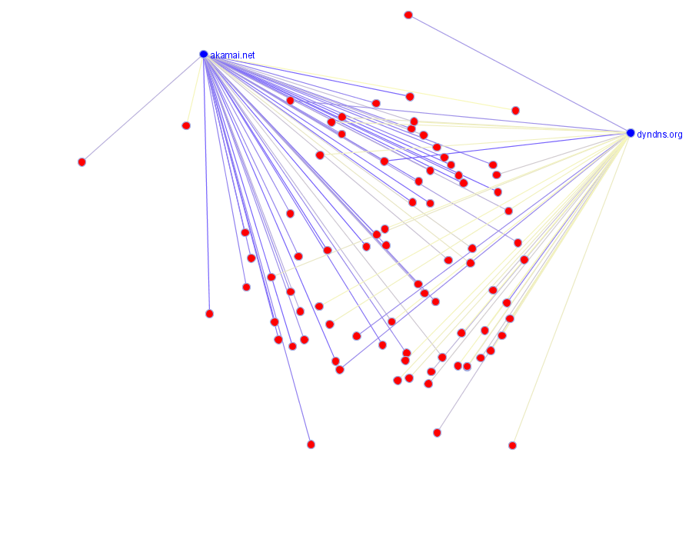
Figure 2
Two conclusions can be made from this section of analysis. The first is that there is a significant distinction between the dynamic behavior of FFDN NS record and that of a typical CDN. The second is the distinction between the degree of a networks dispersion and the degree of flux.

6.2 Flux Rate Distribution and Clustering
Given that a flux rate is easily understood and measured, it is natural to ask the questions (1) Are these rates constant over time? and (2) Do the values group between various A-records? We propose that the rates seem to become asymptotically constant over time periods of several days, and that the clustering provides some insight into possible shared infrastructure in Fast Flux candidates

The rate of flux is simply the value of newly added IP addresses plotted over time. Our inspection of bro data records indicate that some candidates seem to have more stable update characteristics than others. In order to provide a testable data set, we use data provided by the active querying mechanism which takes lookup results every 10 minutes.
Results from plotting a series of representative graphs can be seen in figure 3. Note that there were many different records which grouped together quite closely, so the various records plotted here represent the variation in flux values and are not proportional to the actual distribution of rates.

The flux rate distribution between the different A record lookups seems to be loosely clustered on groupings of A records. Looking at fig 2 we see that there are a series of tracks which seem to be clustered based on the rate of change of IP address additions - d(IP)/dt.

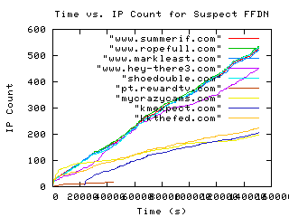
Figure 3
To test the notion of constant rate of change, we look at a plot of d(IP)/dt described above. On initial glance the representation seems to be dominated by noise, but looking at the average behavior it is consistent across the sampling time. There is no guarantee that the values will continue to hold such consistent behavior, but for the duration for the sample data this seems to be a legitimate generalization.

For clustering, we use the following method. First take the time between last and first records available in the data set, creating a series of time boxes which will represent the unit of temporal clustering. Using these boxes, we take vertical slices of the time vs. IP count graph and record the A-record name and IP count value for each possible entry in the slice. For any slice the distance between any pair of A-records is the difference in the IP count for each of the records in that slice. This process is repeated over all possible tie box values where both of the A-records have data points and the result of the distance is averaged. To provide for a complete analysis, we repeat this process for each of the possible combinations of records. If the average distance between the two records is lower than a threshold, then the two records are considered part of a cluster.

After running the clustering script against the data, we saw 5 discrete groupings fall out which align themselves with the groupings described in 6.3.

6.3 Common Addresses Found in Different A-Records
In inspecting the data, we noticed that a number of IP addresses seemed to repeat themselves across multiple A-record response sets. The results of this may point to another possible way to infer FFDN infrastructure shared between multiple domains. The graph visualizations in figure 4 shows a large dataset of FF domains and their IP addresses. The blue nodes are domains and the red nodes are individual IP addresses. Notice that many of the FF domains share the same pool of addresses, forming a nucleus of domains with their orbiting IP addresses.

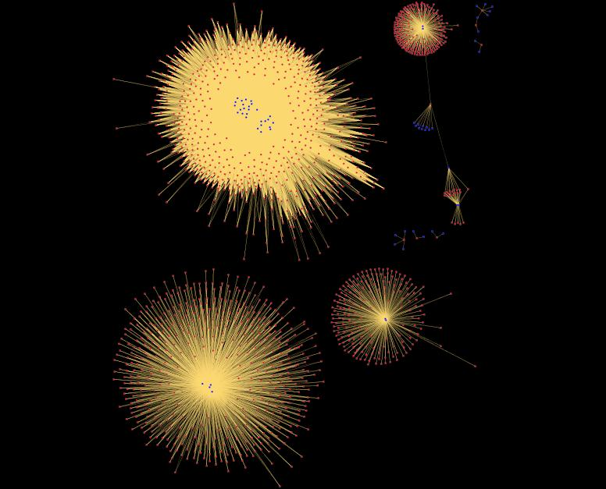
Figure 4 (see appendix II for a larger image)
Figure 5 is a close-up of the cluster in the upper right corner, with a nucleus of 2 domain names. Domain names are labeled (but not IP addresses). Note that there is an edge which leads off the bottom of the image to another address which is shared across 3 clusters of domains, possibly indicating a single host that has been compromised by multiple groups.
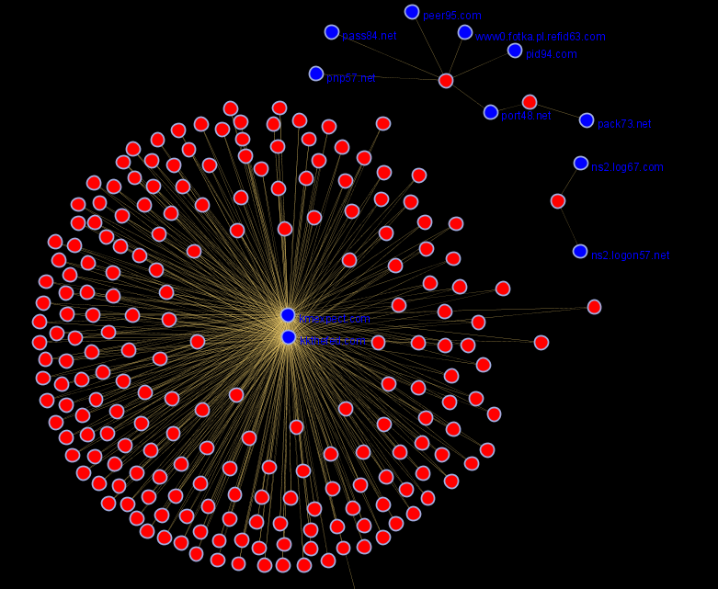
Figure 5
This last image, figure 6, shows a dense clustering of many domains, all sharing the same large pool of addresses. This dense clustering of domains that share the same cloud of IP addresses shows promise as a method of identifying fast flux domains.

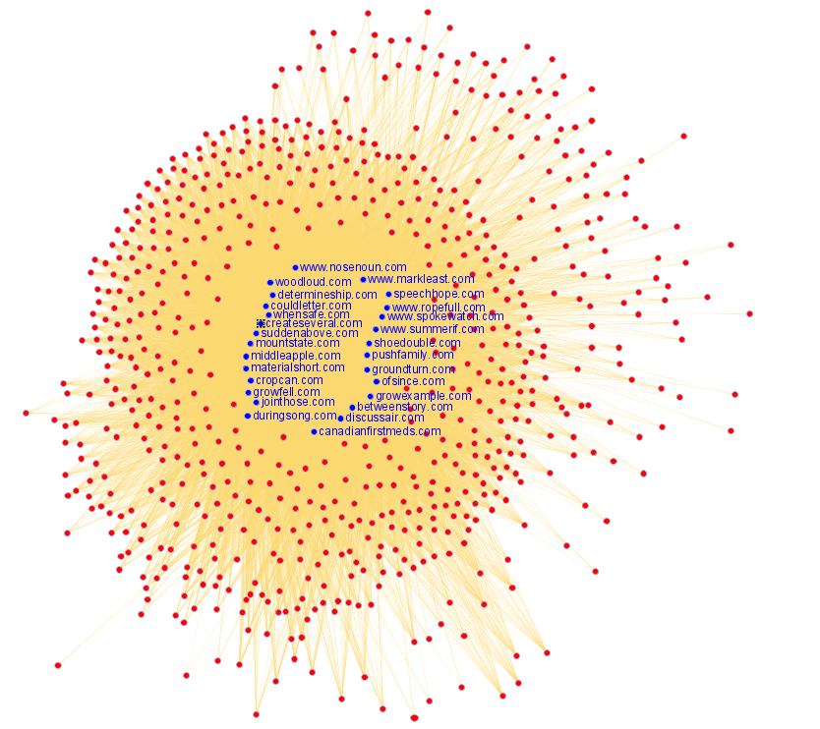
Figure 6
It is important to note the distinction between what we are seeing here and the more common use of virtual domains on a normal web server. In that case you would see several A-record lookups pointing to the same IP address (or small set of IP addresses). What we are observing here are common mappings between dozens of A-records and hundreds of IP addresses. Figure 7 shows a typical virtual domain setup with multiple domains sharing the same IP address, 67.215.66.132, which is simultaneously a single address within the cloud of IP addresses that edit53.com domain shares with several other domains.

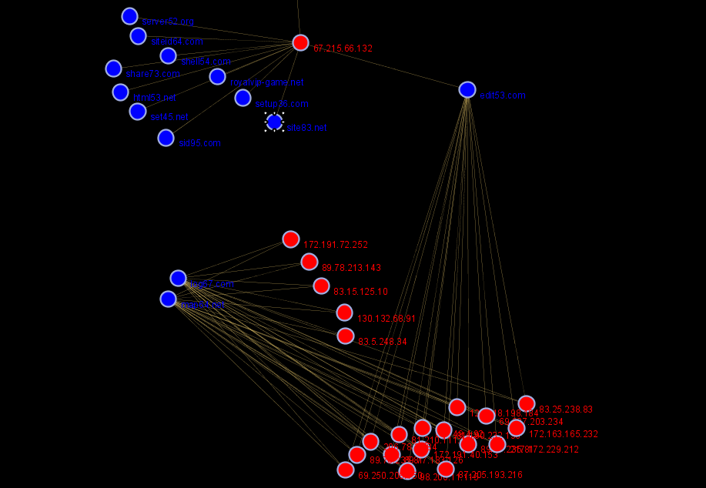
Figure 7

Looking at the distribution of A-record number vs IP address, we see a significant majority ( 15,811 or 91% ) only map between a single IP and a single A-record. For more complex arrangements, figure 8 shows the following distribution:

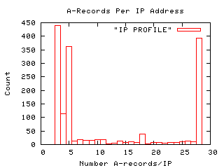
Figure 8
This shows that for some of the larger A-record counts a full 2% of the total addresses looked at map to 28 different A-record lookups.

In the Honey Net paper, they described the existence of only two primary upstream “mothership” hosts which deployed and serviced thousands of flux domains. The current high level of clustering seems to suggest that that observation still holds some degree of truth.

7.0 Future Work

There are a number of natural places for improvement in this analysis. We have identified a number of additions in the detection algorithm and intend to move forward on them. Increasing the breadth of data sources also seems to be a natural place to examine as we can begin doing
consistency checking between different sites to see if there is a significant difference in both Fast Flux content as well as the scope of
IP addresses associated with each domain. It would also be interesting to see of either the set of IP addresses or the content delivered by the
service proxying is affected by geographic location or network ownership. This would indicate a significant advance in that the Fast
Flux networks would also take on Unicast characteristics.

8.0 Conclusion

In this work we have looked at improved methods of Fast Flux network detection and analysis. We also created a distinction between networks that are Dispersed vs. those that are actively exhibiting flux like behavior. The most significant things we found were the identification of shared resources between various domains. This was achieved by looking at clusters of flux rate as well as the mappings between IP addresses and the domains and noting that there was significant overlap in the resulting sets.

9.0 Acknowledgements

We wish to thank Robin Sommer for his generous helping our data gathering.

10.0 References

Karasaridis, Anestis, Meier-Hellstern, Kathleen, Hoeflin, David, “Detection of DNS Anomalies using Flow Data Analysis” Global Telecommunications Conference, 2006. GLOBECOM 2006, Nov. 2006, Pages1 - 6

[SCHO] Antoine Schonewille, Dirk-Jan van Helmond, “The Domain Name Service as an IDS”, Research Project for the Master System- and Network Engineering at the University of Amsterdam February 5, 2006
http://staff.science.uva.nl/~delaat/snb-2005-2006/p12/report.pdf

Gadi Evron, “Looking behind the smoke screen of the Internet: DNS recursive attacks, spamvertised domains, phishing, botnet C&C’s, International Infrastructure and you”, SecuriTeam Blog, Feb 17 2006, http://blogs.securiteam.com/index.php/archives/298

William Salusky, “Phishing by proxy”, SANS Internet Storm Center diary, Nov 28 2006, http://isc.sans.org/diary.html?storyid=1895

[HNP] The Honeynet Project, ”Know Your Enemy: Fast-Flux Service
Networks”, July 2007. http://www.honeynet.org/papers/ff/.

Vern Paxson, “Bro: A System for Detecting Network Intruders in Real-Time”, Computer Networks, 31(23-24), pp. 2435-2463, 14 Dec. 1999.

Anestis Karasaridis, Brian Rexroad, and David Hoeflin, \u201cWide-Scale Botnet Detection and Characterization\u201d , HotBots April 2007, Cambridge, MA

[HOLZ] Thorsten Holz, Christian Gorecki, Konrad Rieck, Felix C. Freiling, “Measuring and Detecting Fast-Flux Service Networks”, 15th Annual Network and Distributed System Security Symposium, February 2008

[SSAC] The Security and Stability Advisory Committee (SSAC) of ICANN, "SAC025, SSAC Advisory on Fast Flux Hosting and DNS"
January, 20008, http://www.icann.org/committees/security/sac025.pdf

[DNS] OpenDNS open recursive DNS resolver http://www.opendns.com

[FREE] Peer Directed Projects Center - Freenode http://www.freenode.org

[STEG] "Detection of peer-to-peer botnets", Matthew Steggink, Igor Idziejczak, Masters Thesis, University of Amsterdam, 2008

[BZ] Bojan Zdrnja, “Security Monitoring of DNS traffic”, CompSci780 project, University of Auckland, May 2006, http://www.caida.org/~nevil/Bojan_Zdrnja_CompSci780_Project.pdf

[OPEN] DMOZ Open Directory Project, http://www.dmoz.org/

[ALEXA] ALEXA Global Top 500 Web Sites, http://www.alexa.com/site/ds/top_sites?ts_mode=global&lang=none

[ODNS] OpenDNS DNS server, http://www.opendns.com/

[FLUX] (From Wikipedia reference for flux) Bird, R. Byron; Stewart, Warren E., and Lightfoot, Edwin N. (1960). Transport Phenomena. Wiley. ISBN 0-471-07392-X.
Appendix I: Data set for ASN Flux from 6.1
Domain | AS NUM | Time(s)
dyndns.org | AS3320 | 0
dyndns.org | AS20773 | 515
dyndns.org | AS28753 | 1294
dyndns.org | AS33517 | 1337
dyndns.org | AS11426 | 1788
dyndns.org | AS33662 | 2587
dyndns.org | AS6128 | 7047
dyndns.org | AS4802 | 8432
dyndns.org | AS13045 | 10190
dyndns.org | AS8767 | 10885
dyndns.org | AS6805 | 12004
dyndns.org | AS1257 | 12394
dyndns.org | AS15594 | 13345
dyndns.org | AS6197 | 19997
dyndns.org | AS812 | 21337
dyndns.org | AS4230 | 25079
dyndns.org | AS33651 | 25095
dyndns.org | AS7303 | 25855
dyndns.org | AS8820 | 27399
dyndns.org | AS7132 | 27886
dyndns.org | AS6739 | 28379
dyndns.org | AS7015 | 28708
dyndns.org | AS20001 | 30022
dyndns.org | AS33668 | 30550
dyndns.org | AS19262 | 31812
dyndns.org | AS16338 | 32611
dyndns.org | AS3209 | 34124
dyndns.org | AS15557 | 34455
dyndns.org | AS12513 | 34471
dyndns.org | AS1221 | 34807
dyndns.org | AS9132 | 34847
dyndns.org | AS5713 | 35301
dyndns.org | AS5430 | 37534
dyndns.org | AS35776 | 40385

Domain | AS NUM | Time (s)
akamai.net | AS2914 | 1
akamai.net | AS2152 | 1
akamai.net | AS20940 | 1
akamai.net | AS4436 | 1
akamai.net | AS209 | 1
akamai.net | AS1299 | 3
akamai.net | AS27524 | 16
akamai.net | AS5650 | 22
akamai.net | AS23393 | 22
akamai.net | AS600 | 42
akamai.net | AS7843 | 42
akamai.net | AS6939 | 77
akamai.net | AS19151 | 87
akamai.net | AS17113 | 156
akamai.net | AS23504 | 294
akamai.net | AS6453 | 308
akamai.net | AS23352 | 308
akamai.net | AS6432 | 325
akamai.net | AS2711 | 354
akamai.net | AS4768 | 711
akamai.net | AS13609 | 723
akamai.net | AS25074 | 729
akamai.net | AS3549 | 744
akamai.net | AS513 | 762
akamai.net | AS7065 | 793
akamai.net | AS4766 | 829
akamai.net | AS7018 | 905
akamai.net | AS13776 | 1024
akamai.net | AS8121 | 1067
akamai.net | AS3356 | 1113
akamai.net | AS5511 | 1113
akamai.net | AS10026 | 1113
akamai.net | AS24730 | 1116
akamai.net | AS7011 | 1269
akamai.net | AS3491 | 1373
akamai.net | AS3320 | 1587
akamai.net | AS11456 | 1845
akamai.net | AS26769 | 3511
akamai.net | AS3257 | 5269
akamai.net | AS701 | 5789
akamai.net | AS1273 | 5960
akamai.net | AS1221 | 6506
akamai.net | AS3 | 6805
akamai.net | AS3462 | 7223
akamai.net | AS20001 | 8328
akamai.net | AS12310 | 9797
akamai.net | AS286 | 10985
akamai.net | AS19817 | 14309
akamai.net | AS237 | 20959
akamai.net | AS4323 | 34880
akamai.net | AS7385 | 39659

Appendix II large versions of graph visualizations

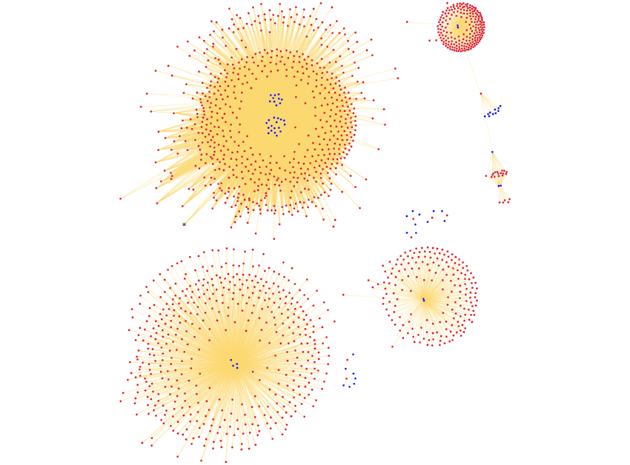
e

