Giovanni MERRA Practice Cases
(Prepared for AMS 2009 short course)

Two Giovanni instances supporting MERRA products have been added into Giovanni family recently. They are:

MERRA_MONTH_2D: Monthly data collection with 2-dimensional variable
http://gdata1.sci.gsfc.nasa.gov/daac-bin/G3/gui.cgi?instance_id=MERRA_MONTH_2D

MERRA_MONTH_3D: Monthly data collection with 3-dimensional variable
http://gdata1.sci.gsfc.nasa.gov/daac-bin/G3/gui.cgi?instance_id=MERRA_MONTH_3D

General features of the MERRA 2D interface:
http://disc.gsfc.nasa.gov/mdisc/ ➔ Tools ➔ Giovanni MERRA_MONTH_2D

- Spatial selection ( layer selection, pan and draw features, drag box or enter lon/lat)
- Parameters selection ( total 6 2D collections, click on parameter to see description, time coverage , collapse of group box, show unit)
- Time selection
- Visualization function selection

Case 1: Lat-lon map Time averaged ➔ Winter Precipitation

- Area: ( 180W – 180E, 50S-50N)
- Total precipitation ( in group: Land surface diagnostics)
- Begin Date: Jan 1979, End Date: Feb 1979
- Lat-lon map, Time averaged
- Click “Generate Visualization”, to process and generate the image
- On the result page, modify min/max to ( 0, 0.0003), or color palette, note that the value has been scaled on the plot
- Click “Generate Visualization” to re-generate the image
- Click on “download data” at the top
- Click on “KMZ” icon to display through GoogleEarth

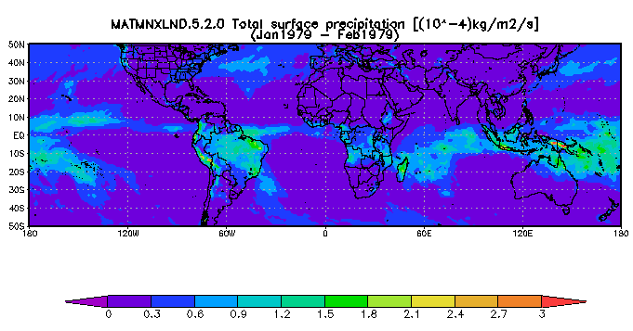

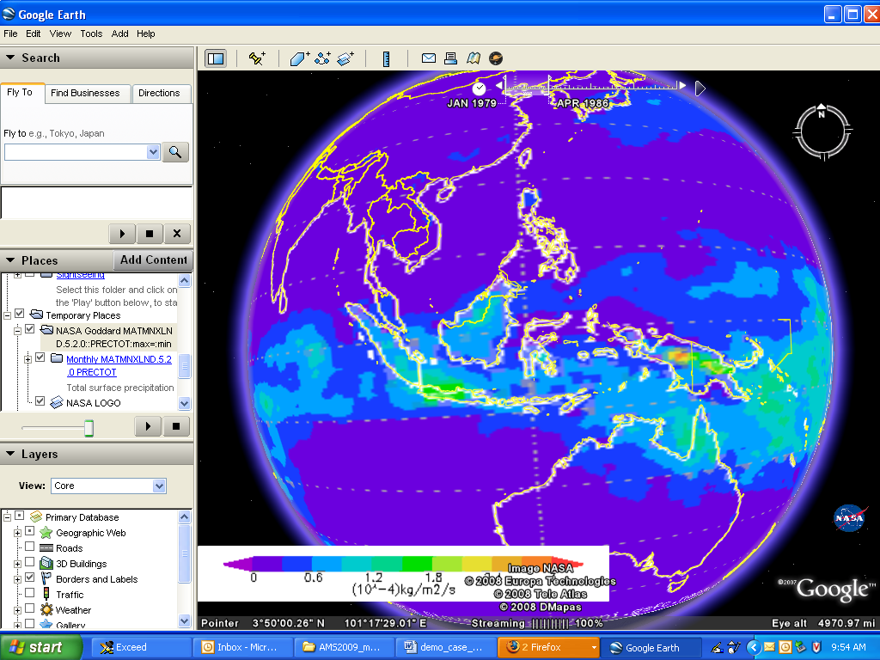

Case 2: Time series ➔ Annual cycle of precipitation and surface temperature over US
- select US region
- Total precipitation ( in group: land surface diagnostics) and surface skin temperature ( in group: surface and TOA radiation fluxes)
- Begin Date: Jan 1979, End Date: Dec 1979
- Time-series
- Click “Generate Visualization”, to process and generate the image
- On the result page, edit plot preference “overlay lines”
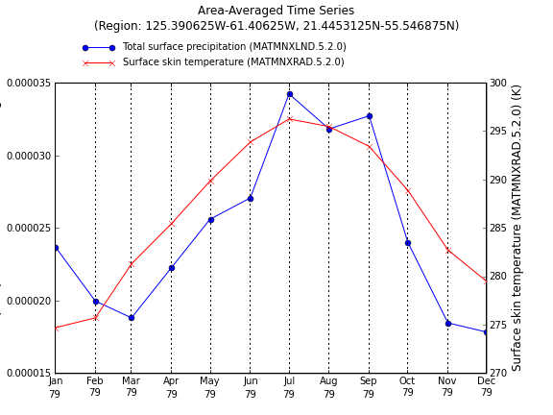

Case 3: Animation ➔ See seasonal variation of surface skin temperature over US
- Area: US
- Parameter: surface skin temperature ( in group: surface and AOT radiation fluxes)
- Begin Date: Jan 1979, End Date: Dec 1979
- Animation
- Click “Generate Visualization”, to process and generate the image
- On the result page: modify color bar, set min/max (250/305) and plot again. This will make all image plotted in the same range.
- Animation features: play, stop, control speed, loop, or swing, etc.

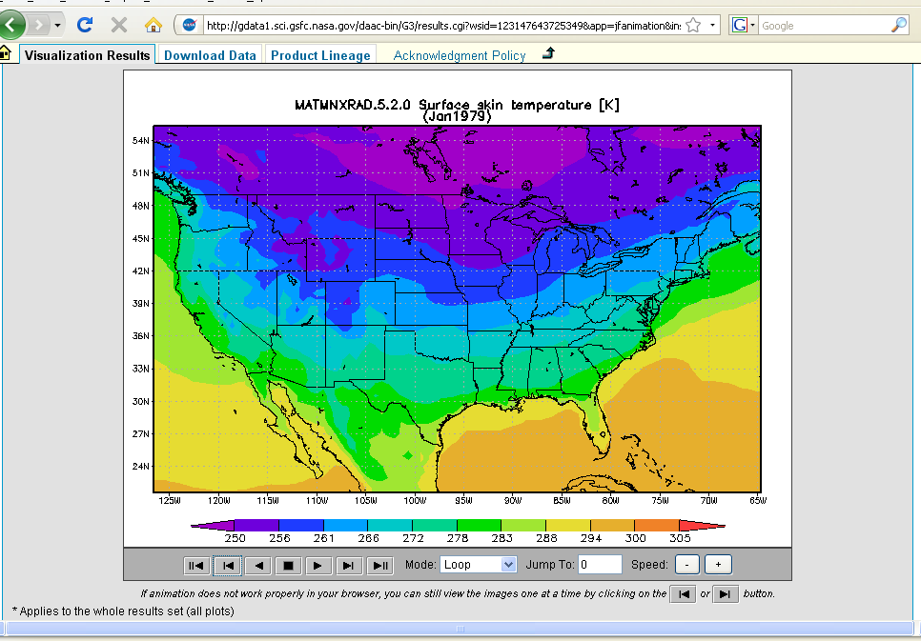

General features of the MERRA 3D instance:
http://disc.gsfc.nasa.gov/mdisc/ ➔ Tools ➔ Giovanni MERRA_MONTH_3D

- 3D interface has features of 2D interface plus:
- Vertical Profile: allow to select vertical levels. Currently, average of levels (layers) is not supported.

Case 4: Cross Map, Latitude-Pressure ➔ zonal mean vertical cross section of air temperature
- Area: global
- Vertical: Upper Level = 100hPa, Low Level = 1000 hPa
- Parameter: Air Temperature (in group: Basic assimilated fields from IAU corrector)
- Begin Date: July 1999, End Date: Jul 1999
- Visualization: Cross Map Latitude-Pressure
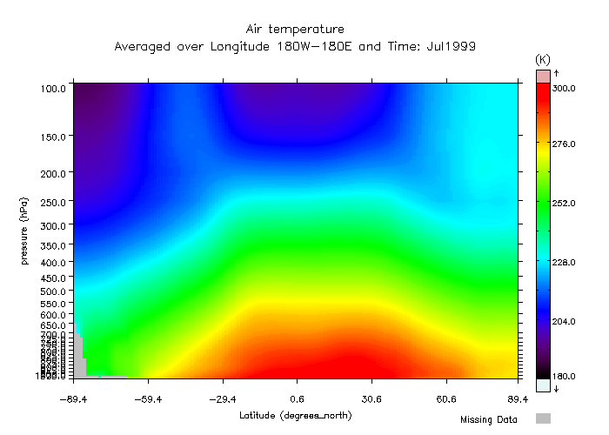

Case 5: Vertical Profile ➔ temperature vertical profile over eastern US
- Area: ( 90W – 80W, 35N-45N)
- Vertical: Upper Level = 0.1 hPa, Low Level = 1000 hPa
- Parameter: Air Temperature (in group: Basic assimilated fields from IAU corrector)
- Begin Date: July 1999, End Date: Jul 1999
- Visualization: Vertical Profile

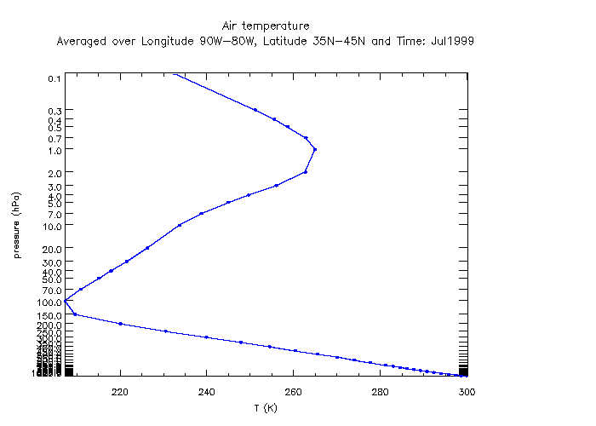

Case 6: A-Train Giovanni ➔ vertical structures of Storm Ernesto
(A preview of a future MERRA feature)
http://giovanni.gsfc.nasa.gov ➔ A-Train
http://gdata1.sci.gsfc.nasa.gov/daac-bin/G3/gui.cgi?instance_id=atrain

- Select location on the track (near US, (18N-45N, 80W- 75W) ). You may change the map view for selecting ascending, descending, or projection, and change the view range
- Date: Aug 31 2006
- Parameters: Specific Humidity Profile of ECMWF model in group Water Vapor, Reflectivity dBZ if CloudSAT in group Cloud
- Click on “Generate Visualization” to re-generate the image



