Learning Unit-A Robot Analysis and Construction (ROBOCON) Project
Joseph S. Miles & Siva Thangam
New Jersey Space Grant, Stevens Institute of Technology
Castle Point on Hudson, Hoboken, NJ 07030

ROBOCON is a unit of lessons guiding students and teachers through the process of building science, mathematics, and engineering concepts utilizing LEGO materials and computer programming skills in the framework of ROBOLAB software. The first learning module focuses on providing a basic grasp of robotics from a historical and applications perspective. The following two modules provide a brief introduction to Lego Robot concepts and a step-by-step approach on construction and programming of a commercially available Lego robot for a non-gripper (or non-prehensile) competition based activity.

Learning Unit approach
The learning unit will help students develop engineering and ROBOLAB programming skills. The three modules structure will guide students through the process of robot design, construction, testing, revision, and competition.

Using this approach
Although designed for self-study, the learning units can be used by teachers to engage all learners in critical thinking throughout the course of each lesson, optimizing classroom time. Teachers may be flexible during lessons, spending more or less time with each lesson to adapt the schedule for students’ needs.

Audience
The target audience is high school students with a science background. Each lesson is presented in steps along with vocabulary to help students understand and develop scientific and technical terms.

Prerequisite skills
Previous experience with design briefs may prepare students for the sequence of each lesson. ROBOLAB requires students to construct Gantt Charts and flowcharts; therefore, it is also suited for teamwork.

Materials
Lego MINDSTORM Group Robot Kit and ROBOLAB software

Learning Unit Module 1: Introduction to Robotics

Summary: Robots can be used in any industry providing work and services, and can be adapted easily to numerous job functions with uncanny skill and unmatched endurance. Over the past decade, highly selective applications for robots resulted in so-called "islands" of automation. Development of more sophisticated automation concepts have lead to increased usage of robots for tasks ranging from home automation to industrial robotics as well as for a wide range of space applications.
Industrial operations are usually best automated through the integration of robots with machines into what is often referred to as a "work cell”. In these configurations, the robots, along with machines that they serve, are treated as a "unified system”. This integration, which causes the need for knowledge about robotics, has become very important in flexible automation today.
The module in this learning unit provides an introduction and a preliminary application to learning the technical aspects of common robots. These modules are written for a reader in high school to provide a practical approach, with simple examples, questions, and a practical application associated with automation. It is designed to provide the reader with a sense of relevancy, especially for space applications. An overview of robot classification, the operation of robot systems, grippers and manipulators, sensors and instrumentation, and safety are given in this module and followed by an activity based robot construction project.

Objectives: This module will help familiarize the reader with the:
- history of robots
- technology of robots
- economic and social issues associated with robots
- present and future applications of robots

In current usage, automation and robots are two closely related technologies connected with the use and control of production operations. In the context of applications involving aerospace industry and space systems, we can define automation as a technology that is concerned with the use of mechanical, electrical/electronic, and computer-based systems to control production processes and complex tasks. Examples of this technology include transfer lines, mechanized assembly machines, feedback control systems, numerically controlled machine tools, robots and human-assisted manipulators. Industrial automation can be classified as fixed automation, programmable automation, and flexible automation.
Fixed automation is used when the volume of production is very high and it is, therefore, appropriate to design specialized equipment to process products at high rates and low cost. A good example of fixed automation can be found in the aircraft and automobile industry, where highly integrated transfer lines are used to perform machining operations. The economics of fixed automation is such that the cost of the special equipment can be divided over a large number of units produced, so that the resulting unit costs can be lower relative to alternative methods of production. For products with short life cycles, fixed automation is not economical.
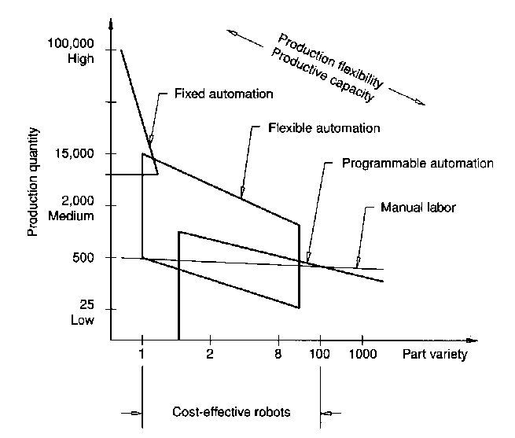
Programmable automation is used when the volume of production is relatively low and there is a variety of products to be made. In this case, the production equipment is designed to be adaptable to variations in a product configuration. This adaptability feature is accomplished by operating the equipment under the control of a "program" of instructions that has been prepared especially for the given product.
The third category between fixed automation and programmable automation is call- Figure 1: Types of Industrial Automation
ed flexible automation. This type
of automation is most suitable for the mid-volume production range. Flexible automation possesses some of the features of both fixed and programmable automation. Other terms used for flexible automation include Flexible Manufacturing Systems (FMS) and Computer-Integrated Manufacturing (CIM). Flexible automation typically consists of a series of workstations that are interconnected by material handling and storage equipment to process different product configurations at the same time on the same manufacturing system. The three types of industrial automation and manual labor are illustrated in Figure 1. The definition of an industrial robot is provided by the Robotics Industries Association (RIA) as follows: “An industrial robot is a reprogrammable, multifunctional manipulator designed to move materials, parts, tools, or special devices through variable programmed motions for the performance of a variety of tasks”.

A historical perspective on the evolution of robots:

The word robot was introduced in 1921 by the Czechoslovakian playwright Karel Capek, in his play P. U. R. (Possum's Universal Robots), and is derived from the Czech word robota, meaning "forced labor." Although Capek introduced the word robot to the world, the term robotics was coined by Isaac Asimov in his science fiction story "Runaround," first published in the March 1942 issue of Astounding, where he portrayed robots not in a negative manner but built with safety measures in mind to assist human beings. Asimov established in his story the three fundamental laws of robotics as follows:

1. A robot may not injure a human being or, through inaction, allow a human being to come to harm.
2. A robot must obey the orders given it by human beings, except where such orders would conflict with the first law.
3. A robot must protect its own existence as long as such protection does not conflict with the first and second laws.

In a broader sense, Capek's term robot meant a manipulator that was activated directly by an operator or other mechanical or electrical means. More generally, an industrial robot has been described by the International Standards Organization (ISO) as follows: A machine formed by a mechanism, including several degrees of freedom, often having the appearance of one or several arms ending in a wrist capable of holding a tool, a workpiece, or an inspection device. In particular, its control unit must use a memorizing device and it may sometimes use sensing or adaptation appliances to take into account environment and circumstances. These multipurpose machines are generally designed to carry out a repetitive function and can be adapted to other functions.
According to Miller (1987), robots were introduced to industry in the early 1960s. Initially, robots sold for an average of $25,000 with a life expectancy of about eight years, cost approximately $4.00 per hour to operate, and had to compete for jobs with human workers earning slightly more per hour than the robot hourly operating cost. Robots, originally, were used in hazardous operations, such as handling toxic and radioactive materials, and loading and unloading hot workpieces from furnaces and handling them in foundries. Some rule-of-thumb applications for robots are the four d’s (dirty, dangerous, difficult, and demeaning, but necessary tasks) and the four h’s (hot, heavy, hazardous, and humble).
By 1970, approximately two hundred robots were in use in U.S. manufacturing facilities. The jobs to which robots were assigned during that decade were primarily hazardous, strenuous, or repetitious and required the robot to respond only to simple input commands. Control and feedback technology at this evolutionary point remained relatively basic, limiting robots to jobs requiring a lot of "brawn" but very little "brain." During the 1970s, with nationally declining productivity and increasing labor rates, a significant increase in robot usage began. Many improvements in controls increased the flexibility and capabilities of robots. The first robots had been introduced in the automotive industry. Ten years later, the same industry was contributing most to the growth of robotics by its widespread acceptance. The average prices of robots increased to approximately $45,000, life expectancy remained at about eight years, operating costs rose to approximately $5.00 per hour, and the average direct labor cost in the automotive industry was twice the hourly operating cost of an industrial robot.
In 1980, there were approximately 4,000 robots in the United States and 26,000 robots worldwide. By the mid-1980s, there were approximately 17,000 industrial robots in the United States. The average price was approximately $60,000, life expectancy increased to fifteen years, operating costs were in the range of $5.50 per hour, and—again using the automotive industry as a comparative example—labor rates were escalated to over $14.50 per hour.
By the end of 1997, RIA estimates, some 84,000 robots were in operation in U.S. factories, ranking the United States second in the world to Japan. According to Dave Lavery, manager of the robotic program at NASA, there are some 650,000 robots at work today worldwide, and the average price is approximately $72,000, life expectancy over seventeen years, and operating costs in the range of $7.00 per hour as compared to average wages of over $24.00 in the automotive industry.

Aerospace and Industrial Automation

Over the past decade, highly selective applications for robots resulted in the development of more sophisticated automation concepts, such as Computer-Integrated Manufacturing (CIM) and Flexible Manufacturing Systems (FMS). Users learned that industrial operations are usually best automated through the integration of robots with machines, which are referred to as a workcell. This integration, which causes the need for knowledge about robots, has become very important in automated manufacturing today.
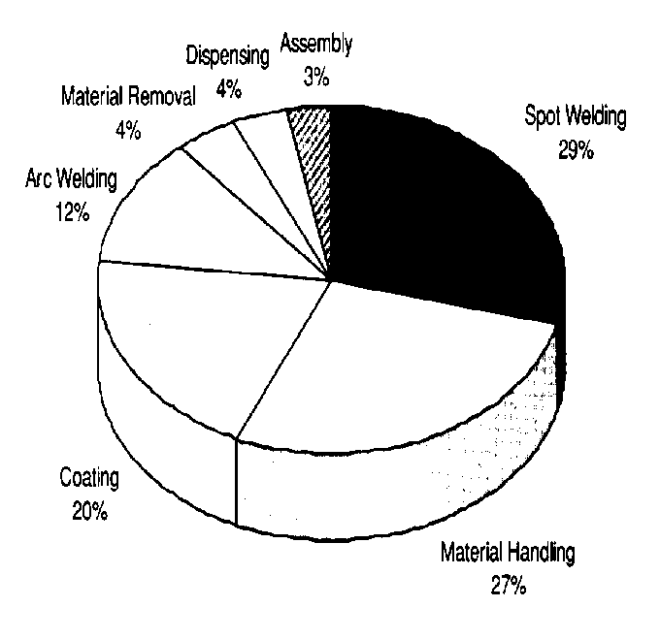
Robots can be used in any industry providing work and services, and can also be adapted easily to numerous job functions with uncanny skill and unmatched endurance.
Figure 2: Robot Application Areas
These factors and many others, such as reducing production cost, improving quality, and increasing productivity, to name just a few, have contributed to the growth of robots and will continue to impact their evolution, both in pace and direction. Robot application areas as a percentage of total robot population for the year 1996 are shown in Figure 2.
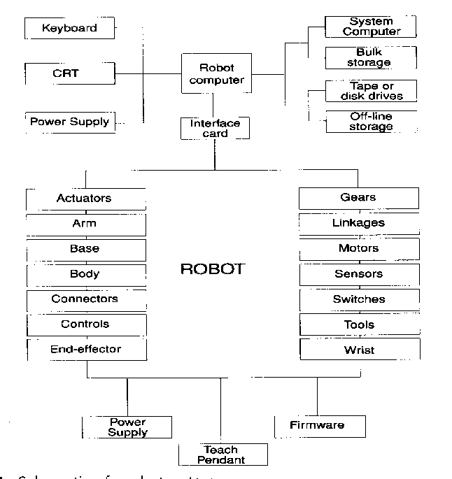
Two reasons are given for selecting a robot to operate in a production line: (1) to reduce labor costs, and (2) to perform repetitive work that is boring, unpleasant, or hazardous for human beings. Computer-controlled robots were commercialized in the early 1970s, with the first robot controlled by a minicomputer appearing in 1974. The primary purpose of the robot as a machine is controlled motion: If it does not move, it is not a robot. All robotic design endeavor has controlled, sensitive, and intelligent motion as its collective goal. The variety of uses for robots is increasing, although their main use still seems to reside in automotive manufacturing. A decade ago the projection was that robots would begin to grow in popularity about the year 1998 after the general public — as well as engineers and scientists — had learned to routinely accept them in their work environments, and that no robot would act or feel like a human being in the foreseeable future. These projections are still true. The primary driving force behind the renewed interest in robots will be lower unit cost, greater reliability, and simpler operation.
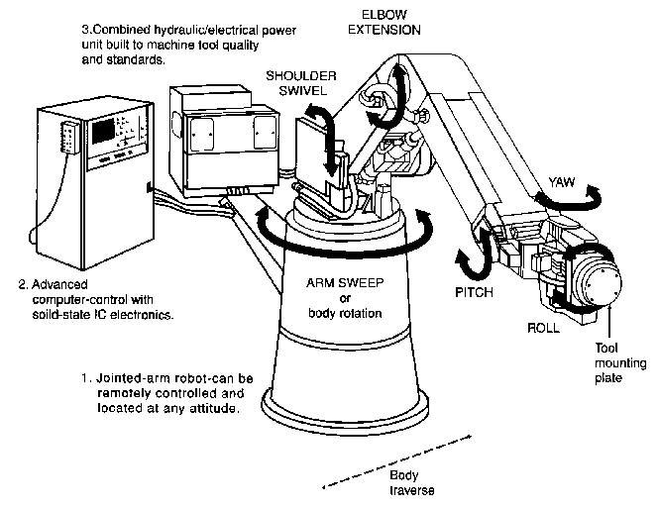
A robot is a machine constructed as an assemblage of joined links so that they can be articulated into desired positions by a programmable controller and precision actuators to perform a variety of tasks. Robots range from simple devices to very complex and "intelligent" systems by virtue of added sensors, computers, and special features. Figure 3 illustrates the possible components of a robot system. There are several hundred types and models of robots.
Figure 3: Robot System Components
They are available in a wide range of shapes, sizes, speeds, load capacities, and other characteristics. Care must be taken to select a robot to match the requirements of the tasks to be done. One way to classify them is by their intended application. In general, there are industrial, laboratory, mobile, military, security, service, hobby, home, and personal robots. The general configuration and operating parameters of an industrial robot with a gripper or a prehensile robot is also shown in Figure 3.
Robots without grippers or non-prehensile robots are also of wide usage in various aerospace and industrial applications: such as excavation, construction, and transportation as well as in communication systems. Such robots could range from autonomous vehicles for performing simple tasks to sophisticated satellites with sensors and data-acquisition systems that are cable of terrain mapping, scouting and surveillance.

Learning Unit Module 2: Introduction to Lego Robots

The LEGO Mind Storms Kit contains most of the parts required to construct a robot that can compete in an arena. Each robot is guided by a navigation beacon from the friendly side of the arena (its home territory) to the enemy side of the arena (the opponent’s territory) by a beacon light. Once on the enemy side of the arena, the robot is required to extinguish a target light before the competing robot does likewise.

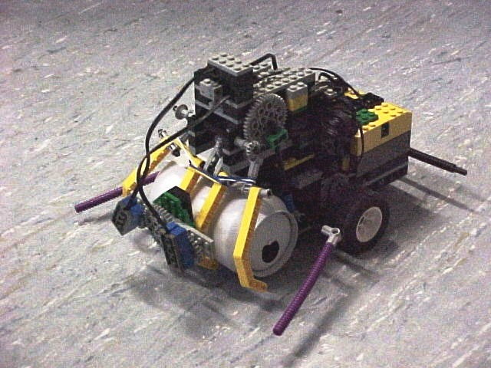
Figure 4: LEGO Robot

Building the robot requires the expertise of a project team of four or five students. Throughout the project, the project team is expected to learn a wide variety of skills such as the overall mechanics of building a robot, project planning and management, time management and teamwork. The team is introduced to the Project Design and Development environment where they experience typical design problems and employ problem-solving techniques.

Background Concepts:
- Mechanics
- Scalars and Vectors
- Distance, Velocity, Acceleration
- Particles and Rigid Bodies

Activity Summary:
- Project Planning and Team Integration
- Building the Competition Arena
- Constructing the Robot Vehicle
- Testing and Calibrating the Robot
- Running the Competition
- Post Project Enhancement Activities

Background Concepts:
Introduction to Mechanics:
Mechanics is the branch of the physical science concerned with the state of rest or motion of bodies (or robots) that are subjected to the action of forces. It deals with the motion of point masses (very small objects) and rigid bodies (large objects that can rotate as a whole, but cannot change their shape). Many practical objects can be approximately considered either point masses or rigid bodies in most situations. While the study of mechanics can encompass many subject areas, the initial study is usually split into two areas; statics and dynamics. Statics is concerned with bodies that either are at rest or move with a constant speed in a fixed direction, whereas dynamics deals with the accelerated motion of bodies. Statics can therefore be considered as a special case of dynamics where the acceleration is zero.
While it is not necessary to sit down and draw free body diagrams or figure out the static coefficient of friction between the LEGO tires and the game board, it is helpful to keep certain mechanical concepts in mind when constructing a robot. If a robot's tires are spinning because they do not grip the floor, then something must be done to increase the friction between the tires and the floor. One solution is to glue a rubber band around the circumference of the tire. That problem/solution did not require an in-depth study of physics. Simply considering the different possibilities can lead to more mechanically creative robots.
Typical problems addressed in classical mechanics are:

- Determining the amount of energy and time that is needed to accelerate a small point mass object to a given speed.
- Predicting the motion of a spacecraft approaching some planet, if its initial position and velocity at a distance from the planet are known. Since the distances are great, the spacecraft can be considered a point mass.
- Finding the trajectory of an object thrown into the air with a specific initial velocity, with the object being considered a point mass.
- Finding the frequency of oscillations in a system of point masses connected by springs.
Before we address how mechanics affects the motion of a robot, let’s define a few other terms. The motion of objects can be described specifically by the following terms - distance, speed, displacement, velocity, acceleration, momentum and friction. Furthermore, these mathematical quantities, which are used to describe the motion of the robot, can be divided into two categories. The quantity is either a vector or a scalar. These two categories can be distinguished from one another by their distinct definitions:
- Scalars are quantities of distance, which are fully described by a magnitude alone.
- Vectors are quantities of distance, which are fully described by both a magnitude and a direction.
- Speed is a measure of how quickly a body is moving. It is defined as the distance traveled per unit time. Speed is a scalar quantity.
- Displacement is a measure of distance in a particular direction. Displacement is a vector quantity.
- Velocity is the rate of change of displacement with respect to time. Velocity is a vector quantity.
- Acceleration is the rate of change of velocity with respect to time. Acceleration is a vector quantity.
- Momentum is defined as the product of an object’s mass and its velocity. This is a very important quantity in mechanics. It arises in many problems particularly those involving collisions. Momentum is a vector quantity.
- Time is the measure of a succession of events and is a basic quantity in dynamics. Time is not involved in the analysis of statics problems. Time is a scalar quantity.

- Length is needed to locate the position of a point in space and describes the size of a physical system. Once a standard unit of length has been defined, it is possible to define distances and geometric properties of a body as a multiple of the unit of length. Length is a scalar quantity.

- Volume is a measurement of the physical size of an object. It refers to how much space an object takes up. Volume is a scalar quantity.
- Mass is a different measurement of the size of an object. The mass, measured in kilograms, depends only on the amount of matter forming the body. Mass is a scalar quantity.
- Density is related to mass and volume. It is defined as the mass per unit volume. This means that an object that has a large mass but a small volume will have a large density. Density is a scalar quantity.
- Forces are influences on a body or system, which, acting alone would cause the motion of that body or system to change. A system or body at rest and then subjected to a force will start to move. To work with forces we need to know the magnitude (size), direction and the point of application of the force. Forces are vector quantities.
- Friction - The robots to be built are wheeled vehicles, and without friction, those wheels would just spin in place without moving the robot anywhere. In order to increase the friction between the wheels and the arena one might use wheels made of a different material or add a rubber band around the wheel's circumference. Friction is not desirable in all cases. When it comes to axles spinning inside of holes in beams or gears rubbing up against beams or even gears pushing against each other, friction can cause two identically constructed gear trains to behave differently. Friction can even render the whole assembly ineffective.
Idealizations:
In mechanics, we look at real life situations and try to predict what will happen. The problem with real life situations is that they are often quite complicated. When studying problems in mechanics we often make idealizations of real life situations that simplify the problem. There are many commonly used idealizations that we will introduce in later sheets. Here follows a list of some common idealizations that are used in mechanics.
Particles are bodies, which can be treated as a point mass in a given context. For example, when modeling the motion of the planets around the Sun, the planets and Sun can be treated as particles. Much of basic mechanics study is concerned with objects that can be treated as particles.
Connected particles arise in problems where two objects are attached in some way and both objects can be treated as particles. For example, two masses, connected by a string, which passes over a pulley, could be modeled as connected particles.
Rigid bodies can be considered as combinations of particles in which all the particles remain at a fixed distance from one another both before and after applying a force i.e. there is no bending or stretching. For example, a brick can in most circumstances be thought of as a rigid body. Many real life objects can be considered rigid bodies to a good approximation.
Rigid Body Dynamics
Many of the things we come in contact with on a daily basis are rigid for all practical purposes. Buildings, chairs, and sidewalks all flex and vibrate, but these effects do not strongly affect us. You might ask, "So what?" The answer is that we need to endow robots with the "knowledge" and skill to manipulate autonomously things so that we can send them into dangerous environments, like a battlefield, the surface of the moon, at the bottom of an ocean, into a nuclear power plant, and repair things rather than humans. The first step to building robots with this knowledge and skill is the development of human scientific knowledge of how bodies interact with each other on a grand scale.
The field of rigid body dynamics is all about designing mathematical models and algorithms to predict the motions of bodies and the contact forces, including friction, that arise between them. The two most exciting applications of rigid body dynamics are robotics, and computer games. In robotics, the goal is to build a robot with the capability to plan, and autonomously carry out dexterous manipulation tasks - like extinguishing lights. Computer games contain physics engines to improve realism - for example, dropping a stone into the gears of a machine could cause jamming, thus stopping the knife blades from swinging across your path, and allowing you to escape the collapsing building.
These two applications differ in a critical way. The physics engine is used to answer the question, "Given the input (motor torques, gravity, etc.), tell me how the robot will move and what contact forces will arise. This is the forward rigid body dynamics problem. For example, if a robot moves its bumper arm in a specified way that causes it to hit a box on a table, the solution to the forward problem will allow us to predict where the box will come to rest, among other things. Once it is possible to predict the consequences of robot actions, it becomes possible to plan the activities of a robot to achieve a goal. Given the current state of the robot and its environment, and a task specified as a goal state, of the robot and its environment, planning is equivalent to finding the set of robot actions that transform the robot and environment to the goal state. Solving this problem is an inverse rigid body dynamics problem, known to be extremely challenging and often counter-intuitive (other reasons I like rigid body dynamics). For this class exercise, we will design a robot to compete in an arena by navigating from one side of the arena to another and extinguish target lights on the opposite side of the arena.
Robots:
Robot project based learning courses entail teaching, logistic, and project management challenges, since they typically use hardware and software labs that have student teams that operate with a high degree of autonomy. These courses use the building of robots and robot software to motivate students to learn various aspects of engineering such as mechanics, dynamics, electronics and information technology. We believe that the lessons learned during creation of a robot will scale to the broader engineering community envisaged in an industrial engineering environment.
Good design does not just happen; it is planned and executed in a systematic way, with random “Eureka” thoughts interspersed as catalysts to the creation of the product. While students need a high degree of autonomy, they nevertheless need both technical and time management guidance in order to pass through the necessary milestones on schedule. Ideally, courses also need to provide “apprenticeship” experience for the student so that they can “see” how good designers function. In this course, students are given a broad ill-defined task, such as “Design a robot to compete in an arena competition,” which encourages them to explore different strategies and concepts using analytical, simulation and hands-on experiments within a bounded design space. While this course has a single goal, it is organized into a series of knowledge checkpoints that must be attained in order to reach the final goal. Each milestone represents an integrated, but limited, piece of knowledge that must be grasped and understood and then utilized to make a design decision. A key need in project courses is to keep the student on track and take action when the student falls behind the planned trajectory.

Learning Unit Module 3: Lego Robot Project

Activities:

Project Planning and Team Dynamics

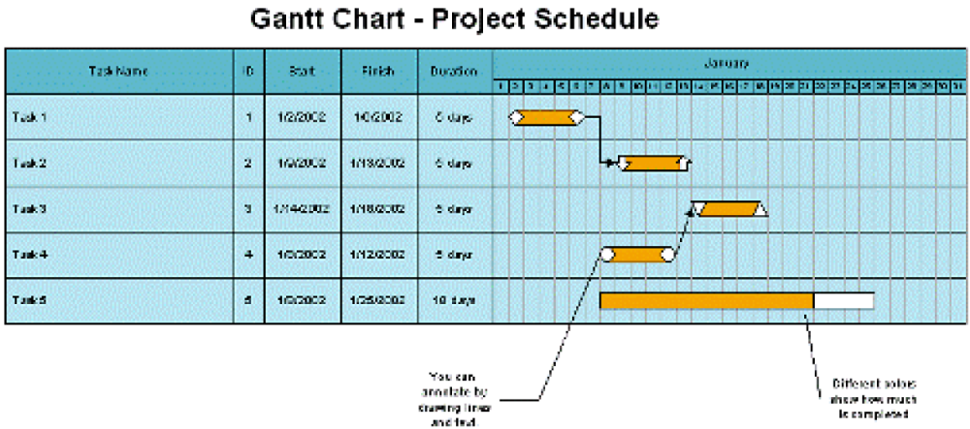
Project planning is the process of breaking down a project into specific tasks and defining a sequence in which those tasks can or must be performed. It is not just scheduling. Once the major tasks are identified, they can be further broken down into sub-tasks and the task duration estimated in number of days. Ultimately, date ranges can be assigned to each of the sub-tasks. Finally, resources, identified by a particular student’s name, can be assigned to each of the sub tasks. Microsoft Project is a useful planning and scheduling tool, which can be utilized for the planning and management activity. Gantt Charts and work break down schedules can be easily created. A sample Gantt Chart is shown below:
Figure 5: A Sample Gantt Chart

Team dynamics goes to the heart of a well functioning group. It is the unseen forces that operate in a team between different people or groups that can strongly influence how a team reacts, behaves or performs, with the effects being very complex. Meanwhile a significant shift is taking place in our modern organizations, which increases the emphasis on the group or the team. Technology is the driving force behind this shift as currant tasks have grown too difficult for individuals to tackle alone. Harnessing the potential power of the team can have a dramatic effect on productivity and job satisfaction leading to the group or team becoming the core unit in many organizations. Research has shown that groups are more effective in solving problems and learn more rapidly than individuals.

Activity #1: Identify students to be part of groups playing to the strength of the student’s background. Assuring that every group has one student with their strength in either the electrical, mechanical or software disciplines, will put the project in the best possible position to succeed.

Activity #2: Monitor the group’s progress throughout the development life cycle taking corrective action as required, especially when a task falls behind a pre-determined task timeline.

The Robot Arena:

Activity #1: Building the Robot Arena
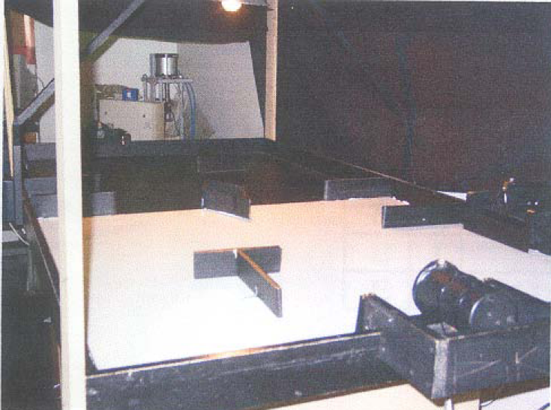
The robot competition should be held in a 4 ft. x 8 ft. arena made of plywood. One–half of the arena is painted black and the other half of the arena is painted white to differentiate friendly and enemy territory. There should be 4-inch walls surrounding the perimeter. Home and enemy territories are determined at the beginning of the competition when one of the first actions of the robot is to use its floor light sensor to read and store the home court color. There are also two types of lights: one navigation light located 30 inches above the direct center of the arena, and four target lights (two friendly target lights and two enemy target lights) located along the perimeter wall of the arena. A light sensor on the robot is angled upward to determine the location of the navigation light, and another light sensor to determine the location of the target lights. Placed within the arena are “obstacles” comprised of 3-inch high wooden shapes, which the robots have to navigate around. The bumpers of the robot, when coming in contact with an obstacle, are used to make course corrections. Two robots compete simultaneously in the arena. The robot to first locate, approach, and ‘knock out’ the enemy’s target lights without knocking out their own target lights, is determined as the winning robot.
Figure 6: The Competition Arena

The Robot Vehicle:
Activity #2 – Building the Robot: This is by far the largest part of the robot project and is broken down into sub-activities 2.1 to 2.5.
The material provided to each team of the class should be a LEGO Mind Storms Logo Kit – Part # 9733 as shown below.

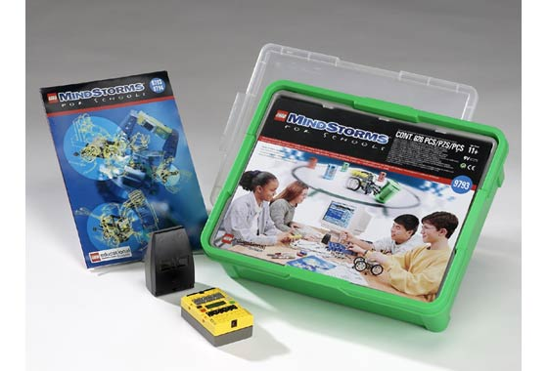
Figure 7: LEGO Mind Storms Kit

The kit contains:
Lego blocks for construction of the robot body and chassis
2 motors for wheel control
1 NiCad battery to power the motors
2 switches for bumper control

Supplemental materials include:
3 photo sensitive resistors to be used for beacon, target and floor modules
1 LED to be used in a floor sensor module

A typical robot that might be built could look like the model shown below:

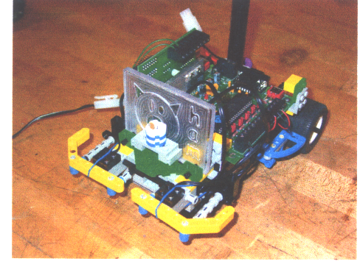
Figure 8: A Sample Robot

Overall Robot Win Strategy:

The overall robot competition strategy should be for the robot to locate the navigation beacon and move toward it while continually checking the floor color. Once it crosses into enemy territory, the robot would detect each of its target lights in sequence while again continually checking the floor color to make sure it did not cross back into friendly territory. If one or both of the robot’s bumpers are hit it might need to back up, turn and reverse course slightly before continuing. Once both target lights are extinguished, the robot’s task is completed. The competition should take 3 to 5 minutes.

Robot Design and Assembly (Activity #2.1):

A low profile chassis seems to work best keeping the robot’s center of gravity close to the ground. Rather than introduce gears, it is advisable to drive the robot directly off the motors to avoid any complications. Two rear wheels and a front roller to glide on the surface of the arena should suffice. The chassis is built from the LEGO pieces provide in the kit. It should be constructed about one-half inch above the surface to allow room for the floor sensor module to be placed beneath it. A second level was built to hold the battery pack, and above that the RCX programmable brick.

Bumper Sensor Module (Activity #2.2):

The robot should be equipped with two bumpers, from the LEGO kit, mounted across the front of the robot. No matter what angle from which an obstacle was hit by the robot, one of the two switches behind the bumpers would be triggered and the robot advised to take evasive action. The two bumper arms should directly come in contact with each of the two contact switches.

Navigation Sensors (Activity #2.3):

A light sensor for the navigation light and a light sensor for the target lights were placed on the robot. The light sensor for the navigation light was placed on the front of the robot facing upwards at about a 45-degree angle to try to detect a more direct light. Shielding was used to isolate the different light angles in respect to the navigation light and its associated light sensor. The target light sensor should be placed directly in front of the robot, to be in the line of sight with the target lights. Shielding can also be used to improve its directionality.

Floor Sensor Module (Activity #2.4):

Create a floor Sensor module to read the floor color (black or white) to determine if the robot is in friendly (home) or enemy territory. Utilize a high currant LED to illuminate the floor powered by the on board battery pack. A light sensor can then determine the floor color by converting light reflected back from the floor into voltage. Additional circuitry may be needed to control the operation of the LED. A transistor can act as a high currant switch, powering the LED directly from the 5 volt on board voltage source, turning on and off according to programming instructions. An electrical schematic of such a circuit can be seen below:
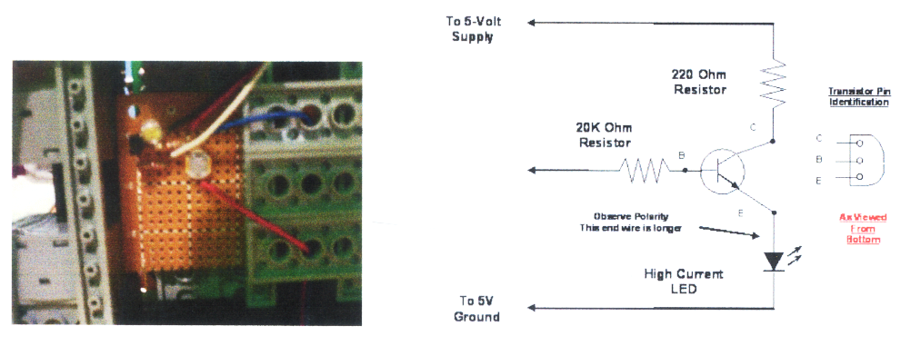
Figure 9: Floor Sensor Module and Circuit Schematic

Floor Sensor Module Parts:
- Printed circuit board for mounting the floor sensor circuitry – approximately 2 in. x 2 in.
- White LED
- Transistor – 2N2222
- 220 ohm – ¼ watt resistor
- 20,000 ohm – ¼ watt resistor
- Assorted color wire about 8 – 15 inches
- Round light sensor shield

Assembly (Activity #2.5)

The materials used in the construction of the robot came from the LEGO Mind storm Kit #9793. One must keep in mind the potential for the robot to break apart upon impact. Therefore it is necessary to use redundant pieces to help reinforce and maintain the stability of the robot and to increase its strength. Special care should be taken on the construction of the bumpers since they will be designed to come in contact with obstacles.

Integration Testing and Calibrating the Robot:
The team should test each component of the system individually since it is easier to find and repair errors in small sections of the robot and the associated code before attempting to integrate the entire project.
Initially test the motors and their control routines. Make sure they can spin forward, in reverse, turn left, turn right. Also, determine the correct speed you would want to have them operate at, depending on the direction they are going in. Take care to note if both motors go at the same rate given the same speed commands.
Next, test the bumpers. Make sure when the right bumper is hit it can be detected by the RCX brick and likewise for the left bumper. Integrate evasive action to the motors depending on which bumper hit was detected.
The integration of the light sensors is the next step. Initially each light sensor needed to be calibrated to determine the voltage measured. A voltage as low as 0.1 volts indicated the brightest light while a voltage as high as 5 volts indicated no light. Since each sensor is unique and then again, its placement is different, measurements need to be taken for the beacon sensor as well as the navigation sensor and action taken based on the measurements.
Finally, test the floor sensor module. Initially turn on the LED by program control. Next, take a light sensor reading, and then turn off the LED. After the light sensor reading taken, it can be determined if the robot was on the white or the black portion of the arena.

Running the Competition in the Arena:
The competition is conducted by double elimination of each team’s robot against every other team’s robot. The team with the highest total score wins the completion. The toss of a coin can determine the team that selects the side of the arena on which they want to place their robot, while the opposing team determines the orientation of the robot (facing the beacon, away from the beacon, or slightly skewed). A stopwatch is started and the robots are turned on while a limit is set (3 minutes is usually sufficient). The first robot to reach the enemy side and extinguish both lights wins the match. Some individual matches may result in re-matches if both robots get stuck on obstacles, while other matches may result in draws with each team receiving ½ point. A typical scoring matrix might look as follows, for six hypothetical teams:
Team | 1 | 2 | 3 | 4 | 5 | 6
1 | X | 1 | 1 | 2.5 | 3 | 1.5
2 | 2 | X | 1 | 3 | 2 | 0
3 | 2 | 2 | X | 1 | 2 | 1.5
4 | 0.5 | 0 | 2 | X | 1 | 2
5 | 0 | 1 | 1 | 2 | X | 3
6 | 1.5 | 3 | 1.5 | 1 | 0 | X
Total | 6 | 7 | 6.5 | 9.5 | 8 | 8

Figure 10: Robot Competition Scoring Matrix

Post Project Enhancement Activities:
Experience with numerous versions of robot construction lead us to propose that the more light sensors, the better control of navigation that occurs. For example, if there were a front and rear beacon detection sensor, it could be more easily determined when the robot is moving forward or in reverse. Likewise, if there are two navigation light sensors, the robot could determine if the target light is to the right or to the left, and move accordingly. However, the introduction of additional light sensors makes the logic of the robot more complicated while giving better control of the vehicle.

